Banking troubles
Students learn to add integers in the context of depositing and withdrawing or transferring money. Students model addition contexts using black and red counters to model positive and negative numbers.

Visible learning

Learning intentions
- To add integers with or without the aid of a visual representation.
- To construct a directed number sentence to model a situation.

Success criteria
- I can use counters to represent positive and negative numbers.
- I can use counters to add directed numbers.
- I can write a directed number sentence for a given situation.

Syllabus outcomes
A student:
- develops understanding and fluency in mathematics through exploring and connecting mathematical concepts, choosing and applying mathematical techniques to solve problems, and communicating their thinking and reasoning coherently and clearly MAO-WM-01
- compares, orders and calculates with integers to solve problems MA4-INT-C-01
Mathematics K–10 Syllabus © NSW Education Standards Authority (NESA) for and on behalf of the Crown in right of the State of New South Wales, 2022.

Activity structure

Launch
- Verbally present the following scenario to students.
Mandy’s banking app on her phone is playing up and will only let her deposit $2 at a time or transfer or withdraw $3.
- Working in visibly random groups of 3, at a vertical non-permanent surface (bit.ly/VNPSstrategy), ask students to find what transactions she can make to end up with $5 in her account.
- Extending prompts could include:
- Can she ever get back to having no money in her account?
- Are there totals that she couldn’t have in her account?
- Lead a class discussion around solutions. Ask students to share how they represented a deposit and a transfer or withdrawal. Discuss any similarities between student representations as well as the advantages and disadvantages of each.

Explore
- Explain to students that historically bookkeepers wrote deposit amounts in black ink and wrote withdrawal amounts or losses in red ink.
- Explain to students that we will be using black counters to represent deposits and red counters to represent transfers or withdrawals.
Figure 1 – black counter representing deposits and red counter representing withdrawals or transfers
Image created using the free virtual manipulatives at Polypad.org.

- Ask students to represent their transactions from the launch using black and red counters. Students can be challenged to additionally represent these transactions using positive and negative numbers. For example, to make $5 students could show:
Figure 2 – four deposits of $2 and one withdrawal of $3
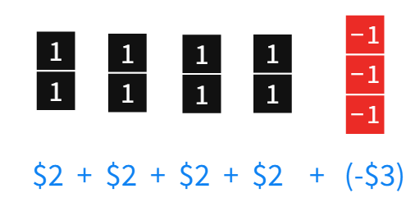
Image created using the free virtual manipulatives at Polypad.org.
A focus on correct terminology is required throughout this unit of learning. Students should be encouraged to read negative numbers as ‘negative 3’ and not ‘minus 3’. The terms ‘plus’ and ‘minus’ should be reserved for operations. For example, 2 - (-3) should be read as ‘2 minus negative 3’.
- Using a Think-Pair-Share (bit.ly/thinkpairsharestrategy), ask students to discuss how their counters can be simplified to show the $5 final total.
During the Think-Pair-Share listen out for language such as ‘cancelling out’ or ’zero pairs’.
- Introduce the concept of zero pairs (if it doesn’t come up in student strategies), by asking students to consider what happens if you have $1 in the bank and then you withdraw $1. Or, if you borrow $1 from a friend and then pay back the $1.
- Demonstrate how zero pairs can be used to simplify the launch problem. The diagram in Figure 3 could be drawn on the board or modelled using Polypad Algebra Tiles (mathigon.org/polypad#algebra-tiles).
Figure 3 – red and black counters being paired up to show zero pairs
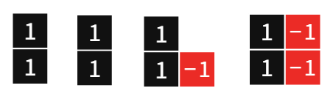
Figure 4 – zero pairs have been replaced with zeroes
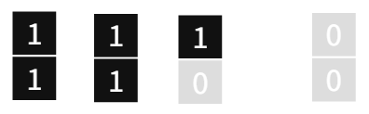
Images created using the free virtual manipulatives at Polypad.org.
When using Polypad algebra tiles, if you drag a black tile on top of a red tile, they are replaced with a zero tile.

Summarise
- Students are to complete worksheet in Appendix A ‘Adding integers’. They will need to represent each scenario by drawing counters and writing an appropriate mathematical expression, before calculating a final total.
- On completion, discuss with students what they noticed and what they wonder.
This activity is designed to show that the commutative rule of addition still applies with negative numbers. For example, 3 + (-2) = (-2) + 3.

Apply

Activity 1 – integer wars
In pairs, students will play ‘Integer wars’.

Equipment:
- One deck of cards per group.
- One pencil and paper per group.

Game rules:
- Using the Ace (1) to 10 cards from a standard deck of cards, each player draws 2 cards from the deck. Red cards are negative and black cards are positive.
- Each player adds their 2 cards together.
- The player who has the largest total wins a point.
- The game continues until someone reaches a score of 10.

Activity 2 – integer magic squares
Students complete the ‘Integer magic squares’ activity in Appendix B. All rows, columns and diagonals add to the same total.
- Students can be challenged to create magic squares that use negative fractions and/or decimals.
- Students could be further challenged by writing an algebraic equation for each row, column or diagonal of the magic square, using a variable to represent the blank cell. For example, (-4) + $x$ + 0 = (-3).

Activity 3 – integer Venns
Students complete the ‘Integer Venns’ activity in Appendix C. Students are asked to create a 2-number addition sum that satisfies each section of the Venn diagram. If they believe a section is impossible to fill, they need to justify their reasoning.
- Two versions of this task have been created. The second uses the same initial criteria from the 2-circle version but adds in criteria to increase the complexity of the task.
- Students will find it easiest to fill sections A, B and C where they only need to satisfy one condition. They can then move on to D, E and F before considering sections G and H.
- Higher achieving students should be challenged to try and make as few changes to their sums between regions as possible.
- Students could be challenged to create their own criteria for an integer Venn, complete with sample solutions.

Assessment and differentiation

Suggested opportunities for differentiation
Counters are used throughout this learning episode to assist in developing conceptual understanding. Students should be encouraged to continue using counters for as long as necessary.
Apply – integer wars
- Students should be encouraged to continue to draw diagrams to assist them with calculating their totals during the ‘Integer wars’ game.
- Students can be challenged by using the Jack, Queen and King cards to represent values of 11, 12 and 13.
- Students could be challenged by drawing and adding more than 2 cards at a time.
Apply – magic squares
- Challenge students to create a magic square that includes decimals or fractions as well as negative numbers.
- Students could be challenged to write an algebraic equation for each row, column or diagonal of the magic square, using a variable to represent the blank cell. For example, (-4) + $x$ + 0 = (-3)
Apply – integer Venns
- Two versions of this task have been created. The second uses the same initial criteria from the two-circle version, but adds in an additional criteria to increase the complexity of the task.
- Students will find it easiest to fill sections A, B and C where they only need to satisfy one condition. They can then move on to D, E and F before considering sections G and H.
- Higher achieving students should be challenged to try and make as few changes to their sums between regions as possible.
- Students could be challenged to create their own criteria for an integer Venn, complete with sample solutions.

Suggested opportunities for assessment
- Teachers should monitor student discussions and answers during class to assess their understanding and use of correct terminology.
- Teachers could choose to ask students to complete (using visual representations if necessary) an exit ticket containing an addition problem involving negative numbers.
- Teachers could choose to collect the Adding integers, Integer magic squares or Integer Venns activities to check for understanding.

Appendix A

Adding integers
- Represent each scenario using counters and as a mathematical expression.
Scenario | Representation using counters | Mathematical expression | Answer
A deposit of $7 followed by a deposit of $2 | 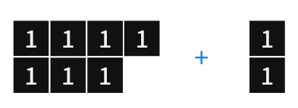 | $7 + $2 | $9
A deposit of $5 followed by a withdrawal of $3 | 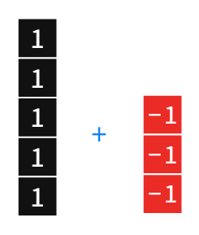
A withdrawal of $3 followed by a deposit of $5
A deposit of $3 followed by a withdrawal of $5
A withdrawal of $5 followed by a deposit of $3
A withdrawal of $1 followed by a withdrawal of $3
A withdrawal of $3 followed by a withdrawal of $1
A withdrawal of $4 followed by a withdrawal of $2 followed by a withdrawal of $5
A withdrawal of $2 followed by a withdrawal of $4 followed by a withdrawal of $5
A withdrawal of $5 followed by a withdrawal of $2 followed by a withdrawal of $4
 |  | 2 + (-2)
 |  | (-2) + 2
 |  | 6 + (-2)
 |  | (-2) + 6
- What do you notice? What do you wonder?
- How many different ways can you find to end up with a final total of $2?

Appendix B

Integer magic squares
- Complete each of the magic squares by filling in numbers so that each row, column and diagonal adds up to the same total.
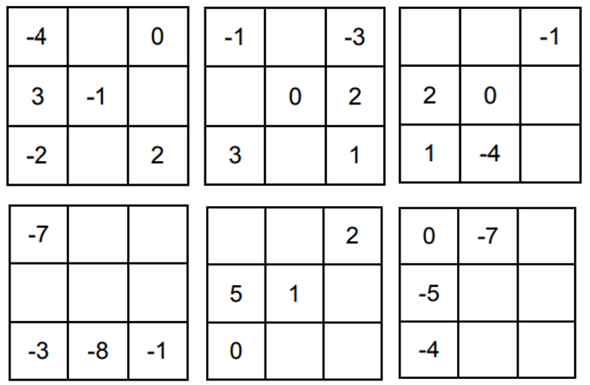
- Create your own magic squares and then share with a friend to complete.

Appendix C

Integer Venns
Think of a 2 number addition sum that could belong in each region. If you think a region is impossible to fill, convince me why!
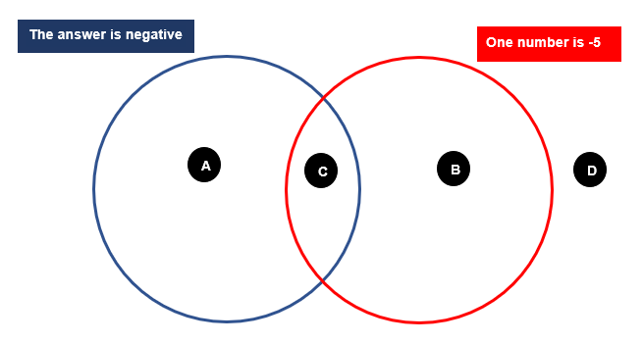

Think of a 2 number addition sum that could belong in each region. If you think a region is impossible to fill, convince me why!
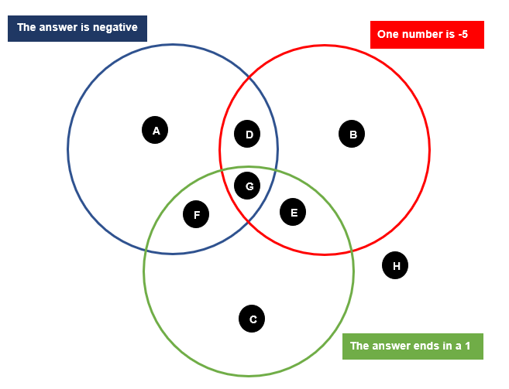

Sample solutions

Appendix A – adding integers
Scenario | Representation using counters | Mathematical expression | Answer
A deposit of $7 followed by a deposit of $2 |  | $7 + $2 | $9
A deposit of $5 followed by a withdrawal of $3 |  | 5 + (-3) | $2
A withdrawal of $3 followed by a deposit of $5 | 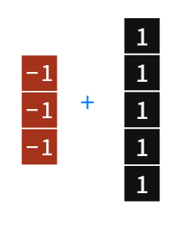 | (-3) + 5 | $2
A deposit of $3 followed by a withdrawal of $5 | 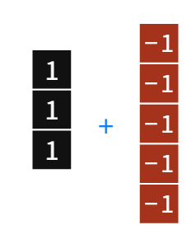 | 3 + (-5) | $(-2)
A withdrawal of $5 followed by a deposit of $3 | 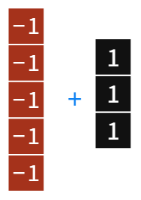 | (-5) + 3 | $(-2)
A withdrawal of $1 followed by a withdrawal of $3 | 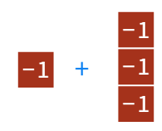 | (-1) + (-3) | $(-4)
A withdrawal of $3 followed by a withdrawal of $1 | 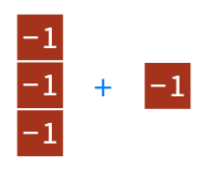 | (-3) + (-1) | $(-4)
A withdrawal of $4 followed by a withdrawal of $2 followed by a withdrawal of $5 | 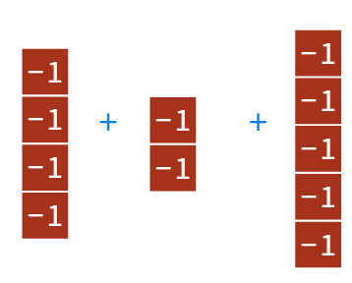 | (-4) + (-2) + (-5) | $(-11)
A withdrawal of $2 followed by a withdrawal of $4 followed by a withdrawal of $5 | 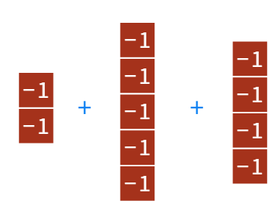 | (-2) + (-5) + (-4) | $(-11)
A withdrawal of $5 followed by a withdrawal of $2 followed by a withdrawal of $4 | 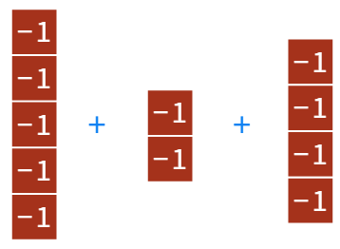 | (-5) + (-2) + (-4) | $(-11)
A deposit of $2 followed by a withdrawal of $2 | 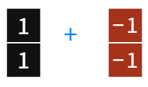 | 2 + (-2) | $0
A withdrawal of $2 followed by a deposit of $2 | 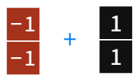 | (-2) + 2 | $0
A deposit of $6 followed by a withdrawal of $2 | 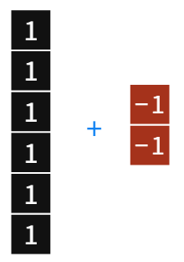 | 6 + (-2) | $4
A withdrawal of $2 followed by a deposit of $6 | 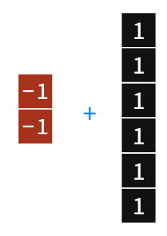 | (-2) + 6 | $4

Appendix B – integer magic squares
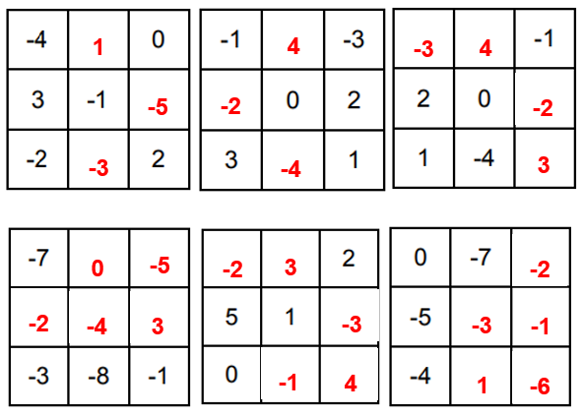
-6

Appendix C – integer Venns

Two circle Venn
Region A: (-10) + 7 = (-3)
Region B: (-5) + 7 = 2
Region C: (-5) + (-2) = (-7)
Region D: (-3) + 5 = 2

Three circle Venn
Region A: (-10) + 7 = (-3)
Region B: (-5) + 7 = 2
Region C: 7 + 4 = 11
Region D: (-5) + (-2) = (-7)
Region E: (-5) + 6 = 1
Region F: (-6) + 5 = (-1)
Region G: (-6) + (-5) = (-11)
Region H: 0 + 4 = 4

References
This resource contains NSW Curriculum and syllabus content. The NSW Curriculum is developed by the NSW Education Standards Authority. This content is prepared by NESA for and on behalf of the Crown in right of the State of New South Wales. The material is protected by Crown copyright.
Please refer to the NESA Copyright Disclaimer for more information https://educationstandards.nsw.edu.au/wps/portal/nesa/mini-footer/copyright.
NESA holds the only official and up-to-date versions of the NSW Curriculum and syllabus documents. Please visit the NSW Education Standards Authority (NESA) website https://educationstandards.nsw.edu.au/ and the NSW Curriculum website https://curriculum.nsw.edu.au/home.
Mathematics K–10 Syllabus © NSW Education Standards Authority (NESA) for and on behalf of the Crown in right of the State of New South Wales, 2022.

© State of New South Wales (Department of Education), 2023
The copyright material published in this resource is subject to the Copyright Act 1968 (Cth) and is owned by the NSW Department of Education or, where indicated, by a party other than the NSW Department of Education (third-party material).
Copyright material available in this resource and owned by the NSW Department of Education is licensed under a Creative Commons Attribution 4.0 International (CC BY 4.0) licence.
This licence allows you to share and adapt the material for any purpose, even commercially.
Attribution should be given to © State of New South Wales (Department of Education), 2023.
Material in this resource not available under a Creative Commons licence:
- the NSW Department of Education logo, other logos and trademark-protected material
- material owned by a third party that has been reproduced with permission. You will need to obtain permission from the third party to reuse its material.
Links to third-party material and websites
Please note that the provided (reading/viewing material/list/links/texts) are a suggestion only and implies no endorsement, by the New South Wales Department of Education, of any author, publisher, or book title. School principals and teachers are best placed to assess the suitability of resources that would complement the curriculum and reflect the needs and interests of their students.
If you use the links provided in this document to access a third-party's website, you acknowledge that the terms of use, including licence terms set out on the third-party's website apply to the use which may be made of the materials on that third-party website or where permitted by the Copyright Act 1968 (Cth). The department accepts no responsibility for content on third-party websites.

