Describing locations
In this activity, students investigate the use of coordinates in the number plane to describe the location of points on maps and the importance of the location of an origin as a frame of reference.

Visible learning

Learning intentions
- To understand the use of the Cartesian plane in describing locations.
- To be able to describe locations on a Cartesian plane using coordinates.

Success criteria
- I can locate a coordinate on the Cartesian plane.
- I can describe a given location on a Cartesian plane using coordinates.
- I can explain how placing a Cartesian plane over a map can assist us to describe locations.

Syllabus outcomes
A student:
- develops understanding and fluency in mathematics through exploring and connecting mathematical concepts, choosing and applying mathematical techniques to solve problems, and communicating their thinking and reasoning coherently and clearly MAO-WM-01
- compares, orders and calculates with integers to solve problems MA4-INT-C-01
- represents and operates with fractions, decimals and percentages to solve problems MA4-FRC-C-01
- creates and displays number patterns and finds graphical solutions to problems involving linear relationships MA4-LIN-C-01
Mathematics K–10 Syllabus © NSW Education Standards Authority (NESA) for and on behalf of the Crown in right of the State of New South Wales, 2022.

Activity structure

Warm up
- Students play a game of battleship in pairs using Appendix A ‘Battleship’. Students can alternatively use the Desmos Graph ‘Battleship’ (bit.ly/desmosbattleship) with 2 devices.
- If students are unfamiliar with the game, use Appendix B ‘Battleship instructions’ to display the instructions, or hand out Appendix B.
- Reflect with students how we use the grid references to describe locations.

Launch
- In pairs, students are given copies of the first page of Appendix C ‘Describing locations game 1’. Student A is given map 1 with locations of towns. Student B receives map 2 which is a blank NSW map and does not see map 1.
- Student A is to describe the locations of the 7 towns on the map for Student B to draw without showing or pointing. Consider having a textbook, or similar, as a wall between the students, similar to a game of battleship.
- Have students compare maps to see how close Student B was able to mark their towns to the actual locations.
- Hand students the second page of Appendix C ‘Describing locations game 2’. Student A is given map 1 with locations of towns and additional points labelled A to F, and student B receives map 2 with the locations of towns only.
To ensure this activity is different for every student and reduce the chances of student B seeing the locations, hand everyone a copy of map 2, and have student A draw 6 points anywhere they want on their map before describing their locations to student B.
- Student A now describes the locations of points A to F and student B attempts to place these markers on their map.
The teacher should observe, record and share the language being used to describe positions including directions such as left, right, above and below, distances such as close and far, and frames of reference including the existing locations and the edges.
- Have pairs review the results of this process, and engage in a Think-Pair-Share (bit.ly/thinkpairsharestrategy) around the following questions.
- How close were student B’s locations to what was on student A’s map?
- What important words did you use when describing the new locations?
- Did having more locations on the map help? How?
- Where have you had to use a map before?
- Was there anything about the maps you have used before that made it easier to read or describe where locations were?
Lead students to conclusions that they used 2 directions, for example ‘up and to the right,’ descriptions of distance, and a frame of reference, for example ‘from Bathurst.’ Also lead students to consider maps they’ve seen in places like theme parks, shopping centres or a zoo, and whether they’ve seen grid references there.

Explore

Cartesian planes with technology
- Open the Desmos graph ‘NSW Map’ (bit.ly/DesmosNSWMap) on the teacher screen.
If devices with internet access are available between pairs of students, give all students the link to open.
- Read the question and use a Pause-Pose-Pounce-Bounce question strategy ([PDF 200KB] (bit.ly/pausepouncebouncestrategy) to take student responses.
- Teacher and/or students press the first switch to turn on the Cartesian plane and have students engage in a Think-Pair-Share (bit.ly/thinkpairsharestrategy) to discuss how they would describe the locations of Forster and Ballina from Bathurst.
Figure 1 – Cartesian plane
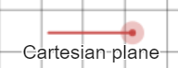
Image created using Desmos and is licensed under the Desmos Terms of Service.
Possible solutions from students could include ‘Forster is 5 spaces to the right of Bathurst, and 1 space up. Ballina is 7.5 right and 6.5 up’.
- Draw on student knowledge from Stage 3 to formally use the coordinate (5,1) and (7.5, 6.5) to locate Forster and Ballina.
- Define the grid as the Cartesian plane, the $x$-axis and the $y$-axis, the number 5 in (5,1) as the $x$-coordinate and the number 1 as the $y$-coordinate.
- Teacher and/or students turn on the second problem in the Desmos graph using the switch.
Figure 2 – second problem switch
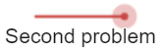
Image created using Desmos and is licensed under the Desmos Terms of Service.
- Demonstrate to students how to grab the black point and drag the Cartesian plane such that Narrandera is at (0,0).
Figure 3 – demonstration of moving the Cartesian plan
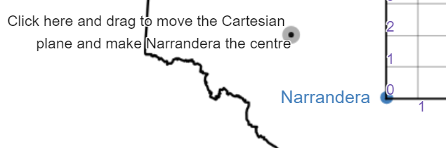
Image created using Desmos and is licensed under the Desmos Terms of Service.
- Students should again engage in a Think-Pair-Share to discuss the new way of describing the locations of Forster and Ballina, as well as now locating Bathurst.
- Teacher and/or students turn on the third problem to show more locations.
Figure 4 – third problem switch
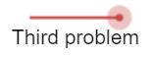
Image created using Desmos and is licensed under the Desmos Terms of Service.
- Drawing on student responses, conclude that no matter where we place the origin (0,0), there will always be locations to the west (left) and south (below) our starting point that we need to describe.
- Teacher and/or students turn on the Full Cartesian plane.
Figure 5 – full Cartesian plane switch
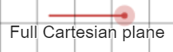
Image created using Desmos and is licensed under the Desmos Terms of Service.
- Have students engage in a Think-Pair-Share to find the coordinates of the 6 locations from Narrandera.

Cartesian plane without technology
The instructions below are to support a classroom where no technology will be used.
- Hand students the first page of Appendix D ‘Cartesian planes without technology’.
- Have students engage in a Think-Pair-Share (bit.ly/thinkpairsharestrategy) to discuss how they would describe the locations of Forster and Ballina from Bathurst.
Possible solutions from students could include ‘Forster is 5 spaces to the right of Bathurst, and 1 space up. Ballina is 7.5 right and 6.5 up’.
- Draw on students’ knowledge from stage 3 to formally use the coordinate (5,1) and (7.5, 6.5) to locate Forster and Ballina.
- Define the grid as the Cartesian plane, the $x$-axis and the $y$-axis, the number 5 in (5,1) as the $x$-coordinate and the number 1 as the $y$-coordinate.
- Without showing students the image below, describe in words where Narrandera is and have students approximately place this point on the map.
Figure 6 – map of NSW
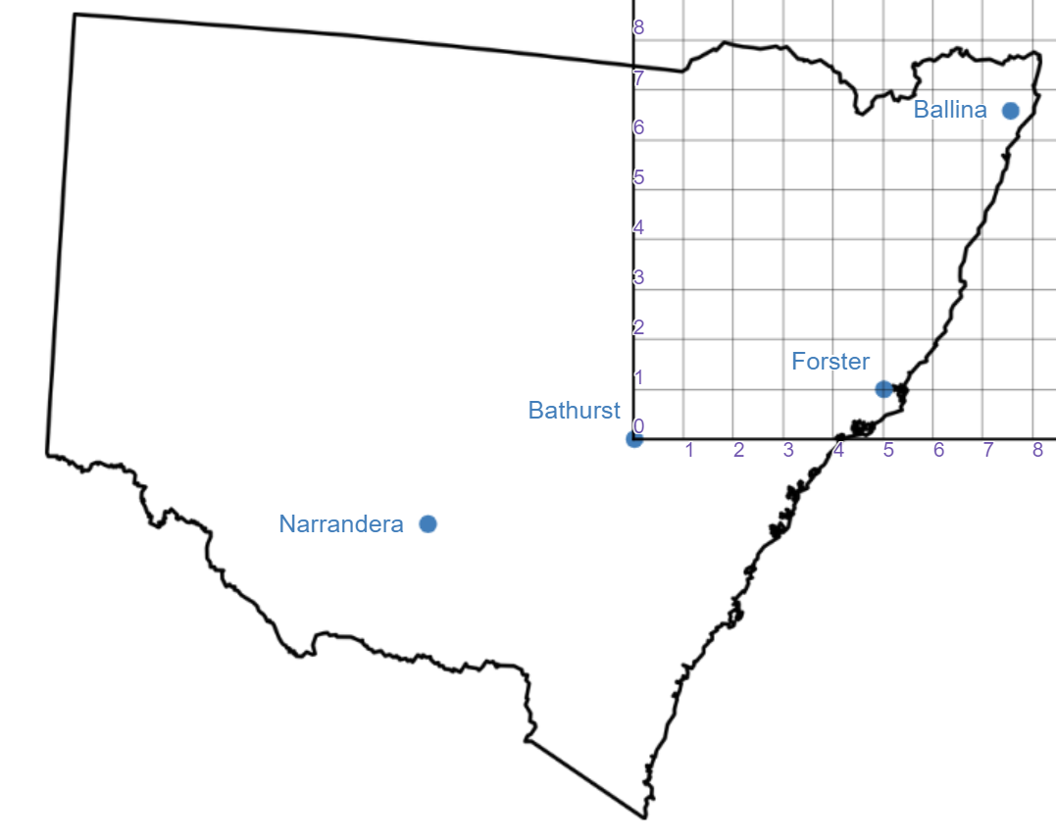
Image created using Desmos and is licensed under the Desmos Terms of Service.
- Reveal the image to see how accurately students have placed Narrandera.
- Drawing on student responses, conclude that no matter where we place the origin (0,0), there will always be locations to the west (left) and south (below) of our starting point that we need to describe.
- Have students engage in a Think-Pair-Share to find the coordinates of the 6 locations from Bathurst on the second page of Appendix D ‘Cartesian planes without technology’.

Summarise

Explicit teaching
Use the Describing locations PowerPoint for explicit teaching of the skills required for finding coordinates in the Cartesian plane.
The explicit teaching technique used in the PowerPoint is ‘Your turn.’ The first slide is a worked example which should be displayed for the students and then use the following steps.
- Reveal the question to students and its solution.
- Students read in silence.
- Students individually think and explain to themselves what is happening in each step.
- Students hold a thumbs up to the teacher when they have finished reading and have some sort of understanding.
- Think-Pair-Share. Students explain the solution to their partner.
- In pairs students then answer the self-explanation questions.
- Finally, randomly select students to share their answers with the whole class.
- When students complete the ‘Your turn’ slides, they will either need to draw their own Cartesian plane, or be handed a copy of Appendix E ‘Using coordinates’.

Locating and describing with coordinates
- Hand out Appendix F ‘Using coordinates in Australia’.
- Working in small groups at vertical non-permanent surfaces (bit.ly/VNPSstrategy) if available, have students write a list of all the locations on this map and the coordinates for that location.
Reflect with students how they used integers, fractions, and decimals to describe locations within coordinates. Answers can be checked by typing coordinates into the Desmos graph ‘Australia map’ (bit.ly/DesmosAusMap).
- Have students attempt to place the following locations on the map.
- Griffith (2.6, -2.7)
- Mount Isa (1, 0.5)
- Rocky Point (2, 2.5)
- Sturt creek (-1.5, 1)

Apply

Dartboard Desmos activity
- Students can engage in the Desmos activity ‘Dartboard Cartesian plane’ (bit.ly/DesmosDartboard) where they pick coordinates to try to get a bullseye on a target.

Topographical maps
- Share this quote from the NSW Mathematics K–10 Syllabus examples with students: ‘Aboriginal art uses topographical views to map Country.’
- Share an Aboriginal artwork and have students engage in a Think-Pair-Share to consider what the symbols in the art might be showing.
Examples of Aboriginal artwork that could be relevant can be found at the Japingka Aboriginal Art website (bit.ly/JapingkaGallery).
Information on common symbols and their usual meaning can be found at the Artark website (bit.ly/ArtarkSymbols), including that “Concentric circles usually represent campsites or rock holes.”
- Have students go to Google Maps (www.google.com/maps) and find your location (suburb). Select Layers in the bottom left corner and then select Terrain to show a topographical map. Ask students what is different about the map.
Figure 7 – Google map layer options
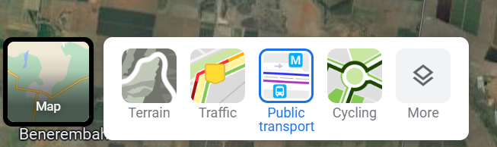
Image © 2023 Google
- Alternatively, send students to the topographic map website (bit.ly/SydneyTopographicMap). Ask students what the colours mean.
- Using the instructions in Appendix G ‘Uploading an image of a map to Desmos’, have students take a screen shot of the map of your local area and upload the image into Desmos to overlay a Cartesian plane.
- Have students describe the locations of 3 places using the coordinates in the Cartesian plane.
Teachers can reach out to their local AECG to better understand locations of cultural significance and bodies of water in your location. Students can then search for these locations on their topographical maps.
- Have students engage in a Think-Pair-Share to consider how to use the coordinates to describe how to get from one location to another.

Assessment and differentiation

Suggested opportunities for differentiation
Launch
- Students should be able to give and interpret descriptions at their level. The activity is designed so that failure is expected, it is unlikely anyone in the room will exactly locate the towns from their peers’ descriptions.
Explore
- Students with sound skills with measuring devices can be challenged to construct their own Cartesian plane around the maps in Appendix C ‘Describing locations game’.
Summarise
- For students working mostly with whole numbers, teachers can explicitly encourage picking the coordinate closest to the location they are looking for. Have these students reflect on how accurate this is.
- Challenge students to review maps of Australia and add known locations to Appendix E, ‘Using coordinates’, by selecting approximate coordinates.
- When adding locations to Appendix F, ‘Using coordinates in Australia’, students can be challenged to compare coordinates with longitude and latitude that can be found online. What relationships can be found between the coordinate descriptions we have invented and longitude and latitude values?

Suggested opportunities for assessment
Warm up and Launch
- If students have difficulty using the grid reference in a game of battleship, they will likely require support when introducing the Cartesian plane. Similarly, monitor if they struggle to provide basic directions of left, right, up or down.
Explore
- Students could be asked to hold up mini whiteboards with coordinates for locations as the number plane is developing for the teacher to get a sense of common errors or misconceptions.
Summarise
- Have students submit their work from Appendix F ‘Using coordinates in Australia’ as evidence of their understanding of basic coordinates. Students can self-assess using the provided Desmos graph.
Apply
- The Desmos dartboard activity allows students to verify their understanding of coordinates by immediately seeing their results on the screen. Teachers can also use the teacher dashboard to assess student abilities.

Appendix A

Battleship
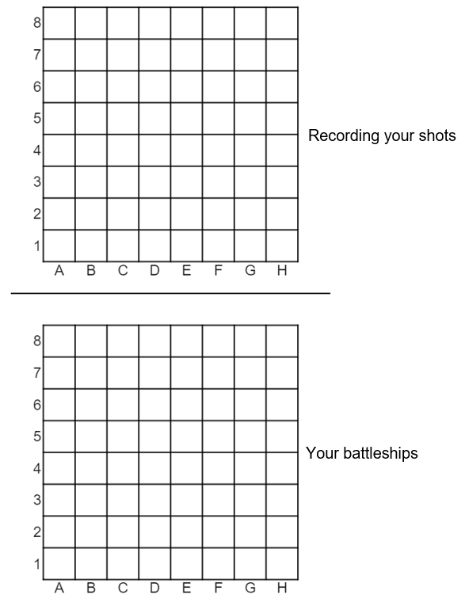

Appendix B

Battleship instructions
- Fold Appendix A, ‘Battleship’ in an L shape so your battleships are on the table in front of you and the other grid is like a wall between you and your opponent.
- Place your 5 battleships anywhere on the gameboard by colouring in squares. You have 5 battleships. One is 5 squares long, one is 4 squares long, two are 3 squares long and one is 2 squares long. An example is below.
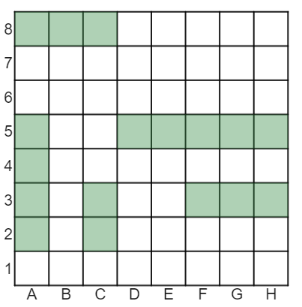
- Battleships cannot cross over one another or go diagonally.
- Take turns picking a location with your partner to shoot at your battleships. For example, the square marked below is ‘A5’.
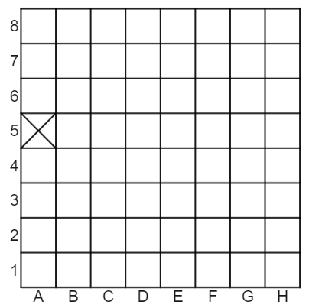
- If your opponent reads out a square that you have a battleship on, say ‘hit’.
- If your opponent reads out a square that does not have a battleship in it, say ‘miss’.
- Record your opponent’s shots on your battleship grid.
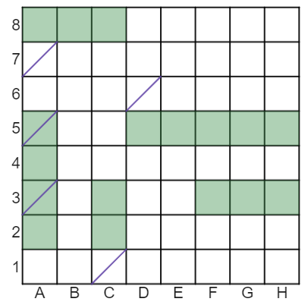
- Record your shots on the top grid, with hits being a cross and misses being an M.
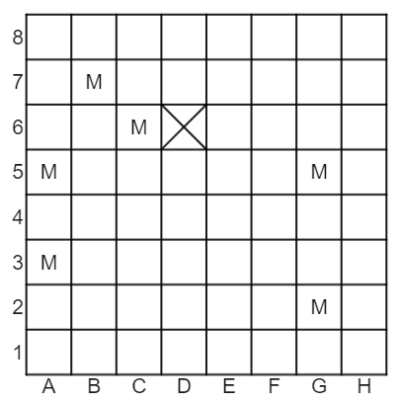

Appendix C

Describing locations game 1
Cut and give one map to each student in a pair.
Map 1 | Map 2
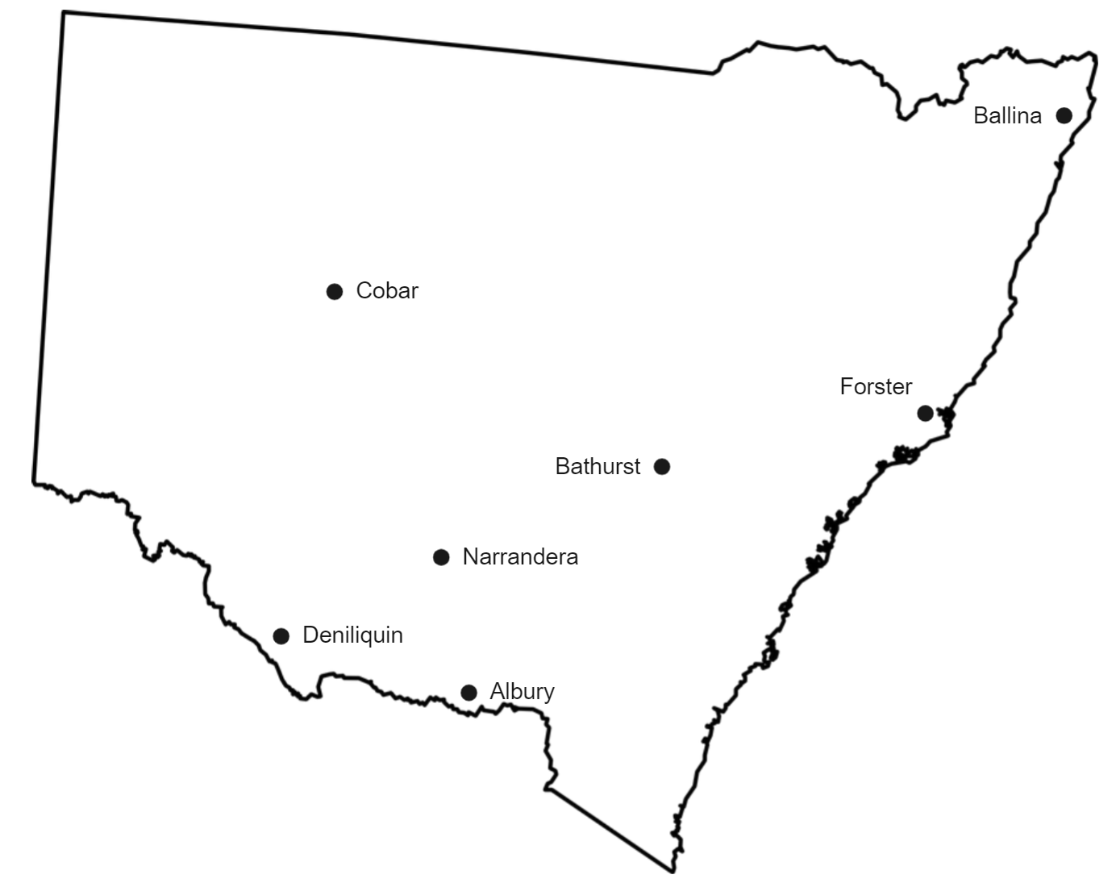 | 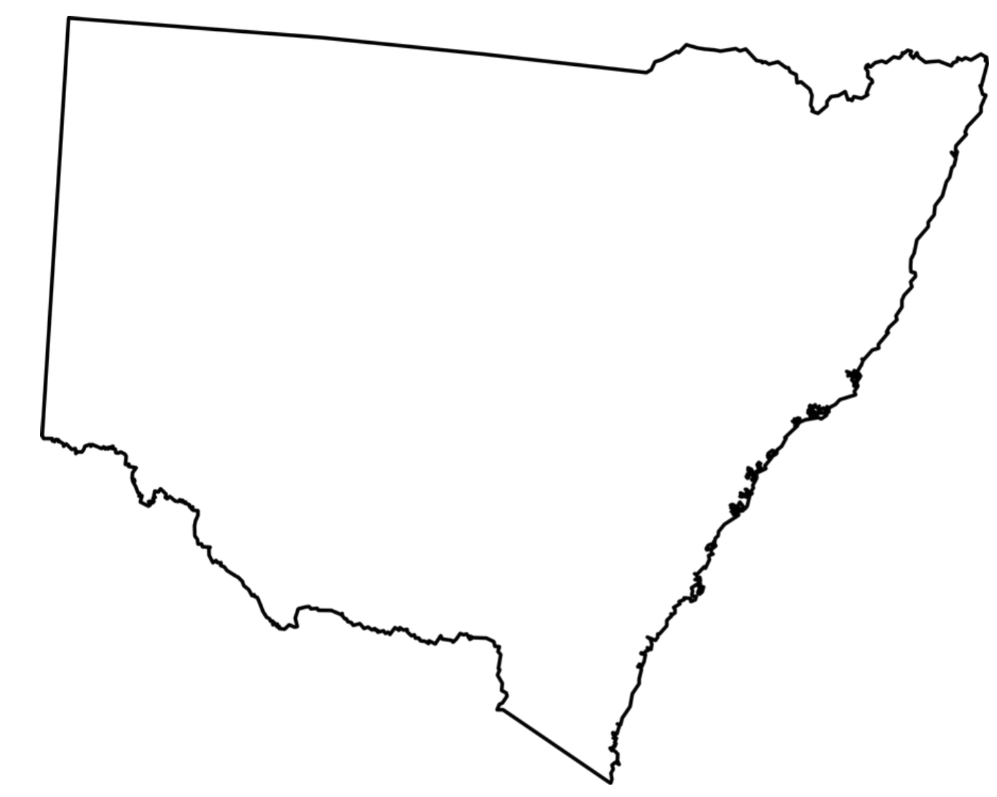

Describing locations game 2
Cut and give one map to each student in a pair.
Map 3 | Map 4
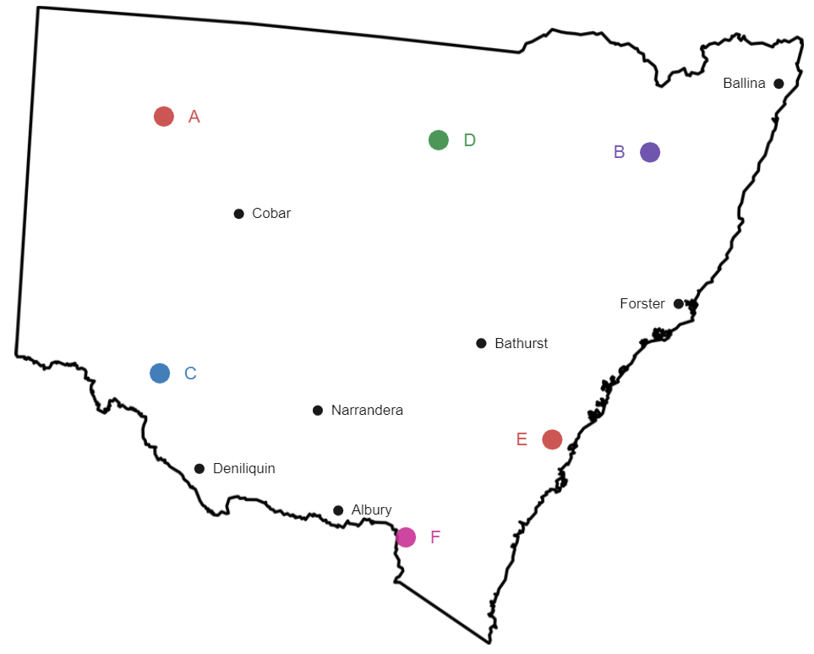

Appendix D

Cartesian planes without technology
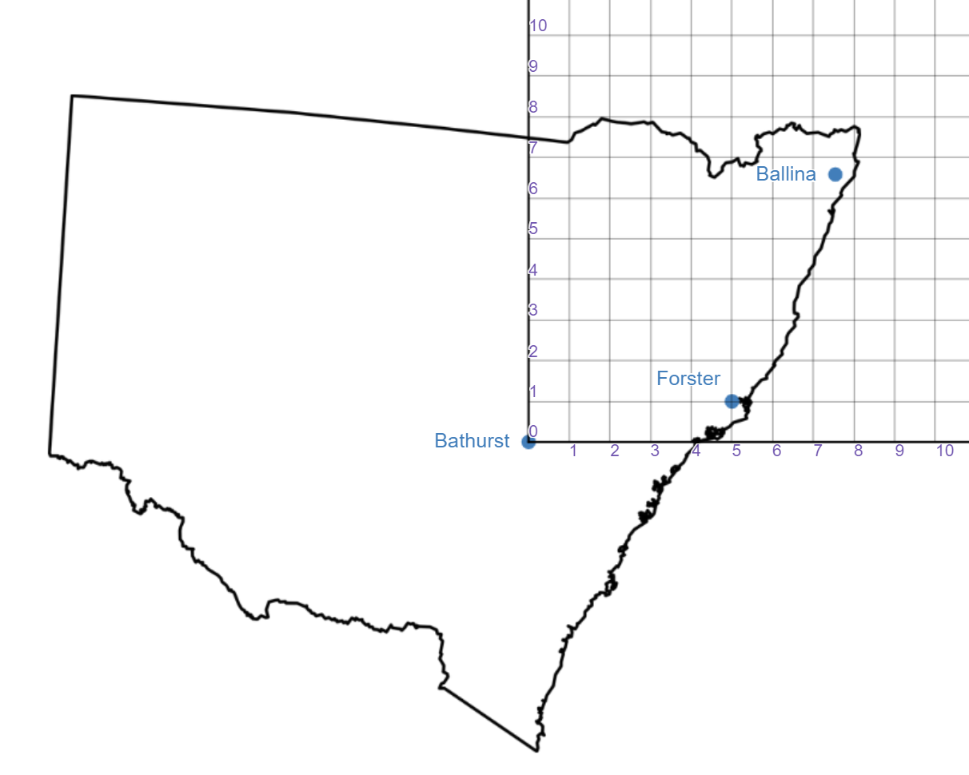
Image created using Desmos and is licensed under the Desmos Terms of Service.
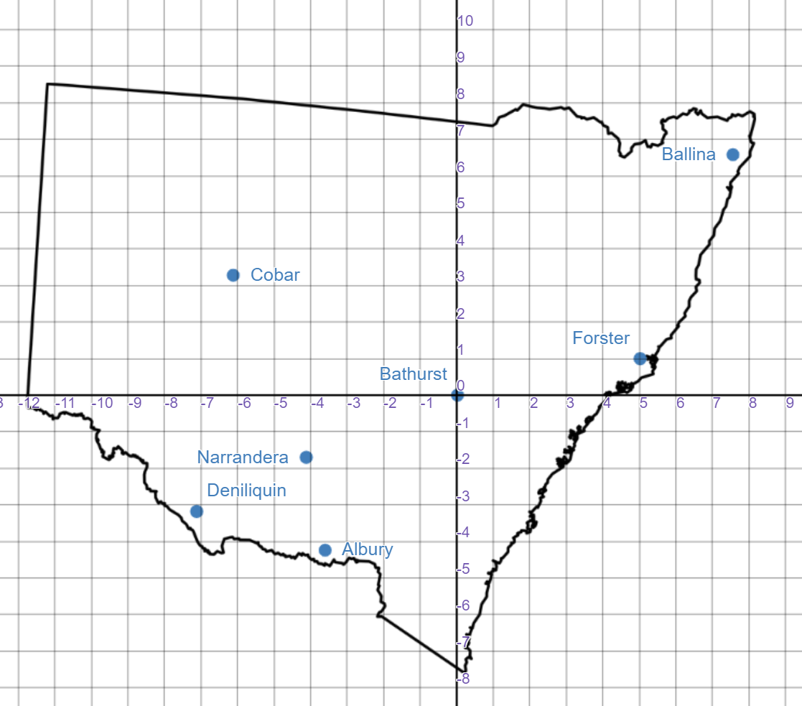
Image created using Desmos and is licensed under the Desmos Terms of Service.

Appendix E

Using coordinates
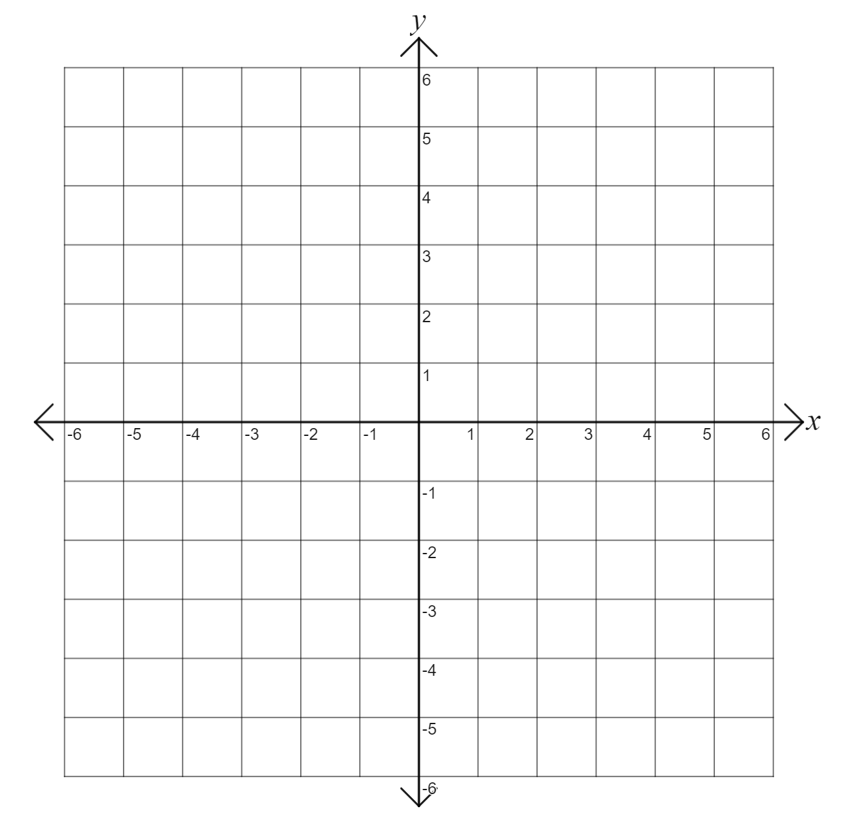

Appendix F

Using coordinates in Australia
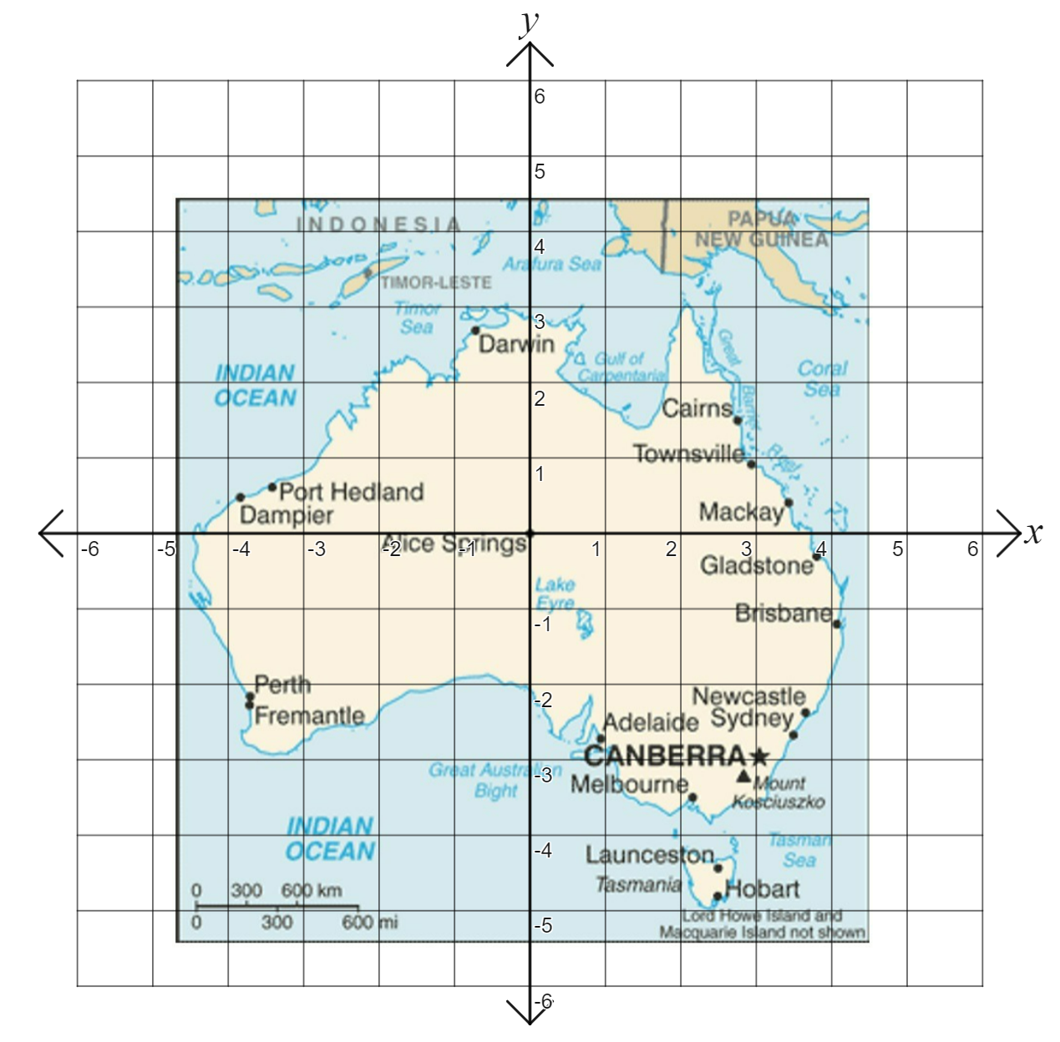
‘Map of Australia’ by United States Central Intelligence Agency is in the Public Domain.

Appendix G

Instructions: Uploading an image of a map to Desmos
- Take a screenshot of your map using a snipping tool.
- Save the image on your desktop.
- Open a Desmos graph and select the + button at the top left of the screen.
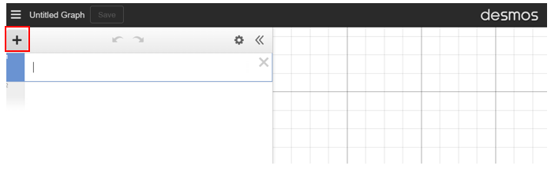
Image created using Desmos and is licensed under the Desmos Terms of Service.
- Select image and find the image on your desktop.
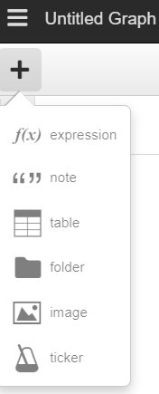
Image created using Desmos and is licensed under the Desmos Terms of Service.
- Your image should now sit behind the Cartesian plane in Desmos.

References
This resource contains NSW Curriculum and syllabus content. The NSW Curriculum is developed by the NSW Education Standards Authority. This content is prepared by NESA for and on behalf of the Crown in right of the State of New South Wales. The material is protected by Crown copyright.
Please refer to the NESA Copyright Disclaimer for more information https://educationstandards.nsw.edu.au/wps/portal/nesa/mini-footer/copyright.
NESA holds the only official and up-to-date versions of the NSW Curriculum and syllabus documents. Please visit the NSW Education Standards Authority (NESA) website https://educationstandards.nsw.edu.au/ and the NSW Curriculum website https://curriculum.nsw.edu.au/home.
Mathematics K–10 Syllabus © NSW Education Standards Authority (NESA) for and on behalf of the Crown in right of the State of New South Wales, 2022.

© State of New South Wales (Department of Education), 2023
The copyright material published in this resource is subject to the Copyright Act 1968 (Cth) and is owned by the NSW Department of Education or, where indicated, by a party other than the NSW Department of Education (third-party material).
Copyright material available in this resource and owned by the NSW Department of Education is licensed under a Creative Commons Attribution 4.0 International (CC BY 4.0) licence.
This licence allows you to share and adapt the material for any purpose, even commercially.
Attribution should be given to © State of New South Wales (Department of Education), 2023.
Material in this resource not available under a Creative Commons licence:
- the NSW Department of Education logo, other logos and trademark-protected material
- material owned by a third party that has been reproduced with permission. You will need to obtain permission from the third party to reuse its material.
Links to third-party material and websites
Please note that the provided (reading/viewing material/list/links/texts) are a suggestion only and implies no endorsement, by the New South Wales Department of Education, of any author, publisher, or book title. School principals and teachers are best placed to assess the suitability of resources that would complement the curriculum and reflect the needs and interests of their students.
If you use the links provided in this document to access a third-party's website, you acknowledge that the terms of use, including licence terms set out on the third-party's website apply to the use which may be made of the materials on that third-party website or where permitted by the Copyright Act 1968 (Cth). The department accepts no responsibility for content on third-party websites.

