Fractions and decimals and percentages, oh my!
Students identify and make use of the relationship between fractions, decimals and percentages to carry out conversions.

Visible learning

Learning intention
- To be able to convert between fractions, decimals and percentages.

Success criteria
- I can convert decimals into equivalent fractions and percentages.
- I can convert fractions into equivalent decimals and percentages.
- I can convert percentages into equivalent decimals and fractions.
- I can represent equivalent fractions, decimals and percentages on a number line.

Syllabus outcomes
A student:
- develops understanding and fluency in mathematics through exploring and connecting mathematical concepts, choosing and applying mathematical techniques to solve problems, and communicating their thinking and reasoning coherently and clearly MAO-WM-01
- represents and operates with fractions, decimals and percentages to solve problems MA4-FRC-C-01
Mathematics K–10 Syllabus © NSW Education Standards Authority (NESA) for and on behalf of the Crown in right of the State of New South Wales, 2022.

Activity structure

Warm up
- Using a Think-Pair-Share (bit.ly/thinkpairsharestrategy) ask students to provide reasoning to justify whether it would be best to use fractions, decimals or percentages for each of the following scenarios:
- Splitting the cost of a bill when paying for a meal shared with friends.
- Cutting a cake into equal slices to share with people at a party.
- Showing how much of a discount is being given in a sale.
- The average number of points scored per game for a professional netball player.
- The win rate for an eSports team.
- In a class discussion allow students to share their responses and reasoning.
- Find students who have identified contradictory representations – emphasise that the need and situation may help to dictate the way in which we represent a number, but this can also vary based on perspective or preference.

Launch
The following is intended to showcase that students already have a rather robust understanding of many aspects of converting between fractions, decimals and percentages.
- Have students watch the most recent weather forecast and/or look at the weather forecast from the Bureau of Meteorology (http://www.bom.gov.au/nsw/forecasts/index.shtml) for your local area.
- As students are engaging with this content, they need to record any language used that involves chance/probability (fractions, percentages, definitions of likelihood of outcomes).
It is encouraged that students undertake this component of the learning sequence in small groups (bit.ly/visiblegroups) using a shared space, such as vertical, non-permanent surfaces (bit.ly/VNPSstrategy) or similar.
- Once students have had the opportunity to record their findings, briefly discuss where and how the metalanguage was used.
- Identify one of the statements made (for example there is a 10% chance of rain expected, the weather today is going to be partly cloudy, or a similar statement) and have the students define it in different ways.
Students should be encouraged to use metalanguage associated with probability and chance to redefine the statements. They should also be encouraged to use their knowledge of fractions, decimals and percentages to redefine non-specific statements with a numerical value instead. For instance, ‘a slight chance of rain’ might become a ‘0.2 chance of rain.’
- Attempt to guide the overall discussion by comparing the language and the mathematical concepts being used, highlighting when students have identified points of conversion from fractions, decimals and/or percentages.

Explore

Comparing fractions, decimals and percentages
Students should have already had an opportunity to develop their capacity to convert decimals and percentages to fractions. If not, these concepts have been covered in the ‘Be Rational’ learning episode.

It is encouraged that students undertake this component of the learning sequence in small groups (bit.ly/visiblegroups) using a shared space, such as vertical, non-permanent surfaces (bit.ly/VNPSstrategy) or similar.
- Provide students with access to the table in Appendix A ‘Equivalent Values Table’, either displayed where they can all see or a copy per group.
- Students should be given the chance to complete as much of this table as they can in their groups.
The purpose of this step is to highlight what students already know and identify areas that need to be explored to fill in the gaps in their knowledge and understanding. Students could be encouraged to use patterns in the table to help them fill in information.
- Using the Pause-Pose-Pounce-Bounce question strategy ([PDF 200KB] bit.ly/pausepouncebounce) have students provide and justify the solutions they have managed to produce.

Explicit teaching
The explicit teaching technique used in the PowerPoint is ‘Your turn’. The first slide is a worked example which should be displayed for the students before using the following steps.
- Reveal the question to students and its solution.
- Students read in silence.
- Students individually explain to themselves what is happening in each step.
- Students hold up a thumbs up to the teacher when they have finished reading and have some sort of understanding.
- Think-Pair-Share. Students explain the solution to their partner.
- In pairs students then answer the self-explanation questions.
- Finally, randomly select students to share their answers with the whole class.
- Use the Fractions and decimals and percentages – oh my! PowerPoint slides 1–18 for explicit teaching of the skills required for converting decimals into percentages.
- Provide students with the opportunity to return to their previously allocated groups and direct them back to Appendix A to complete the gaps that were present from earlier. If students were previously able to finish the whole table, consider challenging them by providing additional fractions to consider such as non-unit fractions, or larger unit fractions.
Students should already have explored converting fractions into decimals – if there are students who have not been able to draw connections between this concept and converting fractions to decimals to percentages, highlight this process through prompting.
- Use the Fractions and decimals and percentages – oh my! PowerPoint slides 19–28 for explicit teaching of the skills required for converting percentages into decimals.
- Students return to Appendix A for a final time in order to complete any remaining gaps.
- Bring the students back for a final class discussion and use Pause-Pose-Pounce-Bounce question strategy ([PDF 200KB] bit.ly/pausepouncebounce)to have students provide and justify the solutions they have managed to produce to complete their table.

Summarise
The experiment below can be completed using the Desmos classroom activity ‘Fractions, decimals and percentages’ (bit.ly/FDPDesmosActivity).

Equipment
- Class set of cards from Appendix B ‘Fraction, decimal and percentage cards 1’.
- Sticky tape or adhesive putty.

Method
- Hand pairs of students a card each from Appendix B.
- Display the Desmos graph ‘Percentage, decimal and fraction lines’ (bit.ly/DesmosPDFLines) on the teacher screen.
The number lines available in the Desmos graph can also be displayed without internet access via the Fractions and decimals and percentages, oh my! PowerPoint slides 29–41. Alternatively, a number line can be drawn on the whiteboard.
- Have students with percentage cards approach the board and place the percentages where they believe they belong along the number line using sticky tape.
- Have all students engage in a short Think-Pair-Share (bit.ly/thinkpairsharestrategy) to consider whether they would change the position of any of the 4 percentage cards.
The teacher can slowly reveal more information on the number line, using the reveal switch, as shown below.
Figure 1 – reveal switch
- Move the slider at the top of the screen to show a new number line and have students with decimal number cards place them where they belong along the number line with sticky tape.
Figure 2 – decimal line
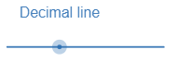
- Have students again engage in a Think-Pair-Share (bit.ly/thinkpairsharestrategy) about which cards they agree with the location and which they would move. Use the reveal switch again to show more information about the decimal number line.
- Finally move the slider to show the fraction number line and have students with fraction cards approach the board and place these cards where they believe they go.
- Students again discuss what they believe is correct and what they would move.
- Move the slider to show all 3 number lines and have students individually write one number they would move and why.
- If space permits, hand pairs of students number cards from Appendix C ‘Fraction, decimal and percentage cards 2’ and have them place them on the wall with sticky tape either side of the board, extending the number line.

Apply
- Have the students play through the games of matching pairs from the NRICH activity https://nrich.maths.org/1249.
This site has the option to play using a digital interface or by printing out cards for students to use. Each level has an increasing level of complexity and provides opportunities for differentiation to better meet the needs of your students.

Assessment and differentiation

Suggested opportunities for differentiation
Explore
- By working in groups and pairs, students have the opportunity to learn facts and strategies from their peers as they work to complete the table in Appendix A.
- Challenge students to use the percentage and decimal representations of the unit fractions in Appendix A to construct a number line with any fraction represented in all 3 forms.
- Students who are not comfortable with basic number operations should be encouraged to convert smaller numbers that can be represented with physical or virtual models.
Summarise
- Students exhibiting less confidence placing fractions, decimals or percentages along number lines can be given the opportunity to wait until partitions are shown on the number line before placing any numbers. Alternatively, students could be asked to reflect on already placed numbers rather than placing the numbers on themselves.
- Challenge students to use reference points from all 3 lines when justifying moving a number.
Apply
- The NRICH activity allows teachers to select between multiple levels of difficulty, depending on the needs of their students.

Suggested opportunities for assessment
Explore
- Teachers should allow students to complete as much of the table in Appendix A as possible without assistance to gather information about what methods students are already fluent in.
Summarise
- The Desmos activity ‘Fractions, decimals and percentages’ collects student responses and reflections about placing fractions, decimals and percentages on number lines and comparing across the 3 forms.
- Students should submit written reflections, including reasoning behind why they would make a possible movement of a fraction, decimal or percentage on the number lines. Comparisons between values should be a key reason used.

Appendix A

Equivalent Values Table
Fraction | Percentage | Decimal
$\frac{1}{1}$ | 100% | 1.0
$\frac{1}{2}$ | 50%
$\frac{1}{3}$
$\frac{1}{4}$
$\frac{1}{5}$
$\frac{1}{6}$
$\frac{1}{7}$
$\frac{1}{8}$
$\frac{1}{9}$
$\frac{1}{10}$

Appendix B

Fraction, decimal and percentage cards 1
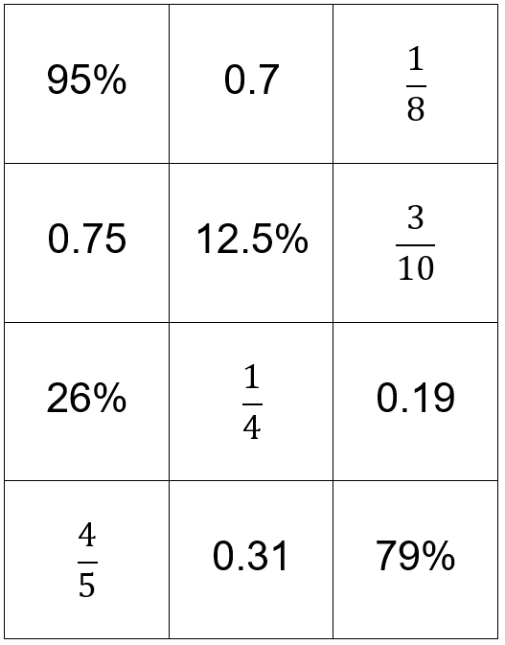

Appendix C

Fraction, decimal and percentage cards 2
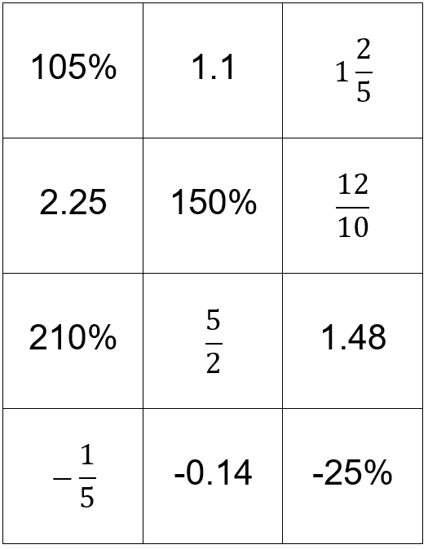

Sample solutions

Appendix A – Equivalent Values Table
Fraction | Percentage | Decimal
$\frac{1}{1}$ | 100% | 1.0
$\frac{1}{2}$ | 50% | 0.5
$\frac{1}{3}$ | 33.33% | 0.333…
$\frac{1}{4}$ | 25% | 0.25
$\frac{1}{5}$ | 20% | 0.2
$\frac{1}{6}$ | 16.67% | 0.166…
$\frac{1}{7}$ | 14.29% | 0.1428514…
$\frac{1}{8}$ | 12.5% | 0.125
$\frac{1}{9}$ | 11.11% | 0.1111…
$\frac{1}{10}$ | 10% | 0.1

Appendix B – Fraction, decimal and percentage cards 1
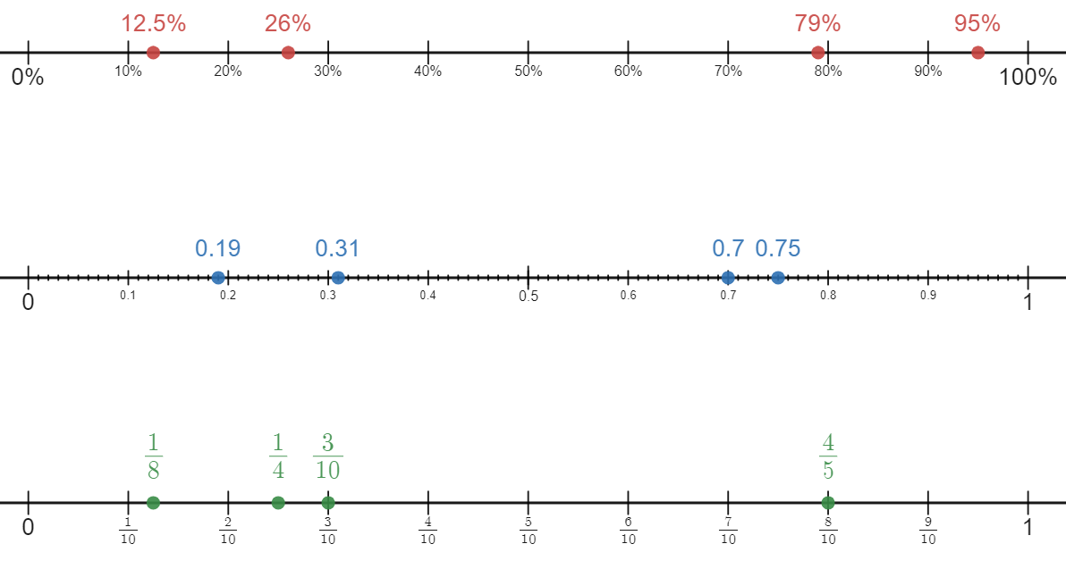

Appendix C – Fraction, decimal and percentage cards 2
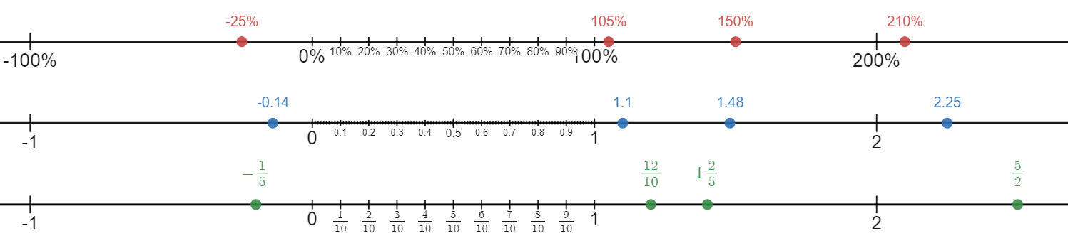

References
This resource contains NSW Curriculum and syllabus content. The NSW Curriculum is developed by the NSW Education Standards Authority. This content is prepared by NESA for and on behalf of the Crown in right of the State of New South Wales. The material is protected by Crown copyright.
Please refer to the NESA Copyright Disclaimer for more information https://educationstandards.nsw.edu.au/wps/portal/nesa/mini-footer/copyright.
NESA holds the only official and up-to-date versions of the NSW Curriculum and syllabus documents. Please visit the NSW Education Standards Authority (NESA) website https://educationstandards.nsw.edu.au/ and the NSW Curriculum website https://curriculum.nsw.edu.au/home.
Mathematics K–10 Syllabus © NSW Education Standards Authority (NESA) for and on behalf of the Crown in right of the State of New South Wales, 2022.

© State of New South Wales (Department of Education), 2023
The copyright material published in this resource is subject to the Copyright Act 1968 (Cth) and is owned by the NSW Department of Education or, where indicated, by a party other than the NSW Department of Education (third-party material).
Copyright material available in this resource and owned by the NSW Department of Education is licensed under a Creative Commons Attribution 4.0 International (CC BY 4.0) licence.
This licence allows you to share and adapt the material for any purpose, even commercially.
Attribution should be given to © State of New South Wales (Department of Education), 2023.
Material in this resource not available under a Creative Commons licence:
- the NSW Department of Education logo, other logos and trademark-protected material
- material owned by a third party that has been reproduced with permission. You will need to obtain permission from the third party to reuse its material.
Links to third-party material and websites
Please note that the provided (reading/viewing material/list/links/texts) are a suggestion only and implies no endorsement, by the New South Wales Department of Education, of any author, publisher, or book title. School principals and teachers are best placed to assess the suitability of resources that would complement the curriculum and reflect the needs and interests of their students.
If you use the links provided in this document to access a third-party's website, you acknowledge that the terms of use, including licence terms set out on the third-party's website apply to the use which may be made of the materials on that third-party website or where permitted by the Copyright Act 1968 (Cth). The department accepts no responsibility for content on third-party websites.

