Be rational
Students learn to convert integers, percentages and terminating decimals into fractions to identify all numbers we know as rational. Students then explore the concept of recurring (repeating) decimals and consider where an irrational number might arise.

Visible learning

Learning intentions
- To be able to convert integers, percentages and terminating decimals into fractions.
- To understand why all numbers that we have studied so far of are rational.

Success criteria
- I can explain what a rational number is.
- I can give examples of terminating and recurring decimals.
- I can convert integers and percentages into fractions.
- I can convert terminating decimals into fractions.

Syllabus outcomes
A student:
- develops understanding and fluency in mathematics through exploring and connecting mathematical concepts, choosing and applying mathematical techniques to solve problems, and communicating their thinking and reasoning coherently and clearly MAO-WM-01
- represents and operates with fractions, decimals and percentages to solve problems MA4-FRC-C-01
Mathematics K–10 Syllabus © NSW Education Standards Authority (NESA) for and on behalf of the Crown in right of the State of New South Wales, 2022.

Activity structure

Launch
- Hand out Appendix A ‘Rational problems’.
- Have students engage in a Think-Pair-Share (bit.ly/thinkpairsharestrategy) to discuss which of the problems they believe can be solved and how.
- All suggestions shared by students should be accepted and acknowledged, whilst also concluding which of the problems students feel are reasonable.
Look for ideas that naturally arise from these 4 prompts. Possible considerations are provided at the end of this document under ‘Sample solutions’, depending on student responses.
- Have students suggest what they believe the words rational and irrational mean. Lead students to look at dictionary definitions of each term, concluding that rational ideas need to make be logical and reasonable.
- Compare this concept with the 4 problems in Appendix A. Which problems do students believe are rational and make sense? Which could you describe as irrational ideas?
- Explain that numbers can be rational and irrational as well. Some numbers make lots of sense and some don’t entirely. Use a Pause-Pose-Pounce-Bounce question strategy ([PDF 200KB] (bit.ly/pausepouncebouncestrategy) to gather student thoughts on which numbers they think might be irrational.

Explore

Defining rational numbers
- Initially define with students that a rational number is a number that is logical and reasonable.
- Challenge students to engage in a Think-Pair-Share to brainstorm everything they know about the fraction $\frac{3}{4}$.
Students should be encouraged to convey all the different ways they know how to represent the fraction $\frac{3}{4}$. Images conveying many of these representations are displayed in Figure 1. Teachers can use these models to represent other fractions to aid their discussions at the links below:
- Fractions on a number line (bit.ly/DesmosFractionNumberLineCompare)
- Fractions as vectors on a number line (bit.ly/DesmosFractionVectorCompare)
- Fractions - Parts of a whole (bit.ly/DesmosFractionPartsCompare)
Figure 1 – representing 3 quarters
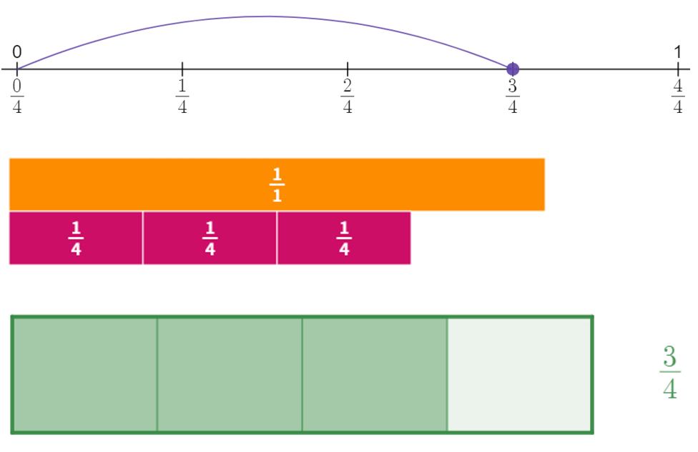
Additional solutions could include:
- anything divided into 4 parts where we get 3.
- a likely chance of something happening.
- halfway between half and a whole.
- Explain that because we know so much about fractions, they are an idea that makes sense and are rational numbers. Explain further that mathematicians have decided that any number that can be written as a fraction with integers in the numerator and the denominator is considered rational, so long as the denominator is not 0.

Integers, decimals and percentages to fractions
- Remind students of the representation of decimal values using base 10 blocks where we define the large cube as one. Emphasise the reasoning that 10 of any value makes one of another.
Figure 2 – representations of decimal place value
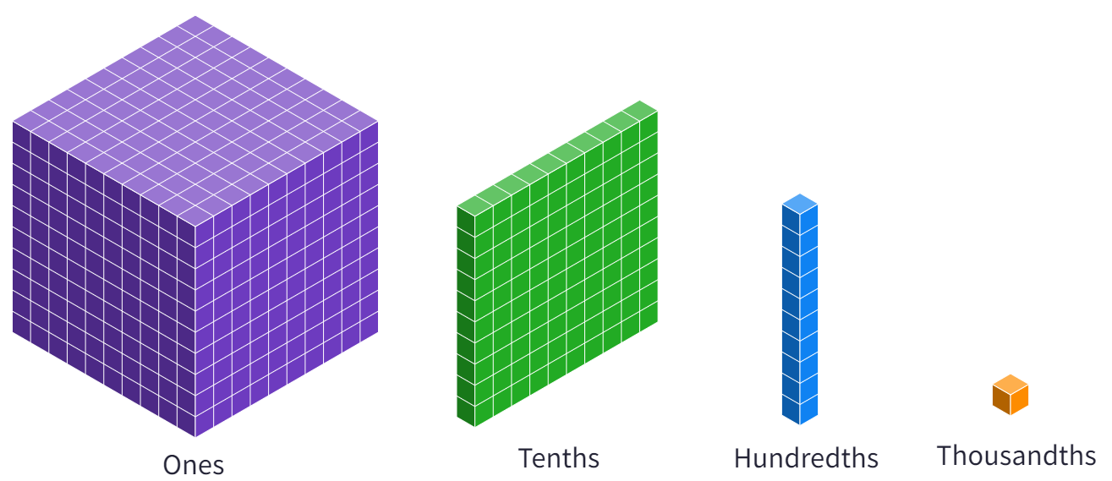
- If students are not entirely familiar with this representation, teachers can have students represent some fractions using either diagrams, physical base 10 blocks or Polypad (bit.ly/PolypadNumberTiles).
- Use slides 2–11 in the Be rational PowerPoint for explicit teaching of the skills required to convert integers, decimals and percentages to fractions.

The explicit teaching technique used in the PowerPoint is ‘Your turn’. The first slide is a worked example which should be displayed for the students before using the following steps.
- Reveal the question to students and its solution.
- Students read in silence.
- Students individually explain to themselves what is happening in each step.
- Students hold up a thumbs up to the teacher when they have finished reading and have some sort of understanding.
- Think-Pair-Share. Students explain the solution to their partner.
- In pairs students then answer the self-explanation questions.
- Finally, randomly select students to share their answers with the whole class.
- Hand students a copy of Appendix B ‘Converting decimals to fractions – faded worked examples’.
- Have students review the first example and attempt to follow this process to convert decimals into fractions.

Terminating and recurring decimals
- Have students use any methods they choose to find an answer to $10÷3$.
- Use the Desmos graph ‘Recurring decimals from division’ (bit.ly/RecurringDecAnimation) to begin speculation on the value of $10÷3$. Press the play button to begin the animation.
Figure 3 – play button
Image created using Desmos and is licensed under the Desmos Terms of Service.
- Have students engage in a Think-Pair-Share to describe how the solution to $10÷3$ will continue to develop.
- Define recurring and terminating decimals, showing the solution to $10÷3$ as $3.\dot{3}$, using and defining the vinculum.
- Use slide 12 to 15 of the Be rational PowerPoint for explicit teaching of the skills required to represent recurring decimals with and without the use of vinculum.
- Have students complete the questions in Appendix C ‘Representing recurring decimals’.

Are recurring decimals rational?

Equipment
- Class set of Appendix D ‘Fractions and recurring decimals’, printed.
- Calculators – one per pair of students.

Method
- Hand students Appendix D ‘Fractions and recurring decimals’ and instruct them to complete question 1, using a calculator to find the fractions as decimals.
- Have students engage in a Think-Pair-Share to consider the patterns they see in their answers.
When students share, the teacher should acknowledge without confirming what is correct and incorrect.
- Remove calculators before students complete question 2.
- Students are to use what they have discovered in their patterns to express the recurring decimals in question 2 as fractions.
- Collect responses from students to conclude that a single decimal place repeated can be expressed as a fraction over 9, 2 decimal places repeated can be expressed as a fraction over 99 and that this will then follow a pattern.
- As such, conclude that recurring decimals can also be expressed as fractions and are rational.

Summarise
- Students complete the exit ticket in Appendix E ‘Exit ticket’, summarising which numbers we know and why they are all rational.
- Students write notes to their future selves (bit.ly/notesstrategy) focusing on the question ‘what do you know about rational numbers?’

Apply
- Refer to the image in the launch. Ask students if a solution to any of the problems could be described using a fraction with integers in the numerator and denominator, with the denominator not equal to 0?
- Have students engage in a Think-Pair-Share to determine which of the problems has a solution that can be considered rational.
- Review the sample solutions for potential responses from students.
- Have students complete this open middle activity. Using the digits 0 to 9, at most one time each, they need to fill in the boxes so that the fraction equals the repeating decimal (https://bit.ly/OMRecurringDecimals).

Assessment and differentiation

Suggested opportunities for differentiation
Launch
- The problems in Appendix A ‘Rational problems?’ have no obtainable correct answer and should be able to be considered by students of varying ability.
Explore
- The ‘your turn’ explicit teaching, faded worked examples in Appendix B and patterns found in Appendix D have students drawing from examples and engaging in discussions with peers to support their entry into the tasks.
- Challenge students to search for recurring decimals outside of the patterns established on Appendix D and consider how these decimals would look as a fraction, testing with a calculator.

Suggested opportunities for assessment
Explore
- Responses on Appendix B can be collected and used as evidence of students’ ability to convert fractions to decimals.
- Responses to Appendix C can be collected and used as evidence of students’ understanding of the concept of recurring decimals.
- Responses to Appendix D can be collected and used as evidence of students’ ability to generalise based on patterns and to use these generalisations to solve problems.
Summarise
- The exit ticket can be collected as a summary of student understanding of the concepts from the lesson.

Appendix A

Rational problems?
Discuss solutions to each of the problems below. Do they all have solutions? Do their solutions make sense?
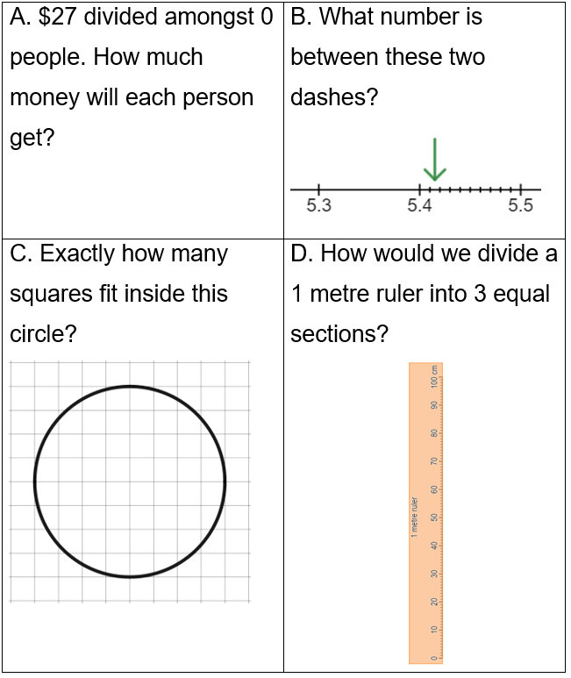

Appendix B

Converting decimals to fractions – faded worked examples
Example 1 | Example 2 | Example 3 | Example 4
Convert 0.41 to a fraction. | Convert 2.3 to a fraction. | Convert 0.522 to a fraction. | Convert 1.56 to a fraction.
0.41 includes 2 decimal places. | 2.3 includes
This is 41 hundredths. | This is 23 | This is 522
$$0.41=\frac{41}{100}$$ | $$2.3=$$

Appendix C

Representing recurring decimals
- Represent the following decimals using vinculum notation.
- $0.5555…$
- $33.5555…$
- $0.535353…$
- $0.531531…$
- $0.6531531…$
- $25.2222…$
- $25.525252…$
- $0.000111…$
- $0.0001010…$
- Show how each of the recurring decimals below repeats. The first is completed for you.
- $0.\dot{6}=0.6666…$
- $23.\overline{73}=$
- $81.001\overline{413}=$
- Explain why the vinculum notation is important.

Appendix D

Fractions and recurring decimals
- Enter the following fractions into a calculator. Your teacher can help you find the button that converts a fraction to a decimal.
- $\frac{2}{9}$
- $\frac{7}{9}$
- $\frac{5}{9}$
- $\frac{12}{99}$
- $\frac{52}{99}$
- $\frac{1}{99}$
- Write down any patterns you notice in each of the answers to question 1.
- Use the trends you noticed in question 1 to write each of the recurring decimals below as fractions.
- $0.\dot{8}$
- $0.111111…$
- $0.575757…$
- $0.\overline{94}$
- $0.\overline{123}$
- $2.\dot{6}$

Appendix E

Exit ticket
- Which of the following numbers are rational? Explain why, with calculations.
- $12$
- $\frac{1}{5}$
- $13.1$
- $6.\dot{7}$
- $13\%$
- Do you know any numbers that are irrational?

Sample solutions

Launch
- A – Students are likely to state that the result of the division in A is that ‘everyone gets $0’. Teachers could reply with ‘Who is everyone if there is no one there?’
- B – It would be valuable to conclude in B that between any 2 points on a number line we can always find another location by considering an additional decimal place.
- C – Students will likely be able to count squares and parts of squares in C and determine a number approximately between 32 and 52. Teachers should emphasise the word ‘exactly’.
- D – Students may find that 33 cm can be added three times to make 99. When splitting the remaining centimetre, students can be encouraged to identify that they are essentially splitting 100 again (hundredths of centimetres).

Apply
Can the solution to these problems be described using a fraction with integers in the numerator and denominator, with the denominator not equal to 0?
A would be represented by $\frac{27}{0}$, which is not rational because we aren’t allowed 0 on the bottom of the fraction.
B could be represented by 5.415, or $\frac{5415}{1000}$ or $5\frac{415}{1000}$.
C cannot be represented by any exact fraction. Anything we do would be approximate.
D can be represented by $\frac{1}{3}$ or any other equivalent fraction.

Appendix B

Converting decimals to fractions – faded worked examples
Example 1 | Example 2 | Example 3 | Example 4
Convert 0.41 to a fraction. | Convert 2.3 to a fraction. | Convert 0.522 to a fraction. | Convert 1.56 to a fraction.
0.41 includes 2 decimal places. | 2.3 includes 1 decimal place. | 0.522 includes 3 decimal places. | 1.56 includes 2 decimal places.
This is 41 hundredths. | This is 23 tenths. | This is 522 thousandths. | This is 156 hundredths.
$$0.41=\frac{41}{100}$$ | $$2.3=\frac{23}{10}$$ | $$0.522=\frac{522}{1000}$$ | $$1.56=\frac{156}{100}$$

Appendix C

Representing recurring decimals
- Represent the following decimals using vinculum notation.
- $0.5555…=0.\dot{5}$
- $33.5555…=35.\dot{5}$
- $0.535353…=0.\overline{53}$
- $0.531531…=0.\overline{531}$
- $0.6531531…=0.6\overline{531}$
- $25.2222…=25.\dot{2}$
- $25.525252…=25.\overline{52}$
- $0.000111…=0.000\dot{1}$
- $0.0001010…=0.00\overline{01}$
- Show how each of the recurring decimals below repeats. The first is completed for you.
- $0.\dot{6}=0.6666…$
- $23.\overline{73}=23.737373…$
- $81.001\overline{413}=81.001413413413…$
- Explain why the vinculum notation is important.
The vinculum notation allows us to write decimals that never end. Without this we need to write an incomplete, endless number.

Appendix D

Fractions and recurring decimals
- Enter the following fractions into a calculator. Your teacher can help you find the button that converts a fraction to a decimal.
- $\frac{2}{9}=0.\dot{2}$
- $\frac{7}{9}=0.\dot{7}$
- $\frac{5}{9}=0.\dot{5}$
- $\frac{12}{99}=0.\overline{12}$
- $\frac{52}{99}=0.\overline{52}$
- $\frac{1}{99}=0.\overline{01}$
- Write down any patterns you notice in each of the answers to question 1.
All fractions with 9 as a denominator repeat the digit in the numerator.
- Use the trends you noticed in question 1 to write each of the recurring decimals below as fractions.
- $0.\dot{8}=\frac{8}{9}$
- $0.111111…=\frac{1}{9}$
- $0.575757…=\frac{57}{99}$
- $0.\overline{94}=\frac{94}{99}$
- $0.\overline{123}=\frac{123}{999}$
- $2.\dot{6}=\frac{26}{9}$

Appendix E

Exit ticket
- Which of the following numbers are rational? Explain why, with calculations.
- $12=\frac{12}{1}$
- $\frac{1}{5}$
- $13.1=\frac{131}{10}$
- $6.\dot{7}=\frac{67}{9}$
- $13\%=\frac{13}{100}$
- Do you know any numbers that are irrational?
There are no numbers that we know that are irrational. Every number we know can be written as a fraction.

References
This resource contains NSW Curriculum and syllabus content. The NSW Curriculum is developed by the NSW Education Standards Authority. This content is prepared by NESA for and on behalf of the Crown in right of the State of New South Wales. The material is protected by Crown copyright.
Please refer to the NESA Copyright Disclaimer for more information https://educationstandards.nsw.edu.au/wps/portal/nesa/mini-footer/copyright.
NESA holds the only official and up-to-date versions of the NSW Curriculum and syllabus documents. Please visit the NSW Education Standards Authority (NESA) website https://educationstandards.nsw.edu.au/ and the NSW Curriculum website https://curriculum.nsw.edu.au/home.
Mathematics K–10 Syllabus © NSW Education Standards Authority (NESA) for and on behalf of the Crown in right of the State of New South Wales, 2022.

© State of New South Wales (Department of Education), 2023
The copyright material published in this resource is subject to the Copyright Act 1968 (Cth) and is owned by the NSW Department of Education or, where indicated, by a party other than the NSW Department of Education (third-party material).
Copyright material available in this resource and owned by the NSW Department of Education is licensed under a Creative Commons Attribution 4.0 International (CC BY 4.0) licence.
This licence allows you to share and adapt the material for any purpose, even commercially.
Attribution should be given to © State of New South Wales (Department of Education), 2023.
Material in this resource not available under a Creative Commons licence:
- the NSW Department of Education logo, other logos and trademark-protected material
- material owned by a third party that has been reproduced with permission. You will need to obtain permission from the third party to reuse its material.
Links to third-party material and websites
Please note that the provided (reading/viewing material/list/links/texts) are a suggestion only and implies no endorsement, by the New South Wales Department of Education, of any author, publisher, or book title. School principals and teachers are best placed to assess the suitability of resources that would complement the curriculum and reflect the needs and interests of their students.
If you use the links provided in this document to access a third-party's website, you acknowledge that the terms of use, including licence terms set out on the third-party's website apply to the use which may be made of the materials on that third-party website or where permitted by the Copyright Act 1968 (Cth). The department accepts no responsibility for content on third-party websites.

