The nasty game
Students create fractions by rolling 10-sided dice and establish a range of visual representations to compare the size of their results.

Visible learning

Learning intentions
- To be able to use visual representations to show and compare the size of fractions.

Success criteria
- I can represent fractions visually in a variety of ways.
- I can compare fractions.

Syllabus outcomes
A student:
- develops understanding and fluency in mathematics through exploring and connecting mathematical concepts, choosing and applying mathematical techniques to solve problems, and communicating their thinking and reasoning coherently and clearly MAO-WM-01
- represents and operates with fractions, decimals and percentages to solve problems MA4-FRC-C-01
Mathematics K–10 Syllabus © NSW Education Standards Authority (NESA) for and on behalf of the Crown in right of the State of New South Wales, 2022.

Activity structure

Warm up

The nasty game 1

Equipment
- 10-sided dice (faces 0–9), one per student. Alternatively, use a virtual dice such as those found in Polypad (bit.ly/PolypadDice).
- Class set of Appendix A ‘The nasty game – three-digit numbers’ printed.

Method
- Give pairs of students at least one copy of Appendix A ‘The nasty game – three-digit numbers’ and a 10-sided dice. Assign who will be player 1 and player 2.
- Students take turns rolling the dice and placing the digit somewhere in the 6 spaces in Game 1 on Appendix A ‘The nasty game – three-digit numbers’. This includes placing a digit in your opponent’s number. Depending on the dice used, it may need to be established that rolling a 10 counts as the digit ‘0’.
- The winner of the game is the person who has the largest number at the end of 6 rolls.
- Repeat the game 3 times.
- Once the game is completed, have students conduct a Think-Pair-Share (bit.ly/thinkpairsharestrategy) to answer the following reflection questions:
- Who won more games?
- Were there any games where you knew who had won before the end?
- If you roll a 0 on the first roll, where should you place it?
- If you roll an 8 on the first roll, where should you place it?

Alternative warm up
- Display Figure 1 below which is a sample of student work.
Figure 1 – fraction representations
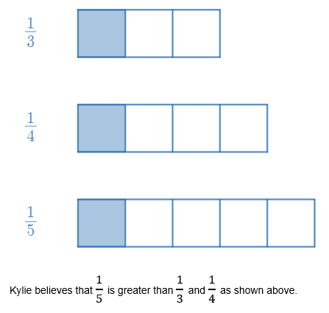
- Have students engage in a Think-Pair-Share (bit.ly/thinkpairsharestrategy) discussing the following questions.
- Do you agree with Kylie? Why?
- Could you represent the fractions in an alternative way? Does this change whether you agree with Kylie?
It is important to clarify the issue with this image – that the 3 fractions need to be represented by a consistent whole. Teachers can display Figure 2 or demonstrate this change dynamically using the Desmos graph ‘Fraction misconception’ (bit.ly/DesmosFractionMisconception).
Figure 2 – fraction representations with a consistent whole
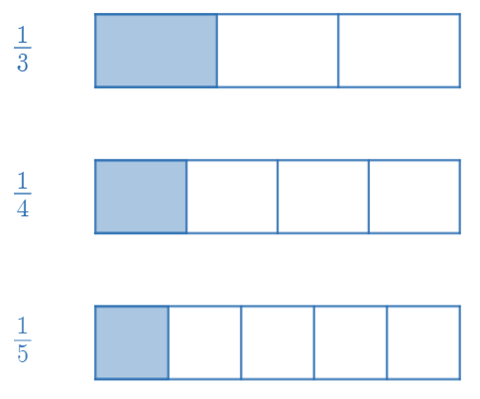

Launch

The nasty game 2

Equipment
- 10-sided dice – one per group.
- Appendix B ‘Nasty game – 1-digit fractions’ – one copy per group.
- Two-sided counters or 2 colours of connector blocks – one large pile per group.
Demonstrate these games by playing with a student in front of the class first. Model a conversation about which fraction is larger and how you know. Keep these fractions to use when demonstrating different models later in the lesson.

Method
- Give groups of 3 to 4 students a copy of Appendix B ‘Nasty game – 1-digit fractions’. Students will need to keep their 10-sided dice. Assign who will be player 1, 2, 3 and 4.
- Play the Nasty game where the digits now form a fraction for each player.
- The winner is the player with the largest proper fraction.
Teachers can take this opportunity to define a proper fraction.
- If the numerator becomes bigger than the denominator, the player loses. The game is a tie if both players have improper fractions.
- Students need to discuss who they believe is the winner by comparing both fractions with benchmark fractions such as quarters and halves. Consider the following questions:
- Are both fractions larger than a half?
- Are both fractions larger than a quarter?
- How close to 1 whole is each fraction?
- Repeat the method for the nasty game 2 using Appendix C ‘Nasty game – 2-digit fractions’.

Explore

Concrete representations
- Demonstrate to students how to represent their fractions from the launch game with counters. An example of results is shown in Appendix D ‘Nasty game – 1-digit fractions example’.
- Have students engage in a Think-Pair-Share (bit.ly/thinkpairsharestrategy) regarding the questions below.
- Who has won the game?
- How does this type of representation make it easier or harder to know which fraction is larger?
- How would you represent improper fractions using this model?
It is important that teachers acknowledge the limitations of this model to represent and then compare fractions. The model does not present a consistent whole and therefore makes comparison difficult and does not extend to representing fractions greater than one.

Representing on a number line
- Open the Desmos graph ‘Fractions on a number line’ (bit.ly/DesmosFractionsNumberLine) to show how to represent one of the fractions from the teacher’s demonstration nasty game on a number line.
- Lead a discussion about how to construct these representations:
- What happens when we change the denominator?
- What happens when we change the numerator?
Students need to identify that the denominator tells us how many equal parts to divide our interval from 0 to 1 into and the numerator tells us how many of these parts to travel.
- Press the Comparison switch to show a second fraction and select a second fraction from the teacher’s demonstration nasty game to represent and compare.
Figure 3 – comparison switch
Image created using Desmos and is licensed under the Desmos Terms of Service.
- Have students use Appendix E ‘Number lines for comparing fractions’ to construct representations of fractions from one of their games in the Launch.
Consider including vectors as a representation using the Desmos graph ‘Fractions as vectors on a number line’ (bit.ly/DesmosFractionVector) and show how to represent the fractions from the teacher’s demonstration nasty game as vectors.

Bar model representations
- Demonstrate to students how to represent fractions as Bars in Polypad. Instructions are available in Appendix F ‘Using Polypad’.
- Students are to build the fractions from one of their nasty games as Bar models in Polypad.
- Have students save their work and send the link to the teacher (also demonstrated in instructions).

Parts of a whole representations
It is common that students internalise a view of fractions as 2 separate values rather than as a number in its own right. As a result, teachers are advised to emphasise number lines and bar models for students whose concept of fractions is still developing.
- Open the Desmos graph ‘Fractions - Parts of a whole’ (bit.ly/DesmosFractionPartsCompare) and show how to represent one of the fractions from the teacher’s demonstration of the nasty game as parts of a whole.
- Lead a discussion about how to construct these representations:
- What happens to the rectangle when we change the denominator?
- What happens to the rectangle when we change the numerator?
Students need to identify that the denominator tells us how many equal parts to divide our rectangle into and the numerator tells us how many of these parts to shade.
- Press the Comparison switch to show a second fraction and select a second fraction from the teacher’s demonstration nasty game to represent and compare.
Figure 4 – comparison switch
Image created using Desmos and is licensed under the Desmos Terms of Service.
- Have students use Appendix G ‘Fractions as parts of a whole’ to construct representations of fractions from one of their games in the launch.

Improper fractions
- Find a student in the room with an improper fraction and have students engage in a Think-Pair-Share (bit.ly/thinkpairsharestrategy) to try to show this fraction on a number line or vector, as a bar model and as part of wholes.
- Examples of what these models can look like can be made using the Desmos links below.
- Fractions on a number line (bit.ly/DesmosFractionNumberLineCompare)
- Fractions as vectors on a number line (bit.ly/DesmosFractionVectorCompare)
- Fractions - Parts of a whole (bit.ly/DesmosFractionPartsCompare)

Summarise
- Students complete Appendix H ‘Comparing fractions’ as an exit ticket, drawing visual representations by hand or using the Desmos graphs to compare the size of fractions and reflect upon their experiences.
- Have students write notes to their future self (bit.ly/notesstrategy) regarding how to represent and compare fractions using these representations.

Apply
- Students play the nasty game with 2-digit fractions, allowing improper fractions.
- Have students reflect on strategies to win the game, discussing the same questions as in the original games.
- Who won more games?
- Were there any games where you knew who had won before the end?
- If you roll a 0 on the first roll, where should you place it?
- If you roll an 8 on the first roll, where should you place it?

Assessment and differentiation

Suggested opportunities for differentiation
Launch
- Students can be limited to single-digit fractions or extended to 3-digit fractions and beyond in the nasty game, depending on their confidence with whole numbers and fractions.
Explore
- Limiting students to a single representation and completing this experience across multiple lessons could support students whose understanding of the concept of a fraction is still in early development.
- Representing fractions as part of a whole can reinforce ideas of a fraction as 2 separate numbers, rather than as a number in its own right. It is recommended that students have significant experience with representing fractions on number lines and as bars before working deeply with parts of a whole.

Suggested opportunities for assessment
Warm up
- Assessing whether students can reason as to which place value is most important when constructing a 3-digit number can inform teachers if students are ready to proceed with examining the size of fractions.
Explore and summarise
- Students can submit their Polypad creations as well as their work on Appendices E, G and H for review.
- Appendix H contains questions that follow a ‘thin slicing’ approach, where students can develop an expectation for a new problem based on considering the result of the previous one. Errors in any question gives insight into how a student approached the previous problem.

Appendix A

Nasty game – 3-digit numbers

Game 1

Game 2

Game 3

Appendix B

Nasty game – 1-digit fractions

Game 1
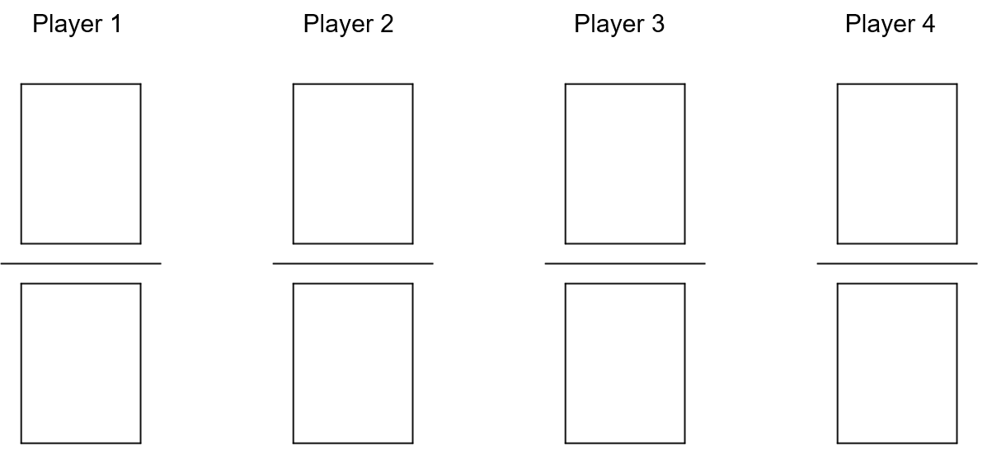

Game 2

Appendix C

Nasty game – 2-digit fractions

Game 1
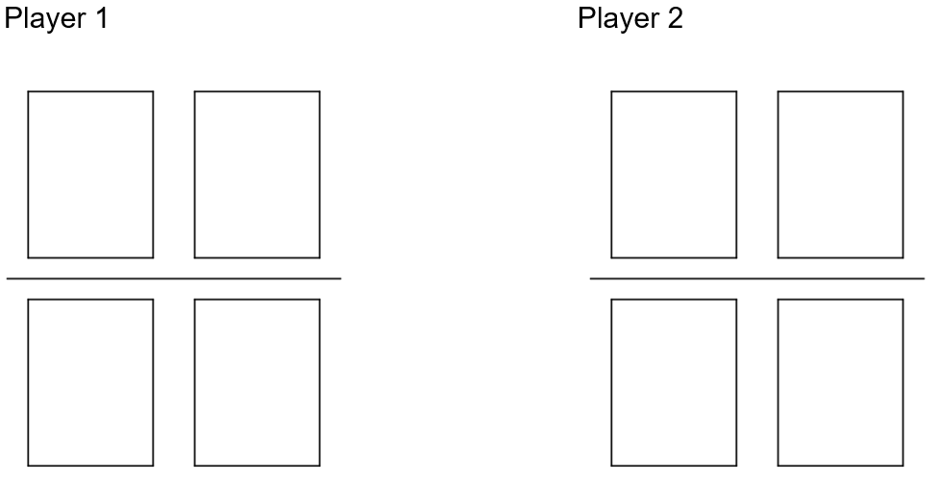

Game 2

Appendix D

Nasty game – 1-digit fractions example

Game 1
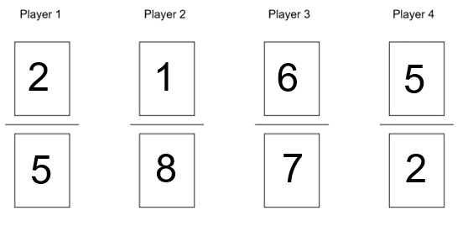
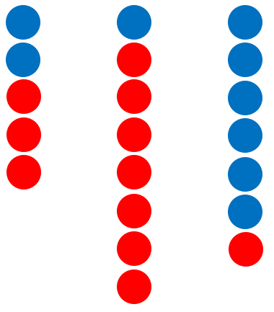

Appendix E

Number lines for comparing fractions

Appendix F

Using Polypad

Constructing fraction bars
- Go to Polypad (https://mathigon.org/polypad#).
- Open the Fractions tab on the left-hand side and select Fraction bars.
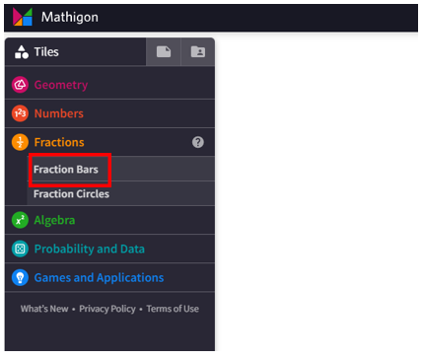
Image created using the free virtual manipulatives at Polypad.org.
- Select on the whole bar, labelled $\frac{1}{1}$, and drag it into the main working space.
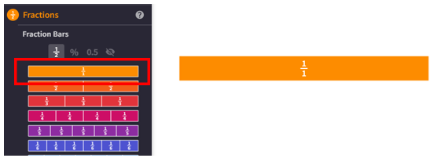
Image created using the free virtual manipulatives at Polypad.org.
- Select on the whole fraction bar to highlight it and Select on the first rename button. Repeat this until the denominator of your fraction is what you desire. We will build the fraction, 7 twelfths, or $\frac{7}{12}$.
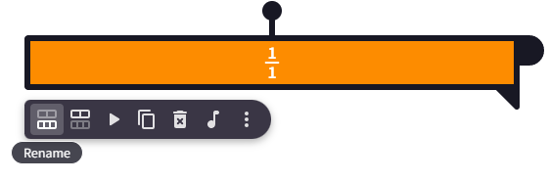
Image created using the free virtual manipulatives at Polypad.org.
- Select on the Split button to split the fractions into individual units.
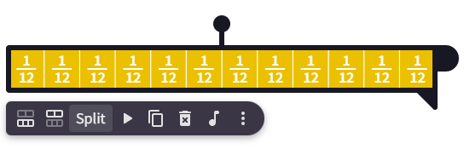
Image created using the free virtual manipulatives at Polypad.org.
- Select anywhere to ’unhighlight’ the bars. Count how many you need and highlight the rest. We will be keeping 7 of the ‘twelfths’ and so will be deleting the remaining 5.
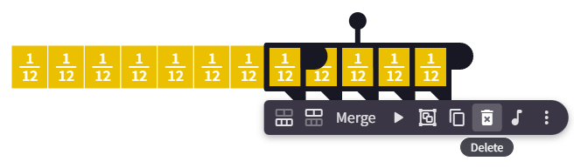
Image created using the free virtual manipulatives at Polypad.org.
- Create a second fraction in the same way to compare. Below is $\frac{7}{12}$ compared with $\frac{4}{7}$.
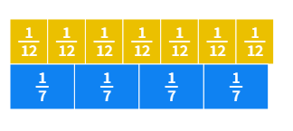
Image created using the free virtual manipulatives at Polypad.org.

Saving your Polypad file
- Students should ensure they are signed in using their NSW Department of Education gmail account, ending in @education.nsw.gov.au.
Image created using the free virtual manipulatives at Polypad.org.
- Select on the file icon in the top left of your screen.
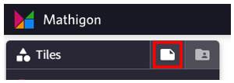
Image created using the free virtual manipulatives at Polypad.org.
- Select on the words Untitled Polypad to give the graph a title.
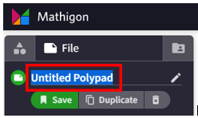
Image created using the free virtual manipulatives at Polypad.org.
- Select save. A link will be generated that can be shared with the teacher.
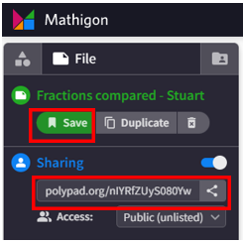
Image created using the free virtual manipulatives at Polypad.org.

Appendix G

Fractions as parts of a whole

Appendix H

Comparing fractions
By drawing visual representations of each fraction, or using the Desmos link, compare the 2 fractions in each row of the table. Us either the greater than (>), less than (<) or equal to (=) symbol to express their relationship. The first has been completed for you.
Fraction 1 | > or < | Fraction 2
$$\frac{1}{5}$$ | > | $$\frac{1}{10}$$
$$\frac{1}{5}$$ |  | $$\frac{2}{10}$$
$$\frac{1}{6}$$ |  | $$\frac{2}{10}$$
$$\frac{4}{6}$$ |  | $$\frac{7}{10}$$
$$\frac{5}{6}$$ |  | $$\frac{9}{10}$$
$$\frac{5}{3}$$ |  | $$\frac{9}{5}$$
$$\frac{5}{2}$$ |  | $$\frac{9}{4}$$
$$\frac{1}{9}$$ |  | $$\frac{1}{8}$$
$$\frac{8}{9}$$ |  | $$\frac{7}{8}$$
- Which comparison was different to what you expected?
- Which representation did you find easiest to use to compare? Why?

Sample solutions

Appendix H
Fraction 1 | > or < | Fraction 2
$$\frac{1}{5}$$ | > | $$\frac{1}{10}$$
$$\frac{1}{5}$$ | = | $$\frac{2}{10}$$
$$\frac{1}{6}$$ | < | $$\frac{2}{10}$$
$$\frac{4}{6}$$ | < | $$\frac{7}{10}$$
$$\frac{5}{6}$$ | < | $$\frac{9}{10}$$
$$\frac{5}{3}$$ | < | $$\frac{9}{5}$$
$$\frac{5}{2}$$ | > | $$\frac{9}{4}$$
$$\frac{1}{9}$$ | < | $$\frac{1}{8}$$
$$\frac{8}{9}$$ | > | $$\frac{7}{8}$$

References
This resource contains NSW Curriculum and syllabus content. The NSW Curriculum is developed by the NSW Education Standards Authority. This content is prepared by NESA for and on behalf of the Crown in right of the State of New South Wales. The material is protected by Crown copyright.
Please refer to the NESA Copyright Disclaimer for more information https://educationstandards.nsw.edu.au/wps/portal/nesa/mini-footer/copyright.
NESA holds the only official and up-to-date versions of the NSW Curriculum and syllabus documents. Please visit the NSW Education Standards Authority (NESA) website https://educationstandards.nsw.edu.au/ and the NSW Curriculum website https://curriculum.nsw.edu.au/home.
Mathematics K–10 Syllabus © NSW Education Standards Authority (NESA) for and on behalf of the Crown in right of the State of New South Wales, 2022.

© State of New South Wales (Department of Education), 2023
The copyright material published in this resource is subject to the Copyright Act 1968 (Cth) and is owned by the NSW Department of Education or, where indicated, by a party other than the NSW Department of Education (third-party material).
Copyright material available in this resource and owned by the NSW Department of Education is licensed under a Creative Commons Attribution 4.0 International (CC BY 4.0) licence.
This licence allows you to share and adapt the material for any purpose, even commercially.
Attribution should be given to © State of New South Wales (Department of Education), 2023.
Material in this resource not available under a Creative Commons licence:
- the NSW Department of Education logo, other logos and trademark-protected material
- material owned by a third party that has been reproduced with permission. You will need to obtain permission from the third party to reuse its material.
Links to third-party material and websites
Please note that the provided (reading/viewing material/list/links/texts) are a suggestion only and implies no endorsement, by the New South Wales Department of Education, of any author, publisher, or book title. School principals and teachers are best placed to assess the suitability of resources that would complement the curriculum and reflect the needs and interests of their students.
If you use the links provided in this document to access a third-party's website, you acknowledge that the terms of use, including licence terms set out on the third-party's website apply to the use which may be made of the materials on that third-party website or where permitted by the Copyright Act 1968 (Cth). The department accepts no responsibility for content on third-party websites.

