Recipe for success
Students explore different combinations of fractional measuring cups to obtain specific quantities for a recipe, deepening their understanding of equivalent fractions.

Visible learning

Learning intention
- To be able to generate equivalent fractions.

Success criteria
- I can compare fractions with different denominators.
- I can find equivalent fractions using number lines.
- I can generate equivalent fractions to solve problems.

Syllabus outcomes
A student:
- develops understanding and fluency in mathematics through exploring and connecting mathematical concepts, choosing and applying mathematical techniques to solve problems, and communicating their thinking and reasoning coherently and clearly MAO-WM-01
- represents and operates with fractions, decimals and percentages to solve problems MA4-FRC-C-01
Mathematics K–10 Syllabus © NSW Education Standards Authority (NESA) for and on behalf of the Crown in right of the State of New South Wales, 2022.

Activity structure
Please use the associated PowerPoint Recipe for success to display images in this lesson.

Launch
To complete the launch of this activity, teachers are advised to liaise with the technological and applied sciences (TAS) faculty at your school for access to measuring cups, bowls and potentially ovens. There is no need for ovens or cooking during the mathematics lesson.
- Open one of the 2 recipes, salt dough (bit.ly/dough_salt) and no-bake cookies (bit.ly/no_bake_cookies) and display the ingredients list on the screen.
Teachers could choose to have all students make both recipes, have groups assigned to a recipe, or select one recipe for the entire class, depending on what is feasible for your context.
- Organise students into visibly random groups of 3 (bit.ly/visiblegroups).
- Have students use Appendix A ‘Recipe plan’ to plan out what measuring tools to use for each ingredient. The table in Appendix A has been created based on a set that contains the device sizes listed below and should be adjusted based on the equipment available.
- 1 cup
- $\frac{3}{4}$ cup
- $\frac{2}{3}$ cup
- $\frac{1}{2}$ cup
- $\frac{1}{3}$ cup
- $\frac{1}{4}$ cup
- 1 tablespoon (tbsp) ($\frac{2}{25}$ cup)
- 1 teaspoon (tsp) ($\frac{1}{50}$ cup)
These metric measuring cups and spoons are based on a 250 mL cup, the standard used in Australia.
- If all groups are completing both recipes, display the second recipe on the screen and have students complete a recipe plan again using Appendix A.
- Organise ingredients and measuring cups so students can access them for their recipe. The ideal method for this learning concept would be for students to collect ingredients using their own set of measuring cups and experience the consequences of having to take multiple ingredients from measuring cups that have already been used.
- Students will need time to collect their ingredients, make the mix, and clean up afterwards.
- Salt dough can be shaped into a decoration for students to take home and bake under supervision if facilities are unavailable at school.
- A microwave may be required to warm the butter if not left out to warm at room temperature prior to the commencement of the activity.
- Seek advice from the TAS faculty at your school regarding the safe use of microwaves, ovens and other related equipment if you plan to use these. (bit.ly/EquipmentSafety)
- Once complete, have students engage in a Think-Pair-Share (bit.ly/thinkpairsharestrategy) to consider the following reflections questions.
- Did you ever have to use a measuring cup for more than one ingredient? Was this difficult?
- Which measuring cup was the most useful? Why?
- Which measuring cup was the least useful? Why?
- Which ingredient was the most difficult to collect?
- If you could have one more measuring cup, what would it be? Why?

Explore
- After reviewing the measuring cups and spoons available, students are to determine as many different ways as they can think of to make the volumes outlined below, using a combination of different measuring cups and spoons:
- $2\frac{1}{2}$ cups
- 1 cup
- $\frac{1}{2}$ a cup
- $1\frac{1}{2}$ cups
- $\frac{2}{3}$ of a cup
- $\frac{1}{4}$ of a cup
- $1$ tablespoon (tbsp)
- Students should be encouraged to use a manipulative such as water or rice to compare and determine equivalent sizes of the measurements listed.

Summarise

Equivalent fractions

Paper based activity
- Explain to students that we would like to write $\frac{5}{15}$ in its simplest form.
- Display the Desmos graph ‘Fraction wall example’ (bit.ly/DesmosFWE) on the screen. Demonstrate to students how to place $\frac{5}{15}$ on a number line by dividing into equal parts and counting a number of parts along the line.
- Alternatively, show this by displaying Figure 1.
Figure 1 – fraction wall on number lines example
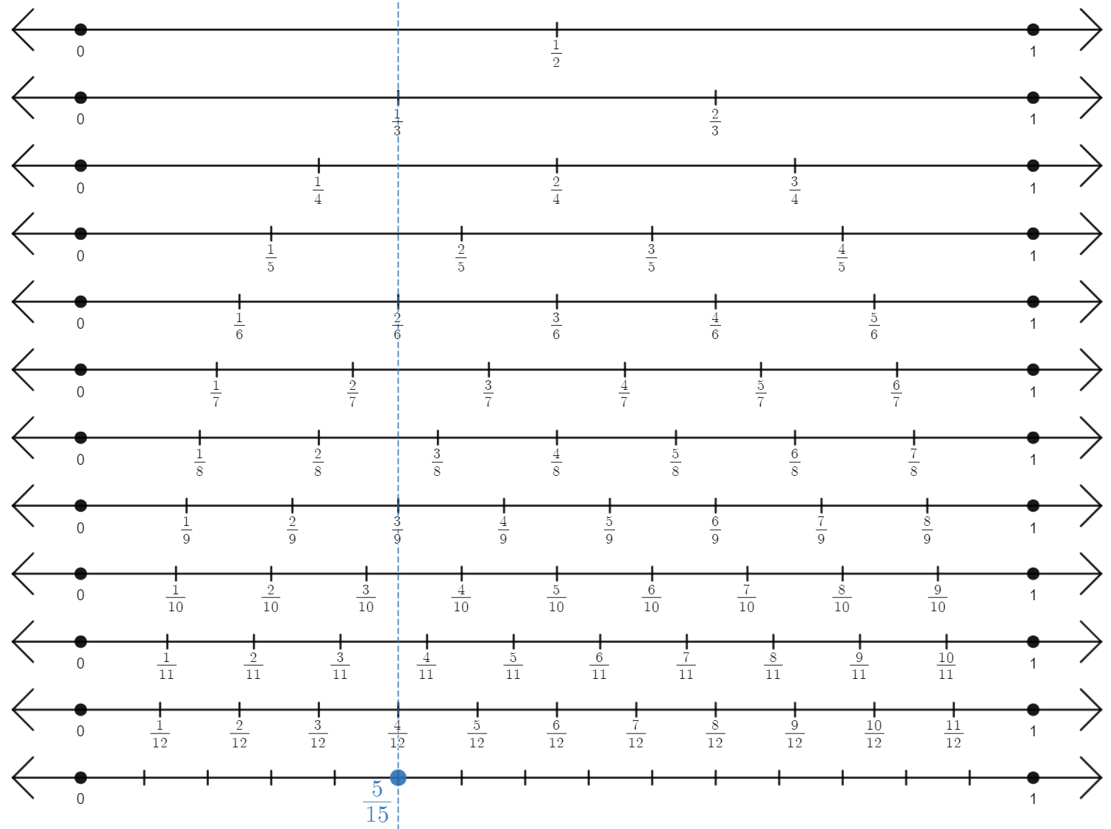
Image created using Desmos and is licensed under the Desmos Terms of Service.
- Have students complete a notice and wonder list (bit.ly/noticewonderstrategy) based on what they see on the fraction wall.
- Lead a discussion to conclude with students that:
- all fractions that we hit on the wall, including $\frac{4}{12}$, $\frac{3}{9}$, $\frac{2}{6}$, $\frac{1}{3}$ are equivalent to $\frac{5}{15}$
- $\frac{1}{3}$ is the simplest fraction shown to be equivalent to $\frac{5}{15}$
- the simplest fraction for any number we put on the fraction wall will always be the highest one that we hit.
- Hand students a copy of Appendix B ‘Simplifying fractions – Fraction wall’ and have them place the fractions onto the number lines at the bottom of the fraction wall and then locate equivalent fractions by drawing vertical lines.

Online tool
- Open either or both of the Desmos graphs ‘Simplifying fractions: Number lines’ (bit.ly/DesmosSimpFrac) and ‘Simplifying fractions: Parts of a whole’ (bit.ly/DesmosSimpFrac2).
- The current fraction should read $\frac{2}{10}$. Flick the switch to turn on fraction simplifying, as shown below.
Figure 2 – how to turn on fraction simplifying
Image created using Desmos and is licensed under the Desmos Terms of Service.
Acknowledge that the fraction that appears is $\frac{0.4}{2}$. Discuss with students whether this is ‘simpler’.

- Drag the new denominator slide until the fraction at the bottom no longer has a decimal in it, as shown below.
Figure 3 – demonstration on where the new denominator slide should go
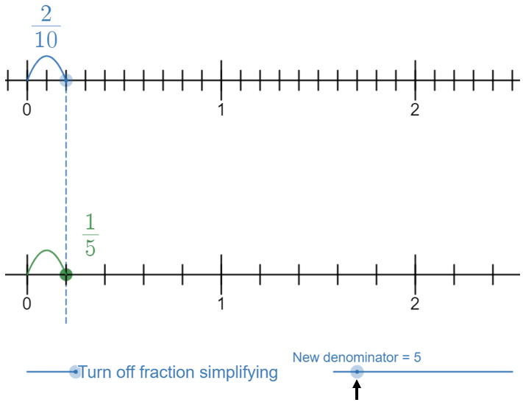
Image created using Desmos and is licensed under the Desmos Terms of Service.
- Conclude that $\frac{2}{10}=\frac{1}{5}$.
- Drag the new denominator further to find other equivalent fractions.

Explicit teaching
Use the Recipe for success PowerPoint slides 3 to 10 for explicit teaching of the skills required for simplifying fractions.
The explicit teaching technique used in the PowerPoint is ‘Your turn.’ The first slide is a worked example which should be displayed for the students and then use the following steps.
- Reveal the question to students and its solution.
- Students read in silence.
- Students individually think and explain to themselves what is happening in each step.
- Students hold up a thumbs up to the teacher when they have finished reading and have some sort of understanding.
- Think-Pair-Share. Students explain the solution to their partner.
- In pairs students then answer the self-explanation questions.
- Finally, randomly select students to share their answers with the whole class.

Apply

Equivalent fractions practice
- Where devices are available, give students access to the Desmos graphs ‘Simplifying fractions: Number lines’ (bit.ly/DesmosSimpFrac) and ‘Simplifying fractions: Parts of a whole’ (bit.ly/DesmosSimpFrac2).
- Have students complete Appendix C ‘Equivalent fractions’, using the visual representations in the Desmos graph and numerically as shown in the PowerPoint ‘your turn’ activity.

Equivalent fractions Venn
Have students complete Appendix D ‘Equivalent fractions Venn’. Students are to identify a fraction for every region of the Venn diagram and provide justifications if they believe a region cannot be filled.

Open middle problem
Have students attempt the Open middle problem ‘Equivalent fractions’, (bit.ly/OMEquivalentF), where students are to use limited digits to create a set of 3 equivalent fractions.

Assessment and differentiation

Suggested opportunities for differentiation
Launch
- Students could be asked to focus on avoiding mixing wet and dry ingredients instead. This same concept also reduces the complexity of the task, with less variables to consider.
- Finding recipes with a more diverse ingredient list would create an increased level of complexity for consideration.
- Limiting the use of the utensils to those less than a cup (or even the measuring spoons) would require a deeper understanding of equivalent fractions to be successful.
Explore
- Limiting the use of the utensils to $\frac{1}{4}$ and $\frac{1}{3}$ of a cup and the measuring spoons would require a deeper understanding of equivalent fractions to be successful.
- For students requiring additional support, limit the equivalent comparison to 1 cup as this is a familiar concept for students and the idea of one whole.
Apply
- Students can continue to use the visual representations if they find operating numerically to be challenging.
- Solutions to the Venn diagram problems in Appendix D and the open middle problem provide evidence of students’ ability to solve problems by using equivalent fractions.

Suggested opportunities for assessment
Launch
- Problem-solving can be formatively assessed as students plan out what measuring tools to use and for what ingredients before creating the recipes.
Explore
- Formative assessment of student responses towards the end of the Explore phase would offer insights into student problem-solving and reasoning.
Summarise and Apply
- Appendix B and C serve as evidence of students’ ability to simplify fractions numerically and use visual representations.

Appendix A

Recipe plan
Write the ingredients for your recipe beside the measuring device you will use to obtain an accurate quantity. Write the number of times you will need to use that device to gather the correct quantity in the ‘No.’ column.
Measuring tool | Ingredient | No. | Ingredient | No. | Ingredient | No.
1 cup
$\frac{3}{4}$ cup
$\frac{2}{3}$ cup
$\frac{1}{2}$ cup
$\frac{1}{3}$ cup
$\frac{1}{4}$ cup
1 tablespoon (tbsp) ($\frac{2}{25}$ cup)
1 teaspoon (tsp) ($\frac{1}{50}$ cup)

Appendix B

Simplifying fractions – Fraction wall
The number lines below contain a fraction wall. The top 3 number lines are blank.
By dividing a blank number line into sections, find the simplest equivalent fraction to each of the following:
- $\frac{10}{15}$
- $\frac{6}{16}$
- $\frac{12}{20}$
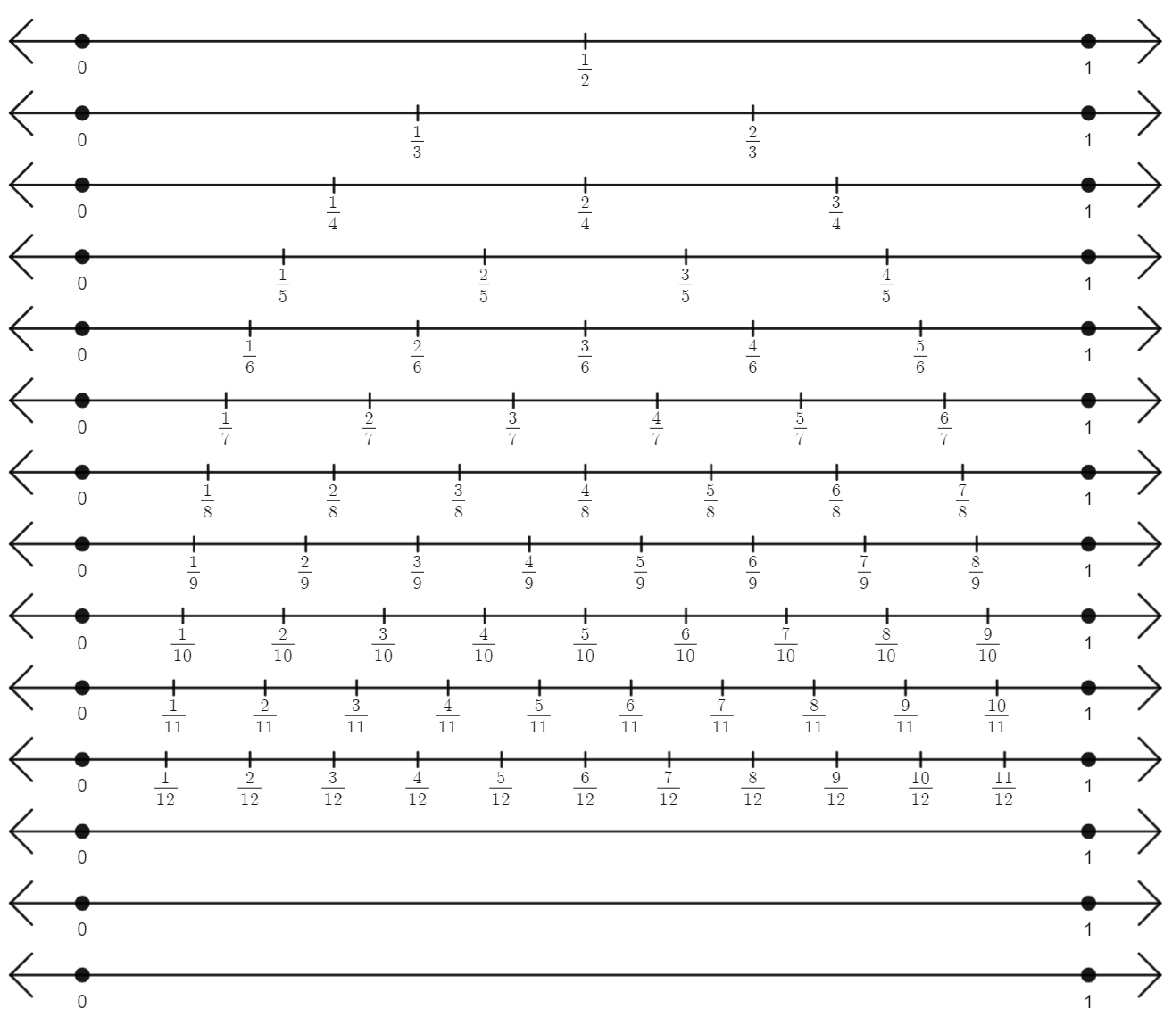
Image created using Desmos and is licensed under the Desmos Terms of Service.

Appendix C

Equivalent fractions
Beside each fraction, write the fully simplified equivalent fraction and one other equivalent fraction.
- $\frac{4}{8}$
- $\frac{4}{10}$
- $\frac{6}{10}$
- $\frac{6}{30}$
- $\frac{25}{30}$
- $\frac{8}{20}$
- $\frac{8}{48}$
- $\frac{80}{48}$
- $\frac{80}{50}$
- $\frac{35}{50}$
- $\frac{35}{45}$
- $\frac{5}{45}$
- $\frac{2}{18}$
- $-\frac{5}{15}$

Appendix D

Equivalent fractions Venn
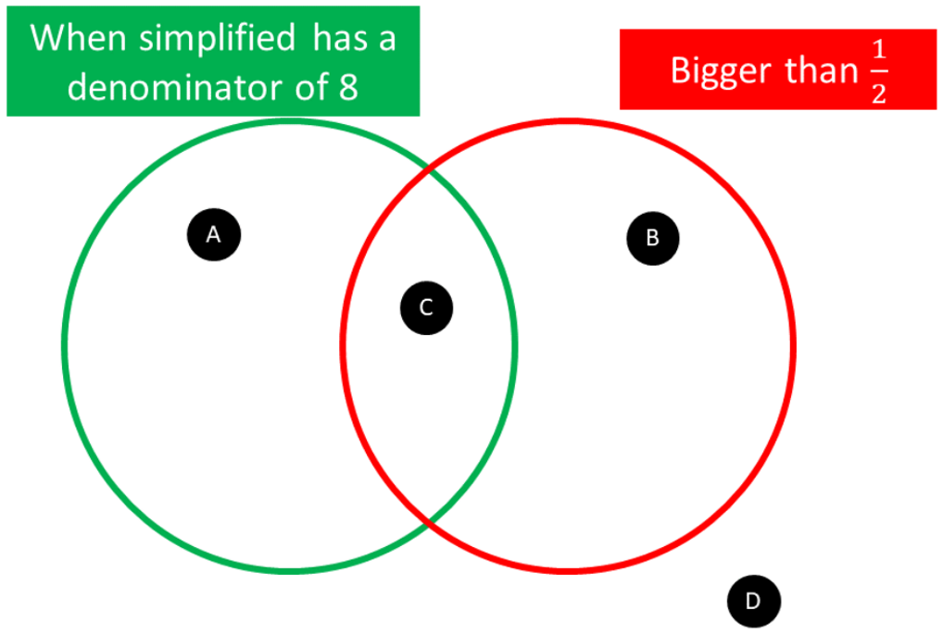
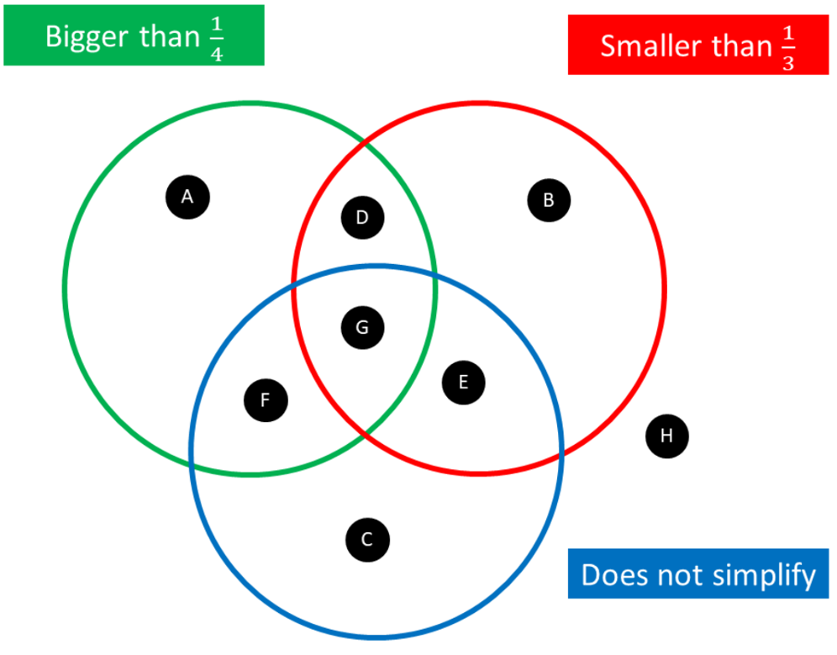

Sample solutions

Appendix A – recipe plan
The sample solution below is a plan for the loaded healthy no-bake cookies.
Measuring tool | Ingredient | No. | Ingredient | No. | Ingredient | No.
1 cup
$\frac{3}{4}$ cup
$\frac{2}{3}$ cup
$\frac{1}{2}$ cup | $\frac{1}{2}$ cup nut butter | 1 | $\frac{1}{2}$ cup oat bran | 1
$\frac{1}{3}$ cup | 1 cup flour | 3
$\frac{1}{4}$ cup | $\frac{1}{4}$ cup chocolate pieces | 1 | $\frac{1}{4}$ cup maple syrup | 1
1 tablespoon (tbsp) ($\frac{2}{25}$ cup) | 1 tbsp milk | 1
1 teaspoon (tsp) ($\frac{1}{50}$ cup) | $\frac{1}{8}$ teaspoon salt | $$\frac{1}{8}$$

Appendix B – fraction wall solutions
- $\frac{10}{15}=\frac{2}{3}$
- $\frac{6}{16}=\frac{3}{8}$
- $\frac{12}{20}=\frac{3}{5}$
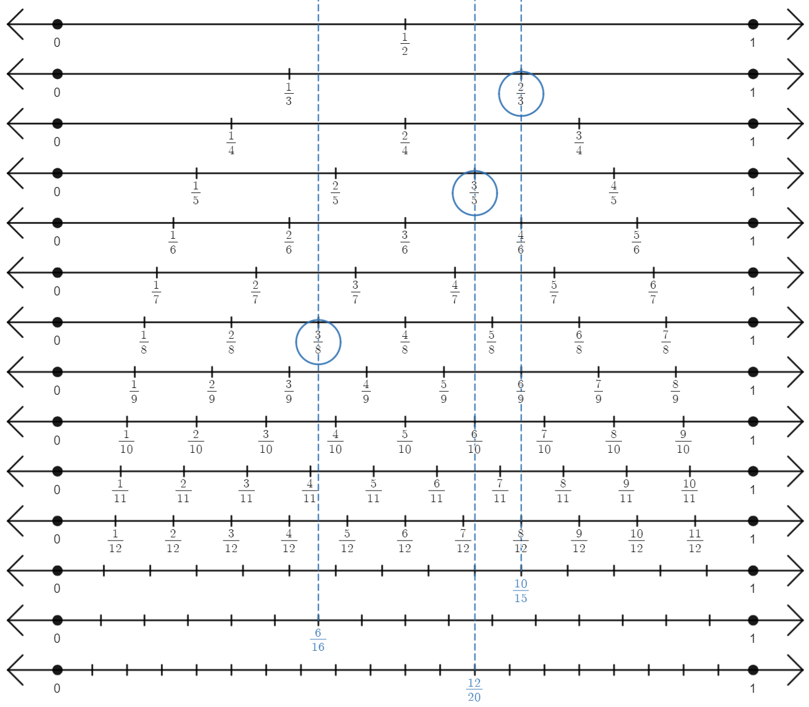
Image created using Desmos and is licensed under the Desmos Terms of Service.

Appendix C – equivalent fractions solutions
- $\frac{4}{8}=\frac{1}{2}$, $\frac{3}{6}$
- $\frac{4}{10}=\frac{2}{5}$, $\frac{6}{15}$
- $\frac{6}{10}=\frac{3}{5}$, $\frac{9}{15}$
- $\frac{6}{30}=\frac{1}{5}$, $\frac{3}{15}$
- $\frac{25}{30}=\frac{5}{6}$, $\frac{50}{60}$
- $\frac{8}{20}=\frac{2}{5}$, $\frac{4}{10}$
- $\frac{8}{48}=\frac{1}{6}$, $\frac{2}{12}$
- $\frac{80}{48}=\frac{5}{3}$ or $1\frac{2}{3}$, $\frac{10}{6}$
- $\frac{80}{50}=\frac{8}{5}$ or $1\frac{3}{5}$, $\frac{16}{10}$
- $\frac{35}{50}=\frac{7}{10}$, $\frac{14}{20}$
- $\frac{35}{45}=\frac{7}{9}$, $\frac{14}{18}$
- $\frac{5}{45}=\frac{1}{9}$, $\frac{2}{18}$
- $\frac{2}{18}=\frac{1}{9}$, $\frac{2}{18}$
- $-\frac{5}{15}=-\frac{1}{3}$, $-\frac{2}{6}$

Appendix D – Equivalent fractions Venn
Small Venn diagram
A = $\frac{2}{16}$
B = $\frac{8}{9}$
C = $\frac{14}{16}$
D = $\frac{2}{8}$
Big Venn diagram
A = $\frac{2}{4}$
B = $\frac{2}{12}$
C has no solutions, because every number must be either larger than $\frac{1}{4}$ or smaller than $\frac{1}{3}$.
D = $\frac{14}{48}$
E = $\frac{1}{10}$
F = $\frac{1}{2}$
G = $\frac{7}{24}$
H has no solutions, because every number must be either larger than $\frac{1}{4}$ or smaller than $\frac{1}{3}$.

References
This resource contains NSW Curriculum and syllabus content. The NSW Curriculum is developed by the NSW Education Standards Authority. This content is prepared by NESA for and on behalf of the Crown in right of the State of New South Wales. The material is protected by Crown copyright.
Please refer to the NESA Copyright Disclaimer for more information https://educationstandards.nsw.edu.au/wps/portal/nesa/mini-footer/copyright.
NESA holds the only official and up-to-date versions of the NSW Curriculum and syllabus documents. Please visit the NSW Education Standards Authority (NESA) website https://educationstandards.nsw.edu.au/ and the NSW Curriculum website https://curriculum.nsw.edu.au/home.
Mathematics K–10 Syllabus © NSW Education Standards Authority (NESA) for and on behalf of the Crown in right of the State of New South Wales, 2022.

© State of New South Wales (Department of Education), 2023
The copyright material published in this resource is subject to the Copyright Act 1968 (Cth) and is owned by the NSW Department of Education or, where indicated, by a party other than the NSW Department of Education (third-party material).
Copyright material available in this resource and owned by the NSW Department of Education is licensed under a Creative Commons Attribution 4.0 International (CC BY 4.0) licence.
This licence allows you to share and adapt the material for any purpose, even commercially.
Attribution should be given to © State of New South Wales (Department of Education), 2023.
Material in this resource not available under a Creative Commons licence:
- the NSW Department of Education logo, other logos and trademark-protected material
- material owned by a third party that has been reproduced with permission. You will need to obtain permission from the third party to reuse its material.
Links to third-party material and websites
Please note that the provided (reading/viewing material/list/links/texts) are a suggestion only and implies no endorsement, by the New South Wales Department of Education, of any author, publisher, or book title. School principals and teachers are best placed to assess the suitability of resources that would complement the curriculum and reflect the needs and interests of their students.
If you use the links provided in this document to access a third-party's website, you acknowledge that the terms of use, including licence terms set out on the third-party's website apply to the use which may be made of the materials on that third-party website or where permitted by the Copyright Act 1968 (Cth). The department accepts no responsibility for content on third-party websites.

