Listen to the music
Music, among other things, is a way of listening to Maths, particularly the beat and tempo of a musical piece which are great tools for building the concept of equivalent fractions.
In this activity, students explore the way fractions can be used to describe and compare music. They then generate equivalent fractions and examine their impact on related aspects of a song.
Students will need at least one digital device per pair to interact with Desmos or Polypad during this lesson.

Visible learning

Learning intentions
- To be able to generate equivalent fractions, utilising auditory, symbolic, and visual representations.

Success criteria
- I can use a bar model to represent fractions.
- I can use a bar model to generate equivalent fractions.

Syllabus outcomes
- Develops understanding and fluency in mathematics through exploring and connecting mathematical concepts, choosing and applying mathematical techniques to solve problems, and communicating their thinking and reasoning coherently and clearly MAO-WM-01
- Examine methods of generating equivalent fractions MA4-FRC-C-01
Mathematics K–10 Syllabus © NSW Education Standards Authority (NESA) for and on behalf of the Crown in right of the State of New South Wales, 2022.

Activity structure

Launch
- Project the video ‘Rhythm Clap Along: Easy[Minecraft Theme] (2:50).’ (https://www.youtube.com/watch?v=Ut-0q0MWC0o)
- Students will clap along to the different rhythm patterns as they are shown in the video.
- Rewind the video and pause while there is a rhythm pattern on the screen. Ask students what they notice and what they wonder.
Questions to consider could be:
- What is the relationship between the red notes to the rest (shh)? (Same value)
- What is the relationship between the green notes to the red notes? (Green notes are half the value of the red notes)
- Play the video ‘Rhythm Clap Along: Advanced [Minecraft Theme] (2:50)’ (https://www.youtube.com/watch?v=mSHWM5TIF30) This video contains harder rhythm patterns.
- Rewind and pause the video whilst there is a rhythm pattern on the screen. Using a Think-Pair-Share strategy (bit.ly/thinkpairsharestrategy) ask students to discuss what they notice and wonder about these notes.
- Use a Pause-Pose-Pounce-Bounce question strategy ([PDF 200KB] (bit.ly/pausepouncebounce) to discuss the following:
- What is the relationship of the blue notes to the red notes? (Four blue notes to one red note)
- What is the relationship between the green notes and the blue notes? (Two blue notes to one green note)
- What is the relationship between the orange notes and the red notes? (Three orange notes to one red note)
- Are the orange notes shorter or longer than the green notes? (Orange notes are shorter than green notes)
- Explain to students that the red notes are called quarter notes or crotchets and that the different shaped notes tell musicians how long to play each note for.
- Ask students, ’If the red notes are quarter notes, what might the green notes be called? What might the blue notes be called?’ Extension: What would be the value of the orange notes?
Table 1– note names and values for reference
Note value and name | Note symbol
Whole note – semibreve | 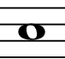
Half note – minim | 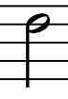
Quarter note – crotchet | 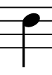
Eighth note – quaver | 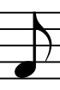
Sixteenth note – semi quaver | 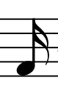

Explore
- Watch the video ‘Drumming in Fractions’ (https://thefutureschannel.com/videos/drumming-in-fractions/) with students. This video focuses on drumming and the application of fractions to the manner in which the drums are played to be able to add filler sounds and create styles of music
- To reinforce their understanding of equivalent fractions and how this applies to music, students will work through slides 1–12 of the Desmos classroom activity ’Listen to the music’ (https://bit.ly/DesmosMusic).
Figure 1 – listen to the music Desmos classroom activity
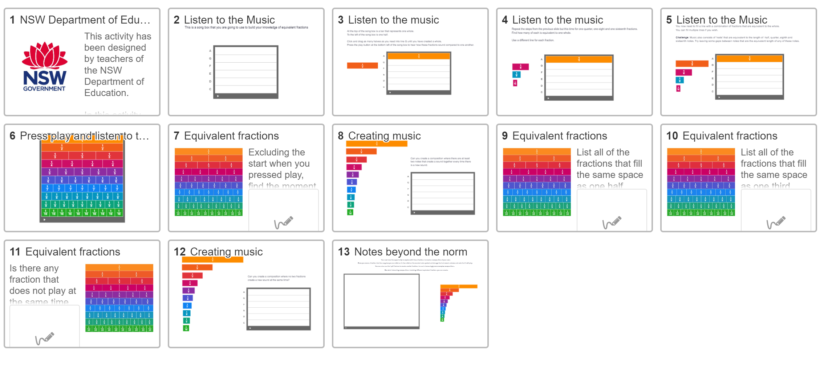
Image created using Desmos and is licensed under the Desmos Terms of Service.
For instructions on how to use Desmos classroom activities with your class, please visit https://my.amplify.com/help/en/collections/3777043-desmos-classroom
- There are teacher notes embedded throughout the Desmos activity to support the slides where appropriate.
Figure 2 – teacher moves in Desmos activity
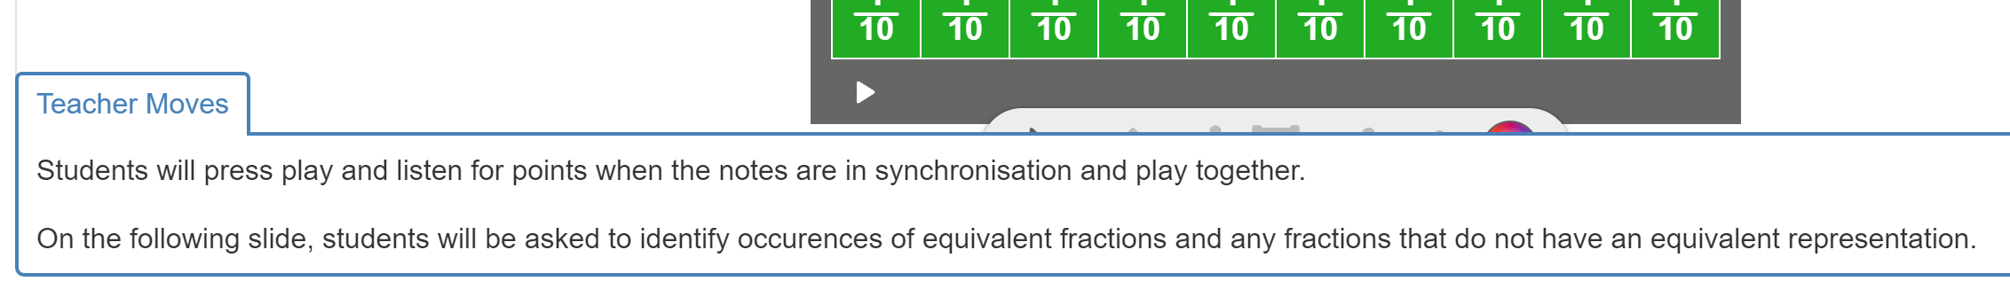
Image created using Desmos and is licensed under the Desmos Terms of Service.

Summarise
- Present the following image to the students:
Figure 3 – fraction wall showing halves, quarters, eighths and sixteenth notes
- Highlight to the students that we can see, and have already heard, that $\frac{2}{4}$ takes up the equivalent amount of space as $\frac{1}{2}$ . Similarly, $\frac{4}{8}$ and $\frac{8}{16}$ occupy the equivalent amount of space as $\frac{1}{2}$ .
- Using a Think-Pair-Share strategy (bit.ly/thinkpairsharestrategy), ask students to use the diagram (or their own work) to brainstorm as many equivalent fractions as they can. You could challenge them to record these equivalences using note symbols.
- In their pairs, students should discuss what they notice about the numerator and denominator of these equivalent fractions. Ask students to consider how we could create equivalent fractions without the fraction wall.
- Again, using a Think-Pair-Share strategy, ask students to consider what we would have to do to create a $\frac{1}{32}$ note?
- Using the Pause-Pose-Pounce-Bounce question strategy ([PDF 200KB] (bit.ly/pausepouncebounce), to have students share their strategies and reasoning.
- Is there more than one way we could create the new note?
- How many $\frac{1}{32}$ notes would be equivalent to $\frac{1}{16}, \text{or} \frac{1}{8} \text{or }\frac{1}{4}$? What strategy did they use to work this out?
- Have students create notes to their future forgetful self (bit.ly/notesstrategy) that reinforce the concept of equivalent fractions.

Apply
- The final slide in the Desmos activity provides an opportunity for students to create increasingly more complex musical representations of fractions, with increasingly larger denominators.
- The following can be shown to students as an example of what can be achieved with time and patience utilising this online tool: https://mathigon.org/polypad/xm8tmMb4On8QZg
Click and drag the mouse pointer to select all the fraction bars and then press the play button that appears on the menu.

Assessment and differentiation

Suggested opportunities for differentiation
- You may be able to team teach this lesson with your music teacher.
Launch
- Students may notice and wonder about the different symbols used. They should be able to identify that there are 2 green notes that take up the same space as a red note.
- Challenge students by showing the ‘Rhythm Clap Along: Advanced [Minecraft Theme] (2:50)’ (https://www.youtube.com/watch?v=mSHWM5TIF30) video and asking them to consider the length of the new notes.
- Students who learn a musical instrument may be able to explain the values of the different notes.
Explore
- Students could be challenged to research rests, and the symbols used for different length rests in music. They could incorporate rests into their compositions.
Apply
- Students can be restricted to whole, half, quarter and eighth notes in their composition or extended to include sixteenth notes and triplets.
- Students could complete a single line of rhythm or be challenged to include multiple lines of rhythms that play simultaneously.

Suggested opportunities for assessment
Launch
- Observe and record observational notes of the students as they listen to the music and identify the fractions in the rhythm.
Explore
- Use the Desmos classroom activity dashboard to evaluate each student's participation in the activity and their ability to explain the fractions they used to create their compositions.

References
This resource contains NSW Curriculum and syllabus content. The NSW Curriculum is developed by the NSW Education Standards Authority. This content is prepared by NESA for and on behalf of the Crown in right of the State of New South Wales. The material is protected by Crown copyright.
Please refer to the NESA Copyright Disclaimer for more information https://educationstandards.nsw.edu.au/wps/portal/nesa/mini-footer/copyright.
NESA holds the only official and up-to-date versions of the NSW Curriculum and syllabus documents. Please visit the NSW Education Standards Authority (NESA) website https://educationstandards.nsw.edu.au/ and the NSW Curriculum website https://curriculum.nsw.edu.au/home.
Mathematics K–10 Syllabus © NSW Education Standards Authority (NESA) for and on behalf of the Crown in right of the State of New South Wales, 2022.

© State of New South Wales (Department of Education), 2023
The copyright material published in this resource is subject to the Copyright Act 1968 (Cth) and is owned by the NSW Department of Education or, where indicated, by a party other than the NSW Department of Education (third-party material).
Copyright material available in this resource and owned by the NSW Department of Education is licensed under a Creative Commons Attribution 4.0 International (CC BY 4.0) licence.
This licence allows you to share and adapt the material for any purpose, even commercially.
Attribution should be given to © State of New South Wales (Department of Education), 2023.
Material in this resource not available under a Creative Commons licence:
- the NSW Department of Education logo, other logos and trademark-protected material
- material owned by a third party that has been reproduced with permission. You will need to obtain permission from the third party to reuse its material.
Links to third-party material and websites
Please note that the provided (reading/viewing material/list/links/texts) are a suggestion only and implies no endorsement, by the New South Wales Department of Education, of any author, publisher, or book title. School principals and teachers are best placed to assess the suitability of resources that would complement the curriculum and reflect the needs and interests of their students.
If you use the links provided in this document to access a third-party's website, you acknowledge that the terms of use, including licence terms set out on the third-party's website apply to the use which may be made of the materials on that third-party website or where permitted by the Copyright Act 1968 (Cth). The department accepts no responsibility for content on third-party websites.

