Zero pairs
Students use balloons and weights in a Desmos activity to investigate going up and down and the idea of zero pairs cancelling out to represent integers in infinite ways.

Visible learning

Learning intention
- To be able to use zero pairs to represent integers in infinite ways.

Success criteria
- I can use zero pairs to represent integers.
- I can explain why there are infinite ways to make any given whole number.

Syllabus outcomes
A student:
- develops understanding and fluency in mathematics through exploring and connecting mathematical concepts, choosing and applying mathematical techniques to solve problems, and communicating their thinking and reasoning coherently and clearly MAO-WM-01
- compares, orders and calculates with integers to solve problems MA4-INT-C-01
Mathematics K–10 Syllabus © NSW Education Standards Authority (NESA) for and on behalf of the Crown in right of the State of New South Wales, 2022.

Activity structure

Warm up

Sealed solution
- Organise students into visibly random groups of 3 (bit.ly/visiblegroups). Where possible, have students work at vertical whiteboards (bit.ly/VNPSstrategy).
- Challenge students to solve the NRICH task, ‘Sealed Solution’ (bit.ly/sealedsolution).
- Other similar ‘Sealed Solution’ tasks can be generated using the Desmos ‘Sealed solution 1’ (bit.ly/DesmosSealedSolution1). This activity may be used by the teacher to generate predetermined tasks or used by the students.

Launch
- Have students watch this video clip from YouTube of a house flying with the assistance of balloons (3:41) (https://www.youtube.com/watch?v=X1nM__RkMP4).
- Have students engage in a Think-Pair-Share (bit.ly/thinkpairsharestrategy) to answer the following questions.
- What would happen if some of the balloons burst?
- If the house was getting too high, how could you bring it back down?
- If you were in the house and it was getting lower, what would you do to keep it flying?
The aim here is to conclude that removing balloons would bring the house lower and that throwing any heavy items out of the house to make it lighter would bring it up.

Explore
- Display the first Desmos graph ‘Falling house’ (bit.ly/DesmosHouseFall) to students. It displays a flying house with 11 balloons where the balloons are disappearing and the house is falling.
- Randomly select students to answer the questions below.
- What is happening to the house?
- How could you stop the house from reaching the ground?
- What happens when we run out of balloons?
- Use the slider on the screen to raise the house before it hits the ground, as shown below.
Figure 1 – balloon slider from ‘Falling House’
Image created using Desmos and is licensed under the Desmos Terms of Service.
- Display the Desmos graph ‘Balloons and weights’ (bit.ly/DesmosFloatingHouse). This looks almost the same, but the house is no longer falling.
- Turn on the levels and randomly select students to define where the house is using the levels.
Figure 2 – turn on levels slider from ‘Balloons and weights’
Image created using Desmos and is licensed under the Desmos Terms of Service.
Students should look at the bottom of the house to define the level. The house in this image is at level 11.
Figure 3 – house at level 11
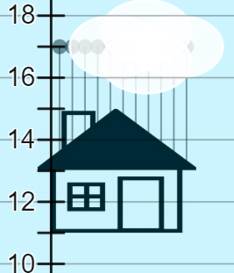
Image created using Desmos and is licensed under the Desmos Terms of Service.
- Explain to students that the man has determined that level 11 is the ideal place to float to avoid buildings, mountains and planes, but is also not too high where there are dangerous weather conditions.
- Use the sliders in the bottom right of the screen to show what happens when a balloon or weight is added or taken away, without explaining.
- Have students engage in a ’Think-Pair-Share’ to answer the questions below.
- What happens when we add a balloon?
- What happens when we add a weight?
- What happens when we remove a balloon?
- What happens when we remove a weight?
- Display Figure 4 and conclude that balloons take the house up one spot and weights take us down one spot and that removing them takes us the opposite way.
Figure 4 – balloons and weights
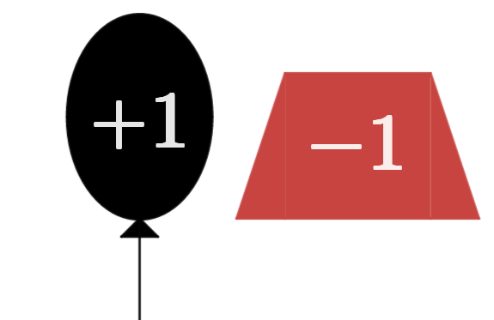
Image created using Desmos and is licensed under the Desmos Terms of Service.
For the remaining steps of the ‘explore’ section, organise students into visibly random groups of 3 (bit.ly/visiblegroups) and have them work at vertical non-permanent surfaces (bit.ly/VNPSstrategy).
- Hand groups of students the first card from Appendix A ‘Zero pairs relay’ to discuss.
- As students complete each card, they can go to the teacher to collect the next question.

Summarise
- Discuss the solutions to Appendix A, concluding specifically that balloons and weights are opposites and a single balloon cancels out a single weight.
- Display Figure 5 to students, asking them to state what number is represented in each case. Alternatively, go to the Polypad activity ‘Zero pairs’ (bit.ly/PolypadZeroPairs) to demonstrate the totals by dragging the blocks number cards on top of one another to count them. If using Polypad, make note of what happens when a 1 and a negative 1 are counted together.
Figure 5 – Polypad zero pairs
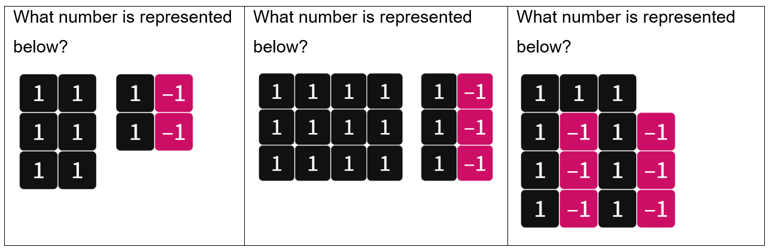
Image created using the free virtual manipulatives at Polypad.org.
- Define a ‘1’ and a ‘−1' (‘negative one’) as a zero pair and emphasise that these sum to 0.
- Have students complete the Appendix B ‘Exit Ticket’ where students are to express 3 integers in 3 different ways each, using zero pairs.
- Reflecting on their answers to Appendix B, lead a discussion with students focusing on the question ‘How many zero pairs can we use when representing a number?’
- Conclude that we can have an infinite amount and can therefore represent any integer in infinite ways.

Apply
- Challenge students to use their understanding of zero pairs to solve problems generated by the Desmos activity ‘Sealed solution 2’ (https://bit.ly/DesmosSealedSolution2) inspired by the task by NRICH ‘Sealed Solution’ (bit.ly/sealedsolution).
- Teachers can change the available numbers in the table on the left of screen.

Assessment and differentiation

Suggested opportunities for differentiation
Explore
- Allowing students to explore with visual representations and concepts that are practical and familiar should act as an entry point for most students. Having a helium filled balloon with a string to attach a weight to it could improve students’ ability to refer to and consider the practical situation.
- Challenge students to generalise the number of weights they need to bring on their journey, which could come to $weights=balloons-11$ or something similar.
Apply
- The ‘Sealed solution’ activity can be modified by reducing the number of envelopes or changing the values within the envelopes. It can also be chosen specifically to ensure there is only one solution.
- Students will likely find a single answer to the ‘Sealed solution’ task and be satisfied. Challenge excelling students to find all possible solutions if more than one exists, or to justify why only one exists. Students could also be challenged to select which envelope to open first such that they know the result of the other 4 envelopes.

Suggested opportunities for assessment
Explore
- Listen for directional language when students are discussing the impact of adding and removing weights and balloons. Students may describe that removing a negative thing has a positive impact and their language can be referred to in later discussions.
Summarise
- Students should submit their exit ticket as evidence of their understanding of zero pairs and their infinite nature.
Apply
- The ‘Sealed solution’ task provides an opportunity to assess students’ ability to use the zero pairs representations introduced to help solve an unfamiliar problem. Monitor and record the representations students are using to consider the possibilities available and to interpret sums involving negative numbers.

Appendix A

Zero pairs relay
Problem label | Problem description
A | The man has 11 balloons and is ready to float on level 11. He added one more balloon and one more weight before he left. What level will he float on now?  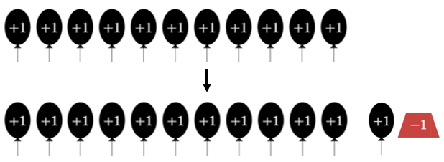  Image created using Desmos and is licensed under the Desmos Terms of Service.
B | The man has flown the house with lots of balloons and weights and is floating at level 11. There is a mountain ahead that goes up to level 16, as shown below.  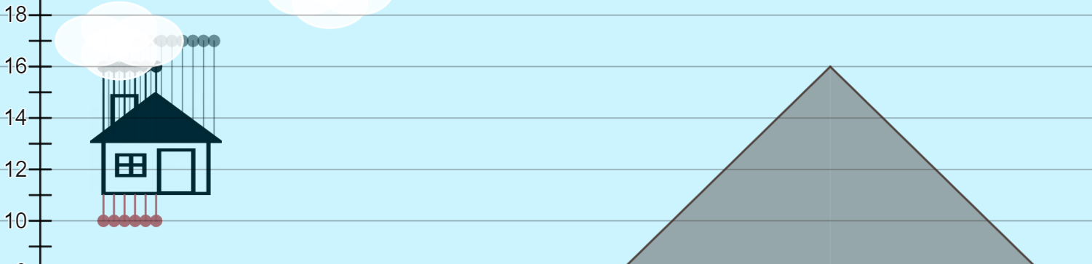  Image created using Desmos and is licensed under the Desmos Terms of Service.  He cannot inflate more balloons and he cannot add more weights. How should the man get the house to go up above the level of the mountain? How would he then get the house to come back down to level 11?
C | If the man runs out of weights, he will have no way of making his house float higher while in the air. He wants to stay at level 11. How many balloons and weights should he take with him when he takes off?
D | The man wants to float at level 11. To avoid obstacles, he needs to go up to level 16, down to level 9 and up to level 20. He then wants to finish back at level 11. What is the minimum number of balloons and weights he needs to take with him?

Appendix B

Exit ticket
The number 6 is expressed below in 3 different ways, using zero pairs.
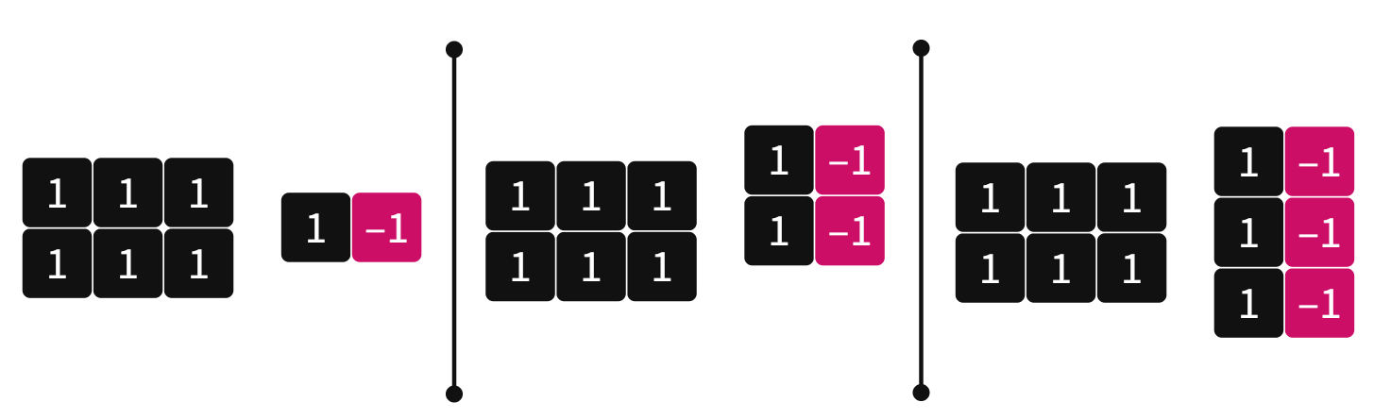
Image created using the free virtual manipulatives at Polypad.org
- Represent the numbers below in 3 different ways by drawing positive 1 counters and negative 1 counters.
- 4
- 15
Images created using the free virtual manipulatives at Polypad.org
- How many different ways could we represent each integer?

Sample solutions

Appendix A – zero pairs relay
Problem label | Problem description
A | He will continue to float at level 11.
B | He will need to release 5 weights to rise up to level 16, then release 5 balloons to go back to level 11.
C | He should take as many balloons as he can and he should take 11 less weights than this number.
D | Because he needs to go up 5 and back down 5, up 2 and back down 2, then up 9 and back down 9, he should take at least 5 + 2 + 9 = 16 balloons and weights, plus the 11 balloons he needs to stay on level 11.

References
This resource contains NSW Curriculum and syllabus content. The NSW Curriculum is developed by the NSW Education Standards Authority. This content is prepared by NESA for and on behalf of the Crown in right of the State of New South Wales. The material is protected by Crown copyright.
Please refer to the NESA Copyright Disclaimer for more information https://educationstandards.nsw.edu.au/wps/portal/nesa/mini-footer/copyright.
NESA holds the only official and up-to-date versions of the NSW Curriculum and syllabus documents. Please visit the NSW Education Standards Authority (NESA) website https://educationstandards.nsw.edu.au/ and the NSW Curriculum website https://curriculum.nsw.edu.au/home.
Mathematics K–10 Syllabus © NSW Education Standards Authority (NESA) for and on behalf of the Crown in right of the State of New South Wales, 2022.

© State of New South Wales (Department of Education), 2023
The copyright material published in this resource is subject to the Copyright Act 1968 (Cth) and is owned by the NSW Department of Education or, where indicated, by a party other than the NSW Department of Education (third-party material).
Copyright material available in this resource and owned by the NSW Department of Education is licensed under a Creative Commons Attribution 4.0 International (CC BY 4.0) licence.
This licence allows you to share and adapt the material for any purpose, even commercially.
Attribution should be given to © State of New South Wales (Department of Education), 2023.
Material in this resource not available under a Creative Commons licence:
- the NSW Department of Education logo, other logos and trademark-protected material
- material owned by a third party that has been reproduced with permission. You will need to obtain permission from the third party to reuse its material.
Links to third-party material and websites
Please note that the provided (reading/viewing material/list/links/texts) are a suggestion only and implies no endorsement, by the New South Wales Department of Education, of any author, publisher, or book title. School principals and teachers are best placed to assess the suitability of resources that would complement the curriculum and reflect the needs and interests of their students.
If you use the links provided in this document to access a third-party's website, you acknowledge that the terms of use, including licence terms set out on the third-party's website apply to the use which may be made of the materials on that third-party website or where permitted by the Copyright Act 1968 (Cth). The department accepts no responsibility for content on third-party websites.

