Mathematics Stage 4 – stage based – sample scope and sequence
This resource has been designed to support teachers by providing an approach to organising syllabus content and can be modified to suit individual school contexts and procedures as required.
The approach used in this resource is designed to support schools working with stage-based classes that work on an even/odd year rotation.
High quality formative and summative assessment should form an integral part of all teaching and learning programs. For more information, please visit NESA’s Advice on assessment page.

Table 1 – even year, Term 1
Uncertainty  Unit title: Making predictions  Weeks 1 to 4 | Uncertainty  Unit title: Making decisions  Weeks 5 to 8 | Uncertainty  Unit title: Shape and skew  Weeks 9 to 10
MAO-WM-01, MA4-FRC-C-01, MA4-PRO-C-01 (Related Life Skills outcomes: MALS-FRC-01, MALS-DEP-01, MALS-PRO-01)  - Compare fractions using equivalence  - Order and compare the value of fractions, decimals and percentages  - Determine probabilities for chance experiments  - List the sample space for chance experiments  - Express the probability of an event, which has a finite number of equally likely outcomes, as $$P\left(event\right)=\frac{number of favourable outcomes}{total number of outcomes}$$  - Recognise that probabilities range from 0 (impossible) to 1 (certain) and that equally likely outcomes have equal probabilities  - Verify that the total of the probabilities of all possible outcomes of an event is 1  - Determine probabilities for complementary events | MAO-WM-01, MA4-DAT-C-01, MA4-DAT-C-02, MA4-PRO-C-01  (Related Life Skills outcomes: MALS-DAT-01, MALS-DAT-02, MALS-PRO-01)  - Classify data as either numerical (discrete or continuous) or categorical (nominal or ordinal) variables  - Display data using graphical representations relevant to the purpose of the data  - Stem-and-leaf plots, divided bar graphs, sector graphs, dot plots and infographics only  - Interpret data in graphical representations  - Calculate and compare the mean, median, mode and range for simple datasets | MAO-WM-01, MA4-DAT-C-02 (Related Life Skills outcomes: MALS-DAT-01, MALS-DAT-02, MALS-PRO-01)  - Interpret the effect individual data points have on measures of centre and range  - Analyse datasets presented in various ways and draw conclusions

Table 2 – even year, Term 2
Number relationships  Unit title: Representing numbers  Weeks 1 to 4 | Number relationships  Unit title: Additive thinking  Weeks 5 to 7 | Number relationships  Unit title: Multiplicative thinking  Weeks 8 to 10
MAO-WM-01, MA4-FRC-C-01  (Related Life Skills outcomes: MALS-FRC-01, MALS-DEP-01)  - Compare fractions using equivalence  - Identify and make use of the relationship between fractions, decimals and percentages to carry out simple conversions  - Order and compare fractions, decimals and percentages  - Represent one quantity as a fraction, decimal or percentage of another, with and without the use of digital tools  - Identify terminating and recurring decimals | MAO-WM-01, MA4-FRC-C-01 (Related Life Skills outcomes: MALS-FRC-01, MALS-DEP-01, MALS-ADS-01)  - Solve problems that involve addition and subtraction of fractions | MAO-WM-01, MA4-FRC-C-01  (Related Life Skills outcomes: MALS-FRC-01, MALS-DEP-01, MALS-MDI-01)  - Solve problems that involve multiplication and division of fractions and decimals  - Represent one quantity as a fraction, decimal or percentage of another, with and without the use of digital tools  - Solve problems that involve the use of percentages
Table 3 – even year, Term 3
Number relationships  Unit title: Ratios  Weeks 1 to 3 | 2D Spatial relations  Unit title: Triangles and quadrilaterals  Weeks 4 to 7 | 2D Spatial relations  Unit title: Investigating triangles  Weeks 8 to 10
MAO-WM-01, MA4-RAT-C-01 (Related Life Skills outcomes: MALS-MDI-01)  - Recognise and simplify ratios  - Solve problems involving ratios | MAO-WM-01, MA4-ANG-C-01, MA4-GEO-C-01 (Related Life Skills outcomes: MALS-GEO-01)  - Apply the language, notation and conventions of geometry  - Classify triangles according to their side and angle properties  - Classify quadrilaterals and describe their properties  - Apply the properties of triangles and quadrilaterals | MAO-WM-01, MA4-EQU-C-01, MA4-PYT-C-01  (Related Life Skills outcomes: MALS-PAT-01, MALS-LEN-01)  - Solve linear equations up to 2 steps  - Solve and verify linear equations by substitution  - Solve quadratic equations  - Identify and define Pythagoras’ theorem  - Examine problems involving Pythagoras’ theorem

Table 4 – even year, Term 4
2D Spatial relations  Unit title: Length and area  Weeks 1 to 6 | 3D Spatial relations  Unit title: Constructing prisms  Weeks 7 to 10
MAO-WM-01, MA4-FRC-C-01, MA4-ALG-C-01, MA4-LEN-C-01, MA4-ARE-C-01, MA4-RAT-C-01  (Related Life Skills outcomes: MALS-DEP-01, MALS-PAT-01, MALS-LEN-01, MALS-ARE-01)  - Round decimals to a specified degree of accuracy using approximations  - Create algebraic expressions and evaluate them by substitution  - Solve problems involving the perimeter of various quadrilateral and simple composite figures  - Develop and use formulas to find the area of rectangles, triangles and parallelograms to solve problems  - Develop and use the formulas to find the area of trapeziums, rhombuses and kites to solve problems  - Choose appropriate units of measurement for area and convert between units  - Recognise and simplify ratios  - Solve problems involving ratios | MAO-WM-01, MA4-VOL-C-01  (Related Life Skills outcomes: MALS-VOL-01)  - Describe the different views of prisms and solids that have been formed from prism combinations  - Develop and apply the formula to find the volume of a prism to solve problems  - Choose appropriate units of measurement for volume and capacity and convert between units

Even year overview
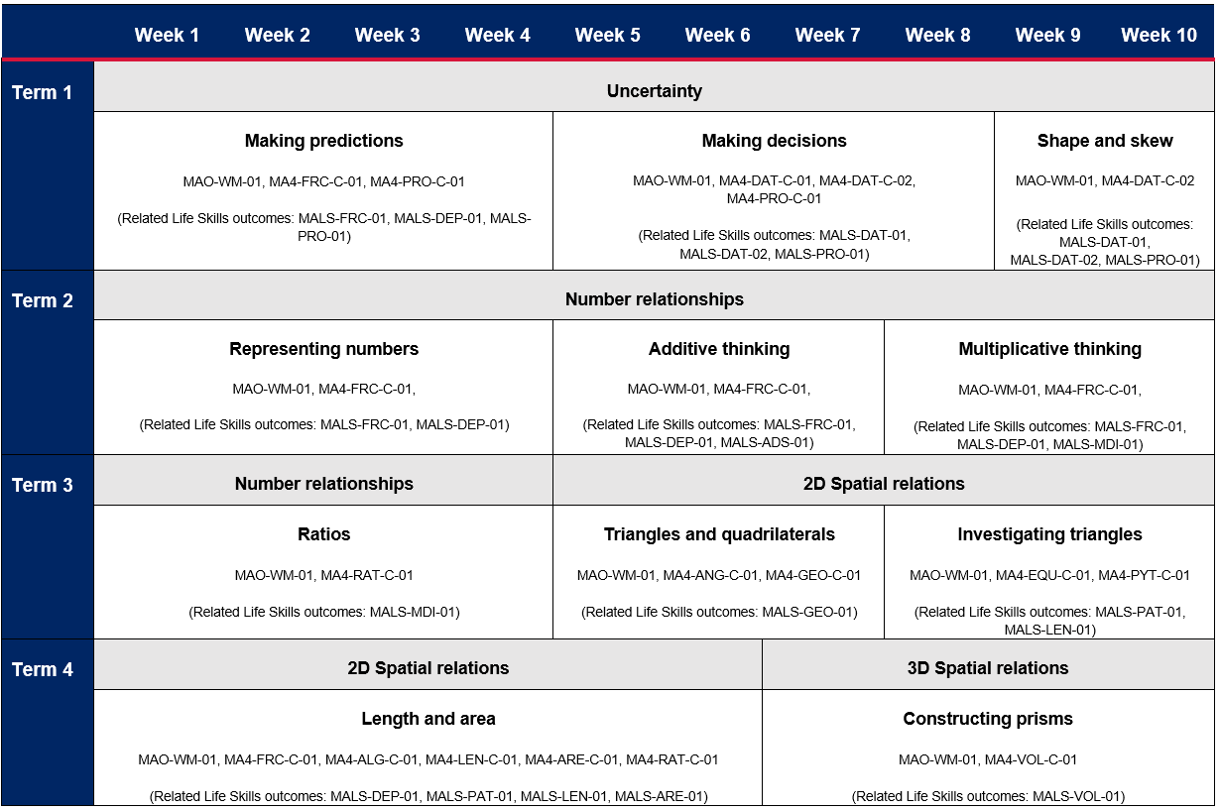
Table 5 – odd year, Term 1
Uncertainty  Unit title: Making predictions  Weeks 1 to 4 | Uncertainty  Unit title: Making decisions  Weeks 5 to 8 | Uncertainty  Unit title: Shape and skew  Weeks 9 to 10
MAO-WM-01, MA4-FRC-C-01, MA4-PRO-C-01  (Related Life Skills outcomes: MALS-FRC-01, MALS-DEP-01, MALS-PRO-01)  - Compare fractions using equivalence  - Order and compare the value of fractions, decimals and percentages  - Determine probabilities for chance experiments | MAO-WM-01, MA4-DAT-C-01, MA4-DAT-C-02 (Related Life Skills outcomes: MALS-DAT-01, MALS-DAT-02, MALS-PRO-01)  - Classify data as either numerical (discrete or continuous) or categorical (nominal or ordinal) variables  - Display data using graphical representations relevant to the purpose of the data  - Focus on frequency histograms and polygons, column graphs, line graphs, pictograms and infographics.  - Interpret data in graphical representations  - Calculate and compare the mean, median, mode and range for simple datasets | MAO-WM-01, MA4-DAT-C-02 (Related Life Skills outcomes: MALS-DAT-01, MALS-DAT-02, MALS-PRO-01)  - Interpret the effect individual data points have on measures of centre and range  - Analyse datasets presented in various ways and draw conclusions
Table 6 – odd year, Term 2
Number relationships  Unit title: Representing numbers  Weeks 1 to 2 | Number relationships  Unit title: Additive thinking  Weeks 3 to 5 | Number relationships  Unit title: Multiplicative thinking  Weeks 6 to 10
MAO-WM-01, MA4-INT-C-01, MA4-ALG-C-01, MA4-LIN-C-01 (Related Life Skills outcomes: MALS-REP-01, MALS-COM-01, MALS-PAT-01)  - Compare and order integers  - Examine the concept of pronumerals as a way of representing numbers  - Plot and identify points on the Cartesian plane | MAO-WM-01, MA4-INT-C-01, MA4-ALG-C-01  (Related Life Skills outcomes: MALS-ADS-01, MALS-PAT-01)  - Add and subtract positive and negative integers  - Solve problems that involve addition and subtraction of fractions  - Extend and apply the laws and properties of arithmetic to algebraic terms and expressions | MAO-WM-01, MA4-INT-C-01, MA4-ALG-C-01, MA4-IND-C-01  (Related Life Skills outcomes: MALS-MDI-01, MALS-PAT-01)  - Multiply and divide positive and negative integers  - Apply the 4 operations to integers  - Extend and apply the laws and properties of arithmetic to algebraic terms and expressions  - Apply index notation to represent whole numbers as products of powers of prime numbers  - Examine cube roots and square roots  - Extend and apply the distributive law to the expansion of algebraic expressions  - Factorise algebraic expressions by identifying numerical and algebraic factors  - Use index notation to establish the index laws with positive-integer indices and the zero index

Table 7 – odd year, Term 3
Number relationships  Unit title: Rates  Weeks 1 to 3 | Linear relationships  Unit title: Analysing patterns  Weeks 4 to 6 | 2D Spatial relations  Unit title: Geometrical relationships  Weeks 7 to 10
MAO-WM-01, MA4-RAT-C-01 (Related Life Skills outcomes: MALS-MDI-01)  - Recognise and simplify rates  - Solve problems involving rates  - Interpret and construct distance-time graphs from authentic data | MAO-WM-01, MA4-LIN-C-01  (Related Life Skills outcomes: MALS-PAT-01, MALS-POS-01)  - Plot and identify points on the Cartesian plane  - Plot linear relationships on the Cartesian plane  - Solve linear equations using graphical techniques | MAO-WM-01, MA4-ANG-C-01  (Related Life Skills outcomes: MALS-GEO-01, MALS-POS-01)  - Apply the language, notation and conventions of geometry  - Identify geometrical properties of angles at a point  - Identify and describe corresponding, alternate and co-interior angles when 2 straight lines are crossed by a transversal, including parallel lines  - Solve numerical problems involving angles using reasoning

Table 8 – odd year, Term 4
2D Spatial relations  Unit title: Exploring circles  Weeks 1 to 6 | 3D Spatial relations  Unit title: Constructing cylinders  Weeks 7 to 10
MAO-WM-01, MA4-FRC-C-01, MA4-EQU-C-01, MA4-LEN-C-01, MA4-ARE-C-01 (Related Life Skills outcomes: MALS-PAT-01, MALS-LEN-01, MALS-ARE-01)  - Examine the concept of irrational numbers  - Solve linear equations up to 2 steps  - Solve and verify linear equations by substitution  - Solve quadratic equations  - Describe the relationships between the features of circles  - Develop and use the formula to find the area of circles and sectors to solve problems | MAO-WM-01, MA4-EQU-C-01, MA4-VOL-C-01 (Related Life Skills outcomes: MALS-PAT-01, MALS-VOL-01)  - Solve linear equations up to 2 steps  - Solve and verify linear equations by substitution  - Solve quadratic equations  - Develop the formula for finding the volume of a cylinder and apply the formula to solve problems

Odd year overview
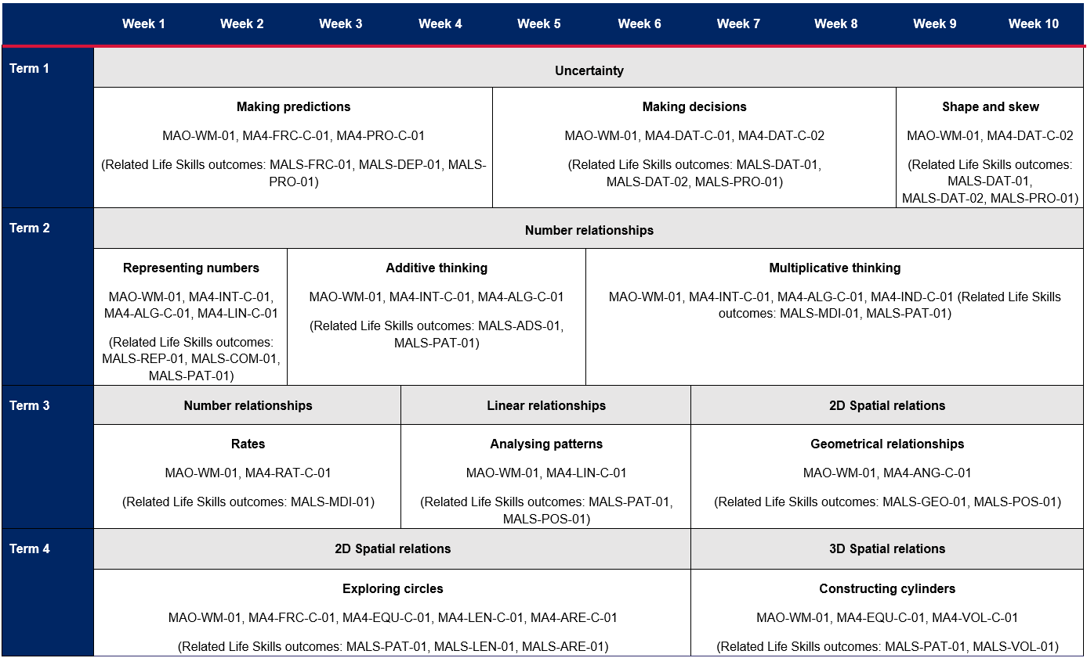

References
This resource contains NSW Curriculum and syllabus content. The NSW Curriculum is developed by the NSW Education Standards Authority. This content is prepared by NESA for and on behalf of the Crown in right of the State of New South Wales. The material is protected by Crown copyright.
Please refer to the NESA Copyright Disclaimer for more information https://educationstandards.nsw.edu.au/wps/portal/nesa/mini-footer/copyright.
NESA holds the only official and up-to-date versions of the NSW Curriculum and syllabus documents. Please visit the NSW Education Standards Authority (NESA) website https://educationstandards.nsw.edu.au/ and the NSW Curriculum website https://curriculum.nsw.edu.au/home.
Mathematics K–10 Syllabus © NSW Education Standards Authority (NESA) for and on behalf of the Crown in right of the State of New South Wales, 2022.
© State of New South Wales (Department of Education), 2023
The copyright material published in this resource is subject to the Copyright Act 1968 (Cth) and is owned by the NSW Department of Education or, where indicated, by a party other than the NSW Department of Education (third-party material).
Copyright material available in this resource and owned by the NSW Department of Education is licensed under a Creative Commons Attribution 4.0 International (CC BY 4.0) licence.
This licence allows you to share and adapt the material for any purpose, even commercially.
Attribution should be given to © State of New South Wales (Department of Education), 2023.
Material in this resource not available under a Creative Commons licence:
- the NSW Department of Education logo, other logos and trademark-protected material
- material owned by a third party that has been reproduced with permission. You will need to obtain permission from the third party to reuse its material.
Links to third-party material and websites
Please note that the provided (reading/viewing material/list/links/texts) are a suggestion only and implies no endorsement, by the New South Wales Department of Education, of any author, publisher, or book title. School principals and teachers are best placed to assess the suitability of resources that would complement the curriculum and reflect the needs and interests of their students.
If you use the links provided in this document to access a third-party's website, you acknowledge that the terms of use, including licence terms set out on the third-party's website apply to the use which may be made of the materials on that third-party website or where permitted by the Copyright Act 1968 (Cth). The department accepts no responsibility for content on third-party websites.

