Mathematics Stage 4 (Year 7) – summative assessment package – annotated sample responses
Contents
Outcomes to be assessed 2
Marking guidelines 3
Approach to marking 3
Student marking sheet 5
Annotated sample responses 6
References 44

This document is part 3 of 3 of a summative assessment package designed to assess the outcomes from Unit 3 of the Department of Education’s Stage 4 (Year 7) sample scope and sequence [DOCX 282KB].
- Part 1: Question bank [DOCX 665 KB]
- Part 2: Sample class test [DOCX 588 KB]
- Part 3: Annotated sample responses

Outcomes to be assessed
Core outcomes being assessed:
- develops understanding and fluency in mathematics through exploring and connecting mathematical concepts, choosing, and applying mathematical techniques to solve problems, and communicating their thinking and reasoning coherently and clearly MAO-WM-01
- compares, orders and calculates with integers to solve problems MA4-INT-C-01
- represents and operates with fractions, decimals and percentages to solve problems MA4-FRC-C-01
Mathematics K–10 Syllabus © NSW Education Standards Authority (NESA) for and on behalf of the Crown in right of the State of New South Wales, 2022.
The outcomes chosen are based on this assessment being implemented during Term 2 of the Department of Education’s Stage 4 (Year 7) sample scope and sequence, after the unit ‘Representing numbers’.
As a result, the outcomes MA4-INT-C-01 and MA4-FRC-C-01 are partially assessed, and related Stage 3 content is considered. The task is complemented by using the ‘Portfolio’ task in Term 3 to collect evidence and monitor progress in these and related outcomes.

Marking guidelines
These annotated sample responses have been provided to support consistent and accurate teacher judgement.

Approach to marking
- Sample answers with marking guidelines have been provided on pages 6 to 33 and give examples of how to interpret responses against the Common Grade Scale (bit.ly/commongradescale).
- The annotations for each sample response determine a grade that has been demonstrated based on the Common Grade Scale (bit.ly/commongradescale). Justification for this determination is made by referencing the content points for the relevant outcome(s) and the Course performance descriptors (bit.ly/CoursePerformanceDescriptors).
- Not all questions provide an opportunity for students to demonstrate every grade level. The first sample response for each question, titled ‘Sample exemplar response’, is an example of the highest level of student response that could be predicted at the time of creating this assessment task. It is unlikely that a higher grade could be demonstrated in response to the question.
- It is intended that teachers review each student’s responses to all questions before determining the grade they have demonstrated in a particular outcome. In each outcome, students should be awarded the highest grade level at which they have demonstrated knowledge and skills.
- A ‘Student marking sheet’ has been provided on page 5 to record the determined grades and give overall feedback to students.
- Opportunities to demonstrate skills with working mathematically processes are embedded in content focused questions. Some student responses will provide more evidence of a student’s aptitude with the working mathematically processes than their knowledge and skills with the mathematics content of the question.
- Versions of the working mathematically outcome MAO-WM-01 have been included on the student marking sheet so these responses can be assessed and possibly reported on.
Students frequently seek ways to reduce their written working without ‘losing marks’. While efficiency should be valued, students need to be empowered to make good decisions about what to include in their responses. The suggested marking guidelines acknowledge students providing relevant representations and elaborations that enhance the clarity or depth of their response. Students should be encouraged to use effective communication techniques to support and improve their answers.

Student marking sheet
Assign each student a grade from A–E based on their demonstrated ability as shown in the annotated sample solutions.
Table 1 – assessment marking recording sheet
Grade | E | D | C | B | A
develops understanding and fluency in mathematics through exploring and connecting mathematical concepts MAO-WM-01
develops understanding and fluency in mathematics through choosing and applying mathematical techniques to solve problems MAO-WM-01
develops understanding and fluency in mathematics through communicating their thinking and reasoning coherently and clearly MAO-WM-01
compares, orders and calculates with integers to solve problems MA4-INT-C-01
represents and operates with fractions, decimals and percentages to solve problems MA4-FRC-C-01
Comments:

Annotated sample responses
Question 1 (MA4-FRC-C-01)
Consider which of the following shows a difference that is more than one half.
- $\frac{7}{8}-\frac{2}{8}$
- $\frac{8}{9}-\frac{5}{9}$
- $\frac{7}{12}-\frac{5}{12}$
Give reasons why each expression is more or less than one half. Use diagrams to support your reasoning where appropriate.
Sample exemplar response:
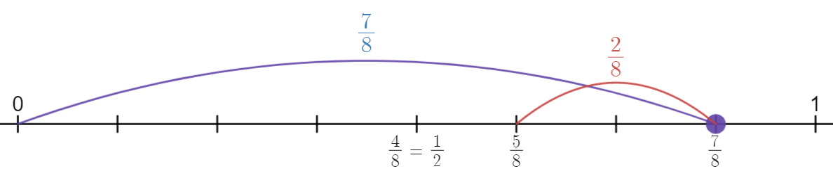
$\frac{7}{8}-\frac{2}{8}=\frac{5}{8}$.
$\frac{5}{8}>\frac{4}{8}$, we know that $\frac{7}{8}-\frac{2}{8}>\frac{1}{2}$.
$\frac{8}{9}-\frac{5}{9}=\frac{3}{9}=\frac{1}{3}$.
$\frac{1}{3}<\frac{1}{2}$ and that $\frac{8}{9}-\frac{5}{9}<\frac{1}{2}$.
$\frac{7}{12}-\frac{5}{12}=\frac{2}{12}=\frac{1}{6}$.
$\frac{1}{6}<\frac{3}{6}$, we know that $\frac{7}{12}-\frac{5}{12}<\frac{1}{2}$.

The student is demonstrating an extensive knowledge of the content and is performing at an A-grade level. The student has constructed a visual representation of one of the expressions and has also solved each expression numerically. In both the visual and numerical explanations, the student has provided information that forms a concise, formal, mathematical argument to justify why their solution is more than one half, or not. The student also uses precise mathematical language consistently and effectively, including symbols such as $<$ and $>$, when explaining their solutions.
Sample response 2:
$\frac{7}{8}-\frac{2}{8}>\frac{1}{2}$ because it is greater than $\frac{4}{8}$.
$\frac{8}{9}-\frac{5}{9}<\frac{1}{2}$ because it is less than $\frac{4.5}{9}$.
$\frac{7}{12}-\frac{5}{12}<\frac{1}{2}$ because it is less than $\frac{6}{12}$.
The student is demonstrating a sound knowledge of the content and is performing at a C-grade level. The student can identify halves with different denominators, including where a decimal is required, showing a sound understanding of the relationships between fractions and decimals. The student has given evidence that they have solved the problem correctly and has provided adequate justification, however their communication is not described as effective given they have not provided a fraction to compare with one half.

Question 2 (MA4-FRC-C-01)
Sienna has been asked which is larger, $\frac{1}{3}$, $\frac{1}{4}$, or $\frac{1}{5}$. She has drawn the diagram below to help compare the 3 fractions.
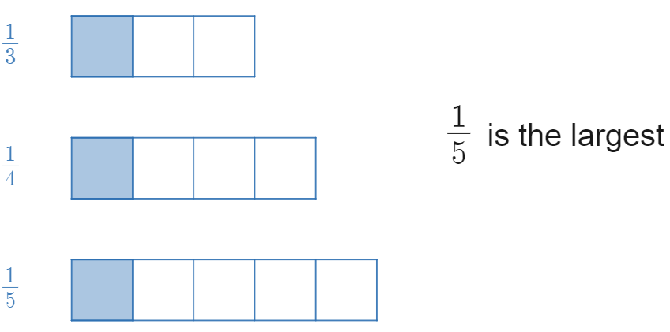
- Explain why Sienna believes $\frac{1}{5}$ is the largest of these 3 fractions.
Sample exemplar response:
Sienna believes $\frac{1}{5}$ is the largest because her diagrams show the ‘whole’ that $\frac{1}{5}$ is taken from to be larger than the other ‘wholes’.
The student is demonstrating a thorough knowledge of the content and is performing at a B-grade level. The student has used abstract symbols of fractions and the supplied visual representations to examine an unfamiliar situation, and applied appropriate, informal mathematical language and reasoning to justify and explain the result.
Sample response 2:
$\frac{1}{5}$ is the largest fraction since 5 is the largest denominator.
The student is demonstrating an elementary knowledge of the content and is performing at an E grade level. The student has provided some informal mathematical language and reasoning. While they recognise the need to compare denominators, they have been unable to use the given representations to correctly interpret the given situation and appear to be agreeing with Sienna.
- Is Sienna correct? Provide reasons and diagrams to explain why or why not.
Sample exemplar response:
Sienna has made the mistake of making the ‘parts’ equal and comparing the unequal ‘wholes’. Sienna should be making the ‘wholes’ equal and comparing the unequal parts. If she does so, she will get this diagram.
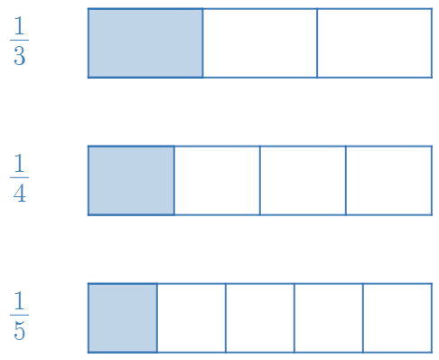
This shows that $\frac{1}{3}$ is the largest fraction.
The student is demonstrating a thorough knowledge of the content and is performing at a B grade level. The student is using appropriate mathematical language effectively to communicate reasoning. They can create and use representations to interpret and analyse this familiar situation. They have demonstrated a thorough understanding of the relationship between the mathematical concepts of unit fractions, common wholes and length.

Sample response 2:
Sienna has compared the ‘wholes’ that the 3 fractions are made from, stating that $\frac{1}{5}$ is the largest because it is from the largest rectangle. She should be looking at the ‘parts’ of the ‘wholes’. Each fraction has one ‘part’ shaded and the lengths of these parts are all equal. This means that $\frac{1}{3}=\frac{1}{4}=\frac{1}{5}$.
The student is demonstrating a sound knowledge of the content and is performing at a C-grade level. The student is using the given representation to interpret the familiar situation. They have used informal mathematical reasoning and appropriate language to explain and justify their solution. They have had some difficulty demonstrating understanding of the relationship between the mathematical concepts of unit fractions, common wholes and length beyond a sound level.

Question 3 (MA4-FRC-C-01)
By first circling the smallest and largest decimal from the list below, subtract the smallest decimal from the largest decimal.
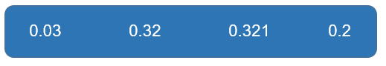
Sample exemplar response:
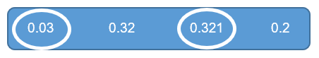
$$0.321-0.03=0.291$$
The student is demonstrating a sound knowledge of the content and is performing at a C-grade level. The student is engaging with familiar situations, solving routine problems of less than 3 steps, having successfully compared decimals of up to 3 decimal places and performed subtraction.
Sample response 2:
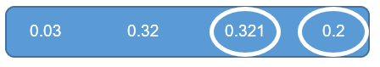
$$0.321-0.2=0.121$$
The student is demonstrating a basic knowledge of the content and is performing at a D-grade level. The student is engaging with familiar situations, attempting to solve a routine problem of up to 3 steps with some success, having successfully subtracted the decimals but incorrectly identified which is the smallest decimal.

Question 4 (MA4-FRC-C-01)
Kasha is wanting to purchase a new laptop and is shopping around for the best deal.
- Shop 1 has the laptop she wants for $1100 with a sale of 25% off and since she holds a membership card the shop will take a further 10% off the sale price.
- Shop 2 has the same laptop she wants for $1000 with a sale of 25% off.
Kasha thinks that Shop 2 is the better deal since it is a cheaper price to begin with.
Is Kasha correct? Provide mathematical arguments to justify your decision.
Sample exemplar response:

Shop 1
$$75\%×1100=\$825 \\ 90\%×825=\$725.50$$
Shop 2
$$75\%×1000=\$750$$

Kasha is incorrect, although Shop 1 had a more expensive initial price it works out to be cheaper than Shop 2 by $24.50 because of the further 10% off the sale price discount.
The student is demonstrating an extensive knowledge of the content and is performing at an A-grade level. The student is applying deductive reasoning and concise, formal mathematical arguments to prove and justify results when solving routine problems involving multiple steps.

Sample response 2:
$$35\%×1100=\$385 \\ 25\%×1000=\$250$$
Kasha is incorrect since Shop 1 has the higher discount.
The student is demonstrating a basic knowledge of the content and is performing at a D-grade level. While the student has related the operation of multiplication with finding the percentage of a quantity, they have been unable to include the effect of repeated percentage decreases in this interpretation. The student has demonstrated a basic level of communicating their thinking and reasoning to justify their decision.

Question 5 (MA4-FRC-C-01)
Find $\frac{3}{5}$ of $40 using the visual representation.
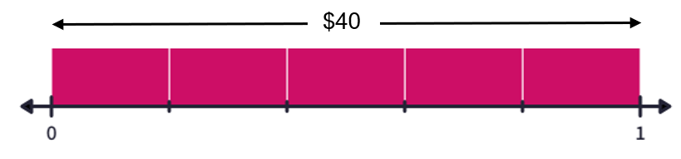
Sample exemplar response:
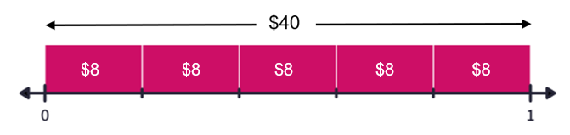
$$40÷5=8$$
$$3×8=\$24$$
The student is demonstrating a sound knowledge of the content and is performing at a C-grade level. The student has used a representation in a familiar situation to solve a routine problem of calculating the fraction of a quantity.
Sample response 2:
$$\$8$$
The student is demonstrating a basic knowledge of the content and is performing at a D-grade level. The student has attempted the routine problem by correctly identifying the value of each part in the visual representation, although from here they have had limited success answering the question and demonstrated very limited mathematical language.

Question 6 (MA4-FRC-C-01)
What number sentence is represented by the diagram below?
Sample exemplar response:
$$\frac{1}{6}+\frac{3}{6}=\frac{4}{6}$$
The student is demonstrating a sound knowledge of the content and is performing at a C-grade level. The student has used a representation in a familiar situation to solve a routine problem to add fractions with a common denominator.
Sample response 2:
$\frac{1}{5}+\frac{3}{3}=\frac{4}{2}$
The student is demonstrating an elementary knowledge of the content and is performing at an E-grade level. The student has attempted the routine problem with limited success and requires further support to interpret visual representations of fractions.

Question 7 (MA4-INT-C-01)
Show that $-5$ and 4 are 9 units apart using a visual representation.
Sample exemplar response:
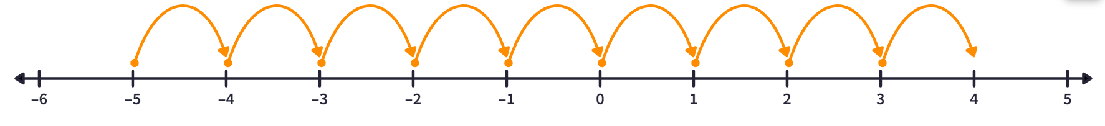
From the number line, there are 9 jumps to get from $-5$ to 4, therefore $-5$ and 4 are 9 units apart.
The student is demonstrating a sound knowledge of the content and is performing at a C-grade level. The student has successfully created a visual representation to support their reasoning in a familiar problem.
Sample response 2:
$-5$ and 4 are 9 units apart since there are 5 between 0 and $-5$ and there are 4 between 0 and 4.
The student is demonstrating a basic knowledge of the content and is performing at a D-grade level. The student has answered the question correctly despite not using a representation as the question asked, and used only basic mathematical language.

Question 8 (MA4-INT-C-01)
What is the value of A, represented on this number line?
Sample exemplar response:
$$-5$$
The student is demonstrating a sound knowledge of the content and is performing at a C-grade level. The student has solved a routine problem in a familiar situation by correctly identifying an integer on a number line.
Sample response
$$-7$$
The student is demonstrating an elementary knowledge of the content and is performing at an E-grade level. The student has attempted the routine problem with limited success, counting on from 1 to the left, missing the zero.

Question 9 (MA4-FRC-C-01)
Determine the possible value of 2 integers that share a common factor of 12.
Sample exemplar response:
12 and 24.
This student is demonstrating a sound knowledge of the content and is performing at a C-grade level. The student has solved the routine problem, interpreting mathematical language of ‘integer’ and ‘factor’ accurately.
Sample response 2:
2 and 6.
This student is demonstrating a basic knowledge of the content and is performing at a D-grade level. Despite the answer being incorrect, the student has attempted the routine problem with some success as they have listed factors of 12. They have accurately interpreted the term ‘factor’, with their error arising from how the term has been used.

Question 10 (MA4-INT-C-01)
- Describe the temperature $-7^{o}C$ in terms of how hot or cold it is in your local area.
Sample exemplar response:
$-7^{o}C$ is very cold since it is a below-zero temperature. Where I live the temperature hasn’t gotten this cold and I believe that this temperature would be more common at the snow.
This student is demonstrating a thorough knowledge of the content and is performing at a B-grade level. The student has demonstrated an understanding of the application of the mathematical concept to the real world, and used effective communication, giving a reference and an example to describe the integer.
Sample response 2:
$-7^{o}C$ is cold.
This student is demonstrating an elementary knowledge of the content and is performing at an E-grade level. The student has used limited communication and reasoning to provide a description and a comparison for $-7^{o}C$ in their context.

- Describe what would happen to the temperature $-7^{o}C$ if the magnitude was increased but the direction remained the same.
Sample exemplar response:
Magnitude increase would mean that the 7 would change to a higher number, such as 15. If direction remains the same, then it will stay as a negative number. This means that if $-7^{o}C$ had its magnitude increased but direction remained the same the temperature represented would get colder, for example $-{15}^{o}C$.
This student is demonstrating an extensive knowledge of the content and is performing at an A-grade level. The student has consistently used precise and effective mathematical language to communicate and explain the result. They have also provided an example integer to support their explanation and given this temperature some context to the real world.
Sample response 2:
The temperature would get bigger.
This student is demonstrating an elementary knowledge of the content and is performing at an E-grade level. The student has recognised some mathematical concepts by connecting the word ‘increase’ with ‘bigger’, although they have used very limited mathematical language and have been unable to identify the relationship between direction and magnitude when interpreting integers.

- Describe what would happen to the temperature $-7^{o}C$ if the magnitude stayed the same but the direction changed.
Sample exemplar response:
If the magnitude stays the same the number 7 would remain. If the direction changed the negative would change to a positive, so the resulting temperature would be $7^{o}C$, which is a warmer temperature, but still cool.
This student is demonstrating a thorough understanding of content and is performing at a B-grade level. The student has used appropriate mathematical language to communicate and explain the solution. They have solved the routine problem successfully and have provided context for the new temperature. The student has demonstrated a thorough understanding of the relationship between the concepts of direction and magnitude, however they have not described numerically the relationship between −7 and 7, being that they are ${14}^{o}C$ apart or that they are $7^{o}C$ either side of 0.
Sample response 2:
$$7^{o}C$$
This student is demonstrating a basic understanding of knowledge of the content and is performing at a D-grade level. The student has provided the correct answer, although they have used limited mathematical language, and provided no description of the new temperature.

Question 11 (MA4-INT-C-01)
David believes that $-5>2$, since $5$ is larger than $2$.
Is he correct? Explain your reasoning using diagrams where appropriate.
Sample exemplar response:
David is incorrect, despite $5$ being larger than $2$, $-5$ is not larger than $2$. This can be shown using a number line.
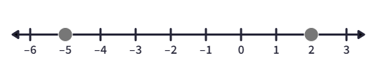
$-5$ is to the left of zero and 2 is to the right of zero.
David should have written $-5<2$ to be correct.
This student is demonstrating a thorough knowledge of the content and is performing at a B-grade level. The student has created a representation to help interpret a situation and explain their reasoning. They have used appropriate mathematical language when comparing the position of integers to zero, however the use of the terms ‘direction’ and ‘magnitude’ would have been more precise language and led to a more concise explanation.
Sample response 2:
David is not correct, 2 is larger than $-5$.
This student is demonstrating a basic knowledge of the content and is performing at a D-grade level. The student has correctly identified some relationships between the concepts of direction and magnitude by identifying that David has made an error and that the integers are in the opposite order. The student used limited mathematical language (‘larger than’) and provided no reasoning.

Question 12 (MA4-INT-C-01)
Which integer is represented by the ‘?’ symbol? Give reasons to support your answer. 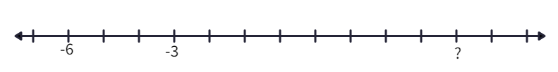
Sample exemplar response:
- Each step is $1$ unit because there are three steps from $-6$ to $-3$.
- ‘?’ is 8 steps above $-3$ and $-3+8=5$.
This student is demonstrating a thorough knowledge of the content and is performing at a B-grade level. The student has correctly interpreted a visual representation, using the relationship between the length and directed numbers to identify integers on a number line. They have used some deductive reasoning to support their conclusion.
Sample response 2:
The value of the ‘?’ is 5, because it is 8 spaces above −3.
This student is demonstrating a sound knowledge of the content and is performing at a C-grade level. The student has correctly identified integers on a number line and used appropriate mathematical language to convey their reasons.

Question 13 (MA4-FRC-C-01)
Which of these diagrams does not represent $\frac{3}{5}$?
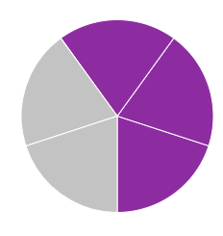

Sample responses
In a multiple-choice question, students will likely provide limited elaborations on their responses. The sample responses below support this question being used as a diagnostic question to identify and address student misconceptions.
Sample exemplar response:
A
This student is demonstrating an elementary knowledge of the content and is performing at an E-grade level. While this student may have recognised some mathematical concepts, they have had difficulty interpreting a fraction represented as part of a circle. They require further opportunities to view and manipulate fraction representations in multiple forms, including matching and comparing different representations of the same fraction.
Sample response 2:
B
This student is demonstrating an elementary knowledge of the content and is performing at an E-grade level. There is a possibility that this student has demonstrated basic knowledge by acknowledging that a and c are both representations of $\frac{3}{5}$ and therefore using representations in familiar situations. The student has had difficulty interpreting an equivalent fraction represented as an area model. They require further opportunities to explore representations of equivalent fractions and explain why they are equivalent.
Sample response 3:
C
This student is demonstrating an elementary knowledge of the content and is performing at an E-grade level. The representation the student has chosen is the most common representation of $\frac{3}{5}$ and the student likely requires further support interpreting basic visual representations of fractions.
Sample response 4:
D
This student is demonstrating a sound knowledge of the content and is performing at a C-grade level. They have interpreted visual representations of fractions in familiar situations and correctly identified where one is not equivalent.
Question 14 (MA4-INT-C-01)
What integer is represented by the image below? Explain your answer.
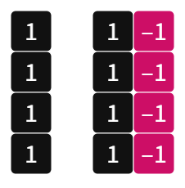
Sample exemplar response:
The image represents the integer 4. There are 4 ‘ones’ on their own. There are then an additional 4 ‘ones’, each of which has a partner ‘negative one’. Together a ‘one’ and a ‘negative one’ act as a zero pair and equal zero, so these tiles add nothing to the 4 we started with.
This student is demonstrating a thorough knowledge of the content and is performing at a B-grade level. The student has used appropriate mathematical language of ‘zero pairs’ to effectively communicate the reasons for their solution. They have interpreted a visual representation and demonstrated a thorough understanding of the relationship between elementary counting principles and negative numbers.
Sample response 2:
The image represents the number 8, because there are 8 counters and then 4 negative ‘ones’. The negative ‘ones’ can’t be counted, so we just count 8.
This student is demonstrating an elementary knowledge of the content and is performing at an E-grade level. The student has used some basic mathematical language to convey their interpretation of the visual representation. They have had difficulty recognising the key mathematical concept and the way positive and negative integers interact.

Question 15 (MA4-FRC-C-01)
Ari and Gabriel order pizzas from different shops. Each pizza is the same size although they have been cut differently. Ari’s pizza is cut into 6 equal pieces and Gabriel’s is cut into 8 equal pieces. Ari and Gabriel both start eating their pizza.
What is the minimum number of whole pieces that each of them needs to eat for them to eat the same amount of pizza? Explain your answer, including diagrams where appropriate.
Sample exemplar response:
The highest common factor of 6 and 8 is 2.
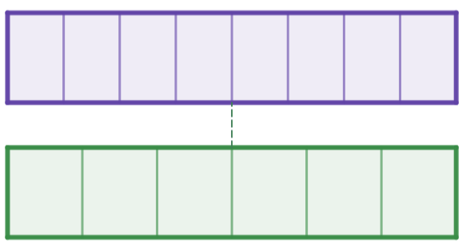
The representation shows one whole divided into eighths and the other whole divided into sixths. The only time they are equivalent is when they are both equal to one half. Ari would need to eat 3 slices of their pizza and Gabriel would need to eat 4 slices of theirs.
This student is demonstrating a thorough knowledge of the content and is performing at a B-grade level. The student has created and used diagrams to represent and interpret familiar situations and to support their argument about equivalent fractions. They have identified some relationships between the concepts, including identifying and using the concept of the highest common factor to support their result.

Sample response 2:
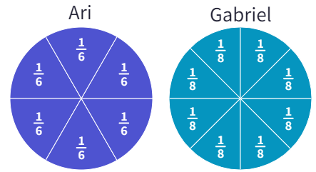
Ari can eat $\frac{1}{6}$, $\frac{2}{6}=\frac{1}{3}$, $\frac{3}{6}=\frac{1}{2}$ or more, while Gabriel can eat $\frac{1}{8}$, $\frac{2}{8}=\frac{1}{4}$, $\frac{3}{8}$, $\frac{4}{8}=\frac{1}{2}$. The first occasion that an equivalent fraction occurs is when they have each eaten half of their pizza. Ari would need to eat 3 slices of their pizza and Gabriel would need to eat 4 slices of theirs.
This student is demonstrating a sound knowledge of the content and is performing at a C-grade level. The student has created and used diagrams to represent and interpret familiar situations. They have identified some relationships between the concepts, identifying the correct answer without calling out any particular relationships between the denominators 6 and 8.

Question 16 (MA4-FRC-C-01)
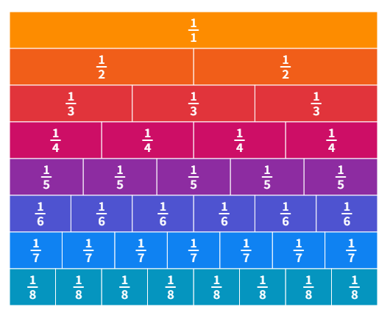
- Using the fraction wall, or otherwise, list 3 equivalent fractions of $\frac{1}{2}$.
Sample exemplar response:
$\frac{2}{4}$, $\frac{3}{6}$, $\frac{4}{8}$.
This student is demonstrating a sound knowledge of the content and is performing at a C-grade level. They have used visual representations to generate equivalent fractions, solving a routine problem in a familiar situation with no more than 3 steps.
Sample response 2:
$\frac{1}{4}$, $\frac{1}{6}$, $\frac{1}{8}$.
This student is demonstrating an elementary knowledge of the content and is performing at an E-grade level. They have interpreted the given representations to identify where equivalent fractions may appear, however they have been unable to identify the relationship between the concepts of fractions and length displayed within the representation.

- Using the fraction wall, or otherwise, simplify $\frac{6}{8}$.
Sample exemplar response:
$$\frac{6}{8}=\frac{3}{4}$$
This student is demonstrating a sound knowledge of the content and is performing at a C-grade level. They have used visual representations to solve a routine problem in a familiar situation with no more than 3 steps.
Sample response 2:
$$\frac{1}{4}$$
This student is demonstrating an elementary knowledge of the content and is performing at an E-grade level. They have interpreted the given representations to identify where equivalent fractions may appear, however they have been unable to identify the relationship between the concepts of fractions and length displayed within the representation.
Question 17 (MA4-FRC-C-01)
Hiromi believes that the fractions $\frac{1}{2},\frac{2}{5},\frac{3}{8}$ are written in order of smallest to largest since both the numerator and denominators are in order from smallest to largest.
Is Hiromi correct? Justify your answer with mathematical reasoning and diagrams where appropriate.
Sample exemplar response:
No Hiromi is incorrect. Fractions cannot be compared by looking at their numerators and denominators separately. Each fraction needs to be considered as parts of a whole to see which is the largest.
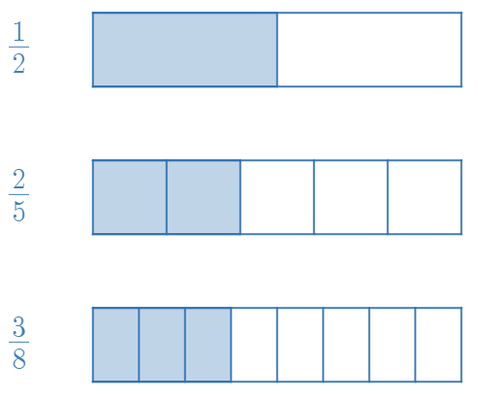
We can see from drawing the 3 fractions and comparing the size of the shaded parts that they should be in the reverse order if ranked from smallest to largest, $\frac{3}{8}$, $\frac{2}{5}$ and finally $\frac{1}{2}$.
This student is demonstrating an extensive knowledge of the content and is performing at an A-grade level. They have created and used representations of this familiar situation to support their argument, comparing fractions with different denominators. They have used some deductive reasoning to develop and justify a mathematical argument and used precise mathematical language to effectively explain their solution.
Sample response 2:
This is correct, $1<2<3$ and $2<5<8$, so $\frac{1}{2}<\frac{2}{5}<\frac{3}{8}$.
This student has been unable to recognise the concept of fractions as a relationship between the numerator and the denominator. As such, when considering the content of fractions, this student is demonstrating an elementary knowledge of the content and is performing at an E-grade level. It should be noted that they are using appropriate mathematical language and symbols to effectively communicate their reasoning. They are also demonstrating evidence of deductive reasoning skills which should be noted and considered moving forward.

Question 18 (MA4-FRC-C-01)
Using only the digits 2, 4, 6 and 8, place a number in the blank spaces to make the statement true. Each digit can only be used once.
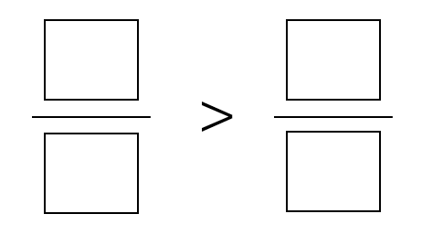
Sample exemplar response:
$$\frac{4}{2}>\frac{6}{8}$$
This student is demonstrating a sound knowledge of the content and is performing at a C-grade level. They have shown a sound understanding of the relationship between the value of proper and improper fractions and the number 1.
Sample response 2:
$$\frac{4}{8}>\frac{2}{6}$$
This student is demonstrating a sound knowledge of the content and is performing at a C-grade level. The student has correctly solved a problem of no more than 3 steps, comparing fractions with different denominators.

Question 19 (MA4-FRC-C-01)
Consider the number line below.
Accurately plot the number 3.6 on the number line.
Sample exemplar response:
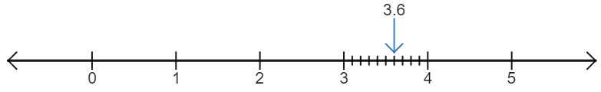
This student is demonstrating a sound knowledge of the content and is performing at a C-grade level. The student has added to an existing representation and effectively used the representation to convey the location of a decimal on a number line.
Sample response 2:
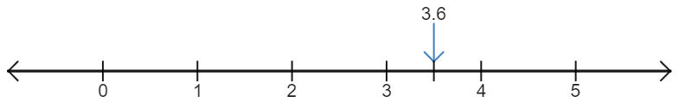
This student is demonstrating a basic knowledge of the content and is performing at a D-grade level. The student has used the given representation to convey a related idea, that 3.6 lies between 3 and 4, without completely solving the problem.

Question 20 (MA4-FRC-C-01)
Using the visual representation, or otherwise, round 3.89 to the nearest tenth. Explain your solution.
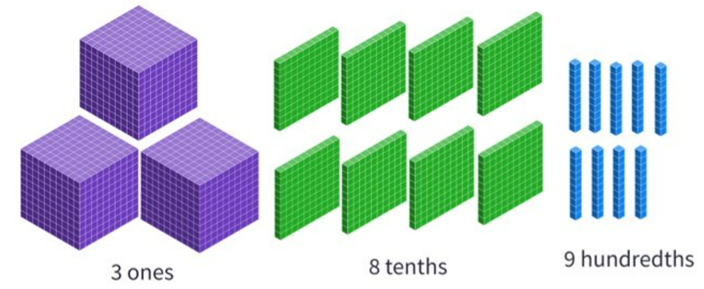

Sample exemplar response:
Because 9 hundredths is closer to 10 hundredths than it is to 0 hundredths, we round this up to make an extra tenth. This means we have 3 ones and 9 tenths and $3.89≈3.9$.
This student is demonstrating a thorough knowledge of the content and is performing at a B-grade level. The student has used the abstract representation of numbers and the visual representation provided to describe how this number rounds to the nearest tenth, without moving between the representations interchangeably. They have used appropriate mathematical language effectively to communicate their reasoning and explain their solution.
Sample response 2:
3.9.
This student is demonstrating a sound knowledge of the content and is performing at a C-grade level. They have been able to communicate their solution using an abstract numerical representation and may have used the given pictorial representation as an aid.

Question 21 (MA4-FRC-C-01)
Accurately place the numbers $\frac{1}{4}$, 85% and 110% on this number line.

Sample exemplar response:
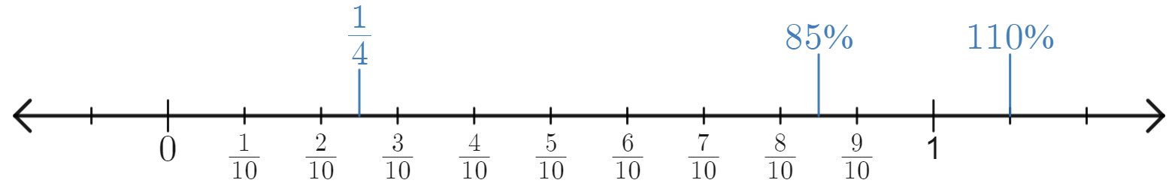
This student is demonstrating a sound knowledge of the content and is performing at a C-grade level. They have solved a routine problem of less than 3 steps in a familiar situation when comparing and ordering fractions and percentages.
Sample response 2:
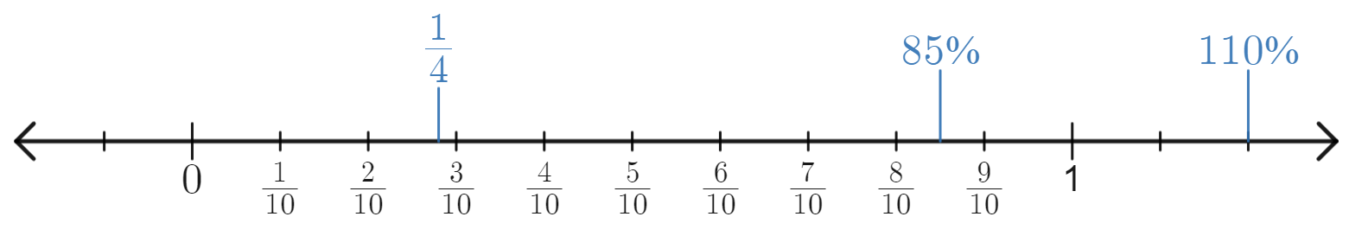
This student is demonstrating a basic knowledge of the content and is performing at a D-grade level. They have solved a routine problem of less than 3 steps with some success. They have been able to use the visual representation to accurately compare fractions and percentages in some situations (85%).

References
This resource contains NSW Curriculum and syllabus content. The NSW Curriculum is developed by the NSW Education Standards Authority. This content is prepared by NESA for and on behalf of the Crown in right of the State of New South Wales. The material is protected by Crown copyright.
Please refer to the NESA Copyright Disclaimer for more information https://educationstandards.nsw.edu.au/wps/portal/nesa/mini-footer/copyright.
NESA holds the only official and up-to-date versions of the NSW Curriculum and syllabus documents. Please visit the NSW Education Standards Authority (NESA) website https://educationstandards.nsw.edu.au/ and the NSW Curriculum website https://curriculum.nsw.edu.au/home.
Mathematics K–10 Syllabus © NSW Education Standards Authority (NESA) for and on behalf of the Crown in right of the State of New South Wales, 2022.

© State of New South Wales (Department of Education), 2023
The copyright material published in this resource is subject to the Copyright Act 1968 (Cth) and is owned by the NSW Department of Education or, where indicated, by a party other than the NSW Department of Education (third-party material).
Copyright material available in this resource and owned by the NSW Department of Education is licensed under a Creative Commons Attribution 4.0 International (CC BY 4.0) license.
This license allows you to share and adapt the material for any purpose, even commercially.
Attribution should be given to © State of New South Wales (Department of Education), 2023.
Material in this resource not available under a Creative Commons license:
- the NSW Department of Education logo, other logos and trademark-protected material
- material owned by a third party that has been reproduced with permission. You will need to obtain permission from the third party to reuse its material.
Links to third-party material and websites
Please note that the provided (reading/viewing material/list/links/texts) are a suggestion only and implies no endorsement, by the New South Wales Department of Education, of any author, publisher, or book title. School principals and teachers are best placed to assess the suitability of resources that would complement the curriculum and reflect the needs and interests of their students.
If you use the links provided in this document to access a third-party's website, you acknowledge that the terms of use, including licence terms set out on the third-party's website apply to the use which may be made of the materials on that third-party website or where permitted by the Copyright Act 1968 (Cth). The department accepts no responsibility for content on third-party websites.

