Mathematics Stage 3 – Unit 5
Contents
Unit description and duration 5
Syllabus outcomes 5
Working mathematically 6
Student prior learning 6
Lesson overview and resources 8
Lesson 1 13
Daily number sense: Place value mystery – 10 minutes 13
Core lesson 1: Data in action – 10 minutes 15
Core lesson 2: School sport survey – 45 minutes 17
Discuss and connect the mathematics – 5 minutes 20
Lesson 2 22
Daily number sense: Larger numbers – 10 minutes 22
Core lesson 1: Reaction time test – 30 minutes 24
Core lesson 2: Thousandths of a second – 15 minutes 27
Consolidation and meaningful practice – 15 minutes 29
Lesson 3 31
Daily number sense: Ordering numbers game – 10 minutes 31
Core lesson 1: Choosing appropriate displays – 20 minutes 32
Core lesson 2: Constructing many-to-one scale column graphs – 30 minutes 34
Consolidation and meaningful practice – 10 minutes 37
Lesson 4 40
Daily number sense: Teacher choice – 10 minutes 40
Core lesson 1: Our growing population – 20 minutes 40
Core lesson 2: Spreadsheets – 30 minutes 42
Discuss and connect the mathematics – 10 minutes 43
Lesson 5 45
Daily number sense: Number talk – 15 minutes 45
Core lesson 1: Creating timelines – 25 minutes 47
Core lesson 2: Interpreting timelines – 20 minutes 49
Discuss and connect the mathematics – 5 minutes 50
Lesson 6 52
Daily number sense: Goat busters – 15 minutes 52
Core lesson 1: Air temperature – 15 minutes 54
Core lesson 2: Australia’s extreme temperatures – 30 minutes 55
Consolidation and meaningful practice – 10 minutes 57
Lesson 7 60
Daily number sense: Which one doesn’t belong? – 15 minutes 60
Core lesson 1: Distribution – 25 minutes 62
Core lesson 2: Our solar system – 20 minutes 63
Consolidation and meaningful practice – 10 minutes 65
Lesson 8 67
Daily number sense: Teacher choice – 10 minutes 67
Core lesson 1: Data in the media and factual text – 30 minutes 67
Core lesson 2: Misleading representations – 25 minutes 71
Discuss and connect the mathematics – 5 minutes 71
Resource 1: Slow reveal graph 73
Resource 2: Data cycle 80
Resource 3: Checklist for survey question development 81
Resource 4: Two stars and a wish 82
Resource 5: Ruler drop reaction time chart 83
Resource 6: Number cards 86
Resource 7: Line graph example 90
Resource 8: Data investigation 91
Resource 9: Slow reveal table 93
Resource 10: Population data 97
Resource 11: Australia’s population by state or territory 98
Resource 12: Example timeline 99
Resource 13: Australian gold rush 100
Resource 14: Temperature in Australia over time 101
Resource 15: Triple Venn diagram 102
Resource 16: Extreme temperatures recorded as integers 103
Resource 17: Which one doesn’t belong? 104
Resource 18: Unlabelled line graph 105
Resource 19: Table of data 106
Resource 20: Solar system distances graph 107
Resource 21: Solar system distances table 108
Resource 22: Melting ice 109
Resource 23: Misleading graphs 110
Syllabus outcomes and content 114
References 120

Unit description and duration
This unit introduces the big idea that questions can be asked and answered by interpreting data.
In this 2-week unit students are provided opportunities to:
- collect categorical and discrete numerical data by observation or survey
- represent and interpret data presented in tables, column graphs and line graphs, with and without the use of digital technologies
- recognise, represent and order numbers in the millions and decimals.

Syllabus outcomes
- MAO-WM-01 develops understanding and fluency in mathematics through exploring and connecting mathematical concepts, choosing and applying mathematical techniques to solve problems, and communicating their thinking and reasoning coherently and clearly
- MA3-RN-01 applies an understanding of place value and the role of zero to represent the properties of numbers
- MA3-RN-02 compares and orders decimals up to 3 decimal places
- MA3-MR-01 selects and applies appropriate strategies to solve multiplication and division problems
- MA3-DATA-01 constructs graphs using many-to-one scales
- MA3-DATA-02 interprets data displays, including timelines and line graphs

Working mathematically
In the Mathematics K–10 Syllabus, there is one overarching Working mathematically outcome (MAO-WM-01). The Working mathematically processes should be embedded within the concepts being taught. The Working mathematically processes present in the Mathematics K–10 Syllabus are:
- communicating
- understanding and fluency
- reasoning
- problem solving.
Mathematics K–10 Syllabus © NSW Education Standards Authority (NESA) for and on behalf of the Crown in right of the State of New South Wales, 2022.

Student prior learning
Before engaging in these teaching and learning activities, students would benefit from prior experience with:
- posing questions and collecting discrete data
- representing and interpreting data using lists, tables, dot plots and column graphs
- reading, ordering and partitioning numbers up to 4 digits.

In NSW classrooms there is a diverse range of students, including Aboriginal and Torres Strait Islander students, students learning English as an additional language or dialect, high potential and gifted students and students with disability. Some students may identify with more than one of these groups or possibly all of them. Refer to Advice on curriculum planning for every student for further information.

Lesson overview and resources
The table below outlines the sequence and approximate timing of lessons, learning intentions and resources.
Lesson | Content | Duration and resources
Lesson 1  Daily number sense learning intention:  - recognise and represent numbers in the millions | Lesson core concept: data is more than a combination of numbers and graphics.  Core concept learning intentions:  - pose and refine questions to construct a survey  - collect discrete data by conducting a survey | Lesson duration: 70 minutes  - Resource 1: Slow reveal graph  - Resource 2: Data cycle  - Resource 3: Checklist for survey question development  - Resource 4: Two stars and a wish  - Website: AusPlay Focus on Participation by Age  - Video: Gathering data with Microsoft Forms (4:10)  - Video: Gathering data with Google Forms (4:30)  - Devices with internet connection and either Google Forms or Microsoft Forms  - Writing materials
Lesson 2  Daily number sense learning intention:  - recognise, represent and round numbers in the millions | Lesson core concept: mathematicians collect and record data.  Core concept learning intentions:  - collect categorical and discrete numerical data by observation  - compare and order decimal numbers to 3 decimal places | Lesson duration: 70 minutes  - Resource 5: Ruler drop reaction time chart  - Interactive: Reaction Timer  - Device with internet connection  - 30 cm rulers  - Writing materials
Lesson 3  Daily number sense learning intention:  - order numbers in the millions | Lesson core concept: mathematicians organise and present data in different ways.  Core concept learning intentions:  - recognise which types of data display are appropriate to represent data  - construct many-to-one scale column graphs | Lesson duration: 70 minutes  - Resource 2: Data cycle  - Resource 6: Number cards  - Resource 7: Line graph example  - Resource 8: Data investigation  - Grid paper  - Writing materials
Lesson 4  Daily number sense learning intention:  - teacher-identified task based on student needs | Lesson core concept: data is represented in different ways for different purposes.  Core concept learning intentions:  - recognise, represent and order numbers in the millions  - create many-to-one scale column graphs with the use of digital technologies  - interpret side-by-side column graphs for 2 categorical variables | Lesson duration: 70 minutes  - Resource 9: Slow reveal table  - Resource 10: Population data  - Resource 11: Australian population by state or territory  - Using digital tools to create graphical displays [DOCX 490KB]  - Devices with Microsoft Excel or Google Sheets  - Writing materials
Lesson 5  Daily number sense learning intention:  - use mental and informal written strategies to solve multiplication problems | Lesson core concept: data can help conceptualise events in history.  Core concept learning intentions:  - construct a timeline  - interpret data on a timeline | Lesson duration: 65 minutes  - Resource 12: Example timeline  - Resource 13: Australian gold rush  - Video: Let's talk 2: number talk (15 x 9) Stage 3 video (6:15)  - 30 cm rulers  - Writing materials
Lesson 6  Daily number sense learning intention:  - use partitioning and place value to multiply 2-digit numbers by one-digit numbers | Lesson core concept: data is represented in different ways for different purposes.  Core concept learning intentions:  - interpret and compare different data displays  - locate and represent negative integers on a number line | Lesson duration: 70 minutes  - Resource 14: Temperature in Australia over time  - Resource 15: Triple Venn diagram  - Resource 16: Extreme temperatures recorded as integers  - Game: Goat busters  - Website: Eyes on the Earth  - 30 cm rulers  - Devices with internet access  - Writing materials
Lesson 7  Daily number sense learning intention:  - use partitioning and place value to multiply 2- and 3-digit numbers by one-digit numbers | Lesson core concept: data can be described in terms of its distribution.  Core concept learning intentions:  - interpret and compare different displays in terms of the shape of the distribution, including the range and the mode  - recognise, represent and order numbers in the millions | Lesson duration: 70 minutes  - Resource 17: Which one doesn’t belong?  - Resource 18: Unlabelled line graph  - Resource 19: Table of data  - Resource 20: Solar system distances graph  - Resource 21: Solar system distances table  - Individual whiteboards  - Whiteboard markers  - Writing materials
Lesson 8  Daily number sense learning intention:  - teacher-identified task based on student needs | Lesson core concept: statistical reasoning helps mathematicians interpret and make inferences about information.  Core concept learning intention:  - identify sources of possible bias and misleading representation of data in the media | Lesson duration: 70 minutes  - Resource 22: Melting ice  - Resource 23: Misleading graphs  - Using digital tools to create graphical displays [DOCX 490KB]  - Devices with Microsoft Excel or Google Sheets  - Writing materials

Lesson 1
Core concept: data is more than a combination of numbers and graphics.

Daily number sense: Place value mystery – 10 minutes
Daily number sense activities for Lessons 1 to 3 ‘activate’ prior number knowledge and support the learning of new content in the unit. These activities can also assist teachers to identify the starting points for learning by revealing the extent of students’ existing knowledge.
The table below contains a suggested learning intention and success criteria. These are best co-constructed with students.
Daily number sense learning intention | Daily number sense success criteria
Students are learning to:  - recognise and represent numbers in the millions. | Students can:  - read and represent numbers greater than 10 million.
This activity is an adaptation from Open-ended Maths Activities: Using ‘Good’ Questions to Enhance Learning in Mathematics, Revised edn by Sullivan and Lilburn.
- Tell students you are thinking of a number. Explain that the:
- number is larger than 10 million
- first 3 digits add to a number greater than 5
- tens of thousands digit is smaller than 4
- thousands digit is even
- hundreds digit is larger than the units digit
- tens digit is larger than the hundreds digit and is odd
- number is a multiple of 5.
- Ask students what they think the number could be and to record their answer.
- Students share their answer with a partner and justify their thinking. Allow time for students to refine their answers.
- As a class, discuss student thinking. Ask questions, such as:
- What is your answer?
- Can you explain why your answer could be correct?
- Is your answer bigger or smaller than your partner’s?
- Can you think of another possible answer?
- Can you think of an incorrect answer and explain why it is incorrect?
This table details opportunities for assessment.
Assessment opportunities | Links
What to look for:  - Can students read and represent numbers greater than 10 million? [MAO-WM-01, MA3-RN-01] | Links to National Numeracy Learning Progressions (NNLP):  - NPV6, NPV7.

Core lesson 1: Data in action – 10 minutes
The table below contains suggested learning intentions and success criteria. These are best co-constructed with students.
Core concept learning intentions | Core concept success criteria
Students are learning to:  - pose and refine questions to construct a survey  - collect discrete data by conducting a survey. | Students can:  - pose questions in a survey to collect data on the matter of interest  - refine survey questions based on feedback.

Note: students are expected to collect categorical and discrete numerical data by observation or survey. As both categorical and discrete numerical data are types of discrete data, they are best represented in a column graph.
Categorical data can be ordinal or nominal. Ordinal categorical data exists in ordered or ranked categories like first, second and third in a race or months of the year. Nominal data has no meaningful order between the categories, for example, eye colour.
Discrete numerical data refers to countable, individualised items whose values are numbers. For example, number of children in each family.
- Display Resource 1: Slow reveal graph, one image at a time. As more information is added to the graph, ask students questions such as:
- Image 1. What do you see? What do you think? What do you wonder?
- Image 2. What new information was added? Does this help you interpret the data?
- Image 3. What does this new information tell us? Can you read the values aloud? Predict what the dataset could be represented.
- Image 4. What new information has been presented? Does it help you make sense of the graph? Has your prediction changed?
- Image 5. How is the data represented? Do the labels on the axes help? What do you think the matter of interest is?
- Image 6. What do you see? What do you think? What do you wonder? What is this data telling us? How could this data be used?
- Image 7. Can you see the same data in this table? Is the graph or table easier to interpret?
- Display slide 8 (Sports or physical activities played at different ages) from Focus on Participation by Age (AusPlay) and press the interactive play icon. Students may require the interactive to be played multiple times.
- Students Think-Pair-Share, focussing on:
- how the data may have been collected
- why the data could be useful
- who could use the data.

Core lesson 2: School sport survey – 45 minutes
- Display Resource 2: Data cycle and explain the different components of the data cycle: posing questions, collecting data, representing data and interpreting data. Explain that students will collect data about school sport through a survey.
- As a class, brainstorm broad ideas about school sport and refine them to develop a statistical question for the class. For example, the question could explore whether your school meets the sporting needs of all students.
Note: statistical questions are those mathematicians ask of the data. Survey questions, in the data collection phase, are asked to get the data. Data collected through surveys allows mathematicians to answer the statistical question.
- Provide small groups of students writing materials, Resource 3: Checklist for survey question development and a device with internet connection to access either Microsoft Forms or Google Forms through the Student Portal.
- Explain that the checklist should be used when writing quality survey questions. Questions need to:
- be related to the topic of interest and provide data to help answer the statistical question
- target a specific audience
- often be closed-ended and to the point
- include appropriate response formats, for example, short answer, multiple choice, rating or scale to allow for informative data to be collected
- be tested and refined based on feedback.
- Play video Gathering data with Microsoft Forms (4:10) (T4L Kids TV) or Gathering data with Google Forms (4:30) (T4L Kids TV).
- In Microsoft Forms or Google Forms, demonstrate the different response formats, for example, multiple choice, short answer, Likert scale or rating. Students to consider these when writing their questions.
- On paper, groups of students to:
- compose 3 quality survey questions to help answer the class’ statistical question
- decide the response format for each question
- predict what the responses will be.
- Survey questions may include:
- Do you enjoy sport?
- What do you enjoy about sport?
- Do you play sport at school?
- Which sport(s) do you play at school?
- Is there a sport that you wish you could play at school?
- Is there a sport that you want to learn how to play?
- What is your favourite sport to play at school in your break times?
- What is your favourite sport to play with your teacher and peers?
- Do you play sport outside of school?
- Do you prefer team or individual sports?
- Have you represented the school in a sport?
- Which sport(s) have you represented the school in?
- Do you think the school has enough sports equipment?
- What equipment would you like to see purchased for the school?
- Do you think the school has enough areas for students to play sport?
- Each group shares their questions with another group. Students give feedback using Resource 3: Checklist for survey question development and refine their survey questions based on feedback received.
- Groups transfer their survey questions into either Microsoft Forms or Google Forms and have each student in the class complete their survey.
- Groups view their survey data and determine if their predictions were correct.
- Each group shares their data with another group for peer feedback using Resource 4: Two stars and a wish. Groups identify 2 things they liked about the survey and one thing they wish they could change.
- Students read feedback and refine their questions further if required.
- Display the class’ statistical question. For example, the question could explore whether your school meets the sporting needs of all students.
- Students reflect on their data and use thumbs up (yes), thumbs sideways (unsure) or thumbs down (no) to answer the question.
- Choose individual students to justify their answer using their survey questions and data to support their response.

This table details opportunities for differentiation.
Too hard? | Too easy?
Students cannot pose questions to construct a survey.  - Provide students a bank of questions to choose from.  - Brainstorm questions as a class. | Students can pose questions to construct a survey.  - Create a second survey with questions about a different school-based activity.  - Students administer their survey across multiple classes in the school and present a summary of the data to the principal.

Discuss and connect the mathematics – 5 minutes
- Students reflect on the process of posing and refining questions and collecting data by conducting a survey. Choose students to share their experiences with the class, both positive and negative, and what they might do differently next time.
- Explain that in future lessons, students will look at the remaining steps in the data cycle by representing and interpreting data.
This table details opportunities for assessment.
Assessment opportunities | Links
What to look for:  - Can students pose and refine questions to collect discrete data through a survey? [MAO-WM-01, MA3-DATA-01] | Links to National Numeracy Learning Progressions (NNLP):  - IRD3, IRD4, IRD5.

Lesson 2
Core concept: mathematicians collect and record data.

Daily number sense: Larger numbers – 10 minutes
The table below contains a suggested learning intention and success criteria. These are best co-constructed with students.
Daily number sense learning intention | Daily number sense success criteria
Students are learning to:  - recognise, represent and round numbers in the millions. | Students can:  - read and write numbers in the millions using the place value grouping of ones, tens and hundreds  - round numbers to the nearest million.
This activity is an adaptation from Open-ended Maths Activities: Using ‘Good’ Questions to Enhance Learning in Mathematics, Revised edn by Sullivan and Lilburn.
- Ask students to write numbers that are:
- larger than one million
- larger than 10 million
- larger than 100 million.
- Select students to share their answers.
- Discuss their responses, asking questions such as:
- What is your answer?
- Can you prove that your answer is larger than one million/10 million/100 million?
- Can you round your answer to the nearest million?
- Can you provide another correct answer that is smaller or larger than your original answer?
This table details opportunities for assessment.
Assessment opportunities | Links
What to look for:  - Can students read and write numbers in the millions using the place value grouping of ones, tens and hundreds? [MAO-WM-01, MA3-RN-01]  - Can students round numbers to the nearest million? [MAO-WM-01, MA3-RN-01] | Links to National Numeracy Learning Progressions (NNLP):  - NPV6, NPV7.

Core lesson 1: Reaction time test – 30 minutes
The table below contains suggested learning intentions and success criteria. These are best co-constructed with students.
Core concept learning intentions | Core concept success criteria
Students are learning to:  - collect categorical and discrete numerical data by observation  - compare and order decimal numbers to 3 decimal places. | Students can:  - collect data from observation and record it in a table  - record and order numbers to 3 decimal places.
This activity is an adaptation of Reaction time test from K-6 Mathematics resources by State of New South Wales (Department of Education).
- Display online Reaction Timer (NRICH) and demonstrate how to click on the screen to make the star disappear and then click again as soon as the star reappears. Explain that the interaction will calculate students’ reaction time.
- Students to take turns predicting and testing their reaction time.
- As a class, discuss what reaction time is.
Note: reaction time is the time between a stimulus and a response.
- Brainstorm events in students’ lives where reaction time is important and record them on the board. Examples could include a swimming or running race, playing tennis or computer games, being driven to school.
- Discuss what the term ‘best’ reaction time means. Ensure students understand that the fastest reaction time is best.
- Brainstorm and record student wonders about what may impact people’s reaction times, including:
- gender
- age
- height
- time of day
- left hand or right hand
- training or practice.
- Students predict what kind of person would have the quickest reaction time and explain their reasoning. For example, different occupations or interests including musicians, gamers and sports people.
- Explain that another way to test reaction time is by using a ruler.
- Demonstrate how to do the activity:
- In pairs, one student holds the ruler at shoulder height. The zero mark on the ruler is at the bottom.
- The other student places their fingers and thumb at the bottom of the ruler, not touching but ready to catch the ruler (see Figure 1).
- At an unpredictable time, the first student drops the ruler.
- The reacting student catches it between their fingers and thumb and reads the distance below their thumb (see Figure 2).
- Each student conducts the test 5 times and records the results in a table. Students add a third column to their table to record corresponding reaction times in Part 2 of the lesson (see Figure 3).
Figure 1 – Reaction time test starting position
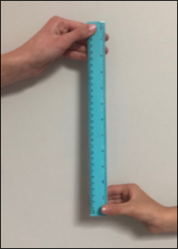
Figure 2 – Reaction time test after drop
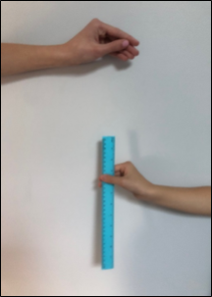
Figure 3 – Ruler drop reaction time test results table
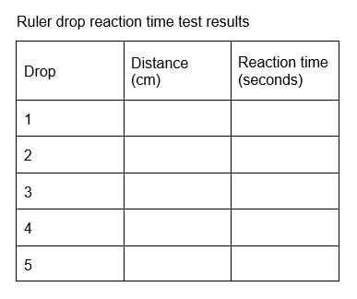

Core lesson 2: Thousandths of a second – 15 minutes
- Display Resource 5: Ruler drop reaction time chart and discuss decimal numbers.
Note: to support place value conceptual understanding, 0.132 would be read as one-hundred and thirty-two thousandths.
- Ask questions, such as:
- What does the 4 in 0.143 represent?
- Why is 0.45 not to 3 decimal places?
- What is the role of the zeros in 0.09?
- Do the numbers get bigger or smaller as the reaction distance increases? Why?
- How do you determine the largest number to 3 decimal places?
- Which number is larger, 0.12 or 0.128?
- Students record their reaction times from Resource 5: Ruler drop reaction time chart, in their table. For example (see Figure 4).
Figure 4 – Example of reaction time test results table
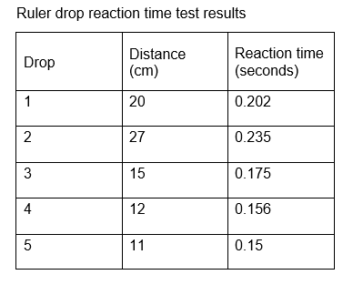
Note: students do not need to time their reaction times. They use the resource to match their ruler distances to the corresponding reaction time in seconds. For example, if the first drop was caught at 15 cm, the reaction time would be 0.175 seconds.

Consolidation and meaningful practice – 15 minutes
- Students order their reaction times from fastest to slowest.
- Model placing decimal numbers up to 3 decimal places on a number line.
- Discuss where zero and one would be placed on their number line.
- Students place their reaction times on a number line.
- Students share their number lines and explain their reasoning behind the spacing between the decimal numbers.
This table details opportunities for differentiation.
Too hard? | Too easy?
Students cannot order reaction times and position them on a number line.  - Students order reaction times to one or 2 decimal places.  - Provide a structured number line. | Students can order reaction times and position them on a number line.  - Students complete the reaction test again and add the additional times to their number line.  - Students use an online reaction time test and compare results with the ruler drop test, justifying their findings.
This table details opportunities for assessment.
Assessment opportunities | Links
What to look for:  - Can students collect data by observation and record it in a table? [MAO-WM-01, MA3-DATA-01]  - Can students compare, order and represent decimals? [MAO-WM-01, MA3-RN-01] | Links to National Numeracy Learning Progressions (NNLP):  - IRD3  - NPV7, NPV8.  Links to suggested Interview for Student Reasoning (IfSR) tasks:  - IfSR-PT: 1A.5, 1A.7  - IfSR-AT: 4B.1  - IfSR-NP: 4D.6.

Lesson 3
Core concept: mathematicians organise and present data in different ways.

Daily number sense: Ordering numbers game – 10 minutes
The table below contains a suggested learning intention and success criteria. These are best co-constructed with students.
Daily number sense learning intention | Daily number sense success criteria
Students are learning to:  - order numbers in the millions. | Students can:  - arrange numbers in the millions in ascending and descending order.
- Divide the class into equal teams.
- Explain that students will be playing a game where they will each be given a number card from Resource 6: Number cards. Teams then need to arrange themselves in ascending order according to their number card.
- Provide each student with a number card from Resource 6: Number cards and instruct them not to look at the number.
- Give a prearranged signal to start the game.
- Students look at their number and teams arrange themselves in ascending order, displaying their number cards.
- When all teams have finished, check each team’s order by asking students to read out the numbers.
- Repeat using different cards.
- Variations could include:
- the first team to arrange themselves in the correct order scores a point
- teams arrange themselves in descending order
- students play in pairs and each pair is given cards to place in the correct order.
This table details opportunities for assessment.
Assessment opportunities | Links
What to look for:  - Can students arrange numbers in the millions in ascending and descending order? [MAO-WM-01, MA3-RN-01] | Links to National Numeracy Learning Progressions (NNLP):  - NPV6, NPV7.

Core lesson 1: Choosing appropriate displays – 20 minutes
The table below contains suggested learning intentions and success criteria. These are best co-constructed with students.
Core concept learning intentions | Core concept success criteria
Students are learning to:  - recognise which types of data display are appropriate to represent data  - construct many-to-one scale column graphs. | Students can:  - identify appropriate data displays to represent data  - create many-to-one scale column graph  - determine an appropriate scale to represent data.
This activity is an adaptation of ‘Discussing Data’ from NZ Maths by the New Zealand Ministry of Education.
Note: numerical data values are expressed as numbers and are obtained by counting or by measurement. Counts are discrete values (for example, number of children in each family) and measurements are continuous values (for example, change in temperature over time). Column graphs can be used for discrete data values and line graphs for continuous data values where meaning can be attached to the points on the line between plotted points.
- As a class, discuss the best way to display different types of data, including:
- picture graphs and dot plots – used to show a small number of data values, with one-to-one correspondence
- column graphs – used to display categorical or discrete numerical data
- line graphs – used to display continuous data.
- Display Resource 7: Line graph example and ask the class questions, such as:
- What do you notice?
- What do you wonder?
- Why is this data represented in a line graph?
- How is a line graph similar and different to a column graph?
- Distribute a copy of Resource 8: Data investigation to each student. Explain that 3 students surveyed their peers and used different representations to display the data they collected.
- In pairs, students examine each dataset and determine which representation is most appropriate.
- Select pairs to share and justify their answers. For example, the line graph is the most appropriate choice in dataset C because it is continuous data. Ask other students if they agree or disagree and why.
This table details opportunities for differentiation.
Too hard? | Too easy?
Students cannot recognise which type of data display is appropriate to represent data.  - State the type of data represented in each example. For example, categorical or continuous numerical data.  - Provide prompts to support student reasoning. | Students can recognise which type of data display is appropriate to represent data.  - Students create their own set of representations to add to the resource.  - Students swap their representations and determine which display is most appropriate to represent the data and why.

Core lesson 2: Constructing many-to-one scale column graphs – 30 minutes
Note: a scale of many-to-one correspondence in a column graph or line graph means that one unit is used to represent more than one of what is being counted or measured. For example, 1 cm on the vertical axis could be used to represent 20 cm of body height.
- Display Resource 2: Data cycle and highlight that this activity involves representing data.
- Asks students to identify their shortest ruler drop distance from Lesson 2.
- In small groups, students record each group member’s shortest ruler drop distance in a table in their workbooks. For example, see Figure 5.
Figure 5 – Example ruler drop distance table
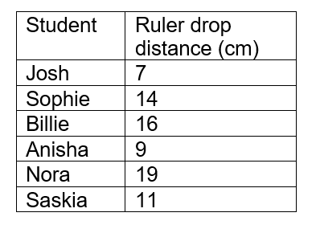
- Explain that a many-to-one scale means that one unit is used to represent more than one of what is being counted or measured and discuss why many-to-one scales are used.
- Brainstorm features that need to be included on a many-to-one scale column graph, such as:
- title
- axes names and labels
- scale.
- As a class, determine a scale to be used to graph the ruler drop data, for example, 1 cm = 2 cm ruler drop distance.
- Using grid paper, students create a column graph for their group’s data. For example, see Figure 6.
Figure 6 – Example ruler drop distance graph
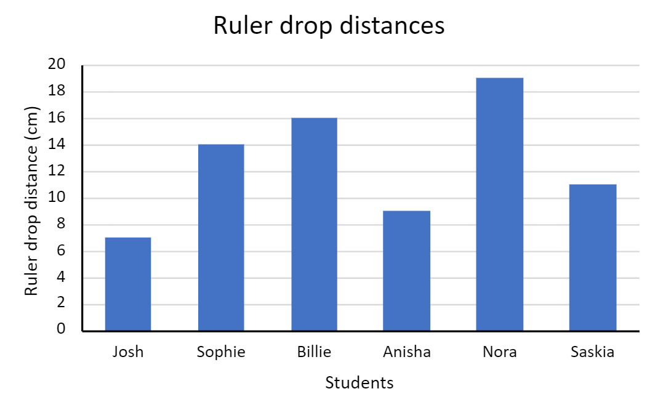
Note: this is an example of nominal categorical data, as the students are the categories along the x-axis.
This table details opportunities for differentiation.
Too hard? | Too easy?
Students cannot create a many-to-one scale column graph.  - Students graph data for less peers.  - Students create the graph on a paper template with a pre-recorded scale on the y-axis. | Students can create a many-to-one scale column graph.  - Students use the same data to make a horizontal column graph.  - Students develop 5 questions about their graph and swap with another group to answer them.

Consolidation and meaningful practice – 10 minutes
- Record the whole class’ shortest ruler drop distances in a table on the board. For example, see Figure 7.
Figure 7 – Example class ruler drop distance table
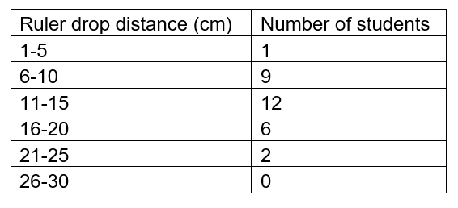
- Create a column graph on the board, representing the frequency of each ruler drop distance for the class. For example, see Figure 8.
Figure 8 – Example class ruler drop distance column graph
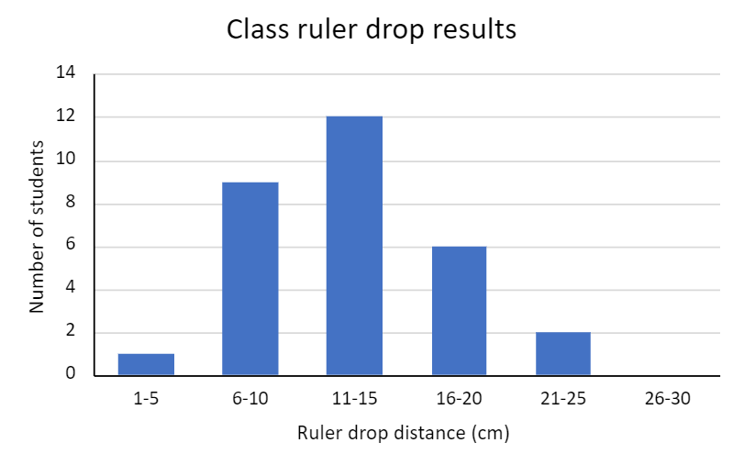
Note: this is an example of discrete numerical data with ruler distance along the x-axis.
- Discuss the similarities and differences between the 2 graphs created in the lesson.
- Ask students:
- What is the total number of students in our class graph?
- How did you calculate the total?

This table details opportunities for assessment.
Assessment opportunities | Links
What to look for:  - Can students identify appropriate data displays to represent data? [MAO-WM-01, MA3-DATA-01]  - Can students create a many-to-one scale column graph? [MAO-WM-01, MA3-DATA-01] | Links to National Numeracy Learning Progressions (NNLP):  - IRD3.

Lesson 4
Core concept: data is represented in different ways for different purposes.

Daily number sense: Teacher choice – 10 minutes
- From a class need surfaced through formative assessment data, identify a short, focused activity that targets students’ knowledge, understanding and skills. Example activities may be drawn from the following resources:
- Mathematics K-6 resources
- Universal Resources Hub.

Core lesson 1: Our growing population – 20 minutes
The table below contains suggested learning intentions and success criteria. These are best co-constructed with students.
Core concept learning intentions | Core concept success criteria
Students are learning to:  - recognise, represent and order numbers in the millions  - create many-to-one scale column graphs with the use of digital technologies  - interpret side-by-side column graphs for 2 categorical variables. | Students can:  - name and order numbers in the millions  - create a many-to-one scale column graph with digital technologies  - interpret side-by-side column graphs.
- Display Image 1 from Resource 9: Slow reveal table and ask students to:
- read the numbers aloud using the place value grouping of ones, tens and hundreds
- find the largest and smallest numbers
- predict what the data represents.
- Reveal Image 2 and then 3 from Resource 9: Slow reveal table and ask students:
- What new information has been added?
- Has it changed your previous prediction? How?
- Do we have enough information to know what data is being represented?
- Display Image 4 from Resource 9: Slow reveal table and ask students:
- What new information has been added?
- Was your previous prediction correct?
- Discuss the reasons for collecting population data by asking:
- Who collects this data?
- How do they collect the data?
- How could this data be used?
- Students list the 1981 population numbers from largest to smallest (descending order).
- Students list the 2022 population numbers from smallest to largest (ascending order).
This table details opportunities for differentiation.
Too hard? | Too easy?
Students cannot read and order numbers in the millions.  - Round each number to the nearest thousand and students order the numbers.  - Reduce the number of states listed in the table. | Students can read and order numbers in the millions.  - Students round each number to the nearest thousand.  - Students predict each state’s population in 2063.

Core lesson 2: Spreadsheets – 30 minutes
- Distribute a copy of Resource 10: Population data to each student.
- Students order the population numbers from largest to smallest.
- With the resource ‘Using digital tools to create graphical displays [490 KB]’ (NSW Department of Education), demonstrate in Microsoft Excel or Google Sheets how to create a many-to-one column graph.
- In pairs, students:
- open Microsoft Excel or Google Sheets on a device
- open a blank spreadsheet
- enter the countries and their population numbers in columns A and B
- highlight the dataset include the headings
- use the top ribbon to select ‘insert’ and ‘column chart’
- add a graph title
- edit the axis names and labels as needed.
- Ask students:
- What is the scale on your y-axis?
- Why is a scale of one not used for this dataset?
- Why is a line graph not appropriate for this data?

Discuss and connect the mathematics – 10 minutes
- Display Resource 11: Australia’s population by state or territory and ask students:
- What do you notice?
- What do you wonder?
- What data is being displayed?
- How is this graph different to column graphs you have created and interpreted previously?
- Which state had the largest population in 1981?
- Which state had the smallest population in 1981?
- Which state had the largest population in 2022?
- Which state had the smallest population in 2022?
- Which state had the largest population growth from 1981 to 2022?
This table details opportunities for assessment.
Assessment opportunities | Links
What to look for:  - Can students name and order numbers in the millions? [MAO-WM-01, MA3-RN-01]  - Can students construct many-to-one scale column graphs? [MAO-WM-01, MA3-DATA-01]  - Can students interpret side-by-side column graphs? [MAO-WM-01, MA3-DATA-02] | Links to National Numeracy Learning Progressions (NNLP):  - NPV7, IRD3, IRD5.

Lesson 5
Core concept: data can help conceptualise events in history.

Daily number sense: Number talk – 15 minutes
Daily number sense activities for Lessons 5 to 7 ‘loop’ back to concepts and procedures covered in previous units to assist students to build an increasingly connected network of ideas. These concepts may differ from the core concepts being covered by the unit.
The table below contains a suggested learning intention and success criteria. These are best co-constructed with students.
Daily number sense learning intention | Daily number sense success criteria
Students are learning to:  - use mental and informal written strategies to solve multiplication problems. | Students can:  - choose, apply and evaluate mental and written multiplication strategies.
This activity is an adaptation of ‘Let's talk 2 – number talk (15 x 9) Stage 3’ from Mathematics K-6 resources by the New South Wales (Department of Education).
- Watch Let's talk 2: number talk (15 x 9) Stage 3 (6:15) as a class.
- Ask students to record at least 2 other strategies that could be used to solve 15 × 9.
- Select students to share their thinking.
- Discuss the strategies shared, asking questions such as:
- Why did you choose that strategy?
- Are there any other strategies that are like this one?
- Have you used any of these strategies before?
- Which strategy do you think is the most efficient? Why?
- Ask students if any of the strategies shared in the video could be used to solve 16 × 25.
- Select students to share their thinking.
- Discuss the strategies shared, asking question such as:
- What makes this strategy suitable for both problems?
- What other problems could this strategy be used for?
This table details opportunities for assessment.
Assessment opportunities | Links
What to look for:  - Can students choose, apply and evaluate mental and written multiplication strategies? [MAO-WM-01, MA3-MR-01] | Links to National Numeracy Learning Progressions (NNLP):  - MuS7.  Links to suggested Interview for Student Reasoning (IfSR) tasks:  - IfSR-MT: 3A.1, 3A.2, 3A.3, 3A.4.

Core lesson 1: Creating timelines – 25 minutes
The table below contains suggested learning intentions and success criteria. These are best co-constructed with students.
Core concept learning intentions | Core concept success criteria
Students are learning to:  - construct a timeline  - interpret data on a timeline. | Students can:  - draw an accurate timeline using an appropriate scale  - interpret data on a timeline using the given scale.
- Distribute a copy of Resource 12: Example timeline to each student.
Note: to ensure the scale is correct, print Resource 12: Example timeline on A4 size paper and do not resize.
- Ask students questions, such as:
- What information is being represented?
- What do you notice?
- What can we learn from this data?
- What year did this student start school?
- How old was this student when they went to zone cross country?
- How many years after starting day care did the student move house?
- What is this type of data representation called?
- What would you need to know to create a timeline of your own life?
- What other data could be represented in a timeline?
- Explain that a timeline is a representation of events listed in chronological order. Explain that students will create a scaled timeline of their own life.
- Brainstorm and record life events that students may place on their personal timeline.
- Explain that, on a scaled timeline, events are placed according to the actual time distance between events. Although not all of the events occur at equal time intervals, the length of the intervals are proportional to the passage of time.
- Discuss an appropriate scale for the students’ personal timelines. For example, 2 cm in their workbooks for every one year of their life.
- Distribute rulers for students to draw a timeline of their own life in their workbooks, adding at least 5 major events and a scale.
- Students turn and talk to check their partner’s timeline and discuss:
- What is similar about their timelines?
- What is different about their timelines? Why?

This table details opportunities for differentiation.
Too hard? | Too easy?
Students cannot create a timeline with an appropriate scale.  - Give students a timeline with year intervals already marked.  - Students add fewer major events to their timeline. | Students can create a timeline with an appropriate scale.  - Students add more events to their timeline.  - Students create a timeline for a famous person’s life.

Core lesson 2: Interpreting timelines – 20 minutes
- Distribute a copy of Resource 13: Australian gold rush to each student and ask:
- What type of data is being displayed?
- How is it being displayed?
- What do you notice?
- Is the scale the same as the one on your personal timeline?
- How do you determine when each event occurred without each event being dated?
Note: to ensure the scale is correct, print Resource 13: Australian gold rush on A4 paper and do not resize.
- Students use a ruler and the scale to mark out 10-year increments along the timeline.
- Ask students:
- How would you determine 5 years on the timeline?
- How would you determine 20 years on the timeline?
- Students calculate and record the missing dates of events on the timeline using the given scale. Answers include:
- J McBrien finds first gold in Australia in 1823
- California gold rush was in 1849
- Eureka Stockade was in 1854
- Influx of Chinese miners to Australia in 1860
- Gold first discovered in Western Australia in 1864
- Gold discovered in Kalgoorlie in 1893
- Ask students:
- How many years after gold was first discovered in Australia, did the Californian gold rush begin?
- How many years before gold was discovered in Kalgoorlie, was gold first discovered in Western Australia?

Discuss and connect the mathematics – 5 minutes
- Students compare the 2 timelines from the lesson. Ask questions, such as:
- How are they similar?
- How are they different?
- What impacts the scale used in each timeline?
- What did you find challenging when interpreting a timeline with a scale?
This table details opportunities for assessment.
Assessment opportunities | Links
What to look for:  - Can students draw an accurate timeline using an appropriate scale? [MAO-WM-01, MA3-DATA-01]  - Can students interpret data on a timeline using the given scale? [MAO-WM-01, MA3-DATA-02] | Links to National Numeracy Learning Progressions (NNLP):  - MeT4, IRD4.

Lesson 6
Core concept: data is represented in different ways for different purposes.

Daily number sense: Goat busters – 15 minutes
The table below contains a suggested learning intention and success criteria. These are best co-constructed with students.
Daily number sense learning intention | Daily number sense success criteria
Students are learning to:  - use partitioning and place value to multiply 2-digit numbers by one-digit numbers. | Students can:  - use the area model to multiply 2-digit numbers by one-digit numbers.
- Remind students that they practised using the area model to multiply a one-digit number by a 2-digit number by playing Goat busters in Unit 1.
- Provide an example of the area model, showing that the 2-digit number needs to be partitioned into tens and ones before multiplying (see Figure 9).
Figure 9 – Area model for 23 × 3
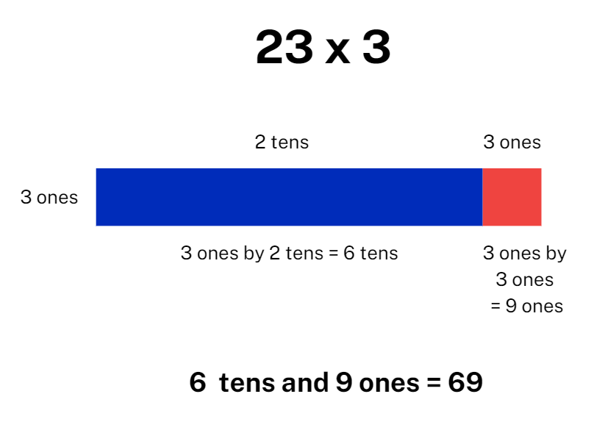
- Students play Goat busters Level one.
This table details opportunities for assessment.
Assessment opportunities | Links
What to look for:  - Can students use the area model to multiply 2-digit numbers by one-digit numbers? [MAO-WM-01, MA3-MR-01] | Links to National Numeracy Learning Progressions (NNLP):  - MuS6, MuS7.  Links to suggested Interview for Student Reasoning (IfSR) tasks:  - IfSR-MT: 3A.1, 3A.2, 3A.3.

Core lesson 1: Air temperature – 15 minutes
The table below contains suggested learning intentions and success criteria. These are best co-constructed with students.
Core concept learning intentions | Core concept success criteria
Students are learning to:  - interpret and compare different data displays  - locate and represent negative integers on a number line. | Students can:  - compare and interpret data presented in tables, column graphs and line graphs  - represent negative numbers on a number line.
- Display Eyes on the Earth, Air temperature (NASA).
- Below the date, toggle the units to display degrees Celsius.
- Click on various locations around the globe to show the air temperature.
- Move between the daytime 3-day average and night 3-day average from the drop-down menu on the right-hand side of the screen and ask students:
- What do you notice?
- What do you wonder?
- How else could this data be represented?
- Where do you see temperature data in your everyday life?
- Who might collect data about temperature? Why?
- Who might use temperature data?
- Can temperature be measured below zero degrees Celsius? How is this represented?

Core lesson 2: Australia’s extreme temperatures – 30 minutes
- Provide pairs of students Resource 14: Temperature in Australia over time and an A3 copy of Resource 15: Triple Venn diagram
- Ask students to name the different data displays in Resource 14: Temperature in Australia over time.
- Students choose 3 displays to compare and use the Venn diagram to record similarities and differences between the displays. Students should record similarities and differences of the features of the displays, as well as the conclusions that can be drawn from the data. For example, see Figure 10.
Note: a triple Venn diagram is used to compare and contrast 3 categories. Each circle represents a different category with the overlapping regions used to represent properties that are shared between the 3 categories.
Figure 10 – Example triple Venn diagram comparing the column graph, line graph and table
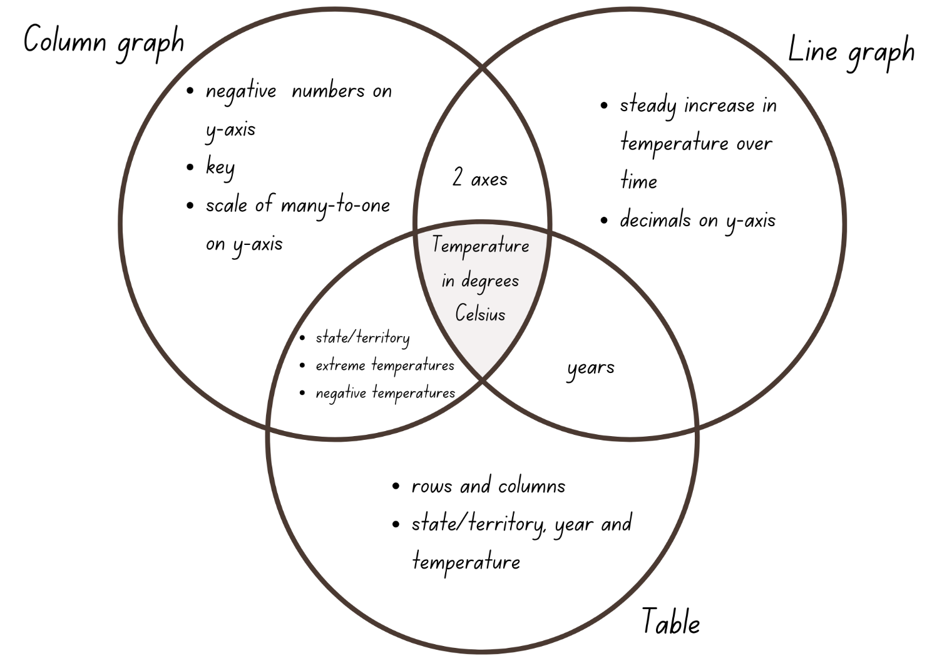
- Students share their answers with the class and add to their Venn diagram if needed.
- In pairs, students write 2 questions related to each of the displays.
- Students swap questions with another pair and use the resource to answer the questions.
- Students share their most challenging question with the class.
- Discuss the data displays as a class, asking questions such as:
- What is the data telling us?
- Can you see any patterns or trends?
- Who collected this data?
- Which data representation is easiest to interpret? Why?
- Which data representation provides the most information? Explain why.
This table details opportunities for differentiation.
Too hard? | Too easy?
Students cannot interpret and compare different data displays.  - Compare 2 displays and use a double Venn diagram.  - Provide interpretation questions for students to answer rather than script. | Students can interpret and compare different data displays.  - Predict the average annual temperature over the next 10 years and continue the line graph.  - Predict which state or territory will next break its record for the lowest or highest temperature and why.

Consolidation and meaningful practice – 10 minutes
- Display Resource 16: Extreme temperatures recorded as integers and distribute a ruler to each student.
- Explain that integers are whole numbers and that the temperatures in the resource have been rounded to the nearest whole number.
- Students represent the temperatures from the resource on an empty number line. Ensure students understand it must be proportional and that negative numbers are placed to the left of zero.
- Ask students:
- What do you notice about the positive numbers and their relation to zero?
- What do you notice about the negative numbers and their relation to zero?
- Which do you find more difficult to place on a number line? Why?
This table details opportunities for differentiation.
Too hard? | Too easy?
Students cannot record negative integers on a number line.  - Provide a structured number line with marked intervals of 10 from −30 to 50.  - Students record only the positive or negative integers on the number line. | Students can record negative integers on a number line.  - Use the number line to calculate the difference between the positive and negative temperature for each state.  - Order the states from highest temperature to lowest temperature.
This table details opportunities for assessment.
Assessment opportunities | Links
What to look for:  - Can students interpret and compare different data displays, such as line graphs, side-by-side column graphs, tables and timelines? [MAO-WM-01, MA3-DATA-02]  - Can students locate and represent negative integers on a number line? [MAO-WM-01, MA3-RN-01] | Links to National Numeracy Learning Progressions (NNLP):  - IRD3, NPV9.

Lesson 7
Core concept: data can be described in terms of its distribution.

Daily number sense: Which one doesn’t belong? – 15 minutes
The table below contains a suggested learning intention and success criteria. These are best co-constructed with students.
Daily number sense learning intention | Daily number sense success criteria
Students are learning to:  - use partitioning and place value to multiply 2- and 3-digit numbers by one-digit numbers. | Students can:  - use strategies, such as partitioning and the area model, to multiply 2- and 3-digit numbers by one-digit numbers.
- Display Resource 17: Which one doesn’t belong?
- Explain that students will need to solve each equation, then determine which one doesn’t belong and why.
- Remind students that they can use a range of mental or written strategies, such as using multiples of 10, partitioning using the distributive property and the area model. Revise that these were taught during Unit 1.
- Provide writing materials and allow time for students to Think-Pair-Share.
- Explain that there are no wrong answers in this activity as there is a case to be made for each of the equations being different to the others. For example:
- A is the only equation where the digits in the answer add to a number less than 10.
- A is the only equation where the digits in the answer are consecutive.
- B is the only equation where both numbers in the question are odd.
- B is the only equation where the answer is a palindrome.
- C is the only equation where a number in the question has 3 digits.
- C is the only equation where the answer does not contain a 4.
- D is the only equation where all the digits in the question are the same.
- D is the only equation where there is a zero in the answer.
- Discuss and compare strategies that students used to solve the equations.
This table details opportunities for assessment.
Assessment opportunities | Links
What to look for:  - Can students use strategies such as partitioning and the area model to multiply 2- and 3-digit numbers by one-digit numbers? [MAO-WM-01, MA3-MR-01] | Links to National Numeracy Learning Progressions (NNLP):  - MuS6, MuS7.  Links to suggested Interview for Student Reasoning (IfSR) tasks:  - IfSR-MT: 3A.1, 3A.2, 3A.3.

Core lesson 1: Distribution – 25 minutes
The table below contains suggested learning intentions and success criteria. These are best co-constructed with students.
Core concept learning intentions | Core concept success criteria
Students are learning to:  - interpret and compare different displays in terms of the shape of the distribution, including the range and the mode  - recognise, represent and order numbers in the millions. | Students can:  - calculate the range and mode of a dataset  - order and round numbers in the millions.
This activity is an adaptation of ‘Data: Making Decisions’ from reSolve: Maths by Inquiry by the Australian Government Department of Education.
Note: students are expected to find the range and mode of a dataset. The range is the measure of the spread within a numerical dataset and can be calculated by subtracting the smallest value from the largest. The mode is the most frequently occurring value in a set of data. There can be more than one mode.
- Distribute copies of Resource 18: Unlabelled line graph and ask students to predict what type of data is represented in the display. Draw students’ attention to the fact it is a line graph and so must be representing continuous data.
- Ask students to describe the shape of the line.
Note: students need to look beyond the plotted points and understand what the line is representing. Encourage students to discuss the nature and movement of the line before considering information on the x- and y-axes. (Diezmann et al. 2009)
- Brainstorm and record the missing elements of the graph including:
- title
- axes names and labels
- equal spaced axes
- scale.
- Ask students what data the graph might be representing. Answers may include temperature or rainfall over time, plant growth, population data, school attendance rates.
- Distribute Resource 19: Table of data to students.
- Students transfer the data from Resource 19: Table of data onto Resource 18: Unlabelled line graph to complete the graph. Ensure students include a title.
- Explain that the mode is the value that occurs most frequently in a dataset. Students find the mode using the table or graph.
- Explain that the difference between the lowest value and the highest value is called the range. Students calculate the range using the table or graph.

Core lesson 2: Our solar system – 20 minutes
- Distribute copies of Resource 20: Solar system distances graph to each student and ask:
- What data is being displayed?
- What is it telling us?
- Is the data accessible? Why or why not?
- Distribute Resource 21: Solar system distances table.
- Students use Resource 20: Solar system distances graph to add the missing planet names to the table.
- Ask students:
- Which planet is furthest from the Sun?
- Which planet is closest to the Sun?
- What is the range of distances to the Sun? How did you calculate your answer?
- Which planet is closest to Earth?
- Which planet is furthest from Earth?
- What is the range of distances to Earth? How did you calculate your answer?
- Which planet would be the hottest? Why?
- Which planet would be the coldest? Why?
- Students order the planets from closest to furthest from the Sun and record the distances next to the planet names.
This table details opportunities for differentiation.
Too hard? | Too easy?
Students cannot interpret data in a side-by-side column graph.  - Students answer questions about one category of data.  - Provide dataset about a fewer number of planets. | Students can interpret data in a side-by-side column graph.  - Students calculate distance between each planet.  - Students identify the planets which are closer to the Earth than they are to the Sun.

Consolidation and meaningful practice – 10 minutes
- Provide students with individual whiteboards and whiteboard markers.
- Write the following numbers on the board:
- 2 657 499
- 1 961 500
- 1 156 789
- 2 659 754.
- Students record answers to the following prompts on their individual whiteboards:
- the numbers in descending order
- each number rounded to the nearest million
- the range and mode for the numbers rounded to the nearest million.
- Repeat for the following numbers:
- 5 346 000
- 8 120 056
- 7 654 000
- 3 445 000.
This table details opportunities for assessment.
Assessment opportunities | Links
What to look for:  - Can students calculate the range and mode of a dataset? [MAO-WM-01, MA3-DATA-02]  - Can students name and order numbers in the millions? [MAO-WM-01, MA3-RN-01]  - Can students round numbers in the millions to a specified place value? [MAO-WM-01, MA3-RN-01] | Links to National Numeracy Learning Progressions (NNLP):  - IRD5, NPV6, NPV7.

Lesson 8
Core concept: statistical reasoning helps mathematicians interpret and make inferences about information.

Daily number sense: Teacher choice – 10 minutes
- From a class need surfaced through formative assessment data, identify a short, focused activity that targets students’ knowledge, understanding and skills. Example activities may be drawn from the following resources:
- Mathematics K-6 resources
- Universal Resources Hub.

Core lesson 1: Data in the media and factual text – 30 minutes
The table below contains a suggested learning intention and success criteria. These are best co-constructed with students.
Core concept learning intentions | Core concept success criteria
Students are learning to:  - identify sources of possible bias and misleading representation of data in the media. | Students can:  - identify sources of possible bias in data representations  - identify potentially misleading data representations.
This activity is an adaptation of ‘Data Distortion’ from NZ Maths by the New Zealand Ministry of Education and ‘Melting Arctic Ice [PDF 330 KB]’ from youcubed by Stanford University.
Statistical reasoning: involves identifying patterns across datasets and making inferences from the data.
- As a class, brainstorm examples of data representations found in the media and factual texts.
- Explain that representations in the media can often be biased and sometimes misleading.
Bias: a systematic favouring of certain outcomes more than others, due to unfair influence (knowingly or otherwise).
- As a class, discuss and record elements of effective and misleading data representations in the media. A graphic organiser such as a T-chart could be used to record responses. See table below for a sample response.
Table 1 – Sample response in a graphic organiser
Effective data representations in the media | Misleading data representations in the media
- accurately represent the whole dataset  - grab the reader’s attention  - make text more interesting  - show trends or changes  - are easy to read  - have a title and labels  - uses colour or patterns to show differences | - use incorrect displays for the data type  - manipulate the axes or scale  - use uneven intervals on the axes  - leave out relevant data  - have axes not starting at zero  - have missing units or axes labels  - exaggerate or minimise differences between numerical values
- Brainstorm various influences on data collection and representation in the media, such as:
- who funded the data collection
- who created the representation
- whether the representation is part of an advertisement.
- Display Resource 22: Melting ice and ask questions, such as:
- What do you notice about the graph?
- Is the graph misleading? Provide reasons why or why not.
- Who created the graph?
- Why do you think they created the graph?
- Can you see a trend in the data? What could be causing it?
- The New York Times released an article saying that some populations of polar bears have declined by 40% between 2000 and 2010. Polar bears live on sea ice. Do you think this graph is related to the decreasing polar bear population?
- How can we change this graph so that it is not misleading?
- Distribute one graph from Resource 23: Misleading graphs to pairs of students. Ensure a mix of the 4 graphs across the class.
- Students to critically evaluate the graph by:
- identifying any misleading elements
- discussing why the graph might have these elements
- recording changes to be made to the graph so it is a true representation of the dataset.
- Students share their findings with the class while other students ask clarifying questions. For example:
- What did you think was misleading about the scale of the graph?
- Would you change the type of graph used to represent this data?
This table details opportunities for differentiation.
Too hard? | Too easy?
Students cannot identify sources of possible bias and misleading representation of data.  - Students identify which elements of the graph are misleading and explain why.  - Provide simplified data representations with only one misleading element. | Students can identify sources of possible bias and misleading representation of data.  - Students examine current media and advertising material for real-life examples of misleading data.  - Students create and conduct a survey that will provide biased data.

Core lesson 2: Misleading representations – 25 minutes
- Pairs of students create their own misleading data representation, either drawn in their workbooks or using Microsoft Excel or Google Sheets. Use Using digital tools to create graphical displays [DOCX 490KB] (NSW Department of Education) to support the use of Microsoft Excel where necessary.
- Students swap misleading representations and use the list recorded at the start of the lesson to identify misleading elements in the representation.

Discuss and connect the mathematics – 5 minutes
- Reflect on the lesson by asking questions, such as:
- What are some positives and negatives of data representations in the media and factual texts?
- What are some of the common problems with the way data is represented in the media?
- Why are some data representations misleading?
- How do you identify potentially misleading representations?
- What are the possible social consequences of misleading representations?
- Will you look at data representations in the media differently now? Why or why not?

This table details opportunities for assessment.
Assessment opportunities | Links
What to look for:  - Can students identify sources of possible bias in representations of data in the media? [MAO-WM-01, MA3-DATA-02]  - Can students identify misleading representations of data in the media? [MAO-WM-01, MA3-DATA-02] | Links to National Numeracy Learning Progressions (NNLP):  - IRD4, IRD5, IRD6.

Resource 1: Slow reveal graph
Image 1
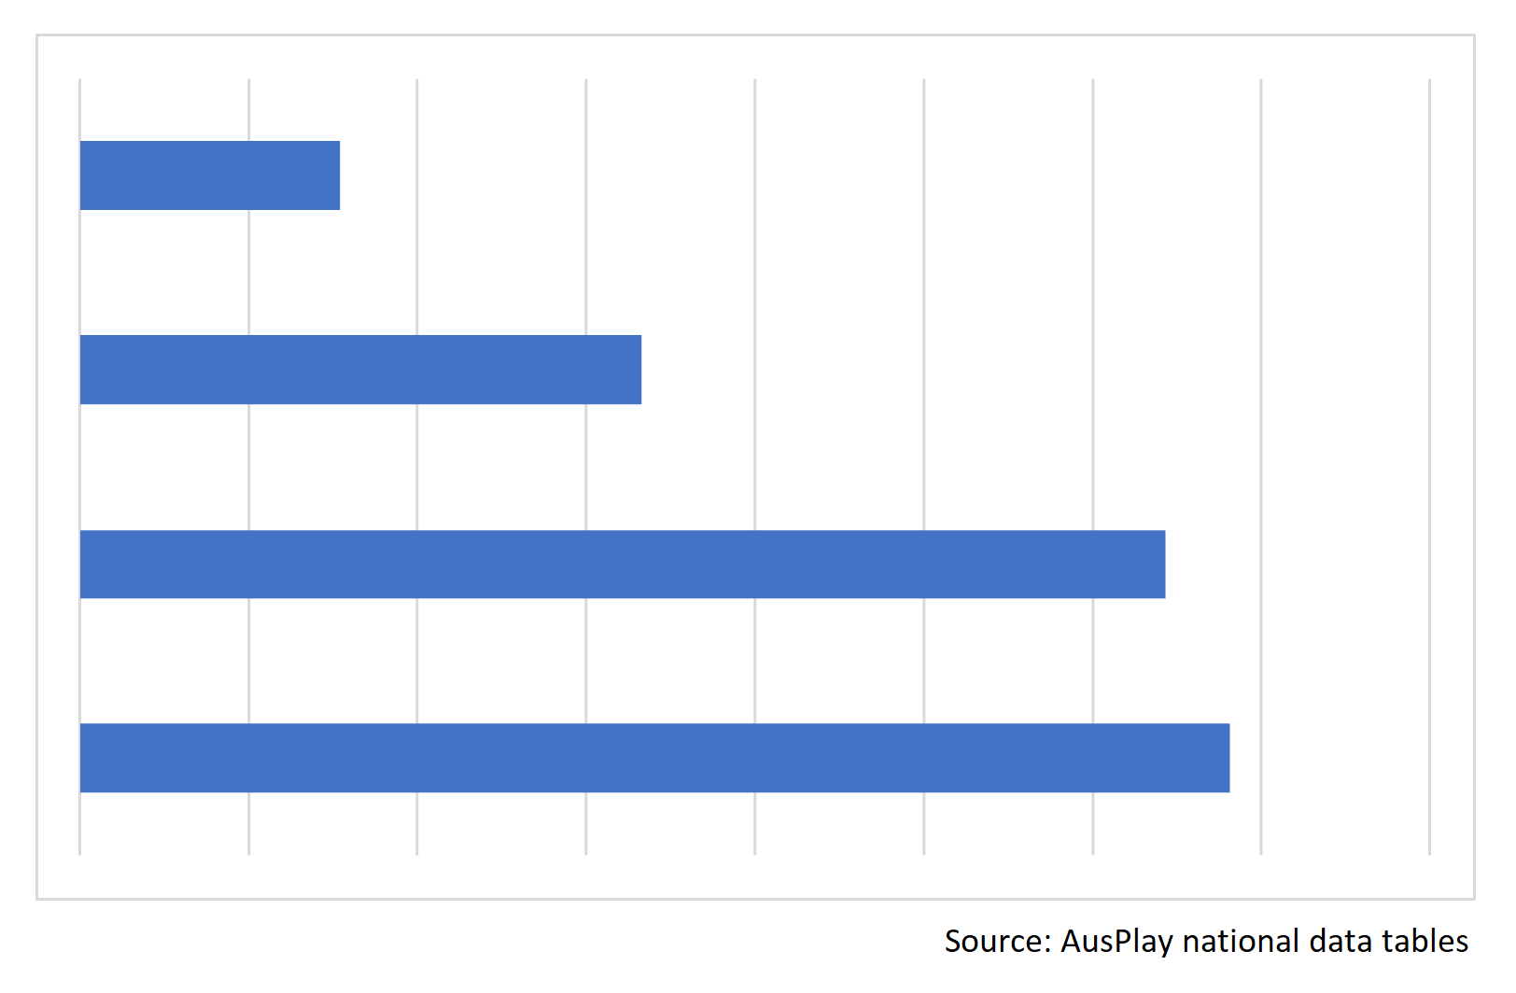
Image 2
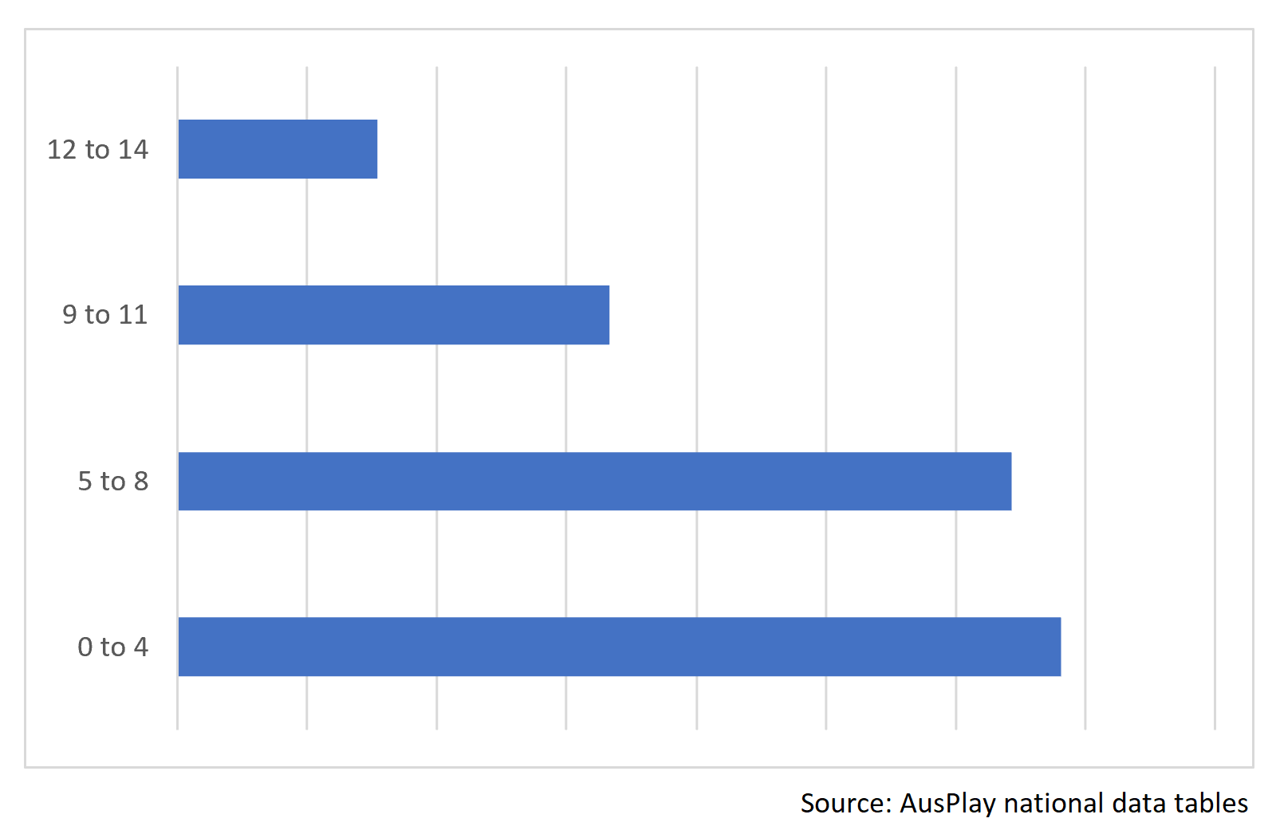
Image 3
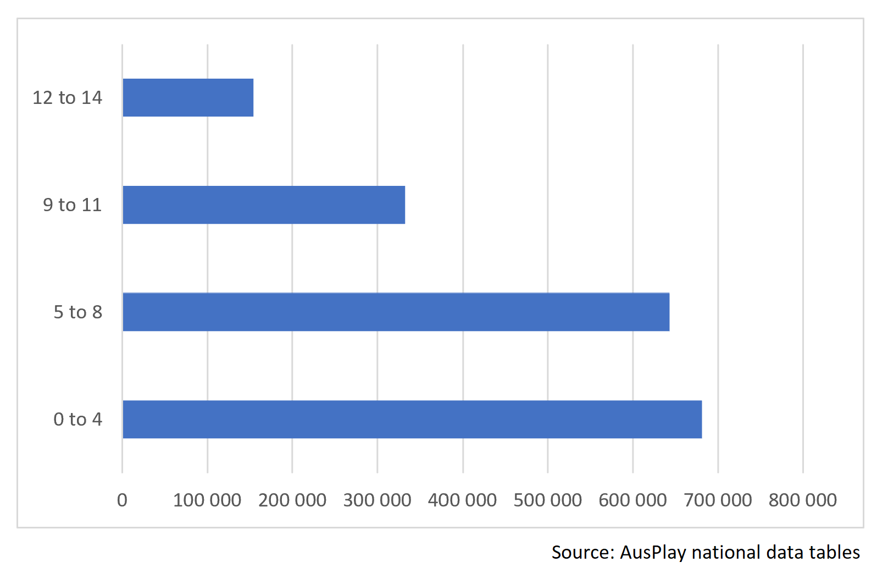
Image 4
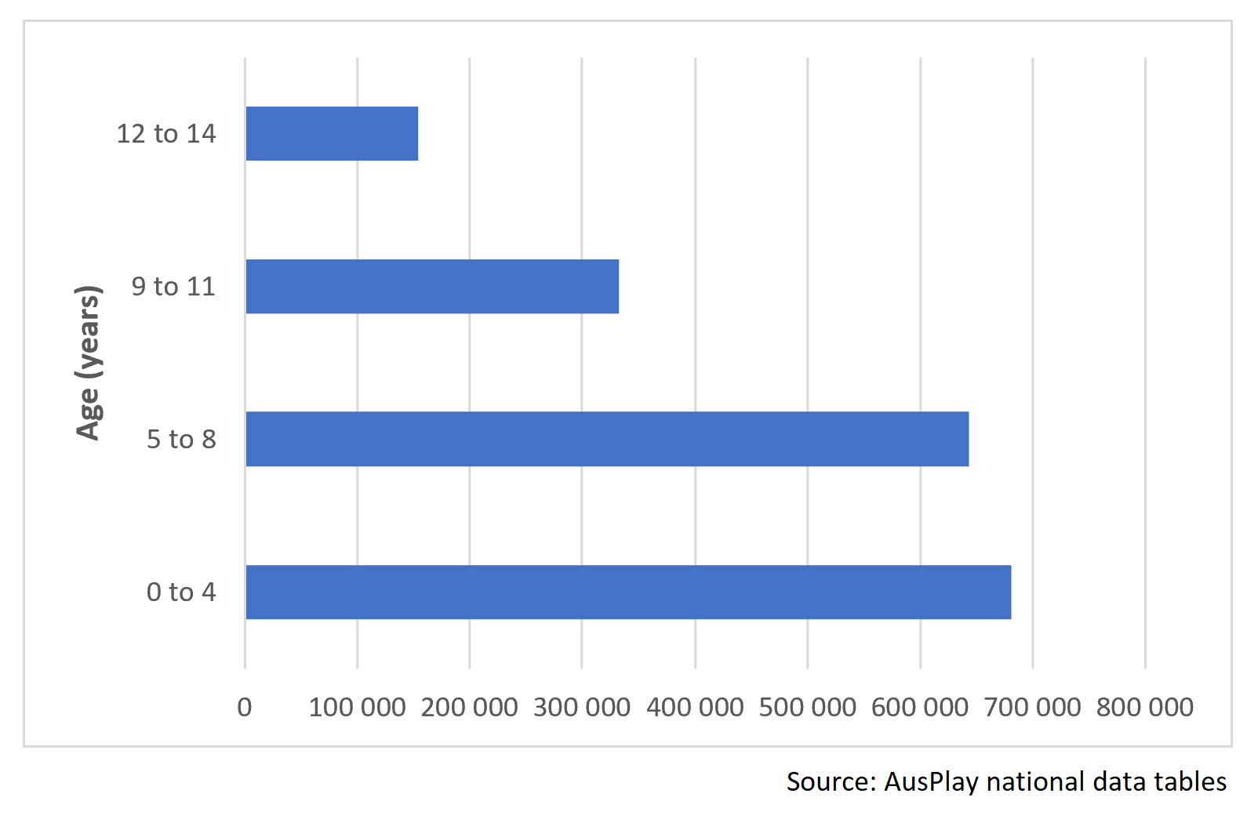
Image 5
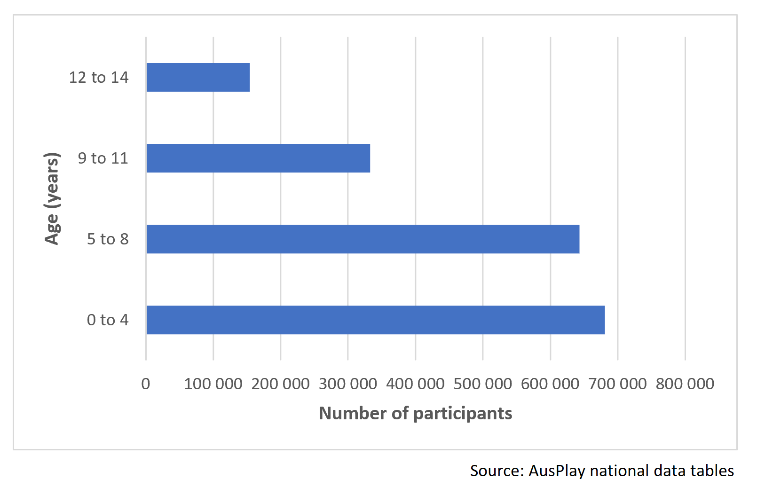
Image 6
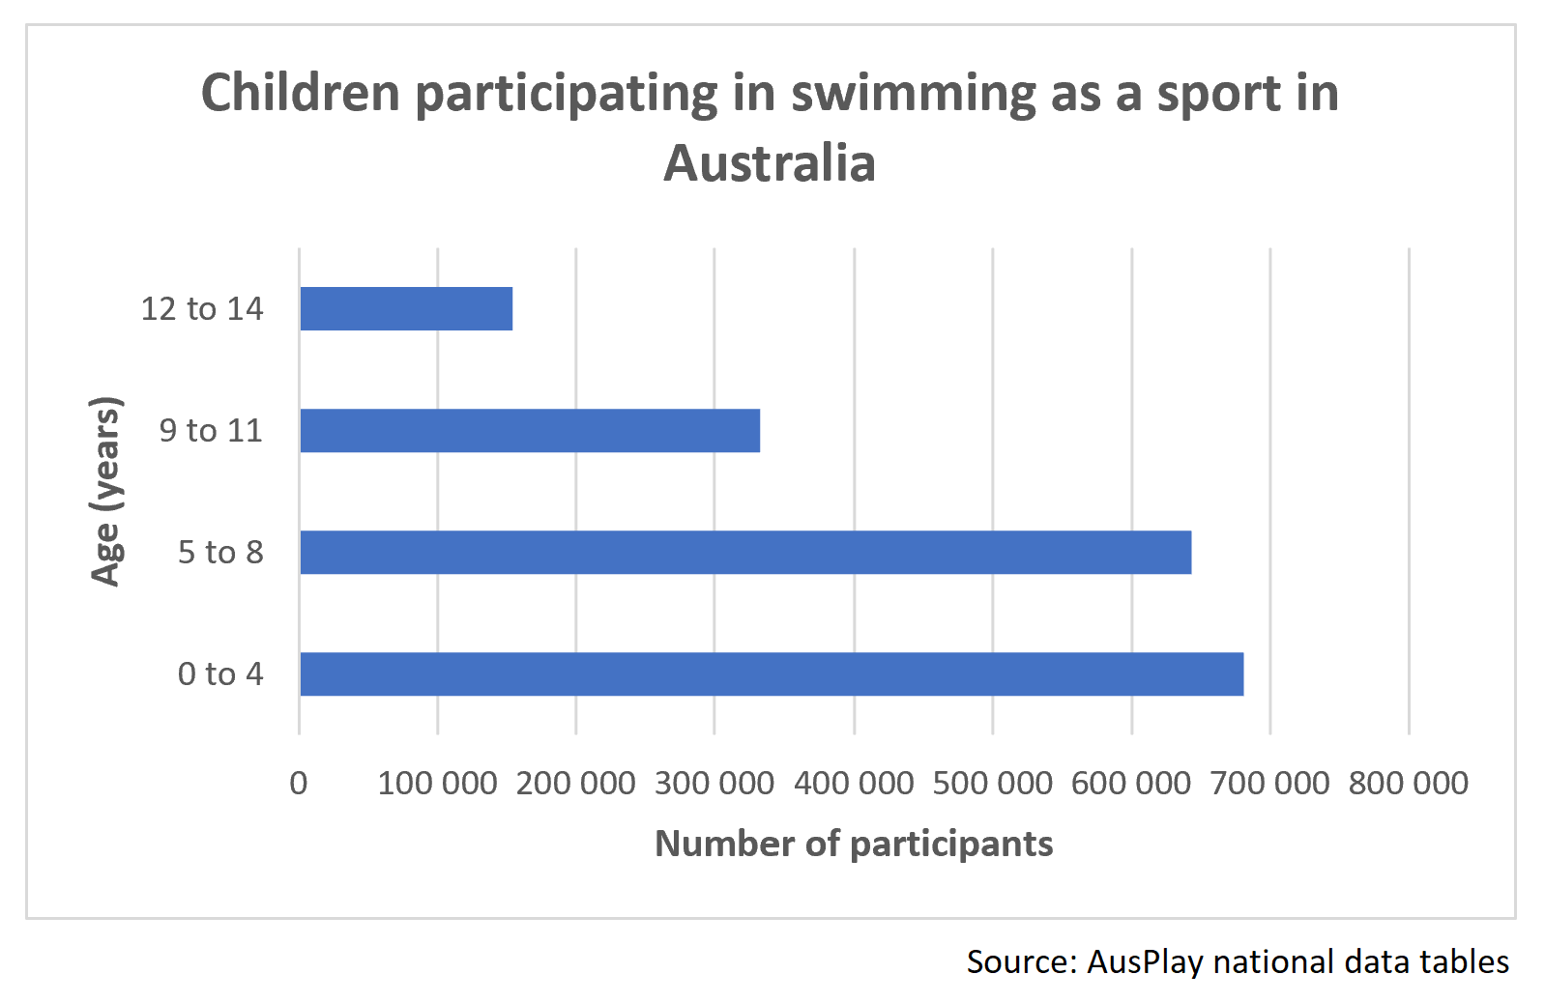
Image 7 – Australian children participating in sport 2022
 | 0–4 years | 5–8 years | 9–11 years | 12–14 years | Total
Swimming | 680 800 | 642 800 | 332 900 | 153 300 | 1 809 800
Gymnastics | 183 800 | 247 300 | 104 500 | 58 400 | 594 100
Football/soccer | 98 900 | 295 000 | 174 900 | 179 400 | 748 200
Source: AusPlay national data tables.

Resource 2: Data cycle
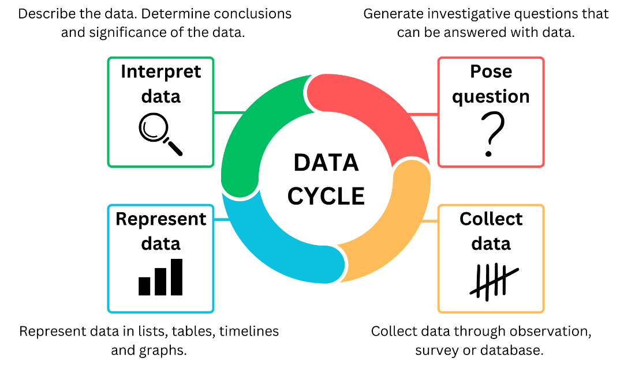

Resource 3: Checklist for survey question development
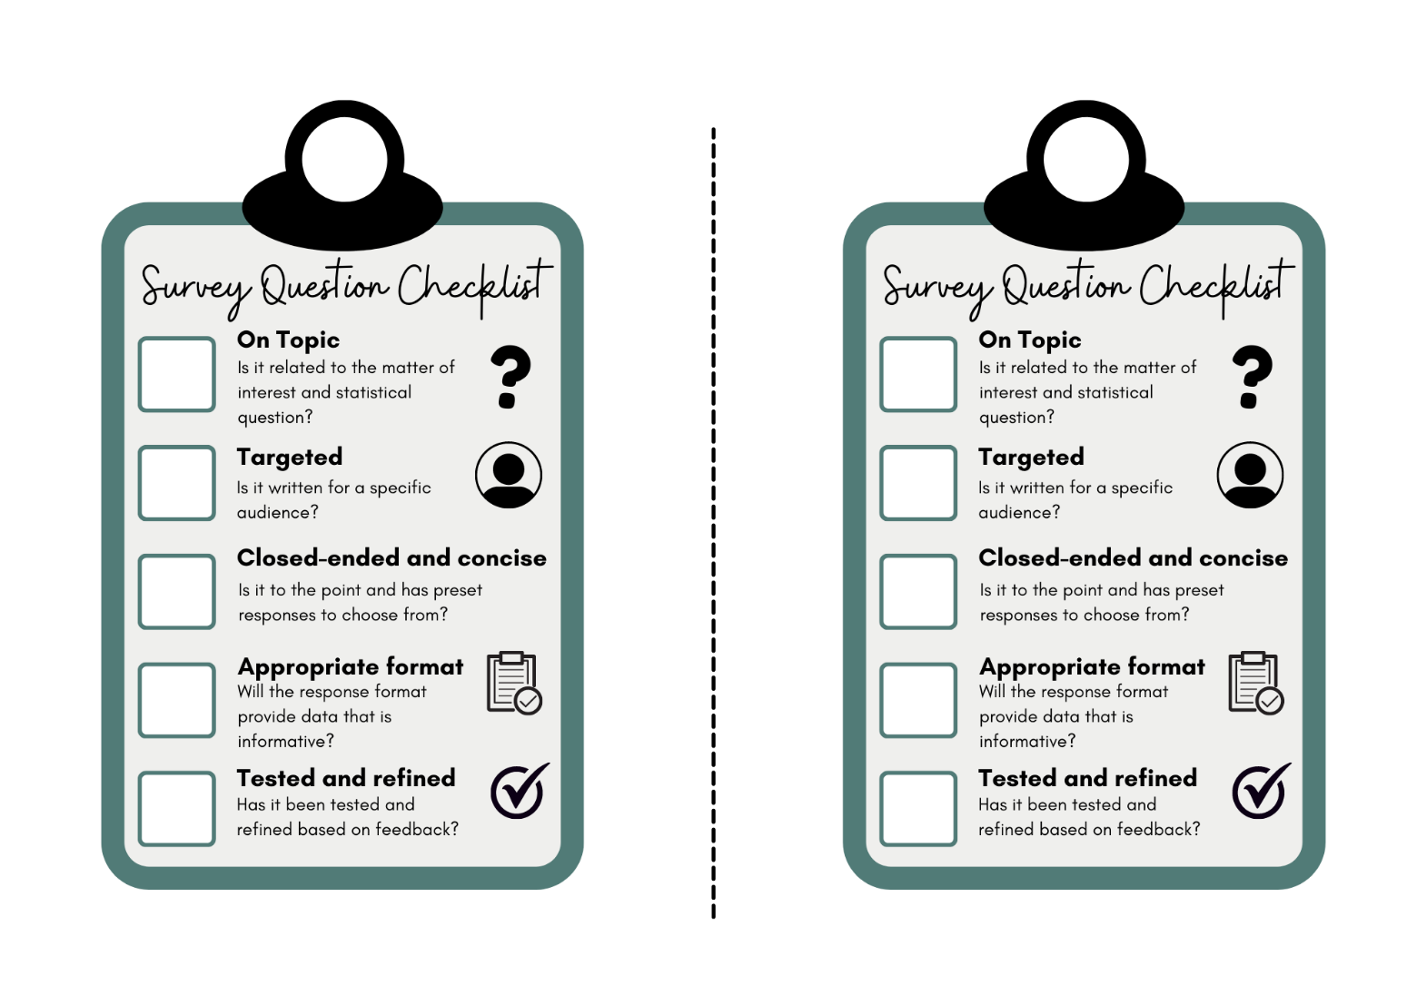

Resource 4: Two stars and a wish
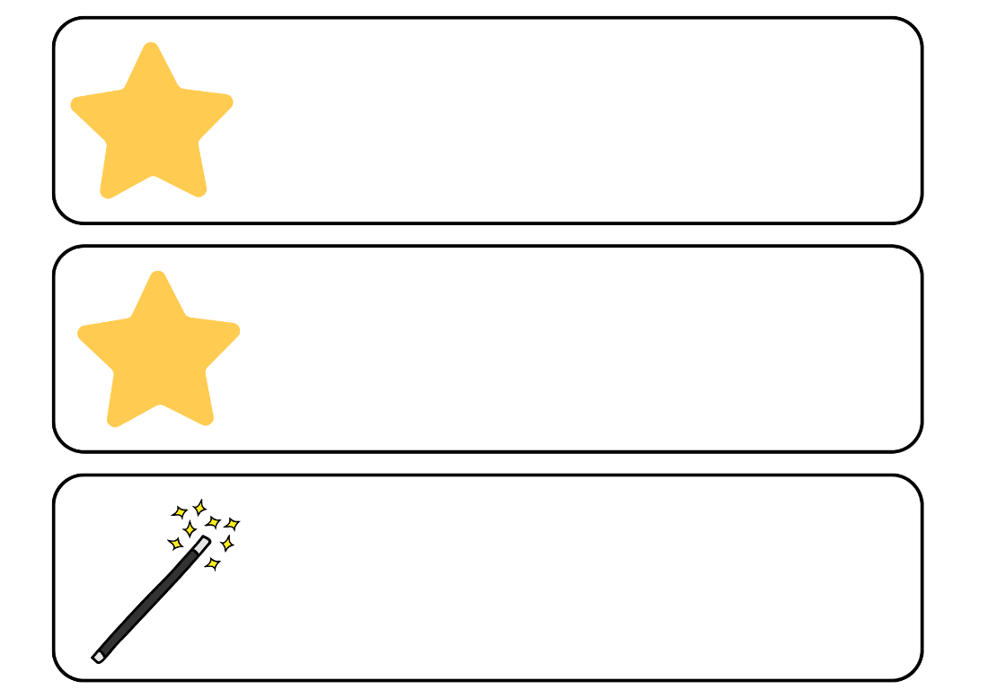

Resource 5: Ruler drop reaction time chart
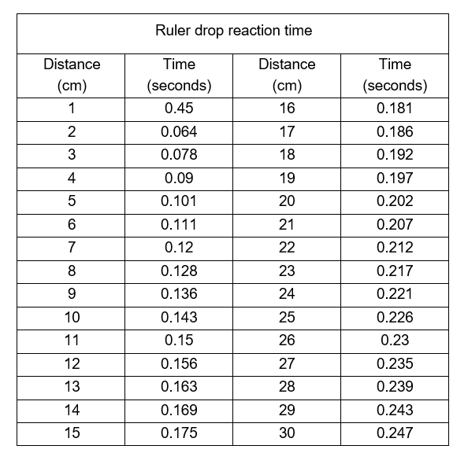
Distance (cm) | Time (seconds) | Distance (cm) | Time (seconds)
1 | 0.45 | 16 | 0.181
2 | 0.064 | 17 | 0.186
3 | 0.078 | 18 | 0.192
4 | 0.09 | 19 | 0.197
5 | 0.101 | 20 | 0.202
6 | 0.111 | 21 | 0.207
7 | 0.12 | 22 | 0.212
8 | 0.128 | 23 | 0.217
9 | 0.136 | 24 | 0.221
10 | 0.143 | 25 | 0.226
11 | 0.15 | 26 | 0.23
12 | 0.156 | 27 | 0.235
13 | 0.163 | 28 | 0.239
14 | 0.169 | 29 | 0.243
15 | 0.175 | 30 | 0.247

Resource 6: Number cards
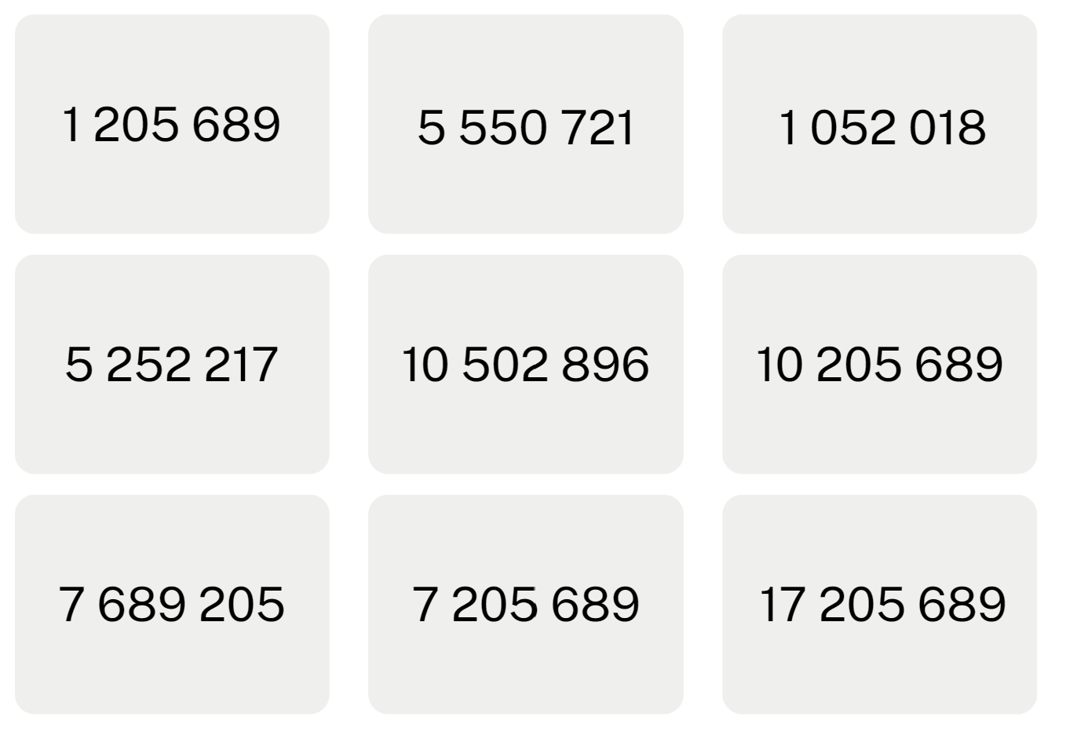
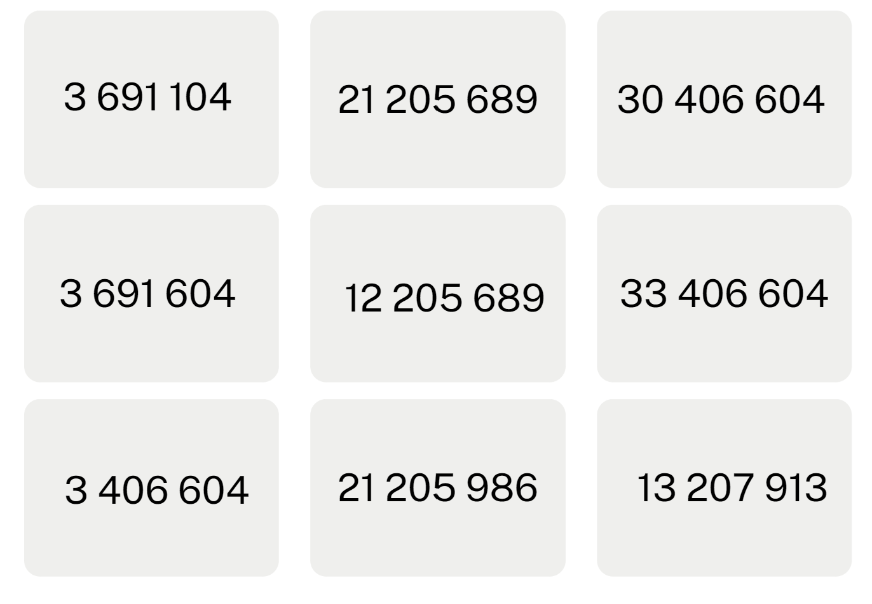
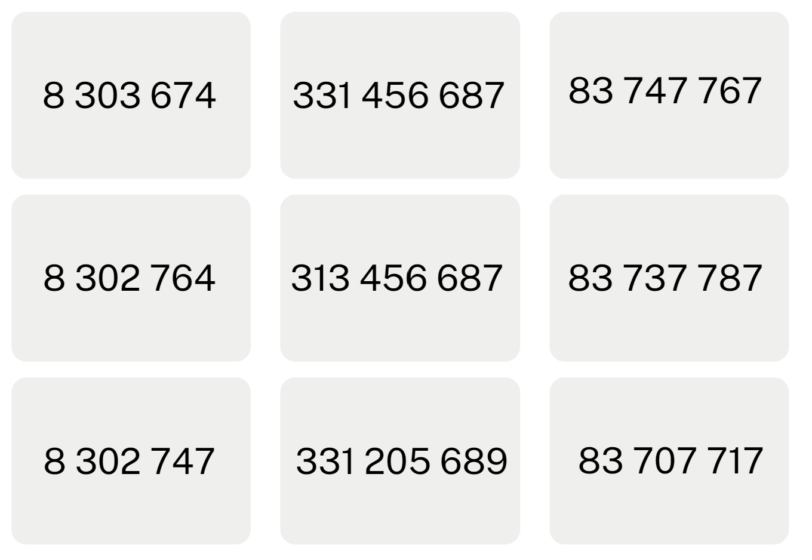
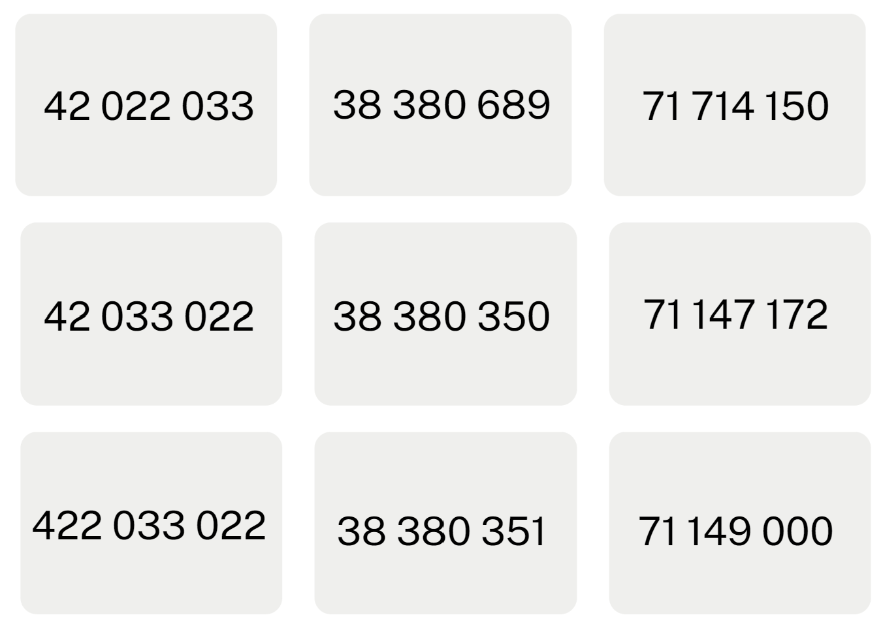

Resource 7: Line graph example
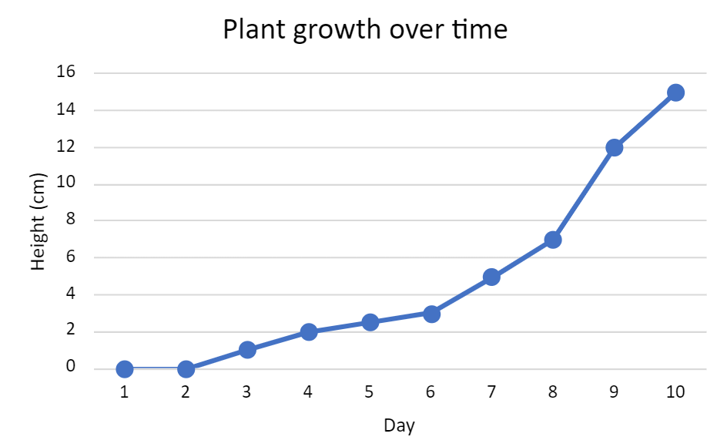

Resource 8: Data investigation
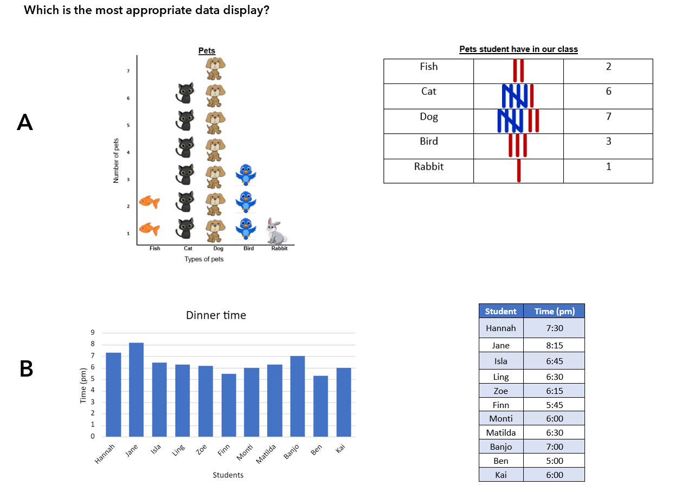
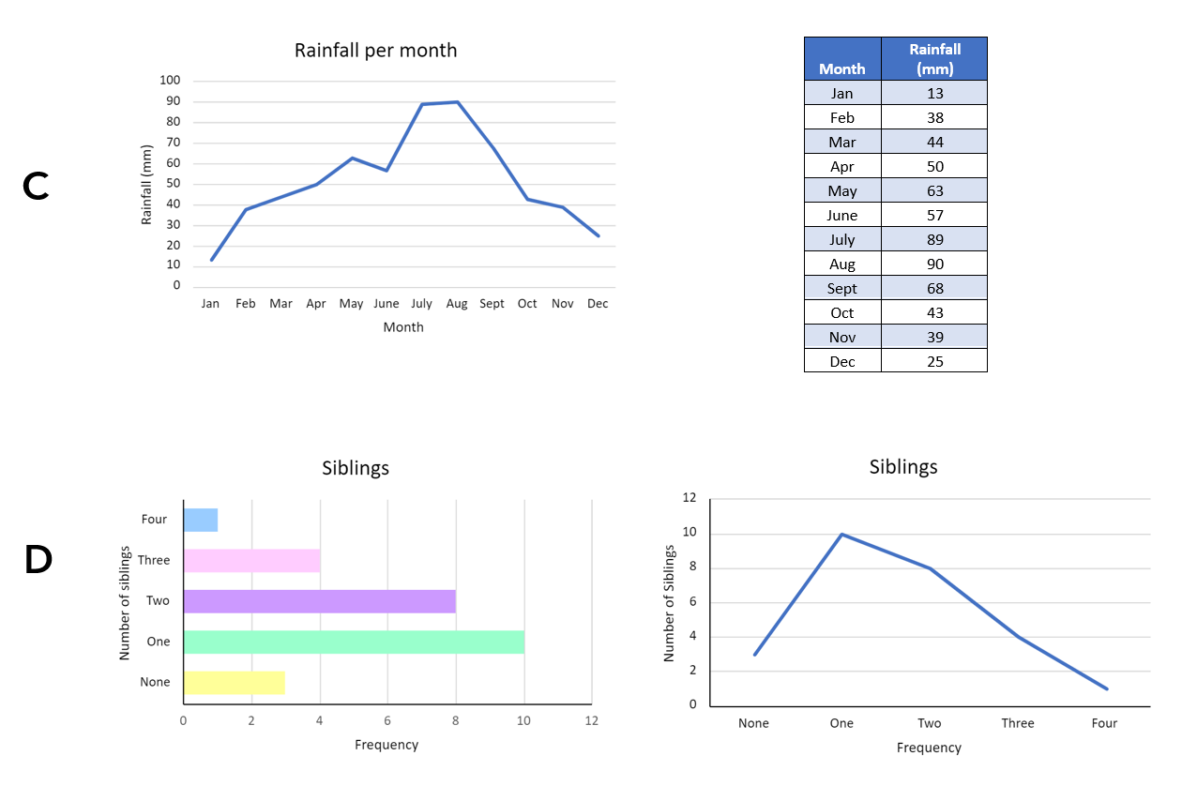

Resource 9: Slow reveal table
Image 1
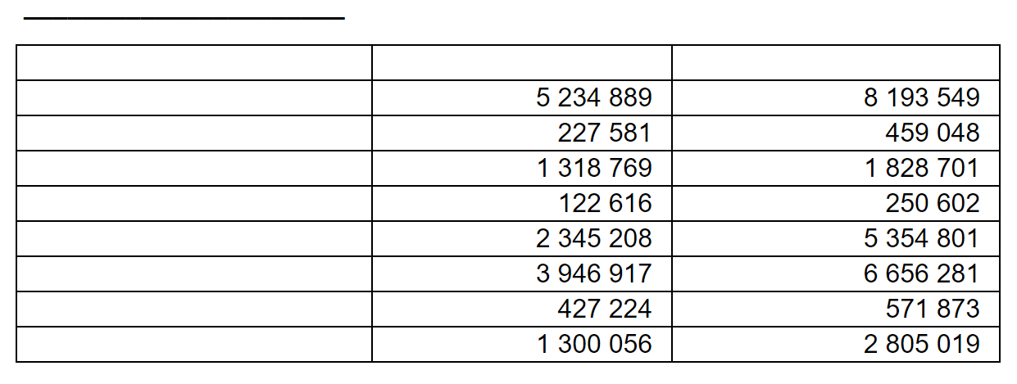
Image 2
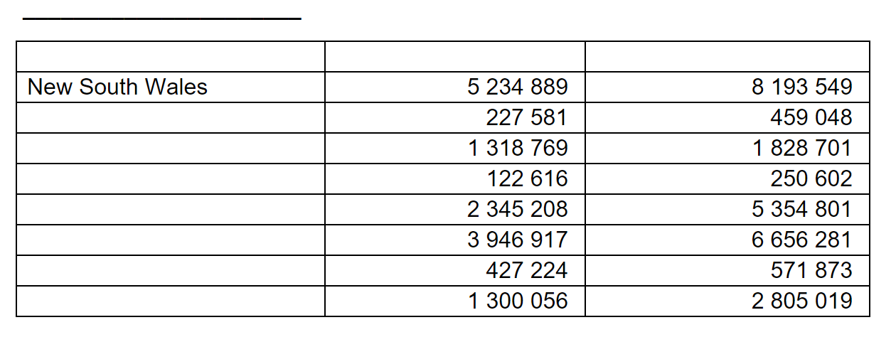
Image 3
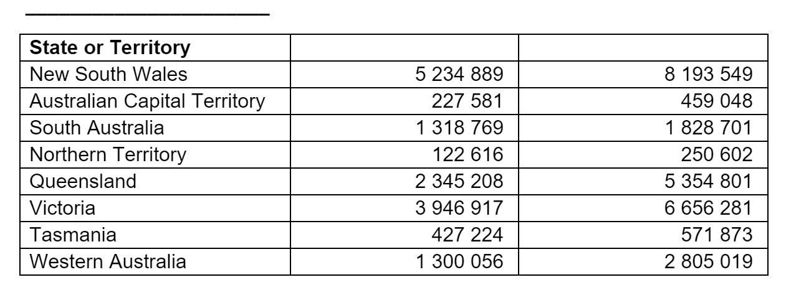
Image 4
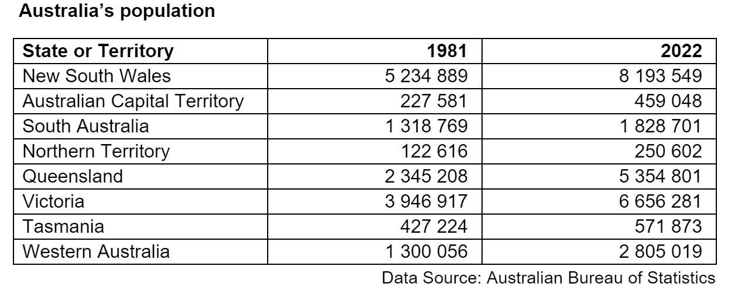

Resource 10: Population data
Country | Population
Australia | 25 498 884
Bangladesh | 164 689 383
Brazil | 212 559 417
Ethiopia | 114 963 588
Germany | 83 783 942
Indonesia | 273 523 615
Iran | 83 992 949
Mexico | 128 932 553
Pakistan | 220 892 340
Philippines | 109 581 078
Russia | 145 934 462
Turkey | 84 333 067
USA | 331 002 651
Vietnam | 97 338 579
Data sourced from Worldometer (2023)

Resource 11: Australia’s population by state or territory
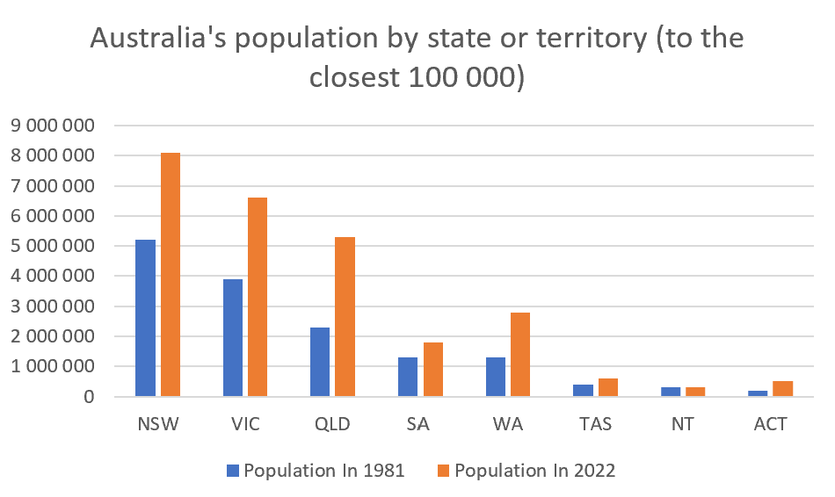
Data sourced from Australian Bureau of Statistics

Resource 12: Example timeline
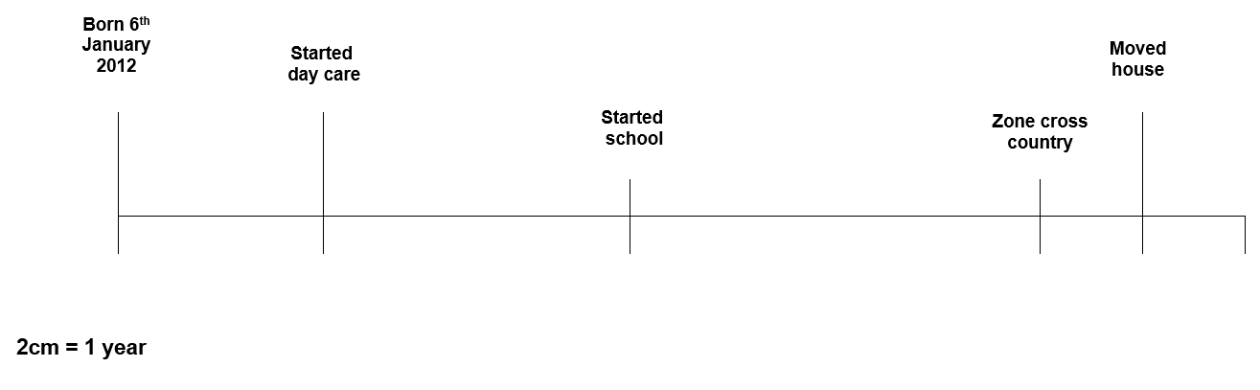

Resource 13: Australian gold rush
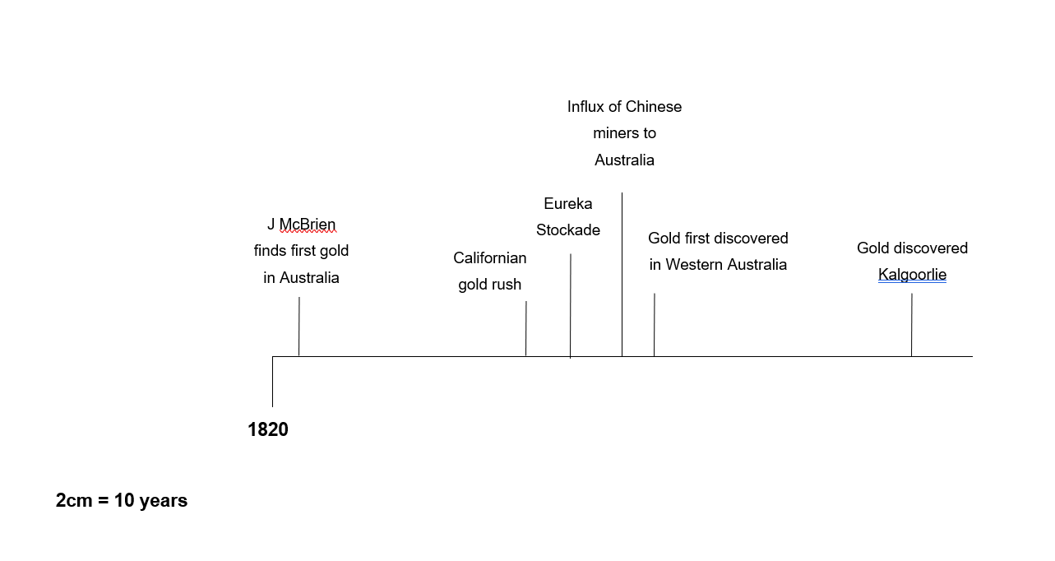

Resource 14: Temperature in Australia over time
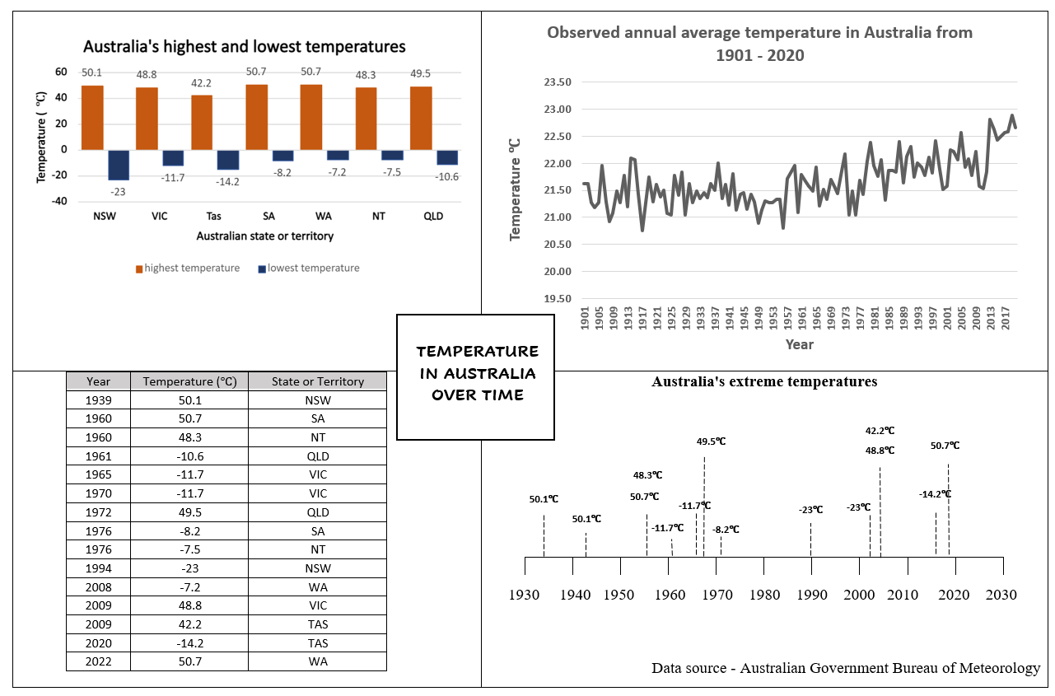

Resource 15: Triple Venn diagram
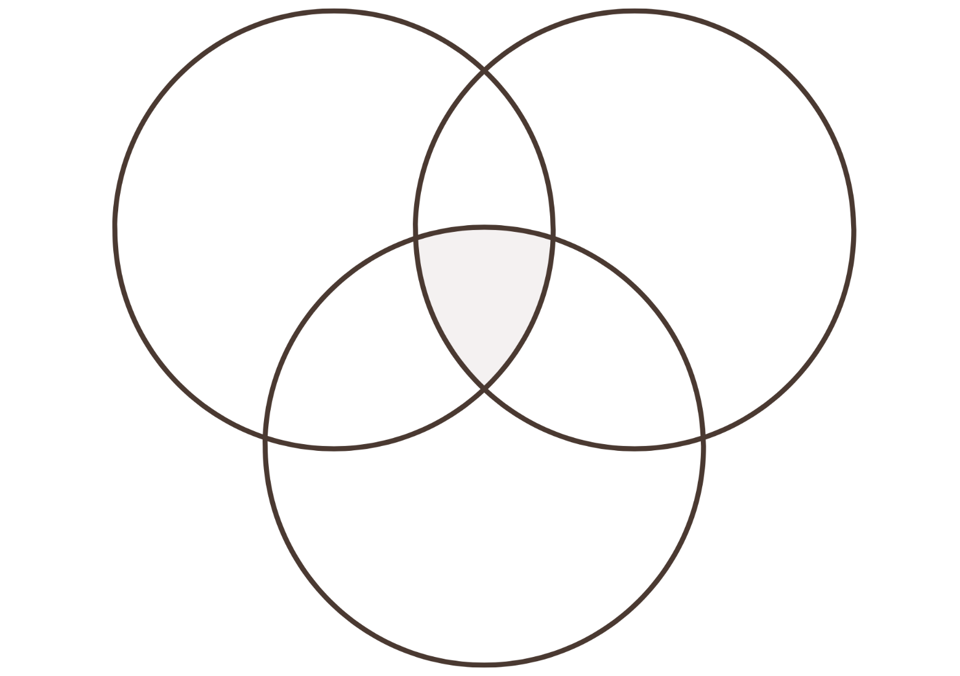

Resource 16: Extreme temperatures recorded as integers
Year | Temperature (°C) | State or Territory
1939 | 50 | NSW
1960 | 51 | SA
1960 | 48 | NT
1961 | -11 | QLD
1965 | -12 | VIC
1970 | -12 | VIC
1972 | 50 | QLD
1976 | -8 | SA
1976 | -8 | NT
1994 | -23 | NSW
2008 | -7 | WA
2009 | 49 | VIC
2009 | 42 | TAS
2020 | -14 | TAS
2022 | 51 | WA

Resource 17: Which one doesn’t belong?
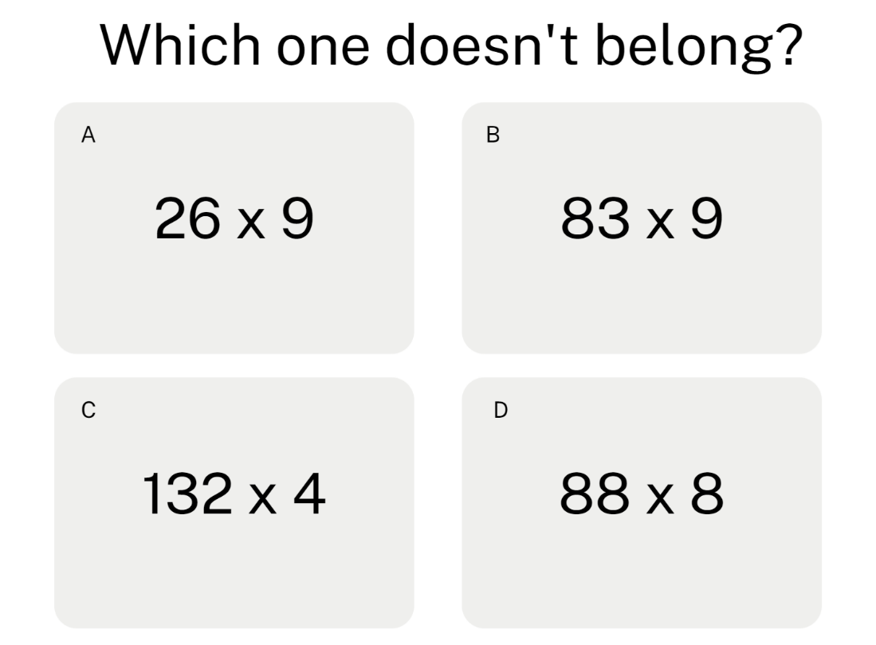

Resource 18: Unlabelled line graph
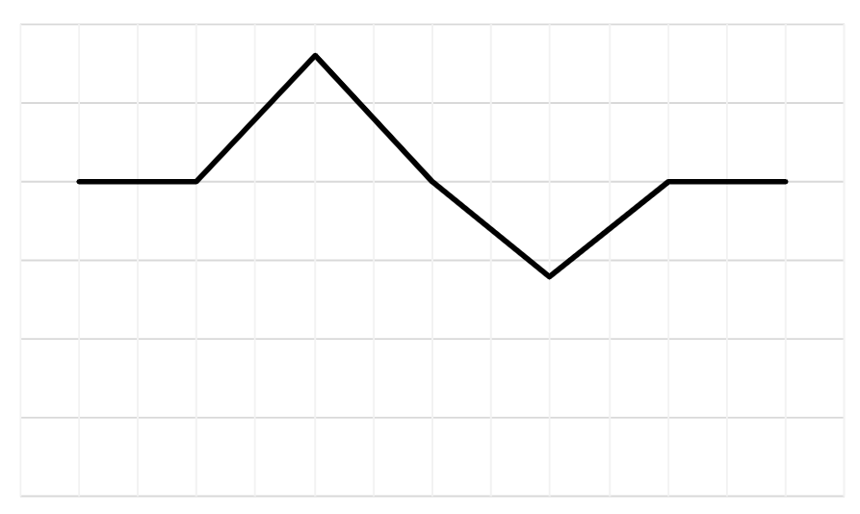

Resource 19: Table of data
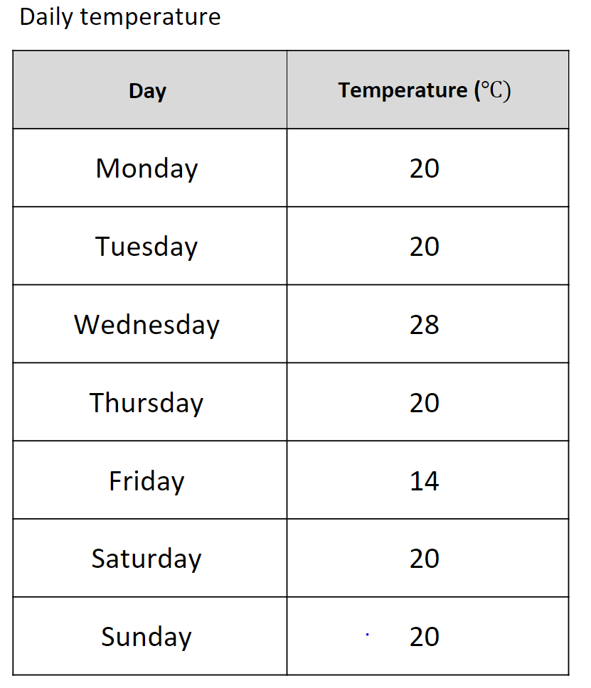

Resource 20: Solar system distances graph
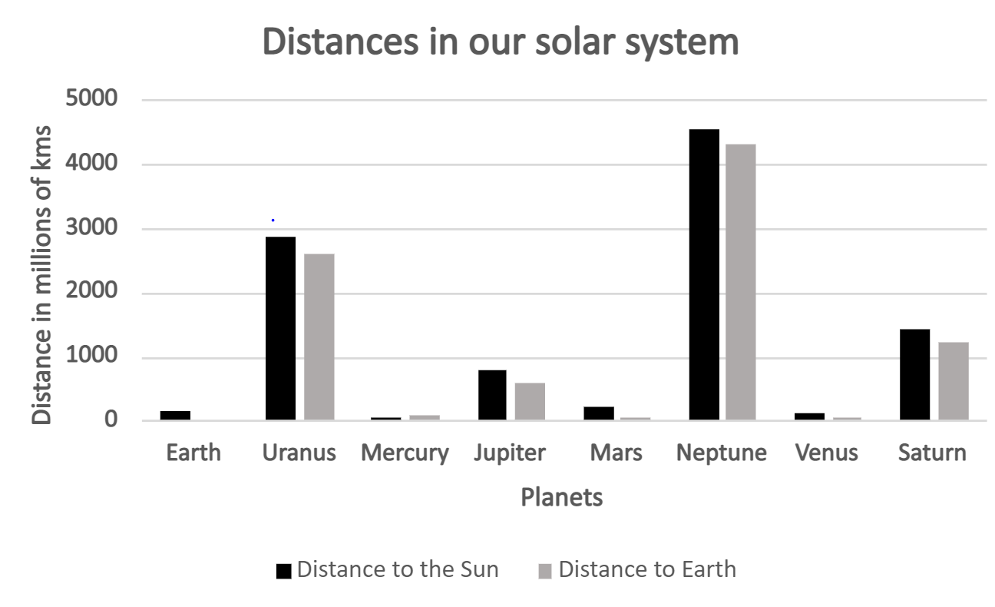
Data sourced from NASA (2023)

Resource 21: Solar system distances table
Planet | Distance to the Sun (km) | Distance to Earth (km)
 | 4 530 000 000 | 4 311 020 000
 | 1 437 000 000 | 1 204 280 000
Mercury | 57 000 000 | 82 500 000
 | 780 000 000 | 591 970 000
Mars | 228 000 000 | 55 650 000
 | 2 871 000 000 | 2 586 880 000
Venus | 108 000 000 | 39 790 000
 | 149 000 000 | 0
Data sourced from NASA (2023)

Resource 22: Melting ice
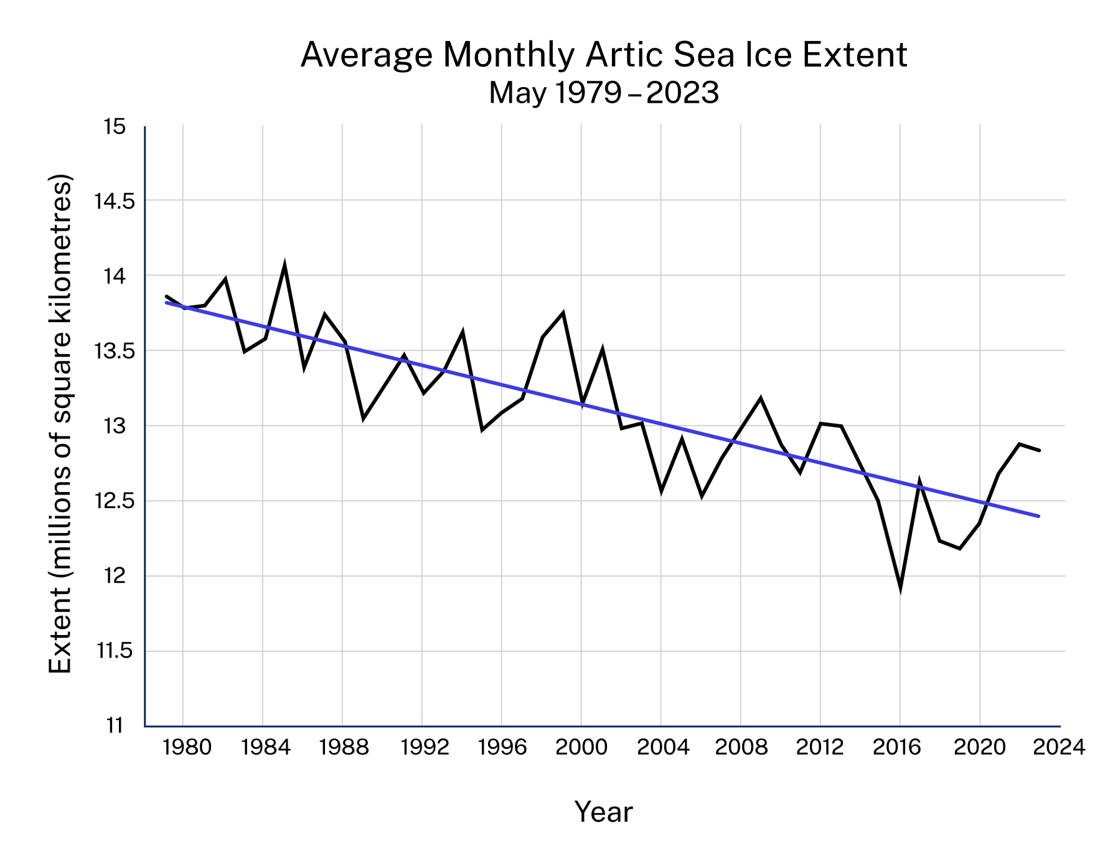
Data sourced from National Snow and Ice Data Center (2023)

Resource 23: Misleading graphs
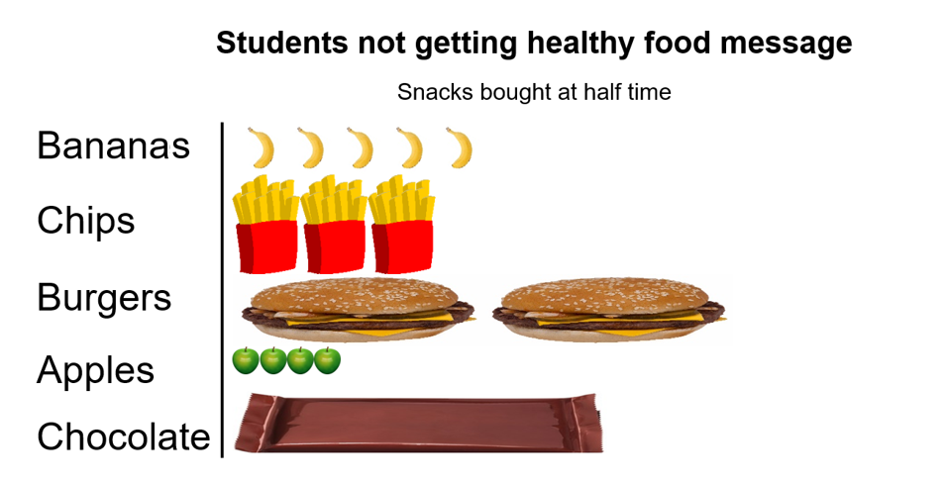
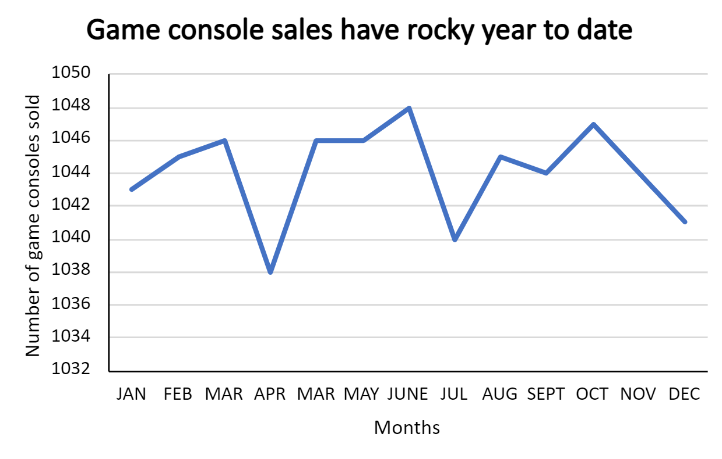
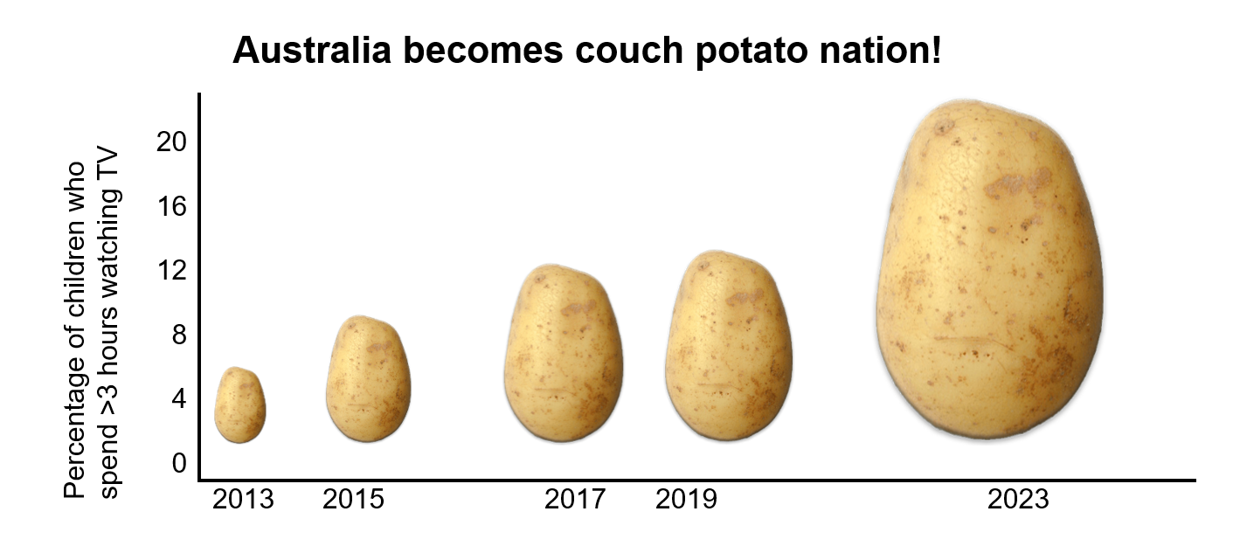
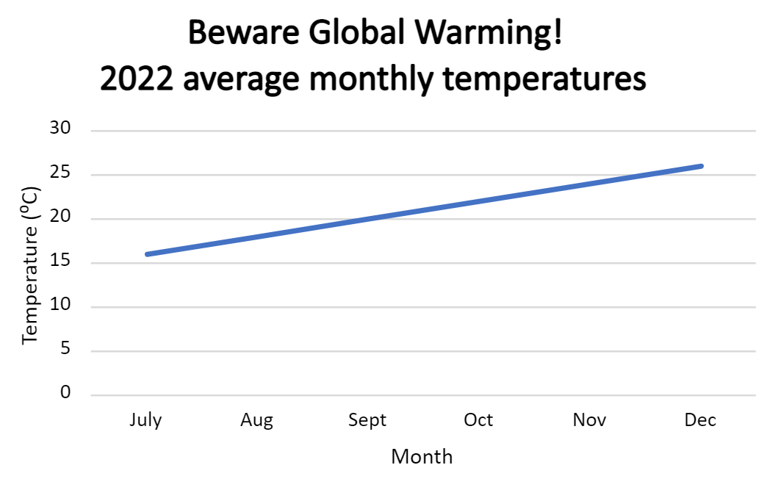

Syllabus outcomes and content
The table below outlines the syllabus outcomes and range of relevant syllabus content covered in this unit. Content is linked to National Numeracy Learning Progression version (3).
Outcomes and content | 1 | 2 | 3 | 4 | 5 | 6 | 7 | 8
Represents numbers A: Whole numbers: Recognise, represent and order numbers in the millions
MAO-WM-01, MA3-RN-01
- Name millions using the place value grouping of ones, tens and hundreds | x | x |  |  |  |  | x
- Arrange numbers in the millions in ascending and descending order using place value |  |  | x | x |  |  | x
- Round numbers to a specified place value |  | x |  |  |  |  | x
Represents numbers A: Decimals and percentages: Recognise that the place value system can be extended beyond hundredths
MAO-WM-01, MA3-RN-02
- Express thousandths as decimals |  | x
- Interpret decimal notation for thousandths |  | x
- Indicate the place value of digits in decimal numbers of up to 3 decimal places |  | x
Represents numbers A: Decimals and percentages: Compare, order and represent decimals
MAO-WM-01, MA3-RN-02
- Compare and order decimal numbers of up to 3 decimal places |  | x
- Interpret zero digit(s) at the end of a decimal |  | x
- Place decimal numbers of up to 3 decimal places on a number line |  | x
Represents numbers B: Whole numbers: Locate and represent integers on a number line
MAO-WM-01, MA3-RN-01
- Recognise the location of negative whole numbers in relation to zero and place them on a number line |  |  |  |  |  | x
- Use the term integers to describe positive and negative whole numbers and zero |  |  |  |  |  | x
- Interpret integers in everyday contexts |  |  |  |  |  | x
Multiplicative relations A: Use partitioning and place value to multiply 2-, 3- and 4-digit numbers by one-digit numbers
MAO-WM-01, MA3-MR-01
- Use mental strategies to multiply one-digit numbers by 10, 100, 1000 and their multiples |  |  |  |  | x | x | x
- Use informal written strategies such as the area model to solve multiplication and division problems |  |  |  |  | x | x | x
- Use the distributive property with the area model to partition numbers in representing multiplication problems |  |  |  |  | x | x | x
- Use the distributive property with partial products to solve problems by multiplying the hundreds, then the tens and then the ones |  |  |  |  | x | x | x
Data A: Collect categorical and discrete numerical data by observation or survey
MAO-WM-01, MA3-DATA-01
- Pose and refine questions to construct a survey to obtain categorical or discrete numerical data about a matter of interest | x | x
- Collect ordinal or nominal categorical data, and discrete numerical data through observation or by conducting surveys | x | x | x
Data A: Choose and use appropriate tables and graphs
MAO-WM-01, MA3-DATA-01
- Tabulate collected data with and without the use of digital technologies such as spreadsheets | x | x |  | x
- Recognise which types of data display are appropriate to represent data (Statistical reasoning) |  |  | x |  |  |  |  | x
- Determine an appropriate scale (horizontal and vertical) to represent the data |  |  | x | x |  |  |  | x
- Construct column graphs using a many-to-one scale, with and without the use of digital technologies |  |  | x | x |  |  |  | x
- Draw an accurate timeline using an appropriate scale |  |  |  |  | x
Data A: Describe and interpret different datasets in context
MAO-WM-01, MA3-DATA-02
- Interpret line graphs using the scales on the axes |  |  |  |  |  |  | x | x
- Describe and interpret data presented in tables, column graphs and line graphs |  |  | x |  |  | x | x | x
- Determine the total number of data values represented in column graphs |  |  | x
Data B: Interpret and compare a range of data displays
MAO-WM-01, MA3-DATA-02
- Interpret side-by-side column graphs for 2 categorical variables |  |  |  | x |  | x | x
- Interpret data on a timeline using the given scale |  |  |  |  | x
- Interpret and compare different displays in terms of the shape of the distribution, including the range and the most frequent value (mode) |  |  |  |  |  |  | x
Data B: Interpret data presented in digital media and elsewhere
MAO-WM-01, MA3-DATA-02
- Interpret data representations found in digital media and in factual texts |  |  |  |  |  |  |  | x
- Identify sources of possible bias in representations of data in the media (Statistical reasoning) |  |  |  |  |  |  |  | x
- Identify misleading representations of data in the media |  |  |  |  |  |  |  | x
Mathematics K–10 Syllabus © NSW Education Standards Authority (NESA) for and on behalf of the Crown in right of the State of New South Wales, 2022.

References
This resource contains NSW Curriculum and syllabus content. The NSW Curriculum is developed by the NSW Education Standards Authority. This content is prepared by NESA for and on behalf of the Crown in right of the State of New South Wales. The material is protected by Crown copyright.
Please refer to the NESA Copyright Disclaimer for more information https://educationstandards.nsw.edu.au/wps/portal/nesa/mini-footer/copyright.
NESA holds the only official and up-to-date versions of the NSW Curriculum and syllabus documents. Please visit the NSW Education Standards Authority (NESA) website https://educationstandards.nsw.edu.au/ and the NSW Curriculum website https://curriculum.nsw.edu.au/home.
Mathematics K–10 Syllabus © NSW Education Standards Authority (NESA) for and on behalf of the Crown in right of the State of New South Wales, 2022.
National Numeracy Learning Progression © Australian Curriculum, Assessment and Reporting Authority (ACARA) 2010 to present, unless otherwise indicated. This material was downloaded from the Australian Curriculum website (National Literacy Learning Progression) (accessed 31 August 2023) and was not modified.
Australian Government Department of Education (2020) ‘Data: Making Decisions’, Teaching resources, reSolve: Maths by Inquiry website, accessed 18 June 2023.
Australian Sports Commission (2023) ‘AusPlay National data tables – January 2022 to December 2022’, Clearinghouse for Sport website, accessed 21 June 2023.
Commonwealth of Australia (2023) National, state and territory population, Australian Bureau of Statistics website, accessed 21 June 2023.
Commonwealth of Australia (2023) Rainfall and temperature records, Australian Bureau of Meteorology website, accessed 21 June 2023.
Diezmann C, Lowrie T, Sugars L and Logan T (2009) ‘The Visual Side to Numeracy: Students' Sensemaking with Graphics’, Australian Primary Mathematics Classroom, 16–20.
NASA (2023) ‘Planetary fact sheet’, NASA website, accessed 21 June 2023.
National Snow and Ice Data Center (2023) Artic Sea Ice News and Analysis, National Snow and Ice Data Center website, accessed 21 June 2023.
New Zealand Ministry of Education (n.d.) ‘Data Distortion’, Resource Finder, NZ Maths website, accessed 16 June 2023.
New Zealand Ministry of Education (n.d.) ‘Discussing Data’, Resource Finder, NZ Maths website, accessed 15 June 2023.
New Zealand Ministry of Education (n.d.) ‘Planning a statistical investigation (Level 3)’, Resource Finder, NZ Maths website, accessed 14 June 2023.
State of New South Wales (Department of Education) (n.d.) ‘Let's talk 2 – number talk (15 x 9) Stage 3’, Mathematics K-6 resources, NSW Department of Education website, accessed 15 June 2023.
State of New South Wales (Department of Education) (n.d.) 'Reaction time test’, Mathematics K-6 resources, NSW Department of Education website, accessed 14 June 2023.
Sullivan P and Lilburn P (2017) Open-ended Maths Activities: Using ‘Good’ Questions to Enhance Learning in Mathematics, Revised edn, Oxford University Press ANZ, Great Britain.
Worldometers.info (n.d.) ‘Countries in the world by population (2023)’, Population by Country, Worldometers.info website, accessed 21 June 2023.
Stanford Graduate School of Education (2020) Melting Arctic Ice [PDF 330 KB], youcubed, accessed 4 September 2023.

© State of New South Wales (Department of Education), 2023
The copyright material published in this resource is subject to the Copyright Act 1968 (Cth) and is owned by the NSW Department of Education or, where indicated, by a party other than the NSW Department of Education (third-party material).
Copyright material available in this resource and owned by the NSW Department of Education is licensed under a Creative Commons Attribution 4.0 International (CC BY 4.0) license.
This license allows you to share and adapt the material for any purpose, even commercially.
Attribution should be given to © State of New South Wales (Department of Education), 2023.
Material in this resource not available under a Creative Commons license:
- the NSW Department of Education logo, other logos and trademark-protected material
- material owned by a third party that has been reproduced with permission. You will need to obtain permission from the third party to reuse its material.
Links to third-party material and websites
Please note that the provided (reading/viewing material/list/links/texts) are a suggestion only and implies no endorsement, by the New South Wales Department of Education, of any author, publisher, or book title. School principals and teachers are best placed to assess the suitability of resources that would complement the curriculum and reflect the needs and interests of their students.
If you use the links provided in this document to access a third-party's website, you acknowledge that the terms of use, including licence terms set out on the third-party's website apply to the use which may be made of the materials on that third-party website or where permitted by the Copyright Act 1968 (Cth). The department accepts no responsibility for content on third-party websites.

