Mathematics Stage 3 – Unit 26

Contents
Unit description and duration 5
Syllabus outcomes 5
Working mathematically 6
Student prior learning 6
Lesson overview and resources 8
Lesson 1 12
Daily number sense – four piles – 10 minutes 12
Core lesson – naming and representing numbers – 40 minutes 14
Consolidation and meaningful practice – 10 minutes 16
Lesson 2 19
Daily number sense – show us how – 10 minutes 19
Core lesson – numbers up to and including billions – 30 minutes 20
Consolidation and meaningful practice – 20 minutes 23
Lesson 3 25
Daily number sense: Which doesn’t belong? – 10 minutes 25
Core lesson – decimals up to the thousandths – 35 minutes 27
Consolidation and meaningful practice – 15 minutes 30
Lesson 4 33
Daily number sense – 10 minutes 33
Core lesson – comparing decimals – 40 minutes 33
Discuss and connect the mathematics – 20 minutes 36
Lesson 5 38
Daily number sense – dicey operations – 10 minutes 38
Core lesson – interpreting decimals up to thousands – 40 minutes 40
Discuss and connect the mathematics – 10 minutes 42
Lesson 6 44
Daily number sense – prove it – 10 minutes 44
Core lesson 1 – adding and subtracting decimals – 15 minutes 45
Core lesson 2 – multiple strategies – 35 minutes 47
Discuss and connect the mathematics – 10 minutes 48
Lesson 7 50
Daily number sense – How many trucks? – 10 minutes 50
Core lesson – adding decimals – 40 minutes 52
Discuss and connect the mathematics – 10 minutes 54
Lesson 8 56
Daily number sense – 15 minutes 56
Core lesson – decimal subtraction face-off – 30 minutes 56
Consolidation and meaningful practice – 15 minutes 58
Resource 1 – four piles 60
Resource 2 – prompting questions 61
Resource 3 – show us how 62
Resource 4 – misconceptions 63
Resource 5 – Less or greater? 64
Resource 6 – athletics carnival 65
Resource 7 – fitness scores 66
Resource 8 – prove it 67
Resource 9 – thousandths word problems 68
Resource 10 – graphic organiser 69
Resource 11 – tenths word problems 70
Resource 12 – multistep problems 71
Resource 13 – How many trucks? 72
Resource 14 – swimming pool designs 73
Resource 15 – explanation spinner 74
Syllabus outcomes and content 75
References 81
Further reading 82

Unit description and duration
This unit develops the big idea that the number system extends infinitely to very large and very small numbers.
In this 2-week unit students are provided opportunities to:
- read, partition, rename, represent and order numbers up to and including billions
- compare, order and represent decimals
- apply place value knowledge and known strategies when solving addition and subtraction problems for whole numbers and decimals.

Syllabus outcomes
- MAO-WM-01 develops understanding and fluency in mathematics through exploring and connecting mathematical concepts, choosing and applying mathematical techniques to solve problems, and communicating their thinking and reasoning coherently and clearly
- MA3-RN-01 applies an understanding of place value and the role of zero to represent the properties of numbers
- MA3-RN-02 compares and orders decimals up to 3 decimal places
- MA3-AR-01 selects and applies appropriate strategies to solve addition and subtraction problems
- MA3-GM-02 selects and uses the appropriate unit and device to measure lengths and distances including perimeters

Working mathematically
In the Mathematics K–10 Syllabus, there is one overarching Working mathematically outcome (MAO-WM-01). The Working mathematically processes should be embedded within the concepts being taught. The Working mathematically processes are:
- communicating
- understanding and fluency
- reasoning
- problem solving.
Mathematics K–10 Syllabus © NSW Education Standards Authority (NESA) for and on behalf of the Crown in right of the State of New South Wales, 2022.

Student prior learning
Before engaging in these teaching and learning activities, students would benefit from prior experience with:
- reading, representing and ordering numbers up to millions
- standard and non-standard partitioning of numbers up to millions
- using a variety of addition and subtraction strategies flexibly.

In NSW classrooms there is a diverse range of students, including Aboriginal and Torres Strait Islander students, students learning English as an additional language or dialect, high potential and gifted students and students with disability. Some students may identify with more than one of these groups or possibly all of them. Refer to Curriculum planning for every student – advice for further information.

Lesson overview and resources
The table below outlines the sequence and approximate timing of lessons, learning intentions and resources.
Lesson | Content | Duration and resources
Lesson 1  Daily number sense learning intention:  - choose and use efficient strategies to solve addition and subtraction problems | Lesson core concept: the position of each digit in a number corresponds to its size  Core concept learning intention:  - recognise the position of the digit corresponds to its size | Lesson duration: 60 minutes  - Resource 1 – four piles  - Resource 2 Prompting questions  - Individual whiteboards  - Sticky notes  - Variety of objects – 100 per pair  - Writing materials
Lesson 2  Daily number sense learning intention:  - choose and use efficient strategies to solve addition and subtraction problems | Lesson core concept: numbers can be renamed in a variety of equivalent ways  Core concept learning intention:  - apply place value understanding to represent the properties of numbers | Lesson duration: 60 minutes  - Resource 3 – show us how  - Resource 4 – misconceptions  - Live population counter  - Large paper  - Individual whiteboards  - Writing materials
Lesson 3  Daily number sense learning intention:  - choose and use efficient strategies to solve addition and subtraction problems | Lesson core concept: the place value system can be extended  Core concept learning intention:  - recognise that the place value system can be extended beyond hundredths | Lesson duration: 60 minutes  - Resource 5 – Less or greater?  - 6-sided dice (3 per pair)  - Masking tape  - Sticky notes  - String  - Writing materials
Lesson 4  Daily number sense learning intention:  - teacher-identified task based on student needs | Lesson core concept: zero in decimals play an important role  Core concept learning intention:  - apply place value knowledge to decimals up to 3-decimal places | Lesson duration: 70 minutes  - Resource 6 – athletics carnival  - Resource 7 – fitness scores  - Writing materials
Lesson 5  Daily number sense learning intention:  - use estimation and place value understanding to determine the reasonableness of solutions | Lesson core concept: decimals can be compared by analysing the place values parts  Core concept learning intention:  - read, write and record decimal notation to the thousandths | Lesson duration: 60 minutes  - Resource 6 – athletics carnival  - Resource 7 – fitness scores  - 9-sided dice  - Individual whiteboards  - Writing materials
Lesson 6  Daily number sense learning intention:  - use estimation and place value understanding to determine the reasonableness of solutions | Lesson core concept: place value understanding helps solve addition and subtraction problems  Core concept learning intention:  - apply known strategies to solve addition and subtraction problems | Lesson duration: 70 minutes  - Resource 8 – prove it  - Resource 9 – thousandths word problems  - Resource 10 – graphic organiser  - Resource 11 – tenths word problems  - Resource 12 – multistep problems  - Writing materials
Lesson 7  Daily number sense learning intention:  - use estimation and place value understanding to determine the reasonableness of solutions | Lesson core concept: known strategies for addition can be applied to decimals  Core concept learning intention:  - apply known additive strategies to solve problems involving length | Lesson duration: 60 minutes  - Resource 13 – How many trucks?  - Resource 14 – swimming pool designs  - Writing materials
Lesson 8  Daily number sense learning intention:  - teacher-identified task based on student needs | Lesson core concept: known strategies for subtraction can be applied to decimals  Core concept learning intention:  - apply known strategies to add and subtract decimals | Lesson duration: 60 minutes  - Resource 15 – explanation spinner  - Playing cards (Ace-9) – one set per pair  - Writing materials

Lesson 1
Core concept: the position of each digit in a number corresponds to its size.

Daily number sense – four piles – 10 minutes
Daily number sense activities for Lessons 1 to 3 ‘activate’ prior number knowledge and support the learning of new content in the unit. These activities can also assist teachers to identify the starting points for learning by revealing the extent of students’ existing knowledge.
The table below contains a suggested learning intention and success criteria. These are best co-constructed with students.
Daily number sense learning intention | Daily number sense success criteria
Students are learning to:  - choose and use efficient strategies to solve addition and subtraction problems. | Students can:  - compare, evaluate and communicate strategies used to solve addition and subtraction problems.
This activity is an adaptation of ‘Task 3 – Four Piles Problem’ from 3-6 – Remote Maths – Edition 9 [PDF 589 KB] by Mathematical Association of Victoria.
- Students work independently or in pairs, using one set of 100 objects.
- Display Resource 1 – four piles.
- Students distribute the 100 objects by following the instructions on Resource 1 – four piles, recording their working on a whiteboard.
- When they have solved the problem, students share their ideas with another student or group, justifying their reasoning.
- Ask students to make their own problem for a partner to solve.
Note: for this activity, the objects could be any small things found around a classroom such as counters, blocks, cubes and so on. Pairs do not have to have the same type of object.
This table details opportunities for assessment.
Assessment opportunities | Links
What to look for:  - Can students compare, evaluate and communicate strategies used to solve addition and subtraction problems? [MAO-WM-01, MA3-RN-01, MA3-AR-01] | Links to National Numeracy Learning Progressions (NNLP):  - AdS7, AdS8.

Core lesson – naming and representing numbers – 40 minutes
The table below contains suggested learning intentions and success criteria. These are best co-constructed with students.
Core concept learning intentions | Core concept success criteria
Students are learning to:  - recognise the position of the digit corresponds to its size. | Students can:  - name and order numbers up to and including billions  - ask questions to determine the value of a number  - round numbers to a specified place value.
- Draw a place value house up to billions onto the board.
- Use the place value house to model how to read and write a number up to the billions (see Figure 1).
Figure 1 – place value house to billions
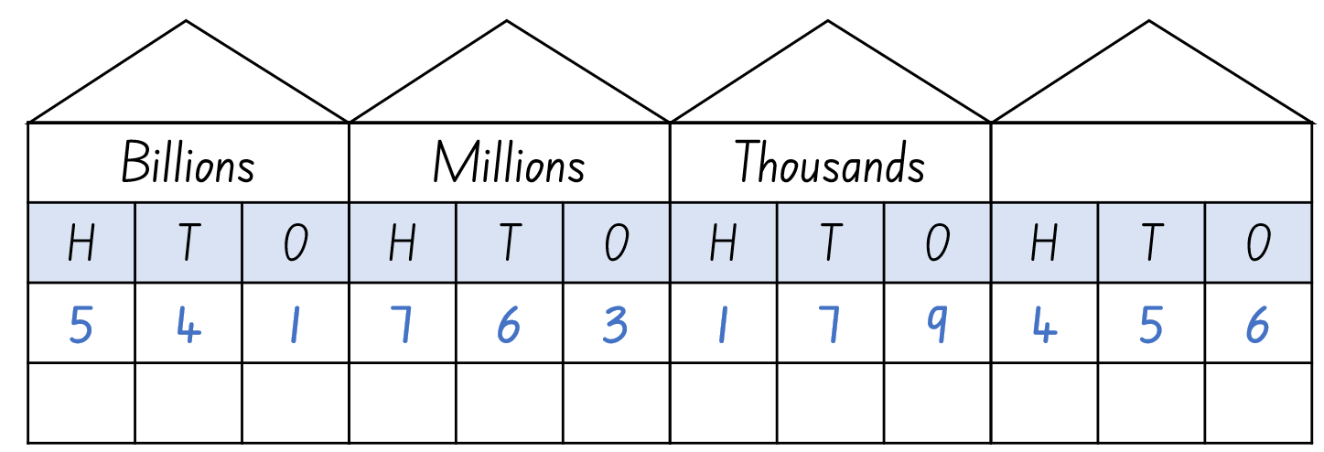
- Students draw their own place value houses on a whiteboard and write a number up to the billions into their place value house.
- In pairs, students turn and talk to practise reading their number aloud.
- Select a student to read their number aloud to the class.
- Ask the student to write their number onto the whiteboard.
- Ask another student to read their number aloud to the class and model using place value knowledge to write their number on the whiteboard, either before or after the previous student’s number, depending on where it would belong if the numbers were in order from smallest to largest. Highlight to students which numbers to look at first when placing numbers in ascending order.
- In groups of 5, ask students to order their numbers in ascending order explaining their reasoning.
- Group students into teams of 3-4 and provide each team with a copy of Resource 2 – prompting questions.
- Introduce the game ‘Place value hotseat’ and explain that Player A from each group will sit in the hotseat. The rest of the team will work together to create a number up to the millions and write this number on a sticky note where Player A cannot see it.
- Player A can use Resource 2 – prompting questions to assist them in guessing the number their team has written on the sticky note. All questions can only be answered with yes or no answers.
- Player A can use a whiteboard to keep track of the answers they have received.
- Once player A has named the number, they take the sticky note and place it onto the whiteboard.
- A different team member takes a seat on the hotseat and they become Player A.
- Repeat this process until every team member has sat in the hotseat.
- Explain to students that once they have named the number, they must place their sticky note on the whiteboard in relation to the first players number so that the numbers are in order from smallest to largest. Students may need to move numbers to allow the numbers to be placed in ascending order.
This table details opportunities for differentiation.
Too hard? | Too easy?
Students cannot read, write and order numbers up to and including millions.  - Provide students with the opportunity to work with smaller numbers.  - Provide students with MAB materials and have them make and name large numbers. | Students can read, write and order numbers up to and including millions.  - Reduce the number range for students to guess and order. For example, the numbers need to be between 4 million and 5 million.  - In pairs, students read a list of clues about a number to their partner. The partner listens to the clues and guesses the number. Repeat with roles swapped.

Consolidation and meaningful practice – 10 minutes
- Read a number up to billions aloud.
- Students record the number on their whiteboards.
- Students share the number they recorded with a partner to check accuracy.
- Ask students to round the number up or down to the nearest ten, hundred, thousand, million or billion.
- Students record the new number on their whiteboards.
- Students share the number they recorded with a partner, justifying their reasoning.
- Repeat activity varying the number students are to round their number to.
This table details opportunities for differentiation.
Too hard? | Too easy?
Students cannot round numbers to a specified place value.  - Provide students with a support structure such as hundreds chart, number line, manipulatives (physical or virtual) to assist them when rounding.  - Assist students by reducing the size of the numbers the students are asked to round. | Students can round numbers to a specified place value.  - Challenge students to use the same number but round it several different times. For example, round their number to the nearest hundred, tens of thousands, million and billion. Compare answers with a classmate.  - Students work in pairs. Player A rolls a 9-sided dice 12 times to create a number into the billions for both players to use. Player B announces what number they will be rounding to. Both partners then round their number accordingly, comparing answers and justifying their reasoning. Repeat and swap roles.
This table details opportunities for assessment.
Assessment opportunities | Links
What to look for:  - Can students read, write and order numbers up to and including millions? [MAO-WM-01, MA3-RN-01]  - Can students ask questions to determine the value of a number? [MAO-WM-01, MA3-RN-01]  - Can students round numbers to a specified place value? [MAO-WM-01, MA3-RN-01] | Links to National Numeracy Learning Progressions (NNLP):  - NPV6, NPV7.

Lesson 2
Core concept: numbers can be renamed in a variety of equivalent ways.

Daily number sense – show us how – 10 minutes
The table below contains a suggested learning intention and success criteria. These are best co-constructed with students.
Daily number sense learning intention | Daily number sense success criteria
Students are learning to:  - choose and use efficient strategies to solve addition and subtraction problems. | Students can:  - compare, evaluate and communicate the strategies used to solve addition and subtraction problems.
This activity is an adaptation of ‘Task 3 – Addition’ from 3-6 – Remote Maths – Edition 2 [PDF 417 KB] by Mathematical Association of Victoria.
- As a class, discuss the various ways addition problems can be represented and solved.
- Display Resource 3 – show us how.
- Explain that students must choose one of the equations from the table and then use it to complete each of the 4 tasks.
- When they have completed the tasks, students choose another student who completed the same equation to compare representations and solutions.
This table details opportunities for assessment.
Assessment opportunities | Links
What to look for:  - Can students compare, evaluate and communicate the strategies used to solve addition and subtraction problems? [MAO-WM-01, MA3-RN-01, MA3-AR-01] | Links to National Numeracy Learning Progressions (NNLP):  - AdS7, AdS8.  Links to suggested Interview for Student Reasoning (IfSR) tasks:  - IfSR-AT: 3A.4.

Core lesson – numbers up to and including billions – 30 minutes
The table below contains suggested learning intentions and success criteria. These are best co-constructed with students.
Core concept learning intentions | Core concept success criteria
Students are learning to:  - apply place value understanding to represent the properties of numbers. | Students can:  - recognise and represent numbers up to and including millions  - apply place value knowledge to rename numbers using non-standard partitioning up to billions.
- Display Resource 4 – misconceptions.
- Students turn and talk to discuss the 4 answers.
- Discuss that there are 2 correct answers. For example, Daniel has used his knowledge of our place value system to know that we need to extend it past hundreds of millions. This is because our place value system is organised into groups of hundreds, tens and ones. The number after 999 999 999 is one billion. This number can also be renamed as 1000 millions, making Javis also correct.
Note: students need to apply their place value knowledge to partition, regroup and rename numbers to one billion by recognising that 1000 millions are the same as one billion.
- Display a Live Population Counter and model reading the current world population.
- Invite students to read other numbers displayed. For example, births and deaths or population growth.
- Navigate to a list showing the top 20 largest countries by population. Select a country and display their population on the board.
- Model how to rename the number using non-standard partitioning and invite students to rename the same number in a different way.
Figure 2 – partitioning of German population
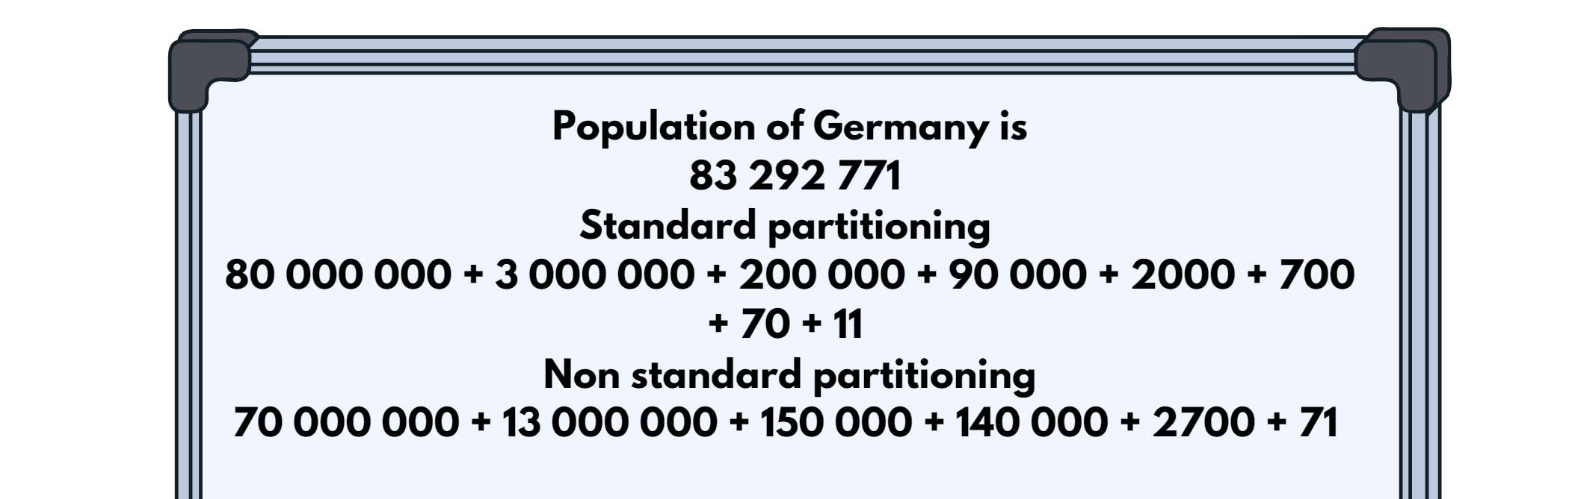
- Divide class into groups of 3-4 students.
- Display the population of another country for all groups to rename using standard and non-standard partitioning.
- Each group works collaboratively to rename the population in different ways.
- As a whole class, compare the different ways the number has been renamed. All groups receive one point for a correct answer. A group receives a bonus point if no other team has the same answer as them.
- Repeat for the population of multiple countries. Continue playing until students can confidently name and rename large numbers.
- In their groups students create a poster to represent the population of a chosen country. A flag is placed in the middle of the poster and the population is renamed in 5 different ways using non-standard partitioning. These posters are then displayed around the classroom.
This table details opportunities for differentiation.
Too hard? | Too easy?
Students cannot apply place value knowledge to rename numbers using non-standard partitioning.  - Provide students with a support structure such as hundreds chart, number line, place value houses, manipulatives (physical or virtual) to assist them.  - Assist students by reducing the size of the numbers the students are asked to use. | Students can apply place value knowledge to rename numbers using non-standard partitioning.  - Ask students to rename the numbers in more than one way.  - Challenge students to rename the numbers without certain place values. For example, rename your number without using thousands.

Consolidation and meaningful practice – 20 minutes
- Divide students into groups of 3-4 and ask them to sit in a circle.
- Explain that Player A writes a number up to the billions on their whiteboard in standard place value form and whispers the number to Player B.
- Player B renames the number on their whiteboard, turns and reads the renamed number to Player C.
- Player C renames the number and records it on their whiteboard.
- All players compare their numbers and discuss the different ways the same number can be recorded.
- Repeat the activity until all students have been Player A.
This table details opportunities for assessment.
Assessment opportunities | Links
What to look for:  - Can students read and write numbers up to and including millions? [MAO-WM-01, MA3-RN-01]  - Can students apply place value knowledge to rename numbers using non-standard partitioning up to billions? [MAO-WM-01, MA3-RN-01] | Links to National Numeracy Learning Progressions (NNLP):  - NPV6. NPV7.

Lesson 3
Core concept: the place value system can be extended.

Daily number sense: Which doesn’t belong? – 10 minutes
The table below contains a suggested learning intention and success criteria. These are best co-constructed with students.
Daily number sense learning intention | Daily number sense success criteria
Students are learning to:  - choose and use efficient strategies to solve addition and subtraction problems. | Students can:  - compare, evaluate and communicate strategies used to solve addition and subtraction problems.
This activity is an adaptation of Which one doesn’t belong? from Mathematics K-6 Resources by State of New South Wales (Department of Education).
- Draw a 4-box grid on the board and write the numbers 9, 16, 25 and 43 in one box each (see Figure 3).
Figure 3 – teacher work example
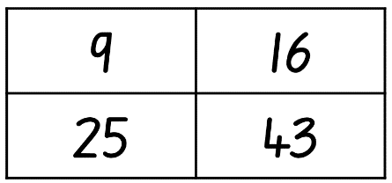
- In pairs, students must decide which number doesn’t belong using addition or subtraction thinking and why. For example, the number 9 is the only number whose digits don’t add up to 7.
- Students record their ideas on a whiteboard.
- Challenge students who finish quickly to make a case for why each of the numbers does not belong.
- When all pairs have a solution, students report back to the class, explaining which number they decided didn’t belong and why. Discuss.
This table details opportunities for assessment.
Assessment opportunities | Links
What to look for:  - Can students compare, evaluate and communicate strategies used to solve addition and subtraction problems? [MAO-WM-01, MA3-RN-01, MA3-AR-01] | Links to National Numeracy Learning Progressions (NNLP):  - AdS7, AdS8.

Core lesson – decimals up to the thousandths – 35 minutes
The table below contains suggested learning intentions and success criteria. These are best co-constructed with students.
Core concept learning intentions | Core concept success criteria
Students are learning to:  - recognise that the place value system can be extended beyond hundredths. | Students can:  - interpret decimal notation for thousandths  - indicate the place value of digits in decimal numbers of up to 3 decimal places  - compare and order decimals on a number line  - use the place value of digits to indicate decimals that are greater than or less than another decimal.
This activity is an adaptation of ‘Task 4 – Double Hat Trick’ from 3-6 – Remote Maths – Edition 8 [PDF 542 KB] by Mathematical Association of Victoria.
- Read the following problem to students: Caitlin is 1.57 m tall, and her brothers Liam and Johnny are 1.49 m and 1.63 m tall respectively. Rank their heights in order from tallest to shortest, explaining your answer.
- In pairs, students turn and talk. Discuss answers as a class.
- Ask students how much taller Johnny is compared to Liam and how much shorter Liam is compared to Caitlin.
- Students calculate the distances between heights by subtracting one height from another and plot these on a number line.
- Explain to students that they will be working in pairs to identify decimals on a number line.
- Player A draws a number line and labels the end points.
- Player A then thinks of a decimal up to 3 decimal places and places a dot on the number line where their number would be.
- Using the position of the dot, Player B guesses what they think the decimal could be.
- Player A states if their decimal is higher or lower than Player B’s guess.
- Player B records all attempts they have made on their own number line until they guess correctly.
- Repeat the activity with players swapping roles.
- Bring the class back together and discuss. Ask students:
- What place value knowledge did you use to help you find your partner’s number?
- What would make this task harder or easier?
Note: through this discussion, revise the idea that the position of each digit in a number corresponds to its size.
- In pairs, Player A rolls 3, 6-sided dice to make a decimal up to the thousandths between zero and one. For example, 5, 2 and 1 could make 0.125.
- Player A places their number on a number line.
- Player B repeats the process to make a new number and places it on the same number line.
- Repeat this process until one player has 4 decimals in a row next to each other.
- Remind students that they need to be strategic about the placement of their decimals. Players can choose to use the numbers rolled to create a decimal that will stop their opponent from winning or a decimal that will help them win the game by making 4 in a row (see Figure 4).
Figure 4 – 4 in a row
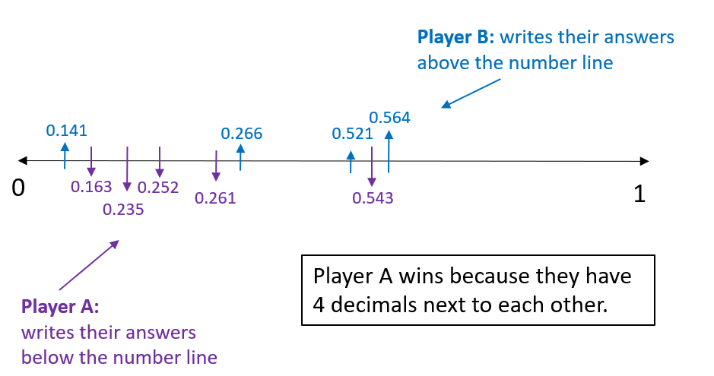
Note: to make identifying a player’s numbers easier, each player could write in different colours, or one could write below the line and one above the line (see Figure 4).
This table details opportunities for differentiation.
Too hard? | Too easy?
Students cannot compare and order decimals on a number line.  - Support students by using only 2 dice to create decimals up to hundredths.  - Assist students by deciding on a winner when a student has only 2 or 3 numbers in a row. | Students can compare and order decimals on a number line.  - Decrease the range of numbers on each end of the number line so that decimals are closer together. For example, decimals between 1.3 and 1.6.  - Challenge each player to add all decimals rolled during the game and compare their totals. Explain the strategy used to add the decimals to their partner.

Consolidation and meaningful practice – 15 minutes
This activity is an adaptation of ‘Greater Than? Less than? The same?’ from Learning to Think Mathematically with the Number Line [PDF 1102 KB] by Frykholm.
- Place a length of string or masking tape along the floor to create a large number line.
- Divide the class into 4 teams.
- Give each team 5 sticky notes with the decimals pre-written on them.
Note: this activity has been left open to enable you to choose decimals within a range appropriate to the class’s needs.
- To start the game, choose a decimal up to the thousandths and place it on the number line.
- Invite Team A to spin the spinner on Resource 5 – Less or Greater? They have a possibility of landing on greater than, less than, miss a turn or remove a decimal.
- If the spinner lands on greater than, Team A must find a decimal in their sticky notes that is greater than the last decimal that was placed on the number line.
- Invite Team B to repeat this process.
- Play continues with Team A and Team B taking alternate turns until one team has placed all their sticky notes on the number line.
This table details opportunities for assessment.
Assessment opportunities | Links
What to look for:  - Can students interpret decimal notation for thousandths? [MAO-WM-01, MA3-RN-02]  - Can students indicate the place value of digits in decimal numbers of up to 3 decimal places? [MAO-WM-01, MA3-RN-02]  - Can students compare and order decimals on a number line? [MAO-WM-01, MA3-RN-02]  - Can students use the place value of digits to indicate decimals that are greater than or less than another decimal? [MAO-WM-01, MA3-RN-02] | Links to National Numeracy Learning Progressions (NNLP):  - NPV7, NPV8.  Links to suggested Interview for Student Reasoning (IfSR) tasks:  - IfSR-NP: 4D.2, 4D.6.

Lesson 4
Core concept: zero in decimals play an important role.

Daily number sense – 10 minutes
- From a class need surfaced through formative assessment data, identify a short, focused activity that targets students’ knowledge, understanding and skills. Example activities may be drawn from the following resources:
- Mathematics K-6 resources
- Universal Resources Hub.

Core lesson – comparing decimals – 40 minutes
The table below contains suggested learning intentions and success criteria. These are best co-constructed with students.
Core concept learning intentions | Core concept success criteria
Students are learning to:  - apply place value knowledge to decimals up to 3 decimal places. | Students can:  - compare and order decimals up to 3 decimal places  - interpret the role of zero in decimals.
This activity is an adaptation of ‘Fitness Fest’ from Navigating through Problem Solving and Reasoning in Grade 6 by Thompson et al.
- Display Resource 6 – athletics carnival and read the scenario aloud with students. Display Resource 7 – fitness scores. Students turn and talk to a partner about what the activity is about. Ask:
- What is this activity asking you to do?
- How would you go about putting these students into different teams?
- Revise the role of zero at the end and in the middle of a decimal. Explain that the decimal 0.170 has the same value as 0.17 but 0.170 does not have the same value as 0.107. Have students Think-Pair-Share why this is the case.
- Ask students:
The table below outlines stimulus prompts to generate conversation about the topic, along with anticipated responses from students.
Prompts | Anticipated student responses
- What do you notice about these scores?  - Why do you think different units of measurement have been used?  - What is the difference between seconds and minutes?  - How can we tell who has run the fastest? | - The 100 m run is measured in seconds, the 800 m run is measured in minutes and the high jump is measured in metres.  - Some measurements are up to 3 decimal places and others are 2 or one.  - The 800 m run is a longer distance and will take more time to complete so they have used minutes instead of seconds.  - One minute is made up of 60 seconds.  - The smallest decimal is the fastest because they have finished the race before everyone else.
- Provide small groups or pairs a copy of Resource 7 – fitness scores. Explain to students that they will be creating the 3 groups for the teachers using the data set. Advise students they will need to create the 3 groups and explain to the class their method of categorising the data and an explanation that is clear for others to follow with a potential different set of data.
Note: this investigation requires reasoning and problem-solving processes that are essential for real-world mathematical modelling to make predictions or decisions. Successful group work in an investigation of this sort typically leads students through cycles of developing, testing and revising trial procedures. There is no one correct solution to this task. The important part of this task is having the students thinking about decimals being revealed through dialogue with their peers.
This table details opportunities for differentiation.
Too hard? | Too easy?
Students cannot compare and order decimals.  - Provide numbers to one decimal place for students to place on a number line. Students work up to numbers that are 2 decimal places.  - Support students by reducing the number of athletes they need to consider. | Students can compare and order decimals.  - Have students approximate the size of decimals by rounding the 3 decimal place numbers to 2 decimal places. For example, 1.254 is converted to 1.25.  - Challenge students to determine the difference between the best and worst scores in each category.

Discuss and connect the mathematics – 20 minutes
- Invite each group or pair to present their ideas to the class ensuring they explain their process and models clearly.
- Ask students to ask clarifying or extending questions of each group.
- Additional questions that could be asked include:
- What challenges did you face in this task? How did you overcome them?
- Why do you believe your method is the most accurate?
- Can you explain a problem in your methodology?
- Do you think there is more than one solution to this task? Why or why not?
- What mathematics knowledge did you use to find a solution to this task?
- After listening to other groups would you change anything in your methods? Can you explain the changes you would make to your model?
This table details opportunities for assessment.
Assessment opportunities | Links
What to look for:  - Can students compare and order decimals up to 3 decimal places? [MAO-WM-01, MA3-RN-01, MA3-RN-02]  - Can students interpret the role of zero in decimals? [MAO-WM-01, MA3-RN-02] | Links to National Numeracy Learning Progressions (NNLP):  - NPV7, NPV8.  Links to suggested Interview for Student Reasoning (IfSR) tasks:  - IfSR-NP: 4D.2, 4D.6.

Lesson 5
Core concept: decimals can be compared by analysing the place values parts.

Daily number sense – dicey operations – 10 minutes
Daily number sense activities for Lessons 5 to 7 ‘loop’ back to concepts and procedures covered in previous units to assist students to build an increasingly connected network of ideas. These concepts may differ from the core concepts being covered by the unit.
The table below contains a suggested learning intention and success criteria. These are best co-constructed with students.
Daily number sense learning intention | Daily number sense success criteria
Students are learning to:  - use estimation and place value understanding to determine the reasonableness of solutions. | Students can:  - use estimation to check the reasonableness of solutions to addition calculations.
- Working in pairs, students draw a 3 by 3 grid on their whiteboard.
- Students take it in turns to roll a 9-sided dice and place their number in one of the squares of their grid.
- When all squares are full, students estimate what they think their total will be and record this number on their whiteboard (see Figure 5).
- Using their knowledge of place value, students add their numbers to come up with a total.
- The student in each pair who got closest to their estimated total gets a point.
Figure 5 – example of student work
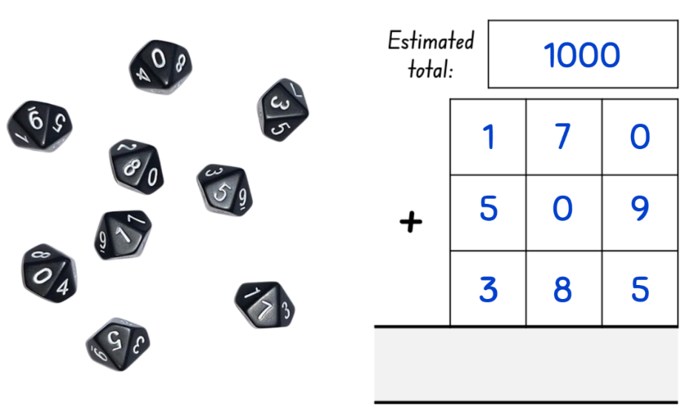
This table details opportunities for assessment.
Assessment opportunities | Links
What to look for:  - Can students use estimation to check the reasonableness of solutions to addition calculations? [MAO-WM-01, MA3-RN-01, MA3-AR-01] | Links to National Numeracy Learning Progressions (NNLP):  - NPV6, AdS8.

Core lesson – interpreting decimals up to thousands – 40 minutes
The table below contains suggested learning intentions and success criteria. These are best co-constructed with students.
Core concept learning intentions | Core concept success criteria
Students are learning to:  - read, write and record decimal notation to the thousandths. | Students can:  - compare and order decimal numbers up to 3 decimal places  - interpret the role of zero at the end of a decimal  - apply place value knowledge to decimals  - apply critical thinking when testing conjectures.
This activity is an adaptation of ‘Fitness Fest’ from Navigating through Problem Solving and Reasoning in Grade 6 by Thompson et al.
- Display and remind students of Resource 6 – athletics carnival. Read the scenario aloud again with students.
- Using Resource 7 – fitness scores students work in small groups to organise the participants into 3 teams that are comparable in ability.
- Emphasise that the event organisers want all the teams to be competitive. Students will need to justify their choices and decisions.
- Remind students that, to interpret the data accurately, they need to recognise that a high score is desirable in some events, such as high jump, but a lower score is best in other events, such as the 800 m run.
Note: in an open-ended, challenging task such as this, the role of the teacher is to be a facilitator, encouraging students to investigate the topic and guide students to think critically and employ Working mathematically skills and strategies. You may offer support and guidance, answer questions, provide clarifications and help students stay focused on the task at hand.
This table details opportunities for differentiation.
Too hard? | Too easy?
Students cannot compare and order decimal numbers up to 3 decimal places.  - Support students to find the best performing student in each category by modelling the strategies they could use.  - Provide students with only the top half of the table so there are fewer decimals to compare. | Students can compare and order decimal numbers up to 3 decimal places.  - Ask the students to record all the strategies they attempted and explain why they were or were not successful.  - Once the task is completed, students create another event including results for all competitors. These results cannot impact on the competitiveness of the teams they have already created.

Discuss and connect the mathematics – 10 minutes
- After teams have been determined, each group will present their results. They will explain the strategy they used to organise their teams and justify the reasoning.
- Encourage the students to challenge each groups choices and engage in a discussion with their peers.
- Allow time for students to review their own strategy and make improvements to the teams they have created.
Note: the focus of this is lesson is to develop critical thinking and reasoning skills that are essential for making real world decisions using place value knowledge. The importance of this lesson is not in the final answer itself, but in the strategies applied and process undertaken. There is no one correct answer.
This table details opportunities for assessment.
Assessment opportunities | Links
What to look for:  - Can students compare and order decimal numbers up to 3 decimal places? [MAO-WM-01, MA3-RN-02]  - Can students interpret the role of zero at the end of a decimal? [MAO-WM-01, MA3-RN-02]  - Can students apply place value knowledge to real life mathematical situations? [MAO-WM-01, MA3-RN-01, MA3-RN-02]  - Can students apply critical thinking when testing conjectures? [MAO-WM-01] | Links to National Numeracy Learning Progressions (NNLP):  - NPV6, NPV8.  Links to suggested Interview for Student Reasoning (IfSR) tasks:  - IfSR-PT: 1A.5, 1A.7  - IfSR-AT: 4B.1  - IfSR-NP: 4D.6.

Lesson 6
Core concept: place value understanding helps solve addition and subtraction problems.

Daily number sense – prove it – 10 minutes
The table below contains a suggested learning intention and success criteria. These are best co-constructed with students.
Daily number sense learning intention | Daily number sense success criteria
Students are learning to:  - use estimation and place value understanding to determine the reasonableness of solutions. | Students can:  - use place value understanding to check for errors in calculations  - use estimation to check the reasonableness of solutions to addition and subtraction calculations.
- Display Resource 8 – prove it and read the scenario to the students.
- Independently students estimate the answer themselves and then explain their thinking to a partner. They must be able to provide evidence to support their answers. For example, John’s answer could not be correct because it is an addition problem however the answer is less than the number he started with. Students then work on whiteboards to check if John’s answer is correct.
- Discuss student answers as a class.
- Ask students:
- How did you determine if the answer was correct?
- Was there a way to determine if the answer was correct without working out the correct answer? How?
This table details opportunities for assessment.
Assessment opportunities | Links
What to look for:  - Can students use place value understanding to check for errors in calculations? [MAO-WM-01, MA3-RN-01, MA3-AR-01]  - Can students use estimation to check the reasonableness of solutions to addition and subtraction calculations? [MAO-WM-01, MA3-RN-01, MA3-AR-01] | Links to National Numeracy Learning Progressions (NNLP):  - NPV5, NPV6, AdS8.

Core lesson 1 – adding and subtracting decimals – 15 minutes
The table below contains suggested learning intentions and success criteria. These are best co-constructed with students.
Core concept learning intentions | Core concept success criteria
Students are learning to:  - apply known strategies to solve addition and subtraction problems. | Students can:  - add and subtract decimals using a known strategy  - show more than one strategy to solve addition and subtraction  - represent their thinking using a variety of methods  - justify their chosen strategy.
- Display 5.96 + 4.15 on the board.
- Students turn and talk about the strategy they would use to solve this number sentence.
- As a class, compare student strategies and collaboratively find the solution. Revise addition and subtraction strategies such as levelling, addition for subtraction, constant difference, compensation, bridging and the formal algorithm. Reflect on which strategies are more efficient for this problem.
- Ask students if they could use the same strategy to solve a subtraction problem.
- Display 27.54 − 14.73 on the board.
- Students turn and talk about the strategy they would use to solve this number sentence.
- As a class, compare student strategies and collaboratively find the solution. Reflect on which strategies are more efficient and if students can use the same strategy for both addition and subtraction.
- Provide students with another addition and subtraction number sentence to solve independently using a formal algorithm.
- Challenge students to represent the problem using a second strategy.

Core lesson 2 – multiple strategies – 35 minutes
- Display Resource 9 – thousandths word problems involving addition and subtraction with decimals. Revise addition and subtraction strategies such as levelling, addition for subtraction, constant difference and bridging.
- Students choose 2 problems and show 4 different ways to solve them using Resource 10 – graphic organiser. Strategies may include an algorithm, levelling and compensation.
- Introduce Resource 12 – multistep problems and have students work in pairs to solve 2 of these problems using Resource 10 – graphic organiser.
This table details opportunities for differentiation.
Too hard? | Too easy?
Students cannot add and subtract decimals using a formal algorithm.  - Students solve the word problems on Resource 11 – tenths word problems  - Provide students with a support structure, such as hundreds chart, number line, place value houses or manipulatives (physical or virtual) to assist them.  - Support students by providing number sentences only. | Students can add and subtract decimals using a formal algorithm.  - Challenge students to use multiple strategies to solve each problem. Discuss with a classmate which strategy they found to be the most efficient and why.

Discuss and connect the mathematics – 10 minutes
- Students sit in a sharing circle where they explain their solutions and strategies to the class.
- Students select the most efficient strategies they used for solving their problem and explain why it was the most efficient.
This table details opportunities for assessment.
Assessment opportunities | Links
What to look for:  - Can students add and subtract decimals using a formal algorithm? [MAO-WM-01, MA3-RN-01, MA3-RN-02, MA3-AR-01]  - Can students show more than one strategy to solve addition and subtraction? [MAO-WM-01, MA3-RN-01, MA3-RN-02, MA3-AR-01]  - Can students represent their thinking using a variety of methods? [MAO-WM-01, MA3-RN-01, MA3-RN-02, MA3-AR-01] | Links to National Numeracy Learning Progressions (NNLP):  - AdS9.

Lesson 7
Core concept: known strategies for addition can be applied to decimals.

Daily number sense – How many trucks? – 10 minutes
The table below contains a suggested learning intention and success criteria. These are best co-constructed with students.
Daily number sense learning intention | Daily number sense success criteria
Students are learning to:  - use estimation and place value understanding to determine the reasonableness of solutions. | Students can:  - use place value understanding to check for errors in calculations  - use estimation to check the reasonableness of solutions to calculations.
- Provide each student with a copy of the Resource 13 – How many trucks?
- Ask students to estimate how many trucks can be seen in the collection.
- Students work independently or in pairs to organise the collection to support efficient counting.
- Choose students to share how they organised their collection and what the total is.
- Ask students:
- How close was your estimation to the actual total number of trucks in the collection?
- Did your estimation help or hinder your ability to determine how many trucks were in the collection?
- What strategy did you use to determine how many trucks were in this collection?
- Was your strategy efficient? Why or why not?
- Were there any other strategies to determine the size of the truck collection that you think would have been more efficient?
This table details opportunities for assessment.
Assessment opportunities | Links
What to look for:  - Can students use place value understanding to check for errors in calculations? [MAO-WM-01, MA3-RN-01, MA3-AR-01]  - Can students use estimation to check the reasonableness of solutions to calculations? [MAO-WM-01, MA3-RN-01, MA3-AR-01] | Links to National Numeracy Learning Progressions (NNLP):  - NPV5, NPV6, AdS8.

Core lesson – adding decimals – 40 minutes
The table below contains suggested learning intentions and success criteria. These are best co-constructed with students.
Core concept learning intentions | Core concept success criteria
Students are learning to:  - apply known additive strategies to solve problems involving length. | Students can:  - compare and order decimals  - add and subtract decimals  - connect decimals to the metric system  - convert between common metric units of length  - calculate and solve problems involving perimeters.
- Display Resource 14 – swimming pool designs.
- Students work in groups of 3–4 to design a swimming pool for their school.
- Write the following lengths on the whiteboard: 7.489 m, 2408 cm, 357 cm, 1.35 m, 4.1 m, 682 cm, 4.01 m, 3.431 m, 1234 cm.
- Ask each group to convert each of the measurements to one consistent measurement (either millimetres, centimetres or metres).
- Discuss which measurement each group chose, the results of the conversion and why they believe theirs to be the most efficient measurement.
- Ask each group to place their measurements in order from smallest to largest using a number line.
- In their groups, students use the measurements listed on the board to investigate and design their swimming pool, recording their ideas on whiteboards. Each measurement may be used more than once.
- Students complete a gallery walk, observing the different answers of their classmates.
- Ask students:
- How did you approach this task?
- What challenges did you face trying to find measurements that would give you the correct perimeter?
- What was helpful in determining these measurements?
- Once the groups have designed their pools, announce that there has been a problem. Unfortunately, the land that was supposed to be used for the pool is no longer suitable. The new piece of land is much narrower at one end. This will mean that pool must have at least 5 sides and a perimeter of 45.276 m. The good thing is the principal has said students can use any measurements they want to create this new pool, so long as they follow the new rules.
- Ask students to redesign their pool to ensure it will be suitable for the new position.
- Challenge the students to design the pool more than one way.
- Students draw their 2 favourite pool designs and label the length of each side in their workbook. Students record how they determined the perimeter of each of their pools.
Note: this activity allows for variation. For example, you may like to challenge students by completing it outside the classroom using actual measurements and measuring tools, such as a trundle wheel or tape measure.
This table details opportunities for differentiation.
Too hard? | Too easy?
Students cannot apply decimal knowledge to add and subtract decimals.  - Provide students with a support structure such as a number line or manipulatives (physical or virtual) to assist them.  - Assist students by reducing the size of the numbers or the number of decimals the students are asked to use. | Students can apply decimal knowledge to add and subtract decimals.  - Challenge students to determine the area of one of their pools.  - In pairs, Student A chooses a 2-digit number with 3 decimal places which becomes the perimeter of a pool they both must design. Student B decides how many sides the pool must have. Both students design a pool that meets the requirements. Students then compare and discuss.

Discuss and connect the mathematics – 10 minutes
- Students find the difference between the 2 perimeters.
- Students participate in a gallery walk to view other groups’ pool designs and drawings.
- Ask students:
- Did you see any pools similar to yours?
- Which pool design appealed to you the most? Why?
- What would you do differently if you had to design a third pool?
This table details opportunities for assessment.
Assessment opportunities | Links
What to look for:  - Can students compare and order decimals? [MAO-WM-01, MA3-RN-02]  - Can students add and subtract decimals? [MAO-WM-01, MA3-RN-02, MA3-AR-01]  - Can students connect decimal representation to the metric system? [MAO-WM-01, MA3-RN-02, MA3-GM-02]  - Can students convert between common metric units of length? [MAO-WM-01, MA3-RN-02, MA3-GM-02]  - Can students calculate and solve problems involving perimeters? [MAO-WM-01, MA3-RN-02, MA3-AR-01, MA3-GM-02] | Links to National Numeracy Learning Progressions (NNLP):  - AdS9, NPV8.

Lesson 8
Core concept: known strategies for subtraction can be applied to decimals.

Daily number sense – 15 minutes
- From a class need surfaced through formative assessment data, identify a short, focused activity that targets students’ knowledge, understanding and skills. Example activities may be drawn from the following resources:
- Mathematics K-6 resources
- Universal Resources Hub.

Core lesson – decimal subtraction face-off – 30 minutes
The table below contains suggested learning intentions and success criteria. These are best co-constructed with students.
Core concept learning intentions | Core concept success criteria
Students are learning to:  - apply known strategies to add and subtract decimals. | Students can:  - use place value knowledge to add and subtract decimals  - describe strategies used to add and subtract decimals.
This activity is an adaptation of ‘Subtraction face-off: thousandths, hundredths and tenths' [PDF 863 KB] from Flexible additive strategies - Decimals by State of New South Wales (Department of Education).
- Provide pairs of students with a set of playing cards (Ace to 9 to represent 1–9) and Resource 15 – explanation spinner.
- Students shuffle the cards and deal them out evenly, face down, between the 2 players.
- Students take the 5 top cards from their pile to form a number in the thousandths and a number in the hundredths. For example, if 5, 5, 6, 1, and 9 were flipped over, the numbers 0.561 and 0.59 could be made.
- Students arrange the cards in any way they like to make the smallest difference between the 2 numbers.
- The student with the smallest difference collects all 10 cards.
- Students continue playing until one student has lost all their cards.
- Have students use the Resource 15 – explanation spinner and share the strategies used to work out differences based on what the spinner lands on. Record these in their workbook.
- Swap partners and repeat.
- As a class, discuss:
- Which strategies were the most efficient when determining the difference between the 2 numbers?
- What strategies did you use to try and have your numbers as close together as possible?
This table details opportunities for differentiation.
Too hard? | Too easy?
Students cannot apply decimal knowledge to add and subtract decimals.  - Assist students by reducing the numbers to be added or subtracted to tenths and hundredths or only tenths.  - Model strategies to be used when adding or subtracting decimals. | Students can apply decimal knowledge to add and subtract decimals.  - Challenge students to include zero cards in their piles to be used appropriately during the game.  - Students can spin the Resource 15 – explanation spinner twice and represent their ideas 2 different ways.

Consolidation and meaningful practice – 15 minutes
This activity is an adaptation of ‘Decimals’ from Decimals, Challenging mathematical tasks: Unlocking the potential of all students by Sullivan.
- Write on the board ‘I subtracted 3 decimal numbers away from 4 to get zero. What might the 3 numbers be?’
- In pairs, students solve this problem as many ways as they can.
- Each pair shares their ideas with another pair, discussing the strategies they used and justifying why their answers are correct.
This table details opportunities for assessment.
Assessment opportunities | Links
What to look for:  - Can students use place value knowledge to add and subtract decimals? [MAO-WM-01, MA3-RN-02, MA3-AR-01]  - Can students describe strategies used to add and subtract decimals? [MAO-WM-01, MA3-RN-02, MA3-AR-01] | Links to National Numeracy Learning Progressions (NNLP):  - AdS9, NPV8.

Resource 1 – four piles
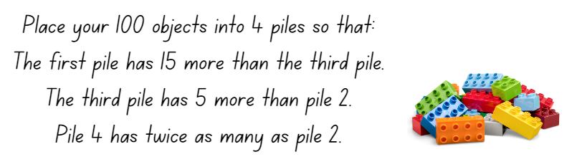

Resource 2 – prompting questions

Resource 3 – show us how
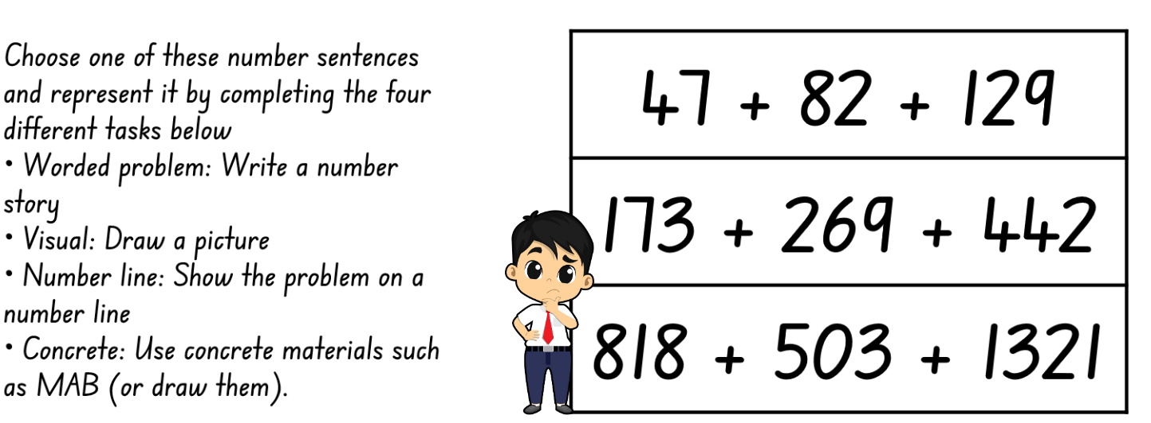

Resource 4 – misconceptions
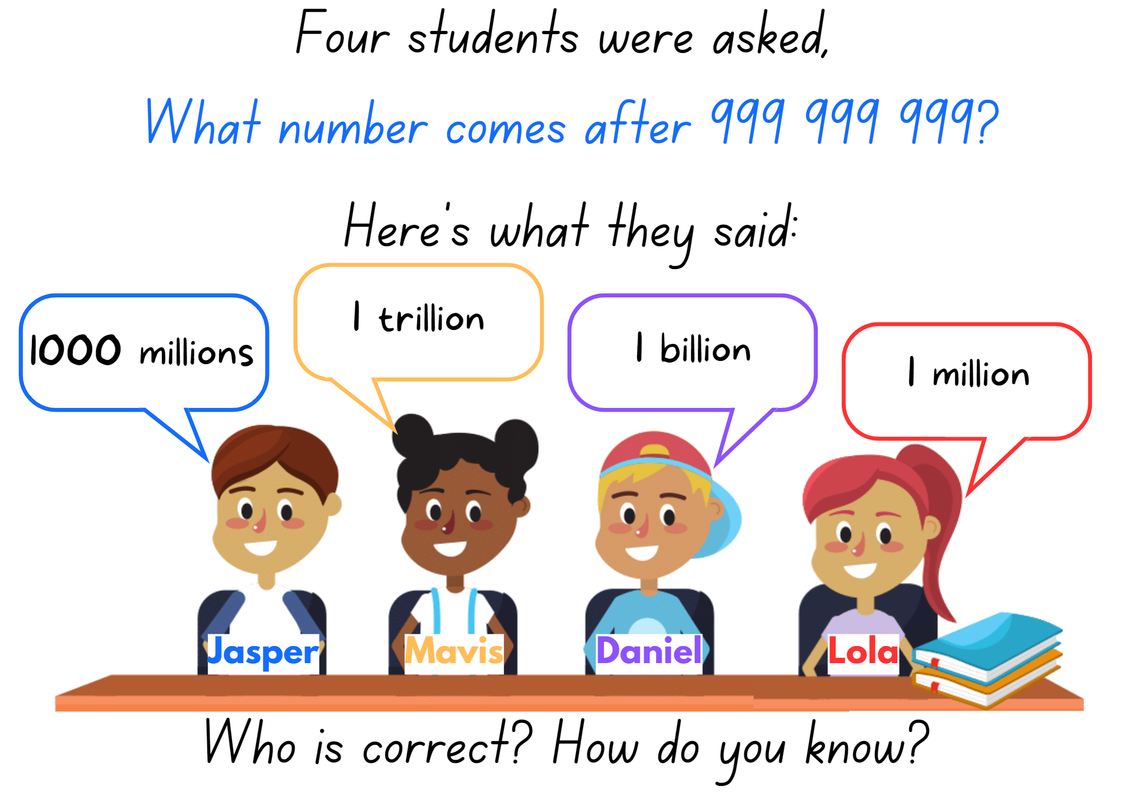

Resource 5 – Less or greater?
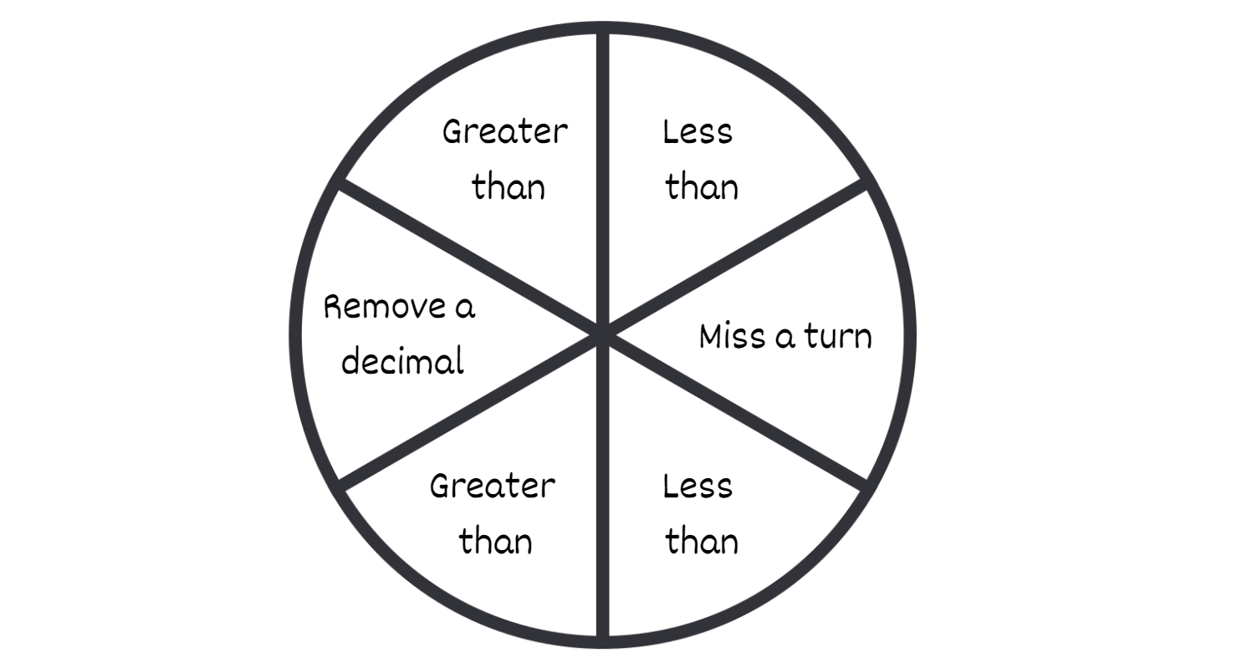

Resource 6 – athletics carnival
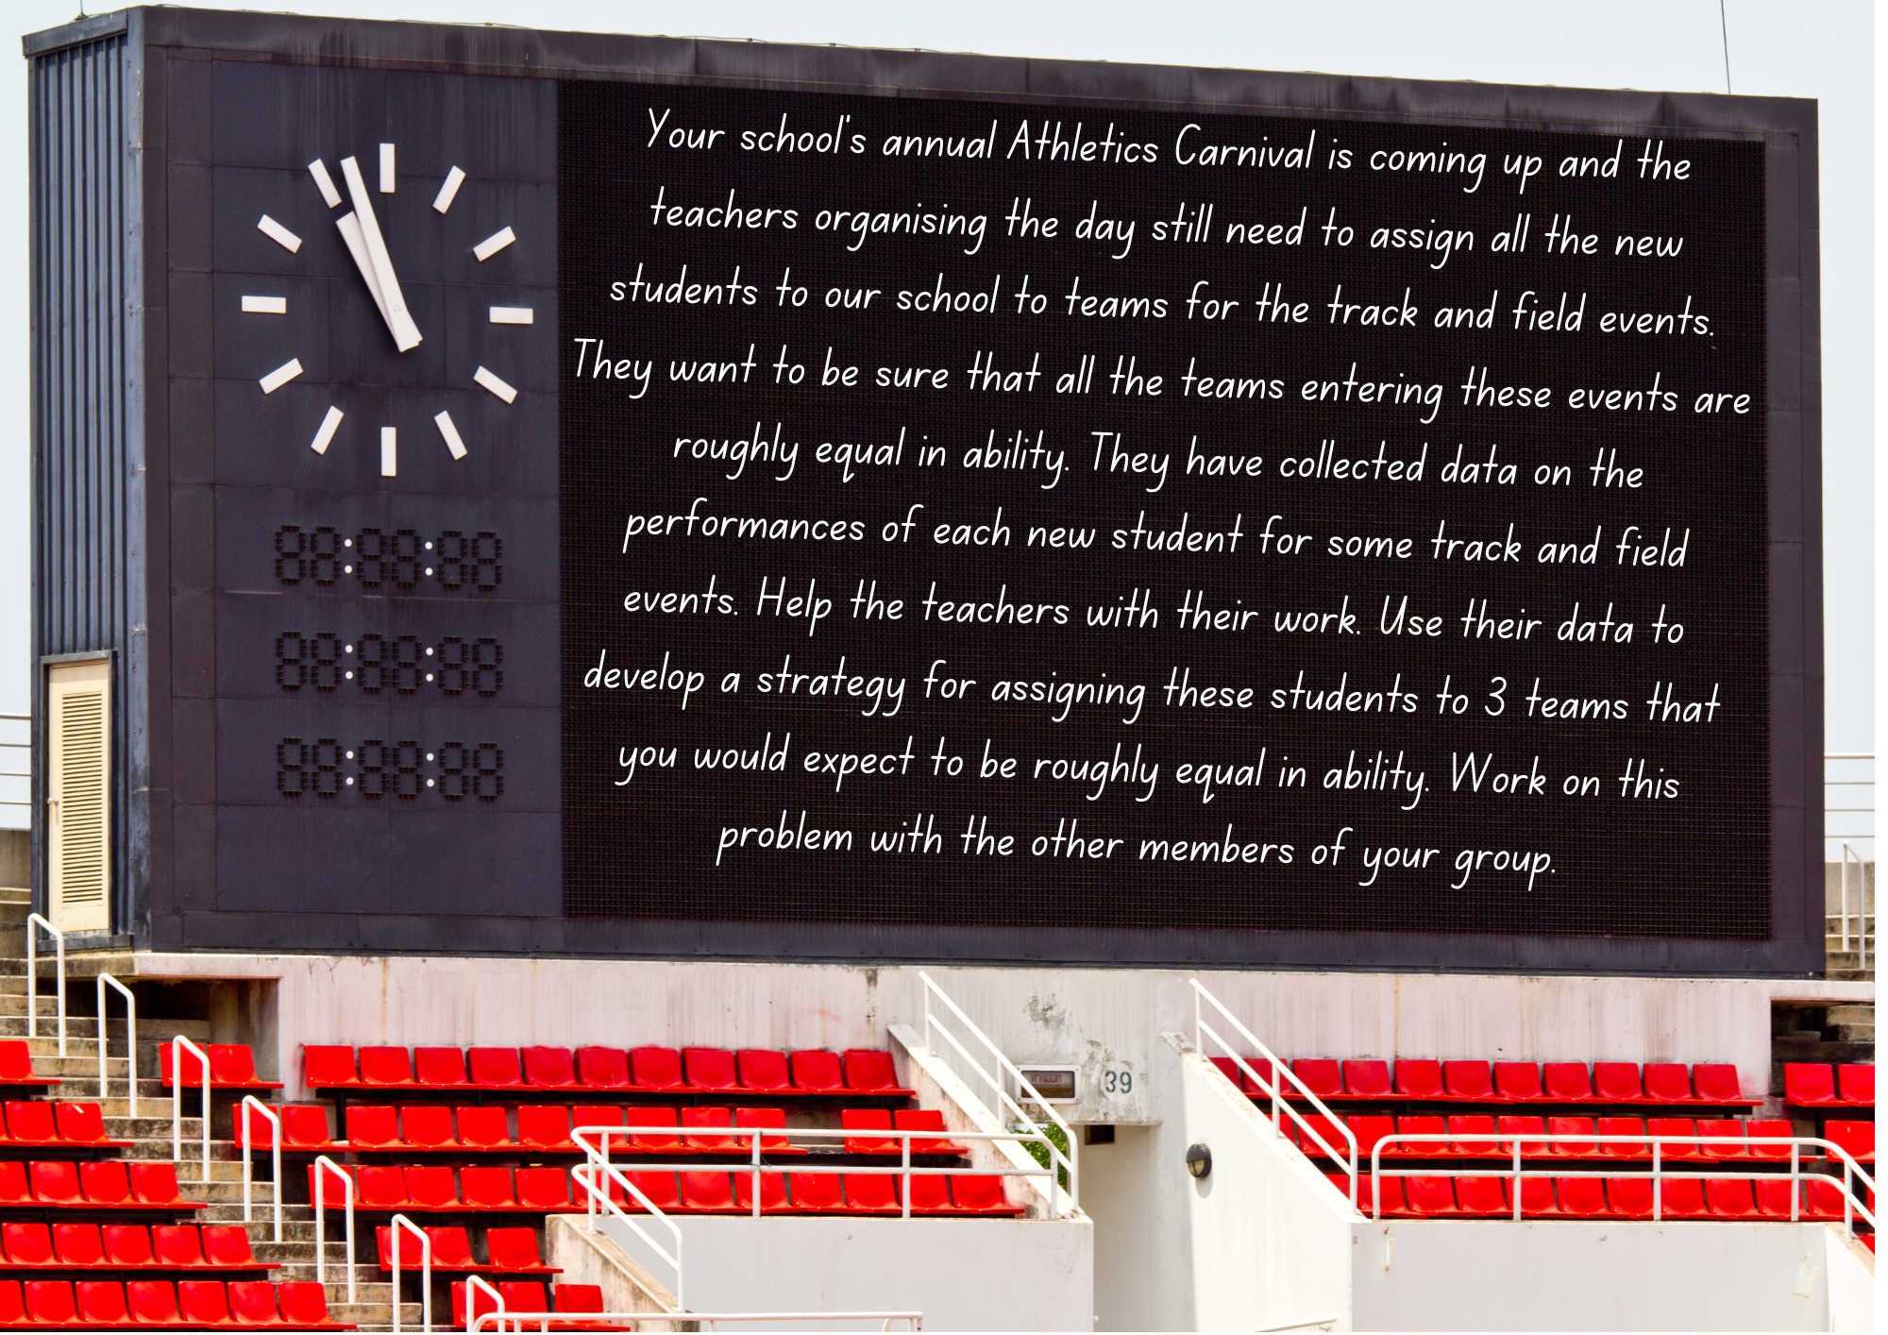

Resource 7 – fitness scores
Student | 100 m sprint (seconds) | 800 m run (minutes) | High jump (metres) | Fitness test*
Ryan | 17.356 | 3.38 | 1.64 | Pass
Carolyn | 16.0 | 7.01 | 1.59 | Fail
Saul | 19.89 | 2.24 | 1.50 | Pass
Nicole | 18.52 | 2.557 | 1.70 | Pass
Jason | 16.48 | 2.55 | 2.5 | Fail
Mark | 27.2 | 3.22 | 1.74 | Pass
Naveed | 25.2 | 4 | 1.67 | Pass
Heather | 18.256 | 3.168 | 1.58 | Fail
Terese | 17.1 | 3.11 | 2.25 | Pass
Leila | 20.32 | 2.51 | 2.11 | Fail
Nat | 16.444 | 5.453 | 3.85 | Pass
Ainslie | 19.2 | 3.12 | 2.22 | Pass
Kristy | 17.085 | 3.505 | 1.13 | Fail
Samit | 18.309 | 3.30 | 1.0 | Fail
Ricardo | 22.06 | 3 | 4.0 | Fail
*All students received a mark of ‘pass’ or ‘fail’. The test consisted of 30 push-ups, 50 star jumps and 20 sit ups.

Resource 8 – prove it
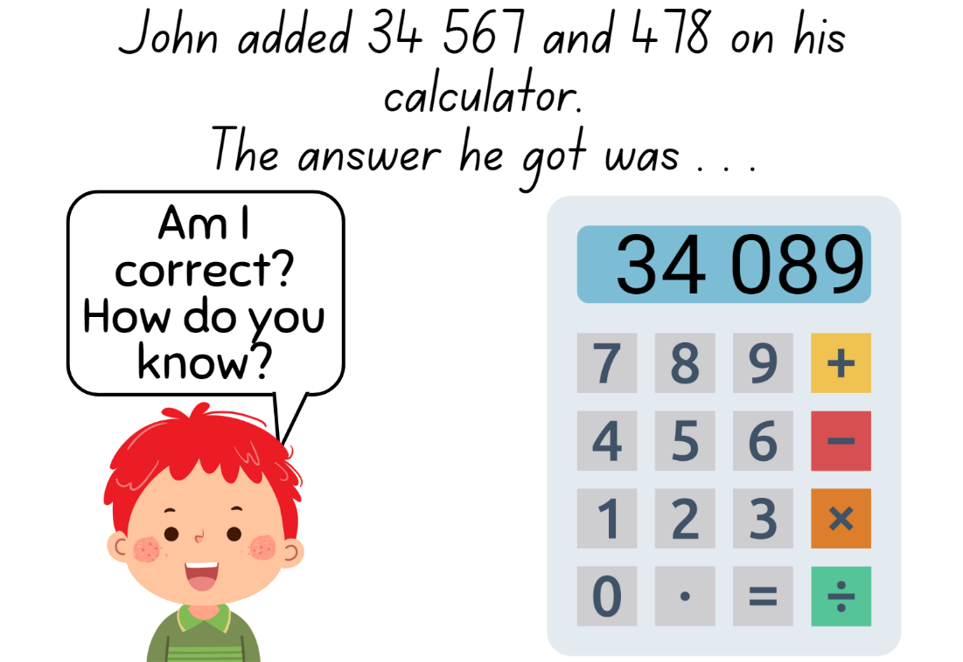

Resource 9 – thousandths word problems
Word problems to thousandths
A swimmer completes a 100 m race in 54.386 seconds. His competitor completes the race in 53.892. How many thousandths of a second difference was there between the 2 swimmers?
A scientist measures the pH level of a solution and records it as 4.672 on Monday. On Wednesday, the scientist measures the pH level as 7.321. What is the total value from both days of the solution’s pH level?
The temperature outside reached 21.749 degrees Celsius. By the afternoon it dropped by 4.83 degrees Celsius and then a further 3.07 degrees. What is the current temperature?
A recipe calls for 0.025 litres of vanilla extract. If you want to make 6 batches of the recipe, how many litres of vanilla extract would you need in total?
A carpenter used 8.503 m of wood to build a table and 3.017 m of wood to build a chair. At the end of the project the carpenter had 7.364 m of wood left. How much did they have at the start of the project?
Sarah bought a book for $15.64 and a pen. In total the cost of the 2 items was less than $19.58. What could have been the cost of the pen?
Maria is planning a school trip to a theme park. She has a budget of $250 to spend on tickets for herself and her friends. The admission ticket costs $28.62 per person. How many of her friends could Maria invite?

Resource 10 – graphic organiser
Strategy 1 | Strategy 2
Strategy 3 | Strategy 4

Resource 11 – tenths word problems
Word problems to tenths
Maria had 3.6 litres of water in a container. She poured 1.2 litres into another container. How much water does she have left in the first container?
A store sold 4.5 kilograms of bananas in the morning and received a delivery of 2.3 kilograms in the afternoon. How many kilograms of bananas does the store have in total?
A rectangular garden measures 6.2 m in length and 4.1 m in width. What is the total perimeter of the garden?
Emma is a long-distance swimmer. On Monday she swam 3.2 kms and on Tuesday she swam 2.9 kms. How many more kilometres does she need to swim on Wednesday, Thursday and Friday to have swum a total of 14.5 km by Saturday?
Sarah and her friend Alex decided to have a lemonade stand on a hot summer day. They made 2 different flavours of lemonade, regular lemonade and strawberry lemonade. In the morning, Sarah sold 2.5 litres of regular lemonade and 1.3 litres of strawberry lemonade. In the afternoon, they sold another 3.7 litres of regular lemonade and 0.8 litres of strawberry lemonade. Can you help them calculate how much lemonade they sold in total throughout the day? In addition, calculate how much more regular lemonade they sold than strawberry lemonade during the day.

Resource 12 – multistep problems
Multi-step worded problems
A recipe calls for 2.345 kilograms of flour. Lisa already has 1.225 kilograms of flour. How much more flour does she need to complete the recipe? If she bought an additional 0.875 kilograms of flour, how much flour does she have in total? Is this enough for the recipe? Why or why not?
A company shipped 185.763 units of a product to one warehouse and 239.405 units to another warehouse. If they later transferred 126.178 units from the first warehouse to the second, how many units are left in each warehouse?
The total cost of Jenny’s sunglasses and designer shoes was $197.25. I know that the shoes were at least $48 more than the sunglasses. How much could the shoes cost? What would be the maximum cost of the sunglasses?

Resource 13 – How many trucks?
© Bim via Canva.com

Resource 14 – swimming pool designs
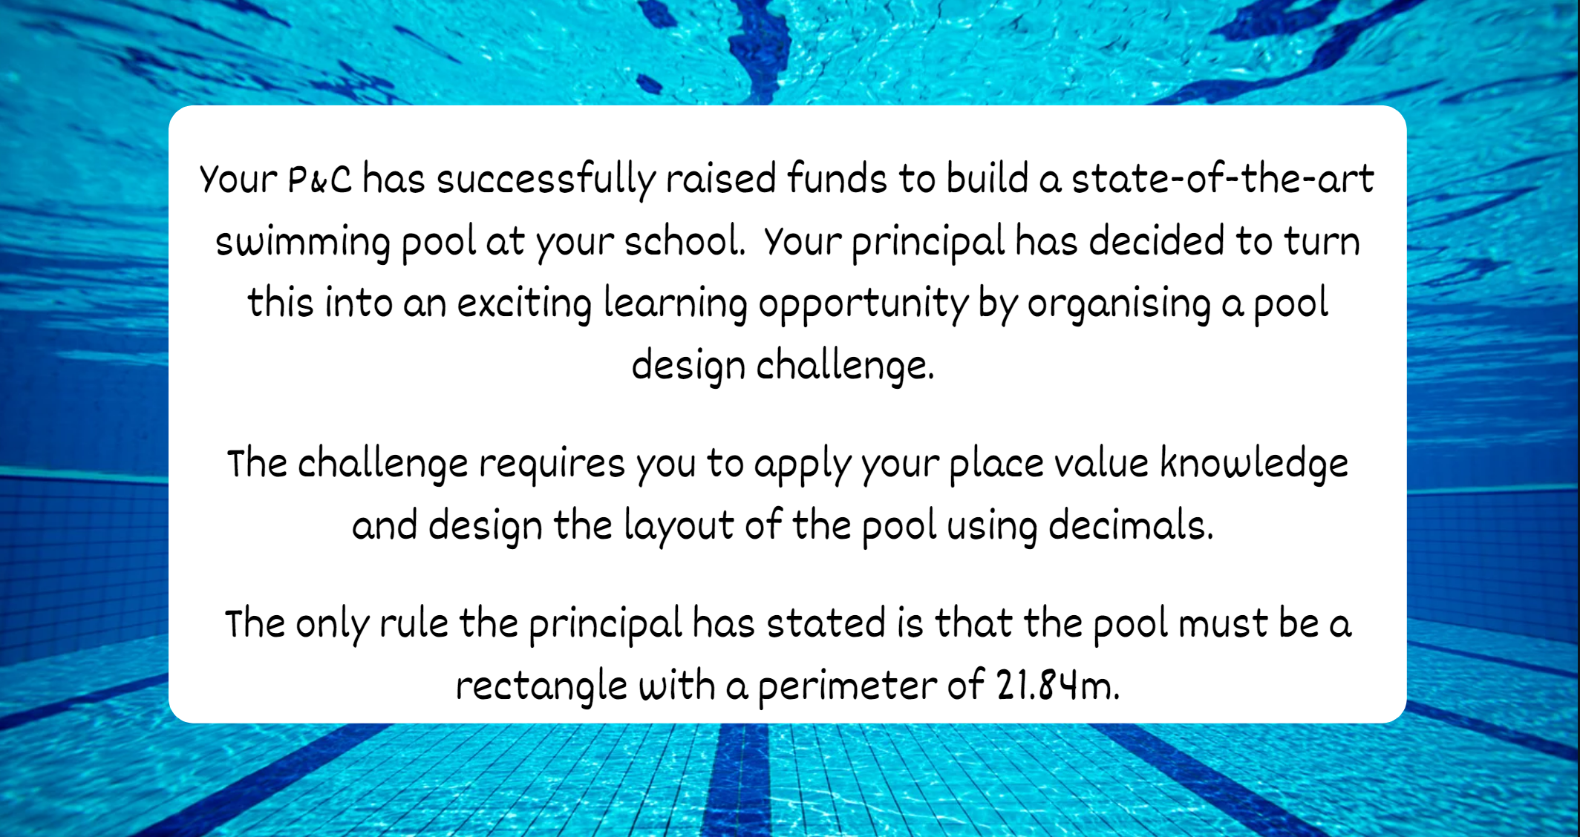

Resource 15 – explanation spinner
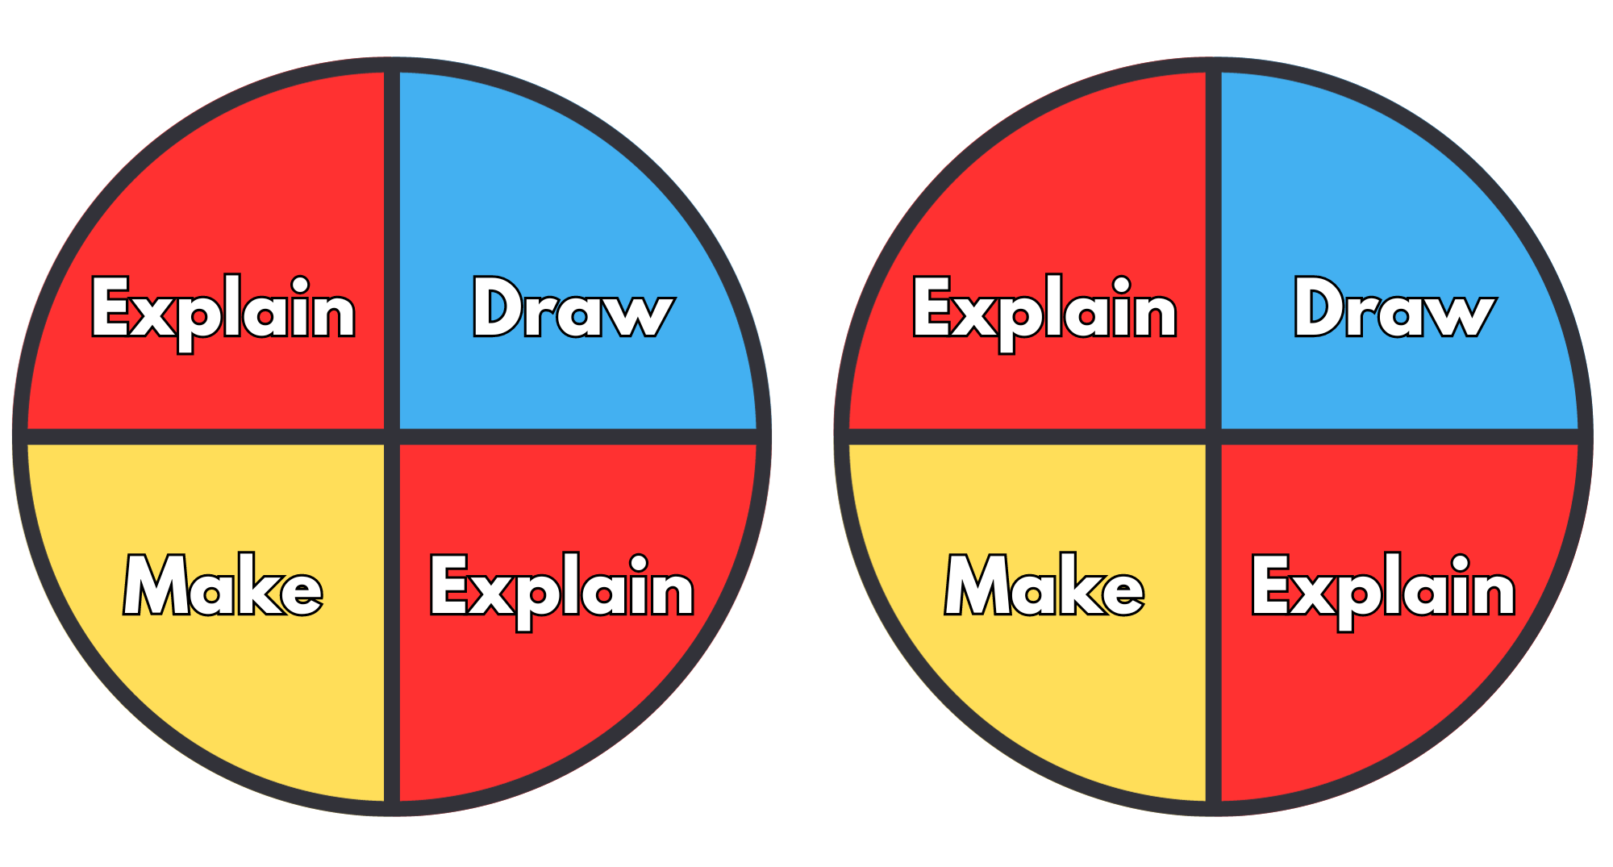

Syllabus outcomes and content
The table below outlines the syllabus outcomes and range of relevant syllabus content covered in this unit. Content is linked to National Numeracy Learning Progression version (3).
Outcomes and content | 1 | 2 | 3 | 4 | 5 | 6 | 7 | 8
Represents numbers A: Whole numbers: Recognise, represent and order numbers in the millions
MAO-WM-01, MA3-RN-01, MA3-RN-02
- Name millions using the place value grouping of ones, tens and hundreds | x | x
- Arrange numbers in the millions in ascending and descending order using place value | x
- Round numbers to a specified place value | x
Represents numbers A: Whole numbers: Apply place value to partition, regroup and rename numbers to 1 billion
MAO-WM-01, MA3-RN-01, MA3-RN-02
- Recognise 1000 thousands is 1 million and 1000 millions is 1 billion |  | x
- Regroup numbers in different forms (Reasons about quantity) |  | x
- Partition numbers to 1 billion in non-standard forms |  | x
Represents numbers A: Decimals and percentages: Recognise that the place value system can be extended beyond hundredths
MAO-WM-01, MA3-RN-02
- Express thousandths as decimals |  |  | x | x | x
- Interpret decimal notation for thousandths |  |  | x | x | x
- Indicate the place value of digits in decimal numbers of up to 3 decimal places |  |  | x | x | x
- Use place value to partition decimals |  |  | x
Represents numbers A: Decimals and percentages: Compare, order and represent decimals
MAO-WM-01, MA3-RN-02
- Compare and order decimal numbers of up to 3 decimal places |  |  | x | x | x |  | x
- Interpret zero digit(s) at the end of a decimal |  |  |  | x | x |  | x
- Place decimal numbers of up to 3 decimal places on a number line |  |  | x
Additive relations A: Apply efficient mental and written strategies to solve addition and subtraction problems
MAO-WM-01, MA3-AR-01
- Solve word problems, including multistep problems |  |  |  |  |  | x
- Apply known strategies such as levelling, addition for subtraction, using constant difference, and bridging (Reasons about relations) |  |  |  |  |  | x | x | x
- Use place value to add or subtract 3 or more numbers with different numbers of digits |  |  |  |  |  | x | x | x
- Identify efficient and inefficient multidigit subtraction strategies |  |  |  |  |  | x
Additive relations A: Use estimation and place value understanding to determine the reasonableness of solutions
MAO-WM-01, MA3-AR-01
- Round numbers appropriately when obtaining estimates to numerical calculations |  |  |  |  |  | x
- Use place value understanding to check for errors in calculations |  |  |  |  |  | x | x | x
- Use estimation to check the reasonableness of solutions to addition and subtraction calculations |  |  |  |  |  | x | x | x
Additive relations B: Choose and use efficient strategies to solve addition and subtraction problems
MAO-WM-01, MA3-AR-01
- Solve multistep word problems, including problems that require more than one operation |  |  |  |  |  | x
- Compare, evaluate and communicate strategies used to solve addition and subtraction problems |  |  |  |  |  | x | x | x
Additive relations B: Applies known strategies to add and subtract decimals
MAO-WM-01, MA3-AR-01
- Model the addition and subtraction of decimals up to 3 decimal places using appropriate representations |  |  |  |  |  | x | x | x
- Solve word problems involving the addition and subtraction of decimals up to 3 decimal places |  |  |  |  |  | x | x | x
- Justify why the strategy used to solve addition and subtraction word problems is appropriate (Reasons about quantity) |  |  |  |  |  | x | x | x
Geometric measure A: Length: Measure lengths to find perimeters
MAO-WM-01, MA3-GM-02
- Use efficient strategies to calculate the perimeter of a large rectangular area in metres |  |  |  |  |  |  | x
- Calculate perimeters of common two-dimensional shapes, including squares, rectangles and triangles |  |  |  |  |  |  | x
Geometric measure B: Length: Connect decimal representations to the metric system
MAO-WM-01, MA3-GM-02
- Recognise the equivalence of whole-number and decimal representations of measurements of length |  |  |  |  | x |  | x
- Interpret decimal notation for lengths and distances |  |  |  |  | x |  | x
- Record lengths and distances using decimal notation |  |  |  |  | x |  | x
Geometric measure B: Solve problems involving the comparison of lengths using appropriate units
MAO-WM-01, MA3-GM-02
- Solve a variety of problems involving length and perimeter, including problems involving different units of length |  |  |  |  |  |  | x
Mathematics K–10 Syllabus © NSW Education Standards Authority (NESA) for and on behalf of the Crown in right of the State of New South Wales, 2022.

References
This resource contains NSW Curriculum and syllabus content. The NSW Curriculum is developed by the NSW Education Standards Authority. This content is prepared by NESA for and on behalf of the Crown in right of the State of New South Wales. The material is protected by Crown copyright.
Please refer to the NESA Copyright Disclaimer for more information https://educationstandards.nsw.edu.au/wps/portal/nesa/mini-footer/copyright.
NESA holds the only official and up-to-date versions of the NSW Curriculum and syllabus documents. Please visit the NSW Education Standards Authority (NESA) website https://educationstandards.nsw.edu.au/ and the NSW Curriculum website https://curriculum.nsw.edu.au/home.
Mathematics K–10 Syllabus © NSW Education Standards Authority (NESA) for and on behalf of the Crown in right of the State of New South Wales, 2022.
National Numeracy Learning Progression © Australian Curriculum, Assessment and Reporting Authority (ACARA) 2010 to present, unless otherwise indicated. This material was downloaded from the Australian Curriculum website (National Numeracy Learning Progression) (accessed 30 June 2023) and was not modified.
Frykholm J (2010) Learning to Think Mathematically with the Number Line [PDF 1102 KB], The Math Learning Center, accessed 3 June 2023.
State of New South Wales (Department of Education) (2023a) Flexible additive strategies – Decimals, NSW Department of Education website, accessed 8 September 2023.
State of New South Wales (Department of Education) (2023b) Which one doesn’t belong Stage 3, DET Mathematics K-6 Resources website, accessed 4 July 2023.
Sullivan P (2018) Decimals, Challenging mathematical tasks: Unlocking the potential of all students, Oxford University Press, Australia.
The Mathematical Association of Victoria (2020a) 3-6 – Remote Maths – Edition 2 [PDF 417 KB], MAV Learning Activities website, accessed 27 June 2023.
The Mathematical Association of Victoria (2020b) 3-6 – Remote Maths – Edition 8 [PDF 542 KB], MAV Learning Activities website, accessed 27 June 2023.
The Mathematical Association of Victoria (2020c) 3-6 – Remote Maths – Edition 9 [PDF 589 KB], MAV Learning Activities website, accessed 27 June 2023.
The Mathematical Association of Victoria (2020d) Beat the Teacher [PDF 169 KB], MAV Mathspiration website, accessed 27 June 2023.
Thompson D, Battista M, Mayberry S, Yeatts K and Zawojewski J (2009) Navigating through Problem Solving and Reasoning in Grade 6, The National Council of Teachers of Mathematics.
University of Cambridge (Faculty of Mathematics) (2023) Dicey Operations in Line for Two, NRICH website, accessed 7 June 2023.

Further reading
Siemon D, Warren E, Beswick K, Faragher R, Miller J, Horne M, Jazby D, Breed M, Clark J and Brady K (2022) Teaching Mathematics: Foundations to Middle Years, 3rd edn, Oxford University Press, Australia.
Van de Walle J, Karp K, Bay-Williams JM, Brass A, Bentley B, Ferguson S, Goff W, Livy S, Marshman M, Martin D, Pearn C, Prodromou T, Symons D and Wilkie K (2019) Primary and Middle Years Mathematics: Teaching Developmentally, 1st edn, Pearson Education Australia, Melbourne.
© State of New South Wales (Department of Education), 2023
The copyright material published in this resource is subject to the Copyright Act 1968 (Cth) and is owned by the NSW Department of Education or, where indicated, by a party other than the NSW Department of Education (third-party material).
Copyright material available in this resource and owned by the NSW Department of Education is licensed under a Creative Commons Attribution 4.0 International (CC BY 4.0) license.
This license allows you to share and adapt the material for any purpose, even commercially.
Attribution should be given to © State of New South Wales (Department of Education), 2023.
Material in this resource not available under a Creative Commons license:
- the NSW Department of Education logo, other logos and trademark-protected material
- material owned by a third party that has been reproduced with permission. You will need to obtain permission from the third party to reuse its material.
Links to third-party material and websites
Please note that the provided (reading/viewing material/list/links/texts) are a suggestion only and implies no endorsement, by the New South Wales Department of Education, of any author, publisher, or book title. School principals and teachers are best placed to assess the suitability of resources that would complement the curriculum and reflect the needs and interests of their students.
If you use the links provided in this document to access a third-party's website, you acknowledge that the terms of use, including licence terms set out on the third-party's website apply to the use which may be made of the materials on that third-party website or where permitted by the Copyright Act 1968 (Cth). The department accepts no responsibility for content on third-party websites.

