Mathematics Stage 3 – Unit 25
Contents
Unit description and duration 5
Syllabus outcomes 5
Working mathematically 6
Student prior learning 6
Lesson overview and resources 8
Lesson 1 13
Daily number sense: Where will you stand? – 15 minutes 13
Core lesson: Pulse rate – 45 minutes 16
Discuss and connect the mathematics – 10 minutes 20
Lesson 2 22
Daily number sense: Sharing chocolate – 15 minutes 22
Core lesson 1: Travelling around Australia – 35 minutes 23
Core lesson 2: Large numbers – 20 minutes 26
Lesson 3 29
Daily number sense: Fairer shares – 15 minutes 29
Core lesson: Speed skating – 35 minutes 31
Consolidation and meaningful practice – 15 minutes 34
Lesson 4 37
Daily number sense – 15 minutes 37
Core lesson: Making evaluations – 35 minutes 37
Consolidation and meaningful practice – 10 minutes 40
Lesson 5 42
Daily number sense: Fractions and percentages – 15 minutes 42
Core lesson 1: Interpreting timelines – 30 minutes 46
Core lesson 2: Visitors – 10 minutes 49
Consolidation and meaningful practice – 10 minutes 50
Lesson 6 52
Daily number sense: Percentages for comparisons – 15 minutes 52
Core lesson 1: Is it biased? – 40 minutes 54
Core lesson 2: Decimals – 15 minutes 58
Lesson 7 61
Daily number sense: Doughnut percents – 10 minutes 61
Core lesson 1: Misleading data – 40 minutes 63
Core lesson 2: Approximating – 10 minutes 66
Lesson 8 69
Daily number sense – 15 minutes 69
Core lesson: Accurate data representations – 45 minutes 69
Discuss and connect the mathematics – 10 minutes 72
Resource 1: Resting heart rate 74
Resource 2: Average maximum heart rate 75
Resource 3: Pulse rates side-by-side column graph 76
Resource 4: Sharing chocolate 77
Resource 5: Unlabelled graph 78
Resource 6: Missing data 79
Resource 7: Short-term visitor arrivals 80
Resource 8: Infographics 81
Resource 9: Speed skating times 85
Resource 10: Number expander 86
Resource 11: Speed skating graphs 87
Resource 12: Beijing weather 89
Resource 13: Lunchtime places 90
Resource 14: Ideas for the library 91
Resource 15: Use of swimming pool facilities 92
Resource 16: Lunchtime activities 93
Resource 17: School bags 94
Resource 18: Data story 95
Resource 19: LEGO timeline 96
Resource 20: Visitor attendance, Billund 97
Resource 21: Visitor attendance, Windsor 98
Resource 22: Survey results 99
Resource 23: Bias answer sheet 100
Resource 24: Scenarios 101
Resource 25: Doughnut percents 102
Resource 26: Comparing data displays 103
Resource 27: Misleading strategies 105
Resource 28: Misleading representations 107
Resource 29: Average worldwide temperature 110
Resource 30: Accurate data representation 111
Syllabus outcomes and content 112
References 117

Unit description and duration
This unit develops the big idea that that questions can be asked and answered by interpreting data.
In this 2-week unit students are provided opportunities to:
- interpret and compare a range of data displays, including data presented in digital media
- identify sources of bias and misleading representations of data
- compare, order and represent decimals.

Syllabus outcomes
- MAO-WM-01 develops understanding and fluency in mathematics through exploring and connecting mathematical concepts, choosing and applying mathematical techniques to solve problems, and communicating their thinking and reasoning coherently and clearly
- MA3-RN-01 applies an understanding of place value and the role of zero to represent the properties of numbers
- MA3-RN-02 compares and orders decimals up to 3 decimal places
- MA3-RN-03 determines percentages of quantities, and finds equivalent fractions and decimals for benchmark percentage values
- MA3-RQF-01 compares and orders fractions with denominators of 2, 3, 4, 5, 6, 8 and 10
- MA3-DATA-01 constructs graphs using many-to-one scales
- MA3-DATA-02 interprets data displays, including timelines and line graphs

Working mathematically
In the Mathematics K–10 Syllabus, there is one overarching Working mathematically outcome (MAO-WM-01). The Working mathematically processes should be embedded within the concepts being taught. The Working mathematically processes present in the Mathematics K–10 Syllabus are:
- communicating
- understanding and fluency
- reasoning
- problem solving.
Mathematics K–10 Syllabus © NSW Education Standards Authority (NESA) for and on behalf of the Crown in right of the State of New South Wales, 2022.

Student prior learning
Before engaging in these teaching and learning activities, students would benefit from prior experience with:
- collecting categorical and discrete numerical data by observation or survey
- representing and interpreting data presented in tables, column graphs and line graphs
- recognising representing and ordering numbers in the millions and decimals.

In NSW classrooms there is a diverse range of students, including Aboriginal and Torres Strait Islander students, students learning English as an additional language or dialect, high potential and gifted students and students with disability. Some students may identify with more than one of these groups or possibly all of them. Refer to Curriculum planning for every student – advice for further information.

Lesson overview and resources
The table below outlines the sequence and approximate timing of lessons, learning intentions and resources.
Lesson | Content | Duration and resources
Lesson 1  Daily number sense learning intention:  - recognise that a fraction can represent division | Lesson core concept: data is more than a combination of numbers and graphics.  Core concept learning intentions:  - collect categorical and discrete numerical data by observation  - choose and use appropriate tables and graphs  - interpret and compare a range of data displays | Lesson duration: 70 minutes  - Resource 1: Resting heart rate  - Resource 2: Average maximum heart rate  - Resource 3: Pulse rates side-by-side column graph  - 6 chocolate bars  - Paper plates  - Student workbooks  - Timer  - Devices with Microsoft Excel or Google Sheets  - Writing materials
Lesson 2  Daily number sense learning intention:  - recognise that a fraction can represent division | Lesson core concept: mathematicians organise and present data in different ways.  Core concept learning intentions:  - interpret data  - recognise, represent and order numbers in the millions | Lesson duration: 70 minutes  - Resource 4: Sharing chocolate  - Resource 5: Unlabelled graph  - Resource 6: Missing data  - Resource 7: Short-term visitor arrivals  - Resource 8: Infographics  - Student workbooks  - Writing materials
Lesson 3  Daily number sense learning intention:  - recognise that a fraction can represent division | Lesson core concept: data is represented in different ways for different purposes.  Core concept learning intentions:  - interpret data presented in digital media and elsewhere  - recognise that the place value system can be extended beyond hundredths  - locate and represent integers on a number line | Lesson duration: 65 minutes  - Resource 4: Sharing chocolate  - Resource 9: Speed skating times  - Resource 10: Number expander  - Resource 11: Speed skating graphs  - Resource 12: Beijing weather  - 30 cm rulers  - Student workbooks  - Writing materials
Lesson 4  Daily number sense learning intention:  - teacher-identified task based on student needs | Lesson core concept: graphs can provide an abundance of information.  Core concept learning intentions:  - interpret and compare a range of data displays  - compare, order and represent decimals | Lesson duration: 60 minutes  - Resource 13: Lunchtime places  - Resource 14: Ideas for the library  - Resource 15: Use of swimming pool facilities  - Resource 16: Lunchtime activities  - Resource 17: School bags  - Student workbooks  - Writing materials
Lesson 5  Daily number sense learning intention:  - make connections between benchmark fractions, decimals and percentages | Lesson core concept: mathematicians use datasets to observe changes and patterns that occur overtime.  Core concept learning intentions:  - interpret and compare a range of data displays  - recognise, represent and order numbers in the millions | Lesson duration: 65 minutes  - Resource 18: Data story  - Resource 19: LEGO timeline  - Resource 20: Visitor attendance, Billund  - Resource 21: Visitor attendance, Windsor  - Interlocking cubes  - 30 cm rulers  - Writing materials
Lesson 6  Daily number sense learning intention:  - make connections between benchmark fractions, decimals and percentages | Lesson core concept: data is used in everyday contexts and influences daily practices.  Core concept learning intentions:  - interpret data presented in digital media and elsewhere  - compare, order and represent decimals | Lesson duration: 70 minutes  - Resource 22: Survey results  - Resource 23: Bias answer sheet  - Resource 24: Scenarios  - Tape  - Writing materials
Lesson 7  Daily number sense learning intention:  - make connections between benchmark fractions, decimals and percentages | Lesson core concept: data can be manipulated and misconstrued when representations are misleading.  Core concept learning intentions:  - interpret data presented in digital media and elsewhere  - compare, order and represent decimals | Lesson duration: 65 minutes  - Resource 25: Doughnut percents  - Resource 26: Comparing data displays  - Resource 27: Misleading strategies  - Resource 28: Misleading representations  - Writing materials
Lesson 8  Daily number sense learning intention:  - teacher-identified task based on student needs | Lesson core concept: statistical reasoning helps mathematicians interpret and make inferences about information.  Core concept learning intention:  - interpret data presented in digital media and elsewhere | Lesson duration: 70 minutes  - Resource 28: Misleading representations  - Resource 29: Average worldwide temperature  - Resource 30: Accurate data representation  - Devices with Microsoft Excel or Google Sheets  - Student workbooks  - Writing materials

Lesson 1
Core concept: data is more than a combination of numbers and graphics.

Daily number sense: Where will you stand? – 15 minutes
Daily number sense activities for Lessons 1 to 3 ‘activate’ prior number knowledge and support the learning of new content in the unit. These activities can also assist teachers to identify the starting points for learning by revealing the extent of students’ existing knowledge.
The table below contains a suggested learning intention and success criteria. These are best co-constructed with students.
Daily number sense learning intention | Daily number sense success criteria
Students are learning to:  - recognise that a fraction can represent division. | Students can:  - identify how the relationship between the number being divided and the divisor is represented in a fraction.
This activity is an adaptation of Lamingtons from reSolve by Australian Government Department of Education.
- Place 3 paper plates at the front of the classroom. Put one chocolate bar on the first plate, 2 on the second and 3 on the third.
Note: other items may be used instead of chocolate, including pictures or concrete materials to represent chocolate bars.
- Explain that this is a game where the chocolate bars will be shared, and the aim is to get as much chocolate as possible. Students will choose which plate to sit behind and at the end of the game, they will share the chocolate bars on their plate with whoever is also sitting behind that plate.
- Select 10 students. Position them so they cannot see the plates until they are called for their turn.
- Ask the first student to sit behind a plate. Ask them to justify their choice.
- Repeat for the other 9 students, reminding them that they will need to share the chocolate with whoever is behind their plate.
- Ask how much chocolate the students behind each plate will receive. Students Think-Pair-Share and justify their thinking.
- Discuss similarities and differences between different strategies used.
- Demonstrate solving the problem by dividing each chocolate bar into the same number of parts as students. For example, see Figure 1. Record how much chocolate students in each group would receive, for example $\frac{3}{5}$.
Figure 1 – equal sharing of the chocolates between students
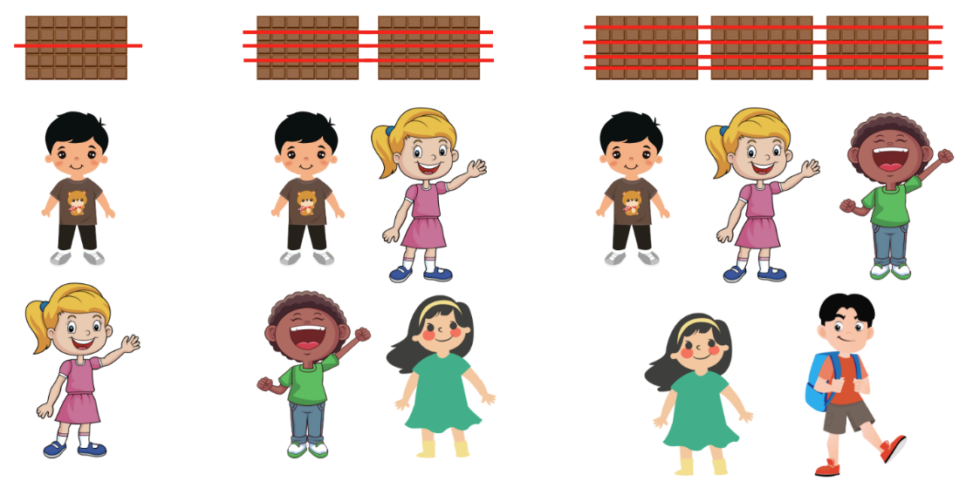
- Explain that this strategy demonstrates that fractions represent division because 3 shared between 5 is equal to $\frac{3}{5}$, so 3 ÷ 5 = $\frac{3}{5}$.
- Ask students to demonstrate if the same applies to the other 2 groups.
This table details opportunities for assessment.
Assessment opportunities | Links
What to look for:  - Can students identify how the relationship between the number being divided and the divisor is represented in a fraction? [MAO-WM-01, MA3-RQF-01] | Links to National Numeracy Learning Progressions (NNLP):  - InF6.

Core lesson: Pulse rate – 45 minutes
The table below contains suggested learning intentions and success criteria. These are best co-constructed with students.
Core concept learning intentions | Core concept success criteria
Students are learning to:  - collect categorical and discrete numerical data by observation  - choose and use appropriate tables and graphs  - interpret and compare a range of data displays. | Students can:  - collect categorical data through observation  - construct column graphs using a many-to-one scale, with the use of digital technologies  - interpret and compare different displays in terms of the shape of the distribution, including the range and the mode.
This activity is an adaption of Pulse rates investigation from Universal Resources Hub by State of New South Wales (Department of Education).
- Ask students:
- What is a pulse rate?
- How can it be measured?
Note: a pulse rate is the measure of heart beats per minute (BPM). It varies according to how much exercise is being done. The more exercise the higher the pulse rate. Resting pulse rate is when you are at rest.
- Display Resource 1: Resting heart rate and ask questions, such as:
- Why does each age group have a range rather than a single number?
- Which age group had the highest number of heart beats per minute? Can you suggest a reason why?
- Which age group had the lowest number of heart beats per minute? Can you suggest a reason why?
- Which age group has the largest range of heart beats per minute? How did you calculate your answer?
- Which group surveyed has the smallest range?
- Explain that students will find their resting pulse rate by:
- sitting quietly for one minute
- finding their pulse in their neck by lightly pressing the side of the neck with their fingers, just below the jawline (see Figure 2).
- counting the number of beats in 6 seconds
- multiply the number by 10 to calculate beats per minute (BPM).
Figure 2 – Student finding their pulse in their neck
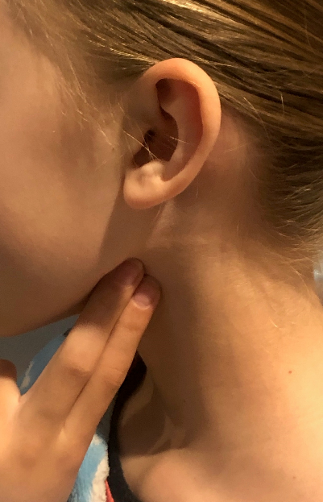
- Students record the resting pulse rates of 10 classmates in a table in their workbook.
Note: provide students with opportunities to describe the characteristics of graphs. In particular, the data can be described in terms of its distribution: how far the data is spread out (range), where most of the data points are (mode) and how the data is arranged visually.
- Ask students:
- What is the range of pulse rates in your data set?
- What is the mode?
- Considering normal heartbeat for adolescents is between 60 to 100 beats per minute at rest, would you say your data set is representative of this statistic? Justify your answers.
- Display Resource 2: Average maximum heart rate
Note: maximum pulse rate is the maximum number of heart beats that will occur in a minute when a person is exercising.
- Discuss the data by asking questions, such as:
- What is the range of the ages that have been surveyed?
- What is the range of maximum heart rates?
- Can you describe the trend in the data?
- How many different age groups were surveyed?
- Can you suggest a different data display that could be used to represent the data more clearly?
- How does someone increase their pulse rate?
- Explain that students will measure their after-exercise pulse rate after exercising for 3 minutes. This may be done inside or outside.
- At the end of the 3 minutes, students take their pulse rate again.
- Students record the after-exercise pulse rates of the same 10 classmates in a table in their workbook.
- Students select their table of either resting or after-exercise pulse rates and create a column graph using Microsoft Excel or Google Sheets.
- Students:
- open Microsoft Excel or Google Sheets on a device
- open a blank spreadsheet
- enter student names and pulse rates in column A and B
- highlight the data, including the headings
- use the top ribbon to select ‘insert’ and ‘column chart’
- add any features missing from the graph, for example title, or axes names or labels.
- Complete a gallery walk to view students graphs and discuss the differences between the graphs.
This table details opportunities for differentiation.
Too hard? | Too easy?
Students cannot construct column graphs with the use of digital technologies.  - Students construct column graphs without the use of digital technologies. | Students can construct column graphs with the use of digital technologies.  - Students compare their graph with a student who graphed the other data set (either resting or after-exercise pulse rate).  - Students predict what the graph would look like for elite athletes or a group of unfit adults.

Discuss and connect the mathematics – 10 minutes
Note: a side-by-side column graph can be used to organise and display the data that arises when a group of individuals or things are categorised according to 2 or more criteria (ACARA).
- Display Resource 3: Pulse rates side-by-side graph and discuss by asking questions, such as:
- How is this graph different to the one you created?
- Why would you use a side-by-side column graph?
- What information can you interpret from this graph?
- What is the range in this graph?
- What is the mode?
- What other variables could you add to this graph? (For example, gender, age, fitness level)
This table details opportunities for assessment.
Assessment opportunities | Links
What to look for:  - Can students collect categorical data through observation? [MAO-WM-01, MA3-DATA-01]  - Can students construct column graphs using a many-to-one scale, with the use of digital technologies? [MAO-WM-01, MA3-DATA-01]  - Can students interpret and compare different displays in terms of the shape of the distribution, including the range and the most frequent value (mode)? [MAO-WM-01, MA3-DATA-02] | Links to National Numeracy Learning Progressions (NNLP):  - IRD3, IRD4, IRD5.

Lesson 2
Core concept: mathematicians organise and present data in different ways.

Daily number sense: Sharing chocolate – 15 minutes
The table below contains a suggested learning intention and success criteria. These are best co-constructed with students.
Daily number sense learning intention | Daily number sense success criteria
Students are learning to:  - recognise that a fraction can represent division. | Students can:  - identify how the relationship between the number being divided and the divisor is represented in a fraction.
This activity is an adaptation of Lamingtons from reSolve by Australian Government Department of Education.
- Explain that another class completed the chocolate bar sharing activity from Lesson 1. However, in this class, all 24 students participated. The first plate had 3 chocolates, the second had 4, the third had 5 and a fourth had 6. The 24 students came into their classroom one at a time and chose where to sit.
- Display Resource 4: Sharing chocolate and ask students to work in pairs and use the fractions as division strategy shown in Lesson 1 to solve the questions. Encourage students to draw their solutions.
- Select pairs to share their thinking.
- Discuss student responses, asking question such as:
- What was challenging about this task? Why?
- Did all pairs have the same answers? Why or why not?
This table details opportunities for assessment.
Assessment opportunities | Links
What to look for:  - Can students identify how the relationship between the number being divided and the divisor is represented in a fraction? [MAO-WM-01, MA3-RQF-01] | Links to National Numeracy Learning Progressions (NNLP):  - InF6.

Core lesson 1: Travelling around Australia – 35 minutes
The table below contains suggested learning intentions and success criteria. These are best co-constructed with students.
Core concept learning intentions | Core concept success criteria
Students are learning to:  - interpret data  - recognise, represent and order numbers in the millions. | Students can:  - interpret data representations found in digital media and in factual texts  - name millions using the place value grouping of ones, tens and hundreds  - arrange numbers in the millions in ascending and descending order using place value  - round numbers to a specified place value.
- Distribute Resource 5: Unlabelled graph and ask students to predict what type of data is being represented in the display. Draw the class’s attention to the fact that column graphs are used to represent discrete data.
Note: numerical data values are expressed as numbers and obtained either by counting or measurement. Counts are discrete values (for example, the number of children in each family) and measurements are continuous values (for example, the change in temperature over time). Column graphs can be used for discrete data values and line graphs for continuous data values, where meaning can be attached to the points on the line between plotted points.
- Brainstorm the missing elements of the graph, including:
- title
- axes names and labels
- equally spaced axes
- scale.
- Give students the topic ‘holidays’ and, as a class, brainstorm what data the graph may represent. For example, destinations, duration of journey, mode of travel.
- Distribute Resource 6: Missing data to pairs of students and explain that the data is not in the same order as presented in Resource 5: Unlabelled graph.
- In pairs, students interpret the data in Resource 6: Missing data to complete the graph in Resource 5: Unlabelled graph. Students label the graph, determine a scale and identify each column based on the size of the numbers in the table.
- Pairs of students swap their graph with another pair to:
- identify the similarities and differences between their graphs
- justify their choice in scale and order of locations on the x-axis.
- Display Resource 7: Short-term visitor arrivals and ask students:
- Is this data? How do you know?
- What is it telling us?
- Where might you see this type of data representation?
- Distribute one infographic from Resource 8: Infographics to small groups of students. Ensure there is a mix of the 3 infographics across the class.
- Groups answer the following questions about their graph:
- What data representations are in your data display?
- What is the data telling us?
- Where might you see this type of data representation?
- Each group composes 3 questions about the data in their display.
- Display each infographic and have each group share their questions for the rest of the class to answer.

Core lesson 2: Large numbers – 20 minutes
- Write the distances from Resource 5: Unlabelled graph (labelled in Core Lesson 1) on the board in metres:
- 2 774 000
- 3 934 300
- 1 140 700
- 1 374 800
- 2 479 300
- Students turn to a partner and take turns reading the numbers from the board.
- Students record the numbers in their workbooks and then write them in ascending order.
- Students specify a place value for their partner to round the numbers to. For example, thousands, tens of thousands, hundreds of thousands or millions. Students record the rounded numbers.
- Write the following numbers on the board:
- 1 189 921
- 1 608 013
- 1 260 552
- 1 375 524
- 1 344 582
- Students record the numbers in their workbooks and then write them in descending order.
- Students specify a place value for their partner to round the numbers to. For example, tens, thousands, tens of thousands, hundreds of thousands or millions. Students record the rounded numbers.
- Reflect on the activity by asking questions, such as:
- Which number did you find most difficult to read? Why?
- Was the first or second set of numbers easier to read? Why?
- Is it easier to order in ascending or descending order?
- Which place value is the easiest to round to? Why?
- Which number did you find the most difficult to round? What place value were you rounding to?
- What strategies help you to read or order or round numbers in the millions?
This table details opportunities for differentiation.
Too hard? | Too easy?
Students cannot arrange or round numbers in the millions.  - Students round the numbers to the nearest million only.  - Provide a list of descending and ascending numbers with some numbers missing for students to fill in. | Students can arrange and round numbers in the millions.  - Students rewrite the list of numbers moving the first 2 digits to the end of the number to create new numbers to order and round.

This table details opportunities for assessment.
Assessment opportunities | Links
What to look for:  - Can students interpret data representations found in digital media and in factual texts? [MAO-WM-01, MA3-DATA-02]  - Can students name millions using the place value grouping of ones, tens and hundreds? [MAO-WM-01, MA3-RN-01]  - Can students arrange numbers in the millions in ascending and descending order using place value? [MAO-WM-01, MA3-RN-01]  - Can students round numbers to a specified place value? [MAO-WM-01, MA3-RN-01] | Links to National Numeracy Learning Progressions (NNLP):  - IRD4, IRD5  - NPV6, NPV7.

Lesson 3
Core concept: data is represented in different ways for different purposes.

Daily number sense: Fairer shares – 15 minutes
The table below contains a suggested learning intention and success criteria. These are best co-constructed with students.
Daily number sense learning intention | Daily number sense success criteria
Students are learning to:  - recognise that a fraction can represent division. | Students can:  - identify how the relationship between the number being divided and the divisor is represented in a fraction.
This activity is an adaptation of Lamingtons from reSolve by Australian Government Department of Education.
- Use Resource 4: Sharing chocolate to review the previous daily number sense activity, reminding students that in the scenario students in the:
- first group received $\frac{3}{5}$
- second group received $\frac{4}{5}$
- third group received $\frac{5}{6}$
- fourth group received $\frac{6}{8}$ .
- Ask students to consider how much each student would receive if the chocolate bars were shared equally across the groups.
- Students Think-Pair-Share strategies to solve the problem.
- Discuss strategies shared, asking questions such as:
- How many students are there? 24.
- How many chocolate bars are there? 18.
- Is the strategy used in the previous lessons the best strategy? Why or why not? It is not the best strategy because it is impractical to cut chocolate bars into 24 pieces.
- How are some suggested strategies similar and how are they different?
- Demonstrate dividing 12 chocolate bars in half, giving 24 halves and therefore, each student $\frac{1}{2}$ . Divide the remaining 6 chocolate bars into quarters, giving 24 quarters and therefore, each student a further $\frac{1}{4}$ . Each student now receives $\frac{1}{2}$ plus $\frac{1}{4}$ .
- Ask students:
- Can you think of another way to write $\frac{1}{2}$ , $\frac{1}{4}$ and $\frac{3}{4}$ ? How do you know?
- Which group gets more using this method? The first group.
- Which group gets less using this method? The second and third groups.
- Which group gets the same using this method? The fourth group.

This table details opportunities for assessment.
Assessment opportunities | Links
What to look for:  - Can students identify how the relationship between the number being divided and the divisor is represented in a fraction? [MAO-WM-01, MA3-RQF-01] | Links to National Numeracy Learning Progressions (NNLP):  - InF6.

Core lesson: Speed skating – 35 minutes
The table below contains suggested learning intentions and success criteria. These are best co-constructed with students.
Core concept learning intentions | Core concept success criteria
Students are learning to:  - interpret data presented in digital media and elsewhere  - recognise that the place value system can be extended beyond hundredths  - locate and represent integers on a number line. | Students can:  - interpret data representations found in digital media  - use place value to partition decimals  - recognise the location of negative whole numbers in relation to zero and place them on a number line  - use the term integers to describe positive and negative whole numbers and zero.
Note: decimals, like fractions, allow students to describe parts of a complete whole. When writing a fraction, the numerator and denominator enable students to show both the number of parts and the size of the parts. Decimals show only the number of parts, and students must determine the size of those parts using their knowledge of place value.
- Write the number 12.345 on the board and ask students:
- Can you read this number aloud? Ensure students are reading the number as 12 and 345 thousandths.
- What do the digits after the decimal point represent?
- Why do we use decimal numbers?
- What is the place value of the numeral 3?
- What is the place value of the numeral 4?
- What is the place value of the numeral 5?
- Write decimal numbers to 3 decimal places on the board, for example, 5.285, 7.902, 3.210. Draw students’ attention to the zero at end of the decimal. Discuss with students that the zero at the end of a decimal does not change the value of the decimal.
- Invite students to read the numbers and identify the place value of different numerals in each number.
- Display Resource 9: Speed skating times and ask students to draw a place value chart in their workbooks including tens, ones, a decimal place, tenths, hundredths and thousandths (see Figure 3).
Figure 3 – Place value chart
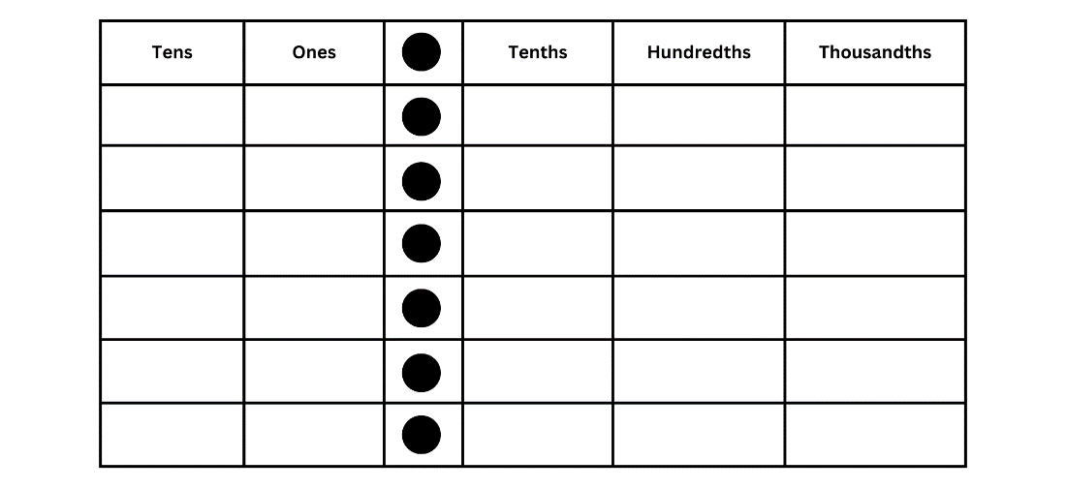
- Students write each skater’s time in their place value chart in their workbook.
- Demonstrate the use of Resource 10: number expander with the number 12.345. Explain that the number in the thousandths place does not represent the only thousandth in the number, just like the digit in the ones column does not represent the only ‘ones’ in the number. Use the number expander to show all place value places.
- Distribute Resource 10: Number expander and have students select a number from Resource 9: Speed skating times to add to their own number expander, showing how many thousandths, hundredths and tenths are in the number.
- Ask selected students to read out their number from their number expander.
- Display Resource 11: Speed skating graphs and ask students:
- What do you see, think or wonder?
- What are the similarities and differences between the men’s and women’s data?
- What is the range for the women’s times?
- What is the range for the men’s times?
This table details opportunities for differentiation.
Too hard? | Too easy?
Students cannot indicate the place value of digits in decimal numbers of up to 3 decimal places.  - Students indicate place value of numbers to 2 decimal places. | Students can indicate the place value of digits in decimal numbers of up to 3 decimal places.  - Students round 3-digit numbers to 2 decimal places.  - Students represent the speed skating times on an empty number line.

Consolidation and meaningful practice – 15 minutes
- Display Resource 12: Beijing weather and ask students:
- What is the graph showing?
- Why are there 2 lines on this graph?
- What do you notice about the numbers on the graph?
- What is a negative integer?
- Explain that integers are whole numbers and the temperatures have been rounded to the nearest whole number on the line graph.
- Students select and order 10 integers (including 5 positive and 5 negative numbers) from the line graph in ascending order and compare their order with a partner.
- Revise features of a number line including:
- integers are in order
- proportional spaces
- negative numbers are placed to the left of zero.
- Students place the 10 integers on an empty number line in their workbooks and compare them with a partner, looking for any similarities and differences.
- As a class discuss number lines, asking question such as:
- What do you notice about positive numbers and their relation to zero?
- What do you notice about the negative numbers and their relation to zero?
- Which do you find more difficult to place on a number line? Why?
This table details opportunities for differentiation.
Too hard? | Too easy?
Students cannot record negative integers on a number line.  - Provide a structured number line with marked intervals from negative 10 to 10.  - Students record only the positive numbers on the number line. | Students can record negative integers on a number line.  - Students calculate the range and mode for the data set.  - Students calculate the difference between the maximum and minimum temperature for each day.

This table details opportunities for assessment.
Assessment opportunities | Links
What to look for:  - Can students interpret data representations found in digital media? [MAO-WM-01, MA3-DATA-02]  - Can students use place value to partition decimals? [MAO-WM-01, MA3-RN-02]  - Can students recognise the location of negative whole numbers in relation to zero and place them on a number line? [MAO-WM-01, MA3-RN-01]  - Can students use the term integers to describe positive and negative whole numbers and zero? [MAO-WM-01, MA3-RN-01] | Links to National Numeracy Learning Progressions (NNLP):  - IRD6  - NPV7, NPV9.

Lesson 4
Core concept: graphs can provide an abundance of information.

Daily number sense – 15 minutes
- From a class need surfaced through formative assessment data, identify a short, focused activity that targets students’ knowledge, understanding and skills. Example activities may be drawn from the following resources:
- Mathematics K-6 resources
- Universal Resources Hub.

Core lesson: Making evaluations – 35 minutes
The table below contains suggested learning intentions and success criteria. These are best co-constructed with students.
Core concept learning intentions | Core concept success criteria
Students are learning to:  - interpret and compare a range of data displays  - compare, order and represent decimals. | Students can:  - interpret side-by-side column graphs for 2 categorical variables  - interpret and compare different displays in terms of the shape of the distribution, including the range and the mode  - compare and order decimal numbers of up to 3 decimal places.
This activity is an adaption of Making evaluations from NZ Maths by New Zealand Ministry of Education.
- Explain that data displays are visual representations of information, such as graphs or tables, that help readers to understand and interpret data.
- Display Resource 13: Lunchtime places and ask students:
- What do you notice or wonder?
- Why would you use a side-by-side column graph?
- What information can you interpret from this graph?
- What might the statistical question be that this data is trying to answer?
- What is the mode for students in years 3-6?
- What is the mode for students in years K-2?
- Read the conclusions below and students move to either side of the room if they agree or disagree. If they feel they don’t have enough information from the graph to answer, they stay in the middle of the room. As students move around the room, ask them to justify their decision using data from the graph. Example questions include:
- The library is equally popular with K-2 and 3-6 students.
- Everyone’s favourite place is the adventure playground.
- The K-2 students play on the concrete because the seniors take over the sports field.
- The treehouse doesn’t hold many people.
- The sandpit is more popular with K-2 students.
- Students pose further questions which could be asked to gather more information about the topic. For example, students could ask why K-2 students don’t use the sports field.
- Display Resource 14: Ideas for the library and, in pairs, students brainstorm recommendations based on data in the graph. For example, the library should get a sofa and cushions as both K-2 and 3-6 students voted for this idea. Encourage students to refer to the data and discuss if they disagree with each other’s recommendations.
- Display Resource 15: Use of swimming pool facilities and have students Think-Pair-Share to describe the shape of one of the lines in the graph.
- Students share their description, referring to the data display.
- Display Resource 16: Lunchtime activities and read out the questions below. Students answer using thumbs up (agree) or thumbs down (disagree) if they can answer the given question by referring to the graph. Example questions include:
- What is more popular, the sports gear or the playground equipment?
- Is there an activity that girls like more than boys?
- Is there an activity that boys like more than girls?
- If the teachers didn’t organise activities like sports practice and production rehearsal, who would this affect the most?
- Should the library only be open on wet days?
- When the drama production is over, what might girls and boys chose to do?
- Who is more interested in sports?
- Select students to support their answers by referring to the data.
- Display Resource 17: School bags and ask students:
- What is the data telling us?
- What is the range of this data set?
- What is the mode of this data set?
This table details opportunities for differentiation.
Too hard? | Too easy?
Students cannot interpret side-by-side column graphs.  - Students interpret column graphs, before moving to side-by-side column graphs.  - Ask student questions related to one variable only in each graph. | Students can interpret side-by-side column graphs.  - Students develop their own questions related to each side-by-side column graph.  - Students brainstorm examples of data which could be represented in a side-by-side column graph.

Consolidation and meaningful practice – 10 minutes
- Display the numbers below. Explain that Mrs Bishop got some books from the library and needs to make sure she puts them back on the shelf in order. Example numbers include:
- 591.420
- 591.421
- 591.008
- 591.914
- 591.422
- 591.108
- Students write the numbers in ascending order in their workbooks.
- Students represent the numbers on an empty number line in their workbooks.
This table details opportunities for assessment.
Assessment opportunities | Links
What to look for:  - Can students interpret side-by-side column graphs for 2 categorical variables? [MAO-WM-01, MA3-DATA-02]  - Can students compare and order decimal numbers of up to 3 decimal places? [MAO-WM-01, MA3-RN-02] | Links to National Numeracy Learning Progressions (NNLP):  - IRD5, NPV8.  Links to suggested Interview for Student Reasoning (IfSR) tasks:  - IfSR-PT: 1A.5, 1A.7.

Lesson 5
Core concept: mathematicians use datasets to observe changes and patterns that occur overtime.

Daily number sense: Fractions and percentages – 15 minutes
Daily number sense activities for Lessons 5 to 7 ‘loop’ back to concepts and procedures covered in previous units to assist students to build an increasingly connected network of ideas. These concepts may differ from the core concepts being covered by the unit.
The table below contains a suggested learning intention and success criteria. These are best co-constructed with students.
Daily number sense learning intention | Daily number sense success criteria
Students are learning to:  - make connections between benchmark fractions, decimals and percentages. | Students can:  - recognise that the symbol % means percent and 100% is the whole amount  - recall commonly used equivalent percentages and fractions  - represent common percentages of lengths as fractions  - recognise that 10% is one-tenth of 100%.
This activity is an adaptation of Simple fractions as percentages from NZ Maths by New Zealand Ministry of Education.
- Show students a stack of 2 interlocking cubes of different colours. For example, see Figure 4.
Figure 4 – 2 interlocking cubes of different colours
- Ask students what fractions can be seen. $\frac{1}{2}$.
- Ask students what percentage can be seen and how it could be written. 50%.
Cent: the word ‘cent’ is derived from the Latin word centum, meaning ‘one hundred’. ‘Per centum’, the Latin origin of per cent, means ‘by the hundred'.
- Show students 2 other stacks of interlocking cubes that also represent 50% of each colour. For example, see Figure 5.
Figure 5 – Stacks of interlocking cubes with equal numbers of each colour
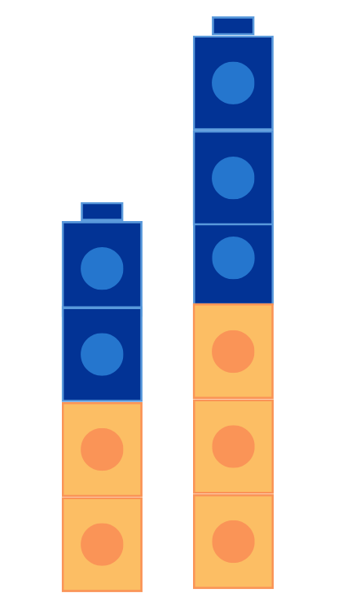
- Ask students:
- What is the same about all 3 stacks and what is different?
- What percentage of each colour is in each stack? 50%.
- How can it be 50% when there are different numbers in each stack? Remind students that 50% is equal to $\frac{1}{2}$.
- How many of each colour would there be if there were 100 cubes in total?
- How could you show 25% of 100 interlocking cubes? Explain your thinking.
- How could you show 10% of 100 cubes? Explain your thinking.
- Distribute interlocking cubes and in small groups make stacks to show:
- 50%
- 25%
- 75%
- 10%
- 100%.
- Select groups to share their stacks and ask:
- How do you know that the percentage is correct?
- Can you think of a fraction that is the same as the percentage?
This table details opportunities for assessment.
Assessment opportunities | Links
What to look for:  - Can students recognise that the symbol % means percent and 100% is the whole amount? [MAO-WM-01, MA3-RN-03]  - Can students recall commonly used equivalent percentages and fractions? [MAO-WM-01, MA3-RN-03]  - Can students represent common percentages of lengths as fractions? [MAO-WM-01, MA3-RN-03]  - Can students recognise that 10% is one-tenth of 100% [MAO-WM-01, MA3-RN-03] | Links to National Numeracy Learning Progressions (NNLP):  - PrT1, PrT2  - UuM8  - InF7.

Core lesson 1: Interpreting timelines – 30 minutes
The table below contains suggested learning intentions and success criteria. These are best co-constructed with students.
Core concept learning intentions | Core concept success criteria
Students are learning to:  - interpret and compare a range of data displays  - recognise, represent and order numbers in the millions. | Students can:  - interpret data on a timeline using the given scale  - arrange numbers in the millions in ascending and descending order using place value  - round numbers to a specified place value.
- Display a line marked with equal intervals and the title ‘Timeline of our formal education’ (see Figure 6).
Figure 6 – Timeline of our formal education
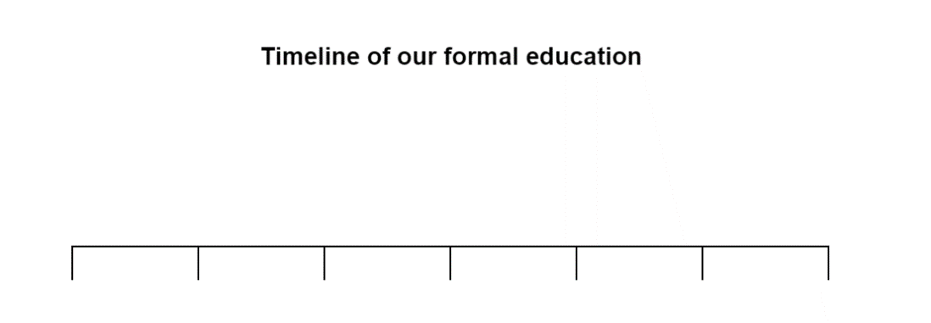
- Students Think-Pair-Share, answering the following questions:
- What is the purpose of this data display?
- What could the intervals be representing?
- How can we complete this timeline?
- Add a scale to the timeline.
- Choose students to provide data to complete the timeline. For example, who started Kindergarten in 2018.
- Display Resource 18: Data story and ask students:
- What do you see, think or wonder?
- Inform students that they are going to complete a timeline of the LEGO company. Explain that in 2022 LEGO celebrated 90 years of play since founder Ole Kirk Kristiansen first started making wooden toys in Denmark.

- Ask students:
- In which year will the timeline begin?
- In which year will the timeline finish?
- What is the range of the timeline?
- Distribute rulers and Resource 19: LEGO timeline to each student.
- Discuss the scale and how to calculate the time distance between events.
- Students calculate and record the year each event occurred on the timeline.
- Check understanding by asking questions, such as:
- In which year did LEGO build their first mini figurine? 1978.
- What was significant about the year 1946? Plastic moulding machine was purchased.
- How many years after the first binding brick was made, was the first plant based plastic brick made? 69 years.
- How many years before LEGO braille bricks were made, was the company officially named LEGO? 84 years.
- In which year did the first LEGOLAND open in Billund Denmark? 1968.
- Which year did you calculate on the timeline first? Why?
- Did you have a strategy for calculating the years on the timeline? What was it?
- How do you know that your answers are correct?
- What was the most difficult part of this activity? Why?

This table details opportunities for differentiation.
Too hard? | Too easy?
Students cannot interpret data on a timeline using a given scale.  - Provide students with a timeline with marked intervals for every 10 years.  - Reduce the number of events on the timeline. | Students can interpret data on a timeline using a given scale.  - Students write 3 questions about the timeline requiring interpretation of the data.  - Students swap questions with a partner to answer them.

Core lesson 2: Visitors – 10 minutes
- Display Resource 20: Visitor attendance, Billund and have students read the passage, then record the attendance numbers in their workbooks.
- Choose individual students to state the numbers referenced in the resource, using the place value grouping of ones, tens and hundreds.
- Students:
- order the numbers in descending order to find which year(s) had the highest attendance
- round the highest number to the nearest 10, 100, 1000, 10 000, 100 000 and 1 000 000.
- Discuss the importance of using the original number each time they round.

This table details opportunities for differentiation.
Too hard? | Too easy?
Students cannot order or round numbers in the millions.  - Provide students with 4- or 5-digit numbers to order and round.  - Students highlight or circle the digit that corresponds with rounding and circle any digits to the right. For example, if rounding 4562 to the nearest 100, students highlight 5 then circle 6 and 2. If the digits circled are greater than the midway point (50) then the highlighted digit is increased by one. | Students can order or round numbers in the millions.  - Students calculate the range once the highest and lowest numbers are rounded to the nearest 100 000 and explain the impact rounding had on the range.  - Students use a 0–9 dice to create and record five 7-digit numbers, then place in descending order.

Consolidation and meaningful practice – 10 minutes
- Display Resource 21: Visitor attendance, Windsor and ask students:
- Can you describe the distribution and the shape of the graph?
- What is the lowest visitor attendance?
- What is the highest visitor attendance?
- What is the range of this data?
- What is the mode?
This table details opportunities for assessment.
Assessment opportunities | Links
What to look for:  - Can students interpret data on a timeline using the given scale? [MAO-WM-01, MA3-DATA-02]  - Can students arrange numbers in the millions in ascending and descending order using place value? [MAO-WM-01, MA3-RN-01]  - Can students round numbers to a specified place value? [MAO-WM-01, MA3-RN-01] | Links to National Numeracy Learning Progressions (NNLP):  - MeT7  - IRD4  - NPV6, NPV7.

Lesson 6
Core concept: data is used in everyday contexts and influences daily practices.

Daily number sense: Percentages for comparisons – 15 minutes
The table below contains a suggested learning intention and success criteria. These are best co-constructed with students.
Daily number sense learning intention | Daily number sense success criteria
Students are learning to:  - make connections between benchmark fractions, decimals and percentages. | Students can:  - recognise that the symbol % means percent and 100% is the whole amount  - represent common percentages of lengths as fractions  - recognise that 10% is one-tenth of 100%.
This activity is an adaptation of Best At? from A Practical Guide to Transforming Primary Mathematics: Activities and tasks that really work by Askew.
- Explain that Remy scored 15 out of 20 on a mathematics test and 20 out of 25 on an English test. Remy said that she was better at English because she got more questions right than she did on the mathematics test. Her friend Ben said that Remy was equally good at mathematics and at English because she got 5 questions wrong in each test. Ask students who they think is correct.
- Select students to share and explain their thinking.
- Explain that students can check their answer by using a double number line.
Note: a double number line helps the conversion of scores into percentages and acts as a visual reminder that whatever is being compared is set up against a benchmark of 100.
- Demonstrate drawing a double number line to represent the mathematics test. For example, see Figure 7. Explain that it has a scale of 0–20 on the top and from 0% to 100% on the bottom. Ask students to assist by adding the benchmark percentages on the bottom, such as 50%, 25%, 75% and 10%, then adding the corresponding score on the top, such as 10, 5, 15 and 2.
Figure 7 – Example double number line
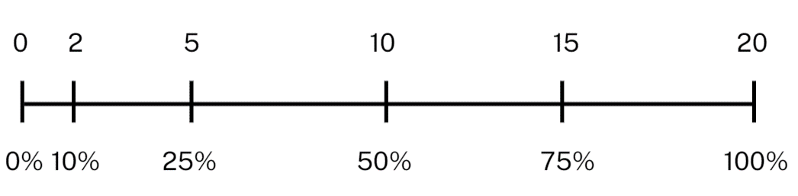
- Identify and record Remy’s mathematics score and corresponding percentage on the number line.
- In pairs, students use the same method to draw a double number line to represent the English test and identify and record Remy’s score. Explain that students will need to mark 10%, then the other percentage multiples of 10 can be added.
- Select students to share their thinking and explain which test result is higher.
This table details opportunities for assessment.
Assessment opportunities | Links
What to look for:  - Can students recognise that the symbol % means percent and 100% is the whole amount? [MAO-WM-01, MA3-RN-03]  - Can students represent common percentages of lengths as fractions? [MAO-WM-01, MA3-RN-03]  - Can students recognise that 10% is one-tenth of 100% [MAO-WM-01, MA3-RN-03] | Links to National Numeracy Learning Progressions (NNLP):  - PrT1, PrT2  - UuM8  - InF7.

Core lesson 1: Is it biased? – 40 minutes
The table below contains suggested learning intentions and success criteria. These are best co-constructed with students.
Core concept learning intentions | Core concept success criteria
Students are learning to:  - interpret data presented in digital media and elsewhere  - compare, order and represent decimals. | Students can:  - identify possible sources of possible bias in representations of data in the media  - compare the place value of digits by determining numbers that are 10 or 100 times the original decimal number, as well as $\frac{1}{10}$ or $\frac{1}{100}$ times the original decimal numbers.
Bias: systematically favouring certain outcomes due to unfair influence (knowingly or otherwise).
- Ask students:
- Have you heard the term bias before?
- What does it mean?
- What are some examples of bias?
- How could data be bias?
- Explain that bias is a systematically favouring certain outcomes due to unfair influence (knowingly or otherwise).
Note: in day-to-day use, bias refers to a prejudice in favour of or against something, usually in a way considered to be unfair. In statistics, bias is essentially when something is unrepresentative of the population. There are different sources of bias that can arise when collecting and analysing data. In Stage 3, students need to recognise that data can present a biased view if it is not representative or is poorly displayed.
- Describe the following scenario: The local council wants to upgrade the public swimming pool, but they also received an application from other community groups to upgrade the soccer fields, netball courts and tennis courts. The council decides that they need to gather some data about what the community want. They send a representative down to a busy part of town (the swimming pool) to survey people. The survey asked what sporting facility community members would like upgraded.
Note: one common form of bias is selection bias. If students only ask a select group of people for their opinions, those opinions will not be representative of the wider population.
- Display Resource 22: Survey results and ask students:
- What is the data showing?
- Do you think this looks like a fair representation of opinions about the topic? Justify your answer.
- Is this an example of biased data collection or representation? Why?
- How could this data be collected without bias?
- Can data bias occur in other contexts? Where?
Sample: a subset of a population used to estimate characteristics of the population. For example, a randomly selected group of 8-year-olds (sample) selected to estimate the height of 8-year-olds in Australia (population).
- Explain to students that bias can be knowingly used in data collection, however it is not always deliberate. There are different ways in which bias can occur in data collection, these may include:
- skewed survey questions
- choosing a specific focus group
- using misleading categorical groupings
- samples that are not random
- sample size that is not representative of the population
- system errors that provide incorrect measures.
- Inform students that a large local primary school has noticed a pattern of late arrivals. They are going to collect data around starting school at a different time.
- Share the 3 scenarios below and ask students to discuss with a partner the potential for bias in each scenario. Select individual students to share their thoughts and reasons why. Example scenarios could include:
- Scenario 1 – arrive early and survey the first 20 people (students, teachers or parents) that walk by. (This would be biased in favour of those that would prefer an early start and would not include those finding it difficult to arrive on time).
- Scenario 2 – after morning assembly, survey the first 20 people who walk into the office. (This would be biased in favour of people who prefer a late start as many people in the office at this time would be those arriving late).
- Scenario 3 – at lunch phone 20 families selected randomly from the home phone number list and do not leave a message. (This would be biased against families who are not at home during the day).
- As a class, brainstorm how the data could be collected in an unbiased way. Discuss methods of collecting and representing the data, random sampling and sample size.
- Distribute Resource 23: Bias answer sheet to small groups of students.
- Display each scenario from Resource 24: Scenarios around the classroom.
- Groups of students have 2 minutes at each scenario to determine whether it is biased or not. If biased, students should identify the type of bias. Students to record their answers on Resource 23: Bias answer sheet.
- Invite students to share their answers and justify their responses. Suggested answers include:
- Scenario A – skewed survey question
- Scenario B – system error that provided incorrect measures
- Scenario C – choosing a specific focus group
- Scenario D – unbiased
- Scenario E – using misleading categorical groupings.
- As a class, brainstorm reasons why data collection and representation can be biased, such as:
- human error (unintentional bias)
- the data collection is funded by a particular group or company
- the data representation is part of an advertisement that is meant to persuade.

Core lesson 2: Decimals – 15 minutes
Note: to multiply 21.34 by 100, tens become thousands, ones become hundreds, tenths become tens, hundredths become ones. A common misunderstanding is that the decimal point moves when a number is multiplied by a power of 10.

- Display the following numbers and explain that the numbers are one-tenth of the people surveyed for different data collection surveys – 0.6, 3.7, 0.8, 21.1, 0.4, 52.4, 4.5 and 0.1.
- Ask students to record how many people were surveyed each time.
- Display the following numbers on the board and explain that the numbers are one-hundredth of the people surveyed for different data collection surveys – 0.8, 3.72, 0.03, 1.45, 0.35, 2.43, 2.04 and 0.09.
- Ask students to record how many people were surveyed each time.
- Display the following numbers and ask students to apply what they know about the place value system to calculate one-tenth of the following decimals – 0.7, 0.35, 0.6, 1.5, 0.25, 6.32, 0.27, 2.34.
- Display the following numbers and ask students to apply what they know about the place value system to calculate one-hundredth of the following decimals – 0.8, 0.4, 35.5, 6.5, 7.6, 1.5, 9.5 and 16.7.
This table details opportunities for differentiation.
Too hard? | Too easy?
Students cannot compare the place value of digits by determining numbers that are 10 or 100 times the original decimal number as well as $\frac{1}{10}$ or $\frac{1}{100}$ times the original decimal numbers.  - Provide a decimal place value chart or slider. | Students can compare the place value of digits by determining numbers that are 10 or 100 times the original decimal number as well as $\frac{1}{10}$ or $\frac{1}{100}$ times the original decimal numbers.  - Provide decimal numbers to 2 and 3 decimal places for students to multiply.  - Students brainstorm where they would apply multiplying and dividing by 10 and 100 in everyday life.
This table details opportunities for assessment.
Assessment opportunities | Links
What to look for:  - Can students identify sources of possible bias? [MAO-WM-01, MA3-DATA-02]  - Can students compare the place value of digits by determining numbers that are 10 or 100 times the original decimal number as well as $\frac{1}{10}$ or $\frac{1}{100}$ times the original decimal numbers? [MAO-WM-01, MA3-RN-02] | Links to National Numeracy Learning Progressions (NNLP):  - IRD4, IRD5  - NPV8.  Links to suggested Interview for Student Reasoning (IfSR) tasks:  - IfSR-PT: 1A.8  - IfSR-NP: 4D.4, 4D.5, 4D.6.

Lesson 7
Core concept: data can be manipulated and misconstrued when representations are misleading.

Daily number sense: Doughnut percents – 10 minutes
The table below contains a suggested learning intention and success criteria. These are best co-constructed with students.
Daily number sense learning intention | Daily number sense success criteria
Students are learning to:  - make connections between benchmark fractions, decimals and percentages. | Students can:  - recognise that the symbol % means percent and 100% is the whole amount  - recall commonly used equivalent percentages, fractions and decimals.
This activity is an adaptation of Doughnut Percents from NRICH by University of Cambridge.
- Distribute the 8 domino cards from Resource 25: Doughnut percents to pairs of students so that each student has 4 dominoes.
- Explain that each student must end up with a set of 4 dominoes arranged to form a ‘doughnut’, where touching ends have equal value. For example, see Figure 8.
Figure 8 – Example dominoes in a doughnut
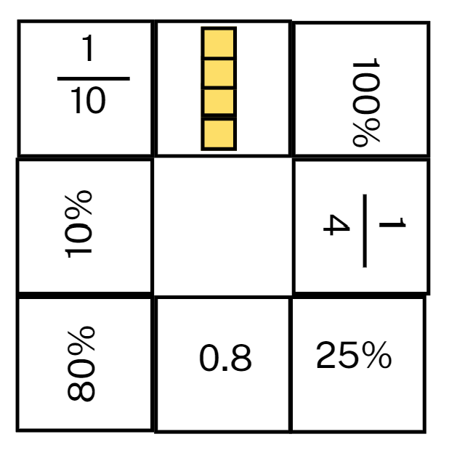
- Explain that the rules are designed to encourage teamwork. The rules are:
- Each player starts with 4 dominoes in front of them.
- The dominoes in front of each person should be visible to both players.
- Players pass dominoes to their partner to help each other complete their doughnut.
- Team members can only give dominoes; they cannot take dominoes from someone else.
- Each team member must always have at least 2 dominoes in front of them.
- No one can talk or give non-verbal signals to other members of the team.
- Reflect on the activity, asking questions such as:
- Which domino ends were the hardest to match? Why?
- Were there any that you didn’t know? Were you still able to match them? What strategy did you use?
- Which domino ends were the easiest to match? Why?
- Would you change anything about this activity? Why or why not?
This table details opportunities for assessment.
Assessment opportunities | Links
What to look for:  - Can students recognise that the symbol % means percent and 100% is the whole amount? [MAO-WM-01, MA3-RN-03]  - Can students recall commonly used equivalent percentages, fractions and decimals? [MAO-WM-01, MA3-RN-03] | Links to National Numeracy Learning Progressions (NNLP):  - PrT1, PrT2  - UuM8.

Core lesson 1: Misleading data – 40 minutes
The table below contains suggested learning intentions and success criteria. These are best co-constructed with students.
Core concept learning intentions | Core concept success criteria
Students are learning to:  - interpret data presented in digital media and elsewhere  - compare, order and represent decimals. | Students can:  - identify misleading representations of data in the media  - approximate the size of decimals.
- Explain that data representations are becoming more popular as a way of presenting information in the media. However, they should be read with a critical eye. There are ways that writers will misrepresent and skew data to support their purpose.
- Display Resource 26: Comparing data displays. Students turn and talk to discuss:
- how the representations are similar and different
- if they represent the same data set
- which representation is misleading and how they know
- the impact of the misleading representation.
- Invite students to share their responses, referring to elements of the graphs to support their opinions.
- Display Resource 27: Misleading strategies. For each of the 4 strategies, students Think-Pair-Share:
- how the strategy can be misleading
- the impact of the strategy
- where the strategy may be used in the media.
- Distribute Resource 28: Misleading representations to small groups of students.
- For each of the 3 data representations, ask students:
- How is the data display misleading?
- Which strategy has been used to make it misleading?
- Why is the display misleading?
- Invite groups to share their thinking, encouraging them to refer to elements of the representations to support their responses. Encourage other groups to challenge or support their peers' opinions.
Note: the data representations in Resource 28: Misleading representations will be used in Lesson 8 where students will remake the representations to ensure they are no longer misleading.
- Summarise the activity by asking question, such as:
- Why would data be presented in a misleading way?
- What could be the purpose of creating a misleading data display?
- How can we identify if a data display is misleading?
- Where might we see misleading data representations?
- What is the difference between bias and misleading data representations?
This table details opportunities for differentiation.
Too hard? | Too easy?
Students cannot identify misleading elements of representations of data in the media.  - Explain the strategy used to mislead for each display and have students identify evidence that the strategy has been used.  - Identify the misleading elements in each data display and have students identify the impact of each. | Students can identify misleading elements of representations of data in the media.  - Students find their own examples of data displays in the media.  - Students annotate the data displays, identifying the misleading elements.

Core lesson 2: Approximating – 10 minutes
Approximate: an estimate of a number or an amount to a particular accuracy.
- Write the following heights on the board and explain they are the heights of women from around the world (from Resource 28: Misleading representations) and a group of schoolgirls who wanted to compare their own heights to the Australian average:
- Australia 1.65 m
- India 1.55 m
- South Africa 1.58 m
- Peru 1.52 m
- Scotland 1.64 m
- Latvia 1.68 m
- Kim 1.1 m
- Kath 1.18 m
- Courtney 1.32 m
- Shazza 1.45 m.
- Ask students to:
- draw an empty number line starting at 0 and ending at 2 in their workbooks
- mark the benchmark numbers 0.25, 0.5, 0.75, 1, 1.25, 1.5 and 1.75
- explain to a partner why they placed the benchmarks where they did and justify their choices.
- Draw an empty number line on the board and model for students where the benchmarks are positioned.
Note: when students place 0.5 on a 0–2 number line, a common misunderstanding is placing the 0.5 in the position of one.
- Students approximate the heights from the board on their number line.
- Select students to explain where they marked each height and how they approximated their position. Encourage students to use the language of ‘I know it is a little more than or a little less than the benchmark…’.
- Students to use their thumb gauge to indicate their understanding:
- Thumb up = I am confident.
- Thumb to side = I am getting there.
- Thumb down = I need support.
- Ask students:
- Which height was easiest to approximate? Why?
- Which height was most difficult to approximate? Why?
- Can you give another height and explain which benchmark it is closest to?

This table details opportunities for assessment.
Assessment opportunities | Links
What to look for:  - Can students identify misleading representations of data in the media? [MAO-WM-01, MA3-DATA-02]  - Can students approximate the size of decimals? [MAO-WM-01, MA3-RN-02] | Links to National Numeracy Learning Progressions (NNLP):  - IRD4, IRD5, IRD6.  Links to suggested Interview for Student Reasoning (IfSR) tasks:  - IfSR-PT: 1A.4, 1A.5, 1A.7.

Lesson 8
Core concept: statistical reasoning helps mathematicians interpret and make inferences about information.

Daily number sense – 15 minutes
- From a class need surfaced through formative assessment data, identify a short, focused activity that targets students’ knowledge, understanding and skills. Example activities may be drawn from the following resources:
- Mathematics K-6 resources
- Universal Resources Hub.

Core lesson: Accurate data representations – 45 minutes
The table below contains suggested learning intentions and success criteria. These are best co-constructed with students.
Core concept learning intentions | Core concept success criteria
Students are learning to:  - interpret data presented in digital media and elsewhere. | Students can:  - identify sources of possible bias in representations of data in the media  - identify misleading representations of data in the media.
- Review strategies used to create misleading data displays explored in Lesson 7:
- omitting baseline
- manipulating the y-axis
- cherry picking data
- using the wrong graph.
- Display Resource 29: Average worldwide temperature and ask students:
- Can you identify sources of possible bias in this representation?
- What strategies have been used to mislead the audience?
- How can we change the display to correct the misleading elements without changing the data set?
- Display Resource 30: Accurate data representation and ask students:
- What elements have changed?
- How are the displays similar and different?
- Do they display the same data set?
- Students individually select a data representation from Resource 28: Misleading representations to recreate as an accurate representation of the data.
- Students use Microsoft Excel or Google Sheets to recreate the data display with all misleading elements corrected.
- Conduct a gallery walk and compare graphs made by different students. Ask students if there are any differences between students’ graphs made for the same data display and why these may exist.
- Select students to display their graph and ask questions, such as:
- What sources of possible bias did you identify in the representation?
- Which elements did you need to correct or change?
- Does the data representation tell the same story?
- What did you find challenging about this task? Why?
- Reflect on the lesson by asking questions, such as:
- What are some positives and negatives of data representations in the media?
- What are some of the common problems with the way data is represented in the media?
- Why are some data representations misleading?
- How do you identify potentially misleading representations?
- What are the possible social consequences of misleading representations?
- Will you look at data representations in the media differently now? Why or why not?
This table details opportunities for differentiation.
Too hard? | Too easy?
Students cannot identify and correct misleading representations of data in the media.  - Identify the misleading elements of the data representation and have students identify how to correct them.  - Students work in pairs or small groups to re-create the data representation. | Students can identify and correct misleading representations of data in the media.  - Students create an advertisement for the misleading data display, including a headline and short paragraph as though it was in a news article.  - Students create their own misleading data representation related to a matter of interest.

Discuss and connect the mathematics – 10 minutes
- Use the 3-2-1 exit ticket, from the Digital learning selector.
- Ask students to record:
- 3 things they have learnt about data during this unit
- 2 things they would like to understand more
- one reason it is important to learn about data.
- Invite students to share their reflections with the class.

This table details opportunities for assessment.
Assessment opportunities | Links
What to look for:  - Can students identify sources of possible bias in representations of data in the media? [WAO-WM-01, MA3-DATA-02]  - Can students identify misleading representations of data in the media? [MAO-WM-01, MA3-DATA-02] | Links to National Numeracy Learning Progressions (NNLP):  - IRD4, IRD5, IRD6.

Resource 1: Resting heart rate
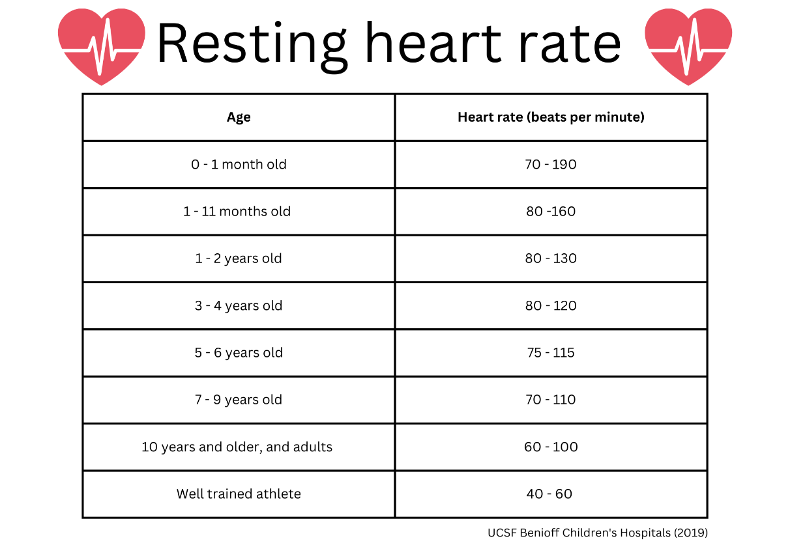

Resource 2: Average maximum heart rate
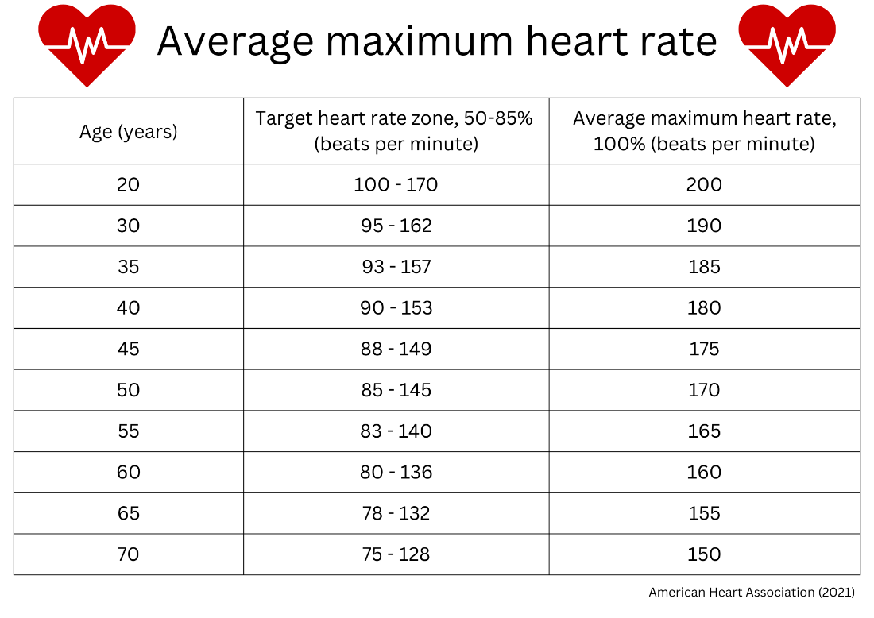

Resource 3: Pulse rates side-by-side column graph
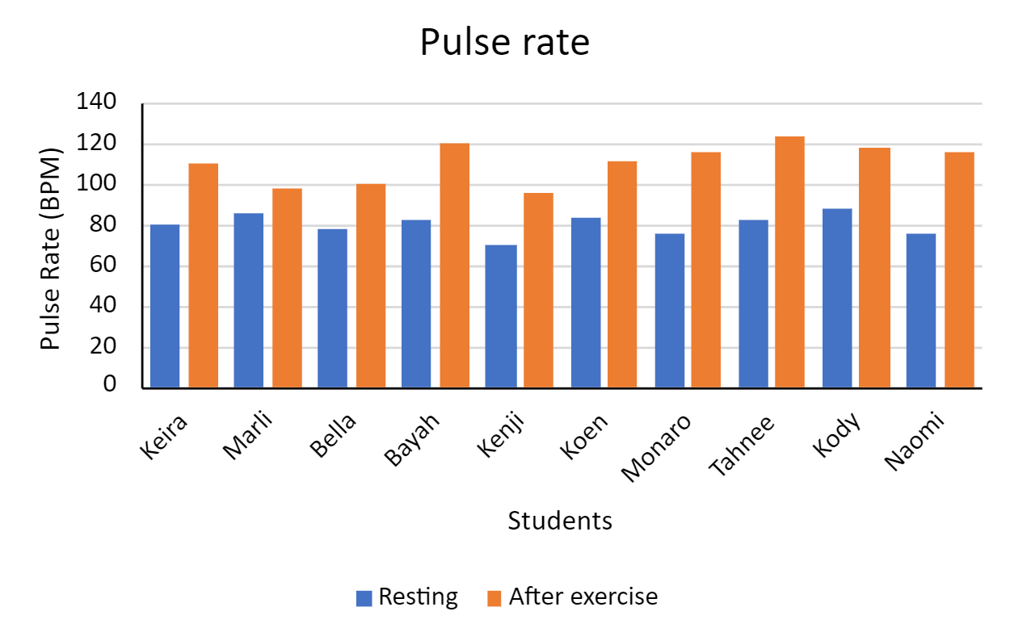

Resource 4: Sharing chocolate
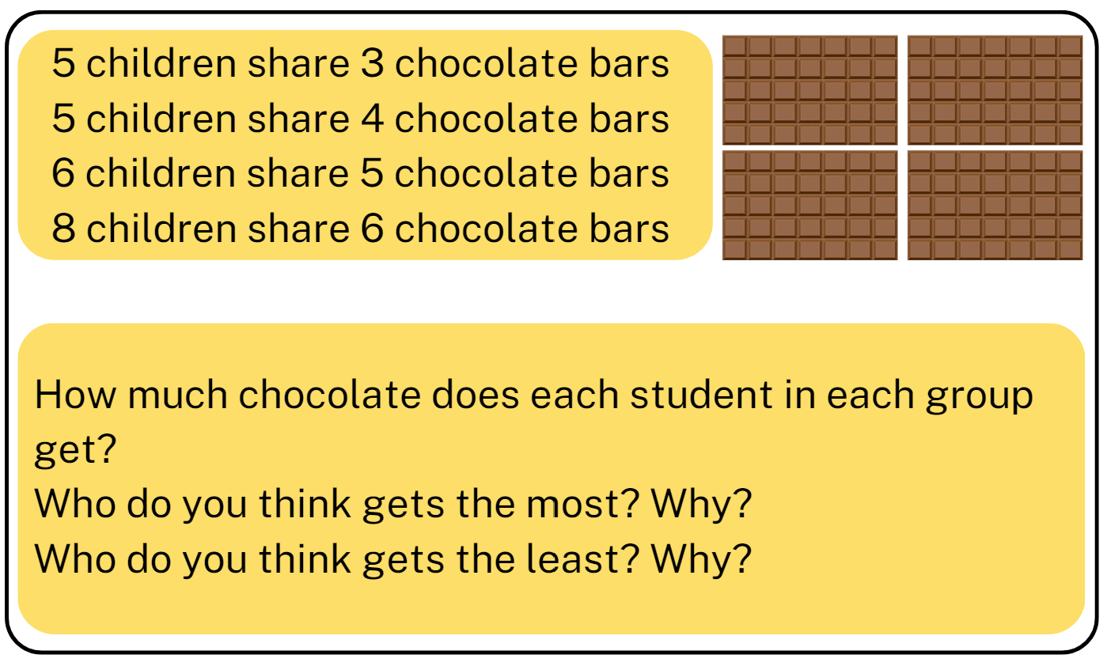

Resource 5: Unlabelled graph
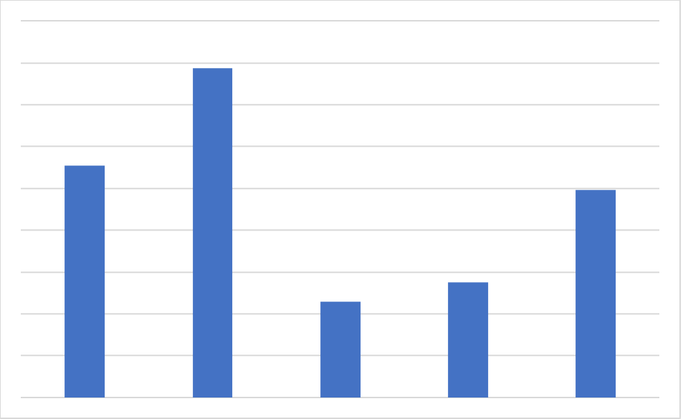

Resource 6: Missing data
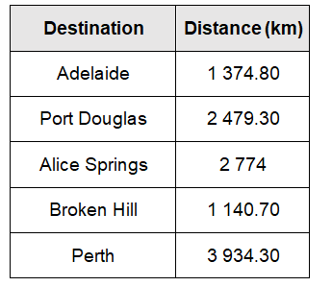
Data source: Google Maps

Resource 7: Short-term visitor arrivals
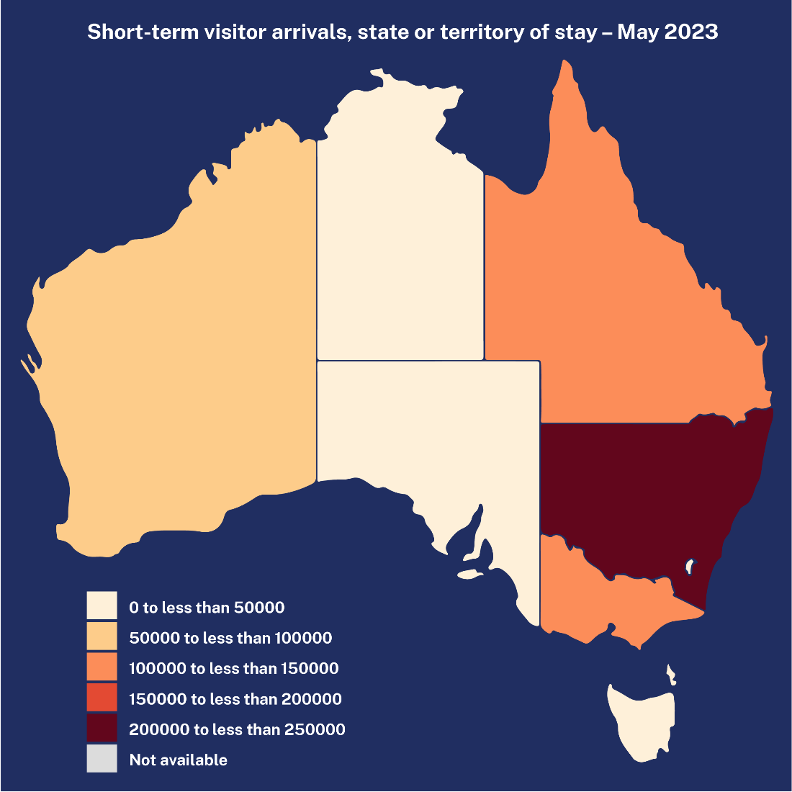
Data source: Australian Bureau of Statistics

Resource 8: Infographics
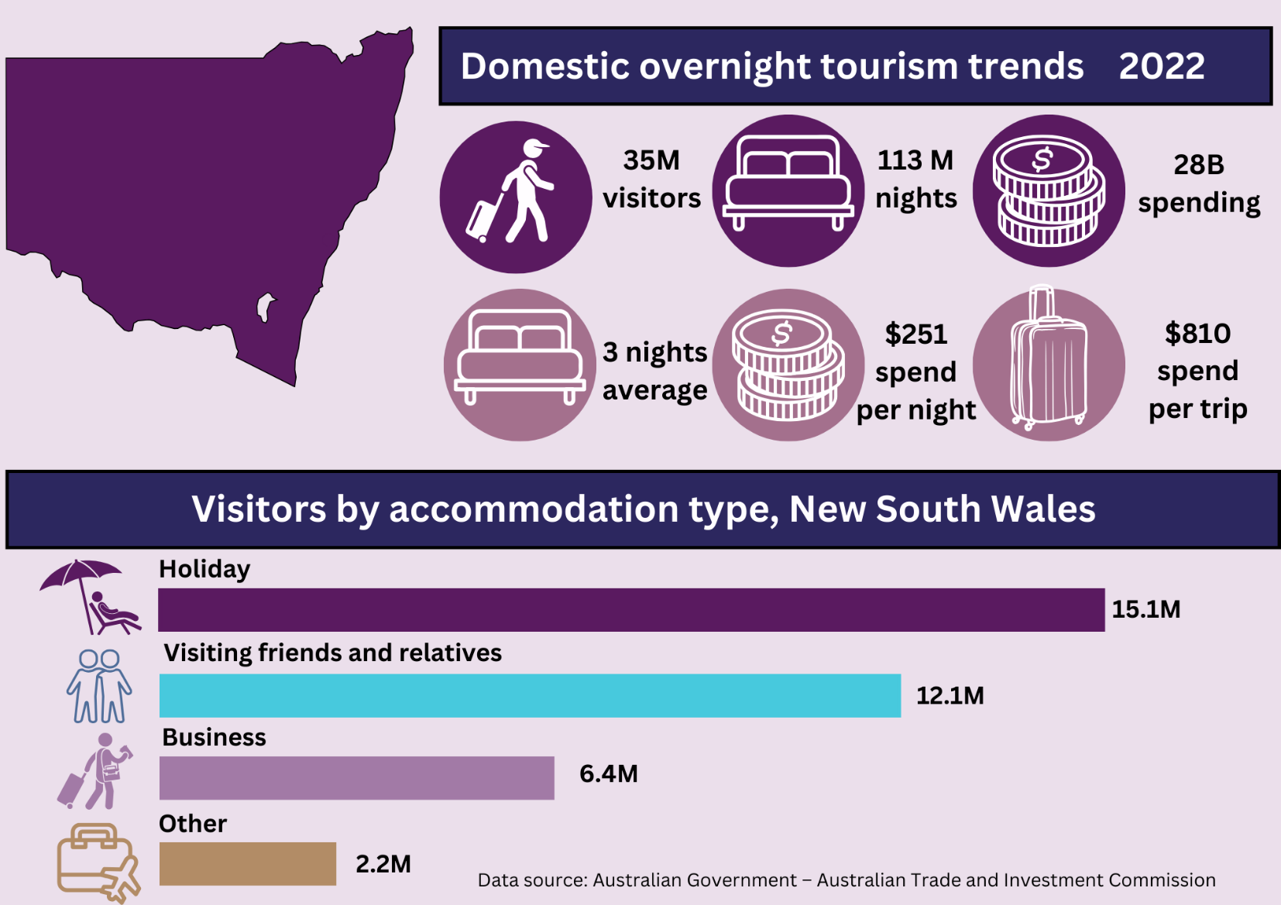
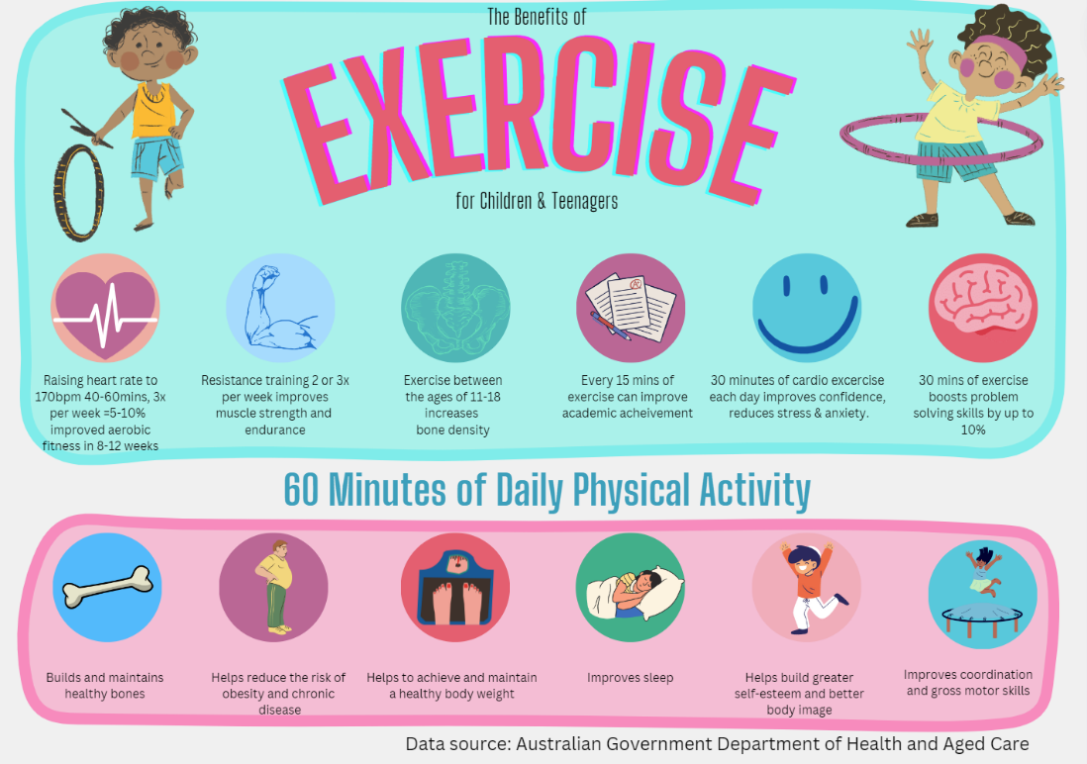
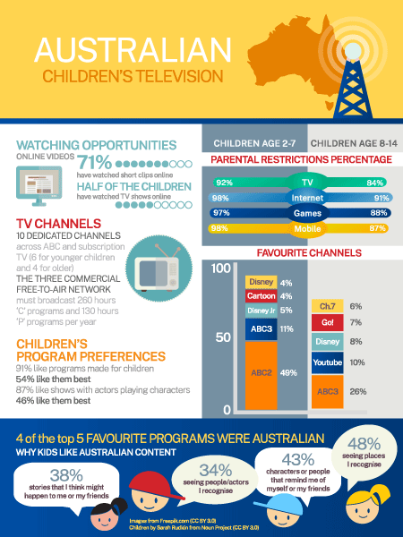
Data source: Screen Australia
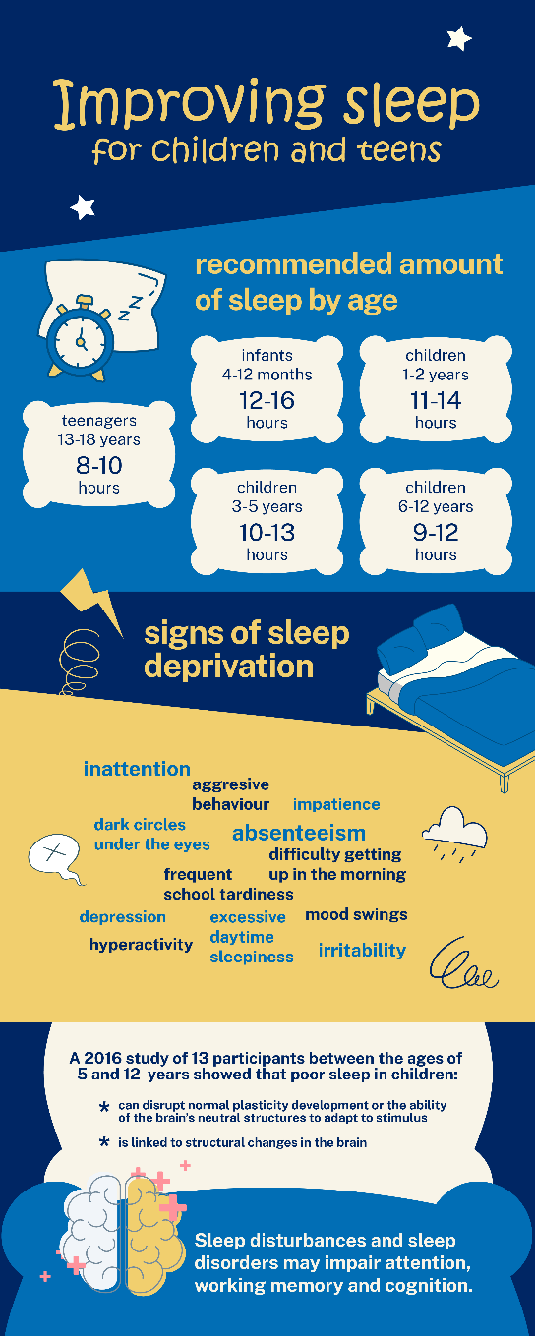
Data source: Regis College

Resource 9: Speed skating times
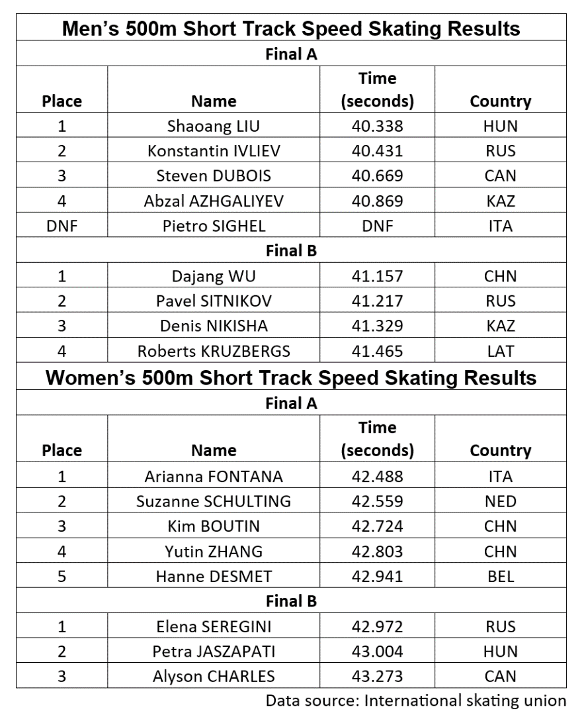

Resource 10: Number expander
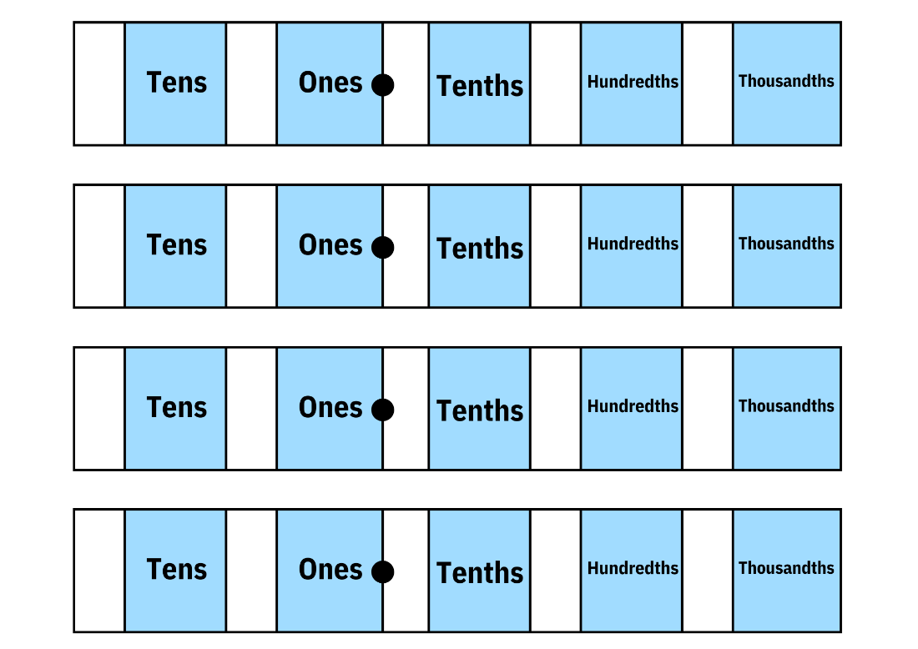

Resource 11: Speed skating graphs
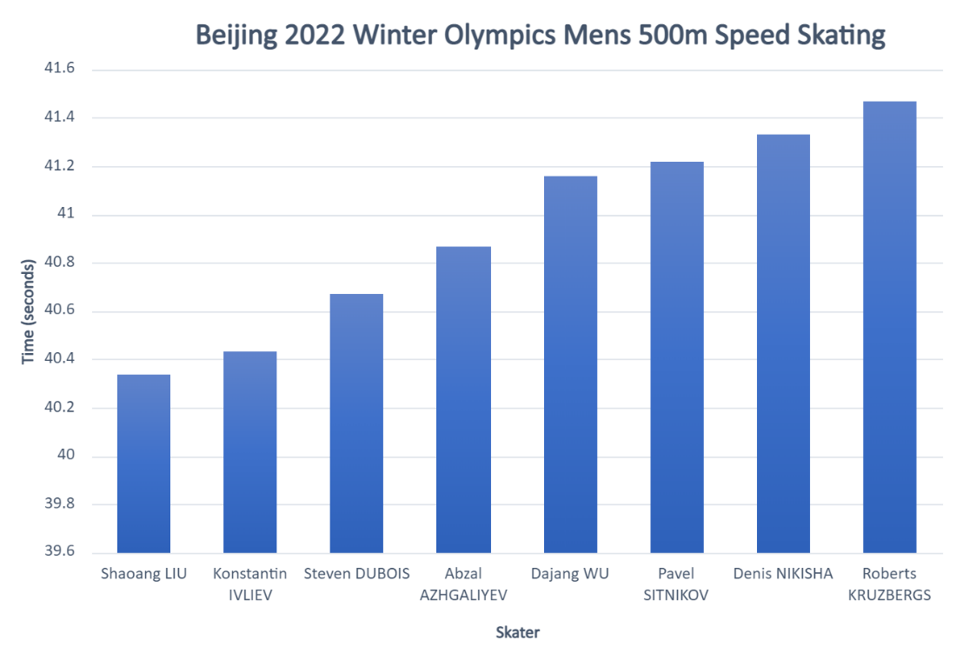
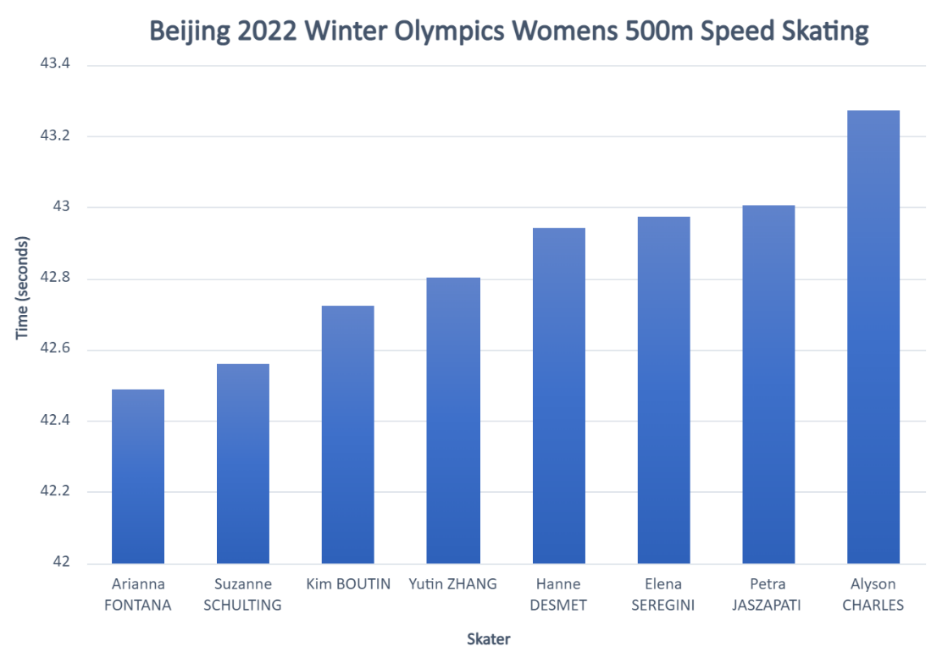
Data source: International skating union

Resource 12: Beijing weather
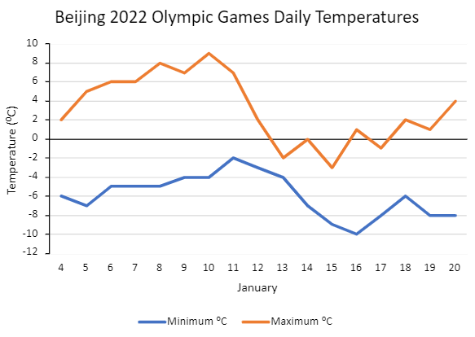
Data source: World weather online

Resource 13: Lunchtime places
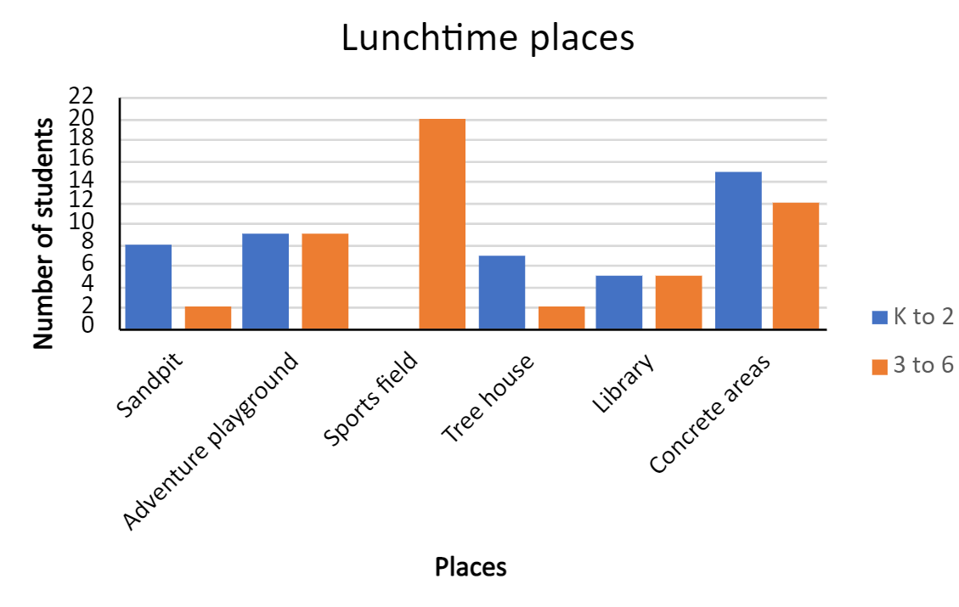

Resource 14: Ideas for the library
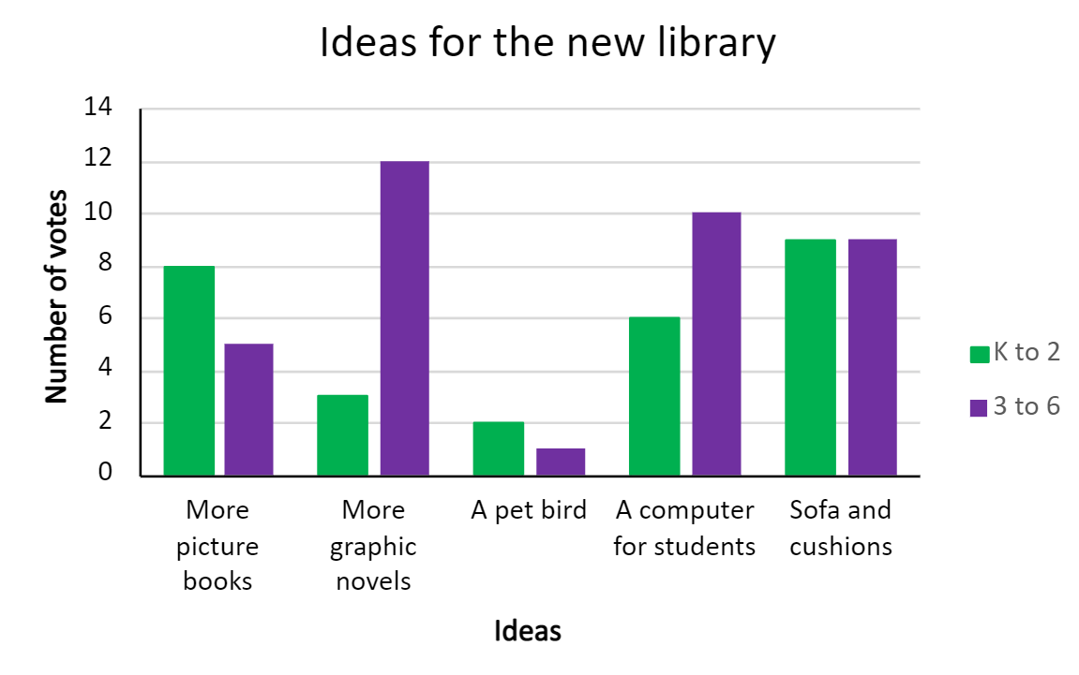

Resource 15: Use of swimming pool facilities
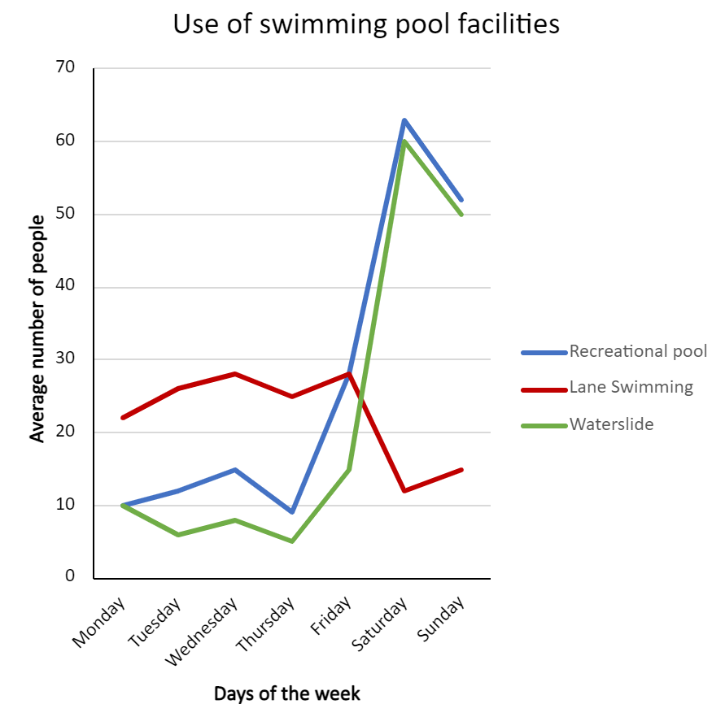

Resource 16: Lunchtime activities
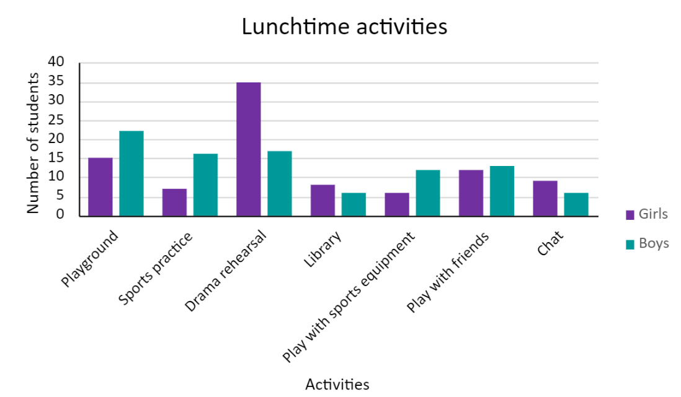

Resource 17: School bags
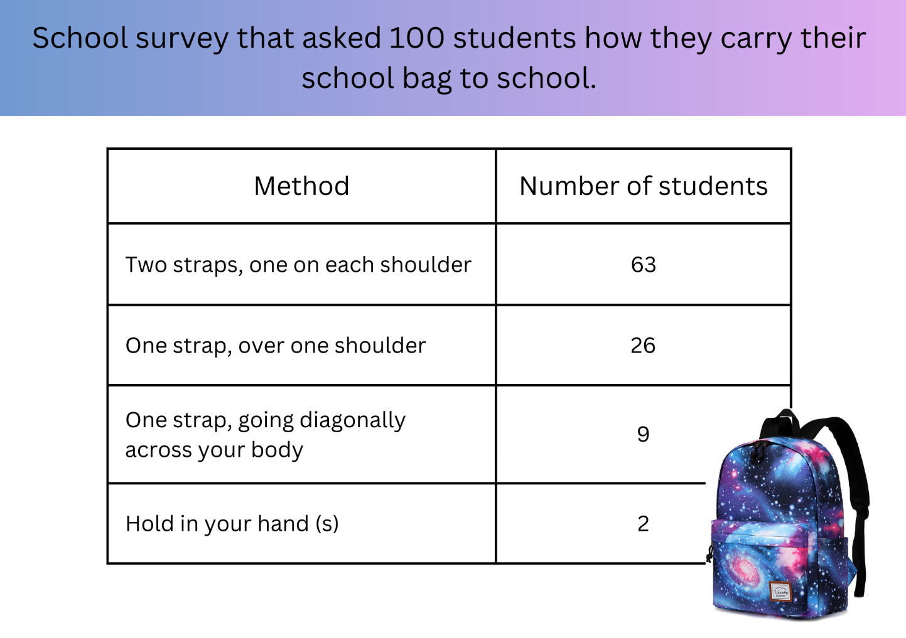

Resource 18: Data story
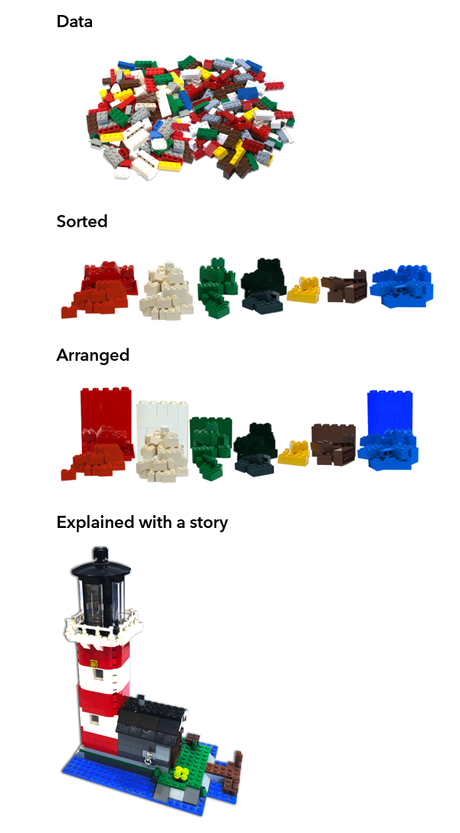

Resource 19: LEGO timeline
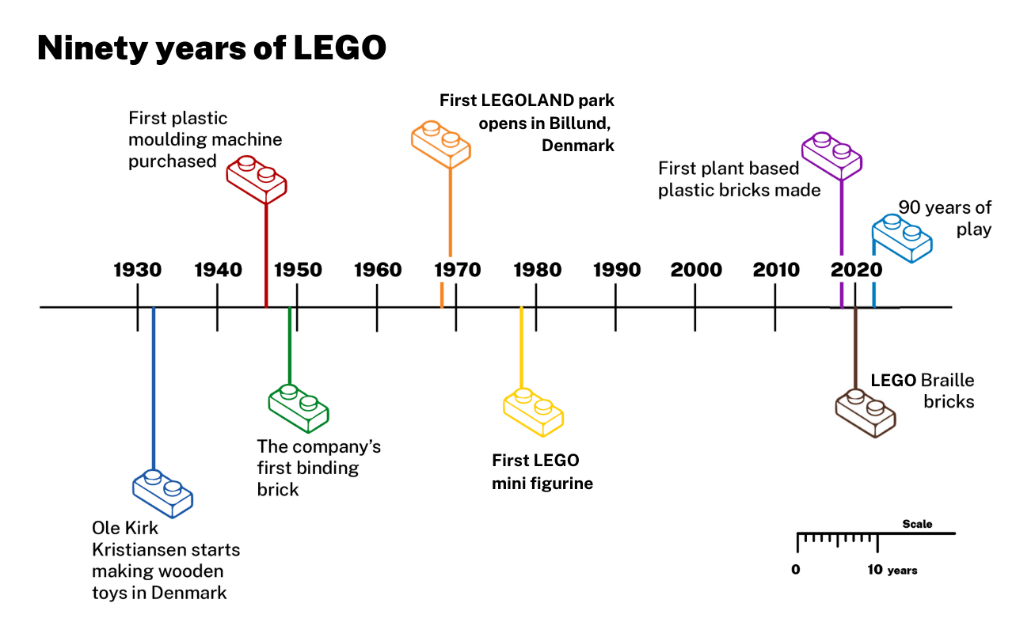
Data source: The LEGO Group

Resource 20: Visitor attendance, Billund
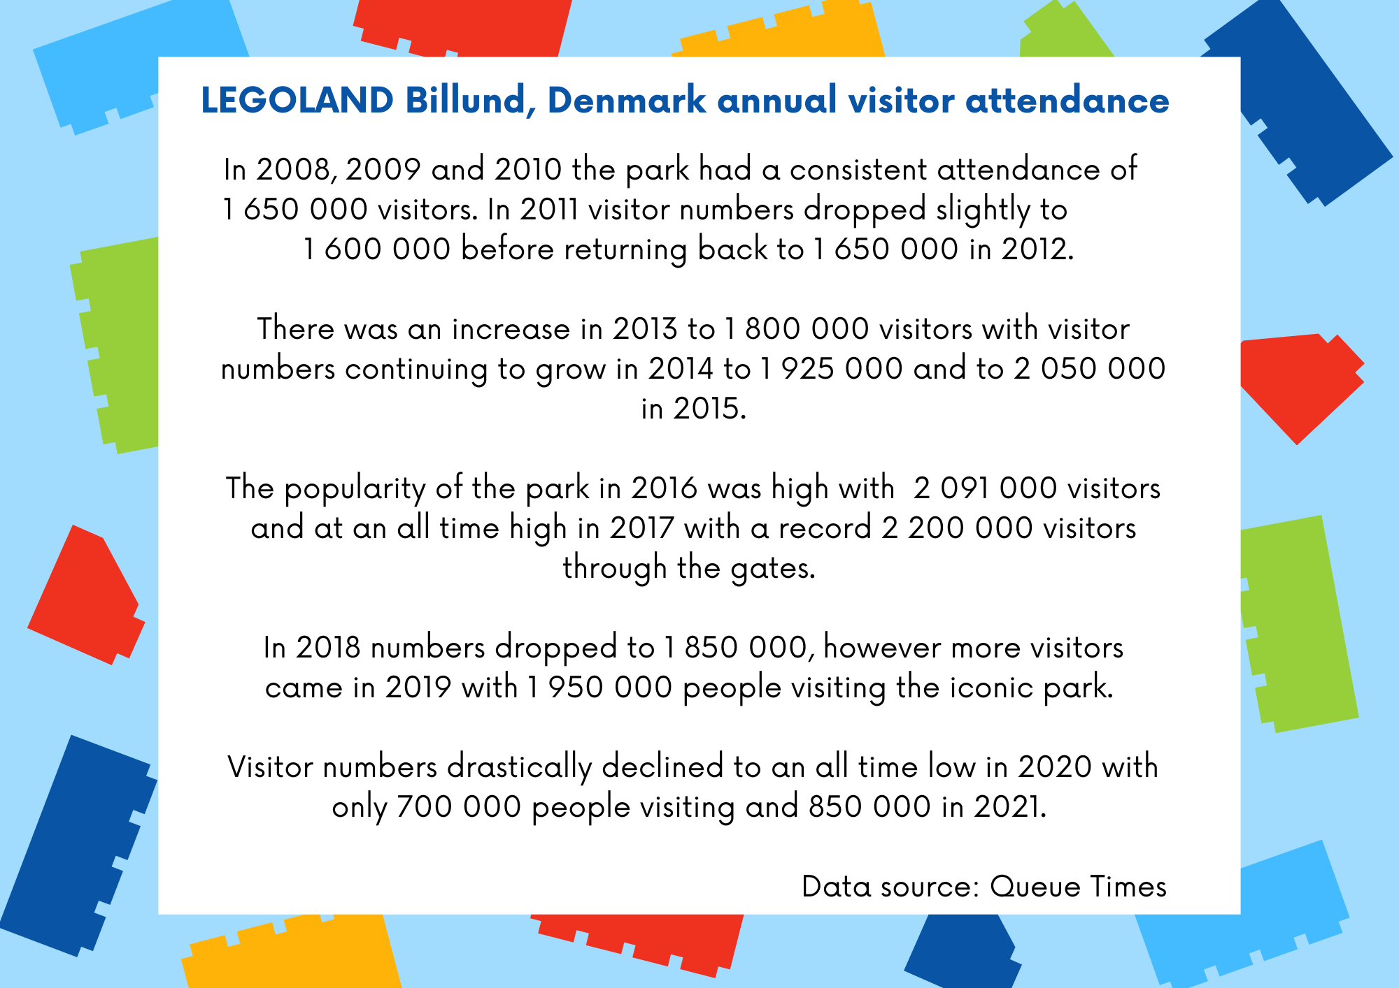

Resource 21: Visitor attendance, Windsor
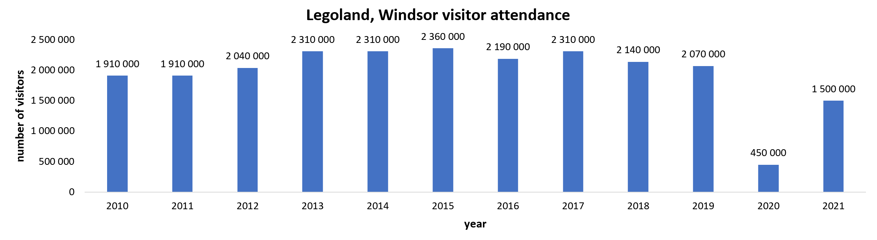
Data source: Queue Times

Resource 22: Survey results
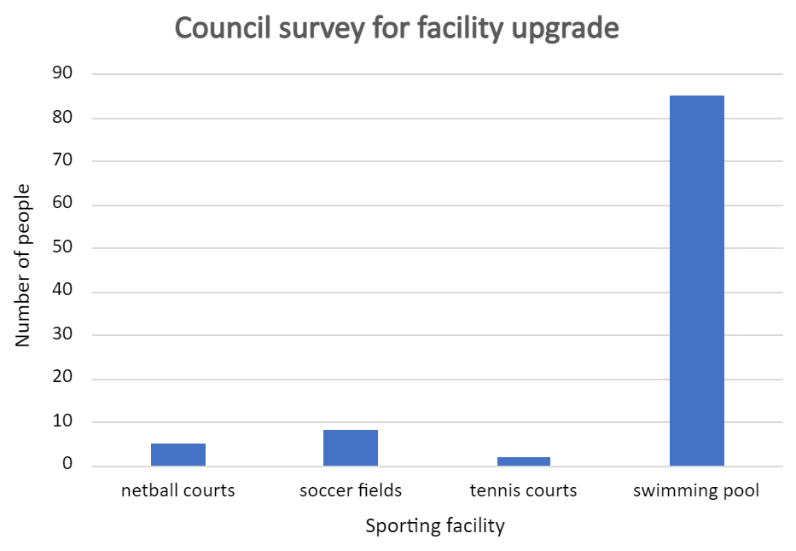

Resource 23: Bias answer sheet
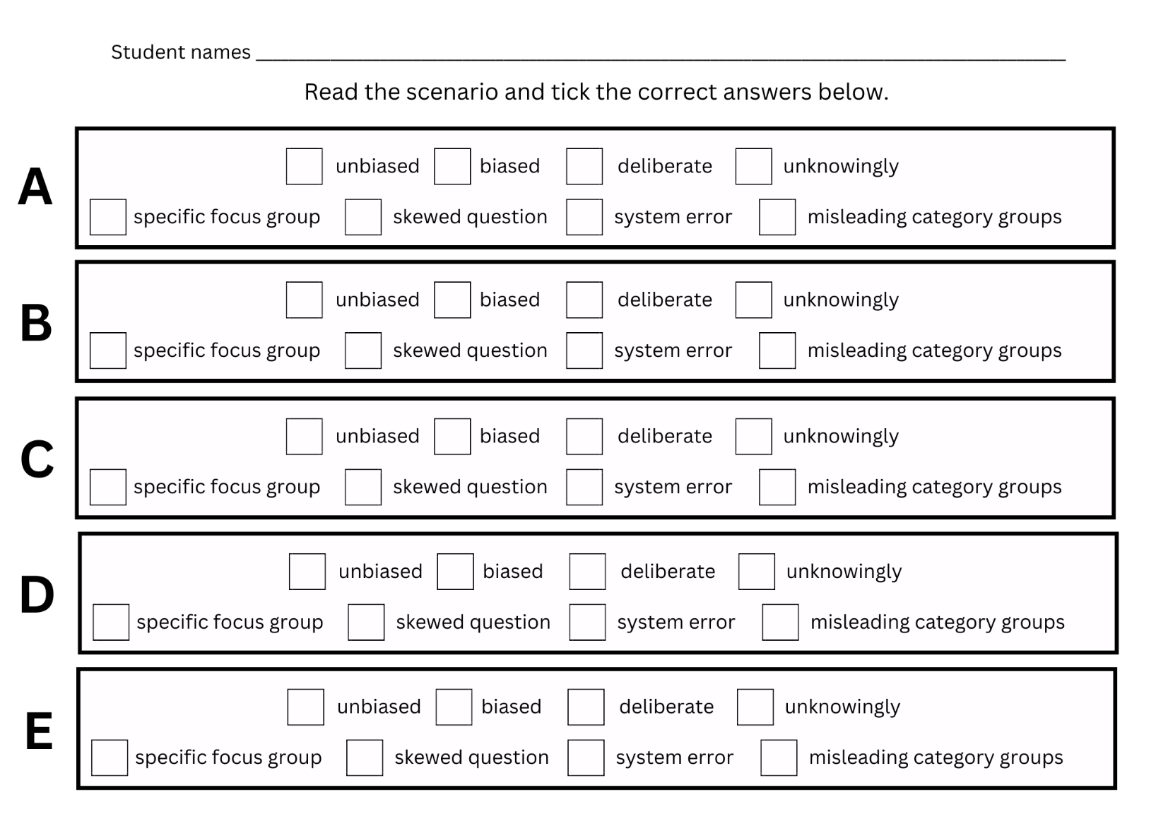

Resource 24: Scenarios
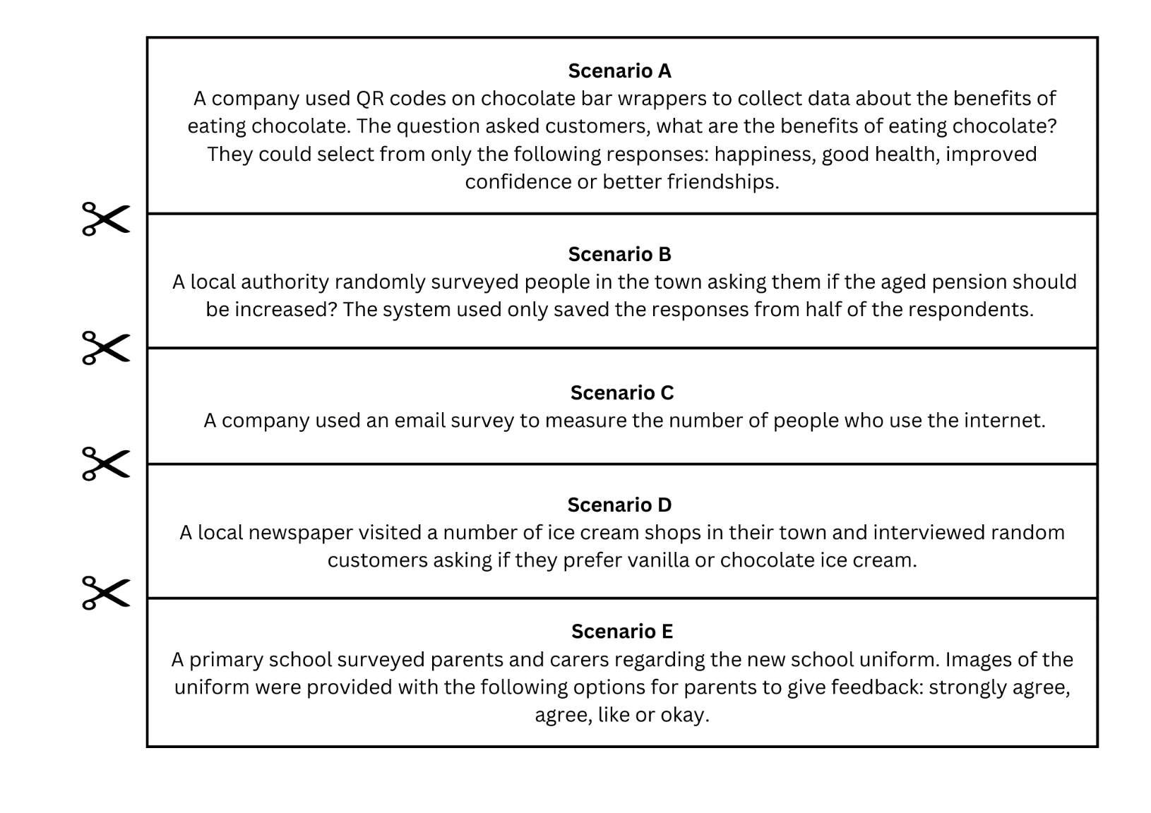

Resource 25: Doughnut percents
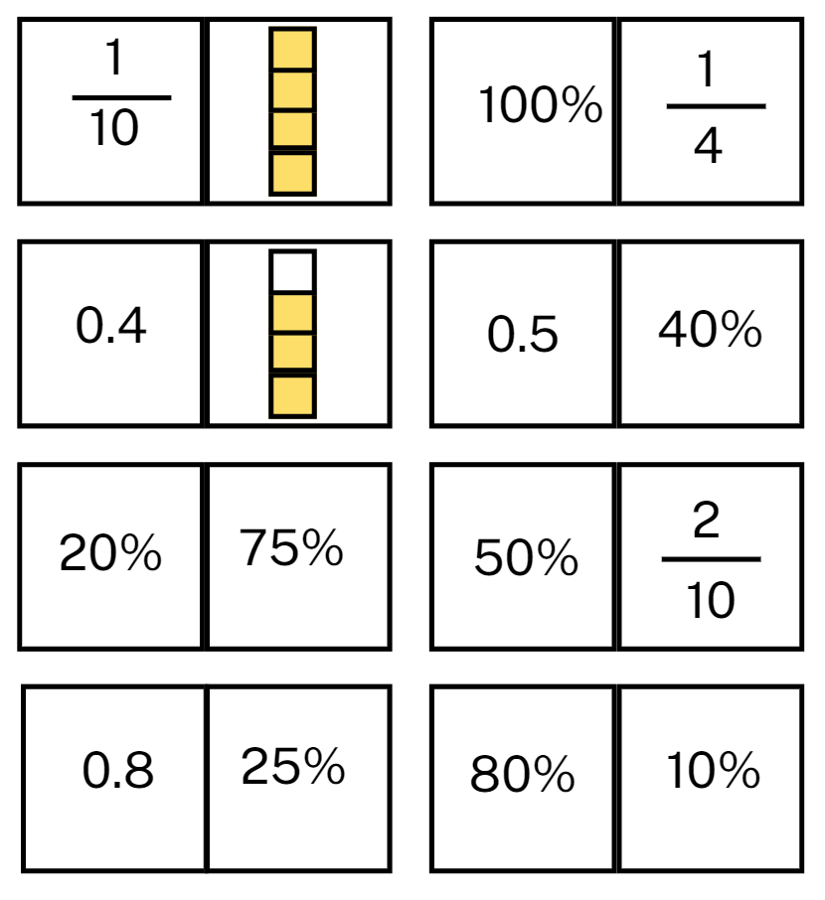

Resource 26: Comparing data displays
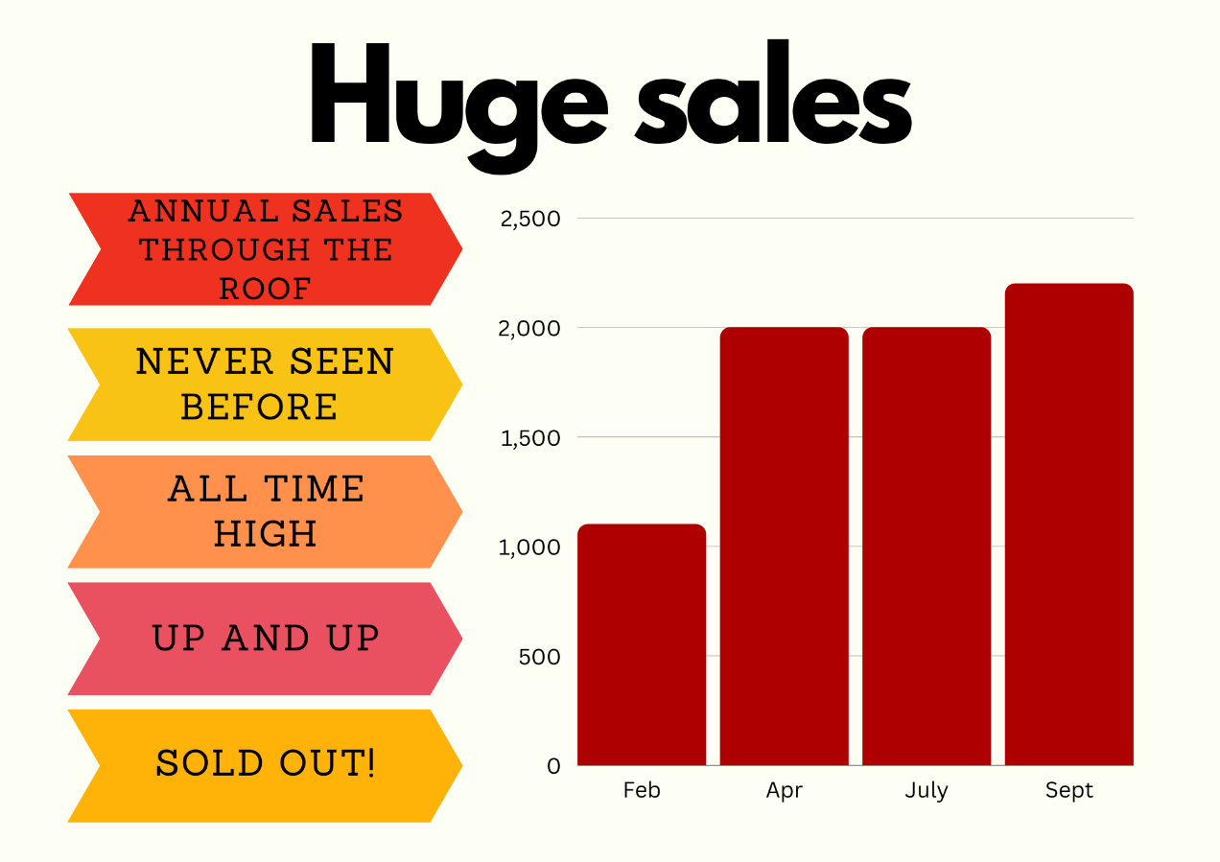
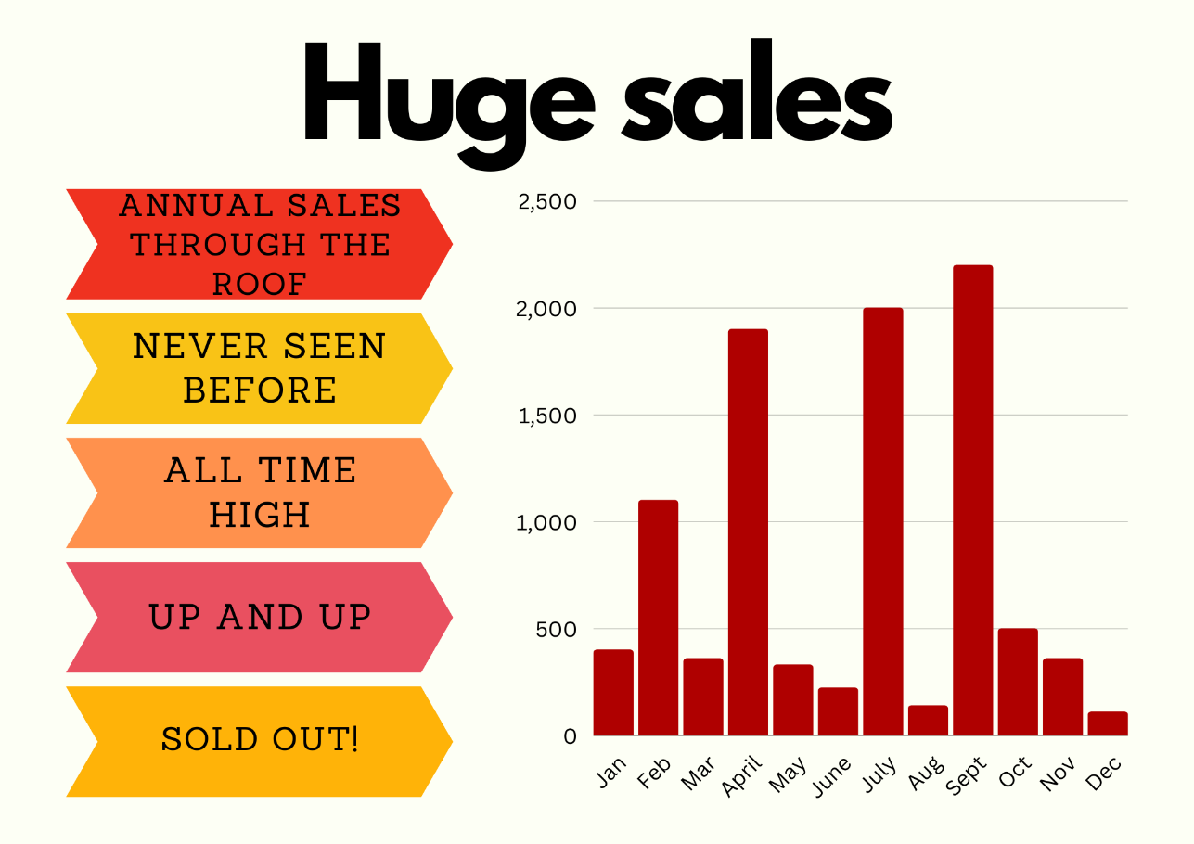

Resource 27: Misleading strategies
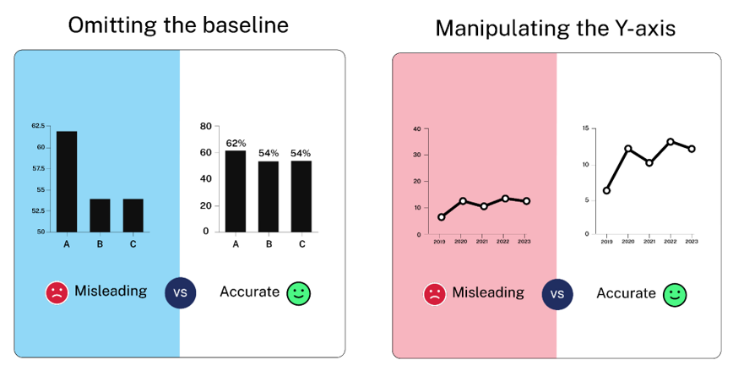
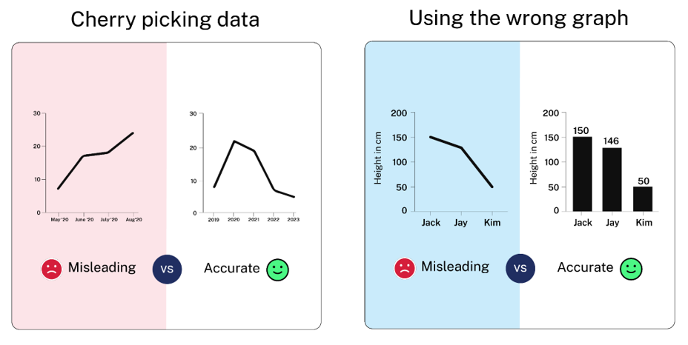
Source: Venngage

Resource 28: Misleading representations
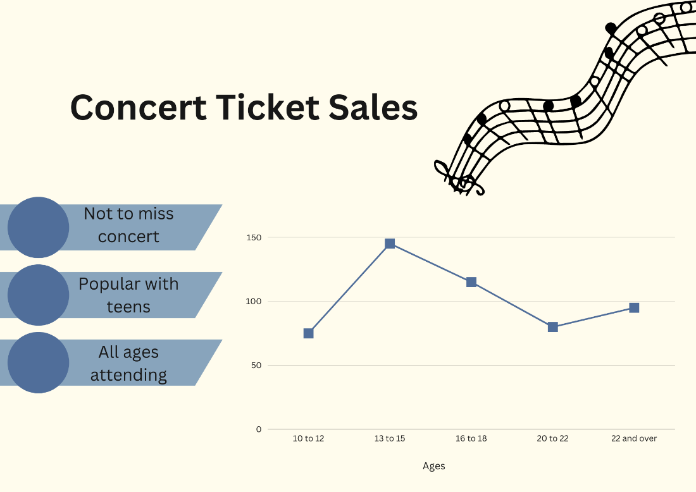
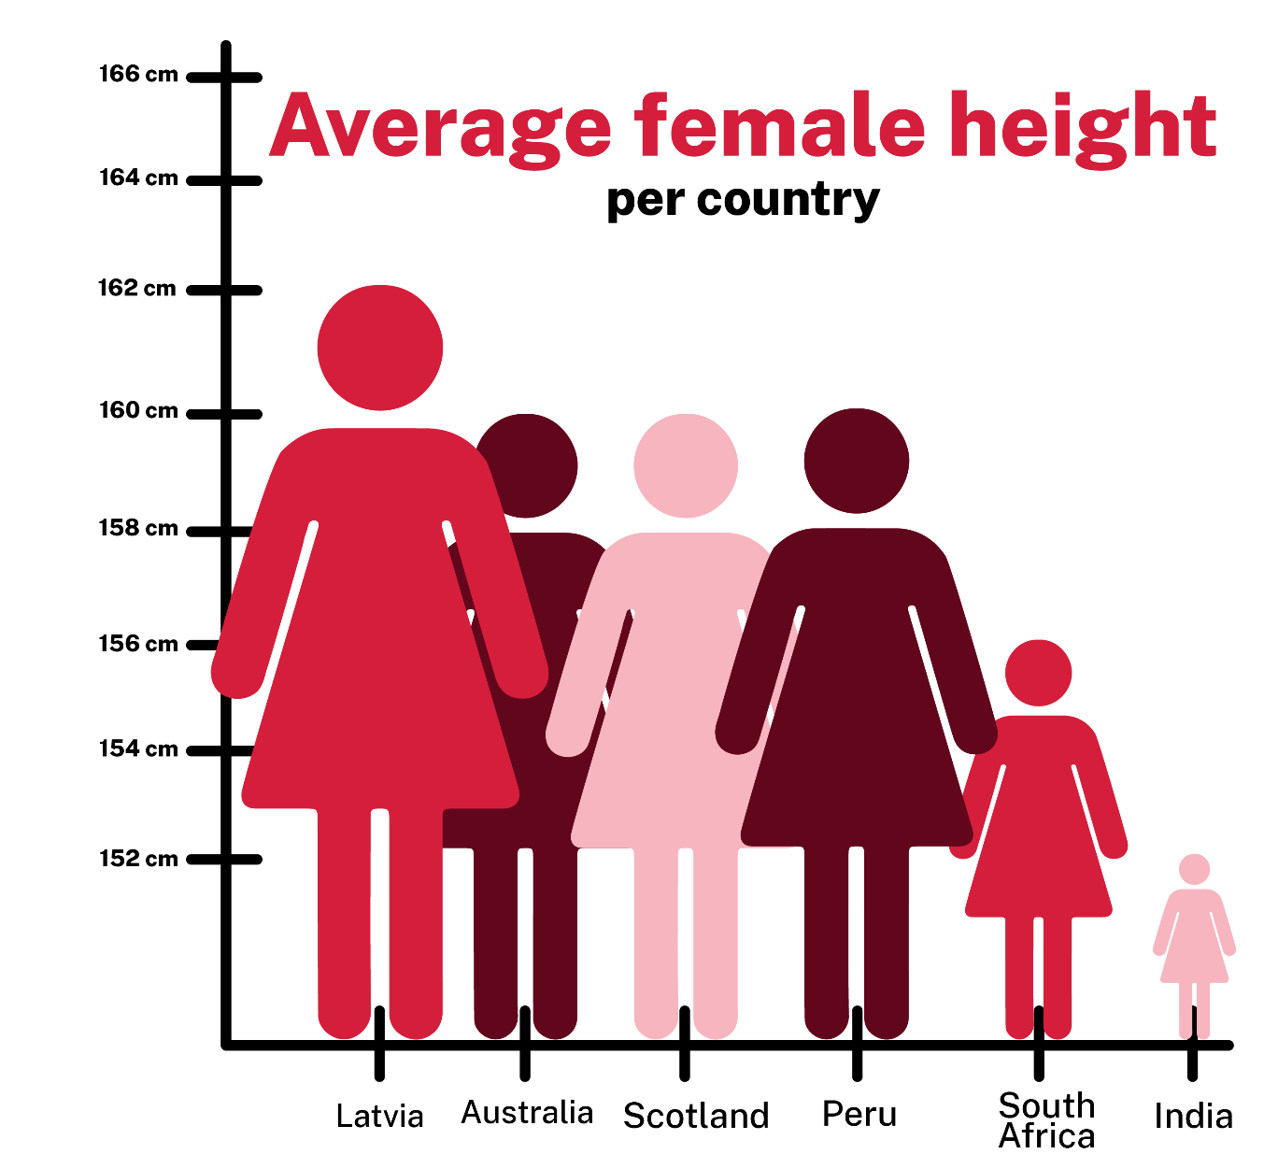
Source: Ibrahim (2020)
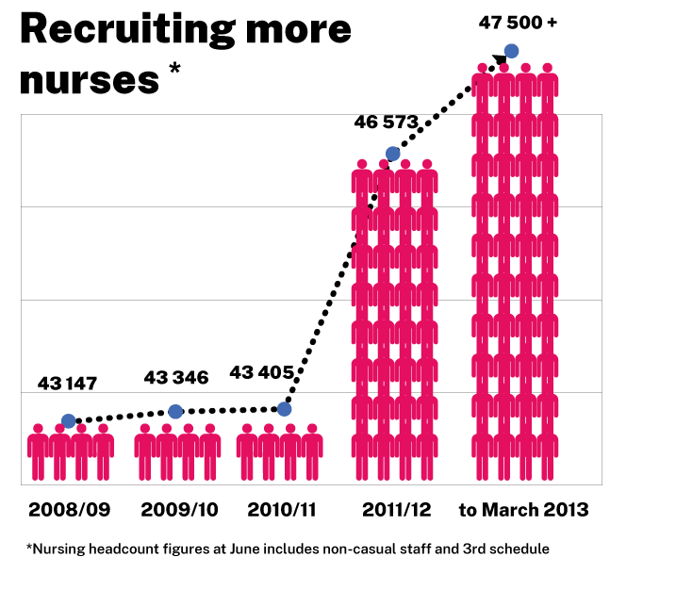

Resource 29: Average worldwide temperature
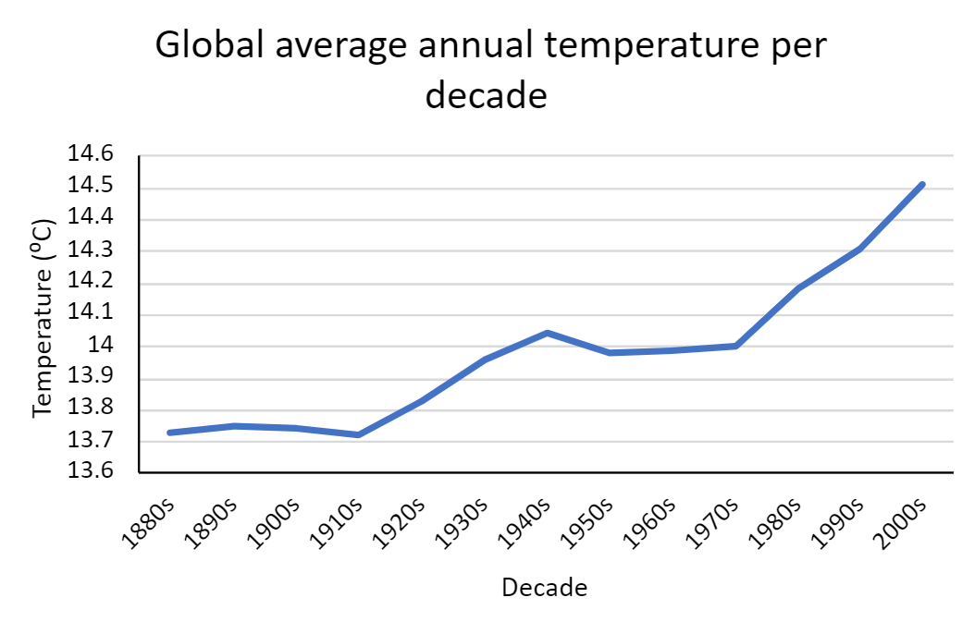
Data source: Current results

Resource 30: Accurate data representation
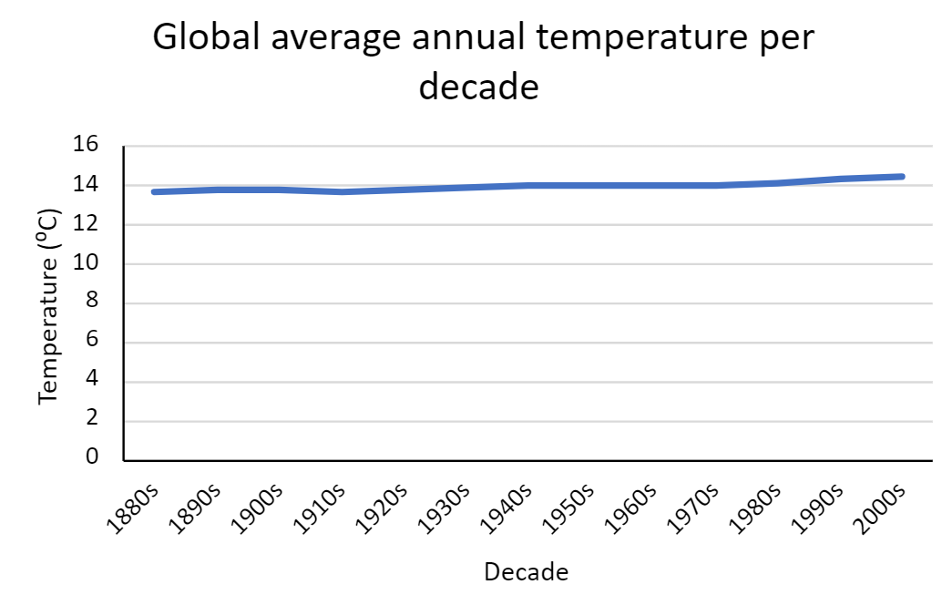
Data source: Current results

Syllabus outcomes and content
The table below outlines the syllabus outcomes and range of relevant syllabus content covered in this unit. Content is linked to National Numeracy Learning Progression version (3).
Outcomes and content | 1 | 2 | 3 | 4 | 5 | 6 | 7 | 8
Represents numbers A: Whole numbers: Recognise, represent and order numbers in the millions
MAO-WM-01, MA3-RN-01
- Name millions using the place value grouping of ones, tens and hundreds |  | x |  |  | x
- Arrange numbers in the millions in ascending and descending order using place value |  | x |  |  | x
- Round numbers to a specified place value |  | x |  |  | x
Represents numbers A: Decimals and percentages: Recognise that the place value system can be extended beyond hundredths
MAO-WM-01, MA3-RN-02
- Express thousandths as decimals |  |  | x | x
- Interpret decimal notation for thousandths |  |  | x | x
- Indicate the place value of digits in decimal numbers of up to 3 decimal places |  |  | x | x
- Use place value to partition decimals |  |  | x
Represents numbers A: Decimals and percentages: Compare, order and represent decimals
MAO-WM-01, MA3-RN-02
- Compare and order decimal numbers of up to 3 decimal places |  |  | x | x
- Interpret zero digit(s) at the end of a decimal |  |  | x
- Compare the place value of digits by determining numbers that are 10 or 100 times the original decimal number as well as $\frac{1}{10}$ and $\frac{1}{100}$ times the original decimal numbers |  |  |  |  |  | x
- Approximate the size of decimals |  |  |  |  |  |  | x
- Place decimal numbers of up to 3 decimal places on a number line |  |  | x | x
Represents numbers B: Whole numbers: Locate and represent integers on a number line
MAO-WM-01, MA3-RN-01
- Recognise the location of negative whole numbers in relation to zero and place them on a number line |  |  | x
- Use the term integers to describe positive and negative whole numbers and zero |  |  | x
- Interpret integers in everyday contexts |  |  | x
Represents numbers B: Decimals and percentages: Make connections between benchmark fractions, decimals and percentages
MAO-WM-01, MA3-RN-03
- Recognise that the symbol % means percent and 100% is the whole amount |  |  |  |  | x | x | x
- Recall commonly used equivalent percentages, decimals and fractions including $\frac{1}{2}$, $\frac{1}{4}$, and $\frac{3}{4}$ |  |  |  |  | x |  | x
- Represent common percentages of quantities and lengths as fractions and decimals |  |  |  |  | x | x
- Recognise that 10% is one-tenth of 100% and use this to find 10% of a quantity (Reasons about relations) |  |  |  |  | x | x
Representing quantity fractions B: Recognising that a fraction can represent division
MAO-WM-01, MA3-RQF-01
- Identify how the relationship between the number being divided and the divisor is represented in a fraction | x | x | x
Data A: Collect categorical and discrete numerical data by observation or survey
MAO-WM-01, MA3-DATA-01
- Collect ordinal or nominal categorical data, and discrete numerical data through observation or by conducting surveys | x
Data A: Choose and use appropriate tables and graphs
MAO-WM-01, MA3-DATA-01
- Tabulate collected data with and without the use of digital technologies such as spreadsheets | x
- Construct column graphs using a many-to-one scale, with and without the use of digital technologies | x |  |  |  |  |  |  | x
Data A: Describe and interpret different datasets in context
MAO-WM-01, MA3-DATA-02
- Interpret line graphs using the scales on the axes |  |  | x
- Describe and interpret data presented in tables, column graphs and line graphs | x | x | x |  |  |  | x
Data B: Interpret and compare a range of data displays
MAO-WM-01, MA3-DATA-02
- Interpret side-by-side column graphs for 2 categorical variables | x |  |  | x
- Interpret data on a timeline using the given scale |  |  |  |  | x
- Interpret and compare different displays in terms of the shape of the distribution, including the range and the most frequent value (mode) | x |  |  | x | x
Data B: Interpret data presented in digital media and elsewhere
MAO-WM-01, MA3-DATA-02
- Interpret data representations found in digital media and in factual texts |  | x | x |  |  |  | x | x
- Identify sources of possible bias in representations of data in the media (Statistical reasoning) |  |  |  |  |  | x |  | x
- Identify misleading representations of data in the media |  |  |  |  |  |  | x | x
Mathematics K–10 Syllabus © NSW Education Standards Authority (NESA) for and on behalf of the Crown in right of the State of New South Wales, 2022.

References
This resource contains NSW Curriculum and syllabus content. The NSW Curriculum is developed by the NSW Education Standards Authority. This content is prepared by NESA for and on behalf of the Crown in right of the State of New South Wales. The material is protected by Crown copyright.
Please refer to the NESA Copyright Disclaimer for more information https://educationstandards.nsw.edu.au/wps/portal/nesa/mini-footer/copyright.
NESA holds the only official and up-to-date versions of the NSW Curriculum and syllabus documents. Please visit the NSW Education Standards Authority (NESA) website https://educationstandards.nsw.edu.au/ and the NSW Curriculum website https://curriculum.nsw.edu.au/home.
Mathematics K–10 Syllabus © NSW Education Standards Authority (NESA) for and on behalf of the Crown in right of the State of New South Wales, 2022.
National Numeracy Learning Progression © Australian Curriculum, Assessment and Reporting Authority (ACARA) 2010 to present, unless otherwise indicated. This material was downloaded from the Australian Curriculum website (National Literacy Learning Progression) (accessed 29 August 2023) and was not modified.
ABS (Australian Bureau of Statistics) (June 2023) Overseas Arrivals and Departures, Australia, ABS website, accessed 3 July 2023.
ACARA (Australian Curriculum, Assessment and Reporting Authority) (n.d.) ‘Mathematics (Version 8.4)’, F–10 curriculum: Learning areas, Australian Curriculum website, accessed 3 July 2023.
A.D.A.M., Inc (Animated Dissection of Anatomy for Medicine) as modified by University of California San Francisco (2019) ‘Pulse’, Medical Tests A–Z, UCSF Benioff Children’s Hospital website, accessed 3 July 2023.
American Heart Association Inc (2021) ‘Target Heart Rates Chart’, Fitness Basics, American Heart Association webpage, accessed 3 July 2023.
Askew M (2016) A Practical Guide to Transforming Primary Mathematics: Activities and tasks that really work, 1st edn, Routledge, UK.
Australian Government Department of Education (2020) ‘Lamingtons’, Teaching resources, reSolve: Math by Inquiry website, accessed 27 June 2023.
Australian Trade and Investment Commission: Tourism Research Australia (2023) ‘National Visitor Survey results’, Reports, Tourism Research Australia website, accessed 3 July 2023.
Department of Health and Aged Care (2021) ‘Physical activity and exercise guidelines for all Australians’, Topics: Physical activity and exercise, Australian Government Department of Health and Aged Care website, accessed 3 July 2023.
Google (n.d.) Google Maps [website], accessed 3 July 2023.
Ibrahim S (7 August 2020) ‘As an Indian woman, I can confirm that too much…’ [Tweet], Sabah Ibrahim X profile, accessed 28 August 2023.
ISU (International Skating Union) (2023) ‘Short Track Speed Skating Results’ [website], accessed 3 July 2023.
McCready R (17 April 2020) ‘5 Ways Writers Use Misleading Graphs To Manipulate You [INFOGRAPHIC]’, Venngage blog, accessed 3 July 2023.
New Zealand Ministry of Education (n.d.) ‘Making Evaluations’, Resources, NZ Maths website, accessed 3 July 2023.
New Zealand Ministry of Education (n.d.) ‘Simple fractions as percentages’, Resources, NZ Maths website, accessed 28 June 2023.
Osborn L (2023) ‘History of Changes in the Earth's Temperature’, Environmental Science Articles, Current Results website, accessed 3 July 2023.
Queue Times (n.d.) ‘Legoland Billund historical attendance data’, Legoland Billund, Queue Times website, accessed 3 July 2023.
Queue Times (n.d.) ‘Legoland Windsor historical attendance data’, Legoland Windsor, Queue Times website, accessed 3 July 2023.
Regis College (12 April 2023) ‘7 Tips for Improving Sleep in Children and Teens’, Regis College blog, accessed 3 July 2023.
Screen Australia (2013) ‘Australian Children’s Television: Did You Know?’, Infographics, Screen Australia website, accessed 3 July 2023.
State of New South Wales (Department of Education) (2023) ‘Pulse rates investigation’, Hub Resources, Universal Resources Hub website, accessed 3 July 2023.
The LEGO Group (2022) ‘The LEGO Group History’, The LEGO Group, LEGO website, accessed 3 July 2023.
University of Cambridge (Faculty of Mathematics) (1997–2023) Doughnut Percents, NRICH website, accessed 28 June 2023.
World Weather Online (2023) ‘Beijing Historical Weather’, Beijing Weather, World Weather Online website, accessed 3 July 2023.

© State of New South Wales (Department of Education), 2023
The copyright material published in this resource is subject to the Copyright Act 1968 (Cth) and is owned by the NSW Department of Education or, where indicated, by a party other than the NSW Department of Education (third-party material).
Copyright material available in this resource and owned by the NSW Department of Education is licensed under a Creative Commons Attribution 4.0 International (CC BY 4.0) license.
This license allows you to share and adapt the material for any purpose, even commercially.
Attribution should be given to © State of New South Wales (Department of Education), 2023.
Material in this resource not available under a Creative Commons license:
- the NSW Department of Education logo, other logos and trademark-protected material
- material owned by a third party that has been reproduced with permission. You will need to obtain permission from the third party to reuse its material.
Links to third-party material and websites
Please note that the provided (reading/viewing material/list/links/texts) are a suggestion only and implies no endorsement, by the New South Wales Department of Education, of any author, publisher, or book title. School principals and teachers are best placed to assess the suitability of resources that would complement the curriculum and reflect the needs and interests of their students.
If you use the links provided in this document to access a third-party's website, you acknowledge that the terms of use, including licence terms set out on the third-party's website apply to the use which may be made of the materials on that third-party website or where permitted by the Copyright Act 1968 (Cth). The department accepts no responsibility for content on third-party websites.

