Mathematics Stage 3 – Unit 23
Contents
Unit description and duration 4
Syllabus outcomes 4
Working mathematically 5
Student prior learning 5
Lesson overview and resources 7
Lesson 1 11
Daily number sense: Adding to 150 – 10 minutes 11
Core lesson: Describing with decimals – 40 minutes 13
Discuss and connect the mathematics – 10 minutes 16
Lesson 2 18
Daily number sense: Kilometre word problems – 10 minutes 18
Core lesson: Metric conversions – 40 minutes 19
Discuss and connect the mathematics – 10 minutes 21
Lesson 3 23
Daily number sense: Travel plans – 10 minutes 23
Core lesson: Select and explain the unit – 40 minutes 25
Discuss and connect the mathematics – 10 minutes 28
Lesson 4 29
Daily number sense – 10 minutes 29
Core lesson: Measure it twice – 30 minutes 29
Consolidation and meaningful practice – 20 minutes 32
Lesson 5 34
Daily number sense: Quarters and wholes – 10 minutes 34
Core lesson: Shapes and perimeters – 40 minutes 35
Discuss and connect the mathematics – 10 minutes 38
Lesson 6 40
Daily number sense: Halves and quarters – 10 minutes 40
Core lesson: A day at school – 40 minutes 41
Discuss and connect the mathematics – 10 minutes 43
Lesson 7 45
Daily number sense: Lemon fractions – 10 minutes 45
Core lesson: ZOOM strategy – 40 minutes 46
Discuss and connect the mathematics – 10 minutes 49
Lesson 8 51
Daily number sense – 10 minutes 51
Core lesson: Measurement investigation – 40 minutes 51
Discuss and connect the mathematics – 10 minutes 54
Resource 1: Place value chart 56
Resource 2: Prefix table 57
Resource 3: Partial conversion chart 58
Resource 4: Converting sheet 59
Resource 5: Number slider 60
Resource 6: Working out distances 61
Resource 7: Full conversion chart 62
Resource 8: Recording lengths 63
Resource 9: Converting lengths table 64
Resource 10: Travel plans 65
Resource 11: Appropriate devices 66
Resource 12: Measuring objects 67
Resource 13: Who is winning? 68
Resource 14: Perimeters 70
Resource 15: Calculating perimeters 71
Resource 16: Halves and quarters 72
Resource 17: 24-hour time 73
Resource 18: School timetable 74
Resource 19: Lemon fractions 75
Resource 20: The ZOOM strategy 76
Resource 21: Elapsed timecards 77
Resource 22: Google Maps example 78
Resource 23: Using Google Maps 79
Syllabus outcomes and content 80
References 86
Further reading 87

Unit description and duration
This unit develops the big idea that what needs to be measured determines the unit of measurement.
In this 2-week unit students are provided opportunities to:
- measure and compare lengths of objects using millimetres, centimetres, metres and kilometres
- measure, create and compare perimeters of two-dimensional shapes
- read and represent timetables in 12-hour and 24-hour time.

Syllabus outcomes
- MAO-WM-01 develops understanding and fluency in mathematics through exploring and connecting mathematical concepts, choosing and applying mathematical techniques to solve problems, and communicating their thinking and reasoning coherently and clearly
- MA3-AR-01 selects and applies appropriate strategies to solve addition and subtraction problems
- MA3-RQF-01 compares and orders fractions with denominators of 2, 3, 4, 5, 6, 8 and 10
- MA3-GM-02 selects and uses the appropriate unit and device to measure lengths and distances including perimeters
- MA3-2DS-01 investigates and classifies two-dimensional shapes, including triangles and quadrilaterals based on their properties
- MA3-NSM-02 measures and compares duration, using 12- and 24-hour time and am and pm notation

Working mathematically
In the Mathematics K–10 Syllabus, there is one overarching Working mathematically outcome (MAO-WM-01). The Working mathematically processes should be embedded within the concepts being taught. The Working mathematically processes present in the Mathematics K–10 Syllabus are:
- communicating
- understanding and fluency
- reasoning
- problem solving.
Mathematics K–10 Syllabus © NSW Education Standards Authority (NESA) for and on behalf of the Crown in right of the State of New South Wales, 2022.

Student prior learning
Before engaging in these teaching and learning activities, students would benefit from prior experience with:
- measuring and comparing lengths of objects with millimetres, centimetres, metres and kilometres
- naming, classifying and measuring two-dimensional shapes
- timetables in 12- and 24-hour time.

In NSW classrooms there is a diverse range of students, including Aboriginal and Torres Strait Islander students, students learning English as an additional language or dialect, high potential and gifted students and students with disability. Some students may identify with more than one of these groups or possibly all of them. Refer to Advice on curriculum planning for every student for further information.

Lesson overview and resources
The table below outlines the sequence and approximate timing of lessons, learning intentions and resources.
Lesson | Content | Duration and resources
Lesson 1  Daily number sense learning intention:  - use efficient strategies to solve addition problems | Lesson core concept: metric units of measurement can be described using the decimal place value system.  Core concept learning intention:  - connect decimal representations of length to the metric system | Lesson duration: 60 minutes  - Resource 1: Place value chart  - Resource 2: Prefix table  - Resource 3: Partial conversion chart  - Resource 4: Converting sheet  - Resource 5: Number slider  - 10-sided dice  - Individual whiteboards  - Student workbooks  - Writing material
Lesson 2  Daily number sense learning intention:  - use efficient strategies to solve addition and subtraction problems | Lesson core concept: length can be renamed using different units of measurement.  Core concept learning intention:  - convert between common metric units of length | Lesson duration: 60 minutes  - Resource 5: Number slider  - Resource 6: Working out distances  - Resource 7: Full conversion chart  - Resource 8: Recording lengths  - Resource 9: Converting length table  - Glue  - Student workbooks  - Writing materials
Lesson 3  Daily number sense learning intention:  - use efficient strategies to solve addition problems | Lesson core concept: the context determines the most suitable measuring device.  Core concept learning intention:  - use a variety of devices and units to measure lengths and distances in different contexts | Lesson duration: 60 minutes  - Resource 10: Travel plans  - Resource 11: Appropriate devices  - Resource 12: Measuring objects  - 30 cm rulers  - Metre rulers  - Student workbooks  - Tape measures  - Trundle wheels  - Writing materials
Lesson 4  Daily number sense learning intention:  - teacher-identified task based on student needs | Lesson core concept: the larger the unit, the smaller the measurement.  Core concept learning intention:  - compare lengths using appropriate units | Lesson duration: 60 minutes  - Resource 8: Recording lengths  - Resource 13: Who is winning?  - 30 cm rulers  - Metre rulers  - Student workbooks  - Writing materials
Lesson 5  Daily number sense learning intention:  - recognise the role of the number 1 as representing the whole | Lesson core concept: different shapes can have the same perimeter.  Core concept learning intention:  - recognise that different shapes can have the same perimeter | Lesson duration: 60 minutes  - Resource 14: Perimeters  - Resource 15: Calculating perimeters  - A3 paper  - 30 cm rulers  - Individual whiteboards or student workbooks  - Writing materials
Lesson 6  Daily number sense learning intention:  - understand that halves and quarters can be different sizes but still represent a half or a quarter of the whole they are part of | Lesson core concept: timetables are an efficient way to communicate and organise lengths of time.  Core concept learning intention:  - understand how timetables can be used to efficiently organise time | Lesson duration: 60 minutes  - Resource 16: Halves and quarters  - Resource 17: 24-hour time  - Resource 18: School timetable  - Writing materials
Lesson 7  Daily number sense learning intention:  - recognise the number one represents a whole | Lesson core concept: mental strategies can be used flexibly to solve problems involving duration.  Core concept learning intention:  - represent and solve problems involving duration | Lesson duration: 60 minutes  - Resource 19: Lemon fractions  - Resource 20: The ZOOM strategy  - Resource 21: Elapsed timecards  - Individual whiteboards  - Reusable sleeves  - Student workbooks  - Writing materials
Lesson 8  Daily number sense learning intention:  - teacher-identified task based on student needs | Lesson core concept: comparing and converting units of measurement helps to make sense of the world.  Core concept learning intention:  - compare and convert units of length and time | Lesson duration: 60 minutes  - Resource 22: Google Maps example  - Resource 23: Using Google Maps  - Devices to access Google Maps (one per student)  - Writing materials

Lesson 1
Core concept: metric units of measurement can be described using the decimal place value system.

Daily number sense: Adding to 150 – 10 minutes
Daily number sense activities for Lessons 1 to 3 ‘activate’ prior number knowledge and support the learning of new content in the unit. These activities can also assist teachers to identify the starting points for learning by revealing the extent of students’ existing knowledge.
The table below contains a suggested learning intention and success criteria. These are best co-constructed with students.
Daily number sense learning intention | Daily number sense success criteria
Students are learning to:  - use efficient strategies to solve addition problems. | Students can:  - apply and explain addition strategies use to find the sum of four 2-digit numbers.
This activity is an adaptation of Reach 100 from NRICH by University of Cambridge (Faculty of Mathematics).
- Display a 2 by 2 grid. Choose 4 different digits from 1–9 and put one in each box (see Figure 1).
Figure 1 – 2 by 2 grid example
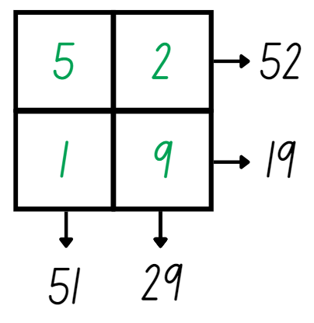
- Reading the grid across and down gives four 2-digit numbers: 52, 19, 51 and 29. Ask students what strategies they could use to find the sum of these numbers (see Figure 1).
- Students share and explain their strategies. For example, one student levels the numbers to make the algorithm 50 + 50 + 3 + 40 + 8. Agree that the sum of the numbers is 151.
- Explain that the challenge is to find 4 different digits that give four 2-digit numbers which add up to exactly 150.
- Provide small groups with an individual whiteboard to draw their grid and solve the problem.
- Select groups to share their numbers and check.
This table details opportunities for assessment.
Assessment opportunities | Links
What to look for:  - Can students apply and explain addition strategies use to find the sum of four 2-digit numbers? [MAO-WM-01, MA3-AR-01] | Links to National Numeracy Learning Progressions (NNLP):  - AdS7, AdS8.

Core lesson: Describing with decimals – 40 minutes
The table below contains suggested learning intentions and success criteria. These are best co-constructed with students.
Core concept learning intentions | Core concept success criteria
Students are learning to:  - connect decimal representations of length to the metric system. | Students can:  - recognise and interpret whole-number and decimal representations of length  - record lengths and distances using decimal notation.
- Display Resource 1: Place value chart and ask:
- What do you know about the base-10 number system?
- What do you notice about the value of each place value column?
- Can you see any patterns or connections between the place value columns?
- Are all place value columns shown? How do you know?
- How does this image relate to what we know about measurement?
- Display Resource 2: Prefix table and discuss the meaning of each of the prefixes and how these connect to the names of units of measurements. Guide students to connect these prefixes to known units of measurement for length. For example, kilometre = 1000 metres, centimetre = 1/100 of a metre, millimetre = 1/1000 of a metre.
- Display Resource 3: Partial conversion chart and identify the operations required to convert between metres and kilometres. Ask:
- Why is the number 1000 used when converting between metres and kilometres?
- How would you know to choose between multiplication and division when converting between metres and kilometres?
- What do you expect to happen to a number when you multiply by 1000? Explain your answer.
- What do you expect to happen to a number when you divide by 1000? Explain your answer.
- What is a strategy for multiplying and dividing numbers by 1000?
- Display Resource 4: Converting sheet and explain to students that they will be converting between metres and kilometres.
- Demonstrate how to convert between metres and kilometres by rolling four 10-sided dice and recording the number rolled in the kilometres squares of Resource 4: Converting sheet. Then, convert the recorded number to metres and record the number in the corresponding boxes (see Figure 2).
Figure 2 – Kilometres to metres
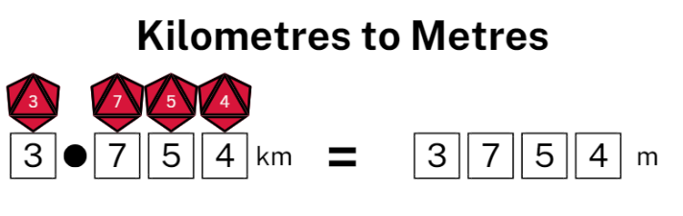
- Use Figure 2 to discuss the value of each digit. Explain how the value of the length remains the same despite recording it using different units.
- Emphasise the connection between the digits in the 2 representations. For example, 3 kilometres is the same as 3 thousand metres, 4 thousandths of a kilometre is the same as 4 metres and so on (see Figure 3).
Figure 3 – Kilometres to metres labelled
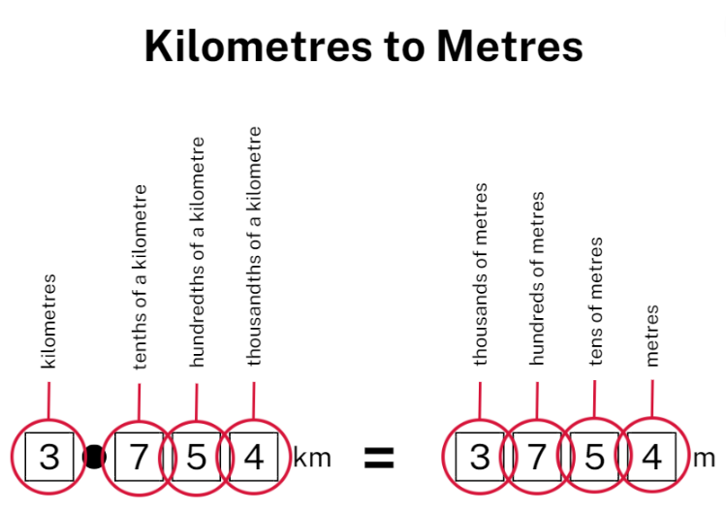
- Provide pairs with Resource 4: Converting sheet, and four 10-sided dice.
Note: it is recommended to use dice that have a zero as it is important that students understand the role of zero in changing the value of the numbers created. Place Resource 4: Converting sheet in a reusable sleeve or laminate it so students can use it multiple times.
- Students take turns rolling the dice for their partner. Partners record the number rolled in the kilometres section and then convert to metres. Students then read both measurements aloud and record in their workbook using the format 3.583 km = 3583 m.
- Begin the activity with students converting kilometres to metres for 5 minutes.
- After 5 minutes, students switch to converting metres to kilometres. Play the game for a further 5 minutes.
This table details opportunities for differentiation.
Too hard? | Too easy?
Students cannot convert between metres and kilometres.  - Provide students a copy of Resource 5: Number slider to make and assist with their conversions.  - Allow students to continue converting kilometres to metres without swapping after 5 minutes to minimise confusion. | Students can convert between metres and kilometres.  - Challenge students to roll the dice and record the metre and kilometre forms of their numbers without the scaffold.  - Challenge students to arrange their recorded lengths in ascending or descending order.

Discuss and connect the mathematics – 10 minutes
- Regroup as a class and discuss the concept. Ask:
- What is the relationship between metres and kilometres?
- What is the role of the decimal point in our number system?
- How did rolling a zero as the first or last digit affect the size of the number recorded?
- What role does zero play when reading numbers?
- Did you experience any challenges in this activity? How did you overcome them?
Note: this is an opportunity to discuss the role of zero as a placeholder in whole and partial numbers, connecting back to place value concepts.
This table details opportunities for assessment.
Assessment opportunities | Links
What to look for:  - Can students recognise and interpret whole-number and decimal representations of length? [MAO-WM-01, MA3-GM-02]  - Can students record lengths and distances using decimal notation? [MAO-WM-01, MA3-GM-02] | Links to National Numeracy Learning Progressions (NNLP):  - NPV7, NPV8, NPV9.

Lesson 2
Core concept: length can be renamed using different units of measurement.

Daily number sense: Kilometre word problems – 10 minutes
The table below contains a suggested learning intention and success criteria. These are best co-constructed with students.
Daily number sense learning intention | Daily number sense success criteria
Students are learning to:  - use efficient strategies to solve addition and subtraction problems. | Students can:  - solve multi-step word problems involving addition and subtraction.
- Provide students with Resource 6: Working out distances and their workbook. Students glue Resource 6: Working out distances into their book, solving the problems using an efficient strategy. Students then record their answers in kilometres using the abbreviation of km.
- Select students to share and explain the strategy and answers.
This table details opportunities for assessment.
Assessment opportunities | Links
What to look for:  - Can students solve multi-step word problems involving addition and subtraction? [MAO-WM-01, MA3-AR-01] | Links to National Numeracy Learning Progressions (NNLP):  - AdS8.

Core lesson: Metric conversions – 40 minutes
The table below contains suggested learning intentions and success criteria. These are best co-constructed with students.
Core concept learning intentions | Core concept success criteria
Students are learning to:  - convert between common metric units of length. | Students can:  - use the decimal place value system to convert between units of length  - convert measurements to the same unit to compare lengths and distances.
- Display Resource 7: Full conversion chart. Ask:
- What do you notice about the image?
- What do you wonder about the image?
- Why are some arrows shorter and longer than others?
- Can you see any connection or pattern in the way the units relate to each other?
- Write ‘A length can be renamed using different units of measurement’. Allow students thinking time. Students then turn and talk to discuss their ideas.
- Select students to share and explain their ideas.
- Explain that lengths can be recorded in different ways. Display Resource 8: Recording lengths and highlight that, despite all the values in each set being equivalent, they vary in their ability to be read, understood and used. Ask:
- Would you describe the distance to the shops as being 1 000 000 mm? Why or why not?
- Would you describe the width of your fingernail using kilometres? Why or why not?
- Revise student understanding of converting between different units of length.
Note: more time revising how to convert lengths may be required before moving on in the lesson.
- Provide students with Resource 5: Number slider to make their own number slider following the instructions.
- Once students have made a number slider, provide them with Resource 9: Converting lengths table. Demonstrate how to convert between the units of length using the number slider as a reference. Encourage students to use their number slider during the explanation.
- Once students are confident using the number slider, they can complete the table.
This table details opportunities for differentiation.
Too hard? | Too easy?
Students cannot convert between common metric units of length.  - Provide students with some simplified conversion tasks, mainly converting between millimetres and centimetres to reinforce multiplying and dividing by 10.  - Students only complete the first 5 rows of the Resource 9: Converting lengths table. | Students can convert between common metric units of length.  - Challenge students to find the sum of a single column of their completed table.  - Challenge students to arrange the recorded lengths in ascending or descending order.

Discuss and connect the mathematics – 10 minutes
- Regroup as a class and summarise the lesson together, drawing out key mathematical ideas. Ask:
- Can you think of any shortcuts for converting between different units of length?
- How does understanding the decimal place value system support us to convert between units of length?
- How does converting lengths to the same unit allow us to compare and order measurements?
- How does the size of the unit change the number of units used when measuring?
This table details opportunities for assessment.
Assessment opportunities | Links
What to look for:  - Can students use the decimal place value system to convert between units of length? [MAO-WM-01, MA3-GM-02]  - Can students convert measurements to the same unit to compare lengths and distances? [MAO-WM-01, MA3-GM-02] | Links to National Numeracy Learning Progressions (NNLP):  - NPV8  - UuM8.

Lesson 3
Core concept: the context determines the most suitable measuring device.

Daily number sense: Travel plans – 10 minutes
The table below contains a suggested learning intention and success criteria. These are best co-constructed with students.
Daily number sense learning intention | Daily number sense success criteria
Students are learning to:  - use efficient strategies to solve addition problems. | Students can:  - solve addition problems that require more than one step.
This activity is an adaptation of ‘Travel Plans' from Mathematics Assessment for Learning: Rich Tasks & Work Samples, 3rd edn by Downton et al.
- Display Resource 10: Travel plans and explain that students need to plan where the fuel stops will be from Melbourne to Brisbane on the Newell Highway. Explain that the car can travel up to 300 km on one tank of petrol.
- Students need to calculate the possible fuels stops, distances between fuel stops and then the total distance for the trip.
- Provide students with Resource 10: Travel plans and their workbooks. Students record the travel plans in their workbook, showing their calculations (see Figure 4).
Figure 4 – Travel plan example
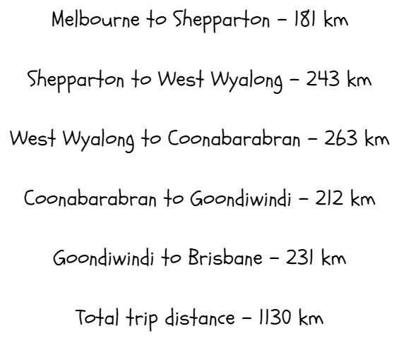
Note: this activity can be adapted to challenge students by asking them to work out the total time it would take to drive from Melbourne to Brisbane on the Newell Highway.

This table details opportunities for assessment.
Assessment opportunities | Links
What to look for:  - Can students solve addition problems that require more than one step? [MAO-WM-01, MA3-AR-01] | Links to National Numeracy Learning Progressions (NNLP):  - AdS8.

Core lesson: Select and explain the unit – 40 minutes
The table below contains suggested learning intentions and success criteria. These are best co-constructed with students.
Core concept learning intentions | Core concept success criteria
Students are learning to:  - use a variety of devices and units to measure lengths and distances in different contexts. | Students can:  - select an appropriate unit of measurement for a given context  - justify the selection of a measuring unit and device for a given context  - correctly record and add lengths using a range of units of measurement.
- Revise devices and units of measurement for length. For example, 30 cm rulers, tape measures, metre rulers, trundle wheels, mm, cm, m, km.
- Display Resource 11: Appropriate devices and ask students to suggest appropriate devices for measuring each image. Ask:
- What device did you select and why?
- What other measuring devices could you use to measure the same image?
- Which unit of measurement would be used for each image?
- Which units of measurement would not be appropriate for measuring each image? Why?
- Explain that students will select 3 different objects to measure and that each of the objects must be measured using either mm, cm or m. For each object, students select an appropriate measuring device and justify their selection. Students then use their selected device to measure and record the length (see Figure 5).
Figure 5 – Appropriate measuring tool example
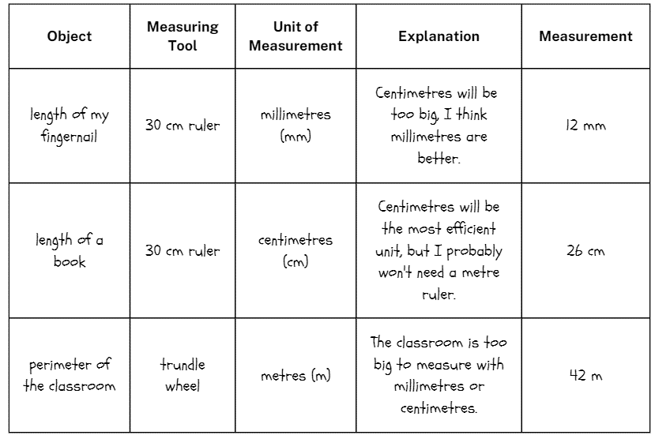
- Provide students with Resource 12: Measuring objects. Students select their 3 objects to measure and record. Select students to share and justify their objects and the unit of measurement. For example, a highlighter and mm.
- Students record their measuring devices and write explanations of why they selected that specific device.
Note: you may wish to direct students to some easily accessible objects indoors or outdoors to best facilitate this lesson. For example, the width of your thumb, the length of your desk, the length of the classroom.
- Provide students with a selection of measuring devices to measure their chosen objects. For example, 30 cm rulers, metre rulers, trundle wheels, tape measures. Students record the lengths in Resource 12: Measuring objects.
- Ask students to add the different lengths together creating a total length of the 3 items.
This table details opportunities for differentiation.
Too hard? | Too easy?
Students cannot use a variety of measuring devices to measure lengths and differences in different contexts.  - Provide a list of objects that could be measured using each unit and device for students to select from.  - Provide an estimate of each length being measured as a point of reference when completing the activity. | Students can use a variety of measuring devices to measure lengths and differences in different contexts.  - Challenge students to record their measurement accurately to 2 decimal places.  - Challenge students to convert each of their recorded measurements to a different unit.

Discuss and connect the mathematics – 10 minutes
- Regroup students to share and discuss their selections, measurements and explanations. Ask:
- Why did you select those specific objects to measure?
- How did you decide which device was the most appropriate for measuring each object?
- Did you encounter any challenges when measuring your objects? What did you learn from overcoming these challenges?
- How did you justify your selection of specific units and devices when measuring?
This table details opportunities for assessment.
Assessment opportunities | Links
What to look for:  - Can students select an appropriate unit of measurement for a given context? [MAO-WM-01, MA3-GM-02]  - Can students justify the selection of a measuring unit and tool based on a given context? [MAO-WM-01, MA3-GM-02]  - Can students correctly record and add lengths using a range of units of measurement? [MAO-WM-01, MA3-GM-02] | Links to National Numeracy Learning Progressions (NNLP):  - UuM6.

Lesson 4
Core concept: the larger the unit, the smaller the measurement.

Daily number sense – 10 minutes
- From a class need surfaced through formative assessment data, identify a short, focused activity that targets students’ knowledge, understanding and skills. Example activities may be drawn from the following resources:
- Mathematics K-6 resources
- Universal Resources Hub.

Core lesson: Measure it twice – 30 minutes
The table below contains suggested learning intentions and success criteria. These are best co-constructed with students.
Core concept learning intentions | Core concept success criteria
Students are learning to:  - compare lengths using appropriate units. | Students can:  - accurately measure and record lengths in both metres and centimetres  - understand that increasing the size of a unit results in a lower recorded measurement.
- Write the sentence ‘The larger the unit, the smaller the measure’. Students Think-Pair-Share their thoughts and understanding.
- Display Resource 8: Recording lengths. Highlight to students that, when the length is the same, the larger the unit used, the smaller the recorded measure. For example, 4 km is the same length as 4000 m, but the unit km is larger than the unit m, producing a smaller recorded measure.
- Explain to students that they will be using both metres and centimetres to measure the same objects and recording both measurements. This will allow students to see that the larger the unit (metres) the smaller recorded value. For example, 4.75 m is the same as 475 cm but is a much smaller recorded value.
- Brainstorm and record objects in the classroom that could be measured using both cm and m. For example, the width of the classroom, the perimeter of a desk or a student’s height.
Note: encourage different formats of length, such as length, height and perimeter to consolidate prior concepts.
- Model measuring and recording the objects using the 2 different units (metres and centimetres).
Note: the purpose of using 2 different units of measurement to measure the same objects is to help students see the same length expressed in 2 different ways, reinforcing the concept that larger units result in smaller recorded values.
- Discuss expectations for recording using decimal notations. For example, one metre and seventy-two centimetres should be recorded in the table as 1.72 m, while 12 centimetres and 4 millimetres should be recorded as 12.4 cm.
- Provide students with their workbook and a selection of measuring devices, such as 30 cm rulers and metre rulers. Students draw a recording table in their workbook, select and measure their objects and record using decimal notation (see Figure 6).
Figure 6 – Recording table example
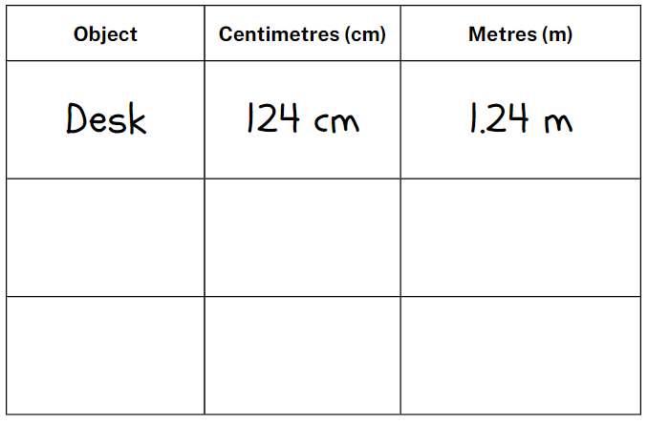
This table details opportunities for differentiation.
Too hard? | Too easy?
Students cannot solve problems that compare lengths using appropriate units.  - Support students by providing one pair of measurements and only requiring them to complete the second part.  - Encourage students to select objects that are close to a metre in length. | Students can solve problems involving the comparisons of lengths using appropriate units.  - Challenge students to only measure each object once and convert it into the second column.  - Challenge students to add a third unit of measurement to their table and convert it without measuring.

Consolidation and meaningful practice – 20 minutes
- Demonstrate how to play ‘Who is winning?’ by playing against a student or the whole class using Resource 13: Who is winning?
- Students make one pile with the centimetre cards and another with the metre cards.
- Students take turns drawing a card from either pile, then compare their 2 lengths. Students can decide whether to compare the lengths in centimetres, metres or both.
- The player with the greater length keeps both cards, and the game continues with the winning player drawing first next round. The player with the most cards at the end of the game wins.
- Regroup students and ask:
- What was your strategy for determining which length was greatest?
- How did your ability to convert between units of measurement support you in this game?
- Did you get better at determining the greater length as the game went on? Why?
This table details opportunities for assessment.
Assessment opportunities | Links
What to look for:  - Can students accurately measure and record lengths in both metres and centimetres? [MAO-WM-01, MA3-GM-02]  - Can students understand that increasing the size of a unit results in a lower recorded measure? [MAO-WM-01, MA3-GM-02] | Links to National Numeracy Learning Progressions (NNLP):  - NPV7, NPV8, NPV9  - UuM6, UuM8.

Lesson 5
Core concept: different shapes can have the same perimeter.

Daily number sense: Quarters and wholes – 10 minutes
Daily number sense activities for Lessons 5 to 7 ‘loop’ back to concepts and procedures covered in previous units to assist students to build an increasingly connected network of ideas. These concepts may differ from the core concepts being covered by the unit.
The table below contains a suggested learning intention and success criteria. These are best co-constructed with students.
Daily number sense learning intention | Daily number sense success criteria
Students are learning to:  - recognise the role of the number 1 as representing the whole. | Students can:  - compare halves and quarters of different sized wholes.
- Write ‘Jake ate $\frac{1}{4}$ of a cake and Kate ate $\frac{1}{2}$ of a different cake. Jake said he ate more than Kate. How could he be correct?’
- Allow time for students to think and the turn and talk to discuss how Jake could be correct.
- Select students to share and explain their strategy. Record and test student responses.
This table details opportunities for assessment.
Assessment opportunities | Links
What to look for:  - Can students compare halves and quarters of different sized wholes? [MAO-WM-01, MA3-RQF-01] | Links to National Numeracy Learning Progressions (NNLP):  - InF5.

Core lesson: Shapes and perimeters – 40 minutes
The table below contains suggested learning intentions and success criteria. These are best co-constructed with students.
Core concept learning intentions | Core concept success criteria
Students are learning to:  - recognise that different shapes can have the same perimeter. | Students can:  - draw shapes and measure lengths to find the perimeter  - identify and explain that different shapes can have the same perimeter  - recognise rotations change the position and orientation but not the size of shapes.
- Display the words regular shape, irregular shape, quadrilateral and triangle on separate sheets of A3 paper. Position these words around the classroom. Students walk around the classroom, writing or drawing what they know about each term. For example, a regular shape is a square or a hexagon.
- Select students to share and justify their responses.
- Instruct students to draw the following shapes on an individual whiteboard or workbook:
- A regular quadrilateral
- An irregular triangle
- An irregular pentagon
- An irregular octagon.
- After each shape has been drawn, choose students to share and justify their drawing.
- Display Resource 14: Perimeters. Ask students to think and then turn and talk to discuss what they notice about the shapes and the perimeter of all the shapes.
- Select students to share what they noticed about the shapes and the perimeters. If not noted by students, highlight the fact that all the shapes have the same perimeter even though they are different.
- Provide students with Resource 15: Calculating perimeters and a 30 cm ruler. Students draw a shape in each box that fits the criteria and shows their working (see Figure 7).
Figure 7 – Calculating perimeter example
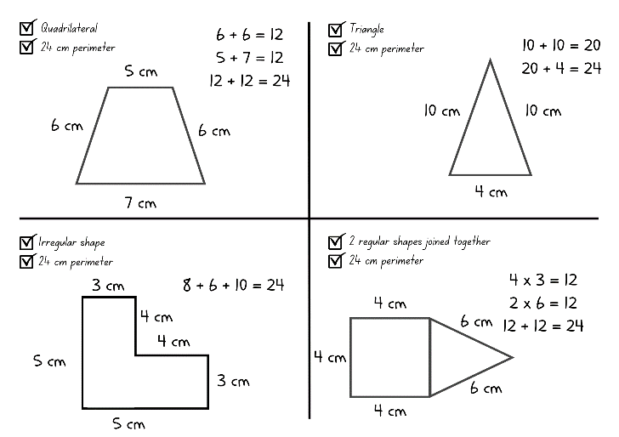
- Ask students to rotate the shapes and identify what is different. Discuss with students that the orientation and position changes, however the perimeter remains the same.
- Students display their work and go on a gallery walk, looking at other shapes that have been drawn to fit the criteria.
This table details opportunities for differentiation.
Too hard? | Too easy?
Students cannot create shapes and measure lengths to find perimeters.  - Provide the length of each side of the shapes and support students to draw and measure the shapes.  - Draw the shapes with the correct lengths and support students to measure the sides to find the perimeter. | Students can measure lengths of shapes to find perimeters.  - Challenge students to draw 2 different shapes in each section.  - Challenge students to draw the same shape in each box reflected or rotated 90 degrees.

Discuss and connect the mathematics – 10 minutes
- Regroup students and ask:
- Did you find any part of this activity challenging? Why or why not?
- Did you see a different shape that still fit the criteria? What was it?
- How is it possible for different shapes to have the same perimeter?
- Can 2 of the same shape have different perimeters?
This table details opportunities for assessment.
Assessment opportunities | Links
What to look for:  - Can students draw shapes and measure lengths to find the perimeter? [MAO-WM-01, MA3-GM-02, MA3-2DS-01]  - Can students identify and explain that different shapes can have the same perimeter? [MAO-WM-01, MA3-GM-02, MA3-2DS-01]  - Can students recognise rotations change the position and orientation but not the size of shapes? [MAO-WM-01, MA3-GM-02, MA3-2DS-01] | Links to National Numeracy Learning Progressions (NNLP):  - UuM5, UuM6, UuM7.

Lesson 6
Core concept: timetables are an efficient way to communicate and organise lengths of time.

Daily number sense: Halves and quarters – 10 minutes
The table below contains a suggested learning intention and success criteria. These are best co-constructed with students.
Daily number sense learning intention | Daily number sense success criteria
Students are learning to:  - understand that halves and quarters can be different sizes but still represent a half or a quarter of the whole they are part of. | Students can:  - justify how quarters and halves can be different sizes but still all be halves and quarters.
- Display Resource 16: Halves and quarters and ask:
- What can you see?
- How many halves can you see? What is the same about them and what is different?
- How many quarters can you see? What is the same about them and what is different?
- What is the same about all the halves and quarters?
- Count the quarters together. For example, one quarter, 2 quarters, 3 quarters, 4 quarters, that’s called one whole; 5 quarters, 6 quarters, 7 quarters, 8 quarters, there’s another whole and so on.
This table details opportunities for assessment.
Assessment opportunities | Links
What to look for:  - Can students justify how quarters and halves can be different sizes but still all be halves and quarters? [MAO-WM-01, MA3-RQF-01] | Links to National Numeracy Learning Progressions (NNLP):  - InF5.

Core lesson: A day at school – 40 minutes
The table below contains suggested learning intentions and success criteria. These are best co-constructed with students.
Core concept learning intentions | Core concept success criteria
Students are learning to:  - understand how timetables can be used to efficiently organise time. | Students can:  - convert between 12- and 24-hour time  - create a timetable using set criteria.
- Display the words ‘time management’. Ask:
- What does this mean?
- Can you think of any situations where time management is needed? Why?
- Can you think of any professions that require time management skills?
- Can you list any resources that support managing time? For example, bus timetables, flight itineraries and school timetables.
- Display Resource 17: 24-hour time and discuss why 24-hour time is an efficient way to read and write time. Revise students’ knowledge that 24-hour time is used to avoid confusion between am and pm.
- Provide students with Resource 18: School timetable and asks students to fill in the 12- and 24-hour times.
- Students create a school timetable using the given criteria.
Note: students will have remaining time sections of their timetable once completing the criteria. Direct students to fill these sections with subjects of their choosing.
- Students display their timetables and go on a gallery walk to compare timetables.
This table details opportunities for differentiation.
Too hard? | Too easy?
Students cannot understand how timetables can be used to efficiently organise time.  - Provide students with recess and lunch times for their timetable.  - Provide students with a copy of printed copy of Resource 17: 24-hour time for students to reference when filling in times.  - Support students by writing the hour conversions for the criteria. For example, 240 minutes is 4 hours. | Students can understand how timetables can be used to efficiently organise time.  - Challenge students by providing additional criteria. For example, 120 minutes of science and technology.  - Challenge students to write questions that relate to their timetable for a peer to solve. For example, students could ask how many minutes there are between Monday’s maths lesson and lunch.

Discuss and connect the mathematics – 10 minutes
- Regroup as a class and summarise the lesson together drawing out key mathematical ideas. Ask:
- Could schools function without timetables? Why or why not?
- Were there any timetables that were easier or harder to read than others? Why?
- How did your timetable help you to organise the week?
- Why is 24-hour time important?
- Was it easier to read the time in 12-hour or 24-hour time? Why?
- Why are timetables an efficient way to communicate and organise lengths of time?
This table details opportunities for assessment.
Assessment opportunities | Links
What to look for:  - Can students convert between 12- and 24-hour time? [MAO-WM-01, MA3-NSM-02]  - Can students create a timetable using set criteria? [MAO-WM-01, MA3-NSM-02] | Links to National Numeracy Learning Progressions (NNLP):  - MeT5.

Lesson 7
Core concept: mental strategies can be used flexibly to solve problems involving duration.

Daily number sense: Lemon fractions – 10 minutes
The table below contains a suggested learning intention and success criteria. These are best co-constructed with students.
Daily number sense learning intention | Daily number sense success criteria
Students are learning to:  - recognise that the number one represents a whole. | Students can:  - determine how many wholes can be made from fractions of lemon slices.
- Display Resource 19: Lemon fractions.
- In small groups, students share ideas about how many whole slices there are and how they can prove this. Students record their thinking on individual whiteboards.
- Select groups to share and explain their ideas with the class.
This table details opportunities for assessment.
Assessment opportunities | Links
What to look for:  - Can students determine how many wholes can be made from fractions of lemon slices? [MAO-WM-01, MA3-RQF-02] | Links to National Numeracy Learning Progressions (NNLP):  - InF4.

Core lesson: ZOOM strategy – 40 minutes
The table below contains suggested learning intentions and success criteria. These are best co-constructed with students.
Core concept learning intentions | Core concept success criteria
Students are learning to:  - represent and solve problems involving duration. | Students can:  - use start and finish times to calculate the duration of events  - explain that elapsed time is the amount of time between the start and the end of an activity or event  - use the zoom strategy to calculate elapsed time.
- Brainstorm what students know about the term ‘duration’ and record ideas on an anchor chart.
- Explain to students that duration is the amount of time something takes. For example, recess is 20 minutes long, which means it has a duration of 20 minutes.
Note: contextualise this example with the duration of your school’s recess.
- Introduce students to the term ‘elapsed time’ and explain that elapsed time is connected to duration.
- Explain that elapsed means something that has passed, so elapsed time means time that has passed. Ask:
- Can you think of examples of elapsed time?
- Is elapsed time only measured with minutes and hours?
- By the end of a school day, how much time has elapsed? How do you know?
Elapsed time: the amount of time that has passed between the start of an event and the end.
- Display Resource 20: The ZOOM strategy and explain it is a strategy that can be used to calculate elapsed time.
- Model using the ZOOM strategy:
- Identify the start time and the end time.
- Bridge to the closest hour. Then, identify how many hours until the finish hour.
- Identify how many minutes (if any) remain until the finish time.
- Add the hours and minutes together to find the total time (see Figure 8).
Figure 8 – ZOOM strategy example
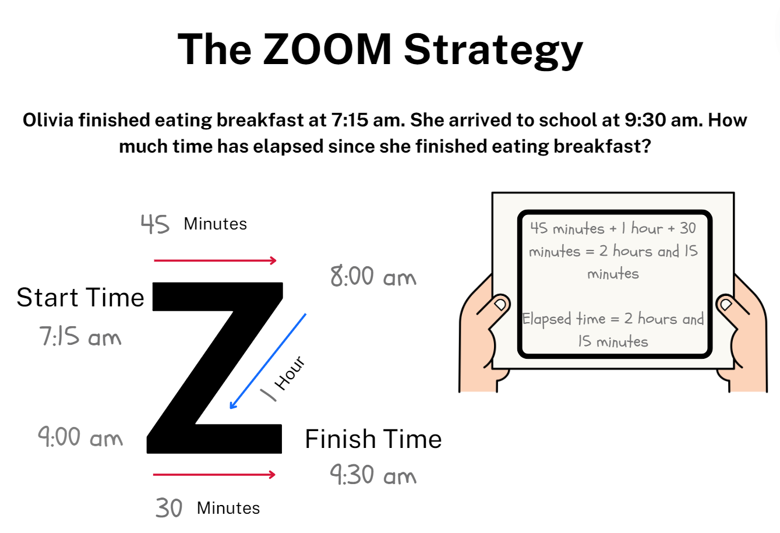
Note: if the elapsed time has a finish time that is on the hour, students will not need to use the final line of the ZOOM model as there are no remaining minutes to add.
- Provide students with Resource 20: The ZOOM strategy (either laminated or in a reusable sleeve), Resource 21: Elapsed timecards and their workbook.
- Students use the ZOOM strategy to find the elapsed time of each of the cards and record their working out and answers in their workbook.
This table details opportunities for differentiation.
Too hard? | Too easy?
Students cannot solve problems involving duration.  - Support students by providing them with only the top row of Resource 21: Elapsed timecards to complete.  - Support students by providing them with a hands-on clock that can be used to visually model the elapsed time. | Students can solve problems involving duration.  - Challenge students to arrange the cards from Resource 21: Elapsed timecards in ascending order related to the elapsed time.  - Challenge students to create their own elapsed time question for a partner to solve using the ZOOM strategy.

Discuss and connect the mathematics – 10 minutes
- Regroup as a class and ask:
- Did you find the ZOOM strategy successful for calculating elapsed time? Why or why not?
- What elapsed time did your record for each card?
- Can you think of any other strategies you could use to calculate elapsed time?
- Why is solving elapsed time a useful skill?
This table details opportunities for assessment.
Assessment opportunities | Links
What to look for:  - Can students use start and finish times to calculate the duration of events? [MAO-WM-01, MA3-NSM-02]  - Can students explain that elapsed time is the amount of time between the start and the end of an activity or event? [MAO-WM-01, MA3-NSM-02]  - Can students use the ZOOM strategy to calculate elapsed time? [MAO-WM-01, MA3-NSM-02] | Links to National Numeracy Learning Progressions (NNLP):  - MeT4, MeT5.

Lesson 8
Core concept: comparing and converting units of measurement helps to make sense of the world.

Daily number sense – 10 minutes
- From a class need surfaced through formative assessment data, identify a short, focused activity that targets students’ knowledge, understanding and skills. Example activities may be drawn from the following resources:
- Mathematics K-6 resources
- Universal Resources Hub.

Core lesson: Measurement investigation – 40 minutes
The table below contains suggested learning intentions and success criteria. These are best co-constructed with students.
Core concept learning intentions | Core concept success criteria
Students are learning to:  - compare and convert units of length and time. | Students can:  - use Google Maps to measure distances  - correctly record distances and durations  - convert between metres and kilometres.
- Explain to students that technological advancements have made measuring larger distances easier and more accessible. Ask:
- Can you think of any digital devices that are used to measure larger distances?
- How have technological advancements impacted the way distances are measured?
- Are measurements that use digital instruments more accurate?
- Have you ever seen someone use a physical map before?
- When would you use a physical map? For example, places that do not have internet service.
- Explain to students that the acronym GPS stands for Global Positioning System and that GPS is used to measure distances via information gathered by satellites. Ask:
- Have you ever heard of the term GPS before?
- Why would GPS be used for larger measurements?
- Can you think of any applications or programs that use GPS?
- Do you think GPS is an accurate device for measuring? Why or why not?
- Display Resource 22: Google Maps example and instruct students to Think-Pair-Share their responses to the question prompts.
Note: this activity can be adapted by using Google Maps in your local area and the guiding questions from Resource 22: Google Maps example to facilitate conversation.
- Display Resource 23: Using Google Maps. Explain that students will be using Google Maps to investigate the distances and duration of time to travel from their school to the specified locations.
- Open Google Maps on the interactive whiteboard display. Ask:
- What information do you need to enter into Google Maps to find the distance from school to The Big Banana?
- Where will you see the distance from school to The Big Banana in kilometres?
- How would you convert this measurement to metres?
- How will you identify the duration of time it would take to drive to The Big Banana in a car?
- How would you identify the duration of time it would take to walk to The Big Banana?
Note: this component of the lesson has been included to model the skills students require to complete the independent activity below.
- Provide students with Resource 23: Using Google Maps and a device that can access Google Maps. Students record their answers in kilometres and then convert the distance into metres.
- Explain to students that the final row in the Resource 23: Using Google Maps has been left blank. Students should select a significant landmark in Australia, then record the distance and duration of time it would take to travel to the landmark from school.
Note: if there are not enough devices to complete the activity in pairs or small groups, display Google Maps on the Interactive Whiteboard and complete the activity as a whole class.
This table details opportunities for differentiation.
Too hard? | Too easy?
Students cannot use Google Maps to solve problems.  - Support students by providing them with Resource 22: Google Maps example as a reference for using and comprehending Google Maps.  - Provide students with the information completed for The Big Banana to reference while completing the other locations. | Students can use Google Maps to solve problems.  - Challenge students to arrange their locations in ascending order based on their distances.  - Challenge students to find the total distance and duration from school to the provided locations and back again.

Discuss and connect the mathematics – 10 minutes
- Regroup as a class and ask:
- Was Google Maps an effective tool for this activity? Why or why not?
- What distances and durations did you record for each location?
- Could you use a physical map to complete the task? Why or why not?
- What additional location did you measure? Why?
- What challenges did you face while completing the activity? How did you overcome these challenges?
This table details opportunities for assessment.
Assessment opportunities | Links
What to look for:  - Can students use Google Maps to measure distances? [MAO-WM-01, MA3-GM-02]  - Can students correctly record distances and durations? [MAO-WM-01, MA3-NSM-02, MA3-GM-02]  - Can students convert between metres and kilometres? [MAO-WM-01, MA3-GM-02] | Links to National Numeracy Learning Progressions (NNLP):  - UuM8  - PrT4.

Resource 1: Place value chart
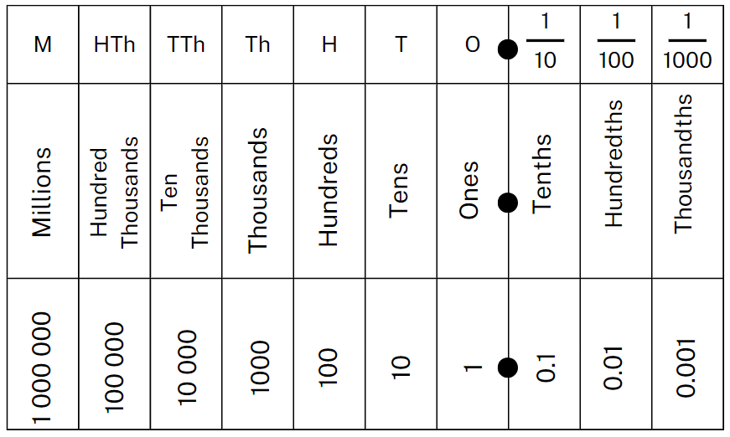

Resource 2: Prefix table
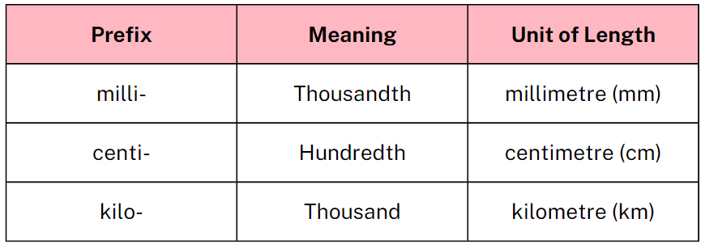

Resource 3: Partial conversion chart
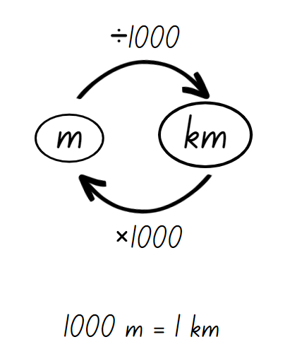

Resource 4: Converting sheet
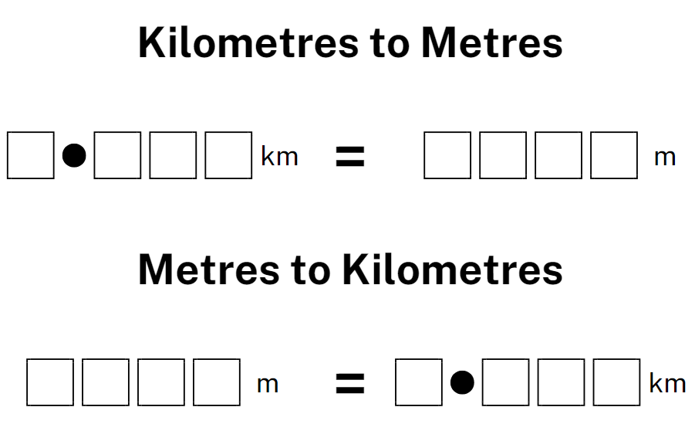

Resource 5: Number slider
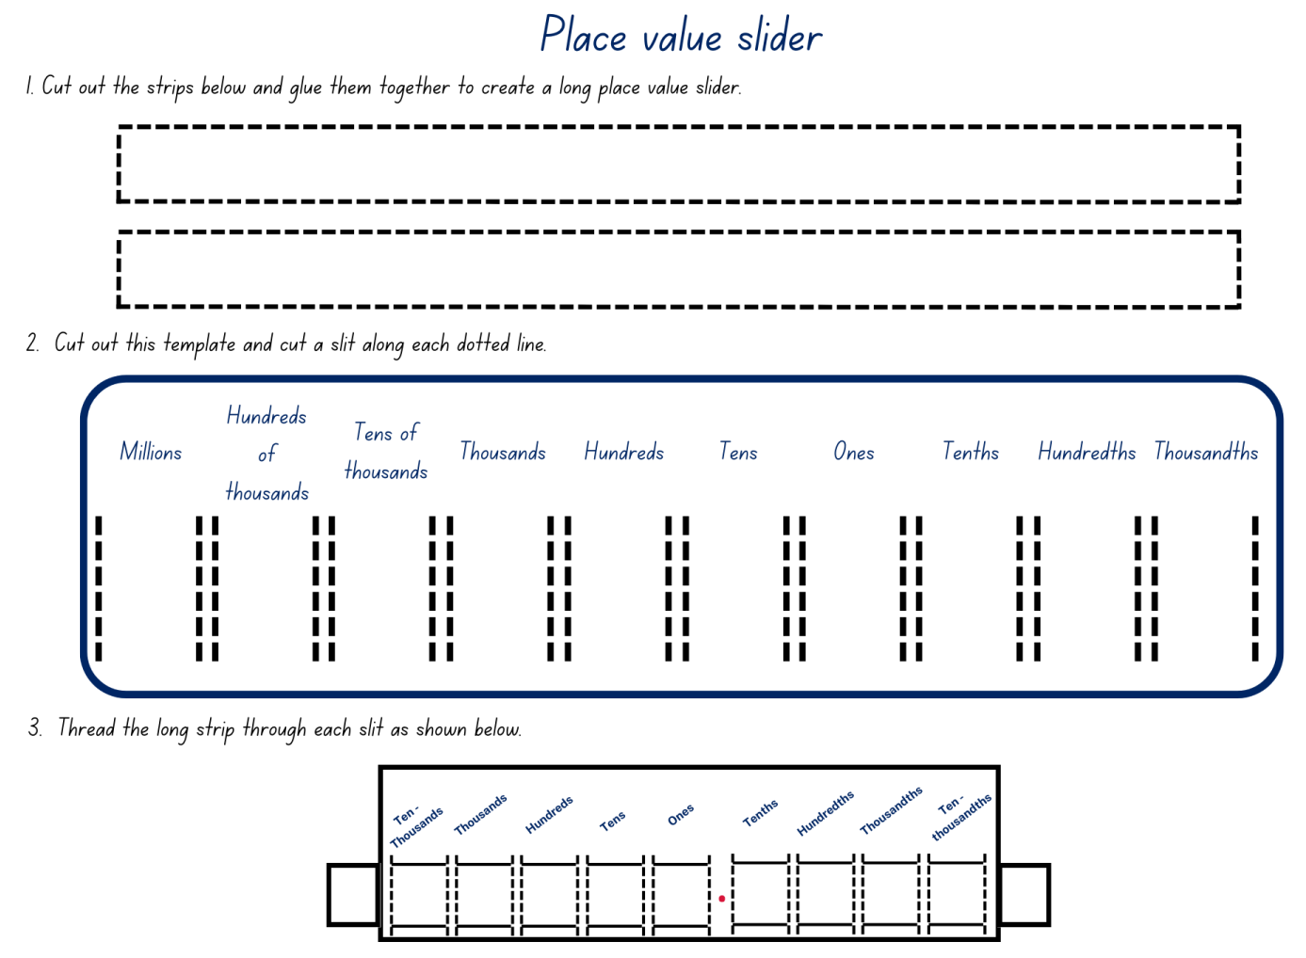

Resource 6: Working out distances
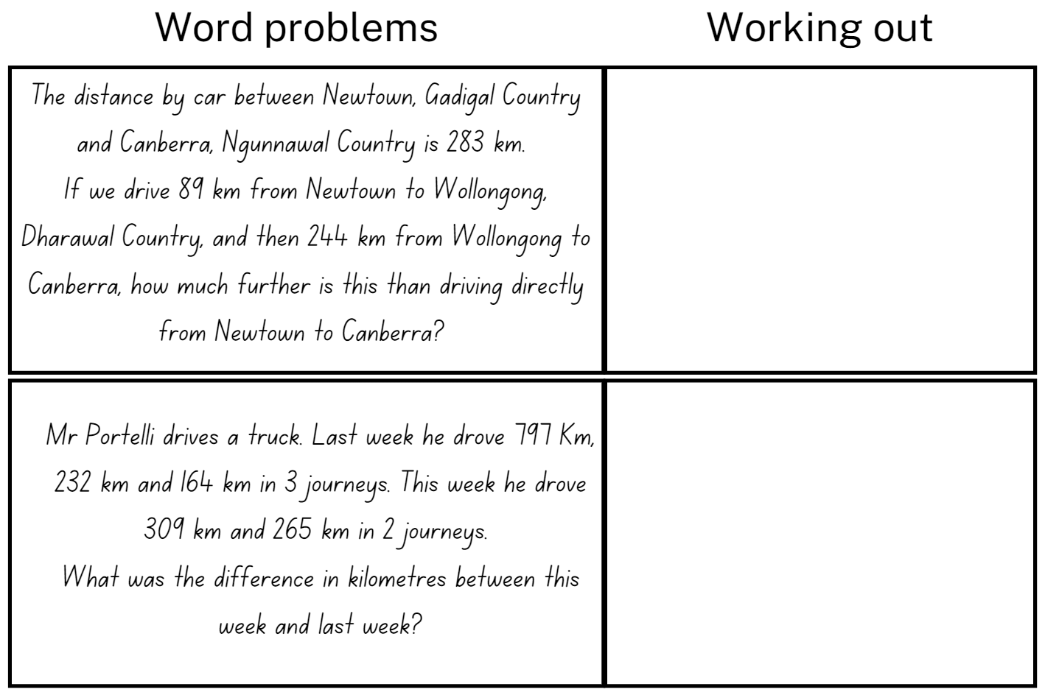

Resource 7: Full conversion chart
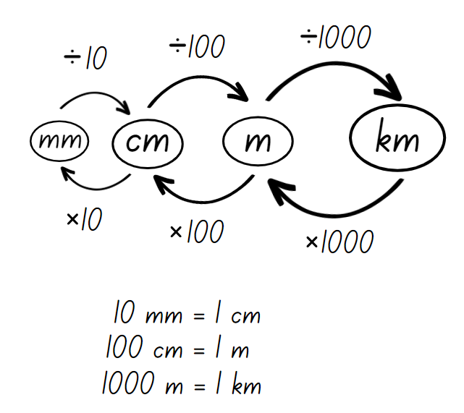

Resource 8: Recording lengths
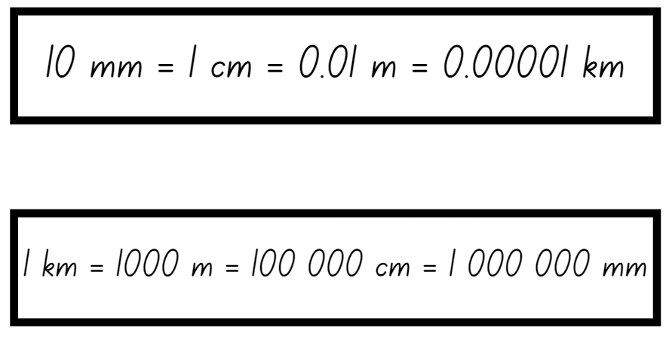

Resource 9: Converting lengths table
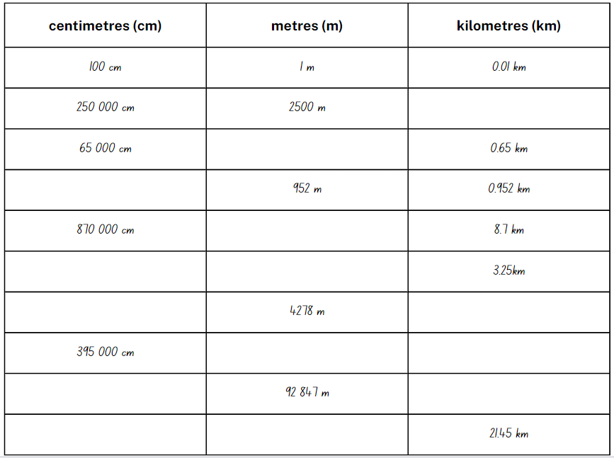

Resource 10: Travel plans
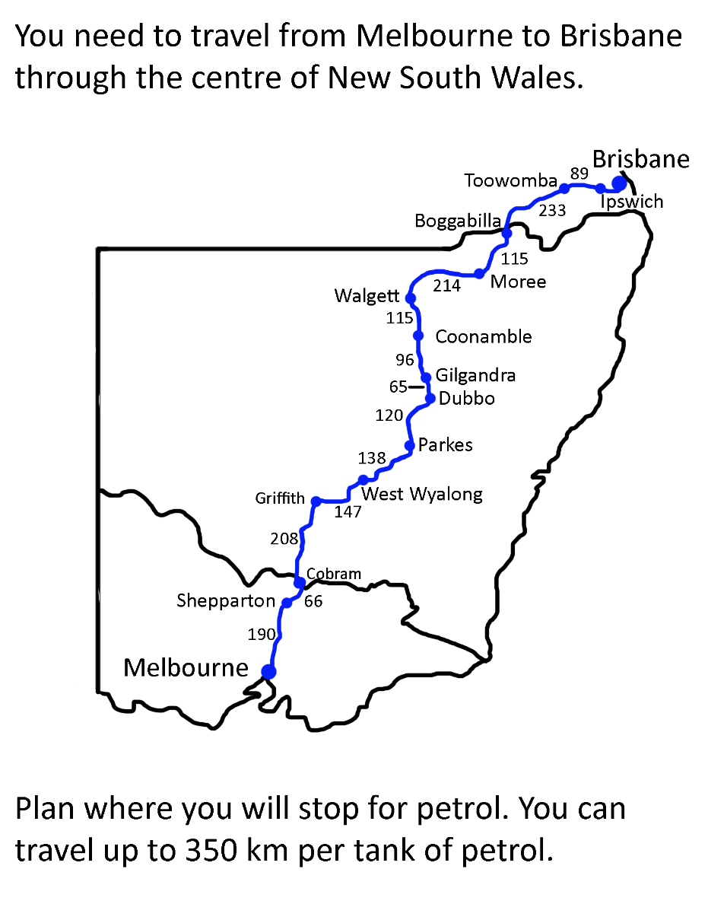

Resource 11: Appropriate devices
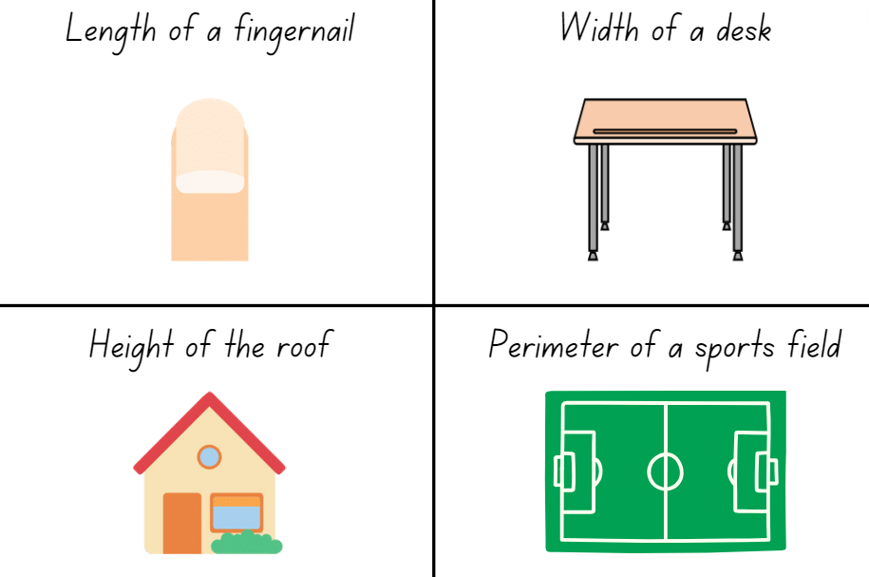

Resource 12: Measuring objects
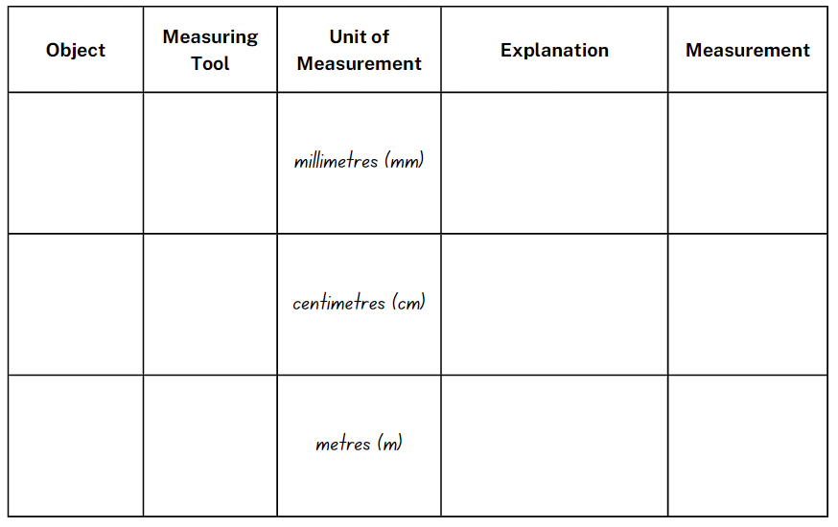

Resource 13: Who is winning?
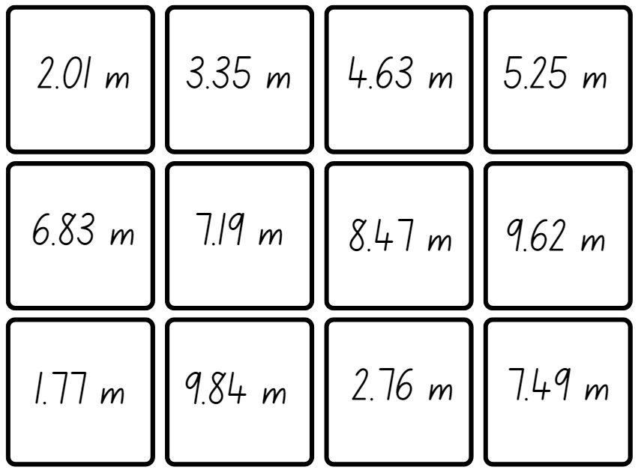
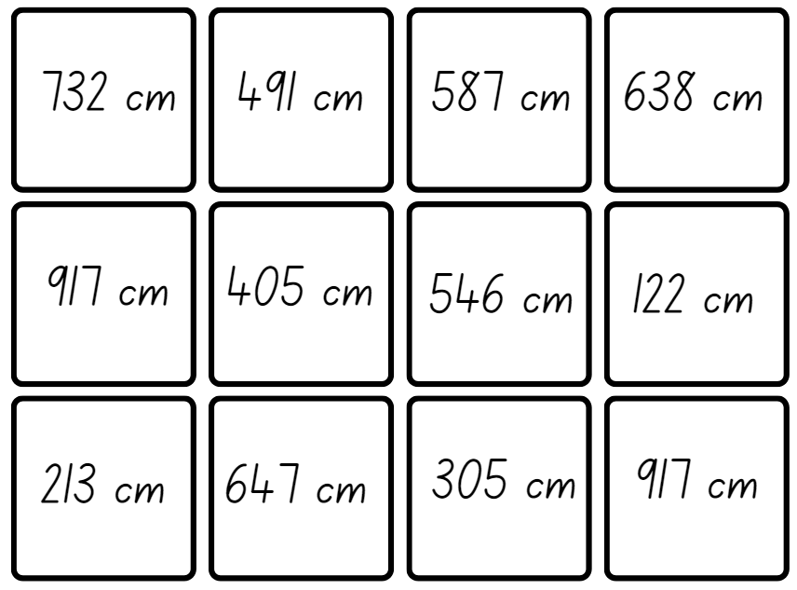

Resource 14: Perimeters
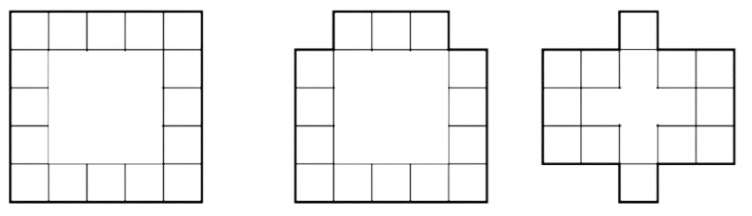

Resource 15: Calculating perimeters
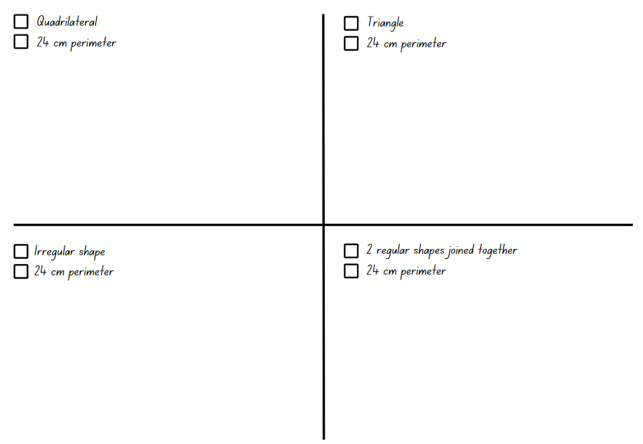

Resource 16: Halves and quarters
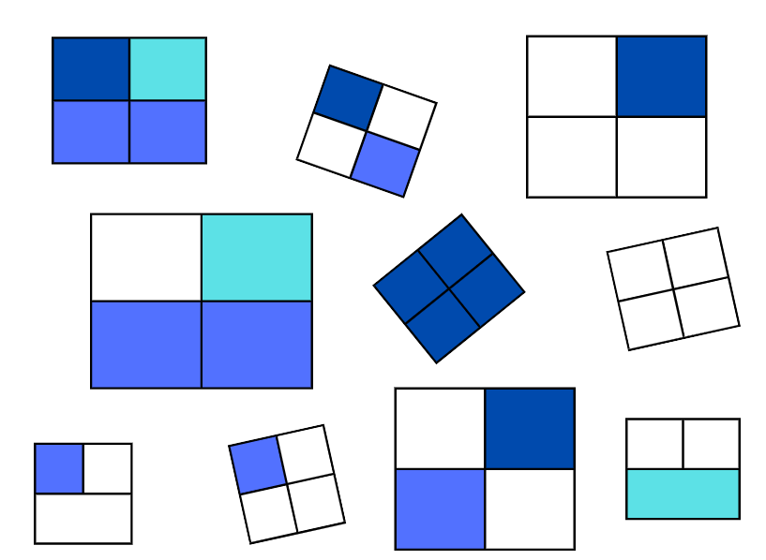

Resource 17: 24-hour time
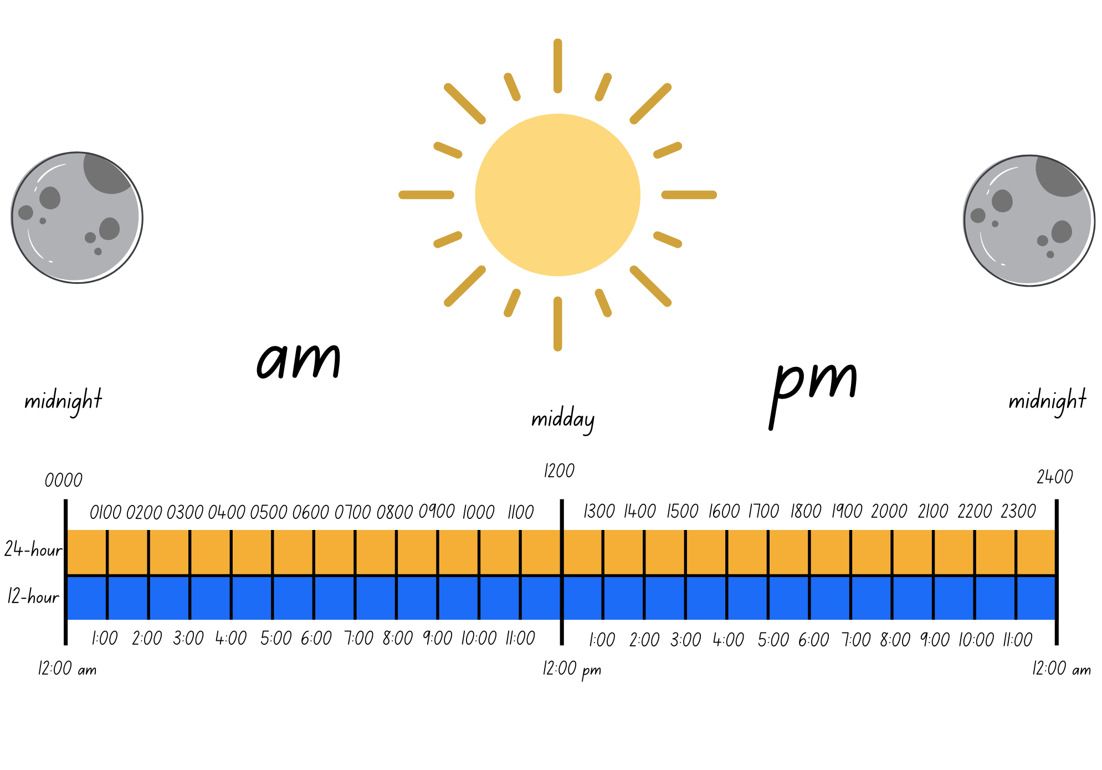

Resource 18: School timetable
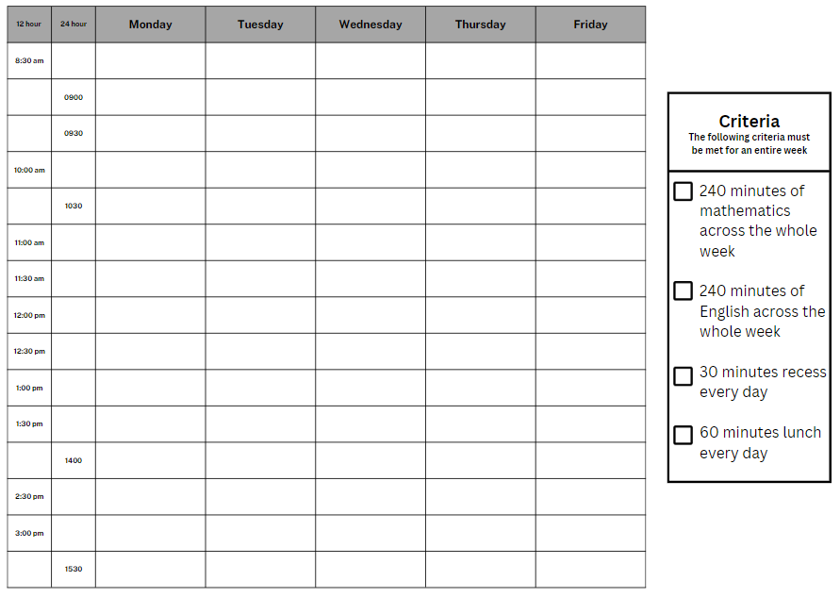

Resource 19: Lemon fractions
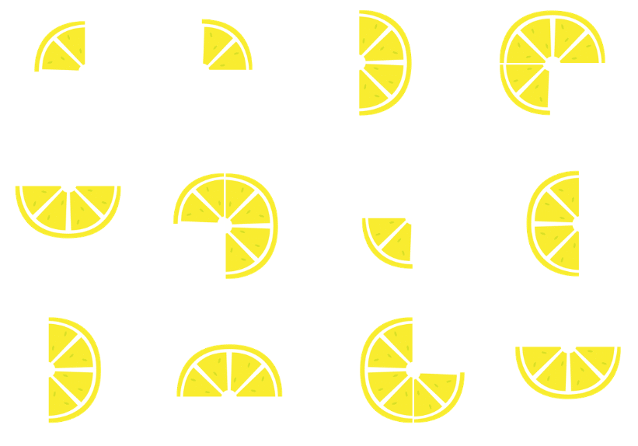

Resource 20: The ZOOM strategy
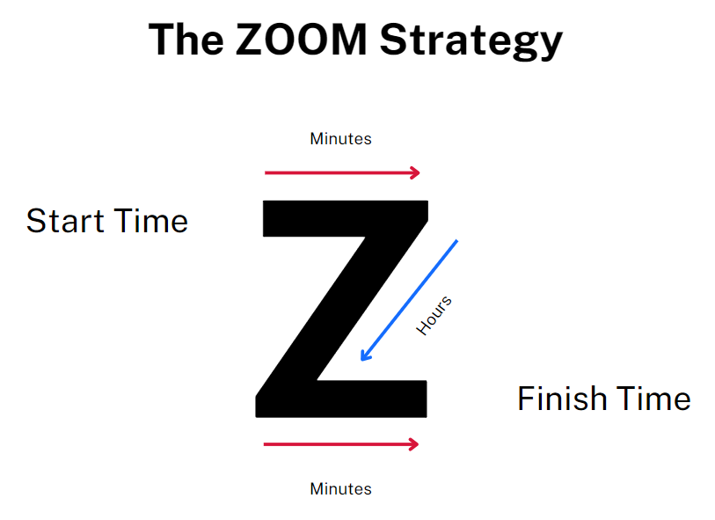

Resource 21: Elapsed timecards
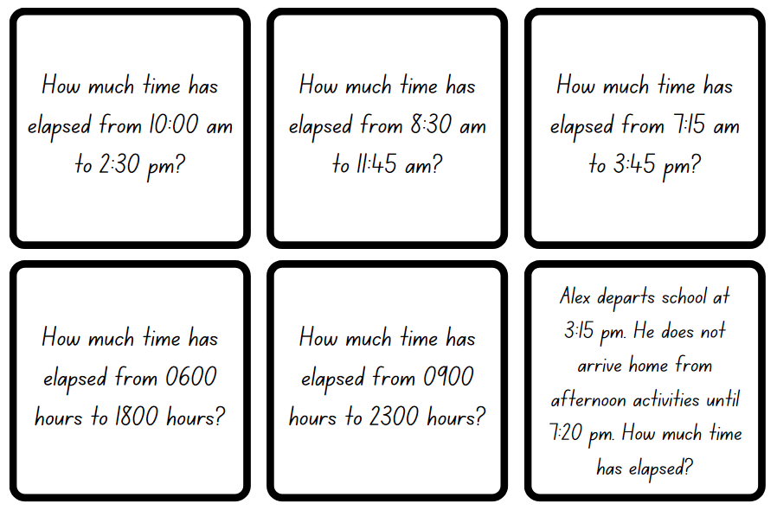

Resource 22: Google Maps example
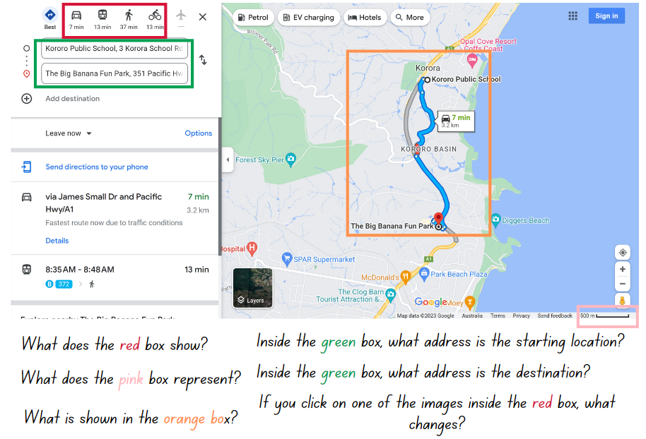
Map data © 2023 Google.

Resource 23: Using Google Maps
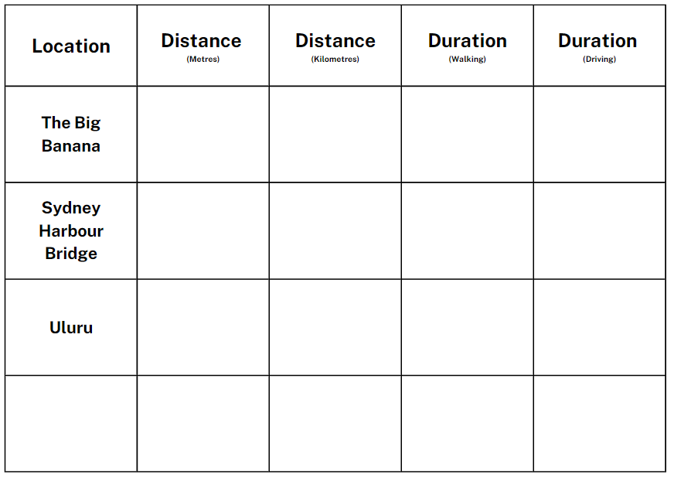

Syllabus outcomes and content
The table below outlines the syllabus outcomes and range of relevant syllabus content covered in this unit. Content is linked to National Numeracy Learning Progression version (3).
Outcomes and content | 1 | 2 | 3 | 4 | 5 | 6 | 7 | 8
Additive relations B: Choose and use efficient strategies to solve addition and subtraction problems
MAO-WM-01, MA3-AR-01
- Solve multistep word problems, including problems that require more than one operation | x | x | x
- Compare, evaluate and communicate strategies used to solve addition and subtraction problems |  | x | x
Representing quantity fractions A: Recognise the role of the number 1 as representing the whole
MAO-WM-01, MA3-RQF-01
- Compare halves and quarters of different sized wholes |  |  |  |  | x | x | x
- Justify the need for fractions to refer to the number 1 as the common whole (Reasons about quantity) |  |  |  |  | x | x | x
Geometric Measure A: Length: Use metres and kilometres for length and distances
MAO-WM-01, MA3-GM-02
- Recognise the need for a formal unit longer than the metre for measuring distance | x | x |  |  |  |  |  | x
- Record distances using the abbreviation for kilometres (km) | x | x |  |  |  |  |  | x
- Use a variety of measuring devices to measure lengths and distances in different contexts |  |  | x | x |  |  |  | x
Geometric Measure A: Length: Measure lengths to find perimeters
MAO-WM-01, MA3-GM-02
- Use efficient strategies to calculate the perimeter of a large rectangular area in metres |  |  | x | x | x
- Calculate perimeters of common two-dimensional shapes, including squares, rectangles and triangles |  |  | x | x | x
- Determine which side lengths are needed to find the perimeter of a shape (Reasons about relations) |  |  | x | x | x
- Recognise that rectangles with the same perimeter may have different dimensions (Spatial reasoning) |  |  |  |  | x
Geometric Measure B: Length: Connect decimal representations to the metric system
MAO-WM-01, MA3-GM-02
- Recognise the equivalence of whole-number and decimal representations of measurements of length | x | x |  | x
- Interpret decimal notation for lengths and distances | x | x |  | x |  |  |  | x
- Record lengths and distances using decimal notation | x | x | x | x |  |  |  | x
Geometric Measure B: Length: Convert between common metric units of length
MAO-WM-01, MA3-GM-02
- Use decimal place value system to convert between metres and kilometres | x | x |  |  |  |  |  | x
- Convert measurements to the same unit to compare lengths and distances |  | x |  | x |  |  |  | x
- Explain and use the relationship between the size of a unit and the number of units needed |  |  |  | x |  |  |  | x
Geometric Measure B: Length: Solve problems involving the comparison of lengths using appropriate units
MAO-WM-01, MA3-GM-02
- Investigate and compare perimeters of rectangles with the same area |  |  |  |  | x
- Solve a variety of problems involving length and perimeter, including problems involving different units of length |  |  | x |  | x
Two-dimensional spatial structure A: 2D shapes: Classify two-dimensional shapes and describe their properties
MAO-WM-01, MA3-2DS-01
- Identify and classify triangles as equilateral, isosceles or scalene triangles |  |  |  |  | x
- Recognise that triangles and quadrilaterals can be classified in more than one way (Reasons about spatial relations) |  |  |  |  | x
- Identify regular and irregular polygons |  |  |  |  | x
Two-dimensional spatial structure B: 2D shapes: Dissect two-dimensional shapes and rearrange them using translations, reflections and rotations
MAO-WM-01, MA3-2DS-01
- Recognise that translations, reflections or rotations change the position and orientation but not the size of shapes (Reasons about spatial orientation) |  |  |  |  | x
Non-spatial measure A: Time: Compare 12- and 24-hour time systems and convert between them
MAO-WM-01, MA3-NSM-02
- Recognise that 24-hour time is used to avoid confusion between am and pm |  |  |  |  |  | x | x
- Read time using appropriate 24-hour time language |  |  |  |  |  | x | x
- Convert between 24-hour time and 12-hour time using am or pm notation |  |  |  |  |  | x
- Read, interpret and use timetables from real-life situations, involving 12- and 24-hour time |  |  |  |  |  | x
Non-spatial measure B: Time: Solve problems involving duration, using 12- and 24-hour time
MAO-WM-01, MA3-NSM-02
- Use start and finish times to calculate the elapsed time of events |  |  |  |  |  | x | x | x
- Add and subtract time mentally using bridging strategies |  |  |  |  |  |  | x
- Round answers to time calculations to the nearest minute or hour |  |  |  |  |  |  | x
- Solve a variety of problems involving duration, including where times are expressed in 12-hour and 24-hour notation |  |  |  |  |  |  | x
Mathematics K–10 Syllabus © NSW Education Standards Authority (NESA) for and on behalf of the Crown in right of the State of New South Wales, 2022.

References
This resource contains NSW Curriculum and syllabus content. The NSW Curriculum is developed by the NSW Education Standards Authority. This content is prepared by NESA for and on behalf of the Crown in right of the State of New South Wales. The material is protected by Crown copyright.
Please refer to the NESA Copyright Disclaimer for more information https://educationstandards.nsw.edu.au/wps/portal/nesa/mini-footer/copyright.
NESA holds the only official and up-to-date versions of the NSW Curriculum and syllabus documents. Please visit the NSW Education Standards Authority (NESA) website https://educationstandards.nsw.edu.au/ and the NSW Curriculum website https://curriculum.nsw.edu.au/home.
Mathematics K–10 Syllabus © NSW Education Standards Authority (NESA) for and on behalf of the Crown in right of the State of New South Wales, 2022.
National Numeracy Learning Progression © Australian Curriculum, Assessment and Reporting Authority (ACARA) 2010 to present, unless otherwise indicated. This material was downloaded from the Australian Curriculum website (National Literacy Learning Progression) (accessed 28 August 2023) and was not modified.
Downton A, Knight R, Clarke D and Lewis G (2006) Mathematics Assessment for Learning: Rich Tasks and Work Samples, 3rd edn, Mathematics Teaching and Learning Centre, Australian Catholic University and Catholic Education Office.
Google Maps (2023) Koror Public School to The Big Banana [Google maps], accessed 30 June 2023.
University of Cambridge (Faculty of Mathematics) (2022) Reach 100, NRICH website, accessed 30 June 2023.

Further reading
Liljedahl P (2021) Building thinking classrooms in mathematics Grades K-12: 14 Teaching Practices for Enhancing Learning (Wheeler L, illus), Corwin Press, United States.
Siemon D, Warren E, Beswick K, Faragher R, Miller J, Horne M, Jazby D, Breed M, Clark J and Brady K (2020) Teaching Mathematics: Foundations to Middle Years, 3rd edn, Oxford University Press Australia and New Zealand.
Van de Walle J, Karp K, Bay-Williams JM, Brass A, Bentley B, Ferguson S, Goff W, Livy S, Marshman M, Martin D, Pearn C, Prodromou T, Symons D and Wilkie K (2019) Primary and Middle Years Mathematics: Teaching Developmentally, 1st Australian edn, Pearson Education Australia, Melbourne.

© State of New South Wales (Department of Education), 2023
The copyright material published in this resource is subject to the Copyright Act 1968 (Cth) and is owned by the NSW Department of Education or, where indicated, by a party other than the NSW Department of Education (third-party material).
Copyright material available in this resource and owned by the NSW Department of Education is licensed under a Creative Commons Attribution 4.0 International (CC BY 4.0) license.
This license allows you to share and adapt the material for any purpose, even commercially.
Attribution should be given to © State of New South Wales (Department of Education), 2023.
Material in this resource not available under a Creative Commons license:
- the NSW Department of Education logo, other logos and trademark-protected material
- material owned by a third party that has been reproduced with permission. You will need to obtain permission from the third party to reuse its material.
Links to third-party material and websites
Please note that the provided (reading/viewing material/list/links/texts) are a suggestion only and implies no endorsement, by the New South Wales Department of Education, of any author, publisher, or book title. School principals and teachers are best placed to assess the suitability of resources that would complement the curriculum and reflect the needs and interests of their students.
If you use the links provided in this document to access a third-party's website, you acknowledge that the terms of use, including licence terms set out on the third-party's website apply to the use which may be made of the materials on that third-party website or where permitted by the Copyright Act 1968 (Cth). The department accepts no responsibility for content on third-party websites.

