Mathematics Stage 3 – Unit 22
Contents
Unit description and duration 4
Syllabus outcomes 4
Working mathematically 5
Student prior learning 5
Lesson overview and resources 7
Lesson 1 11
Daily number sense: About 250 – 10 minutes 11
Core lesson: Place value – 45 minutes 13
Discuss and connect the mathematics – 10 minutes 16
Lesson 2 18
Daily number sense: Hit the target! – 15 minutes 18
Core lesson: Multi-step problems – 35 minutes 20
Consolidation and meaningful practice – 15 minutes 22
Lesson 3 25
Daily number sense: Rounding crowds – 15 minutes 25
Core lesson: Adding decimals – 40 minutes 27
Discuss and connect the mathematics – 10 minutes 29
Lesson 4 31
Daily number sense – 10 minutes 31
Core lesson: Adding time – 35 minutes 31
Consolidation and meaningful practice – 15 minutes 34
Lesson 5 36
Daily number sense: Product target – 10 minutes 36
Core lesson: Number lines solve problems – 40 minutes 38
Consolidation and meaningful practice – 10 minutes 40
Lesson 6 42
Daily number sense: Gridlock – 15 minutes 42
Core lesson: Add and Subtract decimals – 40 minutes 44
Discuss and connect the mathematics – 10 minutes 46
Lesson 7 48
Daily number sense: Factors and multiples – 15 minutes 48
Core lesson: Local fair investigation (Part 1) – 45 minutes 49
Discuss and connect the mathematics – 10 minutes 51
Lesson 8 53
Daily number sense – 10 minutes 53
Core lesson: Local fair investigation (Part 2) – 40 minutes 53
Discuss and connect the mathematics – 15 minutes 55
Resource 1: Moving day 57
Resource 2: Swift concert 58
Resource 3: VIP tickets 59
Resource 4: NRL crowds 60
Resource 5: Decimal misconceptions 63
Resource 6: Long jump 64
Resource 7: Songs 65
Resource 8: Frayer model 66
Resource 9: Music player 67
Resource 10: Recording sheet 68
Resource 11: Holiday time 69
Resource 12: Sarah’s luggage 70
Resource 13: Problems 71
Resource 14: Video games 72
Resource 15: 100 grid 73
Resource 16: Fair set-up 74
Resource 17: Recording sheet 75
Resource 18: Total costs 76
Resource 19: Ongoing costs 77
Resource 20: Y-chart 78
Syllabus outcomes and content 79
References 85

Unit description and duration
This unit develops the big idea that addition and subtraction problems can be solved using a variety of strategies.
In this 2-week unit students are provided opportunities to:
- estimate and apply place value understanding to solve addition and subtraction problems
- identify the connection between addition and subtraction
- select, compare and evaluate efficient flexible strategies when solving problems with more than one operation.

Syllabus outcomes
- MAO-WM-01 develops understanding and fluency in mathematics through exploring and connecting mathematical concepts, choosing and applying mathematical techniques to solve problems, and communicating their thinking and reasoning coherently and clearly
- MA3-RN-01 applies an understanding of place value and the role of zero to represent the properties of numbers
- MA3-RN-02 compares and orders decimals up to 3 decimal places
- MA3-AR-01 selects and applies appropriate strategies to solve addition and subtraction problems
- MA3-MR-01 selects and applies appropriate strategies to solve multiplication and division problems
- MA3-NSM-02 measures and compares duration, using 12- and 24-hour time and am and pm notation
- MA3-DATA-02 interprets data displays, including timelines and line graphs

Working mathematically
In the Mathematics K–10 Syllabus, there is one overarching Working mathematically outcome (MAO-WM-01). The Working mathematically processes should be embedded within the concepts being taught. The Working mathematically processes present in the Mathematics K–10 Syllabus are:
- communicating
- understanding and fluency
- reasoning
- problem solving.
Mathematics K–10 Syllabus © NSW Education Standards Authority (NESA) for and on behalf of the Crown in right of the State of New South Wales, 2022.

Student prior learning
Before engaging in these teaching and learning activities, students would benefit from prior experience with:
- partitioning, rearranging, and regrouping numbers as effective strategies for solving addition and subtraction problems
- identifying unknown quantities in number sentences involving addition and subtraction
- solving addition and subtraction problems using written and mental calculations.

In NSW classrooms there is a diverse range of students, including Aboriginal and Torres Strait Islander students, students learning English as an additional language or dialect, high potential and gifted students and students with disability. Some students may identify with more than one of these groups or all of them. Refer to Advice on curriculum planning for every student for further information.

Lesson overview and resources
The table below outlines the sequence and approximate timing of lessons, learning intentions and resources.
Lesson | Content | Duration and resources
Lesson 1  Daily number sense learning intention:  - use estimation to determine the reasonableness of the solution | Lesson core concept: place value understanding helps solve addition and subtraction problems.  Core concept learning intention:  - choose and use efficient strategies to solve addition and subtraction problems | Lesson duration: 65 minutes  - Resource 1: Moving day  - Individual whiteboards  - Student workbooks  - Writing materials
Lesson 2  Daily number sense learning intention:  - use estimation to check the reasonableness of solutions | Lesson core concept: addition can help solve subtraction problems.  Core concept learning intentions:  - choose and use efficient strategies to solve addition and subtraction problems  - apply known strategies to add and subtract decimals | Lesson duration: 65 minutes  - Resource 2: Swift concert  - Resource 3: VIP tickets  - Individual whiteboards  - Playing cards (Ace to 9)  - Student workbooks  - Writing materials
Lesson 3  Daily number sense learning intentions:  - use estimation and rounding to determine the reasonableness of solutions  - choose and use efficient strategies to solve addition and subtraction problems  - describe and interpret different datasets in context | Lesson core concept: known strategies for addition can be applied to decimals.  Core concept learning intention:  - apply known strategies to add decimals | Lesson duration: 65 minutes  - Resource 4: NRL crowds  - Resource 5: Decimal misconceptions  - Resource 6: Long jump  - Student workbooks  - Writing materials
Lesson 4  Daily number sense learning intention:  - teacher-identified task based on student needs | Lesson core concept: known strategies for subtraction can be applied to decimals.  Core concept learning intention:  - apply known strategies to add and subtract decimals  - solve time problems involving duration | Lesson duration: 60 minutes  - Resource 7: Songs  - Resource 8: Frayer model  - Resource 9: Music player  - Individual whiteboards  - Digital Device (optional)  - Student workbooks  - Writing materials
Lesson 5  Daily number sense learning intention:  - determine products and factors | Lesson core concept: number lines help solve addition and subtraction problems.  Core concept learning intention:  - choose and use efficient strategies to solve addition and subtraction problems | Lesson duration: 60 minutes  - Resource 10: Recording sheet  - Resource 11: Holiday time  - Class set of playing cards (Ace to 9)  - Individual whiteboards  - Student workbooks  - Writing materials
Lesson 6  Daily number sense learning intention:  - determine products and factors | Lesson core concept: estimating and place value understanding helps to determine the reasonableness of solutions.  Core concept learning intention:  - use estimation and place value understanding to determine the reasonableness of solutions | Lesson duration: 65 minutes  - Resource 12: Sarah’s luggage  - Resource 13: Problems  - Resource 14: Video games  - 6-sided dice  - Grid paper  - Individual whiteboards  - Student workbooks  - Writing materials
Lesson 7  Daily number sense learning intention:  - determine products and factors | Lesson core concept: mathematicians solve addition and subtraction problems with more than one operation.  Core concept learning intention:  - apply known strategies to add and subtract decimals | Lesson duration: 70 minutes  - Resource 15: 100 grid  - Resource 16: Fair set-up  - Resource 17: Recording sheet  - Resource 18: Total costs  - Grid paper  - Writing materials
Lesson 8  Daily number sense learning intention:  - teacher-identified task based on student needs | Lesson core concept: mathematicians compare and evaluate strategies used to solve addition and subtraction problems, reasoning which strategy may be most efficient.  Core concept learning intention:  - apply known strategies to add and subtract decimals | Lesson duration: 65 minutes  - Resource 16: Fair set-up  - Resource 18: Total costs  - Resource 19: Ongoing costs  - Resource 20: Y-chart  - Grid paper  - Writing materials

Lesson 1
Core concept: place value understanding helps solve addition and subtraction problems.

Daily number sense: About 250 – 10 minutes
Daily number sense activities for Lessons 1 to 3 ‘activate’ prior number knowledge and support the learning of new content in the unit. These activities can also assist teachers to identify the starting points for learning by revealing the extent of students’ existing knowledge.
The table below contains a suggested learning intention and success criteria. These are best co-constructed with students.
Daily number sense learning intention | Daily number sense success criteria
Students are learning to:  - use estimation to determine the reasonableness of the solution. | Students can:  - use estimation to check the reasonableness of solutions to addition and subtraction calculations.
This activity is an adaptation of ‘About 250’ from Part 3: Flexible strategies with 3-digit numbers [DOCX 794KB] by State New South Wales (Department of Education).
- Display the following questions and provide students with an individual whiteboard.
- 351 – 39 =
- 941 – 314 – 357 =
- 138 + 98 =
- 113 + 82 =
- 25 + 26 + 27 + 28 + 78 =
- 434 – 200 =
- 500 – 97 – 77 – 81 =
- Ask students to estimate and determine which problems would be equivalent to 250. Select students to share their thinking and explore the ways they may have used the value of the digits to estimate. For example, rounding to 10 and using known facts (see Figure 1).
Figure 1 – Rounding up
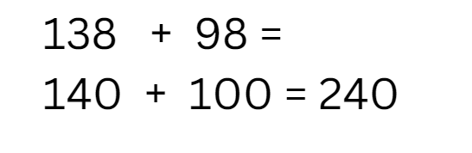
Note: students can sort problems into categories, such as ‘less than 250’ and ‘more than 250’. Change the target number and the problems provided.
This table details opportunities for assessment.
Assessment opportunities | Links
What to look for:  - Can students use estimation to check the reasonableness of solutions to addition and subtraction calculations? [MAO-WM-01, MA3-AR-01] | Links to National Numeracy Learning Progressions (NNLP):  - NPV6  - Ads8.

Core lesson: Place value – 45 minutes
The table below contains a suggested learning intention and success criteria. These are best co-constructed with students.
Core concept learning intentions | Core concept success criteria
Students are learning to:  - choose and use efficient strategies to solve addition and subtraction problems. | Students can:  - name numbers up to millions using the place value groupings of ones, tens and hundreds  - convert grams to kilograms  - round measurements to nearest kilogram  - compare, evaluate and communicate strategies used to solve multistep problems.
This activity is an adaptation of ‘Problems to solve’ [PDF 558KB] from NZ Maths by New Zealand Ministry of Education.
- Display Resource 1: Moving day and ask students to identify and record the list of objects in descending order from heaviest to lightest.
- Discuss with students what they noticed about the masses and if there is a way we can make the numbers easier to work with. Remind students that we can convert the mass from grams to kilograms to make the numbers more efficient.
- Discuss the place value connections with grams to kilograms. Have students convert the measurements from grams to kilograms and round to the nearest kilogram. Record in workbooks.
- In pairs, students find different combinations of items whose total mass is no more than 500 kg.
- Students find different combinations and record their responses in their workbooks.
- Regroup students and ask:
- What strategies did you use to convert grams to kilograms?
- What different combinations did you find?
- What was the closest combination of items you found to 500 kg?
- How can you use estimation to help solve the problem?
- Record students’ suggestions on the board, modelling how place value and partitioning can be used to solve different combinations.
- Tell students they will work with their partner to identify a combination of items that weigh as close to 500 kg as possible, while carrying the least number of items in the truck.
- After some time, regroup students and share different solutions. Ask:
- What method did you use to find the combination of items?
- How do you know you found the best one?
- Tell students to find the minimum number of trips it will take to move all the items. Students work with their partner to find different combinations and identify which results in the fewest number of trips. Encourage students to use their knowledge of place value and estimating when completing this task.
- Regroup students and share solutions by doing a gallery walk.
This table details opportunities for differentiation.
Too hard? | Too easy?
Students cannot compare, evaluate and communicate strategies used to solve multi-step problems  - Students find combinations of items to put in the truck with a weight limit of 100 kg.  - Students use models, such as number lines, to assist when solving problems. | Students can compare, evaluate and communicate strategies used to solve multi-step problems  - Provide students with challenge 1: Students are moving to a new city and only want to make one trip. Ask how many trucks students will need to hire if each truck has a weight limit of 500 kg.  - Provide students with challenge 2: Students want the trucks to be as even in weight as possible. Ask what combination of items they could put in the trucks to make their weight as even as possible.

Discuss and connect the mathematics – 10 minutes
- Regroup students and ask:
- Were there any challenges when finding different combinations?
- Were some of the tasks easier than others? Why?
- What strategies did you find most efficient? Why?
- In what ways has your knowledge of place value or estimation been beneficial in this task?
This table details opportunities for assessment.
Assessment opportunities | Links
What to look for:  - Can students name numbers up to millions using the place value groupings of ones, tens and hundreds? [MAO-WM-01, MA3-RN-01]  - Can students compare, evaluate and communicate strategies used to solve multistep problems? [MAO-WM-01, MA3-AR-01]  - Can students round numbers up to nearest kilogram? [MAO-WM-01, MA3-RN-01, MA3-RN-02]  - Can students convert grams to kilograms? [MAO-WM-01, MA3-NSM-01] | Links to National Numeracy Learning Progressions (NNLP):  - NPV7  - AdS7, AdS8  - MuS8  - UuM8.  Links to suggested Interview for Student Reasoning (IfSR) tasks:  - IfSR-AT: 3A.5.

Lesson 2
Core concept: addition can help solve subtraction problems.

Daily number sense: Hit the target! – 15 minutes
The table below contains a suggested learning intention and success criteria. These are best co-constructed with students.
Daily number sense learning intention | Daily number sense success criteria
Students are learning to:  - use estimation to check the reasonableness of solutions. | Students can:  - use estimation to check the reasonableness of solutions to addition and subtraction calculations.
This activity is an adaptation of ‘Hit the target’ from Part 3: Flexible strategies with 3-digit numbers [DOCX 794KB] by State of New South Wales (Department of Education).
- Provide small groups of students with a whiteboard and a set of playing cards (Ace to 9) to represent numbers one to 9. Students shuffle the cards. The dealer turns over 3 cards to form a 3-digit number, which becomes the target number. The dealer deals 6 cards to each player, face up.
- Players must arrange their cards to form two 3-digit numbers, or a combination of 3-, 2- and 1-digit numbers, which they can add or subtract to hit the target.
The table below outlines stimulus prompts to generate conversation about the topic, along with anticipated responses from students.
Prompts | Anticipated student responses
- How can you use estimation to help solve the problem if the target number is 473 and your cards are 6, 1, 2, 3, 9 and 3?  - What are some of the options you could have to get close to the target number? | - 690 – 230 = 440 or 340 + 190 = 430  - 693 – 231 = 462 or 339 + 126 = 465 or 393 + 62 + 1 = 456
- Students record their estimations on an individual whiteboard.
- The dealer can use vertical algorithms to check students’ answers and the student closest to the target wins the round and a point.
- Play continues for a few rounds.
Note: variations – each player keeps a cumulative total of the difference between their total and the target number. Change the target each round or make the target a 4-digit number.
This table details opportunities for assessment.
Assessment opportunities | Links
What to look for:  - Can students use estimation to check the reasonableness of solutions to addition and subtraction calculations? [MAO-WM-01, MA3-AR-01] | Links to National Numeracy Learning Progressions (NNLP):  - NPV6, NPV7  - AdS8.

Core lesson: Multi-step problems – 35 minutes
The table below contains suggested learning intentions and success criteria. These are best co-constructed with students.
Core concept learning intentions | Core concept success criteria
Students are learning to:  - choose and use efficient strategies to solve addition and subtraction problems  - apply known strategies to add and subtract decimals | Students can:  - solve multi-step word problems requiring more than one operation  - use place value to add or subtract 3 or more numbers with different numbers of digits  - solve word problems involving the addition and subtraction of decimals up to 3 decimal places.  - compare, evaluate and communicate strategies used to solve problems.
- Display Resource 2: Swift concert and provide students with their workbooks.
- In pairs, students solve the multi-step word problems, recording their solutions in their workbook.
- Regroup students. Ask:
- What steps did you take to solve the problem?
- What made you decide to do it that way?
- What challenges did you encounter during the process and how did you overcome them?
- Does the most efficient strategy change depending on the question? Explain your thinking.
- Did you receive any feedback from your partner? How did you use it to improve your performance?
- If you did not have any paper and writing material, how would you approach this task?
- Display Resource 3: VIP tickets and ask:
- Which package is best value for money? Explain your thinking.
- What is the value of the extra items given per VIP package?
- Would you consider a VIP ticket? Why or why not?
- Discuss the different strategies and record them on the board.
This table details opportunities for differentiation.
Too hard? | Too easy?
Students cannot solve multi-step word problems requiring more than one operation.  - Students solve single step problems.  - Provide students with smaller numbers. | Students can solve multi-step word problems requiring more than one operation.  - Challenge question 1: Ask how many people attended the concert altogether if there were 4 sold out shows.  - Challenge question 2: Aarna wanted to buy tickets for some of her friends. She also wanted to purchase a T-shirt for each of her friends for $27.35. She had $2000 to spend. Ask how many friends she could bring, what combinations of tickets she could buy and if she would have any money left over.

Consolidation and meaningful practice – 15 minutes
This activity is an adaptation of ‘Red Dragonfly’ by the NSW Department of Education.
- Display Figure 2 and provide students with individual whiteboards.
Figure 2 – Addition problem
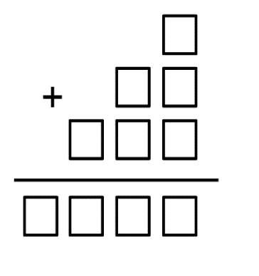
- Tell students they have cards with the digits from zero to 9, one card for each digit. In pairs, students complete Figure 2 using all the cards. Each card can only be used once.
- Regroup students and ask:
- What solutions did you find? (1035 or 1062)
- How did you approach this problem?
- Are everybody’s results the same? Why?
- What would happen if you lost the card with number one and removed the single square at the top of the equation?
This table details opportunities for assessment.
Assessment opportunities | Links
What to look for:  - Can students solve multi-step word problems requiring more than one operation? [MAO-WM-01, MA3-RN-01, MA3-AR-01]  - Can students use place value to add or subtract 3 or more numbers with different numbers of digits? [MAO-WM-01, MA3-AR-01]  - Can students compare, evaluate and communicate strategies used to solve problems? [MAO-WM-01, MA3-AR-01] | Links to National Numeracy Learning Progressions (NNLP):  - AdS7, AdS8  - MuS8.  Links to suggested Interview for Student Reasoning (IfSR) tasks:  - IfSR-AT: 3A.5.

Lesson 3
Core concept: known strategies for addition can be applied to decimals.

Daily number sense: Rounding crowds – 15 minutes
The table below contains suggested learning intentions and success criteria. These are best co-constructed with students.
Daily number sense learning intentions | Daily number sense success criteria
Students are learning to:  - use estimation and rounding to determine the reasonableness of solutions  - choose and use efficient strategies to solve addition and subtraction problems  - describe and interpret different datasets in context. | Students can:  - round numbers to the nearest thousand  - add and subtract numbers using efficient strategies  - interpret data presented in tables.
- Display Resource 4: NRL crowds. Students use the data to round numbers appropriately when estimating numerical calculations.
- Tell students they will be rounding to the nearest thousand to help answer the questions about the NRL crowds (see Figure 3).
Figure 3 – Rounding sample
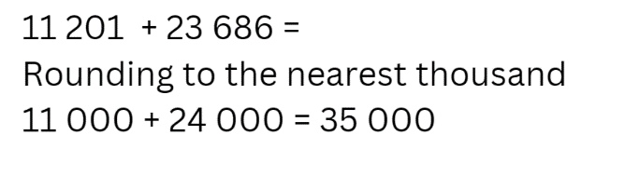
- Provide pairs of students with their workbooks to answer the following questions:
- What was the total number of spectators at your favourite NRL team’s game?
- What was the total number of spectators at your least favourite NRL team’s game?
- Which stadium had the most spectators attend in the month of June?
- Which stadium had the least number of spectators visit in the month of June? How does it compare with the stadium that had the most?
- Can you predict the crowd numbers for the next NRL game?
- What game had more spectators than the June 12th long weekend game? How many more spectators were there?
- What was the difference between the games with the most and least number of spectators?
- How did you use estimating to help solve the problems?
- What other information can you find using the NRL table?
This table details opportunities for assessment.
Assessment opportunities | Links
What to look for:  - Can students round numbers to the nearest thousand? [MAO-WM-01, MA3-RN-01]  - Can students add and subtract numbers using efficient strategies? [MAO-WM-01, MA3-AR-01]  - Can students interpret data presented in tables? [MAO-WM-01, MA3-DATA-02] | Links to National Numeracy Learning Progressions (NNLP):  - NPV6, NPV7  - AdS7, AdS8  - IRD3, IRD4, IRD5.  Links to suggested Interview for Student Reasoning (IfSR) tasks:  - IfSR-AT: 3A.5.

Core lesson: Adding decimals – 40 minutes
The table below contains suggested learning intentions and success criteria. These are best co-constructed with students.
Core concept learning intentions | Core concept success criteria
Students are learning to:  - apply known strategies to add decimals. | Students can:  - solve word problems involving addition of decimals up to 3 decimal places  - justify why the strategies used are appropriate.
- Display Resource 5: Decimal misconceptions and ask students to turn and talk and discuss which child is correct and how they know.
- Share student ideas with the class and clarify any misconceptions.
- Display Resource 6: Long jump and provide students with a whiteboard.
- Explain that the table shows the recorded lengths of children who jumped in long jump at 3 different carnivals. In pairs, ask students to calculate the combined distance that Xavier jumped in carnival A and carnival B and justify their answers to the following questions:
- What was the combined distance Xavier jumped in carnival A and carnival B?
- What strategies did you use to calculate this? Was your strategy efficient?
- What did you notice when adding the decimals together?
- In pairs, students continue to answer questions about Resource 6: Long jump in their workbook.
- What is the combined distance that Stacey jumped at all 3 carnivals?
- Whose combined distance at all 3 carnivals was greater between Xavier and Ishaan?
- Overall, in which carnival did the team perform best?
- Which athlete had the best combined jump overall?
- If you added together 3 athletes’ scores from carnival C and the combined distance was greater than 12 m. Whose scores could you have added?
Note: school carnival data can be used or class data of an activity, for example, throwing a bean bag.
This table details opportunities for differentiation.
Too hard? | Too easy?
Students cannot solve word problems involving adding decimals up to 3 decimal places.  - Provide alternate questions:  - What is the combined distance that Maria jumped at carnival B and carnival C?  - Whose combined distance at carnival A and carnival B was greater, Stuart or Stacey?  - If you added 2 athletes’ scores from carnival C and the combined distance was greater than 8 metres, whose scores could you have added?  - Modify decimals so they only have one decimal place. | Students can solve word problems involving adding decimals up to 3 decimal places.  - Provide alternative questions:  - What was the difference between the teams’ overall score at their highest performing carnival and their lowest performing carnival?  - Who had the largest difference between their longest jump and shortest jump?  - If you added together 3 athletes’ scores from carnival A and carnival B and the combined distance would be greater than 24 metres, whose scores could you have added?  - Modify decimals so they have different place value.

Discuss and connect the mathematics – 10 minutes
- Regroup students and ask:
- What strategies did you use when solving these questions?
- What was the most efficient strategy used?
- What strategy did you find inefficient when adding decimals?
- How do you know you calculated the correct answer? How can you check?
This table details opportunities for assessment.
Assessment opportunities | Links
What to look for:  - Can students solve word problems involving addition of decimals up to 3 decimal places? [MAO-WM-01, MA3-RN-02, MA3-AR-01]  - Can students justify why the strategies used are appropriate? [MAO-WM-01, MA3-RN-02, MA3-AR-01] | Links to National Numeracy Learning Progressions (NNLP):  - AdS9.  Links to suggested Interview for Student Reasoning (IfSR) tasks:  - IfSR-NP/AT/MT: 4A.1, 4A.2, 4A.3, 4A.4.

Lesson 4
Core concept: known strategies for subtraction can be applied to decimals.

Daily number sense – 10 minutes
- From a class need surfaced through formative assessment data, identify a short, focused activity that targets students’ knowledge, understanding and skills. Example activities may be drawn from the following resources:
- Mathematics K-6 resources
- Universal Resources Hub.

Core lesson: Adding time – 35 minutes
The table below contains suggested learning intentions and success criteria. These are best co-constructed with students.
Core concept learning intentions | Core concept success criteria
Students are learning to:  - apply known strategies to add and subtract decimals  - solve time problems involving duration. | Students can:  - solve word problems involving addition and subtraction of decimals up to 3 decimal places  - use start and finish times to calculate elapsed time.
- Display Resource 7: Songs and provide students with an individual whiteboard each.
- In pairs, tell students to find the difference in the length of the song between ‘Anti-Hero’ (Taylor Swift) and ‘As It Was’ (Harry Styles).
- Regroup students. Ask:
- What solution did you find?
- What strategy did you use?
- What did you discover when solving this problem?
- Are there certain strategies that are less effective when solving this problem?
Note: highlight that as students are talking about time, they are not using a base-10 model. Revise that there are 60 seconds in one minute.
- In pairs, tell students to find the difference between ‘As It Was’ (Harry Styles) and ‘Calm down’ (Rema, Selena Gomez). Encourage students to use a different strategy.
- Regroup students and ask:
- What solution did you find? (1:12)
- What strategy did you use?
- Was it more efficient or less efficient than your last one? Why?
- Provide students with their workbook and a digital device.
- In pairs, students pick their 3 favourite songs each. Using a digital device, they research the length of each song. Students calculate the duration of their favourite songs. Once both partners have calculated their total, students work to find the difference between their totals.
- Regroup students and ask:
- Was it easier or harder to work with time questions and why?
- What strategy did you find most efficient and why?
- If there was a 15 second pause between each song, how would this change your solution?
This table details opportunities for differentiation.
Too hard? | Too easy?
Students cannot add or subtract decimals where time is involved.  - Provide students with a number line to model the time subtraction problems.  - Provide students with questions that involve base-10. | Students can add or subtract decimals where time is involved.  - Provide alternative questions:  - If you had 8 minutes, what songs can you listen to in that time? How much time would be left?  - If you have 30 minutes before you had to leave, how many times could you listen to each song in the previous question?  - Students create their own playlist challenge and share it with a peer.

Consolidation and meaningful practice – 15 minutes
This activity is an adaptation from Challenging Mathematical Tasks: Unlocking the potential of all students by Sullivan.
- Provide students with a copy of Resource 8: Frayer model and display Resource 9: Music player. Explain that they need to complete the Frayer model template using 3 different additive strategies and in the last box students need to explain which strategy is most efficient.
- Regroup students. Ask:
- How long would it take to play all 3 songs?
- What strategy did you find most efficient? Why?
- Challenge question: If you were on a 20-minute train trip, how many times could you play all 3 songs?
This table details opportunities for assessment.
Assessment opportunities | Links
What to look for:  - Can students solve word problems involving addition and subtraction of decimals up to 3 decimal places? [MAO-WM-01, MA3-AR-01]  - Can students use start and finish times to calculate elapsed time? [MAO-WM-01, MA3-NSM-02] | Links to National Numeracy Learning Progressions (NNLP):  - AdS9  - MeT4.

Lesson 5
Core concept: number lines help solve addition and subtraction problems.

Daily number sense: Product target – 10 minutes
Daily number sense activities for Lessons 5 to 7 ‘loop’ back to concepts and procedures covered in previous units to assist students to build an increasingly connected network of ideas. These concepts may differ from the core concepts being covered by the unit.
The table below contains a suggested learning intention and success criteria. These are best co-constructed with students.
Daily number sense learning intention | Daily number sense success criteria
Students are learning to:  - determine products and factors. | Students can:  - use the term product to describe the result of multiplying 2 or more numbers.
This activity is an adaptation of ‘Target number’ from Part 3: Flexible strategies with multi-digit numbers [PDF 2.93 MB] by State of New South Wales (Department of Education).
- In pairs, provide students with playing cards Ace to 9 and Resource 10: Recording sheet.
- One student deals out 5 cards to each player and determines the target number. Using their 5 cards, students form any 1-, 2-, or 3-digit number. Players find the product of 2 or more numbers, using addition and subtraction if needed, to get as close to the target number as possible. The total of each equation is then used for the next equation. Each card can only be used once and not all cards need to be used (see Figure 4).
Figure 4 – Student sample
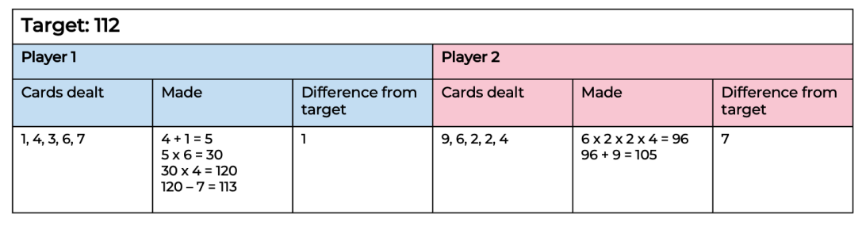
This table details opportunities for assessment.
Assessment opportunities | Links
What to look for:  - Can students use the term product to describe the result of multiplying 2 or more numbers? [MAO-WM-01, MA3-MR-01] | Links to National Numeracy Learning Progressions (NNLP):  - MuS6.

Core lesson: Number lines solve problems – 40 minutes
The table below contains a suggested learning intention and success criteria. These are best co-constructed with students.
Core concept learning intention | Core concept success criteria
Students are learning to:  - choose and use efficient strategies to solve addition and subtraction problems. | Students can:  - partition numbers in standard and non-standard forms  - use a number line to solve addition and subtraction problems  - evaluate and communicate strategies used to solve problems.
- Display Resource 11: Holiday time and tell students they will be creating their dream holiday package. They need to factor in accommodation, food, transport and activities.
- Explain that students have a budget of $10 000. Highlight that they need to decide what their priority for the holiday is and where they would like to spend their money.
- Encourage students to use a number line to add costs together. Model how a number line can be used.
- Provide students with their workbook. Students calculate the cost of their dream trip and record the items they have selected in their workbook.
- Regroup students and ask:
- What did you plan for your trip?
- How did using a number line help you solve addition and subtraction?
- Do you think using a number line is an efficient strategy? Why?
- Tell students the budget for their trip has now been reduced to $5394. Students take away or alter their trip to suit the new budget.
- Regroup students and ask:
- How did you alter the trip to suit the new budget?
- What was helpful about using a number line?
- What was challenging about using a number line?
- What is your preferred addition or subtraction strategy? Why?
This table details opportunities for differentiation.
Too hard? | Too easy?
Students cannot use a number line to solve addition and subtraction problems.  - Provide students with smaller numbers for costs and a blank number line.  - Provide students with a smaller budget. | Students can use a number line to solve addition and subtraction problems.  - Students work in groups to create 2 trips that can be advertised at a local travel agent. Design one for a budget traveller who likes adventure sports with a budget of $3000. Design the other for a luxury traveller who enjoys high-end experiences with a budget of $12 000.  - Provide students with airfares and discuss how this could impact their desired trip.

Consolidation and meaningful practice – 10 minutes
This activity is an adaptation from Open-ended Maths activities by Sullivan and Lilburn.
- Display Figure 5 and provide students with a whiteboard.
Figure 5 – Consolidation task
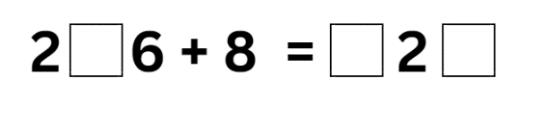
- Students work in pairs to find all possible solutions. There are 9 possible answers and 10 if you allow students to use a zero before the 8.
- Regroup students and ask:
- How many solutions did you find?
- Did you find all the solutions? How do you know?
- How did you approach the problem?
- What strategies did you use? What made you decide to do it that way?
- Would you approach the problem differently next time?
- Is there a strategy used that you have not heard of?

This table details opportunities for assessment.
Assessment opportunities | Links
What to look for:  - Can students use a number line to solve addition and subtraction problems? [MAO-WM-01, MA3-AR-01]  - Can students evaluate and communicate strategies used to solve problems? [MAO-WM-01, MA3-AR-01] | Links to National Numeracy Learning Progressions (NNLP):  - AdS7, AdS8.  Links to suggested Interview for Student Reasoning (IfSR) tasks:  - IfSR-AT: 3A.5.

Lesson 6
Core concept: estimating and place value understanding helps to determine the reasonableness of solutions.

Daily number sense: Gridlock – 15 minutes
The table below contains a suggested learning intention and success criteria. These are best co-constructed with students.
Daily number sense learning intention | Daily number sense success criteria
Students are learning to:  - determine products and factors. | Students can:  - model different ways to show a whole number as a product.
This activity is an adaptation from Math Games with Bad Drawings: 75 1/4 Simple, Challenging, Go-Anywhere Games -And Why They Matter by Orlin.
- In pairs, provide students with two 6-sided dice and grid paper. The aim of the game is to fill as much of the grid as possible before the game is over.
- Each player rolls the 2 dice and uses the results to make a rectangle. For example, if a student rolls a 4 and a 5, they must shade in a 4 by 5 rectangle anywhere on their grid. Players can shade a different way to show a whole number as a product. For example, 4 by 5 is 20, which can be represented by 2 by 10 or one by 20 on the grid. If the rectangle does not fit on the board, the player loses a turn. When both players lose their turn, one after the other, the game ends and whoever has more squares on their grid is the winner.
- If they wish, each player can play one rectangle on their opponent’s board instead of their own (see Figure 6).
Figure 6 – Gridlock board
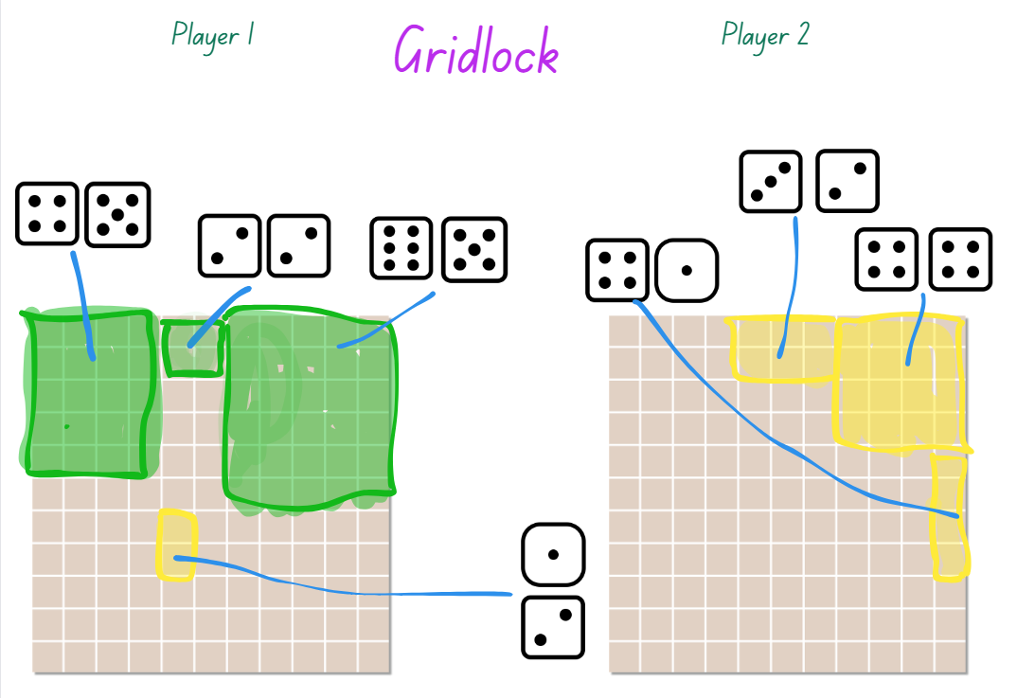
This table details opportunities for assessment.
Assessment opportunities | Links
What to look for:  - Can students model different ways to show a whole number as a product? [MAO-WM-01, MA3-MR-01] | Links to National Numeracy Learning Progressions (NNLP):  - MuS8.

Core lesson: Add and Subtract decimals – 40 minutes
The table below contains a suggested learning intention and success criteria. These are best co-constructed with students.
Core concept learning intention | Core concept success criteria
Students are learning to:  - use estimation and place value understanding to determine the reasonableness of solutions. | Students can:  - round numbers appropriately when obtaining estimates  - use place value understanding to check for errors in calculations  - use estimation to check the reasonableness of solutions.
This activity is an adaptation of Adding and subtracting decimals from the Universal Resources Hub by State of New South Wales (Department of Education).
- Display Resource 12: Sarah’s luggage and provide students with an individual whiteboard.
- Tell students to use rounding to estimate the current weight of Sarah’s bag and ask:
- What solution did you calculate? (3.85 + 1.70 + 1.42 approximately equals 4 + 2 + 1 = 7 kg)
- How did you use estimating?
- Can she add any more items?
- Why is estimating useful?
- Tell students to calculate the exact weight of Sarah’s bag and ask:
- What solution did you calculate?
- How accurate was your estimate?
- Could Sarah’s rounding potentially create any problems in terms of the weight of her luggage?
- Provide students with their workbooks. Display Resource 13: Problems and have students select 3 problems to solve.
- Regroup as class. Share the solutions and strategies used to solve each problem.
This table details opportunities for differentiation.
Too hard? | Too easy?
Students cannot round numbers appropriately when obtaining estimates.  - Provide students with numbers with only one decimal place to estimate, add and subtract.  - Provide students number lines to help support problem solving. | Students can round numbers appropriately when obtaining estimates.  - Students solve problems using a second strategy to confirm their answer and provide the inverse operation to prove their answer.  - Students create their own word problems involving addition and subtraction of decimals and swap with a partner to solve.

Discuss and connect the mathematics – 10 minutes
This activity is an adaptation of Adding and subtracting decimals from the Universal Resources Hub by State New South Wales (Department of Education).
- Display Resource 14: Video games and provide students with individual whiteboards. Students estimate the answer.
- Regroup students and ask:
- What estimate did you find?
- What strategy did you use to estimate?
- Was this an efficient strategy?
- When is estimation helpful?
- How close were you to the actual total?
This table details opportunities for assessment.
Assessment opportunities | Links
What to look for:  - Can students round numbers appropriately when obtaining estimates? [MAO-WM-01, MA3-RN-02, MA3-AR-01]  - Can students use estimation to check the reasonableness of solutions? [MAO-WM-01, MA3-RN-02, MA3-AR-01] | Links to National Numeracy Learning Progressions (NNLP):  - NPV6, NPV7  - AdS8.

Lesson 7
Core concept: mathematicians solve addition and subtraction problems with more than one operation.

Daily number sense: Factors and multiples – 15 minutes
The table below contains a suggested learning intention and success criteria. These are best co-constructed with students.
Daily number sense learning intention | Daily number sense success criteria
Students are learning to:  - determine products and factors. | Students can:  - determine factors or multiples for a given whole number.
This activity is an adaptation of Factors and Multiples from NRICH by University of Cambridge (Faculty of Mathematics).
- Provide pairs of students Resource 15: 100 grid. The aim of the game is to try and make it a challenge for the other player to pick a number that works, that is a factor or multiple of the number given.
Factor: a number that divides another number without a remainder. For example, 1, 2, 3 and 6 are factors of 6 but 4 and 5 are not.
Multiple: products formed using the same base number multiplied by different whole numbers, for example, 3, 6, 9, 12 and so on.
- Player A chooses an even number that is less than 50 and crosses it out on the grid. Player B chooses a number to cross out. The number must be a factor or multiple of the first number.
- Players continue to take it in turns to cross out numbers, at each stage choosing a number that is a factor or multiple of the number just crossed out by the other player. The first player who is unable to cross out a number ends the game.
- Students can play a few rounds of the game.
This table details opportunities for assessment.
Assessment opportunities | Links
What to look for:  - Can students determine factors or multiples for a given whole number? [MAO-WM-01, MA3-MR-01] | Links to National Numeracy Learning Progressions (NNLP):  - MuS6, MuS7.

Core lesson: Local fair investigation (Part 1) – 45 minutes
The table below contains a suggested learning intention and success criteria. These are best co-constructed with students.
Core concept learning intention | Core concept success criteria
Students are learning to:  - apply known strategies to add and subtract decimals. | Students can:  - model the addition and subtraction of decimals using appropriate representation  - solve multi-step problems, including more than one operation  - justify why the strategy used to solve addition and subtraction word problems is appropriate.
This activity is an adaptation of Lunar Theme Park [DOCX 145KB] from UK Maths.
- Tell students they will be designing and organising a local fair that will run for 2 weeks during the school holidays. They will need to think about the types of rides and activities they will have at the fair. They also need to consider the types of facilities they need such as toilets, cafes and so on. The ongoing costs are also important, such as paying staff and the cost of advertising.
- Display Resource 16: Fair set-up and Resource 17: Recording sheet. Discuss the spending limit and the cost of each item. Highlight that, when creating their design, students need to consider not only the cost of their design but also the ongoing costs to run each of their activities for 14 days (about 2 weeks) and the costs to advertise the event.
- Provide each group with a copy of Resource 16: Fair set-up, Resource 17: Recording sheet, Resource 18: Total costs and grid paper. Explain that each item takes up an allocated number of squares on the paper.
- In small groups, students design and draw an arial view of the fair on grid paper. Remind students to ensure they are considering the ongoing costs and advertising, which will be calculated in the next lesson.
- Students record their expenses on Resource 18: Total costs.

This table details opportunities for differentiation.
Too hard? | Too easy?
Students cannot model the addition and subtraction of decimals using appropriate representation.  - Provide students with smaller numbers for the various outgoing costs.  - Reduce the total cost of the budget. | Students can model the addition and subtraction of decimals using appropriate representation.  - Provide an incentive for students to use the least amount of their budget whilst still ensuring the services meet the minimum requirements of the task.  - Students prepare a budget for another school event. In groups students prepare all the background costs for the new event.

Discuss and connect the mathematics – 10 minutes
- Regroup students and ask:
- What did you include in your fair?
- Did you remain under the spending limit? How do you know?
- What addition and subtraction strategies did you use to calculate this?
- Was one strategy more efficient than another when working with numbers of this size?

This table details opportunities for assessment.
Assessment opportunities | Links
What to look for:  - Can students model the addition and subtraction of decimals using appropriate representation? [MAO-WM-01, MA3-AR-01]  - Can students solve multi-step problems, including more than one operation? [MAO-WM-01, MA3-AR-01] | Links to National Numeracy Learning Progressions (NNLP):  - AdS8, AdS9  - MuS8.

Lesson 8
Core concept: mathematicians compare and evaluate strategies used to solve addition and subtraction problems, reasoning which strategy may be most efficient.

Daily number sense – 10 minutes
- From a class need surfaced through formative assessment data, identify a short, focused activity that targets students’ knowledge, understanding and skills. Example activities may be drawn from the following resources:
- Mathematics K-6 resources
- Universal Resources Hub.

Core lesson: Local fair investigation (Part 2) – 40 minutes
The table below contains a suggested learning intention and success criteria. These are best co-constructed with students.
Core concept learning intention | Core concept success criteria
Students are learning to:  - apply known strategies to add and subtract decimals. | Students can:  - model adding and subtracting decimals using appropriate representation  - solve multi-step problems, including more than one operation  - justify why the strategy used to solve addition and subtraction word problems is appropriate.
- Explain that students will continue working in their small groups on their design of a local fair from Lesson 7, by calculating the cost for advertising and ongoing costs.
- Display Resource 16: Fair set-up and discuss options for advertising. Highlight that they need to decide what kind of advertising they will use and how much advertising they will do.
- Display Resource 19: Ongoing costs and explain that they will need to calculate their ongoing costs and highlight that their costs are affected by the rides and facilities they have at their fair.
- Students work in their small groups to calculate the total costs on Resource 18: Total costs. Remind students they need to ensure they stick to the budget.
- Regroup students and tell students to calculate what money they have remaining in their budget.
This table details opportunities for differentiation.
Too hard? | Too easy?
Students cannot model the addition and subtraction of decimals using appropriate representation.  - Provide students with smaller numbers for the various outgoing costs.  - Reduce the total cost of the budget. | Students can model the addition and subtraction of decimals using appropriate representation.  - Provide students with additional challenge question 1: If the fair was going to run for 35 days, how would this impact the cost?  - Provide students with additional challenge question 2: Some fair staff are struck with the flu, and you close all minor rides and shops. How would this impact the profit flow?

Discuss and connect the mathematics – 15 minutes
- Provide each group with a copy of Resource 20: Y-chart. Students complete each section and reflect on the most efficient strategy used while completing the task.
- Students display their recording sheet, Y-chart and fair design on a desk. Groups complete a gallery walk around the room. Encourage students to look that the different strategies used, and different designs created by groups.
- Regroup students and ask:
- Which strategy did you find most efficient? Why?
- What was the total cost of your fair?
- How much money did you have left over from the budget?
- Did you have to make alterations and adjustments to the fair?

This table details opportunities for assessment.
Assessment opportunities | Links
What to look for:  - Can students model the addition and subtraction of decimals using appropriate representation? [MAO-WM-01, MA3-AR-01]  - Can students justify why the strategy used to solve addition and subtraction word problems is appropriate? [MAO-WM-01, MA3-AR-01] | Links to National Numeracy Learning Progressions (NNLP):  - AdS9.  Links to suggested Interview for Student Reasoning (IfSR) tasks:  - IfSR-AT: 4A.1, 4A.2, 4A.3, 4A.4.

Resource 1: Moving day
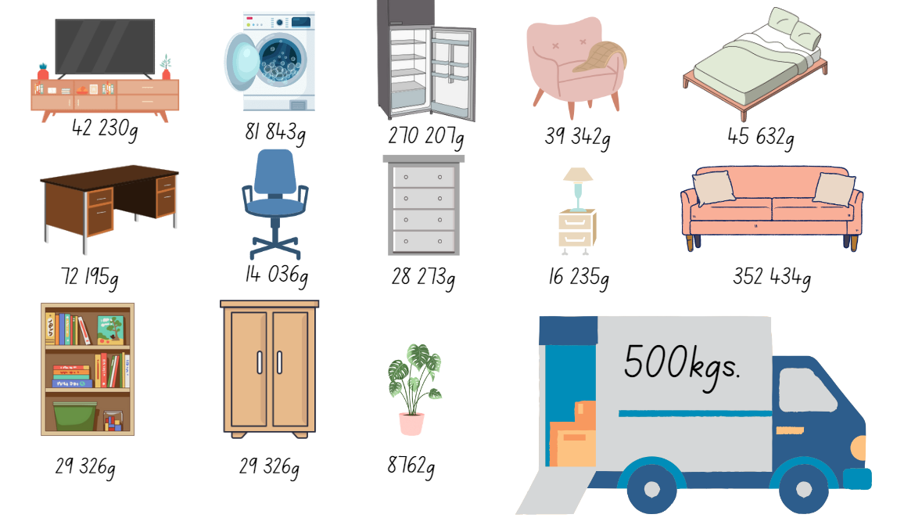

Resource 2: Swift concert
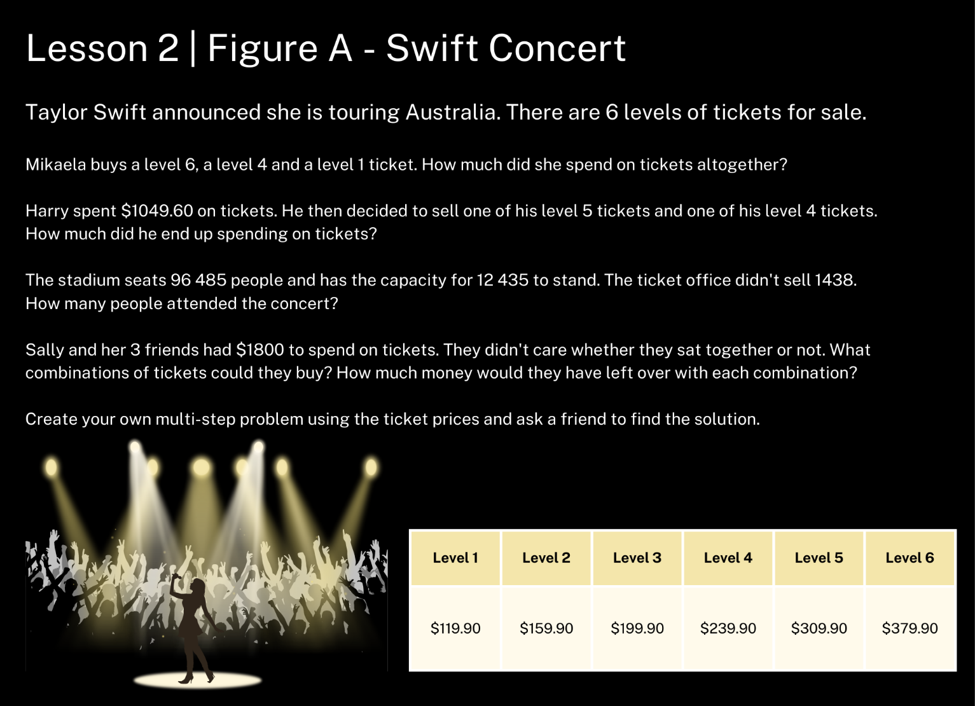

Resource 3: VIP tickets
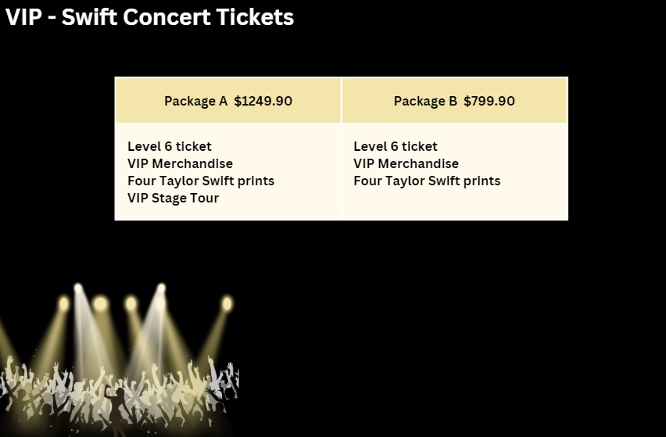

Resource 4: NRL crowds
Date | Event | Venue | Crowd
25/06/23 | Raiders d Roosters | Allianz Stadium | 13 326
25/06/23 | Cowboys d Rabbitohs | Accor Stadium | 11 262
25/06/23 | Titans d Broncos | Suncorp Stadium | 42 249
24/06/23 | Storm d Sea Eagles | AAMI Park | 13 198
24/06/23 | Panthers d Knights | Blue Stadium | 18 589
24/06/23 | Eels d Dolphins | Sunshine Coast Stadium | 8821
23/06/23 | Warriors d Dragons | WIN Stadium | 9275
18/06/23 | Sharks d Bulldogs | Points Stadium | 11 901
17/06/23 | Storm d Tigers | Campbelltown Sports Stadium | 8517
17/06/23 | Eels d Sea Eagles | CommBank Stadium | 21 296
17/06/23 | Roosters d Knights | McDonald Jones Stadium | 21 966
16/06/23 | Cowboys d Panthers | Queensland Country Bank Stadium | 17 277
12/06/23 | Eels d Bulldogs | Accor Stadium | 33 866
11/06/23 | Storm d Sharks | AAMI Stadium | 20 253
10/06/23 | Panthers d Roosters | Allianz Stadium | 26 610
10/06/23 | Broncos d Knights | Suncorp Stadium | 35 814
10/06/23 | Dragons d Rabbitohs | Netstrata Jubilee Stadium | 17 357
09/06/23 | Sea Eagles d Dolphins | Brookvale Oval | 14 598
09/06/23 | Warriors d Raiders | GIO Stadium | 21 089
08/06/23 | Titans d Tigers | Cbus Super Stadium | 10 232
04/06/23 | Panthers d Dragons | Blue Stadium | 16 912
04/06/23 | Cowboys d Storm | Queensland Country Bank Stadium | 18 867
04/06/23 | Roosters d Bulldogs | Industree Group Stadium | 18 338
03/06/23 | Broncos d Sharks | Points Stadium | 12 318
03/06/23 | Rabbitohs d Titans | Cbus Super Stadium | 18 736
03/06/23 | Warriors d Dolphins | Go Media Stadium (NZ) | 23 686
02/06/23 | Raiders d Tigers | Campbelltown Sports Stadium | 11 201

Resource 5: Decimal misconceptions
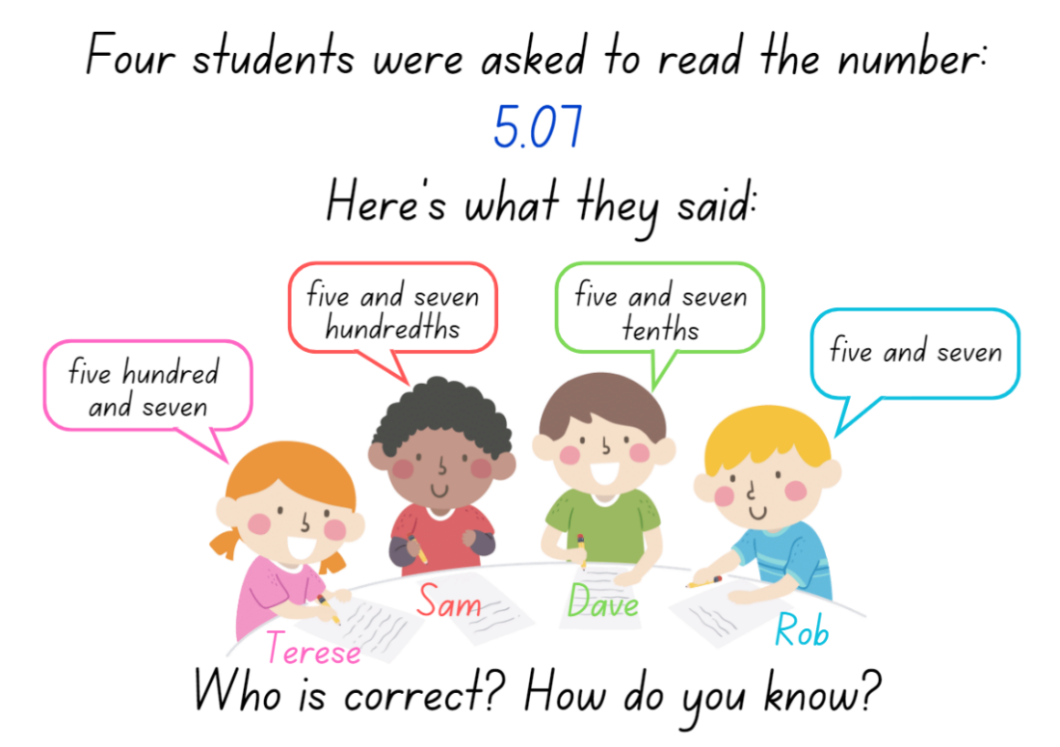

Resource 6: Long jump
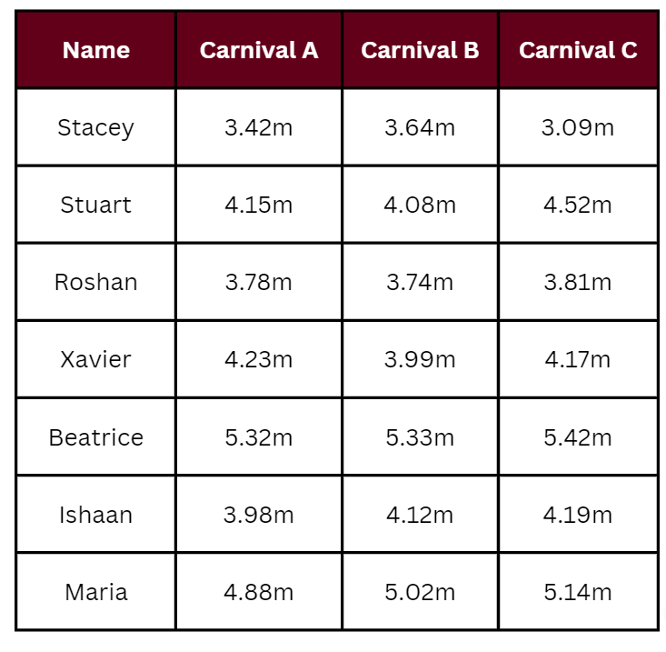

Resource 7: Songs
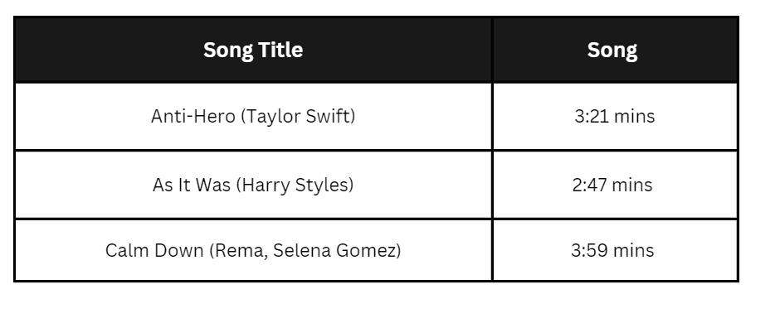

Resource 8: Frayer model
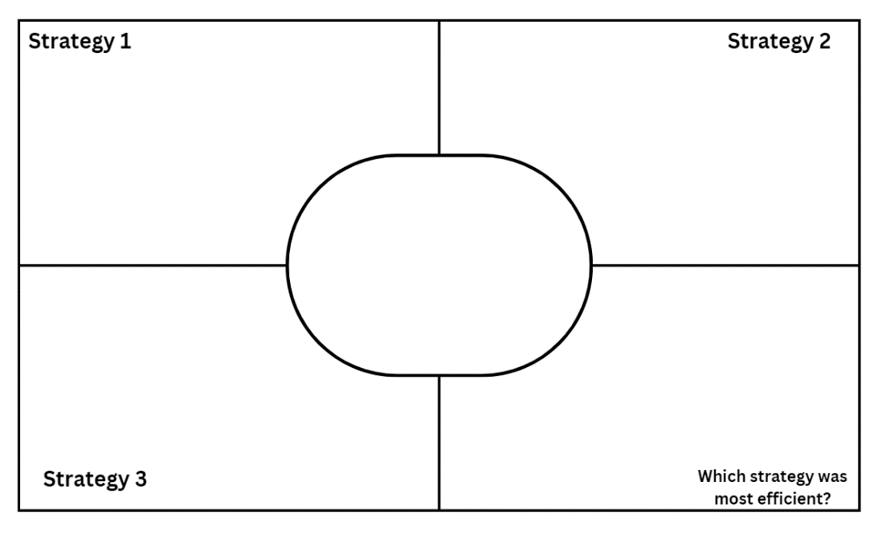

Resource 9: Music player
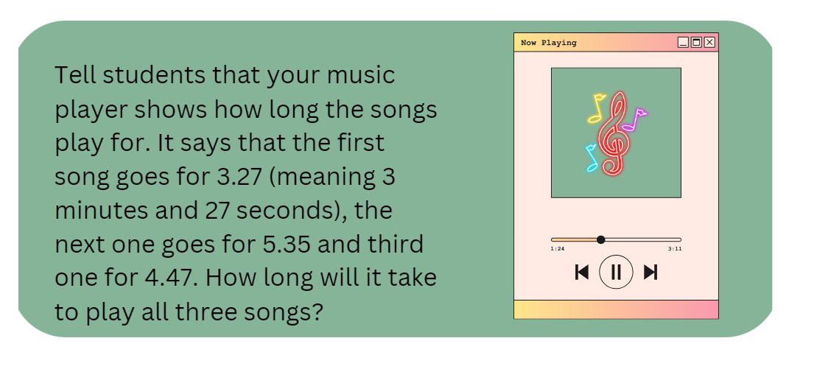

Resource 10: Recording sheet
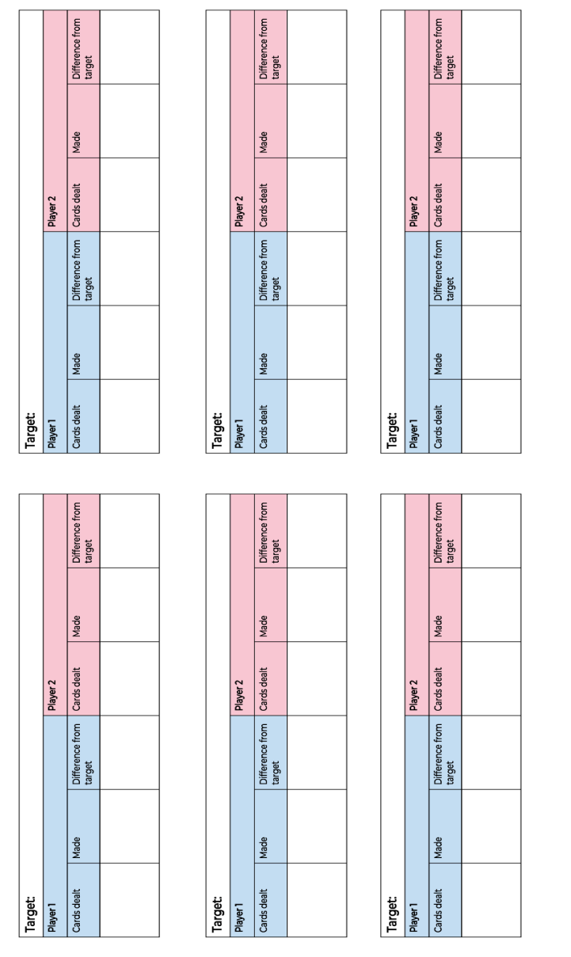

Resource 11: Holiday time
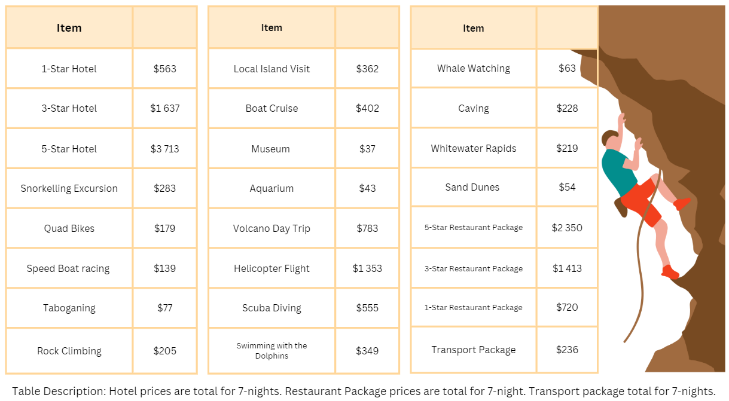

Resource 12: Sarah’s luggage
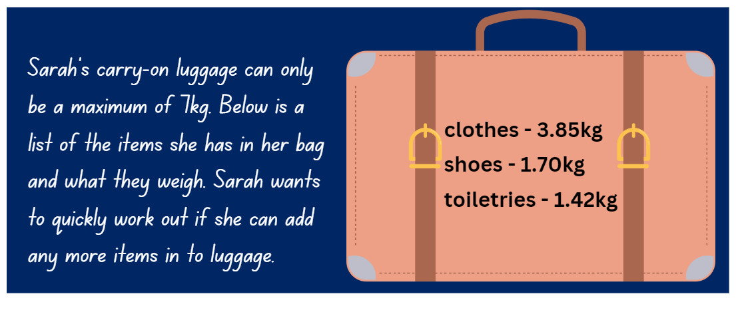

Resource 13: Problems
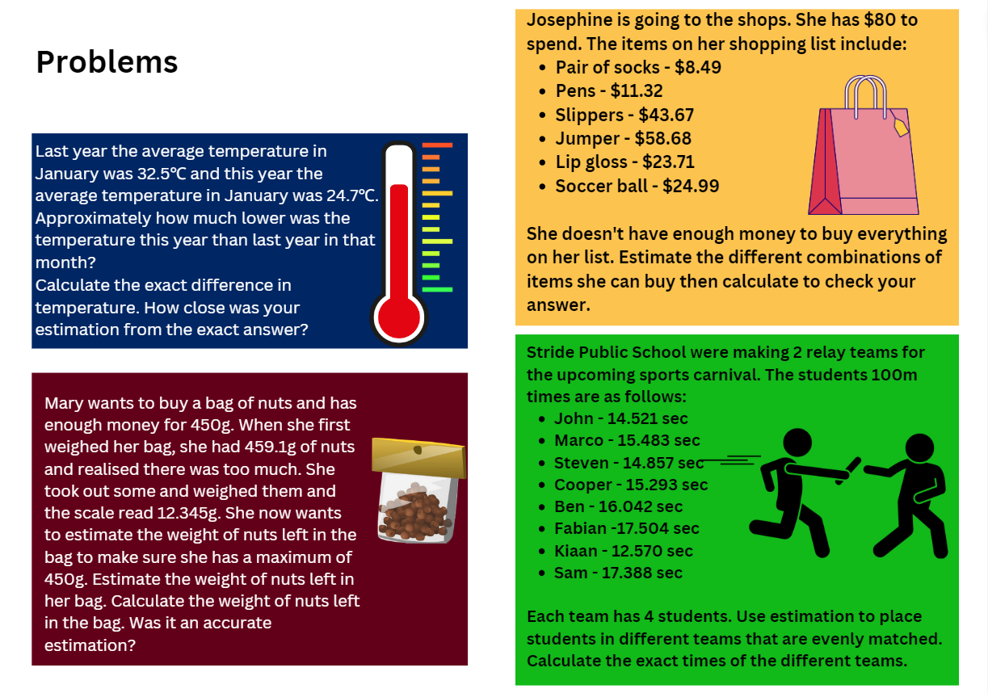

Resource 14: Video games
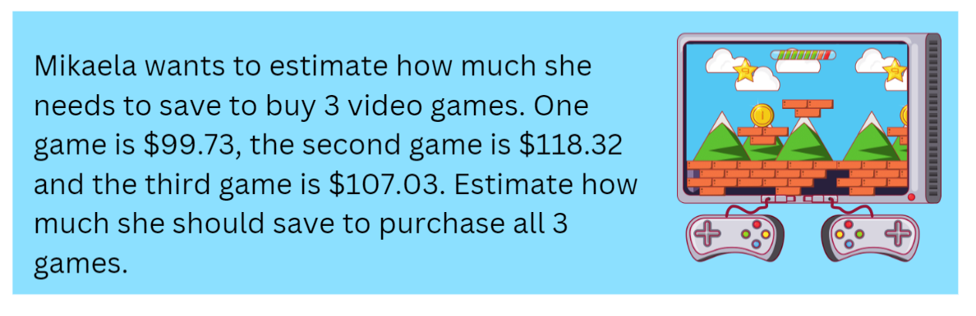

Resource 15: 100 grid
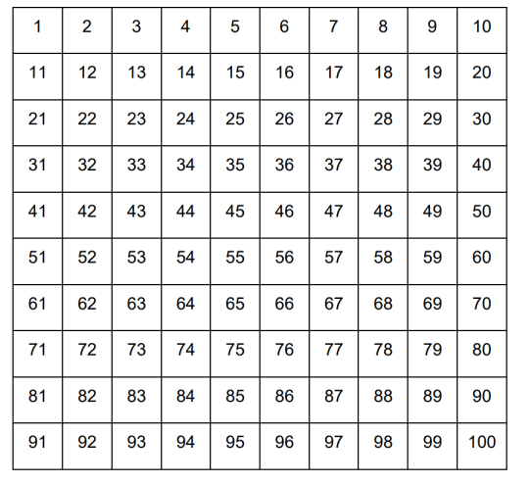

Resource 16: Fair set-up
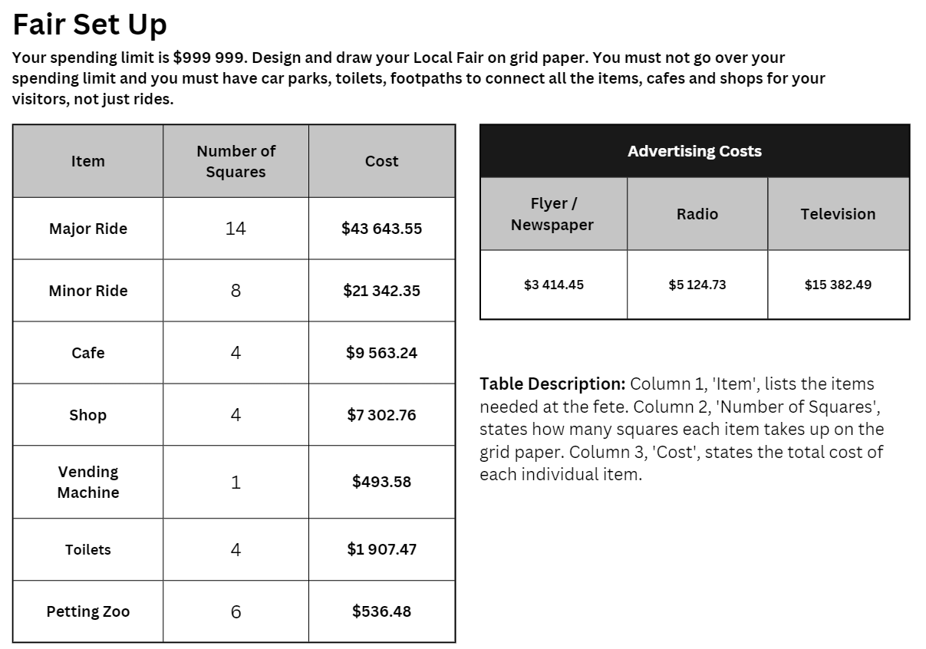

Resource 17: Recording sheet
Item | Number of items | Total cost
Eg Major ride | 2 | $43,643.55 + $43,643.55 =  $87,287.10

Resource 18: Total costs
Item | Total cost of items  (eg 2 major rides cost a total of $87,287.10) | Total of ongoing costs  (for 14 days) | Total cost altogether  (Total cost of items + total of ongoing costs)
Eg Major rides | $87,287.10 | $9044 | $96,331.10
 |  | Total cost of fair = $

Resource 19: Ongoing costs
Item | Number of each item at the fair  (eg Major rides – 2) | Staff costs per day | Electricity/ Maintenance/ Repairs per day | Total costs per day | Total cost for the 14 days
Major ride |  | $150 | $173
Minor ride |  | $97 | $97
Café |  | $104 | $83
Shop |  | $89 | $157
Vending machine |  | – | $31
Toilet |  | –
Petting zoo |  | $173 | –

Resource 20: Y-chart
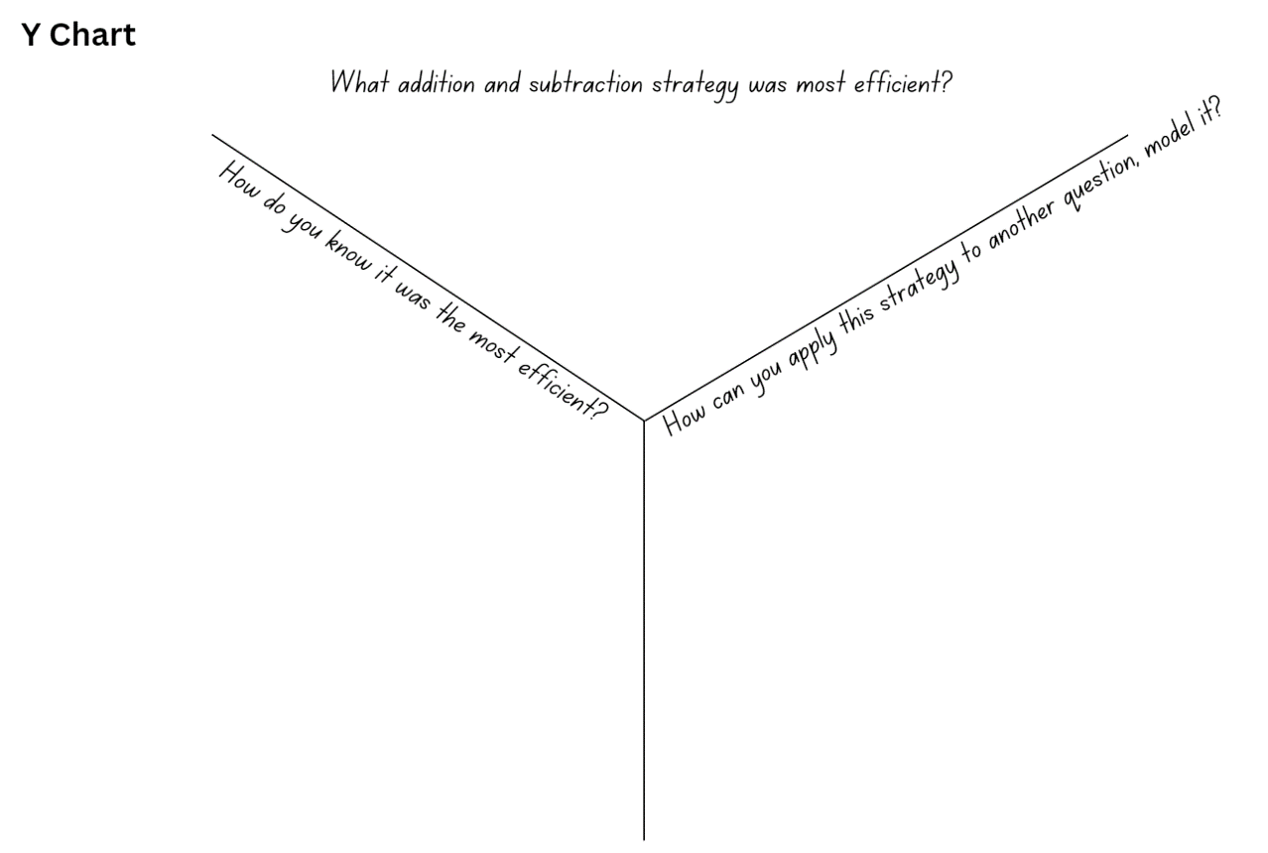

Syllabus outcomes and content
The table below outlines the syllabus outcomes and range of relevant syllabus content covered in this unit. Content is linked to National Numeracy Learning Progression version (3).
Outcomes and content | 1 | 2 | 3 | 4 | 5 | 6 | 7 | 8
Represents numbers A: Whole numbers: Recognise, represent and order numbers in the millions
MAO-WM-01, MA3-RN-01, MA3-RN-02
- Name millions using the place value grouping of ones, tens and hundreds | x |  |  |  | x
- Arrange numbers in the millions in ascending and descending order using place value | x
- Round numbers to a specified place value | x |  | x |  |  | x
Represents numbers A: Whole numbers: Apply place value to partition, regroup and rename numbers to 1 billion
MAO-WM-01, MA3-RN-01, MA3-RN-02
- Regroup numbers in different forms (Reasons about quantity) |  | x
- Partition numbers to 1 billion in non-standard forms | x
Represents numbers A: Decimals and percentages: Recognise that the place value system can be extended beyond hundredths
MAO-WM-01, MA3-RN-01, MA3-RN-02
- Express thousandths as decimals | x
- Interpret decimal notation for thousandths | x
- Indicate the place value of digits in decimal numbers of up to 3 decimal places | x |  | x
- Use place value to partition decimals | x |  | x
Represents numbers A: Decimals and percentages: Compare order and represent decimals
MAO-WM-01, MA3-RN-01, MA3-RN-02
- Compare and order decimal numbers of up to 3 decimal places |  | x | x | x |  | x
- Interpret zero digit(s) at the end of a decimal |  | x | x | x |  | x
Additive relations A: Apply efficient mental and written strategies to solve addition and subtraction problems
MAO-WM-01, MA3-AR-01
- Solve word problems, including multistep problems |  | x |  |  |  | x | x | x
- Apply known strategies such as levelling, addition for subtraction, using constant difference, and bridging (Reasons about relations) | x | x |  |  |  |  | x | x
- Use place value to add or subtract 3 or more numbers with different numbers of digits |  | x |  |  |  |  | x | x
- Identify efficient and inefficient multidigit subtraction strategies |  | x
Additive relations A: Use estimation and place value understanding to determine the reasonableness of solutions
MAO-WM-01, MA3-AR-01
- Round numbers appropriately when obtaining estimates to numerical calculations |  |  | x |  |  | x
- Use place value understanding to check for errors in calculations | x | x | x | x | x | x | x | x
- Use estimation to check the reasonableness of solutions to addition and subtraction calculations | x | x | x | x | x | x | x | x
Additive relations B: Choose and use efficient strategies to solve addition and subtraction problems
MAO-WM-01, MA3-AR-01
- Solve multistep word problems, including problems that require more than one operation | x | x |  |  |  | x | x | x
- Compare, evaluate and communicate strategies used to solve addition and subtraction problems | x | x | x | x | x | x | x | x
Additive relations B: Applies known strategies to add and subtract decimals
MAO-WM-01, MA3-AR-01
- Model the addition and subtraction of decimals up to 3 decimal places using appropriate representations |  | x | x | x |  | x | x | x
- Solve word problems involving the addition and subtraction of decimals up to 3 decimal places |  | x | x |  |  | x | x | x
- Justify why the strategy used to solve addition and subtraction word problems is appropriate (Reasons about quantity) |  | x | x | x |  | x | x | x
Multiplicative relations A: Determine products and factors
MAO-WM-01, MA3-MR-01
- Use the term product to describe the result of multiplying 2 or more numbers |  |  |  |  | x
- Model different ways to show a whole number as a product (Reasons about structure) |  |  |  |  |  | x
- Determine factors for a given whole number |  |  |  |  |  |  | x
Non-spatial measure B: Mass: Convert between common metric units of mass
MAO-WM-01, MA3-NSM-02
- Convert between kilograms and grams and between kilograms and tonnes | x
- Solve problems involving different units of mass | x
Non-spatial measure B: Time: Solve problems involving duration, using 12- and 24-hour time
- Use start and finish times to calculate elapsed time of events |  |  |  | x
DATA A: Describe and interpret different datasets in context
MAO-WM-01, MA3-DATA-02
- Describe and interpret data presented in tables, column graphs and line graphs |  |  | x
Mathematics K–10 Syllabus © NSW Education Standards Authority (NESA) for and on behalf of the Crown in right of the State of New South Wales, 2022.

References
This resource contains NSW Curriculum and syllabus content. The NSW Curriculum is developed by the NSW Education Standards Authority. This content is prepared by NESA for and on behalf of the Crown in right of the State of New South Wales. The material is protected by Crown copyright.
Please refer to the NESA Copyright Disclaimer for more information https://educationstandards.nsw.edu.au/wps/portal/nesa/mini-footer/copyright.
NESA holds the only official and up-to-date versions of the NSW Curriculum and syllabus documents. Please visit the NSW Education Standards Authority (NESA) website https://educationstandards.nsw.edu.au/ and the NSW Curriculum website https://curriculum.nsw.edu.au/home.
Mathematics K–10 Syllabus © NSW Education Standards Authority (NESA) for and on behalf of the Crown in right of the State of New South Wales, 2022.
National Numeracy Learning Progression © Australian Curriculum, Assessment and Reporting Authority (ACARA) 2010 to present, unless otherwise indicated. This material was downloaded from the Australian Curriculum website (National Literacy Learning Progression) (accessed 28 August 2023) and was not modified.
Austadium (2023) NRL Results & Crowds, Austadiums website, accessed 19 July 2023.
New Zealand Ministry of Education (n.d.) Problems to solve [PDF 599KB], NZ Maths website, accessed 19 July 2023.
Orlin B (2022) Math Games with Bad Drawings: 75 1/4 Simple, Challenging, Go-Anywhere Games -And Why They Matter, Black Dog & Leventhal, USA.
Primary Resources (2023) Lunar Theme Park [DOCX 794KB], UK Maths website, accessed 19 July 2023.
State New South Wales (Department of Education) (2023) Adding and Subtracting Decimals, Universal Resource Hub website, accessed 19 July 2023.
State of New South Wales (Department of Education) (2023) Part 3: Flexible strategies with 3 digit numbers [DOCX 794KB], NSW Department of Education, accessed 19 July 2023.
State of New South Wales (Department of Education) (2023) Part 3: Flexible strategies with multi-digit numbers [PDF 2.97MB], NSW Department of Education, accessed 19 July 2023.
State of New South Wales (Department of Education) (2023) Red Dragonfly, Red dragonfly mathematics challenge website, accessed 19 July 2023.
Sullivan P (2018) Challenging Mathematical Tasks: Unlocking the potential of all students, Oxford University Press ANZ.
Sullivan P and Lilburn P (2017) Open-ended Maths activities, Revised edn, Oxford University Press, Victoria.
University of Cambridge (Faculty of Mathematics) (2023) Factors and Multiples Game, NRICH website, accessed 19 July 2023.
© State of New South Wales (Department of Education), 2023
The copyright material published in this resource is subject to the Copyright Act 1968 (Cth) and is owned by the NSW Department of Education or, where indicated, by a party other than the NSW Department of Education (third-party material).
Copyright material available in this resource and owned by the NSW Department of Education is licensed under a Creative Commons Attribution 4.0 International (CC BY 4.0) license.
This license allows you to share and adapt the material for any purpose, even commercially.
Attribution should be given to © State of New South Wales (Department of Education), 2023.
Material in this resource not available under a Creative Commons license:
- the NSW Department of Education logo, other logos and trademark-protected material
- material owned by a third party that has been reproduced with permission. You will need to obtain permission from the third party to reuse its material.
Links to third-party material and websites
Please note that the provided (reading/viewing material/list/links/texts) are a suggestion only and implies no endorsement, by the New South Wales Department of Education, of any author, publisher, or book title. School principals and teachers are best placed to assess the suitability of resources that would complement the curriculum and reflect the needs and interests of their students.
If you use the links provided in this document to access a third-party's website, you acknowledge that the terms of use, including licence terms set out on the third-party's website apply to the use which may be made of the materials on that third-party website or where permitted by the Copyright Act 1968 (Cth). The department accepts no responsibility for content on third-party websites.

