Mathematics Stage 3 – Unit 3

Contents
Unit description and duration 5
Syllabus outcomes 5
Working mathematically 6
Student prior learning 6
Lesson overview and resources 8
Lesson 1 14
Daily number sense – back and forth – 10 minutes 14
Core lesson – kilometre investigation – 50 minutes 16
Discuss and connect the mathematics – 10 minutes 20
Lesson 2 22
Daily number sense – closest to 1000 – 10 minutes 22
Core lesson – the power of 10 – 30 minutes 24
Consolidation and meaningful practice – 20 minutes 26
Lesson 3 28
Daily number sense – adding numbers – 10 minutes 28
Core lesson – tiny town – 40 minutes 30
Discuss and connect the mathematics – 10 minutes 34
Lesson 4 36
Daily number sense – 10 minutes 36
Core lesson – personal benchmarks – 40 minutes 36
Discuss and connect the mathematics – 10 minutes 39
Lesson 5 41
Daily number sense – cover the field – 10 minutes 41
Core lesson – perimeter – 40 minutes 44
Discuss and connect the mathematics – 10 minutes 47
Lesson 6 48
Daily number sense – number chart – 10 minutes 48
Core lesson – the same perimeter – 40 minutes 50
Discuss and connect the mathematics – 20 minutes 52
Lesson 7 54
Daily number sense – word problems – 10 minutes 54
Core lesson – 12-hour and 24-hour time – 40 minutes 56
Discuss and connect the mathematics – 10 minutes 59
Lesson 8 61
Daily number sense – 10 minutes 61
Core lesson – timetables – 40 minutes 61
Discuss and connect the mathematics – 10 minutes 65
Resource 1 – measuring with metres 67
Resource 2 – metric system 68
Resource 3 – KWLH chart 69
Resource 4 – one kilometre investigation 70
Resource 5 – metric conversion display 71
Resource 6 – teacher model 72
Resource 7 – student conversion table 73
Resource 8 – completed conversion table 74
Resource 9 – Who is winning? 75
Resource 10 – 4.75 km labelled 78
Resource 11 – kilometre distances 79
Resource 12 – MAB material 80
Resource 13 – tiny town recording 81
Resource 14 – landmarks 82
Resource 15 – landmarks with measurements 83
Resource 16 – benchmark measuring 84
Resource 17 – gameboard 85
Resource 18 – perimeters 1 86
Resource 19 – perimeters 2 87
Resource 20 – shapes criteria 1 88
Resource 21 – shapes criteria 2 89
Resource 22 – clock 90
Resource 23 – am and pm 91
Resource 24 – time matching cards 92
Resource 25 – 12-hour timetable 95
Resource 26 – 24-hour timetable 96
Resource 27 – dream school day 97
Syllabus outcomes and content 98
References 104

Unit description and duration
This unit develops the big idea that what needs to be measured determines the unit of measurement.
In this 2-week unit students are provided opportunities to:
- measure and compare lengths of objects using millimetres, centimetres, metres and kilometres
- measure, create and compare perimeters of two-dimensional shapes
- represent and read analog, digital, 12-hour and 24-hour time.

Syllabus outcomes
- MAO-WM-01 develops understanding and fluency in mathematics through exploring and connecting mathematical concepts, choosing and applying mathematical techniques to solve problems, and communicating their thinking and reasoning coherently and clearly
- MA2-MR-01 selects and applies appropriate strategies to solve multiplication and division problems
- MA3-AR-01 selects and applies appropriate strategies to solve addition and subtraction problems
- MA2-MR-02 constructs and completes number sentences involving multiplicative relations, applying the order of operations to calculations
- MA3-GM-02 selects and uses the appropriate unit and device to measure lengths and distances including perimeters
- MA3-2DS-01 investigates and classifies two-dimensional shapes, including triangles and quadrilaterals based on their properties
- MA3-NSM-02 measures and compares duration, using 12- and 24-hour time and am and pm notation

Working mathematically
In the Mathematics K–10 Syllabus, there is one overarching Working mathematically outcome (MAO-WM-01). The Working mathematically processes should be embedded within the concepts being taught. The Working mathematically processes present in the Mathematics K–10 Syllabus are:
- communicating
- understanding and fluency
- reasoning
- problem solving.
Mathematics K–10 Syllabus © NSW Education Standards Authority (NESA) for and on behalf of the Crown in right of the State of New South Wales, 2022.

Student prior learning
Before engaging in these teaching and learning activities, students would benefit from prior experience with:
- measuring and comparing lengths of objects with centimetres and millimetres
- naming, classifying and measuring two-dimensional shapes
- reading and representing analog clocks.
In NSW classrooms there is a diverse range of students, including Aboriginal and Torres Strait students, students learning English as an additional language or dialect, high potential and gifted students and students with disability. Some students may identify with more than one of these groups or possibly all of them. Refer to Curriculum planning for every student – advice for further information.

Lesson overview and resources
The table below outlines the sequence and approximate timing of lessons, learning intentions and resources.
Lesson | Content | Duration and resources
Lesson 1  Daily number sense learning intention:  - apply efficient mental and written strategies to solve addition and subtraction problems | Lesson core concept: context determines the most suitable standard unit, sometimes a metre is too small.  Core concept learning intention:  - use metres and kilometres for lengths and distances | Lesson duration: 70 minutes  - Resource 1 – measuring with metres  - Resource 2 – metric system  - Resource 3 – KWLH chart  - Resource 4 – one kilometre investigation  - 9-sided dice  - Counters  - Glue  - Individual whiteboards or paper  - Student workbooks  - Trundle wheels  - Writing materials
Lesson 2  Daily number sense learning intention:  - apply efficient mental and written strategies to solve addition problems | Lesson core concept: metric units of measurement relate to the base-10 place value system.  Core concept learning intention:  - use metres and kilometres for length and distances | Lesson duration: 60 minutes  - Resource 3 – KWLH chart  - Resource 5 – metric conversion display  - Resource 6 – teacher model  - Resource 7 – student conversion table  - Resource 8 – completed conversion table  - Resource 9 – Who is winning?  - 6-sided dice  - Individual whiteboards or paper  - Student workbooks  - Writing materials
Lesson 3  Daily number sense learning intention:  - apply efficient mental and written strategies to solve addition problems  - applies known strategies to add and subtract decimals | Lesson core concept: collections of tenths, hundredths and thousandths are useful in measurement.  Core concept learning intention:  - use metres and kilometres for length and distance | Lesson duration: 60 minutes  - Resource 3 – KWLH chart  - Resource 10 – 4.75 km labelled  - Resource 11 – kilometre distances  - Resource 12 – MAB material  - Resource 13 – tiny town recording  - 6-sided dice  - A3 paper  - Individual whiteboards or paper  - MAB materials  - Student workbooks  - Writing materials
Lesson 4  Daily number sense learning intention:  - teacher-identified task based on student needs | Lesson core concept: estimating length can be guided by using known lengths as benchmarks.  Core concept learning intention:  - estimate, measure and record lengths using metres and kilometres | Lesson duration: 70 minutes  - Resource 3 – KWLH chart  - Resource 14 – landmarks  - Resource 15 – landmarks with measurements  - Resource 16 – benchmark measuring  - Glue  - Student workbooks  - Trundle wheels  - Writing materials
Lesson 5  Daily number sense learning intention:  - represent and solve multiplication problems | Lesson core concept: perimeters of 2D shapes are calculated by finding the total length of the sides.  Core concept learning intention:  - calculate the perimeter of common two-dimensional shapes | Lesson duration: 60 minutes  - Resource 17 – gameboard  - Resource 18 – perimeters 1  - Resource 19 – perimeters 2  - 9-sided dice  - Different coloured markers  - Writing materials
Lesson 6  Daily number sense learning intentions:  - represent and solve multiplication problems | Lesson core concept: different shapes can have the same perimeter.  Core concept learning intention:  - understand that different shapes can have the same perimeter  - rearrange 2D shapes using rotations | Lesson duration: 70 minutes  - Resource 20 – shapes criteria 1  - Resource 21 – shapes criteria 2  - Chalk  - Individual whiteboards or student workbooks  - Metre rulers  - Trundle wheels  - Writing materials
Lesson 7  Daily number sense learning intention:  - represent and solve word problems with number sentences involving multiplication and division | Lesson core concept: lengths of time can be communicated more precisely using 24-hour time.  Core concept learning intention:  - understand the relationship between 12-hour and 24-hour time | Lesson duration: 60 minutes  - Resource 22 – clock  - Resource 23 – am and pm  - Resource 24 – time matching cards  - Individual whiteboards or student workbooks  - Writing materials
Lesson 8  Daily number sense learning intention:  - teacher-identified task based on student needs | Lesson core concept: timetables are an efficient way to communicate and organise lengths of time.  Core concept learning intention:  - apply knowledge of 12-hour and 24-hour time to read and timetables | Lesson duration: 60 minutes  - Resource 25 – 12-hour timetable  - Resource 26 – 24-hour timetable  - Resource 27 – dream school day  - Writing materials

Lesson 1
Core concept: context determines the most suitable standard unit, sometimes a metre is too small.

Daily number sense – back and forth – 10 minutes
Daily number sense activities for Lessons 1 to 3 ‘activate’ prior number knowledge and support the learning of new content in the unit. These activities can also assist teachers to identify the starting points for learning by revealing the extent of students’ existing knowledge.
The table below contains a suggested learning intention and success criteria. These are best co-constructed with students.
Daily number sense learning intention | Daily number sense success criteria
Students are learning to:  - apply efficient mental strategies to solve addition and subtraction problems. | Students can:  - use known strategies to add and subtract 1-digit numbers from 3-digit numbers.
This activity is an adaptation of Tug of War from NRICH by University of Cambridge (Faculty of Mathematics).
- Provide pairs of students three 9-sided dice, a coloured counter and an A3 piece of paper or an individual whiteboard.
- Students draw a number line that starts at 400 and ends at 600 (see Figure 1).
Figure 1 – number line
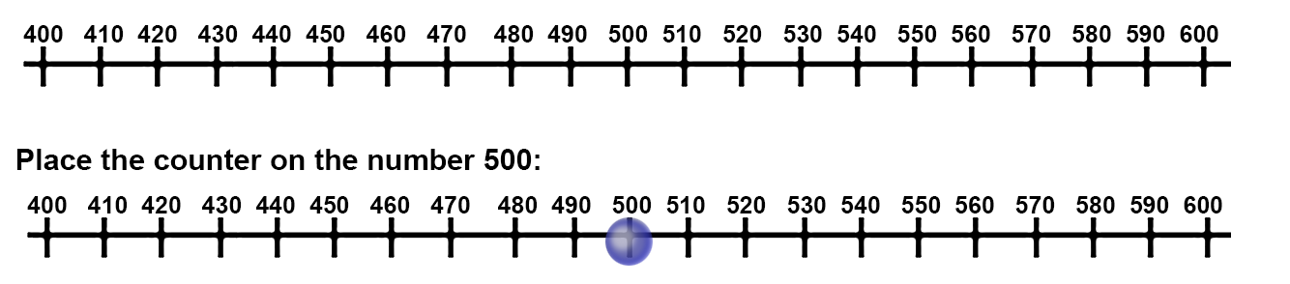
- One student is the ‘Plus’ and the other student is the ‘Minus’. The Plus will move right and Minus will move left.
- Students place the counter on the number 500 and take turns to roll the dice.
- Students add the number rolled and move the counter as many places left or right depending on whose turn it is.
Note: students estimate where the counter will be placed on the number line.
- Students keep rolling the dice and moving until the counter either reaches 400 or 600. If it gets to 400, Minus wins and if it gets to 600, Plus wins.
This table details opportunities for assessment.
Assessment opportunities | Links
What to look for:  - Can students use known strategies to add and subtract 1-digit numbers from 3-digit numbers? [MAO-WM-01, MA3-AR-01] | Links to National Numeracy Learning Progressions (NNLP):  - AdS7, AdS8.

Core lesson – kilometre investigation – 50 minutes
The table below contains a suggested learning intention and success criteria. These are best co-constructed with students.
Core concept learning intentions | Core concept success criteria
Students are learning to:  - use metres and kilometres for lengths and distances. | Students can:  - recognise the need for a formal unit longer than the metre  - explain that 1000 metres is equivalent to one kilometre  - use knowledge of metres to estimate the length of one kilometre  - measure lengths that total one kilometre.
- Brainstorm with students all the units that are used to measure length and distances and record on an anchor chart.
- Display Resource 1 – measuring with metres and discuss objects or locations that can and cannot be measured using metres. Ask:
- If an object or length is too large to be measured with mm, what unit is used?
- If an object or length is too large to be measured with cm, what unit is used?
- What happens if an object or length is too large to be measured with m, what unit is used?
- Explain to students that objects or distances that are greater than 1000 m require a formal unit longer than the metre for measuring distance, that unit of measurement is called a kilometre. 1000 m is equivalent to one kilometre.
- Display Resource 2 – metric system. Ask:
- What do you notice in the images?
- Could a ruler be used to measure one kilometre? Why or why not?
- Why do you think a unit of measurement larger than a metre is required?
- How many kilometres is 3000 m? How do you know?
- Can you identify objects or distances that would be best measured with kilometres?
- Display Resource 3 – KWLH chart and explain to students that this visual organiser is a great way to represent thoughts when learning a new concept. Ask:
- What do you already know about kilometres?
- What do you want to know about kilometres?
Note: KWLH charts can be used as an assessment opportunity to analyse student knowledge and understanding. This activity may be completed as a whole class or individually by printing Resource 3 – KWLH chart. The L and H components are left blank to be completed throughout learning experiences over the next 3 lessons.
- Display Resource 4 – one kilometre investigation to students and explain that students will be measuring the distances of a location in the school using a trundle wheel and placing the information in the Resource 4 – one kilometre investigation. Ask:
- What do you know about a trundle wheel?
- How does a trundle wheel work?
- What does a trundle wheel measure?
- What specific unit of measurement does a trundle wheel measure?
- Provide students with Resource 4 – one kilometre investigation. Students paste this into their workbook.
- Explain that, before measuring, students must estimate how many lengths of their location they will need to reach one kilometre. Ask:
- How will you use a trundle wheel to measure one kilometre?
- How many metre measurements will you see on the trundle wheel when you reach one kilometre?
- Students measure one length of the location using a trundle wheel and record the length on Resource 4 – one kilometre investigation (see Figure 2).
Figure 2 – investigation example
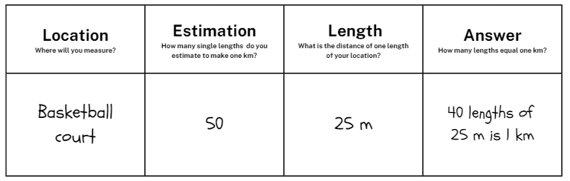
Note: demonstrate that the trundle wheel must keep moving forward so that the mechanism clicks in order to measure length. They cannot roll the trundle wheel backwards as it will not count.
- Instruct students to measure the location as many times as possible until they reach one kilometre and place their results in their table under the heading ‘Answer’.
Note: the purpose of this task is for students to recognise that measuring by metres for an extended distance is inefficient, as sometimes a metre is too small. Facilitate the productive struggle.
This table details opportunities for differentiation.
Too hard? | Too easy?
Students cannot use kilometres to measure lengths.  - Support students by adapting the activity to measure the location and find how many lengths make 100 metres instead of one kilometre.  - Support students by providing them with a location that is 10 metres in length and measure to 100 metres. | Students can use kilometres to measure lengths.  - Challenge students by asking them to solve the answer mathematically using the length of the location and their addition or multiplication knowledge.  - Challenge students by asking how many lengths would be required to make 2, 5 and 10 kilometres.

Discuss and connect the mathematics – 10 minutes
- Regroup students with their completed Resource 4 – one kilometre investigation. Ask:
- What measurement did you record for the length of the location?
- What was your estimation for the number of lengths for the location?
- How many lengths did you measure to make one kilometre?
- Did your estimation match the number of lengths? If not, how would you change your estimation strategy next time?
- Was it efficient measuring one kilometre with a trundle wheel? Why or why not?
- Can you suggest any other strategies that would be more efficient?
This table details opportunities for assessment.
Assessment opportunities | Links
What to look for:  - Can students explain that 1000 metres is equivalent to one kilometre? [MAO-WM-01, MA3-GM-02]  - Can students use knowledge of metres to estimate the length of one kilometre? [MAO-WM-01, MA3-GM-02]  - Can students measure lengths that total one kilometre? [MAO-WM-01, MA3-GM-02] | Links to National Numeracy Learning Progressions (NNLP):  - UuM6.

Lesson 2
Core concept: metric units of measurement relate to the base-10 place value system.

Daily number sense – closest to 1000 – 10 minutes
The table below contains a suggested learning intention and success criteria. These are best co-constructed with students.
Daily number sense learning intention | Daily number sense success criteria
Students are learning to:  - apply efficient mental and written strategies to solve addition problems. | Students can:  - apply known strategies such as levelling, constant difference and bridging  - use place value understanding to add 3-digit numbers.
This activity is an adaptation of Dicey Operations from NRICH by University of Cambridge (Faculty of Mathematics).
- Provide pairs of students with three 6-sided dice and 2 pieces of paper or 2 individual whiteboards.
- Students roll the dice 3 times to make three 3-digit numbers and record in a number sentence (see Figure 3).
Figure 3 – student recording
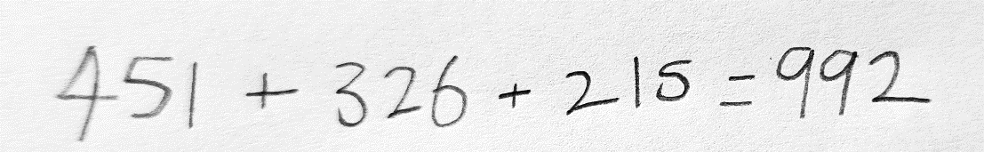
- Students can select their 3-digit numbers from the numbers rolled. For example, if 3, 5 and 2 are rolled, students can choose to record 532, 235 or 352 and so on (see Figure 3).
- Students add the 3 numbers using mental or written strategies. The winner is the student whose total is closest to 1000 without going higher.
- Students play multiple rounds.
This table details opportunities for assessment.
Assessment opportunities | Links
What to look for:  - Can students add 3-digit numbers using mental or written strategies? [MAO-WM-01, MA3-AR-01] | Links to National Numeracy Learning Progressions (NNLP):  - AdS8.  Links to suggested Interview for Student Reasoning (IfSR) tasks:  - IfSR-AT: 3A.2.

Core lesson – the power of 10 – 30 minutes
The table below contains a suggested learning intention and success criteria. These are best co-constructed with students.
Core concept learning intentions | Core concept success criteria
Students are learning to:  - use metres and kilometres for length and distances. | Students can:  - explain that one kilometre contains 1000 metres  - convert between kilometres and metres.
- Review Resource 3 – KWLH chart and students share and record what they now ‘want to know’ and ‘have learned’ so far about kilometres.
Note: if students were provided with individual Resource 3 – KWLH chart charts in Lesson 1, they record reflections in workbooks, if results were recorded on a whole class anchor chart, add to the whole class anchor chart.
- Regroup students and ask:
- What do you know about the number 10?
- What is so important about the number 10?
- Why is our number system called the base-10 system?
- How is the number 10 important in everyday life?
- Display Resource 5 – metric conversion display to students and ask:
- What do you notice about the connection between units of length?
- How does this connect to the base-10 number system?
- Why is it important to understand the base-10 number system when measuring lengths?
- How can this display help us to convert between different units of length? Make connections between place value and 10, 100 and 1000 times larger.
- Display and complete Resource 6 – teacher model using a think aloud. Explicitly show students how to convert between metres and kilometres, referring to Resource 5 – metric conversion display throughout.
- Provide students with Resource 7 – student conversion table to complete individually, converting between metres and kilometres. Display Resource 5 – metric conversion display for student reference.
This table details opportunities for differentiation.
Too hard? | Too easy?
Students cannot convert between kilometres and metres.  - Provide students with Resource 8 – completed conversion table as a reference point to support understanding.  - Support students by providing a completed version of Resource 8 – completed conversion table that has been cut out for students to match. | Students can convert between kilometres and metres.  - Challenge students to estimate distances from their school to local landmarks and write their estimations in metres and kilometres.  - Challenge students to add to their table showing the measurements in centimetres and/or millimetres.

Consolidation and meaningful practice – 20 minutes
- Cut up Resource 9 – Who is winning? and demonstrate how to play by playing against a student or the whole class.
- Students shuffle the cards and each student draws a card from the pile, then compare their 2 lengths.
- The student with the greater length keeps both cards. If they draw the same length, each player keeps their card.
- Repeat steps until all cards have been used. The winner is the student with the most cards in their pile.
This table details opportunities for differentiation.
Too hard? | Too easy?
Students cannot recognise that 10 times 100 metres is one kilometre.  - Support students by providing students with Resource 8 – completed conversion table as a reference point to support understanding.  - Support students by providing them with only sheet one of Resource 9 – Who is winning? | Students can recognise that 10 times 100 metres is one kilometre.  - Challenge students to record how much bigger their winning length was than their opponent’s card.  - Challenge students to place their collected cards into ascending and descending order.
This table details opportunities for assessment.
Assessment opportunities | Links
What to look for:  - Can students explain that one kilometre contains 1000 metres? [MAO-WM-01, MA3-GM-02]  - Can students convert between kilometres and metres? [MAO-WM-01, MA3-GM-02] | Links to National Numeracy Learning Progressions (NNLP):  - UuM6, UuM8.

Lesson 3
Core concept: collections of tenths, hundredths and thousandths are useful in measurement.

Daily number sense – adding numbers – 10 minutes
The table below contains suggested learning intentions and success criteria. These are best co-constructed with students.
Daily number sense learning intention | Daily number sense success criteria
Students are learning to:  - apply efficient mental and written strategies to solve addition problems  - applies known strategies to add and subtract decimals. | Students can:  - record and solve addition problems involving decimals.
This activity is an adaptation of Dicey Operations from NRICH by University of Cambridge (Faculty of Mathematics).
Note: this is a slight variation of the Daily number sense activity from Lesson 2. Students use the first digit as the number of kilometres and the other 2 digits as metres. For example, 352 becomes 3.52 km.
- Provide pairs of students with three 6-sided dice and 2 pieces of paper or 2 individual whiteboards.
- Students roll the dice 3 times to make three 3-digit numbers and record in a number sentence. Reinforcing the previous lesson by asking students to express the numbers in kilometres and metres (see Figure 4).
Figure 4 – student recoding in kilometres
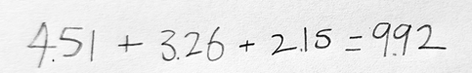
- Students can select their 3-digit numbers from the numbers rolled. For example, if 3, 5 and 2 are rolled, students can choose to record 5.32, 2.35 or 3.52 and so on (see Figure 4).
- Students add the 3 numbers using mental or written strategies. The winner is the student whose total is closest to 10 km without going higher.
- Students play multiple rounds.
This table details opportunities for assessment.
Assessment opportunities | Links
What to look for:  - Can students record and solve addition problems involving decimals? [MAO-WM-01, MA3-AR-01] | Links to National Numeracy Learning Progressions (NNLP):  - AdS9.  Links to suggested Interview for Student Reasoning (IfSR) tasks:  - IfSR-AT: 4A.2.

Core lesson – tiny town – 40 minutes
The table below contains a suggested learning intention and success criteria. These are best co-constructed with students.
Core concept learning intentions | Core concept success criteria
Students are learning to:  - use metres and kilometres for length and distance. | Students can:  - use MAB blocks to represent kilometres and measure distances to different contexts  - record distances using the abbreviations m and km  - recognise that 10 times 100 metres is one kilometre.
- Revise kilometre from Lesson 2 and have students record on Resource 3 – KWLH chart what they now ‘want to know’ and ‘have learned’ so far about kilometres.
Note: if students were provided with individual Resource 3 – KWLH chart charts in Lesson 1, they record reflections in workbooks; if results were originally recorded on a whole class anchor chart, add to the whole class anchor chart.
- Regroup students and write 4.75 km on the board. Ask students to Think-Pair-Share what they notice and what they know. Ask:
- What do you notice about the decimal representation?
- Can you identify how metres are represented?
- Can you identify how many kilometres are represented?
- What is something you know that would be roughly the distance of 4.75 km?
- How many more metres would be required to make 5 kilometres? How do you know?
- Display Resource 10 – 4.75 km labelled and discuss similarities and differences between student responses.
Note: use this discussion to correct any misconceptions that may arise.
- Display Resource 11 – kilometre distances and ask:
- What value is being represented by the identified 5 in 5.35 km?
- What value is being represented by the identified 12 in 12.36 km?
- What value is being represented by the identified 0 in 1.06 km?
- What value is being represented by the identified 3 in 4.35 km?
- Explain to students that they will be designing their own tiny town on A3 paper. In the tiny towns, students must have a school, pool, shopping centre, post office, hospital, sporting complex, a house and roads (see Figure 5).
Figure 5 – tiny town example
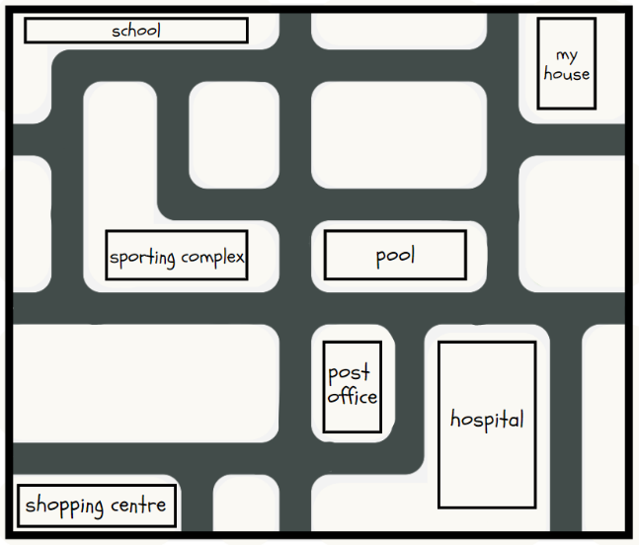
Note: emphasise to students to draw a simple design and not to spend too much time with details.
- When students have designed their tiny town, display Resource 12 – MAB material and explain that the MAB unit will be used to represent 100 metres and the MAB long will be used to represent one kilometre. Ask:
- Why do you think MAB materials will be used for in-class activity to represent kilometres and metres?
- Are the unit MAB materials actually 100 m in length?
- If a unit block is used to represent 100 m, why is a tens block used to represent one kilometre?
- How would 4.6 km be represented with MAB?
- How many tens blocks would be needed to represent 7 kilometres?
Note: it is essential that students have a clear understanding that the MAB materials are being used as a representation and that they are not actually those lengths.
- Provide students with Resource 13 – tiny town recording and MAB materials. Students check that their town has all the required buildings and then measure using the MAB materials. Students then record the distances between the buildings in kilometres and meters.
Note: when students are measuring distances between buildings, highlight that there are 2 ways to measure – in a direct line or by following the roads.
This table details opportunities for differentiation.
Too hard? | Too easy?
Students cannot apply their knowledge of kilometres and metres in different contexts.  - Support students by displaying Resource 12 – MAB material for students to reference and clarify understanding of representations.  - Students measure the distances between the buildings in a straight line only and record. | Students can apply their knowledge of kilometres and metres in different contexts.  - Challenge students to measure the distances between the buildings by following the roads and in a straight line.  - Challenge students to convert the recorded distances into cm and mm.

Discuss and connect the mathematics – 10 minutes
- Students display their tiny town and distances and go on a gallery walk, looking at towns and recorded distances.
- Regroup as a class and summarise the lesson together drawing out key mathematical ideas. Ask:
- Why is it important to measure accurately?
- How did you know the distance between shopping centre and the school?
- Why is 2.4 km 2400 m? How do you know?
- Do you have any questions around converting still?
- What was challenging about this activity? How did you overcome these challenges?
This table details opportunities for assessment.
Assessment opportunities | Links
What to look for:  - Can students use MAB materials to represent kilometres and measure distances to different contexts? [MAO-WM-01, MA3-GM-02]  - Can students record distances using the abbreviations m and km? [MAO-WM-01, MA3-GM-02]  - Can students recognise that 10 times 100 metres is one kilometre [MAO-WM-01, MA3-GM-02] | Links to National Numeracy Learning Progressions (NNLP):  - UuM6, UuM8.

Lesson 4
Core concept: estimating length can be guided by using known lengths as benchmarks.

Daily number sense – 10 minutes
- From a class need surfaced through formative assessment data, identify a short, focused activity that targets students’ knowledge, understanding and skills. Example activities may be drawn from the following resources:
- Mathematics K-6 resources
- Universal Resources Hub.

Core lesson – personal benchmarks – 40 minutes
The table below contains a suggested learning intention and success criteria. These are best co-constructed with students.
Core concept learning intentions | Core concept success criteria
Students are learning to:  - estimate, measure and record lengths using metres and kilometres. | Students can:  - use known lengths as benchmarks  - estimate lengths using known benchmarks  - measure and record lengths using kilometres and metres.
- Revise the term ‘kilometre’ from Lessons 2 and Lesson 3. Students record on Resource 3 – KWLH chart what they now ‘want to know’ and ‘have learned’ so far about kilometres.
- Explain to students that they will estimate lengths of locations in the school before measuring and comparing. Revise estimation by asking:
- What is an estimation?
- Why are estimations used?
- What is an example of a time where an estimation could be used?
- What is an example of a time where an estimation should not be used?
- Explain to students that using known lengths as benchmarks is an efficient way to estimate. For example, using the known length of a rugby league football field (100 metres) or swimming pool (25 or 100 metres), students may be able to estimate how far it is from school to the local shopping centre.
- Display Resource 14 – landmarks and ask students to Think-Pair-Share about their estimations of the length of each landmark. Ask:
- What are your estimations for each location?
- How did you estimate the length and height of the locations?
- Did you use a benchmark to estimate?
- If you used a benchmark, what was it and why did you select this benchmark?
- Display Resource 15 – landmarks with measurements, containing the actual length or height of each location. Students discuss and compare their estimations with the provided measurements, sharing what they notice.
Note: use this time to address any misconceptions or inefficient benchmarks.
- Explain that students will now use known benchmarks to estimate lengths of locations around the school before measuring and comparing.
- Provide students with Resource 16 – benchmark measuring to glue into their workbooks and, as a class, identify 2 locations within the school for students to estimate, measure and compare.
- Display a trundle wheel and revise students’ knowledge. Ask:
- What is this tool called?
- What do you know about a trundle wheel?
- How does a trundle wheel measure length?
- What are some important considerations to remember when using a trundle wheel?
- Take students to identified locations to estimate with their benchmarks and measure using trundle wheels. Students record their results in metres and then convert the measurements to kilometres on Resource 16 – benchmark measuring.
This table details opportunities for differentiation.
Too hard? | Too easy?
Students cannot estimate, measure and record lengths using metres and kilometres.  - Support students to reference the example modelled in Resource 16 – benchmark measuring when measuring and recoding.  - Support students by identifying locations with smaller distances to be measured. For example, the width of the classroom. | Students can estimate, measure and record lengths using metres and kilometres.  - Challenge students by asking if they can find the difference between the lengths of the 2 identified locations.  - Challenge students by providing them an opportunity to estimate, measure and record an additional location in the school of their choosing.

Discuss and connect the mathematics – 10 minutes
- Regroup as a class and summarise the lesson together drawing out key mathematical ideas. Ask:
- How close was your estimation?
- Did your estimations using known benchmarks match the measurements?
- What were your measurements in metres for the locations?
- What were your measurements in kilometres for the locations?
- How did you convert the measurements from metres to kilometres?
- What challenges did you face? How did you overcome them?
Note: this is the final lesson where Resource 3 – KWLH chart will be referred to. Students are to complete this chart.
This table details opportunities for assessment.
Assessment opportunities | Links
What to look for:  - Can students use known lengths as benchmarks? [MAO-WM-01, MA3-GM-02]  - Can students estimate lengths using known benchmarks? [MAO-WM-01, MA3-GM-02]  - Can students measure and record lengths using kilometres and metres? [MAO-WM-01, MA3-GM-02] | Links to National Numeracy Learning Progressions (NNLP):  - UuM6.

Lesson 5
Core concept: perimeters of 2D shapes are calculated by finding the total length of the sides.

Daily number sense – cover the field – 10 minutes
Daily number sense activities for Lessons 5 to 7 ‘loop’ back to concepts and procedures covered in previous units to assist students to build an increasingly connected network of ideas. These concepts may differ from the core concepts being covered by the unit.
The table below contains a suggested learning intention and success criteria. These are best co-constructed with students.
Daily number sense learning intention | Daily number sense success criteria
Students are learning to:  - represent and solve multiplication problems. | Students can:  - use multiplication facts to multiply one-digit numbers  - apply the commutative and properties of multiplication  - complete number sentences involving multiplication.
This activity is an adaptation of ‘Cover the field’ from Mindset Mathematics: Visualising and Investigating Big Ideas, Grade 4 by Boaler et al.
- Demonstrate how to play cover the field by playing against the whole class.
- Use and display Resource 17 – gameboard, two 9-sided dice and 2 different coloured markers.
- Player 1 rolls the dice and multiplies the numbers to create a rectangle. For example, 9 and 6 can make either 9 × 6 = 45 or 6 × 9 = 45. The player decides which rectangles they will use and draws the rectangle on the gameboard. The player then records the equation in the rectangle (see Figure 6).
Figure 6 – cover the field player 1
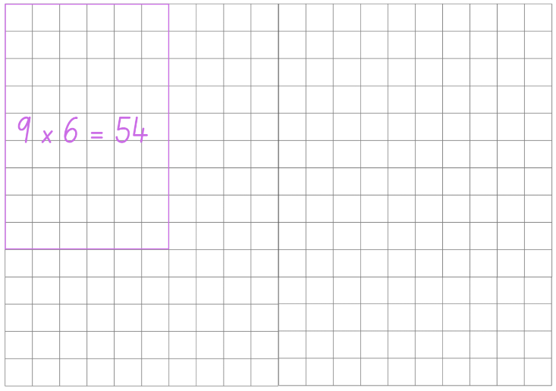
- Player 2 then rolls the dice and uses the numbers rolled to create a rectangle that will fit without overlapping. For example, if player 2 rolls a 4 and 7 and chooses 4 × 7 = 28. Player 2 draws an outline of the array around the correct number of rows and columns and record the equation in the middle, see Figure 7.
Figure 7 – cover the field player 2
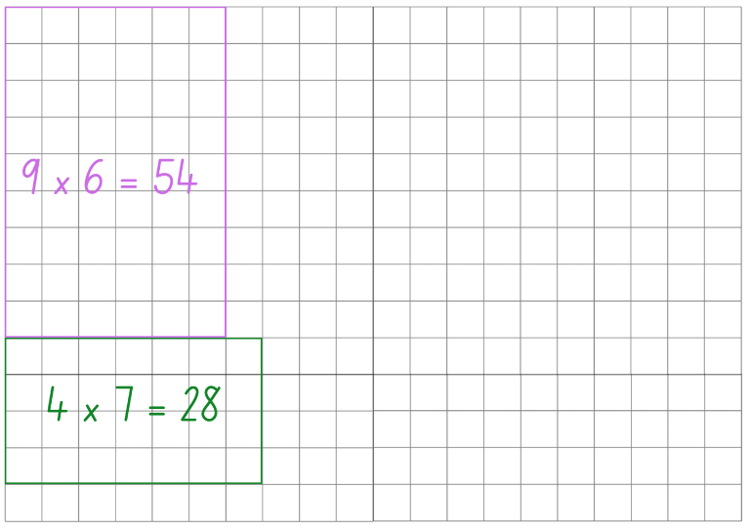
- If a player rolls a rectangle that does not fit without overlapping, it is the other players turn. Players continue to take turns until there is no more room for either player. The player with the most squares covered is the winner.
Note: players are not allowed to overlap or partition into smaller rectangles.
- Once students are confident with the game, provide pairs with Resource 17 – gameboard, two 9-sided dice and 2 different coloured markers. Students take turns playing multiple rounds.
Note: place Resource 17 – gameboard in a reusable sleeve to play multiple rounds or students can use their grid workbook.
This table details opportunities for assessment.
Assessment opportunities | Links
What to look for:  - Can students use multiplication facts to multiply 1-digit numbers? [MAO-WM-01, MA2-MR-01, MA2-MR-02]  - Can students apply the commutative and properties of multiplication? [MAO-WM-01, MA2-MR-01, MA2-MR-02]  - Can students complete number sentences involving multiplication? [MAO-WM-01, MA2-MR-01, MA2-MR-02] | Links to National Numeracy Learning Progressions (NNLP):  - MuS6.  Links to suggested Interview for Student Reasoning (IfSR) tasks:  - IfSR-MT: 2A.4, 2A.6.

Core lesson – perimeter – 40 minutes
The table below contains suggested learning intentions and success criteria. These are best co-constructed with students.
Core concept learning intentions | Core concept success criteria
Students are learning to:  - calculate the perimeter of common two-dimensional shapes. | Students can:  - explain perimeter of two-dimensional shapes  - use efficient strategies to calculate the perimeter of common two-dimensional shapes.
- Display the word perimeter and ask students to brainstorm what they know about the term, recording student ideas on an anchor chart to be displayed around the room and added to throughout the learning process.
- If not identified from students, explain that perimeter is the total distance around an object.
- Display Resource 18 – perimeters 1 and ask:
- What do you notice about the shapes?
- What do the lines on the shapes represent?
- How would you find the missing lengths of the shapes sides?
- How would you calculate the perimeter of the shapes, with some measurements in metres and some in kilometres?
- Provide students time to calculate the perimeter of the shapes in the Resource 18: Perimeters. Select student to share and justify their answers with the class. Ask:
- How did you approach this problem?
- Is this the most efficient way to calculate the perimeter?
- What would be a more efficient approach? Why?
- Can you think of any real-life locations or objects that would be similar to the shapes explored?
- Display Resource 19 – perimeters 2 and explain that students will use their knowledge and understanding of perimeters to find the perimeter of the two-dimensional shapes.
- Provide students with Resource 19 – perimeters 2 to glue in their workbook and complete individually.
- Take students outside to measure the perimeter of school areas or locations. For example, handball court or basketball court. Students use a trundle wheel or metre rulers to measure and record the area or location and perimeter in their workbooks.
Note: emphasise to students that a working out column has been provided so that problem solving can be reviewed and discussed.
This table details opportunities for differentiation.
Too hard? | Too easy?
Students cannot calculate the perimeter of common two-dimensional shapes.  - Support students by providing the missing value for two-dimensional shapes in Resource 19 – perimeters 2.  - Support students by adjusting measurements in Resource 19 – perimeters 2 to simpler two-digit numbers. | Students can calculate the perimeter of common two-dimensional shapes.  - Challenge students to provide their answers in centimetres, metres and kilometres.  - Challenge students to identify which two-dimensional shapes have parallel lines and which have intersecting lines.

Discuss and connect the mathematics – 10 minutes
- Regroup as a class and select students to share and explain their responses. Ask:
- What strategy did you use to find the perimeter of the shapes?
- Was this strategy efficient? Why?
- What is another strategy that you could use?
- Which area or location of the school had the largest perimeter?
- What did you find challenging about this activity? Why?
This table details opportunities for assessment.
Assessment opportunities | Links
What to look for:  - Can students explain what the perimeter of a two-dimensional shape is? [MAO-WM-01, MA3-GM-02]  - Can students use efficient strategies to calculate the perimeter of common two-dimensional shapes? [MAO-WM-01, MA3-GM-02] | Links to National Numeracy Learning Progressions (NNLP):  - UuM5, UuM7, UuM8.

Lesson 6
Core concept: different shapes can have the same perimeter.

Daily number sense – number chart – 10 minutes
The table below contains a suggested learning intention and success criteria. These are best co-constructed with students.
Daily number sense learning intention | Daily number sense success criteria
Students are learning to:  - represent and solve multiplication problems. | Students can:  - complete multiplication questions involving missing numbers.
This activity is an adaptation of ‘Number Charts’ from Teaching Mathematics: Foundations to Middle Years by Siemon et al.
- Provide students with an individual whiteboard and display Figure 8.
Figure 8 – number chart
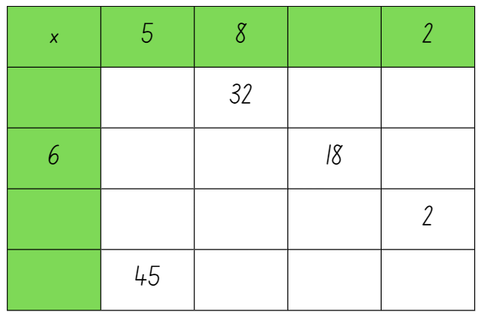
- Students draw the table and use their multiplication knowledge to fill in the missing values.
- Select students to share and justify their completed number chart.
Note: the number chart can be adjusted to suit class needs.
This table details opportunities for assessment.
Assessment opportunities | Links
What to look for:  - Can students complete multiplication questions involving missing numbers? [MAO-WM-01, MA2-MR-01, MA2-MR-02] | Links to National Numeracy Learning Progressions (NNLP):  - MuS6.

Core lesson – the same perimeter – 40 minutes
The table below contains suggested learning intentions and success criteria. These are best co-constructed with students.
Core concept learning intentions | Core concept success criteria
Students are learning to:  - understand that different shapes can have the same perimeter  - rearrange 2D shapes using rotations. | Students can:  - use criteria to create different two-dimensional shapes with the same perimeter  - check and measure the perimeter of two-dimensional shapes using set criteria  - recognise that rotations can change the position and orientation but not the perimeter of the shape.
- Revise student knowledge and the anchor chart from Lesson 5. Add any new information learnt about and/or clarify the term ‘perimeter’.
- Provide students with an individual whiteboard or their workbook and ask then to draw a rectangle with the perimeter of 36 cm.
- Select students to share and explain their rectangles with the class and ask:
- Are all the rectangles the same? Why?
- How do you know your rectangle has a perimeter of 36 cm?
- What is different about the rectangles?
- Why is it important to understand that shapes can have the same perimeter but look different?
- How many different variations of a rectangle with the perimeter of 36 cm do you think you could make?
- Ask students to rotate one of their rectangles and discuss with a partner if the perimeter changes when the shape is rotated. Select students to share their thinking with the whole class.
- Display Resource 20 – shapes criteria 1 and explain to students that they will be working outside in small groups drawing a rectangle, square and triangle each with the perimeter of 12 metres.
- Provide groups with chalk and either a trundle wheel or a metre ruler and each student with Resource 20 – shapes criteria 1, to draw a rectangle, square and triangle each with the perimeter of 12 metres.
Note: Resource 21 – shapes criteria 2 has been included for schools who are unable to complete this activity outside. Students complete the activity by using a ruler to create a square, rectangle and triangle on a page, each with a perimeter of 12 cm.
- While groups are drawing their shapes, walk around and ask:
- How do you know your shapes have a perimeter of 12 m?
- Do you think all your shapes will look like other groups? Why or why not?
This table details opportunities for differentiation.
Too hard? | Too easy?
Students cannot understand that different shapes can have the same perimeter.  - Provide students with Resource 21 – shapes criteria 2 and support them to complete using centimetres instead of metres.  - Support students by creating only the rectangle and square for Resource 20 – shapes criteria 1. | Students can understand that different shapes can have the same perimeter.  - Challenge students to discover the total perimeter of all 3 created shapes.  - Challenge students to record the perimeters of the three shapes in centimetres and kilometres.

Discuss and connect the mathematics – 20 minutes
- Students display their work and go on a gallery walk.
- Tell students that they can use their trundle wheel or metre ruler to measure the drawings and check whether the group has met the criteria (that each shape has a perimeter of 12 m).
- Regroup students and ask:
- Where you able to draw your shapes to meet the criteria?
- Did rotating the shapes change the perimeter? What did change? (orientation and position)
- What did you find challenging about this activity?
- How is it possible for triangles, rectangles and squares to have the same perimeter?
- Why is it important to understand that different two-dimensional shapes can have the same perimeter?
This table details opportunities for assessment.
Assessment opportunities | Links
What to look for:  - Can students use criteria to create different two-dimensional shapes with the same perimeter? [MAO-WM-01, MA3-GM-02, MA3-2DS-01]  - Can students check and measure the perimeter of two-dimensional shapes using set criteria? [MAO-WM-01, MA3-GM-02, MA3-2DS-01]  - Can students recognise that rotations can change the position and orientation but not the perimeter of the shape? [MAO-WM-01, MA3-GM-02, MA3-2DS-01] | Links to National Numeracy Learning Progressions (NNLP):  - UuM5, Uum6, UuM7  - UGP5, UGP6.

Lesson 7
Core concept: lengths of time can be communicated more precisely using 24-hour time.

Daily number sense – word problems – 10 minutes
The table below contains a suggested learning intention and success criteria. These are best co-constructed with students.
Daily number sense learning intention | Daily number sense success criteria
Students are learning to:  - represent and solve word problems with number sentences involving multiplication and division. | Students can:  - solve multiplication and division word problems  - represent word problems using number sentences.
- Write word problems involving multiplication and division for students to solve using their individual whiteboards or workbooks. For example, ‘I buy 6 pens and the total cost is $24. What is the cost of each pen?’
- Demonstrate that the question can be represented as 6 × _ = 24 or 24 ÷ 6 = _. Students record both number sentences and solve the equations.
- Select students to share and explain their answers.
- Continue writing word problems for students to record and solve. For example:
- There are 11 pencils in 5 pencil tins. How many pencils altogether?
- If 6 chickens laid 18 eggs, how many eggs did each chicken lay?
- Jason runs 4 km every day. How far will he run in a week?
- If 32 tomatoes are packed with 8 in each bag, how many bags are needed?
- Have students share their work after each word problems.
This table details opportunities for assessment.
Assessment opportunities | Links
What to look for:  - Can students solve multiplication and division word problems? [MAO-WM-01, MA2-MR-01, MA2-MR-02  - Can students represent word problems using number sentences? [MAO-WM-01, MA2-MR-01, MA2-MR-02] | Links to National Numeracy Learning Progressions (NNLP):  - MuS6, MuS7, MuS8.

Core lesson – 12-hour and 24-hour time – 40 minutes
The table below contains suggested learning intentions and success criteria. These are best co-constructed with students.
Core concept learning intentions | Core concept success criteria
Students are learning to:  - understand the relationship between 12-hour and 24-four-hour time. | Students can:  - explain the difference between 12-hour time and 24-hour time  - match 12-hour times with their 24-hour representations  - identify that 24-hour time is a more precise method for measuring time.
- Display Resource 22 – clock and ask:
- What do you notice about this clock?
- What do you wonder about the green numbers?
- What is the relationship between the black numbers and the green numbers?
- What is the purpose of this clock?
- Explain to students that time can be measured in 2 formats, 12-hour and 24-hour time. Ask:
- What do you know about 12-hour and 24-hour time?
- Can you think of any examples where 12-hour time is used?
- Can you think of any examples where 24-hour time is used?
- Why do you think that there are 2 different formats for measuring time?
- Explain to students that when reading time, the abbreviations ‘am’ and ‘pm’ are used. The term ‘am’ is associated with the morning and is an abbreviation of the Latin phrase ante merīdiem, meaning before midday. The term ‘pm’ is an abbreviation for post merīdiem, meaning after midday.
- Display Resource 23 – am and pm and ask students to Think-Pair-Share what they notice about the image. Ask:
- Can you identify where it changes from am to pm?
- What do you notice about 24-hour time?
- Which format for measuring time do you think is most accurate? Why?
- Highlight to students that 24-hour time is used to avoid confusion between am and pm. For example, schedules for airplanes at airports, buses, ferries and the armed forces.
- Display Resource 24 – time matching cards and model how each card has a matching 12-hour and 24-hour time. For example, 1530 hours is matched to 3:30 pm.
- Provide students with one card each of Resource 24 – time matching cards and tell them keep their card face down.
- Set a timer for students to turn their card over and find their corresponding card and then sit down. Record the time that it took for all students to sit down with their partners. Students play multiple rounds with different cards each time aiming to get faster each round.
Note: to provide additional space, this activity can be played outside.
- Play a variation of time matching by having students that are holding a 12-hour card organise themselves in ascending or descending order line on the left of the room and any student holding a 24-hour card organise themselves in ascending or descending order line on the right of the room.
- Students then swap their cards with another member of their line and to wait for you to say go. When you say go, students turn their card over and must find their corresponding partner then sit down.
This table details opportunities for differentiation.
Too hard? | Too easy?
Students cannot understand the relationship between 12-hour and 24-hour time.  - Support students by displaying Resource 23 – am and pm clearly in the room for students to reference throughout the lesson.  - Support students by allowing them to keep the same card throughout all activities. | Students can understand the relationship between 12-hour and 24-hour time.  - Challenge students to find the difference between their pair’s timecards and the pair’s timecards next to them.  - Challenge students to identify an activity that that commonly happens at their allocated time the day. For example, 1:00 pm is lunch.

Discuss and connect the mathematics – 10 minutes
- Regroup as a class and summarise the lesson together drawing out key mathematical ideas. Ask:
- Which format of time is less confusing for communication, 12-hour or 24-hour? Why?
- What is am an acronym for?
- What is pm an acronym for?
- Can you think of examples where 24-hour time is used?
- Did you face any challenges today? How did you overcome these?
This table details opportunities for assessment.
Assessment opportunities | Links
What to look for:  - Can students explain the difference between 12-hour time and 24-hour time? [MAO-WM-01, MA3-NSM-02]  - Can students match 12-hour times with their 24-hour representations? [MAO-WM-01, MA3-NSM-02]  - Can students identify that 24-hour time is a more precise method for measuring time? [MAO-WM-01, MA3-NSM-02] | Links to National Numeracy Learning Progressions (NNLP):  - MeT5.

Lesson 8
Core concept: timetables are an efficient way to communicate and organise lengths of time.

Daily number sense – 10 minutes
- From a class need surfaced through formative assessment data, identify a short, focused activity that targets students’ knowledge, understanding and skills. Example activities may be drawn from the following resources:
- Mathematics K-6 resources
- Universal Resources Hub.

Core lesson – timetables – 40 minutes
The table below contains suggested learning intentions and success criteria. These are best co-constructed with students.
Core concept learning intentions | Core concept success criteria
Students are learning to:  - apply knowledge of 12-hour and 24-hour time to read and timetables. | Students can:  - read and interpret timetables involving 12-hour and 24-hour time  - create a timetable using 12-hour and 24-hour time.
- Display Resource 25 – 12-hour timetable and ask:
- What do you notice about the image?
- Have you seen a timetable like this before? Where?
- What makes timetables and efficient way to communicate information?
- What time does Mathematics begin on Tuesday?
- How long does the lunch break last?
- What is the duration of the Visual Arts lesson on Friday?
- How many minutes of English lessons are there in a week?
- Display Resource 26 – 24-hour timetable and ask:
- Can you notice any differences between this timetable and the previous timetable?
- Can you notice any similarities between the 2 timetables?
- What time (in 24-hour time) does PDHPE begin on Tuesday?
- What time (in 24-hour time) does recess finish?
- What time (in 12-hour time) does Mathematics begin on Friday?
- What is the combined duration of all Science lessons throughout the week?
- Which timetable can be more effectively communicated? Why?
Note: this is a fantastic opportunity to explore a variety of different timetables and discuss their features.
- Display Resource 27 – dream school day and explain to students that they will create their own dream school day timetable using 12-hour and 24-hour time.
- Students label Resource 27 – dream school day correctly with 12-hour and 24-hour times before adding activities and colouring the duration (see Figure 9).
Figure 9 – dream school day example
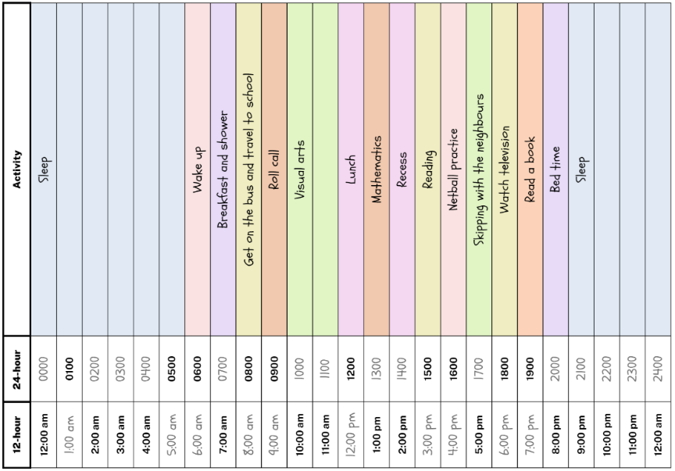
This table details opportunities for differentiation.
Too hard? | Too easy?
Students cannot apply knowledge of 12-hour and 24-hour time to read and represent timetables.  - Support students by printing Resource 23 – am and pm students to reference while creating their timetable.  - Support students by identifying, labelling and colouring key components of the day. For example, recess and lunch. | Students can apply knowledge of 12-hour and 24-hour time to read and represent timetables.  - Challenge students to solve the following problem: ‘One afternoon, Tenneille noticed that the time that had elapsed since midday was equal to half the time remaining until midnight. What is the time?’  - Challenge students to write elapsed time questions for a partner to solve in 12-hour and 24-hour time.

Discuss and connect the mathematics – 10 minutes
- Students display their dream school day and go on a gallery walk to look at the various timetables created.
- Regroup as a class and ask:
- What did you notice when planning your timetable?
- If you had to communicate an activity on your timetable to a friend, would you explain it using 12-hour or 24-hour time? Why?
- Why are timetables an effective form of communication?
- When would a timetable not be an effective form of communication?
This table details opportunities for assessment.
Assessment opportunities | Links
What to look for:  - Can students read and interpret timetables involving 12-hour and 24-hour time? [MAO-WM-01, MA3-NSM-02]  - Can students create a timetable using 12-hour and 24-hour time? [MAO-WM-01, MA3-NSM-02] | Links to National Numeracy Learning Progressions (NNLP):  - MeT4, MeT5.

Resource 1 – measuring with metres
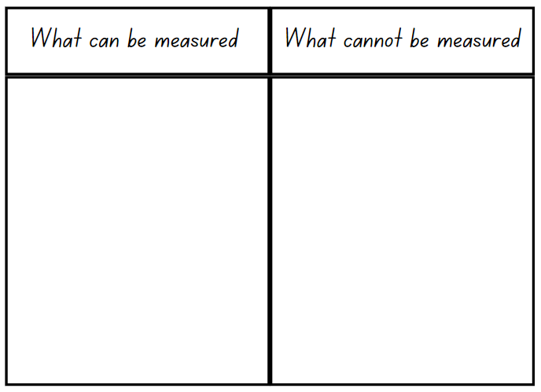

Resource 2 – metric system
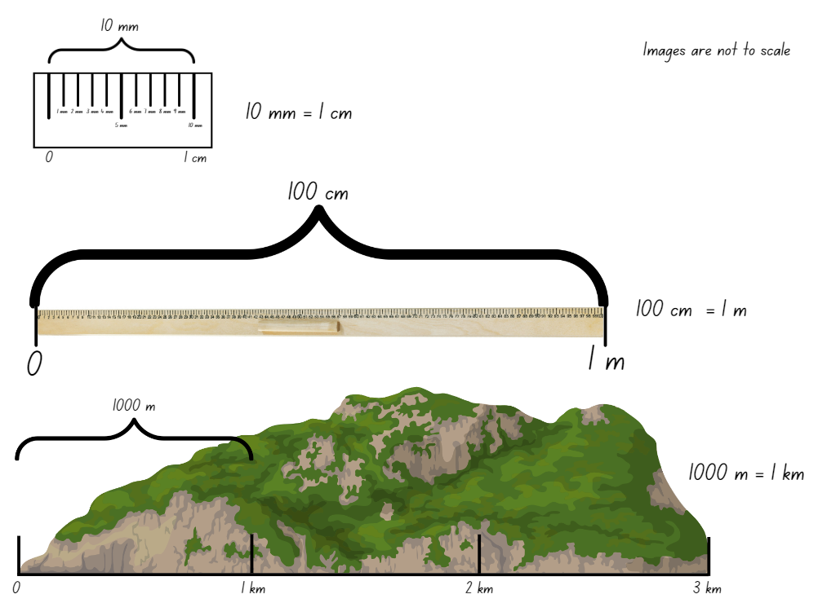

Resource 3 – KWLH chart
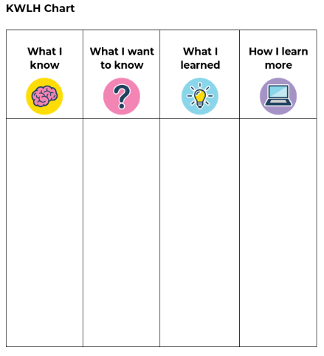

Resource 4 – one kilometre investigation
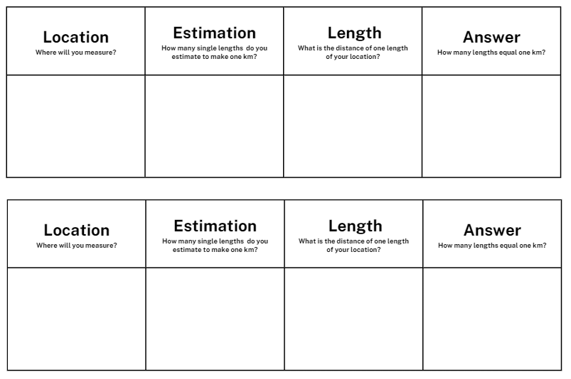

Resource 5 – metric conversion display
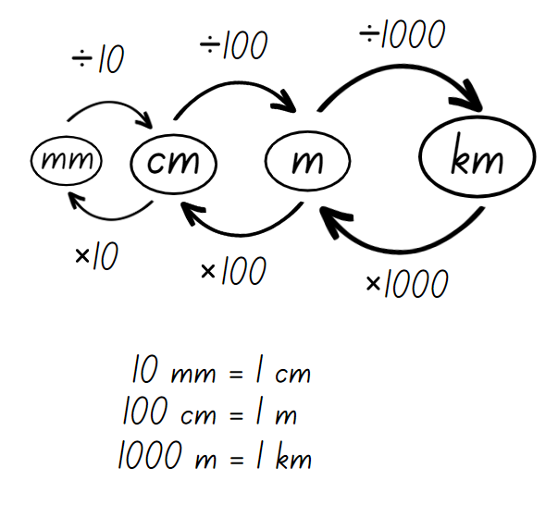

Resource 6 – teacher model
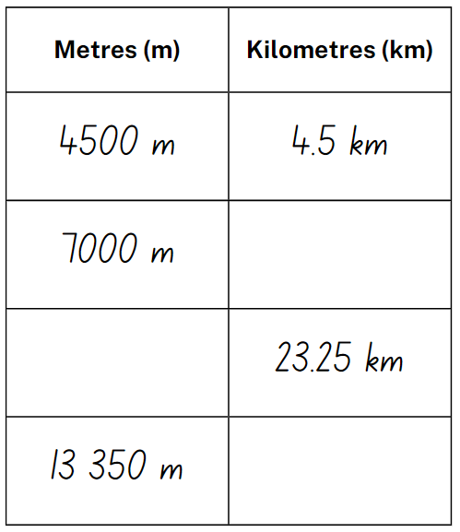

Resource 7 – student conversion table
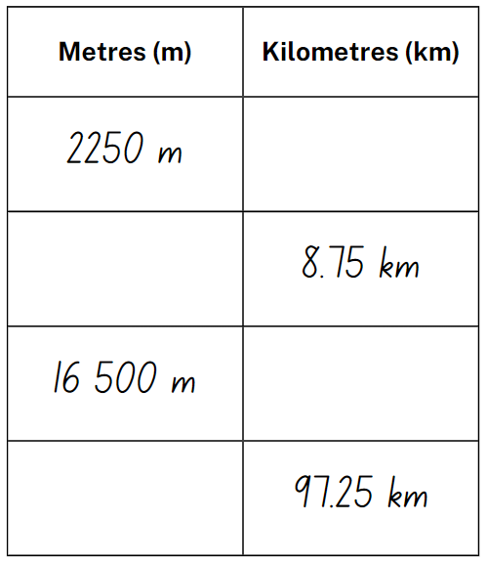

Resource 8 – completed conversion table
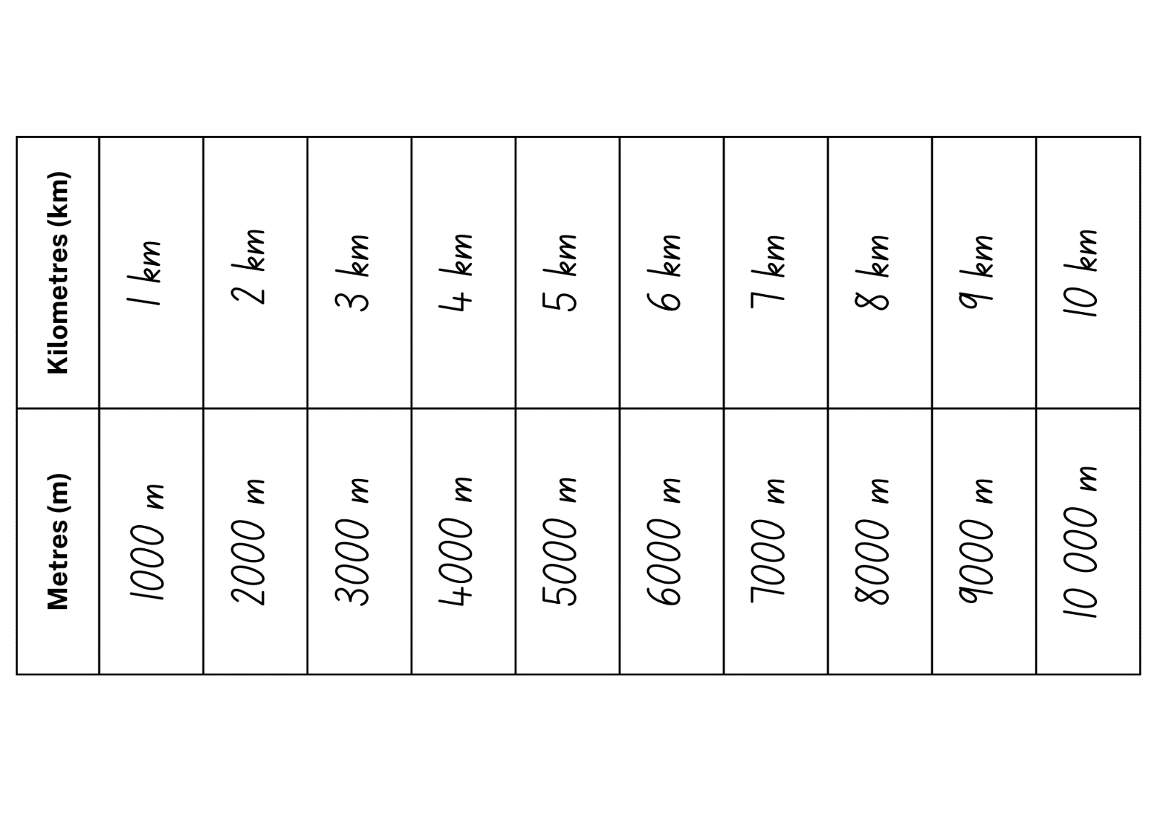

Resource 9 – Who is winning?
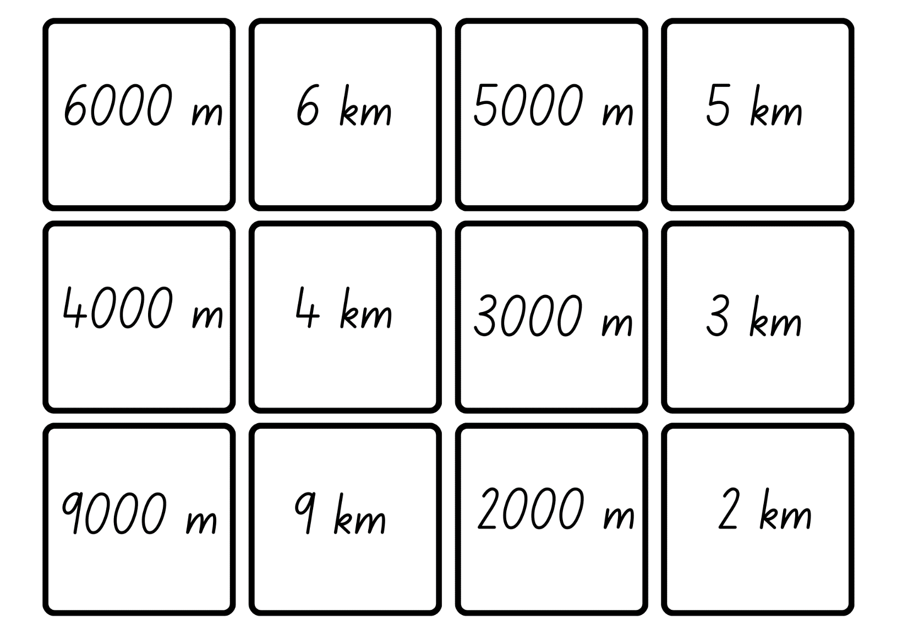
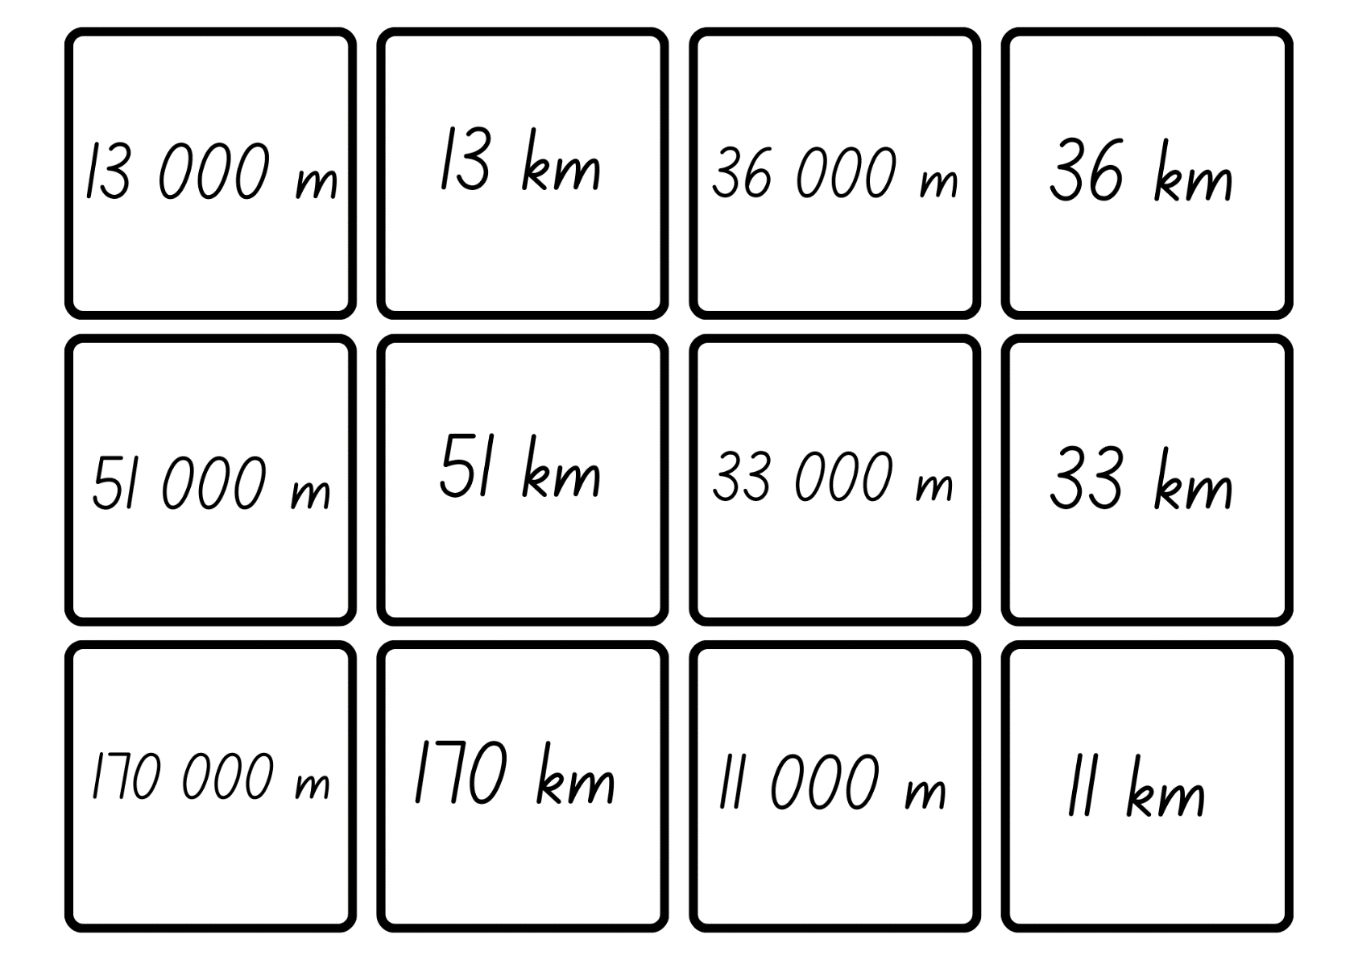
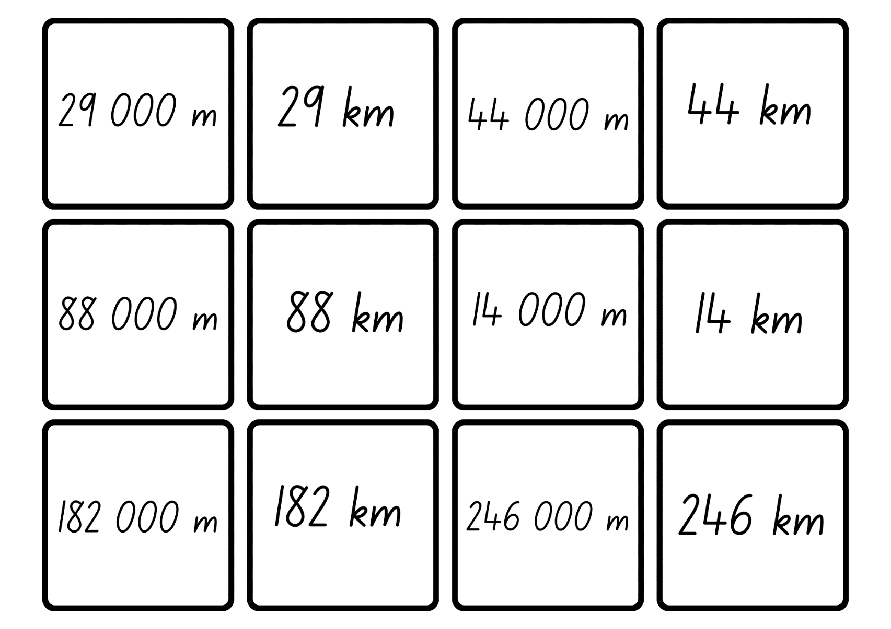

Resource 10 – 4.75 km labelled
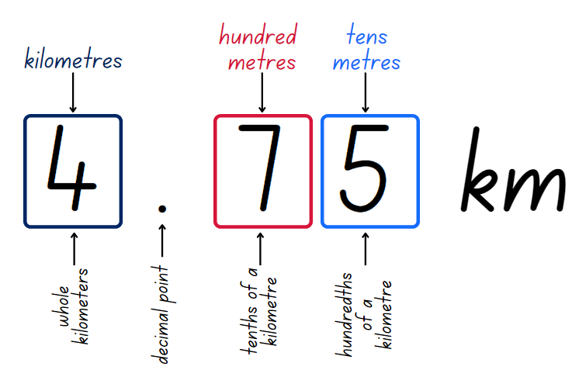

Resource 11 – kilometre distances
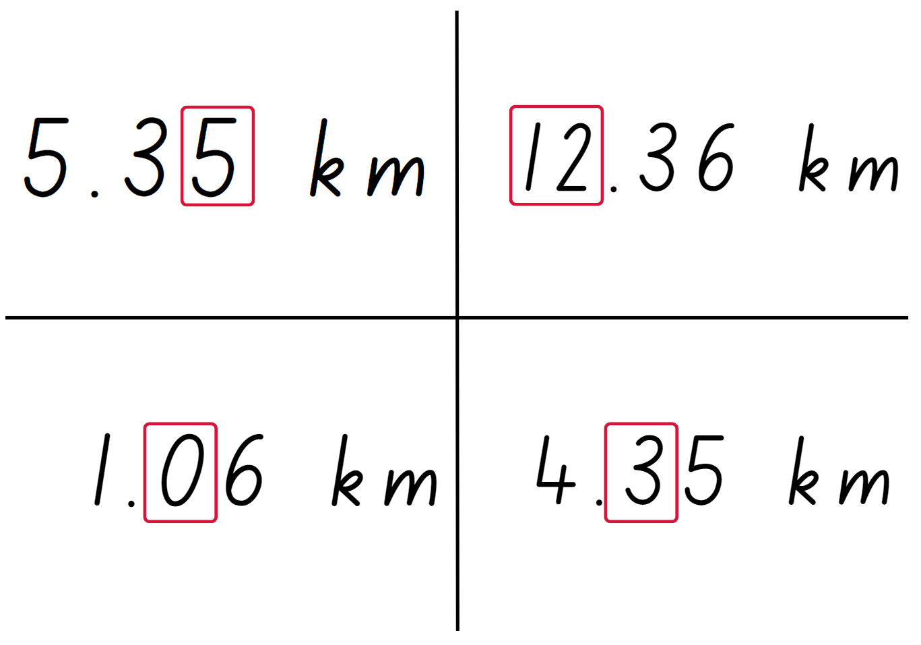

Resource 12 – MAB material
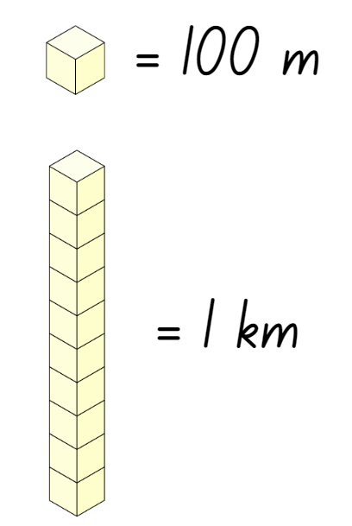

Resource 13 – tiny town recording
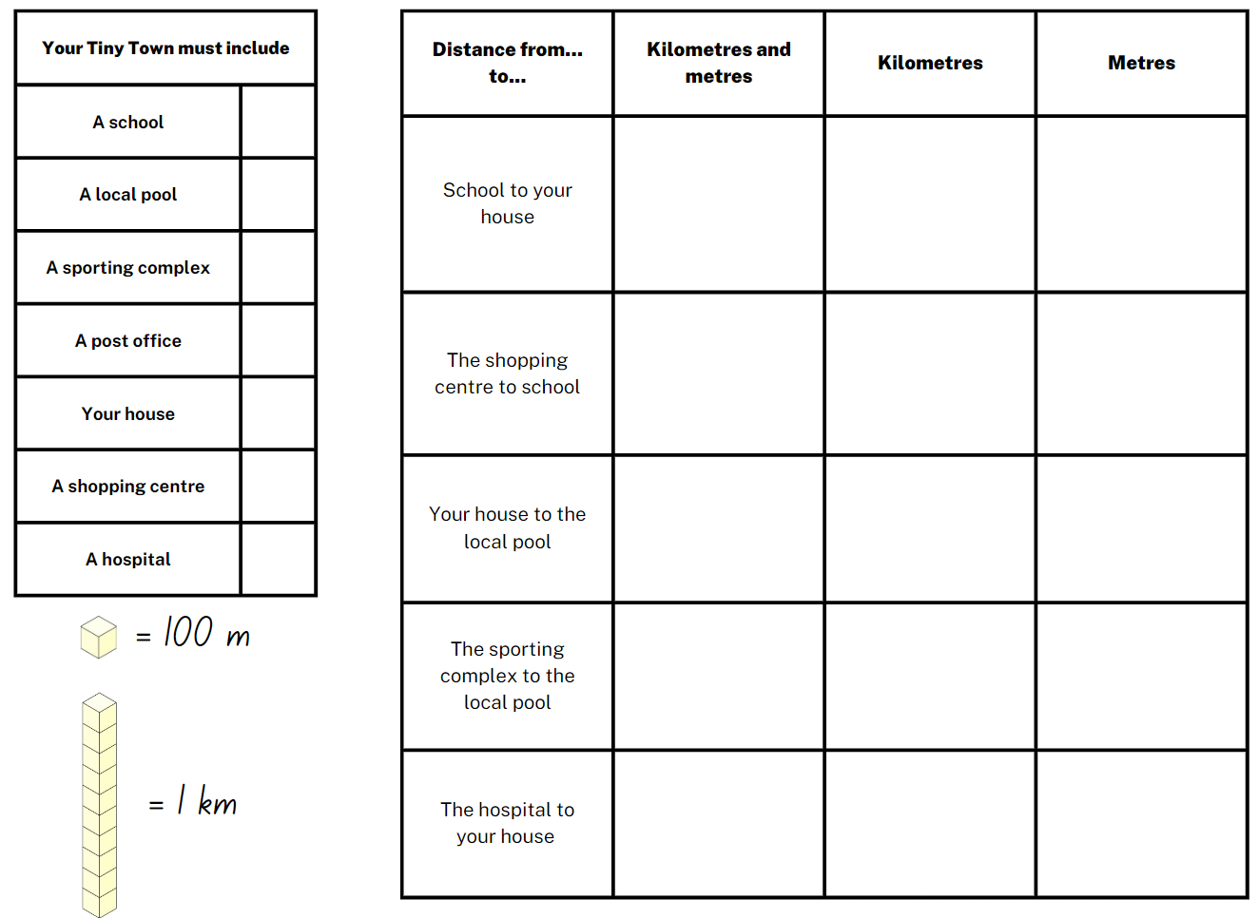

Resource 14 – landmarks
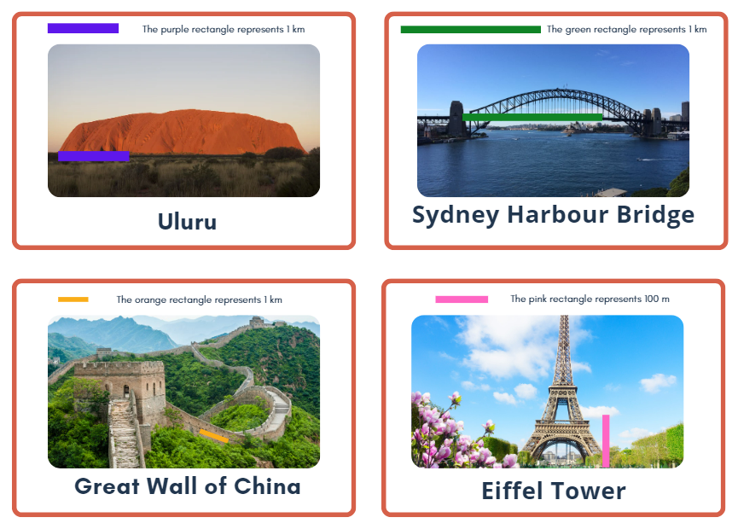

Resource 15 – landmarks with measurements
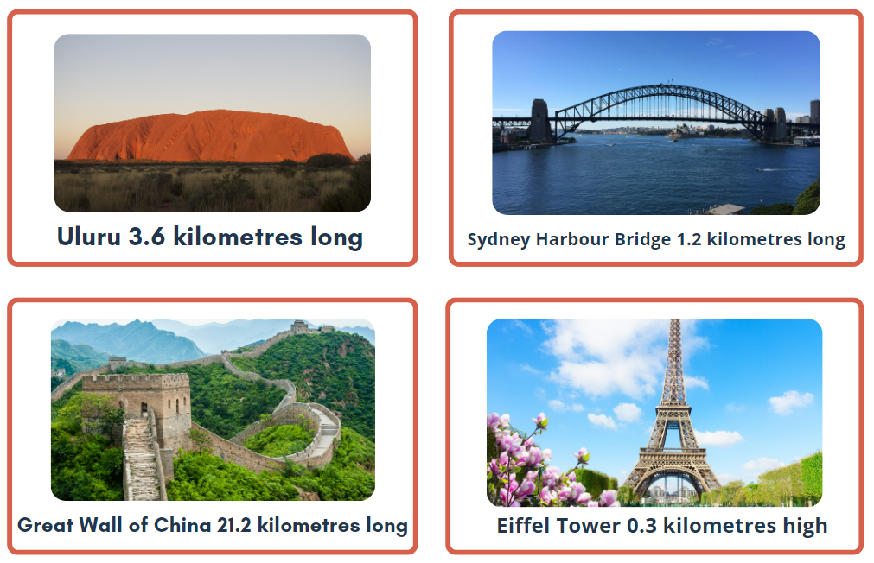

Resource 16 – benchmark measuring
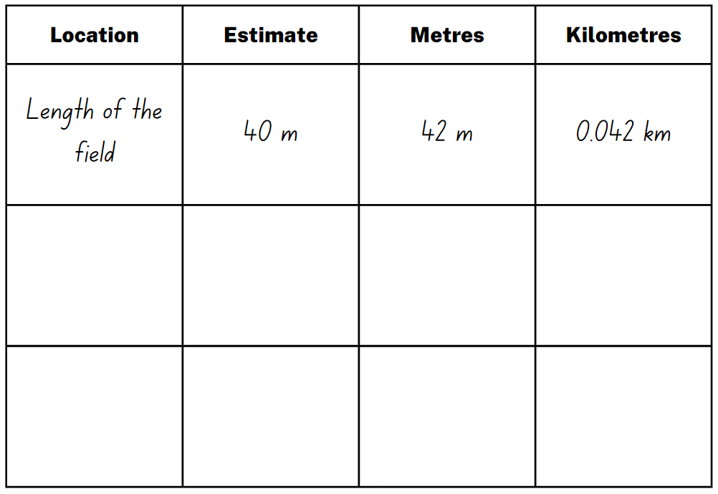

Resource 17 – gameboard

Resource 18 – perimeters 1
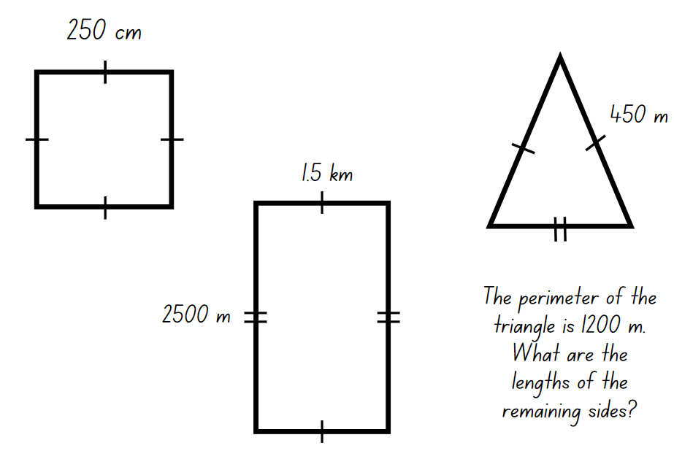

Resource 19 – perimeters 2
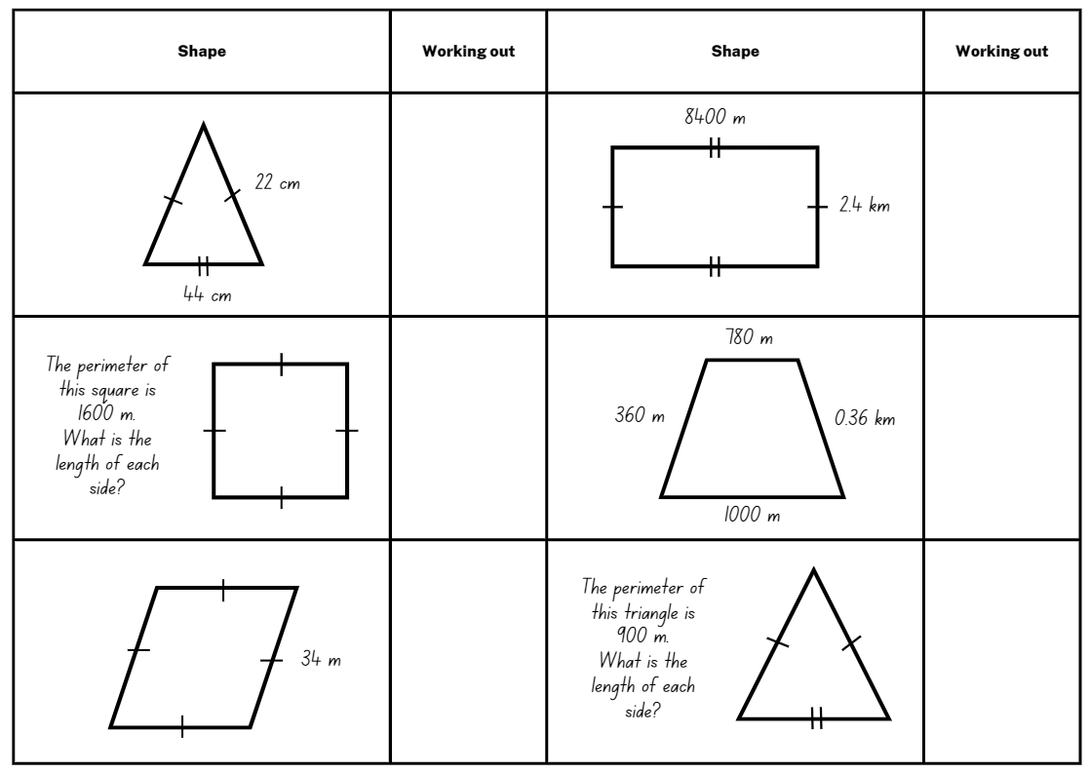

Resource 20 – shapes criteria 1
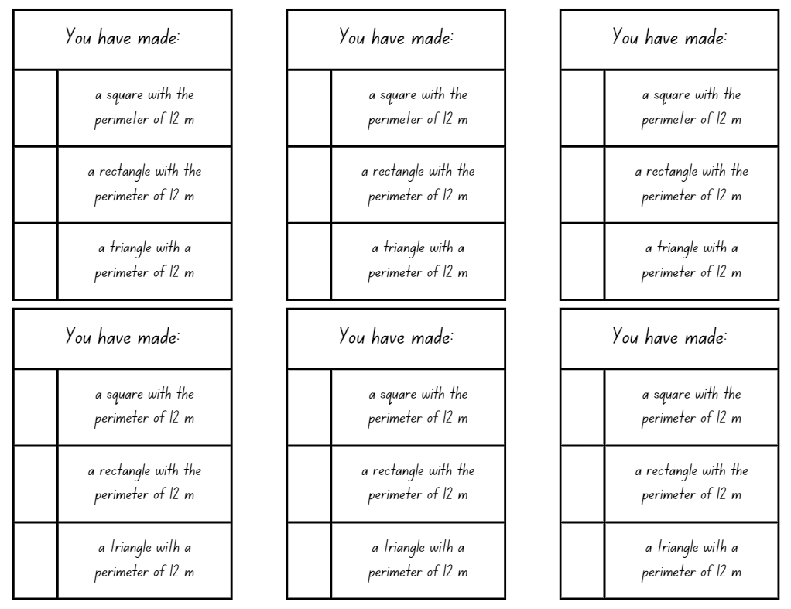

Resource 21 – shapes criteria 2
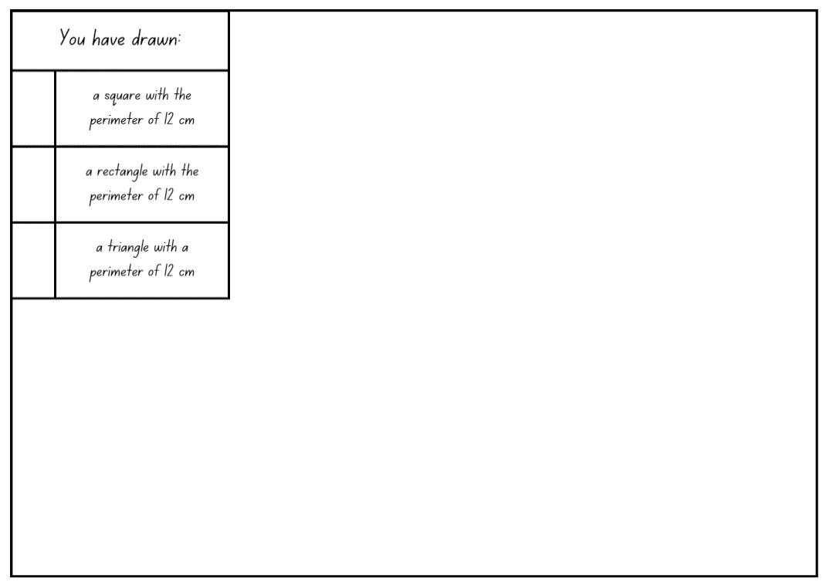

Resource 22 – clock
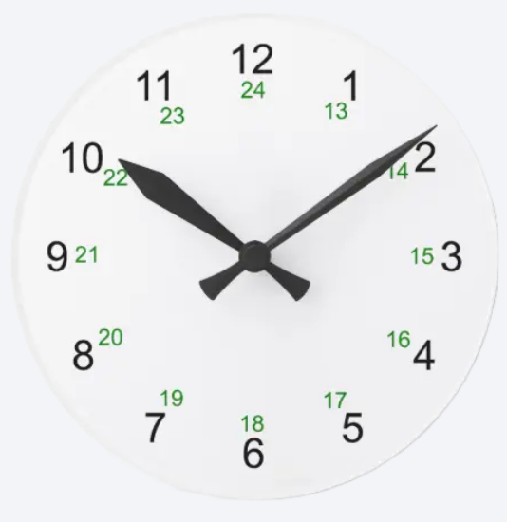

Resource 23 – am and pm
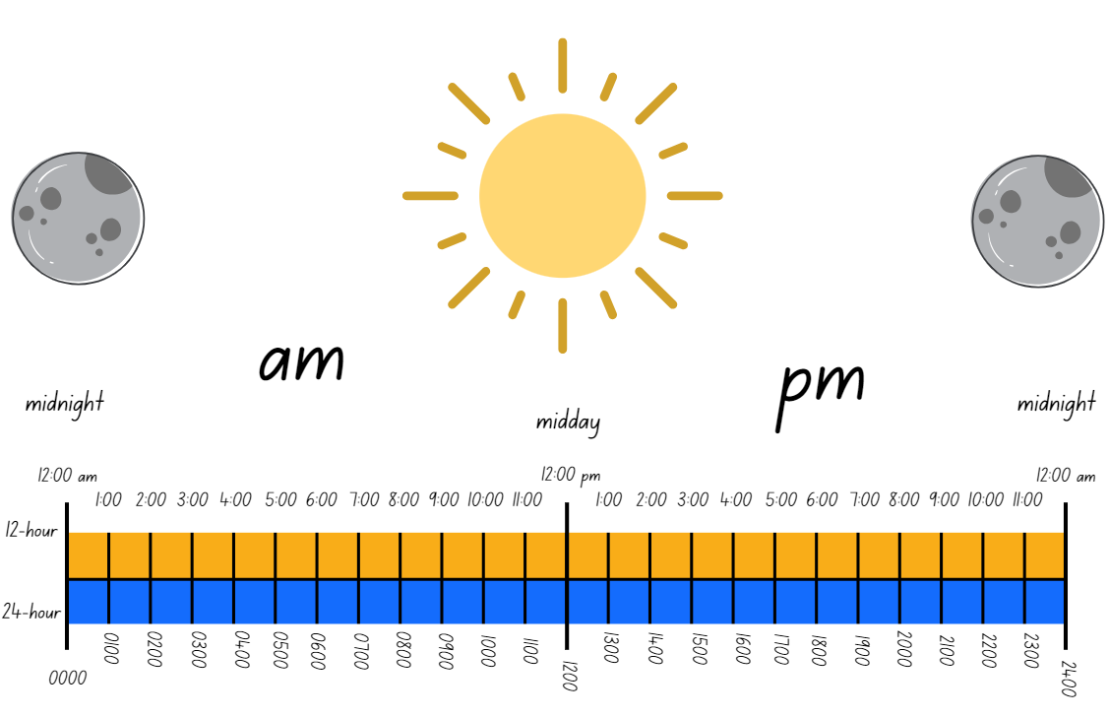

Resource 24 – time matching cards
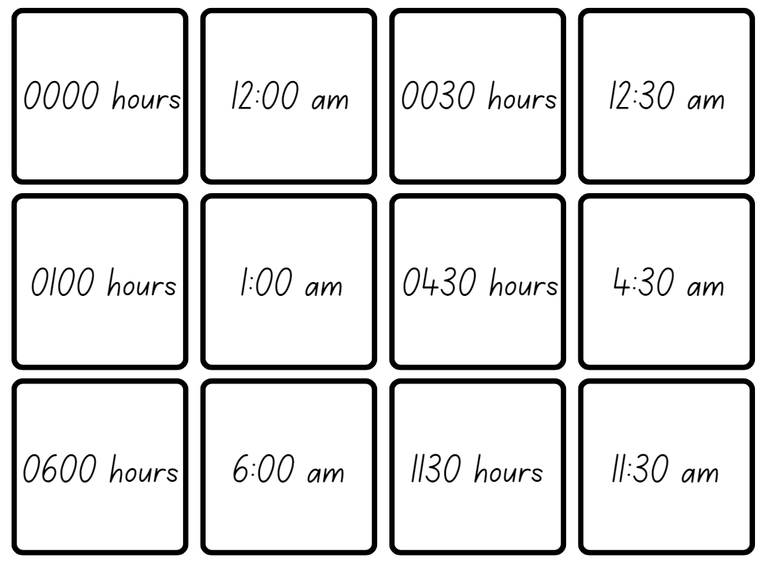

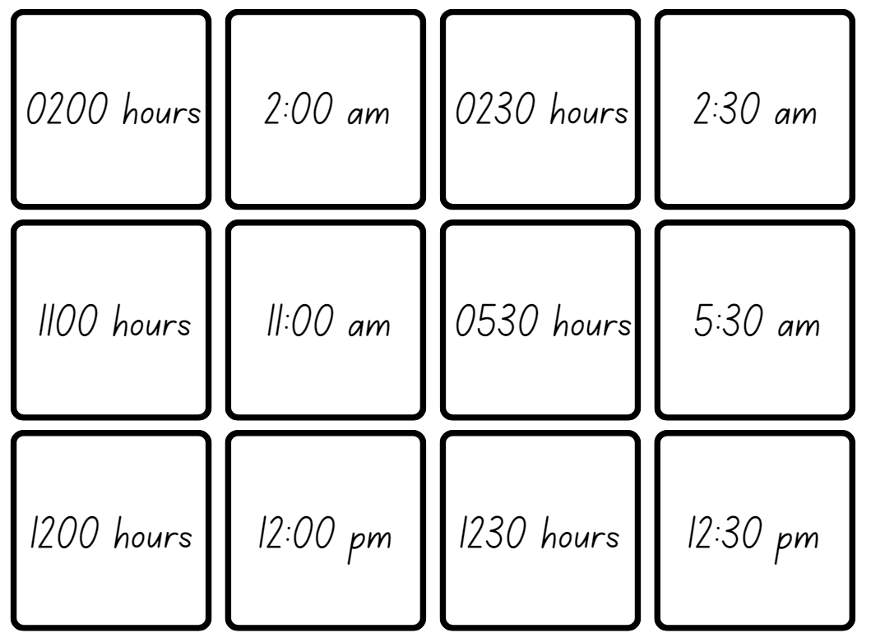

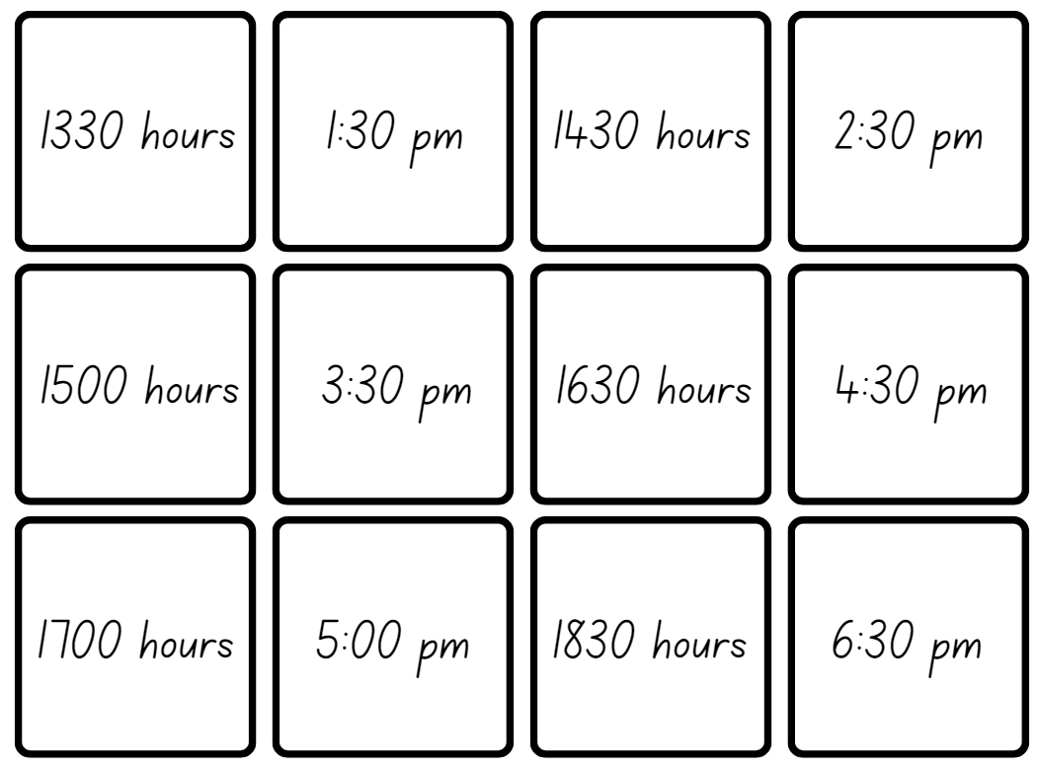

Resource 25 – 12-hour timetable
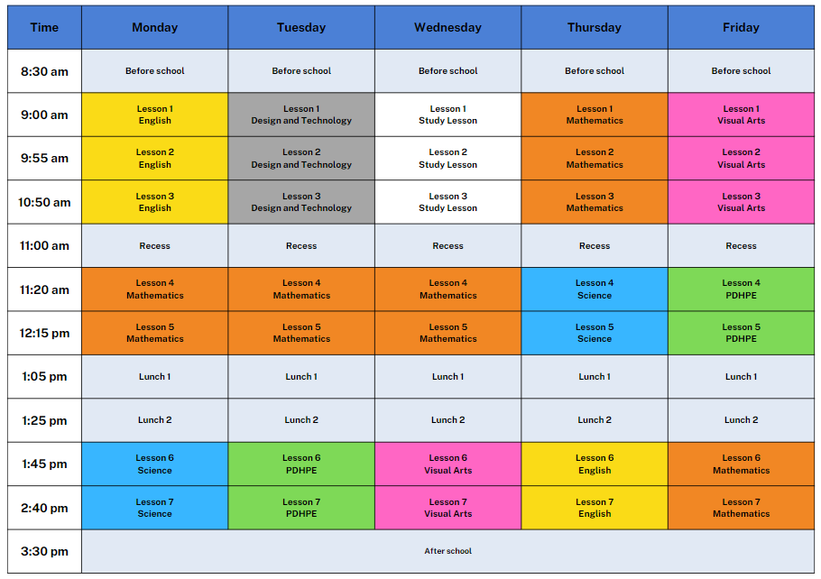

Resource 26 – 24-hour timetable
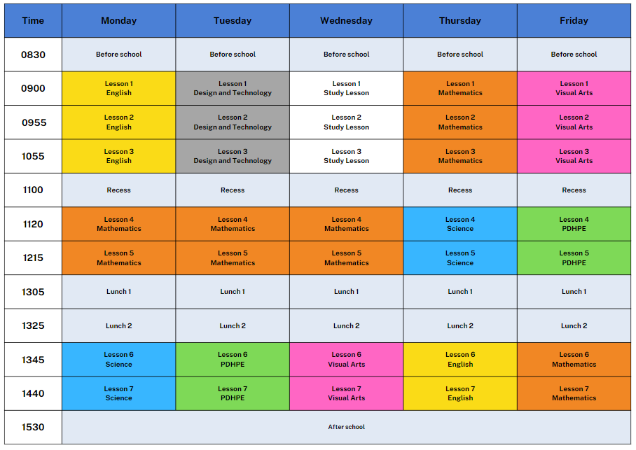

Resource 27 – dream school day
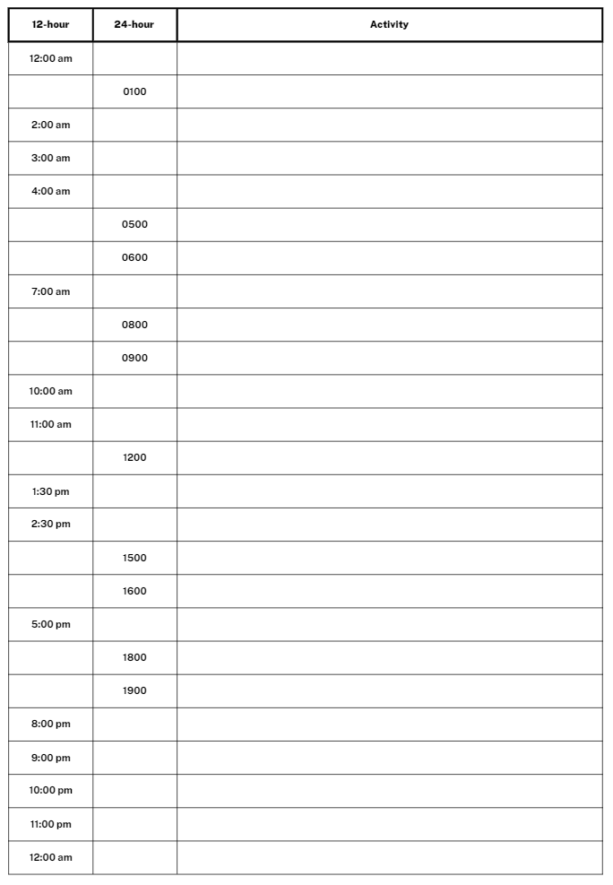

Syllabus outcomes and content
The table below outlines the syllabus outcomes and range of relevant syllabus content covered in this unit. Content is linked to National Numeracy Learning Progression version (3).
Outcomes and content | 1 | 2 | 3 | 4 | 5 | 6 | 7 | 8
Multiplicative relations B: Represent and solve word problems with number sentences involving multiplication or division
MAO-WM-01, MA2-MR-01, MA2-MR-02
- Use the equals sign to record equivalent number relationships involving multiplication (Reasons about relations) |  |  |  |  | x | x | x
- Complete number sentences involving multiplication and division by calculating missing numbers (Reasons about relations) |  |  |  |  | x | x | x
- Represent and solve multiplication and division (both sharing and grouping) word problems using number sentences |  |  |  |  |  |  | x
Additive relations A: Apply efficient mental and written strategies to solve addition and subtraction problems
MAO-WM-01, MA3-AR-01
- Apply known strategies such as levelling, addition for subtraction, using constant difference, and bridging (Reasons about relations) | x | x | x
- Use place value to add or subtract 3 or more numbers with different numbers of digits | x | x | x
Geometric measure A: Length: Use metres and kilometres for length and distances
MAO-WM-01, MA3-GM-02
- Recognise the need for a formal unit longer than the metre for measuring distance | x
- Measure 100 metres and recognise that 10 times 100 metres is one kilometre, ie 1000 metres = 1 kilometre | x | x | x
- Estimate lengths and distances using an appropriate unit | x |  |  | x
- Record distances using the abbreviation for kilometres (km) | x | x | x | x
- Use a variety of measuring devices to measure lengths and distances in different contexts | x |  | x | x
Geometric measure A: Length: Measure lengths to find perimeters
MAO-WM-01, MA3-GM-02
- Use efficient strategies to calculate the perimeter of a large rectangular area in metres |  |  |  |  |  | x
- Calculate perimeters of common two-dimensional shapes, including squares, rectangles and triangles |  |  |  |  | x | x
- Determine which side lengths are needed to find the perimeter of a shape (Reasons about relations) |  |  |  |  | x | x
- Recognise that rectangles with the same perimeter may have different dimensions (Spatial reasoning) |  |  |  |  |  | x
Geometric measure B: Length: Connect decimal representations to the metric system
MAO-WM-01, MA3-GM-02
- Recognise the equivalence of whole-number and decimal representations of measurements of length |  | x | x
- Interpret decimal notation for lengths and distances |  | x | x
- Record lengths and distances using decimal notation |  |  | x | x
Geometric measure B: Length: Solve problems involving the comparison of lengths using appropriate units
MAO-WM-01, MA3-GM-02
- Investigate and compare perimeters of rectangles with the same area |  |  |  |  | x
- Solve a variety of problems involving length and perimeter, including problems involving different units of length |  |  |  |  | x
Two-dimensional spatial structure A: 2D shapes: Classify two-dimensional shapes and describe their properties
MAO-WM-01, MA3-2DS-01
- Recognise that triangles and quadrilaterals can be classified in more than one way (Reasons about spatial relations) |  |  |  |  |  | x
- Compare side and angle properties of triangles and quadrilaterals using measurement and symmetry |  |  |  |  |  | x
Two-dimensional spatial structure B: 2D shapes: Dissect two-dimensional shapes and rearrange them using translations, reflections and rotations
MAO-WM-01, MA3-2DS-01
- Recognise that translations, reflections or rotations change the position and orientation but not the size of shapes (Reasons about spatial orientation) |  |  |  |  |  | x
Non-spatial measure A: Time: Compare 12- and 24-hour time systems and convert between them
MAO-WM-01, MA3-NSM-02
- Recognise that 24-hour time is used to avoid confusion between am and pm |  |  |  |  |  |  | x | x
- Read time using appropriate 24-hour time language |  |  |  |  |  |  | x | x
- Convert between 24-hour time and 12-hour time using am or pm notation |  |  |  |  |  |  | x | x
- Read, interpret and use timetables from real-life situations, involving 12- and 24-hour time |  |  |  |  |  |  |  | x
Non-spatial measure B: Time: Solve problems involving duration, using 12- and 24-hour time
MAO-WM-01, MA3-NSM-02
- Use start and finish times to calculate the elapsed time of events |  |  |  |  |  |  |  | x
- Solve a variety of problems involving duration, including where times are expressed in 12-hour and 24-hour notation |  |  |  |  |  |  |  | x
Mathematics K–10 Syllabus © NSW Education Standards Authority (NESA) for and on behalf of the Crown in right of the State of New South Wales, 2022.

References
This resource contains NSW Curriculum and syllabus content. The NSW Curriculum is developed by the NSW Education Standards Authority. This content is prepared by NESA for and on behalf of the Crown in right of the State of New South Wales. The material is protected by Crown copyright.
Please refer to the NESA Copyright Disclaimer for more information https://educationstandards.nsw.edu.au/wps/portal/nesa/mini-footer/copyright.
NESA holds the only official and up-to-date versions of the NSW Curriculum and syllabus documents. Please visit the NSW Education Standards Authority (NESA) website https://educationstandards.nsw.edu.au/ and the NSW Curriculum website https://curriculum.nsw.edu.au/home.
Mathematics K–10 Syllabus © NSW Education Standards Authority (NESA) for and on behalf of the Crown in right of the State of New South Wales, 2022.
National Numeracy Learning Progression © Australian Curriculum, Assessment and Reporting Authority (ACARA) 2010 to present, unless otherwise indicated. This material was downloaded from the Australian Curriculum website (National Literacy Learning Progression) (accessed 29 August 2023) and was not modified.
Boaler J, Munson J and Williams C (2017) Mindset Mathematics: Visualising and Investigating Big Ideas, Grade 4, Jossey-Bass, US.
Siemon D, Warren E, Beswick K, Faragher R, Miller J, Horne M, Jazby D, Breed M, Clark J and Brady K (2021) Teaching Mathematics: Foundations to Middle Years, 3rd edition, Oxford University Press Australia and New Zealand.
University of Cambridge (Faculty of Mathematics) (2022) Tug of War, NRICH website, accessed 21 June 2023.
University of Cambridge (Faculty of Mathematics) (2022) Dicey Operations, NRICH website, accessed 21 June 2023.

© State of New South Wales (Department of Education), 2023
The copyright material published in this resource is subject to the Copyright Act 1968 (Cth) and is owned by the NSW Department of Education or, where indicated, by a party other than the NSW Department of Education (third-party material).
Copyright material available in this resource and owned by the NSW Department of Education is licensed under a Creative Commons Attribution 4.0 International (CC BY 4.0) license.
This license allows you to share and adapt the material for any purpose, even commercially.
Attribution should be given to © State of New South Wales (Department of Education), 2023.
Material in this resource not available under a Creative Commons license:
- the NSW Department of Education logo, other logos and trademark-protected material
- material owned by a third party that has been reproduced with permission. You will need to obtain permission from the third party to reuse its material.
Links to third-party material and websites
Please note that the provided (reading/viewing material/list/links/texts) are a suggestion only and implies no endorsement, by the New South Wales Department of Education, of any author, publisher, or book title. School principals and teachers are best placed to assess the suitability of resources that would complement the curriculum and reflect the needs and interests of their students.
If you use the links provided in this document to access a third-party's website, you acknowledge that the terms of use, including licence terms set out on the third-party's website apply to the use which may be made of the materials on that third-party website or where permitted by the Copyright Act 1968 (Cth). The department accepts no responsibility for content on third-party websites.

