Mathematics Stage 2 – Unit 5
Contents
Unit description and duration 4
Syllabus outcomes 4
Working mathematically 5
Student prior learning 5
Lesson overview and resources 7
Lesson 1 12
Daily number sense: Hit it (4-digit numbers) – 10 minutes 12
Core lesson 1: Data is all around us – 20 minutes 14
Core lesson 2: Categories – 25 minutes 16
Discuss and connect the mathematics – 5 minutes 19
Lesson 2 21
Daily number sense: What is my number? – 15 minutes 21
Core lesson 1: Sort us out – 30 minutes 23
Core lesson 2: Tables – 20 minutes 25
Discuss and connect the mathematics – 5 minutes 26
Lesson 3 28
Daily number sense: How many ways? – 15 minutes 28
Core lesson 1: Data toss – 30 minutes 32
Core lesson 2: Data toss table – 20 minutes 35
Consolidation and meaningful practice – 5 minutes 36
Lesson 4 38
Daily number sense – 10 minutes 38
Core lesson 1: Dot plots – 25 minutes 38
Core lesson 2: Dice roll – 30 minutes 41
Discuss and connect the mathematics – 5 minutes 42
Lesson 5 45
Daily number sense: Counting by fives – 10 minutes 45
Core lesson 1: Screen time – 20 minutes 47
Core lesson 2: Dot plot to column graph – 25 minutes 51
Consolidation and meaningful practice – 15 minutes 52
Lesson 6 54
Daily number sense: Largest even and odd numbers – 15 minutes 54
Core lesson 1: Interpret the data – 10 minutes 56
Core lesson 2: Making data informed decisions – 30 minutes 58
Consolidation and meaningful practice – 15 minutes 61
Lesson 7 63
Daily number sense: Number patterns – 15 minutes 63
Core lesson 1: Which one doesn’t belong? – 20 minutes 64
Core lesson 2: Animals matter – 25 minutes 67
Consolidation and meaningful practice – 10 minutes 68
Lesson 8 70
Daily number sense – 15 minutes 70
Core lesson: Statistical reasoning – 40 minutes 70
Discuss and connect the mathematics – 5 minutes 73
Resource 1: Data 74
Resource 2: All about me 75
Resource 3: Data table 76
Resource 4: Dot plots 77
Resource 5: Screen time 78
Resource 6: Slow reveal column graph 79
Resource 7: Slow reveal tally table 84
Resource 8: Average steps per day by country 86
Resource 9: Fun day 87
Resource 10: Which one doesn’t belong? 88
Resource 11: Population numbers of animals in the wild 89
Resource 12: Threatened species 90
Resource 13: Deforestation 91
Resource 14: Team birth years 92
Syllabus outcomes and content 93
References 97

Unit description and duration
This unit introduces the big idea that questions can be asked and answered by interpreting data.
In this 2-week unit students are provided opportunities to:
- pose questions and collect discrete data
- display and interpret data using lists, tables, dot plots and column graphs
- read, write, order and partition numbers up to 4 digits.

Syllabus outcomes
- MAO-WM-01 develops understanding and fluency in mathematics through exploring and connecting mathematical concepts, choosing and applying mathematical techniques to solve problems, and communicating their thinking and reasoning coherently and clearly
- MA2-RN-01 applies an understanding of place value and the role of zero to represent numbers to at least tens of thousands
- MA2-MR-01 represents and uses the structure of multiplicative relations to 10 × 10 to solve problems
- MA2-DATA-01 collects discrete data and constructs graphs using a given scale
- MA2-DATA-02 interprets data in tables, dot plots and column graphs

Working mathematically
In the Mathematics K–10 Syllabus, there is one overarching Working mathematically outcome (MAO-WM-01). The Working mathematically processes should be embedded within the concepts being taught. The Working mathematically processes present in the Mathematics K–10 Syllabus are:
- communicating
- understanding and fluency
- reasoning
- problem solving.
Mathematics K–10 Syllabus © NSW Education Standards Authority (NESA) for and on behalf of the Crown in right of the State of New South Wales, 2022.

Student prior learning
Before engaging in these teaching and learning activities, students would benefit from prior experience with:
- sorting gathered data into categories
- representing and interpreting data in lists, tally marks, tables and picture graphs
- forming, regrouping, and renaming 3-digit numbers.

In NSW classrooms there is a diverse range of students, including Aboriginal and Torres Strait Islander students, students learning English as an additional language or dialect, high potential and gifted students and students with disability. Some students may identify with more than one of these groups or possibly all of them. Refer to Advice on curriculum planning for every student for further information.

Lesson overview and resources
The table below outlines the sequence and approximate timing of lessons, learning intentions and resources.
Lesson | Content | Duration and resources
Lesson 1  Daily number sense learning intention:  - record numbers using standard place value form | Lesson core concept: data is all around.  Core concept learning intentions:  - predict and create a list of categories in relation to a matter of interest  - pose questions about a matter of interest to obtain information that can be recorded in categories | Lesson duration: 60 minutes  - 0–9 dice  - Resource 1: Data  - Resource 2: All about me  - Stopwatch  - Writing materials
Lesson 2  Daily number sense learning intention:  - apply place value to partition numbers up to 4 digits | Lesson core concept: there are many ways to categorise data.  Core concept learning intention:  - collect discrete data and organise it efficiently in a table | Lesson duration: 70 minutes  - Resource 2: All about me  - Resource 3: Data table  - Writing materials
Lesson 3  Daily number sense learning intention:  - apply place value to partition and regroup numbers up to 4 digits | Lesson core concept: there are many ways to collect, record and group data.  Core concept learning intention:  - collect discrete data and organise it efficiently in a table | Lesson duration: 70 minutes  - Bean bags  - Chalk  - MAB materials  - Individual whiteboards  - Student workbooks  - Whiteboard markers  - Writing materials
Lesson 4  Daily number sense learning intention:  - teacher-identified task based on student needs | Lesson core concept: data can be displayed in different ways.  Core concept learning intention:  - collect, organise and display data in a dot plot | Lesson duration: 70 minutes  - Resource 4: Dot plots  - Counters (10 for each student)  - Device with camera  - Dice  - Individual whiteboards  - Masking tape  - Rulers  - Small dot stickers  - Student workbooks  - Whiteboard markers  - Writing materials
Lesson 5  Daily number sense learning intention:  - generate number patterns | Lesson core concept: data can be displayed in different ways.  Core concept learning intention:  - construct column graphs with scale intervals of one | Lesson duration: 70 minutes  - Resource 5: Screen time  - 1 cm grid paper  - Chrome Music Lab – Song Maker  - Device with internet connection  - Photo of class birthday month dot plot  - Sticky notes  - Writing materials
Lesson 6  Daily number sense learning intentions:  - recognise the significance of the final digit of a whole number in determining whether a given number is even or odd  - recognise the connection between even numbers and the multiplication facts for 2 | Lesson core concept: data can be interpreted to help make decisions.  Core concept learning intentions:  - interpret and compare data  - read, represent and order numbers to thousands | Lesson duration: 70 minutes  - Resource 6: Slow reveal column graph  - Resource 7: Slow reveal tally table  - Resource 8: Average steps per day by country  - Resource 9: Fun day  - 1–9 die or spinner  - Individual whiteboards  - Whiteboard markers  - Writing materials
Lesson 7  Daily number sense learning intention:  - generate and describe patterns | Lesson core concept: interpreting data helps to solve problems and ask new questions.  Core concept learning intentions:  - interpret and compare data  - read, represent and order numbers to thousands | Lesson duration: 70 minutes  - Resource 10: Which one doesn’t belong?  - Resource 11: Population numbers of animals in the wild  - Resource 12: Threatened animals  - Resource 13: Deforestation  - Chart paper  - Markers  - Individual whiteboards  - Whiteboard markers  - Writing materials
Lesson 8  Daily number sense learning intention:  - teacher-identified task based on student needs | Lesson core concept: statistical reasoning helps mathematicians interpret and make inferences about information.  Core concept learning intentions:  - interpret and compare data  - read, represent and order numbers to thousands | Lesson duration: 60 minutes  - Resource 14: Team birth years  - Writing materials

Lesson 1
Core concept: data is all around.

Daily number sense: Hit it (4-digit numbers) – 10 minutes
Daily number sense activities for Lessons 1 to 3 ‘activate’ prior number knowledge and support the learning of new content in the unit. These activities can also assist teachers to identify the starting points for learning by revealing the extent of students’ existing knowledge.
The table below contains a suggested learning intention and success criteria. These are best co-constructed with students.
Daily number sense learning intention | Daily number sense success criteria
Students are learning to:  - record numbers using standard place value form. | Students can:  - read and record 4-digit numbers.
This activity is an adaptation of Hit it (3-digit numbers) from K-6 Mathematics resources by State of New South Wales (Department of Education).
- In pairs, students choose a multiple of a thousand between 1000 and 9000 as their target number.
- Each student draws their own gameboard with space for a 4-digit number (see Figure 1).
Figure 1 – Hit it (4-digit numbers) gameboard with target number of 3000
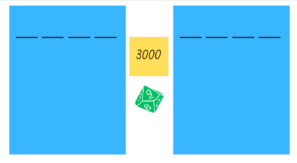
- Students take turns to roll the 0–9 die and record the digit in the thousands, hundreds, tens or ones position. The aim is to get the closest number to the target number.
- Once both players’ digits are full, each student reads their number and determines how far away they are from the target number. They can be over or under the target number.
- The player who is closest to the target number wins a point.
- Students can choose to keep or change their target number between each round.
- The student with the most points after 3 rounds is declared the winner.
- As students play, ask questions such as:
- What number did you roll?
- What would be the best position for that number?
- What might happen if you placed it in a different position?
- What number would you like to roll next?
- How could you make the game easier or harder?
This table details opportunities for assessment.
Assessment opportunities | Links
What to look for:  - Can students read and record 4-digit numbers? [MAO-WM-01 MA2-RN-01] | Links to National Numeracy Learning Progressions (NNLP):  - NPV5, NPV6.  Links to suggested Interview for Student Reasoning (IfSR) tasks:  - IfSR-NP: 4B.2, 4C.5.

Core lesson 1: Data is all around us – 20 minutes
The table below contains suggested learning intentions and success criteria. These are best co-constructed with students.
Core concept learning intentions | Core concept success criteria
Students are learning to:  - predict and create a list of categories relating to a matter of interest  - pose questions about a matter of interest to obtain information that can be recorded in categories. | Students can:  - create a list of categories for data collection  - pose investigative questions that could be used to collect data.
- Display the word ‘data’. Ask students:
- What do you think is meant by the word ‘data’?
- Where have you heard the term used?
Data: facts or units of information collected together.
- Display Resource 1: Data and ask students if each image is an example of data. Guide discussion to highlight that data comes in many forms. For example, numbers, symbols, pictures or text, with numbers often being the most frequent. Explain that the term ‘data’ refers to information that has been collected. Support understanding by providing relevant examples, such as the Aussie Bird Count and WildCount.
- Ask students to brainstorm other everyday places in which data can be found. If needed, prompt students with examples such as weather forecasts, food nutrition information, sporting statistics, bus and train timetables, Premier’s Reading Challenge, Premier’s Sporting Challenge, voting for the school leadership team, and school energy, waste and water audits.
- Ask students how some of their examples of data might be useful or interesting. Responses might include:
- weather data to decide what clothes to wear or activities to undertake
- Premier’s Sporting Challenge data to determine if physical activity levels are adequate
- food nutrition data to decide what foods to eat
- voting data to determine who the school leaders will be
- school energy audit data to see where energy saving practices could be used.
- A graphic organiser, such as a fishbone diagram, may be used to display the class’s information.

Core lesson 2: Categories – 25 minutes
Discrete variable: individual and countable items that can be listed.
Categorical variable: a variable whose values belong to exactly one of a number of categories. A categorical variable describes a quality or characteristic of something. Sometimes this is called a discrete variable. There are 2 types of categorical variables: nominal and ordinal. For example, your home state or blood type are categorical variables.
Note: in Stage 2, students work with discrete data that is either categorical or numerical. Continuous numerical data, that changes over time and is represented in a line graph, is not introduced until Stage 3.
- Explain that students will be recording personal data and collating data about the class.
- Distribute a copy of Resource 2: All about me to each student and ask them to complete it individually.
- In pairs, students select at least 3 matters of interest from Resource 2: All about me, for example, eye colour. Explain that matters of interest must meet the following criteria:
- students in the class would be happy to share information
- it applies to all students in the class
- it is interesting or purposeful.
- Ask pairs of students to predict what categories could be used to group class data for their matters of interest. For example, blue, green, brown and hazel for eye colour. Explain that students need to consider all possible categories and that each piece of data can only fit into one category. Explain that, for the same matter of interest, the data could be arranged into a number of different categories. For example, class pets could be organised by the number of pets each students owns or by the type of animal.
- Select pairs of students to share their thinking and discuss by asking questions such as:
- Who else chose this matter of interest?
- Did you predict the same categories?
- Does it matter if the categories are the same? Why or why not?
- Can you think of any other categories for this matter of interest?
- Would the categories be the same if we used this matter of interest for another class or grade? Why or why not?
- Would the categories be the same if we used this matter of interest for another school? Why or why not?
- Explain that data can be used to answer investigative questions and provide examples such as:
- What is Year 3’s favourite television show?
- What is the most popular lunchtime game at our school?
- What is our class’s favourite ice cream flavour?
- Ask pairs of students to devise and record an investigative question for each of their matters of interest. For each matter of interest students should make a list of categories and a question. For examples from Resource 2: All about me (see Figure 2).
Figure 2 – Example categories and questions
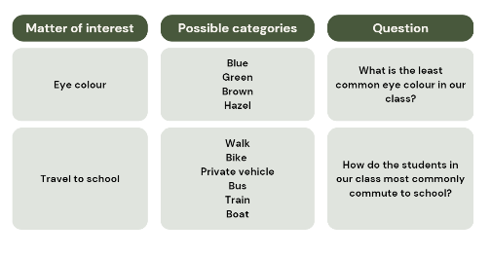
Note: ‘When students formulate the questions, the data they gather becomes more meaningful. How they organise the data and the techniques for analysing them have a purpose.’ (Van De Walle et al., 2019)
- Conduct a gallery walk to share the class’s questions.
- As a class, choose one topic from Resource 2: All about me. Ask how the results could be recorded, for example lists, tally marks, symbols.
- Share the class results for the chosen topic. Students record the class data using a list, tally marks or symbols.
This table details opportunities for differentiation.
Too hard? | Too easy?
Students cannot predict categories or create investigative questions.  - Provide an investigative question and have students predict categories.  - Select topics with a smaller number of possible categories (left or right-handed) or predictable categories (birthday month). | Students can predict categories and create investigative questions.  - Place the matters of interest in order from most predicted categories to least predicted categories and justify their thinking.  - Sort the matter of interest into 2 groups: categories that might change in 12 months and categories that will not change in 12 months. Students justify their thinking.

Discuss and connect the mathematics – 5 minutes
- Reflect on the lesson by asking questions, such as:
- Are there any topics you would like added to Resource 2: All about me. Explain how the topic is interesting or purposeful.
- What categories could be included for that topic?
- Can you pose an investigative question for that topic?
This table details opportunities for assessment.
Assessment opportunities | Links
What to look for:  - Can students predict and create a list of categories for data collection? [MAO-WM-01, MA2-DATA-01]  - Can students create investigative questions that could be used to collect data? [MAO-WM-01, MA2-DATA-01] | Links to National Numeracy Learning Progressions (NNLP):  - IRD2, IRD3.

Lesson 2
Core concept: there are many ways to categorise data.

Daily number sense: What is my number? – 15 minutes
The table below contains a suggested learning intention and success criteria. These are best co-constructed with students.
Daily number sense learning intention | Daily number sense success criteria
Students are learning to:  - apply place value to partition numbers up to 4 digits. | Students can:  - record numbers using standard place value form.
- Explain that the students will try to identify a mystery 3- or 4-digit number by asking questions that require a ‘yes’ or ‘no’ answer.
- Ask students to provide examples of suitable questions, such as:
- Is the number an even number?
- Is the number a 4-digit number?
- Is the number larger than 500?
- Does the number have less than 7 hundreds?
- Select a 3- or 4-digit number and select students to ask questions.
- Assist students to keep track of possible answers and eliminated numbers by asking questions as students play, such as:
- Could the answer be 458? Why or why not?
- Could the answer have a 4 in the ones place? Why or why not?
- Could the answer have more than 25 tens? Why or why not?
- When the mystery number has been guessed, students record the number using standard place value form. For example, 523 = 500 + 20 + 3 or 5 hundreds, 2 tens and 3 ones.
- Discuss, asking questions such as:
- Which questions were the most useful? Why?
- Can you think of any additional questions that would have been useful to ask?
- How could you make the game easier or harder?
- Repeat twice in pairs, allowing students to alternate between creating and guessing a mystery number.
This table details opportunities for assessment.
Assessment opportunities | Links
What to look for:  - Can students record numbers using standard place value form? [MAO-WM-01, MA2-RN-01] | Links to National Numeracy Learning Progressions (NNLP):  - NPV4, NPV5, NPV6.

Core lesson 1: Sort us out – 30 minutes
The table below contains a suggested learning intention and success criteria. These are best co-constructed with students.
Core concept learning intentions | Core concept success criteria
Students are learning to:  - collect discrete data and organise it efficiently in a table. | Students can:  - create categories for data collection  - collect data about a matter of interest  - transfer tally data into a table.
This activity is an adaptation of ‘Guess my rule’ from Primary and Middle Years Mathematics: Teaching Developmentally, 1st Australian edn by Van De Walle et al.
- Students stand around the classroom. Call out a matter of interest from Resource 2: All about me and ask students to organise themselves into categories by forming groups in different parts of the room. Start with topics with less categories. For example, age of students.
- For each topic, record class data on the board as tally marks.
- Continue to call out matters of interest, gradually increasing the complexity. For example, matters of interest that have more flexible categories such as travel to school which could be categorised by distance, travel time or mode of transport.
- As a class, discuss questions such as:
- Which topic was the easiest?
- Which topic was the hardest? Why?
- What other categories could we organise the class into?
- When might you use categories in your everyday life?
- Decide on a matter of interest, but do not tell the class. Direct one student at a time to move to a specific area in the classroom according to categories for the matter of interest.
- After a number of students have been sorted, ask the remaining students to move to the group they think they belong with.
- In their groups, students discuss:
- What is the topic?
- What is their category?
- Does anyone need to move categories? Why?
- Ask groups of students to share their predictions before revealing the answer.
This table details opportunities for differentiation.
Too hard? | Too easy?
Students cannot predict categories for a matter of interest.  - Other students in the class provide them clues as to which group to move to.  - Use topics with only 2 categories. | Students can predict categories for a matter of interest.  - Invite students to choose the hidden matter of interest and categorise the class.  - Students predict other options of categories for the matters of interest explored.

Core lesson 2: Tables – 20 minutes
- For one matter of interest tallied on the board, model how to transfer tally marks into a tally table and total the frequency for each category. For example, see Figure 3.
Figure 3 – Tally marks to data table
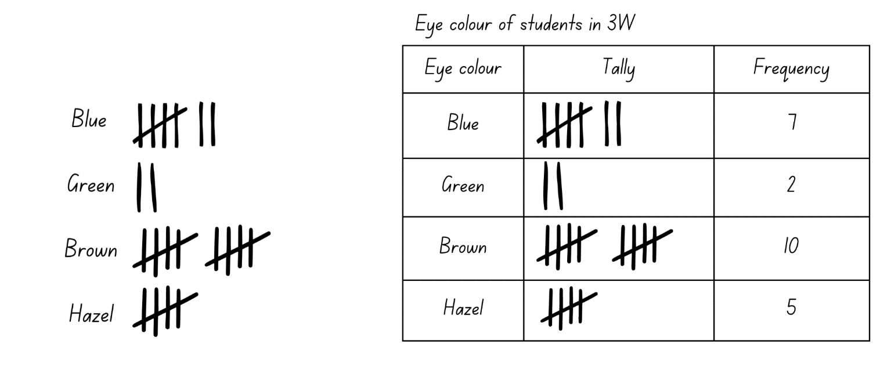
- Distribute Resource 3: Data table for students to transfer data for a different matter of interest from the board into the table. Students total the frequency for each category.
- Ask students:
- What do you notice about your data?
- What do you wonder about your data?
This table details opportunities for differentiation.
Too hard? | Too easy?
Students cannot transfer tally marks into a table.  - Students copy the teacher example from board.  - Choose topics with only 2 categories. | Students can transfer tally marks into a table.  - Students draw their own tally table.  - Students transfer tally marks from board straight to frequency without recording tally marks in the table.

Discuss and connect the mathematics – 5 minutes
- Reflect on the lesson by asking questions such as:
- What are the similarities and differences between the tally marks on the board and the table?
- Which is a more efficient way to record data? Why?
- What other topics could you record in a table?
- Where might you use tables to organise information in everyday life?
This table details opportunities for assessment.
Assessment opportunities | Links
What to look for:  - Can students create a list of categories for data collection? [MAO-WM-01, MA2-DATA-01]  - Can students collect data and organise it efficiently in a table? [MAO-WM-01, MA2-DATA-01] | Links to National Numeracy Learning Progressions (NNLP):  - IRD2, IRD3.

Lesson 3
Core concept: there are many ways to collect, record and group data.

Daily number sense: How many ways? – 15 minutes
The table below contains a suggested learning intention and success criteria. These are best co-constructed with students.
Daily number sense learning intention | Daily number sense success criteria
Students are learning to:  - apply place value to partition and regroup numbers up to 4 digits. | Students can:  - partition and record numbers of up to 4 digits in non-standard forms.
- Using MAB materials, model making a 3- or 4-digit number using standard partitioning. For example, Figure 4.
Figure 4 – 3235 represented using standard partitioning with MAB materials
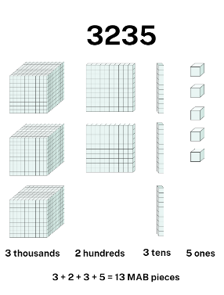
- Ask students if this is the only way to represent the number.
- If the answer is yes, provide an example using non-standard partitioning and record how many MAB pieces were used. For example, Figure 5.
Figure 5 – 3235 represented using non-standard partitioning with MAB materials
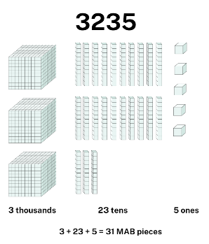
- After providing an example or if the answer is no, ask students how many ways the number can be made.
- Ask students how they will know if they have found all possibilities.
- Demonstrate how to use a table to record different models. For example, see Figure 6.
Figure 6 – Table of non-standard ways to partition 3235
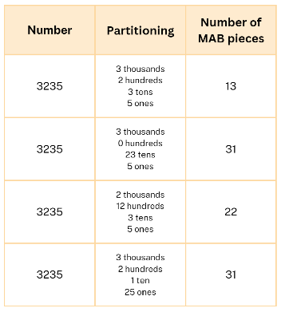
- Provide groups of students with MAB materials to explore predictions.
- Select groups to share their thinking and discuss using questions such as:
- How many possibilities did you find?
- How many more possibilities might there be? How do you know?
- What was the least number of MAB pieces used and how was the number partitioned?
- What was the greatest number of MAB pieces used and how was the number partitioned?
This table details opportunities for assessment.
Assessment opportunities | Links
What to look for:  - Can students partition numbers of up to 4 digits in non-standard forms? [MAO-WM-01, MA2-RN-01] | Links to National Numeracy Learning Progressions (NNLP):  - NPV5, NPV6.  Links to suggested Interview for Student Reasoning (IfSR) tasks:  - IfSR-AT: 3B.2, 3B.3, 3B.4.

Core lesson 1: Data toss – 30 minutes
The table below contains a suggested learning intention and success criteria. These are best co-constructed with students.
Core concept learning intentions | Core concept success criteria
Students are learning to:  - collect discrete data and organise it efficiently in a table. | Students can:  - collect data  - organise data into a table.
This activity is an adaptation of Data toss – Stage 2 and 3 from Mathematics K-6 resources by State of New South Wales (Department of Education).
- Take the class outside to a large concrete area in the school.
- With chalk, draw a data toss target on the ground with a throwing line approximately 2 metres from the target (see Figure 7).
Figure 7 – Data toss target
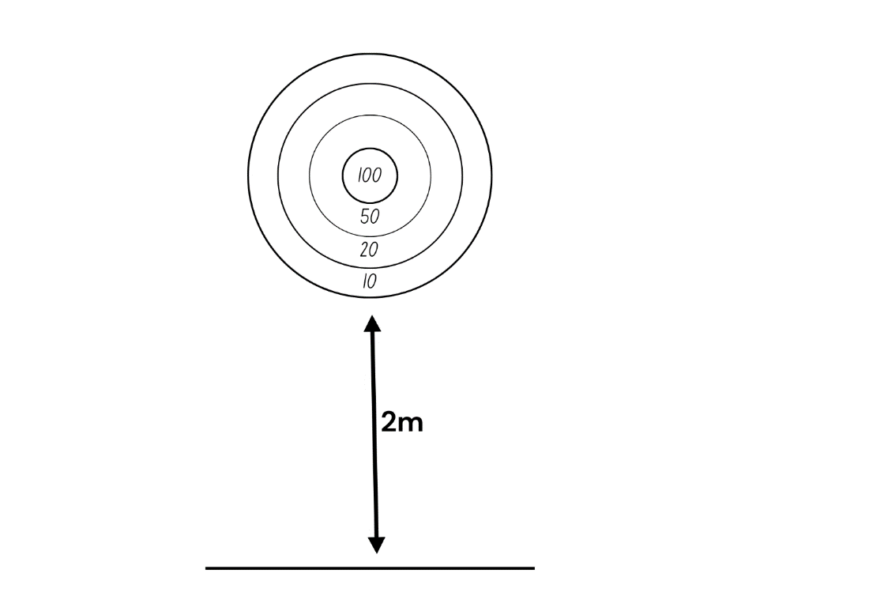
- Explain that in small groups students will draw their own target and take turns throwing a bean bag at the target 20 times each. An alternative throwing object that does not roll can also be used. Students individually record every throw on an individual whiteboard or in their workbook.
- Students pose a question they could ask about the activity. Questions may include:
- Which score will be landed on most often in the class?
- Who will get the highest score in the class?
- Establish class rules before commencing the game to clarify what happens if a student’s throw:
- lands on a line (choose the higher or lower score)
- misses the target (zero and no rethrow or rethrow).
- Show students an example of how the data could be recorded in a list, emphasising that they need a way to record the number of throws and that the data needs to be legible. For example, see Figure 8.
Figure 8 – Example of data toss results on mini whiteboard
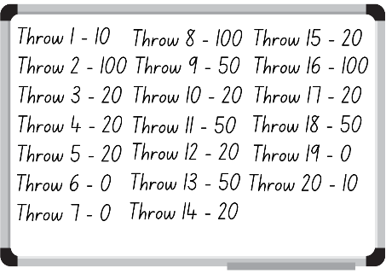
- Distribute chalk, bean bags, whiteboards, and markers.
- In small groups, students complete their data toss and record their 20 scores on their whiteboard.

Core lesson 2: Data toss table – 20 minutes
- In the classroom, ask students to suggest the most efficient method for recording their scores and why. Discuss lists, tally marks, and tables. Explain that tables are an efficient way to record large data sets.
- Draw a data toss table on the board (see Figure 9). Highlight the attributes of a table, including the title and headings. Explain that the column headings for the data toss table are score, tally, frequency and total.
Figure 9 – Data toss table
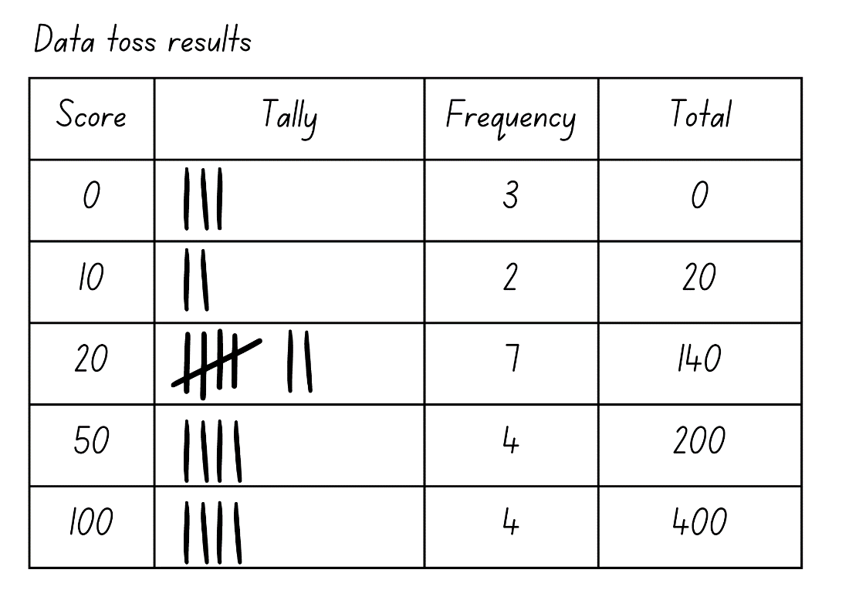
- Model transferring data from a list to the table.
- Students draw their own table, transferring their data toss results to tally marks and frequency in the table.
- Explain that the total is calculated by multiplying the score and frequency.
- Students calculate their totals.
- Ask students:
- What did you notice about your data?
- What affected your total score?
- How could you change the data toss activity to make it easier or harder? Why?
This table details opportunities for differentiation.
Too hard? | Too easy?
Students cannot transfer a list of data into a table and calculate the total.  - Simplify scores in students’ target, for example use 2, 5, 10, 20.  - Decrease the number of throws per student to 10. | Students can transfer a list of data into a table and calculate the total.  - Students predict and explain their total score if they had 40 throws and 60 throws.  - In small groups, students combine their data in a table.

Consolidation and meaningful practice – 5 minutes
- Ask how students could redesign the target to increase the points scored.
- Students record their new target designs.
- Choose students to share and justify their designs.
This table details opportunities for assessment.
Assessment opportunities | Links
What to look for:  - Can students create a list of collected data? [MAO-WM-01, MA2-DATA-01]  - Can students organise data efficiently in a table? [MAO-WM-01, MA2-DATA-01] | Links to National Numeracy Learning Progressions (NNLP):  - IRD2, IRD3.

Lesson 4
Core concept: data can be displayed in different ways.

Daily number sense – 10 minutes
- From a class need surfaced through formative assessment data, identify a short, focused activity that targets students’ knowledge, understanding and skills. Example activities may be drawn from the following resources:
- Mathematics K-6 resources
- Universal Resources Hub.

Core lesson 1: Dot plots – 25 minutes
The table below contains a suggested learning intention and success criteria. These are best co-constructed with students.
Core concept learning intention | Core concept success criteria
Students are learning to:  - collect, organise and display data in a dot plot. | Students can:  - represent data in a dot plot  - create a dot plot from collected data.
This activity is an adaptation of ‘Stand by me’ from Primary and Middle Years Mathematics: Teaching Developmentally, 1st Australian edn by Van De Walle et al.
- Show class Resource 4: Dot plots. Ask students:
- What do you notice?
- What do you wonder?
- Do they remind you of anything?
- Have you seen data represented like this before?
- When might we display data using a dot plot?
Note: dot plots are an alternative to column graphs when there is only a small number of data values. Each value is recorded as a dot so frequencies for each value can be counted easily.
- Mark a line along the front of the room with masking tape. Write months of the year on sticky notes, then distribute them evenly along the line from left to right (see Figure 10).
Figure 10 – Birthday months dot plot x-axis
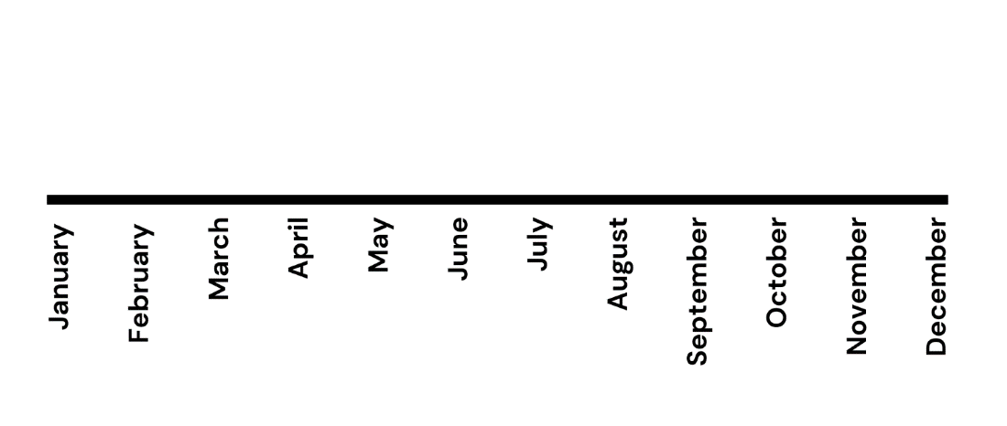
- Students move to their birthday month and sit behind the label.
- Ask students:
- What have we made?
- What data have we collected?
- How is it represented?
- Explain to class the attributes of a dot plot. Draw attention to the title, evenly spaced category labels, one-to-one correspondence and an x-axis.
- Draw a line on the board with months of the year from left to right.
- Give each student a magnetic dot, circular sticker or marker. Have students place their dot on the correct month on the board to create a class dot plot (see Figure 11).
Figure 11 – Example of birthday month dot plot
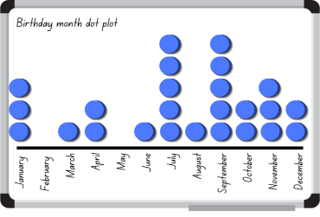
- Discuss the data organisation and features of a dot plot with students. Ask questions, such as:
- What is the most common birthday month?
- Are there any months with no birthdays?
- Are there any months that have the same number of birthdays?
- Take a photo of the dot plot to use in Lesson 5.

Core lesson 2: Dice roll – 30 minutes
- Distribute a 6-sided die, individual whiteboard, whiteboard marker and 10 counters to each student. Arrange students in a circle on the floor.
- Ask students to predict what data they might be collecting.
- Explain that students will roll their die 10 times and record their data in a dot plot using counters.
- Students draw their dot plot on their mini whiteboard with a title, x-axis and category labels.
- Check student understanding by asking them to show their whiteboards.
- Students roll their die 10 times and record each roll on their whiteboard using counters.
- Provide students with dot stickers and ask them to transfer their dot plot into their workbooks.
- Conduct a gallery walk to share and view the classes dot plots.
This table details opportunities for differentiation.
Too hard? | Too easy?
Students cannot organise data into a dot plot.  - Reduce the number of die rolls.  - Use simpler dice, for example dot dice or 1–3 dice. | Students can organise data into a dot plot.  - Use dice with larger numbers, for example, 0–9.  - Students transfer their dot plot to a table and calculate the frequency of each number and total.

Discuss and connect the mathematics – 5 minutes
- Draw a dot plot on the board with numbers 1–5 as the categories (see Figure 12).
Figure 12 – Understanding of dot plots
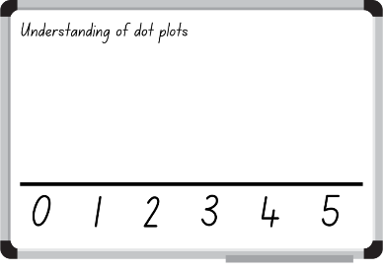
- Use the fist to 5 strategy to elicit student understanding of dot plots. No fingers indicates students have no understanding at all, while 5 fingers indicates they completely understand.
- Distribute one dot sticker to each student and direct them to place their dot on the board above their level of understanding about dot plots.
- Reflect on the lesson by asking questions, such as:
- What are some advantages and disadvantages of using dot plots?
- How is a dot plot similar and different to a number line?
- What other data could be shown using a dot plot?
- When would you not use a dot plot?
This table details opportunities for assessment.
Assessment opportunities | Links
What to look for:  - Can students collect, organise and display data in a dot plot? [MAO-WM-01, MA2-DATA-01] | Links to National Numeracy Learning Progressions (NNLP):  - IRD3.

Lesson 5
Core concept: data can be displayed in different ways.

Daily number sense: Counting by fives – 10 minutes
Daily number sense activities for Lessons 5 to 7 ‘loop’ back to concepts and procedures covered in previous units to assist students to build an increasingly connected network of ideas. These concepts may differ from the core concepts being covered in the unit.
The table below contains a suggested learning intention and success criteria. These are best co-constructed with students.
Daily number sense learning intention | Daily number sense success criteria
Students are learning to:  - generate number patterns. | Students can:  - generate and continue number patterns that increase or decrease by 5.
This activity is an adaptation of Counting game (by multiples of 5) from Mathematics K-6 resources by State of New South Wales (Department of Education).
- In pairs, students choose a target number that is a multiple of 5.
- Ask students how they know that the target number is a multiple of 5.
- Explain that the object of the game is to be the person who says the target number.
- Players take turns to count on by saying the next one, 2 or 3 number words in the fives sequence.
- Pairs record the target number and the number words each turn. For example, see Figure 13.
Figure 13 – Example recording of target number
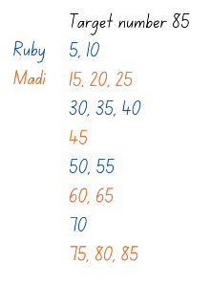
- The player who says the target number receives a point.
- Students choose a new target number and play the game again.
- The game may be varied by starting at the target number and counting backwards to zero.
- Reflect on the activity, asking questions such as:
- Did you prefer going first or second? Why?
- What strategy did you use? How successful was it and why?
- Looking back on the games that you played, can you see any ways that one player could change their moves to win?
- How could you make the game easier or harder?
This table details opportunities for assessment.
Assessment opportunities | Links
What to look for:  - Can students generate and continue number patterns that increase or decrease by 5? [MAO-WM-01, MA2-MR-01] | Links to National Numeracy Learning Progressions (NNLP):  - NPA3.

Core lesson 1: Screen time – 20 minutes
The table below contains a suggested learning intention and success criteria. These are best co-constructed with students.
Core concept learning intentions | Core concept success criteria
Students are learning to:  - construct column graphs with scale intervals of one. | Students can:  - organise data into categories  - mark equal spaces (intervals) on axes  - name and label both x-axis and y-axis  - chose appropriate titles for column graphs.
- Display Resource 5: Screen time and ask students what they notice and wonder about the graph.
- As a class, students make a column graph representing their screen time.
Note: column graphs are used to represent categorical and discrete numerical data.
- Give each student a sticky note and ask them to write the number of hours they spend on screens daily and stick it randomly on the board. Specify that students should only count hours outside of school, on weekdays and they should measure to the nearest hour.
- Students do a variation of Think-Pair-Share called Stand Up, Hand Up and Pair Up where students stand up, put their hand up, find a partner and sit with their partner.
- In pairs, students discuss efficient ways to organise the class data and what categories they might use.
- Ask students to share and justify their ideas.
- Using Resource 5: Screen time as a model, highlight the attributes of a column graph, including:
- an appropriate title
- equal spaces (intervals) on axes
- named and labelled axes
- rectangular bars of equal width, with spaces between them
- rectangular column heights that match the frequency of the category.
Note: when creating column graphs, the columns should not be joined as they represent distinct categorical data.
- Students suggest a title for the class column graph. For example, ‘Class screentime outside of school’. Record the title at the top of the board.
- Students identify the fewest number of screen time hours and the greatest number of screen time hours in the class.
- Model drawing the x-axis, adding evenly spaced categories and an axis label. Categories along the x-axis will be the number of hours of screen time per day.
- Invite students to help rearrange the sticky notes above each number on the x-axis. For example, see Figure 14.
Figure 14 – Example of class screen time outside of school sticky note graph
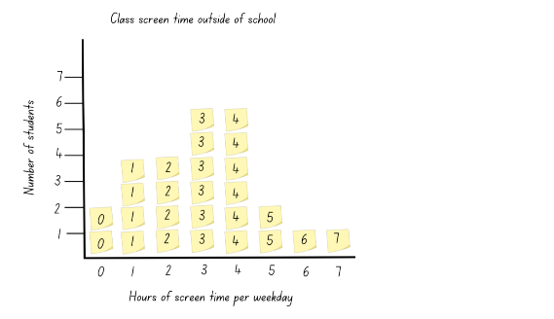
- Draw a y-axis on the board and ask students what the axis represents. Label the y-axis.
- Ask students:
- Is this a column graph or a picture graph? Why?
- How could we turn this into a column graph?
- Trace a line around the sticky notes in the first column and remove the sticky notes to show a rectangular column (see Figure 15). Emphasise that each sticky note represents a value of one.
Figure 15 – Example of class screen time outside of school column graph
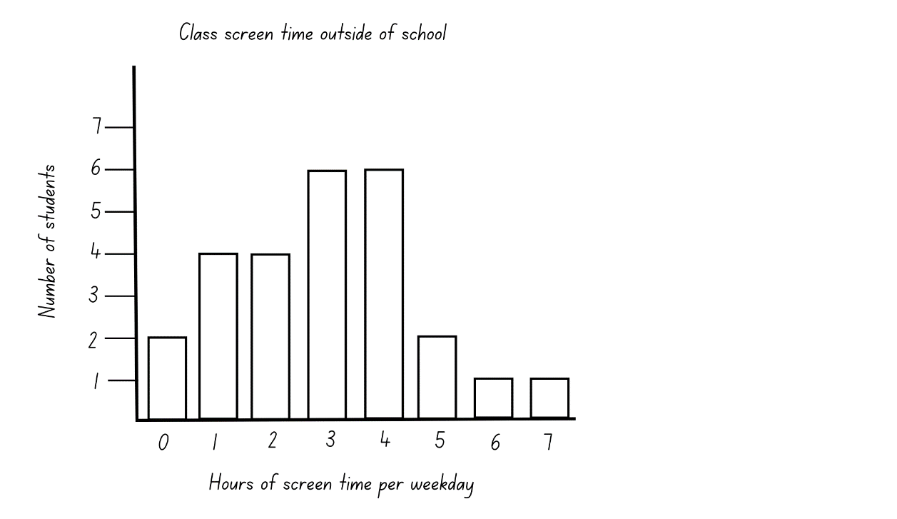
- Repeat for each column, discussing why it might be called a column graph.

Core lesson 2: Dot plot to column graph – 25 minutes
- Display photo of the class birthday month dot plot from Lesson 4. Ask students:
- What is this dot plot displaying?
- Could this data be displayed in a different way?
- Ask students to list the attributes of a column graph discussed in the first part of the lesson and write them on the board.
- On the board, model how to draw a column graph for the birthday month data, ticking each attribute as they are added. Highlight the importance of using a ruler to draw the axes. Only draw a column for the January data. As you work, prompt students by asking questions such as:
- What should the y-axis label be?
- What categories should go on the x-axis?
- What should I add next?
- Is anything missing?
- Distribute 1 cm grid paper and direct students to copy the column graph from the board onto the graph paper and complete the remaining months’ data.
- As a class, share and give feedback on selected students’ column graphs. Referring to the attributes of a column graph, ask:
- Does this column graph meet our success criteria? Why or why not?
- How could it be improved?
- What is the difference between a column graph and a dot plot?
- Do you think a column graph or a dot plot is more efficient in displaying data? Can you justify your answer?
- Is there data that you would not represent using a dot plot?
- Is there data that you would not represent using a column graph?
This table details opportunities for differentiation.
Too hard? | Too easy?
Students cannot construct a column graph.  - Provide a template with pre-drawn axes and labels.  - Provide square tiles and a whiteboard to create the column graph. | Students can construct a column graph.  - Students create a new column graph independently using a previous data set from their workbook.  - Students create a column graph of the daily temperature for their suburb over the past week.

Consolidation and meaningful practice – 15 minutes
- Display Chrome Music Lab – Song Maker on screen for the class.
- Ask students what they notice about the program and if they could use the program to recreate the class screen time column graph.
- Invite students to help transfer the class screen time column graph into Song Maker, emphasising one-to-one correspondence. For example, if 2 students in the class have no screen time they will tap on 2 boxes in the first column in the program, which will change colour.
- Before inputting the remaining class data, ask students:
- How many columns will we need?
- Do you think this data will be long enough to create a song?
- How could we make our song longer only using this data?
- Continue to invite students to add the class data to the program. Repeat the data set to allow for a longer song.
- Play the song to the class and ask students:
- Is this still data?
- How is this representation similar and different to the column graph?
This table details opportunities for assessment.
Assessment opportunities | Links
What to look for:  - Can students construct column graphs with a scale of one? [MAO-WM-01, MA2-DATA-01]  - Can students communicate their thinking and reasoning coherently and clearly? [MAO-WM-01, MA2-DATA-01] | Links to National Numeracy Learning Progressions (NNLP):  - IRD3.

Lesson 6
Core concept: data can be interpreted to help make decisions.

Daily number sense: Largest even and odd numbers – 15 minutes
The table below contains suggested learning intentions and success criteria. These are best co-constructed with students.
Daily number sense learning intention | Daily number sense success criteria
Students are learning to:  - recognise the significance of the final digit of a whole number in determining whether a given number is even or odd  - recognise the connection between even numbers and the multiplication facts for 2. | Students can:  - identify and record odd and even numbers  - explain how they know if a number is even or odd.
This activity is an adaptation of Largest Even from NRICH by University of Cambridge (Faculty of Mathematics).
- Display a variety of odd and even 1-, 2- and 3-digit numbers and ask students to identify if they are odd or even.
- Ask students to explain how they know if a number is odd or even.
- Demonstrate the link between even numbers and the multiplication facts for 2. Then demonstrate the significance of the final digit of a whole number.
Note: one result that follows from our place value system is that any whole number can be written as a multiple of 10 plus a single digit. For example, 153 is 150 plus 3. Since a multiple of 10 is always even because every group of 10 is 2 rows of 5, then whether a number is odd or even can be determined by its final digit.
- Provide students with a random digit between 1 and 9. Alternatively, roll a 1–9 die or use a spinner.
- Ask students to record the largest possible 3-digit even number using the digit provided and 2 digits of their choice.
- Select students to share and justify their thinking. Ask question such as:
- What is your number?
- Where did you place the random digit? Why?
- Is your number an even number?
- How do you know?
- How could you prove that it is an even number?
- Can you prove that this is the largest possible 3-digit even number possible?
- Select another random digit and repeat.
- Students to compare their answers and describe any commonalities.
- Repeat a third time, this time using the random digit and 3 digits of their choice to make the largest 4-digit even number.
- Compare responses with the first 2 and ask what is the same and what is different.
- Repeat, making the largest possible 4-digit odd number.
- Select students to share their thinking and ask:
- What is your number?
- Where did you place the random digit? Why?
- Is your number an odd number?
- How do you know?
- Can you prove that this is the largest possible 4-digit odd number possible?
This table details opportunities for assessment.
Assessment opportunities | Links
What to look for:  - Can students identify and record odd and even numbers? [MAO-WM-01, MA2-MR-01]  - Can students explain how they know if a number is even or odd? [MAO-WM-01, MA2-MR-01] | Links to National Numeracy Learning Progressions (NNLP):  - NPA3.

Core lesson 1: Interpret the data – 10 minutes
The table below contains suggested learning intentions and success criteria. These are best co-constructed with students.
Core concept learning intentions | Core concept success criteria
Students are learning to:  - interpret and compare data  - read, represent and order numbers to thousands. | Students can:  - describe and interpret information presented in tally tables and column graphs to inform decision making  - read and order 4-digit numbers  - position numbers on a number line.
- Display Resource 6: Slow reveal column graph one image at a time. As more information is added to the graph, ask questions such as:
- What do you notice? What do you wonder?
- What do you think the graph is about?
- What story could it be telling?
- What could you add to make meaning?
- What do the numbers represent?
- What could the 2 axes represent?
- Do you need to label the axes? How would you describe them?
- Can you think of a title that describes the graph?
- What question might lead to this graph being created?
Note: when interpreting graphs, encourage students to work through questions that start with what is in the data (‘here’) and move to what can be inferred from the data (‘hidden’).
- Display the completed graph and ask questions such as:
- How many students are in this class?
- What could public transport include?
- Do you think this would look the same in a different class?
- What other categories could be added?
- Who might use this data? Why?
- Display Resource 7: Slow reveal tally table and explain that it represents the same data as Resource 6: Slow reveal graph.
- Students to identify the missing features of the tally table.
- Display the complete tally table for students to check their answers.

Core lesson 2: Making data informed decisions – 30 minutes
- Explain that a relative recently visited a medical practitioner and was advised to be more active to improve their health.
Note: this example is included to provide context to the data set explored in this lesson and can be adapted to suit the context of individual classes.
- Students to brainstorm the reasons behind people’s unhealthy lifestyle choices. Discuss reasons such as not getting enough exercise and eating unhealthy foods.
- Write the number 10 000 on the board. Ask students to read the number aloud and explain that it represents the recommended number of steps per day.
- Students turn and talk about what they wonder about the information and share their wonderings with the class.
- Display Resource 8: Average steps per day by country and ask students:
- What data is displayed?
- What do you notice?
- What do you wonder?
- Is the table and graph displaying the same data? How do you know?
- How could this data have been collected?
- How many steps on average do people in Australia take each day? Did you find it easier to identify that information in the table or the graph?
- Which country takes the largest number of steps on average per day? Did you find it easier to identify that information in the table or graph?
- Distribute individual whiteboards and whiteboard markers to pairs of students. In their pairs, students list the average number of steps from highest to lowest. Encourage students to say the numbers aloud and when their list is complete and write the names of the countries next to each number.
- Students draw a line in their workbook and position the numbers on the blank number line.
- As they work, ask students:
- How will you know what number comes next on your number line?
- How do you know the approximate position of the number?
- How do you ensure you have enough room on the number line for all the numbers?
- After the class has drawn their number line, draw the number line on the board for students to check their answers.
- Display Resource 8: Average steps per day by country again and ask students:
- Why is this data important?
- How could the data be used by each country?
- What variables could affect the data to make it more or less accurate?
- Would this data change year to year?
- What could people do to make sure they are walking 10 000 steps per day?
This table details opportunities for differentiation.
Too hard? | Too easy?
Students cannot position numbers on a number line.  - Round the numbers to the nearest thousand.  - Provide a data set with 2- or 3-digit numbers to be positioned on a number line. | Students cannot position numbers on a number line.  - Provide a small data set of 4-digit numbers which are closer in value.  - Students create a number line for themselves using significant years, such as year of birth and year they started school.

Consolidation and meaningful practice – 15 minutes
- Display Resource 9: Fun day and make a statement about the graph that is either true or false. For example, beach days are more popular than ice skating (true).
Note: the graph used in Resource 9: Fun day consists of horizontal bars to ensure students are exposed to column graphs with vertical columns and horizontal bars.
- Students explain if the statement is true or false and give reasons why. Prompt students to look at the number of students who chose beach day, the number of students who chose ice skating and a comparison between the 2.
- Invite individual students to develop and share a statement about the graph that is either true or false.
- The class predicts if the statement is true or false by writing true or false on an individual whiteboard and holding it up.
- Students to explain why it is true. If they disagree, ask for a reason why.
- Continue to ask individual students to share their statements.
- Record statements and reasons on the board.
This table details opportunities for assessment.
Assessment opportunities | Links
What to look for:  - Can students investigate how data is interpreted to make a decision? [MAO-WM-01, MA2-DATA-01]  - Can students read, represent and order numbers to thousands? [MAO-WM-01, MA2-RN-01] | Links to National Numeracy Learning Progressions (NNLP):  - IRD3, NPV5, NPV6.

Lesson 7
Core concept: interpreting data helps to solve problems and ask new questions.

Daily number sense: Number patterns – 15 minutes
The table below contains a suggested learning intention and success criteria. These are best co-constructed with students.
Daily number sense learning intention | Daily number sense success criteria
Students are learning to:  - generate and describe patterns. | Students can:  - create, continue and describe number patterns that increase or decrease by a constant amount.
- Display the following number patterns:
- 66, 63, 60, 57, 54
- 75, 80, 85, 90, 95
- 110, 108, 106, 104, 102
- For each number pattern, ask students:
- Can you describe the pattern?
- How do you know it is a pattern?
- What would the next 3 numbers be?
- What would the previous 3 numbers be?
- Students create and record their own number patterns that increase or decrease by any number under 12.
- Students give their patterns to a partner and ask them to describe the pattern and record the next 3 numbers.
This table details opportunities for assessment.
Assessment opportunities | Links
What to look for:  - Can students create, continue and describe number patterns that increase or decrease by a constant amount? [MAO-WM-01, MA2-MR-01] | Links to National Numeracy Learning Progressions (NNLP):  - NPA3.  Links to suggested Interview for Student Reasoning (IfSR) tasks:  - IfSR-NP: 4A.1, 4A.2, 4A.3.

Core lesson 1: Which one doesn’t belong? – 20 minutes
The table below contains suggested learning intentions and success criteria. These are best co-constructed with students.
Core concept learning intentions | Core concept success criteria
Students are learning to:  - interpret and compare data  - read, represent and order numbers to thousands. | Students can:  - describe information presented in tally tables and column graphs  - justify decisions made using data  - read and order numbers up to 4-digits  - identify the number before and after a number with an internal zero digit.
- Provide students a copy of Resource 10: Which one doesn’t belong?
- Students turn and talk discussing which representation does not belong and why.
- Students share their responses with the class and invite other students to agree or disagree with a reason why. Ensure that metalanguage from Lesson 6 is displayed and available to students. Encourage students to use language such as axes, categories, title, labels, tally marks, table, dot plot and column graph.
- Explain that there are no wrong answers in this activity as there is a case to be made for each of the displays being different to the others. For example:
- A displays 4-digit numbers
- B has no title or labels
- C has only 3 categories or uses pictures
- D has a zero in its data set.
- Display Resource 11: Population numbers of animals in the wild.
- Distribute individual whiteboards and markers for students to draw a blank number line and label it from 0 to 10 000.
- Students plot the 4 animal populations on the number line and hold their whiteboard under their chin.
- Choose students to explain their number line and why they placed the numbers where they did.
- Discuss proportional reasoning and how to approximate the placement of numbers. For example, 5000 is halfway and 8000 is 2000 less than 10 000.
- Students edit their number line if they wish and show their whiteboard again.
- Explain that animal population numbers change due to births and deaths.
- Students record the number before and after each of the animal population numbers.
Note: internal zeros are more difficult to interpret than lexical zeros. For example, 1099 is more difficult to interpret than 1250. This activity will give students an opportunity to read and name numbers with internal zeros and identify the number before and after.
- As a class, discuss the answers, asking questions such as:
- How many Mountain Gorillas are there?
- What is the number before? What is the number after?
- What strategy did you use to work out the number before?
- Out of the 4 animals, which is the hardest to work out the number before and after? Why do you think?
This table details opportunities for differentiation.
Too hard? | Too easy?
Students cannot read, represent and order 4-digit numbers.  - Provide students with an alternate data set with 2- or 3-digit numbers.  - Provide students with a structured number line with thousands marked. | Students can read, represent and order four-digit numbers.  - Students write the number 10 before and 10 after each population number.  - Students write the number 100 before and 100 after each population number.

Core lesson 2: Animals matter – 25 minutes
- Display Resource 12: Threatened species and ask students:
- Who do you think the intended audience of this representation is? Who was the graph made for?
- Who could have made this graph?
- Why do you think this graph is important?
- Distribute chart paper and markers to small groups of students.
- Students discuss and record any information they can extract from the graph. For example, in 2007 there were 7851 threatened species.
- Conduct a gallery walk to share and view the class’s recordings, encouraging students to add to their original charts after viewing others.
- As a class, direct students to look at the shape of the graph and ask:
- What is the data telling us? How do you know?
- Can you see a pattern or trend in this data?
- What do you predict will happen in the future, for example, in 12 years time?
- What decisions and changes do world leaders and everyday citizens need to make after looking at this data?
This table details opportunities for differentiation.
Too hard? | Too easy?
Students cannot interpret information presented in column graphs.  - Provide sentence prompts describing the data.  - Offer a simplified data set, for example, the tally table from Resource 10: Which one doesn’t belong? | Students can interpret information presented in column graphs.  - Students reconstruct the column graph with horizontal bars.  - Students construct a graph from 2018–2030 with data reflecting positive decisions or changes. Alternatively, construct a graph showing potential data if no change is made.

Consolidation and meaningful practice – 10 minutes
This activity is an adaptation of True or False from NZ Maths by the New Zealand Ministry of Education.
- Display Resource 13: Deforestation and provide background information regarding the Amazon rainforest. Explain that it is the world’s largest tropical rainforest and, although it seems distant to people living in Australia, deforestation of the Amazon rainforest affects the entire globe.
- Make a statement about the graph that is either true or false. For example, deforestation of the Amazon rainforest is decreasing (false).
- Students put their thumbs up if they think the statement is true and their thumbs down if they believe the statement is false.
- Invite students to provide reasons for their response, using data from the graph to support their justification.
- Individual students develop and share a statement about the graph that is either true or false.
- The class predicts if the statement is true or false by using thumbs up or down.
- Students explain why it is true or, if they disagree, ask for a reason why they disagree.
This table details opportunities for assessment.
Assessment opportunities | Links
What to look for:  - Can students investigate how data is interpreted to make a decision? [MAO-WM-01, MA2-DATA-01]  - Can students read, represent and order numbers to thousands? [MAO-WM-01, MA2-RN-01] | Links to National Numeracy Learning Progressions (NNLP):  - IRD3, NPV5, NPV6.

Lesson 8
Core concept: statistical reasoning helps mathematicians interpret and make inferences about information.

Daily number sense – 15 minutes
- From a class need surfaced through formative assessment data, identify a short, focused activity that targets students’ knowledge, understanding and skills. Example activities may be drawn from the following resources:
- Mathematics K-6 resources
- Universal Resources Hub.

Core lesson: Statistical reasoning – 40 minutes
The table below contains suggested learning intentions and success criteria. These are best co-constructed with students.
Core concept learning intentions | Core concept success criteria
Students are learning to:  - interpret and compare data  - read, represent and order numbers to thousands. | Students can:  - describe and interpret information presented in data displays  - represent the same dataset using more than one type of display and compare the displays  - compare and describe the size of numbers by positioning them on a number line.
Statistical reasoning involves identifying patterns across datasets and making inferences from the data.
- Display Resource 14: Team birth years. Explain that it shows the birth years of players from a professional rugby team.
- Divide the class into small groups. Each group displays the data 3 ways by creating a:
- tally table
- dot plot
- column graph.
- As a class, compare the data displays and discuss, asking questions such as:
- Which data display was the easiest to create? Why?
- Which data display was the most challenging to create? Why?
- What is the same about the data displays and what is different?
- How is a dot plot like a number line?
- What is the highest value?
- What is the lowest value?
- What is the difference between the highest and lowest values?
- What is the most common value?
- Which data display is the easiest to interpret? Why?
- Do you think that a different team would have similar results? Why or why not?
- Do you think the data would be the same if we collected it again in 5 years? Why or why not?
This table details opportunities for differentiation.
Too hard? | Too easy?
Students cannot create or interpret data displays.  - Organise the list by birth year.  - Provide template with pre-drawn axes and labels. | Students can create and interpret data displays.  - Use the birth years in the resource to calculate the age of each player.  - Collect data on player ages from a different sport and compare it with Resource 14: Team birth years. Students to explain the differences and similarities.

Discuss and connect the mathematics – 5 minutes
- Discuss as a class how data can be used to make comparisons or draw conclusions. Make a class list of the ways data can be used to make comparisons and draw conclusions and display the list in the classroom.
This table details opportunities for assessment.
Assessment opportunities | Links
What to look for:  - Can students describe and interpret information presented in data displays? [MAO-WM-01, MA2-DATA-02]  - Can students represent the same dataset using more than one type of display and compare the displays? [MAO-WM-01, MA2-DATA-01]  - Can students compare and describe the size of numbers by positioning them on a number line? [MAO-WM-01, MA2-RN-01] | Links to National Numeracy Learning Progressions (NNLP):  - IRD3, NPV4.

Resource 1: Data

Resource 2: All about me
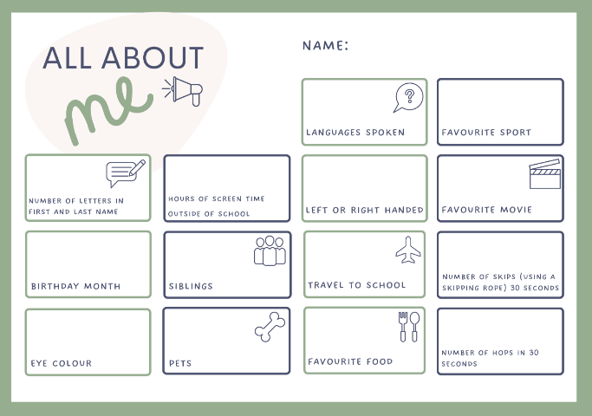

Resource 3: Data table
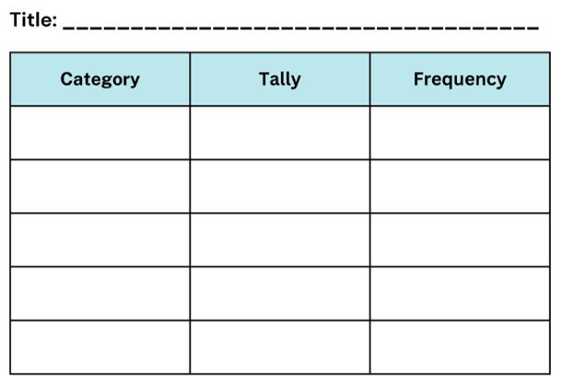

Resource 4: Dot plots
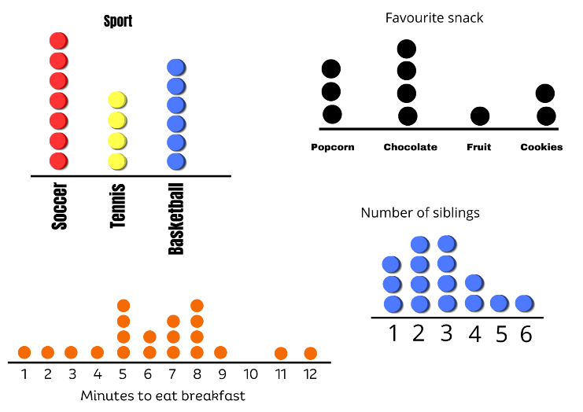

Resource 5: Screen time
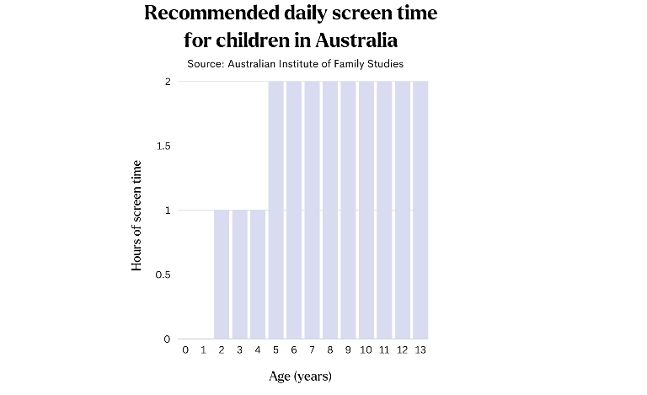

Resource 6: Slow reveal column graph
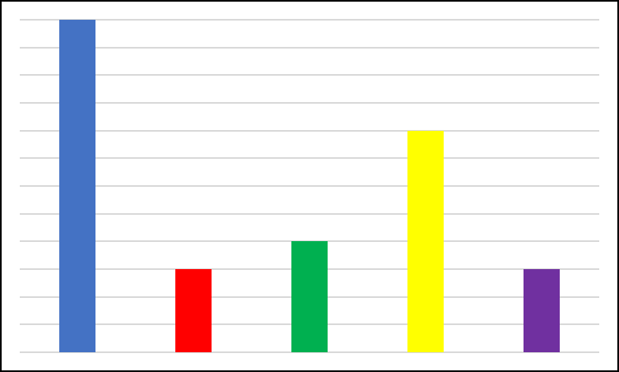
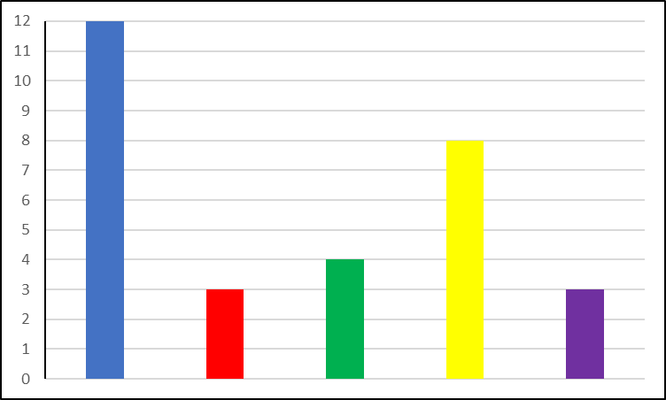
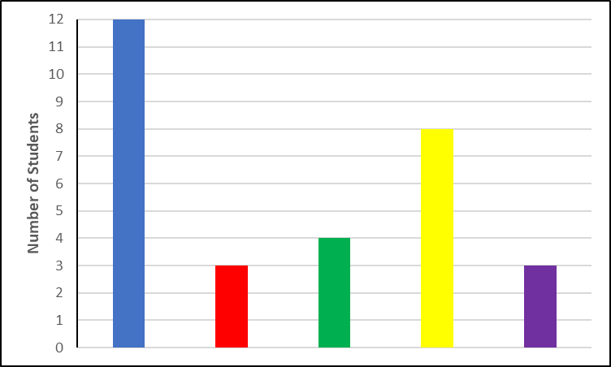
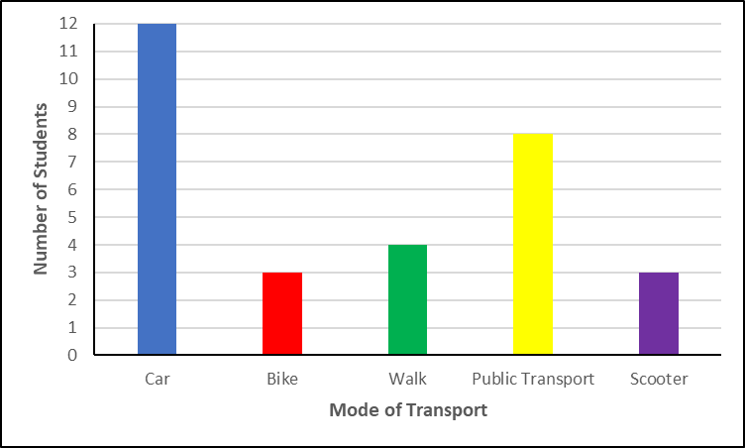
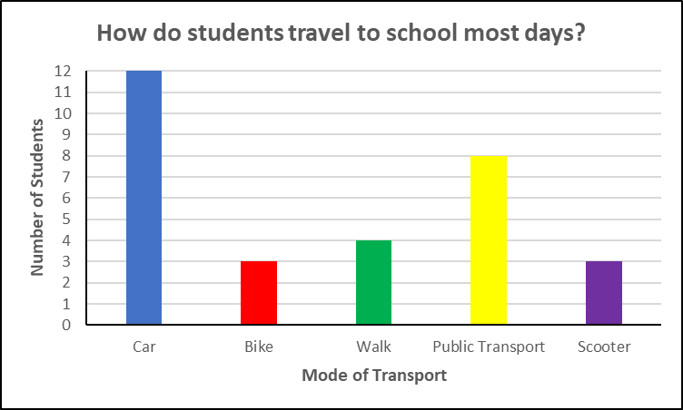

Resource 7: Slow reveal tally table
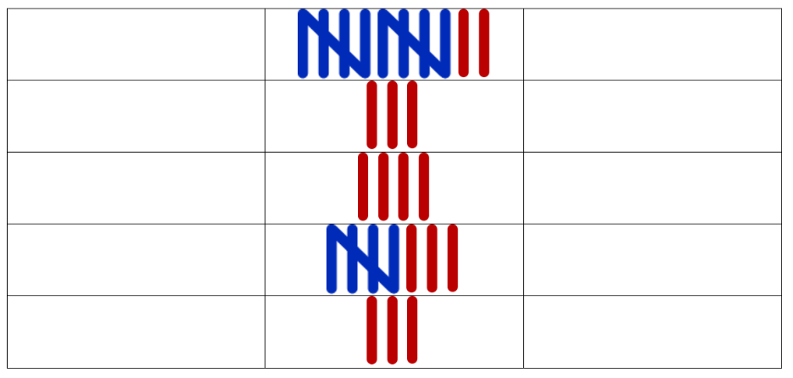
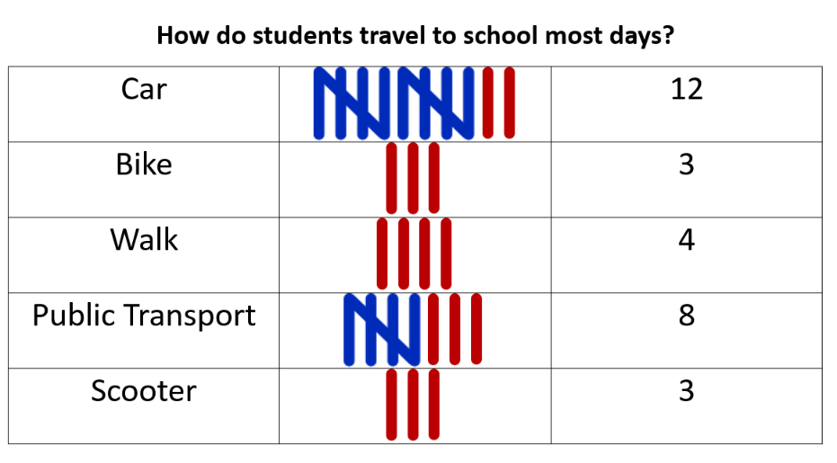

Resource 8: Average steps per day by country
Country | China | Indonesia | United Kingdom | Germany | Hong Kong | Australia | Canada | France | United States | India
Average steps per day | 6189 | 3513 | 5444 | 5205 | 6880 | 4491 | 4819 | 5141 | 4774 | 4297

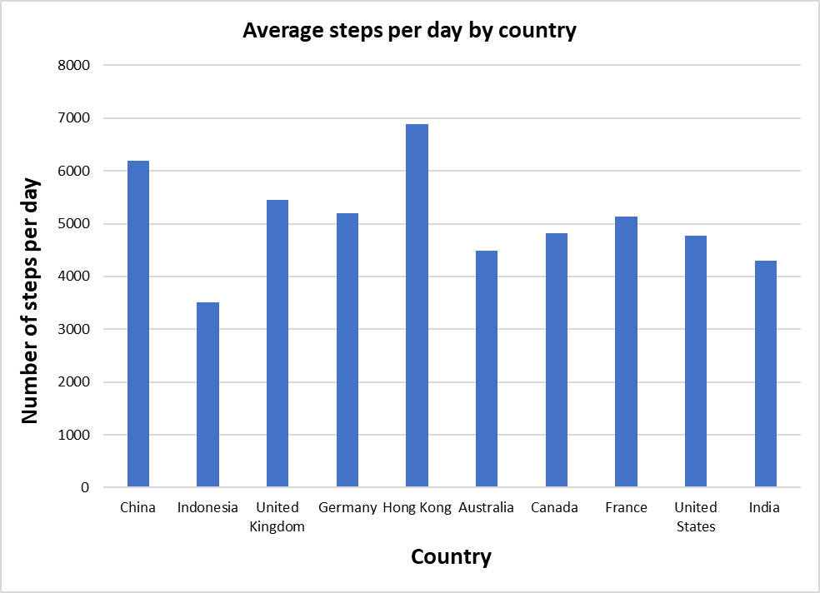
Data sourced from Healthline.

Resource 9: Fun day
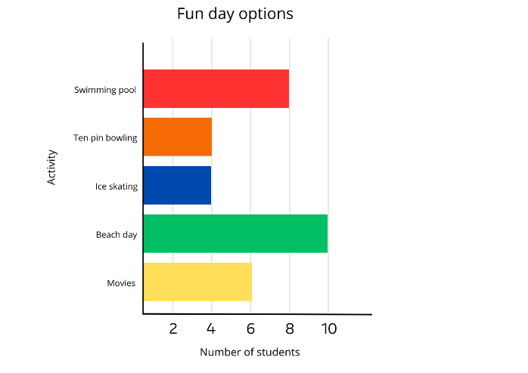

Resource 10: Which one doesn’t belong?
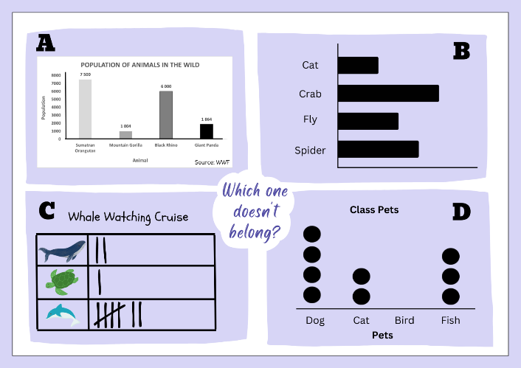

Resource 11: Population numbers of animals in the wild
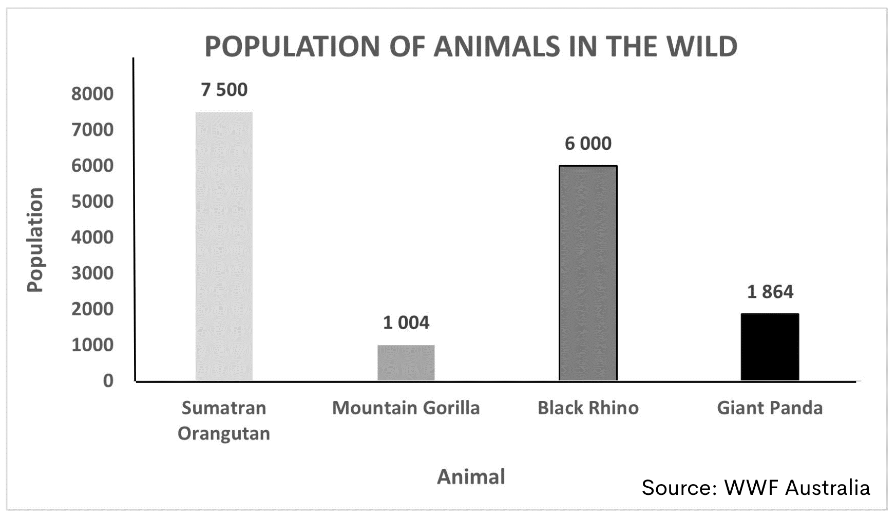

Resource 12: Threatened species
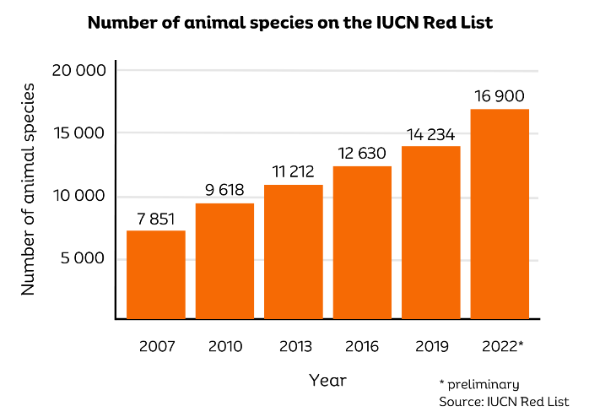

Resource 13: Deforestation
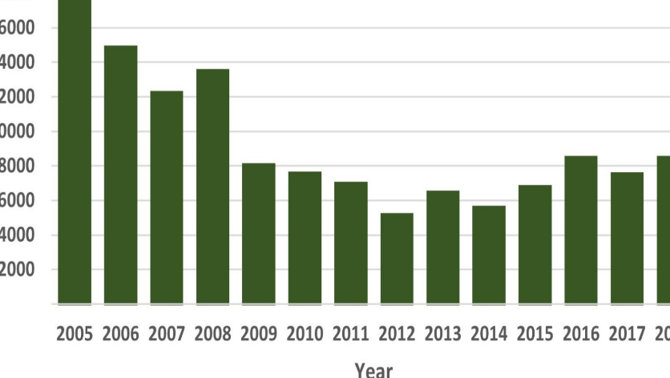
Data sourced from Instituto Nacional de Pesquisas Espaciais.

Resource 14: Team birth years
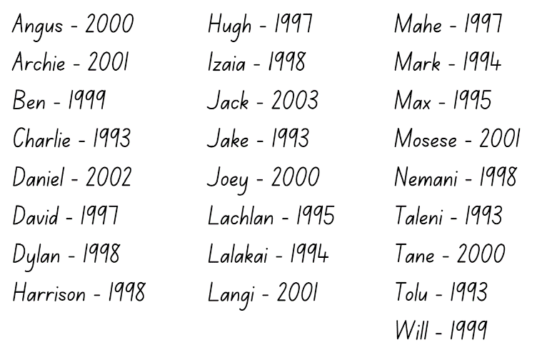

Syllabus outcomes and content
The table below outlines the syllabus outcomes and range of relevant syllabus content covered in this unit. Content is linked to National Numeracy Learning Progression version (3).
Outcomes and content | 1 | 2 | 3 | 4 | 5 | 6 | 7 | 8
Representing numbers using place value A: Whole numbers: Read, represent and order numbers to thousands
MAO-WM-01, MA2-RN-01
- Compare and describe the relative size of numbers by positioning numbers on a number line (Reasons about quantity) |  |  |  |  |  | x | x | x
- Read and order numbers of up to at least 4 digits |  |  |  |  |  | x | x | x
- Identify the number before and after a number with an internal zero digit |  |  |  |  |  |  | x | x
Representing numbers using place value A: Whole numbers: Apply place value to partition and regroup numbers up to 4 digits
MAO-WM-01, MA2-RN-01
- Record numbers using standard place value form | x | x
- Partition numbers of up to 4 digits in non-standard forms (Reasons about quantity) |  |  | x
Multiplicative relations A: Generate and describe patterns
MAO-WM-01, MA2-MR-01
- Model, describe and record patterns of multiples |  |  |  |  | x
- Create and continue a variety of number patterns that increase or decrease by a constant amount |  |  |  |  | x |  | x
- Recognise the significance of the final digit of a whole number in determining whether a given number is even or odd (Reasons about relations) |  |  |  |  |  | x
- Recognise the connection between even numbers and the multiplication facts for 2 (Reasons about relations) |  |  |  |  |  | x
Data A: Collect discrete data
MAO-WM-01, MA2-DATA-01
- Pose questions about a matter of interest to obtain information that can be recorded in categories | x | x
- Collect data from identified sources | x | x | x | x | x
- Predict and create a list of categories for efficient data collection in relation to a matter of interest | x | x | x |  | x
Data A: Organise and display data using tables and graphs
MAO-WM-01, MA2-DATA-01
- Create a list or table to organise the data |  | x | x |  | x |  |  | x
- Construct column graphs (with scale intervals of 1) and dot plots using relevant software where appropriate |  |  |  | x | x |  |  | x
- Mark equal spaces (intervals) on axes, name and label axes and choose appropriate titles for column graphs |  |  |  |  | x |  |  | x
Data A: Interpret and compare data
MAO-WM-01, MA2-DATA-02
- Describe and interpret information presented in tally tables and column graphs |  |  | x |  | x | x | x | x
- Investigate how data is interpreted to make decisions |  |  |  |  |  | x | x
- Represent the same dataset using more than one type of display and compare the displays (Statistical reasoning) |  |  |  |  |  | x |  | x
Mathematics K–10 Syllabus © NSW Education Standards Authority (NESA) for and on behalf of the Crown in right of the State of New South Wales, 2022.

References
This resource contains NSW Curriculum and syllabus content. The NSW Curriculum is developed by the NSW Education Standards Authority. This content is prepared by NESA for and on behalf of the Crown in right of the State of New South Wales. The material is protected by Crown copyright.
Please refer to the NESA Copyright Disclaimer for more information https://educationstandards.nsw.edu.au/wps/portal/nesa/mini-footer/copyright.
NESA holds the only official and up-to-date versions of the NSW Curriculum and syllabus documents. Please visit the NSW Education Standards Authority (NESA) website https://educationstandards.nsw.edu.au/ and the NSW Curriculum website https://curriculum.nsw.edu.au/home.
Mathematics K–10 Syllabus © NSW Education Standards Authority (NESA) for and on behalf of the Crown in right of the State of New South Wales, 2022.
National Numeracy Learning Progression © Australian Curriculum, Assessment and Reporting Authority (ACARA) 2010 to present, unless otherwise indicated. This material was downloaded from the Australian Curriculum website (National Literacy Learning Progression) (accessed 31 August 2023) and was not modified.
Australian Institute of Family Studies (2021) ‘Too much time on screens? Screen time effects and guidelines for children and young people’, Australian Institute of Family Studies, accessed 19 June 2023.
International Union for Conservation of Nature and Natural Resources (2023) The IUCN Red List of Threatened Species, IUCN Red List website, accessed 20 June 2023.
McCarthy N (2020) ‘Brazil Sees Worst Deforestation In A Decade’, Brazil, Statista website, accessed 20 June 2023.
New Zealand Ministry of Education (n.d.) ‘True or false’, NZ Maths website, accessed 11 June 2023.
Santos-Longhorn A (November 27 2018) ‘How Many Steps Do People Take Per Day on Average?’, Healthline website, accessed 19 June 2023.
State of New South Wales (Department of Education) (2023) ‘Counting game (by multiples of 5)’, Mathematics K-6 resources, NSW Department of Education website, accessed 9 June 2023.
State of New South Wales (Department of Education) (2023) ‘Data toss – Stage 2 and 3’, Mathematics K-6 resources, NSW Department of Education website, accessed 7 June 2023.
State of New South Wales (Department of Education) (2023) ‘Hit it (3-digit numbers)’, Mathematics K-6 resources, NSW Department of Education website, accessed 7 June 2023.
University of Cambridge (Faculty of Mathematics) (2023) ‘Largest Even’, NRICH website, accessed 9 June 2023.
Van de Walle J, Karp K, Bay-Williams JM, Brass A, Bentley B, Ferguson S, Goff W, Livy S, Marshman M, Martin D, Pearn C, Prodromou T, Symons D and Wilkie K (2019) Primary and Middle Years Mathematics: Teaching Developmentally, 1st Australian edn, Pearson Education Australia, Melbourne.
WWF-Australia (2018) Living Planet Report 2022, WWF Australia website, accessed 20 June 2022.

© State of New South Wales (Department of Education), 2023
The copyright material published in this resource is subject to the Copyright Act 1968 (Cth) and is owned by the NSW Department of Education or, where indicated, by a party other than the NSW Department of Education (third-party material).
Copyright material available in this resource and owned by the NSW Department of Education is licensed under a Creative Commons Attribution 4.0 International (CC BY 4.0) license.
This license allows you to share and adapt the material for any purpose, even commercially.
Attribution should be given to © State of New South Wales (Department of Education), 2023.
Material in this resource not available under a Creative Commons license:
- the NSW Department of Education logo, other logos and trademark-protected material
- material owned by a third party that has been reproduced with permission. You will need to obtain permission from the third party to reuse its material.
Links to third-party material and websites
Please note that the provided (reading/viewing material/list/links/texts) are a suggestion only and implies no endorsement, by the New South Wales Department of Education, of any author, publisher, or book title. School principals and teachers are best placed to assess the suitability of resources that would complement the curriculum and reflect the needs and interests of their students.
If you use the links provided in this document to access a third-party's website, you acknowledge that the terms of use, including licence terms set out on the third-party's website apply to the use which may be made of the materials on that third-party website or where permitted by the Copyright Act 1968 (Cth). The department accepts no responsibility for content on third-party websites.

