Mathematics Stage 2 – Unit 26

Contents
Unit description and duration 5
Syllabus outcomes 5
Working mathematically 6
Student prior learning 6
Lesson overview and resources 8
Lesson 1 13
Daily number sense – deal it – 10 minutes 13
Core lesson – renaming numbers – 35 minutes 15
Consolidation and meaningful practice – 15 minutes 17
Lesson 2 19
Daily number sense – one or bust – 15 minutes 19
Core lesson – making and representing large collections – 30 minutes 20
Consolidation and meaningful practice – 10 minutes 24
Lesson 3 27
Daily number sense – Is he correct? – 10 minutes 27
Core lesson 1 – comparing numbers – 25 minutes 28
Core lesson 2 – ordering numbers – 15 minutes 31
Discuss and connect the mathematics – 5 minutes 33
Lesson 4 34
Daily number sense – 10 minutes 34
Core lesson – representing tenths – 40 minutes 34
Discuss and connect the mathematics – 10 minutes 38
Lesson 5 40
Daily number sense – prove it – 10 minutes 40
Core lesson 1 – introducing hundredths – 15 minutes 42
Core lesson 2 – the role of zero – 15 minutes 43
Consolidation and meaningful practice – 20 minutes 47
Lesson 6 49
Daily number sense – mine equals yours – 10 minutes 49
Core lesson – decimals as equivalent fraction – 30 minutes 51
Consolidation and meaningful practice – 20 minutes 52
Lesson 7 55
Daily number sense – target number sentence – 10 minutes 55
Core lesson – addition – bridging and partitioning – 30 minutes 56
Consolidation and meaningful practice – 15 minutes 59
Lesson 8 61
Daily number sense – 10 minutes 61
Core lesson 1 – subtraction with standard partitioning – 20 minutes 61
Core lesson 2 – subtraction with non-standard partitioning – 20 minutes 64
Discuss and connect the mathematics – 10 minutes 66
Resource 1 – renaming numbers 68
Resource 2 – beach image 69
Resource 3 – chef’s story 70
Resource 4 – button collection 71
Resource 5 – Is he correct? 72
Resource 6 – place value gameboard 73
Resource 7 – tenths strips 74
Resource 8 – prove it 75
Resource 9 – hundredth strips 76
Resource 10 – single decimal house 77
Resource 11 – comparison houses 78
Resource 12 – recording decimals 79
Resource 13 – linear model 1 80
Resource 14 – linear model 2 81
Resource 15 – the vault 82
Resource 16 – True or False? 83
Resource 17 – subtraction with partitioning 1 84
Resource 18 – subtraction with partitioning 2 85
Resource 19 – non-standard partitioning 86
Syllabus outcomes and content 87
References 93

Unit description and duration
This unit develops the big idea that our number system extends infinitely to very large and very small numbers.
In this 2-week unit students are provided opportunities to:
- partition, rename, represent and order numbers up to 6-digits
- apply place value knowledge to recognise, name and order decimals to hundredths
- identify the relationship between addition and subtraction.

Syllabus outcomes
- MAO-WM-01 develops understanding and fluency in mathematics through exploring and connecting mathematical concepts, choosing and applying mathematical techniques to solve problems, and communicating their thinking and reasoning coherently and clearly
- MA2-RN-01 applies an understanding of place value and the role of zero to represent numbers to at least tens of thousands
- MA2-RN-02 represents and compares decimals up to 2 decimal places using place value
- MA2-AR-01 selects and uses mental and written strategies for addition and subtraction involving 2- and 3-digit numbers

Working mathematically
In the Mathematics K–10 Syllabus, there is one overarching Working mathematically outcome (MAO-WM-01). The Working mathematically processes should be embedded within the concepts being taught. The Working mathematically processes present in the Mathematics K–10 Syllabus are:
- communicating
- understanding and fluency
- reasoning
- problem solving.
Mathematics K–10 Syllabus © NSW Education Standards Authority (NESA) for and on behalf of the Crown in right of the State of New South Wales, 2022.

Student prior learning
Before engaging in these teaching and learning activities, students would benefit from prior experience with:
- reading, representing, partitioning and ordering numbers up to thousands
- applying place value to recognise, name and order decimals to tenths
- selecting strategies flexibly to solve addition and subtraction problems.

In NSW classrooms there is a diverse range of students, including Aboriginal and Torres Strait Islander students, students learning English as an additional language or dialect, high potential and gifted students and students with disability. Some students may identify with more than one of these groups or possibly all of them. Refer to Curriculum planning for every student – advice for further information.

Lesson overview and resources
The table below outlines the sequence and approximate timing of lessons, learning intentions and resources.
Lesson | Content | Duration and resources
Lesson 1  Daily number sense learning intention:  - make connections between decimals | Lesson core concept: numbers can be renamed in equivalent ways using place value.  Core concept learning intention:  - apply place value to partition, regroup and rename numbers up to 6 digits | Lesson duration: 60 minutes  - Resource 1 – renaming numbers  - 9-sided dice  - MAB materials (virtual, physical or paper representations)  - One deck of cards (Ace to 9 per student pair)  - Sticky notes  - Writing materials
Lesson 2  Daily number sense learning intention:  - make connections between decimals | Lesson core concept: collections of tens, hundreds and thousands are really useful.  Core concept learning intention:  - represent and regroup numbers to thousands | Lesson duration: 55 minutes  - Resource 2 – beach image  - Resource 3 – chef’s story  - Resource 4 – button collection  - 10-sided dice (4 per student pair)  - Individual whiteboards  - Pasta (6 different varieties)  - Writing materials
Lesson 3  Daily number sense learning intention:  - make connections between decimals | Lesson core concept: the position of each digit corresponds to its size.  Core concept learning intention:  - recognise the place value of each digit in a number | Lesson duration: 55 minutes  - Resource 5 – Is he correct?  - Resource 6 – place value gameboard  - 10-sided dice  - Individual whiteboards  - MAB materials  - Writing materials
Lesson 4  Daily number sense learning intention:  - teacher-identified task based on student needs | Lesson core concept: the place value system can be extended.  Core concept learning intention:  - extend the place value system | Lesson duration: 60 minutes  - Resource 7 – tenths strips  - Writing materials
Lesson 5  Daily number sense learning intention:  - use the principle of equality | Lesson core concept: zero in decimals play an important role.  Core concept learning intention:  - extend the place value system to hundredths | Lesson duration: 60 minutes  - Resource 7 – tenths strips  - Resource 8 – prove it  - Resource 9 – hundredth strips  - Resource 10 – single decimal house  - Resource 11 – comparison houses  - Resource 12 – recording decimals  - Individual whiteboards (class set)  - Writing materials
Lesson 6  Daily number sense learning intention:  - use the principle of equality | Lesson core concept: connections can be made between fractions and decimals.  Core concept learning intention:  - make connections between fractions and decimals | Lesson duration: 60 minutes  - Resource 7 – tenths strips  - Resource 13 – linear model 1  - Resource 14 – linear model 2  - Resource 15 – the vault  - 10-sided dice (class set)  - Individual whiteboards (class set)  - Writing materials
Lesson 7  Daily number sense learning intention:  - use the principle of equality | Lesson core concept: partitioning into place value parts helps model addition and subtraction.  Core concept learning intention:  - apply known strategies to solve addition and subtraction | Lesson duration: 55 minutes  - Resource 16 – True or False?  - 10-sided dice (class set)  - Individual whiteboards  - Writing materials
Lesson 8  Daily number sense learning intention:  - teacher-identified task based on student needs | Lesson core concept: non-standard partitioning can be an efficient way to solve addition and subtraction problems.  Core concept learning intention:  - apply known strategies to solve addition and subtraction problems | Lesson duration: 60 minutes  - Resource 17 – subtraction with partitioning 1  - Resource 18 – subtraction with partitioning 2  - Resource 19 – non-standard partitioning  - 10-sided dice (class set)  - Individual whiteboards  - One deck of cards per student pair (number cards and aces only)  - Writing materials

Lesson 1
Core concept: numbers can be renamed in equivalent ways using place value.

Daily number sense – deal it – 10 minutes
The table below contains a suggested learning intention and success criteria. These are best co-constructed with students.
Daily number sense learning intention | Daily number sense success criteria
Students are learning to:  - make connections between decimals. | Students can:  - compare and order decimals of up to 2 decimal places.
- In pairs, students divide a deck of cards between them, using number cards and aces for one.
- Each students’ cards remain face down in a pile in front on them.
- On a whiteboard, each student draws a box large enough to fit a playing card, a dot and then 2 more large boxes.
- At the same time, each student turns over 3 cards, placing them into the boxes on their whiteboard (see Figure 1).
Figure 1 – example of student whiteboard
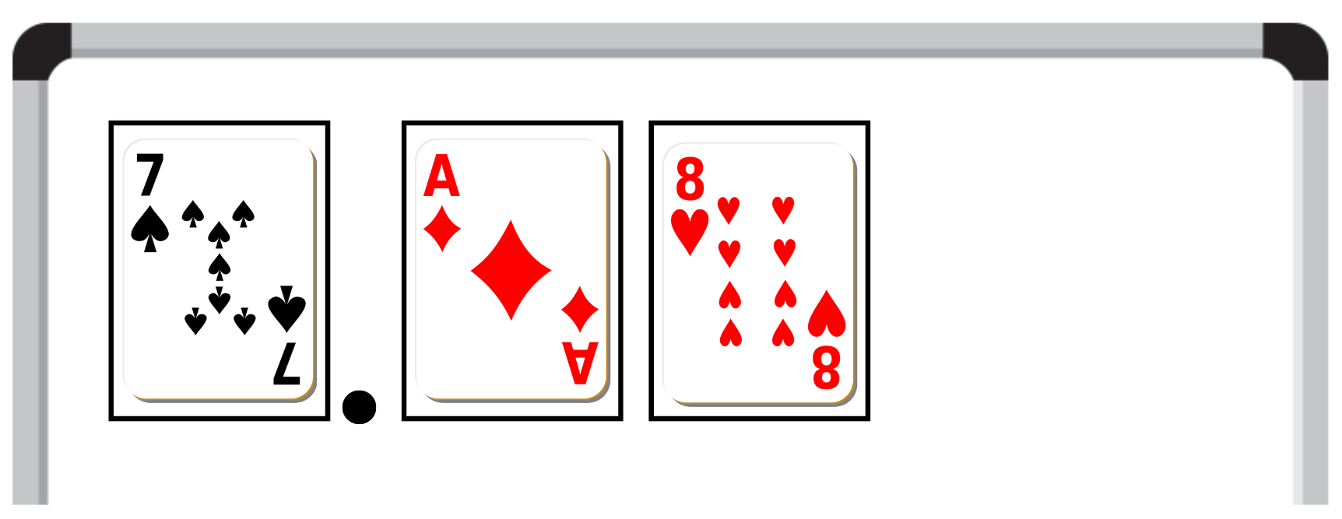
- Each student records their number on a sticky note.
- Students place the sticky notes in ascending order.
- Repeat the process, adding the new sticky notes to the order (see Figure 2).
Figure 2 – sticky notes in ascending order
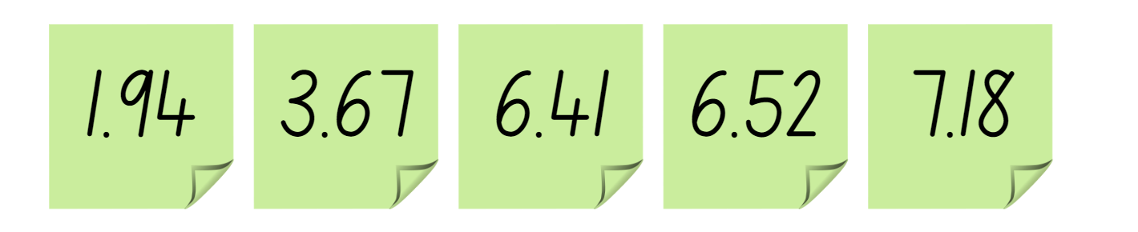
This table details opportunities for assessment.
Assessment opportunities | Links
What to look for:  - Can students compare and order decimals of up to 2 decimal places? [MAO-WM-01, MA2-RN-02] | Links to National Numeracy Learning Progressions (NNLP):  - NPV6, NPV7.  Links to suggested Interview for Student Reasoning (IfSR) tasks:  - IfSR-NP: 4D.1, 4D.4.

Core lesson – renaming numbers – 35 minutes
The table below contains a suggested learning intention and success criteria. These are best co-constructed with students.
Core concept learning intention | Core concept success criteria
Students are learning to:  - apply place value to partition, regroup and rename numbers up to 6 digits. | Students can:  - use MAB materials to represent standard partitioning  - rename a number using non-standard partitioning  - recognise numbers can be renamed in different ways.
This activity is an adaptation of Short activity: Two place value games for building fluency with non-standard partitioning by Russo and Russo.
- Display Resource 1 – renaming numbers. Ask students what they notice and discuss responses.
Note: if students do not identify that the number 145 has been renamed in different ways, discuss the concept of standard and non-standard partitioning. This is a key concept of this lesson and needs to be fully understood before continuing.
Standard place value partitioning: reflects the individual values of each digit in a number (QLD DET 2014).
Non-standard place value partitioning: shows flexible ways to break numbers up (QLD DET 2014).
- Roll a 9-sided dice 6 times and record each number.
- Ask a student to create a 6-digit number using these numbers.
- Ask a different student to represent this number using standard place value partitioning, with virtual MAB materials.
- While the student is representing the number, the teacher ‘renames’ the number using non-standard place value partitioning and records the renamed number on a whiteboard without showing the students. For example, the number 521 367 could be renamed as 521 thousands, 3 hundreds and 67 ones, or 5213 hundreds, 6 tens and 7 ones, or 52 ten thousands, one thousand, 36 hundreds and 7 ones, or 521 367 ones.
- The students take turns guessing how the number has been renamed. Students may use individual whiteboards or virtual MAB materials to support their thinking, if required.
- When the students have guessed the answer correctly, the teacher shows them how they have renamed the number.
- Students play this game in groups of 4, with 2 students taking on the teacher-modelled role, and 2 taking on the student’s role. Pairs then swap roles.
This table details opportunities for differentiation.
Too hard? | Too easy?
Students cannot rename a number using non-standard partitioning.  - Support students to rename numbers by only rolling the dice twice to create a 2- or 3-digit number.  - Assist students to use a systematic recording process. For example, prompt them to rename the number with one ‘10’ first. Ask questions, such as ‘How many ones would there be if you had one 10?’ Repeat for 2 tens, 3 tens and so on. | Students can rename a number using non-standard partitioning.  - Ask students to find 3 or more ways of renaming each number. Students convince a classmate that they are correct.  - Students sit back-to-back, each with a whiteboard. Student A writes a 6-digit number on their whiteboard. The number could be written using standard or non-standard partitioning. Student B asks place value questions about the number until they work out what the number is. Students then compare numbers.

Consolidation and meaningful practice – 15 minutes
- Provide each student with a multi-digit number.
- Students rename the number as many different ways as they can. They can use physical or virtual MAB materials and record their answers on a whiteboard.
- Students compare their ideas with students who have the same number, justifying why they have arranged the numbers as they have.
- Lead a class discussion reflecting on the learning from this lesson.
- Ask students:
- In what ways have you been a mathematician today?
- Can you explain the process you followed to rename your number?
- How did you know if you’d found all the possibilities?
This table details opportunities for assessment.
Assessment opportunities | Links
What to look for:  - Can students use MAB materials to represent standard partitioning? [MAO-WM-01, MA2-RN-01]  - Can students rename a number using non-standard partitioning? [MAO-WM-01, MA2-RN-01]  - Can students recognise numbers can be renamed in different ways? [MAO-WM-01, MA2-RN-01] | Links to National Numeracy Learning Progressions (NNLP):  - NPV5, NPV6.  Links to suggested Interview for Student Reasoning (IfSR) tasks:  - IfSR-AT: 3B.2, 3B.3, 3B.4.

Lesson 2
Core concept: collections of tens, hundreds and thousands are really useful.

Daily number sense – one or bust – 15 minutes
The table below contains a suggested learning intention and success criteria. These are best co-constructed with students.
Daily number sense learning intention | Daily number sense success criteria
Students are learning to:  - make connections between decimals | Students can:  - compare and order decimals of up to 2 decimal places.
- In pairs, students roll two 10-sided dice each.
- Students arrange their 2 dice to make a number between zero and one with 2 decimal places, such as 0.34. Record this number on a sticky note.
- Students draw a number line on a whiteboard and then place their decimal along it (see Figure 3).
Figure 3 – example of student work
Note: the target for this activity can be easily changed, for example, students could be aiming for closest to one, closest to zero, closest to 0.5, largest decimal or smallest decimal.
This table details opportunities for assessment.
Assessment opportunities | Links
What to look for:  - Can students compare and order decimals of up to 2 decimal places? [MAO-WM-01, MA2-RN-02] | Links to National Numeracy Learning Progressions (NNLP):  - NPV6, NPV7.  Links to suggested Interview for Student Reasoning (IfSR) tasks:  - IfSR-NP: 4D.1, 4D.4.

Core lesson – making and representing large collections – 30 minutes
The table below contains a suggested learning intention and success criteria. These are best co-constructed with students.
Core concept learning intention | Core concept success criteria
Students are learning to:  - represent and regroup numbers to thousands. | Students can:  - estimate number of items in a large collection  - group pasta to show the structure of tens, hundreds and thousands  - regroup numbers flexibly  - choose and use an efficient strategy to represent and regroup large numbers.
This lesson is an adaption of the picture book Great Estimations by Goldstone.
- Display Resource 2 – beach image. Ask students:
- About how many people are swimming at the beach?
- Do you see more than 3 people?
- Do you see fewer than 8 000 000?
- Explain to students that estimation is an accurate tool used to get close to the real number.
Estimating: making numbers simpler but keeping their value close to what it was. The result is not exact, but it gives an idea of what the total will be (BBC 2023).
- Display Resource 3 – chef’s story.
- Read the scenario aloud to the class.
- Explain that students will be counting a large collection of objects.
- Display a large collection of 6 different types of pasta.
- Explain that each type of pasta represents a different place value. For example, penne pasta represents ones, spiral pasta represents tens, shell pasta represents hundreds, rigatoni pasta represents thousands, bowtie pasta represents tens of thousands and wheel pasta represents hundreds of thousands (see Figure 4).
Figure 4 – pasta representations
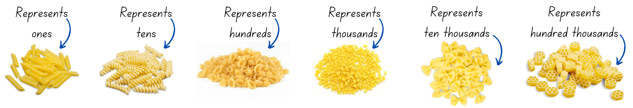
- Divide the class into small groups of 3 or 4 students.
- Provide each group with a collection of 6 different types of pasta.
Note: this collection must include 6 different types of pasta to represent ones, tens, hundreds and thousands, tens of thousands and a hundred thousands. Other objects can be used so long as there are 6 different types or colours of each. For example, counters, pattern blocks or interlocking cubes.
- Without counting, ask students to estimate how much pasta is in their collection and note their estimation on their whiteboard.
- Students work in groups to count their collection and record on their whiteboards.
- Observe how students organise their collection. Look for students who are grouping in ones, tens, hundreds, thousands, tens of thousands and a hundred thousands to make 6-digit numbers.
- Once all groups have counted and organised their collection, invite groups to share with the class how they organised their collection.
- Ask groups to swap places with another group and invite students to time how long it takes to count the other group’s collection.
- Choose students to share with the class how long it took to count the other groups collection. Ask students to then explain whether they were able to count the collection efficiently.
- Students engage in a gallery walk to examine how each group organised their collection.
- Discuss with the class:
- What did you notice?
- How did groups organise their pasta?
- Which was the most efficient strategy you saw?
This table details opportunities for differentiation.
Too hard? | Too easy?
Students cannot group physical or virtual objects to show the structure of tens, hundreds and thousands.  - Assist students by providing only 2 or 3 types of pasta to organise, reducing their number size to 2- or 3-digit numbers.  - Provide a scaffold to support students to organise the pasta. For example, circles in which to place 10 pieces of pasta. | Students can group physical or virtual objects to show the structure of tens, hundreds and thousands.  - Have students use virtual manipulatives to demonstrate how they organised their collection. Use the virtual manipulatives to demonstrate a number of other ways the collection could have been organised.  - Challenge students to combine 2 groups of pasta collections and develop an efficient way of determining how many pieces of pasta are in the combined collection, without using the work the group has already done.

Consolidation and meaningful practice – 10 minutes
- Provide each student with a copy of the Resource 4 – button collection.
- Ask students to estimate how many buttons are in the collection.
- Students work independently to organise the collection and support efficient counting.
- Choose students to share how they organised their collection and what the total is.
- Ask students:
- Did you use a similar strategy to one you saw earlier today?
- Was your strategy efficient? Why or why not?
- How does grouping objects help us count large collections?
This table details opportunities for assessment.
Assessment opportunities | Links
What to look for:  - Can students estimate the total number of objects in a large collection? [MAO-WM-01, MA2-RN-01]  - Can students group pasta to show the structure of tens, hundreds and thousands? [MAO-WM-01, MA2-RN-01]  - Can students regroup numbers flexibly? [MAO-WM-01, MA2-RN-01]  - Can students choose and use an efficient strategy to represent and regroup large numbers? [MAO-WM-01, MA2-RN-01] | Links to National Numeracy Learning Progressions (NNLP):  - NPV4, NPV5, NPV6.  Links to suggested Interview for Student Reasoning (IfSR) tasks:  - IfSR-AT: 3B.1.

Lesson 3
Core concept: the position of each digit corresponds to its size.

Daily number sense – Is he correct? – 10 minutes
The table below contains a suggested learning intention and success criteria. These are best co-constructed with students.
Daily number sense learning intention | Daily number sense success criteria
Students are learning to:  - make connections between decimals. | Students can:  - compare and order decimals of up to 2 decimal places.
- Display Resource 5 – Is he correct?
- Read the scenario to the students.
- Independently or in pairs, students work on whiteboards to determine if Paul’s decimal would be in the correct place. They must provide evidence to support their answers. For example, ‘Paul’s decimal cannot go there because the 4 in the tenths place is smaller than the 5 in the tenths place on the yellow sticky note, so it should be before that one.’
- Discuss student answers as a class.
- Ask:
- How did you determine if the answer was correct?
- Where should Paul place his decimal? How do you know?
- What number could go in the extra square?
- Students share their answers with a partner.
- Repeat activity if time permits using different consecutive numbers.
This table details opportunities for assessment.
Assessment opportunities | Links
What to look for:  - Can students compare and order decimals of up to 2 decimal places? [MAO-WM-01, MA2-RN-02] | Links to National Numeracy Learning Progressions (NNLP):  - NPV6, NPV7.  Links to suggested Interview for Student Reasoning (IfSR) tasks:  - IfSR-NP: 4D.1, 4D.4.

Core lesson 1 – comparing numbers – 25 minutes
The table below contains a suggested learning intention and success criteria. These are best co-constructed with students.
Core concept learning intention | Core concept success criteria
Students are learning to:  - recognise the place value of each digit in a number. | Students can:  - compare the size of each digit in a number  - place numbers in ascending and descending order  - justify their choices when renaming numbers.
This activity is an adaptation of Short activity: Two place value games for building fluency with non-standard partitioning by Russo and Russo.
Note: by this stage of learning, students should have an understanding of standard and non-standard partitioning of 3-digit numbers. Revise this concept as needed before introducing the following activity.
- Model the following activity with another student to explain expectations and how to play.
- Student A rolls six 10-sided dice (physical dice or using virtual dice) to create a 6-digit number, using one of the dice to represent each of the hundred thousands, ten thousands, thousands, hundreds, tens and ones columns. For example, 738 546.
- Student A and Student B use non-standard partitioning to rename the number. Each player records their renamed number on Resource 6 – place value gameboard (see Figure 5).
Figure 5 – gameboard example
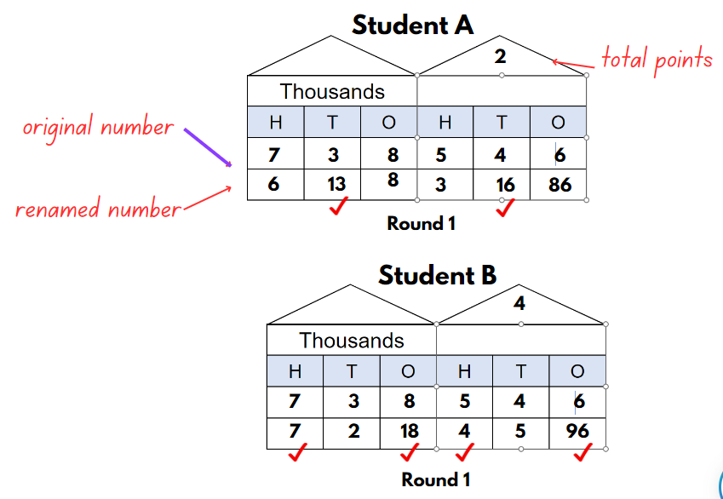
- Beginning with the hundred thousands column, players reveal their renamed number. The player who has the highest number recorded in each place value column (hundred thousands, ten thousands, thousands, hundreds, tens and ones) receives one point. In the event of a tie, neither player is awarded a point.
- The game continues until one of the players records 21 points.
Note: in our example, Student A ‘won’ the ten thousands and tens battle, whilst Student B ‘won’ the hundred thousands, ten thousands, hundreds and ones. Overall, Student B recorded 4 points for the round, and Student A recorded 2 points.
- Students complete the activity.
- As a whole class, ask students:
- What did you notice throughout the duration of the game?
- Is it possible for one player to win all the points?
- Did you use a strategy or is the winner determined solely by luck?
This table details opportunities for differentiation.
Too hard? | Too easy?
Students cannot compare the size of each digit in a number.  - Provide MAB materials for students to use to support them to rename numbers.  - Support students by reducing the number of dice to be rolled to two 10-sided dice to complete the activity. | Students can compare the size of each digit in a number.  - Encourage students to play in groups of 3 or 4 players.  - Challenge students to write their numbers on a whiteboard without the support of a place value house, to complete the task.

Core lesson 2 – ordering numbers – 15 minutes
- Each student writes a number between 1000 and 999 999 on a whiteboard.
- Students turn and read their number to a partner.
- As a class, without speaking, students form a human number line by organising themselves in ascending order.
- Starting with the student who has the smallest number, students read their number aloud, in order, one at a time.
- As a class, discuss if the order students placed themselves in is correct, or if any students need to move positions.
- Have students use their place value knowledge to justify their number placement.
This table details opportunities for differentiation.
Too hard? | Too easy?
Students cannot place numbers in ascending and descending order.  - Model how to use MAB materials to represent large numbers to assist place value understanding.  - Assist students by reducing their number to a 4-digit number or lower. | Students can place numbers in ascending and descending order.  - Ask students to place their numbers along a number line, ensuring spaces are relative to the size of the numbers.  - Challenge students to work in pairs and combine their 2 sets of numbers to plot on a number line. Students must justify how they know which numbers will be placed where on the number line using their place value knowledge.

Discuss and connect the mathematics – 5 minutes
- As a class, discuss:
- How did you know where to stand?
- What clues are in a number that might help us order them?
- What is the value of the digit in the thousands column in this student’s number?
- How could we rename this student’s number?
This table details opportunities for assessment.
Assessment opportunities | Links
What to look for:  - Can students compare the size of each digit in a number? [MAO-WM-01, MA2-RN-01]  - Can students place numbers in ascending and descending order? [MAO-WM-01, MA2-RN-01]  - Can students justify their choices when renaming numbers? [MAO-WM-01, MA2-RN-01] | Links to National Numeracy Learning Progressions (NNLP):  - NPV4, NPV6.

Lesson 4
Core concept: the place value system can be extended.

Daily number sense – 10 minutes
- From a class need surfaced through formative assessment data, identify a short, focused activity that targets students’ knowledge, understanding and skills. Example activities may be drawn from the following resources:
- Mathematics K-6 resources
- Universal Resources Hub.

Core lesson – representing tenths – 40 minutes
The table below contains a suggested learning intention and success criteria. These are best co-constructed with students.
Core concept learning intention | Core concept success criteria
Students are learning to:  - extend the place value system. | Students can:  - express decimals as tenths  - represent decimals as parts of a whole  - demonstrates how to record more than 10 tenths  - apply place value knowledge to decimals.
- Revise and discuss:
- decimals are part of a whole number
- decimals are written with a decimal point
- the decimal point separates the whole number part from the decimal part.
- Ask students where they would see or use decimals in their everyday lives. For example, decimal numbers are used to show how much something costs (money), to show how tall someone is (length), to show how heavy something is (weight).
- Provide students with a strip of paper and ask, if this strip of paper represents one whole, how can it be used it to represent tenths. Provide students with enough time to investigate tenths and share their representations when completed.
Note: students’ representations may include folding the strip into 10 equal parts, drawing lines to show 10 equal parts, or cutting the strip into 10 equal parts.
- Lead students in a discussion and highlight the importance of having divided the strip of paper into 10 parts. Explain that these 10 parts need to be equal in size. If students are unable to do this, provide them with Resource 7 – tenths strips.
- Ask students to label the strip and if they haven’t already done so, then cut the strip into 10 equal parts (see Figure 6).
Figure 6 – tenths
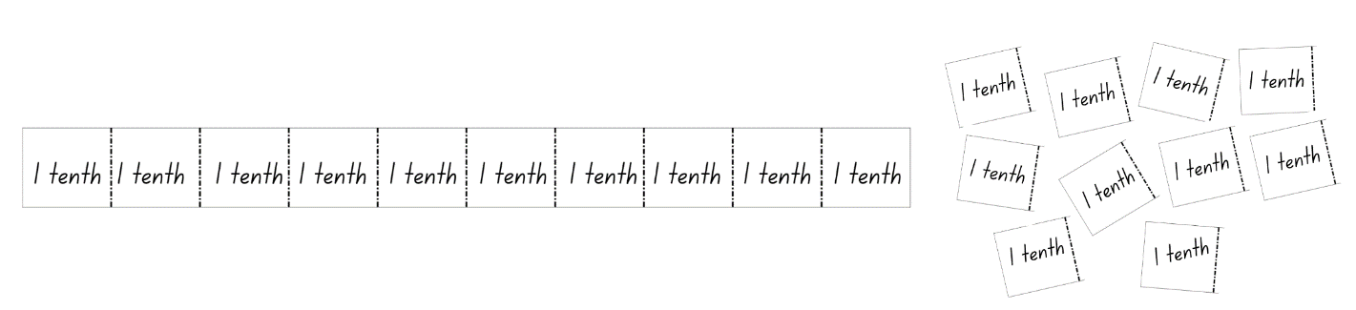
- Using the tenths parts cut up in the previous step, ask students to represent different decimals and record the decimal in a place value house. For example, 4 tenths would be represented with 4 sections of the whole strip by the students. Write 0.4 in the place value house (see Figure 7).
Note: discuss the place value of zero in the ones column and that the first number after the decimal point has a place value of tenths.
Figure 7 – representing decimals
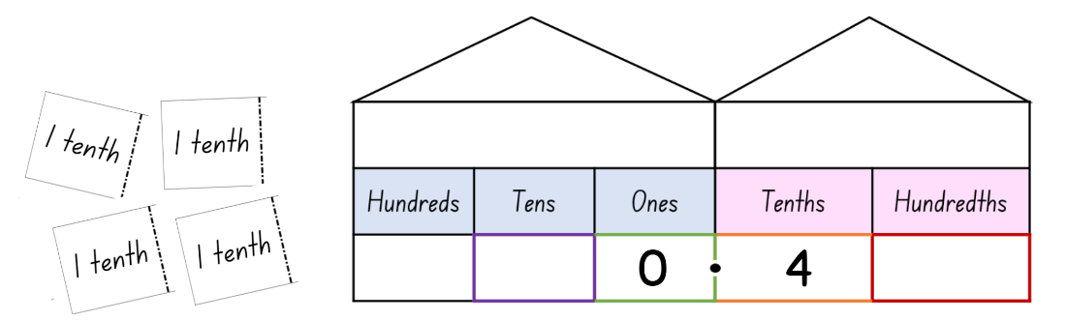
- Continue using the cut-up tenths parts to represent decimals, with students eventually representing decimals with both manipulatives and in the written form independently.
- Provide students with several Resource 7 – tenths strips. Instruct students not to cut these strips into tenths as these strips represent a whole number.
- Students use the whole number strips and cut up tenths parts to investigate how to create a range of numbers and record their decimals on a whiteboard.
Note: investigating decimals with a whole part and decimal part will be new learning. Monitor students’ representations and explicitly teach if needed.
This table details opportunities for differentiation.
Too hard? | Too easy?
Students cannot represent decimals as parts of a whole.  - Students only represent decimals less than one whole.  - Assist students to use manipulatives only to represent decimals.  - Model for students how to write decimals using the place value decimal house. | Students can represent decimals as parts of a whole.  - Ask students to record the decimal that is one tenth more or one tenth less than a given decimal.  - Challenge students to order decimals on a number line. Students show a classmate and discuss how they know their decimals are in the correct places.

Discuss and connect the mathematics – 10 minutes
- Invite students to share numbers they have made and ask:
- How do you read your number?
- How do you record your number?
- How many tenths does your number have?
- What number represents the whole number?
- What number represents the decimal?
- How would you represent 11 tenths?
This table details opportunities for assessment.
Assessment opportunities | Links
What to look for:  - Can students express decimals as tenths? [MAO-WM-01, MA2-RN-02]  - Can students represent decimals as parts of a whole? [MAO-WM-01, MA2-RN-02]  - Can students demonstrate how to record more than ten tenths? [MAO-WM-01, MA2-RN-01, MA2-RN-02]  - Can students apply place value knowledge to decimals? [MAO-WM-01, MA2-RN-02] | Links to National Numeracy Learning Progressions (NNLP):  - NPV6, NPV7.

Lesson 5
Core concept: zero in decimals play an important role.

Daily number sense – prove it – 10 minutes
The table below contains a suggested learning intention and success criteria. These are best co-constructed with students.
Daily number sense learning intention | Daily number sense success criteria
Students are learning to:  - use the principle of equality. | Students can:  - recognise that the equals sign means ‘the same as’  - identify equal differences in number sentences  - provide more than one correct answer to a number sentence.
- Display Resource 8 – prove it. Read the scenario to the students.
- Independently or in pairs, students work on whiteboards to determine who has the correct answer to the number sentence. They must provide justification for their answer, for example, 32 + 24 = 56. 15 + 41 = 56. Eva has the correct answer because her answer is the same as the answer to the number sentence.
- Discuss student answers as a class.
- Ask:
- How did you determine the correct answer?
- Was there more than one correct answer?
- Was there an answer you could rule out right away? Why?
- Ask students if there are any other correct answers to the number sentence that are not on the display.
- Give students an opportunity to write as many different answers to the number sentence as they can on their whiteboards.
- Students share their ideas with a partner, justifying their answers.
This table details opportunities for assessment.
Assessment opportunities | Links
What to look for:  - Can students recognise that the equals sign means ‘the same as’? [MAO-WM-01, MA2-AR-01]  - Can students identify equal differences in number sentences? [MAO-WM-01, MA2-AR-01]  - Can students provide more than one correct answer to a number sentence? [MAO-WM-01, MA2-AR-01] | Links to National Numeracy Learning Progressions (NNLP):  - NPA3, NPA4.  Links to suggested Interview for Student Reasoning (IfSR) tasks:  IfSR-AT: 2A.1.

Core lesson 1 – introducing hundredths – 15 minutes
The table below contains a suggested learning intention and success criteria. These are best co-constructed with students.
Core concept learning intention | Core concept success criteria
Students are learning to:  - extend the place value system to hundredths. | Students can:  - represent decimals up to 2 decimal places  - compare decimals with a zero  - explain the role of zero in decimals.
- Display one tenths strip from Resource 7 – tenths strips.
- Ask students what they know about tenths.
- Introduce hundredths as 10 parts of a tenth.
- Display Resource 9 – hundredth strips and explain that students can extend numbers to have another place after the decimal point. The second number after the decimal point has a place value of hundredths.
- Model completing a place value house and hundredth strip for the decimal number 1.27 (see Figure 8).
Figure 8 – representing hundredths
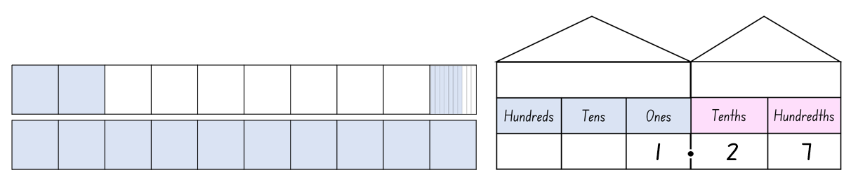
- Using Resource 9 – hundredth strips, students represent a range of decimals containing a whole number and a decimal up to hundredths by colouring in the correct number of parts.
- Repeat this step until students are confident to work independently representing decimals up to hundredths and containing a whole number.

Core lesson 2 – the role of zero – 15 minutes
- Display Resource 10 – single decimal house and write a range of decimals with a zero to discuss the role of zero when it is in different positions. For example, in Figure 9, when the 3 is in the ones place it is a whole number and the decimal point and zero after the number are not necessary. In the decimal 0.3, there are 3 tenths; there is no whole number so a zero is required in the ones place. For 0.03, there are 3 hundredths. There is no whole number and no tenths. Therefore, a zero is required in the ones and tenths place. The zero is considered a place holder.

Note: the role of zero as a placeholder assists in understanding how to say and write decimals. For decimals less than one, zero is written in the ones place to reduce the risk of reading the decimal as a whole number.
Figure 9 – decimal place value
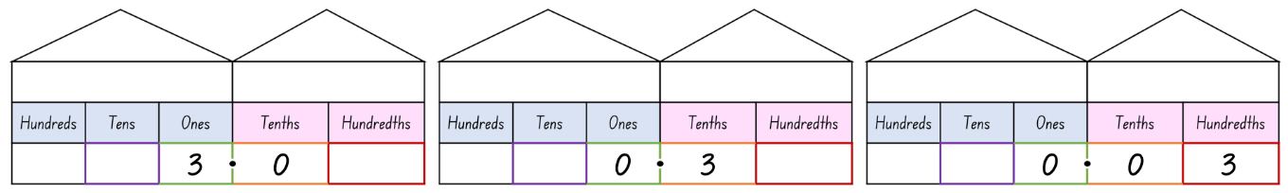
- Model using Resource 11 – comparison houses to compare decimals with hundredths and decimals that have a zero (see Figure 10).
Figure 10 – comparing decimals
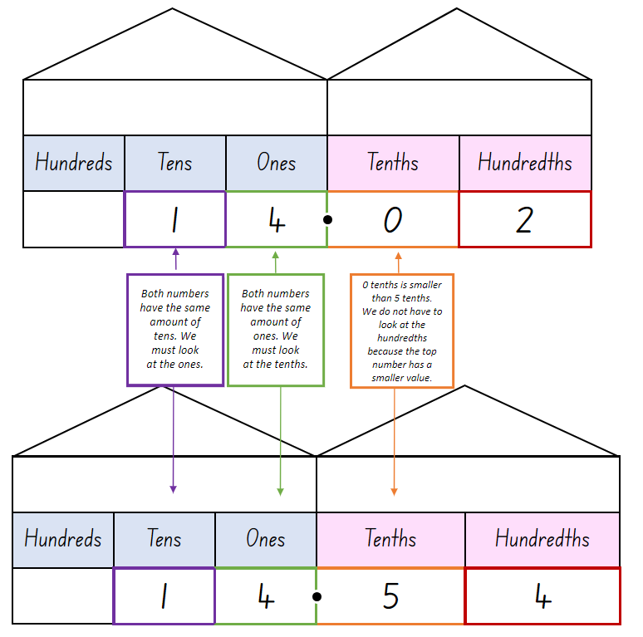
- Give students a copy of Resource 11 – comparison houses.
- List 2 decimals on the board, ensuring one contains a zero.
- Ask students to write the decimals into the comparison houses.
- Discuss where students can see the differences between the 2 numbers and how this helps them to decide which of the numbers is larger or small than the other.
- In pairs, students continue to compare a variety of decimal numbers containing a zero using Resource 11 – comparison houses to determine which of them is the largest or smallest.
This table details opportunities for differentiation.
Too hard? | Too easy?
Students cannot compare decimals with a zero.  - Assist students by reducing the numbers to be compared by providing decimals with tenths only.  - Model the use of Resource 11 – comparison houses to ensure students understand the value of each place. | Students can compare decimals with a zero.  - Ask students to compare 3 numbers with at least one containing a zero. Students can attempt this without using the comparison houses.  - Challenge students to place their decimals in ascending or descending order.

Consolidation and meaningful practice – 20 minutes
- Provide small groups of students with 5 cards. On one card they write a decimal point, on 2 cards they write a zero, and on the remaining 2 cards they write 2 more digits (see Figure 11).
Figure 11 – number cards
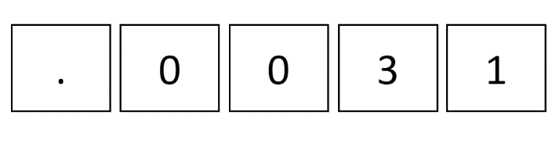
- Students rearrange their cards to complete the Resource 12 – recording decimals and create a range of decimals.
- As a class, formulate rules about the columns where zeros change the size of the number. For example, if a zero is before a whole number or at the end of the decimal it doesn’t change its size.
This table details opportunities for differentiation.
Too hard? | Too easy?
Students cannot interpret zero in decimals.  - Reduce the complexity of the task by asking students to complete this with 4 cards, using only one zero.  - Model how to use Resource 12 – recording decimals for students. | Students can interpret zero in decimals.  - Challenge students to find all the different decimal combinations they can make with their cards.  - Ask students to explain and justify to a classmate how they know that they have found all possible decimals that can be made using their selected cards.
This table details opportunities for assessment.
Assessment opportunities | Links
What to look for:  - Can students represent decimals up to 2 decimal places? [MA0-WM-01, MA2-RN-02]  - Can students compare decimals with a zero? [MA0-WM-01, MA2-RN-02]  - Can students explain the role of zero in decimals? [MA0-WM-01, MA2-RN-02] | Links to National Numeracy Learning Progressions (NNLP):  - NPV6, NPV7.  Links to suggested Interview for Student Reasoning (IfSR) tasks:  - IfSR-NP: 4D.1, 4D.4, 4D.5, 4D.6.

Lesson 6
Core concept: connections can be made between fractions and decimals.

Daily number sense – mine equals yours – 10 minutes
The table below contains a suggested learning intention and success criteria. These are best co-constructed with students.
Daily number sense learning intention | Daily number sense success criteria
Students are learning to:  - use the principle of equality. | Students can:  - recognise that the equals sign means ‘the same as’  - identify equal differences in number sentences  - provide more than one correct answer to a number sentence.
- In pairs, students roll two 10-sided dice.
- Students arrange the dice to make a 2-digit number.
- Each student records a number sentence on their whiteboard that would have the 2-digit number as the answer.
- Students check their partners number sentence and record it as the answer to their number sentence (see Figure 12).
Figure 12 – mine equals yours example
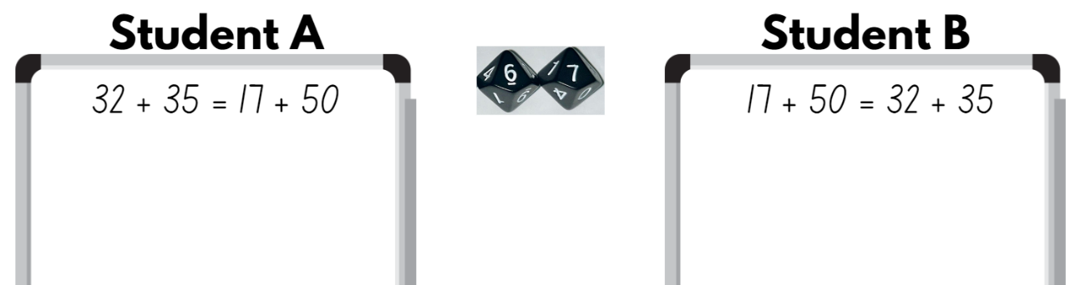
This table details opportunities for assessment.
Assessment opportunities | Links
What to look for:  - Can students recognise that the equals sign means ‘the same as’? [MAO-WM-01, MA2-AR-01]  - Can students identify equal differences in number sentences? [MAO-WM-01, MA2-AR-01]  - Can students provide more than one correct answer to a number sentence? [MAO-WM-01, MA2-AR-01] | Links to National Numeracy Learning Progressions (NNLP):  - NPA3, NPA4.  Links to suggested Interview for Student Reasoning (IfSR) tasks:  - IfSR-AT: 2A.1.

Core lesson – decimals as equivalent fraction – 30 minutes
The table below contains a suggested learning intention and success criteria. These are best co-constructed with students.
Core concept learning intentions | Core concept success criteria
Students are learning to:  - make connections between fractions and decimals. | Students can:  - represent decimals as an equivalent fraction  - apply place value knowledge to investigate a problem.
- Display Resource 7 – tenths strips and revise that the rectangle represents a whole, which has been divided into 10 parts.
- Fill in 3 boxes on one linear model and ask students what they represent.
- Explain that decimals have an equivalent fraction because they are both part of a whole. The 3 boxes which have been filled in, can be represented as 3 tenths, 0.3, or the fractional notation $\frac{3}{10}$ (see Figure 13).
Figure 13 – linear model 1
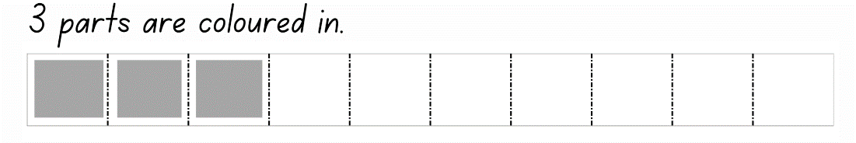
- Collaboratively label all the parts of the linear model with both decimal and fractional notations
- Provide students with a copy of the Resource 7 – tenths strips and ask them to colour in 8 parts.
- Work collaboratively with students to record the equivalent decimal and fractional notations.
- Using Resource 13 – linear model 1, students work independently to interpret the linear model and record the equivalent decimal and fractional notation.
This table details opportunities for differentiation.
Too hard? | Too easy?
Students cannot represent decimals as an equivalent fraction.  - Support students by asking them to only record the decimal notation.  - Assist students to record fractions by only using words. | Students can represent decimals as an equivalent fraction.  - Students complete Resource 14 – linear model 2 and compare their answers with a classmate. Where answers differ, students must explain and justify their solutions.  - Challenge students to order their decimals and fractions from Resource 14 – linear model 2 on a number line.

Consolidation and meaningful practice – 20 minutes
- Display Resource 15 – the vault.
- Read the scenario aloud to the class.
- Explain that students will need to find the equivalent decimal notation to the fractional notation they have been provided.
- In pairs, students work together to solve the code.
Note: the answer to the code is 010509025075131172405. Students needs to convert the fractions to decimals and then remove the decimal point to crack the code and unlock the app.
- Ask students:
- What strategy did you use to solve the code?
- What mathematical knowledge did you need to know to complete this activity?
This table details opportunities for assessment.
Assessment opportunities | Links
What to look for:  - Can students represent decimals as an equivalent fraction? [MA0-WM-01, MA2-RN-02]  - Can students apply place value knowledge to investigate a problem? [MA0-WM-01, MA2-RN-02] | Links to National Numeracy Learning Progressions (NNLP):  - InF6, InF7.  Links to suggested Interview for Student Reasoning (IfSR) tasks:  - IfSR-PT: 2A.10.

Lesson 7
Core concept: partitioning into place value parts helps model addition and subtraction.

Daily number sense – target number sentence – 10 minutes
The table below contains a suggested learning intention and success criteria. These are best co-constructed with students.
Daily number sense learning intention | Daily number sense success criteria
Students are learning to:  - use the principle of equality. | Students can:  - recognise that the equals sign means ‘the same as’  - identify equal differences in number sentences  - provide more than one correct answer to a number sentence.
This activity is an adaptation of ‘Target number’ from Math for love by Finkel.
- Write a target number sentence on the board.
- Using whiteboards, students write down as many different number sentences as they can that have the same answer as the target number sentence. Students must write number sentences to identify equal differences. For example, 46 + 21 = 35 + 32.
- Students turn and talk to a partner to share one of their number sentences, describe the strategies they used to create it and how they know it is correct.
This table details opportunities for assessment.
Assessment opportunities | Links
What to look for:  - Can students recognise that the equals sign means ‘the same as’? [MAO-WM-01, MA2-AR-01]  - Can students identify equal differences in number sentences? [MAO-WM-01, MA2-AR-01]  - Can students provide more than one correct answer to a number sentence? [MAO-WM-01, MA2-AR-01] | Links to National Numeracy Learning Progressions (NNLP):  - NPA3, NPA4.  Links to suggested Interview for Student Reasoning (IfSR) tasks:  - IfSR-AT: 2A.1.

Core lesson – addition – bridging and partitioning – 30 minutes
The table below contains a suggested learning intention and success criteria. These are best co-constructed with students.
Core concept learning intention | Core concept success criteria
Students are learning to:  - apply known strategies to solve addition and subtraction. | Students can:  - bridge numbers to the decade  - use place value knowledge to partition numbers  - investigate the efficiency of a strategy.
- Demonstrate how to use the bridging and partitioning model to solve an addition number sentence (see Figure 14).
Figure 14 – model of bridging
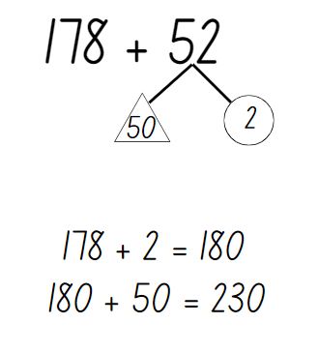
- Write 178 + 52 on the board and explain that this number sentence requires students to break the number into standard place value partitioning. They will need to apply their place value knowledge of hundreds, tens and one to break the number into parts. For example, the number 52 can be partitioned into 50 and 2.
- Discuss the concept of bridging and how parts of a number can be used to bridge to the nearest decade. For example, if a student adds 2 to 178, they have bridged to the nearest decade, 180.
- Write the number sentence 365 + 278 on the board and work collaboratively with students to use the bridging and partitioning model to solve the number sentence. For example, partition 275 into 200, 70 and 5. If students add the 5 to 365, they are bridging to the nearest decade, which is 370. Next add the tens, 370 + 70 = 440.
- Record the final step in the strategy as 440 + 200, which gives the answer to 365 + 278 as 640 (see Figure 15 ).
Figure 15 – 3-digit addition
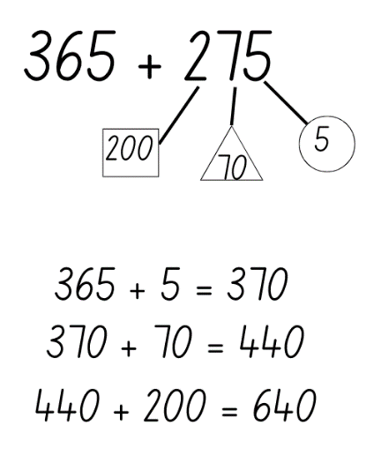
- Students roll three 10-sided dice to create an addition number sentence of two 3-digit numbers.
- Students use the bridging and partitioning model to solve this addition problem.
This table details opportunities for differentiation.
Too hard? | Too easy?
Students cannot bridge numbers to the decade or use place value knowledge to partition numbers.  - Assist the students to solve addition number sentences by reducing their number size to two 2-digit numbers.  - Model the use of MAB materials to complete addition number problems to support students’ thinking. | Students can bridge numbers to the decade or use place value knowledge to partition numbers.  - Challenge students to solve number sentences involving two 4-digit numbers, showing the strategy they used.  - Ask students to write an addition word problem for a partner to solve using the bridging and partitioning strategy.

Consolidation and meaningful practice – 15 minutes
- Provide each student with a copy of Resource 16 – True or False.
- Students use their knowledge of the bridging and partitioning model to check whether each number sentence has been solved correctly.
- In pairs, students share their solutions to confirm their answers and justify their decisions.
This table details opportunities for assessment.
Assessment opportunities | Links
What to look for:  - Can students bridge numbers to the decade? [MA0-WM-01, MA2-RN-01, MA2-AR-01]  - Can students use place value knowledge to partition numbers? [MA0-WM-01, MA2-RN-01, MA2-AR-01]  - Can students investigate the efficiency of a strategy? [MA0-WM-01, MA2-RN-01, MA2-AR-01] | Links to National Numeracy Learning Progressions (NNLP):  - NPV5, NPV6, AdS7.  Links to suggested Interview for Student Reasoning (IfSR) tasks:  - IfSR-AT: 2A.2, 3A.2.

Lesson 8
Core concept: non-standard partitioning can be an efficient way to solve addition and subtraction problems.

Daily number sense – 10 minutes
- From a class need surfaced through formative assessment data, identify a short, focused activity that targets students’ knowledge, understanding and skills. Example activities may be drawn from the following resources:
- Mathematics K-6 resources
- Universal Resources Hub.

Core lesson 1 – subtraction with standard partitioning – 20 minutes
The table below contains a suggested learning intention and success criteria. These are best co-constructed with students.
Core concept learning intention | Core concept success criteria
Students are learning to:  - apply known strategies to solve addition and subtraction problems. | Students can:  - apply standard partitioning to subtraction problems  - use non-standard partitioning to solve subtraction problems  - recognise when to apply standard and non-standard partitioning.
- Model how to solve subtraction number sentences by applying the strategy of standard partitioning.
- Write the number sentence 365 − 43 on the board and explain that, to use standard partitioning, students need to apply their place value knowledge of hundreds, tens and ones to break the number into parts. For example, the number 365 can be partitioned into 300, 60 and 5 and the number 43 can be partitioned into 40 and 3.
- Model writing a number sentence for each place value part. For example, 300 − 0 = 300, 60 − 40 = 20 and 5 − 3 = 2 (see Figure 16).
Figure 16 – standard partitioning subtraction 1
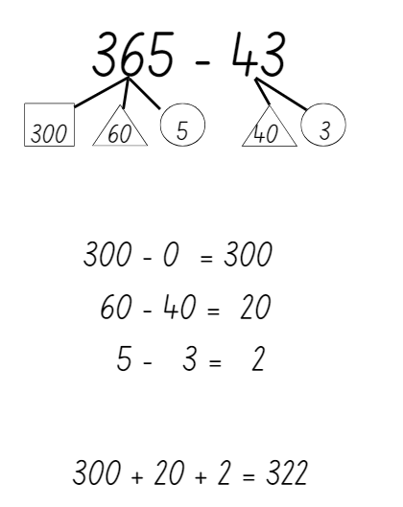
- Record the final step in the strategy as 300 + 20 + 2, which gives the answer to 365 − 43 as 322.
- Display the number sentence 878 − 52 on the board and work collaboratively with students to solve the question together.
- Explain the process of partitioning as you work with students (see Figure 17).
Figure 17 – standard partitioning subtraction 2
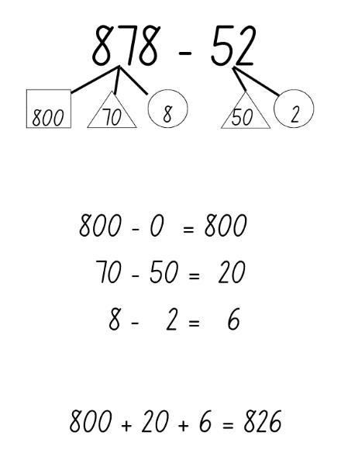
- Repeat this step until students are confident to work independently to solve subtraction number sentences, using standard partitioning.
Note: to ensure standard partitioning can be applied, create number sentences that have digits with a higher place value in the 3-digit number than the 2-digit number.
- Students independently complete number sentences using Resource 17 – subtraction with partitioning 1.
This table details opportunities for differentiation.
Too hard? | Too easy?
Students cannot use standard partitioning to solve addition and subtraction problem.  - Assist the students to solve subtraction number sentences by reducing their number size to two 2-digit numbers.  - Model using MAB materials to complete subtraction number problems to support students’ thinking.  - Complete Resource 18 – subtraction with partitioning 2. | Students can use standard partitioning to solve addition and subtraction problem.  - Challenge students to solve number sentences involving two 3-digit numbers, showing the strategy they used.  - Ask students to write a subtraction word problem for a partner to solve using the standard partitioning strategy.

Core lesson 2 – subtraction with non-standard partitioning – 20 minutes
- Display Resource 19 – non-standard partitioning and ask students:
- What do you notice about how these numbers are partitioned?
- Why were they partitioned this way?
- Invite students to share their ideas and discuss their reasoning. If students do not talk about the value of the digits in each place within the number, explain that they cannot subtract a number with a higher value from a number with a smaller value.
- Use Resource 19 – non-standard partitioning to explain that you have used standard and non-standard partitioning to solve the number sentence 453 − 27. For example, 453 was partitioned into 400, 40 and 13 (instead of 400, 50 and 3) and 27 was partitioned into 20 and 7. Explain that students cannot subtract 7 from 3, but they can subtract 7 from 13. Non-standard partitioning is used when a larger number is being subtracted from a smaller number.
- Model how to use standard and non-standard partitioning to solve subtraction problems (see Figure 18).
Figure 18 – non-standard partitioning example
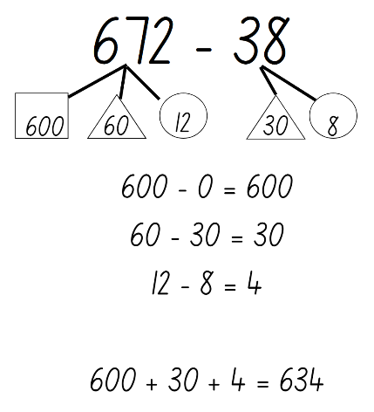
- Students work in pairs to solve subtraction problems.
- Student A uses the number cards and ace from a deck of playing cards. They turn over 3 cards to make a 3-digit number. Student B rolls two 10-sided dice to create a 2-digit number.
- Both students solve the subtraction number sentence individually using the partitioning strategy and record their responses on a whiteboard.
- Students compare their answers and explain how they partitioned the number sentence.
- Partners swap rolls and repeat the task.
Note: students will need to recognise when to apply standard and non-standard partitioning. This will depend on the numbers that are created from the card flip and dice rolled.
This table details opportunities for differentiation.
Too hard? | Too easy?
Students cannot use non-standard partitioning to solve addition and subtraction problems.  - Assist students to solve subtraction number sentences by reducing their number size to two 2-digit numbers.  - Model using MAB materials to complete number problems to support students’ thinking.  - Provide students with number sentences that only require standard partitioning. | Students can use non-standard partitioning to solve addition and subtraction problems.  - Challenge students to solve number sentences involving two 3-digit numbers, showing the strategy they used.  - Ask students to write a word problem for a partner to solve using the strategies they have used over the past few lessons.

Discuss and connect the mathematics – 10 minutes
- Discuss as a whole class how the students knew when to apply standard or non-standard partitioning.
- Ask students:
- How would you explain this strategy to someone else?
- Is this strategy efficient?
- Would you use this strategy again?
This table details opportunities for assessment.
Assessment opportunities | Links
What to look for:  - Can students apply standard partitioning to subtraction problems? [MAO-WM-01, MA2-RN-01, MA2-AR-01]  - Can students use non-standard partitioning to solve subtraction problems? [MAO-WM-01, MA2-RN-01, MA2-AR-01]  - Can students recognise when to apply standard and non-standard partitioning? [MAO-WM-01, MA2-RN-01, MA2-AR-01] | Links to National Numeracy Learning Progressions (NNLP):  - AdS7, AdS8.  Links to suggested Interview for Student Reasoning (IfSR) tasks:  - IfSR-AT: 2A.3, 2A.6, 3A.4.

Resource 1 – renaming numbers
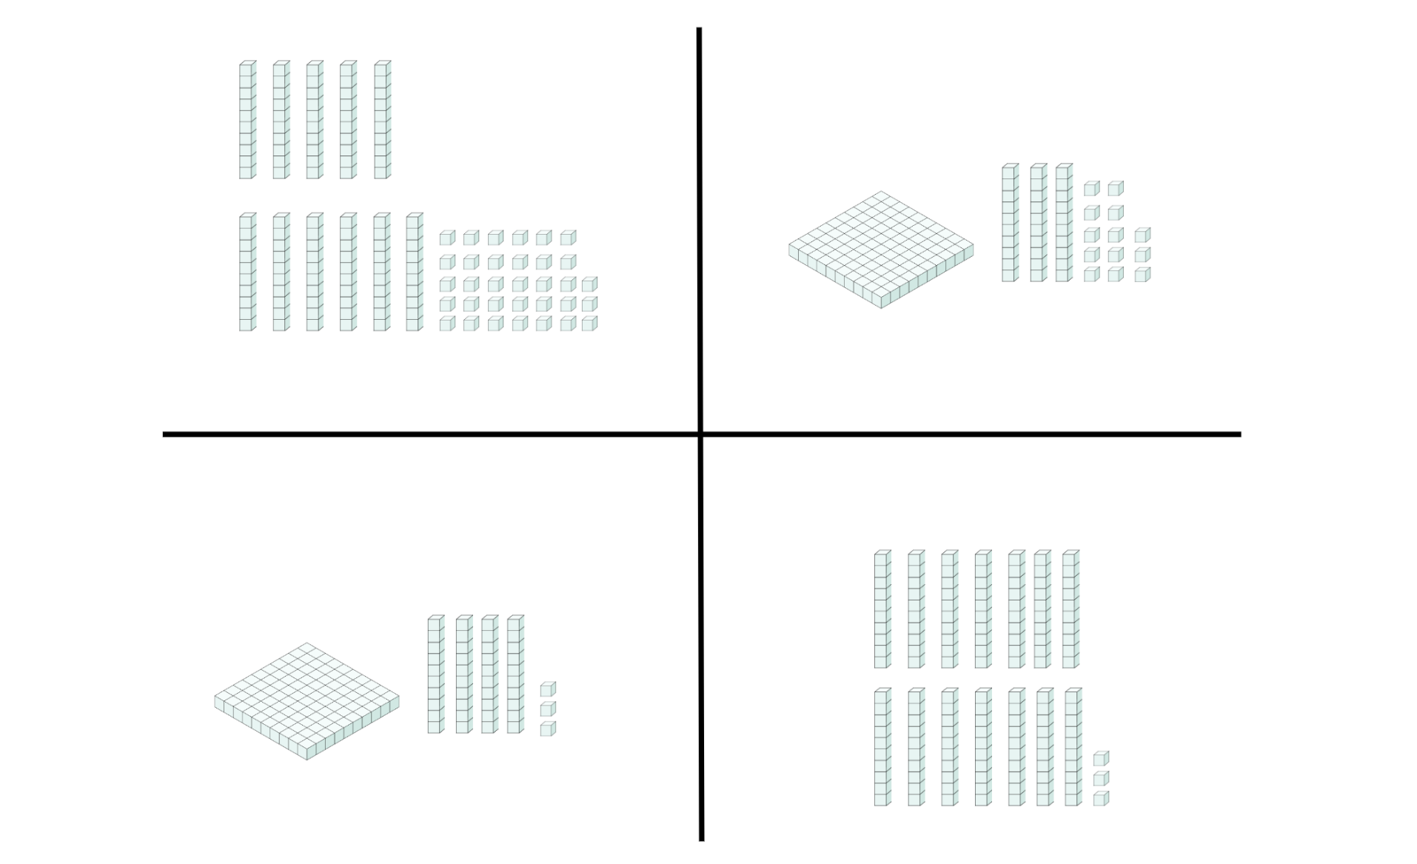

Resource 2 – beach image
© Antenore via Canva.com

Resource 3 – chef’s story
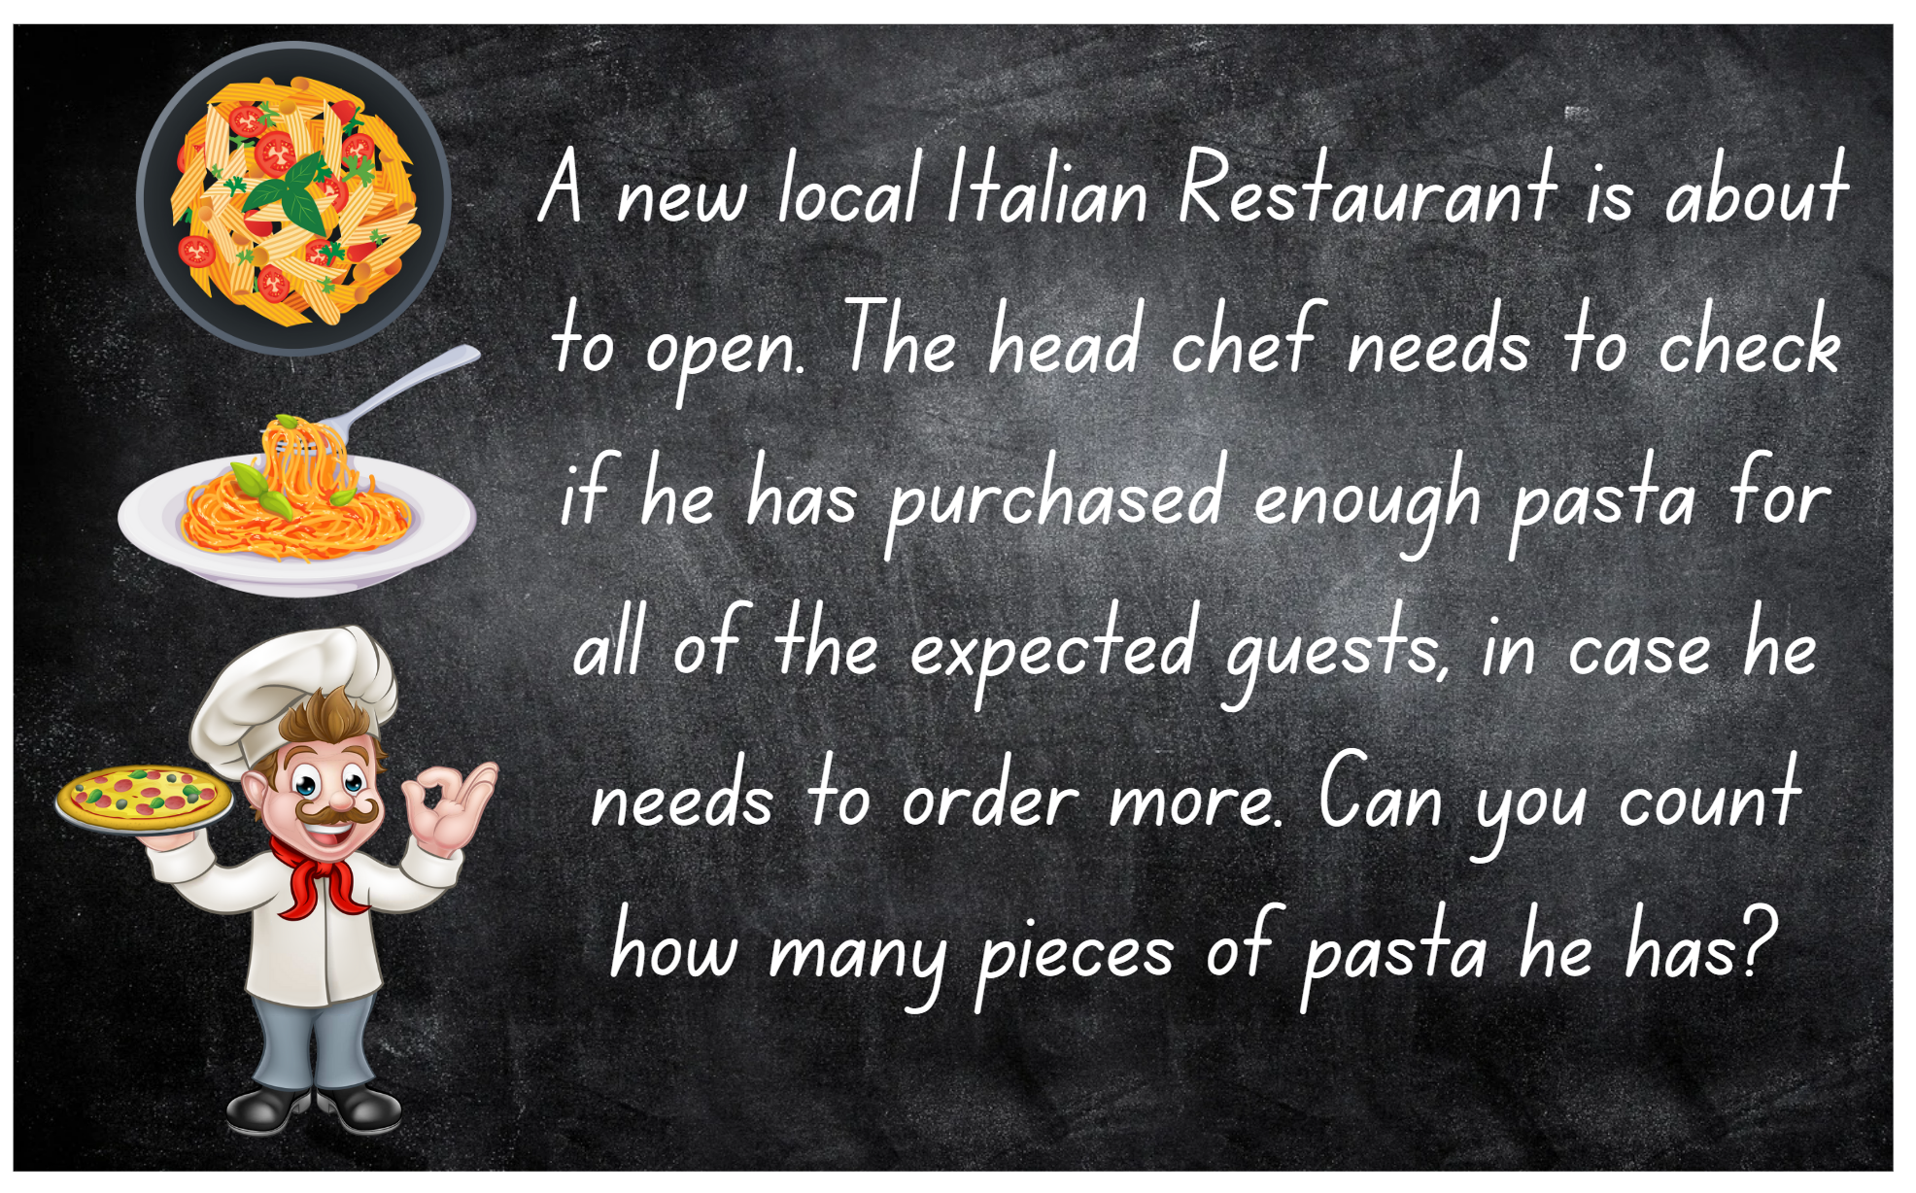

Resource 4 – button collection
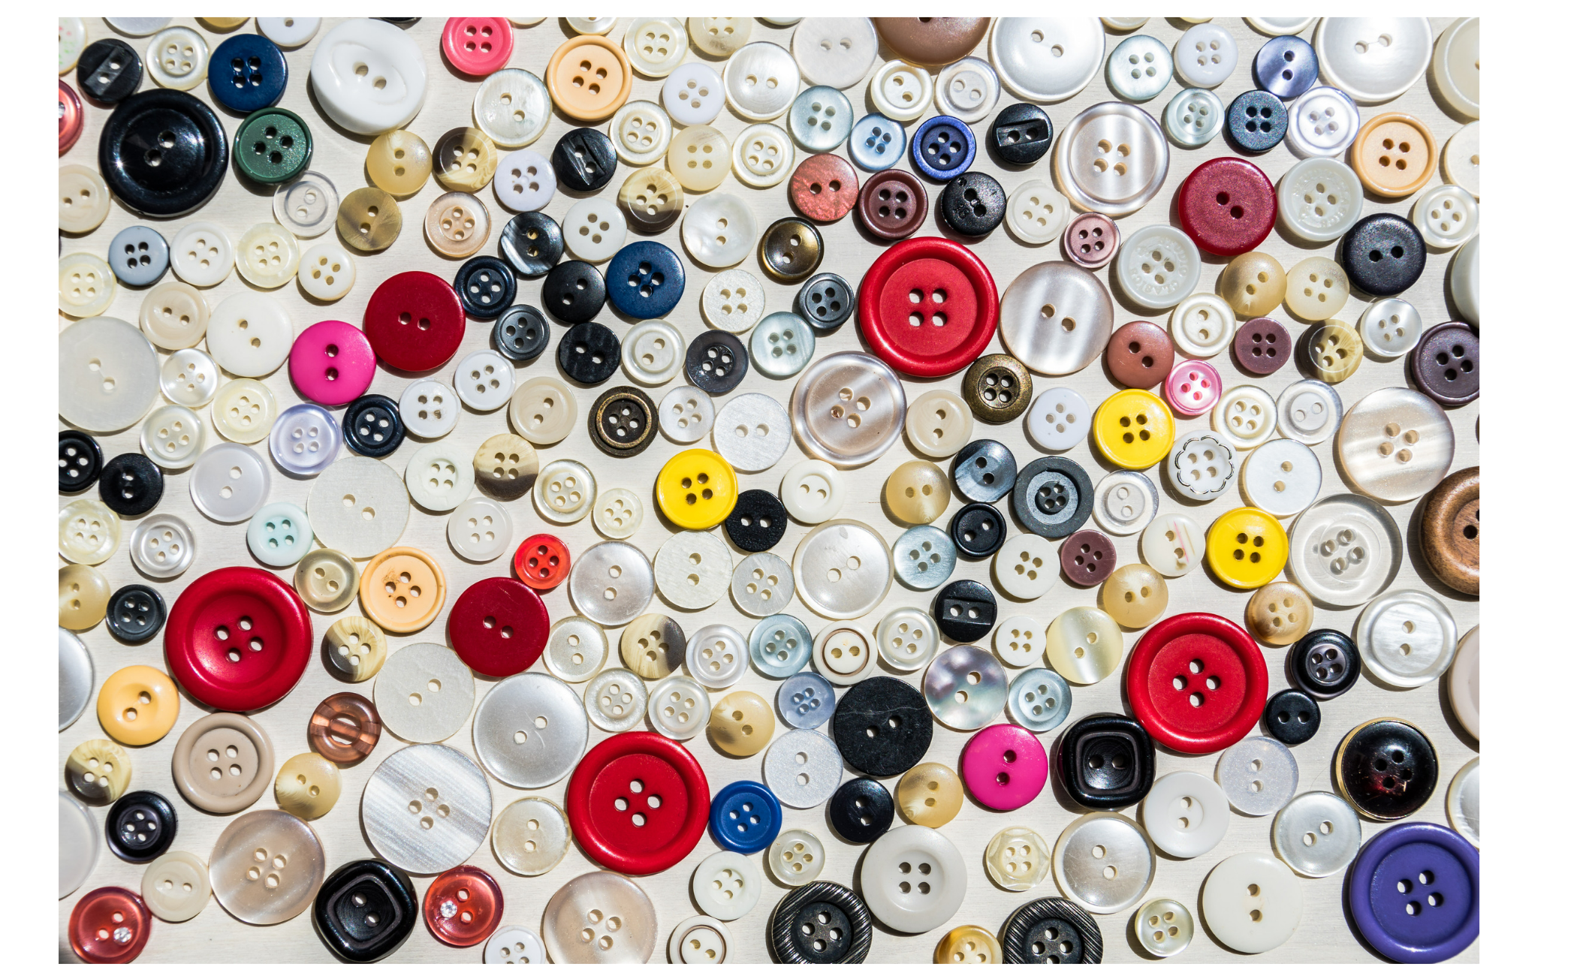
© Toni M via Canva.com

Resource 5 – Is he correct?
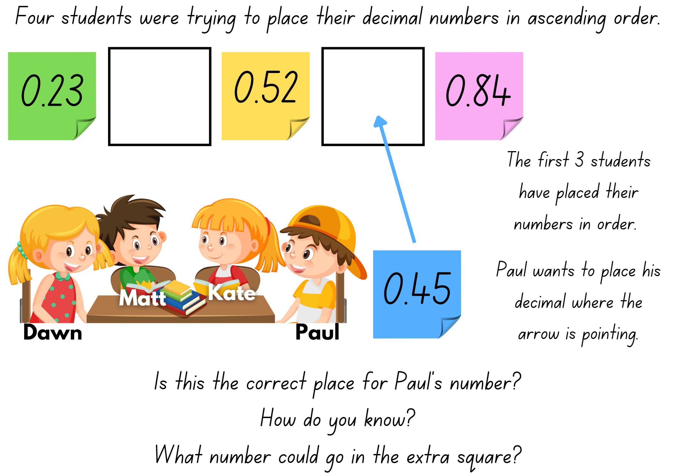

Resource 6 – place value gameboard
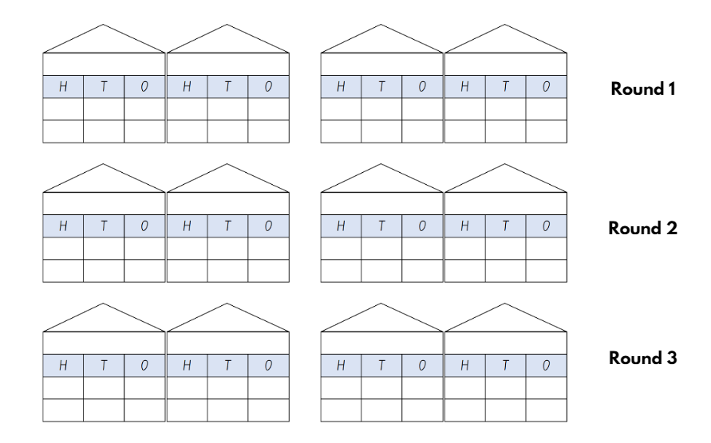

Resource 7 – tenths strips

Resource 8 – prove it
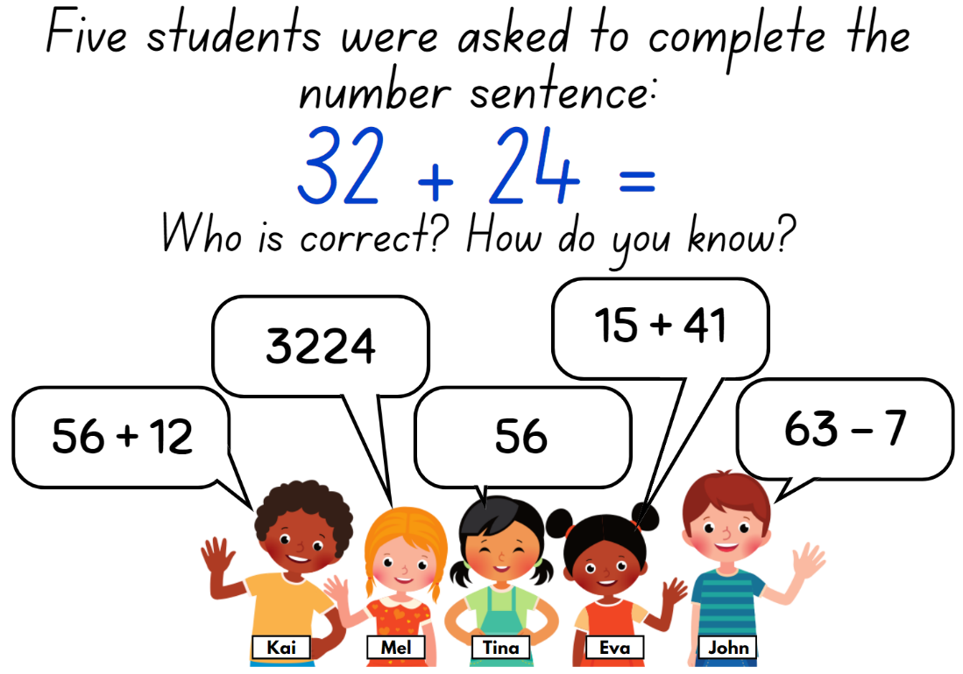

Resource 9 – hundredth strips

Resource 10 – single decimal house
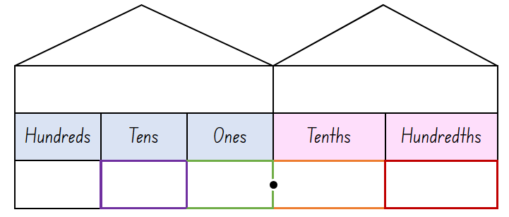

Resource 11 – comparison houses
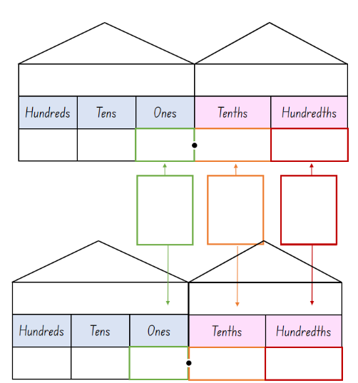

Resource 12 – recording decimals
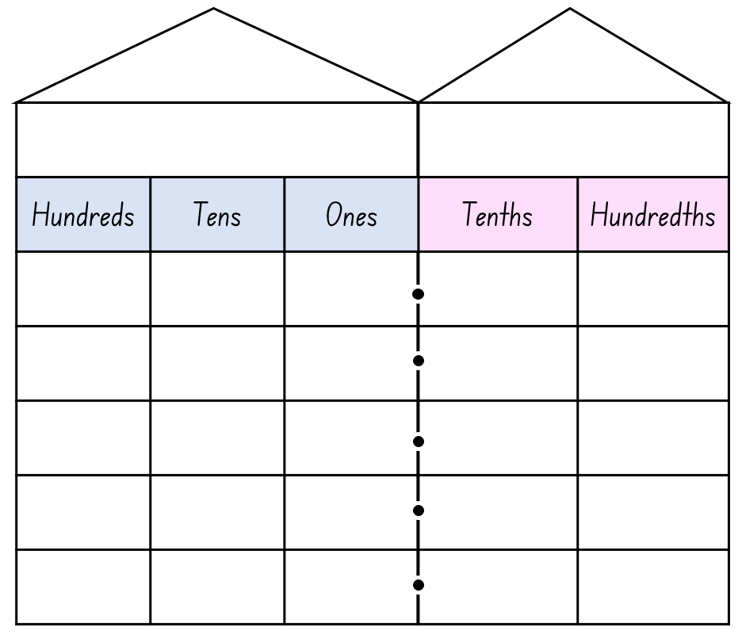

Resource 13 – linear model 1
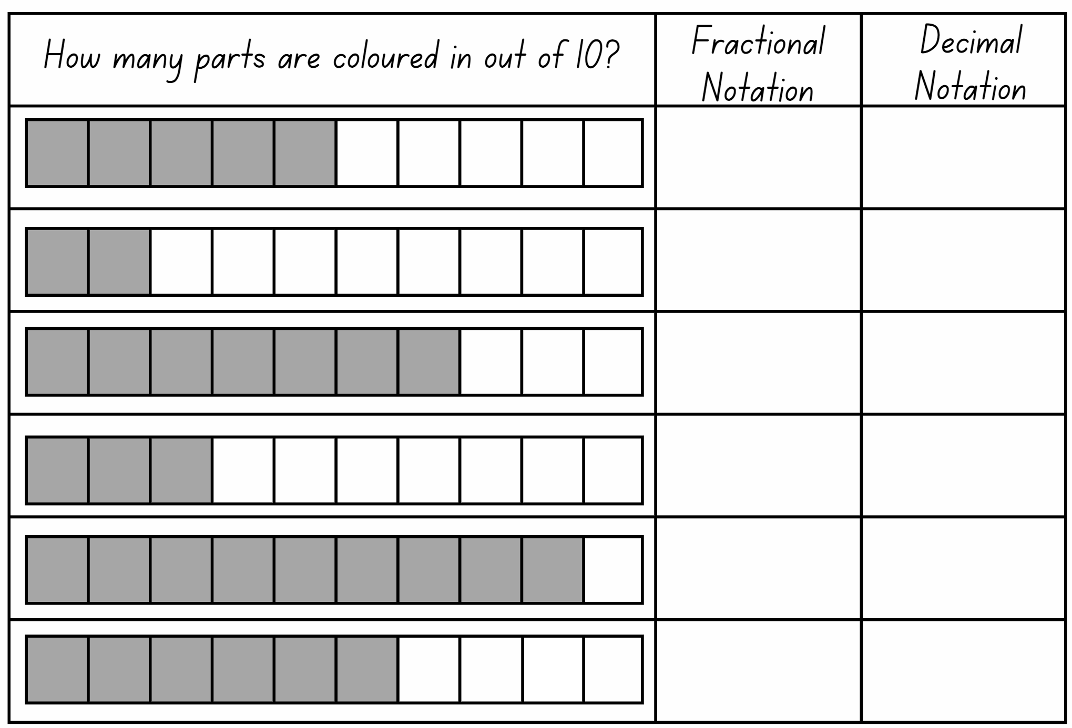

Resource 14 – linear model 2
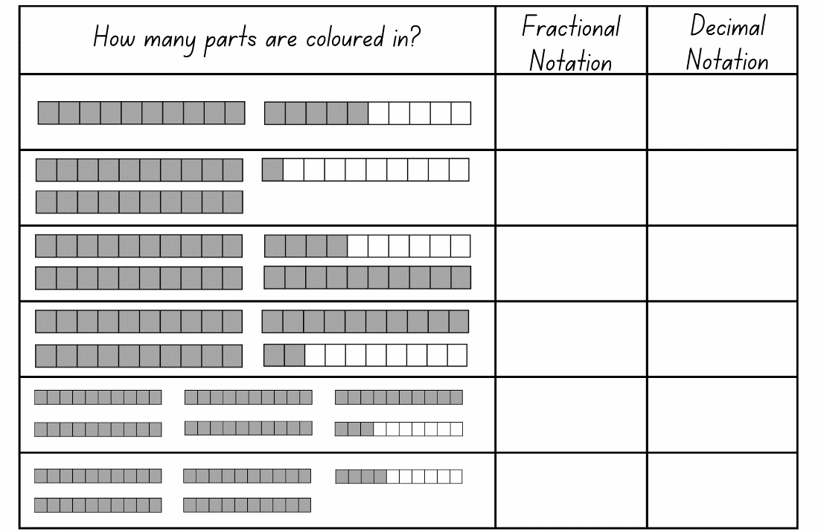

Resource 15 – the vault
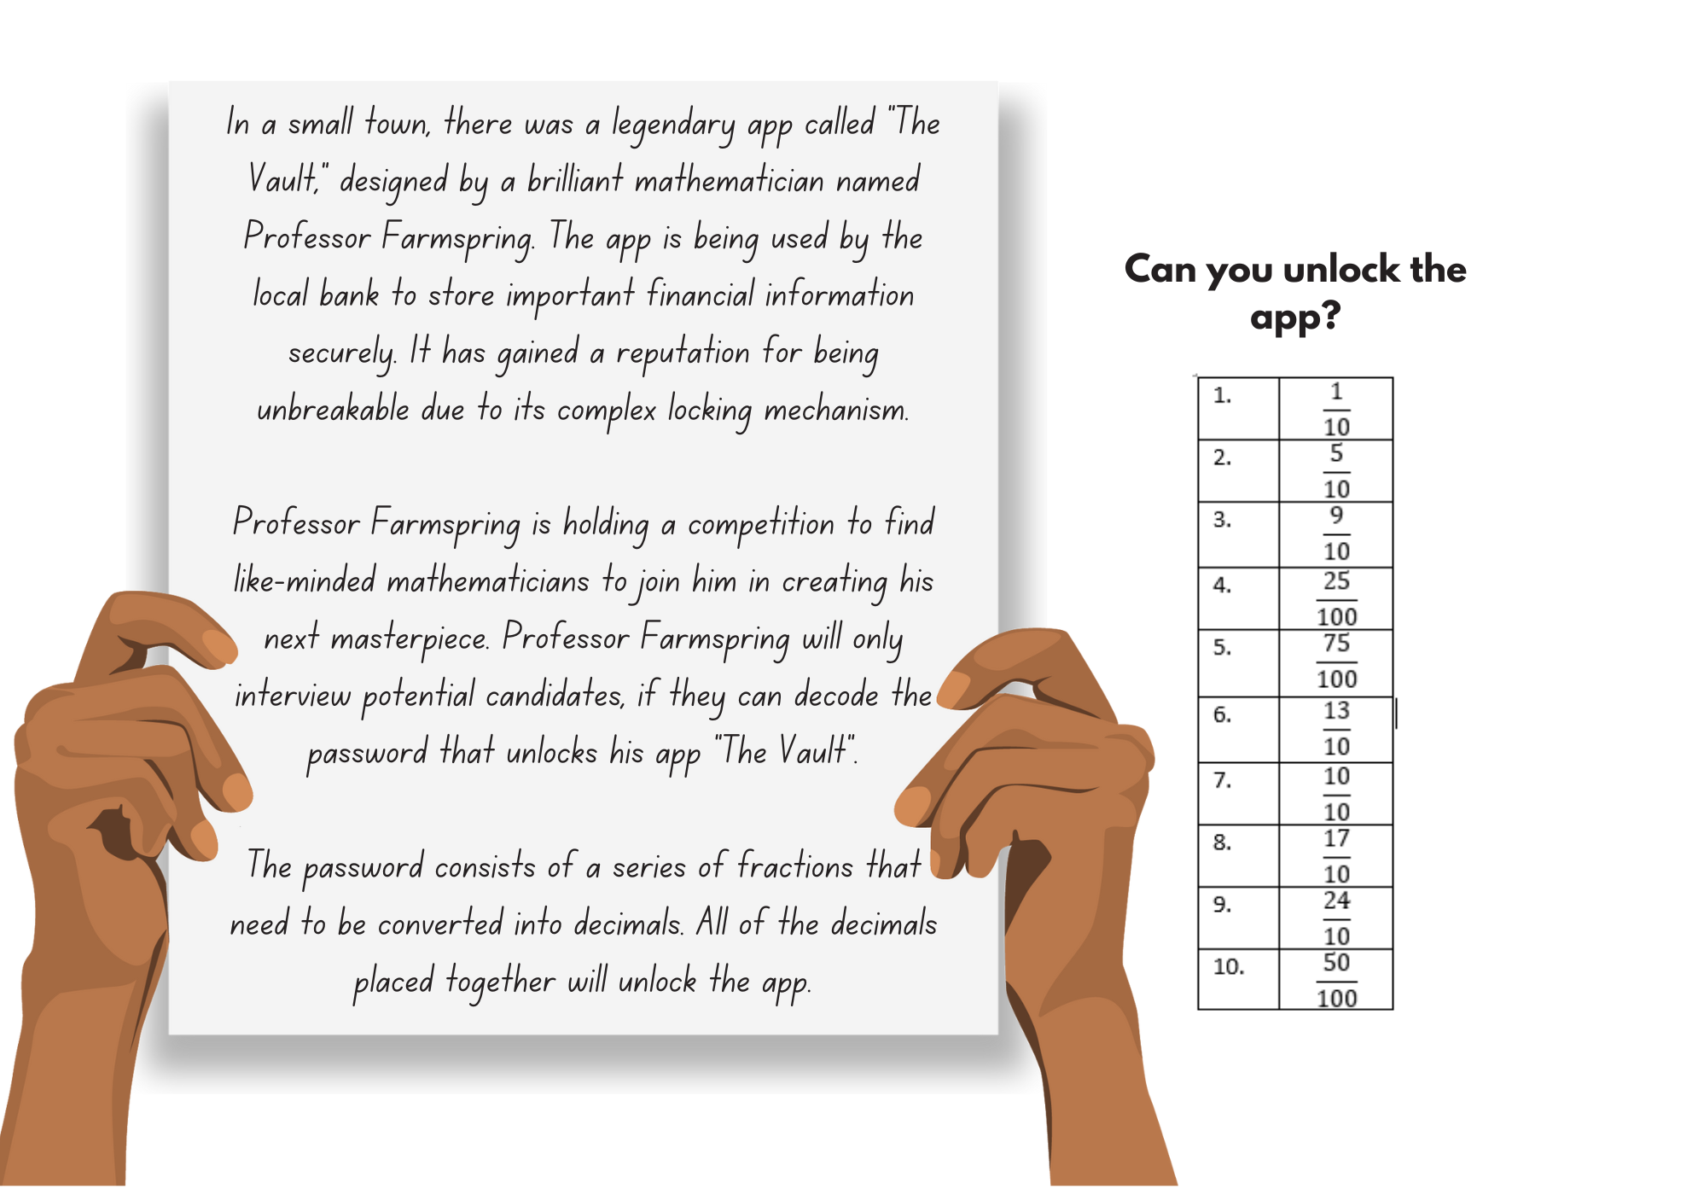

Resource 16 – True or False?
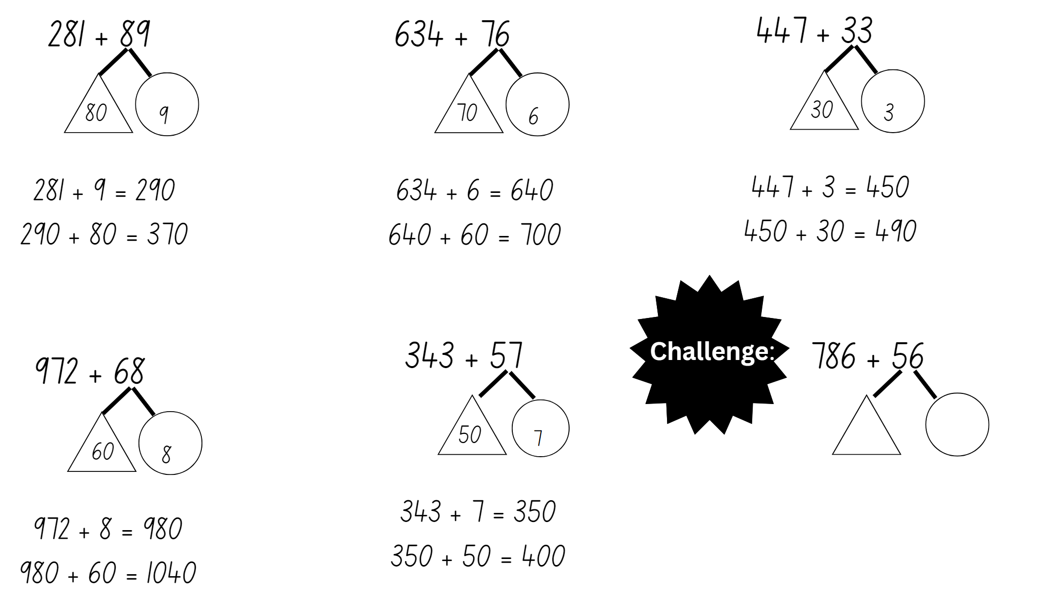

Resource 17 – subtraction with partitioning 1
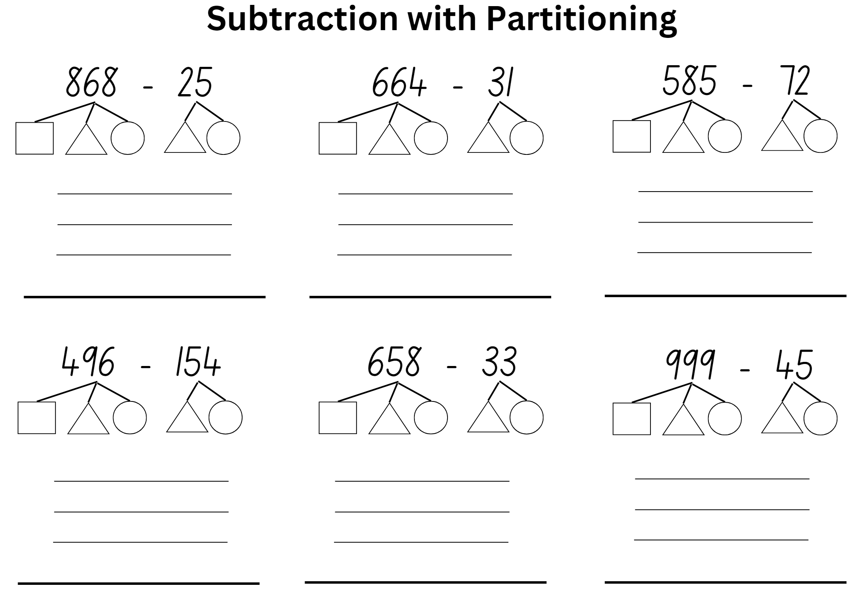

Resource 18 – subtraction with partitioning 2
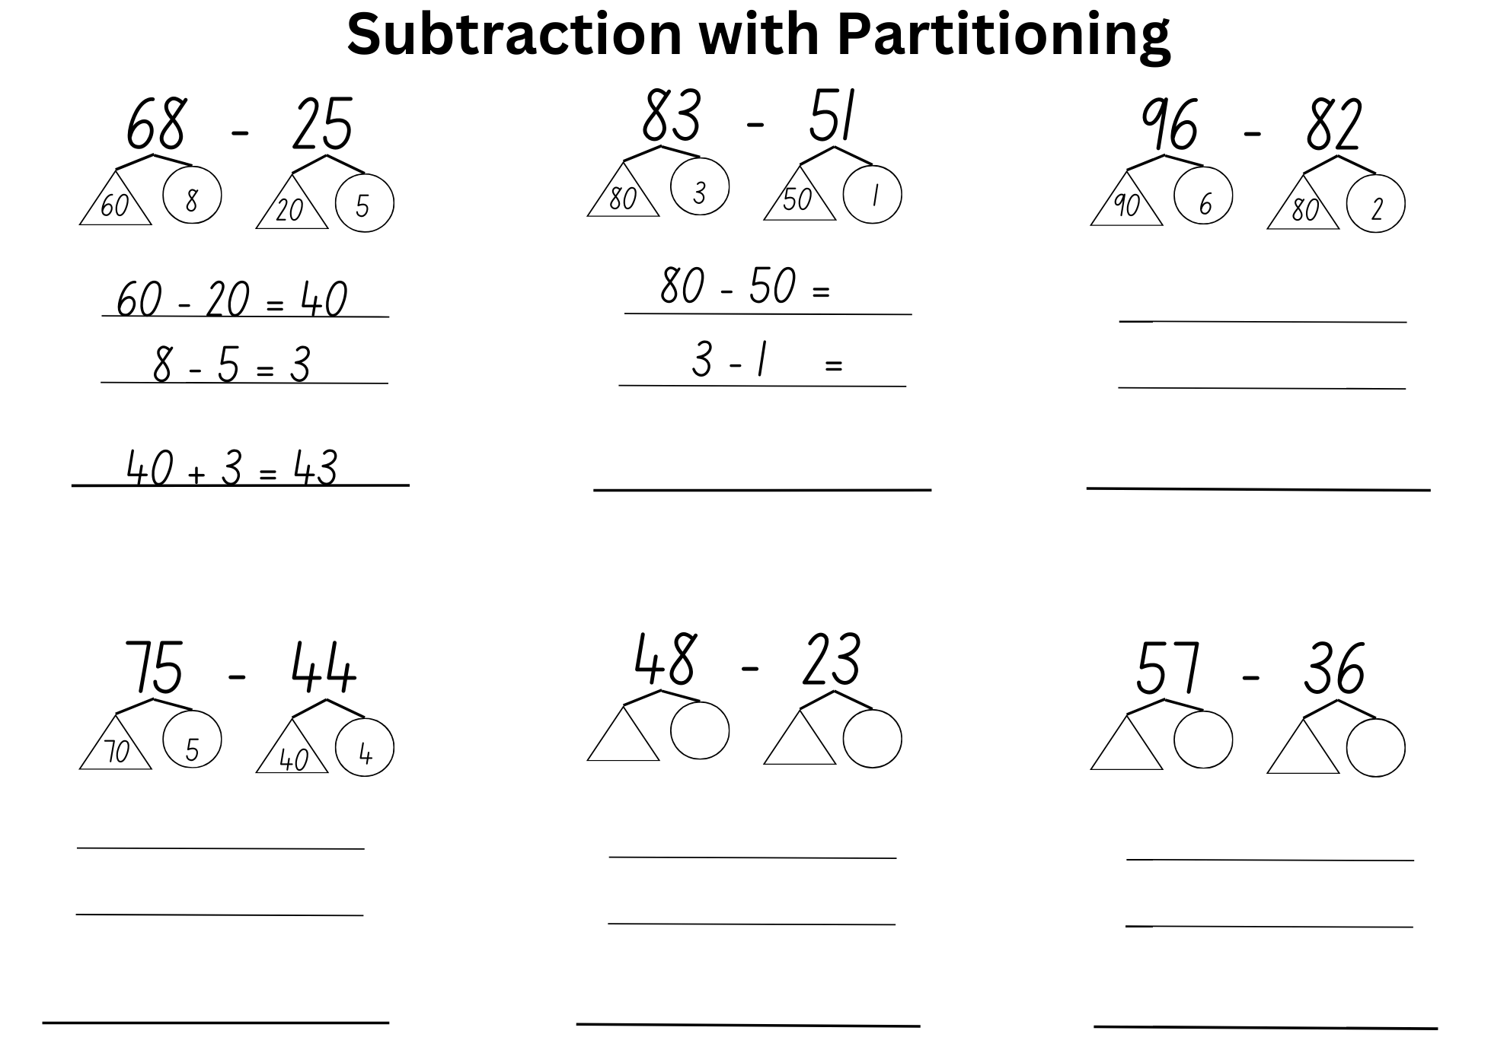

Resource 19 – non-standard partitioning
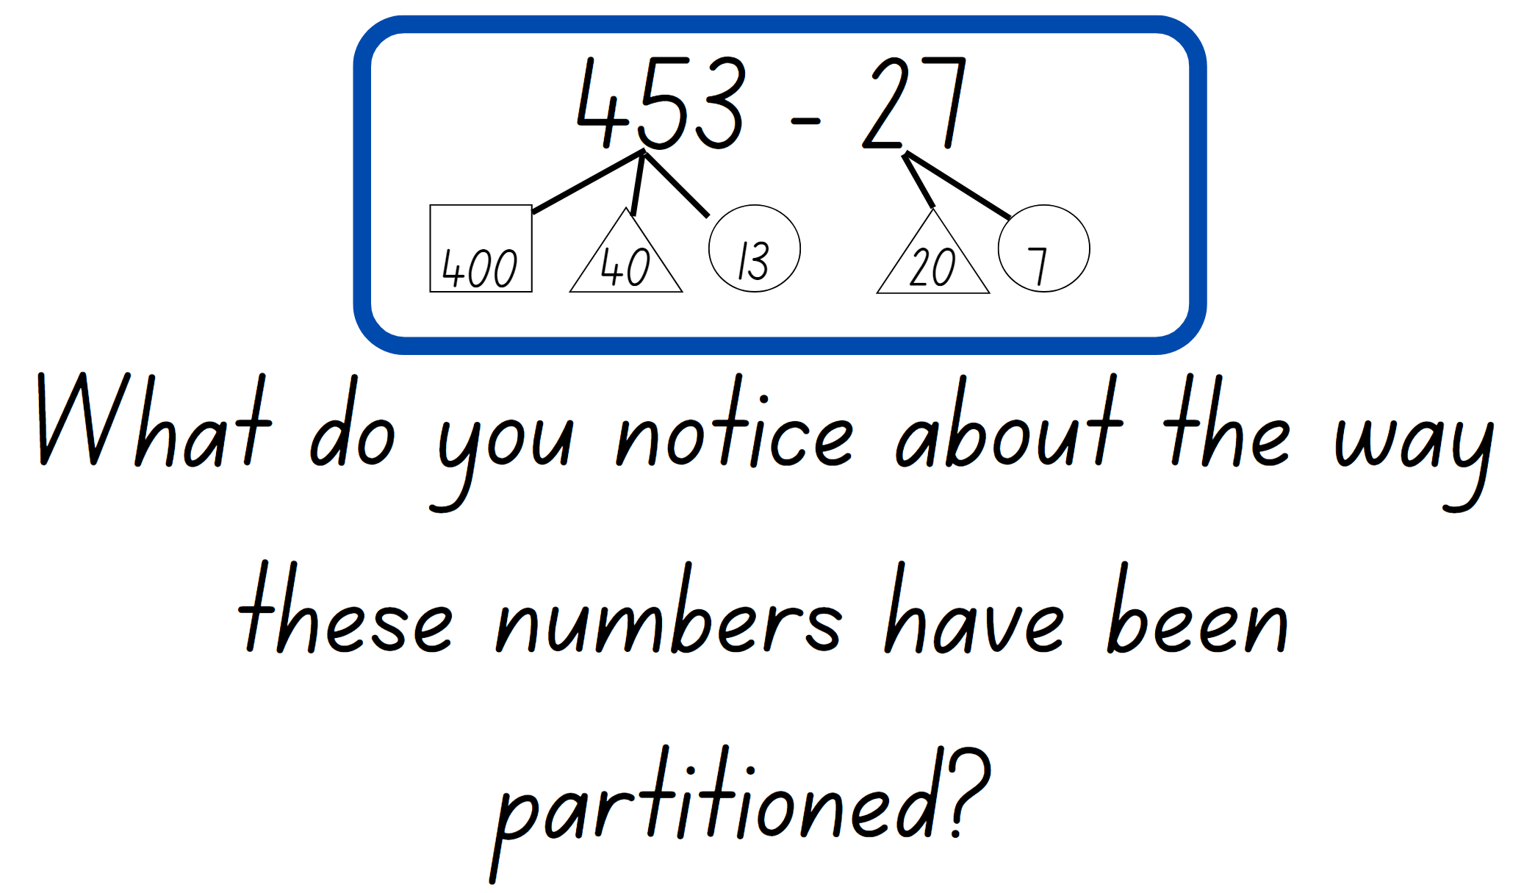

Syllabus outcomes and content
The table below outlines the syllabus outcomes and range of relevant syllabus content covered in this unit. Content is linked to National Numeracy Learning Progression version (3).
Outcomes and content | 1 | 2 | 3 | 4 | 5 | 6 | 7 | 8
Representing numbers using place value A: Whole numbers: Read, represent and order numbers to thousands
MAO-WM-01, MA2-RN-01
- Group physical or virtual objects to show the structure of tens, hundreds and a thousand |  | x
- Regroup numbers flexibly, recognising one thousand as 10 hundreds and one hundred as 10 tens or 100 ones | x | x | x
- Represent numbers up to and including thousands using physical or virtual manipulatives, words, numerals, diagrams and digital displays | x |  | x
- Read and order numbers of up to at least 4 digits |  |  | x
Representing numbers using place value A: Whole numbers: Apply place value to partition and regroup numbers up to 4 digits
MAO-WM-01, MA2-RN-01
- Record numbers using standard place value form | x |  |  |  |  |  | x
- Partition numbers of up to 4 digits in non-standard forms (Reasons about quantity) | x | x |  |  |  |  |  | x
Representing numbers using place value B: Whole numbers: Order numbers in the thousands
MAO-WM-01, MA2-RN-01
- Arrange numbers in the thousands in ascending and descending order |  |  | x
- Recognise and describe how rearranging digits changes the size of a number (Reasons about relations) |  |  | x
Representing numbers using place value B: Whole numbers: Apply place value to partition, regroup and rename numbers up to 6 digits
MAO-WM-01, MA2-RN-01
- Name thousands using the place value grouping of ones, tens and hundreds of thousands | x |  | x |  |  |  |  | x
- Use place value to expand the number notation | x |  | x
- Partition numbers of up to 6 digits in non-standard forms | x |  | x
Representing numbers using place value B: Whole numbers: Recognise and represent numbers that are 10, 100 or 1000 times as large
MAO-WM-01, MA2-RN-01
- Recognise the number of tens, hundreds or thousands in a number | x |  | x
Representing numbers using place value B: Decimals: Extend the application of the place value system from whole numbers to tenths and hundredths
MAO-WM-01, MA2-RN-01, MA2-RN-02
- Divide a length representing one whole into 10 equal parts and label the divisions using decimal notation |  |  | x |  | x
- Use the decimal point as a marker to identify the position of the ones digit when expressing tenths as decimals |  |  |  | x | x | x
- Recognise that 10-tenths is recorded as 1.0 and regroup when using decimal notation |  |  |  | x | x | x
- Represent and compare tenths as decimals using linear representations (Reasons about relations) |  |  |  | x | x | x
- Subdivide tenths into 10 equal parts and record hundredths using place value |  |  |  |  | x
- Express decimals as both tenths and hundredths |  |  |  |  | x
- Interpret zero digits at the end of a decimal |  |  |  |  | x
- Distinguish between the role of zero in various positions |  |  |  |  | x
Representing numbers using place value B: Decimals: Make connections between fractions and decimal notation
MAO-WM-01, MA2-RN-01, MA2-RN-02
- Record equivalent measurements using decimals | x |  |  |  |  | x
- Compare and order decimals of up to 2 decimal places |  |  | x
- Make connections between fractions and decimal notation for key benchmark values (Reasons about relations) | x | x | x |  |  | x
Additive relations A: Use the principle of equality
MAO-WM-01, MA2-AR-01
- Use the equals sign to mean 'the same as', rather than to perform an operation |  |  |  |  |  |  | x
Additive relations A: Select strategies flexibly to solve addition and subtraction problems of up to 3 digits
MAO-WM-01, MA2-AR-01
- Apply known mental strategies that use partitioning to add and subtract, such as bridging the decades |  |  |  |  | x |  | x | x
- Represent solutions to addition and subtraction problems, including word problems, using an empty number line or bar model |  |  |  |  | x
Additive relations B: Partition, rearrange and regroup numbers to at least 1000 to solve additive problems
MAO-WM-01, MA2-AR-01
- Use quantity values and non-standard partitioning to solve addition and subtraction problems |  |  |  |  |  |  | x | x
- Model addition with and without regrouping and record the method used |  |  |  | x |  |  | x
- Model subtraction with and without regrouping and record the method used |  |  |  |  |  |  |  | x
Mathematics K–10 Syllabus © NSW Education Standards Authority (NESA) for and on behalf of the Crown in right of the State of New South Wales, 2022.

References
This resource contains NSW Curriculum and syllabus content. The NSW Curriculum is developed by the NSW Education Standards Authority. This content is prepared by NESA for and on behalf of the Crown in right of the State of New South Wales. The material is protected by Crown copyright.
Please refer to the NESA Copyright Disclaimer for more information https://educationstandards.nsw.edu.au/wps/portal/nesa/mini-footer/copyright.
NESA holds the only official and up-to-date versions of the NSW Curriculum and syllabus documents. Please visit the NSW Education Standards Authority (NESA) website https://educationstandards.nsw.edu.au/ and the NSW Curriculum website https://curriculum.nsw.edu.au/home.
Mathematics K–10 Syllabus © NSW Education Standards Authority (NESA) for and on behalf of the Crown in right of the State of New South Wales, 2022.
National Numeracy Learning Progression © Australian Curriculum, Assessment and Reporting Authority (ACARA) 2010 to present, unless otherwise indicated. This material was downloaded from the Australian Curriculum website (National Numeracy Learning Progression) (accessed 22 March 2024) and was not modified.
BBC (2023) What is estimating?, BBC Bitesize website, accessed 29 June 2023.
Finkel D (2020) ‘Target Number’, Free Lessons, Math for Love website, accessed 21 June 2023.
Goldstone B (2006) Great Estimations, Macmillan Publishers, United States.
Russo J and Russo T (2019) ‘Short activity: Two place value games for building fluency with non-standard partitioning’, APMC, 24(2) 2018:35–36, accessed 25 July 2023.
State of Queensland (Department of Education, Training and Employment) (2014) Partitioning – What is it? (DOCX 488 KB), Curriculum into the Classroom (C2C), State of Queensland (Department of Education, Training and Employment).
University of Cambridge (Faculty of Mathematics) (2022) Doughnut Percents, NRICH website, accessed 21 June 2023.
University of Cambridge (Faculty of Mathematics) (2022) Matching Fractions, NRICH website, accessed 21 June 2023.
Van de Walle J, Karp K, Bay-Williams JM, Brass A, Bentley B, Ferguson S, Goff W, Livy S, Marshman M, Martin D, Pearn C, Prodromou T, Symons D and Wilkie K (2019) Primary and Middle Years Mathematics: Teaching Developmentally, 1st Australian edn, Pearson Education Australia, Melbourne.

© State of New South Wales (Department of Education), 2024
The copyright material published in this resource is subject to the Copyright Act 1968 (Cth) and is owned by the NSW Department of Education or, where indicated, by a party other than the NSW Department of Education (third-party material).
Copyright material available in this resource and owned by the NSW Department of Education is licensed under a Creative Commons Attribution 4.0 International (CC BY 4.0) license.
This license allows you to share and adapt the material for any purpose, even commercially.
Attribution should be given to © State of New South Wales (Department of Education), 2024.
Material in this resource not available under a Creative Commons licence:
- the NSW Department of Education logo, other logos and trademark-protected material
- material owned by a third party that has been reproduced with permission. You will need to obtain permission from the third party to reuse its material.
Links to third-party material and websites
Please note that the provided (reading/viewing material/list/links/texts) are a suggestion only and implies no endorsement, by the New South Wales Department of Education, of any author, publisher, or book title. School principals and teachers are best placed to assess the suitability of resources that would complement the curriculum and reflect the needs and interests of their students.
If you use the links provided in this document to access a third-party's website, you acknowledge that the terms of use, including licence terms set out on the third-party's website apply to the use which may be made of the materials on that third-party website or where permitted by the Copyright Act 1968 (Cth). The department accepts no responsibility for content on third-party websites.

