Mathematics Stage 2 – Unit 25

Contents
Unit description and duration 4
Syllabus outcomes 4
Working mathematically 5
Student prior learning 5
Lesson overview and resources 7
Lesson 1 12
Daily number sense: Counting by tens – 15 minutes 12
Core lesson 1: Posing questions – 15 minutes 14
Core lesson 2: Collecting data on a matter of interest – 20 minutes 16
Consolidation and meaningful practice – 20 minutes 18
Lesson 2 21
Daily number sense: Multiples madness – 15 minutes 21
Core lesson: Let’s make a survey – 35 minutes 23
Consolidation and meaning practice – 20 minutes 27
Lesson 3 29
Daily number sense: Multiplying by multiples – 15 minutes 29
Core lesson: Organising and displaying data – 35 minutes 31
Consolidation and meaningful practice – 20 minutes 34
Lesson 4 37
Daily number sense – 15 minutes 37
Core lesson 1: Many-to-one scale – 10 minutes 37
Core lesson 2: Constructing many-to-one scale column graphs – 25 minutes 39
Consolidation and meaningful practice – 15 minutes 40
Lesson 5 43
Daily number sense: Odds and evens – 15 minutes 43
Core lesson: Rubbish data – 45 minutes 45
Discuss and connect the mathematics – 5 minutes 51
Lesson 6 53
Daily number sense: Number chart patterns – 15 minutes 53
Core lesson: Scrabble stats – 45 minutes 55
Consolidation and meaningful practice –10 minutes 59
Lesson 7 61
Daily number sense: Number patterns – 15 minutes 61
Core lesson: Different data displays – 30 minutes 62
Consolidation and meaningful practice – 15 minutes 65
Lesson 8 68
Daily number sense – 15 minutes 68
Core lesson: If the world were a village – 45 minutes 68
Discuss and connect the mathematics – 5 minutes 71
Resource 1: Multiples madness gameboard 73
Resource 2: Multiples madness scoreboard 74
Resource 3: Survey questions checklist 75
Resource 4: Multiplying multiples 76
Resource 5: Column graph checklist 77
Resource 6: Star column graph 78
Resource 7: Australian animal lengths 79
Resource 8: Australian animal life expectancy 80
Resource 9: Animal weight 81
Resource 10: Always, sometimes or never? 82
Resource 11: Food waste 83
Resource 12: Number chart patterns 84
Resource 13: Number chart 85
Resource 14: Scrabble tiles – point values 86
Resource 15: Scrabble stats tally table 87
Resource 16: Scrabble scores 88
Resource 17: Gold medal picture graph 89
Resource 18: Gold medal column graph 90
Resource 19: Gold medal table 91
Resource 20: Total medal count 92
Resource 21: 100 people 93
Resource 22: Nationalities 94
Resource 23: Energy 95
Syllabus outcomes and content 96
References 101

Unit description and duration
This unit develops the big idea that questions can be asked and answered by interpreting data.
In this 2-week unit students are provided opportunities to:
- select and trial methods for data collection
- construct and interpret data displays with many-to-one scales
- read, write, order and partition numbers up to 4 digits.

Syllabus outcomes
- MAO-WM-01 develops understanding and fluency in mathematics through exploring and connecting mathematical concepts, choosing and applying mathematical techniques to solve problems, and communicating their thinking and reasoning coherently and clearly
- MA2-RN-01 applies an understanding of place value and the role of zero to represent numbers to at least tens of thousands
- MA2-MR-01 represents and uses the structure of multiplicative relations to 10 × 10 to solve problems
- MA2-DATA-01 collects discrete data and constructs graphs using a given scale
- MA2-DATA-02 interprets data in tables, dot plots and column graphs

Working mathematically
In the Mathematics K–10 Syllabus, there is one overarching Working mathematically outcome (MAO-WM-01). The Working mathematically processes should be embedded within the concepts being taught. The Working mathematically processes present in the Mathematics K–10 Syllabus are:
- communicating
- understanding and fluency
- reasoning
- problem solving.
Mathematics K–10 Syllabus © NSW Education Standards Authority (NESA) for and on behalf of the Crown in right of the State of New South Wales, 2022.

Student prior learning
Before engaging in these teaching and learning activities, students would benefit from prior experience with:
- posing questions and collecting discrete data
- displaying and interpreting data using lists, tables, dot plots and column graphs
- reading, writing, ordering and partitioning numbers up to 3 digits.

In NSW classrooms there is a diverse range of students, including Aboriginal and Torres Strait Islander students, students learning English as an additional language or dialect, high potential and gifted students and students with disability. Some students may identify with more than one of these groups or possibly all of them. Refer to Advice on curriculum planning for every student for further information.

Lesson overview and resources
The table below outlines the sequence and approximate timing of lessons, learning intentions and resources.
Lesson | Content | Duration and resources
Lesson 1  Daily number sense learning intention:  - operate with multiples of 10 | Lesson core concept: questions give meaning to data.  Core concept learning intentions:  - collect discrete data  - organise and display data using tables and graphs | Lesson duration: 70 minutes  - 10-sided dice or 1–10 spinner  - 30 cm rulers  - Student workbooks  - Writing materials
Lesson 2  Daily number sense learning intention:  - multiply by 10 | Lesson core concept: collecting data requires a skilful approach.  Core concept learning intention:  - select and trial methods for data collection | Lesson duration: 70 minutes  - Resource 1: Multiples madness gameboard  - Resource 2: Multiples madness scoreboard  - Resource 3: Survey questions checklist  - 0–9 spinners or dice  - Counters  - Student workbooks  - Writing materials
Lesson 3  Daily number sense learning intention:  - multiply with multiples of 10 | Lesson core concept: graphs are a communication tool.  Core concept learning intention:  - organise and display data using a column graph  - interpret and compare data | Lesson duration: 70 minutes  - Resource 4: Multiplying multiples  - Resource 5: Column graph checklist  - Resource 6: Star column graph  - 10-sided dice or spinners  - 30 cm rulers  - Grid paper  - Timer  - Writing materials
Lesson 4  Daily number sense learning intention:  - teacher-identified task based on student needs | Lesson core concept: there are many ways to communicate data.  Core concept learning intentions:  - construct and interpret data displays with many-to-one scales  - read, represent and order numbers to thousands | Lesson duration: 65 minutes  - Resource 7: Australian animal lengths  - Resource 8: Australian animal life expectancy  - Resource 9: Animal weight  - 30 cm rulers  - Grid paper  - Mini whiteboards  - Student workbooks  - Whiteboard markers  - Writing materials
Lesson 5  Daily number sense learning intention:  - generate and describe patterns | Lesson core concept: digital technologies can be used to present data.  Core concept learning intention:  - construct and interpret data displays with many-to-one scales | Lesson duration: 65 minutes  - Resource 10: Always, sometimes or never?  - Resource 11: Food waste  - Website: Household waste statistics  - Devices with Microsoft Excel or Google Sheets  - Writing materials
Lesson 6  Daily number sense learning intention:  - generate and describe patterns | Lesson core concept: data can be presented to convince or persuade.  Core concept learning intentions:  - Construct and interpret data displays with many-to-one scales  - read, represent and order numbers to thousands | Lesson duration: 70 minutes  - Resource 12: Number chart patterns  - Resource 13: Number chart  - Resource 14: Scrabble tiles – point values  - Resource 15: Scrabble stats tally table  - Resources 16: Scrabble scores  - Coloured counters or markers  - Devices with Microsoft Excel or Google Sheets  - Mini whiteboard  - Newspapers, magazines and/or books  - Student workbooks  - Whiteboard markers  - Writing materials
Lesson 7  Daily number sense learning intention:  - generate and describe patterns | Lesson core concept: interpreting data helps to solve problems and ask new questions.  Core concept learning intentions:  - interpret data displays with many-to-one scales  - read, represent and order numbers to thousands | Lesson duration: 60 minutes  - Resource 17: Gold medal picture graph  - Resource 18: Gold medal column graph  - Resource 19: Gold medal table  - Resource 20: Total medal count  - Student workbooks  - Writing materials
Lesson 8  Daily number sense learning intention:  - teacher-identified task based on student needs | Lesson core concept: statistical reasoning helps mathematicians interpret and make inferences about information.  Core concept learning intentions:  - interpret data displays with many-to-one scales  - read, represent and order numbers to thousands | Lesson duration: 65 minutes  - Resource 21: 100 people  - Resource 22: Nationalities  - Resource 23: Energy  - If the World Were a Village: A Book about the World's People (2020) by David J Smith  - 30 cm rulers  - Small dot stickers  - Student workbooks  - Writing materials

Lesson 1
Core concept: questions give meaning to data.

Daily number sense: Counting by tens – 15 minutes
Daily number sense activities for Lessons 1 to 3 ‘activate’ prior number knowledge and support the learning of new content in the unit. These activities can also assist teachers to identify the starting points for learning by revealing the extent of students’ existing knowledge.
The table below contains a suggested learning intention and success criteria. These are best co-constructed with students.
Daily number sense learning intention | Daily number sense success criteria
Students are learning to:  - operate with multiples of 10. | Students can:  - multiply a one-digit number by a multiple of 10.
This activity is an adaptation of the Counting game (by multiples of 10) from Mathematics K-6 resources by State of New South Wales (Department of Education).
- In pairs, students roll a 10-sided die or spin a 1–10 spinner 4 times. Each time, the number rolled or spun is multiplied by 10. The totals are then added together to determine a target number.
- Ask students how they know that the target number is a multiple of 10.
- Explain that the object of the game is to be the person who says the target number.
- Players take turns to count on by saying the next one, 2 or 3 number words in the tens sequence. Students start the game at zero.
- Pairs record the target number and the number words each turn (see Figure 1).
Figure 1 – Example counting game
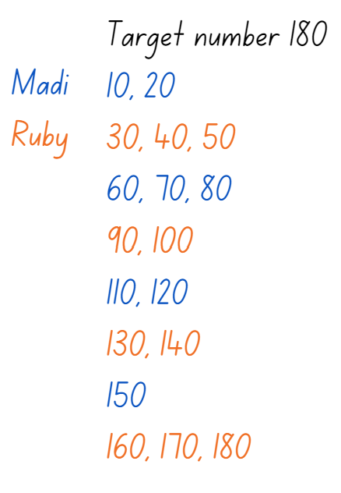
- The player who says the target number receives a point.
- Players then choose a new target number and play the game again.
- The game may be varied by:
- starting at the target number and counting backwards to zero
- rolling the die or spinning the spinner once and multiplying by a multiple of 10, for example, if a player rolls a 5, it becomes 50.
- Reflect on the activity, asking questions such as:
- Did you prefer going first or second? Why?
- What strategy did you use? How successful was it and why?
- Looking back on the games that you played, can you see any ways that one player could change their moves to win?
- How could you make the game easier or harder?
This table details opportunities for assessment.
Assessment opportunities | Links
What to look for:  - Can students multiply a one-digit number by a multiple of 10? [MAO-WM-01, MA2-MR-01] | Links to National Numeracy Learning Progressions (NNLP):  - MuS7.

Core lesson 1: Posing questions – 15 minutes
The table below contains suggested learning intentions and success criteria. These are best co-constructed with students.
Core concept learning intentions | Core concept success criteria
Students are learning to:  - collect discrete data  - organise and display data using tables and graphs. | Students can:  - pose questions about a matter of interest  - predict categories for data collection  - create a table to organise the data  - represent collected data in a dot plot.
- Explain that a statistical question is a question that can be answered by gathering data and which anticipates variability in the data collected. A question is not statistical if the data collected is a single value. For example, ’How old are you?’ is not a statistical question as it has a single value. ‘How old are the students in my school?’ is a statistical question because it anticipates variability in students’ ages.
- Ask the class questions and in small groups, students record whether the question is statistical or not and why. For example:
- How tall is your mother? (Not statistical as data collected is a single value)
- How many students in your class have their ears pierced? (Statistical)
- Do you like apples? (Not statistical as data collected is a single value)
- Which day of the week is the most common to play sport? (Statistical)
- How many days are in June? (Not statistical as data collected is a single value)
- How many students are in each class at your school? (Statistical)
- What time did the students in your class wake up this morning? (Statistical)
- How many brothers does Martha have? (Not statistical as data collected is a single value)
- Which cereal is the most healthy? (Not statistical as the word health is subjective and hard to measure)
- Which brand of cereal has the lowest amount of sugar per serve? (Statistical)
- What is John’s favourite book? (Not statistical as data collected is a single value)
- Ask students:
- Which questions were not statistical? Justify your answer.
- Were there any questions that your group did not agree on? Explain your thinking.
- Can you rephrase any of the questions that are not statistical to turn them into statistical questions?
This table details opportunities for differentiation.
Too hard? | Too easy?
Students cannot recognise statistical questions.  - Tell students which questions are statistical or not and ask them to provide a reason why.  - Provide an example of a statistical and a non-statistical question and have students identify differences. | Students can recognise statistical questions.  - Students to pose their own statistical questions.  - Students to pose multiple statistical questions for the same matter of interest.

Core lesson 2: Collecting data on a matter of interest – 20 minutes
- As a class, choose a matter of interest from Core lesson 1 or another of your choosing. For example, favourite books.
- Students Think-Pair-Share a statistical question related to the matter of interest and, as a class, choose one question to collect class data about. For example, ‘What is our class’s favourite genre of book?’
- As a class, predict and record which categories will be used to group class data. Explain that all possible categories need to be considered and that each piece of data can only fit into one category. Explain that for the same question, the data could be arranged into several different categories. For example, fiction and non-fiction, or based on specific genres.
- Direct students to move to different parts of the classroom to group themselves based on the determined categories. For example, graphic novels, fantasy, factual text, science fiction, historical fiction, mystery, fairy tales, biographies, poetry.
- Tally and display the class results (see Figure 2).
Figure 2 – Example class tally of favourite book genre
- Students transfer the class data into a table in their workbooks, using numerals (see Figure 3).
Figure 3 – Example class frequency table for favourite book genre
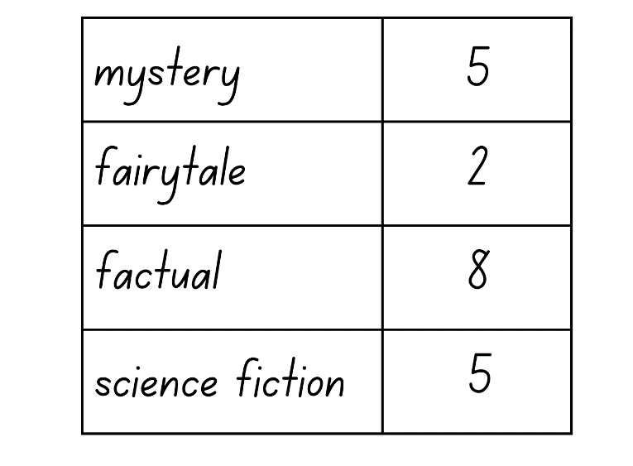

Consolidation and meaningful practice – 20 minutes
- Ask students how else the data could be represented. Discuss appropriate representations, including a dot plot and a column graph as the data is categorical.
Categorical variable: a variable whose values belong to exactly one of a number of categories. A categorical variable describes a quality or characteristic of something. Sometimes called a discrete variable.
- Students represent the class data as a dot plot in their workbooks. Ensure students include a title, label the x-axis and use one-to-one correspondence to represent frequency of each category (see Figure 4).
Note: dot plots are an alternative to a column graph when there are only a small number of data values. Each value is recorded as a dot so that the frequencies for each of the values can be counted easily.
Figure 4 – Example class dot plot for favourite book genre
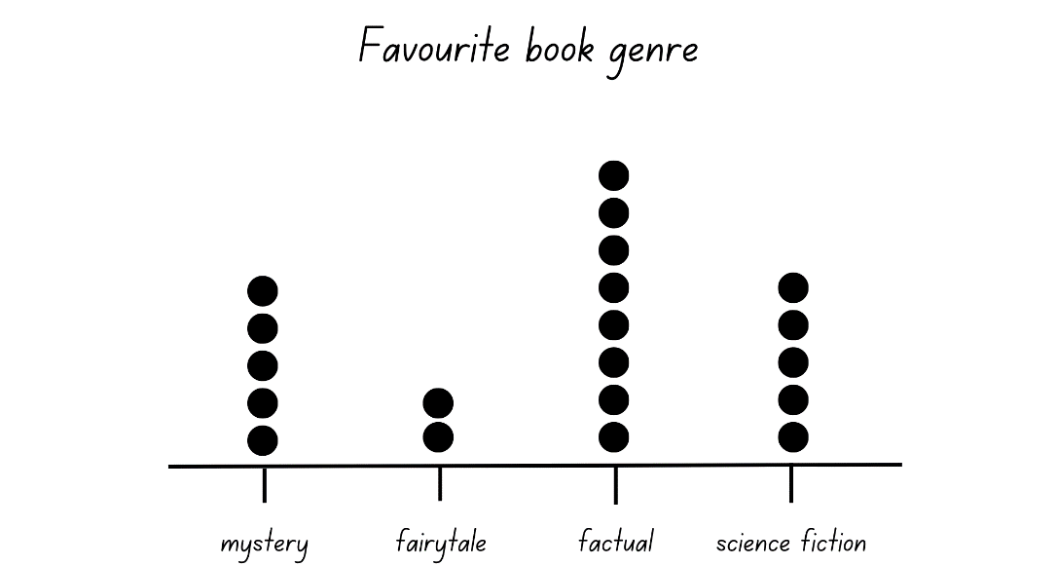
- Discuss the data represented in the dot plot, asking students:
- Is this the most efficient way to represent the data? Explain your thinking.
- Is the table or dot plot easier to interpret? Explain your thinking.
- Can you answer our statistical question?

This table details opportunities for differentiation.
Too hard? | Too easy?
Students cannot represent class data in a dot plot.  - Provide a dot plot template with the title, x-axis and categories labelled.  - Create a class dot plot and have students represent each dot with a dot sticker. | Students can represent class data in a dot plot.  - Students represent the class data in a column graph.  - Students predict what the frequency of each category would be if the data was collected across the whole school.
This table details opportunities for assessment.
Assessment opportunities | Links
What to look for:  - Can students pose questions about a matter of interest? [MAO-WM-01, MA2-DATA-01]  - Can students predict categories for data collection? [MAO-WM-01, MA2-DATA-01]  - Can students create a table to organise the data? [MAO-WM-01, MA2-DATA-01]?  - Can students represent collected data in a dot plot? [MAO-WM-01, MA2-DATA-01] | Links to National Numeracy Learning Progressions (NNLP):  - IRD2, IRD3.

Lesson 2
Core concept: collecting data requires a skilful approach.

Daily number sense: Multiples madness – 15 minutes
The table below contains a suggested learning intention and success criteria. These are best co-constructed with students.
Daily number sense learning intention | Daily number sense success criteria
Students are learning to:  - multiply by 10. | Students can:  - multiply a one-digit number by 10.
This activity is an adaptation of Multiples madness (fives) from Mathematics K-6 resources by State of New South Wales (Department of Education).
- Distribute Resource 1: Multiples madness gameboard, Resource 2: Multiples madness scoreboard, 3 counters of one colour, 3 of a second colour and a 0–9 spinner or die to each pair of students.
- Players take turns to roll the dice or spin the spinner. After each roll or spin, players multiply the number by 10 and explain their thinking to their partner.
- The partner records their thinking, and if they agree, the first player places one of their counters on the number on the gameboard, claiming that place (see Figure 5). If the number is taken, that player misses a turn.
Figure 5 – ‘Multiple madness’ gameboard and score board with the roll 5
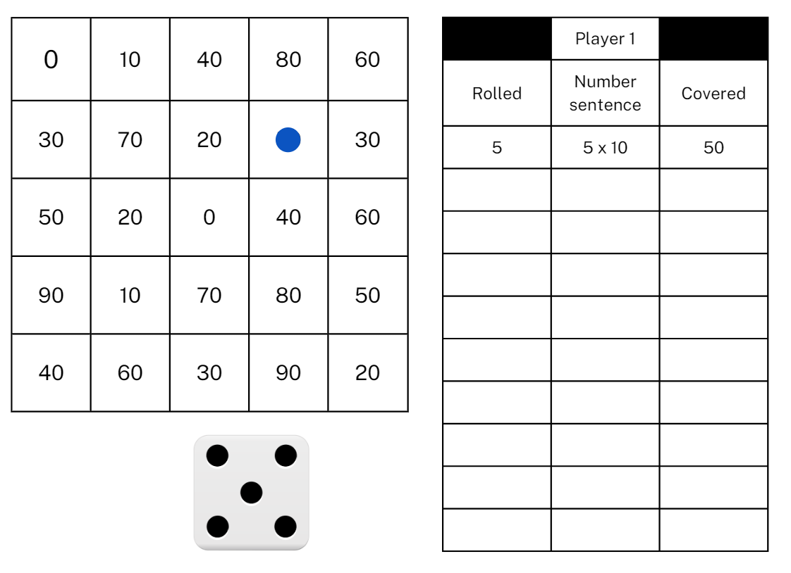
- A player wins by getting 3 counters in a row in any orientation.
- Since players only have 3 counters, they will need to choose which counter to move once all 3 have been placed on the game board.
- Reflect on the activity, asking questions such as:
- Did you prefer going first or second? Why?
- What strategy did you use? How successful was it and why?
- How might the game change if you multiplied by 20?
- Would it be easier if you had more counters? Why?
This table details an opportunity for assessment.
Assessment opportunity | Links
What to look for:  - Can students multiply a one-digit number by 10? [MAO-WM-01, MA2-MR-01] | Links to National Numeracy Learning Progressions (NNLP):  - MuS7.

Core lesson: Let’s make a survey – 35 minutes
The table below contains a suggested learning intention and success criteria. These are best co-constructed with students.
Core concept learning intention | Core concept success criteria
Students are learning to:  - select and trial methods for data collection. | Students can:  - create a survey and related recording sheet  - refine survey questions as necessary after a small trial  - conduct a survey to collect categorical or numerical data  - compare the effectiveness of different methods of collecting and recording data.
- As a class, brainstorm sources of data. Ensure students understand that data sources include observation, surveys and databases.
- Read the following questions to the class. For each question, students move to a predetermined side of the room to indicate if they think it is best answered through observation or survey.
- Who is the class’s favourite author? (survey)
- Which areas of the playground are used most during break time? (observation)
- Who can do the most hops in a minute? (observation)
- What is our class’s favourite hobby? (survey)
- What is the most common car colour to drive past our school each day? (observation)
- How do students travel to school each day? (survey)
- Discuss how data is best collected when a whole population cannot be observed or surveyed. Explain what a sample is and how random selection ensures a sample is representative of a larger population.
Sample: a subset of a population used to estimate characteristics of the population. For example, a randomly selected group of 8-year-olds (sample) selected to estimate the height of 8-year-olds in Australia (population).
- Explain that students will be creating a survey about setting up a breakfast club at school.
- As a class, brainstorm ideas about the importance of eating a nutritious breakfast and refine them to develop an investigative question for the class. For example, ‘Would students in our school use a breakfast club?’
Note: this statistical question can be changed to suit each school’s context and interests.
- Ask students:
- How could we collect information about students’ breakfast habits?
- If we cannot observe everyone eating breakfast, how can we answer our question?
Note: this activity requires students to survey students from other classes. Ensure that classroom visits have been prearranged. Interruptions may be minimised by assigning each group to a single class or grade. Teachers may also conduct the survey on a different day due to the time involved.
- Explain the first step in creating a survey is to develop questions that will provide data to help answer the statistical question.
Note: statistical questions are those mathematicians ask of the data. Survey questions, in the data collection phase, are asked to get the data. Data collected through surveys allows mathematicians to answer the statistical question.
- In small groups, students brainstorm survey questions to help gather data and answer the class question.
- Survey questions could include:
- How often do you eat breakfast?
- Which food do you eat most often for breakfast?
- What is your favourite breakfast cereal?
- What time do you eat breakfast?
- What time do you eat your next meal?
- What time of day do you have the most energy?
- What is your favourite meal of the day?
- What time do you arrive at school each morning?
- Which days of the week would you use a breakfast club at school?
- Invite groups to share their questions and discuss the possible response format for each of the questions. For example, if the question would provide an extended response, short answer, multiple choice response or rating.
- Brainstorm advantages and disadvantages of open-ended and closed questions and the data they provide.
- Groups of students refine their questions as needed. Students may ask broad or vague questions, which will make data collection difficult. Encourage students to include survey questions with a list of predetermined answers. For example, multiple choice or rating responses.
- Distribute copies of Resource 3: Survey questions checklist. Students ask 3 peers, from other groups in the class, to complete their questions and give feedback using the checklist.
- Groups refine their survey questions based on the feedback received.
- Groups share their favourite survey question and their reason for selecting that question.
- Students record the questions, including the response format for each.
- Students copy the questions into their workbooks and respond to the survey questions individually.

This table details opportunities for differentiation.
Too hard? | Too easy?
Students cannot create a survey and related recording sheet.  - Provide a bank of questions for students to choose from.  - Determine the response format and categories for students’ questions. | Students can create a survey and related recording sheet.  - Students create their survey in Microsoft Forms or Google Forms.  - Students develop additional survey questions independently.

Consolidation and meaning practice – 20 minutes
- Each student administers the survey to one other student from another class in the school.
- As a class, brainstorm ways that the survey data could be collated and represented and the advantages and disadvantages of each method. For example, list, tally table, dot plots, column graphs.
Note: the responses from the survey will be collated and represented in Lesson 3.
This table details opportunities for assessment.
Assessment opportunities | Links
What to look for:  - Can students create and refine survey questions? [MAO-WM-01, MA2-DATA-01]  - Can students conduct a survey to collect categorical or numerical data? [MAO-WM-01, MA2-DATA-01]  - Can students compare the effectiveness of different methods of collecting and recording data? [MAO-WM-01, MA2-DATA-01] | Links to National Numeracy Learning Progressions (NNLP):  - IRD3.

Lesson 3
Core concept: graphs are a communication tool.

Daily number sense: Multiplying by multiples – 15 minutes
The table below contains a suggested learning intention and success criteria. These are best co-constructed with students.
Daily number sense learning intention | Daily number sense success criteria
Students are learning to:  - multiply with multiples of 10. | Students can:  - use multiplication facts with multiples of 10 to multiply a one-digit number by a multiple of 10.
- Provide pairs of students with a 10-sided die or spinner and 2 copies of Resource 4: Multiplying multiples.
- Players take turns to roll the die or spin the spinner, twice each turn. The first number becomes the multiplier, while the second number is turned into a multiple of 10 and that becomes the multiplicand. The player then multiplies the numbers and records their thinking in Resource 4: Multiplying multiples. Students can choose which row is used to record their thinking, the objective being to place their rolls in ascending order according to the product (see Figure 6).
Figure 6 – Example multiplying multiples game
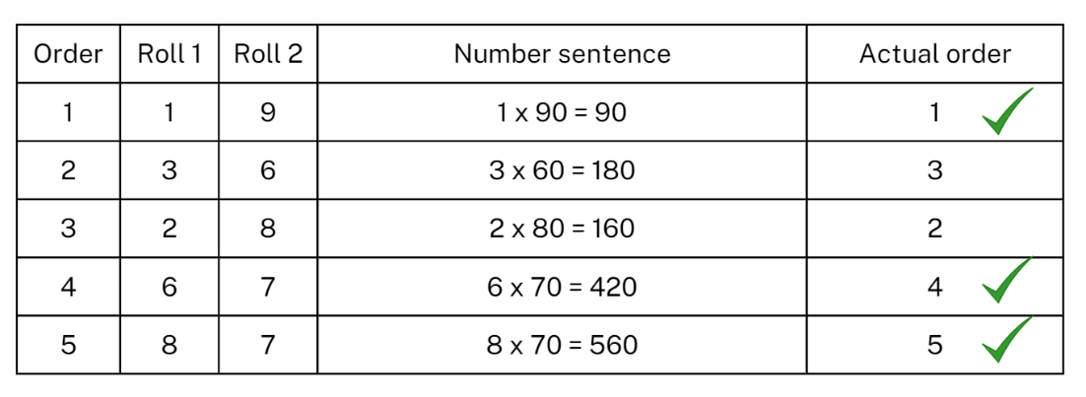
- After each player has completed 5 turns, use the ‘Actual order’ column to record which turns were placed in the correct row. Players score a point for each correct placement. For example, the player in Figure 6 scores 3 points. The player with the most points is the winner.
- Repeat multiple times.
- Reflect on the game, asking questions such as:
- What strategy did you use to multiply?
- How did you decide where to place each answer?
- Did you change your strategy in the next round? Why or why not?
- What modifications could you suggest for the game?

This table details an opportunity for assessment.
Assessment opportunity | Links
What to look for:  - Can students use multiplication facts with multiples of 10 to multiply a one-digit number by a multiple of 10? [MAO-WM-01, MA2-MR-01] | Links to National Numeracy Learning Progressions (NNLP):  - MuS7.

Core lesson: Organising and displaying data – 35 minutes
The table below contains suggested learning intentions and success criteria. These are best co-constructed with students.
Core concept learning intentions | Core concept success criteria
Students are learning to:  - organise and display data using tables and graphs  - interpret and compare data | Students can:  - construct column graphs  - mark equal spaces (intervals) on an axes  - name and label axes  - choose appropriate titles for column graphs  - describe and interpret information.
- Ask students:
- How can we collate and organise the data we collected in Lesson 2?
- How can we best display the data to make it easy to interpret?
- Draw or display a table on the board for collating the survey data (see Table 1).
Table 1 – Example breakfast club survey
Question | Response
What do you think the most important meal of the day is? | Breakfast | Morning tea | Lunch | Afternoon tea | Dinner
How often do you eat breakfast? | Always | Often | Sometimes | Rarely | Never
Which food do you east most often for breakfast? | Toast | Cereal | Fruit | Yoghurt | Other
What time do you arrive to school each morning? | Before 8 am | 8:15 am | 8:30 am | 8:45 am | After 9 am
Which days of the week would you use a breakfast club at school? | Monday | Tuesday | Wednesday | Thursday | Friday
- Read each question aloud and collate the class’s data in the table, using tally marks.
- Distribute grid paper and Resource 5: Column graph checklist to each student and explain that they will create a column graph to represent the data on the board.
- Highlight the attributes of a column graph:
- title
- equal spaces (intervals) on axes
- axes names and labels
- rectangular bars of equal width with spaces between them
- rectangular column heights match the frequency of the category.
Note: when creating column graphs, the columns should not be joined as they represent distinct categorical data.
- Students use a 30 cm ruler to create a column graph on grid paper for the one survey question their group developed in Lesson 2. Ensure that students know that the categories are on the x-axis and the number of students is on the y-axis.
- As a class, display one graph for each of the survey questions.
- Remind students of the statistical question. For example, ‘Would students in our school use a breakfast club?’
- Invite students to answer the question, using the survey questions and data to support their response.
This table details opportunities for differentiation.
Too hard? | Too easy?
Students cannot construct a column graph (with scale intervals of one).  - Provide a graph template with axes named and labelled.  - Students choose a question with fewer response categories. | Students can construct a column graph (with scale intervals of one).  - Students determine the frequency for each response and order their results.  - Students draw their vertical column graph as a horizontal column graph.

Consolidation and meaningful practice – 20 minutes
- Explain that students will draw as many stars as they can in one minute. Emphasise that stars should be drawn as quickly as possible without sacrificing the shape of the stars.
- Students practise drawing stars.
- Time students drawing stars for one minute.
- Students count the number of stars drawn in the minute.
- Place ranges in a table on the board (see Figure 7) and record class results.
Figure 7 – Number of stars table
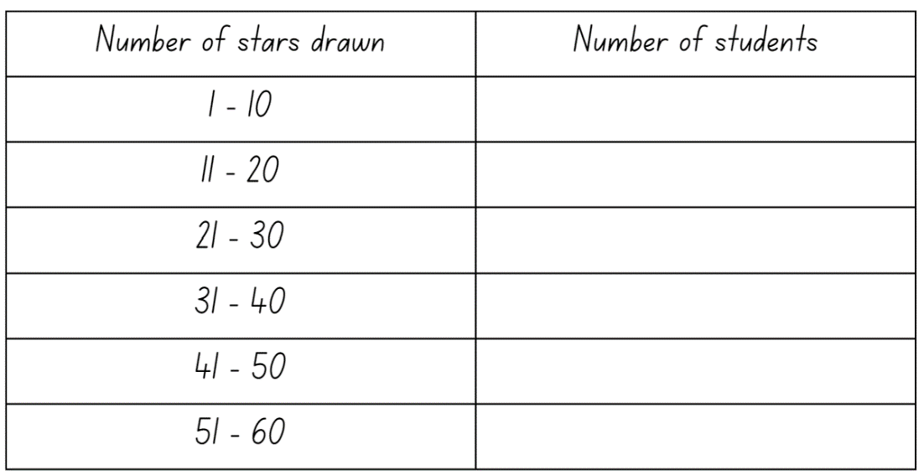
- Distribute a copy of Resource 6: Star column graph to each student.
- Students complete the column graph using the class data from the board.
This table details opportunities for assessment.
Assessment opportunities | Links
What to look for:  - Can students construct column graphs? [MAO-WM-01, MA2-DATA-01]  - Can students mark equal spaces (intervals) on axes? [MAO-WM-01, MA2-DATA-01]  - Can students name and label axes and choose appropriate titles for column graphs? [MAO-WM-01, MA2-DATA-01]  - Can students describe and interpret information? [MAO-WM-01, MA2-DATA-02] | Links to National Numeracy Learning Progressions (NNLP):  - IRD3.

Lesson 4
Core concept: there are many ways to communicate data.

Daily number sense – 15 minutes
- From a class need surfaced through formative assessment data, identify a short, focused activity that targets students’ knowledge, understanding and skills. Example activities may be drawn from the following resources:
- Mathematics K-6 resources
- Universal Resources Hub.

Core lesson 1: Many-to-one scale – 10 minutes
The table below contains suggested learning intentions and success criteria. These are best co-constructed with students.
Core concept learning intentions | Core concept success criteria
Students are learning to:  - construct and interpret data displays with many-to-one scales  - read, represent and order numbers to thousands. | Students can:  - use a given many-to-one scale to represent discrete data in column graphs  - describe and interpret data  - compare and describe the relative size of numbers by positioning them on a number line  - read and order numbers of up to at least 4 digits  - identify the number before and after a number with an internal zero.
Many-to-one scales: a scale of many-to-one uses one unit or interval to represent more than one item or response, such as one centimetre representing 5 items or responses. A dataset needs to contain a sufficiently large number of data points to warrant a many-to-one scale. A narrow range of values, such as 1–5, doesn’t need to use one. However, recording values that range from 1–83 would typically require a many-to-one scale.
- Explain that a ‘many-to-one scale’ means that one unit on the y-axis is used to represent more than one of what is being measured.
- Display Resource 7: Australian animal lengths and ask students:
- What do you notice?
- What do you wonder?
- What is the scale on the y-axis?
- How long is a platypus?
- What is the difference between the length of a bell frog and koala? How did you calculate the answer?
- Why are many-to-one scales used?
- What other many-to-one scale could be used for this data set? Would this change the shape of this graph?
- Students compose a question that requires the interpretation of the many-to-one scale.
- Invite individual students to share their question with the class for others to answer.

Core lesson 2: Constructing many-to-one scale column graphs – 25 minutes
- Distribute a copy of Resource 8: Australian animal life expectancy and grid paper to each student.
- Ask students to:
- add a graph title
- rule the x-axis and y-axis
- name and label the x-axis with animal names, ensuring equal intervals and spaces between categories
- name and label the y-axis with a scale of 1 cm = 5 years.
- Students plot data from the table to create a column graph.
- Students swap their graphs with a partner and provide feedback using Resource 5: Column graph checklist.
- Ask students:
- What did you find challenging about constructing a many-to-one scale column graph?
- Would you do anything differently next time? If yes, please explain.
- Students order and position the numbers from Resource 8: Australian animal life expectancy on an empty number line in their workbooks.
Note: empty number lines are blank lines which students use to represent numbers in relation to other numbers. On an empty number line, students only mark the numbers they need for their calculations.
- Ask students:
- What number did you place on your number line first? Why?
- How did you determine where each number was located on the number line?
- Do you have zero on your number line? Why or why not?
This table details opportunities for differentiation.
Too hard? | Too easy?
Students cannot construct a column graph using a given many-to-one scale.  - Provide a column graph template with title and y-axis labelled with many-to-one scale.  - Provide a simpler data set for students to construct a column graph with a scale of 1–2. | Students can construct a column graph using a given many-to-one scale.  - Provide a data set with larger values requiring a larger many-to-one scale.  - Provide a data set and ask students to create their own many-to-one scale.

Consolidation and meaningful practice – 15 minutes
- Display Resource 9: Animal weight.
- Students read each number aloud to a partner.
- Distribute individual whiteboards and whiteboard markers to each student.
- Ask students to:
- order and record the numbers in ascending order
- write the number before and after each number.
This table details opportunities for differentiation.
Too hard? | Too easy?
Students cannot read, order and write the number before and after numbers with 4 digits.  - Provide 3-digit numbers including internal zeros.  - Provide numbers with zeros only in the ones place. | Students can read, order and write the number before and after numbers with 4 digits.  - Provide numbers with multiple zeros.  - Students create a set of numbers and swap with a partner to place in descending order.
This table details opportunities for assessment.
Assessment opportunities | Links
What to look for:  - Can students use a given many-to-one scale to represent discrete data in column graphs? [MAO-WM-01, MA2-DATA-01]  - Can students describe and interpret data? [MAO-WM-01, MA2-DATA-02]  - Can students compare and describe the relative size of numbers by positioning numbers on a number line? [MAO-WM-01, MA2-RN-01]  - Can students read and order numbers of up to at least 4 digits? [MAO-WM-01, MA2-RN-01]  - Can students identify the number before and after a number with an internal zero digit? [MAO-WM-01, MA2-RN-01] | Links to National Numeracy Learning Progressions (NNLP):  - IRD3, NPV5, NPV6.

Lesson 5
Core concept: digital technologies can be used to present data.

Daily number sense: Odds and evens – 15 minutes
Daily number sense activities for Lessons 5 to 7 ‘loop’ back to concepts and procedures covered in previous units to assist students to build an increasingly connected network of ideas. These concepts may differ from the core concepts being covered by the unit.
The table below contains a suggested learning intention and success criteria. These are best co-constructed with students.
Daily number sense learning intention | Daily number sense success criteria
Students are learning to:  - generate and describe patterns. | Students can:  - recognise the significance of the final digit of a whole number in determining whether a given number is even or odd  - recognise the connection between even numbers and the multiplication facts for 2.
This activity is an adaptation of Always, Sometimes or Never? from NRICH by University of Cambridge (Faculty of Mathematics).
- Display a variety of odd and even one-, 2- and 3-digit numbers and ask students to identify if they are odd or even.
- Ask students to explain how they know if a number is odd or even.
- Demonstrate the link between even numbers and the multiplication facts for 2. Explain the significance of the final digit of a whole number.
Note: one result that follows from the place value system is that any whole number can be written as a multiple of 10 plus a single digit. For example, 153 is 150 plus 3. Since a multiple of 10 is always even because every group of 10 is 2 rows of 5, then whether a number is odd or even can be determined by its final digit.
- Display Resource 10: Always, sometimes or never?
- Students work in pairs or small groups to explore and then record if each statement is always true, sometimes true or never true. Advise students to check each statement with at least 3 different sets of numbers of varying size.
- Select students to share their thinking and discuss, asking questions such as:
- Can you explain your thinking?
- Does anyone disagree? Why?
- Can you explain why this statement is always or never true?
- Can you rewrite this ‘sometimes’ statement so that it changes to an ‘always’ statement?
This table details opportunities for assessment.
Assessment opportunities | Links
What to look for:  - Can students identify odd and even numbers? [MAO-WM-01, MA2-MR-01]  - Can students explain how they know a number is even or odd? [MAO-WM-01, MA2-MR-01] | Links to National Numeracy Learning Progressions (NNLP):  - NPA3.

Core lesson: Rubbish data – 45 minutes
The table below contains a suggested learning intention and success criteria. These are best co-constructed with students.
Core concept learning intention | Core concept success criteria
Students are learning to:  - construct and interpret data displays with many-to-one scales. | Students can:  - use data in a spreadsheet to create column graphs with units on vertical axes that are in multiples  - create a survey and related recording sheet, considering the appropriate organisation of categories for data collection  - describe and interpret information presented in tables and graphs.
This activity is an adaptation of Rubbish recording and reduction: Part 1 from Digital Technologies Hub by Education Services Australia Limited.
- Ask students:
- What different kinds of rubbish are there?
- How much rubbish do you think you bring in to school each week?
- How much rubbish do you think you and your family produce each week?
- How much rubbish do you think people produce worldwide each day?
- Show Resource 11: Food waste and ask students to share something that they:
- find interesting
- find surprising
- think is easy to change
- think is hard to change.
- Display Household waste statistics and explain that one ton equals approximately 907 kilograms. Ask students why they think this information might be important.
Note: this activity requires students to survey other classes. Ensure that classroom visits have been prearranged. Interruptions may be minimised by assigning each group to a single class or grade and then collating the data. Teachers may also vary the number of classes surveyed depending on the size of their school or conduct the survey on a different day due to the time involved.
- Explain that students will be collecting data on what rubbish has been brought to school by students. Students will be working in small groups to answer:
- How much of each rubbish type is being brought to school?
- How much rubbish in total is being brought in by each class?
- Discuss how the data might be collected. For example, examining student lunchboxes to identify potential rubbish, such as foil or soft plastic used to wrap a sandwich.
- Discuss how the different types of rubbish might be categorised. For example, soft plastic, hard plastic, foil, single use drink containers, fruit and vegetable scraps and so on.
- Discuss how the data might be recorded and how it might be set out. For example, columns for each class and tally marks.
- As a class, collect data from students in the class, demonstrating how it should be recorded.
- Students collect data from other classes. Setting a time limit is advised.
- Once the students have returned with their findings, collate the data collected and explain that the data will be entered into a Microsoft Excel spreadsheet to allow them to represent the data in a variety of ways.
Note: Google Sheets may be used instead of Microsoft Excel, depending on school context.
- Demonstrate how to enter data into a simple table in a Microsoft Excel spreadsheet (see Figure 8).
Figure 8 – Example rubbish table
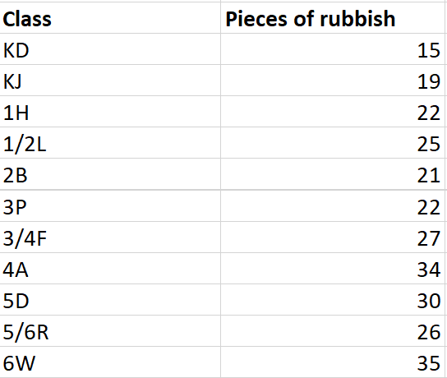
- Students enter the 2 data sets into a Microsoft Excel spreadsheet.
- Demonstrate how to create a column graph from the data in a spreadsheet. For example, in Microsoft Excel, highlight the data, select the Insert tab in the ribbon. Select the Insert Column or Bar Chart icon and then select Clustered Column in 2D Column (see Figure 9).
Figure 9 – Example column graph without axes titles
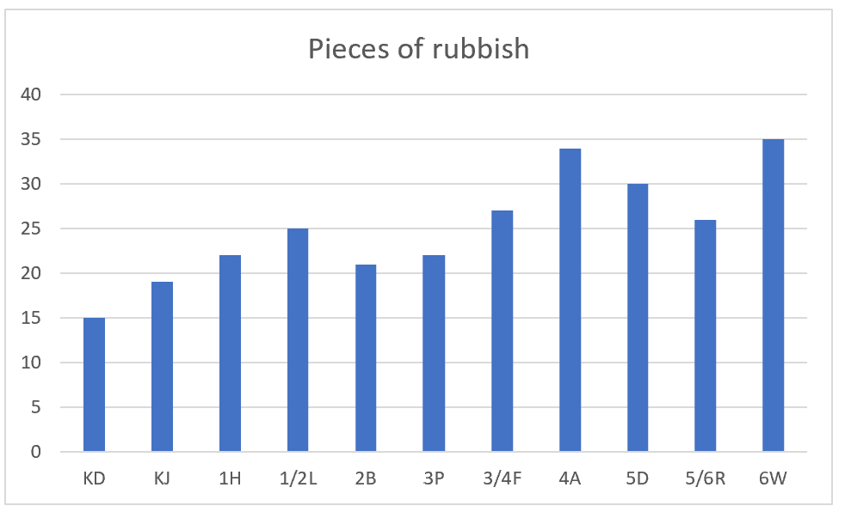
- Examine the features of the graph created, for example, the many-to-one scale used on the y-axis.
- Ask students why a many-to-one scale has been used and how to interpret the graph.
- Students create graphs for each data set in their spreadsheet.
- Ask students if there are any features missing from the graph, for example, titles on the axes.
- Demonstrate how to add titles to the axes by clicking on the graph and selecting the Chart Elements icon (see Figure 10).
Figure 10 – Example complete column graph
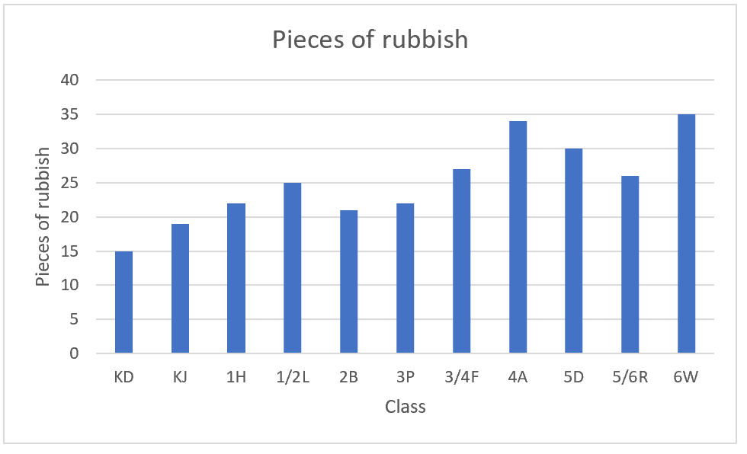
- Students add titles to the axes in each graph in their spreadsheet.
- Conduct a gallery walk and compare graphs made by different groups. Ask students if there are any differences between each group’s graphs and why these may exist.
This table details opportunities for differentiation.
Too hard? | Too easy?
Students cannot enter data and create graphs in Microsoft Excel.  - Model how to enter the data and create a graph for the first data set. Students enter data and create graphs for the other data set. | Students can enter data and create graphs in Microsoft Excel.  - Ask how the process data displays might look if the school was a different size.  - Ask students what the data might look if every school in NSW had similar data – there are approximately 2000 primary schools in NSW (Statista 2023).

Discuss and connect the mathematics – 5 minutes
- Reflect on the activity by asking questions such as:
- Were there any challenges in collecting the data?
- What is the data telling us?
- How could we use this data?
- What kind of graphs might use a many-to-one scale? Why?
- Why might we use technology to display data?
This table details opportunities for assessment.
Assessment opportunities | Links
What to look for:  - Can students use data in a spreadsheet to create column graphs with units on vertical axes that are in multiples? [MAO-WM-01, MA2-DATA-01]  - Can students create a survey and related recording sheet, considering the appropriate organisation of categories for data collection? [MAO-WM-01, MA2-DATA-01]  - Can students describe and interpret information presented in tables and graphs? [MAO-WM-01, MA2-DATA-02] | Links to National Numeracy Learning Progressions (NNLP):  - IRD3.

Lesson 6
Core concept: data can be presented to convince or persuade.

Daily number sense: Number chart patterns – 15 minutes
The table below contains a suggested learning intention and success criteria. These are best co-constructed with students.
Daily number sense learning intention | Daily number sense success criteria
Students are learning to:  - generate and describe patterns. | Students can:  - model, describe and record patterns of multiples  - recognise the connection between even numbers and multiples of 2.
This activity is an adaptation of Multiple Patterns from NZ Maths by New Zealand Ministry of Education.
- Display Resource 12: Number chart patterns.
- Ask students:
- What do you notice?
- What do you wonder?
- What might the pattern look like if multiples of 2 are covered?
- How do we know if a number is a multiple of 2?
- What might the pattern look like if multiples of 10 are covered?
- How do we know if a number is a multiple of 10?
- What might the pattern look like if multiples of 5 are covered?
- How do we know if a number is a multiple of 5?
- Provide students with a copy of Resource 13: Number chart.
- Students to use coloured counters or markers to indicate multiples of 2, 5 and 10.
- Ask students:
- Do the patterns match your predictions?
- What do you notice about the numbers that are not covered?
- What might the pattern look like if multiples of 6 are covered?
- What might the pattern look like if multiples of 8 are covered?
This table details opportunities for assessment.
Assessment opportunities | Links
What to look for:  - Can students model, describe and record patterns of multiples? [MAO-WM-01, MA2-MR-01]  - Can students recognise the connection between even numbers and multiples of 2? [MAO-WM-01, MA2-MR-01] | Links to National Numeracy Learning Progressions (NNLP):  - NPA3, NPA4.

Core lesson: Scrabble stats – 45 minutes
The table below contains suggested learning intentions and success criteria. These are best co-constructed with students.
Core concept learning intentions | Core concept success criteria
Students are learning to:  - construct and interpret data displays with many-to-one scales  - read, represent and order numbers to thousands. | Students can:  - use data in a spreadsheet to create column graphs with units on vertical axes that are in multiples  - describe and interpret data presented  - read and order numbers of up to at least 4 digits  - identify the number before and after a number with an internal zero digit.
This activity is an adaptation of Scrabble stats at Mathematics K-6 resources by State of New South Wales (Department of Education).

- Ask students:
- Have you ever played Scrabble before?
- Do you know the rules of the game?
Note: the objective of Scrabble is to get the most points by creating words. Words are built by placing lettered tiles on a grid. Each tile is assigned a point value and the main strategy is to play words that have the highest possible score based on the combination of letters. Players build off at least one tile in each other's words until no one can build any more words. The player with the highest score wins.
- Explain that the game of Scrabble was invented in 1933. The inventor of Scrabble, Alfred Butts, chose the value of each letter by reviewing newspapers and other sources of text. He calculated the frequency of each letter. The frequency is how common something is or how often it happens. Letters that were used the most were worth fewer points and letters that were rarely used were worth more points.
- Ask students:
- Do you think that letter frequencies might have changed since 1933?
- Why do you think that?
- Display Resource 14: Scrabble tiles – point values and ask students:
- What do you notice?
- What do you wonder?
- Does the Scrabble points system need to be updated?
- How could we answer this question?
- What data would we need to collect?
- What is an efficient way to collect this data?
- Explain that to complete the investigation, students need to find out how often different letters are used in a modern text by recording how many times each letter occurs.
- Display Resource 15: Scrabble stats tally table and students draw their own recording sheet in their workbook.
- Provide recent newspapers, magazines or books for students to select a page to analyse.
- Students record the frequency of each letter in their table using tally marks.
This table details opportunities for differentiation.
Too hard? | Too easy?
Students cannot record the frequency of letters in a text.  - Students tally the frequency of letters for a smaller amount of text.  - Students tally frequency of vowels only. | Students can record the frequency of letters in a text.  - Student tally frequency for a different page in the same text and compare their findings.  - Student tally frequency for a different type of text and compare their findings.
- Students to represent their data in a column graph using Microsoft Excel or Google Sheets. Students to follow the same process as in Lesson 5.
- Students:
- open Microsoft Excel or Google Sheets on a device
- open a blank spreadsheet
- enter the letters and their frequencies in columns A and B
- highlight the data, including the headings
- use the top ribbon to select Insert’ and Insert Column or Bar Chart
- add any features missing from the graph, for example, title or axes names or labels.
- Conduct a gallery walk and compare graphs. Ask students if there are any differences between each student’s graph and why these may exist.
- Discuss results by asking questions such as:
- What do you notice about the frequency of the letters in your table or graph?
- How many times was each letter used in the text you investigated?
- Do any of your results surprise you?
- Which letters were you expecting to be most and least frequent?
- Which letters are most frequent and least frequent?
- Do you think the results would be similar if you investigated a piece of your writing? Why or why not?
- Can you identify any letter which should be given a different score? Justify your answer.
- Does the type of text change the letter frequencies?
- In pairs, students assign each letter a new point value.
- Pairs share their new values and use their data set to justify their values.

Consolidation and meaningful practice –10 minutes
- Display Resource 16: Scrabble scores and explain that the data is 6 people’s Scrabble scores from 10 games of Scrabble.
- Students read each number aloud to a partner.
- Distribute individual whiteboards and whiteboard markers to each student.
- Ask students to:
- order and record the numbers in descending order on their whiteboard
- write the number before and after each number.
This table details opportunities for assessment.
Assessment opportunities | Links
What to look for:  - Can students use data in a spreadsheet to create column graphs with units on vertical axes that are in multiples? [MAO-WM-01, MA2-DATA-01]  - Can students describe and interpret data presented? [MAO-WM-01, MA2-DATA-02]  - Can students read and order numbers of up to at least 4 digits? [MAO-WM-01, MA2-RN-01]  - Can students identify the number before and after a number with an internal zero digit? [MAO-WM-01, MA2-RN-01] | Links to National Numeracy Learning Progressions (NNLP):  - IRD3, NPV5, NPV6.

Lesson 7
Core concept: interpreting data helps to solve problems and ask new questions.

Daily number sense: Number patterns – 15 minutes
The table below contains a suggested learning intention and success criteria. These are best co-constructed with students.
Daily number sense learning intention | Daily number sense success criteria
Students are learning to:  - generate and describe patterns. | Students can:  - create and continue a variety of number patterns that increase or decrease by a constant amount.
- Display the following number patterns:
- 95, 88, 81, 74, 67
- 90, 96, 102, 108, 114
- 79, 88, 97, 106, 115.
- For each number pattern, ask students:
- Can you describe the pattern?
- How do you know it is a pattern?
- What would the next 3 numbers be?
- What would the 3 numbers be before the displayed numbers?
- Students create and record their own number patterns that increase or decrease by any number under 12.
- Students give their patterns to a partner and ask them to describe the pattern and record the next 3 numbers.
This table details an opportunity for assessment.
Assessment opportunity | Links
What to look for:  - Can students create and continue a variety of number patterns that increase or decrease by a constant amount? [MAO-WM-01, MA2-MR-01] | Links to National Numeracy Learning Progressions (NNLP):  - NPA3.  Links to suggested Interview for Student Reasoning (IfSR) tasks:  - IfSR-NP: 4A.1, 4A.2, 4A.3.

Core lesson: Different data displays – 30 minutes
The table below contains suggested learning intentions and success criteria. These are best co-constructed with students.
Core concept learning intentions | Core concept success criteria
Students are learning to:  - interpret data displays with many-to-one scales  - read, represent and order numbers to thousands. | Students can:  - interpret and evaluate the effectiveness of various data displays found in media where displays represent data using a scale of many-to-one  - order numbers of up to at least 4 digits  - identify the number before and after a number with an internal zero digit.
Media: a channel of general communication, information, or entertainment in society such as newspapers, radio, social media or television.
- Explain that media is a way of communicating to the general population.
- As a class, brainstorm and record different types of media. For example, television, radio, podcasts, newspapers, social media.
- Discuss what types of data and representations are used in the media.
- Explain that students are going to look at different data displays in the media and evaluate their effectiveness.
- Display Resource 17: Gold medal picture graph and ask:
- What data is being displayed?
- Is this representation easy to interpret?
- How many gold medals did Australia win at the 2000 Olympics games? How did you calculate your answer?
- How many more gold medals did China win compared to Germany? How did you calculate your answer?
- Display Resource 18: Gold medal column graph and ask students:
- What data is displayed?
- How is this representation similar and different to the picture graph?
- Which is easier to interpret? Explain why.
- Which country won the most gold medals and how many did they win?
- Which country won the least gold medals and how many did they win?
- How many more gold medals did Australia win compared to Great Britain? How did you calculate your answer?
- Display Resource 19: Gold medal table.
- In pairs, students write 3 questions about the data representation to be answered by another pair of students.
- Students swap questions and answer their peers’ questions.
- Invite students to share their questions with the class.
- In pairs, students:
- discuss positives and negatives of all 3 displays
- order the resources from most effective to least effective in communicating the data set.
- Select students to share which representation they believe is the most effective and justify their choice.
This table details opportunities for differentiation.
Too hard? | Too easy?
Students cannot interpret and evaluate the effectiveness of picture and column graphs with many-to-one scales.  - Provide a modified picture graph where one picture equals 2 medals.  - Expand the key in the picture graph to include what one-quarter and what three-quarters of a medal represents. | Students can interpret and evaluate the effectiveness of picture and column graphs with many-to-one scales.  - Investigate possible reasons why particular countries perform consistently well at consecutive Olympic Games.  - Research and graph the performance of Australia at Olympic Games from 2000 to now.

Consolidation and meaningful practice – 15 minutes
- Display Resource 20: Total medal count.
- Students list the countries and number of medals in descending order in their workbooks.
- In pairs, students read aloud and record:
- each country’s total medal tally
- the number that comes before each number
- the number that comes after each number.
- Write the following numbers on the board:
- 2806
- 1508
- 3022
- 1001.
- In pairs, students read aloud and record:
- each number
- the number that comes before each number
- the number that comes after each number.
- Ask students:
- Which numbers did you find the easiest to read aloud?
- Which numbers did you find the hardest to read aloud? Why?
- Which numbers were the easiest to write the number before and after?
- Which numbers were the hardest to write the number before and after? Why?
This table details opportunities for assessment.
Assessment opportunities | Links
What to look for:  - Can students interpret and evaluate the effectiveness of various data displays found in media where displays represent data using a scale of many-to-one? [MAO-WM-01, MA2-DATA-02]  - Can students read and order numbers of up to at least 4 digits? [MAO-WM-01, MA2-RN-01]  - Can students identify the number before and after a number with an internal zero digit? [MAO-WM-01, MA2-RN-01] | Links to National Numeracy Learning Progressions (NNLP):  - IRD3, NPV5, NPV6.

Lesson 8
Core concept: statistical reasoning helps mathematicians interpret and make inferences about information.

Daily number sense – 15 minutes
- From a class need surfaced through formative assessment data, identify a short, focused activity that targets students’ knowledge, understanding and skills. Example activities may be drawn from the following resources:
- Mathematics K-6 resources
- Universal Resources Hub.

Core lesson: If the world were a village – 45 minutes
The table below contains suggested learning intentions and success criteria. These are best co-constructed with students.
Core concept learning intentions | Core concept success criteria
Students are learning to:  - interpret data displays with many-to-one scales  - read, represent and order numbers to thousands. | Students can:  - interpret and evaluate the effectiveness of various data displays using a scale of many-to-one  - compare and describe the relative size of numbers by positioning numbers on a number line.
This activity is an adaptation of If the World Were a Village from NRICH by University of Cambridge (Faculty of Mathematics).
Note: statistical reasoning involves identifying patterns across datasets and making inferences from the data.
- As a class, brainstorm books that present data to their audience.
- Show the front cover of If the World Were a Village: A Book about the World's People and ask students to predict:
- what the book is about
- if the book contains data and justify their reasoning.
- Read the book to the class and ask students:
- What data was in the book?
- How is the data represented?
- Explain that data does not have to be represented visually, it can be communicated through written text.
- Highlight that in the book, the world’s population in mid-2019 was 7 700 000 000. The book represents the population in an imaginary village of 100 people, so each person represents approximately 77 000 000 people from the real world. This is a many-to-one representation.
- Display Resource 21: 100 people and ask students:
- What do you see?
- What do you think?
- What do you wonder?
- Which is the best way to represent the data? Why?
- Distribute a copy of Resource 22: Nationalities to pairs of students.
- Ask students:
- What do you notice?
- Does the data set change in each representation? How do you know?
- Is there any missing information that would help support your understanding?
- Lead students through interpreting the data to write a jointly constructed story of the data. For example, if our world was a village of 100 people, then 59 people would be from Asia, 16 from Africa, 10 from Europe, 9 from South America, 5 from North America and only one would be from Oceania.
- In pairs, students:
- annotate the displays, identifying what is effective and ineffective about each
- choose the most effective display for an audience of Year 3 and 4 students and explain why.
- Select students to share their responses as to which display is most effective and why.
- Students draw an empty number line in their workbooks and place the numbers from the data set (59, 16, 10, 9, 5, 1) on the number line.
- Invite students to explain the order in which they placed the numbers on the number line and why.
- Display Resource 23: Energy.
- In pairs, students represent the data in 4 different ways. For example, a list, tally marks, tally table, frequency table, dot plot, column graph.
- Distribute one dot sticker to each student and conduct a gallery walk to view the class’s data representations.
- Students place their dot sticker on the representation they feel is the most effective in communicating the data.
- Invite students to identify which data display they chose and explain why they believe it is the most effective.
This table details opportunities for differentiation.
Too hard? | Too easy?
Students cannot represent data using a many-to-one scale.  - Students represent the data in one display.  - Provide data display templates with elements added, such as table headings or graph axes names and labels. | Students can represent data using a many-to-one scale.  - Students explain how the data in the book might be used for positive changes.  - Students research countries that make up Oceania and compare their populations, considering how each population might be represented in a village of 100 people from Oceania.

Discuss and connect the mathematics – 5 minutes
- Reflect on the lesson by asking questions such as:
- How effectively is the data represented in the book? Justify your answer.
- How could you represent the data in the book more effectively?
- Are there any topics in the book that would be harder to represent than others? Why?
This table details opportunities for assessment.
Assessment opportunities | Links
What to look for:  - Can students interpret and evaluate the effectiveness of various data displays found in factual texts where displays represent data using a scale of many-to-one? [MAO-WM-01, MA2-DATA-02]  - Can students compare and describe the relative size of numbers by positioning numbers on a number line? [MAO-WM-01, MA2-RN-01] | Links to National Numeracy Learning Progressions (NNLP):  - IRD3, IRD4, NPV5, NPV6.

Resource 1: Multiples madness gameboard
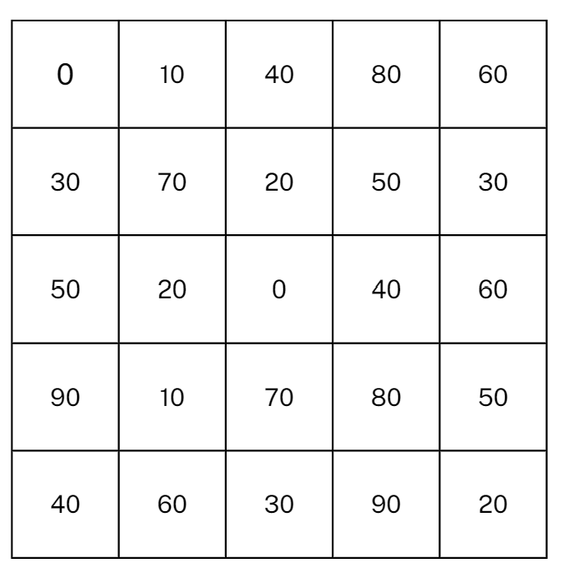

Resource 2: Multiples madness scoreboard
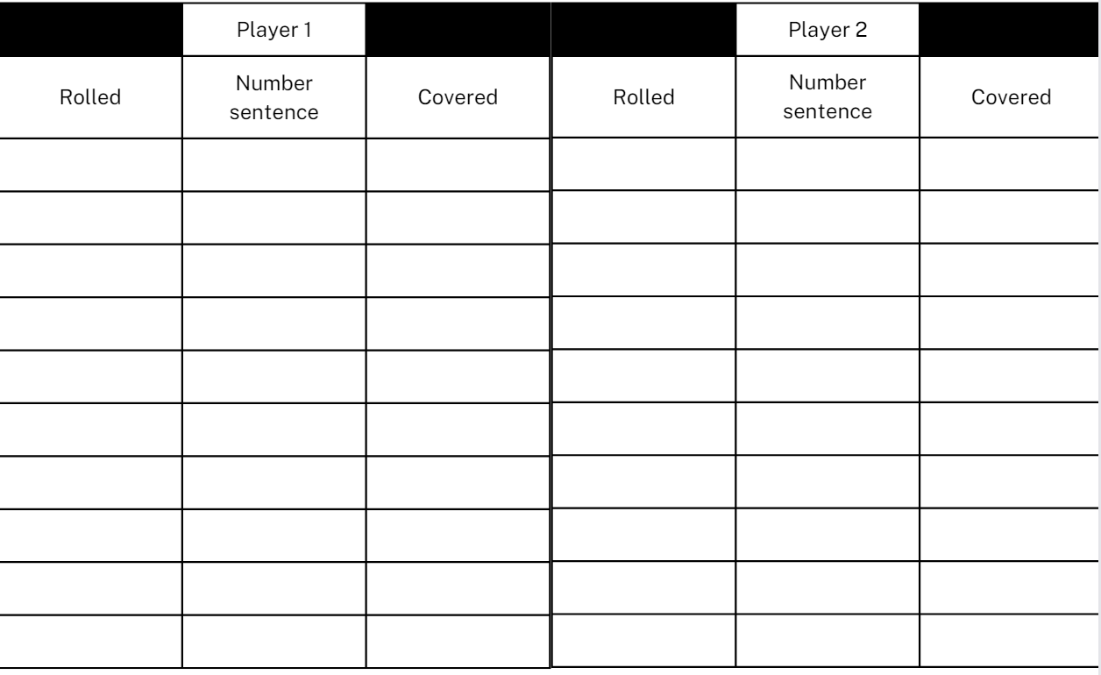

Resource 3: Survey questions checklist
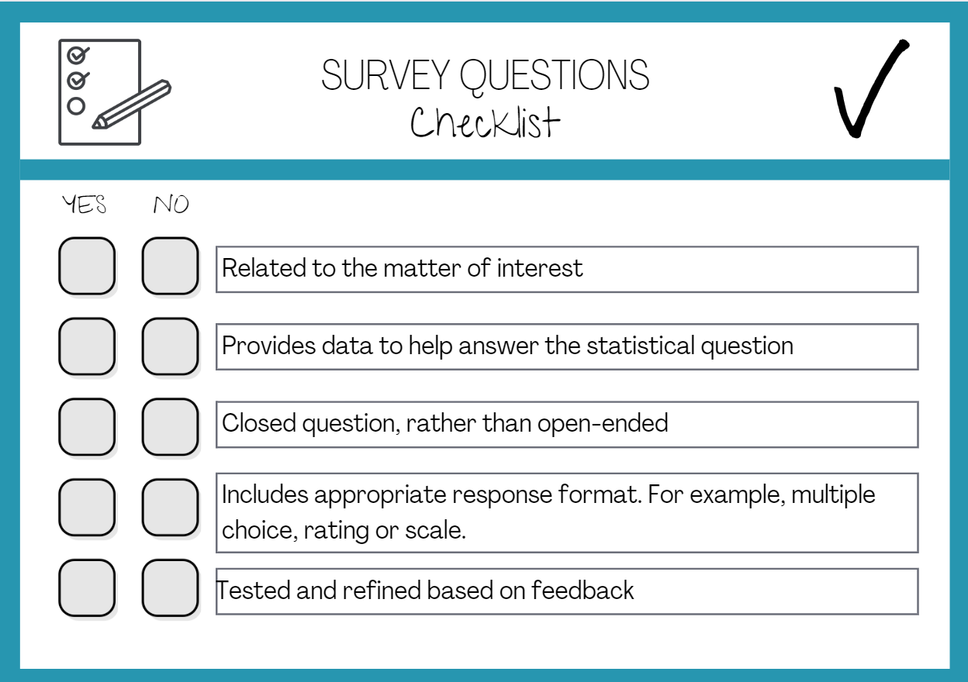

Resource 4: Multiplying multiples
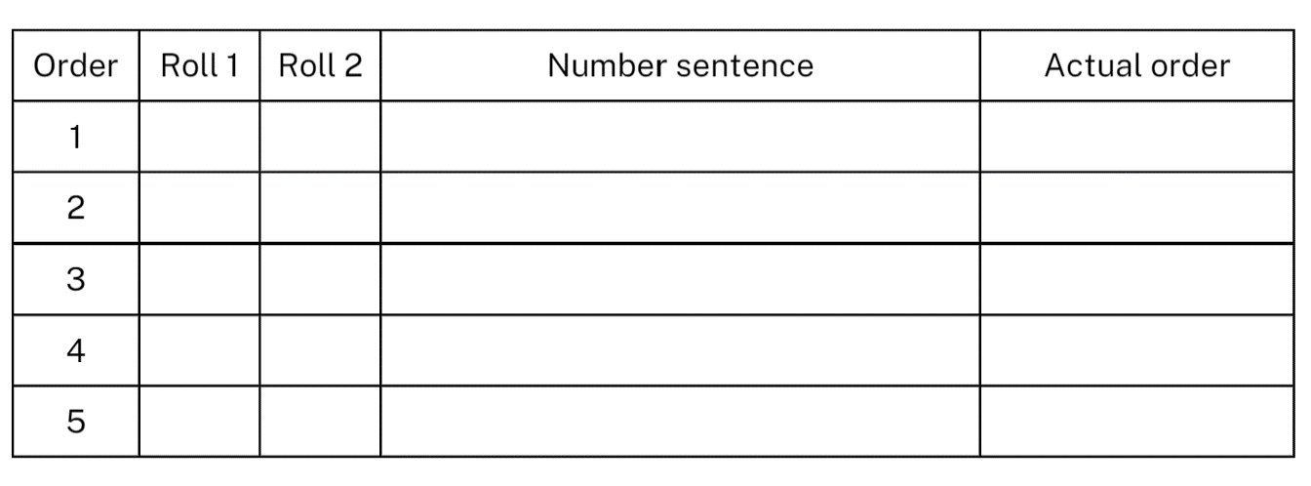

Resource 5: Column graph checklist
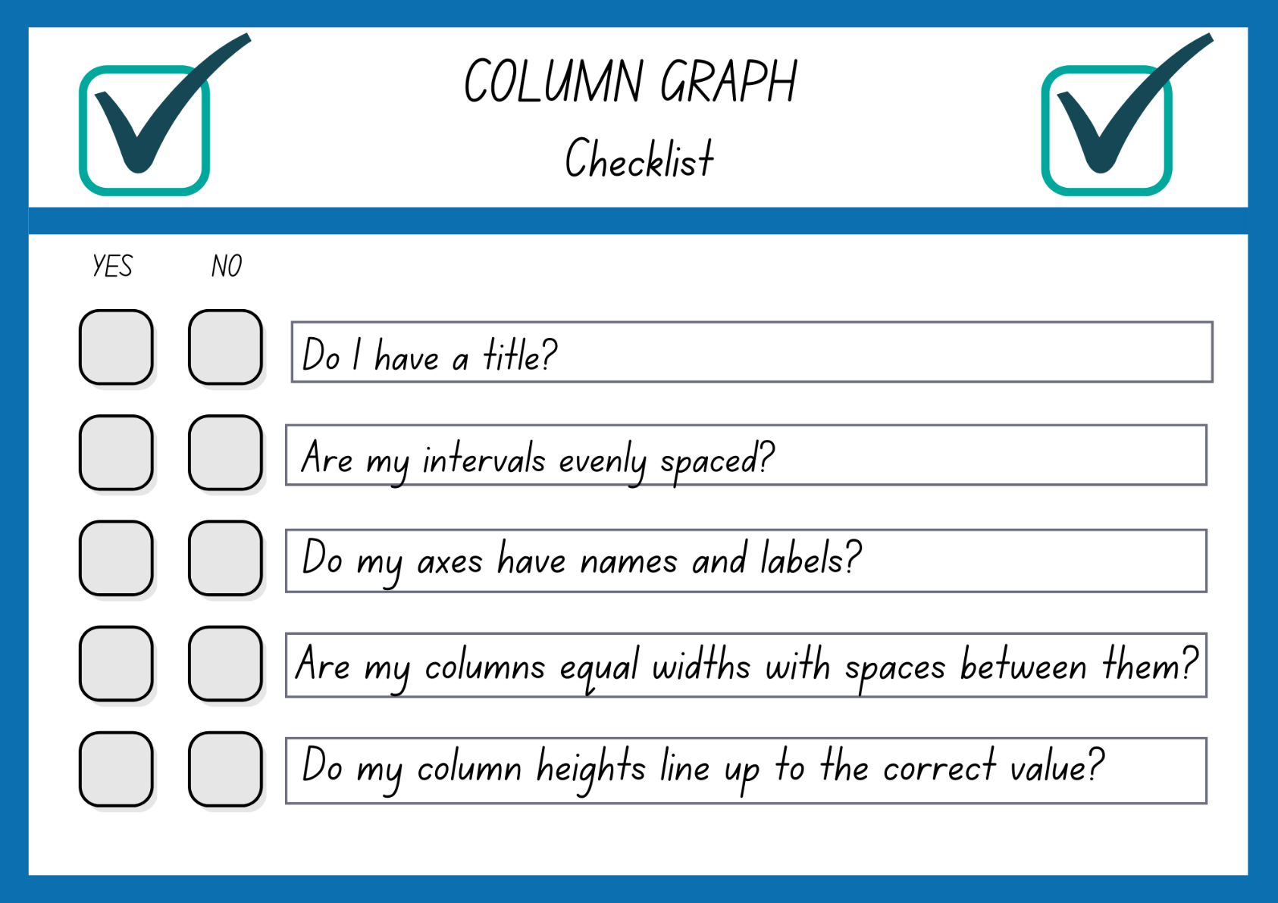

Resource 6: Star column graph
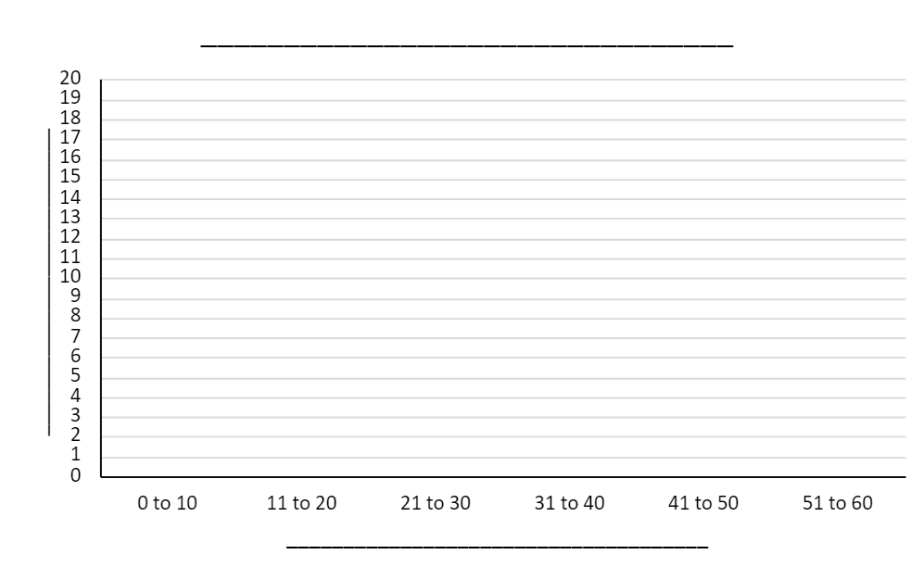

Resource 7: Australian animal lengths
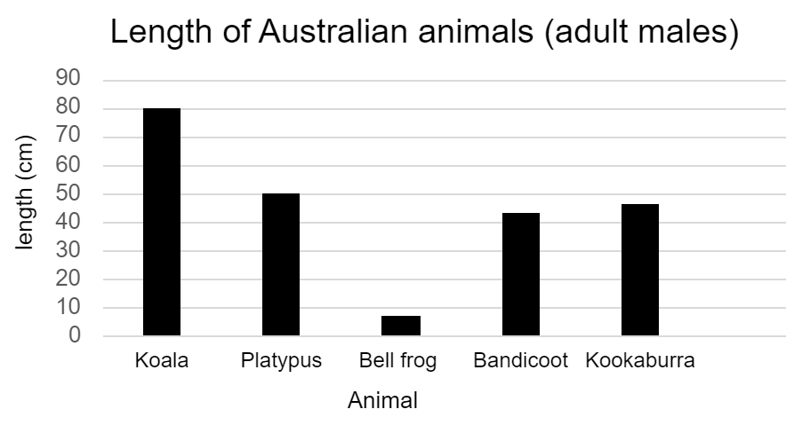
Data sourced from State of New South Wales (Department of Planning and Environment) 2020.

Resource 8: Australian animal life expectancy
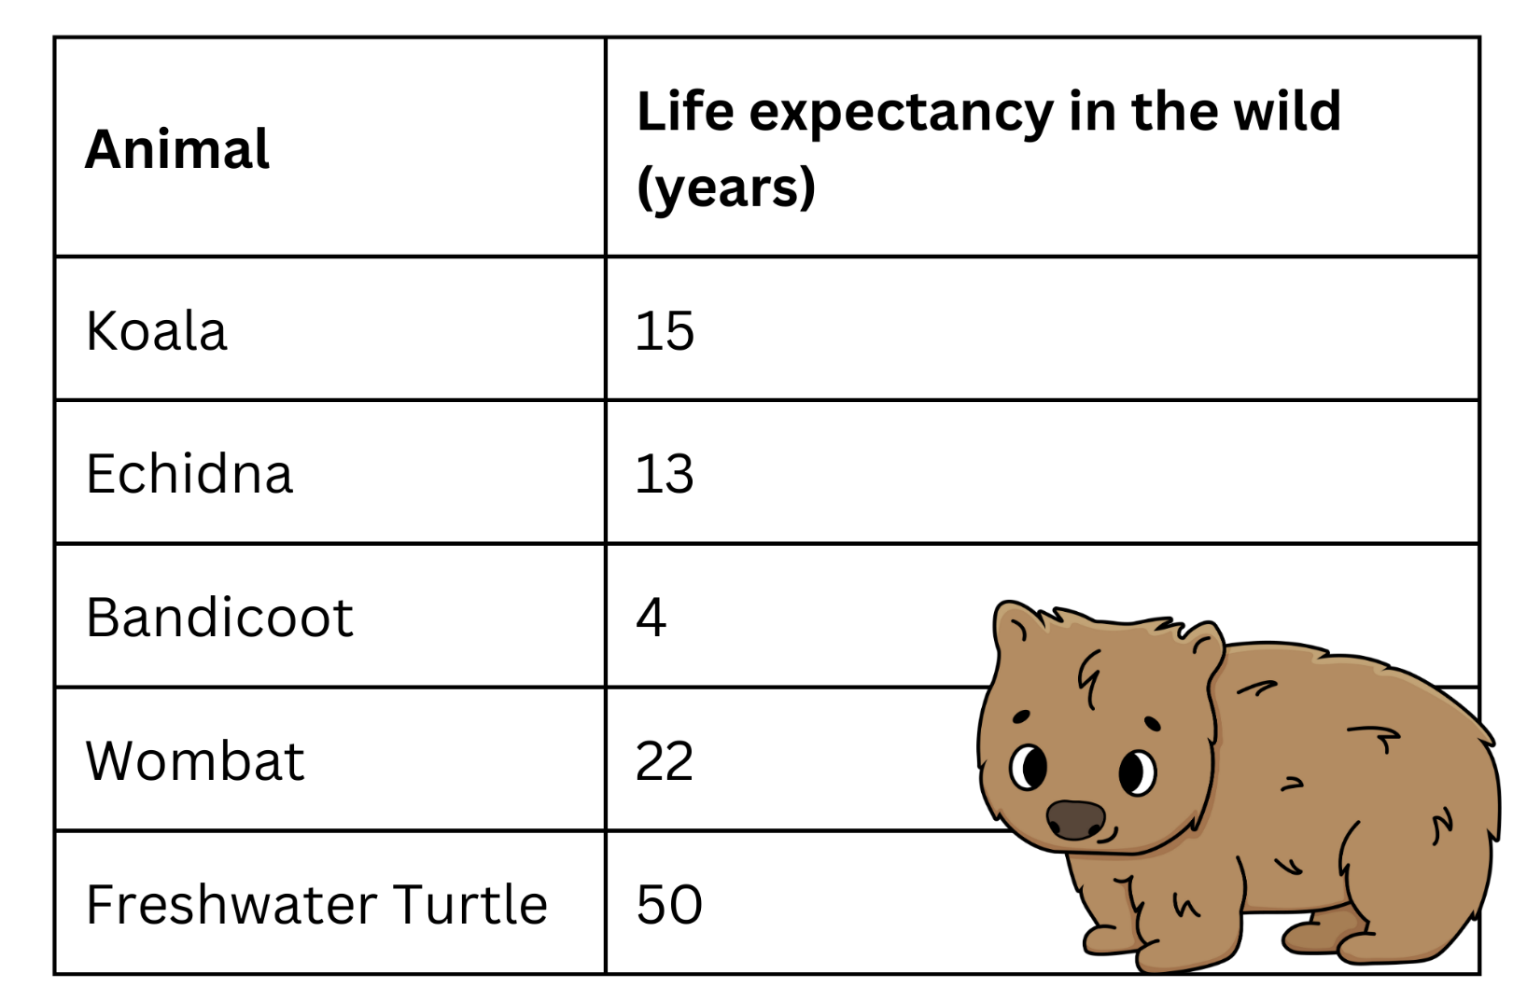
Data sourced from State of New South Wales (Department of Planning and Environment) 2020.

Resource 9: Animal weight
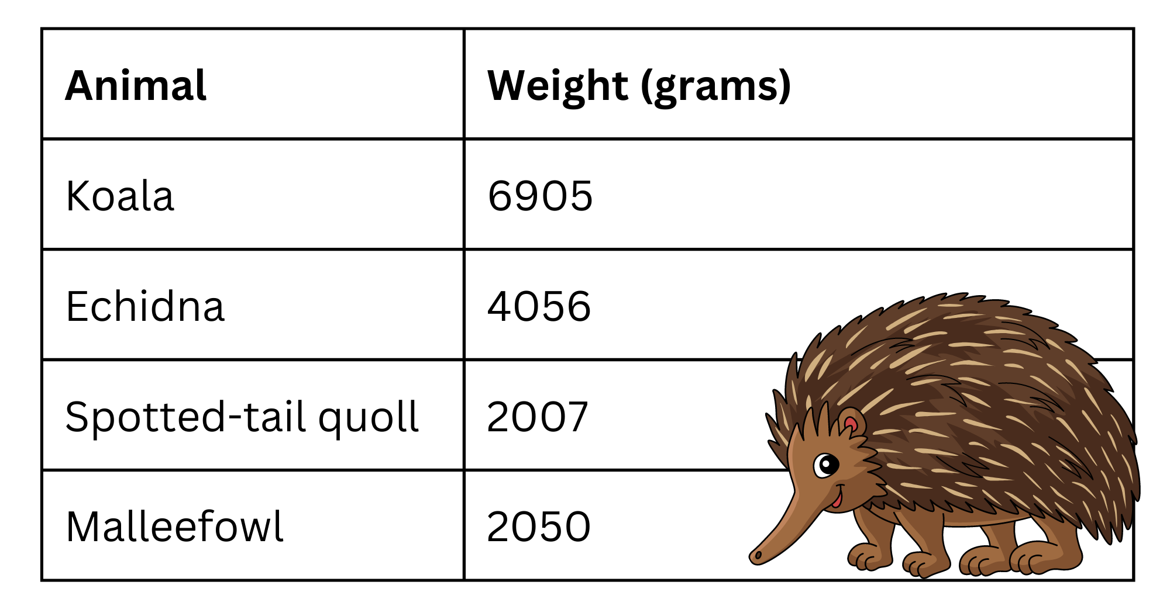
Data sourced from State of New South Wales (Department of Planning and Environment) 2020.

Resource 10: Always, sometimes or never?
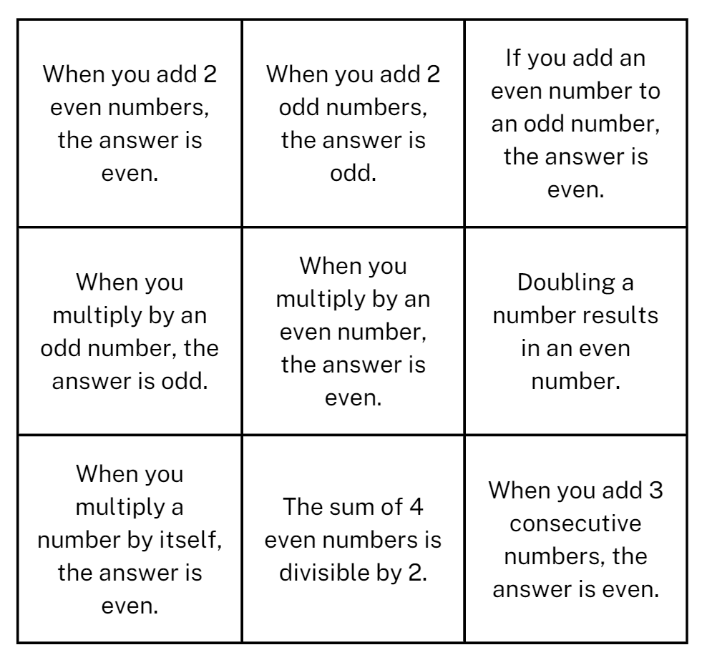

Resource 11: Food waste
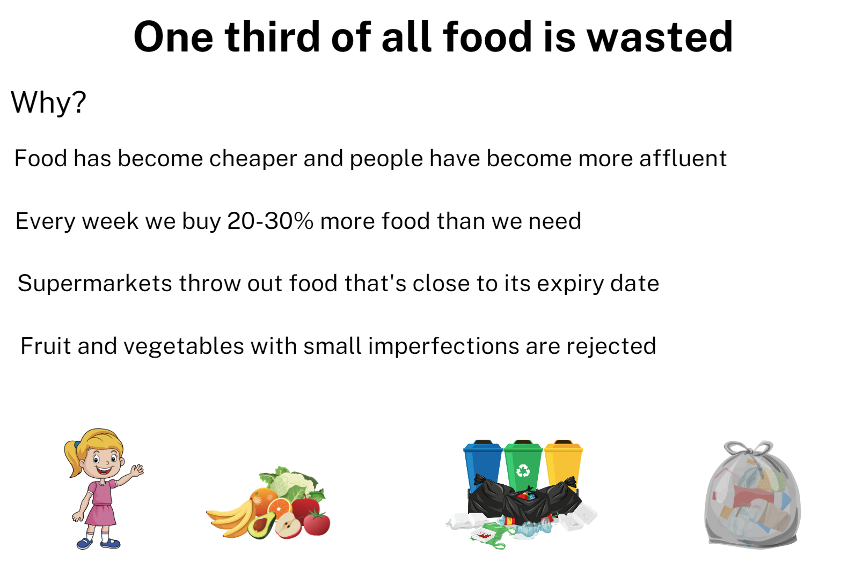
Data sourced from National Geographic (2016).

Resource 12: Number chart patterns
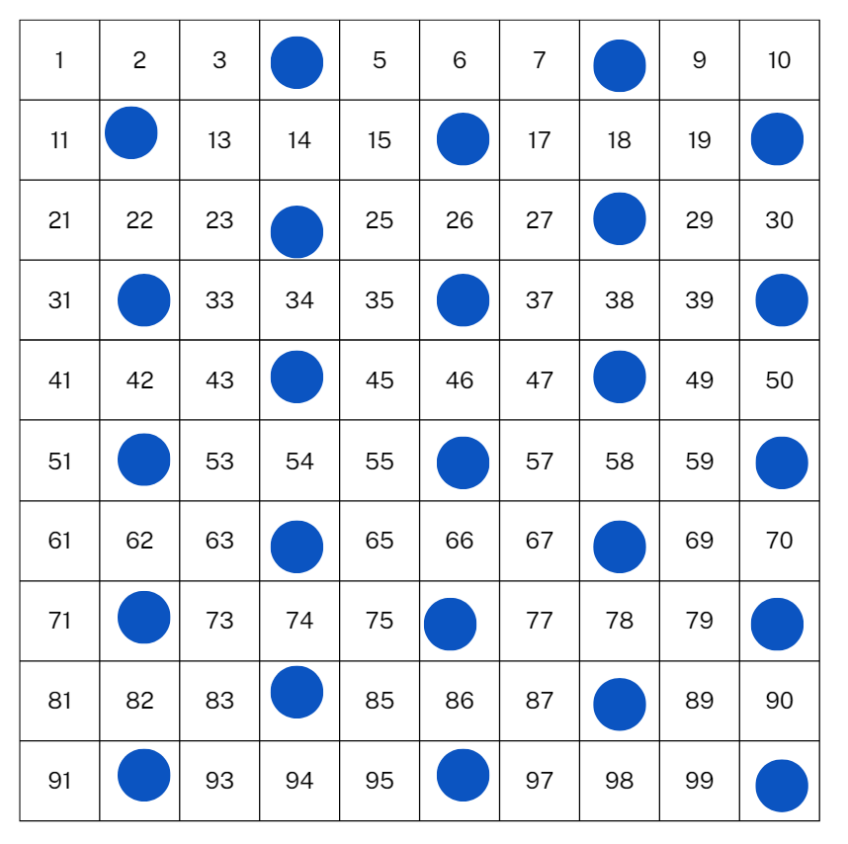

Resource 13: Number chart
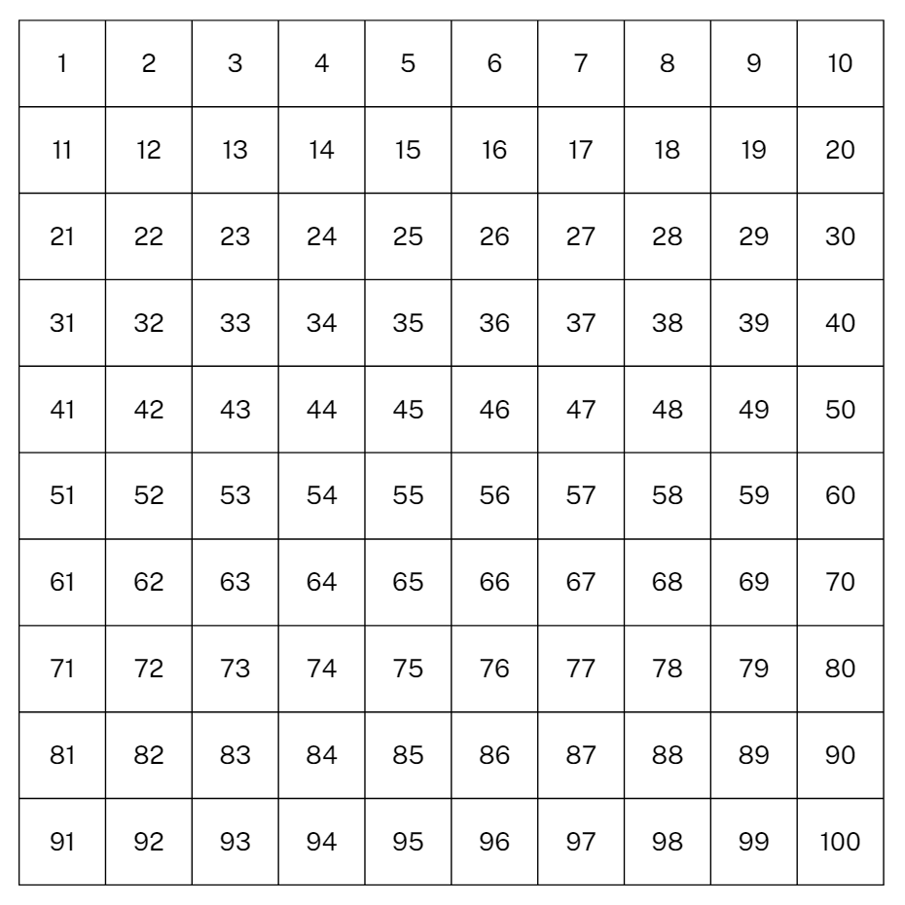

Resource 14: Scrabble tiles – point values
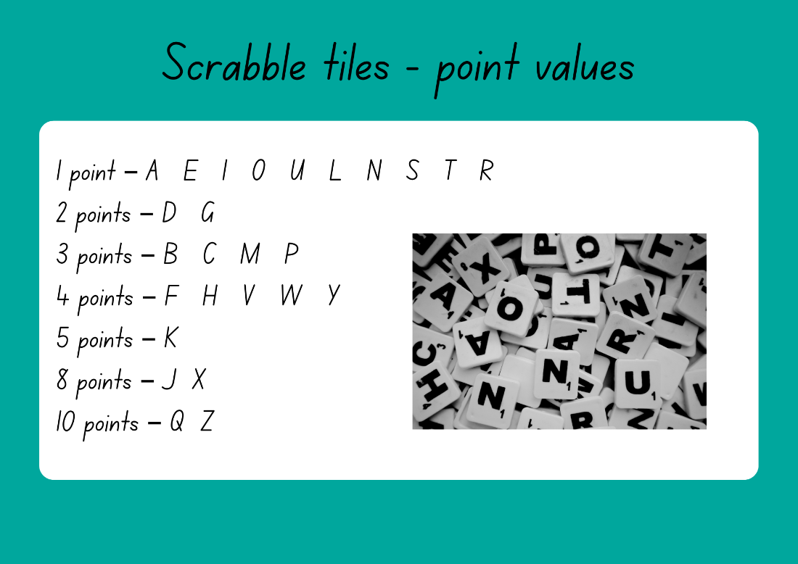

Resource 15: Scrabble stats tally table
Letter | Number of uses | Total frequency
A | 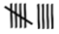 | 9
B
C
D
E
F
G
H
I
J
K
L
M
N
O
P
Q
R
S
T
U
V
W
X
Y
Z

Resource 16: Scrabble scores
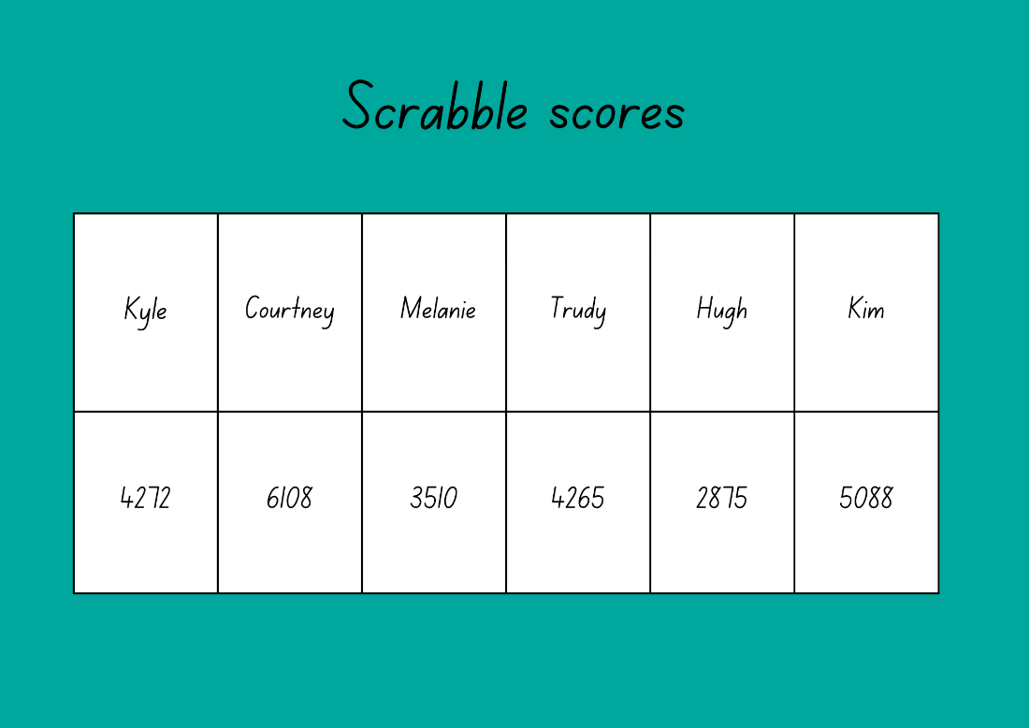

Resource 17: Gold medal picture graph
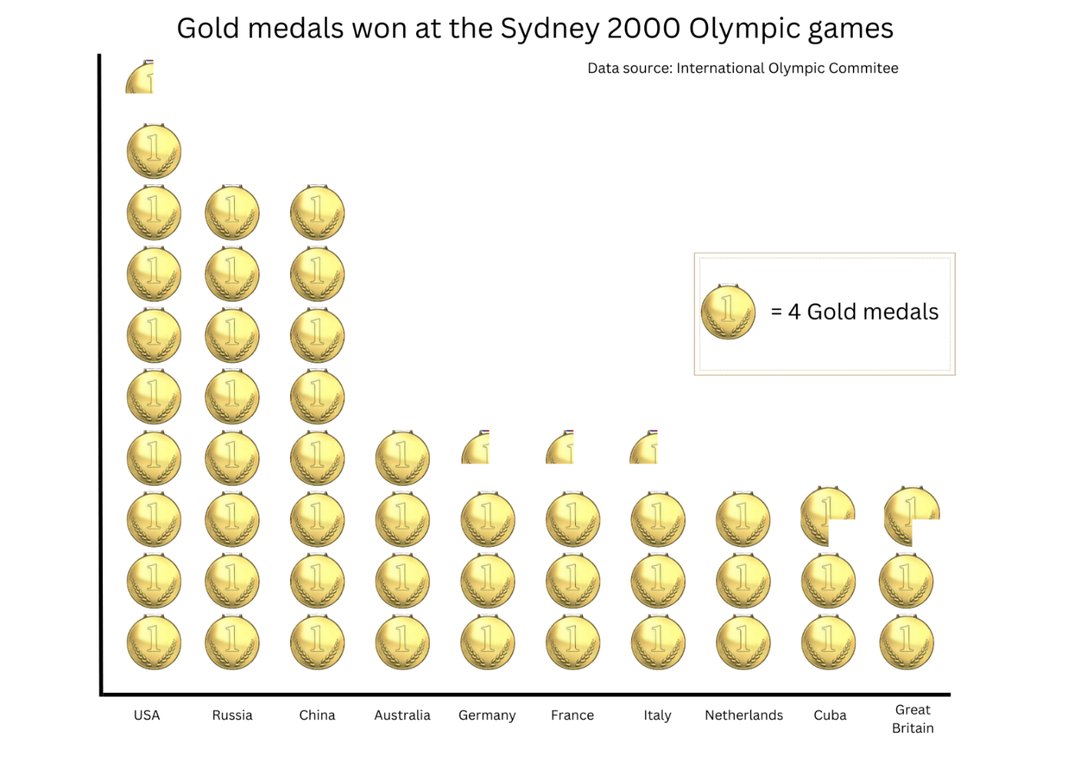
Data sourced from International Olympic Committee (2023).

Resource 18: Gold medal column graph
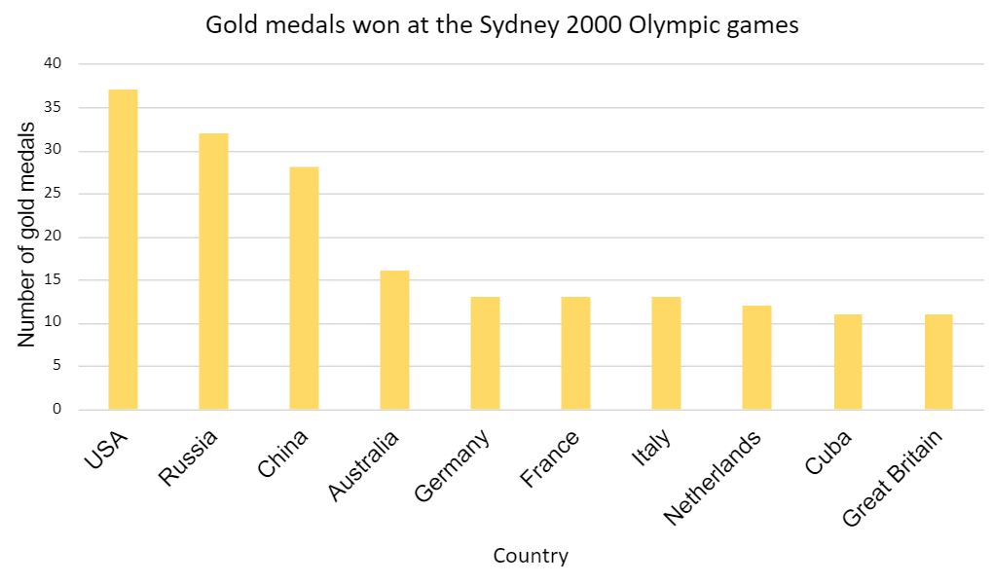
Data sourced from International Olympic Committee (2023).

Resource 19: Gold medal table
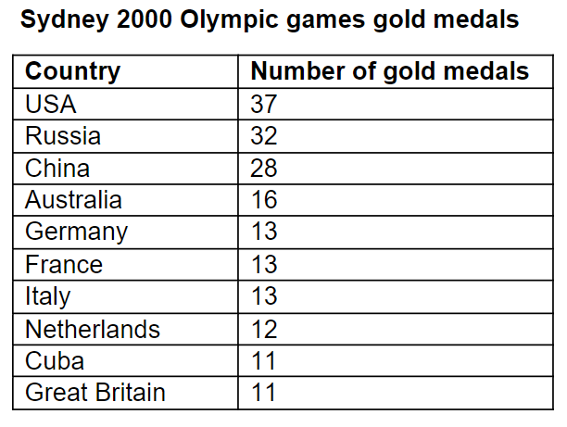
Data sourced from International Olympic Committee (2023).

Resource 20: Total medal count
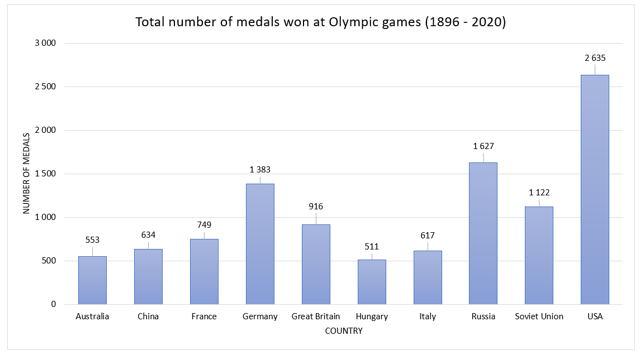
Data sourced from International Olympic Committee (2023).

Resource 21: 100 people
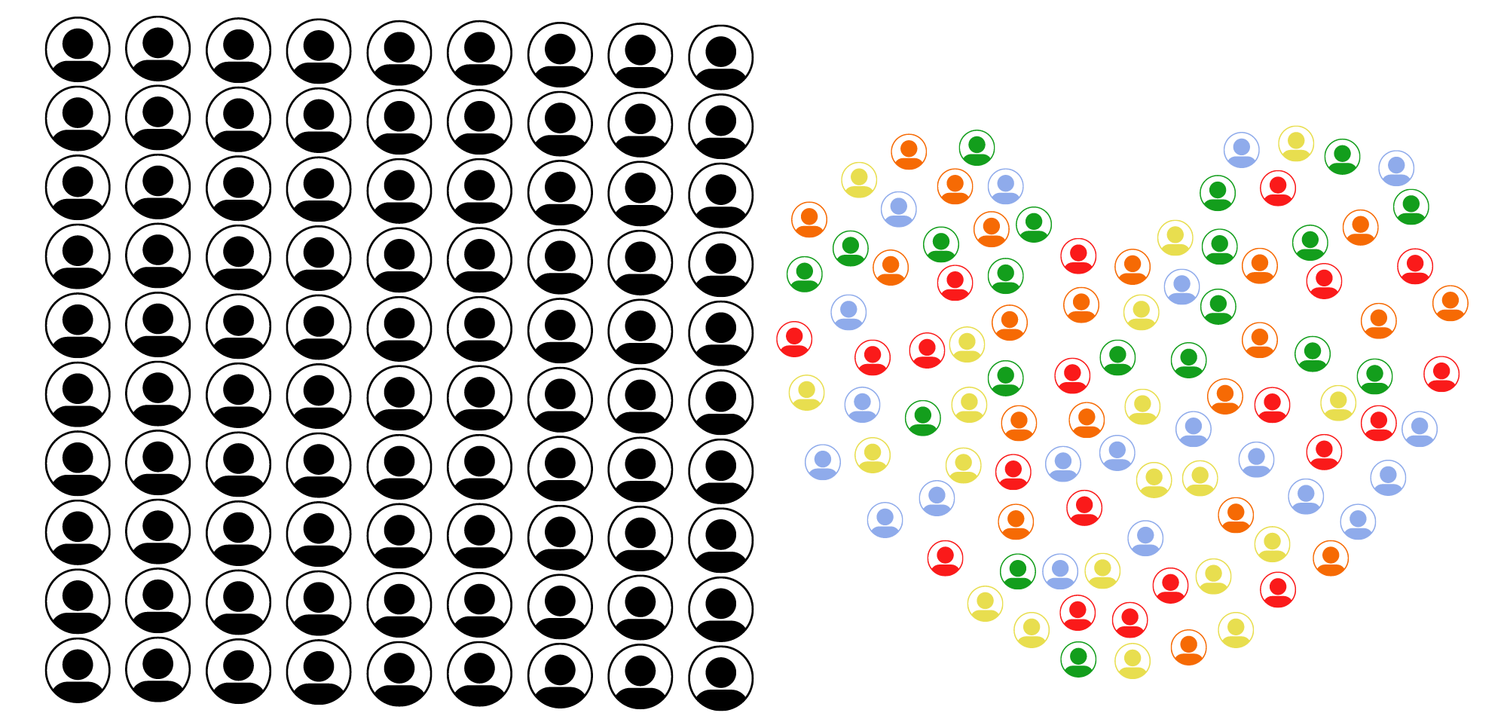

Resource 22: Nationalities
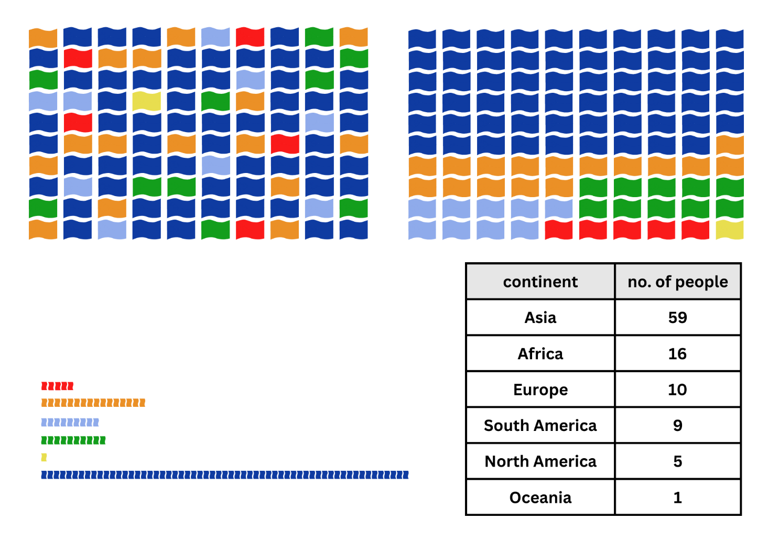

Resource 23: Energy
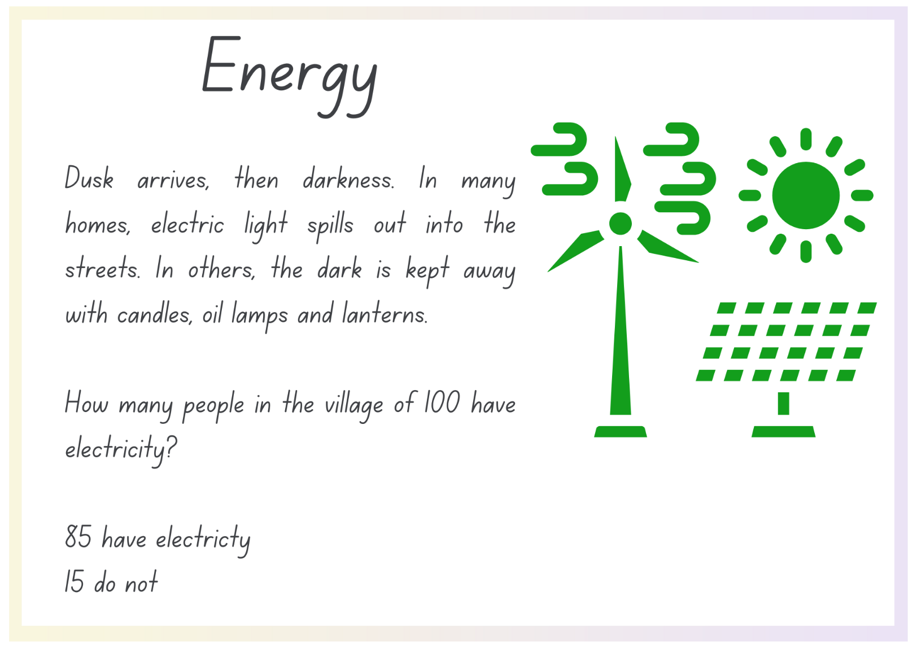
(Smith 2020:25)

Syllabus outcomes and content
The table below outlines the syllabus outcomes and range of relevant syllabus content covered in this unit. Content is linked to National Numeracy Learning Progression version (3).
Outcomes and content | 1 | 2 | 3 | 4 | 5 | 6 | 7 | 8
Representing numbers using place value A: Whole numbers: Read, represent and order numbers to thousands
MAO-WM-01, MA2-RN-01
- Compare and describe the relative size of numbers by positioning numbers on a number line (Reasons about quantity) |  |  |  | x |  |  |  | x
- Read and order numbers of up to at least 4 digits |  |  |  | x |  | x | x
- Identify the number before and after a number with an internal zero digit |  |  |  | x |  | x | x
Multiplicative relations A: Generate and describe patterns
MAO-WM-01, MA2-MR-01
- Model, describe and record patterns of multiples |  |  |  |  |  | x
- Create and continue a variety of number patterns that increase or decrease by a constant amount |  |  |  |  |  |  | x
- Recognise the significance of the final digit of a whole number in determining whether a given number is even or odd (Reasons about relations) |  |  |  |  | x | x
- Recognise the connection between even numbers and the multiplication facts for 2 (Reasons about relations) |  |  |  |  | x | x
Multiplicative relations B: Operate with multiples of 10
MAO-WM-01, MA2-MR-01
- Use multiplication facts with multiples of 10 to multiply a one-digit number by a multiple of 10 | x | x | x
Data A: Collect discrete data
MAO-WM-01, MA2-DATA-01
- Pose questions about a matter of interest to obtain information that can be recorded in categories | x | x
- Collect data from identified sources | x | x | x |  | x | x
- Predict and create a list of categories for efficient data collection in relation to a matter of interest | x | x
Data A: Organise and display data using tables and graphs
MAO-WM-01, MA2-DATA-01
- Create a list or table to organise the data | x |  | x |  |  | x
- Construct column graphs (with scale intervals of 1) and dot plots using relevant software where appropriate | x |  | x
- Mark equal spaces (intervals) on axes, name and label axes and choose appropriate titles for column graphs |  |  | x | x
Data A: Interpret and compare data
MAO-WM-01, MA2-DATA-02
- Describe and interpret information presented in tally tables and column graphs |  |  | x | x | x | x | x
- Investigate how data is interpreted to make decisions |  |  |  |  | x | x
- Represent the same dataset using more than one type of display and compare the displays (Statistical reasoning) |  |  |  |  |  |  | x | x
Data B: Select and trial methods for data collection
MAO-WM-01, MA2-DATA-01
- Create a survey and related recording sheet, considering the appropriate organisation of categories for data collection |  | x |  |  | x
- Refine survey questions as necessary after a small trial |  | x
- Conduct a survey or make observations to collect categorical or numerical data |  | x | x |  | x
- Compare the effectiveness of different methods of collecting and recording data |  | x |  |  |  |  | x | x
Data B: Construct and interpret data displays with many-to-one scales
MAO-WM-01, MA2-DATA-01, MA2-DATA-02
- Use a given many-to-one scale to represent discrete data in column graphs |  |  |  | x
- Use data in a spreadsheet to create column graphs with units on vertical axes that are in multiples |  |  |  |  | x | x
- Interpret and evaluate the effectiveness of various data displays found in media and in factual texts where displays represent data using a scale of many-to-one |  |  |  |  |  |  | x | x
Mathematics K–10 Syllabus © NSW Education Standards Authority (NESA) for and on behalf of the Crown in right of the State of New South Wales, 2022.

References
This resource contains NSW Curriculum and syllabus content. The NSW Curriculum is developed by the NSW Education Standards Authority. This content is prepared by NESA for and on behalf of the Crown in right of the State of New South Wales. The material is protected by Crown copyright.
Please refer to the NESA Copyright Disclaimer for more information https://educationstandards.nsw.edu.au/wps/portal/nesa/mini-footer/copyright.
NESA holds the only official and up-to-date versions of the NSW Curriculum and syllabus documents. Please visit the NSW Education Standards Authority (NESA) website https://educationstandards.nsw.edu.au/ and the NSW Curriculum website https://curriculum.nsw.edu.au/home.
Mathematics K–10 Syllabus © NSW Education Standards Authority (NESA) for and on behalf of the Crown in right of the State of New South Wales, 2022.
National Numeracy Learning Progression © Australian Curriculum, Assessment and Reporting Authority (ACARA) 2010 to present, unless otherwise indicated. This material was downloaded from the Australian Curriculum website (National Literacy Learning Progression) (accessed 31 August 2023) and was not modified.
Education Services Australia Limited (2021) ‘Rubbish recording and reduction: Part 1’, Lesson ideas, Digital Technologies Hub website, accessed 23 June 2023.
International Olympic Committee (2023) ‘Sydney 2000 Medal Table’, Olympic Games Sydney 2000, International Olympic Committee website, access 24 June 2023.
National Geographic (24 February 2016) 'TIL: We Waste One-Third of Food Worldwide | Today I Learned' [video], National Geographic, YouTube, accessed 26 June 2023.
New Zealand Ministry of Education (n.d.) ‘Multiple Patterns’, Resources, NZ Maths website, accessed 23 June 2023.
Smith DJ (2020) If the World Were a Village: A Book about the World's People (Armstrong S illus), 2nd edn, Kids Can Press Ltd, Canada.
State of New South Wales (Department of Education) (2023) ‘Counting game (by multiples of 10)’, Mathematics K-6 resources, NSW Department of Education website, accessed 23 June 2023.
State of New South Wales (Department of Education) (2023) ‘Multiples madness (fives)’, Mathematics K-6 resources, NSW Department of Education website, accessed 23 June 2023.
State of New South Wales (Department of Education) (2023) ‘Scrabble stats’, Mathematics K-6 resources, NSW Department of Education website, accessed 23 June 2023.
State of New South Wales (Department of Planning and Environment) (2020) ‘Native animal facts’, Native animals, NSW Department of Planning and Environment website, accessed 24 June 2023.
University of Cambridge (Faculty of Mathematics) (1997–2023) Always, Sometimes or Never?, NRICH website, accessed 23 June 2023.
University of Cambridge (Faculty of Mathematics) (1997–2023) If The World Were A Village, NRICH website, accessed 23 June 2023.
© State of New South Wales (Department of Education), 2023
The copyright material published in this resource is subject to the Copyright Act 1968 (Cth) and is owned by the NSW Department of Education or, where indicated, by a party other than the NSW Department of Education (third-party material).
Copyright material available in this resource and owned by the NSW Department of Education is licensed under a Creative Commons Attribution 4.0 International (CC BY 4.0) license.
This license allows you to share and adapt the material for any purpose, even commercially.
Attribution should be given to © State of New South Wales (Department of Education), 2023.
Material in this resource not available under a Creative Commons license:
- the NSW Department of Education logo, other logos and trademark-protected material
- material owned by a third party that has been reproduced with permission. You will need to obtain permission from the third party to reuse its material.
Links to third-party material and websites
Please note that the provided (reading/viewing material/list/links/texts) are a suggestion only and implies no endorsement, by the New South Wales Department of Education, of any author, publisher, or book title. School principals and teachers are best placed to assess the suitability of resources that would complement the curriculum and reflect the needs and interests of their students.
If you use the links provided in this document to access a third-party's website, you acknowledge that the terms of use, including licence terms set out on the third-party's website apply to the use which may be made of the materials on that third-party website or where permitted by the Copyright Act 1968 (Cth). The department accepts no responsibility for content on third-party websites.

