Mathematics Stage 2 – Unit 6

Contents
Unit description and duration 5
Syllabus outcomes 5
Working mathematically 6
Student prior learning 6
Lesson overview and resources 8
Lesson 1 13
Daily number sense: Balancing numbers – 10 minutes 13
Core lesson 1 – place value houses – 15 minutes 14
Core lesson 2 – dancing dice – 30 minutes 17
Discuss and connect the mathematics – 10 minutes 19
Lesson 2 21
Daily number sense – balancing number sentences – 10 minutes 21
Core lesson – making and representing large collections – 35 minutes 23
Discuss and connect the mathematics – 15 minutes 25
Lesson 3 27
Daily number sense – recognising equal value – 10 minutes 27
Core lesson 1 – ordering 4-digit numbers – 15 minutes 28
Core lesson 2 – comparing 4-digit numbers – 25 minutes 31
Discuss and connect the mathematics – 10 minutes 33
Lesson 4 35
Daily number sense – 10 minutes 35
Core lesson Part 1 – understanding the role of zero – 10 minutes 35
Core lesson Part 2 – understanding the role of zero – 30 minutes 36
Consolidation and meaningful practice – 10 minutes 38
Lesson 5 39
Daily number sense – target number – 10 minutes 39
Core lesson – partitioning numbers – 45 minutes 40
Discuss and connect the mathematics – 5 minutes 45
Lesson 6 47
Daily number sense – chasing treasure – 10 minutes 47
Core lesson – addition problems – 25 minutes 49
Consolidation and meaningful practice – 20 minutes 52
Lesson 7 54
Daily number sense – you add, I subtract – 10 minutes 54
Core lesson – subtraction problems – 25 minutes 57
Consolidation and meaningful practice – 20 minutes 59
Lesson 8 61
Daily number sense – 10 minutes 61
Core lesson – inverse operations – 40 minutes 61
Discuss and connect the mathematics – 5 minutes 65
Resource 1 – place value houses 67
Resource 2 – number sentences 68
Resource 3 – snap cards 69
Resource 4 – MAB understandings 71
Resource 5 – misconceptions – zero 72
Resource 6 – Which doesn’t belong? 73
Resource 7 – collections of 1224 74
Resource 8 – table of combinations 75
Resource 9 – player sheet 76
Resource 10 – 120 Number chart 78
Resource 11 – addition number sentences 79
Resource 12 – playing cards 80
Resource 13 – subtraction number sentences 81
Resource 14 – bar model puzzle 82
Resource 15 – number cards 84
Syllabus outcomes and content 85
References 90

Unit description and duration
This unit develops the big idea that the number system extends infinitely to very large and very small numbers.
In this 2-week unit students are provided opportunities to:
- read, represent and order numbers to thousands, applying place value to partition numbers up to 4-digits
- use partitioning and place value knowledge to add and subtract
- identify the relationship between addition and subtraction.
Additional lessons on this big idea can be found in Unit 1, Unit 11 and Unit 16.

Syllabus outcomes
- MAO-WM-01 develops understanding and fluency in mathematics through exploring and connecting mathematical concepts, choosing and applying mathematical techniques to solve problems, and communicating their thinking and reasoning coherently and clearly
- MA2-RN-01 applies an understanding of place value and the role of zero to represent numbers to at least tens of thousands
- MA2-AR-01 selects and uses mental and written strategies for addition and subtraction involving 2- and 3-digit numbers

Working mathematically
In the Mathematics K–10 Syllabus, there is one overarching Working mathematically outcome (MAO-WM-01). The Working mathematically processes should be embedded within the concepts being taught. The Working mathematically processes present in the Mathematics K–10 Syllabus are:
- communicating
- understanding and fluency
- reasoning
- problem solving.
Mathematics K–10 Syllabus © NSW Education Standards Authority (NESA) for and on behalf of the Crown in right of the State of New South Wales, 2022.

Student prior learning
Before engaging in these teaching and learning activities, students would benefit from prior experience with:
- reading, representing and ordering numbers up to thousands
- partitioning 2- and 3-digit numbers
- bridging to the decade and using inverse operations to solve addition and subtraction problems.
In NSW classrooms there is a diverse range of students, including Aboriginal and Torres Strait students, students learning English as an additional language or dialect, high potential and gifted students and students with disability. Some students may identify with more than one of these groups or possibly all of them. Refer to Curriculum planning for every student – advice for further information.

Lesson overview and resources
The table below outlines the sequence and approximate timing of lessons, learning intentions and resources.
Lesson | Content | Duration and resources
Lesson 1  Daily number sense learning intention:  - use the principle of equality | Lesson core concept: reading and recording large numbers is a key component of place value.  Core concept learning intention:  - read, represent and order numbers to thousands | Lesson duration: 65 minutes  - Resource 1 – place value houses  - 10-sided dice (0–9)  - 6-sided dice  - Individual whiteboards  - Whiteboard markers  - Writing materials
Lesson 2  Daily number sense learning intention:  - use the principle of equality | Lesson core concept: collections of tens, hundreds and thousands are really useful.  Core concept learning intention:  - group large collections of objects | Lesson duration: 60 minutes  - Resource 2 – number sentences  - Murphy SJ (n.d.) Earth Day – Hooray (Adriani R illus), MathStart website (Online version)  - Hoops (one per pair of students)  - Red, yellow, green and blue counters
Lesson 3  Daily number sense learning intention:  - use the principle of equality | Lesson core concept: the position of each digit in a number corresponds to its size.  Core concept learning intention:  - compare and order 4-digit numbers | Lesson duration: 60 minutes  - Resource 1 – place value houses  - Resource 3 – snap cards  - Resource 4: MAB understanding  - 9-sided dice (0–9)  - MAB materials  - Writing materials
Lesson 4  Daily number sense learning intention:  - teacher-identified task based on student needs | Lesson core concept: zeros in numbers can have different roles.  Core concept learning intention:  - understand the role of zero in large numbers | Lesson duration: 60 minutes  - Resource 5 – misconceptions – zero  - Individual whiteboards  - Whiteboard markers  - Writing materials
Lesson 5  Daily number sense learning intention:  - recognise and explain the connection between addition and subtraction | Lesson core concept: numbers can be renamed in equivalent ways using place value.  Core concept learning intention:  - apply place value to partition and regroup numbers up to 4 digits | Lesson duration: 60 minutes  - Resource 6 – Which doesn’t belong?  - Resource 7 – collections of 1224  - Resource 8 – table of combinations  - Individual whiteboards  - MAB materials  - Whiteboard markers  - Writing materials
Lesson 6  Daily number sense learning intention:  - place value models help solve addition and subtraction problems | Lesson core concept: place value models help solve addition and subtraction problems.  Core concept learning intention:  - use place value models to solve addition problems | Lesson duration: 55 minutes  - Resource 9 – player sheet  - Resource 10 – 120 Number chart  - Resource 11 – addition number sentences  - Counters  - Individual whiteboards  - Interactive 120 number chart  - Teddy bears counters  - Whiteboard markers  - Writing materials
Lesson 7  Daily number sense learning intention:  - recognise and explain the connection between addition and subtraction | Lesson core concept: partitioning into place value parts is an efficient strategy for addition and subtraction.  Core concept learning intention:  - partition numbers into place value parts to solve subtraction problems | Lesson duration: 55 minutes  - Resource 10 – 120 Number chart  - Resource 12 – playing cards  - Resource 13 – subtraction number sentences  - Interactive 120 number chart  - Individual whiteboards  - Whiteboard markers  - Writing materials
Lesson 8  Daily number sense learning intention:  - teacher-identified task based on student needs | Lesson core concept: addition and subtraction are connected.  Core concept learning intention:  - recognise and explain the connection between addition and subtraction | Lesson duration: 55 minutes  - Resource 14 – bar model puzzle  - Resource 15 – number cards  - Writing materials

Lesson 1
Core concept: reading and recording large numbers is a key component of place value.

Daily number sense: Balancing numbers – 10 minutes
Daily number sense activities for lessons 1 to 3 ‘activate’ prior number knowledge and support the learning of new content in the unit. These activities can also assist teachers to identify the starting points for learning by revealing the extent of students’ existing knowledge.
The table below contains a suggested learning intention and success criteria. These are best co-constructed with students.
Daily number sense learning intention | Daily number sense success criteria
Students are learning to:  - use the principle of equality. | Students can:  - use the equals sign to mean 'the same as', rather than to perform an operation.
This activity is an adaptation of Balancing Act – A dice game [PDF 250 KB] from Primary Learning.
- Students play in pairs. Each pair are given a 6-sided die, an individual whiteboard and whiteboard marker.
- Student A rolls the die 10 times and tries to use as many of the numbers as they can to make a number sentence that balances. For example, if they roll a 1, 1, 2, 2, 2, 3, 4, 4, 5, 6 they could make the number sentence 6 + 5 + 4 = 4 + 3 + 1 + 2 + 2 + 2 + 1 (both sides equal 15).
- Students write their equation on the whiteboard for their partner to check and must include at least one plus sign on either side of their equation.
- Student B repeats the activity.
- Points are given according to how many numbers each player has used. If a player uses all 10 numbers they get 10 points, if they only use 6 numbers, they get 6 points. The first player to reach 100 points wins.
This table details opportunities for assessment.
Assessment opportunities | Links
What to look for:  - Can students use the equals sign to mean 'the same as', rather than to perform an operation? [MAO-WM-01, MA2-AR-01] | Links to National Numeracy Learning Progressions (NNLP):  - NPA3.

Core lesson 1 – place value houses – 15 minutes
The table below contains suggested learning intentions and success criteria. These are best co-constructed with students.
Core concept learning intentions | Core concept success criteria
Students are learning to:  - read, represent and order numbers to thousands. | Students can:  - read and record 4-digit numbers  - count forward and backward by tens and hundreds on and off the decade.
- Discuss large numbers with the class. Ask students:
- What makes a large number?
- What do you know about large numbers?
- Where might you see large numbers in day-to-day life?
- Why are they useful?
- How do we name them?
- How do we write them?
- Display Resource 1 – place value houses.
- Remind students that each house is divided up into hundreds, tens and ones. Extra houses are added as number sizes grow.
- Say the number 3651.
- Ask one student to write the numerals in the columns, based on the place value of each digit (see Figure 1).
Figure 1 – place value houses for 3651
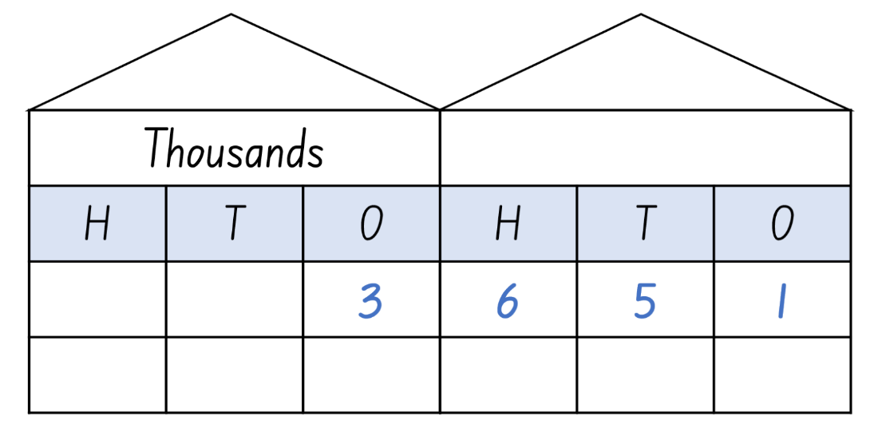
- Highlight to students that the purpose of the place value houses is to assist students to read larger numbers. Discuss how this structure makes reading and recording large numbers easier.
- Read out a 4-digit number. Students record this number using Resource 1 – place value houses.
- Students turn and talk with a partner, comparing where they have written each number and discussing its relative value. For example, the 6 goes in the hundreds column because the number 3651 contains 6 hundreds.
- Repeat for 2 or 3 more 4-digit numbers, modelling how to read and record the number correctly each time.
This table details opportunities for differentiation.
Too hard? | Too easy?
Students cannot read and record 4-digit numbers.  - Assist students by reducing their number to a 2- or 3-digit number.  - Model how to use MAB materials to represent a 2- or 3-digit number. | Students can read and record 4-digit numbers.  - Challenge the students to place the numbers they have recorded into ascending and descending order.  - Working in pairs, students record a 4-digit number without showing their partner. Students take it in turns to ask questions about their partner’s number. For example, ask if their number has a 4 in the hundreds place or if the numeral in the tens place is higher than 5. When they think they have enough information, students can try to guess their partner’s number.

Core lesson 2 – dancing dice – 30 minutes
This activity is an adaptation of ‘Dancing dice’ from Number and Algebra – Stage 2: Mathematics Teaching resource K-6 by Board of Studies, Teaching and Educational Standards NSW.
- In pairs, students take turns to roll a 10-sided dice 4 times.
- Students arrange the rolled numbers into a 4-digit number. They read this number aloud to a partner and record it in their workbook.
- Using the number they made, students write the next 10 numbers, increasing by 10 each time. For example, 3473 – 3483, 3493, 3503, 3513, 3523, 3533, 3543, 3553, 3563, 3573.
- Students use their partner’s number and write the next 10 numbers, increasing by 10 each time.
- Students compare their number lists with their partner. If they disagree with their partner, they must use their place value knowledge to justify how they know their number order is correct. For example, 3681 is after 3671 because 80 is 10 more than 70.
- Students make a new 4-digit number each by rolling the 10-sided dice 4 times. Again, they read this number aloud to their partner and record it in their workbook.
- Using the number they made, students write the next 10 numbers, decreasing by 10 each time.
- Students continue the activity by making new numbers using the dice and repeating the steps above to record and compare the numbers 100 more and 100 less than their new numbers.
This table details opportunities for differentiation.
Too hard? | Too easy?
Students cannot count forward and backward by tens and hundreds on and off the decade.  - Assist students by reducing their number to a 2- or 3- digit number.  - Support students by providing a blank number line or place value houses to help highlight the change of digits. | Students can count forward and backward by tens and hundreds on and off the decade.  - Challenge students to count forwards and backwards from their number by thousands.  - Working with a partner, students roll the 10-sided dice 4 times to create a 4-digit number. Using this number, they take it in turns to say or record the number 10 more or 10 less, 100 more or 100 less or 1000 more or 1000 less. This game continues until one player says or records the wrong number.

Discuss and connect the mathematics – 10 minutes
- Regroup as a class and summarise the lesson together drawing out key mathematical ideas. Ask:
- What did you notice when you were making lists of the numbers 10 more or 10 less than your number?
- What did you notice when you were making lists of the numbers 100 more or 100 less than your number?
- When was it the most difficult to calculate the next number?
- What strategy did you use to make it easier at that stage?
- Why is it important to understand the difference between the same number in a different column? For example, the difference between a 6 in the tens column and a 6 in the hundreds column?
This table details opportunities for assessment.
Assessment opportunities | Links
What to look for:  - Can students read and record 4-digit numbers? [MAO-WM-01, MA2-RN-01]  - Can students count forward and backward by tens and hundreds on and off the decade? [MAO-WM-01, MA2-RN-01] | Links to National Numeracy Learning Progressions (NNLP):  - NPV6, CPr6, CPr7.  Links to suggested Interview for Student Reasoning (IfSR) tasks:  - IfSR-NP: 4C.2, 4C.3, 4C.6.

Lesson 2
Core concept: collections of tens, hundreds and thousands are really useful.

Daily number sense – balancing number sentences – 10 minutes
The table below contains a suggested learning intention and success criteria. These are best co-constructed with students.
Daily number sense learning intention | Daily number sense success criteria
Students are learning to:  - use the principle of equality. | Students can:  - recognise whether a number sentence is equal on either side of the equals sign.
This activity is an adaptation of True or false? from NRICH by University of Cambridge (Faculty of Mathematics).
- Display the number sentence 27 + 13 = 11 + 29 and ask students if the number sentence is true or false. Students turn and talk to a partner to justify their answer.
- Ask students how they know whether a particular number sentence is true or false.
- Emphasise to students that ‘=’ means ‘has the same value as’ and not just the ‘total’ or the ‘answer’.
- Display Resource 2 – number sentences and ask students:
- Which statements are true?
- Which are false?
- How do you know?
- Can you decide without doing any calculating?
- Go through each number sentence one by one as a class.
This table details opportunities for assessment.
Assessment opportunities | Links
What to look for:  - Can students recognise whether a number sentence is equal on either side of the equals sign? [MAO-WM-01, MA2-AR-01] | Links to National Numeracy Learning Progressions (NNLP):  - AdS7.  Links to suggested Interview for Student Reasoning (IfSR) tasks:  - IfSR-AT: 2A.1.

Core lesson – making and representing large collections – 35 minutes
The table below contains suggested learning intentions and success criteria. These are best co-constructed with students.
Core concept learning intentions | Core concept success criteria
Students are learning to:  - group large collections of objects. | Students can:  - group objects in tens, hundreds and thousands  - represent numbers using physical manipulatives, words and numerals  - justify why the strategy used is considered efficient.
This activity is an adaptation of Chicken Scramble [PDF 111KB] from School Sport Unit by State of New South Wales (Department of Education).
Note: this activity is designed to be taught outside. Prior to the lesson, arrange hoops (one per pair of students) spaced 2 metres apart in a circle on a large, flat area. The collection of counters should be placed in the middle of the circle of hoops and spread out to ensure student safety by avoiding students running into each other. There must be 4 different coloured counters.
- Read the text Earth Day – Hooray by Stuart J Murphy. Stop at page 8.
- Explain to students that they will be participating in a ‘collection’ just like the characters in the book. In pairs, students will collect as many counters as they can in one minute, returning their collection to their hoop. Students collect one handful of counters at a time.
- After students have collected their counters, inform them of the value of each coloured counter: red – thousands, yellow – hundreds, green – tens, blue – ones.
- Students work in their pairs to count their collection. During this time, observe how students are counting their collections. Look for students who are grouping in tens, hundreds and thousands to make 4-digit numbers.
- Remind students that collections of 10 or more of the same coloured counters require regrouping. For example, 10 ones will be regrouped into a 10.
- Invite students using efficient counting strategies to share with the class.
- Discuss efficient counting strategies with the class. Ask students:
- How might we group or organise our collection to help with counting?
- How can we group or organise our collection without counting them one by one?
- How could you use skip counting to count large collections?
- Students continue counting their collections, focusing on grouping to count efficiently.
- Students record the total of their collection as numerals and words on a whiteboard.
This table details opportunities for differentiation.
Too hard? | Too easy?
Students cannot group objects to show the structure of tens, hundreds and thousands.  - Students collect all counters as stated above but remove red (thousands) and yellow (hundreds) before counting.  - Assist students by providing Resource 1 – place value houses to highlight the different value of each of the coloured counters. | Students can group objects to show the structure of tens, hundreds and thousands.  - Students represent the number which are 10 and 100 more and less than their total using words.  - Challenge students by adding another counter to the game that represents 10 thousand. Students add these to their original counters and add the numbers again.

Discuss and connect the mathematics – 15 minutes
- Read Earth Day – Hooray by Stuart J Murphy to the end.
- Compare the strategies used by the students in the story to the strategies used during the lesson.
- Ask students:
- Did you use a similar strategy?
- What strategy was the most efficient?
- How does grouping objects help us count large collections?
This table details opportunities for assessment.
Assessment opportunities | Links
What to look for:  - Can students group objects in tens, hundreds and thousands? [MAO-WM-01, MA2-RN-01]  - Can students represent numbers using physical manipulatives, words and numerals? [MAO-WM-01, MA2-RN-01] | Links to National Numeracy Learning Progressions (NNLP):  - NPV5, NPV6.  Links to suggested Interview for Student Reasoning (IfSR) tasks:  - IfSR-NP: 4B.5  - IfSR-AT: 3B.1, 3B.2, 3B.4.

Lesson 3
Core concept: the position of each digit in a number corresponds to its size.

Daily number sense – recognising equal value – 10 minutes
The table below contains a suggested learning intention and success criteria. These are best co-constructed with students.
Daily number sense learning intention | Daily number sense success criteria
Students are learning to:  - use the principle of equality. | Students can:  - recognise when 2 number sentences are equal.
This activity is an adaptation of Same Name snap from NZ Maths by New Zealand Ministry of Education.
- The game can be played in pairs or in small groups. Provide a set of Resource 3 – snap cards to each group.
- Students shuffle all the cards and hand them out so that each player has the same number of cards.
- Each player takes it in turns to place their cards one on top of another in a pile in the middle. If 2 cards have number sentences of equal value, the first student to recognise this can call out ‘same value’. For example, if 2 + 3 is placed on top of 1 + 4, a student must say ‘Same value! 5!’
- The student then collects the pile of cards from the middle and the game starts again.
- The player with the greatest number of cards at the end of the game wins.
This table details opportunities for assessment.
Assessment opportunities | Links
What to look for:  - Can students recognise when 2 number sentences are equal? [MAO-WM-01, MA2-AR-01] | Links to National Numeracy Learning Progressions (NNLP):  - AdS6.

Core lesson 1 – ordering 4-digit numbers – 15 minutes
The table below contains suggested learning intentions and success criteria. These are best co-constructed with students.
Core concept learning intentions | Core concept success criteria
Students are learning to:  - compare and order 4-digit numbers. | Students can:  - make a 4-digit number using manipulatives  - order numbers in ascending and descending order  - explain how the value of a number changes when you move its position in a 4-digit number.
Ascending: to ascend means to go up, numbers in ascending order are going from smallest to largest. (Williams 2023)
- Build student understanding of place value by revising place value houses from Lesson 1. Discuss vocabulary used to order numbers such as ascending and descending (see note box above).
- Roll four 9-sided dice.
Note: alternatively, virtual manipulatives may be used for this activity for rolling the dice.
- Arrange the dice to create a 4-digit number and record this number on the board. Rearrange the dice to create a new 4-digit number and record. Repeat this process until you have created 5 numbers in total (see Figure 2).
Figure 2 – dice numbers
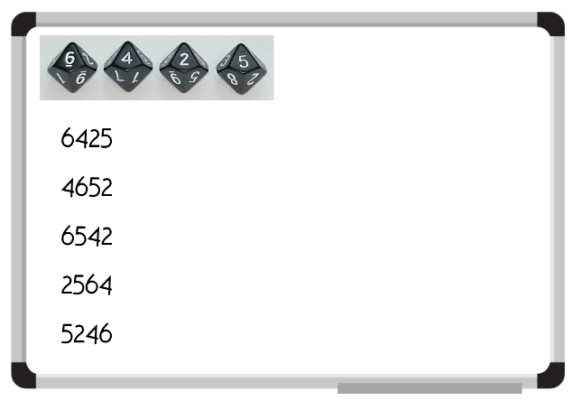
- Model how to arrange the 5 numbers in ascending order, referring to the place value of each digit.
- In pairs, students roll 4 dice to create a 4-digit number.
- Students rearrange the 4 digits to create a new number.
- Students repeat this process until they have created 5 numbers in total and recorded them in their workbooks.
- Using their place value knowledge, students write their numbers in ascending order.
- When they are confident that their numbers are in the correct order, each pair of students works with another pair to convince them that their numbers are in the correct ascending order, referring to the value of each digit.
- Students repeat the steps above to create 5 new 4-digit numbers. Students record the numbers in their workbooks and then place them in descending order using their place value knowledge.
- Working with a different pair of students, each pair attempts to convince their opponents that their numbers are in the correct descending order, referring to the value of each digit.
This table details opportunities for differentiation.
Too hard? | Too easy?
Students cannot order numbers in ascending and descending order.  - Support students to identify the value of each digit by using Resource 1 – place value houses to record numbers.  - Assist students by reducing the number they create to a 3-digit number and the amount of numbers to be ordered to 3. | Students can order numbers in ascending and descending order.  - Students to complete same activity, however all 5 of their numbers must have the same digit in the thousands place.  - Challenge students to place their 5 numbers in the correct order on an empty number line.

Core lesson 2 – comparing 4-digit numbers – 25 minutes
- Display Resource 4 – MAB understandings and revise MAB materials, highlighting the value of the units, longs, flats and cubes.
- Describe how making a number 10 times, 100 times or 1000 times as large changes the place value of digits.
- Explicitly model how to create the number 463 using MAB materials. Explain that the 4 represents 4 hundreds, which can be renamed as ‘four hundred’.
- Create the number 4271 using MAB materials and explain how the value of the 4 has changed from 4 hundreds to 4 thousands.
- Using MAB materials, students make the numbers from Core lesson 1, describing the value of each of the digits. For example, Student A creates the largest 4-digit number using MAB materials and explains the role of each of the digits. Student B rearranges the MAB materials to make the second largest number, explaining how the value of each digit has changed. Repeat for the last 3 numbers.
- Students use Resource 1 – place value houses to record numbers. Support students to identify the value of each digit, starting from the thousands column.
Note: alternatively, virtual manipulatives may be used for this activity for building the numbers with MAB materials.
This table details opportunities for differentiation.
Too hard? | Too easy?
Students cannot explain how the value of a number changes when you move its position in a 4-digit number.  - Students write a 2- or 3-digit number in a place value house. Support students to use the headings in their place value house to read the number and identify the value of each digit.  - Students create the number with MAB materials and verbally identify the value of each digit. | Students can explain how the value of a number changes when you move its position in a 4-digit number.  - Students identify numbers which are 10 and 100 more and less than their numbers. Ask students to justify to a friend how they know their answer is correct.  - Challenge students to explain how they could make each of their number without tens or hundreds.

Discuss and connect the mathematics – 10 minutes
- As a class, reflect on the lesson. Ask students:
- How did you know what the value of each digit was?
- How did you know which 4-digit number was smallest or largest?
- Did you check your answer? How?
- Did using MAB materials support your understanding? How?
- What did you find challenging? How did you overcome any challenges you faced?
- How did you work like a mathematician today?
This table details opportunities for assessment.
Assessment opportunities | Links
What to look for:  - Can students make a 4-digit number using manipulatives? [MAO-WM-01, MA2-RN-01]  - Can students order numbers in ascending and descending order? [MAO-WM-01, MA2-RN-01]  - Can students explain how the value of a number changes when you move its position in a 4-digit number? [MAO-WM-01, MA2-RN-01] | Links to National Numeracy Learning Progressions (NNLP):  - NPV5, NPV6.  Links to suggested Interview for Student Reasoning (IfSR) tasks:  - IfSR-NP: 4B.2.

Lesson 4
Core concept: zeros in numbers can have different roles.

Daily number sense – 10 minutes
- From a class need surfaced through formative assessment data, identify a short, focused activity that targets students’ knowledge, understanding and skills. Example activities may be drawn from the following resources:
- Mathematics K-6 resources
- Universal Resources Hub.

Core lesson Part 1 – understanding the role of zero – 10 minutes
The table below contains suggested learning intentions and success criteria. These are best co-constructed with students.
Core concept learning intentions | Core concept success criteria
Students are learning to:  - understand the role of zero in large numbers. | Students can:  - read and name numbers with an internal zero  - identify the number before and after a number with an internal zero  - articulate the role of zero in 4-digit numbers.
- Display and read Resource 5 – misconceptions – zero. Explain that the class needs to decide which of the students from the display has the correct answer. They must be able to justify why they have chosen that particular student.
- Students record their answer on an individual whiteboard. Their answer must include the student’s name and why they think that choice is correct.
- Students turn and talk to a partner to share and discuss their choices. If students are convinced by their partner that their choice is incorrect, they can change their answer.
- As a class, discuss each response in the display. For example, Pat’s answer is incorrect as he has read the number as 2 separate numbers, not a 4-digit number.

Core lesson Part 2 – understanding the role of zero – 30 minutes
- Write 3402 on the board and ask students how they read the number.
- Choose students to share how they read the number and explain why they read it that way.
- Discuss the role of the internal zero in a 4-digit number. Explain that internal means inside. The zero must be in the tens or hundreds place.
- Repeat the above steps for different numbers, ensuring all numbers contain an internal zero.
- Sit back-to-back with a student. Model writing and then reading a 4-digit number while the student attempts to write this number on their whiteboard. The number must include an internal zero.
- Turn to face your partner and compare numbers. If your numbers do not match, convince your partner why your number is correct using place value knowledge. For example, I know my number is correct because you said three thousand and twenty-one and my number has a zero in the hundreds place.
- In pairs, students take turns to recreate the modelled activity by reading out and writing 4-digit numbers with an internal zero and then comparing the results.
- Students record the number before and after the number that is read out.
This table details opportunities for differentiation.
Too hard? | Too easy?
Students cannot read the number with an internal zero and identify the number before and after.  - Support students to write their 4-digit number by providing Resource 1 – place value houses to help identify the value of each digit.  - Assist students by reducing the number to a 2- or 3-digit number. | Students can read the number with an internal zero and identify the number before and after.  - In pairs, students identify the numbers which are 10 and 100 more and less than the numbers they have written.  - Challenge students to arrange their numbers in ascending and descending order.

Consolidation and meaningful practice – 10 minutes
- Read a 4-digit number with an internal zero to the class. Students record the number on their individual whiteboard.
- Invite students to share how they wrote the number and justify their answer.
This table details opportunities for assessment.
Assessment opportunities | Links
What to look for:  - Can students read and name numbers with an internal zero? [MAO-WM-01, MA2-RN-01]  - Can students identify the number before and after a number with an internal zero? [MAO-WM-01, MA2-RN-01]  - Can students articulate the role of zero in 4-digit numbers? [MAO-WM-01, MA2-RN-01] | Links to National Numeracy Learning Progressions (NNLP):  - NPV5, NPV6.

Lesson 5
Core concept: numbers can be renamed in equivalent ways using place value.

Daily number sense – target number – 10 minutes
Daily number sense activities for Lessons 5 to 7 ‘loop’ back to concepts and procedures covered in previous units to assist students to build an increasingly connected network of ideas. These concepts may differ from the core concepts being covered by the unit.
The table below contains a suggested learning intention and success criteria. These are best co-constructed with students.
Daily number sense learning intention | Daily number sense success criteria
Students are learning to:  - recognise and explain the connection between addition and subtraction. | Students can:  - use addition and subtraction to create a number sentence with a specific total.
This activity is an adaptation of Target Number from Math for Love by Finkel.
- Write a 2-digit ‘target’ number on the board.
- Using individual whiteboards, students write down as many different number sentences that have the target number as the answer. They must use addition and subtraction in their number sentence. For example, 32 + 7 − 4 = 35.
- Students turn and talk to a partner to share one of their number sentences and describe the strategies they used to create it.
This table details opportunities for assessment.
Assessment opportunities | Links
What to look for:  - Can students use addition and subtraction to create a number sentence with a specific total? [MAO-WM-01, MA2-AR-01] | Links to National Numeracy Learning Progressions (NNLP):  - AdS6, AdS7.

Core lesson – partitioning numbers – 45 minutes
The table below contains suggested learning intentions and success criteria. These are best co-constructed with students.
Core concept learning intentions | Core concept success criteria
Students are learning to:  - apply place value to partition and regroup numbers up to 4 digits. | Students can:  - record numbers using standard place value form  - partition numbers of up to 4 digits in non-standard forms.
This activity is an adaptation of Partitioning numbers using place value parts (10:37) from ABC Education by ABC (Australian Broadcasting Corporation).
- Display Resource 6 – Which doesn’t belong? and explain that there are 4 collections to think about. The collections can be sorted and classified several ways. Challenge students to Think-Pair-Share with a partner to decide which of the collections does not belong.
- Select several pairs of students to share which collection they have decided doesn't belong and explain their reasoning.
Note: it could be argued that all 4 collections don’t belong (see Figure 3). This is something that could be discussed with students once they have had the opportunity to think about their own ideas first.
Figure 3 – all collections don’t belong
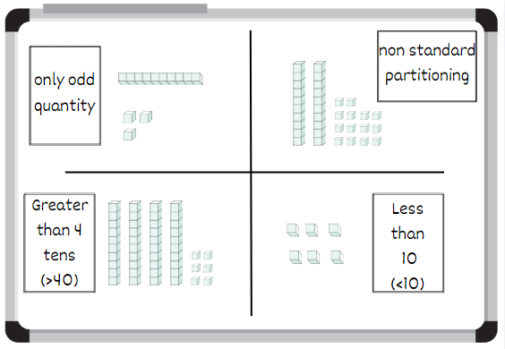
- Display Resource 7 – collections of 1224. Prove that the 3 collections have the same amount by identifying how many thousands, hundreds, tens and ones are in each collection. Identify which representation uses standard place value form and which use non-standard place value form.
- Rename their total as 1224 and write it underneath the collection (see Figure 4).
Figure 4 – annotated collections of 1224
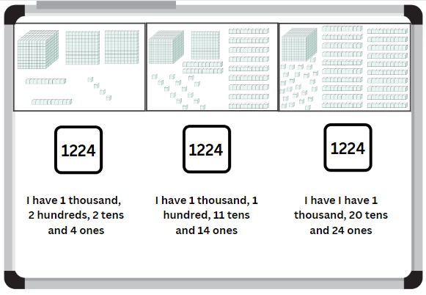
- Model how to organise Resource 7 – collections of 1224 into a table (see Figure 5).
Figure 5 – table containing collections of 1224
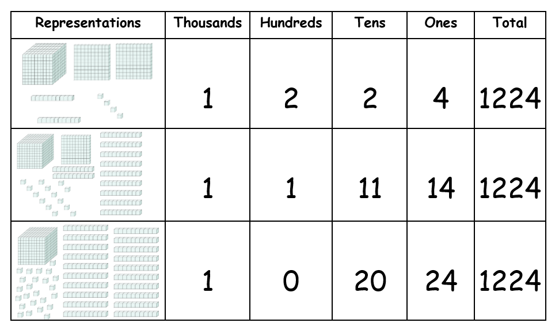
- Students turn and talk to discuss additional ways to represent 1224 using MAB materials.
- Invite students to share their thinking. Use MAB materials to represent any additional combinations of 1224 that can be represented.
Note: order the representations based on how many hundreds are in the number to show all possible combinations. Make connections between counting sequences of the hundreds, tens and ones in the combination.
- Provide students with different numbers up to 9999.
- Students use MAB materials to represent their number using standard place value form and additional non-standard forms.
- Students complete Resource 8 – table of combinations to show the different representations of their number. This could be completed individually or in pairs.
This table details opportunities for differentiation.
Too hard? | Too easy?
Students cannot partition numbers of up to 4 digits in non-standard forms.  - Students identify only the standard place value form to partition numbers.  - Teacher models how to partition the non-standard place value forms and ask students to identify how many thousands, hundreds, tens and ones are in each representation. | Students can partition numbers of up to 4 digits in non-standard forms.  - Students partition 5-digit numbers into standard and non-standard place value form.  - Students explain how they partitioned their 5-digit number.

Discuss and connect the mathematics – 5 minutes
- Reflect on the lesson as a class. Ask students:
- What did you learn about standard and non-standard partitioning today?
- Why is partitioning important when dealing with non-standard collections?
- How does partitioning help us organise and categorise collections?
- How did the table help you to organise and represent your thinking?
This table details opportunities for assessment.
Assessment opportunities | Links
What to look for:  - Can students record numbers using standard place value form? [MAO-WM-01, MA2-RN-01]  - Can students partition numbers of up to 4 digits in non-standard forms? [MAO-WM-01, MA2-RN-01] | Links to National Numeracy Learning Progressions (NNLP):  - NPV4, NPV5, NPV6.  Links to suggested Interview for Student Reasoning (IfSR) tasks:  - IfSR-AT: 3B.2, 3B.3, 3B.4.

Lesson 6
Core concept: place value models help solve addition and subtraction problems.

Daily number sense – chasing treasure – 10 minutes
The table below contains a suggested learning intention and success criteria. These are best co-constructed with students.
Daily number sense learning intention | Daily number sense success criteria
Students are learning to:  - select strategies flexibly to solve addition and subtraction problems of up to 3 digits. | Students can:  - use addition and subtraction strategies flexibly to solve problems.
This activity is an adaptation of The Hundred Chart Game from Math for Love by Finkel.
- Arrange students in groups of 2–4 players.
- Each group gets one of the sections from Resource 9 – player sheet that determines what moves they can make on their turn, Resource 10 – 120 Number chart and one teddy bear counter per student.
- Place 6 to 20 ‘gems’ (counters) at random locations on the chart. The more gems you add, the longer the game will run.
- Each student places their teddy bear counter wherever they would like to start the game.
- On their turn, students choose a move that follows the rule from their Resource 9 – player sheet and move their teddy bear counter accordingly (see Figure 6).
- If a student lands on a ‘gem’, they can keep it.
- When all the ‘gems’ are removed from the number chart, the game is over. The player with the most ‘gems’ wins.
Figure 6 – example of student game play
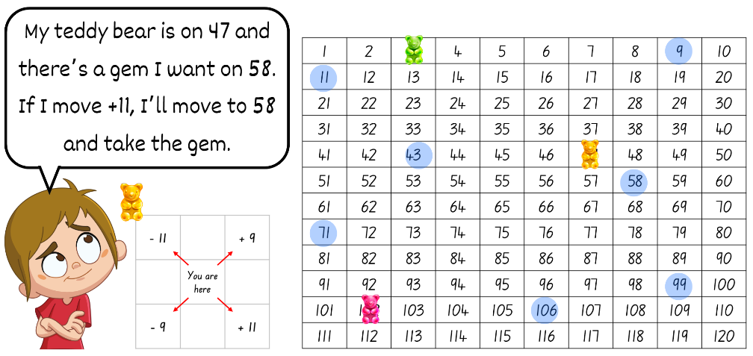
This table details opportunities for assessment.
Assessment opportunities | Links
What to look for:  - Can students use addition and subtraction flexibly to solve problems? [MAO-WM-01, MA2-AR-01] | Links to National Numeracy Learning Progressions (NNLP):  - AdS7.

Core lesson – addition problems – 25 minutes
The table below contains suggested learning intentions and success criteria. These are best co-constructed with students.
Core concept learning intentions | Core concept success criteria
Students are learning to:  - use place value models to solve addition problems. | Students can:  - apply known mental strategies that use partitioning to add such as bridging the decades  - represent solutions to addition problems using an empty number line.
- Build student understanding of how to partition whole numbers, bridge to the decade and use landmark numbers to solve addition problems. For example, students can partition numbers into tens and ones to help solve addition problems. They can use their knowledge of place value and landmark numbers to find the nearest decade when using the bridging strategy.
Partitioning: splitting numbers into smaller parts to make calculations easier.
Bridging the decade: decades are multiples of 10 (for example, 10, 20, 30 and so on). Bridging decades involves using multiples of 10 as landing points for adding and subtracting (AAMT n.d.).
Landmark numbers: ‘friendly numbers’ that are easy to work with, fluently, flexibly and efficiently.
- Use an interactive 120 number chart or Resource 10 – 120 Number chart to demonstrate how to solve the addition problem, 46 + 28. For example, start at 46 and bridge to the nearest decade by counting on 4 ones to reach the landmark number of 50. From 50, count on 2 tens to reach 70. Then count on 4 ones to land on the answer of 74 (see Figure 7).
Figure 7 – 120 number chart for addition
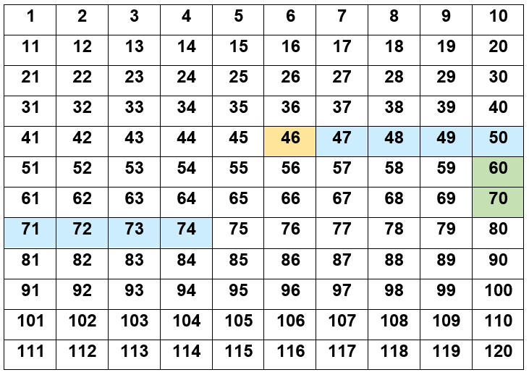
Note: use a different colour to represent the starting number, the ones and the tens. For example, orange for the starting number, blue for the ones and green for the tens. If using a printed copy of the Resource 10 – 120 Number chart, use different coloured counters.
- Record each step taken on the board using a number sentence. For example, 46 + 4 + 20 + 4 = 74.
- In pairs, students use Resource 10 – 120 Number chart and Resource 11 – addition number sentences to solve and record the addition problems. For example, Student A reads a number sentence aloud and solves the equation on the 120 number chart. Student B records the steps Student A has taken as a number sentence on an individual whiteboard.
This table details opportunities for differentiation.
Too hard? | Too easy?
Students cannot bridge to the decade to solve addition problems.  - Support students by having them place counters on each number as they count by ones.  - Encourage students to describe the pattern they see. For example, describe that one row is equivalent to 10.  - Provide students with MAB materials to support the count. | Students can bridge to the decade to solve addition problems.  - Students use number sentences involving two 2-digit numbers which total over 100.  - Challenge students to add a 2-digit number and a 3-digit number using the same method.

Consolidation and meaningful practice – 20 minutes
- Demonstrate how to bridge to the decade using an empty number line, using the same steps from the above equation. See Figure 8 (46 + 28).
Figure 8 – addition number line
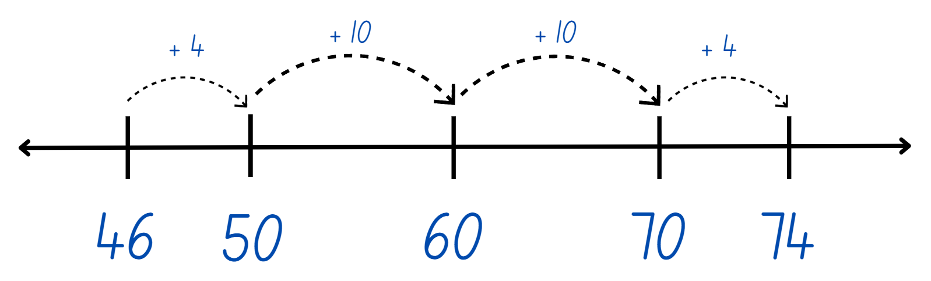
- Students use Resource 11 – addition number sentences and show how to bridge to the decade on an empty number line.
- Reflect on the lesson as a class. Ask students:
- What information did you need to know to use this strategy?
- Why do we bridge to the nearest decade?
- How is this strategy useful?
- Is partitioning a number to bridge to the decade an efficient strategy? Why?
- When would you use this strategy?
This table details opportunities for assessment.
Assessment opportunities | Links
What to look for:  - Can students apply known mental strategies that use partitioning to add such as bridging the decades? [MAO-WM-01, MA2-AR-01]  - Can students represent solutions to addition problems using an empty number line? [MAO-WM-01, MA2-AR-01] | Links to National Numeracy Learning Progressions (NNLP):  - AdS7.  Links to suggested Interview for Student Reasoning (IfSR) tasks:  - IfSR-AT: 2A.2, 3A.2.

Lesson 7
Core concept: partitioning into place value parts is an efficient strategy for addition and subtraction.

Daily number sense – you add, I subtract – 10 minutes
The table below contains a suggested learning intention and success criteria. These are best co-constructed with students.
Daily number sense learning intention | Daily number sense success criteria
Students are learning to:  - recognise and explain the connection between addition and subtraction. | Students can:  - identify the relationship between addition and subtraction.
- Give pairs of students a set of cards from Resource 12 – playing cards. They will also need a whiteboard each to record their number sentences.
- One student starts with the number 50 at the top of their whiteboard. Their aim is to subtract numbers until they reach zero. The other student starts with zero at the top of their whiteboard. Their aim is to add numbers until they reach 50.
- Students place the cards in a pile between them, face down.
- The first student turns over 3 cards. They must select 2 cards for both players to use. These cards can be used individually or combined to make a 2-digit number. If a 2-digit number is made, both students must use the exact same number. The card that is not selected is discarded to a rubbish pile.
- Both students record their number sentence on their individual whiteboard.
- Ask students the following:
- What do you think will happen if 2-digit numbers continue to be added or subtracted to each list?
- How many turns do you think will be needed to reach your target number?
- The second student repeats this process by turning over 3 cards from the top of the pile and choosing which 2 to keep and use.
- The game continues, with the players taking turns to select the cards and recording their individual number sentences until a player hits their target number (see Figure 9).
Figure 9 – you add, I subtract
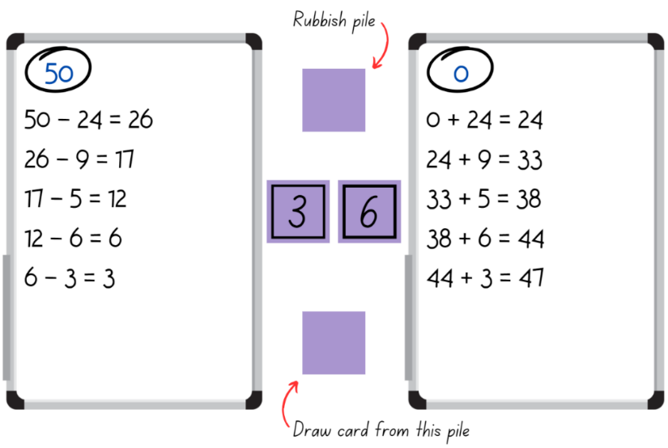
- If time permits, students swap roles and play again. Prior to playing, have students predict whether they'll finish at the same time.
Note: the power in this activity comes from the students noticing what is happening as they progress through the game. As each player is using the same numbers, students should both reach their target number at the same time. A class discussion of how and why this happens is an important teaching opportunity.
This table details opportunities for assessment.
Assessment opportunities | Links
What to look for:  - Can students identify the relationship between addition and subtraction? [MAO-WM-01, MA2-AR-01] | Links to National Numeracy Learning Progressions (NNLP):  - AdS7.

Core lesson – subtraction problems – 25 minutes
The table below contains suggested learning intentions and success criteria. These are best co-constructed with students.
Core concept learning intentions | Core concept success criteria
Students are learning to:  - partition numbers into place value parts to solve subtraction problems. | Students can:  - apply known mental strategies that use partitioning to subtract such as bridging the decades  - represent solutions to subtraction problems using an empty number line.
- Revise Core lesson: Addition problems. Remind students that bridging to the decade is a strategy they can use to help solve addition and subtraction problems.
- Replicate the activity from Core lesson: Addition problems with a subtraction focus.
- Use an interactive 120 number chart or Resource 10 – 120 Number chart to demonstrate how to solve the subtraction problem, 52 − 18 (see Figure 10). For example, start at 52, and bridge to the nearest decade by subtracting 2 ones to reach the landmark number of 50. From 50, subtract one 10 to reach 40. Then subtract 6 ones to land on the answer of 34.
Figure 10 – 120 number chart for subtraction
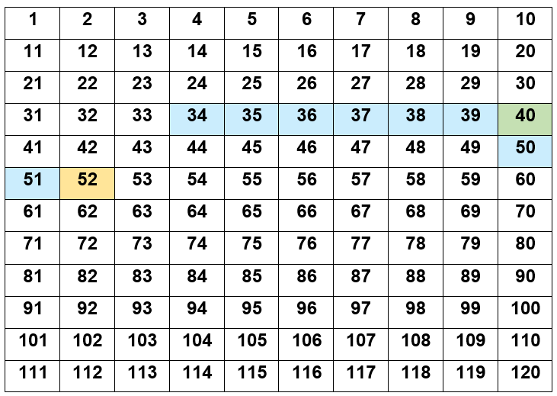
Note: use a different colour to represent the starting number, the ones and the tens. For example, orange for the starting number, blue for the ones and green for the tens. If using a printed copy of the Resource 10 – 120 Number chart, use different coloured counters.
- Record each step on the board using a number sentence. For example, 52 − 2 − 10 − 6 = 34.
- In pairs, students use Resource 10 – 120 Number chart and Resource 13 – subtraction number sentences to solve the subtraction problems. Students record the steps as a number sentence.
This table details opportunities for differentiation.
Too hard? | Too easy?
Students cannot bridge to the decade to solve subtraction problems.  - Support students by having them place counters on each number as they count by ones.  - Encourage students to describe the pattern they see. For example, describe that one row is equivalent to 10.  - Provide students with MAB materials to support the count. | Students can bridge to the decade to solve subtraction problems.  - Students subtract a 2-digit number from a 3-digit number using the same method.  - Students to calculate their sentences mentally, describing the steps to a partner who records the steps on the number chart.

Consolidation and meaningful practice – 20 minutes
- Demonstrate how to subtract by bridging to the decade using an empty number line (see Figure 11).
Figure 11 – subtraction number line
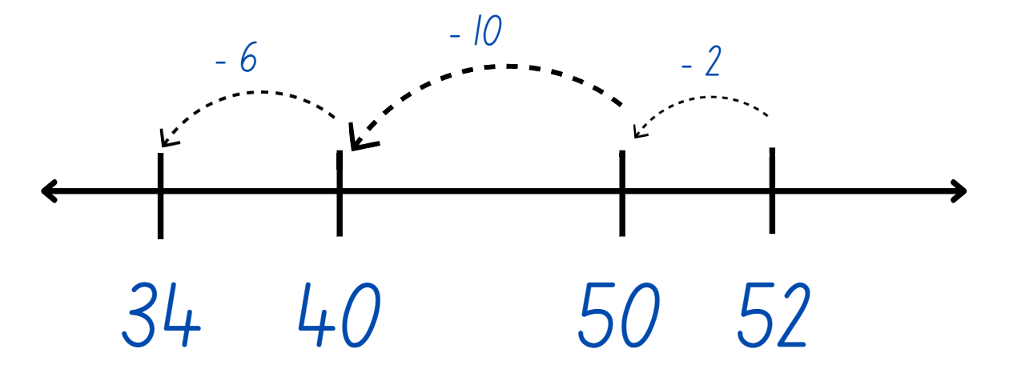
- Students use Resource 13 – subtraction number sentences and show how to bridge to the decade on an empty number line.
- Reflect on the lesson as a class. Ask students:
- What information did you need to know to use this strategy?
- Why do we bridge to the nearest decade?
- How is this strategy useful?
- Is partitioning a number to bridge to the decade an efficient strategy? Why?
- When would you use this strategy?
This table details opportunities for assessment.
Assessment opportunities | Links
What to look for:  - Can students apply known mental strategies that use partitioning to add such as bridging the decades? [MAO-WM-01, MA2-AR-01]  - Can students represent solutions to subtraction problems using an empty number line? [MAO-WM-01, MA2-AR-01] | Links to National Numeracy Learning Progressions (NNLP):  - AdS7.  Links to suggested Interview for Student Reasoning (IfSR) tasks:  - IfSR-AT: 2A.3, 2A.6.

Lesson 8
Core concept: addition and subtraction are connected.

Daily number sense – 10 minutes
- From a class need surfaced through formative assessment data, identify a short, focused activity that targets students’ knowledge, understanding and skills. Example activities may be drawn from the following resources:
- Mathematics K-6 resources
- Universal Resources Hub.

Core lesson – inverse operations – 40 minutes
The table below contains suggested learning intentions and success criteria. These are best co-constructed with students.
Core concept learning intentions | Core concept success criteria
Students are learning to:  - recognise and explain the connection between addition and subtraction. | Students can:  - identify that addition and subtraction are inverse operations  - represent the relationship between addition and subtraction using a bar model.
- Revise the role of the equal sign and discuss that it means ‘equivalence’ when used in a number sentence. For example, in this number sentence 40 = 27 + 13 means 40 is the same as 27 + 13 or 40 is equivalent to 27 + 13.
- Show students what a completed bar model looks like (see Figure 12).
Figure 12 – completed bar model
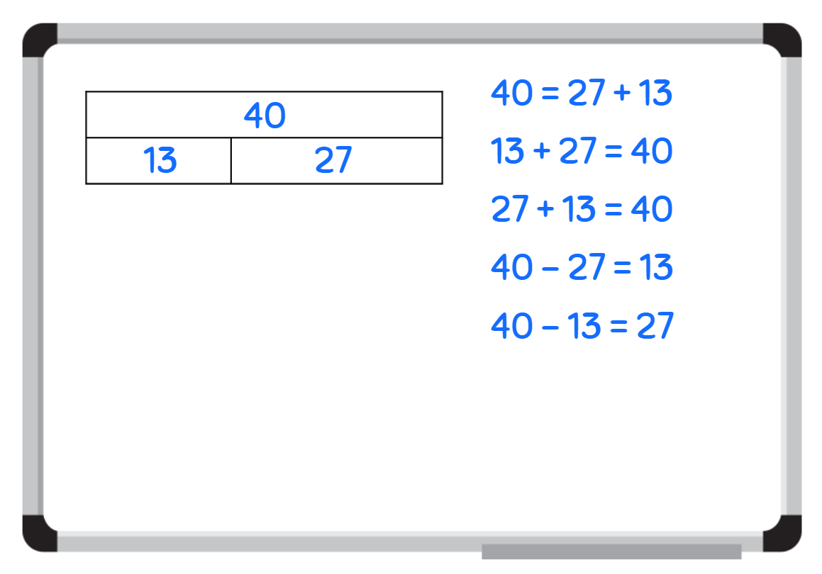
- Students consolidate their part-part-whole knowledge by participating in a puzzle activity.
- Give students an incomplete bar model from Resource 14 – bar model puzzle. Students must find the other parts that match their puzzle piece (see Figure 13). By the end of the activity, students should be in groups of 3.
Figure 13 – matching bar model puzzle cards
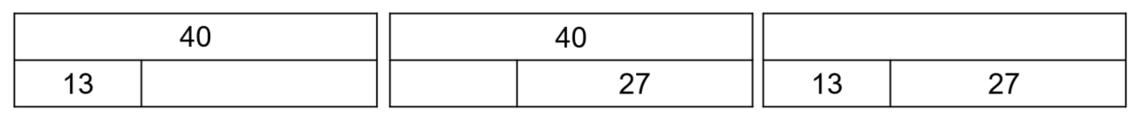
- Ask students:
- Did you find your ability to partition number helpful during this activity? How?
- How does the bar model show a relationship between numbers?
- What steps did you take to complete this activity?
- What mathematical operation did you use to find the missing value?
- What did you notice?
- Using one of the bar model cards from the puzzle activity, explain how the bar model represents the relationship between addition and subtraction.
- Model writing number sentences, using both addition and subtraction operations (see Figure 14).
Figure 14 – relationship between addition and subtraction
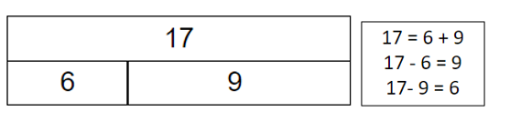
- Use Resource 15 – number cards to draw a blank bar model and complete the number sentences. Highlight the relationship between addition and subtraction when completing this activity (see Figure 15).
Figure 15 – worked example
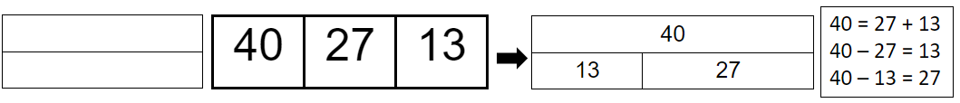
- Students complete the above activity independently for the remaining number on Resource 15 – number cards.
This table details opportunities for differentiation.
Too hard? | Too easy?
Students cannot recognise the relationship between addition and subtraction.  - Provide students with the opportunity to work in pairs to support their learning.  - Give students the completed bar model so that they can write the corresponding inverse number sentences. | Students can recognise the relationship between addition and subtraction.  - Have students work with a partner to justify their thinking.  - Challenge students to create a problem for their partner to solve.

Discuss and connect the mathematics – 5 minutes
- Reflect on the learning from the lesson. Ask students:
- What did you notice?
- How are addition and subtraction connected?
- What mathematical term do we use to describe this connection?
- In what ways have you been a mathematician today?
This table details opportunities for assessment.
Assessment opportunities | Links
What to look for:  - Can students identify that addition and subtraction are inverse operations? [MAO-WM-01, MA2-AR-01]  - Can students represent the relationship between addition and subtraction using a bar model? [MAO-WM-01, MA2-AR-01] | Links to National Numeracy Learning Progressions (NNLP):  - AdS7.

Resource 1 – place value houses
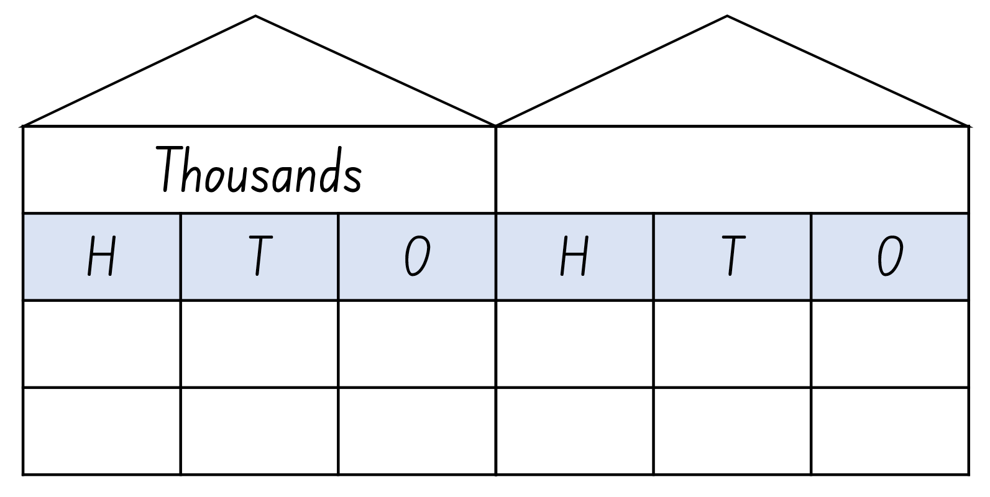

Resource 2 – number sentences
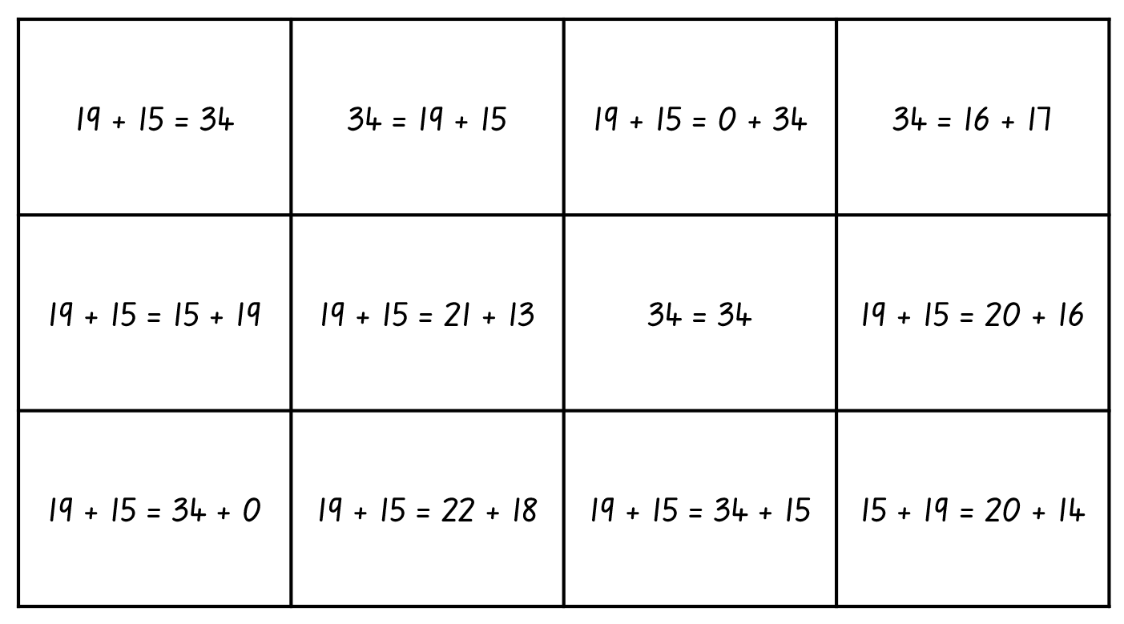

Resource 3 – snap cards
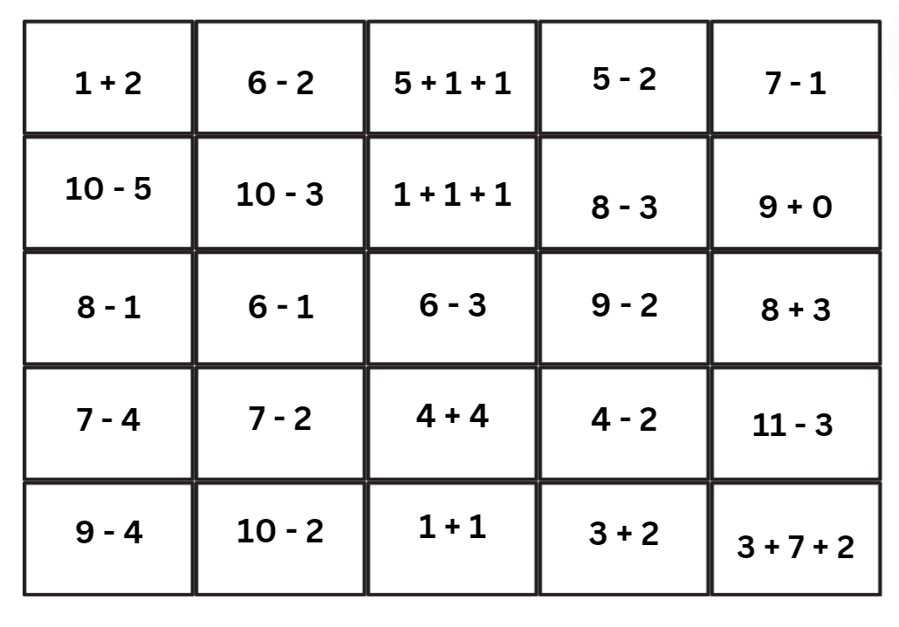
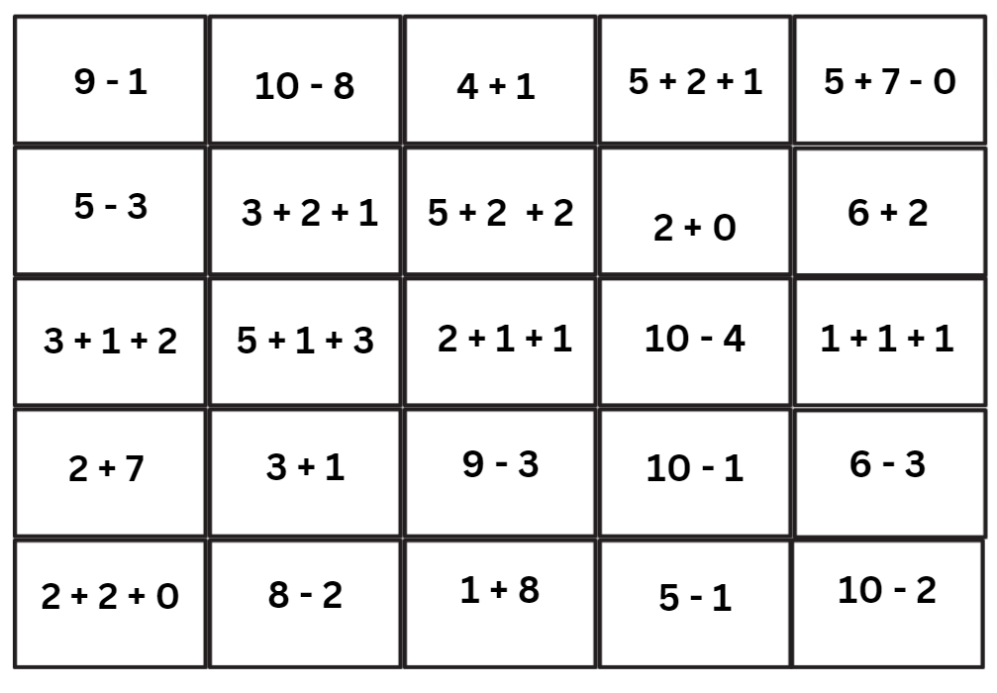

Resource 4 – MAB understandings
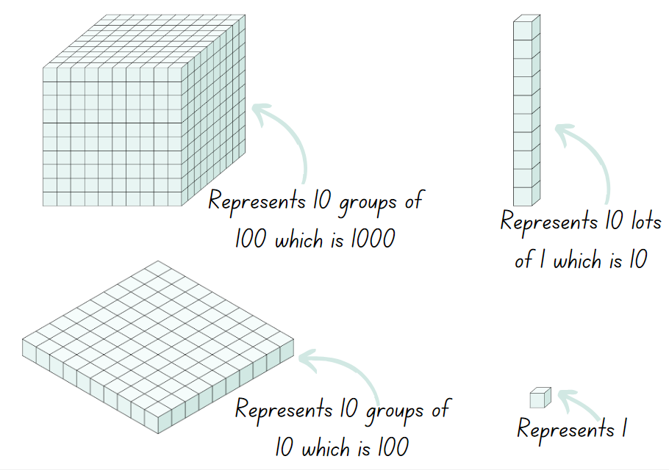

Resource 5 – misconceptions – zero
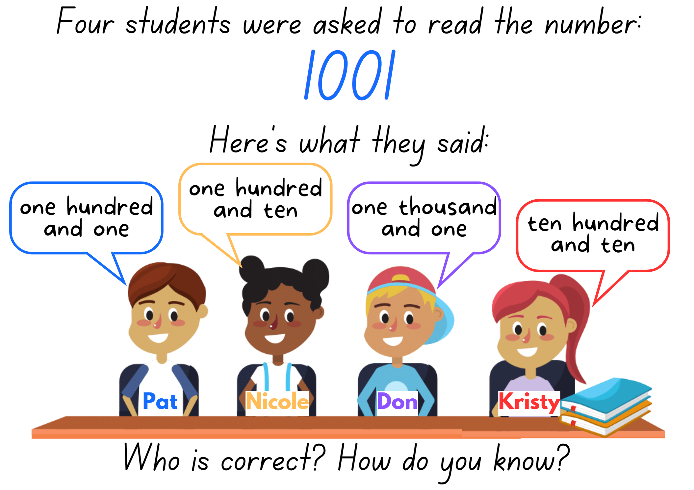

Resource 6 – Which doesn’t belong?
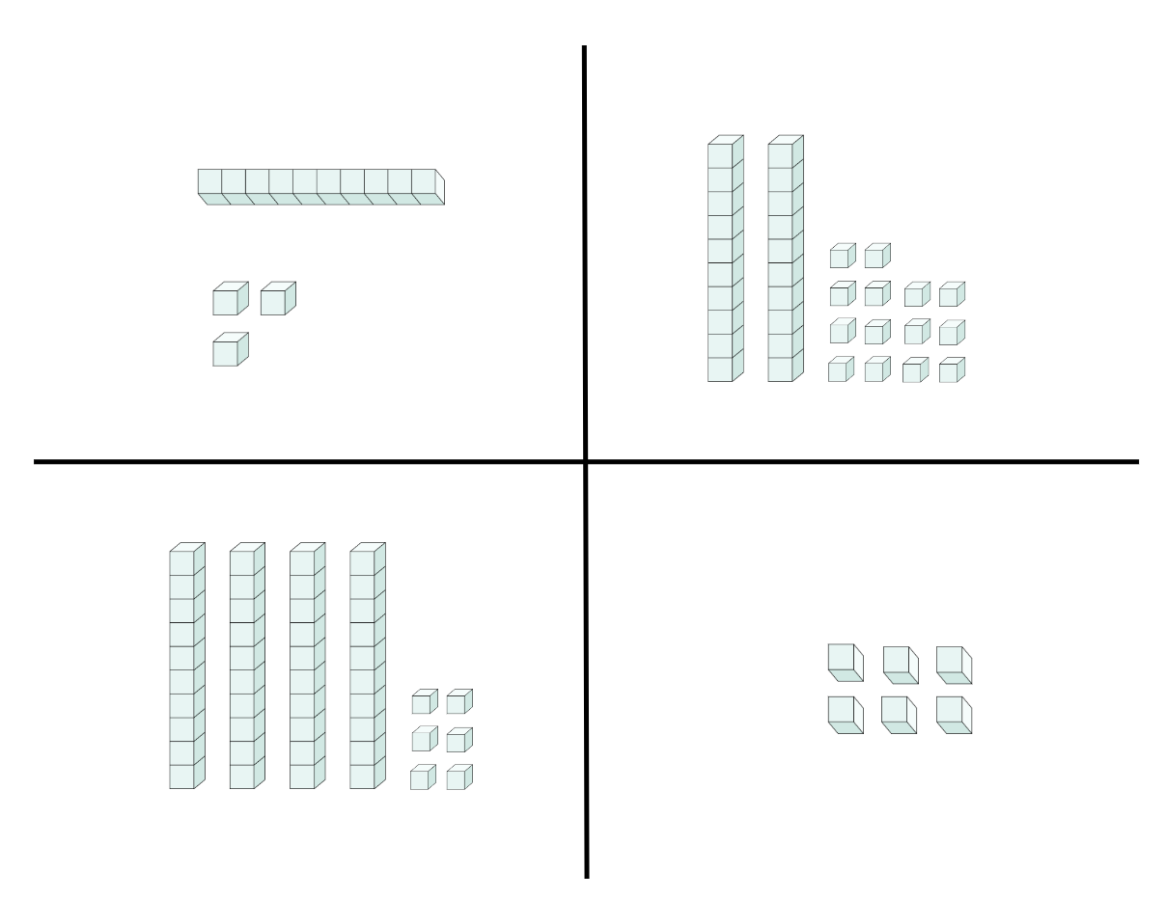

Resource 7 – collections of 1224
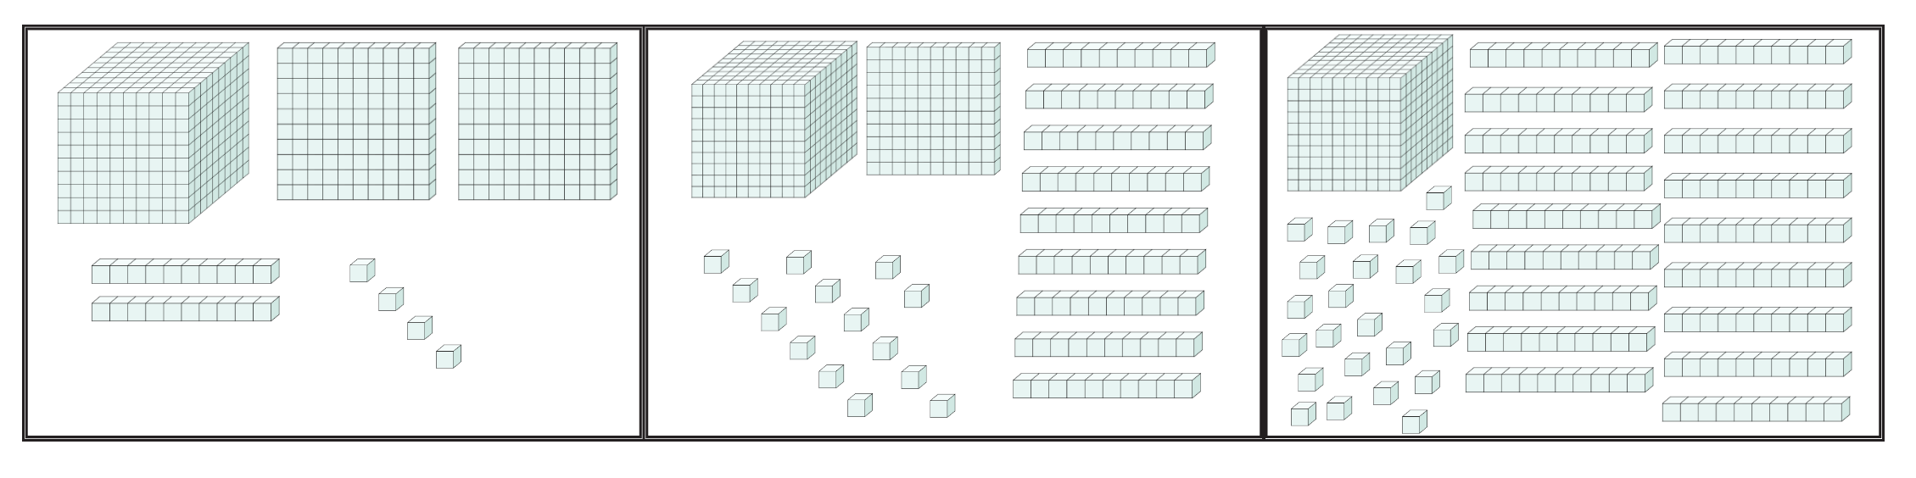

Resource 8 – table of combinations
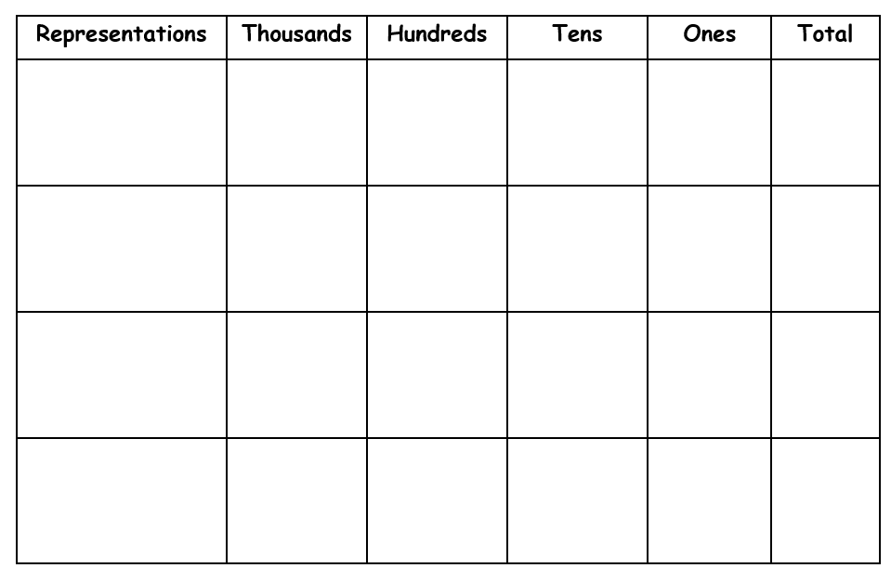

Resource 9 – player sheet
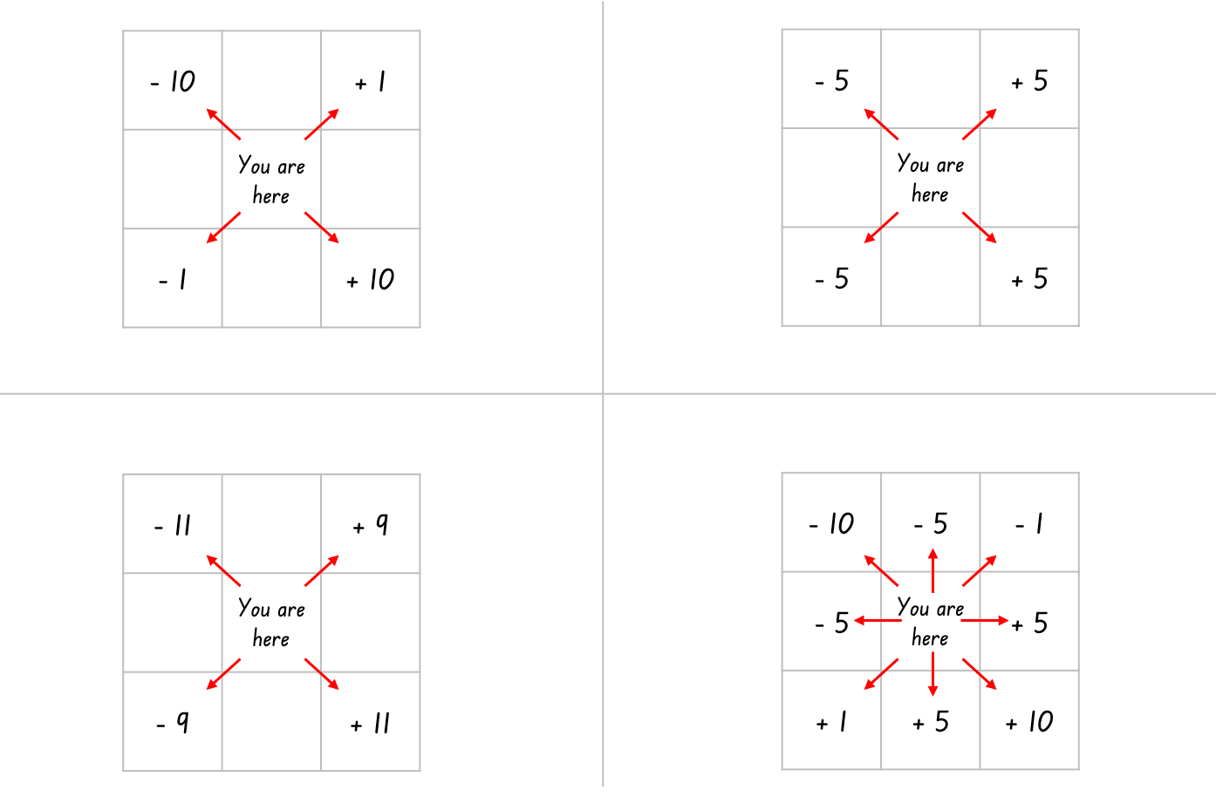
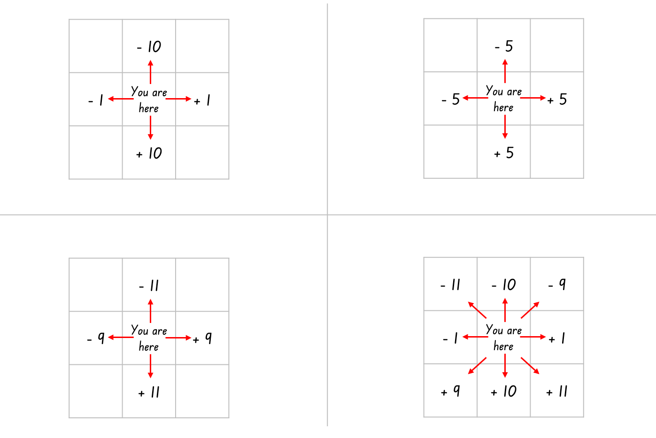

Resource 10 – 120 Number chart
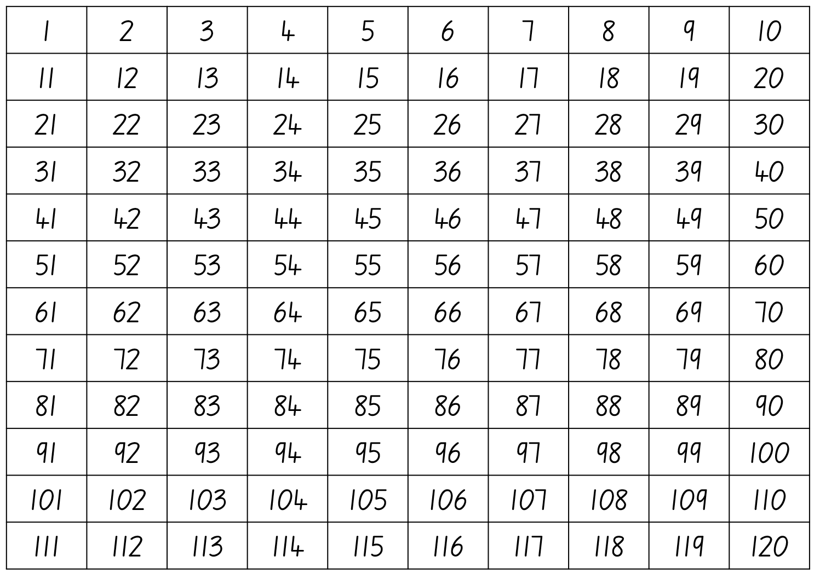

Resource 11 – addition number sentences
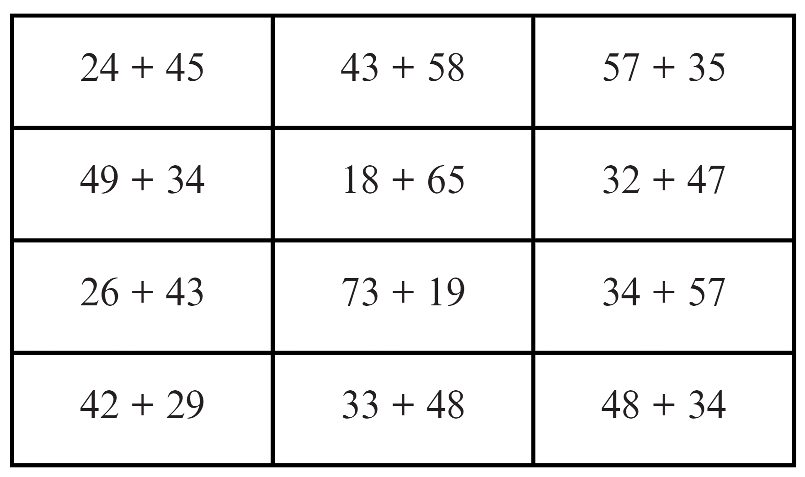

Resource 12 – playing cards
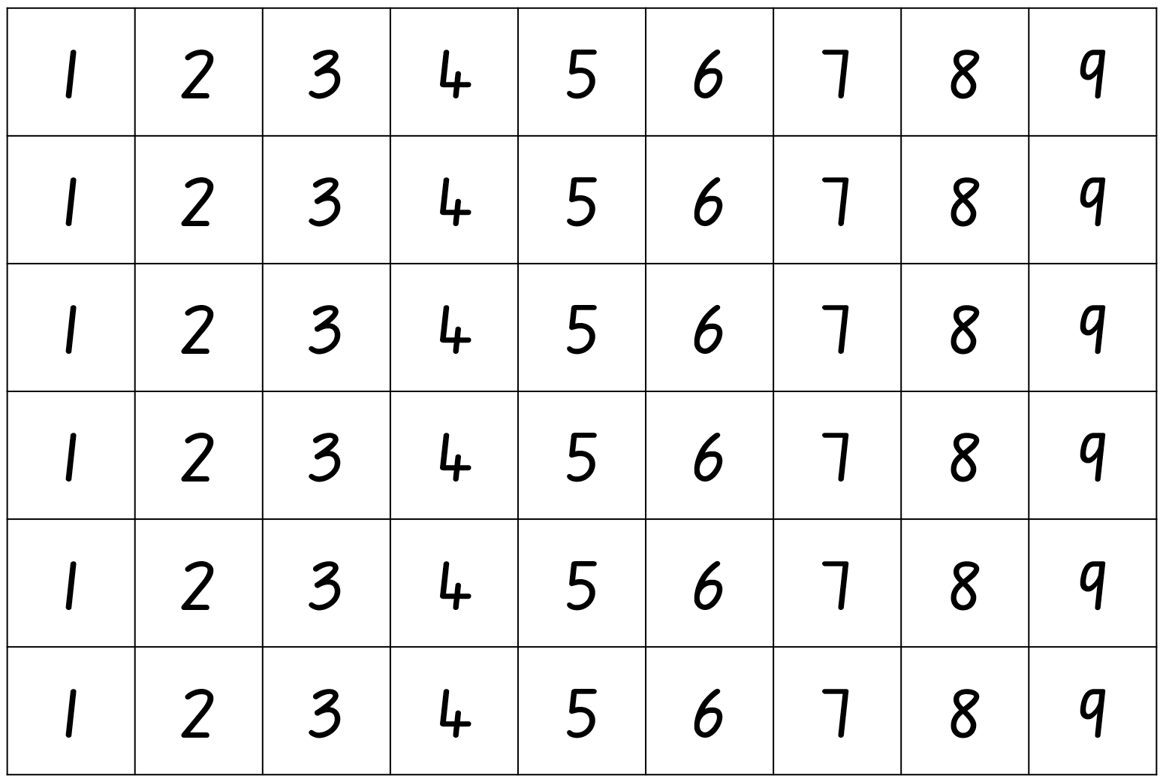

Resource 13 – subtraction number sentences
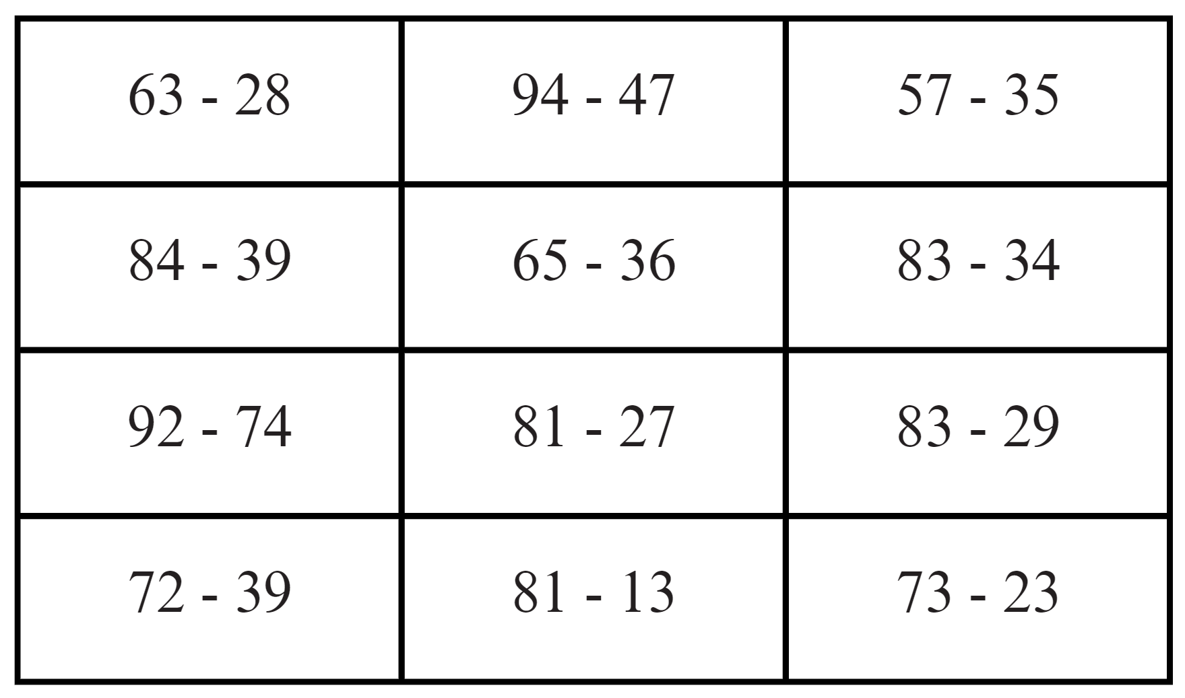

Resource 14 – bar model puzzle
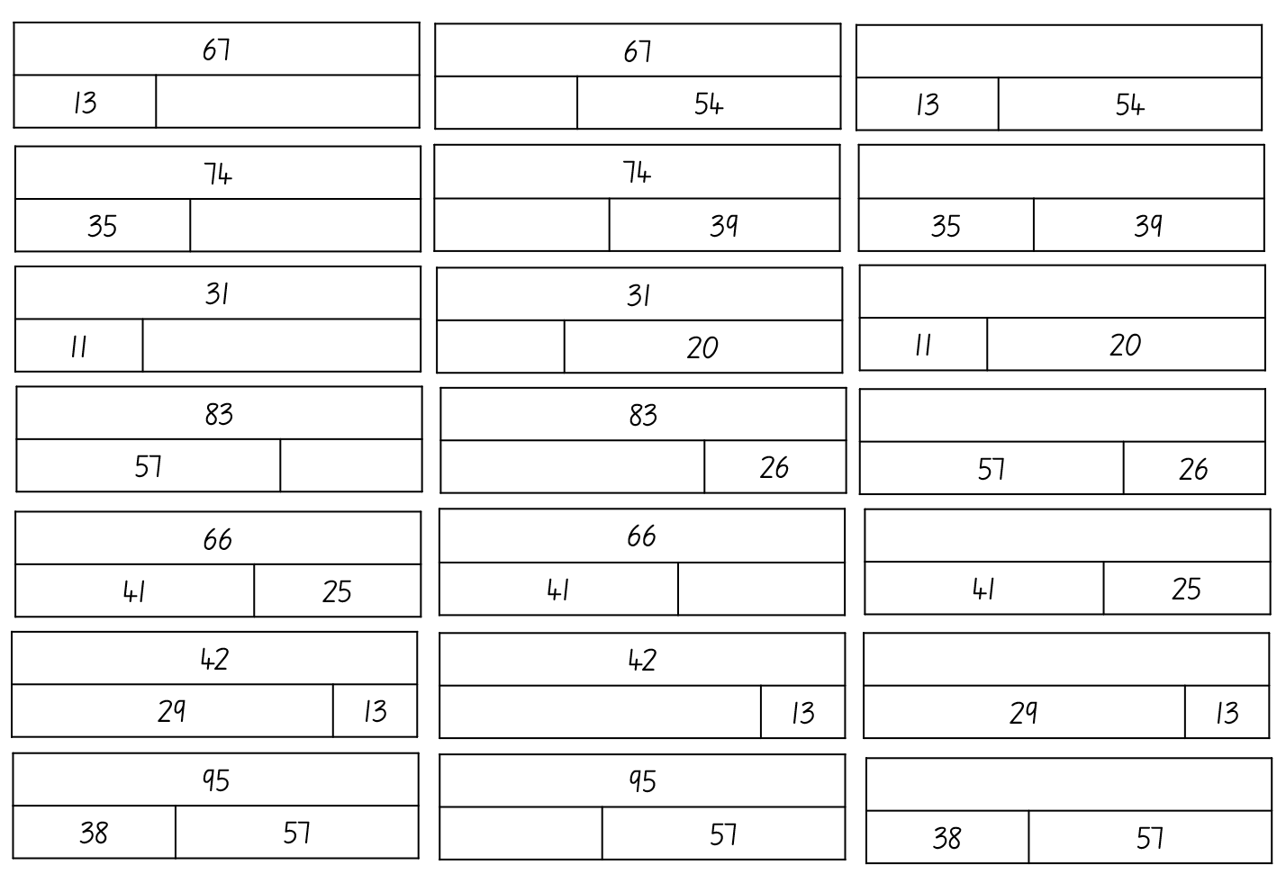
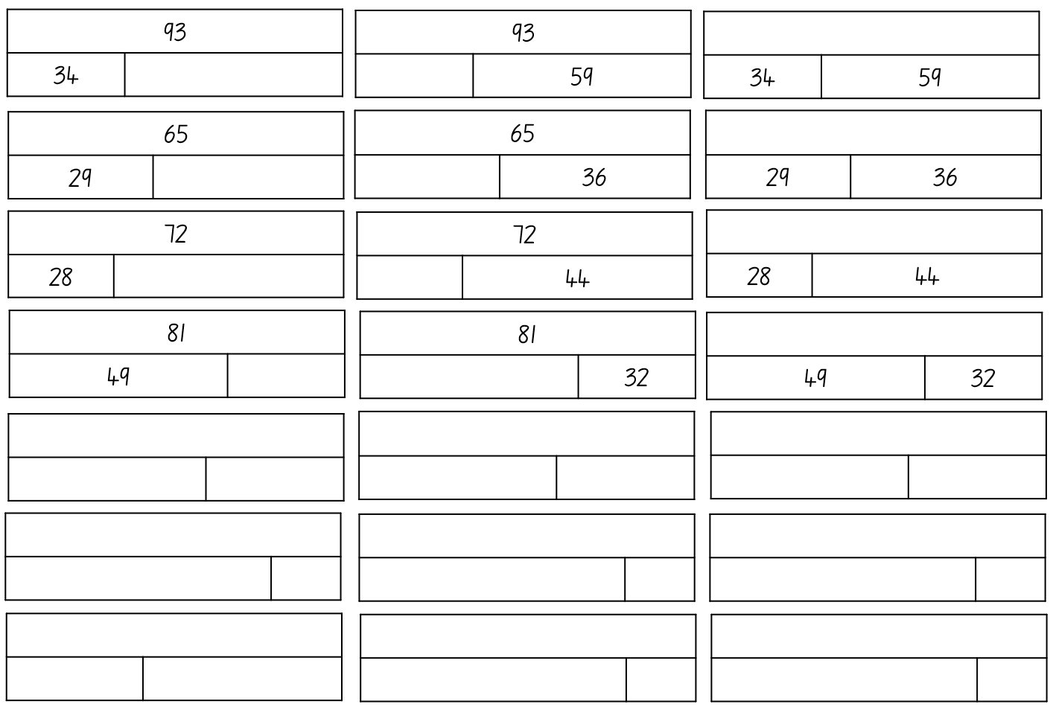

Resource 15 – number cards
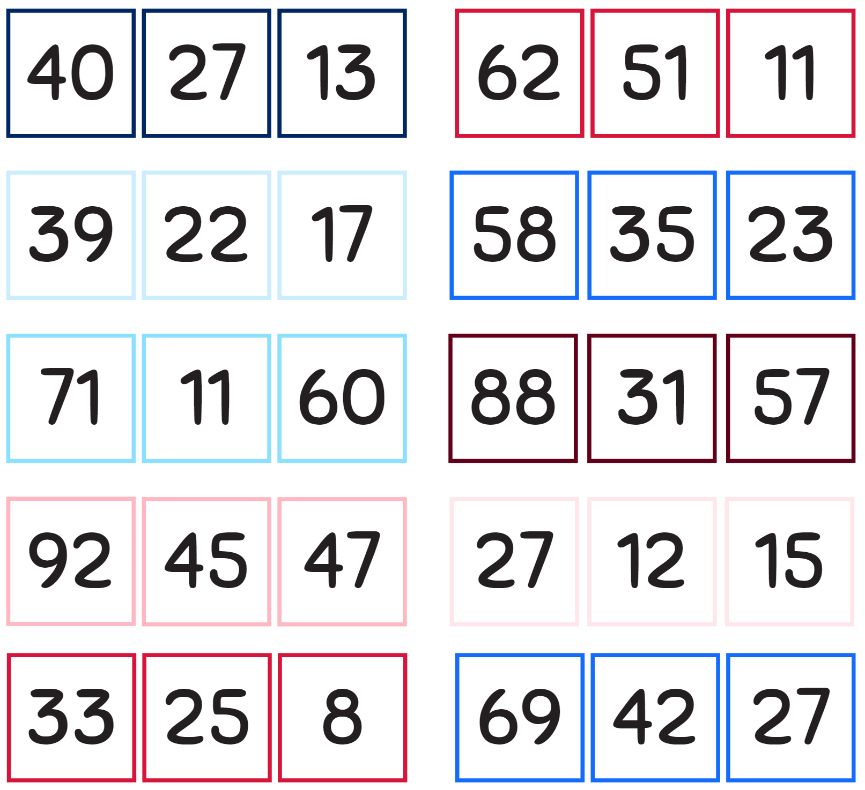

Syllabus outcomes and content
The table below outlines the syllabus outcomes and range of relevant syllabus content covered in this unit. Content is linked to National Numeracy Learning Progression version (3).
Outcomes and content | 1 | 2 | 3 | 4 | 5 | 6 | 7 | 8
Representing numbers using place value A: Whole numbers: Read, represent and order numbers to thousands
MAO-WM-01, MA2-RN-01
- Group physical or virtual objects to show the structure of tens, hundreds and a thousand |  | x | x
- Regroup numbers flexibly, recognising one thousand as 10 hundreds and one hundred as 10 tens or 100 ones |  | x |  |  | x
- Count forwards and backwards by tens and hundreds on and off the decade | x
- Represent numbers up to and including thousands using physical or virtual manipulatives, words, numerals, diagrams and digital displays |  | x | x | x
- Read and order numbers of up to at least 4 digits | x |  | x
- Identify the number before and after a number with an internal zero digit |  |  |  | x
Representing numbers using place value A: Whole numbers: Apply place value to partition and regroup numbers up to 4 digits
MAO-WM-01, MA2-RN-01
- Record numbers using standard place value form |  | x |  | x | x | x | x
- Partition numbers of up to 4 digits in non-standard forms (Reasons about quantity) |  |  |  |  | x
Representing numbers using place value B: Whole numbers: Order numbers in the thousands
MAO-WM-01, MA2-RN-01
- Arrange numbers in the thousands in ascending and descending order |  |  | x
- Recognise and describe how rearranging digits changes the size of a number (Reasons about relations) |  |  | x
Representing numbers using place value B: Whole numbers: Apply place value to partition, regroup and rename numbers up to 6 digits
MAO-WM-01, MA2-RN-01
- Use place value to expand the number notation |  |  |  |  |  | x | x
Representing numbers using place value B: Recognise and represent numbers that are 10, 100 and 1000 times as large
MAO-WM-01, MA2-RN-01
- Recognise the number of tens, hundreds or thousands in a number |  |  | x
Additive relations A: Use the principle of equality
MAO-WM-01, MA2-AR-01
- Use the equals sign to mean 'the same as', rather than to perform an operation | x | x | x |  |  | x | x | x
Additive relations A: Recognise and explain the connection between addition and subtraction
MAO-WM-01, MA2-AR-01
- Use number relation principles to solve related problems (Reasons about relations) |  |  |  |  | x |  | x | x
- Demonstrate how addition and subtraction are inverse operations |  |  |  |  |  |  |  | x
- Use the complement principle of addition and subtraction (Reasons about relations) |  |  |  |  |  |  |  | x
- Explain and check solutions to problems, including by using the inverse operation |  |  |  |  |  |  |  | x
Additive relations A: Select strategies flexibly to solve addition and subtraction problems of up to 3 digits
MAO-WM-01, MA2-AR-01
- Apply known mental strategies that use partitioning to add and subtract, such as bridging the decades |  |  |  |  |  | x | x | x
- Represent solutions to addition and subtraction problems, including word problems, using an empty number line or bar model |  |  |  |  |  | x | x | x
- Compare and evaluate strategies used to solve addition and subtraction problems, reasoning which strategy may be most efficient |  |  |  |  |  | x | x
Additive relations B: Partition, rearrange and regroup numbers to at least 1000 to solve additive problems
MAO-WM-01, MA2-AR-01
- Use quantity values and non-standard partitioning to solve addition and subtraction problems |  |  |  |  |  | x | x
- Model addition with and without regrouping and record the method used |  |  |  |  |  | x
- Model subtraction with and without regrouping and record the method used |  |  |  |  |  |  | x
Mathematics K–10 Syllabus © NSW Education Standards Authority (NESA) for and on behalf of the Crown in right of the State of New South Wales, 2022.

References
This resource contains NSW Curriculum and syllabus content. The NSW Curriculum is developed by the NSW Education Standards Authority. This content is prepared by NESA for and on behalf of the Crown in right of the State of New South Wales. The material is protected by Crown copyright.
Please refer to the NESA Copyright Disclaimer for more information https://educationstandards.nsw.edu.au/wps/portal/nesa/mini-footer/copyright.
NESA holds the only official and up-to-date versions of the NSW Curriculum and syllabus documents. Please visit the NSW Education Standards Authority (NESA) website https://educationstandards.nsw.edu.au/ and the NSW Curriculum website https://curriculum.nsw.edu.au/home.
Mathematics K–10 Syllabus © NSW Education Standards Authority (NESA) for and on behalf of the Crown in right of the State of New South Wales, 2022.
National Numeracy Learning Progression © Australian Curriculum, Assessment and Reporting Authority (ACARA) 2010 to present, unless otherwise indicated. This material was downloaded from the Australian Curriculum website (National Numeracy Learning Progression) (accessed 5 September 2023) and was not modified.
AAMT (The Australian Association of Mathematics Teachers) (n.d.) ‘Bridging decades’, Addition and subtraction, Top Drawer Teachers: resources for teachers of mathematics website, accessed 13 June 2023.
ABC (Australian Broadcasting Corporation) (20 October 2021) 'Maths Years 3–4 with Ms Kirszman: Partitioning numbers using place value parts' [video], ABC Education, ABC website, accessed 13 June 2023.
Ask Media Group, LLC (2020) ‘What is a landmark number?’, Reference* website, accessed 12 September 2023.
BOSTES (Board of Studies, Teaching and Educational Standards NSW) (2015) Number and Algebra – Stage 2: Mathematics Teaching resource K-6, The NESA Shop.
Didax, Inc (2023) ‘120 Number Board’, Virtual Manipulatives, Didax website, accessed 13 June 2023.
Finkel D (2015) ‘Target Number’, Free Lessons, Math for Love website, accessed 13 June 2023.
Finkel D (2016) ‘The Hundred Chart Game’, Free Lessons, Math for Love website, accessed 13 June 2023.
Murphy SJ (n.d.) Earth Day Hooray! (Adriani R illus), MathStart website, accessed 18 June 2023.
New Zealand Ministry of Education (n.d.) ‘Equality and equations’, Resource Finder, NZ Maths website, accessed 13 June 2023.
Primary Learning (2018) Balancing Act – A dice game [PDF 250 KB], Primary Learning, accessed 18 September 2023.
State of New South Wales (Department of Education) (n.d.) Chicken Scramble [PDF 111 KB], School Sport Unit, NSW Department of Education, accessed 18 September 2023.
University of Cambridge (Faculty of Mathematics) (1997–2023) True or False?, NRICH website, accessed 13 June 2023.
Williams E (1 June 2023) ‘Primary Maths Dictionary for Kids and Parents: A Guide To The Mathematical Terms Used In KS1 And KS2’, Third Space Learning Blog, accessed 13 June 2023.

© State of New South Wales (Department of Education), 2023
The copyright material published in this resource is subject to the Copyright Act 1968 (Cth) and is owned by the NSW Department of Education or, where indicated, by a party other than the NSW Department of Education (third-party material).
Copyright material available in this resource and owned by the NSW Department of Education is licensed under a Creative Commons Attribution 4.0 International (CC BY 4.0) license.
This license allows you to share and adapt the material for any purpose, even commercially.
Attribution should be given to © State of New South Wales (Department of Education), 2023.
Material in this resource not available under a Creative Commons license:
- the NSW Department of Education logo, other logos and trademark-protected material
- material owned by a third party that has been reproduced with permission. You will need to obtain permission from the third party to reuse its material.
Links to third-party material and websites
Please note that the provided (reading/viewing material/list/links/texts) are a suggestion only and implies no endorsement, by the New South Wales Department of Education, of any author, publisher, or book title. School principals and teachers are best placed to assess the suitability of resources that would complement the curriculum and reflect the needs and interests of their students.
If you use the links provided in this document to access a third-party's website, you acknowledge that the terms of use, including licence terms set out on the third-party's website apply to the use which may be made of the materials on that third-party website or where permitted by the Copyright Act 1968 (Cth). The department accepts no responsibility for content on third-party websites.

