Mathematics Stage 2 – Unit 3
Contents
Unit description and duration 4
Syllabus outcomes 4
Working mathematically 5
Student prior learning 5
Lesson overview and resources 7
Lesson 1 12
Daily number sense: Where do you fit? – 10 minutes 12
Core lesson: Towering metres – 20 minutes 13
Core lesson: The centimetre – 30 minutes 15
Discuss and connect the mathematics – 10 minutes 17
Lesson 2 19
Daily number sense: Number before and after – 10 minutes 19
Core lesson: Estimating with benchmarks – 50 minutes 21
Discuss and connect the mathematics – 10 minutes 23
Lesson 3 25
Daily number sense: From here to there – 10 minutes 25
Core lesson: Rule and record using centimetres – 30 minutes 27
Consolidation and meaningful practice – 20 minutes 30
Lesson 4 33
Daily number sense – 10 minutes 33
Core lesson: Exploring millimetres – 40 minutes 33
Discuss and connect the mathematics – 10 minutes 35
Lesson 5 37
Daily number sense: Number line addition and subtraction – 10 minutes 37
Core lesson: Measuring perimeter – 40 minutes 39
Discuss and connect the mathematics – 10 minutes 41
Lesson 6 43
Daily number sense: Compensation strategy – 10 minutes 43
Core lesson: Shape exploration – 35 minutes 45
Consolidation and meaningful practice – 15 minutes 47
Lesson 7 50
Daily number sense: Bar model – 10 minutes 50
Core lesson: Time facts and time memory – 40 minutes 52
Discuss and connect the mathematics – 10 minutes 54
Lesson 8 56
Daily number sense – 10 minutes 56
Core lesson: Circular number line activity – 30 minutes 56
Consolidation and meaningful practice – 20 minutes 59
Resource 1: Recording table 61
Resource 2: Benchmark measuring 62
Resource 3: Millimetre Ruler 63
Resource 4: Measuring with millimetres 64
Resource 5: Flip and describe cards 65
Resource 6: Two-dimensional shapes 66
Resource 7: Venn diagram 67
Resource 8: Measuring perimeter 68
Resource 9: Bar model 69
Resource 10: Minute comparison table 70
Resource 11: Time memory 71
Resource 12: Exit ticket 73
Resource 13: Anchor chart 74
Resource 14: Numeral cards 75
Resource 15: Numeral cards 2 76
Resource 16: Circular number line 81
Syllabus outcomes and content 82
References 86

Unit description and duration
This unit develops the big idea that what needs to be measured determines the unit of measurement.
In this 2-week unit students are provided opportunities to:
- measure and compare lengths of objects using metres centimetres and millimetres
- compare and describe features of two-dimensional shapes
- represent and read analog time.

Syllabus outcomes
- MAO-WM-01 develops understanding and fluency in mathematics through exploring and connecting mathematical concepts, choosing and applying mathematical techniques to solve problems, and communicating their thinking and reasoning coherently and clearly
- MA2-RN-01 applies an understanding of place value and the role of zero to represent numbers to at least tens of thousands
- MA2-AR-01 selects and uses mental and written strategies for addition and subtraction involving 2- and 3-digit numbers
- MA2-GM-02 measures and estimates lengths in metres, centimetres and millimetres
- MA2-2DS-01 compares two-dimensional shapes and describes their features
- MA2-NSM-02 represents and interprets analog and digital time in hours, minutes and seconds

Working mathematically
In the Mathematics K–10 Syllabus, there is one overarching Working mathematically outcome (MAO-WM-01). The Working mathematically processes should be embedded within the concepts being taught. The Working mathematically processes present in the Mathematics K–10 Syllabus are:
- communicating
- understanding and fluency
- reasoning
- problem solving.
Mathematics K–10 Syllabus © NSW Education Standards Authority (NESA) for and on behalf of the Crown in right of the State of New South Wales, 2022.

Student prior learning
Before engaging in these teaching and learning activities, students would benefit from prior experience with:
- measuring and comparing lengths of objects with informal and formal units
- naming and classifying two-dimensional shapes
- analog clocks, including half-hour and o’clock.
In NSW classrooms there is a diverse range of students, including Aboriginal and Torres Strait Islander students, students learning English as an additional language or dialect, high potential and gifted students and students with disability. Some students may identify with more than one of these groups or possibly all of them. Refer to Advice on curriculum planning for every student for further information.

Lesson overview and resources
The table below outlines the sequence and approximate timing of lessons, learning intentions and resources.
Lesson | Content | Duration and resources
Lesson 1  Daily number sense learning intention:  - read and order numbers up to thousands | Lesson core concept: standard units are an efficient way to measure length.  Core concept learning intention:  - measure and compare objects using metres, centimetres | Lesson duration: 70 minutes  - 10-sided dice  - Building materials, for example, MAB materials, blocks or pencil tins  - Class set of 30 cm rulers  - Metre ruler  - Sticky notes  - Student workbooks  - Writing materials
Lesson 2  Daily number sense learning intention:  - read, represent and order numbers to thousands | Lesson core concept: use known lengths as personal benchmarks to guide estimation.  Core concept learning intention:  - estimate and measure lengths in metres | Lesson duration: 70 minutes  - Resource 1: Recording table  - 10-sided dice  - Formal measuring tools, for example, one metre rulers or trundle wheels  - Glue  - Student workbooks  - Writing materials
Lesson 3  Daily number sense learning intention:  - read, represent and order numbers to thousands | Lesson core concept: context determines the most suitable standard unit, sometimes a metre is too big.  Core concept learning intention:  - measure and record lengths using centimetres | Lesson duration: 60 minutes  - Resource 2: Benchmark measuring  - 6-sided dice  - 10-sided dice  - Class set of 30 cm rulers  - Coloured pencils  - MAB block  - Individual whiteboards  - Student workbooks  - Writing materials
Lesson 4  Daily number sense learning intention:  - teacher-identified task based on student needs | Lesson core concept: metric units of measurement relate to the base-10 place value system.  Core concept learning intention:  - measure and compare objects using millimetres | Lesson duration: 60 minutes  - Resource 3: Millimetre ruler  - Resource 4: Measuring with millimetres  - Class set of 30 cm rulers  - Writing materials
Lesson 5  Daily number sense learning intention:  - solve addition and subtraction problems | Lesson core concept: length can add precision to descriptions of shapes.  Core concept learning intentions:  - compare and describe features of two-dimensional shapes  - use scaled instruments to measure and compare lengths | Lesson duration: 60 minutes  - Resource 5: Flip and describe cards  - Resource 6: Two-dimensional shapes  - Resource 7: Venn diagram  - Class set of 30 cm rulers  - Writing materials
Lesson 6  Daily number sense learning intention:  - solve addition and subtraction problems | Lesson core concept: shapes can be classified and compared based on the length of their sides.  Core concept learning intentions:  - compare and describe features of two-dimensional shapes  - use scaled instruments to measure and compare lengths | Lesson duration: 60 minutes  - Resource 8: Measuring perimeter  - 9-sided dice  - Individual whiteboards  - Pattern blocks or attribute shapes  - Sticky notes  - Writing materials
Lesson 7  Daily number sense learning intention:  - solve addition and subtraction problems | Lesson core concept: standard units are an efficient way to communicate and compare lengths of time.  Core concept learning intention:  - represent and read analog time | Lesson duration: 60 minutes  - Resource 9: Bar model  - Resource 10: Minute comparison table  - Resource 11: Time memory  - Resource 12: Exit ticket  - Analog clocks  - Individual whiteboards  - Stopwatch or timer  - Writing materials
Lesson 8  Daily number sense learning intention:  - teacher-identified task based on student needs | Lesson core concept: a clock face is a circular 0–60 number line that tracks time using patterns and fractions.  Core concept learning intention:  - represent and read analog time | Lesson duration: 60 minutes  - Resource 12: Exit ticket  - Resource 13: Anchor chart  - Resource 14: Numeral cards  - Resource 15: Numeral cards 2  - Resource 16: Circular number line  - Pegs  - Scissors  - Skipping rope  - Writing materials

Lesson 1
Core concept: standard units are an efficient way to measure length.

Daily number sense: Where do you fit? – 10 minutes
Daily number sense activities for Lessons 1 to 3 ‘activate’ prior number knowledge and support the learning of new content in the unit. These activities can also assist teachers to identify the starting points for learning by revealing the extent of students’ existing knowledge.
The table below contains a suggested learning intention and success criteria. These are best co-constructed with students.
Daily number sense learning intention | Daily number sense success criteria
Students are learning to:  - read and order numbers up to thousands. | Students can:  - read numbers up to thousands  - arrange numbers in ascending or descending order.
- Organise students into groups of 4–6 and provide each group with four 10-sided dice.
- Students take turns rolling the dice to create a 4-digit number. Students record the number on a sticky note and, one by one, read their number aloud and then place themselves in order from smallest to largest.
- When each group has all their members in order, have 2 groups combine. Group members need to adjust their order to ensure they are still in order from smallest to largest.
- Continue to combine groups and adjust placements until the whole class is in order.
Note: this activity can be adapted to use only two or three 10-sided dice.
This table details opportunities for assessment.
Assessment opportunities | Links
What to look for:  - Can students read numbers up to thousands? [MAO-WM-01, MA2-RN-01]  - Can students arrange numbers in ascending or descending order? [MAO-WM-01, MA2-RN-01] | Links to National Numeracy Learning Progressions (NNLP):  - NPV5, NPV6.  Links to suggested Interview for Student Reasoning (IfSR) tasks:  - IfSR-NP: 4B.2, 4C.

Core lesson: Towering metres – 20 minutes
The table below contains a suggested learning intention and success criteria. These are best co-constructed with students.
Core concept learning intentions | Core concept success criteria
Students are learning to:  - measure and compare objects using metres, centimetres. | Students can:  - identify lengths that are approximately one metre  - use a metre ruler to accurately measure a length of one metre  - estimate and measure lengths in centimetres  - label and record lengths using the abbreviation of ‘m’ and ‘cm’
This activity is an adaptation of ‘Towering metres’ from Teaching Measurement Stage 2 – Stage 3 [PDF 686 KB] by NSW Department of Education.
- Brainstorm all the units that can be used to measure length and distance. Record answers on an anchor chart.
- Discuss formal units of measurement that students have suggested and highlight the metre as a standard unit to measure length. Ask:
- Why is it important to have a formal unit of measurement?
- What is some equipment that is used to measure length with a formal unit?
- Can you see items in the room that are about one metre in length?
- Where do you think one metre would reach on your body, if measured from the floor?
- Use a metre ruler to demonstrate the length and height of a metre. Compare a metre ruler to the height of a student and the width of the door.
- Explain to students that they are going to build a tower that is one metre in length.
Note: towers can be built either vertically or horizontally along the ground.
- Provide small groups with their workbooks and materials that can be used to build a tower. For example, MAB materials, blocks or pencil tins. Groups build their tower until students estimate that it measures one metre, then check the length with a metre ruler. Students draw a representation of their tower and record the measurement, using the abbreviation 1 m.
- Students display their tower and go on a gallery walk, looking at other groups’ estimation of one metre. As students are walking around, ask:
- What made you decide to do it that way?
- How close was your estimation to one metre? How do you know?
- Did you use anything to help you estimate one metre? Explain.
- Would you change anything if you had to build your tower again? Why or why not?

Core lesson: The centimetre – 30 minutes
This activity is an adaptation of ‘Any three items’ from Teaching Measurement Stage 2 – Stage 3 [PDF 686 KB] by NSW Department of Education.
- Display a pen or pencil and ask students what the most appropriate formal unit of measurement would be to measure the item.
- If not identified by students, highlight the formal unit ‘centimetre’. Discuss why this is the most appropriate unit of measurement.
- Provide pairs of students with a 30 cm ruler. Ask students to examine the ruler and think of how they would use the ruler to measure an item.
- Select students to share and justify their ideas. Guide the discussion toward 2 important concepts, to measure from the zero point and to read whole centimetres.
- Discuss how long 25 cm is and demonstrate measuring an item that is 25 cm long.
- Explain that, in pairs, students will need to find 3 objects that have a total length of 25 cm (see Figure 1).
Figure 1 – 25 cm total
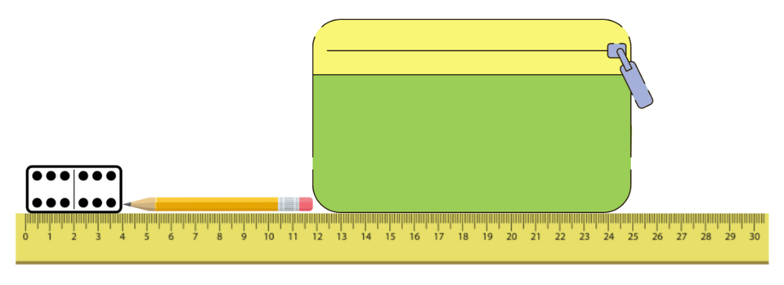
- Students explain how they will know the total length of the 3 objects and which objects could be combined to measure 25 cm. Encourage students to look at their rulers and estimate the length of the proposed objects.
- Students identify 3 objects that total 25 cm and confirm by using a ruler to measure the objects.
- Students leave their arrangement of objects and go on a gallery walk to find out how other groups constructed their collections of 3 items.
- Students choose which 25 cm group of objects to draw and label correctly, recording in their workbooks.

Discuss and connect the mathematics – 10 minutes
- Regroup as a class and ask:
- How did you identify objects that combined to measure 25 cm?
- What advice would you give someone doing this task?
- How did you solve any challenges in this task?
This table details opportunities for differentiation.
Too hard? | Too easy?
Students cannot estimate one metre.  - Provide students with a metre ruler to reference when building their tower.  - Support students to build a tower horizontally with 10 long MAB materials or 100 cm cubes.  Students cannot identify objects that total 25 cm.  - Support students to build a tower that is 25 cm long out of interlocking cubes and measure with their ruler.  - Draw a 25 cm line for students to reference and support students to find objects to fill the strip. | Students can estimate one metre.  - Challenge students to estimate and measure the length of their bodies. For example, fingertips to their nose or arm spans.  - Challenge students to build their tower both vertically and horizontally and measure to see if the towers are the same.  Students can identify objects that total 25 cm.  - Challenge students to use their knowledge of 25 cm to measure longer distances. For example, the classroom or desk. Students identify how many lots of 25 cm are needed to measure the distance.  - Challenge students to discuss and record a more efficient method for measuring the same distances in the classroom. For example, 2 lengths of 25 cm is 50 cm or 4 lengths of 25 cm is one metre.
This table details opportunities for assessment.
Assessment opportunities | Links
What to look for:  - Can students identify lengths that are approximately one metre? [MAO-WM-01, MA2-GM-02]  - Can students use a ruler to accurately measure a length of one metre? [MAO-WM-01, MA2-GM-02]  - Can students estimate and measure lengths in centimetres? [MAO-WM-01, MA2-GM-02]  - Can students label and record lengths using the abbreviation of m and cm? [MAO-WM-01, MA2-GM-02] | Links to National Numeracy Learning Progressions (NNLP):  - UuM6.

Lesson 2
Core concept: use known lengths as personal benchmarks to guide estimation.

Daily number sense: Number before and after – 10 minutes
The table below contains a suggested learning intention and success criteria. These are best co-constructed with students.
Daily number sense learning intention | Daily number sense success criteria
Students are learning to:  - read, represent and order numbers to thousands. | Students can:  - read numbers up to thousands  - identify the number before and after a number.
- Provide students with a 10-sided die. Students roll the die 4 times to create a 4-digit number and record their number in the middle of their individual whiteboard.
Note: using a 10-sided dice with 0–9 will allow students to use and understand the role of the internal zero.
- Students identify and record the number before and the number after their 4-digit number (see Figure 2).
Figure 2 – Number before and after
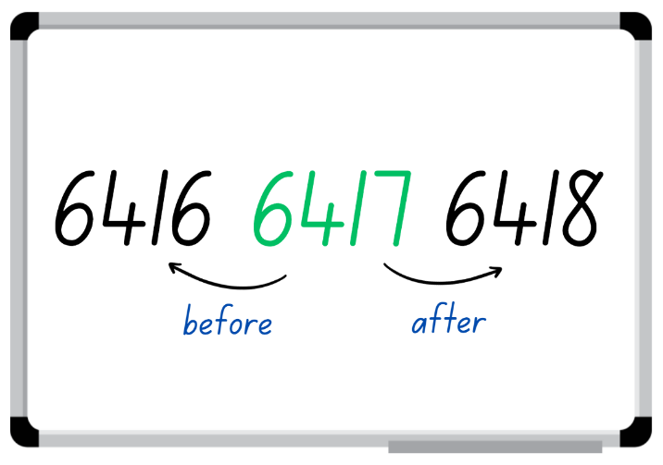
- Select students to share their working and justify how they know the number is more or less than their number.
- Students repeat the above steps with other 4-digit numbers.
This table details opportunities for assessment.
Assessment opportunities | Links
What to look for:  - Can students read and represent numbers up to thousands? [MAO-WM-01, MA2-RN-01]  - Can students identify the number before and after a number? [MAO-WM-01, MA2-RN-01] | Links to National Numeracy Learning Progressions (NNLP):  - NPV5, NPV6.  Links to suggested Interview for Student Reasoning (IfSR) tasks:  - IfSR-NP: 4B.2, 4C.5.

Core lesson: Estimating with benchmarks – 50 minutes
The table below contains a suggested learning intention and success criteria. These are best co-constructed with students.
Core concept learning intentions | Core concept success criteria
Students are learning to:  - estimate and measure lengths in metres. | Students can:  - estimate lengths and distances using known benchmarks  - measure and record lengths in metres.
- Display the word ‘estimation’ and ask students to think of what they know about estimation. Provide students with time to think and then turn and talk to discuss their prior knowledge. Ask:
- What is estimation?
- Why is estimation important?
- What types of jobs use estimating?
- When would it not be appropriate to use estimation? Explain your answer.
- Explain to students that a benchmark is an informal unit of measurement. For example, one full step may be close to one metre in length. Discuss how benchmarks may be used for estimating.
Note: a benchmark is a standard against which something can be compared or measured. Students need to develop personal benchmarks with which to estimate lengths and other measures.
- Display Resource 1: Recording table and explain that students will be estimating lengths using their own personal benchmark.
- Students share and justify a personal benchmark that they will use to complete the activity.
Note: if students share personal benchmarks that are not practical for measuring, use this opportunity to refine their benchmark.
- Provide students with Resource 1: Recording table and have them glue this into their workbook.
- Take students outside and assign locations to be recorded in the table. Based off sight, students write their estimation of length for each location in the template.
- Students measure the locations using personal benchmarks and record results in the table (see Figure 3).
Figure 3 – Example of recording table
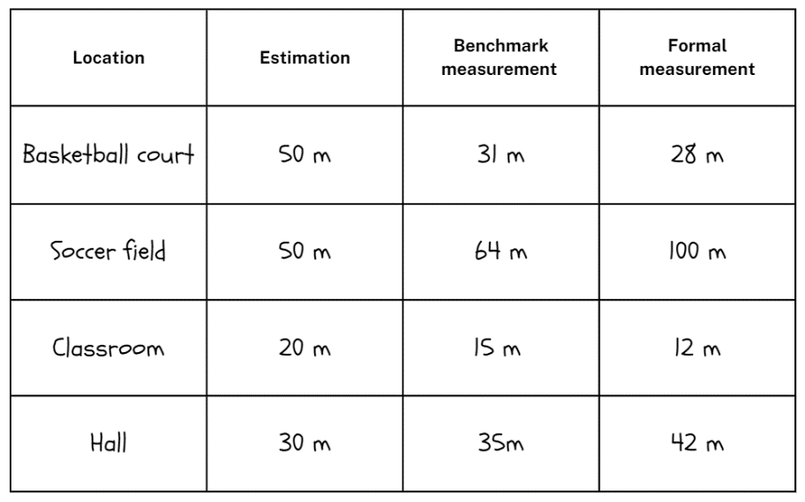
- Using a formal measuring tool, such as a metre ruler or a trundle wheel, students measure the length of the location and record results in the table. Students record measurements in full metres and then centimetres if need. For example, 30 m and 20 cm.
Note: students need to understand and be convinced that one rotation of a trundle wheel is 1 m. If there is not access to enough metre rulers or trundle wheels, consider measuring and pre-cutting string or ribbon to one metre.
This table details opportunities for differentiation.
Too hard? | Too easy?
Students cannot estimate using a personal benchmark.  - Support students by providing a one metre ruler to reference when estimating and measuring distances.  - Support students by allocating locations that require smaller measurements. For example, desks or the width of a classroom. | Students can estimate using a personal benchmark.  - Challenge students to order results in ascending and descending order.  - Challenge students to record distances requiring combined units of length. For example, 3 m and 30 cm.

Discuss and connect the mathematics – 10 minutes
- Redirect students to the classroom with their results. Ask:
- How easy or hard was it to measure using your personal benchmark? Why?
- Was your benchmark an accurate tool for measuring? Why or why not?
- What is a job that might use benchmarks to estimate measurement?
- Was it easier to use your benchmark or the formal tool provided? Why or why not?
- What challenges did you face? How did you solve the problem?
- If you were to start this activity again, would you use the same benchmark for measuring? Explain your reasoning.
This table details opportunities for assessment.
Assessment opportunities | Links
What to look for:  - Can students estimate lengths and distances using known benchmarks? [MAO-WM-01, MAO-GM-02]  - Can students measure and record lengths in metres? [MAO-WM-01, MAO-GM-02] | Links to National Numeracy Learning Progressions (NNLP):  - UuM6.

Lesson 3
Core concept: context determines the most suitable standard unit, sometimes a metre is too big.

Daily number sense: From here to there – 10 minutes
The table below contains a suggested learning intention and success criteria. These are best co-constructed with students.
Daily number sense learning intention | Daily number sense success criteria
Students are learning to:  - read, represent and order numbers to thousands. | Students can:  - represent and read 4-digit numbers  - order 4-digit numbers according to their value.
This activity is an adaptation of ‘From here to there’ from Dice Dazzlers by Swan.
- Group students into pairs and provide each pair with an individual whiteboard and four 10-sided dice.
- One student draws a gameboard on their whiteboard with at least 12 squares. Together they set the starting and finishing numbers and write them on the gameboard.
- The first player rolls the dice to form a number. The player must decide where to place the number on the gameboard so that the sequence of numbers remains in order (see Figure 4). The next player rolls the dice and places their number on the same gameboard. If a number cannot be placed, the player misses their turn.
Figure 4 – Example of play
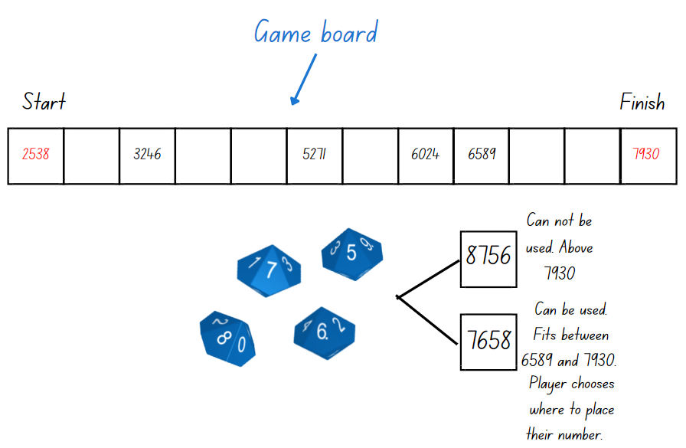
- The winner is the person who completes the sequence of numbers from the starting to the finishing number.
Note: different dice can be used for this activity. If so, guide the students to understand the starting and finishing numbers. For example, if students use four 6-sided dice, the maximum finishing number will be 6666 and the starting number has to be above 1111.
This table details opportunities for assessment.
Assessment opportunities | Links
What to look for:  - Can students represent and read 4-digit numbers? [MAO-WM-01, MA2-RN-01]  - Can students order 4-digit numbers according to their value? [MAO-WM-01, MA2-RN-01] | Links to National Numeracy Learning Progressions (NNLP):  - NPV5, NPV6.  Links to suggested Interview for Student Reasoning (IfSR) tasks:  - IfSR-NP: 4B.2, 4C.5.

Core lesson: Rule and record using centimetres – 30 minutes
The table below contains a suggested learning intention and success criteria. These are best co-constructed with students.
Core concept learning intentions | Core concept success criteria
Students are learning to:  - measure and record lengths using centimetres. | Students can:  - identify when a metre is too long to measure an object  - use a ruler to measure a line in centimetres  - record centimetre measurements using cm.
- Display Resource 2: Benchmark measuring and discuss objects that can and cannot be measured using students’ personal benchmarks from previous lesson.
Note: if students do not provide responses, discuss locations that were used in the previous lesson and classroom items that are clearly measured in centimetres and not metres. Providing opportunities for students to find things in their environment that are 1 cm, 10 cm and 1 m can help establish benchmarks for convenient units of length. Direct experience of measurement units enables students to establish personal benchmarks and make reasonable estimates.
- Ask students how the objects could be measured if they are smaller than one metre. If not shared by students, highlight a centimetre as a unit of measurement smaller than a metre.
Note: this offers a learning opportunity to explore the meaning of the prefix ‘centi’ with students.
- Using an MAB unit block, demonstrate the size of a centimetre to the class (see Figure 5).
Figure 5 – MAB material
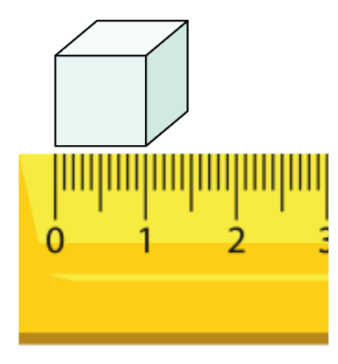
- Provide students with a 30 cm ruler and ask them to Think-Pair-Share, discussing what they notice about the ruler.
- Select students to share their observations and record responses on an anchor chart.
- Model correct use of a 30 cm ruler. Highlight the importance of beginning measurements at the zero-line marked on the ruler.
- Roll two 6-sided dice and add the numbers rolled together. Students draw a line representing the number rolled with their ruler in their workbook. Repeat this step 4 more times until students have 5 ruled lines.
Note: during the ruling process, question students about objects they know that may be a similar length to totals that have been rolled.
- Students swap books with a partner to measure and record the length of the 5 lines, checking for accuracy (see Figure 6).
Figure 6 – Measured lines
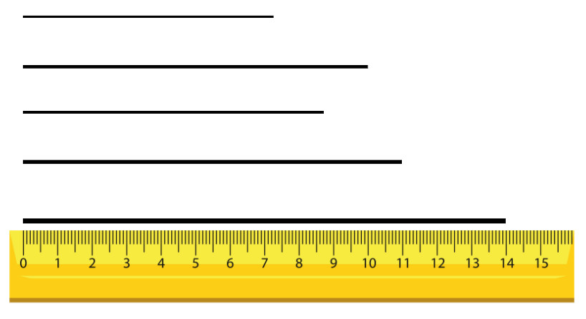
This table details opportunities for differentiation.
Too hard? | Too easy?
Students cannot measure and record lengths using centimetres.  - Support students by providing pre-ruled lines of less than 15 cm for measuring.  - Support students by providing MAB materials to measure lines. For example, 10 MAB unit blocks are equal to 10 cm. | Students can measure and record lengths using centimetres.  - Challenge students to rule and measure longer length lines.  - Challenge students to complete more than 5 lines to rule and measure.

Consolidation and meaningful practice – 20 minutes
- Provide pairs with a 6-sided die, a 30 cm ruler each and their workbook. Students take turns rolling the die and using their ruler to measure and draw a line the length of the number rolled with a coloured pencil. Students must record the length of the line using the correct cm abbreviation.
- Students repeat the process using a different coloured pencil each roll, adding individual lengths until one student reaches 25 cm (see Figure 7).
Figure 7 – Rainbow rule 25 example
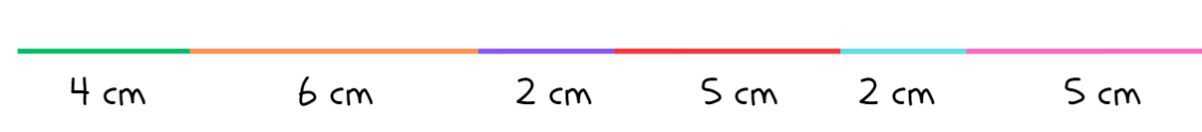
- The winner of the game is the first student to reach 25 cm exactly. For example, if a student is up to 20 cm and rolls a 6, they must skip a turn until they roll a 5 or a number less than 5.
- Repeat the game multiple times.
Note: multiple coloured pencils have been included in this activity to emphasise the different size of lengths measured to support students in making comparisons.
This table details opportunities for differentiation.
Too hard? | Too easy?
Students cannot measure and record lengths using centimetres.  - Provide students with a pre-ruled 25 cm black line in their workbooks as a point of reference for the game.  - Support students by adjusting the target to 10 cm, with students using their number bonds to 10 to fill the line. | Students can measure and record lengths using centimetres.  - Provide students with a 9-, 10- or 20-sided dice to play the game.  - Leverage the game and adjust the target length from 25 cm to 50 cm. Encourage students to be creative with the design of their line to fit the page.

This table details opportunities for assessment.
Assessment opportunities | Links
What to look for:  - Can students identify when a metre is too long to measure an object? [MAO-WM-01, MA2-GM-02]  - Can students use a ruler to measure a line in centimetres? [MAO-WM-01, MA2-GM-02]  - Can students record centimetre measurements using cm? [MAO-WM-01, MA2-GM-02] | Links to National Numeracy Learning Progressions (NNLP):  - UuM6.

Lesson 4
Core concept: metric units of measurement relate to a base-10 place value system.

Daily number sense – 10 minutes
- From a class need surfaced through formative assessment data, identify a short, focused activity that targets students’ knowledge, understanding and skills. Example activities may be drawn from the following resources:
- Mathematics K-6 resources
- Universal Resources Hub.

Core lesson: Exploring millimetres – 40 minutes
The table below contains a suggested learning intention and success criteria. These are best co-constructed with students.
Core concept learning intentions | Core concept success criteria
Students are learning to:  - measure and compare objects using millimetres. | Students can:  - identify that there are 10 millimetres in one centimetre  - use millimetres to measure lengths with a ruler  - record lengths using the abbreviation mm for millimetres.
- Review students’ understanding of the centimetre from Lesson 3. Provide students with further support if needed before moving on to millimetres.
- Display Resource 3: Millimetre ruler and have students Think-Pair-Share, discussing what they notice about the image.
Note: this resource has been created and enlarged to support students when viewing the small components on the ruler. This is not to scale and should not be used as an ongoing point of reference when students are exploring millimetres.
- Select students to share and justify responses.
- Explain to students that 10 mm is equivalent to 1 cm. Ask:
- What items would be best measured in millimetres?
- What items would not be best measured in millimetres?
- Why are millimetres an important unit of measurement?
- How many millimetres are in a centimetre? How do you know?
- How many millimetres are in 3 centimetres?
Note: ensure that the rulers provided to students have millimetres clearly marked.
- Model measuring a familiar item using the think aloud strategy, emphasising that 10 mm is equivalent to 1 cm and this can be used to accurately measure objects.
- Provide students with Resource 4: Measuring with millimetres. Students measure the images and record their measurements using the abbreviation ‘mm’.
Note: this activity may also be completed with concrete classroom materials.
This table details opportunities for differentiation.
Too hard? | Too easy?
Students cannot measure and compare objects using millimetres.  - Support students by instructing them to measure in centimetres.  - Support students by measuring to the nearest centimetre and assist them to count on in millimetres. | Students can measure and compare objects using millimetres.  - Challenge students to record their responses in centimetres and millimetres. For example, 41 mm or 4 cm and 1 mm.  - Challenge students to find additional objects in the classroom to measure and record in millimetres.

Discuss and connect the mathematics – 10 minutes
- Regroup students with their copy of Resource 4: Measuring with millimetres. Ask:
- What measurements did you record for each object?
- How many millimetres are in 1 cm?
- Can you make a connection between measurement and our place value system? Explain your thinking.
- Was the millimetre an accurate form of measurement? Why?
- What are some other objects in the classroom that are best suited to measure in millimetres?
- How many millimetres are in 6 cm? How do you know?
- Can you think of anything that would require a combination of formal units to measure?
This table details opportunities for assessment.
Assessment opportunities | Links
What to look for:  - Can students identify that there are 10 mm in 1 cm? [MAO-WM-01, MA2-GM-02]  - Can students use millimetres to measure lengths with a ruler? [MAO-WM-01, MA2-GM-02]  - Can students record lengths using the abbreviation mm for millimetres? [MAO-WM-01, MA2-GM-02] | Links to National Numeracy Learning Progressions (NNLP):  - UuM6.

Lesson 5
Core concept: length can add precision to descriptions of shapes.

Daily number sense: Number line addition and subtraction – 10 minutes
Daily number sense activities for Lessons 5 to 7 ‘loop’ back to concepts and procedures covered in previous units to assist students to build an increasingly connected network of ideas. These concepts may differ from the core concepts being covered by the unit.
The table below contains a suggested learning intention and success criteria. These are best co-constructed with students.
Daily number sense learning intention | Daily number sense success criteria
Students are learning to:  - solve addition and subtraction problems. | Students can:  - solve addition and subtraction problems involving 2- and 3-digits  - represent addition and subtraction problems on a number line.
- Write 84 − 68 = _ on the board and display a blank number line. Ask students how they could solve the problem using the number line and have students record their thinking on an individual whiteboard (see Figure 8).
Figure 8 – Number line
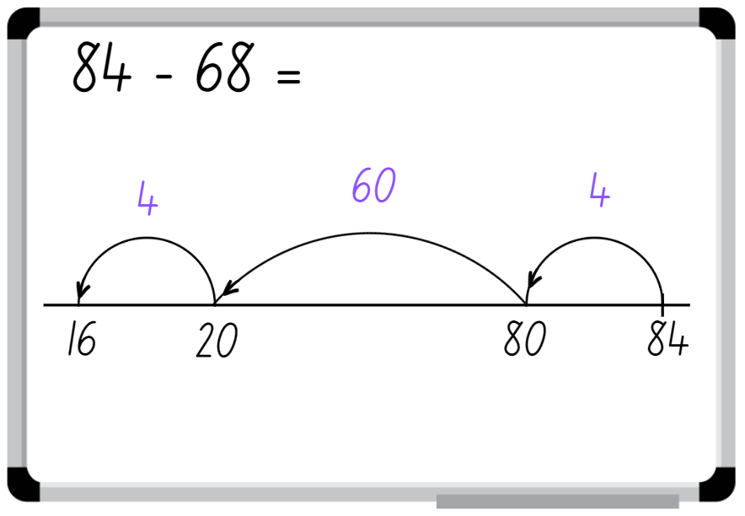
- Select students to share and justify their ideas, checking solutions on the number line.
- Display 38 + 43 = _ and have students record and solve the problem on their whiteboard using a number line. Students share and demonstrate their working.
- Repeat multiple times with other 2- and 3-digit addition and subtraction problems.
Note: this activity can be adapted to 1- or 3-digit numbers.
This table details opportunities for assessment.
Assessment opportunities | Links
What to look for:  - Can students solve addition and subtraction problems involving 2- and 3-digits? [MAO-WM-01, MA2-AR-0]  - Can students represent addition and subtraction problems on a number line? [MAO-WM-01, MA2-AR-01] | Links to National Numeracy Learning Progressions (NNLP):  - AdS7.

Core lesson: Measuring perimeter – 40 minutes
The table below contains suggested learning intentions and success criteria. These are best co-constructed with students.
Core concept learning intentions | Core concept success criteria
Students are learning to:  - compare and describe features of two-dimensional shapes  - use scaled instruments to measure and compare lengths. | Students can:  - describe and compare two-dimensional shapes  - use the term perimeter to describe the distance around the boundary  - measure the perimeter of quadrilaterals.
- Display Resource 5: Flip and describe cards and model how to play flip and describe by playing against the whole class.
- Flip a card and have the class name the two-dimensional shape.
- Once students are confident, provide pairs with Resource 5: Flip and describe cards. Once a student has gone through all the cards, the next student has a turn. Repeat this activity for 5 minutes.
- Regroup students and discuss what they noticed about the two-dimensional shapes.
Note: two-dimensional shapes have been placed on the cards in various orientations to generate student thinking.
- Provide small groups with Resource 6: Two-dimensional shapes and ask students to discuss what they know about rectangles and squares, recording their thinking.
- Regroup as a class and select groups to share their observations relating to the two-dimensional shapes.
- Discuss the term ‘perimeter. Explain to students the meaning of the Latin word ‘peri’ meaning around and ‘metron’ meaning measure.
Perimeter is the outer edge of a flat shape or area.
- Model measuring the perimeter of a rectangle and recording the measurements on all 4 sides and adding the numbers together.
Note: students need opportunities to interpret length as pertaining to a boundary as well as the straight-line distance between 2 points.
- Provide students with 30 cm rulers to measure and record the perimeter of each shape. Students can record the length of the sides in either cm or mm.
- Select students to share their findings with the class, explaining why one shape is a rectangle and the other is a square from the lengths of the sides.
Note: guide students to notice that a rectangle’s sides are different lengths, while a square’s sides are all equal. The rectangle has been intentionally designed to be equivalent to 2 of the squares.
This table details opportunities for differentiation.
Too hard? | Too easy?
Students cannot measure and compare two-dimensional shapes.  - Provide MAB materials to support students when measuring shapes.  - Provide hands-on materials, such as pattern blocks, to support exploration. | Students can measure and compare two-dimensional shapes.  - Challenge students to draw as many regular two-dimensional shapes and record their properties.  - Challenge students to use millimetres when measuring and record results using the abbreviation ‘mm’.

Discuss and connect the mathematics – 10 minutes
- Regroup students and display Resource 7: Venn diagram.
- Discuss the similarities and differences between the rectangle and square, recording students’ thinking on Resource 7: Venn diagram.
- Display the Venn diagram as an anchor chart in the classroom.
This table details opportunities for assessment.
Assessment opportunities | Links
What to look for:  - Can students describe and compare two-dimensional shapes? [MAO-WM-01, MA2-2DS-01]  - Can students use the term perimeter to describe the distance around the boundary of a shape? [MAO-WM-01, MA2-GM-02]  - Can students measure the perimeter of quadrilaterals? [MAO-WM-01, MA2-GM-02] | Links to National Numeracy Learning Progressions (NNLP):  - UGP2, UGP3, UGP4  - UuM7.

Lesson 6
Core concept: shapes can be classified and compared based on the length of their sides.

Daily number sense: Compensation strategy – 10 minutes
The table below contains a suggested learning intention and success criteria. These are best co-constructed with students.
Daily number sense learning intention | Daily number sense success criteria
Students are learning to:  - solve addition and subtraction problems. | Students can:  - solve addition and subtraction problems involving 2-digit numbers  - use the compensation strategy.
- Demonstrate how to use the compensation strategy by rolling a 9-sided die 4 times to make two 2-digit numbers.
- After each throw of the die, decide whether the number is placed in the ones or tens column.
- Explain that the goal is to get as close to 100 as possible. Ask what students need to think about before putting a number in a certain column. For example, putting the 9 in the tens place brings the total too close to 100; you will bust over 100 if you don’t roll a one.
- Model solving the addition number sentence using the compensation strategy. For example, 28 + 35 is the same as 30 + 35 = 65, subtract 2 to obtain 63 (see Figure 9).
Figure 9 – Compensation strategy
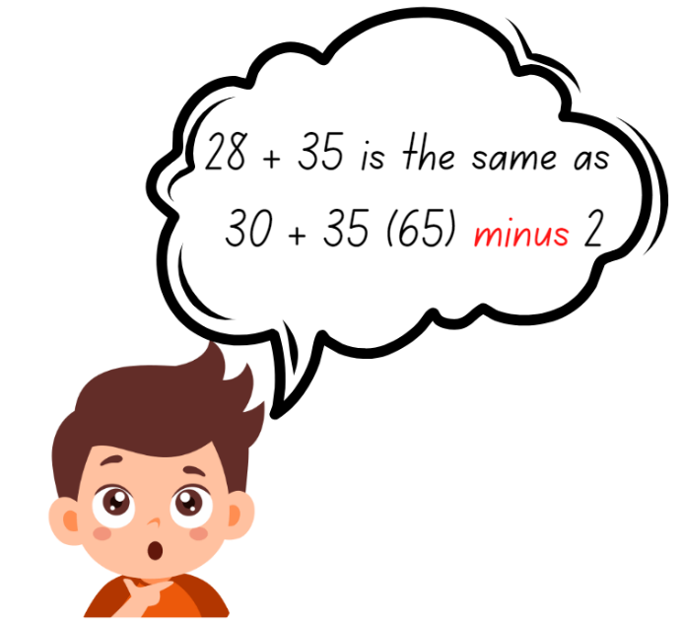
- Once students are confident, provide them with a 9-sided die and an individual whiteboard.
- Students repeat the activity multiple times with both 2-digit addition and subtraction problems.
Note: this activity can be adapted to allow students to add a 2-digit and 1-digit numbers.
This table details opportunities for assessment.
Assessment opportunities | Links
What to look for:  - Can students solve addition and subtraction problems involving 2-digit numbers? [MAO-WM-01, MA2-AR-01]  - Can students use the compensation strategy? [MAO-WM-01, MA2-AR-01] | Links to National Numeracy Learning Progressions (NNLP):  - AdS7.  Links to suggested Interview for Student Reasoning (IfSR) tasks:  - IfSR-AT: 2A.1.

Core lesson: Shape exploration – 35 minutes
The table below contains suggested learning intentions and success criteria. These are best co-constructed with students.
Core concept learning intentions | Core concept success criteria
Students are learning to:  - compare and describe features of two-dimensional shapes  - use scaled instruments to measure and compare lengths. | Students can:  - describe and compare two-dimensional shapes  - use the term perimeter to describe the boundary of a shape  - measure the perimeter of quadrilaterals.
Note: based on a class need, spend time revising common two-dimensional shapes and their features before starting the lesson.
- Describe regular two-dimensional shapes to the class and have students guess the name of the shape. For example, for a square, say:
- I have 4 sides.
- All of my sides are equal.
- Continue playing with other regular two-dimensional shapes.
- Display Resource 8: Measuring perimeter and demonstrate how to measure and record the lengths (perimeter) and properties (see Figure 10).
Figure 10 – Measuring perimeter
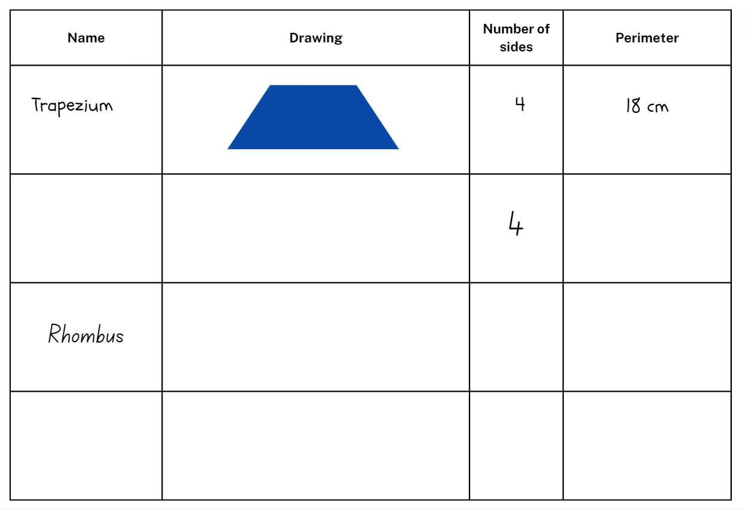
- Provide students with hands-on materials to complete Resource 8: Measure perimeter. For example, pattern blocks or attribute shapes. Supply students with only quadrilaterals.
- Regroup students and ask:
- What was something that all shapes had in common?
- What was different?
- What did you notice about the lengths on each shape?
- What unit of measurement did you use to measure the shapes? Why?
This table details opportunities for differentiation.
Too hard? | Too easy?
Students cannot describe two-dimensional shapes.  - Support students by providing Resource 8: Measuring perimeter with shapes drawn on the page.  - Support students by providing the names of shapes in the resource. | Students can describe two-dimensional shapes.  - Challenge students to group quadrilaterals using one or more attributes.  - Challenge students by drawing the provided shapes in different orientations and measuring their sides.

Consolidation and meaningful practice – 15 minutes
- Provide pairs with a sticky note each and write the name of quadrilaterals on the board for students to choose from. Students write their selected shape on a sticky note, ensuring that it is kept private from their partner.
- Students place their sticky note on their partner’s head and take it in turn to ask questions to determine the properties of their shape. Students can only answer with yes or no.
Note: students must ask a minimum of 3 questions before predicting the shape name.
- The winner is the student who names the shape on the sticky note on their head.
- Repeat the game multiple times with different quadrilaterals.
This table details opportunities for differentiation.
Too hard? | Too easy?
Students cannot identify and describe two-dimensional shapes.  - Display visuals alongside shape names to help students play the game.  - Encourage students to refer to their completed Resource 8: Two-dimensional lengths to formulate the questions asked. | Students can identify and describe two-dimensional shapes.  - Challenge students to ask specific questions that allow the shape to be discovered within 2 questions.  - Encourage students to give directions to their partner that describe how to draw two-dimensional shapes. Ensure students include the measurement of each side and that their partner cannot see the shape being described.
This table details opportunities for assessment.
Assessment opportunities | Links
What to look for:  - Can students describe and compare two-dimensional shapes? [MAO-WM-01, MA2-2DS-01]  - Can students use the term perimeter to describe the distance around the boundary of a shape? [MAO-WM-01, MA2-GM-02]  - Can students measure the perimeter of quadrilaterals? [MAO-WM-01, MA2-GM-02] | Links to National Numeracy Learning Progressions (NNLP):  - UGP2, UGP3, UGP4  - UuM7.

Lesson 7
Core concept: standard units are an efficient way to communicate and compare lengths of time.

Daily number sense: Bar model – 10 minutes
The table below contains a suggested learning intention and success criteria. These are best co-constructed with students.
Daily number sense learning intention | Daily number sense success criteria
Students are learning to:  - solve addition and subtraction problems. | Students can:  - solve addition and subtraction problems involving 2-digit numbers  - demonstrate how addition and subtraction are inverse operations.
- Display Resource 9: Bar model and model the equation represented by the bar model. Demonstrate how to use the inverse operation, 50 − 38 = _ to solve the equation. Explain that the connection between addition and subtraction means subtraction can be used to solve the problem.
- Students record their solution on an individual whiteboard, sharing and justifying their working. Record the answer 50 − 38 = 12. Ask:
- Could you write this subtraction equation in a different way?
- How many ways can you write it?
- Display the following equations:
- 37 + _ = 57
- 58 = 70 − _
- 72 = _ + 15
- 94 − _ = 23
- Students select 2 of the equations, create a bar model to represent the equations and calculate the missing value.
- Choose students to share and justify their answers.
This table details opportunities for assessment.
Assessment opportunities | Links
What to look for:  - Can students solve addition and subtraction problems involving 2-digit numbers? [MAO-WM-01, MA-2-AR-01, MA2-AR-02]  - Can students demonstrate how addition and subtraction are inverse operations? [MAO-WM-01, MA-2-AR-01, MA2-AR-02] | Links to National Numeracy Learning Progressions (NNLP):  - AdS7.  Links to suggested Interview for Student Reasoning (IfSR) tasks:  - IfSR-AT: 2A.5.

Core lesson: Time facts and time memory – 40 minutes
The table below contains a suggested learning intention and success criteria. These are best co-constructed with students.
Core concept learning intentions | Core concept success criteria
Students are learning to:  - represent and read analog time. | Students can:  - use minutes to describe the duration of different events  - identify 30 minutes as half-hour and 60 minutes as an hour  - read analog time.
- Display a one-minute stopwatch or timer and ask students to close their eyes. When they think a minute has elapsed, students put their hands on their head.
- Choose students to share how they knew the minute was up.
Note: use this activity to gauge students’ understanding of a minute and how they calculated a minute.
- Display the word ‘time’. Ask students to consider what they know about the concept, then turn and talk to discuss their prior knowledge. Ask:
- What is time?
- Why is time important?
- Where is time used?
- How is time measured?
- What would happen if we did not measure time?
- Display Resource 10: Minute comparison table and provide students with an opportunity to identify events that are shorter than one minute and events that are longer than one minute.
- Explain to students that an hour is 60 minutes and that a half-hour is 30 minutes.
- Provide students with an analog clock each and have them represent where the hands would be at half-past and o’clock. Once students are confident, ask them to represent different times on the clock, moving the hands to the correct positions.
- After each time, select students to share their clock and justify how they represented the time.
- Provide pairs with Resource 11: Time memory. Students shuffle and place the cards face down.
- Students take turns flipping 2 cards over at a time, attempting to match cards that represent the same duration.
- If a student finds a pair, they keep the cards. If not, the cards are flipped back over and the game continues until all pairs have been discovered.
- The student with the most pairs wins the game.
- Repeat the game multiple times.
This table details opportunities for differentiation.
Too hard? | Too easy?
Students cannot identify that 30 minutes is a half-hour and 60 minutes is an hour.  - Support students by providing only the 60-minute cards to complete the matching activity.  - Adjust the activity so that students view the cards face up and sort under the headings ‘30 minutes’ and ‘60 minutes’. | Students can identify that 30 minutes is a half-hour and 60 minutes is an hour.  - Challenge students to create a list of activities that take 30 minutes and a list of activities that take 60 minutes.  - Challenge students to represent the duration of 30 minutes on an analog clock in as many ways as possible.

Discuss and connect the mathematics – 10 minutes
- Regroup students and provide them with Resource 12: Exit ticket to complete (see Figure 11).
Figure 11 – Exit ticket
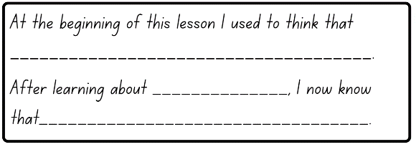
- Students can choose to share their completed exit ticket.
This table details opportunities for assessment.
Assessment opportunities | Links
What to look for:  - Can students use minutes to describe the duration of different events? [MAO-WM-01, MA2-NSM-02]  - Can students identify that 30 minutes is a half-hour and 60 minutes is an hour? [MAO-WM-01, MA2-NSM-02] | Links to National Numeracy Learning Progressions (NNLP):  - MeT2, MeT3.

Lesson 8
Core concept: a clock face is a circular 0–60 number line that tracks time using patterns and fractions.

Daily number sense – 10 minutes
- From a class need surfaced through formative assessment data, identify a short, focused activity that targets students’ knowledge, understanding and skills. Example activities may be drawn from the following resources:
- Mathematics K-6 resources
- Universal Resources Hub.

Core lesson: Circular number line activity – 30 minutes
The table below contains a suggested learning intention and success criteria. These are best co-constructed with students.
Core concept learning intentions | Core concept success criteria
Students are learning to:  - represent and read analog time. | Students can:  - identify 15 minutes is a quarter-hour  - identify 30 minutes is a half-hour  - identify 60 minutes is an hour  - explain that a clock is a circular 60-minute number line.
- Display the terms hour and half-hour. Ask students to Think-Pair-Share about the concepts and record student responses on Resource 13: Anchor chart. Ask:
- What do you predict the heading of the final column on the anchor chart may be?
- What is the difference between the headings?
- Do you notice a pattern?
- Can you continue this pattern?
- Explain to students that a quarter-hour is 15 minutes. Ask students to think, then turn and talk to discuss what they know about a quarter-hour.
- Record student responses in the final column of the Resource 13: Anchor chart.
- Display a skipping rope, stretched out and held up by volunteer students.
- Place the 0, 15, 30, 45 and 60 from Resource 14: Numeral cards onto the skipping rope, using pegs (see Figure 12).
Figure 12 – Numbers on skipping rope
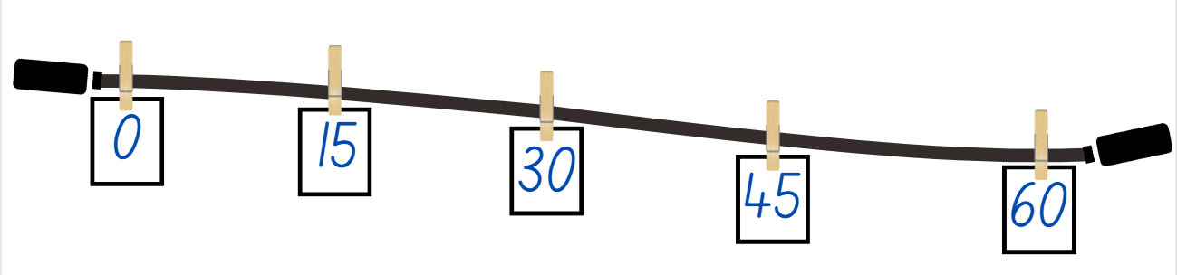
- Ask questions, such as:
- What do you notice?
- Why have these numbers been placed on the skipping rope?
- What does this remind you of?
- How could you fill in the spaces?
Note: this activity may need to be completed outside, or in a larger open indoor learning space.
- Provide students with Resource 15: Numeral cards 2 and have students peg numeral cards on the skipping rope.
- Explain that the skipping rope represents a number line.
- Instruct students holding the skipping rope to place the rope down and join their ends together creating a circle. Ask:
- What do you now notice about the number line?
- Why are the numeral cards 0, 15, 30, 45 and 60 a different size to the other cards?
- What does the number line remind you of?
- Explain to students that a clock face is a circular 0–60 number line that is used to measure time. Ask:
- Starting from zero, where is the 30-minute mark on the circular number line?
- Starting from zero, where is the 15-minute mark on the circular number line?
- Starting from zero, where is the 45-minute mark on the circular number line?
- Starting from zero, where is the 60-minute mark on the circular number line?
This table details opportunities for differentiation.
Too hard? | Too easy?
Students cannot identify quarter-hour, half-hour or hour.  - Support students by providing them with a model clock to refer to during the lesson.  - Support students by providing them with smaller numbers to place on the skipping rope. | Students can identify quarter-hour, half-hour or hour.  - Challenge students to demonstrate on the circular number line where a 15-minute duration would be after the 30-minute mark.  - Challenge students by providing them with larger number to place on the skipping rope first.

Consolidation and meaningful practice – 20 minutes
- Display Resource 16: Circular number line and model to students how to cut out, assemble and glue Resource 16: Circular number line.
Note: this resource has been designed so that the 15, 30, 45 and 60 sections fold in to create a clock face. This resource can be used to explore time in the future using toothpicks or paper clips as the hands.
- Regroup students and provide them with Resource 12: Exit ticket.
This table details opportunities for differentiation.
Too hard? | Too easy?
Students cannot assemble a circular number line.  - Support students by enlarging the Resource 16: Circular number line to A3 before printing.  - Support students by providing a completed Resource 16: Circular number line for them to refer to. | Students can assemble a circular number line.  - Challenge students by instructing them to fill in the missing numerals on the circular number line.  - Challenge students by asking them to represent times using toothpicks or paper clips as hands for their clock.
This table details opportunities for assessment.
Assessment opportunities | Links
What to look for:  - Can students identify 15 minutes is a quarter-hour? [MAO-WM-01, MA2-NSM-02]  - Can students identify 30 minutes is a half-hour? [MAO-WM-01, MA2-NSM-02]  - Can students identify 60 minutes is an hour? [MAO-WM-01, MA2-NSM-02] | Links to National Numeracy Learning Progressions (NNLP):  - MeT3.

Resource 1: Recording table
Location | Estimation | Benchmark measurement | Formal measurement

Resource 2: Benchmark measuring
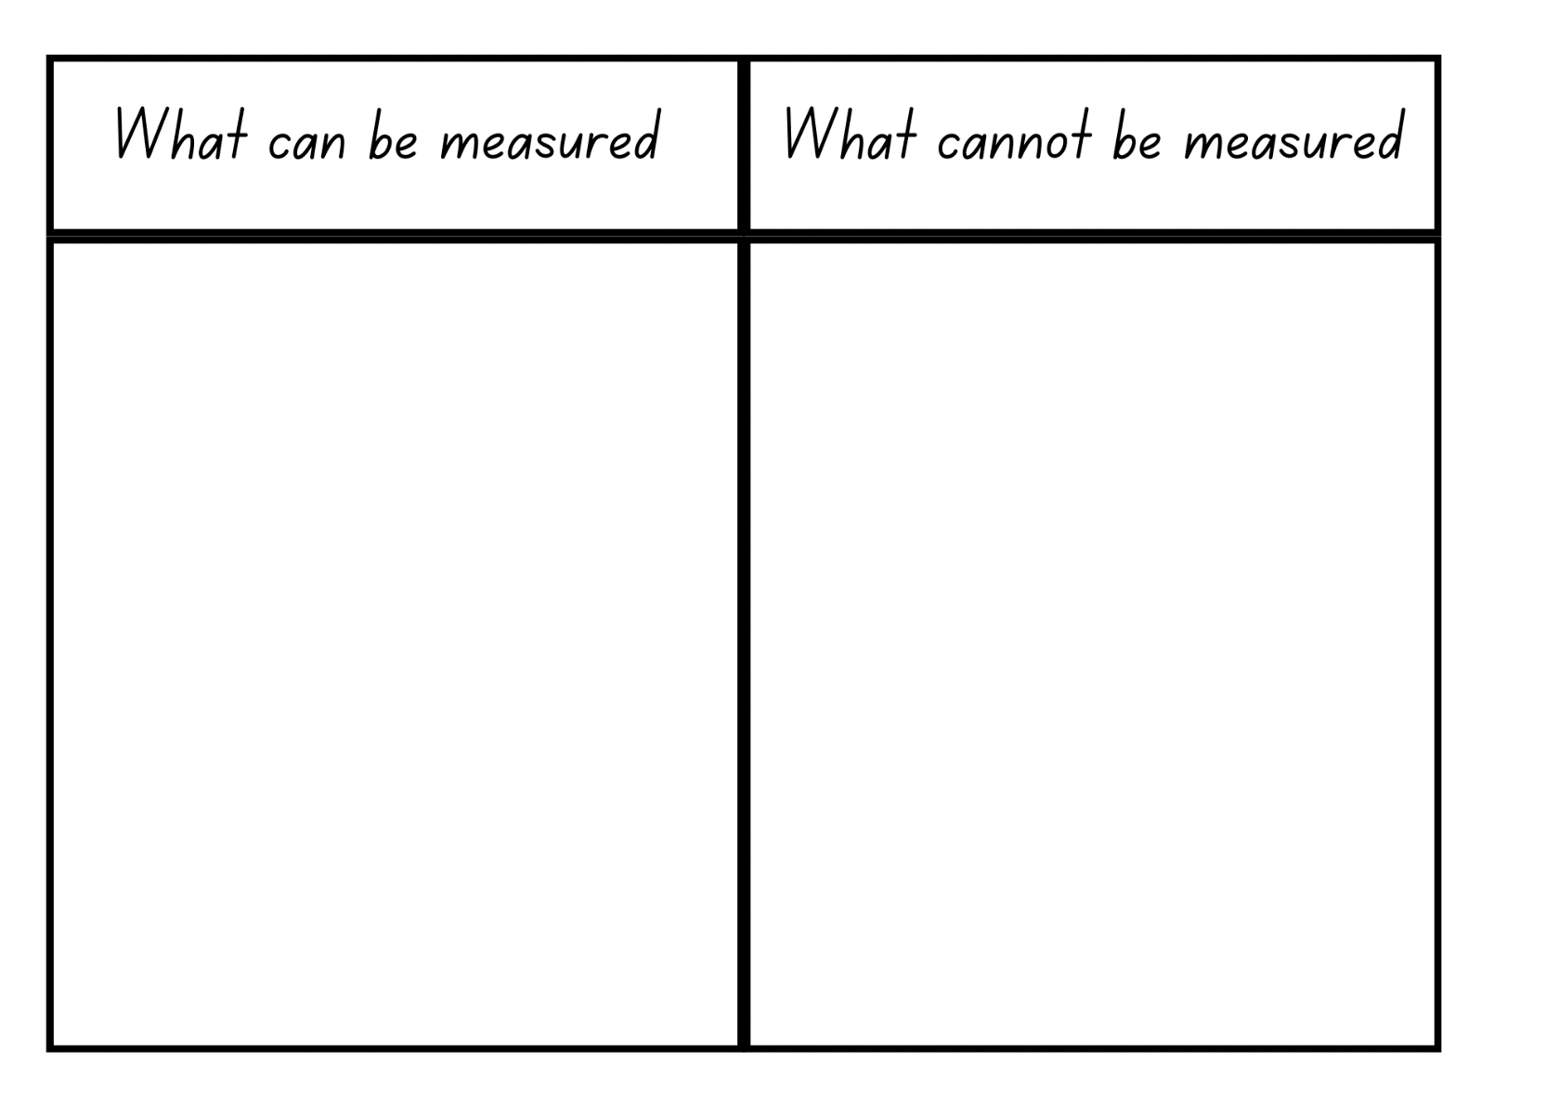

Resource 3: Millimetre Ruler
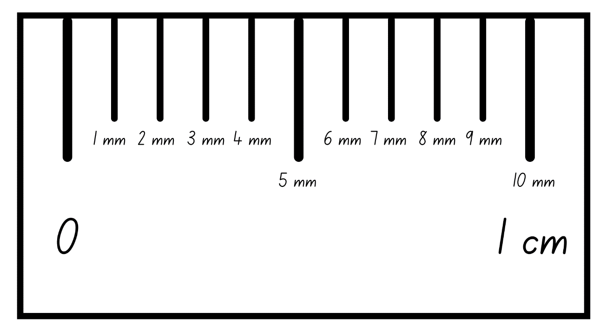

Resource 4: Measuring with millimetres
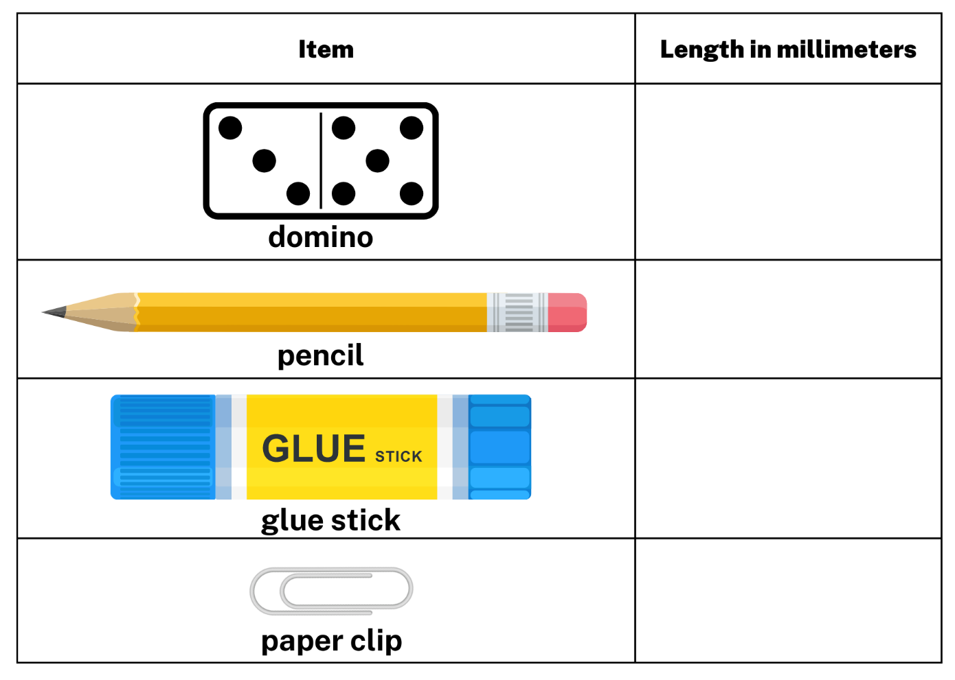

Resource 5: Flip and describe cards
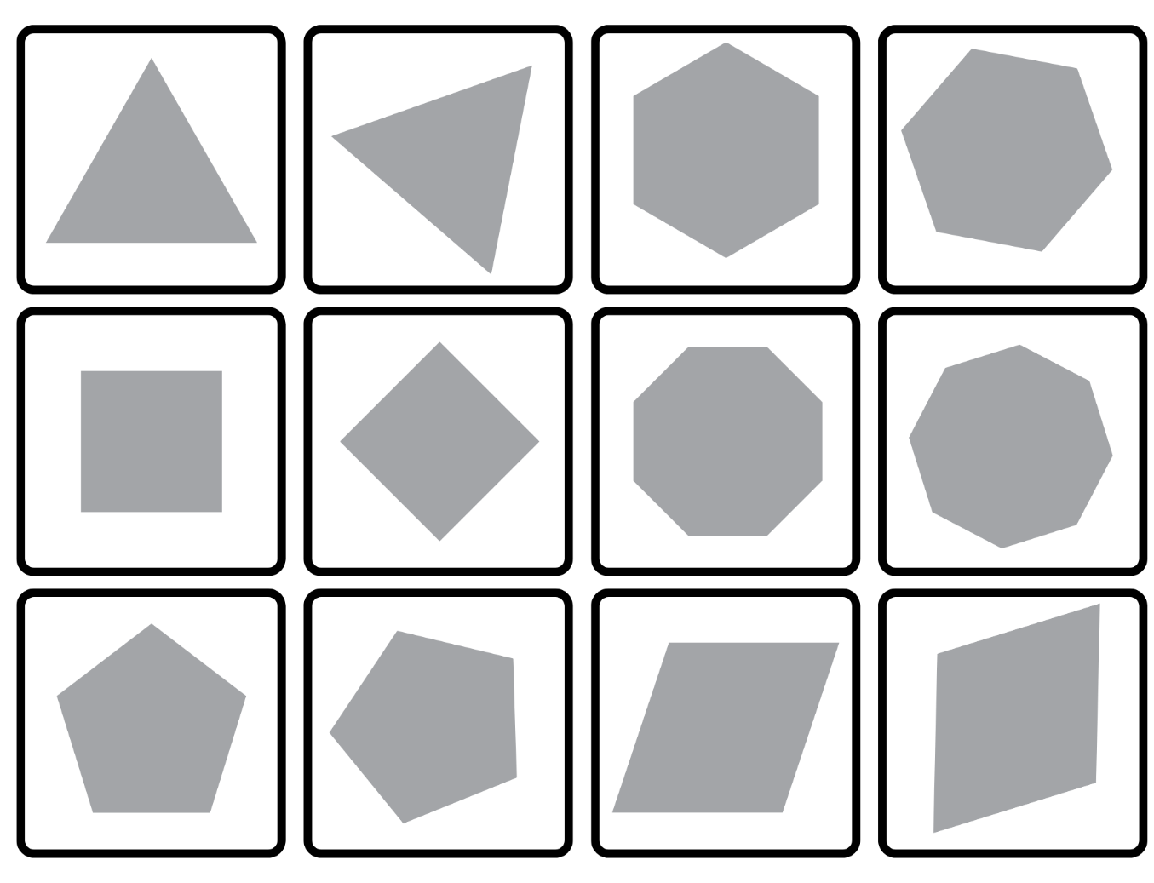

Resource 6: Two-dimensional shapes
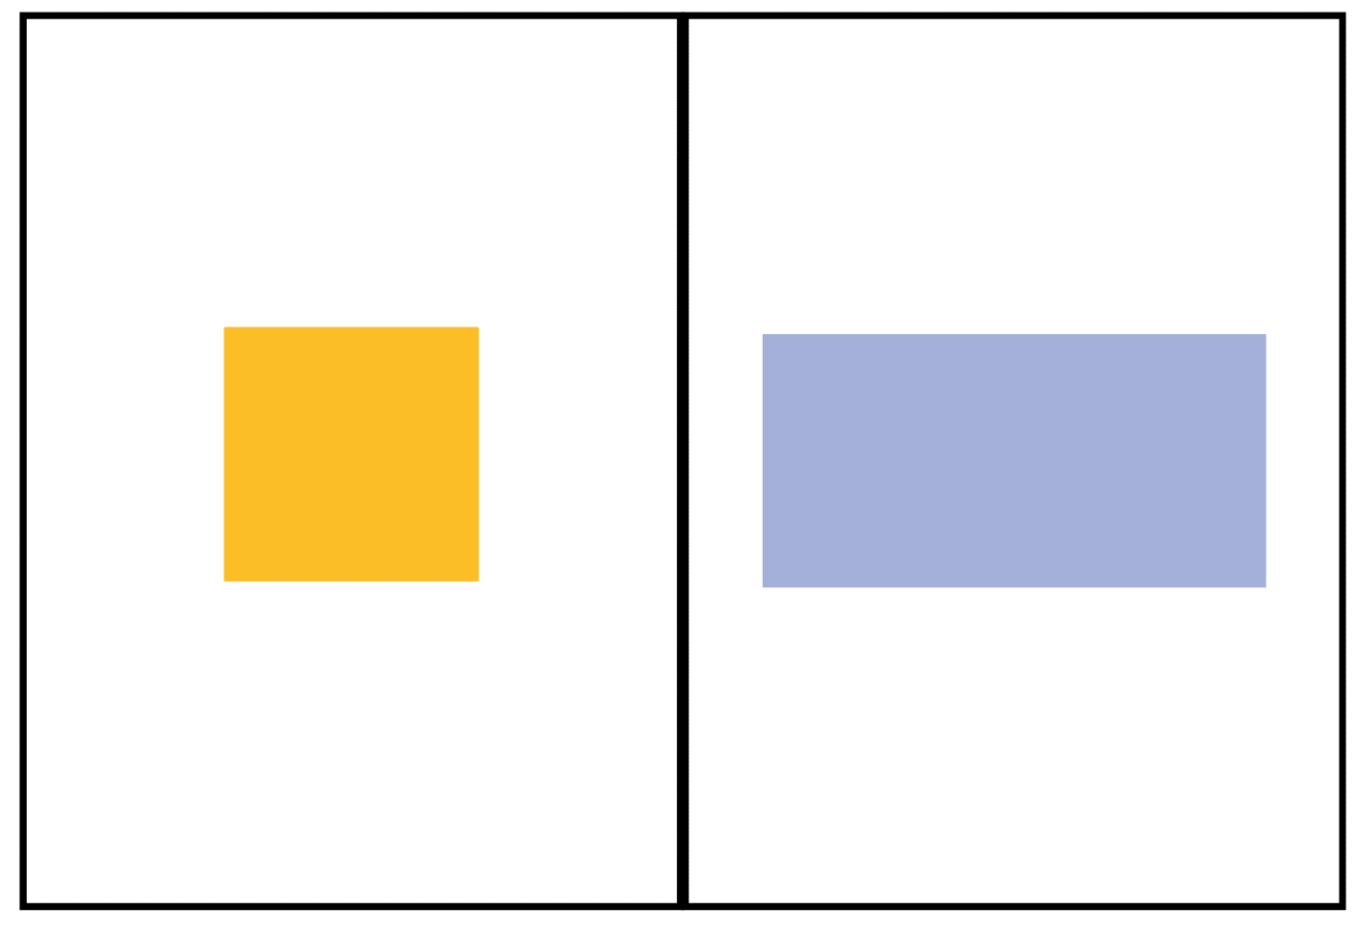

Resource 7: Venn diagram
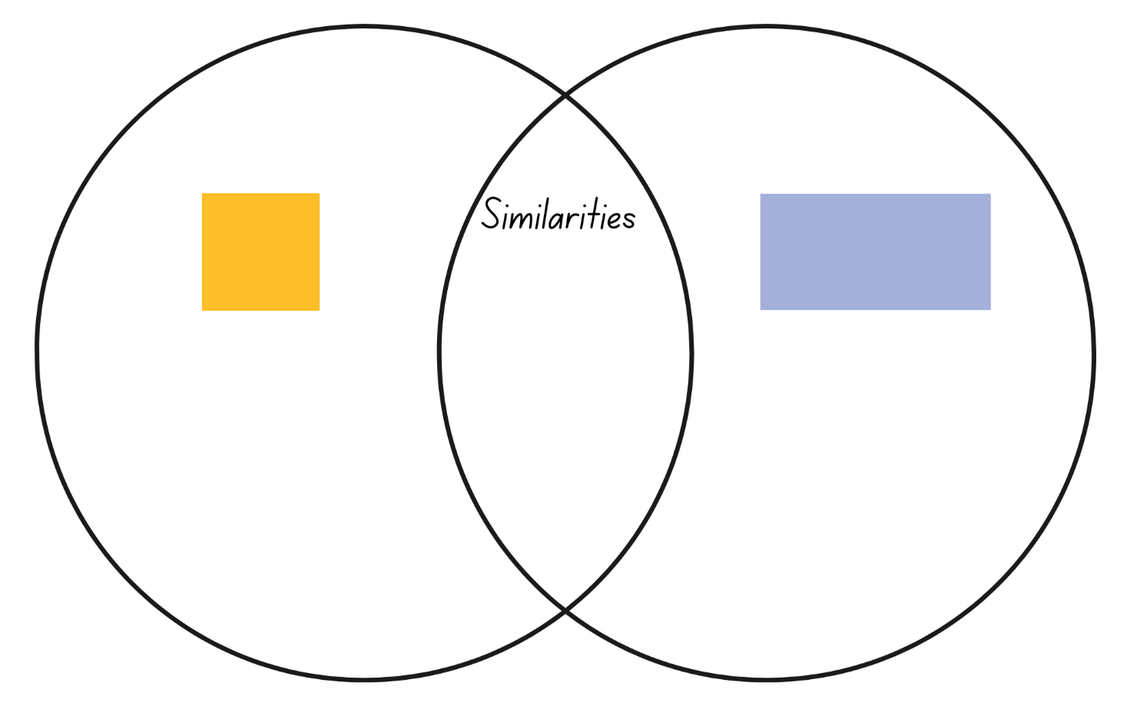

Resource 8: Measuring perimeter
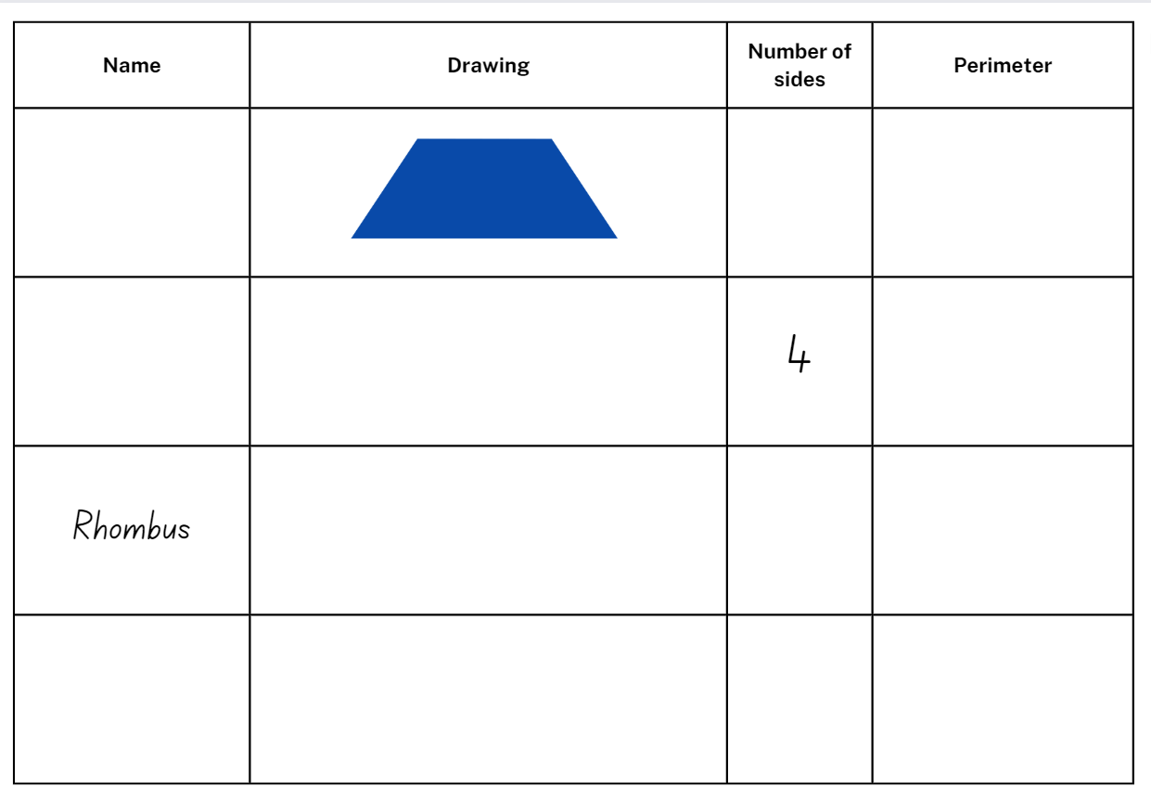

Resource 9: Bar model
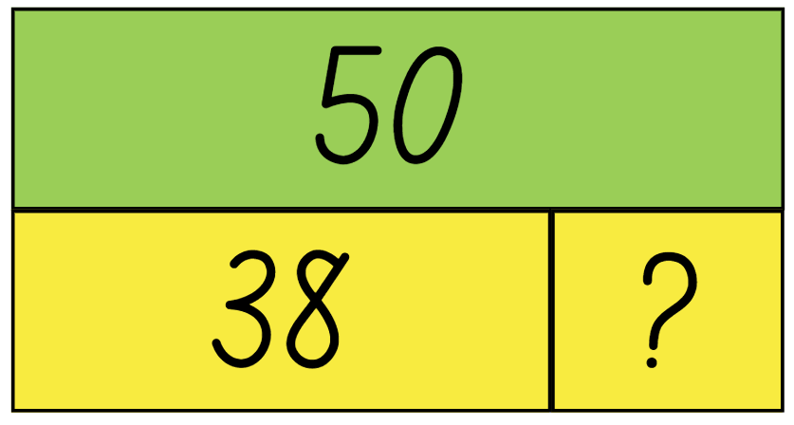

Resource 10: Minute comparison table
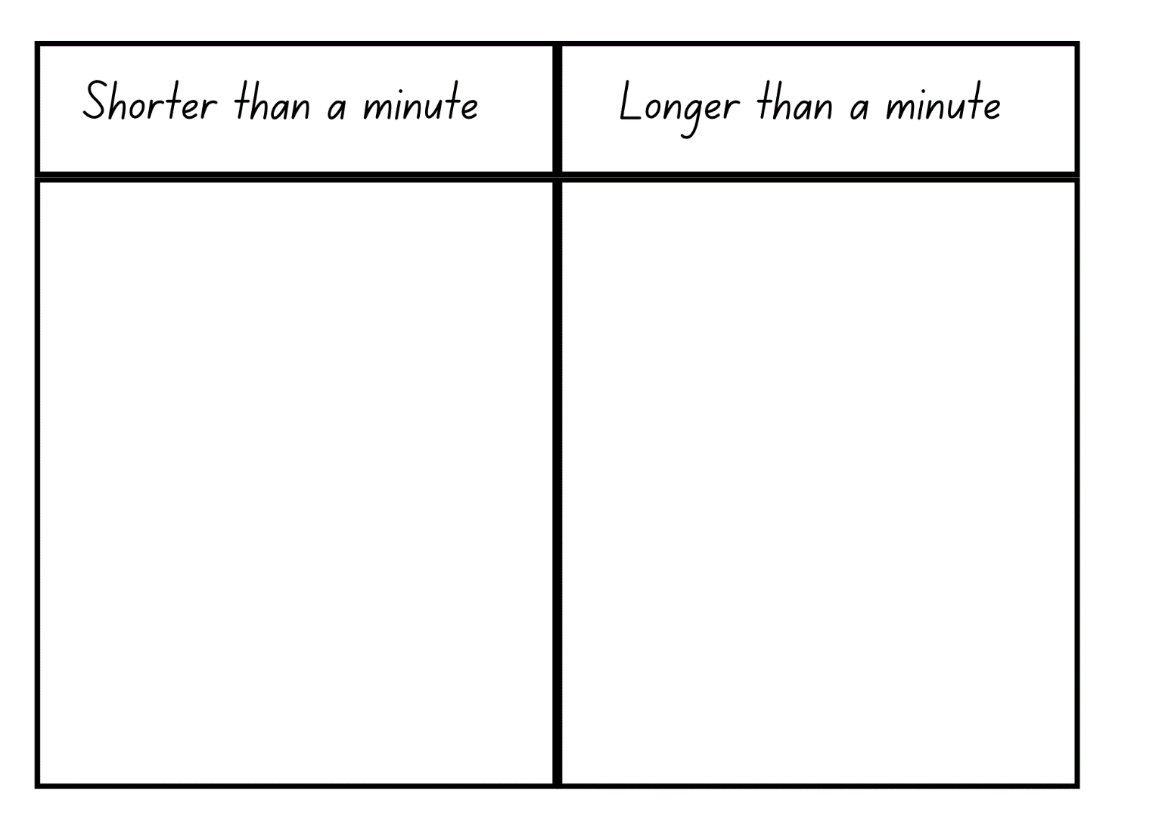

Resource 11: Time memory
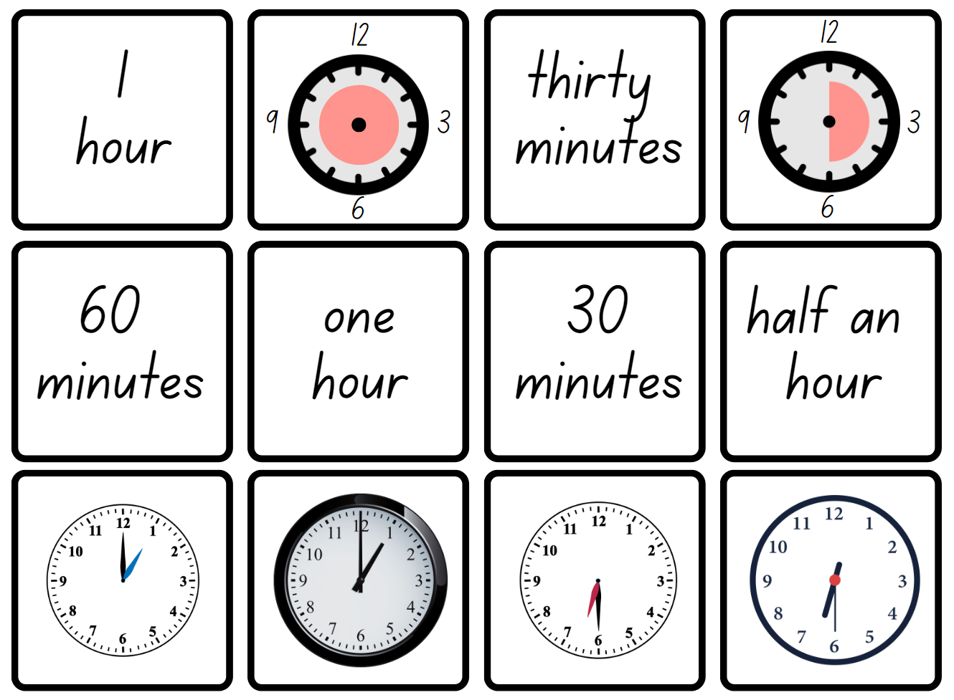
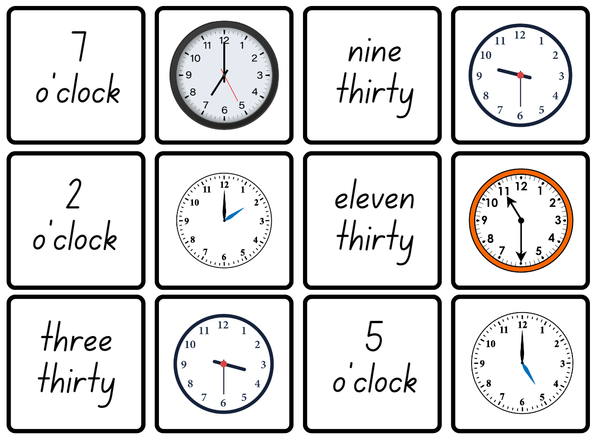

Resource 12: Exit ticket
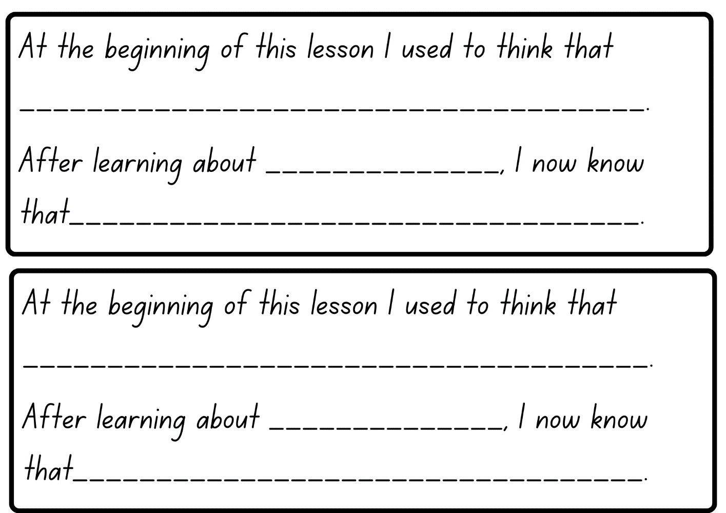

Resource 13: Anchor chart
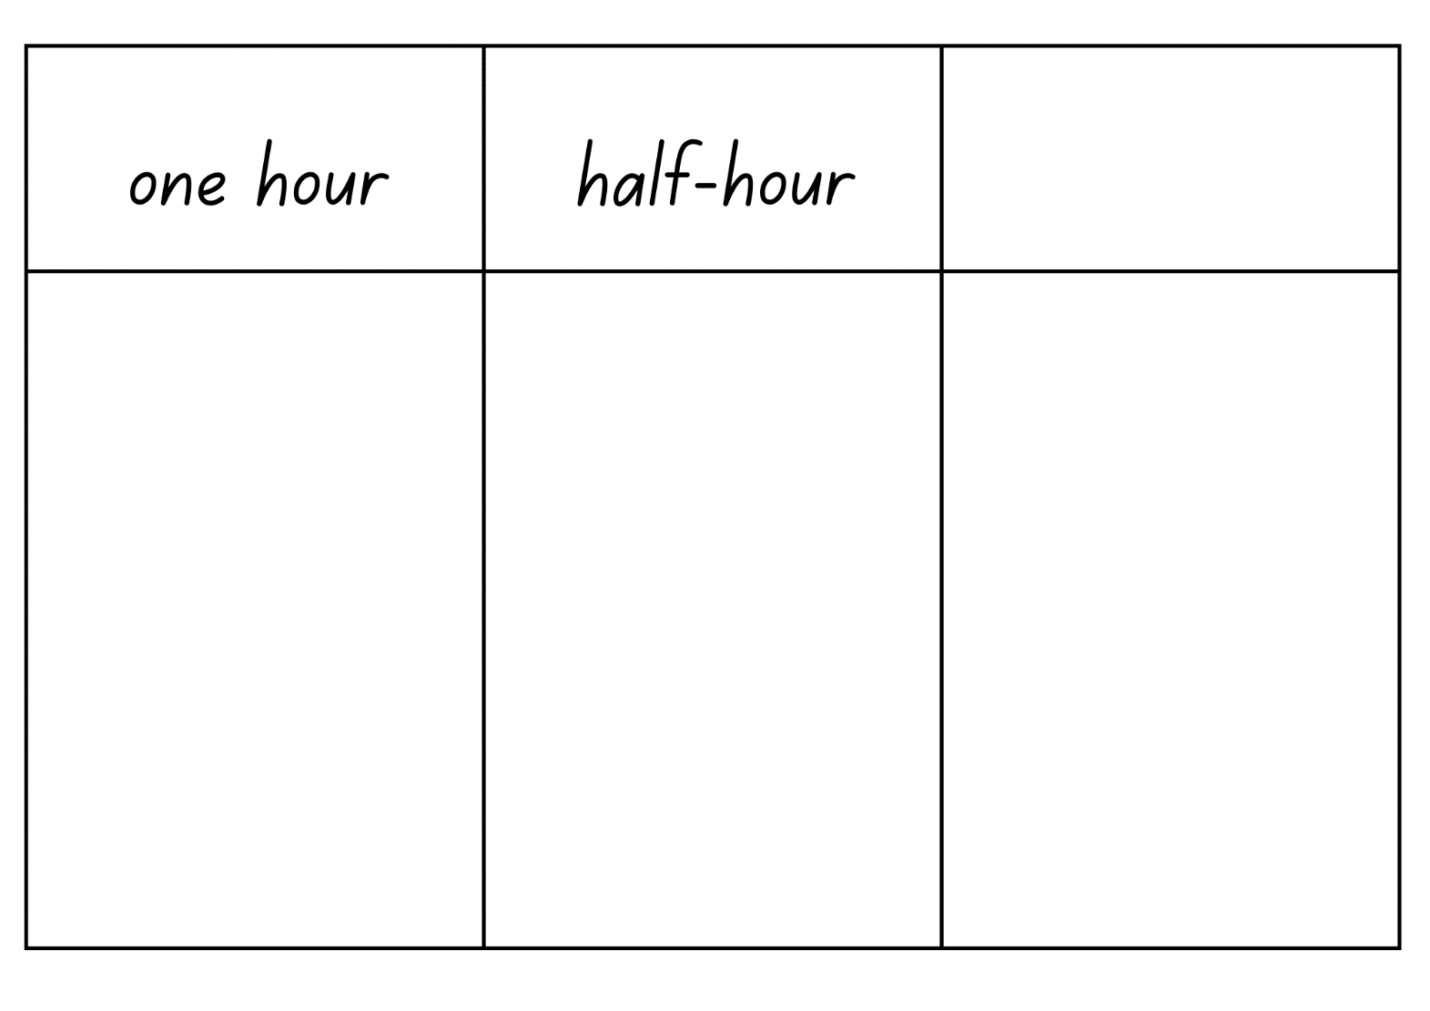

Resource 14: Numeral cards
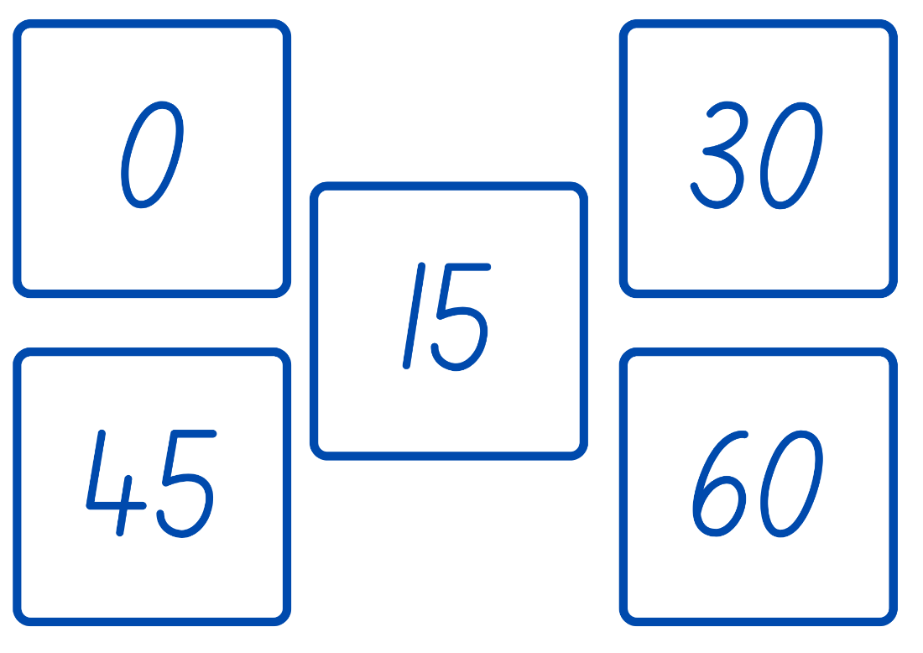

Resource 15: Numeral cards 2
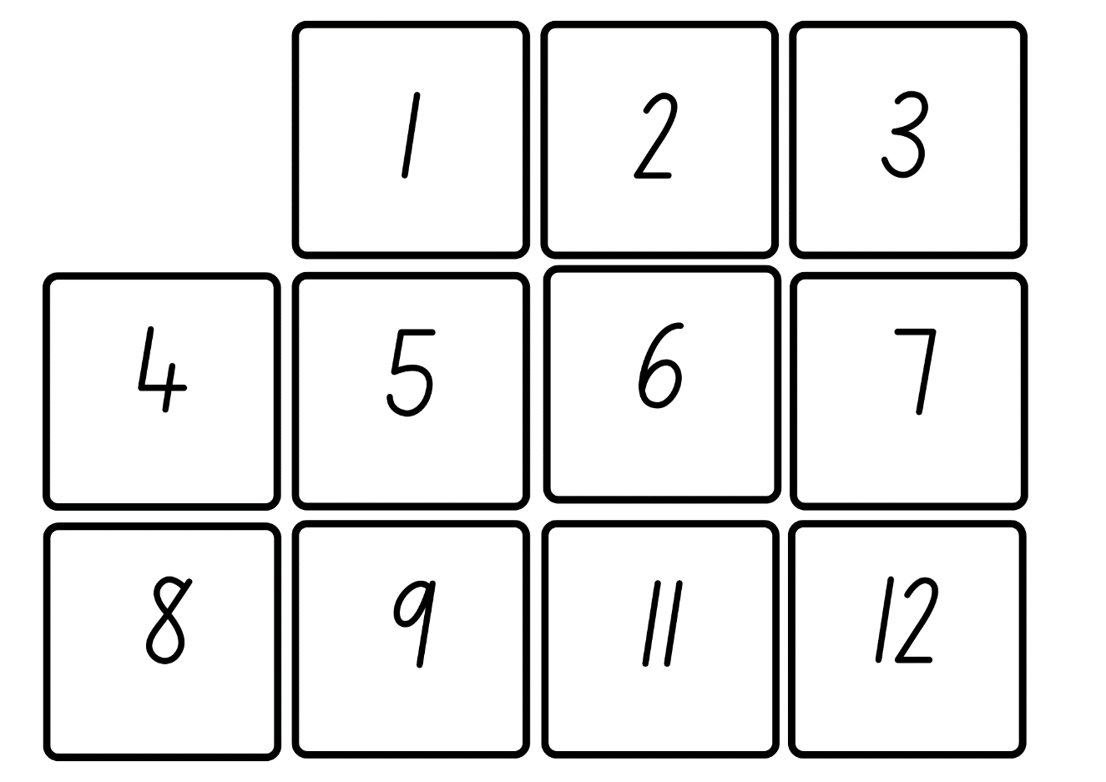
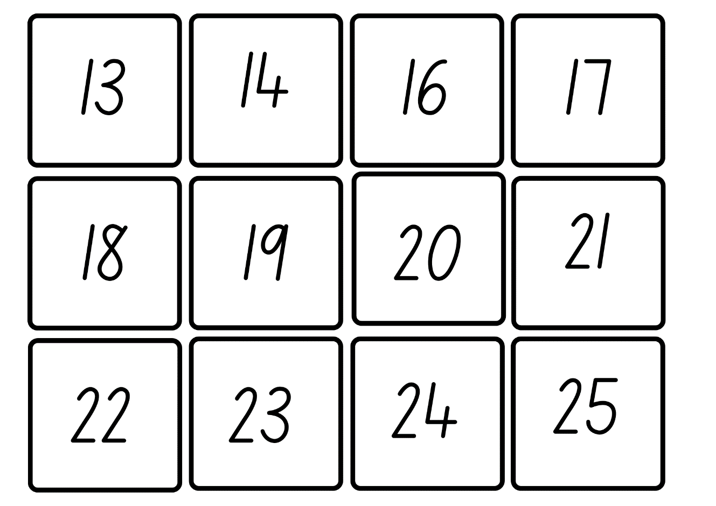
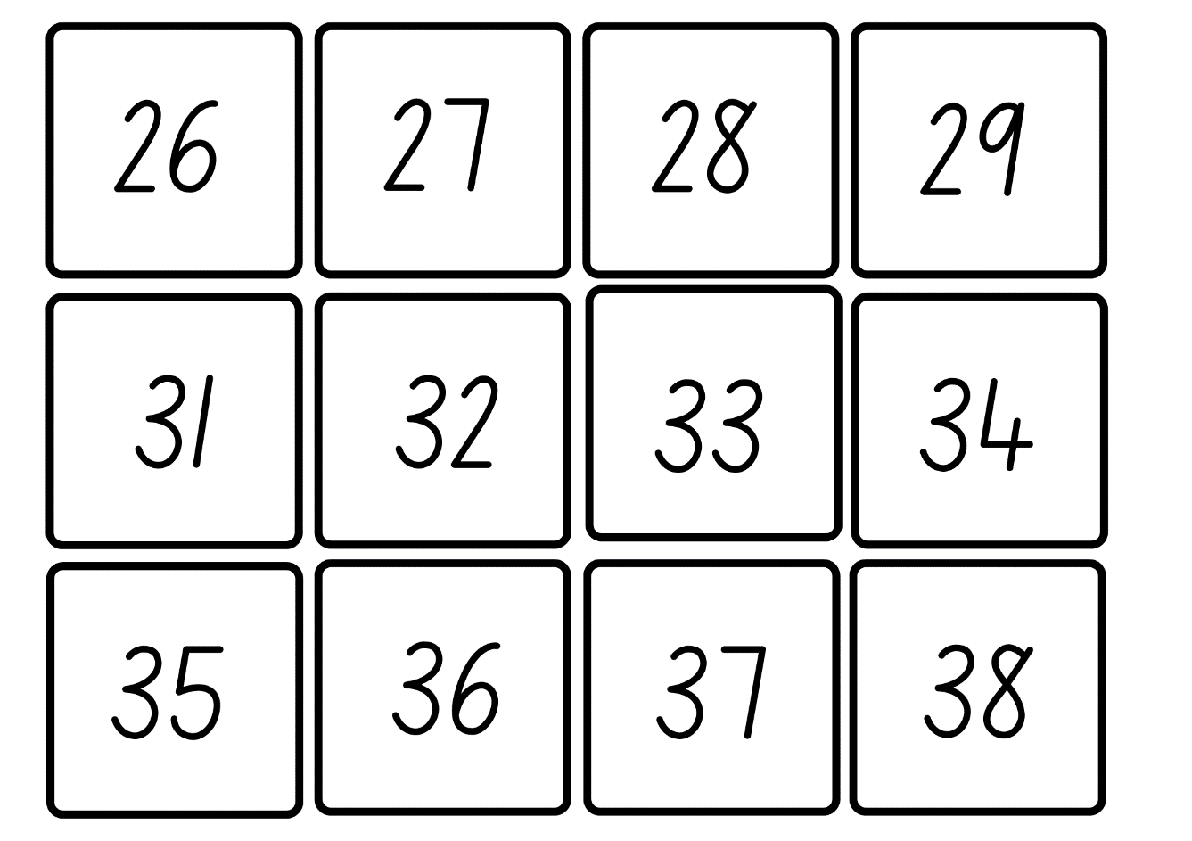
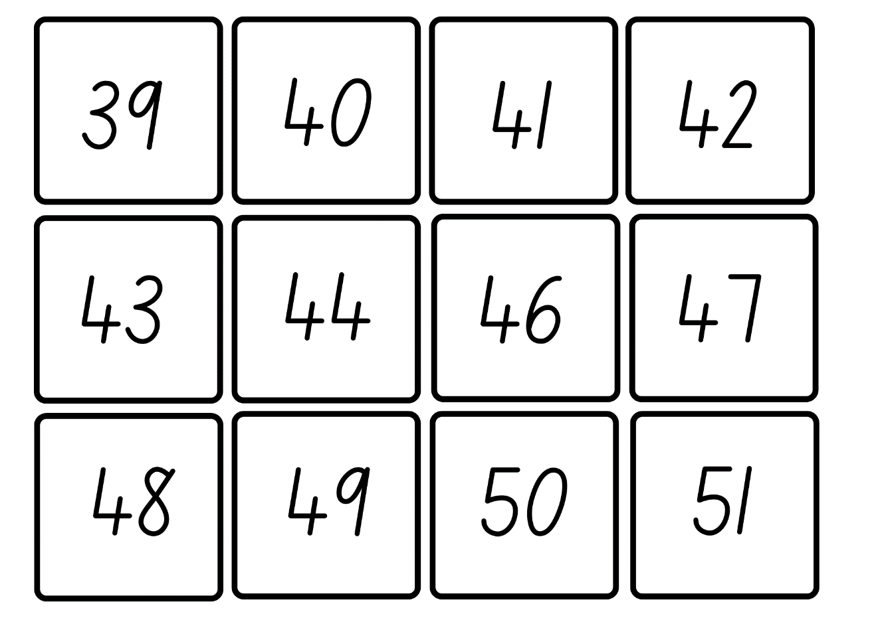
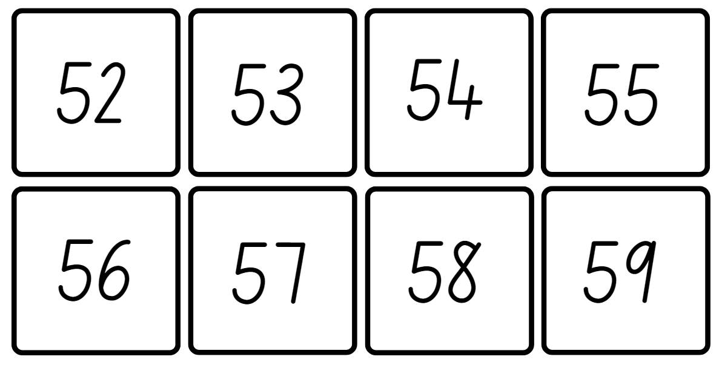

Resource 16: Circular number line
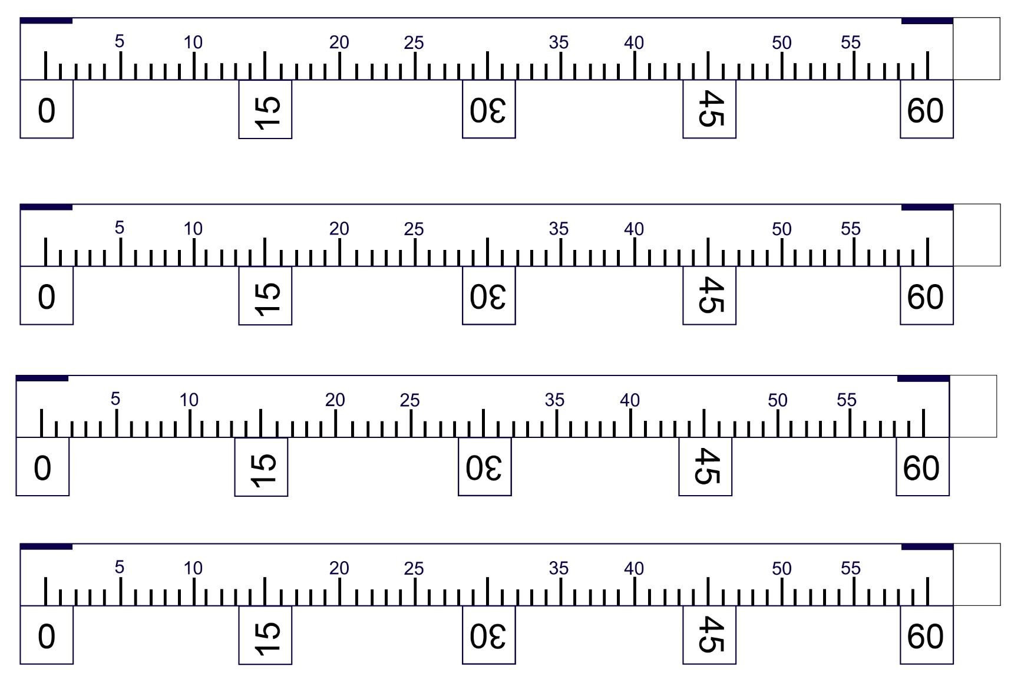

Syllabus outcomes and content
The table below outlines the syllabus outcomes and range of relevant syllabus content covered in this unit. Content is linked to National Numeracy Learning Progression version (3).
Outcomes and content | 1 | 2 | 3 | 4 | 5 | 6 | 7 | 8
Representing numbers using place value A: Whole numbers: Read, represent and order numbers to thousands
MAO-WM-01, MA2-RN-01
- Represent numbers up to and including thousands using physical or virtual manipulatives, words, numerals, diagrams and digital displays | x | x | x
- Read and order numbers of up to at least 4 digits | x | x | x
- Identify the number before and after a number with an internal zero digit |  | x
Additive relations A: Select strategies flexibly to solve addition and subtraction problems of up to 3 digits
MAO-WM-01, MA2-AR-01
- Apply known mental strategies that use partitioning to add and subtract, such as bridging the decades |  |  |  |  | x | x | x
- Use the compensation strategy to add and subtract (Reasons about relations) |  |  |  |  |  | x
- Represent solutions to addition and subtraction problems, including word problems, using an empty number line or bar model |  |  |  |  | x |  | x
Geometric measure A: Length: Measure and compare objects using metres, centimetres and millimetres
MAO-WM-01, MA2-GM-02
- Measure and record lengths and distances using a combination of metres and centimetres | x |  | x |  | x | x
- Estimate lengths and distances using known lengths as benchmarks, in metres and centimetres and check by measuring |  | x
- Compare and order lengths and distances using metres and centimetres | x |  | x
- Recognise the need for a formal unit smaller than the centimetre to measure length |  |  |  | x
- Identify that there are 10 millimetres in one centimetre |  |  |  | x
- Use the millimetre as a unit to measure lengths with a ruler |  |  |  | x
- Record lengths using the abbreviation for millimetres (mm) |  |  |  | x
Geometric measure B: Length: Use scaled instruments to measure and compare lengths
MAO-WM-01, MA2-GM-02
- Select and use an appropriate scaled instrument to measure lengths and distances |  | x
- Use the term perimeter to describe the distance around the boundary |  |  |  |  | x | x
- Estimate and measure the perimeters of quadrilaterals |  |  |  |  | x | x
Two-dimensional spatial structure A: 2D shapes: Compare and describe features of two-dimensional shapes
MAO-WM-01, MA2-2DS-01
- Describe and compare two-dimensional shapes, including parallelograms, rectangles, rhombuses, squares, trapeziums and kites |  |  |  |  | x | x
- Identify quadrilaterals that have all sides equal in length |  |  |  |  | x | x
- Group quadrilaterals using one or more attributes |  |  |  |  | x
Non-spatial measure A: Time: Represent and read analog time
MAO-WM-01, MA2-NSM-02
- Use minutes to describe the duration of events |  |  |  |  |  |  | x
- Identify 30 minutes as being a half-hour and 60 minutes as an hour |  |  |  |  |  |  | x
- Connect the quarter-hour to 15 minutes |  |  |  |  |  |  |  | x
- Recognise that the position of the numerals on an analog timepiece often represents 2 different values |  |  |  |  |  |  |  | x
- Recognise that 5-minute intervals (corresponding to the hour markers) are used as benchmarks to read time on an analog clock |  |  |  |  |  |  |  | x
- Read time as past the hour to half-past and then towards the hour |  |  |  |  |  |  | x | x
- Read analog clocks to the minute |  |  |  |  |  |  | x | x
Mathematics K–10 Syllabus © NSW Education Standards Authority (NESA) for and on behalf of the Crown in right of the State of New South Wales, 2022.

References
This resource contains NSW Curriculum and syllabus content. The NSW Curriculum is developed by the NSW Education Standards Authority. This content is prepared by NESA for and on behalf of the Crown in right of the State of New South Wales. The material is protected by Crown copyright.
Please refer to the NESA Copyright Disclaimer for more information https://educationstandards.nsw.edu.au/wps/portal/nesa/mini-footer/copyright.
NESA holds the only official and up-to-date versions of the NSW Curriculum and syllabus documents. Please visit the NSW Education Standards Authority (NESA) website https://educationstandards.nsw.edu.au/ and the NSW Curriculum website https://curriculum.nsw.edu.au/home.
Mathematics K–10 Syllabus © NSW Education Standards Authority (NESA) for and on behalf of the Crown in right of the State of New South Wales, 2022.
National Numeracy Learning Progression © Australian Curriculum, Assessment and Reporting Authority (ACARA) 2010 to present, unless otherwise indicated. This material was downloaded from the Australian Curriculum website (National Literacy Learning Progression) (accessed 28 August 2023) and was not modified.
State of New South Wales (NSW Department of Education | Learning and Teaching Directorate) (2017) Teaching Measurement Stage 2 – Stage 3 [PDF 686 KB], NSW Government, accessed 30 June 2023.
Swan P (2003) Dice Dazzlers, A-Z Type, Australia.

© State of New South Wales (Department of Education), 2023
The copyright material published in this resource is subject to the Copyright Act 1968 (Cth) and is owned by the NSW Department of Education or, where indicated, by a party other than the NSW Department of Education (third-party material).
Copyright material available in this resource and owned by the NSW Department of Education is licensed under a Creative Commons Attribution 4.0 International (CC BY 4.0) license.
This license allows you to share and adapt the material for any purpose, even commercially.
Attribution should be given to © State of New South Wales (Department of Education), 2023.
Material in this resource not available under a Creative Commons license:
- the NSW Department of Education logo, other logos and trademark-protected material
- material owned by a third party that has been reproduced with permission. You will need to obtain permission from the third party to reuse its material.
Links to third-party material and websites
Please note that the provided (reading/viewing material/list/links/texts) are a suggestion only and implies no endorsement, by the New South Wales Department of Education, of any author, publisher, or book title. School principals and teachers are best placed to assess the suitability of resources that would complement the curriculum and reflect the needs and interests of their students.
If you use the links provided in this document to access a third-party's website, you acknowledge that the terms of use, including licence terms set out on the third-party's website apply to the use which may be made of the materials on that third-party website or where permitted by the Copyright Act 1968 (Cth). The department accepts no responsibility for content on third-party websites.

