Mathematics – Stage 1 – Unit 40
Contents
Unit description and duration 4
Student prior learning 4
Lesson overview and resources 5
Lesson 1: Calendar calculations 11
Daily number sense: Place value game – 10 minutes 11
Calendar investigations – 40 minutes 12
Consolidation and meaningful practice – 10 minutes 14
Lesson 2: Duration and time 15
Daily number sense: Busting a three-digit number – 10 minutes 15
How long will it take? – 30 minutes 16
Consolidation and meaningful practice – 20 minutes 18
Lesson 3: Subtraction 20
Daily number sense: Flexibly renaming – 10 minutes 20
Race from 200 – 30 minutes 21
Consolidation and meaningful practice: Tug of war – 20 minutes 24
Lesson 4: Multiplication bingo 25
Daily number sense: 10 minutes 25
Multiplication bingo – 30 minutes 26
Word problems – 20 minutes 27
Lesson 5: Division 29
Daily number sense: Next 10 – 10 minutes 29
Sharing counters – 30 minutes 30
Division word problems – 20 minutes 32
Lesson 6: Let’s celebrate 34
Daily number sense: Find the next multiple of 10 – 10 minutes 34
Party investigation: Part 1 – 40 minutes 36
Discuss and connect the mathematics – 10 minutes 38
Lesson 7: Celebrate! 40
Daily number sense: Next multiple of 10 – 10 minutes 40
Party investigation: Part 2 – 40 minutes 41
Discuss and connect the mathematics – 10 minutes 43
Lesson 8: Final countdown 45
Daily number sense – 10 minutes 46
Party time – 50 minutes 46
Resource 1: Place value gameboard 51
Resource 2: I wonder... 52
Resource 3: Calendar 53
Resource 4: Calendar problems 55
Resource 5: How long does it take? 57
Resource 6: Race from 200 58
Resource 7: 200 number chart 59
Resource 8: Number chart 60
Resource 9: Bingo gameboard 61
Resource 10: Game cards 63
Resource 11: Multiplication problems 64
Resource 12: Number cards 65
Resource 13: Recording sheet 66
Resource 14: Division problems 67
Resource 15: Decorations catalogue 68
Resource 16: Costing worksheet 69
Resource 17: Party food catalogue 70
Resource 18: Party food recording 71
Resource 19: Lolly bag catalogue 72
Resource 20: Lolly bag recording 73
Resource 21: Battleship gameboards 74
Resource 22: Snail One Hundred 78
Resource 23: Number line zero to 100 79
Resource 24: Number line zero to 500 80
Resource 25: Number cards 81
Syllabus outcomes and content 82
References 88

Unit description and duration
This two-week unit develops student knowledge, understanding and skills to solve problems using critical and strategic thinking. Students are provided opportunities to:
- investigate time and duration problems using calendars and clocks
- solve addition and subtraction problems using objects, diagrams, images and models
- record answers to multiplication and division problems (including those with remainders) using drawings, words and numerals.
Mathematics K–10 Syllabus © 2022 NSW Education Standards Authority (NESA) for and on behalf of the Crown in right of the State of New South Wales.

Student prior learning
Before engaging in these teaching and learning activities, students would benefit from prior experience with:
- opportunities to use a calendar, including days of the week and the months of the year
- measuring and comparing the duration of events using informal units
- applying efficient strategies to solve addition and subtraction problems
- opportunities to solve multiplication and division problems.

Lesson overview and resources
The table below outlines the sequence and approximate timing of lessons; syllabus focus areas and content groups; and resources.
Lesson | Syllabus focus area and content groups | Resources
Lesson 1: Calendar calculations  60 minutes  A calendar is a system of organising and measuring time. | Representing whole numbers B  - Form, regroup, and rename three-digit numbers  Non-spatial measure B  - Time: Describe duration using units of time | - Resource 1: Place value gameboard  - Resource 2: I wonder...  - Resource 3: Calendar  - Resource 4: Calendar problems  - 9-sided dice  - Writing materials
Lesson 2: Duration and time  60 minutes  Duration is how long something exists or lasts or a particular time interval, for example, an hour. | Representing whole numbers B  - Form, regroup, and rename three-digit numbers  Non-spatial measure B  - Time: Describe duration using units of time | - Resource 5: How long does it take?  - Class set of analog clocks or an interactive clock  - Elastic bands  - Large collection of craft sticks or interlocking cubes  - Writing materials
Lesson 3: Subtraction  60 minutes  A collection can be changed by taking some away. | Representing whole numbers B  - Form, regroup, and rename three-digit numbers  Combining and separating quantities A  - Use flexible strategies to solve addition and subtraction problems | - Resource 6: Race from 200  - Resource 7: 200 number chart  - Resource 8: Number chart  - 9-sided dice  - Different coloured counters  - Large collection of MAB blocks  - Writing materials
Lesson 4: Multiplication bingo  60 minutes  Multiplying numbers in any order results in the same answer. | Forming groups A  - Model and use equal groups of objects to represent multiplication  Forming groups B  - Represent and explain multiplication as the combining of equal groups  - Represent multiplication and division problems | - Resource 9: Bingo gameboard  - Resource 10: Game cards  - Resource 11: Multiplication problems  - 6-sided dice  - Large collection of counters  - Writing materials
Lesson 5: Division  60 minutes  A collection can be partitioned into equal or unequal parts. | Representing whole numbers A  - Represent the structure of groups of ten in whole numbers  Representing whole numbers B  - Use counting sequences of ones and tens flexibly  Forming groups A  - Recognise and represent division  Forming groups B  - Represent multiplication and division problems | - Resource 12: Number cards  - Resource 13: Recording sheet  - Resource 14: Division problems  - 6-sided dice  - Large collections of counters  - Number chart  - Writing materials
Lesson 6: Let’s celebrate  60 minutes  Mathematicians use a range of representations to communicate ideas. | Representing whole numbers B  - Use counting sequences of ones and tens flexibly  Combining and separating quantities A  - Use flexible strategies to solve addition and subtraction problems  Forming groups A  - Model and use equal groups of objects to represent multiplication  - Recognise and represent division  Forming groups B  - Represent and explain multiplication as the combining of equal groups  - Represent multiplication and division problems  Non-spatial measure B  - Time: Describe duration using units of time | - Resource 15: Decorations catalogue  - Resources 16: Costing worksheet  - 9-sided dice  - Craft materials  - Writing materials
Lesson 7: Celebrate!  60 minutes  Mathematicians use evidence to make mathematical arguments and justify their thinking. | Representing whole numbers A  - Represent numbers on a line  - Represent the structure of groups of ten in whole numbers  Representing whole numbers B  - Use counting sequences of ones and tens flexibly  Combining and separating quantities A  - Use flexible strategies to solve addition and subtraction problems  Forming groups A  - Model and use equal groups of objects to represent multiplication  - Recognise and represent division  Forming groups B  - Represent and explain multiplication as the combining of equal groups  - Represent multiplication and division problems | - Resource 17: Party food catalogue  - Resource 18: Party food recording  - Resource 19: Lolly bag catalogue  - Resource 20: Lolly bag recording  - Writing materials
Lesson 8: Final countdown  60 minutes  Mathematicians reason and make conjectures when solving problems. | Representing whole numbers A  - Use counting sequences of ones with two-digit numbers and beyond  - Represent the structure of groups of ten in whole numbers  Combining and separating quantities A  - Use advanced count-by-one strategies to solve addition and subtraction problems  - Use flexible strategies to solve addition and subtraction problems  Combining and separating quantities B  - Represent and reason about additive relations  - Form multiples of ten when adding and subtracting two-digit numbers  - Use knowledge of equality to solve related problems  Geometric measure A  - Position: Follow directions to familiar locations | - Resource 21: Battleship gameboards  - Resource 22: Snail one hundred  - Resource 23: Number line zero to 100  - Resource 24: Number line zero to 500  - Resource 25: Number cards  - 6-sided dice  - 9-sided dice  - Barrier  - Counters  - Writing materials

Lesson 1: Calendar calculations
Core concept: A calendar is a system of organising and measuring time.
The table below contains suggested learning intentions and success criteria. These are best co-constructed with students.
Learning intention | Success criteria
Students are learning that calendars are an organised system to measure time. | Students can:  - use a calendar to calculate the number weeks or days until upcoming events  - solve problems related to the calendar.

Daily number sense: Place value game – 10 minutes
This activity has been adapted from The place value game (5:29) by Thinking Mathematically.
- Build student understanding of place value by forming and ordering three-digit numbers in a sequence.
- Explain that the aim of the game is to position three-digit numbers in a sequence on a gameboard.
- Provide pairs with 3 × 9-sided dice and a copy of Resource 1: Place value gameboard to each player.
- Students roll the dice and create a three-digit number. For example, 6, 2 and 9 could be recorded as 629, 692, 296, 269, 962 or 926. Players record their chosen number in the most appropriate position between 100 and 1000 (see Figure 1).
Figure 1 – Place value gameboard
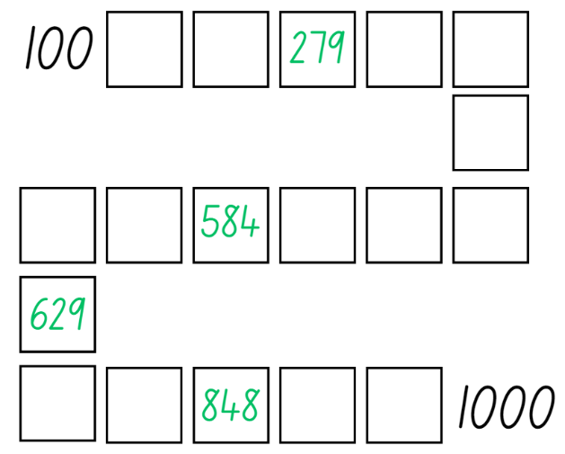
- If numbers cannot be placed, students miss their turn. Play continues until all boxes are filled.
Note: The game can also be played as a whole class. It is recommended to use dice that have a zero as it is important that students understand the role of zero in changing the value of the three-digit numbers created. Using a reusable sleeve for the gameboard will allow students to play multiple games.

Calendar investigations – 40 minutes
This activity has been adapted from Notice and Wonder by Numeracy Teachers Academy.
- Display Resource 2: I wonder... and ask students to look closely at the images. Students turn and talk about what they notice and then select a student to share and explain what they noticed.
Note: First noticings do not have to be maths related.
- Students then turn and talk again about any wonderings about the images. Choose students to share their wonderings.
- Ask students to think about which mathematical concepts the images are all related to.
Note: Through class discussion and questioning, students should notice that all the images are related to time.
- Display Resource 3: Calendar and discuss key features. For example, dates, months, weeks, holidays, seasons and cultural events.
- Provide students with Resource 4: Calendar problems and their workbook. Students solve the problems and record their answers.
- Regroup as a class and select students to share their answers and explain the strategies they used.
This table details assessment opportunities and differentiation ideas.
Assessment opportunities | Too hard? | Too easy?
What to look for:  - Can students use a calendar to calculate the number of weeks or days until upcoming events? (MAO-WM-01, MA1-NSM-02)  - Can students solve problems related to the calendar? (MAO-WM-01, MA1-NSM-02)  What to collect:  - observational data (MAO-WM-01, MA1-NSM-02)  - student work samples (MAO-WM-01, MA1-NSM-02) | Students are unable to use a calendar to solve problems related to weeks or days.  - Support students to name and order days of the week on a blank calendar.  - Students identify events on a given date within the calendar and count the days between the events. | Students can use a calendar to solve problems related to weeks or days.  - Challenge students to fill a blank calendar and create problems for their peers to solve.  - Students keep a diary and record upcoming events for December.

Consolidation and meaningful practice – 10 minutes
- Ask students to create a problem related to the calendar that has not been asked. Once students have created the problem, they swap with a peer, solve and record in their workbooks.
- Regroup and choose students to share their problems. Ask:
- What is the purpose of a calendar?
- How many days are in a week?
- How many months are in a year? Do you know all the names?
- What is your favourite month and why?

Lesson 2: Duration and time
Core concept: Duration is how long something lasts or a particular time interval, for example, an hour.
The table below contains suggested learning intentions and success criteria. These are best co-constructed with students.
Learning intention | Success criteria
Students are learning that duration is how long something takes, measured in units of time. | Students can:  - solve time problems involving hours and minutes  - explain various strategies to measure the duration of events using time.

Daily number sense: Busting a three-digit number – 10 minutes
This activity has been adapted from Number busting – number talk (renaming 26) (2:00) by Thinking Mathematically.
- Build student understanding of place value by partitioning and renaming three-digit numbers in multiple ways.
- Sit in a circle and display 14 groups of 10 and 8 ones using craft sticks or other materials. Tell students you have 148 craft sticks. Students turn and talk to share ideas on how they can prove there are 148 sticks.
Note: Bundles of 10 can be made with craft sticks, interlocking cubes, straws or something similar that can be separated. In Stage 1, it is preferable to use materials that can be joined together and pulled apart, prior to introducing MAB blocks. Before the lesson, watch Number busting – number talk (renaming 26) (2:00).
- Invite students to number bust 148 with you. Model how to use the collection to partition 148 in different ways. Record some of the different ways to rename 148. Invite students to share their ideas. Demonstrate ideas students may not think of, such as 148 is 12 tens and 28 ones. Encourage students to undo the craft stick bundles to check and prove this.
- Repeat and model the above steps with a different three-digit number.

How long will it take? – 30 minutes
This activity has been adapted from Clockwise by NZ Maths.
- Revise the language of time. For example, o’clock, quarter to or half past, six-thirty, hours, minutes and seconds.
- Display a digital and analog clock or an interactive clock.
The table below outlines stimulus prompts to generate conversation about the topic, along with anticipated responses from students.
Prompts | Anticipated student responses
- What does an analog clock have that a digital clock does not have?  - How many hands does an analog clock have?  - What is the job of the short hand on the clock?  - Which hand on the clock is the minute hand?  - Why do we call it the minute hand?  - What does the first and second number of the digital clock show? | - An analog clock has hands that move around a face, while a digital clock displays the time using numbers.  - An analog clock has 2 or 3 hands if it has a seconds hand.  - The short hand travels from one number to the next number in an hour. It is the hour hand.  - The longer hand on the clock is the minute hand.  - We call it the minute hand because it moves every minute.  - The first number shows hours and the second number shows the number of minutes past that hour.
- Provide pairs of students with an analog clock to help solve the following problems:
- Joseph started swimming at 4 o'clock and finished at 5 o'clock. How long did he swim for?
- It takes half an hour to walk from home to school. What is the total time required to walk to school and back home again?
- Nicola’s dentist appointment was at half past 3, but she arrived at 4 o'clock. How late was she for the appointment?
- The movie started at 6 o'clock and ended at half past 7. What was the duration of the movie?
- If a batch of muffins is placed in the oven at half past 5, at what time will the muffins be ready if they take half an hour to bake?
- Sally left to play netball at 4:00 and returned home at 5:30. What was the duration of her absence?
- It takes 60 minutes to walk from home to the beach. What is the total time required to walk to the beach and back home again?
- Alex’s TV programme started at 7:00 and ended at 8:30. What was the duration of the programme?
- Marco arrived at his grandma’s house at 2:00 and stayed there for 6 hours. What time did he leave?
- Potatoes take 30 minutes to boil. If Dad wants them to be ready by 5:30, at what time should he put them in the boiling water?
- As a class, discuss the problems and select pairs to share and explain their reasoning and answers.

Consolidation and meaningful practice – 20 minutes
This activity has been adapted from How long does it take? by NZ Maths.
- As a class, brainstorm activities students do and record in a list. For example, sleep, brush their teeth, sport training, shower, dance class, homework and eating. Once the list is compiled, discuss how often the events occur. For example, discuss whether the activities are daily, just on school days or weekly.
- Provide small groups of students with Resource 5: How long does it take? Students select 2 or 3 activities from the class list and record the time they spend on each event each week. Students share their answers and the strategies they used to find their solutions.
- Regroup as a class and choose students to share their working. Ask:
- What event did you spend the most time on? Why do you think that is?
- Did you find it easy or challenging to keep track of your time? Why or why not?
- Did you use any specific strategies to manage your time during the week? If so, what were they?
- Did you find that certain events were more enjoyable than others? How did that impact the time you spent on each event?
- Do you think you need to make any changes to how you spend your time based on what you learned? If so, what?
- Is it important to keep track of your time? Why or why not?
- What did you discover about yourself from this activity?
- Can you use what you have learned to help you in other areas of your life?
This table details assessment opportunities and differentiation ideas.
Assessment opportunities | Too hard? | Too easy?
What to look for:  - Can students solve time problems involving hours and minutes? (MAO-WM-01, MA1-NSM-02)  - Can students explain various strategies to measure the duration of events? (MAO-WM-01, MA1-NSM-02)  What to collect:  - observational data (MAO-WM-01, MA1-NSM-02)  - student work samples (MAO-WM-01, MA1-NSM-02) | Students are unable to solve time problems involving hours and minutes.  - Provide students with materials (single hand clock – hour hand only) or diagrams to support their thinking.  - Select 3 events that are very different in duration and ask students to compare and order them from the shortest time to the longest time. | Students can solve time problems involving hours and minutes.  - Challenge students to convert events into minutes from hours and hours from minutes.  - Provide students with more challenging problems involving larger numbers that add to more than an hour.

Lesson 3: Subtraction
Core concept: A collection can be changed by taking some away.
The table below contains suggested learning intentions and success criteria. These are best co-constructed with students.
Learning intention | Success criteria
Students are learning that addition and subtraction problems can be solved using various strategies. | Students can:  - use non-count-by-one strategies to solve addition and subtraction problems  - select and apply strategies to solve subtraction problems.

Daily number sense: Flexibly renaming – 10 minutes
- Build student understanding of place value by partitioning and renaming three-digit numbers in different ways.
- Explain that the aim of the task is to flexibly partition three-digit numbers.
- Write 627 on the board and ask the students to flexibly rename 627 as many ways as they can. Students record their answers on individual whiteboards. For example:
- 6 hundreds + 2 tens + 7 ones
- 62 tens + 7 ones
- 627 ones
- 3 hundreds + 32 tens + 7 ones
Note: Concrete materials such as craft sticks or MAB blocks can be used for support.
- Select students to share and justify their different ways of renaming.

Race from 200 – 30 minutes
This activity has been adapted from Race to 200 by Developing Efficient Numeracy Strategies.
- Display Resource 6: Race from 200 and demonstrate how to play the game by competing against the whole class.
- Player A rolls 4 × 9-sided dice and adds the numbers together using known additive strategies. For example, doubles, near doubles or number bonds. Once player A has found the total, they subtract that from 200, recording the results on Resource 6: Race from 200 (see Figure 2).
Figure 2 – Race from 200 gameplay
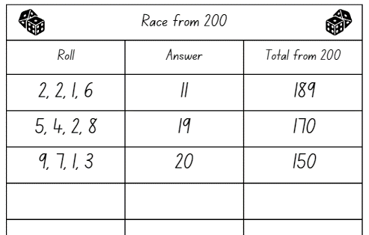
‘Dice’ by creativepriyanka is used in accordance with the Canva Content License Agreement.
- Player B then follows the same steps above. Players take turns, aiming for zero.
Note: Highlight any efficient strategies when adding the rolled numbers and taking away from 200.
- Once students are confident in playing, provide pairs with 4 × 9-sided dice and each student a copy of Resource 6: Race from 200. The winner is the first player to reach zero.
- Regroup as a class and select students to share their strategies during the game. Ask:
- What known facts did you use to add your rolled numbers?
- How did you subtract your number from the total?
- Is there a strategy that you are confident using? Why?
- What challenges did you face? How did you overcome them?
- What questions do you still have?
This table details assessment opportunities and differentiation ideas.
Assessment opportunities | Too hard? | Too easy?
What to look for:  - Can students use non-count-by-one strategies to solve addition problems? (MAO-WM-01, MA1-CSQ-01)  - Can students select and apply strategies to solve subtraction problems? (MAO-WM-01, MA1-CSQ-01)  What to collect:  - student work samples (MAO-WM-01, MA1-CSQ-01) | Students are unable to subtract a quantity from 200.  - Provide students with Resource 7: 200 number chart to reference as they subtract.  - Students race from 100 with 2 × 9-sided dice, consolidating their counting strategies. Provide students with a number chart to reference as they play the game. | Students can subtract a quantity from 200.  - Challenge students to play Race from 200 with 4 × 20-sided dice.  - In pairs play Strike it Out using a number line from zero to 20 on an individual whiteboard.

Consolidation and meaningful practice: Tug of war – 20 minutes
- Display Resource 8: Number chart and explain to students they are going to play a game called tug of war, where the first student that gets to 50, wins.
- Provide pairs with Resource 8: Number chart, one different coloured counter each and a 9-sided die.
- Students start the game by deciding which player will begin on zero and which player will begin on 100. Students then place their counter on their starting number.
- The player starting on zero will add the quantity rolled to zero and begin to move up towards 50 and the player starting on 100 will subtract the quantity rolled from 100 and start moving towards 50.
- If a player is near 50 and rolls a quantity that would go over 50, they do not move from their number and miss their turn. Play continues until one player reaches 50.
- Students swap starting positions and repeat the game.
Note: The game can be adapted so the objective is to reach the other end of the number chart first with players using 2 × 10-sided dice.

Lesson 4: Multiplication bingo
Core concept: Multiplying numbers in any order results in the same answer.
The table below contains suggested learning intentions and success criteria. These are best co-constructed with students.
Learning intention | Success criteria
Students are learning that multiplication problems can be solved using various strategies. | Students can:  - use objects, diagrams, drawings or actions to solve multiplication problems  - justify their reasoning when solving mathematical problems.

Daily number sense: 10 minutes
- From a class need surfaced through formative assessment data, identify a short, focused activity that targets students’ knowledge, understanding and skills. Example activities may be drawn from the following resources:
- Thinking Mathematically Stage 1
- Universal Resources Hub.

Multiplication bingo – 30 minutes
This activity has been adapted from Rolling groups by Developing Efficient Numeracy Strategies.
- Provide students with 1 × 6-sided die, Resource 9: Bingo gameboard, Resource 10: Game cards and a large collection of counters.
- Students roll the die and select a number card from Resource 10: Game cards. Students use up to 2 numbers to skip count or a repeated addition strategy to solve the multiplication problem and find the total. Place a counter on the corresponding number on the gameboard. If a number is already covered, that player misses a turn. Students continue to take turns with the first player to cover the board and call out ‘Bingo!’ being the winner.
Note: If required, students can use counters to model all items to show multiplication as accumulating equal groups. It is preferable for students to make and use arrays rather than ‘groups of’ by the end of Stage 1.
- Regroup as a class and choose students to share the strategies they used to solve the problems. For example, repeated addition, arrays, doubles or forming groups. Ask:
- What strategies did you use to solve the problems?
- Is there a strategy you are more confident with? Why?
- Did you notice any patterns while playing?
- Do you have any questions?

Word problems – 20 minutes
- Write or display the following problem on the board: ‘If each person at a party eats 5 cookies, and there are 8 people at the party, how many cookies will be eaten in total?’ Ask students what the question is asking and what strategies they could use to solve it. Demonstrate how to solve the problem using an efficient strategy with a think aloud.
- Provide students with Resource 11: Multiplication problems and workbooks to record their solutions to the multiplication word problems.
- Regroup as a class and choose students to share the strategies they used to solve the problems. Ask:
- Can you explain the problems in your own words?
- What strategies did you use to solve the problems?
- Did you break the problems down into smaller parts? What steps did you take to solve it?
- Did you use any diagrams, drawings or models to help you understand or solve the problems?
- Is there another way to solve the problems?
This table details assessment opportunities and differentiation ideas.
Assessment opportunities | Too hard? | Too easy?
What to look for:  - Can students use objects, diagrams, drawings or actions to solve multiplication problems? (MAO-WM-01, MA1-FG-01)  - Can students justify their reasoning when solving mathematical problems? (MAO-WM-01, MA1-FG-01)  What to collect:  - student work samples (MAO-WM-01, MA1-FG-01)  - observational data (MAO-WM-01, MA1-FG-01) | Students are unable to solve multiplication problems.  - Provide students with concrete materials to form equal groups and modify the bingo game by drawing the equal groups on the game card.  - Students cover the array they have made and try to work out the total using rhythmic or skip counting to solve the problems. | Students can use various strategies to solve multiplication problems.  - Students create their own multiplication word problems for a peer to solve.  - Provide students with a 10-sided dice and a blank game card. Ask them to create their own gameboard to play with their peers.

Lesson 5: Division
Core concept: A collection can be partitioned into equal or unequal parts.
The table below contains suggested learning intentions and success criteria. These are best co-constructed with students.
Learning intention | Success criteria
Students are learning that division problems can be solved using various strategies. | Students can:  - use objects, diagrams, drawings or actions to solve division problems including remainders  - justify their reasoning when solving division problems.

Daily number sense: Next 10 – 10 minutes
- Build student understanding of the position of numbers by using a number chart to locate the next multiple of 10 following a two- and three-digit number.
- Display a number chart. Select a number and have students locate the next multiple of 10 and consider how many more to that multiple of 10. For example, if you choose 57, the students will say 60 and 3 more.
Note: This activity focuses on identifying the next multiple of 10, not the closest multiple of 10.
- Continue selecting numbers and ask questions such as:
- How do we know it is 60?
- Do you see any patterns?
- Repeat activity for different two- and three-digit numbers between one and 120.

Sharing counters – 30 minutes
This activity has been adapted from Share it out from Developing Efficient Numeracy Strategies.
- Provide pairs with Resource 12: Number cards, a 6-sided die and a large collection of counters. Explain that the die represents the number of groups and the cards represent the number of items.
- Students take turns to roll the die, select a number card and use the counters to find the answer. Player A explains their thinking to Player B, who records their work on Resource 13: Recording sheet (see Figure 3). Any remainder counters are collected by Player A.
Remainder: The part ‘left over’ when dividing a number into equal groups.
- Students swap roles and play multiple rounds. The player with the smallest number of remainders at the end is the winner (see Figure 3).
Figure 3 – Recoding sheet example
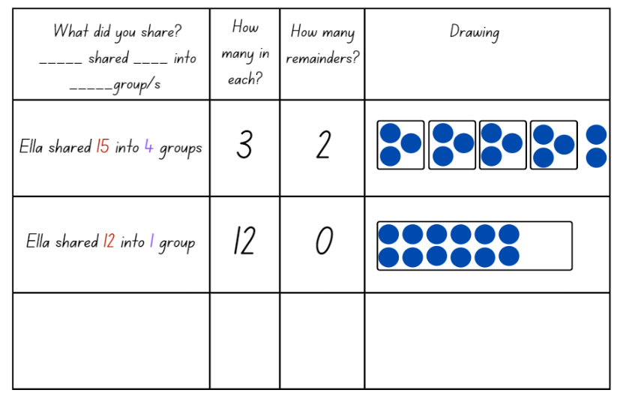
- Regroup as a class and discuss the various strategies students used to share the counters. For example, repeated subtraction, arrays, rows and columns or forming groups. Ask:
- What strategies did you use to solve the problems?
- Is there a strategy you are more confident with? Why?
- Did you notice any patterns while playing?
- Do you have any questions about the remainders?

Division word problems – 20 minutes
- Write or display the following problem on the board: ‘Jonathon has 43 baseball cards that he wants to share equally among his 5 friends. How many baseball cards will each friend get? How many will be left over?’ Ask students what the question is asking and what strategies they could use to solve it. Demonstrate how to solve the problem using an efficient strategy with a think aloud.
- Provide students with Resource 14: Division problems and their workbook to record their solutions to the division word problems.
- Regroup as a class and choose students to share the strategies they used to solve the problems. Ask:
- Can you explain the problem in your own words?
- What strategies did you use to solve the problem?
- Did you break the problem down into smaller parts? What steps did you take to solve it?
- Did you use any diagrams, drawings or models to help you understand or solve the problem?
- Is there a different way to solve the problem?
- Were there any remainders in your solutions?
This table details assessment opportunities and differentiation ideas.
Assessment opportunities | Too hard? | Too easy?
What to look for:  - Can students use objects, diagrams, drawings or actions to solve division problems? (MAO-WM-01, MA1-FG-01)  - Can students justify their reasoning when solving division problems? (MAO-WM-01, MA1-FG-01)  What to collect:  - student work samples (MAO-WM-01, MA1-FG-01)  - observational data (MAO-WM-01, MA1-FG-01) | Students are unable to solve division problems including remainders.  - Provide even number cards for students to form 2 equal groups with no remainders.  - Students represent authentic situations involving equal sharing and equal grouping by drawing the objects, for example, a picture representing 8 people sitting at 2 tables. Students then use counters to represent the sharing. | Students can use various strategies to solve division problems.  - Students create their own division word problems for a peer to solve.  - Provide pairs of students with a 10-sided die and additional number cards. Ask them to share larger quantities of counters and record their solutions.  - Challenge students to form arrays when solving sharing counters problems.

Lesson 6: Let’s celebrate
Core concept: Mathematicians use a range of representations to communicate ideas.
The table below contains suggested learning intentions and success criteria. These are best co-constructed with students.
Learning intention | Success criteria
Students are learning that mathematical problems can be solved using various strategies. | Students can:  - solve and record answers using objects, diagrams, images and actions.  - explain their reasoning for the method they used to solve problems.

Daily number sense: Find the next multiple of 10 – 10 minutes
- Build student understanding of place value by creating a three-digit number and identifying how many more to the next multiple of 10.
Note: This task builds on from the Daily number sense: Next 10 in Lesson 5.
- Provide pairs with 3 × 9-sided dice. Explain that they need to roll the dice to create and record a three-digit number on an individual whiteboard. Students then state the number and record how many more to the next multiple of 10 (see Figure 4).
Figure 4 – Next multiple
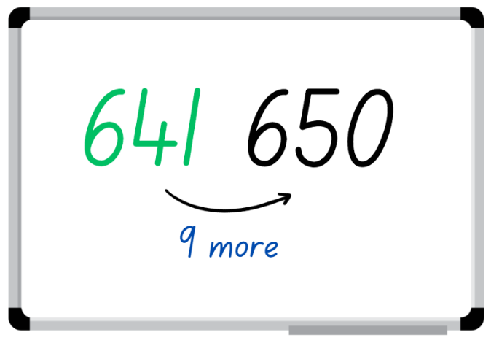
Image sourced from Canva and used in accordance with the Canva Content License Agreement.
Note: This activity focuses on identifying the next multiple of 10, not the closest multiple of 10.
- Students roll again to make a different three-digit number and record their results. State the number and how many more to the next multiple of 10.
- Students repeat activity multiple times.
Note: The activity can be adapted by using 2 × 9-sided dice and creating two-digit numbers.

Party investigation: Part 1 – 40 minutes
This activity has been adapted from Authentic Problems: Tea Party from reSolve: Maths by Inquiry.
- Begin by brainstorming what students know about parties. Ask what people do at parties and what things are usually at parties. Record student ideas on the whiteboard or an anchor chart.
- Explain to students that they will be organising a party for their class. Ask them to think about what they might need at the party.
- If not already identified by students, highlight that parties need invitations. Discuss key features of an invitation, for example, type of event, date, time, duration, location, dress code, RSVP and any additional information required for the party. Provide students with various writing materials and craft materials to create an invitation for the class party (see Figure 5).
Figure 5 – Invitation example
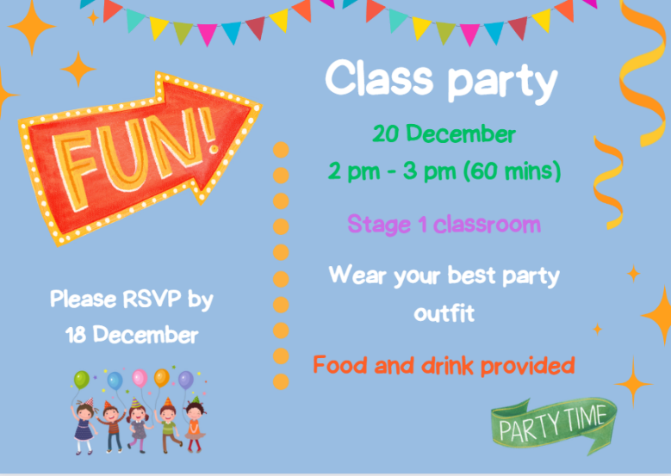
Images sourced from Canva and used in accordance with the Canva Content License Agreement.
- Regroup as a class and explain that students now need to design a seating plan for the class party to ensure there are enough seats and tables for everyone. Students use the total number of students in the class to organise possible seating arrangements in groups. Students then write number sentences to demonstrate their mathematical thinking and record their seating plan in their workbook.
- Select students to share and justify their seating plan. Ask:
- What strategy did you use to create the seating plan?
- Did you face any challenges when organising the seating plan?
- Display Resource 15: Decorations catalogue and explain to the class that they will need to buy decorations for the party, but they cannot spend more than $30. Select students to choose which decorations they would pick and demonstrate how to record the cost on Resource 16: Costing worksheet (see Figure 6).
Figure 6 – Decoration costing example
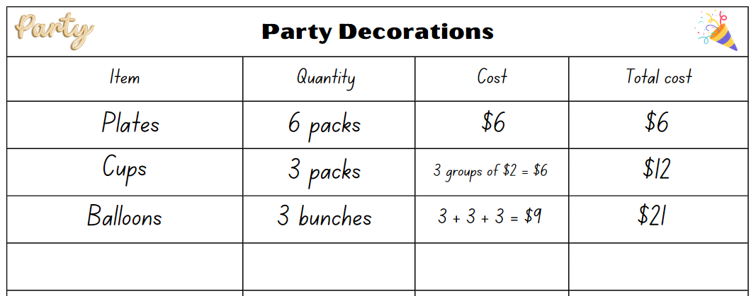
Images sourced from Canva and used in accordance with the Canva Content License Agreement.
- Provide pairs with Resource 15: Decorations catalogue and Resource 16: Costing worksheet. Students decide what items they want to buy, how much each item costs and the total cost of all the decorations. Remind students that they need to stay within their budget of $30.

Discuss and connect the mathematics – 10 minutes
- Regroup as a class and summarise the lesson together, drawing out key mathematical ideas. Ask:
- What were some of the creative ideas that you came up with for your party invitations?
- Have you allowed enough time for party activities?
- Will there be specific time for lunch? If so, for how long?
- Did you encounter any challenges while making the invitations? If so, how did you overcome them?
- What were some of the decorations that you wanted to buy but could not? Why did you make that decision?
- Did you stay within your budget for decorations? If not, what caused you to go over budget?
- Can you explain some of the different types of mathematics used for your investigation?
- What would you do differently if you were to plan a party again?
This table details assessment opportunities and differentiation ideas.
Assessment opportunities | Too hard? | Too easy?
What to look for:  - Can students solve a range of problems and record answers using objects, diagrams, images and actions? (MAO-WM-01, MA1-CSQ-01, MA1-FG-01, MA1-NSM-02)  - Can students apply reasoning for the method they used to solve problems? (MAO-WM-01, MA1-CSQ-01, MA1-FG-01, MA1-NSM-02)  What to collect:  - observational data (MAO-WM-01, MA1-CSQ-01, MA1-FG-01, MA1-NSM-02)  - student work samples (MAO-WM-01, MA1-CSQ-01, MA1-FG-01, MA1-NSM-02) | Students are unable to solve problems related to the seating plan and decorations.  - Provide students with concrete materials to represent the items in the catalogue to support them as they calculate the budget.  - Provide students with grid paper to support them as they design the seating arrangements. | Students can solve problems related to the seating plan and decorations.  - Challenge students to create an activity schedule for the party, including the duration of each activity.  - Students to create a list of decorations that adds up to exactly $30.  - Challenge students to explain and justify the most appropriate seating arrangement for the class numbers.

Lesson 7: Celebrate!
Core concept: Mathematicians use evidence to make mathematical arguments and justify their thinking.
The table below contains suggested learning intentions and success criteria. These are best co-constructed with students.
Learning intention | Success criteria
Students are learning that different strategies can be used to find solutions to problems. | Students can:  - solve problems by using addition and subtraction  - solve problems by using multiplication and division  - justify their reasoning when solving mathematical problems.

Daily number sense: Next multiple of 10 – 10 minutes
- Build student understanding of the counting sequence by identifying how many more to the next multiple of 10.
- Ask students to draw a blank number line on an individual whiteboard and mark the numbers 94 and 102. Ask students how many more to the next multiple of 10 after 94. Students draw the jump to identify how many more and mark the next multiple of 10 (see Figure 7).
Figure 7 – Next multiple of 10
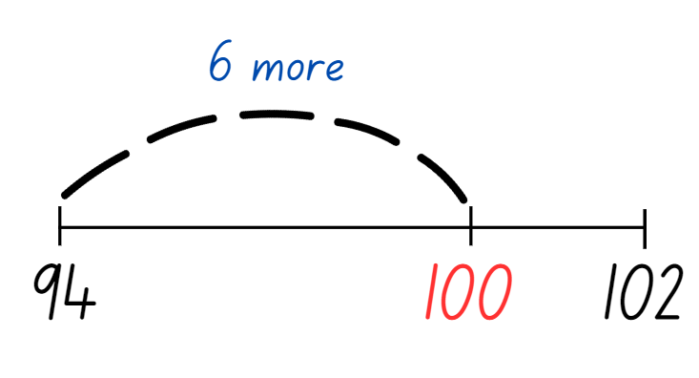
‘Dashed Curve Line Illustration’ by The Darlyns is used in accordance with the Canva Content License Agreement.
- Choose students to share and justify how they know it is the next multiple of 10 and where to place it on the number line.
- Ask students how many more to the next multiple of 10 after 102. Students will need to extend the number line and draw the jump to identify how many more and mark the next multiple of 10.
Note: This activity focuses on identifying the next multiple of 10, not the closest multiple of 10.
- Continue this activity for different two- and three-digit number ranges.

Party investigation: Part 2 – 40 minutes
- Explain that students will be organising the party food and lolly bags for the upcoming class party.
- Display Resource 17: Party food catalogue and explain to the class that they will need to buy food for the party and cannot spend more than $50. Select students to share which food they would buy and demonstrate how to record the cost on Resource 18: Party food recording (see Figure 8).
Figure 8 – Party food recording
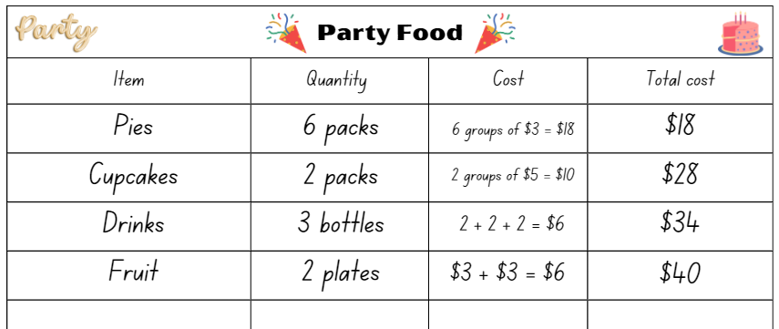
Images sourced from Canva and used in accordance with the Canva Content License Agreement.
- Provide pairs with Resource 17: Party food catalogue and Resource 18: Part food recording. Students decide what items they want to buy, how much each item costs and the total cost of all the food they choose. Remind students that they need to stay within their budget of $50.
- Select students to share the food they have selected and the total cost. Ask:
- What was the most challenging part of creating your party menu?
- Looking back on your menu, is there anything you would have done differently? Why?
- How could you apply the skills you learned in this activity to real-life situations?
- Provide pairs with Resource 19: Lolly bag catalogue and Resource 20: Lolly bag recording. Students select items to create a party bag for each student in the class. Each bag must have a minimum of 3 items and maximum of 4 items in the bag and must not cost more than $5. Students record they selection on Resource 20: Lolly bag recording (see Figure 9).
Figure 9 – Lolly bag example
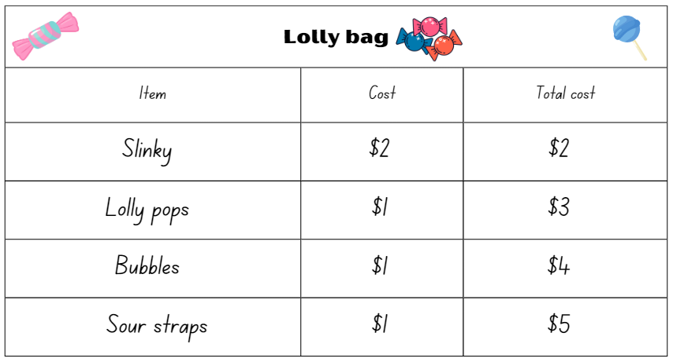
Images sourced from Canva and used in accordance with the Canva Content License Agreement.

Discuss and connect the mathematics – 10 minutes
- Regroup as a class and summarise the lesson together, drawing out key mathematical ideas. Ask:
- What was challenging about creating the lolly bags?
- How did you decide how many of each item to include in the lolly bags? What strategies did you use to make these decisions?
- Did you face any challenges when using multiplication and division to create the lolly bags? How did you overcome them?
- Did you learn anything new about using multiplication and division to organise and divide items through this activity? What was it?
- Are you happy with your planned party? If not, what would you change?
This table details assessment opportunities and differentiation ideas.
Assessment opportunities | Too hard? | Too easy?
What to look for:  - Can students solve problems using addition and subtraction strategies? (MAO-WM-01, MA1-CSQ-01)  - Can students solve problems using multiplication and division strategies? (MAO-WM-01, MA1-FG-01)  - Can students justify their reasoning when solving mathematical problems? (MAO-WM-01, MA1-CSQ-01, MA1-FG-01)  What to collect:  - observational data (MAO-WM-01, MA1-CSQ-01, MA1-FG-01)  - student work samples (MAO-WM-01, MA1-CSQ-01, MA1-FG-01) | Students are unable to solve mathematical problems and justify their reasoning.  - Provide students with concrete materials to represent the items on the catalogues to support the calculations of the budgets.  - Support students to solve the party problems for a class of 10 students. | Students can solve mathematical problems and justify their reasoning.  - Challenge students to create their own catalogue for party toys or games. In groups, students price items and ask peers to cost items within a provided budget.  - Challenge students to organise another event and list what items need to be purchased. Students research items and costs and create a budget.

Lesson 8: Final countdown
Core concept: Mathematicians reason and make conjectures when solving problems.
The table below contains suggested learning intentions and success criteria. These are best co-constructed with students.
Learning intentions | Success criteria
Students are learning that:  Battleships  - positional language is used to describe the location of an object.  Snail One Hundred  - numbers have a sequence based on their value.  Five steps to 100 or 500  - using place value helps to partition and rename three-digit numbers  - mathematicians use tools, such as number lines to solve problems. | Students can:  Battleships  - describe the location of objects using positional language.  Snail One Hundred  - recognise that 10 ones are the same as 1 ten.  Five steps to 100 or 500  - count forwards and backwards by fives, tens and hundreds from any three-digit number  - use effective counting strategies and a number line to find solutions.

Daily number sense – 10 minutes
- From a class need surfaced through formative assessment data, identify a short, focused activity that targets students’ knowledge, understanding and skills. Example activities may be drawn from the following resources:
- Thinking Mathematically Stage 1
- Universal Resources Hub.

Party time – 50 minutes
- The following activities are a selection of popular mathematics games sourced from a variety of Stage 1 sample units. Students can participate in these activities either in pairs or small groups.

Battleships
- Provide pairs with Resource 21: Battleship gameboards, a barrier and 3 counters each. Students set up the gameboards by placing 3 counters (ships) on Resource 21: Battleship gameboards so that the opponents cannot see each other's gameboard (see Figure 10).
Figure 10 – Battleship gameplay
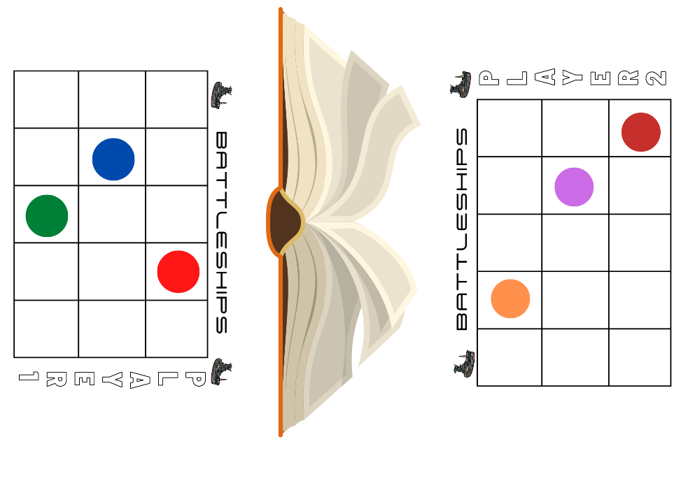
Images sourced from Canva and used in accordance with the Canva Content License Agreement.
- Students take turns guessing the location of each of the counters. The player not guessing responds with ‘miss’ or ‘hit’. The first player to ‘hit’ all ships belonging to their opponent wins. Players may only ask one question each turn and must use positional language. For example, players could ask if there is a counter on the top left, if there is a counter on the square below the last hit or if there is a counter on the middle of the bottom row.
- Students play multiple rounds.

Snail One Hundred
This activity has been adapted from Snail One Hundred from NRICH.
- Build student understanding of counting to 100 by playing Snail One Hundred.
- Provide each player with 3 matching counters and provide pairs with Resource 22: Snail One Hundred and a 6-sided die.
- Both players place one of their counters on the zero, one of their counters on the zero tens, and one of their counters on the zero hundreds.
- Player 1 rolls the dice and moves their counter that number of places along the snail’s body. Player 2 rolls the dice.
- When a player reaches 9 on the snail’s body, they return their counter to zero and move their second counter up to 1 ten.
- Players continue to move their first counter along the snail’s body and move the second counter to the next 10 every time they reach 9.
- When a player’s counter is on ‘9 tens’, it can’t move any further around the spiral. Instead, it goes back to ‘zero tens’ and their third counter moves from zero hundreds to 100. The first player to move their counter onto the 100 space is the winner.

Five steps to 100 or 500
This activity has been adapted from Five Steps to 50 from NRICH.
- Provide pairs of students with Resource 23: Number line zero to 100 and 2 × 9-sided dice.
- Explain that students will be playing with a partner and the objective of the game is to be the player to get on or closest to 100 in 5 moves, by counting on or counting back from the number rolled.
- Player 1 rolls the 2 dice, identifies the smallest two-digit number that can be made and circles that number on the number line. Player 1 must decide how to jump to 100 in 5 jumps by using a combination of adding and/or subtracting fives, tens and ones (see Figure 11).
Figure 11 – Examples of Five Steps to 100
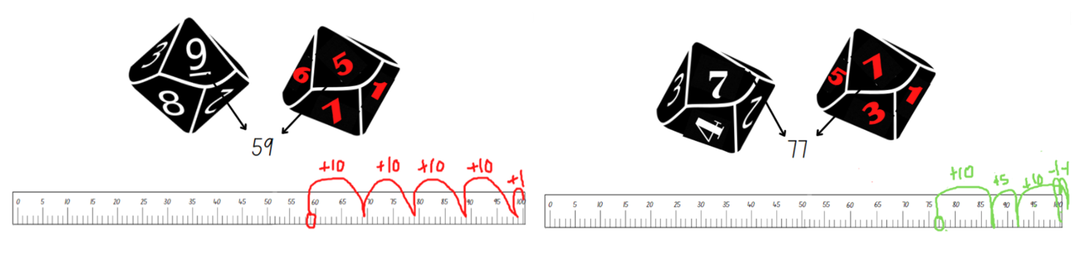
Images sourced from Canva and used in accordance with the Canva Content License Agreement.
- Ensure that students are recording their strategies for each round. For example, 59 + 10 + 10 + 10 + 10 + 1 = 100.
- If students are confident playing to 100, provide each pair of students with Resource 24: Number line zero to 500 and Resource 25: Number cards. Explain that this time, they need to reach 500 using 5 steps by counting on or back using combinations of fives, tens and hundreds.
- Each player turns over a number card from the pile. They read the three-digit number and identify where that number is on the number line. Students then take 5 steps forwards or backwards in an attempt to land on 500.
- Ensure that students record their strategies for later discussions.
- Provide time for students to play multiple rounds. Observe strategies and listen to discussions as students' reason and problem solve.

Resource 1: Place value gameboard
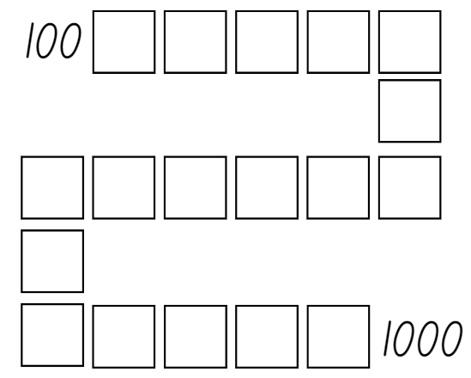

Resource 2: I wonder...
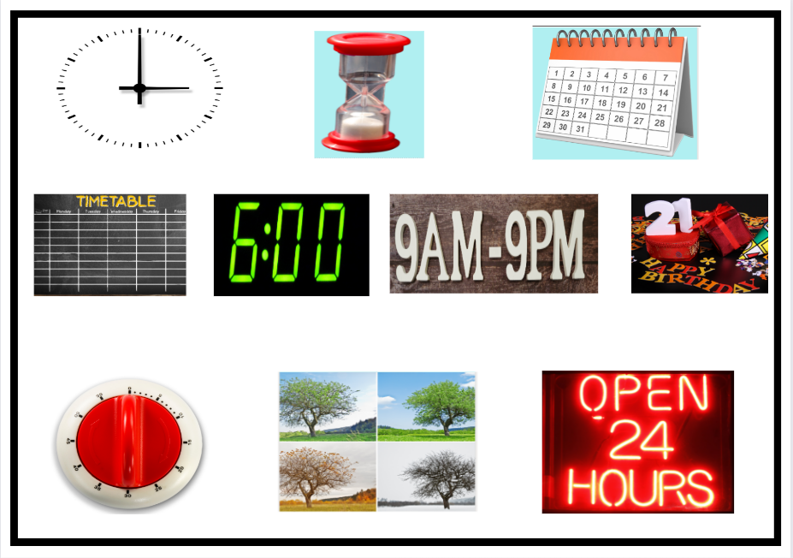
Images sourced from Canva and used in accordance with the Canva Content License Agreement.

Resource 3: Calendar
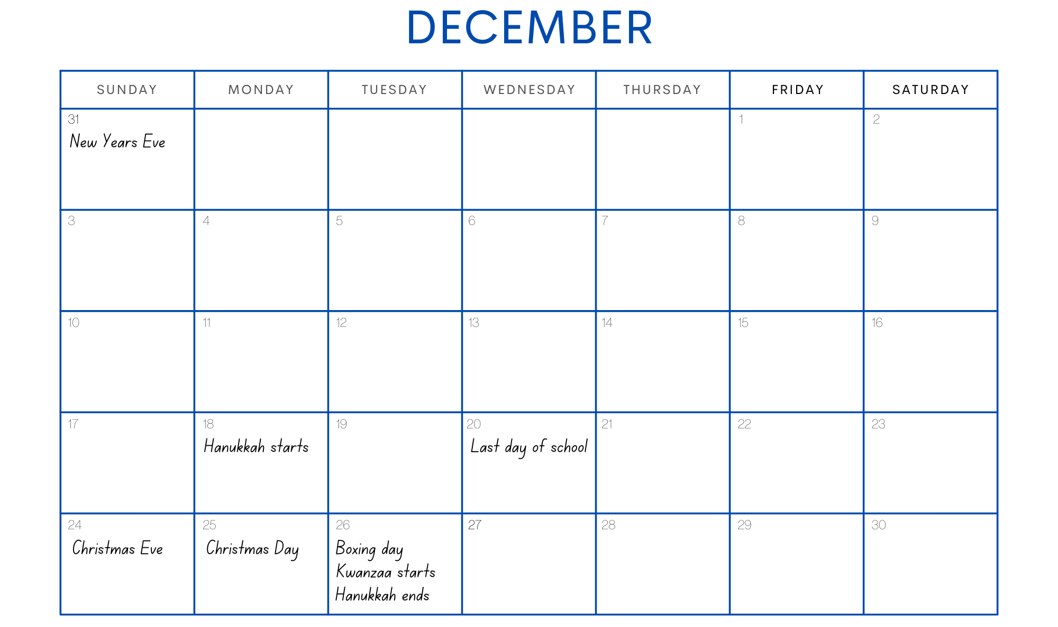
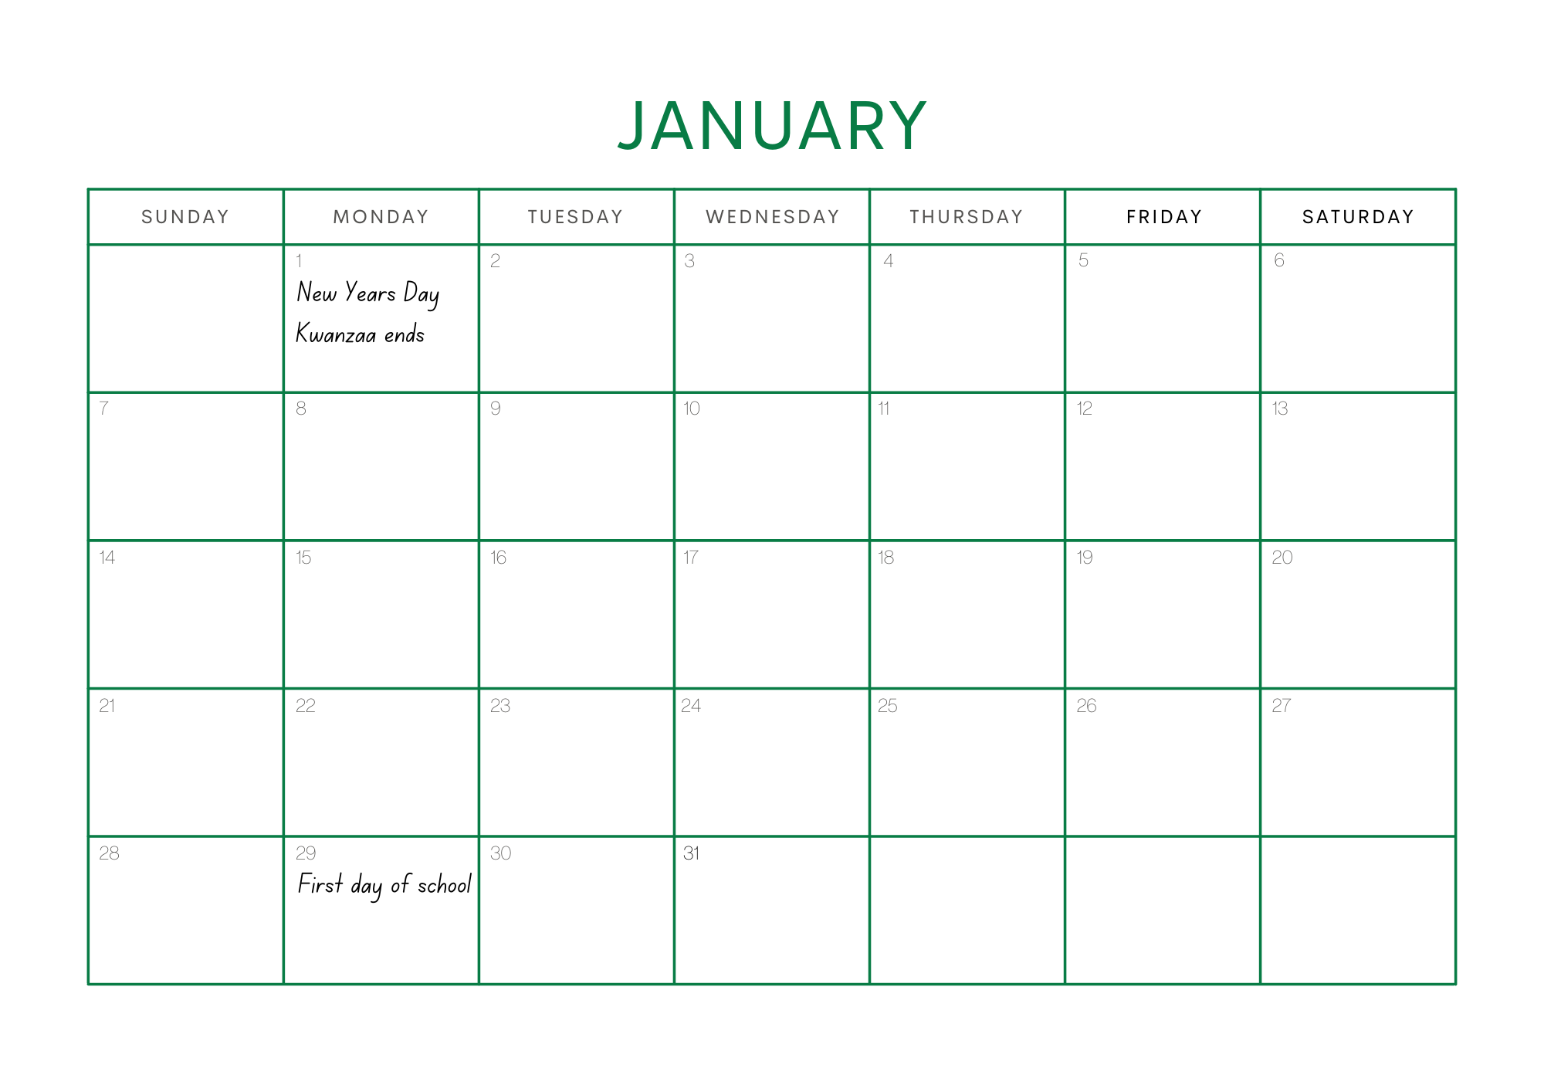

Resource 4: Calendar problems
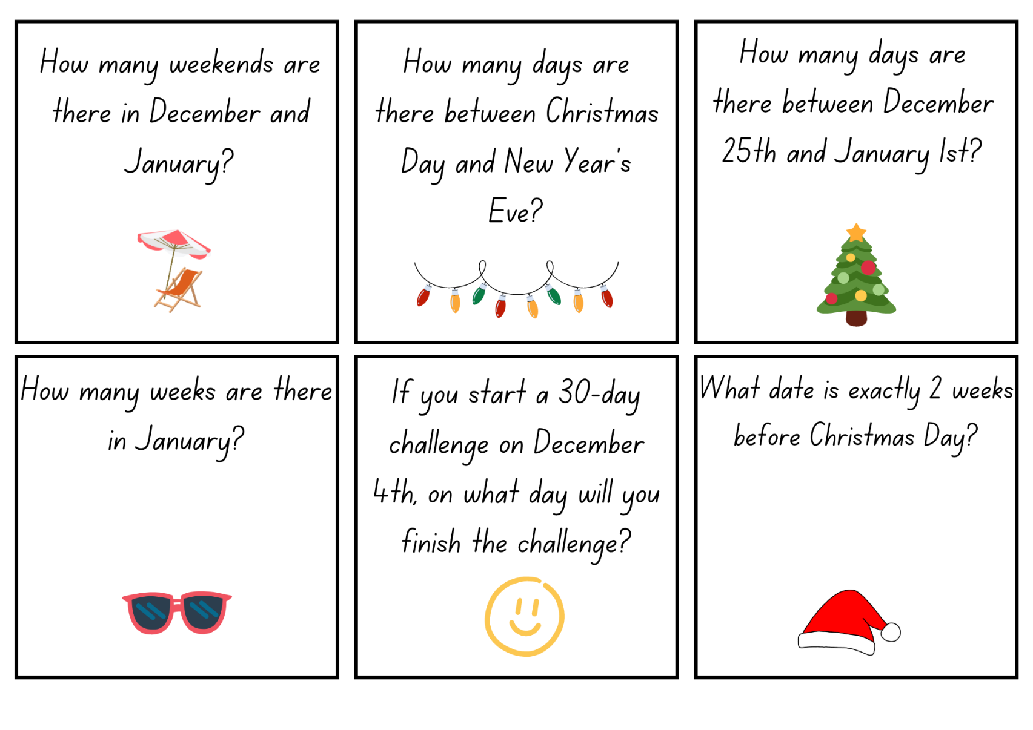
Images sourced from Canva and used in accordance with the Canva Content License Agreement.
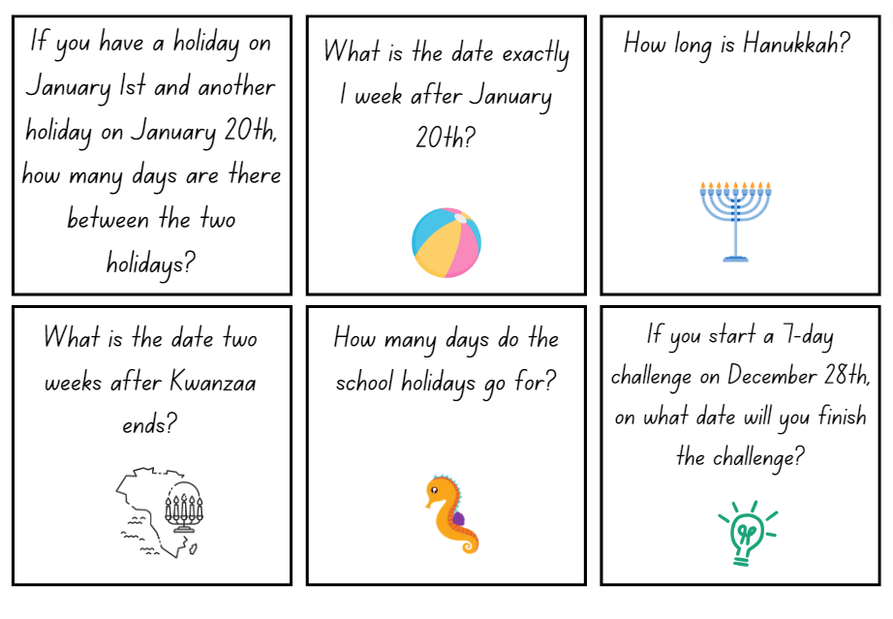
Images sourced from Canva and used in accordance with the Canva Content License Agreement.

Resource 5: How long does it take?
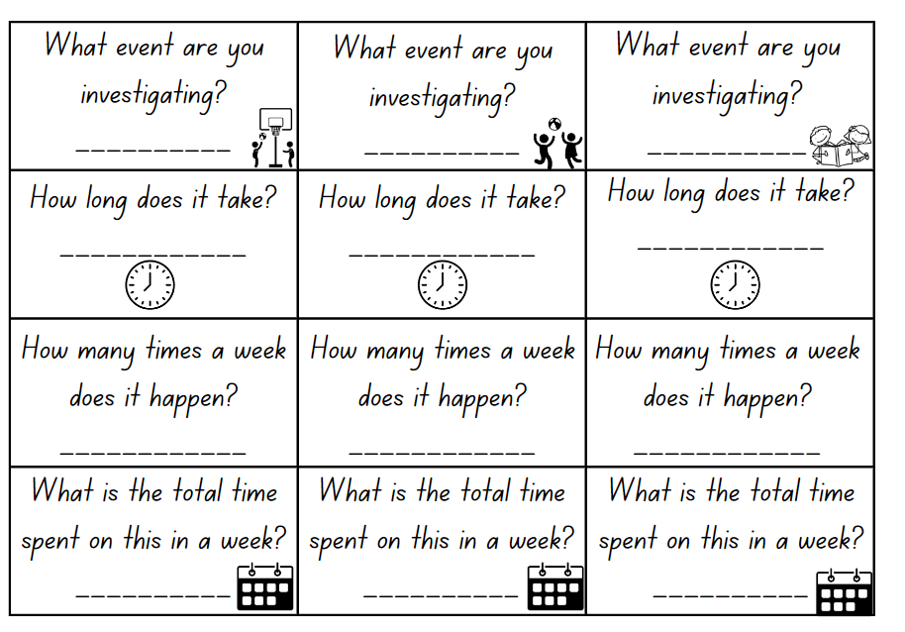
Images sourced from Canva and used in accordance with the Canva Content License Agreement.

Resource 6: Race from 200
‘Dice’ by creativepriyanka is used in accordance with the Canva Content License Agreement.

Resource 7: 200 number chart
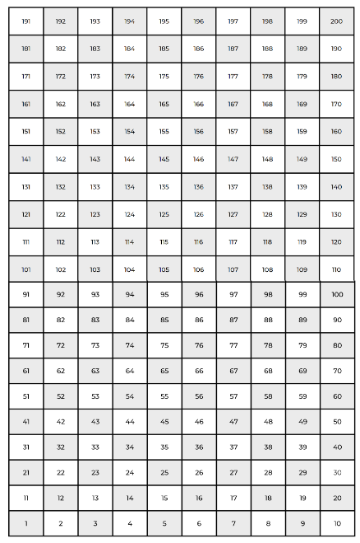

Resource 8: Number chart
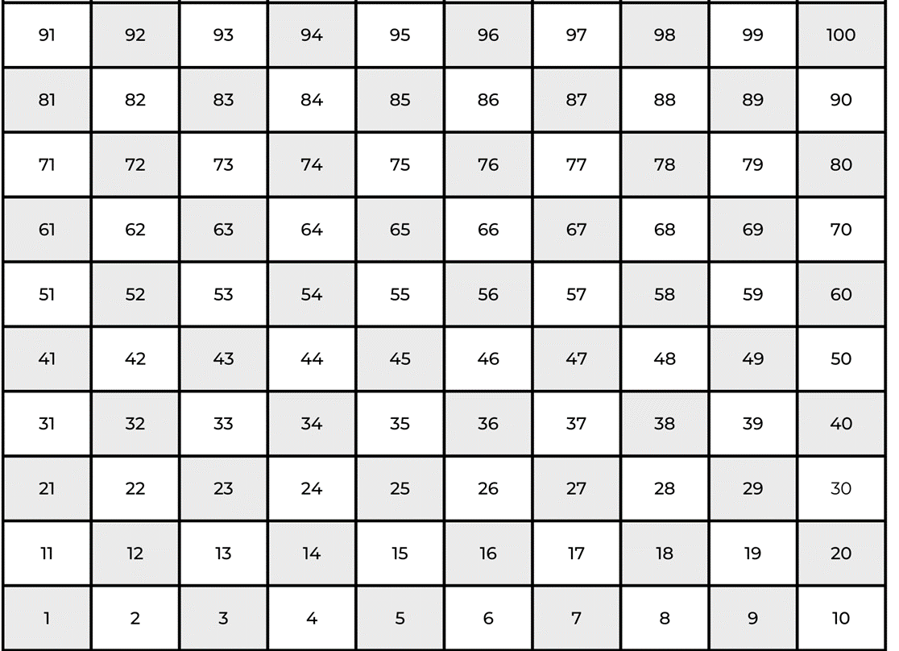

Resource 9: Bingo gameboard
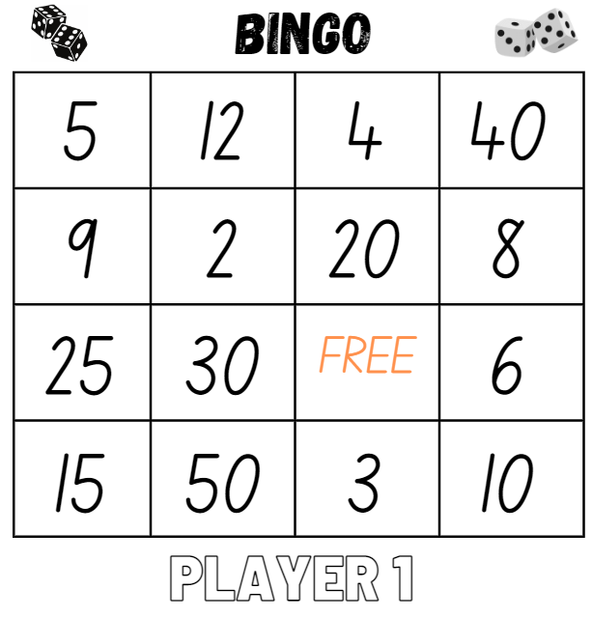
Images sourced from Canva and used in accordance with the Canva Content License Agreement.
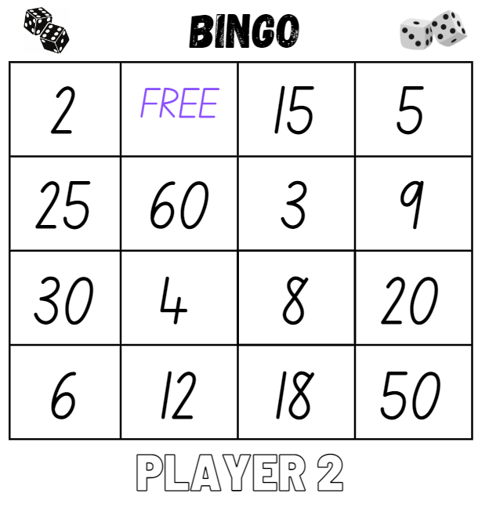
Images sourced from Canva and used in accordance with the Canva Content License Agreement.

Resource 10: Game cards
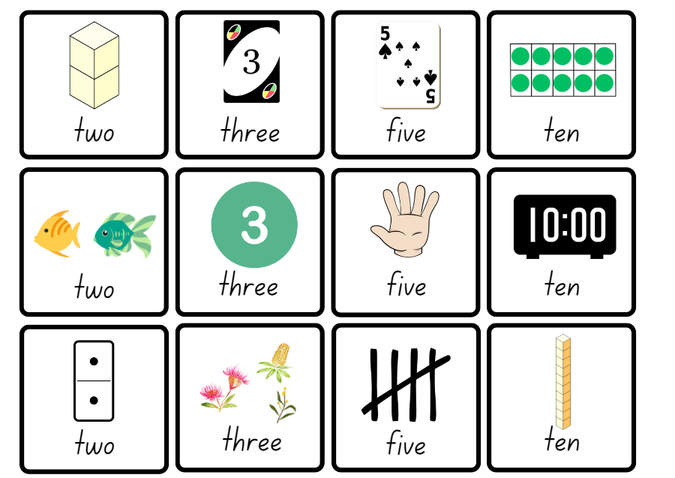
Images sourced from Canva and used in accordance with the Canva Content License Agreement.

Resource 11: Multiplication problems
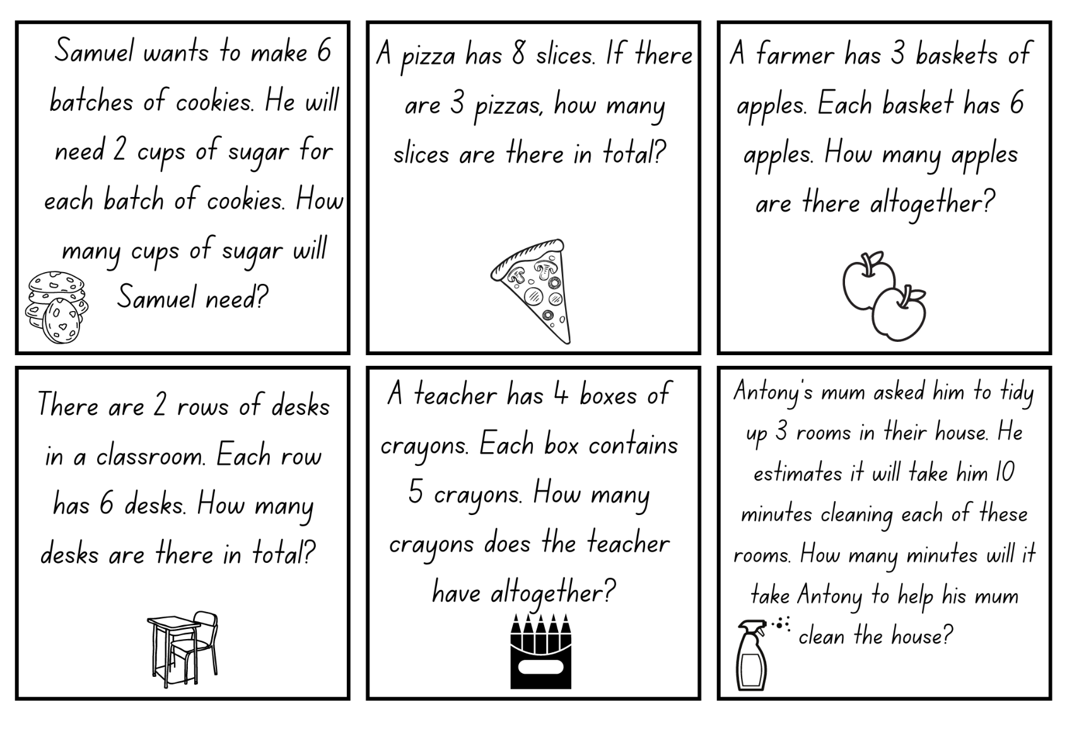
Images sourced from Canva and used in accordance with the Canva Content License Agreement.

Resource 12: Number cards
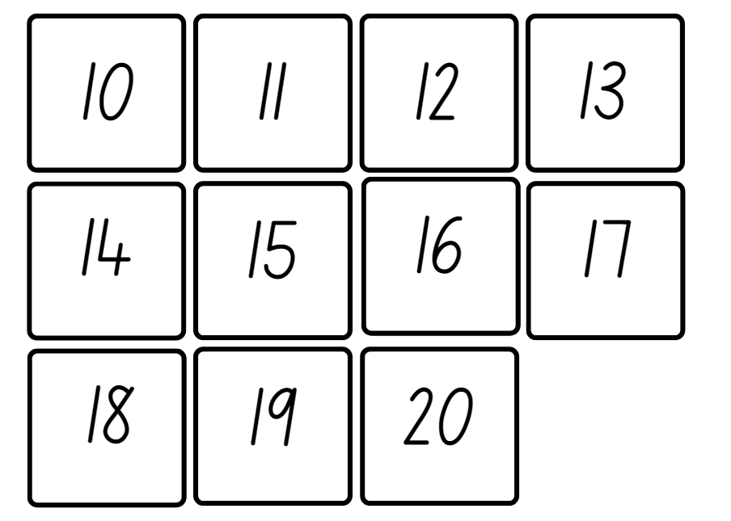

Resource 13: Recording sheet
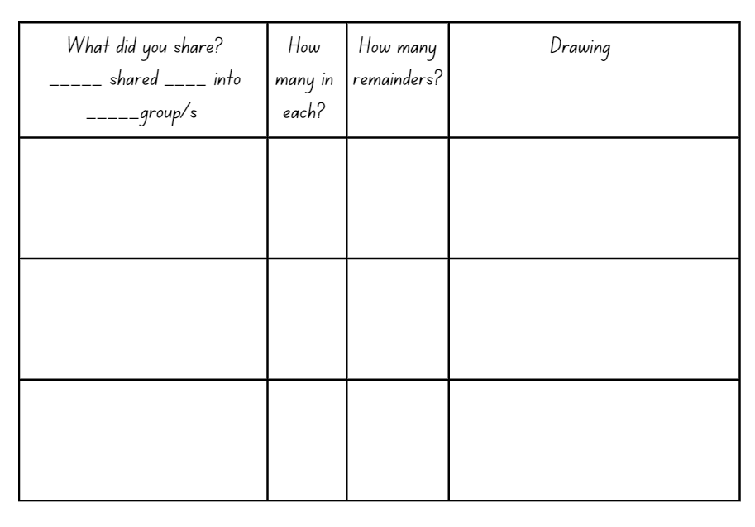

Resource 14: Division problems
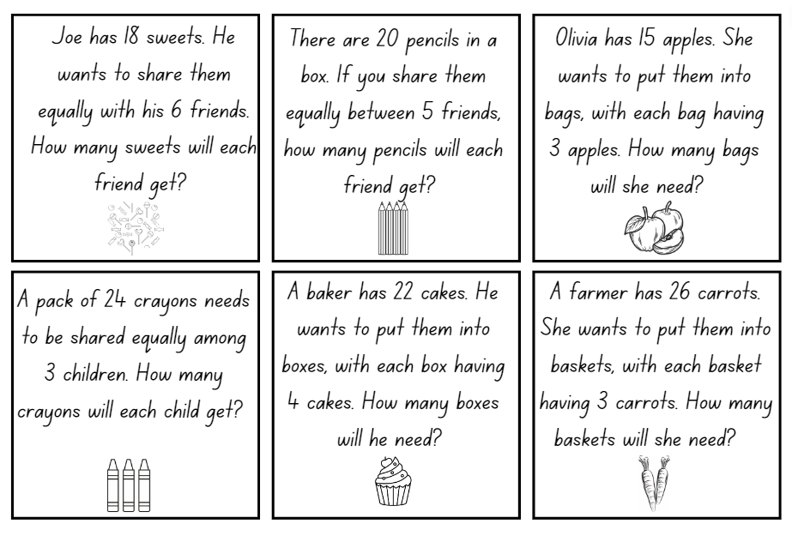
Images sourced from Canva and used in accordance with the Canva Content License Agreement.

Resource 15: Decorations catalogue
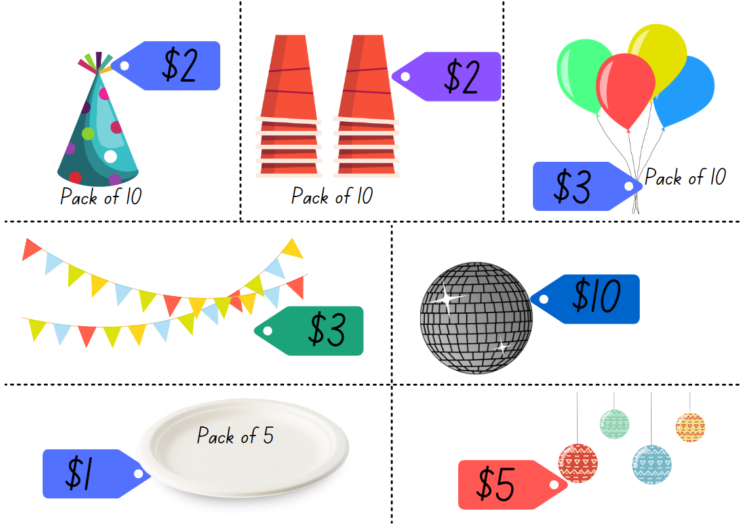
Images sourced from Canva and used in accordance with the Canva Content License Agreement.

Resource 16: Costing worksheet
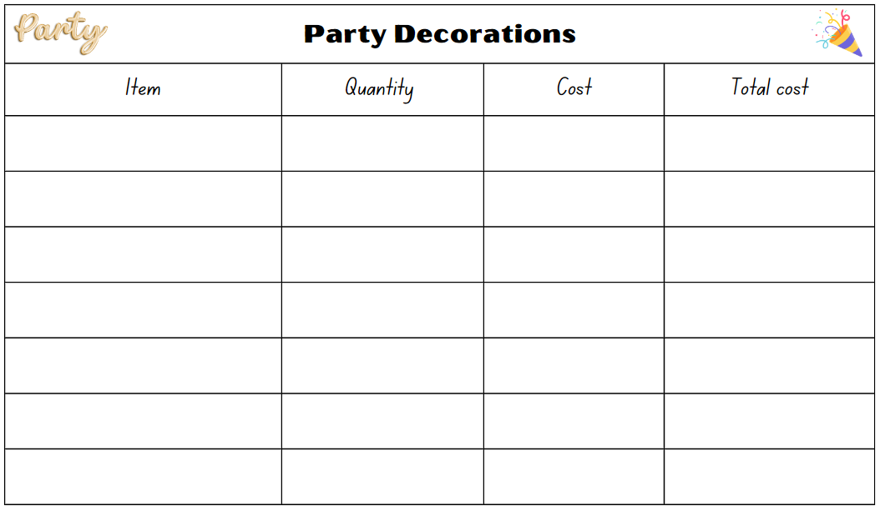
Images sourced from Canva and used in accordance with the Canva Content License Agreement.

Resource 17: Party food catalogue
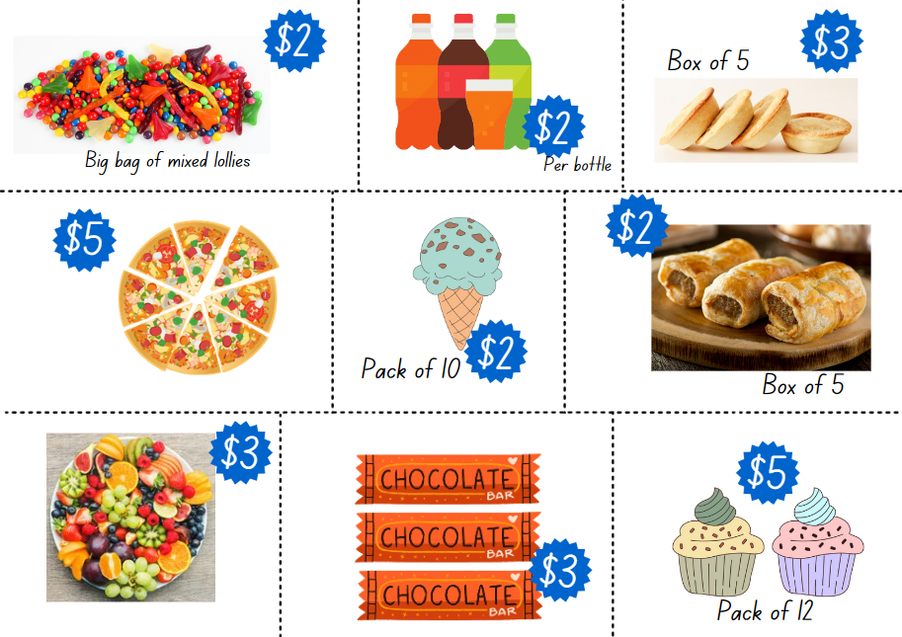
Images sourced from Canva and used in accordance with the Canva Content License Agreement.

Resource 18: Party food recording
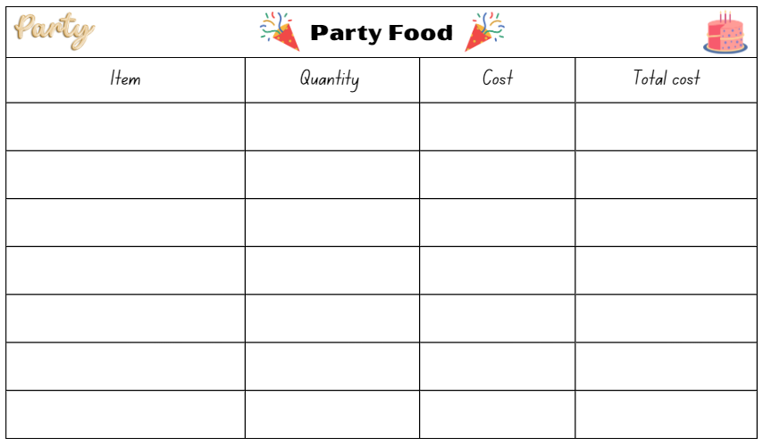
Images sourced from Canva and used in accordance with the Canva Content License Agreement.

Resource 19: Lolly bag catalogue
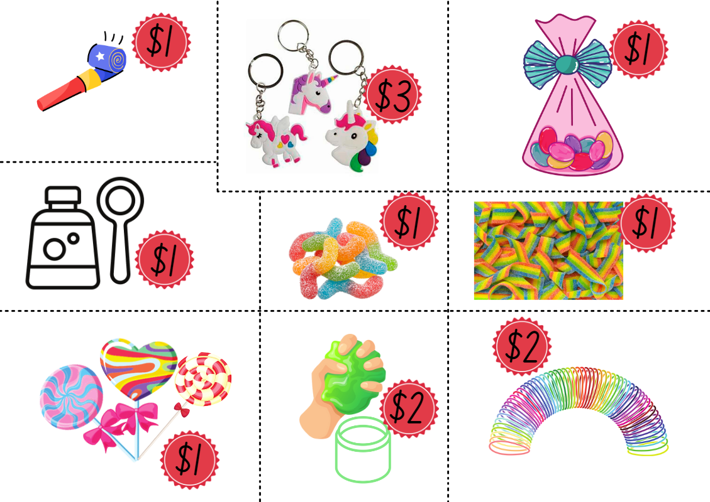
Images sourced from Canva and used in accordance with the Canva Content License Agreement.

Resource 20: Lolly bag recording
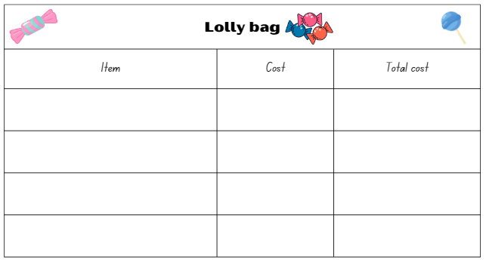
Images sourced from Canva and used in accordance with the Canva Content License Agreement.

Resource 21: Battleship gameboards
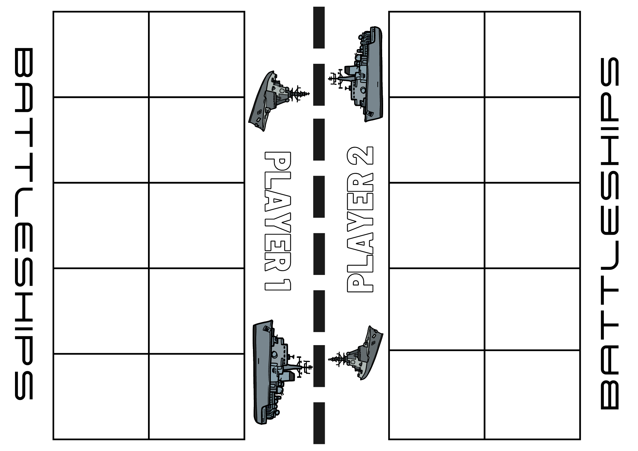
Images sourced from Canva and used in accordance with the Canva Content License Agreement.
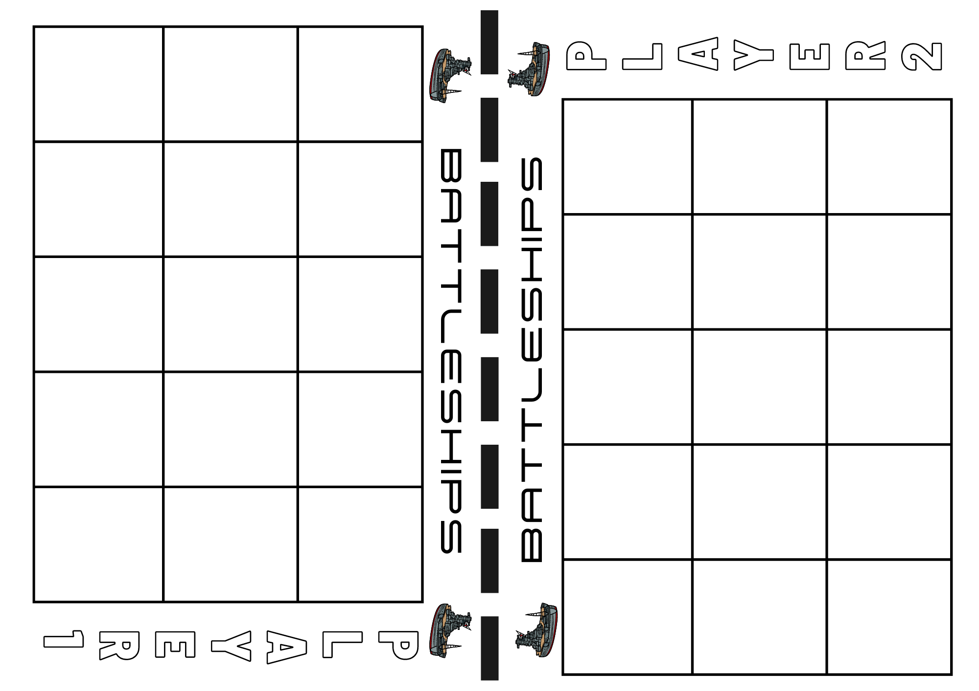
Images sourced from Canva and used in accordance with the Canva Content License Agreement.
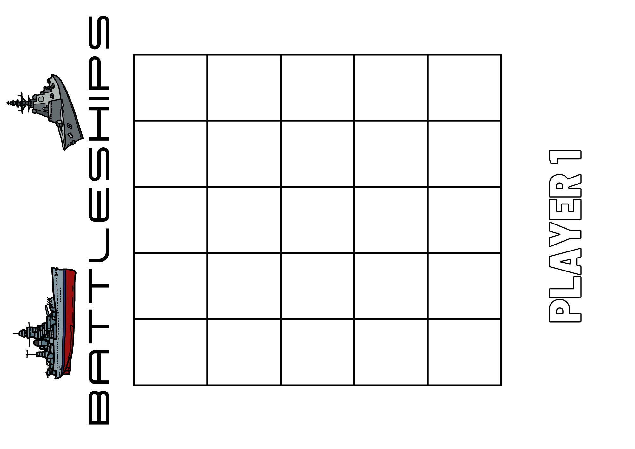
Images sourced from Canva and used in accordance with the Canva Content License Agreement.
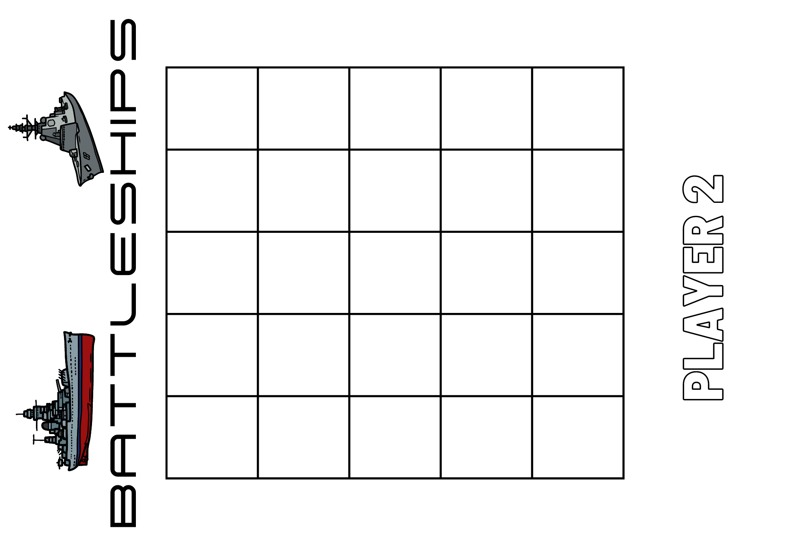
Images sourced from Canva and used in accordance with the Canva Content License Agreement.

Resource 22: Snail One Hundred
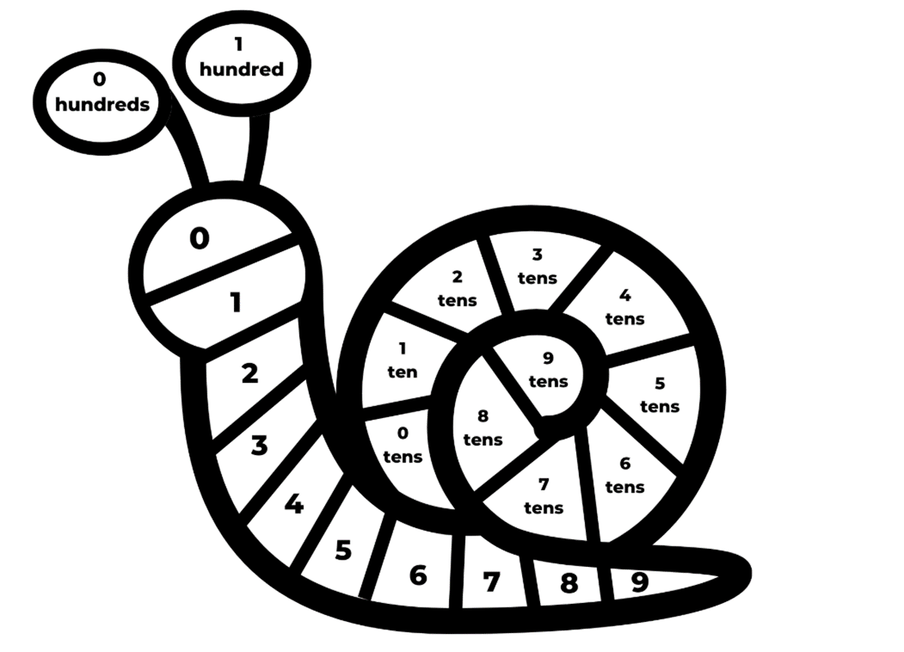
Images sourced from Canva and used in accordance with the Canva Content License Agreement.

Resource 23: Number line zero to 100
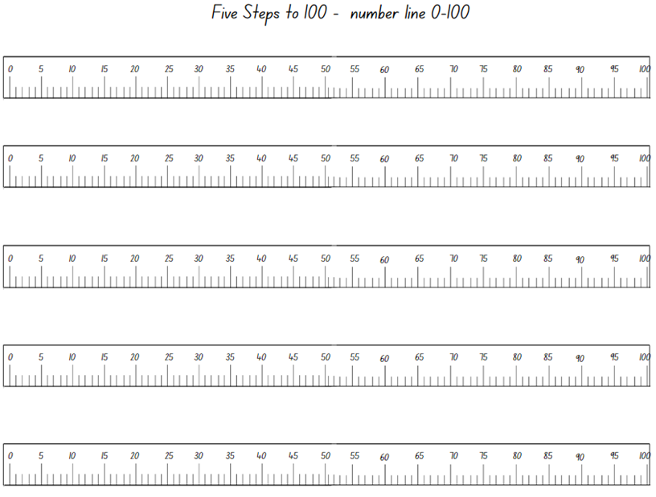
Images sourced from Canva and used in accordance with the Canva Content License Agreement.

Resource 24: Number line zero to 500
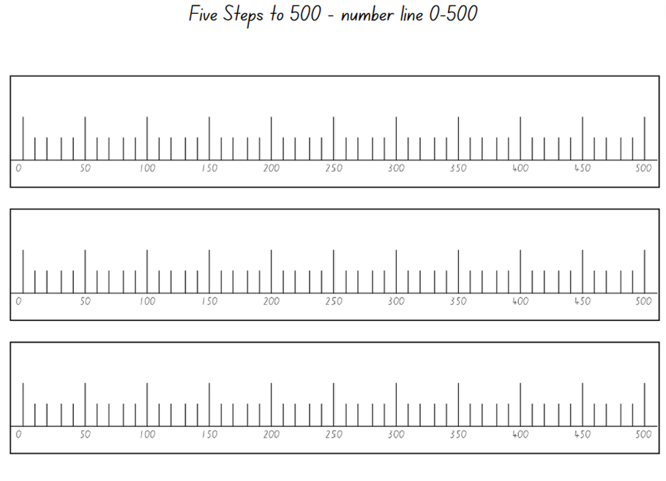
Images sourced from Canva and used in accordance with the Canva Content License Agreement.

Resource 25: Number cards
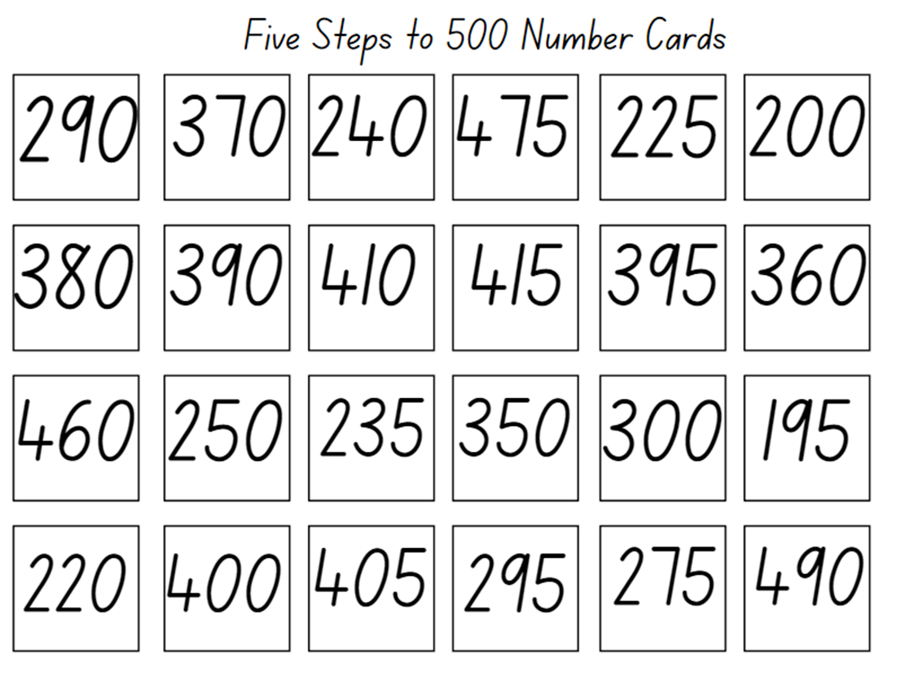

Syllabus outcomes and content
The table below outlines the syllabus outcomes and range of relevant syllabus content covered in this unit. Content is linked to National Numeracy Learning Progression version (3).
Focus area and outcomes | Content groups and content points | Lessons
Representing whole numbers A  MAO-WM-01  MA1-RWN-01  MA1-RWN-02 | Use counting sequences of ones with two-digit numbers and beyond  - Count forwards and backwards by ones from a given number to at least 120 (CPr6)  Represent numbers on a line  - Sequence numbers and arrange them on a line by considering the order and size of those numbers (CPr5)  - Locate the approximate position of multiples of 10 on a model of a number line from 0 to 100 (CPr5)  Represent the structure of groups of ten in whole numbers  - Recognise that ten ones is the same as one ten (NPV2, NPV4)  - Use number lines and number charts to assist with locating the nearest ten to a number | 5, 7, 8
Representing whole numbers B  MAO-WM-01  MA1-RWN-01  MA1-RWN-02 | Use counting sequences of ones and tens flexibly  - Identify how many more to the next multiple of ten within two- and three-digit numbers  Form, regroup, and rename three-digit numbers  - State the quantity value of digits in numbers of up to three digits (Reasons about quantity) (NPV5)  - Use place value to partition and rename three-digit numbers in different ways (Reasons about relations) (NPV5) | 1–3, 5–7
Combining and separating quantities A  MAO-WM-01  MA1-CSQ-01 | Use advanced count-by-one strategies to solve addition and subtraction problems  - Record number sentences in a variety of ways using drawings, words, numerals and symbols (AdS6)  - Fluently use advanced count-by-one strategies including counting on and counting back to solve addition and subtraction problems involving one- and two-digit numbers (Reasons about relations) (AdS3, AdS4, AdS5)  Use flexible strategies to solve addition and subtraction problems  - Use non-count-by-one strategies such as using doubles for near doubles and combining numbers that add to ten (AdS6)  - Select and apply strategies using number bonds to solve addition and subtraction problems with one- and two-digit numbers by partitioning numbers using quantity value and bridging to 10 (Reasons about relations) (AdS6, AdS7) | 3, 6–8
Combining and separating quantities B  MAO-WM-01  MA1-CSQ-01 | Represent and reason about additive relations  - Create, model and solve word problems, using number sentences  - Recall and use related addition and subtraction number facts to at least 20 (AdS7)  Form multiples of ten when adding and subtracting two-digit numbers  - Add two-digit numbers by building to multiples of ten (AdS7)  - Add and subtract from a two-digit number and record on an empty number line (AdS6, AdS7, AdS8)  - Use quantity values to separate tens and ones for addition (only) (AdS7, AdS8)  Use knowledge of equality to solve related problems  - Use number knowledge to solve related problems (Reasons about relations) (AdS7, NPA4)  - Use a variety of ways of writing number sentences (NPA3, NPA4) | 8
Forming groups A  MAO-WM-01  MA1-FG-01 | Model and use equal groups of objects to represent multiplication  - Model and describe collections of objects as groups of (MuS2)  - Determine and distinguish between the number of groups and the number in each group when describing collections of objects (Reasons about relations)  - Find the total number of objects using skip counting of equal groups of a known size (MuS2, MuS3)  Recognise and represent division  - Model sharing division by distributing a collection of objects equally into a given number of groups to determine how many in each group (InF2, MuS5)  - Model grouping division by determining the number of groups of a given size that can be formed (MuS5)  - Describe the part left over when a collection cannot be distributed equally using the given group size (MuS6) | 4–7
Forming groups B  MAO-WM-01  MA1-FG-01 | Represent and explain multiplication as the combining of equal groups  - Use objects, diagrams, images or actions to model multiplication as accumulating equal groups (MuS4)  - Solve multiplication problems using repeated addition (MuS4)  - Form arrays of equal rows and equal columns (MuS5)  - Determine and distinguish between the number of rows/columns and the number in each row/column when describing collections of objects (MuS5)  - Model the commutative property of multiplication, using an array (Reasons about relations) (MuS6)  Represent multiplication and division problems  - Solve multiplication and division problems using objects, diagrams, images and actions (MuS6, MuS7)  - Record answers to multiplication and division problems (including those with remainders) using drawings, words and numerals (MuS6) | 4–7
Geometric measure A  MAO-WM-01  MA1-GM-01 | Position: Follow directions to familiar locations  - Give and follow instructions to position objects in models and drawings (PoL2) | 8
Non-spatial measure B  MAO-WM-01  MA1-NSM-01  MA1-NSM-02 | Time: Describe duration using units of time  - Use a calendar to calculate the number of months, weeks or days until an upcoming event (MeT3)  - Use the terms ‘hour’, ‘minute’ and ‘second’ (MeT2, MeT3)  - Compare the duration of standard time units (MeT2, MeT3)  - Make predictions about the time remaining until a particular event starts or finishes (Reasons about relations) | 1, 2, 6

References
Links to third-party material and websites
Please note that the provided (reading/viewing material/list/links/texts) are a suggestion only and implies no endorsement, by the New South Wales Department of Education, of any author, publisher, or book title. School principals and teachers are best placed to assess the suitability of resources that would complement the curriculum and reflect the needs and interests of their students.
If you use the links provided in this document to access a third-party's website, you acknowledge that the terms of use, including licence terms set out on the third-party's website apply to the use which may be made of the materials on that third-party website or where permitted by the Copyright Act 1968 (Cth). The department accepts no responsibility for content on third-party websites.
Except as otherwise noted, all material is © State of New South Wales (Department of Education), 2023 and licensed under the Creative Commons Attribution 4.0 International License. All other material (third-party material) is used with permission or under licence. Where the copyright owner of third-party material has not licensed their material under a Creative Commons or similar licence, you should contact them directly for permission to reuse their material.
Mathematics K–10 Syllabus © 2022 NSW Education Standards Authority (NESA) for and on behalf of the Crown in right of the State of New South Wales.
© 2022 NSW Education Standards Authority. This document contains NSW Curriculum and syllabus content. The NSW Curriculum is developed by the NSW Education Standards Authority. This content is prepared by NESA for and on behalf of the Crown in right of the State of New South Wales. The material is protected by Crown copyright.
Please refer to the NESA Copyright Disclaimer for more information.
NESA holds the only official and up-to-date versions of the NSW Curriculum and syllabus documents. Please visit the NSW Education Standards Authority (NESA) website and the NSW Curriculum website.
National Numeracy Learning Progression © Australian Curriculum, Assessment and Reporting Authority (ACARA) 2010 to present, unless otherwise indicated. This material was downloaded from the Australian Curriculum website (National Numeracy Learning Progression) (accessed 30 March 2023) and was not modified. The material is licensed under CC BY 4.0. Version updates are tracked in the ‘Curriculum version history’ section on the 'About the Australian Curriculum' page of the Australian Curriculum website.
ACARA does not endorse any product that uses the Australian Curriculum or make any representations as to the quality of such products. Any product that uses material published on this website should not be taken to be affiliated with ACARA or have the sponsorship or approval of ACARA. It is up to each person to make their own assessment of the product, taking into account matters including, but not limited to, the version number and the degree to which the materials align with the content descriptions and achievement standards (where relevant). Where there is a claim of alignment, it is important to check that the materials align with the content descriptions and achievement standards (endorsed by all education Ministers), not the elaborations (examples provided by ACARA).
This resource contains images and content obtained from Canva, and their use outside of this resource is subject to Canva’s Content License Agreement. If you wish to use them separately from the resource, please go to Canva.
Australian Government Department of Education (2018) Authentic Problems: Tea Party, Mathematical Inquiry into Authentic Problems, reSolve: Maths by Inquiry website, accessed 30 March 2023.
Australian Government Department of Education (2023) reSolve: Maths by Inquiry [website], accessed 27 April 2023.
Didax, Inc (2023) ‘120 Number Board’, Virtual Manipulatives, Didax website, accessed 27 April 2023.
New Zealand Ministry of Education (n.d.) ‘Clock wise (time)’, Resource, NZ Maths website, accessed 30 March 2023.
New Zealand Ministry of Education (n.d.) ‘How long does it take?’, Resource, NZ Maths website, accessed 30 March 2023.
New Zealand Ministry of Education (n.d.) NZ Maths [website], accessed 27 April 2023.
Numeracy Teachers Academy Inc (2023) Numeracy Teachers Academy [website], accessed 27 April 2023.
Rogers A (3 August 2022) ‘Notice and Wonder’, Numeracy Teachers Academy: Dr Ange's Blog, accessed 30 March 2023.
State of New South Wales, Department of Education (n.d.) ‘Activities to Support Early Arithmetical Strategies: Race to 200’, Counting on-and-back Strategies, Developing Efficient Numeracy Strategies One website, accessed 27 April 2023.
State of New South Wales, Department of Education (n.d.) ‘Activities to Support Multiplication and Division: Rolling groups’, Counting on-and-back Strategies, Developing Efficient Numeracy Strategies One website, accessed 27 April 2023.
State of New South Wales, Department of Education (n.d.) ‘Activities to Support Multiplication and Division: Share it out’, Counting on-and-back Strategies, Developing Efficient Numeracy Strategies One website, accessed 27 April 2023.
State of New South Wales, Department of Education (n.d.) ‘Foreword’, DENS Introduction, Developing Efficient Numeracy Strategies One website, accessed 27 April 2023.
Toy Theater (2001–2023) Interactive Clock | Telling Time, Time Manipulatives, Toy Theater website, accessed 30 March 2023.
University of Cambridge (Faculty of Mathematics) (1997–2023) Five Steps to 50, NRICH website, accessed 30 March 2023.
University of Cambridge (Faculty of Mathematics) (1997–2023) NRICH [website], accessed 27 April 2023.
University of Cambridge (Faculty of Mathematics) (1997–2023) Snail One Hundred, NRICH website, accessed 30 March 2023.
University of Cambridge (Faculty of Mathematics) (1997–2023) Strike it Out, NRICH website, accessed 30 March 2023.

