Mathematics – Stage 1 – Unit 39
Contents
Unit description and duration 4
Student prior learning 4
Lesson overview and resources 5
Lesson 1: Inspecting 3D objects 11
Daily number sense: Numbers on a line – 10 minutes 11
Shapes and objects – 30 minutes 13
Consolidation and meaningful practice: Feature sort – 15 minutes 17
Lesson 2: Different points of view 19
Daily number sense: Numbers on a line – 10 minutes 19
Different points of view – 30 minutes 21
Consolidation and meaningful practice: Secret object – 15 minutes 24
Lesson 3: Making cubes 25
Daily number sense: Estimating – 10 minutes 25
Unfolding and folding faces – 40 minutes 27
Discussing the mathematics – 10 minutes 31
Lesson 4: Different objects, same volume 32
Daily number sense: Teacher choice – 10 minutes 32
Cube challenge – 30 minutes 33
Discussing the mathematics – 10 minutes 36
Lesson 5: Comparing models 37
Daily number sense: Facts about numbers – 10 minutes 37
Making models: Part 1 – 40 minutes 40
Consolidation and meaningful practice: What does it look like? – 10 minutes 41
Lesson 6: Packing in layers 42
Daily number sense: Jellybean challenge – 10 minutes 42
Packing and stacking: Part 1 – 10 minutes 44
Packing and stacking: Part 2 – 40 minutes 46
Consolidation and meaningful practice: Real life packing and stacking – 10 minutes 49
Lesson 7: Filling and pouring 50
Daily number sense: A lot of bricks – 10 minutes 50
Measuring and comparing: Part 1 – 20 minutes 51
Measuring and comparing: Part 2– 30 minutes 54
Discussing the mathematics: 5 minutes 58
Lesson 8: Investigating prisms and cubes 59
Daily number sense: Swap, steal, sit – 15 minutes 59
Investigating prisms and cubes: Part 1– 25 minutes 60
Investigating prisms and cubes: Part 2 – 20 minutes 62
Discussing the mathematics – 5 minutes 65
Resource 1: 2D Shapes and 3D Objects 66
Resource 2: Objects sort cards 67
Resource 3: Making cubes 68
Resource 4: Pasta shapes 71
Resource 5: Different packaging 72
Resource 6: Jellybean challenge 73
Resource 7: Cargo ships 74
Resource 8: A lot of bricks 75
Syllabus outcomes and content 76
References 82

Unit description and duration
This two-week unit develops student knowledge, understanding and skills with three-dimensional objects, volume and internal volume. Students are provided opportunities to:
- recognise that flat surfaces of 3D objects can be named as 2D shapes
- use mathematical vocabulary to name, describe and compare the features of 2D shapes and 3D objects
- deconstruct and construct prisms and cubes
- see how 3D objects can look different depending on the point of view as it is manipulated
- make and use a calibrated measuring device to measure and compare internal volume
- measure and compare volume of various 3D objects.
Mathematics K–10 Syllabus © 2022 NSW Education Standards Authority (NESA) for and on behalf of the Crown in right of the State of New South Wales.

Student prior learning
Before engaging in these teaching and learning activities, students would benefit from prior experience with:
- manipulating, exploring, sorting, drawing and naming various 2D shapes and 3D objects
- using mathematical vocabulary to describe and name various shapes and objects
- filling, packing and stacking various shaped containers and objects.

Lesson overview and resources
The table below outlines the sequence and approximate timing of lessons; syllabus focus areas and content groups; and resources.
Lesson | Syllabus focus area and content groups | Resources
Lesson 1: Inspecting 3D objects  55 minutes  3D objects have features which can be used to describe, identify and sort them. | Representing whole numbers A  - Represent numbers on a line  Representing whole numbers B  - Use counting sequences of ones and tens flexibly  Two-dimensional spatial structure  - 2D shapes: Recognise and classify shapes using obvious features  Three-dimensional spatial structure A  - 3D objects: Recognise familiar three-dimensional objects  - 3D objects: Sort and describe three-dimensional objects  Three-dimensional spatial structure B  - 3D objects: Describe the features of three-dimensional objects | - Resource 1: 2D shapes and 3D objects  - Resource 2: Object sort cards  - Empty number line  - Writing materials
Lesson 2: Different points of view  55 minutes  The faces you see on a 3D object can change depending on your point of view. | Representing whole numbers A  - Represent numbers on a line  Representing whole numbers B  - Use counting sequences of ones and tens flexibly  Two-dimensional spatial structure  - 2D shapes: Recognise and classify shapes using obvious features  Three-dimensional spatial structure B  - 3D objects: Describe the features of three-dimensional objects | - Resource 1: 2D shapes and 3D objects  - Common 3D objects  - Empty number line  - Large die  - Writing materials or digital devices
Lesson 3: Making cubes  60 minutes  3D objects commonly have faces that are 2D dimensional shapes. | Representing whole numbers B  - Form, regroup, and rename three-digit numbers  Three-dimensional spatial structure B  - 3D objects: Describe the features of three-dimensional objects | - Resource 3: Making cubes  - Resource 4: Pasta Shapes  - Resource 5: Different packaging  - Colour pencils  - Digital marble jar or collections of uniform objects  - Empty food boxes  - Scissors
Lesson 4: Different objects, same volume  50 minutes  Objects that appear different may have the same volume. | Three-dimensional spatial structure A  - Volume: Construct volumes using cubes  Three-dimensional spatial structure B  - Volume: Compare volumes using uniform informal units | - Small cubes or interlocking cubes
Lesson 5: Comparing models  60 minutes  When comparing volume, it is helpful to visualise, construct and deconstruct 3D objects. | Representing whole numbers B  - Use counting sequences of ones and tens flexibly  - Form, regroup, and rename three-digit numbers  Three-dimensional spatial structure A  - Volume: Construct volumes using cubes  Three-dimensional spatial structure B  - Volume: Compare volumes using uniform informal units | - Digital device  - Small cubes or interlocking cubes  - Writing materials
Lesson 6: Packing in layers  70 minutes  Internal volume can be explored by packing and stacking with no gaps. | Representing whole numbers A  - Represent the structure of groups of ten in whole numbers  Representing whole numbers B  - Use counting sequences of ones and tens flexibly  - Form, regroup, and rename three-digit numbers  Three-dimensional spatial structure A  - Volume: Measure the internal volume (capacity) of containers by packing  Three-dimensional spatial structure B  - Volume: Compare containers based on internal volume (capacity) by filling and packing | - Resource 6: Jellybean challenge  - Resource 7: Cargo ships  - Concrete materials  - Digital device  - Jar or container filled with jellybeans  - MAB materials  - Polypad by Mathigon  - Writing materials
Lesson 7: Filling and pouring  65 minutes  Containers can look different but can have the same internal volume. | Representing whole numbers A  - Represent the structure of groups of ten in whole numbers  Representing whole numbers B  - Form, regroup, and rename three-digit numbers  Three-dimensional spatial structure A  - Volume: Measure and compare the internal volumes (capacities) of containers by filling  Three-dimensional spatial structure B  - Volume: Compare containers based on internal volume (capacity) by filling and packing | - Resource 8: A lot of bricks  - Digital device  - Filling material, such as rice or sand or bird seed  - Permanent markers  - Plastic cups  - Small measuring containers, such as egg cup  - Various containers  - Writing materials
Lesson 8: Investigating prisms and cubes  65 minutes  The appearance of an object can affect the internal volume. | Representing whole numbers A  - use counting sequences of ones with two-digit numbers and beyond  Representing whole numbers B  - Form, regroup, and rename three-digit numbers  Two-dimensional spatial structure A  - 2D shapes: Recognise and classify shapes using obvious features  Three-dimensional spatial structure A  - 3D objects: Sort and describe three-dimensional objects  - Volume: Measure and compare the internal volumes (capacities) of containers by filling  Three-dimensional spatial structure B  - 3D objects: Describe the features of three-dimensional objects  - Volume: Compare containers based on internal volume (capacity) by filling and packing | - Calibrated measuring device from Lesson 7.  - Decks of cards  - Digital device  - Filling material, such as rice or sand or bird seed  - Modelling clay or wool  - Permanent markers  - Various boxes  - Writing materials

Lesson 1: Inspecting 3D objects
Core concept: Three-dimensional objects have features that can be used to describe, identify and sort them.
The table below contains suggested learning intentions and success criteria. These are best co-constructed with students.
Learning intentions | Success criteria
Students are learning that:  - mathematicians use specific vocabulary to name and describe the features of three-dimensional objects  - naming and recognising two-dimensional shapes helps to identify the faces of three-dimensional objects. | Students can:  - count forwards and backwards by tens, on and off the decade, with two- and three-digit numbers  - recognise and name familiar two-dimensional shapes and three-dimensional objects  - describe the features of three-dimensional objects, including using two-dimensional shapes to describe faces  - sort three-dimensional objects based on their features and justify their sorts.

Daily number sense: Numbers on a line – 10 minutes
- Build student understanding of counting in multiples of 10 by representing numbers on a number line.
- Draw a blank number line with 3 equally spaced missing numbers, such as Figure 1.
Figure 1 – Missing numbers
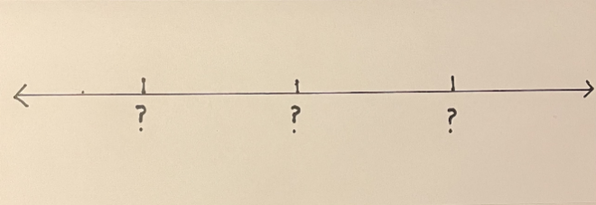
- Draw attention to the equal intervals between the marks on the number line. Discuss the significance of the equal intervals.
- Ask students to think about what numbers could be missing if they were counting in multiples of 10. Encourage students to think of two- and three-digit numbers on and off the decade, for example 10, 20, 30..., 42, 52, 62... 384, 394, 404.
- Students turn and talk and share ideas. Select students to share their responses and annotate the blank number line.
- Share examples where students are required to bridge across hundreds, for example 182, 192, 202.... Some students may be ready to bridge across 1000.
- Repeat the activity with students creating a new blank number line or erasing the previous numbers.
This table details assessment opportunities and differentiation ideas.
Assessment opportunities | Too hard? | Too easy?
What to look for:  - Can students count forwards and backwards by tens, on and off the decade, with two- and three-digit numbers? (MAO-WM-01, MA1-RWN-01).  - Can students bridge across the hundreds when counting by tens? (MAO-WM-01, MA1-RWN-01).  What to collect:  - observations of student counting. (MA1-RWN-01). | Students are not able to count by 10 on and off the decade.  - Provide numeral cards for the tens from 10 to 100. Ask students to arrange in the correct order and rehearse the counting pattern forwards and backwards.  - Provide a number line for students to copy and practice counting patterns forwards and backwards.  - Provide students with a number chart to 120. Use counters to mark each 10, then say the pattern aloud forwards and backwards. | Students can count by 10 on and off the decade.  - Students identify missing numbers if they were counting in multiples of 100, for example 200, 300, 400... or 457, 657, 757...  - Students identify missing numbers if they were counting in multiples of 100 and 10, such as 120, 230, 340...

Shapes and objects – 30 minutes
- Explain that students will be investigating 2D shapes and 3D objects. Share the definitions, using an example of each.
Two-dimensional: Having length and width only (with no depth).
Three-dimensional: Having length, width and depth.
- Brainstorm what 2D shape and 3D object names students already know. Record on an anchor chart for future reference.
- Display Resource 1: 2D shapes and 3D objects. Select students to match names from the class chart to the images on Resource 1. Note shapes or objects that are not known.
- Display a large cube, for example, a large die. Select a student to match the object to the image on Resource 1. Use everyday language to describe the die, including colour and the material it is made of.
- Explain that mathematicians have specific words that they use to describe the features of objects. Share the following definitions:
Face: A flat surface of a 3D object with only straight edges.
Edge: The line segment formed where 2 faces of a 3D object meet.
Vertex: The point where 3 or more faces of a 3D object meet.
- Model identifying the faces, edges and vertices on the cube. If necessary, model with other objects.
- Draw attention to the square faces on the large die. Explain that many 3D objects have 2D shapes on their faces. Refer again to Resource 1: 2D shapes and 3D objects. Students turn and talk to identify 2D shapes on the faces of 3D objects.
- Model tracing the faces of the die or representing the faces of the die on a geoboard, such as Figure 2.
Figure 2 – Faces on 3D objects
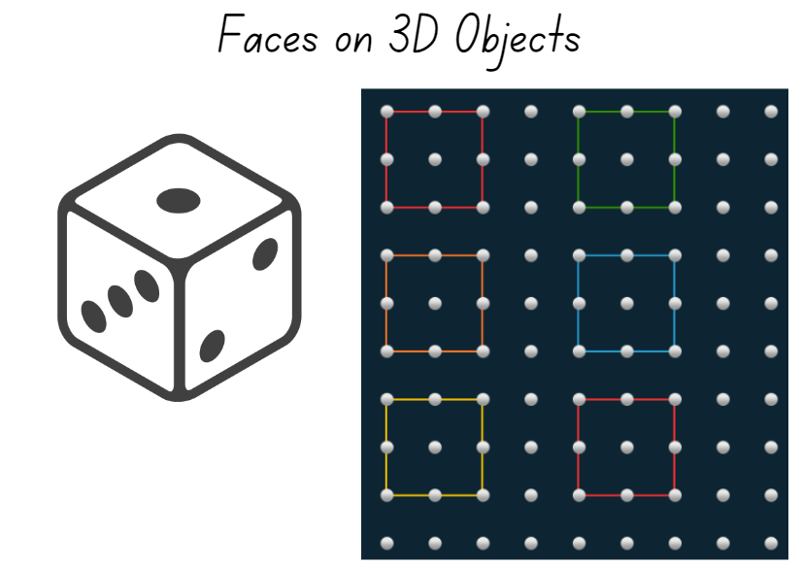
Images licensed under the Canva Content License Agreement.
Note: For Stage 1 students there is no need to trace in a systematic or ordered way, such as when creating a net pattern.
- Ask:
- What 2D shapes can you see and name?
- How can you keep track of all the faces on the object?
- How can you check that you have represented all faces on the object?
- Provide a broad collection of real-life 3D objects for students to explore. Students identify and represent the objects’ faces either by tracing or using geoboards. If using geoboards, students should use physical boards, if available, or digital boards if not. Students may also ‘print’ the faces of objects into modelling clay or kinetic sand.
- While students are recording faces, observe whether they can use the terms ‘face’, ‘edge’ and ‘vertex’ to correctly identify the features of 3D objects.
- Share student samples emphasising the link between the 2D shapes and the faces on 3D objects.
This table details assessment opportunities and differentiation ideas.
Assessment opportunities | Too hard? | Too easy?
What to look for:  - Are students able to identify and name the 2D faces of 3D objects? (MA1-2DS-01, MA1-3DS-01)  - Can students describe prisms using the terms ‘face’, ‘edge’ and ‘vertex’? (MA1-3DS-01)  What to collect:  - student drawings or photographs of 2D shapes (MA1-2DS-01, MA1-3DS-01)  - observations of students naming and using relevant vocabulary. (MA1-2DS-01, MA1-3DS-01) | Students are not able to identify and name 2D shapes and 3D objects.  - Provide labelled images of targeted 2D shapes and 3D objects for students to view and refer to.  - Guide students on how to trace or print and name the faces of one 3D object. | Students can identify and name 2D shapes and 3D objects.  - Introduce students to a wider range of prisms to explore and record.  - Ask students to identify patterns in the number of faces on a prism.  - Ask students to write ‘Who am I?’ clues using vertices, edges and faces for use in Lesson 2.

Consolidation and meaningful practice: Feature sort – 15 minutes
- Provide small groups of students with a range of 3D objects or pictures of 3D objects, for example Resource 2: Objects sort cards
- Instruct students to sort the objects into at least 2 groups based on their features (for example, faces, edges or vertices) and explain the reasoning for their sort. Ask:
- Can you find an object in the class that belongs in one of your groups? Why does it belong?
- Can you find an object in the class that does not belong in any of your groups? Why does it not belong?
- Is there an object whose features you are wondering about?
- Instruct groups to sort their objects in a different way and explain the new sort.
- Ask students to capture their sort on a digital device or draw it using writing materials. Students should annotate the image to explain their sort using the vocabulary from the lesson.
- Keep at least one image of a sort for use in Lesson 3.
This table details assessment opportunities and differentiation ideas.
Assessment opportunities | Too hard? | Too easy?
What to look for:  - Can students sort three-dimensional objects based on their features and justify their decisions using ‘vertex’, ‘edge’ and/or ‘face’? (MAO-WM-01, MA1-3DS-01)  What to collect:  - digital image or drawing of object sort and student annotations. (MAO-WM-01, MA1-3DS-01) | Students are not able to sort 3D objects.  - Provide 2 very different 3D objects. Ask students to identify the faces, edges and vertices of each object.  - Provide a simple sort using 4 objects with similar features. Give students a fifth object to add to the sort, explaining their choice. | Students can sort 3D objects.  - Challenge students to draw one of the selected objects from various points of view.  - Ask students to use a digital device and photograph 3 examples of three-dimensional objects in the classroom.  - Ask students to write 5 clues about one of the images (three-dimensional real-life object) and to give the challenge to a friend to solve.

Lesson 2: Different points of view
Core concept: The faces students see on a three-dimensional object can change depending on their point of view.
The table below contains suggested learning intentions and success criteria. These are best co-constructed with students.
Learning intentions | Success criteria
Students are learning that:  - mathematicians use specific vocabulary to name and describe the features of three-dimensional objects  - there are two-dimensional shapes as the faces of many three-dimensional objects  - identifying how many vertices, edges and faces helps to name the three-dimensional object. | Students can:  - count forwards and backwards by tens, on and off the decade, with two- and three-digit numbers  - recognise and name a variety of two-dimensional shapes and three-dimensional objects from various points of view  - describe the features of three-dimensional objects, by naming the two-dimensional faces and identifying the edges and vertices  - sort three-dimensional objects based on their features and explain their decisions.

Daily number sense: Numbers on a line – 10 minutes
- Build student understanding of counting in multiples of 10 by representing numbers on a number line.
- Asks students to orally count forwards and backwards by 10, on and off the decade.
- Draw a blank number line with number spaces unevenly distributed, such as Figure 3.
Figure 3 – Unevenly distributed boxes on a number line
- Draw students’ attention to the unequal intervals between the marks on the number line. Discuss the significance of the unequal intervals.
- Ask students to think about what numbers could be missing from the number line if they were counting in multiples of 10.
- Students turn and talk and share ideas about what the missing numbers might be, for example 10, 20, 30... 100 or 42, 52, 62... 112.
- Select students to share their responses and annotate on the blank number line. Encourage students to include their reasoning for numbers in the final position. Compare the relative size of the gap between student responses. Ask students how they could ‘prove’ their response was correct.
- Repeat the activity with students creating their own blank number line with unequal intervals or erasing the previous numbers.
This table details assessment opportunities and differentiation ideas.
Assessment opportunities | Too hard? | Too easy?
What to look for:  - Can students count forwards and backwards by 10 on and off the decade? (MA1-RWN-01)  - Do students sequence numbers and arrange them on a line by considering the order and size of those numbers? (MAO-WM-01, MA1-RWN-01)  What to collect:  - observations of student counting and reasoning. (MAO-WM-01, MA1-RWN-01) | Students are not able to count by 10 on or off the decade.  - Provide numeral cards for the tens from 10 to 100. Ask students to arrange in the correct order and rehearse the counting pattern forwards and backwards.  - Provide students with a number chart to 120. Students roll a 10-sided die to choose a starting number. Use counters to mark each additional 10, then say the pattern aloud forwards and backwards. | Students can count by 10 on and off the decade.  - Students count forwards and backwards by hundreds on and off the decade.  - Students count forwards and backwards by a combination of hundreds and tens, such as 120, 230, 340...

Different points of view – 30 minutes
This lesson has been adapted from Connecting 2D representations and 3D objects from Sullivan (2018).
- Display a large cube. Remind students of the definitions of face, edge and vertex.
Face: A flat surface of a 3D object with only straight edges.
Edge: The line segment formed where 2 faces of a 3D object meet.
Vertex: The point where 3 or more faces of a 3D object meet.
- Place the large cube on the centre of a table. Model drawing or photographing the object from different points of view, such as top view, front view, rear view and side view as you move around the object. Explain that you are drawing the 2D shapes you see on the face of an object by using the edges and the vertices of the face to guide you.
- Model visualising the object from underneath, explaining your reasoning aloud.
- Provide students with a range of 3D objects, including common household items such as tissue boxes, cereal boxes and cylindrical tins. Students can also make objects such as rectangular prisms from interlocking or small cubes.
- Students place an object on the centre of a table. Using a digital device or writing materials, students record an outline around the edges of each visible face from multiple points of view, such as top view, front view, rear view and side view. Students label the 2D shapes they can see.
- Ask students to visualise and draw the object as if they were viewing it from underneath. Prompt students to explain their reasoning for the 2D shapes that they record.
- Repeat the activity for at least one other object.
- Using a third and fourth object, have students remain in place and manipulate the objects to view and record the shape of each face. Students label each view. If the object is not easy to move, such as a collection of small cubes, ask students to visualise and record each face without moving themselves or the object.
- Select some students to share their recordings with the class. Ask:
- How did you see or imagine all faces accurately on an object?
- How do/did you know that the faces you visualised are a particular shape? What did you notice or focus on?
- How did you keep track of the number of faces on an object, including ones you cannot see? How do you know you are right?
- Can you tell what 3D object is drawn from the shape of the faces? How?
This table details assessment opportunities and differentiation ideas.
Assessment opportunities | Too hard? | Too easy?
What to look for:  - Do students recognise and name 2D shapes on flat surfaces of 3D objects? (MA1-3DS-01)  - Do students identify edges as the boundary for 2D shapes? (MA1-3DS-01)  - Can students manipulate 3D objects and name the faces, edges and vertices, counting these from different points of view? (MA1-3DS-01)  What to collect:  - images of faces that students have identified on 3D objects. (MA1-3DS-01). | Students are not able to represent 2D shapes on 3D objects.  - Provide modelling clay or kinetic sand. Have students press each face of the object into to reveal 2D shapes.  - Provide students with chalk or stickers to mark each face as they draw or print it. | Students can represent 2D shapes on 3D objects.  - Students arrange 3 to 4 3D objects together to draw or record the outlines of 2D shapes from multiple perspectives.  - Students use small cubes to make and sketch different objects that have exactly 12 faces.

Consolidation and meaningful practice: Secret object – 15 minutes
- Students select a 3D object and prepare ‘Who am I?’ clues for the class based on the faces, edges and vertices. For example:
- I have 8 vertices.
- I have 12 edges.
- I have 6 square faces.
- Who am I? A cube.
- Students read their clues one at a time for others to guess. Display Resource 1: 2D shapes and 3D objects and/or allow students to manipulate objects as the clues are read out. Ask students to justify their guesses by referring to face, edge and vertices.

Lesson 3: Making cubes
Core concept: Three-dimensional objects commonly have faces that are two-dimensional shapes.
The table below contains suggested learning intentions and success criteria. These are best co-constructed with students.
Learning intentions | Success criteria
Students are learning that:  - there are two-dimensional shapes as the faces of many three-dimensional objects  - three-dimensional objects can be represented by making simple models. | Students can:  - estimate, to the nearest 10 or 100, the number of objects in a collection and check by grouping and counting  - recognise and name the flat surfaces of three-dimensional objects as two-dimensional shapes  - represent three-dimensional objects by visualising features and making simple models  - describe rectangular prisms and cubes, using the terms ‘face’, ‘edge’ and ‘vertex’.

Daily number sense: Estimating – 10 minutes
- Build student understanding of whole number by developing strategies to estimate the number of objects within a large collection to the nearest 10 or 100.
Note: Students require a range of opportunities to develop the skills required to accurately estimate. Opportunities to practise estimating meets both mathematical and practical needs. Students need to refer to their knowledge of numbers, make comparisons and draw on what is familiar to understand what is unfamiliar, as well as judge the reasonableness of their estimation.
- Display the digital marble jar. Alternatively, provide a transparent jar or bag with a large collection of the same objects in a range that would challenge the students in your class to estimate.
- Model how the collections can be viewed from the side and rotated to be viewed from the top and bottom, assisting with visualising and calculating how many objects are within. Remind students that mathematicians refer to these views as front view, side view, rear view, top view (or bird’s eye view) and bottom view.
- Ask students to suggest strategies to determine how many marbles are in the jar. For example, students may suggest grouping the marbles into tens, or forming rows or columns of tens and considering the marbles that can’t be seen.
- Provide time for students to turn and talk to discuss their estimating strategies and results. Ask students:
- What is the most useful view to use first? Why is it useful?
- How many marbles do you estimate are in the front view of the jar? How did you estimate?
- If we turn the jar to the rear view, are there the same number of marbles as the front view? If so, how many would you estimate there are all together?
- How can you estimate how many marbles are in the centre of the jar, the view we can't clearly see?
This table details assessment opportunities and differentiation ideas.
Assessment opportunities | Too hard? | Too easy?
What to look for:  - Do students check estimates by grouping and counting by 10 (or more) or by using layers? (MAO-WM-01, MA1-RWN-02)  - Do students adjust their estimates based on additional evidence? (MAO-WM-01, MA1-RWN-02)  What to collect:  - observations about the reasonability of student estimates. (MA1-RWN-02) | Students are not able to group and count by 10.  - Provide a smaller collection to estimate and check, such as the bottom or side of the jar.  - Support students to use handfuls to estimate and compare their judgements. | Students can group and count by 10 (or more).  - Students estimate based on a single point of view, visualising other perspectives.  - Ask students to write a step-by-step guide for their peers of how to estimate a collection to 1000 accurately and efficiently.

Unfolding and folding faces – 40 minutes
Note: Prior to the lesson, ask students to bring in empty cardboard food boxes such as cereal or pasta boxes. Prepare one box so that it is easy to unfold into 6 rectangles. As many food packets have flaps at the top, it may be necessary to tape the flaps shut to keep the top as one rectangular face of the prism. For Stage 1 students, it is not necessary to identify the unfolded shape as a net, but to see that the 3D object is made from 2D rectangular shapes.

Part 1 – Unfolding boxes
- Display Resource 1: 2D Shapes and 3D Objects from Lesson 1 to revise definitions of the features and names of 3D objects. If available, display an image of a student sort from Lesson 1 and discuss the basis for the sort.
- Explain that in this lesson students will focus on the features of rectangular prisms, including cubes.
- Display a food box. Examine the box from different views. Select students to identify each face of the box as well as the edges and vertices. Name the box as a rectangular prism.
- Model how to cut the box along edges of the box to open it out. Model how to colour each of the rectangular faces in a different colour, as in Figure 4.
Figure 4 – Unfolding a box
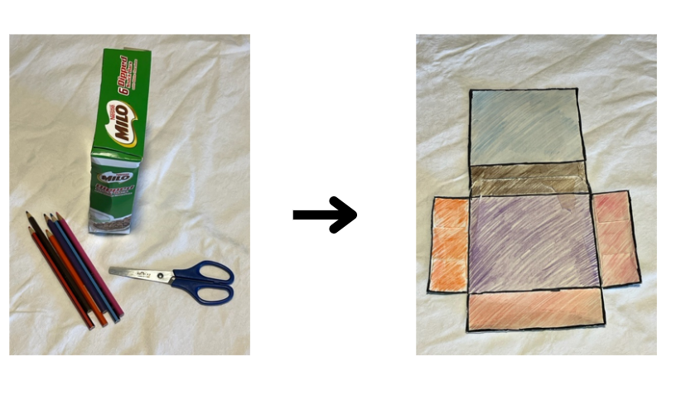
- Provide equipment for students to cut the edges, open the boxes and colour the faces. Instruct students to practice folding and unfolding the boxes. Ask:
- What do you notice?
- How can you prove that this is still can make a prism or a cube?
- If you reposition, flip or turn your unfolded box or look at it from a different point of view, is it still a prism or cube?
- What is the same and/or different if you reposition, flip, or turn your unfolded box?
- Collect the unfolded boxes for future use in Lesson 6 – Part 1.

Part 2 – Folding cubes
Note: This lesson has been adapted from Moss et al. (2021). It is an exploratory introduction to the idea of nets, which are part of Stage 2 outcomes and content, see MA2-3DS-01. Hexomino is the name for a 6-square arrangement where the squares are aligned along at least one common edge. There are 35 hexomino configurations, only 11 of which can be folded to create cubes. Give students the opportunity to fold hexominoes. The language and hand gestures students use when folding can support them to visualise whether a hexomino will fold into a cube. Stage 1 students are not expected to use the terms hexomino or net.
- Display Resource 3: Making cubes. Explain that these shapes represent unfolded cubes, like the unfolded box from Part 1 of the lesson. Display a cube and identify 6 square faces.
- Model how to cut around the outline of each hexomino, emphasising that you do not want to cut out each square.
- Model how to fold on the lines to make a cube. Explain that the lines will become edges. Make an explicit connection between the feature of prisms and cubes and what students will see on the hexomino and the unfolded box.
- Provide students with copies of Resource 3: Making cubes and scissors. Instruct students to cut out the hexominoes (around the outline only) and then fold them to make cubes. As students make the cubes, observe the language and gestures used by students as they fold, such as ‘fold it in’, ‘fold it out’, ‘fold this first, then that’, ‘turn it this way’.
This table details assessment opportunities and differentiation ideas.
Assessment opportunities | Too hard? | Too easy?
What to look for:  - Do students visualise and describe 3D objects using appropriate gestures and language? (MAO-WM-01, MA1-3DS-01)  - Can students recognise and name 2D shapes on flat surfaces of 3D objects? (MA1-3DS-01)  - Can students make models of cubes? (MAO-WM-01, MA1-3DS-01)  What to collect:  - observations of student deconstruction and construction of prisms and cubes, focusing on edges, face, and vertices. (MAO-WM-01, MA1-3DS-01) | Students are not able to make cubes from hexominoes.  - Provide students with small boxes to deconstruct and cut out each face, identifying how many faces there are altogether.  - Provide students with further opportunities to fold shapes into objects, providing support for explicit language and gestures. | Students can make cubes from hexominoes.  - Show students Resource 4: Pasta shapes. Explain that they are to select one type of pasta and create an eye-catching container that is not a cube or prism. Ask students to explain the benefits and issues with their container.  - Show students Resource 5: Different packaging. Ask students to compare the two 3D objects and respond to some of the questions.

Discussing the mathematics – 10 minutes
- Display an unfolded box and 3 different hexominoes. Ask:
- What do you see?
- What do you wonder?
- Did it matter where you started when folding the cubes? Why or why not?
- Why do you see so many prisms and cubes in the supermarket?
- What other 3D objects have you seen at the supermarket?
- What is an unusual 3D object you do not commonly see at the supermarket? Why is that?
- What is a 3D object that you never see at the supermarket?

Lesson 4: Different objects, same volume
Core concept: Objects that appear different may have the same volume.
The table below contains suggested learning intentions and success criteria. These are best co-constructed with students.
Learning intentions | Success criteria
Students are learning that:  - the volume of three-dimensional objects can be measured in uniform informal units  - three-dimensional objects can appear different but have the same volume. | Students can:  - explore, create and compare three-dimensional objects of different appearances from a given number of cubes  - manipulate the orientation of three-dimensional objects.

Daily number sense: Teacher choice – 10 minutes
- From a class need surfaced through formative assessment data, identify a short, focused activity that targets students’ knowledge, understanding and skills. Example activities may be drawn from the following resources:
- Thinking Mathematically Stage 1
- Universal Resources Hub.

Cube challenge – 30 minutes
Note: In each of the following cube activities, cubes must be placed or stacked so that their edges align directly with the edges of at least one other cube, with no gaps or overlaps. When making objects from 3 cubes, there are only 2 possible solutions. When using 4 cubes there are 8 possible solutions (see Figure 5). If you are using cubes that do not interlock, ensure students understand that each cube must line up with the adjacent cube, so all the edges are flush.
Figure 5 – Cube configurations
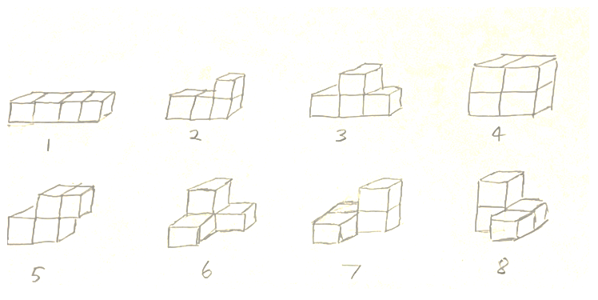
- Remind students of the definition of volume.
Volume: The amount of space occupied by an object.
- Explain that in this lesson students will measure and compare volume by using cubes.
- Provide each student with 3 cubes and ask them to make a 3D object. Ask students to calculate the volume of the 3D object.
- Provide students with 3 more cubes and challenge them to make another 3D object with a different appearance. Ask students to calculate the volume of their new 3D object. Students place their 3D objects side-by-side. Assist students to draw the conclusion that the 3D objects look different yet have the same volume.
- Provide students with 3 more cubes and ask whether they can make another 3D object with a different appearance.
- Ask students if they were able to make a third 3D object. Students who think they have made a third 3D object, share their object with the class.
Note: At this point, some students might realise that it is not possible to build a third unique 3D object with only 3 cubes.
- Invite students to share their third 3D object with the class. Challenge them to change the orientation of the 3D object so that they can draw the conclusion that only 2 unique 3D objects can be made with 3 interlocking cubes. When the 3D object is reflected or turned, they are identical in structure.
- Show students 4 interlocking cubes and ask if they think the volume has changed.
- Ask students to imagine how many different 3D objects they might be able to build. Students share their thinking.
- Give students a collection of cubes and challenge them to make as many unique 4 cube 3D objects.
Note: Some students might need reminders that two 3D objects are the same despite their orientation.
- When students have at least 5 structures, have students display their work and go on a gallery walk. Ask:
- Did anyone else get a different combination to you?
- As a class, do you think we have all the combinations?
- How can we check if two 3D objects are the same?
- Did increasing the volume allow you to build more structures? Why?
- As a class, work together to eliminate any duplicate structures so that only 8 unique 3D objects remain. Keep the eight 3D objects on display with the 2 three-block objects.
This table details assessment opportunities and differentiation ideas.
Assessment opportunities | Too hard? | Too easy?
What to look for:  - Are students able to create and compare 3D objects of different appearances from a given number of cubes? (MAO-WM-01, MA1-3DS-01, MA1-3DS-02)  - Can students manipulate the orientation of their 3D objects to compare objects of the same volume? (MAO-WM-01, MA1-3DS-01, MA-3DS-02)  What to collect:  - photographs of student made objects on display in the gallery walk. (MAO-WM-01, MA1-3DS-01, MA-3DS-02) | Students are not able to make different models or have difficulty comparing different objects.  - Provide 3 to 5 different objects for students to copy.  - Provide 2 identical objects. Show students that by turning or reflecting the object, they can appear different. | Students can make different models and can compare different objects.  - Ask students to explore and record as many objects as they can using 5 cubes, in preparation for Lesson 5.  - Draw the most interesting object they created from 5 cubes.

Discussing the mathematics – 10 minutes
- Looking at the collection of 3 and 4 cube objects ask:
- Did increasing the volume change the number of unique 3D objects?
- Does the volume change if a 3D object looks different?
- Were certain objects easier or more difficult to build? Why?
- How could you describe your 3D object?
- What are you still wondering?

Lesson 5: Comparing models
Core concept: When comparing volume, it is helpful to visualise, construct and deconstruct 3D objects.
The table below contains suggested learning intentions and success criteria. These are best co-constructed with students.
Learning intentions | Success criteria
Students are learning that:  - three-dimensional objects can be described by their features  - objects can have the same name but be a different size. | Students can:  - describe three-dimensional objects using the terms ‘face’, ‘edge’ and ‘vertex’  - make simple models of three-dimensional objects to compare volume and record results using drawings, numerals and words  - compare models with different appearances, recognising when they have the same volume.

Daily number sense: Facts about numbers – 10 minutes
- Build student understanding of three-digit numbers and place value by comparing numbers.
- Display the numbers 241, 889 and 465. Ask students to share what they can see and what they know about numbers as they compare and explore the 3 numbers.
Prompts | Anticipated student responses
- What are you thinking?  - What is the same about these numbers?  - What is different?  - What are some different ways we can name these numbers?  - Which number is the biggest? How do you know?  - Which number has the smallest tens value?  - If we added some extra tens, which number would jump to the next hundreds first? Why?  - Can you name the number that is 10 more than each of the numbers? 100 more?  - Is there anything interesting after you have added an extra 100?  - Which number does not belong in the group? Why? | - They are not in order from the smallest number to the largest number.  - In each number, the last digit is odd and the first number is even.  - 4 is in 2 numbers and 8 is repeated in one number.  - If you combine the 3 digits, for example, 2 and 4 more and one more is 7, then 8 and 8 more and 9 more is 25. 2 and 5 is also 7. But 4 and 6 more and 5 more is only 15, and one and 5 is 6. So, this one is different.  - If you order the numbers, the first digit doubles each time. For example, 2 then 4 then 8.  - 889 is the biggest number because it is 8 hundreds.  - You can say ‘2 hundred and forty-one’ or 24 tens and one or 241 ones.  - If you added 2 tens to 889 you would have 909.  - 251, 899, 475.  - 341, 989, 565.  - 341 is the odd number now because the other numbers have the same digit at the start and end.
- Discuss as a class and record student responses. Provide opportunities for students to share ideas and feedback about the recordings.
- Repeat the task using 3 new three-digit numbers, providing students with writing materials to record their ideas. Discuss.
This table details assessment opportunities and differentiation ideas.
Assessment opportunities | Too hard? | Too easy?
What to look for:  - Can students identify the next multiple of 10 in 3-digit numbers? (MA1-RWN-02)  - Do students identify and name the place value of each number in 3-digit numbers? (MA1-RWN-02)  What to collect:  - anecdotal recordings of student's reasoning. (MA1-RWN-02) | Students are unable to partition and rename three-digit numbers.  - Provide students with three-digit numbers and bundles of craft sticks.  - Use a place value chart and MAB materials to model and support regrouping of simple three-digit numbers. | Students can partition and rename three-digit numbers.  - Students select 3 three-digit numbers and create a challenge for a partner to solve.  - Ask students to find all the three-digit numbers that equals 7 when each digit is added.

Making models: Part 1 – 40 minutes
- Refer to the 8 objects made from the four-block challenge in Lesson 4.
- Ask if increasing the volume to 5 interlocking cubes will change the number of 3D objects that can be created. Students turn and talk and then share their thinking with the class. Record predictions of the number of objects that can be created.
- Select 3 students to build one object each from 5 cubes to start a class collection. Remind students that objects can appear different, though the number of cubes and the volume remains the same. Compare the 3 objects to establish that they are all different. Modify objects if they are identical. Use these 3 objects to start a class collection to be added to.
- Provide students with interlocking cubes to build as many different 3D objects as possible with a volume of 5 cubes. Each time a student thinks they have built a unique 3D object they check it against the class collection. If an object has not been created, it is added to the collection. If it has been created, students try to build another 3D object.
- During the task, observe strategies and ask students if they have fewer or more models than the predicted number.
- Ask students to display their most interesting model on the desk. Provide time for students to view all models. Select students to explain what makes their model interesting or to identify another model they find interesting.
This table details assessment opportunities and differentiation ideas.
Assessment opportunities | Too hard? | Too easy?
What to look for:  - Can students compare the volume of 2 models and identify if the volume is the same or different? (MAO-WM-01, MA1-O3DS-02)  - Do students communicate their reasoning and explain their volume comparisons using drawing, words or numerals? (MAO-WM-01, MA1-3DS-02)  What to collect:  - photographs and annotated work samples. (MAO-WM-01, MA1-3DS-02) | Students are not able to compare volume using 2 different models.  - Provide students with one simple model using 2 to 3 cubes and support students to identify the volume or space needed.  - Model volume using everyday items and ask students to order the items from least to most volume. | Students found solutions to the volume problem and recorded results accurately.  - Provide students with additional cubes to problem solve and find a model that has double the volume of the first model.  - Ask students to arrange 6 or more models in a logical order or pattern and to record and share their reasoning.

Consolidation and meaningful practice: What does it look like? – 10 minutes
- Provide pairs of students with cubes and explain that the answer to a volume question is 11. Ask what the model might look like. Encourage students to come up with as many different options in 5 minutes.
- Select students to share their model ideas and prove that the volume is 11.

Lesson 6: Packing in layers
Core concept: Internal volume can be explored by packing and stacking with no gaps.
The table below contains suggested learning intentions and success criteria. These are best co-constructed with students.
Learning intentions | Success criteria
Students are learning that:  - internal volume can be measured using uniform informal units  - internal volume can be compared and ordered. | Students can:  - pack cubes into containers so that there are no gaps  - estimate and measure the internal volume of a container  - select appropriate informal units to measure internal volume.

Daily number sense: Jellybean challenge – 10 minutes
- Build student understanding of estimating to the nearest hundred by exploring a jar of jellybeans.
- Display Resource 6: Jellybean challenge or a real jar of jellybeans. State that there are 220 jellybeans in the jar. You are wondering how this can be proven without opening the jar and counting the jellybeans by ones.
- Allow time for students to turn and talk with a partner and to view and handle the jar of jellybeans. Observe suggested strategies and how students are grouping the jellybeans in order to count the large collection. If needed, interrupt the discussions and ask:
- Do you agree that there are approximately 200 jellybeans? How do you know?
- How can you estimate and count this large collection more efficiently than counting by ones?
- Provide student pairs with writing materials. Ask students to record their ideas with drawings for sharing with the class.
- As a class, share strategies and discuss solutions. Ensure that students can support their solutions with drawings that represent the jellybeans as groups of tens (see Figure 6).
Figure 6– Jellybean challenge
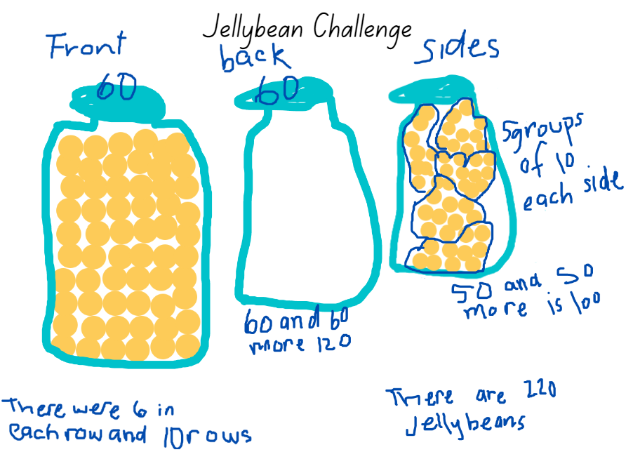
This table details assessment opportunities and differentiation ideas.
Assessment opportunities | Too hard? | Too easy?
What to look for:  - Do students use groups of 10 to count a large collection? (MAO-WM-01, MA1-RWN-02)  - Can students recognise a group of 100 as ten groups of 10? (MAO-WM-01, MA1-RWN-02)  - Can students draw and write representations of solutions showing organised groups of tens and hundreds? (MAO-WM-01, MA1-RWN-02)  What to collect:  - photographs and recordings of students' solutions. (MAO-WM-01, MA1-RWN-02) | Students are unable to count a large collection by grouping in tens.  - Provide students with a container holding 50 coloured bricks and ask students to group these into groups of 10, supporting students to skip count by tens.  - Ask students to circle groups of 10 jellybeans and use concrete materials to represent each group. Support students to skip count by tens. | Students can use groups of 10 to systematically count a large collection.  - Ask students to explore how many different arrays they can create to show the total number of 220 jellybeans.  - Ask students if there would be more or less than 220 if the jar were filled with were Skittles or Smarties. Prompt students to explain how they know.

Packing and stacking: Part 1 – 10 minutes
- Display MAB materials.
- Model how the ‘long’ is made of 10 ones stacked. Explain that 10 ones is equal to one 10. Ask students to count.
- Show students a ‘flat’ and explain that it is a representation of 100. Select students to prove this by layering longs. Ensure that students understand that there are 10 ones in each long as they are placed side by side over a flat. As a class, skip count by tens as each long is placed on the flat.
- Show students a MAB cube and explain that it represents 1000. Display all the faces of the cube, drawing particular attention to how each face looks like a ‘flat’.
Note: Some students mistakenly think that a MAB cube has a value of 600, calculated by only counting each face of the cube.
- Refer to the invisible internal layers of flats within the cube, explaining that each flat is 100. Select students to prove this by layering flats as students skip count by hundreds to 1000. Compare the size of the MAB cube to the cube constructed from flats.
- Ask students to use what they know about the cube (that it contains 1000 units) to calculate the volume.
- Record student responses on an anchor chart titled ‘Volume of a cube’ (see Figure 7).
Figure 7– Example of an anchor chart
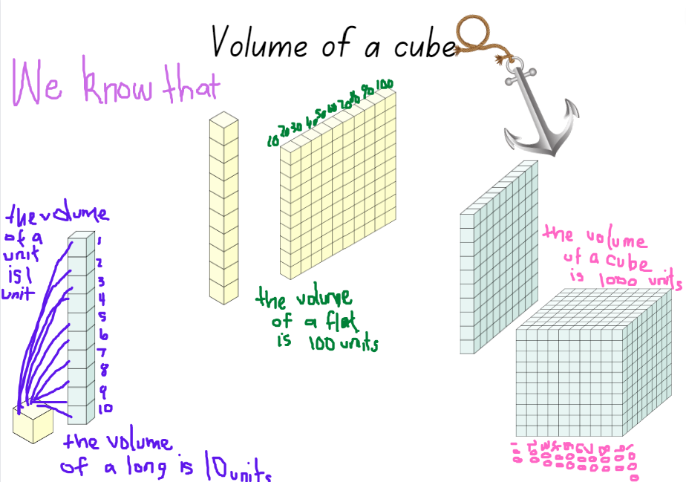
Images licensed under the Canva Content License Agreement.

Packing and stacking: Part 2 – 40 minutes
- Explain that students will pack and stack small cubes to explore the internal volume (capacity) of the models they made in the ‘Unfolding boxes’ activity in Lesson 3 – Part 1.
- Provide students with MAB units, a digital device and/or writing materials to record their investigations. Ensure students understand that the units must be packed with no gaps or spaces. ‘Longs’ and ‘flats’ might also be appropriate for stacking and layering, especially if students have a large box.
- Display the models made by students and ask:
- What difficulties did you encounter as you packed and layered?
- From looking at the models, can you predict which one will have the greatest internal volume?
- Can you see any that you can estimate will have the same internal volume? Why?
- Why do you think having no gaps or spaces is essential?
- What can you do to ensure there are no gaps and spaces?
- Do you think the units were a good measuring device? Why or why not?
This table details assessment opportunities and differentiation ideas.
Assessment opportunities | Too hard? | Too easy?
What to look for:  - Can students compare the internal volume of 2 models by packing with no gaps, recognising this affects the accuracy of results? (MAO-WM-01, MA1-3DS-02)  - Do students recognise which model has the greatest internal volume, justifying their answer by stating how many units were used? (MAO-WM-01, MA1-3DS-02)  - Can students explain that the units can be packed effectively as they are a suitable informal unit to use within a rectangular or square container? (MAO-WM-01, MA1-3DS-02)  - Are students able to skip count by tens? (MA1-RWN-01)  What to collect:  - photographs of students’ models and annotated work samples. (MAO-WM-01, MA1-3DS-02) | Students are not able to track their count when packing and stacking cubes.  - Provide students with writing materials and support them to make marks, such as tally marks, to support the count.  - Emphasise 10 as a count by providing ‘longs’ for students to layer and pack.  Students are not able to pack cubes without leaving gaps in rows and columns. Provide support and model how gaps will result in an inaccurate measure of volume. Support students to pack a small container, measuring the volume. | Students can pack various containers and record the volume accurately.  - Ask students to create a problem for a partner, such as create a container that is double or half of the internal volume of the first.  - Ask students to modify their model, creating a different shaped container and then measure the volume to determine if it is different or the same as the original model.

Consolidation and meaningful practice: Real life packing and stacking – 10 minutes
- Display Resource 7: Cargo ships and ask students:
- What do you see and what do you wonder?
- Have these cargo ships been packed and stacked with no gaps? How do you know?
- Can we accurately measure the internal volume? Can we estimate which cargo ship has the greatest internal volume?
- Are the cargo boxes a useful shape for packing and stacking? Why or why not?
- How would you pack and stack the cargo boxes so that more can fit?
- Which cargo ship has been packed and stacked using the internal volume most effectively? Explain your thinking.

Lesson 7: Filling and pouring
Core concept: Containers can look different but can have the same internal volume (capacity).
The table below contains suggested learning intentions and success criteria. These are best co-constructed with students.
Learning intentions | Success criteria
Students are learning that:  - internal volume can be measured, compared and ordered by filling  - using the same measuring tool to fill containers gives accurate comparison results. | Students can:  - fill various containers and arrange them in order recognising which container holds the most and which holds the least  - identify that 2 containers may look different but have the same internal volume (capacity).

Daily number sense: A lot of bricks – 10 minutes
- Build student understanding of representations of groups of tens by problem solving with large collections.
- Provide pairs of students with a digital device. Explain that students will use Mathigon shapes and/or number tiles and cubes to find 2 possible solutions for a problem.
- Display Resource 8: A lot of bricks. Explain that Roger needs to deliver 345 bricks to a building site, but he is not sure how to best load the truck using rows and columns. Explain that Roger has tried 3 hundreds, 4 tens and 5 units by laying them in an array but it did not work, so he needs other options.
- Ask students to explore at least 2 different solutions to help Roger load the truck, such as Figure 8.
Figure 8 – Example of problem-solving solutions
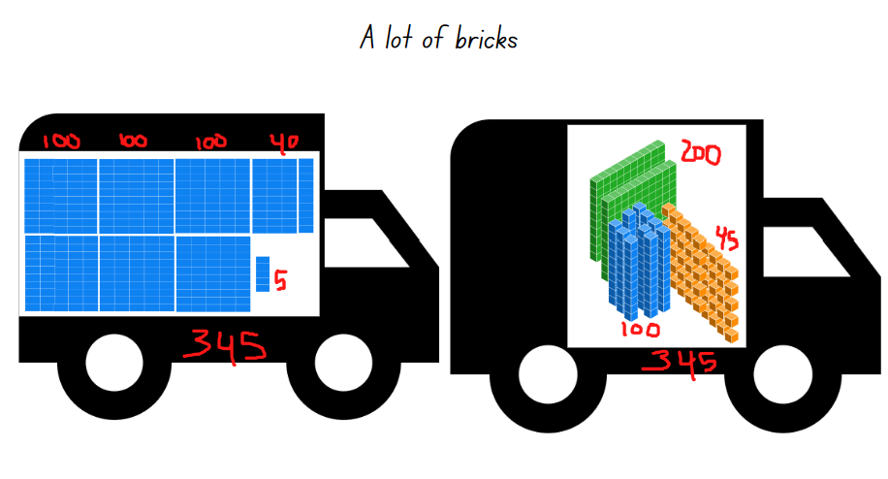
Images licensed under the Canva Content License Agreement.

Measuring and comparing: Part 1 – 20 minutes
Note: For measuring and comparing the internal volume of various containers, you will need rice, sand, water, bird seed or lentils, as well as various shaped containers that have the same and/or different internal volume. For example, various one litre bottles of juice, water or milk, shampoo bottles, jars and various tubs of yoghurt. Each student will need a transparent plastic cup, a permanent marker, and a small container, such as an egg cup, cosmetic containers or small disposable sauce containers, to use for pouring and filling when creating a calibrated measuring device.
A uniform informal calibrated measuring device ensures that comparative results are more consistent and precise.
- Explain that, in pairs, student will be comparing and ordering the internal volume of various containers.
- Display various real life measuring devices such as in Figure 9.
Figure 9 – Real life measuring devices
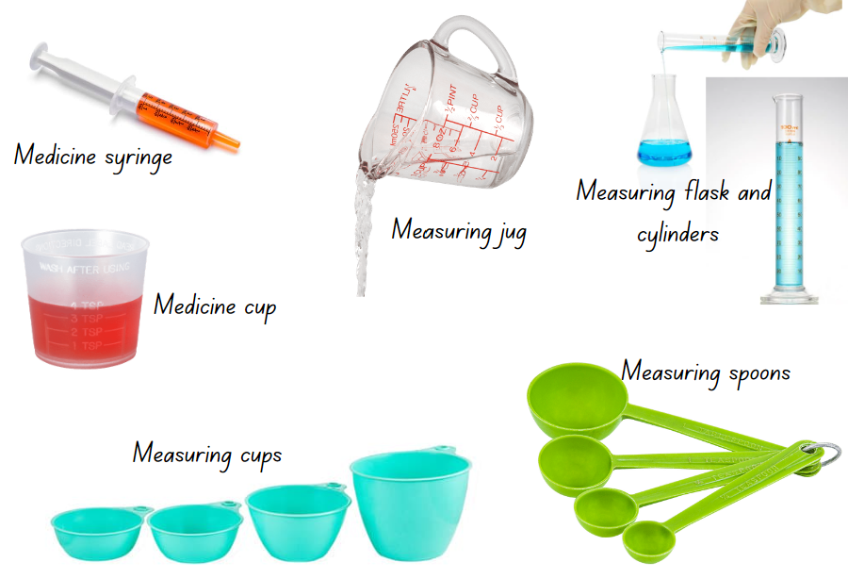
Images licensed under the Canva Content License Agreement.
- Ask students:
- Have you seen these measuring devices (tools) before? Where and how are they used? What do they measure?
- Why and how do you think these were made? How are they labelled and marked?
- Are there specific mathematical words that you need to use when using these measuring devices?
- Do these measuring devices give you a precise measure or just an estimate? How can you prove it?
- Draw attention to the various containers the class will measure. Explain that you are wondering what the internal volume of each of these containers is and if any have the same internal volume or whether they will all be different because each container is a different shape.
- Provide time for students to explore and manipulate the various containers, observing these from different points of views.
- Ask students to turn and talk with a partner to discuss what they observed and what they are wondering. Monitor discussions, share points of interest and identify misconceptions.
- Explain that students do not have access to one of the real-life calibrated measuring devices displayed earlier in the lesson. Instead, students are going to make their own so that they can measure, compare and order the internal volume of the various containers.
- Model the steps for making a calibrated measuring device:
- Select a small container as a unit of measure, such as an egg cup.
- Fill the small container with rice, sand, water or lentils.
- Pour it into the plastic cup.
- Mark a line on the plastic cup to show the level of rice, water or lentils.
- Continue these steps until students have 10 lines (see Figure 10).
Figure 10 – My measuring device
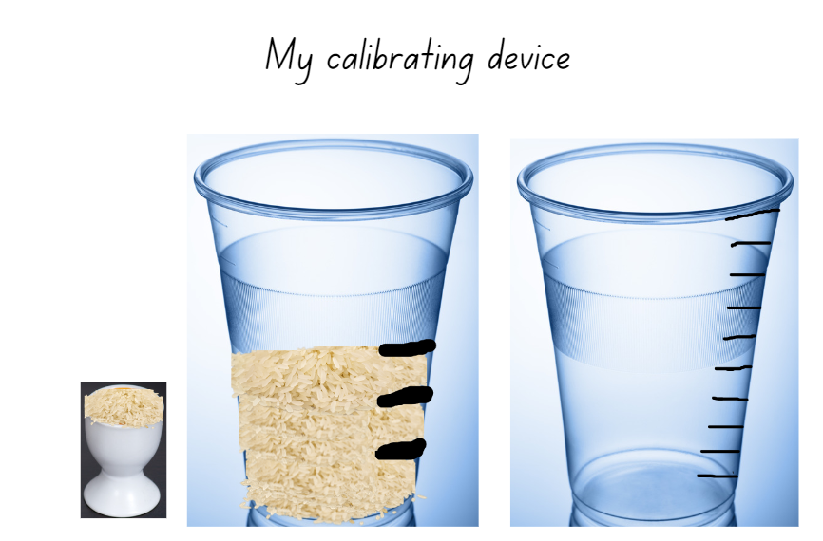
Images licensed under the Canva Content License Agreement.
- Provide pairs of students with materials to make their calibrated device.

Measuring and comparing: Part 2– 30 minutes
- Explain that students will now use their calibrated cup to investigate, compare and order the internal volume of other containers (see Figure 11).
Figure 11 – Which bottle holds more?
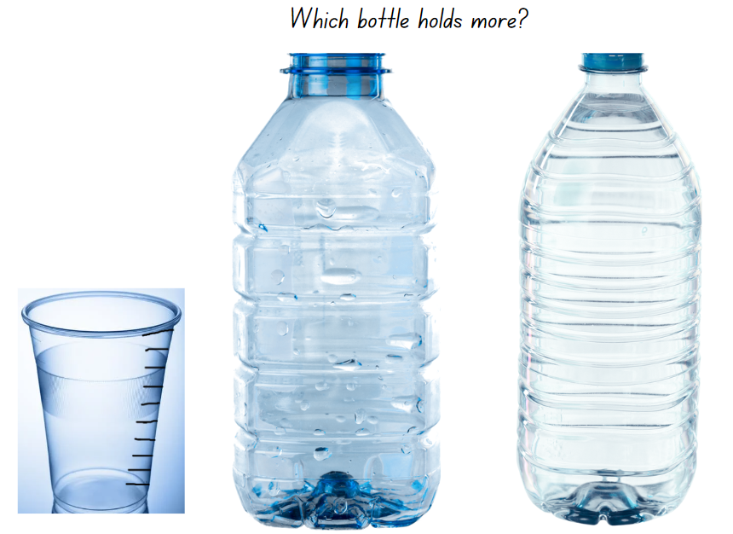
Images licensed under the Canva Content License Agreement.
- Model how to use the measuring device. Remind students that each line on their device represents one scoop and, if they fill it to the top line, it represents 10 scoops. Explain that students should not fill above the top line, as this is not calibrated.
- Ask students to select 4-5 containers and estimate how many scoops each container will need to fill it and record their estimates.
- Provide students with a digital device or writing materials to record their investigation results.
- Students fill the containers using their calibrated cup and record how many scoops were needed to fill it. Ensure that students are comparing and ordering each container by recording how many of the marks on the plastic cup is needed to fill each container. Encourage students to skip count by tens when filling to the top line of their device (see Figure 12).
Figure 12 – Investigating internal volume
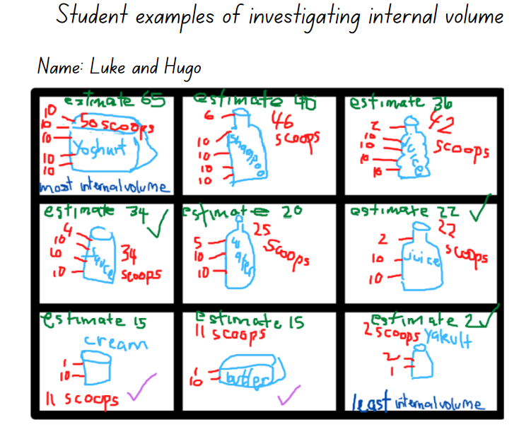
- Discuss findings and order the containers to view similarities and differences in measuring results. Ask:
- What problems did you have when using your calibrated device?
- Are there any containers you found that had the same internal volume? Are they the same shape?
- Are there any containers that you estimated correctly? What strategy did you use?
- Are there any estimates that were incorrect, and the result was very different? Can you explain what was challenging when estimating this container?
- What do you know? What are you still wondering about?
This table details assessment opportunities and differentiation ideas.
Assessment opportunities | Too hard? | Too easy?
What to look for:  - Can students estimate and then measure the internal volume, keeping count of the number of units needed? (MAO-WM-01, MA1-3DS-02)  - Do students explain how they are using their calibrated device to accurately measure how many units altogether are needed to measure the internal volume of a container? (MAO-WM-01, MA1-3DS-02)  - Can students explain why containers that are shaped different may have the same internal volume? (MAO-WM-01, MA1-3DS-02)  - Do students reason, explaining how they have ordered the containers to show the most and least internal volume (capacity)? (MAO-WM-01, MA1-3DS-02)  What to collect:  - photographs and annotated work samples of students’ estimates and recorded measurement results. (MAO-WM-01, MA1-3DS-02) | Students are not able to estimate by using prior knowledge to make a judgement. Provide students with counters to estimate how many in one handful. Allow students time to repeat various using 2 handfuls and then 3.  Students are unable to use the calibrated measuring cup with 10 marks to compare and order the internal volume of containers. Support students to make a calibrated cup that only has 2 marks representing 2 scoops. Encourage students to skip count by twos as they pour and fill. Increase the number of scoops and marks accordingly. | Students can estimate and use their calibrated measuring cup to accurately compare, order and record results.  - Ask students to identify 2 containers that are a different shape but have the same internal volume. Students then explain how this is possible using drawings, diagrams and words.  - Ask students to use a different material (for example, if they used sand, they now use water) to fill a container using their calibrated measuring cup to determine if the results are the same. Students record their findings.

Discussing the mathematics: 5 minutes
- Ask:
- What did you discover?
- What was challenging?
- What else can you measure using your calibrated device?
- What could you not measure using the calibrated device?
- How does your device compare to the real-life calibrated devices shared at the beginning of the lesson? What is the same and what is different? Why?

Lesson 8: Investigating prisms and cubes
Core concept: The appearance of an object can affect the internal volume.
The table below contains suggested learning intentions and success criteria. These are best co-constructed with students.
Learning intentions | Success criteria
Students are learning that:  - three-dimensional objects can have a different appearance and still have the same internal volume  - internal volume can be measured, compared and ordered by filling  - using the same measuring tool to fill containers gives accurate comparison results. | Students can:  - identify 2 containers that appear different but have the same volume by estimating and comparing  - measure and compare the internal volume of containers using a calibrated measuring device.

Daily number sense: Swap, steal, sit – 15 minutes
- Build student understanding of place value and three-digit numbers by playing a card game called ‘Swap, steal, sit’.
Note: If using a deck of cards, it is preferable to use a deck that is clearly labelled as 1-9, instead of using an ace card to represent one. This eliminates confusion when forming, reading and naming numbers.
- Students play in groups of 3 or 4 players. Provide students with a collection of cards labelled 1 to 9. The dealer deals 3 cards per player. Remaining cards are placed in the middle of the group.
- The objective of the game is to make the largest three-digit number possible within 2 rounds by either swapping, stealing or sitting.
- Players look at their cards, without showing the other students. The game commences. Player 1 can either:
- ‘sit’, choose to hold their cards as they believe they have a winning number
- ‘swap’, discard an unwanted card by placing it on the ‘rubbish’ pile and selecting a new card from the deck
- ‘steal’ a card from any player, by giving away an unwanted card to another player and taking an unseen card from that player.
- The game continues for 2 rounds allowing each player to swap, steal or sit.
- All players reveal their cards, forming the largest three-digit number possible. Players name their number, clearly identifying how many hundreds, tens and ones. The player with the largest number wins the round.

Investigating prisms and cubes: Part 1– 25 minutes
Note: Prior to the lesson collect various real-life examples of cubes and prisms ensuring that there are enough for each student. For example, tissue boxes, cereal boxes, cling wrap, foil or toothpaste boxes, pasta boxes, tea boxes, boxes of chocolate and muesli bars. Students will also need to use rice, sand, water, bird seed or lentils for measuring.
- Display the real-life sample boxes, naming these as cubes or prisms and explain that each student will select their own box to investigate.
- Firstly, students will investigate all the faces, edges and vertices on their box and then investigate the internal volume using the calibrated cup they made in Lesson 7.
- Explain that, with a partner, students will investigate the faces, vertices and edges of their box. Each person can assist the other with holding the box, turning the box or taking photographs with the digital device.
- Provide students with modelling clay or wool and a digital device or writing materials to record results. Ensure that each student has their own box and that they are identifying and making a representation of each face using modelling clay or wool. Students need to view the box from all sides and identify these views by naming them side view, front view, top view and rear view. Students also need to count how many edges and vertices their box has altogether by marking the box and recording the results on the representations (see Figure 13).
Figure 13 – Examples of recordings
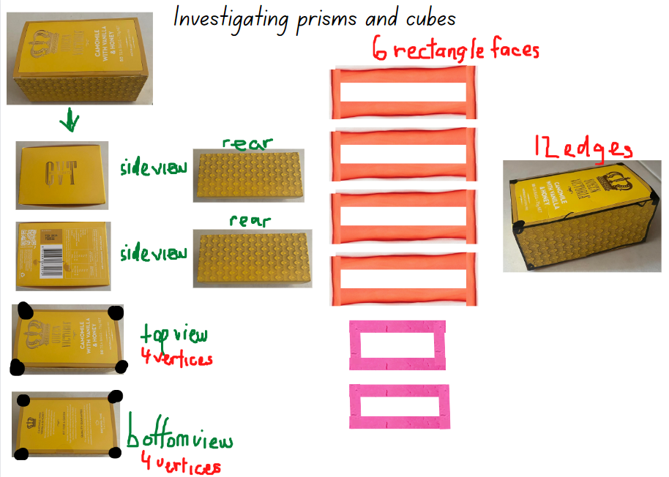

Investigating prisms and cubes: Part 2 – 20 minutes
- Explain that, in pairs, students will explore the internal volume of each of their boxes by using their calibrating cup from Lesson 7. Students will fill their cup with rice, sand, bird seed or lentils and record their results (see Figure 14).
Figure 14 – Examples of recording internal volume
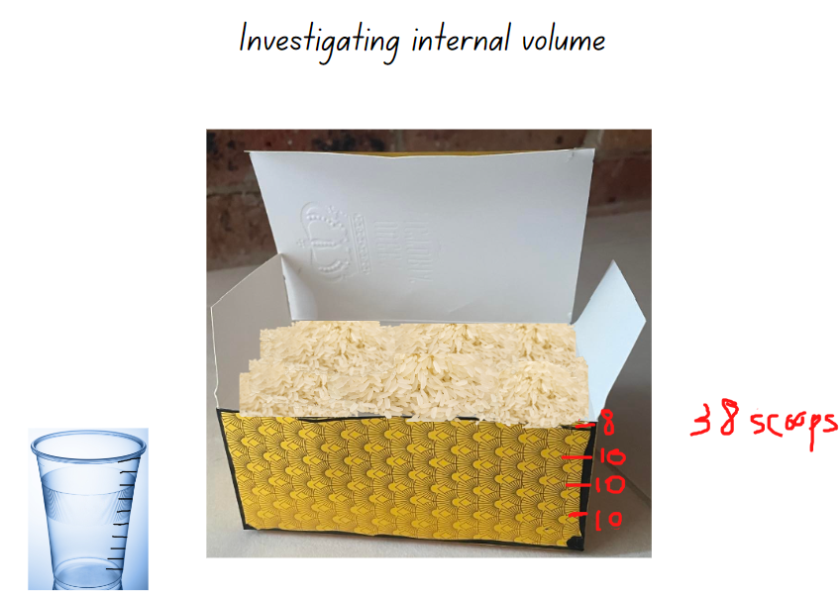
Images licensed under the Canva Content License Agreement.
- Students use their digital device or writing materials to record their findings, which will be shared and discussed as a class.
This table details assessment opportunities and differentiation ideas.
Assessment opportunities | Too hard? | Too easy?
What to look for:  - Can students distinguish between 2D shapes and 3D objects, describing these using appropriate vocabulary? (MA1-2DS-01, MA1-3DS-01)  - Do students describe and draw representations of 3D objects by identifying their features? (MA1-3DS-01)  - Can students use a calibrated device to measure, compare and record results of internal volume? (MAO-WM-01, MA1-3DS-02)  What to collect:  - anecdotal records of vocabulary being used by students (MAO-WM-01, MA1-3DS-02)  - photographs and annotated work samples. (MAO-WM-01, MA1-2DS-01, MA1-3DS-01, MA1-3DS-02). | Students are not able to keep track of a count. Provide students with concrete materials, such as counters.  Students are not able to use their calibrated cup to measure internal volume. Support students to calibrate their cup with only 2 to 5 marks. | Students can investigate and record their results accurately.  - Provide students with concrete materials. Students use these to investigate and record their findings for the volume and internal volume of a cylinder or square pyramid.  - Challenge students to make a prism or cube that has the same internal volume as volume.

Discussing the mathematics – 5 minutes
- Explain that the calibrating device students made was very useful to measure the internal volume in Lessons 7 and 8. Ask:
- Can you describe a situation when a calibrating device would not be useful, or would not work?
- Is there anything that you can think of that you cannot measure the internal volume of with a calibrated device? Why?
- Discuss student responses.

Resource 1: 2D Shapes and 3D Objects
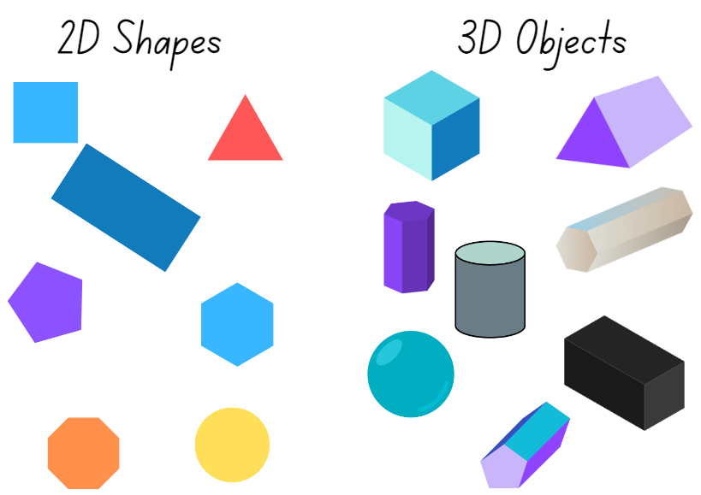
Images licensed under the Canva Content License Agreement.

Resource 2: Objects sort cards
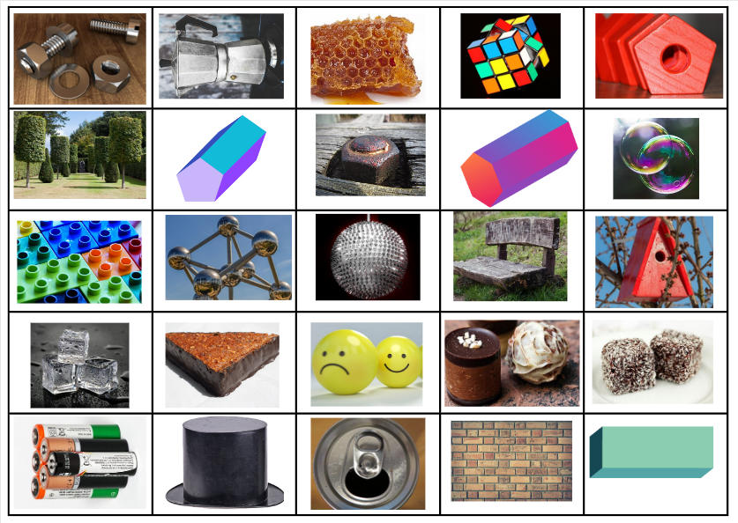
Images licensed under the Canva Content License Agreement.

Resource 3: Making cubes
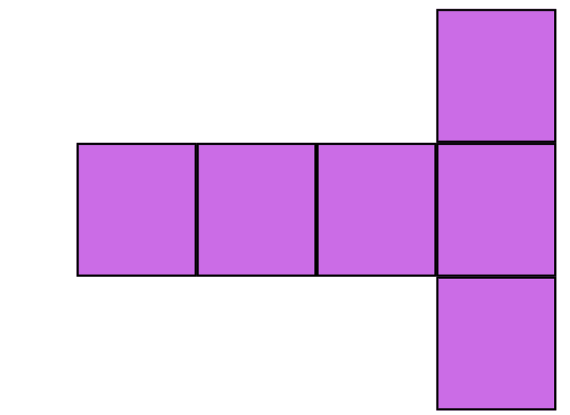
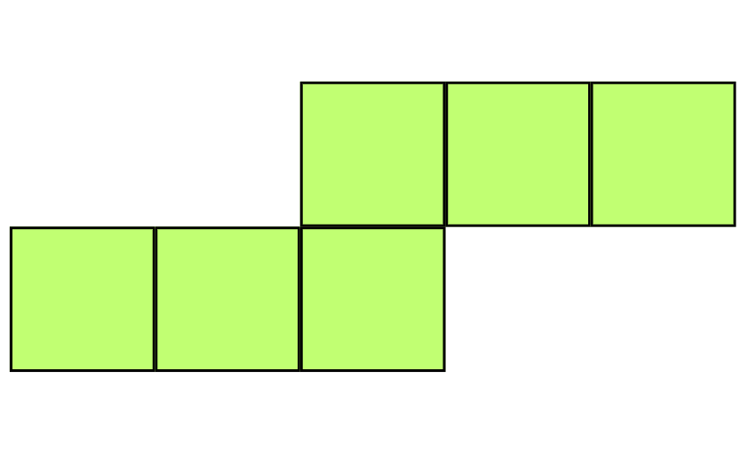
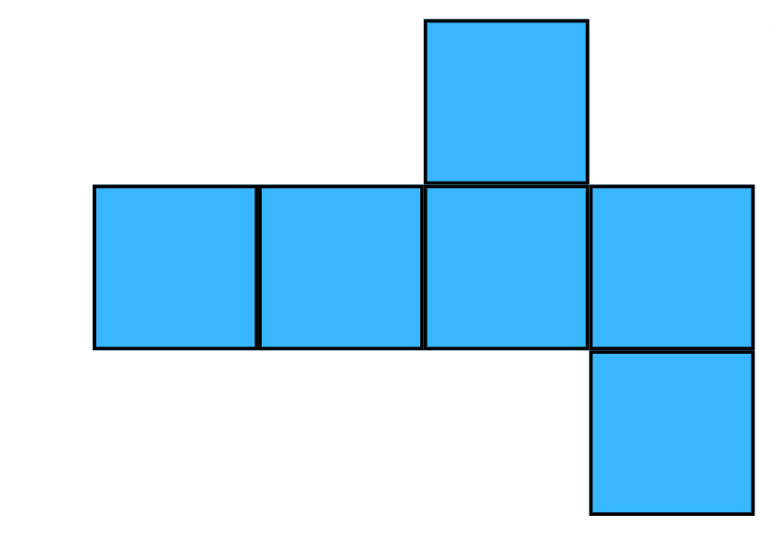

Resource 4: Pasta shapes
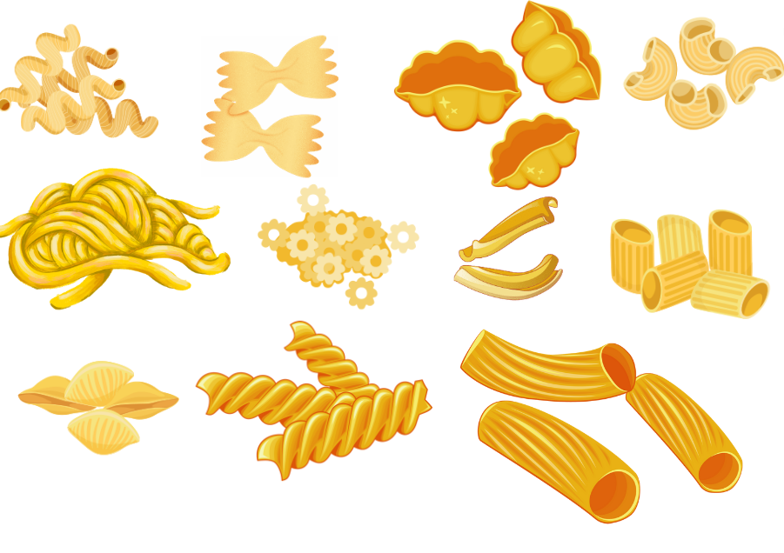
Images licensed under the Canva Content License Agreement.

Resource 5: Different packaging
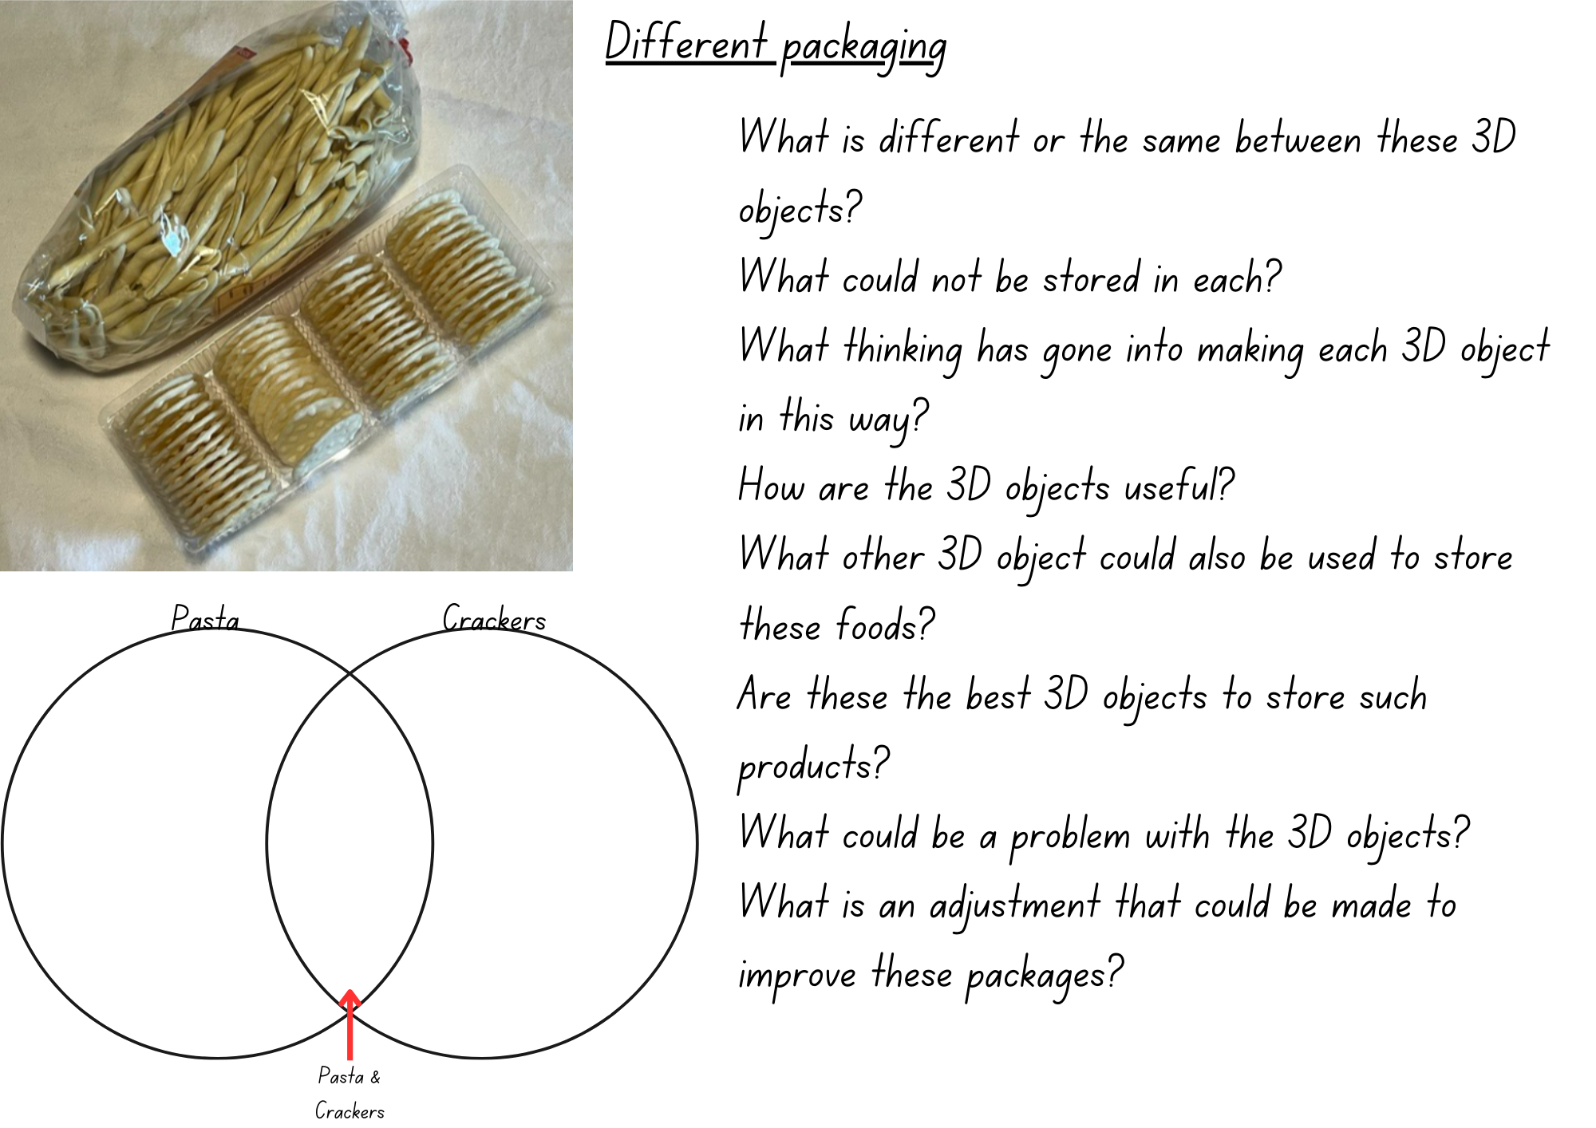

Resource 6: Jellybean challenge
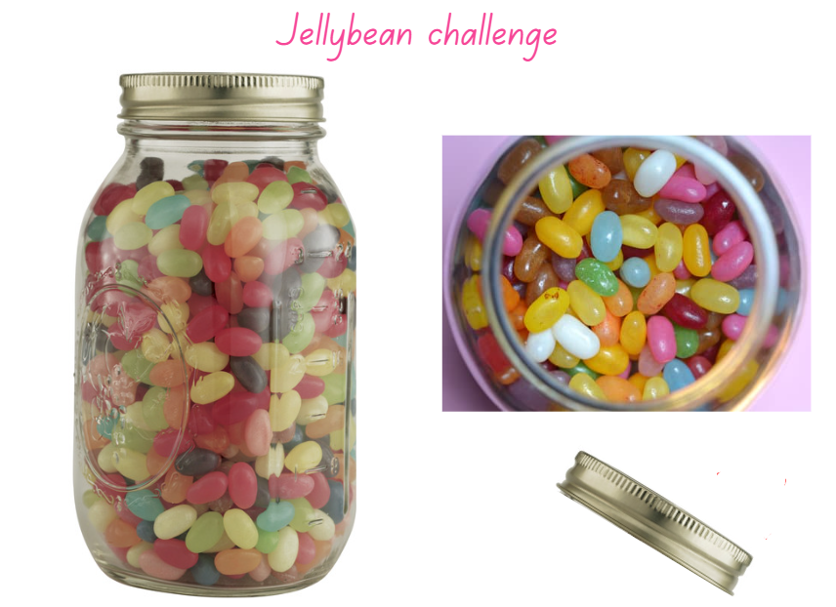
Images licensed under the Canva Content License Agreement.

Resource 7: Cargo ships
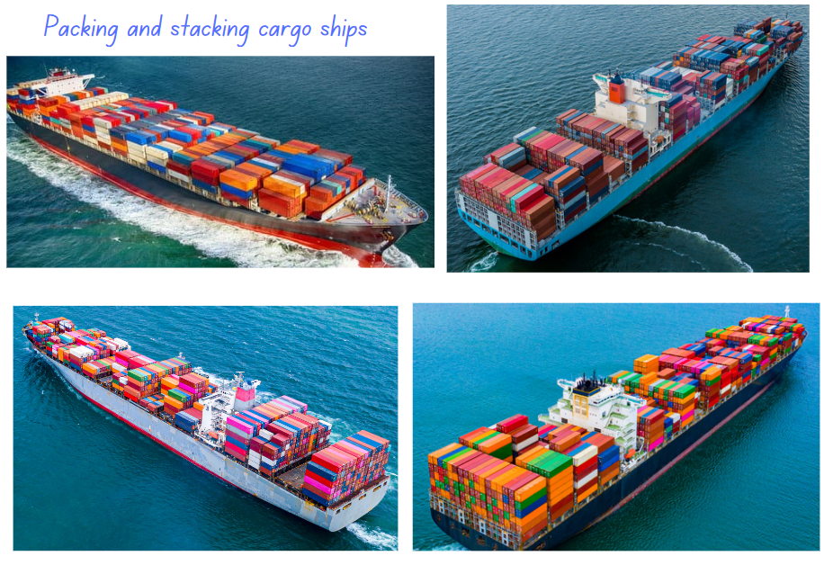
Images licensed under the Canva Content License Agreement.

Resource 8: A lot of bricks
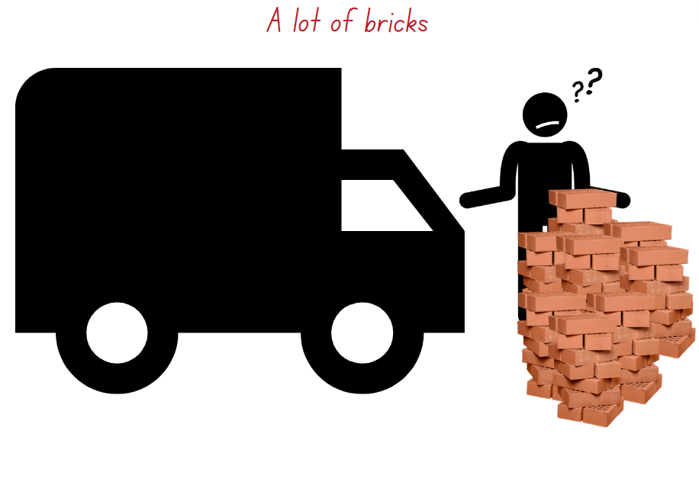
Images licensed under the Canva Content License Agreement.

Syllabus outcomes and content
The table below outlines the syllabus outcomes and range of relevant syllabus content covered in this unit. Content is linked to National Numeracy Learning Progression version (3).
Focus area and outcomes | Content groups and content points | Lessons
Representing whole numbers A  MAO-WM-01  MA1-RWN-01  MA1-RWN-02 | Represent numbers on a line  - Sequence numbers and arrange them on a line by considering the order and size of those numbers (CPr5)  - Locate the approximate position of multiples of 10 on a model of a number line from 0 to 100 (CPr5)  Represent the structure of groups of ten in whole numbers  - Use number lines and number charts to assist with locating the nearest ten to a number  - Estimate, to the nearest ten, the number of objects in a collection and check by counting in groups of ten (Reasons about quantity) (CPr7, NPV6)  Use counting sequences of ones with two-digit numbers and beyond  - Identify the number before and after a given two-digit number | 1, 2, 6–8
Representing whole numbers B  MAO-WM-01  MA1-RWN-01  MA1-RWN-02 | Use counting sequences of ones and tens flexibly  - Count forwards and backwards by tens, on and off the decade, with two- and three-digit numbers (CPr7)  Form, regroup and rename three-digit numbers  - Count and represent large sets of objects by systematically grouping in tens and hundreds (CPr7, NPV5)  - Use models such as base 10 material and interlocking cubes to represent and explain grouping (CPr7)  - State the quantity value of digits in numbers of up to three digits (Reasons about quantity) (NPV5)  - Identify the nearest hundred to a number  - Recognise units of 100 (UnM5, NPV5)  - Use place value to partition and rename three-digit numbers in different ways (Reasons about relations) (NPV5)  - Estimate, to the nearest hundred, the number of objects in a collection and check by grouping and counting (NPV6) | 1, 2, 5–8
Two-dimensional spatial structure A  MAO-WM-01  MA1-2DS-01  MA1-2DS-02 | 2D shapes: Recognise and classify shapes using obvious features  - Select and name a shape from a description of its features, identifying triangles, quadrilaterals, pentagons, hexagons and octagons (Reasons about spatial relations)  - Identify shapes presented in different orientations (UGP2) | 1–2, 8
Three-dimensional spatial structure A  MAO-WM-01  MA1-3DS-01  MA1-3DS-02 | 3D shapes: Recognise familiar three-dimensional objects  - Use the term ‘three-dimensional’ to describe a range of objects (UGP2, UGP3)  - Distinguish between objects, which are three-dimensional (3D) and shapes which are two-dimensional (2D)  - Identify and name familiar three-dimensional objects, including cubes, cylinders, spheres and rectangular prisms  3D shapes: Sort and describe three-dimensional objects  - Manipulate and describe familiar three-dimensional objects (UGP2)  - Use the term ‘surface' in describing familiar three-dimensional objects  - Sort familiar three-dimensional objects according to obvious features  - Use the term ‘face’ to describe the flat surfaces of three-dimensional objects with straight edges (UGP2, UGP3)  - Select and name a familiar three-dimensional object from a description of its features  Volume: Measure and compare the internal volumes (capacities) of containers by filling  - Use uniform informal units to measure how much a container will hold by counting the number of times a smaller container can be filled and emptied into the container being measured (UuM3)  - Select appropriate informal units to measure the capacities of containers  - Compare the internal volumes of two or more containers using appropriate uniform informal units (UuM3)  - Recognise and explain why containers of different shapes may have the same internal volume (Reasons about relations)  - Estimate how much a container holds by referring to the number and type of uniform informal unit used and check by measuring (UuM3, UuM4)  Volume: Measure the internal volume (capacity) of containers by packing  - Pack cubic units (eg blocks) into rectangular containers so that there are no gaps  - Recognise that cubes pack better than other objects in rectangular containers (Reasons about spatial structure)  - Estimate and measure the internal volume of a container by filling the container with uniform informal units and counting the number of units used  - Explain that if there are gaps when packing and stacking, this will affect the accuracy of measuring the internal volume  Volume: Construct volumes using cubes  - Explore different rectangular prisms that can be made from a given number of cubes  - Devise and explain strategies for stacking and counting units to form a rectangular prism (Reasons about spatial structure)  - Record volumes, referring to the number and type of uniform informal unit used | 1–8
Three-dimensional spatial structure B  MAO-WM-01  MA1-3DS-01  MA1-3DS-02 | 3D objects: Describe the features of three-dimensional objects  - Describe three-dimensional objects (prisms) using the terms ‘face’, ‘edge’ and ‘vertex’  - Represent three-dimensional objects by making simple models  - Recognise and name flat surfaces of three-dimensional objects as two-dimensional shapes  Volume: Compare containers based on internal volume (capacity) by filling and packing  - Make and use a device for measuring internal volume (capacity) calibrated in uniform informal units (UuM3, UuM4)  - Compare, order and record the internal volumes (capacities) of two or more containers by measuring each container in uniform informal units (UuM3, UuM4)  - Estimate internal volume (capacity) by referring to the number and type of uniform informal unit used (UuM3)  Volume: Compare volumes using uniform informal units  - Record the results of volume comparisons using drawings, numerals and words, referring to the units used | 1–8

References
Links to third-party material and websites
Please note that the provided (reading/viewing material/list/links/texts) are a suggestion only and implies no endorsement, by the New South Wales Department of Education, of any author, publisher, or book title. School principals and teachers are best placed to assess the suitability of resources that would complement the curriculum and reflect the needs and interests of their students.
If you use the links provided in this document to access a third-party's website, you acknowledge that the terms of use, including licence terms set out on the third-party's website apply to the use which may be made of the materials on that third-party website or where permitted by the Copyright Act 1968 (Cth). The department accepts no responsibility for content on third-party websites.
Except as otherwise noted, all material is © State of New South Wales (Department of Education), 2023 and licensed under the Creative Commons Attribution 4.0 International License. All other material (third-party material) is used with permission or under licence. Where the copyright owner of third-party material has not licensed their material under a Creative Commons or similar licence, you should contact them directly for permission to reuse their material.
Mathematics K–10 Syllabus © 2022 NSW Education Standards Authority (NESA) for and on behalf of the Crown in right of the State of New South Wales.
© 2022 NSW Education Standards Authority. This document contains NSW Curriculum and syllabus content. The NSW Curriculum is developed by the NSW Education Standards Authority. This content is prepared by NESA for and on behalf of the Crown in right of the State of New South Wales. The material is protected by Crown copyright.
Please refer to the NESA Copyright Disclaimer for more information.
NESA holds the only official and up-to-date versions of the NSW Curriculum and syllabus documents. Please visit the NSW Education Standards Authority (NESA) website and the NSW Curriculum website.
National Numeracy Learning Progression © Australian Curriculum, Assessment and Reporting Authority (ACARA) 2010 to present, unless otherwise indicated. This material was downloaded from the Australian Curriculum website (National Numeracy Learning Progression) (accessed 10 March 2023) and was not modified. The material is licensed under CC BY 4.0. Version updates are tracked in the ‘Curriculum version history’ section on the 'About the Australian Curriculum' page of the Australian Curriculum website.
ACARA does not endorse any product that uses the Australian Curriculum or make any representations as to the quality of such products. Any product that uses material published on this website should not be taken to be affiliated with ACARA or have the sponsorship or approval of ACARA. It is up to each person to make their own assessment of the product, taking into account matters including, but not limited to, the version number and the degree to which the materials align with the content descriptions and achievement standards (where relevant). Where there is a claim of alignment, it is important to check that the materials align with the content descriptions and achievement standards (endorsed by all education Ministers), not the elaborations (examples provided by ACARA).
This resource contains images and content obtained from Canva, and their use outside of this resource is subject to Canva’s Content License Agreement. If you wish to use them separately from the resource, please go to Canva.
ABCya.com (2023) How many marbles?, ABCya website, accessed 10 March 2023.
Didax, Inc. (2023) Geoboard, Didax website, accessed 10 March 2023.
Mathigon (2022) Polypad, Mathigon website, accessed 10 March 2023.
Moss J, Bruce CD, Caswell B, Flynn T and Hawes Z (2016) Taking Shape: Activities to Develop Geometric and Spatial Thinking, Grades K-2, Pearson Canada.
Siemon D, Warren E, Beswick K, Faragher R, Miller J, Horne M, Jazby D, Breed M, Clark J and Brady K (2020) Teaching Mathematics: Foundations to Middle Years, 3rd edn, Oxford University Press Australia and New Zealand.
Sullivan P (2018) Challenging Mathematical Tasks: Unlocking the potential of all students, Oxford University Press Australia and New Zealand.

