Mathematics – Stage 1 – Unit 38
Contents
Unit description and duration 4
Student prior learning 4
Lesson overview and resources 5
Lesson 1: Months of the year 10
Daily number sense: Clap it out – 15 minutes 10
Calendar data – 40 minutes 11
Consolidation and meaningful practice: Graph discussion – 10 minutes 15
Lesson 2: Birthdays! 16
Daily number sense: Which number is missing? – 10 minutes 16
Birthday month – 40 minutes 17
Lesson 3: All about us 20
Daily number sense: Teacher choice – 10 minutes 20
Types of questions – 15 minutes 21
All about us – 30 minutes 22
Discuss and connect the mathematics – 10 minutes 23
Lesson 4: Dice data 24
Daily number sense: Find the nearest hundred – 15 minutes 24
Dice data! – 40 minutes 26
Discuss and connect the mathematics – 5 minutes 28
Lesson 5: Domino data 28
Daily number sense: Big numbers at the airport – 15 minutes 29
Domino data – 40 minutes 29
Discuss and connect the mathematics: What’s your favourite? – 5 minutes 31
Lesson 6: Crazy socks 32
Daily number sense: Understanding three-digit numbers – 15 minutes 32
Crazy socks– 40 minutes 33
Discuss and connect the mathematics – 10 minutes 36
Lesson 7: The language of chance 37
Daily number sense: What can you see? – 20 minutes 37
What’s the chance? – 30 minutes 38
Consolidation and meaningful practice: Numbers around us – 5 minutes 40
Lesson 8: Tricky data 41
Daily number sense: Teacher choice – 10 minutes 41
Interpreting data – 40 minutes 42
Discuss and connect the mathematics – 10 minutes 44
Resource 1: Calendar 45
Resource 2: Picture graph example 46
Resource 3: Features of a column graph 47
Resource 4: Data questions 48
Resource 5: Destination Australia 49
Resource 6: Around the world! 50
Resource 7: Basketball hoops A 51
Resource 8: Basketball hoops B 52
Resource 9: Basketball hoops C 53
Syllabus outcomes and content 54
References 58

Unit description and duration
This two-week unit develops student knowledge and understanding of applications of data and chance, and their interconnectedness. Students are provided opportunities to:
- select appropriate methods to collect, display and interpret data
- identify misleading data
- learn the order of seasons and months of the year and how to use a Gregorian calendar
- use the language of chance to reason about possible outcomes in familiar activities.
Mathematics K–10 Syllabus © 2022 NSW Education Standards Authority (NESA) for and on behalf of the Crown in right of the State of New South Wales.

Student prior learning
Before engaging in these teaching and learning activities, students would benefit from prior experience with:
- sorting, classifying and arranging objects to form a data display and describing information presented in the data display
- using comparative language
- thinking about the chance of everyday events occurring
- being aware of multi-cultural and Aboriginal events that happen throughout the year in your community and across Australia.

Lesson overview and resources
The table below outlines the sequence and approximate timing of lessons; syllabus focus areas and content groups; and resources.
Lesson | Syllabus focus area and content groups | Resources
Lesson 1: Months of the year  65 minutes  Months and seasons are organised using the Gregorian calendar. | Representing whole numbers A  - Continue and create number patterns  Non-spatial measure A  - Time: Name and order the cycle of months  Data A  - Ask questions and gather data  - Represent data with objects and drawings and describe the displays  Data B  - Create displays of data and interpret them | - Resource 1: Calendar  - Resource 2: Picture graph example  - Writing materials
Lesson 2: Birthdays!  50 minutes  Seasons and special events can be identified using a Gregorian calendar. | Representing whole numbers A  - Continue and create number patterns  Non-spatial measure  - Time: Name and order the cycle of months  Data A  - Ask questions and gather data  - Represent data with objects and drawings and describe the displays  Data B  - Identify a question of interest and gather relevant data  - Create displays of data and interpret them | - Resource 3: Features of a column graph  - Resource 4: Data questions  - A4 cards with months of the year  - Large grid paper  - Whiteboards and markers  - Writing materials
Lesson 3: All about us  65 minutes  Asking the right questions can help collect and sort data. | Data A  - Ask questions and gather data  - Represent data with objects and drawings and describe the displays  Data B  - Identify a question of interest and gather relevant data  - Create displays of data and interpret them | - Large card or paper  - Writing materials
Lesson 4: Dice data  60 minutes  Data can be organised into a display and used to answer questions. | Representing whole numbers B  - Form, regroup, and rename three-digit numbers  Data A  - Ask questions and gather data  - Represent data with objects and drawings and describe the displays  Data B  - Create displays of data and interpret them | - 3 × 9-sided dice per group  - 12 × 12-sided dice per group  - Whiteboards and markers
Lesson 5: Domino data  60 minutes  Data can be used to predict the likelihood of an event. | Representing whole numbers B  - Form, regroup, and rename three-digit numbers  Data B  - Create displays of data and interpret them  Chance A  - Identify and describe possible outcomes  Chance B  - Identify and describe activities that involve chance | - Resource 5: Destination Australia  - Approximately 6 sets of dominoes  - Writing materials
Lesson 6: Crazy socks  65 minutes  Data collections can be used to make predictions and comparisons. | Representing whole numbers B  - Form, regroup, and rename three-digit numbers  Data A  - Ask questions and gather data  - Represent data with objects and drawings and describe the displays  Chance A  - Identify and describe possible outcomes  Chance B  - Identify and describe activities that involve chance | - Approximately 30 × 9-sided dice  - Container or bag  - Pairs of socks (brought in by students)  - Writing materials
Lesson 7: The language of chance  55 minutes  The language of chance can be used to identify, describe and compare the likelihood of events. | Chance A  - Identify and describe possible outcomes  Chance B  - Identify and describe activities that involve chance | - Resource 6: Around the world!  - A4 pieces of card
Lesson 8: Tricky data  60 minutes  Symbols in graphs can be accurate or misleading. | Data B  - Create displays of data and interpret them | - Resource 7: Basketball hoops A  - Resource 8: Basketball hoops B  - Resource 9: Basketball hoops C  - Individual whiteboards  - Writing materials

Lesson 1: Months of the year
Core concept: Months and seasons are organised using the Gregorian calendar.
The table below contains suggested learning intentions and success criteria. These are best co-constructed with students.
Learning intentions | Success criteria
Students are learning that:  - months of the year have names and always come in the same order  - in the Gregorian calendar, each month has a set number of days, except in a leap year  - symbols can be used to represent data. | Students can:  - name and order the 12 months of the year  - use a calendar to find out how many days are in each month  - collect and display data to find out how many months have 28, 30 and 31 days.

Daily number sense: Clap it out – 15 minutes
This activity is adapted from Clapping Times at NRICH.
- Build student understanding of number patterns by counting forwards and backwards by twos, fives and tens.
- As a class, count aloud from 1 to 20, saying each number and clapping on each number.
- Explain that in the next round of counting, students will say every second number loudly and the other numbers quietly, only clapping on every second number, highlighting the numbers in the twos skip counting pattern.
- Count again, highlighting the numbers in the fives skip counting pattern, clapping and saying loudly the multiples of 5 and counting quietly on the other numbers. Ask students:
- If one of you claps the twos in this way and one of you claps the fives at the same time, can you predict what you would hear?
- Which numbers would be quiet?
- Which numbers would be a bit louder?
- Which numbers would be very loud with both students clapping and counting loudly?
- Ask students to try this in pairs and discuss what they hear. Ask if their predictions were right.
- Students repeat this process for twos and tens, or fives and tens.
- As a class, repeat the process beginning at 20 and counting aloud backwards to zero and clapping.

Calendar data – 40 minutes
- Display Resource 1: Calendar and ask students what it is and how it is used. Choose a few months at random and ask students if they can think of anything that always happens in that month, for example, a birthday, a special event or a public holiday. Identify the days in the calendar.
Note: This is an opportunity to celebrate multicultural and Aboriginal perspectives in your context. The Calendar for Cultural Diversity [PDF 50.8MB] could be a helpful resource.
- Explain that a calendar displays every day of the year, and that a year is made up of 12 months. Ask students to turn and talk about what else they notice about the calendar. Answers may include:
- each week has 7 days
- the days of the week are written across the top of each month
- each day of the month has a number on it
- there are 12 months in total
- most months are made up of 4 and a bit weeks
- some months have more days than others.
- Ask students if there is a way to find out how many days there are in each month. Suggestions may include counting the days of each month or looking at the last day of each month.
- Cut up Resource 1: Calendar and display all the months in a random order on the floor. Ask students to count the days in each month and record this.
- As a class, put the months in the correct order and explore the calendar further.
The table below outlines stimulus prompts to generate conversation about the topic, along with anticipated responses from students.
Prompts | Anticipated student responses
- Now that you have counted all the days in each month, what do you notice?  - How can we arrange the months into categories?  - How can we do this? | - I notice that months have different numbers of days.  - Some months have 31 days, others have 30 days.  - I can see that February only has 28 days.  - We can arrange them by the number of days in each month.  - We can count how many months have 28 days, how many have 30 days and how many have 31.
Note: Explain the concept of the leap year, where every 4 years February has 29 days rather than 28.
- Explain that students can use tally marks when trying to keep count of objects (see Figure 1).
Figure 1 – Tally marks
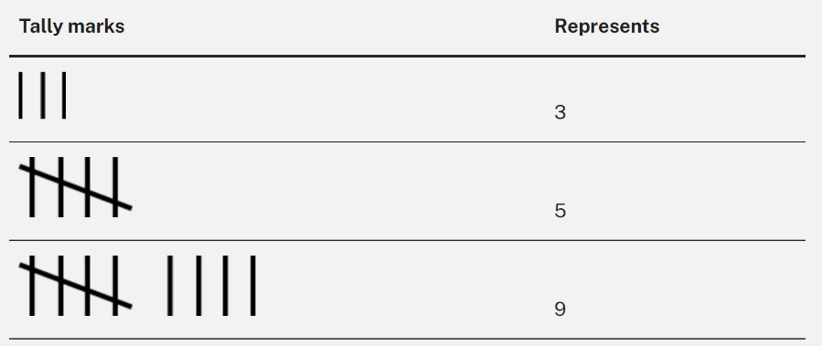
Tally mark: A single mark in a tally represents one observation. Tally marks are usually drawn in groups of 5 with the first 4 marks drawn vertically and the fifth drawn diagonally through the 4.
- Explain and model how tally marks are used. Ask students why they think tally marks are drawn in groups of 5.
- Students work in groups to collect data on how many months have 28, 30 or 31 days using tally marks. Students record their observations in their workbooks.
- Once data has been collected, discuss ways to create a picture graph and what symbols they are going to use to represent their data.
- Display Resource 2: Picture graph example and discuss all the features of a picture graph. Discuss that, when representing data in a picture graph, there must be a baseline, equal spacing and same-sized symbols.
- Students create a picture graph using symbols to show how many months have 28, 30 and 31 days.
This table details assessment opportunities and differentiation ideas.
Assessment opportunities | Too hard? | Too easy?
What to look for:  - Can students use tally marks to track how many days in each month? (MAO-WM-01, MA1-DATA-01)  - Can students create and interpret a picture graph recognising that symbols represent data? (MAO-WM-01, MA1-DATA-02)  What to collect:  - work samples of tally marks and annotated picture graphs. (MAO-WM-01, MA1-DATA-01, MA1-DATA-02) | Students cannot use tally marks to keep an accurate track of the count.  - Give students a ten-frame and counters to keep track of their count and then model how to transfer this into tally marks.  - Have students show you how they are keeping track of their data using tally marks to ensure correct technique.  Students cannot interpret picture graphs with equal spacing and same-sized symbols that represent one item.  - Provide students with the same sized symbols.  - Model equal spacing. | Students can use tally marks and create accurate picture graphs.  - Provide more opportunities for data collecting using tally marks.  - Provide students with the link to Calendars at NRICH. Students engage with this resource to learn about and discuss calendars from different cultures and history.

Consolidation and meaningful practice: Graph discussion – 10 minutes
- Students display their picture graphs and discuss any challenges encountered. Ask students the following questions:
- Why is it so important for the symbols to be the same size?
- Why is it so important for the symbols to be equally spaced?
- What could you do differently next time?

Lesson 2: Birthdays!
Core concept: Seasons and special events can be identified using a Gregorian calendar.
The table below contains suggested learning intentions and success criteria. These are best co-constructed with students.
Learning intentions | Success criteria
Students are learning that:  - months and seasons have names and always come in the same order  - days and dates can be found using a Gregorian calendar  - data can be collected and displayed in many ways  - data can be used to ask and answer questions. | Students can:  - use the months and seasons to organise data  - use a Gregorian calendar to find a date  - collect and display data using tally marks and column graphs  - use data to ask and answer questions.

Daily number sense: Which number is missing? – 10 minutes
This activity has been adapted from Sullivan (2012).
- Build student understanding of number patterns by identifying incorrect and missing parts of patterns.
- As a class, count aloud by twos to 20. Then show students the following patterns on the board and ask what they notice:
- 2, 4, 6, 10, 12, 14
- 4, 7, 8, 10, 12, 14, 16
- 20, 18, 16, 15, 12, 10, 8, 6
- Students record the skip counting pattern with the correct numbers on their individual whiteboards to highlight the correct pattern.
- Repeat the process with threes, fives or tens skip counting patterns.

Birthday month – 40 minutes
- Explain that students will be finding their birthday on a calendar and using this to collect, organise and interpret data.
Note: If needed, provide slips of paper to each student with the date and month in which they were born.
- Provide small groups of students with Gregorian calendars. Students help each other to find their birthdays.
- Print the name of each month onto cardboard or paper and pin them on the wall in a straight line. Alternatively, arrange the months on the floor and ask students to line up in front of the month they were born in, then sit down to form straight lines. Students count how many were born in their birth month and write the results up on the board using tally marks.
- As students are sitting, explain that they have created a human graph. Students have made a column graph using their bodies to line up in front of their birth month. If possible, take a picture and display it for the students.
- Display Resource 3: Features of a column graph and ask students what they notice. Comments may include:
- The names of the seasons of the year are displayed across the bottom.
- The graph looks like grid paper.
- There are numbers on the left-hand side going upwards from zero.
- Provide large grid paper and explain that students will create their own column graph. Revise that students will colour one square for every classmate born in a given month.
- Take a close look at the data collected and have students Think-Pair-Share their questions. For example:
- Which month do most people have birthdays in?
- What season were you born in?
- Which season has the most birthdays in it?
- As a class, discuss the most interesting questions and responses.
This table details assessment opportunities and differentiation ideas.
Assessment opportunities | Too hard? | Too easy?
What to look for:  - Can students recognise the month in which they were born? (MAO-WM-01, MA1-NSM-02)  - Can students convert tally marks into a column graph? (MAO-WM-01, MA1-DATA-01)  - Can students create a column graph with correct features? (MAO-WM-01, MA1-DATA-01)  - Can students interpret data from the graph by asking and answering questions? (MAO-WM-01, MA1-DATA-02)  What to collect:  - photograph of human column graph (MA1-NSM-02)  - work samples of column graphs. (MAO-WM-01, MA1-DATA-02) | Students cannot convert tally marks into a column graph.  - Students use counters to represent tally marks.  - Model how to colour one square for each tally mark.  Students cannot create a column graph with correct features.  - Revise the main features of a column graph.  - Model how to create a column graph. | Students can convert tally marks into a column graph.  - Provide other information in tally marks that students can use to create another column graph.  - Students conduct their own investigation, using tally marks to collect data.  Students can create a column graph with correct features.  - Students create a column graph from their own data collection.  - Students discuss where tally marks might work better than a column graph and vice versa.

Lesson 3: All about us
Core concept: Asking the right questions can help collect and sort data.
The table below contains suggested learning intentions and success criteria. These are best co-constructed with students.
Learning intentions | Success criteria
Students are learning that:  - data can be numerical or categorical  - data collection is more effective if the right questions are asked  - a data display can be interpreted. | Students can:  - recognise when it is best to sort data using numbers or categories  - ask open questions to collect a range of information  - create and interpret a data display on a chosen topic.

Daily number sense: Teacher choice – 10 minutes
- From a class need surfaced through formative assessment data, identify a short, focused activity that targets students’ knowledge, understanding and skills. Example activities may be drawn from the following resources:
- Thinking Mathematically Stage 1
- Universal Resources Hub.

Types of questions – 15 minutes
- Explain that some questions are more effective than others when trying to collect data or information.
- Express that there are 2 different types of questions to ask when collecting data. These are:
- questions that will give numbers as answers
- questions that will give data that can be sorted into categories.
Data categories: Data can be separated into 2 categories: numerical and categorical. Numerical data provides values that will always be in number form, whereas categorial data provides information that can be separated into distinct groups or categories.
- Display Resource 4: Data questions and ask students to identify whether the questions will provide data that is numerical or categorical. For each question students Think-Pair-Share and then agree as a class.
The table below outlines stimulus prompts to generate conversation about the topic, along with anticipated responses from students.
Prompts | Anticipated student responses
- Are there any questions that only give you the option of 2 answers?  - Why do you think this is the case?  - Do you think closed or open questions are the best questions to ask when collecting data? Why? | - Yes. ‘Do you play Minecraft?’, ‘Do you have a brother?’ ‘Do you like tennis?’, ‘Do you prefer chocolate or vanilla?’ and ‘Can you swim butterfly stroke?’  - These are closed questions. These types are for ‘yes’ and ‘no’ or only 2 different choices.  - Open questions are better because you can have more answers.

All about us – 30 minutes
- Tell students that they will conduct an investigation of their own.
- Split the class into 2 groups and explain that each group will brainstorm questions to investigate. From these, students choose one and collect data within the group.
- Remind students that they must create an open question where the data can be separated into several, interesting categories. This means that ‘yes’ or ‘no’ (closed) questions are not suitable for this investigation.
- Students brainstorm and select an effective question, then conduct their investigation.
- Each group records their data in a data display choosing concrete materials, tally marks, lists or symbols. Take photographs of data displays.
This table details assessment opportunities and differentiation ideas.
Assessment opportunities | Too hard? | Too easy?
What to look for:  - Can students create an open question to investigate and collect data? (MAO-WM-01, MA1-DATA-01)  - Can students record their data using concrete materials, tally marks, lists or symbols? (MAO-WM-01, MA1-DATA-01)  What to collect:  - observations of students' discussions and pictures of data collection. (MAO-WM-01, MA1-DATA-01) | Students cannot choose an open question to investigate.  - Revise Resource 4: Data questions and have students explain why some questions are more effective than others.  - Support student to compare data that has been collected from ‘yes’ or ‘no’ questions to numerical or categorical data.  Students cannot record their data using concrete materials, tally marks, lists or symbols.  - Model how to record data using these methods.  - Have students choose a method and support them to record data this way. | Students can choose an open question to investigate.  - Students create questions about the data and have a peer answer them.  - Students brainstorm a list of open questions to investigate. Organise the questions by whether they produce numerical or categorical data.  - Provide students with large grid paper to create a column graph using the data from the group investigation.

Discuss and connect the mathematics – 10 minutes
- Summarise the lesson, drawing out key mathematical ideas about effective questioning and data collecting. Ask:
- Were the data displays numerical or categorical?
- What were the challenges you encountered when trying to pick an open question for your investigation?
- What is your preferred method of recording data and why?
- What would you do differently next time?

Lesson 4: Dice data
Core concept: Data can be organised into a display and used to answer questions.
The table below contains suggested learning intentions and success criteria. These are best co-constructed with students.
Learning intentions | Success criteria
Students are learning that:  - data can be organised in different ways  - groups can be described and compared  - place value understanding can be used to identify the nearest hundred to a given three-digit number. | Students can:  - organise a set of dice throws into a data display using chosen categories  - describe and compare the groups of dice in a data display  - identify the nearest hundred to a given three-digit number.

Daily number sense: Find the nearest hundred – 15 minutes
- Build student understanding of place value by creating three-digit numbers and finding the closest hundred.
- Throw three 9-sided dice and model the following activities:
- make any number and identify the nearest hundred
- count forwards and backwards in hundreds from the closest hundred
- state the quantity value of the digits, for example, in the number 583 the 5 represents 500 or 5 hundreds.
- Students repeat the process in small groups, taking turns to roll the dice.
This table details assessment opportunities and differentiation ideas.
Assessment opportunities | Too hard? | Too easy?
What to look for:  - Can students identify the nearest hundred to a number? (MA1-RWN-02)  What to collect:  - observational records. (MAO-WM-01, MA1-RWN-02) | Students cannot identify the place value parts in three-digit numbers.  - Students play with 2 dice, make two-digit numbers and work out whether the number is closest to zero or a hundred.  - Model placing dice on a place value chart with hundreds, tens and ones.  - Revise the rule for working out whether a number is closer to zero or a hundred. | Students make three-digit numbers and identify the nearest hundred.  - Make the largest number possible and identify the nearest hundred.  - Make the smallest number possible and identify the nearest hundred.  - Students make every number possible with the 3 dice rolls.  - If a number is thrown more than once, explain why there are fewer possible solutions.  - Count forwards and/or backwards by tens. Record the counting sequence.

Dice data! – 40 minutes
- Tell students they are going to collect and organise data using dice rolls and ask if they can think of any ways to do this. Students turn and talk and then share their ideas with the class.
- Roll twelve 12-sided dice and use the results to make a data display with tally marks. Students make statements and ask questions. For example:
- The number 7 was thrown the most times.
- Are there any numbers missing from the data display? Why might this be?
- In small groups, students repeat the process and choose how to record their data using symbols, possibilities include using tally marks, placing blocks or counters in a line or colouring squares on grid paper. Remind students to use equal-sized symbols and equal spacing between their symbols.
- Students take a photograph of their data display and discuss results with other groups using comparative language, identifying biggest and smallest values.
- Ask students to predict what might happen to their group data display if 6 more dice are rolled. Students roll 6 more dice, add the rolls to the data display and compare the results to their predictions.
This table details assessment opportunities and differentiation ideas.
Assessment opportunities | Too hard? | Too easy?
What to look for:  - Can students organise data into a display? (MAO-WM-01, MA1-DATA-01)  - Can students interpret the information presented in their data displays? (MAO-WM-01, MA1-DATA-01)  - Do students use comparative language and identify the biggest and smallest values in their display? (MAO-WM-01, MAE-DATA-01, MA1-DATA-01, MA1-DATA-02).  What to collect:  - work samples of data displays (MAO-WM-01, MA1-DATA-01)  - observational records of statements, questioning and reasoning about displays. (MAO-WM-01, MA1-DATA-01) | Students cannot organise collected data into a display.  - Model the use of tally marks.  - Have students use comparative language such as ‘more than’ and ‘less than’ to describe data. | Students can organise collected data into a display.  - Have students create a column graph from the tally marks with equal separation between numbers to maintain scale.  - Ask students to predict and justify what the graph will look like with double the number of throws.

Discuss and connect the mathematics – 5 minutes
- Share the photographs of the data displays from each group. Ask questions to prompt the use of comparative language.
- Ask students which graphs display the data clearest and why.

Lesson 5: Domino data
Core concept: Data can be used to predict the likelihood of an event.
The table below contains suggested learning intentions and success criteria. These are best co-constructed with students.
Learning intentions | Success criteria
Students are learning that:  - data can be categorised in different ways  - categories can be described and compared  - it can be more or less likely that a value can be drawn from a set of data. | Students can:  - select ways to organise a set of dominoes  - describe and compare groups of dominoes in a data display  - use a data display to reason whether they are more or less likely to pick an item from a particular group. For example, a domino with 6 or more dots selected at random from a set of dominoes.

Daily number sense: Big numbers at the airport – 15 minutes
- Build student understanding of place value by looking for the nearest hundred to a given number in a real-life situation.
- Display Resource 5: Destination Australia. Choose destinations and for each flight number chosen, identify:
- the closest hundred
- the hundred before and the next hundred after.
- Discuss other things students find interesting about the numbers or destinations.

Domino data – 40 minutes
- Provide small groups of students with a set of dominoes. Ask them to investigate all the possible total sums of dots that could be on a domino. The answers are zero to 12.
- Ask students to predict whether they will pull out a domino with a total of 6 dots, less than 6 dots or more than 6 dots from a container with a full domino set.
- Pull out 6 dominoes from a container. Ask students:
- What do you notice about the dots?
- How could we investigate whether it is more likely or less likely to get a number greater than 6 when a random domino is selected?
- Spill the set of dominoes onto the floor and sort them into dominoes with 6 dots, less than 6 dots, or more than 6 dots. Ask students what they can see. Students make statements about the likelihood of drawing a domino with more than 6 dots and explain why they think that is. Students should be able use the data to reason that there is a greater likelihood of drawing a domino that has more than 6 dots.
- Put the dominoes back into the container and have students take turns to draw one, thinking about the result.
- Explain that students will ask questions and conduct their own investigations about domino predictions.
- Ask students how else they could sort the dominoes into groups to predict the likelihood of an event. For example:
- Is it more likely that I will pull out a domino with 8 dots, less than 8 dots, or more than 8 dots?
- Is it less likely that I will pull out a domino with doubles rather than non-doubles?
- Is it more likely that I will pull out a domino with an even rather than odd number of dots?
- In small groups, students choose a question to investigate, organise a set of dominoes into a data display, and explain their reasoning. Students then take a photo of the data display. They then place the dominoes back into the container and take turns to draw a domino and make comparisons with their prediction.
- Ask students if their predictions were correct and if there were any reasons for this.
- This table details assessment opportunities and differentiation ideas.
Assessment opportunities | Too hard? | Too easy?
What to look for:  - Can students pose suitable questions so that the answers form categories? (MAO-WM-01, MA1-DATA-01).  - Can students make predictions about drawing a particular domino using the terms ‘more likely’ or ‘less likely’? (MAO-WM-01, MA1-DATA-01, MA1-DATA-02).  - Can students organise a data display of dominoes using chosen categories? (MAO-WM-01, MA1-DATA-01).  What to collect:  - photographs of data displays (MAO-WM-01, MA1-DATA-01).  - observational records. (MAO-WM-01, MA1-DATA-01, MA1-DATA-02). | Students cannot make predictions about events using the terms ‘less likely’ or ‘more likely’.  - Show students 2 red and 8 blue blocks. Place the blocks into a container and ask which colour you are more likely pick out.  - Have students explain why a red block is less likely to be picked. | Students can make reasoned predictions about events using the terms ‘less likely’ or ‘more likely’.  - Give students the link to Domino Pick at NRICH to consider how probability can affect the fairness of games.  - Students make up their own ‘unfair’ domino games.

Discuss and connect the mathematics: What’s your favourite? – 5 minutes
- What was your favourite way of organising your domino data? Why was this?

Lesson 6: Crazy socks
Core concept: Data collections can be used to make predictions and comparisons.
The table below contains suggested learning intentions and success criteria. These are best co-constructed with students.
Learning intentions | Success criteria
Students are learning that:  - there are different possible outcomes for familiar events  - outcomes can be recorded as data using symbols  - a data display can be described, questioned and interpreted. | Students can:  - identify the possible outcomes when drawing a sock from a bag  - record outcomes in a data display using counters  - interpret their data display to find the biggest and smallest values  - ask and respond to other questions they have about a data display.

Daily number sense: Understanding three-digit numbers – 15 minutes
- Build student understanding of place value by using dice throws to make and describe three-digit numbers.
- Partner A rolls three 9-sided dice and makes the number they think is closest to 1000. Partner A uses their understanding of partitioning to rename the number in 3 different ways. For example, if Partner A rolls a 6, 3 and 7 and makes 763, some ways they could partition and rename this number are:
- 7 hundreds, 6 tens and 3 ones
- 6 hundreds, 16 tens and 3 ones
- 7 hundreds and 63 ones.
- Partner B agrees or disagrees with each description. If there is disagreement, students discuss why each thinks they are correct.
- Partner B repeats the same process.

Crazy socks– 40 minutes
This lesson has been adapted from Odd socks from NZ Maths.
- Use the table below as prompts to generate a discussion about the concept of events being likely or unlikely to happen, along with anticipated responses from students.
Prompts | Anticipated student responses
- What are some events that are likely to happen?  - What are some events that are unlikely to happen? | - It is likely that I will have dinner with my family tonight.  - It is likely that I will go out and play at recess.  - It is unlikely that my favourite football player will walk through the door.  - It is unlikely that I will go swimming in the sea in winter.
- Explain that you have 2 pairs of socks in your laundry basket. Explain that a pair is 2 socks. One pair is stripy and the other pair has spots. Tell students that you really want to wear the stripy ones today. Ask what the possibility is that you pull out the 2 stripy socks at the same time.
Note: Use real socks to model the task. Students can bring in their own pair of socks to do the investigation.
- Show students the 2 different pairs of socks. Place them into a container to represent the washing basket. Ask students:
- What are the different possibilities that I could pull out?
- If one stripy sock is pulled out first, is it likely that another stripy sock will be pulled out?
- If I pull out 2 socks at the same time, is it likely that a pair of matching socks will be pulled out?
- Is it likely that a pair of non-matching socks will be pulled out?
- Choose a student to pick out 2 socks at the same time, without looking.
- Students Think-Pair-Share the possible outcomes. Record the results on the board for all students.
- Replace the socks, shuffle, and choose another student to pick 2 more socks without looking. Do this at least 6 times and keep a record of the combinations that the students pick each time (see Figure 2).
Figure 2 – Sock investigation data
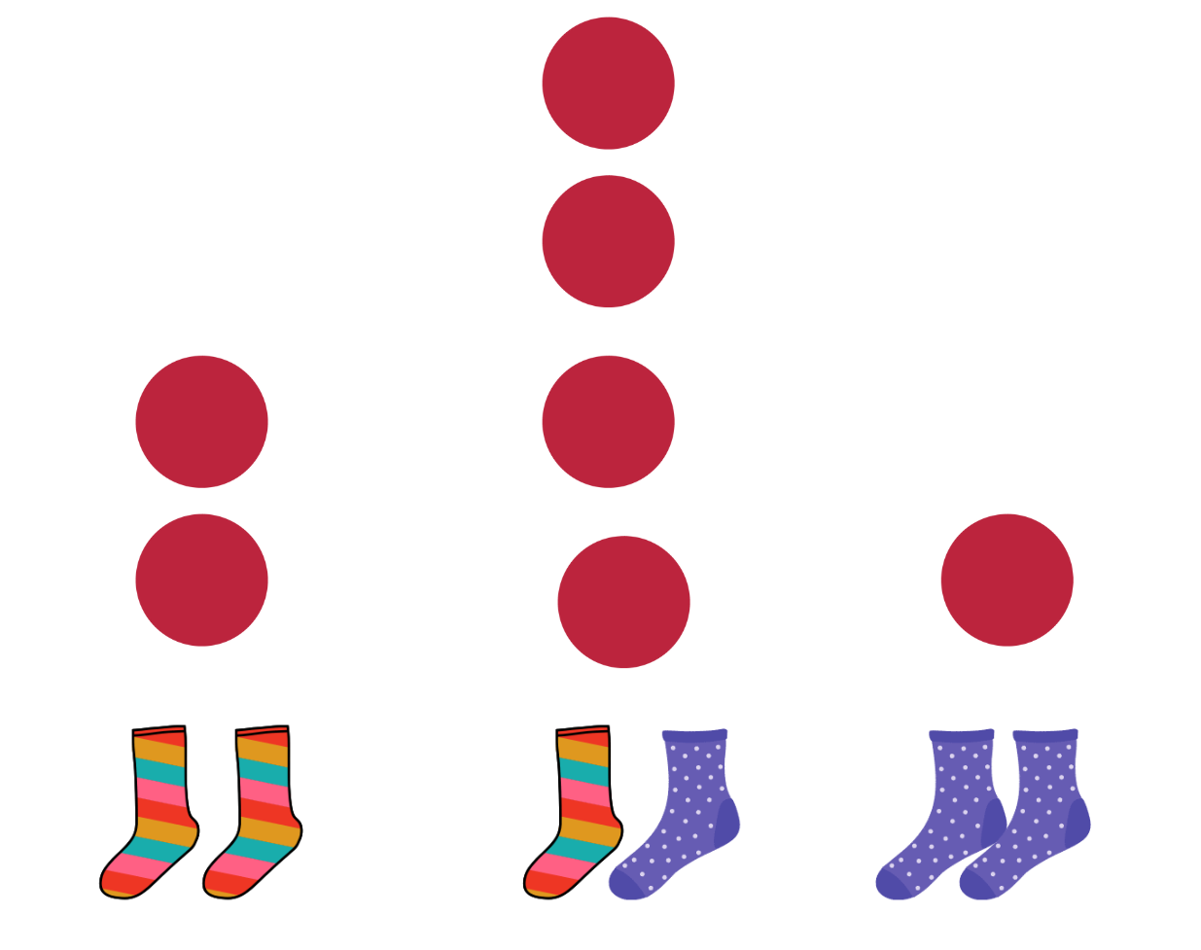
Images from Canva are licensed under the Canva Content License Agreement.
- Look at the class results and ask students if their predictions were correct.
- In pairs, students take a container and place their socks inside. They make predictions and take turns to pull out 2 socks each time without looking. Students record their results choosing their own method of recording the data in their workbooks. They discuss the results compared to their predictions.
This table details assessment opportunities and differentiation ideas.
Assessment opportunities | Too hard? | Too easy?
What to look for:  - Can students make predictions about events being likely, unlikely, less likely or more likely to occur? (MAO-WM-01, MA1-CHAN-01)  - Can students collect data and present it in a display or graph to interpret? (MAO-WM-01, MA1-DATA-01)  What to collect:  - photographs or work samples of predictions and data collection (MAO-WM-01, MA1-CHAN-01)  - observational records. (MAO-WM-01, MA1-CHAN-01) | Students cannot make predictions about events.  - Revise or model events that are likely or unlikely to happen with familiar topics.  - Repeat the sock experiment and have students try to predict what will happen. | Students can make predictions about events.  - Students can predict events that could be described using language such as ‘may, might, possible, likely, unlikely or impossible’.  - Students share ideas with a peer and discuss whether they agree or not.

Discuss and connect the mathematics – 10 minutes
- Summarise the lesson, drawing out key mathematical ideas about predicting the likelihood of events. Ask students:
- Which sock combination is most likely to be drawn out of the basket?
- Which sock combination is least likely to be drawn out of the basket?
- Do you think you would get the same results if you repeated the investigation? Why do you think this?

Lesson 7: The language of chance
Core concept: The language of chance can be used to identify, describe and compare the likelihood of events.
The table below contains suggested learning intentions and success criteria. These are best co-constructed with students.
Learning intentions | Success criteria
Students are learning that:  - the language of chance can be used to identify and describe possible outcomes in everyday activities  - events can be likely, unlikely, more likely, or less likely to happen. | Students can:  - describe events as possible or certain, more or less likely and impossible  - describe and compare the likelihood of events using the language of chance.

Daily number sense: What can you see? – 20 minutes
- Build student understanding of place value by comparing three-digit numbers.
- Ask students what they notice about the numbers on Resource 6: Around the world!. This could include talking about:
- odd or even numbers
- largest and smallest numbers
- the number with the largest hundreds value
- finding numbers over 1000 and explaining how they know this
- 3 numbers that have something in common
- 3 numbers that are all different from each other.
- In small groups, students search for online examples of three-digit numbers in real-life and talk about what they can see.

What’s the chance? – 30 minutes
This activity has been adapted from Sullivan (2012).
- Display the words ‘certain’ and ‘impossible’ on cards and discuss what they mean. Make statements about certain and impossible events using facts about months of the year. Examples include:
- February always comes after January. This is certain.
- December might come in between June and August some years. This is impossible.
- Ask if students know any other words they could use to describe the chance of an event. These include:
- possible
- likely or unlikely
- more likely or less likely
- never.
- Record each word on an A4 card and select some students to hold them up. Decide as a class how to order the cards from least likely to most likely, creating a human probability line. Ask students if they can think of any other words to add. Display the cards as a probability line in the classroom.
- Ask students to describe how likely they are to walk to school the next day using the words certainly, probably, possibly or definitely not. Record students’ answers using tally marks. Have students discuss and make statements about the data.
- Discuss the following scenarios with students to develop their understanding of the language of chance:
- I overheard my mum telling our neighbour that we would definitely do something on the weekend, but I could not hear what it was. What might it be?
- Repeat step (a), but with the word possibly.
- I heard the teacher say, ‘It is (missing word) that all the children in this class will watch television tonight,’ but I didn’t hear one of the words. What might the missing word be?
- What is something that is less likely than all the children watching television tonight?
- Someone asked the principal a question and he/she replied ‘Maybe.’ What might the question have been?
This table details assessment opportunities and differentiation ideas.
Assessment opportunities | Too hard? | Too easy?
What to look for:  - Can students identify and order examples of the language of chance? For example, certain, maybe, more or less likely. (MAO-WM-01, MA1-CHAN-01)  - Can students describe and compare familiar events as being more or less likely to happen? (MAO-WM-01, MA1-CHAN-01)  What to collect:  - observational records. (MAO-WM-01, MA1-CHAN-01) | Students do not understand the language of chance and how it relates to familiar events.  - Choose a fixed daily activity, such as walking to school and discuss how that can be described as almost certain.  - Talk about what might make that event less likely. For example, lots of rain preventing students from walking to school.  - Introduce other events, such as getting on a bus and going to sleep at night. Discuss whether they are more or less likely events than the first. | Students understand the language of chance and how it relates to familiar events.  - Some students may be ready to discuss how different speakers and contexts can affect the meaning of the language of chance.  - For example, when one person says ‘maybe’ to an event, it almost certainly means no; however, when someone else says ‘maybe’, that event has more chance of happening.

Consolidation and meaningful practice: Numbers around us – 5 minutes
- Ask students if they have seen three-digit numbers in real-life situations, such as the airport board in the number sense activity.
- Students suggest ideas that could form a classroom display that can be added to over time.

Lesson 8: Tricky data
Core concept: Symbols in graphs can be accurate or misleading.
The table below contains suggested learning intentions and success criteria. These are best co-constructed with students.
Learning intentions | Success criteria
Students are learning that:  - data can be misleading  - symbols can be used to represent more than one item. | Students can:  - identify and reason about how data can be misleading  - interpret a picture graph where the symbol represents more than one item.

Daily number sense: Teacher choice – 10 minutes
- From a class need surfaced through formative assessment data, identify a short, focused activity that targets students’ knowledge, understanding and skills. Example activities may be drawn from the following resources:
- Thinking Mathematically Stage 1
- Universal Resources Hub.

Interpreting data – 40 minutes
- Show students Resource 7: Basketball hoops A and ask what they notice. After students have shared their ideas, explain that the symbols are different sizes. Ask students how this can be misleading.
- Show students Resource 8: Basketball hoops B and ask what they notice. After students have shared their ideas, explain that the spaces between symbols are not equal and they do not all start on the baseline. Ask students how this can be misleading.
- Show students Resource 9: Basketball hoops C. Explain that this data represents 4 friends taking turns throwing a basketball through a hoop. The graph shows how many balls each friend got through the hoop. Ask students:
- Are the symbols all the same size?
- Are the spaces between the balls the same?
- Do all the symbols or balls start at the baseline?
- Tell students that Caitlin threw 6 balls through the hoop and Johnny threw 7 balls through the hoop. Ask students if they can work out how many hoops Gabriella and Seb threw.
- Students turn and talk about what they think and share their findings with the class. Some students may realise that the symbols are representing 2 items instead of one.
- Ask students:
- Why do you think there is only half a ball displayed?
- What number do you think half a ball represents?
- What number do you think a whole ball represents?
- Explain that, when data is represented this way, it is usually accompanied by a key stating the value of each symbol. In this case, every ball is equal to 2 throws through the hoop. Record a simple key showing one symbol is equivalent to 2 balls in the hoop.
- Have students answer the following questions about the graph:
- How many more balls did Gabriella get through the hoop than Seb?
- How many balls were thrown through the hoop altogether?
- Who threw the most balls through the hoop?
- Who threw the least?
- Who threw more than Johnny?
- Students answer questions on individual whiteboards or in their workbooks, showing their working out.
- Ask students if Resource 9: Basketball hoops C is accurate or misleading and how they know.
This table details assessment opportunities and differentiation ideas.
Assessment opportunities | Too hard? | Too easy?
What to look for:  - Can students identify misleading elements of graphs such as different-sized symbols and inconsistent spacing between symbols? (MAO-WM-01, MA1-DATA-02)  - Are students able to interpret Resource 9: Basketball hoops C, using the knowledge that each symbol is worth 2? (MAO-WM-01, MA1-DATA-02)  What to collect:  - observational records. (MAO-WM-01, MA1-DATA-02) | Students cannot see how Resource 7: Basketball hoops A and Resource 8: Basketball hoops B are misleading.  - Show students a picture graph including a baseline, equal spacing and symbols the same size.  - Point out the elements of accurate graphing.  - Students compare this graph to the misleading graphs. | Students can identify misleading and accurate data.  - Students create other graphs where the symbols represent more than one item.  - Students create a graph that is misleading in 2 ways and ask other students to identify the errors.

Discuss and connect the mathematics – 10 minutes
- Summarise the lesson, drawing out some key mathematical ideas about interpreting data. Ask:
- What were some of the challenges you encountered when interpreting the graph?
- Why is it important that rows or columns of images in a picture graph are aligned?
- Why is it important that all symbols on a picture graph are the same size?
- What else makes a picture graph accurate?

Resource 1: Calendar
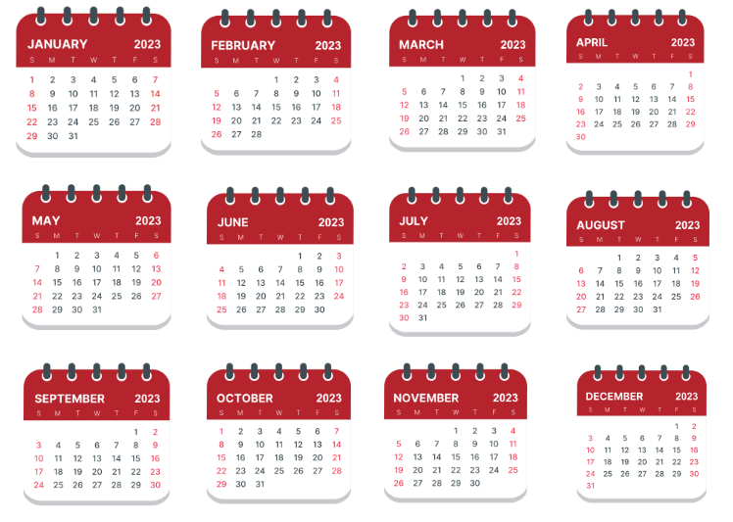
Images from Canva are licensed under the Canva Content License Agreement.

Resource 2: Picture graph example
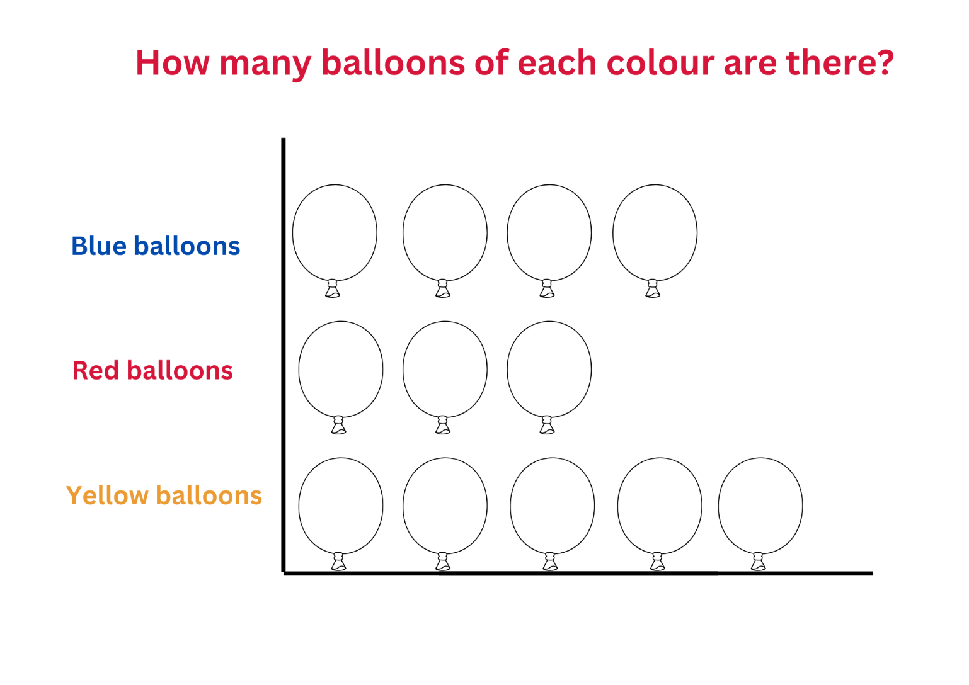
‘Balloon Icon’ by Giuseppe Ramos S is used in accordance with the Canva Content License Agreement.

Resource 3: Features of a column graph
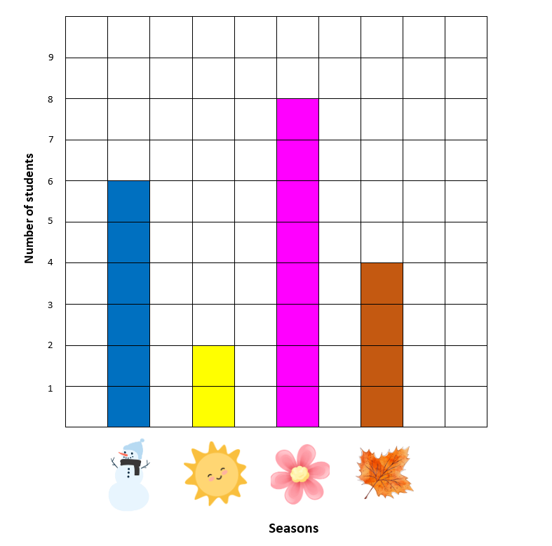
Images from Canva are licensed under the Canva Content License Agreement.

Resource 4: Data questions
What colour are your eyes? | How many people are in your family?
How tall are you? | What is your favourite colour?
What is your favourite season? | How old are you?
Do you prefer chocolate or vanilla? | What is your shoe size?
Do you like tennis? | Do you have a brother?
Can you swim butterfly stroke? | What colour is your hair?
When were you born? | What is your favourite ice-cream?
What football team do you support? | Do you play Minecraft?

Resource 5: Destination Australia
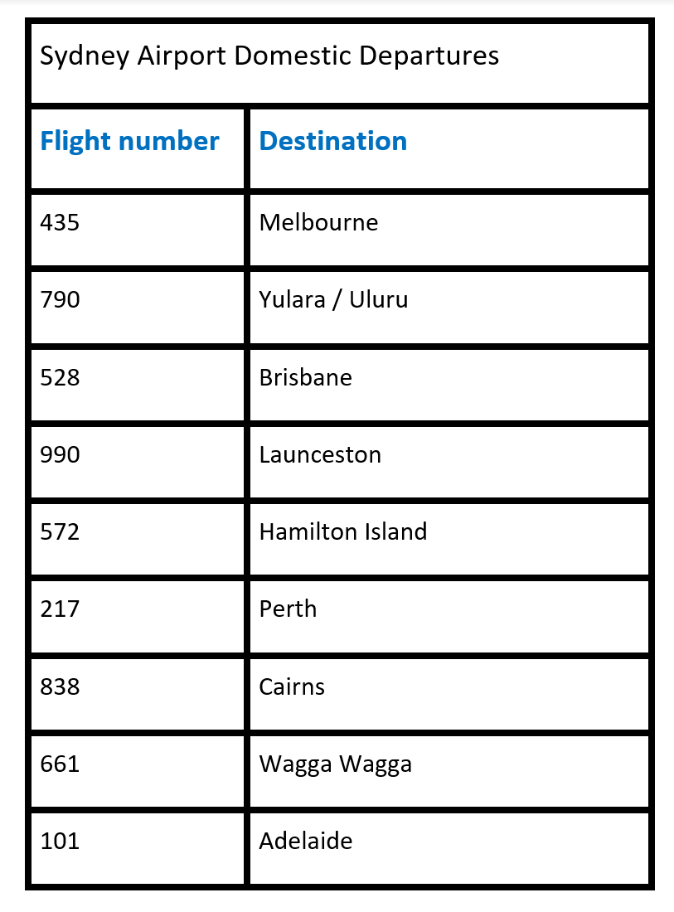

Resource 6: Around the world!
‘Advertisement Airport Departures’ by jlaatz is licensed under the Pixabay License.

Resource 7: Basketball hoops A
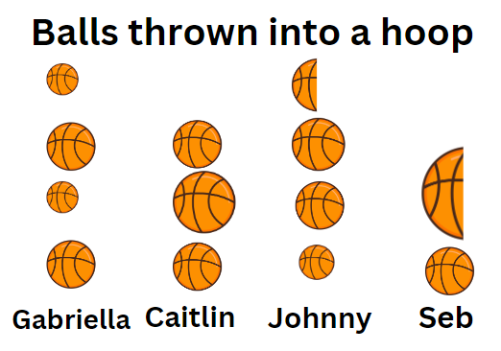
‘Basket Ball’ by Kreason is used in accordance with the Canva Content License Agreement.

Resource 8: Basketball hoops B
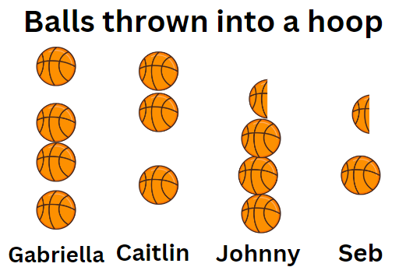
‘Basket Ball’ by Kreason is used in accordance with the Canva Content License Agreement.

Resource 9: Basketball hoops C
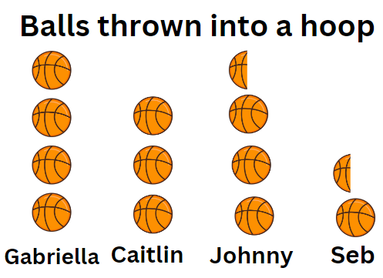
‘Basket Ball’ by Kreason is used in accordance with the Canva Content License Agreement.

Syllabus outcomes and content
The table below outlines the syllabus outcomes and range of relevant syllabus content covered in this unit. Content is linked to National Numeracy Learning Progression version (3).
Focus area and outcomes | Content groups and content points | Lessons
Representing whole numbers A  MAO-WM-01  MA1-RWN-01  MA1-RWN-02 | Continue and create number patterns  - Count forwards and backwards by twos from any starting point (CPr6-CPr7, MuS2) | 1–2
Representing whole numbers B  MAO-WM-01  MA1-RWN-01  MA1-RWN-02 | Form, regroup, and rename three-digit numbers  - Identify the nearest hundred to a number  - Use place value to partition and rename three-digit numbers in different ways (NPV5) | 4–6
Non-spatial measure A  MAO-WM-01  MA1-NSM-01  MA1-NSM-02 | Time: Name and order the cycle of months  - Name and order the months of the year (MeT2)  - Recall the number of days in each month (MeT2)  - Identify a day and date using the Gregorian calendar (MeT2)  - Recognise monthly and annual cycles | 1–2
Data A  MAO-WM-01  MA1-DATA-01  MA1-DATA-02 | Ask questions and gather data  - Investigate a topic of interest by choosing suitable questions to obtain appropriate data (IRD2)  - Gather data and track what has been counted by using concrete materials, tally marks, lists or symbols (IRD3)  Represent data with objects and drawings and describe the displays  - Use concrete materials or pictures of objects as symbols to create data displays where one object or picture represents one data value (IRD2)  - Describe information presented in one-to-one data displays (IRD2)  - Use comparative language to describe information presented in a display, such as ‘more than' and ‘less than’  - Interpret a data display and identify the biggest or smallest values (IRD2) | 1–4, 6, 8
Data B  MAO-WM-01  MA1-DATA-01  MA1-DATA-02 | Identify a question of interest and gather relevant data  - Pose suitable questions where the answers form categories, and predict the likely responses (IRD2)  - Collect data on familiar topics (IRD2)  - Sort data into relevant categories (IRD2)  Create displays of data and interpret them  - Organise collected data into lists and tables to display information (IRD2)  - Represent data in a picture graph using a baseline, equal spacing and same-sized symbols (IRD2)  - Give reasons why some representations of data are misleading  - Interpret information presented in tables and picture graphs (IRD2)  - Record answers to questions using the information in tables and picture graphs (IRD2) | 1–5, 8
Chance A  MAO-WM-01  MA1-CHAN-01 | Identify and describe possible outcomes  - Identify possible outcomes of familiar activities and events  - Describe the chance of possible outcomes for familiar activities and events (UnC1) | 5–7
Chance B  MAO-WM-01  MA1-CHAN-01 | Identify and describe activities that involve chance  - Describe possible outcomes in everyday activities and events as being likely or unlikely to happen (UnC2)  - Compare familiar activities and events and describe them as being more or less likely to happen (UnC2)  - Describe familiar events as being possible (UnC2) | 5–7

References
Links to third-party material and websites
Please note that the provided (reading/viewing material/list/links/texts) are a suggestion only and implies no endorsement, by the New South Wales Department of Education, of any author, publisher, or book title. School principals and teachers are best placed to assess the suitability of resources that would complement the curriculum and reflect the needs and interests of their students.
If you use the links provided in this document to access a third-party's website, you acknowledge that the terms of use, including licence terms set out on the third-party's website apply to the use which may be made of the materials on that third-party website or where permitted by the Copyright Act 1968 (Cth). The department accepts no responsibility for content on third-party websites.
Except as otherwise noted, all material is © State of New South Wales (Department of Education), 2021 and licensed under the Creative Commons Attribution 4.0 International License. All other material (third-party material) is used with permission or under licence. Where the copyright owner of third-party material has not licensed their material under a Creative Commons or similar licence, you should contact them directly for permission to reuse their material.
Mathematics K–10 Syllabus © 2022 NSW Education Standards Authority (NESA) for and on behalf of the Crown in right of the State of New South Wales.
© 2022 NSW Education Standards Authority. This document contains NSW Curriculum and syllabus content. The NSW Curriculum is developed by the NSW Education Standards Authority. This content is prepared by NESA for and on behalf of the Crown in right of the State of New South Wales. The material is protected by Crown copyright.
Please refer to the NESA Copyright Disclaimer for more information.
NESA holds the only official and up-to-date versions of the NSW Curriculum and syllabus documents. Please visit the NSW Education Standards Authority (NESA) website and the NSW Curriculum website.
National Numeracy Learning Progression © Australian Curriculum, Assessment and Reporting Authority (ACARA) 2010 to present, unless otherwise indicated. This material was downloaded from the Australian Curriculum website (National Numeracy Learning Progression) (accessed 14 March 2023) and was not modified. The material is licensed under CC BY 4.0. Version updates are tracked in the ‘Curriculum version history’ section on the 'About the Australian Curriculum' page of the Australian Curriculum website.
ACARA does not endorse any product that uses the Australian Curriculum or make any representations as to the quality of such products. Any product that uses material published on this website should not be taken to be affiliated with ACARA or have the sponsorship or approval of ACARA. It is up to each person to make their own assessment of the product, taking into account matters including, but not limited to, the version number and the degree to which the materials align with the content descriptions and achievement standards (where relevant). Where there is a claim of alignment, it is important to check that the materials align with the content descriptions and achievement standards (endorsed by all education Ministers), not the elaborations (examples provided by ACARA).
This resource contains images and content obtained from Canva, and their use outside of this resource is subject to Canva’s Content License Agreement. If you wish to use them separately from the resource, please go to Canva.
New Zealand Ministry of Education (n.d.) ‘Odd socks’, Resource Finder, NZ Maths website, accessed 14 March 2023.
Sullivan P and Lilburn P (2004) Open-ended Maths Activities: Using ‘good’ questions to enhance learning in Mathematics, 2nd edn, OUP (Oxford University Press) Australia and New Zealand, Melbourne.
Sullivan P, Clarke D and Clarke B (2012) Teaching with Tasks for Effective Mathematics Learning, Spider-Verlag New York Inc., US.
University of Cambridge (Faculty of Mathematics) (2022) Clapping Times, NRICH website, accessed 14 March 2023.

