Mathematics – Stage 1 – Unit 37
Contents
Unit description and duration 4
Student prior learning 4
Lesson overview and resources 5
Lesson 1: Multiple masses 10
Daily number sense: Climb the ladder – 10 minutes 10
Combining weights – 40 minutes 12
Discuss and connect the mathematics – 10 minutes 14
Lesson 2: Comparing capacities 15
Daily number sense: Busting three-digit numbers – 10 minutes 15
Capacities – 40 minutes 16
Discuss and connect the mathematics – 10 minutes 19
Lesson 3: How many blocks? 20
Daily number sense: What is my place value? – 20 minutes 21
Pack it – 40 minutes 23
Lesson 4: Areas of rectangles 26
Daily number sense – 10 minutes 26
Finding areas of rectangles – 40 minutes 27
Discuss and connect the mathematics – 10 minutes 29
Lesson 5: Length hunt 31
Daily number sense: Mastermind – 15 minutes 31
Informal measurement – 30 minutes 33
Consolidation and meaningful practice: Measuring heads – 15 minutes 34
Lesson 6: Measurement scavenger hunt 36
Daily number sense: Thumbs up – 15 minutes 36
Measurement scavenger hunt – 45 minutes 37
Lesson 7: How many centimetres? 41
Daily number sense – 10 minutes 42
The centimetre – 40 minutes 42
Discuss and connect the mathematics – 10 minutes 45
Lesson 8: Air show competition 46
Daily number sense: Place value counting – 10 minutes 47
Paper planes – 40 minutes 48
Discuss and connect the mathematics – 10 minutes 52
Resource 1: Recording sheet 53
Resource 2: Place value 54
Resource 3: Rectangle 55
Resource 4: 3 Rectangles 56
Resource 5: Covered rectangle 57
Resource 6: Covered rectangle 2 58
Resource 7: Measuring strip 59
Resource 8: Scavenger hunt 60
Resource 9: Metres or centimetres? 61
Resource 10: Measurement worksheet 62
Resource 11: Flight recording sheet 63
Syllabus outcomes and content 64
References 72

Unit description and duration
This two-week unit develops student knowledge, understanding and skills of measurement using informal and formal units. Students are provided opportunities to:
- estimate, measure, compare and record a variety of attributes including length, area, volume and mass using informal units
- estimate, measure and record length using formal units of metres and centimetres
- recognise formal units of measurement to ensure consistency and accuracy.
Mathematics K–10 Syllabus © 2022 NSW Education Standards Authority (NESA) for and on behalf of the Crown in right of the State of New South Wales.

Student prior learning
Before engaging in these teaching and learning activities, students would benefit from prior experience with:
- estimating using mathematical language, for example, heavier, lighter, longer, about the same
- measuring the length of objects using informal units of measurement
- comparing the sizes of shapes and objects using informal units of measurement
- using an equal-arm balance to compare the mass of different objects.

Lesson overview and resources
The table below outlines the sequence and approximate timing of lessons; syllabus focus areas and content groups; and resources.
Lesson | Syllabus focus area and content groups | Resources
Lesson 1: Multiple masses  60 minutes  Different informal units can be used to explore mass. | Representing whole numbers B  - Use counting sequences of ones and tens flexibly  - Form, regroup, and rename three-digit number  Non-spatial measure B  - Mass: Compare the masses of objects using an equal-arm balance | - 6-sided dice  - Equal-arm balance (one per group)  - Large collection of classroom objects  - Large collection of uniform informal units, for example, interlocking cubes, marbles, pencils  - Writing materials
Lesson 2: Comparing capacities  60 minutes  Capacity can be compared and measured using informal units. | Representing whole numbers A  - Represent the structure of groups of ten in whole numbers  Representing whole numbers B  - Use counting sequences of ones and tens flexibly  - Form, regroup, and rename three-digit numbers  Three-dimensional spatial structure A  - Volume: Measure and compare the internal volumes (capacities) of containers by filling  Three-dimensional spatial structure B  - Volume: Compare containers based on internal volume (capacity) by filling and packing | - Resource 1: Recoding sheet  - Large collection of craft sticks and elastic bands or interlocking cubes  - Large collection of various sized clear water bottles or containers  - Small plastic cups  - Writing materials
Lesson 3: How many blocks?  60 minutes  Internal volume can be compared and measured by packing. | Representing whole numbers B  - Form, regroup, and rename three-digit numbers  Three-dimensional spatial structure A  - Volume: Measure the internal volume (capacity) of containers by packing  Three-dimensional spatial structure B  - Volume: Compare containers based on internal volume (capacity) by filling and packing  - Volume: Compare volumes using uniform informal units | - Resource 2: Place value  - MAB blocks  - Large collection of uniform informal units. For example, interlocking cubes, marbles, plastic teddies, pasta shells and blocks  - Large collection of various sized boxes  - Writing materials
Lesson 4: Areas of rectangles  60 minutes  Area can be measured using grid structure of rows and columns. | Forming groups B  - Represent and explain multiplication as the combining of equal groups  Two-dimensional spatial structure A  - Area: Measure areas using uniform informal units  Two-dimensional spatial structure B  - Area: Compare rectangular areas using uniform square units of an appropriate size in rows and column | - Resource 3: Rectangle  - Resource 4: 3 rectangles  - Resource 5: Covered rectangle  - Resource 6: Covered rectangle 2  - Mini whiteboards  - Writing materials
Lesson 5: Length hunt  60 minutes  Length can be measured and compared using uniform informal units. | Representing whole numbers B  - Form, regroup, and rename three-digit numbers  Geometric measure A  - Length: Measure the lengths of objects using uniform informal units  - Length: Compare lengths using uniform units  Geometric measure B  - Length: Compare and order lengths, using appropriate uniform informal units | - Large collection of uniform informal units, for example, interlocking cubes, glue sticks, pipe cleaners, rods, craft sticks  - Masking tape or chalk  - Mini whiteboards  - Sticky notes  - String  - Strips of paper  - Writing materials
Lesson 6: Measurement scavenger hunt  60 minutes  There is a need for a formal unit of measurement smaller than the metre. | Representing whole numbers B  - Form, regroup, and rename three-digit numbers  Geometric measure B  - Length: Recognise and use formal units to measure the lengths of objects | - Resource 7: Measuring strip  - Resource 8: Scavenger hunt  - Mini whiteboards  - Playing cards (per pair)  - String (one metre lengths)  - Writing materials
Lesson 7: How many centimetres?  60 minutes  Centimetres can be used to measure smaller lengths. | Geometric measure B  - Length: Recognise and use formal units to measure the lengths of objects | - Resource 7: Measuring strip  - Resource 9: Metres or centimetres?  - Resource 10: Measurement worksheet  - String  - Writing materials
Lesson 8: Air show competition  60 minutes  Recognise and use informal and formal units of measurement. | Representing whole numbers B  - Form, regroup, and rename three-digit numbers  - Use counting sequences of ones and tens flexibly  Geometric measure B  - Length: Recognise and use formal units to measure the lengths of objects  Two-dimensional spatial structure A  - Area: Measure areas using uniform informal units  Non-spatial measure B  - Mass: Compare the masses of objects using an equal-arm balance | - Resource 11: Flight recording sheet  - A4 paper  - Different sizes and thickness of paper  - Equal-arm balances  - Large collection of uniform informal units, for example, interlocking cubes, marbles, pencils, tiles  - MAB blocks  - Measuring tapes  - Rulers (m and cm)  - Writing materials

Lesson 1: Multiple masses
Core concept: Different informal units can be used to explore mass.
The table below contains suggested learning intentions and success criteria. These are best co-constructed with students.
Learning intentions | Success criteria
Students are learning that:  - uniform informal units can be selected to estimate, measure and compare masses  - the number of units needed to measure the mass of an object will depend on the mass of the unit. | Students can:  - select appropriate uniform informal units to estimate, measure and compare masses  - explain why different numbers of units can be used to measure the mass of an everyday object  - compare the masses of 2 or more objects using an equal- arm balance.

Daily number sense: Climb the ladder – 10 minutes
- Build student understanding of place value by forming three-digit numbers, ordering three-digit numbers and stating the value of each digit in the number.
- Explain the aim of the game is to position three-digit numbers in sequence on the ladder rungs.
- Draw a ladder with 5 rungs on the board. Roll 3 × 9-sided dice and form a three-digit number. State the value of each digit, for example, 5 hundreds, 2 tens and 3 ones = 523; or 2 hundreds, 5 tens and 3 ones = 253. Record the chosen three-digit number on one of the ladder rungs (see Figure 1).
Figure 1 – Climb the ladder
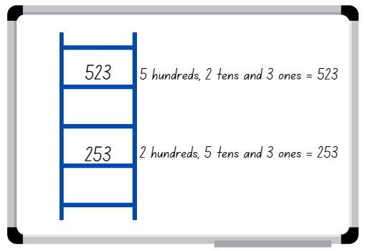
Images sourced from Canva and used in accordance with the Canva Content License Agreement.
- Select a student to roll the 3 dice again and form another three-digit number to place on a rung of the ladder. Ask the student to explain and justify why they selected the three-digit number, which rung they nominated to place it on and to state the value of the digits before recording it on the ladder.
- Continue the game until a player is unable to place their number on the ladder. Discuss if there were any other possible combinations that could have helped a player win.
Note: The game can be played as a whole class or in pairs.

Combining weights – 40 minutes
- Revise how to use an equal-arm balance using uniform informal units and everyday objects. For example, estimate how many marbles will be needed to balance the mass of a stapler. Check estimates using the equal-arm balance. Ask students if they can think of another unit to use and whether they will need more or less of them to equal the mass of the stapler. Test student responses using the equal-arm balance.
- Model a mass story where students use logic, comparison and knowledge of some masses to work out how many uniform informal units are needed for another. For example, ask how many marbles will equal the mass of one book, if a pencil case is equal in mass to 30 marbles and if a book is equal in mass to 2 pencil cases. Provide time for students to turn and talk and select students to share and explain their thinking.
- Demonstrate student responses with concrete materials and an equal arm-balance. Ask students what other units could be used to solve this problem.
- Provide small groups with an equal arm-balance, uniform informal units and everyday classroom objects. Students estimate, create, solve and record three-part mass problems as per the modelled story (see Figure 2).
Figure 2 – Mass story recording
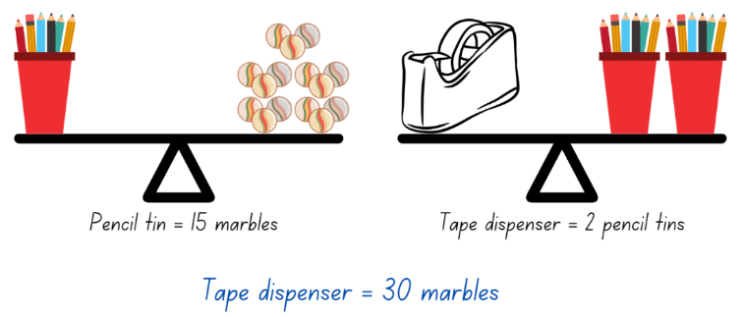
Images sourced from Canva and used in accordance with the Canva Content License Agreement.
- Students display their working and go on a gallery walk, looking at what others have discovered in their mass problems.
The table below details assessment opportunities and differentiation ideas.
Assessment opportunities | Too hard? | Too easy?
What to look for:  - Can students select appropriate uniform informal units to estimate, measure and compare masses? (MAO-WM-01, MA1-NSM-01)  - Can students explain why the number of units needed to measure an object will depend on the mass of the unit? For example, a stapler has a mass equal to 10 marbles or 60 paperclips. (MAO-WM-01, MA1-NSM-01)  - Are students able to compare the mass of 2 or more objects using an equal-arm balance? (MAO-WM-01, MA1-NSM-01)  What to collect:  - observational data during the task (MAO-WM-01, MA1-NSM-01)  - student work samples (MAO-WM-01, MA1-NSM-01) | Students are unable to use an equal-arm balance to compare the masses of 2 or more objects using what they know about the mass of one object.  - Provide students with 2 objects that are very different in weight. Have students heft to identify if one is lighter or heavier. Students sort heavy and light objects into 2 groups.  - Students compare the mass of 2 objects using uniform informal units. For example, a book is equal to 10 marbles and a pencil tin is equal to 6 marbles. | Students can use an equal-arm balance to compare the masses of objects.  - Challenge students to estimate, create, record and solve four-part mass problems.  - Students create their own three- or four-part mass problem for a peer to solve.

Discuss and connect the mathematics – 10 minutes
- Regroup as a class and summarise the lesson together, drawing out key mathematical ideas. Ask:
- How close were you to your estimations?
- Were there any uniform informal units or everyday objects that did not work for this activity? Why?
- Which uniform informal unit was the most efficient to work with? Why?
- What challenges did you face? How did you overcome them?

Lesson 2: Comparing capacities
Core concept: Capacity can be compared and measured using informal units.
The table below contains suggested learning intentions and success criteria. These are best co-constructed with students.
Learning intentions | Success criteria
Students are learning that:  - objects can look different but have the same capacity  - objects can look the same but have different capacities. | Students can estimate, compare, measure and record the capacity of 2 or more containers using informal units.

Daily number sense: Busting three-digit numbers – 10 minutes
This activity has been adapted from Number busting – number talk (renaming 26) (2:00) by Thinking mathematically Stage 1.
- Build student understanding of place value by partitioning and renaming three-digit numbers in multiple ways.
- Sit in a circle and display 13 groups of 10 and 6 ones using craft sticks or other materials. Tell students you have 136 craft sticks. Students turn and talk to share ideas on how they can prove there are 136 sticks.
Note: Bundles of 10 can be made with craft sticks, interlocking cubes, straws or something similar that can be separated. In Stage 1, it is preferable to use materials that can be joined together and pulled apart prior to introducing MAB blocks. Before the lesson, watch Number busting – number talk (renaming 26) (2:00).
- Invite students to number bust 136 with you. Model how to use the collection to partition 136 in different ways. Record some of the different ways to rename 136. Invite students to share their ideas. Demonstrate ideas students may not think of, such as 136 is 12 tens and 16 ones. Encourage students to undo the craft sticks bundles to check and prove this.
- Repeat and model the above steps with a different three-digit number.

Capacities – 40 minutes
This activity has been adapted from Comparing capacities by NZ Maths.
- Show students 2 different sized clear water bottles and place them next to each other. Ask students which container has the largest internal volume (capacity). Students turn and talk to discuss how they know which bottle has the largest capacity.
Internal volume (capacity): The amount a container can hold and is only used in relation to containers. It generally refers to liquid measurement, that is, the amount of liquid is equal to the internal volume of a container.
- Select students to share and explain how they know which bottle holds the most water. Ask:
- How do you know the taller container holds the most water?
- Is it always true that tall containers hold more than short containers?
Note: Some students might raise the possibility that the width of the container might also be important.
- Show a third, different sized clear water bottle to the previous 2 bottles and ask students to order the water bottles from smallest capacity to largest capacity. Ask:
- Why do you think these containers hold different amounts of water?
- Which container will have the smallest capacity? How do you know?
- How can we check which container has the largest capacity?
- Check student responses by filling the largest bottle identified by the class with water and pouring it into the next size bottle. If students are correct, the second container will be filled and there will be water left over.
- Provide small groups with Resource 1: Recording sheet, small plastic cups and 3 larger containers that are about the same height but have different widths. Ask students to estimate, then order the containers according to their capacity from smallest to largest and measure using their cups. Students record their measurements on Resource 1: Recording sheet (see Figure 3).
Figure 3 – Recording capacities.
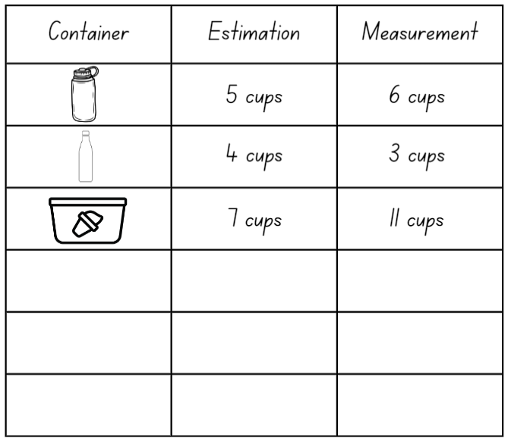
Images sourced from Canva and used in accordance with the Canva Content License Agreement.
- Select groups to share and explain their findings.
- Repeat with 3 bottles or containers that vary in both height and width. Students estimate, order and measure, recording their work on Resource 1: Recording sheet. Students then share and explain their findings about the capacity of their bottles or containers.
Note: Highlight that both height and width determine the capacity of a container.
This table details assessment opportunities and differentiation ideas.
Assessment opportunities | Too hard? | Too easy?
What to look for:  - Can students estimate, compare, measure and record the capacity of 2 or more containers using informal units? (MAO-WM-01, MA1-3DS-02)  - Are students able to explain that both height and width determine the capacity of a container? (MAO-WM-01, MA1-3DS-02)  What to collect:  - observational data (MAO-WM-01, MA1-3DS-02)  - student work samples (MAO-WM-01, MA1-3DS-02) | Students are unable to compare, measure and record the capacities of 2 or more containers.  - Provide students with one container to measure the capacity using informal units. For example, a small cup.  - Provide students with containers that are very different in size. Support students to compare the capacity by pouring water from the larger container into the smaller container and discussing that there is water left over. | Students can compare, measure and record the capacities of containers.  - Challenge students to solve how many cups are in one bottle of soft drink. Students then work out how many bottles of soft drink they would need to buy for a class party of 24 students.  - Students use multiple different sized informal units to measure the capacity of containers, recording each one on Resource 1: Recording sheet.

Discuss and connect the mathematics – 10 minutes
- Summarise the lesson together, drawing out some key mathematical ideas. Ask:
- Does a tall container always hold more than a short container? Why or why not?
- Can you compare the capacity of containers with irregular shapes? How would you do it?
- Can you fill a container to its capacity? Why or why not?
- Can you estimate the capacity of a container without measuring it? Explain your thinking.
- Can different shaped containers have the same capacity?

Lesson 3: How many blocks?
Core concept: Internal volume can be compared and measured by packing.
The table below contains suggested learning intentions and success criteria. These are best co-constructed with students.
Learning intentions | Success criteria
Students are learning that:  - the position of a digit in a number determines its value  - uniform informal units can be used to compare internal volumes (capacities). | Students can:  - make, record and state the value of digits in three-digit numbers  - estimate, measure and compare the internal volume of a container by packing it with uniform informal units.

Daily number sense: What is my place value? – 20 minutes
- Build student understanding of place value by making, recording and stating the value of digits in three-digit numbers.
- Write 462 on the board and ask students how the number can be made using MAB blocks. Students turn and talk about how they could make the number, then share and explain their thinking.
Note: In Stage 1, it is recommended that students have had experiences with materials that can be joined together and pulled apart, for example, bundles of craft sticks, interlocking cubes, straws or similar, before introducing MAB blocks.
- Model student responses with MAB blocks, then draw the MAB blocks, recording and stating the value of the digits as 4 hundreds, 6 tens and 2 ones = 462 or as 4 groups of one hundred, 6 groups of 10 and 2 ones = 462, as seen in Figure 4.
Figure 4 – Modelling with MAB
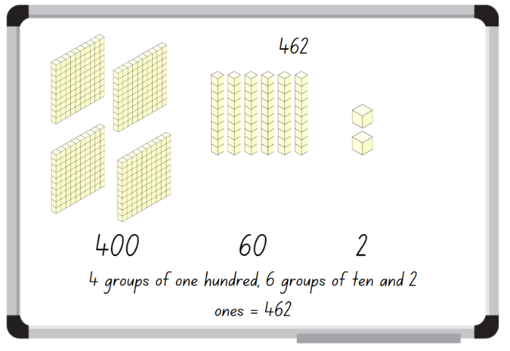
Images sourced from Canva and used in accordance with the Canva Content License Agreement.
- Display Resource 2: Place value and provide students with MAB blocks and their workbooks.
- Students make the three-digit numbers with MAB blocks, record using diagrams and state the value of the digits in their workbook. While students are making and recording, ask:
- How many hundreds have you used to make your number?
- What is the value of the 7 in 762?
- How many tens have you used to make your number?
- What is the value of the 9 in 359?
- What is the value of the 6 in 762?
This table details assessment opportunities and differentiation ideas.
Assessment opportunities | Too hard? | Too easy?
What to look for:  - Can students make a model of a three-digit number using materials? (MAO-WM-01, MA1-RWN-01, MA1-RWN-02)  - Are students able to state the value of digits in three-digit numbers? (MAO-WM-01, MA1-RWN-01, MA1-RWN-02)  - Can students rename three-digit numbers in different ways? (MAO-WM-01, MA1-RWN-02)  What to collect:  - student work samples (MAO-WM-01, MA1-RWN-01, MA1-RWN-02) | Students are unable to make and record three-digit numbers in expanded form.  - In pairs, students flip over two-digit number cards. Students read and make two-digit numbers using MAB blocks.  - Give students further experiences using different concrete materials to represent numbers. | Students can make and record three-digit numbers.  - Students make and record their three-digit number and then identify the nearest hundred to the number.  - Challenge students to make the three-digit numbers in different ways. For example, 326 as 3 groups of one hundred, 2 groups of 10 and 6 ones, or 32 groups of 10 and 6 ones.

Pack it – 40 minutes
This activity has been adapted from How Many Blocks Fit In The Box? from Learning & Teaching with Learning Trajectories.
- Display 3 different boxes, for example, a shoe box, shipping box, tissue box or copy paper box. Explain that you want to mail something to a friend, but you don't know what size box you will need. Students turn and talk to discuss ways the box could be measured.
- Select students to share and explain their strategies.
- If not already discussed through student responses, display a collection of interlocking cubes or blocks and ask how the blocks could be used to measure the capacities of the boxes.
- Provide small groups with different sized boxes and a large collection of interlocking cubes or uniform blocks. Ask students to pack the entire box and then count and record the number of cubes or blocks needed. Students share and discuss their findings. Ask:
- Which box held the most cubes or blocks?
- Which box held the least cubes or blocks?
- How did you pack your box?
- What happens if there are gaps in your packing?
Note: Explain that leaving gaps when packing and stacking will affect accuracy when measuring the internal volume. Working out the volume based on the number of blocks in a row or column of blocks, and the number of rows in a layer depends on systematic packing.
- In small groups, ask students to find one container from the classroom. For example, pencil tin, lunch box, water bottle or tote tray, then measure the internal volume by packing with uniform informal units.
- Provide students with informal units, for example, interlocking cubes, blocks, plastic teddies, pasta shells or marbles and their workbooks. Ask students to estimate the volume of their container in terms of the number of units. Students then measure the volume of the container by packing using the uniform units, and record the results.
- Regroup as a class and choose students to share their working. Ask:
- How did you measure the volume of the container?
- What did you learn about measuring volume using uniform informal units?
- What challenges did you encounter when measuring the volume of the container?
- What could you do to improve your accuracy when measuring volume?
- Why is it that same sized containers can have different volumes?
- Can you think of any real-life situations where measuring volume is important?
This table details assessment opportunities and differentiation ideas.
Assessment opportunities | Too hard? | Too easy?
What to look for:  - Can students estimate, measure and compare the internal volume of a container by packing it with uniform informal units? (MAO-WM-01, MA1-3DS-02)  - Are students able to explain why some same sized containers have different volumes? (MAO-WM-01, MA1-3DS-02)  What to collect:  - observational data (MAO-WM-01, MA1-3DS-02)  - student work samples (MAO-WM-01, MA1-3DS-02) | Students are unable to compare and measure the internal volume of a box by packing it with uniform informal units.  - Provide students with a set of different sized containers, such as plastic cups or cardboard boxes. Ask students to sort the containers according to size.  - Ask students to compare volumes by finding who can hold the most blocks in one hand. Put the blocks in clear plastic cups and compare the height of the blocks in the cup. | Students can compare and measure the internal volume of a box by packing it with uniform informal units.  - Provide students with a set value of uniform blocks, for example, 20 blocks and various sized containers. Ask students to estimate using only the set value of blocks and then check their measure.  - Provide students with A4 cardboard to make an irregular box. Discuss the challenges they may have when measuring the volume of the box.

Lesson 4: Areas of rectangles
Core concept: Area can be measured using grid structure of rows and columns.
The table below contains suggested learning intentions and success criteria. These are best co-constructed with students.
Learning intention | Success criteria
Students are learning that area can be measured and compared by creating repeated rows and columns of square tiles. | Students can:  - measure area by selecting and using appropriate uniform informal units  - form arrays of equal rows and columns to find the area of a rectangle  - explain how the grid structure helps to find the area.

Daily number sense – 10 minutes
- From a class need surfaced through formative assessment data, identify a short, focused activity that targets students’ knowledge, understanding and skills. Example activities may be drawn from the following resources:
- Thinking Mathematically Stage 1
- Universal Resources Hub.

Finding areas of rectangles – 40 minutes
This activity has been adapted from Finding areas of rectangles from NZ Maths.
- Display Resource 3: Rectangle and ask students how many tiles make up the whole rectangle. Students turn and talk, explaining their strategy.
The table below outlines stimulus prompts to generate conversation about the topic, along with anticipated responses from students.
Prompts | Anticipated student responses
- How many tiles are in each column?  - How many tiles are in each row?  - How many tiles make up the whole rectangle?  - What is the area of the rectangle?  - Why is the rectangle measured in squares? | - There are 3 tiles in each column.  - There are 4 tiles in each row.  - The rectangle is made up of 12 tiles.  - The area is 12 tiles.  - They fit together with no gaps.
- Discuss the strategies students used to work out the rectangle contains 12 squares and therefore, the area is 12 squares. For example, additive strategies such as 4 + 4 + 4 = 12 and 3 + 3 + 3 + 3 = 12, or multiplicative strategies such as 4 groups of 3 is 12 and 3 rows of 4 is 12.
Area: The amount of surface inside a closed flat (2D) shape.
- Display Resource 4: 3 rectangles. Ask students to use their individual whiteboard to solve the area of each rectangle.
- Select students to share and explain how they calculated the area of each rectangle.
- Provide students with a sheet of square grid paper or a grid workbook and ask them to draw as many rectangles as possible that have an area of 24 squares.
- Regroup as a class and choose different students to share and explain the different rectangles they have drawn. Ask:
- What strategies did you use to form the rectangles?
- Did you notice a relationship between the rectangles? Explain your answer.
- How do you know you have drawn all the possible rectangles?
- Display and provide Resource 5: Covered rectangle. Ask students to find the area of the rectangle, allowing them to draw the missing squares or grid to calculate the area. Students turn and talk, then share and justify their ideas.
Note: To assist students in developing an appreciation for the structure of repeated units, the teaching progress moves from providing multiple squares to cover an area to providing only one. Using one square requires students to create a pattern or structure of units by drawing or visualising. Drawing an array structure for tessellation of an area assists students to perceive the rows (and columns) as composite units. This perception enables them to connect the side length and area. If students have drawn and talked about the structure of an array, then the structure of three-dimensional stacking may be grasped more easily.
- Provide Resource 6: Covered rectangle 2 and ask students to find the area of the rectangle using the provided square. Select students to share explain the strategies they used to determine the area of the rectangle.

Discuss and connect the mathematics – 10 minutes
- Summarise the lesson together, drawing out some key mathematical ideas. Ask students:
- What strategy did you use to find the area of the rectangle?
- Did you need to draw the grid on the rectangle or did you visualise it?
- Why is the grid structure helpful when finding the area?
- If we changed the size of the square tile, would the area of the rectangle change?
- Why is it important to make sure there are no gaps or overlaps when measuring area?
- What challenges did you face? How did you overcome them?
This table details assessment opportunities and differentiation ideas.
Assessment opportunities | Too hard? | Too easy?
What to look for:  - Can students measure area by selecting and using appropriate uniform informal units? (MAO-WM-01, MA1-2DS-02)  - Are students able to form the array structure of area in rows and columns? (MAO-WM-01, MA1-FG-01, MA1-2DS-02)  - Can students explain how the grid structure helps to find the area? (MAO-WM-01, MA1-2DS-02)  What to collect:  - observational data (MAO-WM-01, MA1-FG-01, MA1-2DS-02)  - student work samples (MAO-WM-01, MA1-FG-01, MA1-2DS-02) | Students are unable to measure the area of a rectangle using informal units.  - Students superimpose rectangles to compare the size and order them from smallest to largest.  - Provide students with square tiles to manipulate when measuring the area of a rectangle. Support students to count tiles with one-to-one correspondence when covering the rectangle. | Students can use uniform informal units to measure the area of various size rectangles.  - Challenge students to explore the area of non-rectangular shapes using the provided square. For example, a triangle or a rhombus.  - Students solve Torn Shapes by NRICH and present to a peer.

Lesson 5: Length hunt
Core concept: Length can be measured and compared using uniform informal units.
The table below contains suggested learning intentions and success criteria. These are best co-constructed with students.
Learning intention | Success criteria
Students are learning that length can be measured using a single uniform informal unit. | Students can:  - use uniform informal units to measure and compare lengths by placing the units end to end without gaps and overlaps  - estimate and record lengths by referring to the number and type of unit used.

Daily number sense: Mastermind – 15 minutes
This activity has been adapted from Mastermind (7:43) from Thinking mathematically Stage 1.
- Build student understanding of place value by stating the value of digits in numbers up to three-digits.
- In pairs, each student records a three-digit number with no repeated digits on a sticky note. Students draw up their game board on a mini whiteboard (see Figure 5).
- Students take turns to guess their partner’s three-digit number. Their partner tells them how many digits are correct and how many are in the correct place (see Figure 5).
Figure 5 – Mastermind game board
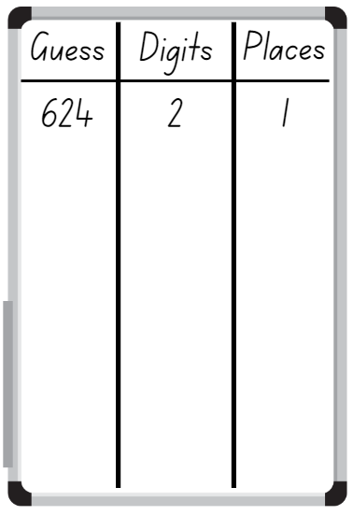
‘Blank Whiteboard Illustration’ by Elena Nazarova is used in accordance with the Canva Content License Agreement.
- Students record their guess, the number of digits that are correct and the number of digits that are in the right place. Students then use this information to refine their guesses.
- The first student to correctly guess their partner’s number is the winner.
- Ask students to discuss the strategies they used to determine the correct answer.
Note: This activity can be adapted by using two-, four- or five-digit numbers.

Informal measurement – 30 minutes
This activity has been adapted from ‘Crooked Paths’ from Primary and Middle Years Mathematics: Teaching Developmentally by Van de Walle et al. (2019).
- Revise the measurement of length by asking students to share language used when measuring or comparing lengths. For example, end to end, gap, estimate, shorter or longer, same as, longest, shortest. Record student responses on an anchor chart.
- Provide pairs with an individual whiteboard and a variety of objects to be their target unit of measure, for example, a pencil, an exercise book, a glue stick, a craft stick. Ask students to find items in the room that are shorter than, longer than or about the same length as their target unit of measure and record their findings on their whiteboard.
- Select students to share and justify the items and the lengths compared to their target unit.
- Make at least 3 crooked or curved paths on the floor or outside with masking tape or chalk. Provide an informal unit of measure, for example, a glue stick, a craft stick, a pencil. Ask students to estimate and then determine which path is the shortest to longest by measuring the lines with their informal unit. Students record their responses on their individual whiteboard, stating the number and type of unit used.
- Select students to share and justify the lengths of the paths. Discuss the various ways students measured the crooked or curved paths. Ask:
- What are some important factors that you need to consider when measuring curved or crooked paths?
- What other items could be used to measure the crooked or curved paths?
- How close was your estimation to the measurement?
- What are some important factors that you need to consider when measuring straight paths?

Consolidation and meaningful practice: Measuring heads – 15 minutes
This activity has been adapted from ‘Who has the biggest head?’ from Teaching measurement Early Stage 1 to Stage 1 by NSW Department of Education.
- Provide small groups with string or strips of paper to measure around their heads, marking the measurement.
- Provide each group with one form of informal unit of measure for example, interlocking cubes, pipe cleaners, rods, craft sticks. Students estimate and then measure their string or strips of paper with their informal unit and record. Students then organise their strings in order of length from shortest to longest.
- Regroup and choose students to share their results. Ask:
- How close was your estimate to the actual length of the string?
- Could you estimate the length of your head without using the string or any other tools?
- What happens when you measure the same object using different informal units?
- Why is it important to use the same unit measure every time you measure something?
- Can you think of a situation where consistent measurement could make a difference? For example, measuring material for making curtains.
- Why is it important to measure things accurately?
This table details assessment opportunities and differentiation ideas.
Assessment opportunities | Too hard? | Too easy?
What to look for:  - Can students use uniform informal units to measure lengths by placing the units end to end without gaps and overlaps? (MAO-WM-01, MA1-GM-02)  - Can students estimate and record lengths and distances by referring to the number and type of unit used? (MAO-WM-01, MA1-GM-02)  What to collect:  - observational data (MAO-WM-01, MA1-GM-02) | Students are unable to estimate, check and count a collection of informal units to measure various lengths.  - Provide students with string and tape to hold the beginning of the string in place when measuring the crooked or curved paths and markers to identify the end of the path. Students then order the lengths of string from shortest to longest.  - Support students to measure short straight paths, modelling how to place informal units end to end without gaps or overlaps. Students count with one-to-one correspondence to find the total length. | Students can estimate, check and count a collection of informal units to measure various lengths.  - Challenge students to solve problems that require estimation, for example, a bug walks around 2 sides of a book and another bug walks diagonally across the desk. Ask students which bug will walk the furthest. Vary this activity by choosing different paths.  - Students make their own informal unit ruler and use it to measure items and the paths.

Lesson 6: Measurement scavenger hunt
Core concept: There is a need for a formal unit of measurement smaller than the metre.
The table below contains suggested learning intentions and success criteria. These are best co-constructed with students.
Learning intention | Success criteria
Students are learning that there is a need for a formal unit of measurement smaller than the metre. | Students can:  - measure the length of objects to the nearest centimetre, using a device with 1 cm markings  - estimate length and distance to the nearest centimetre and check by measuring.

Daily number sense: Thumbs up – 15 minutes
This activity has been adapted from Thumbs Up from Developing Efficient Numeracy Strategies by NSW Department of Education.
- Build student understanding of place value by representing three-digit numbers in a range of ways.
- Provide pairs with playing cards, 1 to 9 and an individual whiteboard. Student A shuffles the cards and deals 3 cards to each player. Each student arranges the cards to make a three-digit number, out of view of their partner. The remaining cards are placed face down in a central pile.
- Student B flips over a card from the central pile and asks their partner about the value of the card. For example, students ask if their partner’s number has 3 tens. Student A responds with either a thumbs up, indicating student B is correct; thumbs horizontal, indicating the digit is in the number but not with that value; or thumbs down, indicating the digit is not in the number. Student B records the digit and response to help them identify the hidden number with either a tick or a cross (see Figure 6).
Figure 6 – Gameplay
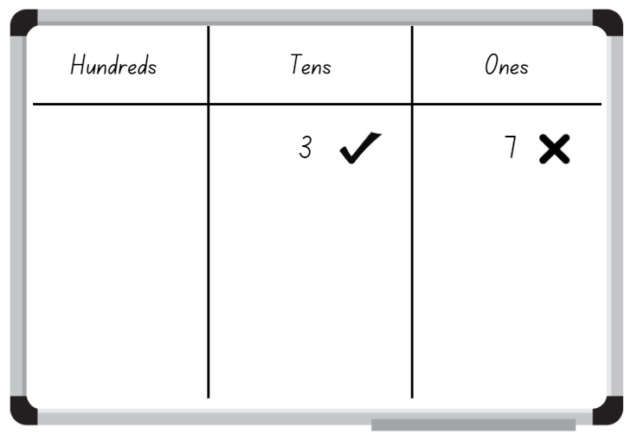
‘Blank Whiteboard Illustration’ by Elena Nazarova is used in accordance with the Canva Content License Agreement.
- Students may keep the card that they received a horizontal thumb for and use it in their next turn or discard the card. Unwanted cards are placed on a discard pile. Students take turns, trying to be the first person to correctly identify their partner’s number.

Measurement scavenger hunt – 45 minutes
- Provide students with a piece of string that is one metre long. Explain that they are going on a hunt for an item around the class that is the same length as the string.
- Students bring their item back to floor to share. Guide student to make collections that they estimate to be:
- less than one metre
- about one metre
- more than one metre along any side.
- Students share their item and record on a class Y-chart, categorising items that are about a metre in length, greater than a metre and less than a metre. Choose 2 items that have been collected that are similar in length and less than one metre. Discuss that students will need to measure the items accurately to determine which is longer, but they cannot use a metre. Ask:
- How can you measure the length of an object that is smaller than a metre using a smaller unit of measurement?
- What is the next smaller unit of measurement for length after a metre?
- How is the smaller unit useful in our daily lives?
- Display Resource 7: Measuring strip and Resource 8: Scavenger hunt. Demonstrate how to estimate, measure and record classroom items accurately and to the nearest centimetre (cm) (see Figure 7). Highlight the importance of starting at zero when measuring.
Figure 7 – Scavenger hunt recording
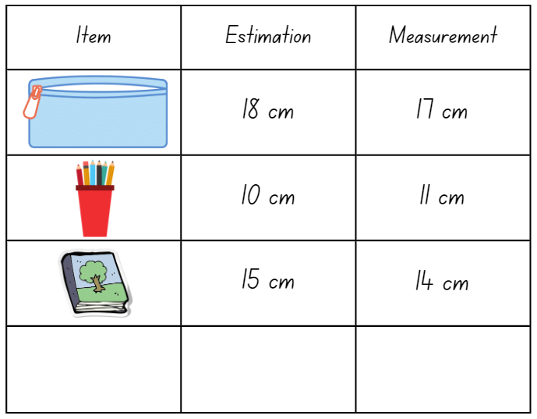
Images sourced from Canva and used in accordance with the Canva Content License Agreement.
- Provide pairs with Resource 7: Measuring strip and Resource 8: Scavenger hunt. Explain that students are going on a scavenger hunt to measure items around the classroom using the measuring strip. Students use Resource 8: Scavenger hunt to record their estimation and measurements.
Note: When recording measurements, a space should be left between the number and the abbreviated unit. For example, 3 cm, not 3cm.
- Students display Resource 8: Scavenger hunt and go on a gallery walk, looking at the items other students have measured and their length.
- Regroup as a class and ask:
- Why is it important to start at zero when measuring?
- How accurate were your measurements?
- Was it challenging to measure the length of certain objects? If so, how did you overcome the challenge?
- Were there objects that were longer than the measuring strip? How did you measure them?
- How close were your estimations?
This table details assessment opportunities and differentiation ideas.
Assessment opportunities | Too hard? | Too easy?
What to look for:  - Can students measure the length of objects to the nearest centimetre, using a device with 1 cm markings? (MAO-WM-01, MA1-GM-02)  - Can students estimate length and distance to the nearest centimetre and check by measuring? (MAO-WM-01, MA1-GM-02)  What to collect:  - observation data (MAO-WM-01, MA1-GM-02)  - student work samples (MAO-WM-01, MA1-GM-02) | Students are unable to measure the length of objects using formal units of metres and centimetres.  - Provide students with a range of uniform informal units to measure classroom items and record.  - Support students to trace the object and then measure the length of the traced object using the strip of paper. | Students can measure the length of objects using formal units of metres and centimetres.  - Challenge students to calculate the perimeter of the classroom objects using Resource 7: Measuring strip.  - Challenge students to identify and record objects at home that would be measured by either formal units of metres or centimetres.

Lesson 7: How many centimetres?
Core concept: Centimetres can be used to measure smaller lengths.
The table below contains suggested learning intentions and success criteria. These are best co-constructed with students.
Learning intentions | Success criteria
Students are learning that:  - there is a need for a formal unit smaller than a metre  - length can be estimated and measured to the nearest centimetre. | Students can:  - accurately measure and record lengths of objects to the nearest centimetre using the abbreviation for centimetres (cm)  - recognise that there are 100 centimetres in one metre.

Daily number sense – 10 minutes
- From a class need surfaced through formative assessment data, identify a short, focused activity that targets students’ knowledge, understanding and skills. Example activities may be drawn from the following resources:
- Thinking Mathematically Stage 1
- Universal Resources Hub.

The centimetre – 40 minutes
This activity has been adapted from Stage 1 – measurement – length by NSW Department of Education.
- Display Resource 9: Metres or centimetres? and students turn and talk about the most appropriate formal unit of measurement for measuring the length of these objects (metres or centimetres).
- Select students to share their thinking and record their responses using the abbreviation for centimetres (cm) and metres (m). Ask:
- Are there any objects that can be measured in both centimetres and metres?
- Why did you think ‘cm’?
- Why did you think ‘m’?
- Provide small groups with Resource 7: Measuring strip for students to measure the length of the one metre length of string from Lesson 6. Remind students to ensure they place their 20 cm strip at the beginning of the string and there are no gaps or overlaps.
- Students count the number of 20 cm pieces they used to measure the length of the string and discover that there are 100 cm in a metre (see Figure 8).
Figure 8 – Measuring one metre string
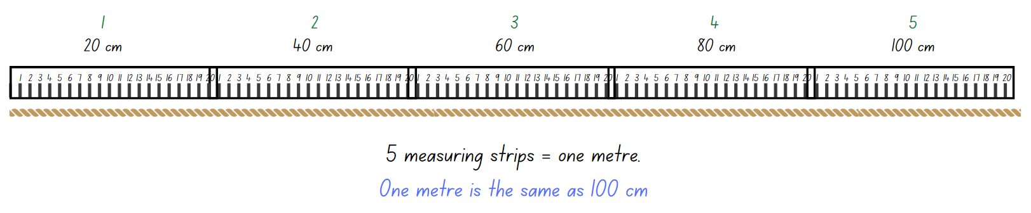
‘Rope Symbol’ by brand311766527 is in accordance with the Canva Content License Agreement.
- Regroup as a class and discuss the following:
- 100 centimetres is the same length as one ________.
- One metre equals __________ centimetres.
- 1 m = _____________ cm.
- Provide Resource 10: Measurement worksheet and ask students to use Resource 7: Measuring strip to measure the length of each line and record the measurement at the end of each line.
- Regroup as a class and ask:
- Why is accuracy important when measuring length?
- How accurate do you need to be when measuring length in centimetres?
- Why is it important to make sure you line up the ends? What happens if you do not?
- Provide student workbooks and ask students to measure 2 items or pencils in their pencil case and record using centimetres (cm) in their workbook using images and numerals (see Figure 9).
Figure 9 – Student work sample
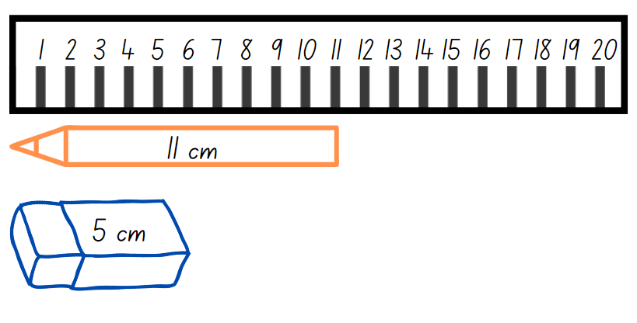
Images sourced from Canva and used in accordance with the Canva Content License Agreement.
This table details assessment opportunities and differentiation ideas.
Assessment opportunities | Too hard? | Too easy?
What to look for:  - Can students accurately measure and record lengths of objects to the nearest centimetre using the abbreviation for centimetres (cm)? (MAO-WM-01, MA1-GM-02)  - Are students able to recognise that there are 100 centimetres in one metre? (MAO-WM-01, MA1-GM-02)  What to collect:  - observational data (MAO-WM-01, MA1-GM-02)  - student work samples (MAO-WM-01, MA1-GM-02) | Students are unable to measure and record length using centimetres.  - Provide students with uniform informal units to measure the length of the lines and record.  - Ask students to identify objects in the classroom that should be measured with metres and those that should be measured with centimetres. Students draw and sort the objects in a table. | Students can measure and record length using centimetres.  - Challenge students to measure multiple classroom items and find the difference between the shortest and longest items.  - Select an item that is more than one metre but less than 2 metres and ask students to measure the item. Discuss with students the need for accuracy and the most efficient way to determine the length.

Discuss and connect the mathematics – 10 minutes
- Regroup as a class and summarise the lesson together, drawing out key mathematical ideas. Ask:
- Can you find the total length of both pencils or items? How?
- What is the difference in length between the 2 pencils or items?
- How accurate do you need to be when measuring length in centimetres?
- How many centimetres are in one metre?
- What tools can you use to measure length in centimetres?
- Did you face any challenges when measuring in centimetres? How did you overcome these?
- Do you still have any questions around centimetres?

Lesson 8: Air show competition
Core concept: Recognise and use informal and formal units of measurement.
The table below contains suggested learning intentions and success criteria. These are best co-constructed with students.
Learning intentions | Success criteria
Students are learning that:  - the position of a digit in a number determines its value  - uniform informal units can be used to measure and compare mass and area  - formal units of measurement for length ensure consistency and accuracy. | Students can:  - use place value to represent three-digit numbers in different ways  - estimate the length of distance by visualising how many formal units and checking by measuring  - record lengths and distances using formal units of metres (m) and centimetres (cm)  - compare the areas of 2 or more surfaces that cannot be moved or superimposed by measuring in uniform informal units  - compare the masses of 2 or more objects using the same informal units.

Daily number sense: Place value counting – 10 minutes
This activity has been adapted from Place Value Cards by reSolve: Maths by Inquiry.
- Build student understanding of place value by representing the quantity value of digits in numbers up to three-digits.
- Show students a large collection of MAB blocks (ones, tens and hundreds). Select one MAB block at a time and ask students to count by adding on according to the value of the MAB block. For example, if you initially display a 10, students count 10. If you then display a hundred, students count 110. If you then display a one, students count 111 and so on.
- Stop counting after several rounds and ask students to record their response. Ask students to consider why they reached the same total when the MAB blocks were presented in a different order.
- Ask students to record the different ways the number can be represented. For example, 245 = 2 hundreds + 4 tens + 5 ones, or 24 tens + 5 ones.
This table details assessment opportunities and differentiation ideas.
Assessment opportunities | Too hard? | Too easy?
What to look for:  - Can students use place value to represent three-digit numbers in different ways? (MAO-WM-01, MA1-RWN-01, MA1-RWN-02)  What to collect:  - observational data (MAO-WM-01, MA1-RWN-01, MA1-RWN-02) | Students are unable to represent three-digit numbers in different ways.  - Provide students with concrete materials to manipulate when recording different representations.  - Reinforce students’ knowledge of two-digit number place value. | Students can represent three-digit numbers in different ways.  - Challenge students by counting forwards and/or backwards when completing the number sequence.  - Students represent four-digit numbers in different ways.

Paper planes – 40 minutes
This activity has been adapted from Paper planes by NZ Maths. Watch How To Fold A Paper Airplane That Flies Far (3:14) prior to teaching this activity.
- Take students to an empty indoor learning space. Tell them they are going to make paper planes and experiment with how far they can fly their plane in a class competition.
- Demonstrate how to make a simple paper plane.
- Provide students with A4 paper and ask them to make a paper plane.
- Students experiment with their paper planes to see how far they fly. Ask:
- How can you measure the distance our planes fly?
- What can you use to measure how far your plane travels?
- What do you need to be careful of when measuring? Why?
- Show students a variety of measurement tools (measuring tape and rulers) and ask:
- Which measuring tools do you think would be best to measure the distance of your plane’s flight? Why?
- What other things could we use to measure?
- Demonstrate how to estimate and accurately measure the distance a paper plane flew and record on Resource 11: Flight recording sheet (see Figure 10).
Figure 10 – Flight recording example
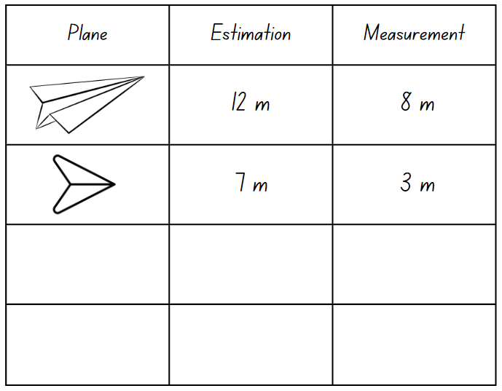
Images sourced from Canva and used in accordance with the Canva Content License Agreement.
Note: Emphasise the importance of an accurate starting point for the flight and accurate use of the measurement tools to the closest metre or centimetre.
- Provide pairs with Resource 11: Flight recording sheet for students to record when estimating and measuring the flights of their paper planes.
- Students reflect on their results and discuss why certain planes flew further than others. Ask:
- How do you think you could improve your plane to make it fly further?
- What did you use to measure the distance of your plane’s flight?
- What steps did you take to ensure your measurements were accurate?
- Provide paper of different sizes and thickness for students to change the weight and size of their designs.
- Provide an equal-arm balance and uniform informal units for students to measure and compare the weight of the paper planes. Students make conjectures about which plane will fly further and record their estimation before testing.
- Ask students to also use uniform informal units to measure the area of the planes, predict which plane will fly further and investigate whether a larger or smaller area has an impact of flight distance.
- Students share and explain the modifications made to their design and repeat the competition with their revised plane models. The student with the furthest flight distance is the winner.
This table details assessment opportunities and differentiation ideas.
Assessment opportunities | Too hard? | Too easy?
What to look for:  - Can students estimate the length of distance by visualising how many formal units there are and checking by measuring? (MAO-WM-02, MA1-GM-02)  - Can students record lengths and distances using metres (m) and centimetres (cm)? (MAO-WM-02, MA1-GM-02)  - Can students compare the areas of 2 or more surfaces that cannot be moved or superimposed by measuring in uniform informal units? (MAO-WM-01, MA1-2DS-02)  - Can students compare the masses of 2 or more objects using the same informal units? (MAO-WM-01, MA1-NSM-01)  What to collect:  - observational data (MAO-WM-01, MA1-GM-02, MA1-2DS-02, MA1-NSM-01)  - student work samples (MAO-WM-01, MA1-GM-02, MA1-2DS-02, MA1-NSM-01) | Students are unable to measure and record the length of their flight using formal unit.  - Provide students with uniform informal units to measure the distance of the flight. Support students to measure with no gaps or overlaps and record.  - Support students to use body parts, for example, feet, to measure the distance of the flight path. | Students can measure and record the length of their flight using formal unit.  - Challenge students to measure their flight distance using at least 2 different measuring tools. For example, measuring tape and metre ruler. Students record both distances, ensuring they match.  - Challenge students to convert their measurements from metres to centimetres or centimetres to metres.

Discuss and connect the mathematics – 10 minutes
- Summarise the lesson together, drawing out some key mathematical ideas. Ask students:
- How does the type of paper used affect the weight of the paper plane and how far it can fly?
- Can the weight of the paper plane be changed by modifying the design?
- Does changing the size of your plane change how far it can fly?
- How does the type of measuring tool used affect the accuracy of the measurements?
- What happened to your measurement if you didn’t begin from the starting point?
- What did you do to make sure your measurement was accurate?
- What challenges did you face? How did you overcome them?
- What questions do you still have?

Resource 1: Recording sheet
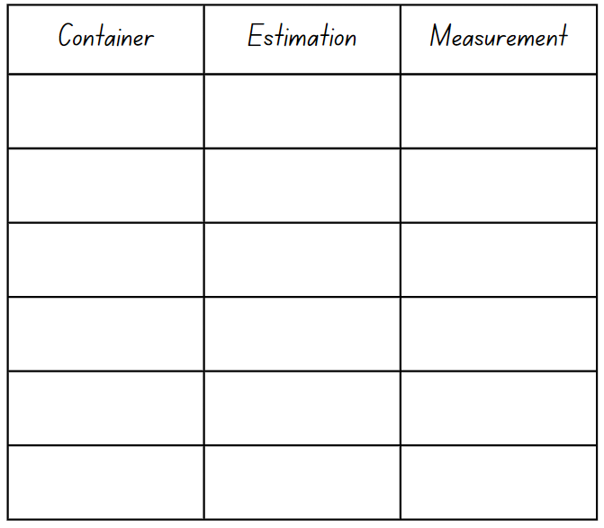

Resource 2: Place value
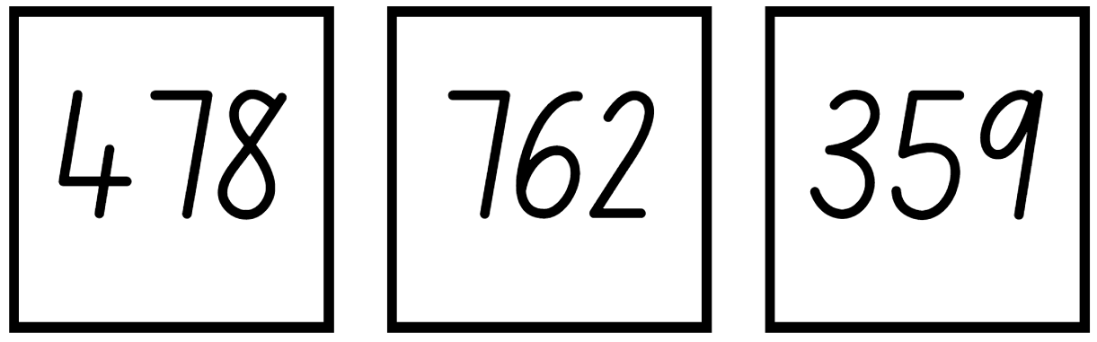

Resource 3: Rectangle
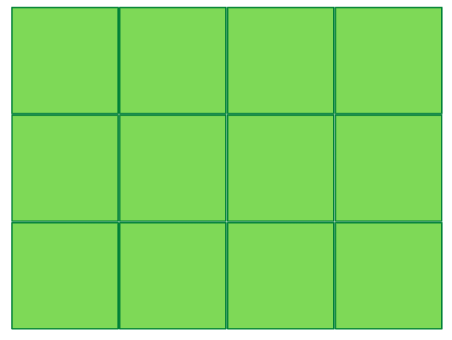

Resource 4: 3 Rectangles
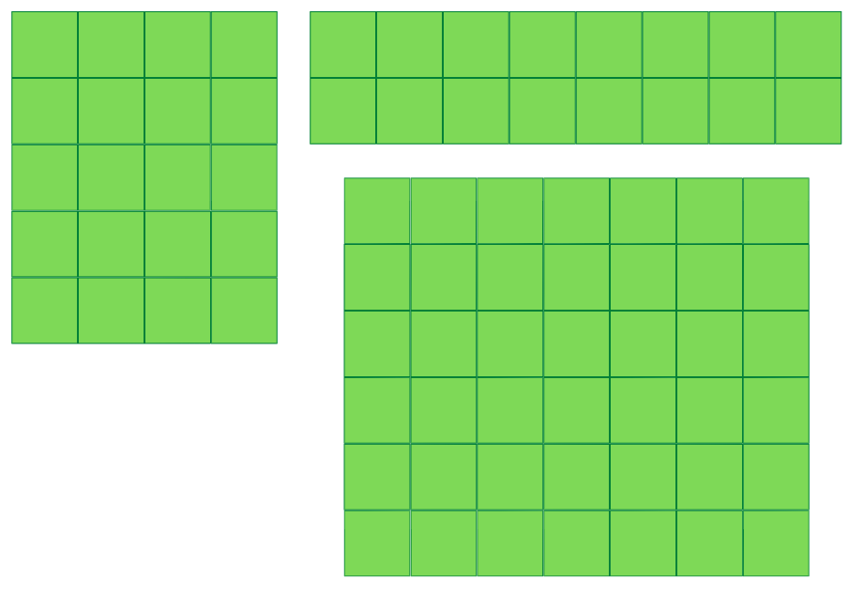

Resource 5: Covered rectangle

Resource 6: Covered rectangle 2

Resource 7: Measuring strip
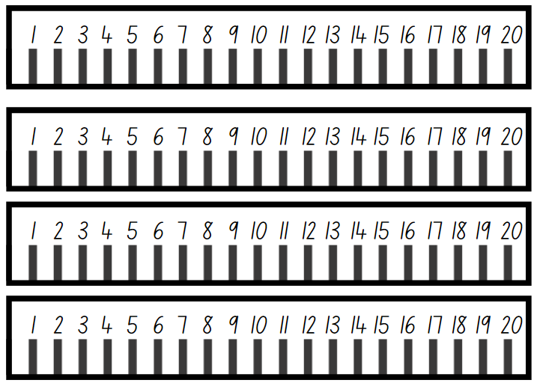

Resource 8: Scavenger hunt
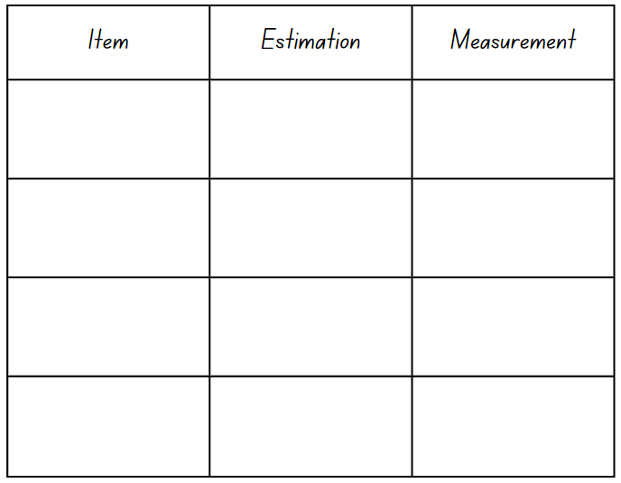

Resource 9: Metres or centimetres?
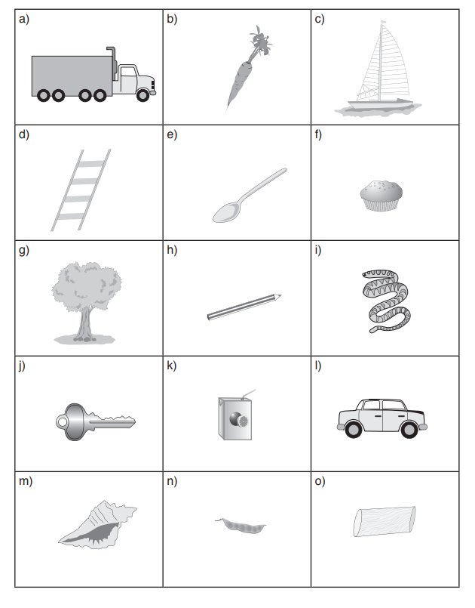
Images sourced from Canva and used in accordance with the Canva Content License Agreement.

Resource 10: Measurement worksheet
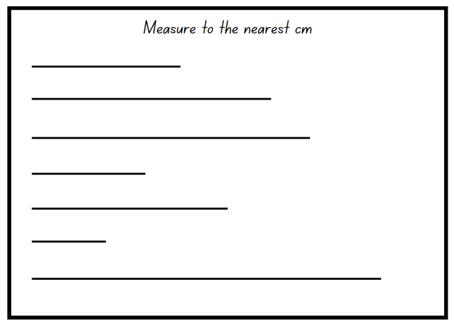

Resource 11: Flight recording sheet
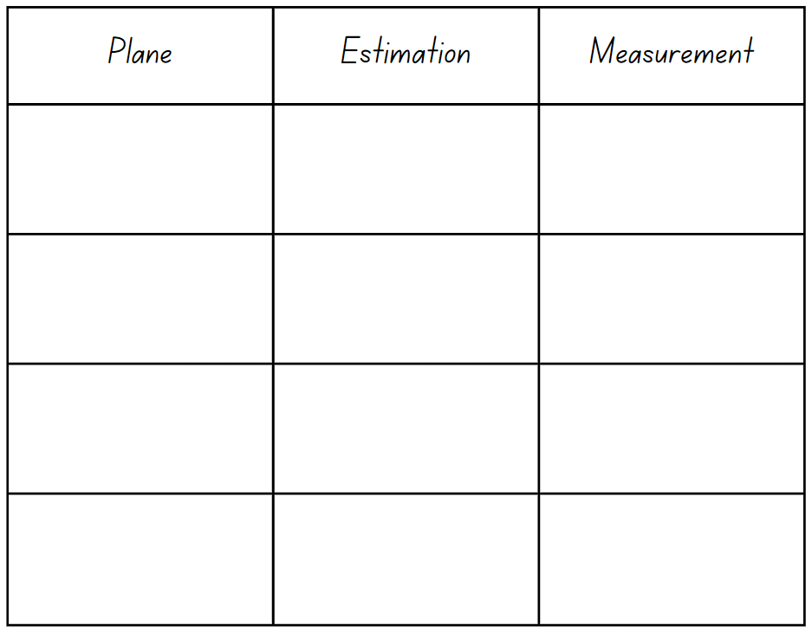

Syllabus outcomes and content
The table below outlines the syllabus outcomes and range of relevant syllabus content covered in this unit. Content is linked to National Numeracy Learning Progression version (3).
Focus area and outcomes | Content groups and content points | Lessons
Representing whole numbers A  MAO-WM-01  MA1-RWN-01  MA1-RWN-02 | Represent the structure of groups of ten in whole numbers  - Recognise that ten ones is the same as one ten (NPV2, NPV4)  - Partition two-digit numbers to show quantity values (NPV4)  - Estimate, to the nearest ten, the number of objects in a collection and check by counting in groups of ten (CPr7, NPV6) | 2
Representing whole numbers B  MAO-WM-01  MA1-RWN-01  MA1-RWN-02 | Use counting sequences of ones and tens flexibly  - Identify how many more to the next multiple of ten within two- and three-digit numbers  Form, regroup, and rename three-digit numbers  - Use models such as base 10 material and interlocking cubes to represent and explain grouping (CPr7, NPV5)  - State the quantity value of digits in numbers of up to three digits (NPV5)  - Recognise units of 100 (UnM5, NPV5)  - Use place value to partition and rename three-digit numbers in different ways (NPV5)  - Estimate, to the nearest hundred, the number of objects in a collection and check by grouping and counting (NPV6) | 1–3, 5–6, 8
Forming groups B  MAO-WM-01  MA1-FG-01 | Represent and explain multiplication as the combining of equal groups  - Solve multiplication problems using repeated addition (MuS4)  - Form arrays of equal rows and equal columns (MuS5)  - Determine and distinguish between the number of rows/columns and the number in each row/column when describing collections of objects (MuS5) | 4
Geometric measure A  MAO-WM-01  MA1-GM-02 | Length: Measure the lengths of objects using uniform informal units  - Use uniform informal units to measure lengths and distances by placing the units end to end without gaps or overlaps (UuM2)  - Count informal units to measure lengths or distances and describe the part left over (UuM4)  - Record lengths and distances by referring to the number and type of unit used (UuM4)  Length: Compare lengths using uniform informal units  - Compare the lengths of two or more objects using appropriate uniform informal units and check by placing the objects side by side and aligning the ends (UuM2-UuM3)  - Estimate lengths, indicating the number and type of unit used and check by measuring (UuM3) | 5
Geometric measure B  MAO-WM-01  MA1-GM-02 | Length: Compare and order lengths, using appropriate uniform informal units  - Compare and order two or more shapes according to their lengths using an appropriate uniform informal unit  - Compare the lengths of two or more objects that cannot be moved or aligned  - Record length comparisons using drawings, numerals and words, and by referring to the uniform informal unit used  Length: Recognise and use formal units to measure the lengths of objects  - Recognise the need for formal units to measure lengths and distances (UuM6)  - Record lengths and distances using the abbreviation for metres (m)  - Estimate lengths and distances to the nearest metre and check by measuring (UuM6)  - Recognise the need for a formal unit smaller than the metre  - Recognise that there are 100 centimetres in one metre  - Measure lengths to the nearest centimetre, using a device with 1-cm markings  - Record lengths and distances using the abbreviation for centimetres (cm)  - Estimate lengths and distances to the nearest centimetre and check by measuring (UuM6) | 5–8
Two-dimensional spatial structure A  MAO-WM-01  MA1-2DS-01  MA1-2DS-02 | Area: Measure areas using uniform informal units  - Explore area using uniform informal units to cover the surface in rows or columns without gaps or overlaps (UuM5)  - Measure area by selecting and using appropriate uniform informal units  - Record areas by referring to the number and type of uniform informal unit used  - Estimate areas by referring to the number and type of uniform informal unit used and check by measuring (UuM3) | 4, 8
Two-dimensional spatial structure B  MAO-WM-01  MA1-2DS-01  MA1-2DS-02 | Area: Compare rectangular areas using uniform square units of an appropriate size in rows and columns  - Cover rectangular surfaces by creating repeated rows of square tiles (UuM5)  - Use a single square to create the array structure of area in rows and columns (UuM5)  - Use the structure of repeated units to find the area of a rectangle (UuM5)  - Explain how the grid structure of rows and columns helps to find the area | 4
Three-dimensional spatial structure A  MAO-WM-01  MA1-3DS-01  MA1-3DS-02 | Volume: Measure and compare the internal volumes (capacities) of containers by filling  - Use uniform informal units to measure how much a container will hold by counting the number of times a smaller container can be filled and emptied into the container being measured (UuM3)  - Compare the internal volumes of two or more containers using appropriate uniform informal units (UuM3)  - Recognise and explain why containers of different shapes may have the same internal volume  - Estimate how much a container holds by referring to the number and type of uniform informal unit used and check by measuring (UuM3-UuM4)  Volume: Measure the internal volume (capacity) of containers by packing  - Pack cubic units (eg blocks) into rectangular containers so that there are no gaps  - Estimate and measure the internal volume of a container by filling the container with uniform informal units and counting the number of units used  - Explain that if there are gaps when packing and stacking, this will affect the accuracy of measuring the internal volume | 2–3
Three-dimensional spatial structure B  MAO-WM-01  MA1-3DS-01  MA1-3DS-02 | Volume: Compare containers based on internal volume (capacity) by filling and packing  - Compare, order and record the internal volumes (capacities) of two or more containers by measuring each container in uniform informal units (UuM3-UuM4)  - Estimate internal volume (capacity) by referring to the number and type of uniform informal unit used (UuM3)  Volume: Compare volumes using uniform informal units  - Estimate the volumes of two or more models and check by counting the number of blocks used in each model  - Compare models with different appearances, recognising when they have the same volume  - Record the results of volume comparisons using drawings, numerals and words, referring to the units used  - Explain that models made of the same number of units may have different volumes depending on the size of the units used | 2–3
Non-spatial measure B  MAO-WM-01  MA1-NSM-01  MA1-NSM-02 | Mass: Compare the masses of objects using an equal-arm balance  - Use uniform informal units to measure the mass of an object by counting the number of units needed to obtain a level balance on an equal-arm balance (UuM3)  - Select an appropriate uniform informal unit to measure the mass of an object and justify the choice (UuM3)  - Explain the relationship between the mass of a unit and the number of units needed  - Compare the masses of two or more objects using the same informal units (UuM3)  - Estimate mass by referring to the number and type of uniform informal unit used and check by measuring (UuM3-UuM4) | 1, 8

References
Links to third-party material and websites
Please note that the provided (reading/viewing material/list/links/texts) are a suggestion only and implies no endorsement, by the New South Wales Department of Education, of any author, publisher, or book title. School principals and teachers are best placed to assess the suitability of resources that would complement the curriculum and reflect the needs and interests of their students.
If you use the links provided in this document to access a third-party's website, you acknowledge that the terms of use, including licence terms set out on the third-party's website apply to the use which may be made of the materials on that third-party website or where permitted by the Copyright Act 1968 (Cth). The department accepts no responsibility for content on third-party websites.
Except as otherwise noted, all material is © State of New South Wales (Department of Education), 2023 and licensed under the Creative Commons Attribution 4.0 International License. All other material (third-party material) is used with permission or under licence. Where the copyright owner of third-party material has not licensed their material under a Creative Commons or similar licence, you should contact them directly for permission to reuse their material.
Mathematics K–10 Syllabus © 2022 NSW Education Standards Authority (NESA) for and on behalf of the Crown in right of the State of New South Wales.
© 2022 NSW Education Standards Authority. This document contains NSW Curriculum and syllabus content. The NSW Curriculum is developed by the NSW Education Standards Authority. This content is prepared by NESA for and on behalf of the Crown in right of the State of New South Wales. The material is protected by Crown copyright.
Please refer to the NESA Copyright Disclaimer for more information.
NESA holds the only official and up-to-date versions of the NSW Curriculum and syllabus documents. Please visit the NSW Education Standards Authority (NESA) website and the NSW Curriculum website.
National Numeracy Learning Progression © Australian Curriculum, Assessment and Reporting Authority (ACARA) 2010 to present, unless otherwise indicated. This material was downloaded from the Australian Curriculum website (National Numeracy Learning Progression) (accessed 17 February 2023) and was not modified. The material is licensed under CC BY 4.0. Version updates are tracked in the ‘Curriculum version history’ section on the 'About the Australian Curriculum' page of the Australian Curriculum website.
ACARA does not endorse any product that uses the Australian Curriculum or make any representations as to the quality of such products. Any product that uses material published on this website should not be taken to be affiliated with ACARA or have the sponsorship or approval of ACARA. It is up to each person to make their own assessment of the product, taking into account matters including, but not limited to, the version number and the degree to which the materials align with the content descriptions and achievement standards (where relevant). Where there is a claim of alignment, it is important to check that the materials align with the content descriptions and achievement standards (endorsed by all education Ministers), not the elaborations (examples provided by ACARA).
This resource contains images and content obtained from Canva, and their use outside of this resource is subject to Canva’s Content License Agreement. If you wish to use them separately from the resource, please go to Canva.
Australian Government Department of Education (2020) ‘Place Value Cards’, Teaching resources, reSolve: Maths by Inquiry website, accessed 17 February 2023.
Australian Government Department of Education (2023) reSolve: Maths by Inquiry [website], accessed 7 March 2023.
Clements DH and Sarama J and Marsico Institute, Morgridge College of Education, University of Denver (2017/2019) ‘How Many Blocks Fit In The Box?’, Volume Quantifier, Learning and teaching with learning trajectories [LT]² website, accessed 17 February 2023.
Clements DH and Sarama J and Marsico Institute, Morgridge College of Education, University of Denver (2017/2019) Learning and teaching with learning trajectories [LT]² [website], accessed 6 March 2023.
New Zealand Ministry of Education (n.d.) ‘Comparing capacities’, Resource, NZ Maths website, accessed 17 February 2023.
New Zealand Ministry of Education (n.d.) ‘Finding areas of rectangles’, Resource, NZ Maths website, accessed 17 February 2023.
New Zealand Ministry of Education (n.d.) NZ Maths [website], accessed 7 March 2023.
New Zealand Ministry of Education (n.d.) ‘Paper planes: Level 2’, Resource, NZ Maths website, accessed 17 February 2023.
State of New South Wales (Department of Education) (n.d.) Activities to support Numeral identification: Thumbs up, Counting-on-and-back Strategies, Developing Efficient Numeracy Strategies One website, accessed 17 February 2023.
TUK Crafts (16 January 2014) ‘How To Fold A Paper Airplane That Flies Far’ [video], TUK Crafts, YouTube, accessed 7 March 2023.
University of Cambridge (Faculty of Mathematics) (1997–2023) NRICH [website], accessed 6 March 2023.
University of Cambridge (Faculty of Mathematics) (1997–2023) Torn Shapes, NRICH website, accessed 17 February 2023.
Van de Walle J, Karp K, Bay-Williams JM, Brass A, Bentley B, Ferguson S, Goff W, Livy S, Marshman M, Martin D, Pearn C, Prodromou T, Symons D and Wilkie K (2019) Primary and Middle Years Mathematics: Teaching Developmentally, 1st Australian edn, Pearson Education Australia.

