Mathematics –Stage 1 – Unit 36
Contents
Unit description and duration 4
Student prior learning 4
Lesson overview and resources 5
Lesson 1: Addition stories 12
Daily number sense: Strike it out – 15 minutes 12
Addition stories – 40 minutes 14
Consolidation and meaningful practice: Thundergoats – 10 minutes 19
Lesson 2: Subtraction stories 20
Daily number sense: Nearest 10 bingo – 10 minutes 20
Gremlins – 30 minutes 22
Consolidation and meaningful practice: Design your own – 20 minutes 25
Lesson 3: Skipping down the hall 26
Daily number sense: Teacher choice – 10 minutes 26
Skipping down the hall – 50 minutes 27
Discuss and connect the mathematics – 5 minutes 30
Lesson 4: Making lunch 31
Daily number sense: Counting game – 15 minutes 31
Making lunch – 40 minutes 33
Discuss and connect the mathematics – 5 minutes 38
Lesson 5: Multiplication stories 39
Daily number sense: Pepperoni pizza – 10 minutes 39
Multiplication stories – 40 minutes 40
Consolidation and meaningful practice: Scrambled eggs – 15 minutes 42
Lesson 6: Division stories 44
Daily number sense: Grouping and estimating – 10 minutes 44
The great divide – 40 minutes 46
Consolidation and meaningful practice: The flower garden – 10 minutes 49
Lesson 7: The doubling donut tree 50
Daily number sense: Array bingo – 20 minutes 50
The doubling donut tree – 30 minutes 51
Consolidation and meaningful practice: Double and half – 10 minutes 54
Lesson 8: Choices, choices, choices 56
Daily number sense: Teacher’s choice – 10 minutes 56
Choices – 45 minutes 57
Discuss and connect the mathematics – 5 minutes 59
Resource 1: Bingo card 60
Resource 2: Number chart 61
Resource 3: Gremlins 62
Resource 4: Endless hallway 63
Resource 5: Lunch box items 64
Resource 6: Lunch box template 69
Resource 7: Equal group problems 70
Resource 8: Array problems 71
Resource 10: Array bingo 73
Resource 11: The doubling donut tree 79
Syllabus outcomes and content 80
References 89

Unit description and duration
This two-week unit develops student knowledge and skills in understanding the many different situations where addition, subtraction, multiplication and division can be used. Students are provided opportunities to:
- investigate the 4 operations through problem solving
- explore inverse operations
- engage in meaningful activities using repeated halving and doubling.
Mathematics K–10 Syllabus © 2022 NSW Education Standards Authority (NESA) for and on behalf of the Crown in right of the State of New South Wales.

Student prior learning
Before engaging in these teaching and learning activities, students would benefit from prior experience with:
- skip counting and using arrays
- doubling collections of objects
- using repeated halving to create fractions
- solving problems using all 4 operations.

Lesson overview and resources
The table below outlines the sequence and approximate timing of lessons; syllabus focus areas and content groups; and resources.
Lesson | Syllabus focus area and content groups | Resources
Lesson 1: Addition stories  65 minutes  Effective addition strategies are selected based on the type of problem. | Representing whole numbers A  - Represent numbers on a line  Combining and separating quantities A  - Use advanced count-by-one strategies to solve addition and subtraction problems  - Recognise and recall number bonds up to ten  - Use flexible strategies to solve addition and subtraction problems  - Represent equality  Combining and separating quantities B  - Represent and reason about additive relations  - Form multiples of ten when adding and subtracting two-digit numbers  - Use knowledge of equality to solve related problems | - Video: Strike it out (addition and subtraction to 20) (7:44)  - Thundergoats  - Concrete materials  - Mini whiteboards  - Whiteboard markers  - Writing materials
Lesson 2: Subtraction stories  60 minutes  Knowing that subtraction is the opposite of addition can help solve problems. | Representing whole numbers A  - Represent the structure of groups of ten in whole numbers  Combining and separating quantities A  - Use advanced count-by-one strategies to solve addition and subtraction problems  - Use flexible strategies to solve addition and subtraction problems  - Represent equality  Combining and separating quantities B  - Represent and reason about additive relations  - Form multiples of ten when adding and subtracting two-digit numbers  - Use knowledge of equality to solve related problems | - Resource 1: Bingo card  - Resource 2: Number chart  - Resource 3: Gremlins  - Interlocking cubes  - Writing materials
Lesson 3: Skipping down the hall  65 minutes  Skip counting is connected to equal groups and arrays. | Forming groups A  - Count in multiples using rhythmic and skip counting  - Use skip counting patterns  - Model and use equal groups of objects to represent multiplication  Forming groups B  - Represent and explain multiplication as the combining of equal groups  - Represent multiplication and division problems | - Resource 4: Endless hallway  - Concrete materials  - Grid paper  - Writing materials
Lesson 4: Making lunch  60 minutes  Multiplication is the combining of equal groups. | Representing whole numbers A  - Represent the structure of groups of ten in whole numbers  Representing whole numbers B  - Use counting sequences of ones and tens flexibly  - Form, regroup, and rename three-digit numbers  Combining and separating quantities A  - Use advanced count-by-one strategies to solve addition and subtraction problems  Forming groups A  - Count in multiples using rhythmic and skip counting  - Model and use equal groups of objects to represent multiplication  Forming groups B  - Represent and explain multiplication as the combining of equal groups  - Represent multiplication and division problems | - Resource 5: Lunch box items  - Resource 6: Lunch box template  - Craft sticks  - Glue  - Mini whiteboard  - Rubber bands  - Scissors  - Whiteboard markers  - Writing materials
Lesson 5: Multiplication stories  65 minutes  Multiplication can be used to solve everyday problems. | Combining and separating quantities A  - Use advanced count-by-one strategies to solve addition and subtraction problems  - Represent equality  Forming groups A  - Count in multiples using rhythmic and skip counting  - Model and use equal groups of objects to represent multiplication  Forming groups B  - Represent and explain multiplication as the combining of equal groups  - Represent multiplication and division problems | - Resource 7: Equal group problems  - Resource 8: Array problems  - 10-sided dice  - Counters  - Blocks  - Egg cartons  - Writing materials
Lesson 6: Division stories  60 minutes  Division can be used to solve everyday problems. | Representing whole numbers B  - Form, regroup, and rename three-digit numbers  Forming groups A  - Count in multiples using rhythmic and skip counting  - Model and use equal groups of objects to represent multiplication  - Recognise and represent division  Forming groups B  - Represent and explain multiplication as the combining of equal groups  - Model doubling and halving with fractions  - Represent multiplication and division problems | - Resource 9: The Great Divide  - The Great Divide: A Mathematical Marathon by Dayle Ann Dodds. ISBN 9780763615925  - Counters  - Interlocking cubes  - Writing materials
Lesson 7: The doubling donut tree  60 minutes  Doubling and halving are opposite operations. | Forming groups A  - Model and use equal groups of objects to represent multiplication  - Recognise and represent division  Forming groups B  - Represent and explain multiplication as the combining of equal groups  - Model doubling and halving with fractions  - Represent multiplication and division problems | - Resource 10: Array bingo  - Resource 2: Number chart  - Resource 11: The doubling donut tree  - Video: Array bingo (8:15)  - Concrete materials  - Writing materials
Lesson 8: Choices, choices, choices  60 minutes  Multiplication and division can be used to solve everyday problems. | Forming groups A  - Count in multiples using rhythmic and skip counting  - Model and use equal groups of objects to represent multiplication  - Recognise and represent division  Forming groups B  - Model doubling and halving with fractions  - Represent multiplication and division problems | - Concrete materials  - Writing materials

Lesson 1: Addition stories
Core concept: Effective addition strategies are selected based on the type of problem.
The table below contains suggested learning intentions and success criteria. These are best co-constructed with students.
Learning intentions | Success criteria
Students are learning that:  - addition can be used to solve everyday problems  - mathematical thinking can be recorded in different ways. | Students can:  - choose an appropriate strategy to solve addition problems  - use a number line to record their thinking  - record number sentences using numerals and symbols.

Daily number sense: Strike it out – 15 minutes
This activity has been adapted from Strike it out (addition and subtraction to 20) (7:44) from Mathematics K-6 resources by NSW Department of Education.
- Build student understanding of addition and subtraction facts to 20 by playing Strike it out (7:44).
- In pairs, provide students with paper and writing materials. Students create a number line from zero to 20.
- The first player chooses 2 numbers from the number line and crosses them out. The same player then circles the sum or difference of the numbers and records the calculation. For example, 5 + 10 = 15 (see Figure 1).
Figure 1 – Strike it out 1
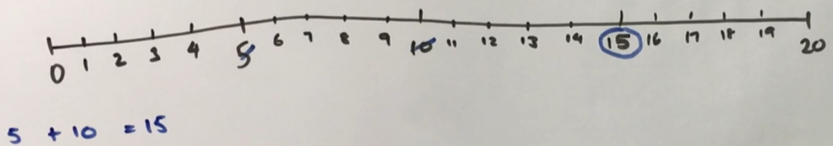
- The second player must start their turn by crossing out the number circled by the first player. The second player then crosses out a second number not already used. Player 2 then circles the sum or difference of the numbers and records the calculation. For example, 15 + 4 = 19 (see Figure 2).
Figure 2 – Strike it out 2
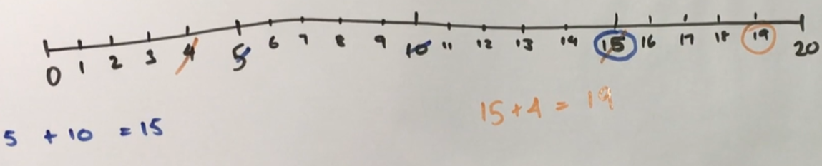
- Play continues until one player is no longer able to make a valid move (see Figure 3). The player who stops their opponent from being able to take a turn is the winner.
Figure 3 – Strike it out 3
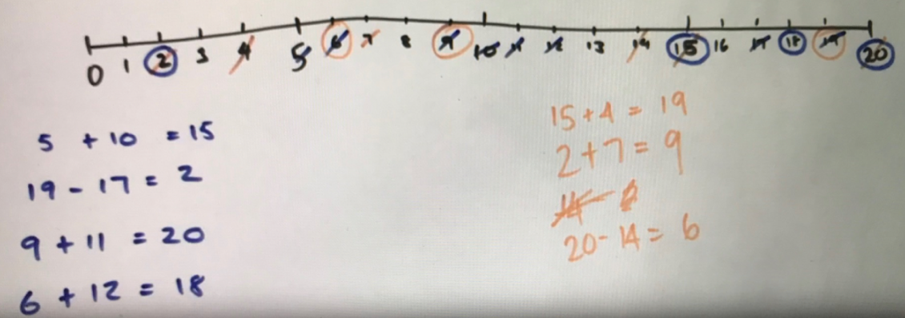
- Play the game again, swapping roles with the other student starting.
- As a class, discuss and reflect on the activity by asking questions such as:
- How did you know when the game was over?
- Share the strategy that you used to try to win the game. Was it successful? Why?
- What addition and subtraction strategies did you find useful?
- When adding, did it matter which way you added the numbers? Why not? (Commutative property).
- Can you think of any ways to make the game easier or harder?

Addition stories – 40 minutes
This activity has been adapted from Challenging Mathematical Tasks: Unlocking the potential of all students by Sullivan (2018).
- Pose the following problems:
- On a farm, there are 36 white chickens and 22 brown chickens. How many chickens are there altogether?
- On a farm, there are 22 chickens. I want to have 58 chickens, how many more do I need?
- On a farm with 58 chickens, 36 of the chickens are white. The rest of the chickens are brown. How many chickens are brown?
Note: There are 3 basic types of word problems involving additive thinking: combine (direct addition), change (How many to get from one number to the other?) and compare (What is the difference?). The problems in this task encourage students to compare the types of questions (Sullivan 2018). Choosing and applying mathematical techniques to solve problems and articulating their thinking is a core component of Working mathematically.
- Ask students to solve their problems and to show their thinking using an empty number line, a number sentence and a diagram (see Figure 4). Students may also choose to use concrete materials and take a photograph.
Figure 4 – Addition story solution
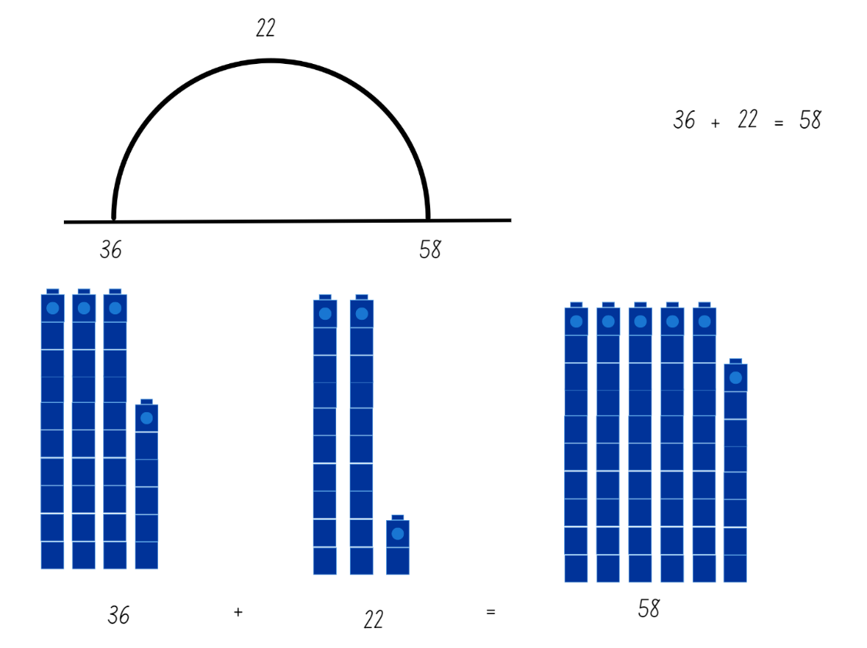
- Select students to share their thinking. Discuss similarities and differences in student thinking and solution strategies.
- Ask students to think about the 3 problems, focusing on how they are the same and how they are different. Students turn and talk to share their ideas. Select students to share with the class.
- Ask students if there is a way that they can check their answers.
- Pose the following problems and follow the same recording and discussion procedure as above:
- In a plantation, there are 23 eucalypt trees and 38 wattle trees. How many trees are there altogether?
- In a plantation, there are 61 trees. Some are eucalypts and some are wattles. If 38 trees are eucalypts, how many are wattles?
- In a plantation, there are 61 trees altogether and 23 of the trees are eucalypts. If the rest of the trees are wattles, how many wattle trees are there?
- Pose the following problems and follow the same recording and discussion procedure as above:
- We are growing tomatoes and capsicums in our vegetable garden. There are 76 plants altogether and 39 are tomato plants. How many capsicum plants are there?
- We are growing tomatoes and capsicums in our vegetable garden. There are 39 tomato plants and 37 capsicum plants. How many plants are there altogether?
- I want to grow 76 plants in our vegetable garden. I already have 37 plants. How many more plants do I need?
- Reflect on and discuss additive strategies used by asking questions such as:
- What strategy did you use to solve the problem? (For example, using number bonds, bridging to the next multiple of 10, jump strategy on the number line, recalling addition facts, separating tens and ones).
- Why did you use that strategy?
- Can you think of another way to solve the problem?
- Did you use different strategies to solve different problems? Why?
- Ask students to work in pairs or small groups to create their own problems using the previous sets of problems as a model. Conduct a gallery walk and allow students to share their problems. Ask students to explain how their problems are like the previous sets of problems.
- Demonstrate how addition can also be used to solve equality problems where a number is missing. For example, 3 + __ = 6 + 2. Discuss how this is similar to the ‘how many more’ problems completed above. Ask students to record and solve the following equality problems:
- 7 + __ = 8 + 6
- 12 + 5 = 3 + __
- 8 + 9 = __ + 7
- 14 + __ = 19 + 4
This table details assessment opportunities and differentiation ideas.
Assessment opportunities | Too hard? | Too easy?
What to look for:  - Can students choose and justify appropriate strategies to solve addition problems? (MAO-WM-01, MA1-CSQ-01)  - Can students solve worded problems using number lines, number sentences and diagrams? (MAO-WM-01, MA1-CSQ-01)  - Can students add and subtract from a two-digit number? (MAO-WM-01, MA1-CSQ-01)  What to collect:  - student work samples (MAO-WM-01, MA1-CSQ-01)  - recordings of student discussion answers (MAO-WM-01, MA1-CSQ-01) | Students cannot solve the problems or show their thinking using a number line, a number sentence and a diagram or concrete materials.  - Pose the problems again using smaller numbers. For example, ‘On a farm, there are 10 white chickens and 8 brown chickens. How many chickens are there altogether?’  - Provide students with a pre-numbered number line. | Students can solve the problems and show their thinking using a number line, a number sentence and a diagram or concrete materials.  - Pose the problems again using larger and more challenging number combinations. For example, ‘On a farm, there are 87 white chickens and 39 brown chickens. How many chickens are there altogether?’  - Provide questions, for example, ‘On a farm, there are 10 more white chickens than brown chickens. There are 78 chickens altogether. How many brown chickens are there?’

Consolidation and meaningful practice: Thundergoats – 10 minutes
- Demonstrate how to play Thundergoats at ABC Education, using either level one or 2 as appropriate. Show how each tool and strategy can be used to make the calculation easier.
- Explain that you will play the game together and students will record their thinking on mini whiteboards.
- Show students a problem. Ask students to solve the problem and record their thinking using drawings, words, numerals and symbols. Students turn and talk to share their thinking. Repeat several times.
- Ask students to discuss and reflect on the activity by asking questions such as:
- Which strategies did you use?
- Did you use different strategies for different questions? Why?
- Which strategies did you find the most useful? Why?
- How did you record your thinking?

Lesson 2: Subtraction stories
Core concept: Knowing subtraction is the opposite of addition can help solve problems.
The table below contains suggested learning intentions and success criteria. These are best co-constructed with students.
Learning intentions | Success criteria
Students are learning that:  - numbers can be grouped in tens  - using number facts can improve efficiency when solving problems  - subtraction and addition are inverse operations. | Students can:  - locate the nearest 10 to a number  - model and explain subtraction number facts to 20  - model how addition and subtraction are opposites.

Daily number sense: Nearest 10 bingo – 10 minutes
- Build student understanding of locating the nearest 10 to a number by playing ‘Nearest 10 bingo’.
- Explain to students that no number is ever more than 5 away from a benchmark of 10 and they may need to count forwards or backwards to find the nearest 10.
- Provide each student with a copy of Resource 1: Bingo card and Resource 2: Number chart. Students write 6 different multiples of 10, ranging from zero to 100, in each box of the bingo card (see Figure 5).
Figure 5 – Nearest 10 bingo card example
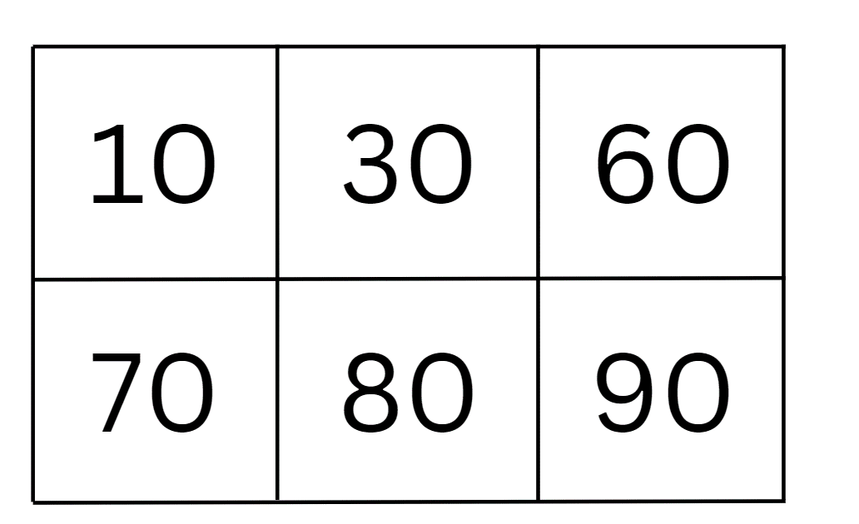
- Read out a series of numbers, ranging from one to 99, but avoiding multiples of 10. After each number, allow students time to mark the nearest 10 to that number if it appears on their bingo card. Students may use a number chart or a number line to assist. When all multiples of 10 on the bingo card are marked, the student calls out, ‘Bingo!’ and is declared the winner. Multiple students may have identical bingo cards, which allows for multiple winners.
Note: Using predetermined numbers or recording numbers as you call them out allows you to check the accuracy of student bingo cards. You may also choose to have students record each number you call out and the nearest 10 to those numbers.
- Repeat the activity as necessary, with students either creating a new bingo card or erasing the previous game markings.
This table details assessment opportunities and differentiation ideas.
Assessment opportunities | Too hard? | Too easy?
What to look for:  - Can students locate the nearest 10 to a number? (MAO-WM-01, MA1-RWN-01)  What to collect:  - completed bingo cards (MAO-WM-01, MA1-RWN-01)  - observations of students playing the game (MAO-WM-01, MA1-RWN-01) | Students cannot locate the nearest 10 to a number.  - Model how to use the number chart or a number line to locate the nearest 10.  - Use numbers that are close to multiples of 10, for example, 9, 11, 19. | Students can locate the nearest 10 to a number.  - Students become the bingo caller and call out and check the numbers for other students.  - Increase the range of numbers to 120.  - Use three-digit numbers and ask students to locate the nearest hundred.

Gremlins – 30 minutes
This activity has been adapted from Gremlins by NZ Maths.
- Explain that gremlins have visited the classroom and drawn faces in place of numbers.
- Provide a copy of Resource 3: Gremlins to each student and say, ‘Oh no! Gremlins have been in and covered up some numbers below. Can you put the equations back together?’
Note: Students become so accustomed to seeing equations in the form 7 − 5 = __ and 5 − 2 = __ that they automatically think that the answer is always the difference. If students are only exposed to this format, they miss the opportunity to form understandings about all parts of the equation and how each part relates to the other.
- Distribute interlocking cubes and ask students to solve each problem and represent them using the cubes.
- As students work, ask:
- Which numbers were easiest to figure out? Why?
- Which numbers were hardest to find? Why?
- How do you know that you have found the correct missing number?
- Do you think that more than one number might work? Why or why not?
Note: Once students are confident with the ‘taking away’ type of subtraction, encourage them to use ‘counting on or back’ where the differences are small (less than 5). This type of subtraction can be more difficult for students to grasp than the ‘taking away’ type but can be more efficient. For example, when comparing 20 with 18, it is easier to ‘count on’ from 18 than take away 18 objects from a collection of 20.
- As a class, ask students to share their solutions:
- What strategy did you use to find the missing number?
- Did anyone use a different strategy?
- Can you think of another subtraction question that has the same answer? For example, 8 − 5 = 3 has the same answer as 6 − 3 = 3.
- Students represent each equation from the resource as a word equation.
- Model how to rearrange the first equation on the resource to represent an addition equation.
- Students to represent the rest of the equations as addition equations.
This table details assessment opportunities and differentiation ideas.
Assessment opportunities | Too hard? | Too easy?
What to look for:  - Can students recognise and use the symbols for plus, minus and equals? (MAO-WM-01, MA1-CSQ-01)  - Can students use advanced count-by-one strategies to solve subtraction problems? (MAO-WM-01, MA1-CSQ-01)  - Can students recall and use subtraction number facts to 20? (MAO-WM-01, MA1-CSQ-01)  - Can students model how addition and subtraction are inverse operations? (MAO-WM-01, MA1-CSQ-01)  What to collect:  - completed Resource 3: Gremlins (MAO-WM-01, MA1-CSQ-01)  - photographs or video of students representing the equations with interlocking cubes (MAO-WM-01, MA1-CSQ-01)  - recording of student discussions (MAO-WM-01, MA1-CSQ-01) | Students cannot solve and represent the problems.  - Provide modelled examples of each type of question.  - Rephrase the questions using numbers where the difference is small. For example, 5 − __. | Students can solve and represent the problems. Pose the problem, ‘The gremlins have covered more than one number. Find as many number combinations as you can that work.’ For example, __ − __ = 12 or 6 − __ = __.

Consolidation and meaningful practice: Design your own – 20 minutes
- Students design a series of subtraction problems based on the Gremlins activity. Ensure that the missing numbers are in a variety of places within the number sentences.
- Students check that their problems are accurate and give to a partner to solve.
- Reflect and discuss the activity by asking questions such as:
- Is it easier to solve the problems or make up your own? Why?
- What processes did you use to make up your problems?
- Which type of problems are the easiest to design? Why?
- How did you check that your problems were accurate?

Lesson 3: Skipping down the hall
Core concept: Skip counting is connected to equal groups and arrays.
The table below contains suggested learning intentions and success criteria. These are best co-constructed with students.
Learning intentions | Success criteria
Students are learning that:  - arrays are one way of showing equal groups  - skip counting is an efficient counting strategy  - skip counting creates patterns. | Students can:  - skip count using an array  - recognise patterns when skip counting  - use skip counting to solve a problem.

Daily number sense: Teacher choice – 10 minutes
- From a class need surfaced through formative assessment data, identify a short, focused activity that targets students’ knowledge, understanding and skills. Example activities may be drawn from the following resources:
- Thinking Mathematically Stage 1
- Universal Resources Hub.

Skipping down the hall – 50 minutes
This activity has been adapted from Mindset Mathematics: Visualising and Investigating Big Ideas, Grade 2 by Boaler et al. (2022).
- Show students Resource 4: Endless hallway. Ask students what they notice and what they wonder.
- Point out that the hallway is tiled all the way down, but they cannot see the end. Show students that the hallway has a width of 5 tiles. It may be necessary to explain that the tiles are all the same size but look smaller as they get further away. Ask students how long the hallway might be. Students turn and talk and then share answers with the class. Discuss which answers might be more reasonable than others, noting that all answers greater than the length shown are possible.
- Provide small groups of students with Resource 4: Endless hallway, grid paper, concrete materials and writing materials. Ask the following questions and have students record their thinking through drawings, a list or in a table (see Figure 6):
- If the hallway is 5 tiles wide, how many tiles could be on the hallway floor? How long could the hallway be?
- What different solutions can you find?
- How can you organise your solutions to keep track of your thinking and look for patterns?
- What patterns can you see in the number of tiles that are possible?
Figure 6 – Hallway thinking table
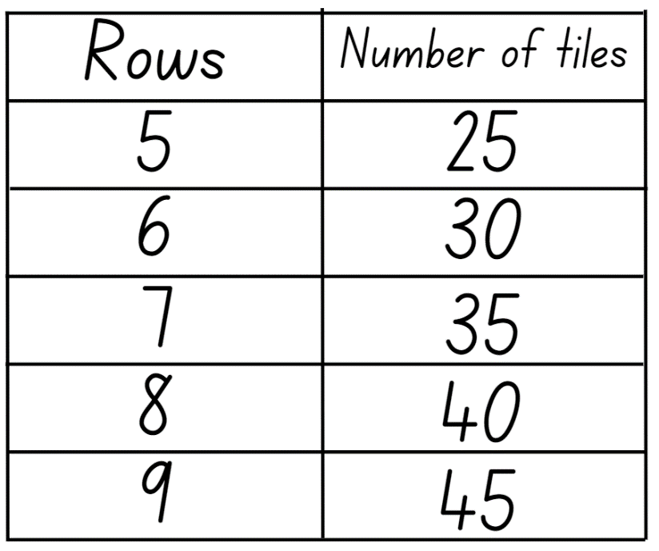
- Move around the room, observing students work. Ask students to explain how they are finding the number of tiles in the hallway. If students are counting by ones, encourage skip counting by asking if there is a way to count the tiles without counting by ones. Support students to develop ideas about how they could use the equal groups in the hallway to count, making it easier to see patterns. Encourage students to organise their thinking in a way that would help them to see patterns.
- Students create their own hallway drawing and explore the following questions:
- What might happen if the hallway was a different width? Choose another width and try this task again.
- How many tiles might be in your hallway?
- How many tiles could there not be? Why?
- Promote reasoning and communicating by using the following discussion questions:
- How did you organise your thinking? Why did you do it that way?
- What strategies did you use for solving the problem?
- What patterns did you notice in the solutions?
- What solutions are not possible? Why?
- What happened when you changed the width of the hallway? What widths did you try and what solutions did you find?
- How did the patterns change?
This table details assessment opportunities and differentiation ideas.
Assessment opportunities | Too hard? | Too easy?
What to look for:  - Can students skip count by fives to find possible solutions? (MAO-WM-01, MA1-FG-01)  - Can students identify and describe patterns when skip counting? (MAO-WM-01, MA1-FG-01)  - Can students connect skip counting to equal groups and arrays? (MAO-WM-01, MA1-FG-01)  What to collect:  - student work samples (MAO-WM-01, MA1-FG-01)  - recording of student discussions (MAO-WM-01, MA1-FG-01) | Students cannot find multiple solutions by skip counting or find patterns in their solutions.  - Provide a number line or number chart and model skip counting by fives.  - Modify the problem by using a hallway that is 2 tiles wide.  - Demonstrate how to use a table to organise student thinking, making it easier to identify patterns. Provide a pre-ruled table to fill in. | Students can find multiple solutions by skip counting and identify patterns in their solutions.  - Extend student thinking by asking similar hallway problems where the total number of tiles is known but the width and length are not.  - For example, there are 50 tiles in the whole hallway. Ask students how wide or long the hallway might be.

Discuss and connect the mathematics – 5 minutes
- Ask students to reflect on their learning by asking questions such as:
- How did equal groups help you find the number of tiles in the hallway?
- Can you think of another time where you have used similar strategies to solve a problem?
- Can you explain why it’s important to organise and record your thinking?
- Connect student learning by asking them to explain how to find the missing number in patterns such as:
- 5, 10, 15, __, 25, 30
- 3, 8, 13, __, 23, 28
- 20, __, 40, 50, 60, 70
- 12, 15, 18, 21, __, 27

Lesson 4: Making lunch
Core concept: Multiplication is the combining of equal groups.
The table below contains suggested learning intentions and success criteria. These are best co-constructed with students.
Learning intentions | Success criteria
Students are learning that:  - numbers can be represented in different ways  - multiplication problems can be solved using repeated addition and arrays. | Students can:  - group concrete materials to represent a three-digit number  - solve multiplication problems using repeated addition  - form arrays to represent multiplication problems.

Daily number sense: Counting game – 15 minutes
This activity has been adapted from Counting game (by multiples of 10) (3:35) from Mathematics K-6 resources by NSW Department of Education.
- Build student understanding of place value by counting forwards and backwards by multiples of 10.
- Provide pairs or small groups of students with loose craft sticks. Ask students to estimate and record how many craft sticks they think they have been given to the nearest 10. Students check their estimate by using rubber bands to bundle the craft sticks into groups of 10 and then count by tens to reach the total. Students turn and talk to share their estimates and results.
- Ask students:
- How could you partition, rename and record your total? For example, 49 as 4 tens and 9 ones.
- How many more craft sticks would you need to get to the next multiple of 10?
- Can you record the number before and the number after your total?
- Any unbundled craft sticks can be discarded prior to commencing the game. The total number of bundled craft sticks then becomes the starting point for the game, for example, 110. Students alternate counting backwards by saying the next one-, two- or three- number words in the number sequence. For example, the first player counts 100, 90, 80. The second player counts 70, 60. Students remove the bundles of 10 craft sticks as they count and record their counting on a piece of paper or mini whiteboard. The goal is to be the player who takes the last bundle and says zero. Repeat the game multiple times.
- Reflect on the activity by asking questions such as:
- How could you change the game to make it easier or harder?
- What did you notice about playing the game by counting backwards? Did it make it easier or harder? Why?
- Did you work out a way to play this game so that you didn’t lose? What was your strategy? Did it work?
This table details assessment opportunities and differentiation ideas.
Assessment opportunities | Too hard? | Too easy?
What to look for:  - Can students group objects into bundles of 10 and find the total? (MAO-WM-01, MA1-RWN-02, MA1-FG-01)  - Can students count forwards and backwards by multiples of 10? (MAO-WM-01, MA1-RWN-02, MA1-FG-01)  What to collect:  - student work samples (MAO-WM-01, MA1-RWN-02, MA1-FG-01)  - video of students playing the game (MAO-WM-01, MA1-RWN-02, MA1-FG-01) | Students cannot count backwards by multiples of 10 to reach zero.  - Provide a number chart and model counting backwards by multiples of 10.  - Students play counting forwards instead of backwards. The target number is the total number of bundled craft sticks. | Students can count backwards by multiples of 10 to reach zero.  - Students include their unbundled craft sticks in the game, so they are counting backwards by multiples of 10 off the decade.  - Create and use bundles of 5 rather than 10. Students count backwards by multiples of 5.

Making lunch – 40 minutes
This activity has been adapted from Multiplication: Making Robots by reSolve: Maths by Inquiry.
- Provide students with a collection of lunch items on paper (Resource 5: Lunch box items) and a copy of Resource 6: Lunch box template. Students should have access to multiple copies of each of the 9 food items, so they have options to create a variety of different lunch boxes.
- Explain that students must create a lunch box that has one sandwich, one piece of fruit and one drink.
- Students make their own lunch box from the different items and glue them onto the lunch box template.
- Students see if they can find anyone else in the class with the same lunch box combination as them.
- Students estimate how many different lunch combinations are possible with 3 sandwiches, 3 pieces of fruit and 3 drinks.
- In small groups, students create a lunch box that no one else in the group has already made.
- Ask students:
- How many different lunch box combinations has your group made?
- Has your group made all the possible lunch combinations? How do you know?
- In small groups, students sort their completed lunch boxes (see Figure 7).
Note: Students are likely to sort based on one of the food items, for example, sorting the lunch boxes based on the sandwich type.
Figure 7 – Example of lunch boxes sorted by sandwich
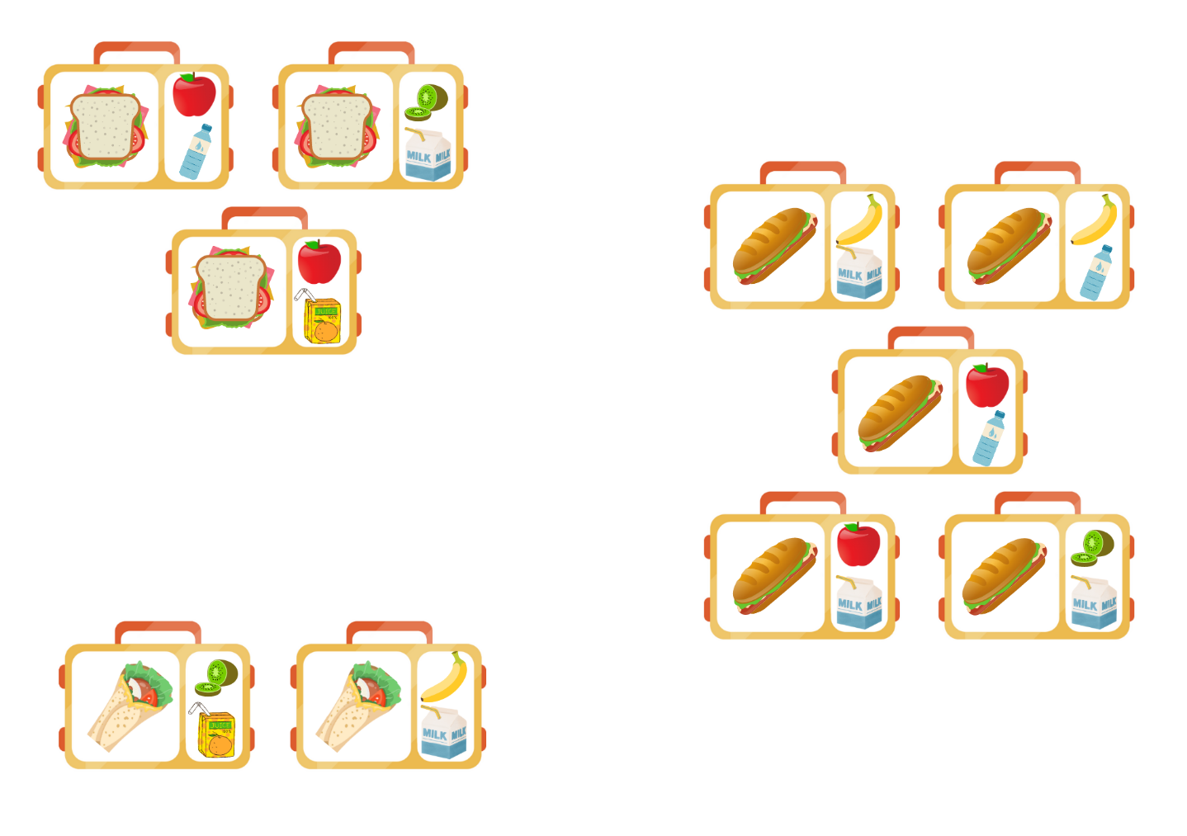
Images licensed under the Canva Content License Agreement.
- As a class, discuss the different ways that groups have sorted their lunch boxes and highlight that sorting by food item creates 3 groups.
- Give students the opportunity to re-sort their lunch boxes if needed.
- Students choose one group of lunch boxes to focus on.
- Ask students if they have all the possible lunch box options for the group that they have selected. Then ask which lunch boxes are missing.
- Ask students how they could organise their lunch boxes to show which ones are missing. Encourage students to arrange the lunch boxes in an array to determine which lunch boxes are missing (see Figure 8).
- Students explore their group of lunch boxes and make any new lunch boxes that they identify as missing.
Figure 8 – Lunch box options arranged in an array
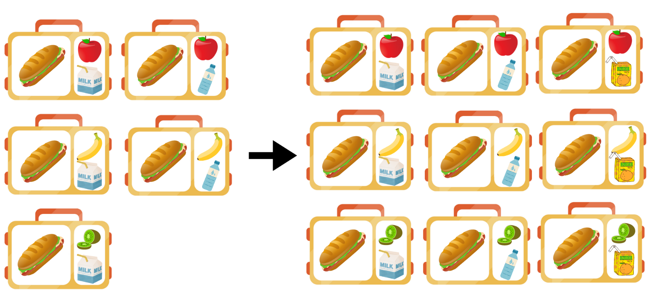
Images licensed under the Canva Content License Agreement.
- Ask students how many lunch boxes could be made in total if 9 lunch boxes can be made for each sandwich/fruit/drink. Students record their thinking using drawing, words and numerals. Students represent the answer using a number sentence. The total number of lunch boxes can be represented as 3 groups of 9, 3 arrays with 3 rows and 3 columns or repeated addition (9 + 9 + 9 = 27).
Note: This task has links to the Cartesian product or ‘for each’ idea of multiplication. However, students in Stage 1 don't need to be able to name or recognise the Cartesian product. This activity is building on the accumulating groups idea, skip counting and the array model to find each combination. This task explores the strategies students use to find the total number of options or combinations.
This table details assessment opportunities and differentiation ideas.
Assessment opportunities | Too hard? | Too easy?
What to look for:  - Can students record number sentences in a variety of ways using drawings, words, numerals and symbols? (MAO-WM-01, MA1-CSQ-01)  - Can students model multiplication as accumulating equal groups and repeated addition? (MAO-WM-01, MA1-FG-01)  - Can students form arrays to help solve multiplication problems? (MAO-WM-01, MA1-FG-01)  What to collect:  - photographs of students’ sorted lunch boxes and arrays (MAO-WM-01, MA1-FG-01)  - recording of group discussions (MAO-WM-01, MA1-FG-01) | Students are unable to represent the total number of lunch boxes using arrays and repeated addition.  - Students work out how many lunch box combinations can be made with a smaller number of each item.  - Students work out how many lunch box combinations can be made with less items in the lunch box. | Students can represent the total number of lunch boxes using arrays and repeated addition.  - Students work out how many lunch box combinations can be made with 4 sandwiches, 3 pieces of fruit and 3 drinks.  - Students work out how many lunch box combinations can be made with 3 sandwiches, 3 pieces of fruit and 4 drinks. Students explain why both answers are the same.  - Students create another category of lunch item, for example, different flavours of yoghurt. Then work out how many lunch box combinations can be made with 3 sandwiches, 3 pieces of fruit, 3 drinks and 3 yoghurts.

Discuss and connect the mathematics – 5 minutes
- Ask students:
- Was it helpful to arrange the lunch boxes in an array? Why?
- Does it matter in which order you add the lunch boxes? Why?
- What might happen if there were only 2 of each item? Explain your thinking.
- What might happen if there were 4 of each item? Explain your thinking.

Lesson 5: Multiplication stories
Core concept: Multiplication can be used to solve everyday problems.
The table below contains suggested learning intentions and success criteria. These are best co-constructed with students.
Learning intention | Success criteria
Students are learning that multiplication problems can be solved by combining equal groups, repeated addition or forming arrays. | Students can:  - model multiplication as accumulating equal groups  - represent and solve multiplication problems using arrays and repeated addition.

Daily number sense: Pepperoni pizza – 10 minutes
This activity has been adapted from Pepperoni Pizza by youcubed.
- Build student understanding of multiplication as the combining of equal groups by playing Pepperoni Pizza.
- In pairs, each student rolls a 10-sided die twice. The first roll tells them how many pizzas to draw. The second roll tells them how many pepperoni slices to put on each pizza.
- Students calculate the total number of pepperoni slices using skip counting, repeated addition or an array model where appropriate.
- Students record their answer using a number sentence that reflects their chosen strategy (see Figure 9).
- The student with the largest number of pepperoni pieces wins and the game is played again.
Figure 9 – Example of recording the total number of pepperonis
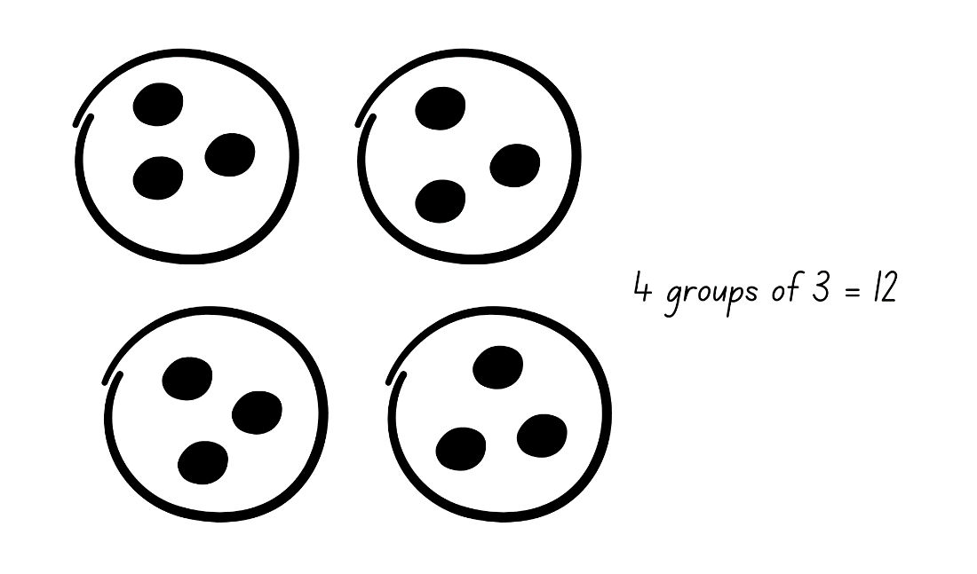

Multiplication stories – 40 minutes
- Distribute a copy of Resource 7: Equal group problems to each student.
- Read each problem to the class and in small groups, ask students to model the problem using counters. Students record their answers as drawings, words or numerals.
- As groups are working, observe what strategies students are using to solve the problem. Encourage students who are counting by ones to use repeated addition or skip counting by asking questions such as:
- What strategy did you use to solve the problem?
- Why did you choose that strategy?
- Is there another strategy you could use to answer the question?
- Which strategy is more efficient?
- Discuss the answers as a class, drawing attention to the different strategies used to solve the same problem.
- Distribute a copy of Resource 8: Array problems to each student. Read each problem to the class. Encourage students to draw an array for each word problem and explain their thinking for each array question.
Note: Students may represent each array using counters to support their thinking.
- As students are working, ask:
- Can you describe your array?
- What strategy did you use to solve the problem?
- Is there a way you could check your answer?
- How does an array help you to answer the question?
- Regroup as a class and summarise the lesson, drawing out key mathematical ideas related to multiplication. Ask students:
- What is the same about all the problems you have just worked on?
- Did you use the same strategy to answer all the questions? Why or why not?
- What challenges did you face? How did you overcome them?
This table details assessment opportunities and differentiation ideas.
Assessment opportunities | Too hard? | Too easy?
What to look for:  - Can students use repeated addition or skip counting to solve multiplication problems? (MAO-WM-01, MA1-FG-01)  - Can students form and describe arrays to represent multiplication problems? (MAO-WM-01, MA1-FG-01)  What to collect:  - student work samples (MAO-WM-01, MA1-FG-01)  - recording of group and class discussion (MAO-WM-01, MA1-FG-01) | Students cannot form arrays and use repeated addition or skip counting to solve multiplication problems.  - Model making an array using equal groups and then using repeated addition and skip counting.  - Provide a number line or number chart to assist with counting.  - Students use cups to represent the number of groups in each problem and counters to represent the number of items in each group. | Students can form arrays and use repeated addition or skip counting to solve multiplication problems.  - Students make up word problems with different answers. For example, write a multiplication problem with an answer of 24.  - Students create their own multiplication word problems with a chosen answer. Students swap problems and represent the answers using drawings, words or numerals.

Consolidation and meaningful practice: Scrambled eggs – 15 minutes
- Write numbers one to 12 in the holes of egg cartons (see Figure 10).
- Place 2 small blocks in each egg carton.
- In small groups, students close the lid of the egg carton and shake it.
- Students open the lid and see where the blocks have landed, then use the numbers to draw an array.
- Students record the total number of items in the array.
- Repeat with students taking turns to shake the egg carton.
Figure 10 – Scrambled eggs egg carton
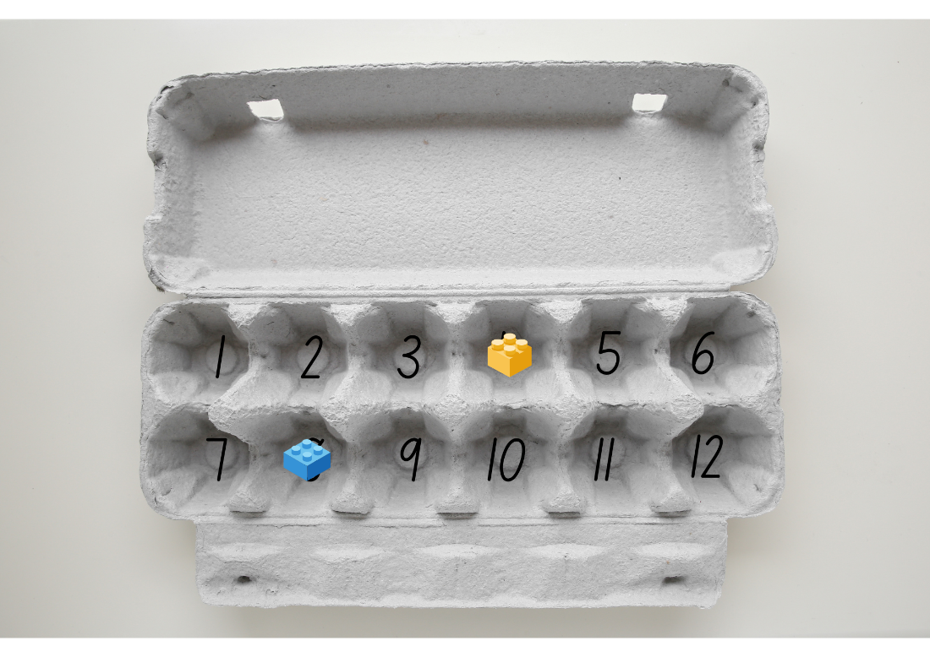
Images licensed under the Canva Content License Agreement.

Lesson 6: Division stories
Core concept: Division can be used to solve everyday problems.
The table below contains suggested learning intentions and success criteria. These are best co-constructed with students.
Learning intentions | Success criteria
Students are learning that:  - place value determines how numbers are represented, read, written and counted  - halving a collection creates 2 equal groups  - an uneven number of objects cannot be divided equally in 2. | Students can:  - group and skip count to find the total of a large number of objects  - use concrete materials to model half a collection  - model division by deconstructing an array equally  - describe the part left over when a collection cannot be distributed equally.

Daily number sense: Grouping and estimating – 10 minutes
- Build student understanding of place value by grouping objects in tens and hundreds.
- Show the class a large number of interlocking cubes (using many cubes will make the task exciting). Ask students to estimate, to the nearest hundred, how many interlocking cubes there are. Record student estimates.
- Explain that students will check their estimates by grouping and counting the interlocking cubes. Divide the interlocking cubes roughly between small groups of students. Ask students to group the interlocking cubes into tens and hundreds as they count and record the total.
Note: As there is a focus on place value in this activity (not counting), it is recommended that students count in units of tens as 1 ten, 2 tens, 3 tens, 4 tens and so on. Students should be able to say that 5 tens is 50.
- As a class, combine each group’s interlocking cubes, regrouping tens and hundreds where necessary. Record the total number of interlocking cubes.
- Ask students to identify the closest hundred to the total number of interlocking cubes.
- Reflect on student learning by asking questions such as:
- How did grouping help to count a large number of objects?
- How does grouping help you to explain what each number in the total represents? For example, the 5 in 152 represents 5 tens.
- What strategies did you use to count and record how many interlocking cubes your group had?
This table details assessment opportunities and differentiation ideas.
Assessment opportunities | Too hard? | Too easy?
What to look for:  - Can students use interlocking cubes to represent and explain grouping? (MAO-WM-01, MA1-RWN-02)  - Can students use grouping and skip counting to find the total number of interlocking cubes? (MAO-WM-01, MA1-RWN-02, MA1-FG-01)  What to collect:  - student observations (MAO-WM-01, MA1-RWN-02, MA1-FG-01)  - recording of student discussion responses (MAO-WM-01, MA1-RWN-02, MA1-FG-01) | Students cannot use grouping and skip counting to estimate and count the total number of interlocking cubes.  - Use a smaller number of interlocking cubes and provide a number chart to assist with skip counting.  - Provide modelled and guided practice opportunities. | Students can use grouping and skip counting to estimate and count the total number of interlocking cubes.  - Students design and represent word problems using interlocking cubes.  - Students find different ways to partition and represent three-digit numbers with interlocking cubes.

The great divide – 40 minutes
This activity has been adapted from the picture book The Great Divide: A Mathematical Marathon by Dayle Ann Dodds.
Summary: 80 participants start out on a cross country race that sees their numbers divided in half at various points in the race until eventually only one racer crosses the finish line.
- Show students the front cover of The Great Divide: A Mathematical Marathon by Dayle Ann Dodds. Ask them to predict what happens in the book and what mathematical concepts may be explored. Students turn and talk and then share answers with the class.
- Read the book, pausing to prompt students’ thinking.
- Draw attention to the organisation of the 80 participants at the start of the race.
- Ask students to estimate the number remaining at each divide.
- Discuss how the author deals with the division of 5 and, before reading on, ask students to predict what will happen now that the groups number is odd.
- Distribute 80 interlocking cubes to small groups of students.
- Read the book again and ask students to represent the changes in the race group with the interlocking cubes. Students begin with 8 towers of 10 to represent the starting group of racers. Digital counters can be used for this activity.
- Distribute a copy of Resource 9: The Great Divide to each student and ask them to represent the changes in the number of racers throughout the book on the number line.
- Pose the questions:
- If 80 is the whole number of racers, what is a half?
- If 80 is the whole number of racers, what is a quarter?
- If 80 is the whole number of racers, what is an eighth?
- Students represent their answers with the cubes, drawings, words or numerals.
- As a class, ask students to share their solutions. Ask:
- What strategy did you use to find a half/quarter/eighth?
- Which fraction was the hardest to calculate? Why?
- How could you check that you have the correct answers?
- Students use counters to represent the 80 racers in an array. Remind students about the 8 groups of 10 racers at the start of the book.
- Students deconstruct the array into 2 equal halves to represent the first divide in the book. Each array should have 40 counters each.
- Ask students to deconstruct one of the new arrays into 2 equal halves to represent the second divide in the book. Each array should have 20 counters each.
- Ask students:
- What strategy did you use to divide the array?
- How did you know that each half had an equal number of counters?
- Did any other group divide their array in a different way? Do you still have the same number of counters in each half?
This table details assessment opportunities and differentiation ideas.
Assessment opportunities | Too hard? | Too easy?
What to look for:  - Can students halve the interlocking cubes to create 2 equal groups? (MAO-WM-01, MA1-FG-01)  - Can students identify a remainder when halving an odd number of objects? (MAO-WM-01, MA1-FG-01)  - Can students represent division by deconstructing arrays? (MAO-WM-01, MA1-FG-01)  What to collect:  - completed Resource 9: The Great Divide (MAO-WM-01, MA1-FG-01)  - photographs or video of students dividing interlocking cubes (MAO-WM-01, MA1-FG-01) | Students cannot model and represent half a collection.  - Model the story by running a race with the class, dividing students into 2 groups at various points and asking half to sit down each time until there are only one or 2 winners.  - At each divide, students share the interlocking cubes equally into 2 groups by distributing them one by one until the collection is exhausted. | Students can model and represent half a collection.  - Students explore what would happen if the number of participants was divided into thirds or fourths at each divide.  - Provide students with a set of word problems related to the book’s concept. For example, if there were 80 participants at the start of the race and one-quarter of them dropped out, how many participants finished the race? If the race started with 80 participants and each group was divided in half 3 times, how many participants crossed the finish line?

Consolidation and meaningful practice: The flower garden – 10 minutes
- Explain that you have a garden where a quarter of the flowers are yellow. Ask students to draw a picture of what the flower garden might look like.
- Conduct a gallery walk and allow students to share their pictures and explain why they have the correct solution.

Lesson 7: The doubling donut tree
Core concept: Doubling and halving are opposite operations.
The table below contains suggested learning intentions and success criteria. These are best co-constructed with students.
Learning intentions | Success criteria
Students are learning that:  - doubling makes collections and number patterns grow very quickly  - doubling and halving are inverse mathematical operations. | Students can:  - continue doubling number patterns  - model doubling and halving groups.

Daily number sense: Array bingo – 20 minutes
This activity has been adapted from Array bingo (8:15) from Mathematics K-6 resources by NSW Department of Education
- Build student understanding of multiplicative strategies by playing Array bingo (8:15).
- Students play in small groups. This game was introduced to students in Stage 1 Unit 10, Lesson 5.
- Provide students with 6 array cards each from Resource 10: Array bingo. Students place their array cards face up on their desks.
- Turn over a descriptor card and display for students. If a player has the matching array card, they may turn over the array card.
- Remind students that they can use the commutative property to rotate the arrays, so they can make a match. For example, students could take an array that was structured as 3 twos and rotate it to show 2 threes.
Commutative property: Two numbers can be added or multiplied in any order and the solution will be the same.
- The winner is the first player to turn over all their cards and say, ‘Bingo!’
- After playing a round, students swap how the piles of cards are used in the game. Make a gameboard from the descriptor cards and turn over the array cards.
- Summarise as a class, drawing out some key mathematical ideas. Ask:
- What strategies did you use to determine how many dots there were in the arrays?
- What strategy did you use to work out the structure of the rows and columns?
- What arrays did you rotate to make a match?
- Did rotating the arrays change the total number of dots? Why or why not?

The doubling donut tree – 30 minutes
This activity has been adapted from CLASS Challenging Tasks: Using Cognitive Load Theory to Inform the Design of Challenging Mathematical Tasks by Russo and Hopkins (2017).
- Explain that Kai and Amaya loved donuts, so their mum decided to plant a donut tree. The tree was magical. Every day, the number of donuts on the tree doubled. Kai was having his birthday party on Friday, so the family decided to not pick any of the donuts off the tree until then. On Monday, there were 3 donuts on the tree.
- Students work out how many donuts there will be on the tree on Friday.
- Students calculate the number of donuts on the tree each day from Monday to Friday. Students can use Resource 2: Number chart. Students record their answers on Resource 11: The doubling donut tree as drawings, words and numerals.
- As a class, ask students to share the strategy they used to find out how many donuts were on the tree on Friday.
The table below outlines stimulus prompts to generate conversation about the topic, along with anticipated responses from students.
Prompt | Anticipated student strategies and responses
What strategy did you use to double the number of donuts each day? | - Worked from the pictures: ‘There are 12 donuts on Wednesday, so for Thursday, I have to draw 12 donuts and then draw another 12 donuts.’  - Used the number chart to count-on: ‘There are 12 donuts on Wednesday, so for Thursday, I have to start on 12 and count-on another 12.’  - Used place value partitioning, and then doubled the numbers in the table: ‘There are 12 donuts on Wednesday, so for Thursday, I have to double 10 and double 2, then put them together.’
- Provide small groups of students with concrete materials, such as counters, to represent the 48 donuts. Students model a half, a quarter and an eighth of the total number of donuts and record their thinking using drawings, word and numerals.
- As a class, ask students to share their solutions. Ask:
- What strategy did you use to solve the problem?
- Why did you use that strategy?
- Did anyone use a different strategy?
- Pose the following questions and ask students to record their thinking:
- If 6 is half the number of guests at the party, what is the total number of guests?
- If 12 is half the number of balloons at the party, what is the total number of balloons?
- If 8 is half the number of cupcakes at the party, what is the total number of cupcakes?
- Reflect on student learning by asking questions such as:
- What patterns did you notice in the number of donuts on the tree each day? How did you use this pattern to make your calculations easier?
- How did you check your answers to make sure they were correct?
- Can you think of any real-life situations where doubling might be important to understand?
- What challenges did you face while working on this activity? How did you overcome them?
This table details assessment opportunities and differentiation ideas.
Assessment opportunities | Too hard? | Too easy?
What to look for:  - Can students double the number of donuts each day? (MAO-WM-01, MA1-FG-01)  - Can students solve problems by recreating the whole when given half? (MAO-WM-01, MA1-FG-01)  What to collect:  - completed Resource 11: The doubling donut tree (MAO-WM-01, MA1-FG-01)  - recording of class discussions (MAO-WM-01, MA1-FG-01) | Students are unable to continue the doubling number pattern to work out the total number of donuts.  - Students complete the task but, instead of there being 3 donuts on the tree on Monday, there is only one donut.  - Show students pictures of subitising and doubling cards to connect prior understanding of double patterns. | Students are able to continue the doubling number pattern to work out the total number of donuts.  - Students work out how many donuts would be on the tree if Kai decided to have the party on Saturday or on Sunday.  - Students see if they can keep the number pattern going.

Consolidation and meaningful practice: Double and half – 10 minutes
- The following numbers are answers. Ask students to create and record both a doubling and a halving question for each answer. For example, the answer is 2, so the number that was doubled is one and the number that was halved is 4. Students may choose to record their responses in a table:
- 8
- 6
- 10
- 20
- 12
- 18
- Ask selected students to share their responses and discuss the following questions:
- Was it easier to create a doubling question or a halving question? Why?
- What strategies did you use to create your questions?
- What do you notice about all the original numbers (answers)? (They are all even numbers.)
- Why do you think this is so?

Lesson 8: Choices, choices, choices
Core concept: Multiplication and division can be used to solve everyday problems.
The table below contains suggested learning intentions and success criteria. These are best co-constructed with students.
Learning intention | Success criteria
Students are learning that mathematical thinking can be used to solve everyday problems. | Students can:  - use sharing, grouping, doubling and halving to solve problems  - explain their thinking using pictures, words and numerals.

Daily number sense: Teacher’s choice – 10 minutes
- From a class need surfaced through formative assessment data, identify a short, focused activity that targets students’ knowledge, understanding and skills. Example activities may be drawn from the following resources:
- Thinking Mathematically Stage 1
- Universal Resources Hub.

Choices – 45 minutes
- Explain the following scenarios, noting that the preferred choice should be the one that is the highest number. Discuss each scenario. Students turn and talk, then share possible strategies that may be used to find a solution. Students work in small groups to solve each problem and use drawings, words or numerals to justify their preferred choices. Concrete materials should be made available to each group:
Note: The names in each scenario are presented as examples. You may prefer to use names of students in your class or names that are representative of your school community.
- Jarrah, Cooper, Lucy and Marley won a prize playing a party game. They won 48 delicious mini donuts to be shared out. Would each person get more if they were to share the donuts equally among themselves or if each winner were to be given 6 donuts.
- Ruby won a prize in the sandcastle building competition. The organisers have 40 toys to give out as prizes. Ruby can choose an eighth of 40 toys or 7 toys.
- Madi came first in the obstacle course race at the school fete. First prize is a choice of either 5 lollipops for each letter in her name or 22 lollipops.
- Zayden and Braxton correctly guessed that there were 88 jellybeans in the jar. The competition organiser has said that they can choose to each have half of the 88 jellybeans or have double 16 jellybeans each.
- Monitor each group, prompting students to explain their thinking by asking questions such as:
- What strategy are you using?
- Why did you choose that strategy?
- How might the concrete materials help?
- Are there any other strategies you could use?
- How are you showing your thinking?
- Is there a way to check that your answer is correct?
- Ask selected groups to share their thinking and explain their choices.
This table details assessment opportunities and differentiation ideas.
Assessment opportunities | Too hard? | Too easy?
What to look for:  - Can students solve and record answers to multiplication and division problems using drawings, words and numerals? (MAO-WM-01, MA1-FG-01)  - Can students justify their choices? (MAO-WM-01, MA1-FG-01)  - Can students use concrete materials to find one half and one eighth of a collection? (MAO-WM-01, MA1-FG-01)  - Can students model doubling? (MAO-WM-01, MA1-FG-01)  What to collect:  - student work samples (MAO-WM-01, MA1-FG-01)  - recordings of student discussion responses (MAO-WM-01, MA1-FG-01) | Students are unable to determine the correct choice in each scenario.  - Rephrase the scenarios using smaller numbers and easier choices. For example, sharing donuts between 2 people instead of 4.  - Model using concrete materials to reflect the choices in each scenario. | Students determine the correct choice for each scenario.  - Students show multiple ways to reach the solution, ranking them in terms of efficiency.  - Students create their own choice-based scenarios for others to solve.

Discuss and connect the mathematics – 5 minutes
- Ask students:
- Which choice was the easiest? Why?
- Which choice was the hardest? Why?
- Can you think of any real-life examples where you might have to use these strategies to solve problems?

Resource 1: Bingo card

Resource 2: Number chart
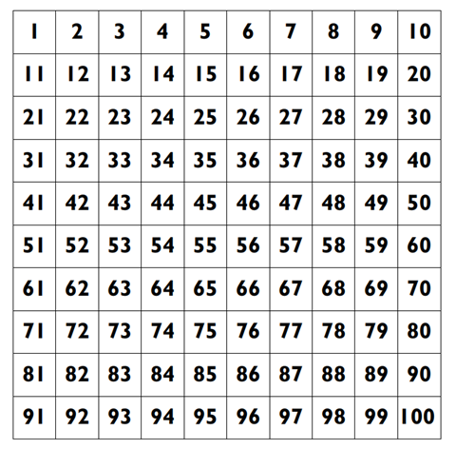

Resource 3: Gremlins
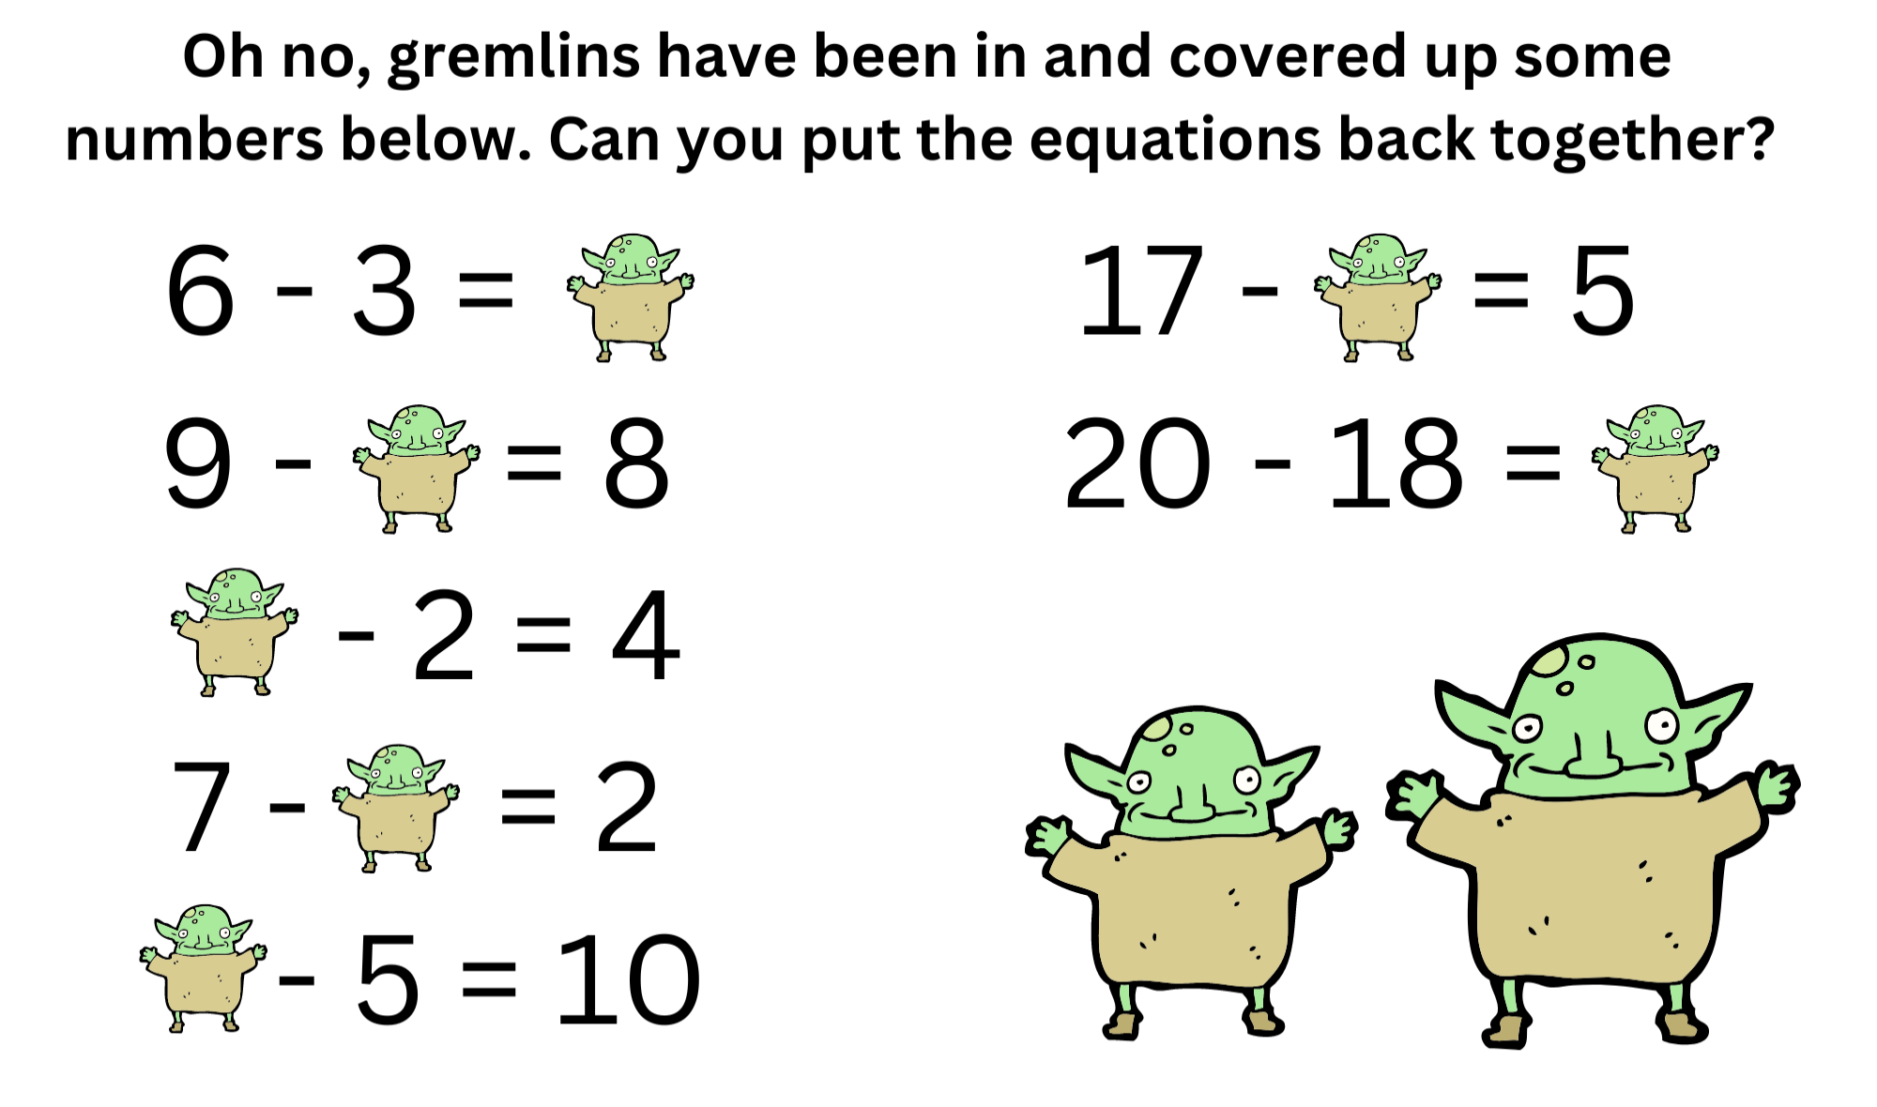
‘Goblin' by Lineartestpilot is licensed under the Canva Content License Agreement.

Resource 4: Endless hallway
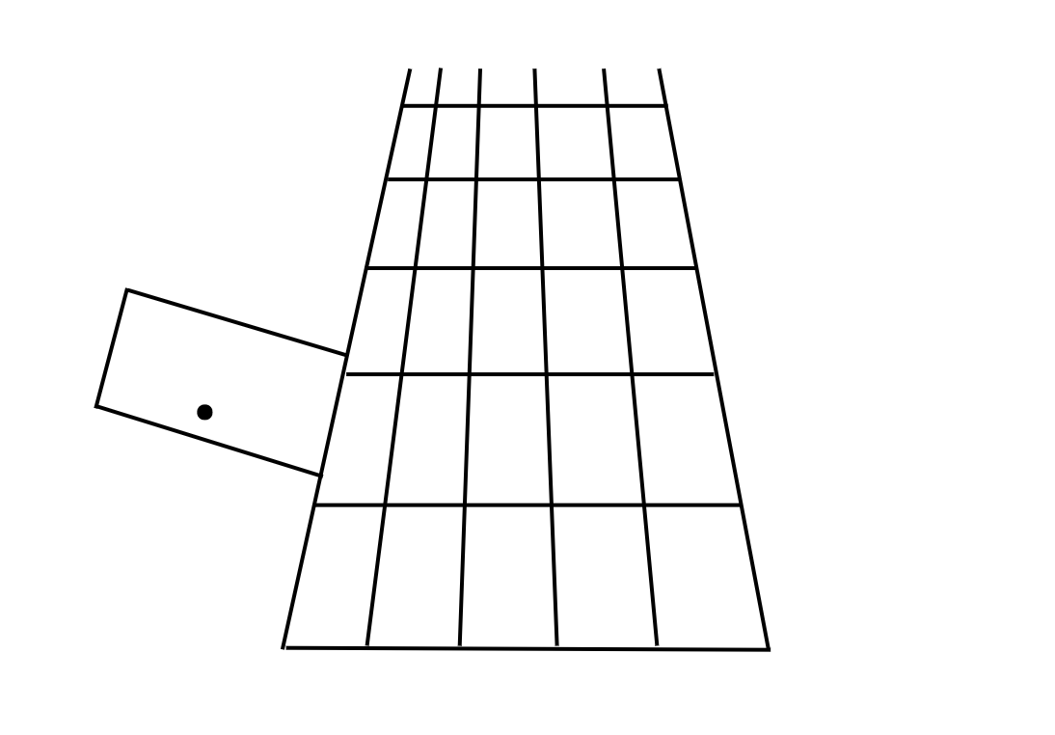
Image adapted from Boaler et al. (2022).

Resource 5: Lunch box items
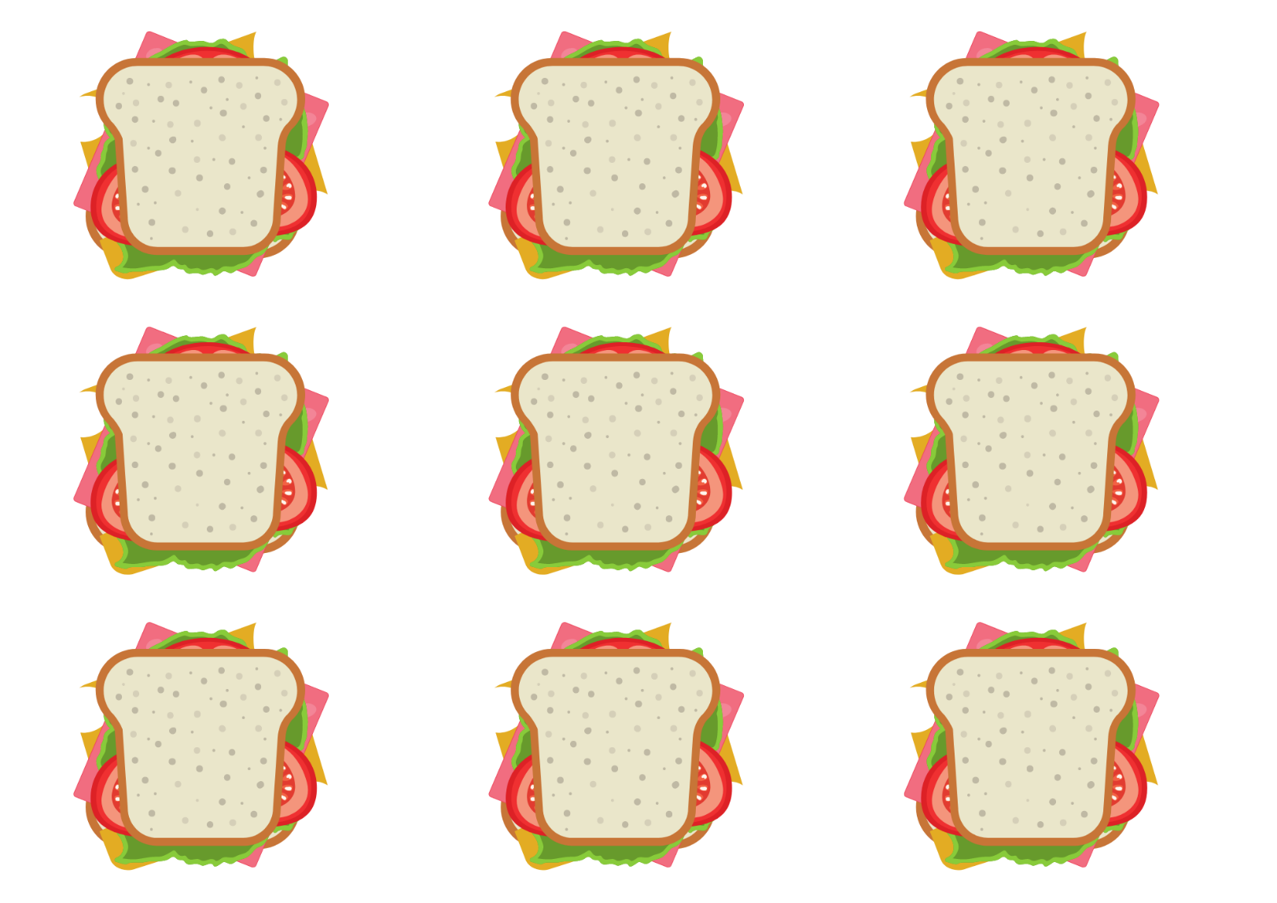
‘Sandwich' by grmarc is licensed under the Canva Content License Agreement.
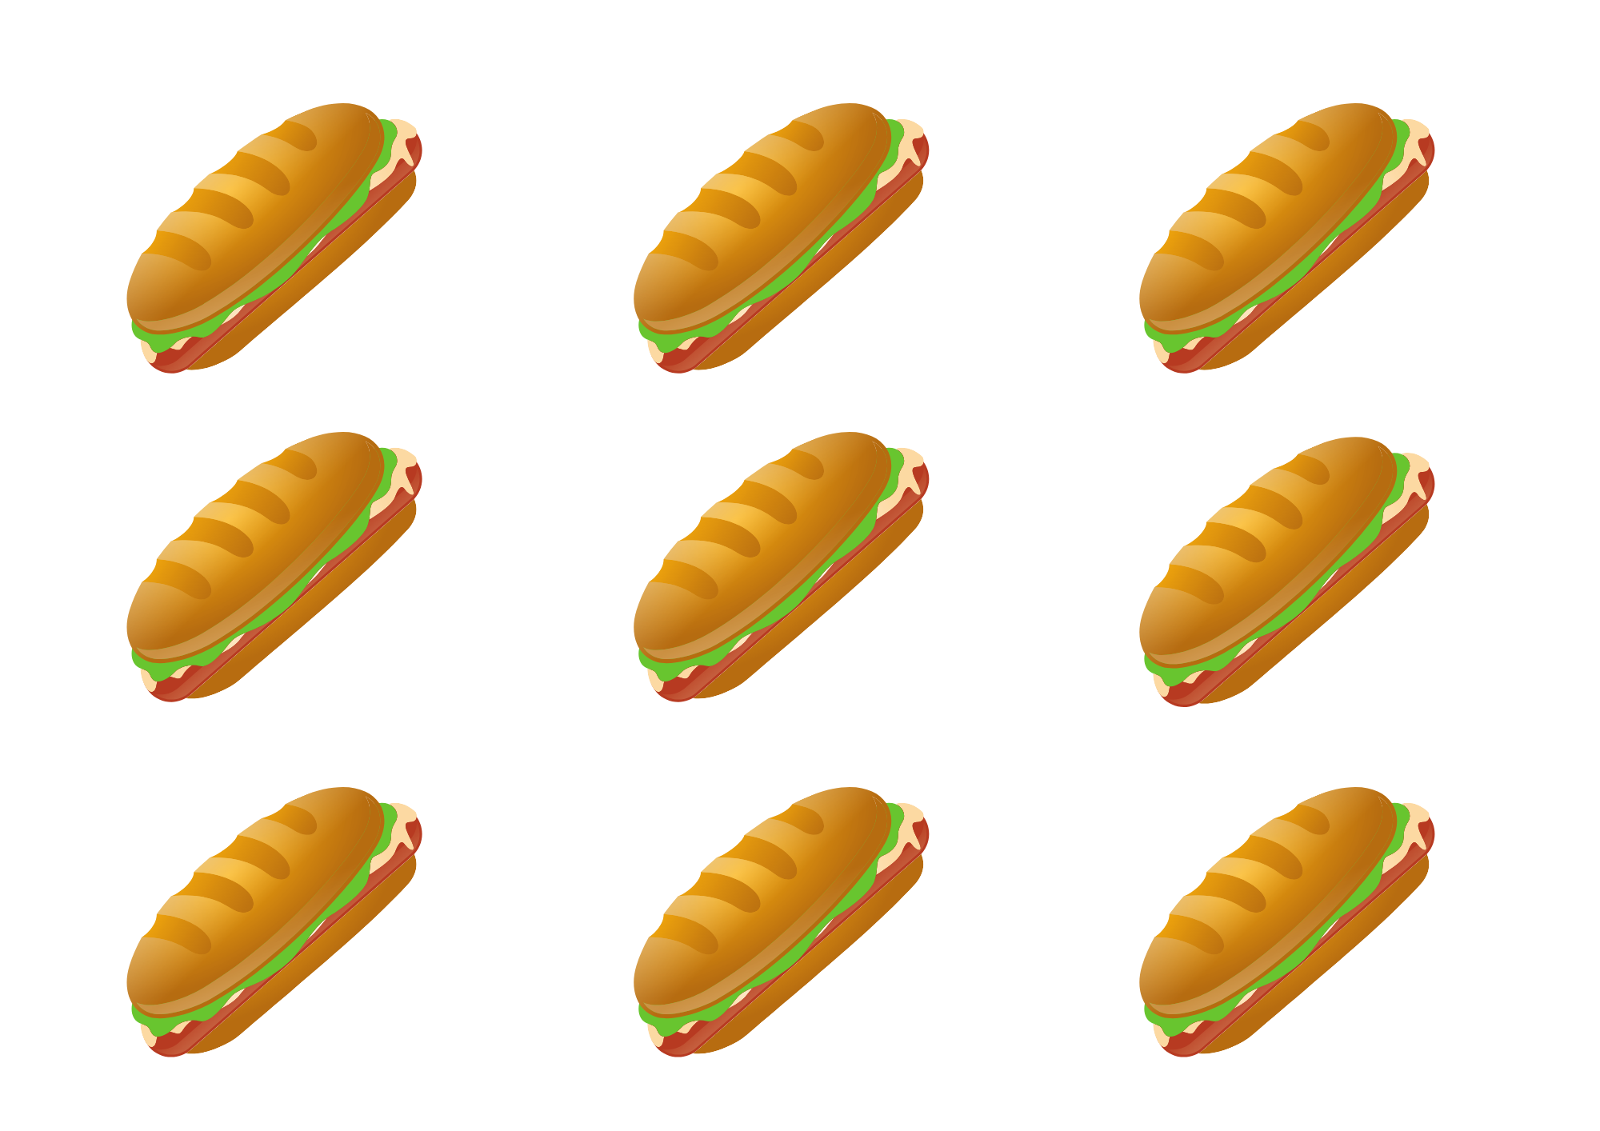
‘sandwich' by DAPA Images is licensed under the Canva Content License Agreement.
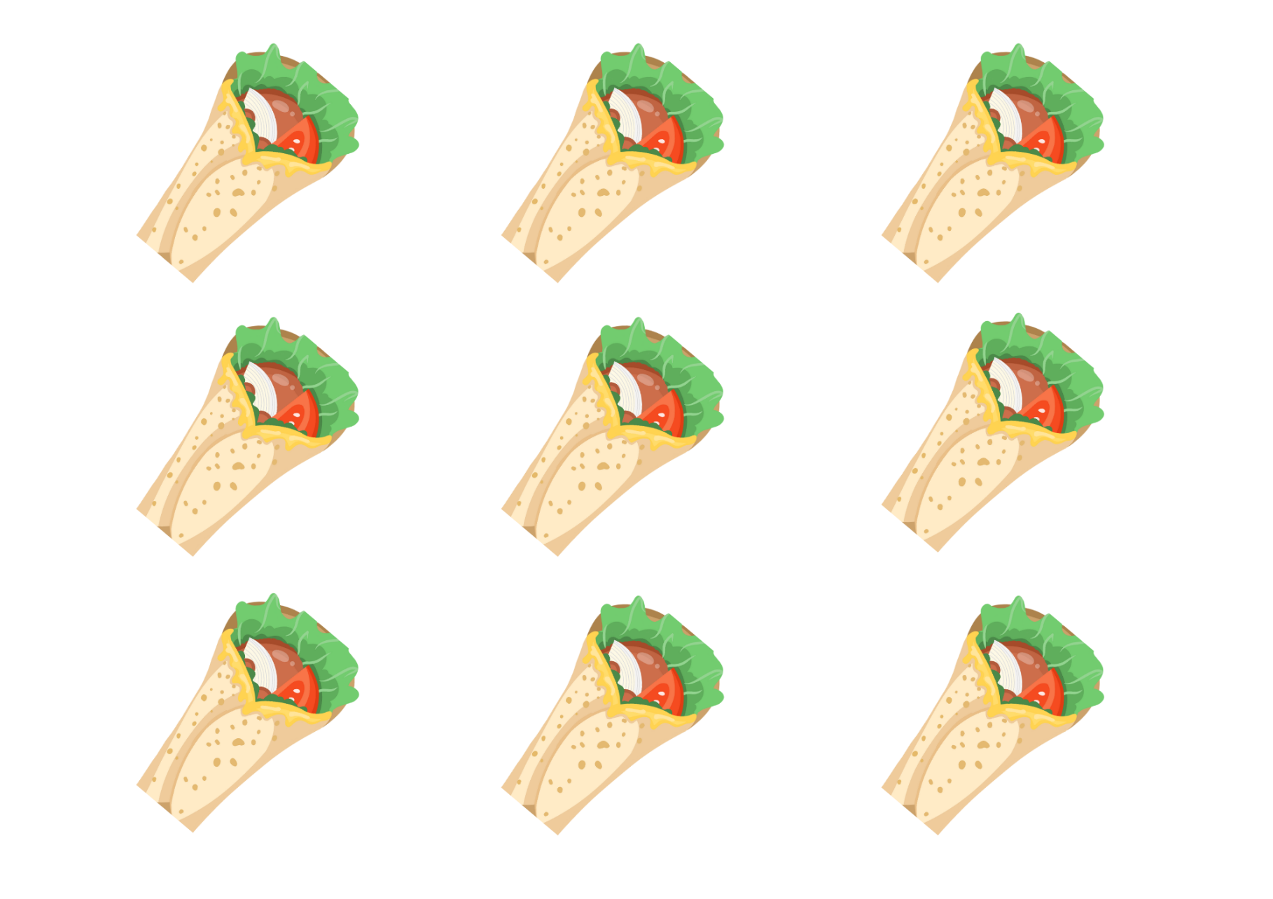
Image licensed under the Canva Content License Agreement.
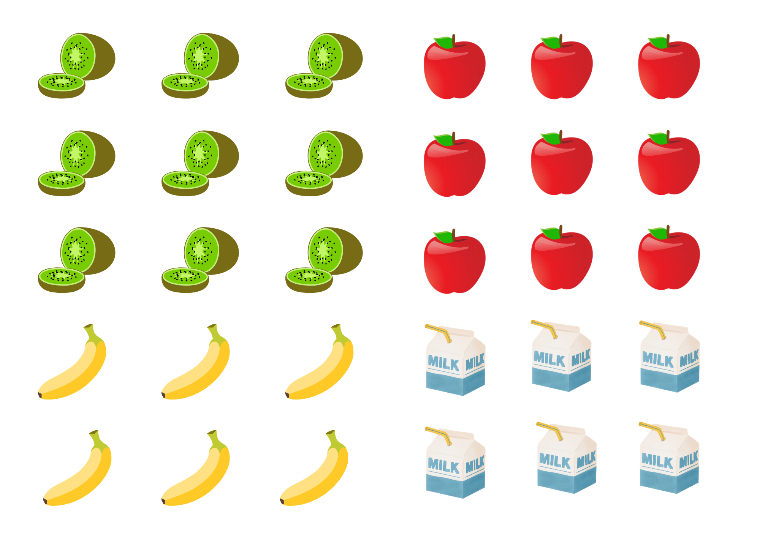
Images licensed under the Canva Content License Agreement.
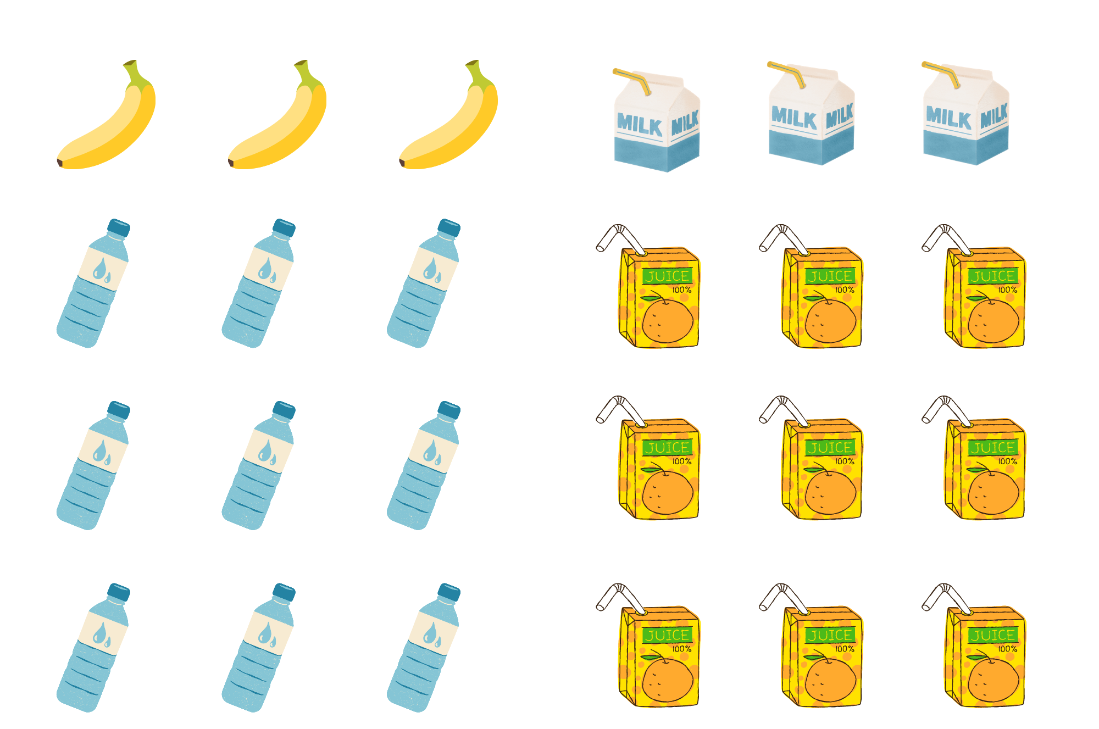
Images licensed under the Canva Content License Agreement.

Resource 6: Lunch box template
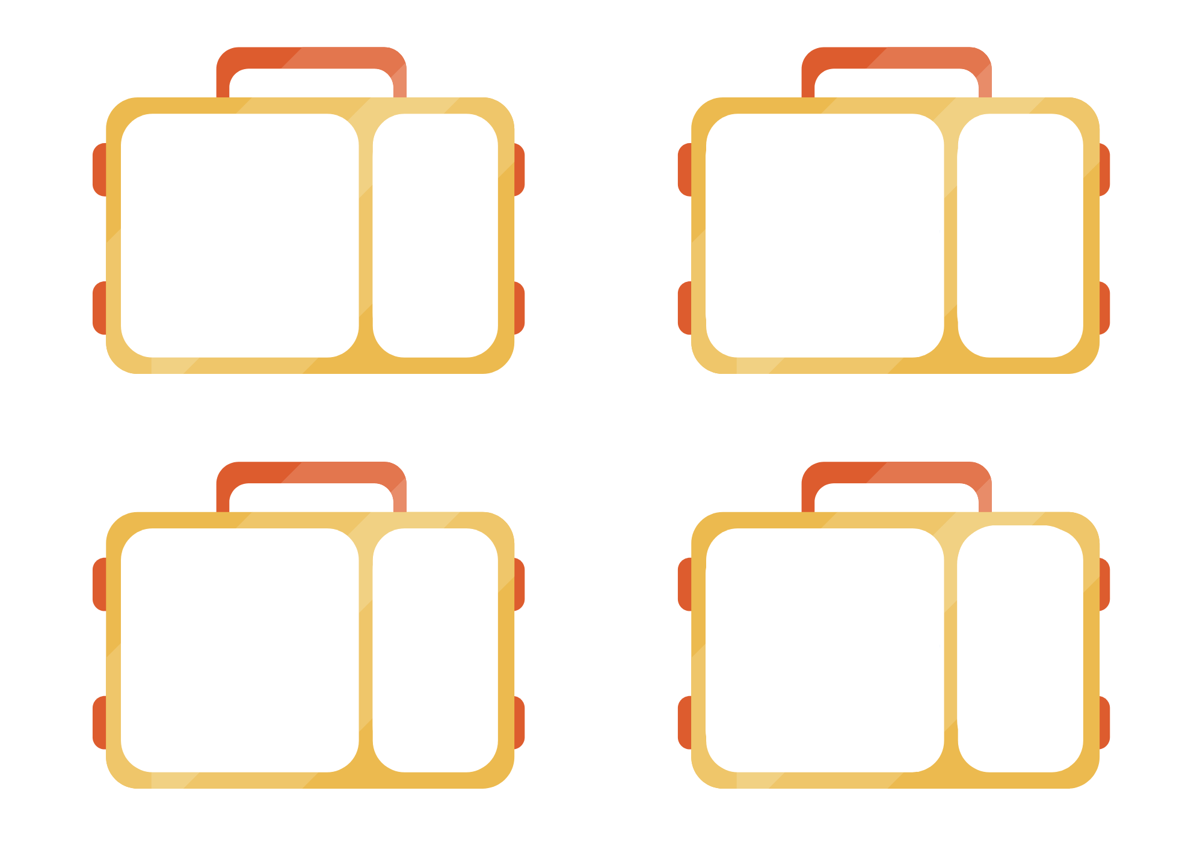
‘Lunch Bag with Sandwich’ by NotionPic is licensed under the Canva Content License Agreement.
.

Resource 7: Equal group problems
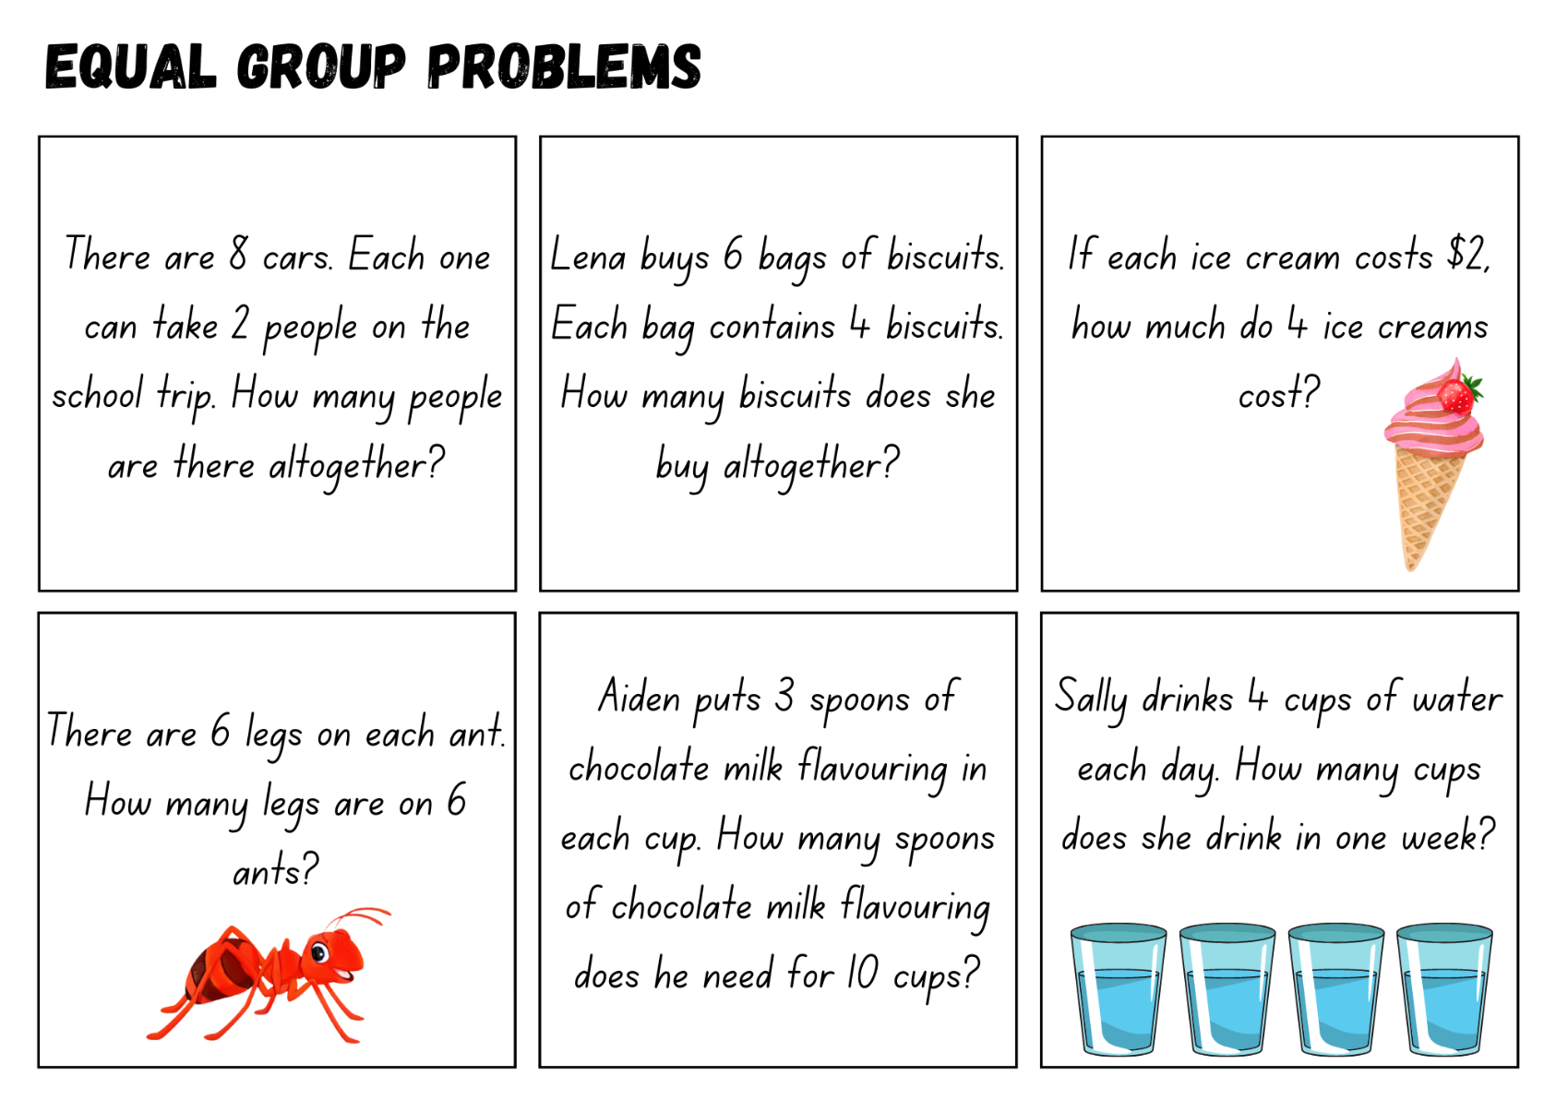
Images sourced from Canva and used in accordance with the Canva Content License Agreement.

Resource 8: Array problems
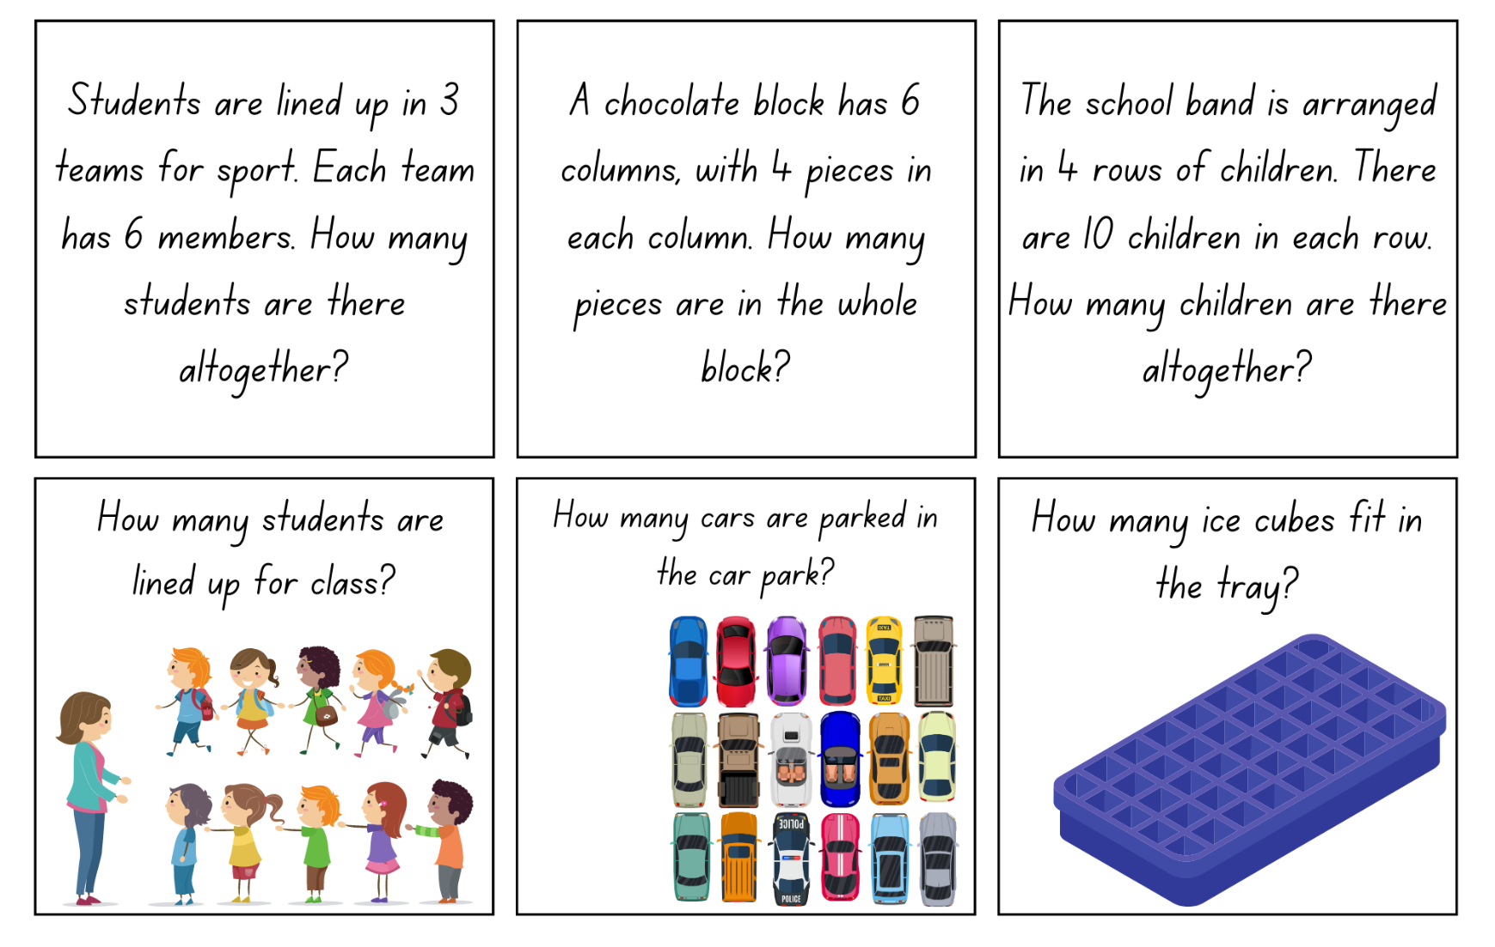
Images licensed under the Canva Content License Agreement.
Resource 9: The Great Divide
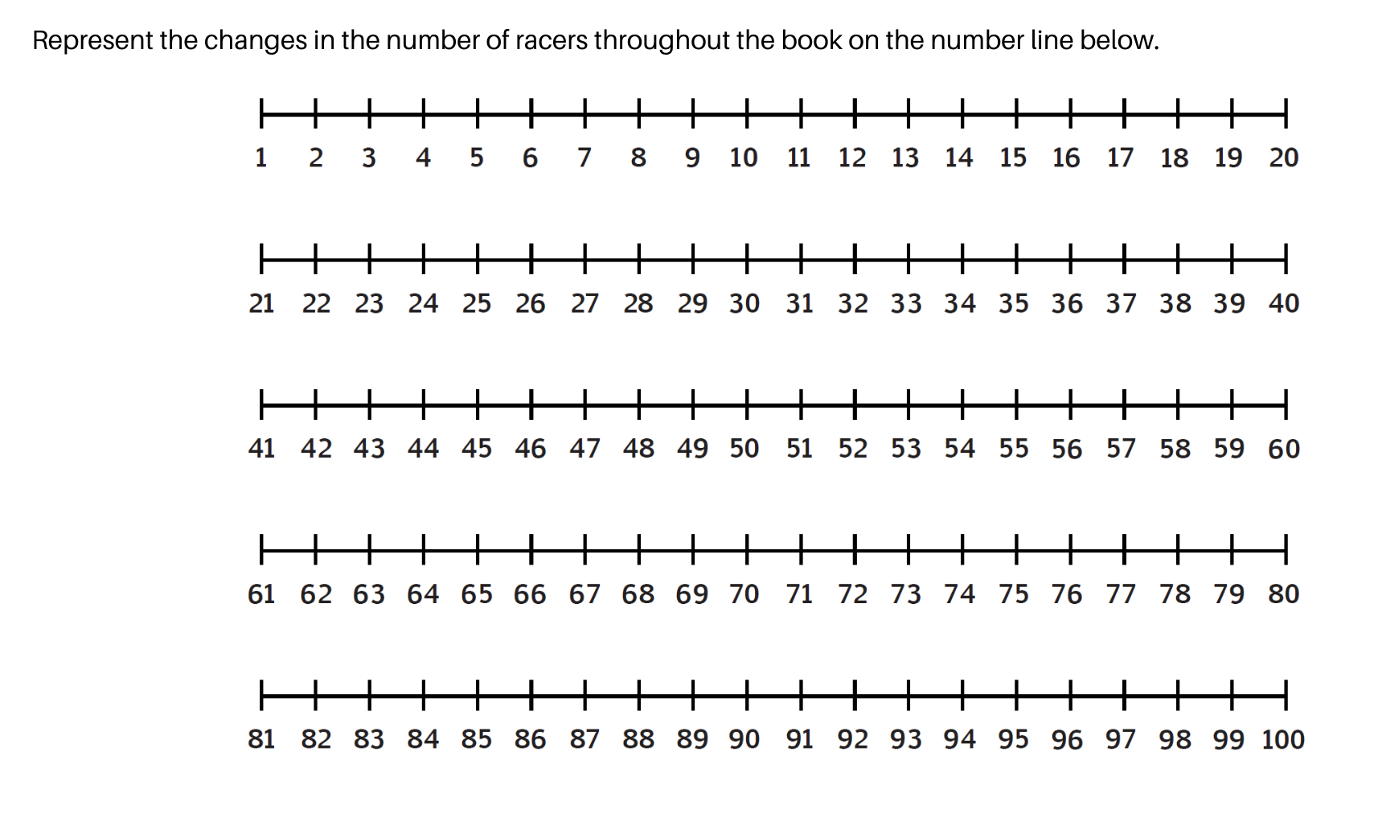

Resource 10: Array bingo
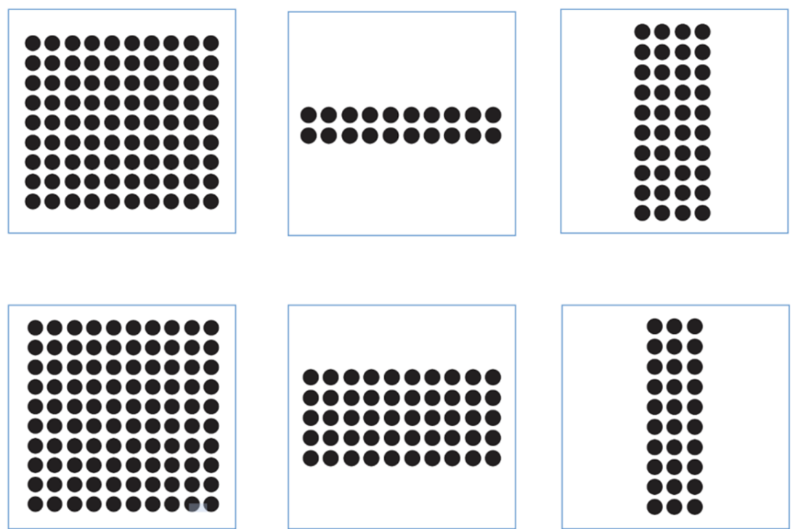
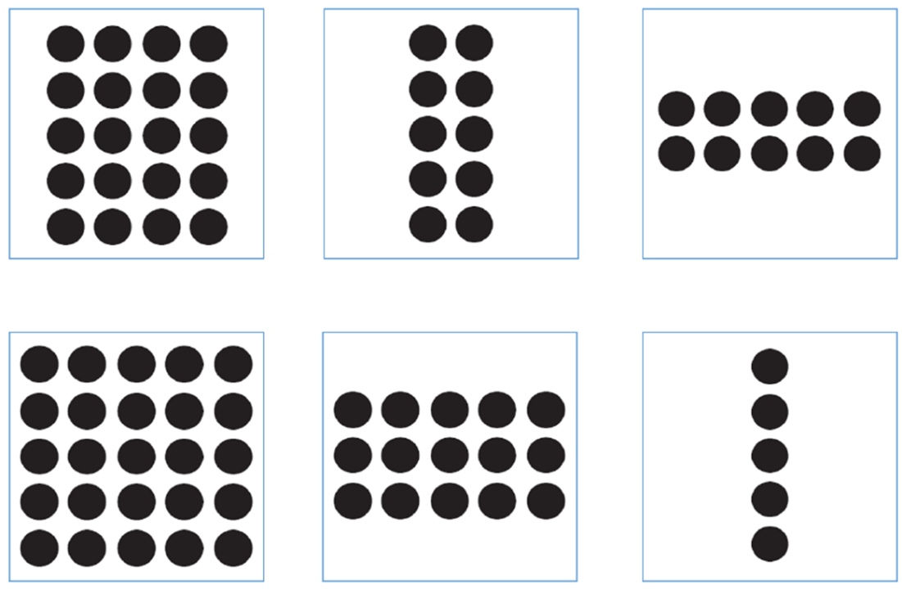
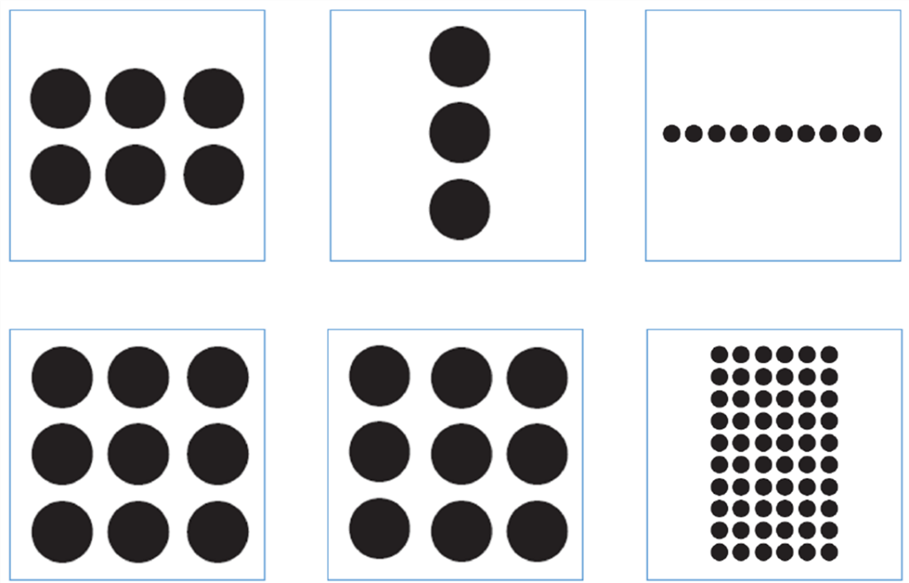

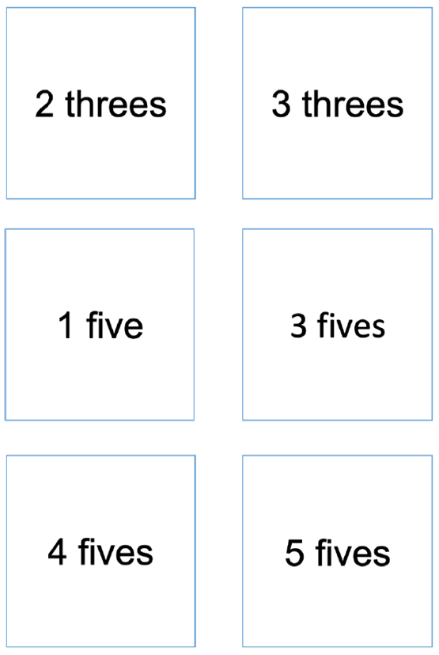
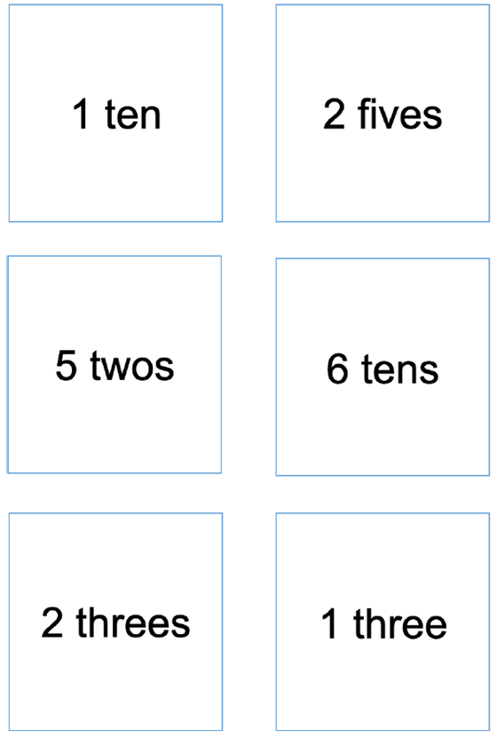
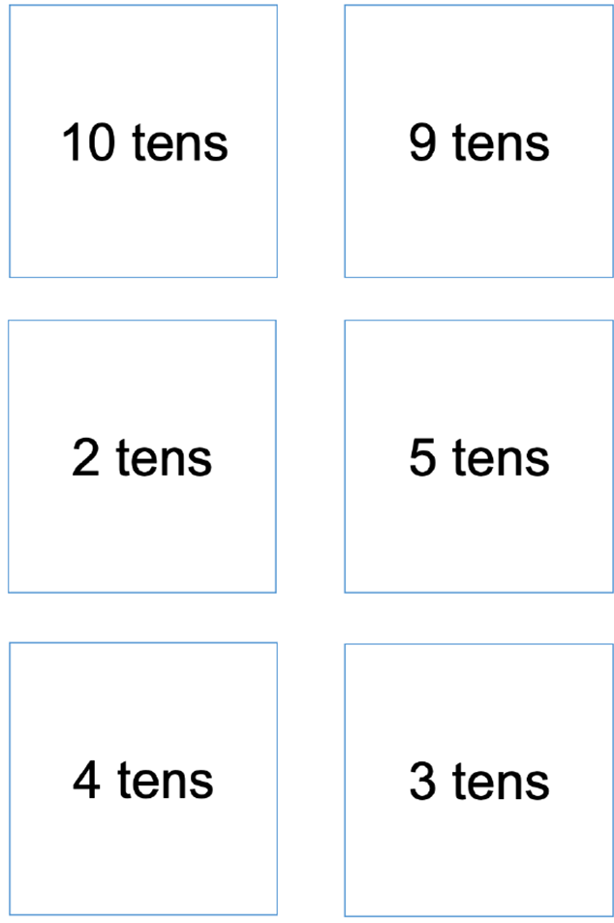

Resource 11: The doubling donut tree
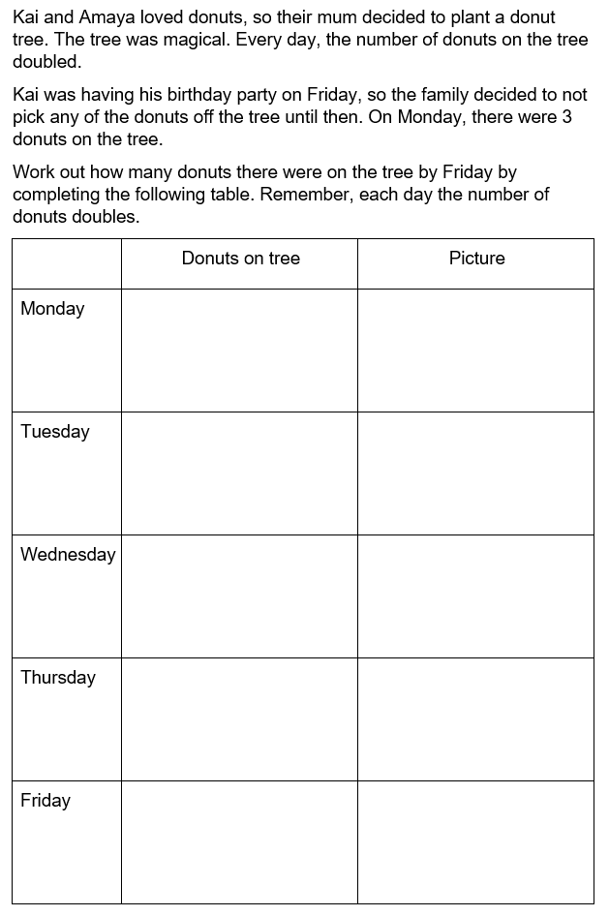

Syllabus outcomes and content
The table below outlines the syllabus outcomes and range of relevant syllabus content covered in this unit. Content is linked to National Numeracy Learning Progression version (3).
Focus area and outcomes | Content groups and content points | Lessons
Representing whole numbers A  MAO-WM-01  MA1-RWN-01  MA1-RWN-02 | Represent numbers on a line  - sequence numbers and arrange them on a line by considering the order and size of those numbers (CPr5)  Represent the structure of groups of ten in whole numbers  - recognise that ten ones is the same as one ten (NPV2, NPV4)  - count large sets of objects by systematically grouping in tens (CPr7)  - use number lines and number charts to assist with locating the nearest ten to a number  - estimate, to the nearest ten, the number of objects in a collection and check by counting in groups of ten (CPr7, NPV6) | 1–2, 4
Representing whole numbers B  MAO-WM-01  MA1-RWN-01  MA1-RWN-02 | Use counting sequences of ones and tens flexibly  - identify the number before and after a given three-digit number  - count forwards and backwards by tens, on and off the decade, with two- and three-digit numbers (CPr7)  - identify how many more to the next multiple of ten within two- and three-digit numbers  Form, regroup, and rename three-digit numbers  - count and represent large sets of objects by systematically grouping in tens and hundreds (CPr7, NPV5)  - use models such as base 10 material and interlocking cubes to represent and explain grouping (CPr7)  - state the quantity value of digits in numbers of up to three digits (NPV5)  - identify the nearest hundred to a number  - recognise units of 100 (UnM5, NPV5)  - use place value to partition and rename three-digit numbers in different ways (NPV5)  - estimate, to the nearest hundred, the number of objects in a collection and check by grouping and counting (NPV6) | 4, 6
Combining and separating quantities A  MAO-WM-01  MA1-CSQ-01 | Use advanced count-by-one strategies to solve addition and subtraction problems  - apply the terms ‘add’, ‘plus’, ‘equals’, ‘is equal to’, ‘is the same as’, ‘take away’, ‘minus’ and ‘the difference between’ to describe combining and separating quantities (AdS1, AdS6)  - recognise and use the symbols for plus (+), minus (–) and equals (=)  - record number sentences in a variety of ways using drawings, words, numerals and symbols (AdS6)  - fluently use advanced count-by-one strategies including counting on and counting back to solve addition and subtraction problems involving one- and two-digit numbers (AdS3-AdS5)  Recognise and recall number bonds up to ten  - recognise, recall and record combinations of two numbers that add up or bond to form 10 (AdS2, AdS6)  - create, recall and recognise combinations of two numbers that add up to numbers less than 10 (AdS2, AdS6)  - describe combinations for numbers using words such as more than, less than and double (AdS6)  Use flexible strategies to solve addition and subtraction problems  - use non-count-by-one strategies such as using doubles for near doubles and combining numbers that add to ten (AdS6)  - represent addition and subtraction using structured materials such as a bead string or similar model (AdS6-AdS7)  - select and apply strategies using number bonds to solve addition and subtraction problems with one- and two-digit numbers by partitioning numbers using quantity value and bridging to 10 (AdS6-AdS7)  Represent equality  - use the equals sign to record equivalent number sentences involving addition, and to mean 'is the same as', rather than as an indication to perform an operation (NPA3)  - model the commutative property for addition and apply it to aid the recall of addition facts (AdS7)  - recall related addition and subtraction facts for numbers to at least 10 (AdS6) | 1–2, 4–5
Combining and separating quantities B  MAO-WM-01  MA1-CSQ-01 | Represent and reason about additive relations  - create, record and recognise combinations of two numbers that add to numbers from 11 up to and including 20 (AdS7)  - create, model and solve word problems, using number sentences  - represent the difference between two numbers using concrete materials and diagrams (AdS6)  - represent a constant difference between pairs of numbers  - model how addition and subtraction are inverse operations using concrete materials, drawings and diagrams (AdS7)  - recall and use related addition and subtraction number facts to at least 20 (AdS7)  Form multiples of ten when adding and subtracting two-digit numbers  - add two-digit numbers by building to multiples of ten (AdS7)  - add and subtract from a two-digit number and record on an empty number line (AdS6-AdS8)  - use quantity values to separate tens and ones for addition (only) (AdS7-AdS8)  - use an inverse strategy to turn a subtraction into an addition (AdS7)  Use knowledge of equality to solve related problems  - use number bonds to determine a missing number (AdS6, NPA3-NPA4)  - use number knowledge to solve related problems (AdS7, NPA4)  - use a variety of ways of writing number sentences (NPA3-NPA4)  - use number bonds to solve equality problems (NPA3-NPA4) | 1–2
Forming groups A  MAO-WM-01  MA1-FG-01 | Count in multiples using rhythmic and skip counting  - count by twos, threes, fives and tens using rhythmic counting and skip counting (MuS2, CPr6)  Use skip counting patterns  - identify and describe patterns when skip counting forwards or backwards by twos, fives and tens (NPA3-NPA4)  - determine a missing number in a number pattern with a constant difference  - describe how the missing number in a number pattern was determined  Model and use equal groups of objects to represent multiplication  - model and describe collections of objects as groups of (MuS2)  - determine and distinguish between the number of groups and the number in each group when describing collections of objects  - find the total number of objects using skip counting of equal groups of a known size (MuS2-MuS3)  Recognise and represent division  - use concrete materials to model a half of a collection and show the relation between the half and the whole (InF1)  - model sharing division by distributing a collection of objects equally into a given number of groups to determine how many in each group (InF2, MuS5)  - describe the part left over when a collection cannot be distributed equally using the given group size (MuS6) | 3–8
Forming groups B  MAO-WM-01  MA1-FG-01 | Represent and explain multiplication as the combining of equal groups  - use objects, diagrams, images or actions to model multiplication as accumulating equal groups (MuS4)  - solve multiplication problems using repeated addition (MuS4)  - form arrays of equal rows and equal columns (MuS5)  - determine and distinguish between the number of rows/columns and the number in each row/column when describing collections of objects (MuS5)  - model the commutative property of multiplication, using an array (MuS6)  - model division by deconstructing an array equally into a given number of rows or columns  Model doubling and halving with fractions  - model doubling and halving groups and the relation between the processes (MuS6, InF2)  - re-create the whole given half (InF3)  - use concrete materials to model a half, a quarter or an eighth of a collection, and explain their thinking (InF2-InF3)  Represent multiplication and division problems  - solve multiplication and division problems using objects, diagrams, images and actions (MuS6-MuS7)  - record answers to multiplication and division problems (including those with remainders) using drawings, words and numerals (MuS6) | 3–8

References
Links to third-party material and websites
Please note that the provided (reading/viewing material/list/links/texts) are a suggestion only and implies no endorsement, by the New South Wales Department of Education, of any author, publisher, or book title. School principals and teachers are best placed to assess the suitability of resources that would complement the curriculum and reflect the needs and interests of their students.
If you use the links provided in this document to access a third-party's website, you acknowledge that the terms of use, including licence terms set out on the third-party's website apply to the use which may be made of the materials on that third-party website or where permitted by the Copyright Act 1968 (Cth). The department accepts no responsibility for content on third-party websites.
Except as otherwise noted, all material is © State of New South Wales (Department of Education), 2023 and licensed under the Creative Commons Attribution 4.0 International License. All other material (third-party material) is used with permission or under licence. Where the copyright owner of third-party material has not licensed their material under a Creative Commons or similar licence, you should contact them directly for permission to reuse their material.
Mathematics K–10 Syllabus © 2022 NSW Education Standards Authority (NESA) for and on behalf of the Crown in right of the State of New South Wales.
© 2022 NSW Education Standards Authority. This document contains NSW Curriculum and syllabus content. The NSW Curriculum is developed by the NSW Education Standards Authority. This content is prepared by NESA for and on behalf of the Crown in right of the State of New South Wales. The material is protected by Crown copyright.
Please refer to the NESA Copyright Disclaimer for more information.
NESA holds the only official and up-to-date versions of the NSW Curriculum and syllabus documents. Please visit the NSW Education Standards Authority (NESA) website and the NSW Curriculum website.
National Numeracy Learning Progression © Australian Curriculum, Assessment and Reporting Authority (ACARA) 2010 to present, unless otherwise indicated. This material was downloaded from the Australian Curriculum website (National Numeracy Learning Progression) (accessed 7 March 2023) and was not modified. The material is licensed under CC BY 4.0. Version updates are tracked in the ‘Curriculum version history’ section on the 'About the Australian Curriculum' page of the Australian Curriculum website.
ACARA does not endorse any product that uses the Australian Curriculum or make any representations as to the quality of such products. Any product that uses material published on this website should not be taken to be affiliated with ACARA or have the sponsorship or approval of ACARA. It is up to each person to make their own assessment of the product, taking into account matters including, but not limited to, the version number and the degree to which the materials align with the content descriptions and achievement standards (where relevant). Where there is a claim of alignment, it is important to check that the materials align with the content descriptions and achievement standards (endorsed by all education Ministers), not the elaborations (examples provided by ACARA).
This resource contains images and content obtained from Canva, and their use outside of this resource is subject to Canva’s Content License Agreement. If you wish to use them separately from the resource, please go to Canva.
ABC (Australian Broadcasting Corporation) Education (2023) ABC Education [website], accessed 23 March 2023.
ABC Education (2023) ‘Thundergoats’, Games, ABC Education website, accessed 7 March 2023.
Australian Government Department of Education (2020) ‘Multiplication: Making Robots’, Teaching resources, reSolve: Maths by Inquiry website, accessed 7 March 2023.
Australian Government Department of Education (2023) reSolve: Maths by Inquiry [website], accessed 23 March 2023.
Boaler J, Munson J and William C (2022) Mindset Mathematics: Visualising and Investigating Big Ideas, Grade 2, Jossey-Bass, New Jersey.
Didax, Inc (2023) ‘Two-Color Counters’, Virtual Manipulatives, Didax website, accessed 23 March 2023.
Dodds DA (2005) The Great Divide: A Mathematical Marathon (Mitchell T, illus.), Candlewick Press, Massachusetts.
New Zealand Ministry of Education (n.d) ‘Gremlins’, Resource, NZ Maths website, accessed 7 March 2023.
New Zealand Ministry of Education (n.d) NZ Maths [website], accessed 23 March 2023.
Russo J and Hopkins S (2017) ‘CLASS Challenging Tasks: Using Cognitive Load Theory to Inform the Design of Challenging Mathematical Tasks’, Australian Primary Mathematics Classroom, 22(1)21–27, accessed 23 March 2023.
Stanford University (n.d.) ‘Pepperoni Pizza’, Number Sense, youcubed website, accessed 7 March 2023.
Stanford University (n.d.) youcubed [website], accessed 23 March 2023.
Sullivan P (2018) Challenging Mathematical Tasks: Unlocking the potential of all students, Oxford University Press, South Melbourne.

