Mathematics – Stage 1 – Unit 20
Contents
Unit description and duration 4
Student prior learning 4
Lesson overview and resources 5
Lesson 1: Grandma’s soup investigation – Part 1 10
Daily number sense: Subitising number talk – 10 minutes 10
Counting and ordering – 40 minutes 11
Discuss and connect the mathematics – 10 minutes 13
Lesson 2: Grandma’s soup investigation – Part 2 15
Daily number sense: Speed circles – 10 minutes 15
Number lines – 20 minutes 16
Bridging to 10 – 30 minutes 18
Consolidation and meaningful practice: Making 100 – 10 minutes 20
Lesson 3: Story mapping with symbols 22
Daily number sense: Symbol number talk – 10 minutes 23
Symbols key – 10 minutes 24
Mathematical story – 30 minutes 25
Consolidation and meaningful practice: Connect the mathematics – 15 minutes 28
Lesson 4: Sharing mathematical stories 28
Daily number sense: Symbol number talk– 15 minutes 29
Sharing story – 30 minutes 30
Consolidation and meaningful practice: Discuss and connect the mathematics: 15 minutes 32
Lesson 5: How many legs? – Part 1 33
Daily number sense: Array talk – 10 minutes 34
How many legs? Addition – 20 minutes 34
How many legs? Multiplication – 20 minutes 35
Discuss and connect the mathematics – 10 minutes 37
Lesson 6: How many legs? – Part 2 38
Daily number sense: Data talk – 10 minutes 38
How many legs? Addition – 20 minutes 39
How many legs? Subtraction – 20 minutes 40
Discuss and connect the mathematics – 10 minutes 41
Lesson 7: Keeping time 42
Daily number sense: How long will it take? – 20 minutes 42
Constant difference rule using a number line – 20 minutes 44
Consolidation and meaningful practice: Clock as a number line – 20 minutes 45
Lesson 8: Let’s test it! 47
Daily number sense: Test our rule on a rekenrek – 20 minutes 47
Word problems – 40 minutes 48
Resource 1: Unorganised pasta 51
Resource 2: Organised pasta 52
Resource 3: Number line to 100 53
Resource 4: Unorganised symbols 54
Resource 5: Organised symbols 55
Resource 6: Sharing bees 56
Resource 7: Sharing flowers 57
Resource 8: Arrays 58
Resource 9: Animal cards 59
Resource 10: Data talk 61
Resource 11: Addition and subtraction word problems 62
Resource 12: Number line 1-20 63
Resource 13: Number line 1-60 64
Resource 14: Word problems 65
Syllabus outcomes and content 66
References 70
Further reading 72

Unit description and duration
This two-week unit develops student knowledge, understanding and skills that problems can be solved and represented in different ways. Students are provided opportunities to:
- solve modelled problems concretely, pictorially, and symbolically to help develop fluency
- count and order a collection of items
- place numbers accurately on a number line
- use symbols to represent a story.
Mathematics K–10 Syllabus © 2022 NSW Education Standards Authority (NESA) for and on behalf of the Crown in right of the State of New South Wales.

Student prior learning
Before engaging in these teaching and learning activities, students would benefit from prior experience with:
- counting and subitising collections to find a total
- describing the actions of combining, separating, grouping, and sharing
- using symbols, drawings, words, and numbers to record their thinking.

Lesson overview and resources
The table below outlines the sequence and approximate timing of lessons; syllabus focus areas and content groups; and resources.
Lesson | Syllabus focus area and content groups | Resources
Lesson 1: Grandma’s soup investigation – Part 1  60 minutes  A collection can be grouped to count more efficiently. | Representing whole numbers A  - Use counting sequences of ones with two-digit numbers and beyond  - Represent the structure of groups of ten in whole numbers  Representing whole numbers B  - Use counting sequences of ones and tens flexibly  Forming groups A  - Count in multiples using rhythmic and skip counting  - Model and use equal groups of objects to represent multiplication. | - Resource 1: Unorganised pasta  - Resource 2: Organised pasta  - Paper  - Scissors  - Spiral pasta or counters  - Writing materials
Lesson 2: Grandma’s soup investigation – Part 2  70 minutes  Addition can be used to solve subtraction. | Representing whole numbers A  - Continue and create number patterns  - Represent numbers on a line  Representing whole numbers B  - Form, regroup and rename three-digit numbers  Combining and separating quantities A  - Use flexible strategies to solve addition and subtraction problems | - Resource 3: Number line to 100  - 6-sided dice (class set)  - Cut out outline of adult hand  - Dice  - Masking tape  - Writing materials
Lesson 3: Story mapping with symbols  65 minutes  Mathematicians use a range of representations to communicate ideas. | Representing whole numbers A  - Use counting sequences of ones with two-digit numbers and beyond  Representing whole numbers B  - Use counting sequences of ones and tens flexibly  - Form, regroup and rename three-digit numbers  Combining and separating quantities A  - Use flexible strategies to solve addition and subtraction problems | - Resource 3: Number line to 100  - Resource 4: Unorganised symbols  - Resource 5: Organised symbols  - A3 paper (one sheet per student)  - Writing materials
Lesson 4: Sharing mathematical stories  60 minutes  The order in which you divide and subtract numbers changes the answer to a problem. | Forming groups A  - Model and use equal groups of objects to represent multiplication  - Recognise and represent division  Forming groups B  - Represent multiplication and division problems  Representing whole numbers A  - Continue and create number patterns | - Resource 6: Sharing bees  - Resource 7: Sharing flowers  - Collections of items including from nature, for example, gumnuts, beads, stones, counters  - Learning maps from Lesson 3  - Sticky notes  - Writing materials
Lesson 5: How many legs? – Part 1  60 minutes  You can multiply and add numbers in any order and the answer does not change. | Combining and separating quantities A  - Use advanced count-by-one strategies to solve addition and subtraction problems  Combining and separating quantities B  - Represent and reason about additive relations  Forming groups A  - Model and use equal groups of objects to represent multiplication  Forming groups B  - Represent multiplication and division problems  - Represent and explain multiplication as the combining of equal groups | - Resource 8: Arrays  - Resource 9: Animal cards  - Gray K (2015) How Many Legs? (Field J, illus.), Hachette Children’s Books, Great Britain. ISBN: 9781444910971  - Writing materials
Lesson 6: How many legs? – Part 2  60 minutes  A collection can be changed by adding items (joining) or taking some away (separating). | Combining and separating quantities A  - Use advanced count-by-one strategies to solve addition and subtraction problems  Combining and separating quantities B  - Represent and reason about additive relations | - Resource 10: Data talk  - Resource 11: Addition and subtraction word problems  - Gray K (2015) How Many Legs? (Field J, illus.), Hachette Children’s Books, Great Britain. ISBN: 9781444910971  - Writing materials
Lesson 7: Keeping time  60 minutes  The difference does not change if you add or subtract the same amount to/from both numbers. | Non-spatial measure B  - Describe duration using units of time  Combining and separating quantities A  - Use flexible strategies to solve addition and subtraction problems | - Resource 12: Number line 1-20  - Resource 13: Number line 1-60  - Number line and spinner  - Timer  - Writing materials
Lesson 8: Let’s test it!  60 minutes  Mathematicians use evidence to make mathematical arguments and justify their thinking. | Non-spatial measure B  - Describe duration using units of time  Combining and separating quantities A  - Use flexible strategies to solve addition and subtraction problems | - Resource 3: Number line to 100  - Resource 14: Word problems  - 20-bead rekenrek or 2 ten-bead rekenreks for students  - 6-sided die  - Writing materials

Lesson 1: Grandma’s soup investigation – Part 1
Core concept: A collection can be grouped to count more efficiently.
The table below contains suggested learning intentions and success criteria. These are best co-constructed with students.
Learning intentions | Success criteria
Students are learning that:  - collections of objects can be organised into groups to count more efficiently  - number sequences are used to order numbers. | Students can:  - organise collections to count efficiently  - arrange numbers from smallest to largest.

Daily number sense: Subitising number talk – 10 minutes
- Build student understanding of subitising by quickly sharing a collection of pasta in 2 different ways.
- Display Resource 1: Unorganised pasta for 2-3 seconds and then remove.
- Ask students:
- How many pasta pieces did you see?
- How could you organise the pasta to see how many pieces there are more easily?
- Could you easily see how many pieces of pasta there were?
- Display Resource 2: Organised pasta for 2-3 seconds and then remove. Students turn and talk about how they saw the collection.
- Reveal Resource 2: Organised pasta and invite selected students to share their thoughts with the class. Ask:
- How many pieces of pasta did you see?
- Was it easier to see how many pieces there were in this photograph compared to the first one?
- How did you see them?
Note: Pattern recognition, sometimes referred to as ‘conceptual subitising’ (Clements 1999), can assist students to develop capabilities of recognising units and combining numbers. Students can also recognise larger numbers of dots when presented in a known pattern.
- As students share their responses, record their thinking.

Counting and ordering – 40 minutes
This lesson has been adapted from Grandma’s Soup from reSolve: Maths by Inquiry.
- Share the following story with the students, letting them know that the narrator is a child: My Grandma makes the best vegetable soup, and she gave me her recipe. It has lots of vegetables and it is thick and chunky. It has pasta in it, so that is what makes it chunky. Last night I made it for the first time, but it was nothing like Grandma’s soup. It was watery and ordinary and not at all chunky. I do not know what went wrong. I put in all the ingredients she told me to add. I put in one small carrot, one brown onion, 2 sticks of chopped celery, 2 tomatoes, 3 cups of water and a handful (using both hands) of spiral pasta. Why was my soup not as chunky as Grandma’s when I followed her recipe exactly?
- Ask students to think about why Grandma’s soup was not the same as the narrators. Elicit and guide responses until students suggest the size of Grandma’s hand and the amount of pasta. It is probably a good time to explain to the students that when pasta is being cooked, it absorbs the liquid around it and expands. The more pasta there is, the more liquid will be absorbed and the chunkier the soup will be.
- Each student takes a handful of pasta using both hands. They count their collection using their own strategy, without prompting. Students record the amount of pasta in their collection in their workbook, before checking the count.
Note: It is best to use pasta such as spirals or shells because they are easy to count. Alternatively, you can use something similar like counters if you do not have access to pasta.
- Ask students what counting strategy they used to count their collection of pasta. Some counting strategies may include skip counting by twos, fives, or tens. Discuss what strategies students thought were the most effective to gain an accurate count. Students Think-Pair-Share and decide how they are going to improve their counting strategy.
- Students check their count using the most effective counting strategy they decided on. Compare the 2 results and discuss whether their count had changed.
Note: Take photographs of the different ways students have grouped their collection.
- When students are confident in the amount of pasta they have, ask them to trace their hand on a piece of paper. Students then write the total amount of pasta they counted inside the hand, before cutting it out.
- Gather students with their cut-out paper hands and ask if they think they will all have the same number of pasta pieces written on their paper hands. Prompt students to explain why or why not.
- Direct students to form groups of 4 or 5 by finding others in the room who have a similar number of pasta pieces.
Note: It is important to allow students to do this unassisted as this gives them the opportunity to justify their choices.
- Ask each group to explain why they have grouped themselves together. As students share, record their numbers on the board alongside their chosen groups.
- Within their group and as a class, students compare and order their hands based on the number in their collection. Together students order the hands from smallest to largest creating a display of the hand cut-outs.
Note: Keep the line of hands display for future reference in Lesson 2: Number lines.

Discuss and connect the mathematics – 10 minutes
- Summarise the lesson together, drawing out some key mathematical ideas.
- Ask students:
- How did you organise your collection?
- Did you change how you organised your collection to make counting more efficient? If so, how?
- Why do you think the soup was not as chunky as Grandma’s soup?
- Do you think the child’s handful and Grandma’s handful would be different?
- Why would the size of the handful of pasta make a difference to the chunkiness of the soup?
- I wonder if your handful would be different to my handful.
This table details assessment opportunities and differentiation ideas.
Assessment opportunities | Too hard? | Too easy?
What to look for:  - Are students using efficient and effective counting strategies to count a collection? (MA1-RWN-01, MA1-RWN-02)  - Can students use more than one strategy to count a collection? (MA1-RWN-01, MA1-RWN-02)  - Do students reflect and adopt ideas and strategies? (MAO-WM-01)  What to collect:  - student work samples (MA1-RWN-01, MA1-RWN-02)  - photographs of how students arrange their collection (MA1-RWN-01, MA1-RWN-02) | Students are having difficulty keeping track of their count or arranging their hands in numerical order.  - Support students by encouraging effective counting strategies using concrete materials, for example, a ten-frame.  - Students are given a number chart where they can identify the order of numbers.  Students are having difficulty recognising that the difference in hand size changes the amount of pasta in a handful.  - Model an adult size hand with pasta and a child size hand with pasta to emphasise the difference in size.  - Explain that, when counting a large collection, we need to be organised to achieve an accurate result. | Students can confidently count their collection and arrange their hands in numerical order.  - Students draw and explain the strategies they use to keep track of a large number of objects.  - Students can arrange three-digit numbers in numerical order.  Students can confidently articulate the relationship between the size of hands and the number of pasta pieces.  - Students write a sentence in their workbook justifying the strategy they used to count their collection and why it was effective.  - Students write additional sentences and read to a partner, sharing their reasoning.

Lesson 2: Grandma’s soup investigation – Part 2
Core concept: Addition can be used to solve subtraction.
The table below contains suggested learning intentions and success criteria. These are best co-constructed with students.
Learning intentions | Success criteria
Students are learning that:  - there are many ways to represent a collection  - representing numbers on a line helps to solve problems  - addition and subtraction are inverse operations. | Students can:  - place a number accurately on a number line  - use a number line to solve problems  - use an inverse strategy to turn a subtraction into addition.

Daily number sense: Speed circles – 10 minutes
- Build student understanding of organising large collections by systematically grouping objects.
- Give students 30 seconds to draw as many circles as they can on their individual whiteboards.
- Students then count how many circles they have drawn. Have students share the different ways they counted their circles.
- Ask students:
- Was it difficult to count your circles?
- Were you counting in the most efficient way?
- Suggest that there may be a way to organise the circles to make counting easier. Students turn and talk with a partner to discuss different strategies they can use to organise their circles.
- Repeat the activity and challenge students to use an efficient way to group their circles.
- When the 30 seconds are up, have students reflect on their work.
- Ask students:
- Did you change the way you grouped your circles?
- What strategy did you use to organise and count your circles?
- Was it quicker to count your circles in your second attempt?

Number lines – 20 minutes
This activity has been adapted from Grandma’s Soup from reSolve: Maths by Inquiry.
- Have students remind you of the problem with Grandma’s soup recipe. Explain that last night, you rang Grandma to explain the problem with the soup. You told her that there might have been a problem with the amount of pasta in your handful; your handful could have been different to her handful. Explain that Grandma checked her handful and said it held 100 pieces of pasta.
- Have a cut-out hand (adult-sized) and write 100 on it to represent Grandma’s handful. Looking at the display of hands from Lesson 1, ask students where it can be added to the line of hands and why it should be positioned there. Remind students that they are comparing the amount of pasta rather than the hand size.
- Ask students:
- Did anyone have the same number as Grandma?
- Was anyone close to Grandma’s number?
- Who had the number closest to Grandma’s?
- Explain to students that a good way to see the position of all the numbers is by arranging them on a number track. Looking at the display of hands, have students consider how to make changes to the display so that it represents a number track.
- Use masking tape to create a line on the ground and have students sequence their hands along it. Any hands with the same number can be ordered together.
- Display Resource 3: Number line to 100.
- Ask students:
- What do you notice?
- What do you wonder?
- How does our number track compare to the number line? What is the same? What is different?
- Discuss that a number line is a more sophisticated model of number. It introduces the idea of distance between numbers. The number line is a model of length. With a number line, students must count the length units and not the numerals.
- Model creating a number line segment using chalk on the floor. Repeat using individual units (such as a piece of paper) and mark the segments to 30.
- Ask students to notice the idea of zero on the number line and explicitly model counting spaces between partitions. Ask students to pay attention to counting the spaces, not the lines.
- Tell students that the number line needs a title so that others can read and understand it. As a class, agree on a suitable title and add it to the number line.

Bridging to 10 – 30 minutes
- Explain to students that in order to make their soup like Grandma’s, they must work out how many more pieces of pasta they each need to add so that students also have 100 pieces. To do this, students must use the bridging to 10 strategy.
Note: The bridging to 10 strategy involves adding 2 numbers to get to the nearest 10. First add the number needed to get to 10, then add the remainder of the number to get your answer. For example, 17 + 8, will be 17 + 3 = 20 and then add the remaining 5 which is 20 + 5 = 25. Students must have a solid understanding of number bonds before using this model.
- Display Resource 3: Number line to 100 and roll 2 dice to form a two-digit number. Model how to place this number on the number line and use the bridging to 10 strategy to work out how many more are needed to get to 100 (see Figure 1). Continue to model this for different numbers and select students to demonstrate this for the class.
Figure 1 – Number line showing bridging strategy
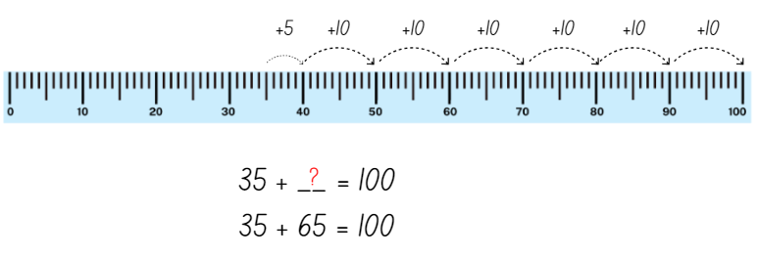
Images sourced from Canva and used in accordance with the Canva Content License Agreement.
- Explain that the inverse operation to addition is subtraction and that the same problem can be solved using both addition and subtraction. Demonstrate how to work backwards on the number line and subtract this number from 100. Explain that this will give students the same number. For example, 100 − 35 = 65 (see Figure 2).
Figure 2 – Number line showing bridging strategy
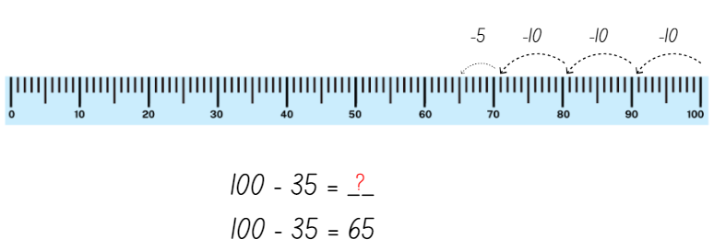
Images sourced from Canva and used in accordance with the Canva Content License Agreement.
- Provide each pair with two 6-sided dice and Resource 3: Number line to 100. Cut the resource up into individual number lines so that students can practise using the bridging to 10 strategy. Students roll the 2 dice to form a two-digit number and mark it on the number line. Students glue the number line into their workbook and show their working as well as writing the matching number sentences (see Figure 1). Students complete a number line for both addition and subtraction before rolling and creating another two-digit number.

Consolidation and meaningful practice: Making 100 – 10 minutes
- Tell students that they now need to calculate how many more pieces of pasta they will need to have 100 pieces of pasta, just like Grandma.
- Students use a number line from Resource 3: Number line to 100 to work out how many more pieces of pasta they need.
- Students glue the number line into their workbook with a title and show their working as well as writing the matching number sentences (see Figure 1).
This table details assessment opportunities and differentiation ideas.
Assessment opportunities | Too hard? | Too easy?
What to look for:  - Are students able to sequence the representation of their handful of pasta accurately on the number line? (MAO-WM-01, MA1-RWN-01, MA1-RWN-02)  - Are students using the bridge to 10 strategy to solve addition and subtraction problems? (MAO-WM-01, MA1-CSQ-01)  - Can students explain their thinking? (MAO-WM-01)  What to collect:  - student work samples (MAO-WM-01, MA1-RWN-01, MA-RWN-02, MA-CSQ-01) | Students find it difficult to use bridging to 10 to solve problems.  - Use smaller numbers and concrete materials, for example, bead strings and hundreds chart, to develop the concept.  - Model the bridging to 10 strategy several times using a number line until the student has a better understanding. | Students have demonstrated a deep understanding of using bridging to 10 to solve addition and subtraction problems.  - Have students add 2 collections together to form a three-digit number and use their knowledge of bridging to solve subtraction problems.  - Students write a sentence to explain how addition assisted them to solve a subtraction problem.

Lesson 3: Story mapping with symbols
Core concept: Mathematicians use a range of representations to communicate ideas.
The table below contains suggested learning intentions and success criteria. These are best co-constructed with students.
Learning intentions | Success criteria
Students are learning that:  - mathematicians use symbols to efficiently describe ideas  - symbols are simple drawings that have meaning and can represent a quantity or an action  - visual displays are an efficient way of communicating information. | Students can:  - use simple drawings and symbols to represent a mathematical story  - use symbols to represent and understand mathematical stories with a start, a change, and a result  - represent numbers on a line to help solve mathematical problems.
Note: Storytelling is an effective way for students to conceptualise mathematical ideas to construct a rich understanding of the operations and assists students to recognise the purposeful nature of mathematics in real-world contexts through actions, gestures, and manipulation of concrete materials (Lemonidis and Kaiafa 2019; Matthews et al. 2017; Van de Walle et al. 2019).

Daily number sense: Symbol number talk – 10 minutes
This lesson has been adapted from Subitising from NRICH (2022).
- Build student understanding of subitising by displaying a collection of symbols in 2 different ways.
- Tell students that you will be showing them a collection of pasta and they must work out how many they see. Let students know that they will not have time to count the pasta one at a time. As mathematicians they will need to visualise what they see to help them work it out.
- Show students Resource 4: Unorganised symbols, for 2-3 seconds and then hide it. Ask questions such as:
- How many symbols did you see?
- Could you easily see how many symbols there were?
- How could you organise the symbols to be able to see how many there are more easily?
- Show students Resource 5: Organised symbols, for 2-3 seconds and then hide it.
- Ask students:
- How many symbols did you see?
- Was it easier to see how many pieces there were in this picture compared to the first one?
- How did you see it?
- Describe what you saw.
- Provide individual thinking time and allow students to Think-Pair-Share.
- Reveal the symbols cards and invite selected students to share their thoughts with the class. Record student thinking.

Symbols key – 10 minutes
Note: When producing a class key, choose to include symbols from Aboriginal and Torres Strait Islander peoples in your local area. Involve students and their cultures when creating symbols. You may wish to engage with your local Aboriginal community to find out the symbols of your local area.
- Remind students that symbols are simple drawings that can be used to solve and map mathematical problems.
- Tell students they will be drawing symbols for the following Australian animals. These are wombats, kangaroos, emus, snakes, and honey ants. Make a class key using symbols used by Aboriginal and Torres Strait Islander peoples in your local area or ask students to suggest symbols to use (see Figure 3).
Figure 3 – Symbols of Australian animals
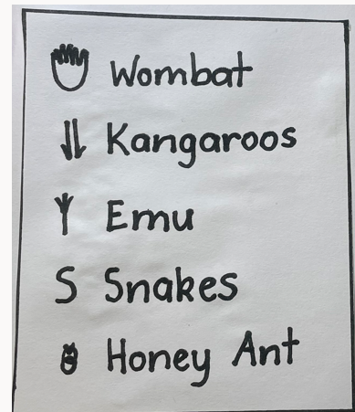

Mathematical story – 30 minutes
Note: MAST (Maths as Story Telling) Additive-Principles Lessons Booklet [PDF 892.24KB] (Cooper et al. 2007) was developed for the Minjerribah Maths Project. Working from the storytelling world of the Indigenous student, it enables students to bring their everyday world of symbols into mathematics and the formal world of algebra.
- Sit in a circle and share the following story: One sunny day, Grandma took Ben for a walk on Country, to connect and explore the natural environment. The day was warm, and he was curious about what they would see. Grandma explained how Aboriginal people use symbols to represent animals. They are all different depending on where you live and have a long history. Ben could not believe how lucky he was! Firstly, he saw 2 families of 4 wombats. Then he saw 6 pairs of kangaroos. Next, 18 emus and after that, 25 snakes. Scary! Finally, Ben saw 50 honey ants. That sure was a lot of animals!
Note: Record the number of animals that Grandma and Ben saw on the board, to be used later.
- Students construct a learning map on A3 paper (see Figure 4). Start by drawing the class key in one of the corners and a track on the page. Add the symbols to represent the number of animals and insects, grouping each animal and insect as Grandma and Ben saw them. Write the number of each animal next to the symbols. Remind students to check the count and label with numbers.
Figure 4 – Sample learning map
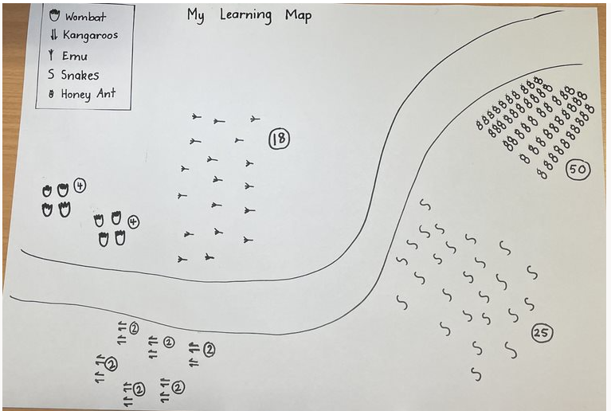
Note: Learning maps can help represent mathematical thinking. They are well organised, easy to follow and are used by Aboriginal peoples.
- Using Resource 3: Number line to 100, calculate the total number of animals that were seen in the story.
This table details assessment opportunities and differentiation ideas.
Assessment opportunities | Too hard? | Too easy?
What to look for:  - Are students able to add the total number of animals and insects accurately using the number line? (MAO-WM-01, MA1-RWN-01, MA1-CSQ-01)  - Are students able to use symbols to help develop fluency when solving problems? (MA1-CSQ-01)  - Can students explain their thinking? (MAO-WM-01)  What to collect:  - learning maps to use for Lesson 4. (MA1-CSQ-01)  - samples of student's addition on number lines (MAO-WM-01, MA1-RWN-01, MA1-CSQ-01) | Students find the given number story too difficult to combine.  - Use smaller and more familiar numbers.  - Provide a range of concrete materials for students to use/manipulate.  - Supply a hundreds chart with counters.  - Model using a number line with students requiring support. | Students demonstrate quick understanding of combining numbers.  - Students use mental strategies to combine numbers.  - Ask students to explain the strategies they used when combining the number of animals.

Consolidation and meaningful practice: Connect the mathematics – 15 minutes
- Summarise the lesson together, drawing out some key mathematical ideas with students. Guide students to notice that:
- mathematicians use simple drawings/symbols to describe ideas in efficient ways
- when students tell mathematical stories, they need to show the start, the change, and the result (end of the story)
- it does not matter in what order students combine numbers, the total will be the same.

Lesson 4: Sharing mathematical stories
Core concept: The order in which you divide and subtract numbers changes the answer to a problem.
The table below contains suggested learning intentions and success criteria. These are best co-constructed with students.
Learning intentions | Success criteria
Students are learning that:  - the bigger number comes first in division and subtraction problems  - the order in which 2 quantities are shared changes the result  - mathematicians can recognise and represent division facts. | Students can:  - write the bigger number first in a mathematical story  - investigate whether the order in which we share collections changes the result  - solve division problems using objects, diagrams, images, and actions.

Daily number sense: Symbol number talk– 15 minutes
- Build student understanding of grouping and sharing by solving problems involving sharing.
- Show students Resource 6: Sharing bees, and ask if they think the 10 bees can be shared between 2 flowers. Allow students to Think-Pair-Share and solve the problem by cutting out the bees and sharing them amongst the flowers.
- Show Resource 7: Sharing flowers, and ask if students think the 2 flowers can be shared between 10 bees. Allow students to Think-Pair-Share. Ask them if they can solve the problem in the same way that they solved the last problem. Write the 2 problems on the board. For example, 10 shared between 2, and 2 shared between 10.
- Ask students the following questions to promote a discussion.
The table below outlines stimulus prompts to generate conversation about the topic, along with anticipated responses from students.
Prompts | Anticipated student responses
- What is the difference between these 2 problems?  - Does it make a difference to the results if we change the numbers around when sharing like we have in this problem? | - There is a bigger number at the beginning of the first problem and a smaller number at the beginning of the second problem.  - Yes, it makes a difference. You cannot share a smaller number into a bigger number so the bigger number must always come first.
- Highlight that, when sharing, the bigger number must always come first.

Sharing story – 30 minutes
- Remind students of the learning maps that were created in Lesson 3. Revisit these and remind students that they were created to represent the animals and insects that Grandma and Ben saw on their walk on Country.
- Tell students: On Grandma and Ben’s return walk, things quickly changed. The wind blew and nature changed the landscape. They noticed the weather forced all the animals to find shelter in equal groups. 8 wombats waddled off for a sleep in 2 burrows, 12 kangaroos sheltered in 3 caves, 18 emus hid under 6 bushes, 25 snakes slithered into 5 holes and 50 honey ants scurried under 5 rocks.
- Ask students if they can think of any strategies that can be used to share the animals into equal groups. Through their number sense activity, students will know that the larger number is to be shared amongst the smaller number. For example, encourage students to recognise that 8 wombats will need to be shared amongst 2 burrows and that 12 kangaroos will need to be shared amongst 3 caves.
- Remind students of how you wrote the sharing problem on the board in activity 3. For example, 10 bees can be shared between 2 flowers. Students write each sharing problem on a sticky note and attach it to their learning map.
- Using concrete materials, for example, counters, beads, gumnuts or stones, practise sharing the collection of each animal into the correct number of groups. Students transfer their learning by circling equal groups on their learning map to match their problems (see Figure 5).
Figure 5 – Learning maps showing equal groups
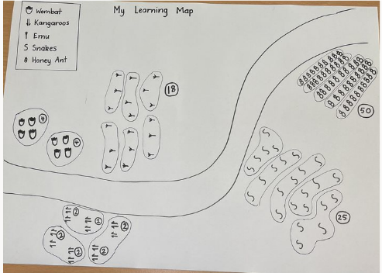
This table details assessment opportunities and differentiation ideas.
Assessment opportunities | Too hard? | Too easy?
What to look for:  - Can students explain their thinking? (MAO-WM-01)  - Can students model sharing division by distributing a collection of objects equally into a given number of groups? (MA1-FG-01)  - Can students model grouping division by determining the number of groups of a given size that can be formed? (MA1-FG-01)  What to collect:  - learning maps work sample (MA1-FG-01)  - samples of students’ sharing problems on sticky notes (MA1-FG-01) | Students find the given number stories too difficult to share between groups.  - Use smaller and more familiar numbers, for example, 4 shared between 2.  - Provide a range of concrete materials for students to use/manipulate.  - Model sharing a collection and work with individual students. | Students demonstrate a quick understanding of sharing large collections.  - Use larger numbers to share into groups.  - Use numbers that will have a remainder to share.  - Students write a multiplication problem that is opposite to the sharing problem.

Consolidation and meaningful practice: Discuss and connect the mathematics: 15 minutes
- Summarise the lesson together, drawing out some key mathematical ideas about sharing with students. Guide students to notice that:
- the bigger number comes first in division and subtraction problems
- the order in which 2 quantities are shared changes the result
- mathematicians can recognise and represent division facts
- when they tell mathematical stories, students need to show the start, the change, and the result (end of the story).

Lesson 5: How many legs? – Part 1
Core concept: You can multiply and add numbers in any order and the answer does not change.
The table below contains suggested learning intentions and success criteria. These are best co-constructed with students.
Learning intentions | Success criteria
Students are learning that:  - numbers can be added and multiplied in any order and the answer to a problem does not change (commutative property)  - repeated addition can be used to solve multiplication problems. | Students can:  - record and solve simple addition problems to show an understanding of commutative property  - record and solve simple multiplication problems  - use repeated addition to solve multiplication problems.

Daily number sense: Array talk – 10 minutes
- Build student understanding of an array by showing them different types of arrays and engaging in a dot talk.
- Display Resource 8: Arrays.
- Ask students:
- What do you see?
- How are these dots arranged?
- How did you work out the total?
- Are the dots the same or different? How do you know?
- Students turn and talk to share their thinking with a partner. Circulate the room, monitoring student thinking.
- As students share their responses, record their thinking on an anchor chart.

How many legs? Addition – 20 minutes
- Read How Many Legs? and discuss. Ask how the boy worked out the total number of legs. Record student ideas on the board.
- Ask students, ‘How many legs would there be altogether, if there was an octopus, a person, and a dog in a room?’
- Students turn and talk to share their thinking with a partner. Circulate the room, monitoring student thinking.
- Students write a number sentence to represent the problem and use additive strategies like counting on to calculate the total number of legs.
- Students share their working with the class, explaining their thinking and how they represented and solved the problem.
- Working in pairs, students cut out animal picture cards from Resource 9: Animal cards and place face down in a pile.
- Students turn over 3 animal picture cards and calculate the total number of legs on all the animals. Students record their number sentence and show their working out. For example, 4 + 2 + 4 = 10, 2 + 4 + 4 = 10.
- Bring the class together and instruct students to change the order of their 3 animal cards. Students record their number sentence and show their working out.
- Explain the commutative property of addition: it does not matter what order students put the numbers in when they are adding. Ask students if the answer would be the same if they changed the order of the cards.
Commutative property states that when the order of numbers in an addition or multiplication operation is changed, the answer remains the same.
- Working in pairs, students turn over 3 different animal picture cards and calculate the total number of legs. Students record their number sentence and show their working out. Students change the order of their 3 animal cards. Students record their number sentence and show their working out. Students discuss why their answers are the same both times.

How many legs? Multiplication – 20 minutes
- Ask students how many legs there would be altogether if there were 3 dogs in the room.
- Students turn and talk to share their thinking with a partner. Circulate the room, monitoring student thinking.
- Ask students to write a multiplication number sentence to work out the total number of legs. For example, 3 groups of 4 = 12.
Note: Students can use an array, skip counting, or repeated addition to solve the problem.
- Students share their number sentence, explaining their thinking. Record students’ number sentences on the board, focusing on repeated addition as the preferred strategy.
- Write the following word problems on the board and discuss what students notice:
- If there are 2 cows in the room, how many legs are there altogether?
- If there are 4 people in the room, how many legs are there altogether?
Note: Prompt students to explain whether they think the answers are the same and if it is an example of commutative property.
- Students record the number sentences in their workbook, showing their working out.
This table details assessment opportunities and differentiation ideas.
Assessment opportunities | Too hard? | Too easy?
What to look for:  - Are students using repeated addition to solve multiplication problems? (MA1-FG-01)  - Are students demonstrating an understanding of commutative property? (MA1-FG-01)  - Can students create a number sentence to record multiplication problems? (MAO-WM-01, MA1-FG-01)  - Can students explain how they got an answer and show their working? (MAO-WM-01)  What to collect:  - observational data (MA1-FG-01, MAO-WM-01)  - student work samples (MA1-FG-01, MAO-WM-01) | Students are unable to draw arrays or use repeated addition to solve multiplication problems.  - Provide a ten-frame and counters to students to help with repeated addition.  - Model how to form arrays with counters and how to then count these.  Students are unable to record multiplication problems using a number sentence. Model how to record number sentences using the arrays that students have formed. | Students can confidently draw arrays and use repeated addition to solve multiplication problems.  - Add more animals to the problems so that students are adding and multiplying more legs.  - Ask students to explain how they came to their answer and where they saw the commutative property during their problem-solving.  - Challenge students with a backwards problem. Tell students that there are 24 legs and ask what animals there could be.

Discuss and connect the mathematics – 10 minutes
- Summarise the lesson together, drawing out some key mathematical ideas.
- Ask students:
- Which strategy did you use to find the solution? Which one are you most comfortable using?
- Did you find any examples of commutative property?
- Does changing the order of the legs change the total?
- How did you work like a mathematician today?

Lesson 6: How many legs? – Part 2
Core concept: A collection can be changed by adding items (joining) or taking some away (separating).
The table below contains suggested learning intentions and success criteria. These are best co-constructed with students.
Learning intentions | Success criteria
Students are learning that:  - a collection can be changed by adding items (joining)  - a collection can be changed by taking away items (separating). | Students can:  - apply the terms join and separate to describe combining and separating quantities  - represent addition and subtraction word problems as number sentences  - solve addition problems using counting on strategies  - solve subtraction problems using counting back strategies.

Daily number sense: Data talk – 10 minutes
- Build student understanding of interpreting data by engaging in a data talk.
- Display Resource 10: Data talk. Ask students what they notice. Students turn and talk to a partner about what they notice.
- Students then share with the class what they noticed.
- Ask students:
- Which animal is the most common? How do you know?
- Which animal is the least common? How do you know?
- Are there any that are the same? How do you know?
- How many more horses are there than cows?
- How many more horses and cows are there altogether?

How many legs? Addition – 20 minutes
- Revise Lesson 5 and the book How Many Legs?
- Ask students how many legs there would be altogether if there were 20 legs at a party and an octopus joined.
- Students turn and talk to a partner about how many legs there would be and how they would work it out.
- Students share their thinking with the class.
- Ask students to write a number sentence to represent the problem.
Note: Explain to students that joining means adding, and they are to use additive strategies, for example, counting on to work out the total number of legs.
- Students record the number sentence in their workbooks, showing their working out.
- Display Resource 11: Addition and subtraction word problems and discuss.
- Working in pairs students solve the addition word problems. They record their number sentences and show their working out in their workbooks.

How many legs? Subtraction – 20 minutes
- Ask how many legs there would be left at the party, if there were 20 legs initially and then an octopus left.
- Students turn and talk to a partner about how many legs would be left and how they would work it out.
- Ask students to write a number sentence to represent the word problem.
Note: Explain to students that to separate means to subtract, and use additive strategies, for example, counting back to work out how many legs are left.
- Students record their number sentence in their workbooks, showing their working out.
- Display Resource 11: Addition and subtraction word problems and discuss.
- Working in pairs, students solve the subtraction word problems. Students record their number sentences and show their working out in their workbooks.
This table details assessment opportunities and differentiation ideas.
Assessment opportunities | Too hard? | Too easy?
What to look for:  - Can students create a number sentence to represent an addition or subtraction word problem? (MAO-WM-01, MA1-CSQ-01)  - Are students using counting on strategies to solve addition problems? (MA1-CSQ-01)  - Are students using counting back strategies to solve subtraction problems? (MA1-CSQ-01)  - Are students explaining how they got an answer and showing their working out? (MAO-WM-01)  Things to collect:  - student work samples (MAO-WM-01, MA1-CSQ-01) | Students are having difficulty using counting on and counting back strategies to solve the problems.  - Use concrete materials like counters and ten-frames to solve addition and subtraction problems.  - Use a different animal that does not have as many legs as an octopus to solve the problem. | Students are easily using flexible strategies to solve addition and subtraction problems.  - Add an extra step to the problems to make them more complicated.  - Ask students to write their own problems and have another student solve them.

Discuss and connect the mathematics – 10 minutes
- Summarise the lesson together, drawing out some key mathematical ideas. Ask:
- Which strategy did you use to work out the addition and subtraction word problems?
- Is counting on or counting back easier? Why?
- Does changing the order in subtraction change the answer?
- How did you work like a mathematician today?

Lesson 7: Keeping time
Core concept: The difference does not change if you add or subtract the same amount to/from both numbers.
The table below contains suggested learning intentions and success criteria. These are best co-constructed with students.
Learning intention | Success criteria
Students are learning that adding the same quantity to 2 durations of time does not change the difference between them. | Students can:  - estimate the duration of events in minutes  - demonstrate an understanding of the properties of addition and subtraction.

Daily number sense: How long will it take? – 20 minutes
- Build student understanding of duration by gathering classroom data about time taken to complete activities.
- Set a number of tasks for the students to undertake and time how long each task takes. Examples of tasks might include eating a piece of fruit, marking the roll, time taken for a student to have a drink from the bubbler, reading activities and so on.
- Ask students to estimate how long they think each task will take. Allow students to Think-Pair-Share and have them record their estimations in their workbooks.
- Display the timer on the board, ensuring all students can see it. Explain to students that they must begin the activity as soon as the timer on the board starts. Once all students finish the activity, stop the timer and record this time to the nearest minute on a class anchor chart. Students record these times next to their original estimates. Retain the anchor chart for Lesson 8.
- Ask students to turn and talk, to brainstorm other activities they might like to add to the chart. You may choose to make this a homework task and include tasks such as brushing teeth, feed a pet, make a bed and so on. These can be added to the anchor chart (see Figure 6).
Figure 6 – Time taken to complete tasks
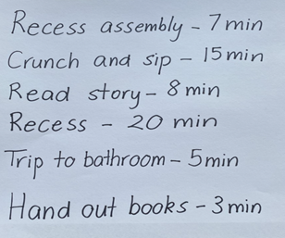
This table details assessment opportunities and differentiation ideas.
Assessment opportunities | Too hard? | Too easy?
What to look for:  - Can students make reasonable estimations on set tasks? (MAO-WM-01, MA1-NSM-02)  - Can students explain their thinking? (MAO-WM-01)  What to collect:  - student estimations and recording of lengths. | Students are having difficulty understanding the different measures of time and estimating time.  - Use an analogue timer with second hand to display time throughout the day to support future learning.  - Revisit telling the time to the hour, half hour, and quarter hour. | Students are easily and confidently estimating time and understanding the different measures of time.  - Hide the timer and ask students to estimate a range of times. For example, 10 seconds, 30 seconds, one minute or 2 minutes.  - Students estimate how long a variable task might take, discussing factors that may influence the duration. For instance, reading a book, collecting something from the office or drawing a picture.

Constant difference rule using a number line – 20 minutes
- Show students a number line Resource 12: Number line 1-20. You may also choose to use a digital number line.
- Ask students what they think the interval is between each number. Students should be able to see that there is one interval between each number on the number line.
- Ask students to work out what the interval is between 5 and 7. Allow students to Think-Pair-Share to work out the answer. Students should be able to work out that there are 2 intervals between 5 and 7. Plot this on the number line.
- Add 10 to 5, plotting this on the number line and ask what the interval is between 5 and 15.
- Add 10 to 7, plotting this on the number line and ask the students what the interval is between 7 and 17 (see Figure 7).
Figure 7 – Number line from 1-20
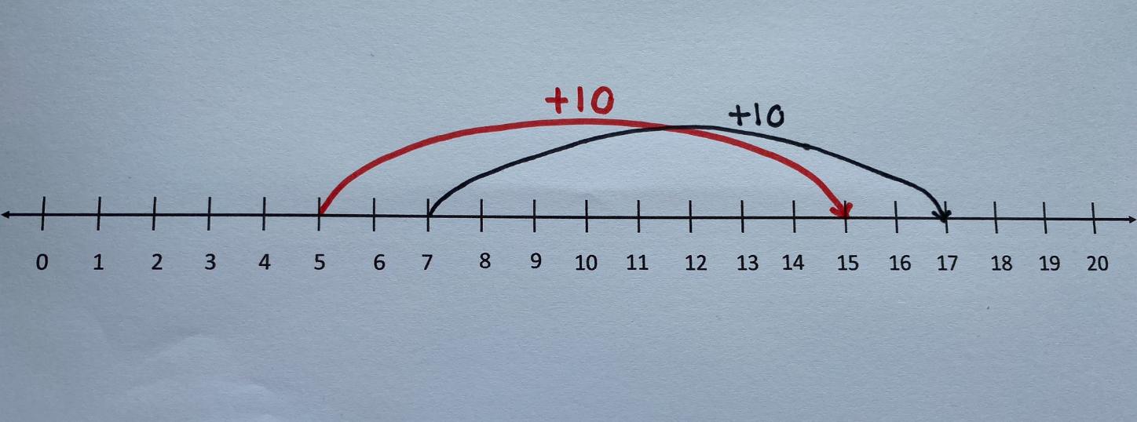
- Ask the students what the difference is between the numbers 15 and 17.
- Ask what students notice about these numbers. Encourage students to discover that, by adding the same amount to each number, the difference between the 2 numbers is the same. Repeat this activity with 2 different numbers if necessary.
- As a class, create a rule for constant difference and record.
- To reinforce this concept, you may choose to use a virtual spinner to spin and record 2 numbers and repeat the exercise outlined above.
- Ask the students if their class rule for constant difference still applies. If not, edit the rule. Save this rule to use in Lesson 8.
- You may repeat this activity to reinforce this concept.

Consolidation and meaningful practice: Clock as a number line – 20 minutes
- Show students a clock face. Ask students what the intervals between numbers on a clock are called. Students should be able to tell you that there are 5 minutes or 5 intervals between each number on a clock face.
- Show students Resource 13: Number line 1-60. Using prompts from the table, ask questions that elicit responses for students to make connections between the number line and the face of a clock.
The table below outlines stimulus prompts to generate conversation about the topic, along with anticipated responses from students.
Prompts | Anticipated student responses
- What do you notice about this number line?  - Does this number line remind you of anything else? | - Numbers from 1-60, counting by 5.  - That there are lines between each of the numbers, but only every fifth number is recorded.  - That a clock face has the same format.
- Explain that an analogue clock is made by curving a number line from 1-12 around the outside of the circle. Prompt students to make the connection between a number line and a clock.
- Using the number line in Resource 13: Number line 1-60, demonstrate consistent difference between 2 points.
- Apply this concept to the face of a clock. For example, demonstrate it takes 5 minutes for the minute hand to move from 2 to 3.
- Promote student discussion to reflect on learning.
The table below outlines stimulus prompts to generate conversation about the topic, along with anticipated responses from students.
Prompts | Anticipated student responses
- If it takes 5 minutes for the minute hand to move from 2 to 3, how long does it take for the minute hand to move from 3 to 4?  - How long does it take for the minute hand to move from 5 to 7? Does it take the same amount of time to travel from 9 to 11?  - How does the clock face relate to our number line? | - It takes 5 minutes for the minute hand to move from one number to the next, irrespective of where it starts.  - It takes 2 minutes and is the same from 5 to 7.  - That a clock face has the same format as a number line.  - We can transfer our knowledge of a number line to a clock.  - The numbers on the clock do not represent the minutes.

Lesson 8: Let’s test it!
Core concept: Mathematicians use evidence to make mathematical arguments and justify their thinking.
The table below contains suggested learning intentions and success criteria. These are best co-constructed with students.
Learning intention | Success criteria
Students are learning that flexible strategies can be used to solve word problems using addition and subtraction. | Students can:  - use flexible thinking to solve addition and subtraction problems  - use the appropriate strategies to solve word problems involving time.

Daily number sense: Test our rule on a rekenrek – 20 minutes
- Build student understanding of addition by solving addition problems.
- Demonstrate to the students using 2 ten-bead rekenreks or the 20-Bead rekenrek.
- Roll a 6-sided die and move the corresponding number of beads on the top rekenrek. Repeat this process for the second rekenrek.
- Roll the dice a third time. Move this number of beads on each rekenrek.
- Ask if the rule students created in Lesson 7 still applies.
- Students repeat this process to test their rule.

Word problems – 40 minutes
- Students complete the word problems in Resource 14: Word problems. You can choose to use Newman’s Error Analysis to support this learning.
- Complete the first word problem as a class. Give students Resource 3: Number line to 100 and have them fill it in at the same time as you. Ask the following questions to prompt discussion.
The table below outlines stimulus prompts to generate conversation about the topic, along with anticipated responses from students.
Prompts | Anticipated student responses
- Where do you think Charlie and Arlo started their race on the number line?  - How do we show how long Charlie took to run the race on the number line?  - How do we show how long Arlo took to run the race on the number line?  - How can we calculate the difference between the 2 boys?  - How can we calculate how long it took Charlie and Arlo to run the second race?  - Has the difference in their running time changed from the first to the second race? | - I think they both started at zero because the race starts at zero seconds.  - We draw a line from 0-60 because Charlie took 60 seconds to run the race.  - We draw a line from 0-90 because Arlo took 90 seconds to run the race.  - You can just take away 60 seconds from 90, or you can just count how many numbers from 60 to 90 on the number line by fives or tens.  - They both took an extra 20 seconds so we just add that to the number line for each.  - The difference is the same because they both took an extra 20 seconds to finish the race.
- Students share their learning and give peer-to-peer feedback.
This table details assessment opportunities and differentiation ideas.
Assessment opportunities | Too hard? | Too easy?
What to look for:  - Students use flexible additive and subtraction strategies to solve word problems. (MAO-WM-01, MA1-CSQ-01)  What to collect:  - observations of students communicating and recording their thinking and reasoning coherently and clearly (MAO-WM-01, MA1-CSQ-01)  - number lines that students have completed (MAO-WM-01, MA1-CSQ-01) | Students have difficulty solving the problems using flexible strategies.  - Pair these students with students that have a thorough understanding of the strategies to model the concepts taught.  - Use Newman’s Prompts as a group. | Students easily and confidently use the flexible strategies to solve the word problems.  - Students can create their own word problems and have their peers solve them.  - Students can explain how they solved the problem and the strategies they used.

Resource 1: Unorganised pasta
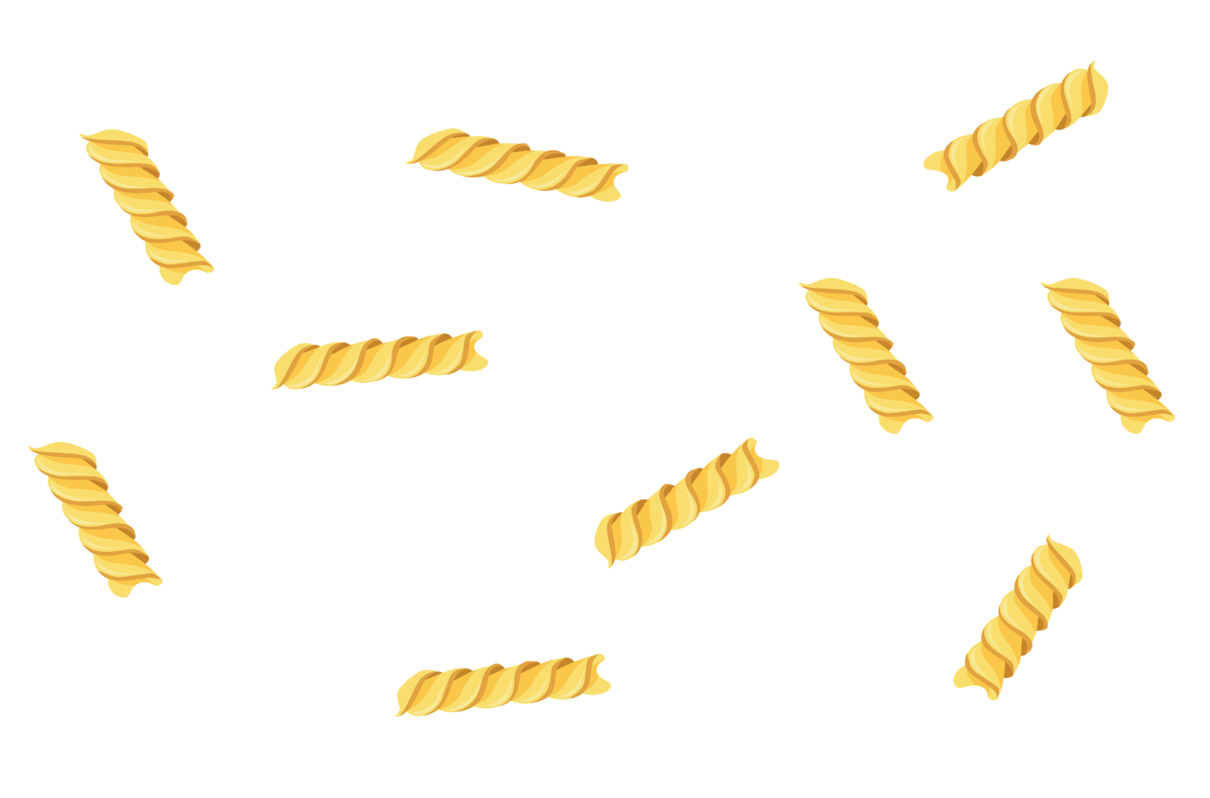
Images sourced from Canva and used in accordance with the Canva Content License Agreement.

Resource 2: Organised pasta
Images sourced from Canva and used in accordance with the Canva Content License Agreement.

Resource 3: Number line to 100
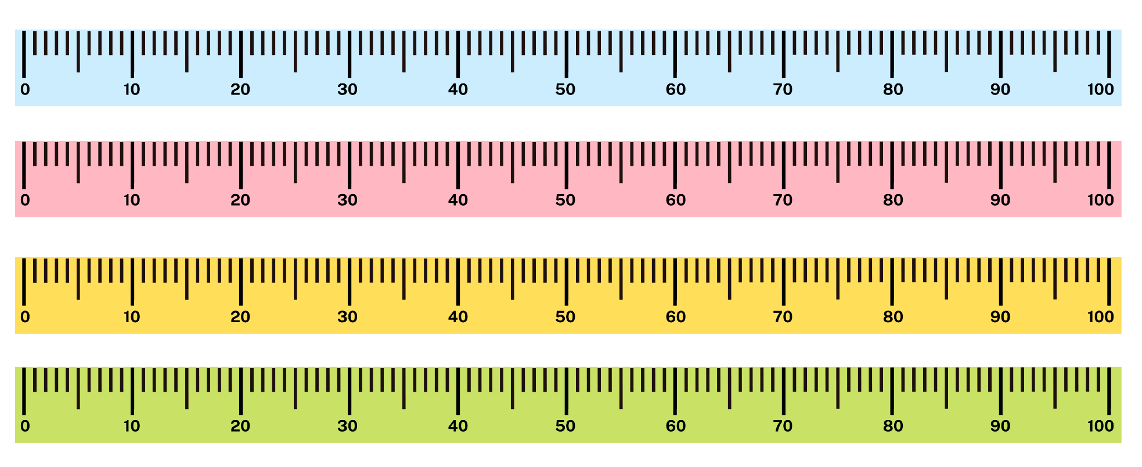
Images sourced from Canva and used in accordance with the Canva Content License Agreement.

Resource 4: Unorganised symbols
Images sourced from Canva and used in accordance with the Canva Content License Agreement.

Resource 5: Organised symbols
Images sourced from Canva and used in accordance with the Canva Content License Agreement.

Resource 6: Sharing bees
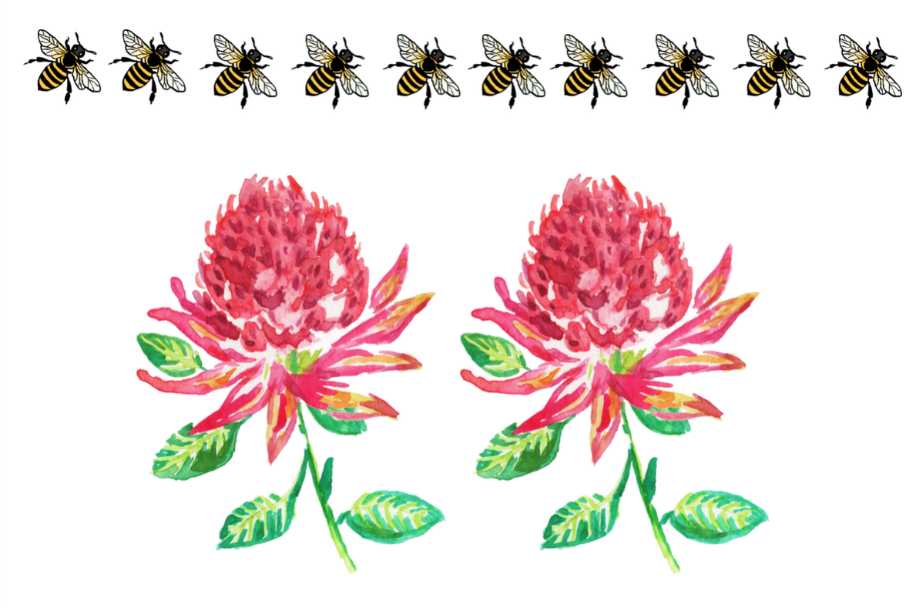
Images sourced from Canva and used in accordance with the Canva Content License Agreement.

Resource 7: Sharing flowers
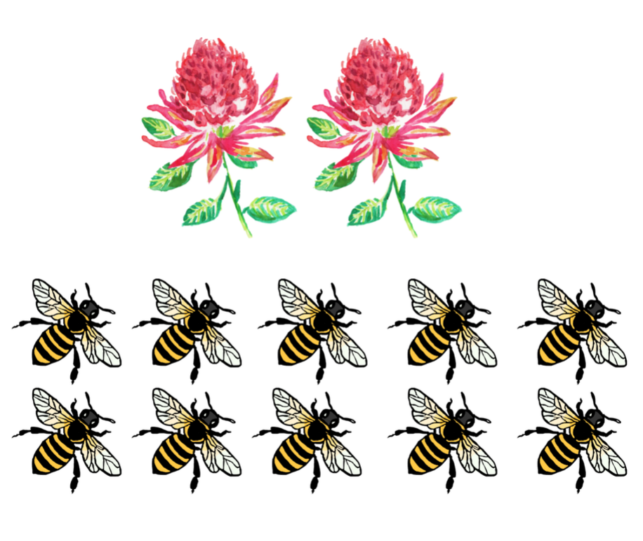
Images sourced from Canva and used in accordance with the Canva Content License Agreement.

Resource 8: Arrays

Resource 9: Animal cards
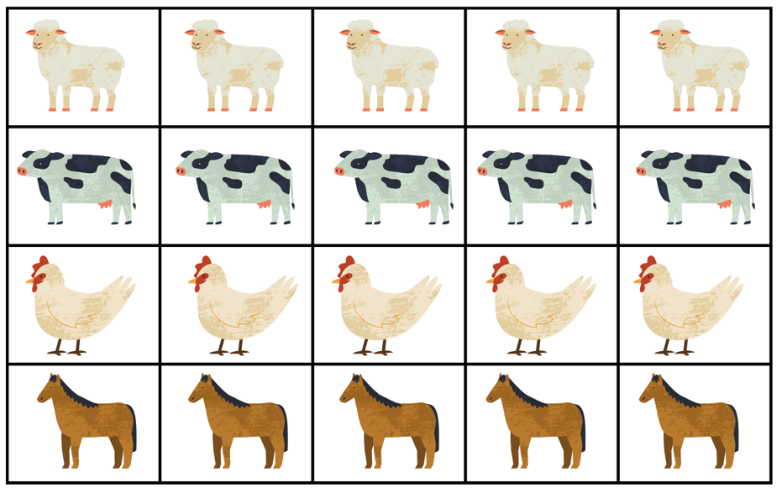
Images sourced from Canva and used in accordance with the Canva Content License Agreement.
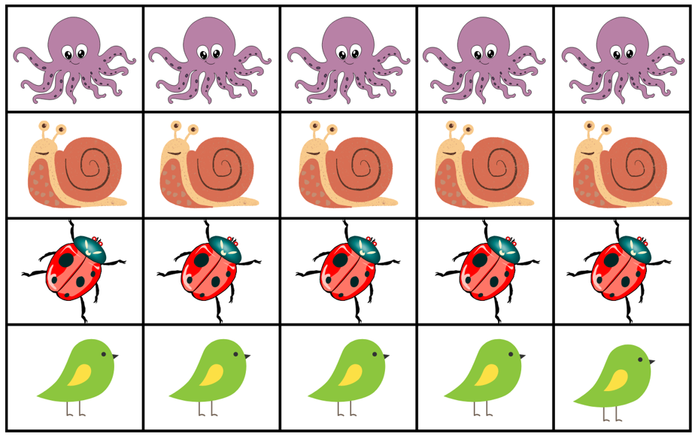
Images sourced from Canva and used in accordance with the Canva Content License Agreement.

Resource 10: Data talk
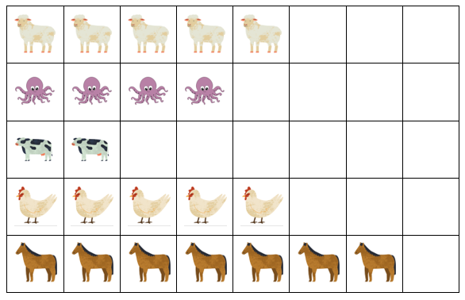
Images sourced from Canva and used in accordance with the Canva Content License Agreement.

Resource 11: Addition and subtraction word problems
Addition
- If there are 10 legs at a party and a ladybug joins the party, how many legs will there be altogether?
- If there are 12 legs at a party and a cow joins the party, how many legs will there be altogether?
- If there are 15 legs at a party and a horse joins the party, how many legs will there be altogether?
- If there are 8 legs at a party and a chicken and octopus join the party, how many legs will there be altogether?
Subtraction
- If there are 16 legs at a party and a horse gets separated from the party, how many legs will be left at the party?
- If there are 12 legs at a party and a chicken gets separated from the party, how many legs will be left at the party?
- If there are 15 legs at a party and a ladybug gets separated from the party, how many legs will be left at the party?
- If there are 11 legs at a party and an octopus gets separated from the party, how many legs will be left at the party?

Resource 12: Number line 1-20
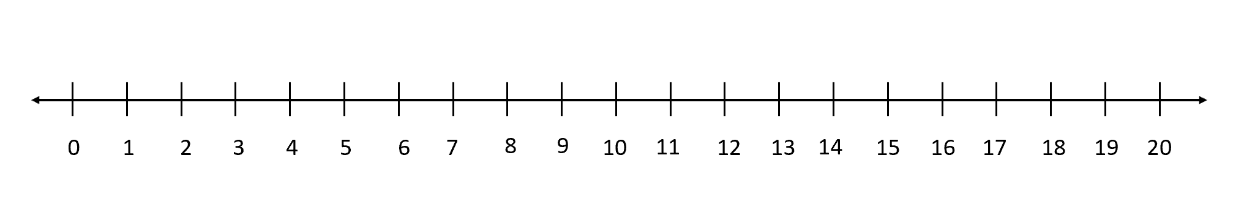

Resource 13: Number line 1-60

Resource 14: Word problems
After calculating each of these problems, test the rule you created in Lesson 7 to see if it still applies.
- Charlie and Arlo ran in a race. Charlie ran the race in 60 seconds, Arlo ran the race in 90 seconds. What is the difference between the 2 boys’ times? The second time the boys ran the same race, they were tired, and it took each of them 20 seconds longer. What time did the boys run in the second race? What is the difference between the 2 boys in this race?
- It will be Matilda’s birthday in 3 days. It will be Harry’s birthday in 10 days. How many days are in between the children’s birthdays? Will the difference be the same tomorrow?
- Kate and Ari were born on the same day, 5 years apart. Kate is 4 and Ari is 9. Next year, how old will the children be? What will be the difference between their ages?
- The minute hand takes 20 minutes to move from 3 to 7 on a clock. After 20 minutes, what will it be pointing to if starts on the 4? What if it starts on the 8? What if it starts on the 10?

Syllabus outcomes and content
The table below outlines the syllabus outcomes and range of relevant syllabus content covered in this unit. Content is linked to National Numeracy Learning Progression version (3).
Focus area and outcomes | Content groups and content points | Lessons
Representing whole numbers A  MAO-WM-01  MA1-RWN-01  MA1-RWN-02 | Use counting sequences of ones with two-digit numbers and beyond  - identify the number before and after a given two-digit number (CPr5)  - count forwards and backwards by ones from a given number to at least 120 (CPr6)  Continue and create number patterns  - count forwards and backwards by twos from any starting point (CPr6, CPr7, MuS2)  Represent numbers on a line  - sequence numbers and arrange them on a line by considering the order and size of those numbers (CPr5) | 1–5
Representing whole numbers B  MAO-WM-01  MA1-RWN-01  MA1-RWN-02 | Use counting sequences of ones and tens flexibly  - count forwards and backwards by tens, on and off the decade, with two- and three-digit numbers (CPr7)  - identify how many more to the next multiple of ten within two- and three-digit numbers  Form, regroup and rename three-digit numbers  - count and represent large sets of objects by systematically grouping in tens and hundreds (CPr7, NPV5)  - state the quantity value of digits in numbers of up to three digits (NPV5) | 1–3
Combining and separating quantities A  MAO-WM-01  MA1-CSQ-01 | Use flexible strategies to solve addition and subtraction problems  - represent addition and subtraction using structured materials such as a bead string or similar model (AdS6, AdS7)  - select and apply strategies using number bonds to solve addition and subtraction problems with one- and two-digit numbers by partitioning numbers using quantity value and bridging to 10 (AdS6, AdS7) | 3, 5–8
Combining and separating quantities B  MAO-WM-01  MA1-CSQ-01 | Represent and reason about additive relations  - create, record and recognise combinations of two numbers that add to numbers from 11 up to and including 20 (AdS7)  - create, model and solve word problems, using number sentences  - represent the difference between two numbers using concrete materials and diagrams (AdS6)  - recall and use related addition and subtraction number facts to at least 20 (AdS7) | 5, 6
Forming groups A  MAO-WM-01  MA1-FG-01 | Model and use equal groups of objects to represent multiplication  - determine and distinguish between the number of groups and the number in each group when describing collections of objects  - find the total number of objects using skip counting of equal groups of a known size (MuS2, MuS3)  Recognise and represent division  - model sharing division by distributing a collection of objects equally into a given number of groups to determine how many in each group (InF2, MuS5)  - model grouping division by determining the number of groups of a given size that can be formed (MuS5) | 1, 4, 5
Forming groups B  MAO-WM-01  MA1-FG-01 | Represent multiplication and division problems  - solve multiplication and division problems using objects, diagrams, images and actions (MuS6, MuS7)  - record answers to multiplication and division problems (including those with remainders) using drawings, words and numerals (MuS6) | 4, 5
Non-spatial measure B  MAO-WM-01  MA1-NSM-01  MA1-NSM-02 | Time: Describe duration using units of time  - estimate and measure the duration of an event using a repeated informal unit (MeT1)  - compare and order the duration of events measured using a repeated informal unit (MeT1)  - use the terms ‘hour’, ‘minute’ and ‘second’ (MeT2, MeT3) | 7, 8

References
Links to third-party material and websites
Please note that the provided (reading/viewing material/list/links/texts) are a suggestion only and implies no endorsement, by the New South Wales Department of Education, of any author, publisher, or book title. School principals and teachers are best placed to assess the suitability of resources that would complement the curriculum and reflect the needs and interests of their students.
If you use the links provided in this document to access a third-party's website, you acknowledge that the terms of use, including licence terms set out on the third-party's website apply to the use which may be made of the materials on that third-party website or where permitted by the Copyright Act 1968 (Cth). The department accepts no responsibility for content on third-party websites.
Except as otherwise noted, all material is © State of New South Wales (Department of Education), 2023 and licensed under the Creative Commons Attribution 4.0 International License. All other material (third-party material) is used with permission or under licence. Where the copyright owner of third-party material has not licensed their material under a Creative Commons or similar licence, you should contact them directly for permission to reuse their material.
Mathematics K–10 Syllabus © 2022 NSW Education Standards Authority (NESA) for and on behalf of the Crown in right of the State of New South Wales.
© 2022 NSW Education Standards Authority. This document contains NSW Curriculum and syllabus content. The NSW Curriculum is developed by the NSW Education Standards Authority. This content is prepared by NESA for and on behalf of the Crown in right of the State of New South Wales. The material is protected by Crown copyright.
Please refer to the NESA Copyright Disclaimer for more information.
NESA holds the only official and up-to-date versions of the NSW Curriculum and syllabus documents. Please visit the NSW Education Standards Authority (NESA) website and the NSW Curriculum website.
National Numeracy Learning Progression © Australian Curriculum, Assessment and Reporting Authority (ACARA) 2010 to present, unless otherwise indicated. This material was downloaded from the Australian Curriculum website (National Numeracy Learning Progression) (accessed 24 October 2022) and was not modified. The material is licensed under CC BY 4.0. Version updates are tracked in the ‘Curriculum version history’ section on the 'About the Australian Curriculum' page of the Australian Curriculum website.
ACARA does not endorse any product that uses the Australian Curriculum or make any representations as to the quality of such products. Any product that uses material published on this website should not be taken to be affiliated with ACARA or have the sponsorship or approval of ACARA. It is up to each person to make their own assessment of the product, taking into account matters including, but not limited to, the version number and the degree to which the materials align with the content descriptions and achievement standards (where relevant). Where there is a claim of alignment, it is important to check that the materials align with the content descriptions and achievement standards (endorsed by all education Ministers), not the elaborations (examples provided by ACARA).
This resource contains images and content obtained from Canva, and their use outside of this resource is subject to Canva’s Content License Agreement. If you wish to use them separately from the resource, please go to Canva.
Australian Government Department of Education (2018) ‘Authentic Problems: Grandma's Soup', Mathematical Inquiry into Authentic Problems, reSolve: Maths by Inquiry website, accessed 24 October 2022.
Clements DH (1999) ‘Subitising: What is it? Why teach it?’, Teaching Children Mathematics, 5(7)400–405, accessed 24 October 2022.
Cooper TJ, Cassady T, Matthews, CJ, Phillips T, Grenfell M, Surha A (2007) MAST (Maths as Story Telling) Additive-Principles Lessons Booklet for Prep. Trial: using created symbols to develop Addition stories, and exploring the principles of compensation and balance [PDF 892.24KB], Minjerribah Maths Project, Queensland University of Technology YuMi Deadly Centre, accessed 24 October 2022.
Gray K (2015) How Many Legs? (Field J, illus.), Hachette Children’s Books, Great Britain.
Lemonidis C and Kaiafa I (2019) ‘The Effect of Using Storytelling Strategy on Students’ Performance in Fractions’, Journal of Education and Learning, 8(2):165–175, doi:10.5539/jel.v8n2p165, accessed 24 October 2022.
University of Cambridge (Faculty of Mathematics) (2022) Subitising, NRICH website, accessed 24 October 2022.
Van De Walle J, Karp K, Bay-Williams J.M, Brass A and Bentley B (2019) Primary and Middle Years Mathematics: Teaching Developmentally, 1st edn, Pearson, Melbourne.

Further reading
New Zealand Ministry of Education (n.d.) How long does it take?, NZ Maths website, accessed 24 October 2022.
Sayers J, Andrews P and Bjorklund Boistrup L (2016) ‘The Role of Conceptual Subitising in the Development of Foundational Number Sense’, in Meaney T, Helenius O, Johansson ML, Lange T and Wernberg A (eds) Mathematics Education in the Early Years, Springer Cham, doi:10.1007/978-3-319-23935-4_21, accessed 24 October 2022.

