Mathematics – Stage 1 – Unit 17
Contents
Unit description and duration 4
Student prior learning 4
Lesson overview and resources 5
Lesson 1: Measuring with formal units – Meet the metre! 10
Daily number sense: Number bonds to 10 – 10 minutes 10
Warm-up: Remembering informal units of measurement – 10 minutes 13
Using consistent units of measurement: What is a metre? – 50 minutes 13
Consolidation and meaningful practice: Thinking about metres – 5 minutes 15
Lesson 2: Measuring with formal units – Meet the centimetre! 16
Daily number sense: Tens and ones – 10 minutes 16
Meet the centimetre – 20 minutes 18
Let’s make a ruler! – 30 minutes 19
Consolidation and meaningful practice: Connections between the metre and the centimetre – 10 minutes 21
Lesson 3: Measuring with consistent units – Broken ruler 21
Daily number sense: Cover the numbers! – 15 minutes 22
Broken ruler – 40 minutes 23
Lesson 4: Heavier, lighter, balanced 27
Daily number sense: Make them the same – 25 minutes 27
How can we balance? – 40 minutes 29
Consolidation and meaningful practice: Let’s think about measuring mass – 5 minutes 33
Lesson 5: Equivalence 34
Daily number sense: At the farm – 20 minutes 34
How can we balance? – 40 minutes 36
Consolidation and meaningful practice: Make 10! – 5 minutes 38
Lesson 6: Fill it up! 39
Daily number sense: Target 16 – 20 minutes 39
Fill it! – 40 minutes 41
Consolidation and meaningful practice: What did we find? – 10 minutes 43
Lesson 7: Pack it! 44
Daily number sense: Number stories – 10 minutes 44
Pack it! – 40 minutes 45
Consolidation and meaningful practice: Same volume – different shape! – 20 minutes 47
Lesson 8: Let’s be organised! 49
Daily number sense: Let’s make arrays – 20 minutes 49
Measure area with arrays – 40 minutes 52
Consolidation and meaningful practice: Smaller, larger, the same as – 10 minutes 54
Resource 1: Less, more, same 55
Resource 2: Cover the numbers! 56
Resource 3: On the farm 57
Resource 4: Three-legged stools 58
Resource 5: Cakes and chocolates 59
Resource 6: Leaves in arrays 60
Syllabus outcomes and content 61
References 69
Further reading 71

Unit description and duration
This two-week unit introduces students to formal units of measurement and further develops student knowledge, understanding and skills of uniform informal units of measurement. Students are provided opportunities to:
- compare, order and match using direct and indirect comparison with length, area, volume, and mass
- consider how choice of measuring unit affects accuracy
- learn why centimetres and metres are useful and how to measure with them.
Mathematics K–10 Syllabus © 2022 NSW Education Standards Authority (NESA) for and on behalf of the Crown in right of the State of New South Wales.

Student prior learning
Before engaging in these teaching and learning activities, students would benefit from prior experience with:
- estimating using mathematical language, for example, heavier, lighter, longer, about the same
- making direct comparisons with measurement, for example, hefting and superimposing
- using everyday language of measurement to sort and compare objects using length, area, volume, and mass.

Lesson overview and resources
The table below outlines the sequence and approximate timing of lessons; syllabus focus areas and content groups; and resources.
Lesson | Syllabus focus area and content groups | Resources
Lesson 1: Measuring with formal units – Meet the metre!  75 minutes  Metres enable consistent measurement of long objects and distances. | Representing whole number A  - Represent the structure of ten in whole numbers  Combining and separating quantities A  - Recognise and recall number bonds up to ten  Geometric measure A  - Measure the length of objects using uniform informal units  Geometric measure B  - Recognise and use formal units to measure the length of objects | - Resource 1: Less, more, same  - Video: Units of Length – Metre (1:08)  - Concrete materials including small everyday objects  - Metre rulers  - One metre ribbons  - Writing materials
Lesson 2: Measuring with formal units – Meet the centimetre!  70 minutes  Centimetres enable consistent measurement of short objects and distances. | Representing whole number A  - Represent the structure of ten in whole numbers  Geometric measure A  - Measure the length of objects using uniform informal units  Geometric measure B  Recognise and use formal units to measure the length of objects | - Cardboard strips 15 cm long  - Large amounts of centimetre cubes  - Metre rulers  - Writing materials
Lesson 3: Measuring with consistent units – Broken ruler  55 minutes  A measurement of length is the space between 2 points. | Combining and separating quantities A  - Use advanced count-by-one strategies to solve addition and subtraction problems  - Use flexible strategies to solve addition and subtraction problems  Geometric measure B  - Recognise and use formal units to measure the length of objects | - Resource 2: Cover the numbers!  - Concrete materials including small everyday objects  - Counters or small blocks  - Large number of 6-sided dice  - Writing materials
Lesson 4: Heavier, lighter, balanced  70 minutes  Masses can be compared, ordered, and matched. | Combining and separating quantities A  - Use advanced count-by-one strategies to solve addition and subtraction problems.  - Represent equality  Non-spatial measure A  - Investigate mass using an equal-arm balance  Non-spatial measure B  - Compare the masses of objects using an equal-arm balance | - Counters or centimetre cubes  - Equal-arm balances  - For each balance: coat hanger, string, hole punch, 2 identical paper or plastic cups, masking tape  - Large quantity of different coloured blocks  - Writing materials
Lesson 5: Equivalence  65 minutes  Equivalence can be found with different units of measurement. | Combining and separating quantities A  - Use advanced count-by-one strategies to solve addition and subtraction problems  - Represent equality  Non-spatial measure B  - Compare the masses of objects using an equal-arm balance | - Resource 3: On the farm  - Resource 4: Three-legged stools  - Equal-arm balances  - Large quantity of coloured blocks  - Mini whiteboards  - Writing materials
Lesson 6: Fill it up!  70 minutes  Informal units of measure can be used to find internal volume (capacity). | Representing whole number  - Represent the structure of ten in whole numbers  Combining and separating quantities A  - Use advanced count-by-one strategies to solve addition and subtraction problems.  - Represent equality  Three-dimensional spatial structure A  - Measure and compare the internal volumes (capacities) of containers by filling  Three-dimensional spatial structure B  - Compare containers based on internal volume (capacity) by filling and packing | - 6-sided dice  - A variety of containers  - Counters and blocks  - Mini whiteboards  - Number line  - Rice  - Spoons and cups  - Writing materials
Lesson 7: Pack it!  70 minutes  Different strategies can be selected and applied to solve problems. | Combining and separating quantities A  - Use advanced count-by-one strategies to solve addition and subtraction problems  Three-dimensional spatial structure A  - Measure the internal volume (capacity) of containers by packing  - Construct volumes using cubes  Three-dimensional spatial structures B  - Compare containers based on internal volume (capacity) by filling and packing  - Compare volumes using uniform informal units | - Resource 5: Cakes and chocolates  - A variety of rectangular containers  - Blocks  - Concrete materials  - Cube-shaped containers  - Marbles  - Writing materials
Lesson 8: Let’s be organised!  70 minutes  Things can be arranged logically to find answers to problems. | Forming groups B  - Representing and explain multiplication as the combining of equal groups  Two-dimensional spatial structure B  - Compare rectangular areas using uniform square units of an appropriate size in rows and columns | - Resource 6: Leaves in arrays  - Concrete materials or natural objects  - Large number of 6-sided dice  - Large, coloured paper squares  - Square sticky notes  - Square tiles  - Writing materials

Lesson 1: Measuring with formal units – Meet the metre!
Core concept: A metre enables consistent measurement of long objects and distances.
The table below contains suggested learning intentions and success criteria. These are best co-constructed with students.
Learning intentions | Success criteria
Students are learning that:  - 10 can be used as a reference in forming numbers from 11 to 20  - formal units of measurement ensure consistency  - estimating metres and half metres helps measure lengths  - length can be measured in straight and curved lines. | Students can:  - use number bonds to 10  - explain why a metre is important  - estimate and measure straight and curved lengths less than, more than or about the same as one metre  - measure an object to the nearest metre or half metre.

Daily number sense: Number bonds to 10 – 10 minutes
This activity has been adapted from Parrish (2022).
- Build student understanding of number by using 10 as a reference.
- Show the number sentence 8 + 2 and ask students:
- What do you see?
- What do you know?
- In pairs, use ‘Talk moves’ to discuss other possible number bonds of 10. For example, 9 +1, 6 + 4, 5 + 5 and so on. Observe for answers that can be shared with the class.
- Display the number sentence 8 + 4 + 2. Ask and record answers to:
- What is the same?
- What is different?
- Display the number sentence: What is 8 + 6? Ask students what is the same and what is different to the previous number sentence. Discuss strategies.
- Display the number sentence: What is 8 + 7? Ask what is the same and what is different. Record ideas, highlighting relationships between number sentences.
The table below outlines stimulus prompts to generate conversation about the topic, along with anticipated responses from students.
Prompts | Anticipated student responses
- How can number bonds of 10 help solve this problem?  - Are there any other strategies that can be used? | - I know that 8 and 2 make 10.  - I can see that 8 and 2 make 10 and 4 more is 14.  - I can see that 4 can be broken into 2 and 2, so 10 plus 2 plus 2 is 14.  - I know 6 is 4 and 2, so then 8 and 2 is 10 and 4 more is 14.  - I know that 8 and 6 is 14 and 7 is 1 more than 6, so 8 and 7 is 15.  - I can break up 7 into 2 and 5, so I know 8 and 2 is 10 and 5 more is 15.
This table details assessment opportunities and differentiation ideas.
Assessment opportunities | Too hard? | Too easy?
What to look for:  - Can students use number bonds to 10 and 10 as a reference to solve a number problem? (MAO-WM-01, MA1-RWN-01)  What to collect:  - observations of students using number bonds to 10 and partitioning to solve addition problems (MAO-WM-01, MA1-RWN-01) | Students cannot mentally visualise number bonds of 10. Students are provided with coloured blocks to make friends of 10. For example, 6 blue blocks and 4 yellow blocks. | Students already understand and apply understanding of number bonds up to 10.  - Students use 10 as a reference to add 18 + 14, 18 + 16 and 18 + 17.  - Students choose two-digit numbers to add and explain what strategies they used.

Warm-up: Remembering informal units of measurement – 10 minutes
- Tell students that they are moving onto the measurement focus of the lesson. Ask students what they already know about measuring length.
- Students turn to a partner and place palms together to see who has the longer hand. Compare hand sizes with partner and others by placing hands on the carpet or desk. Ask students what they notice and discuss observations as a class.
- In pairs, students measure an object with their hands with no overlapping and no spaces. Discuss whether students’ answers were the same or different and why.
- Show students some informal units of measurement they have used in the past, for example, blocks, straws, paper clips. Revise that, although they can use these items like they just used their hands, there will be different answers if one person measures with blocks and another measures with paper clips. Model with informal units if students do not remember.

Using consistent units of measurement: What is a metre? – 50 minutes
- Explain to students that, when measuring, they can use consistent units of measure which are used everywhere. One of these is a metre ruler. Show students a metre ruler. In groups, students see how many of their hands can fit on a metre ruler, including any part-hands left at the end. Discuss how the number of hands is different from student to student, but the metre stays the same. In groups, students compare their arm and a long step to a metre ruler. Ask if these are about a metre or half a metre to build estimating skills.
- Students find items in the classroom that are longer, shorter or the same length as the metre ruler and share observations.
- View the video: Units of Length – Metre (1:08) and discuss what distances or lengths could be measured in metres.
- Outside in pairs, students use a one metre ribbon to measure each other’s shadows. Ask if their shadows are less than, more than or about the same length as one metre.
- Use the ribbon to find and record measurements using Resource 1: Less, more, same. Find objects around the playground or classroom that are less than a metre, more than a metre, and about the same as a metre. Tell students that when they are writing ‘metre’, they can use the abbreviation ‘m’ as they are recording. Share findings as a class using vocabulary of less than, more than, about the same as, longest, shortest, and so on.
- Explain to students that they can also use the ribbon to measure curved objects because it is flexible. Give students a few minutes to find curved objects that are less, more and about the same as a metre and add these to their table.
- Outside, model estimation and measurement of an object or a building that is 3 metres or longer in length. Verbally estimate how many metres long it is and use the metre ribbon to measure, with no spaces or overlaps. Refer to estimate. Students choose an object or building to estimate and measure to the nearest metre with their ribbon.
- Ask if any students found an object that measured one and a half metres, 2 and a half metres, 3 and a half metres and so on. These students can demonstrate how they worked out they had half a metre in their measurement. For example, they could explain how they folded their ribbon in half or used visual estimation to decide that the leftover part was half a metre.
This table details assessment opportunities and differentiation ideas.
Assessment opportunities | Too hard? | Too easy?
What to look for:  - Do students recognise the need for using a metre to estimate, measure and record lengths? (MA1-GM-02)  - Could students use a metre ribbon to record and compare length? (MAO-WM-01, MA1-GM-02)  What to collect:  - observations of student estimations and measuring with no spaces or overlaps (MAO-WM-01, MA1-GM-02)  - work samples of Resource 1: Less, more, same (MA1-GM-02) | Students do not understand why informal units give inconsistent measurements.  - Measure an object with your hands, then the student’s hands.  - Talk about the difference in the 2 measurements and why there are more student hands than teacher hands.  Students cannot use metre ribbon correctly.  - Help students to choose objects that are around 2 metres long.  - Model placing ribbons end to end with no spaces or overlaps. | Students quickly measure large objects with metre ribbons.  - Students estimate the distance from one point in school to another, for example, the classroom to the canteen. In pairs, students use ribbons to measure the distance.  - Students share with the class how they worked out the measurement.

Consolidation and meaningful practice: Thinking about metres – 5 minutes
- Ask students how metres and half-metres are useful.
- Ask students what objects are sensible to measure in metres. Prompt students to explain their thinking.

Lesson 2: Measuring with formal units – Meet the centimetre!
Core concept: Centimetres enable consistent measurement of short objects and distances.
The table below contains suggested learning intentions and success criteria. These are best co-constructed with students.
Learning intentions | Success criteria
Students are learning that:  - a number can be partitioned using place value  - there is a need for a formal unit smaller than a metre (centimetre)  - lengths can be estimated and measured to the nearest centimetre and recorded as ‘cm’. | Students can:  - split a number into tens and ones to solve addition problems  - explain why centimetres are important  - use an estimate to reason whether an answer is correct  - accurately measure lengths of objects to the nearest centimetre by using the beginning point of a ruler.

Daily number sense: Tens and ones – 10 minutes
This activity has been adapted from Parrish (2022).
- Build student understanding of fluency with numbers by using place value to solve problems.
- Display 12 + 17 and ask students what they know about these numbers and their place value.
- Students turn and talk with a partner about place value of the numbers and how it can help them to add the numbers together. Listen for responses that can be shared with the class.
- Display 15 + 14 and ask students what is the same and what is different. Record comments.
- Display 13 + 16. Ask students how this problem is the same and how it is different to 15 + 14. Prompt students to explain how this can help them to add the numbers. Discuss strategies used.
- Display 11 + 18 and discuss.
- Highlight relationships between the number sentences.
The table below outlines stimulus prompts to generate conversation about the topic, along with anticipated responses from students.
Prompts | Anticipated student responses
- What do you know about these numbers?  - How can you use place value to solve this problem?  - What do you see that is the same?  - What do you see that is different? | - I know that 12 is 10 and 2 and I know that 17 is 10 and 7.  - I can see that 10 and 10 is 20 and 7 and 2 is 9, so 20 and 9 is 29.  - 15 can be split into 10 and 5 and 14 can be split into 10 and 4, so 10 plus 10 is 20 and 5 and 4 is 9, so 20 and 9 is 29.  - The units are different in each number sentence, but they always add up to 9.
This table details assessment opportunities and differentiation ideas.
Assessment opportunities | Too hard? | Too easy?
What to look for:  - Can students partition two-digit numbers to solve a number problem? (MAO-WM-01, MA1-RWN-01)  What to collect:  - observations of students using 10 as a reference and partitioning to solve addition problems (MAO-WM-01, MA1-RWN-01) | Students cannot mentally visualise 10 as a reference.  - Students use coloured blocks to partition a two-digit number using 10 as a reference.  - For example, use 10 blue blocks and 2 yellow blocks to partition the quantity 12. | Students already understand and apply partitioning with two-digit numbers.  - Students partition three-digit numbers related to the whole class activity. For example, 120 + 170, 150 + 140.  - Students choose three-digit numbers to add and explain what partition strategies they used. Ask students if they can think of other ways to add three-digit numbers.

Meet the centimetre – 20 minutes
- Revise that, in Lesson 1, students measured with metres because metres are useful for finding longer lengths. Ask if they can see any objects that a metre measurement would not be useful for and explain why. Students might suggest very long distances or small, short objects.
- Explain that there is a useful small measurement called a centimetre.
- Distribute centimetre cubes and explain that each cube is 1 cm long and 1 cm wide and 1 cm high. Ask students to show each other how much of a finger is one centimetre. Give students a one-minute challenge to find objects in the classroom that are about one centimetre long.
- Place 3 cubes end to end and ask how many centimetres there are now. Add one more cube and ask how many centimetres there are now. Add 2 more cubes, discuss and so on.
- Ask students to find 2 small objects in the classroom to measure with centimetre ‘ones’. Students estimate how many centimetre ‘ones’ will be needed, measure lengths with cubes, record answers and see how close they were to their estimates.

Let’s make a ruler! – 30 minutes
- Explain that a ruler is made up of measuring units, so mathematicians don’t have to carry centimetre cubes around with them. Model how to make a ruler using a cardboard strip and cm cubes to mark 0 to 15 along the edge. Emphasise the need to start with zero at the beginning of the card.
- Students make their own 15 cm rulers. Call out numbers between 1 and 15 and ask students to show you that many centimetres each time on their ruler. Ask students to show you where each centimetre is. That is, the spaces in-between the lines on a ruler, rather than the lines themselves.
- Ask students if they can remember the short way mathematicians record metre. Tell them that there is a short way to record centimetres too and it is ‘cm’.
- Students use rulers to estimate and measure objects found in the classroom to the nearest centimetre. Record estimates in and answers using the abbreviation ‘cm’ and refer to students’ estimates to develop estimating skills. In pairs, students describe the shortest and longest measurements.
- Ask students what they learned when they created their own ruler. Hold up a traditional 30 cm ruler and a student-made ruler and ask how they are the same and different.
This table details assessment opportunities and differentiation ideas.
Assessment opportunities | Too hard? | Too easy?
What to look for:  - Did students recognise the need for using centimetres to estimate, measure and record lengths and distances? (MA1-GM-02)  - Could students use their ruler to measure accurately to the nearest centimetre? (MAO-WM-01, MA1-GM-02)  - Did students record measurements using the abbreviation ‘cm’? (MA1-GM-02)  What to collect:  - observations of students demonstrating understanding of what a centimetre is and how to use a ruler accurately (MA1-GM-02) | Students cannot decide what to measure with centimetres.  - Model when to use the smaller measurement (centimetre) and when to use the larger measurement (metre). For example, measuring the length of a door and then a crayon.  - Give students a choice of small objects to measure.  Students do not measure accurately because they have started measuring part of the way along their ruler.  - Model using the 15 cm ruler starting at zero.  - Align the beginning of the ruler and the object being measured at the edge of a desk. | Students measure objects accurately to the nearest centimetre.  - Students order all objects measured from shortest to longest.  - Students measure objects with a traditional 30 cm ruler.

Consolidation and meaningful practice: Connections between the metre and the centimetre – 10 minutes
- Show students a metre ruler and ask them how many centimetres fit into it. Students could use their 15 cm rulers, traditional rulers, or centimetre cubes to find out.
- Ask students when it would be useful to be able to measure in metres, centimetres, or both.

Lesson 3: Measuring with consistent units – Broken ruler
Core concept: A measurement of length is the space between 2 points.
The table below contains suggested learning intentions and success criteria. These are best co-constructed with students.
Learning intentions | Success criteria
Students are learning that:  - many addition and subtraction strategies can be used to find numbers  - estimating to the nearest centimetre helps to measure lengths accurately  - measurements do not always start at zero. | Students can:  - use addition and subtraction with dice throws to find many solutions  - accurately measure length using a broken ruler using counting on and subtraction.

Daily number sense: Cover the numbers! – 15 minutes
This lesson is adapted from Shut the Box at NRICH Mathematics (2022).
- Build student understanding of subitising with addition and subtraction strategies by playing Cover the numbers!
- Display 2 copies of Resource 2: Cover the numbers! and demonstrate the game 1 to 12 with a student.
- Take it in turns to roll two 6-sided dice and cover one number at a time on the number path. The player who rolls the dice can place their counters on either of the 2 numbers rolled, for example, 4 or 5. Or they could add 4 and 5 together and cover number 9. Or subtract 4 from 5 and cover number 1. Students keep a record of thinking using the symbols for plus (+), minus (−) and equals (=).
- The first player to cover all numbers from 1 to 12 is congratulated for showing flexible mathematical thinking.
- Students play the game again but, this time, they can cover all possible solutions made with addition and subtraction with each throw. For example, 4 and 5 can be used to cover the numbers 1, 4, 5 and 9.
This table details assessment opportunities and differentiation ideas.
Assessment opportunities | Too hard? | Too easy?
What to look for:  - Do students apply using 10 as a reference to addition when finding numbers? (MAO-WM-01, MA1-RWN-01)  - Can students use counting strategies to solve addition and subtraction problems using one- and two-digit numbers? (MAO-WM-01, MA1-CSQ-01)  What to collect:  - observations of how students use flexible mathematical thinking to find different numbers using 2 throws of the dice (MAO-WM-01, MA1-CSQ-01) | Students cannot work with numbers above 6. Students fold a 1 to 12 line in half and work with numbers 1 to 6. | Students already know 1 to 12 number bonds.  - Students use Resource 2: Cover the numbers!: 1 to 18 and three 6-sided dice to play the game.  - Students cover all possible solutions using addition and subtraction each throw. For example, throws of 1, 4 and 5 give solutions of 1, 3, 4, 5, 6 and 9.  - Students create their own rules for covering numbers. For example, doubling and halving.

Broken ruler – 40 minutes
- Show students the rulers they made in the previous lesson and revise how they used centimetres to measure lengths. Then show them a real or paper ruler that has been broken. See Figure 1.
Figure 1 – Broken ruler
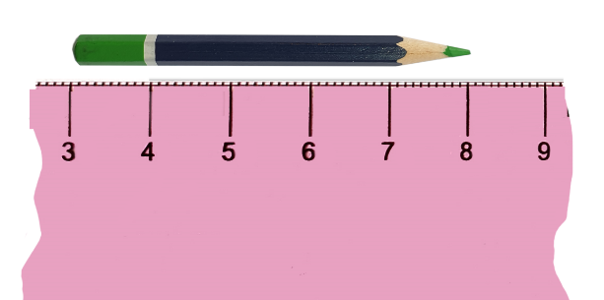
- Ask students if they can see any differences between this ruler and the ruler they made yesterday. Discuss whether they can still measure with a broken ruler.
The table below outlines stimulus prompts to generate conversation about the topic, along with anticipated responses from students.
Prompts | Anticipated student responses
- What is the same about the broken ruler?  - What is different about the broken ruler?  - How can we measure with a broken ruler? | - The ruler still has centimetres.  - The ruler does not start at zero; it starts at a different number.  - I can count the marks from the start of the object to the end.  - I can subtract the small number from the bigger number to find the measurement.
- Students break their ruler from Lesson 2 as in Figure 2.
Figure 2 – Break your ruler
- Ask for volunteers to select 2 small objects in the classroom, such as a crayon or glue stick, and talk about how these could be measured with the broken ruler. Explain how measuring with the broken ruler is very similar to how they measured items previously. Students are still going to find the length of the item by measuring from the start point of the ruler to the end point of the object. The difference is that the ruler is broken so they will not be able to start at zero.
- Model measuring an item with the broken ruler. Align the object at the first number on the broken ruler, for example, 5 cm. Then find the number at the end of the object, for example, 9 cm. Ask students how they would work out the length of the object using the references 5 and 9.
- Explain that there are 2 ways to do this. Firstly, they can count the jumps from the beginning point to the end point. In this case there are 4 jumps from 5 cm to 9 cm, so the length is 4 cm. Or they can subtract the number at the beginning of the object from the number at the end of the object. For example, 9 − 5 = 4 means the length of the object is 4 cm.
- Measure the second object with the class, but this time have students prompt you with the steps to take.
- In pairs, students select small items in the classroom, estimate and measure lengths using their broken ruler and record using the abbreviation ‘cm’. In pairs, students justify why their measurement is correct.
This table details assessment opportunities and differentiation ideas.
Assessment opportunities | Too hard? | Too easy?
What to look for:  - Do students identify objects that are appropriate to measure in centimetres? (MAO-WM-01, MA1-GM-02)  - Can students use flexible addition and subtraction strategies to measure length using a broken ruler? (MAO-WM-01, MA1-CSQ-01, MA1-GM-02)  What to collect:  - observations of students selecting and measuring objects using a broken ruler (MAO-WM-01, MA1-GM-02) | Students cannot use the broken ruler to measure length.  - Model how to start measuring from the beginning point of a broken ruler.  - With students, count by ones from the beginning of the broken ruler to the end point of the object. For example, start at 4 and count 5, 6, 7, 8 to the end point, 9, so the measurement is 9 cm. | Students can measure accurately with their broken ruler.  - Students place an item in the middle of the broken ruler and measure from there.  - Students work out how to measure an item longer than their broken ruler.

Lesson 4: Heavier, lighter, balanced
Core concept: Masses can be compared, ordered, and matched.
The table below contains suggested learning intentions and success criteria. These are best co-constructed with students.
Learning intentions | Success criteria
Students are learning that:  - the equals sign can mean equivalence  - there are multiple ways to achieve equivalence. | Students can:  - use blocks and numbers to find equal masses with a balance  - make and use a scale to find and compare mass using a chosen unit  - use estimation to check whether an answer is reasonable.

Daily number sense: Make them the same – 25 minutes
- Build student understanding of equivalence in number sentences by using an equal-arm balance.
- Review with students what they remember about measuring with an equal-arm balance. Explain that just like they balanced objects, they can also balance number sentences.
- Show students an equal-arm balance with 3 red blocks on the left side and 8 blue blocks on the right side. Ask them how the sides of the equal-arm balance are different. Use ‘Talk moves’ in pairs to discuss how to balance both sides. Show the missing number with a third colour of blocks. Discuss as a class, and record the final answer with a number sentence, for example, 3 + 5 = 8.
The table below outlines stimulus prompts to generate conversation about the topic, along with anticipated responses from students.
Prompts | Anticipated student responses
- What can you see?  - How can we make both sides balanced or equal?  - Is there more than one way to make both sides equal?  - How can you record your answer? | - I can see that the left hand of the balance is lower than the other side.  - I could add 5 blocks to the left to make both sides 8.  - I could take 5 blocks away from the right to make both sides 3.  - I could use one colour of blocks for the first 5 and another colour for the next 3 blocks.  - I can write 3 + 5 = 8.
- Now place 8 blocks on the left side and 3 on the right. Ask students how they will balance the numbers now and what the number sentence will be. Record 8 = 3 + 5 and talk about how this is the same and different to the first problem. Reinforce that it is possible to have a number sentence that begins with the total.
- Place 6 and 8 blocks on the balance. Ask students how the sides are different and how they can make both sides equal.
- In small groups with blocks and an equal-arm balance, students place different quantities of between 1 and 10 blocks on each side of the balance and work out how to achieve equivalence. Record with number sentences.
This table details assessment opportunities and differentiation ideas.
Assessment opportunities | Too hard? | Too easy?
What to look for:  - Can students use flexible addition and subtraction strategies to find equivalence in more than one way? (MAO-WM-01, MA1-CSQ-01, MA1-GM-02)  - Can students record number sentences using symbols for plus, minus and equals? (MAO-WM-01, MA1-CSQ-01)  What to collect:  - observations of flexible mathematical thinking  - work samples of number sentences (MAO-WM-01, MA1-CSQ-01) | Students cannot work with the number of blocks.  - Students work with a smaller number of blocks.  - For example, 5 blocks on one side and 2 on the other.  Students cannot record number sentences using symbols.  - Students can write answers with words to demonstrate their understanding, for example 3 and 5 makes 8.  - Students are supported with sticky notes with symbols placed in the right order. | Students can find equivalence with 1 to 10 blocks on the balance.  - Students repeat activity but must find all possible solutions for equivalence.  - Students work with 11 to 20 blocks using 10 as a reference to colour code blocks.

How can we balance? – 40 minutes
- Ask students what they already know about measuring mass. Students may remember hefting. If necessary, compare a few objects by hefting. Ask students if they have seen mass being measured by something outside of school. Ask:
- Where was it?
- What did it look like?
- What did it measure?
- How did it work?
- Explain that students will be making their own balance. Demonstrate how to make the balance pictured in Figure 3, using the following steps:
- Cut 2 equal lengths of string.
- Use a hole punch to make 2 holes opposite each other in a paper cup. Do this with 2 cups.
- Thread string through the first hole of a cup, hang the cup over one side of the coat hanger and tie a knot around the second hole.
- Repeat this with the second cup.
- Help students fix the loops of string at each end with masking tape.
Figure 3 – Handmade equal-arm balance
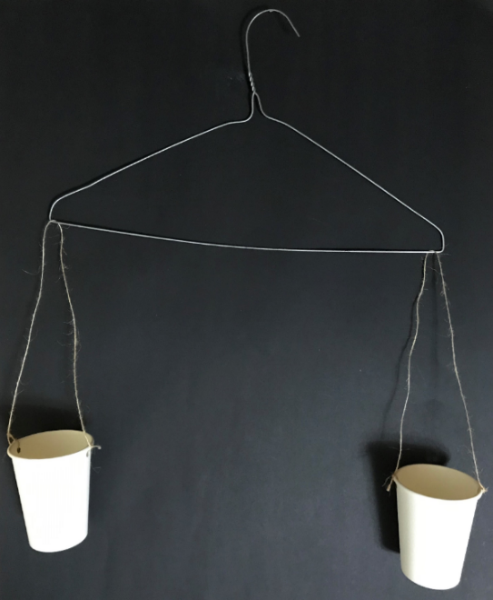
- In groups, students make an equal-arm balance as in Figure 3.
- Model comparing mass by placing one small object in each cup and asking students what they can see. For example, the cup with the glue stick is lower than the cup with the pencil, so the glue stick must be heavier. Emphasise that the 2 cups must stay in the same position on each side of the wire hanger. Demonstrate what happens if one cup is at the end and one cup is in the middle. Discuss how and why the measurement is not accurate.
- Students collect classroom objects and use their equal-arm balance to predict and check which object is heavier or lighter each time.
- Model how to estimate and use the balance to measure the mass of a small classroom object with a uniform informal unit. Place an object in one cup and add centimetre cubes one-by-one to the other cup. Have students describe what happens each time you add a cube and tell you when the cups are level. Find the total number of cubes by counting one-by-one together. Demonstrate how to record the name of the object and the mass in centimetre cubes. For example, a glue stick = 12 cubes.
- Students select a uniform informal unit. Using that unit, students estimate, measure, and record the mass of a range of objects. To develop estimating skills, students describe to a partner how accurate their estimates were and identify the lightest and heaviest objects measured. When students have measured 3 or more objects, they order the objects by consistent units of measurement.
This table details assessment opportunities and differentiation ideas.
Assessment opportunities | Too hard? | Too easy?
What to look for:  - Do students understand how a balance can be used with a measuring unit to compare, order and find masses? (MAO-WM-01, MA1-NSM-01)  - Do students develop estimating skills by comparing answers with estimates? (MAO-WM-01)  What to collect:  - observations of students describing how to achieve equivalence on the equal-arm balance to find masses (MA1-CSQ-01, MA1-NSM-01)  - samples of student recordings of estimates and measurements (MAO-WM-01, MA1-NSM-01) | Students use inappropriate units of measurement or place too many uniform informal units at once.  - Model counting cubes into the cup one-by-one.  - Support students to verbally describe when the equal-arm balance is getting close to level, almost level and level.  Students cannot write numerals.  - Students draw pictures of the object and the equivalent mass of cubes.  - Take photographs. | Students use an appropriate uniform unit to measure and order several small objects.  - Students select another uniform informal unit to measure with, for example, paper clips or marbles. They estimate how many of the new unit they will need. For example, one paper clip is about half the mass of the centimetre cube so I will need twice as many paperclips. Check by measuring.  - Students use their measurements to pose mass problems. For example, the glue stick measures 10 cubes and the ball measures 20 cubes. So, one ball should equal 2 glue sticks.  - Students test ideas by measuring.

Consolidation and meaningful practice: Let’s think about measuring mass – 5 minutes
- Ask students:
- What informal unit of measure did you choose?
- How well did this work and why?
- Would you use the same unit or a different unit next time? Why? Why not?

Lesson 5: Equivalence
Core concept: Equivalence can be found with different units of measurement.
The table below contains suggested learning intentions and success criteria. These are best co-constructed with students.
Learning intentions | Success criteria
Students are learning that:  - there are many ways to use addition to get to the same quantity  - there are many ways to find equivalence. | Students can:  - use flexible thinking strategies to find more than one solution to a story problem  - use blocks to find equivalence.

Daily number sense: At the farm – 20 minutes
- Build student understanding of flexible addition strategies, including commutative addition, by finding more than one solution to a word problem.
- Explain that 2 boys, Sam and Leo, visited a farm. In one field they saw ducks, sheep, ants, and spiders. They counted 16 legs. Display Resource 3: On the farm. Ask students how many legs each creature has. Model one or 2 examples of how Sam and Leo could have seen 16 legs and their equivalent number sentences. Solutions include:
- one spider and one duck give 10 legs and adding one ant makes 16 legs. We can record this as 8 + 2 + 6 = 16 legs.
- 4 sheep could be recorded as 4 + 4 + 4 + 4 = 16 legs.
- 3 sheep and 2 ducks could be recorded as 4 + 4 + 4 + 2 + 2 = 16 legs.
- These solutions demonstrate number bonds to 10 and commutative addition.
Commutative property: Commutative property of addition or multiplication means that 2 numbers can be added or multiplied in any order and the solution will be the same.
- In pairs with mini whiteboards, students find solutions and consider the following prompts:
- What animals could Sam and Leo have seen?
- Is there more than one possible answer?
- What addition strategies will you use?
- How will you record your ideas?
- Can you prove that you have found all the answers?
This table details assessment opportunities and differentiation ideas.
Assessment opportunities | Too hard? | Too easy?
What to look for:  - Do students use commutative properties and number bonds to find more than one solution to the problem? (MA1-RWN-01, MA1-CSQ-01)  - Can students organise their ideas to check that they have found all possible solutions? (MAO-WM-01, MA1-CSQ-01)  What to collect:  - samples of students recording and organising possible answers (MAO-WM-01, MA1-CSQ-01)  - observations of students justifying how many possibilities there are to a partner (MAO-WM-01, MA1-CSQ-01) | Students cannot write numerals.  - Student draws the animals for each solution.  - Provide Resource 3: On the farm to cut up to show solutions.  Student cannot work with number of legs.  - Student begins with single animals with smaller numbers of legs, such as ducks and sheep that can easily be used with repeated addition to reach 16. For example, 2 + 2 + 2 + 2 + 2 + 2 + 2 + 2 and 4 + 4 + 4 + 4. Student then thinks about combinations of ducks and sheep.  - Introduce ants and spiders if student has a good understanding of combinations of other animals. | Students find all combinations of animals.  - Tell students that the farmer brought along some three-legged stools for visitors to sit on. Provide students with Resource 4: Three-legged stools if necessary.  - Students work out how many possible new combinations there are now. Ask them to make connections with number bonds and their original answers. For example, they could replace each ant with 2 stools or a sheep and a duck with 2 stools.

How can we balance? – 40 minutes
- Display an equal-arm balance. Place 12 orange blocks on the right side of the balance and ask students what they can see. Ask how they could make the balance the same on both sides using 2 colours of blocks. For example, 10 blue blocks and 2 red blocks would be equivalent to 12 orange blocks. Prompt students to tell you what the number sentence would be (10 + 2 = 12). Students share ideas. Ask students what the number sentence would be if the 12 orange blocks were moved to the left-hand side (12 = 10 + 2).
- Reinforce that the mass is the same on both sides if the number of blocks is the same on both sides.
- Ask students what other combinations of blocks they can use to level the balance. Place 12 connected orange blocks on the right-hand side of the balance. In pairs, students investigate how they could make the balance even using 2 different colours of blocks on the other side. For example, 8 blue blocks and 4 red blocks, or 11 blue blocks and 1 red block. Revise how these can be recorded as number sentences, for example, 8 + 4 = 12 and 11 + 1 = 12. Ask:
- How will you know if you have found all the answers?
- How can you record your ideas?
- Can you see any increasing number patterns? Are the numbers getting bigger?
- Can you see any decreasing number patterns? Are the numbers getting smaller?
This table details assessment opportunities and differentiation ideas.
Assessment opportunities | Too hard? | Too easy?
What to look for:  - Can students identify the difference between the 2 sides of the equal-arm balance and use this to achieve equivalence? (MA1-NSM-01)  - Can students record possible answers logically to look for patterns? (MAO-WM-01, MA1-CSQ-01)  What to collect:  - observations of students describing how to achieve equivalence on the equal-arm balance (MA1-NSM-01)  - samples of recording different possibilities and labelling number patterns (MAO-WM-01, MA1-CSQ-01) | Students cannot work with 12 blocks.  - Work with 10 blocks and find number bonds to 10 for the other side of the balance.  - Model how to record possibilities so that students can see patterns, for example 9 + 1, 8 + 2, 7 + 3 and so on. | Students find all possible answers.  - Students keep 12 blocks on the left-hand side and use 3 different colours of bricks to find possible answers. For example, 6 + 4 + 2 = 12.  - Record answers logically to look for patterns.  - In pairs, students choose a number of blocks between 15 and 30 to go on the left-hand side of the balance.  - The first student selects a number of blocks to go on the other side and the second student works out how many more blocks are needed to achieve equal mass on both sides.

Consolidation and meaningful practice: Make 10! – 5 minutes
- Ask students questions about connected number bonds to 10. For example:
- 7 and ? make 10?
- 17 and ? make 20?
- 4 and ? make 10?
- 9 and ? make 20?

Lesson 6: Fill it up!
Core concept: Informal units of measure can be used to find internal volume (capacity).
The table below contains suggested learning intentions and success criteria. These are best co-constructed with students.
Learning intentions | Success criteria
Students are learning that:  - many strategies can be selected and applied to solve a problem  - internal volume (capacity) is the space inside an object  - informal units of measurements can be used to find the internal volume (capacity) of an object. | Students can:  - use different strategies to reach a target number  - use a consistent unit of measure to estimate and compare capacity  - use a running total to reach a final answer.

Daily number sense: Target 16 – 20 minutes
- Build student understanding of flexible addition and subtraction strategies by playing Target 16. This builds on number sense skills from the previous lesson (Lesson 5).
- Display the numbers 1, 2, 3, 4, 5 and 10 and explain that students are going to use them to make 16. Explain that the numbers provided can be used more than once.
- Students use ‘Talk moves’ with a partner, sharing ideas and recording possible solutions on a mini whiteboard. When students have found one answer, ask if there are any other solutions.
The table below outlines stimulus prompts to generate conversation about the topic, along with anticipated responses from students.
Prompts | Anticipated student responses
- Can you make the target number using addition?  - Can you make the target number using subtraction?  - Can you use doubles to make the target number? | - I know that 4 and 2 is 6 and 10 more is 16.  - I know 10 and 10 is 20 and 20 take away 4 makes 16.  - I can double 5 to make 10. Then I can double 3 and that makes 6, so then 10 and 6 is 16.
- As a class, list all the solutions students have found. Discuss how they could be organised to decide whether all solutions have been found and add solutions as students spot gaps in the list.
This table details assessment opportunities and differentiation ideas.
Assessment opportunities | Too hard? | Too easy?
What to look for:  - Can students use a combination of addition, subtraction and doubling strategies? (MAO-WM-01, MA1-CSQ-01)  - Can students organise thinking to show they have found all solutions? (MAO-WM-01, MA1-CSQ-01)  What to collect:  - work samples of solutions showing a combination of strategies (MAO-WM-01, MA1-CSQ-01)  - observations of students justifying whether they have found all solutions (MAO-WM-01) | Students cannot make numbers over 10.  - Students find number bonds that add up to 10 first and then other possible solutions.  - Support students to organise their ideas to find more solutions. | Students find all answers.  - Students include the number 3 to encourage more thinking about doubles.  - Students use solutions for target 16 and develop them into solutions for target 24 or target 32. These targets will further develop doubling and commutative addition strategies.

Fill it! – 40 minutes
This activity has been adapted from Volume and Capacity at NZ Maths (2022).
- Explain that volume is the whole amount of space a substance or container takes up. Internal volume or capacity is the space inside a container.
- Demonstrate the game, Fill the cup! Show students a tablespoon and a cup and ask them to estimate how many spoons of rice will be needed to fill the cup. Record the predictions.
- Select a student to roll a 6-sided dice. Once they have rolled, show the dice to the class, and record the number on the board. The student then scoops the same number of spoons of rice into the cup. Discuss how to level the rice with the top of the spoon to get a consistent measurement each time. Ask students if the cup is full yet.
- If not, select another student to roll the dice. This time, add the number rolled to the number recorded on the board. Explain that this is called a running total. Track the running total on a number line. Ask how many spoons of rice are in the cup now.
- Repeat until the cup is full. Students use the running total with the number line to see how many spoons of rice filled the cup and how close they were to their estimation.
- Students play the game in pairs or small groups, first with a cup and then with different sizes of containers. Include another container that looks different but will hold the same amount of rice to develop understanding of conservation of capacity. Compare the sizes of containers by describing how many spoons of rice filled them and identify the smallest and largest capacities (internal volumes).
This table details assessment opportunities and differentiation ideas.
Assessment opportunities | Too hard? | Too easy?
What to look for:  - Can students use a uniform informal unit to estimate, measure and compare internal volumes (capacities) of containers? (MAO-WM-01, MA1-3DS-01)  - Can students identify containers that look different but have the same internal volume (capacity)? (MAO-WM-01, MA1-3DS-01)  What to collect:  - observations of students estimating, measuring and comparing internal volumes (capacities) (MAO-WM-01, MA1-3DS-01) | Students cannot measure accurately or keep a running total.  - Model levelling the rice on the spoon and then student continues measurement.  - Student uses counters to represent spoons of rice and then counts them to find the total when the cup is full. | Students quickly complete the activity.  - Students use teaspoons to play the game.  - Students estimate whether answers will be bigger or smaller and explain why. Then play the game to check.

Consolidation and meaningful practice: What did we find? – 10 minutes
- As a whole class, discuss:
- Which container had the smallest capacity?
- Which container had the largest capacity?
- Did any containers have the same capacity? How could you tell?
- How might answers change if you use a smaller spoon? Or a bigger spoon?
- Ask students if they could use blocks to find the capacity of a cup. Demonstrate and ask if there are any problems. Talk about spaces between blocks and how this affects the measurement of capacity.

Lesson 7: Pack it!
Core concept: Different strategies can be selected and applied to solve problems.
The table below contains suggested learning intentions and success criteria. These are best co-constructed with students.
Learning intentions | Success criteria
Students are learning that:  - mathematicians select the most efficient strategy to solve problems  - uniform informal units can be used to compare internal volumes (capacities)  - objects can look different but have the same volume. | Students can:  - select and apply different strategies to solve addition and subtraction stories  - select the most efficient way to pack objects to compare capacity  - recognise that everyday items can be three-dimensional objects  - make different looking models that contain the same number of blocks.

Daily number sense: Number stories – 10 minutes
- Build student understanding of flexible addition and subtraction strategies by solving number stories.
- Leon had 7 toy cars. His brother gave him 6 more toy cars. Students work out how many cars Leon has now.
- Sophia had 8 crystals. Her sister gave her some more. Now Sophia has 13 crystals. Students work out how many crystals Sophia was given by her sister.
- Krishiv had some toy dinosaurs. His friend Adam gave him 9 more. Now Krishiv has14 toy dinosaurs. Students work out how many dinosaurs Krishiv had to start with.
- Use ‘Talk moves’ in pairs and record strategies used.
- As a class, discuss different strategies students used and which were most efficient.

Pack it! – 40 minutes
- Show students a rectangular container, marbles, and blocks and ask which unit is more appropriate to measure mass with. Discuss which unit would leave the least spaces, which would go right into the corners and so on. If students do not realise that the most appropriate unit of measurement is the block, demonstrate filling using marbles and then blocks. As a class, students estimate how many blocks will fit into a given rectangular container. Fill the container by:
- picking up handfuls of blocks and placing them loosely into the container
- packing blocks into the container by placing them next to each other and building them up in layers.
- Ask students which method of filling gives them more blocks and fewer spaces. Discuss how the second method is more efficient and that building blocks up in layers with no spaces is called packing.
- In small groups, students estimate, pack, and record the number of blocks for at least 3 different rectangular containers. Order and compare the containers by their internal volume (capacity).
- As a class discuss:
- What products do you buy at the supermarket that are packed tightly into containers?
- What products are loosely packed into containers?
- Why are some products packed tightly and other products packed loosely? Think about breakfast cereals and toilet paper.
- What is your favourite treat? How is it packed when you get it from the supermarket? Why?
- Show students a container in the shape of a cube and Resource 5: Cakes and chocolates. Ask students to describe what three-dimensional objects they can see, for example, cylinders, spheres, and prisms. Ask students if they would get more cakes or chocolates if they were packed tightly or loosely into the container. Students estimate how many of each type could be packed into the container. Investigate packing three-dimensional shapes into containers that are cubes, rectangular prisms, or cylinders.
This table details assessment opportunities and differentiation ideas.
Assessment opportunities | Too hard? | Too easy?
What to look for:  - Do students select the most efficient strategy to pack objects into a container? (MAO-WM-01, MA1-3DS-02)  - Can students use estimates to compare and order internal volumes (capacities)? (MAO-WM-01, MA1-3DS-02)  - Can students identify features of three-dimensional objects in everyday items? (MAO-WM-01, MA1-3DS-01)  What to collect:  - observations and work samples of students estimating, measuring and comparing internal volumes (capacities) (MAO-WM-01, MA1-3DS-02) | Students do not pack efficiently.  - Model packing the bottom of the container with a layer of blocks.  - Students repeat by putting layers on top of the first layer until the container is filled to the top.  - Give students a smaller container to pack. | Students can already pack rectangular containers.  - Give students cubes and other three-dimensional containers to estimate and pack.  - Discuss how efficient the containers and units of measurement are. For example, students might suggest that it would be more efficient to pack marbles into a cylinder than blocks.  - Students test ideas using containers and concrete materials.

Consolidation and meaningful practice: Same volume – different shape! – 20 minutes
This activity has been adapted from Barrier games (connecting blocks) from State of Victoria (Department of Education and Training).
- Students each make a model using 12 blocks. In small groups, discuss what is the same and what is different about the models.
- Keep the models and move into AB pairs. Student A breaks their model up into single blocks and copies Student B’s model. Make 2 new models with 12 blocks each and reverse roles.
- Repeat the process with 7 blocks but this time, Student B cannot look at Student A’s model at all. Student A gives Student B instructions about how to build it using mathematical language. For example, on the bottom layer there are 3 blocks in an L shape. Change roles and repeat the process.
This table details assessment opportunities and differentiation ideas.
Assessment opportunities | Too hard? | Too easy?
What to look for:  - Do students recognise models that have the same volume? (MAO-WM-01, MA1-3DS-02)  What to collect:  - observations and work samples of students estimating, measuring and comparing internal volumes (capacities) (MAO-WM-01, MA1-3DS-02) | Student cannot replicate a model.  - Students works with a small quantity of blocks, for example, 4 blocks.  - As students use 4 blocks competently, increase the number of blocks to 7 and then 12. | Students quickly complete all activities.  - Repeat the process that uses 7 blocks but this time, Student A examines Student B’s model for 30 seconds and then makes it from memory.  - Change roles and repeat the process.  - Repeat the process but with a larger number of blocks chosen by the students.

Lesson 8: Let’s be organised!
Core concept: Things can be arranged logically to find answers to problems.
The table below contains suggested learning intentions and success criteria. These are best co-constructed with students.
Learning intentions | Success criteria
Students are learning that:  - objects can be arranged into arrays of rows and columns to make it easier to find the total quantity  - repeated addition can be used to find answers to number and area problems. | Students can:  - arrange a collection into rows and columns and use repeated addition to find a total  - use drawings with a grid structure to compare rectangular areas.

Daily number sense: Let’s make arrays – 20 minutes
- Build student understanding of grouping by creating arrays with concrete materials.
- Display 2 collections of objects. One collection is loosely arranged, and the other is shown as a 4 by 3 array. See Figure 4, for an example using leaves.
Figure 4 – Leaves
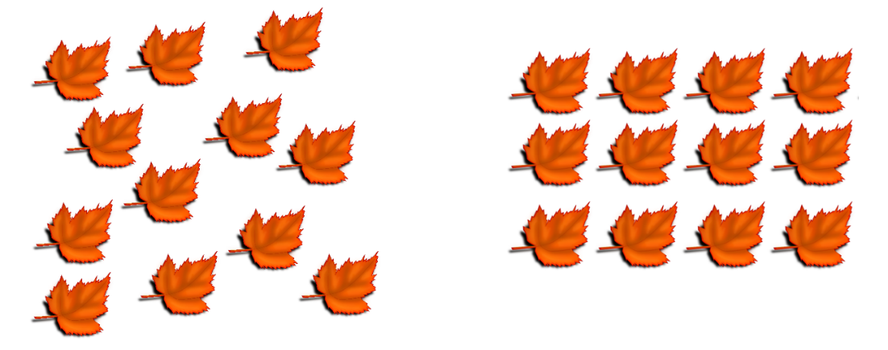
- Ask students what is the same and what is different. Revise with students that the organised collection is called an array.
- Ask what students notice about the array. Revise that the rows go across or are horizontally arranged and the columns go down or are vertically arranged. Explain that an array must have equal rows and columns. Rotate the objects from a 4 by 3 array to a 3 by 4 array. Discuss how although the arrangement might look different there are still the same number of objects, and they are still organised in an array.
- Explain that an array shows repeated or commutative addition. For example, 3 + 3 + 3 + 3 (columns) or 4 + 4 +4 (rows).
- Ask students if there are any other ways to organise 12 objects into an array. For example, 6 by 2 or 12 by 1. Display Resource 6: Leaves in arrays, if students need visual support.
- In pairs, students throw two 6-sided dice and use the 2 numbers to make an array with concrete materials or natural objects.
- Ask students if they can make more than one array with their throws. For example, throws of 3 and 2 could make 2 rows of 3 or 3 rows of 2.
This table details assessment opportunities and differentiation ideas.
Assessment opportunities | Too hard? | Too easy?
What to look for:  - Can students form arrays of equal rows and equal columns? (MA1-FG-01)  - Can students use commutative addition to make and describe 2 arrays using the same number of objects? For example, 12 objects could make arrays of 6 + 6, or 2 + 2 + 2 + 2 + 2 + 2? (MAO-WM-01, MA1-FG-01)  - Can students communicate information about an array by describing the number of rows and columns and the number in each row and column? (MAO-WM-01, MA1-FG-01)  What to collect:  - observations of students creating and describing arrays (MAO-WM-01, MA1-FG-01) | Students do not understand arrays.  - Model simple arrays for students, for example, 2 by 1, 3 by 2 using the language of rows and columns.  - Students then work with 6 objects to find arrays. | Students quickly complete the activity.  - Students rearrange the original array to make other possibilities. For example, a throw of 3 by 2 could make 3 by 2, 2 by 3, 6 by 1 and 1 by 6.  - Students throw two 8- or 12-sided dice and find all possible arrays.

Measure area with arrays – 40 minutes
- Ask students what they can remember about area and how to measure it.
- Explain that area is the space inside a two-dimensional shape and that they are going to find areas of rectangles in the classroom.
Area: The amount of surface inside a closed flat (2D) shape.
- Show students the rectangular face of a book and explain that they will estimate the area using a unit of measurement.
- Give students one square tile or sticky note as a unit of measurement and a piece of paper close to or slightly larger than the area of the book.
- Students draw around the unit of measurement on paper and estimate how many units will be needed to cover the surface of the book by visualising an array. For example, 6 rows of 4 tiles will fit into a book cover and 4 + 4 + 4 + 4 + 4 + 4 makes 24 tiles altogether.
- Draw the grid structure of rows and columns with the tiles or sticky notes to create an array. Explain how to use the array to find how many tiles are needed altogether. For an example, see Figure 5.
- Model the count and allow students to make their own count.
- Students compare their answer to their original estimate.
Figure 5 – My book array grid
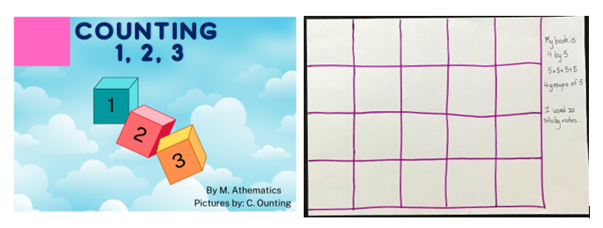
Images sourced from Canva and licensed under the Canva Content License Agreement.
- Students find rectangles in the classroom, either as two-dimensional shapes or rectangular faces of three-dimensional objects and follow the modelled process.
- When students have measured 3 areas, they can order them, identify the smallest and largest areas, and justify by describing arrays used.
This table details assessment opportunities and differentiation ideas.
Assessment opportunities | Too hard? | Too easy?
What to look for:  - Can students explain how they visualise an array to estimate the number of units it will take to cover a rectangular area? (MAO-WM-01, MA1-FG-01, MA1-2DS-02)  - Can students use drawings with a grid structure to compare and order rectangular areas? (MAO-WM-01, MA1-2DS-02)  What to collect:  - observations of visual estimation using arrays (MAO-WM-01, MA1-FG-01, MA1-2DS-02)  - work samples of ordered grid arrays (MAO-WM-01, MA1-2DS-02) | Students cannot manually draw the grid structure.  - Students make the grid structure with tiles or sticky notes and take a photograph.  - Give students very small rectangular areas to draw the grid for. | Students find and order rectangular areas.  - Students repeat the process with repeated use of one sticky note.  - Students repeat the process with different kinds of triangles.  - Students explain how they organised triangles to find the area of the rectangle. For example, combining 2 triangles to make a square and so on.

Consolidation and meaningful practice: Smaller, larger, the same as – 10 minutes
- Throw two 6-sided dice. Hold up a square sticky note and ask students to visualise the array the dice throws would make. Students point to rectangular shapes in the classroom that are smaller than, larger than or about the same size as the array.
- Repeat with large, coloured paper squares to visualise and identify larger areas.

Resource 1: Less, more, same
Less than a metre | More than a metre | About the same as a metre

Resource 2: Cover the numbers!
Photocopy in A3 size so that counters can be used to cover numbers.
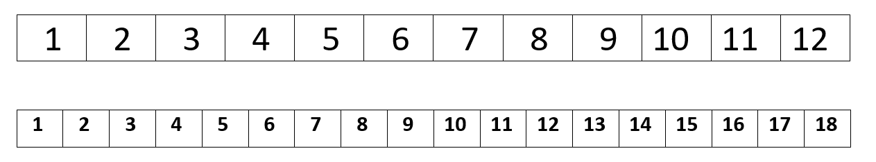

Resource 3: On the farm
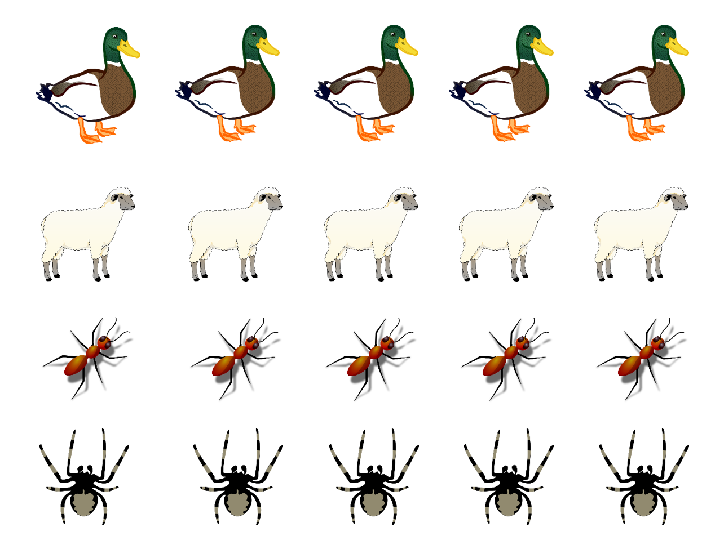
Images sourced from Pixabay and used in accordance with the Pixabay Licence.

Resource 4: Three-legged stools
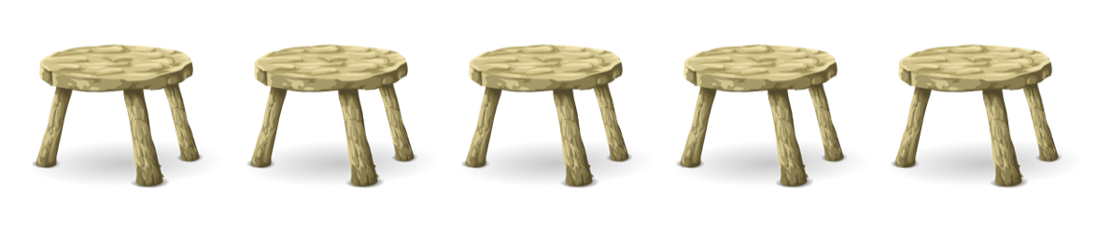
Images sourced from Pixabay and used in accordance with the Pixabay Licence.

Resource 5: Cakes and chocolates
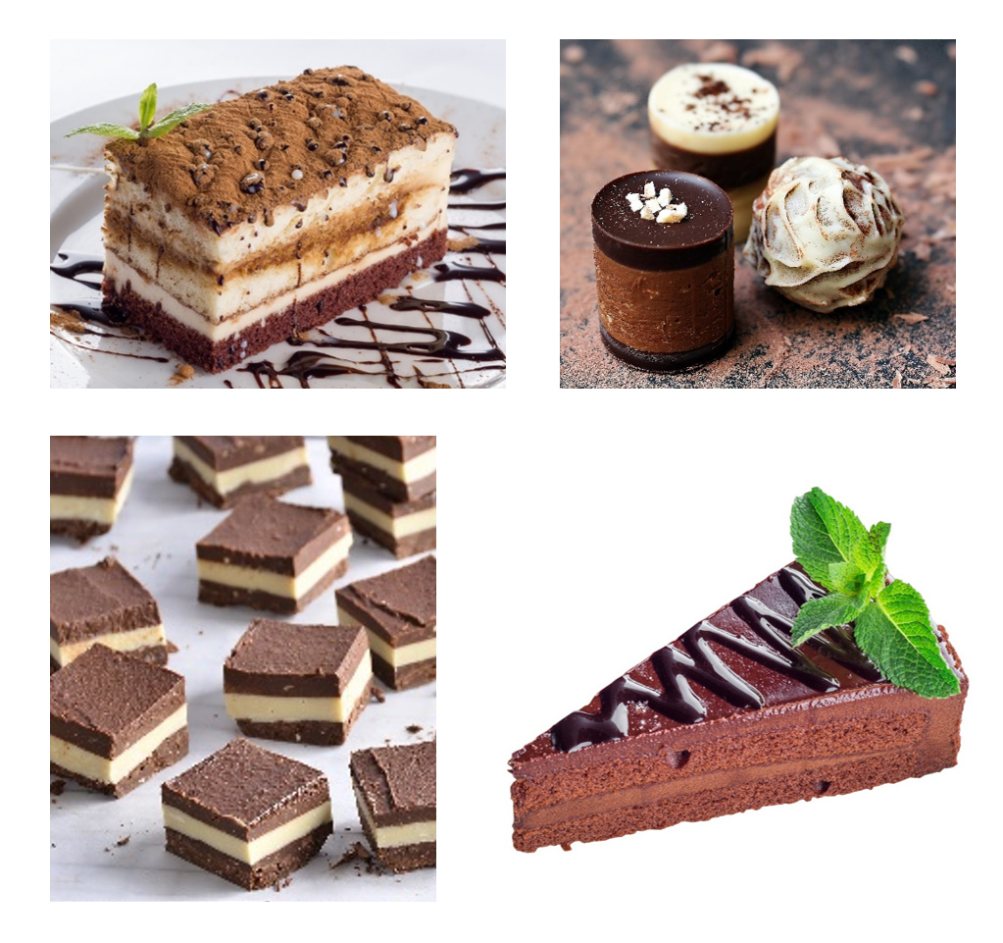
Images sourced from Pixabay and used in accordance with the Pixabay Licence.

Resource 6: Leaves in arrays
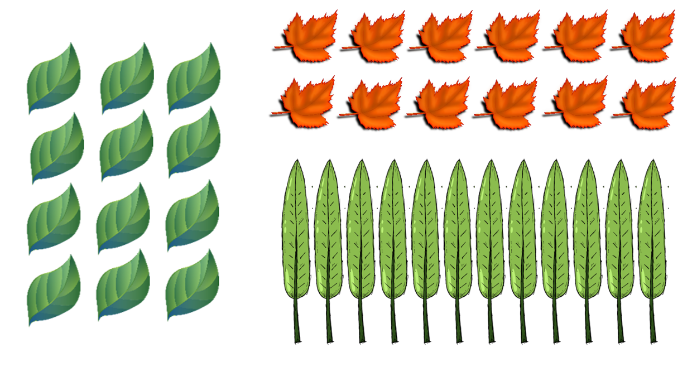
Images sourced from Pixabay and used in accordance with the Pixabay Licence.

Syllabus outcomes and content
The table below outlines the syllabus outcomes and range of relevant syllabus content covered in this unit. Content is linked to National Numeracy Learning Progression version (3).
Focus area and outcomes | Content groups and content points | Lessons
Representing whole numbers  MAO-WM-01  MA1-RWN-01  MA1-RWN-02 | Represent the structure of ten in whole numbers  - Use 10 as a reference in forming numbers from 11 to 20 (CPr7)  - Partition two-digit numbers to show quantity values (NPV4)  Represent numbers on a line  - Sequence numbers and arrange them on a line by considering the size and order of those numbers (CPr5) | 1, 2, and 6
Combining and separating quantities A  MAO-WM-01  MA1-CSQ-01 | Use advanced count-by-one strategies to solve addition and subtraction problems  - Recognise and use the symbols for plus (+), minus (-) and equals (=)  - Record number sentences in a variety of ways using drawings, words, numbers and symbols (AdS6)  - Fluently use advanced count-by-one strategies including counting on and counting back to solve addition and subtraction problems involving one- and two-digit numbers (AdS3, AdS4, AdS5)  Recognise and recall number bonds up to ten  - Recognise, recall and record combinations of two numbers that add up to or bond to form 10 (AdS2, AdS6)  - Create, recall and recognise combinations of two numbers that add up to numbers less than 10 (AdS2, AdS6)  Use flexible strategies to solve addition and subtraction problems  - Select and apply strategies using number bonds to solve addition and subtraction problems with one- and two-digit numbers by partitioning numbers using quantity value and bridging to ten (Reasons about relations). (AdS6, AdS7)  Represent equality  - Model the commutative property for addition and apply it to aid the recall of addition facts (Reasons about relations). (AdS7) | 1, 3–7
Forming groups B  MAO-WM-01  MA1-FG-01 | Represent and explain multiplication as the combining of equal groups  - form arrays of equal rows and equal columns (MuS5)  - Determine and distinguish between the number of rows/columns and the number in each row/column when describing collections of objects. (MuS5)  - Model the commutative property of multiplication, using an array (Reasons about relations). (MuS6) | 8
Geometric measure A  MAO-WM-01  MA1-GM-02 | Measure the lengths of objects using uniform informal units  - Use uniform informal units to measure lengths and distances by placing the units end to end without gaps or overlaps. (UuM2)  - Count informal units to measure lengths or distances and describe the part left over. (UuM4) | 1 and 2
Geometric measure B  MAO-WM-01 MA1-GM-01 MA1-GM-02 MA1-GM-03, | Recognise and use formal units to measure the length of objects  - Recognise the need for formal units to measure lengths and distances (UuM6)  - Use the metre as a unit to measure lengths and distances to the nearest metre or half-metre  - Record lengths and distances using the abbreviation for metres (m)  - Estimate lengths and distances to the nearest metre and check by measuring  - Recognise the need for a formal unit smaller than the metre  - Recognise that there are 100 centimetres in one metre  - Measure lengths to the nearest centimetre, using a device with 1-cm markings  - Record lengths and distances using the abbreviation for centimetres (cm)  - Estimate lengths and distances to the nearest centimetre and check by measuring. (UuM6) | 1–3
Two-dimensional spatial structure B  MAO-WM-01  MA1-2DS-02 | Compare rectangular areas using uniform square units of an appropriate size in rows and columns  - Cover rectangular surfaces by creating repeated rows of square tiles (UuM5)  - Use the structure of repeated units to find the area of a rectangle (UuM5)  - Explain how the grid structure of rows and columns helps to find the area (Reasons about spatial structure).  - Record comparisons of area using drawings, numerals and words, and by referring to the uniform informal unit used. | 8
Three-dimensional spatial structure A  MAO-WM-01  MA1-3DS-01  MA1-3DS-02 | Recognise familiar three-dimensional objects  - Identify and name familiar three-dimensional objects  Measure and compare the internal volumes (capacities) of containers by filling  - Use uniform informal units to measure how much a container will hold by counting the number of times a smaller container can be filled and emptied into the container being measured. (UuM3)  - Compare the internal volumes of two or more containers using appropriate uniform informal units (UuM4)  - Recognise and explain why containers of different shapes may have the same internal volume (Reasons about relations).  - Estimate how much a container holds by referring to the number and type of uniform informal units used and check by measuring. (UuM3, UuM4)  Measure the internal volume (capacity) of containers by packing  - Pack cubic units (eg blocks) into rectangular containers so that there are no gaps  - Recognise that cubes pack better than other objects in rectangular containers (Reasons about spatial structure)  - Estimate and measure the internal volume of a container by filling the container with uniform informal units and counting the number of units used.  - Explain that if there are gaps when packing and stacking, this will affect the accuracy of measuring the internal volume. | 6–7
Three-dimensional spatial structure B  MAO-WM-01  MA1-3DS-02 | Compare containers based on internal volume (capacity) by filling and packing  - Compare, order and record the internal volumes (capacities) of two or more containers by measuring each container in uniform informal units (UuM3, UuM4)  - Estimate internal volume (capacity) by referring to the number and type of uniform informal unit used (UuM3)  Compare volumes using uniform informal units  - Compare models with different appearances, recognising when they have the same volume (Reasons about spatial structure) | 6–7
Non-spatial measure A  MAO-WM-01  MA1-NSM-01 | Investigate mass using an equal-arm balance  - Place objects on either side of an equal-arm balance to obtain a level balance  - Use an equal arm balance to compare the masses of two objects and record, which is heavier or lighter (UuM2)  - Use a balance to find two collections of objects that have the same mass (UuM2) | 5–6
Non-spatial measure B  MAO-WM-01  MA1-NSM-01 | Compare the masses of objects using an equal-arm balance  - Use uniform informal units to measure the mass of an object by counting the number of units needed to obtain a level balance on an equal-arm balance (UuM3)  - Select an appropriate uniform informal unit to measure the mass of an object and justify the choice (Reasons about relations) (UuM4)  - Compare the masses of two or more objects using the same informal units (UuM4)  - Estimate mass by referring to the number and type of uniform informal unit used and check by measuring (UuM3, UuM4) | 5–6

References
Links to third-party material and websites
Please note that the provided (reading/viewing material/list/links/texts) are a suggestion only and implies no endorsement, by the New South Wales Department of Education, of any author, publisher, or book title. School principals and teachers are best placed to assess the suitability of resources that would complement the curriculum and reflect the needs and interests of their students.
If you use the links provided in this document to access a third-party's website, you acknowledge that the terms of use, including licence terms set out on the third-party's website apply to the use which may be made of the materials on that third-party website or where permitted by the Copyright Act 1968 (Cth). The department accepts no responsibility for content on third-party websites.
Except as otherwise noted, all material is © State of New South Wales (Department of Education), 2023 and licensed under the Creative Commons Attribution 4.0 International License. All other material (third-party material) is used with permission or under licence. Where the copyright owner of third-party material has not licensed their material under a Creative Commons or similar licence, you should contact them directly for permission to reuse their material.
Mathematics K–10 Syllabus © 2022 NSW Education Standards Authority (NESA) for and on behalf of the Crown in right of the State of New South Wales.
© 2022 NSW Education Standards Authority. This document contains NSW Curriculum and syllabus content. The NSW Curriculum is developed by the NSW Education Standards Authority. This content is prepared by NESA for and on behalf of the Crown in right of the State of New South Wales. The material is protected by Crown copyright.
Please refer to the NESA Copyright Disclaimer for more information.
NESA holds the only official and up-to-date versions of the NSW Curriculum and syllabus documents. Please visit the NSW Education Standards Authority (NESA) website and the NSW Curriculum website.
National Numeracy Learning Progression © Australian Curriculum, Assessment and Reporting Authority (ACARA) 2010 to present, unless otherwise indicated. This material was downloaded from the Australian Curriculum website (National Numeracy Learning Progression) (accessed 16 September 2022) and was not modified. The material is licensed under CC BY 4.0. Version updates are tracked in the ‘Curriculum version history’ section on the 'About the Australian Curriculum' page of the Australian Curriculum website.
ACARA does not endorse any product that uses the Australian Curriculum or make any representations as to the quality of such products. Any product that uses material published on this website should not be taken to be affiliated with ACARA or have the sponsorship or approval of ACARA. It is up to each person to make their own assessment of the product, taking into account matters including, but not limited to, the version number and the degree to which the materials align with the content descriptions and achievement standards (where relevant). Where there is a claim of alignment, it is important to check that the materials align with the content descriptions and achievement standards (endorsed by all education Ministers), not the elaborations (examples provided by ACARA).
This resource contains images and content obtained from Canva, and their use outside of this resource is subject to Canva’s Content License Agreement. If you wish to use them separately from the resource, please go to Canva.
MatholiaChannel (9 May 2014) ‘Units of Length – Metre’ [video], MatholiaChannel, YouTube, accessed 16 September 2022.
New Zealand Ministry of Education (n.d) Volume and Capacity Units of Work, NZ Maths website, accessed 16 September 2022.
Parrish S (2022) Number Talks: Whole Number Computation, Heinemann Education Books, Portsmouth NH.
State of Victoria (Department of Education and Training) (n.d.), ‘Literacy experience plan: Barrier games (connective blocks)’, Literacy Teaching Toolkit, State of Victoria (Department of Education and Training) website, accessed 16 September 2022.
University of Cambridge (Faculty of Mathematics) (2022) NRICH [website], accessed 16 September 2022.
University of Cambridge (Faculty of Mathematics) (2022) Shut the Box, NRICH website, accessed 16 September 2022.

Further reading
University of Cambridge (Faculty of Mathematics) (2022) Barrier Games, NRICH website, accessed 16 September 2022.

