Mathematics – Stage 1 – Unit 16
Contents
Unit description and duration 4
Student prior learning 4
Lesson overview and resources 5
Lesson 1: Sort them out 9
Daily number sense: Thinking flexibly with numbers – 10 minutes 9
Sort them out – 40 minutes 11
Reflection – 10 minutes 11
Lesson 2: Let’s talk 13
Daily number sense: Race to zero – 10 minutes 13
Let’s talk 1 – 40 minutes 14
Consolidation and meaningful practice: Reflection – 10 minutes 15
Lesson 3: Let’s talk 2 16
Daily number sense: Two truths and one lie – 10 minutes 17
Let’s talk 2 – 40 minutes 18
Consolidation and meaningful practice: Reflection – 10 minutes 19
Lesson 4: Exploring equivalence 21
Daily number sense: Equivalence with dominos – 10 minutes 21
Let’s talk 4 (Part 2) – 40 minutes 24
Consolidation and meaningful practice: Reflection – 10 minutes 25
Lesson 5: Fruit shop 1 27
Daily number sense: Dot talk – 10 minutes 27
Investigating multiplication – 40 minutes 28
Reflection – 10 minutes 29
Lesson 6: Fruit shop 2 31
Daily number sense: Number busting 24 – 10 minutes 31
One array of lemons – 40 minutes 32
Discuss and connect the mathematics – 10 minutes 34
Lesson 7: Sharing cupcakes 35
Daily number sense: Array bingo – 20 minutes 35
Sharing cupcakes – 30 minutes 36
Discuss and connect the mathematics – 10 minutes 38
Lesson 8: Teddy bear’s birthday 38
Daily number sense: Class assembly – 10 minutes 39
Teddy bear’s birthday – 30 minutes 39
Discuss and connect the mathematics – 10 minutes 41
Resource 1: Renaming 12 43
Resource 2: Renaming 43 44
Resource 3: Sorting cards 45
Resource 4: Number chart 49
Resource 5: 20 to 70 spinner 50
Resource 6: 0 to 9 spinner 51
Resource 7: Dot cards 52
Resource 8: Fruit shop 1 53
Resource 9: Fruit shop 2 54
Resource 10: Fruit shop 3 55
Resource 11: Fruit shop 4 56
Resource 12: Fruit shop 5 57
Resource 13: Array bingo cards 58
Resource 14: Recording table 64
Syllabus outcomes and content 65
References 72

Unit description and duration
This two-week unit provides students with opportunities to explore different situations where they can use addition, subtraction, multiplication, and division. Students are provided opportunities to:
- rename and partition numbers
- use flexible strategies to solve addition and subtraction problems
- represent equality
- use equal groups to represent multiplication
- use flexible strategies to solve multiplication and division problems
Mathematics K–10 Syllabus © 2022 NSW Education Standards Authority (NESA) for and on behalf of the Crown in right of the State of New South Wales.

Student prior learning
Before engaging in these teaching and learning activities, students would benefit from prior experience with:
- combining and separating quantities of concrete materials
- recording number sentences using drawings, words, numerals, and symbols
- organising collections efficiently
- modelling and describing collections as ‘groups of’.

Lesson overview and resources
The table below outlines the sequence and approximate timing of lessons; syllabus focus areas and content groups; and resources.
Lesson | Syllabus focus area and content groups | Resources
Lesson 1: Sort them out  60 minutes  Mathematicians can use their knowledge of numbers and operations to make decisions about how they want to solve problems. | Representing whole numbers A  - Represent the structure of groups of ten in whole numbers  Combing and separating quantities A  - Use advanced count-by-one strategies to solve addition and subtraction problems | - Resource 1: Renaming 12  - Resource 2: Renaming 43  - Resource 3: Sorting cards  - Writing materials
Lesson 2: Let’s talk  60 minutes  The same problem can be solved in different ways. | Representing whole numbers A  - Use counting sequences of ones with two-digit numbers and beyond  - Represent the structure of groups of ten in whole numbers  Representing whole numbers B  - Use counting sequences of ones and tens flexibly  Combining and separating quantities A  - Use flexible strategies to solve addition and subtraction problems  - Represent equality | - Resource 4: Number chart  - Resource 5: 20 to 70 Spinner  - Resource 6: 0 to 9 Spinner  - Video: Let’s talk 1 (10:15)  - Paper clips (for spinners)  - Writing materials
Lesson 3: Let’s talk 2  60 minutes  Addition can be used to solve subtraction. | Representing whole numbers A  - Represent the structure of groups of ten in whole numbers  Representing whole numbers B  - Form, regroup and rename three-digit numbers  Combining and separating quantities A  - Use advanced count-by-one strategies to solve addition and subtraction problems  Combining and separating quantities B  - Represent and reason about additive relations | - Video: 2 truths. 1 lie. (4:10)  - Video: Let’s talk 1 (10:15)  - Concrete materials  - Interlocking cubes  - MAB blocks  - Mini whiteboards (class set)  - Writing materials
Lesson 4: Exploring equivalence  60 minutes  Equivalence can be used to solve problems. | Combining and separating quantities A  - Represent equality  Combining and separating quantities B  - Use knowledge of equality to solve related problems | - Video: Let’s talk 4: Part 2 (4:44)  - 12-sided dice  - Concrete materials  - Dominos  - Equal-arm balance  - Interlocking cubes  - Mini whiteboards (class set)  - Writing materials
Lesson 5: Fruit shop 1  60 minutes  A range of mental and written strategies can be used to solve problems. | Forming groups A  - Counts in multiples using rhythmic and skip counting  - Model and use equal groups of objects to represent multiplication | - Resource 7: Dot cards  - Resource 8: Fruit shop 1  - Resource 9: Fruit shop 2  - Resource 10: Fruit shop 3  - Resource 11: Fruit shop 4  - Resource 12: Fruit shop 5  - Large cardboard or paper for posters  - Writing materials
Lesson 6: Fruit shop 2  60 minutes  Representations can be used to make meaning and solve problems. | Forming groups B  - Represent and explain multiplication as the combining of equal groups  - Represent multiplication and division problems | - Resource 8: Fruit shop 1  - Counters or craft sticks  - Large cardboard or paper for posters  - Writing materials
Lesson 7: Sharing cupcakes  60 minutes  In division, start with the total and break it into smaller parts. | Forming groups A  - Model and use equal groups of objects to represent multiplication  - Recognise and represent division  Forming groups B  - Represent and explain multiplication as the combining of equal groups  - Represent multiplication and division problems | - Resource 13: Array bingo cards  - Counters  - Writing materials
Lesson 8: Teddy bear’s birthday  50 minutes  Multiplication and division can be used to solve problems. | Forming groups A  - Recognise and represent division  - Model and use equal groups of objects to represent multiplication  Forming groups B  - Represent multiplication and division problems | - Resource 14: Recording table  - Counters  - Mini whiteboards (class set)  - Writing materials

Lesson 1: Sort them out
Core concept: Mathematicians can use their knowledge of numbers and operations to solve problems.
The table below contains suggested learning intentions and success criteria. These are best co-constructed with students.
Learning intentions | Success criteria
Students are learning that:  - mathematicians use symbols for plus (+), minus (−) and equals (=)  - number sentences can be recorded in a variety of ways, using drawings, words, numerals and symbols  - efficient strategies can be used to solve addition and subtraction problems involving one- and two- digit numbers. | Students can:  - identify addition and subtraction questions and the symbols used  - record problems in different ways  - use appropriate addition and subtraction language.

Daily number sense: Thinking flexibly with numbers – 10 minutes
- Build student understanding of thinking about numbers flexibly by renaming.
- Display Resource 1: Renaming 12 and ask students what they notice. Have students turn and talk to a partner.
- Ask students:
- How many blocks do you see?
- How would you describe what you see?
- Are the totals the same?
- Explain that good mathematicians explain their thinking. Discuss responses and reinforce the concept of renaming. For example, ‘I see one 10 and 2 ones. I can also see 12 ones.’
- Display Resource 2: Renaming 43 and repeat previous step. Listen and record responses.
- Discuss ideas and reinforce renaming. For example, ‘I can see the 4 in 43 represents 4 tens; we call 4 tens forty. I can also see 43 in 43 ones. I can rename 43 as 3 tens and 13 ones.’
This table details assessment opportunities and differentiation ideas.
Assessment opportunities | Too hard? | Too easy?
What to look for:  - Can students rename numbers? (MAO-WM-01, MA1-RW2)  - Can students partition numbers? (MAO-WM-01, MA1-RW2)  What to collect:  - record and collect student responses (MAO-WM-01, MA1-RW2) | Students have difficulty renaming and partitioning numbers.  - Present first image only (12) or 2 displays ranging between 10 and 20.  - Provide concrete materials. | Students can rename and partition numbers. Students draw or model a fourth way of renaming.

Sort them out – 40 minutes
- Show students Resource 3: Sorting cards. Ask students what they notice and wonder about these images. Tell students they are going to sort these images into 2 groups. Have students think about how they could be sorted.
- As a class, sort the cards into 2 groups. Discuss how the cards have been sorted, using language specific to addition and subtraction. For example, add, equals, take away, subtract, minus, plus.
- Discuss the different ways that addition and subtraction can be represented. Reinforce that drawing, words, numerals, and symbols can be used.
- Using the printed Resource 3: Sorting cards, students select a card and show how they would individually solve the problem. Students repeat this process with a selection of different question cards. Students record their responses on whiteboards or paper for sharing.

Reflection – 10 minutes
- Discuss the strategies students used to solve their questions.
- Explore the strategies that demonstrate counting on, counting back, partitioning, and related facts.
- Identify which strategies are most efficient and why.
This table details assessment opportunities and differentiation ideas.
Assessment opportunities | Too hard? | Too easy?
What to look for:  - Can students recognise additions and subtraction symbols? (MA1-CSQ-01)  - Can students solve problems represented in different ways? (MAO-WM-01, MA1-CSQ-01)  - Can students apply different strategies to solve a question? (MAO-WM-01, MA1-CSQ-01)  What to collect:  - student responses and examples of solving addition and subtraction problems (MAO-WM-01, MA1-CSQ-01) | Students have difficulty sorting the cards.  - Reduce the range of representations to solve.  - Provide students with concrete materials that match the questions to solve.  - Provide students with problems 0 to 20. | Students correctly solve the selected problem.  - Students show additional ways to solve their problem.  - Provide more problems with higher numbers.

Lesson 2: Let’s talk
Core concept: The same problem can be solved in different ways.
Learning intentions | Success criteria
Students are learning that:  - in subtraction, start with a total and break it into smaller parts  - the same problem can be solved using many different strategies. | Students can:  - use their knowledge of numbers to select appropriate strategies to solve problems  - start with the total when subtracting  - record subtraction on a number line.

Daily number sense: Race to zero – 10 minutes
This activity has been adapted from Race to zero (0:17).
- Build student understanding of subtracting by spinning a number and counting backwards.
- Display Resource 4: Number chart. Explain that the class will place a counter at the end of 120 and then spin for a number and count backwards.
- Spin a number on Resource 5: 20 to 70 spinner. Ask students to turn and talk to a partner about the most efficient way to subtract the number. Obtain strategies from students and model subtracting.
- Repeat above step with Resource 6: 0 to 9 spinner.
- Repeat until class has reached zero.
This table details assessment opportunities and differentiation ideas.
Assessment opportunities | Too hard? | Too easy?
What to look for:  - Can students count backwards? (MAO-WM-01, MA1-RWN-01)  - Can students count by tens on and off the decade? (MAO-WM-01, MA1-RWN-01)  What to collect:  - record student strategies for subtraction (MAO-WM-01, MA1-RWN-01) | Students have difficulty subtracting.  - Provide students with their own copy of the number chart.  - Students use their own counter and number chart to calculate subtraction strategy.  - Use a number chart cut into a number strip as a game board. | Students can subtract tens and ones successfully. Spin ones and tens spinners together and subtract the total of that number. For example, if the spinners land on 30 and 6, students subtract 36 instead of each number individually.

Let’s talk 1 – 40 minutes
This activity has been adapted from Let’s talk (10:15).
- View the video Let’s talk 1 (10:15). Stop at 4:47.
- Ask students to turn and talk to a partner and explain in their own words how the problem was solved. Record responses.
- Reinforce mathematical language used. Notice how the concrete materials were used in the video.
- Students solve the same problem using a different strategy of their choosing.
- Students record strategies in their workbooks.

Consolidation and meaningful practice: Reflection – 10 minutes
- As a class, share chosen strategies and record.
- Ask students to think about which strategy is most efficient and why. Students turn and talk with a partner.
- Reinforce vocabulary used for subtraction and the importance of solving problems in different ways.
This table details assessment opportunities and differentiation ideas.
Assessment opportunities | Too hard? | Too easy?
What to look for:  - Can students use non-count by one strategies? (MAO-WM-01, MA1-CSQ-01)  - Can students use related facts? (MAO-WM-01, MA1-CSQ-01)  - Can students partition and rename numbers? (MAO-WM-01, MA1-RWN-02)  What to collect:  - student recordings (MAO-WM-01, MA1-RWN-01, MA1-CSQ-01) | Students have difficulty solving the problem. Provide interlocking cubes for students to model strategy. | Students choose efficient strategy to correctly solve the problem. Challenge students to use a third strategy to solve this problem.

Lesson 3: Let’s talk 2
Core concept: Addition can be used to solve subtraction.
The table below contains suggested learning intentions and success criteria. These are best co-constructed with students.
Learning intentions | Success criteria
Students are learning that:  - numbers can be partitioned and renamed  - addition can be used to solve subtraction. | Students can:  - solve subtraction problems using drawings and concrete materials  - solve subtraction problems using addition strategies  - partition and rename two-digit numbers.

Daily number sense: Two truths and one lie – 10 minutes
- Build student understanding of thinking flexibly about numbers by partitioning and renaming numbers.
- Explain to students that numbers can be partitioned in many ways using concrete materials and that thinking flexibly about numbers helps to solve problems.
- View the video: 2 truths. 1 lie. (4:10). Explain to the students that there are 3 statements. Two of these statements are true and students will decide if the third statement is a lie.
- Ask students if they can prove that the third statement, ‘25 cannot be represented with 10 MAB blocks’ is false. Students turn and talk to solve the problem in pairs using MAB blocks.
- Students record their thinking on whiteboards and share their ideas with the class.
- As a class, discuss if the statement was true or false. Record student reasoning.
This table details assessment opportunities and differentiation ideas.
Assessment opportunities | Too hard? | Too easy?
What to look for:  - Can students use concrete materials such as MAB blocks and interlocking cubes to represent and explain grouping? (MAO-WM-01, MA1-RWN-02)  - Can students use place value to partition and rename two-digit numbers? (MAO-WM-01, MA1-RWN-02)  - Can students think flexibly about tens and ones? (MAO-WM-01, MA1-RWN-02)  What to collect:  - recordings of students’ reasoning on whiteboards (MAO-WM-01, MA1-RWN-02)  - photographs of concrete modelling (MAO-WM-01, MA1-RWN-02) | Students have difficulty proving 25 cannot be represented with 10 MAB blocks.  - Use MAB blocks and think alouds to model how to solve the problem. For example, by asking if 25 can be represented using 10 MAB blocks.  - Use the same modelling and language presented in the video. | Students efficiently determine that 25 cannot be represented with 10 MAB blocks.  - Students write their own statements. A partner determines if the statement is true or false.  - Encourage students to explain their reasoning by reminding them that good mathematicians always explain their thinking.

Let’s talk 2 – 40 minutes
This lesson has been adapted from Let’s talk (10:15).
- View video Let’s talk 1 (10:15) from 4:47. Pause at 7:24.
- Students turn and talk to a partner and explain, in their own words, how the problem was solved. Record responses.
- Reinforce the mathematical language used and the importance of using inverse operations to solve problems.
- Provide students with the problem 18 − 11. Ask students to work with a partner to solve the problem using a subtraction strategy and an addition strategy. Students can use concrete materials and drawings to show their strategies.
- When students have completed the problem, pairs find another pair to make a group of 4 with. Each pair takes a turn to show one of their strategies.

Consolidation and meaningful practice: Reflection – 10 minutes
- Gather the class to share and record strategies used.
- Ask pairs which strategy was the most efficient. Ask for responses and model comparing the efficiency of the strategies.
- Reinforce the importance of efficiency and using inverse operations.
This table details assessment opportunities and differentiation ideas.
Assessment opportunities | Too hard? | Too easy?
What to look for:  - Can students correctly use number lines to solve a problem? (MAO-WM-01, MA1-RWN-01)  - Can students partition numbers to assist in solving the problem? (MAO-WM-01, MA1-RWN-02)  - Can students use addition to solve subtraction problems? (MAO-WM-01, MA1-CSQ-01)  - Can students use drawings, words, numerals and symbols when solving a number sentence? (MAO-WM-01, MA1-CSQ-01)  What to collect:  - recordings of student strategies (MAO-WM-01, MA1-RWN-01, MA1-RWN-02, MA1-CSQ-01, MA1-CSQ-01) | Students have difficulty solving the problem using subtraction strategies. Model with concrete materials to solve problem. | Students solve problem with addition and subtraction strategy. Use a third strategy for solving the problem.

Lesson 4: Exploring equivalence
Core concept: Equivalence can be used to solve problems.
The table below contains suggested learning intentions and success criteria. These are best co-constructed with students.
Learning intention | Success criteria
Students are learning that knowing equivalent numbers can help to solve problems. | Students can:  - represent equivalent quantities using concrete materials  - use the equals sign to record equivalent number sentences using addition  - use number bonds to solve addition problems.

Daily number sense: Equivalence with dominos – 10 minutes
This lesson has been adapted from Investigating equivalence with dominos.
- Build student understanding of equivalence by making totals with interlocking cubes from 2 numbers and weighing on an equal-arm balance.
- Provide students with dominos, a 12-sided dice, and interlocking cubes of 2 colours.
- Explain to students that knowing which numbers are equivalent can help to solve problems.
- Model rolling a 12-sided dice and selecting 2 different dominoes that total the number rolled (roll again if 2 combinations are not possible).
- Demonstrate making the rolled number with interlocking cubes, using the numbers from one domino. Repeat again for the second domino with different coloured interlocking cubes.
- Place the interlocking cubes on the equal-arm balance and discuss that the amounts being weighed are the same. Reinforce equivalence by drawing an equivalence sentence using the dominoes (see Figure 1).
- Students work with a partner to complete above steps.
Figure 1 – Recording equivalence with dominos
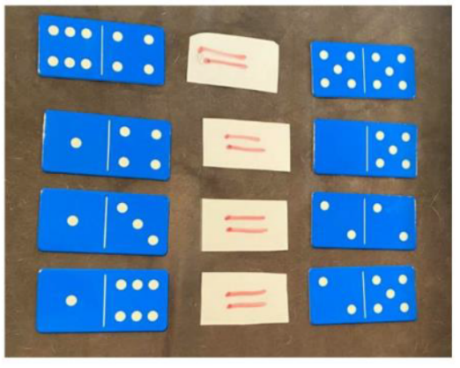
This table details assessment opportunities and differentiation ideas.
Assessment opportunities | Too hard? | Too easy?
What to look for:  - Can students use interlocking cubes to represent numbers and explain which numbers they used to make their total? (MAO-WM-01, MA1-RWN-02)  - Can student use the language of ‘add’, ‘plus’, ‘equals’, ‘is equal to’ and ‘is the same as’ when combining and comparing quantities? (MAO-WM-01, MA1-RWN-02)  What to collect:  - student answers for equivalent numbers (MAO-WM-01, MA1-RWN-02)  - student examples of equivalent domino sentences (MAO-WM-01, MA1-RWN-02) | Students find it difficult to identify 2 different combinations of numbers that total a given amount.  - Use 4 different interlocking cube colours to allow students to see each number individually in the total quantity.  - For example, a student rolls a 9. They select a domino showing 4 and 5 and a domino showing 3 and 6. Select 4 cubes of one colour and 5 cubes of another colour and combine to make the total of 9. Repeat with other domino selecting a different colour for 3 cubes and another colour for 6 cubes and combine. | Students efficiently model equivalence with dominoes and interlocking cubes.  - Use dominos with patterns beyond 6 and roll with a dice larger than 12-sides.  - Students select more than 2 dominos for the total rolled and demonstrate equivalence between all 3 dominos.

Let’s talk 4 (Part 2) – 40 minutes
This lesson has been adapted from Let’s talk.
- View video: Let’s talk 4: Part 2 (4:44)
- Students turn and talk to discuss what they noticed in the video. Students record their ideas on whiteboards. Hear student responses and guide the discussion with questions such as:
- How was the equal-arm balance used?
- How did you know when it was not even?
- How did you know when it was even?
- What did it mean when the balance arms were perfectly straight?
- Ask students if they noticed that inside 6 there are 3 twos. Explain that 6 is equivalent to 2, 2 and 2. Rewatch video: Let’s talk 4: Part 2 (4:44) if required.
- Have students Think-Pair-Share. Ask what other numbers are inside 6 and record student responses.
- Explain that thinking flexibly about numbers can help to solve problems as it allows mathematicians to use what they know to solve what they don’t know. Ask students what other quantities they can find that are equivalent to 8 + 8 + 6. In pairs, students investigate this problem and record their thinking on whiteboards. Students may have an equal-arm balance or other concrete materials to help with their investigation.

Consolidation and meaningful practice: Reflection – 10 minutes
- Gather the class together and listen to, and record student answers. Support students by:
- Modelling some student responses using an equal-arm balance to check equivalence.
- Recording modelled responses as equivalent number sentences.
This table details assessment opportunities and differentiation ideas.
Assessment opportunities | Too hard? | Too easy?
What to look for:  - Can students use the equals sign (=) to record equivalent number sentences involving addition, to mean 'is the same as'? (MAO-WM-01, MA1-RWN-01, MA-RWN-02, MA1-CSQ-01)  - Can students use flexible strategies to investigate addition on an equal-arm balance? (MAO-WM-01, MA1-RWM-01, MA-RWN-02, MA1-CSQ-01)  - Can students apply the terms ‘add’, ‘plus’, ‘equals’, ‘is equal to’, ‘is the same as’ when explaining their thinking? (MAO-WM-01, MA1-CSQ-01)  What to collect:  - the students’ equivalent number sentences (MAO-WM-01, MA1-CSQ-01) | Students have difficulty finding an equivalent value for 8 + 8 + 6.  - Students have their own concrete materials to manipulate. They make 8, 8 and 6.  - Manipulate these concrete materials into a different grouping. For example, 7, 9 and 6. | Students easily find other quantities equal to 8 + 8 + 6.  - Ask students to propose another way. Students explore a third example and record their reasoning.  - Explain that students do not only have to use addition. They could use other operations, for example, 32 − 10.

Lesson 5: Fruit shop 1
Core concept: A range of mental and written strategies can be used to solve problems.
The table below contains suggested learning intentions and success criteria. These are best co-constructed with students.
Learning intentions | Success criteria
Students are learning that:  - multiplication can be shown in different structures such as arrays  - arrays have equal rows and equal columns  - efficient strategies can be used to calculate the total number of objects in an array. | Students can:  - see the number of objects in an array  - explain the difference between rows and columns  - use skip counting or repeated addition to find the total of a collection.

Daily number sense: Dot talk – 10 minutes
- Build student understanding of subitising by quickly sharing a collection of dots and asking how many dots they see. Let students know they will not have time to count the dots one at a time, so as mathematicians they will need to visualise what they see to help them work it out.
- Show students Resource 7: Dot cards for 2-3 seconds and then hide.
- Ask students:
- How many dots did you see?
- How did you see them?
- Provide individual thinking time and then have students share their ideas. Monitor student conversations, preparing to ask some students to share how they saw the collection of dots.
- Reveal the dot card and invite selected students to share their thoughts with the class. Record student thinking.

Investigating multiplication – 40 minutes
This lesson has been adapted from Multiplication: reSolve Fruit Shop.
- Show students Resource 8: Fruit shop 1. Students explore the different details in the picture.
- As a class, discuss what students notice and wonder about the image.
- Ask students what multiplication they can see in the picture. Model mathematical language to support student understanding.
- Students work individually or in pairs to determine how many pieces of fruit are in each array. Students create a poster to record their thinking.
- Conduct a gallery walk to look at the different examples of multiplication found.
- Show students Resource 9: Fruit shop 2, Resource 10: Fruit shop 3, Resource 11: Fruit shop 4 and Resource 12: Fruit shop 5. Give students time to consider how the boxes of fruit are similar or different.
- As a class, discuss what students notice about the arrays of fruit in the different boxes.
The table below outlines stimulus prompts to generate conversation about the topic, along with anticipated responses from students.
Prompts | Anticipated student responses
- What do you notice is the same about these boxes of fruit?  - What is different?  - What are you wondering?  - Can you use the number of fruit in one box to help work out the number of fruit in another box? | - Some arrays have the same number in each, but their orientation has been changed.  - Some amounts of fruit can be determined by doubling the number of fruit in another box.  - Some amounts of fruit can be determined by dividing the number of fruit in another box by half.  - We can add on from what we already know to determine the amount of fruit in other boxes.

Reflection – 10 minutes
- Discuss the strategies students used to determine the amount of fruit in each box.
- Explore the strategies that use skip counting and arrays. Explain why these strategies are more efficient.
This table details assessment opportunities and differentiation ideas.
Assessment opportunities | Too hard? | Too easy?
What to look for:  - Can students use rhythmic or skip counting to identify the total? (MAO-WM-01, MA1-FG-01)  - Can students use their knowledge of equal groups to identify the total? (MAO-WM-01, MA1-FG-01)  What to collect:  - posters from gallery walk where students have used a variety of strategies to determine the number of fruit (MAO-WM-01) | Students find it difficult to use strategies beyond counting by ones to determine the total of an array.  - Provide concrete materials for students to create the arrays.  - Model skip counting using the created arrays.  - Provide students with enlarged, individual copies of the fruit arrays. | Students identify multiplicative strategies to determine the total of the arrays.  - Ask students to find other examples of multiplication within the ‘Fruit Shop’ images.  - Explain that multiplication can also be used to work out the cost of items; for example, the watermelon, multiple punnets of strawberries and blueberries, or more than one bag of lemons.

Lesson 6: Fruit shop 2
Core concept: Representations can be used to make meaning and solve problems.
Learning intentions | Success criteria
Students are learning that:  - problems can be represented visually and with concrete materials  - mathematicians share their thinking with others  - equivalence can be seen when making arrays. | Students can:  - create arrays with equal rows and columns  - explain their thinking  - recognise that collections can be arranged in different ways but still have the same total.

Daily number sense: Number busting 24 – 10 minutes
This lesson has been adapted from Number busting (2:00).
- Build student understanding of place value by portioning and renaming the number 24.
- Watch the video: Number busting (2:00).
- Explain that students will do the same for the number 24. Display 24 objects, such as counters or craft sticks. Digital manipulatives may be used where appropriate. Ask students what they know about this number and how they can bust or partition it. Manipulate the objects to reflect student responses and to further the discussion. Record all answers.
The table below outlines stimulus prompts to generate conversation about the topic, along with anticipated responses from students.
Prompts | Anticipated student responses
- What do you know about the number 24?  - How else can we represent 24?  - What are some ways we can partition or rename 24?  - What does the 2 mean in 24? | - It is even.  - It has two-digits.  - It is double 12.  - It is more than 20  - The 2 stands for 2 tens.  - Students may describe using tally marks, ten frames, MAB blocks or dot dice patterns.  - Responses may include 20 and 4, 10 and 14, 12 and 12, 23 and 1.

One array of lemons – 40 minutes
- Give students the following scenario: The owner of the fruit shop wishes to take the lemons out of the bags and arrange them in a box like the oranges, apples, peaches, apricots, and mangoes. She wants more than one lemon in each row and column. Ask the students how the owner could arrange all the lemons in an array. Once students have found one way, ask them to find other ways.
- Students work individually or in pairs to find different arrays. Provide students with counters to explore the different ways that the lemons might be arranged. Students create a poster to record their thinking.
- Conduct a gallery walk to look at the different examples of arrays found.
- As a class, discuss what students notice about the arrays of lemons. Draw attention to the equal rows and columns shown and the commutative property, for example, by highlighting that an array of 12 rows of 2 and 2 rows of 12 are the same, but their orientation has been altered.
- As a class, create a shared display to show the 6 possible ways of arranging the 24 lemons. Discuss how we know we have found all the possible ways. Write multiplication number sentences to represent the arrays.
This table details assessment opportunities and differentiation ideas.
Assessment opportunities | Too hard? | Too easy?
What to look for:  - Can students model and describe the commutative property of multiplication using an array? (MAO-WM-01, MA1-FG-01)  - Can students form arrays of equal rows and equal columns? (MAO-WM-01, MA1-FG-01)  What to collect:  - student posters (MAO-WM-01, MA1-FG-01) | Students find the collection of 24 too difficult to arrange.  - Use 12 lemons instead of 24.  - Encourage students to move their materials around to view commutative property. | Students can find different arrays. Ask students to find all possible ways to arrange the 24 lemons and explain how they know that they have found all the arrays.

Discuss and connect the mathematics – 10 minutes
- Summarise the lesson together, drawing out some key mathematical ideas with students, including that:
- mathematicians can share their thinking using concrete materials and pictures
- mathematicians can make different arrays with the same total
- mathematicians can write number sentences to show the equivalence of their arrays
- when the orientation of an array changes, the total doesn’t change.

Lesson 7: Sharing cupcakes
Core concept: In division, start with the total and break it into smaller parts.
The table below contains suggested learning intentions and success criteria. These are best co-constructed with students.
Learning intentions | Success criteria
Students are learning that:  - multiplication and division are related  - division problems can be solved by sharing equally. | Students can:  - describe making and sharing groups  - use concrete materials and drawings to show division.

Daily number sense: Array bingo – 20 minutes
This lesson has been adapted from Stage 1 Thinking mathematically’s Array Bingo (8:15).
- Build student understanding of using arrays and commutativity by playing Array Bingo.
- Each player creates a gameboard using 6 array cards from Resource 13: Array bingo cards. Set aside the remaining array cards. Place the word cards in a pile, face down.
- Turn over a word card. If a player has the matching array card on their gameboard, they may turn the array card over. But:
- if both players have the matching array card, they can both turn over their cards
- if neither player has the matching array card, turn over the next word card in the pile.
- Players can use the commutative property to rotate the arrays, so they can make a match. For example, they could take an array that was structured as 3 twos and rotate it to show 2 threes.
- The winner is the first player to turn over all their cards and say ‘Bingo!’

Sharing cupcakes – 30 minutes
This lesson has been adapted from Let Us Divide! By NRICH.
- Present the following problem: It's Jola's birthday and she is having a party. She has 24 cupcakes to share equally between 3 plates for the party. How many cupcakes will go on each plate?
- Ask students what strategies they might use to solve the question.
- Prompt students to consider what they already know that might help them to solve this problems and what materials they could use. For example, counters, drawings, skip counting, anchor chart from previous lesson.
- Students work individually for 5 minutes then turn and talk with a peer to compare their thinking.
- Lead a discussion comparing different answers and strategies found by pairs.
- Ask students what would happen if another person arrived so there were then 4 plates to share equally between.
The table below outlines stimulus prompts to generate conversation about the topic, along with anticipated responses from students.
Prompts | Anticipated student responses
- What do you notice is the same about these collections?  - What do you notice is the different about these collections?  - What if we shared with another person so there are 5 plates? | - There is still an equal share, with none left over.  - Each person now gets fewer cupcakes.  - There will be more people so they will each get fewer cupcakes.
This table details assessment opportunities and differentiation ideas.
Assessment opportunities | Too hard? | Too easy?
What to look for:  - Can students model and describe collections of objects as groups of? (MAO-WM-01, MA1-FG-01)  - Can students model sharing a collection of objects equally into a given number of groups? (MAO-WM-01, MA1-FG-01)  What to collect:  - student responses (MAO-WM-01, MA-FG-01) | Students find the collection of 24 too difficult to divide.  - Use 12 cupcakes instead of 24.  - Students use concrete materials. | Students can find the answer. Ask students to work out how many cupcakes each person would receive if there were 36 or 48 in total.

Discuss and connect the mathematics – 10 minutes
- Summarise the lesson with students by drawing out some key mathematical ideas, such as:
- mathematicians can share their thinking using concrete materials and pictures
- a collection can be shared to make equal groups
- making groups and creating arrays are 2 ways to represent division.

Lesson 8: Teddy bear’s birthday
Core concept: Multiplication and division can be used to solve problems.
The table below contains suggested learning intentions and success criteria. These are best co-constructed with students.
Learning intentions | Success criteria
Students are learning that:  - multiplication and division are related  - any collection of objects can be shared in different ways  - sometimes division results in a remainder  - mathematicians can solve problems in a variety of ways. | Students can:  - describe making and sharing groups  - use concrete materials and drawings to show division  - explain what a remainder means in a division problem  - model and explain their thinking.

Daily number sense: Class assembly – 10 minutes
This lesson has been adapted from Mathematics K-6 Sample Units of Work – Concert Time (Board of Studies 2003, p.49).
- Build student understanding of how to use arrays and commutativity by playing class assembly.
- Students work in small groups to arrange 12 chairs into equal rows for students to sit in for their class assembly.
- Students use mini whiteboards to draw arrays to represent their arrangement of chairs.
- As a class, students share their arrays and compare the different arrangements made for the 12 chairs.
- Ask what similarities and differences students noticed between the arrays. Draw attention to the commutativity of arrays.
- Ask students what array they think is best for the class assembly and why. Possible responses could include:
- One row of 12 so we can all see the stage at assembly.
- 2 rows of 6 because we walk in 2 lines to assembly.
- 4 rows of 3 so we are all sitting closer to our teacher.
- Ask the class if they have found all possible arrays and encourage them to explain how they know.

Teddy bear’s birthday – 30 minutes
This lesson has been adapted from Mathematics K-6 Sample Units of Work – Arranging Desks (Board of Studies 2003, p.49).
- Introduce the following story to students: A teddy bear is having a birthday party and has invited 17 friends. The 18 teddy bears are going to have dinner at a restaurant. The tables at the restaurant come in 3 different shapes: round, triangle, and square. See Figure 2.
Figure 2 – Round, triangle, and square tables
- Provide students with mini whiteboards and counters to investigate the following questions:
- How many round tables would be needed for the 18 teddies?
- How many triangular tables would be needed for the 18 teddies?
- How many square tables would be needed for the 18 teddies?
- What do you notice?
- As a class, record findings in each row of the table shown in Resource 14: Recording table.
- Discuss with students why there are 2 left over. Encourage students to suggest possible solutions such as adding a circular table. Record solutions in the table, ensuring that the last column always has a total of 18 teddies.
- Ask students to find other possible ways to seat the teddies. Students record their thinking by drawing or taking photographs of their arrangements.
- As a class, share solutions and add to the table from Resource 14: Recording table.
This table details assessment opportunities and differentiation ideas.
Assessment opportunities | Too hard? | Too easy?
What to look for:  - Can students model and explain their thinking? (MAO-WM-01)  - Can students share objects into equal groups? (MAO-WM-01, MA1-FG-01)  - Can students explain what the remainder means in a division problem? (MAO-WM-01, MA1-FG-01)  What to collect:  - photos or drawings of table arrangements showing different options (MAO-WM-01, MA1-FG-01) | Students are finding it difficult sharing the collection of 18.  - Provide students with Resource 14: Recording table to assist them with visualising and distributing counters one by one.  - Demonstrate distributing objects one by one. | Students are confident sharing the collection of 18 in a variety of ways.  - Ask students to find all possible solutions and explain how they know they have found them all.  - Ask students what would happen if a different shaped table was available. Students explore what shapes would allow for equal sharing and what shapes may result in remainders.  - Ask students what would happen if the number of teddies was increased to 36.

Discuss and connect the mathematics – 10 minutes
- As a class, look at the recordings in the table from Resource 14: Recording table.
- Ask students to discuss what they notice and give possible explanations. Responses may include:
- There is always an even number of triangular tables.
- You need fewer square tables than circular tables because they can fit more teddies.
- There are many different ways to seat the teddies.
- Summarise the lesson together, reflecting on the success criteria and drawing out some key mathematical ideas with students, including that:
- mathematicians can share their thinking using concrete materials and pictures
- mathematicians can organise their thinking using tables and diagrams
- a collection can be shared to make equal groups but sometimes there is a remainder.

Resource 1: Renaming 12
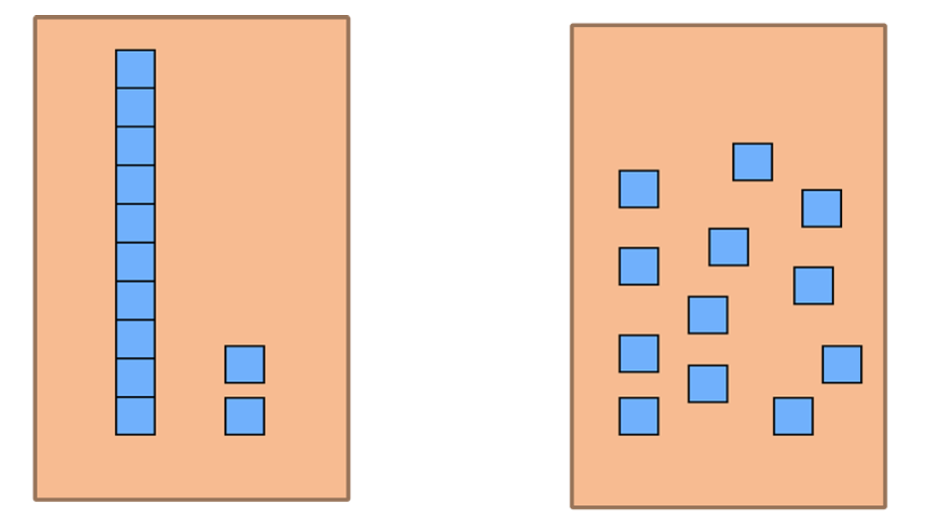

Resource 2: Renaming 43
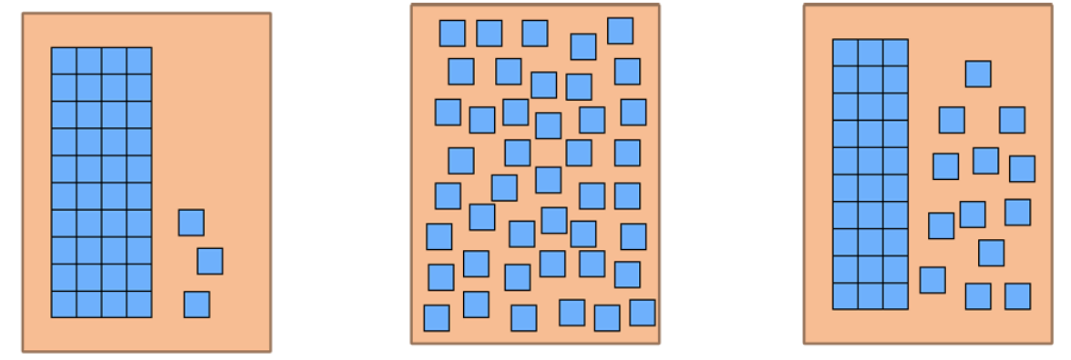

Resource 3: Sorting cards
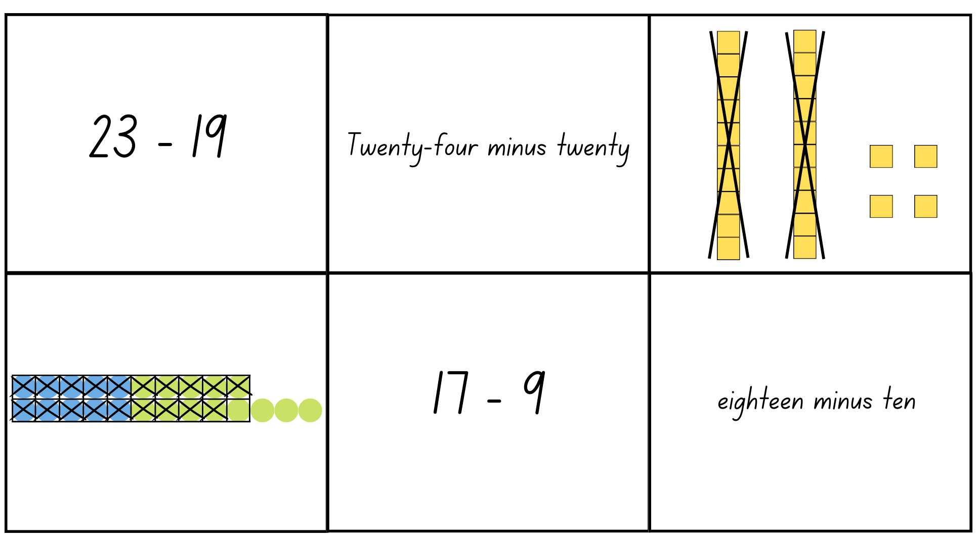
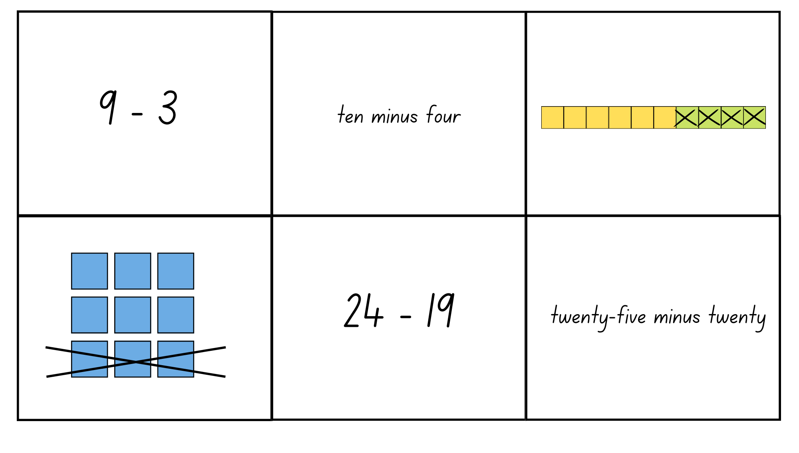
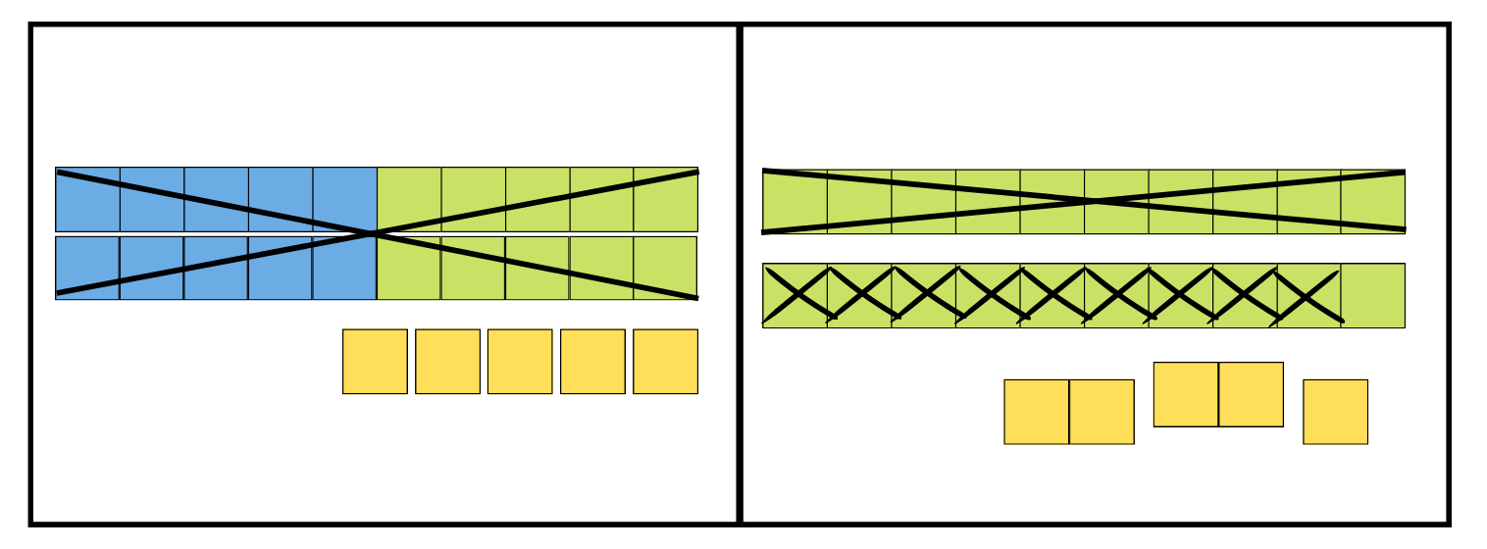
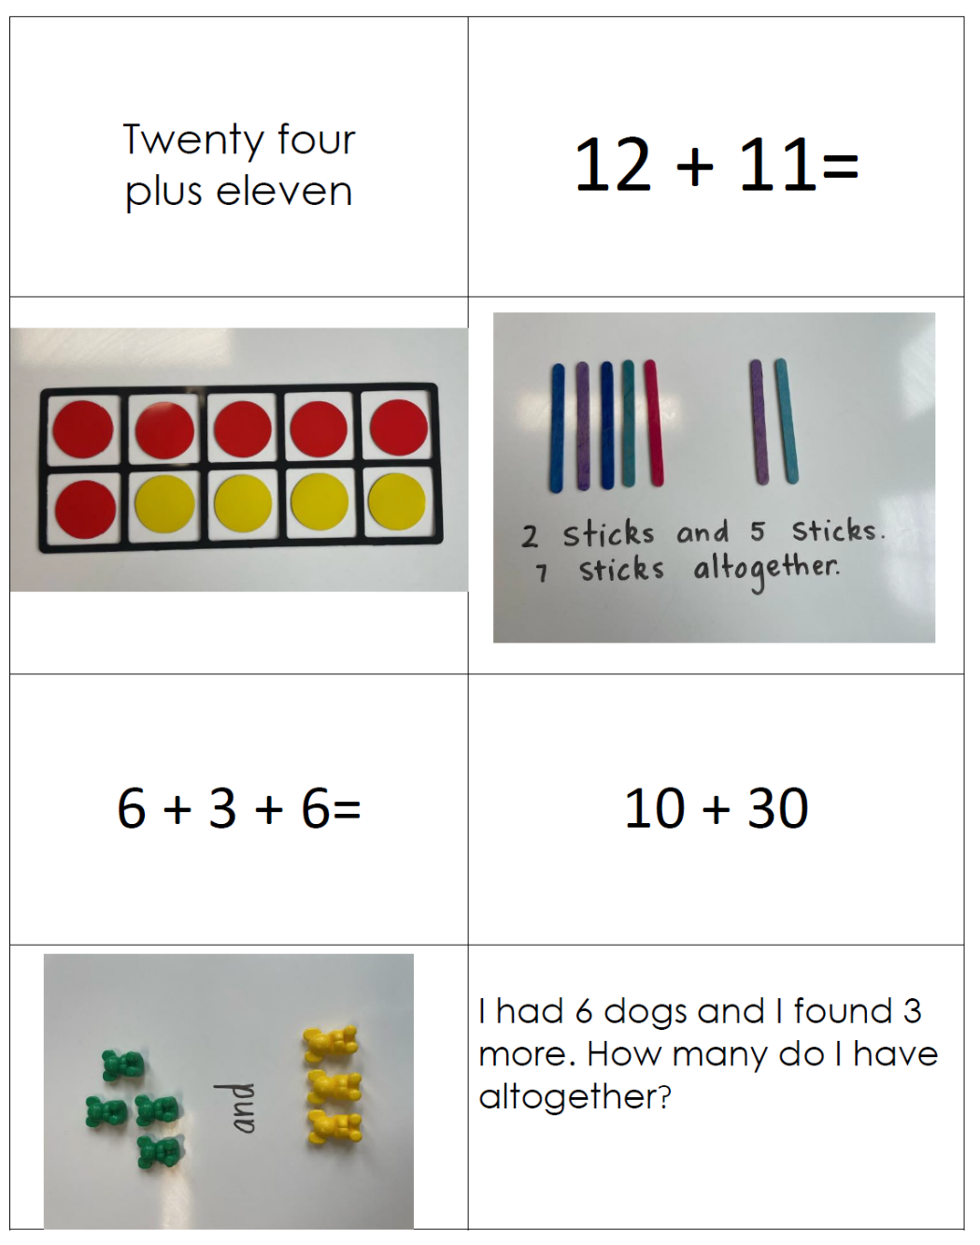

Resource 4: Number chart
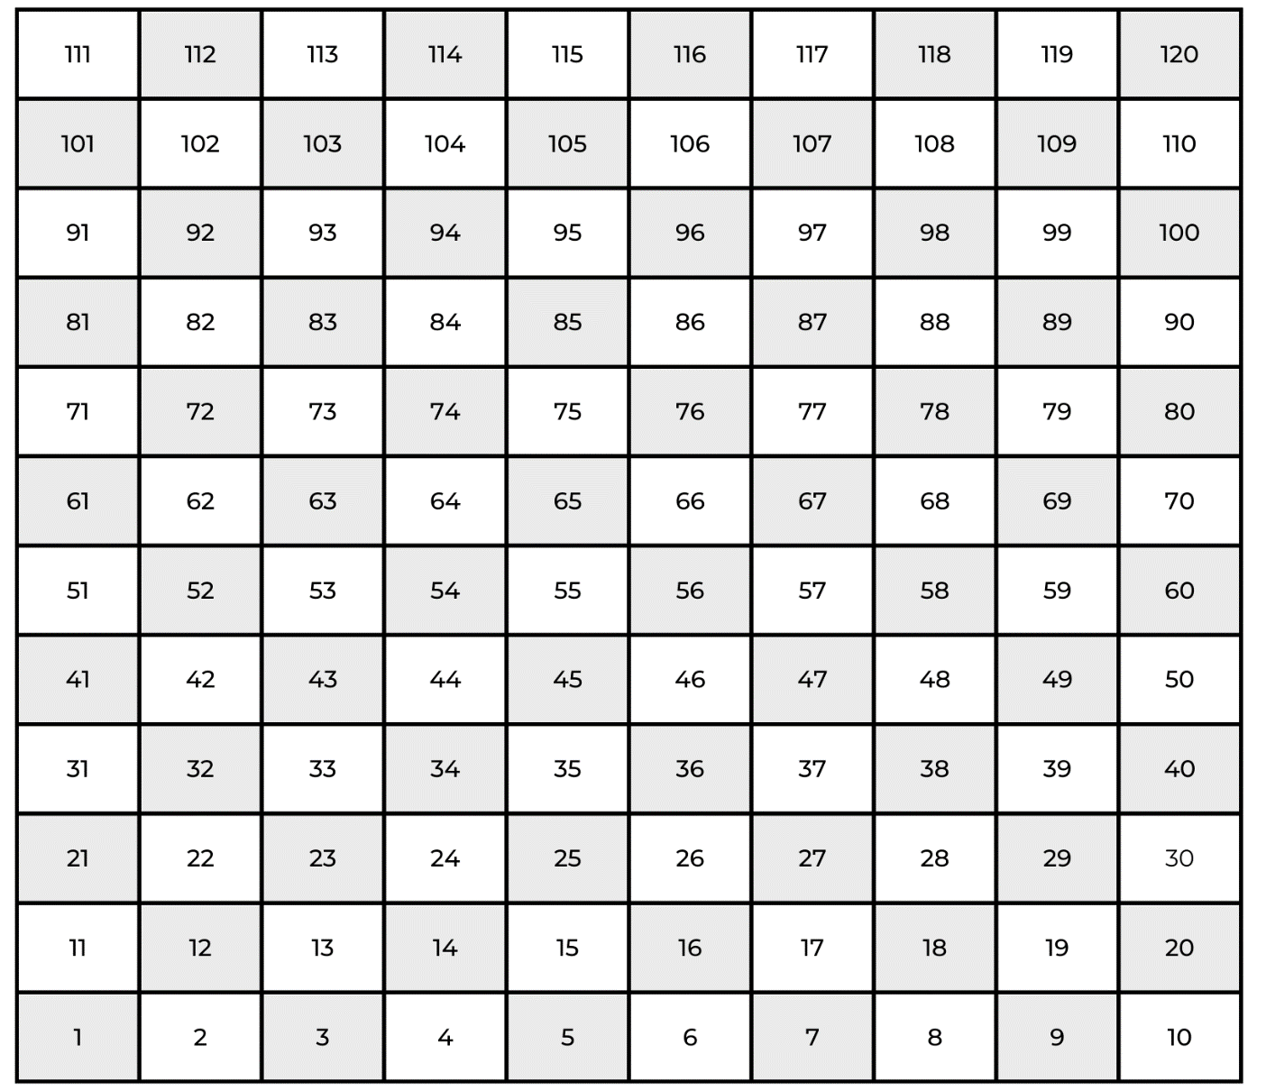

Resource 5: 20 to 70 spinner
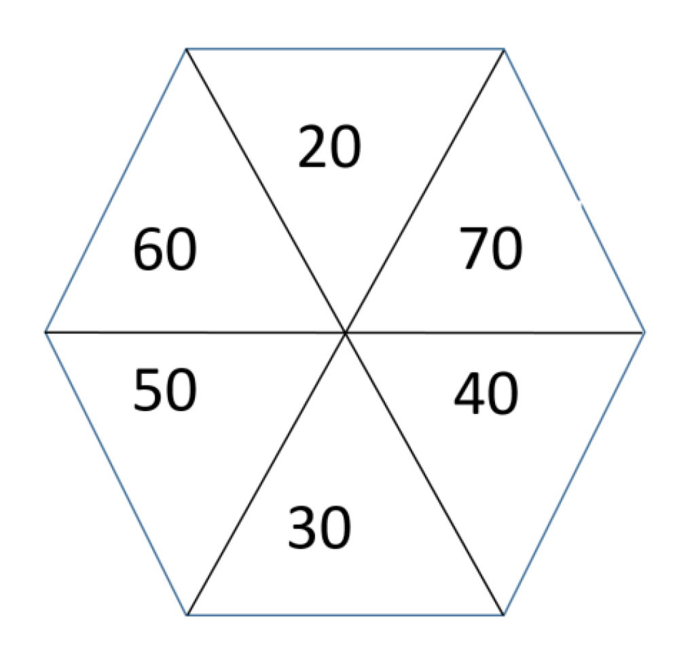

Resource 6: 0 to 9 spinner
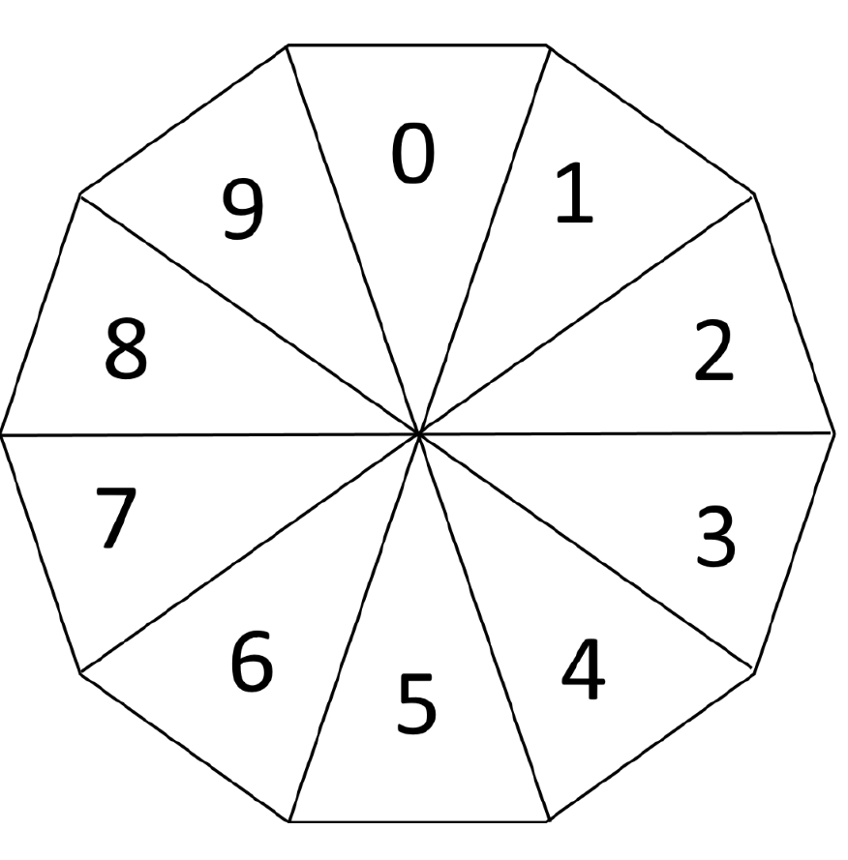

Resource 7: Dot cards
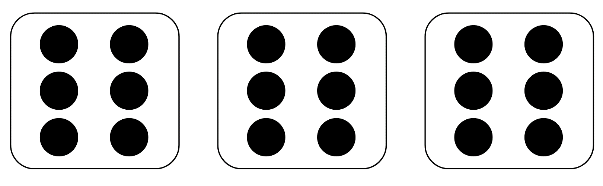

Resource 8: Fruit shop 1
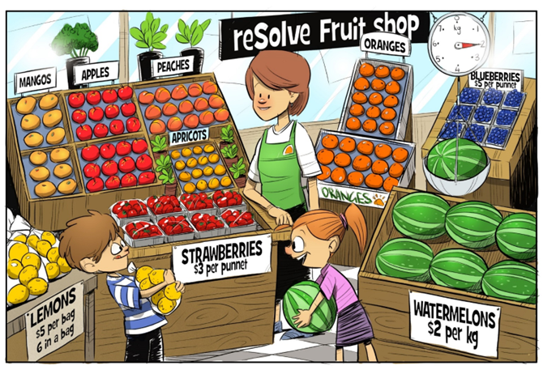
‘reSolve Fruit Shop: 1a reSolve Fruit Shop’ by © Australian Government Department of Education 2022 is licensed under CC BY-SA 4.0

Resource 9: Fruit shop 2
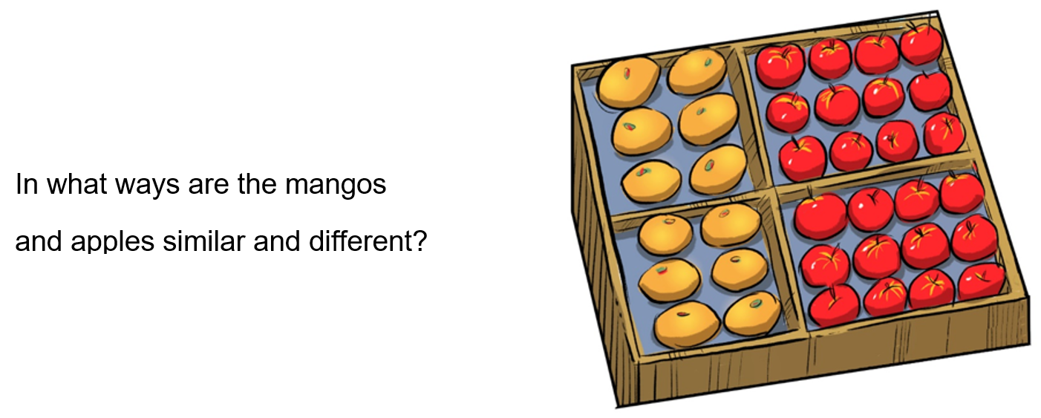
‘reSolve Fruit Shop: 1a reSolve Fruit Shop’ by © Australian Government Department of Education 2022 is licensed under CC BY-SA 4.0

Resource 10: Fruit shop 3
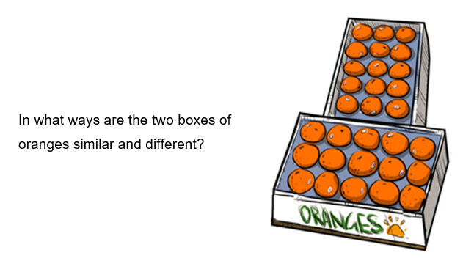
‘reSolve Fruit Shop: 1a reSolve Fruit Shop’ by © Australian Government Department of Education 2022 is licensed under CC BY-SA 4.0

Resource 11: Fruit shop 4
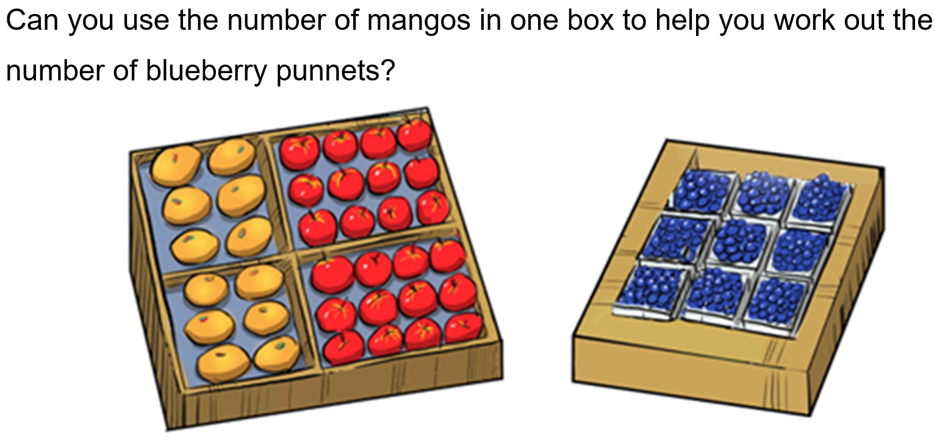
‘reSolve Fruit Shop: 1a reSolve Fruit Shop’ by © Australian Government Department of Education 2022 is licensed under CC BY-SA 4.0

Resource 12: Fruit shop 5
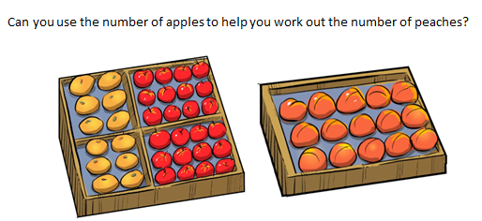
‘reSolve Fruit Shop: 1a reSolve Fruit Shop’ by © Australian Government Department of Education 2022 is licensed under CC BY-SA 4.0

Resource 13: Array bingo cards
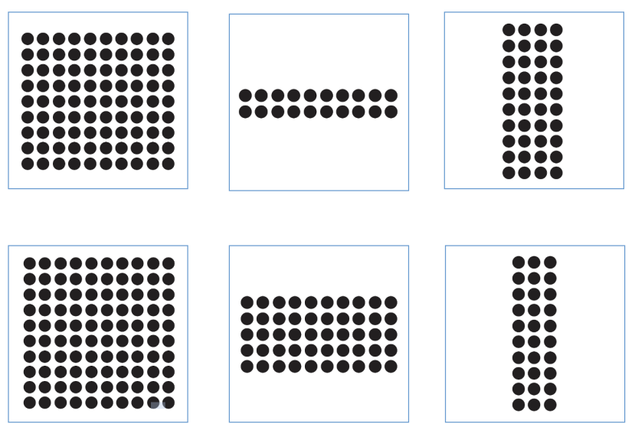
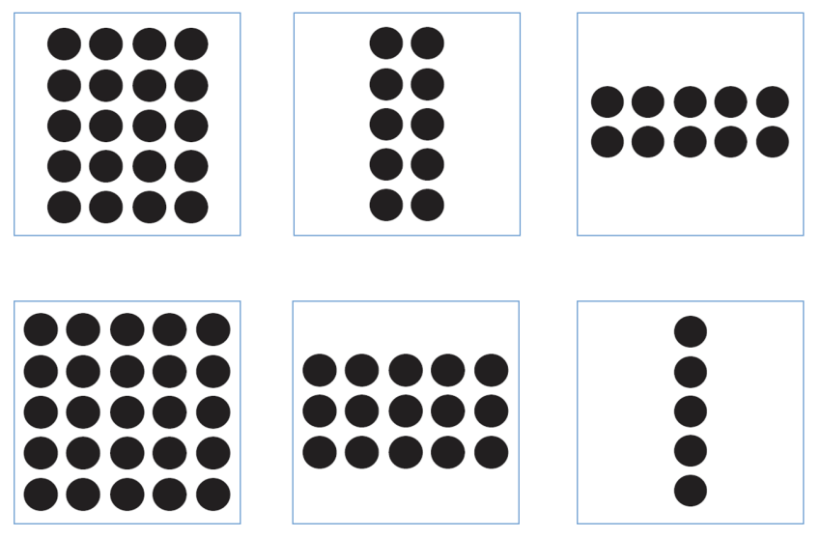
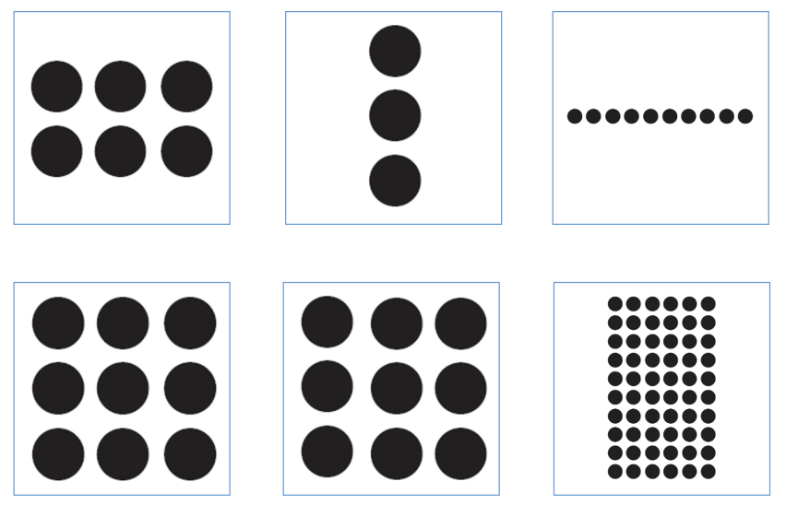
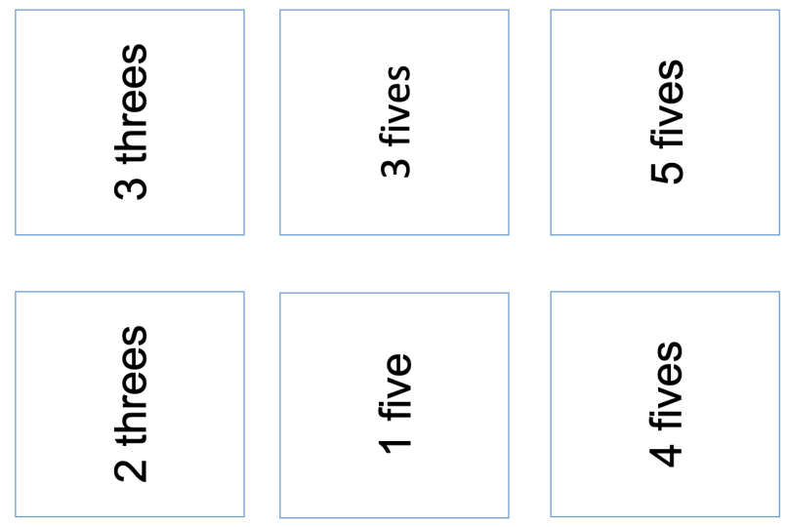
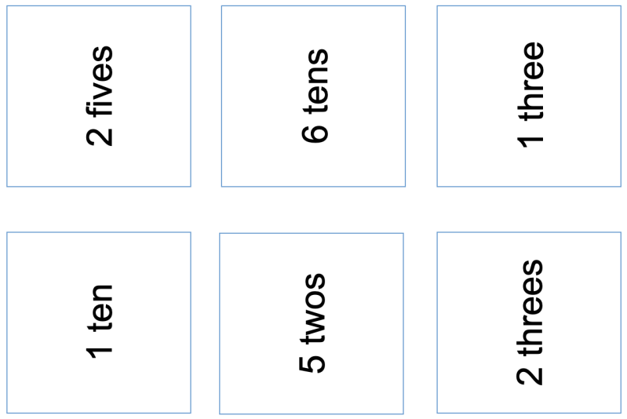
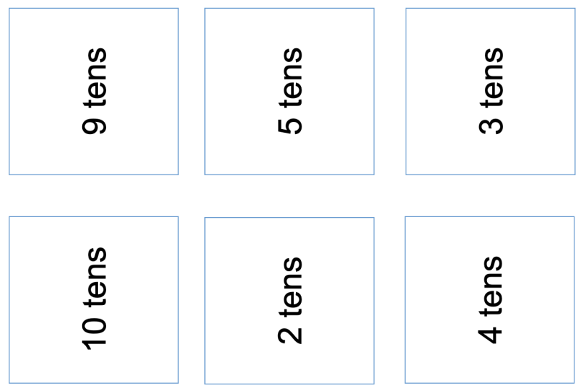

Resource 14: Recording table
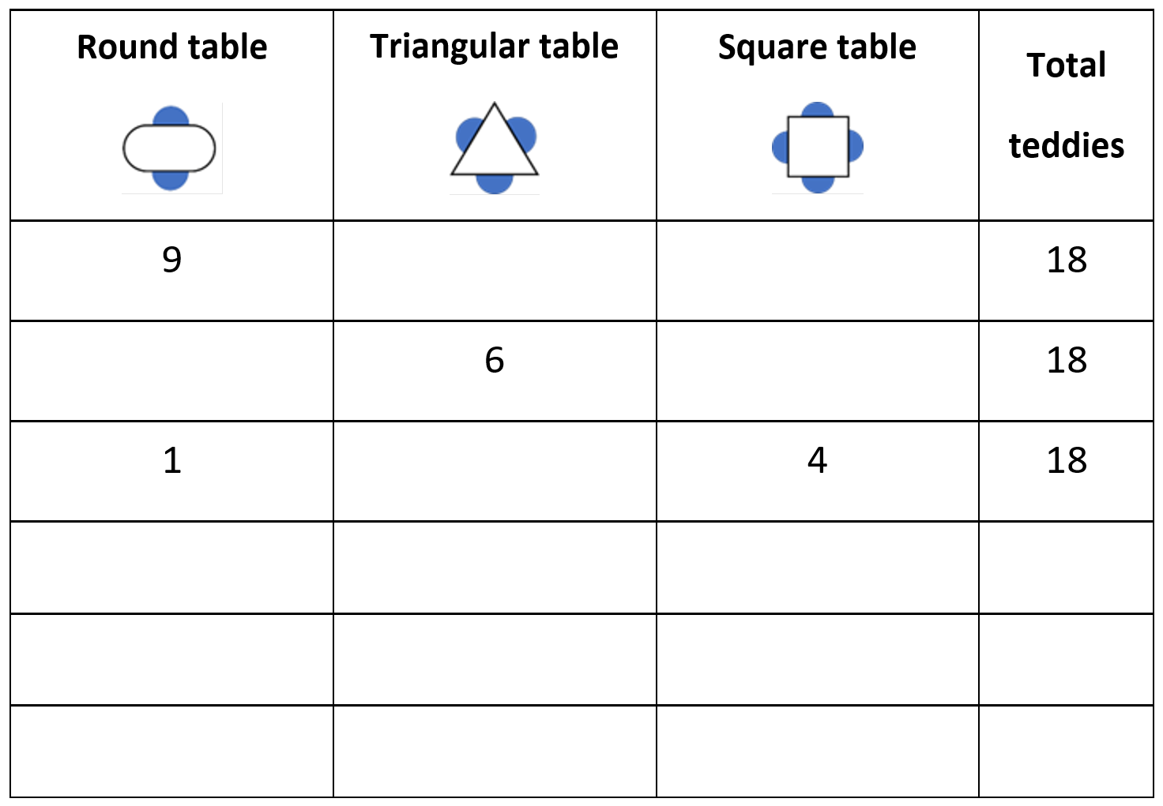

Syllabus outcomes and content
The table below outlines the syllabus outcomes and range of relevant syllabus content covered in this unit. Content is linked to National Numeracy Learning Progression version (3).
Focus area and outcomes | Content groups and content points | Lessons
Representing whole numbers  MAO-WM-01  MA1-RWN-01  MA1-RWN-02 | Use counting sequences of ones with two-digit numbers and beyond  - identify the number before and after a given two-digit number (CPr5)  - count forwards and backwards by ones from a given number to at least 120 (CPr6)  Represent the structure of groups of ten in whole numbers  - recognise that ten ones is the same as one ten (NPV2, NPV4)  - use 10 as a reference in forming numbers from 11 to 20 (CPr7)  - count large sets of objects by systematically grouping in tens (CPr7)  - partition two-digit numbers to show quantity values (NPV4)  - use number lines and number charts to assist with locating the nearest ten to a number  - estimate, to the nearest ten, the number of objects in a collection and check by counting in groups of ten (Reasons about quantity) (CPr7, NPV6)  Use counting sequences of ones and tens flexibly  - identify the number before and after a given three-digit number  - count forwards and backwards by tens, on and off the decade, with two- and three-digit numbers (CPr7)  - identify how many more to the next multiple of ten within two- and three-digit numbers (AdS7)  Form, regroup, and rename three-digit numbers  - count and represent large sets of objects by systematically grouping in tens and hundreds  - use models such as base 10 material and interlocking cubes to represent and explain grouping  - state the quantity value of digits in numbers of up to three digits (Reasons about quantity)  - identify the nearest hundred to a number  - recognise units of 100  - use place value to partition and rename three-digit numbers in different ways (Reasons about relations)  - estimate, to the nearest hundred, the number of objects in a collection and check by grouping and counting | 1–3
Combining and separating quantities  MAO-WM-01  MA1-CSQ-01 | Use advanced count-by-one strategies to solve addition and subtraction problems  - apply the terms ‘add’, ‘plus’, ‘equals’, ‘is equal to’, ‘is the same as’, ‘take away’, ‘minus’ and ‘the difference between’ to describe combining and separating quantities (AdS1, AdS6)  - recognise and use the symbols for plus (+), minus (–) and equals (=)  - record number sentences in a variety of ways using drawings, words, numerals and symbols (AdS6)  - fluently use advanced count-by-one strategies including counting on and counting back to solve addition and subtraction problems involving one- and two-digit numbers (Reasons about relations) (AdS3, AdS4, AdS5)  Use flexible strategies to solve addition and subtraction problems  - use non-count-by-one strategies such as using doubles for near doubles and combining numbers that add to ten (AdS6)  - represent addition and subtraction using structured materials such as a bead string or similar model (AdS6, AdS7)  - select and apply strategies using number bonds to solve addition and subtraction problems with one- and two-digit numbers by partitioning numbers using quantity value and bridging to 10 (Reasons about relations) (AdS6, AdS7)  Represent equality  - use the equals sign to record equivalent number sentences involving addition, and to mean 'is the same as', rather than as an indication to perform an operation (Reasons about relations) (NPA3)  - model the commutative property for addition and apply it to aid the recall of addition facts (Reasons about relations) (AdS7)  - recall related addition and subtraction facts for numbers to at least 10 (Reasons about relations) (AdS6)  Represent and reason about additive relations  - create, record and recognise combinations of two numbers that add to numbers from 11 up to and including 20 (AdS7)  - create, model and solve word problems, using number sentences  - represent the difference between two numbers using concrete materials and diagrams (AdS6)  - represent a constant difference between pairs of numbers  - model how addition and subtraction are inverse operations using concrete materials, drawings and diagrams (AdS7)  - recall and use related addition and subtraction number facts to at least 20 (AdS7)  Use knowledge of equality to solve related problems  - use number bonds to determine a missing number (AdS6, NPA3, NPA4)  - use number knowledge to solve related problems (Reasons about relations) (AdS7, NPA4)  - use a variety of ways of writing number sentences (NPA3, NPA4)  - use number bonds to solve equality problems (NPA3, NPA4) | 1–4
Forming groups  MAO-WM-01  MA1-FG-01 | Count in multiples using rhythmic and skip counting  - count by twos, threes, fives and tens using rhythmic counting and skip counting (MuS2, CPr6)  Model and use equal groups of objects to represent multiplication  - model and describe collections of objects as groups of (MuS2)  - determine and distinguish between the number of groups and the number in each group when describing collections of objects (Reasons about relations)  - find the total number of objects using skip counting of equal groups of a known size (MuS2, MuS3)  Recognise and represent division  - use concrete materials to model a half of a collection and show the relation between the half and the whole (InF1)  - model sharing division by distributing a collection of objects equally into a given number of groups to determine how many in each group (InF2, MuS5)  - model grouping division by determining the number of groups of a given size that can be formed (MuS5)  - describe the part left over when a collection cannot be distributed equally using the given group size (MuS6)  Represent and explain multiplication as the combining of equal groups  - use objects, diagrams, images or actions to model multiplication as accumulating equal groups (MuS4)  - solve multiplication problems using repeated addition (MuS4)  - form arrays of equal rows and equal columns (MuS5)  - determine and distinguish between the number of rows/columns and the number in each row/column when describing collections of objects (MuS5)  - model the commutative property of multiplication, using an array (Reasons about relations) (MuS6)  - model division by deconstructing an array equally into a given number of rows or columns  Represent multiplication and division problems  - solve multiplication and division problems using objects, diagrams, images and actions (MuS6, MuS7)  - record answers to multiplication and division problems (including those with remainders) using drawings, words and numerals (MuS6) | 5–8

References
Links to third-party material and websites
Please note that the provided (reading/viewing material/list/links/texts) are a suggestion only and implies no endorsement, by the New South Wales Department of Education, of any author, publisher, or book title. School principals and teachers are best placed to assess the suitability of resources that would complement the curriculum and reflect the needs and interests of their students.
If you use the links provided in this document to access a third-party's website, you acknowledge that the terms of use, including licence terms set out on the third-party's website apply to the use which may be made of the materials on that third-party website or where permitted by the Copyright Act 1968 (Cth). The department accepts no responsibility for content on third-party websites.
Except as otherwise noted, all material is © State of New South Wales (Department of Education), 2023 and licensed under the Creative Commons Attribution 4.0 International License. All other material (third-party material) is used with permission or under licence. Where the copyright owner of third-party material has not licensed their material under a Creative Commons or similar licence, you should contact them directly for permission to reuse their material.
Mathematics K–10 Syllabus © 2022 NSW Education Standards Authority (NESA) for and on behalf of the Crown in right of the State of New South Wales.
© 2022 NSW Education Standards Authority. This document contains NSW Curriculum and syllabus content. The NSW Curriculum is developed by the NSW Education Standards Authority. This content is prepared by NESA for and on behalf of the Crown in right of the State of New South Wales. The material is protected by Crown copyright.
Please refer to the NESA Copyright Disclaimer for more information.
NESA holds the only official and up-to-date versions of the NSW Curriculum and syllabus documents. Please visit the NSW Education Standards Authority (NESA) website and the NSW Curriculum website.
National Numeracy Learning Progression © Australian Curriculum, Assessment and Reporting Authority (ACARA) 2010 to present, unless otherwise indicated. This material was downloaded from the Australian Curriculum website (National Numeracy Learning Progression) (accessed 16 September 2022) and was not modified. The material is licensed under CC BY 4.0. Version updates are tracked in the ‘Curriculum version history’ section on the 'About the Australian Curriculum' page of the Australian Curriculum website.
ACARA does not endorse any product that uses the Australian Curriculum or make any representations as to the quality of such products. Any product that uses material published on this website should not be taken to be affiliated with ACARA or have the sponsorship or approval of ACARA. It is up to each person to make their own assessment of the product, taking into account matters including, but not limited to, the version number and the degree to which the materials align with the content descriptions and achievement standards (where relevant). Where there is a claim of alignment, it is important to check that the materials align with the content descriptions and achievement standards (endorsed by all education Ministers), not the elaborations (examples provided by ACARA).
This resource contains images and content obtained from Canva, and their use outside of this resource is subject to Canva’s Content License Agreement. If you wish to use them separately from the resource, please go to Canva.
Australian Government Department of Education, Skills and Employment (2022) 'Multiplication: reSolve Fruit Shop', Teaching resources, reSolve website, accessed 16 September 2022.
State of Victoria (Department of Education and Training) (2018) ‘Modelling through think alouds’, Literacy Teaching Toolkit, State of Victoria (Department of Education and Training) website, accessed 16 September 2022.
University of Cambridge (Faculty of Mathematics) (n.d.) Let Us Divide!, NRICH website, accessed 16 September 2022.

