Mathematics – K-2 multi-age – Year B – Unit 19
Contents
Unit description and duration 4
Student prior learning 4
Lesson overview and resources 5
Lesson 1: Inspecting 3D objects 14
Daily number sense: Missing numbers – 10 minutes 15
Shapes and objects – 35 minutes 17
Consolidation and meaningful practice: Feature sort – 15 minutes 22
Lesson 2: Different points of view 24
Daily number sense: Number patterns – 10 minutes 25
Different points of view – 35 minutes 28
Consolidation and meaningful practice: Secret object – 15 minutes 31
Lesson 3: Making objects 32
Daily number sense: Handfuls (Early Stage 1) – 15 minutes 33
Daily number sense: Jarfuls (Stage 1) – 15 minutes 34
3D models – 35 minutes 37
Consolidation and meaningful practice: My models – 10 minutes 40
Lesson 4: Different objects, same volume 42
Daily number sense: Teacher choice – 10 minutes 43
Cube challenge – 35 minutes 43
Discuss and connect the mathematics – 10 minutes 46
Lesson 5: Comparing models 48
Daily number sense: Facts about numbers – 10 minutes 49
Making block models – 40 minutes 51
Consolidation and meaningful practice: What does it look like? – 10 minutes 53
Lesson 6: Packing in layers 54
Daily number sense: Jellybean challenge – 15 minutes 54
Packing and stacking: Part 1 – 15 minutes 58
Packing and stacking: Part 2 – 35 minutes 61
Consolidation and meaningful practice: Real life packing and stacking – 10 minutes 63
Lesson 7: Filling and pouring 64
Daily number sense: A lot of bricks – 10 minutes 65
Measuring and comparing – 45 minutes 68
Discuss and connect the mathematics – 10 minutes 75
Lesson 8: Investigating prisms and cubes 76
Daily number sense: Teacher choice – 10 minutes 77
Features of prisms and cubes: Part 1 – 25 minutes 77
Internal volume of prisms and cubes: Part 2 – 25 minutes 79
Discuss and connect the mathematics – 5 minutes 82
Resource 1: 2D Shapes and 3D Objects 83
Resource 2: 2D Shapes (Early Stage 1) 84
Resource 3: Object sort cards 85
Resource 4: Handfuls game 86
Resource 5: Making cubes 87
Resource 6: Pasta shapes 90
Resource 7: Different packaging 91
Resource 8: Facts about numbers (Set A and Set B) 92
Resource 9: Lots of spots 93
Resource 10: Jellybean challenge (Early Stage 1) 94
Resource 11: Jellybean challenge (Stage 1) 95
Resource 12: Cargo ships 96
Resource 13: A lot of bricks (Early Stage 1) 97
Resource 14: A lot of bricks (Stage 1) 98
Syllabus outcomes and content 99
References 110

Unit description and duration
This two-week unit develops student knowledge, understanding and skills with three-dimensional objects, volume and internal volume. Students are provided opportunities to:
- name, classify, compare and describe 2D shapes and 3D objects according to their features
- recognise that flat surfaces of 3D objects can be named as 2D shapes
- see how 3D objects can look different depending on student point of view
- measure and compare internal volume using uniform informal units, with no gaps or spaces to measure volume
- measure and compare volume of various 3D objects.
Mathematics K–10 Syllabus © 2022 NSW Education Standards Authority (NESA) for and on behalf of the Crown in right of the State of New South Wales.

Student prior learning
Before engaging in these teaching and learning activities, students would benefit from prior experience with:
- manipulating, exploring, sorting, drawing and naming common 2D shapes and 3D objects
- using informal and mathematical vocabulary to describe and name various shapes and objects
- filling, packing and stacking various shaped containers and objects
- opportunities to use concrete materials to construct and deconstruct shapes and objects.

Lesson overview and resources
The table below outlines the sequence and approximate timing of lessons; syllabus focus areas and content groups; and resources.
Lesson | Syllabus focus area and content groups | Resources
Lesson 1: Inspecting 3D objects  60 minutes  3D objects have features that can be used to describe, identify and sort them. | Representing whole numbers  Early Stage 1  - Use the counting sequence of ones flexibly  Stage 1 – Part A  - Represent numbers on a line  Stage 1 – Part B  - Use counting sequences of ones and tens flexibly  Two-dimensional spatial structure  Early Stage 1  - 2D shapes: Sort, describe and name familiar shapes  - 2D shapes: Represent shapes  Stage 1 – Part A  - 2D shapes: Recognise and classify shapes using obvious features  Three-dimensional spatial structure  Early Stage 1  - 3D objects: Explore familiar three-dimensional objects  Stage 1 – Part A  - 3D objects: Recognise familiar three-dimensional objects  - 3D objects: Sort and describe three-dimensional objects  Stage 1 – Part B  - 3D objects: Describe the features of three-dimensional objects | - Resource 1: 2D shapes and 3D objects  - Resource 2: 2D Shapes (Early Stage 1)  - Resource 3: Object sort cards  - Empty number line  - Geoboards or digital boards  - Kinetic sand  - Modelling clay  - Writing materials
Lesson 2: Different points of view  60 minutes  The faces students see on a 3D object can change depending on their point of view. | Representing whole numbers  Early Stage 1  - Use the counting sequence of ones flexibly  Stage 1 – Part A  - Represent numbers on a line  Stage 1 – Part B  - Use counting sequences of ones and tens flexibly  Two-dimensional spatial structure  Early Stage 1  - 2D shapes: Sort, describe and name familiar shapes  - 2D shapes: Represent shapes  Stage 1 – Part A  - 2D shapes: Recognise and classify shapes using obvious features  Three-dimensional spatial structure  Early Stage 1  - 3D objects: Explore familiar three-dimensional objects  Stage 1 – Part B  - 3D objects: Describe the features of three-dimensional objects | - Resource 1: 2D shapes and 3D objects  - Common 3D objects  - Interlocking cubes  - Large die  - Square notes  - Writing materials or digital devices
Lesson 3: Making Objects  60 minutes  3D objects commonly have faces that are 2D shapes. | Representing whole numbers  Early Stage 1  - Connect counting and numerals to quantities  Stage 1 – Part B  - Form, regroup, and rename three-digit numbers  Three-dimensional spatial structure  Early Stage 1  - 3D objects: Explore familiar three-dimensional objects  Stage 1 – Part B  - 3D objects: Describe the features of three-dimensional objects | - Resource 4: Handfuls game  - Resource 5: Making cubes  - Resource 6: Pasta shapes  - Resource 7: Different packaging  - Digital marble jar or collections of uniform objects  - Colour pencils  - Coloured counters  - Modelling clay  - Real-life 3D objects  - Scissors  - Writing materials or digital devices
Lesson 4: Different objects, same volume  55 minutes  Objects that appear different may have the same volume. | Three-dimensional spatial structure  Early Stage 1  - Volume: Compare volume by building  Stage 1 – Part A  - Volume: Construct volumes using cubes  Stage 1 – Part B  - Volume: Compare volumes using uniform informal units | - Small cubes or interlocking cubes
Lesson 5: Comparing models  60 minutes  When comparing volume, it is helpful to visualise, construct and deconstruct 3D objects. | Representing whole numbers  Early Stage 1  - Use the counting sequence of ones flexibly  - Connect counting and numerals to quantities  Stage 1 – Part B  - Use counting sequences of ones and tens flexibly  - Form, regroup, and rename three-digit numbers  Three-dimensional spatial structure A  Early Stage 1  - Volume: Compare volume by building  Stage 1 – Part A  - Volume: Construct volumes using cubes  Stage 1 – Part B  - Volume: Compare volumes using uniform informal units | - Resource 8: Facts about numbers (Set A and Set B)  - Small cubes or interlocking cubes  - Writing materials  - Digital device
Lesson 6: Packing in layers  75 minutes  Internal volume can be explored by packing and stacking with no gaps. | Representing whole numbers  Early Stage 1  - Recognise number patterns  - Connect counting and numerals to quantities  Stage 1 – Part A  - Represent the structure of groups of ten in whole numbers  Stage 1 – Part B  - Use counting sequences of ones and tens flexibly  - Form, regroup, and rename three-digit numbers  Three-dimensional spatial structure  Early Stage 1  - Volume: Compare internal volume by filling and packing  Stage 1 – Part A  - Volume: Measure the internal volume (capacity) of containers by packing  Stage 1 – Part B  - Volume: Compare containers based on internal volume (capacity) by filling and packing | - Resource 9: Lots of spots  - Resource 10: Jellybean challenge (Early Stage 1)  - Resource 11: Jellybean challenge (Stage 1)  - Resource 12: Cargo ships  - Jar or container filled with jellybeans  - MAB materials  - Digital device  - Writing materials  - Concrete materials  - Mathigon
Lesson 7: Filling and pouring  65 minutes  Containers can look different but can have the same internal volume (capacity). | Representing whole numbers  Early Stage 1  - Instantly name the number of objects within small collections  - Connect counting and numerals to quantities  Stage 1 – Part A  - Represent the structure of groups of ten in whole numbers  Stage 1 – Part B  - Form, regroup, and rename three-digit numbers  Three-dimensional spatial structure  Early Stage 1  - Volume: Compare internal volume by filling and packing  Stage 1 – Part A  - Volume: Measure and compare the internal volumes (capacities) of containers by filling  Stage 1 – Part B  - Volume: Compare containers based on internal volume (capacity) by filling and packing | - Resource 13: A lot of bricks (Early Stage 1)  - Resource 14: A lot of bricks (Stage 1)  - Mathigon or MAB materials  - Various containers  - Filling material, such as rice or sand or bird seed  - Plastic cups  - Permanent markers  - Small measuring containers, such as egg cup  - Writing materials  - Digital device
Lesson 8: Investigating prisms and cubes  65 minutes  The features of an object can affect the internal volume. | Two-dimensional spatial structure  Early Stage 1  - 2D shapes: Sort, describe and name familiar shapes  - 2D shapes: Represent shapes  Stage 1 – Part A  - 2D shapes: Recognise and classify shapes using obvious features  Three-dimensional spatial structure  Early Stage 1  - Volume: Compare internal volume by filling and packing  Stage 1 – Part A  - 3D objects: Sort and describe three-dimensional objects  - Volume: Measure and compare the internal volumes (capacities) of containers by filling  Stage 1 – Part B  - 3D objects: Describe the features of three-dimensional objects  - Volume: Compare containers based on internal volume (capacity) by filling and packing | - Various boxes  - Filling material, such as rice or sand or bird seed  - Modelling clay or wool  - Permanent markers  - Writing materials  - Digital device  - Calibrated measuring device or plastic cups from Lesson 7.

Lesson 1: Inspecting 3D objects
Core concept: 3D objects have features that can be used to describe, identify and sort them.
The table below contains suggested learning intentions and success criteria. These are best co-constructed with students.
Learning intentions | Success criteria
All students are learning that:  - two-dimensional shapes can be described, named and represented using their features  - specific vocabulary is used to name and describe the features of three-dimensional objects  - naming and recognising two-dimensional shapes helps with identifying the faces of three-dimensional objects. | All students can:  - use patterns in number sequences to identify missing numbers  - identify and describe familiar shapes in a range of contexts.  In addition, students working towards Early Stage 1 outcomes can make, name and describe two-dimensional shapes by tracing the faces of three-dimensional objects.  In addition, students working towards Stage 1 outcomes can:  - recognise and name familiar two-dimensional shapes and three-dimensional objects  - describe the features of three-dimensional objects, including using two-dimensional shapes to describe faces  - sort three-dimensional objects based on features and justify the sort.

Daily number sense: Missing numbers – 10 minutes
- Build student understanding of counting patterns by representing numbers in a sequence.
- Draw an empty number line (see Figure 1).
Figure 1 – Number line
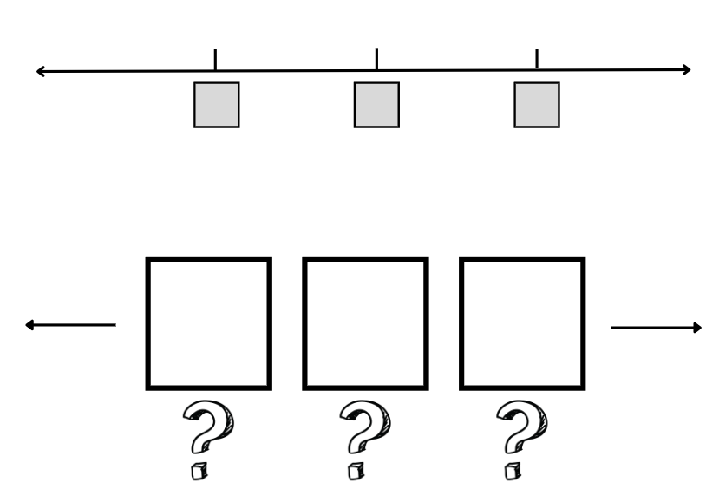
Images sourced from Canva and used in accordance with the Canva Content License Agreement.
- Ask Early Stage 1 students to think about what numbers could be in the boxes if counting by ones.
Note: Remind Early Stage 1 students the order of the numbers doesn’t change on the number line even when counting backwards.
- Ask Stage 1 students to think about what numbers could be in the boxes if they were in multiples of 10.
- Students turn and talk and share ideas about what the missing numbers might be, for example, 4, 5, 6 …; 19, 20, 21...; 10, 20, 30...; or 42, 52, 62.
- Select students to share their responses and annotate on the empty number line.
- Share examples where Early Stage 1 students bridge the teen numbers, or from the twenties to the thirties. Also share examples where Stage 1 students are required to bridge across hundreds, for example ‘182, 192, 202…’. Some students may be ready to bridge across 1000.
This table details assessment opportunities and differentiation ideas.
Assessment opportunities | Too hard? | Too easy?
What to look for:  - Do Early Stage 1 students fluently count forwards and backwards by ones? (MAO-WM-01, MAE-RWN-02)  - Can Early Stage 1 students identify and name the ‘teen’ numbers? (MAE-RWN-01)  - Can Stage 1 students count forwards and backwards by tens, on and off the decade, with two- and three-digit numbers? (MAO-WM-01, MA1-RWN-01)  What to collect:  - observations of student use of patterns when counting (MA1-RWN-01). | Students are not able to identify 3 missing numbers in a sequence.  - Display number cards zero to 10 and then conceal one number card. Students identify the missing number in the sequence. Increase the range concealed as needed.  - Provide a number track for the range zero to 20 and cover up to 3 of the numerals. Students use the counting sequence to identify the covered numerals.  Students are not able to count by 10 on and off the decade.  - Provide numeral cards for the tens from 10 to 100. Ask students to arrange the cards in the correct order and rehearse the counting pattern forwards and backwards.  - Provide students with a number chart to 120. Students roll a 10-sided die to choose a starting number, then use counters to mark each additional 10, saying the pattern aloud forwards and backwards. | Students can count by 10 on and off the decade.  - Students identify missing numbers if they were counting in multiples of 100, for example, 200, 300, 400... or 457, 657, 757...  - Students identify missing numbers if they were counting in multiples of 100 and 10, for example, 120, 230, 340...

Shapes and objects – 35 minutes
- Explain that students will be investigating 2D shapes and 3D objects. Share the definitions, using an example of each.
Two-dimensional: Having length and width only (with no depth).
Three-dimensional: Having length, width and depth.
- Brainstorm what 2D shape and 3D object names students already know. Record on an anchor chart for future reference.
- Display Resource 1: 2D shapes and 3D objects. Select students to match names from the class anchor chart to the images on Resource 1. Note shapes or objects that are not known.
- Display a large cube, for example, a large die. Select a student to match the object to the image on Resource 1. Use everyday language to describe the die, including colour and the material it is made of.
- Explain that mathematicians have specific words that they use to describe the features of 3D objects. Share the following definitions for Stage 1 students:
Face: A flat surface of a 3D object with only straight edges.
Edge: The line segment formed where 2 faces of a 3D object meet.
Vertex: The point where 3 or more faces of a 3D object meet.
- Model identifying the faces, edges and vertices on the cube. If necessary, model with other objects.
- Draw attention to the square faces on the large die. Explain that many 3D objects have 2D shapes on their faces. Refer again to Resource 1: 2D shapes and 3D objects. Students turn and talk to identify 2D shapes on the faces of 3D objects.
- Model tracing the faces of the die or representing the faces of the die on a geoboard, such as Figure 2.
Figure 2 – Faces on 3D objects
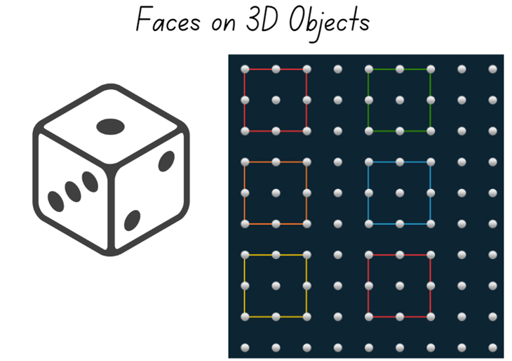
Images sourced from Canva and used in accordance with the Canva Content License Agreement.
Note: There is no need to trace in a systematic or ordered way, such as when creating a net.
- Ask:
- What 2D shapes can you see and name?
- How can you keep track of all the faces on the object?
- How can you check that you have represented all faces on the object?
- Provide a broad collection of real-life 3D objects for students to explore. Students identify and represent the objects’ faces either by tracing or on geoboards. If using geoboards, students should use physical boards, if available, or digital boards, if not. Students may also ‘print’ the faces of objects into modelling clay or kinetic sand.
- While students are recording faces, use the prompts in the table below.
Prompts | Anticipated student responses
Early Stage 1  - What shapes can you see?  - How do you know that is a circle/square/triangle/rectangle?  - Show me a shape that is not a circle/square/triangle/rectangle. How can you be sure?  - How would you explain the difference between... (select 2 shapes)?  - Can you name a real-life item that is this shape? Can you find an item in the classroom that is this shape?  Stage 1  - Can you name this 3D object?  - Can you describe this 3D object using the terms ‘face’, ‘edge’ and ‘vertex’?  - How do you know that you have counted all the faces, edges and vertices?  - Show me an object that is not a sphere/prism/cube/cylinder? Explain why.  - How would you explain the difference between the features of… (select two 3D objects)? | Early Stage 1  - I can see a circle/square/triangle/rectangle.  - Circle: it is round, it has no straight sides, it is a closed shape.  - Triangle: it has 3 straight sides; it is a closed shape.  - Square: it has 4 straight sides that are all the same length, it is a closed shape.  - Rectangle: it has 4 straight sides; opposite sides are the same length, for example, 2 short sides, 2 longer sides.  Stage 1  - It is a sphere/prism/cube/cylinder.  - For example, this object has 6 faces, 12 edges and 8 vertices.  - ‘I tap them as I count’ or ‘I mark them as I count’ or ‘I visualise the object in my head as I count’.  - Using the terms ‘face’, ‘edge’ and ‘vertex’, students explain that the object does not have the relevant features.
- Share students’ representations of 2D shapes, emphasising the link between the 2D shapes and the faces on 3D objects.
This table details assessment opportunities and differentiation ideas.
Assessment opportunities | Too hard? | Too easy?
What to look for:  - Do Early Stage 1 students trace, identify and describe circles, squares, triangles and rectangles? (MAE-2DS-01)  - Are Stage 1 students able to identify and name the 2D faces of 3D objects? (MA1-2DS-01, MA1-3DS-01)  - Do Stage 1 students describe objects using the terms ‘face’, ‘edge’ and ‘vertex’? (MA1-3DS-01)  What to collect:  - student drawings or photographs of 2D shapes (MAE-2DS-01, MA1-2DS-01, MAE-3DS-01, MA1-3DS-01). | Students are not able to trace and/or describe common 2D shapes.  - Guide students on how to trace or print and name the faces of one 3D object.  - Provide Resource 2: 2D Shapes (Early Stage 1) for students to compare the outline of their traces with circles, squares, triangles and rectangles.  Students are not able to identify and name 2D shapes or 3D objects.  - Provide labelled images of targeted 2D shapes and 3D objects for students to view and refer to.  - Provide selected 2D shapes and 3D objects. Support students on a 2D shape and 3D object ‘hunt’ in the classroom. | Students can identify and name 2D shapes and 3D objects.  - Introduce students to a wider range of objects to explore and record.  - Ask students to create repeating linear patterns with shapes, including two- and three-shape patterns.  - Ask students to write ‘Who am I?’ clues using vertices, edges and faces for use in Lesson 2.  - Create, make and name a new 3D object that has combined features of known 3D objects.

Consolidation and meaningful practice: Feature sort – 15 minutes
- Provide small groups of students with a range of 3D objects or pictures of 3D objects, for example, Resource 3: Object sort cards.
- Instruct groups to sort the objects into at least 2 groups based on their features (for example, faces, edges or vertices) and to explain the sort. Ask:
- Can you find an object in the class that belongs in one of your groups? Why does it belong?
- Can you find an object in the class that does not belong in any of your groups? Why does it not belong?
- Is there an object whose features you are wondering about?
- Instruct groups to sort their objects in a different way and explain the new sort.
- Students capture their sort on a digital device or draw it using writing materials and annotate the image to explain their sort.
This table details assessment opportunities and differentiation ideas.
Assessment opportunities | Too hard? | Too easy?
What to look for:  - Do Early Stage 1 students sort objects and identify the attribute used to sort them? (MAO-WM-01, MAE-3DS-01)  - Do Stage 1 students sort 3D objects based on their features and justify their decisions using ‘vertex’, ‘edge’ and/or ‘face’? (MAO-WM-01, MA1-3DS-01)  What to collect:  - digital image or drawing of object sort and student annotations (MAO-WM-01, MAE-3DS-01, MA1-3DS-01). | Students are not able to sort 3D objects.  - Provide 2 very different 3D objects. Ask students to identify the different features each object.  - Provide a simple sort using 4 objects with similar features. Give students a fifth object to add to the sort, explaining their choice. | Students can sort 3D objects.  - Challenge students to draw one of the selected objects from various points of view.  - Ask students to use a digital device and photograph 3 examples of 3D objects in the classroom that would belong in the same sort.

Lesson 2: Different points of view
Core concept: The faces students see on a 3D object can change depending on their point of view.
The table below contains suggested learning intentions and success criteria. These are best co-constructed with students.
Learning intentions | Success criteria
All students are learning that:  - specific vocabulary is used to name and describe the features of three-dimensional objects  - there are two-dimensional shapes on the faces of many three-dimensional objects.  In addition, Early Stage 1 are learning that using the features of three-dimensional objects is helpful when sorting.  In addition, Stage 1 students are learning that identifying how many vertices, edges and faces helps to name the three-dimensional object. | All students can:  - recognise and name a variety of two-dimensional shapes and three-dimensional objects from various points of view  - describe and sort three-dimensional objects based on their features and explain their decisions.  In addition, students working towards Early Stage 1 outcomes can name and order numbers to at least 20.  In addition, students working towards Stage 1 outcomes can:  - count forwards and backwards by tens, on and off the decade, with two- and three-digit numbers  - name the faces and identify the edges and vertices.

Daily number sense: Number patterns – 10 minutes
- Build student understanding of counting by representing number patterns.
- Ask Early Stage 1 students to orally count forwards and backwards to and from at least 20.
- Ask Stage 1 students to orally count forwards and backwards by 10, on and off the decade.
- Arrange some note squares in a line with some gaps, such as one of the arrangements in Figure 3. The dotted spaces may support students to understand that this is where the missing squares were.
Figure 3 – Unevenly distributed note squares
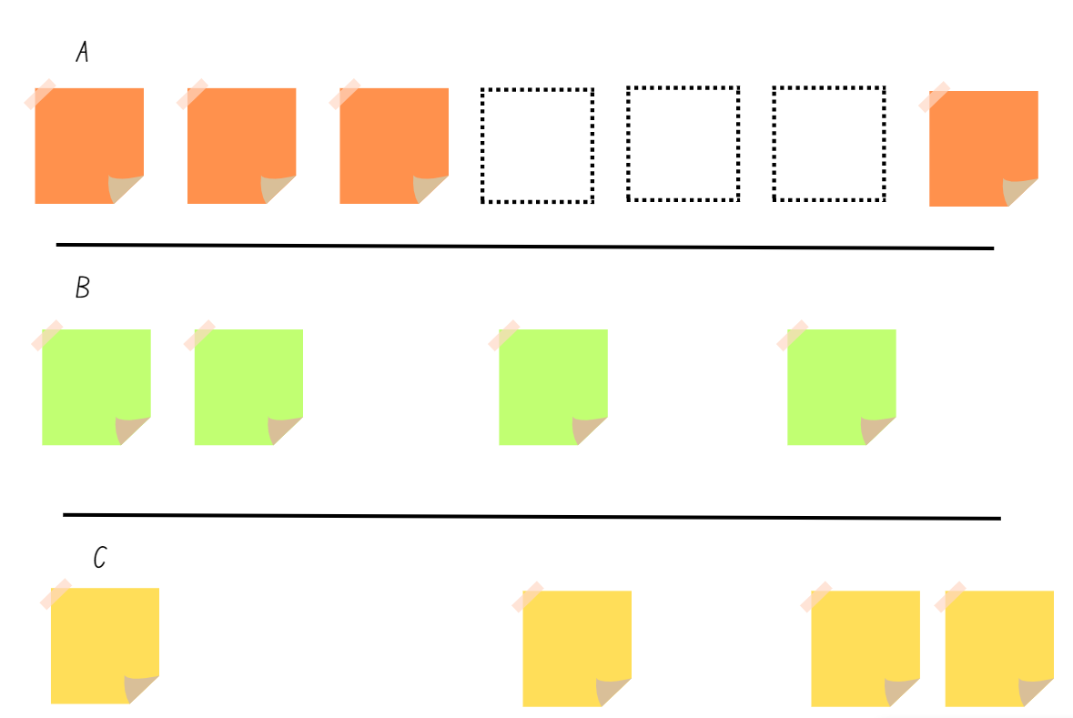
- Explain that you had prepared some note squares in a number pattern, but the wind blew some of them away. Ask the students what they notice and wonder.
- Ask Early Stage 1 students, questions such as:
- What numbers could be missing if the pattern started at zero and counting by ones?
- What numbers could be missing if students started counting at 10?
- What numbers could be missing if we knew the pattern ended at 15?
- What numbers could be missing if the middle square was 9?
- Ask Stage 1 students to think about what numbers could be missing if they were counting in multiples of 10, for example 10, 20, 30... 100 or 42, 52, 62... 112.
- Students turn and talk and share ideas about what the missing numbers might be.
- Select students to share their responses and annotate on the displayed note squares. Encourage students to share their reasoning about their pattern. Ask students how they could ‘prove’ their response was correct.
This table details assessment opportunities and differentiation ideas.
Assessment opportunities | Too hard? | Too easy?
What to look for:  - Can Early Stage 1 students count forwards and backwards to at least 20? (MAE-RWN-01)  - Can Stage 1 students count forwards and backwards by 10 on and off the decade? (MA1-RWN-01)  - Do students sequence numbers by considering the order and size of the numbers? (MAO-WM-01, MAE-RWN-01, MA1-RWN-01)  What to collect:  - observations of student counting and reasoning (MAO-WM-01, MAE-RWN-01, MA1-RWN-01). | Students are not able to identify and order missing numbers to create a counting sequence.  - Display number cards zero to 10 and conceal one number card. Students identify the missing number in the sequence. Increase the range as needed.  - Provide students with a number line labelled zero to 20 and support students to identify possible numbers.  Students are not able to count by 10 on or off the decade.  - Provide numeral cards for the tens from 10 to 100. Ask students to arrange the cards in the correct order and rehearse the counting pattern forwards and backwards.  - Provide students with a number chart to 120. Students roll a 10-sided die to choose a starting number, then use counters to mark each additional 10, saying the pattern aloud forwards and backwards. | Students can suggest and order appropriate numbers.  - Students create a counting pattern challenge including some missing numbers for a friend.  - Students create a number pattern of their choice.  Students can count by 10 on and off the decade.  - Students count forwards and backwards by hundreds on and off the decade.  - Students count forwards and backwards by a combination of hundreds and tens, such as 120, 230, 340...

Different points of view – 35 minutes
This lesson has been adapted from Connecting 2D representations and 3D objects from Sullivan (2017).
- Display and revise the names of shapes and objects on Resource 1: 2D shapes and 3D objects.
- Display a large cube and ask students to describe what they see.
- Remind Stage 1 students of the definitions of face, edge and vertex.
Face: A flat surface of a 3D object with only straight edges.
Edge: The line segment formed where 2 faces of a 3D object meet.
Vertex: The point where 3 or more faces of a 3D object meet.
- Place the large cube in the centre of a table. Model attending to all the features of the cube by pointing, naming and counting. Continue by drawing or photographing the object from different points of view, such as top view, front view, rear view and side view as you move around the object.
- Explicitly model to Early Stage 1 students how to move around the table and view the cube from the different points and view, observing the cube to recognise what 2D shape can be seen on a cube.
- Model visualising the cube from underneath, explaining your reasoning aloud.
- Explain to Early Stage 1 students that, as they move around, they need to identify, trace and air-write a 2D shape they identify on the cube.
- Explain to Stage 1 students that they are air-writing and drawing all the 2D shapes they see on the faces of the cube by using the edges and the vertices of the face to guide them.
- Provide students with a range of 3D objects, including common household items, such as tissue boxes, cereal boxes and cylindrical tins. Students can also make objects, such as rectangular prisms, from interlocking or small cubes.
- In pairs, students place an object in the centre of a table. Using a digital device or writing materials, students record an outline around the edges of each visible face from multiple points of view, such as top view, front view, rear view and side view. Students label the 2D shapes they can see.
- Ask students to visualise and draw the object as if they were viewing it from underneath. Prompt students to explain their reasoning for the 2D shapes that they record.
Note: Ensure that Early Stage 1 students are visualising and using language such as flat, round, curved and that they can also describe the size and function, such as it can roll, it has corners, it has straight sides and it is flat so it can stack on top of the bigger one.
- Repeat the activity for at least one other object.
- Using a third and fourth object, have students remain in place and manipulate the objects to view and record the shape of each face. Students label each view. If the object is not easy to move, such as a collection of small cubes, ask students to visualise and record each face without moving themselves or the object.
- Select some students to share their recordings with the class. Ask:
- How did you see or imagine all faces accurately on an object?
- How did you know that the faces you visualised are a particular shape? What did you notice or focus on?
- How did you keep track of the number of faces on an object, including ones you cannot see? How do you know you are right?
- Can you tell what 3D object is drawn from the shape of the faces? How?
This table details assessment opportunities and differentiation ideas.
Assessment opportunities | Too hard? | Too easy?
What to look for:  - Can students recognise and name 2D shapes on flat surfaces of 3D objects? (MAE-2DS-01, MAE-3DS-01, MA1-3DS-01)  - Can students manipulate 3D objects to identify and draw 2D shapes? (MAO-WM-01, MAE-2DS-01, MAE-3DS-01)  - Can Stage 1 students manipulate 3D objects and name faces, edges and vertices, counting these from different points of view? (MA1-3DS-01)  - Can students communicate their thinking using mathematical vocabulary as they describe the features observed? (MAO-WM-01, MAE-3DS-01, MA1-3DS-01)  What to collect:  - annotated images of 2D faces that students have identified on 3D objects (MAE-2DS-01, MAE-3DS-01, MA1-3DS-01). | Students are not able to represent 2D shapes on 3D objects.  - Provide modelling clay or kinetic sand. Have students press each face of the object to reveal the 2D shapes.  - Provide students with chalk or stickers to mark each face as they draw or print it. | Students can represent 2D shapes on 3D objects.  - Students arrange 3 to 4 objects together to draw or record the outlines of 2D shapes from multiple perspectives.  - Students use small cubes to make and sketch different objects that have exactly 12 faces.

Consolidation and meaningful practice: Secret object – 15 minutes
- Students select a 3D object and prepare ‘Who am I?’ clues for the class.
- Stage 1 students use faces, edges and vertices. For example
- I have 8 vertices.
- I have 12 edges.
- I have 6 square faces.
- Who am I? A cube.
- Early Stage 1 use the 2D shapes and other features observed. For example
- I have 2 circles.
- I have no corners.
- I can roll if I am lying down.
- I can stack if I am standing up.
- Who am I? A cylinder.
- Students read their clues one at a time for others to guess. To support learning, display Resource 1: 2D shapes and 3D objects and/or allow students to manipulate objects as the clues are read out. Ask students to justify their guesses by referring to faces, edges and vertices.

Lesson 3: Making objects
Core concept: 3D objects commonly have faces that are 2D shapes.
The table below contains suggested learning intentions and success criteria. These are best co-constructed with students.
Learning intentions | Success criteria
All students are learning that:  - three-dimensional objects can be described by their features  - there are two-dimensional shapes on the faces of many three-dimensional objects  - three-dimensional objects can be represented by making simple models. | All students can:  - recognise and name the flat surfaces of three-dimensional objects as two-dimensional shapes  - represent three-dimensional objects by visualising features and making simple models.  In addition, students working towards Early Stage 1 outcomes can represent numbers as quantities to at least 20 using objects, number words and numerals.  In addition, students working towards Stage 1 outcomes can:  - estimate, to the nearest 10 or 100, the number of objects in a collection and check by grouping and counting  - describe rectangular prisms and cubes, using the terms ‘face’, ‘edge’ and ‘vertex’.

Daily number sense: Handfuls (Early Stage 1) – 15 minutes
In this lesson, Early Stage 1 students play a counting game with concrete materials while Stage 1 students use a digital tool to develop and apply skills for estimating.
- Build Early Stage 1 understanding of representing numbers to 20 by playing a game called Handfuls.
- For pairs of Early Stage 1 students, provide a collection of at least 30 counters and a copy of Resource 4: Handfuls game.
- Explain that the aim of the game is to cover as many numbers as possible. To play, Player 1 takes a handful of counters from the collection without looking or counting. Player 1 then counts their handful. If the amount in their handful matches a numeral on the board, they place a coloured counter on top. If a numeral is already taken or is outside the range, students miss a turn. Return the counters to the collection for Player 2 to repeat the steps.
- Players continue until all numerals are covered on the board. Ensure students are comparing and noticing that the greater numbers require more counters to be scooped up compared to the lesser numbers. Encourage students to arrange counters in groups, to supporting subitising, skip counting or counting on.
- Students count the counters to see who wins (see Figure 4).
Figure 4 – Handfuls game
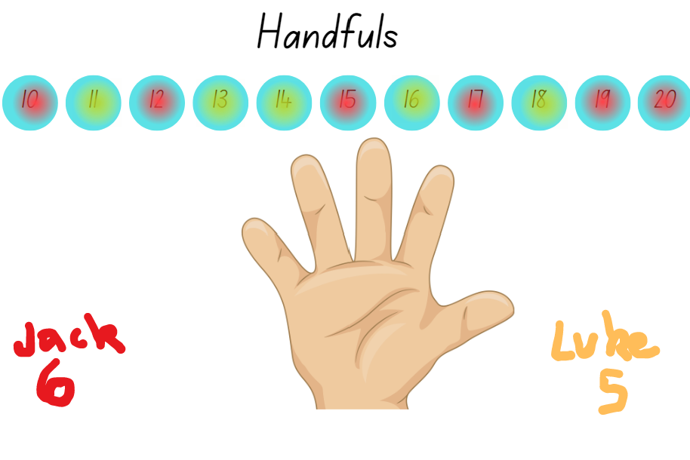
Images sourced from Canva and used in accordance with the Canva Content Licence Agreement.

Daily number sense: Jarfuls (Stage 1) – 15 minutes
- Build Stage 1 student understanding of whole number by developing strategies to estimate the number of objects within a large collection to the nearest 10 or 100.
Note: Stage 1 students require a range of opportunities to develop the skills required to accurately estimate. Opportunities to practise estimating meets both mathematical and practical needs. Students need to refer to their knowledge of numbers, make comparisons and draw on what is familiar to understand what is unfamiliar, as well as judge the reasonableness of their estimation.
- Display the digital marble jar. Alternatively, provide a transparent jar or bag with a large collection of the same objects in a range that would challenge the Stage 1 students in your class to estimate.
- Model how the collection can be viewed from the side and rotated to be viewed from the top and bottom, assisting with visualising and calculating how many objects are within. Remind students that mathematicians refer to these views as front view, side view, rear view, top view (or bird’s eye view) and bottom view.
- Ask students to suggest strategies to determine how many marbles are in the jar. For example, students may suggest grouping the marbles into tens, or forming rows or columns of tens and considering the marbles that cannot be seen.
- Provide time for students to turn and talk and discuss their estimating strategies and results. Ask:
- What is the most useful view to use first? Why is it useful?
- How many marbles do you estimate are in the front view of the jar? How did you estimate?
- If we turn the jar to the rear view, are there the same number of marbles as the front view? If so, how many would you estimate there are all together?
- How can you estimate how many marbles are in the centre of the jar, the view we can't clearly see?
- Reveal the actual number of marbles in the jar (by clicking the ‘check’ button).
This table details assessment opportunities and differentiation ideas.
Assessment opportunities | Too hard? | Too easy?
What to look for:  - Can Early Stage 1 students count a specified number of objects to 20 and match with the correct numeral? (MAE-RWN-01, MAE-RWN-02)  - Can Early Stage 1 arrange the counters in an orderly way, such as rows or groups and count to find the total? (MAO-WM-01, MAE-RWN1)  - Can Stage 1 students check estimates by grouping and counting by 10 (or more)? (MAO-WM-01, MA1-RWN-02)  - Can Stage 1 students adjust their estimates based on additional evidence? (MAO-WM-01, MA1-RWN-02)  What to collect:  - observation of Early Stage 1 student counting strategies (MAE-RWN-01, MAE-RWN-02)  - observations of the reasonability of Stage 1-student estimates (MA1-RWN-02). | Students are not able to count out objects in the range to 20.  - Provide a smaller collection of counters for students to represent numbers in the range one to 10.  - Provide students with number cards to 10 and ask students to match quantities of counters with the number cards.  Students are not able to group and count by 10.  - Provide a smaller collection to estimate and check, such as only the bottom layer of the jar.  - Support students to use handfuls to estimate and compare their judgements. | Students can group and count by 10 (or more).  - Ask students to write a step-by-step guide for their peers of how to estimate a collection to 1000 accurately and efficiently.  - Students document challenges of estimating based on a single point of view and share those challenges with the class.

3D models – 35 minutes

Early Stage 1 – Models
- For Early Stage 1 students, provide a range of real-life 3D objects that represent cubes, rectangular prisms, spheres and cylinders.
- Provide students with modelling clay and ask them to build models for each of the objects. Explain that the models do not have to be the same size as the object but should approximate the object’s features.
Note: Student models do not have to be precise replicas of the object students are representing. Models should have the approximate appearance of the object and is not expected to be a mathematical model. Early Stage 1 students should be using language such as flat, round, curved to describe their model. Students can also describe the size and properties, such as it can roll, it can stand up, it has corners, or it is flat so it can stack on top of the bigger one.
- Once student have made their models, instruct them to trace around the faces of their model and match it to the real-life object. Ask if students noticed the same 2D shapes with their tracing.
- Ask:
- How do you know which model goes with which real-life object?
- How do the models and real-life objects differ from each other? How are they the same?
- Can you find something in the classroom that would go with your model and real-life object? Explain why it belongs.
- Can you find an object in the classroom that does not match any of the models that you have made? Explain why it doesn’t match.
- Students use a digital device to photograph their models next to the real-life object they represent and a matching item from the classroom. Keep the models for later reference.

Stage 1 – Cubes
Note: This lesson has been adapted from Moss et al (2021). It is an exploratory introduction to the idea of nets, which are part of Stage 2 outcomes and content, see MA2-3DS-01. Hexomino is the name for a 6-square arrangement where the squares are aligned along at least one common edge. There are 35 hexomino configurations, only 11 of which can be folded to create cubes. Give students the opportunity to fold hexominoes. The language and hand gestures students use when folding can support them to visualise whether a hexomino will fold into a cube. Stage 1 students are not expected to use the terms hexomino or net.
- While Early Stage 1 students are making their models, display Resource 5: Making cubes. Explain that these shapes represent unfolded cubes. Display a cube and identify 6 square faces.
- Model how to cut around the outline of each hexomino, emphasising that you do not want to cut out each square.
- Model how to fold on the lines to make a cube. Explain that the lines will become edges.
- Provide students with copies of Resource 5: Making cubes and scissors. Instruct students to cut out the hexominoes (around the outline only) and then fold them to make cubes. As students make the cubes, observe the language and gestures used by students as they fold, such as ‘fold it in’, ‘fold it out’, ‘fold this first, then that’, ‘turn it this way’.
- As a class, ask students to view the displayed samples of 3D models made of modelling clay and 3 different hexominoes. Ask:
- What do you see?
- What do you wonder?
- Did it matter where you started when modelling the clay or when folding the cubes? Why or why not?
- What was challenging?
- Was there anything that you need to modify or found challenging?
This table details assessment opportunities and differentiation ideas.
Assessment opportunities | Too hard? | Too easy?
What to look for:  - Can students make models of 3D objects? (MAO-WM-01, MAE-3DS-01, MA1-3DS-01)  - Can Early Stage 1 students identify the same faces on models as real-life objects? (MAO-WM-01, MAE-2DS-01, AE-3DS-01)  - Can Stage 1 students describe and name 3D objects using appropriate language? (MAO-WM-01, MA1-3DS-01)  What to collect:  - observations of student reasoning (MAO-WM-01, MA1-3DS-01). | Students are not able to make models from modelling clay.  - Provide models of a sphere, cylinder, rectangular prism and cube. Guide students to match the models to real-life objects.  - Provide sample 3D objects for students to view and manipulate as they are supported to make a model using the clay.  Students are not able to visualise making cubes from hexominoes.  - Provide students with small boxes to deconstruct and cut out each face, identifying how many faces there are altogether.  - Provide students with further opportunities to fold shapes into objects, providing support for explicit language and gestures. | Students can visualise making cubes from hexominoes.  - Show students Resource 6: Pasta shapes. Explain that they are to select one type of pasta and create an eye-catching container that is not a cube or prism. Ask students to explain the benefits and issues with their container.  - Show students Resource 7: Different packaging. Ask students to compare the 3D objects and respond to some of the questions.

Consolidation and meaningful practice: My models – 10 minutes
- Ask students to imagine that Earth has been visited by friendly aliens who love mathematics. When the aliens leave, they have room for only one 3D object. They ask for a model of Earth’s most important or best 3D object. Ask students which object they should take, what makes it the best and how they would describe it to the aliens. Students identify at least 3 reasons why their 3D object should make it on board the alien spacecraft (see Figure 5).
Figure 5 – Alien spaceship
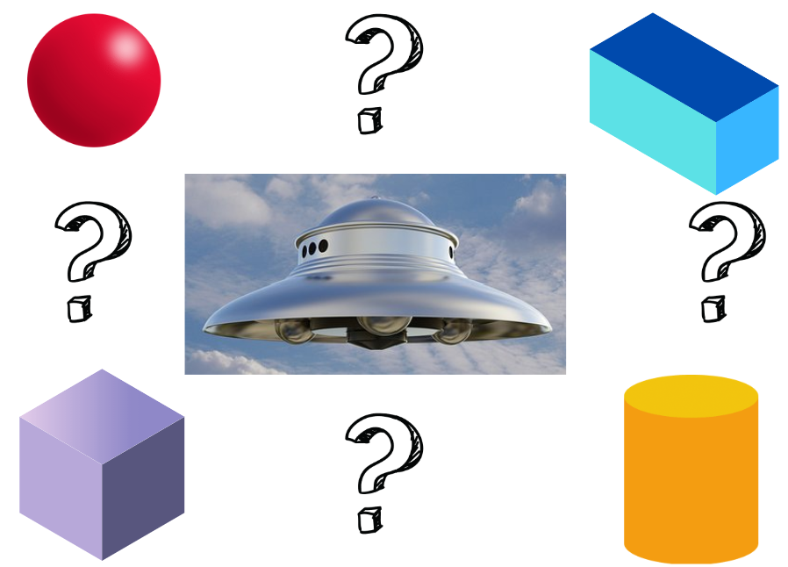
Images sourced from Canva and used in accordance with the Canva Content License Agreement.

Lesson 4: Different objects, same volume
Core concept: Objects that appear different may have the same volume.
The table below contains suggested learning intentions and success criteria. These are best co-constructed with students.
Learning intentions | Success criteria
All students are learning that objects can have the same volume but look different.  In addition, Early Stage 1 are learning that volume can be compared directly by constructing and deconstructing 2 objects.  In addition, Stage 1 students are learning that:  - the volume of three-dimensional objects can be measured in uniform informal units  - three-dimensional objects can appear different but have the same volume. | All students can:  - explore, create and compare three-dimensional objects of different appearances from a given number of cubes  - explain that volume is the amount of space an object occupies.  In addition, students working towards Early Stage 1 outcomes can compare volume by counting cubes used when constructing and deconstructing objects.  In addition, students working towards Stage 1 outcomes can:  - manipulate the orientation of three-dimensional objects  - compare models with different appearances and can recognise when they have the same volume.

Daily number sense: Teacher choice – 10 minutes
- From a class need surfaced through formative assessment data, identify a short, focused activity that targets students’ knowledge, understanding and skills. Example activities may be drawn from the following resources:
- Mathematics K-6 resources
- Universal Resources Hub.

Cube challenge – 35 minutes
Note: In each of the following cube activities, cubes must be placed or stacked so that their edges align directly with the edges of at least one other cube, with no gaps or overlaps. If you are using cubes that do not interlock, ensure students understand that each cube must line up with the adjacent cube, so all the edges are flush. When making objects from 3 cubes, there are only 2 possible solutions. When using 4 cubes there are 8 possible solutions (see Figure 6).
Figure 6 – Cube configurations
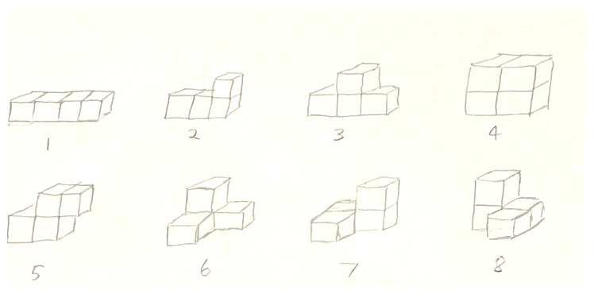
- Remind students of the definition of volume.
Volume: The amount of space occupied by an object.
- Explain that in this lesson students will measure and compare volume by using cubes.
- Provide each student with 3 cubes and ask them to make a 3D object. Ask students to calculate the volume of the 3D object.
- Provide students with 3 more cubes and challenge them to make a second three-cube object with a different appearance. Ask students to calculate the volume of their new 3D object. Students place their 3D objects side-by-side. Assist students to draw the conclusion that the 3D objects look different yet have the same volume.
- Provide students with 3 more cubes and ask whether they can make a third three-cube object with a different appearance.
- Ask students if they were able to make a third 3D object.
Note: Some students might realise that it is not possible to build a third unique 3D object with only 3 cubes.
- Invite students to share their third 3D object with the class. Challenge them to change the orientation of the 3D object so that students can draw the conclusion that only 2 unique 3D objects can be made with 3 interlocking cubes. Explain that, even when the 3D objects are reflected or turned, they are identical in structure.
- Show students 4 interlocking cubes and ask if they think the volume has changed.
- Students predict how many different 3D objects they might be able to build with 4 interlocking cubes. Students share their thinking.
- Give students a collection of cubes and challenge them to make as many unique 4 cube 3D objects as they can.
Note: Some students might need reminders that 3D objects can the same despite their orientation.
- When students have at least 5 structures, have students display their work and go on a gallery walk. Ask:
- Did anyone else have a different 3D object to you?
- As a class, do you think we have all the possible 3D objects?
- How can we check if some of the 3D objects are the same?
- Did increasing the volume allow you to build more structures?
- How can you prove that even though the 3D objects look different, they still share the same volume?
- As a class, work together to eliminate any duplicate structures so that only 8 unique 3D objects remain. Keep the 8 unique 3D objects on display with the 2 three-block objects. These 3D objects are used again in Lesson 5.
This table details assessment opportunities and differentiation ideas.
Assessment opportunities | Too hard? | Too easy?
What to look for:  - Can students create and compare 3D models of the same volume? (MAO-WM-01, MAE-3DS-02, MA1-3DS-01, MA1-3DS-02)  - Can students manipulate different 3D models to determine if they are the same configuration? (MAO-WM-01, MAE-3DS-02, MA1-3DS-01, MA-3DS-02)  What to collect:  - photographs of student made objects on display in the gallery walk (MAO-WM-01, MAE-3DS-02, MA1-3DS-01, MA-3DS-02). | Students are not able to make different models or have difficulty comparing different objects and identifying the volume.  - Provide 3 to 5 different objects for students to copy.  - Provide 2 identical objects. Show students that, by turning or reflecting the objects, they can appear different.  - Provide time for students to deconstruct the models, count the cubes and then re-construct, identifying that the volume is the same. | Students can make different models and can compare different objects.  - Ask students to explore and record as many objects as they can using 5 cubes, in preparation for Lesson 5.  - Draw or take a photograph of the most interesting object they created from 5 cubes.

Discuss and connect the mathematics – 10 minutes
- Looking at the collection of three- and four-cube objects, ask:
- Did increasing the volume change the number of unique 3D objects?
- Does the volume change if a 3D object looks different?
- Were certain objects easier or more difficult to build? Why?
- How could you describe your 3D object?
- What are you still wondering?

Lesson 5: Comparing models
Core concept: When comparing volume, it is helpful to visualise, construct and deconstruct 3D objects.
The table below contains suggested learning intentions and success criteria. These are best co-constructed with students.
Learning intentions | Success criteria
All students are learning that three-dimensional objects can be described by their features.  In addition, Early Stage 1 are learning that volume can be compared directly by constructing and deconstructing 2 objects.  In addition, Stage 1 students are learning that:  - the volume of three-dimensional objects can be measured in uniform informal units  - three-dimensional objects can appear different but have the same volume. | All students can:  - make simple models of three-dimensional objects to compare volume  - compare models with different appearances, recognising when they have the same volume.  In addition, students working towards Early Stage 1 outcomes can compare the volumes of 2 objects made from blocks or connecting cubes directly by deconstructing one object and using its parts to construct a copy of the other object.  In addition, students working towards Stage 1 outcomes can describe three-dimensional objects using the terms ‘face’, ‘edge’ and ‘vertex’.

Daily number sense: Facts about numbers – 10 minutes
- Build student understanding of numbers and place value by comparing numbers.
- Display the numbers in Resource 8: Facts about numbers (Set A and Set B), or any 2 sets of numbers to differentiate for the learning needs in the class.
- Ask students to share what they can see and what they know about numbers as they compare and explore the 3 numbers.
Note: Some students may notice patterns or connections between the 2 sets of numbers.
- Ask all students questions such as:
- What are you thinking or wondering?
- What is the same about these numbers? What is different?
- Which number is the biggest? How do you know?
- What is the number ‘one less’, and the number ‘one more’?
- Which number does not belong in the group? Why?
- Ask Stage 1 students questions such as:
- What are some different ways we can rename these numbers?
- Which number has the smallest tens value?
- If we added some extra tens, which number would jump to the next hundreds first? Why?
- Can you name the number that is 10 more than each of the numbers? 100 more?
- Do you notice anything interesting after you have added an extra 100?
- Discuss and record students’ responses. Provide opportunities for students to share ideas and feedback about the recordings.
This table details assessment opportunities and differentiation ideas.
Assessment opportunities | Too hard? | Too easy?
What to look for:  - Can Early Stage 1 students identify the number one less and one more? (MAE-RWN-01)  - Can Stage 1 students identify the next multiple of 10 in three-digit numbers? (MA1-RWN-02)  - Can Stage 1 students identify and name the place value of each digit in three-digit numbers? (MA1-RWN-02)  What to collect:  - observations of student's reasoning (MA1-RWN-02). | Students are unable to state anything about the numbers displayed.  - Select a single number. Ask students to state any facts about that number.  - Provide a number track to 30. Students identify the numbers displayed with the numbers on the track.  Students are unable to partition and rename three-digit numbers.  - Provide students with two-digit numbers and bundles of craft sticks.  - Use a place value chart and MAB materials to model and support regrouping of three-digit numbers. | Students can partition and rename three-digit numbers.  - Students select 3 three-digit numbers and rename in multiple ways.  - Ask students to find all the three-digit numbers whose digit sum is 7 (for example, 700, 610, 601, 520, 511 …).

Making block models – 40 minutes
- Refer to the 8 objects made from the four-block challenge in Lesson 4.
- Ask students whether increasing the volume to 5 interlocking cubes will change the number of 3D objects that can be created. Students turn and talk and share their thinking with the class. Record predictions.
- Make one object from 5 cubes. Compare this object to the three- and four-cube objects previously made. Establish that the objects have different volumes.
Note: Early Stage 1 students may benefit from opportunities to compare the volumes of 2 objects by deconstructing one object and using its parts to construct a copy of the other object. In this case, if a student deconstructed the five-cube object to copy a four-cube object, the student would have a cube left over.
- Select 3 students to build one object each from 5 cubes to start a class collection. Remind students that objects can appear different, though the number of cubes remains the same. Compare the 3 objects by manipulating and rotating objects to establish that they are different. Modify objects if they are identical. Use these 3 objects to start a class collection for students to add to.
- Provide students with interlocking cubes to build as many different 3D objects as possible with a volume of 5 cubes. Each time a student thinks they have built a unique 3D object they check it against the class collection.
- If an object has not been created, it is added to the collection. If it has been created, students try to build a different 3D object.
- During the task, observe strategies and ask students if there are fewer or more models than the precited number.
- Ask students to display their most interesting model. Allow students to view all models. Ask students to explain their model.
- Ask students:
- When you were building a new model, did you begin in the same way each time?
- How did you know where to begin to build a different model using the 5 cubes?
This table details assessment opportunities and differentiation ideas.
Assessment opportunities | Too hard? | Too easy?
What to look for:  - Can Early Stage 1 students identify the attribute of volume as the amount of space an object occupies? (MAO-WM-01, MAE-3DS-01)  - Can students compare the volume of 2 models and identify if the volume is the same or different? (MAO-WM-01, MAE-3DS-01, MA1-3DS-02)  - Can students communicate their reasoning and explain volume using drawing, words or numerals? (MAO-WM-01, MA1-3DS-02)  What to collect:  - photographs and annotated work samples (MAO-WM-01, MA1-3DS-02). | Students are not able to compare volume using 2 different models.  - Provide students with one simple model using 2 to 3 cubes and support students to identify the volume.  - Model volume using everyday items and ask students to order the items from least to most volume.  - When comparing models, ask students to deconstruct one model and copy another to establish equivalent volume (or not). | Students found solutions to the volume challenge and recorded results accurately.  - Ask students to create a model that has double the volume of the first model.  - Ask students to arrange 6 or more models from the class collection in a logical order or pattern and to record and share their reasoning.

Consolidation and meaningful practice: What does it look like? – 10 minutes
- Provide pairs of students with cubes and explain that the answer to a volume question is 11. Ask what the model might look like. Encourage students to come up with as many different options as they can in 5 minutes.
- Select students to share their model ideas and prove that the volume is 11.

Lesson 6: Packing in layers
Core concept: Internal volume can be explored by packing and stacking with no gaps.
The table below contains suggested learning intentions and success criteria. These are best co-constructed with students.
Learning intentions | Success criteria
All students are learning that:  - internal volume can be measured using uniform informal units  - internal volume can be compared and ordered.  In addition, Early Stage 1 are learning that when comparing and describing the internal volume of containers, it is useful to use language such as full, half full and empty. | All students can:  - pack cubes into containers so that there are no gaps, and the internal space is covered  - estimate, measure and compare the internal volume of containers.  In addition, students working towards Early Stage 1 outcomes can use vocabulary such as full and empty to describe the space inside a container.  In addition, students working towards Stage 1 outcomes can select appropriate informal units to measure internal volume.

Daily number sense: Jellybean challenge – 15 minutes
- Build student understanding of estimating by exploring arrangements or collections, such as a jar of jellybeans.
- Display Resource 9: Lots of spots and ask students to turn and a talk, estimating how many spots there might be on each.
- Ask students:
- How did you estimate?
- Can you see any patterns of spots which remind you of other dot patterns which might be helpful when you are estimating?
- How did you estimate the spots that you can’t see, such as on the other side of the fish or dalmatian?
- Display Resource 10: Jellybean challenge (Early Stage 1) for Early Stage 1 or a real bowl with 30 jellybeans for students to view. State that there are 30 jellybeans in the bowl and you are wondering how this can be proven without counting the jellybeans by ones.
- Display Resource 11: Jellybean challenge (Stage 1) for Stage 1 or a real jar of jellybeans for students to view. State that there are 220 jellybeans in the jar and you are wondering how this can be proven without opening the jar and counting the jellybeans by ones.
- Allow time for students to turn and talk with a partner and to view and handle the jar or the bowl of jellybeans. Observe suggested strategies and how students are estimating and grouping the jellybeans to count the collection. If needed, interrupt the discussions and ask:
- Early Stage 1 students: Do you agree that there are 30 jellybeans? How do you know?
- Stage 1 students: Do you agree that there are 220 jellybeans? How do you know?
- All students: How can you accurately count this collection more efficiently than counting by ones?
- Provide student pairs with writing materials. Ask students to record their ideas for sharing with the class.
- As a class, share strategies and discuss solutions. Ensure that students can support their solutions or make drawings that represent the jellybeans as groups. For example, Early Stage 1 students draw the jellybeans in patterns like dice patterns or domino patterns, while Stage 1 students draw the jellybeans as groups of tens (see Figure 7).
Figure 7 – Examples of solutions
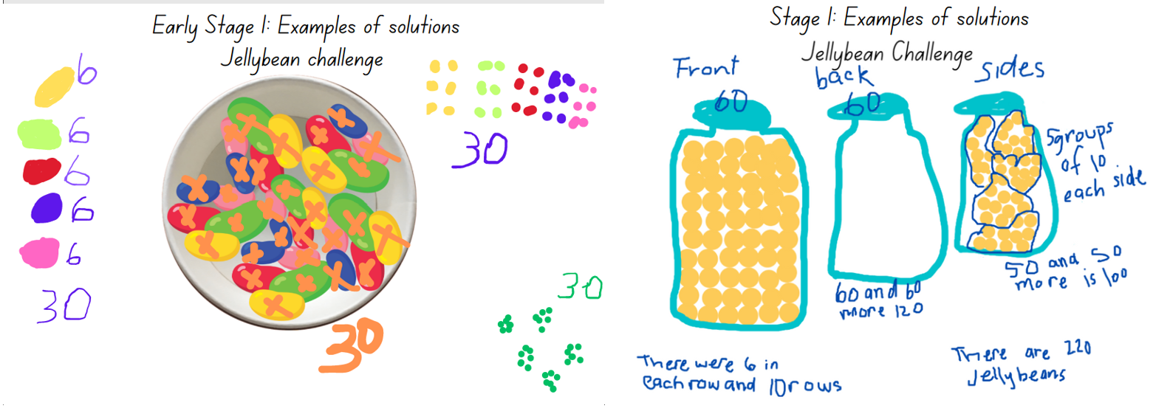
Images sourced from Canva and used in accordance with the Canva Content Licence Agreement.
This table details assessment opportunities and differentiation ideas.
Assessment opportunities | Too hard? | Too easy?
What to look for:  - Can students draw and write representations of solutions showing organised patterns or groups? (MAO-WM-01, MAE-RWN-01, MA1-RWN-02)  - Can Early Stage 1 students subitise a small quantity without counting and identify the total number of items? (MAO-WM-01, MAE-RWN-01)  - Can Early Stage 1 students count a collection and keep track of the count? (MAE-RWN-01)  - Can Stage 1 students use groups of 10 to count a large collection? (MAO-WM-01, MA1-RWN-02)  - Can Stage 1 students recognise a group of 100 as ten groups of 10? (MAO-WM-01, MA1-RWN-02)  What to collect:  - photographs and recordings of students' solutions (MAO-WM-01, MAE-RWN-01, MA1-RWN-02). | Students are not able to subitise and count on from 5.  - Provide students with counters to create 5 small groups of 2 counters and support students to count on from the first group of 2. Increase the quantity of counters in each group as needed.  - Display simple dice and domino patterns to 6 for students to view and subitise.  Students are unable to count a large collection by grouping in tens.  - Provide students with a container holding 50 coloured bricks and ask students to group these into groups of 10, supporting students to skip count by tens.  - Ask students to circle groups of 10 jellybeans and use concrete materials to represent each group. Support students to skip count by tens. | Students can subitise and create patterns to assist with counting a collection.  - Ask students to draw 2 different representations of 30 jellybeans as arrays. Increase to 36 jellybeans if needed.  - Provide students with a collection of 100 coloured bricks or interlocking cubes. Ask students to create 3 different ways to group ‘100’ to make counting the collection more efficient.  Students can use groups of 10 to systematically count a large collection.  - Ask students to explore how many different arrays they can create to show the total number of 220 jellybeans.  - Ask students if there would be more or less than 220, if the jar were filled with were Skittles or Smarties. Prompt students to explain how they know.

Packing and stacking: Part 1 – 15 minutes
- Display MAB materials and model how the ‘long’ is made of 10 ones stacked together. Model ones and ask students to count.
- Explain to students that the stack of 10 ones (or 10 units) means that the ‘long’ has a volume of 10 as this is the amount of space it takes up. Model turning and positioning the ‘long’ in different orientations and explain that the orientation or position does not alter the volume; it is always 10.
- Provide Early Stage 1 students with MAB ones. Explain that, with a partner, students will explore volume using MAB units. Students will create as many representations as possible using 10 MAB ones. Students will use a digital device or draw their representations to be shared with the class on an anchor chart (see Figure 8).
Figure 8 – Example of an Early Stage 1 anchor chart
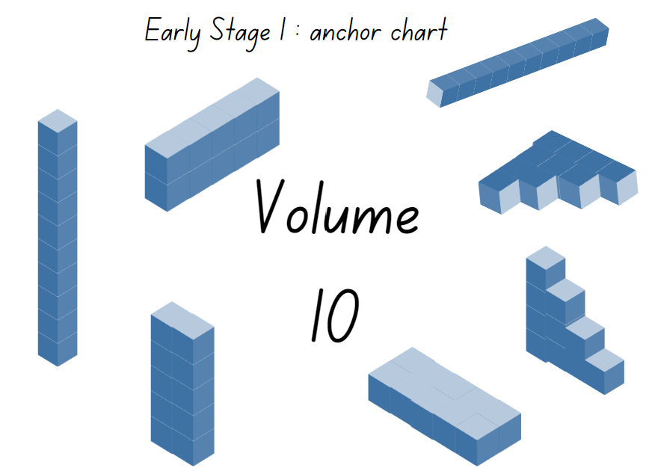
- Show Stage 1 students a ‘flat’ and explain that it is a representation of 100. Select students to prove this by layering 10 longs. As a class, skip count by tens as each long is placed on the flat.
- Show Stage 1 students a MAB cube and explain that it represents 1000. Display all the faces of the cube, drawing particular attention to how each face looks like a ‘flat’.
Note: Some students mistakenly think that a MAB cube has a value of 600, calculated by counting the 100 on each face of the cube.
- Refer to the internal layers within the cube, explaining that each flat has 100 units. Select students to prove this by layering flats as students skip count by hundreds to 1000. Compare the size of the MAB cube to the cube constructed from flats.
- Ask students to use what they know about the cubes to explain its volume (of 1000).
- Record Stage 1 student responses on an anchor chart titled ‘Volume of a cube’ (see Figure 9).
Figure 9 – Example of a Stage 1 anchor chart
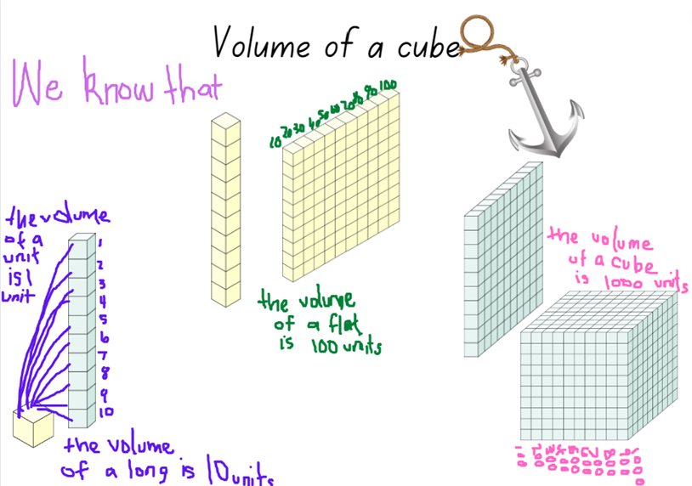
Images sourced from Canva and used in accordance with the Canva Content License Agreement.

Packing and stacking: Part 2 – 35 minutes
Note: Prior to the lesson, ask students to bring in empty small cardboard boxes such as tissue, biscuit, tea or pasta boxes.
- Explain that students will pack and stack MAB materials to explore the internal volume (capacity) of the boxes.
- Provide students with MAB materials, a digital device and/or writing materials to record their investigations. Ensure students understand that the units must be packed with no gaps or spaces.
- Display the models made by students and ask:
- What difficulties did you encounter as you packed and layered?
- From looking at the boxes, can you predict which one will have the greatest internal volume?
- Can you see any that you can estimate will have the same internal volume? Why?
- Why do you think having no gaps or spaces is essential? What can you do to ensure there are no gaps and spaces?
- Do you think the MAB ones were a good measuring device? Why or why not?
This table details assessment opportunities and differentiation ideas.
Assessment opportunities | Too hard? | Too easy?
What to look for:  - Can students compare the internal volume of 2 boxes by packing with no gaps, recognising this affects the accuracy of results? (MAO-WM-01, MAE-3DS-02, MA1-3DS-02)  - Can students recognise which box has the greatest internal volume, justifying their answer by stating how many units were used? (MAO-WM-01, MAE-3DS-02, MA1-3DS-02)  - Can students explain that the units can be packed effectively as they are a suitable informal unit to use within a rectangular or square container? (MAO-WM-01, MA1-3DS-02)  What to collect:  - photographs of students’ boxes and annotated work samples (MAO-WM-01, MAE-3DS-02, MA1-3DS-02). | Students are not able to track their count when packing and stacking cubes.  - Provide students with MAB materials writing tools. Support them to make groups and marks to track the count.  - For Stage 1 students emphasise 10 as a count by providing ‘longs’ for students to layer and pack.  Students are not able to pack cubes without leaving gaps in rows and columns.  - Provide support and model how gaps will result in an inaccurate measure of volume. Support students to pack a small container, measuring the volume.  - Students work with a partner to pack a small container with coloured bricks or interlocking cubes in rows and columns. | Students can pack various containers and record the volume accurately.  - Ask students to create a problem for a partner, such as create a container that is double or half of the internal volume of the first.  - Ask students to modify their model, creating a different shaped container and then measure the volume to determine if it is different or the same as the original model.

Consolidation and meaningful practice: Real life packing and stacking – 10 minutes
- Display Resource 12: Cargo ships and ask:
- What do you see and what do you wonder?
- Have these cargo ships been packed and stacked with no gaps? How do you know?
- Can we accurately measure the internal volume? Can we estimate which cargo ship has the greatest internal volume?
- Are the cargo boxes a useful shape for packing and stacking? Why or why not?
- How would you pack and stack the cargo boxes so that more can fit?
- Which cargo ship has been packed and stacked most effectively? Explain your thinking.

Lesson 7: Filling and pouring
Core concept: Containers can look different but can have the same internal volume (capacity).
The table below contains suggested learning intentions and success criteria. These are best co-constructed with students.
Learning intentions | Success criteria
All students are learning that containers that are shaped differently can have the same internal volume.  In addition, Early Stage 1 are learning that when directly and indirectly comparing internal volume, it is helpful to fill and pour the contents from one container into another and observe the level reached.  In addition, Stage 1 students are learning that:  - internal volume can be measured, compared and ordered by filling  - using the same measuring tool to fill containers gives accurate results for comparison. | All students can:  - fill various containers and arrange them in order to show which container holds the most and which holds the least  - identify that 2 containers may look different but have the same internal volume (capacity).  In addition, students working towards Early Stage 1 outcomes can compare the internal volumes (capacities) of 2 containers directly and indirectly.  In addition, students working towards Stage 1 outcomes can:  - make and use a device for measuring internal volume (capacity) calibrated in uniform informal units  - compare, order and record the internal volumes (capacities) of 2 or more containers by measuring each container in uniform informal units.

Daily number sense: A lot of bricks – 10 minutes
- Build student understanding of numbers as quantities by problem solving.
- Provide pairs of students with a digital device. Explain that students will use Mathigon shapes and/or number tiles and cubes to find 2 possible solutions for a problem.
- Provide Resource 13: A lot of bricks (Early Stage 1) to Early Stage 1 students. Explain that Roger needs to deliver 19 bricks to a building site, but he is not sure how to best load the truck.
- Provide Resource 14: A lot of bricks (Stage 1) to Stage 1 students. Explain that Roger needs to deliver 345 bricks to a building site, but he is not sure how to best load the truck.
- Ask students to explore at least 2 different solutions to help Roger load the truck, such as Figure 10. Share responses.
Figure 10 – Examples of solutions: A lot of bricks
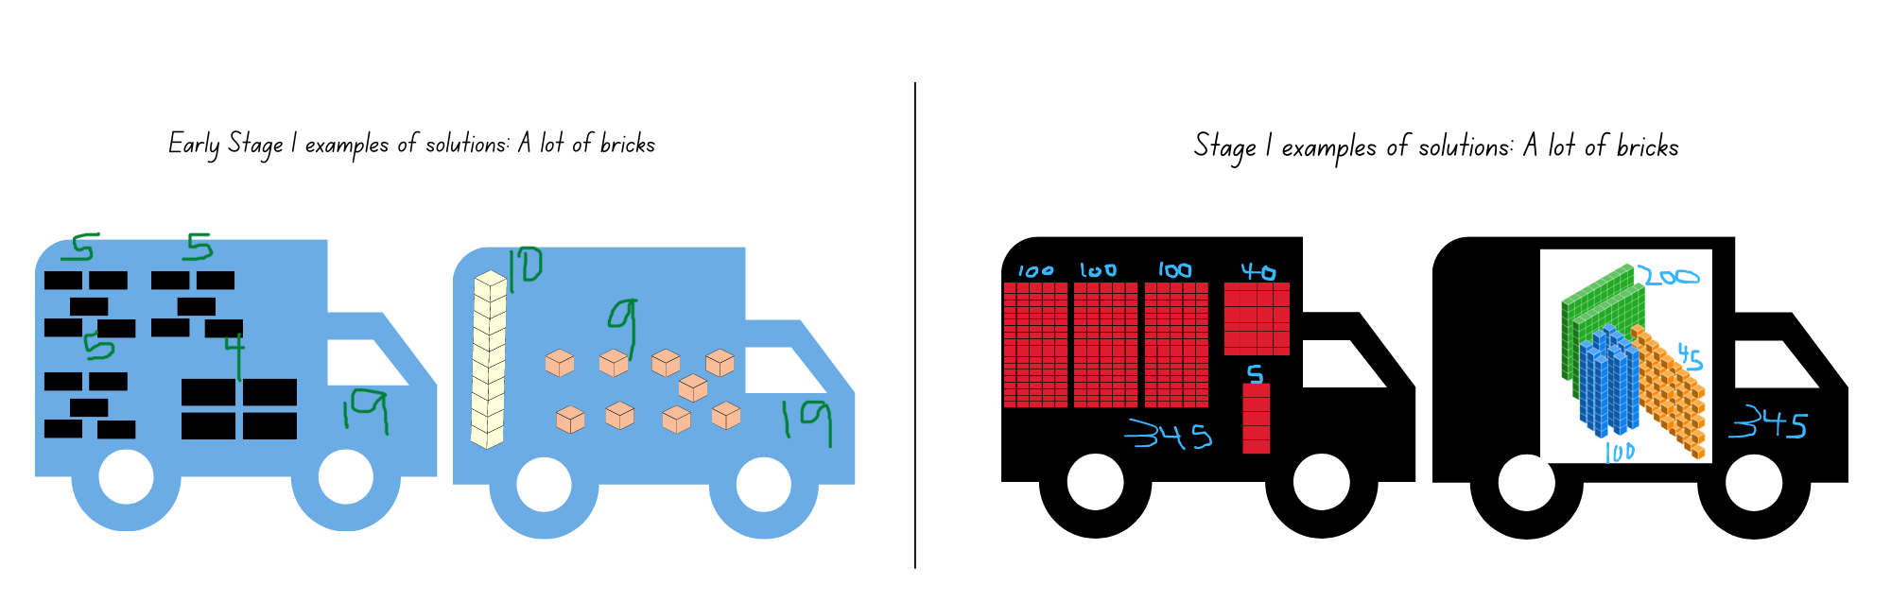
Images sourced from Canva and used in accordance with the Canva Content License Agreement.
Assessment opportunities | Too hard? | Too easy?
What to look for:  - Can Early Stage 1 students represent numbers as quantities using objects and patterns? (MAO-WM-01, MAE-RWN-01, MAE-RWN-02)  - Can Stage 1 students use place value to partition and rename three-digit numbers in different ways? (MAO-WM-01, MA1-RWN-02)  What to collect:  - photographs or drawings of student representations (MAO-WM-01; MAE-RWN-01, MAE-RWN-02 MA1-RWN-02). | Students are not able to represent numbers to 20.  - Provide students with 10 counters. Model an example of how to represent 10, such as 9 and one more. Ask students for other ways to represent 10.  - Provide students with a ten-frame and counters of 2 different colours. Support students to identify all combinations of 10. Increase the range to 20 as appropriate.  Students are not able to represent 345 in at least 2 different ways.  - Model the standard partition of 345 using MAB materials. Ask students to make a second model, exchanging 100 for 10 tens.  - Provide students with other concrete materials such as, bundles of craft sticks. Support students to make 45, 145, 245 and then 345. | Students can represent 345 in at least 2 different ways.  - Ask students to make 5 representations that make a pattern. Students describe the pattern.  - Explain that bricks come in packs of 15 and 25. Ask students to investigate different pack combinations that make exactly 345 or close to 345.

Measuring and comparing – 45 minutes
Note: For measuring and comparing the internal volume of various containers, rice, sand, water, bird seed or lentils, as well as various shaped containers that have the same and/or different internal volume will be needed. For example, various one litre bottles of juice, water or milk, shampoo bottles, jars and various tubs of yoghurt. Each Stage 1 student will need a transparent plastic cup, a permanent marker and a small container, such as an egg cup, cosmetic containers or small disposable sauce containers, to use for pouring and filling when creating a calibrated measuring device. Early Stage 1 students will need 2 identical transparent plastic cups.
- Explain that students will be comparing and ordering the internal volume of various containers.
- Draw attention to the various containers the class will measure. Explain that you are wondering what the internal volume of each of these containers is and if any have the same internal volume.
- Provide time for students to explore and manipulate the various containers, observing these from different points of views.
- Ask students to turn and talk with a partner to discuss what they observed and what they are wondering. Monitor discussions, share points of interest and identify misconceptions.
Note: Early Stage 1 students will first revise and practise direct comparison, then use plastic cups without calibration for indirect comparison. Stage 1 students will make and use a calibrated measuring device for indirect comparison.

Early Stage 1 – Direct comparison
- Provide students with a large collection of containers. Instruct students to predict the order of the containers from smallest to largest internal volume (capacity) by lining the containers up in a row.
- Revise by modelling how to directly compare internal volume (capacity) by pouring the contents of one full container into another to compare, using language such as the terms ‘full’, ‘empty’, ‘about half full’.
- Provide students with measuring materials, such as rice, lentils, bird seed or sand, a funnel and a tray to capture spills.
- Invite students to change the order of the containers if, through direct comparison, they establish that a change is required to correctly order the containers from smallest to largest.

Stage 1 – Calibrated devices
- While Early Stage 1 students are directly comparing the internal volume of containers, display various real life measuring devices for Stage 1 students to view, such as in Figure 11.
Figure 11 – Measuring devices
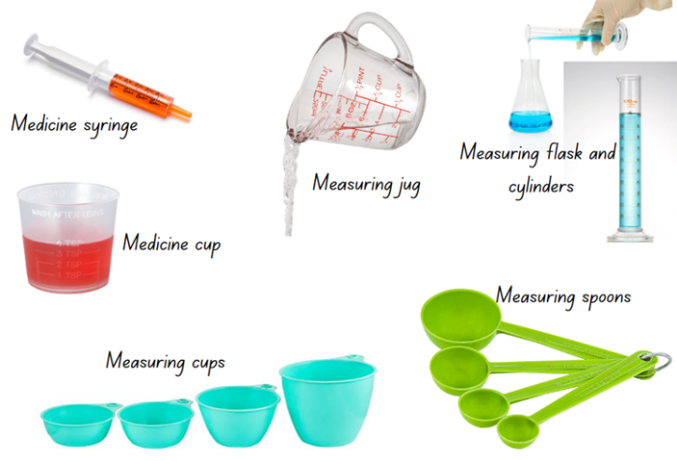
Images sourced from Canva and used in accordance with the Canva Content License Agreement.
- Ask Stage 1 students:
- Have you seen these measuring devices (tools) before? Where and how are they used? What do they measure?
- Why and how do you think these were made? How are they labelled and marked?
- Are there specific mathematical words that you need to use when using these measuring devices?
- Do these measuring devices give you a precise measure or just an estimate? How can you prove it?
- Model the steps for making a calibrated measuring device:
- Select a small container as a unit of measure, such as an egg cup.
- Fill the small container with rice, sand, water or lentils.
- Pour it into the plastic cup.
- Mark a line on the plastic cup to show the level.
- Continue these steps until there are 10 lines, see Figure 12.
Figure 12 – My measuring device
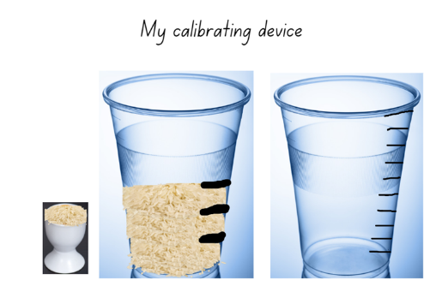
Images sourced from Canva and used in accordance with the Canva Content License Agreement.
- Provide pairs of students with materials to make their calibrated device. Students will use these again in Lesson 8.
- Once made, model how to use the measuring device. Remind students that each line on their device represents one scoop and the top line represents 10 scoops. Explain that students should not fill above the top line, as this is not calibrated.
- Ask students to select 4 to 5 containers and estimate how many scoops each container will need to fill it and record their estimates.
- Provide students with a digital device or writing materials to record their investigation results.
- Students fill the containers using their calibrated cup and record how many calibrated scoops were needed to fill it. Ensure that students are comparing and ordering each container by recording how many of the marks on the plastic cup is needed to fill each container. Encourage students to skip count by tens when filling to the top line of their device (see Figure 13).
Figure 13 – Investigating internal volume
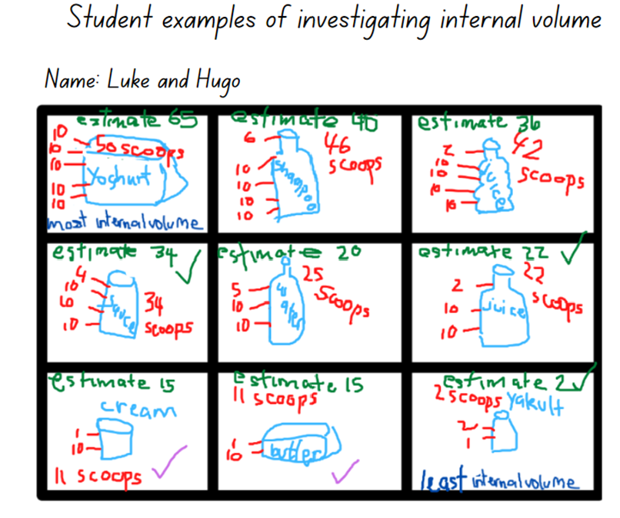

Early Stage 1 – Indirect comparison
Indirect comparison involves filling the containers being compared and pouring the contents into 2 identical containers to compare the levels (see Figure 14).
Figure 14 – Indirect comparison
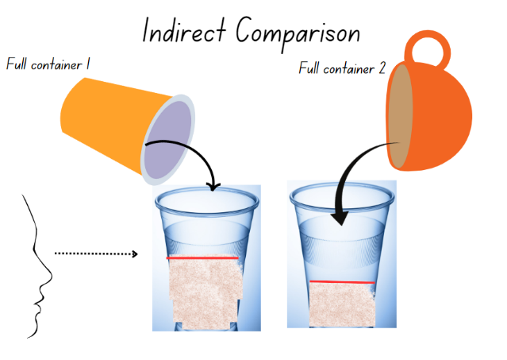
Images sourced from Canva and used in accordance with the Canva Content License Agreement.
- While Stage 1 students are making or using their calibrated devices, provide Early Stage 1 students with 2 identical plastic cups.
- Model how to indirectly compare the internal volume (capacity) of 2 objects, such as in Figure 14 above.
- Instruct Early Stage 1 students to explore the containers in the collection by applying the process of indirect comparison.
This table details assessment opportunities and differentiation ideas.
Assessment opportunities | Too hard? | Too easy?
What to look for:  - Can students explain how they have ordered the containers to show the most and least internal volume (capacity)? (MAO-WM-01, MAE-3DS-02, MA1-3DS-02)  - Can students explain why containers that are shaped differently may have the same internal volume? (MAO-WM-01, MAE-3DS-02, MA1-3DS-02)  - Can Stage 1 students estimate and then measure the internal volume? (MA0-WM-01, MA1-3DS-02)  - Can Stage 1 students explain how to use their calibrated device to measure the internal volume of a container? (MAO-WM-01, MA1-3DS-02)  What to collect:  - photographs and annotated work samples of students’ estimates and recorded measurement results (MAO-WM-01, MAE-3DS-02, MA1-3DS-02). | Students are not able to compare 2 containers.  - Provide students with 2 containers of significantly different size. Model direct comparison to show different capacity. Students repeat.  - Provide students with 2 containers of significantly different size. Model indirect comparison to show different capacity. Students repeat with a third and fourth container.  Students are unable to use the calibrated measuring cup with 10 marks to compare the internal volume of containers.  - Support students to make a calibrated cup that only has 2 marks representing 2 scoops. Encourage students to skip count by 2 as they pour and fill.  - Students work in a small group using a modified calibrated cup that only has 2 marks representing 2 scoops. | Students can estimate and use their calibrated measuring cup to accurately compare, order and record results.  - Ask students to identify 2 containers that are a different shape but have the same internal volume. Students then explain how this is possible using drawings, diagrams and words.  - Ask students to use a different material (for example if they used sand, they now use water) to fill a container using their calibrated measuring cup to determine if the results are the same. Students record their findings.

Discuss and connect the mathematics – 10 minutes
- Discuss findings and order the containers to view similarities and differences in measuring results. Ask:
- Are there any containers you found that had the same internal volume? Are they the same shape?
- Are there any containers that you estimated the volume of correctly? What strategy did you use?
- Are there any estimates that were incorrect, or where the result was very different? Explain what was challenging.
- What challenges did you have when using your calibrated device? (Stage 1)
- What else can you measure using your calibrated device? What could you not measure using the calibrated device? (Stage 1)
- How does your device compare to the real-life calibrated devices shared at the beginning of the lesson? What is the same and what is different? Why? (Stage 1)
- What do you know? What are you still wondering about?

Lesson 8: Investigating prisms and cubes
Core concept: The features of an object can affect the internal volume.
The table below contains suggested learning intentions and success criteria. These are best co-constructed with students.
Learning intentions | Success criteria
All students are learning that:  - three-dimensional objects can have a different appearance, but still have the same internal volume  - internal volume can be measured, compared and ordered by filling.  In addition, Early Stage 1 are learning that when directly comparing internal volume, it is helpful to fill and pour the contents from one container into another and observe the level reached.  In addition, Stage 1 students are learning that using the same measuring tool to fill containers gives accurate results for comparison. | All students can identify 2 containers that appear different but have the same internal volume by estimating and comparing.  In addition, students working towards Early Stage 1 outcomes can measure and compare the internal volumes (capacities) of 2 containers directly.  In addition, students working towards Stage 1 outcomes can measure and compare the internal volume of containers using a calibrated measuring device.

Daily number sense: Teacher choice – 10 minutes
- From a class need surfaced through formative assessment data, identify a short, focused activity that targets students’ knowledge, understanding and skills. Example activities may be drawn from the following resources:
- Mathematics K-6 resources
- Universal Resources Hub.

Features of prisms and cubes: Part 1 – 25 minutes
Note: Prior to the lesson collect various real-life examples of cubes and rectangular prisms ensuring that there are enough for each student. For example, tissue boxes, cereal boxes, cling wrap, foil or toothpaste boxes, pasta boxes, tea boxes, boxes of chocolate and muesli bars. Students will also need to use rice, sand, water, bird seed or lentils for measuring.
- Display the real-life sample boxes, naming these as cubes or rectangular prisms. Early Stage 1 students are not expected to recall or use these names.
- Firstly, Stage 1 students will each select a box and investigate all the faces, edges and vertices on their box. Students then investigate the internal volume of their box using the calibrated cup they made in Lesson 7.
- Early Stage 1 students are not expected to recall or use the terms face, vertex or edge. Instead, they may describe the features of their box using words including ‘flat’, ‘longer’, ‘shorter’ and ‘corner’. Each student will select a box and explore its features. Students then explore the internal volume (capacity) by directly comparing 2 boxes.
- Explain that, with a partner, students will explore the features of their box. Each student can assist the other with holding the box, turning the box or taking photographs with the digital device.
- Provide students with modelling clay or wool and a digital device or writing materials to record results. Ensure that each student has their own box and that they are identifying and making a representation of each face using modelling clay or wool.
- Support Early Stage 1 students to identify and name the rectangles or squares on each face, and to use wool or modelling clay to make and represent the outlines of those shapes.
- Stage 1 students should view the box from all sides and identify these views by naming them side view, front view, top view and rear view. Students also need to count how many edges and vertices their box has altogether by marking the box and recording the results on the representations (see Figure 15).
Figure 15 – Examples of recordings
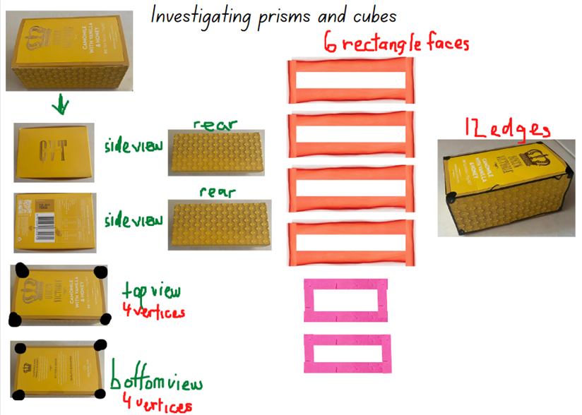
Images sourced from Canva and used in accordance with the Canva Content License Agreement.

Internal volume of prisms and cubes: Part 2 – 25 minutes
- Explain that students will now explore the internal volume of their boxes.
- Early Stage 1 students will work with their partner to fill one box with either rice, sand, bird seed or lentils. Students then estimate if their partner’s box will have the same internal volume, hold less or hold more as another box. Students then pour from one box into the other to directly compare. Alternatively, Early Stage 1 students can indirectly compare their boxes using the method followed in Lesson 7 (see Figure 16).
- Stage 1 students use their calibrated cup from Lesson 7 to fill their box with either rice, sand, bird seed or lentils and record their results (see Figure 16).
Figure 16 – Examples of recording internal volume
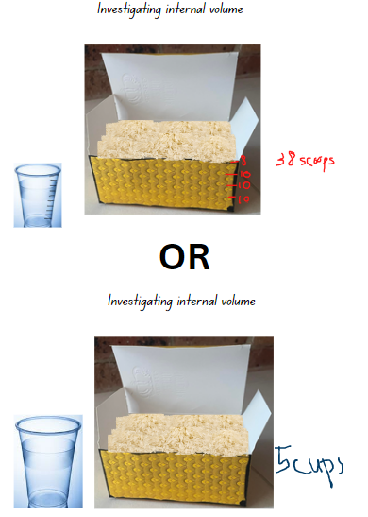
Images sourced from Canva and used in accordance with the Canva Content License Agreement.
- Students use a digital device or writing materials to record their findings, which will be shared and discussed as a class.
This table details assessment opportunities and differentiation ideas.
Assessment opportunities | Too hard? | Too easy?
What to look for:  - Can Early Stage 1 students identify familiar shapes in a range of contexts? (MAE-2DS-01)  - Can Early Stage 1 students describe the features of their box using relevant vocabulary? (MAE-3DS-01)  - Can Early Stage 1 students compare the internal volume of 2 boxes by pouring and filling from one box into another, explaining their results using comparative language? (MAO-WM-01, MAE-3DS-02)  - Can Stage 1 students distinguish between 2D shapes and 3D objects, describing these using appropriate vocabulary? (MA1-2DS-01, MA1-3DS-01)  - Can Stage 1 students use a calibrated device to measure, compare and record internal volume? (MAO-WM-01, MA1-3DS-02)  What to collect:  - anecdotal records of vocabulary being used by students (MAO-WM-01, MA1-3DS-02)  - photographs and annotated work samples (MAO-WM-01, MA1-2DS-01, MA1-3DS-01, MA1-3DS-02). | Early Stage 1 students are not able to compare the internal volume of 2 boxes.  - Students investigate 2 identical boxes. Support students to directly measure and compare the internal volume by filling and pouring the contents of one box into the second box, checking that containers are identical.  - Students identify 2 boxes that appear different in size and shape. Directly compare internal volume by filling and pouring the contents of one box into the second box to prove that the internal volume is different. | Students can investigate and record their results accurately.  - Provide students with concrete materials. Students use these to investigate and record their findings for the volume and internal volume of a cylinder or square pyramid.  - Challenge students to make a prism or cube that has the same volume as the internal volume.

Discuss and connect the mathematics – 5 minutes
- Ask:
- Did you identify 2 boxes that had the same internal volume? Did they appear the same and share the same features?
- Did you notice a pattern in the number of faces? Did you notice a pattern in the faces, edges and vertices? (Stage 1)
- Can you name an object that would be challenging to measure and compare the internal volume? For example, a balloon.
- Can you describe a situation when a calibrating device would not be useful or would not work? (Stage 1)
- Is there anything that you could not measure the internal volume of using a calibrated device? What is it and why? (Stage 1)

Resource 1: 2D Shapes and 3D Objects
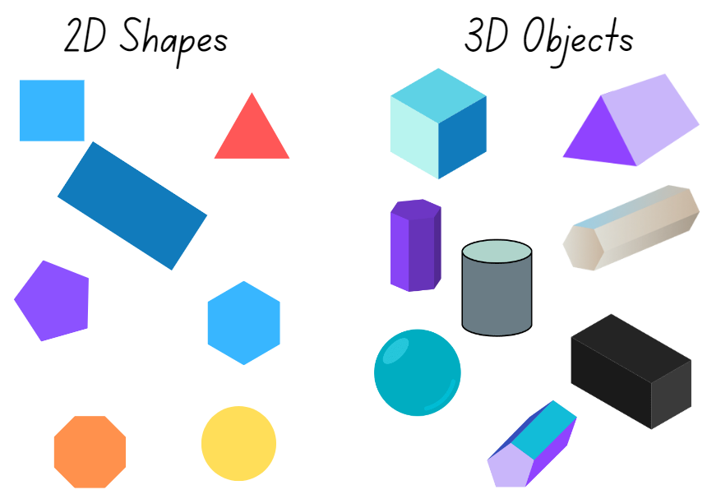
Images sourced from Canva and used in accordance with the Canva Content Licence Agreement.

Resource 2: 2D Shapes (Early Stage 1)
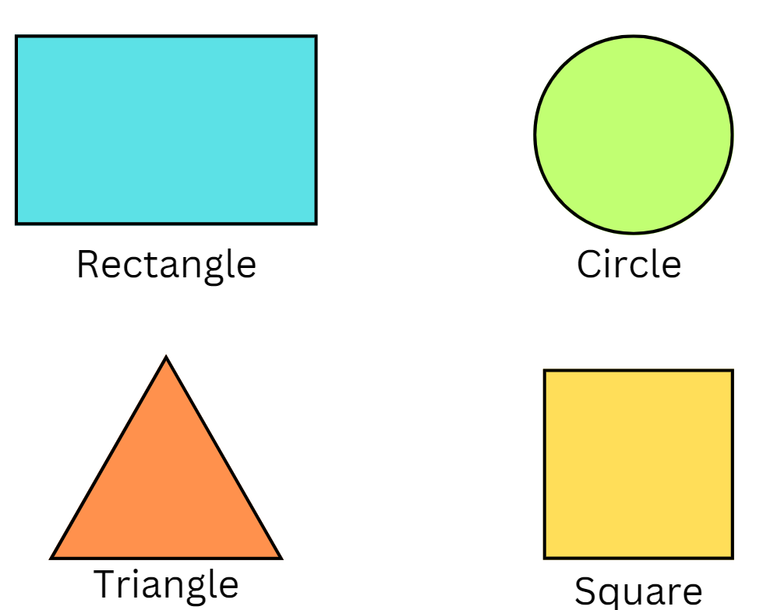

Resource 3: Object sort cards
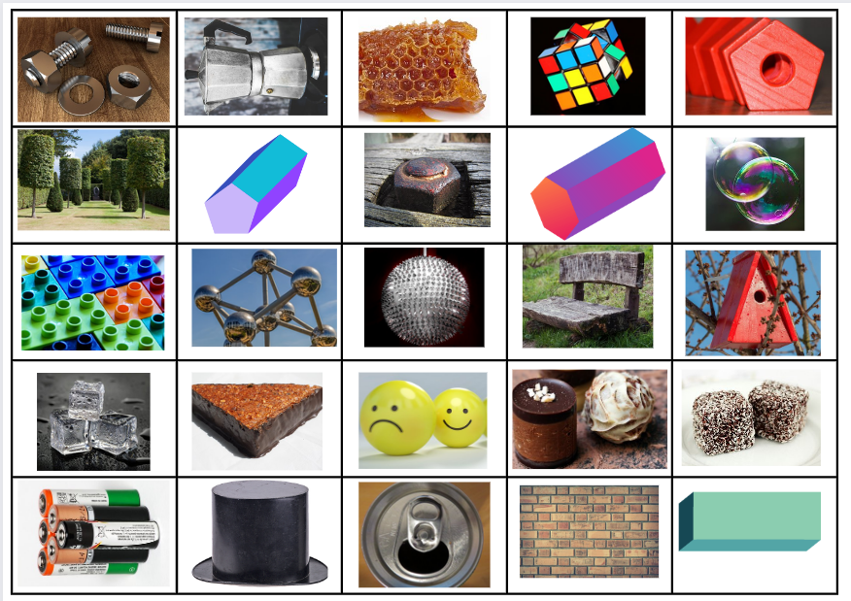
Images sourced from Canva and used in accordance with the Canva Content Licence Agreement.

Resource 4: Handfuls game
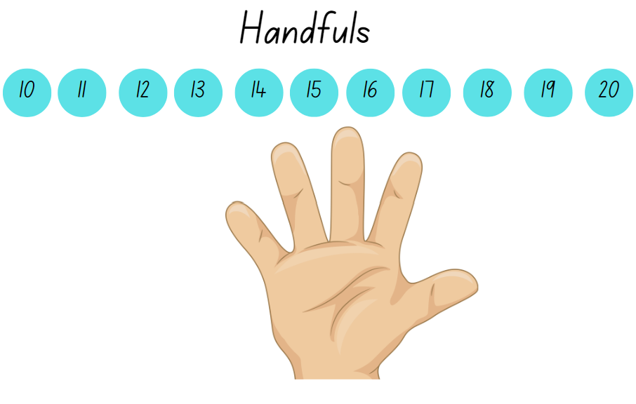
Images sourced from Canva and used in accordance with the Canva Content Licence Agreement.

Resource 5: Making cubes
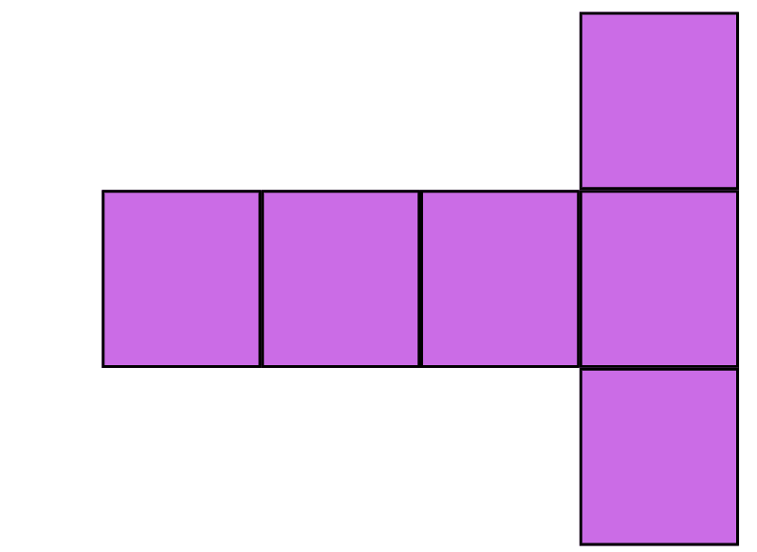
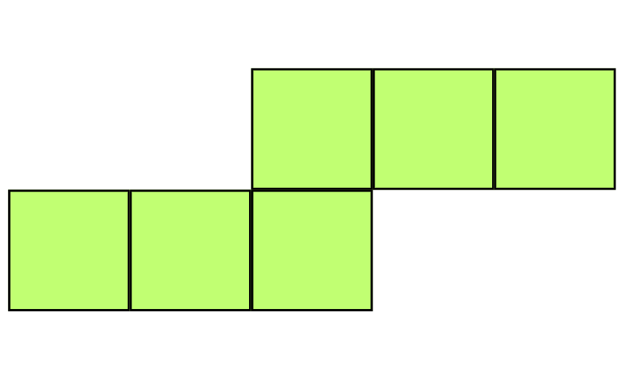
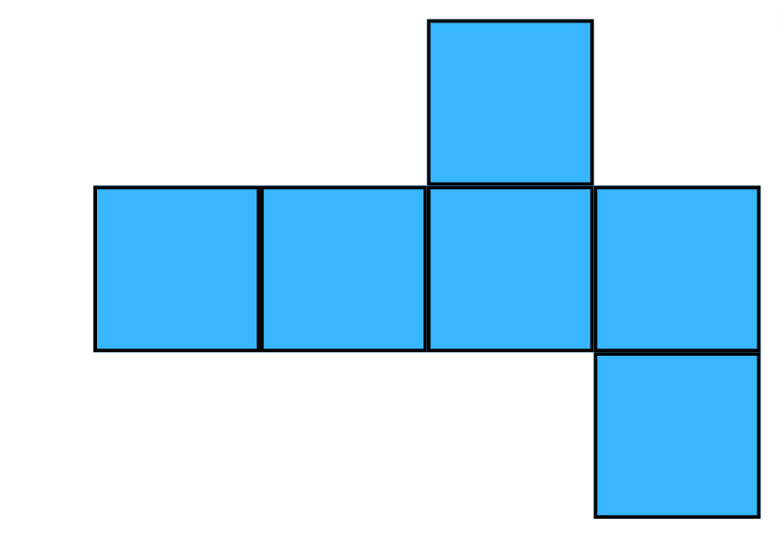

Resource 6: Pasta shapes
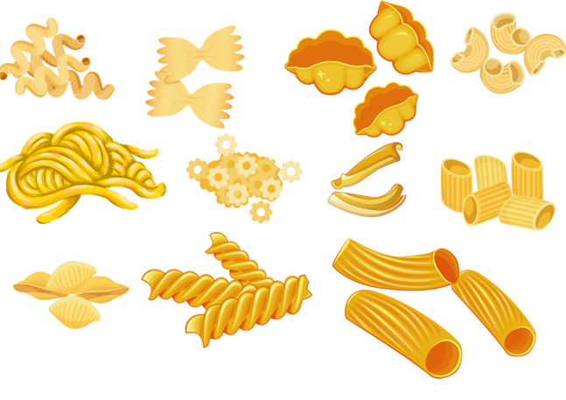
Images sourced from Canva and used in accordance with the Canva Content Licence Agreement.

Resource 7: Different packaging
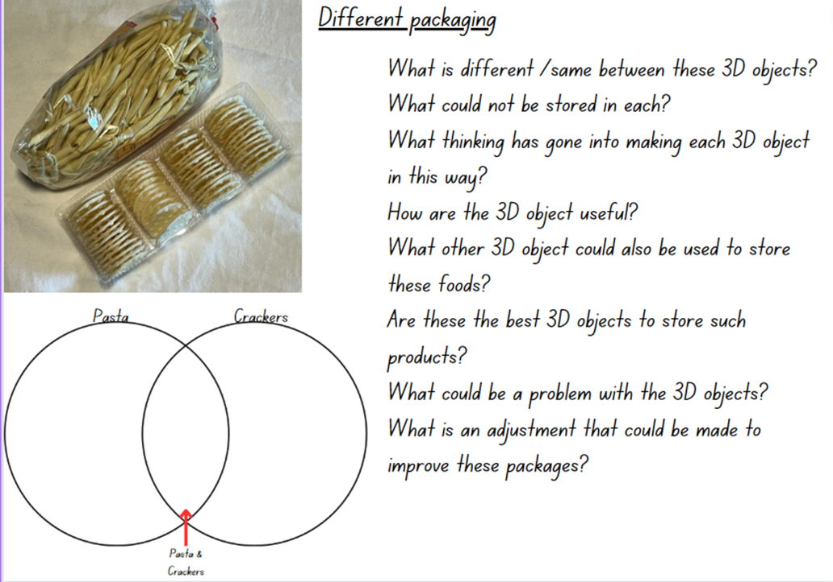
Images sourced from Canva and used in accordance with the Canva Content Licence Agreement.

Resource 8: Facts about numbers (Set A and Set B)
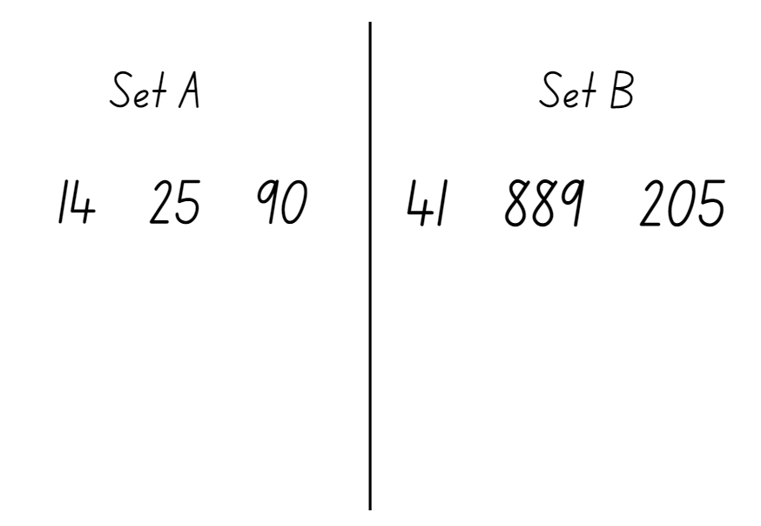

Resource 9: Lots of spots
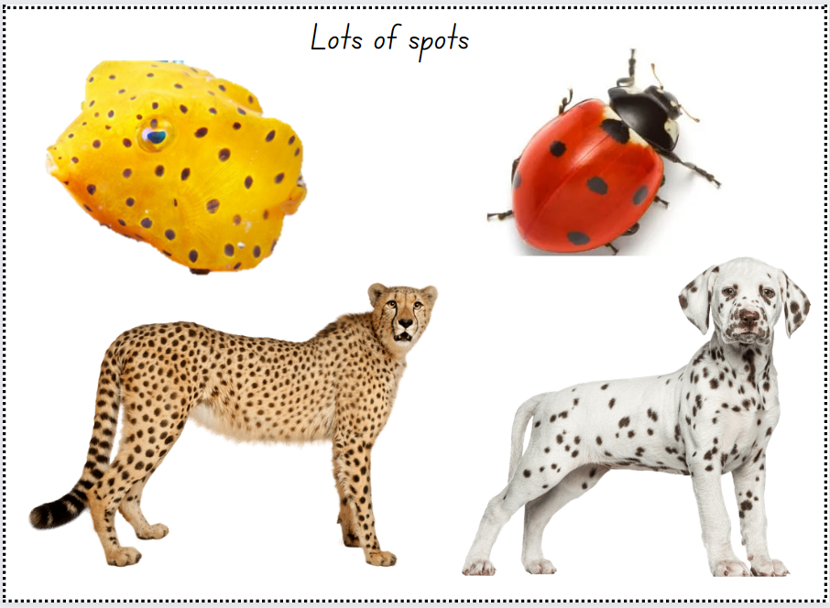
Images sourced from Canva and used in accordance with the Canva Content Licence Agreement.

Resource 10: Jellybean challenge (Early Stage 1)
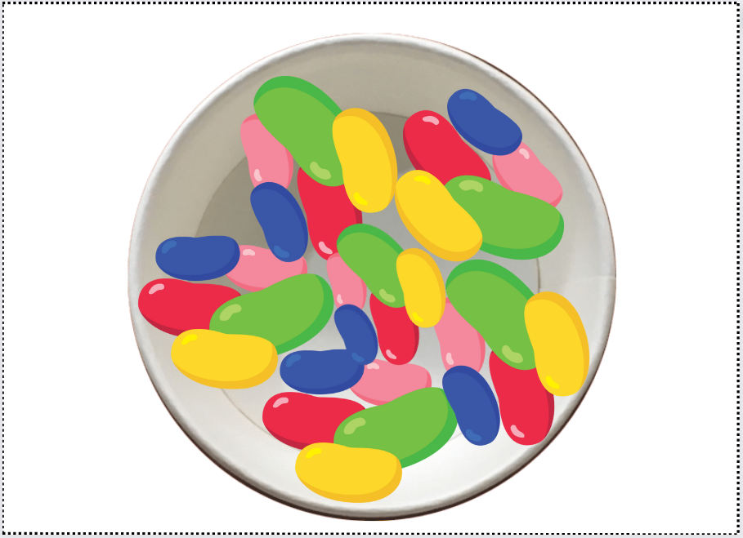
Images sourced from Canva and used in accordance with the Canva Content Licence Agreement.

Resource 11: Jellybean challenge (Stage 1)
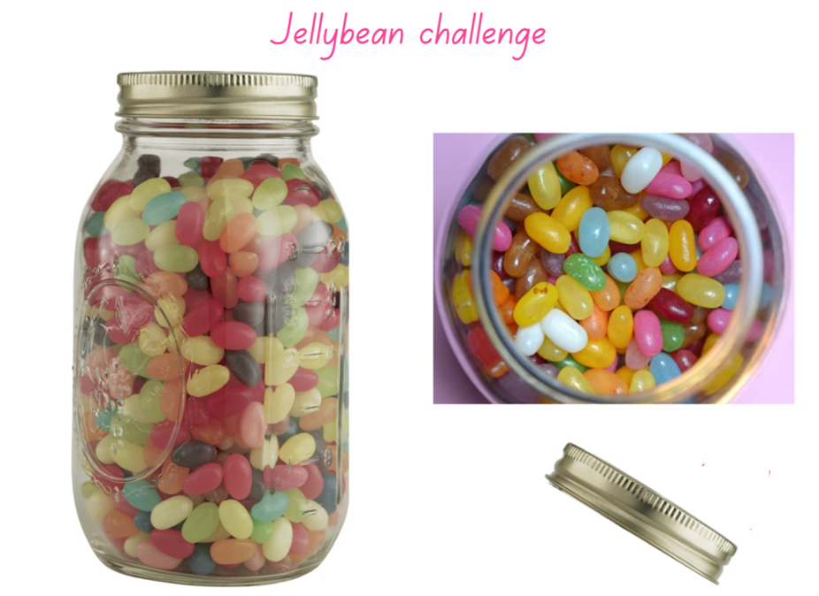
Images sourced from Canva and used in accordance with the Canva Content Licence Agreement.

Resource 12: Cargo ships
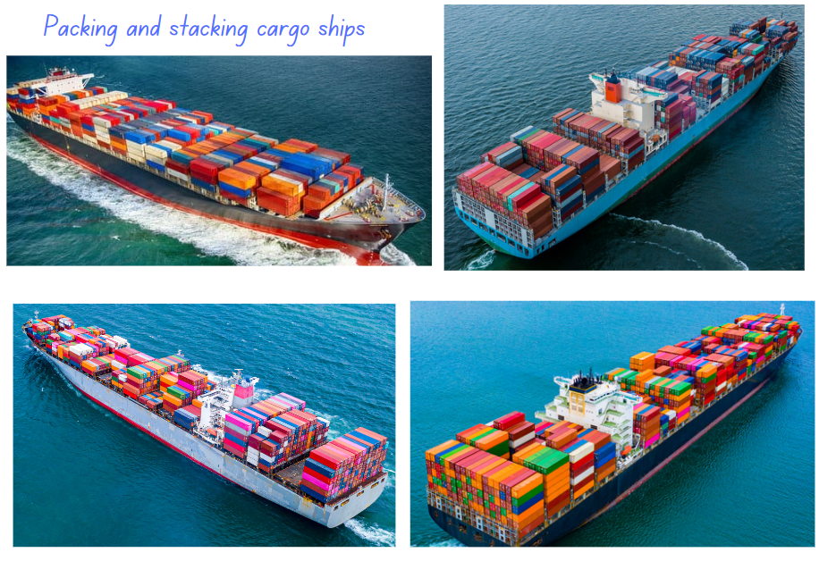
Images sourced from Canva and used in accordance with the Canva Content Licence Agreement.

Resource 13: A lot of bricks (Early Stage 1)
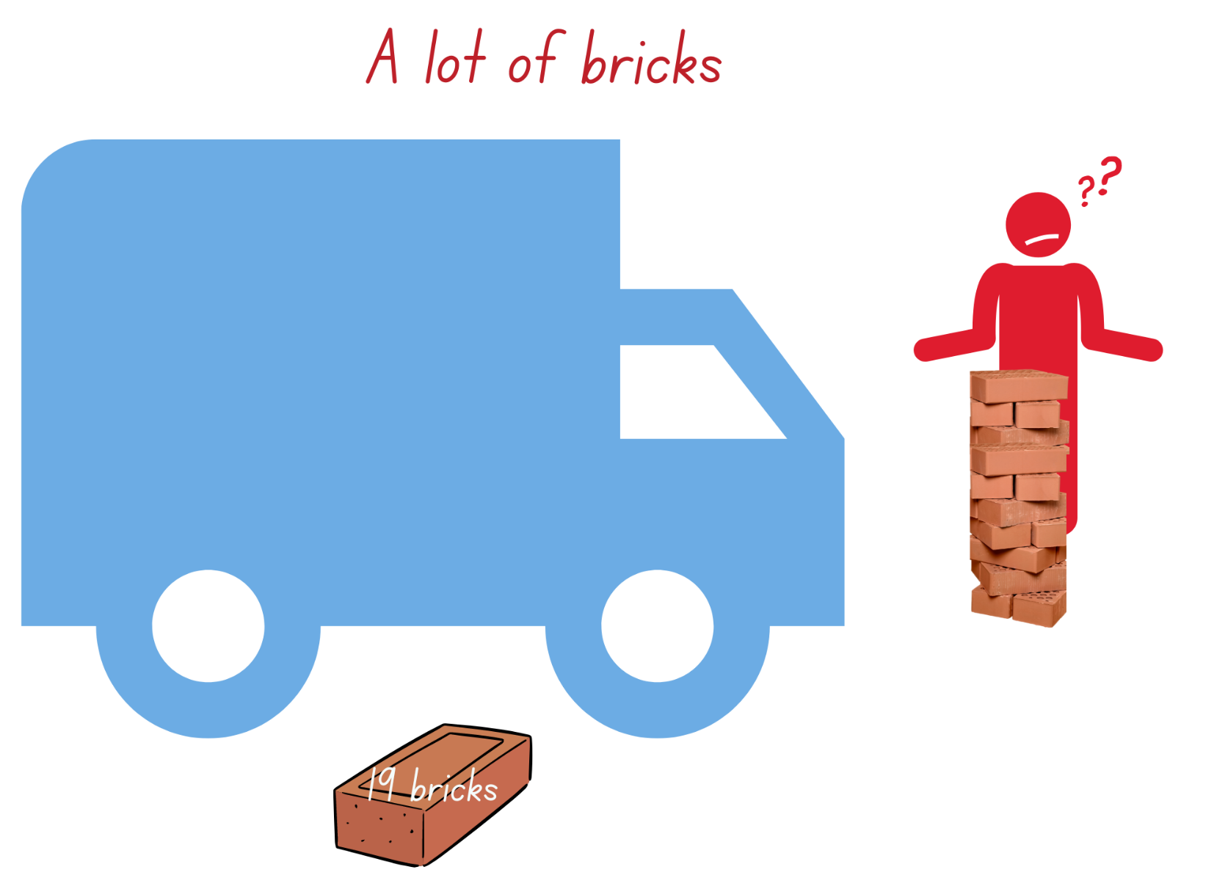
Images sourced from Canva and used in accordance with the Canva Content License Agreement.

Resource 14: A lot of bricks (Stage 1)
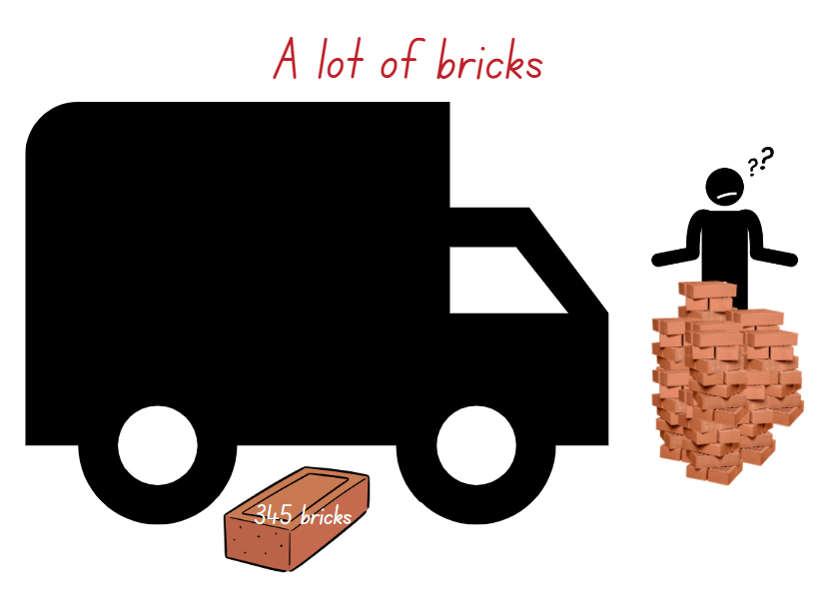
Images sourced from Canva and used in accordance with the Canva Content License Agreement.

Syllabus outcomes and content
The table below outlines the syllabus outcomes and range of relevant syllabus content covered in this unit. Content is linked to National Numeracy Learning Progression version (3).
Focus area and outcomes | Content groups and content points | Lessons
Representing whole numbers  MAO-WM-01  MAE-RWN-01, MA1-RWN-01  MAE-RWN-02, MA1-RWN-02 | Early Stage 1  Instantly name the number of objects within small collections  - Instantly recognise (subitise) the number of items in small groups of up to four items without counting (NPV1, CPr1)  - Identify the number of items in different arrangements (CPr2) | 3, 5–7
Representing whole numbers (cont) | Early Stage 1  Use the counting sequence of ones flexibly  - Count forwards to at least 30 and state the number after or before a given number, without needing to count from one  - Identify and distinguish the ‘teen’ numbers from multiples of ten with the same initial sounds (NPV3) | 1, 2, 5
Representing whole numbers (cont) | Recognise number patterns  - Recognise dice and domino dot patterns (NPA1, NPV2, CPr2) | 6
Representing whole numbers (cont) | Connect counting and numerals to quantities  - Make correspondences between collections (Reasons about quantity)  - Read numerals to at least 20, including zero (NPV3)  - Represent numbers as quantities to at least 20 using objects (such as fingers), number words and numerals (NPV2, NPV3, NPV4, CPr3)  - Compare and order numbers to 20 (NPV2, NPV3) | 3, 5, 6
Representing whole numbers A | Stage 1  Represent numbers on a line  - Sequence numbers and arrange them on a line by considering the order and size of those numbers (CPr5)  - Locate the approximate position of multiples of 10 on a model of a number line from 0 to 100 (CPr5) | 1, 2, 7
Representing whole numbers A  (cont) | Represent the structure of groups of ten in whole number  - Recognise that ten ones is the same as one ten (NPV2, NPV4)  - Count large sets of objects by systematically grouping in tens (CPr7)  - Use number lines and number charts to assist with locating the nearest ten to a number  - Estimate, to the nearest ten, the number of objects in a collection and check by counting in groups of ten (Reasons about quantity) (CPr7, NPV6) | 6, 7
Representing whole numbers B | Stage 1  Use counting sequences of ones and tens flexibly  - Identify the number before and after a given three-digit number  - Count forwards and backwards by tens, on and off the decade, with two- and three-digit numbers (CPr7) | 1, 2, 5–7
Representing whole numbers B  (cont) | Form, regroup, and rename three-digit numbers  - Count and represent large sets of objects by systematically grouping in tens and hundreds (CPr7, NPV5)  - Use models such as base 10 material and interlocking cubes to represent and explain grouping (CPr7)  - State the quantity value of digits in numbers of up to three digits (Reasons about quantity) (NPV5)  - Identify the nearest hundred to a number  - Recognise units of 100 (UnM5, NPV5)  - Use place value to partition and rename three-digit numbers in different ways (Reasons about relations) (NPV5)  - Estimate, to the nearest hundred, the number of objects in a collection and check by grouping and counting (NPV6) | 3, 6
Two-dimensional spatial structure  MAO-WM-01  MAE-2DS-01, MA1-2DS-01  MAE-2DS-02, MA1-2DS-02 | Early Stage 1  2D shapes: Sort, describe and name familiar shapes  - Identify familiar shapes in a range of contexts  - Describe shapes, including circles, squares, triangles and rectangles (UGP1, UGP2)  - Ask and respond to questions that help identify and name a particular shape | 1, 2
Representing whole numbers  (cont) | 2D shapes: Represent shapes  - Manipulate circles, squares, triangles and rectangles, and describe their features (UGP2, UGP3)  - Make representations of shapes in a variety of ways, using paint, paper, movements or technology (UGP3)  - Make two-dimensional shapes by tracing around the faces of three-dimensional objects (UGP3) | 1, 2
Two-dimensional spatial structure A | Stage 1  2D shapes: Recognise and classify shapes using obvious features  - Use the terms ‘side’, ‘vertex’ and ‘two-dimensional’ to describe plane (flat) shapes (UGP1, UGP2)  - Compare, sort and classify polygons according to the number of sides or vertices (UGP3, UGP4)  - Identify shapes presented in different orientations (UGP2) | 1, 2
Three-dimensional spatial structure  MAO-WM-01  MAE-3DS-01, MA1-3DS-01  MAE-3DS-02, MA1-3DS-02 | Early Stage 1  3D objects: Explore familiar three-dimensional objects  - Describe the features of familiar objects (UGP1)  - Sort objects and identify the attribute used to sort them (UGP2)  - Make and describe a variety of three-dimensional models (UGP3) | 1–8
Three-dimensional spatial structure  (cont) | Volume: Compare internal volume by filling and packing  - Fill and empty containers using materials such as water or sand  - Use the terms ‘full’, ‘empty’ and ‘about half full’  - Compare the internal volumes (capacities) of two containers directly by filling one and pouring into the other (UuM2)  - Compare the internal volumes of two containers indirectly by pouring their contents into two other identical containers and observing the level reached in each (UuM3)  - Establish that containers of different shapes may hold the same amount  - Stack and pack blocks into defined spaces (UuM5) | 6–8
Three-dimensional spatial structure  (cont) | Volume: Compare volume by building  - Identify the attribute of volume as the amount of space an object or substance occupies  - Compare the volumes of two objects made from blocks or connecting cubes directly by deconstructing one object and using its parts to construct a copy of the other object | 4
Three-dimensional spatial structure A | Stage 1  3D objects: Recognise familiar three-dimensional objects  - Use the term ‘three-dimensional’ to describe a range of objects (UGP2, UGP3)  - Distinguish between objects, which are three-dimensional (3D) and shapes which are two-dimensional (2D)  - Identify and name familiar three-dimensional objects, including cubes, cylinders, spheres and rectangular prisms | 1–8
Three-dimensional spatial structure A  (cont) | 3D objects: Sort and describe three-dimensional objects  - Manipulate and describe familiar three-dimensional objects (UGP2)  - Sort familiar three-dimensional objects according to obvious features  - Use the term ‘face’ to describe the flat surfaces of three-dimensional objects with straight edges (UGP2, UGP3)  - Select and name a familiar three-dimensional object from a description of its features | 1–8
Three-dimensional spatial structure A  (cont) | Volume: Measure and compare the internal volumes (capacities) of containers by filling  - Use uniform informal units to measure how much a container will hold by counting the number of times a smaller container can be filled and emptied into the container being measured (UuM3)  - Select appropriate informal units to measure the capacities of containers  - Compare the internal volumes of two or more containers using appropriate uniform informal units UuM3)  - Recognise and explain why containers of different shapes may have the same internal volume (Reasons about relations)  - Estimate how much a container holds by referring to the number and type of uniform informal unit used and check by measuring (UuM3, UuM4) | 7, 8
Three-dimensional spatial structure A  (cont) | Volume: Measure the internal volume (capacity) of containers by packing  - Pack cubic units (eg blocks) into rectangular containers so that there are no gaps  - Recognise that cubes pack better than other objects in rectangular containers (Reasons about spatial structure)  - Estimate and measure the internal volume of a container by filling the container with uniform informal units and counting the number of units used  - Explain that if there are gaps when packing and stacking, this will affect the accuracy of measuring the internal volume | 6
Three-dimensional spatial structure A  (cont) | Volume: Construct volumes using cubes  - Explore different rectangular prisms that can be made from a given number of cubes  - Devise and explain strategies for stacking and counting units to form a rectangular prism (Reasons about spatial structure)  - Record volumes, referring to the number and type of uniform informal unit use | 4, 5
Three-dimensional spatial structure B | Stage 1  3D objects: Describe the features of three-dimensional objects  - Describe three-dimensional objects (prisms) using the terms ‘face’, ‘edge’ and ‘vertex’  - Represent three-dimensional objects by making simple models  - Recognise and name flat surfaces of three-dimensional objects as two-dimensional shapes | 1–8
Three-dimensional spatial structure B  (cont) | Volume: Compare containers based on internal volume (capacity) by filling and packing  - Make and use a device for measuring internal volume (capacity) calibrated in uniform informal units (UuM3, UuM4)  - Compare, order and record the internal volumes (capacities) of two or more containers by measuring each container in uniform informal units (UuM3, UuM4)  - Estimate internal volume (capacity) by referring to the number and type of uniform informal unit used (UuM3) | 7, 8
Three-dimensional spatial structure B  (cont) | Volume: Compare volumes using uniform informal units  - Estimate the volumes of two or more models and check by counting the number of blocks used in each model  - Compare models with different appearances, recognising when they have the same volume (Reasons about spatial structure)  - Record the results of volume comparisons using drawings, numerals and words, referring to the units used  - Explain that models made of the same number of units may have different volumes depending on the size of the units used (Reasons about spatial relations) | 4, 5

References
Links to third-party material and websites
Please note that the provided (reading/viewing material/list/links/texts) are a suggestion only and implies no endorsement, by the New South Wales Department of Education, of any author, publisher, or book title. School principals and teachers are best placed to assess the suitability of resources that would complement the curriculum and reflect the needs and interests of their students.
If you use the links provided in this document to access a third-party's website, you acknowledge that the terms of use, including licence terms set out on the third-party's website apply to the use which may be made of the materials on that third-party website or where permitted by the Copyright Act 1968 (Cth). The department accepts no responsibility for content on third-party websites.
Except as otherwise noted, all material is © State of New South Wales (Department of Education), 2023 and licensed under the Creative Commons Attribution 4.0 International License. All other material (third-party material) is used with permission or under licence. Where the copyright owner of third-party material has not licensed their material under a Creative Commons or similar licence, you should contact them directly for permission to reuse their material.
Mathematics K–10 Syllabus © 2022 NSW Education Standards Authority (NESA) for and on behalf of the Crown in right of the State of New South Wales.
© 2022 NSW Education Standards Authority. This document contains NSW Curriculum and syllabus content. The NSW Curriculum is developed by the NSW Education Standards Authority. This content is prepared by NESA for and on behalf of the Crown in right of the State of New South Wales. The material is protected by Crown copyright.
Please refer to the NESA Copyright Disclaimer for more information.
NESA holds the only official and up-to-date versions of the NSW Curriculum and syllabus documents. Please visit the NSW Education Standards Authority (NESA) website and the NSW Curriculum website.
National Numeracy Learning Progression © Australian Curriculum, Assessment and Reporting Authority (ACARA) 2010 to present, unless otherwise indicated. This material was downloaded from the Australian Curriculum website (National Numeracy Learning Progression) (accessed 21/3/2023) and was not] modified. The material is licensed under CC BY 4.0. Version updates are tracked in the ‘Curriculum version history’ section on the 'About the Australian Curriculum' page of the Australian Curriculum website.
ACARA does not endorse any product that uses the Australian Curriculum or make any representations as to the quality of such products. Any product that uses material published on this website should not be taken to be affiliated with ACARA or have the sponsorship or approval of ACARA. It is up to each person to make their own assessment of the product, taking into account matters including, but not limited to, the version number and the degree to which the materials align with the content descriptions and achievement standards (where relevant). Where there is a claim of alignment, it is important to check that the materials align with the content descriptions and achievement standards (endorsed by all education Ministers), not the elaborations (examples provided by ACARA).
This resource contains images and content obtained from Canva, and their use outside of this resource is subject to Canva’s Content License Agreement. If you wish to use them separately from the resource, please go to Canva.
ABCya.com, L.L.C. (2023) How many marbles?, ABCya website, accessed 21 March 2023.
Australian Government Department of Education (2023) ‘Assessing Reasoning Teacher’s Guide’, Teaching resources, reSolve: Maths by Inquiry website, accessed 15 March 2023.
Mathigon (2022) Polypad [website], accessed 21 March 2023.
Moss J, Bruce CD, Caswell B, Flynn T and Hawes Z (2016) Taking Shape: Activities to Develop Geometric and Spatial Thinking, Grades K-2, Pearson Canada.
Siemon D, Warren E, Beswick K, Faragher R, Miller J, Horne M, Jazby D, Breed M, Clark J and Brady K (2020) Teaching Mathematics: Foundations to Middle Years, 3rd edn, Oxford University Press Australia and New Zealand.
Sullivan P (2017) Challenging Mathematical Tasks: Unlocking the potential of all students, Oxford University Press, Australia.

