Mathematics – K-2 multi-age – Year B – Unit 18
Contents
Unit description and duration 4
Student prior learning 4
Lesson overview and resources 5
Lesson 1: Our calendar 14
Daily number sense: Clap it! – 15 minutes 15
What do we do on each day of the week at school? – 45 minutes 16
Lesson 2: Birthdays 23
Daily number sense: Which number is missing? – 10 minutes 23
Which day of the week was I born? – 40 minutes 24
Discuss and connect the mathematics – 5 minutes 28
Lesson 3: All about us 29
Daily number sense: Teacher choice – 5 minutes 30
Types of questions – 15 minutes 30
Getting to school – 15 minutes 31
Lesson 4: Dice data! 37
Daily number sense: Find the nearest! – 15 minutes 38
Dice data! – 40 minutes 39
Graph discussion – 5 minutes 42
Lesson 5: Domino data 43
Daily number sense: Destination Australia! – 15 minutes 43
Domino data – 40 minutes 44
Discuss and connect the mathematics – 5 minutes 48
Lesson 6: Crazy socks 49
Daily number sense: Understanding numbers – 20 minutes 50
Pairs of socks – 40 minutes 51
Discuss and connect the mathematics – 5 minutes 56
Lesson 7: Talking and sorting 57
Daily number sense: NSW road trip! – 15 minutes 58
Sorting out the pile (Early Stage 1) – 40 minutes 59
What’s the chance? (Stage 1) – 40 minutes 61
Consolidation and meaningful practice: More real-life numbers! – 10 minutes 63
Lesson 8: Tricky data! 64
Daily number sense: Teacher choice – 10 minutes 65
Sorting bricks (Early Stage 1) – 45 minutes 65
Interpreting data (Stage 1) – 45 minutes 67
Discuss and connect the mathematics – 10 minutes 70
Resource 1: Different activities 71
Resource 2: Calendar 72
Resource 3: Picture graph example 73
Resource 4: Features of a column graph 74
Resource 5: Data questions 75
Resource 6: Travelling to school 76
Resource 7: Destination Australia 77
Resource 8: One to 20 78
Resource 9: NSW road trip! 79
Resource 10: Venn diagram 80
Resource 11: Basketball hoops A 81
Resource 12: Basketball hoops B 82
Resource 13: Basketball hoops C 83
Syllabus outcomes and content 84
References 90

Unit description and duration
This two-week unit develops student understanding of data and chance, and their interconnectedness. Students are provided opportunities to:
- investigate topics of interest by choosing suitable questions to collect, display and interpret relevant data
- identify misleading data (Stage 1 students)
- learn the names and order of days of the week (Early Stage 1 students)
- learn the order of seasons and months of the year and how to use a Gregorian calendar (Stage 1 students)
- use data with language to reason about possible outcomes in familiar activities (Stage 1 students)
Mathematics K–10 Syllabus © 2022 NSW Education Standards Authority (NESA) for and on behalf of the Crown in right of the State of New South Wales.

Student prior learning
Before engaging in these teaching and learning activities, students would benefit from prior experience with:
- arranging objects according to a characteristic to form a data display and using it to ask questions
- using comparative language in everyday discussions
- thinking about the chance of everyday events occurring
- multi-cultural and Aboriginal events that happen in spring, summer, autumn and winter in your community and across Australia.

Lesson overview and resources
The table below outlines the sequence and approximate timing of lessons; syllabus focus areas and content groups; and resources.
Lesson | Syllabus focus area and content groups | Resources
Lesson 1: Our calendar  60 minutes  Days and months are organised using the Gregorian calendar. | Representing whole numbers  Early Stage 1  - Use the counting sequence of ones flexibly  Stage 1 – Part A  - Continue and create number patterns  Non-spatial measure  Early Stage 1  - Time: Connect days of the week to familiar events and actions  Stage 1 – Part A  - Time: Name and order the cycle of months  Data  Early Stage 1  - Respond to questions, collect information and discuss possible outcomes of activities  - Organise objects into simple data displays and interpret the displays  Stage 1 – Part A  - Ask questions and gather data  - Represent data with objects and drawings and describe the displays  Stage 1 – Part B  - Create displays of data and interpret them | - Resource 1: Different activities  - Resource 2: Calendar  - Resource 3: Picture graph example  - Calendar for Cultural Diversity [PDF 50MB]  - Hula hoops  - Large circles  - Sticky notes  - Writing materials
Lesson 2: Birthdays  55 minutes  Days of the week are connected to familiar events. | Representing whole numbers  Early Stage 1  - Connect counting and numerals to quantities  Stage 1 – Part A  - Continue and create number patterns  Non-spatial measure  Early Stage 1  - Time: Connect days of the week to familiar events and actions  Stage 1 – Part A  - Time: Name and order the cycle of months  Data  Early Stage 1  - Respond to questions, collect information and discuss possible outcomes of activities  - Organise objects into simple data displays and interpret the displays  Stage 1 – Part A  - Ask questions and gather data  - Represent data with objects and drawings and describe the displays  Stage 1 – Part B  - Identify a question of interest and gather relevant data  - Create displays of data and interpret them | - Resource 4: Features of a column graph  - A4 card  - Camera or phone  - Class list of student birthdays  - Large grid paper  - Mini-whiteboards or workbooks  - Sticky notes  - Writing materials
Lesson 3: All About Us!  35 minutes  Asking the right questions can help collect and sort data. | Data  Early Stage 1  - Respond to questions, collect information and discuss possible outcomes of activities  - Organise objects into simple data displays and interpret the displays  Stage 1 – Part A  - Ask questions and gather data  - Represent data with objects and drawings and describe the displays  Stage 1 – Part B  - Identify a question of interest and gather relevant data  - Create displays of data and interpret them | - Resource 5: Data questions  - Resource 6: Travelling to school  - Camera or phone  - Concrete materials  - Container  - Glue  - Large piece of paper
Lesson 4: Dice data!  60 minutes  Data can be organised into a display and used to answer questions. | Representing whole numbers  Early Stage 1  - Instantly name the number of objects within small collections  - Use the counting sequence of ones flexibly  Stage 1 – Part B  - Form, regroup, and rename three-digit numbers  Data  Early Stage 1  - Respond to questions, collect information and discuss possible outcomes of activities  - Organise objects into simple data displays and interpret the displays  Stage 1 – Part B  - Create displays of data and interpret them  Chance  Stage 1 – Part A  - Identify and describe possible outcomes  Stage 1 – Part B  - Identify and describe activities that involve chance | - 12 × 6-sided dice per Early Stage 1 group  - 12 × 12-sided dice per Stage 1 group  - 3 × 9-sided dice  - A few extra 12- and 20-sided dice  - Camera or phone  - Counters  - Cups – one per group  - Grid paper  - Writing materials
Lesson 5: Domino data!  60 minutes  Categories of data can be used to make predictions and answer questions. | Representing whole numbers  Early Stage 1  - Instantly name the number of objects within small collections  - Recognise number patterns  - Connect counting and numerals to quantities  Stage 1 – Part B  - Form, regroup and rename three-digit numbers  Data  Early Stage 1  - Organise objects into simple data displays and interpret the displays  Stage 1 – Part B  - Create displays of data and interpret them  Chance  Stage 1 – Part A  - Identify and describe possible outcomes  Stage 1 – Part B  - Identify and describe activities that involve chance | - Resource 7: Destination Australia  - Resource 8: One to 20  - Counter  - Multiple sets of dominoes – one set per group  - Writing materials
Lesson 6: Crazy socks  65 minutes  Data collections can be used to make predictions and comparisons. | Representing whole numbers  Early Stage 1  - Recognise number patterns  Stage 1 – Part B  - Form, regroup and rename three-digit numbers  Data  Early Stage 1  - Respond to questions, collect information and discuss possible outcomes of activities  - Organise objects into simple data displays and interpret the displays  Stage 1 – Part A  - Ask questions and gather data  - Represent data with objects and drawings and describe the displays  Stage 1 – Part B  - Identify a question of interest and gather relevant data  - Create displays of data and interpret them  Chance  Stage 1 – Part A  - Identify and describe possible outcomes  Stage 1 – Part B  - Identify and describe activities that involve chance | - Camera or phone  - Containers  - Pairs of real socks  - Three 9-sided dice  - Workbooks
Lesson 7: Talking and sorting  65 minutes  Mathematical language can be used to identify, describe and compare. | Representing whole numbers  Early Stage 1  - Connect counting and numerals to quantities  Data  Early Stage 1  - Organise objects into simple data displays and interpret the displays  Stage 1 – Part B  - Identify a question of interest and gather relevant data  Chance  Stage 1 – Part A  - Identify and describe possible outcomes  Stage 1 – Part B  - Identify and describe activities that involve chance | - Resource 9: NSW road trip!  - Resource 10: Venn diagram  - A4 pieces of card  - Small everyday objects, such as leaves, toy cars, shells, pencils  - Writing materials
Lesson 8: Tricky data  65 minutes  Data can be accurate or misleading. | Data  Early Stage 1  - Organise objects into simple data displays and interpret the displays  Stage 1 – Part B  - Create displays of data and interpret them | - Resource 11: Basketball hoops A  - Resource 12: Basketball hoops B  - Resource 13: Basketball hoops C  - Camera or phone  - Lots of coloured bricks – enough for the whole class  - Mini whiteboards  - Paper plates – enough for the whole class  - Writing materials

Lesson 1: Our calendar
Core concept: Days and months are organised using the Gregorian calendar.
The table below contains suggested learning intentions and success criteria. These are best co-constructed with students.
Learning intentions | Success criteria
All students are learning that:  - symbols can be used to represent data  - a data display can be used to ask and answer questions  - days of the week and/or months of the year have names and always come in the same order.  In addition, Early Stage 1 students are learning that days of the week can be connected to familiar events and actions.  In addition, Stage 1 students are learning that in the Gregorian calendar, each month has a set number of days, except in leap years. | All students can:  - collect data and produce a display  - use data to ask and answer questions.  In addition, students working towards Early Stage 1 outcomes can:  - recall the 7 days of the week in order  - create a data display to show things they do on different days of the week at school.  In addition, students working towards Stage 1 outcomes can:  - name and order the 12 months of the year  - use a calendar to find out how many days are in each month  - collect and display data to find out how many months have 28, 30 and 31 days.

Daily number sense: Clap it! – 15 minutes
This activity is adapted from Clapping Times at NRICH.
- Build student understanding of number patterns by counting forwards and backwards by twos, fives and tens.
- As a class, count aloud from one to 30, clapping on each number.
- Explain that in the next round of counting, students will say every second number loudly and the other numbers quietly. Students will clap only on every second number, highlighting the numbers in the twos skip counting pattern. Ask students:
- Which numbers would be quiet?
- Which numbers would be louder?
- Early Stage 1 students repeat the process in pairs.
Note: It is not expected that Early Stage 1 students skip count by twos independently. Provide a number chart or number track to support students with the sequence if needed.
- Stage 1 students count again as a group, highlighting the numbers in the fives skip counting pattern. Students do this by clapping and saying the numbers in the fives skip counting pattern loudly and counting quietly on the other numbers. Ask students:
- If one of you claps the twos in this way and one of you claps the fives at the same time, can you predict what you would hear?
- Which numbers would be quiet?
- Which numbers would be a bit louder?
- Which numbers would be very loud (with both students clapping and counting loudly)?
- Ask Stage 1 students to try this in pairs and discuss what they hear. Ask if their predictions were right.
- Stage 1 students repeat this process for skip patterns of twos and tens or fives and tens.
- As a class, repeat the process beginning at 20, counting aloud backwards to zero and clapping.

What do we do on each day of the week at school? – 45 minutes
- Display a list of days of the week. Read the names of each day, starting at Monday.
- Ask students to list different activities they do at school on each day of the week. This could include:
- visiting the library
- maths lessons
- sport
- school assembly
- ordering lunch.
- Display large circles labelled with each day of the week. Ask students to predict what day of the week might be the most popular day for activities and justify why.
Note: Hula hoops may be used to represent days of the week.
- Draw one of the chosen activities on a sticky note and place it in the correct ‘day of the week’ circle. Provide students with sticky notes to draw pictures of other activities. Students stick their drawings in the ‘day of the week’ circles.
- Working in pairs, Early Stage 1 students look at the data display in order of the days of the week and answer the following questions:
- What happens on Monday? What happens on Tuesday? Continue this process in order of days of the week.
- Do we spend more time doing inside or outside activities?
- What day do we visit the library (or similar)?
- Can the data display be improved?
- Provide students with a sticky note to draw and add activities that have not yet been suggested.
This table details assessment opportunities and differentiation ideas.
Assessment opportunities | Too hard? | Too easy?
What to look for:  - Can students recall the 7 days of the week in order? (MAE-NSM-02)  - Can students help to create a data display to show activities they do on different days of the week? (MAO-WM-01, MAE-NSM-02, MAE-DATA-01)  - Can students interpret data and answer questions? (MAO-WM-01, MAE-NSM-02, MAE-DATA-01)  What to collect:  - Observational records of questions and interpretations. (MAO-WM-01, MAE-NSM-02, MAE-DATA-01)  - Photographs of the data display. (MAE-NSM-02, MAE-DATA-01) | Students cannot draw activities.  - Provide students with Resource 1: Different activities, to cut out and place in the data display.  - Students draw simple symbols to represent their activities.  Students cannot interpret data.  - Model counting the activities one by one, pointing to each picture to reach a total.  - Students place the activities for each day in a row, so they are easier to count. | Students create and interpret a data display.  - Students ask each other comparative questions. For example, students could ask how many more times the class does a maths lesson compared with visits to the library.  - Students describe the display using comparative language, such as ‘more than’ or ‘less than’.
- Display Resource 2: Calendar to Stage 1 students and ask what it is and how it is used. Choose a few months at random and ask students if they can think of anything that always happens in that month, for example, a birthday or a public holiday. Point out the days in the calendar.
Note: This is an opportunity to celebrate multicultural and Aboriginal perspectives in your context. The Calendar for Cultural Diversity [PDF 50MB] could be a helpful resource.
- Explain that a calendar displays every day of the year and that the year is made up of 12 months. Explain how the months can be organised into seasons. Ask students to turn and talk about other things they notice about the calendar. Answers may include:
- most months are made up of 4 and a bit weeks
- each week has 7 days
- each day of the month has a number on it
- there are 12 months in total
- some months have more days than others
- the days of the week are written across the top of each month.
- Ask students if there is a way to find out how many days are in each month. Suggestions may include counting the days of each month or looking at the last day of each month.
- Cut up Resource 2: Calendar and display all the months in a random order on the floor. Ask students to count the days in each month and record their results.
- Organise months in the correct order as a class and explore the calendar further.
The table below outlines stimulus prompts to generate conversation about the topic, along with anticipated responses from students.
Prompts | Anticipated student responses
- Now that you have counted all the days in each month, what do you notice?  - How can we arrange the months into categories? | - I notice that months have different numbers of days.  - Some months have 31 days, others have 30 days.  - I can see that February only has 28 days.  - We can arrange them by the number of days in each month.  - We can count how many months have 28 days, how many have 30 days and how many have 31.
Note: Explain the concept of the leap year, in which every 4 years February is made up of 29 days not 28.
- Explain to students that they can use tally marks to keep count of objects. See Figure 1.
Figure 1 – Tally marks
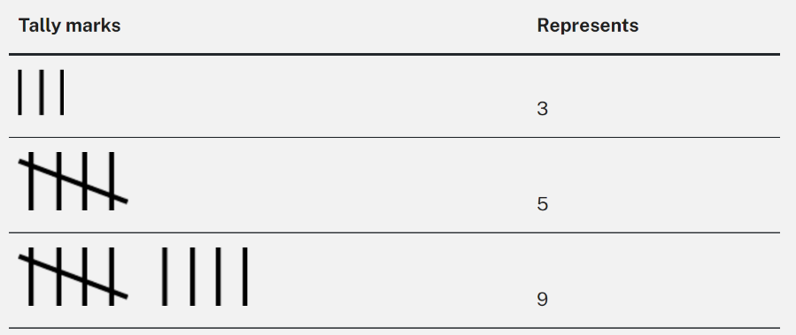
Tally mark: A single mark in a tally represents one observation. Tally marks are usually drawn in groups of 5, with the first 4 marks drawn vertically and the fifth drawn diagonally through the 4.
- Discuss and model how tally marks are used. Ask students why they think tally marks are drawn in groups of 5.
- Students work in groups to collect data on how many months have 28, 30 or 31 days using tally marks. They record this in their workbooks.
Note: It is not expected that Early Stage 1 students will use tally marks independently.
- Once data has been collected, students transfer all their data onto a picture graph and decide what symbols they are going to use for the graph. Display Resource 3: Picture graph example and discuss all the features of a picture graph. Discuss that, when representing data in a picture graph, students must use a baseline, equal spacing and same-sized symbols.
- Students create picture graphs using symbols or the names of the months to show how many months have 28, 30 and 31 days in their workbooks. Students compare the number of months in each group, identifying biggest and smallest groups and using language such as ‘more than’ and ‘less than.’
This table details assessment opportunities and differentiation ideas.
Assessment opportunities | Too hard? | Too easy?
What to look for:  - Can students create a picture graph using symbols to represent data? (MAO-WM-01, MA1-DATA-02)  - Can Stage 1 students use tally marks to track how many days in each month? (MAO-WM-01, MA1-DATA-01)  What to collect:  - Work samples of tally marks and picture graphs. (MAO-WM-01, MA1-DATA-01, MA1-DATA-02) | Students cannot use tally marks to keep an accurate track of the count.  - Give students a ten-frame and counters to keep track of their count and then model how to transfer this into tally marks.  - Have students show you how they are keeping track of their data using tally marks to ensure correct technique.  Students cannot create picture graphs with equal spacing and same-sized symbols that represent one item.  - Provide students with the same sized symbols or words to create their graph.  - Model equal spacing. | Students can use tally marks and create accurate picture graphs.  - Provide more opportunities for data collecting using tally marks.  - Provide students with the link to Calendars at NRICH. Students engage with the resource to learn about and discuss calendars from different cultures and history.

Lesson 2: Birthdays
Core concept: Days of the week are connected to familiar events.
The table below contains suggested learning intentions and success criteria. These are best co-constructed with students.
Learning intentions | Success criteria
All students are learning that:  - days of the week can be connected to familiar events  - data can be collected and displayed in many ways and used to ask and answer questions. | All students can create a data display showing what day of the week they were born on and use it to answer questions.  In addition, students working towards Early Stage 1 outcomes can collect and display data using blocks or counters.  In addition, students working towards Stage 1 outcomes can collect and display data using tally marks and column graphs.

Daily number sense: Which number is missing? – 10 minutes
This activity has been adapted from Sullivan (2012).
- Build student understanding of number patterns by identifying incorrect and missing parts of patterns.
- As a class, count in ones to 20. Display the following patterns on the board and ask students what they notice:
- 1, 2, _, 4, 5, 6, 7, 8
- 11, 12, 13, 14, _, 16, 17
- 20, 19, _, 17, 16, 15
- In pairs, Early Stage 1 students take turns counting a number pattern forwards and backwards by ones from a self-chosen number between one and 20. One student removes one number in the pattern. Their partner listens and identifies the missing or incorrect number, then suggests the correct pattern.
- With Stage 1 students, count aloud by twos to 20. Then display the following patterns on the board and ask students what they notice:
- 2, 4, 6, _, 10, 12, 14
- 4, _, 8, 10, 12, 14, 16
- 20, 18, 16, _, 12, 10, 8
- Students record the skip counting pattern with the correct numbers on individual whiteboards to highlight the correct pattern.
- In pairs, students take turns to present a pattern on a whiteboard with one number missing. The other partner identifies the missing number, then suggests the correct pattern. Students can use whiteboards or paper if they cannot mentally visualise a pattern.
- Some students may enjoy the challenge of missing out more than one number in the pattern or repeating the process with threes, fives or tens skip counting patterns.

Which day of the week was I born? – 40 minutes
Note: Prior to this activity, access a class list of student birthdays. Write the days of the week on which students were born on a small piece of paper for the task.
- Ask students if they know when their birthday is. If students can’t remember, tell them. Talk about how they were born on a day of the week and revise days of the week in order, beginning with Monday. Sing a song about the days of the week.
- Ask if anyone knows what day of the week they were born on. Have students predict which day of the week the most and/or the least of them were born. Ask students to justify and explain their prediction.
- Give each student a piece of paper with their name and the day of the week on which they were born. Ask students how they could sort and organise this information.
- Using large card or paper, display each day of the week on the wall or the carpet. Ask students to line up in front of the day they were born on and sit down forming straight lines.
- Have students from each group count how many were born on their day and write the results up on the board using tally marks.
- As students are sitting, let them know that they have created their own graph. Students have created a column graph using their bodies to line up in front of the day they were born. Take a photograph and show the students.
- Display the photograph on the interactive whiteboard. In groups, Early Stage 1 students use the information in the photograph to create a data display with blocks or counters and draw it in their workbooks. See Figure 2.
Figure 2 – Column graph
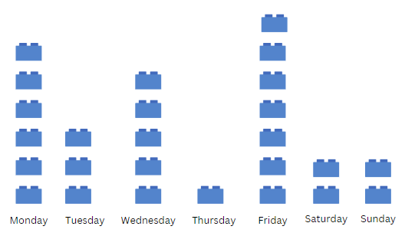
Images sourced from Canva and used in accordance with the Canva Content License Agreement.
- Display Resource 4: Features of a column graph to Stage 1 students and ask what they notice. Comments may include:
- the names of the seasons of the year are displayed across the bottom
- the graph looks like grid paper
- there are numbers on the left-hand side going up from zero.
- Provide large grid paper and tell students they will be creating their own column graph for the information collected about birthdays. Revise that for every student they will be colouring in one square.
- While they are working, each student finds and shows you their birthday on this year’s Gregorian calendar.
- Bring Early Stage 1 and Stage 1 students together and take a close look at the data collected. Have students Think-Pair-Share their questions. For example:
- Which day of the week were most people born on? Why do you think this?
- Only one person in our class was born on a Thursday? Is there a reason for this?
- Is there a difference between weekdays and the weekend?
- Students record answers to 2 or more questions on sticky notes or in workbooks.
This table details assessment opportunities and differentiation ideas.
Assessment opportunities | Too hard? | Too easy?
What to look for:  - Can students recognise and line up behind the day of the week in which they were born? (MAO-WM-01, MA1-NSM-02)  - Can students use the information on the data display to ask and answer questions? (MAO-WM-01, MAE-NSM-02, MAE-DATA-01)  - Can students convert tally marks into a column graph? (MAO-WM-01, MA1-DATA-01)  - Can Stage 1 students create a column graph with correct features? (MAO-WM-01, MA1-DATA-01)  - Can students interpret data from the graph by asking and answering questions? (MAO-WM-01, MA1-DATA-02)  What to collect:  - Workbooks with graph created by blocks or counters. (MAO-WM-01, MAE-DATA-01)  - Photograph of human column graph. (MAE-NSM-02, MA1-NSM-02)  - Work samples of column graphs. (MAO-WM-01, MA1-DATA-02) | Students cannot organise or interpret data.  - Help students place their birthday paper slip in the data display.  - Model asking and answering questions, pointing to the relevant part of the data display.  Students cannot convert tally marks into a column graph.  - Students use counters to represent tally marks.  - Model how to colour one square for each tally mark.  Students cannot create a column graph with correct features.  - Revise the main features of a column graph.  - Model how to create a column graph. | Students can convert tally marks into a column graph.  - Provide other information in tally marks that students can use to create another column graph.  - Students conduct their own investigation, using tally marks to collect data.  Students can create a column graph with correct features.  - Students create a column graph from their own data collection.  - Students discuss where tally marks work better than a column graph and vice versa.

Discuss and connect the mathematics – 5 minutes
- As a class discuss the following:
- If you were to collect this information from another class, would it be the same?
- What other information could we collect from the class to create data and graphs?

Lesson 3: All about us
Core concept: Asking the right questions can help collect and sort data.
The table below contains suggested learning intentions and success criteria. These are best co-constructed with students.
Learning intentions | Success criteria
All students are learning that:  - information can be collected by asking questions  - objects can be sorted into groups and displayed as a table  - a data display can be interpreted.  In addition, Stage 1 students are learning that:  - data can be numerical or categorical  - data collection is more effective when the right questions are asked. | All students can:  - collect and sort information about how their peers travel to school  - create and interpret data displays showing how students travel to school.  In addition, students working towards Stage 1 outcomes can:  - recognise when it is best to sort data using numbers or groups  - ask open questions to collect a range of information.

Daily number sense: Teacher choice – 5 minutes
- From a class need surfaced through formative assessment data, identify a short, focused activity that targets students’ knowledge, understanding and skills. Example activities may be drawn from the following resources:
- Mathematics K-6 resources
- Universal Resources Hub.

Types of questions – 15 minutes
- Explain that when students investigate and gather data, they need to ask the right kinds of questions.
- Express that there are 2 types of questions to ask when collecting data. These are:
- questions that will give numbers as answers
- questions that will give data that can be sorted into categories.
Data categories: Data can be separated into 2 categories, numerical and categorical. Numerical data provides values that will always be in number form, whereas categorial data provides information that can be separated into distinct groups or categories.
- Read students Resource 5: Data questions and ask them to identify whether the questions will result in information that is numerical or categorical. For each question, students Think-Pair-Share and then agree as a class.

The table below outlines stimulus prompts to generate conversation about the topic, along with anticipated responses from students.
Prompts | Anticipated student responses
- Can you find a question that only gives you a yes or no answer?  - How useful are these kinds of questions?  - Do you think closed or open questions are the best questions to ask when collecting data? Why? | - ‘Do you play Minecraft?’, ‘Do you have a brother?’ ‘Do you like tennis?’ and ‘Can you swim butterfly stroke?’  - Not very because you can only have 2 categories of answers. Just yes or no or only 2 answers.  - Open questions can have more answers.

Getting to school – 15 minutes
- Ask students how they travel to school in the morning. Answers may include walking, car, bus, train, riding a bike or scooter or a combination of ways.
- Ask students if they think that the way they travel to school would make a good question for data collection. Prompt students to explain why or why not.
- Ask students what questions they would like to ask about travelling to school. For example:
- I wonder which way is the most popular?
- Which way is the least popular?
- I wonder how many people travel to school the same way as me?
- Give students a copy of Resource 6: Travelling to school so they can cut out their mode of transport. Students using multiple methods of travel may cut out multiple pictures. Students place pictures into one container.
- When all the data has been collected, tip all the pictures onto the floor. Use the suggested question prompts to facilitate a class discussion about the data.
The table below outlines stimulus prompts to generate conversation about the topic, along with anticipated responses from students.
Prompts | Anticipated student responses
- How could we find out the different ways that students travel to school?  - How could we count all the different ways of travel?  - Is there a way we could arrange these pictures so it is easier to see the least and most used ways to travel to school? | - We can put all the squares with the same pictures into piles.  - We can count each pile to find out how many students are travelling using each method.  - We can sort the pictures into straight lines.  - We can put the pile with the greatest number of pictures along the bottom and then put the other piles above going from largest to smallest.
- Have students place the pictures into piles, sorting according to methods of travel.
- Sort Early Stage 1 students into groups to continue with this activity, while Stage 1 students begin another activity. Each group of Early Stage 1 students collects one pile and counts how many are in it. Ask how many pictures are in each pile and, together, order travel from most to least popular.
- Model and discuss the need to add a title, numbers, and travel methods along the axes. See Figure 3 as an example.
Figure 3 – Ways of travelling to school
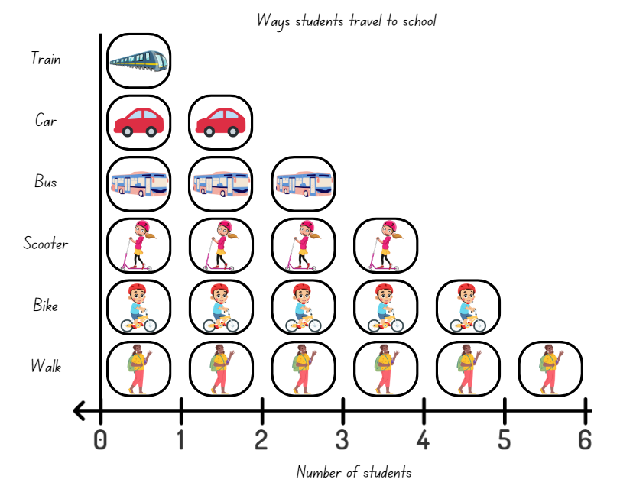
Images sourced from Canva and used in accordance with the Canva Content License Agreement.
- Early Stage 1 students create a picture graph on a large piece of paper by gluing the squares in straight lines.
The table below details assessment opportunities and differentiation ideas.
Assessment opportunities | Too hard? | Too easy?
What to look for:  - Can students sort pictures into piles according to the different methods of travel? (MAO-WM-01, MAE-DATA-01, MA1-DATA-01)  - Can students count to find the most and least popular method of travel in the class using the picture graph? (MAO-WM-01, MAE-DATA-01)  - Can students interpret information in the picture graph to answer questions? (MAO-WM-01, MAE-DATA-01)  What to collect:  - observations of students sorting and counting the data. (MAO-WM-01, MAE-DATA-01) | Students cannot sort pictures according to each method of travel.  - Model sorting blocks or counters according to their colour or shape.  - Have students sort items according to their shape or size.  Students cannot calculate the most and least popular method of travel.  - Arrange counters according to their colour to form a data display.  - Have students count the colours in each row one by one to find the total.  - Have students identify which colour has the most and the least number of counters. | Students can group the pictures into piles according to each method of travel and calculate the most and least popular.  - Using the same pictures as Resource 6: Travelling to school, students create their own data graph including questions.  - Have students use comparative language such as ‘more than’ or ‘less than’ to describe the display.  - Students find the difference between the most and least popular methods of travel in the class.
- Tell Stage 1 students that they will investigate a question of their choice.
- Split students into 2 groups and explain that each will brainstorm questions to investigate. From these questions, students will choose one and collect data.
- Remind students they must create an open question where data can be separated into several, interesting categories. This means that ‘yes’ or ‘no’ (closed) questions are not suitable.
- Students brainstorm and select an effective question, then conduct their investigation.
- Each group displays their data using concrete materials, tally marks, lists or symbols. Take photographs of data displays. The 2 groups describe and discuss their data displays.
This table details assessment opportunities and differentiation ideas.
Assessment opportunities | Too hard? | Too easy?
What to look for:  - Can Stage 1 students create an open question to investigate? (MAO-WM-01, MA1-DATA-01)  - Can Stage 1 students record their data using concrete materials, tally marks, lists or symbols? (MAO-WM-01, MA1-DATA-01)  What to collect:  - Observations of students' discussions and pictures of data collection (MAO-WM-01, MA1-DATA-01) | Students cannot choose an open question to investigate.  - Revise Resource 5: Data questions and have students explain why some questions are more effective than others.  - Support students to compare data that has been collected from ‘yes’ or ‘no’ questions to numerical or categorical data.  - Students cannot record their data using concrete materials, tally marks, lists or symbols.  - Model how to record data using these methods.  - Have students choose a method and support them to record data this way. | Students can choose an open question to investigate.  - Students create questions about the data and have a peer answer them.  - Students brainstorm a list of open questions for investigation.  - Students organise the questions by whether they produce numerical or categorical data.

Lesson 4: Dice data!
Core concept: Data can be organised into a display and used to answer questions.
The table below contains suggested learning intentions and success criteria. These are best co-constructed with students.
Learning intentions | Success criteria
All students are learning that:  - objects can be grouped according to characteristics  - objects can be organised to form a data display  - a data display can be interpreted using statements and questions  - numbers can be described in many ways.  In addition, Stage 1 students are learning that:  - place value can be used to identify the nearest hundred to a given three-digit number  - some techniques to identify the nearest hundred to a given number are more efficient than others. | All students can:  - organise a set of dice throws into a data display using chosen categories  - describe and compare the groups of dice in a data display.  In addition, students working towards Stage 1 outcomes can:  - use comparative language to describe information presented in a display, such as ‘more than’ and ‘less than’.  - identify the nearest hundred to a given three-digit number.

Daily number sense: Find the nearest! – 15 minutes
- Build student understanding of place value by creating numbers and determining how close they are to another number.
- Throw a 9-sided die and model the following activities:
- identify the number one more or one less
- count forwards to 10 and backwards to zero
- ask students whether the number thrown is closest to zero or 10 and reason why.
- Early Stage 1 students repeat this process in small groups.
- Stage 1 students throw three 9-sided dice and do the following activities:
- make and name any three-digit number
- identify the nearest hundred
- count forwards and backwards in hundreds from the closest hundred.
- Make another three-digit number using the same 3 digits.
- Repeat the process in small groups, taking turns to roll the dice.
This table details assessment opportunities and differentiation ideas.
Assessment opportunities | Too hard? | Too easy?
What to look for:  - Can students count forwards and backwards from a given number? (MAE-RWN-02)  - Can Early Stage 1 students identify the number ‘one more’ and ‘one less’ than a given number? (MAE-RWN-02)  - Can Stage 1 students use place value to partition and rename in different ways? (MAO-WM-01, MA1-RWN-02)  - Can Stage 1 students identify the nearest hundred to a number? (MA1-RWN-02)  What to collect:  - Observational records. (MAO-WM-01, MAE-RWN-02, MA1-RWN-02) | Students cannot count forwards and backwards or identify the number after or before a given number.  - Students use a number line or number chart.  - Students use blocks to represent the dice roll and add or take away a block to find one more and one less.  Students cannot identify the place value parts in three-digit numbers.  - Model placing dice on a hundreds, tens and ones table.  - Students play with 2 dice, make two-digit numbers and work out whether the number is closest to zero or 100.  - Revise the rule for whether a number is closest to zero or 100. | Students make three-digit numbers and identify the nearest hundred.  - Make the largest number possible and identify the nearest hundred.  - Make the smallest number possible and identify the nearest hundred.  - Students make every number possible with the 3 dice rolls.  - If a number is thrown more than once, explain why there are fewer possible solutions.

Dice data! – 40 minutes
- Tell students they are going to collect and organise data from rolling dice and ask if they can think of any ways to do this. Students turn and talk and then share ideas as a class.
- As a class, roll twelve 6-sided dice and use the throws to make a data display. Students make statements and ask questions about the data. For example:
- The number 3 was thrown the most.
- Are there any numbers missing from the data collected? Why might this be?
- In small groups, Early Stage 1 students repeat the process using twelve 6-sided dice and record their data. For example, students could take a photo of the dice, draw or tally their results.
- In small groups, Stage 1 students repeat the process using twelve 12-sided dice and record their data using symbols to represent dice throws. Possibilities include using tally marks, blocks or counters in a line or colouring squares on grid paper. Remind students to use equal-sized symbols and equal spacing between their symbols. Students take a photograph of their data display and discuss results using comparative language, identifying the biggest and smallest values.
- Ask all groups to predict what might happen to their data if 6 more dice are rolled.
- Groups roll 6 more dice, add the results to their data display and compare it to their predictions.
This table details assessment opportunities and differentiation ideas.
Assessment opportunities | Too hard? | Too easy?
What to look for:  - Can students organise dice rolls into a data display? (MAO-WM-01, MAE-DATA-01, MA1-DATA-01)  - Can students interpret the data display using statements and questions? (MAO-WM-01, MAE-DATA-01, MA1-DATA-01)  - Do students use comparative language and identify the biggest and smallest values in their display? (MAO-WM-01, MAE-DATA-01, MA1-DATA-01, MA1-DATA-02)  What to collect:  - Observational records of statements, questions and reasoning about the data display (MAO-WM-01, MAE-DATA-01, MA1-DATA-01, MA1-DATA-02)  - Photographs of data displays. (MAO-WM-01, MAE-DATA-01, MA1-DATA-01) | Students cannot organise dice into a data display or use questions and statements to interpret it.  - Model for students how to group equal dots together.  - Pointing to the dice and counting one-by-one, ask students which numbers got rolled the most and the least.  - Ask students if there are any numbers between one and 6 that did not get rolled.  - Model the use of tally marks. | Early Stage 1 students can organise collected data into a display.  - Students throw two 6-sided dice 12 times and record the total each time.  - Students decide how to display the data.  - Students discuss their results, identifying which totals are most frequent and thinking about why.  - Ask students what might happen if they rolled a 12- or 20-sided dice 12 times instead. Ask students why they think this. Students test their ideas.  Stage 1 students can organise collected data into a display using symbols.  - Have students create a column graph with equal spaces between numbers to maintain scale.  - Ask students to predict and justify what the graph will look like with double the number of throws.  - Ask students what might happen if they rolled a 12- or 20-sided dice 12 times instead. Students test their ideas.

Graph discussion – 5 minutes
- Summarise the lesson, drawing out some key mathematical ideas about organising data to ask and answer questions. Ask:
- What worked best when organising your data?
- Were there any challenges?
- What would you do differently next time?
- Which recording strategies displayed data the clearest and why?

Lesson 5: Domino data
Core concept: Categories of data can be used to make predictions and answer questions.
The table below contains suggested learning intentions and success criteria. These are best co-constructed with students.
Learning intentions | Success criteria
All students are learning that:  - objects can be grouped and compared according to characteristics  - objects can be organised to form a data display  - a data display can be used to answer questions.  In addition, Stage 1 students are learning that in a data set there are values which will be more or less likely. | All students can:  - discuss ways to sort dominoes  - organise dominoes into a data display to compare groups  - use the data display to answer questions.  In addition, students working towards Stage 1 outcomes can use a data display to reason whether they are more or less likely to pick an item from a particular group.

Daily number sense: Destination Australia! – 15 minutes
- Build student understanding of place value by identifying and comparing numbers in a real-life situation.
- Display Resource 7: Destination Australia! and identify the numbers under 20 and state the closest 10 to each one.
- Give Early Stage 1 students Resource 8: One to 20. These cards have numbers under 20 from the airport board and blank cards. Students order the cards with numbers on them. Students then use the blank cards to make the missing numbers and form a number track from one to 20.
- If time permits, students can throw a counter at the number track and, with the number that it lands on, complete the following:
- count backwards to zero
- count forwards to 20
- state the number before and after
- show the number with fingers on their hands or with a partner if the number is over 10.
- Stage 1 students choose destinations with larger numbers and for each flight number chosen, identify:
- the closest hundred
- the hundred before and after.
- Discuss other things students find interesting about the numbers or destinations.

Domino data – 40 minutes
Note: Prior to this activity, remove any 11 and 12 dot dominoes from one set to use with the class and then provide enough sets for Early Stage 1 students to use in small groups.
- Show students a set of dominoes and ask them how they could be sorted into groups. Possibilities include:
- the total of dots on each domino, for example, 3 dots, 4 dots, 5 dots and so on
- doubles and non-doubles
- dominoes with dots adding up to less than 5, exactly 5 and more than 5.
- In small groups, Early Stage 1 students choose how to organise a set of dominoes with the 11 and 12 dot dominoes removed. Early Stage 1 students show their data display and explain their reasoning to another group, asking each other:
- How did you organise your dominoes?
- How many groups did you find?
- What is the largest group? Is there a reason why?
- What is the smallest group? Is there a reason why?
- Students take a photograph of their domino data display.
- Repeat the process with another chosen criteria.
- Provide small groups of Stage 1 students with full sets of dominoes. Ask them to investigate all the possible total sums of dots that could be on a domino. The answers are all totals zero to 12. Now ask them to predict whether they will pull out a domino with a total of 6 dots, less than 6 dots or more than 6 dots.
- Pull out 6 dominoes from a container. Ask students:
- What do you notice about the dots?
- How could we investigate whether it is more likely or less likely to get a number greater than 6 when a random domino is selected?
- Spill the set of dominoes onto the floor and sort them into dominoes with 6 dots, less than 6 dots or more than 6 dots and ask students what they can see. Students make statements about the likelihood of drawing a domino with more than 6 dots and explain their reasoning. Students should be able use the data to reason that there is a greater likelihood of drawing a domino that has more than 6 dots.
- Put the dominoes back into the container and have students take turns to draw one, thinking about the result.
- Explain that students will ask questions and conduct their own investigations about domino predictions.
- Ask students what other ways they could sort the dominoes into groups to predict the likelihood of an event. Questions students could ask include:
- Is it more likely that I will pull out a domino with 8 dots, less than 8 dots or more than 8 dots?
- Is it less likely that I will pull out a domino with doubles rather than non-doubles?
- Is it more likely that I will pull out a domino with an even rather than odd number of dots?
- In groups of about 5, students choose a question to investigate, organise a set of dominoes into a data display, and explain their reasoning. Students then take a photo of the data display. Then they place the dominoes back into the container and take turns to draw a domino and make comparisons with their prediction.
This table details assessment opportunities and differentiation ideas.
Assessment opportunities | Too hard? | Too easy?
What to look for:  - Can students choose and justify a way to group a set of dominoes? (MAO-WM-01, MAE-DATA-01)  - Can students organise their dominoes into more than one data display? (MAO-WM-01, MAE-DATA-01, MA1-DATA-01)  - Can students use a data display to answer questions? (MAO-WM-01, MAE-DATA-01, MA1-DATA-01)  - Can Stage 1 students pose suitable questions so that the answers form categories? (MAO-WM-01, MA-DATA-01)  - Can Stage 1 students make predictions about drawing a particular domino using the terms ‘more likely’ or ‘less likely’? Can they justify their reasoning? (MAO-WM-01, MA-DATA-01, MA-DATA-02)  What to collect:  - Observational records of grouping and verbal reasoning (MAO-WM-01, MAE-DATA-01, MA-DATA-01)  - Photographs of domino data displays. (MAO-WM-01, MAE-DATA-01, MA1-DATA-01) | Students cannot organise a domino set or interpret the data display.  - Give students ideas, such as less than 5 dots, exactly 5 dots and more than 5 dots.  - Model one of the groups, for example, all the dominoes with a total of less than 5 dots.  Stage 1 students cannot make predictions about events using the terms ‘less likely’ or ‘more likely’.  - Show students 2 red and 8 blue blocks, place them in a container and ask which coloured block is more likely to be picked out.  - Have students explain why a red block is less likely to be picked. | Students can choose and justify how to organise a domino set and answer questions about their data display.  - Students brainstorm all the ways to organise a set of dominoes. They take one domino and discuss how many categories it could fit into.  - Students work out the difference between the biggest and smallest groups in each data display.  - Students predict how many dominoes would be left in each group in a data display if they removed all dominoes containing a 2, 3, 4 or 5. Students then check their prediction.  Students can make reasoned predictions about events using the terms ‘less likely’ or ‘more likely’.  - Give students the link to Domino Pick at NRICH to consider how probability can affect the fairness of games.  - Students make up their own ‘unfair’ domino games.

Discuss and connect the mathematics – 5 minutes
- Ask students what their favourite method of sorting out the dominoes was and why.

Lesson 6: Crazy socks
Core concept: Data collections can be used to make predictions and comparisons.
The table below contains suggested learning intentions and success criteria. These are best co-constructed with students.
Learning intentions | Success criteria
All students are learning that:  - collecting data can help make predictions and comparisons  - investigations can produce data which can be interpreted.  In addition, Stage 1 students are learning that:  - data can help sort and classify events that are certain and those that are not  - there are different possible outcomes for familiar events  - outcomes can be recorded as data using symbols. | All students can:  - perform simple investigations to collect data and make comparisons  - interpret a data display to find the biggest and smallest values.  In addition, students working towards Stage 1 outcomes can:  - make predictions about familiar events being certain or not certain to happen  - identify the possible outcomes when drawing a sock from a bag  - record outcomes in a data display using counters as symbols.

Daily number sense: Understanding numbers – 20 minutes
- Build student understanding of number by showing different combinations to represent a given number.
- Roll a 9-sided die. Use the suggested question prompts to facilitate a class discussion. The example given is for a throw of 5.
The table below outlines stimulus prompts to generate conversation about the topic, along with anticipated responses from students.
Prompts | Anticipated student responses
- Can you show the number of dots with your fingers?  - How many dots are there altogether?  - Are there any other ways to show 5 using your fingers?  - How could you show 5 if you split it into 3 numbers? For example, 3 and one and one more. | - We could show 3 fingers on one hand and 2 on the other.  - I see 5 dots.  - We could show 4 fingers and one finger or 5 fingers and no fingers.  - We could join up with a partner and use 3 hands.
- Early Stage 1 students continue to play the game in small groups.
- Explain the next level to Stage 1 students. Partner A rolls three 9-sided dice and makes the three-digit number they think is closest to 1000. Students describe their number using understanding of partitioning in 3 different ways. For example, if Partner A rolls a 6, 3 and 7 and makes 763, some ways they could describe this number are:
- 7 hundreds, 6 tens and 3 ones
- 6 hundreds, 16 tens and 3 ones
- 7 hundreds and 63 ones.
- Partner B agrees or disagrees with each description. If there is disagreement, students discuss.
- Partner B follows the same process. The player who gets the closest to 1000 wins the round and takes a counter.
- Repeat the process.

Pairs of socks – 40 minutes
This lesson has been adapted from Odd socks [PDF 195KB] from NZmaths.
- Use the table below as prompts to generate a discussion about the concept of events being certain and not certain to happen with Early Stage 1, and likely or unlikely to happen, with Stage 1, along with anticipated responses from students.
Prompts | Anticipated student responses
Ask Early Stage 1 students:  - What are some events that are certain to happen?  - What are some events that are not certain to happen?  Ask Stage 1 students:  - What are some events that are likely to happen?  - What are some events that are unlikely to happen? | Early Stage 1 student responses:  - It is certain that the sun will rise.  - It is certain that tomorrow will be [Tuesday].  - It is not certain that my soccer team will win their next game.  - It is not certain that I will go swimming in the summer.  Stage 1 student responses:  - It is likely that I will have dinner with my family tonight.  - It is likely that I will go out and play at recess.  - It is unlikely that my favourite football player will walk through the door.  - It is unlikely that I will go swimming in the sea in winter.
- Explain that you have 2 pairs of socks in your laundry basket. One pair is stripy and the other has spots. Explain that you really want to wear the stripy ones today an ask what the possibility is that you will pull out 2 stripy socks at the same time.
Note: Use real socks to model the task. Students bring in their own pair of crazy socks to do the investigation.
- Show students the 2 different pairs of socks. Place them into a container to represent the washing basket. Choose a student to pick 2 socks without looking and discuss what happens.
- Sitting as a class, ask students, ‘What are the different possibilities that I could pull out?’
- Ask Early Stage 1 students:
- If I pull out a stripy sock first, is it certain that I will pull out another stripy sock?
- Is it certain that I will always get a pair of socks that are the same?
- Is it certain that I will always get a pair of socks that are different?
- Ask Stage 1 students:
- If a stripy sock is pulled out first, is it likely that another stripy sock will be pulled out?
- Is it likely that a pair of matching socks will be pulled out?
- Is it likely that a pair of non-matching socks will be pulled out?
- Students Think-Pair-Share the possible outcomes. Record the results on the board for all students. See Figure 4.
Figure 4 – Sock combinations
Images sourced from Canva and used in accordance with the Canva Content License Agreement.
- In pairs, Early Stage 1 students take a container and place the 2 pairs of socks they have brought inside. They take turns to pull out 2 socks at a time without looking. Students record results with drawings. Students then replace the socks into the container and repeat the process.
- In pairs, Stage 1 students take a container and add the 2 pairs of socks they have brought in. Students take turns to pull out 2 socks without looking. They keep a record of the combination pulled out using counters as symbols. Students replace the socks and repeat the process at least 6 times. See Figure 5.
Figure 5 – Data recording of socks
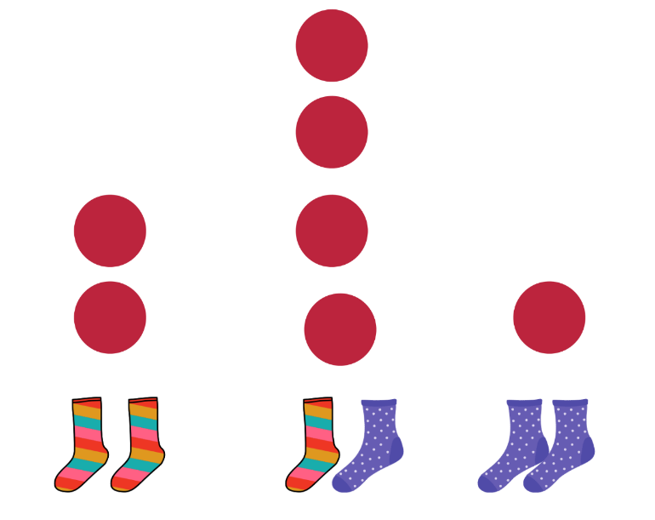
Images sourced from Canva and used in accordance with the Canva Content License Agreement.
- Take photographs of the data displays.
This table details assessment opportunities and differentiation ideas.
Assessment opportunities | Too hard? | Too easy?
What to look for:  - Can Early Stage 1 students make predictions about events being certain or not certain to occur? (MAO-WM-01, MAE-DATA-01)  - Can Stage 1 students make predictions about events being likely, unlikely, less likely or more likely to occur? (MAO-WM-01, MA1-CHAN-01)  - Can students collect data and present it in a display or graph to interpret? (MAO-WM-01, MA1-DA-01)  What to collect:  - Photographs or work samples of predictions and data collection. (MAO-WM-01, MA1-CHAN-01)  - Observational records. (MAO-WM-01, MA1-CHAN-01) | Students cannot make predictions about events.  - Revise or model events that are certain and not certain to happen with familiar topics.  - Revise or model events that are likely or unlikely to happen with familiar topics.  - Repeat the sock experiment and have students try to predict what will happen. | Students can make predictions about events.  - Students can predict events that could be described using the language may, might, possible, likely, unlikely or impossible.  - Students share ideas with a peer and discuss whether they agree or not.

Discuss and connect the mathematics – 5 minutes
- Summarise the lesson, drawing out key mathematical ideas about predicting the likelihood of events. Ask students:
- Which sock combination is most likely to be drawn out of the basket? Why do you think this?
- Which sock combination is least likely to be drawn out of the basket? Why do you think this?
- Do you think you would get the same results if you repeated the investigation? Why do you think this?

Lesson 7: Talking and sorting
Core concept: Mathematical language can be used to identify, describe and compare.
The table below contains suggested learning intentions and success criteria. These are best co-constructed with students.
Learning intentions | Success criteria
All students are learning that:  - mathematical language can be used to identify, describe and compare  - numbers can be compared and ordered.  In addition, Early Stage 1 students are learning that:  - objects can be grouped by different characteristics to form a data display  - the last number in a count represents the total number in a collection.  In addition, Stage 1 students are learning that:  - the language of chance can be used to identify and describe possible outcomes in everyday activities  - events can be likely or unlikely, and more or less likely to happen. | All students can:  - describe and compare objects or events using mathematical language  - discuss and compare numbers on a road sign.  In addition, students working towards Early Stage 1 outcomes can:  - choose a characteristic by which to group objects in a data display  - compare and order the sizes of groups in a display by counting.  In addition, students working towards Stage 1 outcomes can:  - describe events as possible or certain, more or less likely and impossible.  - describe and compare the likelihood of events using the language of chance.

Daily number sense: NSW road trip! – 15 minutes
- Build student understanding of place value by describing and comparing numbers.
- Display Resource 9: NSW road trip! Explain that this shows how far students would need to travel by road to reach each place on the sign from the centre of Sydney. Ask students if they recognise or have been to any of these destinations. Students may like to share their experiences.
Note: Many destinations on Resource 9: NSW road trip! have Aboriginal names and several are designated as significant Aboriginal heritage places. Students may like to research these places afterwards or find other Aboriginal sites and how far away they are from their school.
- Ask students what they notice about the numbers on the sign. This could include talking about:
- largest and smallest numbers
- destinations the closest and farthest away
- numbers with a double digit
- numbers that begin and end with the same digit
- 2 or 3 numbers that have something in common.
- In addition, for Stage 1 the discussion could include:
- odd or even numbers
- the number with the largest hundreds, tens or ones value
- 3 numbers that are all different from each other.

Sorting out the pile (Early Stage 1) – 40 minutes
- Provide students with a pile of everyday objects, for example, leaves, toy cars, shells and pencils. Ask students how they could organise the objects.
- The whole group brainstorms which attributes they could use to sort the objects. For example, type, colour, favourite to least favourite or length. Students choose one attribute to sort the objects and make predictions, such as which groups they think will be the biggest and smallest. Students pick up a handful of objects each and create one data display. Students make lines of objects, taking it in turns to count out loud while adding their objects to a row or column. See Figure 6.
Figure 6 – Example of organising objects using colour
Images sourced from Canva and used in accordance with the Canva Content License Agreement.
- Once the objects are in rows or columns, students decide how to place them for comparison, for example, from the lowest number to the highest number. Students explain their thinking to the group.
- Record the data display using drawings or technology, for example, using clip art with jam boards.
- Students count how many objects are in each part of the data display and compare to their predictions.
- Students ask each other questions, such as:
- What is the biggest group?
- What is the smallest group?
- Were there any surprises?
- Was this the best way to group objects? What makes you say that?
This table details assessment opportunities and differentiation ideas.
Assessment opportunities | Too hard? | Too easy?
What to look for:  - Do students use reasoning when sorting and organising objects? (MAO-WM-01, MAE-RWN-01, MAE-RWN-02, MAE-DATA-01)  - Can students read, compare and order numbers to 20? (MAO-WM-01, MAE-RWN-01, MAE-RWN-02)  What to collect:  - Observations of student counting and reasoning. (MAO-WM-01, MAE-RWN-01, MAE-RWN-02, MAE-DATA-01) | Students cannot organise a group of objects or count groups in a data display.  - Give students ideas for how they could organise their groups, for example, type of object or colour.  - Model part of a data display.  - Point to each object in one part of the data display, counting one by one to reach a total. | Students can organise and justify sorting of objects into a data display.  - Students brainstorm all the ways to sort the objects.  - Give students Resource 10: Venn diagram to sort objects using 2 criteria, considering what objects fit both.

What’s the chance? (Stage 1) – 40 minutes
This activity has been adapted from Sullivan (2012).
- Display the words ‘certain’ and ‘impossible’ on cards and discuss what they mean. Make statements about certain and impossible events using facts about months of the year. Examples include:
- February always comes after January. This is certain.
- December might come in between June and August some years. This is impossible.
- Ask if students know any other words they could use to describe the chance of an event. These include:
- possible
- likely or unlikely
- more likely or less likely
- maybe
- never.
- Record each word on an A4 card and select some students to hold them up. Decide as a class how to order the cards in a line from least likely to most likely, creating a human probability line. Ask students if they can think of any other words to add. Display the cards as a probability line in the classroom.
- Ask students how likely they are to walk to school the next day and record their answers for certainly, probably, possibly, definitely. Record student answers with tally marks. Have students discuss and make statements about the data.
- Discuss the following scenarios to develop students’ understanding of the language of chance:
- I overheard my mum telling our neighbour that we would definitely do something on the weekend, but I could not hear what it was. What might it be?
- Repeat (a) but with the word possibly.
- I heard the teacher say, ‘It is (missing word) that all the children in this class will watch television tonight’, but I didn’t hear one of the words. What might the missing word be?
- What event is less likely to happen than all the children watching television tonight?
- Someone asked the principal a question and they replied ‘maybe.’ What might the question have been?
This table details assessment opportunities and differentiation ideas.
Assessment opportunities | Too hard? | Too easy?
What to look for:  - Can students identify and order examples of the language of chance? For example, certain, maybe, more or less likely. (MAO-WM-01, MA1-CHAN-01)  - Can students describe and compare familiar events as being more or less likely to happen? (MAO-WM-01, MA1-CHAN -01)  What to collect:  - Observational records. (MAO-WM-01, MA1-CHAN-01) | Students do not understand the language of chance and how it relates to familiar events.  - Choose a fixed daily activity, such as walking to school with students and discuss how that can be described as almost certain.  - Talk about what might make those events less likely. For example, lots of rain preventing students from walking to school.  - Introduce other events, such as getting on a bus and going to sleep at night. Discuss whether they are more or less likely events than the first. | Students demonstrate understanding of the language of chance and how it relates to familiar events.  - Some children may be ready to discuss how the context or speaker can also affect the meaning of the language of chance.  - For example, when one person says ‘maybe’ to an event, it almost certainly means no; however, when someone else says ‘maybe’, that event has more chance of happening.

Consolidation and meaningful practice: More real-life numbers! – 10 minutes
- In small groups, students use devices to look for other real-life examples of lists with numbers. They talk about what they notice.

Lesson 8: Tricky data!
Core concept: Data can be accurate or misleading.
The table below contains suggested learning intentions and success criteria. These are best co-constructed with students.
Learning intentions | Success criteria
All students are learning that:  - objects can be organised to form a data display  - a data display can be used to answer questions.  In addition, Early Stage 1 students are learning that:  - objects can be grouped in more than one way  - reasoning about category choices can be communicated using words and concrete materials.  In addition, Stage 1 students are learning that:  - data can be misleading  - symbols can be used to represent more than one item. | All students can:  - consider different ways data can be organised  - use a data display to ask and answer questions.  In addition, students working towards Early Stage 1 outcomes can:  - discuss ways to sort coloured bricks  - organise bricks into a data display to compare groups.  In addition, students working towards Stage 1 outcomes can:  - identify and reason about how data can be misleading  - interpret a picture graph where the symbol represents more than one item.

Daily number sense: Teacher choice – 10 minutes
- From a class need surfaced through formative assessment data, identify a short, focused activity that targets students’ knowledge, understanding and skills. Example activities may be drawn from the following resources:
- Mathematics K-6 resources
- Universal Resources Hub.

Sorting bricks (Early Stage 1) – 45 minutes
- Show students a big tub of coloured bricks and tell them that their help is needed to sort them. Set the scene by explaining, ‘I need to return this big tub of bricks that I have borrowed but they’re in such a mess! We will have to organise them before I give them back. Think about how you could help me do this.’
- Ask small groups of students to collect a big pile of coloured bricks and decide which is the best way to organise them. Offer paper plates as a tool to help organise the sorted bricks.
Note: When preparing the coloured bricks, the more bricks you can provide with an assortment of attributes the better, as this will make the lesson more engaging and exciting for students.
- Once all the groups have collected and sorted their bricks and put them onto different paper plates, ask students to communicate their strategies for sorting. Answers may include:
- colour
- size
- shape.
- In their groups, students organise their sorted bricks into a data display. Students take pictures of their data displays.
- Students count the bricks in their data groups.
- Each group describes the information in their data display to another group. For example, identifying the smallest and largest groups of bricks. The other group decides whether they have accurately organised the bricks.
- Students go on a gallery walk to compare their choice of data display to others. After the walk, they choose another student at random and ask each other:
- How did you organise your bricks? Why did you do it that way?
- Were there any challenges?
- How was your data display the same as other displays?
- How was it different to other displays?
- If time permits, students can repeat this process.
This table details assessment opportunities and differentiation ideas.
Assessment opportunities | Too hard? | Too easy?
What to look for:  - Can students choose and justify a way to group of objects? (MAO-WM-01, MAE-DATA-01)  - Can students organise coloured bricks into a data display to compare groups? (MAO-WM-01, MAE-DATA-01)  - Can students use a data display to answer questions? (MAO-WM-01, MAE-DATA-01)  What to collect:  - observational records of grouping and verbal reasoning (MAO-WM-01, MAE-DATA-01)  - photographs of data displays. (MAO-WM-01, MAE-DATA-01) | Students cannot organise bricks or interpret the data display.  - Give students ideas, such as colour and size.  - Model one kind of brick in the data display and have students continue to place bricks.  - Model ordering the groups of bricks, starting with the smallest group and ending with the largest. | Students can choose and justify how to organise their bricks and compare their display to others.  - Students brainstorm all the ways to organise bricks.  - Students work out the difference between the biggest and smallest groups in their data display.

Interpreting data (Stage 1) – 45 minutes
- Display Resource 11: Basketball hoops A and ask students what they notice. Explain that the symbols are different sizes and discuss how this can be misleading.
- Display Resource 12: Basketball hoops B and ask students what they notice. Explain that the spaces between symbols are not equal and they do not all start on the baseline. Ask students how this can be misleading.
- Display Resource 13: Basketball hoops C. Explain that this data represents 4 friends taking turns throwing a basketball through a hoop. The graph shows how many balls each friend managed to get through the hoop. Ask students:
- Are the symbols all the same size?
- Are the spaces between the balls the same?
- Do all the symbols or balls start at the baseline?
- Tell students that Caitlin threw 6 balls through the hoop, and Johnny threw 7 balls through the hoop. Ask students to work out how many hoops Gabriella and Seb threw.
- Students turn and talk about what they think and share their findings with the class. Some students may realise that the symbols are representing 2 items instead of one.
- Ask students:
- Why do you think there is only half a ball displayed?
- What number do you think it represents?
- What number do you think each ball represents?
- Explain that when data is represented this way it is usually accompanied by a key stating the value of each symbol. In this case every ball is equal to 2 throws through the hoop.
- Have students answer the following questions about the graph:
- How many more balls did Gabriella get through the hoop than Seb?
- How many balls were thrown through the hoop altogether?
- Who threw the most balls through the hoop?
- Who threw the least?
- Who threw more than Johnny?
- Students answer questions on mini whiteboards or in their workbooks, showing their working out.
- Ask students if Resource 13: Basketball hoops C is accurate or misleading and how they know.
This table details assessment opportunities and differentiation ideas.
Assessment opportunities | Too hard? | Too easy?
What to look for:  - Can Stage 1 students identify misleading elements of graphs such as different-sized symbols and inconsistent spacing between symbols? (MAO-WM-01, MA1-DATA-02)  - Can Stage 1 students interpret Resource 13: Basketball hoops C, using the knowledge that each symbol is worth 2? (MAO-WM-01, MA1-DATA-02)  What to collect:  - observational records. (MAO-WM-01, MA1-DATA-02) | Students cannot see how Resource 11: Basketball hoops A and Resource 12: Basketball hoops B are misleading.  - Show students a picture graph including a baseline, equal spacing and symbols the same size.  - Point out these elements of accurate graphing.  - Students compare this graph to the misleading graphs. | Students can identify misleading and accurate data.  - Students create other graphs where the symbols represent more than one item.  - Students create a graph that is misleading in 2 ways and ask other students to identify the errors.

Discuss and connect the mathematics – 10 minutes
- Summarise the lesson, drawing out some key mathematical ideas about interpreting data. Ask:
- What were some of the challenges you encountered when interpreting the graph?
- Why is it important that rows or columns of images in a picture graph are aligned?
- Why is it important that all symbols on a picture graph are the same size?
- What else makes a picture graph accurate?

Resource 1: Different activities
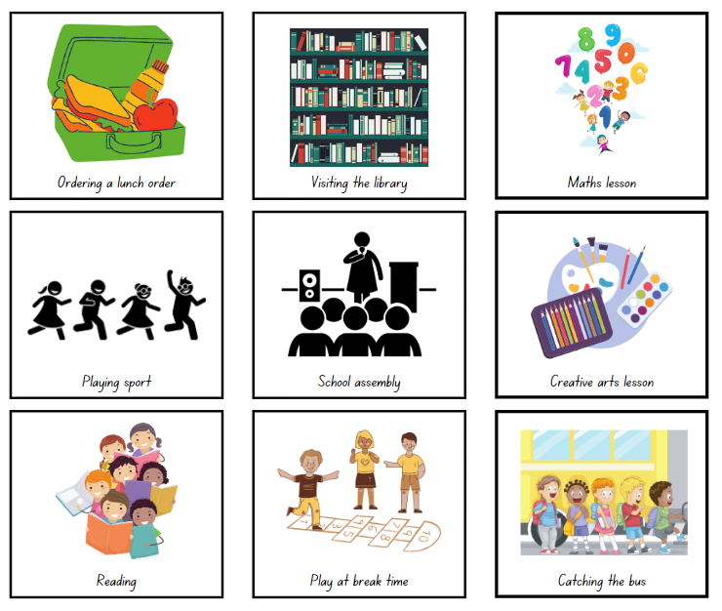
Images sourced from Canva and used in accordance with the Canva Content License Agreement.

Resource 2: Calendar
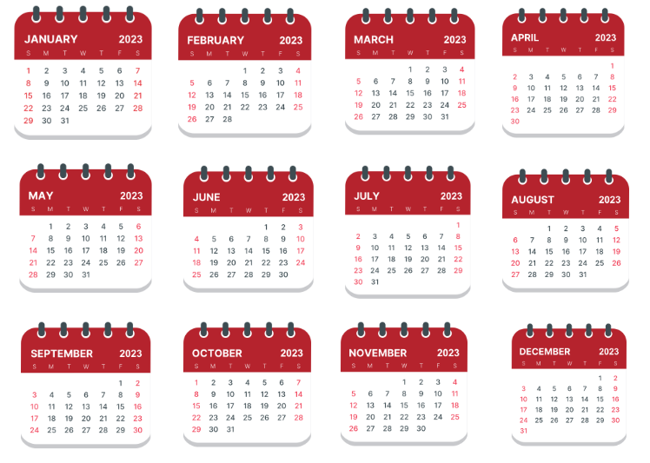
Images sourced from Canva and used in accordance with the Canva Content License Agreement.

Resource 3: Picture graph example
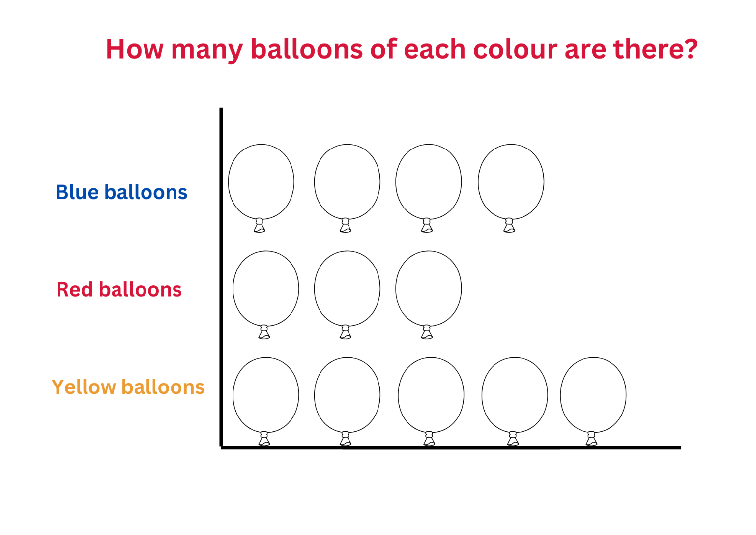
Images sourced from Canva and used in accordance with the Canva Content License Agreement.

Resource 4: Features of a column graph
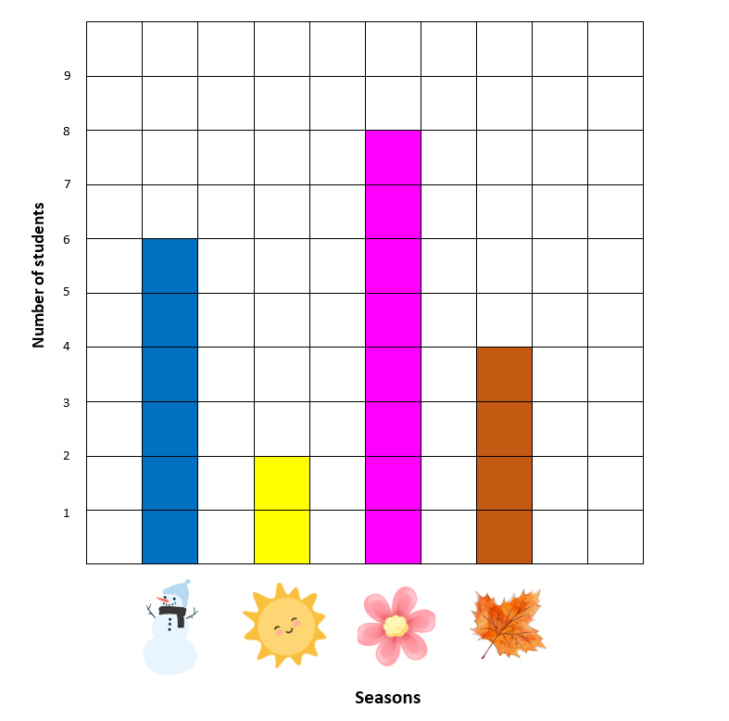
Images sourced from Canva and used in accordance with the Canva Content License Agreement.

Resource 5: Data questions
What colour are your eyes? | How many people are in your family?
How tall are you? | What is your favourite colour?
What is your favourite season? | How old are you?
Do you prefer chocolate or vanilla? | What is your shoe size?
Do you like tennis? | Do you have a brother?
Can you swim butterfly stroke? | What colour is your hair?
When were you born? | What is your favourite ice-cream?
What football team do you support? | Do you play Minecraft?

Resource 6: Travelling to school
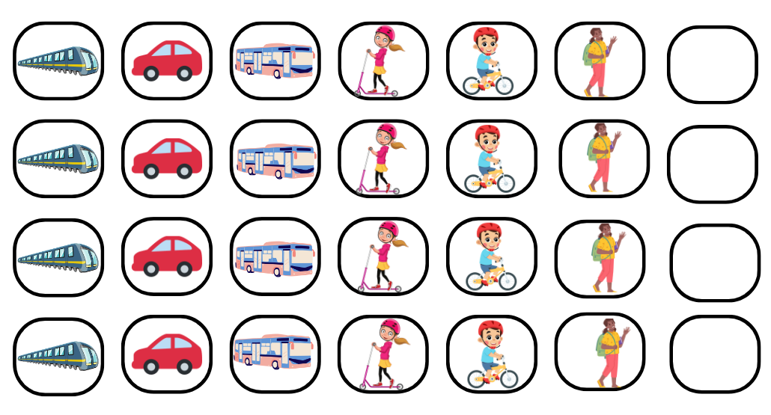
Images sourced from Canva and used in accordance with the Canva Content License Agreement.

Resource 7: Destination Australia
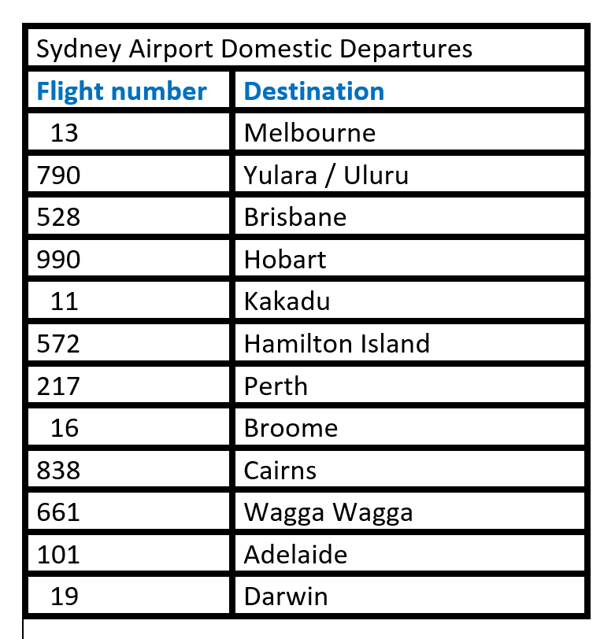

Resource 8: One to 20
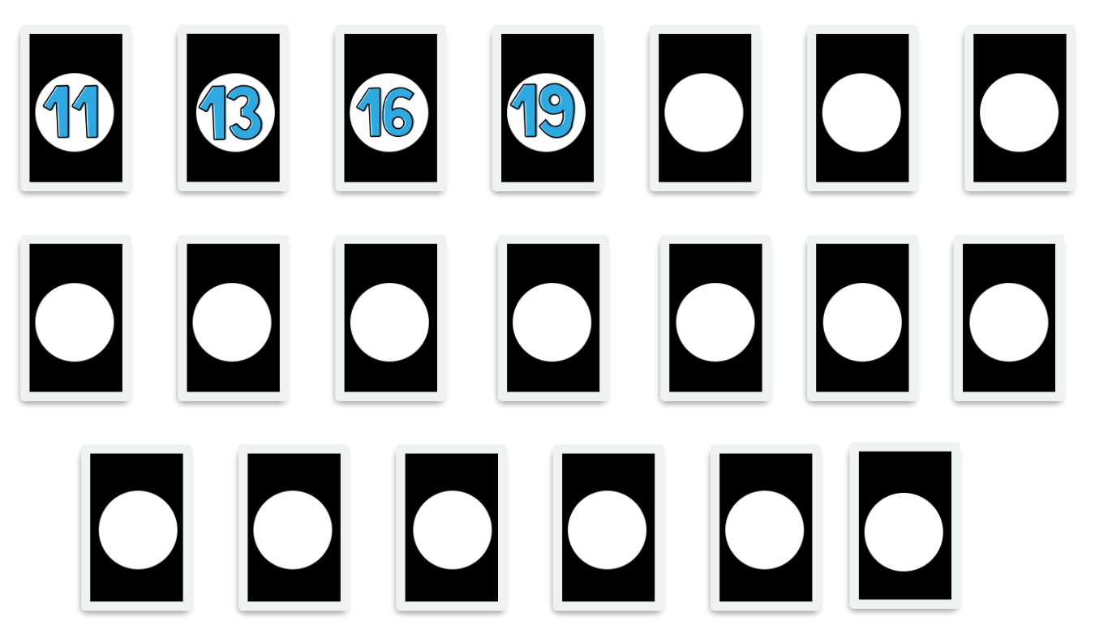
Images sourced from Canva and used in accordance with the Canva Content License Agreement.

Resource 9: NSW road trip!
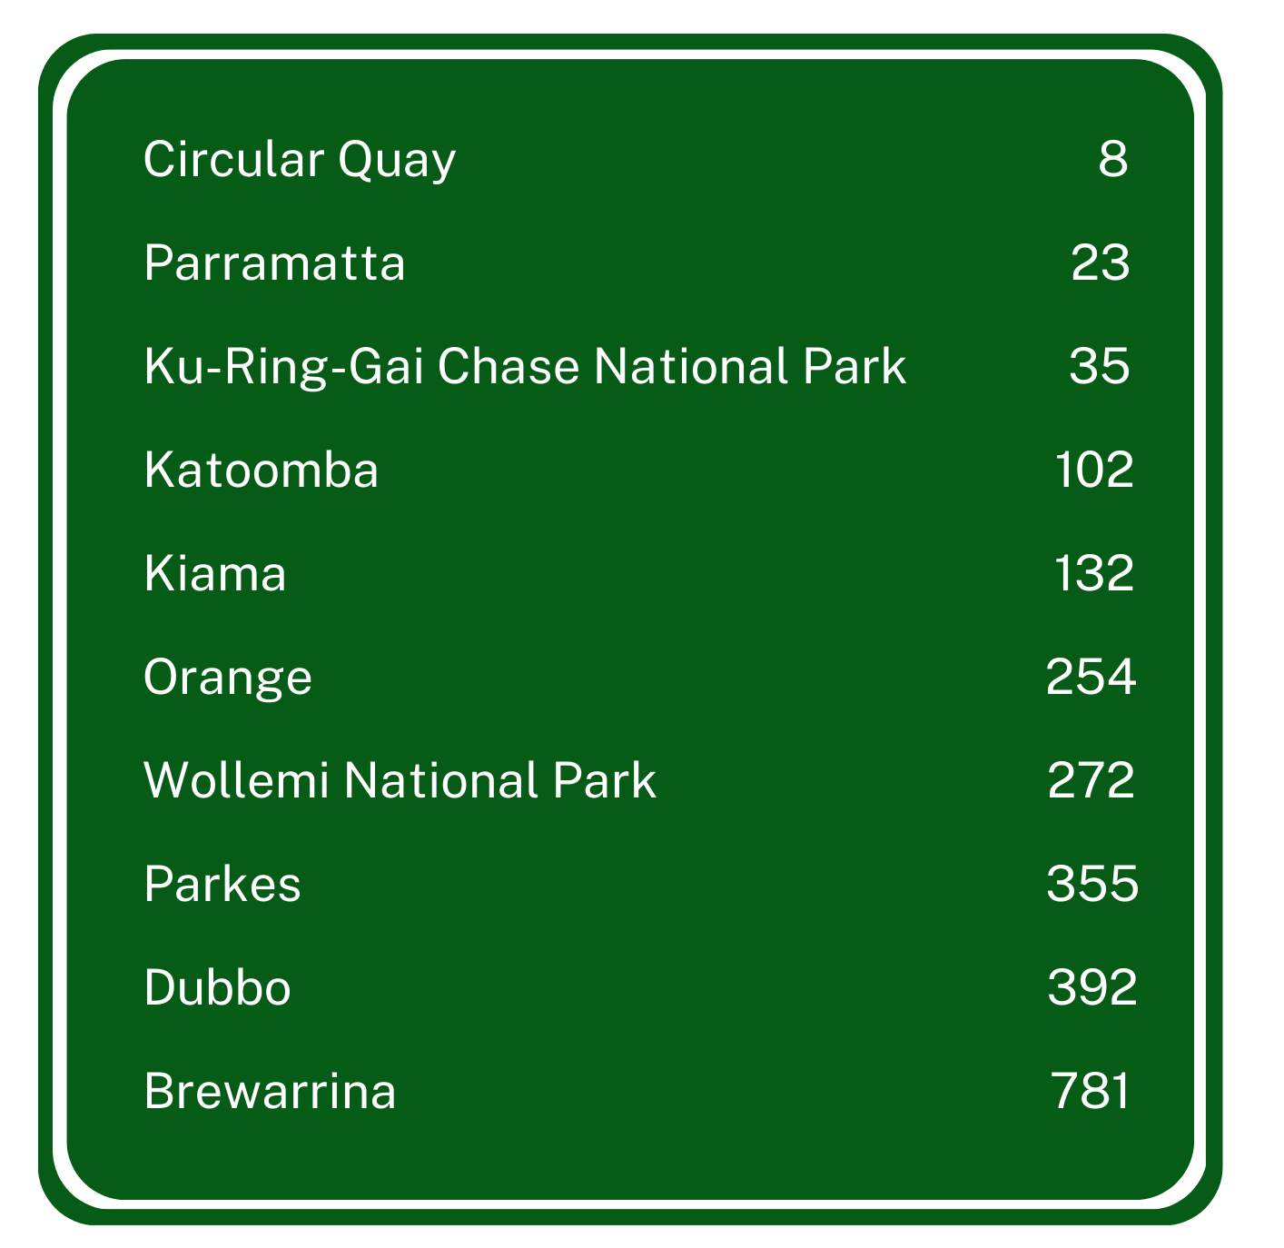

Resource 10: Venn diagram
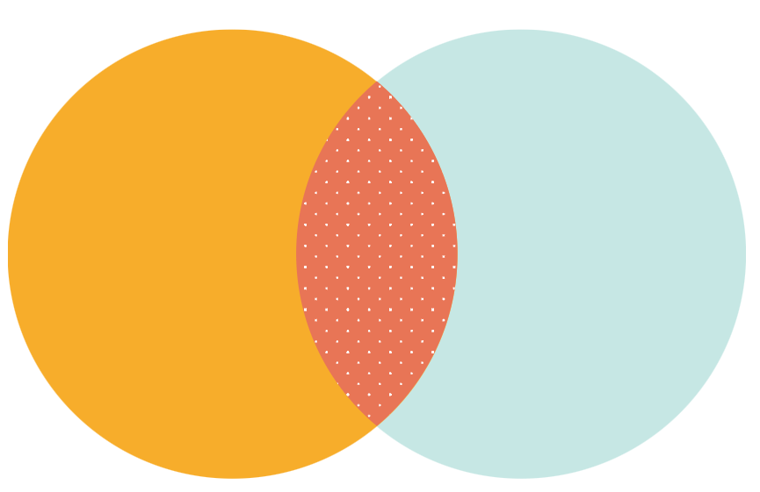

Resource 11: Basketball hoops A
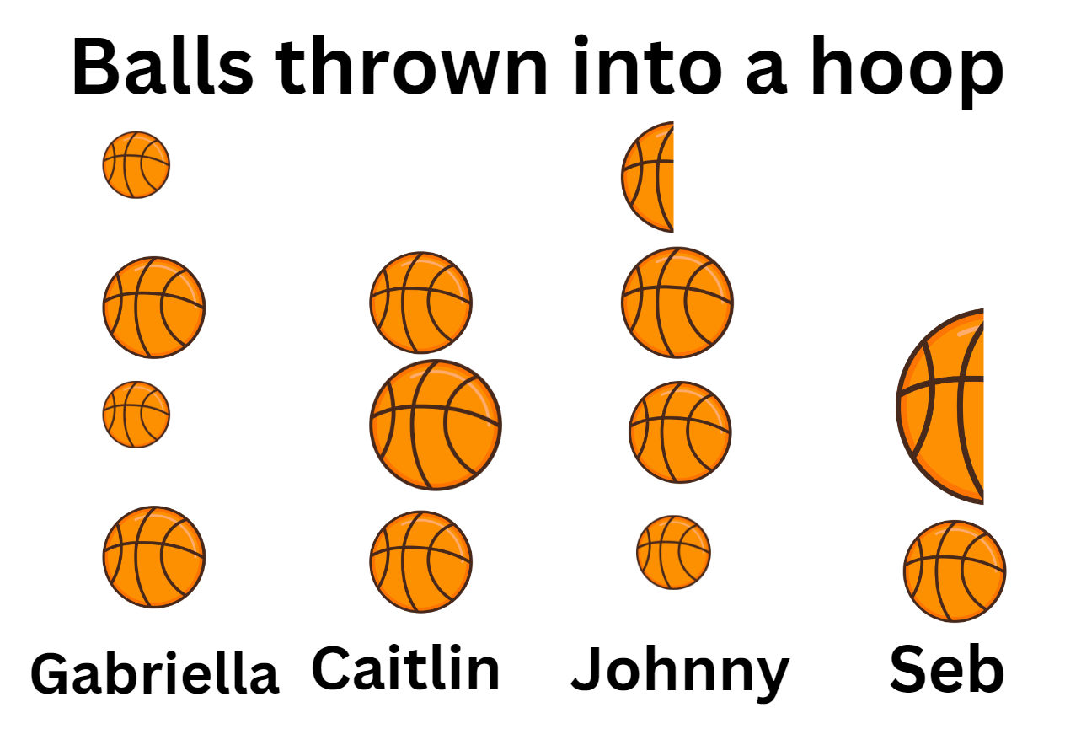
Images sourced from Canva and used in accordance with the Canva Content License Agreement.

Resource 12: Basketball hoops B
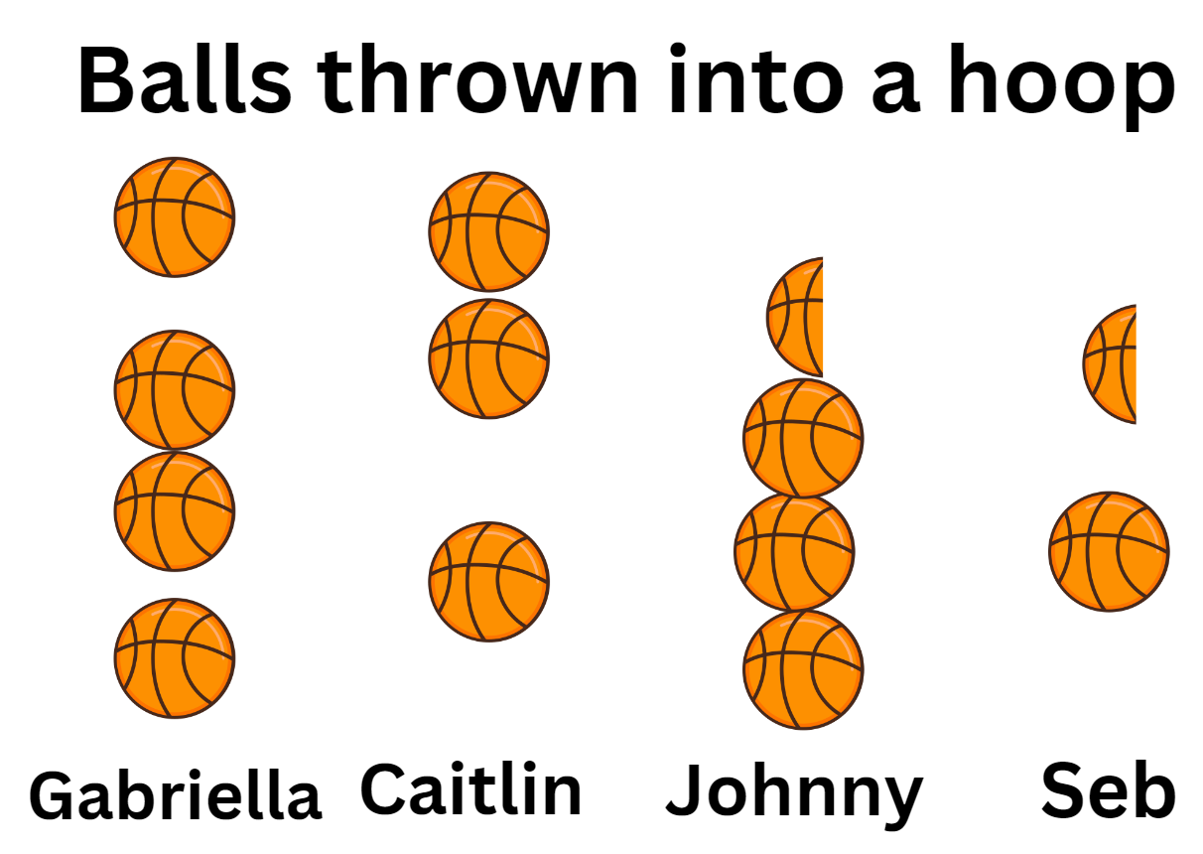
Images sourced from Canva and used in accordance with the Canva Content License Agreement.

Resource 13: Basketball hoops C
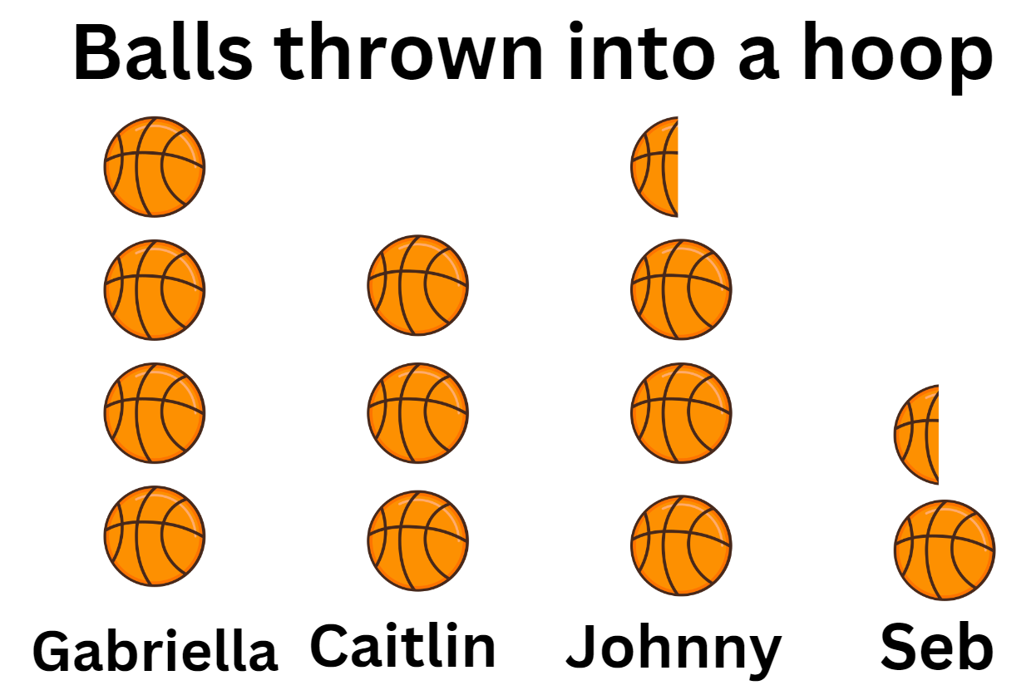
Images sourced from Canva and used in accordance with the Canva Content License Agreement.

Syllabus outcomes and content
The table below outlines the syllabus outcomes and range of relevant syllabus content covered in this unit. Content is linked to National Numeracy Learning Progression version (3).
Focus area and outcomes | Content groups and content points | Lessons
Representing whole numbers  MAO-WM-01  MAE-RWN-01, MA1-RWN-01  MAE-RWN-02, MA1-RWN-02 | Early Stage 1  Instantly name the number of objects within small collections  - Identify the number of items in different arrangements (CPr2)  Use the counting sequence of ones flexibly  - Count forwards to at least 30 and state the number before or after a given number, without needing to count from one (CPr4)  - Count backwards from a given number 20 or less (CPr5) | 1, 4, 5
Representing whole numbers (cont) | Recognise number patterns  - Recognise dice and domino dot patterns (NPA1, NPV2, CPr2) | 5, 6
Representing whole numbers (cont) | Connect counting and numerals to quantities  - Count with one-to-one correspondence, recognising that the last number name represents the total number in the collection (CPr3, CPr5)  - Read numerals to at least 20, including zero (NPV3)  - Compare and order numbers to 20 (NPV2-NPV3) | 2, 5, 7
Representing whole numbers A (cont) | Stage 1  Continue and create number patterns  - Count forwards and backwards by twos from any starting point (CPr6-CPr7, MuS2) | 1–2
Representing whole numbers B (cont) | Stage 1  Form, regroup and rename three-digit numbers  - Identify the nearest hundred to a number  - Use place value to partition and rename three-digit numbers in different ways (Reasons about relations) (NPV5) | 4–6
Non-spatial measure  MAO-WM-01  MAE-NSM-01, MA1-NSM-01  MAE-NSM-02, MA1-NSM-02 | Early Stage 1  Time: Connect days of the week to familiar events and actions  - Recall that there are seven days in a week  - Name and order the days of the week (MeT2)  - Identify events that occur daily and relate events to a particular day or time of day (MeT1) | 1–2
Non-spatial measure A  (cont) | Stage 1  Time: Name and order the cycle of months  - Name and order the months of the year (MeT2)  - Recall the number of days in each month (MeT2)  - Identify a day and date using a Gregorian calendar (MeT2)  - Recognise monthly and annual cycles | 1, 2
Data  MAO-WM-01  MAE-DATA-01, MA1-DATA-01  MA1-DATA-02  NOTE – There is only one data outcome for Early Stage 1. | Early Stage 1  Respond to questions, collect information and discuss possible outcomes of activities  - Predict possible responses to a question  - Collect information from their peers and about their environment (IRD1)  - Pose and respond to questions about the information collected (IRD1) | 1–4, 6
Data (cont) | Organise objects into simple data displays and interpret the displays  - Group objects according to characteristics (IRD1)  - Compare the sizes of groups by counting (Reasons about relations)  - Arrange objects according to a characteristic to form a data display (IRD1)  - Interpret information presented in a data display to answer questions (Reasons about quantity) (IRD2) | 1–8
Data A (cont) | Stage 1  Ask questions and gather data  - Investigate a topic of interest by choosing suitable questions to obtain appropriate data (IRD2)  - Gather data and track what has been counted by using concrete materials, tally marks, lists or symbols (IRD3)  Represent data with objects and drawings and describe the displays  - Use concrete materials or pictures of objects as symbols to create data displays where one object or picture represents one data value (IRD2)  - Describe information presented in one-to-one data displays (Reasons about relations) (IRD2)  - Use comparative language to describe information presented in a display, such as ‘more than’ and ‘less than’  - Interpret a data display and identify the biggest or smallest values (IRD2) | 1–3, 4–6
Data B (cont) | Stage 1  Identify a question of interest and gather relevant data  - Pose suitable questions where the answers form categories, and predict the likely responses (IRD2)  - Collect data on familiar topics (IRD2)  - Sort data into relevant categories (IRD2) | 2, 3, 6, 7
Data B (cont) | Create displays of data and interpret them  - Organise collected data into lists and tables to display information (IRD2)  - Represent data in a picture graph using a baseline, equal spacing and same-sized symbols (IRD2)  - Give reasons why some representations of data are misleading (Reasons about relations) (IRD2)  - Interpret information presented in tables and picture graphs (Reasons about relations) (IRD2)  - Record answers to questions using the information in tables and picture graphs (IRD2) | 1–3, 6, 8
Chance A  MAO-WM-01  MA1-CHAN-01 | Stage 1  Identify and describe possible outcomes  - Identify possible outcomes of familiar activities and events  - Describe the chance of possible outcomes for familiar activities and events (UnC1) | 4–7
Chance (cont)  NOTE – Chance outcomes are introduced in Stage 1. | Identify and describe activities that involve chance  - Describe possible outcomes in everyday activities and events as being likely or unlikely to happen (UnC2)  - Compare familiar activities and events and describe them as being more or less likely to happen (Reasoning about relations) (UnC2)  - Describe familiar events as being possible (UnC2) | 4–7

References
Links to third-party material and websites
Please note that the provided (reading/viewing material/list/links/texts) are a suggestion only and implies no endorsement, by the New South Wales Department of Education, of any author, publisher, or book title. School principals and teachers are best placed to assess the suitability of resources that would complement the curriculum and reflect the needs and interests of their students.
If you use the links provided in this document to access a third-party's website, you acknowledge that the terms of use, including licence terms set out on the third-party's website apply to the use which may be made of the materials on that third-party website or where permitted by the Copyright Act 1968 (Cth). The department accepts no responsibility for content on third-party websites.
Except as otherwise noted, all material is © State of New South Wales (Department of Education), 2023 and licensed under the Creative Commons Attribution 4.0 International License. All other material (third-party material) is used with permission or under licence. Where the copyright owner of third-party material has not licensed their material under a Creative Commons or similar licence, you should contact them directly for permission to reuse their material.
Mathematics K–10 Syllabus © 2022 NSW Education Standards Authority (NESA) for and on behalf of the Crown in right of the State of New South Wales.
© 2022 NSW Education Standards Authority. This document contains NSW Curriculum and syllabus content. The NSW Curriculum is developed by the NSW Education Standards Authority. This content is prepared by NESA for and on behalf of the Crown in right of the State of New South Wales. The material is protected by Crown copyright.
Please refer to the NESA Copyright Disclaimer for more information.
NESA holds the only official and up-to-date versions of the NSW Curriculum and syllabus documents. Please visit the NSW Education Standards Authority (NESA) website and the NSW Curriculum website.
National Numeracy Learning Progression © Australian Curriculum, Assessment and Reporting Authority (ACARA) 2010 to present, unless otherwise indicated. This material was downloaded from the Australian Curriculum website (National Numeracy Learning Progression) (accessed 2 May 2023) and was not modified. The material is licensed under CC BY 4.0. Version updates are tracked in the ‘Curriculum version history’ section on the 'About the Australian Curriculum' page of the Australian Curriculum website.
ACARA does not endorse any product that uses the Australian Curriculum or make any representations as to the quality of such products. Any product that uses material published on this website should not be taken to be affiliated with ACARA or have the sponsorship or approval of ACARA. It is up to each person to make their own assessment of the product, taking into account matters including, but not limited to, the version number and the degree to which the materials align with the content descriptions and achievement standards (where relevant). Where there is a claim of alignment, it is important to check that the materials align with the content descriptions and achievement standards (endorsed by all education Ministers), not the elaborations (examples provided by ACARA).
This resource contains images and content obtained from Canva, and their use outside of this resource is subject to Canva’s Content License Agreement. If you wish to use them separately from the resource, please go to Canva.
New Zealand Ministry of Education (n.d.) ‘Odd socks’ [PDF 195KB], Resource Finder, NZ Maths website, accessed 28 March 2023
Sullivan P, Clarke D and Clarke B (2012) Teaching with Tasks for Effective Mathematics Learning, Spider-Verlag New York Inc., US.
University of Cambridge (Faculty of Mathematics) (2022) Clapping Times, NRICH website, accessed 28 March 2023.

