Mathematics – K-2 multi-age – Year B – Unit 17
Contents
Unit description and duration 4
Student prior learning 4
Lesson overview and resources 5
Lesson 1: Multiple masses 13
Daily number sense: Climb the ladder – 10 minutes 14
Combining weights – 40 minutes 17
Discuss and connect the mathematics – 10 minutes 20
Lesson 2: Comparing capacities 21
Daily number sense: Busting numbers – 10 minutes 22
Capacities – 40 minutes 23
Discuss and connect the mathematics – 10 minutes 26
Lesson 3: How many blocks? 27
Daily number sense: What is my place? – 20 minutes 27
Pack it – 40 minutes 31
Lesson 4: Areas of rectangles 34
Daily number sense – 10 minutes 35
Finding areas of rectangles – 40 minutes 35
Discuss and connect the mathematics – 10 minutes 38
Lesson 5: Length hunt 41
Daily number sense: Mastermind – 15 minutes 42
Informal measurement – 30 minutes 43
Consolidation and meaningful practice: Measuring heads – 15 minutes 44
Lesson 6: Measurement scavenger hunt 47
Daily number sense: Thumbs up – 15 minutes 47
Measurement scavenger hunt – 45 minutes 49
Lesson 7: What is the length? 55
Daily number sense – 10 minutes 55
Comparing and measuring lengths – 40 minutes 56
Discuss and connect the mathematics – 10 minutes 59
Lesson 8: Air show competition 61
Daily number sense: Place value counting – 10 minutes 62
Paper planes – 40 minutes 64
Discuss and connect the mathematics – 10 minutes 69
Resource 1: Recording sheet (Early Stage 1) 70
Resource 2: Recording sheet (Stage 1) 71
Resource 3: Place value 72
Resource 4: Various squares 73
Resource 5: Shapes worksheet 74
Resource 6: Rectangle 75
Resource 7: 3 Rectangles 76
Resource 8: Covered rectangle 77
Resource 9: Covered rectangle 2 78
Resource 10: Strip without measurement 79
Resource 11: Scavenger hunt (Early Stage 1) 80
Resource 12: Measurement strip 81
Resource 13: Scavenger hunt (Stage 1) 82
Resource 14: Length memory game 83
Resource 15: Metres or centimetres 88
Resource 16: Measurement worksheet 89
Resource 17: Flight recording sheet 90
Syllabus outcomes and content 91
References 104

Unit description and duration
This two-week unit develops student knowledge, understanding and skills of measurement using informal and formal units. Students are provided opportunities to:
- estimate, measure, compare and record a variety of attributes including length, area, volume and mass using informal units
- estimate, measure and record length using formal units of metres and centimetres
- recognise formal units of measurement ensure consistency and accuracy.
Mathematics K–10 Syllabus © 2022 NSW Education Standards Authority (NESA) for and on behalf of the Crown in right of the State of New South Wales.

Student prior learning
Before engaging in these teaching and learning activities, students would benefit from prior experience with:
- opportunities exploring measurement using comparative language to describe length, area, volume and mass
- estimating using mathematical language, for example, heavier, lighter, longer, about the same
- measuring the length of objects using informal units of measurement
- comparing the sizes of shapes and objects using informal units of measurement
- using an equal-arm balance to compare the mass of different objects.

Lesson overview and resources
The table below outlines the sequence and approximate timing of lessons; syllabus focus areas and content groups; and resources.
Lesson | Syllabus focus area and content groups | Resources
Lesson 1: Multiple masses  60 minutes  Mass can be explored using hefting and informal units. | Representing whole numbers  Early Stage 1  - Connect counting and numerals to quantities  Stage 1 – Part B  - Use counting sequences of ones and tens flexibly  - Form, regroup and rename three-digit number  Non-spatial measure  Early Stage 1  - Mass: Identify and compare mass using weight  Stage 1 – Part B  - Mass: Compare the masses of objects using an equal-arm balance | - 20-sided dice  - 9-sided dice  - Equal-arm balance (one per group)  - Large collection of classroom objects  - Large collection of uniform informal units. For example, interlocking cubes, marbles, pencils  - Writing materials
Lesson 2: Comparing capacities  60 minutes  Capacity can be compared and measured using informal units. | Representing whole numbers  Early Stage 1  - Connect counting and numerals to quantities  Stage 1 – Part A  - Represent the structure of groups of ten in whole numbers  Stage 1 – Part B  - Use counting sequences of ones and tens flexibly  - Form, regroup and rename three-digit numbers  Three-dimensional spatial structure  Early Stage 1  - Volume: Compare internal volume by filling and packing  Stage 1 – Part A  - Volume: Measure and compare the internal volumes (capacities) of containers by filling  Stage 1 – Part B  - Volume: Compare containers based on internal volume (capacity) by filling and packing | - Resource 1: Recording sheet (Early Stage 1)  - Resource 2: Recording sheet (Stage 1)  - Large collects of craft sticks and elastic bands or interlocking cubes  - Large collection of various sized clear water bottles or containers  - Small plastic cups  - Writing materials
Lesson 3: How many blocks?  60 minutes  Internal volume can be compared and measured by packing. | Representing whole numbers  Early Stage 1  - Use the counting sequence of ones flexibly  - Recognise umber patterns  - Connect counting and numerals to quantities  Stage 1 – Part B  - Form, regroup and rename three-digit numbers  Three-dimensional spatial structure  Early Stage 1  - Volume: Compare volume by building  Stage 1 – Part A  - Volume: Measure the internal volume (capacity) of containers by packing  Stage 1 – Part B  - Volume: Compare containers based on internal volume (capacity) by filling and packing  - Volume: Compare volumes using uniform informal units | - Resource 3: Place value  - 6-sided dice  - Large collection of uniform informal units. For example, interlocking cubes, marbles, plastic teddies, pasta shells and blocks  - Large collection of various sized boxes  - MAB blocks  - Writing materials
Lesson 4: Areas of rectangles  60 minutes  Area can be compared and measured using superimposing and the grid structure of rows and columns. | Forming groups  Stage 1 – Part B  - Represent and explain multiplication as the combining of equal groups  Two-dimensional spatial structure  Early Stage 1  - Area: Identify and compare area  Stage 1 – Part A  - Area: Measure areas using uniform informal units  Stage 1 – Part B  - Area: Compare rectangular areas using uniform square units of an appropriate size in rows and column | - Resource 4: Various squares  - Resource 5: Shapes worksheet  - Resource 6: Rectangle  - Resource 7: 3 rectangles  - Resource 8: Covered rectangle  - Resource 9: Covered rectangle 2  - Writing materials
Lesson 5: Length hunt  60 minutes  Length can be measured and compared using uniform informal units. | Representing whole numbers  Early Stage 1  - Connect counting and numerals to quantities  Stage 1 – Part B  - Form, regroup and rename three-digit numbers  Geometric measure  Early Stage 1  - Length: Use direct and indirect comparison to decide which is longer  Stage 1 – Part A  - Length: Measure the lengths of objects using uniform informal units  - Length: Compare lengths using uniform units  Stage 1 – Part B  - Length: Compare and order lengths, using appropriate uniform informal units | - Large collection of uniform informal units. For example, interlocking cubes, glue sticks, pipe cleaners, rods, craft sticks  - Masking tape or chalk  - Sticky notes  - String  - Strips of paper  - Writing materials
Lesson 6: Measurement scavenger hunt  60 minutes  Length can be compared by aligning ends and measured by using formal and informal units. | Representing whole numbers  Early Stage 1  - Connect counting and numerals to quantities  Stage 1 – Part B  - Form, regroup and rename three-digit numbers  Geometric measure  Early Stage 1  - Length: Use direct and indirect comparison to decide which is longer  Stage 1 – Part B  - Length: Recognise and use formal units to measure the lengths of objects | - Resource 10: Strip without measurement  - Resource 11: Scavenger hunt (Early Stage 1)  - Resource 12: Measuring strip  - Resource 13: Scavenger hunt (Stage 1)  - Playing cards (per pair)  - String (one metre lengths)  - Writing materials
Lesson 7: What is the length?  60 minutes  Length can be described using comparative language and measured using metres and centimetres. | Geometric measure  Early Stage 1  - Length: Use direct and indirect comparison to decide which is longer  Stage 1 – Part B  - Length: Recognise and use formal units to measure the lengths of objects | - Resource 14: Length memory game  - Resource 12: Measuring strip  - Resource 15: Metres or centimetres  - Resource 16: Measurement worksheet  - String  - Writing materials
Lesson 8: Air show competition  60 minutes  Recognise and use informal and formal units of measurement. | Representing whole numbers  Early Stage 1  - Use the counting sequence of ones flexibly  - Connect counting and numerals to quantities  Stage 1 – Part B  - Form, regroup and rename three-digit numbers  - Use counting sequences of ones and tens flexibly  Geometric measure  Early Stage 1  - Length: Use direct and indirect comparison to decide which is longer  Stage 1 – Part B  - Length: Recognise and use formal units to measure the lengths of objects  Two-dimensional spatial structure  Early Stage 1  - Area: Identify and compare area  Stage 1 – Part A  - Area: Measure areas using uniform informal units  Non-spatial measure  Early Stage 1  - Mass: Identify and compare mass using weight  Stage 1 – Part B  - Mass: Compare the masses of objects using an equal-arm balance | - Resource 17: Flight recording sheet  - A4 paper  - Different size and thickness of paper  - Equal-arm balances  - Large collection of uniform informal units. For example, interlocking cubes, marbles, pencils, tiles  - MAB blocks  - Measuring tapes  - Ribbon or string  - Rulers (m and cm)  - String  - Writing materials

Lesson 1: Multiple masses
Core concept: Mass can be explored using hefting and informal units.
The table below contains suggested learning intentions and success criteria. These are best co-constructed with students.
Learning intentions | Success criteria
Students working towards Early Stage 1 outcomes are learning that hefting helps to compare, order and describe the weight of objects.  Students working towards Stage 1 outcomes are learning that:  - uniform informal units can be selected to estimate, measure and compare masses  - the number of units needed to measure the mass of an object will depend on the mass of the unit. | Students working towards Early Stage 1 outcomes can:  - predict, compare and order the weight of various objects by hefting  - use the correct language to compare the weight of objects that are heavier, lighter or about the same as.  Students working towards Stage 1 outcomes can:  - select uniform informal units to estimate, measure and compare masses  - explain why different numbers of units can be used to measure the mass of an everyday object  - compare the masses of 2 or more objects using an equal-arm balance.

Daily number sense: Climb the ladder – 10 minutes
- Build student understanding of place value by forming and comparing one-, two- and three-digit numbers, stating the quantity value of the digits and placing them in order.
- Provide pairs of students with a whiteboard, Early Stage 1 pairs with a 20-sided die and Stage 1 pairs with three 9-sided dice. Explain the aim of the game is to position the numbers in order on their ladder rungs.
- Demonstrate how to play the game by playing against the whole class. Draw a ladder on the board and roll the 20-sided die. For example, 15 is rolled and placed on one of the ladder rungs (see Figure 1). Ask a Stage 1 student to identify the place value parts.
- Roll the die again and place the number on another rung. Continue the game until a player is unable to place their number on the ladder, at which point the game is over.
Note: Students working towards Early Stage 1 outcomes are not required to record the place value partition on their whiteboard.
Figure 1 – Climb the ladder Early Stage 1
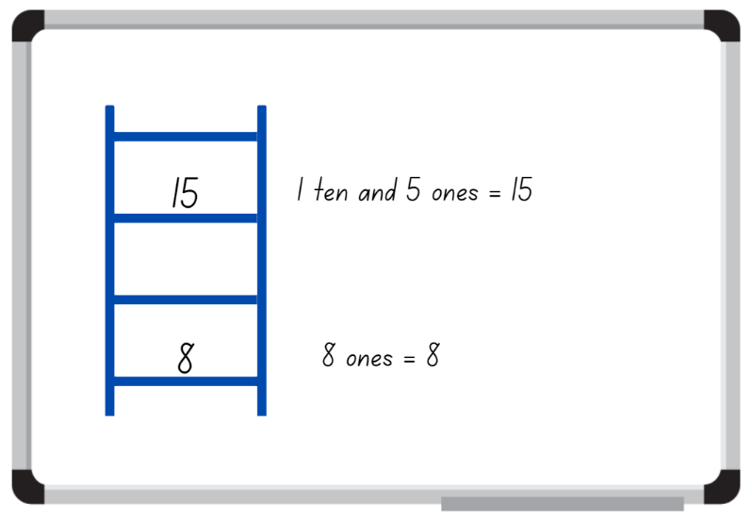
Images licensed under the Canva Content License Agreement.
- While Early Stage 1 are working in pairs, demonstrate to Stage 1 students how to play the game with three-digit numbers. Draw a ladder and roll three 9-sided dice to form a three-digit number. State the quantity value of the digits. For example, 5 hundreds, 2 tens and 3 ones = 523; or 2 hundreds, 5 tens and 3 ones = 253. Place the number on one of the ladder rungs (see Figure 2).
Figure 2 – Climb the ladder Stage 1
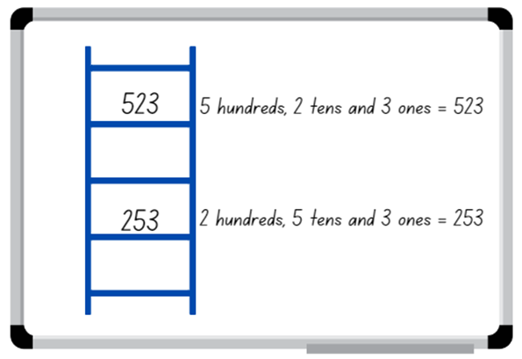
Images licensed under the Canva Content License Agreement.
- Select a student to roll the dice and form a three-digit number to place on another rung of the ladder. Ask the student to explain and justify why they selected the three-digit number for the nominated rung and to state the quantity value of the numerals before recording it on the rung.
- Continue the game until a player is unable to place their number on the ladder, at which point the game is over. Discuss if there were any other possible combinations that could have helped a player win.
Note: The game can be played as whole class or in pairs.

Combining weights – 40 minutes
- Explain to Early Stage 1 students that they will be exploring the weight of objects. Display 2 objects, for example, a craft stick and a book, and ask students to predict which one is heavier, lighter, or has about the same weight as the other object. Ask them to explain the reasoning of their predictions, encouraging students to use words like ‘heavier’, ‘lighter’, ‘more than’, ‘less than’, and ‘about the same as’. Test predictions by having selected students heft the displayed objects and share their results.
Hefting: Testing the weight of an object by lifting and/or balancing it.
- In small groups, Early Stage 1 students collect 5 classroom objects. Students predict the order of their 5 objects from heaviest to lightest and record with words or images, then use hefting to check and confirm their predictions (see Figure 3).
Figure 3 – Early Stage 1 hefting
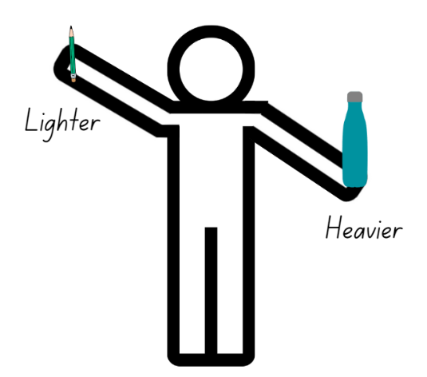
Images licensed under the Canva Content License Agreement.
- While Early Stage 1 students are working in groups, revise with Stage 1 students how to use an equal-arm balance using uniform informal units and everyday objects. For example, estimate how many marbles will be needed if there is a stapler on the other side of the equal-arm balance. Check by comparing. Ask students if they can think of another unit of measurement to use and whether they will need more or less of them to equal the mass of the stapler. Test student responses using the equal-arm balance.
- Model a mass story where students use logic, comparison and knowledge of some masses to work out how many uniform informal units are needed for another. For example, ask how many marbles will equal one book if a pencil case is equal in mass to 30 marbles and a book is equal in mass to 2 pencil cases. Provide time for students to turn and talk and select students to share and explain their thinking.
- Demonstrate student responses with concrete materials and an equal arm-balance. Ask students what other units could be used to solve this problem.
- Provide small groups with an equal arm-balance, uniform informal units and everyday classroom objects. Students estimate, create, solve and record three-part mass problems as per the modelled story (see Figure 4).
Figure 4 – Stage 1 Mass story recoding
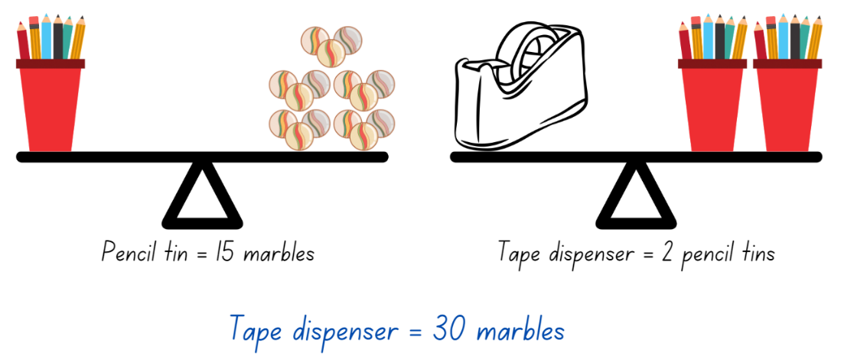
Images licensed under the Canva Content License Agreement.
- All students display their working and go on a gallery walk, looking at what others have discovered in their mass problems and the order of the classroom objects.
The table below details assessment opportunities and differentiation ideas.
Assessment opportunities | Too hard? | Too easy?
What to look for:  - Can students predict and order objects by comparing masses directly by hefting? (MAO-WM-01, MAE-NSM-01)  - Can students use the correct language to compare the weight of objects that are heavier, lighter or about the same as? (MAO-WM-01, MAE-NSM-01)  - Can students select uniform informal units to estimate, measure and compare masses? (MAO-WM-01, MA1-NSM-01)  - Can students explain why different numbers of units can be used to measure the mass of an everyday object? For example, a stapler has a mass the same as 10 marbles or 60 paperclips. (MAO-WM-01, MA1-NSM-01)  - Can students compare the masses of 2 or more objects using an equal-arm balance? (MAO-WM-01, MA1-NSM-01)  What to collect:  - observational data (MAO-WM-01, MAE-NSM-01, MA1-NSM-01)  - student work samples. (MAO-WM-01, MAE-NSM-01, MA1-NSM-01) | Students are unable to compare the weight of items by hefting and use the correct language.  - Students sit and place objects on their lap to feel the resistance against their body to determine if the object is light or heavy.  - Provide students with 2 objects that are very different in weight. Have students use a firm grip to heft and identify if it is lighter or heavier.  Students are unable to use an equal-arm balance to compare the masses of 2 or more objects using what they know about the mass of one object.  - Provide students with 2 objects that are very different in weight. Have students use a firm grip to heft and identify if it is lighter or heavier. Students sort heavy and light objects into 2 groups.  - Students compare the mass of 2 objects using uniform informal units. For example, a book is equal to 10 marbles and a pencil tin is equal to 6 marbles. | Students can compare the weight of items using hefting and use the correct language.  - Provide students with an equal-arm balance to use after they have hefted an item to confirm their thinking.  - Challenge students to find classroom objects that are about the same weight.  Students can use an equal-arm balance to compare the masses of objects.  - Challenge students to estimate, create, record and solve four-part mass problems.  - Students create their own three- or four-part mass problem for a peer to solve.

Discuss and connect the mathematics – 10 minutes
- Regroup as a class and summarise the lesson together drawing out key mathematical ideas. Ask:
- How close were you to your predictions or estimations?
- Did you find any objects that felt about the same weight in your hand when you hefted them? (Early Stage 1)
- How can we use hefting to help us make decisions, for example, like choosing which backpack to use for school? (Early Stage 1)
- Were there any uniform informal units or everyday objects that did not work for this activity? Why? (Stage 1)
- Which uniform informal unit would have been the most efficient to work with? Why? (Stage 1)
- What challenges did you face? How did you overcome them?
- What questions do you still have?

Lesson 2: Comparing capacities
Core concept: Capacity can be compared and measured using informal units.
The table below contains suggested learning intentions and success criteria. These are best co-constructed with students.
Learning intentions | Success criteria
All students are learning that:  - objects can look different but have the same capacity  - objects can look the same but have different capacities. | Students working towards Early Stage 1 outcomes can fill and empty containers and compare the internal volumes (capacities).  Students working towards Stage 1 outcomes can estimate, compare, measure and record the capacity of 2 or more containers using informal units.

Daily number sense: Busting numbers – 10 minutes
This lesson has been adapted from Number busting – number talk (renaming 26) by Thinking Mathematically.
- Build student understanding of counting and place value by partitioning and renaming two- and three-digit numbers.
- Have students sit in a circle and display 2 groups of 10 and 6 ones using craft sticks, interlocking cubes or other materials. Tell students you have 26 craft sticks. Students turn and talk to share ideas on how they can prove there are 26 sticks.
Note: Bundles of 10 can be made with craft sticks, interlocking cubes or straws or something similar that can be separated. In Early Stage 1 and Stage 1, it is preferable to use materials that can be joined together and pulled apart, prior to introducing MAB blocks. Before the lesson, watch Number busting – number talk (renaming 26) (2:00).
- Early Stage 1 students prove there are 26 craft sticks using counting strategies. Students select another number (up to 30) and count out that number of craft sticks showing and explaining how they keep track of the count.
- Invite Stage 1 students to number bust 26 with you. Model how to use the collection to partition 26 in different ways. Record some of the different ways to rename 26. Invite other students to share their ideas. Demonstrate ideas students may not think of, such as unbundling the collections to show 26 is 1 ten and 16 ones.
- Repeat and model the above steps with Stage 1 students using a different two- or three-digit number.

Capacities – 40 minutes
This lesson has been adapted from Comparing capacities by NZ Maths.
- Show students 2 different sized clear water bottles and place them next to each other. Ask students which container has the largest internal volume (capacity). Students turn and talk to discuss how they know which bottle has the largest capacity.
Internal volume (capacity): Refers to the amount a container can hold and is only used in relation to containers. It generally refers to liquid measurement, that is, the amount of liquid is equal to the internal volume of a container.
- Select students to share and explain how they know which bottle holds the most water. Ask:
- How do you know the taller container holds the most water?
- Is it always true that tall containers hold more than short containers?
Note: Some students may suggest that the width of the container might also be important.
- Show a third, clear water bottle that is different in size to the previous 2 bottles. Ask students to order the water bottles from smallest capacity to largest capacity. Ask:
- Why do you think these containers hold different amounts of water?
- Which container will have the smallest capacity? How do you know?
- How can we check which container has the largest capacity?
- Check student responses by filling the largest bottle identified with water and pouring into the next size bottle. If students are correct, the second container will get filled and there will be water left over.
- Provide small groups with Resource 1: Recording sheet (Early Stage 1) for Early Stage 1 students and Resource 2: Recording sheet (Stage 1) for Stage 1 students, small plastic cups and 3 larger containers that are about the same height but have different widths. Ask students to first estimate, then order the containers according to their capacity from smallest to largest. Students then measure the containers using their cups. Students record their measurements on Resource 1: Recording sheet (Early Stage 1) for Early Stage 1 students and Resource 2: Recording sheet (Stage 1) for Stage 1 students (see Figure 5).
Figure 5 – Recording capacities
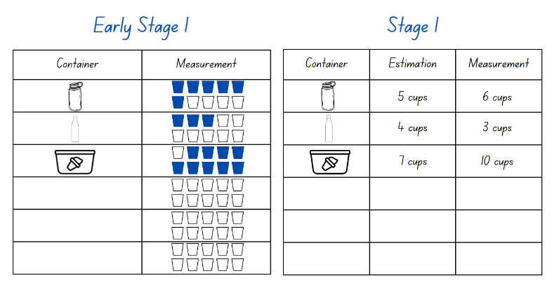
Images licensed under the Canva Content License Agreement.
- Select groups to share and explain their findings.
- Repeat with 3 bottles or containers that vary by both height and width. Students estimate, order and measure, recording their work on Resource 1: Recording sheet (Early Stage 1) or Resource 2: Recording sheet (Stage 1). Students then share and explain their findings about the capacity of their bottles or containers.
Note: Highlight that both height and width determine the capacity of a container.
This table details assessment opportunities and differentiation ideas.
Assessment opportunities | Too hard? | Too easy?
What to look for:  - Can students fill and empty containers and compare the internal volumes (capacities)? (MAO-WM-01, MAE-3DS-02)  - Can students estimate, compare, measure and record the capacity of 2 or more containers using informal units? (MAO-WM-01, MA1-3DS-02)  What to collect:  - observational data (MAO-WM-01, MAE-3DS-02, MA1-3DS-02)  - student work samples. (MAO-WM-01, MAE-3DS-02, MA1-3DS-02) | Students are unable to compare, measure and record the capacities of 2 or more containers.  - Provide students with one container and have them measure the capacity using informal units. For example, a small cup.  - Provide students with containers that are very different in size. Support students to compare the capacity by pouring water from the larger container into the smaller container and discussing that there is water left over. | Students can compare, measure and record the capacities of containers.  - Challenge students to solve how many cups are in one bottle of soft drink or juice. Students then work out how many bottles of soft drink or juice they would need to buy for a class party of 24 students.  - Students use multiple differently sized informal units to measure the capacity of containers, recording each one on Resource 1: Recording sheet (Early Stage 1) or Resource 2: Recording sheet (Stage 1).

Discuss and connect the mathematics – 10 minutes
- Summarise the lesson together, drawing out some key mathematical ideas. Ask:
- Does a tall container always hold more than a short container? Why or why not?
- Can you compare the capacity of containers with irregular shapes? How would you do it?
- Can you fill a container to its capacity? Why or why not?
- Can you estimate the capacity of a container without measuring it? Explain your thinking.
- How close were your estimations to the measurement?
- Did you face any challenges while measuring capacity? How did you overcome these challenges?

Lesson 3: How many blocks?
Core concept: Internal volume can be compared and measured by packing.
The table below contains suggested learning intentions and success criteria. These are best co-constructed with students.
Learning intentions | Success criteria
All students are learning that uniform informal units can be used to compare internal volumes (capacities).  In addition, students working towards Early Stage 1 outcomes are learning that numbers have a sequence based on their value.  In addition, students working towards Stage 1 outcomes are learning that the position of a digit in a number determines the value it represents. | Students working towards Early Stage 1 outcomes can:  - count backwards from a given number  - compare volume by building and comparing the volume of 2 objects.  Students working towards Stage 1 outcomes can:  - make, record and state the value of digits in various sized numbers  - estimate, measure and compare the internal volume of a container by packing it with uniform informal units.

Daily number sense: What is my place? – 20 minutes
- Build students understanding of the counting sequence and place value by making and recording the value of one-, two- and three-digit numbers.
- Provide Early Stage 1 pairs with a 6-sided die and each Early Stage 1 student with an individual whiteboard. Demonstrate how to play ‘Race from 20’ by playing against the whole class.
- Instruct students to write 20 in a circle on the left side of their whiteboard to start. Player A rolls the die and writes the corresponding numbers in sequence on their whiteboard. For example, Player A rolls a 6, then records 19, 18, 17, 16, 15 and 14 on their whiteboard next to 20. Player B rolls and then records their number sequence. Players take turn rolling the die and continuing the number sequence. For example, Player A rolls a 4, then they record 13, 12, 11 and 10 (see Figure 6).
Figure 6 – Race from 20
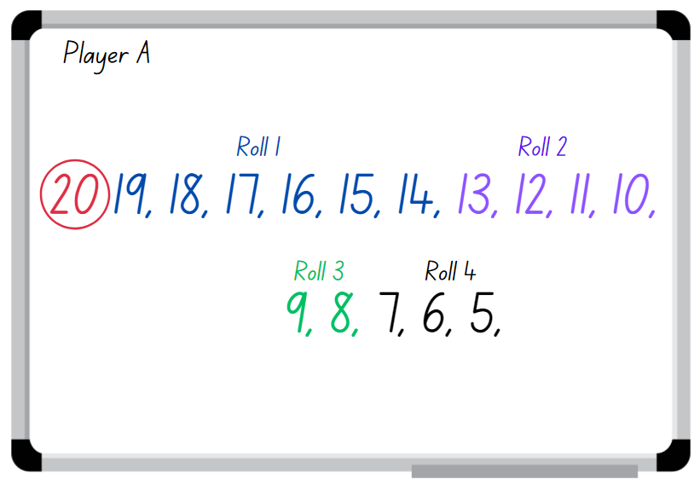
Images licensed under the Canva Content License Agreement.
- The game continues until the first player completes their sequence to zero. However, players must roll the correct number to finish the sequence.
- While Early Stage 1 are playing ‘Race from 20’, demonstrate to Stage 1 how to play what is my place value. Write the number 462 on the board and ask students how the number can be made using MAB blocks. Students turn and talk about how they could make the number and then share and explain their thinking.
Note: In Early Stage 1 and Stage 1, it is recommended that students will have experiences with materials that can be joined together and pulled apart, for example, bundles of craft sticks, interlocking cubes, straws or similar, before introducing MAB blocks.
- Model student responses with MAB blocks. Draw the MAB blocks, record and state the value of the digits (see Figure 7).
Figure 7 – State the value
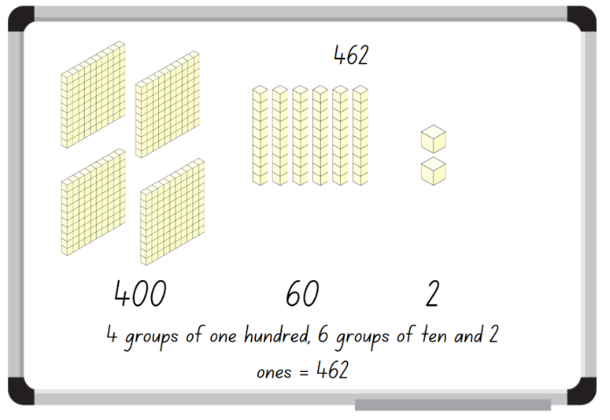
Images licensed under the Canva Content License Agreement.
- Display Resource 3: Place value and provide students with MAB blocks and their workbooks.
- Students make the three-digit numbers with MAB blocks; record using diagrams and state the value of the digits in their workbook. While students are making and recording in expanded form, walk around and ask:
- How many hundreds have you used to make your number?
- What is the value of the 7 in 762?
- How many tens have you used to make your number?
- What is the value of the 9 in 359?
- What is the value of the 6 in 762?
This table details assessment opportunities and differentiation ideas.
Assessment opportunities | Too hard? | Too easy?
What to look for:  - Can students count backwards from a given number? (MAO-WM-01, MAE-RWN-01, MAE-RWN-02)  - Can students make, record and state the value of digits in three-digit numbers? (MAO-WM-01, MA1-RWN-01, MA1-RWN-02)  What to collect:  - student work samples. (MAO-WM-01, MAE-RWN-01, MAE-RWN-02, MA1-RWN-01, MA1-RWN-02) | Students are unable to count backwards from a given number.  - Provide students with a number chart to reference when counting backwards.  - Provide students with 2 ten-frames and counters. Students remove counters as they count backwards from 20.  Students are unable to make and record three-digit numbers.  - In pairs, students flip over two-digit number cards. Students read and make two-digit numbers using MAB blocks.  - Give students further experiences using concrete materials to represent numbers. | Students can count backwards from a given number.  - Challenge students to count backwards from a larger two-digit number. For example, 50.  - Provide students with a 20-sided die and challenge them to play the game from 100.  Students can make and record three-digit numbers.  - Students make and record their three-digit number, then identify the nearest hundred to the number.  - Challenge students to make and rename the three-digit numbers in different ways. For example, 326 as 3 groups of one hundred, 2 groups of 10 and 6 ones, or 32 groups of 10 and 6 ones.

Pack it – 40 minutes
This lesson is adapted from How many blocks fit in the box? from Learning and Teaching with Learning Trajectories
- Display 3 different boxes, for example a shoe box, shipping box, tissue box or copy paper box. Explain that you want to mail a teddy bear to a friend, but you don't know what size box you will need. Students turn and talk to discuss ways the box could be measured.
- Select students to share and explain their strategies.
- If not already discussed through student responses, display a collection of interlocking cubes or blocks and ask how the blocks could be used to measure the capacities of the boxes.
- Provide small groups with different sized boxes and a large collection of interlocking cubes or uniform blocks. Ask students to pack the entire box, then count and record the number of cubes or blocks needed. Students share and discuss their findings. Ask:
- Which box held the most cubes or blocks?
- Which box held the least cubes or blocks?
- How did you pack your box?
- What happens if there are gaps in your packing?
Note: Explain to Stage 1 students that any gaps when packing and stacking will affect the accuracy of measuring the internal volume. Working out the volume based on the number of blocks in a row or column of blocks and the number of rows in a layer depends on systematic packing.
- Ask small groups of students to find one container from the classroom, for example, a pencil tin, lunch box, water bottle or tote tray. Have students measure the internal volume by packing with uniform informal units.
- Provide students with informal units, for example, interlocking cubes, blocks, plastic teddies, pasta shells or marbles and their workbooks. Ask students to estimate the volume of their container in terms of the number of units. Students then measure the volume of the container by packing using the uniform units and record the results.
- Regroup as a class and choose students to share their working. Ask:
- How did you measure the volume of the container?
- Were your estimates close to the actual measurements?
- What did you learn about measuring volume using uniform informal units?
- What challenges did you encounter when measuring the volume of the container?
- What could you do to improve your accuracy when measuring volume?
- Why is it that the same size containers have different volumes?
- Can you think of any real-life situations where measuring volume is important?
This table details assessment opportunities and differentiation ideas.
Assessment opportunities | Too hard? | Too easy?
What to look for:  - Can students compare volume by building and comparing the volume of 2 objects? (MAO-WM-01, MAE-3DS-02)  - Can students estimate, measure and compare the internal volume of a container by packing it with uniform informal units? (MAO-WM-01, MA1-3DS-02)  What to collect:  - observational data (MAO-WM-01, MAE-3DS-02, MA1-3DS-02)  - student work samples. (MAO-WM-01, MAE-3DS-02, MA1-3DS-02) | Students are unable to compare and measure the internal volume of a box by packing it with uniform informal units.  - Provide students with a set of different size containers, such as plastic cups or cardboard boxes. Ask them to sort these containers according to size.  - Ask students to compare volumes by finding out who can hold the most blocks in one hand. Put the blocks in clear plastic cups and compare the height of the blocks in the cup. | Students can compare and measure the internal volume of a box by packing it with uniform informal units.  - Provide students with a set value of uniform blocks, for example, 20 blocks and various size containers. Ask students to estimate using only the set value of blocks and then check their measure.  - Provide students with A4 cardboard to make an irregular box. Discuss the challenges they may have when measuring the volume of the box.

Lesson 4: Areas of rectangles
Core concept: Area can be compared and measured using superimposing and the grid structure of rows and columns.
The table below contains suggested learning intentions and success criteria. These are best co-constructed with students.
Learning intentions | Success criteria
Students working towards Early Stage 1 outcomes are learning that area can be determined by comparing the shapes surface using various strategies.  Students working towards Stage 1 outcomes are learning that area can be measured and compared by creating repeated rows and columns of square tiles. | Students working towards Early Stage 1 outcomes can:  - predict which, out of 2 surfaces, will have the larger area and justify their answer  - compare areas of 2 similar shapes directly by drawing, tracing, or cutting and pasting.  Students working towards Stage 1 outcomes can:  - measure area by selecting and using appropriate uniform informal units  - form arrays of equal rows and columns to find the area of a rectangle  - explain how the grid structure helps to find the area.

Daily number sense – 10 minutes
- From a class need surfaced through formative assessment data, identify a short, focused activity that targets students’ knowledge, understanding and skills. Example activities may be drawn from the following resources:
- Thinking Mathematically
- Universal Resources Hub.

Finding areas of rectangles – 40 minutes
This lesson has been adapted from Finding areas of rectangles by NZ Maths.
- Provide all students with a piece of A4 paper and explain that they must find 3 areas in the classroom that are bigger, smaller or about the same size as the paper. Model how to compare the areas by superimposing.
Superimposing: To place or lay on top of.
- Select students to share what areas they found and how they superimposed the paper to compare the sizes.
Note: During the discussion, encourage students to use the vocabulary of area. For example, surface, inside, outside, shape, area, large area, small area and to superimpose shapes to compare their size.
- Provide Early Stage 1 pairs with Resource 4: Various squares and each student with Resource 5: Shapes worksheet. Students compare the shapes by superimposing and discuss which shape has the larger or smaller area. Once Early Stage 1 students have compared the areas, they match the shapes by superimposing and paste them onto the worksheet.
- While Early Stage 1 students are working in pairs, display Resource 6: Rectangle for Stage 1 students and ask how many tiles make up the whole rectangle. Students turn and talk, explaining their strategy.
The table below outlines stimulus prompts to generate conversation about the topic, along with anticipated responses from students.
Prompts | Anticipated student responses
- How many tiles are in each column?  - How many tiles are in each row?  - How many tiles make up the whole rectangle?  - What is the area of the rectangle?  - Why is the rectangle measured in squares? | - There are 3 tiles in each column.  - There are 4 tiles in each row.  - The rectangle is made up of 12 tiles.  - The area is 12 tiles.  - They fit together with no gaps.
- Discuss the strategies students used to work out the rectangle contains 12 squares and that the area is 12 squares. For example, additive strategies like 4 + 4 + 4 = 12 and 3 + 3 + 3 + 3 = 12, or multiplication like 4 groups of 3 is 12 and 3 rows of 4 is 12.
Area: The amount of surface inside a closed flat (2D) shape.
- Display Resource 7: 3 rectangles for Stage 1 students and ask them to use their individual whiteboards to solve the area of each rectangle.
- Select Stage 1 students to share and explain how they calculated the area of each rectangle.
- Provide Stage 1 students with a sheet of square grid paper or a grid workbook and ask them to draw as many rectangles as possible that have an area of 24 squares.
- Regroup Stage 1 students to share and explain the different rectangles they have drawn. Ask:
- What strategies did you use to form the rectangles?
- Did you notice a relationship between the rectangles? Explain your answer and communicate your thinking.
- How do you know you have drawn all the possible rectangles?
- Provide Stage 1 students with Resource 8: Covered rectangle. Ask students to find the area of the rectangle, allowing them to draw the missing squares or grid to calculate the area. Students turn and talk, then share and justify their ideas.
Note: To assist students in developing an appreciation for the structure of repeated units, the teaching moves from providing multiple squares to cover an area to providing only one. Using one square requires students to create a pattern or structure of units by drawing or visualising. Drawing an array structure for tessellation of an area supports students to perceive the rows (and columns) as composite units. This perception enables students to connect the side length and area. If students have drawn and talked about the structure of an array, it may be easier to grasp the structure of three-dimensional stacking.
- Regroup Early Stage 1 students and explain that they will work in small groups to trace and cut picture books. Students superimpose the picture books to find which has the largest or smallest area and explain how they found out. They then place the picture books in order from smallest area to largest.
- While Early Stage 1 students are working in small groups, display and provide Stage 1 students with Resource 8: Covered rectangle. Ask students to find the area of the rectangle, allowing them to draw the missing squares or grid to calculate the area. Students turn and talk, then share and justify their ideas.
- Provide Stage 1 students Resource 9: Covered rectangle 2 and ask them to find the area of the rectangle using the provided square. Select students to share explain the strategies they used to determine the area of the rectangle.

Discuss and connect the mathematics – 10 minutes
- Summarise the lesson together, drawing out some key mathematical ideas. Ask students:
- Can 2 shapes have the same area even if they look different? (Early Stage 1)
- How can you compare the area of 2 shapes? (Early Stage 1)
- Which picture book is the largest? How do you know? (Early Stage 1)
- Which picture book is the smallest? How do you know? (Early Stage 1)
- How did you arrange the picture books in order from largest to smallest, based on their areas? (Early Stage 1)
- Can you find 2 picture books with the same area? How do you know? (Early Stage 1)
- What strategy did you use to find the area of the rectangle? (Stage 1)
- Did you draw the grid on the rectangle, or did you visualise it? (Stage 1)
- Why is the grid structure helpful when finding the area? (Stage 1)
- If we changed the size of the square tile, would the area of the rectangle change? Why or why not? (Stage 1)
- Why is it important to make sure there are no gaps or overlaps when measuring area? (Stage 1)
- What challenges did you face? How did you overcome them?
This table details assessment opportunities and differentiation ideas.
Assessment opportunities | Too hard? | Too easy?
What to look for:  - Can students compare areas of similar shapes? (MAO-WM-01, MAE-2DS-02)  - Can students measure area by selecting and using appropriate uniform informal units? (MAO-WM-01, MA1-2DS-02)  - Are students able to form the array structure of area in rows and columns? (MAO-WM-01, MA1-FG-01, MA1-2DS-02)  - Can students explain how the grid structure helps to find the area? (MAO-WM-01, MA1-2DS-02)  What to collect:  - observational data (MAO-WM-01, MA1-FG-01, MAE-2DS-02, MA1-2DS-02)  - student work samples. (MAO-WM-01, MA1-FG-01, MAE-2DS-02, MA1-2DS-02) | Students are unable to compare areas of similar objects.  - Provide 2 different shapes with the same area, where one shape can be cut up and pasted onto the other.  - Provide students with a template of a picture book to superimpose on other picture books.  Students are unable to measure the area of a rectangle using informal units.  - Students superimpose rectangles to compare their size and order them from smallest to largest.  - Provide students with square tiles to manipulate when measuring the area of a rectangle. Support students to count tiles with one-to-one correspondence when covering the rectangle. | Students can compare areas of similar shapes by superimposing.  - Provide students various irregular shapes and have them compare the shapes’ area.  - Challenge students to measure and compare the area of the shapes using uniform informal units.  Students can use uniform informal units to measure the area of various size rectangles.  - Challenge students to find the area of non-rectangular shapes using the provided square. For example, the area of a triangle.  - Students solve Torn Shapes from NRICH and present to a peer.

Lesson 5: Length hunt
Core concept: Length can be measured and compared using uniform informal units.
The table below contains suggested learning intentions and success criteria. These are best co-constructed with students.
Learning intentions | Success criteria
All students are learning that length can be compared and measured using a single uniform informal unit. | Students working towards Early Stage 1 outcomes can:  - compare and describe length using language such as longer than, shorter than, the same as  - explain why the length of a piece of string placed in a straight line is the same as a curved line.  Students working towards Stage 1 outcomes can:  - use uniform informal units to measure and compare lengths by placing the units end to end without gaps and overlaps  - estimate and record lengths by referring to the number and type of unit used.

Daily number sense: Mastermind – 15 minutes
This lesson has been adapted from Mastermind from Thinking Mathematically (K-6 resources).
- Build student understanding of place value by stating the quantity values of digits in numbers of up to three-digits.
- In pairs, each student records a two- or three-digit number with no repeated digit on a sticky note and draws up their game board (see Figure 5).
- Students take turns to guess their partner’s two- or three-digit number. Their partner reveals how many digits are correct and how many are in the correct place (see Figure 8).
Figure 8 – Mastermind gameboard
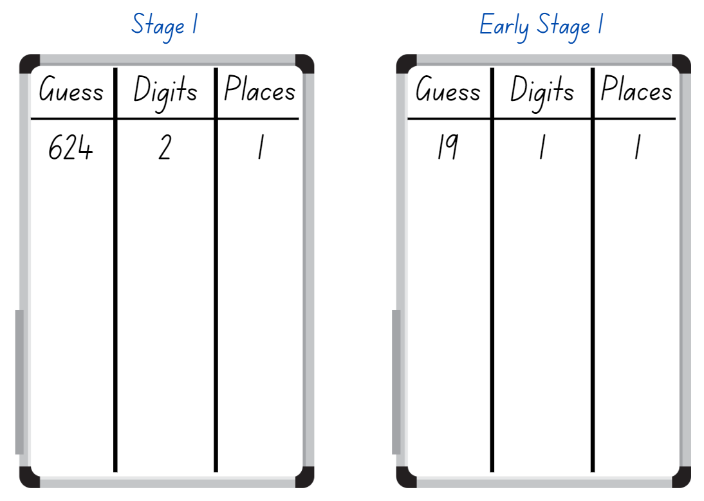
Images licensed under the Canva Content License Agreement.
- Students record their guess, the number of digits that are correct, and the number of digits that are in the right place. Students then use this information to refine their guesses.
- The first student to correctly guess their partner’s number is the winner. Ask students which strategies they used to determine the correct answer.
Note: This activity can be adapted by using four- or five-digit numbers for Stage 1 students.

Informal measurement – 30 minutes
The lesson is adapted from Crooked Paths from Van de Walle et al. (2019)
- Revise the measurement of length by asking students to share the language they used when measuring and/or comparing lengths. For example, end to end, gap, estimate, shorter or longer, same as, longest, shortest. Record student responses on an anchor chart.
- Provide pairs of students with individual whiteboards and a variety of objects to use as their target unit of measure, for example, a pencil, an exercise book, a glue stick, a craft stick. Ask students to find items in the room that are shorter than, longer than or about the same length as their target unit of measure and record their findings on the whiteboard.
- Select students to share and justify the items and the lengths compared to their target unit.
- Make at least 3 crooked or curved paths on the floor or outside with masking tape or chalk. Provide Early Stage 1 pairs with 3 pieces of string that are the length of the curved paths. Early Stage 1 students compare the length of each line and match the string to the path.
- Stage 1 students use an informal unit of measure, for example, a glue stick, craft stick or pencil. Ask students to estimate and then determine which path is the shortest to longest by measuring the lines with their informal unit. Students record their responses on individual whiteboard, stating the number and type of unit used.
- Select students to share and justify the lengths of the paths. Discuss the various ways students measured the crooked or curved paths. Ask:
- Why does the string remain unchanged when placed in a straight line or a curve? (Early Stage 1)
- What are some important factors that you need to consider when measuring curved or crooked paths?
- What other items could be used to measure the crooked or curved paths?
- How close was your estimation to the measurement? (Stage 1)
- What are some important factors that you need to consider when measuring straight paths?

Consolidation and meaningful practice: Measuring heads – 15 minutes
This lesson is adapted from ‘Who has the biggest head?’ from NSW Department of Education [PDF 720KB]
- Provide small groups of students with string or strips of paper. Students use these to measure around their heads, marking the measurement.
- Provide each group with an informal unit of measure for example, interlocking cubes, pipe cleaners, rods, craft sticks. Students estimate and measure their string or strips of paper with the informal unit and record. Students then organise their strings in order of length from shortest to longest.
- Regroup and choose students to share their results. Ask:
- How close was your estimate to the actual length of the string?
- Could you estimate the length of your head without using the string or any other tools?
- What happens when different students measure the same object using different informal units?
- Why is it important to use the same unit measure every time you measure something?
- Can you think of a situation where consistent measurement could make a difference? For example, measuring material for making curtains.
- Why is it important to measure things accurately?
This table details assessment opportunities and differentiation ideas.
Assessment opportunities | Too hard? | Too easy?
What to look for:  - Can students compare and describe length using language such as longer than, shorter than, the same as? (MAO-WM-01, MAE-GM-02)  - Can students explain why the length of a piece of string placed in a straight line is the same as a curved line? (MAO-WM-01, MAE-GM-02)  - Can students use uniform informal units to measure lengths by placing the units end to end without gaps and overlaps? (MAO-WM-01, MA1-GM-02)  - Can students estimate and record lengths and distances by referring to the number and type of unit used? (MAO-WM-01, MA1-GM-02)  What to collect:  - observational data. (MAO-WM-01, MAE-GM-02, MA1-GM-02) | Students cannot explain why the length of a piece of string placed in a straight line is the same as a curve.  - Support students to compare the 2 pieces of string. Ensure one piece remains in a straight line and support the students to make the other one curved.  - Students sort a collection of straight and curved objects.  Students are unable to estimate, check and count a collection of informal units to measure various lengths.  - Provide students with string and tape to hold the beginning of the string in place while they are measuring the crooked or curved paths, and markers to identify the end of the path. Students then order the lengths of string from shortest to longest.  - Support students to measure short straight paths, modelling how to place informal units end to end without gaps or overlaps. Students count with one-to-one correspondence to find the total length. | Students can explain why the length of a piece of string placed in a straight line is the same as a curve.  - Students identify 3 objects that have straight and curved lines. Record by drawing and labelling.  - Draw examples of objects with straight and curved lines.  Students can estimate, check and count a collection of informal units to measure various lengths.  - Challenge students to solve problems that require estimation, for example, a bug walks around 2 sides of a book, and another bug walks diagonally across the desk. Ask students which bug will walk the furthest. Vary this activity by choosing different paths.  - Students make their own informal unit ruler and use it to measure items and the paths.

Lesson 6: Measurement scavenger hunt
Core concept: Length can be compared by aligning ends and measured by using formal and informal units.
The table below contains suggested learning intentions and success criteria. These are best co-constructed with students.
Learning intentions | Success criteria
Students working towards Early Stage 1 outcomes are learning that length can be directly compared by aligning ends.  Students working towards Stage 1 outcomes are learning that there is a need for a formal unit of measurement smaller than the metre. | Students working towards Early Stage 1 outcomes can compare lengths by placing objects side by side and aligning the ends.  Students working towards Stage 1 outcomes can:  - measure the length of objects to the nearest centimetre, using a device with 1 cm markings  - estimate length and distance to the nearest centimetre and check by measuring.

Daily number sense: Thumbs up – 15 minutes
This lesson has been adapted from Thumbs Up from Developing Efficient Numeracy Strategies.
- Build student understanding of the counting sequence and place value by identifying number before and after a given number and representing three-digit numbers in a range of ways.
- Provide Early Stage 1 students with a twenty-sided die and an individual whiteboard. Students roll the die and write the number rolled on their individual whiteboard, then record the number before and after (see Figure 9).
Figure 9 – Number sequence
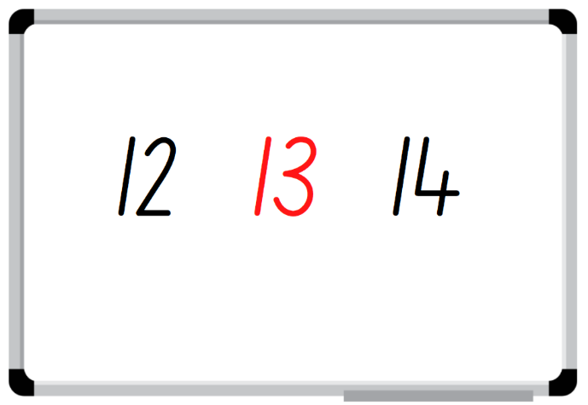
Images licensed under the Canva Content License Agreement.
- Early Stage 1 students continue to roll their die and identify the number before and after.
- Stage 1 students select 3 cards. The remaining cards are face down in a central pile. Each student arranges their cards to make a three-digit number, out of view of their partner.
- Student A flips over a card from the central pile and asks their partner about the value of the card. For example, students could ask if their partner’s number has 3 tens. Student B responds with either a thumbs up, indicating student A is correct; thumbs horizontal, indicating the digit is in the number but not with that value; or thumbs down, indicating the digit is not in the number. Student A records the digit and response to help them identify their partner’s hidden number with either a tick or a cross (see Figure 10).
Figure 10 – Gameplay
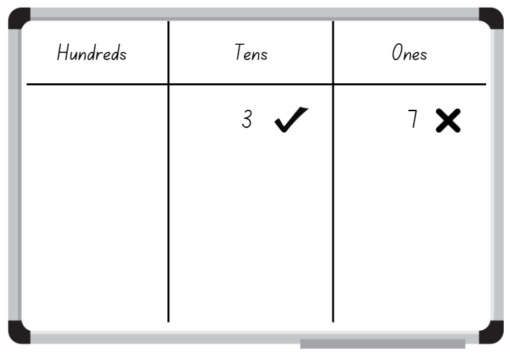
Images licensed under the Canva Content License Agreement.
- Students may keep the card that they received a horizontal thumb for and use it in their next turn or discard the card. Unwanted cards are placed on a discard pile. Students swap roles and continue to take turns. The winner is the first person to correctly identify and name their partner’s number.

Measurement scavenger hunt – 45 minutes
- Provide students with a piece of string one metre long. Explain that they are going on a hunt for an item around the class that is the same length as the string.
Note: Stage 1 students can be aware the string is a metre long, while Early Stage 1 students are comparing the length of string to other items in the classroom.
- Students bring their item back to floor to share. Guide student to make collections that they estimate to be:
- less than the length of string
- about the length of the string
- more than the length of string along any side.
- Provide Early Stage 1 students with Resource 10: Strip without measurements and Resource 11: Scavenger hunt (Early Stage 1) Revise how to directly compare lengths of various classroom items by placing them side by side and aligning the ends (see Figure 11).
Figure 11 – Comparing lengths
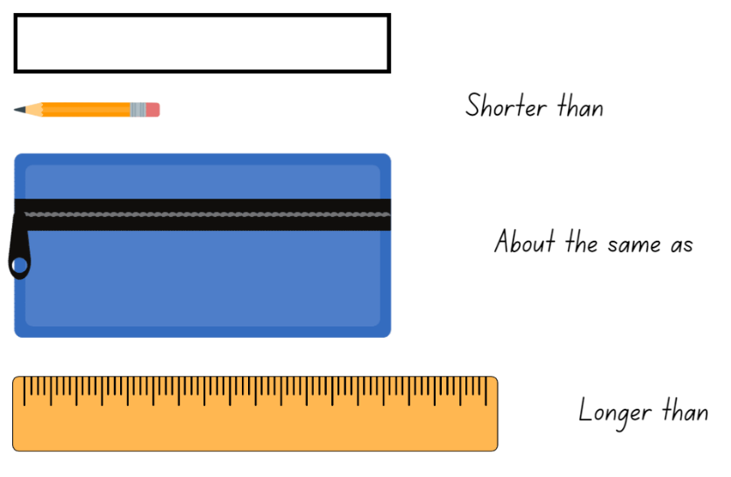
Images licensed under the Canva Content License Agreement.
- In pairs, Early Stage 1 students go on a scavenger hunt to compare items around the classroom. They use Resource 11: Scavenger hunt (Early Stage 1) to record their results by drawing the items found.
- Stage 1 Students share their item and record on a class Y-chart categorising items that are about a metre in length, greater than a metre and less than a metre. Choose 2 items that have been collected that are similar in length and less than one metre. Explain that Stage 1 students will need to measure the items accurately to determine which is longer, but they cannot use a metre. Ask:
- How can you measure the length of an object that is smaller than a metre, using a smaller unit of measurement?
- What is the next smallest unit of measurement for length after a metre?
- How is the smaller unit useful in our daily lives?
- Provide Stage 1 students Resource 12: Measuring strip and Resource 13: Scavenger hunt (Stage 1) and demonstrate how to estimate, measure and record classroom items accurately and to the nearest centimetre (cm) (see Figure 12). Highlight the importance of starting at zero when measuring. In pairs, students go on a scavenger hunt to measure items around the classroom using the measurement strip. Students use Resource 13: Scavenger hunt (Stage 1) to record their estimation and measurements.
Figure 12 – Scavenger hunt recording
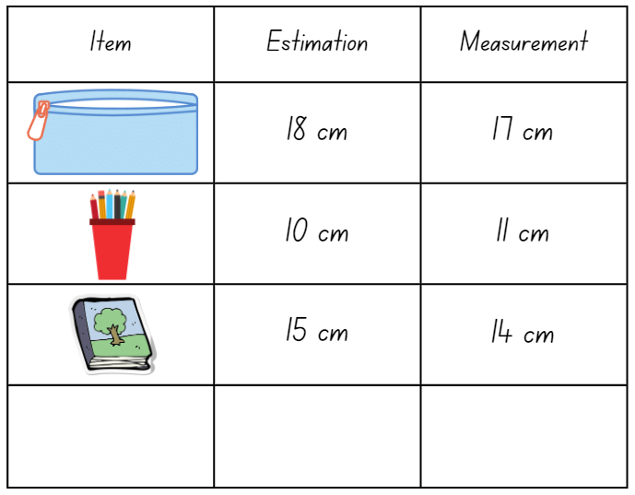
Images licensed under the Canva Content License Agreement.
Note: Highlight to Stage 1 students that, when recording measurements, a space should be left between the number and the abbreviated unit. For example, 3 cm, not 3 cm.
- Students display Resource 11: Scavenger hunt (Early Stage 1) and Resource 13: Scavenger hunt (Stage 1) and go on a gallery walk, looking at the items other students have compared and measured, as well as their length.
- Regroup as a class and ask:
- Why is it important to align the ends when comparing lengths? (Early Stage 1)
- Why is it important to start at zero when measuring? (Stage 1)
- How close were your estimations? (Stage 1)
- How accurate were your measurements? (Stage 1)
- Was it challenging to measure the length of certain objects? If so, how did you overcome the challenge?
- Were there objects that were longer than the measurement strip? How did you measure them?
This table details assessment opportunities and differentiation ideas.
Assessment opportunities | Too hard? | Too easy?
What to look for:  - Can students compare lengths directly by placing objects side by side and aligning the ends? (MAO-WM-01, MAE-GM-02)  - Can students measure the length of objects to the nearest centimetre, using a device with 1 cm markings? (MAO-WM-01, MA1-GM-02)  - Can students estimate length and distance to the nearest centimetre and check by measuring? (MAO-WM-01, MA1-GM-02)  What to collect:  - observation data (MAO-WM-01, MAE-GM-02, MA1-GM-02)  - student work samples. (MAO-WM-01, MAE-GM-02, MA1-GM-02) | Students are unable to compare lengths of objects.  - Provide students with objects that are very different in length and have students identify which object is shorter or longer.  - Provide students with tape to mark the string when comparing objects side by side.  Students are unable to measure the length of objects using formal units of metres and centimetres.  - Provide students with a range of uniform informal units to measure classroom items and record.  - Support students to trace the object and then measure the length of the traced object using the strip of paper. | Students can compare lengths of objects.  - Challenge students to identify and draw objects from home that would be longer and shorter than the string.  - Challenge students to estimate the length of the classroom and/or playground using the string provided.  Students can measure the length of objects using formal units of metres and centimetres.  - Challenge students to calculate the perimeter of the classroom objects using Resource 12: Measurement strip.  - Challenge students to identify and record objects at home that would be measured by either formal units of metres or centimetres.

Lesson 7: What is the length?
Core concept: Length can be described using comparative language and measured using metres and centimetres.
The table below contains suggested learning intentions and success criteria. These are best co-constructed with students.
Learning intentions | Success criteria
Students working towards Early Stage 1 outcomes are learning that comparative language can be used to describe length.  Students working towards Stage 1 outcomes are learning that:  - there is a need for a formal unit smaller than a metre  - length can be estimated and measured to the nearest centimetre. | Students working towards Early Stage 1 outcomes can use comparative language to describe and compare length.  Students working towards Stage 1 outcomes can:  - accurately measure and record length of objects to the nearest centimetre using the abbreviation for centimetres (cm)  - recognise that there are 100 centimetres in one metre.

Daily number sense – 10 minutes
- From a class need surfaced through formative assessment data, identify a short, focused activity that targets students’ knowledge, understanding and skills. Example activities may be drawn from the following resources:
- Thinking Mathematically
- Universal Resources Hub.

Comparing and measuring lengths – 40 minutes
This lesson has been adapted from Stage 1 – measurement – length from NSW Department of Education
- Provide Early Stage 1 pairs with Resource 14: Length Memory game. Students play 3 variations of the game independently until Discuss and connect the mathematics:
- Matching items that are the same length.
- Matching items that are either shorter or longer in length.
- Selecting 10 cards and ordering them from shortest to longest.
- While Early Stage 1 students are working independently, display Resource 15: Metres or centimetres to Stage 1 students and have them turn and talk about the most appropriate formal unit of measurement for measuring the length of the objects (metres or centimetres).
- Select students to share their thinking and record their responses using the abbreviation for centimetres (cm) and metres (m). Ask:
- Are there any objects that can be measured in both centimetres and metres?
- Why did you think cm?
- Why did you think m?
- Provide small groups with Resource 12: Measurement strip and have students measure the length of the one metre length of string from Lesson 6. Remind students to ensure they place their 20 cm strip at the beginning of the string and leave no gaps or overlaps.
- Students count the number of 20 cm pieces they used to measure the length of the string and discover that there are 100 cm in a metre (see Figure 13).
Figure 13 – Measuring one metre string
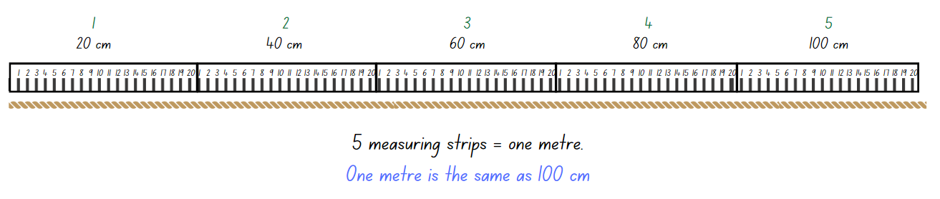
Images licensed under the Canva Content License Agreement.
- Regroup Stage 1 students and discuss the following:
- 100 centimetres is the same length as one __
- One metre equals __ centimetres
- 1 m = __ cm
- Provide Resource 16: Measurement worksheet and ask students to use Resource 12: Measurement strip to measure the length of each line and record the measurement at the end of each line.
- Regroup Stage 1 students and ask:
- How accurate do you need to be when measuring length in centimetres?
- Why is accuracy important when measuring length?
- Why is it important to make sure you line up the ends? What happens if you do not?
- Provide Stage 1 students with their workbooks and ask them to measure 2 items/pencils in their pencil case, then record using centimetres (cm), images and numerals (see Figure 14).
Figure 14 – Student work sample
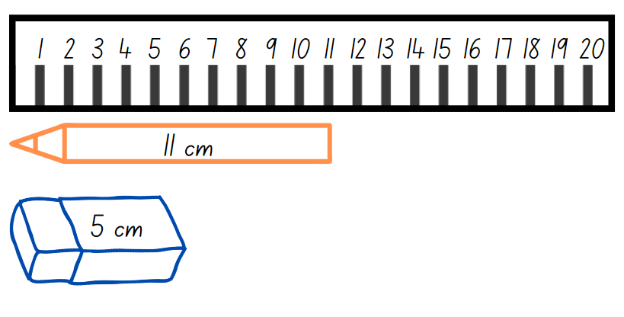
Images licensed under the Canva Content License Agreement.
This table details assessment opportunities and differentiation ideas.
Assessment opportunities | Too hard? | Too easy?
What to look for:  - Are students able to use comparative language to describe and compare length? (MAO-WM-01, MAE-GM-02)  - Can students accurately measure and record lengths of objects to the nearest centimetre using the abbreviation for centimetres (cm)? (MAO-WM-01, MA1-GM-02)  - Are students able to recognise that there are 100 centimetres in one metre? (MAO-WM-01, MA1-GM-02)  What to collect:  - observational data (MAO-WM-01, MAE-GM-02, MA1-GM-02)  - student work samples. (MAO-WM-01, MA1-GM-02) | Students are unable to use comparative language to describe length.  - Provide students pictures that demonstrate various descriptions.  - Ask students to draw their explanation.  Students are unable to measure and record length using centimetres.  - Provide students with uniform informal units to measure the length of the lines and record.  - Ask students to identify objects in the classroom that should be measured with metres and those that should be measured with centimetres. Students draw and sort the objects in a table. | Students use comparative language to describe length.  - Students select 2 memory game cards and write a sentence to describe the objects using comparative language.  - Students select 4 pictures and order them in real life context and justify their response.  Students can measure and record length using centimetres.  - Challenge students to measure multiple classroom items and find the difference between the shortest and longest items.  - Select an item that is more than one metre but less than 2 metres and ask students to measure the item. Discuss the need for accuracy and the most efficient way to determine the length.

Discuss and connect the mathematics – 10 minutes
- Regroup as a class and summarise the lesson together drawing out key mathematical ideas. Ask:
- Did you find it more challenging to match items that were opposites in length compared to items that were the same length? Why or why not? (Early Stage 1)
- Can you think of other activities you have done in the past that involve ordering objects based on size or length? (Early Stage 1)
- Can you find the total length of both pencils/items? How? (Stage 1)
- What is the difference in length between the 2 pencils/items? (Stage 1)
- How accurate do you need to be when measuring length in centimetres? (Stage 1)
- How many centimetres are in one metre? (Stage 1)
- What tools can you use to measure length in centimetres? (Stage 1)
- Did you face any challenges when measuring in centimetres? How did you overcome these?
- Do you still have any questions around centimetres? (Stage 1)

Lesson 8: Air show competition
Core concept: Recognise and use informal and formal units of measurement.
The table below contains suggested learning intentions and success criteria. These are best co-constructed with students.
Learning intentions | Success criteria
Students working towards Early Stage 1 outcomes are learning that:  - numbers have a sequence based on their value  - length can be directly compared by aligning ends  - area and mass can be compared and measured.  Students working towards Stage 1 outcomes are learning that:  - the position of a digit in a number determines the value it represents  - uniform informal units can be used to measure and compare mass and area  - formal units of measurement for length ensure consistency and accuracy. | Students working towards Early Stage 1 outcomes can:  - count backwards from a given number  - compare the length of a distance from end to end  - predict, compare and order the weight of various objects by hefting  - directly compare areas of 2 similar shapes by superimposing.  Students working towards Stage 1 outcomes can:  - use place value to represent three-digit numbers in different ways  - estimate the length of a distance by visualising how many formal units they will need and checking by measuring  - record lengths and distances using formal units of metres (m) and centimetres (cm)  - compare the areas of 2 or more surfaces that cannot be moved or superimposed, by measuring in uniform informal units  - compare the masses of 2 or more objects using the same informal units.

Daily number sense: Place value counting – 10 minutes
The lesson is adapted from Place Value Cards from reSolve: Maths by Inquiry.
- Build student understanding of quantities and place value by representing the quantity value of digits in numbers up to three-digits.
- Show students 2 large mixed collections of blocks. Early Stage 1 students’ tub should have uniform blocks and Stage 1 students’ tub should have MAB blocks (ones and tens and hundreds).
- Ask Early Stage 1 students to scoop a collection of blocks up to 20, count them, record the quantity on an individual whiteboard and count backwards as the blocks are placed back in the tub. Students take turns scooping, recording their quantities and counting backwards.
- While Early Stage 1 students work independently, show Stage 1 students the large mixed collection of MAB blocks (ones, tens and hundreds) and place them in a tub. Randomly select one MAB block at a time and ask students to count according to the value of the MAB block. For example, if you display a 10, students count 10; if you display a hundred, students count 110; if you display a one, students count 111 and so on.
- Stop counting after several rounds and ask students to record their response on an individual whiteboard. Ask students to consider why they reached the same total when the MAB blocks are presented in a different order.
- Ask students to record, on an individual whiteboard, the different ways the number can be represented. For example, 245 = 2 hundreds, 4 tens, 5 ones, or 24 groups of 10 and 5 ones.
This table details assessment opportunities and differentiation ideas.
Assessment opportunities | Too hard? | Too easy?
What to look for:  - Can students count backwards from a given number? (MAO-WM-01, MAE-RWN-01, MAE-RWN-02)  - Can students use place value to represent three-digit numbers in different ways? (MAO-WM-01, MA1-RWN-01, MA1-RWN-02)  What to collect:  - observational data. (MAO-WM-01, MAE-RWN-01, MAE-RWN-02, MA1-RWN-01, MA1-RWN-02) | Students are unable to count backwards from a given number.  - Provide students with a number chart to reference when counting backwards.  - Provide students with 2 ten-frames and counters. Students remove counters as they count backwards from 20.  Students are unable to represent three-digit numbers in different ways.  - Provide students with concrete materials to manipulate when recording different representations.  - Reinforce students’ knowledge of two-digit number place value. | Students can count backwards from a given number.  - Challenge students to count backwards from a larger scoop. For example, 30.  - Challenge students to count backwards by twos when placing the blocks back into the tub.  Students can represent three-digit numbers in different ways.  - Challenge students by counting forwards and/or backwards when completing the number sequence.  - Students represent four-digit numbers in different ways.

Paper planes – 40 minutes
This lesson has been adapted from Paper planes: Level 2 from NZ Maths. Watch How To Fold A Paper Airplane That Flies Far (Full HD) (3:14) prior to teaching this lesson.
- This learning task is best suited to an empty indoor learning space. Explain that students are going to make paper planes and experiment with how far they can fly their plane in a class competition.
- Demonstrate how to make a simple paper plane.
- Provide students with A4 paper and ask them to make a paper plane.
- Students experiment with their paper planes to see how far they fly. Ask:
- How can you compare or measure the distance your planes fly?
- What can you use to measure how far your plane travels?
- What do you need to be careful of when measuring? Why?
- Provide Early Stage 1 students with a ball of string or ribbon and Stage 1 students a variety of measurement tools, such as measuring tape and rulers. Ask students:
- When measuring with the string or ribbon, what things do you need to consider? (Early Stage 1)
- Which measuring tools do you think would be best to measure the distance of your plane’s flight? Why? (Stage 1)
- What other things could we use to measure distance? (Stage 1)
- With Early Stage 1 students, demonstrate how to measure the distance a paper plane flew and mark the string or ribbon. With Stage 1 students, demonstrate how to estimate and accurately measure the distance and record on Resource 17: Flight recording sheet (see Figure 15).
Figure 15 – Flight recording example
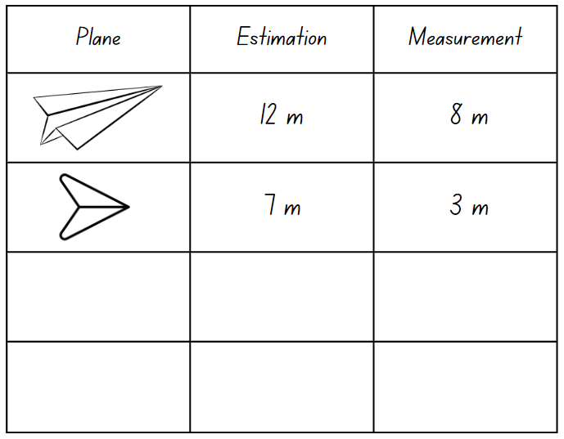
Images licensed under the Canva Content License Agreement.
Note: Emphasise to all students the importance of an accurate starting point for the flight and, for Stage 1 students, accurately using measurement tools to the closest m or cm.
- Provide pairs of Stage 1 students with Resource 17: Flight recording sheet to compare the distance their paper planes travelled. Early Stage 1 students compare the distances that the paper planes flew with the string or ribbon.
- Students reflect on their results and discuss why certain planes flew further than others. Ask:
- How do you think you could improve your plane to make it fly further?
- What did you use to measure the distance of your plane’s flight? (Stage 1)
- What steps did you take to ensure your measurements were accurate? (Stage 1)
- Provide paper of different size and thickness and have students change the weight and size of their designs.
- Early Stage 1 students use hefting to compare the weight of their paper planes. Provide an equal-arm balance and uniform informal units for Stage 1 students to measure and compare the weight of the paper planes. Students make conjectures about which plane will fly further and record their estimation before testing.
- Early Stage 1 students superimpose their planes and investigate if area has an impact of flight distance. Ask Stage 1 students to also use uniform informal units to measure the area of the planes, predict which plane will fly further and investigate whether a larger or smaller area has an impact of flight distance.
- Students share and explain the modifications made to their design and repeat the competition with their revised plane models. The student with the furthest flight distance is the winner.
This table details assessment opportunities and differentiation ideas.
Assessment opportunities | Too hard? | Too easy?
What to look for:  - Can students compare the length of a distance from end to end? (MAO-WM-01, MAE-GM-02)  - Can students predict, compare and order the weight of various objects by hefting? (MAO-WM-01, MAE-NSW-01)  - Can students compare areas of 2 similar shapes directly by superimposing? (MAO-WM-01, MAE-2DS-02)  - Can students estimate the length of distance by visualising how many formal units and checking by measuring? (MAO-WM-02, MA1-GM-02)  - Can students record lengths and distances using metres (m) and centimetres (cm)? (MAO-WM-02, MA1-GM-02)  - Can students compare the areas of 2 or more surfaces that cannot be moved, or superimposed, by measuring in uniform informal units? (MAO-WM-01, MA1-2DS-02)  - Can students compare the masses of 2 or more objects using the same informal units? (MAO-WM-01, MA1-NSM-01)  What to collect:  - observational data (MAO-WM-01, MA1-GM-02, MAE-2DS-02 MA1-2DS-02, MAE-NSW-01 MA1-NSM-01)  - student work samples. (MAO-WM-01, MA1-GM-02, MA1-2DS-02, MA1-NSM-01) | Students are unable to measure and compare the length using string or ribbon.  - Support students to measure the distance of the flight path by using their feet.  - Provide students with chalk to draw the flight path and indirectly compare the lengths.  Students are unable to measure and record the length of their flight using formal units.  - Provide students with uniform informal units to measure the distance of their plane’s flight. Support students to measure with no gaps or overlaps and record.  - Support students to use body parts, such as feet, to measure the distance of the flight path. | Students can measure and compare the length using string or ribbon.  - Challenge students to estimate and then measure the flight distance of their plane by using uniform informal units.  - Students compare and order the flight distances of their peers from shortest to longest.  Students can measure and record the length of their flight using formal units.  - Challenge students to measure their flight distance using at least 2 different measuring tools. For example, measuring tape and metre ruler. Students record both distances, ensuring they match.  - Challenge students to convert their measurements from metres to centimetres or centimetres to metres.

Discuss and connect the mathematics – 10 minutes
- Summarise the lesson together, drawing out some key mathematical ideas. Ask students:
- How does the type of paper used affect the weight of the paper plane and how far it can fly?
- Can the weight of the paper plane be changed by modifying the design?
- Does changing the size of your plane change how far it can fly?
- How does the type of measuring tool used affect the accuracy of the measurements? (Stage 1)
- What happened to your measurement if you didn’t begin from the starting point?
- What did you do to make sure your measurement was accurate?
- What challenges did you face? How did you overcome them?
- What questions do you still have?

Resource 1: Recording sheet (Early Stage 1)
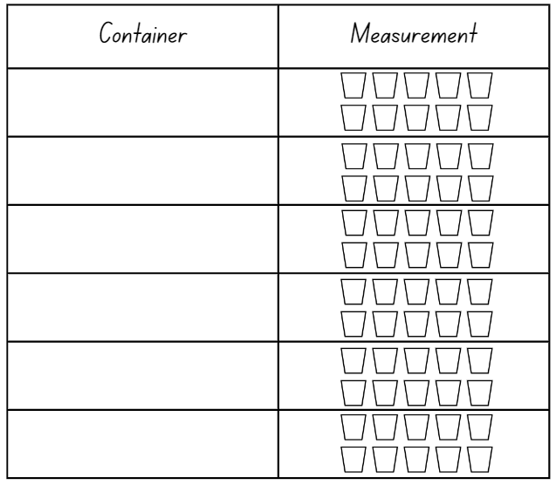

Resource 2: Recording sheet (Stage 1)
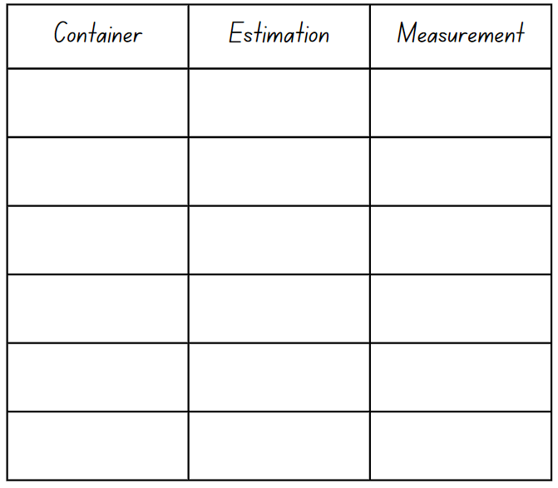

Resource 3: Place value
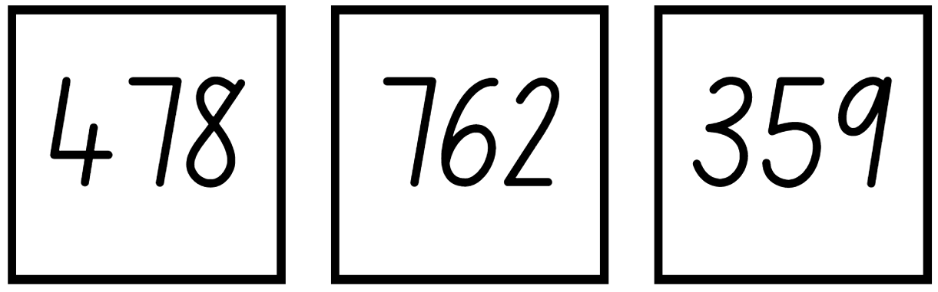

Resource 4: Various squares

Resource 5: Shapes worksheet
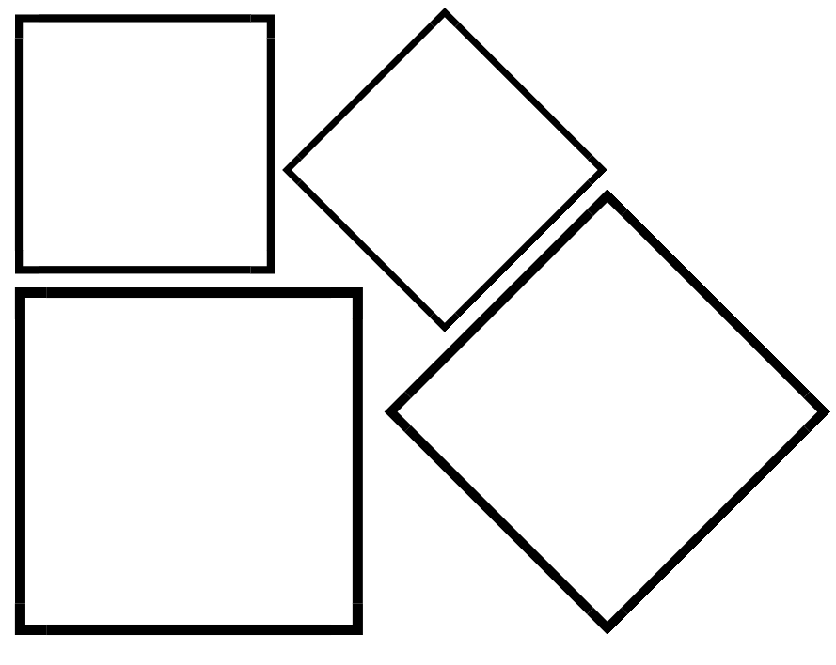

Resource 6: Rectangle
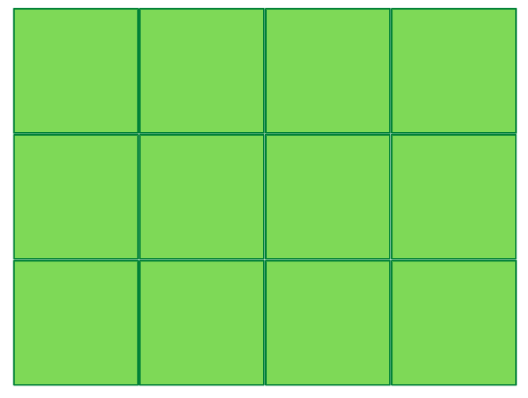

Resource 7: 3 Rectangles
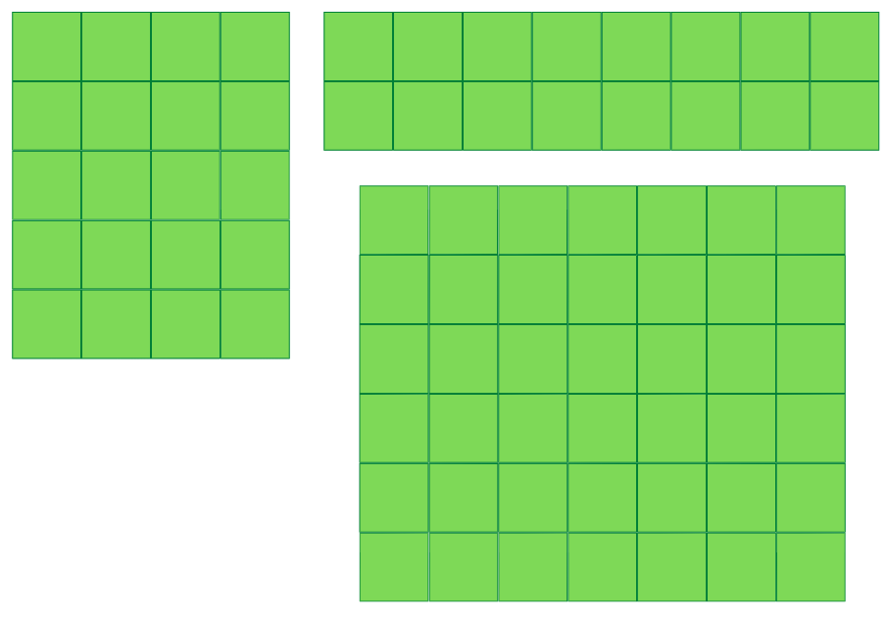

Resource 8: Covered rectangle

Resource 9: Covered rectangle 2

Resource 10: Strip without measurement

Resource 11: Scavenger hunt (Early Stage 1)
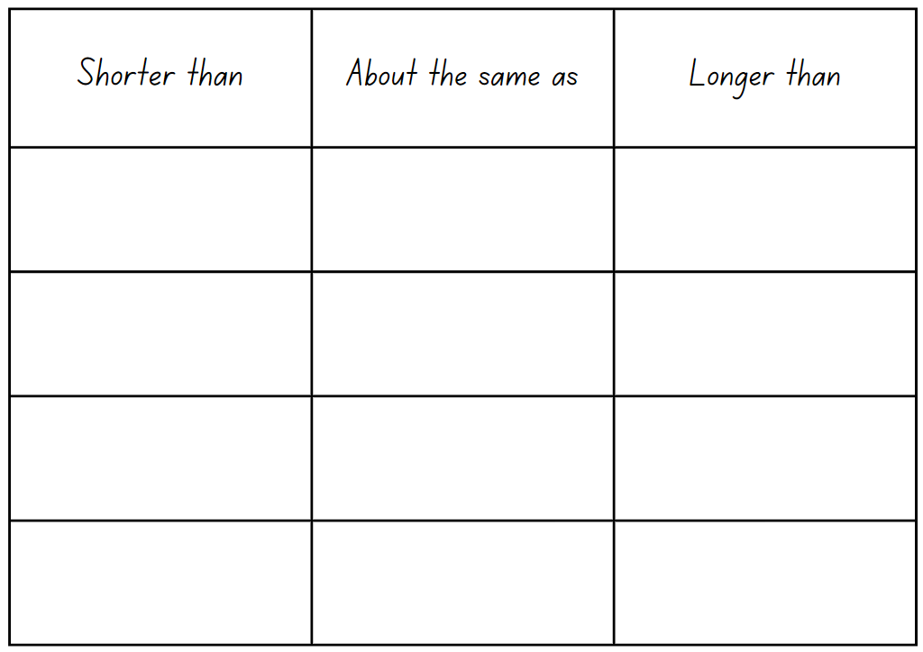

Resource 12: Measurement strip
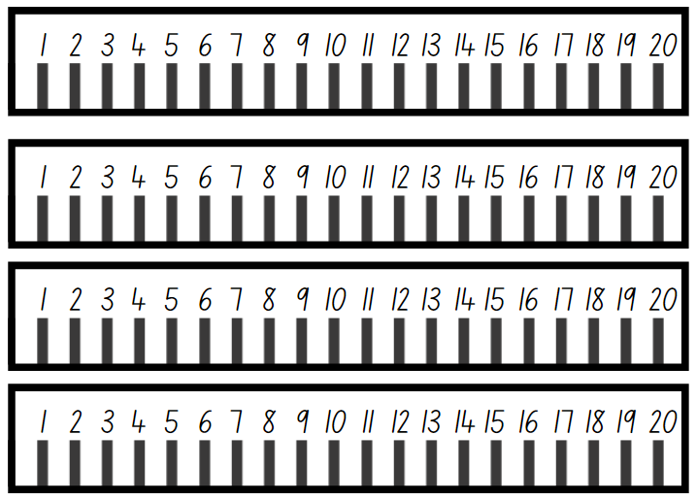

Resource 13: Scavenger hunt (Stage 1)
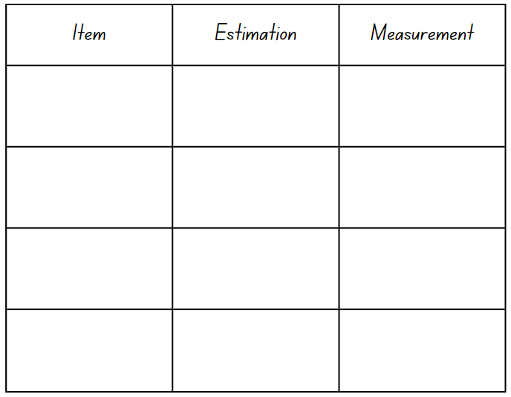

Resource 14: Length memory game
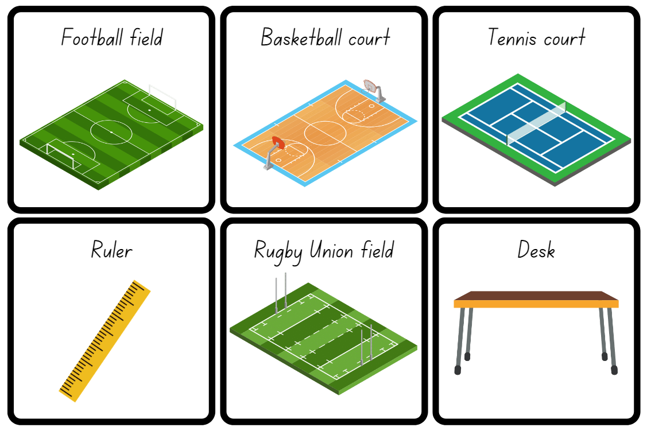
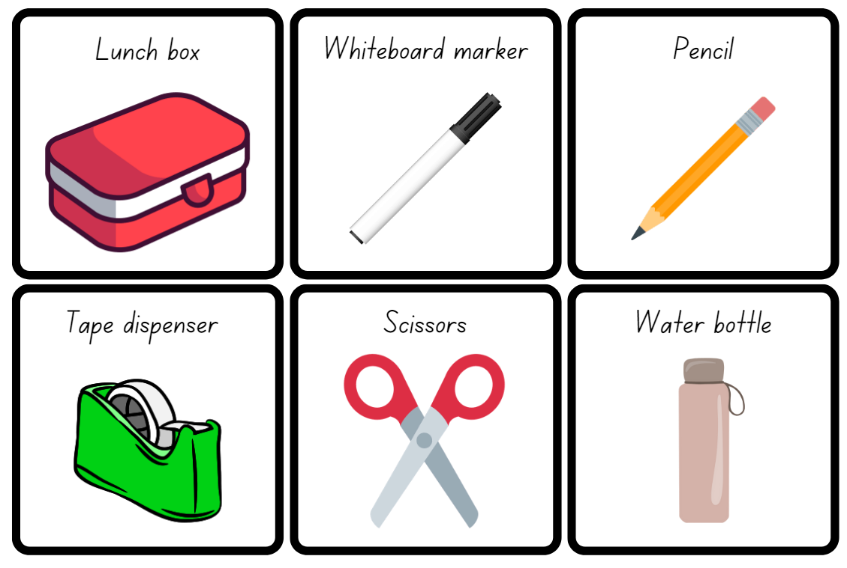
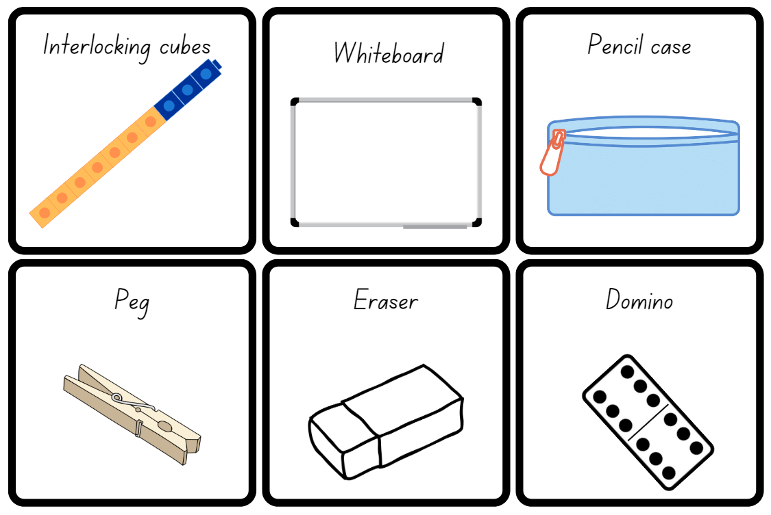
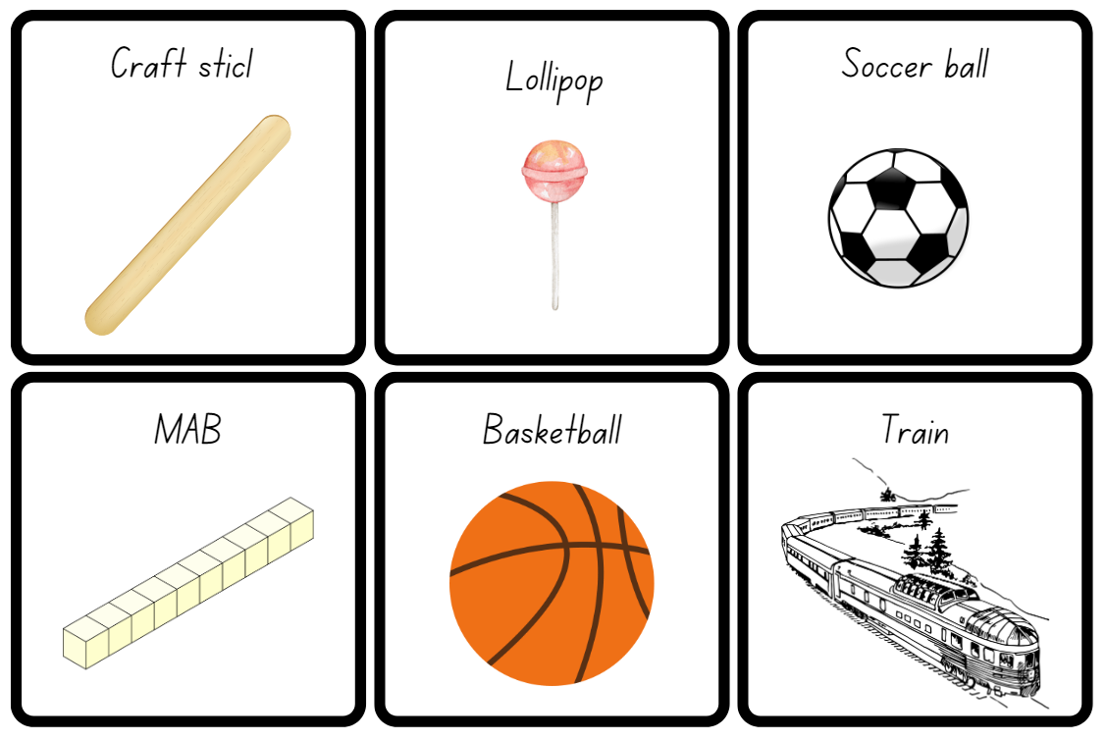
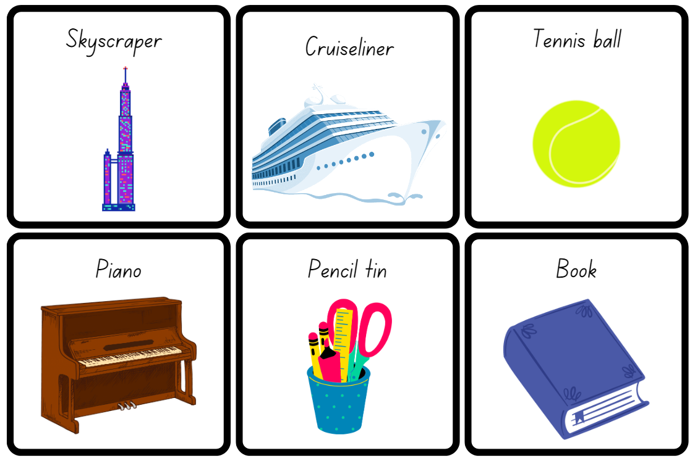
Images licensed under the Canva Content License Agreement.

Resource 15: Metres or centimetres
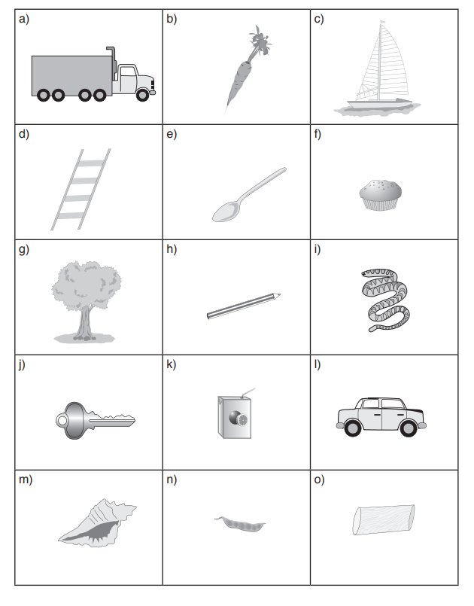
Images licensed under the Canva Content License Agreement.

Resource 16: Measurement worksheet
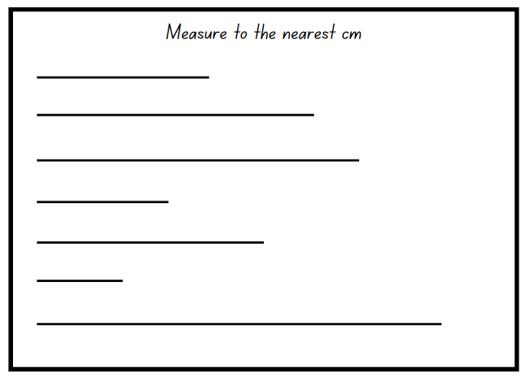

Resource 17: Flight recording sheet
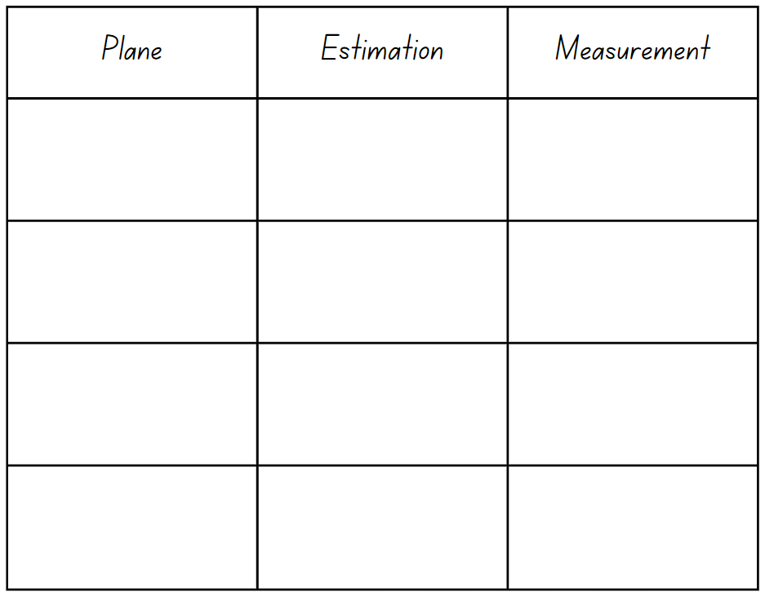

Syllabus outcomes and content
The table below outlines the syllabus outcomes and range of relevant syllabus content covered in this unit. Content is linked to National Numeracy Learning Progression version (3).
Focus area and outcomes | Content groups and content points | Lessons
Representing whole numbers  MAO-WM-01  MAE-RWN-01, MA1-RWN-01  MAE-RWN-02, MA1-RWN-02 | Early Stage 1  Use the counting sequence of ones flexibly  - Count forwards to at least 30 and state the number after or before a given number, without needing to count from one (CPr4)  - Count backwards from a given number 20 or less (CPr5)  - Identify the number before as 'one less' and the number after as 'one more’ than a given number | 3, 8
Representing whole numbers  (cont) | Early Stage 1  Recognise number patterns  - Recognise dice and domino dot patterns (NPA1, NPV2, CPr2) | 3
Representing whole numbers  (cont) | Early Stage 1  Connect counting and numerals to quantities  - Count with one-to-one correspondence, recognising that the last number name represents the total number in the collection (CPr3, CPr5)  - Make correspondences between collections  - Read numerals to at least 20, including zero (NPV3)  - Represent numbers as quantities to at least 20 using objects (such as fingers), number words and numerals (NPV2-NPV4, CPr3)  - Compare and order numbers to 20 (NPV2-NPV3) | 1–3, 5–6, 8
Representing whole numbers A | Stage 1  Represent the structure of groups of ten in whole numbers  - Recognise that ten ones is the same as one ten (NPV2, NPV4)  - Partition two-digit numbers to show quantity values (NPV4)  - Estimate, to the nearest ten, the number of objects in a collection and check by counting in groups of ten (CPr7, NPV6) | 2
Representing whole numbers B | Stage 1  Use counting sequences of ones and tens flexibly  - Identify how many more to the next multiple of ten within two- and three-digit numbers | 1–2
Representing whole numbers B  (cont) | Stage 1  Form, regroup, and rename three-digit numbers  - Use models such as base 10 material and interlocking cubes to represent and explain grouping (CPr7)  - State the quantity value of digits in numbers of up to three digits (NPV5)  - Recognise units of 100 (UnM5, NPV5)  - Use place value to partition and rename three-digit numbers in different ways (NPV5)  - Estimate, to the nearest hundred, the number of objects in a collection and check by grouping and counting (NPV6) | 1–3, 6, 8
Forming groups B  MAO-WM-01  MA1-FG-01 | Stage 1  Represent and explain multiplication as the combining of equal groups  - Solve multiplication problems using repeated addition (MuS4)  - Form arrays of equal rows and equal columns (MuS5)  - Determine and distinguish between the number of rows/columns and the number in each row/column when describing collections of objects (MuS5) | 4
Geometric measure  MAO-WM-01  MAE-GM-01, MA1-GM-01  MAE-GM-02, MA1-GM-02  MAE-GM-03, MA1-GM-03 | Early Stage 1  Length: Use direct and indirect comparison to decide which is longer  - Identify the attribute of 'length' as the measure of an object from end to end  - Use comparative language to describe length (UuM2)  - Compare lengths directly by placing objects side by side and aligning the ends (UuM2)  - Explain why the length of a piece of string remains unchanged whether placed in a straight line or a curve | 5–8
Geometric measure A | Stage 1  Length: Measure the lengths of objects using uniform informal units  - Use uniform informal units to measure lengths and distances by placing the units end to end without gaps or overlaps (UuM2)  - Count informal units to measure lengths or distances and describe the part left over (UuM4)  - Record lengths and distances by referring to the number and type of unit used (UuM4)  Length: Compare lengths using uniform informal units  - Compare the lengths of two or more objects using appropriate uniform informal units and check by placing the objects side by side and aligning the ends (UuM2-UuM3)  - Estimate lengths, indicating the number and type of unit used and check by measuring (UuM3) | 5
Geometric measure B | Stage 1  Length: Compare and order lengths, using appropriate uniform informal units  - Compare and order two or more shapes according to their lengths using an appropriate uniform informal unit  - Compare the lengths of two or more objects that cannot be moved or aligned  - Record length comparisons using drawings, numerals and words, and by referring to the uniform informal unit used | 5
Geometric measure B  (cont) | Stage 1  Length: Recognise and use formal units to measure the lengths of objects  - Recognise the need for formal units to measure lengths and distances (UuM6)  - Record lengths and distances using the abbreviation for metres (m)  - Estimate lengths and distances to the nearest metre and check by measuring (UuM6)  - Recognise the need for a formal unit smaller than the metre  - Recognise that there are 100 centimetres in one metre  - Measure lengths to the nearest centimetre, using a device with 1-cm markings  - Record lengths and distances using the abbreviation for centimetres (cm)  - Estimate lengths and distances to the nearest centimetre and check by measuring (UuM6) | 6–8
Two-dimensional spatial structure  MAO-WM-01  MAE-2DS-01, MA1-2DS-01  MAE-2DS-02, MA1-2DS-02 | Early Stage 1  Area: Identify and compare area  - Use comparative language to describe areas (UuM2)  - Predict which of two surfaces will have the larger area and justify the answer  - Compare areas of two similar shapes directly by drawing, tracing, or cutting and pasting (UuM3-UuM4) | 4, 8
Two-dimensional spatial structure A | Stage 1  Area: Measure areas using uniform informal units  - Explore area using uniform informal units to cover the surface in rows or columns without gaps or overlaps (UuM5)  - Measure area by selecting and using appropriate uniform informal units  - Record areas by referring to the number and type of uniform informal unit used  - Estimate areas by referring to the number and type of uniform informal unit used and check by measuring (UuM3) | 4, 8
Two-dimensional spatial structure B | Stage 1  Area: Compare rectangular areas using uniform square units of an appropriate size in rows and columns  - Cover rectangular surfaces by creating repeated rows of square tiles (UuM5)  - Use a single square to create the array structure of area in rows and columns (UuM5)  - Use the structure of repeated units to find the area of a rectangle (UuM5)  - Explain how the grid structure of rows and columns helps to find the area | 4
Three-dimensional spatial structure  MAO-WM-01  MAE-3DS-01, MA1-3DS-01  MAE-3DS-02, MA1-3DS-02 | Early Stage 1  Volume: Compare internal volume by filling and packing  - Fill and empty containers using materials such as water or sand  - Use the terms ‘full’, ‘empty’ and ‘about half full’  - Compare the internal volumes (capacities) of two containers directly by filling one and pouring into the other (UuM2)  - Compare the internal volumes of two containers indirectly by pouring their contents into two other identical containers and observing the level reached in each (UuM3)  - Establish that containers of different shapes may hold the same amount  - Stack and pack blocks into defined spaces (UuM5) | 2
Three-dimensional spatial structure  (cont) | Early Stage 1  Volume: Compare volume by building  - Identify the attribute of volume as the amount of space an object or substance occupies  - Compare the volumes of two objects made from blocks or connecting cubes directly by deconstructing one object and using its parts to construct a copy of the other object  - Use comparative language to describe volume (UuM2) | 3
Three-dimensional spatial structure A | Stage 1  Volume: Measure and compare the internal volumes (capacities) of containers by filling  - Use uniform informal units to measure how much a container will hold by counting the number of times a smaller container can be filled and emptied into the container being measured (UuM3)  - Compare the internal volumes of two or more containers using appropriate uniform informal units (UuM3)  - Recognise and explain why containers of different shapes may have the same internal volume  - Estimate how much a container holds by referring to the number and type of uniform informal unit used and check by measuring (UuM3-UuM4) | 2
Three-dimensional spatial structure A  (cont) | Stage 1  Volume: Measure the internal volume (capacity) of containers by packing  - Pack cubic units (eg blocks) into rectangular containers so that there are no gaps  - Estimate and measure the internal volume of a container by filling the container with uniform informal units and counting the number of units used  - Explain that if there are gaps when packing and stacking, this will affect the accuracy of measuring the internal volume | 3
Three-dimensional spatial structure B | Stage 1  Volume: Compare containers based on internal volume (capacity) by filling and packing  - Compare, order and record the internal volumes (capacities) of two or more containers by measuring each container in uniform informal units (UuM3-UuM4)  - Estimate internal volume (capacity) by referring to the number and type of uniform informal unit used (UuM3) | 2–3
Three-dimensional spatial structure B  (cont) | Stage 1  Volume: Compare volumes using uniform informal units  - Estimate the volumes of two or more models and check by counting the number of blocks used in each model  - Compare models with different appearances, recognising when they have the same volume  - Record the results of volume comparisons using drawings, numerals and words, referring to the units used  - Explain that models made of the same number of units may have different volumes depending on the size of the units used | 3
Non-spatial measure  MAO-WM-01  MAE-NSM-01, MA1-NSM-01  MAE-NSM-02, MA1-NSM-02 | Early Stage 1  Mass: Identify and compare mass using weight  - Identify that objects can be heavy or light (UuM2)  - Compare two masses directly by hefting (UuM3)  - Predict which object would be heavier than, lighter than, or have about the same weight as another object and explain reasons for this prediction | 1, 8
Non-spatial measure B | Stage 1  Mass: Compare the masses of objects using an equal-arm balance  - Use uniform informal units to measure the mass of an object by counting the number of units needed to obtain a level balance on an equal-arm balance (UuM3)  - Select an appropriate uniform informal unit to measure the mass of an object and justify the choice (UuM3)  - Explain the relationship between the mass of a unit and the number of units needed  - Compare the masses of two or more objects using the same informal units (UuM3)  - Estimate mass by referring to the number and type of uniform informal unit used and check by measuring (UuM3-UuM4) | 1, 8

References
Links to third-party material and websites
Please note that the provided (reading/viewing material/list/links/texts) are a suggestion only and implies no endorsement, by the New South Wales Department of Education, of any author, publisher, or book title. School principals and teachers are best placed to assess the suitability of resources that would complement the curriculum and reflect the needs and interests of their students.
If you use the links provided in this document to access a third-party's website, you acknowledge that the terms of use, including licence terms set out on the third-party's website apply to the use which may be made of the materials on that third-party website or where permitted by the Copyright Act 1968 (Cth). The department accepts no responsibility for content on third-party websites.
Except as otherwise noted, all material is © State of New South Wales (Department of Education), 2023 and licensed under the Creative Commons Attribution 4.0 International License. All other material (third-party material) is used with permission or under licence. Where the copyright owner of third-party material has not licensed their material under a Creative Commons or similar licence, you should contact them directly for permission to reuse their material.
Mathematics K–10 Syllabus © 2022 NSW Education Standards Authority (NESA) for and on behalf of the Crown in right of the State of New South Wales.
© 2022 NSW Education Standards Authority. This document contains NSW Curriculum and syllabus content. The NSW Curriculum is developed by the NSW Education Standards Authority. This content is prepared by NESA for and on behalf of the Crown in right of the State of New South Wales. The material is protected by Crown copyright.
Please refer to the NESA Copyright Disclaimer for more information.
NESA holds the only official and up-to-date versions of the NSW Curriculum and syllabus documents. Please visit the NSW Education Standards Authority (NESA) website and the NSW Curriculum website.
National Numeracy Learning Progression © Australian Curriculum, Assessment and Reporting Authority (ACARA) 2010 to present, unless otherwise indicated. This material was downloaded from the Australian Curriculum website (National Numeracy Learning Progression) (accessed 17 February 2023) and was not modified. The material is licensed under CC BY 4.0. Version updates are tracked in the ‘Curriculum version history’ section on the 'About the Australian Curriculum' page of the Australian Curriculum website.
ACARA does not endorse any product that uses the Australian Curriculum or make any representations as to the quality of such products. Any product that uses material published on this website should not be taken to be affiliated with ACARA or have the sponsorship or approval of ACARA. It is up to each person to make their own assessment of the product, taking into account matters including, but not limited to, the version number and the degree to which the materials align with the content descriptions and achievement standards (where relevant). Where there is a claim of alignment, it is important to check that the materials align with the content descriptions and achievement standards (endorsed by all education Ministers), not the elaborations (examples provided by ACARA).
This resource contains images and content obtained from Canva, and their use outside of this resource is subject to Canva’s Content License Agreement. If you wish to use them separately from the resource, please go to Canva.
Australian Government Department of Education (2020) ‘Place Value Cards’, Teaching resources, reSolve: Maths by Inquiry website, accessed 17 February 2023.
New Zealand Ministry of Education (n.d.) ‘Comparing capacities’, Resource Finder, NZ Maths website, accessed 17 February 2023.
New Zealand Ministry of Education (n.d.) ‘Finding areas of rectangles’, Resource Finder, NZ Maths website, accessed 17 February 2023.
New Zealand Ministry of Education (n.d.) ‘Paper planes: Level 2’, Resource Finder, NZ Maths website, accessed 17 February 2023.
State of New South Wales, Department of Education (n.d.) ‘Thumbs up’, Activities to support Numeral Identification, Developing Efficient Numeracy Strategies One website, accessed 17 February 2023.
University of Cambridge (Faculty of Mathematics) (1997-2023) Torn Shapes, NRICH website, accessed 17 February 2023.
Clements DH and Sarama J (2017/2019) How Many Blocks Fit In The Box, Learning and Teaching with learning trajectories [LT] ² website, accessed 17 February 2023.
Van de Walle J, Karp K, Bay-Williams J, Brass A, Bentley B, Ferguson S, Goff W, Livy S, Marshman M, Martin D, Pearn C, Prodromou T, Symons D and Wilkie K (2019) Primary and Middle Years Mathematics: Teaching Developmentally, 1st Australian edn, Pearson Education Australia, Melbourne.

