Mathematics – K-2 multi-age – Year B – Unit 16
Contents
Unit description and duration 4
Student prior learning 4
Lesson overview and resources 6
Lesson 1: Addition stories 18
Daily number sense: Roll, say, write, count (Early Stage 1) – 10 minutes 18
Daily number sense: Strike it out (Stage 1) – 10 minutes 19
Addition stories – 40 minutes 21
Consolidation and meaningful practice: Thundergoats – 10 minutes 27
Lesson 2: Subtraction stories 28
Daily number sense: Bingo (Early Stage 1) – 10 minutes 28
Daily number sense: Nearest 10 bingo (Stage 1) – 10 minutes 29
Gremlins – 30 minutes 31
Consolidation and meaningful practice: Design your own – 20 minutes 35
Lesson 3: Skipping down the hall 36
Daily number sense: Teacher choice – 10 minutes 36
Skipping down the hall – 50 minutes 37
Discuss and connect the mathematics – 5 minutes 42
Lesson 4: Teddy bear counting 43
Daily number sense: Counting game (by ones) (Early Stage 1) – 15 minutes 43
Daily number sense: Counting game (by multiples of ten) (Stage 1) – 15 minutes 44
Teddy bear counting – 20 minutes 46
Consolidation and meaningful practice: Teddy bear stories – 25 minutes 48
Lesson 5: Equal grouping stories 51
Daily number sense: Go fish (Early Stage 1) – 15 minutes 52
Daily number sense: Pepperoni pizza (Stage 1) – 15 minutes 54
Equal grouping stories – 35 minutes 55
Consolidation and meaningful practice: Scrambled eggs – 15 minutes 58
Lesson 6: The great divide 61
Daily number sense: Counting and representing (Early Stage 1) – 10 minutes 62
Daily number sense: Grouping and estimating (Stage 1) – 10 minutes 62
The great divide – 40 minutes 64
Consolidation and meaningful practice: The flower garden – 10 minutes 69
Lesson 7: The magical donut tree 70
Daily number sense: Subtraction stacks (Early Stage 1) – 20 minutes 70
Daily number sense: Array bingo (Stage 1) – 20 minutes 73
The magical donut tree – 20 minutes 74
Consolidation and meaningful practice: Party food – 20 minutes 75
Lesson 8: Choices, choices, choices 79
Daily number sense: Teacher choice – 10 minutes 79
Choices – 45 minutes 80
Discuss and connect the mathematics – 5 minutes 83
Resource 1: Bingo card 84
Resource 2: Number chart 85
Resource 3: Gremlins (Early Stage 1) 86
Resource 4: Gremlins (Stage 1) 87
Resource 5: Endless hallway 88
Resource 6: Ten-frame 89
Resource 7: Teen-ty cards 90
Resource 8: Equal group problems (Early Stage 1) 94
Resource 9: Equal group problems (Stage 1) 95
Resource 10: Counting problems (Early Stage 1) 96
Resource 11: Array problems (Stage 1) 97
Resource 12: The great divide 98
Resource 13: Dot cards 99
Resource 14: Array bingo 100
Resource 15: The magical donut tree (Early Stage 1) 105
Resource 16: The magical donut tree (Stage 1) 106
Syllabus outcomes and content 107
References 120

Unit description and duration
This two-week unit develops student knowledge and skills in understanding different situations where addition, subtraction, multiplication and division can be used. Students are provided opportunities to:
- investigate the 4 operations through problem solving
- explore the relationship between different operations and inverse operations
- engage in meaningful activities using repeated halving and doubling (Stage 1).
Mathematics K–10 Syllabus © 2022 NSW Education Standards Authority (NESA) for and on behalf of the Crown in right of the State of New South Wales.

Student prior learning
Before engaging in these teaching and learning activities, Early Stage 1 students would benefit from prior experience with:
- counting to at least 30
- combining and separating quantities to and from 20
- creating equal groups from quantities up to 20
- solving everyday problems using mathematical thinking.
Stage 1 students would benefit from prior experience with:
- skip counting and using arrays
- doubling collections of objects
- using repeated halving to create fractions
- solving problems using all 4 operations.

Lesson overview and resources
The table below outlines the sequence and approximate timing of lessons; syllabus focus areas and content groups; and resources.
Lesson | Syllabus focus area and content groups | Resources
Lesson 1: Addition stories  60 minutes  Effective addition strategies are selected based on the type of problem. | Representing whole numbers  Early Stage 1  - Use the counting sequence of ones flexibly  - Connect counting and numerals to quantities  Stage 1 – Part A  - Represent numbers on a line  - Represent the structure of groups of ten in whole numbers  Combining and separating quantities  Early Stage 1  - Model additive relations and compare quantities  - Identify part–whole relationships in numbers up to 10  Stage 1 – Part A  - Use advanced count-by-one strategies to solve addition and subtraction problems  - Recognise and recall number bonds up to ten  - Use flexible strategies to solve addition and subtraction problems  - Represent equality  Stage 1 – Part B  - Represent and reason about additive relations  - Form multiples of ten when adding and subtracting two-digit numbers  - Use knowledge of equality to solve related problems | - Game: Thundergoats  - 20-sided dice  - Concrete materials  - Writing materials
Lesson 2: Subtraction stories  60 minutes  Knowing that subtraction is the opposite of addition can help solve problems. | Representing whole numbers  Early Stage 1  - Connect counting and numerals to quantities  Stage 1 – Part A  - Represent the structure of groups of ten in whole numbers  Combining and separating quantities  Early Stage 1  - Model additive relations and compare quantities  - Identify part–whole relationships in numbers up to 10  Stage 1 – Part A  - Use advanced count-by-one strategies to solve addition and subtraction problems  - Use flexible strategies to solve addition and subtraction problems  - Represent equality  Stage 1 – Part B  - Represent and reason about additive relations  - Form multiples of ten when adding and subtracting two-digit numbers  - Use knowledge of equality to solve related problems | - Resource 1: Bingo card  - Resource 2: Number chart  - Resource 3: Gremlins (Early Stage 1)  - Resource 4: Gremlins (Stage 1)  - Interlocking cubes  - Writing materials
Lesson 3: Skipping down the hall  65 minutes  Combining groups can be an efficient way of solving problems. | Representing whole numbers  Early Stage 1  - Use the counting sequence of ones flexibly  - Connect counting and numerals to quantities  Combining and separating quantities  Early Stage 1  - Model additive relations and compare quantities  - Identify part–whole relationships in numbers up to 10  Forming groups  Stage 1 – Part A  - Count in multiples using rhythmic and skip counting  - Use skip counting patterns  - Model and use equal groups of objects to represent multiplication  Stage 1 – Part B  - Represent and explain multiplication as the combining of equal groups  - Represent multiplication and division problems | - Resource 5: Endless hallway  - Grid paper  - Concrete materials  - Writing materials
Lesson 4: Teddy bear counting  60 minutes  Stories can show ways of combining and separating quantities and forming groups. | Representing whole numbers  Early Stage 1  - Instantly name the number of objects within small collections  - Use the counting sequence of ones flexibly  - Connect counting and numerals to quantities  Stage 1 – Part A  - Represent the structure of groups of ten in whole numbers  Stage 1 – Part B  - Use counting sequences of ones and tens flexibly  - Form, regroup, and rename three-digit numbers  Combining and separating quantities  Early Stage 1  - Model additive relations and compare quantities  - Identify part–whole relationships in numbers up to 10  Stage 1 – Part A  - Use advanced count-by-one strategies to solve addition and subtraction problems  - Represent equality  Stage 1 – Part B  - Represent and reason about additive relations  - Use knowledge of equality to solve related problems  Forming groups  Early Stage 1  - Investigate and form equal groups by sharing  - Record grouping and sharing  Stage 1 – Part A  - Count in multiples using rhythmic and skip counting  - Model and use equal groups of objects to represent multiplication  - Recognise and represent division  Stage 1 – Part B  - Model doubling and halving with fractions  - Represent multiplication and division problems | - Resource 6: Ten-frame  - Counters  - Craft sticks  - McGrath BB (2010) Teddy Bear Counting (T Nihoff, illus), Random House US. ISBN: 9781580892162  - Mini whiteboard  - Rubber bands  - Teddy bear counters or alternative concrete materials  - Whiteboard markers  - Writing materials
Lesson 5: Equal grouping stories  65 minutes  Everyday problems can be solved using multiplication and equal grouping. | Representing whole numbers  Early Stage 1  - Instantly name the number of objects within small collections  - Use the counting sequence of ones flexibly  - Connect counting and numerals to quantities  Combining and separating quantities  Stage 1 – Part A  - Use advanced count-by-one strategies to solve addition and subtraction problems  - Represent equality  Forming groups  Early Stage 1  - Investigate and form equal groups by sharing  - Record grouping and sharing  Stage 1 – Part A  - Count in multiples using rhythmic and skip counting  - Model and use equal groups of objects to represent multiplication  Stage 1 – Part B  - Represent and explain multiplication as the combining of equal groups  - Represent multiplication and division problems | - Resource 7: Teen-ty cards  - Resource 8: Equal group problems (Early Stage 1)  - Resource 9: Equal group problems (Stage 1)  - Resource 10: Counting problems (Early Stage 1)  - Resource 11: Array problems (Stage 1)  - 10-sided dice  - Blocks  - Counters  - Egg cartons  - Writing materials
Lesson 6: The great divide  60 minutes  Division can be used to solve everyday problems. | Representing whole numbers  Early Stage 1  - Use the counting sequence of ones flexibly  - Connect counting and numerals to quantities  Stage 1 – Part B  - Form, regroup, and rename three-digit numbers  Forming groups  Early Stage 1  - Investigate and form equal groups by sharing  - Record grouping and sharing  Stage 1 – Part A  - Count in multiples using rhythmic and skip counting  - Model and use equal groups of objects to represent multiplication  - Recognise and represent division  Stage 1 – Part B  - Represent and explain multiplication as the combining of equal groups  - Model doubling and halving with fractions  - Represent multiplication and division problems | - Resource 12: The great divide  - Dodds DA (2005) The Great Divide: A Mathematical Marathon (Mitchell T, illus.), Walker Books Australia. ISBN: 9780763615925  - Counters  - Interlocking cubes  - Writing materials
Lesson 7: The magical donut tree  60 minutes  Counting on, counting back, doubling and halving are strategies for combining and separating quantities. | Representing whole numbers  Early Stage 1  - Instantly name the number of objects within small collections  - Recognise number patterns  - Connect counting and numerals to quantities  Combining and separating quantities  Early Stage 1  - Model additive relations and compare quantities  - Identify part–whole relationships in numbers up to 10  Forming groups  Early Stage 1  - Investigate and form equal groups by sharing  - Record grouping and sharing  Stage 1 – Part A  - Model and use equal groups of objects to represent multiplication  Stage 1 – Part B  - Represent and explain multiplication as the combining of equal groups  - Model doubling and halving with fractions  - Represent multiplication and division problems | - Resource 13: Dot cards  - Resource 14: Array bingo  - Resource 15: The magical donut tree (Early Stage 1)  - Resource 16: The magical donut tree (Stage 1)  - Resource 2: Number chart  - Concrete materials  - Paper  - Writing materials
Lesson 8: Choices, choices, choices  60 minutes  Multiplicative thinking can be used to solve everyday problems. | Representing whole numbers  Early Stage 1  - Connect counting and numerals to quantities  Combining and separating quantities  Early Stage 1  - Model additive relations and compare quantities  - Identify part–whole relationships in numbers up to 10  Forming groups  Early Stage 1  - Investigate and form equal groups by sharing  - Record grouping and sharing  Stage 1 – Part A  - Count in multiples using rhythmic and skip counting  - Model and use equal groups of objects to represent multiplication  - Recognise and represent division  Stage 1 – Part B  - Model doubling and halving with fractions  - Represent multiplication and division problems | - Concrete materials  - Writing materials

Lesson 1: Addition stories
Core concept: Effective addition strategies are selected based on the type of problem.
The table below contains suggested learning intentions and success criteria. These are best co-constructed with students.
Learning intentions | Success criteria
All students are learning that:  - addition can be used to solve everyday problems  - mathematical thinking can be recorded in different ways. | All students can:  - choose an appropriate strategy to solve addition problems  - record their thinking in different ways.  In addition, students working towards Stage 1 outcomes can:  - use a number line to demonstrate addition  - record number sentences using numerals and symbols.

Daily number sense: Roll, say, write, count (Early Stage 1) – 10 minutes
- Build student understanding of whole numbers by connecting counting and numerals to quantities.
- Provide small groups of Early Stage 1 students with a 20-sided die and writing materials. Students take turns to roll the die. After each roll, the student:
- says the number
- writes the number
- counts backwards to zero from the number.
- After 10 rolls, ask groups to rewrite the numbers in order from smallest to largest.

Daily number sense: Strike it out (Stage 1) – 10 minutes
This activity has been adapted from Strike it out at Mathematics K-6 resources.
- Build student understanding of addition and subtraction facts to 20 by playing Strike it out.
- Provide pairs of students with paper and writing materials. Students create a number line from 0 to 20.
- The first player chooses 2 numbers from the number line and crosses them out. The same player then circles the sum or difference of the numbers and records the calculation. For example, 5 + 10 = 15 (see Figure 1).
Figure 1 – Strike it out 1
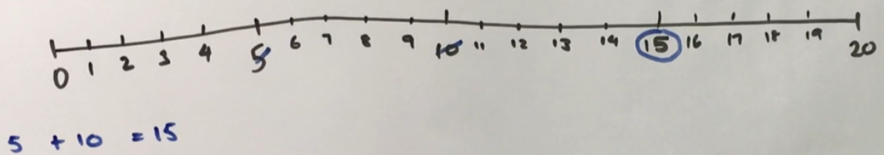
- The second player must start their turn by crossing out the number circled by the first player. The second player then crosses out a second number not already used. Player 2 then circles the sum or difference of the numbers and records the calculation. For example, 15 + 4 = 19 (see Figure 2).
Figure 2 – Strike it out 2
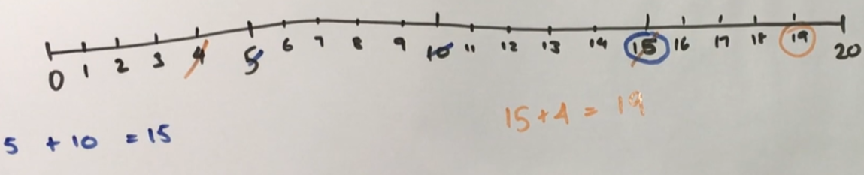
- Play continues until one player is no longer able to make a valid move (see Figure 3). The player who stops their opponent from being able to take a turn is the winner.
Figure 3 – Strike it out 3
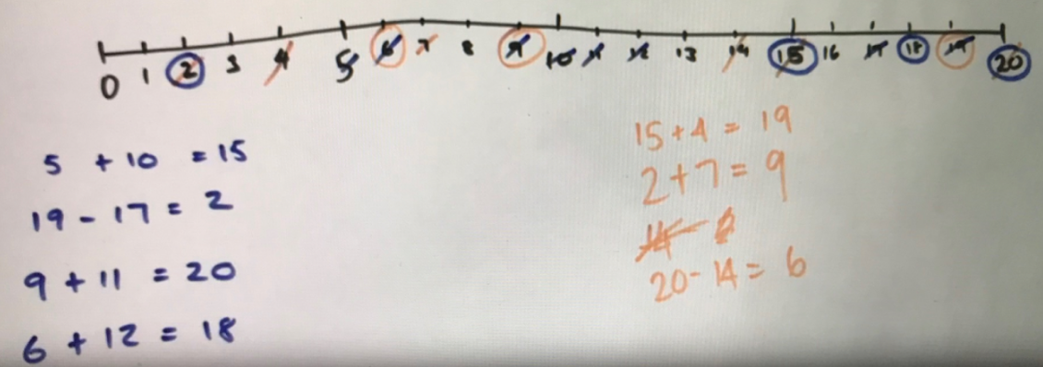
- Play the game again, swapping roles so the other student is starting.
- As a group, discuss and reflect on the activity by asking questions such as:
- How did you know when the game was over?
- Share the strategy you used to try to win the game. Was it successful? Why?
- What addition and subtraction strategies did you find useful?
- When adding, did it matter which way you added the numbers? Why not? (Commutative property).
- Can you think of any ways to make the game easier or harder?

Addition stories – 40 minutes
This activity is adapted from Sullivan (2018).
- Pose the following problems to Early Stage 1 students:
- ‘On a farm, there are 12 white chickens and 8 brown chickens. How many chickens are there altogether?’
- ‘On a farm, there are 12 chickens. If I want to have 20 chickens, how many more do I need?’
- ‘On a farm with 20 chickens, 12 of the chickens are white. The rest of the chickens are brown. How many chickens are brown?’
- Pose the following problems to Stage 1 students:
- ‘On a farm, there are 36 white chickens and 22 brown chickens. How many chickens are there altogether?’
- ‘On a farm, there are 22 chickens. If I want to have 58 chickens, how many more do I need?’
- ‘On a farm with 58 chickens, 36 of the chickens are white. The rest of the chickens are brown. How many chickens are brown?’
Note: There are 3 basic types of word problems involving additive thinking – combine (direct addition), change (how many to get from one number to the other) and compare (what is the difference). The problems in this task encourage students to compare the types of questions (Sullivan 2018). Choosing and applying mathematical techniques to solve problems and articulating their thinking is a core component of Working mathematically.
- Ask Early Stage 1 students to solve their problems and show their thinking using concrete materials, drawings, words and numerals.
- Ask Stage 1 students to solve their problems and show their thinking using an empty number line, a number sentence and a diagram (see Figure 4). Students may also choose to use concrete materials and take a photograph.
Figure 4 – Addition story solution
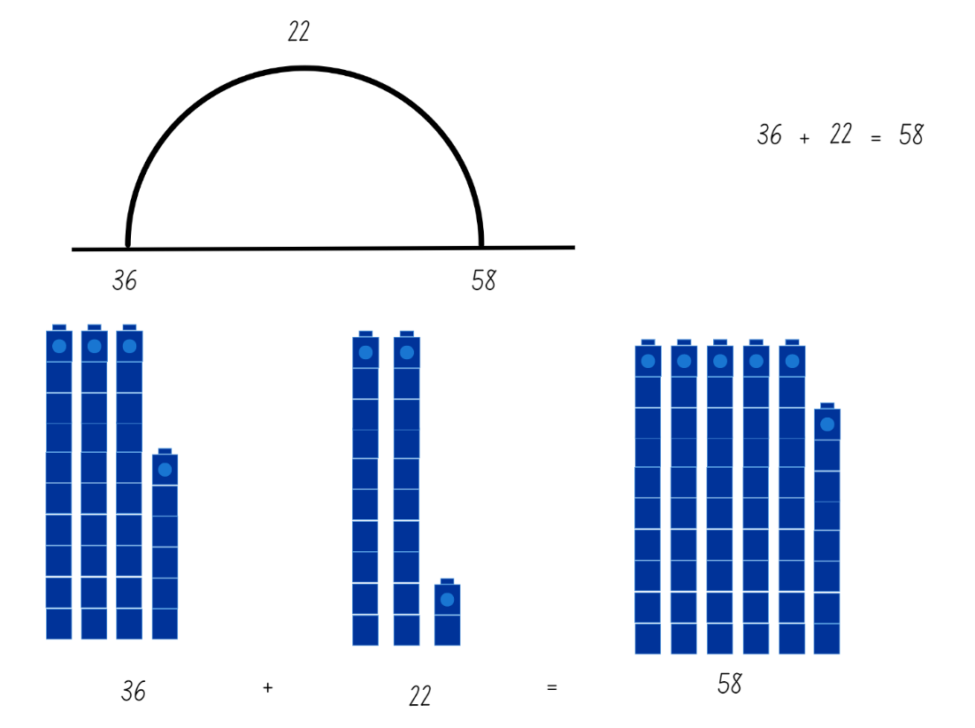
- Select students to share their thinking. Discuss similarities and differences in student strategies.
- Ask students to think about the 3 problems, focusing on how they are the same and how they are different. Students turn and talk to share their ideas. Select students to share with the class.
- Ask students if there is a way that they can check their answers.
- Pose the following problems listed in the table below, and follow the same recording and discussion procedure as above.
Early Stage 1 | Stage 1
- In a plantation, there are 14 eucalypt trees and 8 wattle trees. How many trees are there altogether?  - In a plantation, there are 22 trees. Some are eucalypts and some are wattles. If 14 trees are eucalypts, how many are wattles?  - In a plantation, there are 22 trees altogether. 8 of the trees are wattles. If the rest of the trees are eucalypts, how many eucalypt trees are there?  - We are growing tomatoes and capsicums in our vegetable garden. If there are 17 tomato plants and 8 capsicum plants, how many plants are there altogether?  - We are growing tomatoes and capsicums in our vegetable garden. There are 25 plants altogether. If there are 17 tomato plants, how many capsicum plants are there?  - I want to grow 25 plants in our vegetable garden. I already have 8 plants. How many more plants do I need? | - In a plantation, there are 23 eucalypt trees and 38 wattle trees. How many trees are there altogether?  - In a plantation, there are 61 trees. Some are eucalypts and some are wattles. If 38 trees are eucalypts, how many are wattles?  - In a plantation, there are 61 trees altogether. 23 of the trees are eucalypts. If the rest of the trees are wattles, how many wattle trees are there?  - We are growing tomatoes and capsicums in our vegetable garden. If there are 39 tomato plants and 37 capsicum plants, how many plants are there altogether?  - We are growing tomatoes and capsicums in our vegetable garden. There are 76 plants altogether. If there are 39 tomato plants, how many capsicum plants are there?  - I want to grow 76 plants in our vegetable garden. I already have 37 plants. How many more plants do I need?
- Reflect on and discuss the additive strategies used by asking questions, such as:
- What strategy did you use to solve the problem? For example, using number bonds, bridging to the next multiple of 10, jump strategy on the number line, separating tens and ones.
- Why did you use that strategy?
- Did you use different strategies to solve different problems? Why?
- Ask students to work in pairs or small groups to create their own problems, using the previous sets of problems as a model. Provide a scaffold for Early Stage 1 students if required, allowing students to experiment with and explore different number combinations. Conduct a gallery walk and allow students to share their problems. Ask students to explain how their problems are like the previous sets of problems.
- Demonstrate to Stage 1 students how addition can also be used to solve equality problems where a number is missing. For example, 3 + _ = 6 + 2. Discuss how this is like the ‘how many more’ problems completed above and ask how many more will make this balance. Ask students to record and solve the following equality problems:
- 7 + _ = 8 + 6
- 12 + 5 = 3 + _
- 8 + 9 = _ + 7
- 14 + _ = 19 + 4
This table details assessment opportunities and differentiation ideas.
Assessment opportunities | Too hard? | Too easy?
What to look for:  - Can students solve word problems using drawings, numerals, words, number lines, number sentences or diagrams? (MAO-WM-01, MAE-CSQ-01, MAE-CSQ-02, MA1-CSQ-01)  - Can students choose and justify appropriate strategies to solve addition problems and explain their thinking? (MAO-WM-01, MAE-CSQ-01, MAE-CSQ-02, MA1-CSQ-01)  - Can Stage 1 students add and subtract with two-digit numbers? (MAO-WM-01, MA1-CSQ-01)  What to collect:  - student work samples (MAO-WM-01, MAE-CSQ-01, MAE-CSQ-02, MA1-CSQ-01)  - recordings of student discussion (MAO-WM-01, MAE-CSQ-01, MAE-CSQ-02, MA1-CSQ-01). | Students cannot solve the problems or show their thinking.  - Model how to solve the first set of problems using an appropriate method, for example, combining groups of concrete materials.  - Pose the problems using smaller numbers. For example, for Stage 1 students, explain that there are 10 white chickens and 8 brown chickens on a farm, and ask how many chickens there are altogether.  - Provide students with a pre-numbered number line. | Students can solve the problems and show their thinking using a number line, a number sentence and a diagram or concrete materials.  - Pose the problems using larger and more challenging number combinations. For example, explain that there are 87 white chickens and 39 brown chickens on a farm and ask how many chickens there are altogether.  - Provide more challenging problems. For example, on a farm there are 10 more white chickens than brown chickens. There are 78 chickens altogether. How many brown chickens are there?

Consolidation and meaningful practice: Thundergoats – 10 minutes
- Demonstrate how to play Thundergoats at ABC Education, using either level 1 or 2 as appropriate. Show how each tool and strategy can be used to make the calculation easier.
- Explain that you will play the game together and students will record their thinking on mini whiteboards.
- Show students a problem. Ask students to solve the problem and record their thinking using drawings, words, numerals and symbols. Students turn and talk to share their thinking. Repeat several times.
- Ask students to discuss and reflect on the activity by asking questions such as:
- Which strategies did you use?
- Did you use different strategies for different questions? Why?
- Which strategies did you find the most useful? Why?
- How did you record your thinking?

Lesson 2: Subtraction stories
Core concept: Addition and subtraction are related processes.
The table below contains suggested learning intentions and success criteria. These are best co-constructed with students.
Learning intentions | Success criteria
All students are learning that subtraction and addition are related.  In addition, students working towards Stage 1 outcomes are learning that:  - numbers can be grouped in tens  - using number facts can improve efficiency when solving problems. | All students can separate and combine groups of objects to model subtraction and how it is the opposite of addition.  In addition, students working towards Stage 1 outcomes can:  - locate the nearest 10 to a number  - model and explain subtraction number facts to 20.

Daily number sense: Bingo (Early Stage 1) – 10 minutes
- Build student understanding of reading numerals to at least 20, including zero, by playing Bingo.
- Provide each student with a copy of Resource 1: Bingo card. Students write 6 different numbers, ranging from zero to 20, in each box of the bingo card.
- Read out a series of predetermined numbers, ranging from 0 to 20. After each number, allow students time to mark the number if it appears on their bingo card. When all 6 numbers on the bingo card are marked, the student calls out ‘Bingo!’ and is declared the winner. Multiple students may have identical bingo cards which allows for multiple winners.
Note: Using predetermined numbers or recording numbers as you call them out allows you to check the accuracy of student bingo cards. You may also choose to have students record each number you call out.
- Repeat the activity as necessary, with students either using a new bingo card or erasing the previous numbers and markings.

Daily number sense: Nearest 10 bingo (Stage 1) – 10 minutes
- Build student understanding of the nearest multiple of 10 to a number by playing Nearest 10 bingo.
- Explain to students that no number is ever more than 5 away from a benchmark of 10 and they may need to count forwards or backwards to find the nearest 10.
- Provide each student with a copy of Resource 1: Bingo card and Resource 2: Number chart. Students write 6 different multiples of 10, ranging from 0 to 100, in each box of the bingo card. For example, see Figure 5.
Figure 5 – Nearest 10 bingo card example
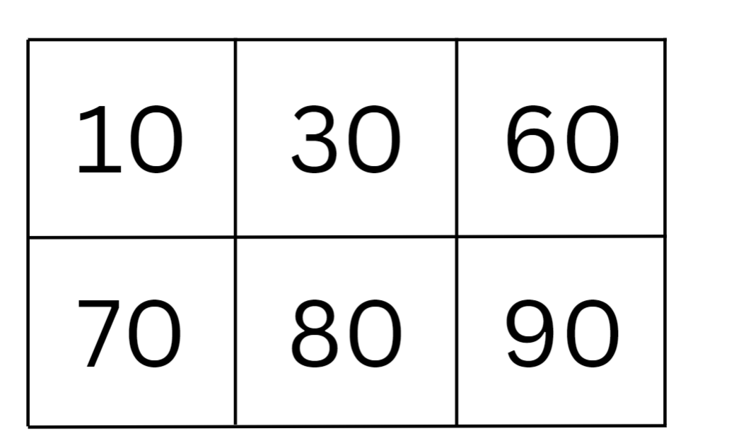
- Read out a series of predetermined numbers, ranging from 1 to 99, avoiding multiples of 10. After each number, allow students time to mark the nearest 10 to that number if it appears on their bingo card. Students may use the number chart or a number line to assist. When all multiples of 10 on the bingo card are marked, the student calls out ‘Bingo!’ and is declared the winner. Multiple students may have identical bingo cards which allows for multiple winners.
Note: Using predetermined numbers or recording numbers as you call them out allows you to check the accuracy of student bingo cards. You may also choose to have students record each number you call out, as well as the nearest 10 to those numbers.
- Repeat the activity as necessary, with students either creating a new bingo card or erasing the previous numbers and markings.
This table details assessment opportunities and differentiation ideas.
Assessment opportunities | Too hard? | Too easy?
What to look for:  - Can students locate the nearest 10 to a number? (MAO-WM-01, MA1-RWN-01)  What to collect:  - completed bingo cards (MAO-WM-01, MA1-RWN-01)  - observations of students playing the game (MAO-WM-01, MA1-RWN-01). | Students cannot locate the nearest 10 to a number.  - Model how to use the number chart or a number line to locate the nearest 10.  - Use numbers that are close to multiples of 10, for example, 9, 11, 19. | Students can locate the nearest 10 to a number.  - Students become the bingo caller, calling out and checking the numbers for other students.  - Increase the range of numbers to 120 or beyond.  - Use three-digit numbers and ask students to locate the nearest hundred.

Gremlins – 30 minutes
This lesson has been adapted from Gremlins at NZ Maths.
- Explain that gremlins have visited the classroom and drawn faces in place of numbers.
- Provide a copy of Resource 3: Gremlins (Early Stage 1) to each Early Stage 1 student and a copy of Resource 4: Gremlins (Stage 1) to each Stage 1 student.
- Ask students to find the missing answers to the problems.
Note: Stage 1 students become accustomed to seeing equations in the form 7 - 5 = ___ and 5 - 2 = ___ and may assume that the answer is always the difference. If students are only exposed to this format, they miss the opportunity to develop their understanding about all parts of the equation and how each part relates to the other.
- Distribute interlocking cubes. Have students use the cubes to represent and solve each problem.
- As students work, ask:
- Which numbers were easiest to figure out? Why? (Stage 1)
- Which numbers were hardest to find? Why? (Stage 1)
- How do you know that you have found the correct missing number?
- Do you think that more than one number might work? Why or why not?
Note: Once Stage 1 students are confident with the ‘taking away’ type of subtraction, encourage them to use ‘counting on or back’ in examples where the differences between numbers are small (less than 5). This type of subtraction can be more difficult for students to grasp but can be more efficient. For example, when comparing 20 with 18, it is easier to count on from 18 than take away 18 objects from a collection of 20.
- Have students share their solutions as a class. Ask:
- What strategy did you use to find the missing number?
- Did anyone use a different strategy?
- Can you think of another subtraction question that has the same answer? For example, 8 - 5 = 3 has the same answer as 6 - 3 = 3. (Stage 1)
- Stage 1 students represent each equation from the resource as a word equation.
- After representing subtraction by taking away, Early Stage 1 students should recombine the collections of interlocking cubes to represent the whole again.
Note: Students model addition and subtraction as they combine and separate groups of items. Students notice that they can remove 4 items from the pile of 10 and have 6 (subtraction), then move the 6 back to have 10 (addition). Draw attention to the fact that these actions, combining and separating, are ‘opposite’ to each other.
- For Stage 1 students, model how to rearrange the first equation on the resource to represent an addition equation.
- Stage 1 students represent the rest of the equations as addition equations.
This table details assessment opportunities and differentiation ideas.
Assessment opportunities | Too hard? | Too easy?
What to look for:  - Can Early Stage 1 students separate and take away part of a group of objects to model subtraction? (MAO-WM-01, MAE-CSQ-01)  - Can Early Stage 1 students describe the actions of separating and combining? (MAO-WM-01, MAE-CSQ-02)  - Can students model how addition and subtraction are inverse operations? (MAO-WM-01, MAE-CSQ-02, MA1-CSQ-01)  - Can Stage 1 students recognise and use the symbols for plus, minus and equals? (MAO-WM-01, MA1-CSQ-01)  - Can Stage 1 students use advanced count-by-one strategies to solve subtraction problems? (MAO-WM-01, MA1-CSQ-01)  - Can Stage 1 students recall and use subtraction number facts to 20? (MAO-WM-01, MA1-CSQ-01)  What to collect:  - completed resources (MAO-WM-01, MAE-CSQ-01, MAE-CSQ-02, MA1-CSQ-01)  - photographs or video of students representing the equations with interlocking cubes (MAO-WM-01, MAE-CSQ-01, MAE-CSQ-02, MA1-CSQ-01). | Early Stage 1 students cannot take away part of a group of objects to model subtraction.  - Start with smaller numbers, for example, numbers less than 10.  - Take away smaller quantities, for example, 1, 2, or 3, and encourage students to count backwards.  Stage 1 students cannot solve and represent the problems.  - Provide modelled examples of each type of question.  - Rephrase the questions using numbers where the difference is small. For example, 5 - _. | Early Stage 1 students can take away part of a group of objects to model subtraction. Pose problems that require students to compare 2 groups. For example, ‘I have 23 pencils and you have 14. How many more pencils do I have?’  Stage 1 students can solve and represent the problems. Explain that the gremlins have covered more than one number. Ask students to find as many number combinations as they can that work. For example, _ - _ = 12 or 6 - _ = _.

Consolidation and meaningful practice: Design your own – 20 minutes
- Students design a series of subtraction problems based on the Gremlins activity. For Stage 1 students, ensure that the missing numbers appear in a variety of places within the number sentences.
- Students check that their problems are accurate and give to a partner to solve.
- Reflect on and discuss the activity by asking questions, such as:
- Is it easier to solve the problems or make up your own? Why?
- What processes did you use to make up your problems?
- Which type of problems are the easiest to design? Why? (Stage 1)
- How did you check that your problems were accurate?

Lesson 3: Skipping down the hall
Core concept: Combining groups is an efficient way to solve problems.
The table below contains suggested learning intentions and success criteria. These are best co-constructed with students.
Learning intentions | Success criteria
All students are learning that:  - there are efficient strategies for counting  - mathematicians organise and record their thinking when solving problems. | Students working towards Early Stage 1 outcomes can:  - use ten-frames to count larger quantities  - count to at least 30.  Students working towards Stage 1 outcomes can:  - skip count using an array  - recognise patterns when skip counting  - use skip counting to solve a problem.

Daily number sense: Teacher choice – 10 minutes
- From a class need surfaced through formative assessment data, identify a short, focused activity that targets students’ knowledge, understanding and skills. Example activities may be drawn from the following resources:
- Mathematics K-6 resources
- Universal Resources Hub.

Skipping down the hall – 50 minutes
This activity has been adapted from Boaler (2022).
- Show students Resource 5: Endless hallway. Ask students what they notice and what they wonder.
- Point out that the hallway is tiled all the way, but they cannot see the end. Show students that the hallway has a width of 5 tiles. It may be necessary to explain that the tiles are all the same size but look smaller as they get further away. Ask students how long the hallway might be. Students turn and talk and then share answers with the class. Discuss which answers might be more reasonable than others, noting that all answers greater than the length shown are possible.
- Provide small groups of students with Resource 5: Endless hallway, grid paper, concrete materials and writing materials.
Note: Early Stage 1 students may be required to count beyond 30 during this activity. Provide appropriate support and make adjustments as required.
- Use Resource 5: Endless hallway to demonstrate how 2 rows of 5 tiles can replicate a ten-frame. Ask Early Stage 1 students:
- Can you identify and clearly mark on your resource each set of 2 rows to replicate ten-frames? (see Figure 6)
- How many ten-frames can you see?
- How many tiles can you see? Students may use the ten-frame markings to help count or students may choose to individually number each tile. It is not an expectation that Early Stage 1 students count by tens.
- How many tiles could be on the hallway floor? How long could the hallway be? Using a pencil, add tiles to Resource 5: Endless hallway to show your thinking.
- What different solutions can you find?
Figure 6 – Hallway ten-frames
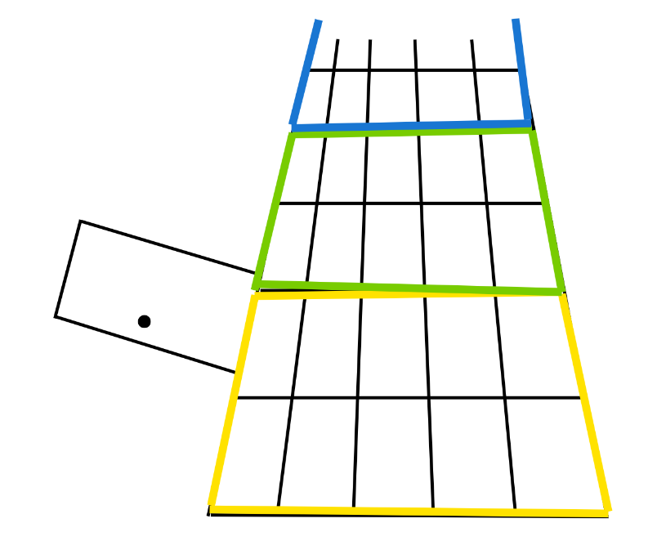
- Ask Stage 1 students the following questions and have them record their thinking through drawings, a list or in a table (see Figure 7):
- If the hallway is 5 tiles wide, how many tiles could be on the hallway floor? How long could the hallway be?
- What different solutions can you find?
- How can you organise your solutions to keep track of your thinking and look for patterns?
- What patterns can you see in the number of tiles that are possible?
Figure 7 – Hallway thinking table
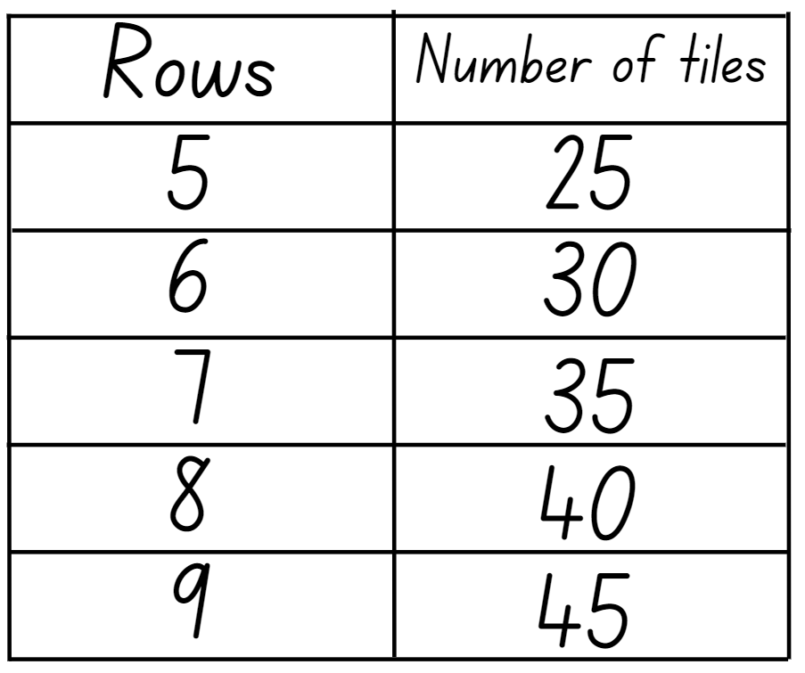
- Move around the room, observing students work. Ask how they are finding the number of tiles in the hallway. If students are counting by ones, ask if there is another way to count the tiles. Encourage Early Stage 1 students to use the ten-frame outlines and Stage 1 students to use skip counting. Support students to develop ideas about how they could use the equal groups in the hallway to count, making it easier to see patterns. Ask Stage 1 students how they could organise their thinking in a way that would help them to see patterns.
- Students create their own hallway drawing and explore the following questions:
- What might happen if the hallway was a different width? Choose another width and try this task again.
- How many tiles might be in your hallway?
- How many tiles could there not be? Why?
Note: Support Early Stage 1 students by creating a hallway that is 2 tiles wide and using a ten-frame structure to assist in counting. Alternatively, have students explore different widths and counting methods.
- Promote reasoning and communicating by using the following discussion questions:
- How did you organise your thinking? Why did you do it that way? (Stage 1)
- What strategies did you use to solve the problem?
- What patterns did you notice in the solutions? (Stage 1)
- What solutions are not possible? Why?
- What happened when you changed the width of the hallway? What widths did you try and what solutions did you find?
- How did the patterns change? (Stage 1)
This table details assessment opportunities and differentiation ideas.
Assessment opportunities | Too hard? | Too easy?
What to look for:  - Can Early Stage 1 students use ten-frames to support the count of the tiles? (MAO-WM-01, MAE-RWN-02, MAE-CSQ-01, MAE-CSQ-02)  - Can Early Stage 1 students find possible solutions? (MAO-WM-01, MAE-CSQ-01, MAE-CSQ-02)  - Can Stage 1 students skip count by fives to find possible solutions? (MAO-WM-01, MA1-FG-01)  - Can Stage 1 students identify and describe patterns when skip counting? (MAO-WM-01, MA1-FG-01)  - Can Stage 1 students connect skip counting to equal groups and arrays? (MAO-WM-01, MA1-FG-01).  What to collect:  - student work samples (MAO-WM-01, MAE-RWN-02, MAE-CSQ-01, MAE-CSQ-02, MA1-FG-01)  - recording of student discussions (MAO-WM-01, MAE-RWN-02, MAE-CSQ-01, MAE-CSQ-02, MA1-FG-01). | Early Stage 1 students cannot use ten-frames to count the number of visible tiles or find possible solutions.  - Model using one ten-frame and then counting on from 10.  - Model using 2 ten-frames and counting on from 20.  - Provide a number track or number chart.  Stage 1 students cannot find multiple solutions by skip counting or find patterns in their solutions.  - Provide a number line or number chart and model skip counting by fives.  - Modify the problem by using a hallway that is 2 tiles wide.  - Demonstrate how to use a table to organise student thinking, making it easier to identify patterns. Provide a pre-ruled table to fill in. | Early Stage 1 students can use ten-frames to count the number of visible tiles or find possible solutions.  - Prompt students to explore skip counting.  - Ask students if they can identify and explain patterns in possible solutions.  Stage 1 students can find multiple solutions by skip counting and identify patterns in their solutions. Extend student thinking by asking similar problems where the total number of tiles is known but the width and length are not. For example, there are 50 tiles in the whole hallway. Ask students how wide or long the hallway might be.

Discuss and connect the mathematics – 5 minutes
- Ask students to reflect on their learning by asking questions, such as:
- How did ten-frames or equal groups help you find the number of tiles in the hallway?
- Can you think of another time where you have used similar strategies to solve a problem?
- Can you explain why it’s important to organise and record your thinking?
- Connect and extend student learning by asking Early Stage 1 students to explain how many ten-frames would be needed to show:
- 10
- 20
- 30
- 40
- Connect student learning by asking Stage 1 students to explain how to find the missing number in patterns, such as:
- 5, 10, 15, _, 25, 30
- 3, 8, 13, _, 23, 28
- 20, _, 40, 50, 60, 70
- 12, 15, 18, 21, _, 27

Lesson 4: Teddy bear counting
Core concept: Stories can show ways of combining and separating quantities and forming groups.
The table below contains suggested learning intentions and success criteria. These are best co-constructed with students.
Learning intention | Success criteria
All students are learning that visual representations of numbers help with combining and separating quantities and forming groups. | All students can:  - model addition, subtraction and equal grouping using concrete materials  - use drawings, words and numerals to create and record solutions to addition, subtraction and grouping problems.  In addition, students working towards Stage 1 outcomes can create and record number sentences in a variety of ways using drawings, words, numerals and symbols.

Daily number sense: Counting game (by ones) (Early Stage 1) – 15 minutes
This activity is adapted from Counting game (by ones) at Mathematics K-6 resources.
- Build student understanding of multiplicative thinking by playing the counting game (by ones).
Note: This game was introduced in Multi-age – Year B – Unit 13 where Early Stage 1 students played by ones and Stage 1 students played by multiples of 5.
- Students play a modified version of the game by counting backwards from the target number.
- Students use Resource 6: Ten-frame to organise the counters in their game.
- In pairs, students choose a target number between 12 and 20 and place that number of counters in their ten-frame.
- Students take turns to count backwards by one each time they remove a counter.
- Students gain a point if they say zero. They then choose a new target number and play again.
- After each game, students count and record the number of counters that they each removed during the game.
- After playing several games, ask students:
- Is playing the game backwards more or less challenging? Why?
- Did you work out a way to play this game so that you did not lose?
- What was your strategy? Did it work?

Daily number sense: Counting game (by multiples of ten) (Stage 1) – 15 minutes
This activity is adapted from Counting game (by multiples of 10) at Mathematics K-6 resources.
- Build student understanding of place value by counting forwards and backwards by multiples of 10.
- Provide pairs or small groups of students with loose craft sticks. Ask students to estimate and record how many craft sticks they think they have to the nearest 10. Students check their estimate by bundling the craft sticks into groups of 10 and then counting by tens to reach the total. Students turn and talk to share their estimates and results.
- Ask students:
- How could you partition, rename and record your total? For example, 49 as 4 tens and 9 ones.
- How many more craft sticks would you need to get to the next multiple of 10?
- Can you record the number before and the number after your total?
- Any unbundled craft sticks can be discarded prior to commencing the game. The total number of bundled craft sticks then becomes the starting point for the game, for example, 110. Students alternate counting backwards by saying the next one, 2 or 3 number words in the number sequence. For example, the first player counts 100, 90, 80. The second player counts 70, 60. Students remove the bundles of 10 craft sticks as they count and record their counting on a piece of paper or mini whiteboard. The goal is to be the player who says zero. Repeat the game multiple times.
- Reflect on the activity by asking questions such as:
- How could you change the game to make it easier or harder?
- What did you notice about playing the game by counting backwards? Did it make it easier or harder? Why?
- Did you work out a way to play this game so that you didn’t lose? What was your strategy? Did it work?
This table details assessment opportunities and differentiation ideas.
Assessment opportunities | Too hard? | Too easy?
What to look for:  - Can Stage 1 students group the craft sticks into bundles of 10 and find the total? (MAO-WM-01, MA1-RWN-02, MA1-FG-01)  - Can Stage 1 students count forwards and backwards by multiples of 10? (MAO-WM-01, MA1-RWN-02, MA1-FG-01)  What to collect:  - student work samples (MAO-WM-01, MA1-RWN-02, MA1-FG-01)  - video of students playing the game (MAO-WM-01, MA1-RWN-02, MA1-FG-01). | Students cannot count backwards by multiples of 10 to reach zero.  - Provide a number chart and model counting backwards by multiples of 10.  - Students play counting forwards instead of backwards. The target number is the total number of bundled craft sticks. | Students can count backwards by multiples of 10 to reach zero.  - Students include their unbundled craft sticks in the game, so they are counting backwards by multiples of 10 off the decade.  - Create and use bundles of 5 rather than 10. Students count backwards by multiples of 5.

Teddy bear counting – 20 minutes
- Show students the front cover of Teddy Bear Counting by Barbara Barbieri McGrath and prompt student thinking by asking:
- What mathematical concepts do you think will be explored in the book?
- How many teddy bears are on the front cover of the book?
- What strategy did you use to determine the number of teddy bears?
- Students turn and talk and then share answers with the class.
- Read the book, pausing throughout the story to discuss the following changes to the quantity of teddy bears as the story progresses:
- Draw attention to when teddy bears are combined, separated and grouped.
- Draw attention to the different representations throughout the book (drawings, words, number sentences). Ask students which representation best helps them to understand the changes to the quantity or arrangement of the teddy bears and why (Stage 1).
- After reading about 6 sets of 2 teddy bears, ask students to predict how many different ways the 12 teddy bears can be organised into equal groups.
Note: The book Teddy Bear Counting includes number sentences such as 2 + 2 + 2 + 2 + 2 + 2 = 12. In Early Stage 1 the learning focus for combining and separating quantities and forming groups should be the use of visual models. Early Stage 1 students use the images in the story and language, such as 2 and 2 more, to describe actions that change quantities. Draw Stage 1 students’ attention to the algorithms throughout the book as they are expected to recognise and record number sentences.
- Distribute 12 teddy bear counters or concrete materials to small groups of students.
- Read the book again and ask students to model the changes to the quantity of teddy bears and groupings throughout the book.
- Use questions to prompt student thinking such as:
- How many teddy bears are there now? How do you know?
- How can you use the pictures in the book to help you count the teddy bears?
- What do you notice about the way the bears are grouped?
- How many teddy bears are in each group when there are 2, 3 or 4 equal groups? How do you know they are equal?
- When reading pages with subtraction equations, ask Stage 1 students to record the related addition number fact.

Consolidation and meaningful practice: Teddy bear stories – 25 minutes
- In small groups, Early Stage 1 students use 12 teddy bear counters or alternative concrete materials to create their own teddy bear story that shows combining, separating and forming groups. Stage 1 students use 24 counters and include doubling and halving in their story.
- Students record their story using drawings, words and numerals. Stage 1 students represent the changes throughout their story as number sentences.
- As students work, ask questions to guide student thinking, such as:
- What have your teddy bears done in this part of the story?
- How did that change the quantity or arrangement of your group of teddy bears?
- What strategy did you use to group the teddy bears?
- Invite groups to share their story with the class and use the teddy bear counters to model the story as they tell it.
This table details assessment opportunities and differentiation ideas.
Assessment opportunities | Too hard? | Too easy?
What to look for:  - Can students model addition, subtraction and equal grouping using concrete materials? (MAO-WM-01, MAE-RWN-01, MAE-CSQ-01, MAE-CSQ-02, MAE-FG-02, MA1-CSQ-01, MA1-FG-01)  - Are students able to create a story, represented as drawings, words and numerals, which demonstrates combining and separating quantities and forming groups? (MAO-WM-01, MAE-RWN-01, MAE-CSQ-01, MAE-CSQ-02, MAE-FG-02, MA1-CSQ-01, MA1-FG-01)  - Can Stage 1 students record number sentences in a variety of ways using drawings, words, numerals and symbols? (MAO-WM-01, MA1-CSQ-01, MA1-FG-01)  What to collect:  - student stories (MAO-WM-01, MAE-RWN-01, MAE-CSQ-01, MAE-CSQ-02, MAE-FG-02, MA1-CSQ-01, MA1-FG-01)  - recording of students modelling their story with counters (MAO-WM-01, MAE-RWN-01, MAE-CSQ-01, MAE-CSQ-02, MAE-FG-02, MA1-CSQ-01, MA1-FG-01). | Students cannot create and describe a story that demonstrates combining and separating quantities or forming groups.  - Use questions to prompt students to design actions that combine, separate or group teddy bears in a story.  - Provide sentence starters to support students to develop a coherent story that shows mathematical actions.  - Reduce the number of teddy bears in the story. | Stage 1 students can create and describe a story that demonstrates combining and separating quantities and forming groups.  - Students represent the 24 teddy bears in different arrays.  - Students extend the story to include a quarter and an eighth of the collection of teddy bears.

Lesson 5: Equal grouping stories
Core concept: Everyday problems can be solved using multiplication and equal grouping.
The table below contains suggested learning intentions and success criteria. These are best co-constructed with students.
Learning intentions | Success criteria
All students are learning that:  - objects and diagrams can be used to solve problems involving equal groups  - collections of objects can be quantified using a range of strategies.  In addition, students working towards Stage 1 outcomes are learning that multiplication problems can be solved by combining equal groups, repeated addition, or forming arrays. | Students working towards Early Stage 1 outcomes can:  - solve problems using equal grouping  - use counting strategies to find the total of different collections.  In addition, students working towards Stage 1 outcomes can:  - model multiplication as accumulating equal groups  - represent and solve multiplication problems using arrays and repeated addition.

Daily number sense: Go fish (Early Stage 1) – 15 minutes
This activity has been adapted from Go fish – teen/ty at Connecting number names, numeral and quantities (NSW Department of Education).
- Build student understanding of the difference between teen numbers and multiples of 10 with the same initial sound by playing Go fish.
Note: In order to explore the difference between ‘teen’ and ‘ty’ numbers, compare these quantities side by side, considering what is the same and what is different. This requires using larger numbers than are usually used in Early Stage 1 counting lessons. Using bundles of 10 to look at collections of 14 and 40 connects them to the numeral and number word, supporting students to see how the value of the digit ‘4’ represents different quantities in 14 compared to 40. Comparing 14, 40 and 41 is also valuable.
- Explain to students that there are different ways to represent numbers. Show students Resource 7: Teen-ty cards and explain what each card represents. Model how to play the game, focusing on correctly enunciating each number represented on the cards.
- In small groups, distribute Resource 7: Teen-ty cards. Shuffle the cards. If there are 2 players, deal 7 cards to each player. If you have 3 or more players, deal 5 cards to each player. Put the left-over cards in a central pile.
- Students take turns to look for matching pairs. Once a student has a pair, they put the pair down and keep it. Students take it in turn to ask another player for a specific card. For example, ‘Amy, do you have ‘thirteen’ in words?’ If the player has the card that was asked for, they must hand over that card. If they don’t have the card, they say, ‘Go fish’ and the student must pick up a card from the central pile. If a player happens to draw a card they need, a pair can be made. Otherwise, it is the next player’s turn.
- Go fish continues until a player has no cards left in their hand or the central pile runs out. The winner is the player with the most matches (sets of pairs).
This table details assessment opportunities and differentiation ideas.
Assessment opportunities | Too hard? | Too easy?
What to look for:  - Can students identify and distinguish the ‘teen’ numbers from multiples of ten with the same initial sounds? (MAO-WM-01, MAE-RWN-01)  - Can students correctly enunciate the ‘teen’ numbers and multiples of ten? (MAE-RWN-01)  What to collect:  - video recording of students playing the game (MAO-WM-01, MAE-RWN-01). | Students cannot identify different representations of multiples of 10.  - Only use cards 10 to 20 and focus on correctly enunciating the ‘teen’ numbers.  - Write the corresponding digits on the word and/or visual representation cards. | Students can identify different representations of multiples of 10.  - Students explain the strategies used during the game and evaluate their effectiveness.  - Students suggest modifications to make the game easier or harder.

Daily number sense: Pepperoni pizza (Stage 1) – 15 minutes
This lesson has been adapted from Pepperoni Pizza at youcubed.
- Build student understanding of multiplication as combining equal groups by playing Pepperoni Pizza.
- In pairs, each student rolls a 10-sided die twice. The first roll tells them how many pizzas to draw. The second roll tells them how many pepperoni slices to put on each pizza.
- Students calculate the total number of pepperoni slices using skip counting, repeated addition or an array model where appropriate.
- Students record their answer using a number sentence (see Figure 8).
- The student with the largest number of pepperoni pieces wins the round and the game is played again.
Figure 8 – Example of recording the total number of pepperonis
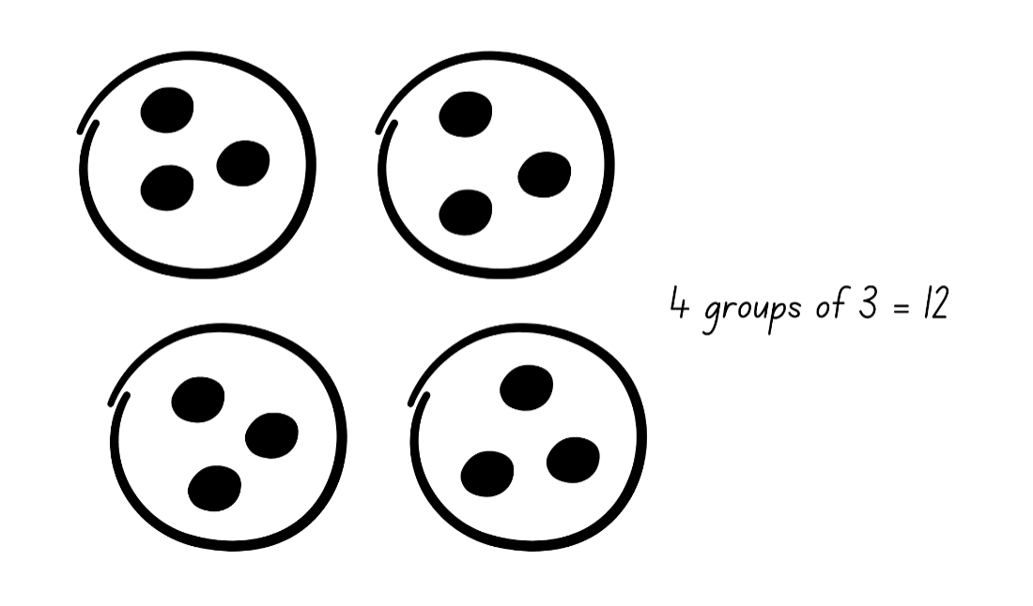

Equal grouping stories – 35 minutes
- Distribute a copy of Resource 8: Equal grouping problems (Early Stage 1) to each Early Stage 1 student and a copy of Resource 9: Equal group problems (Stage 1) to each Stage 1 student.
- Read the first problem to the class, which is the same on both resources, and ask small groups of students to model the problem using counters. Students to record their answer as drawings, words or numerals.
- As groups are working, ask questions such as:
- Are all the groups equal? How can you check? (Early Stage 1)
- What strategy did you use to solve the problem?
- Why did you choose that strategy?
- Is there another strategy you could use to answer the question?
- Which strategy is more efficient?
Note: Encourage Stage 1 students to use repeated addition or skip counting for this task.
- Support groups to work through the remaining questions on their resource, reading the questions aloud where necessary.
- Discuss the answers as a class, drawing attention to the different strategies used to solve the same problem.
- Distribute a copy of Resource 10: Counting problems (Early Stage 1) to each Early Stage 1 student and a copy of Resource 11: Array problems (Stage 1) to each Stage 1 student. Read the first problem to the class, which is the same on both resources, and ask small groups of students record their answers as words or numerals.
Note: Draw Stage 1 students’ attention to the structure of an array.
- Support groups to work through the remaining questions on their resource, reading the questions aloud where necessary. Students may wish to represent each problem using counters to support their thinking. Encourage Stage 1 students to draw an array for each word problem and explain their thinking for each array question.
- As students are working, ask:
- What strategy did you use to solve the problem?
- Is there a way you could check your answer?
- Can you describe your array? (Stage 1)
- How does an array help you to answer the question? (Stage 1)
- Regroup as a class and summarise the lesson, drawing out key mathematical ideas. Ask students:
- What is the same about all the problems you have just worked on? (Stage 1)
- Did you use the same strategy to answer all the questions? Why or why not?
- Does a visual representation a problem make it harder or easier to solve?
- What challenges did you face? How did you overcome them?
This table details assessment opportunities and differentiation ideas.
Assessment opportunities | Too hard? | Too easy?
What to look for:  - Can Early Stage 1 students count with one-to-one correspondence to find the total number in a collection? (MAO-WM-01, MAE-RWN-02)  - Can Early Stage 1 students solve grouping problems by modelling with counters and counting to find the total? (MAO-WM-01, MAE-FG-02)  - Can Stage 1 students use repeated addition or skip counting to solve multiplication problems? (MAO-WM-01, MA1-FG-01)  - Can Stage 1 students form and describe arrays to represent multiplication problems? (MAO-WM-01, MA1-FG-01)  What to collect:  - student work samples (MAO-WM-01, MAE-RWN-02, MAE-FG-02, MA1-FG-01)  - recording of group and class discussion (MAO-WM-01, MAE-RWN-02, MAE-FG-02, MA1-FG-01). | Early Stage 1 students cannot solve grouping problems.  - Students count aloud whilst finding the total of the groups.  - Students use cups to represent the number of groups in each problem and counters to represent the number of items in each group.  Early Stage 1 students are unable to find a total of a collection.  - Students place counters on the resource as they count the items in each collection.  Stage 1 students cannot form arrays and use repeated addition or skip counting to solve multiplication problems.  - Model making an array using equal groups and then using repeated addition and skip counting.  - Provide a number line or number chart to assist with counting. | Early Stage 1 can solve grouping problems.  - Students to distribute the counters in groups of 2.  - Students use counting strategies other than counting by ones, for example, skip counting by twos.  - Students pose a new problem that can be solved by forming equal groups. Students swap problems and represent the answers using drawings, words or numerals.  Stage 1 students can form arrays and use repeated addition or skip counting to solve multiplication problems.  - Students make up word problems with different answers. For example, ‘write a multiplication problem with an answer of 24’.  - Students create their own multiplication word problems with a chosen answer. Students swap problems and represent the answers using drawings, words or numerals.

Consolidation and meaningful practice: Scrambled eggs – 15 minutes
- For Early Stage 1 students, write numbers one to 5 in the holes of half-dozen egg cartons (see Figure 9).
- For Stage 1 students, write numbers one to 12 in the holes of one-dozen egg cartons (see Figure 10).
- Place 2 small blocks in each egg carton.
- Provide small groups of Early Stage 1 students with a half-dozen egg carton and Stage 1 students with a one-dozen egg carton. Students close the lid of the egg carton and shake it.
- Early Stage 1 students open the lid and see where the blocks have landed. Students to use one of the blocks to represent the number of groups and the other block to represent the number in each group. The blank hole in the carton represents student choice. Students draw the groups and record the total.
- Stage 1 students open the lid and see where the blocks have landed, then use the numbers to draw an array. Students record the total number of items in the array.
- Repeat with students taking turns to shake the egg carton.
Figure 9 – Early Stage 1 Scrambled eggs egg carton
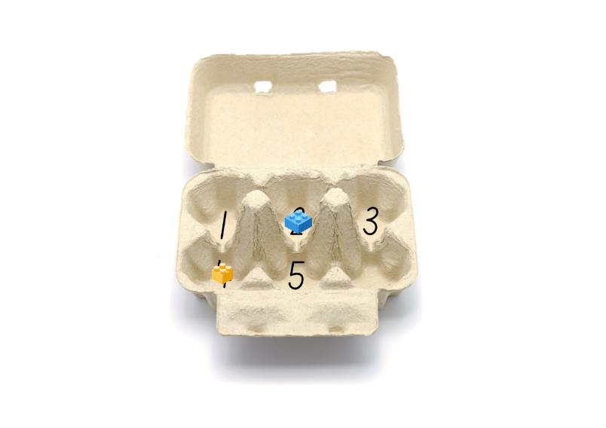
Images sourced from Canva and used in accordance with the Canva Content License Agreement.
Figure 10 – Stage 1 Scrambled eggs egg carton
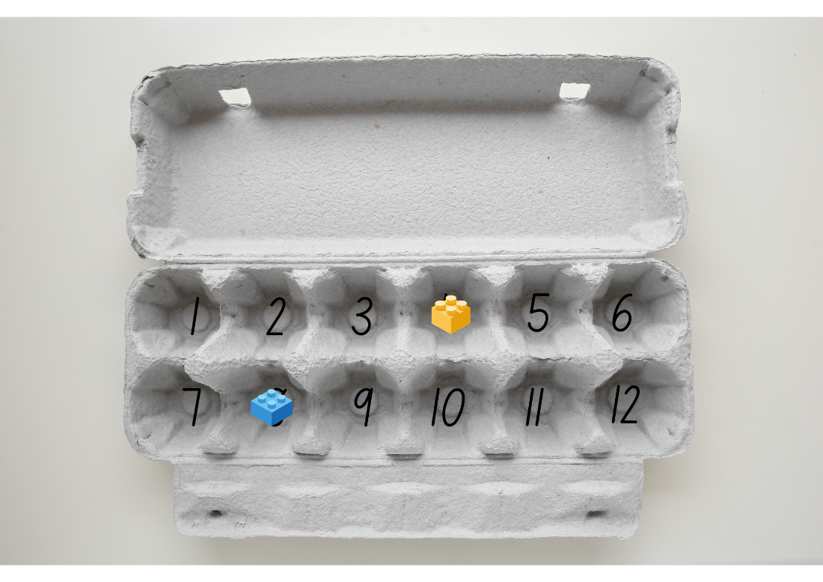
Images sourced from Canva and used in accordance with the Canva Content License Agreement.

Lesson 6: The great divide
Core concept: Division can be used to solve everyday problems.
The table below contains suggested learning intentions and success criteria. These are best co-constructed with students.
Learning intentions | Success criteria
All students are learning that:  - place value determines how numbers are represented, read, written and counted  - halving an even numbered collection creates 2 equal groups  - collections can be shared into equal groups. | Students working towards Early Stage 1 outcomes can:  - group and share concrete materials using different methods  - recognise equal groups.  Students working towards Stage 1 outcomes can:  - group and skip count to find the total of a large number of objects  - use concrete materials to model half a collection  - model division by deconstructing an array equally  - describe the part left over when a collection cannot be distributed equally.

Daily number sense: Counting and representing (Early Stage 1) – 10 minutes
- Build student understanding of whole numbers by counting and representing numbers to 20.
- Provide small groups of Early Stage 1 students with a 20-sided die, interlocking cubes and writing materials. Students take it in turns to roll the die. After each roll, students:
- say the number
- write the number
- represent the number with interlocking cubes
- count to 30 from that number
- state the number before and after.

Daily number sense: Grouping and estimating (Stage 1) – 10 minutes
- Build student understanding of place value by grouping objects in tens and hundreds.
- Show the class a large number of interlocking cubes; lots of cubes will make the task exciting. Ask students to estimate, to the nearest hundred, how many interlocking cubes there are. Record student estimates.
- Explain that students will check their estimates by grouping and counting the interlocking cubes. Divide the interlocking cubes roughly between groups of students. Ask students to group the interlocking cubes into tens and hundreds as they record the total number of interlocking cubes.
Note: As there is a focus on place value in this activity (not counting), it is recommended that students count in units of tens as one 10, 2 tens, 3 tens, 4 tens is 40 and so on.
- As a class, students combine each group’s number, regrouping into hundreds and tens where necessary, and record the total number of interlocking cubes.
- Ask students to identify the closest hundred to the total number of interlocking cubes.
- Reflect on student learning by asking questions, such as:
- How did grouping help you count a large number of objects?
- How does grouping help you to explain what each number in the total represents? For example, the 5 in 152 represents 5 tens.
- What strategies did you use to count and record how many interlocking cubes your group had?
This table details assessment opportunities and differentiation ideas.
Assessment opportunities | Too hard? | Too easy?
What to look for:  - Can students use interlocking cubes to represent and explain grouping? (MAO-WM-01, MA1-RWN-02)  - Can students use grouping and skip counting to find the total number of interlocking cubes? (MAO-WM-01, MA1-RWN-02, MA1-FG-01)  What to collect:  - student observations (MAO-WM-01, MA1-RWN-02, MA1-FG-01)  - recording of student discussion responses (MAO-WM-01, MA1-RWN-02, MA1-FG-01). | Students cannot use grouping and skip counting to estimate and count the total number of interlocking cubes.  - Use a smaller number of interlocking cubes and provide a number chart to assist with skip counting.  - Provide modelled and guided practice opportunities. | Students can use grouping and skip counting to estimate and count the total number of interlocking cubes.  - Students design and represent word problems using interlocking cubes.  - Students find different ways to partition and represent three-digit numbers with interlocking cubes.

The great divide – 40 minutes
This lesson is based on the picture book The Great Divide: A Mathematical Marathon by Dayle Ann Dodds. Summary: 80 participants start out on a cross country race that sees their numbers divided in half at various points in the race, until eventually only one racer crosses the finish line.
- Show students the front cover of The Great Divide: A Mathematical Marathon by Dayle Ann Dodds. Ask them to predict what happens in the book and what mathematical concepts may be explored. Students turn and talk and then share answers with the class.
- Read the book, pausing to prompt students’ thinking.
- Draw attention to how the 80 participants are organised at the start of the race.
- Ask students to estimate the number remaining at each divide.
- Discuss how the author deals with the division of 5 and, before reading on, ask students to predict what will happen now that the groups number is odd.
- Distribute 80 interlocking cubes to small groups of students.
- Read the book again and ask students to represent the changes in the race group with the interlocking cubes. Students begin with 8 trains of 10 for the starting group of racers. Digital counters from the Digital learning selector can be used for this activity.
- Explain to Early Stage 1 students that, as long-distance cycling races are very gruelling events, the race organiser supplied refreshments for the cyclists. However, as the cyclists all prefer different food and drinks, they will be shared in different ways. Provide concrete materials and ask students how many of each refreshment a cyclist will get if:
- 20 bottles of water are shared equally between 5 cyclists
- 20 bananas are shared equally between 10 cyclists
- 20 packets of sports gel are shared between 4 cyclists
- 24 bottles of sports drink are shared between 6 cyclists
- 24 energy bars are shared between 3 cyclists.
- Early Stage 1 students record their thinking using drawings, words and numerals.
- Distribute a copy of Resource 12: The great divide to each Stage 1 student and ask them to represent the changes in the number of racers throughout the book on the number line.
- Pose the questions:
- If 80 is the whole number of racers, what is one-half?
- If 80 is the whole number of racers, what is one-quarter?
- If 80 is the whole number of racers, what is one-eighth?
- Stage 1 students represent their answers with the cubes, drawings, words or numerals.
- Ask Stage 1 students to share their solutions. Ask:
- What strategy did you use to find one half/quarter/eighth?
- Which fraction was the hardest to calculate? Why?
- How could you check that you have the correct answers?
- Stage 1 students use counters to represent the 80 racers in an array. Remind students about the 8 groups of 10 racers at the start of the book.
- Stage 1 students deconstruct the array into 2 equal halves to represent the first divide in the book. Each array should have 40 counters each.
- Ask Stage 1 students to deconstruct one of the new arrays into 2 equal halves to represent the second divide in the book. Each array should have 20 counters each.
- Ask Stage 1 students:
- What strategy did you use to divide the array?
- How did you know that each half had an equal number of counters?
- Did any other group divide their array in a different way? Do you still have the same number of counters in each half?
- Ask Early Stage 1 students to share and discuss their solutions:
- How did you solve the problems?
- How do you know that your solution is correct?
- How did you show your thinking? Can you think of another way?
- Which problem was the hardest? Which problem was the easiest? Why?
This table details assessment opportunities and differentiation ideas.
Assessment opportunities | Too hard? | Too easy?
What to look for:  - Can students halve the interlocking cubes to create 2 equal groups? (MAO-WM-01, MAE-FG-02, MA1-FG-01)  - Can Early Stage 1 students use concrete materials to make equal groups and explain the method they used? (MAO-WM-01, MAE-FG-02)  - Can Early Stage 1 students record grouping and sharing using drawings, words and numerals, and explain their thinking? (MAO-WM-01, MAE-FG-02)  - Can Stage 1 students identify a remainder when halving an odd number of objects? (MAO-WM-01, MA1-FG-01)  - Can Stage 1 students represent division by deconstructing arrays? (MAO-WM-01, MA1-FG-01)  What to collect:  - Early Stage 1 work samples and discussion answers (MAO-WM-01, MAE-FG-02)  - completed Resource 12: The Great Divide (MAO-WM-01, MA1-FG-01)  - photographs or video of Stage 1 students dividing interlocking cubes. (MAO-WM-01, MA1-FG-01) | Early Stage 1 students cannot create equal groups.  - Rephrase the problems and only share between 2 cyclists.  - Share smaller quantities, for example, 10.  Stage 1 students cannot model and represent half a collection.  - Model the story by running a race with the class, dividing students into 2 groups at various points, asking half to sit down each time until there are only one or 2 winners.  - At each divide, students share the interlocking cubes equally into 2 groups by distributing them one by one until the collection is exhausted. | Early Stage 1 students can create equal groups.  - Ask students how many cyclists must have brought their own refreshment (or had none), if each cyclist only had one type of refreshment provided.  - Students investigate how many ways they could equally share different quantities, for example, 24 can be shared 8 different ways.  Stage 1 students can model and represent half a collection.  - Students explore what would happen if the number of participants was divided into thirds or fourths at each divide.  - Provide students with a set of word problems related to the book’s concept. For example, ‘If there were 80 participants at the start of the race and one-quarter of them dropped out, how many participants finished the race? If the race started with 80 participants and each group was divided in half 3 times, how many participants crossed the finish line?’

Consolidation and meaningful practice: The flower garden – 10 minutes
- Explain to Early Stage 1 students that you have a flower garden where one-half of the flowers are red. Explain that this means that if the flowers were shared into 2 equal groups, the red flowers would make up exactly one group. Ask students to draw a picture of what the flower garden might look like.
- Explain to Stage 1 students that you have a flower garden where one-quarter of the flowers are yellow. Ask students to draw a picture of what the flower garden might look like.
- Conduct a gallery walk and allow students to share their pictures and explain why they have the correct solution.

Lesson 7: The magical donut tree
Core concept: Counting on, counting back, doubling and halving are strategies for combining and separating quantities.
The table below contains suggested learning intentions and success criteria. These are best co-constructed with students.
Learning intentions | Success criteria
Early Stage 1 students are learning that:  - addition is the combining of 2 or more groups of objects  - an equal share is when all groups have the same amount.  Stage 1 students are learning that:  - doubling makes collections and number patterns grow very quickly  - doubling and halving are inverse mathematical operations. | Students working towards Early Stage 1 outcomes can:  - combine 2 groups of objects to find a total  - distribute items equally between groups.  Students working towards Stage 1 outcomes can:  - continue doubling number patterns  - model doubling and halving groups.

Daily number sense: Subtraction stacks (Early Stage 1) – 20 minutes
This activity has been adapted from Subtraction stacks (8:39) at Mathematics K-6 resources.
Note: In preparation for this lesson, watch the video and fold strips of paper into 6 equal parts.
- Build student understanding of subtraction by working out the difference between 2 numbers.
- Display dice dot cards one and 5 from Resource 13: Dot cards. Ask students:
- How many dots are on each card?
- What is the difference between the number of dots on the 2 cards?
- Students turn and talk and, after a minute, invite students to share how they worked out the difference in the quantity of dots on each card. Use talk moves to explore the ways students worked out the problem.
- Provide each student with a strip of paper folded into 6 equal parts and 12 counters. Ask students to write the numerals 0 to 5 at the top of each section of the folded paper and place 2 counters under each numeral.
- Students work in pairs. Provide each pair with a set of 2 dot dice. Students take turns to roll the dice and work out the difference between the dots on the dice and remove a counter from the corresponding quantity on their folded paper.
- Circulate amongst students as they play, observing the strategies they use to work out the difference. Ask questions to provide opportunities for students to explain their thinking, such as:
- How did you work out the difference between the 2 dice?
- What are you hoping to roll next and why?
- Have you noticed a result that is more common than others?
- Why do you think some results are more common than others?
This table details assessment opportunities and differentiation ideas.
Assessment opportunities | Too hard? | Too easy?
What to look for:  - Can students instantly recognise the number of dots on the dice dot cards? (MAE-RWN-01)  - Can students work out the difference between the quantities of dots on 2 dice? (MAO-WM-01, MAE-CSQ-01)  - Can students explain their reasoning and observations of the differences on the 2 dice? (MAO-WM-01, MAE-CSQ-01)  - Can students match quantities to the numerals represented on the game board? (MAO-WM-01, MAE-CSQ-01)  What to collect:  - student observations (MAO-WM-01, MAE-CSQ-01). | Students cannot work out the difference in the quantity of dots between 2 dice.  - Provide students with 2 large dice and allow students to cover the smaller quantity of dots on the dice depicting the larger amount.  - Use concrete materials to align rows of both quantities and compare the 2 rows to identify the difference in quantity.  - Add a dot pattern to the game board to support recognition of quantities. | Students can work out the difference in the quantity of dots between 2 dice.  - Use dice with higher quantities represented on each dice and adapt the game board accordingly.  - Students start at 20 and take turns turning over dot cards and subtracting with the aim of being the first to reach zero.

Daily number sense: Array bingo (Stage 1) – 20 minutes
This activity has been adapted from Array bingo at Mathematics K-6 resources.
- Build student understanding of multiplicative strategies by playing Array bingo.
- Students play Array bingo in small groups. This game was introduced to students in Stage 1 Unit 10 Lesson 5.
- Provide students with 6 array cards each from Resource 14: Array bingo. Students place their array cards face up on their desks.
- Turn over a descriptor card and display for students. If a student has the matching array card, they may turn the array card face down.
- Remind students that they can use the commutative property to rotate the arrays so they can make a match. For example, students could take an array that was structured as 3 twos and rotate it to show 2 threes.
Commutative property: Two numbers can be added or multiplied in any order and the solution will be the same.
- The winner is the first player to turn all their arrays cards face down and say, ‘Bingo!’
- After playing a round, swap how the descriptor cards and array cards are used in the game. Students play again with 6 descriptor cards and use the array cards as the display.
- Summarise as a class, drawing out some key mathematical ideas. Ask:
- What strategies did you use to determine how many dots there were in the arrays?
- What strategy did you use to work out the structure of the rows and columns?
- What arrays did you rotate to make a match?
- Did rotating the arrays change the total number of dots? Why or why not?

The magical donut tree – 20 minutes
This lesson has been adapted from Russo J and Hopkins S (2017).
- Explain that Kai and Amaya loved donuts, so their mum decided to plant a donut tree. The tree was magical. Explain to Stage 1 students that every day the number of donuts on the tree doubled. Explain to Early Stage 1 students that the number of donuts increased each day. Kai was having his birthday party on Friday, so the family decided to not pick any of the donuts off the tree until then. On Monday, there were 3 donuts on the tree.
Note: Early Stage 1 students can determine how many donuts are added each day. This is an opportunity for differentiation or challenge.
- Students calculate the number of donuts on the tree each day from Monday to Friday. Students can use Resource 2: Number chart. Students record their answers on Resource 15: The magical donut tree (Early Stage 1) and Resource 16: The magical donut tree (Stage 1) as drawings, words and numerals.
Note: The focus for Early Stage 1 students is combining 2 groups of objects to model addition, while the focus for Stage 1 students is doubling quantities.
- As a class, ask students to share the strategy they used to find out how many donuts were on the tree each day.
The table below outlines stimulus prompts to generate conversation about the topic, along with anticipated responses from students.
Prompts | Anticipated student strategies and responses
What strategy did you use to work out the number of donuts each day? | - Early Stage 1: Counted by ones – I counted all the donuts and there were 11.  - Worked from the pictures – There are 12 donuts on Wednesday, so for Thursday I have to draw 12 donuts and then draw another 12 donuts.  - Used the number chart to count on – There are 12 donuts on Wednesday, so for Thursday I have to start on 12 and count-on another 12.  - Used place value partitioning and then doubled the numbers in the table – There are 12 donuts on Wednesday, so for Thursday I have to double 10 and double 2, then put them together.
- Ask Stage 1 students:
- What patterns did you notice in the number of donuts on the tree each day?
- How did you use this pattern to make your calculations easier?

Consolidation and meaningful practice: Party food – 20 minutes
- Provide small groups of students with concrete materials, such as counters, to represent 48 donuts.
- Early Stage 1 students model sharing the donuts equally between 2, 3 and 4 guests at the party and record their thinking using drawings, words and numerals.
- Stage 1 students model a half, a quarter and an eighth of the total number of donuts and record their thinking using drawings, word and numerals.
- Ask students to share their solutions. Ask:
- What strategy did you use to solve the problem?
- Why did you use that strategy?
- Did anyone use a different strategy?
- Pose the following questions to Early Stage 1 students and ask students to record their thinking:
- Explain that there are 6 guests at the party. They are to play a game in 2 equal teams. How many guests are in each team?
- Explain that there are 12 balloons at the party. Kai wants to share them into 3 equal groups to place around the party. How many balloons are in each group?
- Explain that there are 8 cupcakes at the party. 4 guests want to eat the cupcakes. How cupcakes do each guest get?
- Ask Early Stage 1 students:
- Do all the groups have the same amount? How do you know?
- Can you show me how they are equal or the same as each other?
- Can you find another way to share the 12 balloons into equal groups?
- Pose the following questions to Stage 1 students and ask students to record their thinking:
- If 6 is half the number of guests at the party, what is the total number of guests?
- If 12 is half the number of balloons at the party, what is the total number of balloons?
- If 8 is half the number of cupcakes at the party, what is the total number of cupcakes?
- Reflect on student learning by asking questions, such as:
- How did you check your answers to make sure they were correct?
- Can you think of any real-life situations where equal sharing might be important to understand? (Early Stage 1)
- Can you think of any real-life situations where doubling might be important to understand? (Stage 1)
- What challenges did you face while working on this activity? How did you overcome them?
This table details assessment opportunities and differentiation ideas.
Assessment opportunities | Too hard? | Too easy?
What to look for:  - Can Early Stage 1 students combine 2 groups to find the total? (MAO-WM-01, MAE-CSQ-01)  - Can Early Stage 1 students share items equally by distributing items one by one until the collection is exhausted? (MAO-WM-01, MAE-FG-02)  - Can Early Stage 1 students recognise equal and unequal groups? (MAO-WM-01, MAE-FG-02)  - What strategies do Stage 1 students use to solve doubling problems? (MAO-WM-01, MA1-FG-01)  - Can Stage 1 students solve problems by recreating the whole when given half? (MAO-WM-01, MA1-FG-01)  What to collect:  - completed resources (MAO-WM-01, MAE-CSQ-01, MA1-FG-01)  - recording of class discussions (MAO-WM-01, MAE-CSQ-01, MAE-FG-02, MA1-FG-01). | Early Stage 1 students are unable to form and recognise equal groups.  - Arrange items in each group side-by-side and use direct comparison.  - Students count aloud whilst sharing objects one by one.  - Use a cup or container for each group, to emphasise the number of groups selected.  Stage 1 students cannot continue the doubling number pattern to work out the total number of donuts.  - Students complete the task but, instead of there being 3 donuts on the tree on Monday, there is only one donut.  - Show students pictures of subitising and doubling cards to connect prior understanding of double patterns. | Early Stage 1 students can form and recognise equal groups.  - Repeat task with a larger number of items and groups.  - Students distribute the items by twos.  Stage 1 students can continue the doubling number pattern to work out the total number of donuts.  - Students work out how many donuts would be on the tree if Kai decided to have the party on Saturday or on Sunday.  - Students see if they can keep the number pattern going.

Lesson 8: Choices, choices, choices
Core concept: Multiplicative thinking can be used to solve everyday problems.
The table below contains suggested learning intentions and success criteria. These are best co-constructed with students.
Learning intention | Success criteria
All students are learning that multiplicative thinking can be used to solve everyday problems. | All students can explain their thinking using pictures, words and numerals.  In addition, students working towards Early Stage 1 outcomes can:  - share quantities equally between 2 or 3 groups  - use concrete materials to combine quantities.  In addition, students working towards Stage 1 outcomes can:  - use sharing and grouping to solve problems  - use doubling and halving to solve problems.

Daily number sense: Teacher choice – 10 minutes
- From a class need surfaced through formative assessment data, identify a short, focused activity that targets students’ knowledge, understanding and skills. Example activities may be drawn from the following resources:
- Mathematics K-6 resources
- Universal Resources Hub.

Choices – 45 minutes
- Explain the scenarios below, noting that the preferred choice should be the one that is the highest number. Discuss each scenario. Students turn and talk, then share possible strategies that may be used to find a solution. Students work in small groups to solve each problem and use drawings, words or numerals to justify their preferred choices. Concrete materials should be made available to each group.
Note: The names in each scenario are presented as examples. You may prefer to use names of students in your class or names that are representative of your school community.
- Early Stage 1 problems:
- Jarrah, Cooper, Lucy and Marley won a prize playing a party game. They won 16 mini donuts to be shared out. Would each person get more if they were to share the donuts equally among themselves or if each winner were to be given 3 donuts?
- Ruby won a prize in the sandcastle building competition. The organisers have 12 toys to give out as prizes. Ruby can choose to share the toys equally with the other 2 prize winners or take 5 toys.
- Madi came first in the obstacle course race at the school fete. First prize is a choice of either 2 lollipops for each letter in her name or 10 lollipops.
- Zayden and Braxton correctly guessed that there were 22 jellybeans in the jar. The competition organiser has said that they can choose to share the jellybeans equally or have 10 jellybeans each.
- Stage 1 problems:
- Jarrah, Cooper, Lucy and Marley won a prize playing a party game. They won 48 mini donuts to be shared out. Would each person get more if they were to share the donuts equally among themselves or if each winner were to be given 6 donuts?
- Ruby won a prize in the sandcastle building competition. The organisers have 40 toys to give out as prizes. Ruby can choose an eighth of 40 toys or 7 toys.
- Madi came first in the obstacle course race at the school fete. First prize is a choice of either 5 lollipops for each letter in her name or 22 lollipops.
- Zayden and Braxton correctly guessed that there were 88 jellybeans in the jar. The competition organiser has said that they can choose to each have half of the 88 jellybeans or have double 16 jellybeans each.
- Monitor each group, prompting students to explain their thinking by asking questions, such as:
- What strategy are you using?
- Why did you choose that strategy?
- How might the concrete materials help?
- Are there any other strategies you could use?
- How are you showing your thinking?
- Is there a way to check that your answer is correct?
- Ask selected groups to share their thinking and explain their choices.
This table details assessment opportunities and differentiation ideas.
Assessment opportunities | Too hard? | Too easy?
What to look for:  - Can students solve and record answers to problems using concrete materials, drawings, words or numerals? (MAO-WM-01, MAE-CSQ-01, MAE-CSQ-02, MAE-FG-02, MA1-FG-01)  - Can students justify their choices? (MAO-WM-01, MAE-RWN-01, MAE-CSQ-01, MAE-FG-02, MA1-FG-01)  - Can Stage 1 students use concrete materials to find one half and one eighth of a collection? (MAO-WM-01, MA1-FG-01)  - Can Stage 1 students model doubling? (MAO-WM-01, MA1-FG-01)  What to collect:  - student work samples (MAO-WM-01, MAE-RWN-01, MAE-CSQ-01, MAE-CSQ-02, MAE-FG-02, MA1-FG-01)  - recordings of student discussion responses (MAO-WM-01, MAE-CSQ-01, MAE-CSQ-02, MAE-FG-02, MA1-FG-01). | Students are unable to determine the correct choice in each scenario.  - Rephrase the scenarios, using smaller numbers and easier choices. For example, sharing donuts between 2 people instead of 4.  - Model using concrete materials to reflect the choices in each scenario. | Students determine the correct choice for each scenario.  - Students show multiple ways to reach the solution, ranking the methods in terms of efficiency.  - Students create their own choice-based scenarios for others to solve.

Discuss and connect the mathematics – 5 minutes
- Ask students:
- Which choice was the easiest? Why?
- Which choice was the hardest? Why?
- Can you think of any real-life examples where you might have to use these strategies to solve problems?

Resource 1: Bingo card

Resource 2: Number chart
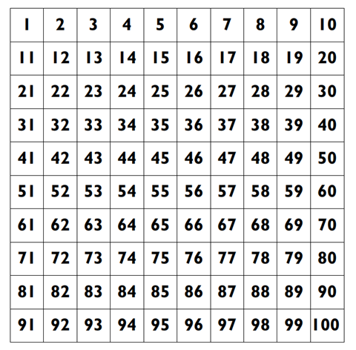

Resource 3: Gremlins (Early Stage 1)
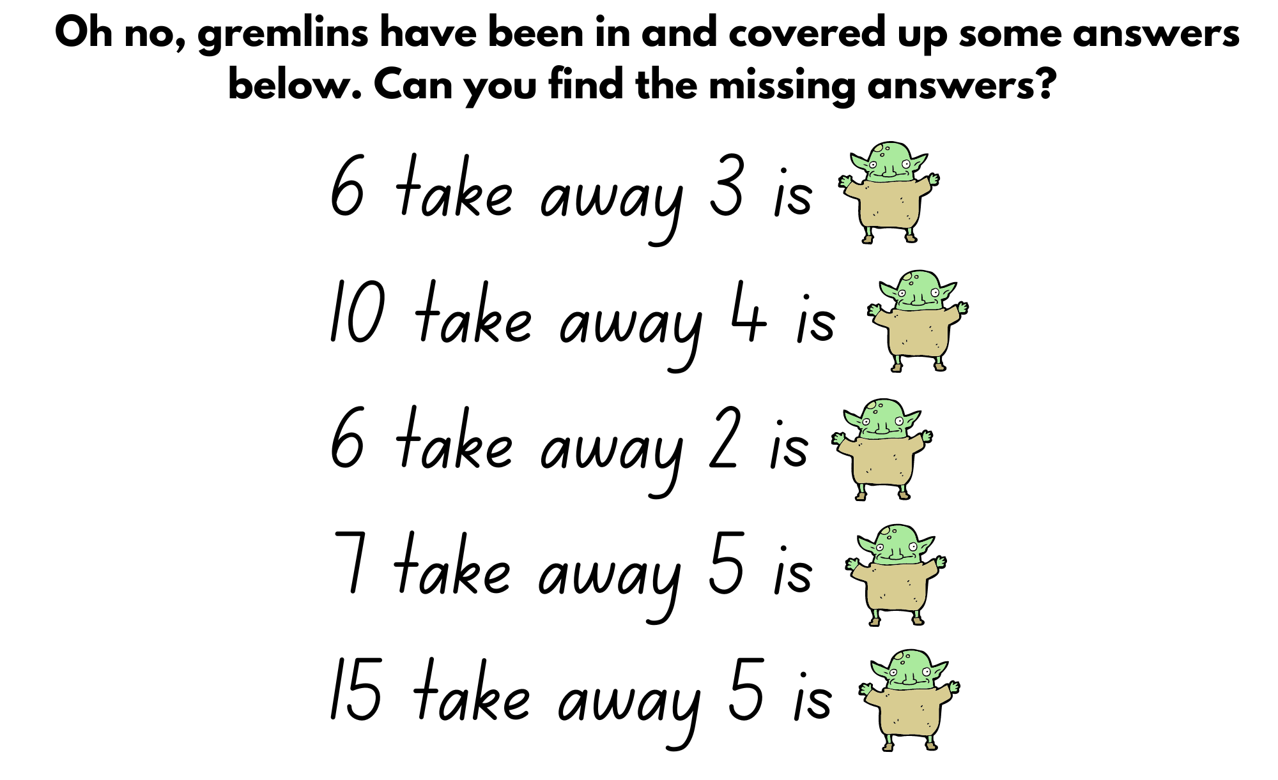
Images sourced from Canva and used in accordance with the Canva Content License Agreement.

Resource 4: Gremlins (Stage 1)
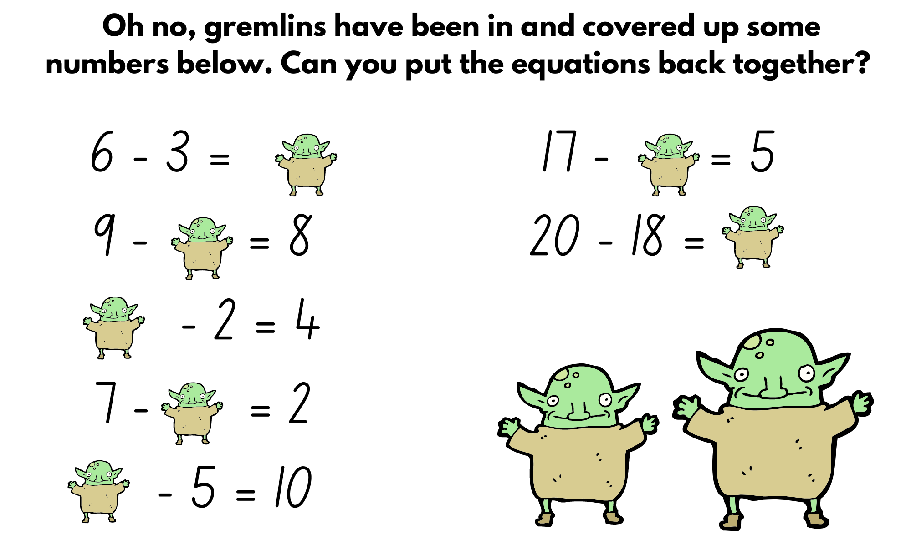
Images sourced from Canva and used in accordance with the Canva Content License Agreement.

Resource 5: Endless hallway
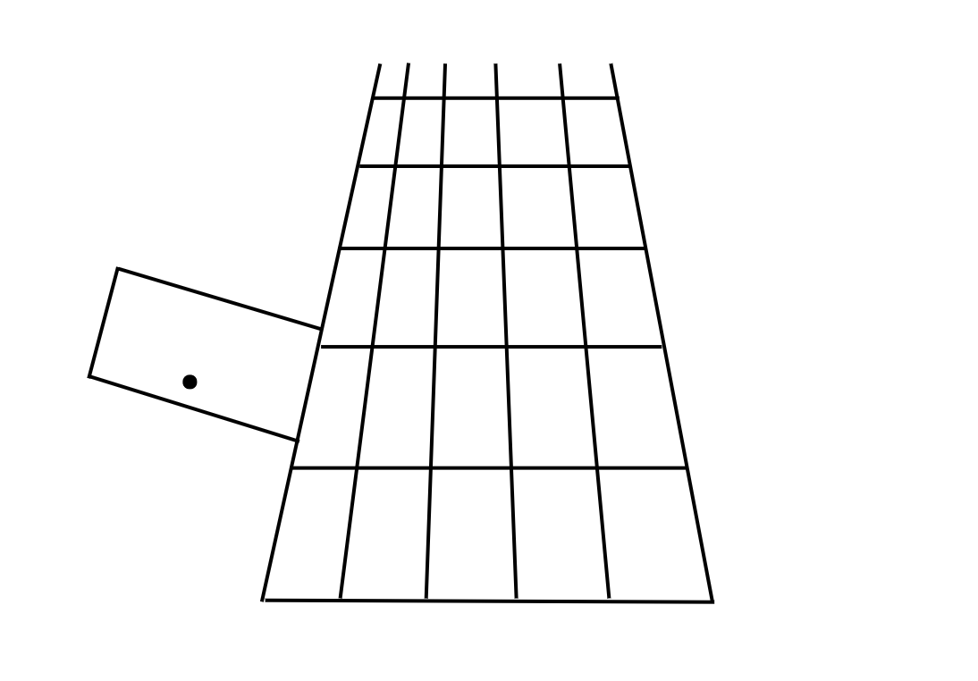
Adapted from Boaler (2022).

Resource 6: Ten-frame
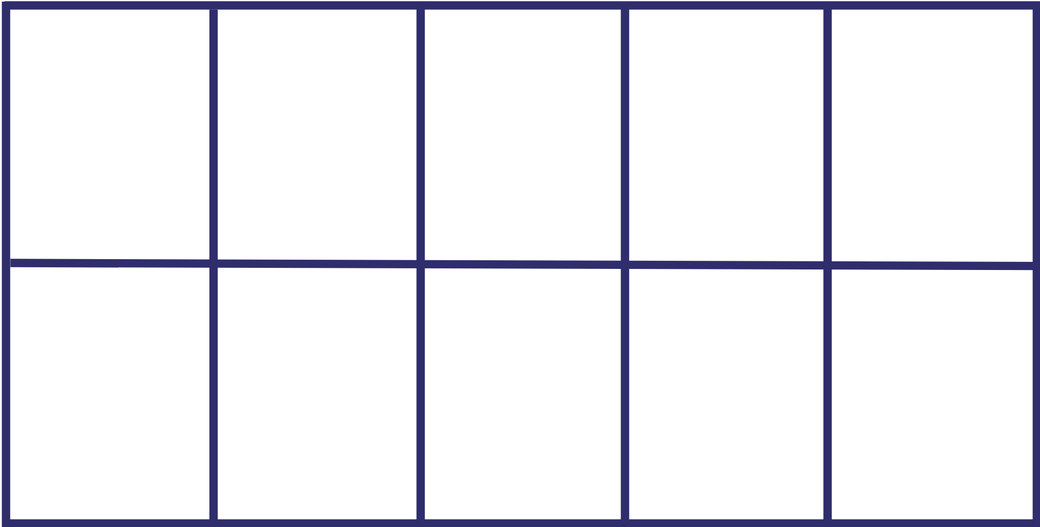

Resource 7: Teen-ty cards
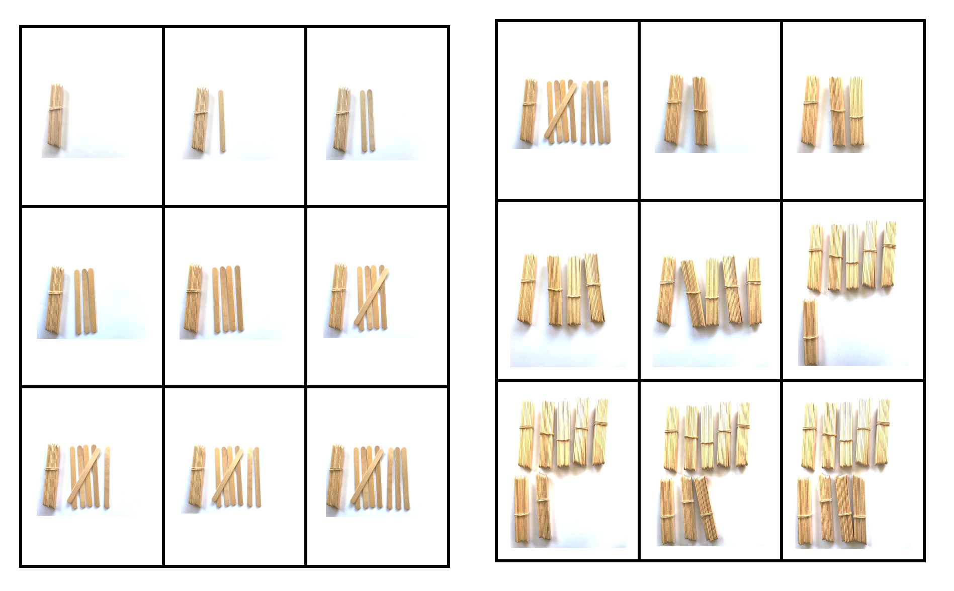
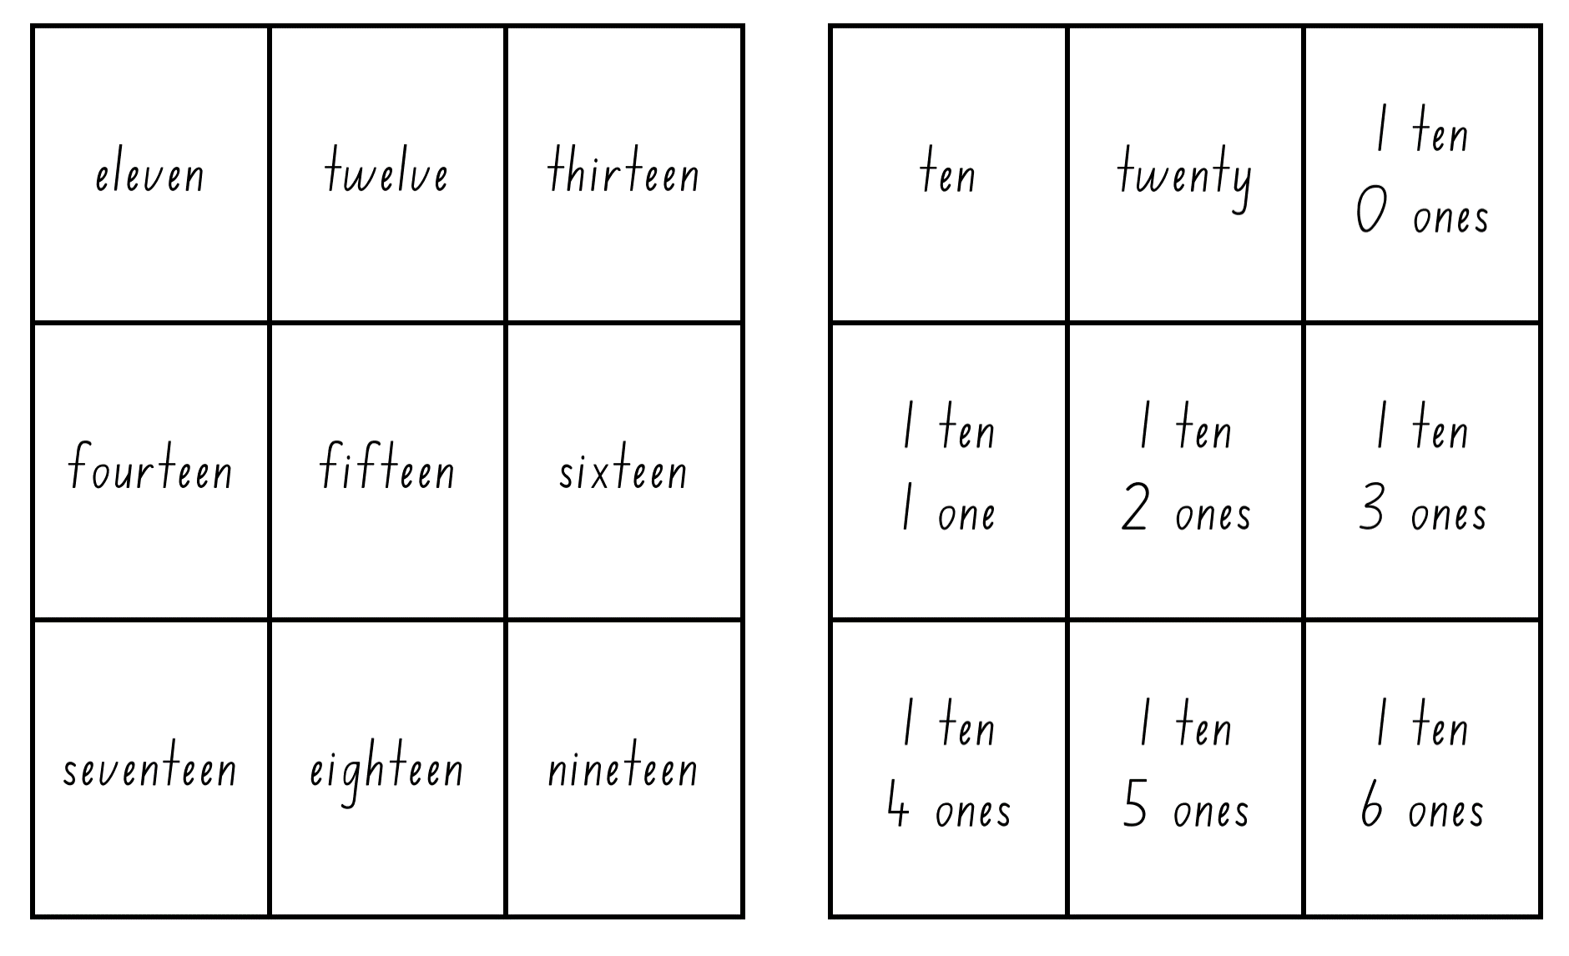
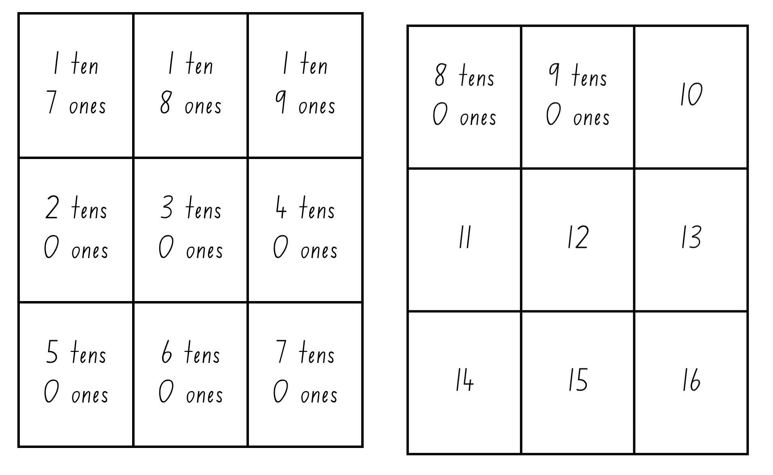
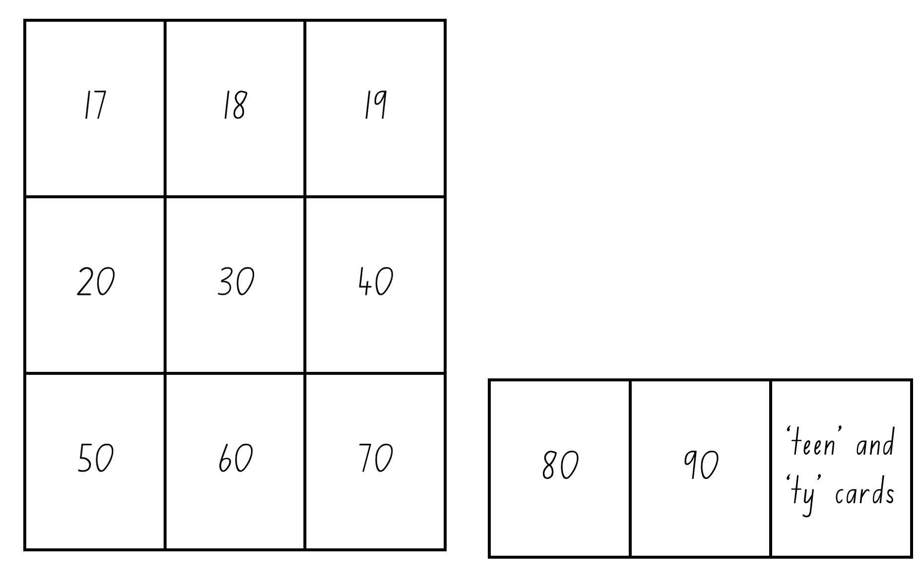

Resource 8: Equal group problems (Early Stage 1)
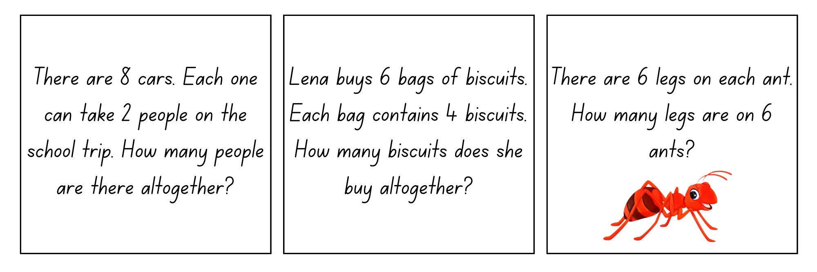
Images sourced from Canva and used in accordance with the Canva Content License Agreement.

Resource 9: Equal group problems (Stage 1)
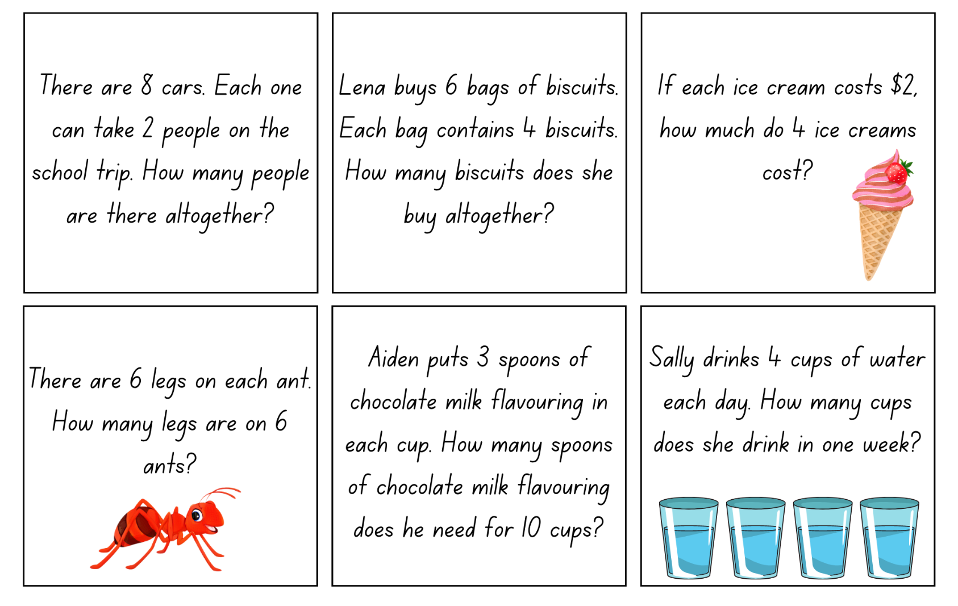
Images sourced from Canva and used in accordance with the Canva Content License Agreement.

Resource 10: Counting problems (Early Stage 1)
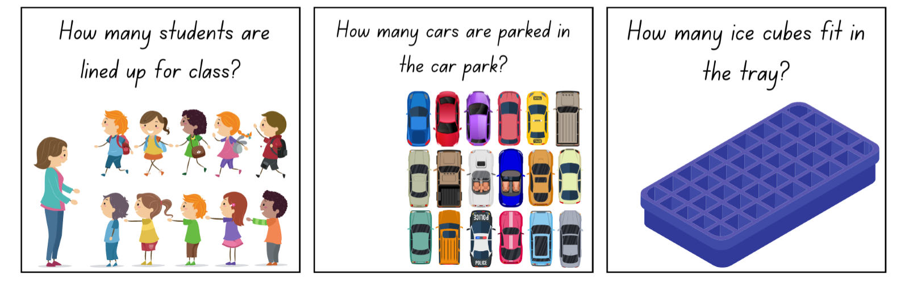
Images sourced from Canva and used in accordance with the Canva Content License Agreement.

Resource 11: Array problems (Stage 1)
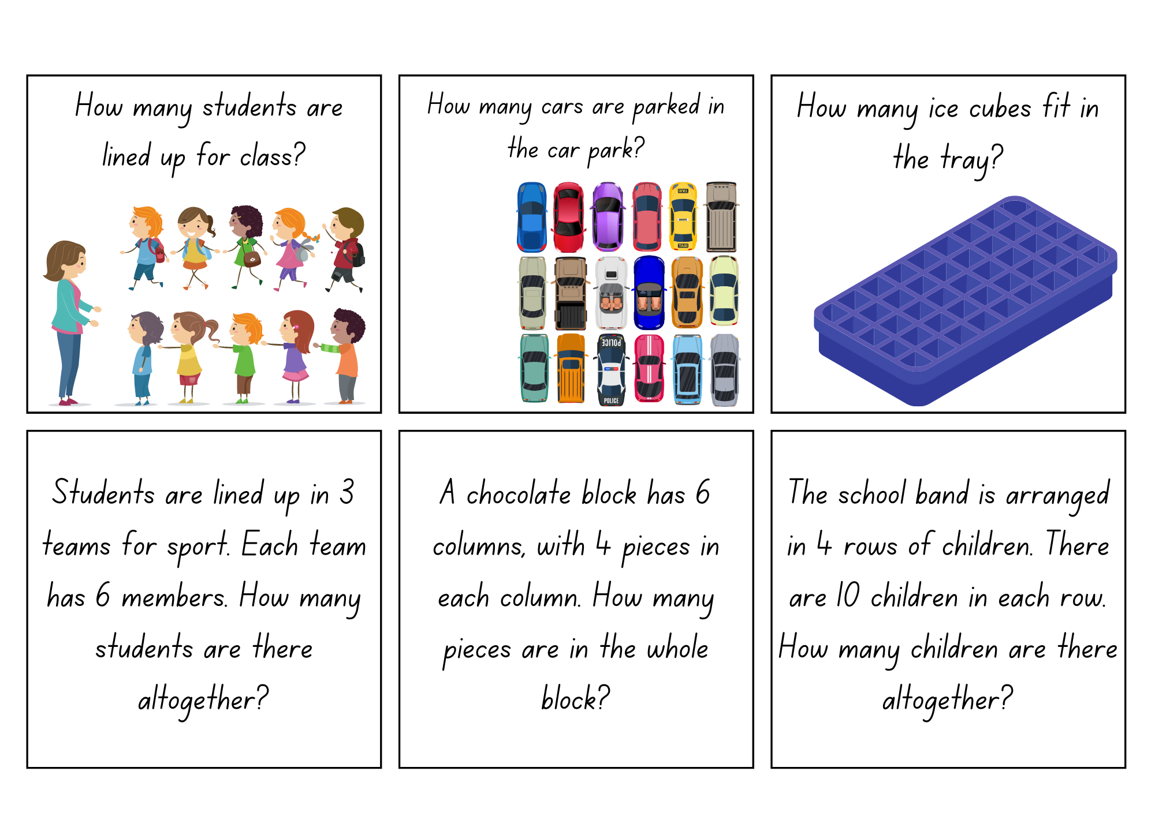
Images sourced from Canva and used in accordance with the Canva Content License Agreement.

Resource 12: The great divide
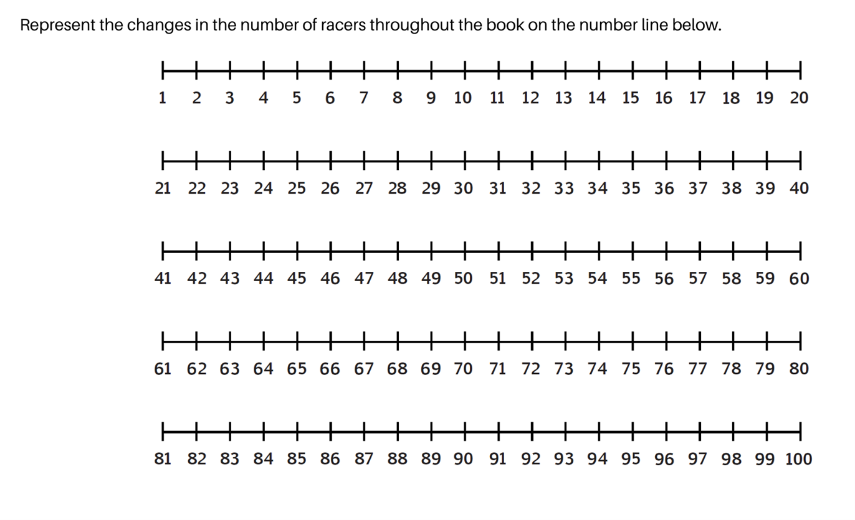

Resource 13: Dot cards
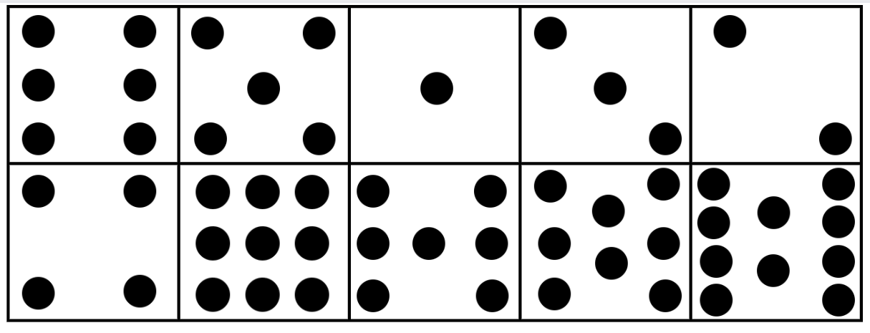

Resource 14: Array bingo
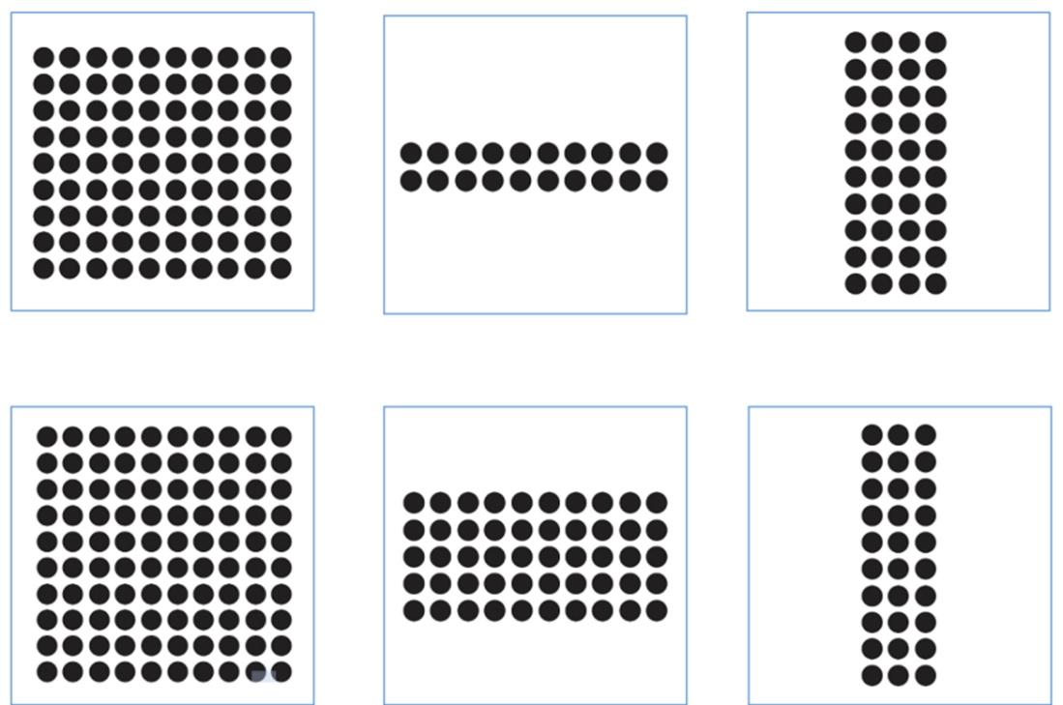
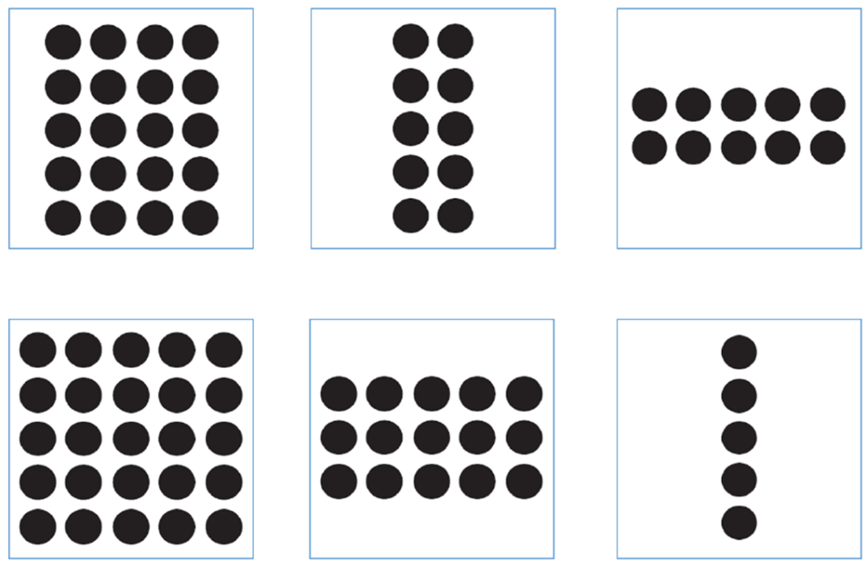
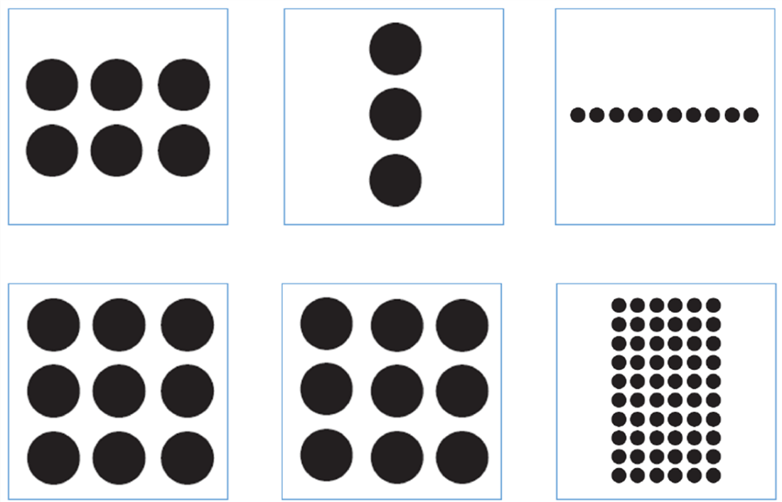
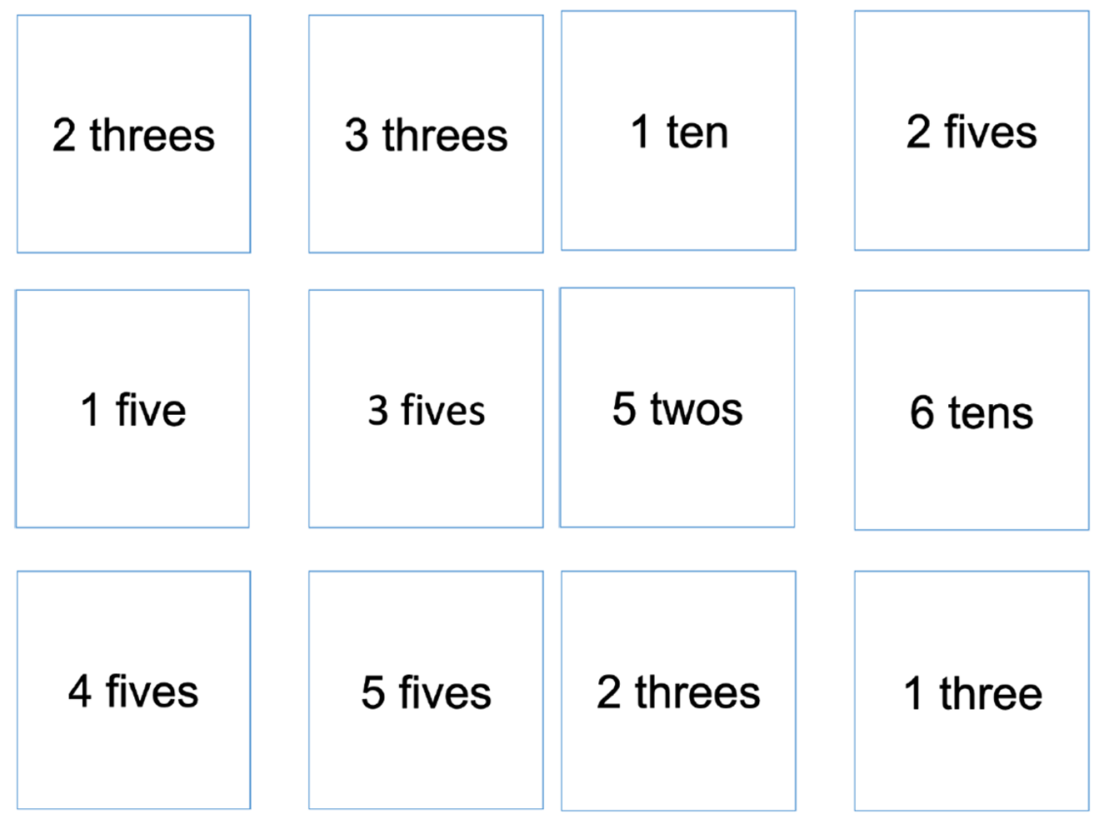
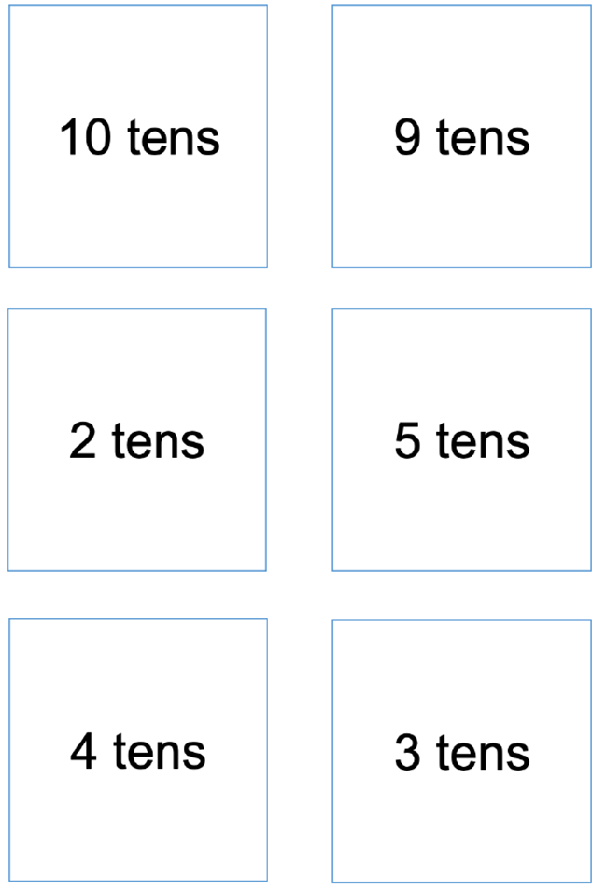

Resource 15: The magical donut tree (Early Stage 1)
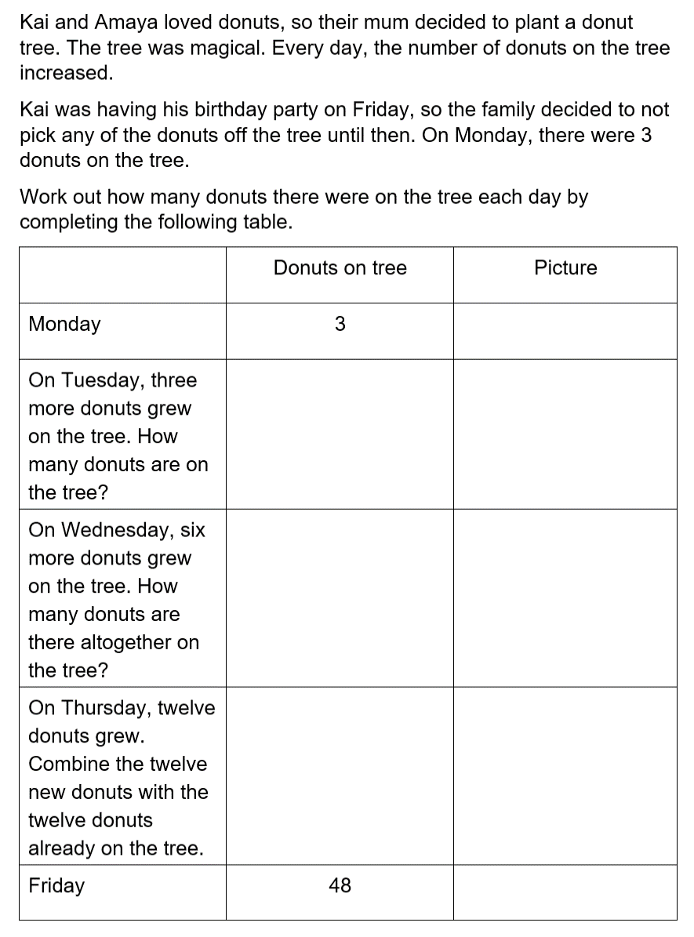

Resource 16: The magical donut tree (Stage 1)
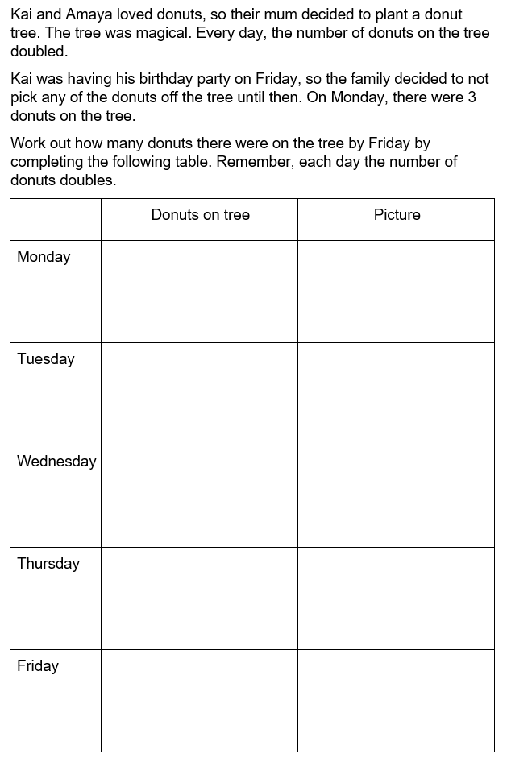

Syllabus outcomes and content
The table below outlines the syllabus outcomes and range of relevant syllabus content covered in this unit. Content is linked to National Numeracy Learning Progression version (3).
Focus area and outcomes | Content groups and content points | Lessons
Representing whole numbers  MAO-WM-01  MAE-RWN-01, MA1-RWN-01  MAE-RWN-02, MA1-RWN-02 | Early Stage 1  Instantly name the number of objects within small collections  - Instantly recognise (subitise) the number of items in small groups of up to four items without counting (NPV1, CPr1)  - Identify the number of items in different arrangements (CPr2) | 4, 5, 7
Representing whole numbers (cont) | Early Stage 1  Use the counting sequence of ones flexibly  - Count forwards to at least 30 and state the number after or before a given number, without needing to count from one (CPr4)  - Identify and distinguish the ‘teen’ numbers from multiples of ten with the same initial sounds (NPV3)  - Count backwards from a given number 20 or less (CPr5)  - Identify the number before as 'one less' and the number after as 'one more’ than a given number | 1, 3–6
Representing whole numbers (cont) | Early Stage 1  Recognise number patterns  - Recognise dice and domino dot patterns (NPA1, NPV2, CPr2) | 7
Representing whole numbers (cont) | Early Stage 1  Connect counting and numerals to quantities  - Count with one-to-one correspondence, recognising that the last number name represents the total number in the collection (CPr3, CPr5)  - Count out a specified number of objects (from 5 to 20) from a larger collection, keeping track of the count (CPr4-CPr5)  - Make correspondences between collections  - Read numerals to at least 20, including zero (NPV3)  - Represent numbers as quantities to at least 20 using objects (such as fingers), number words and numerals (NPV2-NPV4, CPr3)  - Compare and order numbers to 20 (NPV2-NPV3) | 1–8
Representing whole numbers A | Stage 1  Represent numbers on a line  - Sequence numbers and arrange them on a line by considering the order and size of those numbers (CPr5) | 1
Representing whole numbers A (cont) | Stage 1  Represent the structure of groups of ten in whole numbers  - Recognise that ten ones is the same as one ten (NPV2, NPV4)  - Count large sets of objects by systematically grouping in tens (CPr7)  - Use number lines and number charts to assist with locating the nearest ten to a number  - Estimate, to the nearest ten, the number of objects in a collection and check by counting in groups of ten (CPr7, NPV6) | 1, 2, 4
Representing whole numbers B | Stage 1  Use counting sequences of ones and tens flexibly  - Identify the number before and after a given three-digit number  - Count forwards and backwards by tens, on and off the decade, with two- and three-digit numbers (CPr7)  - Identify how many more to the next multiple of ten within two- and three-digit numbers | 4
Representing whole numbers B (cont) | Stage 1  Form, regroup, and rename three-digit numbers  - Count and represent large sets of objects by systematically grouping in tens and hundreds (CPr7, NPV5)  - Use models such as base 10 material and interlocking cubes to represent and explain grouping (CPr7)  - State the quantity value of digits in numbers of up to three digits (NPV5)  - Identify the nearest hundred to a number  - Recognise units of 100 (UnM5, NPV5)  - Use place value to partition and rename three-digit numbers in different ways (NPV5)  - Estimate, to the nearest hundred, the number of objects in a collection and check by grouping and counting (NPV6) | 4, 6
Combining and separating quantities  MAO-WM-01  MAE-CSQ-01, MA1-CSQ-01  MAE-CSQ-02 | Early Stage 1  Model additive relations and compare quantities  - Identify situations in which addition and subtraction may be applied (AdS1-AdS2)  - Combine two or more groups of objects to model addition, identifying the relationship between the parts and the whole (AdS1-AdS2)  - Separate and take away part of a group of objects to model subtraction (AdS1-AdS2)  - Use concrete materials or fingers to model and solve addition and subtraction questions, counting forwards or backwards by ones as necessary (AdS1-AdS2, NPV3)  - Compare two groups of objects to determine how many more (NPV1, AdS2) | 1–4, 7–8
Combining and separating quantities (cont) | Early Stage 1  Identify part–whole relationships in numbers up to 10  - Use visual representations of numbers to assist with combining and separating quantities, identifying the relationship between the quantities (NPV2, NPA2, AdS2-AdS3)  - Describe the action of combining, separating and comparing (AdS1)  - Count by ones to find the total or difference (AdS2-AdS3)  - Use drawings, words and numerals to record addition and subtraction, and explain their thinking (AdS2) | 1–4, 7–8
Combining and separating quantities A | Stage 1  Use advanced count-by-one strategies to solve addition and subtraction problems  - Apply the terms ‘add’, ‘plus’, ‘equals’, ‘is equal to’, ‘is the same as’, ‘take away’, ‘minus’ and ‘the difference between’ to describe combining and separating quantities (AdS1, AdS6)  - Recognise and use the symbols for plus (+), minus (–) and equals (=)  - Record number sentences in a variety of ways using drawings, words, numerals and symbols (AdS6)  - Fluently use advanced count-by-one strategies including counting on and counting back to solve addition and subtraction problems involving one- and two-digit numbers (AdS3-AdS5) | 1, 2, 4, 5
Combining and separating quantities A (cont) | Stage 1  Recognise and recall number bonds up to ten  - Recognise, recall and record combinations of two numbers that add up or bond to form 10 (AdS2, AdS6)  - Describe combinations for numbers using words such as more than, less than and double (Reasons about relations) (AdS6) | 1
Combining and separating quantities A (cont) | Stage 1  Use flexible strategies to solve addition and subtraction problems  - Use non-count-by-one strategies such as using doubles for near doubles and combining numbers that add to ten (AdS6)  - Represent addition and subtraction using structured materials such as a bead string or similar model (AdS6-AdS7)  - Select and apply strategies using number bonds to solve addition and subtraction problems with one- and two-digit numbers by partitioning numbers using quantity value and bridging to 10 (AdS6-AdS7) | 1–2
Combining and separating quantities A (cont) | Stage 1  Represent equality  - Use the equals sign to record equivalent number sentences involving addition, and to mean 'is the same as', rather than as an indication to perform an operation (NPA3)  - Model the commutative property for addition and apply it to aid the recall of addition facts (AdS7)  - Recall related addition and subtraction facts for numbers to at least 10 (AdS6) | 1–2, 4–5
Combining and separating quantities B | Stage 1  Represent and reason about additive relations  - Create, record and recognise combinations of two numbers that add to numbers from 11 up to and including 20 (AdS7)  - Create, model and solve word problems, using number sentences  - Represent the difference between two numbers using concrete materials and diagrams (AdS6)  - Represent a constant difference between pairs of numbers  - Model how addition and subtraction are inverse operations using concrete materials, drawings and diagrams (AdS7)  - Recall and use related addition and subtraction number facts to at least 20 (AdS7) | 1–2, 4
Combining and separating quantities B (cont) | Stage 1  Form multiples of ten when adding and subtracting two-digit numbers  - Add two-digit numbers by building to multiples of ten (AdS7)  - Add and subtract from a two-digit number and record on an empty number line (AdS6-AdS8)  - Use quantity values to separate tens and ones for addition (only) (AdS7-AdS8)  - Use an inverse strategy to turn a subtraction into an addition (AdS7) | 1–2
Combining and separating quantities B (cont) | Stage 1  Use knowledge of equality to solve related problems  - Use number bonds to determine a missing number (AdS6, NPA3-NPA4)  - Use number knowledge to solve related problems (AdS7, NPA4)  - Use a variety of ways of writing number sentences (NPA3-NPA4)  - Use number bonds to solve equality problems (NPA3-NPA4) | 1–2, 4
Forming groups  MAO-WM-01  MAE-FG-01, MA1-FG-01  MAE-FG-02 | Early Stage 1  Investigate and form equal groups by sharing  - Distribute a group of familiar objects into smaller groups and recognise whether the number in each group is equal or not (MuS1-MuS2)  - Group and share concrete materials by distributing objects one by one or using another method (MuS1-MuS2) | 4–8
Forming groups (cont) | Early Stage 1  Record grouping and sharing  - Label the number of objects in a group  - Record grouping and sharing using drawings, words and numerals, and explain their thinking (MuS2) | 4–8
Forming groups A | Stage 1  Count in multiples using rhythmic and skip counting  - Count by twos, threes, fives and tens using rhythmic counting and skip counting (MuS2, CPr6) | 3–5, 6, 8
Forming groups A (cont) | Stage 1  Use skip counting patterns  - Identify and describe patterns when skip counting forwards or backwards by twos, fives and tens (NPA3-NPA4)  - Determine a missing number in a number pattern with a constant difference  - Describe how the missing number in a number pattern was determined | 3
Forming groups A (cont) | Stage 1  Model and use equal groups of objects to represent multiplication  - Model and describe collections of objects as groups of (MuS2)  - Determine and distinguish between the number of groups and the number in each group when describing collections of objects  - Find the total number of objects using skip counting of equal groups of a known size (MuS2-MuS3) | 3–8
Forming groups A (cont) | Stage 1  Recognise and represent division  - Use concrete materials to model a half of a collection and show the relation between the half and the whole (InF1)  - Model sharing division by distributing a collection of objects equally into a given number of groups to determine how many in each group (InF2, MuS5)  - Describe the part left over when a collection cannot be distributed equally using the given group size (MuS6) | 4, 6, 8
Forming groups B | Stage 1  Represent and explain multiplication as the combining of equal groups  - Use objects, diagrams, images or actions to model multiplication as accumulating equal groups (MuS4)  - Solve multiplication problems using repeated addition (MuS4)  - Form arrays of equal rows and equal columns (MuS5)  - Determine and distinguish between the number of rows/columns and the number in each row/column when describing collections of objects (MuS5)  - Model the commutative property of multiplication, using an array (MuS6)  - Model division by deconstructing an array equally into a given number of rows or columns | 3, 5–7
Forming groups B (cont) | Stage 1  Model doubling and halving with fractions  - Model doubling and halving groups and the relation between the processes (MuS6, InF2)  - Re-create the whole given half (InF3)  - Use concrete materials to model a half, a quarter or an eighth of a collection, and explain their thinking (InF2-InF3) | 4, 6–8
Forming groups B (cont) | Stage 1  Represent multiplication and division problems  - Solve multiplication and division problems using objects, diagrams, images and actions (MuS6-MuS7)  - Record answers to multiplication and division problems (including those with remainders) using drawings, words and numerals (MuS6) | 3–8

References
Links to third-party material and websites
Please note that the provided (reading/viewing material/list/links/texts) are a suggestion only and implies no endorsement, by the New South Wales Department of Education, of any author, publisher, or book title. School principals and teachers are best placed to assess the suitability of resources that would complement the curriculum and reflect the needs and interests of their students.
If you use the links provided in this document to access a third-party's website, you acknowledge that the terms of use, including licence terms set out on the third-party's website apply to the use which may be made of the materials on that third-party website or where permitted by the Copyright Act 1968 (Cth). The department accepts no responsibility for content on third-party websites.
Except as otherwise noted, all material is © State of New South Wales (Department of Education), 2023 and licensed under the Creative Commons Attribution 4.0 International License. All other material (third-party material) is used with permission or under licence. Where the copyright owner of third-party material has not licensed their material under a Creative Commons or similar licence, you should contact them directly for permission to reuse their material.
Mathematics K–10 Syllabus © 2022 NSW Education Standards Authority (NESA) for and on behalf of the Crown in right of the State of New South Wales.
© 2022 NSW Education Standards Authority. This document contains NSW Curriculum and syllabus content. The NSW Curriculum is developed by the NSW Education Standards Authority. This content is prepared by NESA for and on behalf of the Crown in right of the State of New South Wales. The material is protected by Crown copyright.
Please refer to the NESA Copyright Disclaimer for more information.
NESA holds the only official and up-to-date versions of the NSW Curriculum and syllabus documents. Please visit the NSW Education Standards Authority (NESA) website and the NSW Curriculum website.
National Numeracy Learning Progression © Australian Curriculum, Assessment and Reporting Authority (ACARA) 2010 to present, unless otherwise indicated. This material was downloaded from the Australian Curriculum website (National Numeracy Learning Progression) (accessed 23 03 2023) and was not modified. The material is licensed under CC BY 4.0. Version updates are tracked in the ‘Curriculum version history’ section on the 'About the Australian Curriculum' page of the Australian Curriculum website.
ACARA does not endorse any product that uses the Australian Curriculum or make any representations as to the quality of such products. Any product that uses material published on this website should not be taken to be affiliated with ACARA or have the sponsorship or approval of ACARA. It is up to each person to make their own assessment of the product, taking into account matters including, but not limited to, the version number and the degree to which the materials align with the content descriptions and achievement standards (where relevant). Where there is a claim of alignment, it is important to check that the materials align with the content descriptions and achievement standards (endorsed by all education Ministers), not the elaborations (examples provided by ACARA).
This resource contains images and content obtained from Canva, and their use outside of this resource is subject to Canva’s Content License Agreement. If you wish to use them separately from the resource, please go to Canva.
ABC Education (n.d.) Thundergoats, ABC Education website, accessed 7 March 2023.
Boaler J, Munson J and William C (2022) Mindset Mathematics: Visualising and Investigating Big Ideas, Grade 2, Jossey-Bass, New Jersey.
Dodds DA (2005) The Great Divide: A Mathematical Marathon (Mitchell T, illus.), Walker Books Australia.
McGrath BB (2010) Teddy Bear Counting (T Nihoff, illus), Random House US.
New Zealand Ministry of Education (n.d) Gremlins, NZ Maths website, accessed 7 March 2023.
NSW Department of Education (2022) ‘Counting game (by multiples of 10)’, Mathematics K-6 resources, NSW Department of Education website, accessed 7 March 2023.
NSW Department of Education (2022) ‘Counting game (by ones)’, Mathematics K-6 resources, NSW Department of Education website, accessed 7 March 2023.
NSW Department of Education (2022) ‘Strike it out’, Mathematics K-6 resources, NSW Department of Education website, accessed 7 March 2023.
NSW Department of Education (2023) ‘Array bingo’, Mathematics K-6 resources, NSW Department of Education website, accessed 7 March 2023.
NSW Department of Education (2023) ‘Subtraction Stacks’, Mathematics K-6 resources, NSW Department of Education website, accessed 7 March 2023.
Russo J and Hopkins S (2017) ‘CLASS Challenging Tasks: Using Cognitive Load Theory to Inform the Design of Challenging Mathematical Tasks’, Australian Primary Mathematics Classroom, 22(1):21–27.
Stanford University (n.d.) ‘Pepperoni Pizza’, Tasks, youcubed website, accessed 7 March 2023.
Sullivan P (2018) Challenging Mathematical Tasks, Oxford University Press, South Melbourne.

