Mathematics – K-2 multi-age –Year A – Unit 20
Contents
Unit description and duration 4
Student prior learning 4
Lesson overview and resources 5
Lesson 1: Grandma’s soup investigation – Part 1 14
Daily number sense: Subitising number talk – 10 minutes 14
Counting and ordering – 40 minutes 15
Discuss and connect the mathematics – 10 minutes 18
Lesson 2: Grandma’s soup investigation – Part 2 20
Daily number sense: Speed circles – 10 minutes 20
Number lines – 20 minutes 21
Bridging to 10 – 30 minutes 23
Lesson 3: Story mapping with symbols 27
Daily number sense: Symbol number talk – 10 minutes 28
Symbols key – 10 minutes 29
Mathematical story – 30 minutes 30
Consolidation and meaningful practice: Connect the mathematics – 15 minutes 33
Lesson 4: Sharing mathematical stories 34
Daily number sense: Symbol number talk – 15 minutes 34
Sharing story – 30 minutes 35
Consolidation and meaningful practice: Discuss and connect the mathematics – 15 minutes 38
Lesson 5: How many legs? – Part 1 38
Daily number sense: Array talk – 10 minutes 39
How many legs? Addition – 20 minutes 40
How many legs? Multiplication – 20 minutes 41
Discuss and connect the mathematics – 10 minutes 43
Lesson 6: How many legs? – Part 2 44
Daily number sense: Data – 15 minutes 45
How many legs? Addition – 15 minutes 45
How many legs? Subtraction – 15 minutes 46
Consolidation and meaningful practice: Discussing and connecting some of the mathematics – 10 minutes 48
Lesson 7: Keeping time 49
Daily number sense: How long will it take? – 20 minutes 49
Constant difference rule using a number line – 20 minutes 51
Consolidation and meaningful practice: Clock as a number line – 20 minutes 53
Lesson 8: Let’s test it! 57
Daily number sense: Constant difference on a rekenrek – 20 minutes 58
Timeline of activities – 30 minutes 58
Consolidation and meaningful practice: Word problems – 20 minutes 61
Resource 1: Unorganised pasta 63
Resource 2: Organised pasta 64
Resource 3: Numeral cards 0-30 65
Resource 4: Number line to 100 66
Resource 5: Number line to 20 67
Resource 6: Unorganised symbols 68
Resource 7: Organised symbols 69
Resource 8: Sharing bees 70
Resource 9: Organised bees 71
Resource 10: Arrays 72
Resource 11: Animal cards 73
Resource 12: Data talk 75
Resource 13: Addition and subtraction word problems 76
Resource 14: Number line 1-60 77
Resource 15: Word problems 78
Syllabus outcomes and content 79
References 86
Further reading 88

Unit description and duration
This two-week unit develops student knowledge, understanding and skills that problems can be solved and represented in different ways. Students are provided opportunities to:
- solve modelled problems concretely, pictorially, and symbolically to help develop fluency
- count and order a collection of items
- place numbers accurately on a number line
- use symbols to represent a story.
Mathematics K–10 Syllabus © 2022 NSW Education Standards Authority (NESA) for and on behalf of the Crown in right of the State of New South Wales.

Student prior learning
Before engaging in these teaching and learning activities, students would benefit from prior experience with:
- counting and subitising collections to find a total
- describing the actions of combining, separating, grouping and sharing
- using symbols, drawings, words and numbers to record their thinking

Lesson overview and resources
The table below outlines the sequence and approximate timing of lessons; syllabus focus areas and content groups; and resources.
Lesson | Syllabus focus area and content groups | Resources
Lesson 1: Grandma’s soup investigation – Part 1  60 minutes  A collection can be grouped to count more efficiently. | Representing whole numbers  Early Stage 1  - Instantly name the number of objects within small collections  - Recognise dice and domino dot patterns  Stage 1 – Part A  - Use counting sequences of ones with two-digit numbers and beyond  - Represent the structure of groups of ten in whole numbers  Stage 1 – Part B  - Use counting sequences of ones and tens flexibly  Forming groups  Early Stage 1  - Investigate and form equal groups by sharing  - Record grouping and sharing  Stage 1 – Part A  - Count in multiples using rhythmic and skip counting  - Model and use equal groups of objects to represent multiplication | - Resource 1: Unorganised pasta  - Resource 2: Organised pasta  - Camera to document learning  - Paper  - Scissors  - Spiral pasta or counters  - Ten-frame  - Writing materials
Lesson 2: Grandma’s soup investigation – Part 2  60 minutes  Addition can be used to solve subtraction. | Representing whole numbers  Early Stage 1  - Use the counting sequence of ones flexibly  Stage 1 – Part A  - Continue and create number patterns  - Represent numbers on a line  Stage 1 – Part B  - Form, regroup and rename three-digit numbers  Combining and separating quantities  Early Stage 1  - Model additive relations and compare quantities  Stage 1 – Part A  - Use flexible strategies to solve addition and subtraction problems. | - Resource 3: Numeral cards 0-30  - Resource 4: Number line to 100  - 6-sided dice (class set)  - Chalk  - Counters  - Cut-out outline of adult hand  - Cut-outs of students’ hands from Lesson 1  - Individual whiteboards  - Writing materials
Lesson 3: Story mapping with symbols  65 minutes  Mathematicians use a range of representations to communicate ideas. | Representing whole numbers  Early Stage 1  - Recognise number patterns  Stage 1 – Part A  - Use counting sequences of ones with two-digit numbers and beyond  Stage 1 – Part B  - Use counting sequences of ones and tens flexibly  - Form, regroup and rename three-digit numbers  Combining and separating quantities  Early Stage 1  - Model additive relations and compare quantities  Stage 1 – Part A  - Use flexible strategies to solve addition and subtraction problems | - Resource 4: Number line to 100  - Resource 5: Number line to 20 (one copy per Early Stage 1 student)  - Resource 6: Unorganised symbols  - Resource 7: Organised symbols  - A3 paper (one sheet per student)  - Writing materials
Lesson 4: Sharing mathematical stories  60 minutes  The order in which you divide and subtract numbers changes the answer to a problem. | Forming groups  Early Stage 1  - Investigate and form equal groups by sharing  Stage 1 – Part A  - Model and use equal groups of objects to represent multiplication  - Recognise and represent division  Stage 1 – Part B  - Represent multiplication and division problems  Representing whole numbers  Early Stage 1  - Connect counting and numerals to quantities  Stage 1 – Part A  - Continue and create number patterns | - Resource 8: Sharing bees  - Resource 9: Organised bees  - Collections of items or found objects in nature, for example, gumnuts, beads, stones, counters  - Learning maps from Lesson 3  - Writing materials
Lesson 5: How many legs? – Part 1  60 minutes  You can multiply and add numbers in any order and the answer to a problem does not change. | Combining and Separating Quantities  Early Stage 1  - Model additive relations and compare quantities  Stage 1 – Part A  - Use advanced count-by-one strategies to solve addition and subtraction problems  Stage 1 – Part B  - Represent and reason about additive relations  Forming Groups  Early Stage 1  - Investigate and form equal groups by sharing  - Record grouping and sharing  Stage 1 – Part A  - Model and use equal groups of objects to represent multiplication  Stage 1 – Part B  - Represent multiplication and division problems  - Represent and explain multiplication as the combining of equal groups | - Resource 10: Arrays  - Resource 11: Animal cards  - Gray K (2015) How Many Legs? (Field J, illus.), Hachette Children’s Books, Great Britain. ISBN: 9781444910971  - Counters  - Writing materials
Lesson 6: How many legs? – Part 2  55 minutes  A collection can be changed by adding items (joining) or taking some away (separating). | Combing and Separating Quantities  Early Stage 1  - Model additive relations and compare quantities  Stage 1 – Part A  - Use advanced count-by-one strategies to solve addition and subtraction problems  Stage 1 – Part B  - Represent and reason about additive relations | - Resource 12: Data talk  - Resource 13: Problems  - Counters  - Ten-frames  - Writing materials
Lesson 7: Keeping time  60 minutes  The difference does not change if you add or subtract the same amount to/from both numbers. | Non- spatial measure  Early Stage 1  - Time: Compare and order the duration of events using the language of time  Stage 1 – Part B  - Describe duration using units of time  Combining and separating quantities  Early Stage 1  - Model additive relations and compare quantities  Stage 1 – Part A  - Use flexible strategies to solve addition and subtraction problems | - Resource 3: Numeral cards 0-30  - Resource 5: Number line to 20  - Resource 14: Number line 1-60  - Digital Number line  - Chalk  - Clock face  - Counters, beads  - Paper strips  - Timer  - Writing materials
Lesson 8: Let’s test it!  70 minutes  Mathematicians use evidence to make mathematical arguments and justify their thinking. | Non- spatial measure  Early Stage 1  - Time: Compare and order the duration of events using the language of time  Stage 1 – Part B  - Describe duration using units of time  Combining and separating quantities  Stage 1 – Part A  - Use flexible strategies to solve addition and subtraction problems | - Resource 5: Number line to 20 (printed for each student)  - Resource 15: Word problems  - 20-Bead rekenrek  - 2 ten-bead rekenreks for each students  - 6-sided die  - Anchor chart from Lesson 7  - Butcher paper  - Magazines (for cutting out pictures)  - Writing materials

Lesson 1: Grandma’s soup investigation – Part 1
Core concept: A collection can be grouped to count more efficiently.
The table below contains suggested learning intentions and success criteria. These are best co-constructed with students.
Learning intentions | Success criteria
Students are learning that:  - collections of objects can be organised into groups to count more efficiently  - number sequences are used to order numbers. | Students can:  - organise collections to count efficiently  - arrange numbers from smallest to largest.

Daily number sense: Subitising number talk – 10 minutes
- Build student understanding of subitising by quickly sharing a collection of pasta in 2 different ways.
- Display Resource 1: Unorganised pasta for 2-3 seconds and then remove. Ask the students:
- How many pasta pieces did you see?
- How could you organise the pasta to see how many pieces there are more easily?
- Could you easily see how many pieces of pasta there were?
- Display Resource 2: Organised pasta, for 2-3 seconds and then remove. Students turn and talk about how they saw the collection.
- Reveal Resource 2: Organised pasta and select students to share their ideas with the class. Ask the students:
- How many pasta pieces did you see?
- How did you see the pasta pieces?
- Can you see any dice patterns inside the image?
- Was it easier to see how many pieces there were in this photo compared to the first one?
Note: Pattern recognition, sometimes referred to as ‘conceptual subitising’ (Clements, 1999), can assist students to develop capabilities of recognising units and combining numbers. Stage 1 can also recognise larger numbers of dots when presented in a known pattern.
- In pairs, students use 0-30 pasta pieces to create a pattern on ten-frames, cover with a piece of paper, display quickly to a partner and have a partner describe what they saw.
Note: Early Stage 1 students can subitise numbers on one or 2 ten-frames.
- Ask students to share their responses and record their thinking.

Counting and ordering – 40 minutes
This lesson was adapted from Grandma’s Soup from reSolve: Maths by Inquiry.
- Share the following story with the students, letting the students know that the narrator is a child: My Grandma makes the best vegetable soup, and she gave me her recipe. It has lots of vegetables and it is thick and chunky. It has pasta in it, so that is what makes it chunky. Last night I made it for the first time, but it was nothing like Grandma’s soup. It was watery and ordinary and not at all chunky. I do not know what went wrong. I put in all the ingredients she told me to add. I put in one small carrot, one brown onion, 2 sticks of chopped celery, 2 tomatoes, 3 cups of water and one handful of spiral pasta.
- Ask why the narrator’s soup was not as chunky as Grandma’s when they followed her recipe exactly. Elicit responses until the pasta is suggested.
- Ask students to think about why Grandma’s soup was not the same as the narrator’s soup. Elicit and guide responses until students suggest the size of Grandma’s hand and the amount of pasta. It is probably a good time to explain to the students that when pasta is being cooked, it absorbs the liquid around it and expands. The more pasta there is, the more liquid will be absorbed and the chunkier the soup will be.
- Each student takes a large handful of pasta using both hands.
- Students count their collection using their own strategy, without prompting. Students record the amount of pasta in their collection in their workbook, before checking the count.
Note: It is best to use pasta such as spirals or shells because they are easy to count. Alternatively, you can use something similar like counters if you do not have access to pasta.
- Ask students what counting strategy they used to count their collection of pasta. For Early Stage 1, support students to count with one-to-one correspondence and recognise that the last number name represents the total in the collection.
- For Stage 1, counting strategies may include skip counting by twos, fives, or tens. Discuss what strategies students thought were the most effective to gain an accurate count.
- Students Think-Pair-Share and decide how they are going to improve their counting strategy.
- Students check their count using the most effective counting strategy they decided on. Compare the 2 results and discuss whether their count had changed.
Note: Take photographs of the different ways students have grouped their collection to display counting strategies.
- Ask students to trace their hand on a piece of paper. Students place pasta pieces on their hand tracing, then write the total amount of pasta they counted inside the hand, before cutting it out.
- Gather students with their paper hand cut-outs and ask if they think they will all have the same number of pasta pieces written on their paper hands. Prompt students to explain why or why not.
- Direct students to form groups of 4 or 5 by finding others in the room who have a similar number of pasta pieces.
Note: It is important to allow students to do this unassisted as this gives them the opportunity to justify their choices.
- Ask each group to explain why they have grouped themselves together. As students share, record their numbers on the board alongside their chosen groups.
- Within their group and as a class, students compare and order their hands based on the number in their collection. Together, students order the hand cut-outs from smallest to largest creating a display.
Note: Keep the line of hands display for future reference in Lesson 2: Number lines.

Discuss and connect the mathematics – 10 minutes
- Summarise the lesson together, drawing out some key mathematical ideas.
- Ask students:
- How did you organise your collection?
- Did you change how you organised your collection to make it more efficient? If so, how?
- Why do you think the soup was not as chunky as Grandma’s soup?
- Do you think my handful and Grandma’s handful would be different?
- Why would the size of the handful of pasta make a difference to the chunkiness of the soup?
- I wonder if your handful would be different to my handful.
This table details assessment opportunities and differentiation ideas.
Assessment opportunities | Too hard? | Too easy?
What to look for:  - Are students able to keep track of their count with one-to-one correspondence? (MAE-RWN0-01, MAE-RWM-02)  - Are students using efficient and effective counting strategies to count a collection? (MAE-RWN-01, MAE-RWN-02, MA1-RWN-01, MA1-RWN-02)  - Can students use more than one strategy to count a collection? (MA1-RWN-01, MA1-RWN-02)  - Do students reflect and adopt ideas and strategies? (MAO-WM-01)  What to collect:  - student work samples (MAE-RWN-01, MAE-RWN-02, MA1-RWN-01, MA1-RWN-02)  - photographs of how students arrange their collection (MAO-WM-01, MAE-RWN-01, MAE-RWN-02, MA1-RWN-01, MA1-RWN-02) | Students are not able to keep track of their count or arrange their hands in numerical order.  - Support students by encouraging effective counting strategies using concrete materials, for example, a ten-frame.  - Students are given a number chart where they can identify the order of numbers.  Students are not able to recognise the difference in hand size changes the amount of pasta in a handful.  - Model an adult-sized hand with pasta and a child-sized hand with pasta. Display amounts on a ten-frame to emphasise the difference in size.  - Display amount on a ten-frame. Explain that when counting a large collection, we need to organise the collection to achieve an accurate result. | Students are able to count their collection and arrange their hands in numerical order.  - Students draw and explain the strategies they use to keep track of a large number of objects.  - Ask students to count on from a group of 10 and make the distinction between the suffixes -teen and -ty when counting.  Students are able to articulate the relationship between the size of hands and the number of pasta pieces.  - Students could estimate before counting and then round up collections to the nearest 10.  - Students share their solutions with a peer and record their thinking.

Lesson 2: Grandma’s soup investigation – Part 2
Core concept: Addition can be used to solve subtraction.
The table below contains suggested learning intentions and success criteria. These are best co-constructed with students.
Learning intentions | Success criteria
Students are learning that:  - the use of number bonds to 10 can help solve addition and subtraction problems  - addition and subtraction can be represented using structured materials such as a number track or number line. | Students can represent combinations of numbers to 10.  In addition, students working towards Early Stage 1 outcomes can compare and order numbers from 1-20.  In addition, students working towards Stage 1 outcomes can:  - place a number accurately on a number line  - use a number line to combine and separate quantities.

Daily number sense: Speed circles – 10 minutes
- Build student understanding of organising large collections by systematically grouping objects.
- Give students 30 seconds to draw as many circles as they can on their individual whiteboards.
- Students then count how many circles they have drawn. Have students share the different ways they counted their circles.
- Ask students:
- Was it difficult to count your circles?
- Were you counting in the most efficient way?
- Suggest that there may be a way to organise the circles to make counting easier. Repeat the activity and challenge students to use an efficient way to group their circles.
- When the 30 seconds are up, have them reflect on their work. Ask:
- Did you change the way you grouped your circles?
- What strategy did you use to organise and count your circles?
- Was it quicker to count your circles in your second attempt?
- For Stage 1, students could record their thinking by drawing around their circles in a different colour and then representing the counting technique using numerals.
- Students turn and talk with a partner to discuss different strategies they can use to organise and count their circles.

Number lines – 20 minutes
This activity was adapted from Grandma’s Soup from reSolve: Maths by Inquiry.
- Have students remind you of the problem with Grandma’s soup recipe from Lesson 1. Explain that last night, you rang Grandma to explain the problem with the soup. You told her that there might have been a problem with the amount of pasta in your handful. Your handful could have been different to her handful. Explain that Grandma checked her handful and said it held 100 pieces of pasta.
- Have a cut-out hand (adult-sized) and write 100 on it to represent Grandma’s handful.
- Looking at the display of hands from Lesson 1, ask students where it can be added to the line of hands and why it should be positioned there. Remind students that they are comparing the amount of pasta rather than the hand size.
- Ask the students:
- Did anyone have the same number as Grandma?
- Was anyone close to Grandma’s number? How do you know?
- Who had the number closest to Grandma’s? How do you know?
- Explain to students that a good way to see the position of all the numbers is by arranging them on a number track. Looking at the display of hands, have students consider how to make changes to the display so that it represents a number track.
- Use chalk or masking tape to create a line on the ground and have students sequence their hands along it. Any hands with the same number can be ordered together.
- For Early Stage 1, students can begin by sequencing Resource 3: Numeral cards 0-30 and then placing their hand in the correct position.
- Ask students:
- Can you point to the number one less than 7?
- Can you point to the number one more than 12?
- Can you continue counting on your number track from 4?
- Can you count backwards on your number track from 15?
Variation: Ask students to repeat activity in pairs. Students can sequence cards but in backward sequences beginning at 30, or remove a card from the sequence and ask students to identify missing card correctly.
- For Stage 1, Display Resource 4: Number line to 100 and ask the students:
- What do you notice?
- What do you wonder?
- How does our number track compare to the number line? What is the same? What is different?
- Discuss that a number line is a more sophisticated model of a number track. It introduces the idea of distance between numbers. The number line is a model of length. With a number line, students must count the length units and not the numerals.
- Model creating a number line segment using chalk on floor. Repeat using individual units (such as a piece of paper) and mark the segments to 100.
- Ask students to notice the idea of zero on the number line and explicitly model counting spaces between partitions. Ask students to pay attention to counting the spaces, not the lines.
- Tell students that the number line needs a title so that others can read and understand it. As a class, agree on a suitable title and add it to the number line.

Bridging to 10 – 30 minutes
- Explain to students that, in order to make their soup like Grandma’s, students must work out how many more pieces of pasta they each need so they also have 100 pieces.
- Display Resource 4: Number line to 100.
- Ask students to locate 35 on the number line. Ask students how many tens are in 35, demonstrate counting the 3 ten-spaces between partitions. Ask students how many ones are in 35 and count 5 ones on the number line. Remind students that we are not counting the lines but the spaces.
- Ask students to turn and talk to discuss how they can work out how many more pasta shells they would need to get to 100.
- Students share their solutions while you model recording their thinking on the board using a number line.
- Demonstrate bridging to the next multiple of 10 on the board. Discuss the importance of knowing number bonds up to 10.
- Ask the students, ‘How many more pasta shells do I need to get to the nearest 10, which is 40?’ Record bridging to 40 on number line.
- Ask students, ‘How many more tens do I need to get to 100?’ Demonstrate bridging to 100. Record learning on the number line. Variation: Continue to model this for different numbers and select students to demonstrate this for the class.
- For Early Stage 1, focus on number bonds between 0-20. Students can roll a dice and place a counter on a number line 0-20. Ask students to count how many more are needed to get to 10, and then 20. Students must roll correct amount on dice to win. See Figure 1.
Figure 1 – Bridging strategy recording
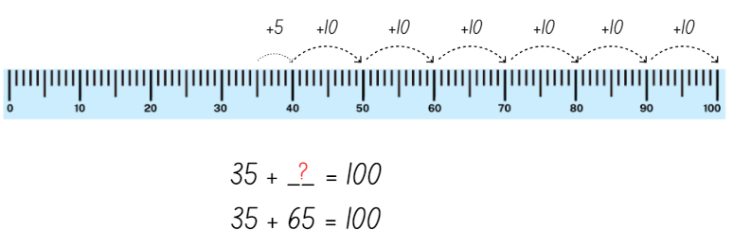
Images sourced from Canva and used in accordance with the Canva Content License Agreement.
- Explain to Stage 1 students that an inverse operation reverses the effect of the original operation. For example, a shopkeeper’s method of giving change often uses the inverse strategy of addition to perform a subtraction. Because addition and subtraction are inverse operations a student can add up from the smaller number to the larger number to obtain the answer.
- For example, using the inverse strategy to solve the following problem:
- Start at 100
- Subtract 3 tens to make 70
- Then subtract 5 to make 65
- So the answer is 100 − (30 + 5) = 65. See Figure 2.
Figure 2 – Inverse strategy recording
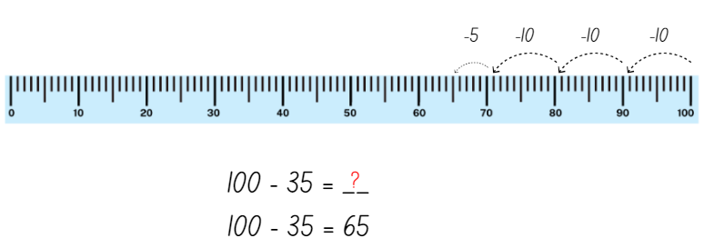
Images sourced from Canva and used in accordance with the Canva Content License Agreement.
- In pairs, provide Stage 1 with a number hand from Lesson 1 and Resource 4: Number line to 100 (cut into individual number lines).
- Students mark numbers on the number line and record.
- Students use the bridging method to 100 and record learning in their books. Encourage students to make use of multiples of 10 and number bonds.
- Students use the inverse strategy to 100 and record learning in their books.
- For Early Stage 1, ask students to record the number bonds from their game 0-20 in their books using pictures, symbols, and words.
This table details assessment opportunities and differentiation ideas.
Assessment opportunities | Too hard? | Too easy?
What to look for:  - Are students able to sequence the numeral cards? (MAE-WM-ES1, MAO-WM-01, MAE-RWN-01)  - Are students using mental strategies such as the bridge to 10 and inverse strategy to solve addition and subtraction problems? (MAO-WM-01, MA1-CSQ-01)  - Can students explain their thinking? (MAE-WM-ES1, MAO-WM-01)  What to collect:  - observational data (MAO-WM-01, MAE-RWN-01, MAE-CSQ-01, MA1-RWN-01, MA-RWN-02, MA-CSQ-01)  - student work samples (MAO-WM-01, MA1-RWN-01, MA-RWN-02, MA-CSQ-01) | Students are not able to sequence numeral cards to 20.  - Provide students with counters to represent quantities to assist them to order cards.  - Complete matching activities where students are presented with a sample number (for example, the numeral 5) and several pictures to select from.  - Challenge students to only sequence numeral cards from 0-10.  Students are not able to use bridging to 10 to solve the number problem.  - Use smaller numbers and concrete materials, for example, bead strings and hundreds chart, to develop the concept.  - Model the bridging strategy several times using a number line until the student has a better understanding. | Students are able to sequence numeral cards to 20.  - Cover cards in the ordered sequence and ask students which cards have been covered.  - Increase range for students to order, for example, forwards and backwards to 30.  Students are able to use bridging to 10 to solve number problem.  - Have students add 2 collections together to form a two-digit number and use their knowledge of bridging to solve the subtraction problem.  - Students write a sentence to explain how addition assisted them to solve a subtraction problem.

Lesson 3: Story mapping with symbols
Core concept: Mathematicians use a range of representations to communicate ideas.
The table below contains suggested learning intentions and success criteria. These are best co-constructed with students.
Learning Intentions | Success criteria
Students are learning that:  - mathematicians use symbols to efficiently describe ideas  - symbols are simple drawings that have meaning and can represent a quantity or an action  - visual displays are an efficient way of communicating information. | Students can use simple drawings/symbols to represent a mathematical story.  In addition, students working towards Early Stage 1 outcomes can combine 2 or more groups of objects up to 20.  In addition, students working towards Stage 1 outcomes can:  - combine 2 or more groups of objects up to 100  - represent numbers on a line to help solve mathematical problems.

Daily number sense: Symbol number talk – 10 minutes
- Build student understanding of whole number by subitising collections.
- Show students Resource 6: Unorganised symbols, for 2-3 seconds and then hide it. Ask questions such as:
- How many symbols did you see?
- Could you easily see how many symbols there were?
- How could you organise the symbols to be able to see how many pieces there are more easily?
- Show students Resource 7: Organised symbols for 2-3 seconds and then hide it. Ask questions such as:
- How many symbols did you see?
- Was it easier to see how many pieces there were in this picture compared to the first one?
- How did you see it?
- Describe what you saw.
- Provide individual thinking time and allow students to Think-Pair-Share. Monitor student conversations, preparing to ask some students to share how they saw the collection of symbols.
- Let students know that they will not have time to count the symbols one at a time. As mathematicians, they will need to visualise what they see to help them work it out.
- Reveal the symbols cards and invite selected students to share their thoughts with the class. Record student thinking.
Note: Some students may identify the number of footprints. However, some students could see this in groups of 3 toes in each. This is a great opportunity to extend thinking and multiplicative thinking with Stage 1 students.

Symbols key – 10 minutes
This lesson has been adapted from MAST (Maths as Story Telling) Additive-Principles Lessons Booklet [PDF 892.24KB] (Cooper et al. 2007) from the Minjerribah Maths Project. The storytelling perspective enables students to bring the everyday world of symbols into mathematics and the formal world of algebra.
- Remind students that symbols are simple drawings that can be used to solve and map mathematical problems.
- Tell students they will be drawing symbols for the following Australian animals. These are wombats, kangaroos, emus, snakes, and honey ants. Make a class key using symbols used by Aboriginal and Torres Strait Island peoples in your local area, or ask students to suggest symbols to use (see Figure 3).
Figure 3 – Symbols of Australian animals
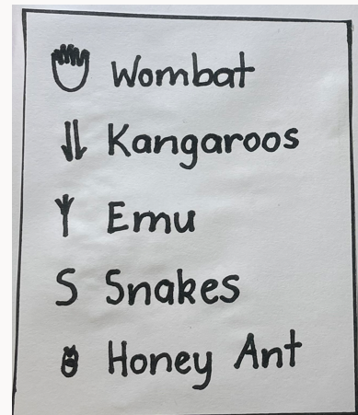
Note: When completing a class key, choose to include symbols from Aboriginal and Torres Strait Islander peoples in your local area. Involve students and their cultures when creating symbols and allow them to create, share and explain personal symbols. You may wish to engage with your local Aboriginal community to find out the symbols of your local area.

Mathematical story – 30 minutes
- Share the following story: One sunny day, Grandma took Ben for a walk on Country, to connect and explore the natural environment. The day was warm, and he was curious about what they would see. Grandma explained how Aboriginal people use symbols to represent animals. They are all different depending on where you live and have a long history. Ben could not believe how lucky he was! Firstly, he saw 2 families of 4 wombats. Then he saw 6 pairs of kangaroos. Next, 18 emus and after that, 25 snakes. Scary! Finally, Ben saw 50 honey ants. That sure was a lot of animals!
- For Stage 1, record the number of animals that Grandma and Ben saw on an anchor chart to be used later (see Figure 4). Construct a learning map, by drawing the class key in one of the corners and a track on the page. Add the symbols to represent the number of animals and insects, grouping each animal and insect as Grandma and Ben saw them. Write the number of each animal next to the symbols. Remind students to check the count and label with numbers.
Figure 4 – Sample learning map
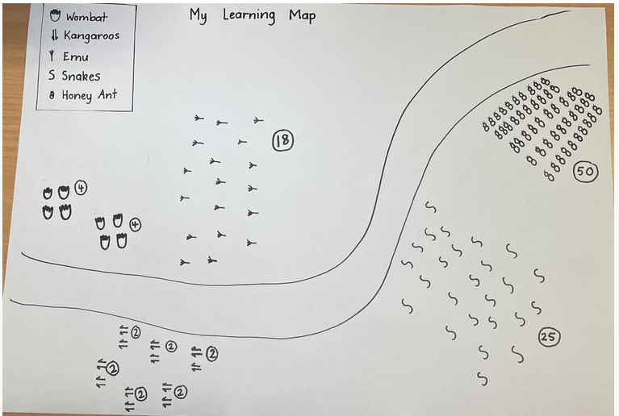
- For Early Stage 1, adjust the story by changing what Ben saw. First, he saw 2 wombats, then he saw 4 kangaroos. Next, he saw 4 emus and after that, 6 snakes. Finally, Ben saw 4 honey ants. Construct a learning map for Early Stage 1 (see Figure 4).
Note: Learning maps can help represent mathematical thinking. They are well organised, easy to follow, and are used by Aboriginal people.
- Discuss that students now need to find the total number of animals found on their map. They need to count efficiently using number lines to help.
- For Stage 1, students will use Resource 4: Number line to 100 to calculate the total number of animals that were seen in the story. Students should focus on using flexible strategies to solve addition problems. This includes non-count-by-one strategies such as doubles, number bonds, and reasoning about relations.
- For Early Stage 1 students, use Resource 5: Number line to 20 to support finding the total number of animals that were seen in the story. Students should use concrete materials such as counters and focus on counting forwards and number bonds where appropriate. Use ‘Talk moves’ to support.
This table details assessment opportunities and differentiation ideas.
Assessment opportunities | Too hard? | Too easy?
What to look for:  - Are students able to add the total number of animals and insects accurately using the number line? (MAO-WM-01, MA1-RWN-01, MA1-CSQ-01)  - Are students able to use symbols to help develop fluency when solving problems? (MAE-CSQ-01, MA1-CSQ-01)  - Can students communicate and explain their thinking? (MAO-WM-01)  What to collect:  - samples of student’s addition on number lines (MAO-WM-01, MAE-RWN-01, MAE-CSQ-01, MA1-RWN-01, MA1-CSQ-01) | Students are unable to find the total of the symbols in the story.  - Use smaller and more familiar numbers.  - Provide a range of concrete materials for students to manipulate such as counters and a ten-frame.  - Model using a number line with students requiring support.  Students are unable to communicate their thinking when recording their ideas on learning map and number line.  - Provide multiple opportunities to develop confidence in terms of counting forwards/backwards, more than/less than, number lines, and so on.  - Support language with visual aids and concrete displays. | Students are able to combine numbers to find the total of the symbols in the story.  - Students record the use of mental strategies to combine numbers on a number line.  - Ask students to explain the strategies they used when combining the number of animals.  Students are able to communicate their thinking when recording their ideas on learning map and number line.  - Students can cross the decades and experience with sequences beyond 100.  - Extend responses by asking students to represent numbers using numerals above 100.

Consolidation and meaningful practice: Connect the mathematics – 15 minutes
- Students share their learning map and calculations with peers in a gallery walk.
- Ask students:
- What did you notice about using simple drawings/symbols in mathematical problems?
- Was it helpful?
- What did you notice about the order of combining numbers and the total?
- What did you notice about using the number line to support combining quantities?

Lesson 4: Sharing mathematical stories
Core concept: The order in which you divide and subtract numbers changes the answer to a problem.
The table below contains suggested learning intentions and success criteria. These are best co-constructed with students.
Learning intentions | Success criteria
Students are learning that:  - the order in which 2 quantities are shared changes the result  - mathematicians can recognise and represent division facts. | Students can:  - record grouping and sharing using drawings, words and numerals  - explain their thinking when sharing collections into 2 groups.  In addition, students working towards Early Stage 1 outcomes can distribute items into equal groups.  In addition, students working towards Stage 1 outcomes can investigate whether the order in which they share collections changes the result.

Daily number sense: Symbol number talk – 15 minutes
- Build student understanding of forming groups and representing division by sharing bees equally on 2 flowers.
- Display Resource 8: Sharing bees. Students turn and talk and discuss, by looking and thinking, if 10 bees can be shared between 2 flowers.
- Ask if 2 flowers can be shared between 10 bees, if you rearranged the numbers.
- Display Resource 9: Organised bees and investigate.
- For Early Stage 1, model distributing objects one-by-one with students until the supply is exhausted.
- For Stage 1, ask the students if it will make a difference to the result if the quantities commute (change position).
The table below outlines stimulus prompts to generate conversation about the topic, along with anticipated responses from students.
Prompts | Anticipated student responses
- What is the difference between these 2 problems?  - Does it make a difference to the results if we change the numbers around when sharing like we have in this problem? | - There is a bigger number at the beginning of the first problem and a smaller number at the beginning of the second problem.  - Yes, it makes a difference. You cannot share a smaller number into a bigger number so the bigger number must always come first.

Sharing story – 30 minutes
- Re-visit the learning maps from Lesson 3.
- Tell Stage 1 students: On Grandma and Ben’s return walk, things quickly changed. The wind blew and nature changed the landscape. They noticed the weather had made all the animals find shelter in equal groups. 8 wombats waddled off for a sleep in 2 burrows, 12 kangaroos sheltered in 3 caves, 18 emus hid under 6 bushes, 25 snakes slithered into 5 holes and 50 honey ants scurried under 5 rocks.
- For Early Stage 1, adjust the story to the following: 2 wombats waddled off to their burrow, 4 kangaroos sheltered in 2 caves, 4 emus hid under one bush, 6 snakes slithered into 3 holes and 4 honey ants scurried under 4 rocks.
- Ask the students:
- Can you think of any strategies we can use to share the animals into equal groups?
- What are some different ways we can represent sharing?
- Use concrete materials, for example, counters, beads, gumnuts, or stones to distribute the collection of each animal into the correct number of groups.
- Discuss how many animals are in each group.
- Students transfer their learning by circling equal groups on their learning map to match their problems (see Figure 5).
Figure 5 – Learning map showing equal groups
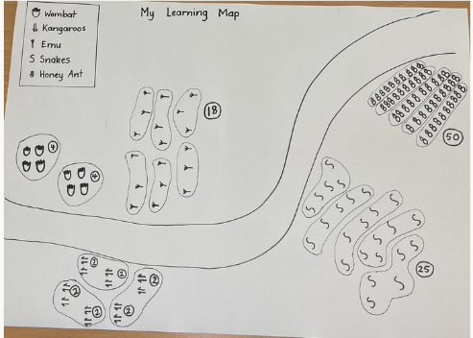
This table details assessment opportunities and differentiation ideas.
Assessment opportunities | Too hard? | Too easy?
What to look for:  - Can students model sharing division by distributing a collection of objects equally into a given number of groups? (MAE-FG-01, MA1-FG-01)  - Can students model grouping division by determining the number of groups of a given size that can be formed? (MAE-FG-01, MA1-FG-01)  - Can students explain their thinking? (MAO-WM-01)  What to collect:  - learning maps work sample (MAE-FG-01, MA1-FG-01)  - samples of student’s addition on number lines (MAE-FG-01, MA1-FG-01) | Students are unable to share collections equally between 2 shelters.  - Use smaller and more familiar numbers, for example, 4 shared between 2.  - Provide a range of concrete materials for students to use/manipulate.  - Model sharing a collection and work with individual students.  Students are unable to explain their thinking.  - Provide multiple opportunities to develop confidence in terms of grouping, sharing and equivalence.  - Support language with visual aids and concrete displays. | Students are able to share equally large collections between 2 shelters.  - Use larger numbers to share into groups.  - Use numbers that will have a remainder to share.  - Students write the multiplication problem that is opposite of the sharing problem.  Students are able to explain their thinking.  - Provide opportunities to record learning and connect words and symbols of division in written number sentences.  - Justify results by the reversal of the process linking multiplication and division.

Consolidation and meaningful practice: Discuss and connect the mathematics – 15 minutes
- Summarise the lesson together, drawing out some key mathematical ideas about sharing with students. Guide students to notice that:
- the bigger number comes first in division and subtraction problems
- the order in which 2 quantities are shared changes the result
- mathematicians can recognise and represent division facts
- when students tell mathematical stories, they need to show the start, the change, and the result (end of the story).

Lesson 5: How many legs? – Part 1
Core concept: You can multiply and add numbers in any order and the answer does not change
The table below contains suggested learning intentions and success criteria. These are best co-constructed with students.
Learning intentions | Success criteria
All students are learning that:  - numbers can be multiplied in any order and the answer to a problem does not change (commutative property)  - numbers can be added in any order and the answer to a problem does not change (commutative property)  - repeated addition can be used to solve multiplication problems. | All students can:  - use concrete materials or fingers to model and solve addition and subtraction questions, counting forwards or backwards by ones as necessary  - record grouping using drawings, words, and numerals, and explain their thinking.  Students working towards Early Stage 1 outcomes can describe the action of combining, separating and comparing quantities.  Students working towards Stage 1 outcomes can:  - use repeated addition to solve multiplication problems  - record and solve simple multiplication problems to show an understanding of commutative property  - record and solve simple multiplication problems.

Daily number sense: Array talk – 10 minutes
- Build student understanding of whole numbers by subitising dots in arrays.
- Display Resource 10: Arrays.
- Ask students:
- What do you see?
- How are the dots arranged?
- How did you work out the total?
- Are the dots the same or different? How do you know?
- Students turn and talk to share their thinking with a partner.
- Ask students to share their responses. Record students’ thinking on a class anchor chart.

How many legs? Addition – 20 minutes
- Read How Many Legs? Ask the students how the boy worked out the total number of legs. Record student ideas on the board.
- Ask the students how many legs there would be altogether if there was an octopus, a person, and a dog in a room.
- Students turn and talk to share their thinking with a partner. Circulate the room, monitoring student thinking.
- Students write a number sentence to represent the problem and use additive strategies like counting-on to calculate the total number of legs.
- Students share their working with the class, explaining their thinking and how they represented and solved the problem.
- Working in pairs, students cut out animal picture cards from Resource 11: Animal cards and place face down in a pile.
- Students turn over 3 animal picture cards and calculate the total number of legs on all the animals. Students record their number sentence and show their working out. For example, 4 + 2 + 4 = 10, 2 + 4 + 4 = 10.
- Early Stage 1 students use concrete materials to count and record using drawings, words, and numerals to explain their thinking.
- Bring the class together and instruct students to change the order of their 3 animal cards. Students record their number sentence.
- Explain the commutative property of addition. Ask students if the answer would be the same if they changed the order of the cards.
Commutative property states that when the order of numbers in an addition or multiplication operation are changed, the answer remains the same.

How many legs? Multiplication – 20 minutes
- Ask the students how many legs there would be altogether if there were 3 dogs in a room.
- Students turn and talk to share their thinking with a partner. Circulate the room, monitoring student thinking.
- Ask Early Stage 1 students to draw 3 dogs and count the dogs’ legs, focusing on one-to-one correspondence.
- Ask Stage 1 students to write a multiplication number sentence to work out the total number of legs. For example, 3 groups of 4 = ? (see Figure 6).
Figure 6 – Example arrays of 12 counters
Note: Stage 1 students can use an array, skip counting, or repeated addition to solve the problem.
- Students share their number sentence, explaining their thinking. Record students’ number sentences on the board, focusing on repeated addition as the preferred strategy.
- Write the following word problems on the board and discuss what students notice:
- If there are 2 cows in the room, how many legs are there altogether?
- If there are 4 people in the room, how many legs are there altogether?
- Prompt students to explain whether they think the answers are the same and if it is an example of commutative property.
- For Early Stage 1, students use counters to group and solve the problems.
This table details assessment opportunities and differentiation ideas.
Assessment opportunities | Too hard? | Too easy?
What to look for:  - Are students creating arrays to solve multiplication problems? (MAE-FG-01, MA1-FG-01)  - Are students using repeated addition to solve multiplication problems? (MA1-FG-01)  - Are students demonstrating an understanding of commutative property? (MA1-FG-01)  - Can students create a number sentence to record multiplication problems? (MA1-FG-01)  - Can students explain how they got an answer and show their working? (MAO-WM-01)  What to collect:  - observational data (MAO-WM-01, MAE-FG-01, MA1-FG-01)  - student work samples (MAO-WM-01, MAE-FG-01, MA1-FG-01) | Students are unable to draw arrays or use repeated addition to solve multiplication problems.  - Remove some animals from the problems so that students are adding less legs.  - Provide ten-frames and counters to students to help with repeated addition.  - Model how to form arrays with counters and how to then count these.  Students are unable to record multiplication problems using a number sentence.  - Model how to record number sentences using the arrays that students have formed.  - Use ‘groups of’ and repeated addition before progressing to rows and columns of. | Students are able to draw arrays and use repeated addition to solve multiplication problems.  - Add more animals to the problems so that students are adding and multiplying more legs.  - Challenge students with a backwards problem. Tell students that there are 24 legs and ask what animals there could be.  Students are able to record multiplication problems using a number sentence.  - Model commutative property of multiplication. For example, 2 rows of 3 is the same amount as 3 rows of 2.  - Ask students to explain and justify how they came to their answer.

Discuss and connect the mathematics – 10 minutes
- Summarise the lesson together, drawing out some key mathematical ideas.
- Ask students:
- Which strategy did you use to find the solution? Which one are you most comfortable using?
- Did you find any examples of commutative property?
- Does changing the order of the legs change the total?
- Were the arrays the same or different? Why?
- How did you work like a mathematician today?

Lesson 6: How many legs? – Part 2
Core concept: A collection can be changed by adding items (joining) or taking some away (separating).
The table below contains suggested learning intentions and success criteria. These are best co-constructed with students.
Learning intentions | Success criteria
All students are learning that:  - a collection can be changed by adding items (joining)  - a collection can be changed by taking away items (separating). | All students can apply the terms ‘join’ and ‘separate’ to describe combining and separating quantities.  In addition, students working towards Early Stage 1 outcomes can use concrete materials or fingers to model and solve addition and subtraction questions, counting forwards or backwards by ones as necessary.  In addition, students working towards Stage 1 outcomes can:  - represent addition and subtraction word problems as number sentences  - solve addition problems using counting on strategies  - solve subtraction problems using counting back strategies.

Daily number sense: Data – 15 minutes
- Build student understanding of data by interpreting data displays.
- Display Resource 12: Data talk. Ask students what they notice. Students turn and talk to a partner about what they notice.
- Students share what they noticed with the class. Ask the students:
- Which animal is the most common? How do you know?
- Which animal is the least common? How do you know?
- Are there any that are the same? How do you know?
- How many more horses are there than cows?
- How many horses and cows are there altogether?

How many legs? Addition – 15 minutes
- Explain that there were 10 legs at a party and ask students what this could look like. Students turn and talk to share their thinking with a partner. Circulate the room, monitoring student thinking.
- Ask pairs of Early Stage 1 students to draw as many possibilities of 10 animal legs as possible. Record learning by drawing a picture.
- Ask Stage 1 students how many legs there would be altogether if an octopus joined.
- Ask the students to write a number sentence to represent the word problem. Explain to students that joining means adding, and they are to use additive strategies, for example, counting on to work out the total number of legs. Students record number sentences and show their working out.
- Display and discuss addition and subtraction word problems.
- Working in pairs, students solve the addition word problems. They record their number sentences and show their working out in their workbooks.

How many legs? Subtraction – 15 minutes
- Explain that there are 20 legs at the party and then the octopus leaves. Ask how many legs are left.
- Students turn and talk to share their thinking with a partner. Circulate the room, monitoring student thinking.
- Ask students to write a number sentence to represent the word problem.
- For Early Stage 1 students, provide 2 ten-frames with counters. Ask students to take away 8 counters and count backwards.
- Students can draw representations and discuss with a partner.
- Explain to students that to separate means to subtract and use additive strategies, for example, counting back to work out how many legs are left. Students record their number sentence and show their working out.
- Working in pairs, Stage 1 students solve the subtraction word problems on Resource 13: Problems. Students record their number sentences and show their working out.
Note: Formal writing of number sentences, including the use of the symbols +, − and = is introduced in Stage 1.
This table details assessment opportunities and differentiation ideas.
Assessment opportunities | Too hard? | Too easy?
What to look for:  - Are students using a number sentence to represent an addition or subtraction word problem? (MAE-CSQ-01, MA1-CSQ-01)  - Are students using counting on strategies to solve addition problems? (MAE-CSQ-01, MA1-CSQ-01)  - Are students using counting back strategies to solve subtraction problems? (MAE-CSQ-01, MA1-CSQ-01)  - Are students explaining how they got an answer and showing their working out? (MAO-WM-01)  What to collect:  - students’ drawings or workbooks with the working out to the problems (MAE-CSQ-01, MA1-CSQ-0, MAO-WM-01) | Students are unable to use counting on and counting back strategies to solve the problems.  - Use concrete materials like counters and ten-frames to solve addition and subtraction problems.  - Use a different animal that does not have as many legs as an octopus to solve the problem.  Students are unable to explain and record their thinking.  - Support engagement through storytelling of combining and separating quantities  - Visualise and model drawing experiences to further develop vocabulary of counting forwards, combining, counting backwards and so on. | Students are able to use flexible strategies to solve addition and subtraction problems.  - Add an extra step to the problems to make them more complicated.  - Ask students to write their own problems and see if another student can solve them.  Students are able to explain and record their thinking  - Discuss different ways of expressing subtraction such as minus, take away, less than, how many are left and so on.  - Discuss the word order which makes questions challenging.

Consolidation and meaningful practice: Discussing and connecting some of the mathematics – 10 minutes
- Gather and display the number sentences from each group of students. Bring the class together to discuss what they notice.
The table below outlines stimulus prompts to generate conversation about the topic, along with anticipated responses from students.
Prompt | Anticipated student responses
What do you notice about the number sentences and working out? | - When we join or add numbers to a collection, the total number goes up.  - When we separate or subtract numbers from a collection, the total number goes down.

Lesson 7: Keeping time
Core concept: The difference does not change if you add or subtract the same amount to/from both numbers.
The table below contains suggested learning intentions and success criteria. These are best co-constructed with students.
Learning intentions | Success criteria
All students are learning that:  - adding the same quantity to 2 durations of time does not change the difference between them  - seeing and creating number patterns helps us see the relationship between numbers. | All students can:  - estimate duration using units of time  - demonstrate understanding of the properties of addition and subtraction.  In addition, students working towards Early Stage 1 outcomes can:  - read numerals and represents whole numbers to at least 20  - sequence events.  In addition, students working towards Stage 1 outcomes can understand the similarities between a number line and a clock.

Daily number sense: How long will it take? – 20 minutes
- Build student understanding of duration by gathering classroom data about time taken to complete activities.
- Build student understanding of sense of time by practical experiences measuring time.
- Set 5 tasks for the students to undertake and ask students to estimate how long each task takes in minutes. Examples of tasks might include eating a piece of fruit, marking the roll, time taken for a student to have a drink from the bubbler, reading activities and so on. Allow students to Think-Pair-Share and have them record their estimations in their books.
- Display the timer on the board, ensuring all students can see it. Explain to students that they must start doing their activity as soon as the timer on the board starts, and as soon as everybody finishes this activity, you will stop the timer and allow the students to record this time to the nearest minute.
- Students then record these times next to their original estimates. Record the actual times that all the tasks take on an anchor chart and retain this chart for Lesson 8 as a reference.
- Ask students to turn and talk, brainstorming other activities they might like to add to the chart.
- Alternatively, you may choose to make this a homework task and include tasks such as brushing teeth, feed a pet, make a bed and so on. These can be added to the anchor chart (see Figure 7).
Figure 7 – Time taken to complete tasks
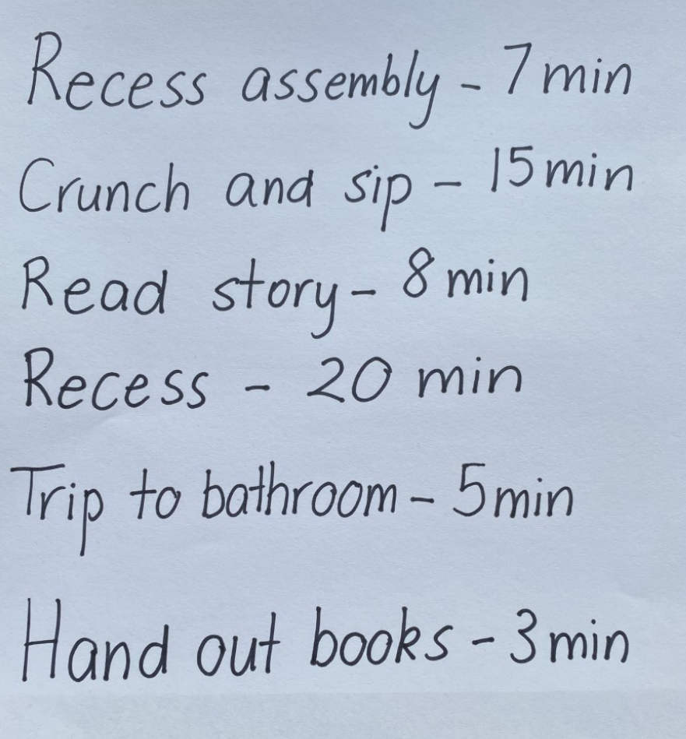
This table details assessment opportunities and differentiation ideas.
Assessment opportunities | Too hard? | Too easy?
What to look for:  - Can students make reasonable estimations on set tasks? (MAO-WM-01, MA1-NSM-02)  What to collect:  - student estimations and recording of lengths (MAO-WM-01) | Students are unable to measure and estimate time.  - Use an analogue timer with second hand to display time throughout the day to support future learning.  - Provide opportunities to develop confidence using vocabulary such as time, minute, clock, second and so on.  - Revisit telling the time to the hour, half hour and quarter hour. | Students are able to estimate and measure time.  - Hide the timer and ask students to estimate a range of times. For example, 10 seconds, 30 seconds, one minute or 2 minutes.  - Estimate how long a variable task might take, discussing factors that may influence the duration. For instance, reading a book, collecting something from the office or drawing a picture.

Constant difference rule using a number line – 20 minutes
- Ask Early Stage 1 students to order numeral cards 1-20 and then write each numeral on their independent whiteboard and match with corresponding number of counters.
- Draw an empty number line of the floor using chalk. Tell Stage 1 students they need to help write the numbers on the number line.
- Ask students where the number 20 would be placed on the number line.
- Ask students to use their mathematical looking and thinking to work out where 10 would be placed.
- Repeat with numbers 5, 11,19. Ask students to justify their responses.
- Discuss that the numbers and spaces on the number line are called intervals.
- Remind students that the space between each interval must be an even unit.
- Display Resource 5: Number line to 20.
- Alternatively, you may also choose to use the digital Number line.
- Ask students what they think the interval is between each number. Students should be able to see that there is one interval between each number on the number line.
Constant difference refers to a common difference between pairs of numbers. For example, the difference between 3 and 7 is 4, and another pair of numbers that has a difference of 4 is 2 and 6.
- Ask students:
- What are the intervals between 5 and 7? How many intervals are there?
- What is the difference between the numbers 15 and 17?
- How are the numbers the same? How are these numbers different?
- Ask the students, ‘What do you notice about the numbers?’ Encourage students to discover that by adding the same amount to each number, the difference between the 2 numbers is the same. Repeat this activity with 2 more numbers if necessary.
- Ask the students the following and model moving forwards and backwards to perform the calculations on the number line:
- If I started at 5, and needed to add 10, what are the intervals between 5 and 15?
- If I added 10 to 7 on the number line, what is the interval between 7 and 17?
- How are the numbers the same? How are these numbers different?
- Ask the students, ‘What do you notice about these 2 numbers?’ Encourage students to discover that by adding the same amount to each number, the difference between the 2 numbers is the same (see Figure 8).
Figure 8 – Number line from 1-20
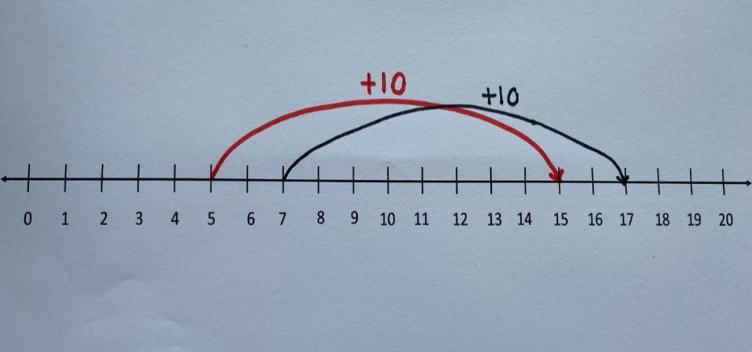
- As a class, discuss that constant difference refers to the idea that the difference between 2 numbers does not change after adding or subtracting the same quantity to both numbers. Record on an anchor chart to be used in Lesson 8.

Consolidation and meaningful practice: Clock as a number line – 20 minutes
- Show students a clock face and Resource 14: Number line 1-60.
- Using prompts from the table, ask questions that elicit responses for students to make connections between the number line and the face of a clock.
The table below outlines stimulus prompts to generate conversation about the topic, along with anticipated responses from students.
Prompts | Anticipated student responses
- What do you notice about this number line?  - Does this number line remind you of anything else?  - What is the same about the clock face and the number line?  - What pattern can you see in the numbers? | - Numbers from 1-60, counting by fives.  - That there are lines between each of the numbers, but only every fifth number is recorded.  - That a clock face has the same format as the number line, it is just in a circle.  - The clock face counts by 5 intervals.
- Explain to students that an analogue clock is made by curving a number line from 1-12 around the outside of the circle. Prompt students to make the connection between a number line and a clock.
- Using the number line in Resource 14: Number line 1-60, demonstrate the constant difference between 2 points.
- Apply this concept to the face of a clock. For example, demonstrate it takes 5 minutes for the minute hand to move from 2 to 3.
The table below outlines stimulus prompts to generate conversation about the topic, along with anticipated responses from students.
Prompts | Anticipated student responses
- If it takes 5 minutes for the minute hand to move from 2 to 3, how long does it take for the minute hand to move from 3 to 4?  - How long does it take for the minute hand to move from 5 to 7? Does it take the same amount of time to travel from 9 to 11?  - How does the clock face relate to our number line? | - It takes 5 minutes for the minute hand to move from one number to the next, irrespective of where it starts.  - That there are lines between each of the numbers, but only every fifth number is recorded.  - That a clock face has the same format as a number line.  - We can transfer our knowledge of a number line to a clock.  - That the numbers on the clock do not represent the minutes.
- For Early Stage 1 students, explain to students that the numbers on the clock face are in a pattern.
- Have students make patterns with counters or beads.
- Place Resource 3: Numeral cards 0-30 face down in order from 0-20 in a circle. Ask Early Stage 1 students to turn over every card and identify the number and what number comes before and after each number.
- Have students sequence numeral cards 1-12 and make a circle with the numeral cards to represent a clock face.
- Ask students to draw a picture representing day and night. Discuss things that generally happen during the day and the night.
- Ask students to tell you if something is more likely to happen during the day or night, for example, going to school, eating breakfast, going to bed.
- Provide each Stage 1 student with 2 strips of paper. Ask students to draw their own number line counting by ones to 12, measuring the intervals to ensure these are even. This represents the hours on the clock (see Figure 9).
- Ask students to draw a second number line with the same intervals, but to label it by counting by fives to 60. This represents the minutes on the clock.
- Ask students to compare the 2 number lines and look for patterns.

- Ask students:
- What do you notice?
- How many minutes relate to 2 hours?
- How many minutes relate to 6 hours?
Figure 9 – Clock on a number line
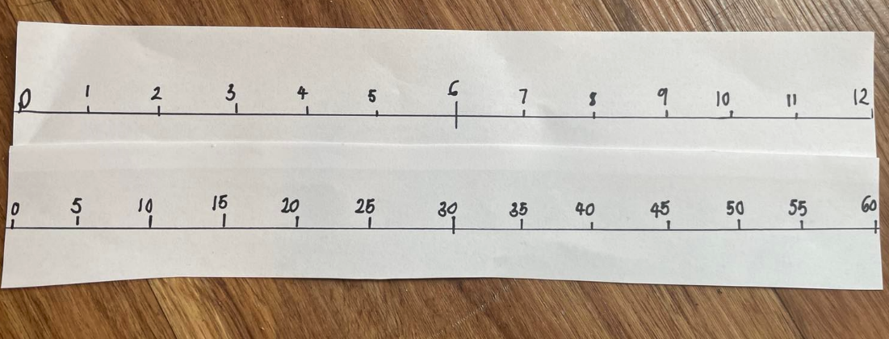

Lesson 8: Let’s test it!
Core concept: Mathematicians use evidence to make mathematical arguments and justify their thinking.
The table below contains suggested learning intentions and success criteria. These are best co-constructed with students.
Learning intentions | Success criteria
Students are learning that:  - using flexible addition and subtraction strategies efficiently solve number problems  - they can represent addition and subtraction using structured materials such as a number track or number line. | All students can:  - use flexible thinking to solve addition and subtraction problems  - use appropriate strategies to solve word problems involving time.  In addition, students working towards Early Stage 1 outcomes can:  - compare the duration of 2 events  - sequence events in time.  In addition, students working towards Stage 1 outcomes can sequence numbers and arrange them in order.

Daily number sense: Constant difference on a rekenrek – 20 minutes
- Build student understanding of combining and separating quantities by exploring constant difference.
- Remind students constant difference refers to a common difference between pairs of numbers.
- Display a digital rekenrek from the Digital Learning Selector.
- Roll a 6-sided die and move the corresponding number of beads on the top rekenrek.
- Roll a 6-sided die again and move the corresponding number of beads on the bottom rekenrek.
- Roll the 6-sided die a third time. Move this number of beads on each rekenrek.
- Ask students:
- What did you notice?
- What is the difference between rekenrek 1 and 2?
- Is the difference the same or different?
- Is the rule from the anchor chart in Lesson 7 still correct?
- In pairs, students can repeat the process using their own rekenrek and 6-sided die.

Timeline of activities – 30 minutes
- Display the anchor chart from timed activities in Lesson 7 and provide each student with Resource 5: Number line to 20.
- Demonstrate finding the number of minutes on the number line and marking. For example, it took 3 minutes to hand out books, find 3 on the number line and mark and label.
- Continue to mark the 5 events on the number line or use the numeral cards and counters for Early Stage 1 students.
- Once students have plotted all the activities on the number line, ask the students to turn and talk and discuss:
- What activity takes the longest to complete?
- How many more minutes does it take to read a story than go to the bathroom?
- What takes longer, assembly or crunch and sip? How much longer?
- If I was to read a story and go to assembly, how long would it take me altogether?
Note: For Stage 1 students, encourage students to use efficient and flexible mental strategies such as bridging to 10, number bonds and so on to solve problems
- Ask students what the word difference means. Discuss, in everyday language, that the word difference can refer to any attribute. However, it has a specific meaning in number questions where it means the distance between 2 numbers on a number line.
- Explain that students need to know the difference in time in everyday life. Ask the students if they can think of an example where it would be helpful to know the difference in time.
- Ask the students to turn and talk to discuss everyday time differences. For example, making sure you have enough time to get ready for a birthday party, knowing how long it will take to drive somewhere and so on.
This table details assessment opportunities and differentiation ideas.
Assessment opportunities | Too hard? | Too easy?
What to look for:  - Are students able to count by ones to find the total or difference? (MAO-WM-01, MAE-CSQ-01)  - Are students using flexible additive strategies to solve word problems? (MAO-WM-01, MA1-CSQ-01)  What to collect:  - observational data (MAO-WM-01, MAE-CSQ-01)  - observations of students communicating and recording their thinking and reasoning coherently and clearly (MAO-WM-01, MA1-CSQ-01)  - number lines that students have completed (MAO-WM-01, MA1-CSQ-01) | Students are unable to plot the events correctly on the number line.  - Pair these students with students that have a thorough understanding of the strategies to model the concepts taught.  - Model plotting points on a number line.  Students are unable to solve problems using flexible addition and subtraction strategies.  - Use smaller numbers and concrete materials, for example, bead strings and hundreds chart, to develop the concept.  - Model the flexible strategies several times using a number line until the student has a better understanding. | Students are able to plot events correctly on the number line.  - Students create their own word problems about the timeline and have their peers solve them.  - Students can explain how they solved the problem and the strategies they used.  Students are able to solve word problems using flexible addition and subtraction strategies.  - Students write a sentence to explain how addition assisted them to solve a subtraction problem.  - Once students are confident with taking away on the number lines, students could use inverse relationships such as counting on to solve problems.

Consolidation and meaningful practice: Word problems – 20 minutes
- Ask Early Stage 1 students to look for pictures of night-time and daytime activities in a magazine. They then cut out and glue the pictures onto butcher’s paper, showing night-time activities at the top and daytime activities at the bottom of the paper. Students can draw additional activities if they can’t find the pictures. Ask students to share their poster with the class and discuss activities that could possibly be done during the day or night.
- Provide groups of Stage 1 students with a large piece of butcher’s paper and have them complete the word problems on Resource 15: Word problems.
- Explain that mathematicians draw to help them solve problems. Students may draw a number line to help solve the problems.
- As a group, read the question in Problem 2 and discuss the important information. Ask students:
- Are there are any words they need help with?
- Can you tell me what the question is asking you to find out?
- What could you do to get to the answer?
- Ask students to try to solve the word problems. As they are completing a problem, use ‘Talk moves’ to guide and support reasoning.
- Ask students to record the answer.
- Repeat process for other problems.
- Students share their learning and give peer-to-peer feedback.
Note: Teachers may choose to use Newman’s Error Analysis to support this learning.
This table details assessment opportunities and differentiation ideas.
Assessment opportunities | Too hard? | Too easy?
What to look for:  - Are students using flexible additive and subtraction strategies to solve word problems? (MAO-WM-01, MA1-CSQ-01)  - Can students sequence events? (MAE-NSM-02)  What to collect:  - work samples (MAE-NSM-02, MA1-CSQ-01)  - students communicating and recording their thinking and reasoning coherently and clearly (MAO-WM-01, MA1-CSQ-01) | Students have difficulty solving the problems using flexible strategies.  - Pair these students with students that have a thorough understanding of the strategies to model the concepts taught.  - Use Newman’s Prompts as a group. | Students easily and confidently use flexible strategies to solve the word problems.  - Students can create their own word problems and have their peers solve them.  - Students can explain how they solved the problem and the strategies they used.

Resource 1: Unorganised pasta
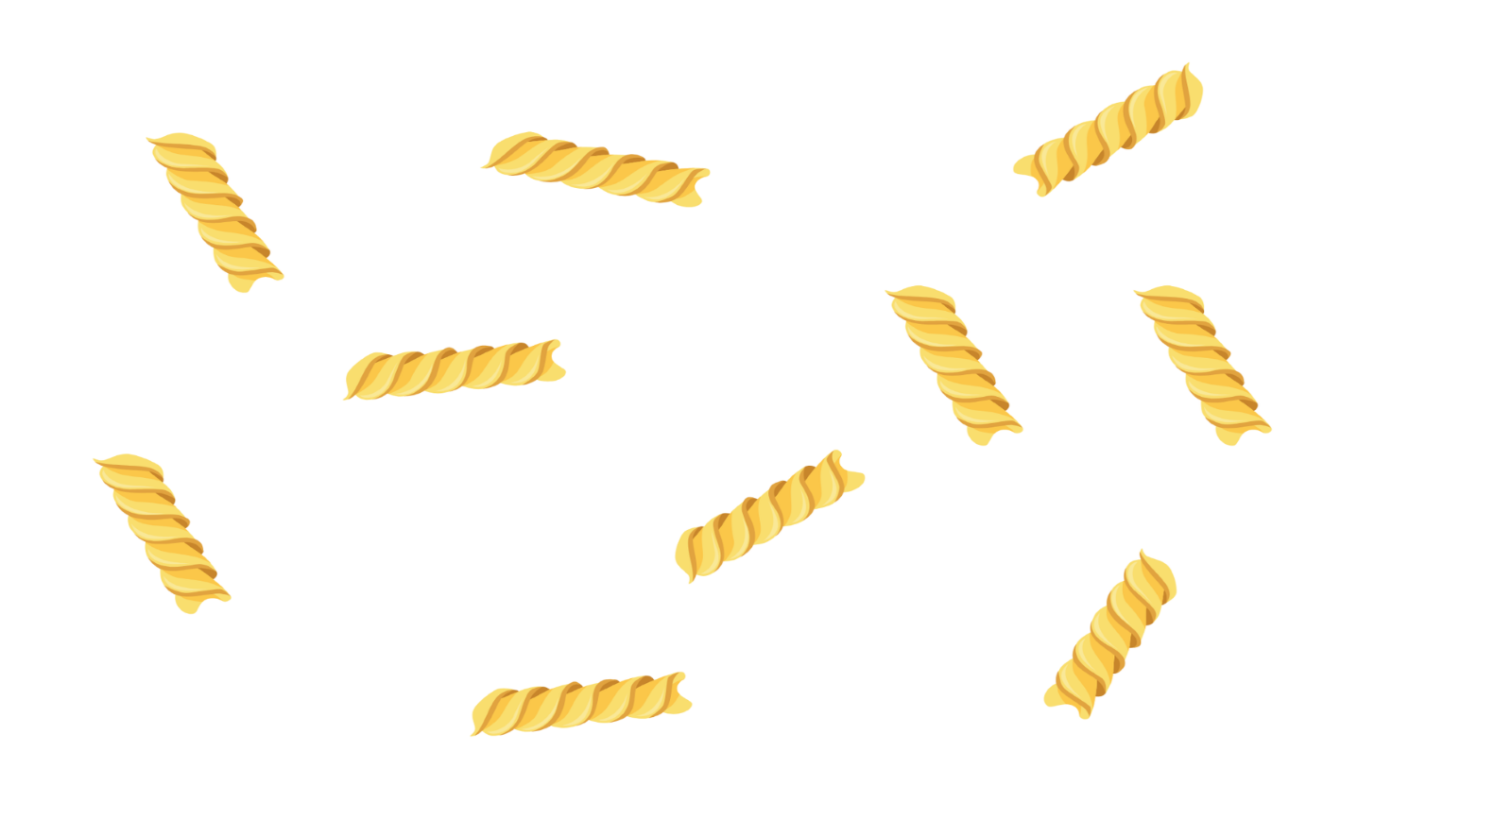
Image sourced from Canva and used in accordance with the Canva Content License Agreement.

Resource 2: Organised pasta
Image sourced from Canva and used in accordance with the Canva Content License Agreement.

Resource 3: Numeral cards 0-30
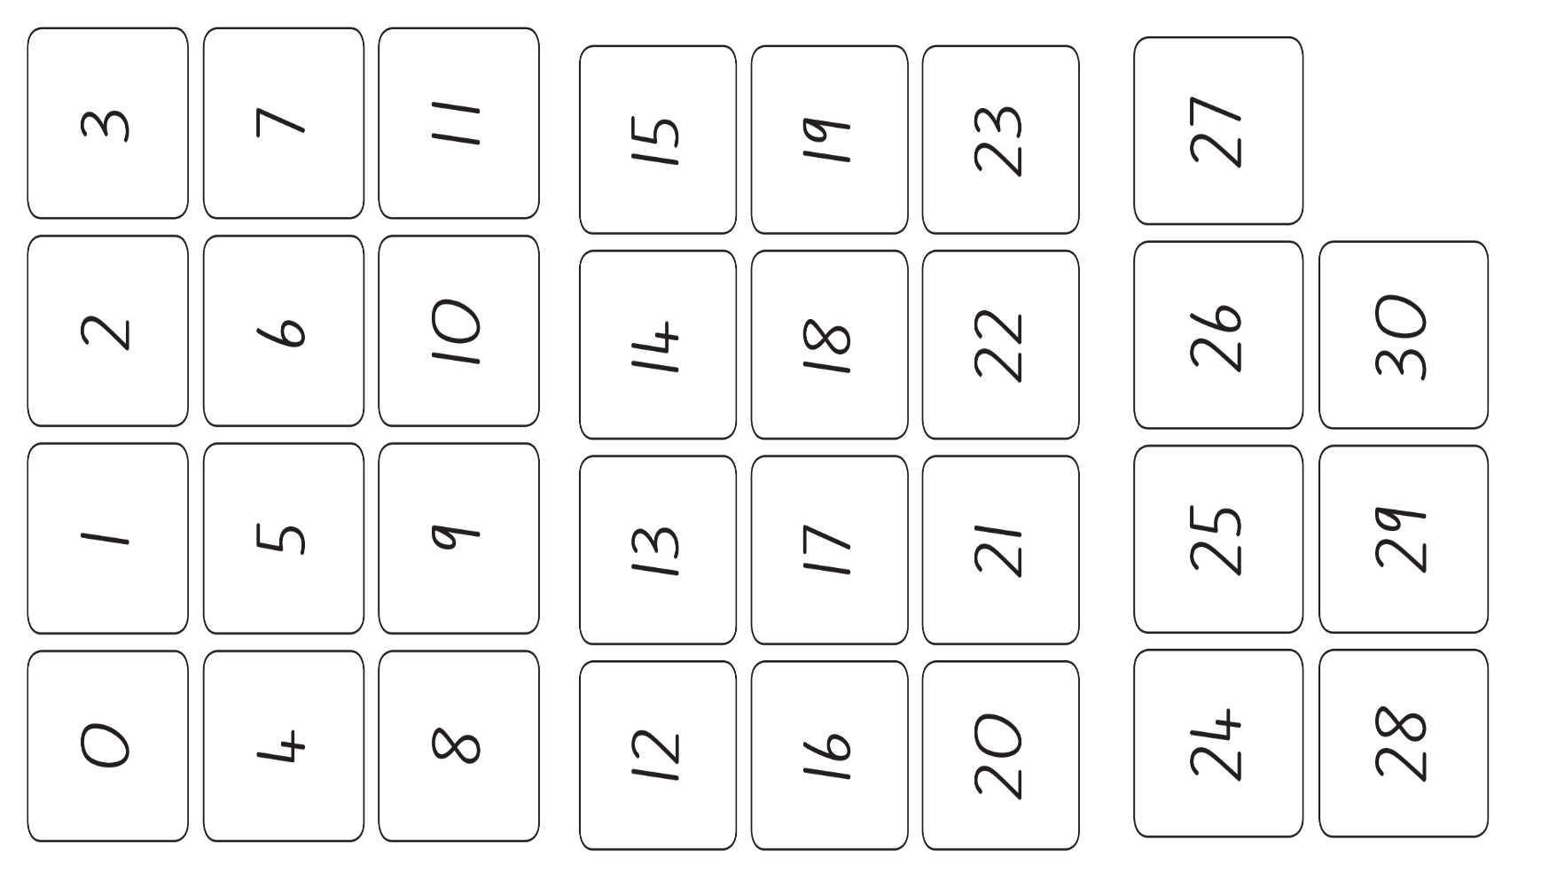

Resource 4: Number line to 100
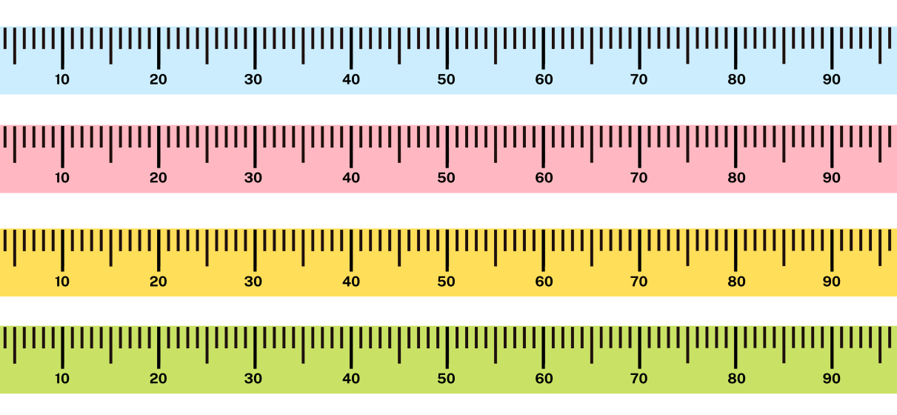
Images sourced from Canva and used in accordance with the Canva Content License Agreement.

Resource 5: Number line to 20
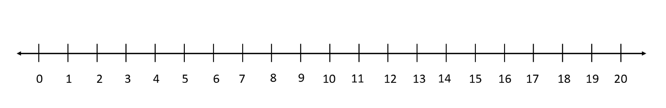

Resource 6: Unorganised symbols
Images sourced from Canva and used in accordance with the Canva Content License Agreement.

Resource 7: Organised symbols
Images sourced from Canva and used in accordance with the Canva Content License Agreement.

Resource 8: Sharing bees
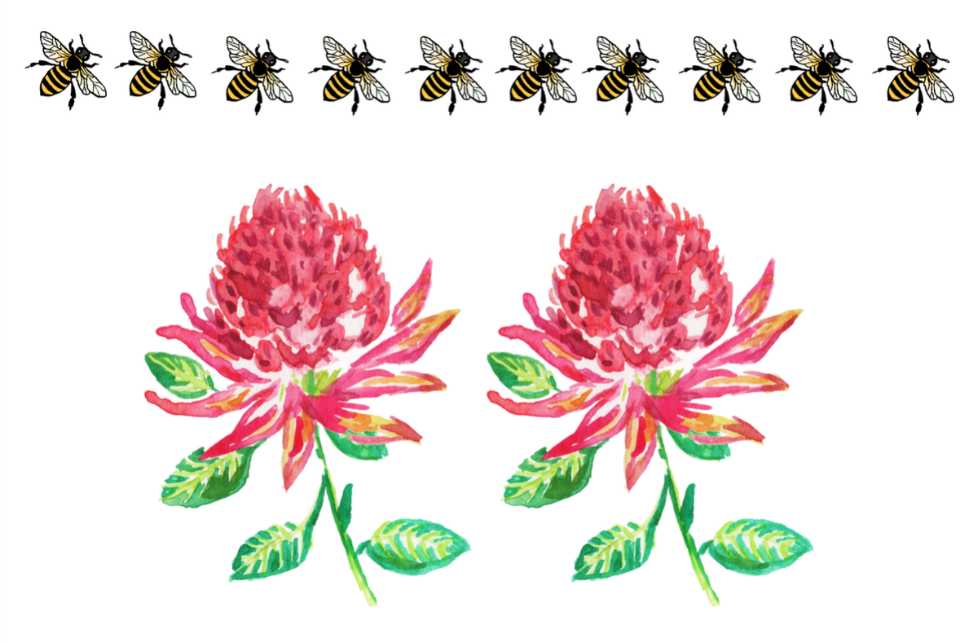
Images sourced from Canva and used in accordance with the Canva Content License Agreement.

Resource 9: Organised bees
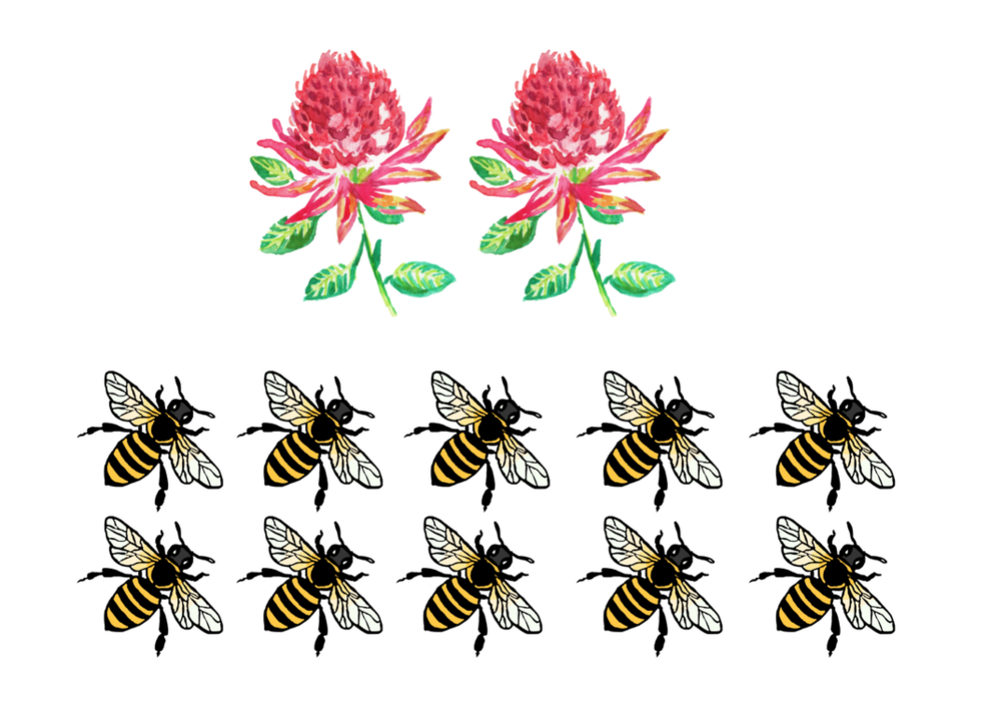
Images sourced from Canva and used in accordance with the Canva Content License Agreement.

Resource 10: Arrays

Resource 11: Animal cards
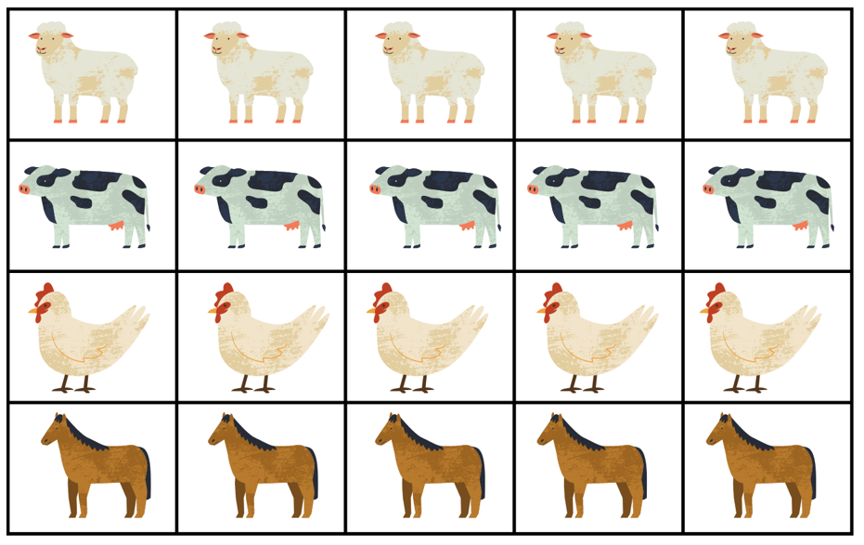
Images sourced from Canva and used in accordance with the Canva Content License Agreement.
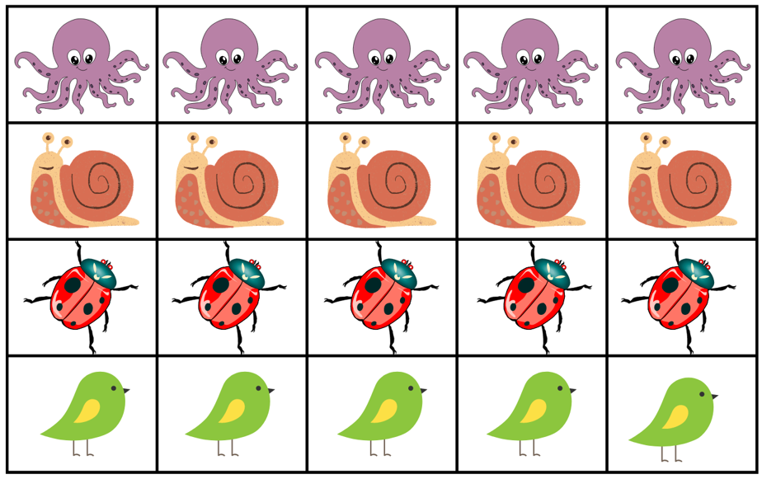
Images sourced from Canva and used in accordance with the Canva Content License Agreement.

Resource 12: Data talk
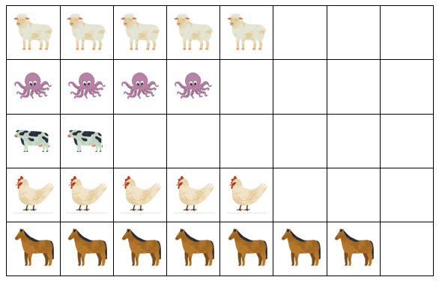
Images sourced from Canva and used in accordance with the Canva Content License Agreement.

Resource 13: Addition and subtraction word problems
Addition
- If there are 10 legs at a party and a ladybug joins the party, how many legs will there be altogether?
- If there are 12 legs at a party and a cow joins the party, how many legs will there be altogether?
- If there are 15 legs at a party and a horse joins the party, how many legs will there be altogether?
- If there are 8 legs at a party and a chicken and octopus join the party, how many legs will there be altogether?
Subtraction
- If there are 16 legs at a party and a horse gets separated from the party, how many legs will be left at the party?
- If there are 12 legs at a party and a chicken gets separated from the party, how many legs will be left at the party?
- If there are 15 legs at a party and a ladybug gets separated from the party, how many legs will be left at the party?
- If there are 11 legs at a party and an octopus gets separated from the party, how many legs will be left at the party?

Resource 14: Number line 1-60

Resource 15: Word problems
After calculating each of these problems, test the rule you created in Lesson 7 to see if it still applies.
- Charlie and Arlo ran in a race. Charlie ran the race in 60 seconds, Arlo ran the race in 90 seconds. What is the difference between the 2 boys’ times? The second time the boys ran the same race, they were tired, and it took each of them 20 seconds longer. What time did the boys run in the second race? What is the difference between the 2 boys in this race?
- It will be Matilda’s birthday in 3 days. It will be Harry’s birthday in 10 days. How many days are in between the children’s birthdays? Will the difference be the same tomorrow?
- Kate and Ari were born on the same day, 5 years apart. Kate is 4 and Ari is 9. Next year, how old will the children be? What will be the difference between their ages?
- The minute hand takes 20 minutes to move from 3 to 7 on a clock. After 20 minutes, what will it be pointing to if starts on the 4? What if it starts on the 8? What if it starts on the 10?

Syllabus outcomes and content
The table below outlines the syllabus outcomes and range of relevant syllabus content covered in this unit. Content is linked to National Numeracy Learning Progression version (3).
Focus area and outcomes | Content groups and content points | Lessons
Representing whole numbers  MAO-WM-01  MAE-RWN-01  MAE-RWN-02 | Early Stage 1  Instantly name the number of objects within small collections  - instantly recognise (subitise) the number of items in small groups of up to four items without counting (NPV2, CPr1)  Use the counting sequence of ones flexibly  - count forwards to at least 30 and state the number after or before a given number, without needing to count from one (CPr4)  Recognise number patterns  - recognise dice and domino dot patterns (NPA1, NPV2, CPr2)  Connect counting and numerals to quantities  - count with one-to-one correspondence, recognising that the last number name represents the total number in the collection (CPr3, CPr5)  - count out a specified number of objects (from 5 to 20) from a larger collection, keeping track of the count (CPr4, CPr5)  - compare and order numbers to 20 (NPV2, NPV3) | 1-4
Representing whole numbers A  MAO-WM-01  MA1-RWN-01  MA1-RWN-02 | Stage 1  Use counting sequences of ones with two-digit numbers and beyond  - identify the number before and after a given two-digit number (CPr5)  - count forwards and backwards by ones from a given number to at least 120 (CPr6)  Continue and create number patterns  - count forwards and backwards by twos from any starting point (CPr6-CPr7, MuS2)  Represent numbers on a line  - sequence numbers and arrange them on a line by considering the order and size of those numbers (QuN8) (CPr5) | 1-5
Representing whole numbers B  MAO-WM-01  MA1-RWN-01  MA1-RWN-02 | Use counting sequences of ones and tens flexibly  - count forwards and backwards by tens, on and off the decade, with two- and three-digit numbers (CPr7)  - identify how many more to the next multiple of ten within two- and three-digit numbers  Form, regroup and rename three-digit numbers  - count and represent large sets of objects by systematically grouping in tens and hundreds (CPr7, NPV5)  - state the quantity value of digits in numbers of up to three digits (NPV5) | 1-3
Combining and separating quantities  MAO-WM-01  MAE-CSQ-01  MAE-CSQ-02 | Early Stage 1  Model additive relations and compare quantities  - identify situations in which addition and subtraction may be applied (AdS1-AdS2)  - combine two or more groups of objects to model addition, identifying the relationship between the parts and the whole (AdS1, AdS2)  - use concrete materials or fingers to model and solve addition and subtraction questions, counting forwards or backwards by ones as necessary (AdS1-AdS2, NPV3) | 2-3, 5-8
Combining and separating quantities A  MAO-WM-01  MA1-CSQ-01 | Stage 1  Use flexible strategies to solve addition and subtraction problems  - represent addition and subtraction using structured materials such as a bead string or similar model (AdS6-AdS7)  - select and apply strategies using number bonds to solve addition and subtraction problems with one- and two-digit numbers by partitioning numbers using quantity value and bridging to 10 (AdS6-AdS7) | 3, 5-8
Combining and separating quantities B  MAO-WM-01  MA1-CSQ-01 | Stage 1  Represent and reason about additive relations  - create, record and recognise combinations of two numbers that add to numbers from 11 up to and including 20 (AdS7)  - create, model and solve word problems, using number sentences  - represent the difference between two numbers using concrete materials and diagrams (AdS6)  - recall and use related addition and subtraction number facts to at least 20 (AdS7) | 5, 6
Forming groups  MAO-WM-01  MAE-FG-01  MAE-FG-02 | Early Stage 1:  Investigate and form equal groups by sharing  - distribute a group of familiar objects into smaller groups and recognise whether the number in each group is equal or not (MuS1-MuS2)  Record grouping and sharing  - label the number of objects in a group  - record grouping and sharing using drawings, words and numerals, and explain their thinking (MuS2) | 1, 4, 5
Forming groups A  MAO-WM-01  MA1-FG-01 | Stage 1  Model and use equal groups of objects to represent multiplication  - determine and distinguish between the number of groups and the number in each group when describing collections of objects  - find the total number of objects using skip counting of equal groups of a known size (MuS2-MuS3)  Recognise and represent division  - model sharing division by distributing a collection of objects equally into a given number of groups to determine how many in each group (InF2, MuS5)  - model grouping division by determining the number of groups of a given size that can be formed (MuS5) | 1, 4, 5
Forming groups B  MAO-WM-01  MA1-FG-01 | Stage 1  Represent multiplication and division problems  - solve multiplication and division problems using objects, diagrams, images and actions (MuS6-MuS7)  - record answers to multiplication and division problems (including those with remainders) using drawings, words and numerals (MuS6) | 4, 5
Non-spatial measure  MAO-WM-01  MAE-NSM-01  MAE-NSM-02 | Early Stage 1  Time: Compare and order the duration of events using the language of time  - sequence events in time (MeT1) | 7, 8
Non-spatial measure B  MAO-WM-01  MA1-NSM-01  MA1-NSM-02 | Stage 1  - time: describe duration using units of time  - estimate and measure the duration of an event using a repeated informal unit (MeT1)  - compare and order the duration of events measured using a repeated informal unit (MeT1)  - use the terms ‘hour’, ‘minute’ and ‘second’ (MeT2-MeT3) | 7, 8

References
Links to third-party material and websites
Please note that the provided (reading/viewing material/list/links/texts) are a suggestion only and implies no endorsement, by the New South Wales Department of Education, of any author, publisher, or book title. School principals and teachers are best placed to assess the suitability of resources that would complement the curriculum and reflect the needs and interests of their students.
If you use the links provided in this document to access a third-party's website, you acknowledge that the terms of use, including licence terms set out on the third-party's website apply to the use which may be made of the materials on that third-party website or where permitted by the Copyright Act 1968 (Cth). The department accepts no responsibility for content on third-party websites.
Except as otherwise noted, all material is © State of New South Wales (Department of Education), 2023 and licensed under the Creative Commons Attribution 4.0 International License. All other material (third-party material) is used with permission or under licence. Where the copyright owner of third-party material has not licensed their material under a Creative Commons or similar licence, you should contact them directly for permission to reuse their material.
Mathematics K–10 Syllabus © 2022 NSW Education Standards Authority (NESA) for and on behalf of the Crown in right of the State of New South Wales.
© 2022 NSW Education Standards Authority. This document contains NSW Curriculum and syllabus content. The NSW Curriculum is developed by the NSW Education Standards Authority. This content is prepared by NESA for and on behalf of the Crown in right of the State of New South Wales. The material is protected by Crown copyright.
Please refer to the NESA Copyright Disclaimer for more information.
NESA holds the only official and up-to-date versions of the NSW Curriculum and syllabus documents. Please visit the NSW Education Standards Authority (NESA) website and the NSW Curriculum website.
National Numeracy Learning Progression © Australian Curriculum, Assessment and Reporting Authority (ACARA) 2010 to present, unless otherwise indicated. This material was downloaded from the Australian Curriculum website (National Numeracy Learning Progression) (accessed 21 October 2022) and was not modified. The material is licensed under CC BY 4.0. Version updates are tracked in the ‘Curriculum version history’ section on the 'About the Australian Curriculum' page of the Australian Curriculum website.
ACARA does not endorse any product that uses the Australian Curriculum or make any representations as to the quality of such products. Any product that uses material published on this website should not be taken to be affiliated with ACARA or have the sponsorship or approval of ACARA. It is up to each person to make their own assessment of the product, taking into account matters including, but not limited to, the version number and the degree to which the materials align with the content descriptions and achievement standards (where relevant). Where there is a claim of alignment, it is important to check that the materials align with the content descriptions and achievement standards (endorsed by all education Ministers), not the elaborations (examples provided by ACARA).
This resource contains images and content obtained from Canva, and their use outside of this resource is subject to Canva’s Content License Agreement. If you wish to use them separately from the resource, please go to Canva.
Australian Government Department of Education (2018) ‘Authentic Problems: Grandma's Soup’, Mathematical Inquiry into Authentic Problems, reSolve: Maths by Inquiry website, accessed 21 October 2022.
Australian Government Department of Education (2022) reSolve: Maths by Inquiry [website], accessed 21 October 2022.
Clements DH (1999) ‘Subitising: What is it? Why teach it?’, Teaching Children Mathematics, 5(7)400–405, accessed 21 October 2022.
Cooper TJ, Cassady T, Matthews, CJ, Phillips T, Grenfell M, Surha A (2007) MAST (Maths as Story Telling) Additive-Principles Lessons Booklet for Prep. Trial: using created symbols to develop Addition stories, and exploring the principles of compensation and balance [PDF 892.24KB], Minjerribah Maths Project, Queensland University of Technology YuMi Deadly Centre, accessed 25 October 2022.
Gray K (2015) How Many Legs? (Field J, illus.), Hachette Children’s Books, Great Britain.

Further reading
New Zealand Ministry of Education (n.d.) ‘How long does it take?’, Resource, NZ Maths website, accessed 25 October 2022.
Sayers J, Andrews P and Bjorklund Boistrup L (2016) ‘The Role of Conceptual Subitising in the Development of Foundational Number Sense’, in Meaney T, Helenius O, Johansson ML, Lange T and Wernberg A (eds) Mathematics Education in the Early Years, Springer Cham, doi:10.1007/978-3-319-23935-4_21, accessed 25 October 2022.

