Mathematics – K-2 multi-age – Year A – Unit 19
Contents
Unit description and duration 3
Student prior learning 3
Lesson overview and resources 5
Lesson 1: Sorting and classifying 16
Daily number sense: Number chart puzzle – 15 minutes 17
Sorting and classifying 2D shapes and 3D objects – 35 minutes 18
Discuss and connect the mathematics – 10 minutes 20
Lesson 2: Inspecting objects 23
Daily number sense: Numbers on a line – 10 minutes 23
Building 3D objects – 40 minutes 24
Discuss and connect the mathematics – 10 minutes 26
Lesson 3: Shape shadows 28
Daily number sense: Making one dollar – 10 minutes 28
2D Shadows – 40 minutes 30
Discuss and connect the mathematics – 10 minutes 32
Lesson 4: The cylinder 35
Daily number sense – 10 minutes 36
Making a cylinder – 30 minutes 36
Discuss and connect the mathematics – 10 minutes 38
Consolidation and meaningful practice: Mystery object – 10 minutes 39
Lesson 5: Deconstructing 3D objects 41
Daily number sense: Number representation – 10 minutes 41
Deconstructing 3D objects – 40 minutes 42
Discuss and connect the mathematics – 10 minutes 44
Lesson 6: Prism buildings 46
Daily number sense: Garbage Cards – 20 minutes 47
City of prisms – 30 minutes 48
Lesson 7: Turn up the volume 53
Daily number sense – 10 minutes 54
Volume – 30 minutes 54
Consolidation and meaningful practice – 20 minutes 57
Lesson 8: Internal volume 59
Daily number sense: Number Patterns – 10 minutes 60
Packing containers – 40 minutes 61
Consolidation and meaningful practice – 20 minutes 64
Resource 1: 2D shapes 67
Resource 2: Making one dollar 68
Resource 3: Shape shadows 69
Resource 4: Shadows table 70
Resource 5: Architectural drawings 71
Resource 6: Prism city 72
Syllabus outcomes and content 73
References 82

Unit description and duration
This two-week unit develops student knowledge, understanding and skills with two-dimensional (2D) shapes, three-dimensional (3D) objects and volume. Students are provided opportunities to:
- classify 2D shapes and 3D objects in different ways according to their features
- recognise that flat surfaces of 3D objects can be named as 2D shapes
- understand that 3D objects are named according to their features
- see how 3D objects can look different depending on the perspective
- measure internal volume using uniform informal units
- compare and order internal volume based on size
- recognise that 3D objects can have the same name but be a different size and appearance
- compare 3D objects of a different appearance which have the same volume
- understand that volume is recorded by referring to the number and type of uniform informal units used.
Mathematics K–10 Syllabus © 2022 NSW Education Standards Authority (NESA) for and on behalf of the Crown in right of the State of New South Wales.

Student prior learning
Before engaging in these teaching and learning activities, students would benefit from prior experience with:
- classifying and sorting 2D shapes based on their features
- opportunities to investigate 2D shapes and 3D objects through playing with pattern blocks, solid objects, and geoboards
- using mathematical language in relation to shapes such as sides, equal, vertices and straight
- opportunities to build and compare solid objects with interlocking cubes
- filling and packing containers with various objects
- describing objects using language such as flat, curved or round.

Lesson overview and resources
The table below outlines the sequence and approximate timing of lessons; syllabus focus areas and content groups; and resources.
Lesson | Syllabus focus area and content groups | Resources
Lesson 1: Sorting and classifying  60 minutes  Shapes and objects can be sorted and classified in different ways. | Representing whole numbers  Early Stage 1  - Use the counting sequence of ones flexibly  Stage 1 – Part A  - Use counting sequences of ones with two-digit numbers and beyond  Two-dimensional spatial structure  Early Stage 1  - 2D shapes: Sort, describe and name familiar shapes  Stage 1 – Part A  - 2D shapes: Recognise and classify shapes using obvious features  Three-dimensional spatial structure  Early Stage 1  - 3D objects: Explore familiar three-dimensional objects  Stage 1 – Part A  - 3D objects: Recognise familiar three-dimensional objects  - 3D objects: Sort and describe three-dimensional objects  Stage 1 – Part B  - 3D objects: Describe the features of three-dimensional objects | - Resource 1: 2D shapes  - Class set of whiteboards  - Collection of 3D objects  - Collection of pattern or attribute blocks  - Writing materials
Lesson 2: Inspecting objects  60 minutes  There are 2D shapes hiding in the faces of 3D objects. | Representing whole numbers  Early Stage 1  - Use the counting sequence of ones flexibly  Stage 1 – Part A  - Represent numbers on a line  Two-dimensional spatial structure  Early Stage 1  - 2D shapes: Sort, describe and name familiar shapes  - 2D shapes: Represent shapes  Stage 1 – Part A  - 2D shapes: Recognise and classify shapes using obvious features  Three-dimensional spatial structure  Early Stage 1  - 3D objects: Explore familiar three-dimensional objects  Stage 1 – Part A  - 3D objects: Recognise familiar three-dimensional objects  - 3D objects: Sort and describe three-dimensional objects  Stage 1 – Part B  - 3D objects: Describe the features of three-dimensional objects | - 2D construction pieces/blocks  - Variety of prisms (one per pair)  - Writing materials
Lesson 3: Shape shadows  60 minutes  3D objects can look different depending on the perspective. | Representing whole numbers  Early Stage 1  - Connect counting and numerals to quantities  Stage 1 – Part B  - Form, regroup and rename three-digit numbers  Two-dimensional spatial structure  Early Stage 1  - 2D shapes: Sort, describe and name familiar shapes  - 2D shapes: Represent shapes  Stage 1 – Part A  - 2D shapes: Recognise and classify shapes using obvious features  Three-dimensional spatial structure  Early Stage 1  - 3D objects: Explore familiar three-dimensional objects  Stage 1 – Part A  - 3D objects: Recognise familiar three-dimensional objects  - 3D objects: Sort and describe three-dimensional objects  Stage 1 – Part B  - 3D objects: Describe the features of three-dimensional objects | - Resource 2: Making one dollar  - Resource 3: Shape shadows  - Resource 4: Shadows table  - A collection of 3D objects  - Class set of whiteboards  - Light source (torch or digital torch)  - Writing materials
Lesson 4: The cylinder  60 minutes  2D shapes can be found in 3D objects with curved surfaces and a base. | Two-dimensional spatial structure  Early Stage 1  - 2D shapes: Sort, describe and name familiar shapes  - 2D shapes: Represent shapes  Stage 1 – Part A  - 2D shapes: Recognise and classify shapes using obvious features  Three-dimensional spatial structure  Early Stage 1  - 3D objects: Explore familiar three-dimensional objects  Stage 1 – Part A  - 3D objects: Recognise familiar three-dimensional objects  - 3D objects: Sort and describe three-dimensional objects  Stage 1 – Part B  - 3D objects: Describe the features of three-dimensional objects | - Bag or box with a collection of 3D objects inside  - Collection of cylinders  - Coloured paper  - Class set of 3D objects  - Digital tablet  - Scissors  - Sticky tape  - Writing materials
Lesson 5: Deconstructing 3D objects  60 minutes  3D objects are made up of 2D shapes. | Representing whole numbers  Early Stage 1  - Connect counting and numerals to quantities  Stage 1 – Part A  - Represent the structure of groups of ten in whole numbers  Two-dimensional spatial structure  Stage 1 – Part A  - 2D shapes: Recognise and classify shapes using obvious features  Three-dimensional spatial structure  Early Stage 1  - 3D objects: Explore familiar three-dimensional objects  Stage 1 – Part A  - 3D objects: Recognise familiar three-dimensional objects  - 3D objects: Sort and describe three-dimensional objects  Stage 1 – Part B  - 3D objects: Describe the features of three-dimensional objects | - Large collection of everyday 3D objects, for example cereal, chocolate, cracker boxes in different shapes and sizes  - Large poster paper or cardboard  - Scissors  - Writing materials
Lesson 6: Prism buildings  60 minutes  Objects can have the same name but a different appearance. | Representing whole numbers  Early Stage 1  - Use the counting sequence of ones flexibly  - Connect counting and numerals to quantities  Stage 1 – Part A  - Use counting sequences of ones with two-digit numbers and beyond  - Represent numbers on a line  Three-dimensional spatial structure  Early Stage 1  - 3D objects: Explore familiar three-dimensional objects  - Volume: Compare volume by building  Stage 1 – Part A  - 3D objects: Recognise familiar three-dimensional objects  - 3D objects: Sort and describe three-dimensional objects  - Volume: Construct volumes using cubes  Stage 1 – Part B  - 3D objects: Describe the features of three-dimensional objects | - Resource 5: Architectural drawings  - Resource 6: Prism city  - Video: Garbage! (4:44)  - Large collection of interlocking cubes  - Photographs of buildings within your school or local area.  - Playing cards/number cards one to ten (one set between 2 students)  - Writing materials
Lesson 7: Turn up the volume  60 minutes  Objects can have the same volume but look different. | Three-dimensional spatial structure  Early Stage 1  - 3D objects: Explore familiar three-dimensional objects  - Volume: Compare volume by building  Stage 1 – Part A  - 3D objects: Recognise familiar three-dimensional objects  - Volume: Construct volumes using cubes  Stage 1 – Part B  - 3D objects: Describe the features of three-dimensional objects  - Volume: Compare volumes using uniform informal units | - Large collection of interlocking cubes  - Writing materials
Lesson 8: Internal volume  70 minutes  Internal volume is how much a container can hold. | Representing whole numbers  Early Stage 1  - Recognise number patterns  - Connect counting and numerals to quantities  Stage 1 – Part A  - Continue and create number patterns  Three-dimensional spatial structure  Early Stage 1  - Compare internal volume by filling and packing  Stage 1 – Part A  - Volume: Measure and compare the internal volumes (capacities) of containers by filling  - Volume: Measure the internal volume (capacity) of containers by packing  Stage 1 – Part B  - Volume: compare containers based on internal volume (capacity) by filling and packing  - Volume: compare volumes using uniform informal units | - 10- or 12-sided dice and 20-sided dice  - Class set of whiteboards  - Collection of informal units, for example counters, pompoms, teddies, dinosaurs and so on  - Collection of objects (recycled boxes, lunchboxes, counters, teddies, blocks of different sizes, marbles, interlocking cubes, pipe cleaners)  - Counters  - Large collection of rectangular containers  - Large collection of blocks/interlocking cubes  - Masking tape (to construct number line on carpet)  - Sticky notes  - Writing materials

Lesson 1: Sorting and classifying
Core concept: Shapes and objects can be sorted and classified in different ways.
The table below contains suggested learning intentions and success criteria. These are best co-constructed with students.
Learning intention | Success criteria
Students are learning that two-dimensional shapes and three-dimensional objects can be classified in different ways according to their features. | Students working towards Early Stage 1 outcomes can compare, sort, classify and identify 2D shapes and 3D objects based on features, such as size and shape.  Students working towards Stage 1 outcomes can:  - identify that 2D shapes are flat and their 2 dimensions are length and height  - identify that 3D objects are solid, and their 3 dimensions are length, width, and height  - compare, sort, classify and identify 2D shapes and 3D objects based on features, such as the number of sides, faces, surfaces, and vertices.

Daily number sense: Number chart puzzle – 15 minutes
This lesson has been adapted from Open-Ended Maths Activities by Sullivan P and Lilburn P (2017).
- Build student understanding of number patterns by connecting a number to its neighbours on a number chart.
- Draw a number chart puzzle piece (see Figure 1) and tell students that the shape covers the number 43 on a number chart. Ask students what other numbers it might be covering.
Figure 1 – Puzzle piece
- Students use individual whiteboards to draw different possibilities and share them with the class.
- Using the same puzzle piece, complete the activity with a different two-digit number.
- Provide Early Stage 1 students with different numbers below 20 and ask them to identify the numbers that come before and after the given number.
Note: Initially some students may need to refer to a number chart.

Sorting and classifying 2D shapes and 3D objects – 35 minutes
- Display to the class some patterns or attribute blocks, Resource 1: 2D shapes and a range of 3D objects. Ask students to name and identify any familiar shapes or objects.
Note: Early Stage 1 students are not expected to know the names of 3D objects. Stage 1 students are expected to identify and name familiar objects, including cubes, cylinders, spheres, and rectangular prisms. Correct any misconceptions or incorrect vocabulary and provide students with the correct names for any unknown shapes or objects.
- Arrange students into stage-based groups and provide each group with a small collection of pattern or attribute blocks, Resource 1: 2D shapes and a range of 3D objects. Ask groups to sort and classify the collection of items.
- Groups share and justify with the class, how they have sorted their items. When students are sharing their sort, model and provide students with the correct use of vocabulary for the features of a 3D object.
Note: The expectation for Early Stage 1 students is to describe the features of an object using the language of flat, round and curved and they may describe sorting items based on their size, shape, and function. The expectation for Stage 1 students is to describe the features of an object using the language of curved surface, flat surface, faces and vertices. Stage 1 students may describe sorting items based on prisms/non-prisms, curved surface/flat surface, faces/circular surfaces, can roll/cannot roll, symmetrical/non-symmetrical or vertices/no vertices.
- Focus the last discussion on a group who sorted their items into 2D shapes and 3D objects. Explicitly discuss how the dimensions of the items are the difference in this sort. Ask students to sort their items into 2D shapes and 3D objects and compare what is similar and different about the items. Continue to focus on providing the students with the correct language to name and describe the items.
Two-dimensional: Having length and width only (with no depth).
Three-dimensional: Having length, width, and height (with depth).
- Students work with their group to sort and classify the items into different groups. Repeat several times to give students the opportunity to explore and make comparisons between shapes and objects.
- Ask students:
- Is there another way that you could sort these items? How do you know?
- What is the same and what is different about these items?
- How many ways can you sort these items?
- Can you re-sort within the groups you have already made?
- What else could we add to this collection using items from the classroom?
- Students record each of their sorts by taking a photo. For example, I have sorted my collection into groups with a curve and without a curve (see Figure 2).
Figure 2 – Sorting a collection
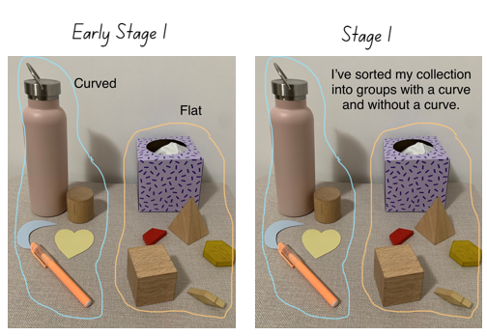
Note: If the group does not have access to a camera, students can draw and record their sort in their workbook. Take photographs of the different ways students have grouped their items.

Discuss and connect the mathematics – 10 minutes
- Display photographs of the different ways students sorted and classified their items and have students justify their sort.
- Ask students:
- How did you classify your sort?
- Was this the only way you sorted the collection?
- Were you able to re-sort within the groups you made?
- What else are you wondering about 2D shapes and 3D objects?
This table details assessment opportunities and differentiation ideas.
Assessment opportunities | Too hard? | Too easy?
What to look for:  - Are students able to identify that 2D shapes are flat and have 2 dimensions which are length and height? (MA1-2DS-01)  - Are students able to identify that 3D objects are a solid figure and have 3 dimensions, length, width and height? (MA1-3DS-01)  - Can students compare, sort, classify and identify 2D shapes and 3D objects based on features, such as size and shape? (MAO-WM-01, MAE-2DS-01, MAE-3DS-01)  - Are students able to compare, sort, classify and identify 2D shapes and 3D objects based on features, such as the number of sides, faces, surfaces and vertices? (MAO-WM-01, MA1-2DS-01, MA1-3DS-01)  What to collect:  - photographs of students work or work samples (MAO-WM-01, MAE-2DS-01, MAE-3DS-01, MA1-2DS-01, MA1-3DS-01) | Students are not confident sorting and classifying their collection.  - Support students to look at their collection and find similarities between 2 objects. For example, the circle and the cylinder are similar as the cylinder has a circular surface.  - Support students to sort their collection into 2D shapes and 3D objects with a focus on identifying the difference between 2D shapes and 3D objects. | Students are confident sorting and classifying their collection.  - Students find additional items from around the classroom and include these within their sort.  - Challenge students to make multiple classifications within their sort.  - Students name all the items in the collection and label their poster. Challenge students to write descriptions for different items.

Lesson 2: Inspecting objects
Core concept: There are 2D shapes hiding in the faces of 3D objects.
The table below contains suggested learning intentions and success criteria. These are best co-constructed with students.
Learning intentions | Success criteria
Students are learning that:  - flat surfaces of three-dimensional objects can be named as two-dimensional shapes  - constructing a three-dimensional object requires two-dimensional shapes. | All students can make and describe a variety of three-dimensional models.  In addition, students working towards Early Stage 1 outcomes can make 2D shapes by tracing around the faces of 3D objects.  In addition, students working towards Stage 1 outcomes can:  - use vocabulary such as face, edge, and vertex to describe 3D objects (prisms)  - recognise and name flat surfaces of 3D objects as 2D shapes.

Daily number sense: Numbers on a line – 10 minutes
- Build student understanding of counting by representing numbers on a number line.
- Draw a blank number line (see Figure 3).
Figure 3 – Blank number line
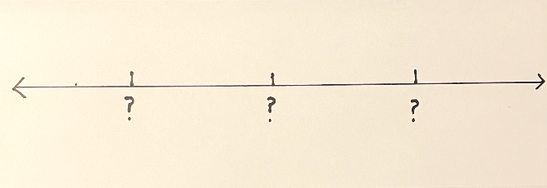
- Ask Early Stage 1 students to think about what numbers could be missing from the number line if you were counting backwards by ones starting with a number of their choice.
- Ask Stage 1 students to think about what numbers could be missing from the number line if you were counting in multiples of 10.
- Students turn and talk and share ideas about what the missing numbers might be, for example 10, 20, 30..., 42, 52, 62..., 4, 3, 2... or 21, 20, 19.
- Select students to share their responses and annotate on the blank number line.

Building 3D objects – 40 minutes
This lesson has been adapted from Activity 21.4: Inspecting Objects from Siemon et al. (2020).
- Give each pair a prism and students take turns to inspect their 3D object. They describe everything they observe about the object to their partner.
- Students share their observations with the class.
Note: Students may tell you about what material the object is made from or features like its colour. Early Stage 1 students are encouraged to describe the features of familiar objects, using the terms flat, round, or curved. This prepares students to sort objects based on attributes, such as size, shape, or function. The key features for Stage 1 students are the number of vertices, edges, faces and the 2D shapes which make up the 3D object.
- With their partner, students plan and build their prism using 2D shape construction pieces.
- Early Stage 1 partners inspect their prism. Then they trace around the faces of the object to determine which 2D shapes they will need to collect to build the 3D object.
- Stage 1 partners inspect their prism. Then they identify and record/draw in their workbook how many different 2D shapes they think they need to collect to build their 3D object (see Figure 4).
Figure 4 – Building a prism
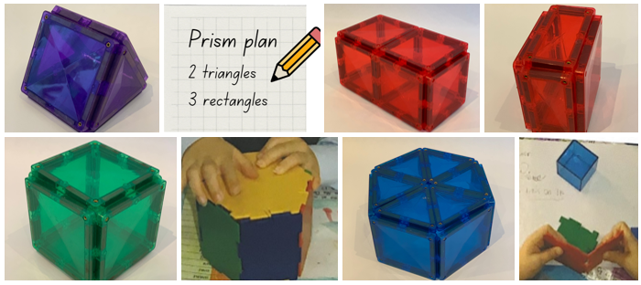
Pencil image sourced from Canva and used in accordance with the Canva Content License Agreement.
- Students find the 2D construction pieces they recorded in their plan and start building their 3D object.
- As students build, they may realise that more 2D construction pieces are required to complete their 3D object. If needed, students make modifications to their plan and get the additional materials.
- Whilst students are building their 3D objects, move between groups and have students explain their plan, any revisions, and the process they are using to construct their 3D object.

Discuss and connect the mathematics – 10 minutes
- Students reflect and share how they built their 3D object.
- Ask students:
- What 3D object did you build?
- What 2D shapes were needed to build the object?
- How did your plan change? Why?
- Students share the model of their 3D object and identify its features.
Note: Early Stage 1 students should use the term ‘flat’ when describing the faces of a prism. They also may identify 2D shapes which make up the 3D object. Focus on observing if Stage 1 students can identify features such as vertices, edges, faces and the 2D shapes which make up the 3D object.
This table details assessment opportunities and differentiation ideas.
Assessment opportunities | Too hard? | Too easy?
What to look for:  - Can students make 2D shapes by tracing around the faces of 3D objects? (MAE-2DS-01, MAE-3DS-01)  - Are students able to identify and name the 2D shapes which make up the faces of 3D objects? (MA1-2DS-01, MA1-3DS-01)  - Can students use vocabulary such as face, edge and vertex to describe 3D objects (prisms)? (MA1-3DS-01)  - Can students make a 3D object using their plan? (MAO-WM-01, MAE-2DS-01, MAE-3DS-01, MA1-2DS-01, MA1-3DS-01)  What to collect:  - student work samples (MAO-WM-01, MAE-2DS-01, MAE-3DS-01, MA1-2DS-01, MA1-3DS-01) | Students are not confident naming the 2D shapes which make up the faces of the 3D objects, or are not confident using the correct vocabulary.  - Ask students to identify any 2D shapes they know and provide them with the matching 2D shape block.  - For the shapes students cannot identify, provide them with a shape block and revise the name of the shape. Students match the shape blocks and the faces of objects together.  - Play a name identification game, say a feature such as vertex and the student points to a vertex. Support students with this one-to-one matching activity. | Students are confident constructing a prism using a variety of 2D shapes.  - Challenge students by providing them with the correct amount of 2D shapes to create a certain object.  - Have students manipulate the pieces to build the object.

Lesson 3: Shape shadows
Core concept: 3D objects can look different depending on the perspective.
The table below contains suggested learning intentions and success criteria. These are best co-constructed with students.
Learning intentions | Success criteria
Students are learning that:  - three-dimensional objects have faces or flat surfaces that are composed of two-dimensional shapes  - three-dimensional objects are named according to their features  - three-dimensional objects can look different depending on the perspective. | All students can:  - describe and identify the 2D shapes on the faces/surfaces of a 3D object  - examine a 3D object from different views to identify 2D shapes in the shadows made by the object.

Daily number sense: Making one dollar – 10 minutes
- Build student understanding of recognising units of 100 and identifying coins by adding and subtracting coins to make 100 cents or grouping collections of coins.
- Display Resource 2: Making one dollar.
- Early Stage 1 students group coins of the same value and count the collection. Students record the total of each collection on their individual whiteboard, Figure 5.
- Stage 1 students choose coins from inside the box and coins from outside the box to combine and subtract to make one dollar. Students use their individual whiteboard to record their combinations (see Figure 5).
Figure 5 – Making one dollar
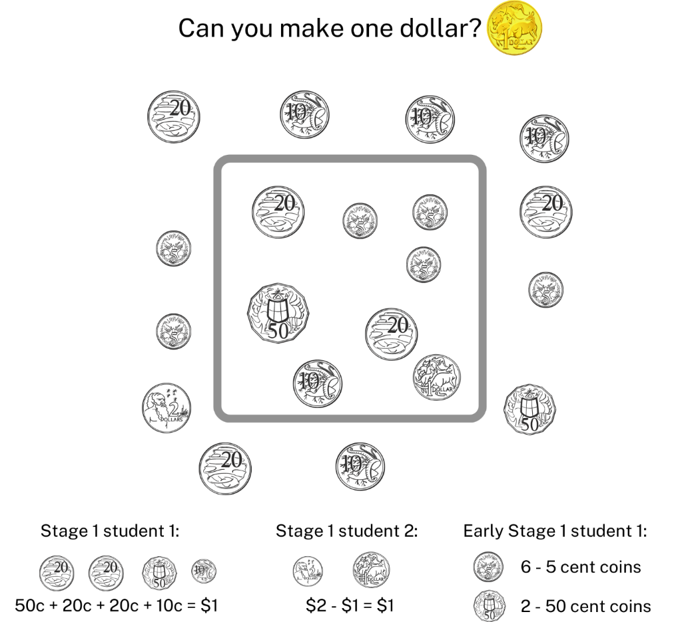
Images sourced from Canva and used in accordance with the Canva Content License Agreement.
- Early Stage 1 students share the total of each collection and Stage 1 students share how they created one dollar.

2D Shadows – 40 minutes
This lesson has been adapted from Shape: Shadows from Resolve (2020).
- Show students, a collection of 3D objects and as a class have students identify the features of each 3D object and its name (see Figure 6).
Note: Encourage Early Stage 1 students to describe the features of familiar objects, using the terms flat, round, or curved. The key features for Stage 1 students are the number of vertices, edges, faces and the 2D shapes which make up the 3D object.
Figure 6 – 2D shapes and 3D objects
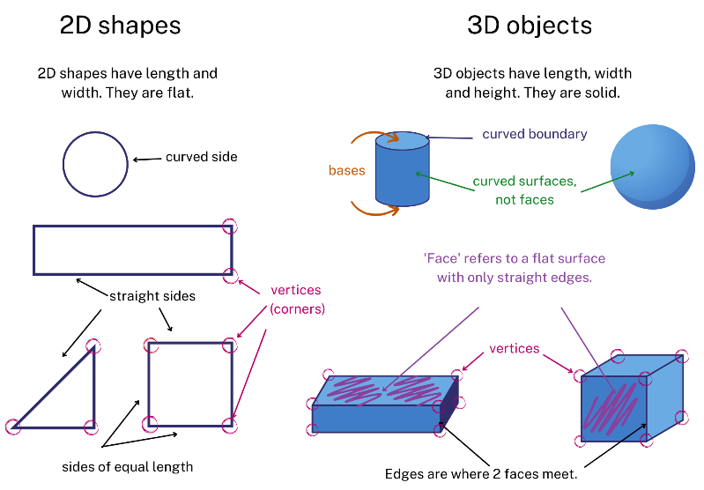
Images sourced from Canva and used in accordance with the Canva Content License Agreement.
- Show students Resource 3: Shape shadows and ask them to predict which 3D objects might have made these 2D shape shadows.
- Provide partners with a light source and a collection of 3D objects. Students examine the shadows created from different perspectives on the objects and try to identify which objects made the shadows in Resource 3: Shape shadows.
Note: Resource 3: Shape shadows displays the shadows made by shining a light on 3D objects. Using different angles and perspectives, all 5 shadows can be made with only a cube and a cone. You may need to demonstrate how shining a light on various 3D objects from different angles and perspectives can create different 2D shadows.
- Partners share with the class which 3D objects they think made the shadows in Resource 3: Shape shadows and how they were able to determine this. Students demonstrate to the class how they used their light source from different angles or perspectives to draw their conclusion.
- Provide small groups with a collection of 3D objects and ask students to investigate what 2D shape shadows can be made from each 3D object.
- Students work with their group to trace and record all the different 2D shape shadows their 3D objects make.
- Explicitly show Early Stage 1 students how to hold the light source and 3D object at different distances and angles.
Note: Holding the light source at a different distance but maintaining the same perspective will see the 2D shape change in size but not features. Monitor for misconceptions.

Discuss and connect the mathematics – 10 minutes
- Students reflect on the task and share their thinking.
- Ask students:
- How many different shapes can be created by one object?
- How could you predict the shadow that an object will make?
- Does changing the perspective change the shadow/shape?
- Are there any 2D shapes you cannot identify?
- As a class, jointly construct Resource 4: Shadows table using the information discovered (see Figure 7). Support students to identify the relationship between the shadows and the faces/surfaces of the 3D objects.
Figure 7 – Completing the table
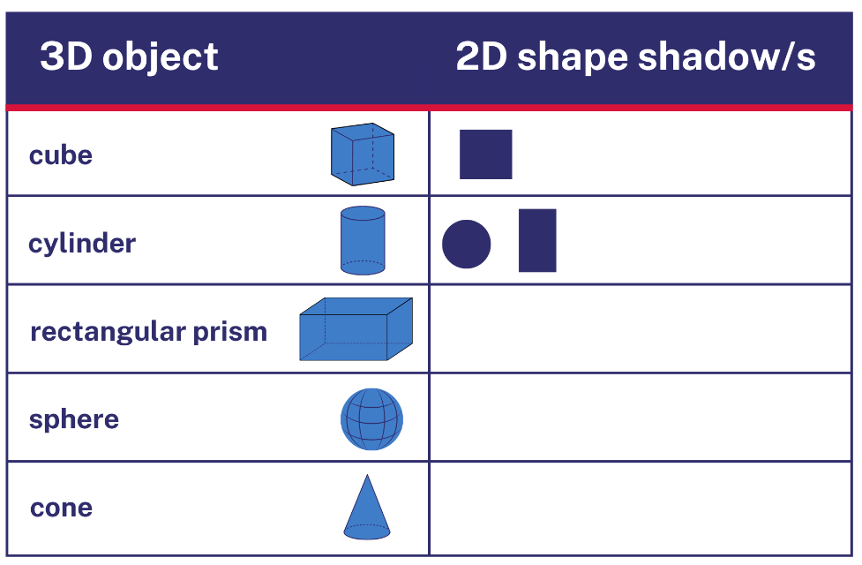
Images sourced from Canva and used in accordance with the Canva Content License Agreement.
This table details assessment opportunities and differentiation ideas.
Assessment opportunities | Too hard? | Too easy?
What to look for:  - Can students identify and make 2D shapes by tracing around the shadows of 3D objects? (MAO-WM-01, MAE-2DS-01, MAE-3DS-01)  - Are students able to describe and identify the 2D shapes on the faces/surfaces of a 3D object? (MA MAO-WM-01, MA1-2DS-01, MA1-3DS-01)  What to collect:  - student work samples. (MAO-WM-01, MAE-2DS-02, MAE-3DS-02, MA1-2DS-01, MA1-3DS-01) | Students are not confident identifying the 2D shapes made by the shadow of a 3D object.  - Have a collection of 2D shape blocks available for students and encourage students to use these to match the shadow.  - Allow students to trace the faces of the 3D objects and identify the 2D shapes. For any 2D shapes students are not familiar with, provide them with pattern blocks and the shapes name. | Students are confident identifying the 2D shapes made by the shadow of a 3D object.  - Ask students how they can predict the shadow an object will make. Have students record their response.  - Challenge students to combine 3D objects and predict what 2D shape shadows they will make.

Lesson 4: The cylinder
Core concept: 2D shapes can be found in 3D objects with curved surfaces and a base.
The table below contains suggested learning intentions and success criteria. These are best co-constructed with students.
Learning intentions | Success criteria
Students are learning that:  - three-dimensional objects have faces or flat surfaces that are composed of two-dimensional shapes  - three-dimensional objects are named according to their features. | Students working towards Early Stage 1 outcomes can:  - make and identify 2D shapes in a cylinder  - use vocabulary such as flat, round or curved to describe 3D objects.  Students working towards Stage 1 outcomes can:  - identify and name the 2D shapes which are the surface or base of a cylinder  - use vocabulary such as face, edge, vertex, base, curved surface, or curved boundary to describe 3D objects  - identify and name a 3D object from a description of its features.

Daily number sense – 10 minutes
- From a class need surfaced through formative assessment data, identify a short, focused activity that targets students’ knowledge, understanding and skills. Example activities may be drawn from the following resources.
- Thinking Mathematically Stage 1
- Universal Resources Hub

Making a cylinder – 30 minutes
- Show students a cylinder and have them find cylinders in the classroom and/or playground.
- Provide pairs with a cylinder and have students turn and talk about the features. Listen to students’ descriptions and guide them to identify the correct language to describe a 3D object with a curved surface compared to a 3D object with a flat face.
Cylinder: 3D object with one curved surface, 2 bases and 2 curved boundaries.
Sphere: 3D object with no faces, vertices, or edges, just a curved surface.
Note: The expectation for Early Stage 1 students is to describe an object using the language of flat, round, and curved.
- Provide students with a cylinder, paper, scissors, and sticky tape and ask students to use the paper provided to determine which 2D shapes make up a cylinder (see Figure 8).
Figure 8 – Making a cylinder
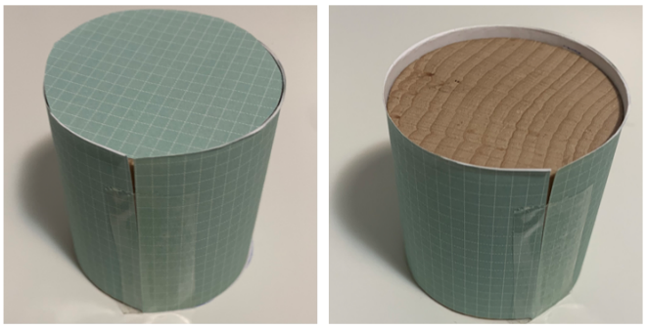
Note: Allow students to use their problem solving and reasoning skills to undertake this challenge before providing students with guidance on how to use paper to construct their 2D shapes from the cylinder.
- After students have investigated which 2D shapes are in a cylinder, they use their paper shapes to construct an informative poster (see Figure 9).
Figure 9 – Poster
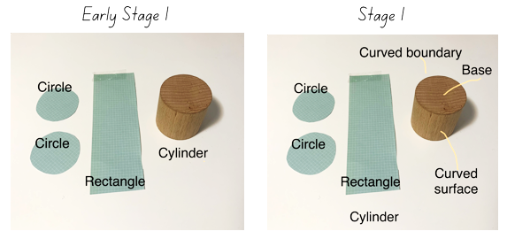
Note: If the poster cannot be made digitally, students can construct it in their book by gluing in and labelling their 2D shapes.

Discuss and connect the mathematics – 10 minutes
- Have students display their posters.
- Ask students:
- Did you create a plan before you started?
- How did you work out which 2D shapes make up a cylinder?
- Does the size of your cylinder change which 2D shapes make up a cylinder?
- Is there anything else you are wondering about cylinders?

Consolidation and meaningful practice: Mystery object – 10 minutes
- Have a box/bag with a collection of 3D objects and choose a student to pick out an object without the class seeing.
- The student shares known features about the 3D object with the rest of the class. As each clue is given, provide opportunity for the rest of the class to guess the 3D object.
Note: The focus for Early Stage 1 is on the language of flat, round, curved and identifying any known 2D shapes which make up a 3D object.
This table details assessment opportunities and differentiation ideas.
Assessment opportunities | Too hard? | Too easy?
What to look for.  - Can students identify and name the 2D shapes found in a cylinder? (MAE-2DS-01, MAE-3DS-01, MA1-2DS-01, MA1-3DS-01)  - Can students identify the features of a cylinder as 2 bases, a curved surface and 2 curved boundaries? (MA1-2DS-01, MA1-3DS-01)  - Are students able to identify and name a 3D object from a description of its features using the correct language? (MA1-2DS-01, MA1-3DS-01)  - Are students able to use vocabulary such as flat, round or curved to describe 3D objects? (MAE-3DS-01)  What to collect:  - student work samples (MAO-WM-01, MAE-2DS-01, MAE-3DS-01, MA1-2DS-01, MA1-3DS-01) | Students are not confident making and/or identifying the features of a cylinder.  - Provide students with the correct language on the board to help them match the words to the correct parts of a cylinder.  - Demonstrate how to wrap a piece of paper around a cylinder and draw a cutting line to create a rectangle. | Students are confident in identifying the features of a cylinder.  - Students create a Venn diagram to compare the features of different 3D objects looking for similarities and differences.  - Students make a class poster labelling 3D objects using correct language.

Lesson 5: Deconstructing 3D objects
Core concept: 3D objects are made up of 2D shapes.
The table below contains suggested learning intentions and success criteria. These are best co-constructed with students.
Learning intentions | Success criteria
All students are learning that three-dimensional objects are defined and named by their features.  In addition, Stage 1 students are learning that three-dimensional objects have faces that are composed of two-dimensional shapes. | Students working towards Early Stage 1 outcomes can:  - make and describe a variety of 3D models  - predict the stacking capabilities of 3D objects.  Students working towards Stage 1 outcomes can:  - describe and identify the 2D shapes in the faces of a 3D object  - identify and name familiar 3D objects like rectangular prisms.

Daily number sense: Number representation – 10 minutes
This lesson has been adapted from Open-Ended Maths Activities from Sullivan P and Lilburn P (2017).
- Build student understanding of the representation of whole numbers by communicating known facts about a given number.
- Ask students to write down everything they know about the number 18.
- Select students to share their responses and record them.
Note: Accept any suitable response, for example, 18 comes before 19 or 18 is 10 + 8. Provide Early Stage 1 students with numbers up to 30 and Stage 1 with numbers up to 120.
- Repeat with a different number.

Deconstructing 3D objects – 40 minutes
This lesson has been adapted from Activity 21.5: Deconstruct and construct from Siemon et al. (2020).
- Display a collection of everyday containers, for example, tissue, cereal, cracker and chocolate boxes of different size and shape.
- Ask students:
- What do you know about these objects?
- Can you name the 3D objects?
- What 2D shapes can you see in these objects?
- Provide Early Stage 1 students with a collection of 3D objects, including everyday objects. Students create models that challenge them to predict and test the stacking capabilities of the 3D objects. Early Stage 1 students take photographs of the models they have created for use in ‘Discuss and connect the mathematics’ further on in Lesson 5. Challenge Early Stage 1 students to draw their models and identify and label any shapes, objects or features they may know. Students continue with this activity until you reach ‘Discuss and connect the mathematics’.
- Model to Stage 1 students how to safely open the everyday object (cereal or tissue box) to display it as a flat shape.
Note: The boxes will need to be easy for students to open so thin cardboard is preferred. Boxes may need to be pre-trimmed to cut off the extra faces used to seal a box. If you do not have access to enough boxes, students can trace each of the faces of a 3D object onto a large piece of paper. The focus is identifying 2D shapes and not the concept of a net.
- Provide pairs of Stage 1 students with an everyday object and have them identify the name of the 3D object.
- Stage 1 students open their everyday object and examine it as a flat shape. Ask:
- What 2D shapes can you see?
- How many 2D faces does your flat object have?
- What is similar and different between the object being 2D and 3D?
- In pairs, Stage 1 students outline and colour each face of their flat shape, identifying all the different 2D shapes.
- Stage 1 glue their flat shape onto a large piece of paper or card and label all the 2D shapes they can identify (see Figure 10).
Figure 10 – Flat object poster
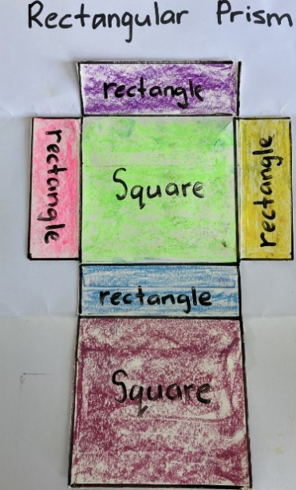

Discuss and connect the mathematics – 10 minutes
- Early Stage 1 students display their different models and diagrams, and Stage 1 students display their poster. All students go on a gallery walk.
- Ask Stage 1 students:
- What do you notice about the different posters?
- What 2D shapes are the most common?
- Do they all have the same number of faces?
- Looking at the Early Stage 1 models and diagrams, ask students to describe their model and the features of the 3D objects they have used. Follow this up with Stage 1 students by asking them about the 2D shapes they can find in their model.
This table details assessment opportunities and differentiation ideas.
Assessment opportunities | Too hard? | Too easy?
What to look for:  - Are students able to describe and identify the 2D shapes in the faces of a 3D object? (MA1-2DS-01, MA1-3DS-01)  - Can students identify and name familiar 3D objects like rectangular prisms? (MA1-3DS-01)  - Can students make and describe a variety of 3D models? (MAO-WM-01, MAE-3DS-01)  - Can students predict the stacking capabilities of 3D objects? (MAO-WM-01, MAE-3DS-01)  What to collect:  - student work samples (MAO-WM-01, MAE-2DS-01, MAE-3DS-01, MA1-2DS-01, MA1-3DS-01) | Students are not confident identifying and describing the 2D shapes in their flat 3D object.  - Allow students to trace the faces of the 3D objects in different colours and identify the 2D shapes they know.  - For any 2D shapes students are not familiar with, provide them with pattern blocks and the shape name to help strengthen the connection. | Students are confident identifying and describing the 2D shapes within their flat object.  - Provide students with a triangular prism made of cardboard, and have students cut and identify the different 2D shapes they have discovered.  - Provide students with a 3D object and challenge students to draw a flat lay of the object and identify the 2D shapes.

Lesson 6: Prism buildings
Core concept: Objects can have the same name but a different appearance.
The table below contains suggested learning intentions and success criteria. These are best co-constructed with students.
Learning intentions | Success criteria
Students are learning that:  - numbers have a sequence from any given number  - three-dimensional objects can have the same name but be a different size and appearance. | All students can describe and compare the volume of 2 objects.  In addition, students working towards Early Stage 1 outcomes can:  - compare and order given numbers under 10  - make a 3D model and describe the features of a familiar object.  In addition, students working towards Stage 1 outcomes can:  - sequence numbers by identifying the order and size of a given number  - explore and create rectangular prisms of different appearances from a given number of cubes  - demonstrate and explain strategies for stacking and counting units to form a rectangular prism.

Daily number sense: Garbage Cards – 20 minutes
This lesson has been adapted from Garbage! (4:44) from Thinking Mathematically. Watch Garbage! (4:44) prior to playing for a greater understanding of the rules.
- Build student understanding of ordering and sequencing numbers to 10 by playing Garbage!
- Provide pairs with a deck of cards (one to ten) and students draw 10 cards each and place them individually face down in a line.
- The first player draws a card from the deck and places it in the corresponding position as the face down card, for example a 4 is turned over and then it is placed where the fourth face down card is positioned.
- The player then turns over the facedown card and determines where to place the card in the 1-10 order. They continue play until they can no longer go.
- Students continue playing against each other until there is a winner.
Note: An ace can be used as a one or use number cards from one to ten.
This table details assessment opportunities and differentiation ideas.
Assessment opportunities | Too hard? | Too easy?
What to look for:  - Are students able to compare and order given numbers under 10? (MAO-WM-01, MAE-RWM-01)  - Can students sequence numbers by identifying the order and size of a given number? (MAO-WM-01, MA1-RWM-01)  What to collect:  - observational data (MAO-WM-01, MAE-RWN-01, MA1-RWN-01) | Students are not confident sequencing numbers from 1-10.  - Have students sequence numbers one to five and become confident with a smaller range before moving to one to ten.  - Provide students with a number chart to refer to the sequence of numbers and numbers before and after. | Students are confident sequencing numbers from 1-10.  - Provide students with a larger number range, for example 20-30. Provide them with number cards for this range.  - Challenge students to sequence a number pattern, for example, counting by twos from a given number.

City of prisms – 30 minutes
This lesson has been adapted from the task City of cubes in Boaler et al. (2018).
- Display Resource 5: Architectural drawings and students turn and talk to share what they notice about the images.
Note: Include photographs of buildings within your school or local area.
- Choose students to share their thinking.
The table outlines stimulus prompts to generate conversation about the topic, along with anticipated responses from students.
Prompts | Anticipated student responses
- What do you notice in the images?  - What is different?  - What are you wondering? | - I can identify different 3D objects like a rectangular prism and 2D shapes like rectangles.  - Some of the differences are the classification structures such as height, colour, materials.  - I can identify the placement of buildings and the use of positional language like in front of, between and next to.
- Display Resource 6: Prism city and have students turn and talk to share what they notice in the images.
- Early Stage 1 students should be able to distinguish features like flat, round or curved and describe the 2D shapes that make up the 3D objects.
- Ask Stage 1 student to identify the most common 3D object in Resource 6: Prism city. Stage 1 students should identify that the most common 3D object is a rectangular prism. Ask students how they know that the buildings are rectangular prisms.
Note: Stage 1 students should correctly state the features of a rectangular prism.
Rectangular prism: A 3D object with 6 rectangular faces, 8 vertices (corners – the point where 3 or more faces meet) and 12 straight edges (the line segment where 2 or more faces meet). It has length, width, and height.
- Provide pairs with a collection of interlocking cubes and challenge students to create their own rectangular prism city using all the cubes (see Figure 11).
Figure 11 – Prism city
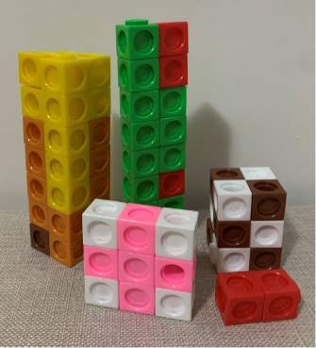
Note: When creating a rectangular prism, students should make layers and ensure there are no gaps between units.
- As students are building their city, ask:
- Can you describe your city?
- What is similar and different between your buildings?
- What makes the rectangular prisms different?
- Have you had to change any buildings to use all the interlocking cubes?
- Students display their rectangular prism city and go on a gallery walk to see how other pairs have created their city.
Discuss and connect the mathematics – 10 minutes
- Select students to share their different rectangular prisms.
- Ask students:
- Which of your buildings has the smallest number of cubes? How do you know?
- Which of your buildings has the largest number of cubes? How do you know?
- Do any of your buildings have the same number of cubes? How do you know?
- How do you know your buildings are rectangular prisms?
Note: This discussion provides the beginning links to volume. Students need to keep at least one of their buildings for Lesson 7.
This table details assessment opportunities and differentiation ideas.
Assessment opportunities | Too hard? | Too easy?
What to look for:  - Are students able to create rectangular prisms from a given number of cubes? (MAO-WM-01, MAE-3DS-01, MAE-3DS-02, MA1-3DS-01, MA1-3DS-02)  - Can students describe and compare the volume of 2 objects? (MAO-WM-01, MAE-3DS-01, MAE-3DS-02, MA1-3DS-01, MA1-3DS-02)  - Are students able to demonstrate and explain strategies for stacking and counting units to form a rectangular prism? (MAO-WM-01, MA1-3DS-01, MA1-3DS-02)  What to collect:  - observational data (MAO-WM-01, MAE-3DS-01, MAE-3DS-02, MA1-3DS-01, MA1-3DS-02) | Students are not confident creating rectangular prisms from a given number of cubes and/or comparing the volume.  - Provide students with a small, even amount of cubes and challenge them to build 2 towers.  - Guide students to count-by-ones to compare the total of 2 towers. Provide them with the language that one of the prisms has a greater number of cubes and ‘takes up more space’. | Students are confident creating rectangular prisms from a given number of cubes and/or comparing the volume.  - Provide students with an odd amount of cubes and challenge them to only build 3 towers.  - Students create multiple rectangular prisms with the same volume but a different appearance.

Lesson 7: Turn up the volume
Core concept: Objects can have the same volume but look different.
The table below contains suggested learning intentions and success criteria. These are best co-constructed with students.
Learning intentions | Success criteria
All students are learning that objects can have the same volume but look different.  In addition, students working towards Early Stage 1 are learning that volume can be compared by counting the uniform informal units used in 2 different objects.  In addition, students working towards Stage 1 are learning that:  - three-dimensional objects can have a different appearance yet have the same volume  - volume is recorded by referring to the number and type of uniform informal unit used. | All students can identify and explain that volume is the amount of space an object occupies.  In addition, students working towards Early Stage 1 outcomes can describe and compare the volume of 2 made objects using the language of ‘takes up more/less space’ (comparative language).  In addition, students working towards Stage 1 outcomes can:  - compare models with different appearances and can recognise when they have the same volume  - record volume using drawings, numerals, and words such as high, wide, and long.

Daily number sense – 10 minutes
- From a class need surfaced through formative assessment data, identify a short, focused activity that targets students’ knowledge, understanding and skills. Example activities may be drawn from the following resources.
- Thinking Mathematically Stage 1
- Universal Resources Hub

Volume – 30 minutes
- Choose one of the rectangular prisms from Lesson 6 and explain that the prism takes up space and this is called volume. Ask students how we can work out and record the volume of this prism. Students turn and talk to share ideas and then share with the class.
Volume: The amount of space occupied by an object.
- Model to Early Stage 1 students how to determine the volume by counting with one-to-one correspondence by deconstructing and constructing the same object.
- Demonstrate to Stage 1 students how to record the volume of the rectangular prism (see Figure 12).
Figure 12 – Volume drawing
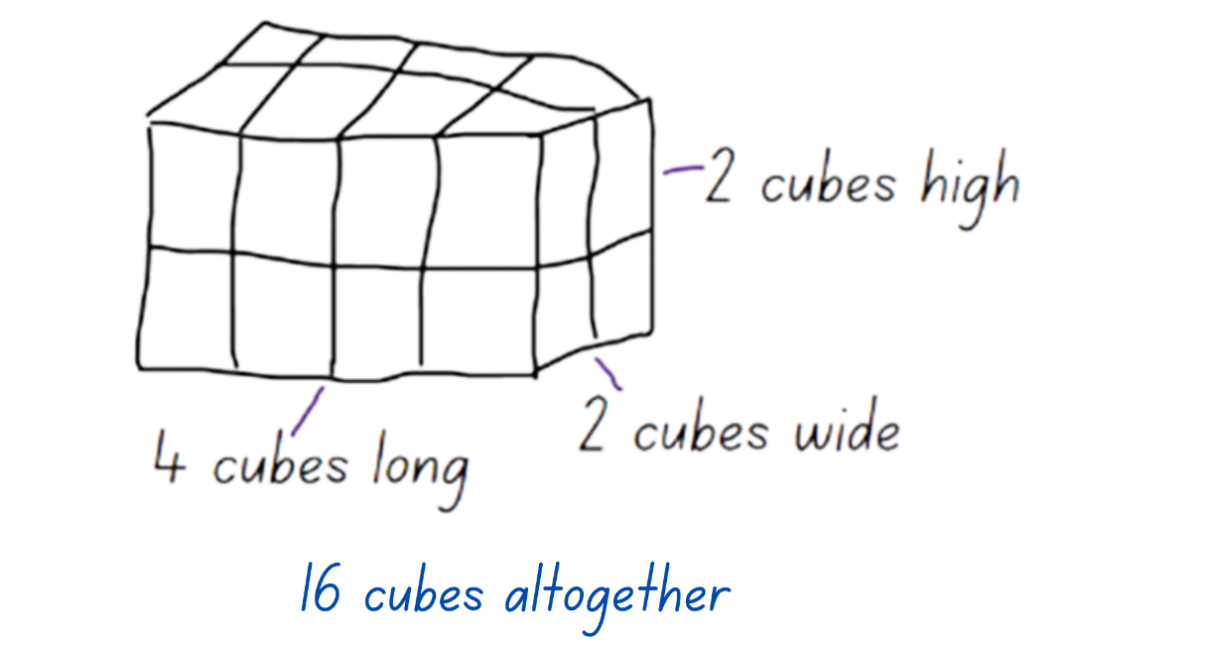
Note: Stage 1 students record the volume using simple language, 2 cubes high, 2 cubes wide and 4 cubes long. The volume is 16 cubes. Students may count the interlocking cubes by one, use skip counting or groups of to find the total volume.
- Ask students to choose one building from their city in Lesson 6 and then estimate and calculate the volume. Early Stage 1 students count with one-to-one correspondence by deconstructing and constructing their building. Stage 1 students record the volume by either taking a photograph or drawing the model and adding text (see Figure 13).
Figure 13 – Recording volume
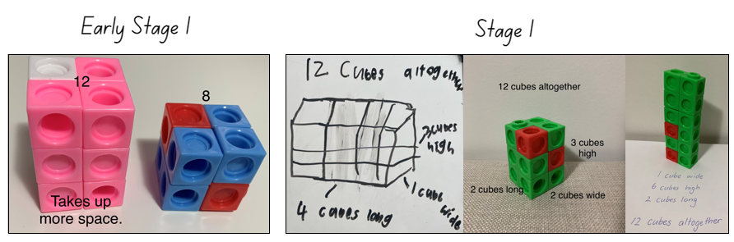
- Early Stage 1 students consider the number of cubes in their building and then collect a larger number of interlocking cubes. Using these cubes, they construct another building that has a greater volume. Students compare the volumes of the 2 buildings and use the comparative language of ‘takes up more space’ to describe the building with the larger volume (see Figure 13).
Note: Early Stage 1 students verbally compare and describe the volumes of their buildings and may construct a simple poster (see Figure 13).
- Stage 1 students deconstruct their model and use the same cubes to create a second rectangular prism of a different appearance (see Figure 13). Stage 1 students take another photo/drawing and record the volume of their new prism. Looking at both images, students compare the total volume and appearance of each model.

Consolidation and meaningful practice – 20 minutes
- In pairs, Early Stage 1 students are provided with interlocking cubes to create 2 different rectangular prisms. They show their partner their prisms and their partner compares the volume of them. Then they use comparative language to describe the difference in volume, ‘takes up more space’ or ‘takes up less space’. Student take turns creating prisms for their partner to compare.
- Stage 1 students deconstruct their model and use the cubes to create a third prism of a different appearance. Students take another photo/drawing and record the volume of their new prism. Looking at all the images, students compare the total volume and appearance of each model (see Figure 13). Challenge students to create a fourth building of a different appearance and record the volume.
- Select students to share their recordings of the different appearances of their rectangular prisms. Ask students:
- How do you know the volume of your prism?
- How do you know when your prism ‘takes up more space’?
- Did the volume of your prism change when you changed its appearance?
- Were there any challenges with making a model with the same volume in a different appearance?
- If one cube is taken away from the prism, does the volume change?
This table details assessment opportunities and differentiation ideas.
Assessment opportunities | Too hard? | Too easy?
What to look for:  - Are students able to create rectangular prisms of different appearances using the same number of cubes? (MAO-WM-01, MA1-3DS-01, MA1-3DS-02)  - Can students record volume using drawings and vocabulary such as 2 cubes high, 2 cubes wide and 4 cubes long? (MA1-3DS-01, MA1-3DS-02)  - Are students able to identify and explain that volume is the amount of space an object occupies? (MAE-3DS-01, MAE-3DS-02, MA1-3DS-01, MA1-3DS-02)  - Are students able to describe and compare the volume of 2 objects made using the language of takes up more/less space? (MAE-3DS-01, MAE-3DS-02)  What to collect:  - student work samples (MAO-WM-01, MA1-3DS-01, MA1-3DS-02)  - observational data (MAO-WM-01, MAE-3DS-01, MAE-3DS-02, MA1-3DS-01, MA1-3DS-02) | Students are not confident comparing models that have the same volume with a different appearance.  - Students compare their 2 models by deconstructing and constructing their model.  - Students use one-to-one correspondence to recognise the volume.  Students are not confident recording the volume using drawings and vocabulary.  - Provide the students with word cards to stick onto their model to demonstrate high, wide, and long.  - Remove the focus from drawing the model and use a digital device to record students building their model and verbally explaining the features. | Students are confident comparing models that have the same volume with a different appearance.  - Students are given a set number of interlocking cubes, for example, 24 cubes. Students create as many different prisms using all 24 interlocking cubes.  - Students record the volume of each prism using the language of high, wide, and long.

Lesson 8: Internal volume
Core concept: Internal volume is how much a container can hold.
The table below contains suggested learning intentions and success criteria. These are best co-constructed with students.
Learning intentions | Success criteria
Students are learning that:  - internal volume can be measured using uniform informal units  - internal volume can be compared and ordered. | All students can compare the internal volume of 2 containers.  In addition, students working towards Early Stage 1 outcomes can stack and pack objects into defined spaces.  In addition, students working towards Stage 1 outcomes can:  - pack cubes into rectangular containers so that there are no gaps  - estimate and measure the internal volume of a container  - select appropriate informal units to measure internal volume.

Daily number sense: Number Patterns – 10 minutes
This lesson has been adapted from Dice Dazzlers: Odd and Even by Swan (2003).
- Build student understanding of number patterns by identifying numbers.
- Provide pairs of students with an individual whiteboard, Early Stage 1 with a 10- or 12-sided die, and Stage 1 with a 20-sided die.
- Early Stage 1 students roll the die and draw different dice pattern to represent the number rolled (see Figure 14). Students take turns rolling and drawing different dice patterns.
Figure 14 – Dice patterns
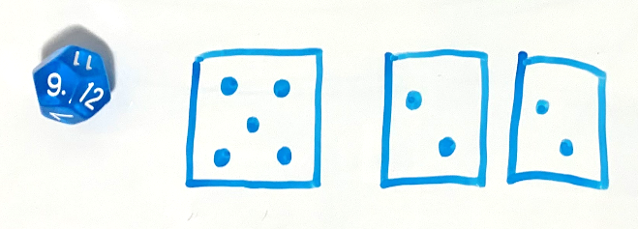
- Stage 1 students decide which player will be even and which will be odd.
- Players take turns to roll the die. If an even number is rolled, the student who chose even receives a counter. If an odd number is rolled, then the student who chose odd receives a counter.
- Students continue to play until a player has 10 counters.

Packing containers – 40 minutes
- Display a variety of rectangular containers and different collections of objects, for example recycled boxes, lunchboxes, counters, teddies, blocks of different sizes, marbles, interlocking cubes, pipe cleaners, and so on.
- Ask students how they would measure the internal volume of one of the containers. Students Think-Pair-Share.
Note: Listen to student discussions and responses to see if they connect their knowledge of volume from Lesson 6 and Lesson 7 to the concept of internal volume.
- Build onto student responses to explain the concept of internal volume and using informal units to measure.
Internal volume (capacity): A measure of how much a container can hold.
- Provide Early Stage 1 students with a collection of containers and informal units like teddies, dinosaurs, pompoms, and so on. Working with a partner, students place the informal unit into the container one at a time, counting as each one is added. Students can also pack the contents of one container and add it into another container to see if it will hold more or hold less. Early Stage 1 students continue with this activity using a variety of containers and objects.
Note: Provide shorter containers that hold more than some taller containers and vice versa. Ensure there are different shaped containers that hold the same amount, for example a tall narrow container may hold the same amount as a short wide container.
- Provide Stage 1 partners with a rectangular container and students choose an informal unit to use. Stage 1 students examine their container and informal unit, then estimate and record the internal volume of the container. For example, I estimate my container has the internal volume of 62 counters.
- Stage 1 students work with their partner to measure and record the internal volume. For example, the internal volume of my container is 82 counters.
Note: Stage 1 students may not choose the most effective informal unit. This allows them the opportunity for discovery and problem solving later in the lesson.
- All students display their work and go on a gallery walk to see how other groups have measured their internal volume.
- Have students consider the informal unit they chose and how they packed their container.
- Ask students:
- Do you think you have accurately measured the internal volume?
- Would you use a different informal unit? Why?
- Were your informal units all the same size? Does size make a difference to the internal volume?
- How close was your estimation from your measurement?
- Provide Early Stage 1 pairs with blocks/interlocking cubes so that students can stack and pack the provided containers. With their partner, students discuss and compare the difference in interval volume between the containers and which container takes up more space. Students draw and compare the internal volume of 2 of their containers (see Figure 15).
Figure 15 – Comparing containers
- Ask Stage 1 students to consider a way of measuring the container so there are no gaps, using an efficient packing and stacking method.
Note: Through this discussion, students should recognise that blocks/interlocking cubes are the most effective informal unit to use as they can be packed with no gaps.
- Provide Stage 1 students with a collection of blocks/interlocking cubes. Stage 1 students estimate and record what they think the internal volume might be. They then measure the internal volume using their informal units.
Note: If students have correctly used uniform informal units like blocks/interlocking cubes during their first measure and understand that they need to be packed and stacked to avoid gaps, have these students attempt to draw a diagram and label with the internal volume using the words high, wide, and long.

Consolidation and meaningful practice – 20 minutes
- Provide all pairs with a sticky note to write the total measurement of their internal volume.
- On the carpet construct a long line of masking tape to represent a number line.
- Ask students to come and place their container with their sticky note along the number line. Students need to compare the size of the internal volumes to ensure they have placed their container in the correction position.
- Summarise the lesson together, drawing out some key mathematical ideas.
- Ask students:
- Which container has the largest internal volume?
- Which container has the smallest internal volume?
- Do any of the containers have the same internal volume?
- Are you surprised by the position of any of the internal volumes?
- Why is it important to use uniform informal units?
- Why is it important that there are no gaps when packing and stacking?
This table details assessment opportunities and differentiation ideas.
Assessment opportunities | Too hard? | Too easy?
What to look for:  - Are students able to compare the internal volume of 2 containers? (MAO-WM-01, MAE-3DS-02, MA1-3DS-02)  - Can students stack and pack objects into defined spaces? (MAE-3DS-02)  - Are students able to pack cubes into rectangular containers so that there are no gaps? (MA1-3DS-02)  - Can students estimate and measure the internal volume of a container? (MAO-WM-01, MA1-3DS-02)  - Can students select appropriate informal units to measure internal volume? (MAO-WM-01, MA1-3DS-02)  What to collect:  - student work samples (MAO-WM-01, MAE-3DS-02, MA1-3DS-02)  - observational data (MAO-WM-01, MAE-3DS-02, MA1-3DS-02) | Students are not confident stacking and packing containers and identifying the need for no gaps.  - Provide students with a small container and the correct number of blocks. Students are challenged to fit all the blocks into the container.  - Demonstrate using round objects to pack a container and compare it to the container packed with cubes. Have students identify gaps and space created by the round object. | Students are confident stacking and packing containers and identifying the need for no gaps.  - Students draw a diagram and label with the internal volume using the words high, wide, and long for one of their containers.  - Challenge students to construct a model of the height, length and width of their container and use this information to determine the total internal volume.

Resource 1: 2D shapes

Resource 2: Making one dollar
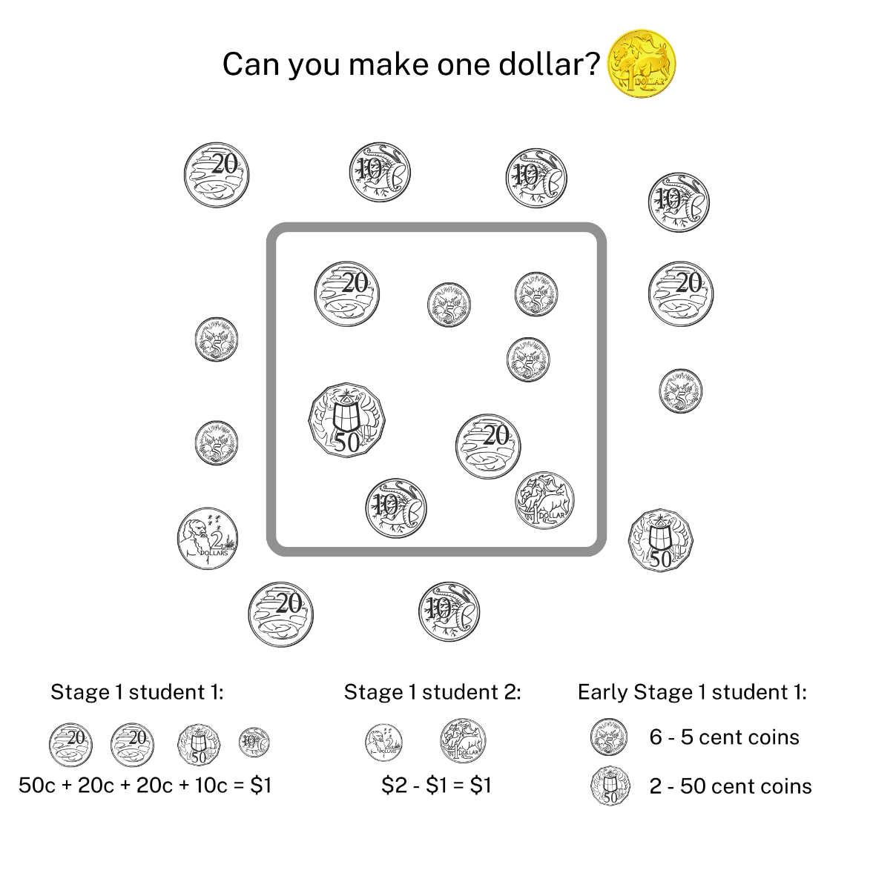
Images sourced from Canva and used in accordance with the Canva Content License Agreement.

Resource 3: Shape shadows
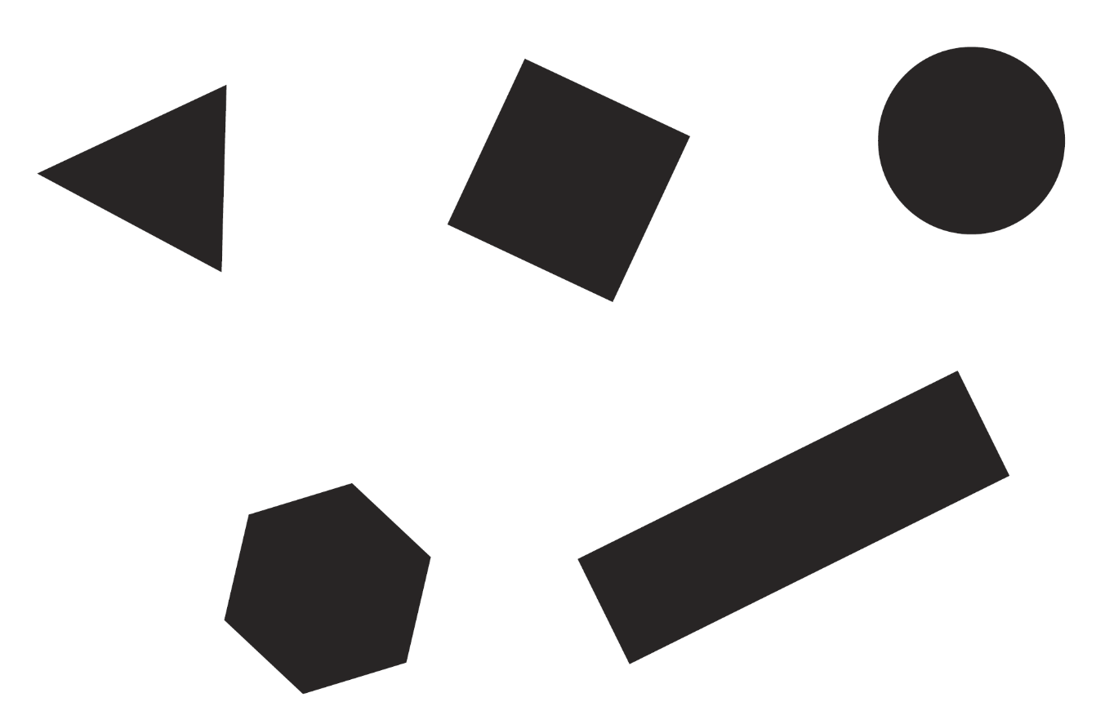
‘Shape: Shadows’ by Australian Government Department of Education is licensed under CC BY-NC-SA 4.0

Resource 4: Shadows table
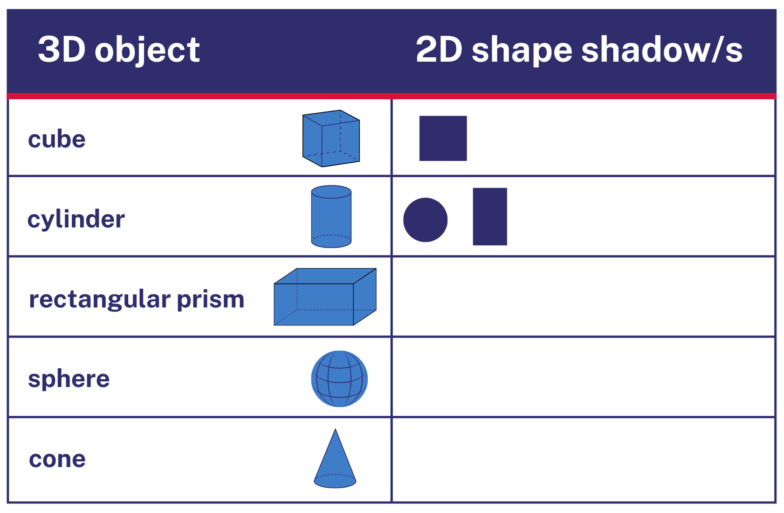
Images sourced from Canva and used in accordance with the Canva Content License Agreement.

Resource 5: Architectural drawings
‘buildings illuminated city’ by hbieser, ‘sketch city skyline architecture’ by LUCAS GREY, ‘abu dhabi city skyline emirates’ by neil dodhia, ‘architecture tower building design drawing lines’ by ractapopulous are used in accordance with the Pixabay License

Resource 6: Prism city
‘architecture office city business’ by Artistic Operations, ‘white cloud stratus cirrus building’ by lin2015 are used in accordance with the Pixabay License

Syllabus outcomes and content
The table below outlines the syllabus outcomes and range of relevant syllabus content covered in this unit. Content is linked to National Numeracy Learning Progression version (3).
Focus area and outcomes | Content groups and content points | Lessons
Representing whole numbers  MAO-WM-01  MAE-RWN-01, MA1-RWN-01  MAE-RWN-02, MA1-RWN-02 | Early Stage 1  Use the counting sequence of ones flexibly  - count forwards to at least 30 and state the number after or before a given number, without needing to count from one (CPr4)  - identify the number before as 'one less' and the number after as 'one more’ than a given number | 1, 2, 6
Representing whole numbers (cont) | Early Stage 1  Recognise number patterns  - recognise dice and domino patterns (NPA1, NPV2, CPr2) | 8
Representing whole numbers (cont) | Early Stage 1  Connect counting and numerals to quantities  - make correspondences between collections (Reasons about quantity)  - represent numbers as quantities to at least 20 using objects, number words and numerals (NPV2-NPV4, CPr3)  - compare and order numbers to 20 (NPV2-NPV3) | 3, 5, 6, 8
Representing whole numbers A (cont) | Stage 1  Use counting sequences of ones with two-digit numbers and beyond  - identify the number before and after a given two-digit number (CPr5) | 1, 6
Representing whole numbers A (cont) | Stage 1  Continue and create number patterns  - model and describe ‘odd’ and ‘even’ numbers using items paired in two rows | 8
Representing whole numbers A (cont) | Stage 1  Represent numbers on a line  - sequence numbers and arrange them on a line by considering the order and size of those numbers (CPr5)  - locate the approximate position of multiples of 10 on a model of a number line for 0 to 100 (CPr5) | 2, 6
Representing whole numbers A (cont) | Stage 1  Represent the structure of groups of ten in whole numbers  - partition two-digit numbers to show quantity values (NPV4) | 5
Representing whole numbers B (cont) | Stage 1  Form, regroup and rename three-digit numbers  - recognise units of 100 (UnM5, NPV5) | 3
Two-dimensional spatial structure  MAO-WM-01  MAE-2DS-01, MA1-2DS-01  MAE-2DS-02, MA1-2DS-02 | Early Stage 1  Sort, describe and name familiar shapes  - identify familiar shapes in a range of contexts  - recognise and explain how a group of shapes has been sorted (Reasons about spatial relations)  - describe shapes, including circles, squares, triangles and rectangles (UGP1-UGP2) | 1-4
Two-dimensional spatial structure  (cont) | Early Stage 1  Represent shapes  - make representations of shapes in a variety of ways, using paint, paper, movements or technology (UGP3)  - make pictures and designs using a selection of shapes  - make two-dimensional shapes by tracing around the faces of three-dimensional objects (UGP3) | 2-4
Two-dimensional spatial structure A (cont) | Stage 1  Recognise and classify shapes using obvious features  - explore, manipulate and describe features of polygons (UGP3)  - use the terms ‘side’, ‘vertex’ and ‘two-dimensional’ to describe plane (flat) shapes (UGP1-UGP2)  - compare, sort and classify polygons according to the number of sides or vertices (UGP3-UGP4)  - identify shapes presented in different orientations (UGP2) | 1-5
Three-dimensional spatial structure  MAO-WM-01  MAE-3DS-01, MA1-3DS-01  MAE-3DS-02, MA1-3DS-02 | Early Stage 1  Explore familiar three-dimensional objects  - describe the features of familiar objects (UGP1)  - sort objects and identify the attribute used to sort them (UGP2)  - make and describe a variety of three-dimensional models (UGP3)  - predict the stacking capabilities of various three-dimensional objects | 1-7
Three-dimensional spatial structure (cont) | Early Stage 1  Volume: Compare internal volume by filling and packing  - compare the internal volume of two containers indirectly by pouring their contents into two other identical containers and observing the level reached in each (UuM3)  - establish that containers of different shapes may hold the same amount  - stack and pack blocks into defined spaces (UuM5) | 8
Three-dimensional spatial structure (cont) | Early Stage 1  Volume: Compare volume by building  - identify the attributes of volume as the amount of space an object or substance occupies  - compare the volumes of two objects made from blocks or connecting cubes directly by deconstructing one object and using its parts to construct a copy of the other object  - use comparative language to describe volume (UuM2) | 6-7
Three-dimensional spatial structure A (cont) | Stage 1  3D Objects: Recognise familiar three-dimensional objects  - use the term ‘three-dimensional’ to describe a range of objects (UGP2-UGP3)  - distinguish between objects, which are three-dimensional (3D) and shapes which are two-dimensional (2D)  - identify and name familiar three-dimensional objects, including cubes, cylinders, spheres and rectangular prisms | 1-7
Three-dimensional spatial structure A (cont) | Stage 1  3D Objects: Sort and describe three-dimensional objects  - manipulate and describe familiar three-dimensional objects (UGP2)  - use the term ‘surface’ in describing familiar three-dimensional objects  - sort familiar three-dimensional objects according to obvious features  - use the term ‘face’ to describe the flat surfaces of three-dimensional objects with straight edges (UGP2-UGP3)  - select and name a familiar three-dimensional object from a description of its features | 1-6
Three-dimensional spatial structure A (cont) | Stage 1  Volume: Measure and compare the internal volumes (capacities) of containers by filling  - select appropriate informal units to measure the capacities of containers  - compare the internal volumes of two or more containers using appropriate uniform informal units (UuM3)  - estimate how much a container holds by referring to the number and type of uniform informal units used and check by measuring (UuM3-UuM4)  Volume: Measure the internal volume (capacity) of containers by packing  - pack cubic units (eg blocks) into rectangular containers so that there are no gaps  - recognise that cubes pack better than other objects in rectangular containers (Reasons about spatial structure)  - estimate and measure the internal volume of a container by filling the container with uniform informal units and counting the number of units used  - explain that if there are gaps when packing and stacking, this will affect the accuracy of measuring the internal volume | 8
Three-dimensional spatial structure A (cont) | Stage 1  Volume: Construct volumes using cubes  - explore different rectangular prisms that can be made from a given number of cubes  - record volumes, referring to the number and type of uniform informal unit used | 6-8
Three-dimensional spatial structure B (cont) | Stage 1  3D Objects: Describe the features of three-dimensional objects  - describe three-dimensional objects (prisms) using the terms ‘face’, ‘edge’ and ‘vertex’  - represent three-dimensional objects by making simple models  - recognise and name flat surfaces of three-dimensional objects as two-dimensional shapes | 1-7
Three-dimensional spatial structure B (cont) | Stage 1  Volume: Compare containers based on internal volume (capacity) by filling and packing  - compare, order and record the internal volumes (capacities) of two or more containers by measuring each container in uniform informal units (UuM3-UuM4)  - estimate internal volume (capacity) by referring to the number and type of uniform informal unit used (UuM3) | 8
Three-dimensional spatial structure B (cont) | Stage 1  Volume: Compare volumes using uniform informal units  - compare models with different appearances, recognising when they have the same volume (Reasons about spatial structure)  - record the results of volume comparisons using drawings, numerals and words, referring to the units used | 7-8

References
Links to third-party material and websites
Please note that the provided (reading/viewing material/list/links/texts) are a suggestion only and implies no endorsement, by the New South Wales Department of Education, of any author, publisher, or book title. School principals and teachers are best placed to assess the suitability of resources that would complement the curriculum and reflect the needs and interests of their students.
If you use the links provided in this document to access a third-party's website, you acknowledge that the terms of use, including licence terms set out on the third-party's website apply to the use which may be made of the materials on that third-party website or where permitted by the Copyright Act 1968 (Cth). The department accepts no responsibility for content on third-party websites.
Except as otherwise noted, all material is © State of New South Wales (Department of Education), 2023 and licensed under the Creative Commons Attribution 4.0 International License. All other material (third-party material) is used with permission or under licence. Where the copyright owner of third-party material has not licensed their material under a Creative Commons or similar licence, you should contact them directly for permission to reuse their material.
Mathematics K–10 Syllabus © 2022 NSW Education Standards Authority (NESA) for and on behalf of the Crown in right of the State of New South Wales.
© 2022 NSW Education Standards Authority. This document contains NSW Curriculum and syllabus content. The NSW Curriculum is developed by the NSW Education Standards Authority. This content is prepared by NESA for and on behalf of the Crown in right of the State of New South Wales. The material is protected by Crown copyright.
Please refer to the NESA Copyright Disclaimer for more information.
NESA holds the only official and up-to-date versions of the NSW Curriculum and syllabus documents. Please visit the NSW Education Standards Authority (NESA) website and the NSW Curriculum website.
National Numeracy Learning Progression © Australian Curriculum, Assessment and Reporting Authority (ACARA) 2010 to present, unless otherwise indicated. This material was downloaded from the Australian Curriculum website (National Numeracy Learning Progression) (accessed 29 September 2022) and was not modified. The material is licensed under CC BY 4.0. Version updates are tracked in the ‘Curriculum version history’ section on the 'About the Australian Curriculum' page of the Australian Curriculum website.
ACARA does not endorse any product that uses the Australian Curriculum or make any representations as to the quality of such products. Any product that uses material published on this website should not be taken to be affiliated with ACARA or have the sponsorship or approval of ACARA. It is up to each person to make their own assessment of the product, taking into account matters including, but not limited to, the version number and the degree to which the materials align with the content descriptions and achievement standards (where relevant). Where there is a claim of alignment, it is important to check that the materials align with the content descriptions and achievement standards (endorsed by all education Ministers), not the elaborations (examples provided by ACARA).
This resource contains images and content obtained from Canva, and their use outside of this resource is subject to Canva’s Content License Agreement. If you wish to use them separately from the resource, please go to Canva.
Australian Government Department of Education (2022) 'Shape: Shadows', Teaching resources, reSolve website, accessed 29 September 2022.
Boaler J, Munson J and Williams C (2018) Mindset Mathematics: Visualising and Investigating Big Ideas, Grade 5, Jossey-Bass, US.
Siemon D, Warren E, Beswick K, Faragher R, Miller J, Horne M, Jazby D, Breed M, Clark J and Brady K (2020) Teaching Mathematics: Foundations to Middle Years, 3rd edn, Oxford University Press Australia and New Zealand.
Sullivan P and Lilburn P (2017) Open-Ended Maths Activities, Rev edn, Oxford University Press, UK.
Swan P (2003) Dice Dazzlers: Odd and even, A-Z Type, Australia.

