Mathematics – K-2 multi-age – Year A – Unit 18
Contents
Unit description and duration 4
Student prior learning 4
Lesson overview and resources 5
Lesson 1: Building bricks! 18
Daily number sense: Sorting building bricks – 10 minutes 19
Building bricks! – 40 minutes 19
Consolidation and meaningful practice: Building bricks! – 15 minutes 23
Lesson 2: Planning playgrounds – Part 1 24
Daily number sense: Counting fives – 10 minutes 25
Let’s collect data! – 40 minutes 26
Consolidation and meaningful practice: What were the most popular? – 10 minutes 29
Lesson 3: Planning playgrounds – Part 2 30
Daily number sense: Data talk – 10 minutes 31
Asking others – 40 minutes 32
Consolidation and meaningful practice: Playground preferences – 10 minutes 34
Lesson 4: Planning playgrounds – Part 3 35
Daily number sense: Number talk – 10 minutes 36
Perfect playgrounds – 40 minutes 37
Consolidation and meaningful practice: Problem solved! – 20 minutes 39
Lesson 5: Sort the Street 40
Daily number sense: Data talk – 10 minutes 40
Sort the Street – 45 minutes 42
Consolidation and meaningful practice: Re-think and reflect – 10 minutes 48
Lesson 6: Our favourite fruit 49
Daily number sense: Data talk – 10 minutes 50
Our favourite fruit – 50 minutes 51
Lesson 7: What rubbish is in my lunch box? 57
Daily number sense: What number could this be? – 15 minutes 57
What rubbish is in my lunch box? – 30 minutes 59
Consolidation and meaningful practice: What helped us read the data? – 15 minutes 65
Lesson 8: What bin do we need? 67
Daily number sense: Favourite season data talk – 15 minutes 67
What bin do we need the most? – 40 minutes 68
Consolidation and meaningful practice: Gallery walk – 15 minutes 72
Resource 1: Hundreds chart 73
Resource 2: Playgrounds 74
Resource 3: Playground equipment 75
Resource 4: Playground tally chart 76
Resource 5: Column graph 77
Resource 6: Popular fruit graph 78
Resource 7: Data talk 1 79
Resource 8: House cards 80
Resource 9: N.W.L. (Notice Wonder Learnt) chart 81
Resource 10: Data talk 2 82
Resource 11: Fruit cards 83
Resource 12: Additional fruit cards 84
Resource 13: Fruit table 86
Resource 14: Picture graph 87
Resource 15: Drawing template 88
Resource 16: Number lines 89
Resource 17: Lunch box images 90
Resource 18: Graph template 91
Resource 19: Favourite season graph 92
Resource 20: Tally mark table 93
Resource 21: Recycling graph 94
Syllabus outcomes and content 95
References 100

Unit description and duration
This two-week unit develops student knowledge, understanding and skills of data. Students are provided opportunities to:
- arrange objects to form a data display
- organise and represent data in effective and accurate ways
- recognise and describe the element of chance in everyday events
- conduct surveys to collect data and use data to solve problems
- gather and organise data and then display it in tables and picture graphs
- interpret a data display and describe information using comparative language.
Mathematics K–10 Syllabus © 2022 NSW Education Standards Authority (NESA) for and on behalf of the Crown in right of the State of New South Wales.

Student prior learning
Before engaging in these teaching and learning activities, students would benefit from prior experience with:
- responding to questions, collecting information, and discussing possible outcomes of activities
- organising objects into simple data displays and interpreting the displays.

Lesson overview and resources
The table below outlines the sequence and approximate timing of lessons; syllabus focus areas and content groups; and resources.
Lesson | Syllabus focus area and content groups | Resources
Lesson 1: Building bricks!  65 minutes  Data can be sorted, categorised, and represented in different ways. | Representing whole numbers  Early Stage 1  - Instantly name the number of objects within small collections  - Connect counting and numerals to quantities  Stage 1 – Part A  - Use counting sequences of ones with two-digit numbers and beyond  Data  Early Stage 1  - Respond to questions, collect information and discuss possible outcomes of activities  - Organise objects into simple data displays and interpret the displays  Stage 1 – Part A  - Ask questions and gather data  - Represent data with objects and drawings and describe the displays  Stage 1 – Part B  - Identify a question of interest and gather relevant data  Chance  Stage 1 – Part A  - Identify and describe possible outcomes | - Video: Brick data (9:48)  - Bag with building bricks concealed inside  - Building bricks  - Large sheet of paper or cardboard (to create anchor chart)  - Writing materials
Lesson 2: Planning playgrounds – Part 1  60 minutes  Data can be collected and represented in graphs. | Representing whole numbers  Early Stage 1  - Instantly name the number of objects within small collections  - Connect counting and numerals to quantities  Stage 1 – Part A  - Use counting sequences of ones with two-digit numbers and beyond  Data  Early Stage 1  - Respond to questions, collect information and discuss possible outcomes of activities  - Organise objects into simple data displays and interpret the displays  Stage 1 – Part A  - Ask questions and gather data  - Represent data with objects and drawings and describe the displays  Chance  Stage 1 – Part A  - Identify and describe possible outcomes  Stage 1 – Part B  - Identify and describe activities that involve chance | - Resource 1: Hundreds chart  - Resource 2: Playgrounds or own images of local playgrounds  - Resource 3: Playground equipment  - Resource 4: Playground tally chart  - Resource 5: Column graph  - Interlocking cubes  - Writing materials
Lesson 3: Planning playgrounds – Part 2  60 minutes  Data can be used to answer questions and make informed decisions. | Representing whole numbers  Early Stage 1  - Instantly name the number of objects within small collections  - Connect counting and numerals to quantities  Stage 1 – Part A  - Use counting sequences of ones with two-digit numbers and beyond  Data  Early Stage 1  - Respond to questions, collect information and discuss possible outcomes of activities  - Organise objects into simple data displays and interpret the displays  Stage 1 – Part A  - Ask questions and gather data  - Represent data with objects and drawings and describe the displays  Stage 1 – Part B  - Identify a question of interest and gather relevant data  - Create displays of data and interpret them  Chance  Stage 1 – Part A  - Identify and describe possible outcomes  Stage 1 – Part B  - Identify and describe activities that involve chance | - Resource 6: Popular fruit graph  - Resource 4: Playground tally chart  - Resource 5: Column graph  - Sticky notes
Lesson 4: Planning playgrounds – Part 3  70 minutes  Organising data helps find solutions to problems. | Representing whole numbers  Early Stage 1  - Instantly name the number of objects within small collections  - Connect counting and numerals to quantities  Stage 1 – Part A  - Use counting sequences of ones with two-digit numbers and beyond  Data  Early Stage 1  - Respond to questions, collect information and discuss possible outcomes of activities  - Organise objects into simple data displays and interpret the displays  Stage 1 – Part A  - Ask questions and gather data  - Represent data with objects and drawings and describe the displays  Stage 1 – Part B  - Identify a question of interest and gather relevant data  - Create displays of data and interpret them  Chance  Stage 1 – Part A  - Identify and describe possible outcomes  Stage 1 – Part B  - Identify and describe activities that involve chance | - Resource 5: Column graph  - Resource 3: Playground equipment (Early Stage 1)  - 12 building bricks matching the colours in Figure 3  - Building bricks  - Class surveys from Lesson 3  - Drawing materials
Lesson 5: Sort the Street  65 minutes  Data helps make sense of our world. | Representing whole numbers  Early Stage 1  - Instantly name the number of objects within small collections  - Connect counting and numerals to quantities  Stage 1 – Part A  - Use counting sequences of ones with two-digit numbers and beyond  Data  Early Stage 1  - Respond to questions, collect information and discuss possible outcomes of activities  - Organise objects into simple data displays and interpret the displays  Stage 1 – Part A  - Ask questions and gather data  - Represent data with objects and drawings and describe the displays  Stage 1 – Part B  - Identify a question of interest and gather relevant data  - Create displays of data and interpret them  Chance  Stage 1 – Part A  - Identify and describe possible outcomes  Stage 1 – Part B  - Identify and describe activities that involve chance | - Resource 7: Data talk 1  - Resource 8: House cards – one set per pair  - Resource 9: N.W.L. (Notice Wonder Learnt) chart  - A3 paper
Lesson 6: Our favourite fruit  60 minutes  Thinking about the data can help make predictions about the future. | Representing whole numbers  Early Stage 1  - Instantly name the number of objects within small collections  - Connect counting and numerals to quantities  Stage 1 – Part A  - Use counting sequences of ones with two-digit numbers and beyond  Data  Early Stage 1  - Respond to questions, collect information and discuss possible outcomes of activities  - Organise objects into simple data displays and interpret the displays  Stage 1 – Part A  - Ask questions and gather data  - Represent data with objects and drawings and describe the displays  Stage 1 – Part B  - Identify a question of interest and gather relevant data  - Create displays of data and interpret them  Representing whole numbers  Stage 1 – Part A  - Sequence numbers and arrange them on a line by considering the order and size of those numbers  Chance  Stage 1 – Part A  - Identify and describe possible outcomes  Stage 1 – Part B  - Identify and describe activities that involve chance | - Resource 10: Data talk 2  - Resource 11: Fruit cards  - Resource 12: Additional fruit cards  - Resource 13: Fruit table  - Resource 14 Picture graph  - Resource 15: Drawing template
Lesson 7: What rubbish is in my lunch box?  60 minutes  Data can be collected and displayed to investigate a topic or answer a question. | Representing whole numbers  Early Stage 1  - Instantly name the number of objects within small collections  - Connect counting and numerals to quantities  Stage 1 – Part A  - Use counting sequences of ones with two-digit numbers and beyond  Data  Early Stage 1  - Respond to questions, collect information and discuss possible outcomes of activities  - Organise objects into simple data displays and interpret the displays  Stage 1 – Part A  - Ask questions and gather data  - Represent data with objects and drawings and describe the displays  Stage 1 – Part B  - Identify a question of interest and gather relevant data  - Create displays of data and interpret them  Representing whole numbers  Stage 1 – Part A  - Represent numbers on a line  Chance  Stage 1 – Part A  - Identify and describe possible outcomes  Stage 1 – Part B  - Identify and describe activities that involve chance | - Resource 16: Number lines  - Resource 17: Lunch box images  - Resource 18: Graph template  - A3 paper
Lesson 8: What bin do we need?  70 minutes  The same data can be used to answer different questions. | Representing whole numbers  Early Stage 1  - Instantly name the number of objects within small collections  - Connect counting and numerals to quantities  Stage 1 – Part A  - Use counting sequences of ones with two-digit numbers and beyond  Non-spatial measure  Stage 1 – Part A  - Time: Name and order the cycle of months  Data  Early Stage 1  - Respond to questions, collect information and discuss possible outcomes of activities  - Organise objects into simple data displays and interpret the displays  Stage 1 – Part A  - Ask questions and gather data  - Represent data with objects and drawings and describe the displays  Stage 1 – Part B  - Identify a question of interest and gather relevant data  - Create displays of data and interpret them  Chance  Stage 1 – Part A  - Identify and describe possible outcomes  Stage 1 – Part B  - Identify and describe activities that involve chance | - Resource 19: Favourite season graph  - Resource 20: Tally mark table  - Resource 21: Recycling graph  - Data displays from Lesson 7

Lesson 1: Building bricks!
Core concept: Data can be sorted and represented in different ways.
The table below contains suggested learning intentions and success criteria. These are best co-constructed with students.
Learning intentions | Success criteria
All students are learning that:  - graphs organise data in an efficient way  - objects can be sorted into categories by their attributes  - possible outcomes can be described and predicted. | All students can:  - organise building bricks into categories or groups  - arrange building brick categories into columns in a graph.  In addition, students working towards Early Stage 1 outcomes can:  - explain how they sorted their objects  - answer questions about their data display.  In addition, students working towards Stage 1 outcomes can:  - describe possible outcomes  - use comparative language to describe their display, such as ‘more than' and ‘less than’.

Daily number sense: Sorting building bricks – 10 minutes
- Build student understanding of chance and data by predicting colours and organising building bricks efficiently.
- Show students a bag with building bricks concealed inside. Ask students to predict the colours they could get. Ask students to collect a handful at random.
- Students compare their predictions to the colours they received. Explain that students are now going to organise their pile in an efficient way. You may need to explain that in this activity, the word ‘efficient’ means organised in a way that their building bricks can be seen easily.
- Discuss student thinking with the class.
Prompts | Anticipated student responses
- How did you organise your pieces?  - What is the same or different?  - What are you wondering? | - I grouped them in colours first.  - I organised them into colours, then lined them up neatly in columns to count them easily.  - I used number combinations when they were organised into colours. For example, I counted by twos, fives and so on.

Building bricks! – 40 minutes
- Watch Brick data (9:48) and ask students:
- What way was the most efficient way to show the building bricks?
- What way was the least efficient way to show the building bricks?
- Is it easier to look at graphs that have gaps or no gaps?
- What would be the best graph to show your answers?
- Create a data anchor chart that shows how to represent data using column graphs, picture graphs, and tally marks. For example, see Figure 1.
Figure 1 – Types of Graphs anchor chart
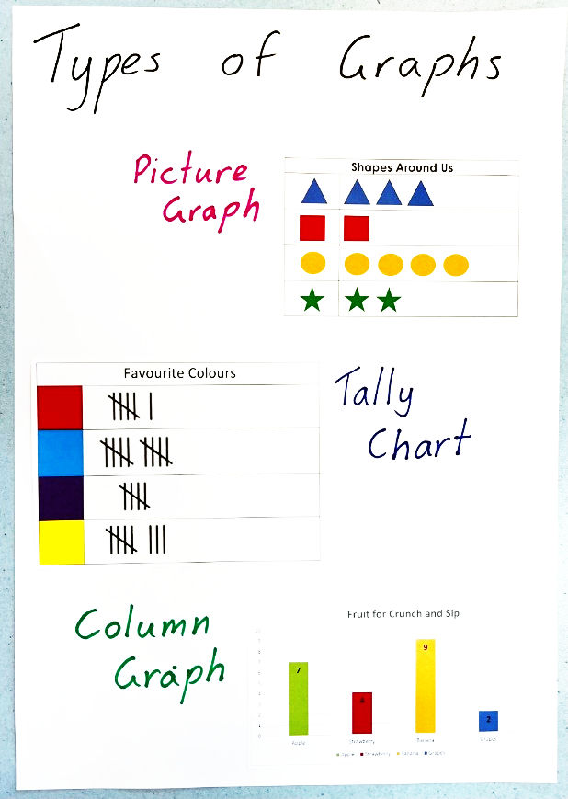
- Draw attention to the common features of these graphs including the titles, columns, number and so on.
- Briefly discuss that graphs can show different kinds of data. For example, tally charts can show how many cars and buses drive past, and column graphs can show your class’s favourite ice cream flavour. Ask students if they can think of any other topics.
- Use these examples to create an anchor chart about data and graphs to display in the classroom. Students can refer to this chart throughout the unit.
- Discuss ‘chance’ and ‘data’ using the prompts below. Student responses can be added to the anchor chart throughout the lesson.
Prompts | Anticipated student responses
- What does chance describe?  - What is data?  - Why do we have data?  - Who uses data?  - What are some examples of data?  - How do people show data? | - Chance describes how likely something is to happen.  - Data is information.  - We collect data to share information about different things.  - Everyone uses data.  - People show data through different types of graphs, pictures, and numbers.
- Stage 1 students organise and sort their building bricks from the Daily number sense activity in an efficient way. Students share their data sorts with the class and explain how they have organised their building bricks into categories.
- Early Stage 1 students stay on the floor as a group with the teacher, who models how to make a column graph using the building bricks. Ask:
- What do you notice about the graph?
- Do you see any patterns?
- Can you see the graph increasing (growing)?
- What is the biggest (most popular)?
- What is the smallest (least popular)?
- If time allows, students can show their data in another way. For example, sorting into rows or building towers.
This table details assessment opportunities and differentiation ideas.
Assessment opportunities | Too hard? | Too easy?
What to look for:  - Can students describe the chance of events? (MA1-CHAN-01)  - Are students able to organise their building bricks into categories without leaving gaps? (MAE-DATA-01, MA1-DATA-01, MA1-DATA-02)  - Can students explain their sort? For example, 'I organised my building bricks into colour groups.’ (MAO-WM-01, MAE-DATA-01, MA1-DATA-01, MA1-DATA-02)  - Can students collect and answer questions about data collected? (MAE-DATA-01, MA1-DATA-01, MA1-DATA-02)  What to collect:  - photos of students’ work and work samples as evidence of learning (MAO-WM-01, MAE-DATA-01, MA1-DATA-01, MA1-DATA-02) | Students cannot identify an attribute, such as colour, to sort their objects.  - Support students to identify one attribute to sort their objects, for example, sorting by colour.  - Model how to arrange the objects into distinct categories that makes it clear how many there are in each group. | Students can sort their objects by an identified attribute.  - Provide students with additional building bricks and ask them to complete another attribute sort.  - Students look for as many different attributes to sort their building bricks as they can identify. For example, colour, shape, size, number of dots on their building bricks, and so on.

Consolidation and meaningful practice: Building bricks! – 15 minutes
- Students go on a data gallery walk around the classroom, comparing different ways to organise and represent data. If needed, refer to the data sense activity video Brick data (9:48) and revise how to represent efficiently.
- As a class, students turn and talk to share their data organisation and representations with one another. Ask students:
- What are some similarities that you noticed in the ways groups organised their data?
- What are some differences you found?
- Did anyone organise their building bricks differently to someone else?
- Were your predictions about the colours accurate or not?
- Is there anything that you are still wondering?
- A summary of student learning can be added to the data anchor chart.

Lesson 2: Planning playgrounds – Part 1
Core concept: Data can be collected and represented in graphs.
This lesson has been adapted from Statistics: Planning Playgrounds from reSolve (2020).
The table below contains suggested learning intentions and success criteria. These are best co-constructed with students.
Learning intentions | Success criteria
All students are learning that:  - data can be represented in different ways  - different types of graphs can be read in different ways  - topics of interest can be investigated by choosing suitable questions  - possible outcomes in activities and events can be described as likely or unlikely to happen  - objects can be arranged to form a data display. | All students can:  - work together to gather data on playground facilities  - explain how to read different types of graphs.  In addition, students working towards Early Stage 1 outcomes can:  - arrange objects to form a data display  - interpret information and answer questions.  In addition, students working towards Stage 1 outcomes can:  - describe possible outcomes in the survey as likely or unlikely  - use tally marks to gather and track what has been counted.

Daily number sense: Counting fives – 10 minutes
- Build student understanding of the importance of skip counting by identifying patterns of 5.
- Students are provided with a copy of Resource 1: Hundreds chart or use the Interactive hundreds chart, with the fives and tens column highlighted. As a class, ask students to identify the pattern they see on the hundreds chart provided.
- Discuss with students the importance of skip counting. For example, you could ask students why skip counting by fives might be useful or ask them if there was a time when they used skip counting. Practise skip counting by fives as a whole class.
- Explain that we can identify the number 5 in different ways other than numerals, for example:
- tallies
- hands
- groups of
- half the decade.
- Write the number 8 on the board in tally marks. Ask:
- Why do you think there is a strike for the fifth tally?
- Is it easier to keep track of numbers by using tally marks?
- How can we add on the last 3 tallies?
- Give a demonstration of a non-example and compare it to an example of tallying. For example, draw marks for the number 23 that aren’t bundled as tallies of 5, then repeat using the tally method. Talk about which way is more efficient.

Let’s collect data! – 40 minutes
- Explain that words such as ‘might’, ‘possible’, ‘less likely’, ‘more likely’ or ‘equally likely’ describe the chance of something happening. Use examples of the weather for students to practise using these words in a familiar context.
- Revise the anchor chart and learning from the previous lesson. Use Resource 2: Playgrounds, or use your own local images, to introduce students to images of playground equipment.
- Students share problems they may have faced when trying to use playground equipment, for example, not having enough of the popular equipment. Use this discussion to decide on a question to be asked and solved throughout the ‘Planning playgrounds’ lessons, for example:
- What equipment should every playground include?
- How many of each equipment type should the playground have?
- What equipment should a playground include to accommodate an age/ability group?
- Ask students how likely they think it is that the swings will be the most popular equipment, then record some predictions. Explain that we can use data to know for certain what the answer will be.
- Use the images from Resource 3: Playground equipment on an A3 piece of paper or whiteboard as a survey, to collect data from students in the class. Each student places an interlocking cube on the image of their preferred equipment. See Figure 2.
Figure 2 – Playground data towers
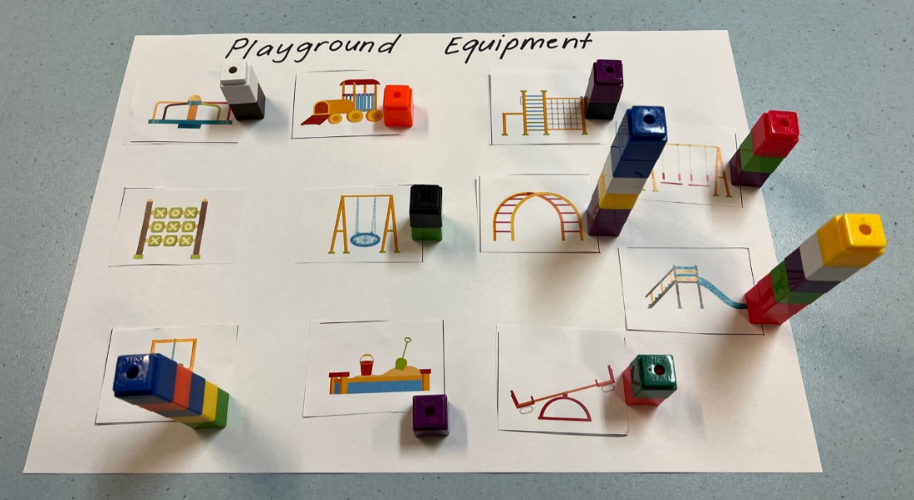
- Use the results to demonstrate how to convert into tally marks using Resource 4: Playground tally chart.
- Ask students if the tally marks made it easier to count the results and were the results what students predicted they would be.
- Draw students' attention to the information shown in the tally chart. For example, most students wanted more slides, but only a few students wanted more sandpits in the playground.
- Demonstrate how to record one piece of playground equipment on Resource 5: Column graph. Students then record the remaining responses on their own copy of the graph.
- Early Stage 1 students do this with the teacher, then answer questions about the collected data together. For example, what was the most popular equipment and what was the least popular equipment.
This table details assessment opportunities and differentiation ideas.
Assessment opportunities | Too hard? | Too easy?
What to look for:  Early Stage 1:  - Are students able to answer questions about collected data? (MAE-DATA-01)  Stage 1:  - Can students describe the chance of events? (MA1-CHAN-01)  - Are students able to interpret the information collected from a survey? (MA1-DATA-02)  - Can students use data to create a simple column graph? (MA1-DATA-01)  What to collect:  - student work samples and images of the completed graph (MAE-DATA-01, MA1-DATA-01) | Students have difficulty presenting the data as a column graph.  - Support students by counting the tallies to find the total amounts.  - Remind students about the question that this data is being collected to answer.  - Model how to construct a graph from the data and have students mirror the modelling. | Students correctly use the data to create graphs.  - Ask students to find other ways to present the data. For example, students could create a bar graph or picture graph.  - Ask students to show how this graph would change if one block represented a different value, for example, with one block equalling 2 students.

Consolidation and meaningful practice: What were the most popular? – 10 minutes
- Prompt students to discuss the answers to the following questions, using the completed class graph:
- What playground equipment was the most popular?
- What playground equipment was the least popular?
- If we interviewed another class, would we have the same results? Why do you think this?
- Students share their thinking about how we can collect and share data clearly, for example:
- Mathematicians use tally marks to record results so they can be counted efficiently.
- We compare the columns and blank spaces to determine the popularity and gaps that are in the data we collected.
- Summarise the lesson and add to the anchor chart any important mathematical language and the focus of the lesson, which is that data can be collected and represented in graphs.

Lesson 3: Planning playgrounds – Part 2
Core concept: Data is used to answer questions and make decisions.
Note: In this lesson students will have the opportunity to survey other students in the school to collect their own data set. This may need to be negotiated with other teachers about an appropriate time and format.
The table below contains suggested learning intentions and success criteria. These are best co-constructed with students.
Learning intentions | Success criteria
All students are learning that:  - data can be collected by surveying  - data needs to be represented accurately  - possible outcomes of familiar activities and events can be described. | All students can:  - ask questions and record data in an effective way, for example, by using tally marks  - use mathematical language to describe their results, such as more than, less than, double, most, least and total.  In addition, students working towards Early Stage 1 outcomes can:  - describe gathered data and represent it in a picture graph  - pose and respond to questions about the information collected.  In addition, students working towards Stage 1 outcomes can:  - represent data in a picture graph using a baseline, equal spacing and same-sized symbols  - identify possible outcomes of familiar activities and events.

Daily number sense: Data talk – 10 minutes
- Build student understanding of different types of data displays by interpreting the visual display on Popular Fruits [PDF 311KB] from youcubed.
- Show Resource 6: Popular fruit graph. Ask students what they notice and what they wonder.
- Pairs of students record their thinking on sticky notes and place the notes around the display. Early Stage 1 students can draw pictures or be paired with a Stage 1 student to support them. Alternatively, while Stage 1 students complete their sticky notes, have a group discussion, and scribe the responses from Early Stage 1 students.
- Ask students to explain their thinking. Possible discussion prompts include:
- What do you think this data display is communicating?
- What do you think the sizes of the pictures represent?
- Can we rearrange this graph to compare popularity in another way?

Asking others – 40 minutes
This lesson has been adapted from Statistics: Planning Playgrounds from reSolve (2020).
- As a class, revise the playground problem posed by the class in Lesson 2. Encourage students to use mathematical language to respond to the discussion prompts below.
The table below outlines stimulus prompts to generate conversation about the topic, along with anticipated responses from students.
Prompts | Anticipated student responses
- What were our original predictions about the playground equipment?  - Did we find out from our data if our predictions were accurate?  - Is there enough data to create a solution to our problem?  - If we asked another class, or somewhere else in NSW, would we get the same results?  - What if they are an older or younger class? | - Our original prediction was…  - Our predictions were/weren’t accurate because…  - The most popular was…  - There were twice as many…  - There were __ more people who liked __ than __.
- Explain that students are going to interview a class of a different age group, to answer the question posed in Lesson 2. Prompt students to prepare questions, such as ‘Which is your favourite type of playground equipment?’ Ask students if they predict that the responses will be similar or different and why.
- Organise students into small groups and visit classes that you have negotiated with prior to the lesson. Early Stage 1 students should be paired with Stage 1 students or be kept as a whole group that you will support.
- Provide a copy of Resource 4: Playground tally chart for each group to record their responses as tally marks. Decide as a class the types of equipment to include in the survey.
- Remind students of the appropriate way to move around the school and approach other classes. Students then survey other classes.
- Stage 1 students present their findings in Resource 5: Column graph once they return.
- Early Stage 1 students complete the task as a whole group. Model and support students to count by fives, find the total and complete Resource 5: Column graph. Alternatively, you may choose to do a picture graph.
This table details assessment opportunities and differentiation ideas.
Assessment opportunities | Too hard? | Too easy?
What to look for:  - Can students describe the chance of an event occurring? (MA1-CHAN-01)  - Can students contribute to the collection and interpretation of data? (MAE-DATA-01)  - Are students able to track the data collected using tally marks? (MA1-DATA-01)  - Can students convert tally marks into a column graph? (MA1-DATA-01)  What to collect:  - student work samples, including survey results and graphs (MA1-DATA-01) | Students have difficulty tracking tally marks. Support students by practising counting by fives and counting on.  Students are having difficulty converting tally marks into a column graph.  - Model transferring one tally mark to one unit in the column graph.  - Support students by completing the graph as a group. | Students accurately represent the data in a column graph.  - Revise the variety of graphs for students to select from the class-constructed anchor chart in Lesson 1.  - Students choose a different style of graph to present their findings.

Consolidation and meaningful practice: Playground preferences – 10 minutes
- As a class, discuss the results of the collected data from other classes. Students make inferences by comparing the graph they created and the original class graph.
Prompts | Anticipated student responses
- What did you notice about the data from the different classes? Were your predictions accurate?  - Were there any similarities or differences?  - Why do you think there are differences between the 2 graphs?  - Can you use both sets of data to predict how many students will use the playground equipment each day?  - Is there anything you are still wondering? | - Some students liked the same equipment as us, but some students had different choices.  - Not every student wants the same equipment as we did.  - Older students might have preferred climbing equipment over swings.  - Younger students might like equipment that appears safer.
- Summarise the lesson by reminding students that data can be used to answer questions and make informed decisions.

Lesson 4: Planning playgrounds – Part 3
Core concept: Organising and representing data helps us to solve problems.
The table below contains suggested learning intentions and success criteria. These are best co-constructed with students.
Learning intentions | Success criteria
Students are learning that:  - possible outcomes can be predicted and described  - graphs can be read and interpreted  - data can be used to find answers and solve problems. | All students can pose and respond to questions about the information collected.  In addition, students working towards Early Stage 1 outcomes can interpret information presented in a data display to answer questions.  In addition, students working towards Stage 1 outcomes can:  - predict and describe possible outcomes  - describe gathered data and represent it as a graph.

Daily number sense: Number talk – 10 minutes
- Build student understanding of interpreting data by noticing and wondering about the information in an image.
- Arrange 12 building bricks as seen in Figure 3. Ask students what they notice about.
Figure 3 – Building bricks number talk
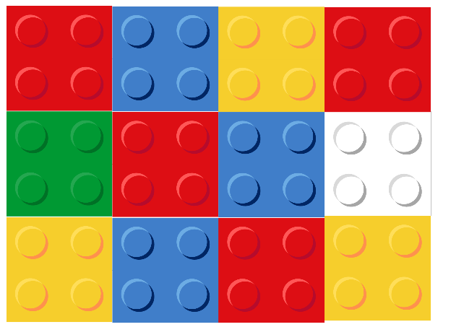
Images sourced from Canva and used in accordance with the Canva Content License Agreement.
- Some student answers could be:
- I noticed that there were 3 blue blocks.
- I saw 3 rows of 4 blocks.
- All the blocks have 4 studs.
- Together there are 12 blocks.
- Ask if there is a more efficient way to arrange the building bricks. For example, organising the blocks by students’ favourite colour.
- Once arranged into the colour groupings, ask students what they notice and what they wonder.
- Prompt Stage 1 students to notice that each piece has 4 studs. Each stud could represent one person. Ask if this changes what students notice, for example, do 3 people like blue or 12 people?

Perfect playgrounds – 40 minutes
This lesson has been adapted from Statistics: Planning Playgrounds from reSolve (2020). Refer to the class problem from Lesson 2.
- Explain that in this lesson students will look at both sets of data, including from the classes surveyed in Lesson 3.
- Ask Stage 1 students to predict how likely it is that the swings will be the most popular, giving reasons for their predictions.
- Model how to combine the class data with the results from another class surveyed into the one graph, using Resource 5: Column graph. See Figure 4.
Figure 4 – Example data and Stage 1 playground design
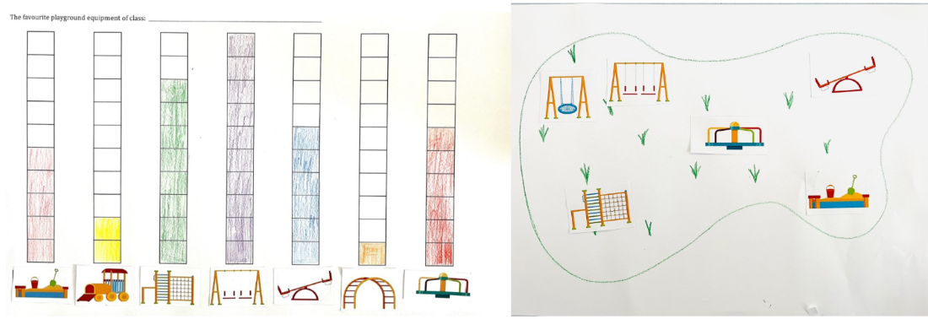
- Discuss how the data from this new graph could be used to design a playground that provides greater access to the most popular equipment. For example:
- Only one person liked monkey bars, so I didn’t include one.
- The swings were the most popular, so I included 3 swings.
- In groups, Stage 1 students discuss their combined data and make decisions about the playground equipment to include in their design. Students will need to justify their decisions.
- Stage 1 students create a playground design using building bricks, as a drawing or digitally.
- Support Early Stage 1 students to use pictures from Resource 2: Playgrounds to design their playground together.
This table details assessment opportunities and differentiation ideas.
Assessment opportunities | Too hard? | Too easy?
What to look for:  - Can students describe the chance of an event occurring? (MA1-CHAN-01)  - Are students able to interpret a data display and use it to make informed decisions? (MAE-DATA-01, MA1-DATA-02)  - Do the students’ playground models reflect their data? (MAE-DATA-01, MA1-DATA-02)  What to collect:  - photo evidence or work samples of data displays and playground designs (MAE-DATA-01, MA1-DATA-02) | Students are having difficulty making decisions regarding playground choices.  - Support students by looking at the graph as a small group and identifying the most popular equipment.  - Support students by using questioning to guide their decisions. For example, prompt students to look at the graph and ask if they can see whether children want swings in their playground. Encourage students to explain how they know. | Students consistently make informed decisions about the types of equipment.  - Prompt students to consider how the difference between 2 columns could affect the quantity of equipment. For example, if the popularity of the swings was double that of the slide, they might double the amount of swing equipment.  - Students compare the results across classes and consider how they could cater to different age groups. For example, 2 slides of different difficulties could be included.

Consolidation and meaningful practice: Problem solved! – 20 minutes
- Each group displays their playground designs alongside their data displays.
- Facilitate a guided gallery walk. Groups take turns to present their playground designs, justifying their equipment choices by referring to their graph display.
- Tell students you are looking for people who can give constructive feedback using mathematical language. For example, I can see that you used only one seesaw because it wasn’t very popular.
- Revisit the initial problem. Ask if students have used the data to find a solution to their problem. Prompt students to explain how they know.
- Highlight how organising data helps find solutions to problems. A summary of student learning can be added to the data anchor chart.

Lesson 5: Sort the Street
Core concept: Data helps make sense of our world.
The table below contains suggested learning intentions and success criteria. These are best co-constructed with students.
Learning intentions | Success criteria
Students are learning that:  - organising objects by attributes enables data to be sorted efficiently  - data can be represented by objects and pictures, where one object or picture represents one data value  - possible outcomes can be predicted and described. | Students can:  - identify and sort items based on categories such as colour, shape, and size  - explain what a data display shows.  In addition, students working towards Early Stage 1 outcomes can arrange objects according to characteristics.  In addition, students working towards Stage 1 outcomes can:  - show information in a data display that can be easily understood by using pictures, columns, rows, or arrays  - predict and describe possible outcomes.

Daily number sense: Data talk – 10 minutes
- Build student understanding of interpreting a data display by engaging in observations and conversations about data.
- Show Resource 7: Data talk 1 and ask students about their noticings and wonderings.
The table below outlines stimulus prompts to generate conversation about the topic, along with anticipated responses from students.
Prompts | Anticipated student responses
- What do you notice?  - What do you wonder?  - What question do you think this graph is trying to answer? What makes you think that? | - I noticed that there are numbers at the end of each line, and I think that they represent how many people play the sports.  - I notice that it looks like a graph and the heading tells me that it is about school sports.  - I wonder if the graph is about how many people play each type of sport.  - I wonder why there is only one picture next to each sport, but the value is more than one in all but basketball.
This table details assessment opportunities and differentiation ideas.
Assessment opportunities | Too hard? | Too easy?
What to look for:  - Are students able to pose and respond to questions about the information collected? (MAE-DATA-01)  - Can students interpret information presented in the graph? (MAO-WM-01)  - Do students provide reasons for their thinking? (MAO-WM-01)  What to collect:  - observations of students responding to ‘wondering’ and ‘noticing’ questions (MAE-DATA-01, MA1-DATA-02) | Students are unable to interpret information presented in the graph.  - Support students to focus their attention on 2 rows by covering the other rows.  - Ask them what information they think each row shows. | Students can interpret information presented in the graph.  - Extend students’ thinking by asking ‘If 8 people liked handball, where would it fit on this graph? Why would you put it there?’  - Further extend students thinking by asking ‘Do you think the categories would change in different parts of the world? Why?’

Sort the Street – 45 minutes
This lesson has been adapted from Sort the Street from NRICH (2022).
- Explain to students that they will work in pairs to sort and organise some data. Show students Resource 8: House cards and provide each pair a copy of the 12 cards.
- Students sort the 12 houses in a way of their choosing. Explain that mathematicians always share their thinking and encourage students to discuss with their partners their reasoning for their sorting decisions.
Note: This is an opportunity for students to engage in mathematical reasoning, so don’t tell students how to sort their houses.
- Early Stage 1 students remain with you to identify the attributes of the houses and discuss how they could be sorted.
- Allow students time to explore the sort, monitoring and observing them. For example, Figure 5 shows how houses might be sorted. Instead, some might be sorted by 2 attributes, as in Figure 6.
Figure 5 – Houses sorted by roof colour
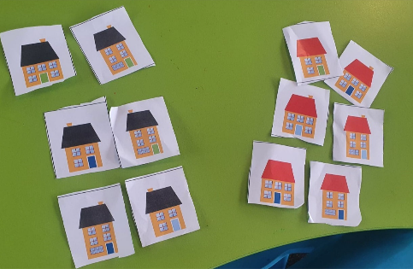
Figure 6 – Houses sorted by roof colour and door colour
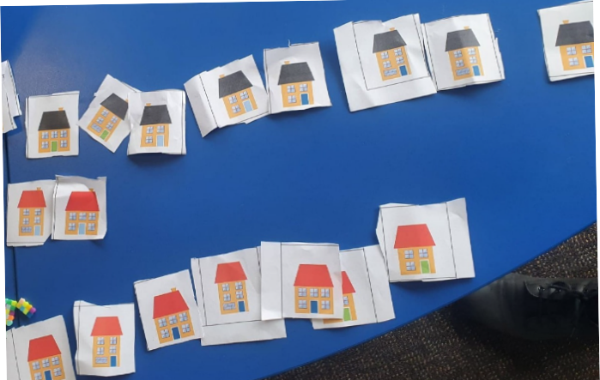
- As students arrange the sort, observe if students are providing their reasoning. Prompt students to identify the attributes that are similar and different and use this reasoning in their discussions.
- Students decide how to display their sorts, for example, in groups, piles or lines. Strategically select a pair that has organised their houses in a way that is easy to read and most represents a picture graph.
- Bring students together, leaving their data sort to return to later. Display Resource 8: House cards and ask what they notice about the 12 houses. Prompt students to turn and talk, asking the following questions:
- What do you notice?
- What is the same about the houses?
- What is different about the houses?
- What do you wonder?
- Use talk moves and strategically select students to share their thinking. Use Resource 9: N.W.L. (Notice Wonder Learnt) chart to record their responses on the Notice and Wonder parts of the chart. For an example, see Figure 7.
Figure 7 – A Notice, Wonder, Learnt chart
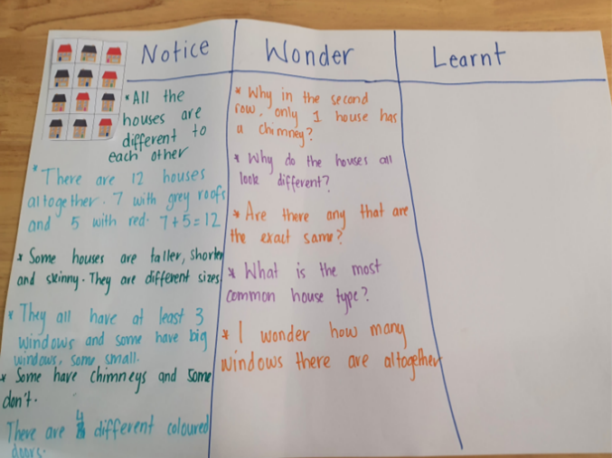
The table below outlines stimulus prompts to generate conversation about the topic, along with anticipated responses from students.
Prompts | Anticipated student responses
- What do you notice about the houses?  - What is the same about the houses?  - What is different about the houses?  - What do you wonder? | - There are 12 houses altogether because there are 5 with red roofs and 7 with black roofs. Five plus 7 equals 12.  - The houses are different sizes, some are larger, and some are smaller.  - The houses can be sorted by how many windows they have.
- Explain that the purpose for sorting the data is so it can be easily understood and to answer any questions about the houses.
- Prompt students to think about how to display their data so that it can be easily read. Take students on a gallery walk to observe how other groups have organised their houses. Encourage students to give feedback to each other on their sort, by asking the following questions:
- What do you notice about how the houses have been sorted?
- Is it similar or different to your own sort? How?
- Which displays make it easier to see how the houses have been sorted? What makes it easier?
- Highlight groups that have sorted the houses in an efficient way. For example, bring attention to a sort where the houses have been lined up in an array or rows. If there are sorts that have been chunked together or piled on top of each other explain that this method makes it difficult to see all the data.
- Explain that the data can be organised by first choosing at least one attribute to sort. Ask students to choose an attribute to model for the display.
- Model how this can be done by showing that houses can be sorted into those with red roofs and those with black roofs. Display the houses in 2 rows, a row with red roofs and a row with black roofs.
- Ask students what they notice when the data is sorted and presented like this. Prompt students to consider whether the rows look like a graph or an array. Some students might notice that it is now easier to see the different attributes of the houses.
- Model how to provide reasoning behind the way the data was sorted. For example, ‘I organised the data based on the different roof colours,’ or ‘I organised the data into how many windows each house had’, or ‘If I wanted to know how many red-roofed houses there were, then this is a good way to organise them’.
- Encourage students to consider what other attributes the houses have and give students time to revise their initial sort using the following prompts:
- How did you organise your data?
- What attribute did you choose to sort your data by?
- Can you re-sort your data using a different attribute? Does it look different now? Why?
- How many ways can you sort the data?
- In pairs, students share their revised sort, explaining their reasoning and receiving feedback from their peers. Students can revise their thinking based on this feedback and make any last changes to their sort, before formally recording it.
- Students formally record their data sort by gluing the houses on A3 paper to create their own data display. They label their display, identifying the attributes that were used for the sort. Display each pair’s data display ready for another gallery walk.
- Work with Early Stage 1 students in a group to complete their final data sort.
This table details assessment opportunities and differentiation ideas.
Assessment opportunities | Too hard? | Too easy?
What to look for:  - Can students describe the chance of an event occurring? (MA1-CHAN-01)  - Are students able to contribute to the data display by sorting according to specific attributes? (MAE-DATA-01)  - Do students organise their data into a display that represents a graph, or table? (MA1-DATA-01)  - Can students provide reasons for how they have represented their data? (MAO-WM-01)  What to collect:  - work samples of student data displays showing how they sorted their houses (MAE-DATA-01, MA1-DATA-01) | Students cannot identify one attribute to sort the houses by. Model that one way to sort the houses is by taking 2 houses and asking what is the same about them. Students then add more houses to this pair by looking for those that match the attribute. For example, the houses have 5 windows.  Students cannot label their display with reference to characteristics. Work with students to complete their final data sort. They can assist with labelling the display, by counting the houses in each collection. | Students who can sort the houses by one attribute will have more of a challenge finding 2 or more attributes to sort by. For example, these houses have 5 windows, red roofs and are taller than the others.  - Students display their houses with several attributes in a picture graph, using a baseline to compare them accurately.  - Students identify the attributes used for each of their combined sorts, using tally marks to record their findings.

Consolidation and meaningful practice: Re-think and reflect – 10 minutes
- Take students on a gallery walk to look, compare and think about what they notice about the houses. Prompt students to consider what they have learnt about organising data and record their responses on the ‘Learnt’ part of Resource 9: N.W.L. (Notice Wonder Learnt) chart. Ask the following questions:
- Is it easier to identify different attributes of the houses now that the data has been sorted? Why?
- What is different about the sorts? What is similar?
- What did you learn from the data?
- What questions could we ask about the data?
- Explain to students that by sorting and organising the houses by their attributes, it makes it easier to notice and wonder things about the data.

Lesson 6: Our favourite fruit
Core concept: Data can be collected and organised to help answer questions.
The table below contains suggested learning intentions and success criteria. These are best co-constructed with students.
Learning intention | Success criteria
All students are learning that possible outcomes of events can be identified and described. | All students can:  - ask questions to gather data about the class’s favourite fruit  - collect and record data on the class’s favourite fruit.  In addition, students working towards Early Stage 1 outcomes can create a data display of the class’s favourite fruit.  In addition, students working towards Stage 1 outcomes can:  - identify how likely or unlikely a type of fruit will be selected  - make choices based on how likely or unlikely a fruit will be selected  - organise collected data into tables to display information  - represent data in a picture graph.

Daily number sense: Data talk – 10 minutes
- Build student understanding of interpreting data displays and proportional reasoning, by locating approximate positions of numbers on a number line.
- Students are provided with a copy of Resource 10: Data talk 2. This builds on the data talk activity in Lesson 5 but adds an ‘Other’ column.
- Ask students what they notice and what they think the category ‘other’ means.
- Ask how many children they think play ‘other’ sports, prompting students to explain how they know. Students Think-Pair-Share with a partner, then share their thinking with a class. Record their responses on a T-chart, as in Figure 8.
Figure 8 – Sample T-chart
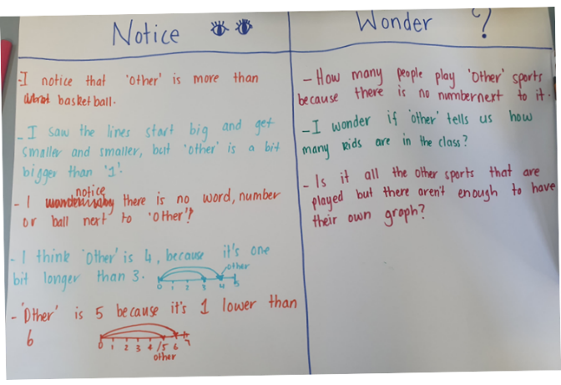
The table below outlines stimulus prompts to generate conversation about the topic, along with anticipated responses from students.
Prompts | Anticipated student responses
- What do you notice about this data display?  - What do you wonder?  - What do you think the category ‘other’ means?  - How many children do you think play ‘other’ sports? How do you know? | - I noticed that the ‘other’ is less than rugby league and soccer.  - I think that ‘other’ is 4, because it is one unit longer than 3.  - I think ‘other’ is 5 because it is one unit lower than 6.  - I think 4 or 5 people play other sports because the bar is less than 6, but more than 3.  - I wonder how many people play ‘other’ sports because there is no number next to it.  - I wonder if ‘other’ is only one sport, or if it means there are lots of sports that are represented.

Our favourite fruit – 50 minutes
- Display Resource 11: Fruit cards. Explain to students that each corner of the classroom will represent the different fruits. For example, corner 1 will be oranges, corner 2 will be apples, corner 3 will be bananas and corner 4 will be watermelons.
- Place the 4 fruit cards into a bag. Ask students to choose a corner to stand in. Select a card from the bag. Students who are in that corner sit down. Place the card back into the bag. The remaining students can select a new corner. Select another card and continue playing until one student is left or all students are out.
- Print Resource 12: Additional fruit cards. Explain to students that now in the bag there will be 10 apple cards, 5 orange cards, 3 banana cards and 1 watermelon card. Play several rounds of the game again.
- Ask students the following questions:
- What fruit am I most likely to select? How do you know?
- What fruit am I less likely to select? How do you know?
- Is it possible, I would select grapes? Why or why not?
- Is it possible, I would select a watermelon? Why or why not?
- Is it more likely I will select a watermelon or an apple? Explain your reasoning.
- Tell students that mathematicians gather data to help understand the world around them. Today we are going to gather data about our class’s favourite fruit snacks.
- Discuss with students what question we would need to ask if we wanted to find out our class’s favourite fruit. Make a class list of possible questions and discuss the value of specific questioning when gathering data. Make a class decision on the best question to ask.
- Pose the question to the class and record responses on the board using tally marks. See Figure 9.
Figure 9 – Class tally
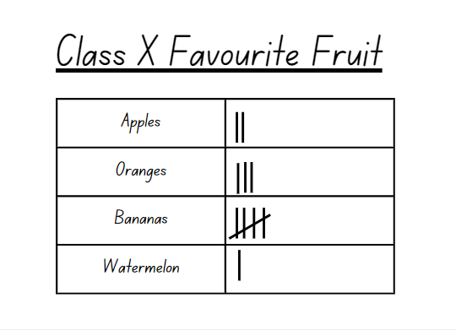
Note: To ensure a reasonable size data set, it is suggested that the number of fruits recorded is limited to 5 or 6 different fruits.
- For Stage 1 students, give them a copy of Resource 13: Fruit table. Have them total the amounts for each choice and record in the table. Stage 1 students use Resource 14: Picture graph to create a picture graph to display the results.
- For Early Stage 1 students, support counting the totals for each fruit. Give students several copies of Resource 15: Drawing template. Have students draw pictures to represent the fruit in each box. Students cut the fruit out and arrange the fruit pictures to create a data display, see Figure 10.
Figure 10 – Fruit data display
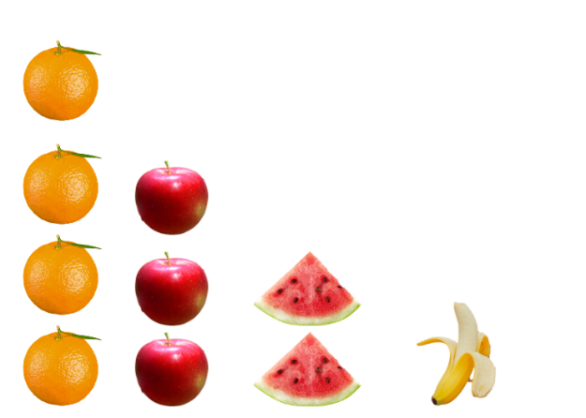
Images sourced from Canva and used in accordance with the Canva Content License Agreement.
- As a class, discuss the following questions:
- Which fruit was the most popular? Explain your reasons.
- Which fruit was the least popular? How do you know?
- How many students in our class chose apples? How did you work this out?
- Were any fruits chosen the same number of times?
This table details assessment opportunities and differentiation ideas.
Assessment opportunities | Too hard? | Too easy?
What to look for:  - Are students identifying possible outcomes and revising their estimates throughout the problem-solving process? (MAO-WM-01, MA1-CHAN-01)  - Are students able to contribute to the collection of data? (MAO-WM-01, MAE-DATA-01, MA1-DATA-01, MA1-DATA-02)  - Can students record their data in a table? (MAO-WM-01, MA1-DATA-02)  - Can students arrange fruit pictures to form a data display? (MAO-WM-01, MAE-DATA-01)  - Are students able to organise the data collected into a picture graph? (MAO-WM-01, MA1-DATA-01, MA1-DATA-02)  - Are students able to interpret information presented in a data display? (MAO-WM-01, MAE-DATA-01, MA1-DATA-01, MA1-DATA-02)  What to collect:  - photographs of data displays (MAO-WM-01, MAE-DATA-01)  - Resource 14: Picture graph (MAO-WM-01, MA1-DATA-01, MA1-DATA-02) | Students are unable to record their data in a table.  - Revise with students how to count tally marks.  - Model recording the first data set in the table to provide an exemplar.  Students are unable to arrange fruit pictures to form a data display.  - Provide a scaffold for students to overlay pictures on top, for example Resource 15: Drawing template.  - Model placing 2 fruit pictures to show the vertical structure of the display. | Students are able to organise the data collected into a picture graph. Students create some additional questions that could be asked about the data. For example, how many students liked apples over oranges?

Lesson 7: What rubbish is in my lunch box?
Core concept: We can collect and display data to investigate a topic of interest or answer a question.
The table below contains suggested learning intentions and success criteria. These are best co-constructed with students.
Learning intentions | Success criteria
All students are learning that:  - data can be collected and displayed to answer a question or to investigate a topic of interest  - picture graphs can display data  - the chance of possible outcomes of events can be described. | All students can collect data to answer a question of interest.  In addition, students working towards Early Stage 1 outcomes can:  - collect information about their environment  - Interpret information shown in a data display.  In addition, students working towards Stage 1 outcomes can:  - use symbols to represent concrete materials in a picture graph  - describe possible outcomes for different events.

Daily number sense: What number could this be? – 15 minutes
- Build student understanding of number sense by asking them to identify a missing value on a number line, using other numbers as a reference guide.
- Show Resource 16: Number lines and ask students about their noticings and wonderings. Give students time to think, then share with a partner. For Early Stage 1 students, edit the number line to include the numbers 0-20, or show the second number line with missing numbers instead.
The table below outlines stimulus prompts to generate conversation about the topic, along with anticipated responses from students.
Prompts | Anticipated student responses
- What do you notice? What do you wonder?  - What number could the question mark represent?  - Can you explain why you think that?  - Do you think it is likely that your prediction will be correct? Why? | - I noticed that there is a number line starting at 0 and ending at 100.  - I wonder why the question mark is in that location?  - I think it is less than 50 because the halfway mark would be 50.
This table details assessment opportunities and differentiation ideas.
Assessment opportunities | Too hard? | Too easy?
What to look for:  - Can students compare and order numbers to 20? (MAE-RWN-02)  - Do students describe the chance of events occurring? (MA1-CHAN-01)  - Do students justify their reasoning? (MAO-WM-01)  - Do students consider order and size of numbers when sequencing and arranging numbers on a number line? (MA1-RWN-01)  What to collect:  - observations of student reasoning during whole-class discussions (MAO-WM-01, MAE-RWN-02, MA1-RWN-01) | Students find it difficult to work with numbers in the range 0-100.  - Change the number line to be between 0-20.  - Use a number track with missing numbers instead of a number line. | Students can track numbers on a line beyond 100.  - Extend the number line to have students work beyond 100.  - Use a number line that shows 150-250, or numbers off the decade.

What rubbish is in my lunch box? – 30 minutes
This task has been adapted from What A Load Of Rubbish! from reSolve (2020).
- Students sit in a circle with their lunch box open. Ask them to look in their lunch box and imagine that they saved their rubbish in it all day. Ask students what rubbish they would be left with and how much of it would be plastic or food scraps.
- Discuss what they notice about the properties of rubbish that they will be left with at the end of the day. For example, plastic, foil, paper, cardboard, and food scraps.
- Students cut out a picture from the rubbish images Resource 17: Lunch box images to match each piece of rubbish they have. For example, if students have a sandwich wrapped in plastic wrap, they choose a picture of plastic wrap. See Figure 11.
Figure 11 – Images matched to foods
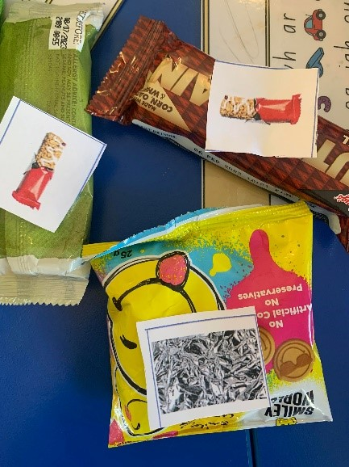
- If students have a different type of fruit food scrap, they can use the picture of the apple core or banana peel to represent what they will be left with, or they can draw their own picture to represent that piece of rubbish.
- Show students a pile of rubbish pictures and ask the following questions:
- Is it easy to see the different types of rubbish?
- Is there another way we can display the rubbish data?
- Explain that they have collected data about their lunch box and now they will organise it to make the data easier to see. They will organise the pictures into similar groups to answer the question ‘What sort of rubbish is in my lunch box?’
- Model how a single piece of rubbish will represent one piece of data on a picture graph. Students join a group to create a combined picture graph of their lunch box images on A3 paper, based on their sorting.
- Students discuss how they will sort their data on the page to display the information that they have collected. Allow students time to experience productive struggle. Work with Early Stage 1 students as a group as they contribute to the collection of pictures and sorting of data together.
- If needed, prompt students to recognise that the data can be displayed by placing the representations of rubbish in columns or rows and using a baseline.
- Monitor for student representations that demonstrate columns, evenly spaced pictures, and a baseline. Strategically select student work to highlight and display to the class.
- Ask students to consider the placement of the rubbish, ensuring rows and columns are aligned so the data can be easily read. Prompt students to notice that all the images of the rubbish are the same size and need to be equally spaced. See Figure 12.
Figure 12 – An example graph
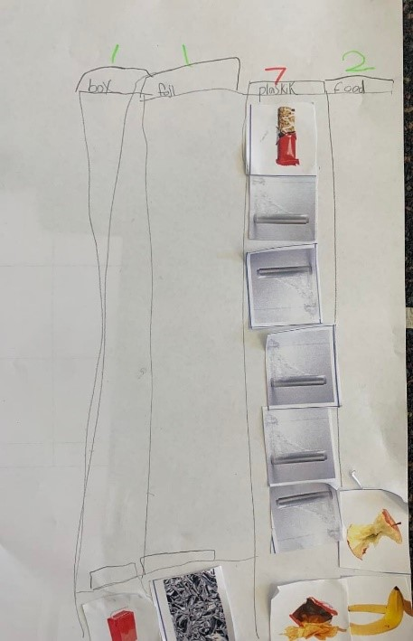
- If students are struggling to find a way to display their data, give them the option of using Resource 18: Graph template on A3 paper, as in Figure 13.
Figure 13 – Graph of rubbish sort
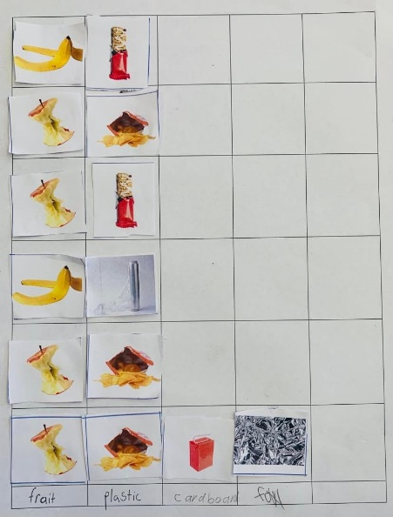
- Share examples of student data displays. Compare 2 examples that show a display with labels and one without labels and ask the following questions:
- What is the same about these data displays?
- What is different about them?
- How do you know these types of rubbish go together?
- What part of the display tells you how it has been sorted?
- Prompt students to notice and wonder about aspects of their graphs. Ask the following questions:
- Do all categories have the same number of pieces of rubbish?
- What type of rubbish has the largest number/the smallest number? Encourage Early Stage 1 students to compare the size of groups by counting with 1:1 correspondence.
- Why do you think that some types of rubbish are more common than others?
- Are each of the student groups’ picture graphs similar?
This table details assessment opportunities and differentiation ideas.
Assessment opportunities | Too hard? | Too easy?
What to look for:  - Are students able to collect data to answer a question of interest? (MAE-DATA-01)  - Do students group objects according to characteristics? (MAE-DATA-01)  - Can students use pictures of objects as symbols to create data displays where one picture represents one data value? (MA1-DATA-01)  - Are students able to align the picture representations into columns and rows to easily read their data display? (MA1-DATA-02)  - Do students choose and apply efficient techniques to solve the problem? (MAO-WM-01)  What to collect:  - observations of students’ discussions and sorting according to characteristics in a way that’s easy to see (MAO-WM-01, MAE-DATA-01)  - students’ picture graphs and observations of student responses to data questions (MAO-WM-01, MA1-DATA-02) | Students are unable to organise the data so that it can be read by others.  - Support students to work in a group so that they can contribute to the collection of data rather than doing it independently.  - Provide students with a copy of Resource 18: Graph template. Students use the pre-prepared spaces to glue the pictures into and label each column.  - Ask why this might help. | Students are confident working with data and displaying it in a picture graph.  - Ask students to use the data from 2 groups to create a new data display, combining the totals for both groups.  - These results may be difficult to fit on one graph using the images and a 1:1 scale, so students may need to find another way to represent the data. For example, they might decide to have each image represent 2 pieces of rubbish.

Consolidation and meaningful practice: What helped us read the data? – 15 minutes
- Place the completed data display next to a pile of unsorted lunch box images, as in Figure 14. Explain to students that the display and the pile both show data, but only one has been organised. Ask the following questions:
- What display makes it easier to see the different types of rubbish?
- What features of the display make it easier?
- Is there anything in the organised data display that you are still wondering about?
- Have our data displays answered the question ‘What sort of rubbish is in my lunch box?’
Figure 14 – Data display alongside an unsorted pile
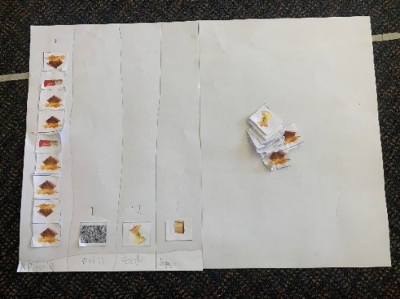
The table below outlines stimulus prompts to generate conversation about the topic, along with anticipated responses from students.
Prompts | Anticipated student responses
- I wonder if it would have been as easy for us to see the types of rubbish if we left them in a group instead of using rows and columns? Why? Why not?  - What helped us to understand the types of rubbish that were in our lunch boxes?  - I wonder if there is another way we could display the same data? | - No, because we can’t see what’s underneath the top ones.  - The pictures that matched the rubbish. One for each type.  - We sorted them into groups.  - Yes, we could draw pictures instead.  - We could display the groups in rows and columns.

Lesson 8: What bin do we need?
Core concept: The same data can be used to answer different questions.
The table below contains suggested learning intentions and success criteria. These are best co-constructed with students.
Learning intentions | Success criteria
All students are learning that:  - data can be reorganised to answer different questions  - data can be represented in a variety of ways  - the chance of possible outcomes of events can be described. | All students can use data to answer a given question.  In addition, students working towards Early Stage 1 outcomes can:  - interpret information presented in a data display to answer questions  - arrange objects according to characteristics to form a data display.  In addition, students working towards Stage 1 outcomes can:  - use tally marks and a graph to display their data  - describe possible outcomes for different events.

Daily number sense: Favourite season data talk – 15 minutes
- Build student understanding of interpreting data displays, based on the youcubed resource ‘Favourite Season’.
- Display Resource 19: Favourite season graph and use the prompts below to facilitate a data talk.
- Provide students with thinking time, as well as the opportunity to turn and talk. Record responses using talk moves.
The table below outlines stimulus prompts to generate conversation about the topic, along with anticipated responses from students.
Prompts | Anticipated student responses
- What do you notice about this image?  - What are you wondering?  - What question do you think was asked?  - What is the order of the months of the year?  - If we asked our class this question, would the data look the same? Why/why not?  - Could we further label the seasons to show which months are in each season? | - There is one tree, it has all the seasons, autumn has the most, winter has the least.  - The numbers add up to 100.  - I wonder where the people who answered the questions live. Why is it in a circle? What do the numbers and the percentage symbol mean?  - What is your favourite season? What season do you like the most?  - Students may explain the data would be different because different people like different seasons.

What bin do we need the most? – 40 minutes
This task has been adapted from What A Load Of Rubbish! from reSolve (2020).
- Revise the completed data displays from the previous lesson that answered the question ‘What sort of rubbish is in my lunch box?’. Ask students to share what they noticed and learned from their data display. For example, students might notice that plastic is the most common type of rubbish and food scraps are the least common.
- Ask students if the data collected in Lesson 7 could be used to answer different questions. Students share their thinking with a partner.
- Explain that data can be reorganised to help answer different questions. As a class, consider other questions that could be asked to show different information. Use the prompts box below, then share and record responses.
The table below outlines stimulus prompts to generate conversation about the topic, along with anticipated responses from students.
Prompts | Anticipated student responses
- What else might you want to find out about the rubbish?  - What other questions could we ask about our rubbish?  - What do we do with our rubbish?  - Can we ask a question about recycling or composting? | - What type of bins do we need to put each different type of rubbish in?  - What bin would we need the most? For example, if we have lots of compost, maybe we need lots of compost bins.  - Is there more compost waste or packaging waste?
- Select a question to investigate further or suggest ‘What type of bin do we need the most at our school?’ Prompt students to consider how the data on their picture graphs created in the previous lesson can help answer the question.
- In the same groups from the previous lesson, give students time to review their data to see how they can reorganise it to answer the above question.
- Discuss how each group has reorganised their data to answer the new question. Strategically select groups that have organised their data according to rubbish type to show the class.
- Display Resource 20: Tally mark table. Explain how data can be organised into the different categories of rubbish. For example, the rubbish can be sorted into recycling, rubbish, REDcycle and compost. Give examples of what goes into each.
- Show students how to complete the tally table. Remind students that one tally mark represents one piece of data. Explain to students that mathematicians revise their thinking. Give time for groups to reorganise their data into the rubbish categories and complete the tally table. Support Early Stage 1 students as they contribute to a joint tally table by counting out the tally marks as a group.
- Students share their completed tables. Ask the following questions:
- Which bin do you predict we will need the most? Why?
- Can you describe how likely you think it is that we will need each type of bin?
- How do you know?
- Ask whether tally marks are the most effective way to display their data, or if they could represent their data using a different way. Allow students the chance to share their ideas and suggestions for alternative methods.
- Show Resource 21: Recycling graph and ask students to independently represent their group’s tally marks data in a picture or column graph. Early Stage 1 students work as a group with the teacher.
This table details assessment opportunities and differentiation ideas.
Assessment opportunities | Too hard? | Too easy?
What to look for:  - Do students describe the chance of events occurring? (MA1-CHAN-01)  - Can students interpret information presented in a data display? (MAE-DATA-01)  - Do students use tally marks to represent their data? (MA1-DATA-01)  - Can students recategorise their data? (MA1-DATA-02)  - Can students convert the collected data into a graph? (MA1-DATA-01)  - Are students able to demonstrate their understanding of their data and how it answers their questions? (MAO-WM-01)  What to collect:  - observations of students’ discussions and sorting to answer the class data question (MAO-WM-01, MAE-DATA-01)  - completed Resource 20: Tally mark table and graphs, where students have recategorised their data from the previous lesson (MAE-DATA-01, MA1-DATA-01, MA1-DATA-02) | Students find it difficult to independently create picture or column graph.  - Support students to complete the graph as a group. Explain that they are using the previous lesson’s data in a different way, to answer a new question, such as ‘What type of bin do you need the most at your school?’  - Provide a copy of Resource 21: Recycling graph to students to scaffold their new sort.  Students find it difficult to transfer their organised data into the tally mark table. Support students to use the lunch box images from the previous lesson to create the tally mark table. Emphasise that each image is represented by one tally mark. | Students independently use tally marks and graphs to represent their data.  - Students write a short response to the class question, referring to data in their graph to justify their response.  - Ask students to consider if there are any other questions that their data could answer. Students re-sort their data into a graph to find an answer to their new question.

Consolidation and meaningful practice: Gallery walk – 15 minutes
- Complete a gallery walk of the tally mark tables and column graphs. Ask the following questions:
- What do you notice about the different graphs?
- Is everyone's data the same? How do you know?
- Can you identify which bin is most needed in each group? Explain your thinking.
- Could you use the data again to answer a different question? How?
- Can we use this data to help us make changes that are more environmentally friendly?
- Explain this lesson showed how the same data can be used to answer different questions. To conclude the unit of learning revisit the data anchor chart and Resource 9: N.W.L. (Notice Wonder Learnt) chart. Use this as an opportunity to celebrate the students’ learning growth as mathematicians.

Resource 1: Hundreds chart
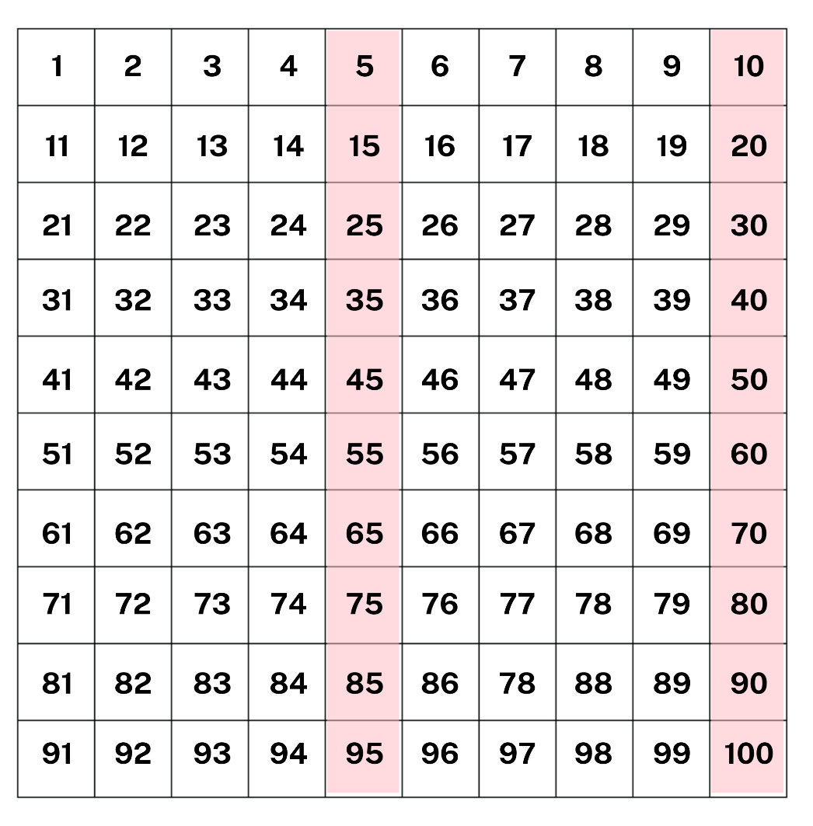

Resource 2: Playgrounds
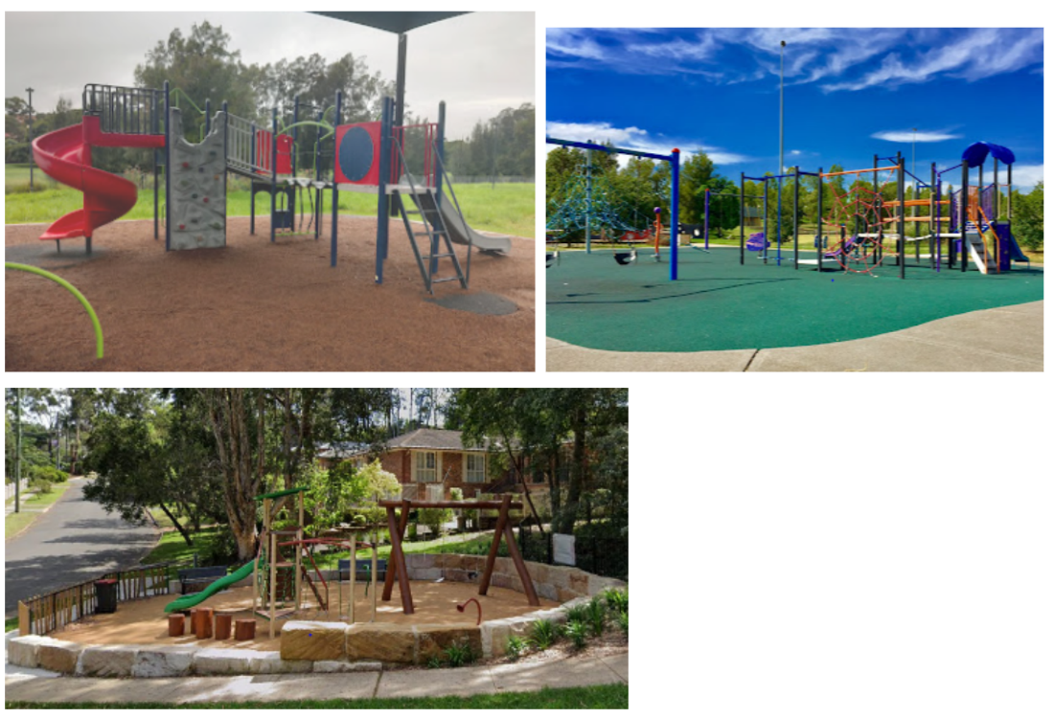

Resource 3: Playground equipment
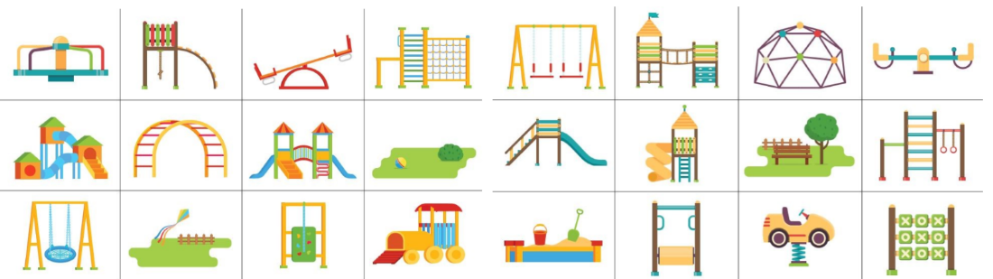
‘1a Playground Equipment’ by reSolve is licensed under CC-BY-NC-SA 4.0.

Resource 4: Playground tally chart
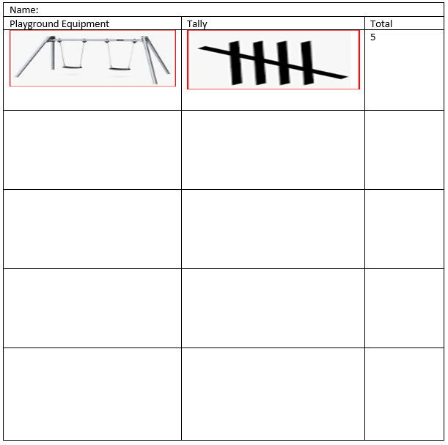

Resource 5: Column graph
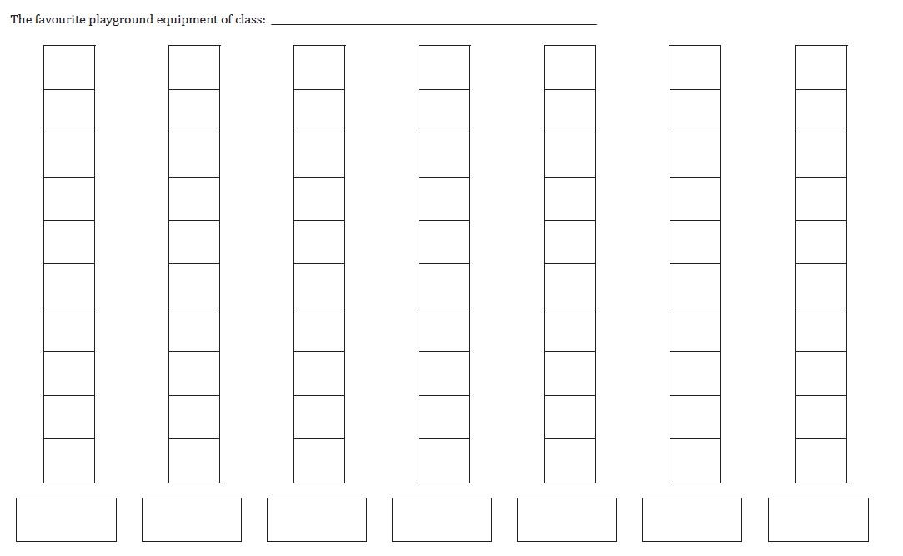
‘Lesson 3 Student Sheet: Other Class Graph’ by reSolve is licensed under CC-BY-NC-SA 4.0.

Resource 6: Popular fruit graph
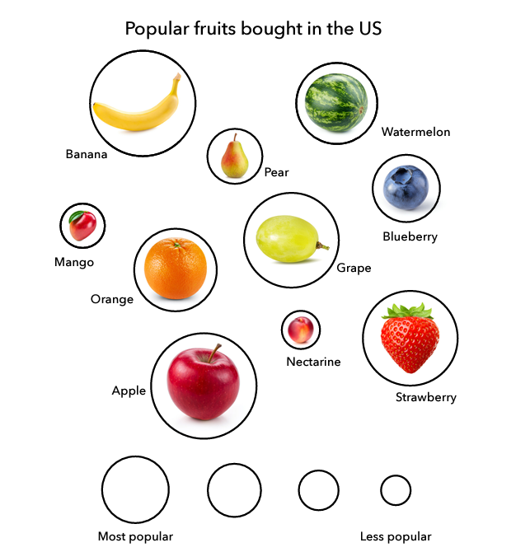
‘Popular Fruits’ by Youcubed is licensed under CC BY 4.0.

Resource 7: Data talk 1
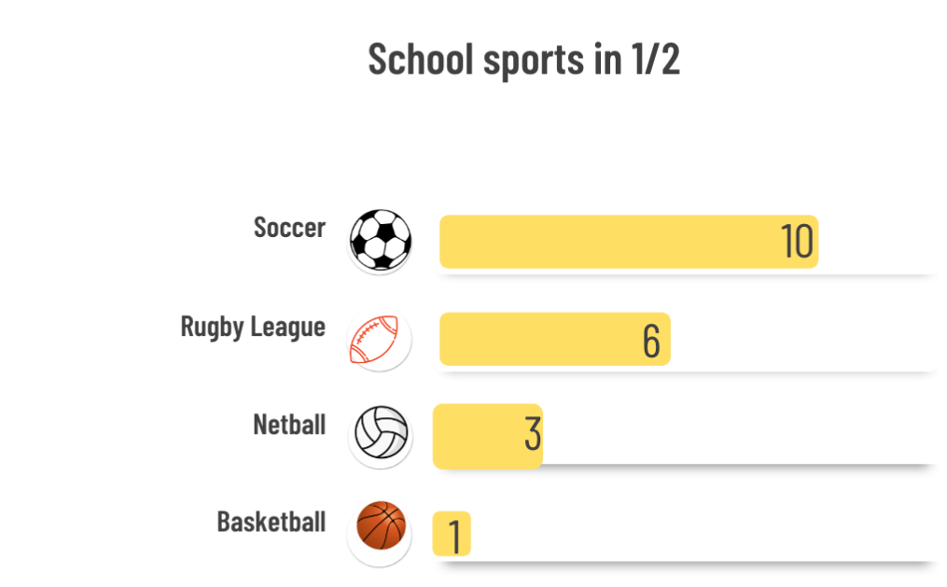
Images sourced from Canva and used in accordance with the Canva Content License Agreement.

Resource 8: House cards
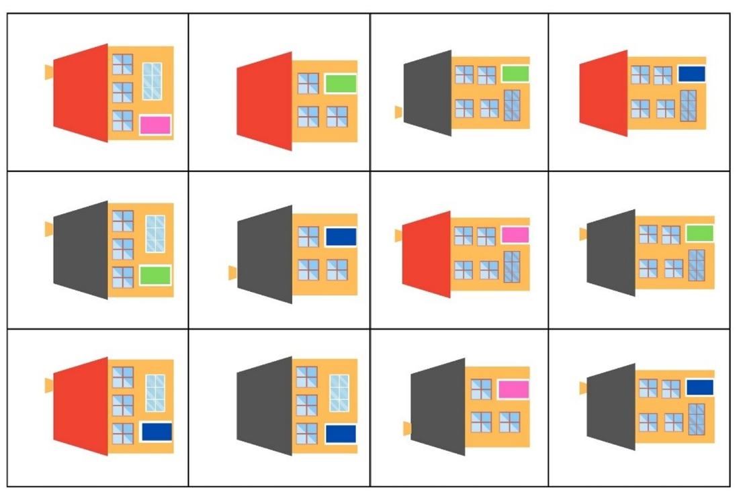
Adapted from ‘Sort the Street’ by University of Cambridge (Faculty of Mathematics).

Resource 9: N.W.L. (Notice Wonder Learnt) chart
Notice | Wonder | Learnt

Resource 10: Data talk 2
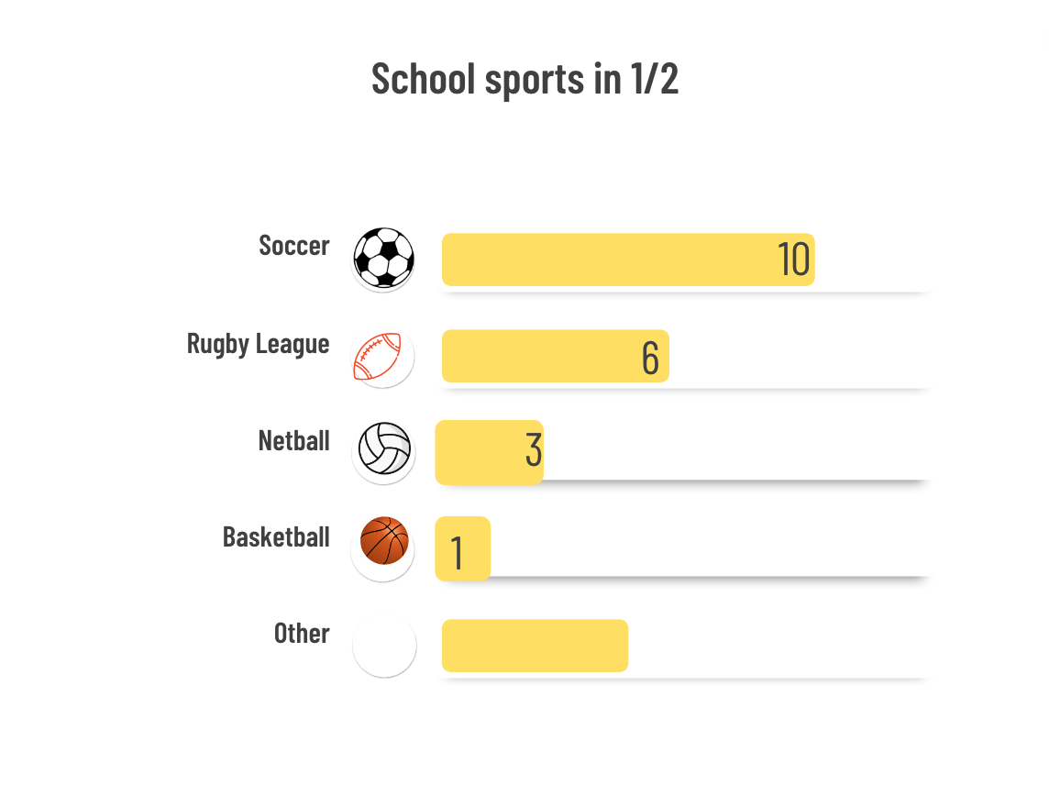
Images sourced from Canva and used in accordance with the Canva Content License Agreement.

Resource 11: Fruit cards
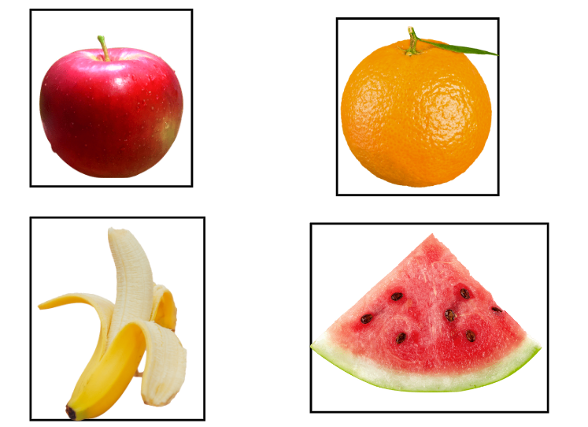
Images sourced from Canva and used in accordance with the Canva Content License Agreement.

Resource 12: Additional fruit cards
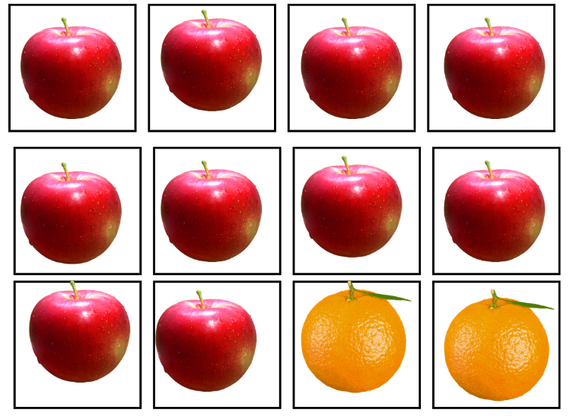
Images sourced from Canva and used in accordance with the Canva Content License Agreement.
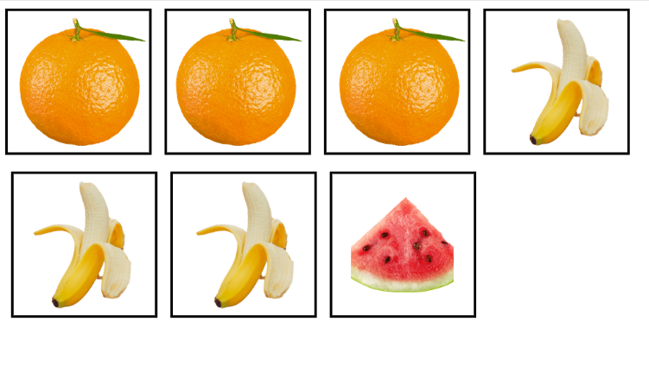
Images sourced from Canva and used in accordance with the Canva Content License Agreement.

Resource 13: Fruit table
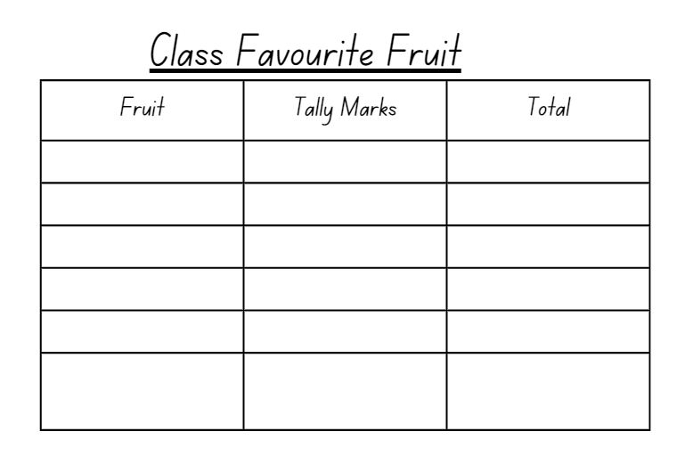

Resource 14: Picture graph
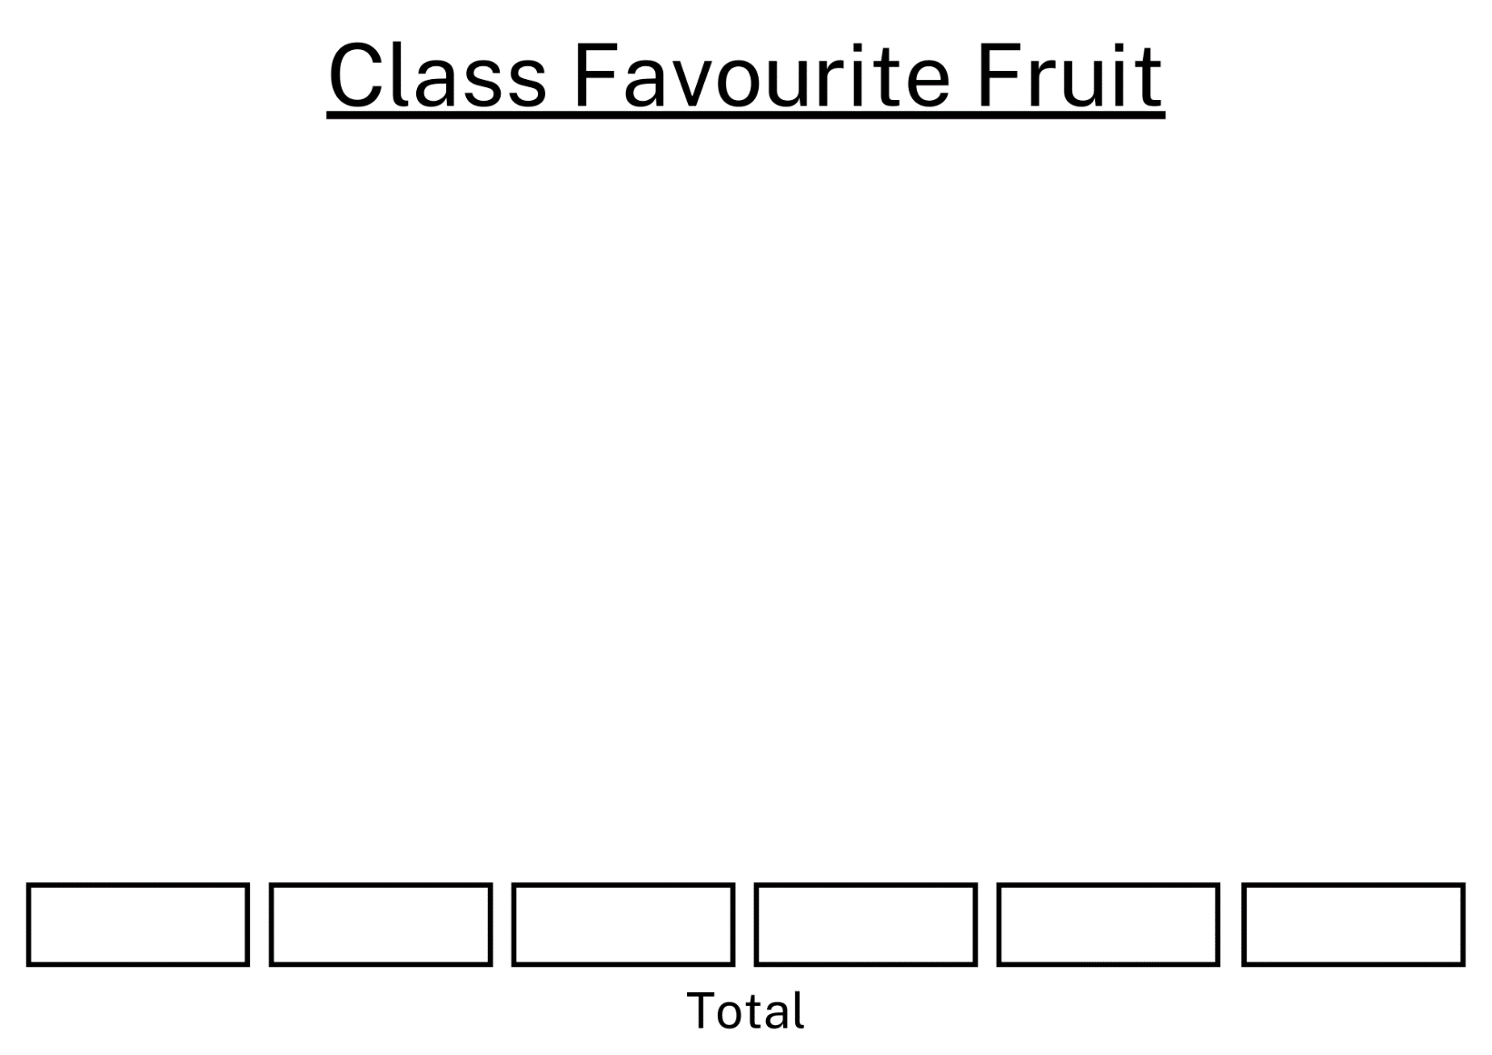

Resource 15: Drawing template

Resource 16: Number lines
Image sourced from Canva and used in accordance with the Canva Content License Agreement.

Resource 17: Lunch box images
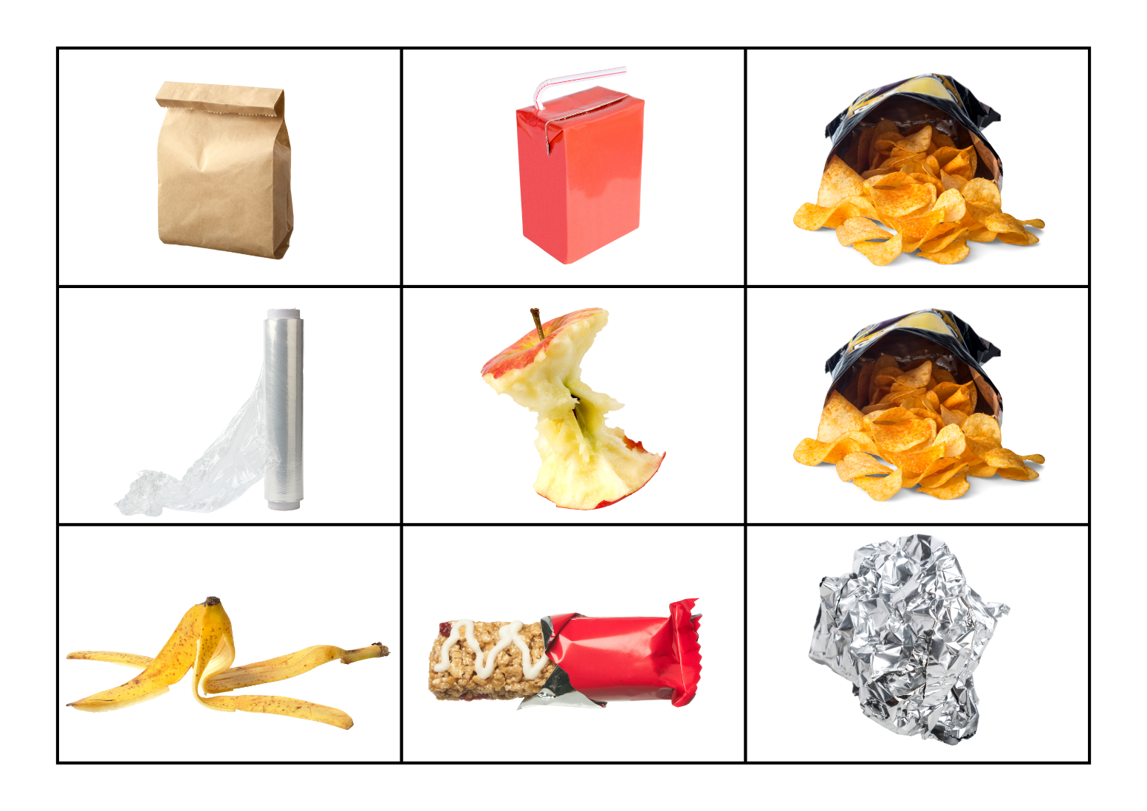
Images sourced from Canva and used in accordance with the Canva Content License Agreement.

Resource 18: Graph template

Resource 19: Favourite season graph
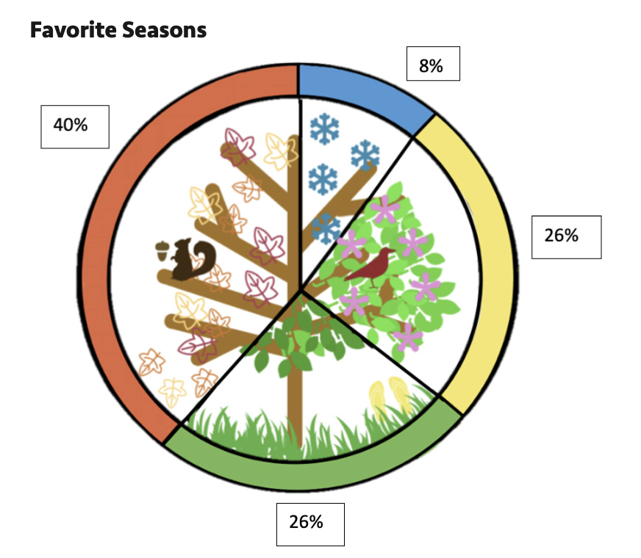
‘Favorite Season’ by Youcubed is licensed under CC BY 4.0.

Resource 20: Tally mark table
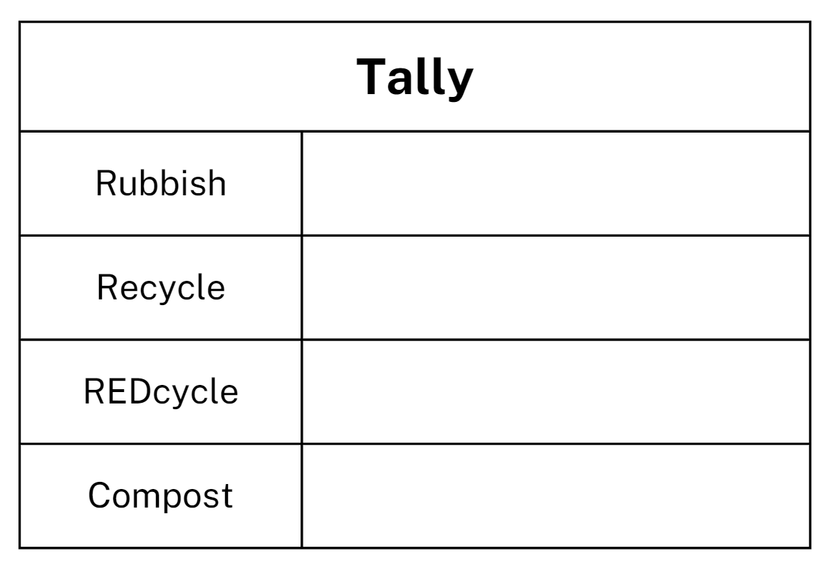

Resource 21: Recycling graph
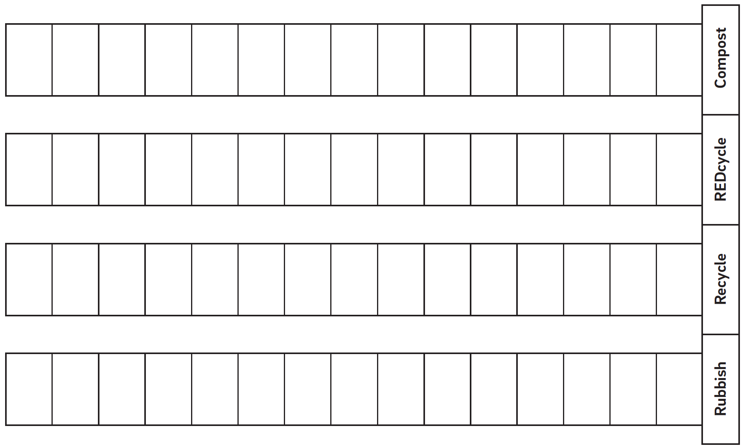
‘Lesson 2 Student Sheet: Recycling Graph’ by reSolve is licensed under CC-BY-NC-SA 4.0.

Syllabus outcomes and content
The table below outlines the syllabus outcomes and range of relevant syllabus content covered in this unit. Content is linked to National Numeracy Learning Progression version (3).
Focus area and outcomes | Content groups and content points | Lessons
Representing whole numbers  MAO-WM-01  MAE-RWN-01, MA1-RWN-01  MAE-RWN-02, MA1-RWN-02 | Early Stage 1  Instantly name the number of objects within small collections  - instantly recognise (subitise) the number of items in small groups of up to four items without counting (NPV1, CPR1)  identify the number of items in different arrangements (CPR2)  Connect counting and numerals to quantities  - count with one-to-one correspondence, recognising that the last number name represents the total number in the collection (CPr3, CPr5)  - make correspondences between collections (Reasons about quantity)  - read numerals to at least 20, including zero (NPV3) | 1-8
Representing whole numbers A (cont.) | Stage 1  Use counting sequences of ones with two-digit numbers and beyond  - identify the number before and after a given two-digit number (CPr5) | 1-8
Representing whole numbers A (cont.) | Stage 1  Represent numbers on a line  - sequence numbers and arrange them on a line by considering the order and size of those numbers (CPr5) | 7
Non-spatial measure  MAO-WM-01  MA1-NSM-01 | Stage 1  Time: Name and order the cycle of months  - name and order the months of the year (MeT2)  - recognise monthly and annual cycles | 8
Data  MAO-WM-01  MAE-DATA-01, MA1-DATA-01  MA1-DATA-02 | Early Stage 1  Respond to questions, collect information and discuss possible outcomes of activities  - predict possible responses to a question  - collect information from their peers and about their environment (IRD1)  - pose and respond to questions about the information collected (IRD1)  Organise objects into simple data displays and interpret the displays  - group objects according to characteristics (IRD1)  - compare the sizes of groups of objects by counting (Reasons about relations)  - arrange objects according to a characteristic to form a data display (IRD1)  - interpret information presented in a data display to answer questions (Reasons about quantity) (IRD2) | 1-8
Data A (cont.) | Stage 1  Ask questions and gather data  - investigate a topic of interest by choosing suitable questions to obtain appropriate data (IRD2)  - gather data and track what has been counted by using concrete materials, tally marks, lists or symbols (IRD3)  Represent data with objects and drawings and describe the displays  - use concrete materials or pictures of objects as symbols to create data displays where one object or picture represents one data value (IRD2)  - describe information presented in one-to-one data displays (Reasons about relations) (IRD2)  - use comparative language to describe information presented in a display, such as ‘more than' and ‘less than’  interpret a data display and identify the biggest or smallest values (IRD2) | 1-8
Data B (cont.) | Stage 1  Identify a question of interest and gather relevant data  - pose suitable questions where the answers form categories, and predict the likely responses (IRD2)  - collect data on familiar topics (IRD2)  - sort data into relevant categories (IRD2)  Create displays of data and interpret them  - organise collected data into lists and tables to display information (IRD2)  - represent data in a picture graph using a baseline, equal spacing and same-sized symbols (IRD2)  - give reasons why some representations of data are misleading (Reasons about relations)  - interpret information presented in tables and picture graphs (Reasons about relations) (IRD2)  record answers to questions using the information in tables and picture graphs (IRD2) | 1-8
Chance A  MAO-WM-01  MA1-CHAN-01 | Stage 1  Identify and describe possible outcomes  - identify possible outcomes of familiar activities and events  - describe the chance of possible outcomes for familiar activities and events (UnC1) | 1-8
Chance B (cont.) | Stage 1  Identify and describe activities that involve chance  - describe possible outcomes in everyday activities and events as being likely or unlikely to happen (UnC2)  - compare familiar activities and events and describe them as being more or less likely to happen (Reasoning about relations) (UnC2)  - describe familiar events as being possible (UnC2) | 2-8

References
Links to third-party material and websites
Please note that the provided (reading/viewing material/list/links/texts) are a suggestion only and implies no endorsement, by the New South Wales Department of Education, of any author, publisher, or book title. School principals and teachers are best placed to assess the suitability of resources that would complement the curriculum and reflect the needs and interests of their students.
If you use the links provided in this document to access a third-party's website, you acknowledge that the terms of use, including licence terms set out on the third-party's website apply to the use which may be made of the materials on that third-party website or where permitted by the Copyright Act 1968 (Cth). The department accepts no responsibility for content on third-party websites.
Except as otherwise noted, all material is © State of New South Wales (Department of Education), 2023 and licensed under the Creative Commons Attribution 4.0 International License. All other material (third-party material) is used with permission or under licence. Where the copyright owner of third-party material has not licensed their material under a Creative Commons or similar licence, you should contact them directly for permission to reuse their material.
Mathematics K–10 Syllabus © 2022 NSW Education Standards Authority (NESA) for and on behalf of the Crown in right of the State of New South Wales.
© 2022 NSW Education Standards Authority. This document contains NSW Curriculum and syllabus content. The NSW Curriculum is developed by the NSW Education Standards Authority. This content is prepared by NESA for and on behalf of the Crown in right of the State of New South Wales. The material is protected by Crown copyright.
Please refer to the NESA Copyright Disclaimer for more information.
NESA holds the only official and up-to-date versions of the NSW Curriculum and syllabus documents. Please visit the NSW Education Standards Authority (NESA) website and the NSW Curriculum website.
National Numeracy Learning Progression © Australian Curriculum, Assessment and Reporting Authority (ACARA) 2010 to present, unless otherwise indicated. This material was downloaded from the Australian Curriculum website (National Numeracy Learning Progression) (accessed 18 August 2022) and was not modified. The material is licensed under CC BY 4.0. Version updates are tracked in the ‘Curriculum version history’ section on the 'About the Australian Curriculum' page of the Australian Curriculum website.
ACARA does not endorse any product that uses the Australian Curriculum or make any representations as to the quality of such products. Any product that uses material published on this website should not be taken to be affiliated with ACARA or have the sponsorship or approval of ACARA. It is up to each person to make their own assessment of the product, taking into account matters including, but not limited to, the version number and the degree to which the materials align with the content descriptions and achievement standards (where relevant). Where there is a claim of alignment, it is important to check that the materials align with the content descriptions and achievement standards (endorsed by all education Ministers), not the elaborations (examples provided by ACARA).
This resource contains images and content obtained from Canva, and their use outside of this resource is subject to Canva’s Content License Agreement. If you wish to use them separately from the resource, please go to Canva.
Australian Government Department of Education (2020) ‘Statistics: Planning Playgrounds’, Teaching resources, reSolve website, accessed 4 October 2022.
Australian Government Department of Education, Skills and Employment (2020) ‘What A Load Of Rubbish!’, Teaching resources, reSolve website, accessed 18 August 2022.
Australian Government Department of Education, Skills and Employment (2020) ReSolve [website], accessed 4 October 2022.
Math Playground LLC (2022) Interactive Hundreds Chart, Maths Playground website, accessed 4 October 2022.
RG Programs & Services Pty Ltd (2021) REDcycle [website], accessed 4 October 2022.
Stanford University (n.d.) ‘Favourite Season’, Data talks, youcubed website, accessed 4 October 2022.
Stanford University (n.d.) ‘Popular Fruits’, Data talks, youcubed website, accessed 4 October 2022.
University of Cambridge (Faculty of Mathematics) (2022) Sort the Street, NRICH website, accessed 4 October 2022.

