Mathematics – K-2 multi-age – Year A – Unit 17
Contents
Unit description and duration 4
Student prior learning 4
Lesson overview and resources 5
Lesson 1: Let’s explore measurement! 13
Number Talk: Mystery lengths –10 minutes 14
What do we know about measurement? – 40 minutes 15
Consolidation and meaningful practice: Thinking about measurement – 10 minutes 18
Lesson 2: Formal units – meet the metre! 19
Daily number sense: Number bonds to ten – 10 minutes 20
Using consistent units of measurement – What is a metre? – 50 minutes 22
Consolidation and meaningful practice: Thinking about metres – 10 minutes 25
Lesson 3: Formal units – meet the centimetre! 25
Daily number sense: Tens and ones – 10 minutes 26
Let’s make a ruler – 50 minutes 29
Consolidation and meaningful practice: Connections between metres and centimetres – 10 minutes 31
Lesson 4: Measuring with consistent units – Broken ruler 32
Daily number sense: Cover the numbers! – 15 minutes 33
A broken ruler – 40 minutes 34
Consolidation and meaningful practice: Fixed or broken? – 5 minutes 37
Lesson 5: Heavier, lighter, balanced 38
Daily number sense: Make them the same – 10 minutes 38
How can we balance? – 40 minutes 40
Consolidation and meaningful practice: Thinking about measuring mass – 10 minutes 42
Lesson 6: Equivalence 43
Daily number sense: On the farm – 20 minutes 43
How can we balance? – 40 minutes 45
Consolidation and meaningful practice: Number bonds to 10 – 10 minutes 47
Lesson 7: Fill it up! 48
Daily number sense: Target 16 – 20 minutes 48
Fill it! – 40 minutes 50
Consolidation and meaningful practice: What did we find? – 10 minutes 52
Lesson 8: Pack it! 53
Daily number sense: Number stories – 10 minutes 54
Pack it! – 40 minutes 54
Consolidation and meaningful practice: Same volume, different shape! – 20 minutes 57
Resource 1: Mystery lengths 59
Resource 2: Less, more, same 60
Resource 3: Number talk 1 61
Resource 4: Cover the numbers 62
Resource 5: On the farm 63
Resource 6: Number stories 64
Resource 7: Cakes and chocolates 65
Syllabus outcomes and content 66
References 78

Unit description and duration
This two-week unit introduces students to formal units of measurement in length and further develops student knowledge, understanding and skills of uniform informal units of measurement. Students are provided opportunities to:
- compare, order and match using direct and indirect comparison with length, area, volume, and mass
- consider how choice of measuring unit affects accuracy
- learn why centimetres and metres are useful and how to measure with them.
Mathematics K–10 Syllabus © 2022 NSW Education Standards Authority (NESA) for and on behalf of the Crown in right of the State of New South Wales.

Student prior learning
Before engaging in these teaching and learning activities, students would benefit from prior experience with:
- making estimates using mathematical language, for example, heavier, lighter, longer, about the same
- making direct comparisons with measurement, for example, hefting and superimposing
- using everyday language of measurement to sort and compare objects using length, area, volume, and mass.

Lesson overview and resources
The table below outlines the sequence and approximate timing of lessons; syllabus focus areas and content groups; and resources.
Lesson | Syllabus focus area and content groups | Resources
Lesson 1: Let’s explore measurement!  60 minutes  A metre is useful to measure long objects and distances. | Geometric measure  Early Stage 1  - Length: Use direct and indirect comparisons to decide which is longer  Stage 1 – Part A  - Measure the length of objects using uniform informal units | - Resource 1: Mystery lengths  - A selection of small objects to measure including pencils  - Writing materials
Lesson 2: Formal units – meet the metre!  70 minutes  A metre is useful to measure long objects and distances. | Representing whole numbers  Early Stage 1  - Connect counting and numerals to quantities  Stage 1 – Part A  - Represent the structure of ten in whole numbers  Combining and separating quantities  Early Stage 1  - Identify part–whole relationships in numbers up to 10  Stage 1 – Part A  - Recognise and recall number bonds up to ten  Geometric measure  Early Stage 1  - Length: Use direct and indirect comparisons to decide which is longer  Stage 1 – Part A  - Measure the length of objects using uniform informal units  Stage 1 – Part B  - Recognise and use formal units to measure the length of objects | - Resource 2: Less, more, same  - A selection of small everyday objects to use for measuring  - Coloured blocks  - Metre rulers  - One metre lengths of string or ribbon  - Writing materials
Lesson 3: Formal units – meet the centimetre!  70 minutes  Centimetres enable consistent measurement of short objects and distances. | Representing whole numbers  Early Stage 1  - Use the counting sequence of ones flexibly  Stage 1 – Part A  - Represent the structure of ten in whole numbers  Combining and separating quantities  Early Stage 1  - Identify part–whole relationships in numbers up to 10  Stage 1 – Part A  - Recognise and recall number bonds up to ten  Geometric measure  Early Stage 1  - Length: Use direct and indirect comparisons to decide which is longer  Stage 1 – Part A  - Measure the length of objects using uniform informal units  Stage 1 – Part B  - Recognise and use formal units to measure the length of objects | - Resource 3: Number talk 1  - Carboard strips (15 cm long)  - Centimetre cubes  - Coloured blocks  - Metre ruler  - Writing materials
Lesson 4: Measuring with consistent units – Broken ruler  60 minutes  A measurement of length is the space between 2 points. | Combining and separating quantities  Early Stage 1  - Model additive relations and compare quantities  Stage 1 – Part A  - Use advanced count-by-one strategies to solve addition and subtraction problems  - Use flexible strategies to solve addition and subtraction problems  Geometric measure  Early Stage 1  - Length: Create half a length  Stage 1 – Part  - Recognise and use formal units to measure the length of objects | - Resource 4: Cover the numbers  - 6-sided dice for groups  - A range of small everyday objects  - Counters or small blocks  - Writing materials
Lesson 5: Heavier, lighter, balanced  60 minutes  Masses can be compared, ordered, and matched. | Combining and separating quantities Early Stage 1  - Model additive relations and compare quantities  Stage 1 – Part A  - Use advanced count-by-one strategies to solve addition and subtraction problems  - Represent equality  Non-spatial measure  Early Stage 1  - Mass: Identify and compare mass using weight  Stage 1 – Part A  - Investigate mass using an equal-arm balance  Stage 1 – Part B  - Compare the masses of objects using an equal-arm balance | - Counters or centimetre cubes  - Equal-arm balances  - ‘Heavier’ or ‘lighter’ labels  - Large quantity of coloured blocks  - Mini whiteboards  - Writing materials
Lesson 6: Equivalence  70 minutes  Equivalence can be found with different units of measurement. | Combining and separating quantities Early Stage 1  - Model additive relations and compare quantities  Stage 1 – Part A  - Use advanced count-by-one strategies to solve addition and subtraction problems  - Represent equality  Stage 1 – Part B  - Compare the masses of objects using an equal-arm balance | - Resource 5: On the farm  - Blocks  - Equal-arm balance  - Large quantity of coloured blocks  - Mini whiteboards  - Writing materials
Lesson 7: Fill it up!  70 minutes  Informal units of measure can be used to find internal volume (capacity). | Representing whole numbers  Early Stage 1  - Connect counting and numerals to quantities  Stage 1 – Part A  - Represent the structure of ten in whole numbers  Combining and separating quantities Early Stage 1  - Model additive relations and compare quantities  Stage 1 – Part A  - Use advanced count-by-one strategies to solve addition and subtraction problems  - Represent equality  Three-dimensional spatial structure  Early Stage 1  - Volume: Compare internal volume by filling and packing  Stage 1 – Part A  - Measure and compare the internal volumes (capacities) of containers by filling  Stage 1 – Part B  - Compare containers based on internal volume (capacity) by filling and packing | - A variety of containers  - Counters and blocks  - Dice  - Marbles  - Rice  - Spoons and cups  - Writing materials
Lesson 8: Pack it!  70 minutes  Different strategies can be selected and applied to solve problems. | Combining and separating quantities  Early Stage 1  - Model additive relations and compare quantities  Stage 1 – Part A  - Use advanced count-by-one strategies to solve addition and subtraction problems  Three-dimensional spatial structure  Early Stage 1  - Volume: Compare internal volume by filling and packing  - Volume: Compare volume by building  Stage 1 – Part A  - Measure the internal volume (capacity) of containers by packing  - Construct volumes using cubes  Stage 1 – Part B  - Compare containers based on internal volume (capacity) by filling ang packing  - Compare volumes using uniform informal units | - Resource 6: Number stories  - Resource 7: Cakes and chocolates  - A range of small objects  - A variety of rectangular containers  - Coloured blocks  - Container in the shape of a cube  - Writing materials

Lesson 1: Let’s explore measurement!
Core concept: We can measure our world in different ways.
The table below contains suggested learning intentions and success criteria. These are best co-constructed with students.
Learning intentions | Success criteria
All students are learning that:  - objects can be measured using uniform informal units  - length is an attribute that can be measured  - lengths of objects can be compared by placing them side-by-side with ends aligned (direct comparison)  - lengths of 2 or more objects that cannot be moved or aligned can be compared using indirect comparison. | All students can:  - identify the attribute of ‘length’ as the measure of an object from end-to-end  - communicate their understandings of the attribute ‘length’.  In addition, students working towards Early Stage 1 outcomes can:  - place objects side-by-side and align ends to compare lengths  - use comparative language to describe length.  In addition, students working towards Stage 1 outcomes can:  - select appropriate uniform informal units to measure length  - compare the lengths of 2 or more objects using appropriate uniform informal units  - measure by aligning informal units end to end with no gaps  - use appropriate language to explain their choice of units and working out.

Number Talk: Mystery lengths –10 minutes
- Display Resource 1: Mystery lengths and discuss what students notice and wonder about the different objects, using the prompts table below.
The table below outlines stimulus prompts to generate conversation about the topic, along with anticipated responses from students.
Prompts | Anticipated student responses
- What do you notice?  - What do you wonder?  - What is the same?  - What is different?  - Which is the longest? Shortest? How do you know?  - Compare the curly line and pencil. Which one is longer? How can we check? | - There are 2 straight lines and 2 curved lines.  - The pencil and the arrowed lines are the same length.  - Three of the lines have the same baseline.  - The top line is the longest because it....  - The worm is the shortest because it...  - The worm is not the shortest because if you stretch it out it will be longer than the arrow.  - If you straighten the worm, it might be the same as the arrow.  - The pencil is longer than the others because it touches the other side of the box, but the other lines don’t.

What do we know about measurement? – 40 minutes
- Engage students’ prior knowledge by asking what they already know about ‘measurement’. Students turn and talk with a partner before sharing their thoughts with the class.
- Use an anchor chart to record responses to the questions:
- What is measurement?
- What are some objects we can measure?
- What are some attributes we can measure? For example, length, area, mass, volume, capacity, and time.
- Why do we need to measure things?
- What do you wonder about measuring?
- Explain that students will be learning about measuring length. Define ‘length’ as the measure of an object from end to end.
- In pairs, Early Stage 1 students choose 5 pencils of various lengths. Ask how they could compare the lengths to order their pencils from shortest to longest. Identify the need to use a baseline for direct comparison. Give students time to order the length of their pencils. When they have finished, the task can be repeated using different pencils.
- In pairs, Stage 1 students select 2 objects from the classroom to measure. They then choose another object as an informal unit to measure the first 2 objects. Encourage students to estimate which objects will be longer or shorter, then check using their informal unit.
- Identify the importance of aligning units with no gaps or overlaps. Stage 1 students will record their findings, labelling the objects measured and the length of each object in informal units. For example, the glue stick is 8 paperclips long.
Note: This is an opportunity to observe the type of units that students choose for their objects and how they use the uniform units to measure. It is also an opportunity to see if students are making comparisons between objects and are using a baseline for comparisons.
- Early Stage 1 students discuss how they measured the pencil lengths. Reinforce the need to use a consistent baseline for direct comparison.
- Stage 1 students share their findings. For example, the glue stick is 8 paperclips long. Reinforce the importance of aligning units with no gaps or overlaps.
- Once students have measured and recorded their findings, take them on a gallery walk to see how each pair measured their objects. Ask various students:
- What have you measured?
- How did you measure it?
- Which object is longer? How do you know?
- What did you find challenging?
- Did anyone else have the same measurement/use the same unit? If not, why?
- Regroup as a class and ask how students can compare the length of larger things that cannot be moved.
- Students work in pairs to measure and compare the lengths of 2 objects in the classroom that cannot be moved or aligned. For example, students might choose a table and a window to compare which is longer.
- Demonstrate how to choose an informal unit to measure the objects, making comparisons about which object is longer or shorter. Highlight the importance of aligning units with no gaps or overlaps.
- After measuring, students draw a picture of the 2 objects and record how they measured each object’s length.
Assessment opportunities | Too hard? | Too easy?
What to look for:  - Can students identify the attribute of ‘length’, comparing lengths of objects by placing them side-by-side with ends aligned? (MAO-WM-01, MAE-GM-02)  - Can students align identical units end to end without overlapping or leaving gaps? (MA1-GM-02)  - Do students explain their choice of units and working out using appropriate language? (MAO-WM-01, MA1-GM-02)  What to collect:  - pictures and observations of how students order their pencils and describe ‘length’ (MAO-WM-01, MAE-GM-02)  - pictures and observations of student estimations and measuring with no spaces or overlaps (MAO-WM-01, MA1-GM-02) | Students find it difficult to place uniform objects end to end.  - Provide uniform objects to measure with that can be easily placed end to end, such as blocks.  - Model how to measure a small object, demonstrating that there can be no gaps between the blocks.  Students find it difficult to compare lengths using indirect comparison.  - Support students to choose an appropriate informal unit, such as an A4 piece of paper to measure a larger object.  - Show students where a baseline could be and how the units can be placed end to end.  - Model counting the length for each object and how to repeat the process, using the same unit for the object that is being compared. | Students can select and use different informal units to measure objects.  - Pairs use at least 3 different informal units and discuss their results with another pair, describing what they noticed.  - Students identify which is the most appropriate unit to measure and compare the size of the different objects.  - Pairs give each other feedback on whether they would do the same or different, and why.

Consolidation and meaningful practice: Thinking about measurement – 10 minutes
- Discuss the findings of the measurement task as a class, to determine how students measured the objects and identify the different units of measurement they used.
- Prompt students to think how the second activity was different to the first one, where they could put their objects side by side. Ask:
- Was it easier or better to measure with larger or smaller informal units? What made it better?
- Why did the same objects sometimes have different measurements?
- What could we do to make sure our measurements are always the same?
- Why would it be easier to have a consistent unit of measure?
- Clarify the meaning of any new vocabulary used.

Lesson 2: Formal units – meet the metre!
Core concept: A metre is useful for consistent measurement of long objects and distances.
The table below contains suggested learning intentions and success criteria. These are best co-constructed with students.
Learning intentions | Success criteria
All students are learning that:  - 10 can be used as a reference in forming numbers from 11 to 20  - length can be measured using informal and formal units  - using formal units, such as the metre, ensures reliability and consistency when measuring  - lengths can be compared by aligning the ends for direct comparison. | Early Stage 1 students can:  - recognise combinations for numbers up to 10  - compare lengths directly by placing objects side by side.  In addition, students working towards Stage 1 outcomes can:  - use number bonds to 10  - explain why a metre is important  - estimate and measure straight and curved lengths to the nearest metre or half metre.

Daily number sense: Number bonds to ten – 10 minutes
This activity has been adapted from Parrish (2022).
- Build student understanding of using 10 as a reference to make larger numbers.
- Show the number sentence 8 and 2 and ask students what they see and what they know.
- In pairs, students turn and talk to discuss other bonds of 10. For example, 9 and 1, 6 and 4, 5 and 5, and so on. Observe for answers that can be shared with the class.
- Display the following number sentences:
- What is 4 and 4 and 2? Record responses and strategies students used to find the total.
- What is 8 and 6? Ask students what is the same and what is different to the previous number sentence. Discuss responses and strategies students used to find the total.
- What is 8 and 7? Ask students what is the same and what is different to the previous number sentences. Record ideas, prompting students to notice relationships between the number sentences.
- Summarise that 10 is a useful number to help make larger numbers.
The table below outlines stimulus prompts to generate conversation about the topic, along with anticipated responses from students.
Prompts | Anticipated student responses
- How can number bonds of 10 help solve this problem?  - Are there any other strategies that can be used? | - I know that 8 and 2 make 10.  - I can see that 8 and 2 make 10 and 4 more is 14.  - I can see that 4 can be broken into 2 and 2, so 10 plus 2 plus 2 is 14.  - I know 6 is 4 and 2, so then 8 and 2 is 10 and 4 more is 14.  - I know that 8 and 6 is 14 and 7 is one more than 6, so 8 and 7 is 15.  - I can break up 7 into 2 and 5, so I know 8 and 2 is 10 and 5 more is 15.
This table details assessment opportunities and differentiation ideas.
Assessment opportunities | Too hard? | Too easy?
What to look for:  - Can students recognise combinations to 10? (MAE-CSQ-02)  - Can students use 10 as a reference to solve a number problem? (MAO-WM-01, MA1-RWN-01)  What to collect:  - observations of students recognising combinations to 10 and partitioning to solve addition problems (MAE-CSQ-02, MAO-WM-01, MA1-RWN-01) | Students cannot mentally visualise number bonds of 10.  - Students make a tower of 10 blocks. Partition it into 2 pieces. Compare their tower to a partner.  - Ask students if there are the same number of blocks or if the number is different. Students check whether they still have 10 blocks. | Students already understand and apply understanding of number bonds up to 10.  - Students use 10 as a reference to add 18 + 14, 18 + 16, and 18 + 17.  - Students choose two-digit numbers to add and explain what strategies they used.

Using consistent units of measurement – What is a metre? – 50 minutes
- Explain that the focus of this lesson is length as a type of measurement. Ask students what they already know about measuring length.
- Ask students to identify who has the longest hand in the class. Give students time brainstorm ways they can find out. Allow students to compare the lengths of their hands.
- Display a collection of objects used in the last lesson for measuring, for example blocks, straws, paper clips, counters, and markers. Students choose an object to use as their informal unit for measuring.
Note: Students trace their hand on a piece of paper to make it easier to measure the length from the base of the palm to the top of the middle finger.
- Have students record the length of their hand as a sentence, indicating the number and type of unit used. For example, ‘My hand is 5 blocks long’.
- Identify who has the longest hand. Ask students how they know. Prompt students to look at who has the highest number of units recorded, then use direct comparison to check.
- Ask why some hands had a higher number of units but, when they were compared, were actually shorter than some hands that measured fewer units. After discussion, identify that, to compare different lengths, the unit of measurement needs to remain the same.
- Revise that students have used small informal units to measure their hands and ask if these units would be suitable to measure the classroom. Prompt students to offer alternatives.
- Explain that, to maintain consistency when measuring, students can use units of measure that are used everywhere, for example, a metre ruler. Show students a metre ruler.
- In groups, students see how many of each student’s hands can fit along the length of a metre ruler. Discuss how the number of hands is different, but the metre stays the same.
- Compare an arm or a long step to a metre ruler. Ask if these are about a metre or closer to half a metre to build student awareness of estimation.
- Students find items in the classroom that are longer, shorter than, or the same length as the metre ruler and share observations.
- Give pairs of students a one metre length of string or ribbon. Have students use the one metre length and Resource 2: Less, more, same to find objects around the playground or classroom that are less than, more than, or about the same as a metre. Explain that when writing ‘metre’, the abbreviation ‘m’ can be used and encourage students to use this when recording.
- After students measure some lengths, regroup as a class and share findings. Highlight the use of vocabulary including less than, more than, about the same as, longest, and shortest.
- Ask how students could measure curved objects. Explain that they can also use the one metre length to measure curved objects because it is flexible. Give students a few minutes to find curved objects that are less than, more than, or about the same as a metre and add these to their table.
This table details assessment opportunities and differentiation ideas.
Assessment opportunities | Too hard? | Too easy?
What to look for:  - Can students use comparative language such as longer, shorter, more than, less than to describe the lengths of objects? (MAO-WM-01, MAE-GM-02)  - Do students recognise the need for using a metre to estimate, measure and record lengths? (MA1-GM-02)  - Could students use a metre to record and compare length? (MAO-WM-01, MA1-GM-02)  What to collect:  - observations of student estimations and measuring with no spaces or overlaps (MAO-WM-01, MAE-GM-02, MA1-GM-02)  - work samples of Resource 2: Less, more, same (MAE-GM-02, MA1-GM-02) | Students do not understand why informal units give inconsistent measurements.  - Measure an object with your hands, then repeat using a student’s hands.  - Prompt students to consider why there is a difference in the 2 measurements and why there are more students’ hands than your hands.  - Support students to choose and measure objects using the one metre length.  - Model placing the one metre length end to end with no spaces or overlaps. | Students quickly measure large objects with metre ribbons.  - Students estimate the distance from one point at school to another. For example, they could measure the classroom to the canteen. In pairs, students use ribbons to measure the distance.  - Students share how they completed these estimations and measurements with the class. Ask how students could record their measurements. Prompt students to use a table to compare the measurements then ask what they notice.

Consolidation and meaningful practice: Thinking about metres – 10 minutes
- Ask students when it is useful to measure in metres. Encourage students to explain their thinking.
- Clarify the meaning of any new vocabulary used.

Lesson 3: Formal units – meet the centimetre!
Core concept: A centimetre is useful for measuring short lengths consistently.
The table below contains suggested learning intentions and success criteria. These are best co-constructed with students.
Learning intentions | Success criteria
All students are learning that:  - a number can be broken up using place value  - there is a need for a formal unit smaller than a metre (centimetre)  - lengths can be estimated and measured to the nearest centimetre and recorded as ‘cm’. | All students can:  - break a number into tens and ones to solve addition problems  - use an estimate to reason whether an answer is correct.  In addition, students working towards Early Stage 1 outcomes can:  - combine 2 or more groups of objects to find the total  - identify combinations for numbers up to 10  - recognise the need for informal units to estimate, measure and record lengths and distances.  In addition, students working towards Stage 1 outcomes can:  - explain why centimetres are important  - accurately measure the length of an object to the nearest centimetre by using the beginning point of a ruler.

Daily number sense: Tens and ones – 10 minutes
The second part of this activity is adapted from Parrish (2020).
- Build student understanding of fluency with numbers by identifying part–whole relationships in numbers up to 10, as well as using place value to solve problems.
- Show Image 1 from Resource 3: Number talk 1 and ask how many dots there would be if all the dots from both ten-frames were joined. Encourage students to explain how they know and how they see the dots. Select several Early Stage 1 students to share their responses.
- Repeat the process for Image 2 from Resource 3: Number talk 1. Ask students what they think is the same and what they think is different about both images. Select several Early Stage 1 students to share their responses.
- Display 12 + 17 and ask Early Stage 1 students to work in pairs using a ten-frame and counters to find the total.
- Ask Stage 1 students to turn and talk with a partner about the place value of the numbers and how this can help add the numbers together. Students share responses with the class.
- Repeat this process for Early Stage 1 and Stage 1 students with the number combinations of 15 + 14, 13 + 16, and 11 + 18. Students share responses with the class and highlight the relationships between the number sentences.
The table below outlines stimulus prompts to generate conversation about the topic, along with anticipated responses from students.
Prompts | Anticipated student responses
- What do we know about these numbers?  - How can you use place value to solve this problem?  - What do you see that is the same?  - What do you see that is different? | - I know that 12 is 10 and 2 and I know that 17 is 10 and 7.  - I can see that 10 and 10 is 20 and 7 and 2 is 9, so 20 and 9 is 29.  - 15 can be broken into 10 and 5 and 14 can be broken into 10 and 4, so 10 plus 10 is 20 plus 5 and 4, so 20 and 9 is 29.  - The units are different in each number sentence, but they always add up to 9.
This table details assessment opportunities and differentiation ideas.
Assessment opportunities | Too hard? | Too easy?
What to look for:  - Can students subitise the number of items in small groups without counting? (MAE-RWN-02)  - Are students able to combine 2 or more groups of objects to model addition? (MAO-WM-01, MAE-CSQ-01)  - Can students partition two-digit numbers to solve a number problem? (MAO-WM-01, MA1-RWN-01)  What to collect:  - observations of students subitising items in small groups and modelling addition (MAE-RWN-02, MAO-WM-01, MAE-CSQ-01)  - observations of students using 10 as a reference and partitioning to solve addition problems. (MAO-WM-01, MA1-RWN-01) | Students find it difficult to visualise 10 as a reference or describe how to combine quantities.  - Provide materials such as counters and a blank ten-frame to support students to explain their thinking.  - Provide coloured blocks to partition a two-digit number using 10 as a reference.  - For example, use 10 blue blocks and 2 yellow blocks to partition the quantity 12. | Students already understand and apply partitioning with two-digit numbers.  - Students partition three-digit numbers related to the whole class activity. For example, 120 + 170, 150 + 140.  - Students choose three-digit numbers to add and explain what partitioning strategies they used.  - Ask students if they can think of other ways to add three-digit numbers.

Let’s make a ruler – 50 minutes
- Review the previous lesson and discuss whether there are instances when using a metre to measure length is not accurate enough. Prompt students to explain their thinking. Lead discussion towards using length to measure height. Select 2 students of similar height and ask the class how they could determine who is taller. Trial suggestions and ask students what to do when the metre measurement is not accurate.
- Explain that there is a useful small measurement called a centimetre. Ask students if they can remember the short way mathematicians record metre. Tell them that there is a short way to record centimetre too: ‘cm’.
- Distribute centimetre cubes and explain that each cube is 1 cm long and 1 cm wide and 1 cm high. Ask students to show each other how much of their index finger is one centimetre.
- Place 3 cubes end to end and ask how many centimetres there are. Add 2 cubes and ask how many centimetres there are now. Add 4 more and discuss the total.
- Pair up Early Stage 1 students with a Stage 1 partner. Ask students to find 2 small objects in the classroom to measure with centimetre ‘ones’. Each pair estimates how many centimetre ‘ones’ will be needed, measure the lengths, and check against their estimates. Students record their estimates and answers.
- Model how to make a ruler using a cardboard strip and centimetre cubes to mark 0 to 15 along the edge. Emphasise the need to start with zero at the beginning of the cardboard strip.
- Students make their own 15 cm rulers. Call out the numbers between one and 15 and ask students to show where that length is on their ruler. Ask students to show where each centimetre is. Revise that a centimetre is the space in-between the lines on a ruler, rather than the lines themselves.
- Students use their ruler to estimate and measure objects found in the classroom to the nearest centimetre. In pairs, describe their shortest and longest measurements.
- Ask:
- What have you learned by creating your own ruler?
- What does it mean to measure the length of something in centimetres?
- Hold up a traditional ruler and a student made ruler and ask how they are the same and how they are different.
Note: Have students keep the ruler they made to use in the following lesson.
This table details assessment opportunities and differentiation ideas.
Assessment opportunities | Too hard? | Too easy?
What to look for:  - Did students recognise the need for informal units to estimate, measure and record lengths and distances? (MAO-WM-01, MAE-GM-01)  - Could students use centimetres to estimate, measure and record lengths and distances? (MAO-WM-01, MA1-GM-02)  - Did students record measurements using the abbreviation ‘cm’? (MA1-GM-02)  What to collect:  - observations and work samples of students measuring length with informal units (MAO-WM-01, MAE-GM-01)  - observations and work samples of students measuring with centimetres accurately. (MAO-WM-01, MA1-GM-02) | Students cannot decide what to measure with centimetres.  - Model when to use the smaller measurement (centimetre) and when to use the larger measurement (metre). For example, measuring the length of a door and measuring the length of a crayon.  - Give students a choice of small objects to measure.  Students do not measure accurately because they start measuring part way along their ruler.  - Model starting at zero when measuring with the 15 cm ruler.  - Align the beginning of the ruler and the object being measured at the edge of a desk. | Students quickly measure objects accurately to the nearest centimetre.  - Students order objects measured from shortest to longest.  - Provide some additional objects for students to measure with a traditional 30 cm ruler.  - Students work out how many centimetres fit into a metre.

Consolidation and meaningful practice: Connections between metres and centimetres – 10 minutes
- Revise the meanings of the measurement language used in the lesson.
- Show students a metre ruler and ask them how many centimetres might fit into it. Students could use their 15 cm rulers, traditional rulers, or centimetre blocks to find out.
- Ask students when it would be useful to measure in metres, centimetres, or both.

Lesson 4: Measuring with consistent units – Broken ruler
Core concept: A measurement of length is the space between 2 points.
The table below contains suggested learning intentions and success criteria. These are best co-constructed with students.
Learning intentions | Success criteria
Students are learning that:  - many addition and subtraction strategies can be used to find numbers  - estimating to the nearest centimetre helps to measure lengths accurately  - measurements do not always start at zero. | All students can:  - use dice patterns with addition and subtraction to find different numbers  - accurately measure length using a broken ruler, counting on, and subtraction.  In addition, students working towards Early Stage 1 outcomes can divide a length into 2 equal parts and distinguish between the halfway point and half a length.  In addition, students working towards Stage 1 outcomes can model half of a whole length.

Daily number sense: Cover the numbers! – 15 minutes
Adapted from Shut the Box by NRICH Mathematics (2022).
- Build student understanding of subitising with addition and subtraction by playing ‘Cover the numbers’.
- Display 2 copies of Resource 4: Cover the numbers and demonstrate the game with a student.
- Take turns rolling two 6-sided dice. The player who rolls the dice can place their counters on the 2 numbers rolled. For example, a player rolls 4 and 5. They add 4 and 5 together and cover number 9 or subtract 4 from 5 and covers number one.
- The first player to cover all numbers from 1 to 12 is the winner.
This table details assessment opportunities and differentiation ideas.
Assessment opportunities | Too hard? | Too easy?
What to look for:  - Do students demonstrate automaticity and fluency when recognising number combinations up to 10? (MAE-CSQ-02)  - Do students apply using ten as a reference to addition when finding numbers? (MAO-WM-01, MA1-RWN-01)  - Can students use counting strategies to solve addition and subtraction problems using one- and two-digit numbers? (MAO-WM-01, MA1-CSQ-01)  What to collect:  - observations of how students find different numbers using 2 throws of the dice (MAO-WM-01, CSQ-01, MA1-CSQ-01) | Students find it difficult identifying part-whole relationships for numbers up to 10.  - Support students by folding the 1 to 12 number line in half.  - Play the game with the numbers 1 to 6. | Students already know 1 to 12 number bonds.  - Students use Resource 4: Cover the numbers and three 6-sided dice to play ‘Cover the numbers’.  - Students cover all possible solutions using addition and subtraction for each throw. For example, throws of 1, 4 and 5 give solutions of 1, 3, 4, 5, 6 and 9.

A broken ruler – 40 minutes
- Give pairs of students a rectangular strip of paper. Explain that they must split it in half so that they can each write their name on it. Ask students how they could divide the piece of paper into 2 equal parts.
- Students turn and talk to their partner before deciding how they will halve the paper. Encourage students to see if they can locate the halfway point of the full length before they split it. Once students have split the paper into halves, ask students how they can check if the halves are equal in length.
- Show students the ruler they made previously and revise that they used centimetres to measure. Then show a real or paper ruler that has been broken. See Figure 1.
Figure 1 – Broken ruler
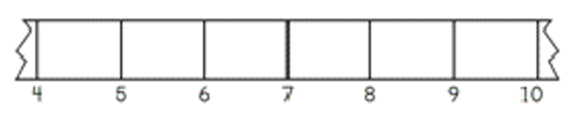
- Give students their ruler from the previous lesson. Ask if they can see any differences between their ruler and Figure 1.
- Ask them to ‘break’ their ruler by tearing off a portion from each end. In pairs, students use ‘Talk moves’ to discuss if they can still measure with a broken ruler.
The table below outlines stimulus prompts to generate conversation about the topic, along with anticipated responses from students.
Prompts | Anticipated student responses
- What is the same?  - What is different?  - How can we measure with a broken ruler? | - The ruler still has centimetres.  - The ruler does not start at zero; it starts at a different number.  - I can count the marks from the start of the object to the end.  - I can subtract the small number from the bigger number to find the measurement.
- Ask for a few volunteers to select small objects in the classroom such as a crayon, pencil, or glue stick. Ask how the objects could be measured with a broken ruler. Observe student responses as they discuss.
- Explain how measuring with a broken ruler is similar to how students measured items in the previous lesson. They are still going to find the length of the item by measuring from the start point of the ruler to the end point of the object. The difference is that the ruler is broken so they will not be able to start at zero.
- Demonstrate how to measure an item with a broken ruler. Align the object at the first number on the broken ruler, for example, 5 cm. Then find the number at the end of the object, for example, 9 cm. Ask students how they would work out the length of the object using the references 5 and 9.
- Reinforce that there are 2 ways to do this. Firstly, students can count the jumps from the beginning point to the end point of the ruler. For example, there are 4 jumps from 5 cm to 9 cm, so the length is 4 cm. Students can also subtract the number at the beginning of the object from the number at the end of the object, for example, 9 − 5 = 4 so the length of the object is 4 cm.
- Early Stage 1 students select pairs of items in the classroom and compare their lengths using direct comparison. They record their findings by drawing a picture, labelling which object was longer.
- Stage 1 students select small items in the classroom. They will estimate and measure the lengths using their broken ruler, recording the lengths using the abbreviation ‘cm’.
This table details assessment opportunities and differentiation ideas.
Assessment opportunities | Too hard? | Too easy?
What to look for:  - Are students able to divide a length into 2 equal parts? (MAE-GM-03)  - Can students compare lengths by placing objects side by side and aligning ends? (MAE-GM-02)  - Do students identify objects that are appropriate to measure in cm? (MAO-WM-01, MA1-GM-02)  - Can students use flexible addition and subtraction strategies to measure length using a broken ruler? (MAO-WM-01, MA1-RWN-01, MA1-GM-02)  What to collect:  - observations and work samples from students measuring objects with a ‘broken ruler’ (MAO-WM-01, MA1-GM-02) | Students cannot use the broken ruler to measure length.  - Model how to start measuring from the beginning point of a broken ruler.  - Model how to count by ones from the beginning of the broken ruler to the end point of the object. For example, start at 4 and count 5, 6, 7, 8 to the end point, 9. | Students can already accurately use their broken ruler.  - Students place an item in the middle of the broken ruler and measure from there.  - Students work out how to measure an item longer than their broken ruler.

Consolidation and meaningful practice: Fixed or broken? – 5 minutes
- Ask students if their broken ruler was really ‘broken’, or whether it could still be used to measure lengths.
- Revise the measurement language used in the lesson.
- Ask students when they think it would be helpful to measure lengths with a 30 cm ruler rather than a metre ruler.

Lesson 5: Heavier, lighter, balanced
Core concept: Masses can be compared, ordered, and matched.
The table below contains suggested learning intentions and success criteria. These are best co-constructed with students.
Learning intentions | Success criteria
Students are learning that:  - the equal sign means ‘the same as’  - there are multiple ways to achieve equivalence  - scales are used to find and compare equivalent masses. | Students can:  - use blocks and numbers to find equal masses using a balance  - use estimation to check if an answer is reasonable.  In addition, students working towards Stage 1 outcomes can explain how to use a scale to find and compare equivalent masses.

Daily number sense: Make them the same – 10 minutes
- Build student understanding of equivalent quantities by using an equal-arm balance.
- Review what students can remember about using an equal-arm balance. Explain that just like they balanced objects they can also balance number sentences. Place an ‘=’ sign in the middle of the equal arm balance to demonstrate that whatever is on one side equals (is the same as) the other side.
- Show students an equal-arm balance with 8 blocks on the left side and 3 blocks on the right side. Ask them how the sides of the equal-arm balance are different. Use ‘Talk moves’ in pairs to discuss how to make both sides balanced, or the same. Record the final answer with number sentences, for example, 8 = 3 + 5.
The table below outlines stimulus prompts to generate conversation about the topic, along with anticipated responses from students.
Prompts | Anticipated student responses
- What can you see?  - How can we make both sides balance?  - Is there more than one way to make both sides balance?  - How can you record your answer? | - I can see that the left hand of the balance is lower than the other side.  - I could add 5 blocks to the right.  - I could take 5 blocks away from the left.  - I could colour the blocks at the start in one colour and the blocks at the end in a different colour to show how I made both sides the same.  - I can write 3 + 5 = 8.
- Place 6 and 8 on the balance. Students use ‘Talk moves’ to discuss the differences between the sides and how to achieve equivalence.

How can we balance? – 40 minutes
- Discuss when people might need to measure mass in the world. Ask students if they have seen ways that mass has been measured, for example, food scales or doctor’s scales. Students share what they already know about measuring mass.
- Students sit in a circle to play ‘Heavier or Lighter’. An object is placed in the middle of the circle. Next to the object are 2 cards placed face down with the words ‘heavier’ and ‘lighter’ on them. The object is passed around so that each child gets to lift it and feel its mass, also known as hefting.
- Once everyone has had a go at hefting the object, the teacher turns over a card. Depending on if it says ‘heavier’ or ‘lighter’, a student is chosen to find an object that is heavier or lighter than the object. Students discuss whether they agree with the student about the mass of the object. Each student has a chance to heft both items.
- Students predict the action of the equal arm balance before putting the objects in to confirm. They observe the equal-arm balance, sharing what they notice as the objects are placed in either side.
- Explain that students will now be using equal-arm balances to estimate and measure the mass of objects. Demonstrate how to estimate and use the scale to measure the mass of a small classroom object with a uniform informal unit.
- Place an object in one end and add centimetre cubes one by one to the other end. Have students describe what is happening each time a cube is added and identify when the arms are level. Count the cubes together and demonstrate recording the name of the object and the mass in centimetre cubes.
- Students choose several small objects to measure with a partner or a small group. Early Stage 1 students are buddied up with a Stage 1 partner.
- Students record an estimate and the actual mass for each object. Students discuss how close they were to their estimate each time with their partner. Students identify the lightest and heaviest object measured and see if this matches the hefting.
This table details assessment opportunities and differentiation ideas.
Assessment opportunities | Too hard? | Too easy?
What to look for:  - Can students explain how to find equal masses with a balance? (MAO-WM-01, MAE-NSM-01)  - Do students understand how a balance can be used to compare, order, and find equivalent masses? (MAO-WM-01, MA1-NSM-01)  - Can students select a uniform informal unit to estimate, measure and compare masses? (MAO-WM-01, MA1-NSM-01, MA1-CSQ-01)  What to collect:  - observations of students describing how they achieve equivalence on the equal-arm balance. (MAE-NSM-01, MA1-CSQ-01, MA1-NSM-01)  - student recordings of estimates and measurements of objects (MAO-WM-01, MA1-NSM-01) | Students have difficulty selecting appropriate objects or informal units of measurement to use on the equal arm balance.  - Support students to select appropriate objects for measurement.  - Model counting cubes into the cup one by one.  - Support students to describe when the equal balance is getting close, almost level, and level. | Students select an appropriate uniform unit to quickly measure and order several small objects.  - Students use measurements to pose mass problems. For example, the glue stick measures 10 cubes and the ball measures 20 cubes. So, one ball should equal 2 glue sticks.  - Students test their ideas by checking with the objects.

Consolidation and meaningful practice: Thinking about measuring mass – 10 minutes
- Ask:
- What informal unit of measure did you choose to weigh your items?
- How well did this work and why?
- Would you use the same unit or a different unit next time? Why? Why not?

Lesson 6: Equivalence
Core concept: Equivalence can be found with different units of measurement.
The table below contains suggested learning intentions and success criteria. These are best co-constructed with students.
Learning intentions | Success criteria
Students are learning that:  - there are many ways to use addition to make a quantity  - there are many ways to achieve equivalence  - scales are used to find and compare equivalent masses. | Students can:  - use flexible thinking strategies to find more than one solution to a story problem  - use blocks to find equivalence  - use scales to find and compare equivalent masses.  In addition, students working towards Early Stage 1 outcomes can use drawings to record and explain their thinking.

Daily number sense: On the farm – 20 minutes
- Build student understanding of number equivalence by playing ‘On the farm’.
- Tell the students that 2 boys, Sam and Leo, visited the farm. In one field, they counted 16 legs. Display Resource 5: On the farm. Ask students which animals the boys might have seen and how many legs each animal would have.
- Early Stage 1 students draw pictures of the possible animal solutions without recording number sentences.
- Stage 1 students draw pictures of the possible animal solutions and record as a number sentence. Model one or 2 examples of solutions with animals and their equivalent number sentences. For example, 4 sheep could be recorded as 4 + 4 + 4 + 4 = 16 legs; 3 sheep and 2 ducks could be recorded as 4 + 4 + 4 + 2 + 2 = 16 legs. These solutions demonstrate number bonds to 10 and commutative addition.
Commutative property: Commutative property of addition or multiplication means that 2 numbers can be added or multiplied in any order and the solution will remain the same.
- In pairs, using mini-whiteboards, students find solutions by thinking about the following questions:
- What animals could Sam and Leo have seen?
- Is there more than one possible answer?
- What addition strategies will you use?
- Can you prove that you have found all the answers?
This table details assessment opportunities and differentiation ideas.
Assessment opportunities | Too hard? | Too easy?
What to look for:  - Do students use number bonds to find a solution to the problem? (MAO-WM-01, MAE-RWN-01, MAE-CSQ-01)  - Do students use commutative properties to find more than one solution to the problem? (MA1-RWN-01, MAO-WM-01, MA1-CSQ-01)  What to collect:  - observations of students finding and justifying possible solutions (MAO-WM-01, MAE-RWN-01, MAE-CSQ-01, MA1-RWN-01, MA1-CSQ-01) | Students cannot find a combination of animals with a total of 16 legs.  - Support students to find the combinations for a smaller number of legs, such as 8, or use animals such as ducks or sheep to reach 16 with repeated addition.  - Support students to then work on a combination of ducks and sheep. | Students find all combinations of animals.  - Tell students that the farmer brought along some three-legged stools to sit on. Students work out how many possible new combinations there are now.  - Provide a larger number for the story, for example 36 legs for students to find possible combinations for.

How can we balance? – 40 minutes
- Display an equal-arm balance. Place 12 orange blocks on the left side of the balance and ask students what they can see.
- Ask how students could make the balance the same on both sides using 2 different coloured blocks. Students use ‘Talk moves’ to share ideas.
- Explain that students can write a number sentence to show how they balanced both sides. For example, 12 orange blocks are the same as 7 red blocks and 5 yellow blocks. Place 7 red blocks and 5 yellow blocks on the right-hand side of the balance to show equivalence. Write 7 + 5 = 12 and 5 + 7 = 12.
- Ask students what is the same about both sides now. Reinforce that the mass is the same on both sides if the number of blocks is the same on both sides.
- Ask students what other combinations of blocks they can use to level the balance. Place 12 connected orange blocks on the left-hand side of the balance. Ask students how they could make the balance even using 2 different coloured blocks on the other side. For example, 7 green blocks and 5 red blocks, 11 green blocks and 1 red block. Ask:
- How will you know if you have found all the answers?
- How can you record your ideas?
- Can you see any increasing number patterns? Are the numbers getting bigger?
- Can you see any decreasing number patterns? Are the numbers getting smaller?
This table details assessment opportunities and differentiation ideas.
Assessment opportunities | Too hard? | Too easy?
What to look for:  - Can students explain how to find equal masses with a balance? (MAO-WM-01, MAE-NSM-01)  - Can students identify the difference between the 2 sides of the equal-arm balance and use this to achieve equivalence? (MA1-NSM-01)  - Can students record possible answers logically to look for patterns? (MAO-WM-01, MA1-CSQ-01)  What to collect:  - observations of students describing how to achieve equivalence on the equal-arm balance (MAE-NSM-01, MA1-NSM-01)  - samples of students recording different possibilities and labelling number patterns. (MAO-WM-01, MA1-CSQ-01) | Students cannot make combinations of 12 blocks.  - Support students to work with 10 blocks and find ‘friends of 10’ for the other side of the balance.  - Model how to record possibilities so that students can see patterns, for example, 9 + 1, 8 + 3 and so on. | Students find all possible answers.  - Students keep 12 blocks on the left-hand side but use 3 different coloured blocks to find possible combinations of 3 numbers.  - Ask students to record their answers in a systematic way to look for patterns.  - In pairs, students select a different number of blocks to go on one side and work out possible combinations to achieve equal mass on both sides.

Consolidation and meaningful practice: Number bonds to 10 – 10 minutes
- Ask students questions about connected number bonds to 10. For example:
- 7 and ? make 10?
- 17 and ? make 20?
- 4 and ? make 10?
- 9 and ? make 20?
- Summarise the lesson by asking what the word ‘equivalent’ means.

Lesson 7: Fill it up!
Core concept: Informal units of measure can be used to find internal volume (capacity).
The table below contains suggested learning intentions and success criteria. These are best co-constructed with students.
Learning intentions | Success criteria
Students are learning that:  - many strategies can be selected and applied to solve a problem  - capacity is the internal space of an object and can be described in words  - informal units of measurements can be used to find the capacity of an object. | Students can:  - reach a target number with different strategies.  - recognise capacity as the internal space of an object.  In addition, students working towards Early Stage 1 outcomes can describe the capacity of an object using the terms full, empty, and half-full.  In addition, students working towards Stage 1 outcomes can identify the need to use a consistent unit of measure to estimate and compare capacity.

Daily number sense: Target 16 – 20 minutes
- Build student understanding of flexible addition and subtraction strategies by playing ‘Target 16’, which builds on number sense skills from the previous lesson.
- Show the numbers 1, 4, 10, 2, 3 and 5 to students and explain that they are going to use them to make 16. Explain that the numbers provided can be used more than once.
- Students use ‘Talk moves’ with a partner, sharing ideas and recording possible solutions on a whiteboard. When students have found one answer, ask if there are any other solutions.
- Early Stage 1 students are given 16 blocks to support their problem solving.
The table below outlines stimulus prompts to generate conversation about the topic, along with anticipated responses from students.
Prompts | Anticipated student responses
- Can you make the target number using addition?  - Can you make the target number using subtraction?  - Can you use doubles to make the target number? | - I know that 4 and 2 is 6 and 10 more is 16.  - I know 10 and 10 is 20 and 20 take away 4 makes 16.  - I can double 5, that makes 10. Then I can double 3 and that makes 6 and then 10 and 6 is 16.
- As a class, list all the solutions students have found. Discuss how they could be organised to decide whether all solutions have been found and add solutions as students spot gaps in the list.
This table details assessment opportunities and differentiation ideas.
Assessment opportunities | Too hard? | Too easy?
What to look for:  - Can students use a combination of addition, subtraction, and doubling strategies? (MAO-WM-01, MAE-CSQ-01, MA1-CSQ-01)  - Do students organise their thinking to show how they found their solutions? (MAO-WM-01, MAE-CSQ-01, MA1-CSQ-01)  What to collect:  - work samples of solutions showing a combination of strategies (MAO-WM-01, MAE-CSQ-01, MA1-CSQ-01)  - observations of students justifying whether they have found all possible solutions. (MAO-WM-01) | Students cannot make numbers over 10.  - Provide students with blocks and counters to support their thinking.  - Students use the same numbers to find number bonds that add up to 10, then other possible solutions.  - Support students to organise their ideas to find more solutions. | Students quickly find all answers.  - Students include the number 3 to encourage thinking about doubles.  - Students target the numbers 24 or 32, to further develop doubling and commutative addition strategies.

Fill it! – 40 minutes
This activity has been adapted from Volume and Capacity by NZ Maths.
- Explain that volume is the whole amount of space a substance or container takes up. Internal volume, or capacity, is the space inside a container.
- Demonstrate the game ‘Fill the cup!’ Show students a tablespoon and a cup and ask them to estimate how many spoons of rice will be needed to fill the cup. Record student predictions on the board.
- Select a student to roll a die. They show it to the class and state the number rolled. The student then scoops the same number of spoons of rice into the cup. Discuss how to level the rice with the top of the spoon to get a consistent measurement each time. Ask students if the cup full yet.
- If not, select another student to roll the dice. This time, add the number rolled to the number recorded on the board. Explain to students that this is called a running total. Track the running total on a number line. Ask students how many spoons of rice there are in the cup now.
- Repeat until the cup is full. Students use the running total to see how many spoons of rice filled the cup and how close they were to their estimation.
- Students play the game in pairs or small groups, first with a cup, and then with different sized containers.
- Include another container that looks different but will hold the same amount of rice. Compare the sizes of containers by describing how many spoons of rice it took to fill them and identify the smallest and largest capacities (or internal volumes).
This table details assessment opportunities and differentiation ideas.
Assessment opportunities | Too hard? | Too easy?
What to look for:  - Can students describe internal volumes as ‘full’, ‘empty’ and ‘half-full’? (MAE-MW-01, MAE-3DS-01)  - Do students use an informal unit to estimate, measure and compare internal volumes of containers? (MAE-MW-01, MAE-3DS-01, MA1-MW-01, MA1-3DS-01)  - Can students identify containers that look different but have the same internal volume (capacity)? (MA1-MW-01, MA1-3DS-01)  What to collect:  - observations of students estimating, measuring, and comparing internal volumes (MAE-MW-01, MAE-3DS-01, MA1-MW-01, MA1-3DS-01) | Students cannot measure accurately or keep a running total.  - Model levelling the rice on the spoon before the student continues measurement.  - Student uses counters to represent spoons of rice and then counts them to find the total when the cup is full. | Students quickly complete the activity.  - Students use teaspoons to play the game.  - Students estimate whether the answers will be bigger or smaller and explain why, then play the game to check.

Consolidation and meaningful practice: What did we find? – 10 minutes
- As a whole class, ask:
- Which container had the smallest capacity?
- Which container had the largest capacity?
- Did any containers have the same capacity? How could you tell?
- How might answers change if we used a smaller spoon? What about if we used a bigger spoon?
- Ask students if they could use blocks to find the capacity of a cup. Demonstrate and ask if there are any problems. Talk about the spaces between blocks and how this affects the measurement of capacity.

Lesson 8: Pack it!
Core concept: Different strategies can be selected and applied to solve problems.
The table below contains suggested learning intentions and success criteria. These are best co-constructed with students.
Learning intentions | Success criteria
Students are learning that:  - mathematicians select the most efficient strategy to solve problems  - uniform informal units can be used to compare internal volumes (capacities)  - objects can look different but have the same volume. | Students can:  - select and apply different strategies to solve addition and subtraction stories  - select the most efficient way to pack objects to compare capacity  - recognise that everyday items can be three-dimensional objects  - make different looking models that contain the same number of blocks.  In addition, students working towards Stage 1 outcomes can use uniform informal units to measure and compare internal volumes.

Daily number sense: Number stories – 10 minutes
- Build student understanding of flexible addition and subtraction strategies by solving number stories.
- Display Resource 6: Number stories. Students work in pairs to solve these, using ‘Talk moves’, counters, and whiteboards to record the strategies used.
- As a class, discuss the different strategies that students used and decide which were most efficient.

Pack it! – 40 minutes
- Show students a jug ‘half full’ of water. Use think alouds to wonder how much water is in the jug and how much more is needed to make it full. Listen for responses as students consider how they would check. Add another jug that is a different size and shape but is also half full of water. Ask which jug has more water in it and how students could check.
- Students turn and talk with a partner as they think of suggestions.
- Place some larger, clear containers or jugs (with 2 identical to the original jugs) in the middle to prompt their thinking. Select several students to share their ideas with the class. Prompt students to consider comparing the internal volumes (capacities) of the containers by pouring the water into 2 other identical containers and observing the level reached in each.
- Show students a rectangular container, marbles, and blocks and ask which unit is more appropriate to measure volume. Discuss which unit would leave the least spaces, which would go right into the corners and so on.
- If students do not realise that the most appropriate unit of measurement is the block, demonstrate filling using marbles and then blocks. As a class, students estimate how many blocks will fill a given rectangular container. Fill the container by:
- picking up handfuls of blocks and then dumping them into the container
- packing blocks into the container by placing them next to each other and building them up in layers.
- Ask students which method of filling gives them more blocks. Discuss how the second method is more efficient and that building blocks up in layers with no spaces is called packing.
- In small groups, students estimate, pack, and record the number of blocks for at least 3 different rectangular containers. Order and compare the containers by their internal volume (capacity).
- Bring the class together and ask:
- What products do you buy at the supermarket that are packed tightly into containers?
- What products are loosely packed into containers?
- Why are some products packed tightly and other products packed loosely? For example, breakfast cereals.
- What is your favourite treat? How is it packed when you get it from the supermarket? Why?
- Show students a container in the shape of a cube and Resource 7: Cakes and chocolates. Ask students to describe what three-dimensional objects they can see, for example, cylinders, spheres, and prisms.
- Ask students if they would get more cakes or chocolates if they were packed tightly or loosely into the container. Students estimate how many cakes of each type could be packed into the container. Investigate packing three-dimensional shapes into containers that are cubes, rectangular prisms, or cylinders.
This table details assessment opportunities and differentiation ideas.
Assessment opportunities | Too hard? | Too easy?
What to look for:  - Can students identify features of three-dimensional objects in everyday items? (MAO-WM-01, MAE-3DS-01)  - Do students estimate the volume and select the most efficient strategy to pack objects into a container? (MAO-WM-01, MA1-3DS-02)  - Do students identify features of three-dimensional objects? (MAO-WM-01, MA1-3DS-01)  What to collect:  - observations and work samples of students estimating, measuring and comparing internal volumes. (MAO-WM-01, MAE-3DS-01, MA1-3DS-02) | Student cannot pack efficiently.  - Provide students with a smaller container to pack.  - Model packing the bottom of the container with a layer of blocks.  - Support students to repeat the first layer on top of this until the container is filled to the top. | Students can already pack rectangular containers.  - Give students other three-dimensional objects to estimate and pack.  - Discuss how efficient the different containers and units of measurement are. For example, students might suggest it is more efficient to pack marbles into a cylinder than blocks.  - Students test their ideas using containers and concrete materials.

Consolidation and meaningful practice: Same volume, different shape! – 20 minutes
This activity has been adapted from Barrier games (connecting blocks) from State of Victoria (Department of Education and Training).
- Students each make a model using 12 blocks. In small groups, discuss what is the same and what is different about the models.
- Students keep the models and move into pairs. One student breaks their model into single blocks and copies the other student’s model.
- Both students then make 2 new models with 12 blocks each and reverse roles.
- Repeat the process with 7 blocks but this time, one student breaks their model into single blocks and cannot look at the other student’s model. The second student gives instructions about how to build it using mathematical language. For example, on the bottom layer there are 3 blocks in an ‘L’ shape.
- Students change roles and repeat the process.
This table details assessment opportunities and differentiation ideas.
Assessment opportunities | Too hard? | Too easy?
What to look for:  - Do students recognise models that have the same volume? (MAO-WM-01, MA1-3DS-02)  What to collect:  - observations and work samples of students estimating, measuring and comparing internal volumes (capacities) (MAO-WM-01, MA1-3DS-02) | Students cannot replicate a model.  - Student works with a small quantity of blocks, for example 4 blocks. Increase the number of blocks used to 7 and then 12.  - Support students by modelling the mathematical language needed in the game. | Students quickly complete all activities.  - Repeat the process, but this time one student examines the other student’s model and tries to make it from memory. Change roles and repeat the process.  - Repeat the process but with a larger number of blocks chosen by the students.
- Summarise the lesson by asking what students noticed when playing the game. Students share anything that they are still wondering.
- Highlight that, although the shapes made with the blocks looked different, they had the same volumes (capacities).

Resource 1: Mystery lengths
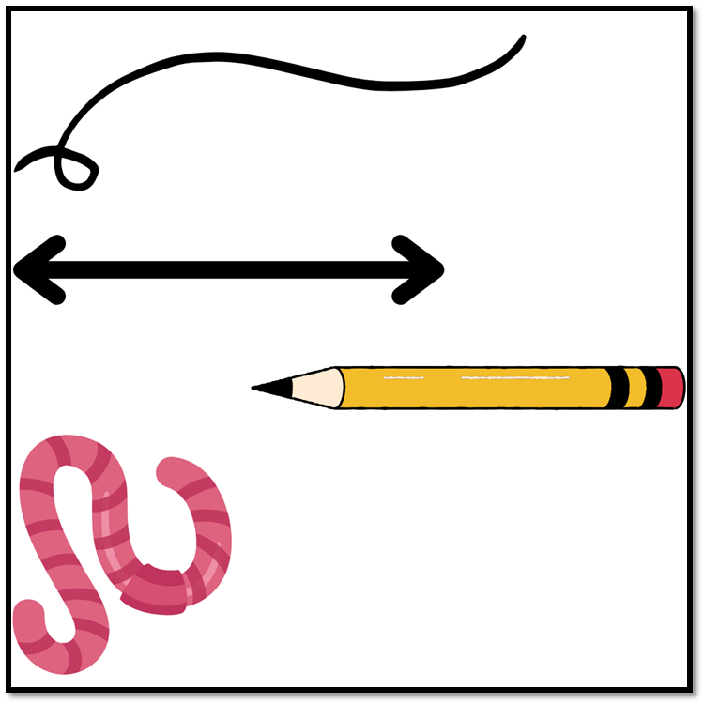
Images sourced from Canva and used in accordance with the Canva Content License Agreement.

Resource 2: Less, more, same
Less than a metre | More than a metre | About the same as a metre

Resource 3: Number talk 1
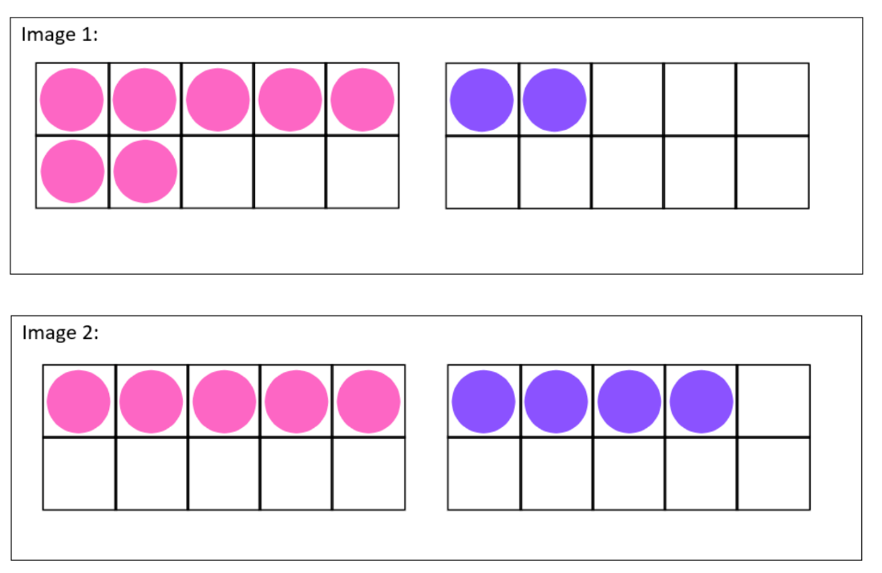

Resource 4: Cover the numbers
Photocopy in A3 size so that counters can be used to cover numbers.
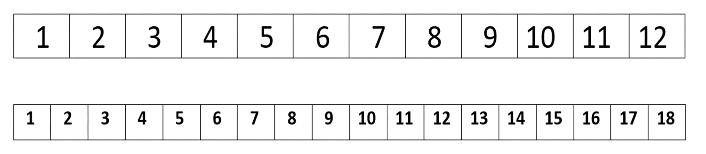

Resource 5: On the farm
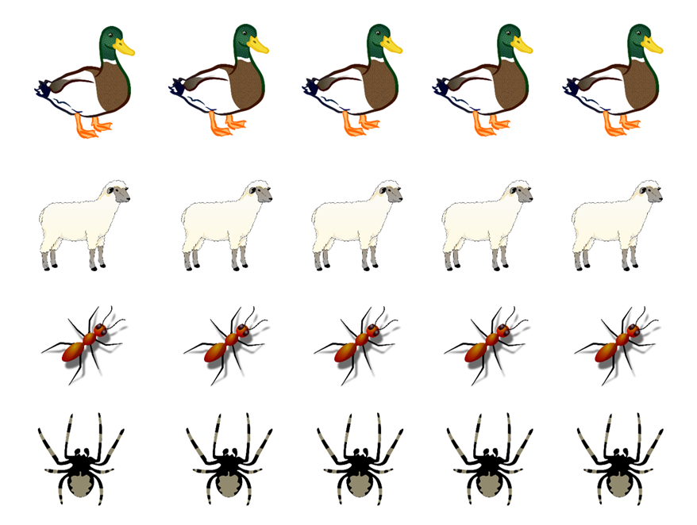
Images sourced from Pixabay and used in accordance with the Pixabay Licence.

Resource 6: Number stories
- Leon had 7 toy cars. His brother gave him 6 more toy cars. How many cars does Leon have now?
- Sophia had 8 crystals. Her sister gave her some more. Now Sophia has 13 crystals. How many crystals was Sophia given by her sister?
- Krishiv had some toy dinosaurs. His friend Adam gave him 9 more. Now Krishiv has 14 dinosaurs. How many dinosaurs did Krishiv have to start with?

Resource 7: Cakes and chocolates
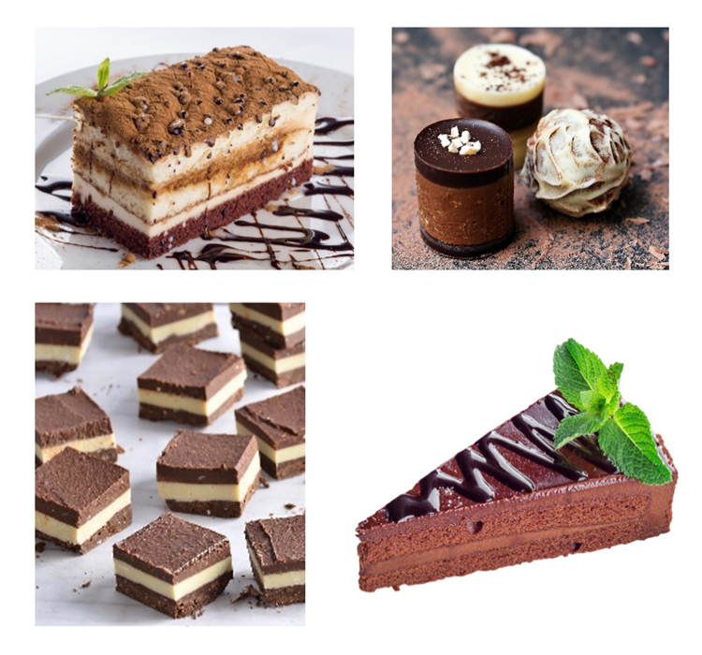
Images sourced from Pixabay and used in accordance with the Pixabay Licence.

Syllabus outcomes and content
The table below outlines the syllabus outcomes and range of relevant syllabus content covered in this unit. Content is linked to National Numeracy Learning Progression version (3).
Focus area and outcomes | Content groups and content points | Lessons
Representing whole numbers  MAO-WM-01  MAE-RWN-01, MA1-RWN-01  MAE-RWN-02, MA1-RWN-02 | Early Stage 1  Use the counting sequence of ones flexibly  - Count forwards to at least 30 and state the number after or before a given number, without needing to count from one [QuN6] (CPr4)  - Identify the number before as 'one less' and the number after as 'one more’ than a given number | 3
Representing whole numbers (cont) | Early Stage 1  Connect counting and numerals to quantities  - Count with one-to-one correspondence, recognising that the last number name represents the total number in the collection [QuN3] (CPr3, CPr5)  - Count out a specified number of objects (from 5 to 20) from a larger collection, keeping track of the count [QuN5] (CPr4, CPr5) | 2 and 7
Representing whole numbers A (cont) | Stage 1  Represent the structure of groups of ten in whole numbers  - Use 10 as a reference in forming numbers from 11 to 20 [QuN8] (CPr7)  - Partition two-digit numbers to show quantity values [QuN8] (NPV4) | 2, 3 and 7
Combining and separating quantities  MAO-WM-01  MAE-CSQ-01, MA1-CSQ-01 | Early Stage 1  Model additive relations and compare quantities  - Combine two or more groups of objects to model addition, identifying the relationship between the parts and the whole [AdS1, AdS2] (AdS1, AdS2)  - Separate and take away part of a group of objects to model subtraction [AdS2] (AdS1, AdS2)  - Use concrete materials or fingers to model and solve addition and subtraction questions, counting forwards or backwards by ones as necessary [AdS2] (AdS1, AdS2, NPV3) | 4-8
Combining and separating quantities (cont) | Early Stage 1  Identify part–whole relationships in numbers up to 10  - Use visual representations of numbers to assist with combining and separating quantities, identifying the relationship between the quantities [NPA2, NPA3, AdS2, AdS3] (NPV2, AdS2, AdS3, NPA2)  - Describe the action of combining, separating and comparing (AdS1)  - Create, model and recognise combinations for numbers up to ten [AdS2] (AdS2) | 2 and 3
Combining and separating quantities A (cont) | Stage 1  Use advanced count-by-one strategies to solve addition and subtraction problems  - Record number sentences in a variety of ways using drawings, words, numbers and symbols [AdS6] (AdS6)  - Fluently use advanced count-by-one strategies including counting on and counting back to solve addition and subtraction problems involving one- and two-digit numbers [AdS3, AdS4, AdS5] (AdS3, AdS4, AdS5) | 4-8
Combining and separating quantities A (cont) | Stage 1  Recognise and recall number bonds up to ten  - Recognise, recall and record combinations of two numbers that add up to or bond to form 10 [AdS2, AdS6] (AdS2, AdS6)  - Create, recall and recognise combinations of two numbers that add up to numbers less than 10 [AdS2, AdS6) (AdS2, AdS6) | 2 and 3
Combining and separating quantities A (cont) | Stage 1  Use flexible strategies to solve addition and subtraction problems  - Select and apply strategies using number bonds to solve addition and subtraction problems with one- and two-digit numbers by partitioning numbers using quantity value and bridging to ten (Reasons about relations). [AdS6, AdS7] (AdS6, AdS7) | 4
Combining and separating quantities A (cont) | Stage 1  Represent equality  - Model the commutative property for addition and apply it to aid the recall of addition facts (Reasons about relations) (AdS7). | 5-7
Geometric measure  MAO-WM-01  MAE-GM-02, MA1-GM-02  MAE-GM-03 | Early Stage 1  Length: Use direct and indirect comparisons to decide which is longer  - Identify the attribute of 'length' as the measure of an object from end to end  - Use comparative language to describe length [UuM2] (UuM2)  - Compare lengths directly by placing objects side by side and aligning the ends [UuM1] (UuM2)  - Explain why the length of a piece of string remains unchanged whether placed in a straight line or a curve  - Compare lengths indirectly by copying a length (Reasons about relations) [UuM2] (UuM3) | 1-3
Geometric measure (cont) | Early Stage 1  Length: Create half a length  - Divide a length into two equal parts (Reasons about relations) [InF1] (InF1)  - Distinguish between the halfway point and half a length [InF1]  - Describe positions as 'about halfway', 'more than halfway' or 'less than halfway' (InF2) | 4
Geometric measure A (cont) | Stage 1  Measure the lengths of objects using uniform informal units  - Use uniform informal units to measure lengths and distances by placing the units end to end without gaps or overlaps. [UuM3] (UuM2)  - Count informal units to measure lengths or distances and describe the part left over. [UuM5] (UuM4) | 1-3
Geometric measure B (cont) | Stage 1  Recognise and use formal units to measure the length of objects  - Recognise the need for formal units to measure lengths and distances [UuM7] (UuM6)  - Use the metre as a unit to measure lengths and distances to the nearest metre or half-metre  - Record lengths and distances using the abbreviation for metres (m)  - Estimate lengths and distances to the nearest metre and check by measuring  - Recognise the need for a formal unit smaller than the metre  - Recognise that there are 100 centimetres in one metre  - Measure lengths to the nearest centimetre, using a device with 1-cm markings  - Record lengths and distances using the abbreviation for centimetres (cm)  - Estimate lengths and distances to the nearest centimetre and check by measuring. (UuM6) | 2-4
Three-dimensional spatial structure  MAO-WM-01  MA1-3DS-01  MAE-3DS-02, MA1-3DS-02 | Early Stage 1  Volume: Compare internal volume by filling and packing  - Fill and empty containers using materials such as water or sand  - Use the terms ‘full’, ‘empty’ and ‘about half full’  - Compare the internal volumes of two containers indirectly by pouring their contents into two other identical containers and observing the level reached in each (UuM3)  - Establish that containers of different shapes may hold the same amount  - Stack and pack blocks into defined spaces ([UuM3]) [UuM5] | 7-8
Three-dimensional spatial structure (cont) | Early Stage 1  Volume: Compare volume by building  - Identify the attribute of volume as the amount of space an object or substance occupies  - Compare the volumes of two objects made from blocks or connecting cubes directly by deconstructing one object and using its parts to construct a copy of the other object  - Use comparative language to describe volume [UuM2] (UuM2) | 8
Three-dimensional spatial structure A (cont) | Stage 1  3D objects: Recognise familiar three-dimensional objects  - Identify and name familiar three-dimensional objects [UGP2] | 8
Three-dimensional spatial structure A (cont) | Stage 1  Volume: Measure and compare the internal volumes (capacities) of containers by filling  - Use uniform informal units to measure how much a container will hold by counting the number of times a smaller container can be filled and emptied into the container being measured. [UuM3, UuM4] (UuM3)  - Compare the internal volumes of two or more containers using appropriate uniform informal units [UuM3] (UuM4)  - Recognise and explain why containers of different shapes may have the same internal volume (Reasons about relations).  - Estimate how much a container holds by referring to the number and type of uniform informal units used and check by measuring. [UuM3, UuM4] (UuM3, UuM4) | 7
Three-dimensional spatial structure A (cont) | Stage 1  Volume: Measure the internal volume (capacity) of containers by packing  - Pack cubic units (eg blocks) into rectangular containers so that there are no gaps  - Recognise that cubes pack better than other objects in rectangular containers (Reasons about spatial structure)  - Estimate and measure the internal volume of a container by filling the container with uniform informal units and counting the number of units used.  - Explain that if there are gaps when packing and stacking, this will affect the accuracy of measuring the internal volume. | 8
Three-dimensional spatial structure A (cont) | Stage 1  Volume: Construct volumes using cubes  - Explore different rectangular prisms that can be made from a given number of cubes | 8
Three-dimensional spatial structure B (cont) | Stage 1  Volume: Compare containers based on internal volume (capacity) by filling and packing  - Compare, order and record the internal volumes (capacities) of two or more containers by measuring each container in uniform informal units [UuM3, UuM4, UuM5] (UuM3, UuM4)  - Estimate internal volume (capacity) by referring to the number and type of uniform informal unit used [UuM3] (UuM3) | 7 and 8
Three-dimensional spatial structure B (cont) | Stage 1  Volume: Compare volumes using uniform informal units  Compare models with different appearances, recognising when they have the same volume | 8
Non-spatial measure  MAO-WM-01  MAE-NSM-01, MA1-NSM-01 | Early Stage 1  Mass: Identify and compare mass using weight  - Identify that objects can be heavy or light [UuM2] (UuM2)  - Compare two masses directly by hefting [UuM2] (UuM3)  - Predict which object would be heavier than, lighter than, or have about the same weight as another object and explain reasons for this prediction | 5 and 6
Non-spatial measure A (cont) | Stage 1  Investigate mass using an equal-arm balance  - Place objects on either side of an equal-arm balance to obtain a level balance  - Use an equal arm balance to compare the masses of two objects and record, which is heavier or lighter [UuM2] (UuM2)  - Use a balance to find two collections of objects that have the same mass [UuM2] (UuM2) | 5 and 6
Non-spatial measure B (cont) | Stage 1  Compare the masses of objects using an equal-arm balance  - Use uniform informal units to measure the mass of an object by counting the number of units needed to obtain a level balance on an equal-arm balance [UuM3] (UuM3)  - Select an appropriate uniform informal unit to measure the mass of an object and justify the choice (Reasons about relations) [UuM3] (UuM4)  - Compare the masses of two or more objects using the same informal units [UuM3] (UuM4)  - Estimate mass by referring to the number and type of uniform informal unit used and check by measuring [UuM3, UuM4, UuM5] (UuM3, UuM4) | 5 and 6

References
Links to third-party material and websites
Please note that the provided (reading/viewing material/list/links/texts) are a suggestion only and implies no endorsement, by the New South Wales Department of Education, of any author, publisher, or book title. School principals and teachers are best placed to assess the suitability of resources that would complement the curriculum and reflect the needs and interests of their students.
If you use the links provided in this document to access a third-party's website, you acknowledge that the terms of use, including licence terms set out on the third-party's website apply to the use which may be made of the materials on that third-party website or where permitted by the Copyright Act 1968 (Cth). The department accepts no responsibility for content on third-party websites.
Except as otherwise noted, all material is © State of New South Wales (Department of Education), 2023 and licensed under the Creative Commons Attribution 4.0 International License. All other material (third-party material) is used with permission or under licence. Where the copyright owner of third-party material has not licensed their material under a Creative Commons or similar licence, you should contact them directly for permission to reuse their material.
Mathematics K–10 Syllabus © 2022 NSW Education Standards Authority (NESA) for and on behalf of the Crown in right of the State of New South Wales.
© 2022 NSW Education Standards Authority. This document contains NSW Curriculum and syllabus content. The NSW Curriculum is developed by the NSW Education Standards Authority. This content is prepared by NESA for and on behalf of the Crown in right of the State of New South Wales. The material is protected by Crown copyright.
Please refer to the NESA Copyright Disclaimer for more information.
NESA holds the only official and up-to-date versions of the NSW Curriculum and syllabus documents. Please visit the NSW Education Standards Authority (NESA) website and the NSW Curriculum website.
National Numeracy Learning Progression © Australian Curriculum, Assessment and Reporting Authority (ACARA) 2010 to present, unless otherwise indicated. This material was downloaded from the Australian Curriculum website (National Numeracy Learning Progression) (accessed 16 September 2022) and was not modified. The material is licensed under CC BY 4.0. Version updates are tracked in the ‘Curriculum version history’ section on the 'About the Australian Curriculum' page of the Australian Curriculum website.
ACARA does not endorse any product that uses the Australian Curriculum or make any representations as to the quality of such products. Any product that uses material published on this website should not be taken to be affiliated with ACARA or have the sponsorship or approval of ACARA. It is up to each person to make their own assessment of the product, taking into account matters including, but not limited to, the version number and the degree to which the materials align with the content descriptions and achievement standards (where relevant). Where there is a claim of alignment, it is important to check that the materials align with the content descriptions and achievement standards (endorsed by all education Ministers), not the elaborations (examples provided by ACARA).
This resource contains images and content obtained from Canva, and their use outside of this resource is subject to Canva’s Content License Agreement. If you wish to use them separately from the resource, please go to Canva.
New Zealand Ministry of Education (n.d) Volume and Capacity Units of Work, NZ Maths website, accessed 16 September 2022.
Parrish S (2022) Number Talks: Whole Number Computation, Heinemann Education Books, Portsmouth NH.
State of Victoria (Department of Education and Training) (n.d.), ‘Literacy experience plan: Barrier games (connective blocks)’, Literacy Teaching Toolkit, State of Victoria (Department of Education and Training) website, accessed 16 September 2022.
University of Cambridge (Faculty of Mathematics) (2022) NRICH [website], accessed 16 September 2022.
University of Cambridge (Faculty of Mathematics) (2022) Shut the Box, NRICH website, accessed 16 September 2022.

