Mathematics – K-2 multi-age – Year A – Unit 16
Contents
Unit description and duration 4
Student prior learning 4
Lesson overview and resources 5
Lesson 1: Sort them out 11
Daily number sense: Thinking flexibly with numbers – 10 minutes 11
Sort them out – 40 minutes 13
Reflection – 10 minutes 14
Lesson 2: Let’s talk 15
Daily number sense: Race to zero – 10 minutes 16
Let’s talk 1 – 40 minutes 17
Consolidation and meaningful practice: Reflection – 10 minutes 18
Lesson 3: Let’s talk 2 20
Daily number sense: Two truths and one lie – 10 minutes 20
Let’s talk 2 – 40 minutes 23
Consolidation and meaningful practice: Reflection – 10 minutes 23
Lesson 4: Exploring equivalence 26
Daily number sense: Equivalence with dominos – 10 minutes 26
Let’s talk 4 (Part 2) – 40 minutes 30
Consolidation and meaningful practice: Reflection – 10 minutes 31
Lesson 5: Fruit shop 1 33
Daily number sense: Dot talk – 10 minutes 33
Investigating multiplication – 40 minutes 34
Reflection – 10 minutes 35
Lesson 6: Fruit shop 2 37
Daily number sense: Number busting 24 – 10 minutes 37
One array of lemons – 40 minutes 39
Discuss and connect the mathematics – 10 minutes 40
Lesson 7: Sharing cupcakes 41
Daily number sense: Class assembly –10 minutes 42
Sharing cupcakes – 30 minutes 42
Discuss and connect the mathematics – 10 minutes 44
Lesson 8: Teddy bear’s birthday 45
Daily number sense: How many legs? – 10 minutes 45
Teddy bear’s birthday – 30 minutes 46
Discuss and connect the mathematics – 10 minutes 48
Resource 1: Renaming 12 49
Resource 2: Renaming 43 50
Resource 3: Sorting cards 51
Resource 4: Number chart 55
Resource 5: 20 to 70 spinner 56
Resource 6: 0 to 9 spinner 57
Resource 7: 2 truths and a lie 58
Resource 8: Dot cards 59
Resource 9: Fruit shop 1 60
Resource 10: Fruit shop 2 61
Resource 11: Fruit shop 3 62
Resource 12: Fruit shop 4 63
Resource 13: Fruit shop 5 64
Resource 14: Recording table 65
Syllabus outcomes and content 66
References 76

Unit description and duration
This two-week unit provides students with opportunities to explore different situations where you can use addition, subtraction, multiplication, and division. Students are provided opportunities to:
- rename and partition numbers
- use flexible strategies to solve addition and subtraction problems
- represent equality
- use equal groups to represent multiplication
- use flexible strategies to solve multiplication and division problems
Mathematics K–10 Syllabus © 2022 NSW Education Standards Authority (NESA) for and on behalf of the Crown in right of the State of New South Wales.

Student prior learning
Before engaging in these teaching and learning activities, students would benefit from prior experience with:
- combining and separating quantities of concrete materials
- record number sentences using drawings, words, numerals, and symbols
- organising collections efficiently
- model and describe collections as ‘groups of’.

Lesson overview and resources
The table below outlines the sequence and approximate timing of lessons; syllabus focus areas and content groups; and resources.
Lesson | Syllabus focus area and content groups | Resources
Lesson 1: Sort them out  60 minutes  Mathematicians can use their knowledge of numbers and operations to make decisions about how they want to solve problems. | Representing whole numbers  Early Stage 1  - Connect counting and numerals to quantities  Stage 1 – Part A  - Represent the structure of groups of ten in whole numbers  Combining and separating quantities  Early Stage 1  - Model additive relations and compare quantities  Stage 1 – Part A  - Use advanced count-by-one strategies to solve addition and subtraction problems | - Resource 1: Renaming 12  - Resource 2: Renaming 43  - Resource 3: Sorting cards  - MAB blocks  - Mini whiteboards (class set)  - Writing materials
Lesson 2: Let’s talk  60 minutes  The same problem can be solved in different ways. | Representing whole numbers  Early Stage 1  - Connect counting and numerals to quantities  Stage 1 – Part A  - Represent the structure of groups of ten in whole numbers  Stage 1 – Part B  - Form, regroup and rename three-digit numbers  Combining and separating quantities  Early Stage 1  - Model additive relations and compare quantities  Stage 1 – Part A  - Use advanced count-by-one strategies to solve addition and subtraction problems  Stage 1 – Part B  - Represent and reason about additive relations | - Resource 4: Number chart  - Resource 5: 20 to 70 spinner  - Resource 6: 0 to 9 spinner  - Video: Let’s talk 1 (10:15)  - Paper clips (for spinners)  - Writing materials
Lesson 3: Let’s talk 2  60 minutes  Addition can be used to solve subtraction. | Representing whole numbers  Early Stage 1  - Connect counting and numerals to quantities  Stage 1 – Part A  - Use counting sequences of ones with two-digit numbers and beyond  - Represent the structure of groups of ten in whole numbers  Stage 1 – Part B  - Use counting sequences of ones and tens flexibly  Combining and separating quantities  Early Stage 1  - Model additive relations and compare quantities  Stage 1 – Part A  - Use flexible strategies to solve addition and subtraction problems.  - Represent equality | - Resource 7: 2 truths and a lie  - Video: 2 truths. 1 lie. (4:10)  - Video: Let’s talk 1 (10:15)  - Concrete materials  - Interlocking cubes  - MAB blocks  - Mini whiteboards (class set)  - Writing materials
Lesson 4: Exploring equivalence  60 minutes  Equivalence can be used to solve problems. | Combining and separating quantities  Early Stage 1  - Model additive relations and compare quantities  Stage 1 – Part A  - Represent equality  Stage 1 – Part B  - Use knowledge of equality to solve related problems | - Video: Let’s talk 4: Part 2 (4:44)  - Video: Balancing numbers 1 (0:41)  - 12-sided dice  - Concrete materials  - Dominos  - Equal-arm balances  - Interlocking cubes  - Mini whiteboards (class set)  - Writing materials
Lesson 5: Fruit shop 1  60 minutes  A range of mental and written strategies can be used to solve problems. | Forming groups  Early Stage 1  - Investigate and form equal groups by sharing  - Record grouping and sharing  Stage 1 – Part A  - Counts in multiples using rhythmic and skip counting  - Model and use equal groups of objects to represent multiplication | - Resource 8: Dot cards  - Resource 9: Fruit shop 1  - Resource 10: Fruit shop 2  - Resource 11: Fruit shop 3  - Resource 12: Fruit shop 4  - Resource 13: Fruit shop 5  - Large cardboard or paper for posters  - Writing materials
Lesson 6: Fruit shop 2  60 minutes  Representations can be used to make meaning and solve problems. | Forming groups  Early Stage 1  - Investigate and form equal groups by sharing  - Record grouping and sharing  Stage 1 – Part B  - Represent and explain multiplication as the combining of equal groups  - Represent multiplication and division problems | - Resource 9: Fruit shop 1  - Video: Number busting (2:00)  - Counters  - Large cardboard or paper for posters  - Writing materials
Lesson 7: Sharing cupcakes  60 minutes  In division, start with the total and break it into smaller parts. | Forming groups  Early Stage 1  - Investigate and form equal groups by sharing  - Record grouping and sharing  Stage 1 – Part A  - Model and use equal groups of objects to represent multiplication  - Recognise and represent division  Stage 1 – Part B  - Represent and explain multiplication as the combining of equal groups  - Represent multiplication and division problems | - Counters  - Mini whiteboards (class set)  - Writing materials
Lesson 8: Teddy bear’s birthday  50 minutes  Multiplication and division can be used to solve problems. | Forming groups  Early Stage 1  - Investigate and form equal groups by sharing  - Record grouping and sharing  Stage 1 – Part A  - Recognise and represent division  - Model and use equal groups of objects to represent multiplication  Stage 1 – Part B  - Represent multiplication and division problems | - Resource 14: Recording table  - Counters  - Mini whiteboards  - Writing materials

Lesson 1: Sort them out
Core concept: Mathematicians can use their knowledge of numbers and operations to solve problems.
The table below contains suggested learning intentions and success criteria. These are best co-constructed with students.
Learning intentions | Success criteria
All students are learning that number sentences can be solved in a variety of ways, using drawings, words, numerals, and symbols  In addition, Stage 1 students are learning that:  - mathematicians use symbols for plus (+), minus (−) and equals (=)  - efficient strategies can be used to solve addition and subtraction problems involving one- and two-digit numbers. | All students can:  - identify addition and subtraction situations  - solve problems in different ways  - use appropriate addition and subtraction language.  In addition, Stage 1 students can identify and use symbols for plus (+), minus (−) and equals (=)

Daily number sense: Thinking flexibly with numbers – 10 minutes
- Build student understanding of thinking about numbers flexibly by renaming.
- Display Resource 1: Renaming 12 and ask students what they notice. Have students turn and talk to a partner.
- Ask students:
- How many blocks do you see?
- How would you describe what you see?
- Are the totals the same?
- Explain that good mathematicians explain their thinking. Discuss responses and reinforce the concept of renaming. For example, I see one 10 and 2 ones. I can also see 12 ones.
- Display Resource 2: Renaming 43 and repeat previous step. Listen and record responses. Early Stage 1 students may continue with teen numbers. Use MAB blocks to display a ten and some more. For example, one 10 and 4 ones.
- Discuss ideas and reinforce renaming. For example, I can see the 4 in 43 represents 4 tens; we call 4 tens 40. I can also see 43 in 43 ones. I can rename 43 as 3 tens and 13 ones. Early Stage 1 students may reinforce subitising by identifying the number in a different arrangement.
This table details assessment opportunities and differentiation ideas.
Assessment opportunities | Too hard? | Too easy?
What to look for:  - Can students identify numbers in different arrangements? (MAO-WM-01, MAE-RWN-01, MAE-RWN-02)  - Can students rename numbers? (MAO-WM-01, MA1-RWN-02)  - Can students partition numbers? (MAO-WM-01, MA1-RWN-02)  What to collect:  - record and collect student responses (MAO-WM-01, MA1-RWN-02, MAE-RWN-01, MAE-RWN-02) | Students have difficulty renaming and partitioning numbers.  - Present first image only (Resource 1: Renaming 12) or 2 displays ranging between 10 and 20.  - Provide MAB blocks.  - Early Stage 1 students may present numbers up to 10, using 5 as a reference in forming numbers from 6 to10. | - Students can rename and partition numbers.  - Students draw or model a fourth way of renaming.  - Students model different ways of partitioning numbers.

Sort them out – 40 minutes
- Show students Resource 3: Sorting cards. Ask students what they notice and wonder about these images. Tell students they are going to sort these images into 2 groups. Have students think about how they could be sorted. Early Stage 1 students use images of concrete materials to model addition and subtraction.
- As a class, sort the cards into 2 groups. Discuss how the cards have been sorted, using language specific to addition and subtraction. For example, add, equals, take away, subtract, minus, plus. Early Stage 1 students may use combines with, joins, take away, altogether.
- Discuss the different ways that addition and subtraction can be represented. Reinforce that drawings, words, numerals, and symbols can be used.
- Using the printed Resource 3: Sorting cards, Stage 1 students select a card and show how they would individually solve the problem. Early Stage 1 students use concrete material cards only. Students repeat this process with a selection of different question cards. Students record their responses on whiteboards or paper for sharing.

Reflection – 10 minutes
- Discuss the strategies students used to solve their questions.
- Explore the strategies that demonstrate counting on, counting back, partitioning, related facts. With Early Stage 1 students, discuss and model combining groups for addition and taking away part of a group for subtraction. Stage 1 students identify which strategies are most efficient and why.
This table details assessment opportunities and differentiation ideas.
Assessment opportunities | Too hard? | Too easy?
What to look for:  - Can students use images of concrete materials or fingers to model and solve addition and subtraction questions? (MAO-WM-01, MAE-CSQ-01, MAE-CSQ-02)  - Can students rename numbers? (MAO-WM-01, MA1-RWN-02)  - Can students partition numbers? (MAO-WM-01, MA1-RWN-02)  What to collect:  - record and collect student responses. (MAO-WM-01, MAE-RWN-01, MAE-RWN-02, MA1-RWN-02) | Students have difficulty renaming and partitioning numbers.  - Provide concrete materials.  - Early Stage 1 students may use resources that identify part-whole relationships in numbers up to 10. | Students can rename and partition numbers.  - Students draw or model a fourth way of renaming and partitioning.  - Students model different ways of partitioning numbers.

Lesson 2: Let’s talk
Core concept: The same problem can be solved in different ways.
The table below contains suggested learning intentions and success criteria. These are best co-constructed with students.
Learning intentions | Success criteria
All students are learning that:  - in subtraction, start with a total and break it into smaller parts  - the same problem can be solved using many different strategies. | All students can:  - use their knowledge of addition and subtraction to select appropriate strategies to solve problems  - separate and take away part of a group of objects to model subtraction  - start with the total when subtracting.  In addition, Stage 1 students can record subtraction on a number line.

Daily number sense: Race to zero – 10 minutes
This lesson has been adapted from Race to zero (0:17).
- Build student understanding of subtracting by spinning a number and counting backwards.
- Display Resource 4: Number chart. Early Stage 1 students place a counter on 20 to count backwards from. Stage 1 students place a counter on their largest number (120) and spin for a number and count backwards.
- Spin a number on Resource 5: 20 to 70 spinner. Ask Stage 1 students turn and talk to a partner about the most efficient way to subtract the number. Obtain strategies from students and model subtracting.
- Repeat above step with Resource 6: 0 to 9 spinner for Early Stage 1 students.
- Repeat until class has reached zero.
Note: Early Stage 1 students will use Resource 6: 0 to 9 spinner only to spin and count backwards.
This table details assessment opportunities and differentiation ideas.
Assessment opportunities | Too hard? | Too easy?
What to look for:  - Can students count backwards? (MAO-WM-01, MAE-RWN-02, MAO-WM-01, MA1-RWN-01)  - Can students count by tens on and off the decade? (MAO-WM-01, MA1-RWN-01)  What to collect:  - record student strategies for subtracting (MAO-WM-01, MAE-RWN-02, MA1-RWN-01) | - Students have difficulty subtracting.  - Provide students with their own copy of the number chart.  - Students use their own counter and number chart to calculate subtraction strategy.  - Use a number chart cut into a number strip as a game board. | Students can subtract successfully.  - Early Stage 1 Students use a number chart with higher numbers. For example, putting counter on a number above 20.  - Stage 1 students spin ones and tens spinners together and subtract the total of that number. For example, if 30 and 6 are spun, students subtract 36 instead of each number individually.

Let’s talk 1 – 40 minutes
This activity has been adapted from Let’s talk 1 (10:15).
- View the video Let’s talk 1 (10:15). Stop at 4:47. Early Stage one students make a teen number with interlocking cubes and model subtracting a single digit number.
- Ask students to turn and talk to a partner and explain in their own words how the problem was solved. Record responses.
- Reinforce mathematical language used. Notice how the concrete materials were used in the video.
- Students solve the same problem using a different strategy of their choosing.
- Students record strategies in their workbooks. Early Stage 1 model with concrete materials only.

Consolidation and meaningful practice: Reflection – 10 minutes
- As a class, share chosen strategies and record.
- Ask students to think about which strategy is most efficient and why. Students turn and talk with a partner.
- Reinforce vocabulary used for subtraction and the importance of solving problems in different ways.
This table details assessment opportunities and differentiation ideas.
Assessment opportunities | Too hard? | Too easy?
What to look for:  - Can students separate and take away part of a group of objects to model subtraction? (MAO-WM-01, MAE-CSQ-01)  - Can students use concrete materials to model and solve subtraction questions, counting backwards by ones? (MAO-WM-01, MAE-CSQ-01)  - Can students use non-count by one strategies? (MAO-WM-01, MA1-CSQ-01)  - Can students use related facts? (MAO-WM-01, MA1-CSQ-01)  - Can students partition and rename numbers? (MAO-WM-01, MA1-RWN-02)  What to collect:  - Students' recordings. (MAO-WM-01, MAE-CSQ-01, MA1-RWN-01, MA1-CSQ-01) | Students have difficulty solving the problem.  - Provide interlocking cubes for students to model strategy.  - Students re-model the strategy from the demonstration and explain the strategy while modelling (Early Stage 1). | Students choose efficient strategy to correctly solve the problem.  - Challenge students to use a third strategy that could be used to solve the problem.  - Model a subtraction strategy to solve the problem, using drawings, words, or numerals (Early Stage 1).

Lesson 3: Let’s talk 2
Core concept: Addition can be used to solve subtraction.
The table below contains suggested learning intentions and success criteria. These are best co-constructed with students.
Learning intentions | Success criteria
All students are learning that:  - addition can be used to solve subtraction  - numbers can be partitioned and renamed | All students can:  - solve subtraction problems using drawings and concrete materials  - solve subtraction problems using addition strategies  - partition and rename teen numbers.  In addition, Stage 1 students can partition and rename two-digit numbers.

Daily number sense: Two truths and one lie – 10 minutes
This lesson has been adapted from 2 truths. 1 lie. (4:10).
- Build student understanding of thinking flexibly about numbers by partitioning and renaming numbers.
- Explain to students that numbers can be partitioned in many ways using concrete materials and that thinking flexibly about numbers helps to solve problems.
- View the video 2 truths. 1 lie. (4:10). Early Stage 1 use Resource 7: 2 truths and a lie. Explain to students that there are 3 statements or examples. Two of these statements are true and students will decide if the third statement is a lie.
Note: Early Stage 1 students will decide which number representation does not equal 15.
- Ask Stage 1 students if they can prove that the third statement ‘25 cannot be represented with 10 MAB blocks’ is false. Students turn and talk to solve the problem in pairs using MAB blocks.
- Students record their thinking on whiteboards and share their ideas with the class.
- As a class, discuss if the statement was true or false. Record student reasoning. Early Stage 1 students discuss which one is a lie and explain why.
This table details assessment opportunities and differentiation ideas.
Assessment opportunities | Too hard? | Too easy?
What to look for:  - Can students represent numbers as quantities to at least 20 using objects, number words and numerals? (MAO-WM-01, MAE-RWN-02)  - Can students compare and order numbers to 20? (MAO-WM-01, MAE-RWN-02)  - Can students use concrete materials such as MAB blocks and interlocking cubes to represent and explain grouping? (MAO-WM-01, MA1-RWN-02)  - Can students use place value to partition and rename two-digit numbers? (MAO-WM-01, MA1-RWN-02)  - Can students think flexibly about tens and ones? (MAO-WM-01, MA1-RWN-02)  What to collect:  - recordings of students reasoning on whiteboards (MAO-WM-01, MAE-RWN-02, MA1-RWM-02)  - photographs of their concrete modelling (MAO-WM-01, MAE-RWN-02, MA1-RWN-02) | Early Stage 1 have difficulty identifying which representation is not equal to 15.  - Use concrete materials to make the representations shown.  - Model different representations of numbers using objects.  Stage 1 students have difficulty proving 25 cannot be represented with 10 MAB blocks.  - Use MAB blocks and think aloud to model how to solve the problem. For example, by asking if 25 can be represented using 10 MAB blocks.  - Use the same modelling and language presented in the video. | Early Stage 1 students efficiently determine which representation is false.  - Create a different representation for 15.  - Create different representations for other two-digit numbers.  Stage 1 students efficiently determine that 25 cannot be represented with 10 MAB blocks.  - Students write their own statements. A partner determines if the statement is true or false.  - Encourage students to explain their reasoning by reminding them that good mathematicians explain their thinking.

Let’s talk 2 – 40 minutes
This lesson has been adapted from Let’s talk 1 (10:15).
- View the video: Let’s talk 1 (10:15) from 4:47. Pause at 7:24.
- Students turn and talk to a partner and explain, in their own words, how the problem was solved. Record responses.
- Reinforce the mathematical language used and the importance of using inverse operations to solve problems.
- Provide students with the problem 18 − 11. Ask students to work with a partner to solve the problem using a subtraction and an addition strategy. Students can use concrete materials and drawings to show their strategies.
- When students have completed the problem, pairs find another pair to make a group of 4. Each pair takes a turn to show one of their strategies.
Note: Early Stage 1 solve 18 - 11 using interlocking cubes to model subtraction.

Consolidation and meaningful practice: Reflection – 10 minutes
- Gather the class to share and record strategies used.
- Ask pairs which strategy was the most efficient. Ask for responses and model comparing the efficiency of the strategies.
- Reinforce the importance of efficiency and using inverse operations.
This table details assessment opportunities and differentiation ideas.
Assessment opportunities | Too hard? | Too easy?
What to look for:  - Can students use drawings, words, numerals and symbols when solving a number sentence? (MAO-WM-01, MAE-CSQ-01)  - Can students separate and take away part of a group of objects to model subtraction? (MAO-WM-01, MAE-CSQ-01)  - Can students count backwards to model subtraction? (MAO-WM-01, MAE-CSQ-01)  - Can students use numerals to record subtraction problems? (MAO-WM-01, MAE-CSQ-02)  - Can students correctly use number lines to solve a problem? (MAO-WM-01, MA1-RWN-01)  - Can students partition numbers to assist in solving the problem? (MAO-WM-01, MA1-RWN-02)  - Can students use addition to solve subtraction problems? (MAO-WM-01, MA1-CSQ-01)  What to collect:  - Recordings of student strategies. (MAO-WM-01, MAE-CSQ-01, MAE-CSQ-02, MA1-RWN-01, MA1-RWN-02, MA1-CSQ-01, MA1-CSQ-01) | Students have difficulty using addition to solve subtraction.  - Model using concrete materials and drawings.  - Use interlocking cubes to solve the subtraction problem. | Early Stage 1 students solve problem with subtraction strategy  - Use numerals to record subtraction.  - Use number line to record subtraction.  Stage 1 students solve problem with addition and subtraction strategy. Use a third strategy for solving the problem.

Lesson 4: Exploring equivalence
Core concept: Equivalence can be used to solve problems.
The table below contains suggested learning intentions and success criteria. These are best co-constructed with students.
Learning intentions | Success criteria
All students are learning that:  - knowing equivalent numbers can help to solve addition problems  - knowing equivalent numbers can help solve subtraction problems. | All students can:  - recognise dice and domino dot patterns  - represent finger patterns for the same number  - use the term ‘is the same as’ and ‘is equal to’ to explain groups of the same size.  - represent equivalent quantities using concrete materials.  In addition, Stage 1 students can use the equals sign to record equivalent number sentences using addition.

Daily number sense: Equivalence with dominos – 10 minutes
This lesson has been adapted from Investigating equivalence with dominos.
- Build student understanding of equivalence by making totals with interlocking cubes from 2 numbers and weighing on an equal-arm balance.
- Provide students with dominos, a 12-sided dice, and interlocking cubes of 2 colours.
- Explain to students that knowing which numbers are equivalent can help to solve problems.
- Model rolling a 12-sided dice and selecting 2 different dominoes that total the number rolled (roll again if 2 combinations are not possible).
- Demonstrate making the rolled number with interlocking cubes, using the numbers from one domino. Repeat again for the second domino with different coloured interlocking cubes.
- Place the interlocking cubes on the equal-arm balance and discuss that the amounts being weighed are the same. Reinforce equivalence by drawing an equivalence sentence using the dominoes (see Figure 2).
- Students work with a partner to complete above steps.
Note: Early Stage 1 students will roll a 12-sided dice and find 2 dominoes that both equal the number rolled. For example, a student rolls the number 10. Students could then locate a domino showing 6 and 4 or 5 and 5. Students roll again and repeat the same steps.
Figure 2 – Example of recording equivalence with dominos
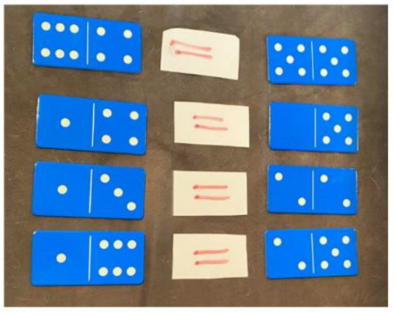
This table details assessment opportunities and differentiation ideas.
Assessment opportunities | Too hard? | Too easy?
What to look for:  - Can students recognise domino dot patterns to determine a number? (MAO-WM-01, MAE-RWN-01)  - Can students combine dot patterns to find a total? (MAO-WM-01, MAE-CSQ-01)  - Can students use interlocking cubes to represent numbers and explain which numbers they used to make their total? (MAO-WM-01, MA1-RWN-02)  - Can student use the language of ‘add’, ‘plus’, ‘equals’, ‘is equal to’ and ‘is the same as’ when combining and comparing quantities? (MAO-WM-01, MA1-RWN-02)  What to collect:  - student answers for equivalent numbers (MAO-WM-01, MAE-CSQ-01, MA1-RWN-02)  - student examples of equivalent domino sentences (MAO-WM-01, MA1-RWN-02) | Early Stage 1 students have difficulty finding dominoes that are equivalent to the dice value.  - Model finding dominoes that match the dice value.  - Roll a dice and make the equivalent quantity in counters.  Stage 1 students find it difficult to identify 2 different combinations of numbers that total a given amount.  - Use 4 different interlocking cube colours to allow students to see each number individually in the total quantity.  - For example, a student rolls 9. They select a domino showing 4 and 5 and a domino showing 3 and 6. Select 4 cubes of one colour and 5 cubes of another colour and combine to make the total of 9. Repeat with other domino selecting a different colour for 3 cubes and another colour for 6 cubes and combine. | Students efficiently model equivalence with dominoes and interlocking cubes.  - Use dominos with patterns beyond 6 and roll with a dice larger than 12-sides.  - Students select more than 2 dominos for the total rolled and demonstrate equivalence between all 3 dominos.

Let’s talk 4 (Part 2) – 40 minutes
This activity has been adapted from Let’s talk 1 (10:15).
- View the video Let’s talk 4: Part 2 (4:44).
- Students turn and talk to discuss what they noticed in the video. Students record their ideas on whiteboards. Listen to student responses and guide the discussion with questions such as:
- How was the equal-arm balance used?
- How did you know that it was not even?
- How did you know when it was even?
- What did it mean when the balance arms were perfectly straight?
- Did you notice that inside 6 there are 3 twos? So, 6 is equivalent to 2, 2 and 2.
- Rewatch the video Let’s talk 4: Part 2 (4:44) if required.
- Have students Think-Pair-Share. Ask what other numbers are inside 6 and record student responses.
- Explain that thinking flexibly about numbers can help to solve problems as it allows mathematicians to use what they know to solve what they do not know. Ask students what other quantities they can find that are equivalent to 8 + 8 + 6? In pairs, students investigate this problem and record their thinking on whiteboards. Students may have an equal-arm balance or other concrete materials to help with their investigation.
Note: Early Stage 1 students can watch the video Balancing numbers 1 (0:41) to explore equivalence and counting principles using an equal-arm balance. Ask what they notice and what they wonder and record answers. Draw students’ attention to the balance scales in the video and ask the above questions to guide discussion.

Consolidation and meaningful practice: Reflection – 10 minutes
- Gather the class together and listen to, and record student answers. Support students by:
- modelling some student responses using an equal-arm balance to check equivalence
- recording modelled responses as equivalent number sentences.
This table details assessment opportunities and differentiation ideas.
Assessment opportunities | Too hard? | Too easy?
What to look for:  - Can students state that one quantity is ‘equal to’ another? (MAO-WM-01, MAE-RWN-01, MAE-RWN-02)  - Can students use the equals sign (=) to record equivalent number sentences involving addition, to mean 'is the same as'? (MAO-WM-01, MA1-RWN-01, MA1-RWN-02, MA1-CSQ-01)  - Can students use flexible strategies to investigate addition on an equal-arm balance? (MAO-WM-01, MA1-RWN-01, MA1-RWN-02, MA1-CSQ-01)  - Can students apply the terms ‘add’, ‘plus’, ‘equals’, ‘is equal to’, ‘is the same as’ when explaining their thinking? (MA-WM-01, MA1-CSQ-01)  What to collect:  - students’ equivalent number sentences (MA-WM-01, MA1-CSQ-01)  - responses to the video Balancing numbers 1 (0:41) (MAO-WM-01, MAE-RWN-01, MAE-RWN-02) | Early Stage 1, students may have difficulty understanding the equivalence of 2 quantities presented.  - Model equivalence using concrete materials  - Students explore equivalence using a balance arm and concrete materials.  Students have difficulty finding an equivalent value for 8 + 8 + 6.  - Students have their own concrete materials to manipulate. They make 8, 8 and 6.  - Manipulate these concrete materials into a different grouping. Example: 7, 9 and 6. | Students easily find other quantities equal to 8 + 8 + 6.  - Ask students to propose another way. Students explore a third example and record their reasoning.  - Ask students to model, using subtraction, to find the answer to the problem, for example, 32 − 10.

Lesson 5: Fruit shop 1
Core concept: A range of mental and written strategies can be used to solve problems.
The table below contains suggested learning intentions and success criteria. These are best co-constructed with students.
Learning intentions | Success criteria
All students are learning that:  - multiplication can be shown in different structures such as repeated addition and arrays  - arrays have equal rows and columns  - efficient strategies can be used to determine the total number of objects in an array. | All students can:  - label the number of objects in a group  - see the number of objects in an array  - explain the difference between rows and columns  - use skip counting or repeated addition to find the total of a collection.

Daily number sense: Dot talk – 10 minutes
- Build student understanding of subitising by quickly sharing a collection of dots and asking how many dots they see. Let students know they will not have time to count the dots one at a time, so as mathematicians they will need to visualise what they saw to help them work it out.
- Show students Resource 8: Dot cards for 2 to 3 seconds and then hide.
- Ask students:
- How many dots did you see?
- How did you see them?
- Provide individual thinking time and then students share their ideas. Monitor student conversations, preparing to ask some students to share how they saw the collection of dots.
- Reveal the dot card and invite selected students to share their thoughts with the class. Record student thinking.

Investigating multiplication – 40 minutes
This lesson has been adapted from Multiplication: reSolve Fruit Shop.
- Show students Resource 9: Fruit Shop 1 from Multiplication: reSolve Fruit Shop. Students explore the different details in the picture.
- As a class, discuss what students notice and wonder about the image.
- Ask students what multiplication they can see in the picture. Model mathematical language to support student understanding.
- Students work individually or in pairs to determine how many pieces of fruit are in each array. Students create a poster to label how many objects are in each group and record their strategies for determining the total.
- Conduct a gallery walk to look at the different examples of multiplication found.
- Show students Resource 10: Fruit shop 2, Resource 11: Fruit shop 3, Resource 12: Fruit shop 4 and Resource 13: Fruit shop 5 from Multiplication: reSolve Fruit Shop. Give students time to consider how the boxes of fruit are similar or different.
- As a class, discuss what students notice about the arrays of fruit in the different boxes.
The table below outlines stimulus prompts to generate conversation about the topic, along with anticipated responses from students.
Prompts | Anticipated student responses
- What do you notice is the same about these boxes of fruit?  - What is different?  - What are you wondering?  - Can you use the number of fruit in one box to help work out the number of fruit in another box? | - Some arrays have the same number in each, but their orientation has been changed.  - Some amounts of fruit can be determined by doubling the number of fruit in another box.  - Some amounts of fruit can be determined by dividing the number of fruit in another box by half.  - We can add on from what we already know to determine the amount of fruit in other boxes.

Reflection – 10 minutes
- Discuss the strategies students used to determine the amount of fruit in each box.
- Explore the strategies that use skip counting and arrays. Explain why these strategies are more efficient.
This table details assessment opportunities and differentiation ideas.
Assessment opportunities | Too hard? | Too easy?
What to look for:  - Can students label the number of objects in a group? (MAO-WM-01, MAE-FG-02)  - Can students recognise if groups/rows are equal or not? (MAO-WM-01, MAE-FG-02)  - Can students use rhythmic or skip counting to identify the total? (MAO-WM-01, MA1-FG-01)  - Can students use their knowledge of equal groups to identify the total? (MAO-WM-01, MA1-FG-01)  What to collect:  - posters from gallery walk where students have used a variety of strategies to determine the number of fruit (MAE-FG-02, MAO-WM-01, MA1-FG-02) | Students find it difficult to recognise when groups/rows are equal or unequal.  - Prompt students to ensure rows and columns are equally spaced to allow direct comparison.  - Provide concrete materials for students to create arrays.  Students find it difficult to use strategies beyond counting by ones to determine the total of an array.  - Provide concrete materials for students to create the arrays.  - Model skip counting using the created arrays.  - Provide students with enlarged, individual copies of the fruit arrays. | Students identify multiplicative strategies to determine the total of the arrays.  - Ask students to find other examples of multiplication within the fruit shop images.  - Explain that multiplication can also be used to work out the cost of items; for example, the watermelon, multiple punnets of strawberries and blueberries, or more than one bag of lemons.

Lesson 6: Fruit shop 2
Core concept: Representations can be used to make meaning and solve problems.
The table below contains suggested learning intentions and success criteria. These are best co-constructed with students.
Learning intentions | Success criteria
All students are learning that:  - problems can be represented visually and with concrete materials  - mathematicians share their thinking with others  - equivalence can be seen when making arrays. | All students can:  - label the number of objects in a group  - group and share by distributing objects one by one or other methods  - create arrays with equal rows and columns  - recognise that collections can be arranged in different ways but still have the same total  - explain their thinking.

Daily number sense: Number busting 24 – 10 minutes
This activity has been adapted from Number busting (2:00).
- Build student understanding of place value by portioning and renaming the number 24.
- Watch the video Number busting (2:00).
- Explain that students will do the same for the number 24. Display 24 objects, such as counters or craft sticks. Digital manipulatives may be used where appropriate. Ask students what they know about this number and how they can bust or partition it. Manipulate the objects to reflect student responses and to further the discussion. Record all answers.
The table below outlines stimulus prompts to generate conversation about the topic, along with anticipated responses from students.
Prompts | Anticipated student responses
- What do you know about the number 24?  - How else can we represent 24?  - What are some ways we can partition or rename 24?  - What does the 2 mean in 24? | - It is even.  - It has two-digits.  - It is double 12.  - It is more than 20.  - Students may describe using tally marks, ten frames, MABs, dot dice patterns or other groupings.  - Responses may include 20 and 4, 10 and 14, 12 and 12, 23 and 1.  - The 2 stands for 2 tens.

One array of lemons – 40 minutes
- Show students Resource 9: Fruit shop 1. Tell students there are 4 bags of lemons then ask them to determine how many lemons that is all together. Ask students to share their strategies for finding the total.
- Give students the following scenario: The owner of the fruit shop wishes to take the lemons out of the bags and arrange them in a box like the oranges, apples, peaches, apricots, and mangoes. She wants more than one lemon in each row and column. Ask the students how the owner could arrange all the lemons in an array. Once students have found one way, ask them to find other ways.
- Students work individually or in pairs to find different arrays. Provide students with counters to explore the different ways that the lemons might be arranged. Students create a poster to record their thinking.
- Conduct a gallery walk to look at the different examples of arrays found.
- As a class, discuss what students notice about the arrays of lemons. Draw attention to the equal rows and columns shown and to the commutative property, for example, by highlighting that an array of 12 rows of 2 and 2 rows of 12 are the same, but their orientation has been altered.
- As a class, create a shared display to show the 6 possible ways of arranging the 24 lemons. Discuss how we know we have found all the possible ways. Write multiplication number sentences to represent the arrays.
This table details assessment opportunities and differentiation ideas.
Assessment opportunities | Too hard? | Too easy?
What to look for:  - Can students label the number of objects in a group? (MAO-WM-01, MAE-FG-02)  - Can students distribute objects one by one or use other strategies to share equally? (MAO-WM-01, MAE-FG-02)  - Can students’ model and describe the commutative property of multiplication using an array? (MAO-WM-01, MA1-FG-01)  - Can students form arrays of equal rows and equal columns? (MA1-FG-01)  What to collect:  - student posters (MAO-WM-01, MAE-FG-02, MA1-FG-01) | Students find the collection of 24 too difficult to arrange.  - Assist students to create equal groups by sharing one-by-one, then arrange into an array.  - Use 12 lemons instead of 24.  - Encourage students to move their materials around to view commutative property. | Students confidently find different arrays. Ask students to find all possible ways to arrange the 24 lemons and explain how they know that they have found all the arrays.

Discuss and connect the mathematics – 10 minutes
- Summarise the lesson together, drawing out some key mathematical ideas with students, including that:
- mathematicians can share their thinking using concrete materials and pictures
- arrays and equal groups can both show multiplication
- mathematicians can make different arrays with the same total
- mathematicians can write number sentences to show the equivalence of their arrays
- when the orientation of an array changes, the total doesn’t change.

Lesson 7: Sharing cupcakes
Core concept: In division, start with the total and break it into smaller parts
The table below contains suggested learning intentions and success criteria. These are best co-constructed with students.
Learning intentions | Success criteria
All students are learning that:  - multiplication and division are related  - division problems can be solved by sharing equally. | All students can:  - group and share by distributing objects one by one or other methods  - describe making and sharing groups  - use concrete materials and drawings to show division as sharing.

Daily number sense: Class assembly –10 minutes
This lesson has been adapted from Mathematics K–6 Sample Units of Work – Concert Time (Board of Studies 2003, p 49).
- Build student understanding of how to use arrays and commutativity by playing ‘Class Assembly’.
- Students work in small groups to arrange 12 chairs into equal rows for students to sit in for their ‘Class Assembly’.
- Students use mini whiteboards to draw arrays to represent their arrangement of chairs.
- As a class, students share their arrays and compare the different arrangements made for the 12 chairs.
- Ask what similarities and differences students noticed between the arrays. Draw attention to the commutativity of arrays.
- Ask students what array they think is best for the class assembly and why. Possible responses could include:
- One row of 12 so we can all see the stage at assembly.
- 2 rows of 6 because we walk in two lines to assembly.
- 4 rows of 3 so we are all sitting closer to our teacher.
- Ask the class if they have found all possible arrays, encouraging them to explain how they know.

Sharing cupcakes – 30 minutes
This lesson has been adapted from Let Us Divide! by NRICH.
- Present the following problem: It's Jola's birthday and she is having a party. She has 24 cupcakes to share equally between 3 plates for the party. How many cupcakes will go on each plate?
- Ask students what strategies they might use to solve the question.
- Prompt students to consider what they already know that might help them to solve this problems and what materials they could use. For example, counters, drawings, skip counting, anchor chart from previous lesson.
- Students work individually for 5 minutes then turn and talk with a peer to compare their thinking.
- Lead a discussion comparing different answers and strategies found by pairs.
- Ask students what would happen if another person arrived so there were then 4 plates to share between.
The table below outlines stimulus prompts to generate conversation about the topic, along with anticipated responses from students.
Prompts | Anticipated student responses
- What do you notice is the same about these collections?  - What do you notice is the different about these collections?  - What if we shared with another person so there are now 5 plates? | - There is still an equal share, with none left over.  - Each person now gets fewer cupcakes.  - There will be more people so they will each get fewer cupcakes.
This table details assessment opportunities and differentiation ideas.
Assessment opportunities | Too hard? | Too easy?
What to look for:  - Can students distribute objects one by one or use other strategies to share equally? (MAO-WM-01, MAE-FG-02)  - Can students model and describe collections of objects as groups of? (MAO-WM-01, MA1-FG-01)  - Can students model sharing a collection of objects equally into a given number of groups? (MAO-WM-01, MA1-FG-01)  What to collect:  - student responses (MAO-WM-01, MAE-FG-02, MA1-FG-01) | Students find the collection of 24 too difficult to divide.  - Guide students to use 12 cupcakes instead of 24.  - Students use concrete materials to support their understanding of dividing a collection. | Students confidently find the answer.  - Ask students to work out how many cupcakes each person would receive if there were 36 in total.  - Ask students to work out how many cupcakes each person would receive if there were 48 in total.

Discuss and connect the mathematics – 10 minutes
- Summarise the lesson with students, by drawing out some key mathematical ideas, such as:
- mathematicians can share their thinking using concrete materials and pictures
- a collection can be shared to make equal groups
- making groups and creating arrays are 2 ways to represent division.

Lesson 8: Teddy bear’s birthday
Core concept: Multiplication and division can be used to solve problems
The table below contains suggested learning intentions and success criteria. These are best co-constructed with students.
Learning intentions | Success criteria
All students are learning that:  - multiplication and division are related  - any collection of objects can be shared in different ways  - sometimes division results in a remainder  - mathematicians can solve problems in a variety of ways. | All students can:  - share objects equally  - record sharing using drawings, words, and numerals  - describe making and sharing groups  - use concrete materials and drawings to show division  - model and explain their thinking.  In addition, Stage 1 students can explain what a remainder means in division.

Daily number sense: How many legs? – 10 minutes
- Build student understanding of using division to solve problems by playing How many legs?
- Give students the following scenario: You went to the zoo and saw 20 animal legs all together. Ask what animals you might have seen. Students record their thinking and strategies on mini whiteboards. Students compare their answers with a partner.
- This activity could be repeated using a different given number of legs.

Teddy bear’s birthday – 30 minutes
This lesson has been adapted from Mathematics K–6 Sample Units of Work – Arranging Desks (Board of Studies 2003, p.49).
- Introduce the following story to students: A teddy bear is having a birthday party and has invited 17 friends. The 18 teddy bears are going to have dinner at a restaurant. The tables at the restaurant come in 3 different shapes: round, triangular and square. See Figure 3.
Figure 3 – Round, triangular and square tables
- Provide students with mini whiteboards and counters to investigate the following questions: How many round tables would be needed for the 18 teddies?
- How many triangular tables would be needed for the 18 teddies?
- How many square tables would be needed for the 18 teddies? What do you notice?
- As a class, record findings in each row of the table shown in Resource 14: Recording table.
- Discuss with students why there are 2 left over. Encourage students to suggest possible solutions such as adding a circular table. Record one solution in the table to ensure that the last column always has a total of 18 teddies.
- Ask students to find other possible ways to seat the teddies. Students record their thinking by drawing or taking photographs of their arrangements.
- As a class, share solutions and add to the table from Resource 14: Recording table.
This table details assessment opportunities and differentiation ideas.
Assessment opportunities | Too hard? | Too easy?
What to look for:  - Can students distribute objects one by one or use other strategies to share equally? (MAO-WM-01, MAE-FG-02, MA1-FG-01)  - Can students explain what the remainder means in a division problem? (MAO-WM-01, MA1-FG-01)  - Can students model and explain their thinking? (MAO-WM-01)  What to collect:  - photos or drawings of table arrangements showing different options (MAO-WM-01, MAE-FG-01. MA1-FG-01) | Students find it difficult sharing the collection of 18.  - Provide students with Resource 14: Recording table.  - Model distributing objects one by one. | Students are confident sharing the collection of 18 in a variety of ways.  - Ask students to find all possible solutions and explain how they know they have found them all.  - Ask students what would happen if a different shaped table was available. Students explore what shapes would allow for equal sharing and what shapes may result in remainders.  - Ask students what would happen if the number of teddies was increased to 36.

Discuss and connect the mathematics – 10 minutes
- As a class, look at the recordings in the table from Resource 14: Recording table.
- Ask students to discuss what they notice and give possible explanations. Responses may include:
- There is always an even number of triangular tables.
- You need fewer square tables than circular tables because they can fit more teddies.
- There are many different ways to seat the teddies.
- Summarise the lesson together, reflecting on the success criteria and drawing out some key mathematical ideas with students, including that:
- mathematicians can share their thinking using concrete materials and pictures
- mathematicians can organise their thinking using tables and diagrams
- a collection can be shared to make equal groups but sometimes there is a remainder.

Resource 1: Renaming 12
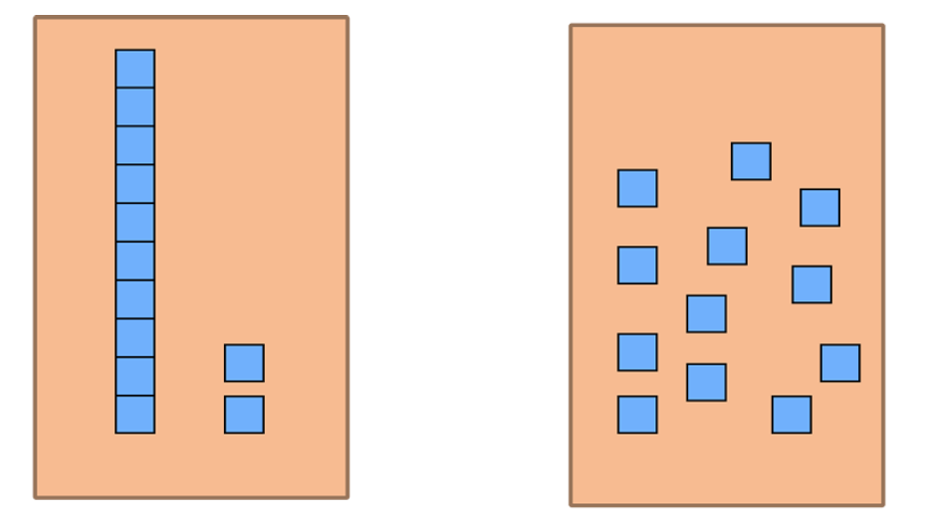

Resource 2: Renaming 43
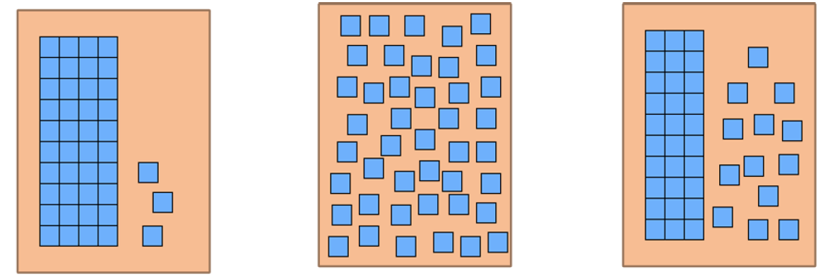

Resource 3: Sorting cards
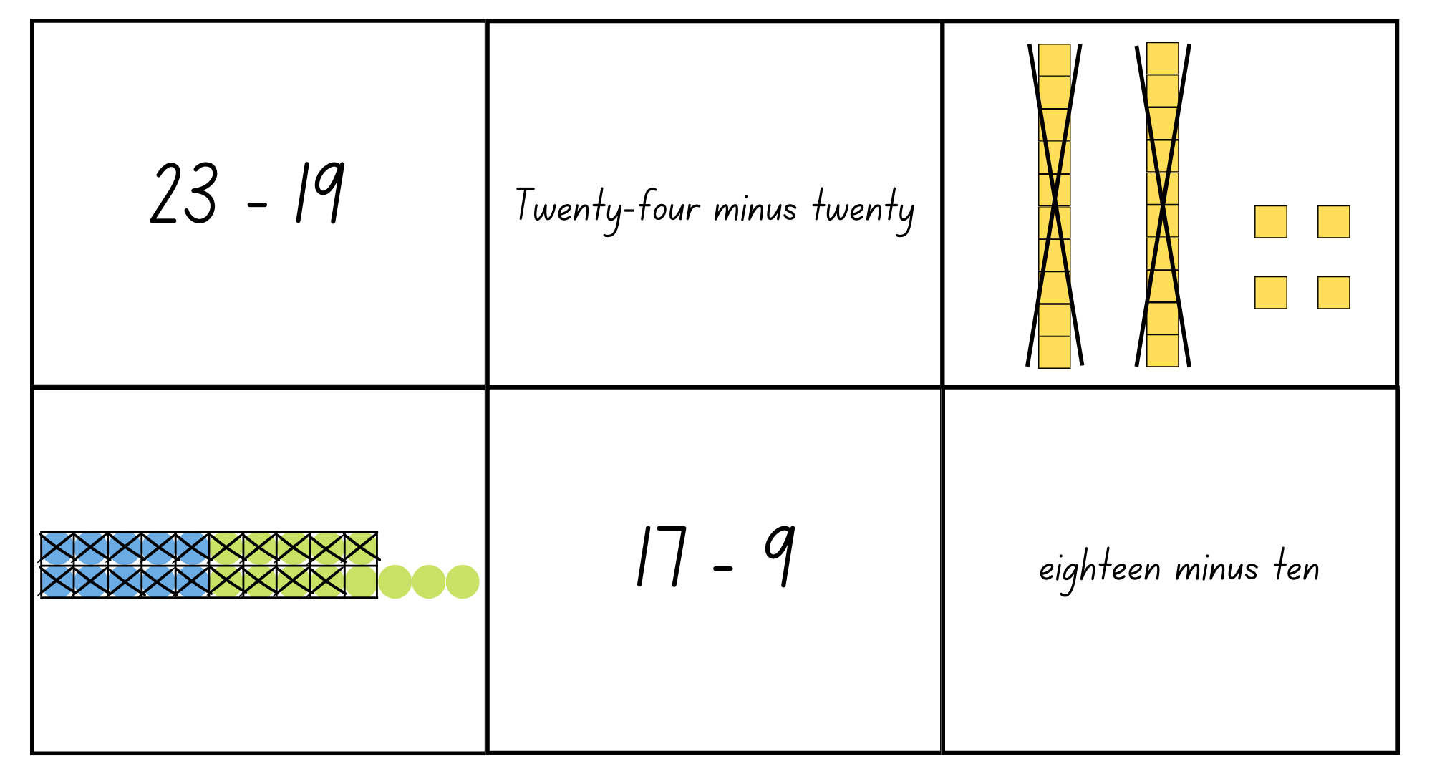
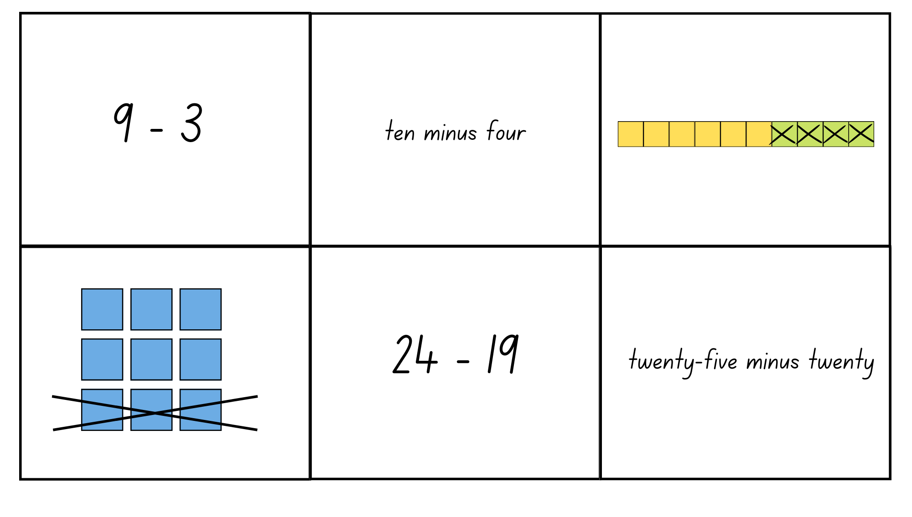
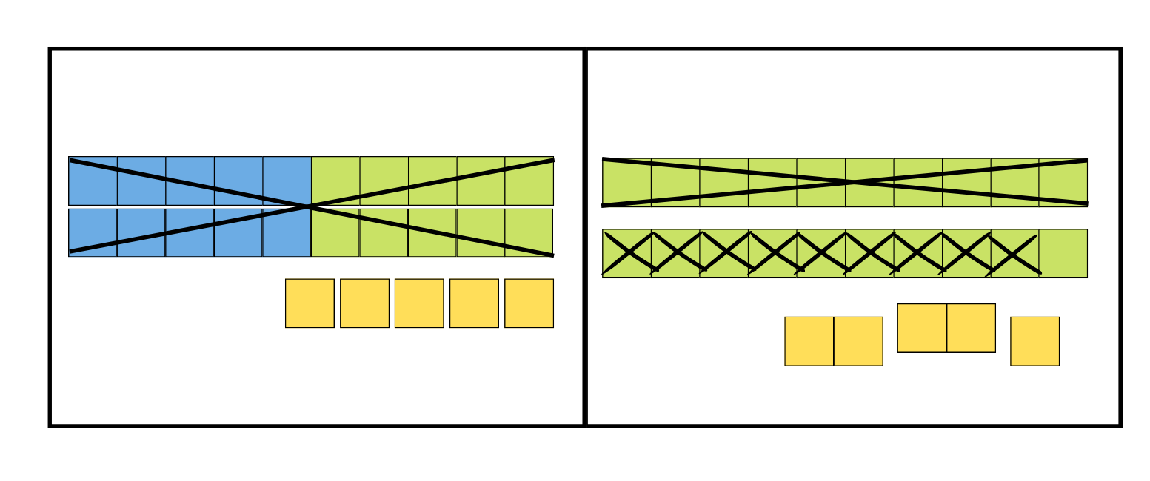
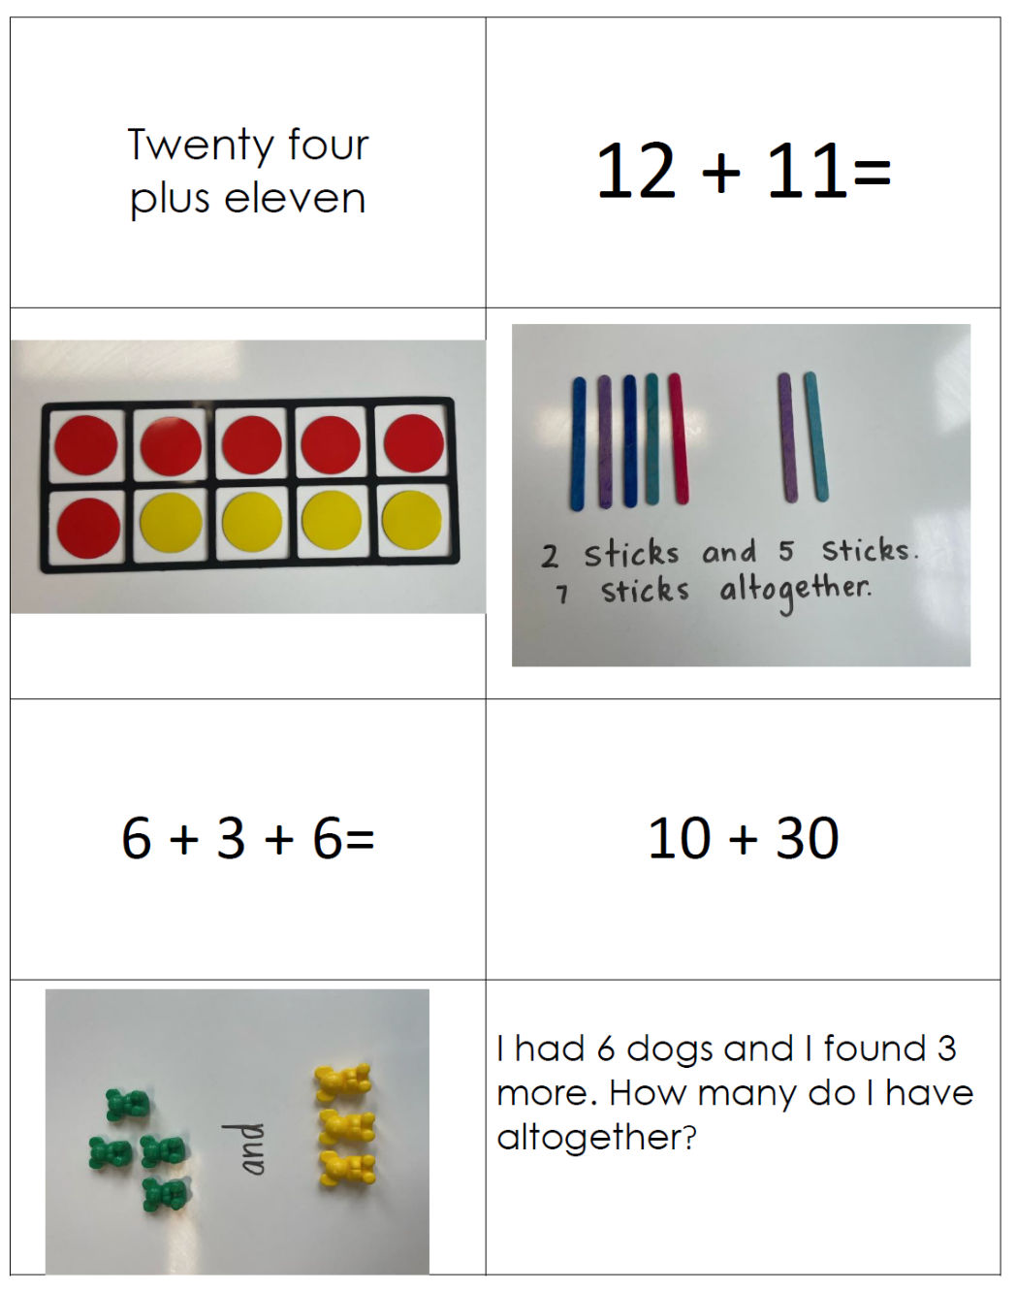

Resource 4: Number chart
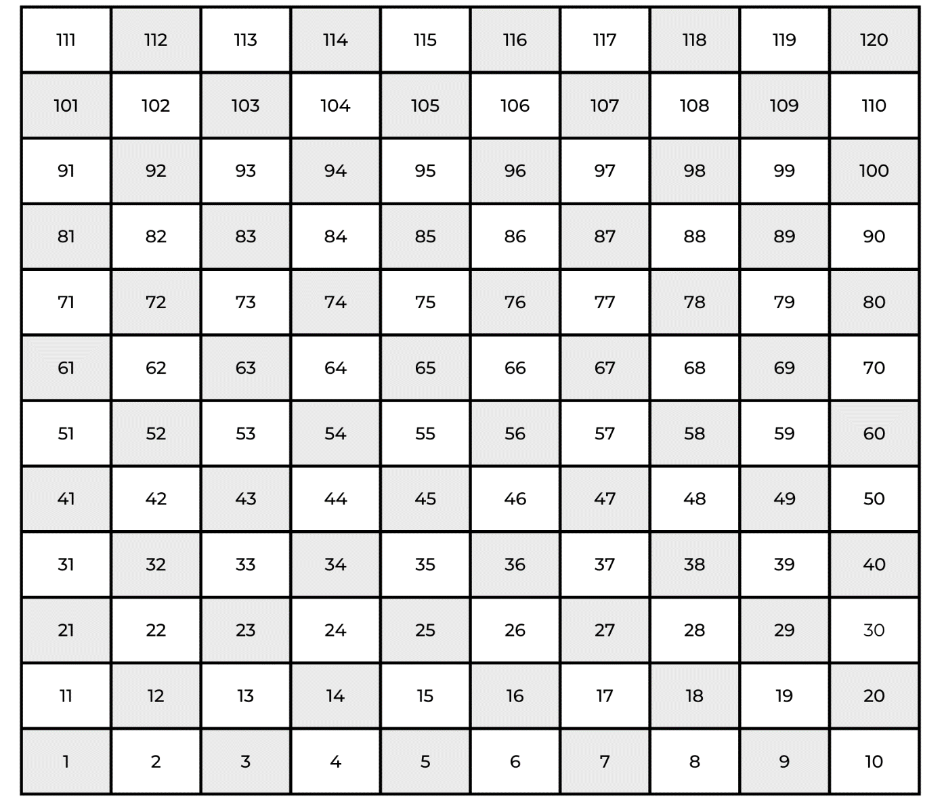

Resource 5: 20 to 70 spinner
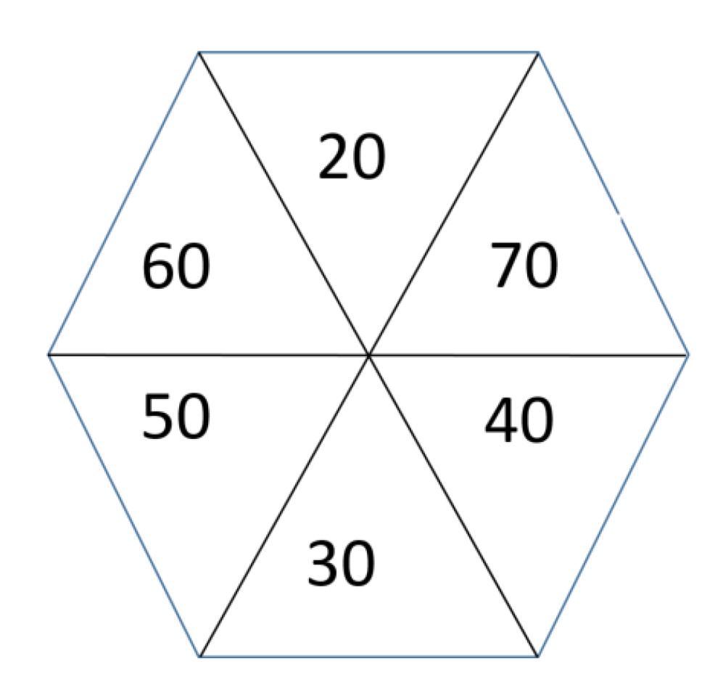

Resource 6: 0 to 9 spinner
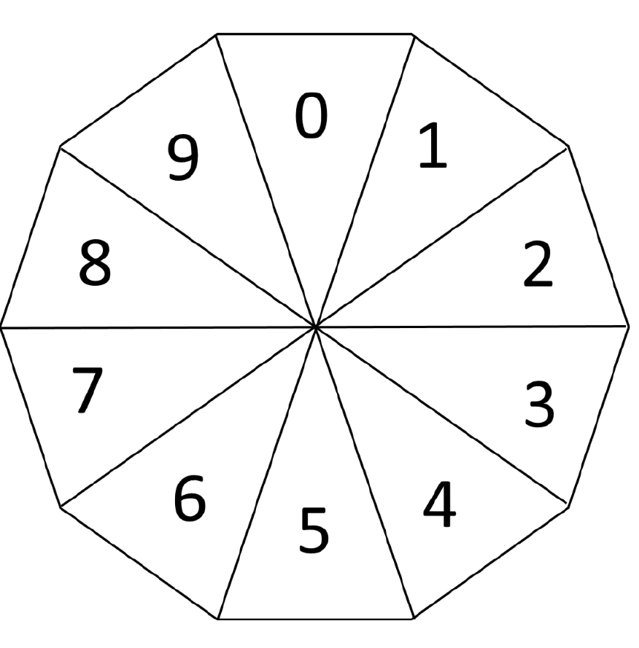

Resource 7: 2 truths and a lie
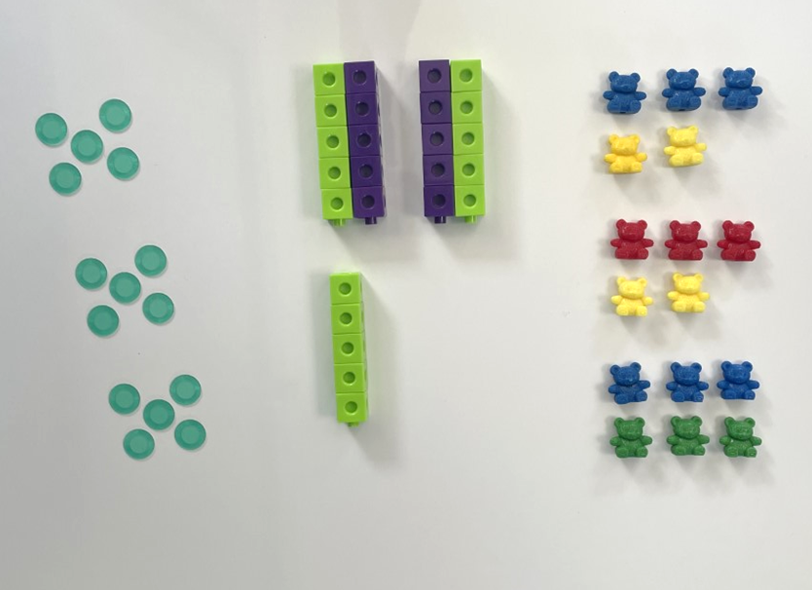

Resource 8: Dot cards
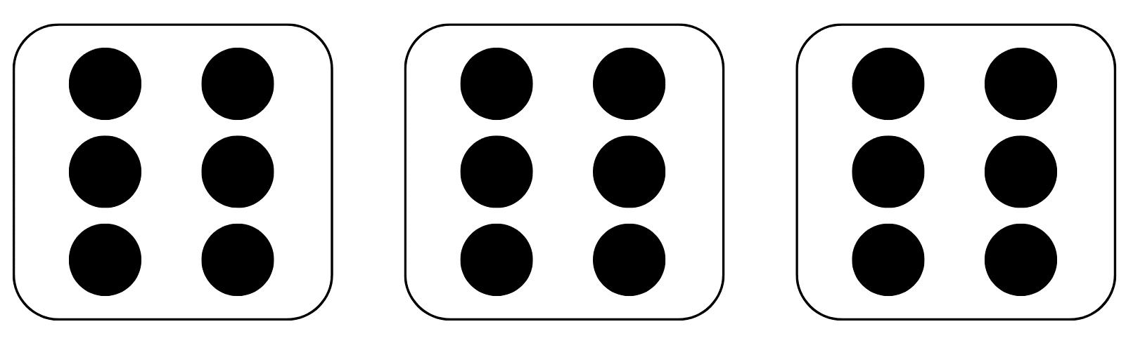

Resource 9: Fruit shop 1
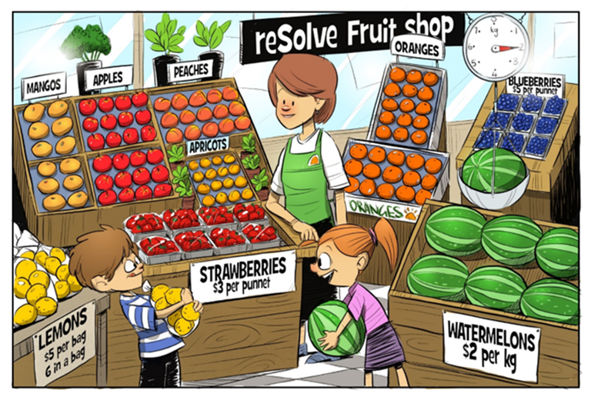
‘reSolve Fruit Shop: 1a reSolve Fruit Shop’ by © Australian Government Department of Education 2022 is licensed under CC BY-SA 4.0

Resource 10: Fruit shop 2
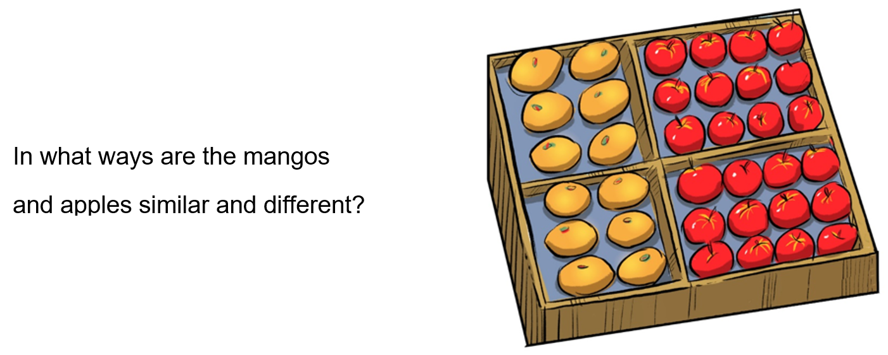
‘reSolve Fruit Shop: 1a reSolve Fruit Shop’ by © Australian Government Department of Education 2022 is licensed under CC BY-SA 4.0

Resource 11: Fruit shop 3
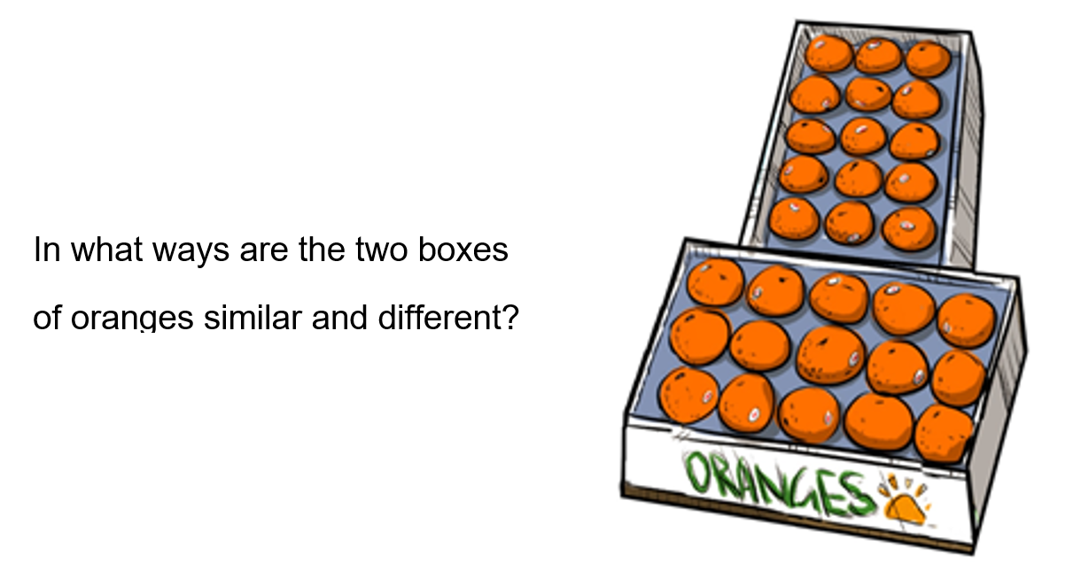
‘reSolve Fruit Shop: 1a reSolve Fruit Shop’ by © Australian Government Department of Education 2022 is licensed under CC BY-SA 4.0

Resource 12: Fruit shop 4
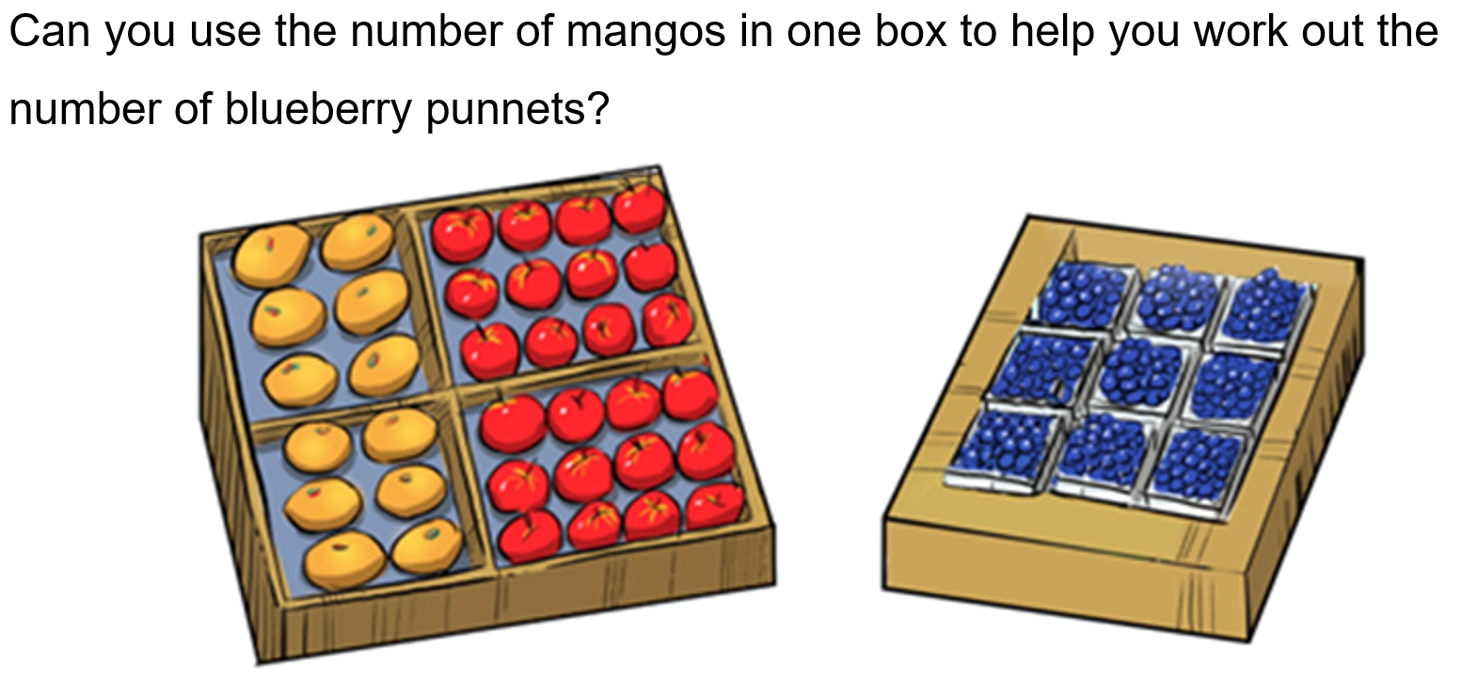
‘reSolve Fruit Shop: 1a reSolve Fruit Shop’ by © Australian Government Department of Education 2022 is licensed under CC BY-SA 4.0

Resource 13: Fruit shop 5
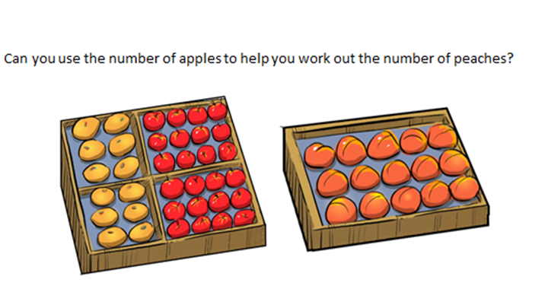
‘reSolve Fruit Shop: 1a reSolve Fruit Shop’ by © Australian Government Department of Education 2022 is licensed under CC BY-SA 4.0

Resource 14: Recording table
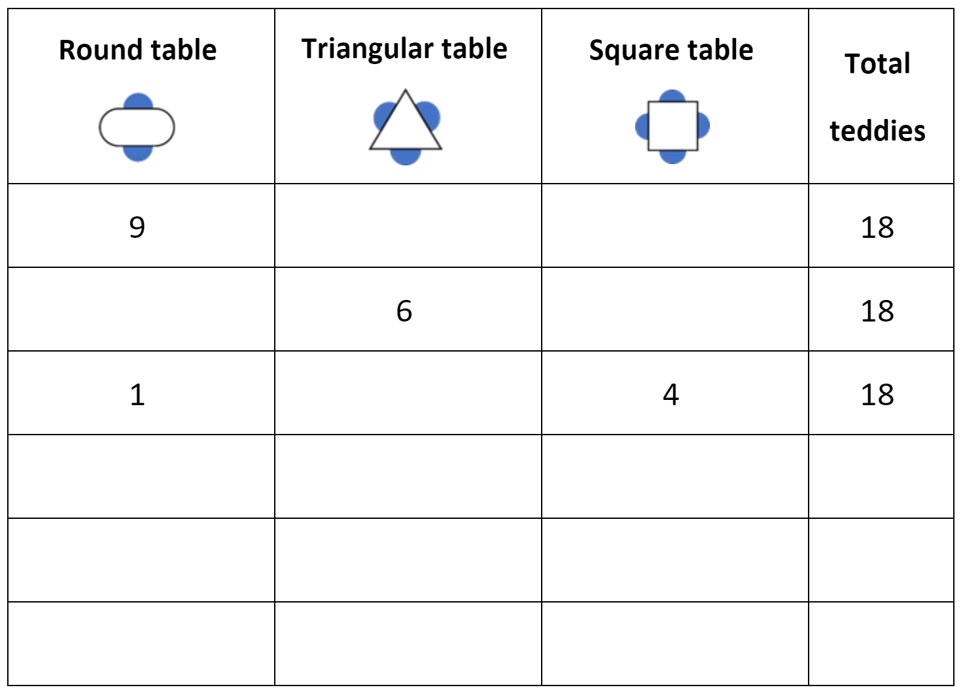

Syllabus outcomes and content
The table below outlines the syllabus outcomes and range of relevant syllabus content covered in this unit. Content is linked to National Numeracy Learning Progression version (3).
Focus area and outcomes | Content groups and content points | Lessons
Representing whole numbers  MAO-WM-01  MAE-RWN-01, MAE-RWN-02 | Early Stage 1  Connect counting and numerals to quantities  - count with one-to-one correspondence, recognising that the last number name represents the total number in the collection (CPr3, CPr5)  - count out a specified number of objects (from 5 to 20) from a larger collection, keeping track of the count (CPr4, CPr5)  - make correspondences between collections (Reasons about quantity)  - read numerals to at least 20, including zero (NPV3)  - represent numbers as quantities to at least 20 using objects (such as fingers), number words and numerals (NPV2, NPV3, NPV4, CPr3)  - compare and order numbers to 20 (NPV2, NPV3)  - use the term ‘is the same as’ to express equality of groups (Reasons about quantity) (CPr4, CPr5, MuS1) | 1-3
Representing whole numbers A (cont) | Stage 1  Use counting sequences of ones with two-digit numbers and beyond  - identify the number before and after a given two-digit number (CPr5)  - count forwards and backwards by ones from a given number to at least 120 (CPr6)  Represent the structure of groups of ten in whole numbers  - recognise that ten ones is the same as one ten (NPV2, NPV4)  - use 10 as a reference in forming numbers from 11 to 20 (CPr7)  - count large sets of objects by systematically grouping in tens (CPr7)  - partition two-digit numbers to show quantity values (NPV4)  - use number lines and number charts to assist with locating the nearest ten to a number  - estimate, to the nearest ten, the number of objects in a collection and check by counting in groups of ten (Reasons about quantity) (CPr7, NPV6) | 1-3
Representing whole numbers B | Stage 1  Use counting sequences of ones and tens flexibly  - identify the number before and after a given three-digit number  - count forwards and backwards by tens, on and off the decade, with two- and three-digit numbers (CPr7)  - identify how many more to the next multiple of ten within two- and three-digit numbers (AdS7)  Form, regroup and rename three-digit numbers  - count and represent large sets of objects by systematically grouping in tens and hundreds  - use models such as base 10 material and interlocking cubes to represent and explain grouping  - state the quantity value of digits in numbers of up to three digits (Reasons about quantity)  - identify the nearest hundred to a number  - recognise units of 100  - use place value to partition and rename three-digit numbers in different ways (Reasons about relations)  - estimate, to the nearest hundred, the number of objects in a collection and check by grouping and counting | 1-3
Combining and separating quantities  MAO-WM-01  MAE-CSQ-01, MAE-CSQ-02 | Early Stage 1  Model additive relations and compare quantities  - identify situations in which addition and subtraction may be applied (AdS1, AdS2)  - combine two or more groups of objects to model addition, identifying the relationship between the parts and the whole (AdS1, AdS2)  - separate and take away part of a group of objects to model subtraction (AdS1, AdS2)  - use concrete materials or fingers to model and solve addition and subtraction questions, counting forwards or backwards by ones as necessary (AdS1, AdS2, NPV3)  - compare two groups of objects to determine how many more (Reasons about quantity) (NPV1, AdS2) | 1-4
Combining and separating quantities A  MAO-WM-01  MA1-CSQ-01  NOTE – there is only one combining and separating quantities outcome for Stage 1 | Stage 1  Use advanced count-by-one strategies to solve addition and subtraction problems  - apply the terms ‘add’, ‘plus’, ‘equals’, ‘is equal to’, ‘is the same as’, ‘take away’, ‘minus’ and ‘the difference between’ to describe combining and separating quantities (AdS1, AdS6)  - recognise and use the symbols for plus (+), minus (–) and equals (=)  - record number sentences in a variety of ways using drawings, words, numerals and symbols (AdS6)  - fluently use advanced count-by-one strategies including counting on and counting back to solve addition and subtraction problems involving one- and two-digit numbers (Reasons about relations) (AdS3, AdS4, AdS5)  Use flexible strategies to solve addition and subtraction problems  - use non-count-by-one strategies such as using doubles for near doubles and combining numbers that add to ten (AdS6)  - represent addition and subtraction using structured materials such as a bead string or similar model (AdS6, AdS7)  - select and apply strategies using number bonds to solve addition and subtraction problems with one- and two-digit numbers by partitioning numbers using quantity value and bridging to 10 (Reasons about relations) (AdS6, AdS7)  Represent equality  - use the equals sign to record equivalent number sentences involving addition, and to mean 'is the same as', rather than as an indication to perform an operation (Reasons about relations) (NPA3)  - model the commutative property for addition and apply it to aid the recall of addition facts (Reasons about relations) (AdS7)  - recall related addition and subtraction facts for numbers to at least 10 (Reasons about relations) (AdS6) | 1-4
Combining and separating quantities B  MAO-WM-01  MA1-CSQ-01 | Stage 1  Represent and reason about additive relations  - create, record and recognise combinations of two numbers that add to numbers from 11 up to and including 20 (AdS7)  - create, model and solve word problems, using number sentences  - represent the difference between two numbers using concrete materials and diagrams (AdS6)  - represent a constant difference between pairs of numbers  - model how addition and subtraction are inverse operations using concrete materials, drawings and diagrams (AdS7)  - recall and use related addition and subtraction number facts to at least 20 (AdS7)  Use knowledge of equality to solve related problems  - use number bonds to determine a missing number (AdS6, NPA3, NPA4)  - use number knowledge to solve related problems (Reasons about relations) (AdS7, NPA4)  - use a variety of ways of writing number sentences (NPA3, NPA4)  - use number bonds to solve equality problems (NPA3, NPA4) | 1-4
Forming groups  MAO-WM-01, MAE-FG-01, MAE-FG-02 | Early Stage 1  Investigate and form equal groups by sharing  - distribute a group of familiar objects into smaller groups and recognise whether the number in each group is equal or not (MuS1, MuS2)  - group and share concrete materials by distributing objects one by one or using another method (MuS1, MuS2)  Record grouping and sharing  - label the number of objects in a group  - record grouping and sharing using drawings, words and numerals, and explain their thinking (Reasons about relations) (MuS2) | 5-8
Forming groups A  MAO-WM-01  MA1-FG-01  NOTE – there is only one forming groups outcome for Stage 1 | Stage 1  Count in multiples using rhythmic and skip counting  - count by twos, threes, fives and tens using rhythmic counting and skip counting (MuS2, CPr6)  Model and use equal groups of objects to represent multiplication  - model and describe collections of objects as groups of (MuS2)  - determine and distinguish between the number of groups and the number in each group when describing collections of objects (Reasons about relations)  - find the total number of objects using skip counting of equal groups of a known size (MuS2, MuS3)  Recognise and represent division  - use concrete materials to model a half of a collection and show the relation between the half and the whole (InF1)  - model sharing division by distributing a collection of objects equally into a given number of groups to determine how many in each group (InF2, MuS5)  - model grouping division by determining the number of groups of a given size that can be formed (MuS5)  - describe the part left over when a collection cannot be distributed equally using the given group size (MuS6) | 5-8
Forming groups B  MAO-WM-01  MA1-FG-01  NOTE – there is only one forming groups outcome for Stage 1 | Stage 1  Represent and explain multiplication as the combining of equal groups  - use objects, diagrams, images or actions to model multiplication as accumulating equal groups (MuS4)  - solve multiplication problems using repeated addition (MuS4)  - form arrays of equal rows and equal columns (MuS5)  - determine and distinguish between the number of rows/columns and the number in each row/column when describing collections of objects (MuS5)  - model the commutative property of multiplication, using an array (Reasons about relations) (MuS6)  - model division by deconstructing an array equally into a given number of rows or columns  Represent multiplication and division problems  - solve multiplication and division problems using objects, diagrams, images and actions (MuS6, MuS7)  - record answers to multiplication and division problems (including those with remainders) using drawings, words and numerals (MuS6) | 5-8

References
Links to third-party material and websites
Please note that the provided (reading/viewing material/list/links/texts) are a suggestion only and implies no endorsement, by the New South Wales Department of Education, of any author, publisher, or book title. School principals and teachers are best placed to assess the suitability of resources that would complement the curriculum and reflect the needs and interests of their students.
If you use the links provided in this document to access a third-party's website, you acknowledge that the terms of use, including licence terms set out on the third-party's website apply to the use which may be made of the materials on that third-party website or where permitted by the Copyright Act 1968 (Cth). The department accepts no responsibility for content on third-party websites.
Except as otherwise noted, all material is © State of New South Wales (Department of Education), 2023 and licensed under the Creative Commons Attribution 4.0 International License. All other material (third-party material) is used with permission or under licence. Where the copyright owner of third-party material has not licensed their material under a Creative Commons or similar licence, you should contact them directly for permission to reuse their material.
Mathematics K–10 Syllabus © 2021 NSW Education Standards Authority (NESA) for and on behalf of the Crown in right of the State of New South Wales.
© 2022 NSW Education Standards Authority. This document contains NSW Curriculum and syllabus content. The NSW Curriculum is developed by the NSW Education Standards Authority. This content is prepared by NESA for and on behalf of the Crown in right of the State of New South Wales. The material is protected by Crown copyright.
Please refer to the NESA Copyright Disclaimer for more information.
NESA holds the only official and up-to-date versions of the NSW Curriculum and syllabus documents. Please visit the NSW Education Standards Authority (NESA) website and the NSW Curriculum website.
National Numeracy Learning Progression © Australian Curriculum, Assessment and Reporting Authority (ACARA) 2010 to present, unless otherwise indicated. This material was downloaded from the Australian Curriculum website (National Numeracy Learning Progression) (accessed 19 September 2022) and was not modified. The material is licensed under CC BY 4.0. Version updates are tracked in the ‘Curriculum version history’ section on the 'About the Australian Curriculum' page of the Australian Curriculum website.
ACARA does not endorse any product that uses the Australian Curriculum or make any representations as to the quality of such products. Any product that uses material published on this website should not be taken to be affiliated with ACARA or have the sponsorship or approval of ACARA. It is up to each person to make their own assessment of the product, taking into account matters including, but not limited to, the version number and the degree to which the materials align with the content descriptions and achievement standards (where relevant). Where there is a claim of alignment, it is important to check that the materials align with the content descriptions and achievement standards (endorsed by all education Ministers), not the elaborations (examples provided by ACARA).
This resource contains images and content obtained from Canva, and their use outside of this resource is subject to Canva’s Content License Agreement. If you wish to use them separately from the resource, please go to Canva.
Australian Government Department of Education, Skills and Employment (2022) 'Multiplication: reSolve Fruit Shop', Teaching resources, reSolve website, accessed 19 September 2022.
State of Victoria (Department of Education and Training) (2018) ‘Modelling through think alouds’, Literacy Teaching Toolkit, State of Victoria (Department of Education and Training) website, accessed 19 September 2022.
University of Cambridge (Faculty of Mathematics) (n.d.) Let Us Divide!, NRICH website, accessed 19 September 2022.

