Mathematics – Early Stage 1 – Unit 20
Contents
Unit description and duration 4
Student prior learning 4
Lesson overview and resources 5
Lesson 1: Faster and slower 10
Daily number sense: Order up – 10 minutes 10
Which one is fastest? – 25 minutes 12
Consolidation and meaningful practice: The fastest way – 25 minutes 14
Lesson 2: A day in my life 17
Daily number sense: Hiding numbers – 10 minutes 17
A day in my life – 30 minutes 18
Consolidation and meaningful practice: What's the time Mr Wolf? – 20 minutes 20
Lesson 3: Foot parade 22
Daily number sense: 10 minutes 22
Foot parade – 40 minutes 23
Consolidation and meaningful practice: What a parade – 10 minutes 26
Lesson 4: Zios and Zepts 27
Daily number sense: Some steps forward, some steps back – 20 minutes 27
Zios and Zepts – 30 minutes 28
Consolidation and meaningful practice: Noticing and wondering – 10 minutes 31
Lesson 5: Investigating sums 32
Daily number sense: Go fish – 10 minutes 32
Investigating sums: Part 1 – 20 minutes 34
Investigating sums: Part 2 – 20 minutes 36
Consolidation and meaningful practice: Making sense of the mathematics – 10 minutes 37
Lesson 6: Let’s celebrate 39
Daily number sense: 10 minutes 39
Let’s celebrate – 40 minutes 40
Consolidation and meaningful practice: Noticing and wondering – 10 minutes 42
Lesson 7: Preparing a maths celebration 43
Daily number sense: Handfuls – 15 minutes 43
Preparing a maths celebration – 15 minutes 46
Preparing placemats – 20 minutes 47
Consolidation and meaningful practice: Preparing a maths celebration – 10 minutes 49
Lesson 8: Maths celebration 51
Revisiting a daily number sense: 10 minutes 51
Maths celebration – 30 minutes 52
Consolidation and meaningful practice: Check it – 20 minutes 56
Resource 1: Numeral cards 57
Resource 2: Yoko and Ravi 58
Resource 3: Time language 59
Resource 4: Storyboard 60
Resource 5: Animal Parade 61
Resource 6: Animal parade deck 62
Resource 7: Number of steps 63
Resource 8: Zios and Zepts 64
Resource 9: Sums investigation 65
Resource 10: Sums investigation – pairs 66
Resource 11: Party sequence 67
Resource 12: Party needs 68
Syllabus outcomes and content 69
References 74

Unit description and duration
This two-week unit develops student knowledge, understanding and skills for solving problems related to number and time concepts. Students are provided opportunities to:
- solve problems by combining, separating and forming groups
- sequence and identify the duration of events using a range of methods
- read hour time on analog clocks
- explain and represent mathematical thinking in a variety of ways.
Mathematics K–10 Syllabus © 2022 NSW Education Standards Authority (NESA) for and on behalf of the Crown in right of the State of New South Wales.

Student prior learning
Before engaging in these teaching and learning activities, students would benefit from prior experience with:
- using materials or fingers to model and solve addition and subtraction questions, counting forwards or backwards by ones
- using time language to describe the duration and sequence of events
- using symbols, drawings, words, and numbers to record their thinking.

Lesson overview and resources
The table below outlines the sequence and approximate timing of lessons; syllabus focus areas and content groups; and resources.
Lesson | Syllabus focus area and content groups | Resources
Lesson 1: Faster and slower  60 minutes  The duration of 2 events can be compared. | Representing whole numbers  - Instantly name the number of objects within small collections  - Use the counting sequence of ones flexibly  - Connect counting and numerals to quantities  Non-spatial measure  - Time: Compare and order the duration of events using the language of time  - Time: Tell time on the hour on analog and digital clocks | - Resource 1: Numeral cards  - Resource 2: Yoko and Ravi  - Cardboard  - Markers blocks  - Masking tape  - Resources to measure time (for example, a song, sand timer, upturned dripper bottle, metronome)  - Scissors  - Toy cars  - Whiteboards
Lesson 2: A day in my life  60 minutes  Events can be sequenced according to when they take place. | Representing whole numbers  - Use the counting sequence of ones flexibly  - Connect counting and numerals to quantities  Non-spatial measure  - Time: Compare and order the duration of events using the language of time  - Time: Tell time on the hour on analog and digital clocks | - Resource 3: Time language  - Resource 4: Storyboard  - Cups – one per pair  - Gliori D (2021) What’s The Time Mr Wolf? Bloomsbury, UK. ISBN: 9781408819418  - Small objects – 10 per student  - Writing materials
Lesson 3: Foot parade  60 minutes  A quantity remains the same, no matter how it is arranged. | Representing whole numbers  - Instantly name the number of objects within small collections  - Use the counting sequence of ones flexibly  - Recognise number patterns  - Connect counting and numerals to quantities  Combining and separating quantities  - Model additive relations and compare quantities  - Identify part-whole relationships in numbers up to 10  Forming groups  - Investigate and form equal groups by sharing  - Record grouping and sharing | - Resource 5: Animal parade  - Resource 6: Animal parade deck  - The ants go marching one by one | Ants at war (4:10) song  - Glue  - Paper  - Pencils and markers  - Scissors
Lesson 4: Zios and Zepts  60 minutes  Mathematicians can solve the same problem in different ways. | Representing whole numbers  - Instantly name the number of objects within small collections  - Use the counting sequence of ones flexibly  - Connect counting and numerals to quantities  Combining and separating quantities  - Model additive relations and compare quantities  - Identify part-whole relationships in numbers up to 10 | - Resource 7: Number of steps  - Resource 8: Zios and Zepts  - Counters  - Markers  - Ten-frames  - Whiteboards  - Writing materials
Lesson 5: Investigating sums  60 minutes  Visuals and number combinations can be used to solve problems. | Representing whole numbers  - Instantly name the number of objects within small collections  - Use the counting sequence of ones flexibly  - Recognise number patterns  - Connect counting and numerals to quantities  Combining and separating quantities  - Model additive relations and compare quantities  - Identify part-whole relationships in numbers up to 10 | - Resource 9: Sums investigation  - Resource 10: Sums investigation – pairs  - Counters  - Markers  - Ten-frames  - Whiteboards
Lesson 6: Let’s celebrate  60 minutes  Events can be organised to create a schedule. | Non-spatial measure  - Time: Compare and order the duration of events using the language of time  - Time: Tell time on the hour on analog and digital clocks | - Resource 11: Party sequence  - Whiteboards  - Markers
Lesson 7: Preparing a maths celebration  60 minutes  A collection can be shared into equal groups using different methods. | Representing whole numbers  - Instantly name the number of objects within small collections  - Use the counting sequence of ones flexibly  - Recognise number patterns  - Connect counting and numerals to quantities  Combining and separating quantities  - Model additive relations and compare quantities  - Identify part-whole relationships in numbers up to 10  Forming groups  - Investigate and form equal groups by sharing  - Record grouping and sharing | - Resource 1: Numeral cards  - 20 lolly bags marked with the numbers 1 to 20 – 3 sets for class  - A3 or A4 paper  - Markers  - Party equipment (for example, plates, cups, forks, spoons)  - Pencils or markers  - Whiteboards
Lesson 8: Maths celebration  60 minutes  Mathematicians record what they notice to help them solve problems. | Representing whole numbers  - Instantly name the number of objects within small collections  - Use the counting sequence of ones flexibly  - Connect counting and numerals to quantities  Combining and separating quantities  - Model additive relations and compare quantities  - Identify part-whole relationships in numbers up to 10 | - Markers  - Party equipment (for example, plates, cups, forks, spoons)  - Student placemats from previous lesson  - Whiteboards

Lesson 1: Faster and slower
Core concept: The duration of 2 events can be compared.
The table below contains suggested learning intentions and success criteria. These are best co-constructed with students.
Learning intentions | Success criteria
Students are learning that:  - the duration of an event is the length of time between the beginning and end  - the duration of events can be compared using informal methods  - mathematicians communicate their ideas to develop solutions to problems. | Students can:  - describe the duration of an event as the time that passes between the beginning and end point  - compare the duration of 2 events using an informal method  - communicate their ideas to develop solutions to problems.

Daily number sense: Order up – 10 minutes
This lesson is adapted from the resource Well Played: Building Mathematical Thinking Through Number Games and Puzzles by Dacey et al (2016).
- Build student understanding of comparing and ordering numbers by playing ‘Order up’. The aim of the game is to be the first player to have 5 numbers in order from smallest to largest, left to right. See Figure 1.
Figure 1 – Arranging cards in ascending order left to right
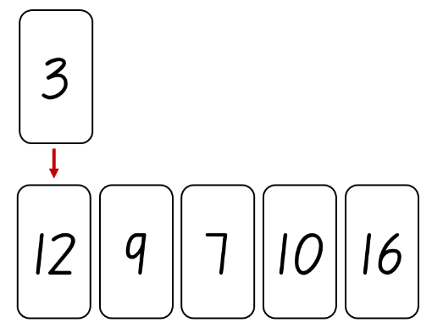
- Students play against a partner. Provide each pair with a set of Resource 1: Numeral cards.
- Students shuffle the cards and deal 5 cards to each player, face-down.
- Students arrange their 5 cards in a row in the order they were dealt, then turn them face-up.
- Students create a central pile with the remaining cards. As they play the game, students will also create a garbage pile.
- On each turn, a student selects a card from the top of the central pile. They can choose to either keep the card they picked up by swapping it with one of their existing cards or put it on the garbage pile.
- Students can only have 5 cards at a time. They must put one card on the garbage pile each turn.
- The first student with 5 cards in order of smallest to largest, from left to right, wins the game.
- Students play several rounds of the game.

Which one is fastest? – 25 minutes
Note: Early Stage 1 students are not required to use formal units of time to measure the duration of events. Guide students to use alternative methods for noticing the passing of time, such as playing a song, using a sand timer, an upturned dripper bottle or a device that plays a steady, repeating sound, such as a metronome, and count the clicks.
- Begin the lesson in an open space where it is safe to move around freely.
- Explain that students will need to complete 2 tasks one after the other, as quickly as they can. They will then be asked to describe how long each task took.
- Provide students with 2 simple challenges, for example:
- run to a specific landmark and back
- complete a short obstacle course.
- Allow students to complete the tasks.
- Gather students together and ask:
- Which took the longest amount of time? Which took the shortest amount of time?
- How long did each task take? How do you know?
- How else could you describe the length of time the tasks took?
- Is there a way we could measure how long tasks like this, or other events, take?
- Can we compare the lengths of time of events?
- Establish a method for measuring the duration of an event, for example, singing a familiar song while each event occurs.
- As a class, decide which method of timing students will use. Determine how they will record this, for example, by noting how many times the song is sung during each event.
- Students repeat each task, using the agreed method to measure how much time passes.
- After all students have completed the task, compare the results. Ask students if they have changed their ideas about the duration of each event since first attempting the tasks and why.
This table details assessment opportunities and differentiation ideas.
Assessment opportunities | Too hard? | Too easy?
What to look for:  - Can students estimate, describe and compare the duration of events? (MAO-WM-01, MAE-NSM-02)  - Can students compare the duration of 2 events using an informal method to measure the passing of time? (MAO-WM-01, MAE-NSM-02)  - Can students communicate their ideas to develop solutions to problems? (MAO-WM-01, MAE-NSM-02)  What to collect:  - observation data (MAO-WM-01, MAE-NSM-02)  - student work samples. (MAO-WM-01, MAE-NSM-02) | Students are unable to estimate, describe and compare the duration of events using informal methods.  - Provide students with key words and phrases to describe the comparison of duration between 2 events, such as ‘this took longer than that’.  - Use a visual representation of the method used to informally measure time to allow students to compare the quantities in another way.  - Ask one student to observe the time measurement tool whilst another student completes the 2 tasks. | Students can estimate, describe and compare the duration of events using informal methods.  - Ask students to estimate and compare an additional event against the 2 completed events.  - Ask students to develop an idea for another task that would take a similar amount of time to one of the events. Students test their estimation for accuracy.

Consolidation and meaningful practice: The fastest way – 25 minutes
- Display Resource 2: Yoko and Ravi. Explain that Yoko and Ravi were having a disagreement. They wanted to make a ramp and attach it to their fort made of blocks so a toy car could roll out and get to the road as fast as possible. Yoko thought it would be faster to use a short ramp resting on one block. Ravi argued it would be better to use a longer ramp and make it steeper by resting it on 4 blocks. Ask students which idea would get the car from the fort to the road faster.
- Students turn and talk to a partner about how they could investigate which ramp is the fastest. Students share their thinking.
- As a class, decide on a way to determine which ramp would make the toy car roll the fastest. For example, measure the time it takes for the toy car to reach a designated point. This could be the bottom of the ramp or a finish line on the floor. Explain that students will use an informal unit of measurement to measure the length of time each car takes.
- Students work in small groups, using a toy car, blocks and stiff cardboard to create 2 ramps.
Note: Students may need to use masking tape to secure the cardboard to the blocks. They may also need to fold a small section on each side of the ramps upward, to prevent the car from falling off the ramp as it rolls down.
- Students use the same toy car to roll down each ramp. They use an informal method of measurement to determine the length of time each car takes to reach the designated point. Students repeat the investigation at least 3 times for each ramp, to be sure of results.
- As a class, provide students with the opportunity to share what they have found out using questions, such as:
- What did you notice about the speed of the car on each ramp?
- How did you measure the time it took the car to go from the top of the ramp to the finish line?
- What challenges did you need to solve to make sure the results were fair?
- Which ramp would you recommend to Yoko and Ravi and why?
This table details assessment opportunities and differentiation ideas.
Assessment opportunities | Too hard? | Too easy?
What to look for:  - Can students estimate, describe and compare the duration of events? (MAO-WM-01, MAE-NSM-02)  - Are students able to compare the duration of 2 events using an informal method? (MAO-WM-01, MAE-NSM-02)  - Do students communicate their ideas to develop solutions to problems? (MAO-WM-01, MAE-NSM-02)  What to collect:  - observation data (MAO-WM-01, MAE-NSM-02)  - student work samples. (MAO-WM-01, MAE-NSM-02) | Students are unable to estimate, describe and compare the duration of events using informal methods.  - Model the use of a chosen method of informal time measurement that provides a clear visual record of the measure of time.  - Model statements that describe the comparison of 2 events for students to repeat. | Students can estimate, describe and compare the duration of events using informal methods.  - Ask students to compare 2 different informal methods of measuring time and explain which one is likely to be more accurate and why.  - Ask students if it would matter if Yoko and Ravi used a different length or height for their actual ramp and why.

Lesson 2: A day in my life
Core concept: Events can be sequenced according to when they take place.
The table below contains suggested learning intentions and success criteria. These are best co-constructed with students.
Learning intentions | Success criteria
Students are learning that:  - the duration of an event is the length of time between the beginning and end  - the sequence of events can be described using words  - time can be represented and read to the hour on an analog clock. | Students can:  - describe the duration of an event as the time that passes between the beginning and end  - order a sequence of events using words  - read analog clocks to the hour.

Daily number sense: Hiding numbers – 10 minutes
This lesson has been adapted from How Many Are Hiding by youcubed.
- Build student understanding of number combinations to 10 by playing ‘How many are hiding?’
- Students play in pairs. Provide each pair of students with 10 small objects and an opaque cup.
- Students take it in turns to hide some of the 10 objects under the cup, showing how many are left. Their partner works out how many are hiding under the cup. Once an answer has been given, both students check the number of objects hiding under the cup.
- While students are working, circulate around the class, looking and listening for efficient strategies to highlight. For example, ‘Phil said he can see 6, so he knows 4 are hiding; 6 and 4 makes 10’.

A day in my life – 30 minutes
Note: This activity can be adapted to describe a specific event, such as a special celebration day or holiday.
- Build student understanding of sequencing events by using a storyboard.
- Display, read aloud and discuss the vocabulary on Resource 3: Time language anchor chart.
- Ask students if any of the words could be put in order. For example, ‘morning’ would be ordered before ‘afternoon’ and so on.
- Use student responses to place words, phrases and times in a sequence from morning to night.
- Ask students what activities or events happen at different times throughout the day and night, recording their ideas.
- Explain that a storyboard is a way of structuring steps in a story from beginning to end. Students may find it helpful to annotate each image with a title or brief description of the activity depicted.
- Model how to draw 5 simple images that depict a sequence of events over a day and night. Use time language to describe when each activity or event takes place.
- Provide students with a copy of Resource 4: Storyboard. Students draw a simple image of activities or events sequenced according to when they take place, in each box from left to right. Allow students time to draw images.
- Select a few students to share the storyboard of their day, describing the time of day each event takes place.
This table details assessment opportunities and differentiation ideas.
Assessment opportunities | Too hard? | Too easy?
What to look for:  - Can students describe the duration of an event? (MAO-WM-01, MAE-NSM-01)  - Can students describe the duration of an event as the time that passes between the beginning and end? (MAO-WM-01, MAE-NSM-01)  - Can students order a sequence of events using words? (MAO-WM-01, MAE-NSM-01)  What to collect:  - observation data (MAO-WM-01, MAE-NSM-01)  - student work samples. (MAO-WM-01, MAE-NSM-01) | Students are unable to order a sequence of events using words.  - Provide students with time related language to describe times of day daily events.  - Reduce the number events to be depicted. Compare 2 events.  - Model statements about each part of the day to provide students with an example to repeat and adapt. | Students can order a sequence of events using words.  - Suggest other events in the day, such as eating afternoon tea, and ask students to identify where in the sequence this additional event might be placed.  - Ask students the hour time that would closely match when each event takes place.

Consolidation and meaningful practice: What's the time Mr Wolf? – 20 minutes
- Begin by playing ‘What’s the time Mr Wolf?’ in an open space where students can safely move around. To play the game:
- One student is Mr Wolf and stands at the end of the space, away from the other students.
- Mr Wolf faces away from the main group of students.
- The students chant ‘What’s the time Mr Wolf?’ and Mr Wolf replies with an hour time.
- The students take that number of steps towards Mr Wolf. For example, if Mr Wolf says 4 o’clock, the students take 4 steps forwards.
- This continues until Mr Wolf calls ‘Dinnertime!’ and chases the students back to where they started.
- If Mr Wolf tips someone it is their turn to be Mr Wolf.
- After a few turns of the game, gather students together and display an analog clock that allows for the hour hand and minute hand to be manipulated.
- Ask students to describe the features of the clock. Focus on the numbers and the hands.
- Explain that the hour hand indicates what hour it is. It takes one hour to travel from one number to the next. The hour hand takes 12 hours to make one full rotation around the clock. Model this on the clock as you are speaking.
- The long hand on the clock is the minute hand. We call it the minute hand because it moves every minute. Ask students to describe the position of the long hand on the clock. When it is o’clock, the long hand points to the 12.
- Point the hour hand to the 2 on the clock and read the o’clock time together.
- Read the story What’s the time, Mr Wolf? by Debi Gliori. Ask students to notice the words and phrases used in the story that describe the time throughout the day. Record any language used to describe time that students notice in the book.
Note: If the suggested picture book is not available, any story about the sequence of events throughout a day can be used as an alternative.

Lesson 3: Foot parade
Core concept: A quantity remains the same, no matter how it is arranged.
The table below contains suggested learning intentions and success criteria. These are best co-constructed with students.
Learning intentions | Success criteria
Students are learning that:  - items in groups can be arranged differently but the total remains the same  - numbers can be combined in different ways to make 10  - some problems have many different solutions. | Students can:  - display the same number of items in different arrangements  - create, model and recognise number combinations to 10  - identify different solutions to the same problem.

Daily number sense: 10 minutes
- From a class need surfaced through formative assessment data, identify a short, focused activity that targets students’ knowledge, understanding and skills. Example activities may be drawn from the following resources:
- Mathematics K-6 resources
- Universal Resources Hub.

Foot parade – 40 minutes
This lesson is adapted from ‘Foot Parade’ in Mindset Mathematics Grade K by Boaler et al (2020).
Note: An optional introduction is to sing the song The ants go marching one by one song | Ants at war (4:11). When students are confident with the words, they march around in a circle as they sing, using simple actions as they move.
- Introduce students to the idea of a parade, like the one the ants did in the song. Ask students:
- What is a parade?
- What are some parades that you’ve seen or experienced?
- Explain that parades usually include people marching from one place to another as a crowd watches.
- Display Resource 5: Animal parade.
- Determine how many feet each animal has and record this on the image below each animal.
- Using cards from Resource 6: Animal parade deck, model an animal parade where the number of feet add up to 10. See Figure 2.
Figure 2 – Foot parade totalling 10
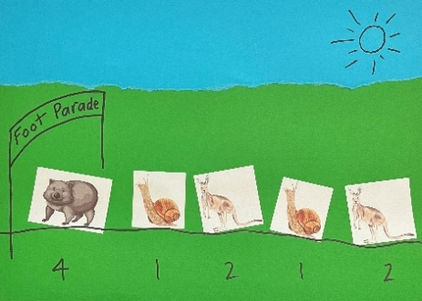
Images sourced from Canva and used in accordance with the Canva Content License Agreement.
- Provide students with the Resource 6: Animal parade deck images. Ask students to design their own animal parade that will add up to 10. When they are sure they have the correct number of feet, students can glue their animal parade onto a larger piece of paper.
- Take the students on a gallery walk of the different animal parades with 10 feet. Ask students questions, such as:
- How did you choose the animals to be in your foot parade?
- What methods have you used you work out how many feet there are in each parade altogether?
- Are there any parades that use the same combination of animals?
- Are there any parades that use only one type of animal?
- Can you point out 2 parades that are completely different and explain why?
This table details assessment opportunities and differentiation ideas.
Assessment opportunities | Too hard? | Too easy?
What to look for:  - Can students create, model and recognise number combinations to 10? (MAO-WM-01, MAE-RWN-02, MAE-CSQ-01, MAE-CSQ-02)  - Can students identify different solutions to the same problem? (MAO-WM-01, MAE-RWN-02, MAE-CSQ-01, MAE-CSQ-02)  What to collect:  - observation data (MAO-WM-01, MAE-RWN-02, MAE-CSQ-01, MAE-CSQ-02)  - student work samples. (MAO-WM-01, MAE-RWN-02, MAE-CSQ-01, MAE-CSQ-02) | Students are unable to create, model and recognise number combinations to 10.  - Use coloured counters to represent the legs of each animal. Ask students to touch and move the counters as they count each one.  - Draw dots at the base of each animal image to represent legs, to support the count.  - Use a ten-frame and counters to count the number of legs for each image, to find how many more are needed to reach a total of 10.  - Reduce the number target number of legs in the parade. | Students can create, model and recognise number combinations to 10.  - Ask students to create a parade of 12, 15 or 20 feet.  - Select a particular animal image and ask students to include this animal within the total.

Consolidation and meaningful practice: What a parade – 10 minutes
- Look at the parades on display. Remind students that what they have done is work out a variety of number combinations to 10. Review combinations and the part–whole relationships in numbers up to 10.
- Students work in pairs with the Resource 6: Animal parade deck images to create:
- the parade with the most animals that still adds up to 10
- the parade with the fewest animals that still adds up to 10.
- Pose questions such as:
- Which animal made a parade longer and why?
- Which animal made a parade shorter and why?

Lesson 4: Zios and Zepts
Core concept: Mathematicians can solve the same problem in different ways.
The table below contains suggested learning intentions and success criteria. These are best co-constructed with students.
Learning intentions | Success criteria
Students are learning that:  - there are combinations of numbers that make 10  - there can be more than one solution to a problem  - mathematicians use drawings, objects and numbers to find solutions and record their thinking. | Students can:  - find combinations of numbers that make 10  - find more than one solution to a problem  - use drawings, objects and numbers to find solutions and record their thinking.

Daily number sense: Some steps forward, some steps back – 20 minutes
This lesson is adapted from Some steps forward, some steps back in Mathematics K-6 resources.
- Build student understanding of testing ideas and looking for patterns by playing ‘Some steps forward, some steps back’.
- Show students the video Some steps forward, some steps back, Part 1.
- Provide each student with a copy of Resource 7: Number of steps, a counter and writing materials. Ask a student to suggest one possible strategy. Support students to use that strategy with counter and numbers.
- Invite one student to demonstrate how the solution could be recorded on a class display, using the method shown in the video. Select another student to explain what this method of recording means.
- As the student demonstrates, the class observes and records the solution using their writing materials.
- Allow students several minutes to attempt other solutions and record what they find.
- Pause and ask students to share the solutions they have tried and record these on the class display.
- Show students the video Some steps forward, some steps back, Part 2. Compare the solutions on the video with those found by students in the class.

Zios and Zepts – 30 minutes
This lesson is adapted from the resource Zios and Zepts by NRICH.
- Display Resource 8: Zios and Zepts. Explain that on the planet Vuv there are 2 sorts of creatures. The Zios have 4 legs and the Zepts have 6 legs.
- Explain the space explorer, Nat, visited the planet and saw some Zios and Zepts. She hid from them but could see a mix of 14 legs. Ask students:
- How many Zios and how many Zepts did Nat see?
- How can we work it out?
- Have students offer solutions, recording these on the whiteboard. Discuss why the only possible solution is that Nat saw 2 Zios and one Zept to total 14 legs.
- Explain that Nat kept exploring and saw a bigger group of Zios and Zepts. She hid from them again and counted 18 legs. Ask students:
- How many Zios and how many Zepts there were?
- Do you think there are any different possible combinations?
- Highlight that mathematicians can solve the same problem in different ways. Explain that students will be working with a partner to find the combinations of Zios and Zepts that could have 18 legs.
- Provide pairs of students with ten-frames, counters and whiteboards to help them record their thinking.
- Students work with their partner to find as many different solutions to the problem as possible.
Note: While students are working with their partner, look at their solutions as well as their methods. Some may use a trial and improvement approach, either with the materials provided or using pictures; some may have counted by 4 and 6 in very systematic ways and then made totals. Having the freedom to approach this problem in any way is important. In talking to others, some students might change the way they work. Record several effective strategies students used to solve the problem, to share with the class later.
This table details assessment opportunities and differentiation ideas.
Assessment opportunities | Too hard? | Too easy?
What to look for:  - Can students record and explain their thinking using drawings, objects and numbers? (MAO-WM-01, MAE-RWN-01, MAE-RWN-02, MAE-CSQ-01)  - Can students find more than one solution to a problem? (MAO-WM-01, MAE-RWN-01, MAE-RWN-02, MAE-CSQ-01)  What to collect:  - observations of students explaining their solutions (MAO-WM-01, MAE-RWN-01, MAE-RWN-02, MAE-CSQ-01, MAE-CSQ-02)  - student work samples that record their mathematical thinking. (MAO-WM-01, MAE-RWN-01, MAE-RWN-02, MAE-CSQ-01, MAE-CSQ-02) | Students are unable to find more than one solution to a problem.  - Support students to solve a simpler problem, for example, ask how many legs would there be for 1 Zio and 1 Zept?  - Model how to use ten-frames, counters and a whiteboard to record a solution to the problem.  - Support students to explain how this helped solve the problem, before finding a solution for a larger target number. | Students are able to find more than one solution to a problem.  - Challenge students to find how many Zios and Zepts there could be if Nat saw 26 legs or 38 legs.  - Ask students to see if they can show each solution in a different way, for example, by using different drawings and diagrams.

Consolidation and meaningful practice: Noticing and wondering – 10 minutes
- Tell students that Nat has safely made it back from the planet Vuv. Ask the class:
- What were some of the ways you and your partner found solutions to the problem? (Prompt any students who used effective strategies to share these with the class).
- As you were working with your partner, did you discover a more useful strategy? What was it?
- Of all the strategies, which did you think was the most efficient? Why?
- Did you notice any patterns during this activity?
- Is there anything that you are still wondering about this activity?
- As a class, compare the different ways the class used to solve the same problem. Highlight to students that mathematicians can solve the same problem in different ways.

Lesson 5: Investigating sums
Core concept: Visuals and number combinations can be used to solve problems.
The table below contains suggested learning intentions and success criteria. These are best co-constructed with students.
Learning intentions | Success criteria
Students are learning that:  - combinations of numbers to 10 can be recognised and created  - drawings, words and numerals can be used to identify the parts and the whole  - mathematical reasoning can be communicated. | Students can:  - recognise and create combinations of numbers to 10  - use drawings, words and numerals to identify the parts and the whole  - communicate their mathematical reasoning through drawings, words and numerals.

Daily number sense: Go fish – 10 minutes
This activity has been adapted from Go Fish 10 by NZ Maths.
- Build student understanding of combinations to 10 by playing ‘Go fish 10’.
- Students play ‘Go fish 10’ in groups of 2 to 4. The aim of the game is to get the most pairs that have a total of 10.
- Before starting the game, remove all picture and number 10 cards from the deck. One student deals 10 cards to each player.
- The remaining cards are placed in a pile, face down. This is the ‘Go fish’ pile.
- Students look through their cards and make pairs that have a total of 10. Students place these pairs face up in front of them (see Figure 3).
Figure 3 – Go fish 10
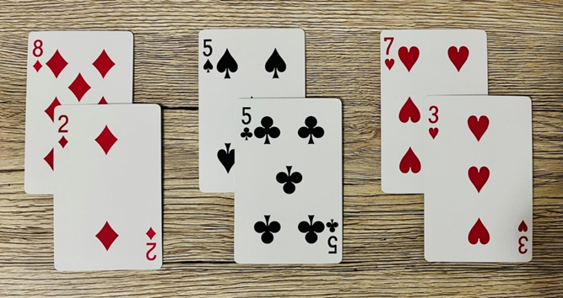
- Taking turns, students ask each other for a card to use with one of their remaining cards to make a total of 10.
- If a student has the card, they must give it to the asking player.
- If a student does not have the card, they say ‘Go fish’. The asking player must take the top card from the ‘Go fish’ pile.
- The next student has a turn.
- The winner of the round is the student who has the most pairs that add up to 10.
This table details assessment opportunities and differentiation ideas.
Assessment opportunities | Too hard? | Too easy?
What to look for:  - Can students recognise and create combinations of numbers up to 10? (MAO-WM-01, MAE-CSQ-01, MAE-CSQ-02)  What to collect:  - observations of student’s responses during the game (MAO-WM-01, MAE-CSQ-01, MAE-CSQ-02). | Students are unable to recognise and create combinations of numbers up to 10.  - Provide students with a ten-frame and concrete materials to support addition.  - Model counting on when counting the visual patterns on 2 playing cards using one-to-one correspondence. | Students recognise and create combinations of numbers up to 10.  - Challenge students to combine 3 cards to make combinations to 10.  - Encourage students to look for combinations to 20.

Investigating sums: Part 1 – 20 minutes
This lesson has been adapted from Sums investigations by youcubed.
- Build student understanding of how numbers can be combined in different ways to support addition.
- Introduce the lesson as another investigation where there can be different ways of solving the same problem.
- Explain that students will use combinations of different numbers to solve addition problems. These numbers can be added in a variety of ways to arrive at the same answer.
- Display Resource 9: Sums investigations and say that these 5 numbers (5, 6, 9, 12 and 14) will be hidden in a bag. On each turn, 2 numbers will be drawn out.
- Students work with a partner to find the total of the 2 numbers. They can use ten-frames, counters and whiteboards to find their solution. Encourage students to use the language of ‘part’ and ‘whole’ as they work on their solutions.
- After providing time for students to work with their partner, ask them to share their solutions and model the strategy they used on the whiteboard.
- Draw students’ attention to the range of strategies used. Ask:
- Did another group use the same strategy as you to find the solution?
- Is there a strategy that you hadn’t thought of using?
- Is there a strategy that you think is the most helpful to find the solution?
- Is there a new strategy you might like to try with your partner?
- Draw out 2 new numbers from the bag. Again, students use ten-frames, counters and whiteboards to find the solution.
- Ask students to share their solutions and model the strategy they used on the whiteboard. Focus students’ attention on the language of ‘part’ and ‘whole’ when combining groups together.
- Compare the range of strategies used. Ask:
- Did you use the same strategy as before with your partner, or did you try something different?
- Did another group use the same strategy as you to find the solution?
- Is there a strategy that you hadn’t thought of using?
- Did you notice any patterns?
- Is there a strategy that you think is the most helpful to find the solution?
- Is there a new strategy you might like to try with your partner?

Investigating sums: Part 2 – 20 minutes
Note: After several rounds of this activity, students may work with a different partner. This can provide an opportunity for students to experience a wider range of mathematical reasoning.
- Provide students with a copy of Resource 10: Sums investigations – pairs. Students repeat the process several more times, drawing out their own 2 numbers for them to add with their partner.
- Continue to provide regular opportunities for students to share the reasoning that they used to solve each problem.
This table details assessment opportunities and differentiation ideas.
Assessment opportunities | Too hard? | Too easy?
What to look for:  - Can students use visuals to model addition, identifying the relationship between the parts and the whole? (MAO-WM-01, MAE-RWN-01, MAE-RWN-02, MAE-CSQ-01)  - Do students communicate their mathematical reasoning using drawings, words and numerals? (MAO-WM-01, MAE-RWN-01, MAE-RWN-02, MAE-CSQ-01)  What to collect:  - observation data (MAO-WM-01, MAE-RWN-01, MAE-RWN-02, MAE-CSQ-01)  - student work samples (MAO-WM-01, MAE-RWN-01, MAE-RWN-02, MAE-CSQ-01) | Students are unable to use visuals to model addition.  - Model how to create the 2 groups needing to be added. Discuss other ways that these amounts can be represented visually, for example, using counters on ten-frames or drawing as dots on dice.  - Support students to find ways to rearrange the combinations to support an efficient count.  - Model the use of mathematical language, ‘part’ and ‘whole’ when combining groups of objects.  - Assist students to record their mathematical reasoning used in finding the solutions using drawings, words and numerals. | Students use visuals to model addition.  - Ask students to draw 2 different ways of representing their solution.  - Provide students with 3 numbers from the bag. Ask students to see if they can use their strategies with a larger number of objects.  - Ask students to plan a short class talk, explaining which of the strategies was most useful for adding numbers and why. They can present their reasoning to the class during the Consolidation and meaningful practice part of the lesson.

Consolidation and meaningful practice: Making sense of the mathematics – 10 minutes
- Remind students that the lesson was about finding different ways of solving the same problem.
- Ask students to think back to the strategy they used to solve the very first problem. For example, ask if they were still using the same strategy at the end of the lesson, or if had they learnt some new ways.
- Invite students to share the strategy they found the most helpful, asking questions such as:
- Can you show us how you used your strategy to solve the problem?
- Why did you find this strategy, or these visuals, the most useful?
- Draw students’ attention to the total number of different strategies students shared during the lesson.

Lesson 6: Let’s celebrate
Core concept: Events can be organised to create a schedule.
The table below contains suggested learning intentions and success criteria. These are best co-constructed with students.
Learning intentions | Success criteria
Students are learning that:  - words can be used to describe a sequence of events  - the length of time an event takes can be described and compared  - people choose the order of activities at special events. | Students can:  - use words to describe a sequence of events  - describe and compare the length of time an event takes  - order activities at special events.

Daily number sense: 10 minutes
- From a class need surfaced through formative assessment data, identify a short, focused activity that targets students’ knowledge, understanding and skills. Example activities may be drawn from the following resources:
- Mathematics K-6 resources
- Universal Resources Hub.

Let’s celebrate – 40 minutes
Note: Lessons 6 to 8 follow a theme of planning a maths party to celebrate the student’s learning. These have been adapted from the reSolve resource ‘Tea party’. The maths celebration could include revisiting the mathematical games that were popular in previous lessons.
- Brainstorm different types of parties and celebrations. These could include a birthday party, teddy bears’ picnic, yum cha, family barbecue or having afternoon tea with a friend or family member.
- Choose one event as an example and list the types of activities that could be included. For example, singing happy birthday, playing ‘pass the parcel’ and opening presents.
- Ask students about which events would take the longest time and which would be the shortest to complete.
- Discuss the best way to order these events to make the party enjoyable. For example, singing happy birthday and blowing out candles on a birthday cake might happen later in the party once all the guests have arrived.
- Explain that students will be planning a maths celebration to acknowledge their learning in mathematics this year. As a part of the party preparations, they will need to select activities that will help them celebrate while being appropriate to the school setting. These may include setting up, playing some favourite maths games, eating food, dancing and so on.
- Looking at the list they have compiled, pose the questions:
- How should we order these activities?
- Why would you put the activities in this order?
- In pairs or small groups, students decide which would be the best order to participate in the party activities. Students discuss their decisions with the whole class.
- Using Resource 11: Party sequence students order a sequence of party pictures, providing a justification for their choices.
This table details assessment opportunities and differentiation ideas.
Assessment opportunities | Too hard? | Too easy?
What to look for:  - Can students identify the order of activities at special events? (MAO-WM-01, MAE-NSM-01)  - Can students use words to describe a sequence of events? (MAO-WM-01, MAE-NSM-01)  What to collect:  - observation data (MAO-WM-01, MAE-NSM-01)  - student work samples. (MAO-WM-01, MAE-NSM-01) | Students are unable to sequence images and describe a sequence of events using the language of time.  - Provide students with a reduced number of images to sequence.  - Provide examples of time language, such as before, after and next to help sort the images.  - Ask one student to describe each event in sequenced order while their partner identifies the image that describes that event. | Students can sequence images of events in a day and describe the sequence of events using the language of time.  - Ask students if they can describe the order of events at a special celebration that they have attended.  - Ask students what language may be needed if a celebration went over several days.

Consolidation and meaningful practice: Noticing and wondering – 10 minutes
- Provide an opportunity for students to share their proposed sequence of events for the maths celebration.
- Ask students:
- What did you notice while you were working with your partner?
- What are the similarities and differences between the maths celebration and other celebrations they have attended?
- Is there anything that you are still wondering about?
- As a class, decide on the final sequence of events for the upcoming maths celebration.
- Explain any other information that students will need to know about the upcoming maths celebration.

Lesson 7: Preparing a maths celebration
Core concept: A collection can be shared into equal groups using different methods.
The table below contains suggested learning intentions and success criteria. These are best co-constructed with students.
Learning intentions | Success criteria
Students are learning that:  - quantities can be organised into smaller groups to support efficient counting  - collections can be shared in different ways, including distributing one by one  - grouping and sharing can be explained and recorded using drawings, words and numerals. | Students can:  - organise a collection into smaller groups and count the total using an efficient strategy  - share a collection into equal groups one by one, or by using another method  - use drawings, words and numerals to record and explain how they shared a group of objects.

Daily number sense: Handfuls – 15 minutes
This lesson is adapted from Ann Gervasoni, Monash University, published on reSolve: Maths by Inquiry.
- Build student understanding of comparing quantities less than 20 by playing ‘Handfuls’.
- Provide each student with writing materials and a handful of counters (or other small objects for counting).
- Ask students to imagine how many they have in their hand.
- Students record their estimate, for example, by using pictures, numbers or words.
- Ask students to describe what their collection might look like by visualising and imagining.
- Students then organise their collection so that someone else can determine how many items there are by subitising or quick counting.
- Ask students:
- How many do you have altogether?
- How have you organised your collection?
- Did you have more or less than your estimation?
- Can you organise them differently?
- Could you arrange your collection a different way so that you can see how many there are by subitising or quick counting?
- Share several different examples of arranging the collections with the class (see Figure 4).
Figure 4 – Collection arrangements
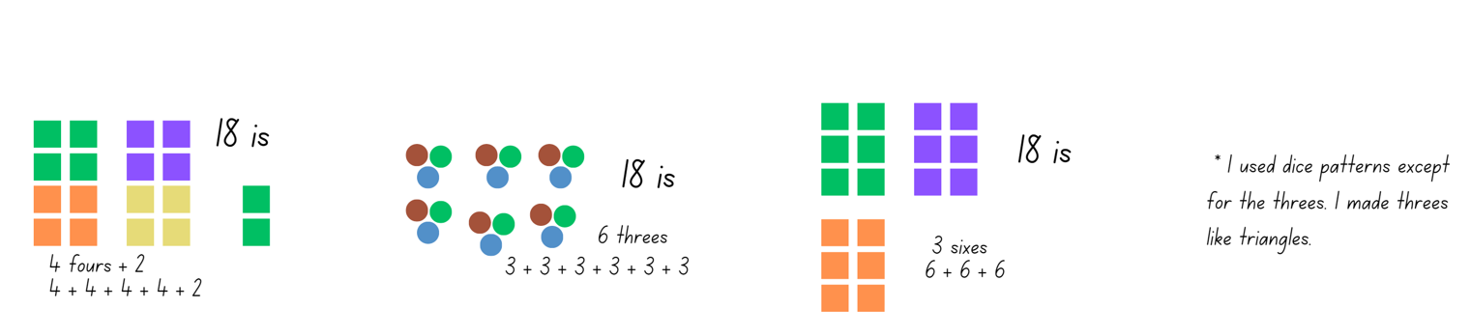
This table details assessment opportunities and differentiation ideas.
Assessment opportunities | Too hard? | Too easy?
What to look for:  - Are students able to organise a collection into smaller groups? (MAO-WM-01, MAE-RWN-01, MAE-RWN-02)  - Can students share a collection into equal groups one by one, or by using another method? (MAO-WM-01, MAE-RWN-01, MAE-RWN-02)  - Do students use drawings, words and numerals to record and explain how they shared a group of objects? (MAO-WM-01, MAE-RWN-01, MAE-RWN-02)  What to collect:  - observation data (MAO-WM-01, MAE-RWN-01, MAE-RWN-02)  - student work samples. (MAO-WM-01, MAE-RWN-01, MAE-RWN-02) | Students are unable to organise a collection into smaller groups.  - Students use a smaller number of objects to estimate and count.  - Model how to estimate, arrange and count the total of a collection of objects.  Students are unable to use drawings, words and numerals to record and explain how they shared a group of objects.  - Model how to use drawings, words and numerals to record and explain the number of objects.  - Use a number chart to support students’ understanding of the comparative size of numbers. | Students are able to use drawings, words and numerals to record and explain how they shared a group of objects.  - Students to compare their total with a partner’s. They work out which is the largest amount and by how much.  - Ask students to use drawings, words and numerals to record and explain how many more would be needed to make the groups equal.

Preparing a maths celebration – 15 minutes
This lesson is adapted from the reSolve resource ‘Tea party’.
- Revise the previous lesson with the class. Explain that in the next lesson they will be having a maths celebration and that today they will do some party problem solving.
- Form small groups of 4 to 6 students.
- Students count the number of group members to check the group size. Ask about their counting process, checking that students know the total number in their group is the last number counted aloud.
- Have students record the names of people in their group on their sheet of paper, providing assistance if needed.
- Discuss with the class what a placemat is and how it can help with setting a table.
Note: A4 or A3 paper can be used during this activity to make the placemat. This will assist students to organise the items they will need for each person at the maths celebration.
- Explain that the number of students in the group is the number of placemats their group will need.

Preparing placemats – 20 minutes
- As a class, brainstorm the items that would be needed to eat at a party, for example, a plate, cup, spoon and some food items.
- Model drawing a placemat with ideas from the brainstorm, including labels (see Figure 5).
Figure 5 – Example placemat
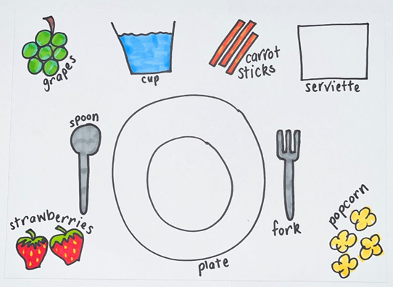
- Tell the class they will now plan the maths celebration by designing their placemat. Students can draw the objects and foods they would like to have during the celebration on their own placemat.
- As a group, students decide what items they need to include on each placemat. Group members must all agree to an item before it can be drawn on the placemat.
- Ask students to determine how many of each object their group will need. Each group member must have the same items on their placemat, but the number of that item and their placement may differ. For example, a group may decide to have popcorn on their placemat, but one student may have 2 pieces and another student may have 5 pieces.
- Circulate amongst students to observe the methods students use to solve the problem. Ask questions, such as:
- How many spoons will your group need?
- Will your group need more (or less) spoons than another group?
- Select a few students to share their problem-solving methods and record their solutions.
This table details assessment opportunities and differentiation ideas.
Assessment opportunities | Too hard? | Too easy?
What to look for:  - Can students organise a collection into smaller groups and find the total? (MAO-WM-01, MAE-RWN-01, MAE-FG-02)  - What methods do students use to share a collection into equal groups one by one, or by using another method? (MAO-WM-01, MAE-RWN-01, MAE-FG-02)  - Can students use drawings, words and numerals to record and explain how they shared a group of objects? (MAO-WM-01, MAE-RWN-01, MAE-FG-02)  What to collect:  - observation data (MAO-WM-01, MAE-RWN-01, MAE-FG-02)  - student work samples. (MAO-WM-01, MAE-RWN-01, MAE-FG-02) | Students are unable to share a collection into equal groups one by one, or by using another method.  - Support students to count how many people are in their group, then choose an item to use first, for example, cups.  - Use items to represent cups and model how to count them out one by one to each group member. Count the total of items handed out to find the total needed. | Students are able to share a collection into equal groups one by one, or by using another method.  - Extend the problem to include extra students in their group. Students find out how many of each item would be needed for one, 2, 3 or 5 more students.  - Students work with a partner to find how many items would be needed for the whole class. Encourage them to represent this in a picture or diagram.

Consolidation and meaningful practice: Preparing a maths celebration – 10 minutes
- Remind students that in the next lesson they will be holding their maths celebration. Discuss that this an opportunity to celebrate their learning in mathematics and play some of their favourite maths games.
- Ask students to nominate some of their favourite maths games they have played and list them.
- Explain how much time they will have for the celebration, as well as any other activities planned for this time. These could include:
- setting the tables with the party equipment from this lesson
- playing some maths games with the whole class
- playing some maths games with a partner or small group
- discussing things they have learnt, their favourite lessons and areas of improvement that are proud of.
- Remind students that the previously learned events can be sequenced in order. Ask the class to review the chosen sequence of events for the maths celebration. Students can make suggestions to change the order of events if needed.

Lesson 8: Maths celebration
Core concept: Mathematicians record what they notice to help them solve problems.
The table below contains suggested learning intentions and success criteria. These are best co-constructed with students.
Learning intentions | Success criteria
Students are learning that:  - visual representations can assist when combining and separating quantities  - flexible strategies can be used when solving addition and subtraction problems. | Students can:  - use drawings, labels and numerals to record what they notice when combining and separating quantities  - use a variety of strategies to solve addition and subtraction problems.

Revisiting a daily number sense: 10 minutes
- To begin the maths celebration, choose a short, focused activity that develop students’ knowledge, understanding and skills in an area of need. Example activities may be drawn from the following resources:
- Mathematics K-6 resources
- Universal Resources Hub.

Maths celebration – 30 minutes
This lesson is adapted from the reSolve resource ‘Tea party’.
- Have students sit in the same groups they were in the previous day and distribute the placemats they created during Lesson 7.
- Looking at the placemats, ask students how they will show what they need for their whole group. List students’ ideas of how they could show what they need altogether, highlighting ways to record this information on whiteboards or paper.
- Model different ways of recording the items needed, including drawings, labels, and numbers. For example, if one group has 6 people, students will need to work out how many cups they will need. Ask how they could record this to get the correct number of cups. Students could draw 6 cups, they could draw one cup and write 6 next to it or they could write 6 cups in words. See Figure 6.
Figure 6 – Example of recording items
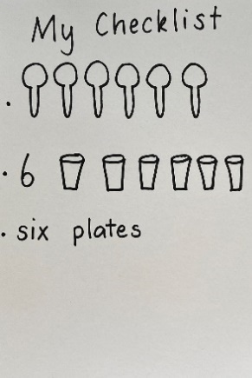
- Have groups discuss how they are going to record the items they need. Once they have decided on their method, students work together to record what their group will need.
- When all members of the group have finished recording, they compare their lists to ensure they each have the same quantities recorded. If they do not, ask how they can check who has the correct number recorded. Allow students an opportunity to check their findings and fix their recordings.
- Record each groups list on the board or large piece of paper so that all students can see it. See Figure 7.
Figure 7 – Example table of items needed
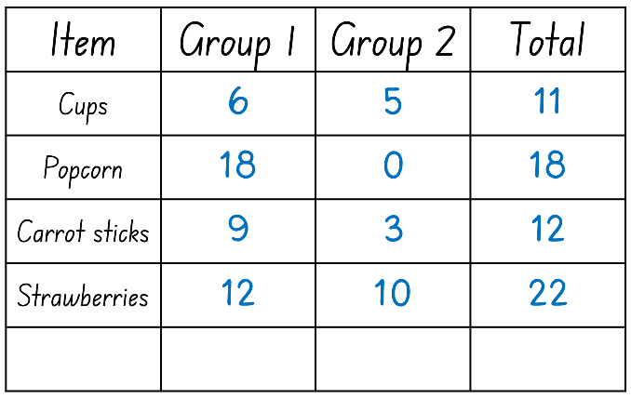
- Ask students how many cups Group 1 and Group 2 will need altogether. Allow students time to work this out using whiteboards and display their answers. Highlight the different ways students have represented and solved this problem.
- Ask students to continue to combine their groups’ items with the items of another group and record their results on their whiteboards.
- When the students have completed this, discuss the variety of ways they were able to represent and solve these problems.
- Pose the following questions:
- If Group 1 and Group 2 have 18 pieces of popcorn and 5 pieces drop on the ground, how many do they have left?
- If Group 2 and Group 3 need 10 strawberries but there are only 8 strawberries left, how many more do they need?
- Ask students to look at their placemats to determine what things most groups have in common. These could include plates, cups, spoons. Make a list of the common items they come up with.
- Explain to the students that they need to check if they have enough of each item for the whole class to have the maths party.
- Have students sit in a circle and count the number of students in the class. Count in a different direction to demonstrate that the total number does not change when students are counted in a different order.
- Pose questions to connect the number of students to the number of objects needed for the party, for example:
- There are 21 people in our class. How many plates will we need?
- How many cups will we need?
- How can we make sure we have enough for everyone in our class?
- Place piles of these items on a nearby table or in the middle of the circle. Ask students to check if there are enough objects for everyone in the class to participate in the party.
- Start with plates. Ask a student to count to check if there are enough for everyone. At this time, you could purposely present problems by providing either more or less objects than needed. Errors in counting can be used as an opportunity to provide key teaching moments.
This table details assessment opportunities and differentiation ideas.
Assessment opportunities | Too hard? | Too easy?
What to look for:  - Can students use a variety of strategies to solve addition and subtraction problems? (MAO-WM-01, MAE-CSQ-01)  - Can students use drawings, labels and numerals to record what happens when combining and separating quantities? (MAO-WM-01, MAE-RWN-01, MAE-RWN-02, MAE-CSQ-01)  What to collect:  - observation data (MAO-WM-01, MAE-RWN-01, MAE-RWN-02, MAE-CSQ-01)  - student work samples. (MAO-WM-01, MAE-RWN-01, MAE-RWN-02, MAE-CSQ-01) | Students are unable to use drawings, labels and numerals to record what happens when combining and separating quantities.  - Support students to count by ones to find how many items they need.  - Use concrete materials to represent cups and model how to count them out one by one to each group member. Then, count the total of items to find the total needed. | Students are able to use drawings, labels and numerals to record what they notice when combining and separating quantities.  - Extend the problem to include extra students in their group. Students find out how many of each item would be needed for one, 2, 3 or 5 more students.  - Students work with a partner to find how many items would be needed for the whole class. Encourage them to represent this in a picture or diagram.

Consolidation and meaningful practice: Check it – 20 minutes
- Summarise the lesson together, drawing out some key mathematical ideas about combining and separating groups and recording strategies with students. Ask students:
- What method of recording work best for you? Why?
- What strategy did you use to combine the items from 2 groups?
- Would you try something different next time? Why?
Note: Now it’s time to celebrate! The mathematics class party is an optional event.

Resource 1: Numeral cards
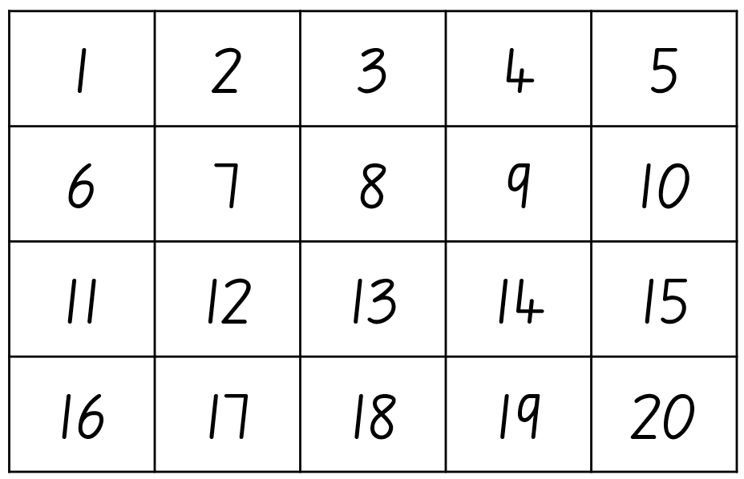

Resource 2: Yoko and Ravi
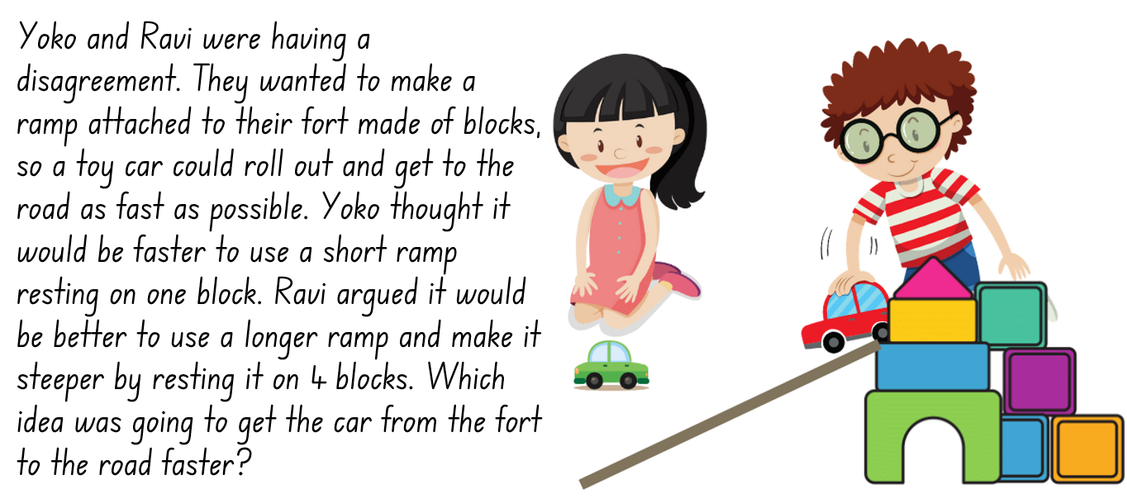
Images sourced from Canva and used in accordance with the Canva Content License Agreement.

Resource 3: Time language
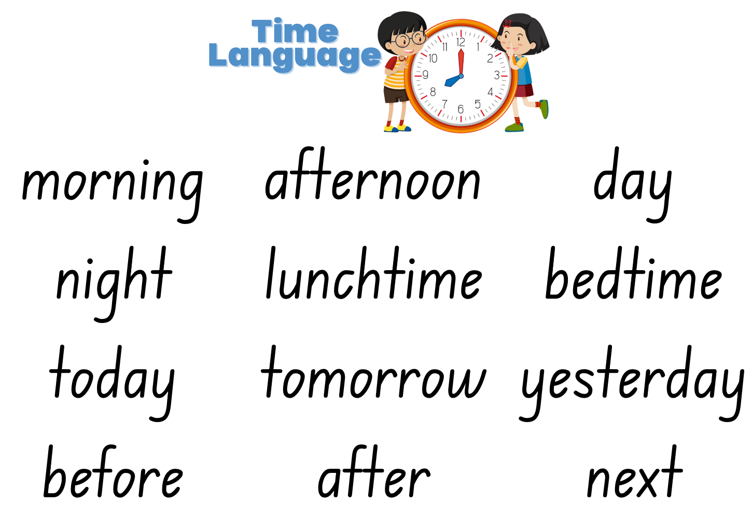
Images sourced from Canva and used in accordance with the Canva Content License Agreement.

Resource 4: Storyboard
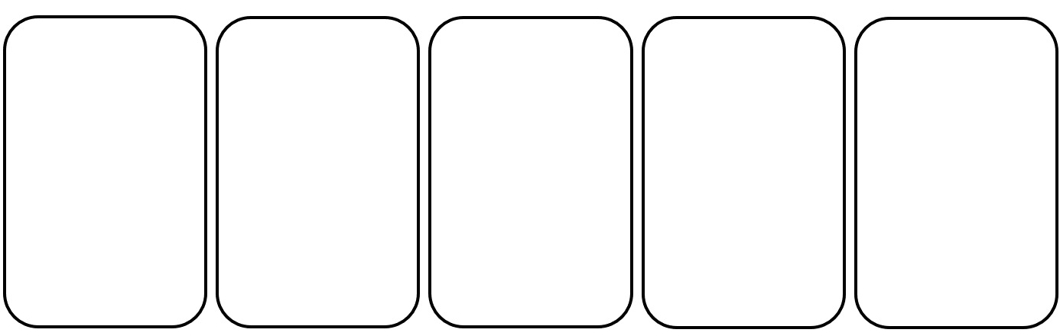

Resource 5: Animal Parade
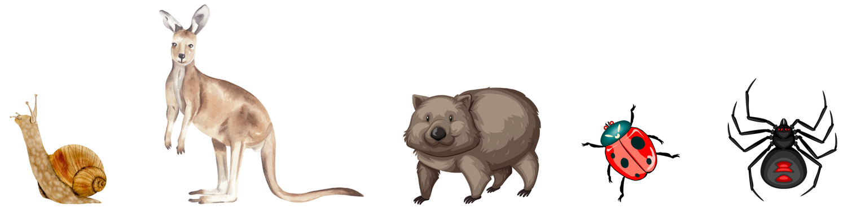
Images sourced from Canva and used in accordance with the Canva Content License Agreement.

Resource 6: Animal parade deck
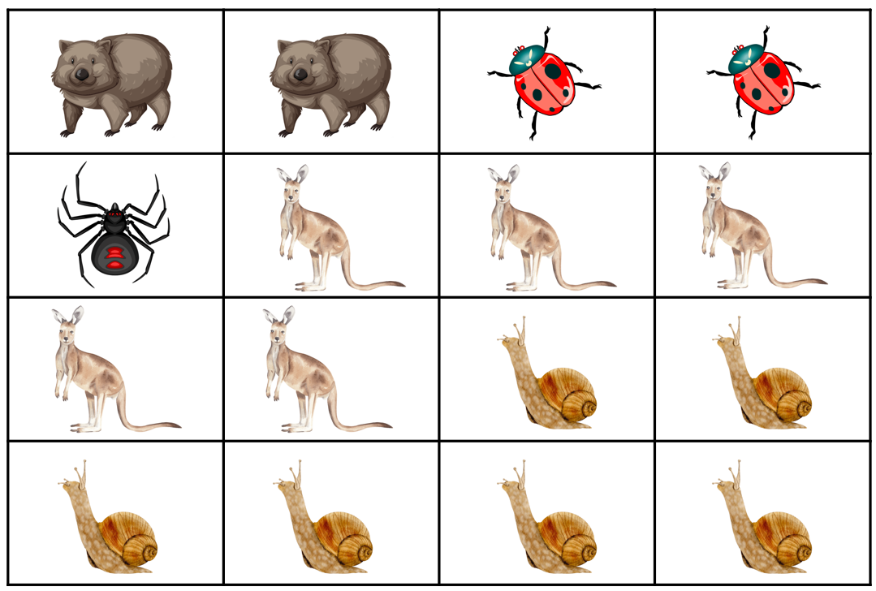
Images sourced from Canva and used in accordance with the Canva Content License Agreement.

Resource 7: Number of steps
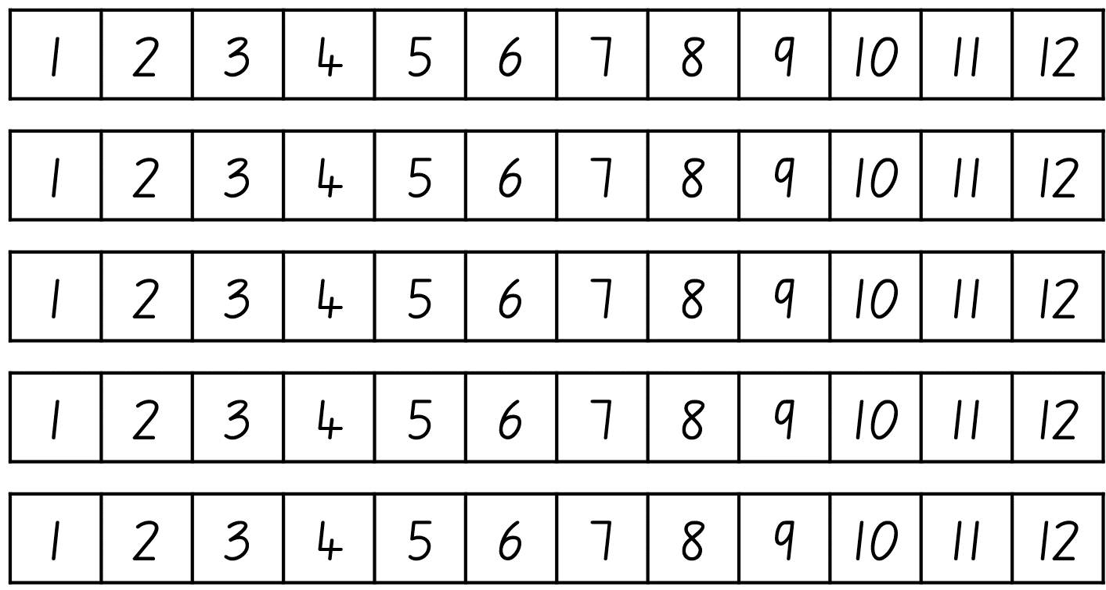

Resource 8: Zios and Zepts
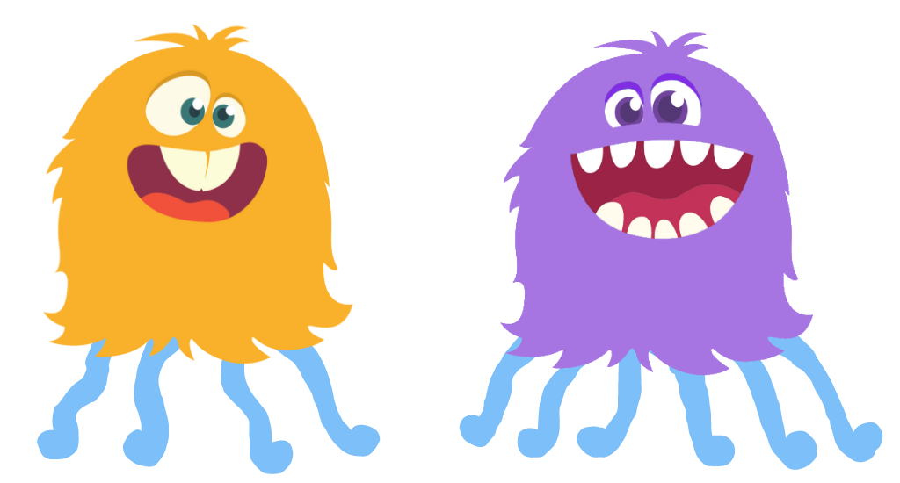
Images sourced from Canva and used in accordance with the Canva Content License Agreement.

Resource 9: Sums investigation
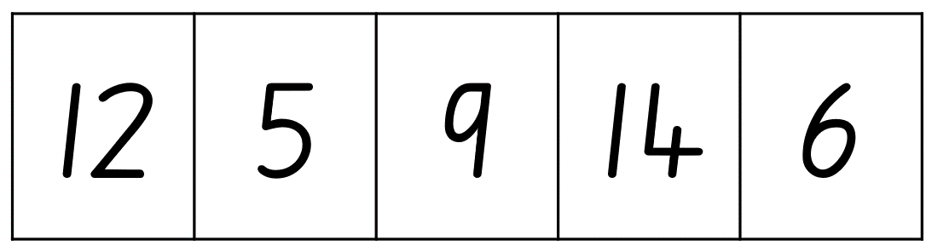

Resource 10: Sums investigation – pairs
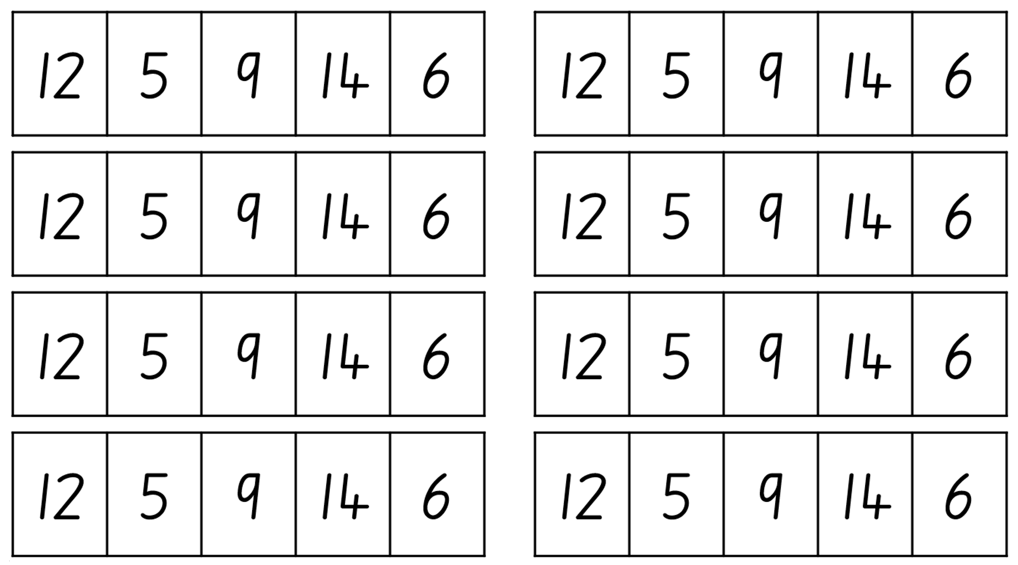

Resource 11: Party sequence
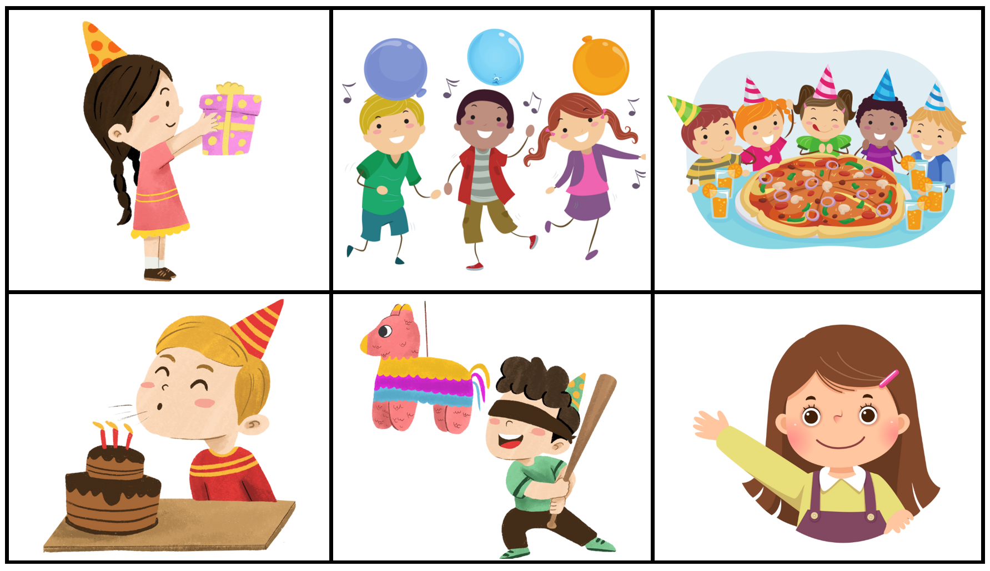
Images sourced from Canva and used in accordance with the Canva Content License Agreement.

Resource 12: Party needs
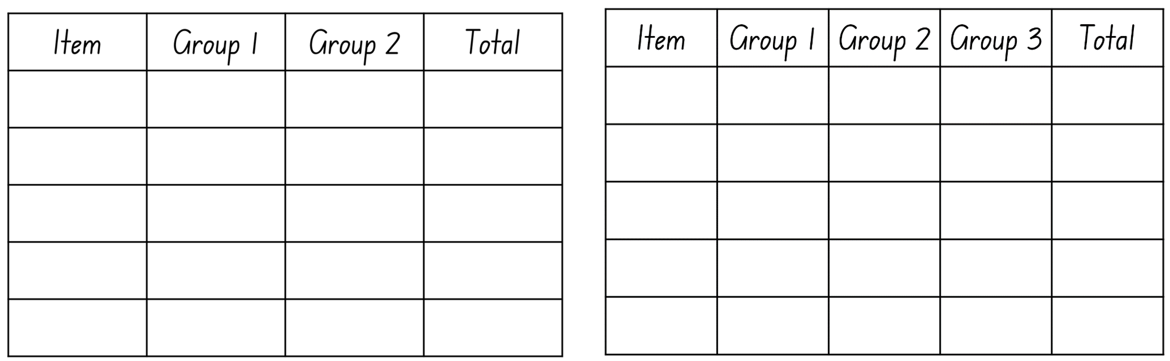

Syllabus outcomes and content
The table below outlines the syllabus outcomes and range of relevant syllabus content covered in this unit. Content is linked to National Numeracy Learning Progression version (3).
Focus area and outcomes | Content groups and content points | Lessons
Representing whole numbers  MAO-WM-01  MAE-RWN-01  MAE-RWN-02 | Instantly name the number of objects within small collections  - Instantly recognise (subitise) the number of items in small groups of up to four items without counting (NPV1, CPr1)  - Identify the number of items in different arrangements (CPr2)  Use the counting sequence of ones flexibly  - Count forwards to at least 30 and state the number after or before a given number, without needing to count from one (CPr4)  - Identify and distinguish the ‘teen’ numbers from multiples of ten with the same initial sounds (NPV3)  - Count backwards from a given number 20 or less (CPr5)  - Identify the number before as ‘one less’ and the number after as ‘one more’ than a given number  Recognise number patterns  - Recognise dice and domino dot patterns (NPA1, NPV2, CPr2)  - Recognise different finger patterns for the same number (NPA2)  Connect counting and numerals to quantities  - Count with one-to-one correspondence, recognising that the last number name represents the total number in the collection (CPr3, CPr5)  - Make correspondences between collections  - Read numerals to at least 20, including zero (NPV3)  - Represent numbers as quantities to at least 20 using objects (such as fingers), number words and numerals (NPV2-NPV4, CPr3) | 1–5, 7–8
Combining and separating quantities  MAO-WM-01  MAE-CSQ-01  MAE-CSQ-02 | Model additive relations and compare quantities  - Identify situations in which addition and subtraction may be applied (AdS1-AdS2)  - Combine two or more groups of objects to model addition, identifying the relationship between the parts and the whole (AdS1-AdS2)  - Separate and take away part of a group of objects to model subtraction (AdS1-AdS2)  - Use concrete materials or fingers to model and solve addition and subtraction questions, counting forwards or backwards by ones as necessary (AdS1-AdS2, NPV3)  - Compare two groups of objects to determine how many more (NPV1, AdS2)  Identify part–whole relationships in numbers up to 10  - Use visual representations of numbers to assist with combining and separating quantities, identifying the relationship between the quantities (NPV2, NPA2, AdS2-AdS3)  - Describe the action of combining, separating and comparing (AdS1)  - Use five as a reference in forming numbers from six to ten  - Create, model and recognise combinations for numbers up to ten (AdS2)  - Count by ones to find the total or difference (AdS2-AdS3)  - Use drawings, words and numerals to record addition and subtraction, and explain their thinking (AdS2) | 3–5, 7–8
Forming groups  MAO-WM-01  MAE-FG-01  MAE-FG-02 | Investigate and form equal groups by sharing  - Distribute a group of familiar objects into smaller groups and recognise whether the number in each group is equal or not (MuS1-MuS2)  - Group and share concrete materials by distributing objects one by one or using another method (MuS1-MuS2)  Record grouping and sharing  - Label the number of objects in a group  - Record grouping and sharing using drawings, words and numerals, and explain their thinking (MuS2) | 3, 7
Non-spatial measure  MAO-WM-01  MAE-NSM-01  MAE-NSM-02 | Time: Compare and order the duration of events using the language of time  - Use terms such as daytime, night-time, morning, afternoon, today, tomorrow, yesterday, before, after and next (MeT1)  - Sequence events in time (MeT1)  - Compare the duration of two events (MeT1)  Tell time on the hour on analog and digital clocks  - Create the layout of an analog clock (MeT2)  - Read analog and digital clocks to the hour using the term ‘o’clock’ (MeT2-MeT3)  - Describe the position of the hour and minute hands on an analog clock when reading hour time (MeT2) | 1–2, 6

References
Links to third-party material and websites
Please note that the provided (reading/viewing material/list/links/texts) are a suggestion only and implies no endorsement, by the New South Wales Department of Education, of any author, publisher, or book title. School principals and teachers are best placed to assess the suitability of resources that would complement the curriculum and reflect the needs and interests of their students.
If you use the links provided in this document to access a third-party's website, you acknowledge that the terms of use, including licence terms set out on the third-party's website apply to the use which may be made of the materials on that third-party website or where permitted by the Copyright Act 1968 (Cth). The department accepts no responsibility for content on third-party websites.
Except as otherwise noted, all material is © State of New South Wales (Department of Education), 2023 and licensed under the Creative Commons Attribution 4.0 International License. All other material (third-party material) is used with permission or under licence. Where the copyright owner of third-party material has not licensed their material under a Creative Commons or similar licence, you should contact them directly for permission to reuse their material.
Mathematics K–10 Syllabus © 2022 NSW Education Standards Authority (NESA) for and on behalf of the Crown in right of the State of New South Wales.
© 2022 NSW Education Standards Authority. This document contains NSW Curriculum and syllabus content. The NSW Curriculum is developed by the NSW Education Standards Authority. This content is prepared by NESA for and on behalf of the Crown in right of the State of New South Wales. The material is protected by Crown copyright.
Please refer to the NESA Copyright Disclaimer for more information.
NESA holds the only official and up-to-date versions of the NSW Curriculum and syllabus documents. Please visit the NSW Education Standards Authority (NESA) website and the NSW Curriculum website.
National Numeracy Learning Progression © Australian Curriculum, Assessment and Reporting Authority (ACARA) 2010 to present, unless otherwise indicated. This material was downloaded from the Australian Curriculum website (National Numeracy Learning Progression) (accessed 27 April 2023) and was not modified. The material is licensed under CC BY 4.0. Version updates are tracked in the ‘Curriculum version history’ section on the 'About the Australian Curriculum' page of the Australian Curriculum website.
ACARA does not endorse any product that uses the Australian Curriculum or make any representations as to the quality of such products. Any product that uses material published on this website should not be taken to be affiliated with ACARA or have the sponsorship or approval of ACARA. It is up to each person to make their own assessment of the product, taking into account matters including, but not limited to, the version number and the degree to which the materials align with the content descriptions and achievement standards (where relevant). Where there is a claim of alignment, it is important to check that the materials align with the content descriptions and achievement standards (endorsed by all education Ministers), not the elaborations (examples provided by ACARA).
This resource contains images and content obtained from Canva, and their use outside of this resource is subject to Canva’s Content License Agreement. If you wish to use them separately from the resource, please go to Canva.
Australian Government Department of Education (2018) ‘Authentic Problems: Tea Party’, Teaching resources, reSolve: Maths by Inquiry website, accessed 27 April 2023.
Boaler J, Munson J and William C (2020) Mindset Mathematics: Visualising and Investigating Big Ideas, Grade K, Jossey-Bass, New Jersey.
Dacey L, Gartland K and Bamford Lynch J (2016) Well Played: Building Mathematical Thinking Through Number Games and Puzzles, Grades K-2, Stenhouse Publishers, United States.
New Zealand Ministry of Education (n.d.) ‘Go Fish 10’, Resource Finder, NZ Maths website, accessed 27 April 2023.
Stanford University (n.d.) How Many Are Hiding, youcubed website, accessed 27 April 2023.
Stanford University (n.d.) Sums Investigation, youcubed website, accessed 27 April 2023.
Stanford University (n.d.) The Pocket Game, youcubed website, accessed 27 April 2023.
University of Cambridge (Faculty of Mathematics) (1997-2023) Zios and Zepts, NRICH website, accessed 27 April 2023.
Van de Walle J, Karp K, Bay-Williams J, Brass A, Bentley B, Ferguson S, Goff W, Livy S, Marshman M, Martin D, Pearn C, Prodromou T, Symons D and Wilkie K (2019) Primary and Middle Years Mathematics: Teaching Developmentally, 1st Australian edn, Pearson Education Australia, Melbourne.

