Mathematics – Early Stage 1 – Unit 19
Contents
Unit description and duration 4
Student prior learning 4
Lesson overview and resources 5
Lesson 1: Inspecting 3D objects 10
Daily number sense: Sorting shirts – 15 minutes 10
3D UFOs – 35 minutes 13
Consolidation and meaningful practice: Feature sort – 10 minutes 17
Lesson 2: Different points of view 18
Daily number sense: Sorting T-shirts 2 – 10 minutes 18
Different points of view – 40 minutes 21
Consolidation and meaningful practice: Secret object – 10 minutes 23
Lesson 3: Making objects 25
Daily number sense: Sorting shirts 3 – 15 minutes 25
3D models and UFOs – 40 minutes 27
Consolidation and meaningful practice: Gallery walk – 10 minutes 30
Lesson 4: Understanding volume 32
Daily number sense: Handfuls – 15 minutes 32
Volume of objects – 30 minutes 34
Consolidation and meaningful practice: Points of view – 15 minutes 37
Lesson 5: Different objects, same volume 40
Daily number sense: Teacher choice – 10 minutes 40
Building challenge – 30 minutes 41
Consolidation and meaningful practice: Class collection – 10 minutes 43
Lesson 6: Packing in layers 44
Daily number sense: Facts about numbers – 15 minutes 44
Packing and stacking Part 1 – 10 minutes 46
Packing and stacking Part 2 – 30 minutes 48
Consolidation and meaningful practice: Real life packing and stacking – 10 minutes 50
Lesson 7: Filling and pouring 52
Daily number sense: Jellybean challenge – 15 minutes 52
Filling and comparing – 40 minutes 55
Discussing the mathematics – 10 minutes 57
Lesson 8: Investigating 3D objects 59
Daily number sense: Construction site – 10 minutes 59
Features of common boxes: Part 1 – 20 minutes 62
Internal volume of boxes: Part 2 – 20 minutes 63
Discussing the mathematics – 10 minutes 64
Resource 1: T-shirt sort 1 66
Resource 2: Modified T-shirt sort 67
Resource 3: UFOs 68
Resource 4: Object sort cards 70
Resource 5: T-shirt sort 2 and 2A 71
Resource 6: T-shirt sort 3 and 3A 73
Resource 7: Handfuls game 75
Resource 8: Double ten-frame 76
Resource 9: Two handfuls 77
Resource 10: 30 or bust! 78
Resource 11: Volume in our world 79
Resource 12: Facts about numbers 80
Resource 13: Cargo ships 81
Resource 14: Delivery trucks 82
Resource 15: Lots of spots 83
Resource 16: Jellybean challenge 84
Resource 17: Construction site 85
Syllabus outcomes and content 86
References 90

Unit description and duration
This two-week unit develops student knowledge, understanding and skills with 2D shapes, 3D objects, volume, and internal volume (capacity). Students are provided opportunities to:
- name, describe and represent 2D shapes
- explore familiar 3D objects by sorting, stacking, describing, and making representations
- recognise that flat surfaces of 3D objects can be named as 2D shapes
- measure and compare volume of various 3D objects
- measure and compare internal volume (capacity) of various 3D objects.
Mathematics K–10 Syllabus © 2022 NSW Education Standards Authority (NESA) for and on behalf of the Crown in right of the State of New South Wales.

Student prior learning
Before engaging in these teaching and learning activities, students would benefit from prior experience with:
- identifying specific features which give 2D shapes their name
- sorting, describing, and naming familiar 2D shapes, including circles, squares, triangles, and rectangles
- manipulating, exploring, sorting, and making 3D objects
- using informal vocabulary to describe and name various shapes and objects.

Lesson overview and resources
The table below outlines the sequence and approximate timing of lessons; syllabus focus areas and content groups; and resources.
Lesson | Syllabus focus area and content groups | Resources
Lesson 1: Inspecting 3D objects  45 minutes  2D shapes can be identified in the features of 3D objects. | Representing whole numbers  - Use the counting sequence of ones flexibly  - Recognise number patterns  Two-dimensional spatial structure  - 2D shapes: Sort, describe and name familiar shapes  - 2D shapes: Represent shapes  Three-dimensional spatial structure  - 3D objects: Explore familiar three-dimensional objects | - Resource 1: T-shirt sort 1  - Resource 2: Modified T-shirt sort  - Resource 3: UFOs  - Resource 4: Object sort cards  - 2D shape tiles  - 3D objects  - Digital device  - Geoboards or digital boards  - String and pegs  - Writing materials
Lesson 2: Different points of view  60 minutes  Faces on a 3D object can change depending on your point of view. | Representing whole numbers  - Use the counting sequence of ones flexibly  - Recognise number patterns  Two-dimensional spatial structure  - 2D shapes: Sort, describe and name familiar shapes  - 2D shapes: Represent shapes  Three-dimensional spatial structure  - 3D objects: Explore familiar three-dimensional objects | - Resource 3: UFOs  - Resource 5: T-shirt sort 2 and 2A  - Digital device  - Large cube, such as a die  - String and pegs  - Various 3D objects  - Writing materials
Lesson 3: Making objects  65 minutes  2D shapes can be identified in the features of 3D objects. | Representing whole numbers  - Use the counting sequence of ones flexibly  - Recognise number patterns  Two-dimensional spatial structure  - 2D shapes: Sort, describe and name familiar shapes  - 2D shapes: Represent shapes  Three-dimensional spatial structure  - 3D objects: Explore familiar three-dimensional objects  - Volume: Compare volume by building | - Resource 2: Modified T-shirt sort  - Resource 6: T-shirt sort 3 and 3A  - Digital device  - Geoboard  - String and pegs  - Modelling clay  - Variety of real-life 3D objects  - Writing materials
Lesson 4: Understanding volume  60 minutes  Volume is the amount of space an object occupies. | Representing whole numbers  - Use the counting sequence of ones flexibly  - Connect counting and numerals to quantities  Three-dimensional spatial structure  - Volume: Compare volume by building | - Resource 7: Handfuls game  - Resource 8: Double ten-frame  - Resource 9: Two handfuls  - Resource 10: 30 or bust!  - Resource 11: Volume in our world  - Balloons  - Counters  - Interlocking cubes  - Small and large common 3D objects  - String, wool, or chalk
Lesson 5: Different objects, same volume  50 minutes  Objects that appear different may have the same volume. | Representing whole numbers  - Connect counting and numerals to quantities  Three-dimensional spatial structure  - Volume: Compare volume by building | - 2 large equal sized dice or cubes  - 2 different sized water bottles  - Interlocking cubes
Lesson 6: Packing in layers  65 minutes  Internal volume can be explored by packing and stacking with no gaps. | Representing whole numbers  - Use the counting sequence of ones flexibly  - Connect counting and numerals to quantities  Three-dimensional spatial structure  - Volume: Compare internal volume by filling and packing | - Resource 12: Facts about numbers  - Resource 13: Cargo ships  - Resource 14: Delivery trucks  - Digital device  - MAB or other uniform blocks  - Uniform informal objects  - Various small/medium real-life boxes (student provided)  - Writing materials
Lesson 7: Filling and pouring  65 minutes  Containers can look different but can have the same internal volume (capacity). | Representing whole numbers  - Instantly name the number of objects within small collections  - Use the counting sequence of ones flexibly  - Recognise number patterns  - Connect counting and numerals to quantities  Three-dimensional spatial structure  - Volume: Compare internal volume by filling and packing | - Resource 15: Lots of spots  - Resource 16: Jellybean challenge  - Counters  - Filling material, such as rice, birdseed, lentils or sand  - Funnel  - Plastic cups  - Tray  - Various containers  - Writing materials
Lesson 8: Investigating 3D objects  60 minutes  An object’s features can affect its internal volume. | Representing whole numbers  - Connect counting and numerals to quantities  Two-dimensional spatial structure  - 2D shapes: Sort, describe and name familiar shapes  - 2D shapes: Represent shapes  Three-dimensional spatial structure  - 3D objects: Explore familiar three-dimensional objects  - Volume: Compare internal volume by filling and packing | - Resource 17: Construction site  - Digital device  - Filling material, such as rice, birdseed, lentils or sand  - Modelling clay or wool  - Various small/medium real-life boxes  - Writing materials

Lesson 1: Inspecting 3D objects
Core concept: 2D shapes can be identified in the features of 3D objects.
The table below contains suggested learning intentions and success criteria. These are best co-constructed with students.
Learning intentions | Success criteria
Students are learning that:  - familiar number and dot patterns are helpful when counting and ordering numbers  - 2D shapes can be described, named and represented using their features  - naming and recognising 2D shapes help with identifying the faces of 3D objects. | Students can:  - recognise dots and number patterns when sorting and ordering numbers  - identify and describe familiar 2D shapes in a range of contexts  - make, name and describe 2D shapes by tracing around the faces of 3D objects.

Daily number sense: Sorting shirts – 15 minutes
- Build student understanding of counting and number quantities by investigating, comparing and grouping representations of numbers.
Note: Prior to the lesson, prepare Resource 1: T-shirt sort 1 by cutting out the T-shirts and having them placed randomly on the floor for students to view.
- Explain that you are wondering how the T-shirts could be sorted into groups. See Figure 1.
Figure 1 – Examples of sorting T-shirts
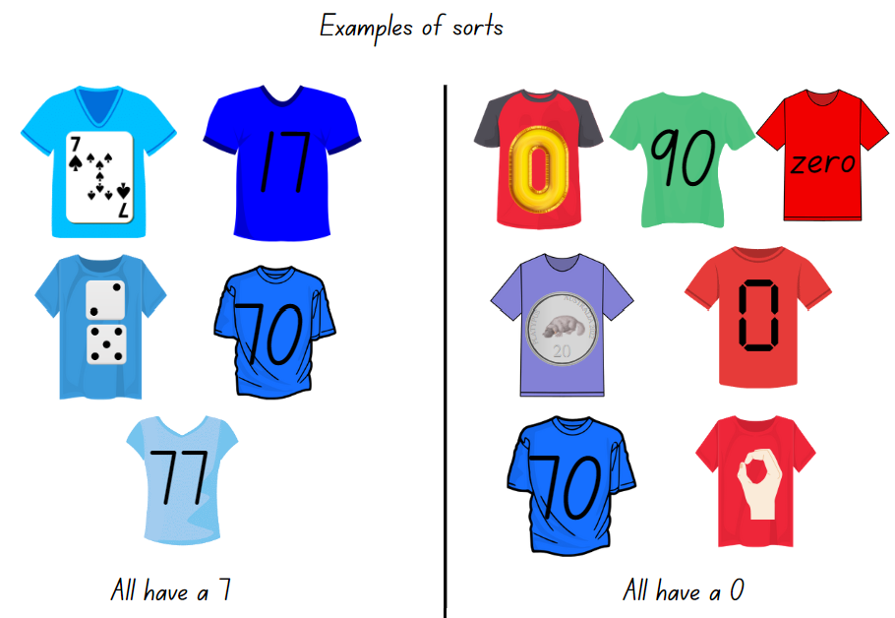
Images licensed in accordance with the Canva Content License Agreement.
- Provide time for students to view the T-shirts and to turn and talk with a partner sharing ideas and solutions. Ask:
- What can you see?
- Are there any patterns? Can you describe a number pattern that you saw?
- How many ways do you think there are to sort the T-shirts?
- What is one way that you cannot sort the T-shirts?
- How are the numbers or quantities displayed on the T-shirts helping you with your ideas for a sort?
- What is important to think about when sorting the T-shirts?
- Provide students with writing materials and ask them to draw or write a ‘sort’ idea that they have identified.
- As students share their sorting suggestions, display the sort on a board. Engage the class by asking, ‘Can you suggest a T-shirt we could add to this sort?’
This table details assessment opportunities and differentiation ideas.
Assessment opportunities | Too hard? | Too easy?
What to look for:  - Can students instantly recognise (subitise) the number of items in small groups without counting? (MAO-WM-01, MAE-RWN-01)  - Can students name and group numbers represented in various ways? (MAO-WM-01, MAE-RWN-01)  - Can students communicate their reasoning using appropriate mathematical language? (MAO-WM-01, MAE-RWN-01)  What to collect:  - work samples showing sorts and mathematical language to show reasoning. (MAO-WM-01, MAE-RWN-01) | Students cannot group using more than one representation.  - Provide students with T-shirts that only focus on one attribute such as, zero or dominoes.  - In pairs, students use only one colour of T-shirt, for example, blue, to sort and identify a second attribute.  Students cannot recognise, name or order numbers beyond 20.  - Use dot arrangements to 12 and support students to order the T-shirts.  - Provide students with Resource 2: Modified T-shirt sort. Students match or order the numbers on the T-shirts. | Students can group using a variety of representations.  - Students make 5 more T-shirts that could be added to each of their sorts.  - Students create an assortment of numbers for a peer to sort in 2 different ways.

3D UFOs – 35 minutes
Prior to the lesson, prepare a variety of 2D shape tiles and 3D objects.
Note: Early Stage 1 students should be using descriptive language that supports identifying, naming and describing 2D shapes and recognising these shapes on 3D objects. For example, straight, 4 sides, corner, flat, curved, triangle, circle, square, rectangle, longer, shorter and/or bigger and smaller. Exploring, manipulating, and making representations of 3D objects provides opportunities for students to make connections with real life objects and images of 3D objects that are present in their daily environments. It is not expected that Early Stage 1 students will use formal names and mathematical vocabulary associated with 3D objects.
- Tell students the following narrative: ‘There is a galaxy out in space where the aliens are extremely interested in learning about mathematics and becoming mathematicians, just like you. The aliens have travelled to Earth and landed with their UFOs. Here is a picture of their UFOs (Display Resource 3: UFOs). The aliens want their UFOs to look like 3D objects that we have here on Earth.’
- Explain that parts of the UFOs are concealed by clouds of smoke making it difficult to see all the features. Ask students to turn and talk with a partner and to name the 2D shapes they can see.
- Display various 2D shapes and 3D objects on the floor. Ask students to ‘eye-spy’ if they can see a 2D shape on a 3D object that is the same as one they spotted on the UFOs picture. Refer to Resource 3: UFOs and ask:
- What 2D shapes can you see? Can you air-write a 2D shape you saw?
- I wonder which UFO that shape belongs to. What do you think?
- I wonder if the same 2D shape can be seen on another UFO. Did you ‘eye-spy’ this shape on more than one UFO?
- I wonder what 2D shapes we cannot see. What 2D shapes do you think are hidden behind the clouds of smoke?
- I wonder what 3D objects the aliens used to make their UFOs if these are the features we can see. What do you think?
- Using the displayed 3D objects select students to pick one and match it with a UFO, explaining the features they noticed that makes them a match. On a class anchor chart, draw and annotate representations using the language shared by students. See Figure 2.
Figure 2 – Example of an anchor chart
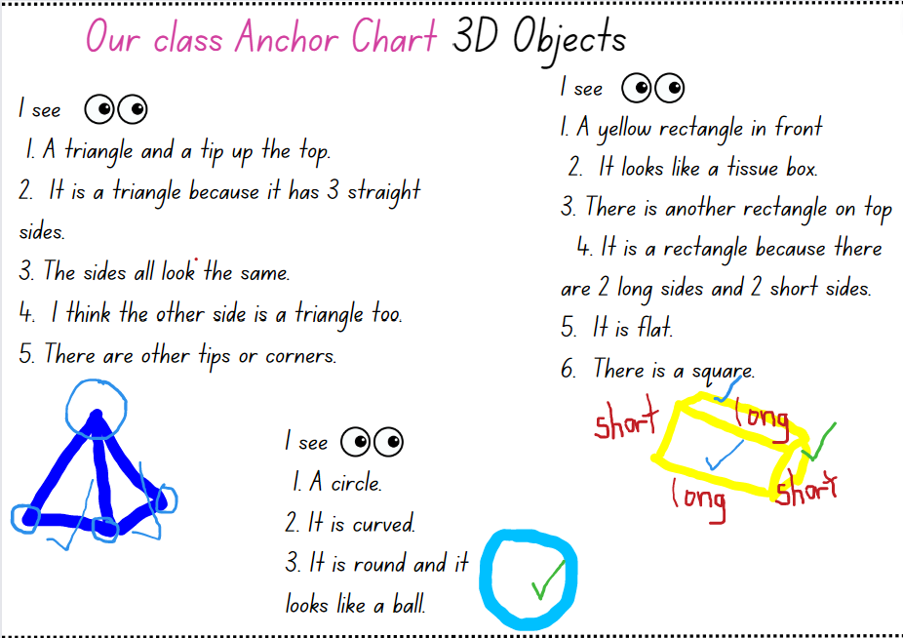
- Select one of the UFOs and the matching 3D object. Model turning the object and tracing the faces, then making the faces on a geoboard or drawing the shapes. State the features aloud. For example, there are squares on the purple UFO, they have 4 sides, and they are all the same, there are 6 squares altogether, and it looks like a box.
Note: There is no need to trace in a systematic or ordered way, such as when creating a net pattern.
- Provide students with a geoboard or writing materials. Ask students to identify and represent a UFO of their choice either by tracing or using geoboards. If using geoboards, students should use physical boards, if available, or digital boards if not.
- Ask:
- How do you know that is a circle/square/triangle/rectangle?
- Show me a shape that is not a circle/square/triangle/rectangle. How can you be sure?
- How would you explain the difference between (select two 2D shapes)?
- Can you name a real-life item that is this object? Can you find an example in the classroom that looks like your chosen UFO?
- What are you wondering about?
This table details assessment opportunities and differentiation ideas.
Assessment opportunities | Too hard? | Too easy?
What to look for:  - Can students trace, identify and describe circles, squares, triangles and rectangles? (MAO-WM-01, MAE-2DS-01)  - Can students identify 2D shapes on a 3D object? (MAO-WM-01, MAE-2DS-01, MAE-3DS-01)  What to collect:  - student drawings, geoboards or photographs of 2D shapes. (MAE-2DS-01) | Students are not able to trace and/or describe common 2D shapes.  - Guide students on how to trace or print and name the faces of one 3D object.  - Provide 2D shape tiles for students to compare the outline of their traces to circles, squares, triangles and rectangles.  Students are not able to identify and name 2D shapes or 3D objects.  - Provide labelled images of targeted 2D shapes and 3D objects for students to view and refer to.  - In pairs, students identify 2D shapes and 3D objects in the classroom. | Students can identify and name 2D shapes and 3D objects.  - Introduce students to a wider range of objects to explore and record.  - Ask students to create repeating patterns with shapes, including two- and three-shape patterns.

Consolidation and meaningful practice: Feature sort – 10 minutes
- Provide small groups of students with Resource 4: Object sort cards.
- Instruct students to sort the objects into at least 2 groups based on their features (for example, 2D shapes on faces of 3D objects, number of sides, colour, flat or curved) and to explain their sort. Ask:
- Can you find an object in the class that belongs in one of your groups? Why does it belong?
- Can you find an object in the class that does not belong in any of your groups? Why does it not belong?
- Is there an object that reminds you of one of the UFOs from the previous lesson? How? What features in particular?
- Is there an object whose features you are wondering about?
- Instruct groups to sort their objects in a different way and explain the new sort.
- Students capture their sort on a digital device or draw it using writing materials and annotate the image to explain their sort.

Lesson 2: Different points of view
Core concept: Faces on a 3D object can change depending on your point of view.
The table below contains suggested learning intentions and success criteria. These are best co-constructed with students.
Learning intentions | Success criteria
Students are learning that:  - numbers have a name, can be ordered and are represented by numerals  - there is helpful vocabulary that mathematicians use to describe the features of 3D objects  - using the features of 3D objects is helpful when sorting. | Students can:  - name, compare and order numbers to 20  - recognise and name a variety of 2D shapes seen on 3D objects from various points of view  - use language, such as longer, shorter, the same as, square, circle, rectangle, straight, curved, corner, biggest and smallest.

Daily number sense: Sorting T-shirts 2 – 10 minutes
- Build student understanding of the counting sequence of one by comparing numbers.
Note: Prior to the lesson prepare Resource 5: T-shirt sort 2 and 2A by cutting out the T-shirts and having them randomly placed on the floor face down so the students cannot see the numbers.
- Display a string line with pegs and provide students with writing materials. Explain that there are T-shirts numbered 9-20 on the floor. Choral count with the class from 9 to 20 and then backwards from 20 to 9.
- Explain that the T-shirts need to be hung up in order from 9 to 20. Peg the 9 and the 20 (at either end of the line) to provide visual benchmarks for the students.
- Have a student select a T-shirt at random, reveal and name the number displayed, then peg it on the clothesline. Ask the student to justify the position of the T-shirt. Invite other students to agree or challenge the location of the T-shirt and explain their reasoning. Draw students’ attention to the sequence of the numbers and the equal spacing between numbers on the clothesline.
- Once the T-shirt is positioned in an agreed place, ask students to write the number they think comes before and after the displayed number. Select a student to name the number before and after the displayed number. Repeat the process until all numbers are displayed.
- Repeat choral counting forwards and backwards from 9 to 20. Ask:
- What patterns can you see with the numbers on the T-shirts?
- Mathematicians have a name for the numbers 11 to 19, do you know what they are called? Can you name all the teen numbers?
- What are some numbers that come before the numbers visible on the T-shirts? Where would they hang on the line?
- How does a pattern help you work out what comes next?
- Count on from a T-shirt number, for example 17 to 30. Count back from 20 to the number on the T-shirt, for example, 11.
- Select a student to remove a T-shirt from the line, stating the number that comes before and after as they do so.
- Continue until all T-shirts have been removed from the line.
- End by choral counting backwards from 20 to 9.
This table details assessment opportunities and differentiation ideas.
Assessment opportunities | Too hard? | Too easy?
What to look for:  - Can students identify the number that comes before and after a selected number to 20? (MAE-RWN-01)  - Are students identifying and naming the teen numbers? (MAE-RWN-01)  - Can students count forwards to at least 30 and backwards from 20? (MAE-RWN-01)  What to collect:  - annotations and/or videos of students counting, naming and ordering numbers. (MAE-RWN-01) | Students cannot recognise, name or order the ‘teen’ numbers.  - Provide a number track from zero to 30 and counters. Students place counters on each of the teen numbers as they say them.  - Provide a double ten-frame and counters. Students place one colour counter as they count from one to 10, then a different colour as they count from 11 to 20. | Students can recognise, name and order the teen numbers.  - Ask students to record 10 more or less than some selected T-shirts.  - Students make 5 more T-shirts that could be added to the clothesline.  - Students identify and record a number pattern that they can see in the number sequence 9 to 20.

Different points of view – 40 minutes
This lesson has been adapted from ‘Connecting 2D representations and 3D objects’ from Sullivan (2017).
- Display a large cube on the centre of a table and ask students to describe what they see.
- Continue the alien narrative from Lesson 1. Explain that an important thing the visiting aliens need to know about 3D objects is that they can look different, depending on where a person is standing. Ask students to show the aliens how this part of mathematics works.
- Explicitly model how to move around the table and view the cube from the different points and views, observing the cube to recognise what 2D shapes are visible.
- Model drawing or photographing the object from different points of view, stating the view, for example, top view, front view, rear view, and side view, as you move around the object.
- Model visualising the cube from underneath, explaining your reasoning aloud.
- Explain that, as students move around, they need to identify, trace and then air-write a 2D shape that they identify on the cube.
- Provide students with a range of 3D objects, including common household items such as tissue boxes, cereal boxes and cylindrical tins.
- In pairs, students place an object on the centre of a table. Using a digital device or writing materials, students record an outline around the edges of each visible face, from multiple points of view, such as top view, front view, rear view and side view. Students label the 2D shapes they can see.
- Ask students to visualise and draw the object as if they were viewing it from underneath. Prompt students to explain their reasoning for the 2D shapes that they record.
Note: The manipulation of a variety of 3D objects supports the development of imagery, language and representation. Manipulating 3D objects and observing them from different viewpoints supports students to develop skills in identifying the structural features of objects.
- Display Resource 3: UFOS and remind students of the discussions and the anchor chart from Lesson 1. Ask students:
- What are you wondering?
- What 2D shapes or 3D objects can you see that are the same as each other?
- What 2D shapes or 3D objects can you see that are different to each other?
- What information can you share with the aliens about 2D shapes and 3D objects?
- What new information do we need to include on the anchor chart?
This table details assessment opportunities and differentiation ideas.
Assessment opportunities | Too hard? | Too easy?
What to look for:  - Can students view and manipulate objects to identify 2D shapes, naming and drawing representations? (MAE-2DS-01)  - Can students recognise and name features of 2D shapes on flat surfaces of 3D objects? (MAE-2DS-01, MAE-3DS-01)  - Can students communicate their reasoning using mathematical vocabulary as they describe the features observed? (MAE-WM-01, MAE-2DS-01, MAE-3DS-01)  What to collect:  - annotated images of 2D faces that students have identified on 3D objects. (MAE-2DS-01, MAE-3DS-01) | Students are not able to represent 2D shapes on 3D objects.  - Provide modelling clay or kinetic sand. Have students press each face of the object to reveal 2D shapes.  - Provide students with chalk or stickers to mark each face as they draw or print it. | Students can represent 2D shapes on 3D objects.  - Students arrange 2 objects together to draw or record the outlines of 2D shapes from multiple perspectives.  - Students use one of their representations and create a ‘fact file’ for the aliens with 3 facts about 3D objects.

Consolidation and meaningful practice: Secret object – 10 minutes
- Students select a 3D object and prepare ‘Who am I?’ clues for the class based on the 2D shapes observed on 3D objects. For example:
- I have 2 circles.
- I have no corners.
- I can roll if I am lying down.
- I can stack if I am standing up.
- Who am I? A cylinder.
- Students read their clues one at a time for others to guess. To support learning, display 2D shapes and common 3D objects and/or allow students to manipulate objects as the clues are read out. Ask students to justify their guesses by referring to features, such as 4 straight sides, curved surface, 3 corners, looks like a ball or has 4 flat rectangles.

Lesson 3: Making objects
Core concept: 2D shapes can be identified in the features of 3D objects.
The table below contains suggested learning intentions and success criteria. These are best co-constructed with students.
Learning intentions | Success criteria
Students are learning that:  - numbers have a name, can be ordered, and are represented by numerals  - 3D objects can be described by their features  - there are 2D shapes on the faces of many 3D objects  - 3D objects can be represented by making simple models. | Students can:  - compare and order numbers to 20  - distinguish between teen numbers and multiples of 10  - recognise and name the flat surfaces of 3D objects as 2D shapes  - represent 3D objects by observing features and making simple models.

Daily number sense: Sorting shirts 3 – 15 minutes
- Build student understanding of the counting sequence of one by comparing numbers from 9 to 20 with a focus on distinguishing between the teen numbers and multiples of 10.
Note: Prior to the lesson, prepare Resource 6: T-shirt sort 3 and 3A by cutting out the T-shirts and randomly placing them on the floor face down so the students cannot see the numbers. The 2 sets of T-shirts are intended to check whether students can distinguish between the teen numbers and similar sounding multiples of 10.
- Display a string line with pegs. Explain that our team shirts were mixed in with some T-shirts from another team and that it is our job to sort them out. Explain that students are looking for shirts numbered 9 to 20. Display a digital hundreds chart and colour the target range 9 to 20. Choral count with the class from 9 to 20 and then backwards from 20 to 9.
- Explain that the shirts need to be hung up in order from 9 to 20. Point to the location of where you would expect 9 to be and where you might expect 20 (at either end of the line).
- Have a student select a shirt and peg it on the clothesline. Ask to the student to read the number and state the number that comes before and after. Invite other students to explain whether the shirt is pegged in a reasonable location or should be moved.
- Ask a second student to locate the number on the digital hundreds chart. Record the shirt numbers on the chart, drawing attention to the difference with the teen numbers.
- Hang numbers in the range 9 to 20 on the line. Place the numbers 30 to 90 in a pile.
- Once all the numbers have been placed on the line or the pile, select multiples of 10 to match with the (at times confusing) teen number. Discuss how students can remember the differences between those 2 numbers. Address student misconceptions.
This table details assessment opportunities and differentiation ideas.
Assessment opportunities | Too hard? | Too easy?
What to look for:  - Can students compare and order numbers to 20? (MAE-WN-01, MAE-RWN-02, MAO-WM-01)  - Can students distinguish between teens and multiples of ten? (MAE-RWN-01, MAE-RWN-02, MAO-WM-01)  What to collect:  - observations of student counting, comparing and communication of reasoning. (MAE-WN-01, MAE-RWN-02, MAO-WM-01) | Students cannot recognise, name or order numbers beyond 20.  - Provide a number track from zero to 20 for students to refer to when selecting and placing a number on the line.  - Provide students with Resource 2: Modified T-shirt sort. Match each shirt to a number on a number track from zero to 20. | Students can sort using a variety of attributes.  - Students match quantities to tens numbers using MAB longs or bundles and compare with teen numbers.  - Students make 5 more T-shirts that could be added to each of their sorts.  - Students create an arrangement of numbers for a peer to sort in 2 different ways.

3D models and UFOs – 40 minutes

Part 1 – 3D models
- Provide a range of real-life 3D objects that represent cubes, rectangular prisms, spheres and cylinders.
- Provide students with modelling clay and ask them to build models for each of those objects. Explain that the models do not have to be the same size as the object but should approximate the object’s features.
Note: Student models do not have to be precise replicas of the object students are representing. Models should have the approximate appearance of the object and are not expected to be a mathematical model. Early Stage 1 students should be using language such as flat, round or curved to describe their model. Students can also describe the size and properties of their model, such as it can roll, it can stand up, it has corners or is flat so it can stack on top of the bigger one.
- Once the models are made, instruct students to trace around the faces or bases of their model and matching real-life object. Ask:
- Do you notice the same 2D shapes with your tracing?
- How do you know which model goes with which real-life object?
- How do the models and real-life objects differ from each other? How are they the same?
- Can you find something in the classroom that would go with your model and real-life object? Explain why it belongs.
- Can you find an object in the classroom that does not match any of the models that you have made? Explain why it doesn’t match.
- Students use a digital device to photograph their models next to the real-life object they represent and a matching item from the classroom.

Part 2 – UFOs
- Refer to the UFOs constructed in Lesson 1.
- Invite students to now combine their clay models into a UFO. It can replicate the original UFO or be a new design. Students may construct their UFO vertically or horizontally. Students may also wish to make additional components, each of which may be representations of cubes, rectangular prisms, spheres, cylinders or pyramids. Students are not expected to know the formal mathematical names for those objects.
Note: If making their UFO vertically, students may observe that objects which did not stack in Lesson 1, will now stack due to the malleable properties of the modelling clay.
- Remind students of the steps for drawing from different points of view in Lesson 2.
- Students draw their UFO from different points of view or use a geoboard to make 2D shapes from their UFO.
The table below outlines stimulus prompts to generate conversation about the topic, along with anticipated responses from students.
Prompts | Anticipated student responses
- What 2D shapes can you see on your UFO?  - Where can you see those shapes in the classroom?  - What 3D objects can you see in your UFO?  - Where you can you see those objects outside of school?  - What is different about this model to that from Lesson 1?  - Why did you choose that object as a base?  - What are you wondering? | - Rectangles, circles, squares, triangles  - Books, counters, dice, cut sandwiches, triangle instrument  - Ball, box, cube, tube. Note – students may use formal 3D names, but this is not an expectation in Early Stage 1  - Sports, shops, kitchen  - This one is easier to stack or stick together  - It’s flat. I want mine not to roll  - It’s a ball because I want mine to roll
- Arrange the UFOs for a gallery walk.
This table details assessment opportunities and differentiation ideas.
Assessment opportunities | Too hard? | Too easy?
What to look for:  - Can students make models of 3D objects? (MAO-WM-01, MAE-3DS-01)  - Can students identify the same 2D faces on models as real-life objects? (MAO-WM-01, MAE-2DS-01, MAE-3DS-01)  What to collect:  - photographs of student models with real-life objects selected by students (MAO-WM-01, MAE-3DS-01)  - samples of student tracings of the faces of 3D objects. (MAO-WM-01, MAE-2DS-01, MAE-3DS-01) | Students are not able to make models or represent 2D shapes from their models.  - Provide models of a sphere, cylinder, rectangular prism and cube. Guide students to match the models to real-life objects.  - Remodel how to trace around the edges of an object. Provide shape tiles for students to match the tracing to. | Students can make various models from modelling clay.  - Make a representation of a 3D object using different concrete materials. For example, making a sphere or pyramid from coloured bricks.  - Provide a wide range of 2D representations of 3D objects for students to make 3D models. For example, make objects from the images on Resource 4: Object sort cards

Consolidation and meaningful practice: Gallery walk – 10 minutes
- Conduct a gallery walk of all the UFOs.
- Select students to share their UFO with the class by describing the objects they used, the 2D shapes they see and design elements that they liked.
- Share topics that students were wondering about whilst making the UFO.

Lesson 4: Understanding volume
Core concept: Volume is the amount of space an object occupies.
The table below contains suggested learning intentions and success criteria. These are best co-constructed with students.
Learning intentions | Success criteria
Students are learning that:  - counting and numerals are connected to quantities  - the amount of space an object takes up is called volume  - the volume of objects can be described and compared. | Students can:  - represent numbers as quantities to at least 20 using objects, number words and numerals  - compare objects by the amount of space they occupy.

Daily number sense: Handfuls – 15 minutes
- Build understanding of representing numbers to 20 by playing a game called handfuls.
- For pairs of students, provide a collection of at least 30 counters and a copy of Resource 7: Handfuls game.
- Explain that the aim of the game is to cover as many numbers as possible. To play, Player 1 takes a handful of counters from the collection without looking or counting. Player 1 then counts their handful. If the amount in their handful matches a numeral on the board, they place a coloured counter on top. If a numeral is already taken or is outside the range, students miss a turn. Return the counters to the collection for Player 2 to repeat the steps.
- Players continue until all numerals are covered on the board. Ensure students are comparing and noticing that the greater numbers require more to be scooped up as a handful compared to the smaller numbers. Encourage students to arrange counters in groups to support subitising, skip counting or counting on.
- Students count the counters to see who wins. See Figure 3.
Figure 3 – Handfuls game
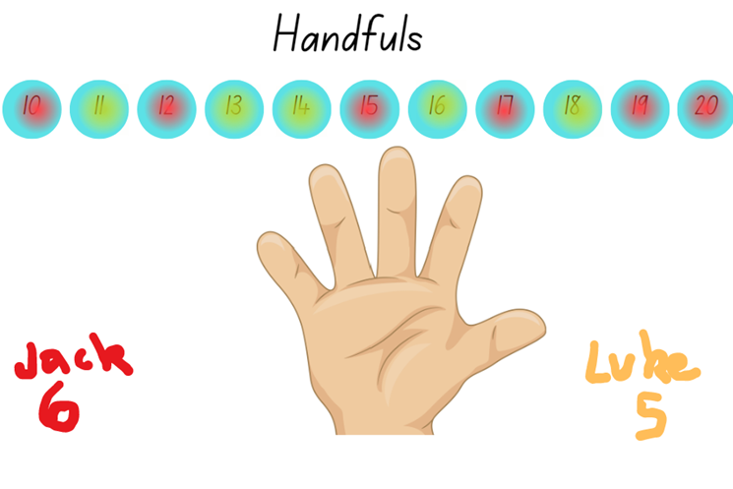
Images licensed in accordance with the Canva Content License Agreement.
This table details assessment opportunities and differentiation ideas.
Assessment opportunities | Too hard? | Too easy?
What to look for:  - Can students count a specified number of objects to 20 and match with the correct numeral? (MAE-RWN-01, MAE-RWN-02)  - Can students arrange the counters in an orderly way, such as rows or groups and then count on to determine the total? (MAO-WM-01, MAE-RWN1, MAE-RWN-02)  What to collect:  - observation of student counting strategies. (MAE-RWN-01, MAE-RWN-02) | Students are not able to count objects in the range to 20.  - Provide a smaller collection of counters for students to represent numbers in the range one to 10.  - Provide a copy of Resource 8: Double ten-frame for students to arrange and count their counters. | Students can count objects in the range to 20.  - Students grab 2 handfuls and match to numbers in the range 20 to 40 using Resource 9: Two handfuls  - Students play a game called 30 or bust. Roll a zero to 10 die and add counters to Resource 10: 30 or bust! Students decide when to stop rolling. Closest to 30 wins. If students exceed 30, they are out.

Volume of objects – 30 minutes

Part 1 – Introducing volume
- Introduce the definition of volume.
Volume: The amount of space occupied by an object.
- Display a small object and a large object from the classroom. Brainstorm and record the words students use to describe the 2 objects. Make connections to other measurement such as mass, length and area. Circle or highlight words relating to volume and comparison of size, such as the same, almost the same, equal, small, smaller, large, larger, big, bigger. Introduce the phrase ‘takes up more space’ to the vocabulary list.
- Select a student to come to the front and stand next to you. Ask the class to compare the student’s volume to yours (the teacher’s volume) using the definition for volume already discussed.
- Display a deflated balloon. Discuss and compare its volume before and after you inflate it.
- Display Resource 11: Volume in our world. Students turn and talk to compare the volume of the animals and people. Ask students to think about their own families, pets, cars and houses and to share their thoughts and reasoning about volume.

Part 2 – Comparing volume
Note: Students will need interlocking blocks of the same size. Use of matching-sized blocks supports student understanding of uniform informal units. Use of multiple-sized blocks makes comparison of volume more problematic.
- Refer to the UFOs constructed in Lesson 1 and Lesson 3.
- Explain that students are to construct an alien using between 10 and 20 blocks.
- Provide up to 20 interlocking blocks for students to make an alien.
- Groups of 4 to 5 students share their design. Students compare the amount of space that their alien occupies by placing them side by side and observing from multiple points of view. Students then count the number of blocks used to determine whose alien has the greatest volume. Observe the strategies, vocabulary and reasoning used by students in their groups.
Note: Students may compare the volumes of 2 objects made from blocks or connecting cubes directly by deconstructing one object and using its parts to construct a copy of the other object.
- Make a track on the floor or table using string, wool or chalk. Label one end ‘smallest volume’ and the other end ‘largest volume’.
- Select students to place numeral cards 10 to 20 in appropriate positions on the number track.
- Explain that the volume of the aliens can be compared by counting the number of blocks. Remind students that the blocks must the same size to compare them. Instruct students to count the number of blocks in their alien. Swap with a peer and check the count.
- Invite students with an alien of 10 blocks to position their alien on the alien number line. Repeat until all students have matched their volume to the numeral on the track, see Figure 4.
Figure 4 – Alien number line
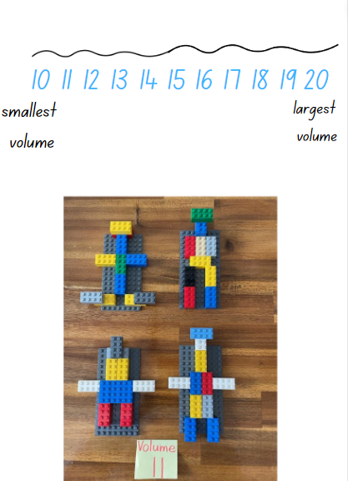
- Ask:
- Who has an alien that looks the same as another? Do they have the same volume?
- Who has an alien that is different to another? Which has the greater volume?
- How can we work out which alien has the greatest/smallest volume?
- If I used different sized blocks, what effect does that have on the volume?
- If an alien is too big for a spaceship, what can you do?
- Focus students’ attention on one volume on the number track, for example 11, where there are multiple aliens. Explain that the aliens may look different but have the same volume. Note that students will explore this idea further in Lesson 5.

Consolidation and meaningful practice: Points of view – 15 minutes
- Select one alien from the class collection. Demonstrate sketching the alien from the front view, drawing individual blocks. Count and record the number of blocks represented in the drawing.
- Students draw their own alien and record the number of blocks used.
- Repeat with another student’s alien.
This table details assessment opportunities and differentiation ideas.
Assessment opportunities | Too hard? | Too easy?
What to look for:  - Can students describe and compare objects by the amount of space they occupy? (MAO-WM-01, MAE-3DS-02)  - Can students describe and compare objects by the number of uniform informal units used? (MAO-WM-01, MAE-3DS-02)  What to collect:  - photograph of class collection arranged in size (MAO-WM-01, MAE-3DS-02)  - student drawings of their alien and count of blocks. (MAO-WM-01, MAE-3DS-02) | Students are not able to describe and compare volume.  - Ask students to make a model from 5 blocks and a second model from 10 blocks. Support students to observe and describe differences between the models.  - Construct a simple model for students to copy. Ask students to count the blocks used in the model. | Students can describe and compare volume.  - Student pairs play a barrier game, copying unseen aliens based on their partner’s descriptions.  - Ask students to build and draw 3 aliens of similar design but of different size/scale. Students count and label the number of bricks and, look for patterns. See Figure 5.
Figure 5 – Pattern alien
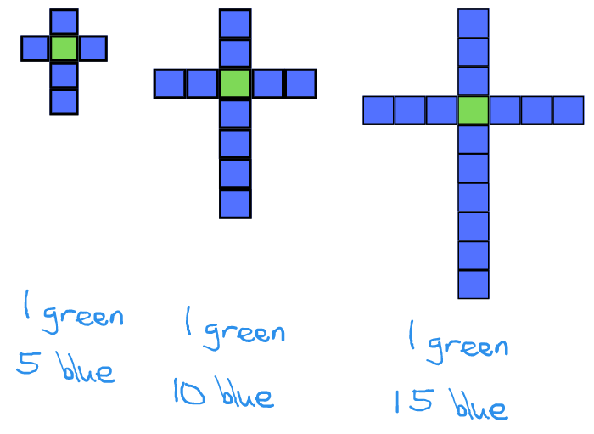

Lesson 5: Different objects, same volume
Core concept: Objects that appear different may have the same volume.
The table below contains suggested learning intentions and success criteria. These are best co-constructed with students.
Learning intentions | Success criteria
Students are learning that:  - counting and numerals are connected to quantities  - the amount of space an object takes up is called volume  - the volume of objects can be described and compared. | Students can:  - build objects that have the same volume but look different  - compare objects directly by constructing and deconstructing 2 objects  - use comparative language to describe volume.

Daily number sense: Teacher choice – 10 minutes
- From a class need surfaced through formative assessment data, identify a short, focused activity that targets students’ knowledge, understanding and skills. Example activities may be drawn from the following resources:
- Mathematics K-6 resources
- Universal Resources Hub.

Building challenge – 30 minutes
Note: In each of the following cube activities, cubes must be placed or stacked so that their edges align directly with the edges of at least one other cube, with no gaps or overlaps. When making objects from 3 cubes there are only 2 possible solutions. When using 4 cubes there are 8 possible solutions and for 5 cubes there are 29 possible solutions. Refer to The Puzzling World of Polyhedral Dissections (Fig. 51). If you are using cubes that do not interlock, ensure students understand that each cube must line up so all the edges are flush.
- Revise the concept and definition of volume.
Volume: The amount of space occupied by an object.
- Display 2 differently sized water bottles. Ask which takes up the most space.
- Display 2 large cubes of equal size, like dice. Through questions and discussion, establish an understanding that the dice have the same volume because they take up the same amount of space.
- Continue the alien story from previous lessons. Explain that these aliens do not like to walk, so they have jetpacks that they use to fly around. The jet packs are made from 4 blocks of the same size. The alien commander is wondering how many different shaped jetpacks there are with only 4 cubes.
- Show the class interlocking cubes to be used to make jetpacks. Through questions and discussion, establish that the interlocking cubes have the same volume because they take up the same amount of space.
- Model making one object from 4 cubes, explaining that the edges of each cube must align with the edges of at least one other cube. When finished, state that the jetpack has a volume of 4 cubes.
- Select 3 students to make an object each out of 4 cubes and display them together to the class. Ask:
- Do they look the same or different to each other?
- Do these objects have the same volume? Why?
- How can I prove that they are not the same? (Turn or flip)
- Eliminate duplicate jetpacks that have the same structure as an existing jetpack. Use the remaining models to make a class collection. Leave the collection in a central place.
- Allocate interlocking blocks to student groups of 3 or 4. Ask each group to make as many different four-block jetpacks as possible.
- Observe student strategies, vocabulary and reasoning when making and comparing the jetpacks. Encourage students to compare their models to those already in the class collection.
This table details assessment opportunities and differentiation ideas.
Assessment opportunities | Too hard? | Too easy?
What to look for:  - Do students identify the attribute of volume as the amount of space an object or substance occupies? (MAO-WM-01, MAE-3DS-02)  - Can students compare the volume of 2 models and identify if the volume is the same or different? (MAO-WM-01, MAE-3DS-02)  What to collect:  - photograph of group constructions. (MAO-WM-01, MAE-3DS-02) | Students are unable to make and compare more than one four-block object.  - Provide a model of 3 different jetpacks for students to copy, describe and compare.  - Display 2 different jetpack designs. Model how to deconstruct one model to copy the second, showing that each has 4 blocks. | Students can make and compare more than one four-block object.  - Challenge students to find all 8 possible jetpacks. Ask how students can prove that there are no further models.  - Provide additional blocks. Instruct students to make at least 12 different five-block models.

Consolidation and meaningful practice: Class collection – 10 minutes
- Gather all the students around the class collection.
- Invite students to nominate add a new jetpack to the class collection. Ask the student to explain why it is different from existing jetpacks. Invite others to challenge the addition of the jetpack.

Lesson 6: Packing in layers
Core concept: Internal volume can be explored by packing and stacking with no gaps.
The table below contains suggested learning intentions and success criteria. These are best co-constructed with students.
Learning intentions | Success criteria
Students are learning that:  - internal volume can be measured and compared using uniform blocks  - when comparing and describing the internal volume of containers it is useful to use language such as full, half full and empty. | Students can:  - pack blocks into containers so that there are no gaps and the internal space is covered  - measure and compare the internal volume of containers  - use vocabulary, such as full, half full and empty, to describe the space inside a container.

Daily number sense: Facts about numbers – 15 minutes
- Build student understanding of numbers and quantity value by comparing numbers.
- Display the numbers in Resource 12: Facts about numbers or any set of numbers to differentiate for the learning needs in the class.
- Ask students to share what they can see and what they know about the numbers.
The table below outlines stimulus prompts to generate conversation about the topic, along with anticipated responses from students.
Prompts | Anticipated student responses
- What can you tell me about these numbers?  - Where might you see these numbers in real life?  - Select a number from the chart. What comes before and after this number?  - What patterns do you notice?  - What groups can you make with these numbers?  - What is a number that we could add to a group? Explain your thinking.  - What is a number that could not go into any of the groups that you see? Explain your thinking. | - Say the name of each number.  - Shops, sport games, computer games, television.  - Students state the number before and after.  - The numbers are not in order. There are 2 twenties in the middle. That there are 2 teen numbers.  - 80 could go with the tens; 18 could go with the teens.  - Various responses with explanation.  - 6 does not belong because it only has one digit and there are no other sixes; 33 does not belong because there are no other threes.
This table details assessment opportunities and differentiation ideas.
Assessment opportunities | Too hard? | Too easy?
What to look for:  - Are students communicating their reasoning when grouping numbers? (MAO-WM-01, MAE-RWN-01)  - Can students identify the number one less and one more? (MAE-RWN-01)  - Can students count forwards to at least 30 and backwards from 20? (MAE-RWN-01)  What to collect:  - observations of students’ reasoning. (MAE-RWN-01) | Students are unable to state anything about the numbers displayed.  - Select a single number. Ask the students to state facts about that number.  - Provide a number track to 30. Students match the numbers displayed with the numbers on the track. | Students display a detailed understanding of the numbers displayed.  - Students use a place value chart and MAB materials to model and regroup the two-digit numbers. For example, 90 is 9 tens or 8 tens and 10 ones.  - Provide bundles of craft sticks. Ask students to model the numbers displayed and then state 10 more and 10 less.

Packing and stacking Part 1 – 10 minutes
- Display MAB materials.
- Model how the ‘long’ is made of 10 units stacked together. Copy the ‘long’ using units and ask students to count the units.
- Explain to students that the stack of 10 units (or 10 ones) means that the ‘long’ has a volume of 10 as this is the amount of space it takes up.
- Model turning and positioning the ‘long’ in different orientations and explain how the 10 units are always together stacked so the orientation or position does not alter the volume – it is always 10.
- Show students 10 ‘units’ and ask students to turn and talk with a partner and problem solve what the volume of all the 10 units is together. Discuss.
- Provide students with units. Explain that, with a partner, students will explore volume using MAB units. Students will use MAB units to problem solve and create as many representations as possible that have a volume of 10. Explain that the units must line up to the edges of at least one other unit.
- Students will use a digital device or draw their representation to be shared with the class on an anchor chart. See Figure 6.
Figure 6 – Example of an anchor chart
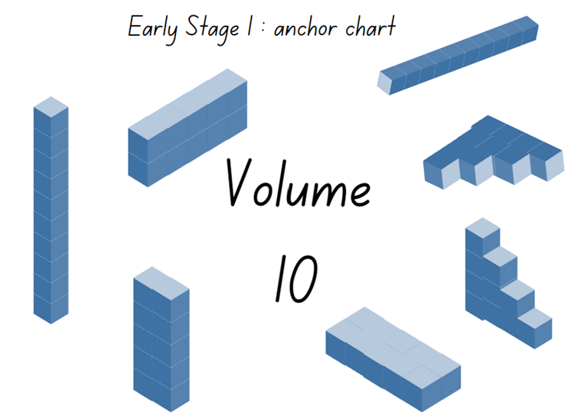
Images licensed in accordance with the Canva Content License Agreement

Packing and stacking Part 2 – 30 minutes
Note: Prior to the lesson, ask students to bring in empty small cardboard boxes such as tissue, biscuit, tea or pasta boxes. In Early Stage 1, comparisons of internal volume can be made directly, using methods such as packing the contents of one container into another. Internal volume can also be compared indirectly, as in seen in Lesson 7.
- Continue the story about the aliens from previous lessons. Explain that, here on Earth, people also measure and compare how much containers can hold. One way to do that is to pack containers with blocks of the same size.
- Display the selection of boxes available to the class. Explain that the word ‘container’ applies to these boxes, as well as to objects such as bottles, jars and tubs.
- Explain that students will pack and stack MAB materials or other uniform informal objects to explore the internal volume (capacity) of boxes. Students do not need to count the blocks.
- Model the steps for direct comparison with blocks:
- Pack a container with no gaps or spaces.
- Select a second container.
- Transfer the blocks from container 1 to container 2.
- Share reasoning about the internal volume (capacity) of each container such as container 1 holds more blocks than container 2 because it is longer and taller.
- Model recording your results.
- Provide students with MAB units and a digital device or writing materials to record their investigations. Ensure students understand that the units must be packed with no gaps or spaces.
- Display the packed boxes and ask:
- What difficulties did you encounter as you packed and layered?
- Can you predict which one will have the greatest internal volume?
- Can you see any that you think will have the same internal volume? Why?
- Why do you think having no gaps or spaces is essential?
- What can you do to ensure there are no gaps or spaces?
- Do you think the units were a good measuring device? Why or why not?
- Students select a second container for comparison. Students remove the MAB materials from their first container and pack them into the second, observing whether there is not enough room, if the blocks fit exactly or if there is additional space.
This table details assessment opportunities and differentiation ideas.
Assessment opportunities | Too hard? | Too easy?
What to look for:  - Can students compare the internal volume of 2 boxes by packing with no gaps, recognising this affects the accuracy of results? (MAO-WM-01, MAE-3DS-02)  - Do students recognise which box has the greatest internal volume, justifying their answer by stating how many units were used? (MAO-WM-01, MAE-3DS-02)  - Can students keep track of the count as they count a large collection of units? (MAE-RWN-01)  What to collect:  - photographs of students’ boxes and annotated work samples. (MAO-WM-01, MAE-3DS-02) | Students are not able to compare internal volume by stacking without leaving gaps or explain their results.  - Provide support and model how gaps will result in an inaccurate measure of volume. Support students to pack a small container, measuring the internal volume.  - Provide students with a word bank and matching visual examples to support vocabulary development. | Students can pack various containers and record the volume accurately.  - Ask students to create a problem for a partner such as, find another box that is of a different shape to compare with the first box, but that has the exact same internal volume.  - Ask students to use other concrete materials such as square tiles or coloured bricks to pack and fill their box, comparing if the internal volume results are the same or different. Students record their findings.

Consolidation and meaningful practice: Real life packing and stacking – 10 minutes
- Display Resource 13: Cargo ships and/or Resource 14: Delivery trucks and ask:
- What do you see and what do you wonder?
- Have these cargo ships and/or delivery trucks been packed and stacked with no gaps? How do you know?
- Can we accurately measure the internal volume of the ship or truck? Can we estimate which cargo ship and/or delivery truck has the greatest internal volume?
- Are the cargo boxes and/or the objects on the delivery trucks useful shapes for packing and stacking? Why or why not?
- How would you pack and stack the cargo boxes and/or objects so that more can fit?
- Which cargo ship and/or delivery truck has been packed and stacked using the internal volume most effectively? Explain your thinking.

Lesson 7: Filling and pouring
Core concept: Containers can look different but can have the same internal volume (capacity).
The table below contains suggested learning intentions and success criteria. These are best co-constructed with students.
Learning intentions | Success criteria
Students are learning that:  - when comparing internal volume, containers that are shaped differently can still have the same volume  - when comparing internal volume, it is helpful to fill and pour the contents from one container into another and observe the level reached. | Students can:  - fill various containers and recognise which container holds the most and which holds the least  - identify that 2 containers may look different but have the same internal volume (capacity).

Daily number sense: Jellybean challenge – 15 minutes
- Build student understanding of how to keep track of a count by exploring collections, such as a bowl of jellybeans.
- Display Resource 15: Lots of spots. Ask students to turn and talk, keeping track how many spots on each animal and then comparing the number of dots.
- Share students’ count for one animal at time. Ask:
- How did you count and how do you know that the strategy you used is useful?
- How do you know that you counted all the dots on the animal?
- Did you see any patterns of spots when you were counting?
- Are there any patterns that remind you of patterns you have seen before?
- Display Resource 16: Jellybean challenge or a real bowl with 20 jellybeans for students to view.
- State that there are 20 jellybeans in the bowl. You are wondering how this can be proven without counting the jellybeans by ones.
- Allow time for students to turn and talk. Observe suggested strategies and how students are estimating and grouping the jellybeans to count the collection. Ask:
- Do you agree that there are 20 jellybeans? How do you know?
- How can you accurately count this collection more efficiently than counting by ones?
- Provide student pairs with writing materials. Ask students to record their ideas for sharing with the class.
- As a class, share strategies and discuss solutions. Ensure that students can support their solutions or make drawings that represent the jellybeans as groups. For example, students draw the jellybeans in patterns like dice patterns or domino patterns, or count by colour to track count more accurately. See Figure 7.
Figure 7 – Examples of solutions
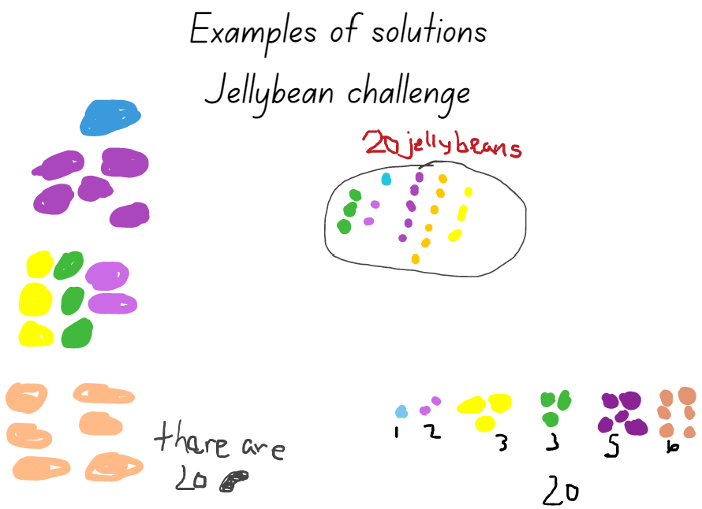
This table details assessment opportunities and differentiation ideas.
Assessment opportunities | Too hard? | Too easy?
What to look for:  - Can students subitise a small quantity without counting and identify the number of items altogether? (MAO-WM-01, MAE-RWN-01)  - Can students count a collection and keep track of the count? (MAE-RWN-01)  What to collect:  - photographs and recordings of students' solutions. (MAO-WM-01, MAE-RWN-01) | Students are unable to track the count.  - Provide coloured counters for students to count by ones.  - Provide students with a copy of the template to mark off jellybeans as they counted by 2 or 5.  - Provide students with counters to create 5 small groups of 2. Support students to count on from the first group of 2. Increase the quantity of counters in each group as needed.  - Display dice and domino patterns to 6 for students to view and subitise. | Students can subitise and create patterns to assist with counting a collection.  - Ask students to draw 2 different representations of 20 jellybeans as equal groups. Increase to 40 jellybeans if needed.  - Draw different ways of sharing the 20 jellybeans between the student and some friends.

Filling and comparing – 40 minutes
Note: For measuring and comparing the internal volume of various containers, you will need rice, sand, water, bird seed or lentils, as well as various shaped containers that have the same and/or different internal volume. For example, various one litre bottles of juice, water or milk, shampoo bottles, jars and various tubs of yoghurt. For indirect comparison, students will need 2 identical transparent plastic cups.
- Continue the story about the aliens from previous lessons. Remind students that, here on Earth, humans fill and compare how much containers can hold. In Lesson 6 the students packed containers with blocks. Another way to check how much containers can hold is to fill containers with material that can be poured.
- Explain that students will be comparing the internal volume of various containers which is how much the different containers can hold. This is also called capacity.
- Draw attention to the various containers the class will compare. Explain that you are wondering which will hold the least, which will hold the most and if any will hold the same amount, even if they look different.
- Provide time for students to explore and manipulate the various containers, observing these from different points of view.
- Ask students to Think-Pair-Share with a partner and discuss what they observed and what they are wondering. Monitor discussions, share points of interest and identify misconceptions.

Direct comparison
- Instruct students to select 2 containers to compare.
- Revise (by modelling) how to directly compare internal volume (capacity) by pouring the contents of one full container into another, using language such as full, empty, about half full.
- Provide students with measuring material, such as rice, lentils, bird seed or sand, a funnel and a tray to capture spills.
- Invite students to repeat steps with different containers.

Indirect comparison
Note: Indirect comparison involves filling the containers and pouring the contents into 2 identical containers to compare the levels, see Figure 8.
Figure 8 – Indirect comparison
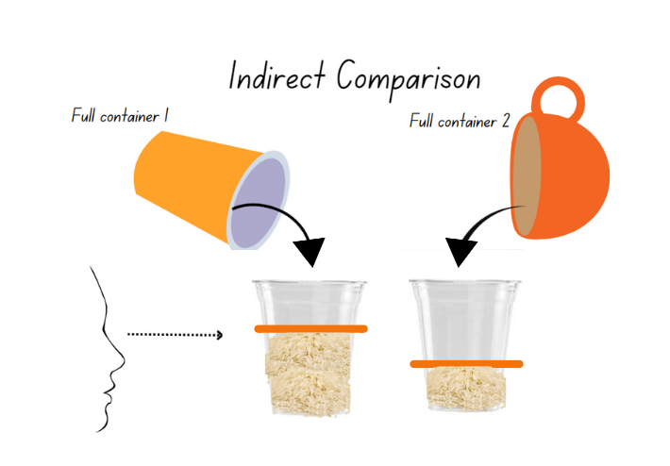
Images licensed in accordance with the Canva Content License Agreement.
- Provide students with 2 identical plastic cups.
- Model how to indirectly compare 2 of the objects, as described in Figure 9 above.
- Instruct students to explore the containers in the collection by indirectly comparing internal volume (capacity).

Discussing the mathematics – 10 minutes
- Discuss findings and view similarities and differences in measuring results. Ask:
- Are there any containers you found that had the same internal volume? Are they the same shape?
- What was easier, direct comparison or indirect comparison? Why?
- What challenges did you have?
- Why do think you might need direct/indirect comparison in real-life situations?
This table details assessment opportunities and differentiation ideas.
Assessment opportunities | Too hard? | Too easy?
What to look for:  - Can students explain how they have compared the internal volume (capacity) directly and indirectly? (MAO-WM-01, MAE-3DS-02)  - Can students recognise and explain why containers that are shaped differently may have the same internal volume? (MAO-WM-01, MAE-3DS-02)  What to collect:  - photographs and annotated work samples of students’ comparisons. (MAO-WM-01, MAE-3DS-02) | Students are not able to compare 2 containers.  - Provide students with 2 containers of significantly different capacity. Model direct comparison to show different capacity. Students repeat with a third container.  - Provide students with 2 containers of significantly different size. Model indirect comparison to show different capacity. Students repeat with a third and fourth container. | Students can compare internal volume (capacity) directly and indirectly.  - Use indirect comparison and reasoning to compare and order 4 containers. For example, A holds more than B and B holds more than C, so C is the smallest.  - Ask students to identify 2 containers that are a different shape but have the same internal volume. Students then explain how this is possible using drawings, diagrams and words.

Lesson 8: Investigating 3D objects
Core concept: An object’s features can affect its internal volume.
The table below contains suggested learning intentions and success criteria. These are best co-constructed with students.
Learning intentions | Success criteria
Students are learning that:  - there are various helpful ways to keep track of a count when counting a large collection  - 3D objects can have a different appearance and still have the same internal volume  - internal volume can be measured and compared by filling  - when comparing internal volume, it is helpful to fill and pour the contents from one container into another and observe the level reached. | Students can:  - apply strategies to help with keeping track of a count when counting a large collection  - identify 2 containers that appear different but have the same internal volume by comparing  - measure and compare the internal volumes (capacities) of 2 containers.

Daily number sense: Construction site – 10 minutes
- Build student understanding of whole numbers, 2D shapes and 3D objects by noticing and recording items from a construction site.
- Explain that the students are the supervisor or boss of a very busy construction site. It is very important for builders to keep a record of the things that they have on their site. This makes sure that they keep people safe and that they do not lose things on the site.
- Display Resource 17: Construction site. Ask:
- What do you see?
- What do you wonder?
- What do you know about construction sites? Make a vocabulary list of items.
- What 2D shapes can you see? Draw and label representations of them.
- What 3D objects can you see? Draw and label representations of them.
- Can you see only 6 of something?
- Can you see exactly 10 of something?
- Can you see more than 20 of something?
- Record items that students notice. Draw attention to some of the shapes and objects that they have worked with in the previous lessons.
This table details assessment opportunities and differentiation ideas.
Assessment opportunities | Too hard? | Too easy?
What to look for:  - Can students keep track of the count as they count collections? (MAE-RWN-01)  - Can students subitise small quantities of items without counting? (MAE-RWN-01)  - Can students use counting strategies and arrangements, such as grouping or marking to efficiently count quantities? (MAO-WM-01, MAE-RWN-01)  What to collect:  - photographs and annotated work samples of student’s counting and identify the number of items. (MAO-WM-01, MAE-RWN-01, MAE-RWN-02) | Students are not able to match quantities with numerals or track a count.  - Nominate specific items for students to count, such as hats, dogs, spades, vehicles and piles of dirt.  - Draw students’ attention to specific shapes, such as how many rectangles there are. | Students can match quantities with numerals or track a count.  - Students identify 3 triangles and 3 non-triangles in the image.  - Ask students to identify and continue patterns that they can see in the image.

Features of common boxes: Part 1 – 20 minutes
Note: Prior to the lesson, collect various real-life examples of cubes and rectangular prisms, ensuring that there are enough for each student. For example, tissue boxes, cereal boxes, cling wrap, foil or toothpaste boxes, pasta boxes, tea boxes, boxes of chocolate and muesli bars. Students will also need to use rice, sand, water, bird seed or lentils for measuring.
- Continue the alien story from previous lessons. Explain that the aliens are about to leave Earth and head back to their home planet. They have asked for more information about the boxes that they see everywhere they go.
- Display the real-life sample boxes. Support students to use descriptive vocabulary, such as flat, longer, shorter, biggest, smaller than and corner. Ask:
- What is the same about the boxes?
- What is different about the boxes?
- How can you describe these boxes? What do they remind you of? Where have you seen them before?
- What can you see? Are there any 2D shapes that you can name and describe?
- Explain that students will be working with a partner. Each student will select a box, explore the features of their selected box and explore the internal volume (capacity) by directly comparing 2 boxes.
- Provide students with modelling clay or wool and a digital device or writing materials to record results.
- Support students to identify and name the rectangles or squares on each face, then use wool or modelling clay to make and represent the outlines of those shapes.
- Ensure that each student has their own box and that they are identifying and representing of each face using modelling clay or wool. See Figure 9.
Figure 9 – Examples of recordings
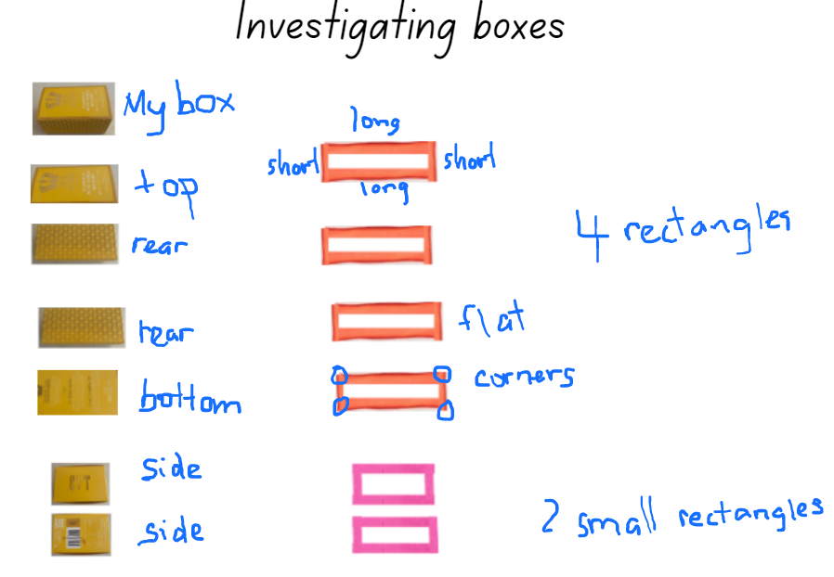

Internal volume of boxes: Part 2 – 20 minutes
- Explain that students will now compare how much each box holds.
- Students will work with their partner to fill one box with either rice, sand, bird seed or lentils. Students then predict if their partner’s box will hold the same, hold less or hold more of the content as they pour from one box into the other to directly compare.
- Alternatively, students can indirectly compare their boxes by pouring the contents into 2 containers that are the same. See Figure 10.
Figure 10 – Examples of comparisons
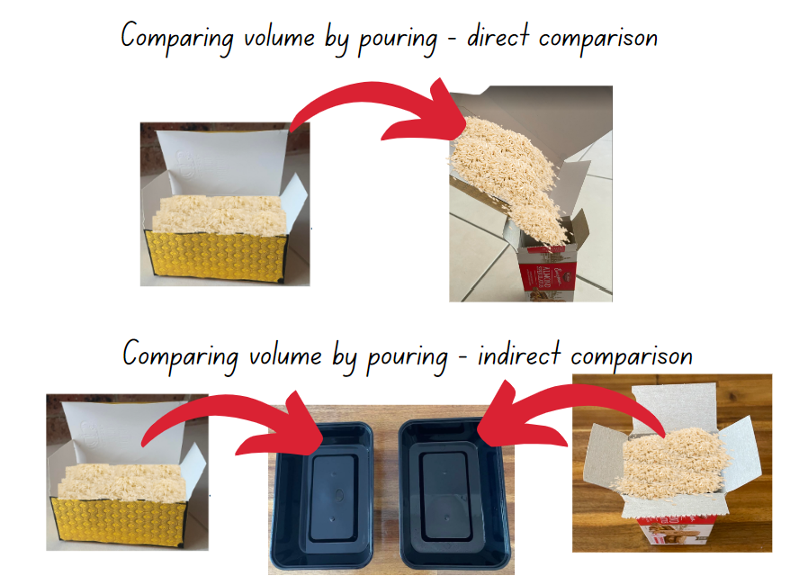

Discussing the mathematics – 10 minutes
- Discuss findings and order the boxes to view similarities and differences in measuring results. Ask:
- Are there any boxes you found that hold the same? Are they the same shape?
- Are there any boxes that you predicted correctly? What strategy did you use?
- Are there any predictions where the result was very different? Can you explain what was challenging when predicting this box?
This table details assessment opportunities and differentiation ideas.
Assessment opportunities | Too hard? | Too easy?
What to look for:  - Can students explain their predictions and how they have compared the 2 boxes to show which one holds the most? (MAO-WM-01, MAE-3DS-02)  - Can students recognise and explain why containers that are shaped differently may have the same internal volume? (MAO-WM-01, MAE-3DS-02)  What to collect:  - photographs and annotated work samples of students’ investigations and comparisons. (MAO-WM-01, MAE-3DS-02) | Students are not able to compare 2 containers.  - Provide students with 2 boxes or containers of significantly different size. Model direct comparison to show different capacity. Students repeat with a third box or container.  - Provide students with 2 boxes or containers of significantly different size. Model indirect comparison to show different capacity. Students repeat with a third and fourth box or container. | Students can predict, order, compare and measure internal volume (capacity) and record results.  - Ask students to identify 2 boxes that are a different shape but have the same internal volume. Have students use drawings, diagrams and words to explain how this is possible.  - Ask students to use a different material (for example, if they used sand, they now use bird seeds or lentils) to fill their box and predict if the results will be the same. Students record their findings.

Resource 1: T-shirt sort 1
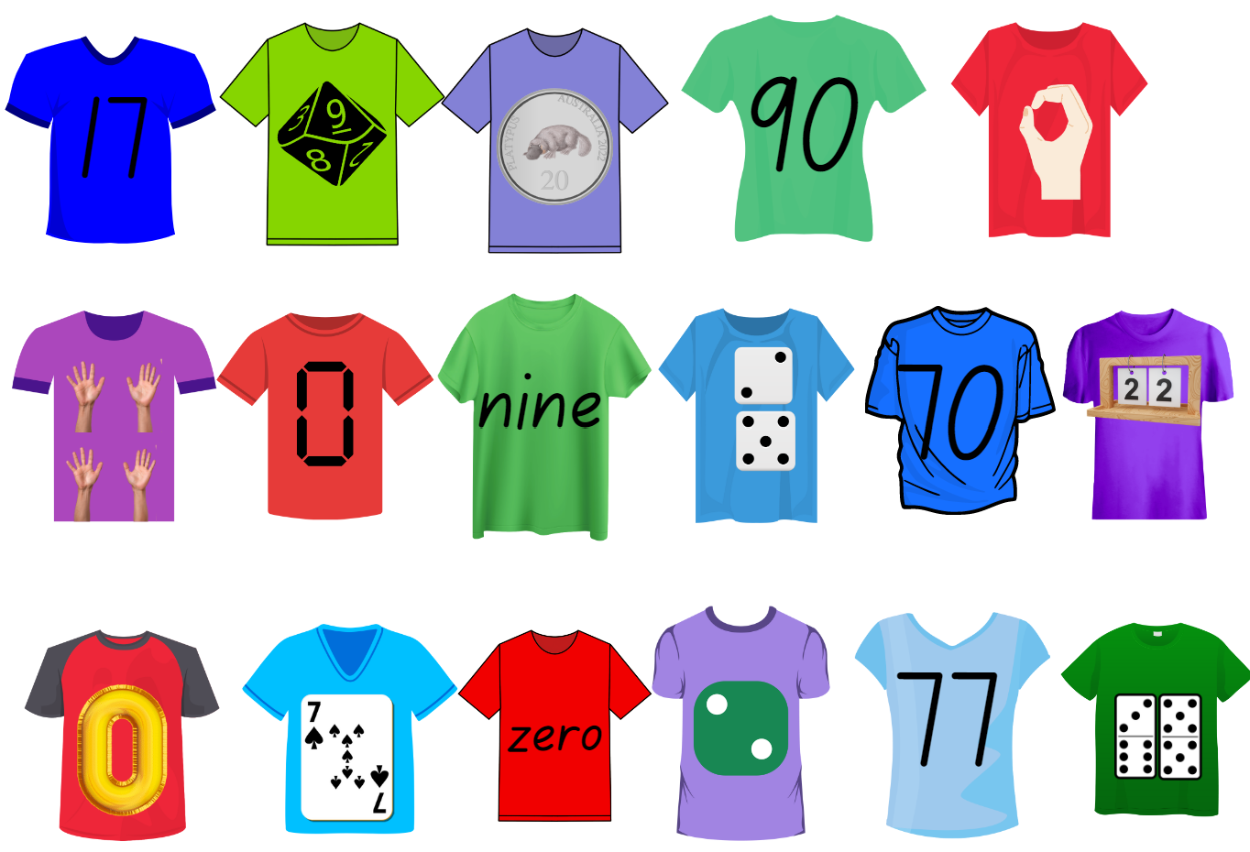
Images licensed in accordance with the Canva Content License Agreement.

Resource 2: Modified T-shirt sort
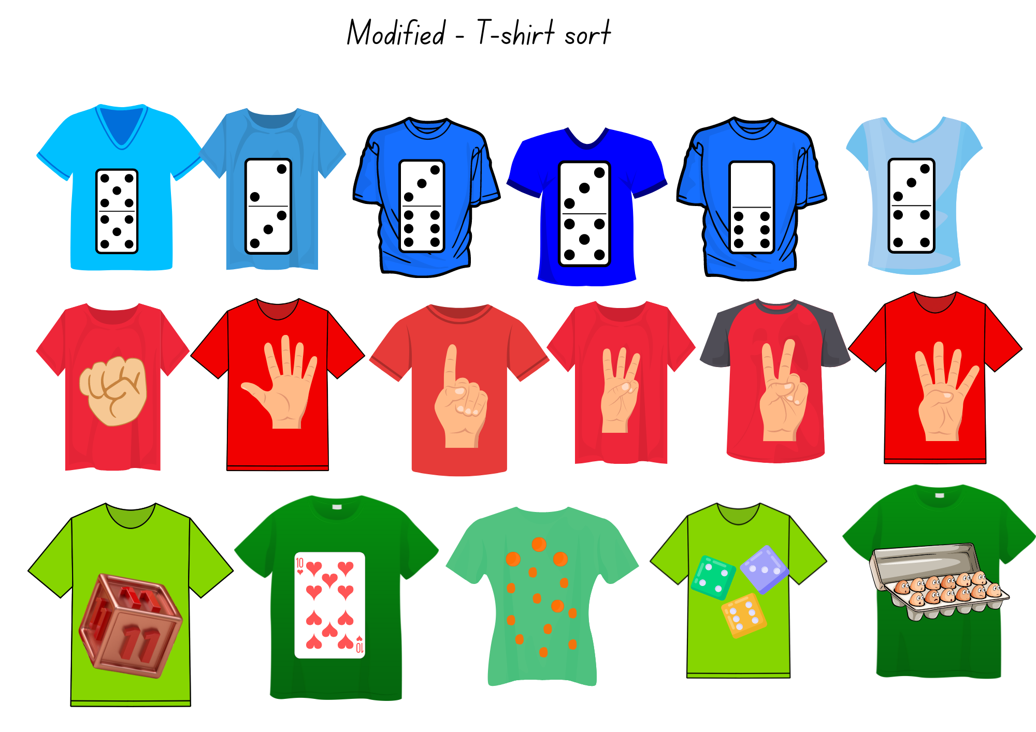
Images licensed in accordance with the Canva Content License Agreement.

Resource 3: UFOs
Images licensed in accordance with the Canva Content License Agreement.
Images licensed in accordance with the Canva Content License Agreement.

Resource 4: Object sort cards
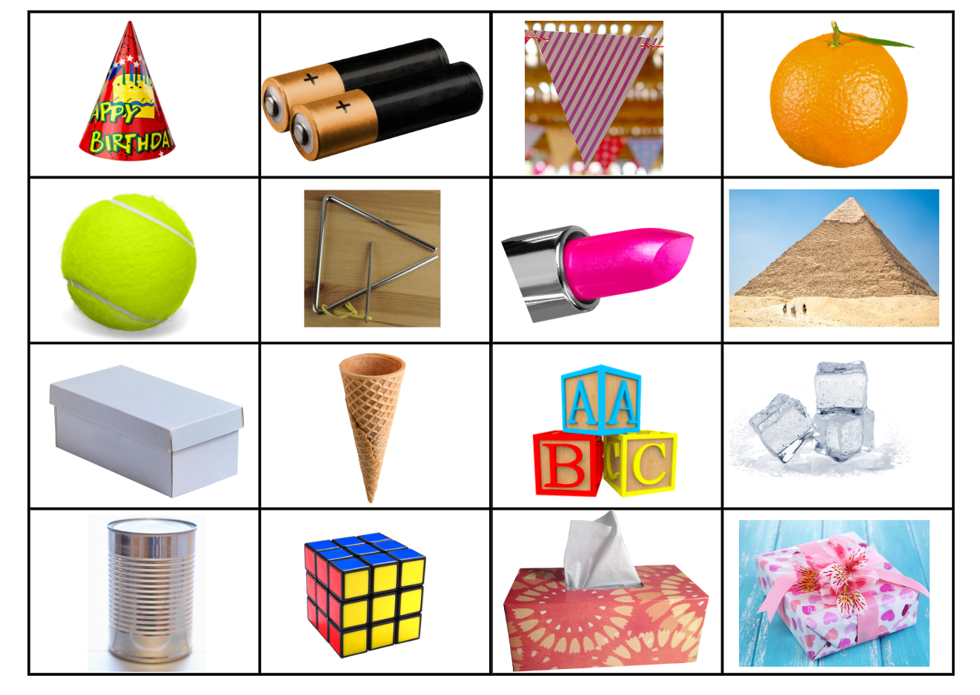
Images licensed in accordance with the Canva Content License Agreement.

Resource 5: T-shirt sort 2 and 2A
Set 2
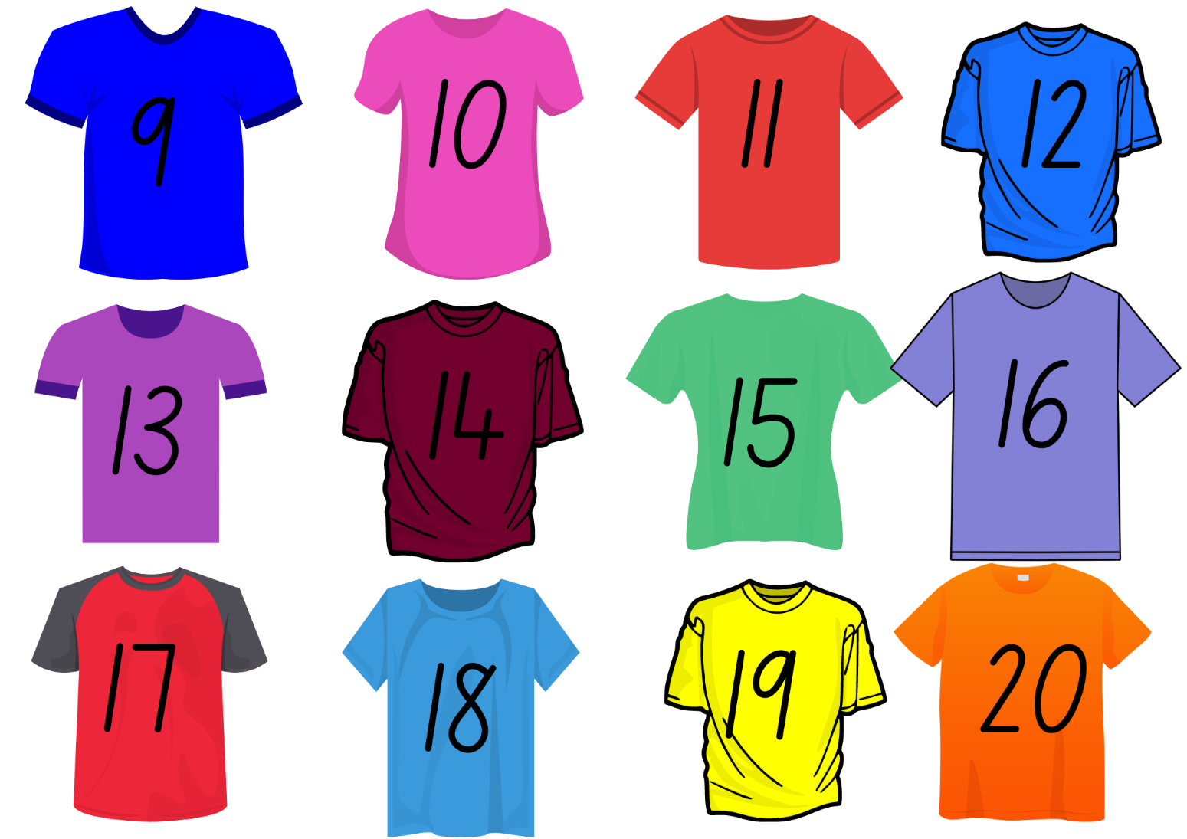
Images licensed in accordance with the Canva Content License Agreement.
Set 2A
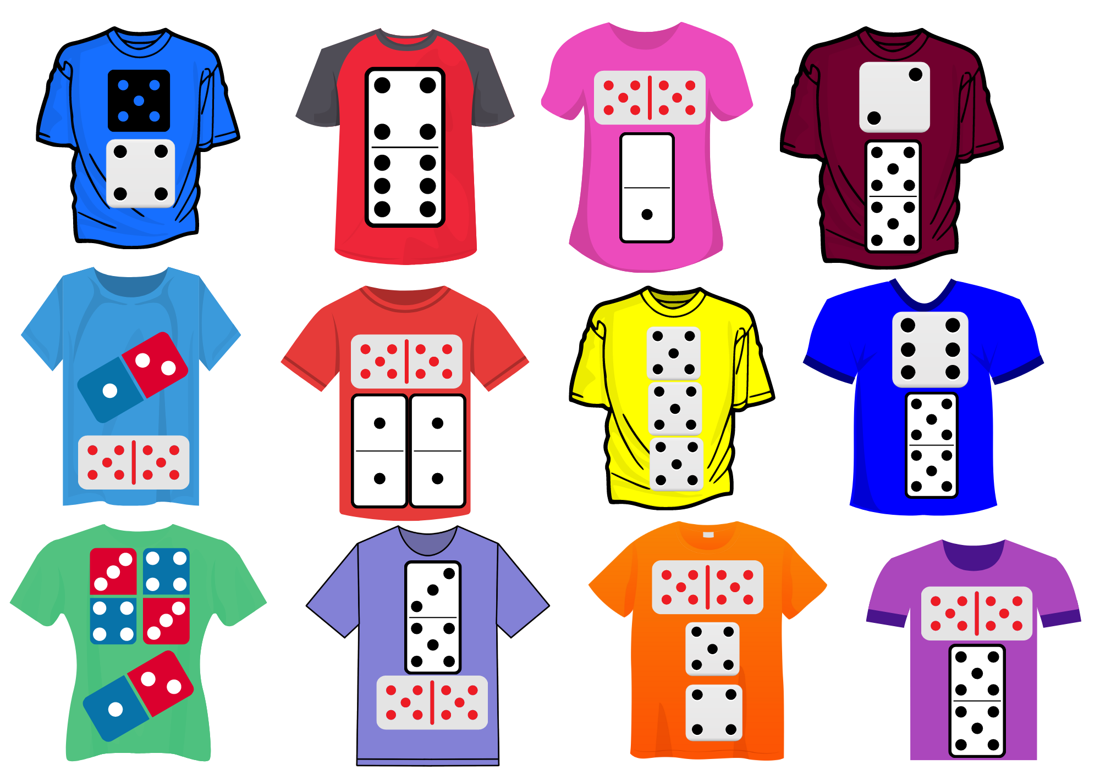
Images licensed in accordance with the Canva Content License Agreement.

Resource 6: T-shirt sort 3 and 3A
Set 3
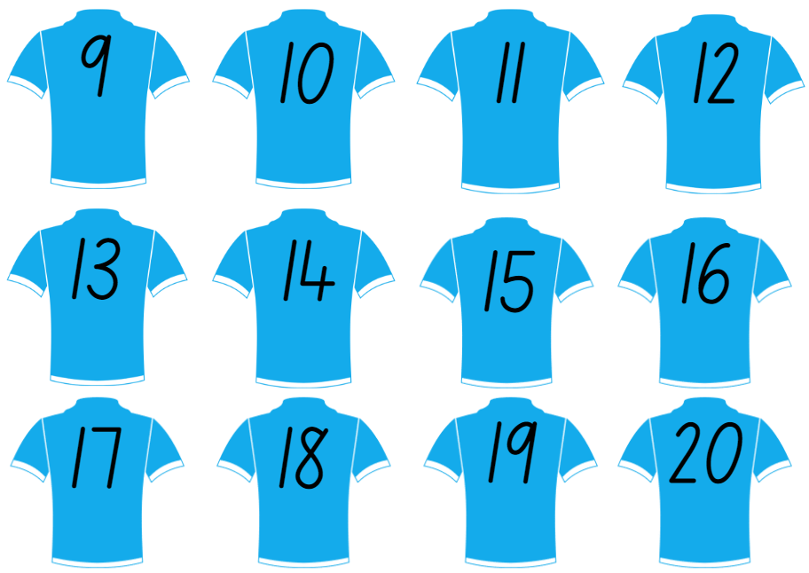
Images licensed in accordance with the Canva Content License Agreement.
Set 3A
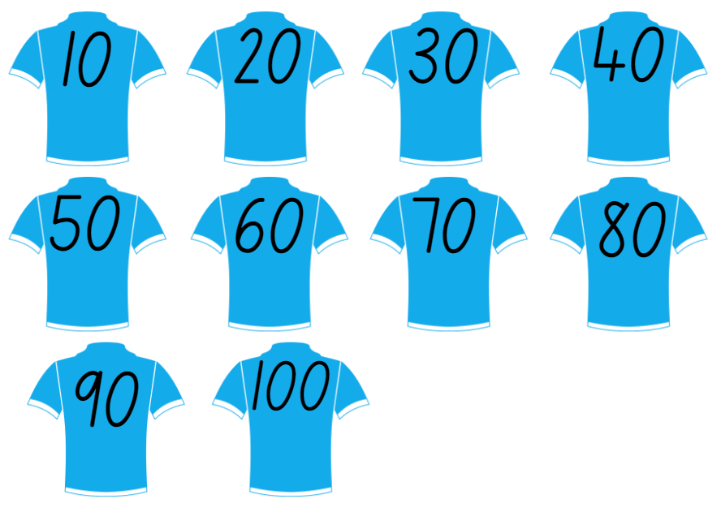
Images licensed in accordance with the Canva Content License Agreement.

Resource 7: Handfuls game
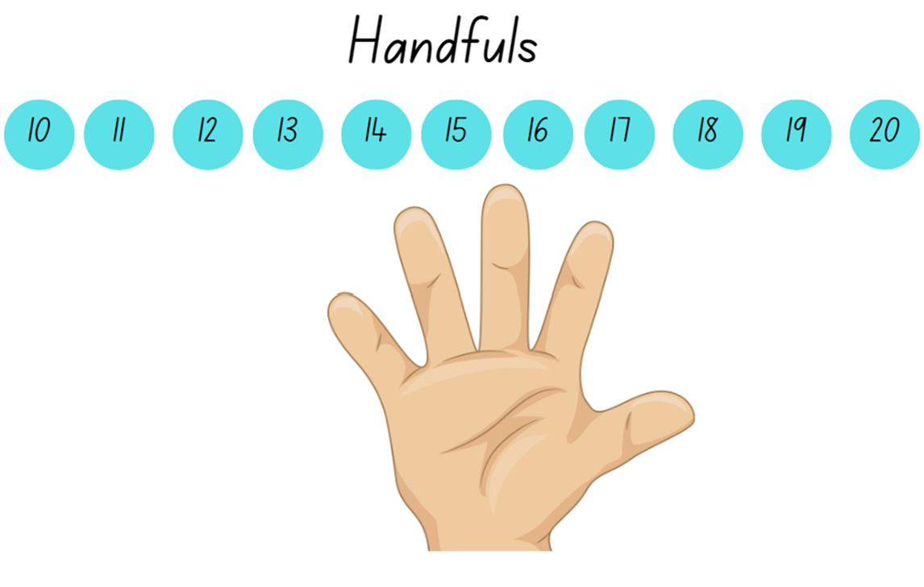
Images licensed in accordance with the Canva Content License Agreement.

Resource 8: Double ten-frame
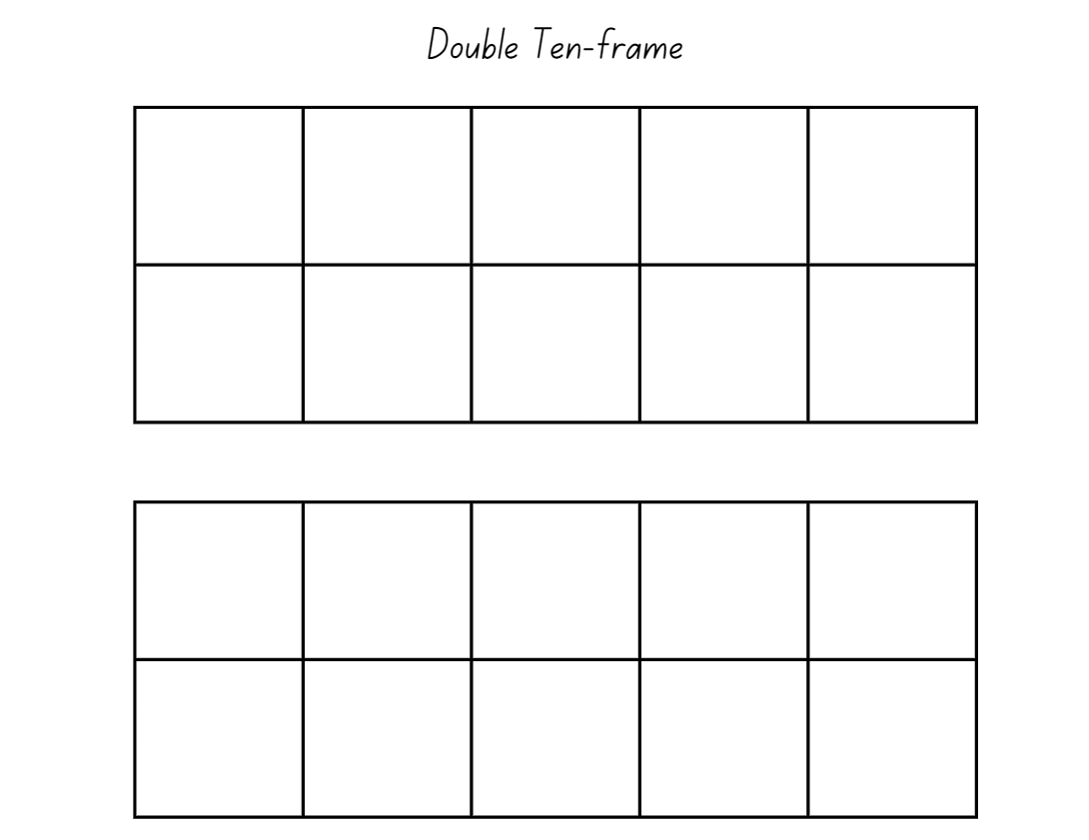

Resource 9: Two handfuls
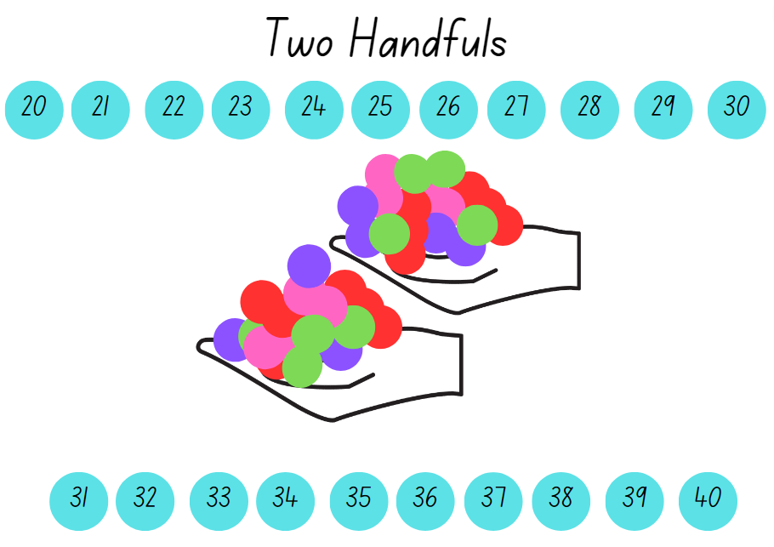
Images licensed in accordance with the Canva Content License Agreement.

Resource 10: 30 or bust!
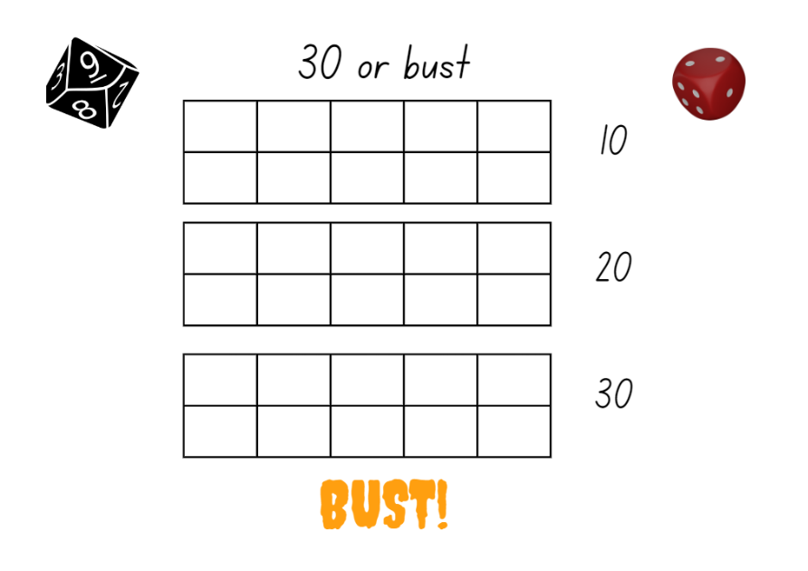
Images licensed in accordance with the Canva Content License Agreement.

Resource 11: Volume in our world
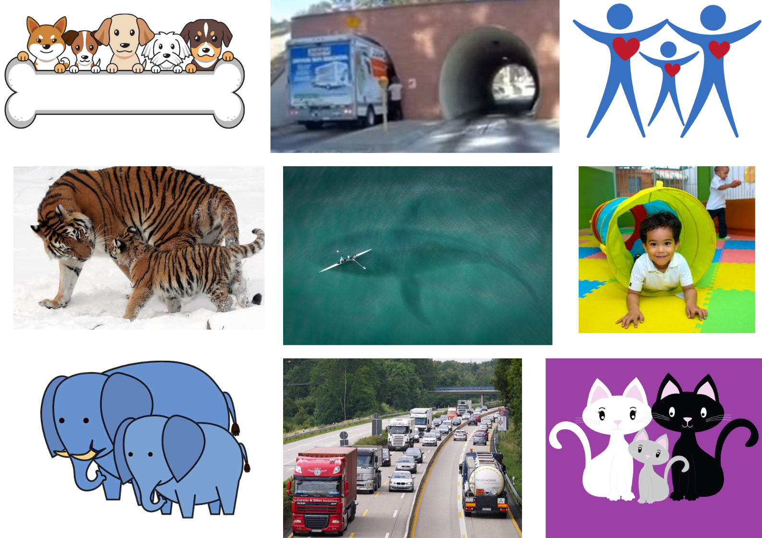
Images licensed in accordance with the Canva Content License Agreement.

Resource 12: Facts about numbers
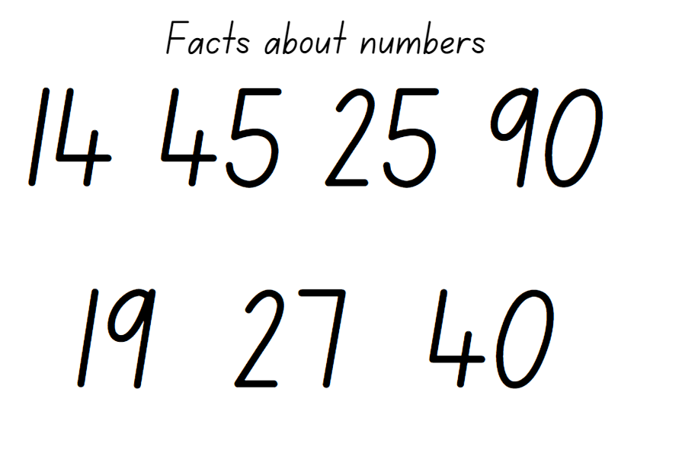

Resource 13: Cargo ships
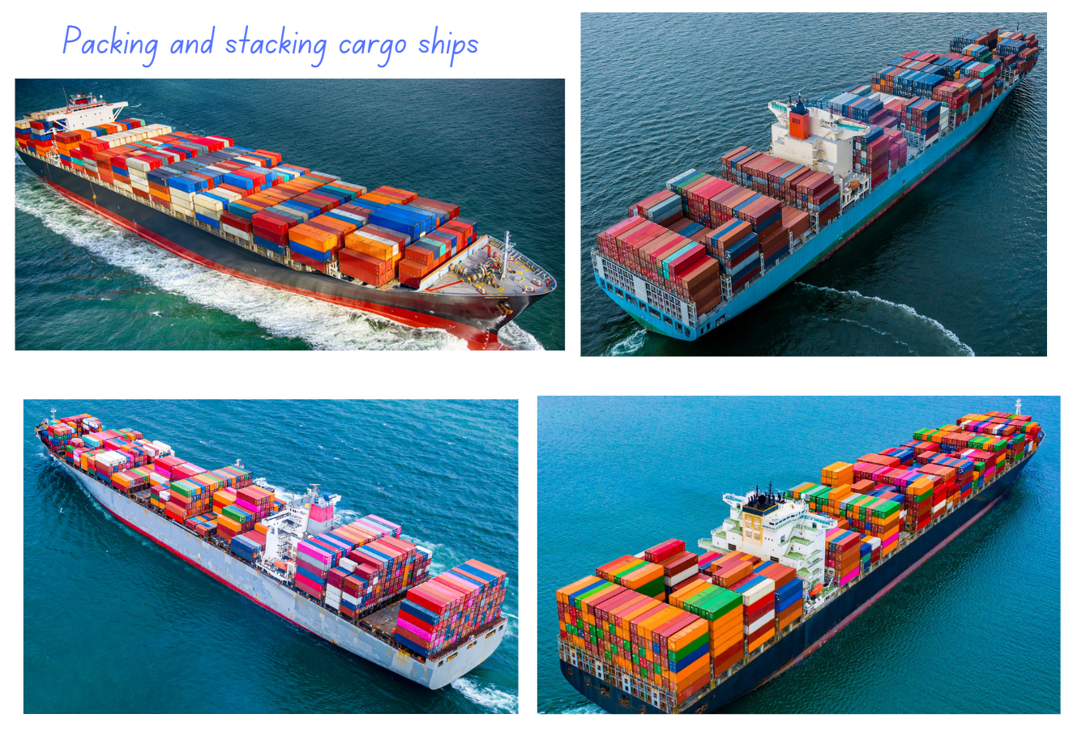
Images licensed in accordance with the Canva Content License Agreement.

Resource 14: Delivery trucks
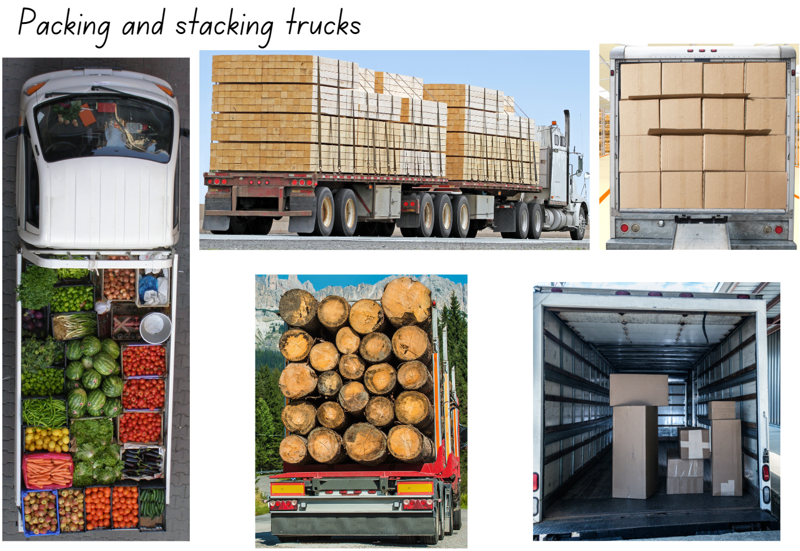
Images licensed in accordance with the Canva Content License Agreement.

Resource 15: Lots of spots
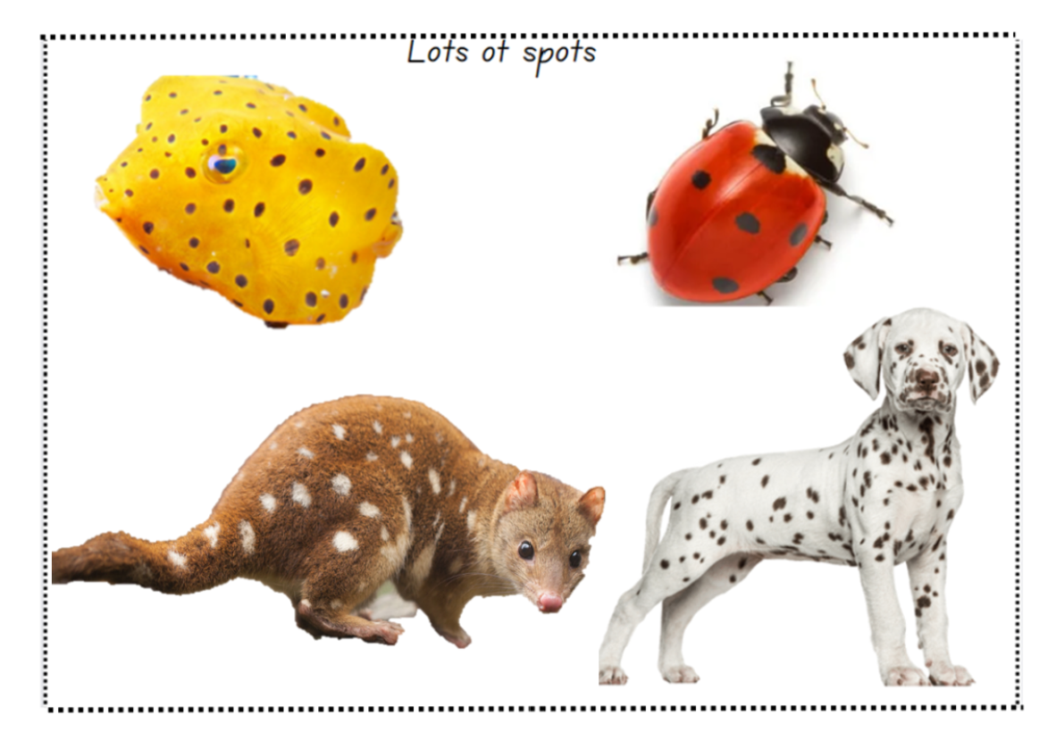
Images licensed in accordance with the Canva Content License Agreement.

Resource 16: Jellybean challenge
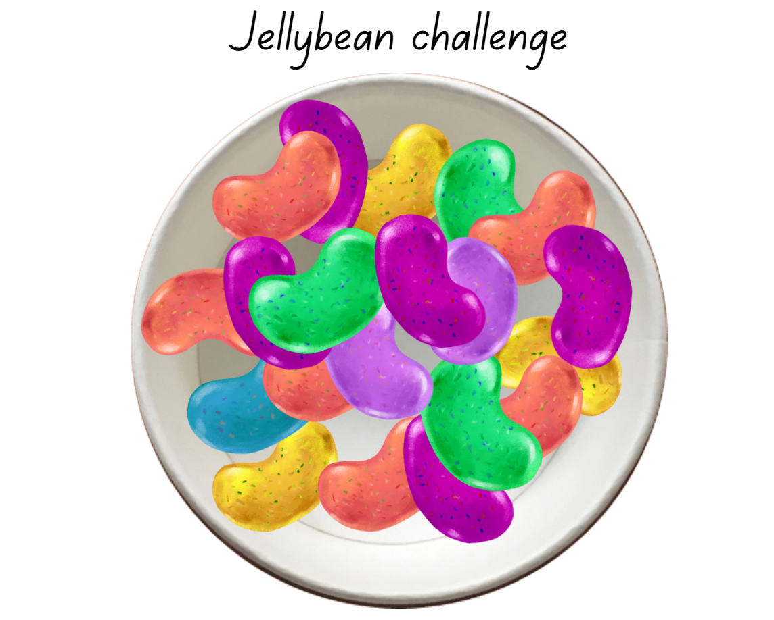
Images licensed in accordance with the Canva Content License Agreement.

Resource 17: Construction site
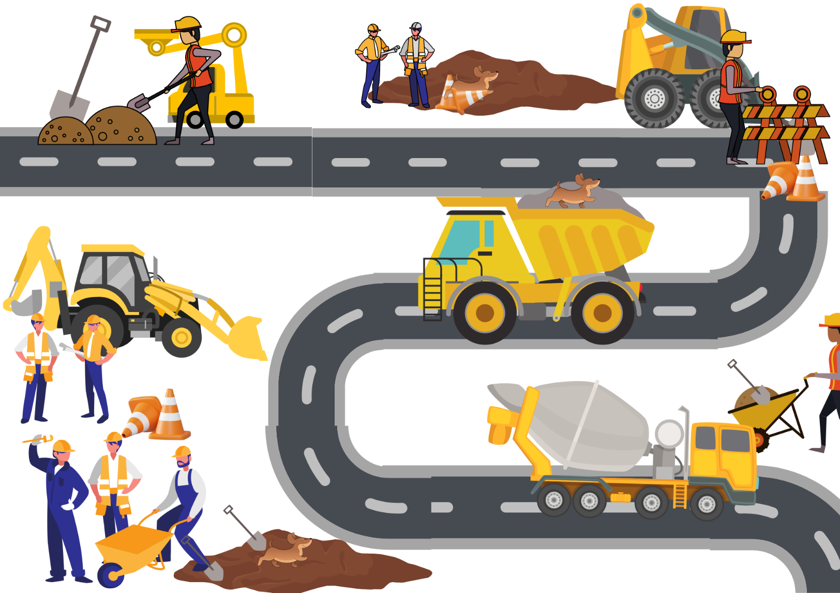
Images licensed in accordance with the Canva Content License Agreement.

Syllabus outcomes and content
The table below outlines the syllabus outcomes and range of relevant syllabus content covered in this unit. Content is linked to National Numeracy Learning Progression version (3).
Focus area and outcomes | Content groups and content points | Lessons
Representing whole numbers  MAO-WM-01  MAE-RWN-01  MAE-RWN-02 | Instantly name the number of objects within small collections  - Instantly recognise (subitise) the number of items in small groups of up to four items without counting (NPV1, CPr1)  - Identify the number of items in different arrangements (CPr2)  Use the counting sequence of ones flexibly  - Count forwards to at least 30 and state the number after or before a given number, without needing to count from one (CPr4)  - Identify and distinguish the ‘teen’ numbers from multiples of ten with the same initial sounds (NPV3)  - Count backwards from a given number 20 or less (CPr5)  - Identify the number before as 'one less' and the number after as 'one more’ than a given number  Recognise number patterns  - Recognise dice and domino dot patterns (NPA1, NPV2, CPr2)  - Recognise different finger patterns for the same number (NPA2)  Connect counting and numerals to quantities  - Count with one-to-one correspondence, recognising that the last number name represents the total number in the collection (CPr3, CPr5)  - Count out a specified number of objects (from 5 to 20) from a larger collection, keeping track of the count (CPr4, CPr5)  - Make correspondences between collections (Reasons about quantity)  - Read numerals to at least 20, including zero (NPV3)  - Represent numbers as quantities to at least 20 using objects (such as fingers), number words and numerals (NPV2, NPV3, NPV4, CPr3)  - Compare and order numbers to 20 (NPV2, NPV3) | 1–8
Two-dimensional spatial structure  MAO-WM-01  MAE-2DS-01  MAE-2DS-02 | 2D shapes: Sort, describe and name familiar shapes  - Identify familiar shapes in a range of contexts  - Sort shapes according to features such as size and shape (UGP1, UGP2)  - Recognise and explain how a group of shapes has been sorted (Reasons about spatial relations)  - Describe shapes, including circles, squares, triangles and rectangles (UGP1, UGP2)  - Ask and respond to questions that help identify and name a particular shape  2D shapes: Represent shapes  - Manipulate circles, squares, triangles and rectangles, and describe their features (UGP2, UGP3)  - Make representations of shapes in a variety of ways, using paint, paper, movements or technology (UGP3)  - Make two-dimensional shapes by tracing around the faces of three-dimensional objects (UGP3) | 1–3, 8
Three-dimensional spatial structure  MAO-WM-01  MAE-3DS-01  MAE-3DS-02 | 3D objects: Explore familiar three-dimensional objects  - Describe the features of familiar objects (UGP1)  - Sort objects and identify the attribute used to sort them (UGP2)  - Make and describe a variety of three-dimensional models (UGP3)  - Predict the stacking capabilities of various three-dimensional objects (Reasons about spatial relations)  Volume: Compare internal volume by filling and packing  - Fill and empty containers using materials such as water or sand  - Use the terms ‘full’, ‘empty’ and ‘about half full’  - Compare the internal volumes (capacities) of two containers directly by filling one and pouring into the other (UuM2)  - Compare the internal volumes of two containers indirectly by pouring their contents into two other identical containers and observing the level reached in each (UuM3)  - Stack and pack blocks into defined spaces (UuM5)  Volume: Compare volume by building  - Identify the attribute of volume as the amount of space an object or substance occupies  - Compare the volumes of two objects made from blocks or connecting cubes directly by deconstructing one object and using its parts to construct a copy of the other object  - Use comparative language to describe volume (UuM2) | 1–8

References
Links to third-party material and websites
Please note that the provided (reading/viewing material/list/links/texts) are a suggestion only and implies no endorsement, by the New South Wales Department of Education, of any author, publisher, or book title. School principals and teachers are best placed to assess the suitability of resources that would complement the curriculum and reflect the needs and interests of their students.
If you use the links provided in this document to access a third-party's website, you acknowledge that the terms of use, including licence terms set out on the third-party's website apply to the use which may be made of the materials on that third-party website or where permitted by the Copyright Act 1968 (Cth). The department accepts no responsibility for content on third-party websites.
Except as otherwise noted, all material is © State of New South Wales (Department of Education), 2023 and licensed under the Creative Commons Attribution 4.0 International License. All other material (third-party material) is used with permission or under licence. Where the copyright owner of third-party material has not licensed their material under a Creative Commons or similar licence, you should contact them directly for permission to reuse their material.
Mathematics K–10 Syllabus © 2022 NSW Education Standards Authority (NESA) for and on behalf of the Crown in right of the State of New South Wales.
© 2022 NSW Education Standards Authority. This document contains NSW Curriculum and syllabus content. The NSW Curriculum is developed by the NSW Education Standards Authority. This content is prepared by NESA for and on behalf of the Crown in right of the State of New South Wales. The material is protected by Crown copyright.
Please refer to the NESA Copyright Disclaimer for more information.
NESA holds the only official and up-to-date versions of the NSW Curriculum and syllabus documents. Please visit the NSW Education Standards Authority (NESA) website and the NSW Curriculum website.
National Numeracy Learning Progression © Australian Curriculum, Assessment and Reporting Authority (ACARA) 2010 to present, unless otherwise indicated. This material was downloaded from the Australian Curriculum website (National Numeracy Learning Progression) (accessed 03 April 2023) and was not] modified. The material is licensed under CC BY 4.0. Version updates are tracked in the ‘Curriculum version history’ section on the 'About the Australian Curriculum' page of the Australian Curriculum website.
ACARA does not endorse any product that uses the Australian Curriculum or make any representations as to the quality of such products. Any product that uses material published on this website should not be taken to be affiliated with ACARA or have the sponsorship or approval of ACARA. It is up to each person to make their own assessment of the product, taking into account matters including, but not limited to, the version number and the degree to which the materials align with the content descriptions and achievement standards (where relevant). Where there is a claim of alignment, it is important to check that the materials align with the content descriptions and achievement standards (endorsed by all education Ministers), not the elaborations (examples provided by ACARA).
This resource contains images and content obtained from Canva, and their use outside of this resource is subject to Canva’s Content License Agreement. If you wish to use them separately from the resource, please go to Canva.
Moss J, Bruce CD, Caswell B, Flynn T, Hawes Z (2016) Taking Shape: Activities to Develop Geometric and Spatial Thinking – Grades K-2, Pearson Canada.
Siemon D, Warren E, Beswick K, Faragher R, Miller J, Horne M, Jazby D, Breed M, Clark J, Brady K (2020) Teaching Mathematics: Foundations to Middle Years (3rd ed), Oxford University Press, Australia and New Zealand.
Sullivan P (2017) Challenging Mathematical Tasks: Unlocking the potential of all students, Oxford University Press, Australia and New Zealand.

