Mathematics – Early Stage 1 – Unit 18
Contents
Unit description and duration 4
Student prior learning 4
Lesson overview and resources 5
Lesson 1: All about us! 9
Daily number sense: Counting taps – 15 minutes 9
Getting to school – 35 minutes 10
Discuss and connect the mathematics – 10 minutes 14
Lesson 2: Days of the week 15
Daily number sense: Teacher choice – 10 minutes 15
What do we do on each day of the week at school? – 40 minutes 16
Consolidation and meaningful practice: Organising data – 10 minutes 18
Lesson 3: What day were you born? 18
Daily number sense: Counting strips – 15 minutes 19
Which day of the week was I born? – 35 minutes 20
Consolidation and meaningful practice: Days of the week – 5 minutes 22
Lesson 4: Dice data! 23
Daily number sense: Guess my number – 15 minutes 23
Dice data! – 40 minutes 26
Discuss and connect the mathematics – 10 minutes 27
Lesson 5: I love books! 28
Daily number sense: Sorting out the pile – 15 minutes 28
Our favourite books! – 40 minutes 30
Consolidation and meaningful practice: Data displays – 5 minutes 32
Lesson 6: Domino data! 32
Daily number sense: Domino dots! – 15 minutes 32
Domino data – 40 minutes 33
Consolidation and meaningful practice: What’s your favourite? – 5 minutes 35
Lesson 7: Odd socks! 36
Daily number sense: Show the sound! – 10 minutes 36
Pairs of socks – 40 minutes 37
Discuss and connect the mathematics – 10 minutes 40
Lesson 8: Brick sort! 41
Daily number sense: Teacher choice – 10 minutes 41
Sorting bricks – 45 minutes 42
Discuss and connect the mathematics – 10 minutes 44
Resource 1: Pattern cards 45
Resource 2: Travelling to school 46
Resource 3: Different activities 47
Resource 4: Number strips 48
Resource 5: Number cards 49
Resource 6: Venn diagram 50
Resource 7: Red and blue socks 51
Syllabus outcomes and content 52
References 55

Unit description and duration
This two-week unit develops student knowledge and skills in displaying and interpreting data, as well as connecting familiar events and actions to days of the week. Students are provided opportunities to:
- collect, sort and organise data into displays
- interpret data through asking and responding to questions
- collect and interpret data relating to their experiences with days of the week.
Mathematics K–10 Syllabus © 2022 NSW Education Standards Authority (NESA) for and on behalf of the Crown in right of the State of New South Wales.

Student prior learning
Before engaging in these teaching and learning activities, students would benefit from prior experience with:
- opportunities to sort collections based on common characteristics
- recognising small quantities without counting (subitising)
- informal talking about days of the week.

Lesson overview and resources
The table below outlines the sequence and approximate timing of lessons; syllabus focus areas and content groups; and resources.
Lesson | Syllabus focus area and content groups | Resources
Lesson 1: All about us!  60 minutes  Information can be collected and sorted. | Representing whole numbers  - Connect counting and numerals to quantities  Data  - Respond to questions, collect information and discuss possible outcomes of activities  - Organise objects into simple data displays and interpret the displays | - Resource 1: Pattern cards  - Resource 2: Travelling to school  - Small squares of paper (one per student)  - Writing materials
Lesson 2: Days of the week  60 minutes  Activities can be organised using days of the week. | Non-spatial measure  - Time: Connect days of the week to familiar events and actions  Data  - Respond to questions, collect information and discuss possible outcomes of activities  - Organise objects into simple data displays and interpret the displays | - Resource 3: Different activities  - Large circles labelled with each day of the week  - Sticky notes  - Writing materials
Lesson 3: What day were you born?  55 minutes  Days of the week are connected to familiar events. | Representing whole numbers  - Connect counting and numerals to quantities  Non-spatial measure  - Time: Connect days of the week to familiar events and actions  Data  - Respond to questions, collect information and discuss possible outcomes of activities  - Organise objects into simple data displays and interpret the displays | - Resource 4: Number strips (print A3)  - Counters  - Paper slips for each student with their name and the day of the week they were born  - Cards with the days of the week written on them  - Writing materials
Lesson 4: Dice data!  65 minutes  Data can be organised into a display and used to answer questions. | Representing whole numbers  - Instantly name the number of objects within small collections  - Use the counting sequence of ones flexibly  Data  - Respond to questions, collect information and discuss possible outcomes of activities  - Organise objects into simple data displays and interpret the displays | - Resource 5: Number cards  - A few 12- and 20-sided dice  - Cups (one per group)  - 12 × 6-sided dice per group  - Writing materials
Lesson 5: I love books!  60 minutes  Objects can be grouped in different ways. | Representing whole numbers  - Instantly name the number of objects within small collections  - Recognise number patterns  - Connect counting and numerals to quantities  Data  - Respond to questions, collect information and discuss possible outcomes of activities  - Organise objects into simple data displays and interpret the displays | - Resource 6: Venn diagram  - Small everyday objects, such as leaves, cars, shells, pencils  - Students’ favourite books  - Writing materials
Lesson 6: Domino data!  60 minutes  Data can be organised in different ways. | Representing whole numbers  - Instantly name the number of objects within small collections  - Recognise number patterns  Data  - Organise objects into simple data displays and interpret the displays | - Multiple sets of dominoes (one set per group)  - Writing materials
Lesson 7: Odd socks!  60 minutes  Events have different possible outcomes. | Representing whole numbers  - Recognise number patterns  Data  - Respond to questions, collect information and discuss possible outcomes of activities  - Organise objects into simple data displays and interpret the displays | - Resource 7: Red and blue socks (one per group)  - Writing materials
Lesson 8: Brick sort!  65 minutes  Data can be organised and interpreted. | Data  - Organise objects into simple data displays and interpret the displays | - Coloured bricks (enough for the whole class)  - Paper plates (enough for the whole class)  - Writing materials

Lesson 1: All about us!
Core concept: Information can be collected and sorted.
The table below contains suggested learning intentions and success criteria. These are best co-constructed with students.
Learning intentions | Success criteria
Students are learning that:  - information can be collected by asking questions  - objects can be sorted into groups and displayed as a table. | Students can:  - collect and sort information about how their peers travel to school  - create data displays showing the various methods of travelling to school.

Daily number sense: Counting taps – 15 minutes
This activity has been adapted from Counting on Counting from NZ Maths.
- Build understanding of counting with one-to-one correspondence by having students count items they cannot see or touch.
- In pairs, students sit back-to-back, with one student facing the teacher. Hold up a pattern card from Resource 1: Pattern cards so only one of the students can see it. Show the card for a short period of time, approximately 3 to 5 seconds.
- Withdraw the card so that the students can’t see it anymore.
- Without speaking, the student turns around and gently taps the quantity they saw on the pattern card on their partner’s shoulder or back. The partner shows how many taps they felt by holding up that number of fingers.
- Hold up the pattern card again. Both students turn to check if the number of fingers match the number on the pattern card.
- Partners swap roles and repeat the activity.

Getting to school – 35 minutes
- Ask students how they travel to school in the morning. Answers may include walking, car, bus, train, riding a bike or scooter, or a combination of ways.
- Give students a small square piece of paper and ask them to draw how they travel to school each morning. Students using multiple methods of travel may draw each method on different pieces of paper. Students place pictures into a box.
Note: Instead of having students draw their mode of travel, Resource 2: Travelling to school may be used.
- When all the data has been collected, gather students and tip the box with all the pictures onto the floor. Use the suggested question prompts to facilitate a class discussion about the data.
The table below outlines stimulus prompts to generate conversation about the topic, along with anticipated responses from students
Prompts | Anticipated student responses
- How could we find out how many different ways students travel to school?  - How could we count all the different ways of travel?  - Is there a way we could arrange these pictures so that it is easier to see which is the least and most used way to travel to school? | - We can put all the squares with the same pictures into piles.  - We can count each pile to find out how many students are travelling for each method.  - We can sort the pictures into straight lines.  - We can put the pile with the greatest number of pictures along the bottom and put the other piles above going from largest to smallest.
- Have students place the pictures into piles, sorting according to methods of travel.
- In groups, students collect one pile and count how many are in it. Ask each group how many pictures are in their pile and, as a class, determine the order of travel from most to least popular.
- As a class, students create a picture graph on a large piece of paper by gluing the squares in straight lines.
- Model and discuss the need to add a title, numbers and travel methods along the axis. See Figure 1 as an example.
Figure 1 – Ways of travelling to school
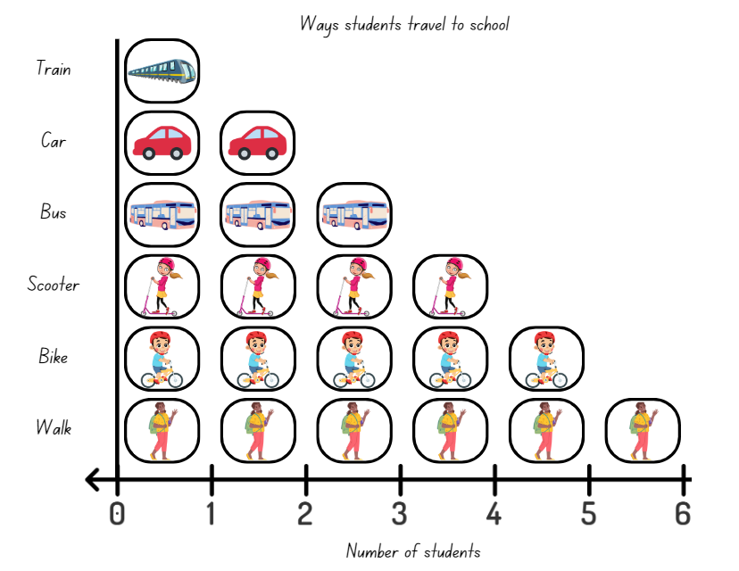
Images sourced from Canva and used in accordance with the Canva Content License Agreement.
Note: Explain to students that, in another activity (Lesson 5), they will be organising their favourite books into a data display. Communicate with parents and carers about students bringing in their favourite book for that lesson.
The table below details assessment opportunities and differentiation ideas.
Assessment opportunities | Too hard? | Too easy?
What to look for:  - Can students group the pictures into piles according to the different methods of travel? (MAO-WM-01, MAE-DATA-01)  - Can students count to find the most and least popular method of travel in the class using the picture graph? (MAO-WM-01, MAE-DATA-01)  - Are students able to interpret information in the picture graph to answer questions? (MAO-WM-01, MAE-DATA-01)  What to collect:  - observations of students sorting and counting the data. (MAO-WM-01, MAE-DATA-01) | Students cannot group the pictures into piles according to each method of travel.  - Model sorting blocks or counters according to their colour or shape.  - Have students sort items according to their shape or size.  Students cannot calculate the most popular and least popular method of travel.  - Model sorting and arranging counters according to their colour to form a data display.  - Have students count the colours in each row one-by-one to work out the totals.  - Have students identify which colour has the most and the least. | Students can group the pictures into piles according to each method of travel and calculate the most and least popular method.  - Using the same pictures as Resource 2: Travelling to school, students create their own data graph including questions.  - Have students use comparative language like ‘more than’ or ‘less than’ to describe the display.  - Students find the difference between the most and least popular methods of travel in the class.

Discuss and connect the mathematics – 10 minutes
- Summarise the lesson, drawing out some key mathematical ideas about collecting and sorting information. Ask:
- What did you notice about the most popular method of travel to school?
- What other information would be useful to collect about the students in this class?
- What did you wonder when sorting the pictures into piles?
- What strategies did you use to count the total in each pile?

Lesson 2: Days of the week
Core concept: Activities can be organised using days of the week.
The table below contains suggested learning intentions and success criteria. These are best co-constructed with students.
Learning intentions | Success criteria
Students are learning that:  - there are 7 days in each week, and they are always in the same order  - days of the week can be connected to familiar events and actions  - a data display can be used to ask and answer questions. | Students can:  - recall the 7 days of the week in order  - create a data display to show things they do on different days of the week at school  - use data to ask and answer questions about days of the week.

Daily number sense: Teacher choice – 10 minutes
- From a class need surfaced through formative assessment data, identify a short, focused activity that targets students’ knowledge, understanding and skills. Example activities may be drawn from the following resources:
- Thinking Mathematically Early Stage 1
- Universal Resources Hub.

What do we do on each day of the week at school? – 40 minutes
- Show students a list of the days of the week. Read the names of each day, starting at Monday.
- Ask students to list the different activities they do at school on each day of the week. This could include:
- visiting the library
- maths lesson
- sport
- school assembly
- ordering lunch.
- Show students large circles labelled with each day of the week. Ask students to predict what day of the week might be the most popular day for activities and justify why.
Note: Hula hoops may be used for the large circles representing days of the week.
- Draw one of the chosen activities on a sticky note and place it in the associated ‘day of the week’ circle. Provide students with sticky notes to draw pictures of other activities. Students stick their drawings in the 'day of the week’ circles.
- Look at the data display in order of the days of the week. Ask:
- What happens on Monday? What happens on Tuesday? Continue this process in the order of the days of the week.
- Do we spend more time doing inside or outside activities?
- What day do we visit a quiet space?
- Can the data display be improved?
This table details assessment opportunities and differentiation ideas.
Assessment opportunities | Too hard? | Too easy?
What to look for:  - Can students recall the 7 days of the week in order? (MAE-NSM-02)  - Can students help to create a data display to show activities they do on different days of the week? (MAO-WM-01, MAE-NSM-02, MAE-DATA-01)  - Are students able to interpret the data and answer questions? (MAO-WM-01, MAE-NSM-02, MAE-DATA-01)  What to collect:  - observational records of questions and interpretations (MAO-WM-01, MAE-NSM-02, MAE-DATA-01)  - photographs of the data display. (MAE-NSM-02, MAE-DATA-01) | Students cannot draw activities.  - Provide students with Resource 3: different activities, to cut out and place in the data display.  - Students draw simple symbols to represent their activities.  Students cannot interpret data.  - Model counting the activities one-by-one, pointing to each picture to reach a total.  - Students place the activities for each day in a row, so they are easier to count. | Students create and interpret a data display.  - Students ask each other comparative questions. For example, students could ask how many more times the class does a maths lesson than visits the library.  - Students describe the display using comparative language such as ‘more than’ or ‘less than’.

Consolidation and meaningful practice: Organising data – 10 minutes
- Ask students if there are other ways the data could be arranged. For example:
- by activity instead of by days of the week
- in rows
- in columns.

Lesson 3: What day were you born?
Core concept: Days of the week are connected to familiar events.
The table below contains suggested learning intentions and success criteria. These are best co-constructed with students.
Learning intentions | Success criteria
Students are learning that:  - counting with one-to-one correspondence can be used to find the total number in a collection  - there are 7 days in each week, and they are always in the same order  - days of the week can be connected to familiar events. | Students can:  - count objects one-by-one to find a total number  - recall the 7 days of the week in order  - create a data display showing what day of the week they were born on and use it to answer questions.

Daily number sense: Counting strips – 15 minutes
This activity has been adapted from Counting on Counting from NZ Maths.
- Build student understanding of counting with one-to-one correspondence, recognising that the last number name represents the total number in the collection.
- Give each student a strip of numbers from Resource 4: Number strips and some counters.
Note: This task works best with solid-coloured counters. Transparent counters will allow students to see the numbers underneath.
- Ask students to count out 7 counters using at least 3 different colours. For example, 2 blue, 2 red and 3 green.
- Model the task placing counters on the number strip, placing one at a time, starting at one. Ask students to copy, starting with their chosen colour and adding one counter at a time, starting at one (see Figure 2).
Figure 2 – Counters on the number strip
- Once students have placed their third counter down, ask them what number they think their last counter will go on.
Note: The cardinality principle recognises that the last number name represents the total number in the collection. Students who understand cardinality will know that the last counter should go on number 7.
- Once students have placed their fifth counter down, ask again, what number they think their last counter will go on.
- Discuss:
- What would happen if you repeated this activity but, this time, began with a different coloured counter?
- What number will the last counter land on this time?
- Students are given the opportunity to share their predictions. Students should notice that placing the counters in a different colour order does not make a difference to the last number, which is still 7.
- Repeat the task with a different number.

Which day of the week was I born? – 35 minutes
Note: Prior to this activity, access a class list of student birthdays. Write the days of the week on which students were born on a small piece of paper for the task.
- Ask students if they know when their birthday is. If students can’t remember, tell them. Talk about how they were born on a day of the week and revise days of the week in order, beginning with Monday. Sing a song about the days of the week.
- Ask if anyone knows the day of the week they were born on. Have students predict which day of the week might have the most and the least amount of students born. Ask students to justify and explain their prediction.
- Give each student a piece of paper that contains their name and the day of the week on which they were born. Ask students how they could sort and organise this information. After a discussion, create a class data display.
- Discuss whether the chosen method is successful in displaying the data, giving reasons why or why not. If the display is effective, have students ask questions and make statements about the data. For example:
- Which days of the week were most people born on? Why do you think this?
- Nobody in our class was born on a Saturday.
- Is there a difference between weekdays and the weekend?
Note: To extend this learning, you could share your birth story with students and include what day you were born and whether it was in the morning, afternoon or evening. Students may volunteer information over subsequent days which could be added to a ‘What time of the day was I born?’ display.
This table details assessment opportunities and differentiation ideas.
Assessment opportunities | Too hard? | Too easy?
What to look for:  - Can students recall the 7 days of the week in order? (MAE-NSM-01)  - Can students help to create a data display? (MAO-WM-01, MAE-NSM-02, MAE-DATA-01)  - Can students use the information on the data display to ask and answer questions? (MAO-WM-01, MAE-NSM-02, MAE-DATA-01)  What to collect:  - observational records of questions and interpretations (MAO-WM-01, MAE-NSM-02, MAE-DATA-01)  - photographs of the data display. (MAE-NSM-02, MAE-DATA-01) | Students cannot recall the 7 days of the week in order.  - Display cards showing the 7 days of the week in order.  - Provide students with another set of cards. Students place their cards on top of the first set and practise saying the days of the week.  Students cannot organise or interpret data.  - Help students place their birthday paper slip in the data display.  - Model asking and answering questions, pointing to the relevant part of the data display. | Students recall the 7 days of the week in order.  - Give students cards featuring the months of the year to put in order.  - Students discuss events that happen in each month.

Consolidation and meaningful practice: Days of the week – 5 minutes
- Revise the days of the week in order, beginning with Monday, or revisit a song about the days of the week.
- Hold up a card with a day of the week and ask students to name the day before and the day after.

Lesson 4: Dice data!
Core concept: Data can be organised into a display and used to answer questions.
The table below contains suggested learning intentions and success criteria. These are best co-constructed with students.
Learning intentions | Success criteria
Students are learning that:  - numbers can be organised on a number line  - objects can be grouped according to characteristics  - objects can be organised to form a data display  - a data display can be interpreted using statements and questions. | Students can:  - use clues to find a secret number  - organise numbers on a number line  - organise data into a data display  - use a data display to respond to statements and questions.

Daily number sense: Guess my number – 15 minutes
This lesson has been adapted from Guess my number from Thinking Mathematically.
- Build student understanding of counting by comparing and ordering numbers to 20.
- In pairs, provide students with a set of cards Resource 5: Number cards.
- Lay the cards facing upwards (see Figure 3). Without touching the cards, one student chooses a number as the secret number.
Figure 3 – Number cards
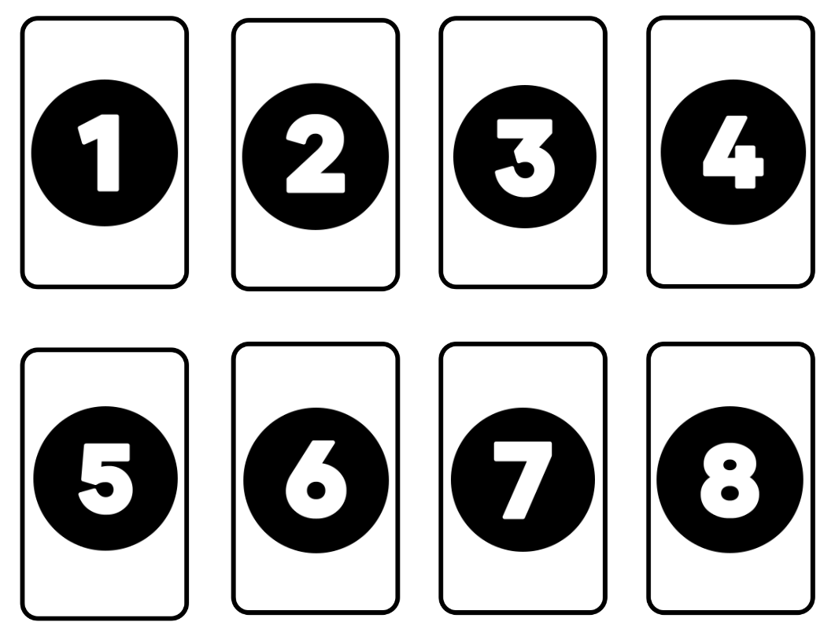
- The other student tries to guess the secret number. The student with the secret number replies whether it is more or less than their partner’s guess. The ‘guesser’ can remember which numbers have been discounted or eliminate numbers on paper or a whiteboard.
- Students try to guess the secret number in the fewest number of guesses possible.
- After the first game, ask:
- What strategies did you use to guess the secret number?
- What would you do differently to guess the secret number faster?
- Repeat the game. As each secret number is found, students take that card away.
- After playing several times, students make a number line with the remaining cards, thinking about where to leave spaces for the missing numbers. Encourage the students to visualise each of the numbers on the number line. Discuss the numbers that are missing and ask students to explain how they know the number that is missing.
This table details assessment opportunities and differentiation ideas.
Assessment opportunities | Too hard? | Too easy?
What to look for:  - Can students use comparative language with numbers one to 10? (MAO-WM-01, MAE-RWN-01, MAE-RWN-02)  - Are students able to identify the number before as 'one less' and the number after as 'one more’ than a given number? (MAO-WM-01, MAE-RWN-01, MAE-RWN-02)  - Can students explain the counting sequence when ordering numbers? (MAO-WM-01, MAE-RWN-01, MAE-RWN-02)  What to collect:  - observations of students playing games (MAO-WM-01, MAE-RWN-01, MAE-RWN-02)  - recordings of strategy discussions. (MAO-WM-01, MAE-RWN-01, MAE-RWN-02) | Students cannot explore comparative relationships between numbers one to 10.  - Represent numbers using blocks to visually support comparing quantities.  - Use a number track for visual support. | Students can explore comparative relationships between numbers one to 10.  - Students use cards from one to 20.  - Students try to guess the secret number with 3 guesses only.

Dice data! – 40 minutes
- Tell students they are going to collect and organise data from rolling multiple dice. Ask students to think of ways to do this. Students turn and talk and then share ideas as a class.
- Roll 12 × 6-sided dice and use the results to make statements and ask questions about the data. For example:
- The number 3 was thrown the most.
- Are there any numbers missing from the data collected? Why might this be?
- Create a data display by organising the dice into sorted groups. Ask students how sorting the dice helps to see the data.
- In small groups, students repeat the process and record their data. For example, take a photo of the dice, draw or tally their results.
- Ask students to predict what might happen to their group data if 6 more dice are rolled.
- Students roll 6 more dice, add the results to their data display and compare it to their predictions.
This table details assessment opportunities and differentiation ideas.
Assessment opportunities | Too hard? | Too easy?
What to look for:  - Can students organise dice rolls into a data display? (MAO-WM-01, MAE-DATA-01)  - Can students interpret the data display using statements and questions? (MAO-WM-01, MAE-DATA-01)  What to collect:  - observational records of statements and questions and reasoning about the data display (MAO-WM-01, MAE-DATA-01)  - photographs of data displays. (MAO-WM-01, MAE-DATA-01) | Students cannot organise dice into a data display or use questions and statements to interpret it.  - Model a second set of 12 dice rolls, showing students how to group equal dots together.  - Pointing to the dice and counting one-by-one, ask students which numbers got rolled the most and the least.  - Ask students if there are any numbers between one and 6 that did not get rolled. | Students create and interpret the data display.  - Students throw 2 × 6-sided dice 12 times and record the total each time.  - Students decide how to display the data.  - Students discuss their results, identifying which totals are most frequent and thinking about why.  - Ask students what might happen if they rolled a 12- or 20-sided dice 12 times instead. Ask them why they think this. Students test their ideas.

Discuss and connect the mathematics – 10 minutes
- Summarise the lesson, drawing out some key mathematical ideas about organising data to ask and answer questions. Ask:
- What worked best when organising your data?
- What difficulties did you have when organising your dice rolls into a data display?
- What would you do differently next time?
Note: Students will need to bring their favourite book to school for the next lesson.

Lesson 5: I love books!
Core concept: Objects can be grouped in different ways.
The table below contains suggested learning intentions and success criteria. These are best co-constructed with students.
Learning intentions | Success criteria
Students are learning that:  - objects can be grouped according to characteristics  - objects can be organised to form a data display  - a data display can be used to answer questions. | Students can:  - choose and justify ways to sort their favourite books  - organise their favourite books into a data display  - use the data display to ask and answer questions.

Daily number sense: Sorting out the pile – 15 minutes
- Build understanding of numbers by counting, comparing and organising quantities from one to 20.
- Provide groups of students with a pile of everyday objects, for example, leaves, cars, shells, pencils. Each student picks up a handful of objects and the group decides what attributes they will use to sort them. For example, type, colour, favourite to least favourite or size. Students make lines of objects, taking it in turns to count out loud while adding their objects to a row or column.
- Once the objects are in rows or columns, students decide how to place them for comparison, for example, from the lowest number to the highest number.
- Ask students how many objects are in each part of the data display and discuss what they notice.
This table details assessment opportunities and differentiation ideas.
Assessment opportunities | Too hard? | Too easy?
What to look for:  - Do students use reasoning when sorting and organising objects? (MAO-WM-01, MAE-RWN-01, MAE-RWN-02, MAE-DATA-01)  - Can students read, compare and order numbers to 20? (MAO-WM-01, MAE-RWN-01, MAE-RWN-02)  What to collect:  - observations of student counting and reasoning (MAO-WM-01, MAE-RWN-01, MAE-RWN-02, MAE-DATA-01) | Students cannot organise a group of objects or count groups in a data display.  - Give students ideas for how they could organise their groups, for example, type of object or colour.  - Model part of a data display.  - Point to each object in one part of the data display, counting one-by-one to reach a total. | Students can organise and justify sorting of objects into a data display.  - Students brainstorm all the ways to sort the objects.  - Give students Resource 6: Venn diagram to sort objects using 2 criteria, considering what objects fit both.

Our favourite books! – 40 minutes
- Students share their favourite books. Ask students to give reasons why these are their favourites.
- Ask students how they could organise the books into a data display. Students turn and talk and then share ideas with the class. Some ideas for organising the books could be:
- soft or hard covered books
- size
- type or genre, for example, adventure, fantasy, facts
- book titles beginning with the letter…
- how many book titles begin with the word ‘The’
- colours on the cover.
- Students decide on an approach to organise the books into a data display and group the books. Write labels for the different groups. As a class and then in small groups, students make statements and then ask and respond to questions about the display.
- Repeat the process using a different criterion.
This table details assessment opportunities and differentiation ideas.
Assessment opportunities | Too hard? | Too easy?
What to look for:  - Can students choose and justify ways to sort favourite books? (MAO-WM-01, MAE-DATA-01)  - Can students organise books into a data display to compare groups? (MAO-WM-01, MAE-DATA-01)  - Are students able to interpret the data and answer questions? (MAO-WM-01, MAE-NSM-02, MAE-DATA-01)  What to collect:  - observational records of reasons for grouping, statements and questions (MAO-WM-01, MAE-DATA-01)  - photographs of labelled book data displays. (MAO-WM-01, MAE-DATA-01) | Students cannot choose and justify ways to sort their favourite books.  - Have students sort blocks, counters or collected items according to size, colour or shape.  - Students then arrange the objects into a data display. | Students think of several ways to group books, making statements and asking and responding to questions to interpret the data.  - Show students pictures of book week displays and ask them what criteria they would use to group the books.  - Students justify the criteria they have used to group the books and interpret the data display by identifying the biggest and smallest values.

Consolidation and meaningful practice: Data displays – 5 minutes
- Ask students:
- Did your favourite book data display show useful information? What makes you say that?
- What would you do differently if you reorganised the books to make another data display? Why?

Lesson 6: Domino data!
Core concept: Data can be organised in different ways.
The table below contains suggested learning intentions and success criteria. These are best co-constructed with students.
Learning intentions | Success criteria
Students are learning that:  - objects can be grouped according to characteristics  - objects can be organised to form a data display  - a data display can be used to answer questions. | Students can:  - discuss ways to sort dominoes  - organise dominoes into a data display to compare groups  - use the data display to answer questions.

Daily number sense: Domino dots! – 15 minutes
- Build understanding of number by using different finger combinations to represent a given number.
Note: Prior to this activity, remove all dominoes that contain one or 2 sets of 6 dots.
- Place a set of dominoes facedown. Students take turns to choose a domino and show it to the class. For example, a student selects a domino with 3 dots and 2 dots. Use the suggested question prompts to facilitate a class discussion.
The table below outlines stimulus prompts to generate conversation about the topic, along with anticipated responses from students.
Prompts | Anticipated student responses
- Can you show the number of dots with your fingers?  - How many dots are there altogether?  - Are there any other ways to show 5 using your fingers?  - How could you show 5 if you split it into 3 numbers? For example, 3 and one and one more. | - We could show 3 fingers on one hand and 2 on the other.  - I see 5 dots.  - We could show 4 fingers and one finger or 5 fingers and no fingers.  - We could join up with a partner and use 3 hands.

Domino data – 40 minutes
Note: Prior to this activity, remove any 11 and 12 dot dominoes from the sets.
- Provide small groups of students with a set of dominoes. Ask them how they could sort them into groups. Possibilities include:
- the total of dots on each domino, for example, 3 dots, 4 dots, 5 dots and so on
- doubles and non-doubles
- dominoes with dots adding up to less than 5, exactly 5 and more than 5.
- Each time a group organises their dominoes, have students explain their reasoning. If devices are available, students take a photo of their domino data display. Ask:
- How did you organise your dominoes?
- How many groups did you find?
- What is the largest group? Is there a reason why?
- What is the smallest group? Is there a reason why?
- Repeat the process with another chosen criteria.
This table details assessment opportunities and differentiation ideas.
Assessment opportunities | Too hard? | Too easy?
What to look for:  - Can students choose and justify a way to group a set of dominoes? (MAO-WM-01, MAE-DATA-01)  - Can students organise their dominoes into more than one data display? (MAO-WM-01, MAE-DATA-01)  - Can students use a data display to answer questions? (MAO-WM-01, MAE-DATA-01)  What to collect:  - observational records of grouping and verbal reasoning (MAO-WM-01, MAE-DATA-01)  - photographs of domino data displays. (MAO-WM-01, MAE-DATA-01) | Students cannot organise a domino set or interpret the data display.  - Give students ideas, such as less than 5 dots, exactly 5 dots, more than 5 dots.  - Model one of the groups, for example, all the dominoes with a total of less than 5 dots. | Students can choose and justify how to organise a domino set and answer questions about their data display.  - Students brainstorm all the ways to organise a set of dominoes.  - Students work out the difference between the biggest and smallest groups in each data display.  - Students predict how many dominoes would be left in each group in a data display if they removed all dominoes containing a 2, 3, 4 or 5.  - Students check their prediction.

Consolidation and meaningful practice: What’s your favourite? – 5 minutes
- Ask students what their favourite method of sorting out the dominoes was and why.

Lesson 7: Odd socks!
Core concept: Collecting data can help make predictions and comparisons.
The table below contains suggested learning intentions and success criteria. These are best co-constructed with students.
Learning intentions | Success criteria
Students are learning that:  - collecting data can help make predictions and comparisons  - data can help sort and classify events that are certain and those that are not  - simple experiments can produce data. | Students can:  - make predictions using the language of chance  - make predictions about familiar events being certain or not certain to happen  - perform simple experiments to collect data and make comparisons.

Daily number sense: Show the sound! – 10 minutes
- Build student understanding of representing numbers as quantities by using objects (such as fingers), number words and numerals.
- Represent 2 numbers between one and 5 with sounds, for example, percussion instruments. Have students listen and then show the 2 numbers with their fingers.
- Use the question prompts from Daily number sense in the previous lesson (Lesson 6) to facilitate a discussion.
- Ask students if they have found all the solutions to show a number and how they can explain their reasoning.
- Students work in groups of 3, taking turns to communicate numbers between 5 and 10 with body percussion clicks and claps. Students can work together to use up to 4 hands to represent numbers.

Pairs of socks – 40 minutes
This lesson has been adapted from Odd socks from NZ Maths.
- Use the table below as prompts to generate a discussion about the concept of events being certain or not certain, along with anticipated responses from students.
Prompts | Anticipated student responses
- What are some events that are certain to happen?  - What are some events that are not certain to happen? | - It is certain that the sun will rise.  - It is certain that tomorrow will be Tuesday (or whatever day of the week depending on when the lesson is being taught).  - It is not certain that my soccer team will win their next game.  - It is not certain that I will go swimming in the summer.
- Explain to students that Jasmine has 2 blue socks and 2 red socks in the laundry basket. Ask whether she could pick 2 socks of the same colour if she picked 2 socks from the basket without looking.
Note: Use real socks to model the task. Students could bring in their own pair of crazy socks.
- Use Resource 7: Red and blue socks and cut out each sock. Place them into a container to represent the washing basket. Choose a student to pick 2 socks without looking.
- Ask:
- What are the different possibilities that Jasmine could pull out first?
- If she pulls out a red sock first, is it certain that she will pull out another red sock?
- Is it certain that she will always get a pair of socks the same colour?
- Is it certain that she will always get a pair of socks of different colours?
- Students Think-Pair-Share the possible outcomes. Record the results on the board for all students to see.
- Replace the socks, shuffle the container, and choose another student to pick 2 more socks without looking. Do this at least 6 times and keep a record of the colours that the students pick each time (see Figure 4).
Figure 4 – Sock selection
Images sourced from Canva and used in accordance with the Canva Content License Agreement.
- Look at the class results and ask students if their predictions were correct.
- In pairs, students take a container with 4 socks, 2 in one colour and 2 in another colour. They take turns to pull out 2 socks at a time without looking. Students record results with drawings, making predictions about the outcomes.
This table details assessment opportunities and differentiation ideas.
Assessment opportunities | Too hard? | Too easy?
What to look for:  - Can students make predictions about events being certain or not certain to occur? (MAO-WM-01, MAE-DATA-01)  What to collect:  - recordings of data collection and predictions. (MAO-WM-01, MAE-DATA-01) | Students cannot make predictions about certain events.  - Revise or model events that are certain and not certain to happen with familiar topics.  - Repeat the sock experiment and have students try to predict what will happen. | Students can make predictions about events.  - Students can predict events that are certain, possible, likely, unlikely or impossible.  - Students share ideas with a peer and discuss whether or not they agree.

Discuss and connect the mathematics – 10 minutes
- Summarise the lesson, drawing out key mathematical ideas about predicting the likelihood of events. Ask students:
- What colour did you pick out the most in the sock experiment?
- Do you think you would get the same results if you repeated the experiment? Why or why not?

Lesson 8: Brick sort!
Core concept: Data can be organised and interpreted in different ways.
The table below contains suggested learning intentions and success criteria. These are best co-constructed with students.
Learning intentions | Success criteria
Students are learning that:  - objects can be grouped according to characteristics  - objects can be organised to form a data display  - a data display can be used to answer questions. | Students can:  - discuss ways to sort coloured bricks  - organise bricks into a data display to compare groups  - use the brick data display to answer questions.

Daily number sense: Teacher choice – 10 minutes
- From a class need surfaced through formative assessment data, identify a short, focused activity that targets students’ knowledge, understanding and skills. Example activities may be drawn from the following resources:
- Thinking Mathematically Early Stage 1
- Universal Resources Hub.

Sorting bricks – 45 minutes
- Show students a big tub of coloured bricks and tell them that their help is needed to sort them. Set the scene and explain, ‘I need to return this big tub of bricks that I have borrowed but they’re in such a mess! We will have to organise them before I give them back. Think about how you could help me do this.’
- In small groups, students are asked to collect a big pile of coloured bricks and decide on which is the best way to organise them. Offer paper plates as a tool to help organise the sorted bricks.
Note: When preparing the coloured bricks, the more bricks with an assortment of attributes the better as this will make the lesson more engaging and exciting for students.
- Once all the groups have collected and sorted their bricks and put them onto different paper plates, ask students to communicate their strategies for sorting. Answers may include by:
- colour
- size
- shape.
- In their groups, students organise their sorted bricks into a data display. Students take pictures of their data displays.
- Students count the bricks in their data groups. Ask students what strategies they could use to count the bricks.
- Each group describes the information in their data display to another group. For example, identifying the smallest and largest groups of blocks.
- Students go on a gallery walk to compare their choice of data display to others. After the walk, ask:
- How did you organise your bricks? Why was that?
- Were there any challenges?
- How was your data display the same as other displays?
- How was it different to other displays?
This table details assessment opportunities and differentiation ideas.
Assessment opportunities | Too hard? | Too easy?
What to look for:  - Can students choose and justify a way to group of objects? (MAO-WM-01, MAE-DATA-01)  - Can students organise coloured bricks into a data display to compare groups? (MAO-WM-01, MAE-DATA-01)  - Can students use a data display to answer questions? (MAO-WM-01, MAE-DATA-01)  What to collect:  - observational records of grouping and verbal reasoning (MAO-WM-01, MAE-DATA-01)  - photographs of data displays. (MAO-WM-01, MAE-DATA-01) | Students cannot organise bricks or interpret the data display.  - Give students ideas, such as colour and size.  - Model one kind of brick in the data display and have students continue to place bricks.  - Model ordering the groups of bricks, starting with the smallest group and ending with the largest. | Students can choose and justify how to organise their bricks and compare their display to others.  - Students brainstorm all the ways to organise bricks.  - Students work out the difference between the biggest and smallest groups in their data display.

Discuss and connect the mathematics – 10 minutes
- Summarise the lesson, drawing out key mathematical ideas about the best ways to sort out and present data. Ask students:
- Which was the best way to sort the bricks so that they can be returned?
- How did you count all the bricks in your data display? What counting strategies did you use?

Resource 1: Pattern cards
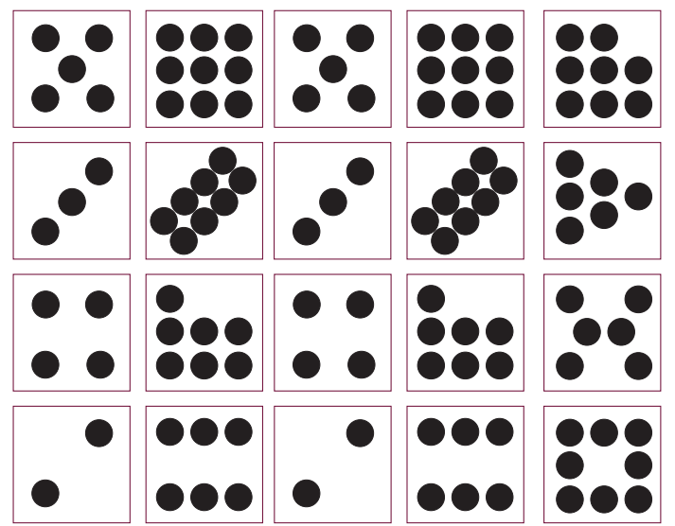
Image from Counting on Counting is licensed under NZ Maths.

Resource 2: Travelling to school
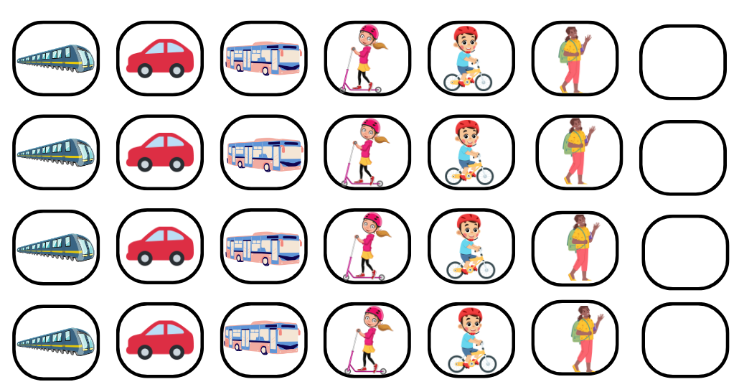
Images sourced from Canva and used in accordance with the Canva Content License Agreement.

Resource 3: Different activities
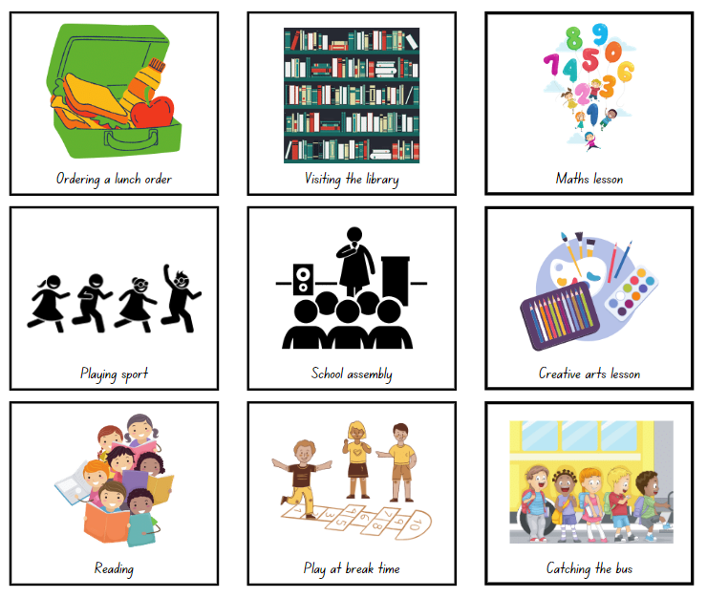
Images sourced from Canva and used in accordance with the Canva Content License Agreement.

Resource 4: Number strips
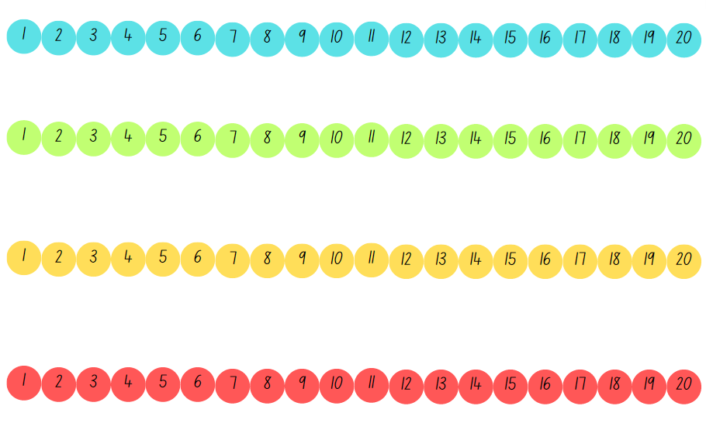

Resource 5: Number cards

Resource 6: Venn diagram

Resource 7: Red and blue socks
Images sourced from Canva and used in accordance with the Canva Content License Agreement.

Syllabus outcomes and content
The table below outlines the syllabus outcomes and range of relevant syllabus content covered in this unit. Content is linked to National Numeracy Learning Progression version (3).
Focus area and outcomes | Content groups and content points | Lessons
Representing whole numbers  MAO-WM-01  MAE-RWN-01  MAE-RWN-02 | Instantly name the number of objects within small collections  - Identify the number of items in different arrangements (CPr2)  Recognise number patterns  - Recognise dice and domino dot patterns (NPA1, NVA2, CPr2)  - Recognise different finger patterns for the same number (NPA2)  Connect counting and numerals to quantities  - Count with one-to-one correspondence, recognising that the last number name represents the total number in the collection (CPr3, CPr5)  - Read numerals to at least 20, including zero (NPV3)  - Compare and order numbers to 20 (NPV2-NPV3) | 1, 2, 4, 5–7
Combining and separating quantities  MAO-WM-01  MAE-CSQ-02 | Identify part–whole relationships in numbers up to 10  - Count by ones to find the total or difference (AdS2-AdS3) | 7
Non-spatial measure  MAO-WM-01  MAE-NSM-02 | Time: Compare and order the duration of events using the language of time  - Use terms such as 'daytime', 'night-time', 'morning', 'afternoon', 'today', 'tomorrow', 'yesterday', 'before', 'after' and 'next' (MeT1)  Time: Connect days of the week to familiar events and actions  - Recall that there are seven days in a week  - Name and order the days of the week (MeT2)  - Identify events that occur daily and relate events to a particular day or time of day (MeT1) | 2–3
Data  MAO-WM-01  MAE-DATA-01 | Respond to questions, collect information and discuss possible outcomes of activities  - Predict possible responses to a question  - Collect information from their peers and about their environment (IRD1)  - Pose and respond to questions about the information collected (IRD1)  Organise objects into simple data displays and interpret the displays  - Group objects according to characteristics (IRD1)  - Compare the sizes of groups of objects by counting  - Arrange objects according to a characteristic to form a data display (IRD1)  - Interpret information presented in a data display to answer questions (IRD2) | 1–8

References
Links to third-party material and websites
Please note that the provided links are a suggestion only and imply no endorsement by the New South Wales Department of Education, of any author, publisher, or book title. School principals and teachers are best placed to assess the suitability of resources that would complement the curriculum and reflect the needs and interests of their students.
If you use the links provided in this document to access a third-party's website, you acknowledge that the terms of use, including licence terms set out on the third-party's website apply to the use which may be made of the materials on that third-party website or where permitted by the Copyright Act 1968 (Cth). The department accepts no responsibility for content on third-party websites.
Except as otherwise noted, all material is © State of New South Wales (Department of Education), 2023 and licensed under the Creative Commons Attribution 4.0 International License. All other material (third-party material) is used with permission or under licence. Where the copyright owner of third-party material has not licensed their material under a Creative Commons or similar licence, you should contact them directly for permission to reuse their material.
Mathematics K–10 Syllabus © 2022 NSW Education Standards Authority (NESA) for and on behalf of the Crown in right of the State of New South Wales.
© 2022 NSW Education Standards Authority. This document contains NSW Curriculum and syllabus content. The NSW Curriculum is developed by the NSW Education Standards Authority. This content is prepared by NESA for and on behalf of the Crown in right of the State of New South Wales. The material is protected by Crown copyright.
Please refer to the NESA Copyright Disclaimer for more information.
NESA holds the only official and up-to-date versions of the NSW Curriculum and syllabus documents. Please visit the NSW Education Standards Authority (NESA) website and the NSW Curriculum website.
National Numeracy Learning Progression © Australian Curriculum, Assessment and Reporting Authority (ACARA) 2010 to present, unless otherwise indicated. This material was downloaded from the Australian Curriculum website (National Numeracy Learning Progression) accessed 2 March 2023 and was not modified. The material is licensed under CC BY 4.0. Version updates are tracked in the ‘Curriculum version history’ section on the 'About the Australian Curriculum' page of the Australian Curriculum website.
ACARA does not endorse any product that uses the Australian Curriculum or make any representations as to the quality of such products. Any product that uses material published on this website should not be taken to be affiliated with ACARA or have the sponsorship or approval of ACARA. It is up to each person to make their own assessment of the product, taking into account matters including, but not limited to, the version number and the degree to which the materials align with the content descriptions and achievement standards (where relevant). Where there is a claim of alignment, it is important to check that the materials align with the content descriptions and achievement standards (endorsed by all education Ministers), not the elaborations (examples provided by ACARA).
This resource contains images and content obtained from Canva, and their use outside of this resource is subject to Canva’s Content License Agreement. If you wish to use them separately from the resource, please go to Canva.
New Zealand Ministry of Education (n.d.) ‘Counting on Counting’, Resource, NZ Maths website, accessed 1 March 2023.
New Zealand Ministry of Education (n.d.) ‘Odd socks’, Resource, NZ Maths website, accessed 1 March 2023.

