Mathematics – Early Stage 1 – Unit 17
Contents
Unit description and duration 4
Student prior learning 4
Lesson overview and resources 5
Lesson 1: Learning length 9
Daily number sense: Counting collections – 15 minutes 9
Long letters – 30 minutes 10
Discuss and connect the mathematics – 15 minutes 12
Lesson 2: Quick sticks 13
Daily number sense: E-quill groups – 15 minutes 13
Same but different – 20 minutes 15
Consolidation and meaningful practice: Stick sorting – 25 minutes 16
Lesson 3: Rock-wallaby rescue 18
Daily number sense: Rock-wallaby relay race – 15 minutes 18
Stick shape shelter – 35 minutes 20
Discuss and connect the mathematics: 10 minutes 22
Lesson 4: Familiar footprints 23
Daily number sense: Wandering wallabies – 20 minutes 24
Whose footprint is this? – 25 minutes 26
Consolidation and meaningful practice: Track and trace – 15 minutes 28
Lesson 5: Water wise 29
Daily number sense: I spy – 10 minutes 29
Musical maths – 20 minutes 30
Consolidation and meaningful practice: The biggest splat – 30 minutes 33
Lesson 6: Volume 34
Daily number sense – 10 minutes 35
The sandpit – 30 minutes 35
Building – 20 minutes 37
Lesson 7: Measuring mass 39
Daily number sense: Number match – 15 minutes 39
Hefting – 15 minutes 40
Consolidation and meaningful practice: Ramp rolling – 30 minutes 42
Lesson 8: Sink the boat 44
Daily number sense: Dot talk – 10 minutes 44
How much weight can keep a boat afloat? – 40 minutes 45
Discuss and connect the mathematics – 10 minutes 46
Resource 1: Echidna 48
Resource 2: Rock-wallaby 49
Resource 3: Rock-wallaby cave 50
Resource 4: Lilly pilly berries 51
Resource 5: Less and more 52
Resource 6: Animal footprints 1 53
Resource 7: Animal footprints 2 54
Resource 8: Number match 55
Resource 9: Dot talk 62
Syllabus outcomes and content 63
References 68

Unit description and duration
This two-week unit develops student knowledge, understanding and skills in determining what needs to be measured and the unit of measurement needed. Students are provided opportunities to:
- use comparative language to describe length
- identify and compare the area of similar shapes using comparative language
- compare internal volume by filling and packing
- predict, identify and compare mass by hefting
- communicating their thinking to others
Mathematics K–10 Syllabus © 2022 NSW Education Standards Authority (NESA) for and on behalf of the Crown in right of the State of New South Wales.

Student prior learning
Before engaging in these teaching and learning activities, students would benefit from prior experience with:
- opportunities exploring measurement using comparative language to describe length, area, volume and mass
- experimenting with a wide variety of manipulatives
- contributing constructively to mathematical discussions.

Lesson overview and resources
The table below outlines the sequence and approximate timing of lessons; syllabus focus areas and content groups; and resources.
Lesson | Syllabus focus area and content groups | Resources
Lesson 1: Learning length  60 minutes  Different lengths can be measured by using comparisons. | Representing whole numbers  - Recognise number patterns  - Connect counting and numerals to quantities  Geometric measure  - Length: Use direct and indirect comparisons to decide which is longer | - 20-sided dice (one per student)  - Coloured paper circles or sticky notes  - Large collection of objects, for example, pompoms, counters, gumnuts, pattern blocks, interlocking cubes or craft sticks  - Writing materials
Lesson 2: Quick sticks  60 minutes  Length remains unchanged whether in a straight line or a curved line. | Representing whole numbers  - Recognise number patterns  - Connect counting and numerals to quantities  Geometric measure  - Length: Use direct and indirect comparisons to decide which is longer | - Resource 1: Echidna  - Craft sticks (8 per student)  - Dominoes  - Dot dice  - Sticks (outside activity)  - String/pipe cleaners  - Writing materials
Lesson 3: Rock-wallaby rescue  60 minutes  Area can be described using comparative language. | Representing whole numbers  - Use the counting sequence of ones flexibly  - Recognise number patterns  - Connect counting and numerals to quantities  Two-dimensional spatial structure  - Area: Identify and compare area | - Resource 2: Rock-wallaby  - Resource 3: Rock-wallaby cave  - A4 paper  - Large collection of objects, for example, craft sticks, pipe cleaners, straws, match sticks or sticks  - Writing materials
Lesson 4: Familiar footprints  60 minutes  Area can be described using comparative language. | Representing whole numbers  - Use the counting sequence of ones flexibly  - Recognise number patterns  - Connect counting and numerals to quantities  Two-dimensional spatial structure  - Area: Identify and compare area | - Resource 2: Rock-wallaby  - Resource 4: Lilly pilly berries  - Resource 5: Less and more  - Resource 6: Animal footprints 1  - Resource 7: Animal footprints 2  - 20-sided dice  - A4 paper  - Collection of objects, for example, pompoms, counters, gumnuts, pattern blocks, interlocking cubes or craft sticks  - Scissors and glue  - Writing materials
Lesson 5: Water wise  60 minutes  Containers can hold different amounts. | Representing whole numbers  - Use the counting sequence of ones flexibly  - Connect counting and numerals to quantities  Two-dimensional spatial structure  - Area: Identify and compare area  Three-dimensional spatial structure  - Volume: Compare internal volume by filling and packing | - Large collection of different shaped containers  - Playing cards  - Spoons
Lesson 6: Volume  60 minutes  There are many ways to measure how much a container can hold. | Three-dimensional spatial structure  - Volume: Compare internal volume by filling and packing  - Volume: Compare volume by building | - Interlocking cubes  - Large collection of different shaped containers
Lesson 7: Measuring mass  60 minutes  Mathematicians use hefting to directly compare 2 masses. | Representing whole numbers  - Connect counting and numerals to quantities  Geometric measure  - Length: Use direct and indirect comparisons to decide which is longer  Non-spatial measure  - Mass: Identify and compare mass using weight | - Resource 8: Number match  - Counters  - Items to construct a ramp  - Large collection of different objects for hefting  - Large collection of objects that can roll
Lesson 8: Sink the boat  60 minutes  Mass can be compared and ordered using direct comparison. | Representing whole numbers  - Instantly name the number of objects within small collections  - Recognise number patterns  - Connect counting and numerals to quantities  Non-spatial measure  - Mass: Identify and compare mass using weight | - Resource 9: Dot talk  - Aluminium foil  - Large collection of objects  - Containers for water  - Writing materials

Lesson 1: Learning length
Core concept: Different lengths can be measured by using comparisons.
The table below contains suggested learning intentions and success criteria. These are best co-constructed with students.
Learning intention | Success criteria
Students are learning that length can be compared by aligning the ends and described using comparative language. | Students can compare and describe length using language such as longer than, shorter than, the same as.

Daily number sense: Counting collections – 15 minutes
- Build student understanding of connecting counting to quantities by counting out a specified number of objects from a larger collection.
- Provide students with a collection of objects, for example, pompoms, counters, gumnuts, pattern blocks, interlocking cubes or craft sticks and a twenty-sided die.
- Students roll the die and collect the corresponding number of objects from their larger collection. Students use the objects to create a picture.

Long letters – 30 minutes
- Tell a story about a caterpillar who has a unique name, Coolabah. Explain that a Coolabah is a type of eucalyptus tree native to Australia. Coolabah the caterpillar loved their name until they started Kindergarten because it is so long.
- Explain to students that everyone has a different total number of letters in their names, which determines the length.
- Write and display the name Coolabah. Ask students to find the total number of letters in the name Coolabah. Point to each letter while counting aloud to reinforce one-to-one correspondence. Ask students to hold up a finger to represent each of the letters in the name Coolabah and to determine the total number of letters.
- Explain that students will be investigating length using their own names by creating a caterpillar.
- Model writing the name Coolabah on paper circles or sticky notes by writing one letter on each paper circle or sticky note (see Figure 1).
Figure 1 – Caterpillar names
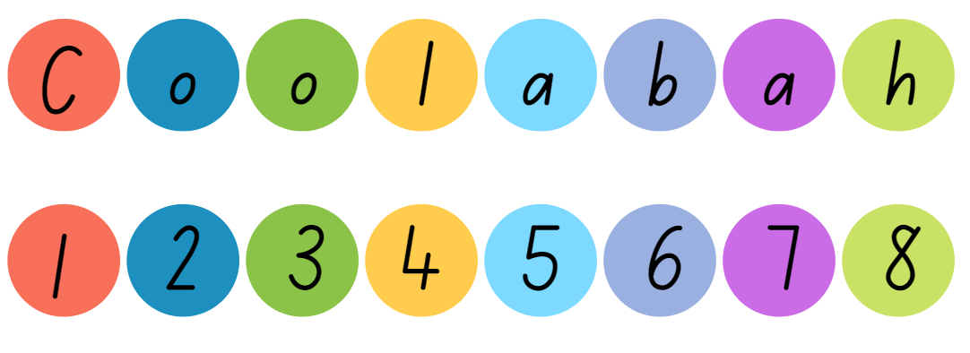
- Model turning the paper circles or sticky notes over and writing numerals on the back in ascending order (see Figure 1).
- Provide students with coloured circles or sticky notes and ask students to record their name on the coloured circles or sticky notes.
- Place students in groups of 6 and ask students to order the names from shortest to longest (see Figure 2).
Figure 2 – Ascending order
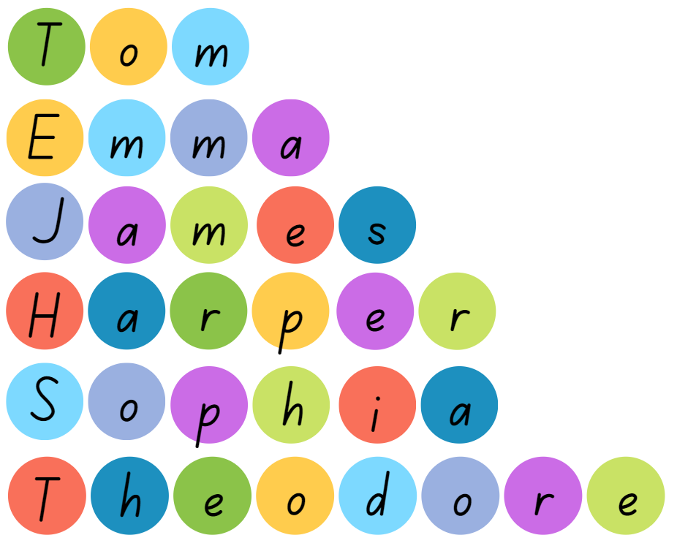
- Provide time for students to discuss the length of their groups name and encourage students to use the language, longer than, shorter than and the same as.
This table details assessment opportunities and differentiation ideas.
Assessment opportunities | Too hard? | Too easy?
What to look for:  - Can students compare and describe length using language such as longer than, shorter than, the same as? (MAO-WM-01, MAE-GM-02)  What to collect:  - observational data. (MAO-WM-01, MAE-GM-02) | Students cannot compare and describe length using language such as longer than, shorter than, the same as.  - Support students to identify objects within the classroom that are longer than their name and shorter than their name.  - Model how to align the ends of objects to compare if an item is longer or shorter. | Students can compare and describe length using language such as longer than, shorter than, the same as.  - Students draw an object that is longer than their name, then compare and describe the lengths.  - Encourage students to move independently around the classroom and identify 3 objects that are longer than or shorter than their name. Students record this by drawing and labelling their objects.

Discuss and connect the mathematics – 15 minutes
- Summarise the lesson together, drawing out key mathematical ideas. Ask:
- Who had the longest name in your group? What was the length?
- Who had the shortest name in your group? What was the length?
- Was anyone's name the same length?
- Why is it important to line up the first letter of each name when you are measuring?
Note: Groups can glue their display on a large piece of paper and record comparative language on their poster or glue their own name in their workbook.

Lesson 2: Quick sticks
Core concept: Length remains unchanged whether in a straight line or a curved line.
The table below contains suggested learning intentions and success criteria. These are best co-constructed with students.
Learning intentions | Success criteria
Students are learning that:  - equality of groups is when groups of objects have the same number of elements  - the length of a piece of string remains unchanged whether placed in a straight line or a curved line  - length can be compared by aligning the ends and described using comparative language. | Students can:  - use the phrase is the same as or is equal to express equality of groups  - explain why the length of a piece of string placed in a straight line is the same as a curved line  - compare and describe length using language such as longer than, shorter than, the same as.

Daily number sense: E-quill groups – 15 minutes
- Build student understanding of connecting counting and numerals to quantities by demonstrating the equality of numbers.
- Display Resource 1: Echidna and explain that echidnas are native Australian egg-laying monotremes that have quills to protect themselves from predators.
- Provide students with 8 craft sticks each to represent echidna quills.
- Tell students that they need to use the dot dice and dominoes patterns to represent 8. Challenge students to create as many combinations as possible with their given dice and dominoes, (see Figure 3).
Figure 3 – Dice and dominoes representation
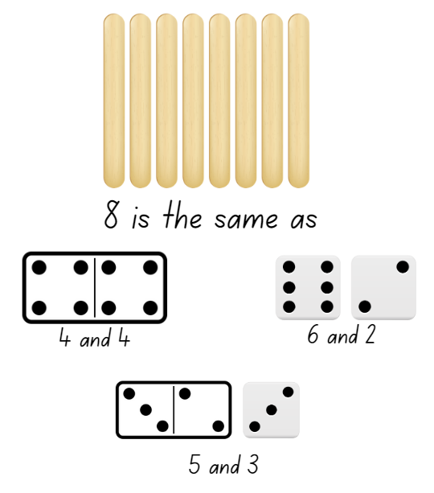
Images sourced from Canva and used in accordance with the Canva Content License Agreement.
- Regroup as a class and identify and record different student combinations. Encourage students to use the terms is the same as or is equal to express equality of groups.

This table details assessment opportunities and differentiation ideas.
Assessment opportunities | Too hard? | Too easy?
What to look for:  - Can students use the phrase is the same as or is equal to express equality of groups? (MAO-WM-01, MAE-RWN-01, MAE-RWN-02)  What to collect:  - observational data. (MAO-WM-01, MAE-RWN-01, MAE-RWN-02) | Students cannot use the term is the same as or is equal to express equality of groups.  - Model different vocabulary used to compare and describe equality of groups.  - Provide students with a ten-frame to visualise equality of groups. | Students can use the term is the same as or is equal to express equality of groups.  - Provide students with larger number of craft sticks and challenge students to use the dice and domino patterns to represent a larger number.  - Challenge students to compare and find an echidna with one more and one less.

Same but different – 20 minutes
- Refer to Resource 1: Echidna and model using a piece of string or pipe cleaner to create straight lines like an echidna quills and curved lines like the shape of an echidna’s body.
- In pairs, provide students with 2 pieces of string/pipe cleaners that are the same length for students to create one straight line and one curved line to reflect the quills and body of an echidna.
- Ask students to explain why they think the length of a piece of string remains unchanged whether placed in a straight line or a curved line.
- Allow students to explore this concept using different length string/pipe cleaners. Ensure that students are always using 2 pieces of string/pipe cleaners so that they can compare the same length of the string/pipe cleaners. This will help build students’ understanding that the length of the string/pipe cleaner remains the same despite its placement.
This table details assessment opportunities and differentiation ideas.
Assessment opportunities | Too hard? | Too easy?
What to look for:  - Can students explain why the length of a piece of string placed in a straight line is the same as a piece of string in a curved line? (MAO-WM-01, MAE-GM-02)  What to collect:  - observational data. (MAO-WM-01, MAE-GM-02) | Students cannot explain why the length of a piece of string placed in a straight line is the same as a curve.  - Support students to compare the 2 pieces of string as the same length. One piece remains in a straight line and support the students to make the other one curved.  - Students sort a collection of straight and curved objects. | Students can explain why the length of a piece of string placed in a straight line is the same as a curve.  - Students identify 3 objects that have straight and curved lines. Record by drawing and labelling.  - Draw examples of objects with straight and curved lines.

Consolidation and meaningful practice: Stick sorting – 25 minutes
- Lead students to the playground and explain that they will need to find one stick each.
- Find a line in the playground, for example, sports court line or line in the concrete to use as a baseline. Explain that students will take turns to lay their stick side by side ensuring that the end of their stick aligns with the chosen baseline.
- Tell students that the challenge is to put their stick in the correct position so that the sticks are arranged in order from shortest to longest (see Figure 4).
Figure 4 – Shortest to longest
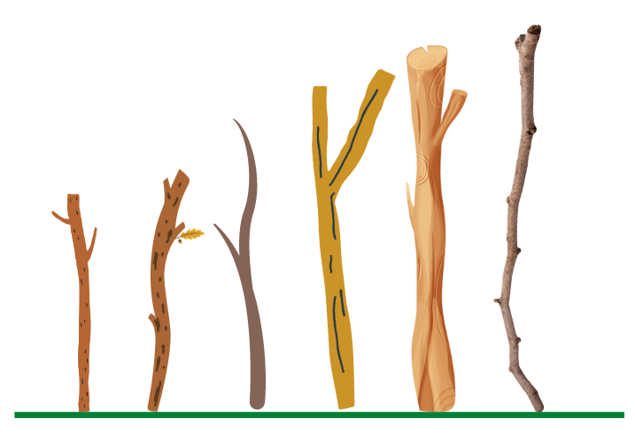
Images sourced from Canva and used in accordance with the Canva Content License Agreement.
- Encourage students to use comparative language such as longer than, shorter than and the same as.
Note: The non-uniformity of the sticks helps to facilitate mathematical discussions around whether a stick with a bend in it is longer than one that is straight. Provide students with string to help measure curved sticks.

Lesson 3: Rock-wallaby rescue
Core concept: Area can be described using comparative language.
The table below contains suggested learning intentions and success criteria. These are best co-constructed with students.
Learning intentions | Success criteria
Students are learning that:  - numbers have a sequence based on their value  - area is the inside part of a shape  - area measures the space that a closed shape takes up. | Students can:  - identify the number before as one less and the number after as one more than a given number  - use comparative language such as bigger than, smaller than and the same as to describe areas  - compare areas of similar shapes by directly placing one on top of another.

Daily number sense: Rock-wallaby relay race – 15 minutes
- Build student understanding of the counting sequence by identifying the number before as one less and the number after as one more.
- Show students Resource 2: Rock-wallaby and model and ask students to imitate how a rock-wallaby moves.
- Choose one student to hop like a rock-wallaby out to the board and roll the 20-sided interactive die.
- Students use their individual whiteboard to record the rolled number in the middle of their board. Students then record the numbers that are one less and one more than the rolled number (see Figure 5).
Figure 5 – One less, one more
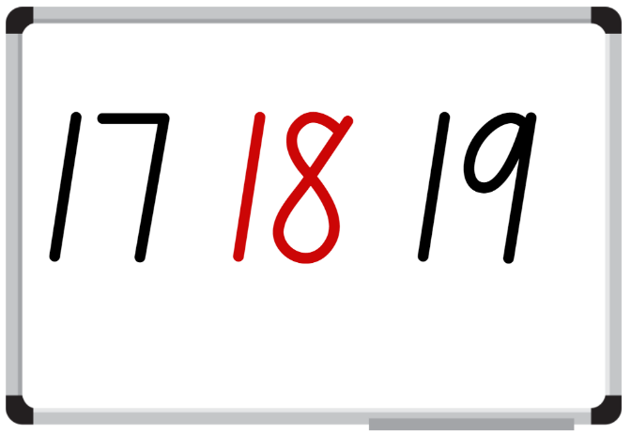
Images sourced from Canva and used in accordance with the Canva Content License Agreement.
- Have students share and justify their responses using the language of one more and one less.
This table details assessment opportunities and differentiation ideas.
Assessment opportunities | Too hard? | Too easy?
What to look for:  - Can students identify the number before as one less and the number after as one more than a given number? (MAO-WM-01, MAE-RWN-01, MAE-RWN-02)  What to collect:  - observational data. (MAO-WM-01, MAE-RWN-01, MAE-RWN-02) | Students are unable to identify the number before as one less and the number after as one more than a given number.  - Display a number chart for students to reference whilst identifying the number that is one less and one more.  - Provide students with a ten-frame and counters. Students roll the die and place the corresponding counters on the ten-frame. Students remove a counter to identify the number that is one less and add a counter to identify the number that is one more. | Students can identify the number before as one less and the number after as one more than a given number.  - Provide students with two 6-sided die to make a two-digit number and challenge students to identify the number that is one less and one more.  - Challenge students to identify and record the number 2 less and 2 more than the given number.

Stick shape shelter – 35 minutes
- Provide students with a piece of paper and a collection of objects, for example, craft sticks, pipe cleaners, straws, match sticks or sticks.
- Challenge students to create shapes to form a shelter for a rock-wallaby using 10 sticks on their piece of paper. Explain that rock-wallabies live along rocky hills, boulders and caves. Display Resource 3: Rock-wallaby cave as a visual stimulus.
- When students have created their shelter, model tracing around the stick shape shelter to make a closed shape. Then, cut around the shape (see Figure 6).
Figure 6 – Shelter area
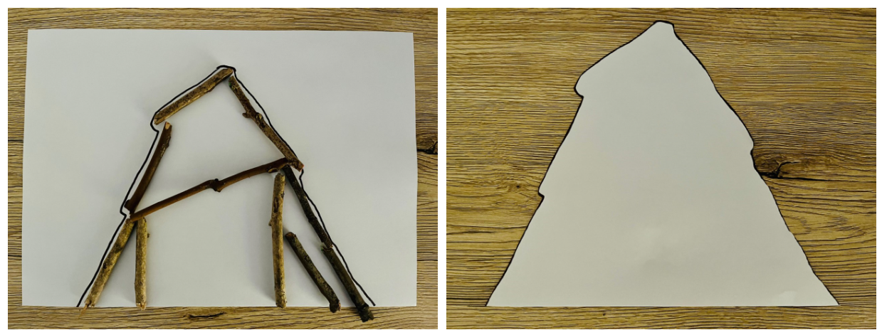
- Students display their shelters and go on a gallery walk to look at the different shelters.
- Regroup and reinforce the concept that the attribute of area is the measure of the surface inside a closed shape. Ask:
- Which shelter do you think has the biggest area?
- Which shelter do you think is the smallest in area?
- Are you confident with your responses? How can you be sure?
- Using 2 shelters, model how to superimpose the shelters to help determine which shelter has the largest surface.
Superimpose: Comparing areas by placing one area on top of another.
- Arrange students into small groups with their shelters. Students predict the order of the shelters from smallest surface to biggest surface and then measure the surfaces by superimposing the shelters. Encourage students to use comparative language, such as bigger than, smaller than and the same as when ordering their shelters.

Discuss and connect the mathematics: 10 minutes
- Regroup as a class and have students display their shelters from the smallest to the biggest and justify the placement of each shelter. Ask:
- Can you demonstrate how you superimposed the shelters?
- Were there any shelters that you were unsure about? Why?
- Did any of the shelters have the same surface?
- What challenges did you face today? How did you overcome this challenge?
This table details assessment opportunities and differentiation ideas.
Assessment opportunities | Too hard? | Too easy?
What to look for:  - Are students able to compare areas of similar shapes by directly placing one area on top of another? (MAO-WM-01, MAE-2DS-02)  - Can students use comparative language such as bigger than, smaller than and the same as to describe areas? (MAO-WM-01, MAE-2DS-02)  What to collect:  - observational data. (MAO-WM-01, MAE-2DS-02) | Students cannot use comparative language such as bigger than, smaller than and the same as to describe areas.  - Model comparing 2 similar objects of different areas where one fits inside the boundary of the other.  - Model comparing 2 different shaped areas where one can be placed on top of the other. | Students can use comparative language such as bigger than, smaller than and the same as to describe areas.  - Students identify an object that is bigger than and smaller than the rock wallaby shelter they created.  - Students predict and find 2 shapes that might have the same area.

Lesson 4: Familiar footprints
Core concept: Area can be described using comparative language.
The table below contains suggested learning intentions and success criteria. These are best co-constructed with students.
Learning intentions | Success criteria
Students are learning that:  - numbers have a sequence based on their value  - area is the inside part of a shape  - area measures the space that a closed shape takes up. | Students can:  - identify the number before as one less and the number after as one more than a given number  - use comparative language such as bigger than, smaller than, the same as to describe areas  - make and compare areas of 2 similar shapes directly by placing one on top of the other.

Daily number sense: Wandering wallabies – 20 minutes
- Build student understanding of the counting sequence by identifying the number before as one less and the number after as one more.
- Introduce students to a wallaby named Warrang and display Resource 2: Rock-wallaby. Explain that rock wallabies are a marsupial native to Australia, belonging to the same family as the kangaroo. Tell a story about a wallaby named Warrang. Warrang the wallaby is a herbivore that likes to wander to find and eat leaves and berries from the lilly pilly tree, Resource 4: Lilly pilly berries.
Note: Warrang is a Dhurag word for child. Dhurag is the Aboriginal language spoken from Jervis Bay area to Wallaga Lake on the NSW south coast.
- Display Resource 5: Less and more and model rolling a 20-sided die. Record the number rolled as the target number and draw dot dice and domino patterns to represent the given number. Then model counting out some objects from a larger collection to represent one less and one more than the target number (see Figure 7).
Figure 7 – Less and more gameplay
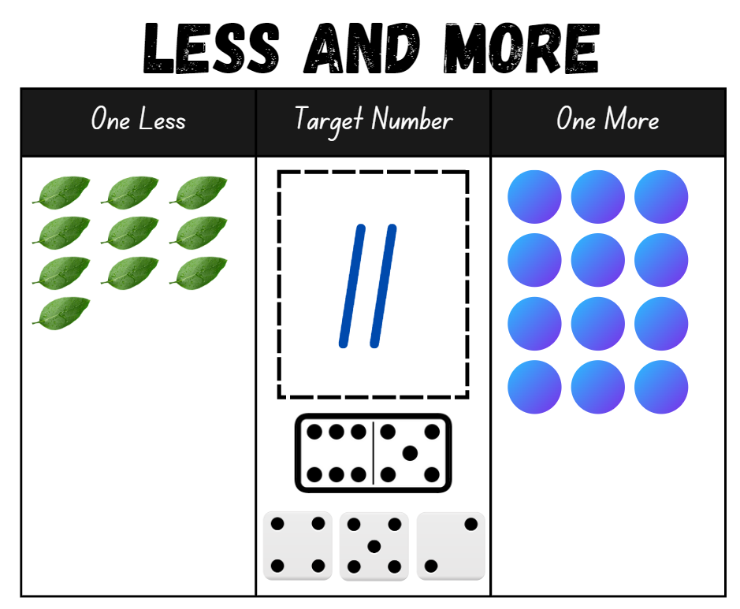
Images sourced from Canva and used in accordance with the Canva Content License Agreement.
Note: Use Resource 5: Less and more in a reusable sleeve so that this activity can be played multiple times.
- Students play with a partner, rolling the die to represent different numbers.
This table details assessment opportunities and differentiation ideas.
Assessment opportunities | Too hard? | Too easy?
What to look for:  - Can students represent numbers by making groups of objects that are one less and one more than a given number? (MAO-WM-01, MAE-RWN-01, MAE-RWN-02)  What to collect:  - observational data. (MAO-WM-01, MAE-RWN-01, MAE-RWN-02) | Students cannot represent numbers by making groups of objects that are one less and one more than a given number.  - Provide students with a number chart to help identify numbers.  - Model counting objects using one-to-one correspondence. | Students can represent numbers by making groups of objects that are one less and one more than a given number.  - Represent numbers in a variety of ways using finger patterns.  - Challenge students to roll a twenty-sided die and identify numbers 2 less and 2 more that the given number.

Whose footprint is this? – 25 minutes
This lesson has been adapted from Prints and Outlines at NZ Maths.
- Display Resource 6: Animal footprints 1 and ask students to guess which footprint belongs to native Australian animals, such as a kookaburra, emu, kangaroo and dingo.
- Reinforce that area is the inside part of a shape. Discuss the footprints with students.
- Provide students with Resource 7: Animal footprints 2 to cut and place in order from smallest to biggest area covered.
- Ask students questions such as:
- Which footprint takes up the most space? How do you know?
- Which footprint covers the least space? How do you know?
- Provide students with a piece of paper and have each student trace around one of their feet and cut out the shape.
- Ask students to predict and give reasons about where they think their footprint would fit in comparison to the native Australian animal footprints, ordered from smallest to biggest area covered. Reinforce using comparative language such as bigger than, smaller than or the same as when comparing areas.
- Students then glue all footprints in their workbook from smallest to biggest.
- Regroup as a class and ask:
- Which native Australian animal footprint has a larger area than your footprint?
- Which native Australian animal footprint has a smaller area than your footprint?
- Is the dingo footprint bigger than, smaller than or the same as your footprint?
This table details assessment opportunities and differentiation ideas.
Assessment opportunities | Too hard? | Too easy?
What to look for:  - Are students able to make and compare areas of 2 similar shapes directly by directly placing one area on top of another? (MAO-WM-01, MAE-2DS-02)  - Can students use comparative language such as bigger than, smaller than, the same as to describe area? (MAO-WM-01, MAE-2DS-02)  What to collect:  - student work samples. (MAO-WM-01, MAE-2DS-02) | Students cannot use comparative language such as bigger than, smaller than, the same as to describe areas.  - Model comparing 2 footprints where one can be placed on top of the other.  - Model using comparative language such as bigger than, smaller than or the same as when comparing areas. | Students can use comparative language such as bigger than, smaller than, the same as to describe areas.  - Students identify an object that is bigger than and smaller than their footprint.  - Students predict and find 2 shapes that might have the same area as their footprint.

Consolidation and meaningful practice: Track and trace – 15 minutes
- As a class brainstorm other native Australian animals that create tracks (footprints) that have different areas.
- Ask students to create their own animal footprint that is bigger than their own foot.
- Students draw and cut out their created animal footprint and glue into their workbook.
- Share and discuss animal footprint drawings in comparison to their own.
- Reinforce the use of comparative language in their descriptions such as bigger than, smaller than and the same as.

Lesson 5: Water wise
Core concept: Containers can hold different amounts.
The table below contains suggested learning intentions and success criteria. These are best co-constructed with students.
Learning intentions | Success criteria
Students are learning that:  - counting forwards and backwards can assist finding numbers before or after a given number  - volume is the amount of space an object occupies. | Students can:  - identify numbers before and after by counting forwards and backwards  - use the terms full, empty and about half full to describe the contents of containers.

Daily number sense: I spy – 10 minutes
- Build student understanding of the counting sequence of ones by counting forwards and backwards.
- Introduce I spy by laying out a deck of playing cards face up in rows and columns with all picture cards removed from the deck, Figure 8. This can also be done using interactive playing cards.
Figure 8 – I spy gameplay
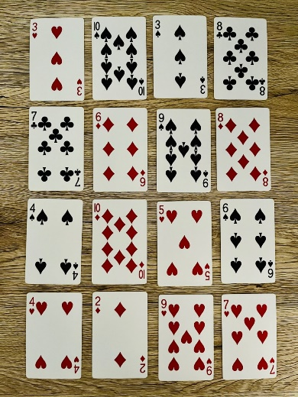
- Students say I spy statements to the class for the other students to identify the chosen card. Model different ways to give clues, for example, ‘I spy a card that is one less than 3 or I spy a card that is one more than 8.’ Turn the card over when a student has identified the correct number.
- Reinforce that students may need to count forwards and backwards to find the number.
- Repeat the game multiple times as a class or in small groups.

Musical maths – 20 minutes
This lesson has been adapted from Messy Maths: A Playful, Outdoor Approach to Early Years from Robertson (2017).
- Take students outside with a collection of different containers of different shapes, spoons, as well as the resources for the second part of this lesson, The Biggest Splat.
- Explain that students will be filling their containers with water, listening to the sound it produces when tapped and describing the amount of water in the containers as full, empty or about half full, (see Figure 9).
Internal volume (capacity): A measure of how much a container can hold.
Note: Internal volume or capacity is only used in relation to containers and generally refers to liquid measurement. Knowing these definitions is not an expectation at this stage in learning.
Figure 9 – Containers
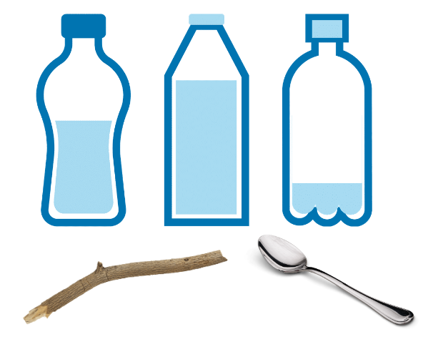
Images sourced from Canva and used in accordance with the Canva Content License Agreement.
- Model and ask students in small groups to experiment with sound when the containers are tapped with sticks, spoons or other objects. As students experiment, encourage them to identify containers as full, empty or about half full.
- Ask questions such as:
- Does the container that is full have a different sound to a container that is half full?
- Does the container that is empty have a different sound to a container that is full?
- What happens if 2 of your containers have the same amount of water and shape?
- Ask students to order their containers according to the different amounts of water (internal volume). Students tap each container to hear the changing pitch. Students demonstrate to the class.
This table details assessment opportunities and differentiation ideas.
Assessment opportunities | Too hard? | Too easy?
What to look for:  - Can students use the terms full, empty and about half full to describe the contents of containers? (MAO-WM-01, MAE-3DS-02)  What to collect:  - observational data. (MAO-WM-01, MAE-3DS-02) | Students cannot use the terms full, empty and about half full to describe the contents of containers.  - Support students to fill and empty containers using materials such as water or sand.  - Model using the terms full, empty and about half full to describe contents of containers. | Students can use the terms full, empty and about half full to describe the contents of containers.  - Students brainstorm types of containers that hold more and hold less than their water bottle.  - Challenge students to draw and label other objects that can be filled and described using the terms full, empty and about half full.

Consolidation and meaningful practice: The biggest splat – 30 minutes
This lesson has been adapted from Messy Maths: A Playful, Outdoor Approach to Early Years by Robertson (2017).
- Regroup as a class and explain that students will be experimenting with internal volume (capacity) by determining which container filled with water creates the biggest splat when tipped upside down.
- Model pouring and emptying the water from 2 different shaped containers onto the ground to create splat marks.
- Students predict and then observe the splats and compare which splat has the largest area and justify their response (see Figure 10). Students use comparative language, such as bigger than, smaller than and the same as, to describe the splats.
Figure 10 – Splat
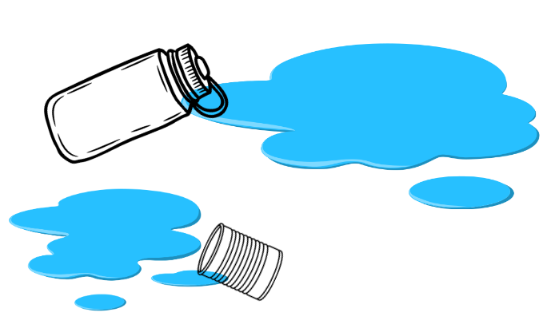
Images sourced from Canva and used in accordance with the Canva Content License Agreement.
Note: Water can also be thrown against a wall.
- Provide time for students to play the biggest splat in pairs with a focus on predicting and comparing which splat has the largest area and justifying their response using comparative language.
- Use 'Talk moves' to facilitate class discussion and make connections between internal volume (capacity) and the area of the splat.

Lesson 6: Volume
Core concept: There are many ways to measure how much a container can hold.
The table below contains suggested learning intentions and success criteria. These are best co-constructed with students.
Learning intentions | Success criteria
Students are learning that:  - volume is the amount of space an object occupies  - objects can have the same volume but look different. | Students can:  - use the terms full, empty and about half full to describe the contents of containers  - describe and compare the volume of 2 objects using the language of takes up more and less space (comparative language)  - compare the volumes of 2 objects by deconstructing one object and using its parts to construct the other object.

Daily number sense – 10 minutes
- From a class need surfaced through formative assessment data, identify a short, focused activity that targets students’ knowledge, understanding and skills. Example activities may be drawn from the following resources:
- Thinking Mathematically Early Stage 1
- Universal Resources Hub.

The sandpit – 30 minutes
- Take students outside with a collection of different size and shaped containers to a sandpit.
Note: If a sandpit is not available, students can use something similar, for example, rice or water to complete the following activity.
- Demonstrate how to compare the internal volume (capacity) of 2 containers directly by filling one and pouring into the other. Display a few different containers and ask:
- Which container do you think will hold the most amount of sand? Why?
- Which container do you think will hold the least amount of sand? Why?
- Do you think any of the containers hold the same amount of sand? Why?
- Which container holds more/less sand? How do you know?
- As a class, demonstrate pouring sand into the containers as students provide answers to the previous questions.
- Provide small groups of students with a collection of containers so that they can directly compare the internal volumes (capacities). Students need to be provided with containers that are:
- shorter and hold more
- taller and hold less
- shorter and hold less
- taller and hold more
- short and hold the same as a tall container.
Note: A variety of containers supports students into understanding that a taller container does not always hold the most.
This table details assessment opportunities and differentiation ideas.
Assessment opportunities | Too hard? | Too easy?
What to look for:  - Can students use the terms full, empty and about half full to describe the contents of containers? (MAO-WM-01, MAE-3DS-02)  What to collect:  - observational data. (MAO-WM-01, MAE-3DS-02) | Students cannot use the terms full, empty and about half full to describe the contents of containers.  - Support students to fill and empty containers using materials such as water or sand.  - Model using the terms full, empty and about half full to describe contents of containers. | Students can use the terms full, empty and about half full to describe the contents of containers.  - Students brainstorm types of containers that hold more and hold less than their water bottle.  - Challenge students to draw and label other objects that can be filled and described using the terms full, empty and about half full.

Building – 20 minutes
- Reflect with students on how internal volume (capacity) is how much a container can hold and that volume is the amount of space an object occupies.
- Show students 2 different models made from interlocking cubes which have different volumes. Ask students what would happen if you deconstructed object 1 and use the same blocks to construct object 2. Students turn and talk and then share and justify their ideas with the class.
- Ask a student to model how they would deconstruct object 1 and use the same blocks to construct object 2. Discuss how it was not possible because each object has a different volume and takes up a different amount of space. Model using comparative language, such as takes up more/less space, when describing the object.
- Provide partners with interlocking cubes. Partner 1 builds 2 objects and shows their partner. Partner 2 compares the volumes of the 2 objects and deconstructs object 1 and uses the same blocks to construct object 2. Students discuss if it is possible and use comparative language to describe the volume of the objects. Students swap roles and continue to build and deconstruct objects.
- Students share their objects and what they discovered about their objects with the class.
This table details assessment opportunities and differentiation ideas.
Assessment opportunities | Too hard? | Too easy?
What to look for:  - Are students able to compare the volumes of 2 objects by deconstructing one object and using its parts to construct the other object? (MAO-WM-01, MAE-3DS-02)  - Are students able to describe and compare the volume of 2 objects using the language of takes up more/less space? (MAO-WM-01, MAE-3DS-02)  What to collect:  - observational data. (MAO-WM-01, MAE-3DS-02) | Students are not confident comparing objects.  - Students compare their 2 models by deconstructing and constructing their model.  - Students use one-to-one correspondence to recognise the volume. | Students are confident comparing objects.  - Students are given a set number of interlocking cubes, for example, 24 cubes. Students create as many different prisms using all 24 interlocking cubes.  - Students record the volume of each prism using the language of high, wide and long.

Lesson 7: Measuring mass
Core concept: Mathematicians use hefting to directly compare 2 masses.
The table below contains suggested learning intentions and success criteria. These are best co-constructed with students.
Learning intentions | Success criteria
Students are learning that:  - hefting helps to compare and describe the weight of objects  - an object’s weight cannot be determined just by looking at it. | Students can:  - use the correct language to predict and compare the weight of objects that are heavier than, lighter than or have about the same weight as  - compare the weight of 2 objects by hefting.

Daily number sense: Number match – 15 minutes
- Provide each student with a gameboard from Resource 8: Number match and a collection of counters. Allow time for students to look carefully at their gameboard and identify all the number representations.
Note: Laminating Resource 8: Number match or placing it in a reusable sleeve will allow for it to be used in subsequent units.
- Call out a number between zero and 20 and record it on the board. If a student has the corresponding number on their gameboard, they place a counter on it.
- Continue to call out and record numbers between zero and 20. When a student covers all their number representations, they call out number match.
- Students can play again with a different gameboard.

Hefting – 15 minutes
- Display 2 different objects and ask students how they can determine the weight of 2 different objects. Students turn and talk and then share and justify their response with the class.
- If not identified during discussion, inform students that hefting is used to test the weight of an object by lifting or holding and balancing it, for example, holding one object in each hand and feeling the weight. Model to students how to use vocabulary to describe the weight of the objects as, heavier than, lighter than or have about the same weight as.
- Set up around the classroom some weighing stations with various objects. Stations should have objects that are:
- light and large
- heavy and large
- light and small
- heavy and small
- large but lighter than a smaller object.
- Students move around the classroom predicting, hefting and comparing 2 different objects and using the correct vocabulary, heavier than, lighter than or have about the same weight as, to describe the weight of their objects.
Note: Students who have already demonstrated an understanding of mass could be extended in their learning by exploring the placement of mass at different points on an equal-arm balance.
- Regroup as a class and have students share what they noticed when they were hefting the objects. Ask:
- Did the size of the object impact the weight? Explain why/why not.
- Were there any items that were hard to determine the weight of?
- What questions do you still have?
This table details assessment opportunities and differentiation ideas.
Assessment opportunities | Too hard? | Too easy?
What to look for:  - Are students able to use the correct language to predict and compare the weight of objects that are heavier than, lighter than or have about the same weight as? (MAO-WM-01, MAE-NSM-01)  - Can students compare the weight of 2 objects by hefting? (MAO-WM-01, MAE-NSM-01)  What to collect:  - observational data. (MAO-WM-01, MAE-NSM-01) | Students cannot use the correct language to predict and compare the weight of objects that are heavier than, lighter than or have about the same weight as.  - Students look at their reflection in a mirror to see what happens to their hands and arms when hefting light and heavy objects.  - Introduce examples of big objects that have a lighter mass than a smaller object.  Students cannot compare the weight of 2 objects by hefting.  - Provide time for students to compare 2 objects that are quite different in mass.  - Show and describe the difference between masses when hefting. | Students can use the correct language to predict and compare the weight of objects that are heavier than, lighter than or have about the same weight as.  - Challenge students to find big objects that are lighter in weight than a small object.  - Students play I spy by looking out the window and making predictions about which objects would be heavier than, lighter than or have about the same weight as their school bag and explain reasons for this prediction.  Students can compare the weight of 2 objects by hefting.  - Students use hefting to place objects in order from lightest to heaviest.  - Students draw a picture of themselves hefting 2 objects of about the same mass.

Consolidation and meaningful practice: Ramp rolling – 30 minutes
This lesson has been adapted from Messy Maths: A Playful, Outdoor Approach to Early Years by Robertson (2017).
- Show students 2 objects, for example, a can and a tennis ball or a water bottle and a pencil. Ask students to predict which object they think would roll down the ramp and travel the fastest and furthest length. Students turn and talk and then share their prediction and justification with the class.
- If not identified during discussion, ask if students think the weight of the objects impacts the speed and the distance the object travels.
- Provide small groups with a range of round objects of varying weights, for example, soup can, coin, piece of fruit, water bottle, pencil, as well as something to make a ramp with, for example, tote tray and book. Before students roll the 2 objects they need to predict and heft the objects to identify which object they think will travel faster and/or further. Groups continue to do this with different objects.
- Regroup as a class and discuss what students noticed when rolling their objects. Ask:
- How does weight impact the speed and/or distance of an object?
- Were there 2 objects that were a similar speed and/or distance?
- What are you still wondering?

Lesson 8: Sink the boat
Core concept: Mass can be compared and ordered using direct comparison.
The table below contains suggested learning intentions and success criteria. These are best co-constructed with students.
Learning intentions | Success criteria
Students are learning that:  - objects that are small may be heavier than a larger object  - an objects weight cannot be determined just by looking at it. | Students can:  - identify and predict which object would be heavier than, lighter than, or have about the same weight as another object and explain reasons for this prediction.

Daily number sense: Dot talk – 10 minutes
This activity has been adapted from ‘Seeing spots’ in Mindset Mathematics: Visualizing and Investigating Big Ideas by Boaler et al. (2021).
- Build student understanding of subitising, composing and decomposing numbers by engaging in a dot talk.
- Display Resource 9: Dot talk for a few seconds. Ask students how many dots they saw. Students turn and talk to a partner about how they saw the dots.
- Students share their thinking by showing or describing the different clusters they saw. Colour code the different groups to help others see their thinking (see Figure 11).
Figure 11 – Recoding dot talk
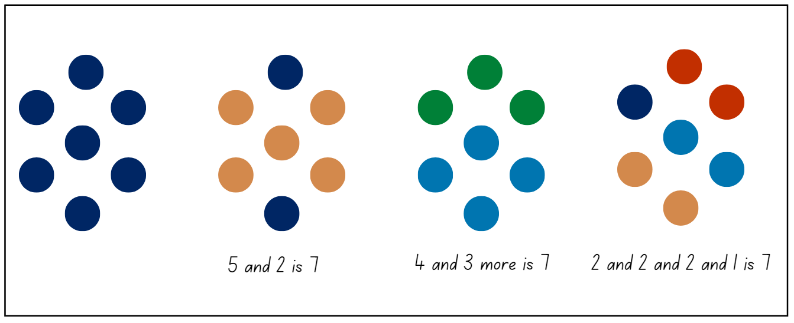
Note: Students may use the symmetry of the dots, their knowledge of dice patterns, decomposition in rows, or other strategies. These connections support students to think visually about numbers and make connections between physical objects and the number used to represent them.

How much weight can keep a boat afloat? – 40 minutes
- Explain that students will be create a boat using aluminium foil or a similar material, then adding a variety of objects to see how much weight the boat can carry before it sinks.
- Model how to make a boat using aluminium foil by making 2 boats of the same size. Carefully place one boat at a time on top of the water in a container. Choose 2 different objects and make a prediction of which boat will sink first. Then gently add different objects in each boat until it sinks. For example, adding interlocking cubes into boat 1 and wooden pattern blocks into boat 2.
- Once a boat has been sunk, discuss why it sank first.
- Repeat with different objects and have students predict which objects will sink the boat first and justify their response. Students need to use the language heavier than, lighter then or have about the same weight as when discussing objects.
- Provide pairs with aluminium foil, a large collection of objects and a container of water. Pairs make the same size boats and predict which objects will be heavier than, lighter than or have about the same weight as and which boat they think will sink first. Students place objects in the boats until one sinks and reflect on their predictions. Students repeat the process with different objects.

Discuss and connect the mathematics – 10 minutes
- Regroup as a class and summarise the lesson together drawing out key mathematical ideas. Ask:
- How did the objects impact which boat sunk first?
- Were your predictions correct? Explain.
- Was an object heavier than you thought?
- Was an object lighter than you thought?
- Did you have any objects that had about the same weight?
- Did you have an object that did not sink the boat? Explain why.
This table details assessment opportunities and differentiation ideas.
Assessment opportunities | Too hard? | Too easy?
What to look for:  - Can students identify and predict which object would be heavier than, lighter than, or have about the same weight as another object and explain reasons for this prediction? (MAO-WM-01, MAE-NSM-01)  What to collect:  - observational data. (MAO-WM-01, MAE-NSM-01) | Students cannot identify and predict which object would be heavier than, lighter than, or have about the same weight as another object and explain reasons for this prediction.  - Model how to use hefting to feel the difference between 2 objects and compare using comparative language.  - Provide time for students to compare 2 objects that are quite different in weight. | Students can identify and predict which object would be heavier than, lighter than, or have about the same weight as another object and explain reasons for this prediction.  - Challenge students to find small objects that are heavier in weight than a large object.  - Students play I spy by looking out the window and making predictions about which objects would be heavier than, lighter than, or have about the same weight as their school hat and explain reasons for this prediction.

Resource 1: Echidna
“Echidna” by CraigRJD is used in accordance with the Canva Content License Agreement.

Resource 2: Rock-wallaby
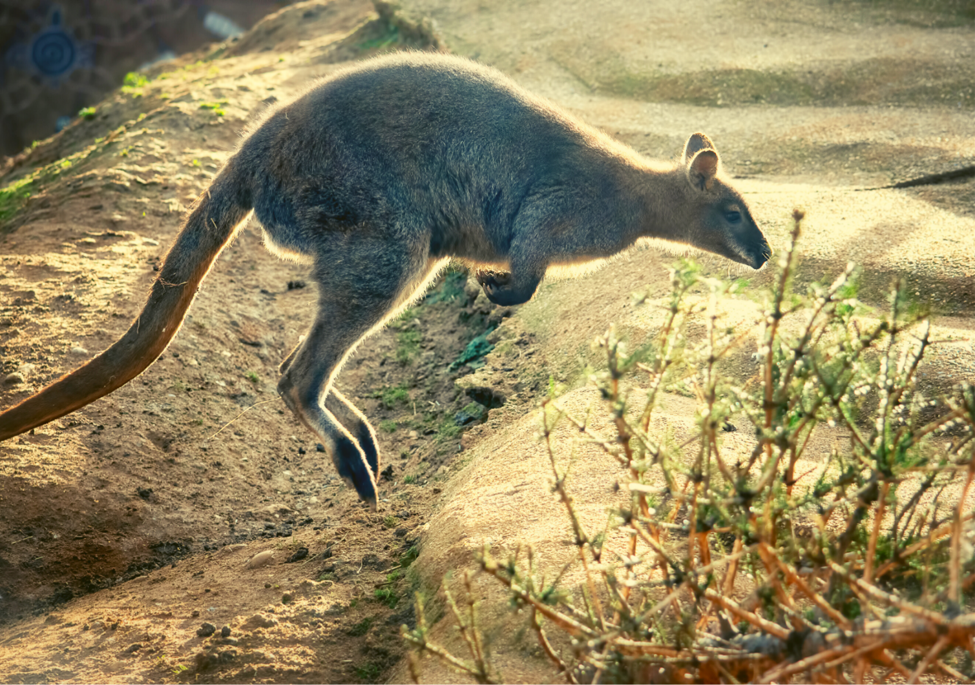
“Hopping Australian Wallaby” by stanzi11 is used in accordance with the Canva Content License Agreement.

Resource 3: Rock-wallaby cave
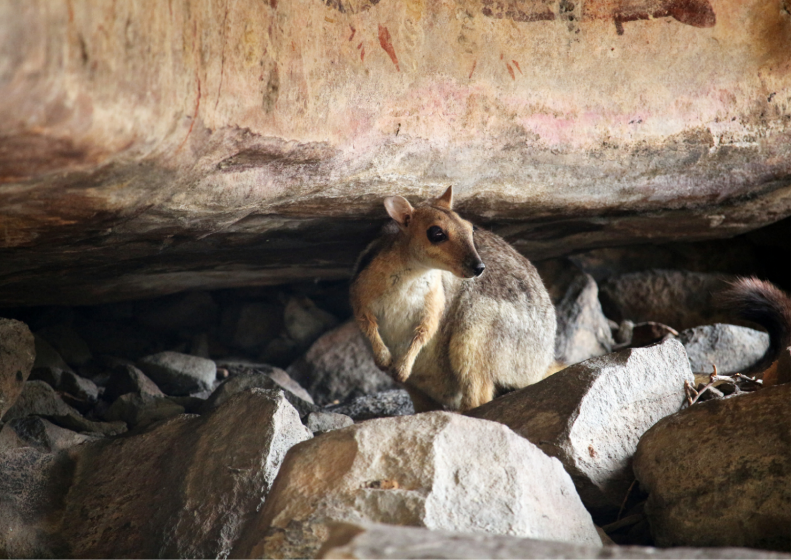
“rock wallaby” by Qin Xie is used in accordance with the Canva Content License Agreement.

Resource 4: Lilly pilly berries
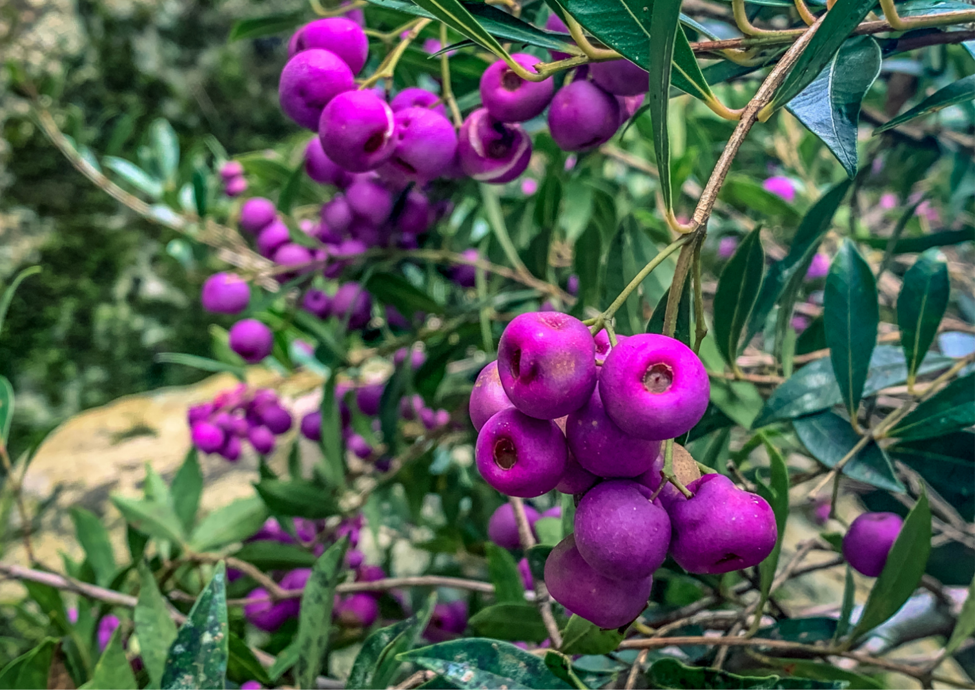
“Creek Lilly Pilly” by IainStych is used in accordance with the Canva Content License Agreement.

Resource 5: Less and more
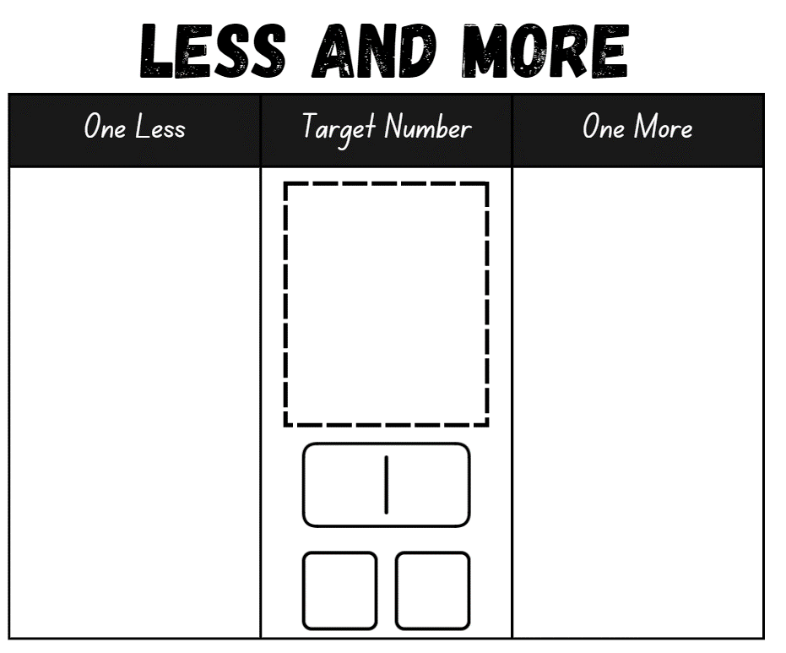

Resource 6: Animal footprints 1
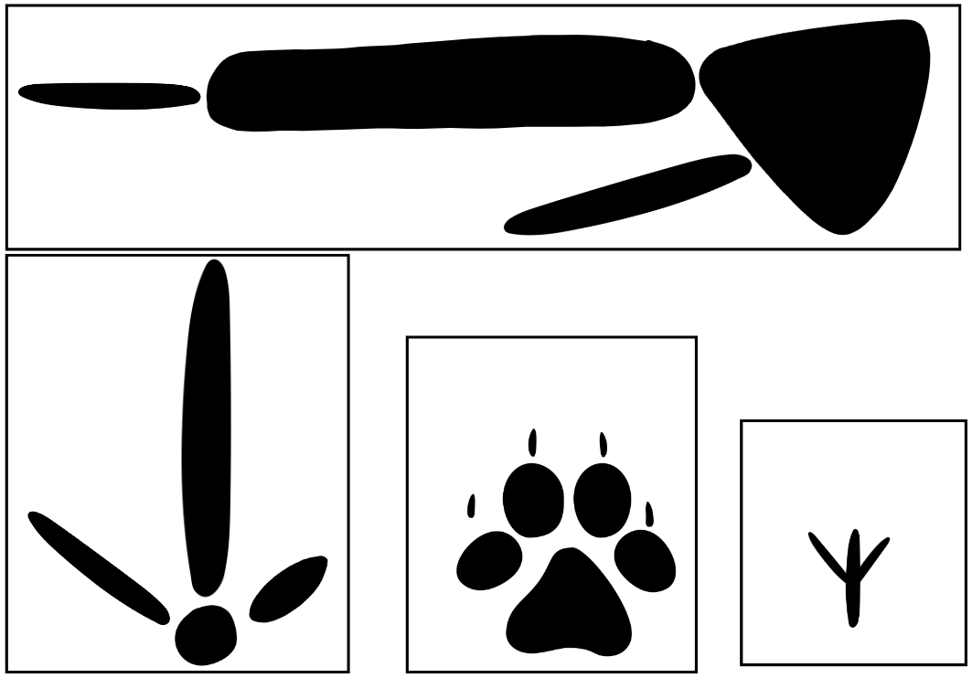
Images sourced from Canva and used in accordance with the Canva Content License Agreement.

Resource 7: Animal footprints 2
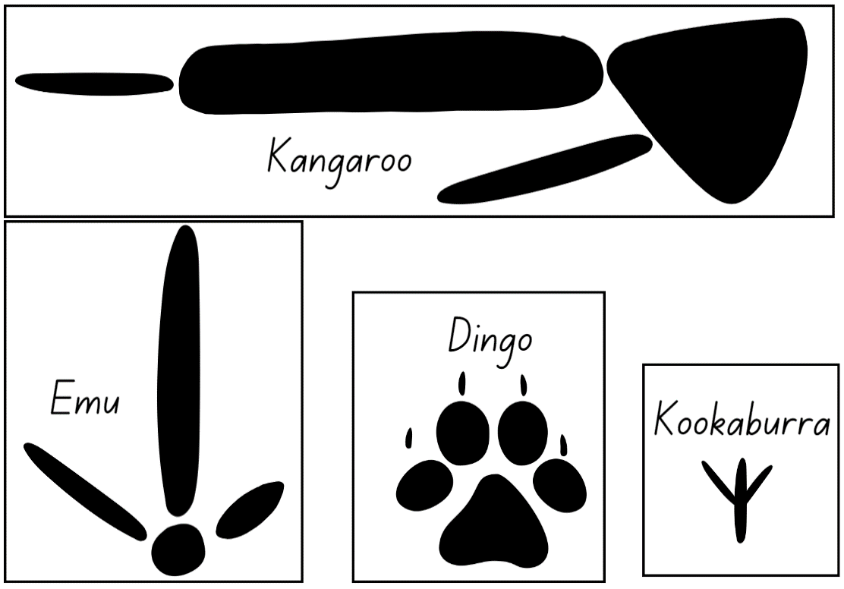
Images sourced from Canva and used in accordance with the Canva Content License Agreement.

Resource 8: Number match
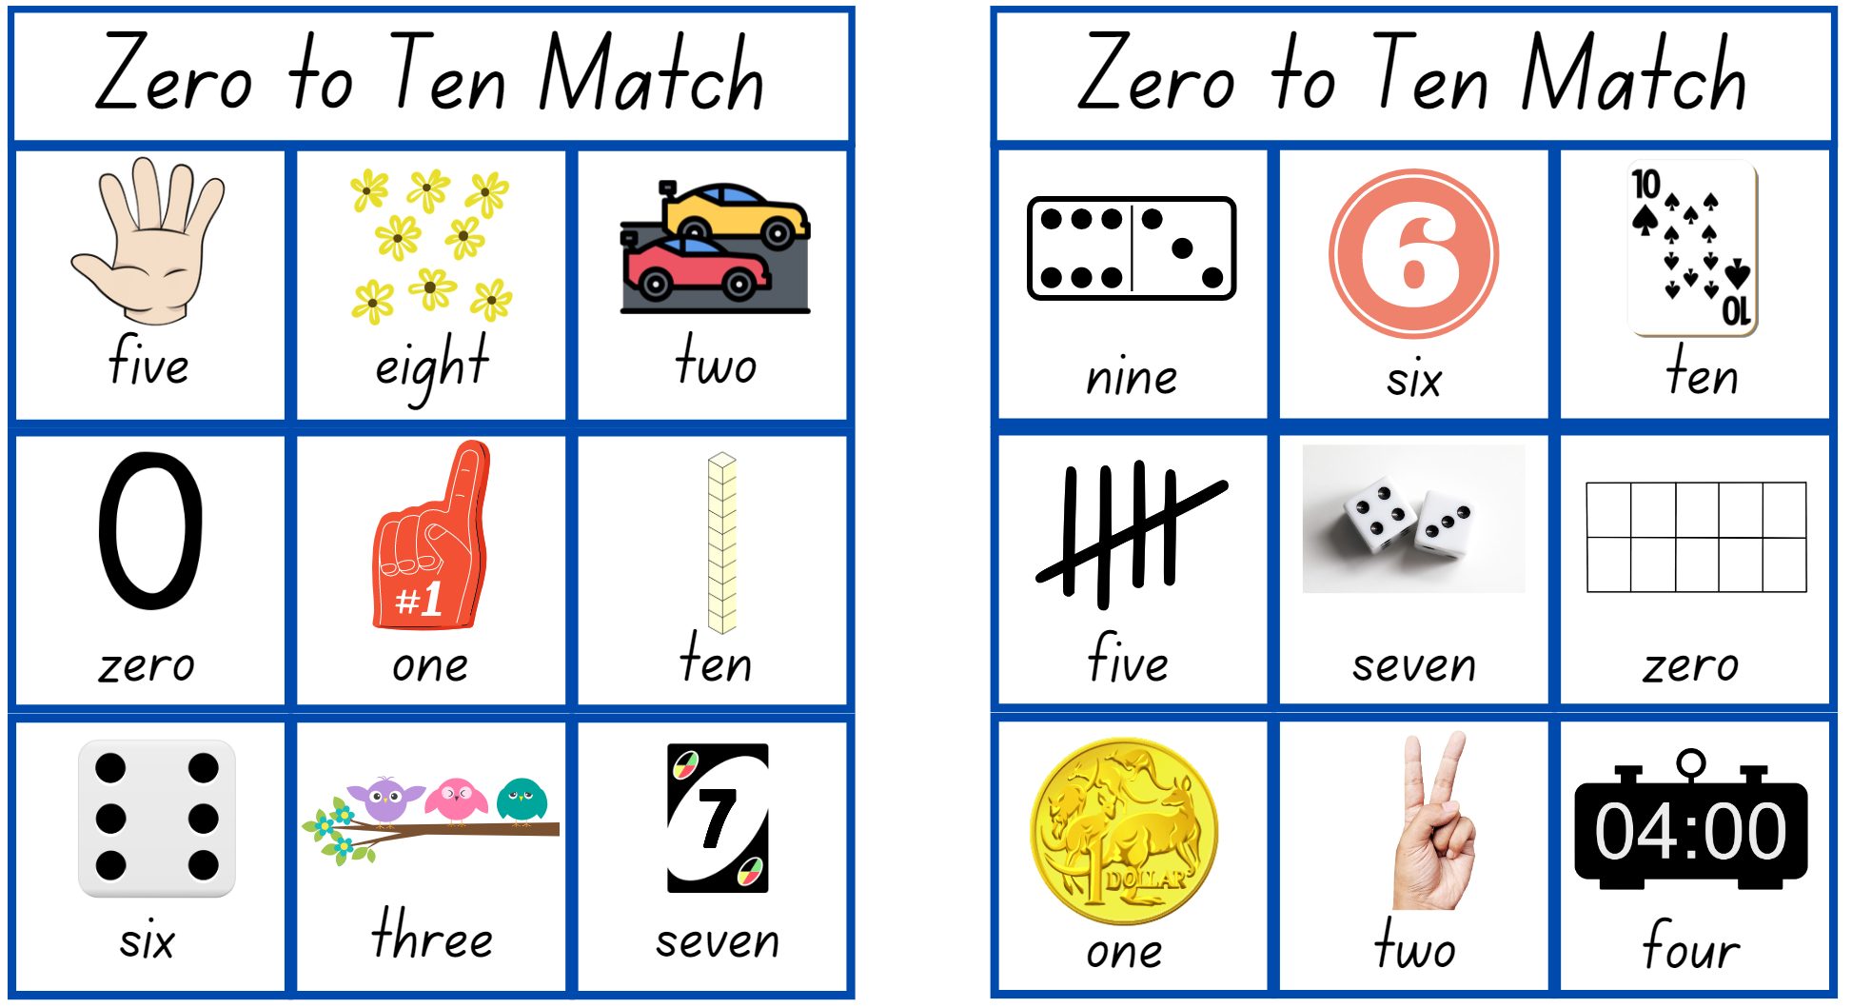
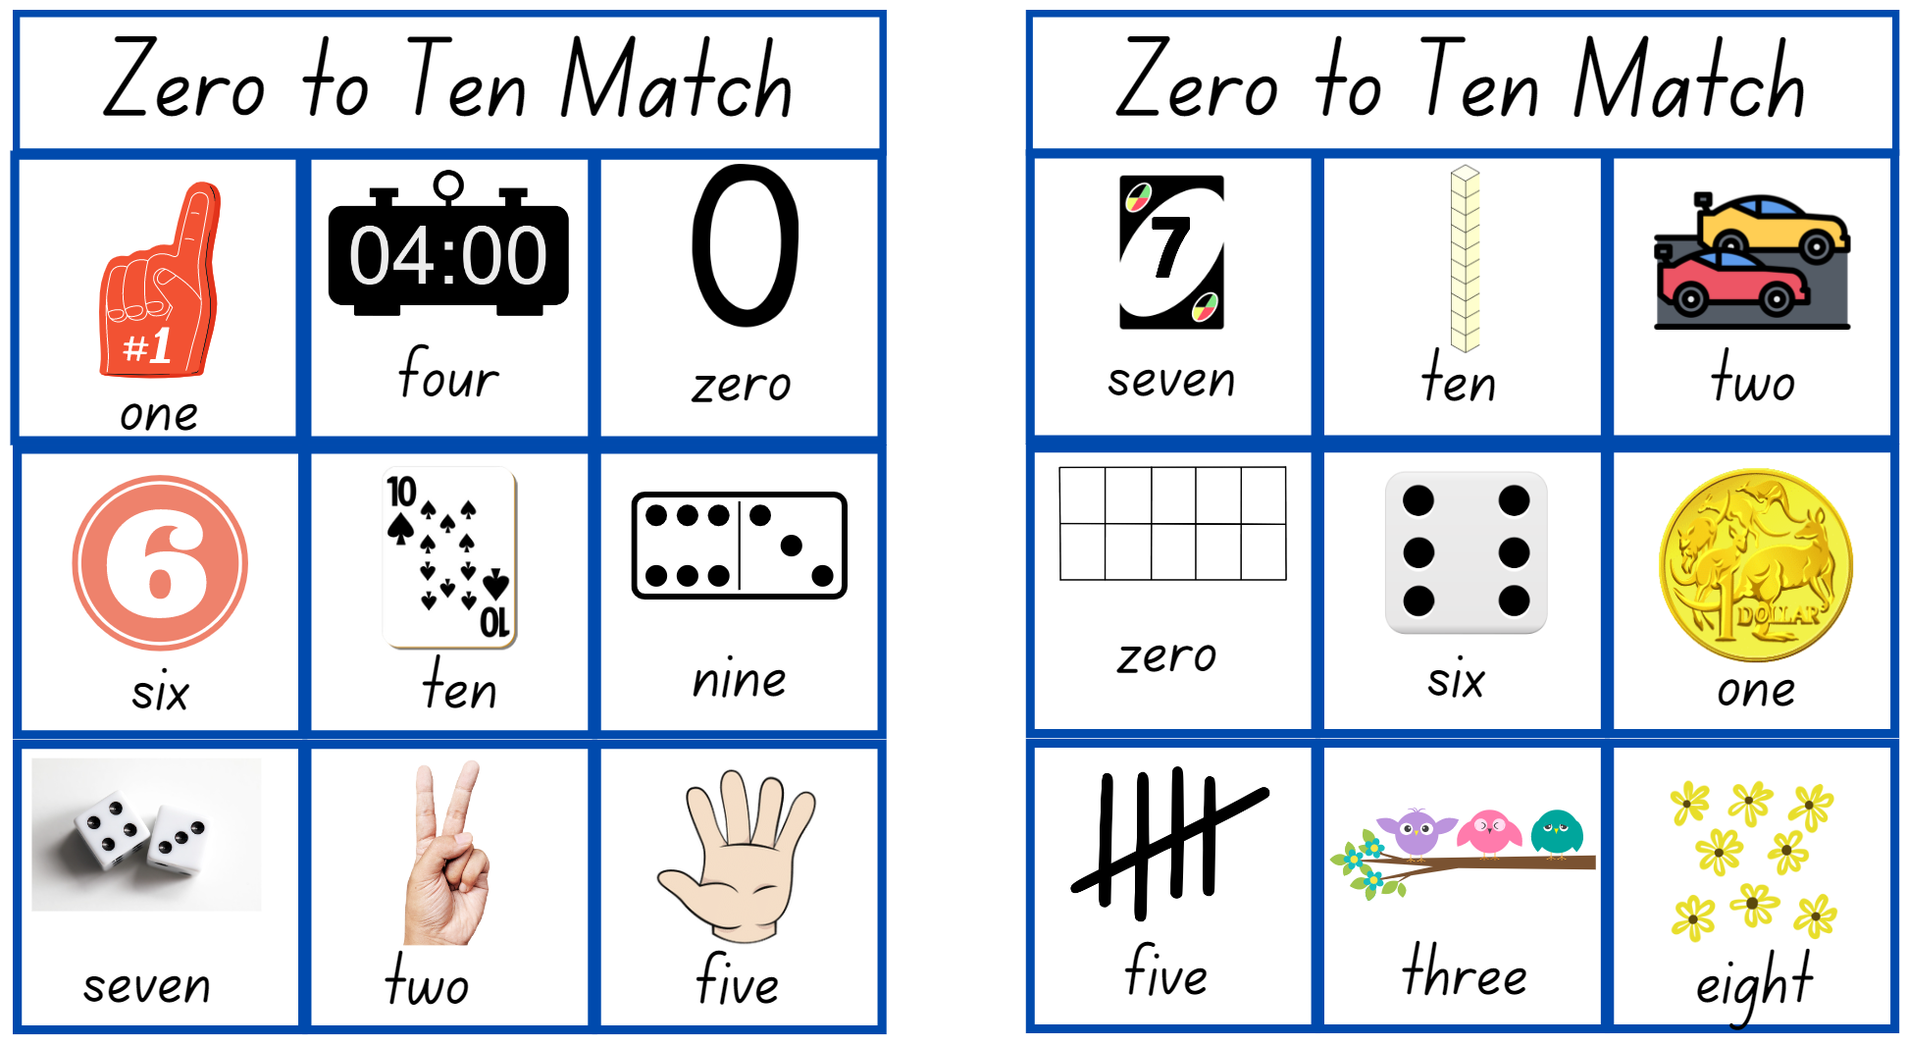
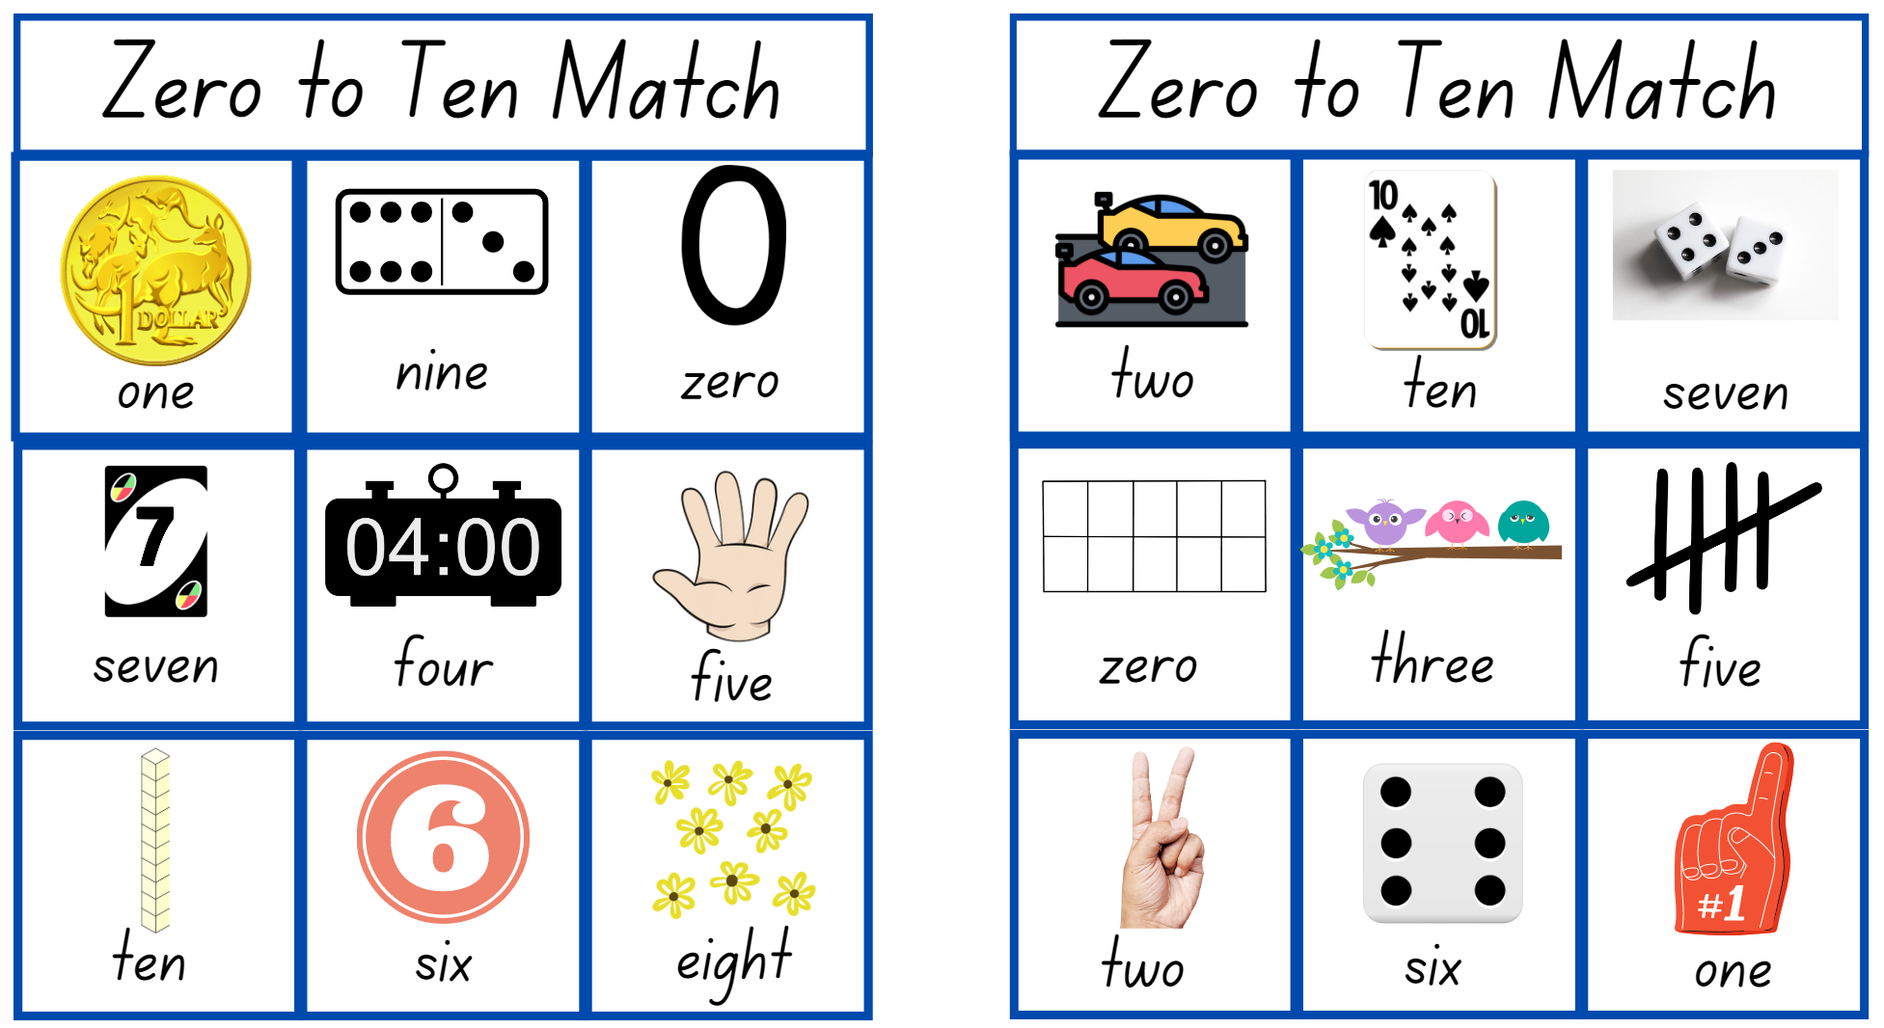
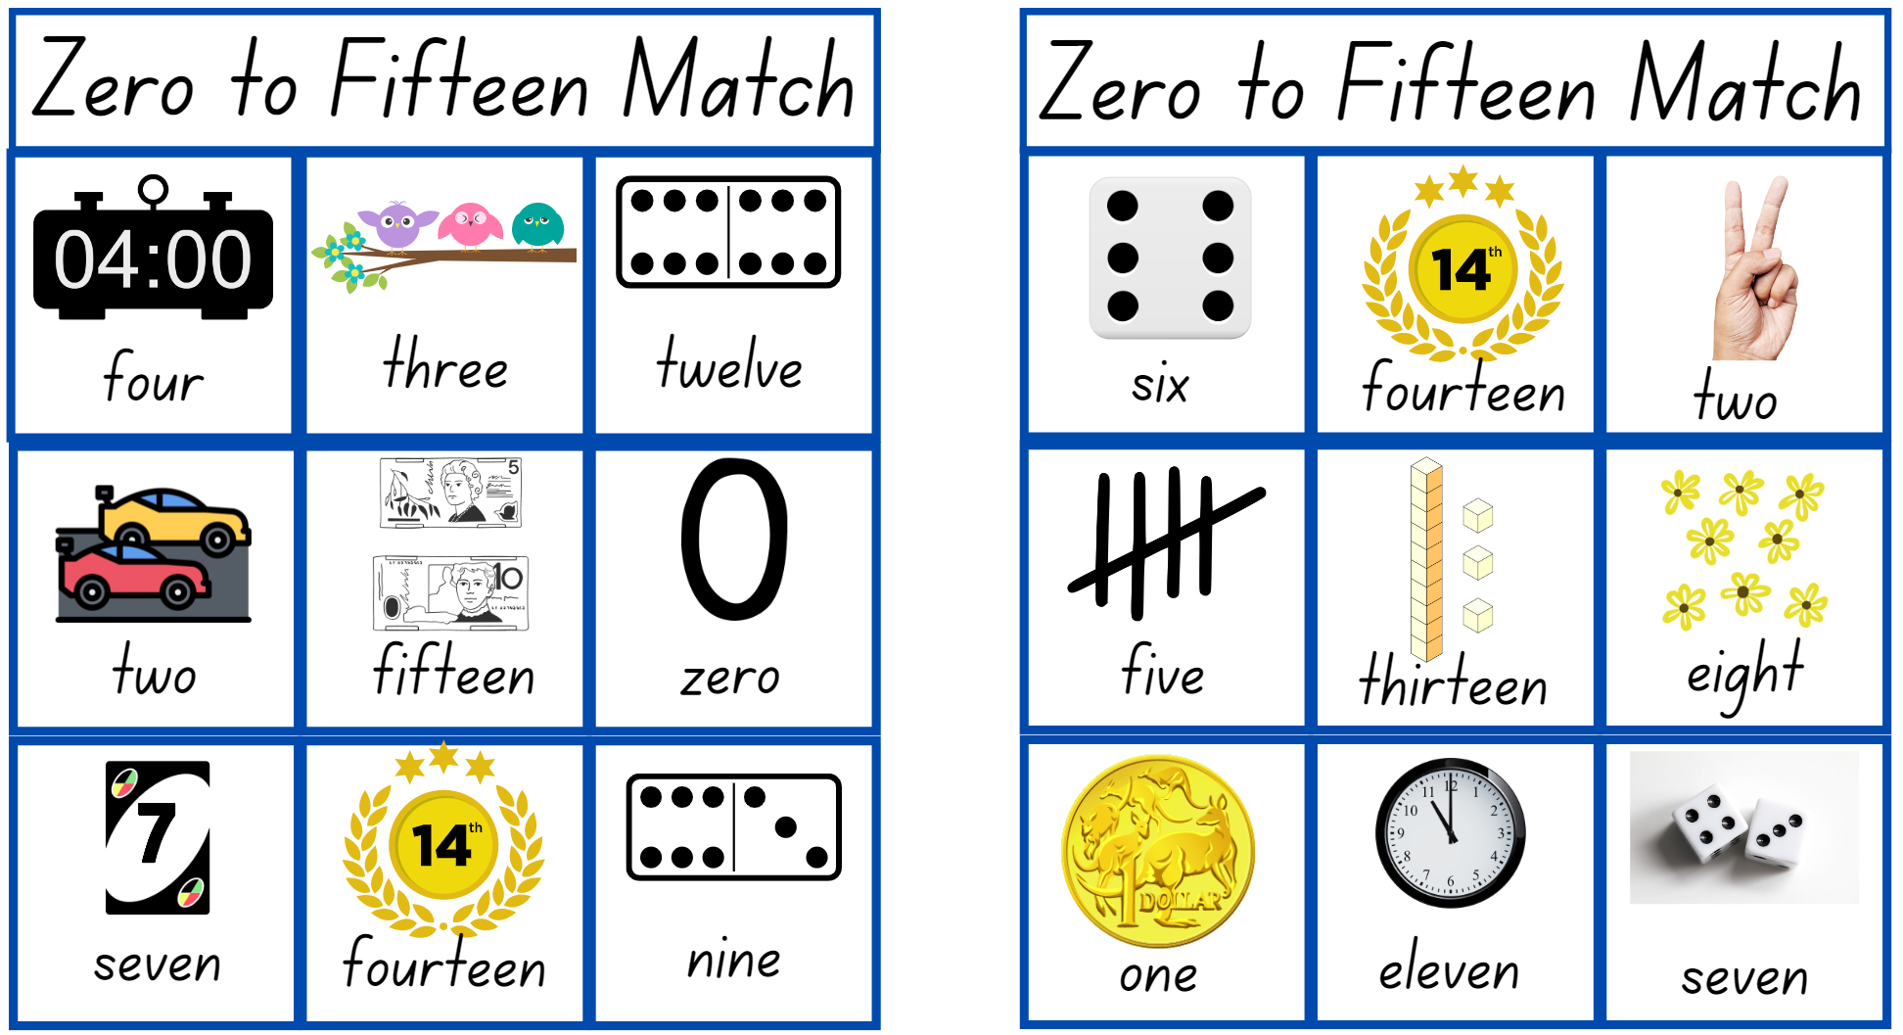
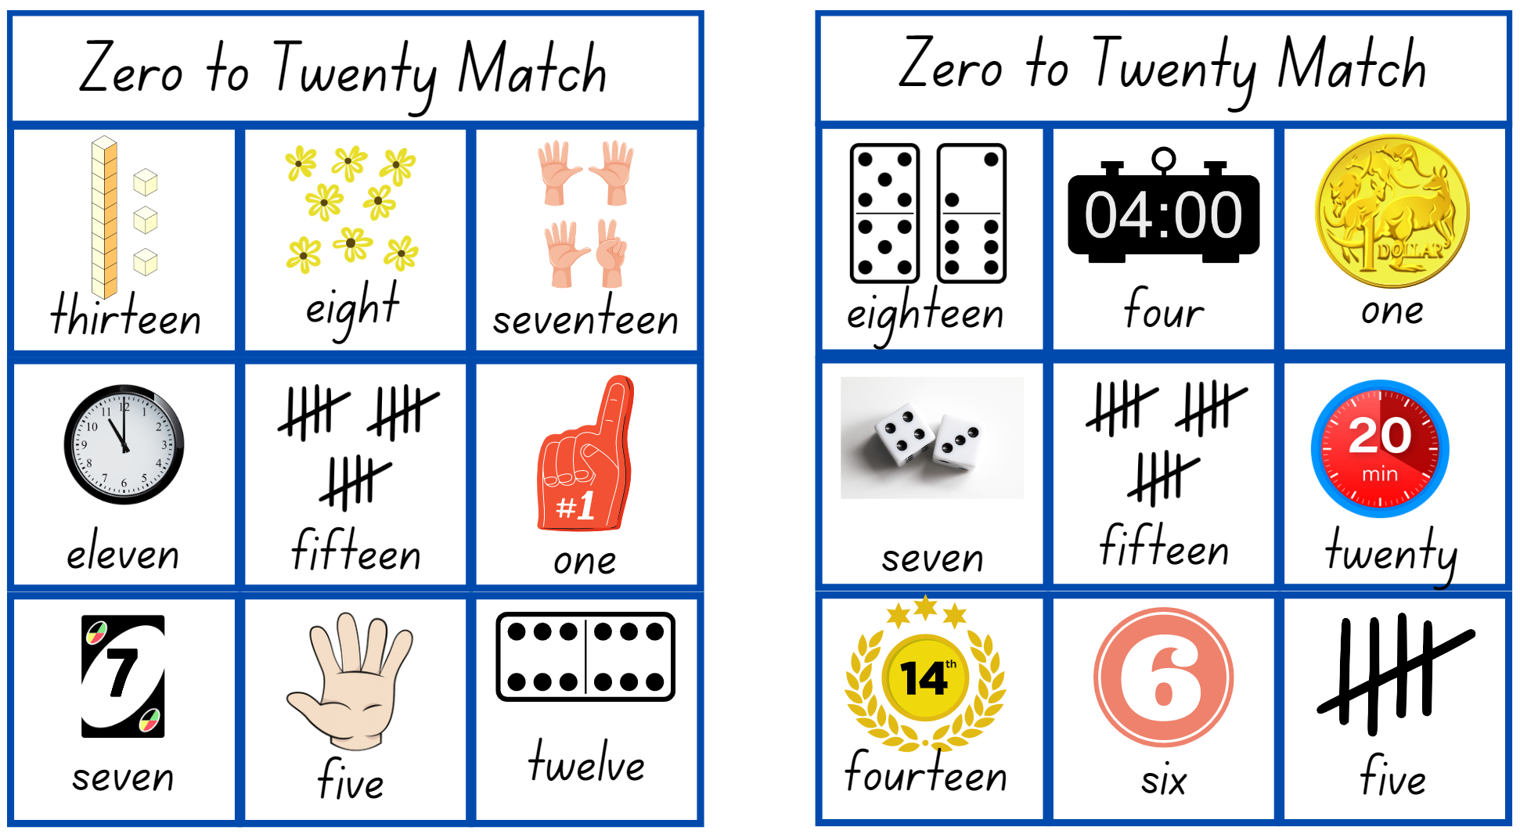
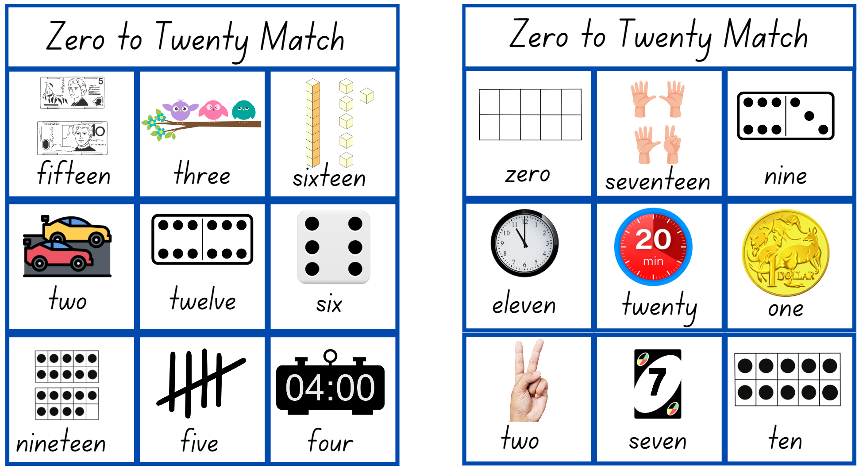
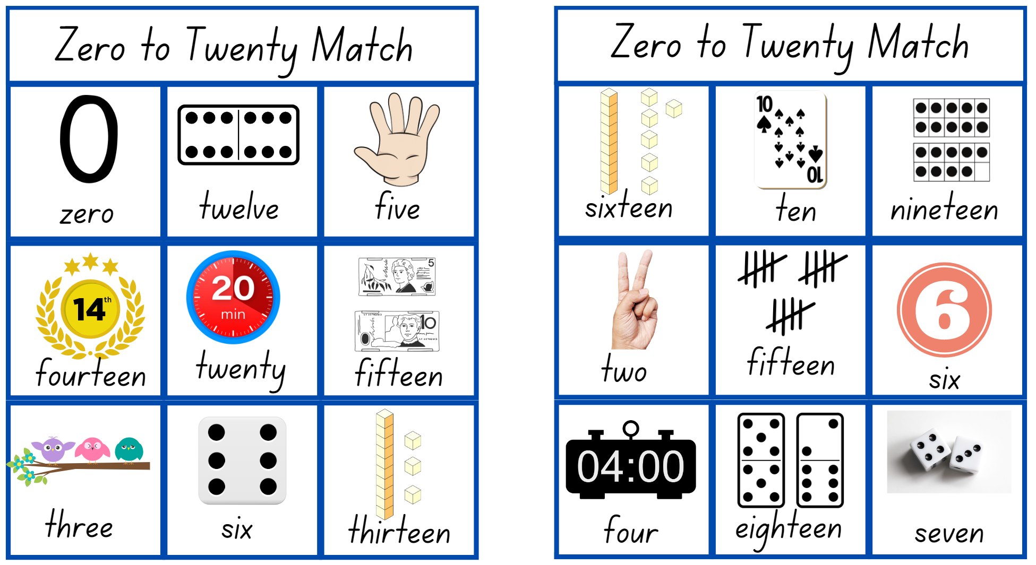
Images sourced from Canva and used in accordance with the Canva Content License Agreement.

Resource 9: Dot talk

Syllabus outcomes and content
The table below outlines the syllabus outcomes and range of relevant syllabus content covered in this unit. Content is linked to National Numeracy Learning Progression version (3).
Focus area and outcomes | Content groups and content points | Lessons
Representing whole numbers  MAO-WM-01  MAE-RWN-01  MAE-RWN-02 | Instantly name the number of objects within small collections  - instantly recognise (subitise) the number of items in small groups of up to four items without counting (NPV1, CPr1)  - identify the number of items in different arrangements (CPr2)  Use the counting sequence of ones flexibly  - count forwards to at least 30 and state the number after or before a given number, without needing to count from one (CPr4)  - identify and distinguish the ‘teen’ numbers from multiples of ten with the same initial sounds (NPV3)  - count backwards from a given number 20 or less (CPr5)  - identify the number before as 'one less' and the number after as 'one more’ than a given number  Recognise number patterns  - recognise dice and domino dot patterns (NPA1, NPV2, CPr2)  - recognise different finger patterns for the same number (NPA2)  Connect counting and numerals to quantities  - count with one-to-one correspondence, recognising that the last number name represents the total number in the collection (CPr3, CPr5)  - count out a specified number of objects (from 5 to 20) from a larger collection, keeping track of the count (CPr4-CPr5)  - make correspondences between collections  - read numerals to at least 20, including zero (NPV3)  - represent numbers as quantities to at least 20 using objects (such as fingers), number words and numerals (NPV2-NPV4, CPr3)  - compare and order numbers to 20 (NPV2-NPV3)  - use the term ‘is the same as’ to express equality of groups (CPr4-CPr5, MuS1) | 1-5, 7-8
Geometric measure  MAO-WM-01  MAE-GM-02 | Length: Use direct and indirect comparisons to decide which is longer  - identify the attribute of 'length' as the measure of an object from end to end  - use comparative language to describe length (UuM2)  - compare lengths directly by placing objects side by side and aligning the ends (UuM2)  - explain why the length of a piece of string remains unchanged whether placed in a straight line or a curve  - compare lengths indirectly by copying a length (UuM3) | 1-2, 7
Two-dimensional spatial structure  MAO-WM-01  MAE-2DS-02 | Area: Identify and compare area  - make closed shapes and identify the attribute of area as the measure of the amount of surface  - use comparative language to describe areas (UuM2)  - predict which of two surfaces will have the larger area and justify the answer  - compare areas of two similar shapes directly by drawing, tracing, or cutting and pasting (UuM3-UuM4) | 3-5
Three-dimensional spatial structure  MAO-WM-01  MAE-3DS-02 | Volume: Compare internal volume by filling and packing  - fill and empty containers using materials such as water or sand  - use the terms ‘full’, ‘empty’ and ‘about half full’  - compare the internal volumes (capacities) of two containers directly by filling one and pouring into the other (UuM2)  - compare the internal volumes of two containers indirectly by pouring their contents into two other identical containers and observing the level reached in each (UuM3)  - establish that containers of different shapes may hold the same amount  - stack and pack blocks into defined spaces (UuM5)  Volume: Compare volume by building  - identify the attribute of volume as the amount of space an object or substance occupies  - compare the volumes of two objects made from blocks or connecting cubes directly by deconstructing one object and using its parts to construct a copy of the other object  - use comparative language to describe volume (UuM2) | 5-6
Non-spatial measure  MAO-WM-01  MAE-NSM-01 | Mass: Identify and compare mass using weight  - identify that objects can be heavy or light (UuM2)  - compare two masses directly by hefting (UuM3)  - predict which object would be heavier than, lighter than, or have about the same weight as another object and explain reasons for this prediction | 7-8

References
Links to third-party material and websites
Please note that the provided (reading/viewing material/list/links/texts) are a suggestion only and implies no endorsement, by the New South Wales Department of Education, of any author, publisher, or book title. School principals and teachers are best placed to assess the suitability of resources that would complement the curriculum and reflect the needs and interests of their students.
If you use the links provided in this document to access a third-party's website, you acknowledge that the terms of use, including licence terms set out on the third-party's website apply to the use which may be made of the materials on that third-party website or where permitted by the Copyright Act 1968 (Cth). The department accepts no responsibility for content on third-party websites.
Except as otherwise noted, all material is © State of New South Wales (Department of Education), 2023 and licensed under the Creative Commons Attribution 4.0 International License. All other material (third-party material) is used with permission or under licence. Where the copyright owner of third-party material has not licensed their material under a Creative Commons or similar licence, you should contact them directly for permission to reuse their material.
Mathematics K–10 Syllabus © 2022 NSW Education Standards Authority (NESA) for and on behalf of the Crown in right of the State of New South Wales.
© 2022 NSW Education Standards Authority. This document contains NSW Curriculum and syllabus content. The NSW Curriculum is developed by the NSW Education Standards Authority. This content is prepared by NESA for and on behalf of the Crown in right of the State of New South Wales. The material is protected by Crown copyright.
Please refer to the NESA Copyright Disclaimer for more information.
NESA holds the only official and up-to-date versions of the NSW Curriculum and syllabus documents. Please visit the NSW Education Standards Authority (NESA) website and the NSW Curriculum website.
National Numeracy Learning Progression © Australian Curriculum, Assessment and Reporting Authority (ACARA) 2010 to present, unless otherwise indicated. This material was downloaded from the Australian Curriculum website (accessed 6 February 2023) and was not modified. The material is licensed under CC BY 4.0. Version updates are tracked in the ‘Curriculum version history’ section on the 'About the Australian Curriculum' page of the Australian Curriculum website.
ACARA does not endorse any product that uses the Australian Curriculum or make any representations as to the quality of such products. Any product that uses material published on this website should not be taken to be affiliated with ACARA or have the sponsorship or approval of ACARA. It is up to each person to make their own assessment of the product, taking into account matters including, but not limited to, the version number and the degree to which the materials align with the content descriptions and achievement standards (where relevant). Where there is a claim of alignment, it is important to check that the materials align with the content descriptions and achievement standards (endorsed by all education Ministers), not the elaborations (examples provided by ACARA).
This resource contains images and content obtained from Canva, and their use outside of this resource is subject to Canva’s Content License Agreement. If you wish to use them separately from the resource, please go to Canva.
Boaler J, Munson J and William C (2021) Mindset Mathematics: Visualizing and Investigating Big Ideas, Grade 1, Jossey-Bass, New Jersey.
New Zealand Ministry of Education (n.d.) 'Prints and Outlines', Resource, NZ Maths website, accessed 6 February 2023.
Robertson J (2017) Messy Maths: A Playful, Outdoor Approach to Early Years, Independent Thinking Press, UK.
Toy Theater (2001-2023) ‘Dice’, Virtual Manipulatives, Toy Theater website, accessed 6 February 2023.
Toy Theater (2001-2023) ‘Playing cards’, Virtual Manipulatives, Toy Theater website, accessed 6 February 2023.

