Mathematics – Early Stage 1 – Unit 16
Contents
Unit description and duration 4
Student prior learning 4
Lesson overview and resources 5
Lesson 1: Stories about families 13
Daily number sense: Number necklaces – 10 minutes 13
Growing families – 40 minutes 15
Consolidation and meaningful practice: Family stories – 20 minutes 18
Lesson 2: Quantities within 20 18
Daily number sense: Numbers growing on trees – 15 minutes 19
Spot the animals – 20 minutes 19
Number sandwiches – 20 minutes 21
Consolidation and meaningful practice: Beanbag throw – 15 minutes 24
Lesson 3: Changing quantities 25
Daily number sense: Counting collections – 15 minutes 25
Let's go shopping – 35 minutes 27
Consolidation and meaningful practice: Subtraction stacks – 20 minutes 30
Lesson 4: Legs and lamingtons 32
Daily number sense: Musical groups – 15 minutes 33
Legs – 35 minutes 33
Consolidation and meaningful practice: Sharing lamingtons – 20 minutes 35
Lesson 5: Ten chicks 39
Daily number sense: Teen fishing – 15 minutes 39
Call and response to ten – 15 minutes 41
Storytime – 20 minutes 42
Consolidation and meaningful practice: Bead strings – 15 minutes 42
Lesson 6: Balloons and gardens 45
Daily number sense: Teacher identified activity – 10 minutes 46
Bunches of balloons – 30 minutes 46
Consolidation and meaningful practice: Maths in the garden – 30 minutes 48
Lesson 7: Adventures with quantities 51
Daily number sense: Number walks – 15 minutes 52
Natural collections – 15 minutes 53
Maths adventures on the bus – 30 minutes 54
Consolidation and meaningful practice: Dice counting on – 10 minutes 56
Lesson 8: Fun with teddies 57
Daily number sense: Hungry crocodile – 15 minutes 57
Teddy bear adventures – 45 minutes 60
Resource 1: Numeral cards 63
Resource 2: Number representations 64
Resource 3: Dot cards 65
Resource 4: Lamingtons 66
Resource 5: Multiples of 10 67
Resource 6: Garden bed 68
Resource 7: Bus 69
Resource 8: Animal images 70
Syllabus outcomes and content 71
References 75

Unit description and duration
This two-week unit develops student knowledge, understanding and skills of combining, separating, comparing and forming groups with quantities. Students are provided opportunities to:
- combine and separate quantities to identify the smaller parts that are found within a total quantity
- compare quantities and identify the difference between quantities or equal groups
- distribute items from a collection into smaller groups and recognise whether the groups are equal or not.
Mathematics K–10 Syllabus © 2022 NSW Education Standards Authority (NESA) for and on behalf of the Crown in right of the State of New South Wales.

Student prior learning
Before engaging in these teaching and learning activities, students would benefit from prior experience with:
- counting to at least 10 with one-to-one correspondence
- recognising numerals, visual representations and words for quantities up to 10
- recognising that the last number stated in a count represents the total of the count.

Lesson overview and resources
The table below outlines the sequence and approximate timing of lessons; syllabus focus areas and content groups; and resources.
Lesson | Syllabus focus area and content groups | Resources
Lesson 1: Stories about families  70 minutes  A collection grows in quantity as more is added to it. | Representing whole numbers  - Instantly name the number of objects within small collections  - Use the counting sequence of ones flexibly  - Connect counting and numerals to quantities  Combining and separating quantities  - Model additive relations and compare quantities  - Identify part-whole relationships in numbers up to 10 | - Resource 1: Numeral cards – at least 2 sets  - Resource 2: Number representations – at least one set  - Digital device – one per pair of students  - 50 cm lengths of string – one per student  - Magnetic counters  - Rekenreks  - Ten-frames  - Writing materials
Lesson 2: Quantities within 20  70 minutes  A quantity can be partitioned in different ways. | Representing whole numbers  - Instantly name the number of objects within small collections  - Use the counting sequence of ones flexibly  - Recognise number patterns  - Connect counting and numerals to quantities  Combining and separating quantities  - Model additive relations and compare quantities  - Identify part-whole relationships in numbers up to 10  Forming groups  - Record grouping and sharing | - Resource 1: Numeral cards – at least 2 sets  - Resource 2: Number representations – at least one set  - Resource 3: Dot cards – 2 sets per pair  - Bancroft B (2009) An Australian 1, 2, 3 of Animals, Hardie Grant, Australia ISBN 9781921272851  - Beanbags or similar – 20 per group  - Hoop – one per group  - Loose items  - Rekenreks  - Ten-frames  - Modelling clay or wooden blocks  - Writing materials
Lesson 3: Changing quantities  70 minutes  Quantities can grow and shrink by adding and subtracting. | Representing whole numbers  - Instantly name the number of objects within small collections  - Use the counting sequence of ones flexibly  - Recognise number patterns  - Connect counting and numerals to quantities  Combining and separating quantities  - Model additive relations and compare quantities  - Identify part-whole relationships in numbers up to 10 | - Resource 3: Dot cards  - A shopping basket  - Burningham J (1992) The shopping basket, Random House UK ISBN 9780099899303  - Counters – 12 per student  - Dot dice – 2 per pair  - Loose items  - Pretend shop items  - Sets of counting collection between 15-30 – one per student  - Strip of paper folded into 6 equal parts – one per student  - Ten-frames, patty pans, bowls, cups, rubber bands, grids, number charts  - Writing materials
Lesson 4: Legs and lamingtons  70 minutes  Items can be distributed one at a time into a set number of groups to form equal groups. | Representing whole numbers  - Instantly name the number of objects within small collections  - Use the counting sequence of ones flexibly  - Recognise number patterns  - Connect counting and numerals to quantities  Forming groups  - Investigate and form equal groups by sharing  - Record grouping and sharing | - Resource 4: Lamingtons  - Blocks – 18 per student  - Coloured paper  - Concrete materials Device to play music  - Digital device – one for teacher  - King SM (2019) Three, Scholastic Press, Australia ISBN 9781760664053  - Loose items including matchsticks, craft sticks or pasta – about 20 per student  - Modelling clay – one lump per student  - Writing materials
Lesson 5: Ten chicks  65 minutes  The part-whole relationships up to 10 can be manipulated to solve problems. | Representing whole numbers  - Instantly name the number of objects within small collections  - Use the counting sequence of ones flexibly  - Recognise number patterns  - Connect counting and numerals to quantities  Combining and separating quantities  - Model additive relations and compare quantities  - Identify part-whole relationships in numbers up to 10 | - Resource 1: Numeral cards – one set of numerals 10-20 per pair  - Resource 2: Number representations – one set of 10-20 per pair  - Resource 5: Multiples of 10  - Video: Handa’s Hen (4:22)  - Coloured beads or threading items – 20 per student  - Digital device with pre-recorded voice for numerals 10-20  - Percussion instruments  - Threading string with small stick tied to the end – at least one per student  - Writing materials
Lesson 6: Balloons and gardens  70 minutes  An equal number of items can be repeatedly shared to find the number of unknown groups. | Representing whole numbers  - Instantly name the number of objects within small collections  - Use the counting sequence of ones flexibly  - Connect counting and numerals to quantities  Combining and separating quantities  - Model additive relations and compare quantities  - Identify part-whole relationships in numbers up to 10  Forming groups  - Investigate and form equal groups by sharing  - Record grouping and sharing | - Resource 6: Garden bed  - Bunches of balloons (13:36)  - Counters – 20 per student  - Digital device  - Loose items – 18 per student  - Modelling clay  - Sticky notes  - Writing materials
Lesson 7: Adventures with quantities  70 minutes  Stories can describe situations in which combining, separating and comparing take place. | Representing whole numbers  - Instantly name the number of objects within small collections  - Use the counting sequence of ones flexibly  - Recognise number patterns  - Connect counting and numerals to quantities  Combining and separating quantities  - Model additive relations and compare quantities  - Identify part-whole relationships in numbers up to 10 | - Resource 7: Bus – enlarged to A3  - Resource 8: Animal images  - Chalk  - Collection of a few different natural materials  - Large dice – one per group  - Muir F and Lawson S (2021) Sharing (Mulgo Watson L, illus) Magabala Books, Broome WA. ISBN 9781925768749  - Piers H (1996) Is There Room on the Bus? (Giffard H, illus) Frances Lincoln, London. ISBN 0711209510  - Rekenreks  - Sticky putty  - Ten-frames  - 2 large dot dice  - Writing materials
Lesson 8: Fun with teddies  60 minutes  Stories can show ways of combining, separating and comparing quantities and forming groups. | Representing whole numbers  - Instantly name the number of objects within small collections  - Use the counting sequence of ones flexibly  - Recognise number patterns  - Connect counting and numerals to quantities  Combining and separating quantities  - Model additive relations and compare quantities  - Identify part-whole relationships in numbers up to 10  Forming groups  - Investigate and form equal groups by sharing  - Record grouping and sharing | - Bucket  - Cup – one per pair  - Digital device  - Document camera  - MAB ones – 12 per pair  - McGrath BB (2010) Teddy Bear Counting (Nihoff T, illus) Random House US. ISBN:9781580892162  - Number charts  - Teddy bear counters or alternative loose items – 3 greens, 3 yellows, 3 reds, and 3 blues per pair  - Ten-frames  - 12 tennis balls  - Writing materials

Lesson 1: Stories about families
Core concept: A collection grows in quantity as more is added to it.
The table below contains suggested learning intentions and success criteria. These are best co-constructed with students.
Learning intentions | Success criteria
Students are learning that:  - combining smaller parts creates a larger quantity  - mathematicians keep track of quantities through diagrams and models  - mathematicians check and adjust the accuracy of their work. | Students can:  - combine smaller parts to find the total  - draw a diagram to keep track of the smaller parts that combine to make a total quantity  - compare and adjust a recording of their thinking with the information provided in a problem.

Daily number sense: Number necklaces – 10 minutes
This lesson has been adapted from Van de Walle (2019).
- Build student understanding of how to read numerals zero to 20 and recognise numerals that are one more or one less than a quantity by playing number games with necklaces.
- Provide students with a card from Resource 1: Numeral cards attached to a loop of string. Students wear the card like a necklace.
Note: If the number of students in the class exceeds 21, consider adding digits beyond 21 or creating a second copy of some numerals that target the needs of your students.
- Cut up and shuffle a second set of Resource 1: Numeral cards and Resource 2: Number representations cards.
- Students form a circle standing up. Hold one card up at a time and ask the student with the matching numeral or quantity to sit down. The last student standing can be the person who shows the cards in a second round of the game.
- Play a different version of the game by adapting the criteria. Ask students to sit down if they have one more or one less than the displayed numeral or quantity.
This table details assessment opportunities and differentiation ideas.
Assessment opportunities | Too hard? | Too easy?
What to look for:  - Are students able to read numerals zero to 20? (MAE-RWN-02)  - Are students able to match numerals zero to 20 with the same numeral and quantity? (MAE-RWN-02)  - Are students able to recognise one more and one less for numerals zero to 20? (MAE-RWN-01)  What to collect:  - observation data (MAE-RWN-01, MAE-RWN-02). | Students cannot read and match numerals and quantities zero to 20.  - Begin the game by reading the numerals on each necklace in unison.  - Provide students with an unfamiliar numeral and begin the game by reading the numeral together and counting the matching quantity.  - Use a smaller selection of familiar and unfamiliar numerals and matching quantities. | Students can read and match numerals and quantities zero to 20.  - Play the game in smaller groups and provide more challenging instructions such as 2 more or 2 less or finding a partner whose card combines to match the displayed numeral or quantity.  - Provide cards to students with numerals and quantities beyond 20.

Growing families – 40 minutes
Storytelling supports students to make connections with real-world situations and mathematical concepts. Stories can be used as a basis for modelling and drawing with symbols that represent combining, separating and comparing. (Matthews 2015)
Note: The following activity references First there was Frances by Bob Graham, however any book that introduces characters or items one at a time may be used. The adding of items to a collection is the core concept being addressed.
- Show students the cover and title of the book First there was Frances by Bob Graham. Introduce and discuss the word ‘first’ and the suggestion that something will follow. Ask students to predict what might happen.
- Read the first page of the story and identify the one character, Frances. Read the second page. Ask students to describe what happened to the number of characters. Use student responses to identify that one new character was added to the story and now there are 2 characters. Ask students to continue to notice who else is added to the story and what happens to the number of characters.
- Continue to read the story to the end. Ask students:
- What did you notice?
- What do you wonder?
- Use student responses to develop a shared question that invites the investigation of how many characters were in Frances’ house by the end of the story.
- Provide students with writing materials and ask students to record each new character introduced in the story with diagrams or drawings.
- Read each page of the story again, pausing after the introduction of new characters to allow students time to record.
- Ask students to use their diagrams to find the total number of characters in Frances’ house at the end of the story.
- Ask students to share the total they have counted and use ‘Talk moves’ to compare and share reasoning. Select some students to share the methods they used to record each new character and count to find the total. Use student work samples to discuss the different methods to record information about quantities with drawings.
- Explain how mathematical tools can be used to record quantities. Introduce 2 ten-frames and magnetic counters or a rekenrek. Ask students how the tool could be used to record each new character.
- Read the story once more. Add a magnetic counter to the ten-frames or move a bead on a rekenrek, as each new character is introduced. Students can use the final reading of the book to check the diagrams they have recorded and adjust as necessary.
- Use the mathematical tool to establish the final quantity and ask students to compare this result with their diagrams. Explain that mathematicians use mathematical tools and review the way problems are recorded to check the accuracy of their work.
This table details assessment opportunities and differentiation ideas.
Assessment opportunities | Too hard? | Too easy?
What to look for:  - How do students record the addition of each new character in the story to keep track of the total? (MAE-CSQ-01, MAO-WM-01)  - What methods do students use to add up the total of characters? (MAE-CSQ-01, MAO-WM-01)  - What vocabulary do students use to describe the changes to the quantity throughout the story? (MAE-CSQ-01, MAO-WM-01)  What to collect:  - student work samples (MAE-CSQ-01, MAO-WM-01)  - observation data (MAE-CSQ-01, MAO-WM-01). | Students cannot describe and model the story to find the total.  - Scaffold the language in the story to ensure students are aware of the introduction of new characters throughout the book.  - Use peer suggestions to support the process of drawing diagrams to represent quantities.  - Use concrete materials to represent each new character in the story. | Students can describe and model the story to find the total.  - Ask students to record numerals to match each new collection of characters added in each part of the story.  - Ask students to describe how many separate new quantities were added throughout the story.  - Use students’ work samples to provide a stimulus for a discussion about effective and efficient methods of recording quantities with diagrams.

Consolidation and meaningful practice: Family stories – 20 minutes
- Gather students together and draw a picture of your family and pets as you describe the way it has grown and changed over time. Describe the change in quantity for each part of the story.
- Ask students to draw a picture of the way their own family has grown and changed.
- Students Think-Pair-Share with a partner and use a digital device to record an oral story describing each new change to their family.

Lesson 2: Quantities within 20
Core concept: A quantity can be partitioned in different ways.
The table below contains suggested learning intentions and success criteria. These are best co-constructed with students.
Learning intentions | Success criteria
Students are learning that:  - quantities can be partitioned into smaller parts  - 2 quantities can be compared as equal or not  - an unknown quantity can be determined by comparing the known quantity with the total quantity. | Students can:  - describe the smaller parts within a quantity  - identify if 2 groups are equal or not  - work out an unknown quantity by comparing a known quantity with the known total.

Daily number sense: Numbers growing on trees – 15 minutes
- Build student understanding of how to read and match numerals 0-20 by matching numerals with visual representations.
- Use an outdoor space to hang number necklace cards on shrubs, which were created from Resource 1: Numeral cards in the previous lesson.
- Provide students with a card from Resource 2: Number representations.
- Students search for the matching numeral for their allocated card and return to a ‘homebase’ spot. Students hang the numeral cards on the shrubs and swap cards with another student. Repeat the searching game several more times.
- Play another round of the game by adapting the criteria. Ask students to find a card that is one more or one less than the quantity represented on their card.

Spot the animals – 20 minutes
- Gather students in a yarning circle. Ask students what animals they have seen around the local area. Show students the cover of the book An Australian 1, 2, 3 of animals by Bronwyn Bancroft. Discuss Australian animals the students have seen.
- Read the story to students. As you read each new page, ask students to model the quantity represented on each page with their fingers. For example, on the page for 4, students represent 2 fingers on each hand to mirror the image of crocodiles on the double page.
- Draw students’ attention to the equal and unequal groups within the total quantity, represented on every second page from 4 onwards. Use students’ finger representations to reinforce matching or non-matching quantities.
- After reading the book, return to the double page representing 2 and 3. Discuss the number on each page. Ask students:
- Which group of animals has more?
- How many more koalas are there than brolgas?
- Which group of animals has less?
- How many less brolgas are there than koalas?
- How could we make the 2 groups of animals equal?
- How many animals can you count altogether if you combine the brolgas and koalas?
- Cover the numerals on each page with sticky notes. Randomly open the book at different pages, show the image for 2-3 seconds and ask students how many animals they saw and how they saw them. Repeat for several different images.
This table details assessment opportunities and differentiation ideas.
Assessment opportunities | Too hard? | Too easy?
What to look for:  - How do students represent quantities with fingers? (MAO-WM-01, MAE-RWN-01, MAE-RWN-02)  - What methods are students using to combine quantities? (MAO-WM-01, MAE-RWN-01, MAE-RWN-02, MAE-CSQ-01)  - Are students able to recognise equal and unequal groups? (MAO-WM-01, MAE-FG-02)  - Are students able to instantly recognise quantities under 5? (MAO-WM-01, MAE-RWN-01)  What to collect:  - observation data (MAO-WM-01, MAE-RWN-01, MAE-RWN-02, MAE-CSQ-01, MAE-FG-02). | Students cannot accurately represent quantities with fingers.  - Provide students with loose items to represent the quantities on the page.  - Provide students with writing materials to draw the quantities on the page.  Students cannot recognise quantities under 5 and combine 2 quantities to find a total.  - Cover one page at a time and ask students to work out how many animals there are per page, before counting both pages to combine.  - Increase the amount of time the image is displayed to allow students time to count the quantity. | Students flexibly recognise and combine quantities in images to work out the total in each image.  - Ask students to combine 3 or 4 sets of animals to find a total.  - Ask students to find the total number of animals in the book.

Number sandwiches – 20 minutes
This lesson has been adapted from Van de Walle (2019).
- Show students 2 sets of Resource 3: Dot cards. Ask students to find 2 cards in the collection that combine to make 13. Provide students time to think and indicate when they have found 2 cards that combine to make 13.
- Select a student to come and share the 2 cards they have seen that combine to make 13. Ask if other students had the same idea or an alternative option. Select further students to share alternative ideas, asking for feedback from the class each time, until all possibilities have been exhausted.
- Select the 8 and 5 dot cards. Place them back-to-back with 8 dots facing out. Ask students how many dots they can see and how they see them.
- Ask students if they can work out what card is facing you if the cards combine to make 13. Offer students mathematical tools and loose items and ask them to Think-Pair-Share and discuss solutions.
- Select students to share their responses and explain the methods students used to work out how many are on the card facing you.
- Students work in pairs. Provide each pair with 2 sets of Resource 3: Dot cards. Students lay out the cards face up.
- Call out a quantity between 5 and 20. Each student selects 2 cards that combine to make that quantity and sets aside the pair. Students continue to collect pairs of cards that match the quantity until they have exhausted all possibilities.
- Provide students with something to hold the pairs of cards vertically, such as chunks of modelling clay or wooden blocks to wedge the cards in. Students sit opposite one another so they can each see one side of the sandwiched cards. Students place the backs of each pair of cards together, so the dots face outwards and display the cards vertically.
- Students take turns pointing to a set and stating the number of dots they can see on one side of the sandwiched card. Students use mathematical tools and loose items to work out how many dots are on the other side of the sandwiched cards. Students facing the opposite side of the sandwiched card can confirm answers or suggest trying again.
- Repeat the game with several more quantities between 5 and 20.
This table details assessment opportunities and differentiation ideas.
Assessment opportunities | Too hard? | Too easy?
What to look for:  - Are students able to identify the small parts that combine to make a specific quantity under 20? (MAE-RWN-01, MAE-RWN-02, MAE-CSQ-01, MAE-CSQ-02, MAO-WM-01)  - Are students able to work out the missing part which combines with a known part to make a total quantity? (MAE-RWN-01, MAE-RWN-02, MAE-CSQ-01, MAE-CSQ-02, MAO-WM-01)  - What methods do students use to work out an unknown part to combine with a known part to make a total quantity? (MAE-RWN-01, MAE-RWN-02, MAE-CSQ-01, MAE-CSQ-02, MAO-WM-01)  What to collect:  - observation data (MAO-WM-01, MAE-RWN-01, MAE-RWN-02, MAE-CSQ-01, MAE-CSQ-02). | Students require further support with identifying the smaller parts that combine to make a total quantity.  - Use a smaller total quantity to partition.  - Use concrete materials to partition the smaller parts within the whole.  - Use ten-frames to support working out the removal of an unseen quantity. | Students accurately identify the smaller parts that combine to make a total quantity.  - Ask students to explain the method they use to identify the unknown part that combines with a known part to make a total quantity.  - Provide students with quantities between 21 to 30 and ask students to find 4 dot cards that combine to make the total.

Consolidation and meaningful practice: Beanbag throw – 15 minutes
- Students work in small groups. Provide each group with 20 beanbags and a hoop. Students take 5 large steps back from the hoop and take turns throwing the beanbags one at a time towards the hoop.
- After 20 beanbags have been thrown, ask students to count how many beanbags landed in the hoop and how many landed outside the hoop.
- Students record the combinations for beanbags in and out of the hoop before gathering up the beanbags and repeating the process of throwing them towards the hoop again.
- Gather students together. Use students’ recorded combinations of beanbags to create a class display of combinations of beanbags that combine to make 20.

Lesson 3: Changing quantities
Core concept: Quantities can grow and shrink by adding and subtracting.
The table below contains suggested learning intentions and success criteria. These are best co-constructed with students.
Learning intentions | Success criteria
Students are learning that:  - quantities change by adding and taking away  - stories from real-world contexts can describe mathematical ideas  - the difference in quantities can be identified through comparing. | Students can:  - work out the total of a quantity after adding to it or taking away from it  - tell stories that describe adding and taking away in a play-based scenario  - compare quantities under 6 to find the difference.

Daily number sense: Counting collections – 15 minutes
This lesson has been adapted from Boaler et al. (2021) and Counting Collections by Teacher Education by Design (TEDD).
Counting collections is an instructional activity which provides a structured opportunity for students to explore methods of counting, for organising and recording a count for a collection of items. Students can apply counting to a context and explore and discuss the base-ten structure of the counting system and develop efficient skills in counting.
- Build student understanding of how to count by organising and counting a collection.
- Provide students with collections of 15 to 30 and a selection of tools that might support counting such as sets of ten-frames, patty pans, cups, bowls, rubber bands, grids and number charts.
Note: Counting collections are sets of items which can be stored in snap-lock bags or boxes. The quantity of items varies in each collection to suit the counting range being explored by students. A selection of items, such as natural items, craft materials, recycled items and stationary products, stored for regular counting routines supports ongoing counting investigations.
- Students work in pairs and select a collection to count. Ask students to estimate how many may be in the count and record it. This provides useful assessment data to indicate the accuracy of students’ understanding of quantity.
- Select 1 or 2 students to share their estimation and ask students:
- How did you come to that estimation?
- Who agrees with that estimation?
- Who thinks it may be more and why?
- Who thinks it may be less and why?
- Ask students to count their collection and organise it as they count to support keeping track of the count.
- Students record what they have counted to share with others after the count.
- Circulate amongst students to observe and record the strategies students use to count, organise and record the collection as they count. Ask questions, such as:
- Why have you decided to count your collection that way?
- How are you keeping track of what you have already counted?
- Bring students back together to discuss counting, organising and recording strategies. Select students to share the methods used. Ask questions, such as:
- What was your estimation and how close was it to the actual count?
- Can you describe the way you arranged the items as you counted?
- How did you count your collection and why?
- How did you record your count?

Let's go shopping – 35 minutes
- In preparation for this lesson, have a basket ready and a few play items set up to create a pretend shop. Ensure there are multiple quantities of each item.
- Begin the lesson by modelling a pretend trip to a shop. Select varying quantities of items in the pretend shop to add to your basket. Pretend to pay an invisible shopkeeper and bring the basket to share with students gathered in a yarning circle. Discuss the smaller quantities of each item and invite the class to count the total number of items in unison.
- Explain that Steven will be taking a basket to the shops in the book you will read. Ask students to notice the items in the basket throughout the book.
- Read The Shopping Basket by John Burningham and pause at various places throughout the book to discuss the way the items come in and out of the basket throughout the story. Count the quantities of items in Steven’s basket at a few different intervals during the story.
- Provide small groups of students with a variety of loose items and a space to model the events in the story.
- Read through the story again and pause as new items are added to the basket. Pause when students have modelled all the items Steven has purchased, just before he meets the bear. Ask students:
- What do you notice about these items?
- How many different groups of items are there?
- How many items are there in total?
- How does the illustration in the story help us to see the difference in the quantities of each item?
- How have you organised your items?
- Is there another way that you can organise the items?
- Continue to read the story as students remove items from their models to reflect the events of the story. Pause and use questions to invite students to explore the changes to quantities of items in the basket. Ask questions, such as:
- How many bananas are in Steven’s basket now?
- How many items are in Steven’s basket altogether?
- How many items did Steven present to his mother?
- At the end of the story, discuss the way that the total quantity of items in the basket became more as Steven purchased items in the shop, but as different animals took items away the total quantity of items became fewer.
- Select one student to take the basket to the pretend shop. Ask the student to describe the items they are purchasing. Count how many items in each group and how many altogether.
- Select another student to pretend to be an animal character and describe taking away an item from the basket. Discuss how many items are in the basket after something is taken away. Continue with a couple more students pretending to be animals and removing items from the basket.
This table details assessment opportunities and differentiation ideas.
Assessment opportunities | Too hard? | Too easy?
What to look for:  - Are students able to model the quantities described in the book? (MAO-WM-01, MAE-RWN-01, MAE-RWN-02, MAE-CSQ-01, MAE-CSQ-02)  - What language do students use to describe the changes to the quantities in the story? (MAO-WM-01, MAE-RWN-01, MAE-RWN-02, MAE-CSQ-01, MAE-CSQ-02)  What to collect:  - observation data (MAO-WM-01, MAE-RWN-01, MAE-RWN-02, MAE-CSQ-01, MAE-CSQ-02). | Students cannot model and describe the changes to the quantities in the story.  - Draw a model as a scaffold.  - Act out adding an item or taking it away to model the language. | Students can model and describe the changes to the quantities in the story.  - Ask students to remove larger quantities of items from the basket before working out the remaining quantity.  - Ask students to use the pretend shop to create their own mathematical story.

Consolidation and meaningful practice: Subtraction stacks – 20 minutes
This activity has been adapted from Early Stage 1 Thinking Mathematically Subtraction stacks (8:39).
In preparation for this activity watch the video and fold strips of paper into 6 equal parts.
- Display dice dot cards 1 and 5 from Resource 3: Dot cards. Ask students:
- How many dots are on each card?
- What is the difference between the number of dots on the 2 cards?
- Students turn and talk and, after a minute, invite students to share how they worked out the difference in the quantity of dots on each card. Use ‘Talk moves’ to explore the ways students worked out the problem.
- Provide each student with a strip of paper folded into 6 equal parts and 12 counters. Ask students to write the numerals 0-5 at the top of each section of the folded paper and place 2 counters under each numeral.
- Students work in pairs. Provide each pair with a set of 2 dot dice. Students take turns to roll the dice and work out the difference between the dots on the dice and remove a counter from the corresponding quantity on their folded paper.
- Circulate amongst students as they play, observing the strategies they use to work out the difference. Ask questions to provide opportunities for students to explain their thinking, such as:
- How did you work out the difference between the 2 dice?
- What are you hoping to roll next and why?
- Have you noticed a result that is more common than others?
- Why do you think some results are more common than others?
This table details assessment opportunities and differentiation ideas.
Assessment opportunities | Too hard? | Too easy?
What to look for:  - How do students work out the difference between the quantities of dots on 2 dice? (MAE-CSQ-01, MAO-WM-01)  - How do students describe their reasoning and observations of the differences rolled on the 2 dice? (MAE-CSQ-01, MAO-WM-01)  - Are students able to match the quantities to the numerals represented on the gameboard? (MAE-CSQ-01, MAO-WM-01)  What to collect:  - observation data (MAE-CSQ-01, MAO-WM-01). | Students cannot work out the difference in the quantity of dots between 2 dice.  - Provide students with 2 large dice and allow students to cover the smaller quantity of dots on the dice depicting the smaller amount.  - Use concrete materials to align rows of both quantities and compare the 2 rows to identify the difference in quantity.  - Add a dot pattern to the gameboard to support recognition of quantities. | Students can work out the difference in the quantity of dots between 2 dice.  - Use dice with higher quantities represented on each dice and adapt the gameboard accordingly.  - Use dice with numerals.

Lesson 4: Legs and lamingtons
Core concept: Items can be distributed one at a time into a set number of groups to form equal groups.
The table below contains suggested learning intentions and success criteria. These are best co-constructed with students.
Learning intentions | Success criteria
Students are learning that:  - quantities can be shared equally into groups  - quantities of groups can be compared to find out if they are equal or not  - there are different ways to distribute items into equal groups. | Students can:  - share quantities into equal groups  - identify if groups are equal or not  - use different methods to distribute items into equal groups.

Daily number sense: Musical groups – 15 minutes
- Build student understanding of how to form equal groups by playing musical groups.
- Gather students in a safe, open space that allows students to move around easily.
- Select 6 students to stand up and form one group. Ask the other students how many groups there are and how many are in the group. Use student responses to explain the meaning of these 2 phrases.
- Ask the same group of 6 students to make 2 groups and then 3 groups. Repeat the process of identifying how many groups and how many in each group.
- Invite the whole class to find a space. Play music to cue students to move around the space. When the music stops, call out a quantity and ask students to group themselves to match that quantity. Ask students to check the accuracy of their group and indicate with fingers how many in their group.
- Discuss groups that are equal and groups that are not equal. Use unequal groups as an opportunity to discuss how many would need to be added or removed to make the group equal to the other groups.
- Continue playing musical groups using different quantities several more times.

Legs – 35 minutes
- Gather students together and ask them to Think-Pair-Share and discuss what has 4 legs. After a minute of discussion, ask students to share their ideas and record ideas with drawings and words on a display.
- Show students the cover of the book Three by Stephen Michael King and read the title together. Provide students time to look at the cover and share what they notice and what they wonder.
- Read the story. Pause to allow students to notice the details in the illustrations. Use questions to encourage students to notice the quantities represented in the images and text.
- Provide students with a lump of modelling clay and loose items such as matchsticks, craft sticks or pasta.
- Ask students to create 3 balls of modelling clay as the bodies of creatures.
- Ask students to count out a collection of 12 loose items which will represent legs on the creatures.
- Ask students to work out how many legs each creature will have if 12 legs are shared equally between the 3 bodies. Allow students time to place the legs on the creatures.
- Circulate amongst students and observe how they distribute the legs amongst the 3 bodies.
- Invite students to share what they have found and describe the way they shared the legs between the 3 creature bodies.
- Ask students what the creatures could be. Refer to the displayed list of ideas for four-legged creatures and ask students to add further features to their creatures to show what type of creatures they are.
- Record students’ work with a digital device.
- Students remove legs from the modelling clay and re-model the lumps into 3 bodies. Ask students to count out 18 legs and share the legs equally between the 3 bodies to work out how many legs each creature has.
- Circulate amongst students and observe how they distribute the legs amongst the 3 bodies.
- Ask students to share how many legs each creature has and what type of creature it could be. Invite a selection of students to describe the methods they used to share the legs between the 3 bodies.
- Provide students time to add further features to their creatures to show what type of creature it is.
- Record students’ work with a digital device.
This table details assessment opportunities and differentiation ideas.
Assessment opportunities | Too hard? | Too easy?
What to look for:  - Are students able to distribute quantities equally to a set number of groups? (MAO-WM-01, MAE-FG-02)  - What methods do students use to distribute quantities equally amongst groups? (MAO-WM-01, MAE-FG-02)  What to collect:  - observation data (MAO-WM-01, MAE-FG-02)  - student digital work samples (MAO-WM-01, MAE-FG-02). | Students require support sharing a quantity equally across a set number of groups.  - Reduce the number of pieces of modelling clay to 2 with a smaller number of legs.  - Use ten-frames to share the quantities of legs and check quantities match before inserting them into the modelling clay. | Students can share legs amongst a set number of groups.  - Increase the number of legs and bodies.  - Ask students to describe 2 different ways the legs can be shared equally.

Consolidation and meaningful practice: Sharing lamingtons – 20 minutes
- Show students Resource 4: Lamingtons. Provide students time to look at the image and use questions to facilitate student-led discussion.
The table below outlines stimulus prompts to generate conversation about the topic, along with anticipated responses from students.
Prompts | Anticipated student responses
- What do you notice?  - What do you wonder? | - There are 6 sections with 3 lamingtons in each section.  - There are 3 columns with 6 lamingtons in each column.  - There are 2 rows with 9 lamingtons in each row.  - There are 18 lamingtons altogether.  - Half of the lamingtons are in the top row and the other half of the lamingtons are in the bottom row.  - I wonder if the lamingtons could be shared equally 4 ways?  - I wonder if the lamingtons could be shared equally 5 ways?  - I wonder if there are enough lamingtons for everyone in our class?
- Provide students with blocks to model the image of 18 lamingtons. Ask students to explain how they know the model they have made shows the same arrangement of quantities as the image of lamingtons.
- Tell the following story: A family with 6 kids were getting ready for school one morning. They had this tray of lamingtons to share for morning tea. Can you estimate whether the lamingtons are likely to be able to be shared equally between their 6 lunchboxes?
- Invite students to share their ideas and reasoning. Provide students with writing materials to draw 6 groups and place the pretend lamingtons in each group. Students then trace the lamingtons and label the quantities in each group.
- Select a few students to share whether their prediction was accurate and the way they worked it out.
- Extend the story and tell students that one of the kids in the family has remembered that they are going to a special morning tea and will not need lamingtons that day. Ask students to predict if the lamingtons can be shared equally between only 5 lunchboxes. Select a few students to share their ideas and reasoning. Students demonstrate and record their thinking.
- Invite students to share what they have found using ‘Talk moves’. Ask students:
- Are there other possible ways the lamingtons could be shared equally?
- Are there groupings you think would not be equal and why?
- Do others agree with what you think is possible or not possible?
- How could you prove your ideas for what is possible or not?
- Use student responses to develop an agreed plan for investigating ideas that students have differing views about. Provide students with time to investigate the ways in which lamingtons can be shared.
This table details assessment opportunities and differentiation ideas.
Assessment opportunities | Too hard? | Too easy?
What to look for:  - What methods do students use to share items equally between groups? (MAO-WM-01, MAE-FG-02)  - Are students able to explain their reasoning for mathematical ideas? (MAO-WM-01, MAE-FG-02)  What to collect:  - observation data (MAO-WM-01, MAE-FG-02)  - student work samples (MAO-WM-01, MAE-FG-02). | Students require further support with sharing items equally into groups.  - Provide students with coloured paper to define groups.  - Model how to share items one at a time into groups.  Students require further support with recording quantities for equal groups and explaining their reasoning for mathematical ideas.  - Ask students to model their thinking with concrete materials and photograph the work.  - Use specific questions to prompt thinking.  - Rephrase ideas using accurate mathematical language and ask students to repeat what is said. | Students can share items into equal groups, record their thinking and explain their reasoning.  - Ask students to describe why some methods of sharing are more efficient than others.  - Ask students to develop their own mathematical stories based on the image of lamingtons.

Lesson 5: Ten chicks
Core concept: The part-whole relationships up to 10 can be manipulated to solve problems.
The table below contains suggested learning intentions and success criteria. These are best co-constructed with students.
Learning intentions | Success criteria
Students are learning that:  - the last syllable of numbers 13 to 19 is pronounced ‘teen’  - 10 can be separated into smaller quantities  - quantities can be compared to determine if they are equal, more, or less. | Students can:  - correctly articulate the number names for all numbers 10 to 20  - separate 10 into smaller quantities  - create drawings and models of the smaller parts within 10  - compare groups and explain if they are equal, more, or less.

Daily number sense: Teen fishing – 15 minutes
- Build student understanding of recognising and saying numbers 10 to 20 by playing ‘Teen Go Fish’.
- Begin by showing students the numeral cards for numbers 10 to 20 in a random order and read them in unison. Ensure that students say ‘teen’ at the end of numbers 13 to 19 and exaggerate the second syllable to support students’ articulation.
- Students work in pairs. Provide each pair with numerals 10 to 20, cut up from Resource 1: Numeral cards and the cards representing 10-20 from Resource 2: Number representations.
- Students shuffle both sets of cards and deal 3 cards to each player. Spread the rest of the cards face down between the 2 players.
- Explain that the aim of the game is to find a pair of cards with matching quantities in their hand. The player with the highest number of matching pairs at the end is the winner.
- Player 1 begins by asking the other player if they have a card that matches a specific quantity in their hand. If Player 2 holds that card, they must hand it over. If they do not hold the card, they say ‘Go fish’. Player 1 then selects a random card from the central collection of cards. If the cards match, they set aside the pair, otherwise they hold the card as part of their hand. The second player repeats this process.
- As students play the game, circulate amongst them and observe the way students say the number names and identify matching quantities. Record assessment data based on your observations.
- Students may play the game through a second time.
This table details assessment opportunities and differentiation ideas.
Assessment opportunities | Too hard? | Too easy?
What to look for:  - How accurately do students pronounce the number names from 10 to 20? (MAE-RWN-02, MAO-WM-01)  - Are students able to accurately match the visual representation with numerals 10 to 20? (MAE-RWN-02, MAO-WM-01)  What to collect:  - observation data (MAE-RWN-02, MAO-WM-01). | Students cannot recognise or read numerals 10 to 20 or match them with a visual representation of the quantity.  - Model the pronunciation of each numeral, emphasising the ‘teen’ at the end of numbers 13 to 19 and ask students to repeat.  - Use a digital app or camera to pre-record the pronunciation of each number to match the numeral and visual representation for students to refer to. | Students can recognise and read numerals 10 to 20 and accurately match numerals with visual representations of the quantity.  - Provide visual representations of all quantities 1 to 20 in Resource 2: Number representations and allow students to turn over 2 cards and add or subtract quantities to match the numeral.  - Use Resource 5: Multiples of 10 to add to the game.

Call and response to ten – 15 minutes
- Ask students to listen carefully to the number of sounds they hear and show on their fingers how many sounds they heard. Use body percussion or a percussion instrument such as clapping sticks or a triangle to create 3 distinct sounds.
- Continue to make sets of distinct sounds for quantities between 1 and 10, pausing to allow students to indicate how many sounds they heard each time.
- Explain that you will create a set of sounds and you would like someone else to continue making more sounds to create 10 sounds in total.
- Play 6 sounds and ask students how many sounds they heard. Use a diagram to model the 6 sounds with a symbol for each sound.
- Ask students how many more sounds would be needed to make a total of 10 sounds. Students turn and talk. Invite students to share their ideas and reasoning. Use ‘Talk moves’ to come to an agreed quantity of sounds that will combine with 6 to make 10.
- Make 6 sounds again and ask the students to follow with 4 sounds to check that the total equals 10. Add 4 different symbols to the diagram on the board and play through the sounds one more time.
- Repeat this process with 2 more examples, using a diagram to visually support the understanding of the smaller parts of sounds within the whole.
- Ask students to work in pairs and use body percussion, percussion instruments or body movements to create a call and response to 10.

Storytime – 20 minutes
- Watch the story Handa’s Hen (4:22) by Eileen Browne. Pause throughout the story to invite students to notice and wonder using the illustrations in the book. Count the animals on each page and use opportunities to discuss how quantities are depicted in some of the illustrations. Listen to how many times the cheeping sound is made by the chicks under the bushes and count the sounds. Draw students’ attention to equal groups, such as the wings on birds and butterflies, legs on animals and toes in footprints.
- Finish the story and return to pause at 3:21 to look at the illustration of the hen with her 10 chicks. Ask students what they notice. Discuss the different coloured chicks and use student observations to notice the smaller quantities within 10.
- Provide students with writing materials to represent the quantities of each group of different coloured chicks. Ask students to label each group.

Consolidation and meaningful practice: Bead strings – 15 minutes
- Provide each student with a string that has a short stick tied to the end as a barrier. Provide a range of coloured beads for all students.
- Ask students to represent the groups of different coloured chicks by threading beads onto a string.
Note: Any coloured beads or threading items can be used to represent the groups of chicks in the story. At least 4 different colours or types of threading items are required. Ensure each item is clearly visible when it is threaded onto the string.
- Use questions to guide students’ discussion of the structure of the model, such as:
- How many different groups are represented?
- How many are in each group?
- Are the groups equal or not?
- Which group has the most?
- How many more does the largest group have?
- Ask students to think of a different combination of coloured chicks that the hen might have next time she has 10 chicks. Invite students to represent their ideas using a model of beads on a string.
Note: The combinations could include 2 quantities or more than 2.
- Provide students time to create a set of 10 beads depicting smaller groups within the whole. Students display their beads.
- Take students on a gallery walk to look at the different bead strings. Use questions to support what students notice, such as:
- Are there any bead strings that have the same quantities in each group?
- Which bead string has the least number of groups?
- Which bead string has the most number of groups?
- Is there a way we can count all the different combinations we have represented?
This table details assessment opportunities and differentiation ideas.
Assessment opportunities | Too hard? | Too easy?
What to look for:  - Are students able to identify the smaller parts within 10? (MAE-RWN-01, MAE-CSQ-01, MAE-CSQ-02, MAO-WM-01)  - Are students able to model 10 by combining smaller parts to represent the whole quantity? (MAE-RWN-01, MAE-CSQ-01, MAE-CSQ-02, MAO-WM-01)  - What language do students use to explain the structure of the smaller parts within the whole? (MAE-RWN-01, MAE-CSQ-01, MAE-CSQ-02, MAO-WM-01)  - Are students able to recognise if groups are equal or not? (MAE-FG-02, MAO-WM-01)  What to collect:  - observation data (MAE-RWN-01, MAE-CSQ-01, MAE-CSQ-02, MAE-FG-02, MAO-WM-01). | Students cannot model 10 by combining smaller parts.  - Provide students with a ten-frame to lay out groups of beads before threading them onto a string.  - Place a small number of beads on a string and ask the student to continue adding beads of another colour to create a total of 10. | Students can identify and model the smaller parts within 10.  - Provide students with several strings to create a range of possible models for combinations within 10.  - Ask students to consider all the combinations made by other students and create a combination that isn’t already represented.

Lesson 6: Balloons and gardens
Core concept: An equal number of items can be repeatedly shared to find the number of unknown groups.
The table below contains suggested learning intentions and success criteria. These are best co-constructed with students.
Learning intentions | Success criteria
Students are learning that:  - an equal number of items can be repeatedly shared from a larger quantity  - repeatedly sharing equal groups of quantities determines the number of groups  - stories provide information that can be used to find the answer to questions. | Students can:  - repeatedly share the same quantity from a collection to work out how many groups  - identify if groups are equal or not  - identify information in stories that can be used to find the answers to questions.

Daily number sense: Teacher identified activity – 10 minutes
- From a class need surfaced through formative assessment data, identify a short, focused activity that targets students’ knowledge, understanding and skills. Example activities may be drawn from the following resources:
- Thinking Mathematically Early Stage 1
- Universal Resources Hub.

Bunches of balloons – 30 minutes
- In preparation for this lesson watch Bunches of balloons (13:36) from Thinking mathematically.
Note: This lesson can be used to consolidate sharing 18 into groups, or an alternative quantity can be selected to provide students with a different quantity to solve the balloon problem.
- Begin with a story that describes a party in which a big bunch of 18 balloons can be used to decorate the space. The balloons can be grouped in a few different ways to decorate the space. Each bunch of balloons needs to have the same quantity to look attractive. Explain that you would like students to work out what the possibilities are.
- Ask students what could be used to work out the problem. Use student responses to brainstorm ideas for how to model or draw the possibilities. Provide students with modelling clay or other loose items to create a collection of 18 balloons.
- Ask students to create groups of 3 from the 18 items. Ask students:
- Are the groups equal or not?
- How many groups are there?
- What methods have you used to create the groups of 3?
- Discuss the need to record what has been modelled to ensure the solution can be referred to later. Model a way to represent the groups of 3 balloons using a diagram and label each part of the diagram to indicate the number of groups.
- Provide students with writing materials to record the results of sharing 18 in groups of 3.
- Ask student to create groups of 4 from the 18 items. Use the same questions as above and highlight that sharing 18 balloons into bunches of 4 will not provide equal groups. Model how to record a solution without equal groups and compare with a recorded solution for equal groups. Explain that students are only required to record equal groups for this activity.
- Ask students to continue to create bunches of balloons for the quantities 2, 5, 6, 7, 8 and 9. Ask students to record the results that share equally using their writing materials.
This table details assessment opportunities and differentiation ideas.
Assessment opportunities | Too hard? | Too easy?
What to look for:  - Are students able to identify groups that are equal or not? (MAE-FG-02, MAO-WM-01)  - Are students able to form equal groups from a larger collection? (MAE-FG-02, MAO-WM-01)  - How do students draw and label a model of equal groups? (MAE-FG-02, MAE-RWN-01, MAO-WM-01)  What to collect:  - observation data (MAE-FG-02, MAO-WM-01).  - student work samples (MAE-FG-02, MAO-WM-01). | Students cannot identify and form equal groups.  - Provide a smaller collection of balloons in the problem posed.  - Provide sticky notes for students to place on small groups to clearly delineate each group.  Students cannot clearly draw and label the model of equal groups.  - Photograph the model students have made and use digital mark-up feature to label each quantity.  - Scaffold the drawing process by folding a page to represent an equal number of groups. Model a simple shape for students to copy. | Students accurately model, draw and label equal groups.  - Ask students to estimate how many groups there may be before they create a model.  - Tell students that a bird has flown in and pecked at 3 of the balloons and now there are only 15 and ask students to work out the possibilities for equal bunches of balloons.

Consolidation and meaningful practice: Maths in the garden – 30 minutes
- Provide each student with a pile of around 20 counters.
- Pose this problem to students: Kindergarten are planting a bed of snow peas. They had a cupful of seeds. They worked out they could plant the seeds in 2 equal rows, 4 equal rows or 8 equal rows. The cup blew over in the wind and the seeds went everywhere. The students searched and gathered them up. They have 14 seeds in the cup but they’re not sure if they have found all the seeds. They know there were less than 20 seeds. Can you work out if they have found all the seeds and how many they might still be looking for?
- Ask students what they already know in the problem. Use student responses to record the information provided in the story.
- Ask students to explain what question is being investigated and write the question on the board. Record the numbers 14, 15, 16, 17, 18 and 19 on the board as possible answers to the question based on the information.
- Ask students to explain how the counters could be used to find the answer. Provide students time to investigate whether 14 can be shared into 2, 4 and 8 equal rows. Invite students to share what they have found and give reasons for their thinking. Cross out 14 on the recorded list on the board.
- Invite students to explore another possible solution from the list. Continue asking for what students have found. Use student responses and reasoning to eliminate different quantities on the list.
- When students have established that 16 is the only possibility, ask students to work out the answer to the second part of the question and find how many seeds the students are still looking for. Students use counters to model their working and record the solution. Select a few students to share their thinking with the class.
- Explain that there was something uncomfortable inside the kindergarten teacher’s shoe, so the teacher took off their shoe and discovered 2 seeds.
- Show students Resource 6: Garden bed and ask students which solution for planting the seeds would fit the bed nicely and why.
- Provide pairs of students with 16 counters to create the different possibilities for planting equal rows of seeds. Ask students to share their ideas using ‘Talk moves’ to facilitate their discussion.
This table details assessment opportunities and differentiation ideas.
Assessment opportunities | Too hard? | Too easy?
What to look for:  - Are students able to identify whether rows are equal or not? (MAO-WM-01, MAE-RWN-01, MAE-FG-02)  - Are students able to identify important information in a story to help them solve a problem? (MAO-WM-01, MAE-RWN-01, MAE-FG-02)  - Are students able to model a problem with counters to find an unknown part of a known quantity? (MAO-WM-01, MAE-RWN-01, MAE-CSQ-01, MAE-FG-02)  - How do students explain their reasoning for the best arrangement of equal rows to use in the garden bed? (MAO-WM-01)  What to collect:  - observation data (MAO-WM-01, MAE-RWN-01, MAE-CSQ-01, MAE-FG-02)  - student work samples (MAO-WM-01, MAE-RWN-01, MAE-CSQ-01, MAE-FG-02). | Students cannot identify information in a story and model a problem to find a solution.  - Provide students with the exact number of counters to investigate each new part of the problem.  - Scaffold and prompt each step of trialling rows for each new quantity. | Students can identify information in a story and model a problem to find a solution.  - Ask students if there is a larger number of seeds that could be shared into 2, 4 and 8 equal rows.  - Ask students to predict which of the quantities they think it will be before working out the problem and ask them to explain their reasons.

Lesson 7: Adventures with quantities
Core concept: Stories can describe situations in which combining, separating and comparing take place.
The table below contains suggested learning intentions and success criteria. These are best co-constructed with students.
Learning intentions | Success criteria
Students are learning that:  - quantities can be combined to find a total  - quantities can be combined using different methods  - quantities can be combined by counting on from the larger number. | Students can:  - combine quantities to find a total  - explain the way they have combined quantities  - identify the larger quantity of 2 quantities  - count on from the larger quantity to find the total of 2 combined quantities.

Daily number sense: Number walks – 15 minutes
This activity has been adapted from Siemon et al. (2021).
- Build student understanding of how to count from any given number by playing number walks.
- In preparation for this lesson, use chalk to draw a number of narrow paths, each path broken into 21 boxes. Write one numeral per box from 0 to 20. Draw enough paths so that there is one path for each group.
- Students work in small groups. Students take turns rolling a large die while one student moves to the matching numeral on the number path. Students roll the die again and the student on the number path steps forward one box at a time with a matching number of steps. Students say the number they have landed on in unison.
- Students roll the die 2 more times and the student on the number path steps forward with the matching number of steps each time. After 3 rolls, students swap and another student takes a turn stepping along the number path.
- Allow students several minutes to have a few turns each at stepping along the number path. As students play, circulate amongst the groups and observe students. Ask questions, such as:
- Which number are you on now?
- What numbers did your group roll for you to get there?
- How many more steps will you need to get to 15?
- Gather students together and use questions to guide a reflection, such as:
- What was the highest number anyone in your group got to?
- What numbers did you roll to get to the highest number?
- If you were allowed to roll one more time, what would you need to roll to get to 20?
- What was the lowest number anyone in your group got to?
- What numbers did you roll to get to the lowest number?
- If you wanted to land on 10, what are 3 numbers you could roll?

Natural collections – 15 minutes
This activity has been adapted from Robertson J (2017).
- Gather students together and read the picture book Sharing by Aunty Fay Muir and Sue Lawson. Show students a few interesting natural items you have collected from a natural area in the playground and describe why they were interesting to you. Explain that students will have a few minutes to explore a natural area in the playground to gather their own natural treasures to use for counting and comparing.
Note: Use this opportunity to show students a way that respect for Country can be enacted is to only take what is needed and, if items are removed from a living plant, to thank the plant and ensure enough is left to sustain the plant and other living things nearby.
- Ask students to be seated in a gathering circle and arrange their items in front of them. Provide students time to organise and count their collection.
- Call out different actions, such as:
- Hands on shoulders if you have fewer than 10 items.
- Swap places with someone if you have 7 items.
- Stand on one leg if you have between 8 and 14 items.
- Find one other person with an item in their collection that matches yours and find the total number of both of your collections.
- Share your items equally with a friend.

Maths adventures on the bus – 30 minutes
Note: Any story in which consecutive quantities are added throughout the story can be used as an alternative picture book for this lesson.
- In preparation for this lesson, enlarge Resource 7: Bus or draw an outline of a large bus, so that the images from Resource 8: Animal images will all fit inside the outline of the bus.
- Read the book Is There Room on the Bus? by Helen Piers. As Driver Dan and new animals are added to the bus, pause the story to use sticky putty to attach the corresponding images to the bus on display. Count the total number on the bus each time a new quantity is added and record on the display.
- When you read the part of the story where 10 bees join the bus, add the bee images and count the total. Continue to read the story and remove the bees after reading that they fly away. Count the total again and compare the totals, illustrating increase and decrease in quantity.
- Students work in small groups. Provide each group with a set of one type of animal from Resource 8: Animal images. Combine Driver Dan, the lion and cows for one of the groups.
- Ask each group to select 3 body parts, such as legs, eyes, ears, flippers, horns, trunks or tails.
- Provide students with concrete materials and mathematical tools such as rekenreks and ten-frames. Ask students to work together to find the quantity of each selected body part in the group of animals.
- Circulate amongst students to observe the methods they use to combine quantities.
- Provide each group the opportunity to share how they worked out one of the solutions and what the total was. Use student sharing to compare the results across groups. Ask questions, such as:
- I wonder why the total number of legs was different between these 2 groups even though both animals have 4 legs?
- Was the total number of each of the body parts the same in your group? Why or why not?
This table details assessment opportunities and differentiation ideas.
Assessment opportunities | Too hard? | Too easy?
What to look for:  - Are students able to combine quantities to find a total? (MAE-RWN-01, MAE-CSQ-01, MAE-CSQ-02, MAO-WM-01)  - What methods do students use to find the total combined quantity? (MAE-RWN-01, MAE-CSQ-01, MAE-CSQ-02, MAO-WM-01)  What to collect:  - observation data (MAE-RWN-01, MAE-CSQ-01, MAE-CSQ-02, MAO-WM-01). | Students cannot accurately combine quantities to find the total.  - Ask students to combine smaller quantities of animals or body parts.  - Use ten-frames to support students’ working. | Students can accurately combine quantities to find the total.  - Ask students to work out how many eyes Driver Dan and all the animals on the bus have in total.  - Ask students to share the method they use to combine quantities.

Consolidation and meaningful practice: Dice counting on – 10 minutes
- Gather students together. Roll 2 large dice. Allow 2-3 seconds for students to see the dice and cover the dice. Ask students how many dots were on each die. Discuss how they know. Uncover the dice and check the accuracy of students’ responses.
- Ask students which quantity is larger. Restate the quantity and cover it. Point to the dots on the exposed die as you model how to count on to combine the 2 quantities.
- Roll the dice again and repeat the process. Ask students to count in unison from the larger quantity.
- Select a few students to come forward and roll the dice and cover the larger quantity as the rest of the class count on in unison.

Lesson 8: Fun with teddies
Core concept: Stories can show ways of combining, separating and comparing quantities and forming groups.
The table below contains suggested learning intentions and success criteria. These are best co-constructed with students.
Learning intentions | Success criteria
Students are learning that:  - an unknown quantity can be found if one part and the total quantity are known  - actions in stories can demonstrate addition, subtraction and forming groups  - information included in stories helps to understand and work out a mathematical problem. | Students can:  - find an unknown quantity when one part and the total are known  - identify the action in a story and model the changes to add, subtract or form groups  - create a story that describes combining, separating, comparing or forming groups.

Daily number sense: Hungry crocodile – 15 minutes
This activity is adapted from Robertson J (2017).
- Build student understanding of counting from any number to 12 by playing Hungry crocodile.
Note: A container large enough to cover the 12 items can be used as the snapping crocodile for this lesson. Any smaller items can be used to represent 12 frogs.
- Gather students together and place 12 tennis balls on a surface and explain that they are frogs. Ask students how many frogs are in the swamp and how do they see the quantity. Use student responses to check the quantity and share the different ways of seeing 12.
- Upturn a bucket and lift one side of the bucket to emulate a crocodile mouth. Snap the bucket down over some of the frogs. Count how many frogs can still be seen in the swamp. Ask students to turn and talk with a partner and work out how many frogs the crocodile ate. Provide students time to discuss and invite students to share their thinking using ‘Talk moves’. Use labelled diagrams and drawings to model the ways students work out how many the crocodile ate.
- Repeat 2 more times as a class and use ‘Talk moves’ to share ways of working out the number of frogs the crocodile ate.
- Students work in pairs. Provide each pair with a cup and 12 MAB ones. Students take turns using the cup to ‘snap’ over small parts of the MAB ones and working out how many the crocodile ate. Students can use writing materials to model their thinking and record what they work out.
- Circulate amongst students and observe the methods they use to solve the problem.
This table details assessment opportunities and differentiation ideas.
Assessment opportunities | Too hard? | Too easy?
What to look for:  - What methods do students use to find an unknown part of a known total? (MAE-CSQ-01, MAE-CSQ-02, MAE-RWN-01, MAO-WM-01)  - How do students model and record their thinking? (MAE-CSQ-01, MAE-CSQ-02, MAE-RWN-01, MAO-WM-01)  What to collect:  - observation data (MAE-CSQ-01, MAE-CSQ-02, MAE-RWN-01, MAO-WM-01)  - student work samples (MAE-CSQ-01, MAE-CSQ-02, MAE-RWN-01, MAO-WM-01). | Students cannot find and record an unknown part of a known total.  - Reduce the number of items.  - Model a method of keeping track of the unseen items, such as counting on and keeping track on fingers, ten-frames or number charts.  - Video the students working as a record of work. | Students can find and record an unknown part of a known total.  - Increase the quantity of frogs for the crocodile to eat.  - Ask students to explain one way of working out the problem, then explain a second way that demonstrates they have checked the answer.

Teddy bear adventures – 45 minutes
Note: The book Teddy bear counting includes number sentences such as 2 + 2 + 2 + 2 + 2 + 2 = 12. In Early Stage 1 the focus for learning about combining and separating quantities and forming groups should be centred around visual models. Although these algorithms are provided, use the images in the story and the language such as ‘2 and 2 more’ to describe the actions that change quantities.
- Read the book Teddy bear counting by Barbara Barbieri McGrath. Pause throughout the story to discuss the changes to the quantities as each new teddy bear is added to the story. Model what is happening in the story with teddy bear counters or similar.
Note: A document camera can be used to project the model of the teddy bears onto a screen to allow all students to see it.
- Students can be invited to add to the changes in the model as the story progresses. Use questions to prompt student thinking such as:
- How many teddy bears are there now?
- What do you notice about the way the bears are grouped?
- What do you notice about the quantity 12 from this part of the story?
- Students work in pairs. Provide students with 12 teddy bear counters or alternative-coloured loose items.
- Provide students time to use the 12 counters to create their own teddy bear stories to show combining, separating and forming groups.
- Circulate amongst students to observe the way they develop their stories. Use questions to guide students’ thinking, such as:
- What have your teddy bears done in the story?
- How did that change the quantity or the arrangement of your group of teddy bears?
- Invite students to share their stories with the class and use the teddy bear counters or loose items to model the story as they tell it.
This table details assessment opportunities and differentiation ideas.
Assessment opportunities | Too hard? | Too easy?
What to look for:  - Are students able to create a story which demonstrates combining, separating, comparing or forming groups? (MAO-WM-01, MAE-RWN-01, MAE-CSQ-01, MAE-CSQ-02, MAE-FG-02)  - What language do students use to describe the actions of the teddy bears to demonstrate the mathematical concepts in their story? (MAO-WM-01, MAE-RWN-01, MAE-CSQ-01, MAE-CSQ-02, MAE-FG-02)  What to collect:  - observation data (MAO-WM-01, MAE-RWN-01, MAE-CSQ-01, MAE-CSQ-02, MAE-FG-02). | Students require further support to create and describe a story which demonstrates combining, separating, comparing or forming groups.  - Use questions to prompt students to design actions that combine, separate, compare or group teddy bears in a story.  - Use the book to stimulate ideas for how actions change the quantity or formation of groups.  - Provide sentence starters to support students to develop a coherent story that shows mathematical actions.  - Reduce the number of teddy bears in the story. | Students can create and describe a story which demonstrates combining, separating, comparing or forming groups.  - Ask students to extend the story to show at least 2 different changes to the quantity or formations of groups within 12.  - Ask students to record the story using a labelled diagram.

Resource 1: Numeral cards
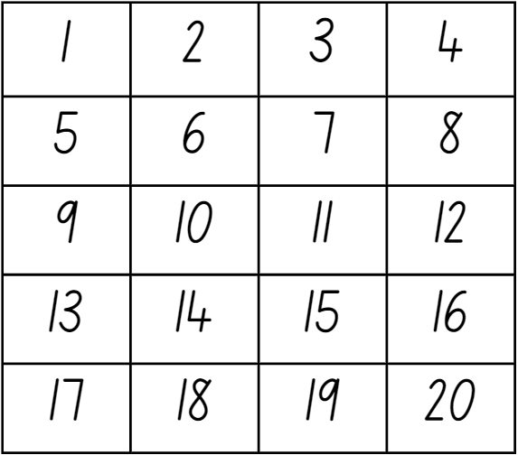

Resource 2: Number representations
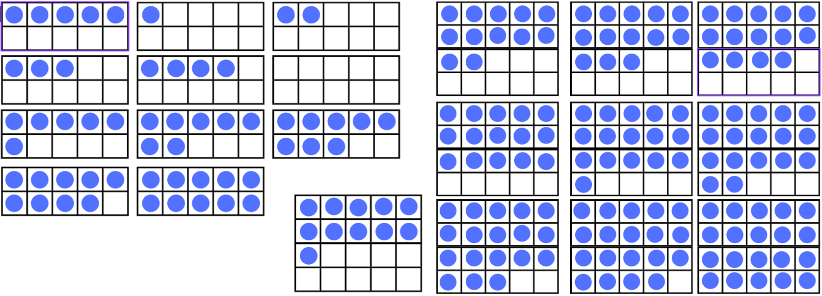

Resource 3: Dot cards
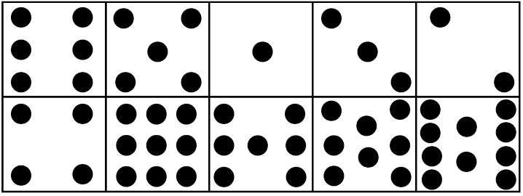

Resource 4: Lamingtons
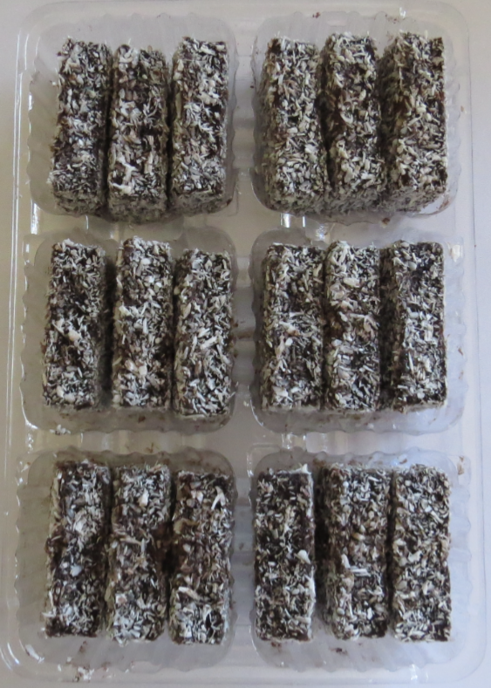

Resource 5: Multiples of 10
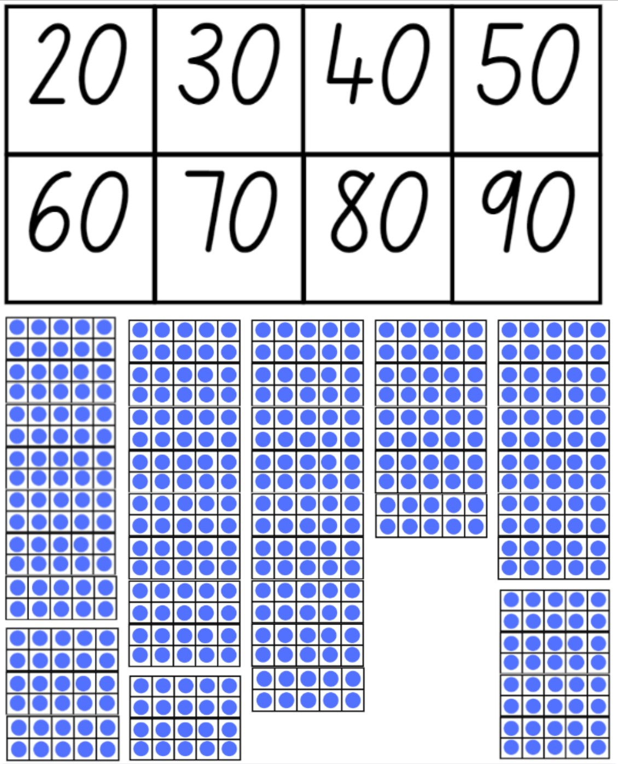

Resource 6: Garden bed
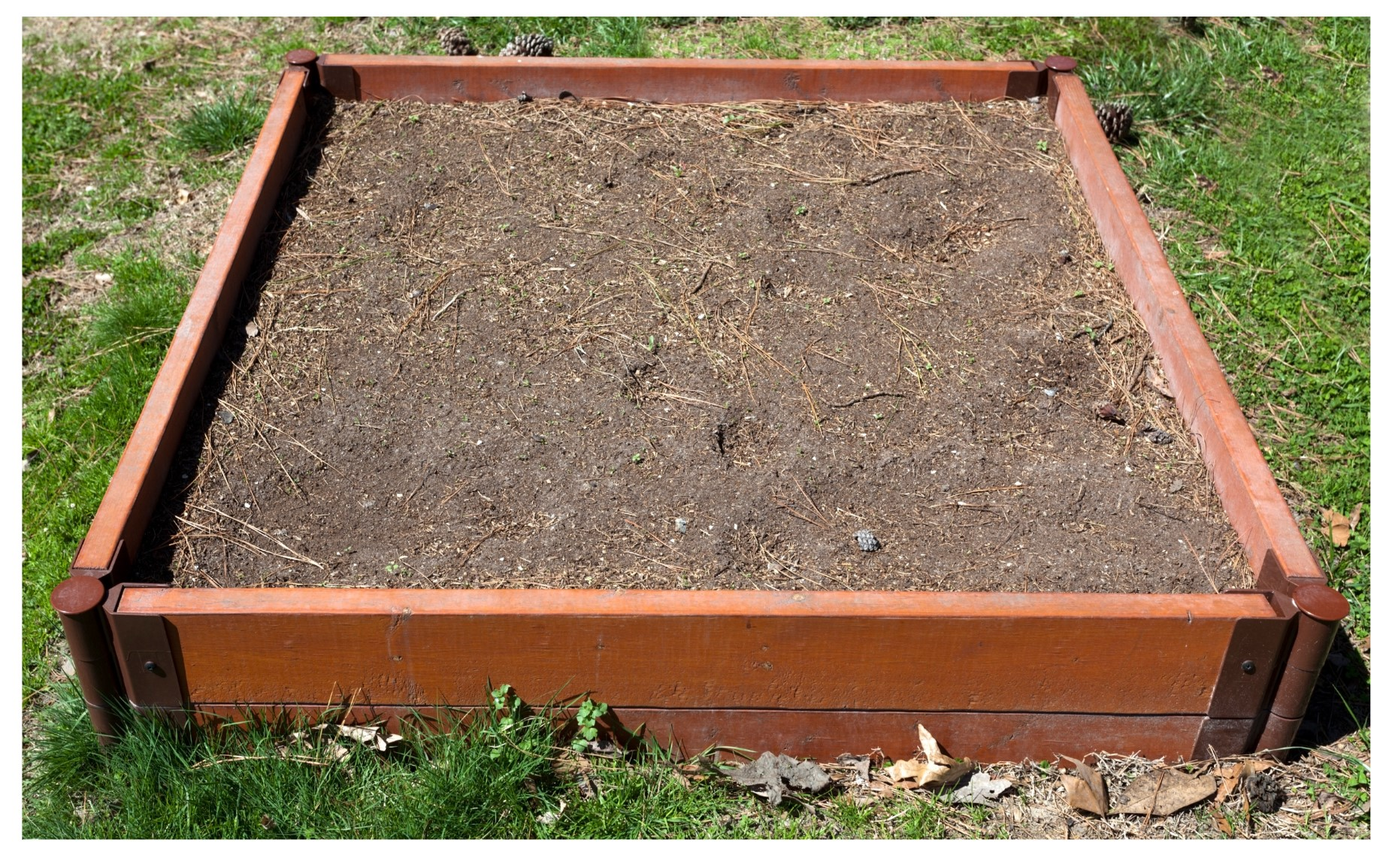
Images sourced from Canva and used in accordance with the Canva Content License Agreement.

Resource 7: Bus
Images sourced from Canva and used in accordance with the Canva Content License Agreement.

Resource 8: Animal images
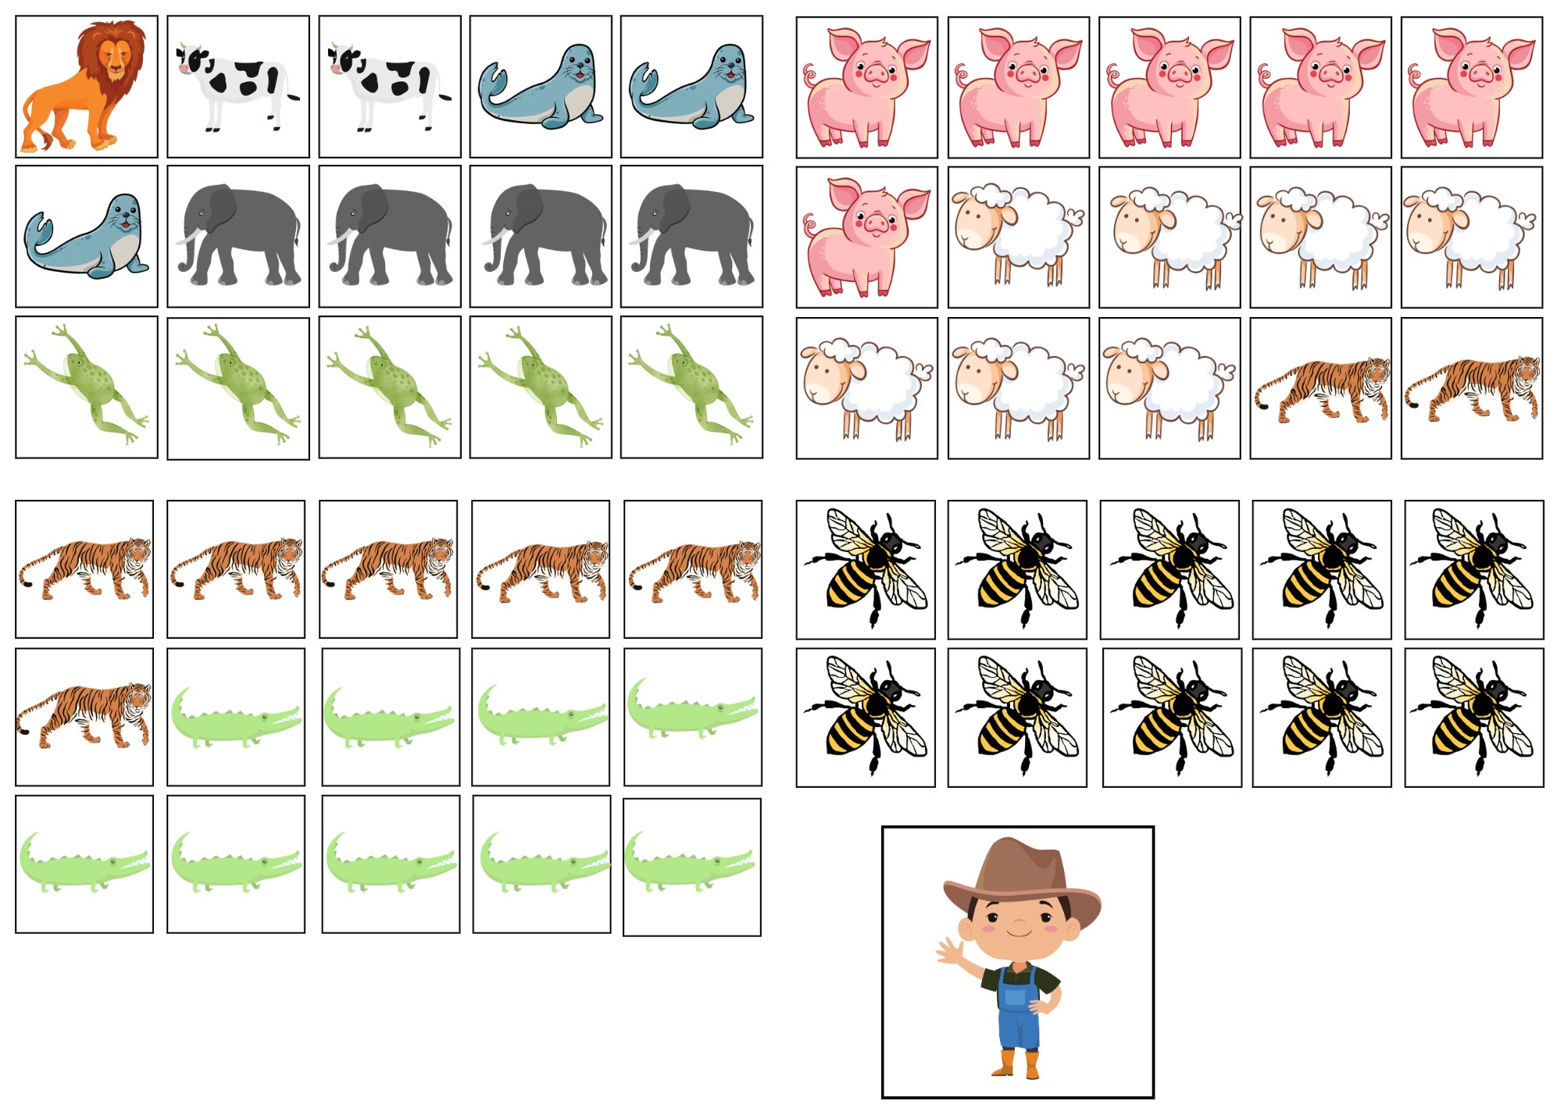
Images sourced from Canva and used in accordance with the Canva Content License Agreement.

Syllabus outcomes and content
The table below outlines the syllabus outcomes and range of relevant syllabus content covered in this unit. Content is linked to National Numeracy Learning Progression version (3).
Focus area and outcomes | Content groups and content points | Lessons
Representing whole numbers  MAO-WM-01  MAE-RWN-01  MAE-RWN-02 | Instantly name the number of objects within small collections  - instantly recognise (subitise) the number of items in small groups of up to four items without counting (NPV1, CPr1)  - identify the number of items in different arrangements (CPr2)  Use the counting sequence of ones flexibly  - count forwards to at least 30 and state the number after or before a given number, without needing to count from one (CPr4)  - identify and distinguish the ‘teen’ numbers from multiples of ten with the same initial sounds (NPV3)  - count backwards from a given number 20 or less (CPr5)  - identify the number before as ‘one less’ and the number after as ‘one more’ than a given number  Recognise number patterns  - recognise dice and domino dot patterns (NPA1, NPV2, CPr2)  - recognise different finger patterns for the same number (NPA2)  Connect counting and numerals to quantities  - count with one-to-one correspondence, recognising that the last number name represents the total number in the collection (CPr3, CPr5)  - make correspondences between collections  - read numerals to at least 20, including zero (NPV3)  - represent numbers as quantities to at least 20 using objects (such as fingers), number words and numerals (NPV2-NPV4, CPr3) | 1–8
Combining and separating quantities  MAO-WM-01  MAE-CSQ-01  MAE-CSQ-02 | Model additive relations and compare quantities  - identify situations in which addition and subtraction may be applied (AdS1-AdS2)  - combine two or more groups of objects to model addition, identifying the relationship between the parts and the whole (AdS1-AdS2)  - separate and take away part of a group of objects to model subtraction (AdS1-AdS2)  - use concrete materials or fingers to model and solve addition and subtraction questions, counting forwards or backwards by ones as necessary (AdS1-AdS2, NPV3)  - compare two groups of objects to determine how many more (NPV1, AdS2)  Identify part–whole relationships in numbers up to 10  - use visual representations of numbers to assist with combining and separating quantities, identifying the relationship between the quantities (NPV2, NPA2, AdS2-AdS3)  - describe the action of combining, separating and comparing (AdS1)  - use five as a reference in forming numbers from six to ten  - create, model and recognise combinations for numbers up to ten (AdS2)  - count by ones to find the total or difference (AdS2-AdS3)  - use drawings, words and numerals to record addition and subtraction, and explain their thinking (AdS2) | 1–3, 5–8
Forming groups  MAO-WM-01  MAE-FG-01  MAE-FG-02 | Investigate and form equal groups by sharing  - distribute a group of familiar objects into smaller groups and recognise whether the number in each group is equal or not (MuS1-MuS2)  - group and share concrete materials by distributing objects one by one or using another method (MuS1-MuS2)  Record grouping and sharing  - label the number of objects in a group  - record grouping and sharing using drawings, words and numerals, and explain their thinking (MuS2) | 2, 4, 6, 8

References
Links to third-party material and websites
Please note that the provided (reading/viewing material/list/links/texts) are a suggestion only and implies no endorsement, by the New South Wales Department of Education, of any author, publisher, or book title. School principals and teachers are best placed to assess the suitability of resources that would complement the curriculum and reflect the needs and interests of their students.
If you use the links provided in this document to access a third-party's website, you acknowledge that the terms of use, including licence terms set out on the third-party's website apply to the use which may be made of the materials on that third-party website or where permitted by the Copyright Act 1968 (Cth). The department accepts no responsibility for content on third-party websites.
Except as otherwise noted, all material is © State of New South Wales (Department of Education), 2023 and licensed under the Creative Commons Attribution 4.0 International License. All other material (third-party material) is used with permission or under licence. Where the copyright owner of third-party material has not licensed their material under a Creative Commons or similar licence, you should contact them directly for permission to reuse their material.
Mathematics K–10 Syllabus © 2022 NSW Education Standards Authority (NESA) for and on behalf of the Crown in right of the State of New South Wales.
© 2022 NSW Education Standards Authority. This document contains NSW Curriculum and syllabus content. The NSW Curriculum is developed by the NSW Education Standards Authority. This content is prepared by NESA for and on behalf of the Crown in right of the State of New South Wales. The material is protected by Crown copyright.
Please refer to the NESA Copyright Disclaimer for more information.
NESA holds the only official and up-to-date versions of the NSW Curriculum and syllabus documents. Please visit the NSW Education Standards Authority (NESA) website and the NSW Curriculum website.
National Numeracy Learning Progression © Australian Curriculum, Assessment and Reporting Authority (ACARA) 2010 to present, unless otherwise indicated. This material was downloaded from the Australian Curriculum website (National Literacy Learning Progression) (accessed 13 December 2022) and was not modified. The material is licensed under CC BY 4.0. Version updates are tracked in the ‘Curriculum version history’ section on the 'About the Australian Curriculum' page of the Australian Curriculum website.
ACARA does not endorse any product that uses the Australian Curriculum or make any representations as to the quality of such products. Any product that uses material published on this website should not be taken to be affiliated with ACARA or have the sponsorship or approval of ACARA. It is up to each person to make their own assessment of the product, taking into account matters including, but not limited to, the version number and the degree to which the materials align with the content descriptions and achievement standards (where relevant). Where there is a claim of alignment, it is important to check that the materials align with the content descriptions and achievement standards (endorsed by all education Ministers), not the elaborations (examples provided by ACARA).
Bancroft B (2009) An Australian 1, 2, 3 of animals, Hardie Grant, Australia.
Boaler J, Munson M & Williams C (2021) Mindset mathematics: Visualising and Investigating Big Ideas, Grade 1, Jossey-Bass, US.
Burningham J (1992) The shopping basket, Random House UK.
Candlewick Press (1 March 2013) ‘Handa’s Hen’ [video], Candlewick Press, vimeo, accessed 12 December 2022.
Graham B (1985) First there was Frances, Lothian Publishing Company, Melbourne Australia.
King SM (2019) Three, Scholastic Press, Australia.
Matthews C (2015) ‘Maths as Storytelling: Maths is Beautiful’, in Price K (ed) (2nd edn) Aboriginal and Torres Strait Islander Education: An introduction for the teaching profession, Cambridge University Press, Port Melbourne.
McGrath BB (2010) Teddy Bear Counting (T Nihoff, illus), Random House US.
Muir F and Lawson S (2021) Sharing (L Mulgo Watson, illus), Magabala Books, Broome WA.
Piers H (1996) Is There Room on the Bus? (H Giffard, illus), Frances Lincoln, London.
Robertson J (2017) Messy Maths. A Playful, Outdoor Approach for Early Years, Crown House Publishing, UK.
Siemon D, Warren E, Beswick K, Faragher R, Miller J, Horne M, Jazby D, Breed M, Clark J and Brady K (2021) Teaching Mathematics Foundations to Middle Years, 3rd edn, Oxford University Press, UK.
Teacher Education by Design, University of Washington (2014) 'Counting Collections', Maths Activities, Teacher Education by Design website, accessed 12 December 2022.
Van de Walle J, Karp K, Bay-Williams JM, Brass A, Bentley B, Ferguson S, Goff W, Livy S, Marshman M, Martin D, Pearn C, Prodromou T, Symons D and Wilkie K (2019) Primary and Middle Years Mathematics: Teaching Developmentally, 1st Australian edn, Pearson Education Australia, Melbourne.

