Mathematics 3-6 multi-age – Year B – Unit 5
Contents
Unit description and duration 5
Syllabus outcomes 5
Working mathematically 6
Student prior learning 7
Lesson overview and resources 8
Lesson 1 17
Daily number sense: Counting by 10s – 15 minutes 17
Core lesson: Pulse rate – 45 minutes 20
Discuss and connect the mathematics – 10 minutes 24
Lesson 2 26
Daily number sense: Multiples madness – 15 minutes 26
Core lesson: Travelling around Australia – 40 minutes 29
Consolidation and meaningful practice – 20 minutes 32
Lesson 3 36
Daily number sense: Multiplying by multiples – 15 minutes 36
Core lesson: 40 minutes 39
Consolidation and meaningful practice – 20 minutes 43
Lesson 4 46
Daily number sense – 10 minutes 46
Core lesson: Lunchtime activities – 45 minutes 46
Consolidation and meaningful practice – 10 minutes 50
Lesson 5 53
Daily number sense: Benchmark fractions – 15 minutes 53
Core lesson: 40 minutes 56
Consolidation and meaningful practice – 10 minutes 60
Lesson 6 62
Daily number sense: Fractions for comparison – 15 minutes 62
Core lesson: 45 minutes 65
Discuss and connect the mathematics – 15 minutes 72
Lesson 7 76
Daily number sense: Doughnut decimals – 10 minutes 76
Core lesson: 45 minutes 79
Discuss and connect the mathematics – 10 minutes 84
Lesson 8 87
Daily number sense – 10 minutes 87
Core lesson: 50 minutes 87
Discuss and connect the mathematics – 10 minutes 92
Resource 1: Resting heart rate 94
Resource 2: Average maximum heart rate 95
Resource 3: Pulse rates side-by-side column graph 96
Resource 4: Multiples madness gameboard 97
Resource 5: Multiples madness scoreboard 98
Resource 6: Unlabelled graph 99
Resource 7: Infographics 100
Resource 8: Beijing weather 102
Resource 9: Speed skating times 103
Resource 10: Lunchtime places 104
Resource 11: Lunchtime activities 105
Resource 12: Data story 106
Resource 13: LEGO timeline 107
Resource 14: Brick set pieces 108
Resource 15: Visitor attendance – Windsor 109
Resource 16: Theme park attendance 110
Resource 17: Scrabble tiles 111
Resource 18: Survey results 112
Resource 19: Scenarios 113
Resource 20: Doughnut decimals 114
Resource 21: Gold medal picture graph 115
Resource 22: Gold medal column graph 116
Resource 23: Total medal count 117
Resource 24: Comparing data displays 118
Resource 25: Misleading strategies 119
Resource 26: Misleading representations 120
Resource 27: 100 people 122
Resource 28: Nationalities 123
Resource 29: Energy 124
Resource 30: Average worldwide temperature 125
Resource 31: Accurate data representation 126
Syllabus outcomes and content 127
Stage 2 127
Stage 3 132
References 137

Unit description and duration
This unit introduces the big idea that questions can be asked and answered by interpreting data.
In this 2-week unit students are provided opportunities to:
- collect data and construct, interpret and compare a range of data displays, including data presented in digital media
- interpret and evaluate the effectiveness of various data displays found in media and factual texts, identifying sources of bias and misleading representations
- compare, order and represent whole numbers and decimals.
This multi-age unit is informed by the lessons in Stage 2 Year B Unit 25 and Stage 3 Year B Unit 25. Please refer to these units for additional lesson guidance.

Syllabus outcomes
- MAO-WM-01 develops understanding and fluency in mathematics through exploring and connecting mathematical concepts, choosing and applying mathematical techniques to solve problems, and communicating their thinking and reasoning coherently and clearly

Stage 2
- MA2-RN-01 applies an understanding of place value and the role of zero to represent numbers to at least tens of thousands
- MA2-RN-02 represents and compares decimals up to 2 decimal places using place value
- MA2-MR-01 represents and uses the structure of multiplicative relations to 10 × 10 to solve problems
- MA2-PF-01 represents and compares halves, quarters, thirds and fifths as lengths on a number line and their related fractions formed by halving (eighths, sixths and tenths)
- MA2-DATA-01 collects discrete data and constructs graphs using a given scale
- MA2-DATA-02 interprets data in tables, dot plots and column graphs

Stage 3
- MA3-RN-01 applies an understanding of place value and the role of zero to represent the properties of numbers
- MA3-RN-02 compares and orders decimals up to 3 decimal places
- MA3-RN-03 determines percentages of quantities, and finds equivalent fractions and decimals for benchmark percentage values
- MA3-MR-01 selects and applies appropriate strategies to solve multiplication and division problems
- MA3-DATA-01 constructs graphs using many-to-one scales
- MA3-DATA-02 interprets data displays, including timelines and line graphs

Working mathematically
In the Mathematics K–10 Syllabus, there is one overarching Working mathematically outcome (MAO-WM-01). The Working mathematically processes should be embedded within the concepts being taught. The Working mathematically processes present in the Mathematics K–10 Syllabus are:
- communicating
- understanding and fluency
- reasoning
- problem solving.
Mathematics K–10 Syllabus © NSW Education Standards Authority (NESA) for and on behalf of the Crown in right of the State of New South Wales, 2022.

Student prior learning
Before engaging in these teaching and learning activities, students would benefit from prior experience with:
- posing questions and collecting discrete data, by observation or survey
- displaying, representing and interpreting data presented in lists, tables and a variety of graphs
- reading, writing, representing, ordering and partitioning whole numbers and decimals.
In NSW classrooms there is a diverse range of students, including Aboriginal and Torres Strait Islander students, students learning English as an additional language or dialect, high potential and gifted students and students with disability. Some students may identify with more than one of these groups or possibly all of them. Refer to Curriculum planning for every student – advice for further information.

Lesson overview and resources
To cover the content of the syllabus across Stage 2 and Stage 3, some core lessons in the unit contain both a Stage 2 and a Stage 3 task. Teachers are encouraged to adapt and contextualise the units to meet the needs of their students.
The table below outlines the sequence and approximate timing of lessons, learning intentions and resources.
Lesson | Content | Duration and resources
Lesson 1  Daily number sense  Stage 2:  - Multiplicative relations B: Operate with multiples of 10  Stage 3:  - Multiplicative relations A: Use partitioning and place value to multiply 2-, 3- and 4-digit numbers by one-digit numbers | Lesson core concept: asking questions gives meaning to data, which is more than just numbers and graphics.  Stage 2:  - Data A: Collect discrete data  - Data A: Organise and display data using tables and graphs  - Data A: Interpret and compare data  - Data B: Select and trial methods for data collection  Stage 3:  - Data A: Collect categorical and discrete numerical data by observation or survey  - Data A: Choose and use appropriate tables and graphs  - Data B: Interpret and compare a range of data displays | Lesson duration: 70 minutes  - Resource 1: Resting heart rate  - Resource 2: Average maximum heart rate  - Resource 3: Pulse rates side-by-side column graph  - 10-sided dice (one per pair)  - 1–10 spinner (one per pair)  - Devices with Microsoft Excel or Google Sheets  - Timer  - Whiteboards  - Writing materials
Lesson 2  Daily number sense  Stage 2:  - Multiplicative relations B: Operate with multiples of 10  Stage 3:  - Multiplicative relations A: Use partitioning and place value to multiply 2-, 3- and 4-digit numbers by one-digit numbers | Lesson core concept: mathematicians collect, organise and present data in different ways.  Stage 2:  - Representing numbers using place value A: Whole numbers: Read, represent and order numbers to thousands  - Data A: Organise and display data using tables and graphs  - Data A: Interpret and compare data  Stage 3:  - Represents numbers A: Whole numbers: Recognise, represent and order numbers in the millions  - Data B: Interpret data presented in digital media and elsewhere | Lesson duration: 75 minutes  - Resource 4: Multiples madness gameboard  - Resource 5: Multiples madness scoreboard  - Resource 6: Unlabelled graph  - Resource 7: Infographics  - 0–9 spinner (one per pair)  - 0–9 dice (one per pair)  - Counters (6 per pair, 3 each of 2 different colours)  - Writing materials
Lesson 3  Daily number sense  Stage 2:  - Multiplicative relations B: Operate with multiples of 10  Stage 3:  - Multiplicative relations A: Use partitioning and place value to multiply 2-, 3- and 4-digit numbers by one-digit numbers | Lesson core concept: data is represented in different ways for different purposes.  Stage 2:  - Representing numbers using place value B: Decimals: Extend the application of the place value system from whole numbers to tenths and hundredths  - Data A: Organise and display data using tables and graphs  - Data B: Construct and interpret data displays with many-to-one scales  Stage 3:  - Represents numbers A: Decimals and percentages: Recognise that the place value system can be extended beyond hundredths  - Represents numbers B: Whole numbers: Locate and represent integers on a number line  - Data B: Interpret data presented in digital media and elsewhere | Lesson duration: 75 minutes  - Resource 8: Beijing weather  - Resource 9: Speed skating times  - Individual whiteboards  - Writing materials
Lesson 4  Daily number sense  - teacher-identified task based on student needs | Lesson core concept: there are many ways to communicate data.  Stage 2:  - Representing numbers using place value B: Decimals: Extend the application of the place value system from whole numbers to tenths and hundredths  - Data A: Organise and display data using tables and graphs  - Data B: Select and trial methods for data collection  - Data B: Construct and interpret data displays with many-to-one scales  Stage 3:  - Represents numbers A: Decimals and percentages: Compare, order and represent decimals  - Data B: Interpret and compare a range of data displays | Lesson duration: 65 minutes  - Resource 10: Lunchtime places  - Resource 11: Lunchtime activities  - Writing materials
Lesson 5  Daily number sense  Stage 2:  - Partitioned fractions B: Model equivalent fractions as lengths  Stage 3:  - Represents numbers B: Decimals and percentages: Make connections between benchmark fractions, decimals and percentages | Lesson core concept: mathematicians interpret and evaluate the effectiveness of data displays.  Stage 2:  - Representing numbers using place value B: Whole numbers: Order numbers in the thousands  - Data A: Organise and display data using tables and graphs  Stage 3:  - Represents numbers A: Whole numbers: Recognise, represent and order numbers in the millions  - Data B: Interpret and compare a range of data displays | Lesson duration: 65 minutes  - Resource 12: Data story  - Resource 13: LEGO timeline  - Resource 14: Brick set pieces  - Resource 15: Visitor attendance – Windsor  - Resource 16: Theme park attendance  - Interlocking cubes (different colours)  - Rulers (one per student)  - Writing materials
Lesson 6  Daily number sense  Stage 2:  - Partitioned fractions B: Model equivalent fractions as lengths  Stage 3:  - Represents numbers B: Decimals and percentages: Make connections between benchmark fractions, decimals and percentages | Lesson core concept: data can be presented to convince or persuade but must be scrutinised to ensure it is not biased or misleading.  Stage 2:  - Representing numbers using place value A: Whole numbers: Read, represent and order numbers to thousands  - Representing numbers using place value B: Decimals: Make connections between fractions and decimal notation  - Data B: Construct and interpret data displays with many-to-one scales  Stage 3:  - Represents numbers A: Decimals and percentages: Compare, order and represent decimals  - Data B: Interpret data presented in digital media and elsewhere | Lesson duration: 75 minutes  - Resource 17: Scrabble tiles  - Resource 18: Survey results  - Resource 19: Scenarios  - Devices with Microsoft Excel or Google Sheets  - Individual whiteboards  - Newspapers, magazines or books  - Writing materials
Lesson 7  Daily number sense  Stage 2:  - Representing numbers using place value B: Decimals: Make connections between fractions and decimal notation  Stage 3:  - Represents numbers B: Decimals and percentages: Make connections between benchmark fractions, decimals and percentages | Lesson core concept: interpreting data from everyday contexts helps solve problems, ask questions and influences daily practices.  Stage 2:  - Representing numbers using place value A: Whole numbers: Read, represent and order numbers to thousands  - Representing numbers using place value B: Decimals: Make connections between fractions and decimal notation  - Data B: Construct and interpret data displays with many-to-one scales  Stage 3:  - Represents numbers A: Decimals and percentages: Compare, order and represent decimals  - Data B: Interpret data presented in digital media and elsewhere | Lesson duration: 70 minutes  - Resource 20: Doughnut decimals  - Resource 21: Gold medal picture graph  - Resource 22: Gold medal column graph  - Resource 23: Total medal count  - Resource 24: Comparing data displays  - Resource 25: Misleading strategies  - Resource 26: Misleading representations  - Writing materials
Lesson 8  Daily number sense  - teacher-identified task based on student needs | Lesson core concept: statistical reasoning helps mathematicians interpret and make inferences about information.  Stage 2:  - Representing numbers using place value A: Whole numbers: Read, represent and order numbers to thousands  - Data B: Construct and interpret data displays with many-to-one scales  Stage 3:  - Data B: Interpret data presented in digital media and elsewhere | Lesson duration: 70 minutes  - Resource 26: Misleading representations  - Resource 27: 100 people  - Resource 28: Nationalities  - Resource 29: Energy  - Resource 30: Average worldwide temperature  - Resource 31: Accurate data representation  - Smith DJ (2020) If the World Were a Village. ISBN:9781553377320  - 30 cm rulers  - Devices with Microsoft Excel or Google Sheets  - Small dot stickers  - Student workbooks  - Writing materials

Lesson 1
Core concept: asking questions gives meaning to data, which is more than just numbers and graphics.

Daily number sense: Counting by 10s – 15 minutes
Daily number sense activities for Lessons 1 to 3 ‘activate’ prior number knowledge and support the learning of new content in the unit. These activities can also assist teachers to identify the starting points for learning by revealing the extent of students’ existing knowledge.
The table below contains a suggested learning intention and success criteria. These are best co-constructed with students.
Daily number sense learning intention | Daily number sense success criteria
All students are learning to:  - operate with multiples of 10. | Students working towards Stage 2 outcomes can:  - multiply a one-digit number by a multiple of 10.  Students working towards Stage 3 outcomes can:  - use mental strategies to multiply one-digit numbers by 10, 100, 1000 and their multiples.
This activity is an adaptation of Counting game (by multiples of 10) from Mathematics K-6 resources by State of New South Wales (Department of Education).
- In pairs, students roll a 10-sided die or spin a 1–10 spinner 4 times. Each time, the number rolled or spun is multiplied by 10. The totals are then added together to determine a target number.
- Ask students how they know that the target number is a multiple of 10.
- Explain that the object of the game is to be the person who says the target number.
- Players take turns to count on by saying the next 1, 2 or 3 number words in the tens sequence. Students start the game at zero.
- Pairs record the target number and the number words each turn (see Figure 1).
Figure 1 – Example counting game
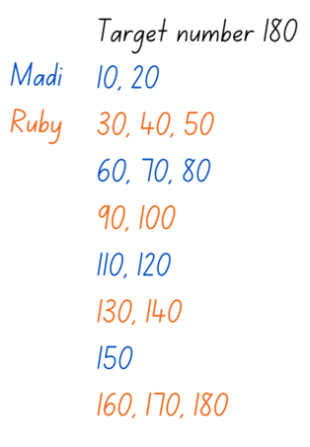
- The player who says the target number receives a point.
- Players then choose a new target number and play the game again.
- The game may be varied by:
- starting at the target number and counting backwards to zero
- rolling the die or spinning the spinner once and multiplying by a multiple of 10, for example, if a player rolls a 5 it becomes 50.
- Reflect on the activity, asking questions such as:
- Did you prefer going first or second? Why?
- What strategy did you use? How successful was it and why?
- Looking back on the games that you played, can you see any ways that one player could change their moves to win?
- How could you make the game easier or harder?
Multi-age: students working towards Stage 3 outcomes can be given opportunities to multiply the dice or spinner by a multiple of 10, for example, if a player rolls a 5 it becomes 50. Students could also multiply this number by 100 or 1000.
This table details opportunities for assessment.
Assessment opportunities | Links
What to look for:  - Can Stage 2 students multiply a one-digit number by a multiple of 10? [MAO-WM-01, MA2-MR-01]  - Can Stage 3 students use mental strategies to multiply one-digit numbers by 10, 100, 1000 and their multiples? [MAO-WM-01, MA3-MR-01] | Links to National Numeracy Learning Progressions (NNLP):  - Stage 2 – MuS7  - Stage 3 – MuS7.

Core lesson: Pulse rate – 45 minutes
The table below contains suggested learning intentions and success criteria. These are best co-constructed with students.
Core concept learning intentions | Core concept success criteria
All students are learning to:  - collect discrete data by observation  - organise and display data using tables and graphs  - interpret and compare a range of data displays. | Students working towards Stage 2 outcomes can:  - collect numerical data through observation  - construct column graphs using digital technologies  - describe and interpret information provided in tally tables and column graphs.  Students working towards Stage 3 outcomes can:  - collect numerical data through observation  - construct column graphs using digital technologies  - interpret and compare different displays in terms of the shape of the distribution, including the range and the mode  - interpret side-by-side column graphs for 2 categorical variables.
This activity is an adaptation of Pulse rates investigation from Universal Resources Hub by State of New South Wales (Department of Education).
- Ask students:
- What is pulse rate?
- How can it be measured?
- Display Resource 1: Resting heart rate and ask the questions listed on the resource.
Note: provide students with opportunities to describe the characteristics of graphs. In particular, the data can be described in terms of its distribution: how far the data is spread out (range), where most of the data points are (mode) and how the data is arranged visually.
Multi-age: students working towards Stage 2 outcomes are not expected to use terms such as range and mode. This terminology is an expectation for Stage 3 students.

- Explain that students will find their resting pulse rate by:
- sitting quietly for one minute
- finding their pulse in their neck by lightly pressing the side of the neck with their fingers, just below the jawline (see Figure 2).
- counting the number of beats in 6 seconds
- multiply the number by 10 to calculate beats per minute (BPM).
Figure 2 – Student finding their pulse in their neck
- Students record the resting pulse rates of 10 classmates in a table in their workbook.
- Ask students:
- What is the range of pulse rates in your data set?
- What is the mode?
- Considering normal heartbeat for adolescents is between 60 to 100 beats per minute at rest, would you say your data set is representative of this statistic? Justify your answers.
- Display Resource 2: Average maximum heart rate and discuss the data by asking questions listed on the resource.
- Explain that students will measure their after-exercise pulse rate after exercising for 3 minutes. This may be done inside or outside.
- At the end of the 3 minutes, students take their pulse rate again.
- Students record the after-exercise pulse rates of the same 10 classmates in a table in their workbook.
- Students select their table of either resting or after-exercise pulse rates and create a column graph using Microsoft Excel or Google Sheets.
- Students:
- open Microsoft Excel or Google Sheets on a device
- open a blank spreadsheet
- enter student names and pulse rates in column A and B
- highlight the data, including the headings
- use the top ribbon to select ‘insert’ and ‘column chart’
- add any features missing from the graph, for example title, or axes names or labels.
- Complete a gallery walk to view students graphs and discuss the differences between the graphs.
This table details opportunities for differentiation.
Too hard? | Too easy?
Students cannot construct column graphs using digital technologies.  - Students construct column graphs without the use of digital technologies. | Students can construct column graphs using digital technologies.  - Students predict what the graph would look like for elite athletes or a group of unfit adults.

Discuss and connect the mathematics – 10 minutes
Side-by-side column graph: these can be used to organise and display the data that arises when a group of individuals or things are categorised according to 2 or more criteria (ACARA).
- Display Resource 3: Pulse rates side-by-side column graph and discuss by asking the questions listed on the resource.
This table details opportunities for assessment.
Assessment opportunities | Links
What to look for:  - Can Stage 2 students collect numerical data through observation? [MAO-WM-01, MA2-DATA-01]  - Can Stage 2 students construct column graphs using digital technologies? [MAO-WM-01, MA2-DATA-01]  - Can Stage 2 students describe and interpret information provided in tally tables and column graphs? [MAO-WM-01, MA2-DATA-02]  - Can Stage 3 students collect numerical data through observation? [MAO-WM-01, MA3-DATA-01]  - Can Stage 3 students construct column graphs using digital technologies? [MAO-WM-01, MA3-DATA-01]  - Can Stage 3 students interpret and compare different displays in terms of the shape of the distribution, including the range and the mode? [MAO-WM-01, MA2-DATA-02]  - Can Stage 3 interpret side-by-side column graphs for 2 categorical variables? [MAO-WM-01, MA2-DATA-02] | Links to National Numeracy Learning Progressions (NNLP):  - Stage 2 – IRD2  - Stage 3 – IRD3, IRD4, IRD5.

Lesson 2
Core concept: mathematicians collect, organise and present data in different ways.

Daily number sense: Multiples madness – 15 minutes
The table below contains a suggested learning intention and success criteria. These are best co-constructed with students.
Daily number sense learning intention | Daily number sense success criteria
All students are learning to:  - operate with multiples of 10. | Students working towards Stage 2 outcomes can:  - multiply a one-digit number by a multiple of 10.  Students working towards Stage 3 outcomes can:  - use mental strategies to multiply one-digit numbers by 10, 100, 1000 and their multiples.
- Distribute Resource 4: Multiples madness gameboard, Resource 5: Multiples madness scoreboard, 3 counters of one colour, 3 of a second colour and 0–9 spinner or die to each pair of students.
- Players take turns to roll the dice or spin the spinner. After each roll or spin, players multiply the number by 10 and explain their thinking to their partner.
- The partner records their thinking, and if they agree, the first player places one of their counters on the number on the gameboard, claiming that place. For example, demonstrate the Multiple madness gameboard and score board with the roll 5. If the number is taken, that player misses a turn (see Figure 3).
Figure 3 – Multiple madness gameboard and score board with the roll 5
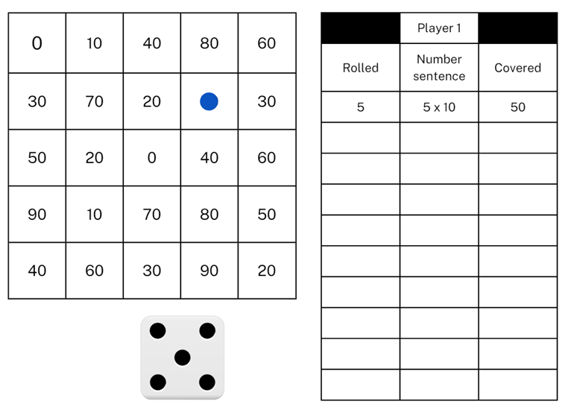
- A player wins by getting 3 counters in a row in any orientation.
- Since players only have 3 counters, they will need to choose which counter to move once all 3 have been placed on the gameboard.
- Reflect on the activity, asking questions such as:
- Did you prefer going first or second? Why?
- What strategy did you use? How successful was it and why?
- How might the game change if you multiplied by 20?
- Would it be easier if you had more counters? Why?
Multi-age: students working towards Stage 3 outcomes can draw their own gameboard based on the displayed gameboard. Students can work with their partner to multiply the number they spin or roll by 10, 100, 1000 or their multiples. For example, students could choose to multiply by 20 or 300. Before starting the game, students would need to work together to fill in their gameboard with the appropriate numbers depending on their chosen multiple.
This table details opportunities for assessment.
Assessment opportunities | Links
What to look for:  - Can Stage 2 students multiply a one-digit number by a multiple of 10? [MAO-WM-01, MA2-MR-01]  - Can Stage 3 students use mental strategies to multiply one-digit numbers by 10, 100, 1000 and their multiples? [MAO-WM-01, MA3-MR-01] | Links to National Numeracy Learning Progressions (NNLP):  - Stage 2 – MuS7  - Stage 3 – MuS7.

Core lesson: Travelling around Australia – 40 minutes
The table below contains suggested learning intentions and success criteria. These are best co-constructed with students.
Core concept learning intentions | Core concept success criteria
Students are learning to:  - interpret data displays presented in digital media with many-to-one scales  - read, represent and order large numbers | Students working towards Stage 2 outcomes can:  - interpret and evaluate the effectiveness of various data displays found in media where displays represent data using a scale of many-to-one  - order numbers of up to at least 6 digits  - identify the number before and after a number with an internal zero digit.  Students working towards Stage 3 outcomes can:  - interpret data representations found in digital media and in factual texts  - name millions using the place value grouping of ones, tens and hundreds  - arrange numbers in the millions in ascending and descending order using place value  - round numbers to a specified place value.
- Distribute Resource 6: Unlabelled graph and ask students to predict what type of data is being represented in the display. Draw the class’s attention to the fact that column graphs are used to represent discrete data.
Note: numerical data values are expressed as numbers and obtained either by counting or measurement. Counts are discrete values (for example, the number of children in each family) and measurements are continuous values (for example, the change in temperature over time). Column graphs can be used for discrete data values and line graphs for continuous data values, where meaning can be attached to the points on the line between plotted points.
- Brainstorm the missing elements of the graph, including title, axes names and labels, equally spaced axes and scale.
- Give students the topic ‘holidays’ and, as a class, brainstorm what data the graph may represent. For example, destinations, duration of journey, mode of travel.
- Write on the board the data included in Figure 4. Explain that the data is not in the same order as presented in Resource 6: Unlabelled graph.
Figure 4 – Destination data
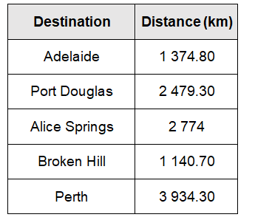
Data sourced from Google Maps
- In pairs, students interpret the data in the table to complete the graph in Resource 6: Unlabelled graph. Students label the graph, determine a scale and identify each column based on the size of the numbers in the table.
- Pairs of students swap their graph with another pair to:
- identify the similarities and differences between their graphs
- justify their choice in scale and order of locations on the x-axis.
- Distribute Resource 7: Infographics to small groups of students.
- Groups select one of the infographics to use to answer the questions listed on the resource.
- Each group composes 3 questions about the data in their display.
- Display each infographic and have each group share their questions for the rest of the class to answer.
Multi-age: please note that the infographics for this activity cover various number ranges. Please select the resource which is appropriate to each student’s level of development.
This table details opportunities for differentiation.
Too hard? | Too easy?
Stage 2 students cannot interpret and evaluate the effectiveness of various data displays found in media.  - Support students to interpret the data displayed by limiting the amount of information they are looking at to one section of one of the infographics.  Stage 3 students cannot interpret data representations found in digital media.  - Support students to interpret the data displayed by limiting the amount of information they are looking at to one section of one of the infographics. | Stage 2 students can interpret and evaluate the effectiveness of various data displays found in media.  - Students create their own infographic using information about themselves or their school.  Stage 3 students can interpret data representations found in digital media.  - Students create their own infographic using information about themselves or their school (this could be completed using digital software).

Consolidation and meaningful practice – 20 minutes
- Write the distances from Figure 4 on board in metres: 2 774 000, 3 934 300, 1 140 700, 1 374 800 and 2 479 300.
Multi-age: for students working towards Stage 2 outcomes, display the original Figure 4 distances in kilometres on the board for students to read and record.
- Students turn to a partner and take turns reading the numbers from the board.
- Students record the numbers in their workbooks and then write them in ascending order.
- Students specify a place value for their partner to round the numbers to. For example, thousands, tens of thousands, hundreds of thousands or millions. Students record the rounded numbers.
- Write 5 numbers on the board.
Multi-age: for students working towards Stage 2 outcomes, write numbers up to 6-digits. For students working towards Stage 3 outcomes, write numbers up to millions. Students record the numbers in their workbooks and then write them in descending order.
- Students specify a place value for their partner to round the numbers to. For example, tens, thousands, tens of thousands, hundreds of thousands or millions. Students record the rounded numbers.
- Students then identify the number before and the number after each distance and record the number in their workbooks.
- Reflect on the activity by asking questions, such as:
- Which number did you find most difficult to read? Why?
- Was the first or second set of numbers easier to read? Why?
- Is it easier to order in ascending or descending order?
- Which place value is the easiest to round to? Why?
- Which number did you find the most difficult to round? What place value were you rounding to?
- What strategies help you to read or order or round numbers in the millions?
This table details opportunities for differentiation.
Too hard? | Too easy?
Stage 2 students cannot order numbers of up to at least 6 digits.  - Assist students by reducing the numbers they order to a 3-, 4- or 5-digit numbers.  Stage 3 students cannot arrange or round numbers in the millions.  - Students round the numbers to the nearest million only.  - Provide a list of descending and ascending numbers with some numbers missing for students to fill in. | Stage 2 students can order numbers of up to at least 6 digits.  - In pairs, students use a 9-sided dice to create numbers up to at least 6 digits and take turns placing them in ascending or descending order.  Stage 3 students can arrange or round numbers in the millions.  - Students rewrite the list of numbers moving the first 2 digits to the end of the number to create new numbers to order and round.
This table details opportunities for assessment.
Assessment opportunities | Links
What to look for:  - Can Stage 2 students interpret and evaluate the effectiveness of various data displays found in media where displays represent data using a scale of many-to-one? [MAO-WM-01, MA2-DATA-02]  - Can Stage 2 students order numbers of up to at least 6 digits? [MAO-WM-01, MA2-RN-01]  - Can Stage 2 students identify the number before and after a number with an internal zero digit? [MAO-WM-01, MA2-RN-01]  - Can Stage 3 students interpret data representations found in digital media and in factual texts? [MAO-WM-01, MA3-DATA-02]  - Can Stage 3 students name millions using the place value grouping of ones, tens and hundreds? [MAO-WM-01, MA3-RN-01]  - Can Stage 3 students arrange numbers in the millions in ascending and descending order using place value? [MAO-WM-01, RN-01]  - Can Stage 3 students round numbers to a specified place value? [MAO-WM-01, MA3-RN-01] | Links to National Numeracy Learning Progressions (NNLP):  - Stage 2 – IRD3, NPV5, NPV6, NPV7  - Stage 3 – IRD4, IRD5, NPV6, NPV7.

Lesson 3
Core concept: data is represented in different ways for different purposes.

Daily number sense: Multiplying by multiples – 15 minutes
The table below contains a suggested learning intention and success criteria. These are best co-constructed with students.
Daily number sense learning intention | Daily number sense success criteria
Students working towards Stage 2 outcomes are learning to:  - operate with multiples of 10.  Students working towards Stage 3 outcomes are learning to:  - use partitioning and place value to multiply 2-, 3- and 4-digit numbers by one-digit numbers. | Students working towards Stage 2 outcomes can:  - use multiplication facts with multiples of 10 to multiply a one-digit number by a multiple of 10.  Students working towards Stage 3 outcomes can:  - use mental strategies to multiply one-digit numbers by 10, 100, 1000 and their multiples.
- Provide pairs of students with a 10-sided die or spinner and ask students to draw Figure 5 on their whiteboards.
Figure 5 – Multiplying multiples
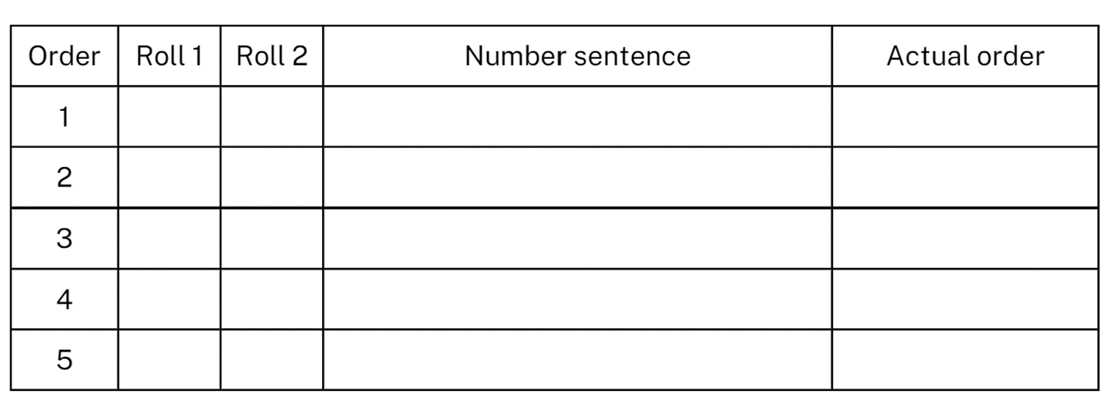
- Players take turns to roll the die or spin the spinner twice each turn. The first number becomes the multiplier, while the second number is turned into a multiple of 10 and that becomes the multiplicand. The player then multiplies the numbers and records their thinking in the table on their whiteboard. Students can choose which row is used to record their thinking, the objective being to place their rolls in ascending order according to the product (see Figure 6).
Figure 6 – Example multiplying multiples game
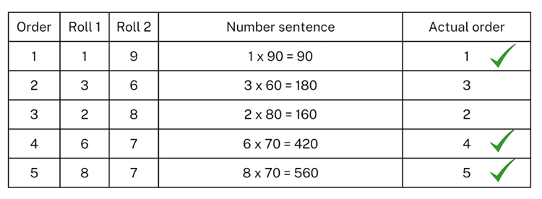
- After each player has completed 5 turns, use the ‘Actual order’ column to record which turns were placed in the correct row. Players score a point for each correct placement. For example, the player in Figure 6 scores 3 points. The player with the most points is the winner.
- Repeat multiple times.
- Reflect on the game, asking questions such as:
- What strategy did you use to multiply?
- How did you decide where to place each answer?
- Did you change your strategy in the next round? Why or why not?
- What modifications could you suggest for the game?
Multi-age: students working towards Stage 3 outcomes can turn their second number into a multiple of 10, 100 or 1000 so that it becomes the multiplicand.
This table details opportunities for assessment.
Assessment opportunities | Links
What to look for:  - Can Stage 2 students use multiplication facts with multiples of 10 to multiply a one-digit number by a multiple of 10? [MAO-WM-01, MA2-MR-01]  - Can Stage 3 students use mental strategies to multiply one-digit numbers by 10, 100, 1000 and their multiples? [MAO-WM-01, MA3-MR-01] | Links to National Numeracy Learning Progressions (NNLP):  - Stage 2 – MuS7  - Stage 3 – MuS7.

Core lesson: 40 minutes
The table below contains suggested learning intentions and success criteria. These are best co-constructed with students.
Core concept learning intentions | Core concept success criteria
Students working towards Stage 2 outcomes are learning to:  - construct and interpret data displays  - extend the place value system.  Students working towards Stage 3 outcomes are learning to:  - interpret data presented in digital media and elsewhere  - recognise that the place value system can be extended beyond hundredths  - locate and represent integers on a number line. | Students working towards Stage 2 outcomes can:  - collect discrete data  - construct column graphs  - mark equal spaces on axes, names and label axes and choose appropriate titles  - locate and order decimals representing tenths and hundredths on a number line, describing their relative size  - interpret zero digits at the end of a decimal  - distinguish between the role of zero in various positions.  Students working towards Stage 3 outcomes can:  - interpret data representations found in digital media  - use place value to partition decimals  - recognise the location of negative whole numbers in relation to zero and place them on a number line  - use the term integers to describe positive and negative whole numbers and zero.

Stage 2 task: Beijing weather 1
- Display Resource 8: Beijing weather and ask students to answer the questions below their graph.
- In pairs, students formulate 3 questions that could be asked using the information from the graph.
- Students swap questions with another group. When complete, groups compare answers, communicating their reasoning.
- Students use a weather website to record the maximum daily temperature for the past 6 days for the area they live in.
- Students use this information to create a column graph in workbooks. Ensure students mark equal spaces (intervals) on axes, name and label axes and choose appropriate titles for column graphs.

Stage 3 task: Beijing weather 2
- Display Resource 8: Beijing weather and ask students to answer the questions below their graph.
- Explain that integers are whole numbers and the temperatures have been rounded to the nearest whole number on the line graph. Discuss negative numbers in relation to the weather.
- Students select and order 10 integers (including 5 positive and 5 negative numbers) from the line graph in ascending order and compare their order with a partner.
- Revise features of a number line including:
- integers are in order
- proportional spaces
- negative numbers are placed to the left of zero.
- Students place the 10 integers on an empty number line in their workbooks and compare them with a partner, looking for any similarities and differences.
- As a class discuss number lines, asking question such as:
- What do you notice about positive numbers and their relation to zero?
- What do you notice about the negative numbers and their relation to zero?
- Which do you find more difficult to place on a number line? Why?
- Students create questions that can be answered from the information in the graph for a partner to answers. For example, which day was the coldest or which day had the largest range.

This table details opportunities for differentiation.
Too hard? | Too easy?
Stage 2 students cannot construct column graphs using digital technologies.  - Provide a simpler data set for students to use when constructing a column graph using digital technology.  Stage 3 students cannot record negative numbers on a number line.  - Provide a structured number line with marked intervals from negative 10 to 10.  - Students record only the positive numbers on the number line. | Stage 2 students can construct column graphs using digital technologies.  - Students write 3 questions using the graph they created for a classmate to answer. Students discuss and justify their answers.  Stage 3 students can record negative numbers on a number line.  - Students calculate the range and mode for the data set.  - Students calculate the difference between the maximum and minimum temperature for each day.

Consolidation and meaningful practice – 20 minutes
- Write the number 12.345 seconds on the board and ask students:
- Can you read this number aloud? Ensure students are reading the number as 12 seconds and 345 thousandths of a second.
- What do the digits after the decimal point represent?
- Why do we use decimal numbers?
- What is the place value of the numeral 3? What does it represent?
- What is the place value of the numeral 4? What does it represent?
- What is the place value of the numeral 5? What does it represent?
- Display Resource 9: Speed skating times. Draw students’ attention to the zero in some of the decimals. Discuss with students that the zero at the end of a decimal does not change the value of the decimal. Discuss the role of zero as a placeholder.
- Ask students to select one of the data sets and draw a number line that represents the fastest and the slowest time. For example, Men’s Final A, students draw a number line starting at 40 seconds and ending at 41 seconds.
- Students then plot the times in order on the number line for their chosen data set.
Multi-age: Stage 2 students are expected to extend the place value system to tenths and hundredths. Stage 3 students are expected to extend the place value system to thousandths.

This table details opportunities for differentiation.
Too hard? | Too easy?
Stage 2 students cannot locate and order decimals representing tenths and hundredths on a number line, describing their relative size.  - Model the using of a number line to order decimals.  Stage 3 students cannot indicate the place value of digits in a decimal.  - Students indicate place value of numbers to 2 decimal places. | Stage 2 students can locate and order decimals representing tenths and hundredths on a number line, describing their relative size.  - In pairs, students create a number with 3 decimal places. They take it in turns to place this number on a number line. The first person with 3 numbers in a line, is the winner.  Stage 3 students can indicate the place value of digits in a decimal.  - Students round 3-digit number to 2 decimal places.
This table details opportunities for assessment.
Assessment opportunities | Links
What to look for:  - Can Stage 2 students collect discrete data? [MAO-WM-01, MA2-DATA-01]  - Can Stage 2 students construct column graphs using marked equal spaces on axes, naming and labelling axes and choosing appropriate titles? [MAO-WM-01, MA2-DATA-01]  - Can Stage 2 students locate and order decimals representing tenths and hundredths on a number line, describing their relative size? [MAO-WM-01, MA2-RN-02]  - Can Stage 2 students interpret zero digits at the end of a decimal? [MAO-WM-01, MA2-RN-02]  - Can Stage 2 students distinguish between the role of zero in various positions? [MAO-WM-01, MA1-RN-01, MA2-RN-02]  - Can Stage 3 students interpret data representations found in digital media? [MAO-WM-01, MA3-DATA-02]  - Can Stage 3 students use place value to partition decimals? [MAO-WM-01, MA3-RN-02]  - Can Stage 3 students recognise the location of negative whole numbers in relation to zero and place them on a number line? [MAO-WM-01, MA3-RN-01]  - Can Stage 3 students use the term integers to describe positive and negative whole numbers and zero? [MAO-WM-01, MA3-RN-01] | Links to National Numeracy Learning Progressions (NNLP):  - Stage 2 – IRD3, NPV5, NPV7, NPV8  - Stage 3 – IRD4, IRD5, NPV7, NPV9.

Lesson 4
Core concept: there are many ways to communicate data.

Daily number sense – 10 minutes
- From a class need surfaced through formative assessment data, identify a short, focused activity that targets students’ knowledge, understanding and skills. Example activities may be drawn from the following resources:
- Mathematics K-6 resources
- Universal Resources Hub.

Core lesson: Lunchtime activities – 45 minutes
The table below contains suggested learning intentions and success criteria. These are best co-constructed with students.
Core concept learning intentions | Core concept success criteria
Students working towards Stage 2 outcomes are learning to:  - select and trial methods for data collection  - construct, interpret and compare data displays  - extend the place value system.  Students working towards Stage 3 outcomes are learning to:  - interpret and compare a range of data displays  - compare, order and represent decimals. | Students working towards Stage 2 outcomes can:  - investigate how data is interpreted to make decisions  - create a survey and related recording sheet, refining survey questions as necessary after a small trial  - conduct a survey to collect categorical or numerical data  - compare the effectiveness of different methods of collecting and recording data  - construct column graphs using digital technologies  - locate and order decimals representing tenths and hundredths on a number line, describing their relative size.  Students working towards Stage 3 outcomes can:  - interpret side-by-side column graphs for 2 categorical variables  - interpret and compare different displays in terms of the shape of the distribution, including the range and the mode  - compare and order decimal numbers of up to 3 decimal places.
This activity is an adaptation of Making evaluations from NZ Maths by New Zealand Ministry of Education.
- Display Resource 10: Lunchtime places and ask the students the questions listed on the resource.
- Read the statements below and students move to either side of the room if that agree or disagree. If students feel they don’t have enough information from the graph to answer, they stay in the middle of the room. As students move around the room, ask them to justify their decision using data from the graph. Example statements include:
- The library is equally popular with K-2 and 3-6 students.
- Everyone’s favourite place is the adventure playground.
- The K-2 students play on the concrete because the seniors take over the sports field.
- The treehouse doesn’t hold many people.
- The sandpit is more popular with K-2 students.
Multi-age: students working towards Stage 3 outcomes continue the lesson. Students working towards Stage 2 outcomes will be working on collecting data and creating a column graph.
- Stage 3 students continue to observe Resource 10: Lunchtime places. In pairs, students brainstorm recommendations based on data in the graph. For example, the adventure playground should get more equipment as both K-2 and 3-6 enjoy playing there. Encourage students to refer to the data and discuss if they disagree with each other’s recommendations.
- Students pose further questions which could be asked to gather more information about the topic. For example, students could ask why K-2 students don’t use the sports field.
- Explain to Stage 2 students that they are going to collect some data on lunchtime activities at their school.
- Students Think-Pair-Share a statistical question related to the matter of interest and, as a class, choose one question to collect class data about. For example, What is our class’s favourite lunchtime activity?
- Predict and record which categories will be used to group class data. Explain that all possible categories need to be considered and that each piece of data can only fit into one category. For example soccer and football could be recorded into the category ball games. Stage 2 students determine at least 5 categories for example, ball games, playground equipment, library, talking with friends, concrete areas.
- As a class direct all students to move to different parts of the classroom to group themselves based on the determined categories.
- Tally and display the class results.
- Stage 2 students transfer the class data into a table in their workbooks, using numerals and use their table to create a column graph using Microsoft Excel or Google Sheets. Students follow the instructions from Lesson 1. Students share their graph with a partner and discuss the differences between the graphs.
- For Stage 3 students display Resource 11: Lunchtime activities and read out the questions below. Students answer using thumbs up (agree) or thumbs down (disagree) if they can answer the given question by referring to the graph. Example questions include:
- What is more popular, the sports gear or the playground equipment?
- Is there an activity that girls like more than boys?
- Is there an activity that boys like more than girls?
- If the teachers didn’t organise activities like sports practice and production rehearsal, who would this affect the most?
- Should the library only be open on wet days?
- When the drama production is over, what might girls and boys chose to do?
- Who is more interested in sports?
- What is the most frequently selected? (mode)
- Can you identify the range in the data set?
- Select students to support their answers by referring to the data.

This table details opportunities for differentiation.
Too hard? | Too easy?
Stage 2 students cannot construct column graphs using digital technologies.  - Provide a simpler data set for students to use when constructing a column graph using digital technology.  Stage 3 students cannot interpret side-by-side graphs.  - Students interpret column graphs, before moving to side-by-side column graphs.  - Ask student questions related to one variable only in each graph. | Stage 2 students can construct column graphs using digital technologies.  - Students write 3 questions using the graph they created for a classmate to answer. Students discuss and justify their answers.  Stage 3 students can interpret side-by-side graphs.  - Students develop their own questions related to each side-by-side column graph.  - Students brainstorm examples of data which could be represented in a side-by-side column graph.

Consolidation and meaningful practice – 10 minutes
- Explain that Mrs Bishop got some books from the library and needs to make sure she puts them back on the shelf in order. Display the following book numbers for Stage 2 – 591.42, 591.08, 591.91, 591.22 and 591.10 and the following numbers for Stage 3 – 591.420, 591.421, 591.008, 591.914, 591.422 and 591.108.
- Students write the numbers in ascending order in their workbooks.
- Students represent the numbers on an empty number line in their workbooks.
This table details opportunities for differentiation.
Too hard? | Too easy?
Stage 2 students cannot order decimals on a number line.  - Model using a number line to order decimals.  Stage 3 students cannot compare and order decimal numbers of up to 3 decimal places.  - Assist students by reducing the number of decimal places to 2 or one. | Stage 2 students can order decimals on a number line.  - In pairs, students create a number with up to 3 decimal places. They take it in turns to place this number on a number line. The first person with 3 numbers in a line, is the winner.  Stage 3 students can compare and order decimal numbers of up to 3 decimal places.  - Students play the same game as above.
This table details opportunities for assessment.
Assessment opportunities | Links
What to look for:  - Can Stage 2 students investigate how data is interpreted to make decisions? [MAO-WM-01, MA2-DATA-02]  - Can Stage 2 students create a survey and related recording sheet, refining survey questions as necessary after a small trial? [MAO-WM-01, MA2-DATA-01]  - Can Stage 2 students conduct a survey to collect categorical or numerical data? [MAO-WM-01, MA2-DATA-01]  - Can Stage 2 students compare the effectiveness of different methods of collecting and recording data? [MAO-WM-01, MA2-DATA-01]  - Can Stage 2 students construct column graphs using digital technologies? [MAO-WM-01, MA2-DATA-01]  - Can Stage 2 students locate and order decimals representing tenths and hundredths on a number line, describing their relative size? [MAO-WM-01, MA2-RN-02]  - Can Stage 3 students interpret side-by-side column graphs for 2 categorical variables? [MAO-WM-01, MA3-DATA-02]  - Can Stage 3 students interpret and compare different displays in terms of the shape of the distribution, including the range and the mode? [MAO-WM-01, MA3-DATA-02]  - Can Stage 3 students compare and order decimal numbers of up to 3 decimal places? [MAO-WM-01, MA3-RN-02] | Links to National Numeracy Learning Progressions (NNLP):  - Stage 2 – IRD3, NPV7, NPV8  - Stage 3 – IRD5, NPV8.  Links to suggested Interview for Student Reasoning (IfSR) tasks:  - Stage 3 – IfSR-PT: 1A.5, 1A.7.

Lesson 5
Core concept: mathematicians interpret and evaluate the effectiveness of data displays.

Daily number sense: Benchmark fractions – 15 minutes
Daily number sense activities for Lessons 5 to 7 ‘loop’ back to concepts and procedures covered in previous units to assist students to build an increasingly connected network of ideas. These concepts may differ from the core concepts being covered by the unit.
The table below contains a suggested learning intention and success criteria. These are best co-constructed with students.
Daily number sense learning intention | Daily number sense success criteria
Students working towards Stage 2 outcomes are learning to:  - model equivalent fractions as lengths  - represent fractional quantities equal to and greater than one.  Students working towards Stage 3 outcomes are learning to:  - make connections between benchmark fractions, decimals and percentages. | Students working towards Stage 2 outcomes can:  - represent the equivalence of fractions with related denominators as lengths, using concrete materials, diagrams and number lines  - rename 10 tenths as one whole.  Students working towards Stage 3 outcomes can:  - recognise that the symbol % means percent and 100% is the whole amount  - recall commonly used equivalent percentages and fractions  - represent common percentages of lengths as fractions.
This activity is an adaptation of Simple fractions as percentages from NZ Maths by New Zealand Ministry of Education.
- Show students 2 interlocking cubes of different colours.
- Ask students what fractions they can see.
- Show students 2 other stacks of interlocking cubes that also represent ½ of each colour (see Figure 7).
Figure 7 – Stacks of interlocking cubes with equal numbers of each colour
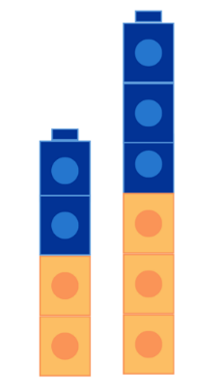
- Ask students:
- What is the same about all 3 stacks and what is different?
- What fraction of each colour is in each stack?
- How can it be half when there are different numbers in each stack?
- How many of each colour would there be if there were 100 cubes in total?
- How could you show a quarter of 100 interlocking cubes? Explain your thinking.
- How could you show one tenth of 100 cubes? Explain your thinking.
- Distribute interlocking cubes and in small groups make stacks to show $\frac{1}{2}$ , $\frac{1}{4}$ , $\frac{3}{4}$ , $\frac{1}{10}$ and $\frac{10}{10}$.
- Select groups to share their stacks and ask:
- How do you know that the fraction is correct?
- How else could you describe 10 tenths?
Multi-age: students working towards Stage 3 outcomes can record the percentages that can be seen and how it can be written.
Cent: the word ‘cent’ is derived from the Latin word centum, meaning ‘one hundred’. ‘Per centum’, the Latin origin of per cent, means ‘by the hundred'.

This table details opportunities for assessment.
Assessment opportunities | Links
What to look for:  - Can Stage 2 students represent the equivalence of fractions with related denominators as lengths, using concrete materials, diagrams and number lines? [MAO-WM-01 MA2-PF-01]  - Can Stage 2 students rename 10 tenths as one whole [aligned to success criteria for this activity]? [MAO-WM-01 MA2-PF-01]  - Can Stage 3 students recognise that the symbol % means percent and 100% is the whole amount? [MAO-WM-01, MA3-RN-03]  - Can Stage 3 students recall commonly used equivalent percentages and fractions? [MAO-WM-01, MA3-RN-03]  - Can Stage 3 students represent common percentages of lengths as fractions? [MAO-WM-01, MA3-RN-03] | Links to National Numeracy Learning Progressions (NNLP):  - Stage 2 – InF5  - Stage 3 – PrT1, PrT2, InF7.

Core lesson: 40 minutes
The table below contains suggested learning intentions and success criteria. These are best co-constructed with students.
Core concept learning intentions | Core concept success criteria
Students working towards Stage 2 outcomes are learning to:  - organise and display data using tables and graphs  - order numbers in the thousands.  Students working towards Stage 3 outcomes are learning to:  - interpret and compare a range of data displays  - recognise, represent and order numbers in the millions. | Students working towards Stage 2 outcomes can:  - construct column graphs using relevant software  - arrange numbers in the thousands in ascending and descending order  - identify the nearest thousand, 10 thousand or 100 thousand to numbers.  Students working towards Stage 3 outcomes can:  - interpret data on a timeline using the given scale  - arrange numbers in the millions in ascending and descending order using place value  - round numbers to a specified place value.
- Display Resource 12: Data story and ask students the questions listed on the resource.
Multi-age: students working towards Stage 3 outcomes will be creating timelines, while students working towards Stage 2 outcomes will be creating a column graph using software.

Stage 2 task: Brick set pieces
- Display Resource 12: Data story and explain that students should use the information on this resource to represent the data in a column graph using Microsoft Excel or Google Sheets. Students follow the instructions on the resource.
- Conduct a gallery walk and compare graphs made by different students. Ask students if there are any differences between each student’s graph and why these may exist.

Stage 3 task: LEGO timeline
- Inform students that they are going to complete a timeline of the LEGO company. Explain that in 2022 LEGO celebrated 90 years of play since founder Ole Kirk Kristiansen first started making wooden toys in Denmark.
- Display Resource 13: LEGO timeline and ask students the questions listed on the resource.
- Distribute rulers and a copy of Resource 13: LEGO timeline to each student.
Note: there is a built-in ruler on Resource 13: LEGO timeline which can be used if printing or photocopying distorts the actual measurements of the timeline.
- Discuss the scale and how to calculate the time distance between events.
- Students calculate and record the year each event occurred on the timeline.
- Check students’ understanding by asking questions, such as:
- In which year did LEGO build their first mini figurine? 1978
- What was significant about the year 1946? Plastic moulding machine was purchased.
- How many years after the first binding brick was made, was the first plant based plastic brick made? 69 years.
- How many years before LEGO braille bricks were made, was the company officially named LEGO? 84 years.
- In which year did the first LEGOland open in Billund Denmark? 1968.
- Which year did you calculate on the timeline first? Why?
- Did you have a strategy for calculating the years on the timeline? What was it?
- How do you know that your answers are correct?
- What was the most difficult part of this activity? Why?
This table details opportunities for differentiation.
Too hard? | Too easy?
Stage 2 students cannot enter data and create graphs in Microsoft Excel.  - Model how to enter the data and create a graph for the first data set. Students enter data and create graphs for the other data set.  Stage 3 students cannot interpret data on a timeline using a given scale.  - Provide students with a timeline with marked intervals for every 10 years. | Stage 2 students can enter data and create graphs in Microsoft Excel.  - Ask how the data displays might look if the brick sets were a different size.  Stage 3 students can interpret data on a timeline using a given scale.  - Students write 3 questions about the timeline requiring interpretation of the data.  - Students swap questions with a partner to answer them.

Consolidation and meaningful practice – 10 minutes
- Display Resource 15: Visitor attendance – Windsor for students working towards Stage 3 outcomes and Resource 16: Theme park attendance for students working towards Stage 2 outcomes. Students record the attendance numbers in their workbooks.
- Choose individual students to state the numbers referenced in the resource, using the place value grouping of ones, tens and hundreds.
- Ask the students the questions listed on Resource 15: Visitor attendance – Windsor and Resource 16: Theme park attendance.
Multi-age: students working towards Stage 2 outcomes only need to identify the nearest 10, 100, 1000 and 10 000.
- Discuss the importance of using the original number each time they round.
This table details opportunities for differentiation.
Too hard? | Too easy?
Students cannot order or round large numbers.  - Provide students with smaller numbers to order and round. | Students can order and round large numbers.  - Students use a 0–9 dice to create and record 5 larger numbers, then place in descending order.

This table details opportunities for assessment.
Assessment opportunities | Links
What to look for:  - Can Stage 2 students construct column graphs using relevant software? [MAO-WM-01, MA2-DATA-01]  - Can Stage 2 students arrange numbers in the thousands in ascending and descending order? [MAO-WM-01, MA2-RN-01]  - Can Stage 2 students identify the nearest thousand, 10 thousand or 100 thousand to numbers? [MAO-WM-01, MA2-RN-01]  - Can Stage 3 students interpret data on a timeline using the given scale? [MAO-WM-01, MA3-DATA-02]  - Can Stage 3 students arrange numbers in the millions in ascending and descending order using place value? [MAO-WM-01, MA3-RN-01]  - Can Stage 3 students round numbers to a specified place value? [MAO-WM-01, MA3-RN-01] | Links to National Numeracy Learning Progressions (NNLP):  - Stage 2 – IRD3, NPV6, NPV7  - Stage 3 – IRD4, MeT7, NPV6, NPV7.  Links to suggested Interview for Student Reasoning (IfSR) tasks:  - Stage 2 – IfSR-NP: 4C.8  - Stage 3 – IfSR-NP: 4C.8.

Lesson 6
Core concept: data can be presented to convince or persuade but must be scrutinised to ensure it is not biased or misleading.

Daily number sense: Fractions for comparison – 15 minutes
The table below contains a suggested learning intention and success criteria. These are best co-constructed with students.
Daily number sense learning intention | Daily number sense success criteria
Students working towards Stage 2 outcomes are learning to:  - model equivalent fractions as lengths.  Students working towards Stage 3 outcomes are learning to:  - make connections between benchmark fractions, decimals and percentages. | Students working towards Stage 2 outcomes can:  - represent the equivalence of fractions with related denominators as lengths, using concrete materials, diagrams and number lines  - represent fractions with the same-size whole to make valid comparisons (denominators of 2, 4 and 8; 3 and 6; 5 and 10).  Students working towards Stage 3 outcomes can:  - recognise that the symbol % means percent and 100% is the whole amount  - represent common percentages of lengths as fractions.
This activity is an adaptation of Best At? from A Practical Guide to Transforming Primary Mathematics: Activities and tasks that really work by Askew.
- Explain that Remy scored 8 out of 10 on a mathematics test and 3 out of 5 on an English test. Remy said that she was better at mathematics because she got more questions right than she did on the English test. Her friend Ben said that Remy was equally good at mathematics and at English because she got 2 questions wrong in each test. Ask students who they think is correct.
- Select students to share and explain their thinking.
- Explain that students can check their answer by using two number lines on top of the other (see Figure 8).
Figure 8 – Two number lines on top of the other
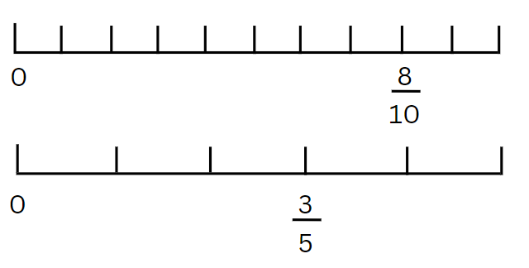
- Demonstrate drawing a number line to represent the mathematics test. Identify and record Remy’s mathematics score on the number line.
- In pairs, students use the same method to draw a number line to represent the English test and identify and record Remy’s score. Explain the importance of representing fractions with the same-size whole to make valid comparisons.
- Select students to share their thinking and explain which test result is higher.
Multi-age: students working towards Stage 3 outcomes can use the number lines created and annotate them to record corresponding percentages so that it becomes a double number line.
This table details opportunities for assessment.
Assessment opportunities | Links
What to look for:  - Can Stage 2 students represent the equivalence of fractions with related denominators as lengths, using concrete materials, diagrams and number lines? [MAO-WM-01, MA2-PF-01]  - Can Stage 2 students represent fractions with the same-size whole to make valid comparisons (denominators of 2, 4 and 8; 3 and 6; 5 and 10)? [MAO-WM-01, MA2-PF-01]  - Can Stage 3 students recognise that the symbol % means percent and 100% is the whole amount? [MAO-WM-01, MA3-RN-03]  - Can Stage 3 students represent common percentages of lengths as fractions? [MAO-WM-01, MA3-RN-03] | Links to National Numeracy Learning Progressions (NNLP):  - Stage 2 – InF5  - Stage 3 – PrT1, PrT2, InF7.

Core lesson: 45 minutes

Stage 2 task: Scrabble stats
The table below contains suggested learning intentions and success criteria. These are best co-constructed with students.
Core concept learning intentions | Core concept success criteria
Students working towards Stage 2 outcomes are learning to:  - construct and interpret data displays with many-to-one scales.  - read, represent and order numbers to thousands  - make connections between fractions and decimal notation. | Students working towards Stage 2 outcomes can:  - use data in a spreadsheet to create column graphs with units on vertical axes that are in multiples  - read and order numbers of up to at least 4 digits  - identify the number before and after a number with an internal zero digit  - compare and order decimals of up to 2 decimal places.
This activity is an adaptation of Scrabble stats from Mathematics K-6 resources by State of New South Wales (Department of Education).
- Ask students:
- Have you ever played Scrabble before?
- Do you know the rules of the game?
Note: The objective of Scrabble is to get the most points by creating words. Words are built by placing lettered tiles on a grid. Each tile is assigned a point value and the main strategy is to play words that have the highest possible score based on the combination of letters. Players build off at least one tile in each other's words until no one can build any more words. The player with the highest score wins.
- Explain that the game of Scrabble was invented in 1933. The inventor of Scrabble, Alfred Butts, chose the value of each letter by reviewing newspapers and other sources of text. He calculated the frequency of each letter. The frequency is how common something is or how often it happens. Letters that were used the most were worth fewer points and letters that were rarely used were worth more points.
- Ask students:
- Do you think that letter frequencies might have changed since 1933?
- Why do you think that?
- Display Resource 17: Scrabble tiles and ask the students the questions listed on the resource.
- Explain that, to complete the investigation, students need to find out how often different letters are used in a modern text by recording how many times each letter occurs.
- Modelling drawing the table in Figure 9, continuing for all letters on the whiteboard. Students copy by drawing their own recording sheet in their workbook.
Figure 9 – Scrabble stats tally table
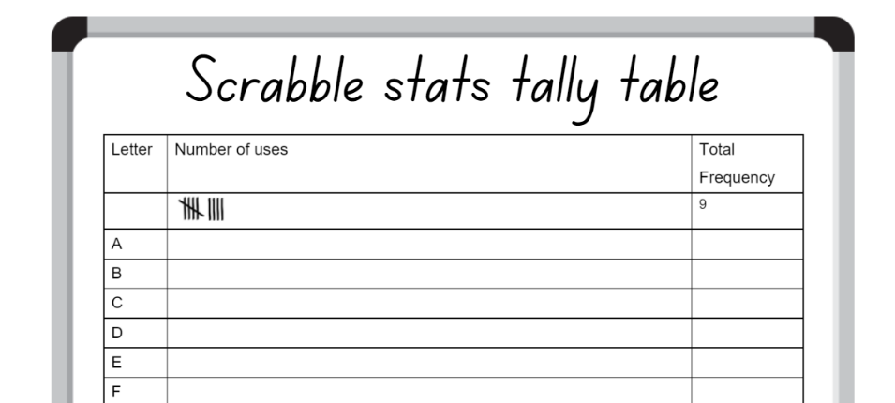
- Provide recent newspapers, magazines or books for students to select a page to analyse.
- Students record the frequency of each letter in their table using tally marks.
This table details opportunities for differentiation.
Too hard? | Too easy?
Stage 2 students cannot record the frequency of letters in a text.  - Students tally the frequency of letters for a smaller amount of text. | Stage 2 students can record the frequency of letters in a text.  - Student tally frequency for a different page in the same text and compare their findings.
- Students to represent their data in a column graph using Microsoft Excel or Google Sheets. Students to follow the same process as in Lesson 5, entering letters and their frequency in column A and B.
- Conduct a gallery walk and compare graphs. Ask students if there are any differences between each student’s graph and why these may exist.
- Discuss results by asking questions, such as:
- What do you notice about the frequency of the letters in your table or graph?
- How many times was each letter used in the text you investigated?
- Do any of your results surprise you?
- Which letters were you expecting to be most and least frequent?
- Which letters are most frequent and least frequent?
- Do you think the results would be similar if you investigated a piece of your writing? Why or why not?
- Can you identify any letter which should be given a different score? Justify your answer.
- Does the type of text change the letter frequencies?
- In pairs, students assign each letter a new points value.
- Pairs share their new values and use their data set to justify their values.
- Record Figure 10 on the whiteboard and explain that the data is 6 people’s Scrabble scores from 10 games of Scrabble.
Figure 10 – 6 students Scrabble scores
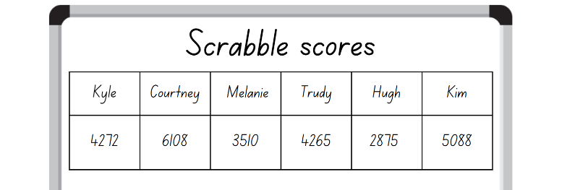
- Students read each number aloud to a partner.
- On whiteboards, ask students to:
- order and record the numbers in descending order on their whiteboard
- write the number before and after each number.

Stage 3 task: Is it biased?
The table below contains suggested learning intentions and success criteria. These are best co-constructed with students.
Core concept learning intentions | Core concept success criteria
Students working towards Stage 3 outcomes are learning to:  - interpret data presented in digital media and elsewhere  - compare, order and represent decimals. | Students working towards Stage 3 outcomes can:  - identify sources of possible bias in representations of data in the media  - compare the place value of digits by determining numbers that are 10 or 100 times the original decimal number, as well as $\frac{1}{10}$ or $\frac{1}{100}$ times the original decimal numbers.
Bias: systematically favouring certain outcomes due to unfair influence (knowingly or otherwise).
- Ask students:
- Have you heard the term bias before?
- What does it mean?
- What are some examples of bias?
- How could data be bias?
- Explain that bias is a systematically favouring certain outcomes due to unfair influence (knowingly or otherwise).
- Describe the following scenario: The local council wants to upgrade the public swimming pool, but they also received an application from other community groups to upgrade the soccer fields, netball courts and tennis courts. The council decides that they need to gather some data about what the community want. They send a representative down to a busy part of town (the swimming pool) to survey people. The survey asked what sporting facility community members would like upgraded.
- Display Resource 18: Survey results and ask students the questions listed on the resource.
Sample: a subset of a population used to estimate characteristics of the population. For example, a randomly selected group of 8-year-olds (sample) selected to estimate the height of 8-year-olds in Australia (population).
- Explain to students that bias can be knowingly used in data collection, however it is not always deliberate. There are different ways in which bias can occur in data collection, which may include:
- skewed survey questions
- choosing a specific focus group
- using misleading categorical groupings
- samples that are not random
- sample size that is not representative of the population
- system errors that provide incorrect measures.
- Inform students that a large local primary school has noticed a pattern of late arrivals. They are going to collect data around starting school at a different time.
- Share the 3 scenarios below and ask students to discuss with a partner the potential for bias in each scenario. Select individual students to share their thoughts and reasons why. Example scenarios could include:
- Scenario 1 – arrive early and survey the first 20 people (students, teachers or parents) that walk by. (This would be biased in favour of those that would prefer an early start and would not include those finding it difficult to arrive on time).
- Scenario 2 – after morning assembly, survey the first 20 people who walk into the office. (This would be biased in favour of people who prefer a late start as many people in the office at this time would be those arriving late).
- Scenario 3 – at lunch phone 20 families selected randomly from the home phone number list and do not leave a message. (This would be biased against families who are not at home during the day).
- As a class, brainstorm how the data could be collected in an unbiased way. Discuss methods of collecting and representing the data, random sampling and sample size.
- Record Figure 11 on the whiteboard. Students copy onto their own whiteboard.
Figure 11 – Bias answer key
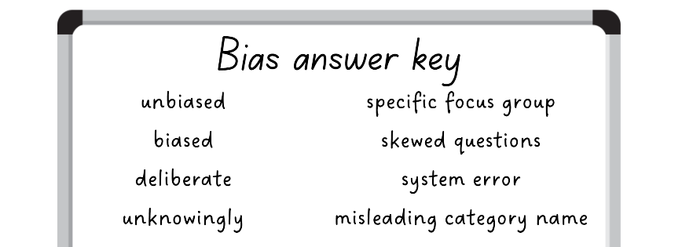
- Display each scenario from Resource 19: Scenarios around the classroom.
- Groups of students have 2 minutes at each scenario to determine whether it is biased or not. If biased, students should identify the type of bias. Students to record their answers on their whiteboard using the bias answer key.
- Invite students to share their answers and justify their responses.
- As a class, brainstorm reasons why data collection and representation can be biased, such as:
- human error (unintentional bias)
- the data collection is funded by a particular group or company
- the data representation is part of an advertisement that is meant to persuade.

Discuss and connect the mathematics – 15 minutes
Note: to multiply 21.34 by 100, tens become thousands, ones become hundreds, tenths become tens, hundredths become ones. A common misunderstanding is that the decimal point moves when a number is multiplied by a power of 10.
- Display the following numbers and explain that the numbers are one-tenth of the people surveyed for different data collection surveys – 0.6, 3.7, 0.8, 21.1, 0.4, 52.4, 4.5 and 0.1.
- Ask Stage 3 students to record how many people were surveyed each time.
Multi-age: students working towards Stage 2 outcomes, order the numbers displayed in ascending order on individual whiteboards.
- Display the following numbers on the board and explain that the numbers are one-hundredth of the people surveyed for different data collection surveys – 0.8, 3.72, 0.03, 1.45, 0.35, 2.43, 2.04 and 0.09.
- Ask Stage 3 students to record how many people were surveyed each time.
Multi-age: students working towards Stage 2 outcomes, order the numbers displayed in ascending order on individual whiteboards.
- Display the following numbers and ask Stage 3 students to apply what they know about the place value system to calculate one-tenth of the following decimals – 0.7, 0.35, 0.6, 1.5, 0.25, 6.32, 0.27 and 2.34.
Multi-age: students working towards Stage 2 outcomes, order the numbers displayed in ascending order on individual whiteboards.
- Display the following numbers and ask Stage 3 students to apply what they know about the place value system to calculate one-hundredth of the following decimals – 0.8, 0.4, 35.5, 6.5, 7.6, 1.5, 9.5 and 16.7.
Multi-age: students working towards Stage 2 outcomes, order the numbers displayed in ascending order on individual whiteboards.
This table details opportunities for differentiation.
Too hard? | Too easy?
Stage 2 students cannot order decimals of up to 2 decimal places.  - Provide a decimal place value chart.  Stage 3 students cannot compare the place value of digits by determining numbers that are 10 or 100 times the original decimal number as well as $\frac{1}{10}$ and $\frac{1}{100}$ times the original numbers.  - Provide a decimal place value chart or slider. | Stage 2 students can order decimals of up to 2 decimal places.  - Provide decimal numbers to 3 decimal places for students to order.  Stage 3 students can compare the place value of digits by determining numbers that are 10 or 100 times the original decimal number as well as $\frac{1}{10}$ and $\frac{1}{100}$ times the original numbers.  - Provide decimal numbers to 2 and 3 decimal places for students to multiply.
This table details opportunities for assessment.
Assessment opportunities | Links
What to look for:  - Can Stage 2 students use data in a spreadsheet to create column graphs with units on vertical axes that are in multiples? [MAO-WM-01, MA2-DATA-01]  - Can Stage 2 students read and order numbers of up to at least 4 digits? [MAO-WM-01, MA2-RN-01]  - Can Stage 2 students identify the number before and after a number with an internal zero digit? [MAO-WM-01, MA2-RN-01]  - Can Stage 2 students compare and order decimals of up to 2 decimal places? [MAO-WM-01, MA2-RN-02]  - Can Stage 3 students identify sources of possible bias? [MAO-WM-01, MA3-DATA-02]  - Can Stage 3 students compare the place value of digits by determining numbers that are 10 or 100 times the original decimal number as well as $\frac{1}{10} and \frac{1}{100}$ times the original decimal numbers? [MAO-WM-01, MA3-RN-02] | Links to National Numeracy Learning Progressions (NNLP):  - Stage 2 – IRD3, NPV4, NPV5, NPV6, NPV7  - Stage 3 – IRD4, IRD5, NPV8.  Links to suggested Interview for Student Reasoning (IfSR) tasks:  - Stage 2 – IfSR-NP: 4B.2, 4C.5, 4D.1, 4D.4  - Stage 3 – IfSR-NP: 4D.8.

Lesson 7
Core concept: interpreting data from everyday contexts helps solve problems, ask questions and influences daily practices.

Daily number sense: Doughnut decimals – 10 minutes
The table below contains a suggested learning intention and success criteria. These are best co-constructed with students.
Daily number sense learning intention | Daily number sense success criteria
Students working towards Stage 2 outcomes are learning to:  - make connections between fractions and decimal notation.  Students working towards Stage 3 outcomes are learning to:  - make connections between benchmark fractions, decimals and percentages. | Students working towards Stage 2 outcomes can:  - make connections between fractions and decimal notation for key benchmark values.  Students working towards Stage 3 outcomes can:  - recognise that the symbol % means percent and 100% is the whole amount  - recall commonly used equivalent percentages, fractions and decimals.
This activity is an adaptation of Doughnut Percents from NRICH by University of Cambridge.
- Distribute the 8 domino cards from Resource 20: Doughnut decimals to pairs of students so that each student has 4 dominoes.
- Explain that each student must end up with a set of 4 dominoes arranged to form a ‘doughnut’, where touching ends have equal value (see Figure 12).
Figure 12 – Example dominoes in a doughnut
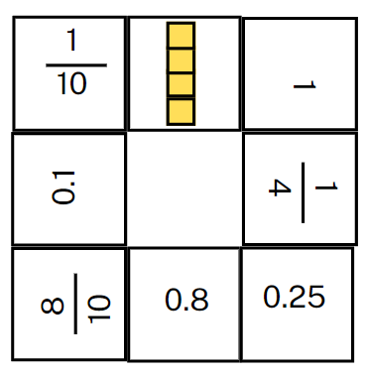
- Explain that the rules are designed to encourage teamwork. The rules are:
- Each player starts with 4 dominoes in front of them.
- The dominoes in front of each person should be visible to both players.
- Players pass dominoes to their partner to help each other complete their doughnut.
- Team members can only give dominoes; they cannot take dominoes from someone else.
- Each team member must always have at least 2 dominoes in front of them.
- No one can talk or give non-verbal signals to other members of the team.
- Reflect on the activity, asking questions such as:
- Which domino ends were the hardest to match? Why?
- Were there any that you didn’t know? Were you still able to match them? What strategy did you use?
- Which domino ends were the easiest to match? Why?
- Would you change anything about this activity? Why or why not?
Multi-age: students working towards Stage 3 outcomes can annotate the fractions and decimals on their dominoes with percentages.
This table details opportunities for assessment.
Assessment opportunities | Links
What to look for:  - Can Stage 2 students make connections between fractions and decimal notation for key benchmark values? [MAO-WM-01, MA2-RN-02]  - Can Stage 3 students recognise that the symbol % means percent and 100% is the whole amount? [MAO-WM-01, MA3-RN-03]  - Can Stage 3 students represent common percentages of lengths as fractions? [MAO-WM-01, MA3-RN-03] | Links to National Numeracy Learning Progressions (NNLP):  - Stage 2 – NPV6, NPV7, InF6  - Stage 3 – PrT1, PrT2, InF7.  Links to suggested Interview for Student Reasoning (IfSR) tasks:  - Stage 2 – IfSR-NP: 4D.3, 4D.7  - Stage 3 – IfSR-NP: 4D.3, 4D.7.

Core lesson: 45 minutes

Stage 2 task: Different data displays
The table below contains suggested learning intentions and success criteria. These are best co-constructed with students.
Core concept learning intentions | Core concept success criteria
Students working towards Stage 2 outcomes are learning to:  - interpret data displays with many-to-one scales  - read, represent and order numbers to thousands  - make connections between fractions and decimal notation. | Students working towards Stage 2 outcomes can:  - interpret and evaluate the effectiveness of various data displays found in media where displays represent data using a scale of many-to-one  - order numbers of up to at least 4 digits  - identify the number before and after a number with an internal zero digit  - compare and order decimals of up to 2 decimal places.
Media: a channel of general communication, information, or entertainment in society, such as newspapers, radio, social media or television.
- Explain that media is a way of communicating to the general population.
- As a class, brainstorm and record different types of media. For example, television, radio, podcasts, newspapers, social media.
- Discuss what types of data and representations are used in the media.
- Explain that students are going to look at different data displays in the media and evaluate their effectiveness.
- Display Resource 21: Gold medal picture graph and ask students the questions listed on the resource.
- Display Resource 22: Gold medal column graph and ask students the questions listed on the resource.
- In pairs, students write 3 questions about the data representation to be answered by another pair of students.
- Students swap questions and answer their peers’ questions.
- Invite students to share their questions with the class.
- In pairs, students:
- discuss positives and negatives of both displays
- order the resources from most effective to least effective in communicating the data set.
- Select students to share which representation they believe is the most effective and justify their choice.
- Display Resource 23: Total medal count.
- Students list the countries and number of medals in descending order in their workbooks.
- In pairs, students read aloud and record:
- each country’s total medal tally
- the number that comes before each number
- the number that comes after each number.
- Write the following numbers on the board – 2806, 1508, 3022 and 1001.
- In pairs, students read aloud and record:
- each number
- the number that comes before each number
- the number that comes after each number.
- Ask students:
- Which numbers did you find the easiest to read aloud?
- Which numbers did you find the hardest to read aloud? Why?
- Which numbers were easiest to write the number before and after?
- Which numbers were hardest to write the number before and after? Why?
This table details opportunities for differentiation.
Too hard? | Too easy?
Stage 2 students cannot interpret and evaluate the effectiveness of picture and column graphs with many-to-one scales.  - Provide a modified picture graph where one picture equals 2 medals. | Stage 2 students can interpret and evaluate the effectiveness of picture and column graphs with many-to-one scales.  - Research and graph the performance of Australia at Olympic Games from 2000 to now.

Stage 3 task: Misleading data
The table below contains suggested learning intentions and success criteria. These are best co-constructed with students.
Core concept learning intentions | Core concept success criteria
Students working towards Stage 3 outcomes are learning to:  - interpret data presented in digital media and elsewhere  - compare, order and represent decimals. | Students working towards Stage 3 outcomes can:  - identify misleading representations of data in the media  - approximate the size of decimals.
- Explain that data representations are becoming more popular as a way of presenting information in the media. However, they should be read with a critical eye. There are ways that writers will misrepresent and skew data to support their purpose.
- Display Resource 24: Comparing data displays and students turn and talk, discussing the questions listed on the resource.
- Invite students to share their responses, referring to elements of the graphs to support their opinions.
- Display Resource 25: Misleading strategies. For each of the 4 strategies, students Think-Pair-Share to discuss the questions listed on the resource.
- Distribute Resource 26: Misleading representations to small groups of students and ask them to discuss the questions listed regarding each of the 3 data representations.
- For each of the 3 data representations, ask students to discuss the questions listed on the resource.
- Invite groups to share their thinking, encouraging them to refer to elements of the representations to support their responses.
- Encourage other groups to challenge or support their peers' opinions.
Note: the data representations in Resource 26: Misleading representations to will be used in Lesson 8 where students will remake the representations to ensure they are no longer misleading.
- Summarise the activity by asking question, such as:
- Why would data be presented in a misleading way?
- What could be the purpose of creating a misleading data display?
- How can we identify if a data display is misleading?
- Where might we see misleading data representations?
- What is the difference between bias and misleading data representations?

This table details opportunities for differentiation.
Too hard? | Too easy?
Stage 3 students cannot identify misleading elements of representations of data in the media.  - Explain the strategy used to mislead for each display and have students identify evidence that the strategy has been used. | Stage 3 students can identify misleading elements of representations of data in the media.  - Students find their own examples of data displays in the media.

Discuss and connect the mathematics – 10 minutes
Approximate: an estimate of a number or an amount to a particular accuracy.
- Write the following heights on the board and explain they are the heights of women from around the world (from Resource 26: Misleading representations) and a group of schoolgirls who wanted to compare their own heights to the Australian average – Australia 1.65 m, India 1.55 m, South Africa 1.58 m, Peru 1.52 m, Scotland 1.64 m, Latvia 1.68 m, Kim 1.1 m, Kath 1.18 m, Courtney 1.32 m and Shazza 1.45 m.
- Ask students to:
- draw an empty number line starting at 0 and ending at 2 in their workbooks
- mark the benchmark numbers 0.25, 0.5, 0.75, 1, 1.25, 1.5 and 1.75
- explain to a partner why they placed the benchmarks where they did and justify their choices.
- Draw an empty number line on the board and model for students where the benchmarks are positioned.
Note: when students place 0.5 on a 0–2 number line, a common misunderstanding is placing the 0.5 in the position of one.
- Students approximate the heights from the board on their number line.
- Select students to explain where they marked each height and how they approximated their position. Encourage students to use the language of ‘I know it is a little more than or a little less than the benchmark…’.
- Students to use their thumb gauge to indicate their understanding:
- Thumb up = I am confident.
- Thumb to side = I am getting there.
- Thumb down = I need support.
- Ask students:
- Which height was easiest to approximate? Why?
- Which height was most difficult to approximate? Why?
- Can you give another height and explain which benchmark it is closest to?

This table details opportunities for assessment.
Assessment opportunities | Links
What to look for:  - Can Stage 2 students interpret and evaluate the effectiveness of various data displays found in media where displays represent data using a scale of many-to-one? [MAO-WM-01, MA2-DATA-02]  - Can Stage 2 students read and order numbers of up to at least 4 digits? [MAO-WM-01, MA2-RN-01]  - Can Stage 2 students identify the number before and after a number with an internal zero digit? [MAO-WM-01, MA2-RN-01]  - Can Stage 2 students compare and order decimals of up to 2 decimal places? [MAO-WM-01, MA2-RN-02]  - Can Stage 3 students identify misleading representations of data in the media? [MAO-WM-01, MA3-DATA-02]  - Can Stage 3 students approximate the size of decimals? [MAO-WM-01, MA3-RN-02] | Links to National Numeracy Learning Progressions (NNLP):  - Stage 2 – IRD3, NPV4, NPV5, NPV6, NPV7  - Stage 3 – IRD4, IRD5, IRD6, NPV8.  Links to suggested Interview for Student Reasoning (IfSR) tasks:  - Stage 2 – IfSR-NP: 4B.2, 4D.1, 4D.4  - Stage 3 – IfSR-NP: 4D.5, 4D.6.

Lesson 8
Core concept: statistical reasoning helps mathematicians interpret and make inferences about information.

Daily number sense – 10 minutes
- From a class need surfaced through formative assessment data, identify a short, focused activity that targets students’ knowledge, understanding and skills. Example activities may be drawn from the following resources:
- Mathematics K-6 resources
- Universal Resources Hub. Core lesson: [insert number] minutes

Core lesson: 50 minutes

Stage 2 task: If the world were a village
The table below contains suggested learning intentions and success criteria. These are best co-constructed with students.
Core concept learning intentions | Core concept success criteria
Students working towards Stage 2 outcomes are learning to:  - interpret data displays with many-to-one scales  - read, represent and order numbers to thousands. | Students working towards Stage 2 outcomes can:  - interpret and evaluate the effectiveness of various data displays using a scale of many-to-one  - compare and describe the relative size of numbers by positioning numbers on a number line.
This activity is an adaptation of If the World Were a Village at NRICH by University of Cambridge (Faculty of Mathematics).
Note: statistical reasoning involves identifying patterns across datasets and making inferences from the data.
- Show the front cover of If the World Were a Village and ask students to predict what the book is about and if the book contains data, justifying their reasoning.
- Read the book to the class and ask students:
- What data was in the book?
- How is the data represented?
- Explain that data does not have to be represented visually, it can be communicated through written text.
- Highlight that in the book, the world’s population in mid-2019 was 7 700 000 000. The book represents the population in an imaginary village of 100 people, so each person represents approximately 77 000 000 of people from the real world. This is a many-to-one representation.
- Display Resource 27: 100 people and ask the students the questions listed on the resource.
- Distribute a copy of Resource 28: Nationalities to pairs of students and ask the students to discuss the questions listed on the resource.
- Lead students through interpreting the data to write a jointly constructed story of the data. For example, if our world was a village of 100 people, then 59 people would be from Asia, 16 from Africa, 10 from Europe, 9 from South America, 5 from North America and only one would be from Oceania.
- In pairs, students:
- annotate the displays, identifying what is effective and ineffective about each
- choose the most effective display for an audience of Year 3 and 4 students and explain why.
- Select students to share their responses as to which display is most effective and why.
- Students draw an empty number line in their workbooks and place the numbers from the data set (59, 16, 10, 9, 5, 1) on the number line.
- Invite students to explain the order in which they placed the numbers on the number line and why.
- Display Resource 29: Energy.
- In pairs, students represent the data in 4 different ways. For example, a list, tally marks, tally table, frequency table, dot plot, column graph.
- Distribute one dot sticker to each student and conduct a gallery walk to view the class’s data representations.
- Students place their dot sticker on the representation they feel is the most effective in communicating the data.
- Invite students to identify which data display they chose and explain why they believe it is the most effective.

This table details opportunities for differentiation.
Too hard? | Too easy?
Stage 2 students cannot represent data using a many-to-one scale.  - Students represent the data in one display. | Stage 2 students can represent data using a many-to-one scale.  - Students research countries that make up Oceania and compare their populations, considering how each population might be represented in a village of 100 people from Oceania.

Stage 3 task: Accurate data representations
The table below contains a suggested learning intention and success criteria. These are best co-constructed with students.
Core concept learning intentions | Core concept success criteria
Students working towards Stage 3 outcomes are learning to:  - interpret data presented in digital media and elsewhere. | Students working towards Stage 3 outcomes can:  - identify sources of possible bias in representations of data in the media  - identify misleading representations of data in the media.
- Review strategies used to create misleading data displays explored in Lesson 7 – omitting baseline, manipulating the y-axis, cherry picking data and using the wrong graph.
- Display Resource 30: Average worldwide temperature and ask students the questions listed on the resource.
- Display Resource 31: Accurate data representation and ask students the questions listed on the resource.
- Students individually select a data representation from Resource 26: Misleading representations to recreate as an accurate representation of the data.
- Students use Microsoft Excel or Google Sheets to recreate the data display with all misleading elements corrected.
- Conduct a gallery walk and compare graphs made by different students. Ask students if there are any differences between students’ graphs made for the same data display and why these may exist.
- Select students to display their graph and ask questions, such as:
- What sources of possible bias did you identify in the representation?
- Which elements did you need to correct or change?
- Does the data representation tell the same story?
- What did you find challenging about this task? Why?
- Reflect on the lesson by asking questions, such as:
- What are some positives and negatives of data representations in the media?
- What are some of the common problems with the way data is represented in the media?
- Why are some data representations misleading?
- How do you identify potentially misleading representations?
- What are the possible social consequences of misleading representations?
- Will you look at data representations in the media differently now? Why or why not?

This table details opportunities for differentiation.
Too hard? | Too easy?
Stage 3 students cannot identify and correct misleading representations of data in the media.  - Identify the misleading elements of the data representation and have students identify how to correct them. | Stage 3 students can identify and correct misleading representations of data in the media.  - Students create an advertisement for the misleading data display, including a headline and short paragraph as though it was in a news article.

Discuss and connect the mathematics – 10 minutes
- Use the 3-2-1 exit ticket, from the Digital learning selector. Ask students to record:
- 3 things they have learnt about data during this unit
- 2 things they would like to understand more
- one reason it is important to learn about data
- Invite students to share their reflections with the class.

This table details opportunities for assessment.
Assessment opportunities | Links
What to look for:  - Can Stage 2 students interpret and evaluate the effectiveness of various data displays found in factual texts where displays represent data using a scale of many-to-one? [MA2-DATA-02, MAO-WM-01]  - Can Stage 2 students compare and describe the relative size of numbers by positioning numbers on a number line? [MA2-RN-01, MAO-WM-01]  - Can Stage 3 students identify sources of possible bias in representations of data in the media? [WAO-WM-01, MA3-DATA-02]  - Can Stage 3 students identify misleading representations of data in the media? [MAO-WM-01, MA3-DATA-02] | Links to National Numeracy Learning Progressions (NNLP):  - Stage 2 – IRD4, NPV4  - Stage 3 – IRD4, IRD5, IRD6.

Resource 1: Resting heart rate
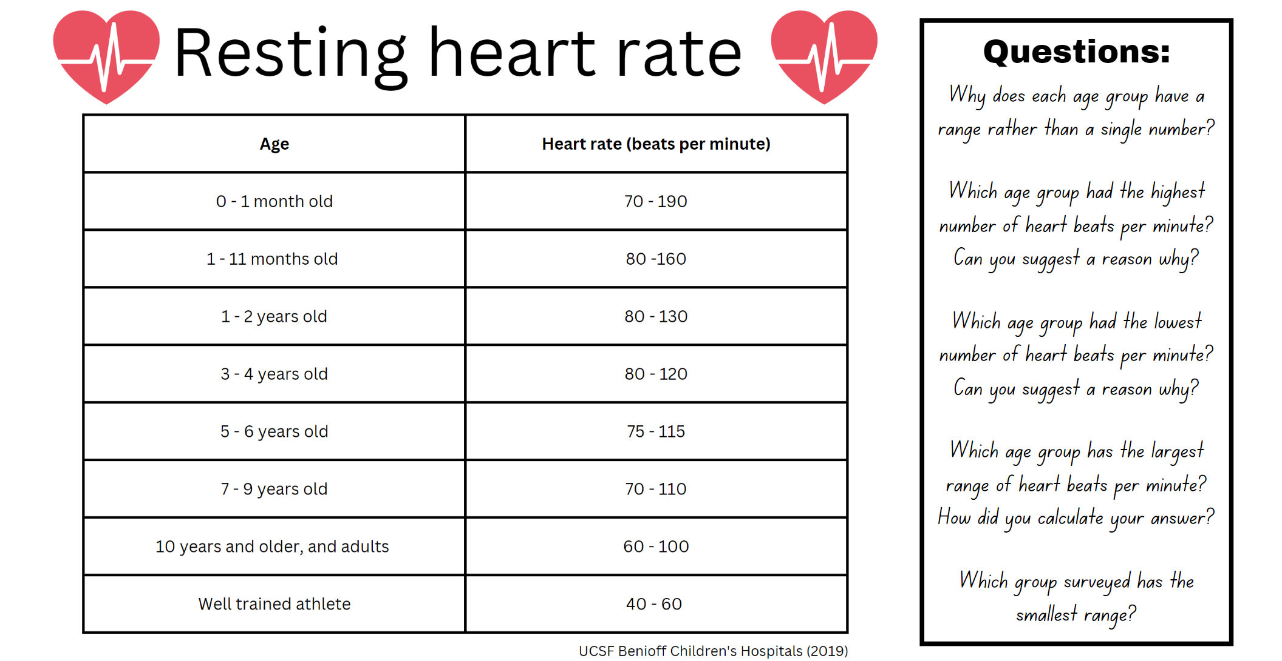

Resource 2: Average maximum heart rate
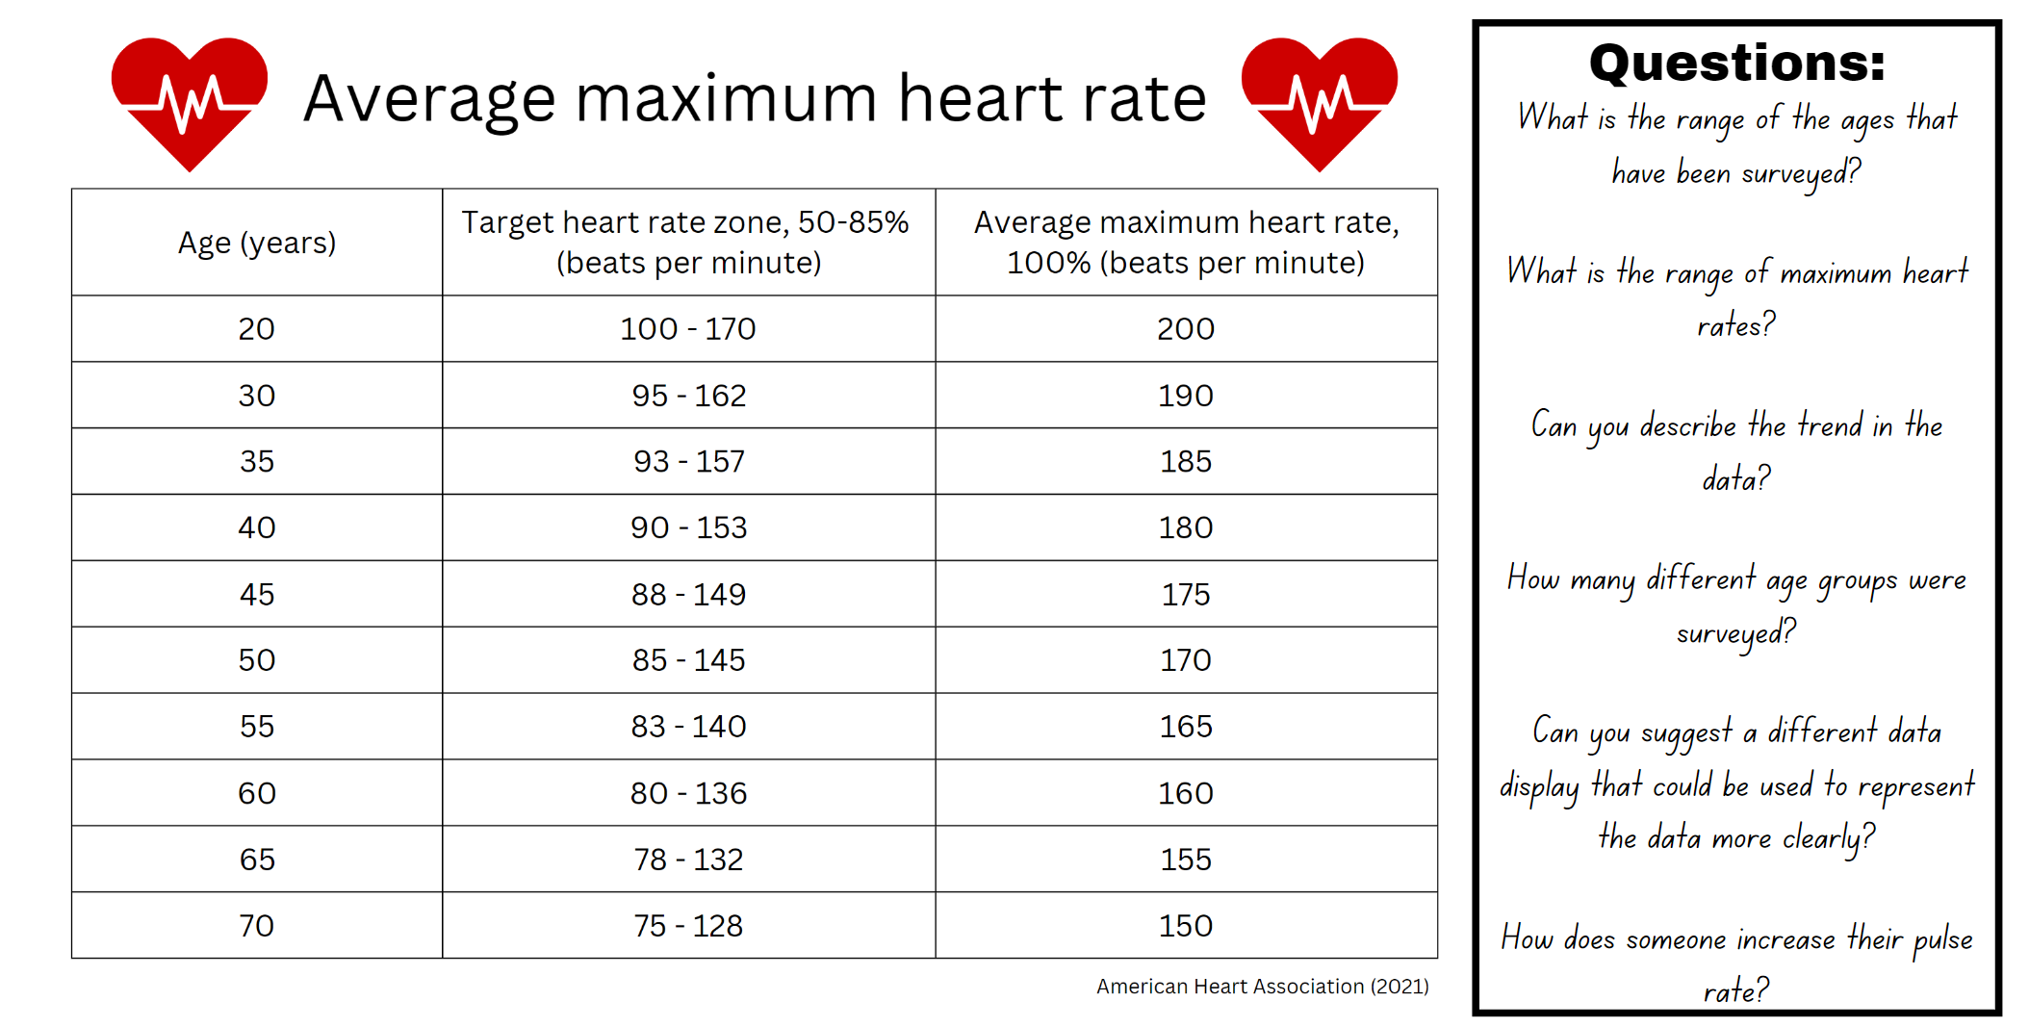

Resource 3: Pulse rates side-by-side column graph
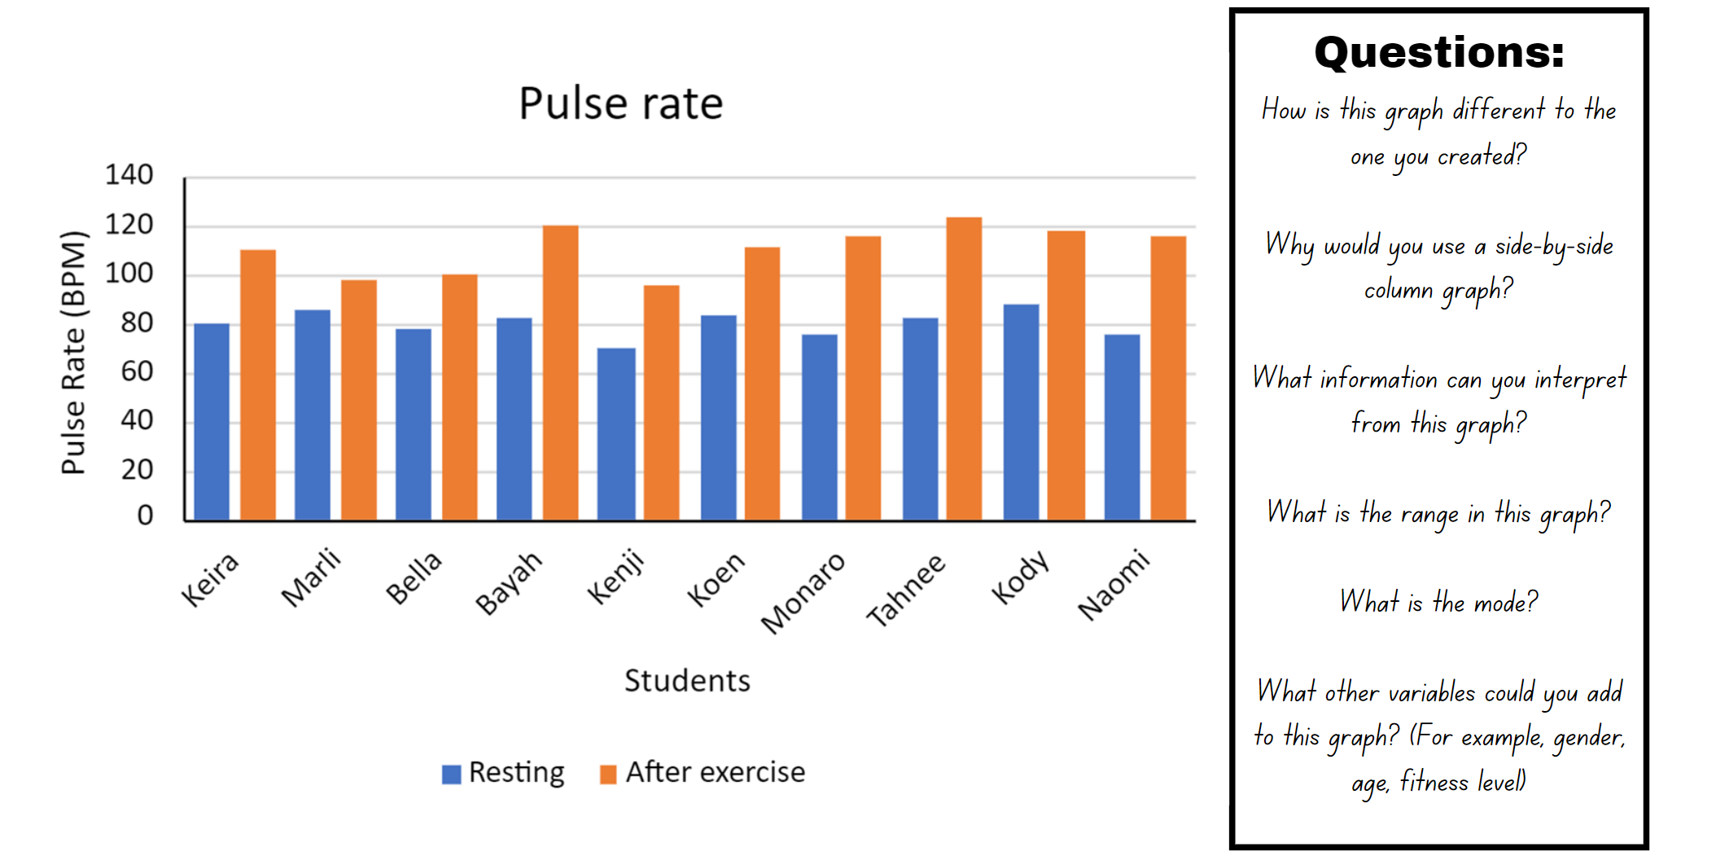

Resource 4: Multiples madness gameboard
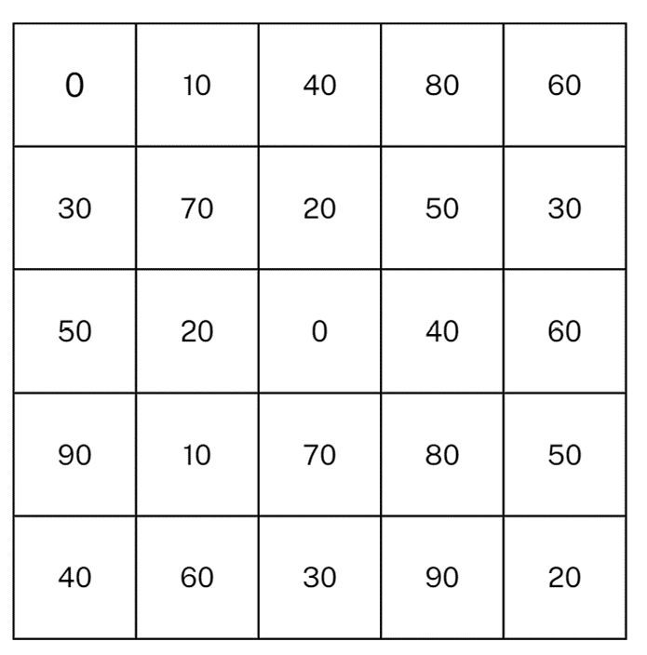

Resource 5: Multiples madness scoreboard
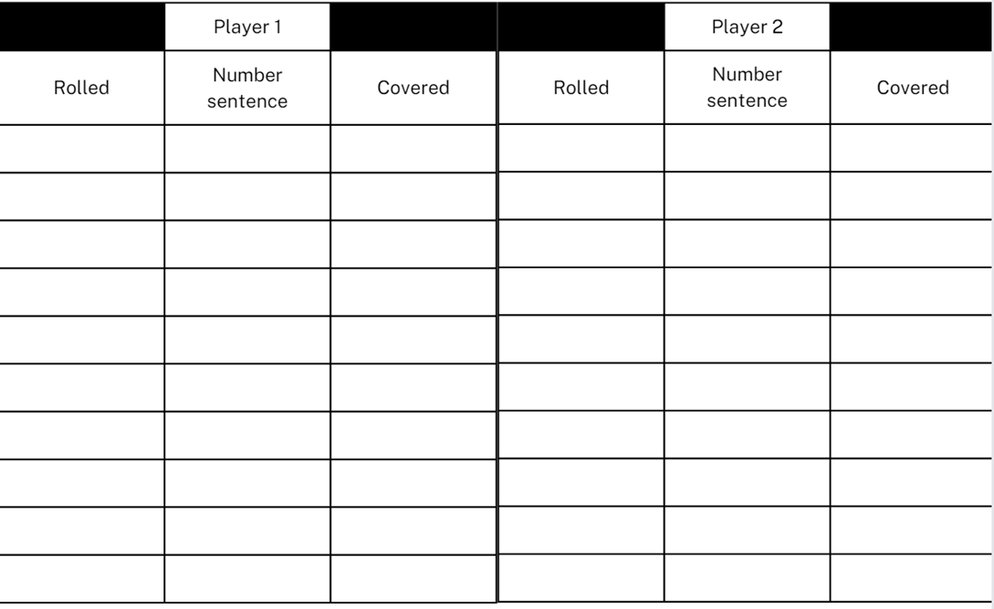

Resource 6: Unlabelled graph
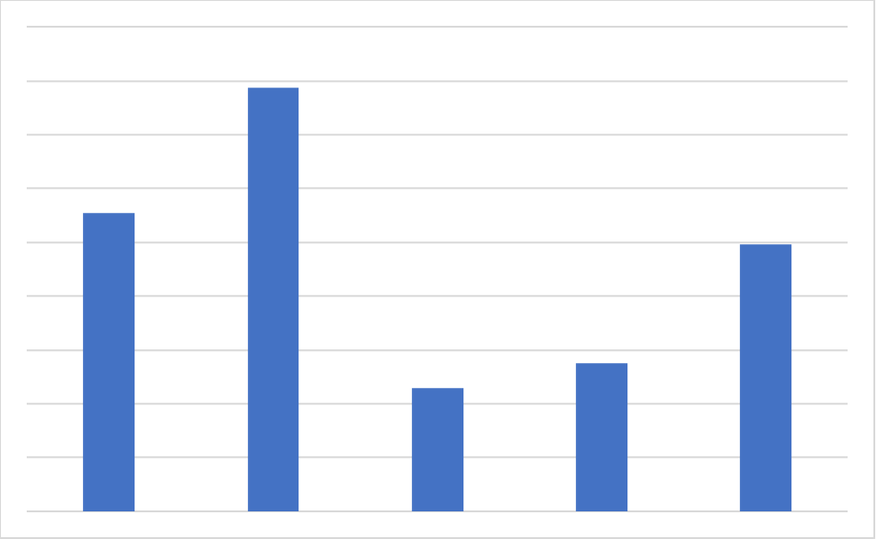

Resource 7: Infographics
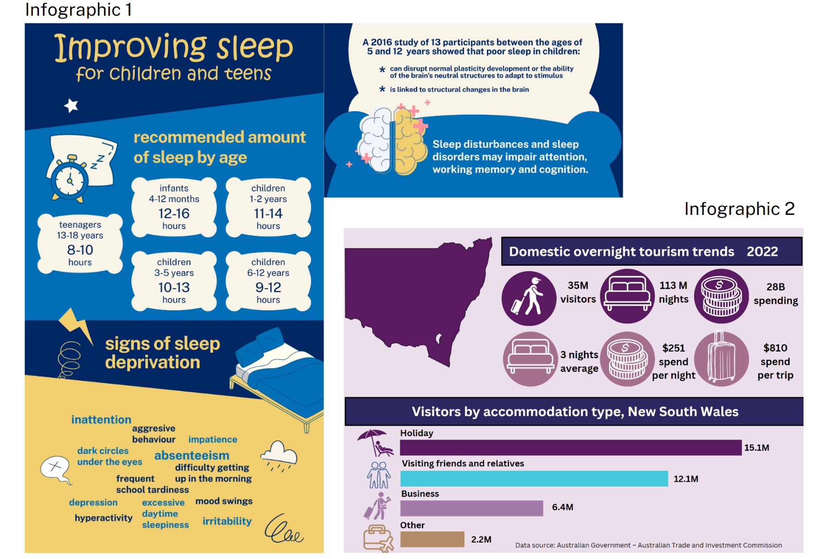
Data source for Infographic 1: Regis College
Data source for Infographic 2: Australian Government – Australian Trade and Investment Commission
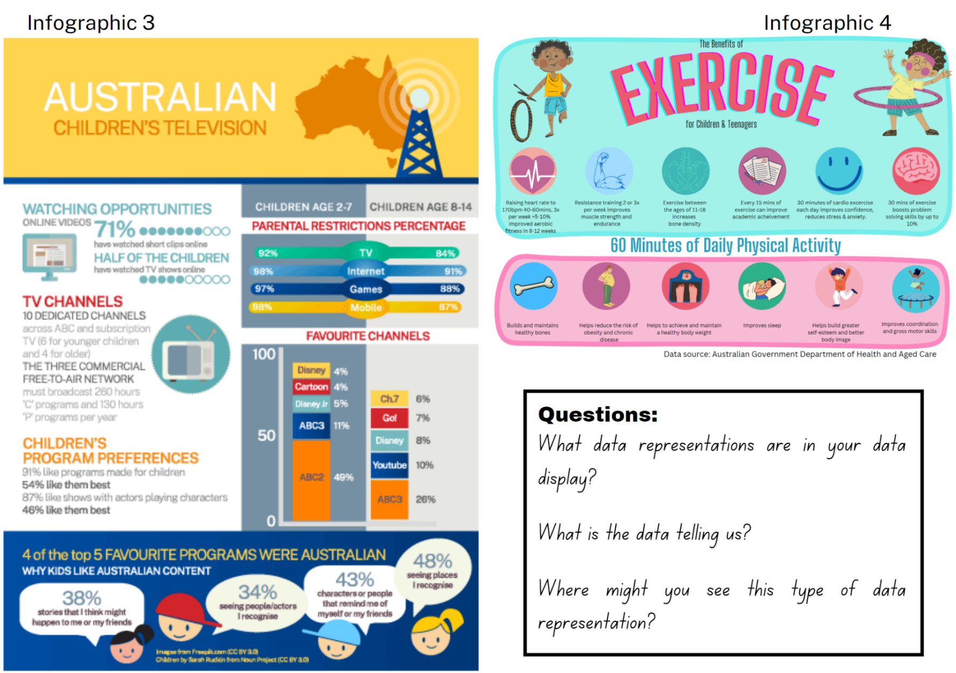
Data source for Infographic 3: Screen Australia
Data source for Infographic 4: Australian Government Department of Health and Aged Care

Resource 8: Beijing weather
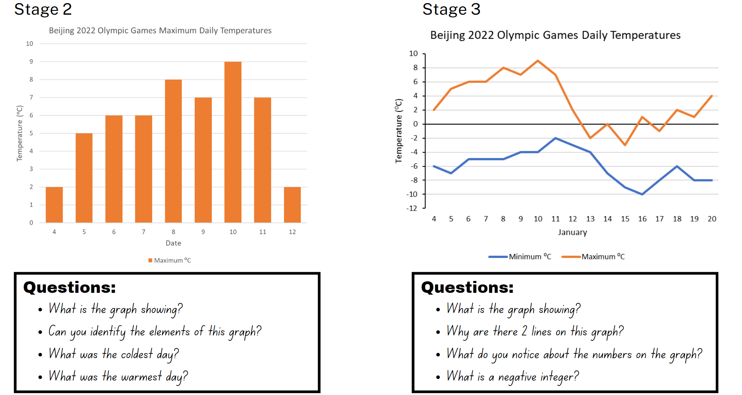
Data source: World weather online

Resource 9: Speed skating times
Men’s Final A
Place | Name | Time (seconds) | Country
1 | Shaoang LIU | 40.34 | HUN
2 | Konstantin IVLIEV | 40.43 | RUS
3 | Steven DUBOIS | 40.68 | CAN
4 | Abzal AZHGALIYEV | 40.87 | KAZ
DNF | Pietro SIGHEL | DNF | ITA
Men’s Final B
Place | Name | Time (seconds) | Country
1 | Dajang WU | 41.157 | CHN
2 | Pavel SITNIKOV | 41.217 | RUS
3 | Denis NIKISHA | 41.329 | KAZ
4 | Roberts KRUZBERGS | 41.465 | LAT
Women’s Final A
Place | Name | Time (seconds) | Country
1 | Arianna FONTANA | 42.49 | ITA
2 | Suzanne SCHULTING | 42.56 | NED
3 | Kim BOUTIN | 42.72 | CHN
4 | Yutin ZHANG | 42.80 | CHN
5 | Hanne DESMET | 42.94 | BEL
Women’s Final B
Place | Name | Time (seconds) | Country
1 | Elena SEREGINI | 42.972 | RUS
2 | Petra JASZAPATI | 43.004 | HUN
3 | Alyson CHARLES | 43.273 | CAN

Resource 10: Lunchtime places
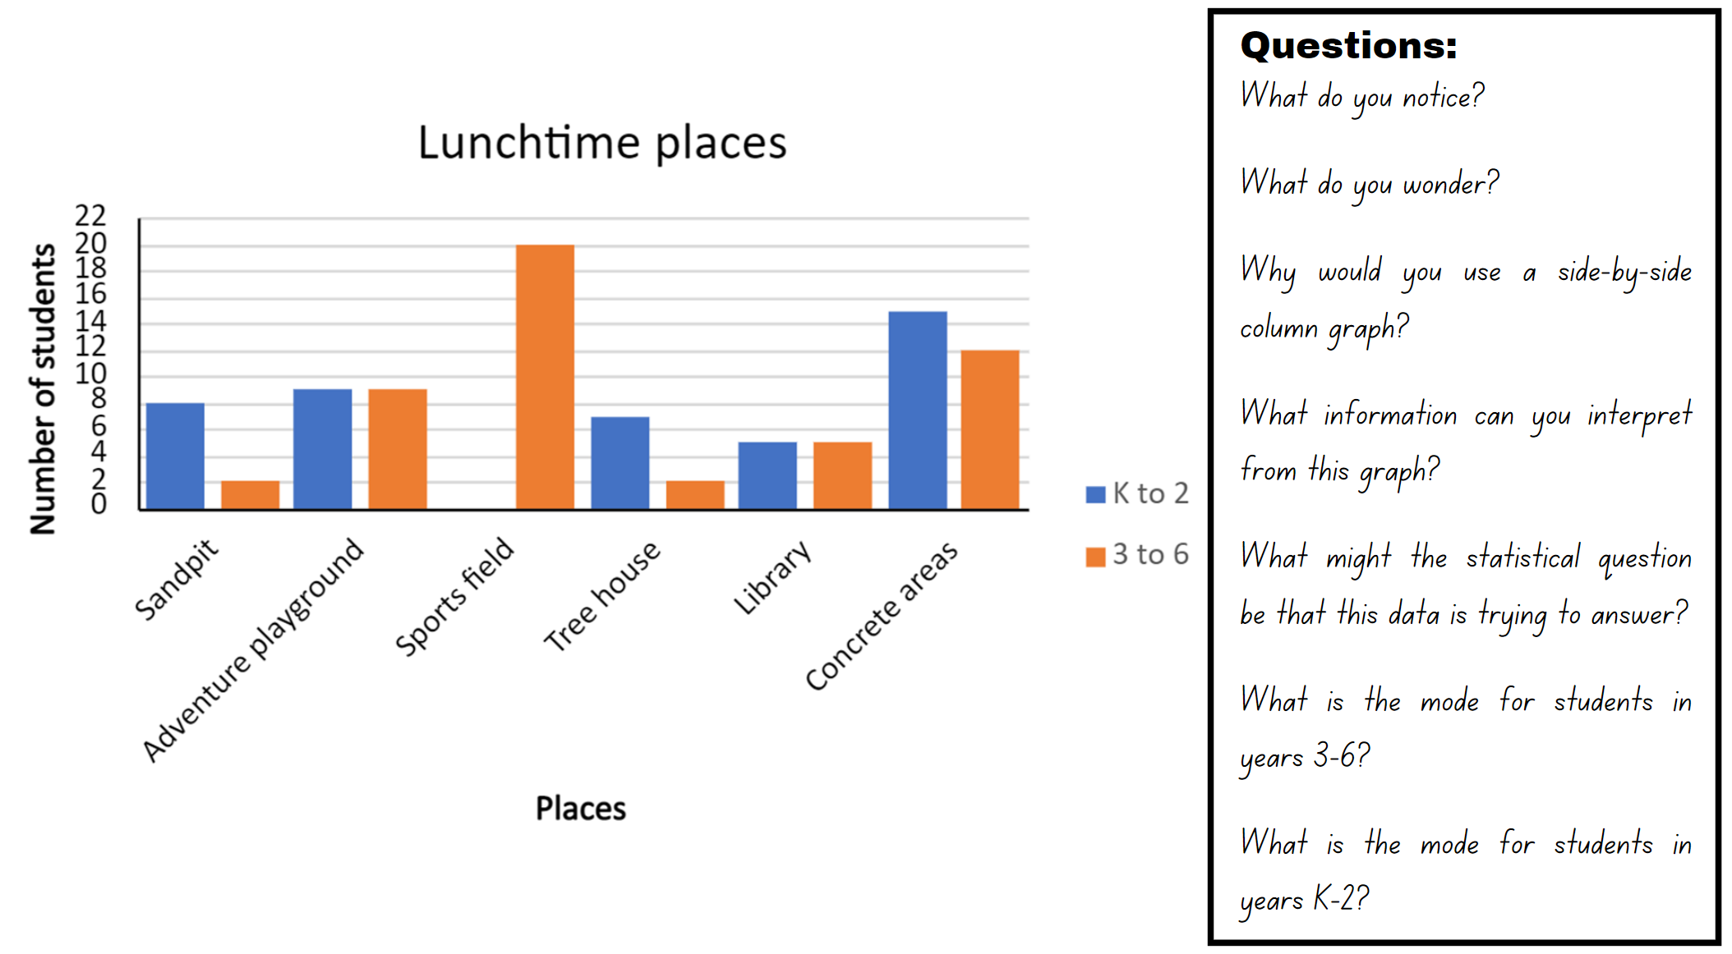

Resource 11: Lunchtime activities
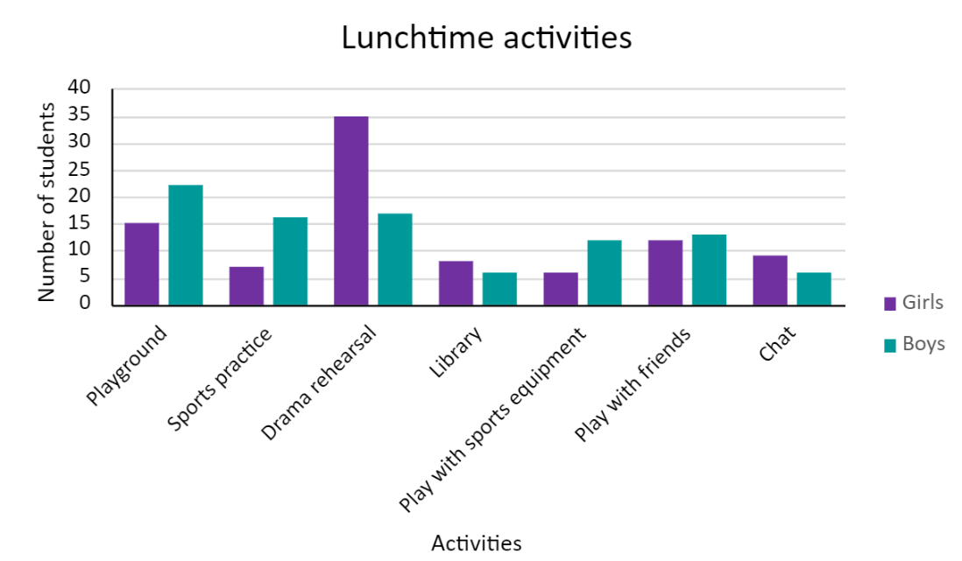

Resource 12: Data story
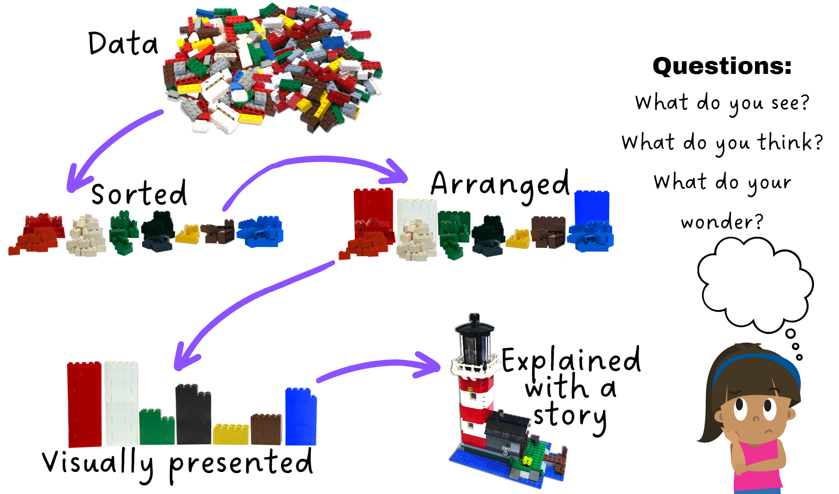

Resource 13: LEGO timeline
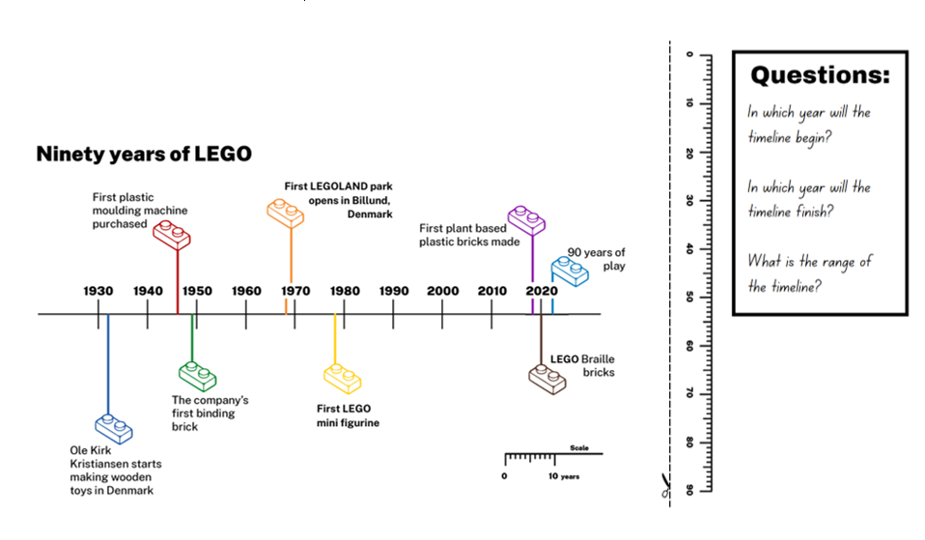

Resource 14: Brick set pieces
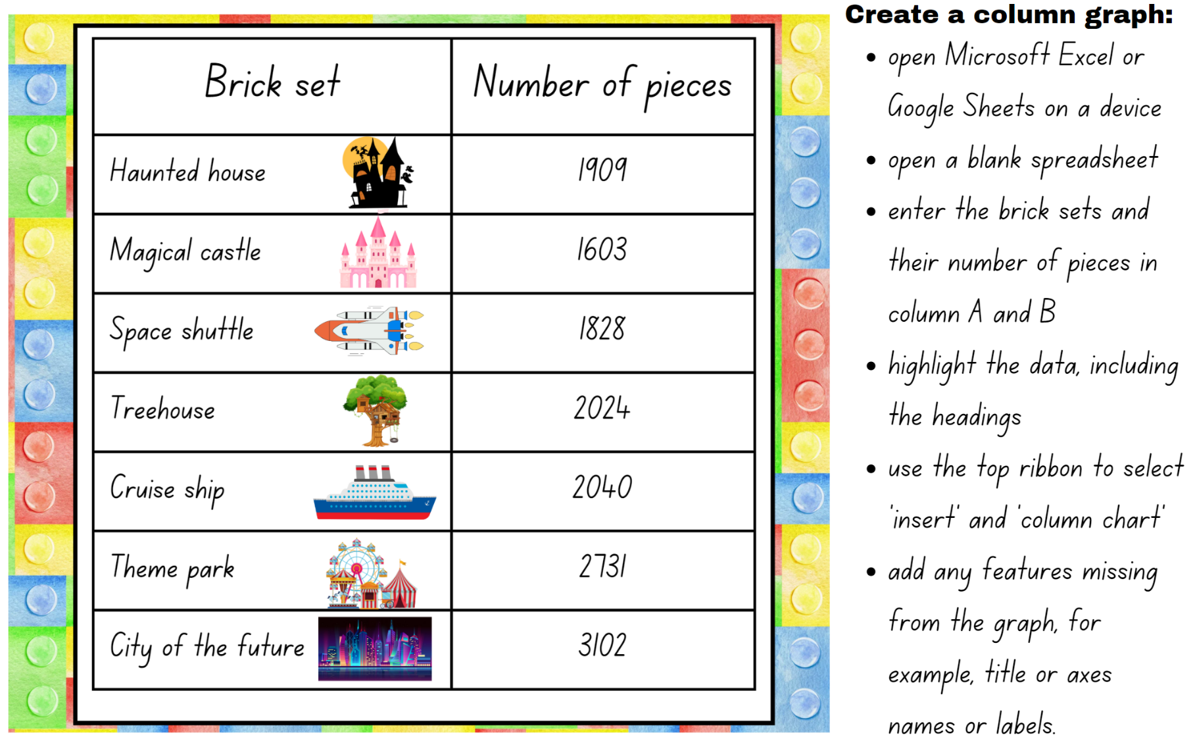

Resource 15: Visitor attendance – Windsor
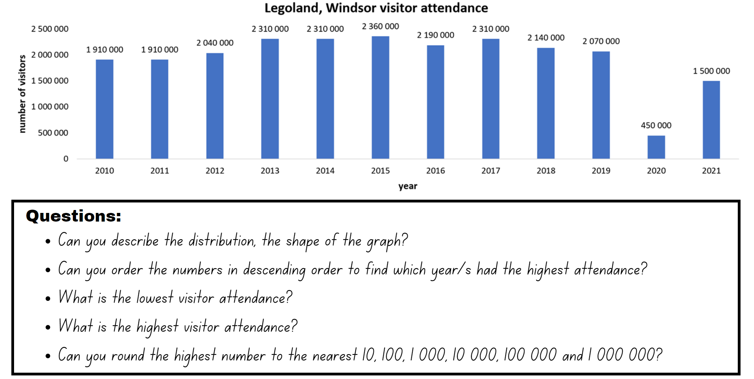
Data source: Queue Times

Resource 16: Theme park attendance
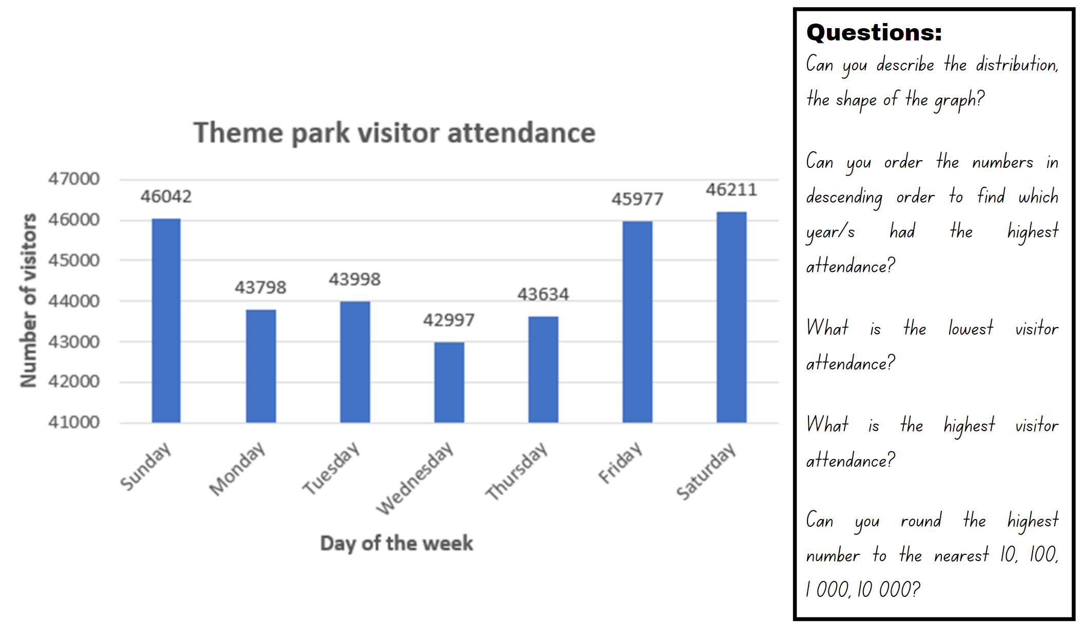

Resource 17: Scrabble tiles
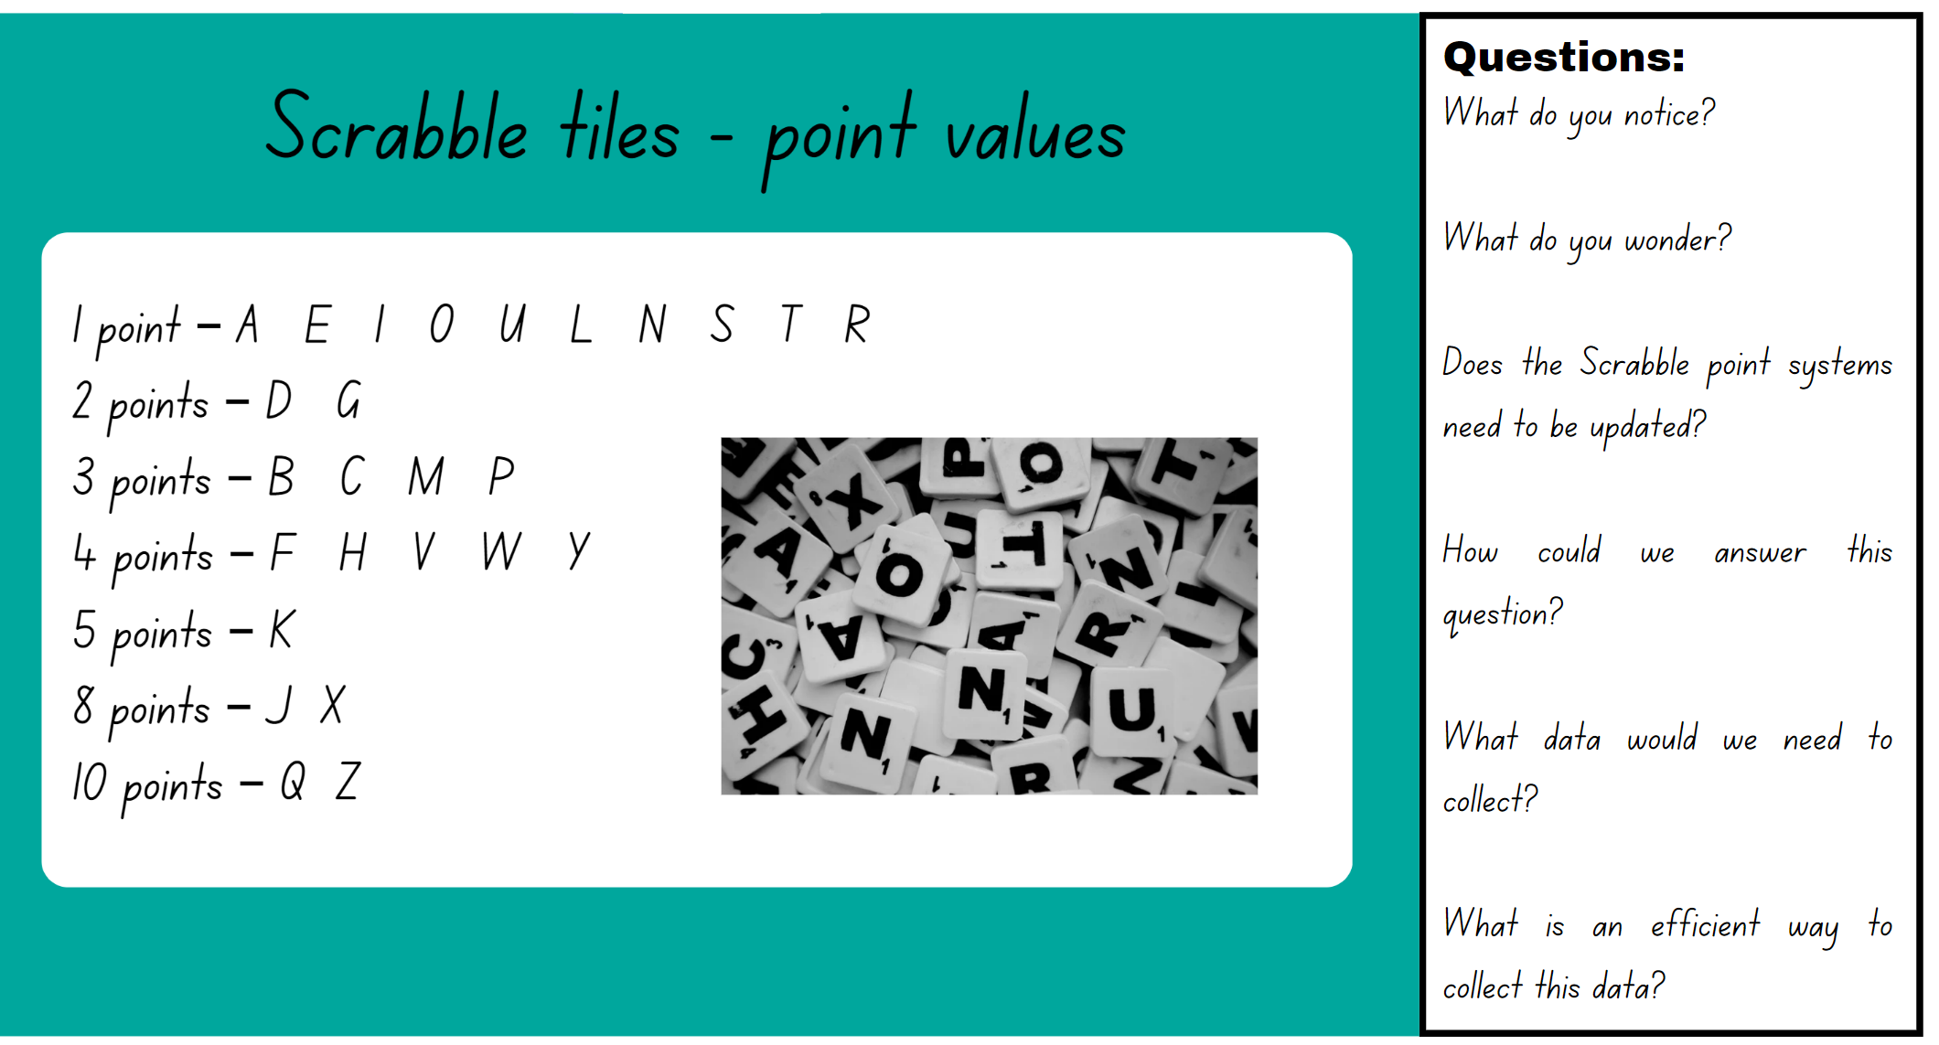

Resource 18: Survey results
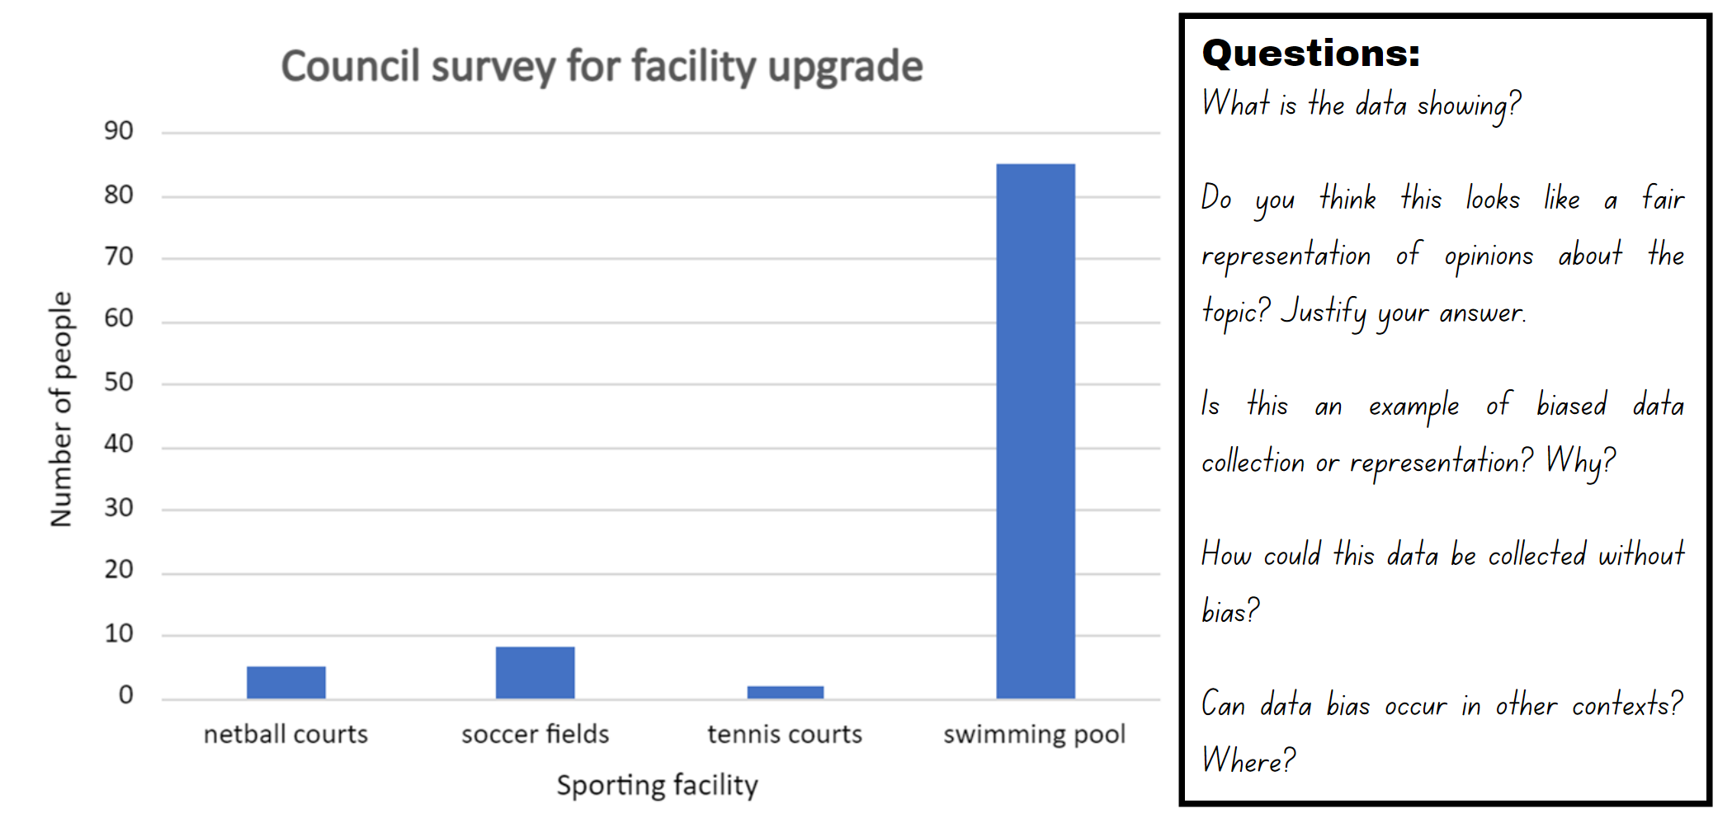

Resource 19: Scenarios
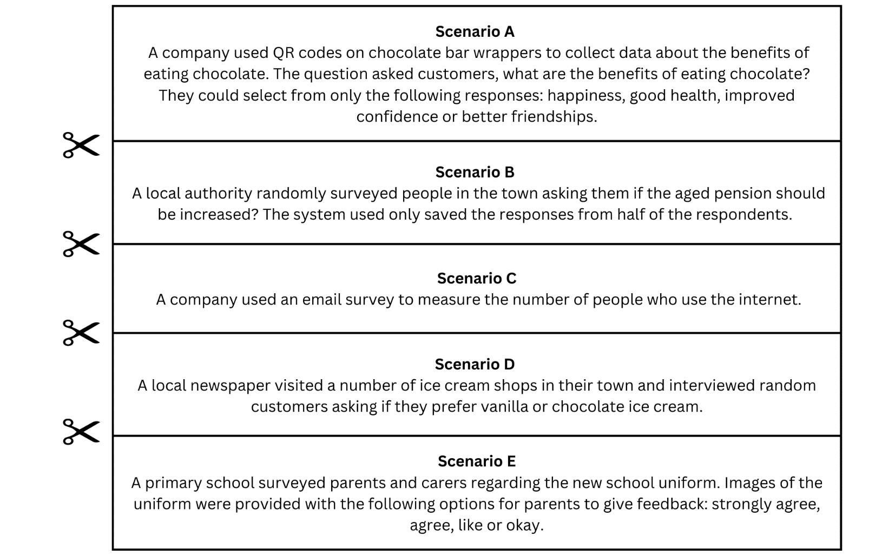

Resource 20: Doughnut decimals
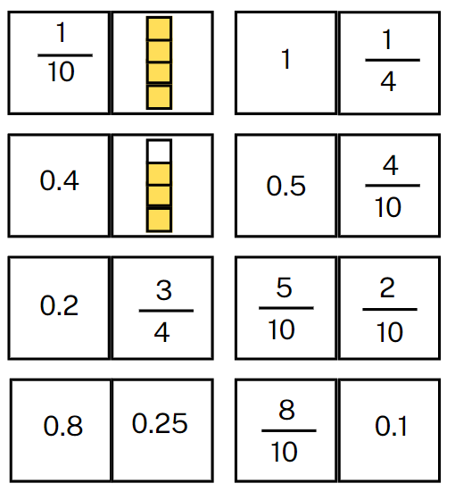

Resource 21: Gold medal picture graph
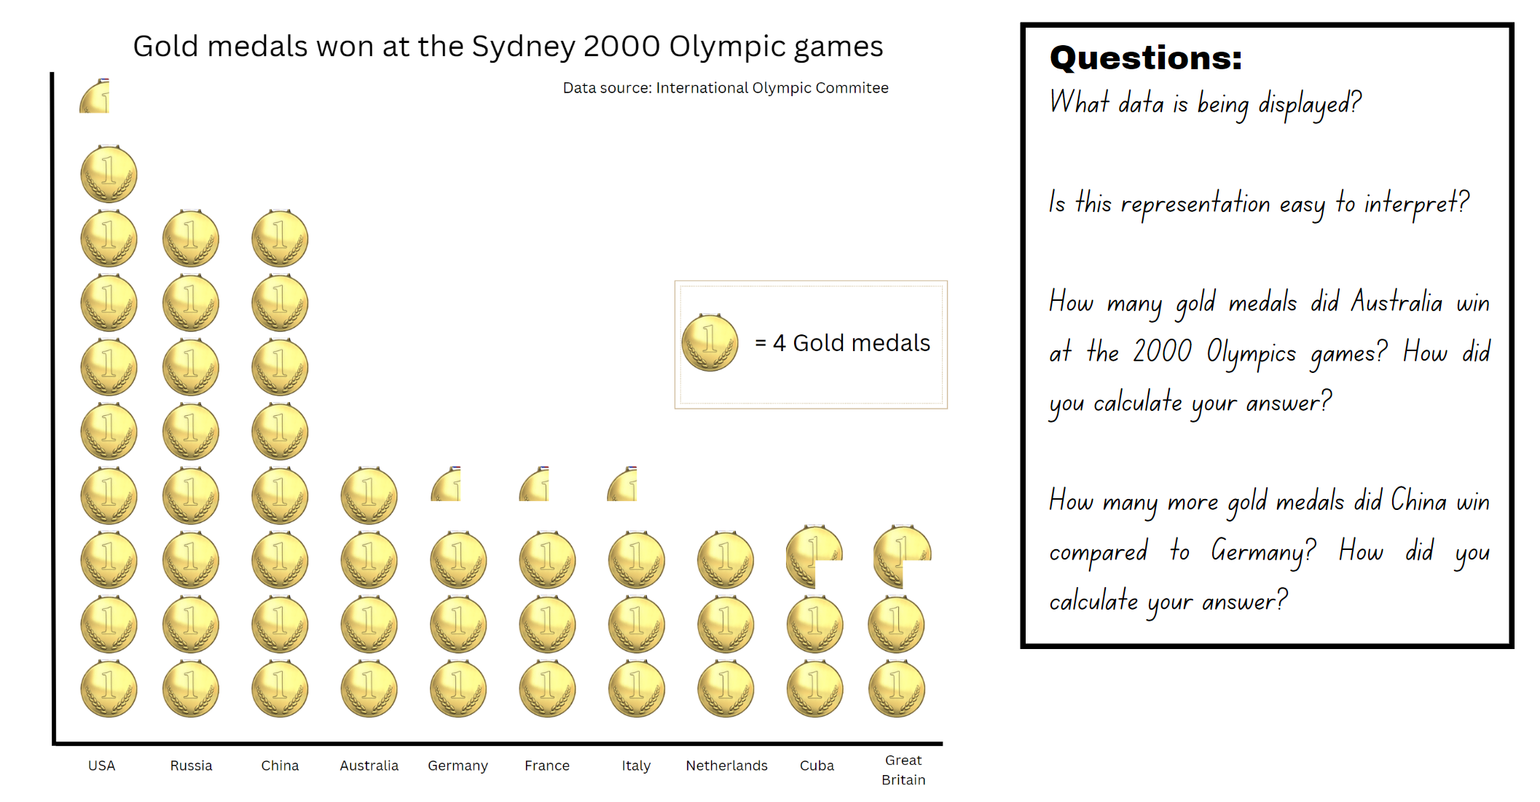

Resource 22: Gold medal column graph
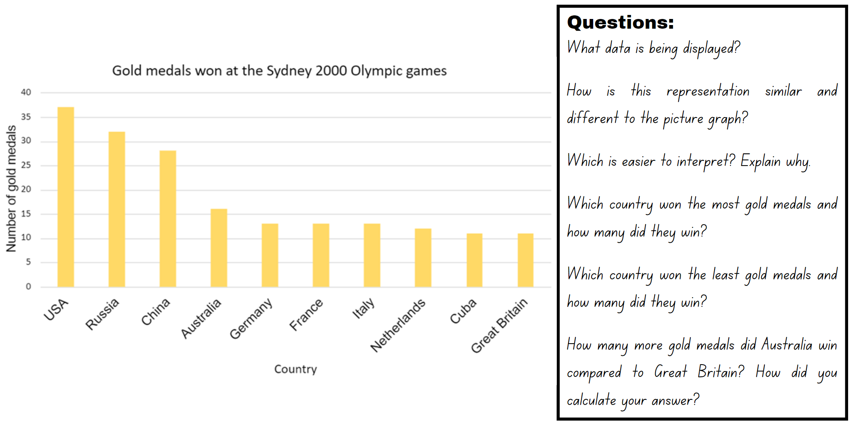

Resource 23: Total medal count
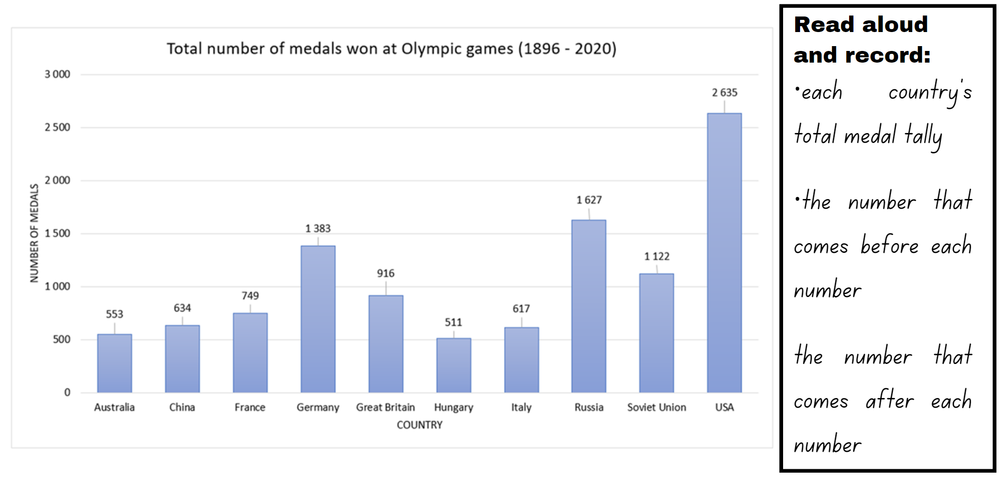

Resource 24: Comparing data displays
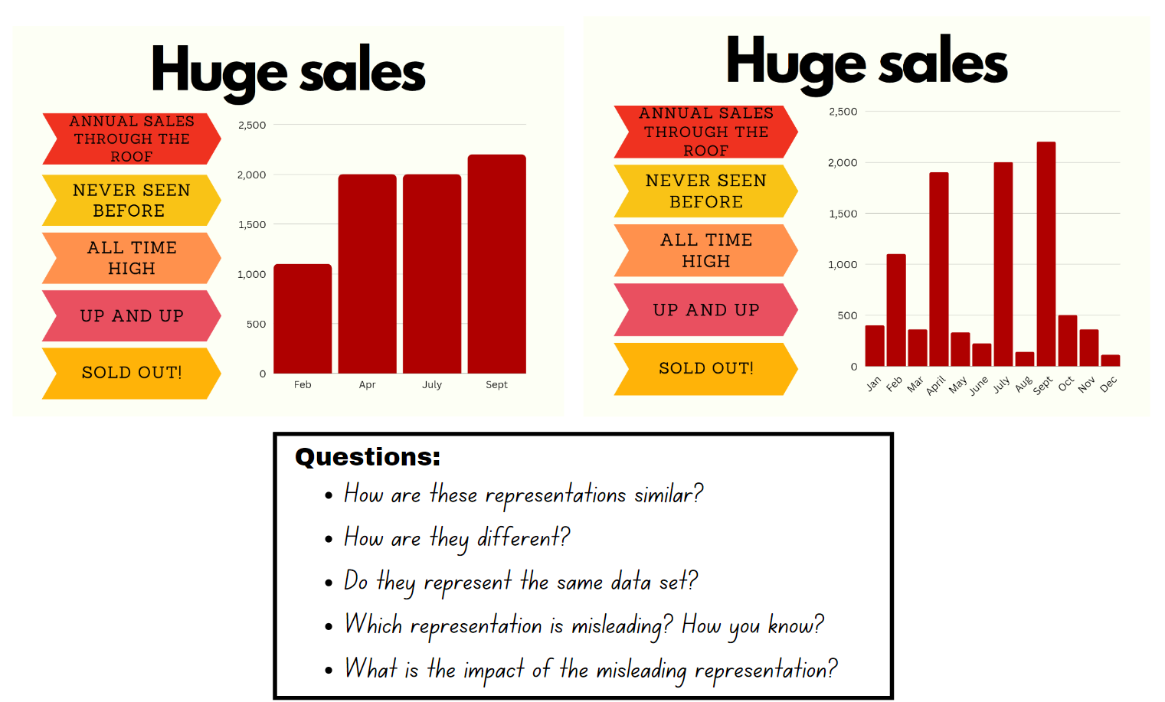

Resource 25: Misleading strategies
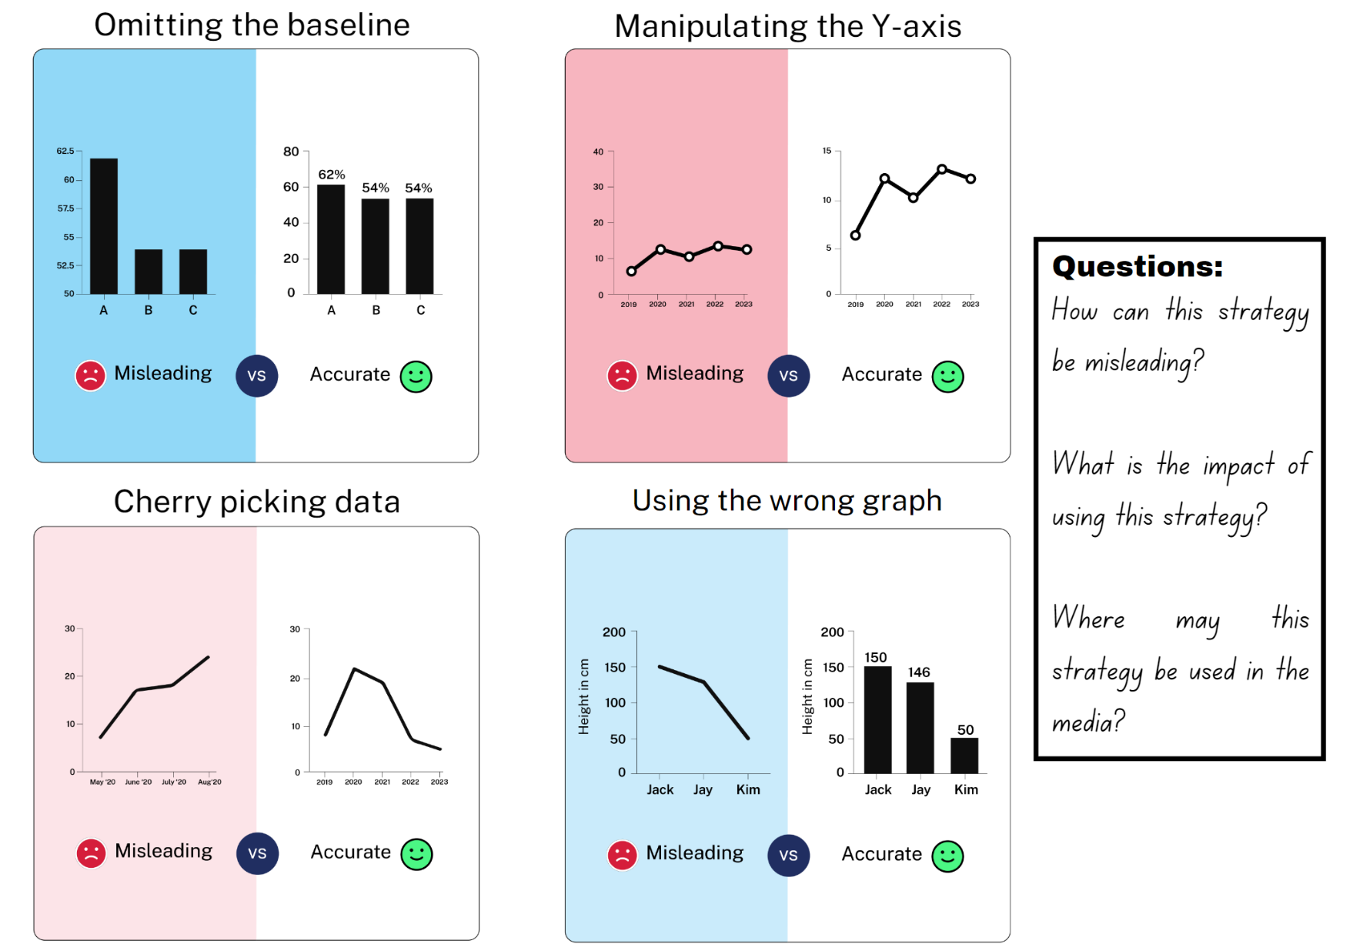
Source: Venngage

Resource 26: Misleading representations
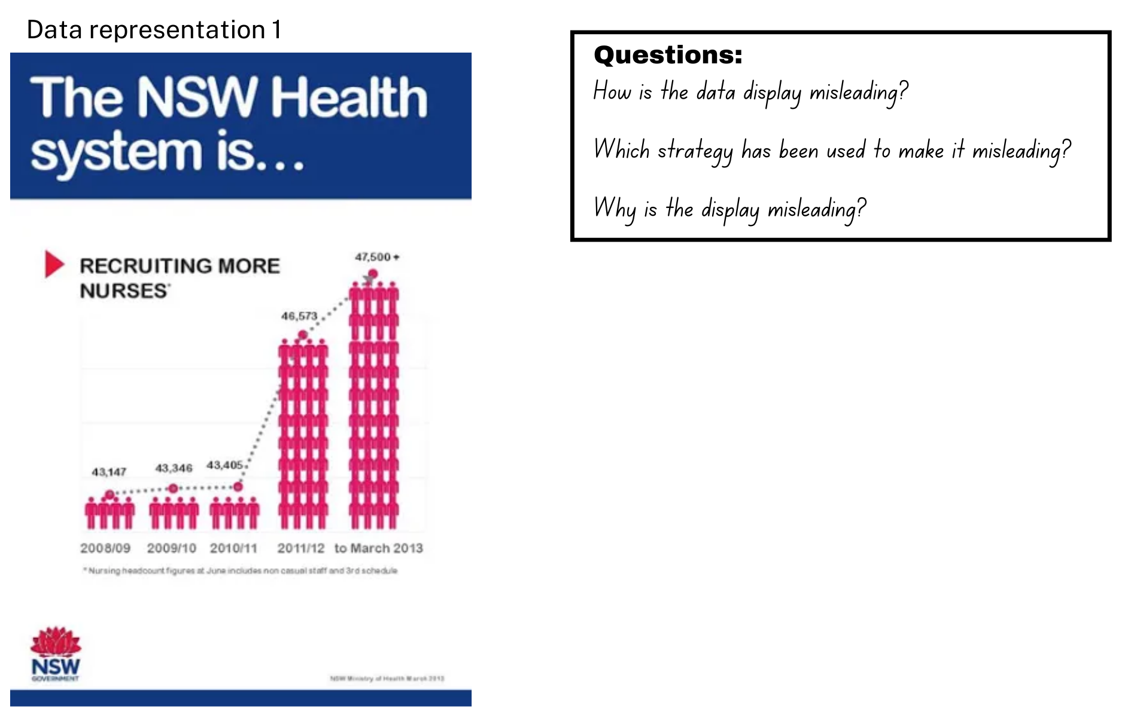
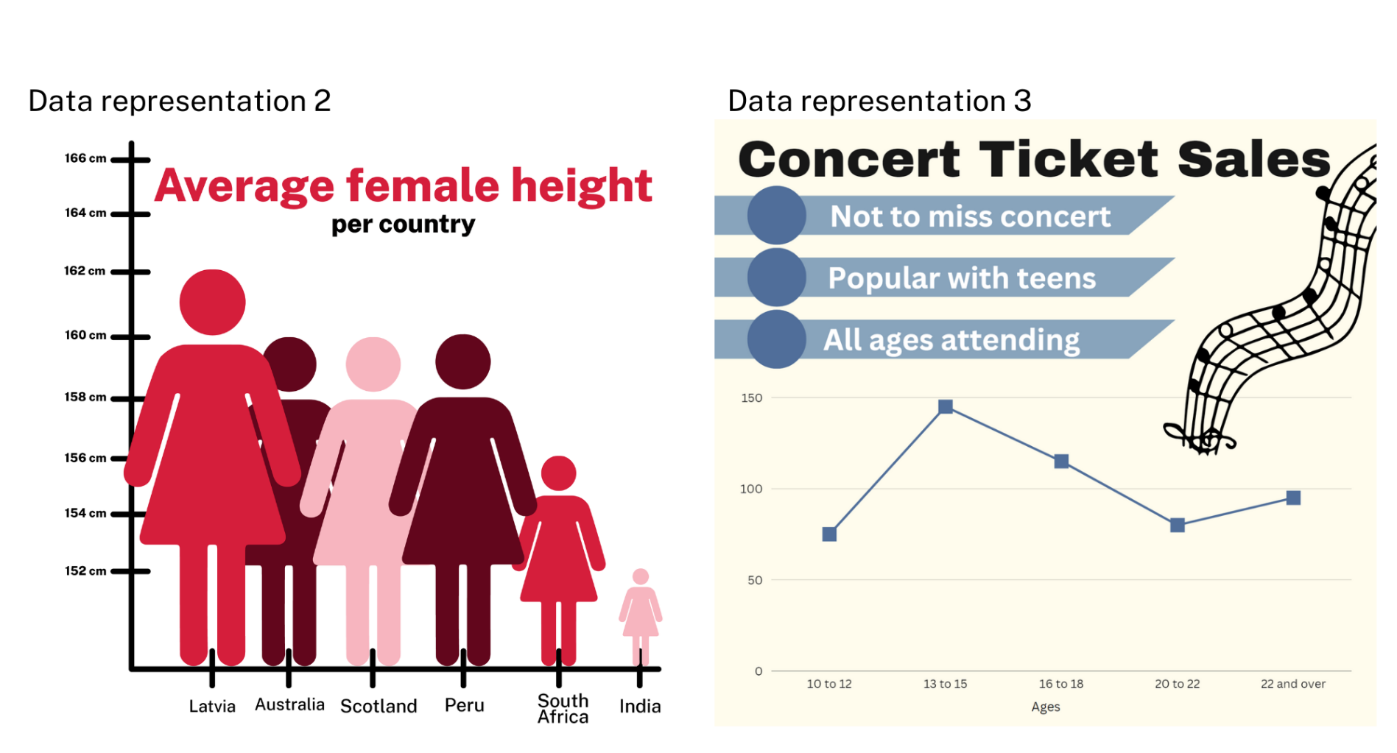
Data representation 2 source: Ibrahim (2020)

Resource 27: 100 people
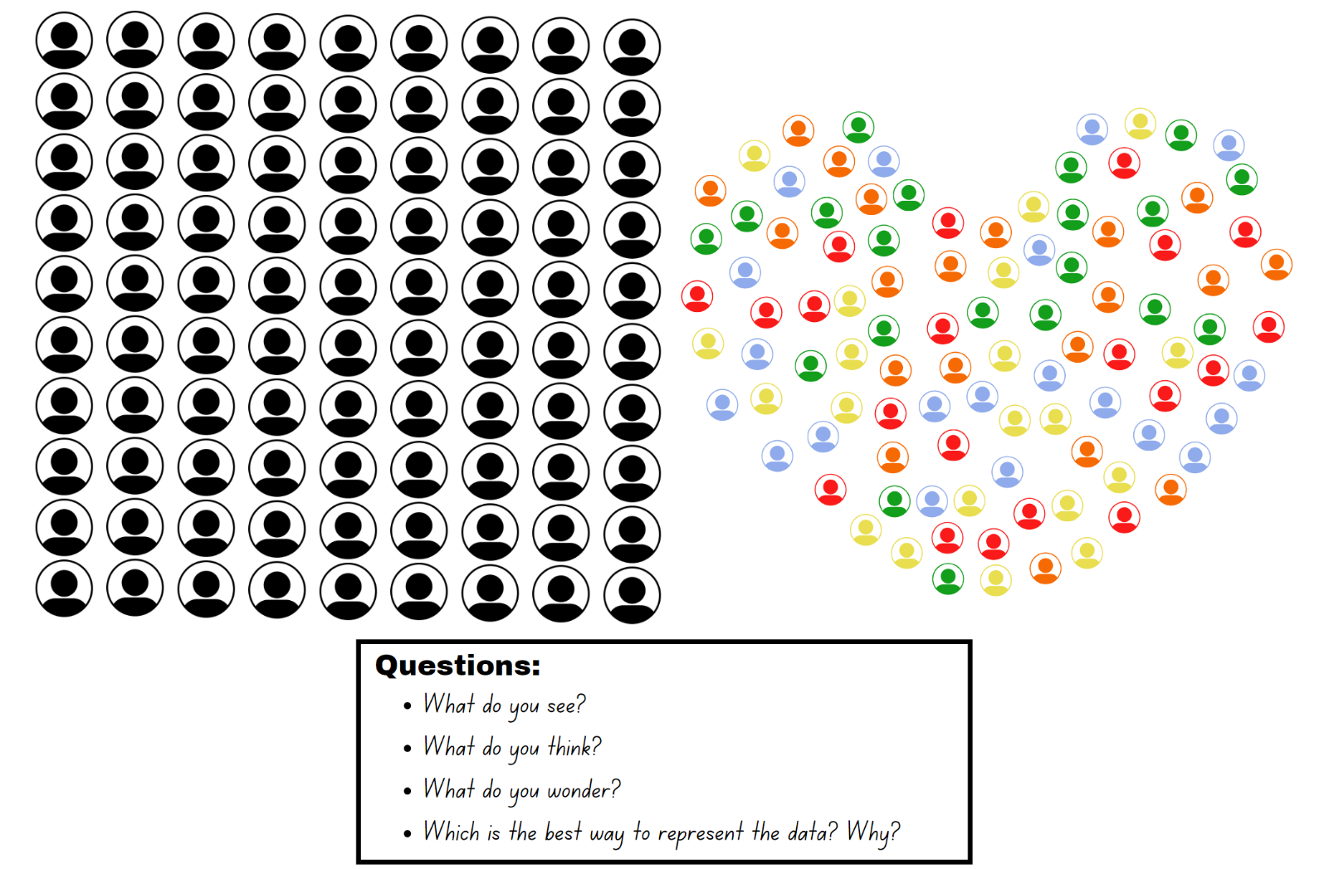

Resource 28: Nationalities
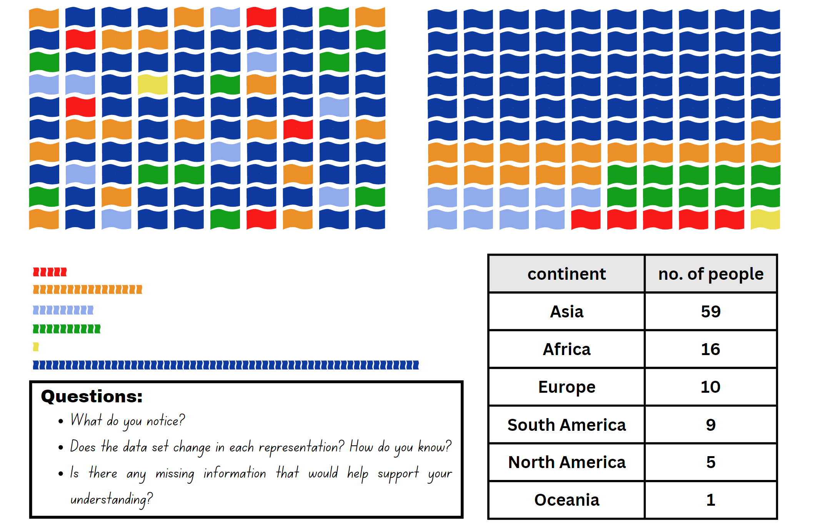

Resource 29: Energy
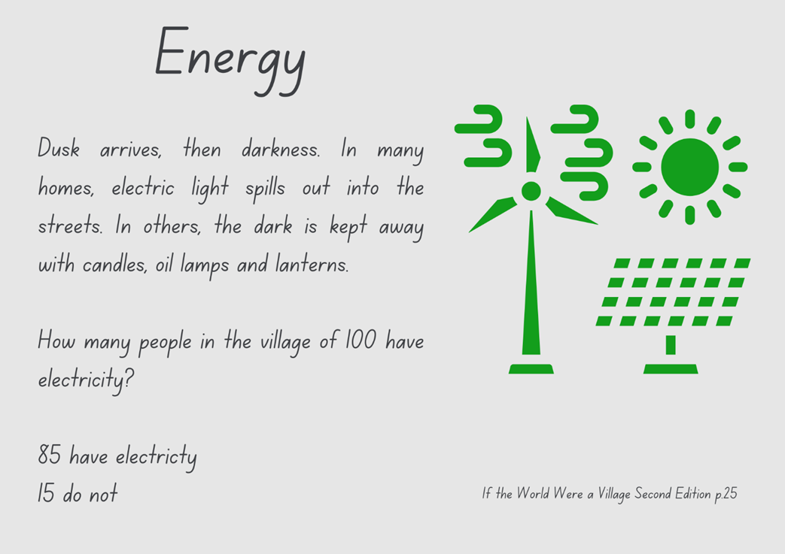

Resource 30: Average worldwide temperature
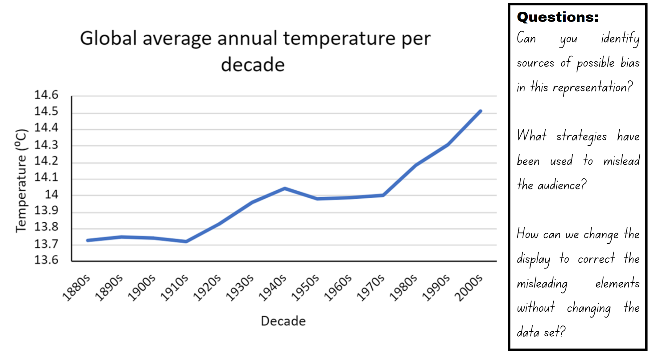

Resource 31: Accurate data representation
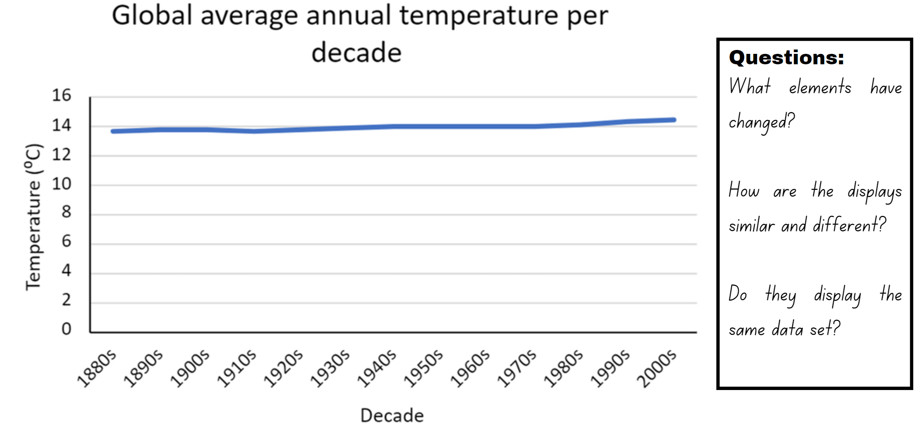

Syllabus outcomes and content

Stage 2
The table below outlines the syllabus outcomes and range of relevant syllabus content covered in this unit. Content is linked to National Numeracy Learning Progression version (3).
Outcomes and content | 1 | 2 | 3 | 4 | 5 | 6 | 7 | 8
Representing numbers using place value A: Whole numbers: Read, represent and order numbers to thousands
MAO-WM-01, MA2-RN-01, MA2-RN-02
- Compare and describe the relative size of numbers by positioning numbers on a number line (Reasons about quantity) |  |  |  |  |  |  |  | x
- Read and order numbers of up to at least 4 digits |  | x |  |  |  | x | x
- Identify the number before and after a number with an internal zero digit |  | x |  |  |  | x | x
Representing numbers using place value B: Whole numbers: Order numbers in the thousands
MAO-WM-01, MA2-RN-01, MA2-RN-02
- Arrange numbers in the thousands in ascending and descending order |  |  |  |  | x
- Identify the nearest thousand, 10 thousand or 100 thousand to numbers |  |  |  |  | x
Representing numbers using place value B: Decimals: Extend the application of the place value system from whole numbers to tenths and hundredths
MAO-WM-01, MA2-RN-01, MA2-RN-02
- Locate and order decimals representing tenths and hundredths on a number line, describing their relative size |  |  | x | x
- Interpret zero digits at the end of a decimal |  |  | x
- Distinguish between the role of zero in various positions |  |  | x
Representing numbers using place value B: Decimals: Make connections between fractions and decimal notation
MAO-WM-01, MA2-RN-01, MA2-RN-02
- Compare and order decimals of up to 2 decimal places |  |  |  |  |  | x | x
- Make connections between fractions and decimal notation for key benchmark values (Reasons about relations) |  |  |  |  |  |  | x
Multiplicative relations B: Operate with multiples of 10
MAO-WM-01, MA2-MR-01
- Use multiplication facts with multiples of 10 to multiply a one-digit number by a multiple of 10 | x | x | x
Partitioned fractions B: Model equivalent fractions as lengths
MAO-WM-01, MA2-PF-01
- Represent the equivalence of fractions with related denominators as lengths, using concrete materials, diagrams and number lines |  |  |  |  | x | x
- Represent fractions with the same-size whole to make valid comparisons (denominators of 2, 4 and 8; 3 and 6; 5 and 10) |  |  |  |  |  | x
Partitioned fractions B: Represent fractional quantities equal to and greater than one
MAO-WM-01, MA2-PF-01
- Rename 2 halves, 3 thirds, 4 quarters, 5 fifths, 6 sixths, 8 eighths and 10 tenths as one whole |  |  |  |  | x
Data A: Collect discrete data
MAO-WM-01, MA2-DATA-01, MA2-DATA-02
- Collect data from identified sources | x
Data A: Organise and display data using tables and graphs
MAO-WM-01, MA2-DATA-01, MA2-DATA-02
- Construct column graphs (with scale intervals of 1) and dot plots using relevant software where appropriate | x | x | x | x | x
- Mark equal spaces (intervals) on axes, name and label axes and choose appropriate titles for column graphs | x | x | x | x
Data A: Interpret and compare data
MAO-WM-01, MA2-DATA-01, MA2-DATA-02
- Describe and interpret information presented in tally tables and column graphs | x | x |  | x
Data B: Select and trial methods for data collection
MAO-WM-01, MA2-DATA-01, MA2-DATA-02
- Create a survey and related recording sheet, considering the appropriate organisation of categories for data collection |  |  |  | x
- Conduct a survey or make observations to collect categorical or numerical data | x |  |  | x
Data B: Construct and interpret data displays with many-to-one scales
MAO-WM-01, MA2-DATA-01, MA2-DATA-02
- Use data in a spreadsheet to create column graphs with units on vertical axes that are in multiples |  |  |  |  |  | x
- Interpret and evaluate the effectiveness of various data displays found in media and in factual texts where displays represent data using a scale of many-to-one |  |  | x | x |  |  | x | x
Mathematics K–10 Syllabus © NSW Education Standards Authority (NESA) for and on behalf of the Crown in right of the State of New South Wales, 2022.

Stage 3
The table below outlines the syllabus outcomes and range of relevant syllabus content covered in this unit. Content is linked to National Numeracy Learning Progression version (3).
Outcomes and content | 1 | 2 | 3 | 4 | 5 | 6 | 7 | 8
Represents numbers A: Whole numbers: Recognise, represent and order numbers in the millions
MAO-WM-01, MA3-RN-01
- Name millions using the place value grouping of ones, tens and hundreds |  | x
- Arrange numbers in the millions in ascending and descending order using place value |  | x |  |  | x
- Round numbers to a specified place value |  | x |  |  | x
Represents numbers A: Decimals and percentages: Recognise that the place value system can be extended beyond hundredths
MAO-WM-01, MA3-RN-01, MA3-RN-02
- Use place value to partition decimals |  |  | x
Represents numbers A: Decimals and percentages: Compare, order and represent decimals
MAO-WM-01, MA3-RN-01, MA3-RN-02
- Compare the place value of digits by determining numbers that are 10 or 100 times the original decimal number as well as $\frac{1}{10}$ or $\frac{1}{100}$ times the original decimal numbers |  |  |  | x |  | x
- Approximate the size of decimals |  |  | x |  |  |  | x
Represents numbers B: Whole numbers: Locate and represent integers on a number line
MAO-WM-01, MA3-RN-01, MA3-RN-02
- Recognise the location of negative whole numbers in relation to zero and place them on a number line |  |  | x
- Use the term integers to describe positive and negative whole numbers and zero |  |  | x
Represents numbers B: Decimals and percentages: Make connections between benchmark fractions, decimals and percentages
MAO-WM-01, MA3-RN-01, MA3-RN-02, MA3-RN-03
- Recognise that the symbol % means percent and 100% is the whole amount |  |  |  |  | x | x | x
- Recall commonly used equivalent percentages, decimals and fractions including $\frac{1}{2}, \frac{1}{4}$ and $\frac{3}{4}$ |  |  |  |  | x
- Represent common percentages of quantities and lengths as fractions and decimals |  |  |  |  | x | x | x
Multiplicative relations A: Use partitioning and place value to multiply 2-, 3- and 4-digit numbers by one-digit numbers
MAO-WM-01, MA3-MR-01
- Use mental strategies to multiply one-digit numbers by 10, 100, 1000 and their multiples | x | x | x
Data A: Collect categorical and discrete numerical data by observation or survey
MAO-WM-01, MA3-DATA-01, MA3-DATA-02
- Collect ordinal or nominal categorical data, and discrete numerical data through observation or by conducting surveys | x
Data A: Choose and use appropriate tables and graphs
MAO-WM-01, MA3-DATA-01, MA3-DATA-02
- Construct column graphs using a many-to-one scale, with and without the use of digital technologies | x
Data B: Interpret and compare a range of data displays
MAO-WM-01, MA3-DATA-01, MA3-DATA-02
- Interpret side-by-side column graphs for 2 categorical variables | x |  |  | x
- Interpret data on a timeline using the given scale |  |  |  |  | x
- Interpret and compare different displays in terms of the shape of the distribution, including the range and the most frequent value (mode) | x |  | x | x
Data B: Interpret data presented in digital media and elsewhere
MAO-WM-01, MA3-DATA-01, MA3-DATA-02
- Interpret data representations found in digital media and in factual texts |  | x | x
- Identify sources of possible bias in representations of data in the media (Statistical reasoning) |  |  |  |  |  | x |  | x
- Identify misleading representations of data in the media |  |  |  |  |  |  | x | x
Mathematics K–10 Syllabus © NSW Education Standards Authority (NESA) for and on behalf of the Crown in right of the State of New South Wales, 2022.

References
This resource contains NSW Curriculum and syllabus content. The NSW Curriculum is developed by the NSW Education Standards Authority. This content is prepared by NESA for and on behalf of the Crown in right of the State of New South Wales. The material is protected by Crown copyright.
Please refer to the NESA Copyright Disclaimer for more information https://educationstandards.nsw.edu.au/wps/portal/nesa/mini-footer/copyright.
NESA holds the only official and up-to-date versions of the NSW Curriculum and syllabus documents. Please visit the NSW Education Standards Authority (NESA) website https://educationstandards.nsw.edu.au/ and the NSW Curriculum website https://curriculum.nsw.edu.au/home.
Mathematics K–10 Syllabus © NSW Education Standards Authority (NESA) for and on behalf of the Crown in right of the State of New South Wales, 2022.
National Numeracy Learning Progression © Australian Curriculum, Assessment and Reporting Authority (ACARA) 2010 to present, unless otherwise indicated. This material was downloaded from the Australian Curriculum website (National Literacy Learning Progression) (accessed 5 September 2023) and was not modified.
ACARA (Australian Curriculum, Assessment and Reporting Authority) (n.d.) ‘Mathematics (Version 8.4)’, F–10 curriculum: Learning areas, Australian Curriculum website, accessed 3 July 2023.
A.D.A.M., Inc (Animated Dissection of Anatomy for Medicine) as modified by University of California San Francisco (2019) ‘Pulse’, Medical Tests A–Z, UCSF Benioff Children’s Hospital website, accessed 3 July 2023.
American Heart Association Inc (2021) ‘Target Heart Rates Chart’, Fitness Basics, American Heart Association webpage, accessed 3 July 2023.
Askew M (2016) A Practical Guide to Transforming Primary Mathematics: Activities and tasks that really work, 1st edn, Routledge, UK.
Australian Trade and Investment Commission: Tourism Research Australia (2023) ‘National Visitor Survey results’, Reports, Tourism Research Australia website, accessed 3 July 2023.
Department of Health and Aged Care (2021) ‘Physical activity and exercise guidelines for all Australians’, Topics: Physical activity and exercise, Australian Government Department of Health and Aged Care website, accessed 3 July 2023.
International Olympic Committee (n.d.) Sydney 2000 Medal Tally, International Olympic Committee website, accessed 24 June 2023.
ISU (International Skating Union) (2023) ‘Short Track Speed Skating Results’ [website], accessed 3 July 2023.
McCready R (17 April 2020) ‘5 Ways Writers Use Misleading Graphs To Manipulate You [INFOGRAPHIC]’, Venngage blog, accessed 3 July 2023.
New Zealand Ministry of Education (n.d) ‘Multiple Patterns’, Resources, NZ Maths website, accessed 23 June 2023.
New Zealand Ministry of Education (n.d.) ‘Making Evaluations’, Resources, NZ Maths website, accessed 3 July 2023.
New Zealand Ministry of Education (n.d.) ‘Simple fractions as percentages’, Resources, NZ Maths website, accessed 28 June 2023.
Osborn L (2023) ‘History of Changes in the Earth's Temperature’, Environmental Science Articles, Current Results website, accessed 3 July 2023.
Queue Times (n.d.) ‘Legoland Windsor historical attendance data’, Legoland Windsor, Queue Times website, accessed 3 July 2023.
Regis College (12 April 2023) ‘7 Tips for Improving Sleep in Children and Teens’, Regis College blog, accessed 3 July 2023.
Screen Australia (2013) ‘Australian Children’s Television: Did You Know?’, Infographics, Screen Australia website, accessed 3 July 2023.
Smith DJ (2020) If the World Were a Village, (Armstrong S, illus.) 2nd edn, Kids Can Press, Canada.
State of New South Wales (Department of Education) (2023) ‘Counting game (by multiples of 10)’, Mathematics K-6 resources website, accessed 23 June 2023.
State of New South Wales (Department of Education) (2023) ‘Multiples madness (fives)’, Mathematics K-6 resources website, accessed 23 June 2023.
State of New South Wales (Department of Education) (2023) ‘Scrabble stats’, Mathematics K-6 resources website, accessed 23 June 2023.
State of New South Wales (Department of Education) (2023) ‘Pulse rates investigation’, Hub Resources, Universal Resources Hub website, accessed 3 July 2023.
The LEGO Group (2022) ‘The LEGO Group History’, The LEGO Group, LEGO website, accessed 3 July 2023.
University of Cambridge (Faculty of Mathematics) (1997–2023) Doughnut Percents, NRICH website, accessed 28 June 2023.
University of Cambridge (Faculty of Mathematics) (1997–2023) ‘If The World Were A Village’, NRICH website, accessed 23 June 2023.
World Weather Online (2023) ‘Beijing Historical Weather’, Beijing Weather, World Weather Online website, accessed 3 July 2023.

© State of New South Wales (Department of Education), 2023
The copyright material published in this resource is subject to the Copyright Act 1968 (Cth) and is owned by the NSW Department of Education or, where indicated, by a party other than the NSW Department of Education (third-party material).
Copyright material available in this resource and owned by the NSW Department of Education is licensed under a Creative Commons Attribution 4.0 International (CC BY 4.0) license.
This license allows you to share and adapt the material for any purpose, even commercially.
Attribution should be given to © State of New South Wales (Department of Education), 2023.
Material in this resource not available under a Creative Commons license:
- the NSW Department of Education logo, other logos and trademark-protected material
- material owned by a third party that has been reproduced with permission. You will need to obtain permission from the third party to reuse its material.
Links to third-party material and websites
Please note that the provided (reading/viewing material/list/links/texts) are a suggestion only and implies no endorsement, by the New South Wales Department of Education, of any author, publisher, or book title. School principals and teachers are best placed to assess the suitability of resources that would complement the curriculum and reflect the needs and interests of their students.
If you use the links provided in this document to access a third-party's website, you acknowledge that the terms of use, including licence terms set out on the third-party's website apply to the use which may be made of the materials on that third-party website or where permitted by the Copyright Act 1968 (Cth). The department accepts no responsibility for content on third-party websites.

