Mathematics 3-6 multi-age – Year B – Unit 2
Contents
Unit description and duration 4
Syllabus outcomes 4
Working mathematically 5
Student prior learning 6
Lesson overview and resources 7
Lesson 1 15
Daily number sense: About 250 – 10 minutes 15
Core lesson: Regrouping addition – 40 minutes 18
Consolidation and meaningful practice – 10 minutes 20
Lesson 2 22
Daily number sense: Balance to 100 – 10 minutes 22
Core lesson – 40 minutes 25
Consolidation and meaningful practice – 15 minutes 30
Lesson 3 32
Daily number sense: Equal differences – 10 minutes 32
Core lesson – 40 minutes 34
Discuss and connect the mathematics – 10 minutes 40
Lesson 4 42
Daily number sense: Teacher choice – 10 minutes 42
Core lesson: Inverse operations – 40 minutes 42
Consolidation and meaningful practice – 15 minutes 45
Lesson 5 47
Daily number sense: Target number – 10 minutes 47
Core lesson: Number lines solve problems – 50 minutes 50
Consolidation and meaningful practice – 10 minutes 53
Lesson 6 55
Daily number sense: Gridlock – 15 minutes 55
Core lesson – 40 minutes 58
Discuss and connect the mathematics – 15 minutes 64
Lesson 7 65
Daily number sense: Partitioning – 10 minutes 65
Core lesson – 45 minutes 68
Discuss and connect the mathematics – 10 minutes 74
Lesson 8 77
Daily number sense: Teacher choice – 10 minutes 77
Core lesson – 40 minutes 77
Consolidation and meaningful practice – 15 minutes 81
Resource 1: Create 1000 84
Resource 2: Take the plunge! 85
Resource 3: Take a plunge! 86
Resource 4: Swift concert 87
Resource 5: VIP tickets 88
Resource 6: Grocery shopping 89
Resource 7: Long jump 90
Resource 8: Tape model problems 91
Resource 9: Recording sheet 92
Resource 10: Holiday time (Stage 3) 93
Resource 11: Holiday time (Stage 2) 94
Resource 12: Problems 95
Resource 13: Empty algorithm 96
Resource 14: Fair set-up 97
Resource 15: Maths investigation 98
Resource 16: Ongoing costs 99
Syllabus outcomes and content 100
Stage 2 100
Stage 3 107
References 112

Unit description and duration
This unit develops the big idea that addition and subtraction problems can be solved by using a variety of strategies.
In this 2-week unit students are provided opportunities to:
- apply place value understanding to solve addition and subtraction problems
- identify the connection between addition and subtraction
- select and explain efficient flexible strategies when solving problems.
This multi-age unit is informed by the lessons in Stage 2 Year B Unit 22 and Stage 3 Year B Unit 22. Please refer to these units for additional lesson guidance.

Syllabus outcomes
- MAO-WM-01 develops understanding and fluency in mathematics through exploring and connecting mathematical concepts, choosing and applying mathematical techniques to solve problems, and communicating their thinking and reasoning coherently and clearly

Stage 2
- MA2-RN-01 applies an understanding of place value and the role of zero to represent numbers to at least tens of thousands
- MA2-AR-01 selects and uses mental and written strategies for addition and subtraction involving 2- and 3-digit numbers
- MA2-AR-02 completes number sentences involving addition and subtraction by finding missing values
- MA12-MR-01 represents and uses the structure of multiplicative relations to 10 × 10 to solve problems
- MA2-MR-02 completes number sentences involving multiplication and division by finding missing values

Stage 3
- MA3-RN-01 applies an understanding of place value and the role of zero to represent the properties of numbers
- MA3-RN-02 compares and orders decimals up to 3 decimal places
- MA3-AR-01 selects and applies appropriate strategies to solve addition and subtraction problems
- MA3-MR-01 selects and applies appropriate strategies to solve multiplication and division problems

Working mathematically
In the Mathematics K–10 Syllabus, there is one overarching Working mathematically outcome (MAO-WM-01). The Working mathematically processes should be embedded within the concepts being taught. The Working mathematically processes present in the Mathematics K–10 Syllabus are:
- communicating
- understanding and fluency
- reasoning
- problem solving.
Mathematics K–10 Syllabus © NSW Education Standards Authority (NESA) for and on behalf of the Crown in right of the State of New South Wales, 2022.

Student prior learning
Before engaging in these teaching and learning activities, students would benefit from prior experience with:
- partitioning, rearranging, and regrouping numbers for solving addition and subtraction problems
- identifying unknown quantities in number sentences involving addition and subtraction
- solving addition and subtraction problems using written and mental calculations.
In NSW classrooms there is a diverse range of students, including Aboriginal and Torres Strait Islander students, students learning English as an additional language or dialect, high potential and gifted students and students with disability. Some students may identify with more than one of these groups or possibly all of them. Refer to Advice on curriculum planning for every student for further information.

Lesson overview and resources
To cover the content of the syllabus across Stage 2 and Stage 3, some core lessons in the unit contain both a Stage 2 and a Stage 3 task. Teachers are encouraged to adapt and contextualise the units to meet the needs of their students.
The table below outlines the sequence and approximate timing of lessons, learning intentions and resources.
Lesson | Content | Duration and resources
Lesson 1  Daily number sense  Stage 2:  - Additive relations B: Apply addition and subtraction to familiar contexts, including money and budgeting  Stage 3:  - Additive relations A: Use estimation and place value understanding to determine the reasonableness of solutions | Lesson core concept: numbers can be built up or taken apart in a variety of ways to make the numbers easier to work with.  Stage 2:  - Additive relations B: Partition, rearrange and regroup numbers to at least 1000 to solve additive problems  Stage 3:  - Additive relations A: Apply efficient mental and written strategies to solve addition and subtraction problems | Lesson duration: 60 minutes  - Resource 1: Create 1000  - Counters  - Writing materials
Lesson 2  Daily number sense  Stage 2:  - Additive relations A: Use the principle of equality  Stage 3:  - Additive relations A: Apply efficient mental and written strategies to solve addition and subtraction problems | Lesson core concept: known strategies can be applied to solve problems in different contexts.  Stage 2:  - Additive relations B: Partition, rearrange and regroup numbers to at least 1000 to solve additive problems  Stage 3:  - Additive relations B: Choose and use efficient strategies to solve addition and subtraction problems  - Additive relations B: Applies known strategies to add and subtract decimals | Lesson duration: 65 minutes  - Resource 2: Take the plunge!  - Resource 3: Take a plunge!  - Resource 4: Swift concert  - Resource 5: VIP tickets  - Counters (10 per pair)  - Calculators  - Individual whiteboards  - Writing materials
Lesson 3  Daily number sense  Stage 2:  - Additive relations A: Use the principle of equality  Stage 3:  - Additive relations A: Apply efficient mental and written strategies to solve addition and subtraction problems | Lesson core concept: place value understanding helps solve addition and subtraction problems.  Stage 2:  - Additive relations B: Partition, rearrange and regroup numbers to at least 1000 to solve additive problems  Stage 3:  - Additive relations B: Apply known strategies to add and subtract decimals | Lesson duration: 60 minutes  - Resource 6: Grocery shopping  - Resource 7: Long jump  - Individual whiteboards  - Writing materials
Lesson 4  Daily number sense  - teacher-identified task based on student needs | Lesson core concept: addition can help solve subtraction problems.  Stage 2:  - Additive relations A: Recognise and explain the connection between addition and subtraction  Stage 3:  - Additive relations B: Choose and use efficient strategies to solve addition and subtraction problems | Lesson duration: 65 minutes  - Resource 8: Tape model problems  - Individual whiteboards  - Student workbooks  - Writing materials
Lesson 5  Daily number sense  Stage 2:  - Multiplicative relations B: Use known number facts and strategies  Stage 3:  - Multiplicative relations A: Determine products and factors | Lesson core concept: number lines help solve addition and subtraction problems.  Stage 2:  - Additive relations A: Select strategies flexibly to solve addition and subtraction problems of up to 3 digits  - Additive relations B: Apply addition and subtraction to familiar contexts, including money and budgeting  Stage 3:  - Additive relations B: Choose and use efficient strategies to solve addition and subtraction problems | Lesson duration: 70 minutes  - Resource 9: Recording sheet  - Resource 10: Holiday time (Stage 3)  - Resource 11: Holiday time (Stage 2)  - Playing cards  - Student workbooks  - Writing materials
Lesson 6  Daily number sense  Stage 2:  - Multiplicative relations B: Use the structure of the area model to represent multiplication and division  Stage 3:  - Multiplicative relations A: Determine products and factors | Lesson core concept: place value understanding can be used to estimate and check for errors.  Stage 2:  - Additive relations B: Partition, rearrange and regroup numbers to at least 1000 to solve additive problems  Stage 3:  - Additive relations A: Use estimation and place value understanding to determine the reasonableness of solutions | Lesson duration: 70 minutes  - Resource 12: Problems  - 6-sided dice (2 per pair)  - Grid paper  - Individual whiteboards
Lesson 7  Daily number sense  Stage 2:  - Representing numbers using place value A: Whole numbers: Apply place value to partition and regroup numbers  Stage 3:  - Represents numbers A: Whole numbers: Apply place value to partition, regroup and rename numbers to 1 billion | Lesson core concept: mathematicians solve problems using more than one operation.  Stage 2:  - Additive relations B: Partition, rearrange and regroup numbers to at least 1000 to solve additive problems  - Additive relations B: Apply addition and subtraction to familiar contexts, including money and budgeting  Stage 3:  - Additive relations A: Use estimation and place value understanding to determine the reasonableness of solutions  - Additive relations B: Choose and use efficient strategies to solve addition and subtraction problems  - Additive relations B: Applies known strategies to add and subtract decimals  - Multiplicative relations A: Determine products and factors | Lesson duration: 55 minutes  - Resource 13: Empty algorithm  - Resource 14: Fair set-up  - 0–9 numeral cards  - 1 cm x 1 cm grid paper  - Individual whiteboards  - Student workbooks  - Writing materials
Lesson 8  Daily number sense  - teacher-identified task based on student needs | Lesson core concept: mathematicians compare and evaluate strategies to solve addition and subtraction problems, reasoning which strategy is the most efficient.  Stage 2:  - Additive relations A: Select strategies flexibly to solve addition and subtraction problems of up to 3 digits  - Additive relations B: Partition, rearrange and regroup numbers to at least 1000 to solve additive problems  - Additive relations B: Apply addition and subtraction to familiar contexts, including money and budgeting  Stage 3:  - Additive relations A: Apply efficient mental and written strategies to solve addition and subtraction problems  - Additive relations B: Choose and use efficient strategies to solve addition and subtraction problems  - Additive relations B: Applies known strategies to add and subtract decimals | Lesson duration: 65 minutes  - Resource 14: Fair set-up  - Resource 15: Maths investigation  - Resource 16: Ongoing costs  - Writing materials

Lesson 1
Core concept: numbers can be built up or taken apart in a variety of ways to make the numbers easier to work with.

Daily number sense: About 250 – 10 minutes
Daily number sense activities for Lessons 1 to 3 ‘activate’ prior number knowledge and support the learning of new content in the unit. These activities can also assist teachers to identify the starting points for learning by revealing the extent of students’ existing knowledge.
The table below contains suggested learning intentions and success criteria. These are best co-constructed with students.
Daily number sense learning intention | Daily number sense success criteria
Students working towards Stage 2 outcomes are learning to:  - apply addition and subtraction to familiar contexts, including money and budgeting.  Students working towards Stage 3 outcomes are learning to:  - use estimation to determine the reasonableness of the solution. | Students working towards Stage 2 outcomes can:  - use estimation to check the validity of solutions to addition and subtraction problems.  Students working towards Stage 3 outcomes can:  - round numbers appropriately when obtaining estimates to numerical calculations  - use estimation to check the reasonableness of solutions to addition and subtraction calculations.
This activity is an adaptation of ‘About 250’ from Part 3: Flexible strategies with 3-digit numbers [PDF 663KB] by State of New South Wales (Department of Education).
- Display the following questions and provide students an individual whiteboard:
- 351 – 39 =
- 941 – 314 – 357 =
- 138 + 98 =
- 113 + 82 =
- 25 + 26 + 27 + 28 + 78 =
- 434 – 200 =
- 500 – 97 – 77 – 81 =
- Ask students to estimate and determine which problems would be equivalent to 250 by sorting the problems into the following categories:
- Less than 250.
- About 250.
- Greater than 250.
- Select students to share their thinking and explore the ways they may have used the value of the digits to estimate. For example, rounding to 10 and using known facts (See Figure 1).
Figure 1 – Rounding example
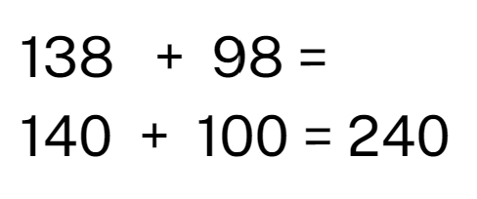
Multi-age: students working towards Stage 2 outcomes could be given problems containing 2-digit numbers and organise them into categories such as less than 100, about 100 and greater than 100.
This table details opportunities for assessment.
Assessment opportunities | Links
What to look for:  - Can Stage 2 students use estimation to check the validity of solutions to addition and subtraction problems? [MAO-WM-01, MA2-AR-01]  - Can Stage 3 students use estimation to check the reasonableness of solutions to addition and subtraction calculations? [MAO-WM-01, MA3-AR-01]  - Can Stage 3 students round numbers appropriately when obtaining estimates to numerical calculations? [MAO-WM-01, MA3-AR-01] | Links to National Numeracy Learning Progressions (NNLP):  - Stage 2 – AdS8  - Stage 3 – NPV6, NPV7, AdS8.

Core lesson: Regrouping addition – 40 minutes
The table below contains suggested learning intentions and success criteria. These are best co-constructed with students.
Core concept learning intentions | Core concept success criteria
Students working towards Stage 2 outcomes are learning to:  - partition, rearrange and regroup numbers to at least 1000 to solve addition problems.  Students working towards Stage 3 outcomes are learning to:  - apply efficient mental and written strategies to solve addition and subtraction problems. | Students working towards Stage 2 outcomes can:  - model addition with and without regrouping and record the method used  - partition numbers of up to 5-digits using non-standard form.  Students working towards Stage 3 outcomes can:  - apply known strategies such as levelling, addition for subtraction, using constant difference, and bridging.
This activity is an adaptation of Create 5000 from NZ Maths by New Zealand Ministry of Education.
- Display the number sentence 281 + 309 = ? and ask students to identify the strategies that can be used to solve this number sentence. Record student suggestions.
- Model using regrouping to solve the number sentence using standard and non-standard partitioning. For example, 281 + 309 is easier to solve by partitioning it into 200 + 300 + 81 + 9 = 500 + 90 = 590.
Multi-age: students working towards Stage 3 outcomes could be given a problem with 3 or more numbers with different numbers of digits.
- Provide pairs or small groups of students with a copy of Resource 1: Create 1000 and each student with a counter and their workbook.
- Each player chooses a number to place their counter on. Students take turns moving their counter to another number by moving along the lines. They then add the new number to their total. In the next move, players cannot go back to where they came from, they must go to a different number. The first player to make it to 1000 or the closest to 1000 is the winner.
- Encourage students to use regrouping when adding numbers. Students record their calculations in their workbook.
This table details opportunities for differentiation.
Too hard? | Too easy?
Students cannot use regrouping to model addition.  - Provide MAB materials to support regrouping.  - Provide a target number that is 2 digits. | Students can use regrouping to model addition.  - Challenge students to reach 5000 in the fewest turns and explain their strategy to a partner.  - Alternate between addition and subtraction. For the first move, students add the numbers, the second move would then subtract, the third move would add, the fourth would subtract. The process continues until a player passes 5000.

Consolidation and meaningful practice – 10 minutes
- Display the problem that in Stage 2 and Stage 3 there are 467 students. There are more girls than boys. Ask how many girls and how many boys there could there be.
Multi-age: students working towards Stage 3 outcomes could be given a problem with a larger number or a multistep problem.
- Students work in pairs to find solutions.
- Share and record student responses, then ask:
- How did you solve the problem?
- What made you decide to do it that way?
- What strategies did you use?
- Is there more than one solution?
This table details opportunities for assessment.
Assessment opportunities | Links
What to look for:  - Can Stage 2 students solve addition problems with and without regrouping and record the method used? [MAO-WM-01, MA2-RN-01, MA2-AR-01]  - Can Stage 2 students partition numbers of up to 5-digits using non-standard form? [MAO-WM-01, MA2-RN-01, MA2-AR-01]  - Can Stage 3 students apply known strategies such as levelling, addition for subtraction, using constant difference, and bridging? [MAO-WM-01, MA3-AR-01] | Links to National Numeracy Learning Progressions (NNLP):  - Stage 2 – AdS7, AdS8  - Stage 3 – AdS7, AdS8.  Links to suggested Interview for Student Reasoning (IfSR) tasks:  - Stage 2 – [IfSR-NP/AT/MT: 3A.1, 3A.2, 3A.4, 3A.5  - Stage 3 – IfSR-AT: 3A.1, 3A.2, 3A.4, 3A.5.

Lesson 2
Core concept: known strategies can be applied to solve problems in different contexts.

Daily number sense: Balance to 100 – 10 minutes
The table below contains suggested learning intentions and success criteria. These are best co-constructed with students.
Daily number sense learning intention | Daily number sense success criteria
Students working towards Stage 2 outcomes are learning to:  - use the principle of equality.  Students working towards Stage 3 outcomes are learning to:  - apply efficient mental and written strategies to solve addition and subtraction problems. | Students working towards Stage 2 outcomes can:  - use the equals sign to mean ‘the same as’ to solve addition and subtraction problems  - apply the associative property of addition to form multiples of 10.  Students working towards Stage 3 outcomes can:  - apply known strategies such as levelling, addition for subtraction, using constant difference, and bridging (Reasons about relations).
This activity is an adaptation of Reach 100 from NRICH by University of Cambridge (Faculty of Mathematics).
- Students draw a square and divide it into quarters. They choose 4 different digits from 1–9 and put them in each box. The aim is to find 4 different digits that give four 2-digit numbers which add/balance to a total of 100 (see Figure 2).
Figure 2 – Balance 100 example
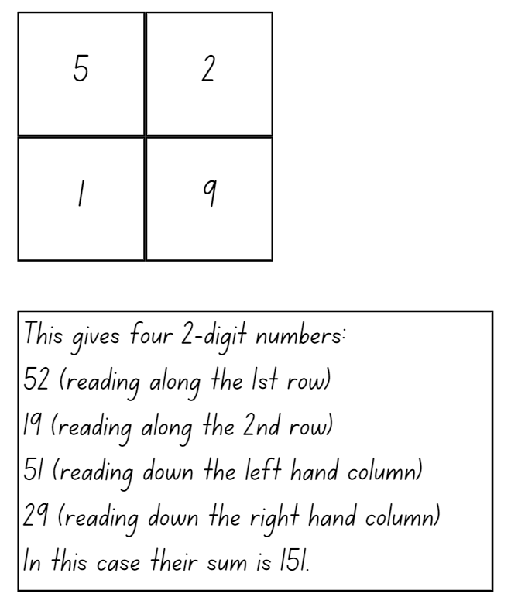
- Explain that the using associative property of addition to form multiples of 10 is a useful strategy. For example, 52 + 19 + 51 + 29 = 51 + 19 + 52 + 29. Explain that using place value understanding flexibly makes it is easier to solve 51 +19 = 70 and then add on 52 + 29.
Associative law: when more than 2 numbers are added or multiplied, the result is unchanged regardless of how they are grouped or associated. For example, 22 + 13 + 8 = 22 +8 + 13 = 30 + 13 = 43.
- In pairs students try to solve the challenge and record all the solutions they can find.
- As a class, discuss the different strategies students used to find balancing equations to 100.
This table details opportunities for assessment.
Assessment opportunities | Links
What to look for:  - Can Stage 2 students use the equals sign to mean ‘the same as’ to solve addition and subtraction problems? [MAO-WM-01, MA2-AR-01]  - Can Stage 2 students apply the associative property of addition to form multiples of 10? [MAO-WM-01, MA2-AR-01]  - Can Stage 3 students apply known strategies such as levelling, addition for subtraction, using constant difference, and bridging? [MAO-WM-01, MA3-AR-01] | Links to National Numeracy Learning Progressions (NNLP):  - Stage 2 – NPA3, NPA7, AdS7  - Stage 3 – AdS7, AdS8.  Links to suggested Interview for Student Reasoning (IfSR) tasks:  - Stage 2 – IfSR-AT: 2A.1, 2A.5  - Stage 3 – IfSR-AT: 3A.4, 3A.5.

Core lesson – 40 minutes

Stage 2: Regrouping subtraction
The table below contains a suggested learning intention and success criteria. These are best co-constructed with students.
Core concept learning intentions | Core concept success criteria
Students working towards Stage 2 outcomes are learning to:  - partition, rearrange and regroup numbers for addition and subtraction. | Students working towards Stage 2 outcomes can:  - model subtraction with and without regrouping and record the method used  - partition numbers of up to 5-digits using non-standard form.
- Display the problem: 653 students were surveyed to ask whether they lived in a house or an apartment. In the responses, 227 students said that they lived in an apartment. Students work out how many live in a house. Ask:
- What number sentence can be used to represent this problem?
- How can regrouping be used to solve this number sentence?
- Model using regrouping to solve the number sentence. Demonstrate to students that the numbers can also be separated using standard and non-standard partitioning. For example, see Figure 3
Figure 3 – Regrouping with non-standard partitioning
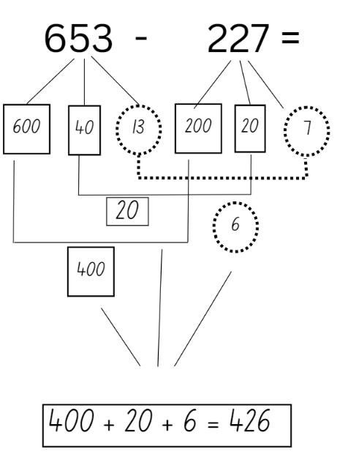
- Provide pairs of students with 10 counters, a calculator, a copy of Resource 2: Take the plunge! And a whiteboard each.
- Introduce the game Take the plunge! Explain that the aim of the game is to move from one yellow donut to the one on the other side of the pool. One player begins on the left-hand side of the gameboard and the other starts on the right-hand side of the gameboard. Players choose the path they take and can move in any direction.
- Players take turns moving one donut at a time. They solve the number sentence on their whiteboard. Encourage students to use regrouping to solve the subtraction question. The other player uses the calculator to check their partner’s answer. If the answer is correct, the player places one of their counters on the number sentence and this donut is out of play.
- Players continue taking turns. The first player to reach the yellow donut on the other side is the winner.
This table details opportunities for differentiation.
Too hard? | Too easy?
Stage 2 students cannot use regrouping to model subtraction.  - Provide students with Resource 3: Take a plunge! Using smaller numbers.  - Provide students with concrete materials, such as MAB blocks, to model the number sentence. | Stage 2 students can regrouping to model subtraction.  - Students create their own game in pairs with additional rules to challenge others.  - Include word problems to challenge students for additional points.
This table details opportunities for assessment.
Assessment opportunities | Links
What to look for:  - Can Stage 2 students use regrouping to solve subtraction problems? [MAO-WM-01, MA2-RN-01, MA2-AR-01, MA2-AR-02] | Links to National Numeracy Learning Progressions (NNLP):  - Stage 2 – AdS8.  Links to suggested Interview for Student Reasoning (IfSR) tasks:  - Stage 2 – [IfSR-NP/AT/MT: 3A.2.

Stage 3: Multi-step problems
The table below contains suggested learning intentions and success criteria. These are best co-constructed with students.
Core concept learning intentions | Core concept success criteria
Students working towards Stage 3 outcomes are learning to:  - choose and use efficient strategies to solve addition and subtraction problems  - apply known strategies to add and subtract decimals. | Students working towards Stage 3 outcomes can:  - solve multi-step word problems requiring more than one operation  - use place value to add or subtract 3 or more numbers with different numbers of digits  - solve word problems involving the addition and subtraction of decimals up to 3 decimal places  - compare, evaluate and communicate strategies used to solve problems.
- Display Resource 4: Swift concert.
- In pairs, students solve the multi-step word problems, recording their solutions.
- Ask students:
- What steps did you take to solve the problem?
- What made you decide to do it that way?
- What challenges did you encounter during the process and how did you overcome them?
- Does the most efficient strategy change depending on the question? Explain your thinking.
- Did you receive any feedback from your partner? How did you use it to improve your performance?
- How would you approach this task If you did not have any paper or writing material?
- Display Resource 5: VIP tickets and ask:
- Which package is best value for money? Explain your thinking.
- What is the value of the extra items given per VIP package?
- Would you consider a VIP ticket? Why or why not?
- Discuss and record the different strategies.
This table details opportunities for differentiation.
Too hard? | Too easy?
Stage 3 students cannot solve multi-step word problems requiring more than one operation.  - Students solve single step problems.  - Provide students with smaller numbers to solve. | Stage 3 students can solve multi-step word problems requiring more than one operation.  - Challenge question 1: Ask how many people attended the concert altogether if there were 4 sold out shows.  - Challenge question 2: Aarna wanted to buy tickets for some of her friends. She also wanted to purchase a t-shirt for each of her friends for $27.35 She had $2000 to spend. Ask how many friends she could bring, what combinations of tickets could she buy and if she would have any money left over.
This table details opportunities for assessment.
Assessment opportunities | Links
What to look for:  - Can Stage 3 students solve multi-step word problems requiring more than one operation? [WAO-WM-01, MA3-RN-01, MA3-AR-01]  - Can Stage 3 students place value to add or subtract 3 or more numbers with different numbers of digits? [WAO-WM-01, MA3-AR-01]  - Can Stage 3 students compare, evaluate and communicate strategies used to solve problems? [WAO-WM-01, MA3-AR-01] | Links to National Numeracy Learning Progressions (NNLP):  - Stage 3 – AdS7, AdS8.  Links to suggested Interview for Student Reasoning (IfSR) tasks:  - Stage 3 – IfSR-AT: 3A.5.

Consolidation and meaningful practice – 15 minutes
This activity is an adaptation of Problems to solve by NZ Maths by New Zealand Ministry of Education.
- Explain that you want to use a calculator to check the answer to a problem, such as 164 – 45 or 1164 + 845, but the 4 and 6 buttons aren’t working. Ask students to suggest several ways that the calculator could still be used.
- Before completing the question, ask:
- How might you approach this task?
- How can partitioning this number in non-standard form help in finding a solution?
- Is there more than one way to solve this problem?
- Why is it important to use a calculator to check your answer?

Lesson 3
Core concept: place value understanding helps solve addition and subtraction problems.

Daily number sense: Equal differences – 10 minutes
The table below contains suggested learning intentions and success criteria. These are best co-constructed with students.
Daily number sense learning intention | Daily number sense success criteria
Students working towards Stage 2 outcomes are learning to:  - use the principle of equality.  Students working towards Stage 3 outcomes are learning to:  - apply efficient mental and written strategies to solve addition and subtraction problems. | Students working towards Stage 2 outcomes can:  - recognise equal differences and record them in number sentences.  Students working towards Stage 3 outcomes can:  - apply known strategies such as levelling, addition for subtraction, using constant difference, and bridging (Reasons about relations).

- Display subtraction equations where one number is missing, such as:
- _ – 3 = 72 – 7
- 63 – 13 = _ – 16
- 39 – 15 = 48 – _
- 72 – _ = 67 – 12
- 85 – _ = 45 – 23
- _ – 21 = 52 – 32
- 76 – 17 = _ – 23
- In pairs, students solve and record the subtraction number sentences in their workbook to support their understanding of the solution.
- Select students to share their thinking.
- Discuss student learning, asking questions such as:
- What does it mean for the differences to be equal?
- What strategies did you use to solve the problems?
- Did you use any visual support to find the answers?
- What strategies did you learn from your partner that you can use next time?
- Did you use addition to help solve any of the number sentences?
- Did you have any challenges while solving the problems? How did you resolve them?
Multi-age: students working towards Stage 3 outcomes could be given equations with larger numbers.
This table details opportunities for assessment.
Assessment opportunities | Links
What to look for:  - Can Stage 2 students recognise equal differences and record them in number sentences? [MAO-WM-01, MA2-AR-01, MA2-AR-02]  - Can Stage 3 students apply known strategies such as levelling, addition for subtraction, using constant difference, and bridging (Reasons about relations)? [MAO-WM-01, MA3-AR-01] | Links to National Numeracy Learning Progressions (NNLP):  - Stage 2 – AdS7  - Stage 3 – AdS7, AdS8.  Links to suggested Interview for Student Reasoning (IfSR) tasks:  - Stage 2 – IfSR-AT: 2A.5  - Stage 3 – IfSR-AT: 2A.5, 3A.1.

Core lesson – 40 minutes

Stage 2: Grocery shopping
The table below contains a suggested learning intention and success criteria. These are best co-constructed with students.
Core concept learning intentions | Core concept success criteria
Students working towards Stage 2 outcomes are learning to:  - partition, rearrange and regroup numbers for addition and subtraction problems. | Students working towards Stage 2 outcomes can:  - identify the place value of numbers  - use non-standard partitioning to solve addition and subtraction problems.
This activity is an adaptation of Problems to solve by NZ Maths by New Zealand Ministry of Education.
- Display Resource 6: Grocery shopping and ask how many combinations of these groceries could be put in a bag if you can only carry 1000 grams.
- In pairs, students find different combinations of items that could add to a total weight of 1000 grams. Encourage students to use their knowledge of non-standard partitioning to find different combinations.
- Students experiment with different combinations, recording their responses.
- Regroup students and ask:
- What different combinations did you find?
- What was the closest combination of items you found to 1000 g?
- Model how non-standard partitioning can be used to solve different combinations. For example, finding the total weight of 196 g ham and a 23 g tea bag. 196 can be partitioned into 190 + 6 and 23 can be partitioned into 10 + 10 + 3. 190 + 10 + 10 = 210, then 210 + 6 + 3 = 219.
- Using the same shopping list, tell students they now need to work with their partner to see what combination of groceries they can find that weighs closest to 1000 g carrying the least number of items.
- Regroup students and share different solutions.
- Tell students that the bag is too heavy at 1000 g. Ask them what can be removed to make the bag under 500 g. Students work with their partner to find possible combinations of groceries that can be removed.
- Select students to share their thinking.
- Discuss the task, asking questions such as:
- Were there any challenges when finding different combinations?
- Were some tasks easier than others? Why?
- What strategies did you find most efficient? Why?
- If Joey brought home 3 items in a paper bag and the weight totalled over 200 g, what items might he have in the bag?
This table details opportunities for differentiation.
Too hard? | Too easy?
Stage 2 students cannot use place value to solve addition and subtraction questions.  - Provide students with concrete materials such as MAB materials to model solving the problem.  - Alter the task so students work to find combinations of groceries to put in a bag with a weight limit of 500 g. | Stage 2 students can use place value to solve addition and subtraction questions.  - Provide students with the additional problems. For example, someone wants to take home all the groceries available in the list, so they brought a second bag to the shop to help carry them. Ask how students could fit all the items in the bags, if each bag has a weight limit of 1000 g.  - Explain that you want the bags to be as even in weight as possible. Ask what combination of groceries you could put in the 2 bags to make their weight as close as possible.
This table details opportunities for assessment.
Assessment opportunities | Links
What to look for:  - Can Stage 2 students partition, rearrange and regroup numbers to at least 1000 to solve additive problems? [MAO-WM-01, MA2-AR-01] | Links to National Numeracy Learning Progressions (NNLP):  - Stage 2 – NPV5, NPV6, AdS7.  Links to suggested Interview for Student Reasoning (IfSR) tasks:  - Stage 2 – IfSR-AT: 3A.3, 3B.2, 3B.4.

Stage 3: Adding decimals
The table below contains a suggested learning intention and success criteria. These are best co-constructed with students.
Core concept learning intentions | Core concept success criteria
Students working towards Stage 3 outcomes are learning to:  - apply known strategies to add decimals. | Students working towards Stage 3 outcomes can:  - solve word problems involving addition of decimals up to 3 decimal places  - justify why the strategies used are appropriate.
- Display and discuss misconceptions around reading decimals. For example, reading 5.07 as:
- 507
- 5 and 7 hundredths
- 5 and 7 tenths
- 5 and 7.
- Ask students to turn and talk and discuss which is correct and how they know.
- Share student ideas and clarify any misconceptions.
- Display Resource 7: Long jump and provide students with a whiteboard.
- Explain that the table shows the recorded lengths of children who jumped in long jump at 3 different athletics carnivals. In pairs, ask students to calculate the combined distance that Xavier jumped in carnival A and carnival B and justify their answers to the following questions:
- What was the combined distance Xavier jumped in carnival A and carnival B?
- What strategies did you use to calculate this? Was your strategy efficient?
- What did you notice when adding the decimals together?
- In pairs, students continue to answer questions about Resource 7: Long jump:
- What is the combined distance that Stacey jumped at all 3 carnivals?
- Whose combined distance at all 3 carnivals was greater between Xavier and Ishaan?
- Overall, in which carnival did the team perform best?
- Which athlete had the best combined jump overall?
- If you added together 3 athletes’ scores from carnival C and the combined distance was greater than 12 m, whose distances could you have added?
Note: school athletics carnival data can be used or class data from an activity, for example, throwing a bean bag.
This table details opportunities for differentiation.
Too hard? | Too easy?
Stage 3 students cannot solve word problems involving adding decimals up to 3 decimal places.  - Provide alternate questions:  - What is the combined distance that Maria jumped at carnival B and carnival C?  - Whose combined distance at carnival A and carnival B was greater, Stuart’s or Stacey’s?  - If you added 2 athletes’ scores from carnival C and the combined distance was greater than 8 m, whose scores could you have added?  - Modify decimals so they only have one decimal place. | Stage 3 students can solve word problems involving adding decimals up to 3 decimal places.  - Provide alternative questions:  - What was the difference between the teams’ overall score at their highest performing carnival and their lowest performing carnival?  - Who had the largest difference between their longest jump and shortest jump?  - If you added together 3 athletes’ scores from carnival A and carnival B and the combined distance was greater than 24 m, whose scores could you have added?  - Modify decimals so they have different place value.
This table details opportunities for assessment.
Assessment opportunities | Links
What to look for:  - Can Stage 3 students solve word problems involving addition of decimals up to 3 decimal places? [MAO-WM-01, MA3-RN-02, MA3-AR-01]  - Can Stage 3 students justify why the strategies used are appropriate? [MAO-WM-01, MA3-RN-02, MA3-AR-01] | Links to National Numeracy Learning Progressions (NNLP):  - Stage 3 – AdS9.  Links to suggested Interview for Student Reasoning (IfSR) tasks:  - Stage 3 – IfSR-AT: 4A.1, 4A.2.

Discuss and connect the mathematics – 10 minutes
- Discuss student learning, asking questions such as:
- What strategies did you use when solving these questions?
- What was the most efficient strategy used?
- Did you find any inefficient strategies? Explain your thinking.
- How do you know you calculated the correct answer? How can you check?

Lesson 4
Core concept: addition can help solve subtraction problems.

Daily number sense: Teacher choice – 10 minutes
- From a class need surfaced through formative assessment data, identify a short, focused activity that targets students’ knowledge, understanding and skills. Example activities may be drawn from the following resources:
- Mathematics K-6 resources
- Universal Resources Hub.

Core lesson: Inverse operations – 40 minutes
The table below contains suggested learning intentions and success criteria. These are best co-constructed with students.
Core concept learning intentions | Core concept success criteria
Students working towards Stage 2 outcomes are learning to:  - recognise and explain the connection between addition and subtraction.  Students working towards Stage 3 outcomes are learning to:  - choose and use efficient strategies to solve addition and subtraction problems. | Students working towards Stage 2 outcomes can:  - use inverse operations to solve problems  - explain and check solutions to problems, including by using the inverse operation.  Students working towards Stage 3 outcomes can:  - compare, evaluate and communicate strategies used to solve addition and subtraction problems.
This activity is an adaptation of Maths games [PDF 529KB] and Maths explorer [PDF 530KB] from APSMO and Open-Ended Maths Activities by Sullivan and Lilburn.
- Display an addition problem and represent it using the tape model, for example see Figure 4.
Figure 4 – Tape model example
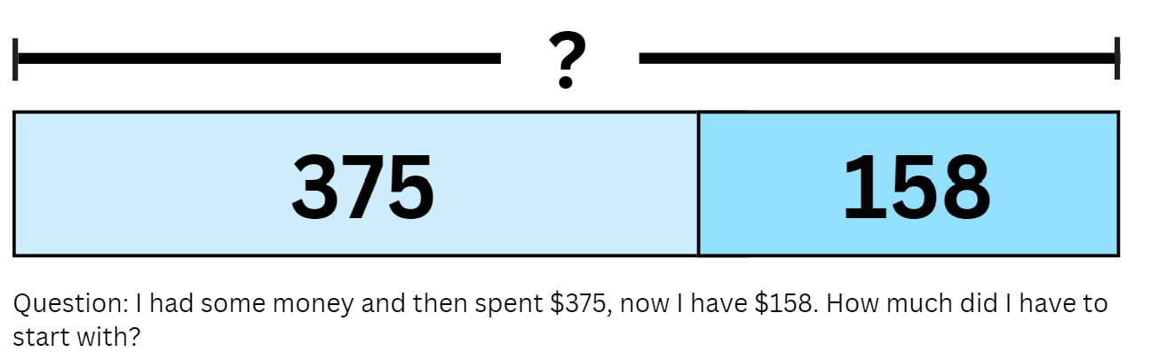
- In pairs, students solve the problem.
- Regroup students and ask:
- What was the question asking?
- What is the number sentence you used to represent the problem?
- What strategies did you use to solve the problem?
- How did the tape model help you solve the problem?
- Is there another way you could solve this problem? Is it more efficient? Why or why not?
- Highlight inverse operations and model how the number sentence can be written in different ways. Discuss the connection between addition and subtraction. Explain that students can also use this relationship to check our answers to problems. For example, see Figure 5.
Figure 5 – Inverse equations example
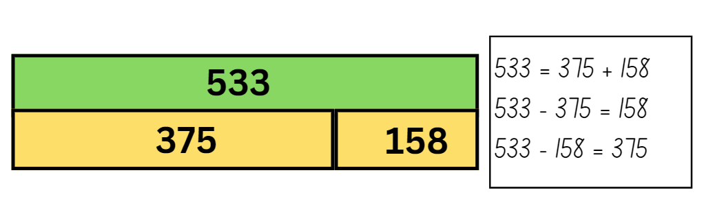
- Display Resource 8: Tape model problems. Provide students with their workbooks.
- Students work in pairs to solve the problems. Encourage students to create a model, such as the bar or tape model, to help them solve the problems and use the inverse relationship to check their solution. All working out should be recorded in their workbooks.
- Select students to share their thinking.
Multi-age: students working towards Stage 3 outcomes could be given problems with larger numbers or decimals.
This table details opportunities for differentiation.
Too hard? | Too easy?
Students cannot use inverse operations to solve addition and subtraction.  - Provide students with MAB materials to model solutions.  - Provide students with models, such as a bar or tape model, to help visualise the problem. | Students can use inverse operations to solve addition and subtraction.  - Students create their own word problems to share with peers.  - Create bar models with missing quantities for peers to solve or create a problem.

Consolidation and meaningful practice – 15 minutes
This activity is an adaptation of ‘Additive word problems’ from Challenging mathematical tasks by Sullivan.
- Regroup students and display the word problem: In a garden there are tomatoes, cucumber and capsicum plants. Explain that there are 487 plants in total and 143 of them are tomato plants. Ask how many cucumber and capsicum plants there could be.
- Students record their solutions on individual whiteboards and ask:
- Would you use addition or subtraction to solve this number sentence? Why?
- How did you use addition to solve this number sentence? Was this strategy efficient?
- How did you use addition to solve this number sentence? Was this strategy efficient?
- How can you use addition or subtraction to check your answers?
- Is there more than one solution?
- Is there a more efficient strategy you could use?
This table details opportunities for assessment.
Assessment opportunities | Links
What to look for:  - Can Stage 2 students use inverse operations to solve problems? [MAO-WM-01, MA2-AR-01]  - Can Stage 2 students check the solution of their problem using the inverse operation? [MAO-WM-01, MA2-AR-01]  - Can Stage 3 students compare, evaluate and communicate strategies used to solve addition and subtraction problems? [MAO-WM-01, MA3-AR-01] | Links to National Numeracy Learning Progressions (NNLP):  - Stage 2 – AdS7  - Stage 3 – AdS7, AdS8.  Links to suggested Interview for Student Reasoning (IfSR) tasks:  - Stage 2 – IfSR-AT: 2A.5  - Stage 3 – IfSR-AT: 3A.1, 3A.3.

Lesson 5
Core concept: number lines help solve addition and subtraction problems.

Daily number sense: Target number – 10 minutes
Daily number sense activities for Lessons 5 to 7 ‘loop’ back to concepts and procedures covered in previous units to assist students to build an increasingly connected network of ideas. These concepts may differ from the core concepts being covered by the unit.
The table below contains suggested learning intentions and success criteria. These are best co-constructed with students.
Daily number sense learning intention | Daily number sense success criteria
Students working towards Stage 2 outcomes are learning to:  - use known number facts and strategies.  Students working towards Stage 3 outcomes are learning to:  - determine products and factors. | Students working towards Stage 2 outcomes can:  - use known facts to find unknown multiples.  Students working towards Stage 3 outcomes can:  - use the term ‘product’ to describe the result of multiplying 2 or more numbers.
This activity is an adaptation of ‘Target number’ from Part 3: Flexible strategies with multi-digit numbers [PDF 3.0MB] by State of New South Wales (Department of Education).
- Provide pairs of students playing cards Ace to 9 and Resource 9: Recording sheet.
- One student deals out 5 cards to each player and determines the target number. Using their 5 cards, students form any one-, 2-, or 3-digit number. Players find the product of 2 or more numbers, using addition and subtraction if needed, to get as close to the target number as possible. The total of each equation is then used for the next equation. Each card can only be used once and not all cards need to be used. For example, see Figure 6.
- Encourage students to use multiple operations and to find multiple solutions, using strategies such as:
- known facts to solve unknown problems
- doubles
- commutative property
- inverse operations.
Figure 6 – Target number example
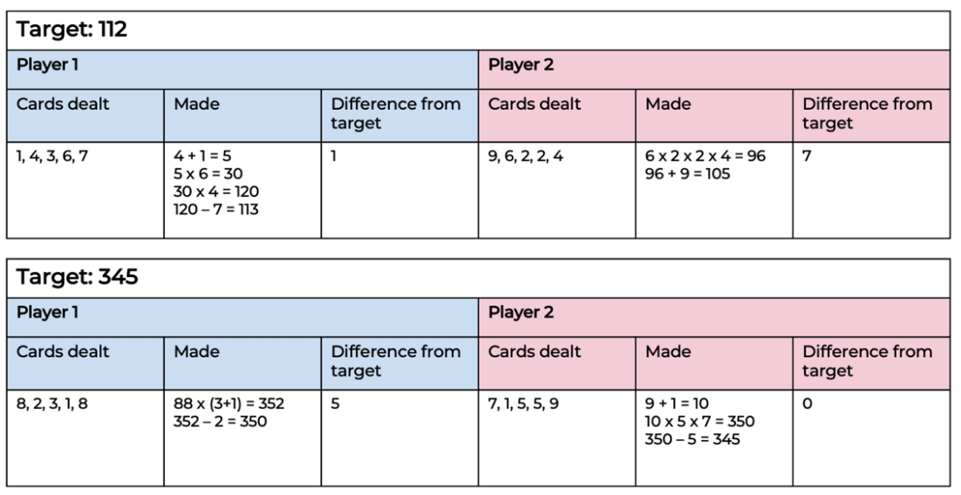
- Discuss student learning, asking questions such as:
- What strategies did you use?
- How did you know that your answer was correct?
- What could you change to get closer to the target?
Multi-age: students working towards Stage 2 outcomes could be given a multiplication chart and encouraged to focus on addition, subtraction and multiplication.

This table details opportunities for assessment.
Assessment opportunities | Links
What to look for:  - Can Stage 2 students use known facts to find unknown multiples? [MAO-WM-01, MA2-MR-01]  - Can Stage 3 students use the term ‘product’ to describe the result of multiplying 2 or more numbers?? [MAO-WM-01, MA3-MR-01] | Links to National Numeracy Learning Progressions (NNLP):  - Stage 2 – MuS6  - Stage 3 – MuS6.

Core lesson: Number lines solve problems – 50 minutes
The table below contains suggested learning intentions and success criteria. These are best co-constructed with students.
Core concept learning intentions | Core concept success criteria
Students working towards Stage 2 outcomes are learning to:  - select strategies flexibly to solve addition and subtraction problems of up to 3 digits  - apply addition and subtraction to familiar contexts, including money and budgeting.  Students working towards Stage 3 outcomes are learning to:  - choose and use efficient strategies to solve addition and subtraction problems. | Students working towards Stage 2 outcomes can:  - represent solutions to addition and subtraction problems, including word problems, using an empty number line  - interpret problems involving money as requiring either addition or subtraction.  Students working towards Stage 3 outcomes can:  - partition numbers in standard and non-standard forms  - use a number line to solve addition and subtraction problems  - evaluate and communicate strategies used to solve problems.
- Display Resource 10: Holiday time (Stage 3) and Resource 11: Holiday time (Stage 2) and tell students they will be creating their dream holiday package. Stage 3 students can use the first table of values and Stage 2 can use the second table of values They need to factor in accommodation, food, transport and activities.
- Explain that Stage 3 students have a budget of $10 000 and Stage 2 students have a budget of $1000. Highlight that they need to decide what their priority for the holiday is and where they would like to spend their money.
- Encourage students to use a number line to add costs together. Model how a number line can be used.
- Provide students with their workbook. Students calculate the cost of their dream trip and record the items they have selected in their workbook.
- Regroup students and ask:
- What did you plan for your trip?
- How did using a number line help you solve addition and subtraction?
- Do you think using a number line is an efficient strategy? Why?
- Tell Stage 3 students the budget for their trip has now been reduced to $5394. Tell Stage 2 students the budget for their trip has now been reduced to $694. Students take away or alter their trip to suit the new budget.
- Regroup students and ask:
- How did you alter the trip to suit the new budget?
- What was helpful about using a number line?
- What was challenging about using a number line?
- What is your preferred addition or subtraction strategy? Why?
This table details opportunities for differentiation.
Too hard? | Too easy?
Students cannot use a number line to solve addition and subtraction problems.  - Provide students with smaller numbers for costs and a blank number line.  - Provide students with a smaller budget. | Students can use a number line to solve addition and subtraction problems.  - Students work in groups to create 2 trips that can be advertised at a local travel agent. Design one for a budget traveller who likes adventure sports with a budget of $3000. Design the other for a luxury traveller who enjoys high end experiences with a budget of $12 000.  - Provide students with airfares and discuss how this could impact their desired trip.

This table details opportunities for assessment.
Assessment opportunities | Links
What to look for:  - Can Stage 2 students represent solutions to addition and subtraction problems, including word problems, using an empty number line? [MAO-WM-01, MA2-AR-01]  - Can Stage 2 students interpret problems involving money as requiring either addition or subtraction? [MAO-WM-01, MA2-AR-01]  - Can Stage 3 students use a number line to solve addition and subtraction problems? [MAO-WM-01, MA3-AR-01]  - Can Stage 3 students evaluate and communicate strategies used to solve problems? [MAO-WM-01, MA3-AR-01] | Links to National Numeracy Learning Progressions (NNLP):  - Stage 2 – AdS7, AdS8  - Stage 3 – AdS7, AdS8.

Consolidation and meaningful practice – 10 minutes
- Display the problem 2_6 + 8 = _2_
- Explain that students need to fill in the missing numbers to make the equation true.
- Students work in pairs to find all possible solutions. There are 9 possible answers; 10 if you allow students to use a zero before the 8.

- Regroup students and ask:
- How many solutions did you find?
- Did you find all the solutions? How do you know?
- How did you approach the problem?
- What strategies did you use? What made you decide to do it that way?
- Would you approach the problem differently next time?
- Is there a strategy used that you have not heard of?

Lesson 6
Core concept: place value understanding can be used to estimate and check for errors.

Daily number sense: Gridlock – 15 minutes
The table below contains suggested learning intentions and success criteria. These are best co-constructed with students.
Daily number sense learning intention | Daily number sense success criteria
Students working towards Stage 2 outcomes are learning to:  - use the structure of the area model to represent multiplication and division.  Students working towards Stage 3 outcomes are learning to:  - determine products and factors. | Students working towards Stage 2 outcomes can:  - create and represent multiplicative structure including arrays and the area model.  Students working towards Stage 3 outcomes can:  - model different ways to show a whole number as a product.
This activity is an adaptation from Maths Games with Bad Drawings by Orlin.
- Provide pairs of students with two 6-sided dice and grid paper. The aim of the game is to fill as much of the grid as possible before the game is over.
- Each player rolls the 2 dice and uses the results to make a rectangle for example, if a student rolls a 4 and a 5, they must shade in a 4 by 5 rectangle anywhere on their grid. Players can shade a different way to show a whole number as a product, for example, 4 by 5 is 20, which can be represented by 2 by 10 or one by 20 on the grid. If the rectangle does not fit on the board, the player loses a turn. When both players lose their turn one after the other, the game ends and whoever has more squares on their grid is the winner.
- If they wish, each player can play one rectangle on their opponent’s board instead of their own (see Figure 7).
Figure 7 – Gridlock example
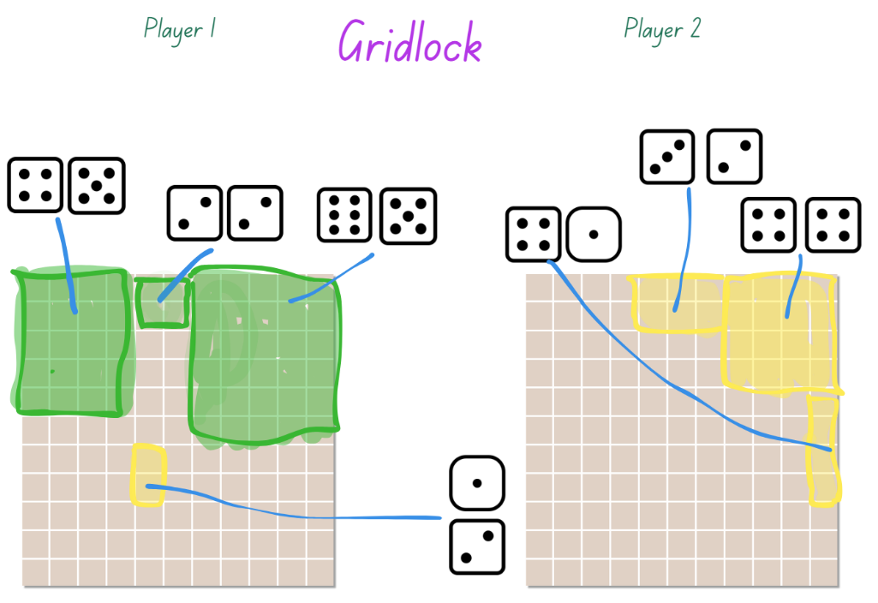
- At the conclusion of the game, ask questions such as:
- What strategy did you use to try to win the game?
- Can you think of a move that you could have represented differently? What impact might it have had on the game?
- Can you think of a way to make the game easier or harder?
Multi-age: students working towards Stage 2 outcomes may require support such as modelling or counters to demonstrate moving from arrays to the area model to represent multiplication.
This table details opportunities for assessment.
Assessment opportunities | Links
What to look for:  - Can Stage 2 students create and represent multiplicative structure including arrays and the area model? [MAO-WM-01, MA2-MR-01]  - Can Stage 3 students model different ways to show a whole number as a product? [MAO-WM-01, MA3-MR-01] | Links to National Numeracy Learning Progressions (NNLP):  - Stage 2 – MuS5, MuS6  - Stage 3 – MuS5, MuS6.  Links to suggested Interview for Student Reasoning (IfSR) tasks:  - Stage 2 – IfSR-MT: 2A3  - Stage 3 – IfSR-MT: 2A.3.

Core lesson – 40 minutes

Stage 2: Addition algorithms
The table below contains a suggested learning intention and success criteria. These are best co-constructed with students.
Core concept learning intentions | Core concept success criteria
Students working towards Stage 2 outcomes are learning to:  - partition, rearrange and regroup numbers to at least 1000 to solve additive problems. | Students working towards Stage 2 outcomes can:  - recognise the number of tens, hundreds or thousands in a number  - use an algorithm to record addition calculations  - calculate missing numbers by completing number sentences involving addition.
This activity is an adaptation of Equivalent number sentences from Universal Resources Hub by State of New South Wales (Department of Education).
- Display the number sentence 286 + 437 and ask students to identify strategies they can use to solve the problem. Record and display responses.
- Model setting up an algorithm for the equation 286 + 437. Demonstrate that the numbers in the equation are lined up according to place value. Explain that if the numbers are not correctly aligned it will significantly change the answer. Model solving the algorithm alongside the use of MAB materials (see Figure 8).
Figure 8 – Addition algorithm example
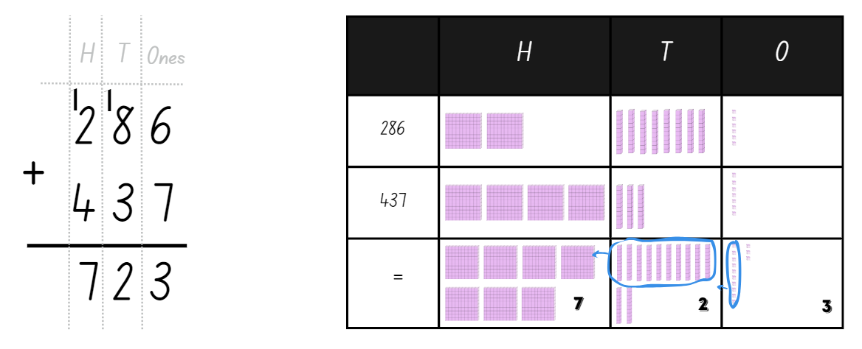
- Explain that the exchange across each of the place value columns is recorded as a one at the top of the column. Students need to add this one when adding the numbers in that place value column.
- Introduce the game ‘True or False’. Students look at number sentences and decide if they are true or false, using an algorithm to check.
- Display the number sentence 356 + 475 = 284 + 647. Ask students to share their responses (number sentence is incorrect).
- Highlight that the equals sign represents equivalence. This means that the total of the left-hand side of the number sentence is equal to the total of the right-hand side of the number sentence.
- Model setting up and solving an algorithm for 356 + 475 =. Then, model setting up and solving an algorithm for 284 + 647. Students identify if the number sentence is true or false (see Figure 9).
Figure 9 – True or false example
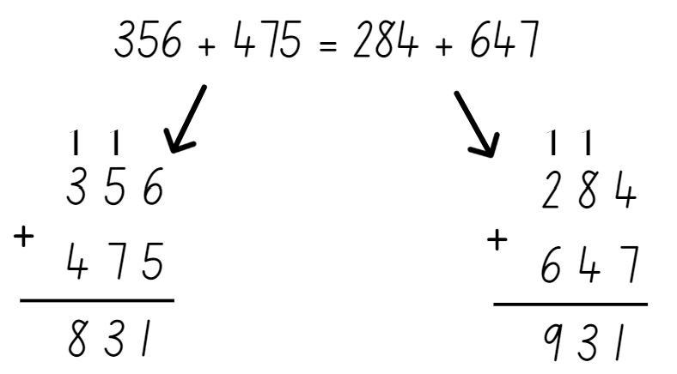
- Provide questions such as:
- 157 +233 = 252 + 138
- 364 + 433 = 336 + 451
- 549 + 641 = 462 + 717
- 667 + 188 = 428 + 438
- 401 + 632 = 448 + 585
- 480 + 365 = 657 + 188
- Students use algorithms to check if each number sentence is true or false.
This table details opportunities for differentiation.
Too hard? | Too easy?
Stage 2 students cannot use an algorithm to solve addition calculations.  - Provide students with number sentences that require 2-digit calculations.  - Provide students with MAB materials. | Stage 2 students can use an algorithm to solve addition calculations.  - Provide students with number sentences that require 4-digit calculations.  - Ask students to balance each false number sentence by adding another value to one side so they become equivalent.
This table details opportunities for assessment.
Assessment opportunities | Links
What to look for:  - Can Stage 2 students recognise the number of tens, hundreds or thousands in a number?? [MAO-WM-01, MA2-RN-01]  - Can Stage 2 students use an algorithm to record addition calculations? [MAO-WM-01, MA2-AR-01, MA2-AR-02]  - Can Stage 2 students calculate missing numbers by completing number sentences involving addition? [MAO-WM-01, MA2-AR-02] | Links to National Numeracy Learning Progressions (NNLP):  - Stage 2 – NPV7, AdS8, NPA3, NPA4.  Links to suggested Interview for Student Reasoning (IfSR) tasks:  - Stage 2 – IfSR-AT: 3A.2.

Stage 3: Adding and subtracting decimals
The table below contains a suggested learning intention and success criteria. These are best co-constructed with students.
Core concept learning intentions | Core concept success criteria
Students working towards Stage 3 outcomes are learning to:  - use estimation and place value understanding to determine the reasonableness of solutions. | Students working towards Stage 3 outcomes can:  - round numbers appropriately when obtaining estimates  - use place value understanding to check for errors in calculations  - use estimation to check the reasonableness of solutions.
This activity is an adaptation of Adding and Subtracting Decimals from Universal Resources Hub by State of New South Wales (Department of Education).
- Provide students with an individual whiteboard and explain the following problem. Sarah’s carry-on luggage can only be a maximum of 7 kg. Sarah wants to quickly work out if she can add any more items into the luggage. Below is a list of the items she has in her bag and what they weigh:
- clothes 3.85 kg
- shoes 1.70 kg
- toiletries 1.42 kg
- Ask students to use rounding to estimate the current weight of Sarah’s bag and ask:
- What solution did you calculate? (3.85 + 1.70 + 1.42 approximately equals 4 + 2 + 1 = 7 kg)
- How did you use estimating?
- Can she add any more items?
- Why is estimating useful?
- Ask students to calculate the exact weight of Sarah’s bag and ask:
- What solution did you calculate?
- How accurate was your estimate?
- Could Sarah’s rounding potentially create any problems in terms of the weight of her luggage?
- Provide students with their workbooks, display Resource 12: Problems and have students select 3 problems to solve.
This table details opportunities for differentiation.
Too hard? | Too easy?
Stage 3 students cannot round numbers appropriately when obtaining estimates.  - Provide students with numbers with only one decimal place to estimate, add and subtract.  - Provide students with number lines to help support problem solving. | Stage 3 students can round numbers appropriately when obtaining estimates.  - Students solve problems using a second strategy to confirm their answer and provide the inverse operation to prove their answer.  - Students create their own word problems involving addition and subtraction of decimals and swap with a partner to solve.
This table details opportunities for assessment.
Assessment opportunities | Links
What to look for:  - Can Stage 3 students round numbers appropriately when obtaining estimates? [MAO-WM-01, MA3-RN-02, MA3-AR-01]  - Can Stage 3 students use estimation to check the reasonableness of solutions? [MAO-WM-01, MA3-RN-02, MA3-AR-01] | Links to National Numeracy Learning Progressions (NNLP):  - Stage 3 – NPV6, NPV7, AdS8.

Discuss and connect the mathematics – 15 minutes
- As a class, select students to share their thinking.

Lesson 7
Core concept: mathematicians solve problems using more than one operation.

Daily number sense: Partitioning – 10 minutes
The table below contains suggested learning intentions and success criteria. These are best co-constructed with students.
Daily number sense learning intention | Daily number sense success criteria
Students working towards Stage 2 outcomes are learning to:  - apply place value to partition and regroup numbers.  Students working towards Stage 3 outcomes are learning to:  - apply place value to partition, regroup and rename numbers to 1 billion. | Students working towards Stage 2 outcomes can:  - record numbers using standard place value form  - partition numbers using non-standard place value form.  Students working towards Stage 3 outcomes can:  - regroup numbers in different forms  - partition numbers to one billion in non-standard forms.
- In pairs students shuffle numeral cards numbered 0–9 and place them face down in a stack.
- Each player takes turns drawing 4 cards from the stack to form a 4-digit number.
- Each player records the 4-digit number formed, the standard place value form and a non-standard place value representation (see Figure 10).
Figure 10 – Student sample
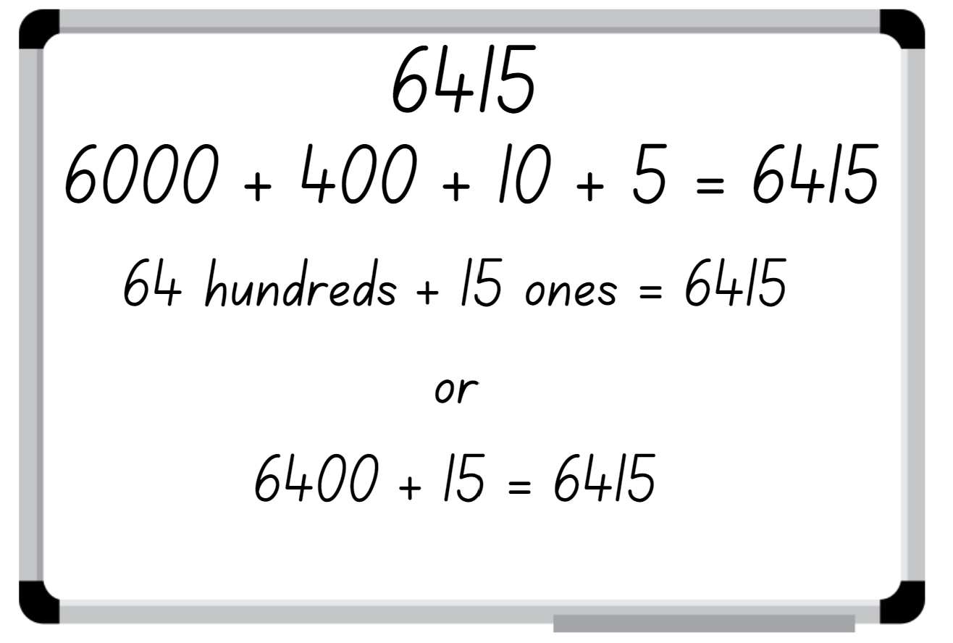
- Each player swaps their whiteboard and checks their peer’s standard and non-standard representations.
Note: number expanders can assist students to understand place value and renaming numbers into non-standard forms.
- If the representation is correct, the student gets a point.
- Player 2 selects 4 cards to form a new 4-digit number and repeats the process.
- Repeat the process for 5 rounds.
- Regroup and ask students to identify the strategies they used and to justify their answers when identifying the place value in non-standard form.
Multi-age: students working towards Stage 3 outcomes may draw 5 or 6 cards to create 5- or 6-digit numbers.
This table details opportunities for assessment.
Assessment opportunities | Links
What to look for:  - Can Stage 2 students record numbers using standard place value form? [MAO-WM-01, MA2-RN-01]  - Can Stage 2 students partition numbers using non-standard place value form? [MAO-WM-01, MA2-RN-01]  - Can Stage 3 students regroup numbers in different forms? [MAO-WM-01, MA3-RN-01]  - Can Stage 3 students partition numbers to 1 billion in non-standard forms? [MAO-WM-01, MA3-RN-01] | Links to National Numeracy Learning Progressions (NNLP):  - Stage 2 – NPV4, NPV5, NPV6  - Stage 3 – NPV6.  Links to suggested Interview for Student Reasoning (IfSR) tasks:  - Stage 2 – IfSR-AT: 3B.2, 3B.4.

Core lesson – 45 minutes

Stage 2 task: Subtraction algorithms
The table below contains a suggested learning intention and success criteria. These are best co-constructed with students.
Core concept learning intentions | Core concept success criteria
Students are learning to:  - partition, rearrange and regroup numbers to solve subtraction problems. | Students can:  - use an algorithm to solve unknown numbers of addition and subtraction problems  - recognise how hundreds are exchanged in subtraction algorithms requiring regrouping  - recognise when mental strategies would be more efficient than a vertical algorithm for subtraction.
- Display the equation 528 – 43 on the board and ask students to identify strategies that can be used to solve the problem. Record student responses on the board.
- Model setting up an algorithm for the equation 528 – 43. Explain that, when a vertical algorithm is used for subtraction, students may need to exchange and regroup across the place value columns to solve the equation.
Note: solving a subtraction algorithm requires ‘trading units,’ which involves partitioning and regrouping. To subtract 43 from 528 using an algorithm, the 528 is thought of as being decomposed into 5 hundreds, 2 tens and 8 ones. Then one hundred is traded for 10 tens so that 528 is represented as 4 hundreds, 12 tens and 8 ones (see Figure 11).
Figure 11 – Subtraction algorithm
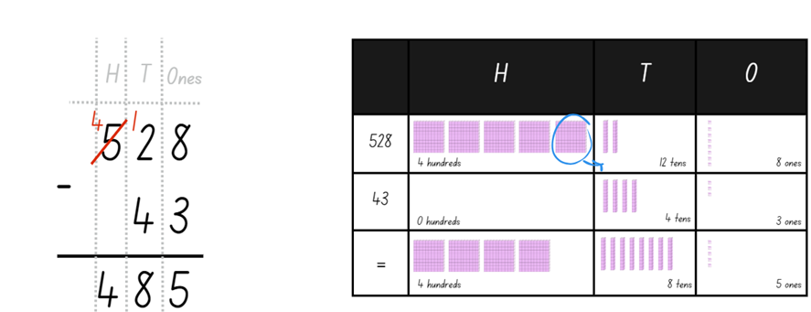
Note: one of the most common misconceptions associated with the subtraction algorithm is known as the smaller-from-larger error (Resnick 2020). When students focus only on the values of the digits in the subtraction, some ‘simplify’ by reordering the terms to always subtract the smaller value from the larger digit.
- Tell students they are going to play a game called King of Cards. In pairs, students will need a deck of cards numbered 0–9 and their workbook.
- Player A turns over 5 cards and places them in line to form a subtraction algorithm creating a 3-digit and a 2-digit number (see Figure 12).
Figure 12 – Sample cards
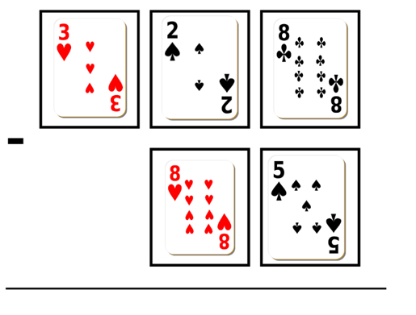
- Each player records and solves the subtraction algorithm in their workbook.
This table details opportunities for differentiation.
Too hard? | Too easy?
Students cannot solve subtraction questions using an algorithm.  - Provide students with MAB materials to model solving the subtraction algorithm.  - Students solve 2-digit and one-digit questions. | Students can solve subtraction questions using an algorithm.  - Students solve questions involving larger numbers.  - Students leave one digit out of the algorithm and include the answer. Their partner solves the missing digit.

Stage 3 task: Part 1 Local fair investigation
The table below contains a suggested learning intention and success criteria. These are best co-constructed with students.
Core concept learning intentions | Core concept success criteria
Students are learning to:  - apply known strategies to add and subtract decimals. | Students can:  - solve word problems involving the addition and subtraction of decimals up to 3 decimal places  - solve multi-step problems, including more than one operation  - justify why the strategy used to solve addition and subtraction word problems is appropriate.
This activity is an adaptation of Lunar Theme Park from UK Maths (Part 2 appears in Lesson 8).
- Tell students they will be designing and organising a local fair that will run for 2 weeks during the school holidays. They will need to think about the types of rides and activities they will have at the fair. They also need to consider the types of facilities they need such as toilets, cafes and so on.
- Provide a copy of Resource 14: Fair set up and explain the represented information. Each fairground item will take up an allocated number of squares on the grid paper. Students decide the number of items included in the design and calculate outgoing costs and ongoing costs, such as paying staff and the cost of advertising.
- Provide each group with grid paper and ask students to create a fairground layout.
Note: ongoing costs will be explained in Lesson 8.
- Discuss the spending limit and the cost of each item. Highlight that students need to consider not only the cost of their design but also the ongoing costs to run each of their activities for 14 days (about 2 weeks) and the costs to advertise the event.
- Students must record their planning in tables as shown in Figure 13 and Figure 14. Students create these tables in their workbooks.
Figure 13 – Recording sheet
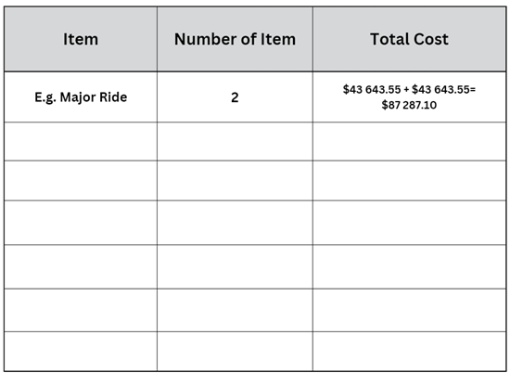
Figure 14 – Total costs
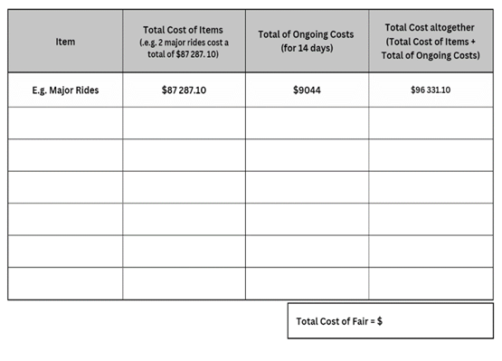
- In small groups, students design and draw the fair on grid paper. Remind students to ensure they are considering the ongoing costs and advertising, which will be calculated in the next lesson.
- Students record expenses in their workbooks on the table of total costs (see Figure 14).
This table details opportunities for differentiation.
Too hard? | Too easy?
Students cannot model the addition and subtraction of decimals using appropriate representation.  - Provide students with smaller numbers for the various outgoing costs.  - Reduce the total cost of the budget. | Students can model the addition and subtraction of decimals using appropriate representation.  - Provide an incentive for students to use the least amount of their budget whilst still ensuring the services meet the minimum requirements of the task.  - Students prepare a budget for another school event. In groups students prepare all the background costs for the new event.

Discuss and connect the mathematics – 10 minutes
- Display Resource 13: Empty algorithm and ask Stage 2 students:
- What numbers could go inside the boxes?
- Is there more than one solution?
- Can the tens be exchanged for hundreds?
- What did you think about when determining the 3-digit number?
- Is there a rule or pattern with subtraction? How would you explain this to a friend?
- What if we added a zero to the answer box in the ones column? How would that change your thinking?
- When are mental strategies more efficient than a vertical algorithm for subtraction?
- Ask Stage 3 students:
- What did you include in your fair?
- Did you remain under the spending limit? How do you know?
- What addition and subtraction strategies did you use to calculate this?
- Was one strategy more efficient than another when working with numbers of this size?
Note: another common challenge with learning to use the vertical subtraction algorithm is dealing with zeros. Sometimes students believe that zero means ‘nothing’, so it can be ignored.
This table details opportunities for assessment.
Assessment opportunities | Links
What to look for:  - Can Stage 2 students recognise how hundreds are exchanged in subtraction algorithms requiring regrouping? [MAO-WM-01, MA2-RN-01, MA2-AR-01, MA2-AR-02]  - Can Stage 2 students use an algorithm to solve unknown numbers of addition and subtraction problems? [MAO-WM-01, MA2-AR-01, MA2-AR-02]  - Can Stage 2 students recognise when mental strategies would be more efficient than a vertical algorithm for subtraction? [MAO-WM-01, MA2-RN-01, MA2-AR-01, MA2-AR-02]  - Can Stage 3 students model the addition and subtraction of decimals using appropriate representation? [MAO-WM-01, MA3-AR-01]  - Can Stage 3 students solve multi-step problems, including more than one operation? [MAO-WM-01, MA3-AR-01] | Links to National Numeracy Learning Progressions (NNLP):  - Stage 2 – AdS8  - Stage 3 – AdS8, AdS9.

Lesson 8
Core concept: mathematicians compare and evaluate strategies to solve addition and subtraction problems, reasoning which strategy is the most efficient.

Daily number sense: Teacher choice – 10 minutes
- From a class need surfaced through formative assessment data, identify a short, focused activity that targets students’ knowledge, understanding and skills. Example activities may be drawn from the following resources:
- Mathematics K-6 resources
- Universal Resources Hub.

Core lesson – 40 minutes

Stage 2: Maths investigation
The table below contains a suggested learning intention and success criteria. These are best co-constructed with students.
Core concept learning intentions | Core concept success criteria
Students are learning to:  - apply addition and subtraction to familiar contexts. | Students can:  - select appropriate strategies for addition and subtraction problems  - reflect on a chosen strategy for solving a problem, considering whether it can be improved.
- Display Resource 15: Maths investigation, read the task to the class and ask if there are any questions.
- Provide small groups of students with their workbooks to record their calculations.
- After students have recorded their solutions, regroup as a class and ask:
- What solutions did you find?
- What strategies did you use?
- What strategy did you find most efficient?
- What was your total cost?
- How much budget did you have left?
- What challenges did you find? How did you overcome them?
- Did you use a model to help you solve the investigation?

This table details opportunities for differentiation.
Too hard? | Too easy?
Students cannot apply addition and subtraction to familiar contexts.  - Provide students with concrete materials such as MAB materials to model addition and subtraction.  - Students work to find the solution for furnishing one class with a budget of $5000. | Students can apply addition and subtraction to familiar contexts.  - Modify school details to: Total classrooms – 14, Kindergarten to Year 2 – 7 classes, Year 3 to Year 6 – 5 classes.  - Students work with a budget of $60 000.

Stage 3: Local fair investigation part 2
The table below contains a suggested learning intention and success criteria. These are best co-constructed with students.
Core concept learning intentions | Core concept success criteria
Students are learning to:  - apply known strategies to add and subtract decimals. | Students can:  - solve multi-step problems, including more than one operation  - solve word problems involving the addition and subtraction of decimals up to 3 decimal places  - justify why the strategy used to solve addition and subtraction word problems is appropriate.
- Explain that students will continue working in their small groups on their design of a local fair from Lesson 7, by calculating the cost for advertising and ongoing costs.
- Display Resource 14: Fair set-up and discuss options for advertising. Highlight that students need to decide what kind of advertising they will use and how much their advertising will cost.
- Students calculate their advertising costs and record it in their total costs table started in Lesson 7.
- Distribute Resource 16: Ongoing costs and explain that students will need to calculate their ongoing costs. Highlight that their ongoing costs are affected by the rides and facilities they have at their fair.
- Students calculate their ongoing costs and record them on Resource 16: Ongoing costs.
- Students record their ongoing costs in their total costs table.
- Students calculate what money they have remaining in their budget.
This table details opportunities for differentiation.
Too hard? | Too easy?
Students cannot solve multi-step problems, including more than one operation.  - Students calculate the total cost of the fair without the ongoing costs.  - Students calculate the costs, to the nearest whole number. | Students can solve multi-step problems, including more than one operation.  - Provide students with challenge question 1: If the fair was going to run for 35 days, what would be the total cost?  - Provide students with challenge question 2: Some fair staff are struck with the flu and you close all minor rides and shops. How would this impact the cost?

Consolidation and meaningful practice – 15 minutes
This Stage 2 activity is an adaptation of ‘Additive word problems’ from Challenging mathematical tasks by Sullivan.
- Model creating a template for the Frayer model as used in previous units (see Figure 15) and ask students to create their own in their workbooks.
Figure 15 – Frayer model
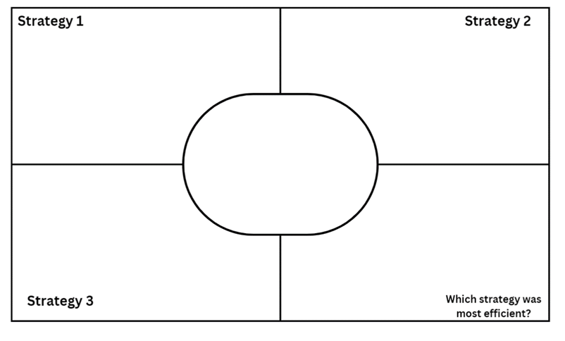
- Read the following problem to Stage 2 students: The school purchased some new basketballs and soccer balls. The total cost of all the balls was $447. The soccer balls cost at least $80 more than the basketballs. Ask what the cost of the basketballs might be, then what the cost of the soccer balls might be.
- Stage 2 students record 3 different strategies used to solve the problem.
- Stage 3 students record 3 different strategies used when completing the fair investigation.
- Invite students to share their solutions (Stage 2) and strategies and justify which strategy was the most efficient.
- Students identify their least efficient strategy and record how it could be improved.

This table details opportunities for assessment.
Assessment opportunities | Links
What to look for:  - Can Stage 2 students apply addition and subtraction to familiar contexts? [MAO-WM-01, MA2-AR-01]  - Can Stage 2 students reflect on a chosen strategy for solving a problem, considering whether it can be improved? [MAO-WM-01, MA2-AR-01, MA2-AR-02]  - Can Stage 3 students model the addition and subtraction of decimals using appropriate representation? [MAO-WM-01, MA3-AR-01]  - Can Stage 3 students solve multi-step problems, including more than one operation? [MAO-WM-01, MA3-AR-01]  - Can Stage 3 students solve word problems involving the addition and subtraction of decimals up to 3 decimal places? [MAO-WM-01, MA3-AR-01]  - Can Stage 3 students justify why the strategy used to solve addition and subtraction word problems is appropriate? [MAO-WM-01, MA3-AR-01] | Links to National Numeracy Learning Progressions (NNLP):  - Stage 2 – AdS7, AdS8, MuS7  - Stage 3 – AdS8, AdS9, MuS7.

Resource 1: Create 1000
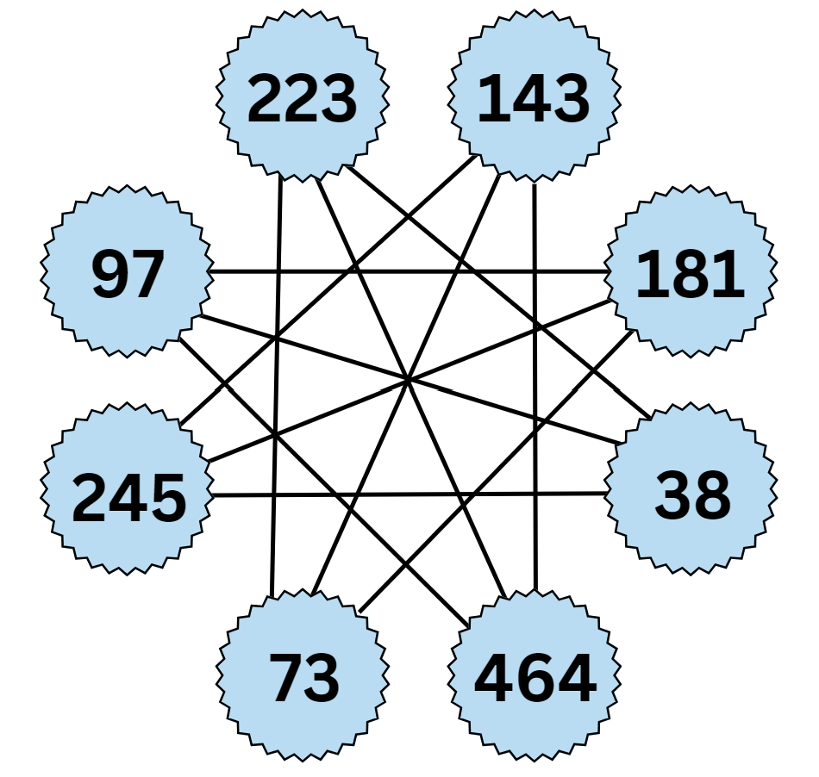

Resource 2: Take the plunge!
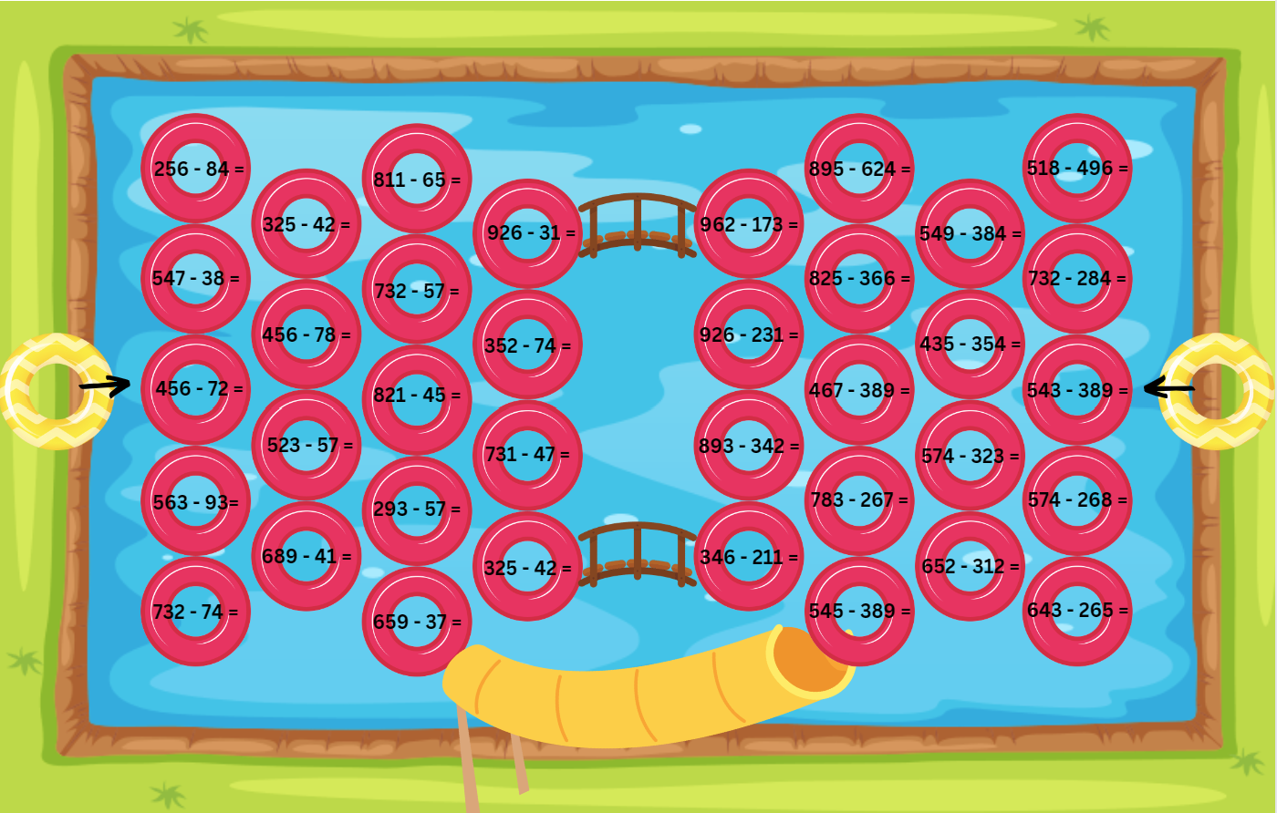

Resource 3: Take a plunge!
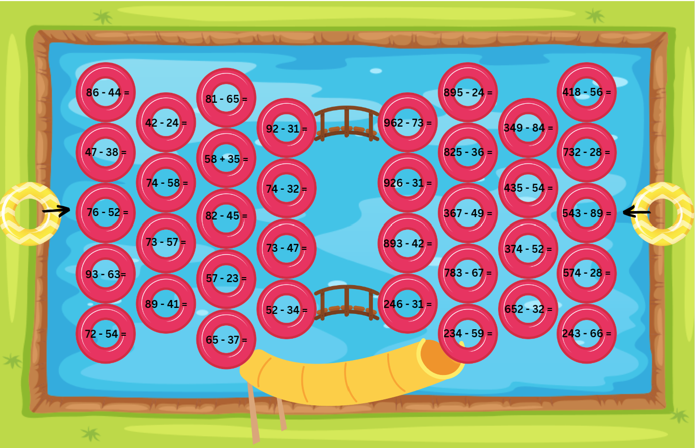

Resource 4: Swift concert
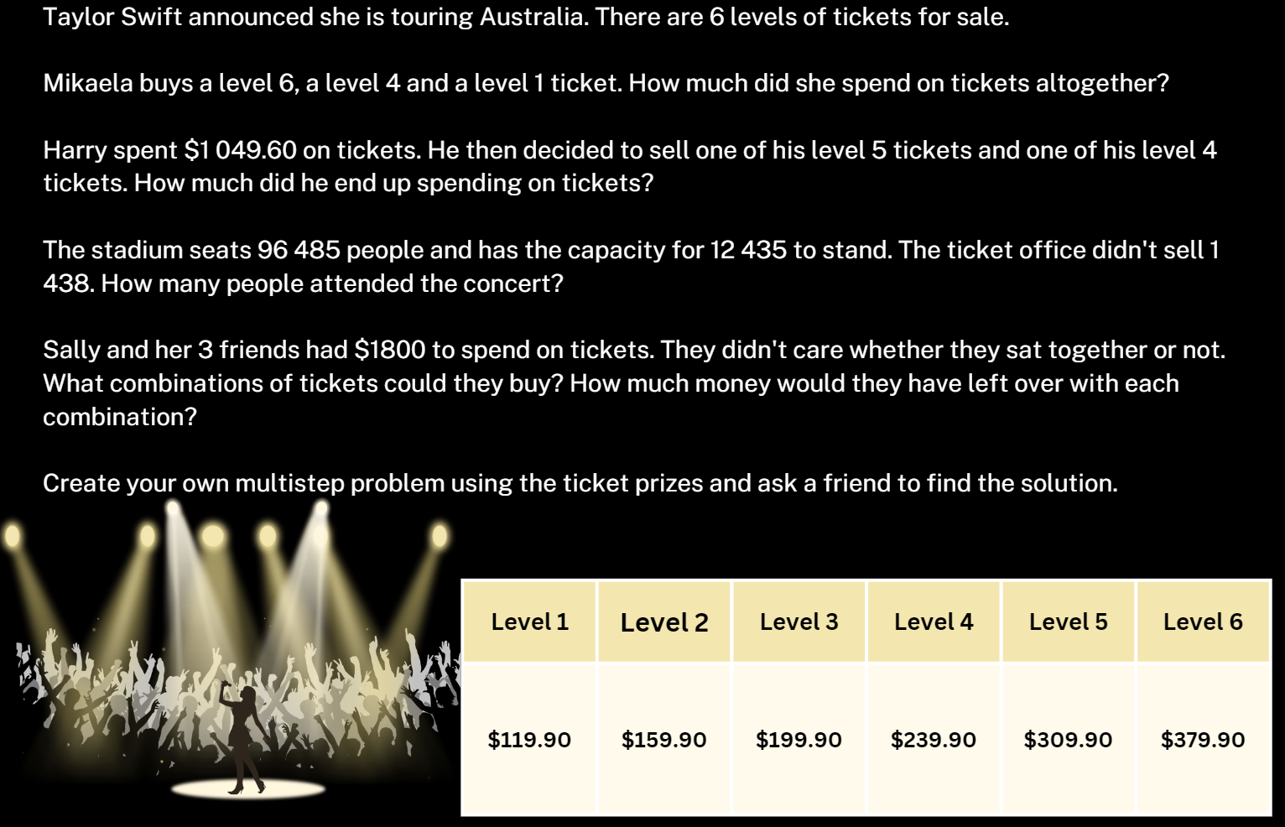

Resource 5: VIP tickets
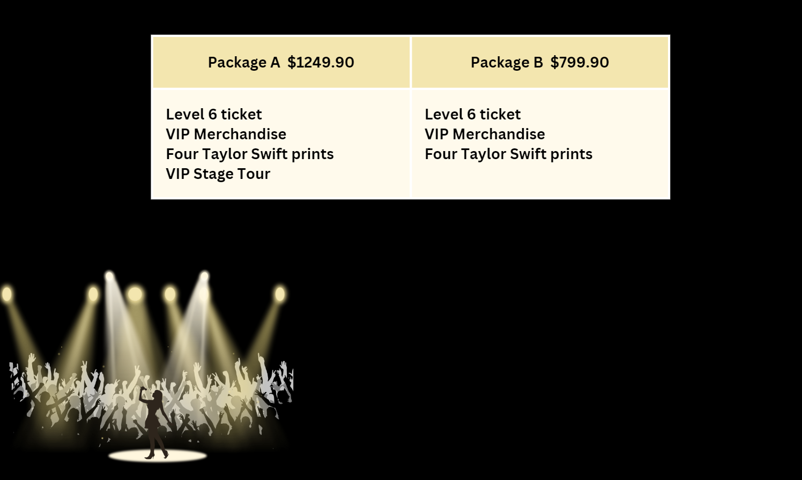

Resource 6: Grocery shopping
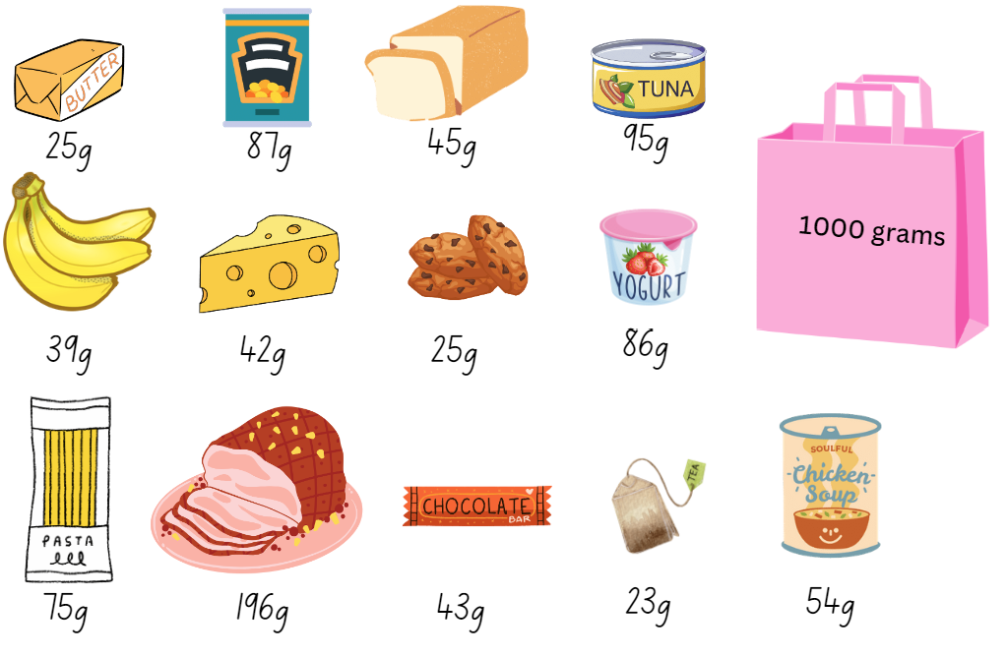

Resource 7: Long jump
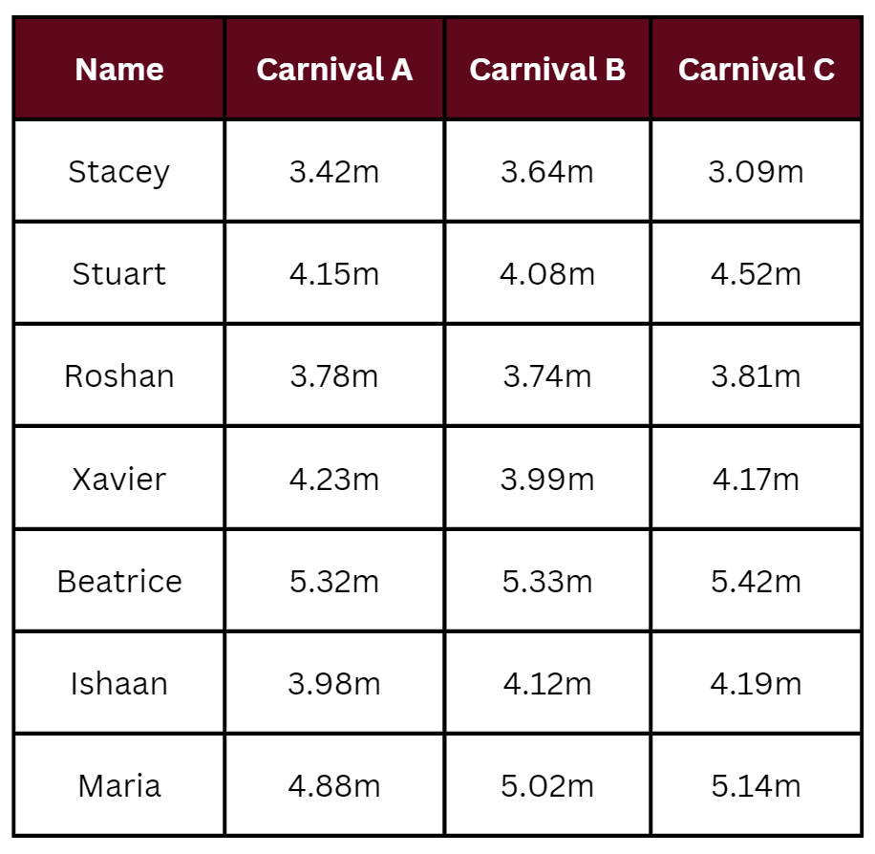

Resource 8: Tape model problems
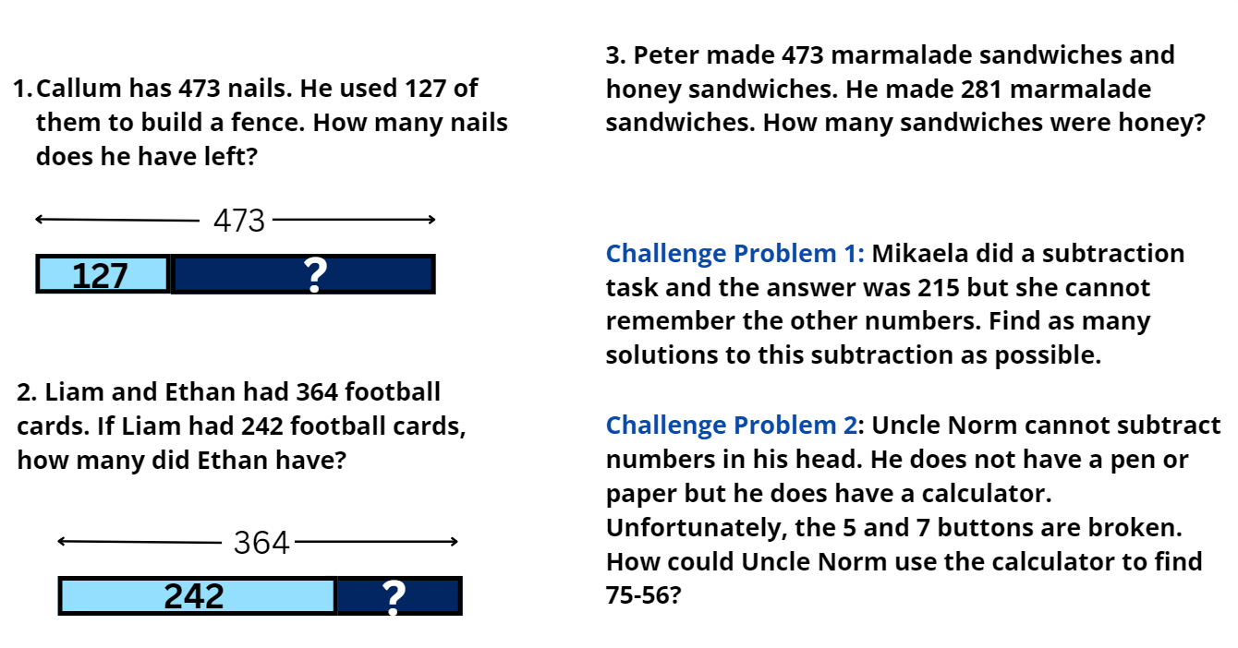

Resource 9: Recording sheet
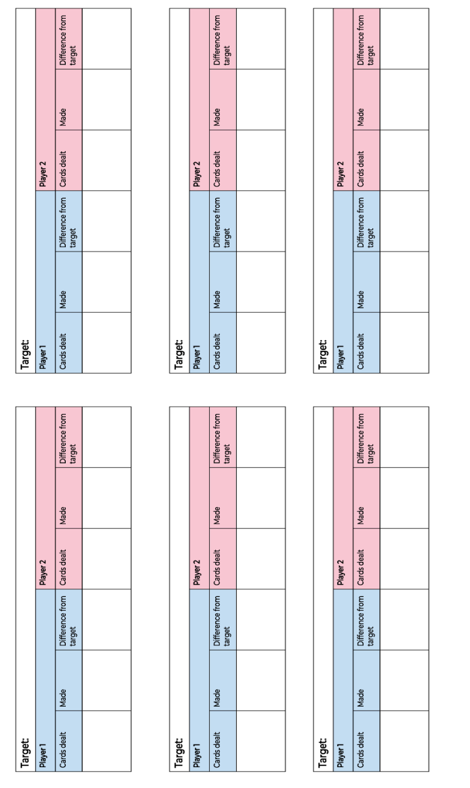

Resource 10: Holiday time (Stage 3)
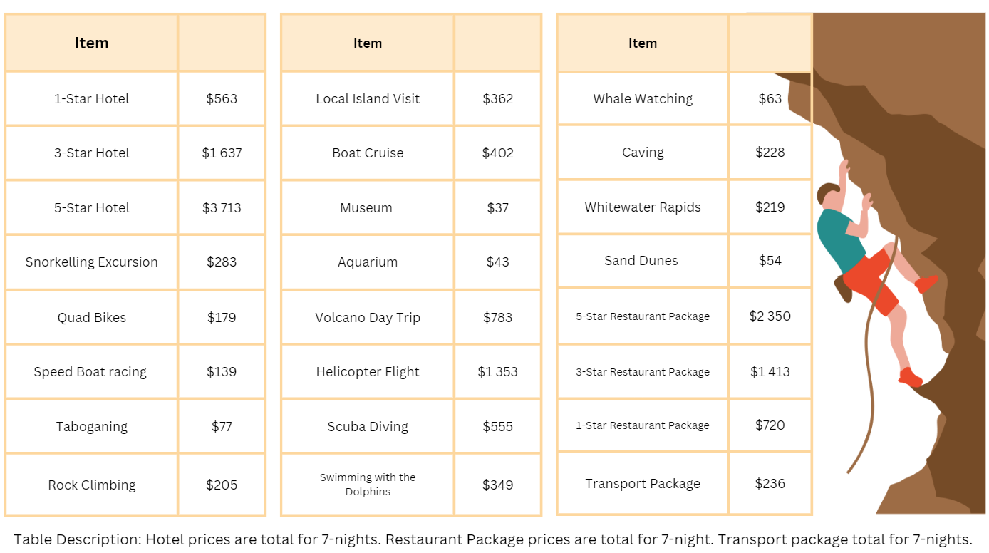

Resource 11: Holiday time (Stage 2)
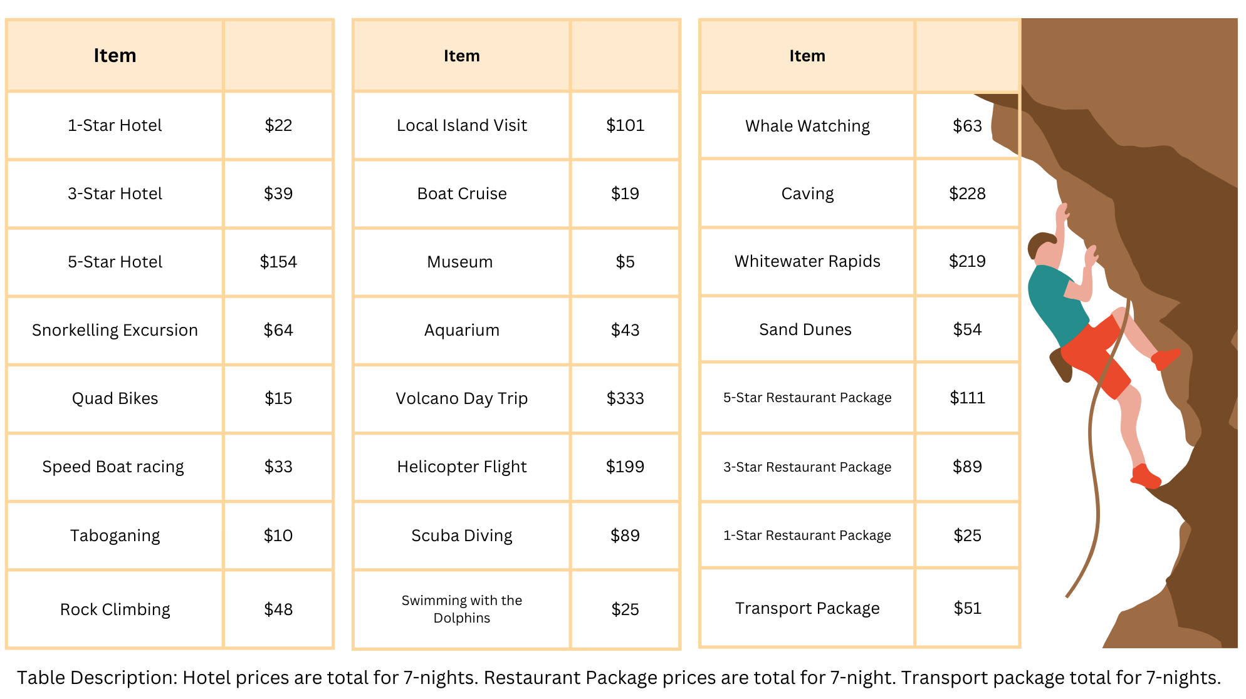

Resource 12: Problems
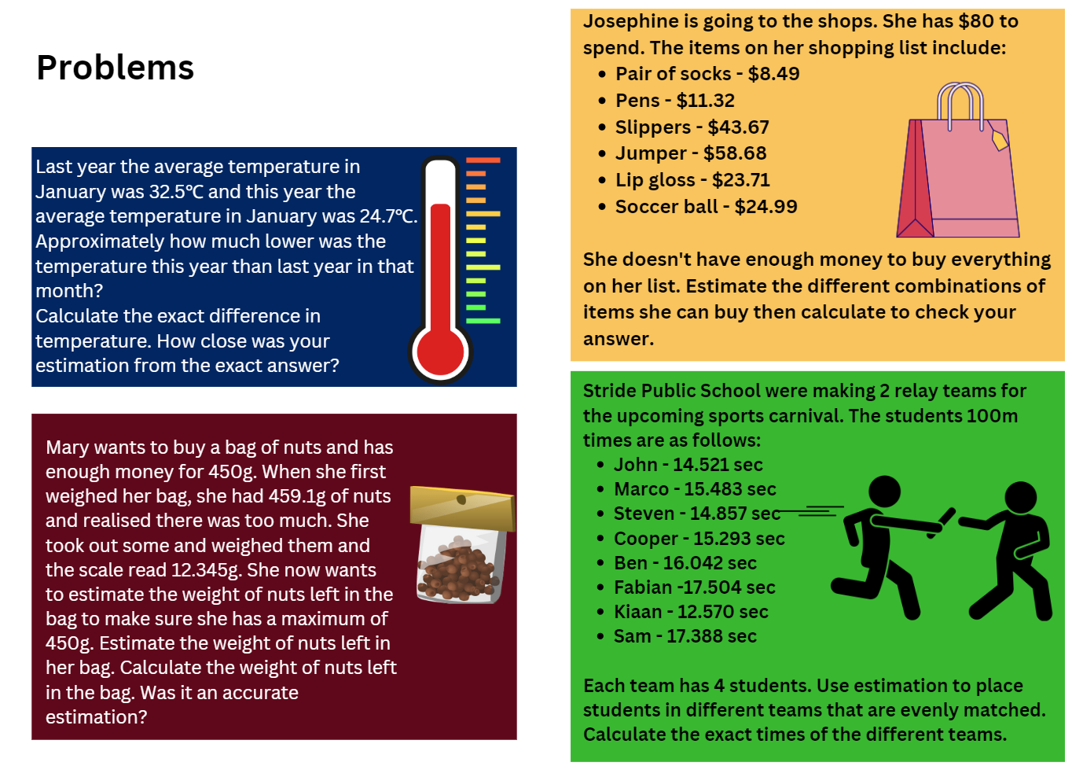

Resource 13: Empty algorithm
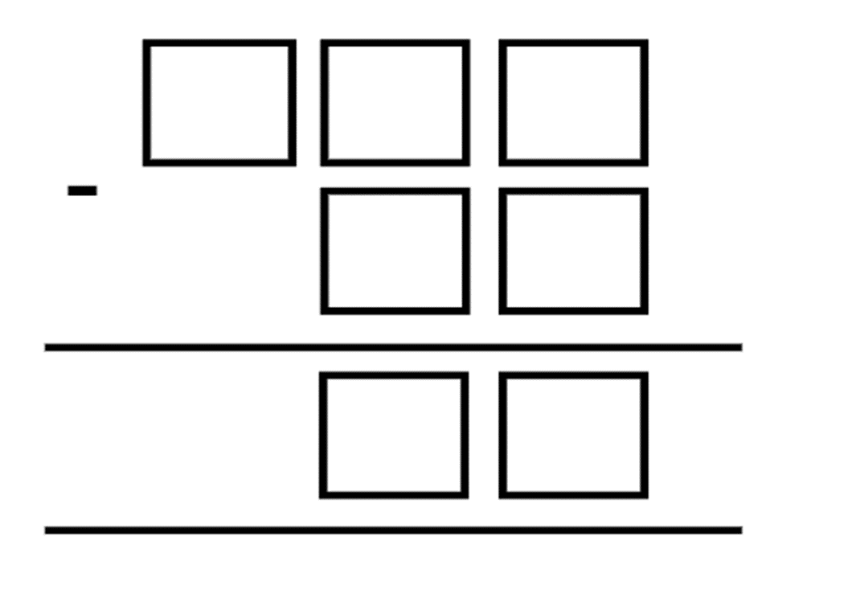

Resource 14: Fair set-up
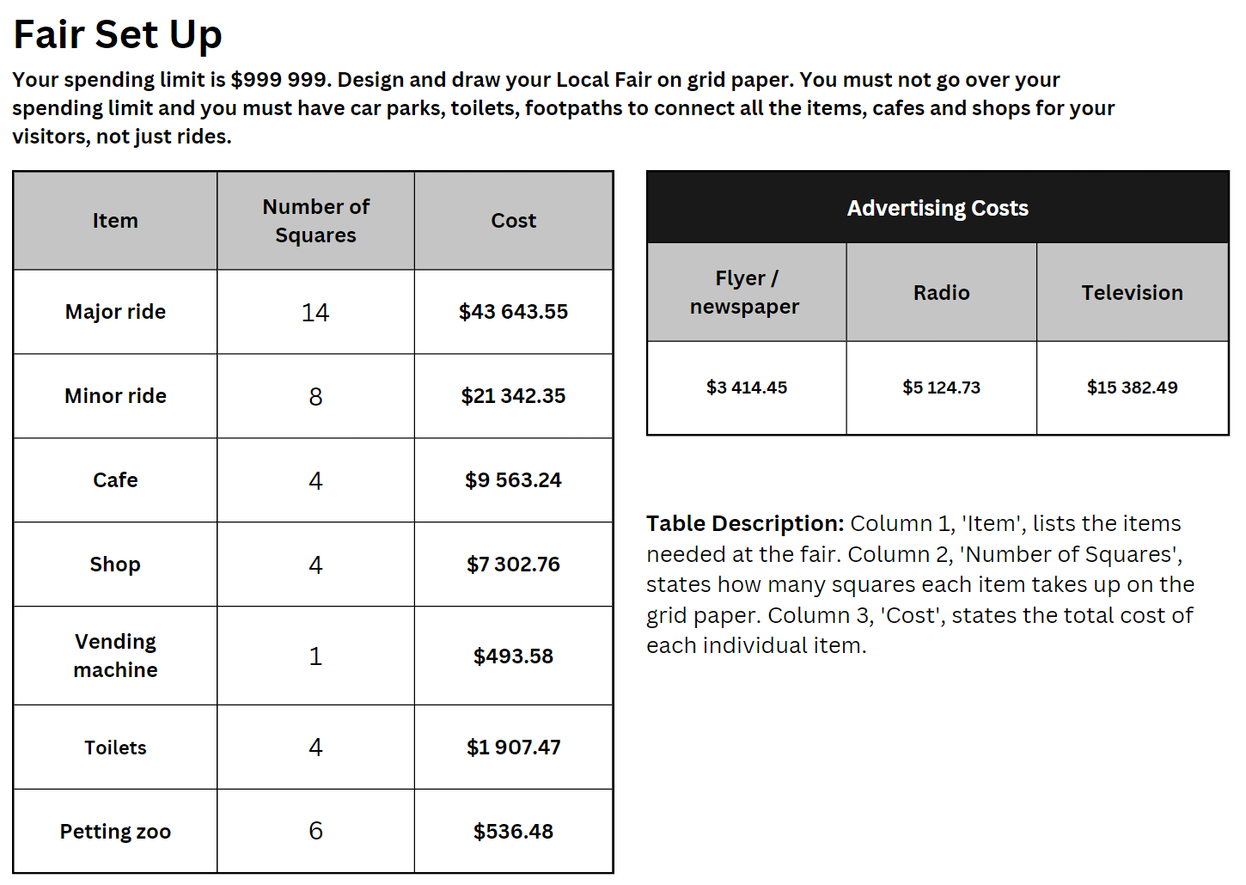

Resource 15: Maths investigation
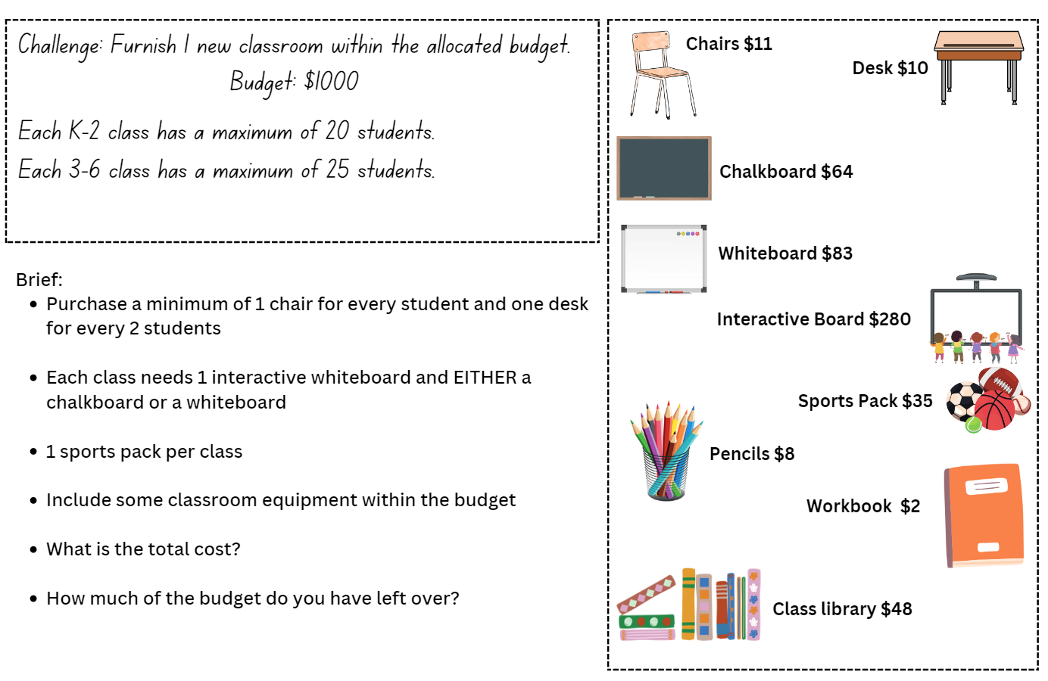

Resource 16: Ongoing costs
Item | Number of each item at the fair  (eg Major rides – 2) | Staff costs per day | Electricity/ Maintenance/ Repairs per day | Total costs per day | Total cost for the 14 days
Major ride |  | $150 | $173
Minor ride |  | $97 | $97
Café |  | $104 | $83
Shop |  | $89 | $157
Vending machine |  | – | $31
Toilet |  | –
Petting zoo |  | $173 | –

Syllabus outcomes and content

Stage 2
The table below outlines the syllabus outcomes and range of relevant syllabus content covered in this unit. Content is linked to National Numeracy Learning Progression version (3).
Outcomes and content | 1 | 2 | 3 | 4 | 5 | 6 | 7 | 8
Representing numbers using place value A: Whole numbers: Read, represent and order numbers to thousands
MAO-WM-01, MA2-RN-01
- Group physical or virtual objects to show the structure of tens, hundreds and a thousand |  | x | x |  |  | x
- Regroup numbers flexibly, recognising one thousand as 10 hundreds and one hundred as 10 tens or 100 ones |  | x | x |  |  | x
Representing numbers using place value A: Whole numbers: Apply place value to partition and regroup numbers up to 4 digits
MAO-WM-01, MA2-RN-01
- Record numbers using standard place value form |  |  |  |  |  | x | x
- Partition numbers of up to 4 digits in non-standard forms (Reasons about quantity) | x | x | x |  |  | x | x
Representing numbers using place value B: Whole numbers: Apply place value to partition, regroup and rename numbers up to 6 digits
MAO-WM-01, MA2-RN-01
- Name thousands using the place value grouping of ones, tens and hundreds of thousands | x | x | x
- Partition numbers of up to 6 digits in non-standard forms | x | x | x
Representing numbers using place value B: Whole numbers: Recognise and represent numbers that are 10, 100 or 1000 times as large
MAO-WM-01, MA2-RN-01
- Recognise the number of tens, hundreds or thousands in a number | x | x |  |  |  | x
Additive relations A: Use the principle of equality
MAO-WM-01, MA2-AR-01
- Use the equals sign to mean 'the same as', rather than to perform an operation |  | x | x
- Apply the associative property of addition to forming multiples of 10 (Reasons about relations) |  | x
Additive relations A: Recognise and explain the connection between addition and subtraction
MAO-WM-01, MA2-AR-01
- Use number relation principles to solve related problems (Reasons about relations) |  |  |  | x
- Demonstrate how addition and subtraction are inverse operations |  |  |  | x
- Explain and check solutions to problems, including by using the inverse operation |  |  |  | x
Additive relations A: Select strategies flexibly to solve addition and subtraction problems of up to 3 digits
MAO-WM-01, MA2-AR-01
- Apply known mental strategies that use partitioning to add and subtract, such as bridging the decades | x
- Represent solutions to addition and subtraction problems, including word problems, using an empty number line or bar model |  |  |  |  | x
- Compare and evaluate strategies used to solve addition and subtraction problems, reasoning which strategy may be most efficient |  |  |  |  | x
Additive relations A: Represent money values in multiple ways
MAO-WM-01, MA2-AR-01
- Perform calculations with money, including finding change |  |  |  |  | x
Additive relations B: Partition, rearrange and regroup numbers to at least 1000 to solve additive problems
MAO-WM-01, MA2-AR-01, MA2-AR-02
- Use quantity values and non-standard partitioning to solve addition and subtraction problems | x | x | x |  |  |  |  | x
- Model addition with and without regrouping and record the method used | x |  | x |  |  |  |  | x
- Model subtraction with and without regrouping and record the method used |  | x | x
- Use an algorithm with understanding to record addition and subtraction calculations, where efficient, involving 3-digit numbers |  |  |  |  |  | x | x | x
- Recognise how hundreds are exchanged in subtraction algorithms requiring regrouping |  |  |  |  |  |  | x
- Recognise when mental strategies would be more efficient than a vertical algorithm for subtraction (Reasons about relations) |  |  |  |  |  |  | x
- Solve subtraction questions with missing digits given the difference (Reasons about relations) |  |  |  | x
Additive relations B: Apply addition and subtraction to familiar contexts, including money and budgeting
MAO-WM-01, MA2-AR-01, MA2-AR-02
- Use estimation to check the validity of solutions to addition and subtraction problems, including those involving money | x |  |  |  | x
- Reflect on a chosen strategy for solving a problem, considering whether it can be improved |  | x | x | x | x | x | x | x
- Interpret problems involving money as requiring either addition or subtraction |  |  |  |  | x |  |  | x
Additive relations B: Complete number sentences involving additive relations to find unknown quantities
MAO-WM-01, MA2-AR-02
- Calculate missing numbers by completing number sentences involving addition and subtraction (Algebraic reasoning) |  |  | x | x |  | x
Multiplicative relations A: Use arrays to establish multiplication facts from multiples of 2 and 4, 5 and 10
MAO-WM-01, MA12-MR-01
- Use the array structure to coordinate the number of groups with the number in each group |  |  |  |  |  | x
Multiplicative relations B: Use known number facts and strategies
MAO-WM-01, MA2-MR-02
- Use known number facts to find unknown multiples (Reasons about relations) |  |  |  |  | x | x
Multiplicative relations B: Use the structure of the area model to represent multiplication and division
MAO-WM-01, MA2-MR-02
- Create and represent multiplicative structure, moving from arrays to partially covered area models |  |  |  |  |  | x
Mathematics K–10 Syllabus © NSW Education Standards Authority (NESA) for and on behalf of the Crown in right of the State of New South Wales, 2022.

Stage 3
The table below outlines the syllabus outcomes and range of relevant syllabus content covered in this unit. Content is linked to National Numeracy Learning Progression version (3).
Outcomes and content | 1 | 2 | 3 | 4 | 5 | 6 | 7 | 8
Represents numbers A: Whole numbers: Recognise, represent and order numbers in the millions
MAO-WM-01, MA3-RN-01, MA3-RN-02
- Round numbers to a specified place value |  |  |  |  |  | x
Represents numbers A: Whole numbers: Apply place value to partition, regroup and rename numbers to 1 billion
MAO-WM-01, MA3-RN-01, MA3-RN-02
- Regroup numbers in different forms (Reasons about quantity) |  | x |  |  |  |  | x
- Partition numbers to 1 billion in non-standard forms |  |  |  |  |  |  | x
Represents numbers A: Decimals and percentages: Recognise that the place value system can be extended beyond hundredths
MAO-WM-01, MA3-RN-01, MA3-RN-02
- Interpret decimal notation for thousandths |  |  | x
- Indicate the place value of digits in decimal numbers of up to 3 decimal places |  |  | x
Represents numbers A: Decimals and percentages: Compare order and represent decimals
MAO-WM-01, MA3-RN-01, MA3-RN-02
- Compare and order decimal numbers of up to 3 decimal places |  | x | x |  |  | x
- Interpret zero digit(s) at the end of a decimal |  | x | x |  |  | x
Additive relations A: Apply efficient mental and written strategies to solve addition and subtraction problems
MAO-WM-01, MA3-AR-01
- Solve word problems, including multistep problems |  | x |  |  |  | x | x | x
- Apply known strategies such as levelling, addition for subtraction, using constant difference, and bridging (Reasons about relations) | x | x | x | x |  |  | X | x
- Use place value to add or subtract 3 or more numbers with different numbers of digits |  | x |  |  |  |  | x | x
- Identify efficient and inefficient multidigit subtraction strategies |  | x
Additive relations A: Use estimation and place value understanding to determine the reasonableness of solutions
MAO-WM-01, MA3-AR-01
- Round numbers appropriately when obtaining estimates to numerical calculations | x
- Use place value understanding to check for errors in calculations |  |  |  |  | x |  | x
- Use estimation to check the reasonableness of solutions to addition and subtraction calculations | x |  |  |  | x |  | x
Additive relations B: Choose and use efficient strategies to solve addition and subtraction problems
MAO-WM-01, MA3-AR-01
- Solve multistep word problems, including problems that require more than one operation |  | x |  |  |  | x | x | x
- Compare, evaluate and communicate strategies used to solve addition and subtraction problems |  | x | x | x | x | x | x | x
Additive relations B: Applies known strategies to add and subtract decimals
MAO-WM-01, MA3-AR-01
- Model the addition and subtraction of decimals up to 3 decimal places using appropriate representation |  | x | x |  |  | x | x
- Solve word problems involving the addition and subtraction of decimals up to 3 decimal places |  | x | x |  |  | x | x | x
- Justify why the strategy used to solve addition and subtraction word problems is appropriate (Reasons about quantity) |  | x | x |  |  | x | x | x
Multiplicative relations A: Determine products and factors
MAO-WM-01, MA3-MR-01
- Use the term product to describe the result of multiplying 2 or more numbers |  |  |  |  | x
- Model different ways to show a whole number as a product (Reasons about structure) |  |  |  |  |  | x
- Determine factors for a given whole number |  |  |  |  |  |  | x
Mathematics K–10 Syllabus © NSW Education Standards Authority (NESA) for and on behalf of the Crown in right of the State of New South Wales, 2022.

References
This resource contains NSW Curriculum and syllabus content. The NSW Curriculum is developed by the NSW Education Standards Authority. This content is prepared by NESA for and on behalf of the Crown in right of the State of New South Wales. The material is protected by Crown copyright.
Please refer to the NESA Copyright Disclaimer for more information https://educationstandards.nsw.edu.au/wps/portal/nesa/mini-footer/copyright.
NESA holds the only official and up-to-date versions of the NSW Curriculum and syllabus documents. Please visit the NSW Education Standards Authority (NESA) website https://educationstandards.nsw.edu.au/ and the NSW Curriculum website https://curriculum.nsw.edu.au/home.
Mathematics K–10 Syllabus © NSW Education Standards Authority (NESA) for and on behalf of the Crown in right of the State of New South Wales, 2022.
National Numeracy Learning Progression © Australian Curriculum, Assessment and Reporting Authority (ACARA) 2010 to present, unless otherwise indicated. This material was downloaded from the Australian Curriculum website (National Literacy Learning Progression) (accessed 4 September 2023) and was not modified.
Australasian Problem-Solving Mathematical Olympiads (APSMO) Inc. (n.d) Maths games [PDF 529KB], APSMO, accessed 19 July 2023.
Australasian Problem-Solving Mathematical Olympiads (APSMO) Inc. (n.d) Maths explorer [PDF 530KB], APSMO, accessed 19 July 2023.
New Zealand Ministry of Education (n.d) ‘Create 5000’, NZ Maths, accessed 19 July 2023.
New Zealand Ministry of Education (n.d.) Problems to solve [PDF 599KB], NZ Maths, accessed 19 July 2023.
Orlin B (2022) Maths Games with Bad Drawings, Black Dog and Leventhal Publishers, USA.
Primary Resources (2023) Lunar Theme Park [DOCX 794KB], UK Maths website, accessed 19 July 2023.
Resnick LB (2020) 'Syntax and semantics in learning to subtract', in Carpenter TP, Moser JM, Romberg TA (eds) Addition and subtraction: A cognitive perspective, Routledge, London.
State of New South Wales (Department of Education) (2023), Part 3: Flexible strategies with 3-digit numbers [PDF 663KB], NSW Department of Education, accessed 19 July 2023.
State of New South Wales (Department of Education) (2023) 'Adding and subtracting decimals', Hub Resources, Universal Resources Hub website, accessed 19 July 2023.
State of New South Wales (Department of Education) (2023) ‘Equivalent number sentences', Hub Resources, Universal Resources Hub website, accessed 19 July 2023.
State of New South Wales (Department of Education) (2023) Part 3: Flexible strategies with multi-digit numbers [PDF 3.0MB], NSW Department of Education, accessed 19 July 2023.
Sullivan P (2018) Challenging Mathematical Tasks: Unlocking the potential of all students, Oxford University Press ANZ.
Sullivan P and Lilburn P (2017) Open-Ended Maths Activities, Revised edn, Oxford University Press, Victoria.
University of Cambridge (Faculty of Mathematics) (2023) Reach 100, NRICH website accessed 19 July 2023.
© State of New South Wales (Department of Education), 2023
The copyright material published in this resource is subject to the Copyright Act 1968 (Cth) and is owned by the NSW Department of Education or, where indicated, by a party other than the NSW Department of Education (third-party material).
Copyright material available in this resource and owned by the NSW Department of Education is licensed under a Creative Commons Attribution 4.0 International (CC BY 4.0) license.
This license allows you to share and adapt the material for any purpose, even commercially.
Attribution should be given to © State of New South Wales (Department of Education), 2023.
Material in this resource not available under a Creative Commons license:
- the NSW Department of Education logo, other logos and trademark-protected material
- material owned by a third party that has been reproduced with permission. You will need to obtain permission from the third party to reuse its material.
Links to third-party material and websites
Please note that the provided (reading/viewing material/list/links/texts) are a suggestion only and implies no endorsement, by the New South Wales Department of Education, of any author, publisher, or book title. School principals and teachers are best placed to assess the suitability of resources that would complement the curriculum and reflect the needs and interests of their students.
If you use the links provided in this document to access a third-party's website, you acknowledge that the terms of use, including licence terms set out on the third-party's website apply to the use which may be made of the materials on that third-party website or where permitted by the Copyright Act 1968 (Cth). The department accepts no responsibility for content on third-party websites.

