Mathematics 3-6 multi-age – Year B – Unit 1
Contents
Unit description and duration 5
Syllabus outcomes 5
Working mathematically 6
Student prior learning 7
Lesson overview and resources 8
Lesson 1 18
Daily number sense: Place value game – 10 minutes 18
Core lesson 1: Making and representing numbers – 30 minutes 20
Core lesson 2: Understanding and Ordering numbers – 20 minutes 22
Discuss and connect the mathematics – 10 minutes 23
Lesson 2 25
Daily number sense: Hit it 99 999 – 10 minutes 25
Core lesson: Place Value – 45 minutes 27
Discuss and connect the mathematics – 10 minutes 30
Lesson 3 32
Daily number sense: More or less – 15 minutes 32
Core lesson: Exploring the size of numbers – 50 minutes 34
Discuss and connect the mathematics – 10 minutes 37
Lesson 4 39
Daily number sense: Teacher choice – 10 minutes 39
Core lesson 1: Exploring decimals – 30 minutes 39
Core lesson 2: Decimal Bingo – 20 minutes 45
Consolidation and meaningful practice – 10 minutes 46
Lesson 5 48
Daily number sense: Ordering decimals – 10 minutes 48
Core lesson: Base-10 patterns – 40 minutes 50
Consolidation and meaningful practice – 20 minutes 56
Lesson 6 59
Daily number sense: Ordering decimals – 10 minutes 59
Core lesson – 45 minutes 60
Core lesson – 45 minutes 64
Discuss and connect the mathematics – 5 minutes 67
Lesson 7 68
Daily number sense: Decimal bingo – 15 minutes 68
Core lesson: Making multiples – 15 minutes 69
Core lesson – 30 minutes 70
Core lesson – 30 minutes 72
Discuss and connect the mathematics – 10 minutes 75
Lesson 8 76
Daily number sense: Teacher choice – 15 minutes 76
Core lesson – 45 minutes 76
Core lesson – 45 minutes 81
Consolidation and meaningful practice – 10 minutes 84
Resource 1: Place value gameboard 85
Resource 2: Place value houses 86
Resource 3: Australian town populations 2023 87
Resource 4: Country populations 2023 88
Resource 5: Big numbers questions 89
Resource 6: Big numbers answers 90
Resource 7: Place value structure 91
Resource 8: Decimal strip 92
Resource 9: Stage 2 gameboards 93
Resource 10: Stage 3 gameboards 95
Resource 11: Class number slide 97
Resource 12: Place value slider 99
Resource 13: Base-10 patterns 100
Resource 14: Make... 101
Resource 15: Multiplication patterns 1 102
Resource 16: Multiplication patterns 2 103
Resource 17: Suki’s sweets 104
Resource 18: Suki’s sweets 2 105
Syllabus outcomes and content 106
Stage 2 106
Stage 3 113
References 116
Further reading 117

Unit description and duration
This unit develops the big idea that our number system extends infinitely to very large and very small numbers.
In this 2-week unit students are provided opportunities to:
- partition, represent and order larger numbers
- apply place value to recognise, regroup and order whole and decimal numbers
- explore the link between multiplicative structures and place value to solve problems.
This multi-age unit is informed by the lessons in Stage 2 Year B Unit 21 and Stage 3 Year B Unit 21. Please refer to these units for additional lesson guidance.

Syllabus outcomes
- MAO-WM-01 develops understanding and fluency in mathematics through exploring and connecting mathematical concepts, choosing and applying mathematical techniques to solve problems, and communicating their thinking and reasoning coherently and clearly

Stage 2
- MA2-RN-01 applies an understanding of place value and the role of zero to represent numbers to at least tens of thousands
- MA2-RN-02 represents and compares decimals up to 2 decimal places using place value
- MA2-MR-01 represents and uses the structure of multiplicative relations to 10 × 10 to solve problems
- MA2-MR-02 completes number sentences involving multiplication and division by finding missing values

Stage 3
- MA3-RN-01 applies an understanding of place value and the role of zero to represent the properties of numbers
- MA3-RN-02 compares and orders decimals up to 3 decimal places
- MA3-MR-01 selects and applies appropriate strategies to solve multiplication and division problems

Working mathematically
In the Mathematics K–10 Syllabus, there is one overarching Working mathematically outcome (MAO-WM-01). The Working mathematically processes should be embedded within the concepts being taught. The Working mathematically processes present in the Mathematics K–10 Syllabus are:
- communicating
- understanding and fluency
- reasoning
- problem solving.
Mathematics K–10 Syllabus © NSW Education Standards Authority (NESA) for and on behalf of the Crown in right of the State of New South Wales, 2022.

Student prior learning
Before engaging in these teaching and learning activities, students would benefit from prior experience with:
- applying place value to partition and read whole numbers up to thousands
- reading and representing whole and decimal numbers as equal groups of ten
- creating, continuing and representing number patterns as multiplicative relations.
In NSW classrooms there is a diverse range of students, including Aboriginal and Torres Strait Islander students, students learning English as an additional language or dialect, high potential and gifted students and students with disability. Some students may identify with more than one of these groups or possibly all of them. Refer to Advice on curriculum planning for every student for further information.

Lesson overview and resources
To cover the content of the syllabus across Stage 2 and Stage 3, some core lessons in the unit contain both a Stage 2 and a Stage 3 task. Teachers are encouraged to adapt and contextualise the units to meet the needs of their students.
The table below outlines the sequence and approximate timing of lessons, learning intentions and resources.
Lesson | Content | Duration and resources
Lesson 1  Daily number sense  Stage 2:  - Representing numbers using place value B: Whole numbers: Order numbers in the thousands  Stage 3:  - Represents numbers A: Whole numbers: Recognise, represent and order numbers in the millions | Lesson core concept: numbers can be renamed in a variety of equivalent ways.  Stage 2:  - Representing numbers using place value A: Whole numbers: Read, represent and order numbers to thousands  - Representing numbers using place value B: Whole numbers: Apply place value to partition, regroup and rename numbers up to 6 digits  Stage 3:  - Represents numbers A: Whole numbers: Recognise, represent and order numbers in the millions  - Represents numbers A: Whole numbers: Apply place value to partition, regroup and rename numbers to 1 billion | Lesson duration: 70 minutes  - Resource 1: Place value gameboard  - Resource 2: Place value houses  - Resource 3: Australian town populations 2023  - Resource 4: Country populations 2023  - 9-sided dice  - MAB materials (or Mathematics virtual manipulatives)  - Student workbooks  - Writing materials
Lesson 2  Daily number sense  Stage 2:  - Representing numbers using place value B: Whole numbers: Order numbers in the thousands  Stage 3:  - Represents numbers A: Whole numbers: Recognise, represent and order numbers in the millions | Lesson core concept: the position of each digit in a number corresponds to its size.  Stage 2:  - Representing numbers using place value A: Whole numbers: Read, represent and order numbers to thousands  - Representing numbers using place value B: Whole numbers: Apply place value to partition, regroup and rename numbers up to 6 digits  Stage 3:  - Represents numbers A: Whole numbers: Recognise, represent and order numbers in the millions  - Represents numbers A: Whole numbers: Apply place value to partition, regroup and rename numbers to 1 billion | Lesson duration: 65 minutes  - Resource 2: Place value houses  - 9-sided dice  - MAB materials  - Individual whiteboards  - Student workbooks  - Writing materials
Lesson 3  Daily number sense  Stage 2:  - Representing numbers using place value B: Whole numbers: Order numbers in the thousands  Stage 3:  - Represents numbers A: Whole numbers: Recognise, represent and order numbers in the millions | Lesson core concept: naming and representing large numbers are key components of place value.  Stage 2:  - Representing numbers using place value B: Whole numbers: Order numbers in the thousands  - Representing numbers using place value B: Whole numbers: Apply place value to partition, regroup and rename numbers up to 6 digits  - Representing numbers using place value B: Whole numbers: Recognise and represent numbers that are 10, 100 or 1000 times as large  Stage 3:  - Represents numbers A: Whole numbers: Recognise, represent and order numbers in the millions  - Represents numbers A: Whole numbers: Apply place value to partition, regroup and rename numbers to 1 billion | Lesson duration: 65 minutes  - Resource 5: Big numbers questions  - Resource 6: Big numbers answers  - Resource 7: Place value structure  - 6-sided dice  - Individual whiteboards  - Online calculator  - Writing materials
Lesson 4  Daily number sense  - teacher-identified task based on student needs | Lesson core concept: the place value system can be extended, compared and analysed.  Stage 2:  - Representing numbers using place value B: Decimals: Extend the application of the place value system from whole numbers to tenths and hundredths  Stage 3:  - Represents numbers A: Decimals and percentages: Recognise that the place value system can be extended beyond hundredths  - Represents numbers A: Decimals and percentages: Compare, order and represent decimals | Lesson duration: 70 minutes  - Resource 8: Decimal strip  - Resource 9: Stage 2 gameboards  - Resource 10: Stage 3 gameboards  - Strips of paper  - Student workbooks  - Transparent counters  - Writing materials
Lesson 5  Daily number sense  Stage 2:  - Representing numbers using place value B: Decimals: Extend the application of the place value system from whole numbers to tenths and hundredths  Stage 3:  - Represents numbers A: Decimals and percentages: Compare, order and represent decimals | Lesson core concept: number patterns can be multiplicative.  Stage 2:  - Multiplicative relations A: Generate and describe patterns  - Multiplicative relations B: Use known number facts and strategies  Stage 3:  - Multiplicative relations B: Represent and describe number patterns formed by multiples | Lesson duration: 70 minutes  - Resource 7: Place value structure (student copies and an A3 teacher copy)  - Resource 11: Class number slide  - Resource 12: Place value slider  - Resource 13: Base-10 patterns  - Writing materials
Lesson 6  Daily number sense  Stage 2:  - Representing numbers using place value B: Decimals: Extend the application of the place value system from whole numbers to tenths and hundredths  Stage 3:  - Represents numbers A: Decimals and percentages: Compare, order and represent decimals | Lesson core concept: structures can support multiplicative thinking.  Stage 2:  - Multiplicative relations A: Use arrays to establish multiplication facts from multiples of 2 and 4, 5 and 10  - Multiplicative relations A: Recall multiplication facts of 2 and 4, 5 and 10 and related division facts  - Multiplicative relations B: Investigate number sequences involving related multiples  - Multiplicative relations B: Use known number facts and strategies  Stage 3:  - Multiplicative relations A: Use partitioning and place value to multiply 2-, 3- and 4-digit numbers by one-digit numbers  - Multiplicative relations A: Select and apply mental and written strategies to multiply 2- and 3-digit numbers by 2-digit numbers  - Multiplicative relations B: Represent and describe number patterns formed by multiples | Lesson duration: 60 minutes  - Resource 14: Make...  - 6-sided dice  - 12-sided dice  - Grid paper  - Plain paper  - Sticky notes  - Writing materials
Lesson 7  Daily number sense  Stage 2:  - Representing numbers using place value B: Decimals: Extend the application of the place value system from whole numbers to tenths and hundredths  Stage 3:  - Represents numbers A: Decimals and percentages: Compare, order and represent decimals | Lesson core concept: known number facts and strategies support multiplicative understanding.  Stage 2:  - Multiplicative relations A: Use arrays to establish multiplication facts from multiples of 2 and 4, 5 and 10  - Multiplicative relations A: Recall multiplication facts of 2 and 4, 5 and 10 and related division facts  - Multiplicative relations B: Investigate number sequences involving related multiples  - Multiplicative relations B: Use known number facts and strategies  - Multiplicative relations B: Operate with multiples of 10  Stage 3:  - Multiplicative relations A: Use partitioning and place value to multiply 2-, 3- and 4-digit numbers by one-digit numbers  - Multiplicative relations A: Select and apply mental and written strategies to multiply 2- and 3-digit numbers by 2-digit numbers  - Multiplicative relations B: Represent and describe number patterns formed by multiples | Lesson duration: 70 minutes  - Interactive multiplication chart  - 6-sided dice  - MAB materials  - Writing materials
Lesson 8  Daily number sense  - teacher-identified task based on student needs | Lesson core concept: flexible methods of computation in multiplication and division involve composing and decomposing numbers.  Stage 2:  - Multiplicative relations A: Use arrays to establish multiplication facts from multiples of 2 and 4, 5 and 10  - Multiplicative relations A: Recall multiplication facts of 2 and 4, 5 and 10 and related division facts  - Multiplicative relations B: Investigate number sequences involving related multiples  - Multiplicative relations B: Use known number facts and strategies  Stage 3:  - Multiplicative relations A: Use partitioning and place value to multiply 2-, 3- and 4-digit numbers by one-digit numbers  - Multiplicative relations A: Select and apply mental and written strategies to multiply 2- and 3-digit numbers by 2-digit numbers  - Multiplicative relations B: Represent and describe number patterns formed by multiples | Lesson duration: 70 minutes  - Resource 15: Multiplication patterns 1  - Resource 16: Multiplication patterns 2  - Resource 17: Suki’s sweets  - Resource 18: Suki’s sweets 2  - Writing materials

Lesson 1
Core concept: numbers can be renamed in a variety of equivalent ways.

Daily number sense: Place value game – 10 minutes
Daily number sense activities for Lessons 1 to 3 ‘activate’ prior number knowledge and support the learning of new content in the unit. These activities can also assist teachers to identify the starting points for learning by revealing the extent of students’ existing knowledge.
The table below contains a suggested learning intention and success criteria. These are best co-constructed with students.
Daily number sense learning intention | Daily number sense success criteria
All students are learning to:  - read, represent and order larger numbers. | All students can:  - read and order numbers to at least 5 digits
This activity is an adaptation of Place value game (5:29) from Mathematics K-6 resources by State of New South Wales (Department of Education).
- Explain that the aim of the game is to order 5-digit numbers in order on a gameboard.
- Provide pairs with five 9-sided dice and a copy of Resource 1: Place value gameboard for each player.
- Students roll the dice and create a 5-digit number. For example, 6, 2, 8, 3 and 9 could be recorded as 62 389, 36 892, 29 863, 38 269, 93 628 or 39 286. Players record their chosen number in the most appropriate position between 10 000 and 100 000 (see Figure 1).
Figure 1 – Stage 2 example
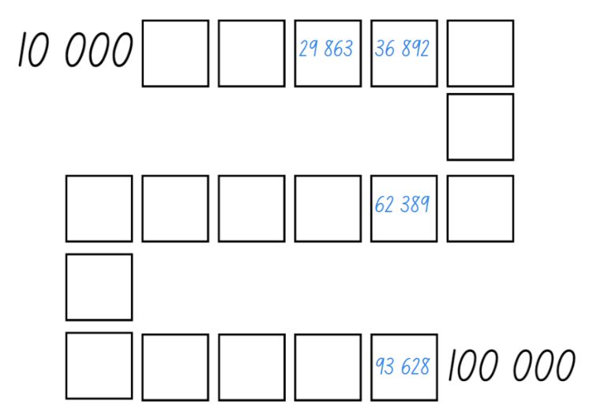
- If numbers cannot be placed, students miss their turn. Play continues until all boxes are filled.
- Stage 3 students can use numbers up to millions.
This table details an opportunity for assessment.
Assessment opportunity | Links
What to look for:  - Can students read and order numbers of up 5-digits? [MAO-WM-01, MA2-RN-01, MA3-RN-01] | Links to National Numeracy Learning Progressions (NNLP):  - Stage 2 – NPV6, NPV7  - Stage 3 – NPV7.

Core lesson 1: Making and representing numbers – 30 minutes
The table below contains suggested learning intentions and success criteria. These are best co-constructed with students.
Core concept learning intentions | Core concept success criteria
All students are learning to:  - apply place value to partition, regroup and rename larger numbers  - recognise, read and represent numbers that are 10, 100 or 1000 times as large  - arrange numbers in ascending and descending order. | All students can:  - represent numbers using MAB materials using standard and non-standard partitioning  - describe how making a number 10, 100, 1000 times as large changes the value of digits  - arrange numbers in ascending and descending order.
- Display a collection of MAB materials and revise their value. A cube has a value of 1000, a flat has a value of 100, a long has a value of 10 and a mini has the value of one.
- Provide students with MAB materials or access to Mathematics virtual manipulatives. Ask students to work with a partner and make and record 4- or 5-digit numbers using Resource 2: Place value houses.
- Ask students to identify one of their recorded numbers. Ask:
- Can you make the number 10 times larger? What is the name of the new number? Can you make this number with MAB materials? Can you record this number?
- Can you make the number 100 times larger? What is the name of the new number? Can you make this number with MAB materials? Can you record this number?
- Can you make the number 1000 times larger? What is the name of the new number? Can you make this number with MAB materials? Can you record this number?
- How does making a number 10 times, 100 times or 1000 times larger change the place value of the digits?
- Invite a student to show their number using MAB materials. Ask the class if this is the only way this number can be represented. Ask students to demonstrate other ways using non-standard partitioning to make their recorded numbers.
- Challenge students to find as many ways as possible to make the numbers. Ask students to explain how they will know they have found all possible solutions.
This table details opportunities for differentiation.
Too hard? | Too easy?
Students cannot describe how making a number 10, 100 or 1000 times larger changes the place value of digits.  - Provide students with MAB materials to make with 2-digit numbers.  - Provide students with MAB materials and a place value house to explore 3-digit numbers | Students can describe how making a number 10, 100 or 1000 times larger changes the place value of digits.  - Challenge students to make numbers that are 200 times as large. Ask students how this changes the numbers.  - Challenge students to make numbers that are 1200 times as large. Ask students how this changes the numbers.

Core lesson 2: Understanding and Ordering numbers – 20 minutes
- Provide Stage 2 students with Resource 3: Australian town populations 2023 and Stage 3 students with Resource 4: Country populations 2023.
- Ask students to turn and talk with a partner and read the numbers aloud. Students order the numbers in ascending order and record them in their workbooks.
- Have students create puzzle place value questions for their numbers. For example:
- find a number that can be partitioned with 45 tens and 14 ones (464)
- find a number larger than 45 000 but less than 67 569
- find a number with a digit in the tens column that is double the digit in the ones column.
- In pairs, students find the answers to their partners questions.
Note: students may be interested in the World population count. You can contextualise this, recognising the cultural heritage depending on class demographics.
This table details opportunities for differentiation.
Too hard? | Too easy?
Students cannot arrange numbers in ascending order.  - Provide smaller numbers for students to order.  - Provide students with concrete materials. | Students can arrange numbers in ascending order.  - Ask students to create their own numbers for a partner to place in descending order.  - Have students create a historical timeline of their life based on dates and years.

Discuss and connect the mathematics – 10 minutes
- Review and discuss how numbers can be partitioned and renamed in standard and non-standard forms.
- Ask students which the hardest numbers were to partition and rename in non-standard ways and to explain why.
- Ask students:
- How do you know that your numbers are ordered from the smallest to the largest?
- Which digit did you pay most attention to when deciding? Why?
- Are there rules that can be followed when arranging numbers in order of size? What are the rules?
- What strategy did you use to order your numbers in descending order?
- What was challenging when you were deciding the sequence of the numbers in both the descending and ascending order?
This table details opportunities for assessment.
Assessment opportunities | Links
What to look for:  - Can students represent numbers using MAB materials using standard and non-standard partitioning? [MAO-WM-01, MA2-RN-01, MA3-RN-01]  - Can students describe how making a number 10, 100, 1000 times as large changes the value of digits? [MAO-WM-01, MA2-RN-01, MA3-RN-01]  - Can students arrange numbers in ascending and descending order, explaining reasoning? [MAO-WM-01, MA2-RN-01, MA3-RN-01] | Links to National Numeracy Learning Progressions (NNLP):  - Stage 2 – NPV6, NPV7  - Stage 3 – NPV8, NPV9.  Links to suggested Interview for Student Reasoning (IfSR) tasks:  - Stage 2 – IfSR-NP/AT/MT: 4B.1, 4B.2, 4B.3, 4B.4, 4B.5, 4B.6  - Stage 3 – IfSR-NP: 4B.3, 4B.4, 4B.5, 4B.6

Lesson 2
Core concept: the position of each digit in a number corresponds to its size.

Daily number sense: Hit it 99 999 – 10 minutes
The table below contains a suggested learning intention and success criteria. These are best co-constructed with students.
Daily number sense learning intention | Daily number sense success criteria
All students are learning to:  - use place value to name numbers. | All students can:  - name, read and record numbers using place value.
This activity is an adaptation of Hit it (3-digit numbers) from Mathematics K-6 resources by State of New South Wales (Department of Education).
- Provide pairs with markers, a whiteboard and a 9-sided die.
- Students draw a gameboard on their whiteboard with 5 lines to represent the 5-digits.
- The aim of the game is to make numbers as close to 99 999 as possible, with the closest number winning a point. The player with the most points after 5 rounds is declared the winner (see Figure 2).
Figure 2 – Hit it gameboard
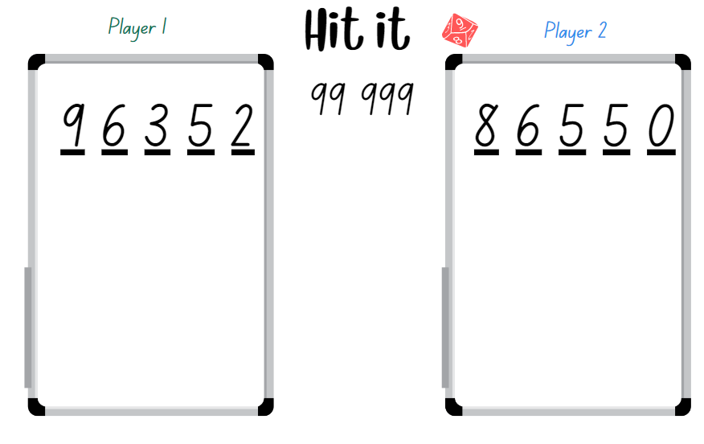
- Students take turns to roll the die. After each roll, place the number on one of the lines to begin forming a 5-digit number.
- Once the 5 blank lines are full, players read their numbers and explain which they think is the closest to 99 999. The winner gets one point.
- Stage 3 students can use numbers up to millions.
This table details an opportunity for assessment.
Assessment opportunity | Links
What to look for:  - Can students name and record 5-digit numbers? [MAO-WM-01, MA2-RN-01, MA3-RN-01] | Links to National Numeracy Learning Progressions (NNLP):  - NPV6, NPV7.

Core lesson: Place Value – 45 minutes
The table below contains a suggested learning intention and success criteria. These are best co-constructed with students.
Core concept learning intention | Core concept success criteria
All students are learning to:  - apply an understanding of place value and the role of zero to represent numbers. | Students working towards Stage 2 outcomes can:  - name and recognise the number of tens, hundreds and thousands in any given number  - use place value to expand the number  - partition numbers up to 6-digits in standard and non-standard form.  Students working towards Stage 3 outcomes can:  - name millions using the place value grouping of ones, tens and hundreds  - regroup numbers in different forms  - partition numbers to one million in non-standard forms.
- Display Resource 2: Place value houses. Stage 2 students roll a 9-sided die 6 times and record each digit on the place value house to create a 6-digit number (see Figure 3). Stage 3 students roll a 9-sided die 7 times and record each digit on the place value house to create a 7-digit number.
Figure 3 – Stage 2 example
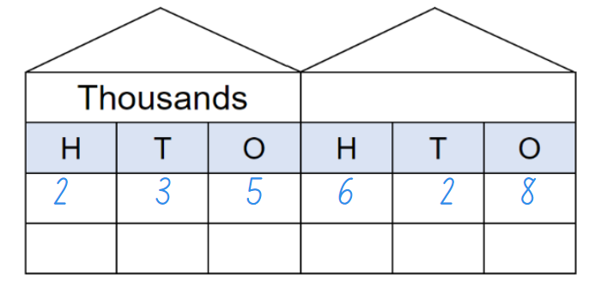
- Select students to read their numbers allowed monitoring for correct naming of large numbers.
- Explain to students that the quantity value of the numbers is clear when they read the number aloud. For example, 235 628 is read as two hundred and thirty-five thousand, six hundred and twenty-eight.
- Identify the quantity value of the 6 as 600.
Quantity value: the amount a digit represents in a number. For example, the quantity value of the 5 in 546 is 500 and the quantity value of the 4 is 40.
- Ask students to turn and talk to identify the quantity values of each digit in 235 628. Invite students to share their thinking with the class.
- Record the number 235 628 in expanded notation and explain the quantity value of each digit. For example, 235 628 = 200 000 + 30 000 + 5 000 + 600 + 20 + 8. Explain to students that, by recording a number using expanded form, they can identify the quantity values of each digit in large numbers. Model writing numbers using expanded form (see Figure 4).
Figure 4 – Stage 2 expanded notation
- Students continue rolling the die, creating 6- or 7-digit numbers and recording the expanded form in their workbooks. Invite students to share their examples and identify the quantity values within the numbers.
- Regroup as a class and ask:
- How can you represent numbers using place value?
- How can rearranging the digits change the size of your number?
- Can you name the quantity value for the second digit in one of your selected numbers?
- Can you name the quantity value for the third digit in one of your selected numbers?
- Display a 6-digit number. Ask students to work with a partner and identify another way we can partition this number into non-standard form. For example, 421 573 can be renamed as 42 tens of thousands, 15 hundreds and 73 ones. Provide MAB materials to test conjectures.
- Students rename the numbers in their workbook using non-standard forms.

Discuss and connect the mathematics – 10 minutes
- Display the number 985 407. Ask students:
- What do you know or understand about place value? Explain your thinking using this number.
- What is the quantity value of the digit 4 in this number?
- How many hundred thousands are in this number? How do you know?
- What is the largest number you can make if you rearranged these digits?
- What is the smallest number you could make?
- How can we rename this number? Is there another way?
This table details opportunities for assessment.
Assessment opportunities | Links
What to look for:  - Can Stage 2 students name and recognise the number of tens, hundreds and thousands in any given number? [MAO-WM-01, MA2-RN-01]  - Can Stage 2 students use place value to expand the number? [MAO-WM-01, MA2-RN-01]  - Can Stage 2 students partition numbers up to 6-digits in standard and non-standard form? [MAO-WM-01, MA2-RN-01]  - Can Stage 3 students name millions using the place value grouping of ones, tens and hundreds? [MAO-WM-01, MA3-RN-01]  - Can Stage 3 students regroup numbers in different forms? [MAO-WM-01, MA3-RN-01]  - Can Stage 3 students partition numbers to 1 million in non-standard forms? [MAO-WM-01, MA3-RN-01] | Links to National Numeracy Learning Progressions (NNLP):  - Stage 2 – NPV6, NPV7  - Stage 3 – NPV6, NPV7.

Lesson 3
Core concept: naming and representing large numbers are key components of place value.

Daily number sense: More or less – 15 minutes
The table below contains a suggested learning intention and success criteria. These are best co-constructed with students.
Daily number sense learning intention | Daily number sense success criteria
All students are learning to:  - read, record and order numbers in ascending and descending order. | All students can:  - name and record 5-digit numbers  - order 5-digit numbers in ascending and descending order.
- Organise students into small groups of 4, made up of 2 teams of 2 students. Provide group with five 6-sided dice and writing materials.
- Explain that Team 1 will roll the 5 dice and make a 5-digit number. Team 1 writes the 5-digit number in the first row, deciding if they want their number to be the ‘more’ number of the ‘less’ number for this round.
- Team 2 rolls the 5 dice and makes a 5-digit number that is either more than or less than the first team’s number (see Figure 5).
Figure 5 – More or less example
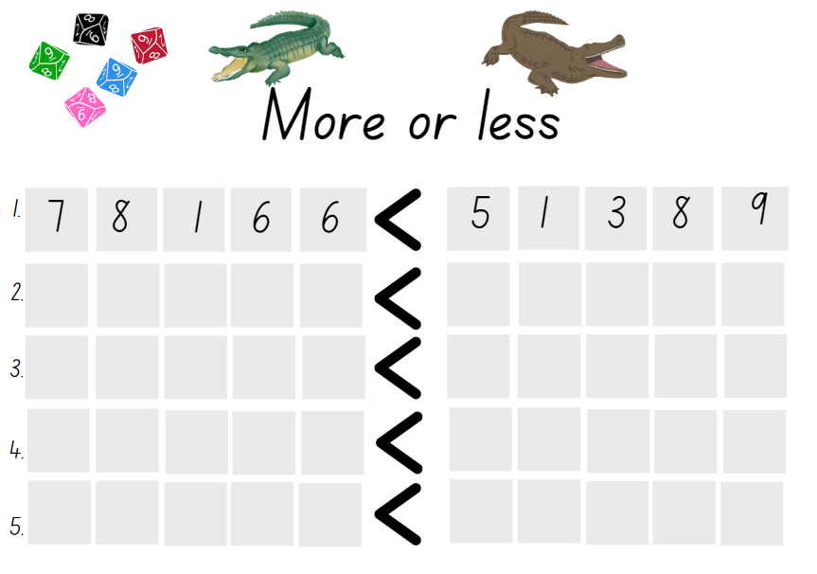
- After 5 rounds, both teams read and order the numbers to see which team made the largest and smallest numbers. Play again, alternating the team that rolls first.
- Stage 3 students can use numbers up to millions.
This table details opportunities for assessment.
Assessment opportunities | Links
What to look for:  - Can students name and record 5-digit numbers? [MAO-WM-01, MA2-RN-01, MA3-RN-01]  - Can students order 5-digit numbers in ascending and descending order? [MAO-WM-01, MA2-RN-01, MA3-RN-01] | Links to National Numeracy Learning Progressions (NNLP):  - Stage 2 – NPV6, NPV7  - Stage 3 – NPV6, NPV7.

Core lesson: Exploring the size of numbers – 50 minutes
The table below contains suggested a learning intention and success criteria. These are best co-constructed with students.
Core concept learning intention | Core concept success criteria
All students are learning to:  - read, represent and order numbers. | All students can:  - understand the role of zero in large numbers  - understand place value groupings of ones, tens and hundreds.  Students working towards Stage 2 outcomes can:  - read and represent numbers up to 6-digits  - describe how making a number 10, 100 or 1000 times as large changes the place value of digits.  Students working towards Stage 3 outcomes can:  - read and represent numbers in the billions.
- Ask students if they can think other real-life examples of very big numbers like the country and town populations explored in the previous lesson.
- Display and discuss Resource 5: Big numbers questions then Resource 6: Big numbers answers.
- Review how the base-10 number system is organised. For example:
- 10 ones always make 10 – 10 ones make 10
- 10 tens always make one hundred – 10 tens make 100
- 10 hundreds always make one thousand – 10 hundreds make 1000
- 1000 thousands always make one million – 1000 thousands make 1 000 000
- 1000 millions always make one billion – 1000 millions make 1 000 000 000.
Multi-age: Stage 2 students represent numbers to at least tens of thousands.
- Provide Resource 7: Place value structure as reference for students. Ask if they can see any patterns, for example, each place value position is 10 times larger than the previous position.
- Ask students which 2 digits are used in all the numbers – one and zero. Ask why zero is so important. Students use mini whiteboards to write 100 as a numeral, then rub out a zero and tell you what they have now. Discuss how different the numbers 100 and 10 are. Ask students to think about things they would rather have 10 of than 100 and things they would rather have 100 of than 10. For example, homework assignments or chocolates.
Multi-age: in pairs or small stage-based groups, students use mini whiteboards to write numbers using one and a variety of zeros to make larger numbers. Stage 2 students can rewrite numbers up to 6-digits. For example, 10, 100, 1000, 10 000, 100 000. Stage 3 students can rewrite numbers up to millions. For example, 10, 100, 1000, 10 000, 100 000, 1 000 000.
- As a class, discuss the place value of the numbers they have written and what would happen to their numbers if they remove a zero and then another zero. Emphasise the multiplicative relationships between the numbers.
- Explain that students are going to work in small groups to investigate how many days they have been alive. Some groups will be able to do this with no further instruction, but other groups may need to consider these questions:
- How many years old are you now? How many days are there in each of those years?
- How many days is that? Do you need to think about leap years?
- How long has it been since your last birthday? Add on these days.
- Students discuss what strategies they used to work out their own total. Students add them together to get a group total. Calculators can be used to support calculations. Each group then works out a total for their group.
- Once groups have worked out their total days alive, come together as a class and order the group totals in ascending order. Display an online calculator to add the group totals. Have students indicate when the total goes past 10 000 and 100 000. An average Stage 3 class will have a total of more than 100 000.
- Using the class total, discuss and work out how many classes of their size students would need to reach a total of one million days alive. Draw attention to the multiplicative relationship between 10 000, 100 000 and 1 000 000.

Discuss and connect the mathematics – 10 minutes
- Review reading, writing and naming large numbers using place value groupings.
- Discuss the strategies students used to determine their number of days alive. Ask what worked, what was unsuccessful and why.
This table details opportunities for assessment.
Assessment opportunities | Links
What to look for:  - Do students understand the role of zero in large numbers? [MAO-WM-01, MA2-RN-01, MA3-RN-01]  - Do students understand place value groupings of ones, tens and hundreds? [MAO-WM-01, MA2-RN-01, MA3-RN-01]  - Can Stage 2 students read and represent numbers up to 6-digits? [MAO-WM-01, MA2-RN-01]  - Can Stage 2 students describe how making a number 10, 100 or 1000 times as large changes the place value of digits? [MAO-WM-01, MA2-RN-01]  - Can Stage 3 students read and represent numbers in the billions? [MAO-WM-01, MA3-RN-01] | Links to National Numeracy Learning Progressions (NNLP):  - Stage 2 – NPV6, NPV7  - Stage 3 – NPV6, NPV7.

Lesson 4
Core concept: the place value system can be extended, compared and analysed.

Daily number sense: Teacher choice – 10 minutes
- From a class need surfaced through formative assessment data, identify a short, focused activity that targets students’ knowledge, understanding and skills. Example activities may be drawn from the following resources:
- Mathematics K-6 resources
- Universal Resources Hub.

Core lesson 1: Exploring decimals – 30 minutes
The table below contains suggested a learning intention and success criteria. These are best co-constructed with students.
Core concept learning intention | Core concept success criteria
All students are learning to:  - extend the place value system from whole numbers to decimals. | All students can:  - divide a length representing one whole into 10 equal parts and label the parts using decimal notation  - record decimals using decimal notation  - identify the role of zero in different positions in decimals.  Students working towards Stage 2 outcomes can:  - compare and order decimals number up to tenths on a line.  Students working towards Stage 3 outcomes can:  - compare and order decimals number up to hundredths on a line.
- Display a strip of paper labelled with a zero at one end and a one at the other, with equal space lines to represent the tenths (see Figure 6).
Figure 6 – Decimals 1
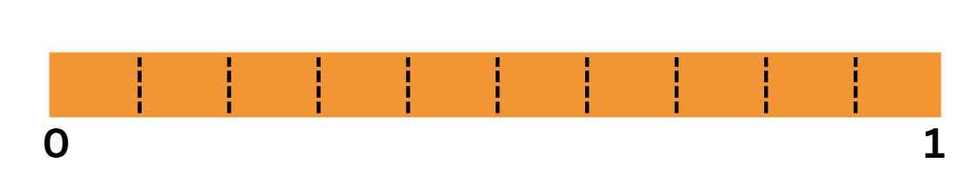
- Ask students:
- What do you notice about the strip?
- What do you notice about the spaced markings?
- What do think is between zero and one? How do you know?
- Using the marker, cut a tenth out of the strip of paper. Ask students:
- What do you notice?
- What do you think this smaller piece represents? What does this remind you of?
- Is this piece part of a whole or something else? Explain your answer.
- Discuss how many pieces students would have if they continued to cut the paper strip at the marks between zero and one. Prompt students to prove their answer.
- Explain to students that there are smaller numbers between whole numbers called decimals. Tell students the smaller part is named 1 tenth, which is one-tenth of the whole. The whole has been partitioned into 10 equal parts. Label the piece ‘1 tenth’ (see Figure 7).
Figure 7 – 1 tenth
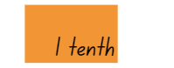
Decimal: used to describe aspects of the base-10 number system. The decimal point separates the whole number part of a number from its decimal part.
- Move the 1 tenth up onto a new line and move another tenth up next to it (see Figure 8).
Figure 8 – 2 tenths
- Ask students to look at the first tenth that is labelled and make a prediction about what the second piece can be named.
- Have students share their ideas, identifying that the second one makes 2 tenths (see Figure 9).
Figure 9 – Adding tenths
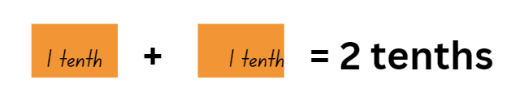
- Repeat the same steps, moving each tenth up and naming it 3 tenths, 4 tenths, 5 tenths until 10 tenths. Ask students if they can rename 10 tenths in a different way. Highlight to students that 10 tenths make one whole.
- Explain that students are extending the place value system to numbers smaller than a whole and this can be represented using decimal notation.
Note: to support place value conceptual understanding, 6.1 would be read as ‘six and one tenth’. The word ‘and’ connects the decimal fraction with the whole number and makes a link with common fractions. When recording decimal notation, students partition one into 10 equal pieces to form tenths when recording decimal notation. The primary purpose of the decimal point is to show where the ones column is.
- Model writing the decimal notation for 1 tenth as 0.1. Explain to students there are 0 ones and 1 tenth. Discuss the purpose of the decimal point.
- Ask students to turn and talk to a partner about how they would write 2 tenths using decimal notation. Have students share their thinking with the class.
- Provide students with Resource 8: Decimal strip. Students label the strip using decimal notation.
- Display only the 2 tenths on the board. Then add another whole strip to the 2 tenths (see Figure 10).
Figure 10 – Two tenths and one whole
- Ask students:
- What do we have now?
- How can we record this?
- How can we say this number?
- Model recording 1.2 and reading the decimal as ‘one and 2 tenths’. Explain that students have one whole and 2 tenths. Make a connection to a number line representation. These 2 extra tenths are part of the next whole on the number line (see Figure 11).
Figure 11 – Decimals on a line
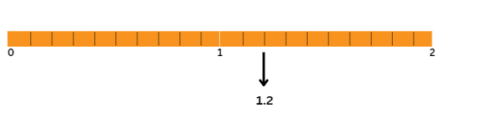
- Students draw a number line from 0–3 in their workbooks.
- Explain that, in pairs, Stage 2 students will investigate where the following selected decimals would be recorded on the marked intervals on the given number line.
- Stage 2 students record decimals, such as 1.7, 0.9, 2.5 and 3.0. Provide time for students record the decimals on their number line.
- Revise hundredths and thousandths with Stage 3 students.
- Stage 3 students record decimals, such as 1.78, 0.902, 2.54 and 3.709. Provide time for students to record the decimals on their number line.
- As a class, share solutions and explanations of number positions on the line.
Note: by the end of Stage 3, students will be able to compare and order decimals up to 3 decimal places. Stage 2 students will be able to compare and order decimals up to 2 decimal places.

Core lesson 2: Decimal Bingo – 20 minutes
This activity is an adaptation of Missing Number Bingo from NZ Maths by New Zealand Ministry of Education.
- Explain to students that zero plays an important role in whole numbers and it also plays an important role in decimals.
- Record the decimal ‘0.5’ on the board and ask students to turn and talk about the role of the zero in this decimal and why it is important.
- As a class, discuss that the zero in decimals can be a place holder and it helps students understand how to say and write decimals.
- Refer to the 0.5 on the board and explain that, for decimals between zero and one, the zero is written in the ones place to reduce the risk of misreading the decimal as a whole number. Record ‘.5’ and explain that this could be confused for 5.
Note: prior to the lesson, collect multiple transparent counters and prepare copies of the bingo game Resource 9: Stage 2 gameboards and Resource 10: Stage 3 gameboards, ensuring there is a copy for each student. Numbers are not repeated so use a copy of the 2 resources as the call out card.
- Provide each student with a bingo board and transparent counters.
- Explain that you will call out decimal numbers and students need to identify the corresponding decimal on their bingo board and cover it with a counter.
- Explain that when a student covers all the decimals on their bingo board, they must call out ‘BINGO!’. The first student to cover all their decimals wins the game.
Note: this bingo game will be played again in Lesson 7.

Consolidation and meaningful practice – 10 minutes
- Revise the number line as a model to help order decimals and compare their sizes.
- Students select 4 decimals from their bingo card and order them on a number line in their workbooks.
- Ask students:
- What numbers did you write first on your number line? Why?
- Did you identify any benchmark decimals? Which ones?
- How did the benchmark decimals assist you in ordering the decimals?
- Which place value was most important to look at first, second and third?
- Did this change as you began ordering the numbers? Explain your thinking.
This table details opportunities for assessment.
Assessment opportunities | Links
What to look for:  - Can students divide a length representing one whole into 10 equal parts and label the parts using decimal notation? [MAO-WM-01, MA2-RN-02, MA3-RN-02]  - Can students record decimals using decimal notation? [MAO-WM-01, MA2-RN-02, MA3-RN-02]  - Can students identify the role of zero in different positions in decimals? [MAO-WM-01, MA2-RN-02, MA3-RN-02]  - Can Stage 2 students compare and order decimals number up to tenths on a line? [MAO-WM-01, MA2-RN-02]  - Can Stage 3 students compare and order decimals number up to hundredths on a line? [MAO-WM-01, MA3-RN-02] | Links to National Numeracy Learning Progressions (NNLP):  - Stage 2 – NPV6, NPV7, NPV8  - Stage 3 – NPV6, NPV7, NPV8.  Links to suggested Interview for Student Reasoning (IfSR) tasks:  - Stage 2 – IfSR-NP: 4D.1, 4D.3, 4D.4  - Stage 3 – IfSR-NP: 4D.5, 4D.6.

Lesson 5
Core concept: number patterns can be multiplicative.

Daily number sense: Ordering decimals – 10 minutes
Daily number sense activities for Lessons 5 to 7 ‘loop’ back to concepts and procedures covered in previous units to assist students to build an increasingly connected network of ideas. These concepts may differ from the core concepts being covered by the unit.
The table below contains a suggested learning intention and success criteria. These are best co-constructed with students.
Daily number sense learning intention | Daily number sense success criteria
All students are learning to:  - extend the place value system from whole numbers to decimals. | All students can:  - identify the role of zero in decimal numbers  - compare and order decimals.
- Display the following decimal on the board ‘0.2’. Ask Stage 2 students to draw a number line from 0–1 and place the decimal on the line.
- Then display the following decimal on the board ‘0.05’. Ask Stage 3 students to draw a number line from 0–1 and place the decimal on the line.
- In pairs, ask students to explain their decision to their partner.
- Ask the students to place the same decimal on a number line from 0–5. Ask the students what has changed and what remains the same. Highlight the role of zero in both decimals.
Note: one decimal misconception is sometimes called ‘Longer is Larger’, where students consider that the number with more decimal places is larger. Another misconception is sometimes called ‘Shorter is Larger’, where students consider that the number with fewer decimal places is larger.
This table details opportunities for assessment.
Assessment opportunities | Links
What to look for:  - Can students identify the role of zero in decimal numbers? [MAO-WM-01, MA2-RN-02, MA3-RN-02]  - Can students compare and order decimals? [MA0-WM-01, MA2, RN-02, MA3-RN-02] | Links to National Numeracy Learning Progressions (NNLP):  - Stage 2 – NPV6, NPV7  - Stage 3 – NPV7.  Links to suggested Interview for Student Reasoning (IfSR) tasks:  - Stage 2 – IfSR-NP: 4D.4  - Stage 3 – IfSR-NP: 4D.4, 4D.5, 4D.6.

Core lesson: Base-10 patterns – 40 minutes
The table below contains suggested learning intentions and success criteria. These are best co-constructed with students.
Core concept learning intentions | Core concept success criteria
All students are learning to:  - apply an understanding of place value and the role of zero to represent numbers  - compare and order decimals up to 3 decimal places. | All students can:  - represent and read numbers using place value  - record and explain a multiplicative number pattern  - explain the role of zero in representing multiplication by 10 in place value  - identify that the decimal point does not move in multiplication or division  - compare numbers up to 3 decimal places.
Note: prior to the lesson, prepare cards from Resource 11: Class number slide. Each student should also have an individual slide made using Resource 12: Place value slider and a copy of Resource 7: Place value structure. The student number slides will be used in subsequent units. Have a copy of Resource 7: Place value structure printed on A3 for the lesson conclusion.
- On the floor or a wall, set out the place value cards for ones to millions from Resource 11: Class number slide. The 2 key relationships to explore are:
- 10 of these is one of those, for example, 10 hundreds is 1000.
- 1000 of these is one of those, for example, 1000 thousands is 1 000 000.
- Give one student a digit card, such as 6, and ask them to stand in the ones place facing the class. Explain that, in the base-10 number system, there must always be a digit in the ones place. Ask the student to state the value of the digit card, for example, 6 ones.
- Provide another student with a ×10 card. Ask:
- What happens to the value of the ones if we multiply by 10?
- How can we show that in place value?
- What is the relationship between the tens and the one? 10 is 10 times larger than one.
- Students should identify that the digit card moves to the next place value position and a zero is required. Place the ×10 card in front of the tens place. Move the digit card and provide a zero card for the ones. The number should now read 60.
- Hand out a further ×10 card. Ask:
- What happens to the value of the tens if we multiply by 10?
- How can we show that in place value?
- What is the relationship between the hundreds and the tens? (×10)
- What is the relationship between the hundreds and the ones? (10 × 10)
- Repeat the steps, questions and reasoning process using zeros to represent the properties of the numbers to millions (see Figure 12 for a partially completed class number slide).
Figure 12 – Class number slide in action
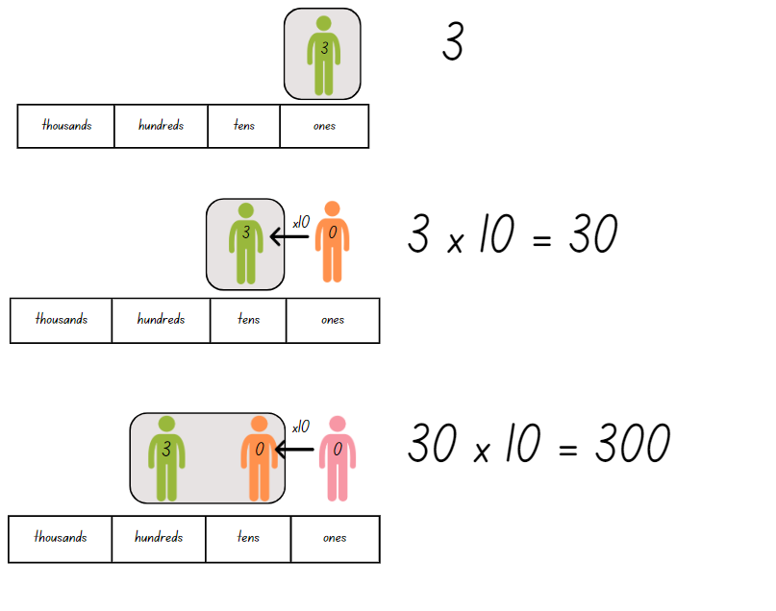
- Once students have made one million, hand out a ÷10 card and apply the same question set. Ask about the new value of the digits, the representation of the number using place value and the relationship between the new and previous number (that it is 10 times smaller).
- Repeat the steps, questions and reasoning process until the original digit is back in the ones place.
- Introduce the decimal point and the cards for tenths, hundreds and thousandths.
- Explain that the decimal point never moves. It exists to show the difference between the whole number places and decimal fraction places. It stays in its place while the numbers move.
- Provide another ÷10 card. Ask:
- What happens to the value of the ones if we divide by 10?
- How can we show that? (Ensure students note that the ones place will now have a zero card)
- What is the relationship between the tenths and the one? (A tenth is 10 times smaller than one)
- Individually or in pairs, students select a 2-digit number. Use the number slide to model multiplying and dividing their number from the ones and tens up to the millions and then back to the thousandths (see Figure 13). Record the numbers at each step.
Figure 13 – Number slider example
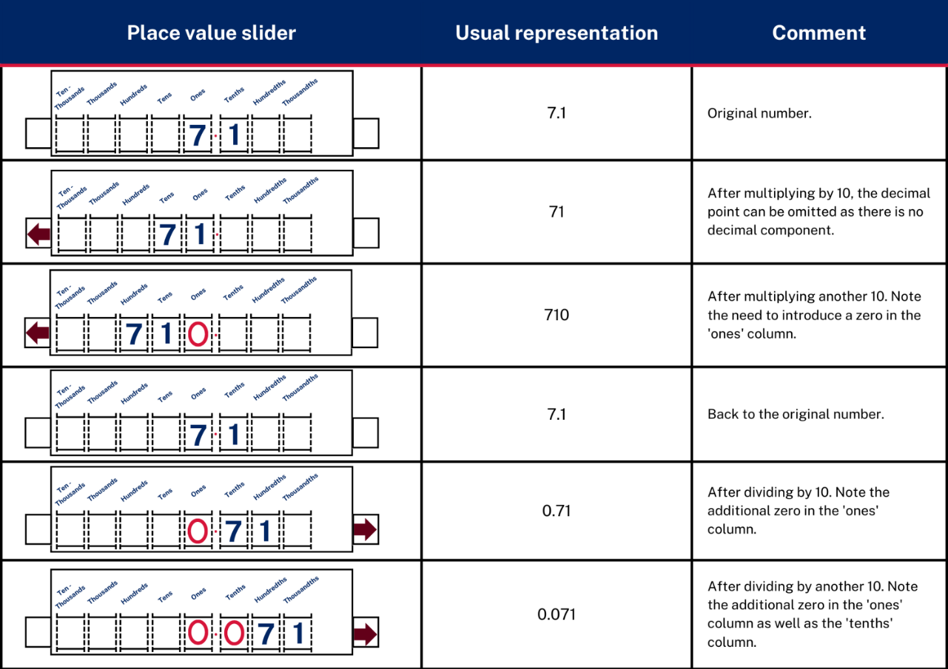
Image adapted from Number Slide: Example 1 (Stacey et al. 2011).
Note: zeros should be added to a number slide as place holders when multiplying and dividing by powers of 10. This assists when comparing the place value of digits by determining numbers that are 10 or 100 times the original number.
- Ask students to identify and describe useful patterns.
- Ask students to select 2 numbers from their list and identify the relationship between them, for example, 23 is 10 times larger than 2.3 or 5400 is 1000 times smaller than 5 400 000.
Multi-age: Stage 2 students can work with whole numbers up to 6-digits and decimal numbers including tenths. Stage 3 students can work with whole numbers up to billions and decimals to thousandths.
This table details opportunities for differentiation.
Too hard? | Too easy?
Students cannot use a number slide to represent multiplication and division in place value.  - Students use a single digit number with the slide.  - Use a place value mat and concrete materials. Roll a die and regroup, for example, 10 ones into one 10. Continue until 100.  - Explore patterns with a calculator such as 1 ÷ 10, 2 ÷ 10 and so on. Record the pattern. | Students can use a number slide to represent multiplication and division in place value.  - Students record the multiplicative relationships between one number, such as 34 000 and numbers ranging in place value from billions to thousandths.  - Students investigate numbers larger than one billion and smaller than a thousandth, focusing on groups of place value. Explore real-life contexts where these are used.

Consolidation and meaningful practice – 20 minutes
- Display Resource 13: Base-10 patterns.
The table below outlines stimulus prompts to generate conversation about the topic, along with anticipated responses from students.
Prompts | Anticipated student responses
- What patterns can you see? How can that help you understand place value? | - The digits in the original number do not change when you multiply by 10, 100 or 1000.  - The digits shift one place to the left each time the number gets 10 times larger.  - The digits shift to the right each time the number gets 10 times smaller.  - The large numbers are grouped in threes. This helps me to read the number in chunks.
- What do you notice about the ones place? | - There is always a digit in the ones place but not in the decimal places.
- Select 2 numbers from the pattern. Ask students to explain the relationship between them. | - For example, 340 is 1000 times smaller than 340 000.
- Can you see pairs of numbers that are 10 times smaller or larger than each other? What do you notice?  - Can you see pairs of numbers that are 100 times smaller or larger than each other?  - Can you see pairs of numbers that are 1000 times smaller or larger than each other? | - 34/340, 340/3400, 3400/34 000, 3.4/34. They are next to each other.  - 34/3400, 340/34 000, 3400/340 000, 3.4/340. They are 2 place value positions away from each other.  - 34/3400, 340/34 000, 3400/340 000, 3.4/3400. They are 3 place value positions away from each other.
This table details opportunities for assessment.
Assessment opportunities | Links
What to look for:  - Can students represent and read numbers using place value? [MAO-WM-01, MA2-RN-01, MA2-RN-02, MA3-RN-01, MA3-RN-02]  - Can students record and explain a number pattern? [MAO-WM-01, MA2-RN-01, MA2-MR-01, MA3-RN-01, MA3-RN-02, MA3-MR-01]  - Can students explain the multiplicative relationship between each place value position? [MAO-WM-01, MA2-MR-01, MA3-RN-01]  - Can students explain the role of zero in representing multiplication in place value? [MA3-RN-01]  - Can students identify that the decimal point does not move in multiplication or division? [MAO-WM-01, MA2-RN-02, MA3-RN-01, MA3-RN-02]  - Can students compare numbers up to 3 decimal places by describing the multiplicative relationship between them? [MAO-WM-01, MA2-RN-02, MA3-RN-02] | Links to National Numeracy Learning Progressions (NNLP):  - Stage 2 – NPV7, NPV8  - Stage 3 – NPV7, NPV8.  Links to suggested Interview for Student Reasoning (IfSR) tasks:  - Stage 2 – IfSR-NP: 4D.1  - Stage 3 – IfSR-PT: 1.A5, 1.A7.

Lesson 6
Core concept: structures can support multiplicative thinking.

Daily number sense: Ordering decimals – 10 minutes
The table below contains a suggested learning intention and success criteria. These are best co-constructed with students.
Daily number sense learning intention | Daily number sense success criteria
All students are learning to:  - extend the place value system from whole numbers to decimals. | All students can:  - identify the role of zero in decimal numbers  - compare and order decimals.
- Display the following numbers for Stage 3 students, 1.24, 2.323, 0.56, 1.789, 3.650, and ask students to read the decimals aloud.
- Display the following numbers for Stage 2 students, 1.2, 2.3, 0.5, 1.7, 3.6, and ask students to read the decimals aloud.
- In pairs, provide students with sticky notes and ask them to write the decimals and order them on a line from smallest to largest.
- Have students share their thinking and clarify misconceptions.

This table details opportunities for assessment.
Assessment opportunities | Links
What to look for:  - Can students identify the role of zero in decimal numbers? [MAO-WM-01, MA2-RN-02, MA3-RN-02]  - Can students compare and order decimals? [MAO-WM-01, MA2, MA2-RN-02, MA3-RN-02] | Links to National Numeracy Learning Progressions (NNLP):  - Stage 2 – NPV7  - Stage 3 – NPV8.  Links to suggested Interview for Student Reasoning (IfSR) tasks:  - Stage 2 – IfSR-NP: 4D.1  - Stage 3 – IfSR-PT: 1A.5, 1A.5, 1A.7.

Core lesson – 45 minutes

Stage 2 task: Useful arrays
The table below contains suggested learning intentions and success criteria. These are best co-constructed with students.
Core concept learning intentions | Core concept success criteria
Students working towards Stage 2 outcomes are learning to:  - use arrays to establish multiplication facts  - use number properties to find related multiplication facts. | Students working towards Stage 2 outcomes can:  - use arrays to coordinate the number of groups with the number in each group  - recall multiplication facts  - recognise and use the symbols for multiplied by and equals  - identify the commutative property of multiplication.
This activity is an adaptation of ‘Cover the field’ from Mindset Mathematics: Visualizing and Investigating Big Ideas, Grade 4 by Boaler et al.
Note: by playing this game, students will represent a multiplicative structure to create an array.
- Explain that the aim of the game is to cover the field as completely as possible and record a multiplication equation for each rectangle made.
- Provide pairs of students with four 6-sided dice, plain paper, grid paper and markers.
- Players take turns rolling the 4 dice and use the values shown to form a multiplication equation. Students must combine 2 pairs of dice to become the side of each rectangle or array. For example, if 6, 4, 3 and one are rolled, the player might choose the sum 4 + 3 = 7 and 6 + 1 = 7. The rectangle becomes 7 × 7. Alternatively, students might make the sum 3 + 6 = 9 and 4 + 1 = 5, in which case the rectangle would be 9 ×5.
- Using the plain paper, students record the strategy they used to form the array they are going to cover on their field (see Figure 14).
Figure 14 – Example student recording
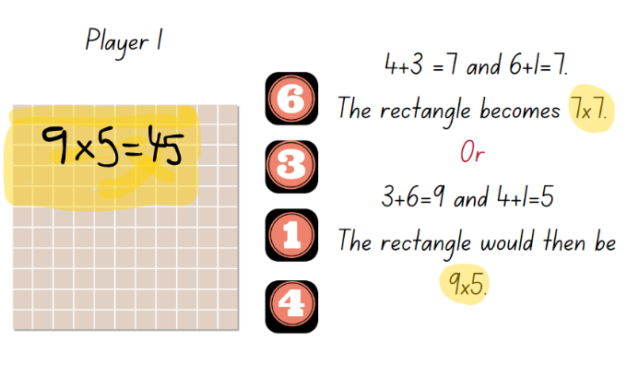
- Once students have decided on the rectangle, they draw it on the field. The rectangle cannot overlap with an existing rectangle or be broken into smaller pieces.
- Students label and record their multiplication equation on the rectangle formed. Play ends when one player rolls the 4 dice and cannot make any rectangle that will fit on the field. The winner is the player with the most rectangles covered.
This table details opportunities for differentiation.
Too hard? | Too easy?
Students cannot create and represent multiplicative structure using an array model.  - Support students to create the pairs of numbers and identify the corresponding array on the grid.  - Provide students with one of the side numbers, so they only need to create the total for the other length of the array. | Students can create and represent multiplicative structure using the array model.  - Students repeat the game, but this time aiming to cover the smallest area possible by using the difference between one pair of numbers rolled.  - In pairs, students repeat the activity using one sheet of grid paper, competing to fill the most squares on the page.
This table details opportunities for assessment.
Assessment opportunities | Links
What to look for:  - Can students use arrays to coordinate the number of groups with the number in each group? [MAO-WM-01, MA2-MR- 01]  - Can students recall multiplication facts? [MAO-WM-01, MA2-MR-01]  - Can students recognise and use the symbols for multiplied by and equals? [MAO-WM-01, MA2-MR-01]  - Can students identify the commutative property of multiplication? [MAO-WM-01, MA2-MR-01] | Links to National Numeracy Learning Progressions (NNLP):  - Stage 2 – MuS6, MuS7.

Core lesson – 45 minutes

Stage 3 task: Make 10!
The table below contains suggested learning intentions and success criteria. These are best co-constructed with students.
Core concept learning intentions | Core concept success criteria
Students working towards Stage 3 outcomes are learning to:  - indicate the value of digits in decimal numbers including tenths  - select multiplication or division to solve a problem. | Students working towards Stage 3 outcomes can:  - show an understanding of place value when dividing a number by 10  - use multiplication or division to get close to a desired number.
This activity is an adaptation of Make 100, 1000, 10, 1: Adding and subtracting using place value [PDF 1.10 MB] from Inspired Mathematics Teaching by Anita Chin Mathematics Consultancy.
- Explain to Stage 3 students that they will play a game called ‘Make 10!’ The aim is to roll a 12-sided dice 7 times and apply a choice of rules to get as close to 10 by the end of the game.
- Students must decide if they need to multiply or divide their throw by 10. For example:
- Multiply by one. Ask students what this means. Give examples as necessary to show that the throw will remain the same.
- Divide by 10. Ask students what this means. Give examples and discuss how that it means the score is 10 times smaller than the throw. Write down some throws and then show the number 10 times smaller. For example, 9 will become 9 tenths, which is written as 0.9; 2 will become 2 tenths, written as 0.2; 12 will become one whole and 2 tenths, written as 1.2 and so on.
- Provide each student with Resource 14: Make...
- Make sure that students are recording each column of the gameboard correctly and checking their progressive totals with a partner. Revise what the progressive total is after each of the first few throws. Some students may need paper to work out their progressive totals, others will do this mentally.
- For the last 3 throws, students can decide individually which rule to apply so that there are different totals to compare at the end of the game (see Figure 15 for how the final scores could be different).
Figure 15 – Make 10 example
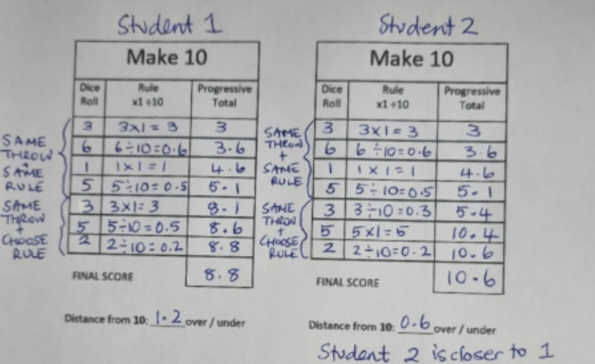
- After the seventh throw, students record their final score at the bottom of the game board and work out how close they are to exactly 10. Discuss how a number higher than 10 might be closer to 10 than an answer that is lower.
- Work out which students got the closest to 10. Ask the class which move or moves they think made a big difference to the game and if there was anything they would not do if they played the game again. This might include not multiplying 10, 11 or 12 by one because that guarantees the final score being much higher than 10.
- In groups of 4, playing pair against pair, students use Resource 14: Make… and a small 12-sided die to play the remaining games in the time available. Move around groups, supporting students to consider options and use the gameboard correctly.
This table details opportunities for differentiation.
Too hard? | Too easy?
Students cannot play the game because they do not understand the place value involved with dividing a number by 10.  - Students use a calculator to divide a number by 10 and/or find the progressive total. | Students can play the game, demonstrating understanding of multiplying by one and dividing by 10.  - Students play the game with a 20-sided die.  - Students include dividing by 100 as a rule.  - After the sixth throw, students can change the rule they applied to one of their throws and update their progressive total before the last throw.
This table details opportunities for assessment.
Assessment opportunities | Links
What to look for:  - Do students show an understanding of place value when dividing a number by 10? [MAO-WM-01, MA3-RN-02, MA3-MR-01]  - Can students use and explain reasoning to apply multiplication or division to get the closest to 10? [MAO-WM-01, MA3-RN-01, MA3-RN-02, MA3-MR-01] | Links to National Numeracy Learning Progressions (NNLP):  - Stage 3 – MuS6, MuS7.

Discuss and connect the mathematics – 5 minutes
- Regroup as class and ask:
- What did you notice as you played both games?
- Did your decisions change from the beginning of the game to the end of the game?
- What made this game challenging? How did you overcome the challenge?

Lesson 7
Core concept: known number facts and strategies support multiplicative understanding.

Daily number sense: Decimal bingo – 15 minutes
The table below contains a suggested learning intention and success criteria. These are best co-constructed with students.
Daily number sense learning intention | Daily number sense success criteria
Students working towards Stage 2 outcomes are learning to:  - extend the place value system from whole numbers to tenths.  Students working towards Stage 3 outcomes are learning to:  - extend the place value system from whole numbers to thousandths. | Students working towards Stage 2 outcomes can:  - express decimals as tenths.  Students working towards Stage 3 outcomes can:  - express decimals up to 3 decimal places.
- As a class, play ‘Decimal bingo’ from Lesson 4.

Core lesson: Making multiples – 15 minutes
The table below contains suggested learning intentions and success criteria. These are best co-constructed with students.
Core concept learning intentions | Core concept success criteria
All students are learning to:  - operate with multiples of 10  - use known number facts and strategies. | All students can:  - multiply a one-digit number by a multiple of 10  - use place value to rename groups of 10 to multiply  - use the commutative property to multiply by multiples of 10  - use known facts to find unknown multiples  - recognise and use the symbols for multiplied by and equals.
This activity is an adaptation of Multiply Multiples 3 from NRICH by University of Cambridge (Faculty of Mathematics).
- Display an interactive multiplication chart and highlight the multiples of 10. Ask students what they notice.
- Explain to students that understanding place value can help solve multiplication problems.
- For Stage 2 students, display the number sentence 10 × 2 = 20 × 1. Provide groups of students with MAB materials to help prove or disprove the statement.
- For Stage 3 students, display the number sentence 1000 × 7 = 200 × 35
- As a class, share some of the students’ strategies identifying that the equation is true.
- Display the number sentence 20 × 4 = _. Students turn and talk to a partner about how they can solve this equation.
- Prompt students to identify that 20 × 4 is 4 groups of 2 tens, which is equal to 8 tens, which is 80.
- Repeat this with an additional example using a multiple of 10 multiplied by a one-digit number. For example, 30 × 4 is 4 groups of 3 tens, which is equal to 12 tens, which is 120.

Core lesson – 30 minutes

Stage 2 task: Multiples of 10
The table below contains a suggested learning intention and success criteria. These are best co-constructed with students.
Core concept learning intentions | Core concept success criteria
Students are learning to:  - operate with multiples of 10  - use known number facts and strategies. | Students can:  - multiply a one-digit number by a multiple of 10  - use place value to rename groups of 10 to multiply  - use the commutative property to multiply by multiples of 10  - use known facts to find unknown multiples  - recognise and use the symbols for multiplied by and equals.
- Provide students MAB materials and ask them to solve the following equations explaining their reasoning:
- 40 × 3 =
- 80 × 2 =
- 20 × 5 =
- 70 × 4 =
- 30 × 6 =
- In groups or pairs, students to roll a standard 6-sided die twice. This will determine the digit in the tens place for the multiple of 10, and second number to multiply by. For example, students to record a dice roll of 4 and 2 to reflect 40 × 2.
- For each number sentence, ask students to create a diagram or use concrete materials to prove their answers.
Stage 2 students will repeat this activity to develop fluency and automaticity in multiplicative strategies.
This table details opportunities for differentiation.
Too hard? | Too easy?
Students cannot multiply a one-digit number by a multiple of 10.  - Have students use the multiplication chart to identify single digits multiplied by 10. Have students create models using concrete materials. | Students can multiply a one-digit number by a multiple of 10.  - Ask students to explain how knowing 4 × 20 = 80 could help someone work out 4 × 19. Have students explain their thinking using a diagram.  - Ask students to determine what 4 × 200 would be and explain their thinking using concrete materials or a diagram.

This table details opportunities for assessment.
Assessment opportunities | Links
What to look for:  - Can students multiply a one-digit number by a multiple of 10? [MAO-WM-01, MA2-MR-01, MA2-MR-02]  - Can students use place value to rename groups of 10 to multiply? [MAO-WM-01, MA2-MR-01, MA2-MR-02]  - Can students use the commutative property to multiply by multiples of 10? [MAO-WM-01, MA2-MR-01, MA2-MR-02]  - Can students use known facts to find unknown multiples? [MAO-WM-01, MA2-MR-01, MA2-MR-02]  - Can students recognise and use the symbols for multiplied by and equals? [MAO-WM-01, MA2-MR-01, MA2-MR-02] | Links to National Numeracy Learning Progressions (NNLP):  - Stage 2 – MuS5, MuS6, MuS7.

Core lesson – 30 minutes

Stage 3 task: Multiplying larger numbers
The table below contains a suggested learning intention and success criteria. These are best co-constructed with students.
Core concept learning intention | Core concept success criteria
Students working towards Stage 3 outcomes are learning to:  - select and apply appropriate strategies to solve multiplication problems. | Students working towards Stage 3 outcomes can:  - use partitioning and place value to multiply 2- and 3-digit numbers by one digit  - use mental and written strategies to multiply 2- and 3-digit numbers by 2-digit numbers.
- Explain that Stage 3 students will now be using their place value understanding to partition numbers and solve multiplication problems.
- Provide students with MAB materials and ask them to solve the following equations, explaining their reasoning:
- 15 × 8 =
- 23 × 9 =
- 12 × 25 =
- 83 × 20 =
- 200 × 15 =
- 70 × 14 =
- 300 × 6 =
- 3000 × 100 =
- In groups or pairs, students create their own 2-, 3-digit numbers by 2-digit numbers to create a multiplication number sentence. Students swap their number sentence with a partner and create a diagram or use concrete materials to find a solution.
This table details opportunities for differentiation.
Too hard? | Too easy?
Students cannot use partitioning and place value to multiply.  - Provide students with a multiplication chart and MAB materials to support their thinking.  - Students work with smaller numbers. | Students can use partitioning and place value to multiply.  - Students multiply 4-digit numbers by one-digit numbers.  - Students create equations with missing values for a partner to solve. For example, 17 × ? = 85.
This table details opportunities for assessment.
Assessment opportunities | Links
What to look for:  - Can students use partitioning and place value to multiply 2- and 3-digit numbers by one digit? [MAO-WM-01, MA3-RN-01, MA3-RN-02, MA3-MR-01]  - Can students use mental and written strategies to multiply 2- and 3- digit numbers by 2-digit numbers? [MAO-WM-01, MA3-RN-01, MA3-RN-02, MA3-MR-01] | Links to National Numeracy Learning Progressions (NNLP):  - Stage 3 – MuS6, MuS7.  Links to suggested Interview for Student Reasoning (IfSR) tasks:  - Stage 3 – IfSR-MT: 3A.1, 3A.2, 3A.3.

Discuss and connect the mathematics – 10 minutes
- Regroup as a class and ask:
- What did you notice?
- What did you wonder?
- What patterns did you identify?
- How did an understanding of place value help solve these equations?
- What is the relationship between multiplication and our place value system?

Lesson 8
Core concept: flexible methods of computation in multiplication and division involve composing and decomposing numbers.

Daily number sense: Teacher choice – 15 minutes
- From a class need surfaced through formative assessment data, identify a short, focused activity that targets students’ knowledge, understanding and skills. Example activities may be drawn from the following resources:
- Mathematics K-6 resources
- Universal Resources Hub.

Core lesson – 45 minutes

Stage 2 task: Patterns
The table below contains a suggested learning intention and success criteria. These are best co-constructed with students.
Core concept learning intention | Core concept success criteria
Students working towards Stage 2 outcomes are learning to:  - use known number facts and strategies to generate and describe number patterns. | Students working towards Stage 2 outcomes can:  - investigate and continue number patterns involving known multiplication facts.
This activity is an adaption of Multiplication Table Patterns from 5280 Math by Burkart.
- Display Resource 15: Multiplication patterns 1
- Ask students what they notice and wonder. Give students time to discuss and think about the image.
The table below outlines stimulus prompts to generate conversation about the topic, along with anticipated responses from students.
Prompts | Anticipated student responses
- What do you notice?  - What are you wondering?  - Does the same thing happen for the green and brown numbers?  - What happens if I add some of the numbers in the shaded squares?  - How do the sums of the blue and purple numbers compare to each other?  - How do the sums of the brown and green numbers compare to each other?  - Why do these things happen?  - What happens if I add all 8 shaded numbers?  - What if I make squares around other middle numbers? Will the patterns be the same? | - There are numbers surrounded by coloured squares.  - Why are there different colours in the squares?  - The colours on opposite sides are the same.  - The left blue number is smaller than the middle number by the same amount that the right blue number is bigger.  - The same thing happens with the purple numbers.  - The blue sum equals the purple sum. These sums are double the number in the middle.  - If I take 3 from the 12 add it to the 6, there will be 3 nines in a row.  - I can use the same idea to make 3 in a row of numbers in other purple and blue squares.  - The sum of the 4 blues and purples equals the sum of the 4 greens and browns.  - The browns always add up to 2 more than double the middle number.  - The greens always add up to 2 less than double the middle number.  - The sum of all the coloured numbers is 8 times the middle number.
- Record their noticing and wonderings using a T-chart.
Note: all patterns have regularities that students can perceive visually, auditorily and somatically (through tactile or action-based sensations). To discern, describe, extend, adjust, make and translate patterns, students need to be able to identify the repeating core or pattern rule, which repeats over and over and over again.
- Provide students with Resource 16: Multiplication patterns 2. Explain that students are going to use the multiplication chart to generate and investigate the number patterns involving related multiples.
- Students highlight the 2, 4, 8 multiples using one coloured highlighter. In pairs, students discuss the patterns and answer the following questions:
- What connection can you make between the twos, fours and eights?
- Why do these patterns exist?
- Will these patterns continue forever? Why or why not?
- What else do you notice?
- Students highlight the 3, 6 and 9 multiples in a different coloured highlighter. In pairs, students discuss any patterns and answer the following questions:
- What connection can you make between the threes, sixes and nines?
- Why do these patterns exist?
- Will these patterns continue forever? Why or why not?
- What else do you notice?
Note: students need to recognise that the commutative property of multiplication is that the product of A and B is the same as B and A.
- Ask students to create a sequence of steps to describe how to generate related multiple of 2, 4, 8, and 3, 6 and 9. Have students swap their sequence of steps with a partner to test and create the next 5 sequences in the pattern.

This table details opportunities for differentiation.
Too hard? | Too easy?
Students cannot investigate number patterns involving related multiples.  - Provide students with concrete materials to make the patterns.  - Provide number lines or number charts to support identifying the next number in the pattern. | Students can investigate number patterns involving related multiples.  - Provide students with a copy of the multiplication grid. Have students identify other patterns in related multiples, such as 5 and 10.  - Ask students to highlight the 3, 5 and 8 columns. Ask students to identify products of these multiples. Prompt students to explain what they notice and what conjectures they can make.
This table details opportunities for assessment.
Assessment opportunities | Links
What to look for:  - Can students investigate and continue number patterns involving related multiples? [MAO-WM-01, MA2-MR-01]  - Can students use the known strategy of doubling to connect multiples of 3 to 6 and 4 to 8? [MAO-WM-01, MA2-MR-01]  - Can students recognise the connection between even numbers and multiplication facts? [MAO-WM-01, MA2-MR-01]  - Can students identify the commutative property of multiplication? [MAO-WM-01, MA2-MR-01] | Links to National Numeracy Learning Progressions (NNLP):  - Stage 2 - NPA3, NPA4, MuS6.  Links to suggested Interview for Student Reasoning (IfSR) tasks:  - Stage 2 – IfSR-MT: 2A.4, 2A.6, 2A.9.
- Explain that a deep understanding of place value is very helpful when problem solving that require estimating, selecting efficient strategies and checking answers for reasonableness. This is especially important when numbers get very large or very small.
Note: all patterns have regularities that students can perceive visually, auditorily and somatically (through tactile or action-based sensations). To discern, describe, extend, adjust, make and translate patterns, students need to be able to identify the repeating core or pattern rule, which repeats over and over and over again.

Core lesson – 45 minutes

Stage 3 task: Packing problems
The table below contains suggested a learning intention and success criteria. These are best co-constructed with students.
Core concept learning intention | Core concept success criteria
Students working towards Stage 3 outcomes are learning to:  - apply an understanding of place value and the role of zero to represent the properties of numbers. | Students working towards Stage 3 outcomes can:  - regroup numbers in different forms  - identify multiplicative patterns in place value to solve problems.
- Display Resource 17: Suki’s sweets or Resource 18: Suki’s sweets 2. Read through the problem aloud to identify key words. Explain that there are multiple correct answers.
- To support flexible student thinking, ask the following questions as necessary:
- What is the least number of boxes required?
- What is the highest number of boxes required?
- If there were only 2 large boxes available, what would be the least number required?
- If you only had medium boxes, what would be the least number required?
- Are there any patterns that you used to help you solve the problem in more than one way?
- As a class, discuss different strategies to solve the word problem. Record using words, algorithms and diagrams.
- Share solutions and student reasoning, such as ‘5436 sweets would be 543 tens and 6 ones, so you would need 544 packets’ or ‘Medium boxes hold 100 tens or 1000 sweets, so you would need 6 medium boxes’.

This table details opportunities for differentiation.
Too hard? | Too easy?
Students cannot identify multiplicative patterns in place value to help with problem solving.  - Students use a number slide from a previous lesson to model the multiplication of 5 boxes of different sizes.  - Use MAB materials to model one solution to the problem. | Students can identify multiplicative patterns in place value to help with problem solving.  - Students write their own packing problems, extending numbers into the millions for real contexts.  - Students investigate sales of a common item in Australia such as fruit and vegetables.  - Add a time constraint to the problem. For example, ask how long it would take to load a truck if 5 boxes can be loaded in a minute.
This table details opportunities for assessment.
Assessment opportunities | Links
What to look for:  - Can students regroup numbers in different forms? [MAO-WM-01, MA3-RN-01]  - Can students identify multiplicative patterns in place value to solve problems aligned? [MAO-WM-01, MA3-RN-01, MA3-RN-02, MA3-MR-01] | Links to National Numeracy Learning Progressions (NNLP):  - Stage 3 – NPV6.

Consolidation and meaningful practice – 10 minutes
- Students write a reflection in their workbooks answering the following prompt questions:
- What do you now know that you didn’t know previously about place value?
- What connections are there between the base-10 system and multiplicative thinking?
- How does an understanding of place value help solve multiplication problems?
- Can you explain the connection with a diagram or image?

Resource 1: Place value gameboard
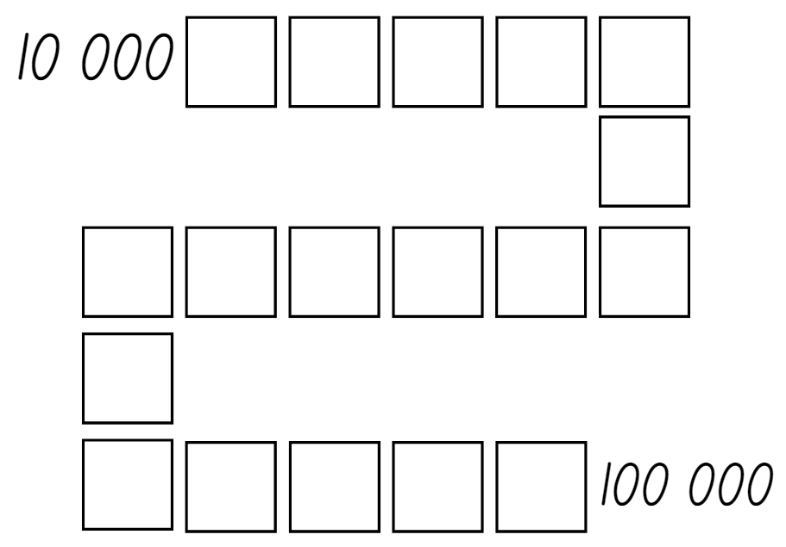

Resource 2: Place value houses
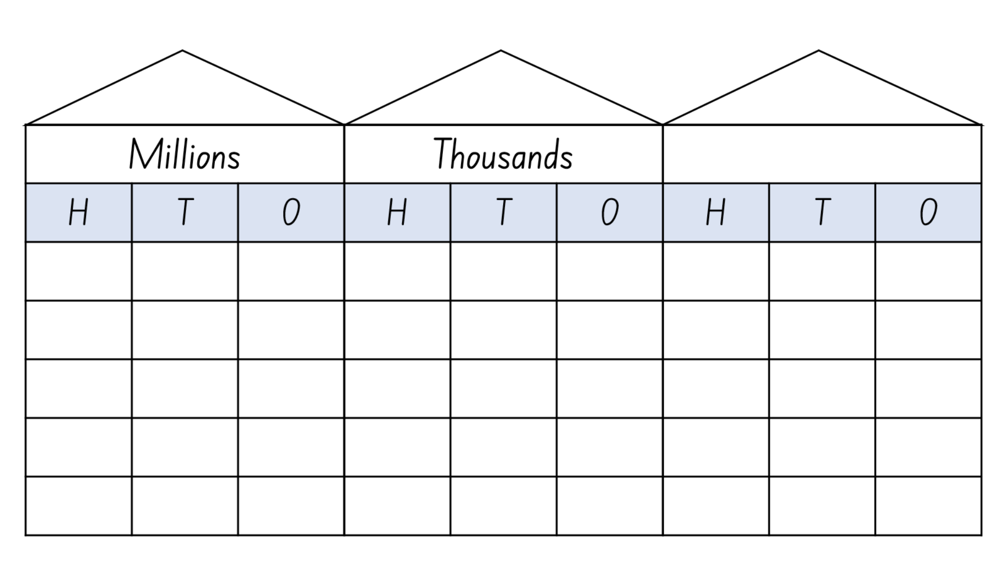

Resource 3: Australian town populations 2023
Australian town | Population
Mount Lawley | 10 703
Maitland | 67 132
Vermont | 9902
Hope Vale | 849
Ballarat | 97,937
Parkes | 10 026
Mackay | 74 219

Resource 4: Country populations 2023
Country | Population
China | 1 439 000 000
USA | 331 002 651
India | 1 380 004 000
Mexico | 128 932 753
Bangladesh | 164 689 000
Brazil | 212 559 000
Indonesia | 273 523 615
Nigeria | 206 139 589

Resource 5: Big numbers questions

Resource 6: Big numbers answers
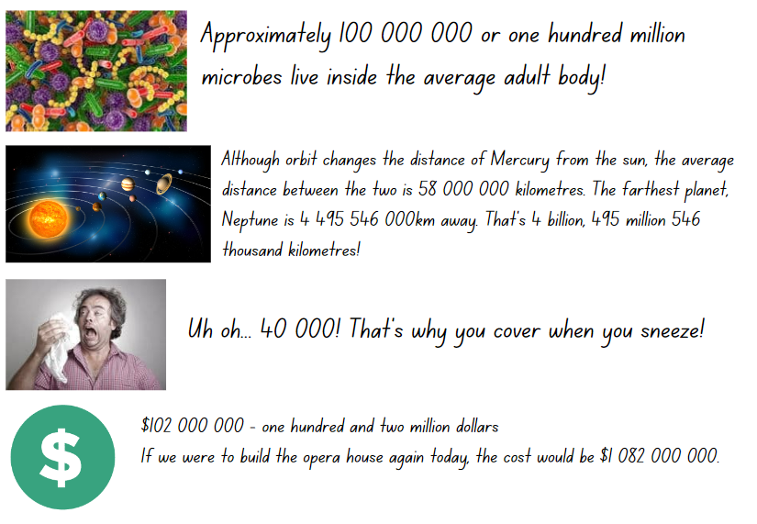

Resource 7: Place value structure
Name | Notation | Value
Millions | 1 000 000 | 1 ×10 × 10 × 10 × 10 × 10 × 10
Hundreds of thousands | 100 000 | 1 × 10 × 10 × 10 × 10 × 10
Tens of thousands | 10 000 | 1 × 10 x 10 × 10 × 10
Thousands | 1000 | 1 × 10 × 10 × 10
Hundreds | 100 | 1 × 10 × 10
Tens | 10 | 1 × 10
Ones | 1 | 1
Tenths | 0.1 | 1 ÷ 10
Hundredths | 0.01 | 1 ÷ 10 ÷ 10
Thousandths | 0.001 | 1 ÷ 10 ÷ 10 ÷ 10

Resource 8: Decimal strip

Resource 9: Stage 2 gameboards
1.2 | One and 5 tenths | 7.8 | Three and 6 tenths | 4.2
6.3 | 12.4 | Thirteen and 3 tenths | Six and 9 tenths | 2.6
5.8 | 3.9 | Three and 1 tenth | Seven and 7 tenths | 34.1

1.7 | Ten and one tenth | 17.8 | 3.5 | 13.2
Nine and 6 tenths | 4.8 | Six and 4 tenths | Nine and 9 tenths | 1.9
3.6 | Fourteen and 5 tenths | 0.6 | One and 1 tenth | Six and 4 tenths

8.6 | Ninety-nine and 2 tenths | 6.3 | 3.2 | Sixty and 3 tenths
Nine and 2 tenths | 17.9 | 4.4 | Five and 1 tenth | 21.5
8.9 | Forty and 4 tenths | 99.5 | 88.5 | Nine and 8 tenths

16.6 | 7.8 | Six and 2 tenths | 2.2 | 4.5
32.8 | Seven and 4 tenths | 78.5 | Sixty and 4 tenths | 44.2
22.9 | 99.6 | Ten and 3 tenths | 3.8 | Seven and 8 tenths

Eight and 6 tenths | 44.7 | Thirty-two and 6 tenths | Nine and 5 tenths | Fifty and 7 tenths
22.0 | Fifty-five and 2 tenths | 33.2 | 66.8 | 33.4
Sixty and 2 tenths | 99.9 | 48.7 | 88.2 | Six and 4 tenths

78.8 | 47.9 | Sixty-six and 6 tenths | 9.3 | 66.7
Ninety-four and 5 tenths | 88.3 | Thirty and 8 tenths | 15.4 | 7.4
95.2 | Forty-six and 5 tenths | 44.4 | 33.6 | 54.4

Resource 10: Stage 3 gameboards
2.368 | 4.587 | 8.45 | 3.98 | 4.12
120.369 | 978.25 | 2.189 | 34.002 | 65.203
123.345 | 6.548 | 0.3 | 44.4 | 66.7

52.069 | 58.96 | 52.15 | 74.95 | 12.201
32.02 | 789.001 | 33.698 | 589.77 | 201.456
472.32 | 100.002 | 45.4 | 95.2 | 2.2

9.8 | 2.2 | 8.9 | 6.9 | 902.667
12.001 | 87.608 | 44.2 | 17.9 | 35.111
76.540 | 99.010 | 732.22 | 77.11 | 60.009

78.8 | 22.015 | 2.2 | 601.87 | 56.487
43.125 | 88.3 | 55.555 | 15.4 | 67.45
55.876 | 78.9 | 44.4 | 974.2 | 54.4

1.2 | 6.3 | 87.540 | 87.66 | 752.2
1.9 | 98.5 | 784.55 | 398.290 | 11.11
58142.369 | 9.19 | 456.22 | 22.765 | 20.38

12.45 | 812.789 | 9.8 | 98.47 | 654.123
90.84 | 647.200 | 7.25 | 55.55 | 852.258
79.33 | 72.311 | 9.302 | 45.2 | 9321.005

Resource 11: Class number slide
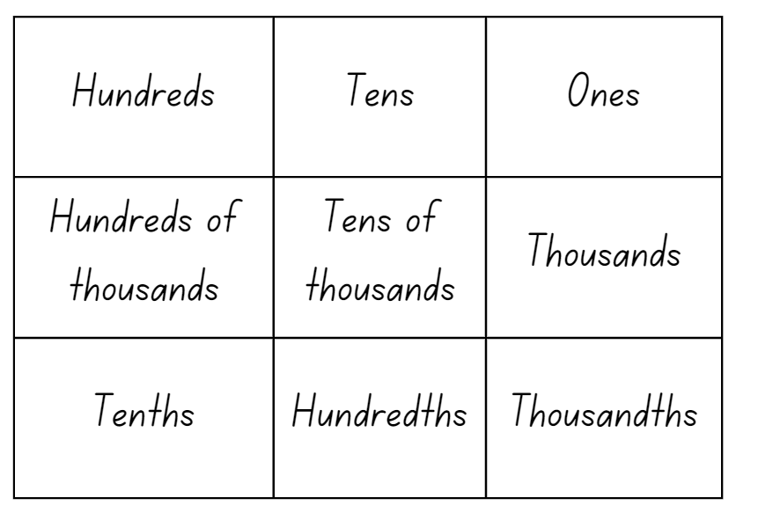
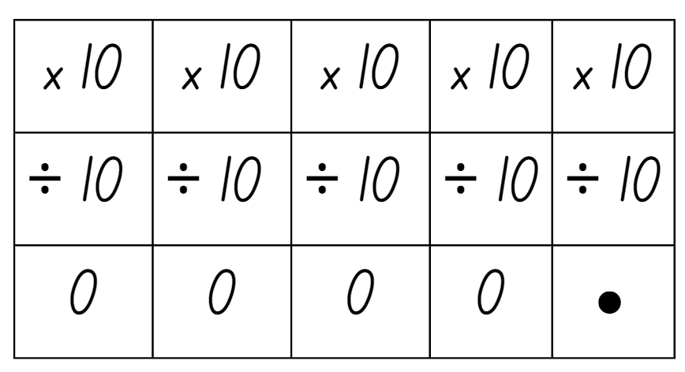

Resource 12: Place value slider
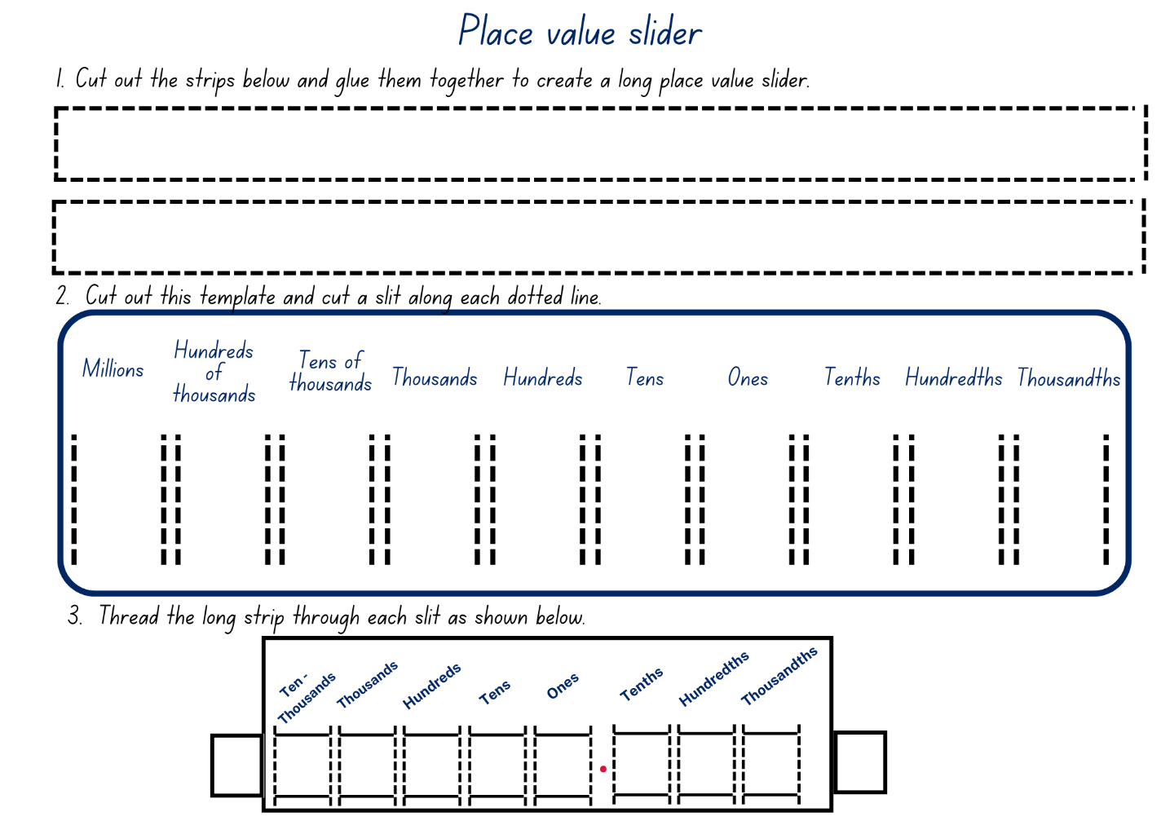

Resource 13: Base-10 patterns
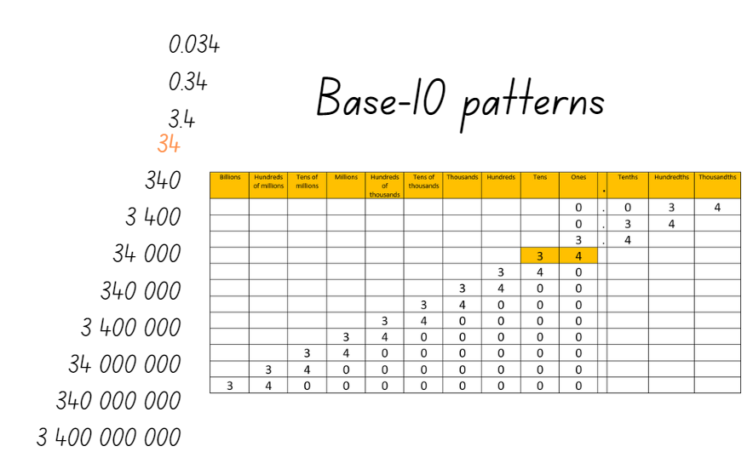

Resource 14: Make...
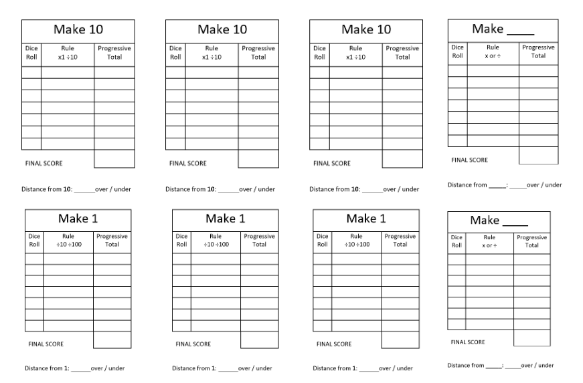

Resource 15: Multiplication patterns 1
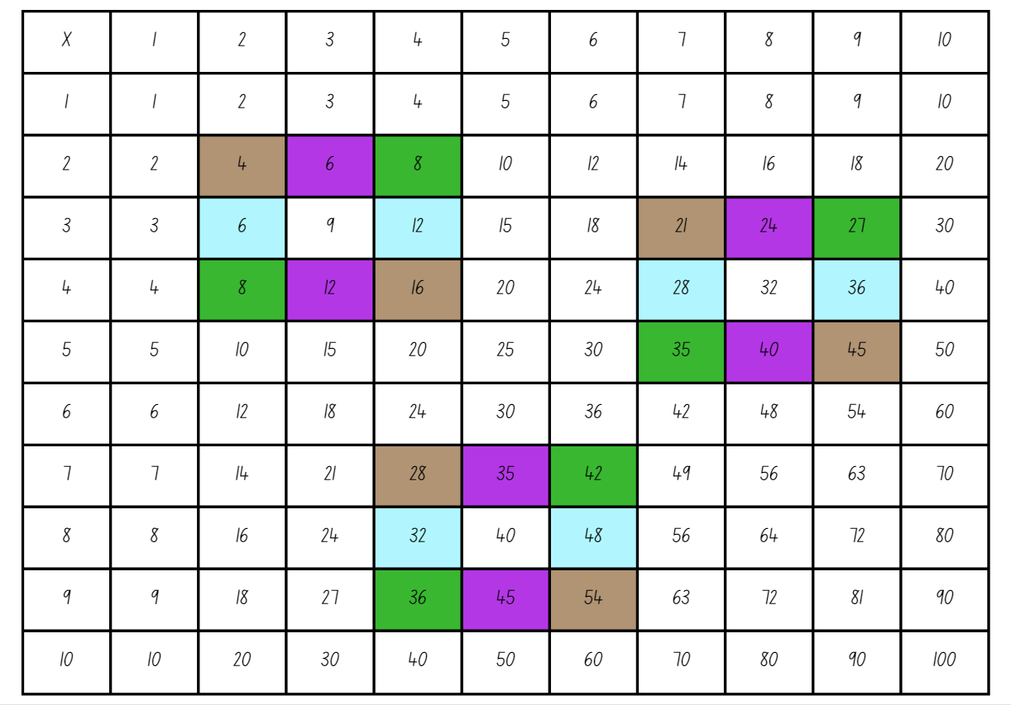

Resource 16: Multiplication patterns 2
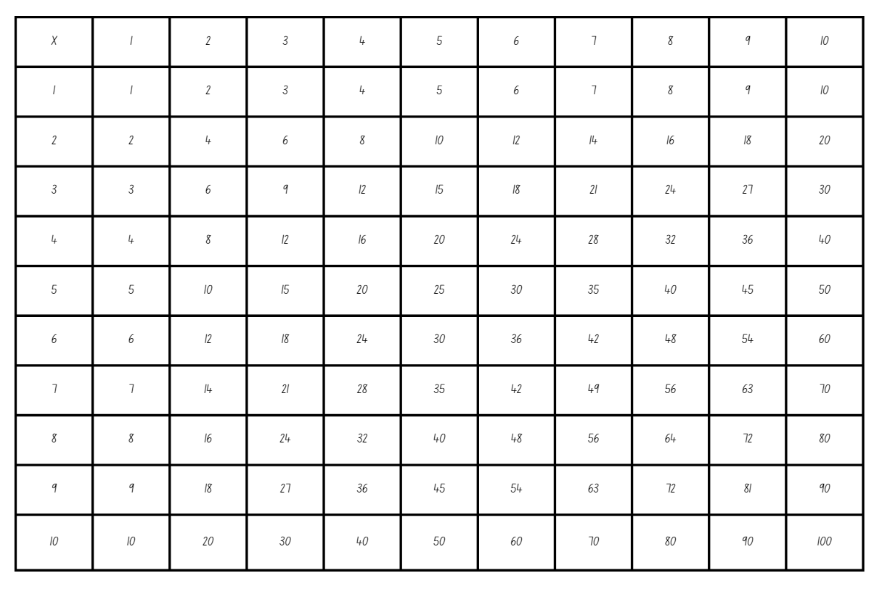

Resource 17: Suki’s sweets
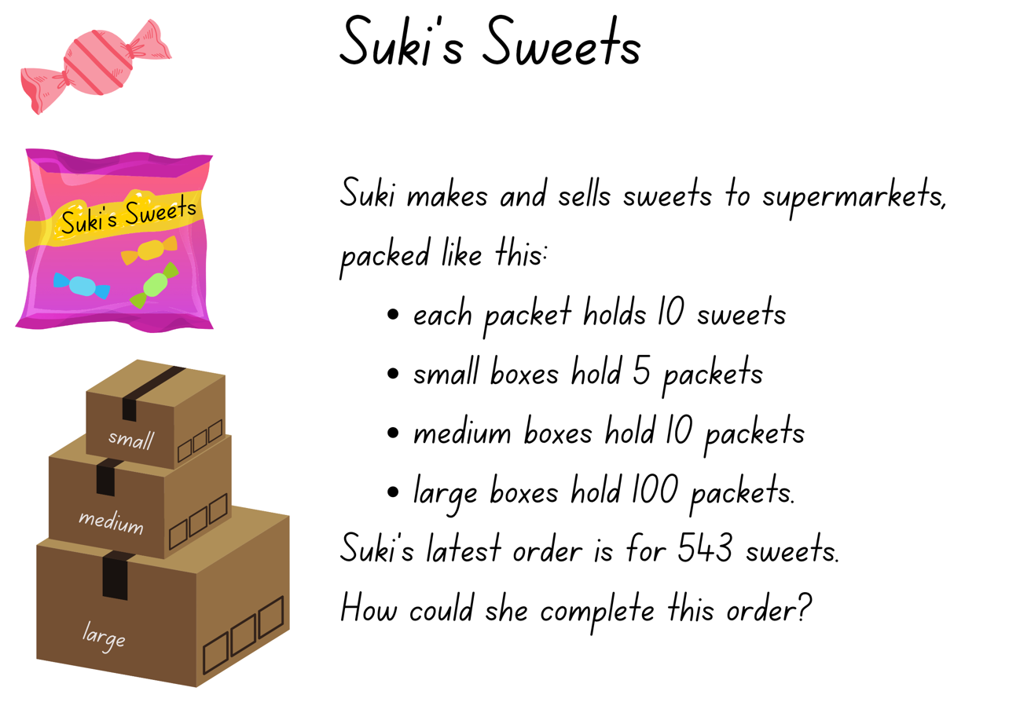

Resource 18: Suki’s sweets 2
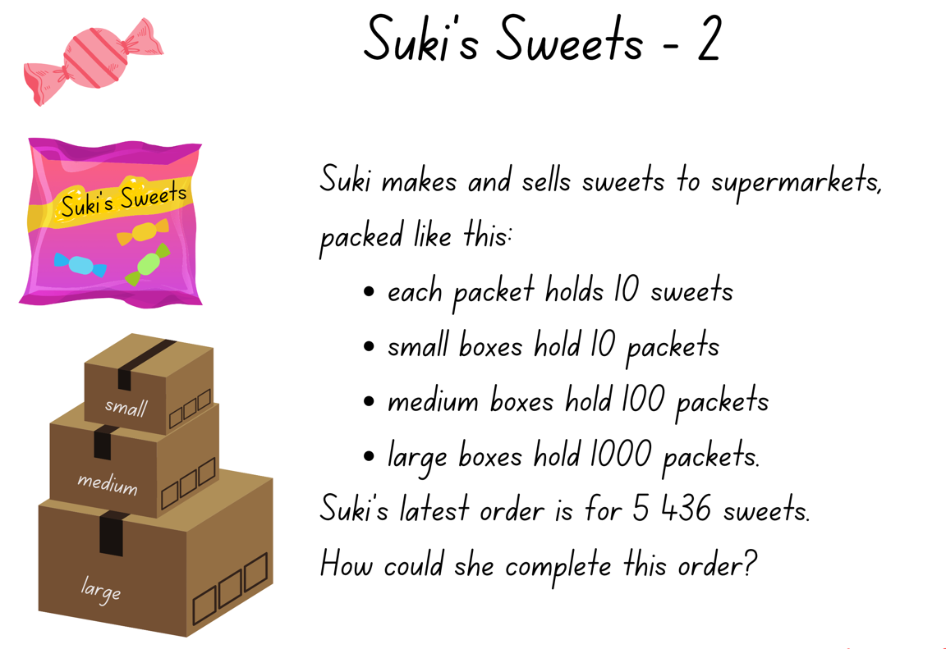

Syllabus outcomes and content

Stage 2
The table below outlines the syllabus outcomes and range of relevant syllabus content covered in this unit. Content is linked to National Numeracy Learning Progression version (3).
Outcomes and content | 1 | 2 | 3 | 4 | 5 | 6 | 7 | 8
Representing numbers using place value A: Whole numbers: Read, represent and order numbers to thousands
MAO-WM-01, MA2-RN-01
- Group physical or virtual objects to show the structure of tens, hundreds and a thousand | x |  |  |  |  |  | x
- Regroup numbers flexibly, recognising one thousand as 10 hundreds and one hundred as 10 tens or 100 ones | x
- Compare and describe the relative size of numbers by positioning numbers on a number line (Reasons about quantity) | x
- Represent numbers up to and including thousands using physical or virtual manipulatives, words, numerals, diagrams and digital displays | x | x |  |  | x
- Read and order numbers of up to at least 4 digits | x | x |  |  | x
- Identify the number before and after a number with an internal zero digit
Representing numbers using place value A: Whole numbers: Apply place value to partition and regroup numbers up to 4 digits
MAO-WM-01, MA2-RN-01
- Record numbers using standard place value form | x | x |  |  | x
- Partition numbers of up to 4 digits in non-standard forms (Reasons about quantity) | x | x
Representing numbers using place value B: Whole numbers: Order numbers in the thousands
MAO-WM-01, MA2-RN-01
- Arrange numbers in the thousands in ascending and descending order | x | x
- Recognise and describe how rearranging digits changes the size of a number (Reasons about relations) | x | x
Representing numbers using place value B: Whole numbers: Apply place value to partition, regroup and rename numbers up to 6 digits
MAO-WM-01, MA2-RN-01
- Name thousands using the place value grouping of ones, tens and hundreds of thousands | x | x | x |  | x
- Use place value to expand the number notation |  | x
- Partition numbers of up to 6 digits in non-standard forms | x | x | x |  |  |  | x
Representing numbers using place value B: Whole numbers: Whole numbers: Recognise and represent numbers that are 10, 100 or 1000 times as large
MAO-WM-01, MA2-RN-01
- Recognise the number of tens, hundreds or thousands in a number | x | x |  |  | x |  | x
- Describe how making a number 10, 100 or 1000 times as large changes the place value of digits | x | x |  |  | x |  | x
Representing numbers using place value B: Decimals: Extend the application of the place value system from whole numbers to tenths and hundredths
MAO-WM-01, MA2-RN-02
- Divide a length representing one whole into 10 equal parts and label the divisions using decimal notation |  |  |  | x
- Use the decimal point as a marker to identify the position of the ones digit when expressing tenths as decimals |  |  |  |  | x | x | x
- Recognise that 10-tenths is recorded as 1.0 and regroup when using decimal notation |  |  |  | x | x | x | x
- Represent and compare tenths as decimals using linear representations (Reasons about relations) |  |  |  | x
- Subdivide tenths into 10 equal parts and record hundredths using place value |  |  |  | x
- Locate and order decimals representing tenths and hundredths on a number line, describing their relative size |  |  |  | x
- Interpret zero digits as the end of a decimal |  |  |  |  | x | x | x
- Distinguish between the role of zero in various positions |  |  |  |  | x | x | x
Multiplicative relations A: Generate and describe patterns
MAO-WM-01, MA2-MR-01, MA2-MR-02
- Model, describe and record patterns of multiples |  |  |  |  | x |  | x
- Create and continue a variety of number patterns that increase or decrease by a constant amount |  |  |  |  |  |  |  | x
Multiplicative relations A: Use arrays to establish multiplication facts from multiples of 2 and 4, 5 and 10
MAO-WM-01, MA2-MR-01, MA2-MR-02
- Create and represent multiplicative structure, using the term multiples when connecting and grouping to arrays |  |  |  |  |  | x |  | x
- Use the array structure to coordinate the number of groups with the number in each group |  |  |  |  |  | x
Multiplicative relations A: Recall multiplication facts of 2 and 4, 5 and 10 and related division facts
MAO-WM-01, MA2-MR-01, MA2-MR-02
- Recognise and use the symbols for multiplied by (×), divided by (÷) and equals (=) |  |  |  |  | x | x | x | x
- Link multiplication and division fact families using arrays |  |  |  |  |  | x
- Generate multiplication fact families for multiples of 2 and 4, 5 and 10 |  |  |  |  |  |  |  | x
- Model and apply the commutative property of multiplication |  |  |  |  |  | x |  | x
Multiplicative relations B: Investigate number sequences involving related multiples
MAO-WM-01, MA2-MR-01, MA2-MR-02
- Generate number patterns using related multiples |  |  |  |  | x | x | x | x
- Investigate number patterns involving related multiples |  |  |  |  | x | x | x | x
Multiplicative relations B: Use known number facts and strategies
MAO-WM-01, MA2-MR-01, MA2-MR-02
- Apply the known strategy of doubling to connect multiples of 3 to 6 and 4 to 8 (Reasons about relations) |  |  |  |  |  | x |  | x
- Use known facts to find unknown multiples (Reasons about relations) |  |  |  |  |  |  | x
Multiplicative relations B: Operate with multiples of 10
MAO-WM-01, MA2-MR-01, MA2-MR-02
- Use multiplication facts with multiples of 10 to multiply a one-digit number by a multiple of 10 |  |  |  |  |  |  | x | x
- Use place value to rename groups of 10 to multiply |  |  |  |  | x |  | x | x
Mathematics K–10 Syllabus © NSW Education Standards Authority (NESA) for and on behalf of the Crown in right of the State of New South Wales, 2022.

Stage 3
The table below outlines the syllabus outcomes and range of relevant syllabus content covered in this unit. Content is linked to National Numeracy Learning Progression version (3).
Outcomes and content | 1 | 2 | 3 | 4 | 5 | 6 | 7 | 8
Represents numbers A: Whole numbers: Recognise, represent and order numbers in the millions
MAO-WM-01, MA3-RN-01
- Name millions using the place value grouping of ones, tens and hundreds | x | x | x | x
Represents numbers A: Whole numbers: Apply place value to partition, regroup and rename numbers to 1 billion
MAO-WM-01, MA3-RN-01
- Recognise 1000 thousands is 1 million and 1000 millions is 1 billion | x | x
- Regroup numbers in different forms (Reason about quantity) | x | x | x |  |  |  | x
Represents numbers A: Decimals and percentages: Recognise that the place value system can be extended beyond hundredths
MAO-WM-01, MA3-RN-02
- Express thousandths as decimals |  |  |  | x | x | x | x
- Interpret decimal notation for thousandths |  |  |  | x | x | x | x
- Indicate the place value of digits in decimal numbers of up to 3 decimal places |  |  |  | x | x | x | x
Represents numbers A: Decimals and percentages: Compare, order and represent decimals
MAO-WM-01, MA3-RN-02
- Compare and order decimal numbers of up to 3 decimal places |  |  |  | x | x | x | x
- Interpret zero digit(s) at the end of a decimal |  |  |  | x | x | x | x
- Compare the place value of digits by determining numbers that are 10 or 100 times the original decimal number as well as $\frac{1}{10}$ or $\frac{1}{100}$ times the original decimal numbers |  |  |  |  | x
- Place decimal numbers of up to 3 decimal places on a number line |  |  |  | x | x | x
Multiplicative relations A: Use partitioning and place value to multiply 2-, 3- and 4-digit numbers by one-digit numbers
MAO-WM-01, MA3-MR-01
- Use mental strategies to multiply one-digit numbers by 10, 100, 1000 and their multiples |  |  |  |  | x | x | x | X
- Estimate the product of 2 numbers (one-digit by 2- or 3-digit numbers) using multiples of 10 or 100 |  |  |  |  |  | x | x | x
Multiplicative relations A: Select and apply mental and written strategies to multiply 2- and 3-digit numbers by 2-digit numbers
MAO-WM-01, MA3-MR-01
- Use a multiplication algorithm with understanding (Reasons about relations) |  |  |  |  |  | x | x | x
- Solve multiplication word problems |  |  |  |  |  |  |  | x
Multiplicative relations B: Represent and describe number patterns formed by multiples
MAO-WM-01, MA3-MR-01
- Describe a pattern formed by multiples in words, in terms of multiplication rather than addition |  |  |  |  | x | x | x | x
Mathematics K–10 Syllabus © NSW Education Standards Authority (NESA) for and on behalf of the Crown in right of the State of New South Wales, 2022.

References
This resource contains NSW Curriculum and syllabus content. The NSW Curriculum is developed by the NSW Education Standards Authority. This content is prepared by NESA for and on behalf of the Crown in right of the State of New South Wales. The material is protected by Crown copyright.
Please refer to the NESA Copyright Disclaimer for more information https://educationstandards.nsw.edu.au/wps/portal/nesa/mini-footer/copyright.
NESA holds the only official and up-to-date versions of the NSW Curriculum and syllabus documents. Please visit the NSW Education Standards Authority (NESA) website https://educationstandards.nsw.edu.au/ and the NSW Curriculum website https://curriculum.nsw.edu.au/home.
Mathematics K–10 Syllabus © NSW Education Standards Authority (NESA) for and on behalf of the Crown in right of the State of New South Wales, 2022.
National Numeracy Learning Progression © Australian Curriculum, Assessment and Reporting Authority (ACARA) 2010 to present, unless otherwise indicated. This material was downloaded from the Australian Curriculum website (National Literacy Learning Progression) (accessed 1 September 2023) and was not modified.
Boaler J, Munson J and Williams C (2017) Mindset Mathematics: Visualizing and Investigating Big Ideas, Grade 4, Jossey-Bass, San Francisco.
Burkhart J (2015–2023) Deep Math Projects: Multiplication Table Patterns, 5280 Math website, accessed 5 July 2023.
Chin A (2015) Make 100, 1000, 10, 1: Adding and subtracting using place value [PDF 1.10 MB], Inspired Mathematics Teaching, Anita Chin Mathematics Consultancy, accessed 30 August 2023.
Commonwealth of Australia (The Treasury) (2021) ‘Population in local government areas’, Dashboards, Centre for Population website, accessed 18 May 2023.
New Zealand Ministry of Education (n.d.) ‘Missing Number Bingo’, Resource, NZ Maths website, accessed 18 May 2023.
State of New South Wales (Department of Education) (2023) Hit it (3-digit numbers), Mathematics K-6 resources, NSW Department of Education website, accessed 18 May 2023.
State of New South Wales (Department of Education) (2023) ‘Place value game’, Mathematics K-6 resources, NSW Department of Education website, accessed 28 July 2023.
University of Cambridge (Faculty of Mathematics) (1997–2023) Multiply Multiples 3, NRICH website, accessed 5 July 2023.
University of Melbourne (Faculty of Education) (2011) ‘Number Slides’, Teaching, University of Melbourne website, accessed 18 May 2023.
Worldometers.info (2023) Current World Population, Worldometer website, accessed 18 May 2023.

Further reading
Clarke D and Roche A (2014) Engaging Maths: 25 Favourite Lessons, 2nd edn, Mathematics Teaching and Learning Centre, Australian Catholic University and Catholic Education office, Melbourne.
Dabell J (28 April 2021) ‘Maths Misconceptions: Multiplying by 10’, Maths — No Problem! blog, accessed 18 May 2023.

© State of New South Wales (Department of Education), 2023
The copyright material published in this resource is subject to the Copyright Act 1968 (Cth) and is owned by the NSW Department of Education or, where indicated, by a party other than the NSW Department of Education (third-party material).
Copyright material available in this resource and owned by the NSW Department of Education is licensed under a Creative Commons Attribution 4.0 International (CC BY 4.0) license.
This license allows you to share and adapt the material for any purpose, even commercially.
Attribution should be given to © State of New South Wales (Department of Education), 2023.
Material in this resource not available under a Creative Commons license:
- the NSW Department of Education logo, other logos and trademark-protected material
- material owned by a third party that has been reproduced with permission. You will need to obtain permission from the third party to reuse its material.
Links to third-party material and websites
Please note that the provided (reading/viewing material/list/links/texts) are a suggestion only and implies no endorsement, by the New South Wales Department of Education, of any author, publisher, or book title. School principals and teachers are best placed to assess the suitability of resources that would complement the curriculum and reflect the needs and interests of their students.
If you use the links provided in this document to access a third-party's website, you acknowledge that the terms of use, including licence terms set out on the third-party's website apply to the use which may be made of the materials on that third-party website or where permitted by the Copyright Act 1968 (Cth). The department accepts no responsibility for content on third-party websites.

