Mathematics 3–6 multi-age – Year B – Unit 6

Contents
Unit description and duration 6
Syllabus outcomes 6
Stage 2 6
Stage 3 7
Working mathematically 7
Student prior learning 8
Lesson overview and resources 9
Lesson 1 18
Daily number sense – deal it – 15 minutes 18
Core lesson – naming and ordering numbers – 40 minutes 20
Consolidation and meaningful practice – 15 minutes 24
Lesson 2 27
Daily number sense – one or bust – 15 minutes 27
Core lesson – large numbers – 30 minutes 29
Consolidation and meaningful practice – 20 minutes 33
Lesson 3 35
Daily number sense – Is he correct? – 10 minutes 35
Core lesson – 40 minutes 37
Stage 2 task – representing tenths 37
Stage 3 task – decimals up to thousandths 41
Consolidation and meaningful practice – 15 minutes 45
Lesson 4 48
Daily number sense – 10 minutes 48
Core lesson – 35 minutes 48
Stage 2 task – the role of zero 48
Stage 3 task – comparing decimals 54
Consolidation and meaningful practice – 20 minutes 56
Lesson 5 59
Daily number sense – Which one doesn’t belong? – 10 minutes 59
Core lesson – 40 minutes 61
Stage 2 task – decimals as equivalent fractions 61
Stage 3 task – interpreting decimals up to thousands 63
Discuss and connect the mathematics – 10 minutes 65
Lesson 6 67
Daily number sense – mine equals yours – 10 minutes 67
Core lesson – 50 minutes 69
Stage 2 – addition – bridging and partitioning 69
Stage 3 – adding and subtracting decimals 72
Discuss and connect the mathematics – 5 minutes 74
Lesson 7 76
Daily number sense – target number sentence – 10 minutes 76
Core lesson – 45 minutes 78
Stage 2 task – subtraction with standard and non-standard partitioning 78
Stage 3 task – decimal subtraction face-off 83
Discuss and connect the mathematics – 10 minutes 86
Lesson 8 88
Daily number sense – 15 minutes 88
Core lesson – show us how – 30 minutes 88
Discuss and connect the mathematics – 15 minutes 91
Resource 1 – place value houses 93
Resource 2 – prompting questions 94
Resource 3 – Is he correct? 95
Resource 4 – tenths strips 97
Resource 5 – Less or greater? 98
Resource 6 – hundredths strips 99
Resource 7 – single decimal house 100
Resource 8 – comparison houses 101
Resource 9 – fitness scores 102
Resource 10 – linear model 1 103
Resource 11 – linear model 2 104
Resource 12 – the vault 105
Resource 13 – True or false? 106
Resource 14 – word problems to thousandths 107
Resource 15 – Frayer model 108
Resource 16 – word problems to tenths 109
Resource 17 – multi-step problems 110
Resource 18 – subtraction with partitioning 1 111
Resource 19 – subtraction with partitioning 2 112
Resource 20 – non-standard partitioning 113
Resource 21 – explanation spinner 114
Resource 22 – show us how 1 115
Resource 23 – show us how 2 116
Syllabus outcomes and content 117
Stage 2 117
Stage 3 123
References 127
Further reading 128

Unit description and duration
This unit develops the big idea that the number system extends infinitely to very large and very small numbers.
In this 2-week unit students are provided opportunities to:
- read, partition, rename, represent and order numbers up to 6-digits (Stage 2) or up to and including billions (Stage 3)
- recognise, name, compare, order and represent decimals
- identify the relationship between addition and subtraction (Stage 2)
- apply place value knowledge and known strategies when solving addition and subtraction problems for whole numbers and decimals (Stage 3).
This multi-age unit is informed by the lessons in Stage 2 Year B Unit 26 and Stage 3 Year B Unit 26. Please refer to these units for additional lesson guidance.

Syllabus outcomes
- MAO-WM-01 develops understanding and fluency in mathematics through exploring and connecting mathematical concepts, choosing and applying mathematical techniques to solve problems, and communicating their thinking and reasoning coherently and clearly

Stage 2
- MA2-RN-01 applies an understanding of place value and the role of zero to represent numbers to at least tens of thousands
- MA2-RN-02 represents and compares decimals up to 2 decimal places using place value
- MA2-AR-01 selects and uses mental and written strategies for addition and subtraction involving 2- and 3-digit numbers

Stage 3
- MA3-RN-01 applies an understanding of place value and the role of zero to represent the properties of numbers
- MA3-RN-02 compares and orders decimals up to 3 decimal places
- MA3-AR-01 selects and applies appropriate strategies to solve addition and subtraction problems

Working mathematically
In the Mathematics K–10 Syllabus, there is one overarching Working mathematically outcome (MAO-WM-01). The Working mathematically processes should be embedded within the concepts being taught. The Working mathematically processes present in the Mathematics K–10 Syllabus are:
- communicating
- understanding and fluency
- reasoning
- problem solving.
Mathematics K–10 Syllabus © NSW Education Standards Authority (NESA) for and on behalf of the Crown in right of the State of New South Wales, 2022.

Student prior learning
Before engaging in these teaching and learning activities, students would benefit from prior experience with:
- reading, representing and ordering numbers up to thousands (Stage 2) or millions (Stage 3)
- applying place value to recognise, name and order decimals to tenths
- standard and non-standard partitioning of numbers up to millions (Stage 3)
- selecting strategies flexibly to solve addition and subtraction problems.
In NSW classrooms there is a diverse range of students, including Aboriginal and Torres Strait Islander students, students learning English as an additional language or dialect, high potential and gifted students and students with disability. Some students may identify with more than one of these groups or possibly all of them. Refer to Curriculum planning for every student – advice for further information.

Lesson overview and resources
To cover the content of the syllabus across Stage 2 and Stage 3, some core lessons in the unit contain both a Stage 2 and a Stage 3 task. Teachers are encouraged to adapt and contextualise the units to meet the needs of their students.
The table below outlines the sequence and approximate timing of lessons, learning intentions and resources.
Lesson | Content | Duration and resources
Lesson 1  Daily number sense  Stage 2:  - Representing numbers using place value B: Decimals: Make connections between fractions and decimal notation  Stage 3:  - Represents numbers A: Decimals and percentages: Compare, order and represent decimals | Lesson core concept: the position of each digit in a number corresponds to its size.  Stage 2:  - Representing numbers using place value B: Whole numbers: Order numbers in the thousands  - Representing numbers using place value B: Whole numbers: Apply place value to partition, regroup and rename numbers up to 6 digits  Stage 3:  - Represents numbers A: Whole numbers: Recognise, represent and order numbers in the millions | Lesson duration: 70 minutes  - Resource 1 – place value houses  - Resource 2 – prompting questions  - Individual whiteboards  - One deck of cards (ace to 9) per pair  - Sticky notes  - Whiteboard markers  - Writing materials
Lesson 2  Daily number sense  Stage 2:  - Representing numbers using place value B: Decimals: Extend the application of the place value system from whole numbers to tenths and hundredths  - Representing numbers using place value B: Decimals: Make connections between fractions and decimal notation  Stage 3:  - Represents numbers A: Decimals and percentages: Compare, order and represent decimals | Lesson core concept: numbers can be renamed in equivalent ways using place value.  Stage 2:  - Representing numbers using place value B: Whole numbers: Apply place value to partition, regroup and rename numbers up to 6 digits  Stage 3:  - Represents numbers A: Whole numbers: Apply place value to partition, regroup and rename numbers to one billion | Lesson duration: 65 minutes  - 10-sided dice  - Individual whiteboards  - Sticky notes  - Whiteboard markers  - Writing materials
Lesson 3  Daily number sense  Stage 2:  - Representing numbers using place value B: Decimals: Make connections between fractions and decimal notation  Stage 3:  - Represents numbers A: Decimals and percentages: Compare, order and represent decimals | Lesson core concept: the place value system can be extended.  Stage 2:  - Representing numbers using place value B: Decimals: Extend the application of the place value system from whole numbers to tenths and hundredths  Stage 3:  - Represents numbers A: Decimals and percentages: Recognise that the place value system can be extended beyond hundredths  - Represents numbers A: Decimals and percentages: Compare, order and represent decimals | Lesson duration: 65 minutes  - Resource 3 – Is he correct?  - Resource 4 – tenths strips  - Resource 5 – Less or greater?  - 6-sided dice  - Individual whiteboards  - Masking tape  - Scissors  - Sticky notes  - String  - Strips of paper  - Whiteboard markers  - Writing materials
Lesson 4  Daily number sense  - teacher-identified task based on student needs | Lesson core concept: zeroes in decimals play an important role.  Stage 2:  - Representing numbers using place value B: Decimals: Extend the application of the place value system from whole numbers to tenths and hundredths  Stage 3:  - Represents numbers A: Decimals and percentages: Recognise that the place value system can be extended beyond hundredths  - Represents numbers A: Decimals and percentages: Compare, order and represent decimal | Lesson duration: 65 minutes  - Resource 4 – tenths strips  - Resource 6 – hundredths strips  - Resource 7 – single decimal house  - Resource 8 – comparison houses  - Resource 9 – fitness scores  - Card paper  - Writing materials
Lesson 5  Daily number sense  Stage 2:  - Additive relations A: Select strategies flexibly to solve addition and subtraction problems of up to 3 digits  Stage 3:  - Additive relations B: Choose and use efficient strategies to solve addition and subtraction problems | Lesson core concept: connections can be made between fractions and decimals (Stage 2). Decimals can be compared by analysing the place values parts (Stage 3).  Stage 2:  - Representing numbers using place value B: Decimals: Extend the application of the place value system from whole numbers to tenths and hundredths  - Representing numbers using place value B: Decimals: Make connections between fractions and decimal notation  Stage 3:  - Represents numbers A: Decimals and percentages: Recognise that the place value system can be extended beyond hundredths  - Represents numbers A: Decimals and percentages: Compare, order and represent decimals | Lesson duration: 60 minutes  - Resource 4 – tenths strips  - Resource 9 – fitness scores  - Resource 10 – linear model 1  - Resource 11 – linear model 2  - Resource 12 – the vault  - Coloured pencils  - Individual whiteboards  - Whiteboard makers  - Writing materials
Lesson 6  Daily number sense  Stage 2:  - Additive relations A: Use the principle of equality  Stage 3:  - Additive relations A: Apply efficient mental and written strategies to solve addition and subtraction problems | Lesson core concept: place value understanding helps solve addition and subtraction problems.  Stage 2:  - Additive relations A: Select strategies flexibly to solve addition and subtraction problems of up to 3 digits  - Additive relations B: Partition, rearrange and regroup numbers to at least 1000 to solve additive problems  Stage 3:  - Additive relations A: Apply efficient mental and written strategies to solve addition and subtraction problems  - Additive relations A: Use estimation and place value understanding to determine the reasonableness of solutions  - Additive relations B: Applies known strategies to add and subtract decimals | Lesson duration: 65 minutes  - Resource 13 – True or False?  - Resource 14 – word problems to thousandths  - Resource 15 – Frayer model  - Resource 16 – word problems to tenths  - Resource 17 – multi-step problems  - 10-sided dice  - Individual whiteboards  - Whiteboard markers  - Writing materials
Lesson 7  Daily number sense  Stage 2:  - Additive relations A: Use the principle of equality  Stage 3:  - Additive relations A: Apply efficient mental and written strategies to solve addition and subtraction problems | Lesson core concept: non-standard partitioning can be an efficient way to solve addition and subtraction problems (Stage 2). Known strategies for subtraction can be applied to decimals (Stage 3).  Stage 2:  - Representing numbers using place value A: Whole numbers: Apply place value to partition and regroup numbers up to 4 digits  - Additive relations A: Select strategies flexibly to solve addition and subtraction problems of up to 3 digits  - Additive relations B: Partition, rearrange and regroup numbers to at least 1000 to solve additive problems  Stage 3:  - Additive relations A: Apply efficient mental and written strategies to solve addition and subtraction problems  - Additive relations B: Applies known strategies to add and subtract decimals | Lesson duration: 65 minutes  - Resource 18 – subtraction with partitioning 1  - Resource 19 – subtraction with partitioning 2  - Resource 20 – non-standard partitioning  - Resource 21 – explanation spinner  - 10-sided dice  - Individual whiteboards  - One deck of cards (ace to 9) per pair  - Whiteboard markers  - Writing materials
Lesson 8  Daily number sense  - teacher-identified task based on student needs | Lesson core concept: place value understanding helps solve addition and subtraction problems.  Stage 2:  - Additive relations A: Select strategies flexibly to solve addition and subtraction problems of up to 3 digits  Stage 3:  - Additive relations A: Apply efficient mental and written strategies to solve addition and subtraction problems  - Additive relations B: Choose and use efficient strategies to solve addition and subtraction problems | Lesson duration: 60 minutes  - Resource 22 – show us how 1  - Resource 23 – show us how 2  - Writing materials

Lesson 1
Core concept: the position of each digit in a number corresponds to its size.

Daily number sense – deal it – 15 minutes
Daily number sense activities for Lessons 1 to 3 ‘activate’ prior number knowledge and support the learning of new content in the unit. These activities can also assist teachers to identify the starting points for learning by revealing the extent of students’ existing knowledge.
The table below contains a suggested learning intention and success criteria. These are best co-constructed with students.
Daily number sense learning intention | Daily number sense success criteria
All students are learning to:  - make comparisons between decimals. | Students working towards Stage 2 outcomes can:  - compare and order decimals of up to 2 decimal places.  Students working towards Stage 3 outcomes can:  - compare and order decimal numbers of up to 3 decimal places.
- In stage-based pairs, students divide a deck of cards between them, using only the number cards and aces for one.
- Each student’s cards are placed face down in a pile in front on them.
- On an individual whiteboard, Stage 2 students draw a box large enough to fit a playing card, a decimal point and then 2 more large boxes. Stage 3 students draw a large box, a decimal point and then 3 more large boxes.
- At the same time, Stage 2 students turn over 3 cards, placing them into the boxes on their whiteboard. Stage 3 students turn over 4 cards. For example, see Figure 1.
Figure 1 – example student whiteboards
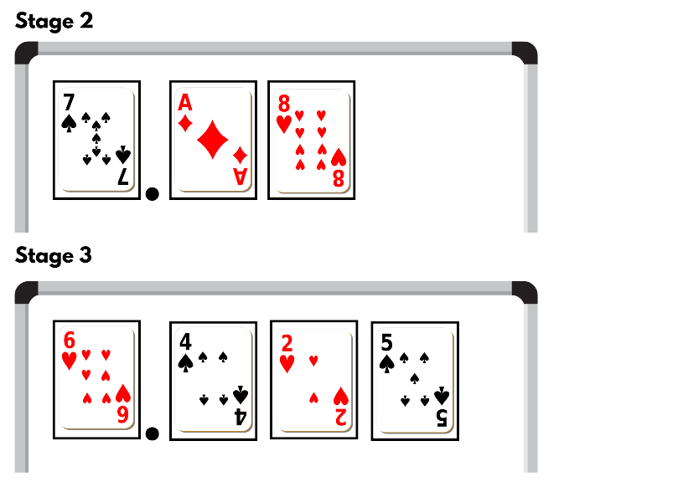
- Each student records their number on a sticky note.
- Students place the sticky notes in ascending order.
- Students repeat the process, adding the new sticky notes to the order each round.
This table details opportunities for assessment.
Assessment opportunities | Links
What to look for:  - Can Stage 2 students compare and order decimals of up to 2 decimal places? [MAO-WM-01, MA2-RN-02]  - Can Stage 3 students compare and order decimals of up to 3 decimal places? [MAO-WM-01, MA3-RN-02] | Links to National Numeracy Learning Progressions (NNLP):  - Stage 2 – NPV6, NPV7  - Stage 3 – NPV8.  Links to suggested Interview for Student Reasoning (IfSR) tasks:  - Stage 2 – IfSR-NP: 4D.1, 4D.4  - Stage 3 – IfSR-PT: 1A.5, 1A.7  - Stage 3 – IfSR-AT: 4B.1  - Stage 3 – IfSR-NP: 4D.6.

Core lesson – naming and ordering numbers – 40 minutes
The table below contains a suggested learning intention and success criteria. These are best co-constructed with students.
Core concept learning intentions | Core concept success criteria
All students are learning to:  - recognise, represent and order numbers. | Students working towards Stage 2 outcomes can:  - name thousands using the place value grouping of ones, tens and hundreds of thousands  - arrange numbers in the thousands in ascending and descending order  - identify the nearest thousand, 10 thousand or 100 thousand to numbers.  Students working towards Stage 3 outcomes can:  - name millions using the place value grouping of ones, tens and hundreds  - arrange numbers in the millions in ascending and descending order using place value  - round numbers to a specified place value.
Multi-age: Stage 2 students are to read, represent and order numbers in the thousands. Stage 3 students are to recognise, represent and order numbers in the millions.
- Display Resource 1 – place value houses and explicitly model how to read and write a number in the thousands (for Stage 2) and in the millions (for Stage 3).
- Distribute Resource 1 – place value houses for students write their own number in the place value houses.
- In pairs, students turn and talk to practice reading their number aloud.
- Group students into stage-based teams of 3-4 and provide each team with a copy of Resource 2 – prompting questions.
- Introduce the game ‘Place value hotseat’ and explain that Player A from each group will sit in the hotseat. The rest of the team will work together to create a number in the thousands (Stage 2) or in the millions (Stage 3) and write this number on a sticky note where Player A cannot see it.
- Player A can use Resource 2 – prompting questions to assist them in guessing the number their team has written on the sticky note. All questions can only be answered with yes or no answers.
- Player A can use a whiteboard to keep track of the answers they have received.
- Once Player A has named the number, they take the sticky note and place it onto the whiteboard.
- A different team member takes a seat on the hotseat and they become Player A.
- Repeat this process until every team member has sat in the hotseat.
- Explain to students that, once they have named the number, they must place their sticky note on the whiteboard in relation to the first player’s number so that the numbers are in order from smallest to largest. Students may need to move numbers to allow the numbers to be placed in ascending order.
- Stage 2 students write a number between 1000 and 999 999 on a whiteboard. Stage 3 students write a number between 1 000 000 and 999 999 999 on a whiteboard.
- Students turn and read their number to a partner.
- In stage groups, without speaking, students form a human number line by organising themselves in ascending order.
- Starting with the students who have the smallest number, students read their number aloud, in order, one at a time.
- In stage groups, discuss if the order students placed themselves in is correct, or if any students need to move positions. Students use their place value knowledge to justify their number placement.
- As a class, discuss:
- How did you know where to stand?
- What clues are in a number that might help us order them?
- How many tens/hundreds/thousands are in your number?
- How could you rename your number?
This table details opportunities for differentiation.
Too hard? | Too easy?
Students cannot read, represent and order numbers.  - Model how to use MAB materials to represent large numbers to assist place value understanding.  - Provide students the opportunity to work with smaller numbers. | Students can read, represent and order numbers.  - Reduce the number range for students to guess and order. For example, for Stage 2 the numbers need to be between 100 000 and 200 000 and for Stage 3 the numbers need to be between 4 million and 5 million.  - In pairs, students read a list of clues about a number to their partner. The partner listens to the clues and guesses the number.  - Stage-based groups place their numbers on a number line, ensuring spaces are relative to the size of the numbers.

Consolidation and meaningful practice – 15 minutes
- Read a number in the thousands to Stage 2 and a number in the millions to Stage 3.
- Students record the number on their individual whiteboards.
- Students share the number they recorded with a partner to check accuracy.
- Stage 2 students round the number to the nearest thousand, 10 thousand or 100 thousand. Stage 3 students to round the number to a place value of your choice.
- Students record the new number on their whiteboards and share the number with a partner, justifying their reasoning.
- Repeat the activity varying the number and the specific place value they are to round to.
This table details opportunities for differentiation.
Too hard? | Too easy?
Students cannot round numbers to a specified place value.  - Provide students with a support structure such as place value houses or manipulatives (physical or virtual) to assist them when rounding.  - Reduce the size of the numbers students are asked to round to. | Students can round numbers to a specified place value.  - Students use the same number and round it several different times. For example, round their number to the nearest 10, hundred, thousand, 10 thousand and 100 thousand.  - Stage 2 students round numbers in the millions to a specific place value and Stage 3 students round numbers in the billions to a specific place value.
This table details opportunities for assessment.
Assessment opportunities | Links
What to look for:  - Can Stage 2 students name thousands using the place value grouping of ones, tens and hundreds of thousands? [MAO-WM-01, MA2-RN-01]  - Can Stage 2 students arrange numbers in the thousands in ascending and descending order? [MAO-WM-01, MA2-RN-01]  - Can Stage 2 students identify the nearest thousand, 10 thousand or 100 thousand to numbers? [MAO-WM-01, MA2-RN-01]  - Can Stage 3 students name millions using the place value grouping of ones, tens and hundreds? [MAO-WM-01, MA3-RN-01]  - Can Stage 3 students arrange numbers in the millions in ascending and descending order using place value? [MAO-WM-01, MA3-RN-01]  - Can Stage 3 students round numbers to a specified place value? [MAO-WM-01, MA3-RN-01] | Links to National Numeracy Learning Progressions (NNLP):  - Stage 2 – NPV6, NPV7  - Stage 3 – NPV6, NPV7.  Links to suggested Interview for Student Reasoning (IfSR) tasks:  - Stage 2 – IfSR-NP: 4C.5, 4C.8.

Lesson 2
Core concept: numbers can be renamed in equivalent ways using place value.

Daily number sense – one or bust – 15 minutes
The table below contains a suggested learning intention and success criteria. These are best co-constructed with students.
Daily number sense learning intention | Daily number sense success criteria
All students are learning to:  - make comparisons between decimals. | Students working towards Stage 2 outcomes can:  - compare and order decimals of up to 2 decimal places  - locate and order decimals representing tenths and hundredths on a number line, describing their relative size.  Students working towards Stage 3 outcomes can:  - compare and order decimal numbers of up to 3 decimal places  - place decimal numbers of up to 3 decimal places on a number line.
- In pairs, Stage 2 students roll two 10-sided dice each. Stage 3 students roll three 10-sided dice each.
- Stage 2 students arrange their 2 dice to make a number between zero and one with 2 decimal places, such as 0.34. Stage 3 students arrange their 3 dice to make a number between zero and one with 3 decimal places, such as 0.341.
- Students record their number on a sticky note.
- Students draw a number line on an individual whiteboard and place their decimal along it. For example, see Figure 2.
Figure 2 – example of a Stage 2 number line
Note: the target for this activity can be easily changed, for example, students could be aiming for closest to one, closest to zero, closest to 0.5, largest decimal or smallest decimal.
This table details opportunities for assessment.
Assessment opportunities | Links
What to look for:  - Can Stage 2 students compare and order decimals of up to 2 decimal places? [MAO-WM-01, MA2-RN-02]  - Can Stage 2 students locate and order decimals representing tenths and hundredths on a number line, describing their relative size? [MAO-WM-01, MA2-RN-02]  - Can Stage 3 students compare and order decimals of up to 3 decimal places? [MAO-WM-01, MA3-RN-02]  - Can Stage 3 students place decimal numbers of up to 3 decimal places on a number line? [MAO-WM-01, MA3-RN-02] | Links to National Numeracy Learning Progressions (NNLP):  - Stage 2 – NPV6, NPV7, NPV8  - Stage 3 – NPV8.  Links to suggested Interview for Student Reasoning (IfSR) tasks:  - Stage 2 – IfSR-NP: 4D.1, 4D.4  - Stage 3 – IfSR-PT: 1A.5, 1A.7  - Stage 3 – IfSR-AT: 4B.1  - Stage 3 – IfSR-NP: 4D.6.

Core lesson – large numbers – 30 minutes
The table below contains suggested learning intentions and success criteria. These are best co-constructed with students.
Core concept learning intentions | Core concept success criteria
Students working towards Stage 2 outcomes are learning to:  - apply place value to partition, regroup and rename numbers up to 6 digits.  Students working towards Stage 3 outcomes are learning to:  - apply place value to partition, regroup and rename numbers to one billion. | Students working towards Stage 2 outcomes can:  - name thousands using the place value grouping of ones, tens and hundreds of thousands  - partition numbers of up to 6 digits in non-standard forms.  Students working towards Stage 3 outcomes can:  - recognise 1000 thousands is 1 million and 1000 millions is 1 billion  - partition numbers to 1 billion in non-standard forms.
- Explain that 4 students were asked what number comes after 999 999 999. Their answers were:
- 1000 millions
- 1 trillion
- 1 million
- 1 billion.
- Ask students to turn and talk and discuss the 4 answers and decide which is correct and why.
- Discuss that there are 2 correct answers. For example, Student C has used their knowledge of place value to know that it needs to extend past hundreds of millions. This is because the place value system is organised into groups of hundreds, tens and ones. The number after 999 999 999 is 1 billion. This number can also be renamed as 1000 millions, making Student A also correct.
Note: students need to apply their place value knowledge to partition, regroup and rename numbers to one billion by recognising that 1000 millions are the same as 1 billion.
- Display a live population counter and model reading the current world population.
- Select students to read other numbers displayed. For example, births and deaths or population growth.
- Navigate to a list showing the top 20 largest countries by population. Select a country and display their population on the board.
- Model how to rename the number using non-standard partitioning and invite students to rename the same number in a different way. For example, see Figure 3.
Figure 3 – population partitioning example
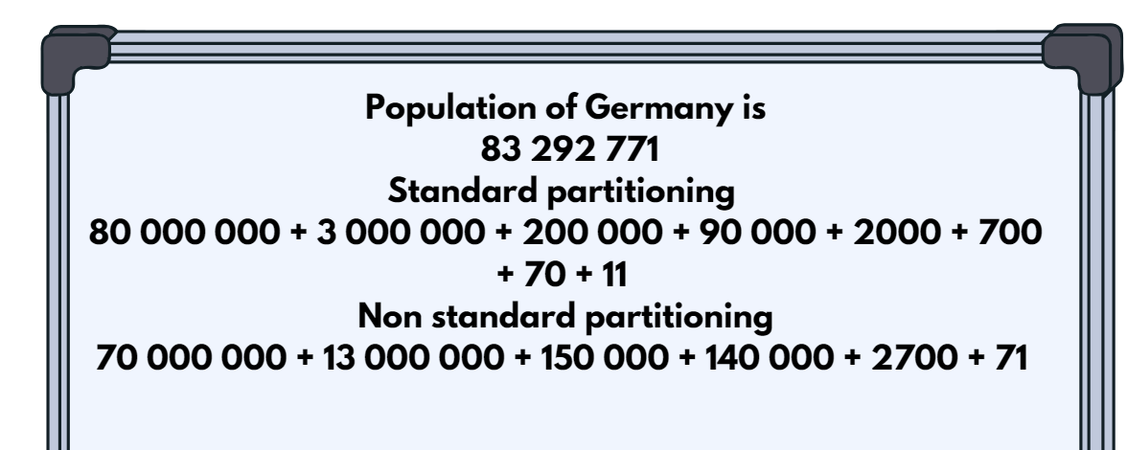
- Divide the class into groups of 3-4 students.
- Display the population of another country for all groups to rename using standard and non-standard partitioning.
- Each group works collaboratively to rename the population in different ways.
- As a class, compare the different ways the number has been renamed. All groups receive one point for a correct answer. A group receives a bonus point if no other team has the same answer as them.
- Repeat for the population of multiple countries. Continue playing until students can confidently name and rename large numbers.
- In their groups students create a poster to represent the population of a chosen country. A flag is placed in the middle of the poster and the population is renamed in 5 different ways using non-standard partitioning. These posters are displayed around the classroom.
Multi-age: students working towards Stage 2 outcomes should use numbers up to 6 digits. This could be achieved by using daily births instead of the world population from the live population counter, and using the 20 smallest countries by population.
This table details opportunities for differentiation.
Too hard? | Too easy?
Students cannot apply place value knowledge to rename numbers using non-standard partitioning.  - Provide students with a support structure such as hundreds chart, number line, place value houses, manipulatives (physical or virtual) to assist them.  - Reduce the size of the numbers the students are asked to use. | Students can apply place value knowledge to rename numbers using non-standard partitioning.  - Ask students to rename the numbers in more than one way.  - Challenge students to rename the numbers without certain place values. For example, rename your number without using thousands.

Consolidation and meaningful practice – 20 minutes
- Divide students into groups of 3–4 and ask them to sit in a circle.
- Explain that Player A writes a number up to the billions on their whiteboard in standard place value form and whispers the number to Player B.
- Player B renames the number on their whiteboard, turns and reads the renamed number to Player C.
- Player C renames the number and records it on their whiteboard.
- All players compare their numbers and discuss the different ways the same number can be recorded.
- Repeat the activity until all students have been Player A.
Multi-age: students working towards Stage 2 outcomes use numbers up to 6 digits.
This table details opportunities for assessment.
Assessment opportunities | Links
What to look for:  - Can Stage 2 students name thousands using the place value grouping of ones, tens and hundreds of thousands? [MAO-WM-01, MA2-RN-01]  - Can Stage 2 students partition numbers of up to 6 digits in non-standard forms? [MAO-WM-01, MA2-RN-01]  - Can Stage 3 students recognise 1000 thousands is 1 million and 1000 millions is 1 billion? [MAO-WM-01, MA3-RN-01]  - Can Stage 3 students partition numbers to 1 billion in non-standard forms? [MAO-WM-01, MA3-RN-01] | Links to National Numeracy Learning Progressions (NNLP):  - Stage 2 – NPV7  - Stage 3 – NPV6.

Lesson 3
Core concept: the place value system can be extended.

Daily number sense – Is he correct? – 10 minutes
The table below contains a suggested learning intention and success criteria. These are best co-constructed with students.
Daily number sense learning intention | Daily number sense success criteria
All students are learning to:  - make comparisons between decimals. | Students working towards Stage 2 outcomes can:  - compare and order decimals of up to 2 decimal places.  Students working towards Stage 3 outcomes can:  - compare and order decimal numbers of up to 3 decimal places.
- Display Resource 3 – Is he correct? and read the Stage 2 scenario to Stage 2 and the Stage 3 scenario to Stage 3.
- In pairs, students work on individual whiteboards to determine if Paul (Stage 2) or Ryan’s (Stage 3) decimal would be in the correct place. Students must provide evidence to support their answers. For example, Paul’s decimal cannot go there because the 4 in the tenths place is smaller than the 5 in the tenths place on the yellow sticky note, so it should be before that one.
- Invite students to share their answers with the group.
- Ask:
- How did you determine if the answer was correct?
- Where should Paul/Ryan place his decimal? How do you know?
- What number could go in the extra square?
- Repeat the activity if time permits using different numbers.
This table details opportunities for assessment.
Assessment opportunities | Links
What to look for:  - Can Stage 2 students compare and order decimals of up to 2 decimal places? [MAO-WM-01, MA2-RN-02]  - Can Stage 3 students compare and order decimals of up to 3 decimal places? [MAO-WM-01, MA3-RN-02] | Links to National Numeracy Learning Progressions (NNLP):  - Stage 2 – NPV6, NPV7  - Stage 3 – NPV8.  Links to suggested Interview for Student Reasoning (IfSR) tasks:  - Stage 2 – IfSR-NP: 4D.1, 4D.4  - Stage 3 – IfSR-PT: 1A.5, 1A.7  - Stage 3 – IfSR-AT: 4B.1  - Stage 3 – IfSR-NP: 4D.6.

Core lesson – 40 minutes

Stage 2 task – representing tenths
The table below contains suggested a learning intention and success criteria. These are best co-constructed with students.
Core concept learning intentions | Core concept success criteria
Students working towards Stage 2 outcomes are learning to:  - extend the place value system. | Students working towards Stage 2 outcomes can:  - express decimals as tenths  - represent decimals as parts of a whole  - demonstrates how to record more than 10 tenths  - apply place value knowledge to decimals.
- Revise and discuss:
- decimals are part of a whole number
- decimals are written with a decimal point
- the decimal point separates the whole number part from the decimal part.
- Ask students where they would see or use decimals in their everyday lives. For example, decimal numbers are used to show how much something costs (money), to show how tall someone is (length), to show how heavy something is (weight).
- Provide students with a strip of paper and ask, ‘If this strip of paper represents one whole, how it can be used it to represent tenths?’ Provide students with enough time to investigate tenths and share their representations when completed.
Note: students’ representations may include folding the strip into 10 equal parts, drawing lines to show 10 equal parts, or cutting the strip into 10 equal parts.
- Lead students in a discussion and highlight the importance of having divided the strip of paper into 10 parts. Explain that these 10 parts need to be equal in size. If students are unable to do this, provide them with Resource 4 – tenths strips.
- Ask students to label the strip and if they haven’t already done so, then cut the strip into 10 equal parts (see Figure 4).
Figure 4 – tenths strips example
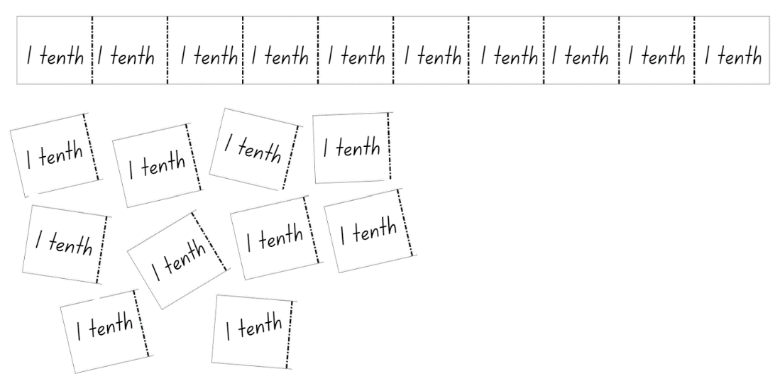
- Using the tenths parts cut up in the previous step, ask students to represent different decimals and record the decimal in a place value house. For example, 4 tenths would be represented with 4 sections of the whole strip by the students. Write 0.4 in the place value house (see Figure 5).
Note: discuss the place value of zero in the ones column and that the first number after the decimal point has a place value of tenths.
Figure 5 – tenths place value houses
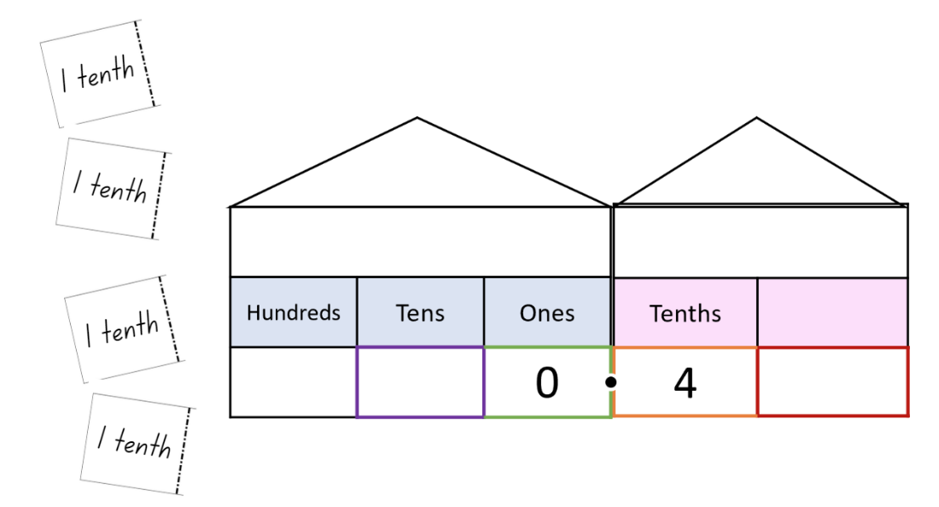
- Continue using the cut-up tenths parts to represent decimals, with students eventually representing decimals using both manipulatives and in the written form independently.
- Provide students with several Resource 4 – tenths strips. Instruct students not to cut these strips into tenths as these strips represent a whole number.
- Students use the whole number strips and cut up tenths parts to investigate how to create a range of numbers and record their decimals on a whiteboard.
Note: investigating decimals with a whole part and decimal part will be new learning. Monitor students’ representations and explicitly teach if needed.
This table details opportunities for differentiation.
Too hard? | Too easy?
Students cannot represent decimals as parts of a whole.  - Students only represent decimals less than one whole.  - Assist students to use manipulatives only to represent decimals.  - Model for students how to write decimals using the place value decimal house. | Students can represent decimals as parts of a whole.  - Ask students to record the decimal that is one tenth more or one tenth less than a given decimal.  - Challenge students to order decimals on a number line.  - Students show a classmate and discuss how they know their decimals are in the correct places.

Stage 3 task – decimals up to thousandths
The table below contains a suggested learning intention and success criteria. These are best co-constructed with students.
Core concept learning intentions | Core concept success criteria
Students working towards Stage 3 outcomes are learning to:  - recognise that the place value system can be extended beyond hundredths. | Students working towards Stage 3 outcomes can:  - interpret decimal notation for thousandths  - indicate the place value of digits in decimal numbers of up to 3 decimal places  - compare and order decimals on a number line  - use the place value of digits to indicate decimals that are greater than or less than another decimal.
This activity is an adaptation of ‘Task 4: Double Hat Trick’ from 3–6: Remote Maths – Edition 8 [PDF 542 KB] by Mathematical Association of Victoria.
- Read the following problem to students: Caitlin is 1.57 m tall, and her brothers Liam and Johnny are 1.49 m and 1.63 m tall respectively. Rank their heights in order from tallest to shortest, explaining your answer.
- In pairs, students turn and talk. Discuss answers as a class.
- Ask students how much taller Johnny is than Liam, and how much taller Liam is than Caitlin. Ask if this will this affect their distance on a number line if they were plotted.
- Students calculate the distances between heights by subtracting one height from another and plot these on a number line.
- Explain to students that they will be working in pairs to identify decimals on a number line.
- Player A draws a number line and labels the end points.
- Player A then thinks of a decimal up to 3 decimal places and places a dot on the number line where their number would be.
- Using the position of the dot, Player B guesses what they think the decimal could be.
- Player A states if their decimal is higher or lower than Player B’s guess.
- Player B records all attempts they have made on their own number line until they guess correctly.
- Repeat the activity with players swapping roles.
- Bring Stage 3 students back together and discuss. Ask students:
- What place value knowledge did you use to help you find your partner’s number?
- What would make this task harder or easier?
Note: through this discussion, revise the idea that the position of each digit in a number corresponds to its size.
- In pairs, Player A rolls three 6-sided dice to make a decimal up to the thousandths between zero and one. For example, 5, 2 and 1 could make 0.125.
- Player A places their number on a number line.
- Player B repeats the process to make a new number and places it on the same number line.
- Repeat this process until one player has 4 decimals in a row next to each other.
- Remind students that they need to be strategic about the placement of their decimals. Players can choose to use the numbers rolled to create a decimal that will stop their opponent from winning or a decimal that will help them win the game by making 4 in a row (see Figure 6).
Figure 6 – decimals number line
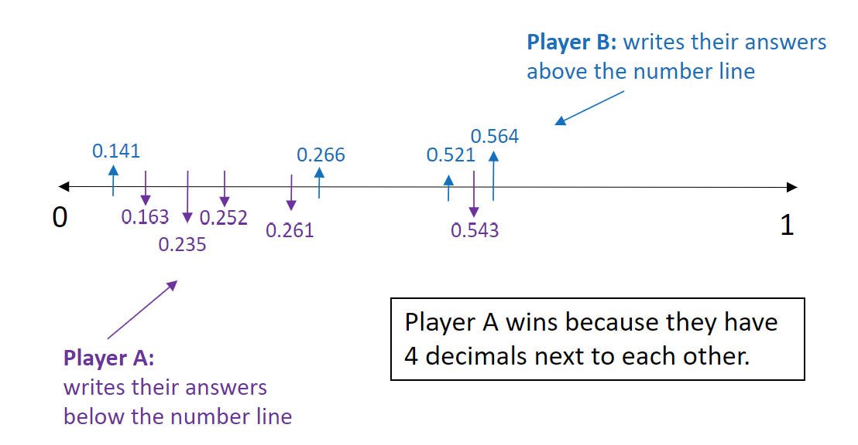
Note: to make identifying a player’s numbers easier, each player could write in different colours, or one could write below the line and one above the line (see Figure 6).
This table details opportunities for differentiation.
Too hard? | Too easy?
Students cannot compare and order decimals on a number line.  - Support students by using only 2 dice to create decimals up to hundredths.  - Assist students by deciding on a winner when a student has only 2 or 3 numbers in a row. | Students can compare and order decimals on a number line.  - Decrease the range of numbers on each end of the number line so that decimals are closer together. For example, decimals between 1.3 and 1.6.  - Challenge each player to add all decimals rolled during the game and compare their totals. Explain the strategy used to add the decimals to their partner.

Consolidation and meaningful practice – 15 minutes
This activity is an adaptation of ‘Greater Than? Less than? The same?’ from Learning to Think Mathematically with the Number Line [PDF 1102 KB] by Frykholm.
- Place a length of string or masking tape along the floor to create a large number line.
- Divide the class into 4 teams.
- Give each team 5 sticky notes with the decimals pre-written on them.
Note: this activity has been left open to enable you to choose decimals within a range appropriate to the class’s needs.
- To start the game, choose a decimal up to the thousandths and place it on the number line.
- Invite Team A to spin the spinner on Resource 5 – Less or greater? They have a possibility of landing on greater than, less than, miss a turn or take a number off.
- If the spinner lands on greater than, Team A must find a decimal in their sticky notes that is greater than the last decimal that was placed on the number line.
- Invite Team B to repeat this process.
- Play continues with Team A and Team B taking alternate turns until one team has placed all their sticky notes on the number line.
This table details opportunities for assessment.
Assessment opportunities | Links
What to look for:  - Can Stage 2 students express decimals as tenths? [MAO-WM-01, MA2-RN-02]  - Can Stage 2 students represent decimals as parts of a whole? [MAO-WM-01, MA2-RN-02]  - Can Stage 2 students demonstrate how to record more than ten tenths? [MAO-WM-01, MA2-RN-02]  - Can Stage 2 students apply place value knowledge to decimals? [MAO-WM-01, MA2-RN-02]  - Can Stage 3 students interpret decimal notation for thousandths? [MAO-WM-01, MA3-RN-02]  - Can Stage 3 students indicate the place value of digits in decimal numbers of up to 3 decimal places? [MAO-WM-01, MA3-RN-02]  - Can Stage 3 students compare and order decimals on a number line? [MAO-WM-01, MA3-RN-02]  - Can Stage 3 students use the place value of digits to indicate decimals that are greater than or less than another decimal? [MAO-WM-01, MA3-RN-02] | Links to National Numeracy Learning Progressions (NNLP):  - Stage 2 – NPV6, NPV7  - Stage 3 – NPV7, NPV8.  Links to suggested Interview for Student Reasoning (IfSR) tasks:  - Stage 3 – IfSR-NP: 4D.2, 4D.6.

Lesson 4
Core concept: zeroes in decimals play an important role.

Daily number sense – 10 minutes
- From a class need surfaced through formative assessment data, identify a short, focused activity that targets students’ knowledge, understanding and skills. Example activities may be drawn from the following resources:
- Mathematics K-6 resources
- Universal Resources Hub.

Core lesson – 35 minutes

Stage 2 task – the role of zero
The table below contains suggested learning intentions and success criteria. These are best co-constructed with students.
Core concept learning intentions | Core concept success criteria
Students working towards Stage 2 outcomes are learning to:  - extend the place value system to hundredths. | Students working towards Stage 2 outcomes can:  - represent decimals up to 2 decimal places  - compare decimals with a zero  - explain the role of zero in decimals.
- Display one tenths strip from Resource 4 – tenths strips.
- Ask students what they know about tenths.
- Introduce hundredths as 10 parts of a tenth.
- Display Resource 6 – hundredth strips and explain that students can extend numbers to have another place after the decimal point. The second number after the decimal point has a place value of hundredths.
- Model completing a place value house and hundredth strip for the decimal number 1.27 (see Figure 7).
Figure 7 – hundredth strip and place value house example
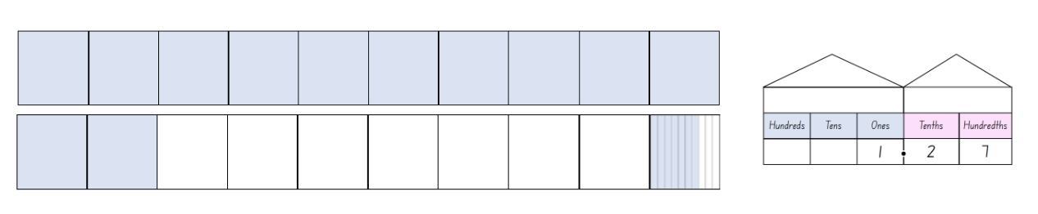
- Using Resource 6 – hundredth strips, students represent a range of decimals containing a whole number and a decimal up to hundredths by colouring in the correct number of parts.
- Repeat this step until students are confident to work independently representing decimals up to hundredths and containing a whole number.
- Display Resource 7 – single decimal house and write a range of decimals with a zero to discuss the role of zero when it is in different positions. For example, in Figure 8, when the 3 is in the ones place it is a whole number, and the decimal point and zero after the number are not necessary. In the decimal 0.3, there are 3 tenths; there is no whole number so a zero is required in the ones place. For 0.03, there are 3 hundredths. There is no whole number and no tenths. Therefore, a zero is required in the ones and tenths place. The zero is considered a place holder.
Note: the role of zero as a placeholder assists in understanding how to say and write decimals. For decimals less than one, zero is written in the ones place to reduce the risk of reading the decimal as a whole number.
Figure 8 – role of zero in decimals
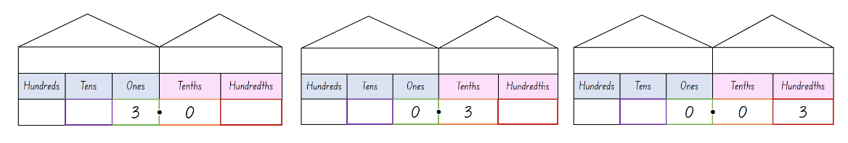
- Model using Resource 8 – comparison houses to compare decimals with hundredths and decimals that have a zero (see Figure 9).
Figure 9 – comparison houses example
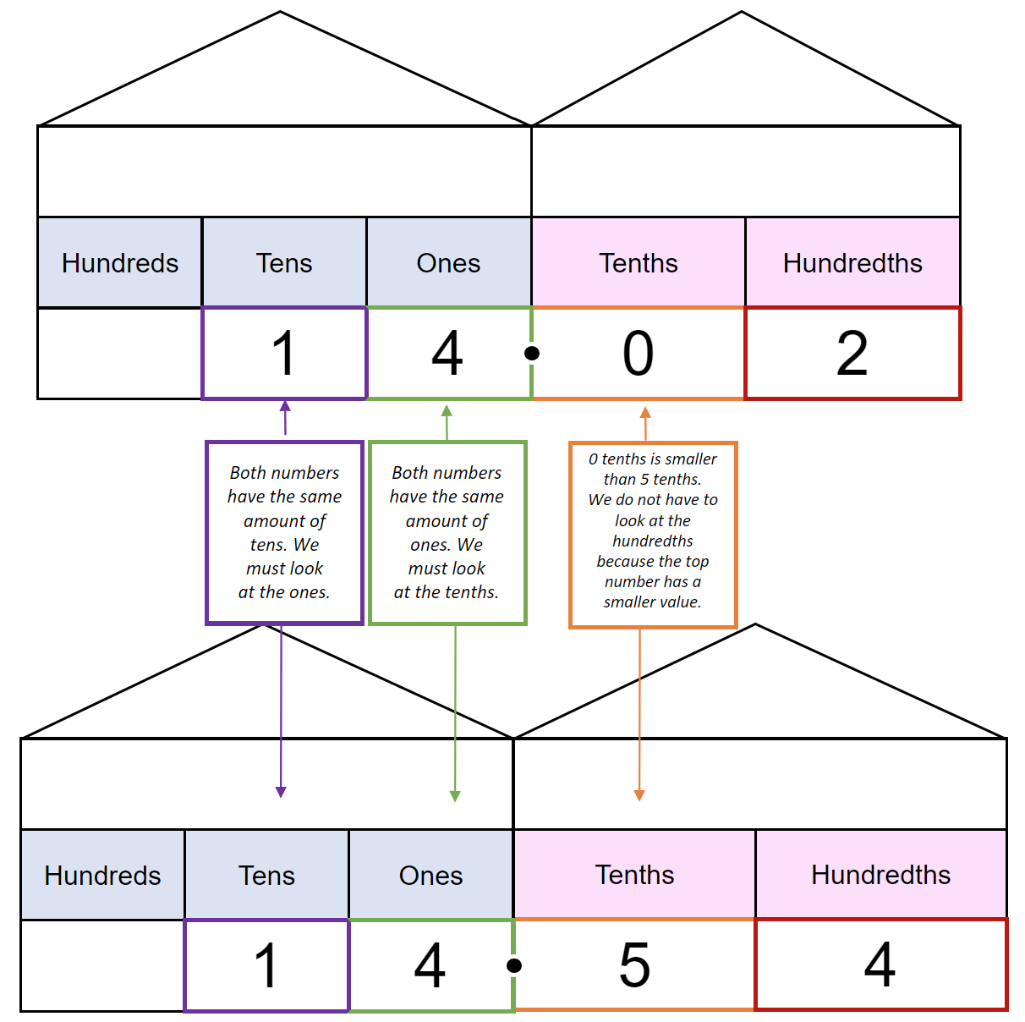
- Give students a copy of Resource 8 – comparison houses.
- List 2 decimals on the board, ensuring one contains a zero.
- Ask students to write the decimals into the comparison houses.
- Discuss where students can see the differences between the 2 numbers and how this helps them to decide which of the numbers is larger or small than the other.
- In pairs, students continue to compare a variety of decimal numbers containing a zero using Resource 8 – comparison houses to determine which of them is the largest or smallest.
This table details opportunities for differentiation.
Too hard? | Too easy?
Students cannot compare decimals with a zero.  - Assist students by reducing the numbers to be compared by providing decimals with tenths only.  - Model the use of Resource 8 – comparison houses to ensure students understand the value of each place. | Students can compare decimals with a zero.  - Ask students to compare 3 numbers with at least one containing a zero. Students can attempt this without using the comparison houses.  - Challenge students to place their decimals in ascending or descending order.

Stage 3 task – comparing decimals
The table below contains suggested learning intentions and success criteria. These are best co-constructed with students.
Core concept learning intentions | Core concept success criteria
Students working towards Stage 3 outcomes are learning to:  - apply place value knowledge to a real-life mathematical problem. | Students working towards Stage 3 outcomes can:  - compare and order decimals up to 3 decimal places  - interpret the role of zero in decimals.
This activity is an adaptation of ‘Fitness Fest’ from Navigating through Problem Solving and Reasoning in Grade 6 by Thompson et al.
- Explain the following scenario to students: Your school's annual Athletics Carnival is coming up and the teachers organising the day still need to assign all the new students to our school to teams for the track and field events. They want to be sure that all the teams entering these events are roughly equal in ability. The school has collected data on the performances of each new student for some track and field events. Help the teachers with their work. Use their data to develop a strategy for assigning these students to 3 teams that you would expect to be roughly equal in ability. Work on this problem with the other members of your group.
- Students turn and talk to a partner about what the activity is about. Ask:
- What is this activity asking you to do?
- How would you go about putting these students into different teams?
- Display Resource 9 – fitness scores and explain that these scores are the data they will be working with to assign students to the different teams. Ask students:
The table below outlines stimulus prompts to generate conversation about the topic, along with anticipated responses from students.
Prompts | Anticipated student responses
- What do you notice about these scores?  - Why do you think different units of measurement have been used?  - What is the difference between seconds and minutes?  - How can we tell who has run the fastest? | - The 100 m run is measured in seconds, the 800 m run is measured in minutes and the high jump is measured in metres.  - Some measurements are up to 3 decimal places and others are 2 or one.  - The 800 m run is a longer distance and will take more time to complete so they have used minutes instead of seconds.  - One minute is made up of 60 seconds.  - The smallest decimal is the fastest because they have finished the race before everyone else.
- Revise the role of zero at the end and in the middle of a decimal. Explain that the decimal 0.170 has the same value as 0.17 but 0.170 does not have the same value as 0.107. Students Think-Pair-Share why this is the case.
- Using Resource 9 – fitness scores, have students order the decimals from each category including 100 m run, 800 m run and high jump by drawing number lines for each and placing all the values on the number line.
- Students draw number lines for each category and place each decimal of up to 3 decimal places on the number lines.
This table details opportunities for differentiation.
Too hard? | Too easy?
Students cannot compare and order decimals.  - Provide numbers to one decimal place for students to place on a number line. Students work up to numbers that are 2 decimal places.  - Support students by reducing the number of athletes they need to consider. | Students can compare and order decimals.  - Have students approximate the size of decimals by rounding the 3 decimal place numbers to 2 decimal places. For example, 1.254 is converted to 1.25.  - Challenge students to determine the difference between the best and worst scores in each category.

Consolidation and meaningful practice – 20 minutes
- Provide small groups of students with 5 cards. On one card they write a decimal point, on 2 cards they write a zero, and on the remaining 2 cards they write 2 more digits (see Figure 10).
Figure 10 – decimal cards
- Students rearrange their cards to create a range of decimals. They then order the decimals from smallest to largest and record them.
Multi-age: students working towards Stage 3 outcomes rearrange their cards to form thousandths.
- As a class, formulate rules about the columns where zeros change the size of the number. For example, if a zero is before a whole number or at the end of the decimal it doesn’t change its size.
This table details opportunities for differentiation.
Too hard? | Too easy?
Students cannot interpret zero in decimals.  - Reduce the complexity of the task by asking students to complete this with 4 cards, using only one zero. | Students can interpret zero in decimals.  - Challenge students to find all the different decimal combinations they can make with their cards.  - Ask students to explain and justify to a classmate how they know that they have found all possible decimals that can be made using their selected cards.
This table details opportunities for assessment.
Assessment opportunities | Links
What to look for:  - Can Stage 2 students represent decimals up to 2 decimal places? [MA0-WM-01, MA2-RN-02]  - Can Stage 2 students compare decimals with a zero? [MA0-WM-01, MA2-RN-02]  - Can Stage 2 and Stage 3 students explain the role of zero in decimals? [MA0-WM-01, MA2-RN-02, MA3-RN-02]  - Can Stage 3 students compare and order decimals up to 3 decimal places? [MAO-WM-01, MA3-RN-02] | Links to National Numeracy Learning Progressions (NNLP):  - Stage 2 – NPV6, NPV7  - Stage 3 – NPV7, NPV8.  Links to suggested Interview for Student Reasoning (IfSR) tasks:  - Stage 2 – IfSR-NP: 4D.1, 4D.4, 4D.5, 4D.6  - Stage 3 – IfSR-NP: 4D.2, 4D.6.

Lesson 5
Core concept: connections can be made between fractions and decimals (Stage 2). Decimals can be compared by analysing the place values parts (Stage 3).

Daily number sense – Which one doesn’t belong? – 10 minutes
Daily number sense activities for Lessons 5 to 7 ‘loop’ back to concepts and procedures covered in previous units to assist students to build an increasingly connected network of ideas. These concepts may differ from the core concepts being covered by the unit.
The table below contains a suggested learning intention and success criteria. These are best co-constructed with students.
Daily number sense learning intention | Daily number sense success criteria
All students are learning to:  - choose and use efficient strategies to solve addition and subtraction problems. | All students can:  - compare, evaluate and communicate strategies used to solve addition and subtraction problems.
This activity is an adaptation of Which one doesn’t belong? from Mathematics K-6 Resources by State of New South Wales (Department of Education).
- Draw a 4-box grid on the board and write the numbers 9, 16, 25 and 43 in one box each (see Figure 11).
Figure 11 – Which one doesn't belong?
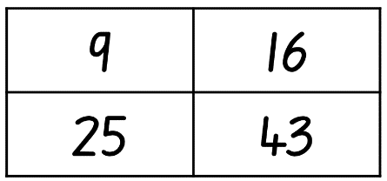
- In pairs, students must decide which number doesn’t belong using addition or subtraction thinking and justify their answer. For example, the number 9 is the only number whose digits do not add up to 7.
- Students record their ideas on individual whiteboards.
- Challenge students who finish quickly to make a case for why each of the numbers do not belong.
- Invite students to share which number they chose and why.
This table details opportunities for assessment.
Assessment opportunities | Links
What to look for:  - Can students compare, evaluate and communicate strategies used to solve addition and subtraction problems? [MAO-WM-01, MA2-AR-01, MA3-AR-01] | Links to National Numeracy Learning Progressions (NNLP):  - Stage 2 – AdS7  - Stage 3 – AdS7, AdS8.

Core lesson – 40 minutes

Stage 2 task – decimals as equivalent fractions
The table below contains suggested learning intentions and success criteria. These are best co-constructed with students.
Core concept learning intentions | Core concept success criteria
Students working towards Stage 2 outcomes are learning to:  - make connections between fractions and decimals. | Students working towards Stage 2 outcomes can:  - represent decimals as an equivalent fraction  - apply place value knowledge to investigate a problem.
- Display Resource 4 – tenths strips and revise that each rectangle strip represents a whole, which has been divided into 10 parts.
- Fill in 3 boxes on one linear model and ask students what they represent.
- Explain that decimals have an equivalent fraction because they are both part of a whole. The 3 boxes which have been filled in can be represented as 3 tenths, 0.3, or as the fraction $\frac{3}{10}$.
- Collaboratively label all the parts of the linear model with both decimal and fractional notations
- Provide students with a copy of Resource 4 – tenths strips and ask them to colour in 8 parts.
- Work collaboratively with students to record the equivalent decimal and fractional notations.
- Using Resource 10 – linear model 1, students work independently to interpret the linear model and record the equivalent decimal and fractional notation.
- Display Resource 12 – the vault and read the scenario with students.
- Explain that students will need to find the equivalent decimal notation to the fractional notation they have been provided.
- In pairs, students work together to solve the code.
Note: the answer to the code is 010509025075131172405. Students need to convert the fractions to decimals and then remove the decimal point to crack the code and unlock the app.
This table details opportunities for differentiation.
Too hard? | Too easy?
Students cannot represent decimals as an equivalent fraction.  - Support students by asking them to only record the decimal notation.  - Assist students to record fractions by only using words. | Students can represent decimals as an equivalent fraction.  - Students complete Resource 11 – linear model 2 and compare their answers with a classmate.  - Challenge students to order their decimals and fractions from Resource 11 – linear model 2 on a number line.

Stage 3 task – interpreting decimals up to thousands
The table below contains suggested learning intentions and success criteria. These are best co-constructed with students.
Core concept learning intentions | Core concept success criteria
Students working towards Stage 3 outcomes are learning to:  - read, write, and record decimal notation to thousandths. | Students working towards Stage 3 outcomes can:  - compare and order decimal numbers up to 3 decimal places  - interpret the role of zero at the end of a decimal  - apply place value knowledge to real life mathematical situations.
This activity is an adaptation of ‘Fitness Fest’ from Navigating through Problem Solving and Reasoning in Grade 6 by Thompson et al.
- Display and remind students of the athletics carnival scenario in Lesson 4. Read the scenario aloud again with students.
- Using Resource 9 – fitness scores, students work in small groups to organise the participants into 3 teams that are comparable in ability.
- Emphasise that the event organisers want all the teams to be competitive. Students will need to justify their choices.
Note: the focus of this lesson is to develop critical thinking and reasoning skills that are essential for making real world decisions using place value knowledge. The importance of this lesson is not in the final answer itself, but in the strategies applied and process undertaken. There is no one correct answer.
- Remind students that, to interpret the data accurately, they need to recognise that a high score is desirable in some events, such as high jump, but a low score is best in other events, such as the 800 m run.
Note: in an open-ended, challenging task such as this, the role of the teacher is to be a facilitator, encouraging students to investigate the topic and guide students to think critically and employ working mathematically skills and strategies.
This table details opportunities for differentiation.
Too hard? | Too easy?
Students cannot compare and order decimal numbers up to 3 decimal places.  - Support students to find the best performing student in each category by modelling the strategies they could use.  - Provide students with only the top half of the table so there are fewer decimals to compare. | Students can compare and order decimal numbers up to 3 decimal places.  - Ask students to record all the strategies they attempted and explain why they were or were not successful.  - Once the task is completed, students create another event including results for all competitors. These results cannot impact on the competitiveness of the teams they have already created.

Discuss and connect the mathematics – 10 minutes
- Ask Stage 2 students:
- What is the code?
- What strategy did you use to solve the code?
- What mathematical knowledge did you need to know to complete this activity?
- Ask Stage 3 students:
- How did you organise your teams?
- What strategy did you use?
- What mathematical knowledge did you need to know to complete this activity?
This table details opportunities for assessment.
Assessment opportunities | Links
What to look for:  - Can Stage 2 students represent decimals as an equivalent fraction? [MA0-WM-01, MA2-RN-02]  - Can Stage 2 students apply place value knowledge to investigate a problem? [MA0-WM-01, MA2-RN-02]  - Can Stage 3 students compare and order decimal numbers up to 3 decimal places? [MAO-WM-01, MA3-RN-02]  - Can Stage 3 students interpret the role of zero at the end of a decimal? [MAO-WM-01, MA3-RN-02]  - Can Stage 3 students apply place value knowledge to real life mathematical situations? [MAO-WM-01, MA3-RN-02] | Links to National Numeracy Learning Progressions (NNLP):  - Stage 2 – InF6, InF7  - Stage 3 – NPV6, NPV8.  Links to suggested Interview for Student Reasoning (IfSR) tasks:  - Stage 2 – IfSR-PT: 2A.10  - Stage 3 – IfSR-PT: 1A.5, 1A.7  - Stage 3 – IfSR-AT: 4B.1  - Stage 3 – IfSR-NP: 4D.6.

Lesson 6
Core concept: place value understanding helps solve addition and subtraction problems.

Daily number sense – mine equals yours – 10 minutes
The table below contains a suggested learning intention and success criteria. These are best co-constructed with students.
Daily number sense learning intention | Daily number sense success criteria
Students working towards Stage 2 outcomes are learning to:  - use the principle of equality.  Students working towards Stage 3 outcomes are learning to:  - apply efficient mental and written strategies to solve addition and subtraction problems. | Students working towards Stage 2 outcomes can:  - recognise that the equals sign means ‘the same as’  - recognise equal differences in number sentences.  Students working towards Stage 3 outcomes can:  - apply known strategies such as levelling, addition for subtraction, using constant difference, and bridging  - use place value to add or subtract 3 or more numbers with different numbers of digits.
- In pairs, students roll two 10-sided dice.
- Students arrange the dice to make a 2-digit number.
- Each student records a number sentence on their whiteboard that would have the 2-digit number as the answer.
- Students check their partners number sentence and record it as the answer to their number sentence (see Figure 12).
Figure 12– mine equals yours example
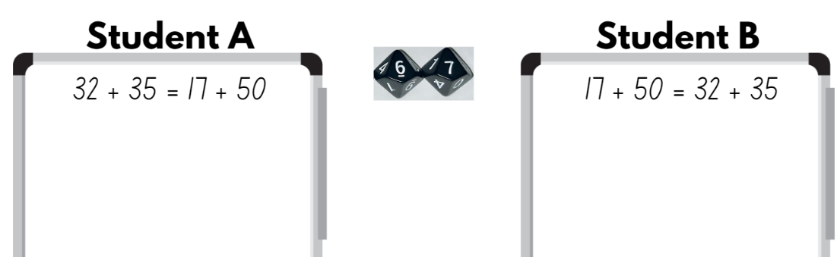
Multi-age: students working towards Stage 3 outcomes should roll three 10-sided dice to make a 3-digit number. They should be encouraged to include 3 or more numbers with different numbers of digits in their number sentence.
This table details opportunities for assessment.
Assessment opportunities | Links
What to look for:  - Can Stage 2 students recognise that the equals sign means ‘the same as’? [MAO-WM-01, MA2-AR-01]  - Can Stage 2 students recognise equal differences in number sentences [MAO-WM-01, MA2-AR-01]  - Can Stage 3 students apply known strategies such as levelling, addition for subtraction, using constant difference, and bridging? [MAO-WM-01, MA3-AR-01]  - Can Stage 3 students use place value to add or subtract 3 or more numbers with different numbers of digits? [MAO-WM-01, MA3-AR-01] | Links to National Numeracy Learning Progressions (NNLP):  - Stage 2 – NPA3, NPA4  - Stage 3 – AdS7, AdS8.  Links to suggested Interview for Student Reasoning (IfSR) tasks:  - Stage 2 – IfSR-AT: 2A.1  - Stage 3 – IfSR-AT: 3A.4, 3A.5.

Core lesson – 50 minutes

Stage 2 – addition – bridging and partitioning
The table below contains suggested learning intentions and success criteria. These are best co-constructed with students.
Core concept learning intentions | Core concept success criteria
Students working towards Stage 2 outcomes are learning to:  - apply known strategies to solve addition and subtraction. | Students working towards Stage 2 outcomes can:  - bridge numbers to the decade  - use place value knowledge to partition numbers  - investigate the efficiency of a strategy.
- Demonstrate how to use the bridging and partitioning model to solve an addition number sentence (see Figure 13).
Figure 13 – bridging and partitioning example 1
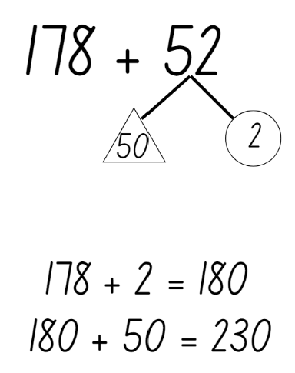
- Write 178 + 52 on the board and explain that this number sentence requires students to break the number into standard place value partitioning. They will need to apply their place value knowledge of hundreds, tens and one to break the number into parts. For example, the number 52 can be partitioned into 50 and 2.
- Discuss the concept of bridging and how parts of a number can be used to bridge to the nearest decade. For example, if a student adds 2 to 178, they have bridged to the nearest decade, 180.
- Write the number sentence 365 + 278 on the board and work collaboratively with students to use the bridging and partitioning model to solve the number sentence. For example, partition 275 into 200, 70 and 5. If students add the 5 to 365, they are bridging to the nearest decade, which is 370. Next, add the tens, 370 + 70 = 440.
- Record the final step in the strategy as 440 + 200, which gives the answer to 365 + 278 as 640 (see Figure 14).
Figure 14 – bridging and partitioning example 2
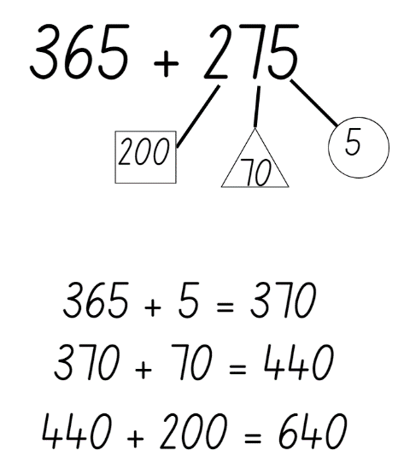
- Students roll three 10-sided dice twice to create an addition number sentence of two 3-digit numbers.
- Students use the bridging and partitioning model to solve this addition problem.
- Provide each student with a copy of Resource 13 – True or false?
- Students use their knowledge of the bridging and partitioning model to check whether each number sentence has been solved correctly.
This table details opportunities for differentiation.
Too hard? | Too easy?
Students cannot bridge numbers to the decade or use place value knowledge to partition numbers.  - Assist students to solve addition number sentences by reducing their number size to two 2-digit numbers.  - Model the use of MAB materials to complete addition number problems to support students’ thinking. | Students can bridge numbers to the decade or use place value knowledge to partition numbers.  - Challenge students to solve number sentences involving two 4-digit numbers, showing the strategy they used.  - Ask students to write an addition word problem for a partner to solve using the bridging and partitioning strategy.

Stage 3 – adding and subtracting decimals
The table below contains suggested learning intentions and success criteria. These are best co-constructed with students.
Core concept learning intentions | Core concept success criteria
Students working towards Stage 3 outcomes are learning to:  - apply known strategies to solve addition and subtraction problems. | Students working towards Stage 3 outcomes can:  - add and subtract decimals using a formal algorithm  - show more than one strategy to solve addition and subtraction  - represent their thinking using a variety of methods.
- Display 5.96 + 4.15 on the board.
- Students turn and talk about the strategy they would use to solve the number sentence.
- Compare student strategies and collaboratively find the solution. Reflect on which strategies are more efficient.
Note: if students are not using the formal algorithm, model this strategy on the board.
- Ask students if they could use the same strategy to solve a subtraction problem.
- Display 27.54 − 14.73 on the board.
- Students turn and talk about the strategy they would use to solve the number sentence.
- Compare student strategies and collaboratively find the solution. Reflect on which strategies are more efficient and if students can use the same strategy for both addition and subtraction.
- Provide students with another addition and subtraction number sentence to solve independently using a formal algorithm.
- Challenge students to represent the problem using a second strategy.
- Display Resource 14 – word problems to thousandths. Students choose 2 problems and show at least 2 different ways to solve them using Resource 15 – Frayer model. Strategies may include an algorithm, levelling, and compensation.
This table details opportunities for differentiation.
Too hard? | Too easy?
Students cannot add and subtract decimals using a formal algorithm.  - Students solve the word problems on Resource 16 – word problems to tenths.  - Support students by providing number sentences only. | Students can add and subtract decimals using a formal algorithm.  - Students solve the word problems on Resource 17 – multi-step problems.  - Challenge students to use multiple strategies to solve each problem. Discuss with a classmate which strategy they found to be the most efficient and why.

Discuss and connect the mathematics – 5 minutes
- Students sit in a sharing circle where they explain their solutions and strategies.
- Ask Stage 3 students to identify the most efficient strategy and justify their choice.
This table details opportunities for assessment.
Assessment opportunities | Links
What to look for:  - Can Stage 2 students bridge numbers to the decade? [MA0-WM-01, MA2-RN-01, MA2-AR-01]  - Can Stage 2 students use place value knowledge to partition numbers? [MA0-WM-01, MA2-RN-01, MA2-AR-01]  - Can Stage 2 students investigate the efficiency of a strategy? [MA0-WM-01, MA2-RN-01, MA2-AR-01]  - Can Stage 3 students add and subtract decimals using a formal algorithm? [MAO-WM-01, MA3-RN-01, MA3-RN-02, MA3-AR-01]  - Can Stage 3 students show more than one strategy to solve addition and subtraction? [MAO-WM-01, MA3-RN-01, MA3-RN-02, MA3-AR-01]  - Can Stage 3 students represent their thinking using a variety of methods? [MAO-WM-01, MA3-RN-01, MA3-RN-02, MA3-AR-01] | Links to National Numeracy Learning Progressions (NNLP):  - Stage 2 – NPV5, NPV6, AdS7  - Stage 3 – AdS9.  Links to suggested Interview for Student Reasoning (IfSR) tasks:  - Stage 2 – IfSR-AT: 2A.2, 3A.2.

Lesson 7
Core concept: non-standard partitioning can be an efficient way to solve addition and subtraction problems (Stage 2). Known strategies for subtraction can be applied to decimals (Stage 3).

Daily number sense – target number sentence – 10 minutes
The table below contains a suggested learning intention and success criteria. These are best co-constructed with students.
Daily number sense learning intention | Daily number sense success criteria
Students working towards Stage 2 outcomes are learning to:  - use the principle of equality.  Students working towards Stage 3 outcomes are learning to:  - apply efficient mental and written strategies to solve addition and subtraction problems. | Students working towards Stage 2 outcomes can:  - recognise equal differences and record them in number sentences  - use the equals sign to mean 'the same as'.  Students working towards Stage 3 outcomes can:  - apply known strategies such as levelling, addition for subtraction, using constant difference, and bridging  - use place value to add or subtract 3 or more numbers with different numbers of digits.
This activity is an adaptation of ‘Target number’ from Math for love by Finkel.
- Write a target number on the board. Different target numbers can be chosen for Stage 2 and Stage 3 students.
- Using whiteboards, students write down as many different number sentences as they can, that have the target number as the answer.
Multi-age: Stage 2 students must use equal differences in their number sentences. For example, 46 + 21 = 35 + 32. Stage 3 students must add or subtract at least 3 numbers with different numbers of digits in their number sentences.
- Students turn and talk to a stage-based partner to share one of their number sentences, describe the strategies they used to create it and how they know it is correct.
This table details opportunities for assessment.
Assessment opportunities | Links
What to look for:  - Can Stage 2 students recognise equal differences and record them in number sentences? [MAO-WM-01, MA2-AR-01]  - Can Stage 2 students use the equals sign to mean 'the same as'? [MAO-WM-01, MA2-AR-01]  - Can Stage 3 students apply known strategies such as levelling, addition for subtraction, using constant difference, and bridging? [MAO-WM-01, MA3-AR-01]  - Can Stage 3 students use place value to add or subtract 3 or more numbers with different numbers of digits? [MAO-WM-01, MA3-AR-01] | Links to National Numeracy Learning Progressions (NNLP):  - Stage 2 – NPA3  - Stage 3 – AsS7, AdS8.  Links to suggested Interview for Student Reasoning (IfSR) tasks:  - Stage 3 – IfSR-AT: 3A.4.

Core lesson – 45 minutes

Stage 2 task – subtraction with standard and non-standard partitioning
The table below contains suggested learning intentions and success criteria. These are best co-constructed with students.
Core concept learning intentions | Core concept success criteria
Students working towards Stage 2 outcomes are learning to:  - apply known strategies to solve addition and subtraction problems. | Students working towards Stage 2 outcomes can:  - apply standard partitioning to subtraction problems  - use non-standard partitioning to solve subtraction problems  - recognise when to apply standard and non-standard partitioning.
- Model how to solve subtraction number sentences by applying the strategy of standard partitioning.
- Write the number sentence 365 − 43 on the board and explain that, to use standard partitioning, students need to apply their place value knowledge of hundreds, tens and ones to break the number into parts. For example, the number 365 can be partitioned into 300, 60 and 5 and the number 43 can be partitioned into 40 and 3.
- Model writing a number sentence for each place value part. For example, 300 − 0 = 300, 60 − 40 = 20 and 5 − 3 = 2 (see Figure 15).
Figure 15 – subtraction partitioning example 1
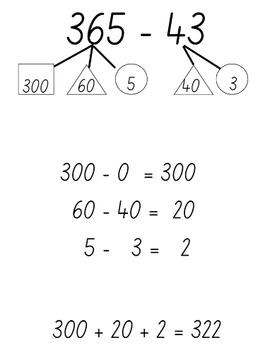
- Record the final step in the strategy as 300 + 20 + 2, which gives the answer to 365 − 43 as 322.
- Display the number sentence 878 − 52 on the board and work collaboratively with students to solve the question together.
- Explain the process of partitioning as you work with students (see Figure 16).
Figure 16 – subtraction partitioning example 2
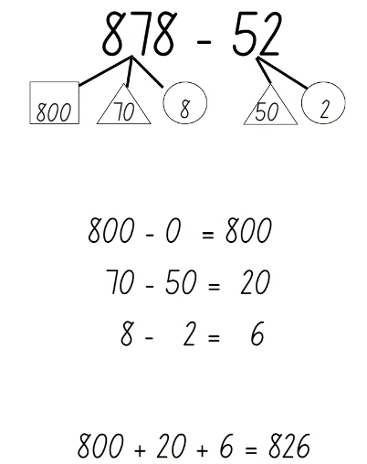
- Repeat this step until students are confident to work independently to solve subtraction number sentences, using standard partitioning.
Note: to ensure standard partitioning can be applied, create number sentences that have digits with a higher place value in the 3-digit number than the 2-digit number.
- Students independently complete number sentences in Resource 18 – subtraction with partitioning 1.
This table details opportunities for differentiation.
Too hard? | Too easy?
Students cannot use standard partitioning to solve addition and subtraction problem.  - Assist the students to solve subtraction number sentences by reducing their number size to two 2-digit numbers.  - Model using MAB materials to complete subtraction number problems to support students’ thinking.  - Students to complete Resource 19 – subtraction with partitioning 2. | Students can use standard partitioning to solve addition and subtraction problem.  - Challenge students to solve number sentences involving two 3-digit numbers, showing the strategy they used.  - Ask students to write a subtraction word problem for a partner to solve using the standard partitioning strategy.
- Display Resource 20 – non-standard partitioning and ask students:
- What do you notice about how these numbers are partitioned?
- Why were they partitioned this way?
- Invite students to share their ideas and discuss their reasoning. If students do not talk about the value of the digits in each place within the number, explain that they cannot subtract a number with a higher value from a number with a smaller value.
- Use Resource 20 – non-standard partitioning to explain that standard and non-standard partitioning must be used to solve the number sentence 453 − 27. For example, 453 was partitioned into 400, 40 and 13 (instead of 400, 50 and 3) and 27 was partitioned into 20 and 7. Explain that students cannot subtract 7 from 3, but they can subtract 7 from 13. Non-standard partitioning is used when a larger number is being subtracted from a smaller number.
- Model how to use standard and non-standard partitioning to solve subtraction problems (see Figure 17).
Figure 17 – subtraction partitioning example 3
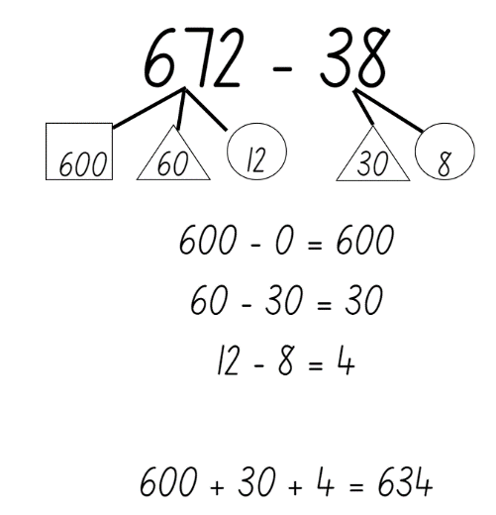
- Students work in pairs to solve subtraction problems. Student A uses the number cards and ace from a deck of playing cards. They turn over 3 cards to make a 3-digit number. Student B rolls two 10-sided dice to create a 2-digit number.
- Both students solve the subtraction number sentence individually using the partitioning strategy and record their responses on a whiteboard.
- Students compare their answers and explain how they partitioned the number sentence.
- Partners swap rolls and repeat the task.
Note: students will need to recognise when to apply standard and non-standard partitioning. This will depend on the numbers that are created from the cards flipped and dice rolled.
This table details opportunities for differentiation.
Too hard? | Too easy?
Students cannot use non-standard partitioning to solve addition and subtraction problems.  - Assist students to solve subtraction number sentences by reducing their number size to two 2-digit numbers.  - Model using MAB materials to complete number problems to support students’ thinking. | Students can use non-standard partitioning to solve addition and subtraction problems.  - Challenge students to solve number sentences involving two 3-digit numbers, showing the strategy they used.  - Ask students to write a word problem for a partner to solve using the strategies they have used over the past few lessons.

Stage 3 task – decimal subtraction face-off
The table below contains suggested learning intentions and success criteria. These are best co-constructed with students.
Core concept learning intentions | Core concept success criteria
Students working towards Stage 3 outcomes are learning to:  - apply known strategies to add and subtract decimals. | Students working towards Stage 3 outcomes can:  - use place value knowledge to add and subtract decimals  - describe strategies used to add and subtract decimals  - work collaboratively on a mathematical task, communicating their thinking and reasoning.
This activity is an adaptation of ‘Subtraction face-off: thousandths, hundredths and tenths' [PDF 863 KB] from Flexible additive strategies - Decimals by State of New South Wales (Department of Education).
- Provide pairs of students with a set of playing cards (ace to 9 to represent 1–9) and Resource 21 – explanation spinner.
- Students shuffle the cards and deal them out evenly, face down, between the 2 players.
- Students take the 5 top cards from their pile to form a number in the thousandths and a number in the hundredths. For example, if 5, 5, 6, 1, and 9 were flipped over, students could make the numbers 0.561 and 0.59.
- Students arrange the cards in any way they like to make the smallest difference between the 2 numbers.
- The student with the smallest difference collects all 10 cards.
- Students continue playing until one student has lost all their cards.
- Students use Resource 21 – explanation spinner and share the strategies used to work out differences based on what the spinner lands on. Students record these in their workbook.
- Students to swap partners and repeat.
- Bring the group back together and ask:
- Which strategies were the most efficient when determining the difference between the 2 numbers?
- What strategies did you use to try and have your numbers as close together as possible?
This table details opportunities for differentiation.
Too hard? | Too easy?
Students cannot apply decimal knowledge to add and subtract decimals.  - Assist students by reducing the numbers to be added or subtracted to tenths and hundredths or only tenths.  - Model strategies to be used when adding or subtracting decimals. | Students can apply decimal knowledge to add and subtract decimals.  - Challenge students to include zero cards in their piles to be used appropriately during the game.  - Students spin the Resource 21 – explanation spinner twice and represent their ideas 2 different ways.
This activity is an adaptation of ‘Decimals’ from Decimals, Challenging mathematical tasks: Unlocking the potential of all students by Sullivan.
- Write on the board ‘I subtracted 3 decimal numbers away from 4 to get zero. What might the 3 numbers be?’
- In pairs, students solve this problem as many ways as they can.

Discuss and connect the mathematics – 10 minutes
- Discuss with Stage 2 students how they knew when to apply standard or non-standard partitioning.
- Ask Stage 2 students:
- How would you explain this strategy to someone else?
- Is this strategy efficient?
- Would you use this strategy again?
- Ask Stage 3 students:
- What strategies did you use?
- Can you justify why your answers are correct?
This table details opportunities for assessment.
Assessment opportunities | Links
What to look for:  - Can Stage 2 students apply standard partitioning to subtraction problems? [MAO-WM-01, MA2-RN-01, MA2-AR-01]  - Can Stage 2 students use non-standard partitioning to solve subtraction problems? [MAO-WM-01, MA2-RN-01, MA2-AR-01]  - Can Stage 2 students recognise when to apply standard and non-standard partitioning? [MAO-WM-01, MA2-RN-01, MA2-AR-01]  - Can Stage 3 students apply decimal knowledge to real life situations? [MAO-WM-01, MA3-RN-01, MA3-RN-02, MA3-AR-01]  - Can Stage 3 students describe strategies used to add and subtract decimals? [MAO-WM-01, MA3-RN-01, MA3-RN-02, MA3-AR-01]  - Can Stage 3 students work collaboratively on a mathematical task, communicating their thinking and reasoning? [MAO-WM-01, MA3-RN-01, MA3-RN-02, MA3-AR-01] | Links to National Numeracy Learning Progressions (NNLP):  - Stage 2 – AdS7, AdS8  - Stage 3 – AdS9, NPV8.  Links to suggested Interview for Student Reasoning (IfSR) tasks:  - Stage 2 – IfSR-AT: 2A.3, 2A.6, 3A.4.

Lesson 8
Core concept: place value understanding helps solve addition and subtraction problems.

Daily number sense – 15 minutes
- From a class need surfaced through formative assessment data, identify a short, focused activity that targets students’ knowledge, understanding and skills. Example activities may be drawn from the following resources:
- Mathematics K-6 resources
- Universal Resources Hub.

Core lesson – show us how – 30 minutes
The table below contains suggested learning intentions and success criteria. These are best co-constructed with students.
Core concept learning intentions | Core concept success criteria
Students working towards Stage 2 outcomes are learning to:  - select strategies flexibly to solve addition and subtraction problems of up to 3 digits.  Students working towards Stage 3 outcomes are learning to:  - apply efficient mental and written strategies to solve addition and subtraction problems  - choose and use efficient strategies to solve addition and subtraction problems. | Students working towards Stage 2 outcomes can:  - apply known mental strategies that use partitioning to add and subtract, such as bridging the decades  - represent solutions to addition and subtraction problems, including word problems, using an empty number line or bar model  - compare and evaluate strategies used to solve addition and subtraction problems, reasoning which strategy may be most efficient.  Students working towards Stage 3 outcomes can:  - apply known strategies such as levelling, addition for subtraction, using constant difference, and bridging  - use place value to add or subtract 3 or more numbers with different numbers of digits  - compare, evaluate and communicate the strategies used to solve addition and subtraction problems.
This activity is an adaptation of ‘Task 3: Addition’ from 3–6: Remote Maths – Edition 2 [PDF 417 KB] by Mathematical Association of Victoria.
- As a class, revise and discuss the various ways addition problems can be represented and solved.
- Display Resource 22 – show us how 1.
- Explain that students must choose 2 of the equations and then use them to complete each of the 4 tasks.
- When they have completed the tasks, students choose another student who completed the same equations to compare representations and solutions.
- As a class, revise and discuss the various ways subtraction problems can be represented and solved.
- Repeat the above task using Resource 23 – show us how 2.
This table details opportunities for differentiation.
Too hard? | Too easy?
Students cannot apply known strategies to solve addition or subtraction problems.  - Provide concrete materials to support student thinking.  - Provide alternate questions using two 2-digit numbers for addition and two- and one-digit numbers for subtraction. | Students can apply known strategies to solve addition or subtraction problems.  - Provide open-ended addition and subtraction problems.  - Ask students to categorise a list of addition and subtraction problems according to which strategy would be the most efficient way of solving it.

Discuss and connect the mathematics – 15 minutes
- Discuss and reflect on the activity by asking questions, such as:
- What technique did you use when estimating? Why?
- What strategy did you use to solve the problems? Why?
- What is another strategy you could have used? Would it have been more or less efficient? Why?
- Did you use different strategies for different problems? Why or why not?
This table details opportunities for assessment.
Assessment opportunities | Links
What to look for:  - Can Stage 2 students apply known mental strategies that use partitioning to add and subtract, such as bridging the decades? [MAO-WM-01, MA2-AR-01]  - Can Stage 2 students represent solutions to addition and subtraction problems, including word problems, using an empty number line or bar model? [MAO-WM-01, MA2-AR-01]  - Can Stage 2 students compare and evaluate strategies used to solve addition and subtraction problems, reasoning which strategy may be most efficient? [MAO-WM-01, MA2-AR-01]  - Can Stage 3 students apply known strategies such as levelling, addition for subtraction, using constant difference, and bridging? [MAO-WM-01, MA3-AR-01]  - Can Stage 3 students use place value to add or subtract 3 or more numbers with different numbers of digits? [MAO-WM-01, MA3-AR-01]  - Can Stage 3 students compare, evaluate and communicate the strategies used to solve addition and subtraction problems? [MAO-WM-01, MA3-AR-01] | Links to National Numeracy Learning Progressions (NNLP):  - Stage 2 – AdS6, AdS7  - Stage 3 – AdS7, AdS8.  Links to suggested Interview for Student Reasoning (IfSR) tasks:  - Stage 2 – IfSR-AT: 3A.2  - Stage 3 – IfSR- AT: 3A.4, 3A.5.

Resource 1 – place value houses
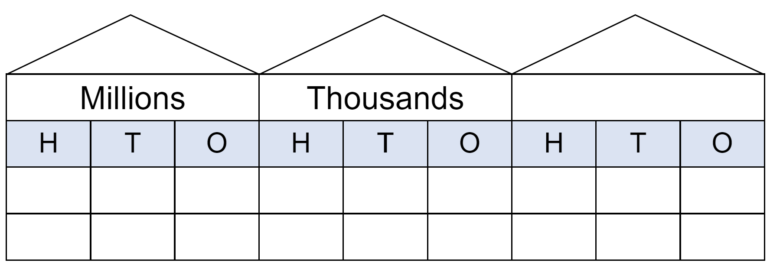

Resource 2 – prompting questions

Resource 3 – Is he correct?
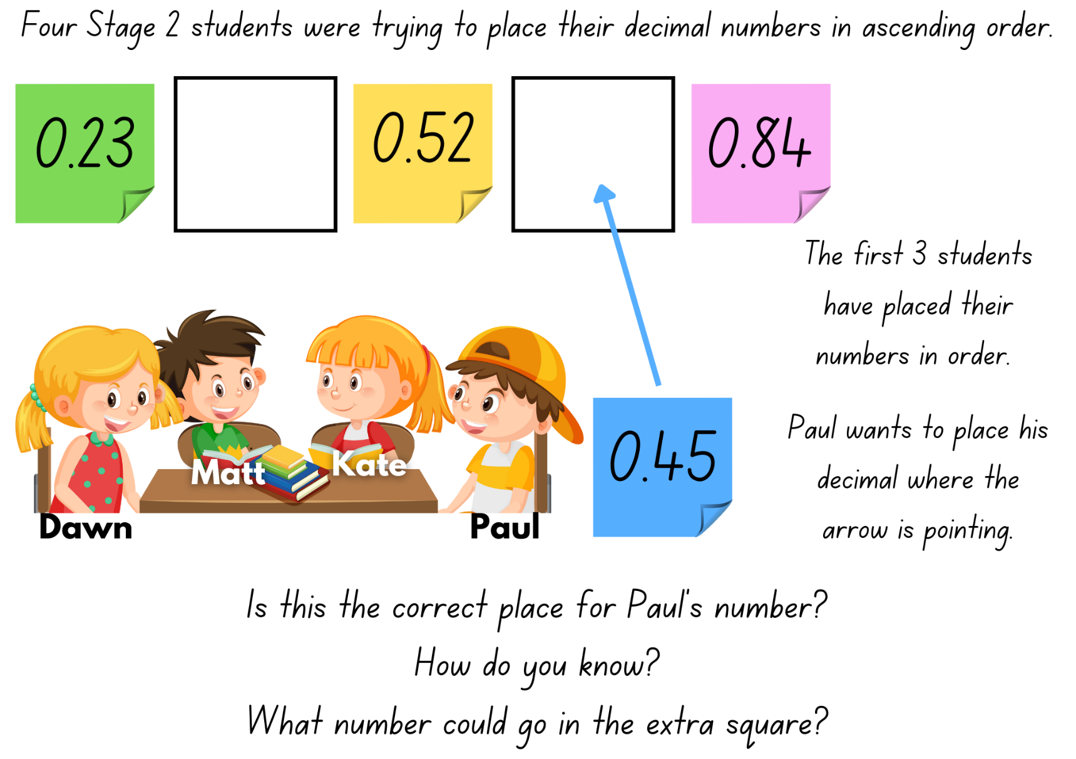

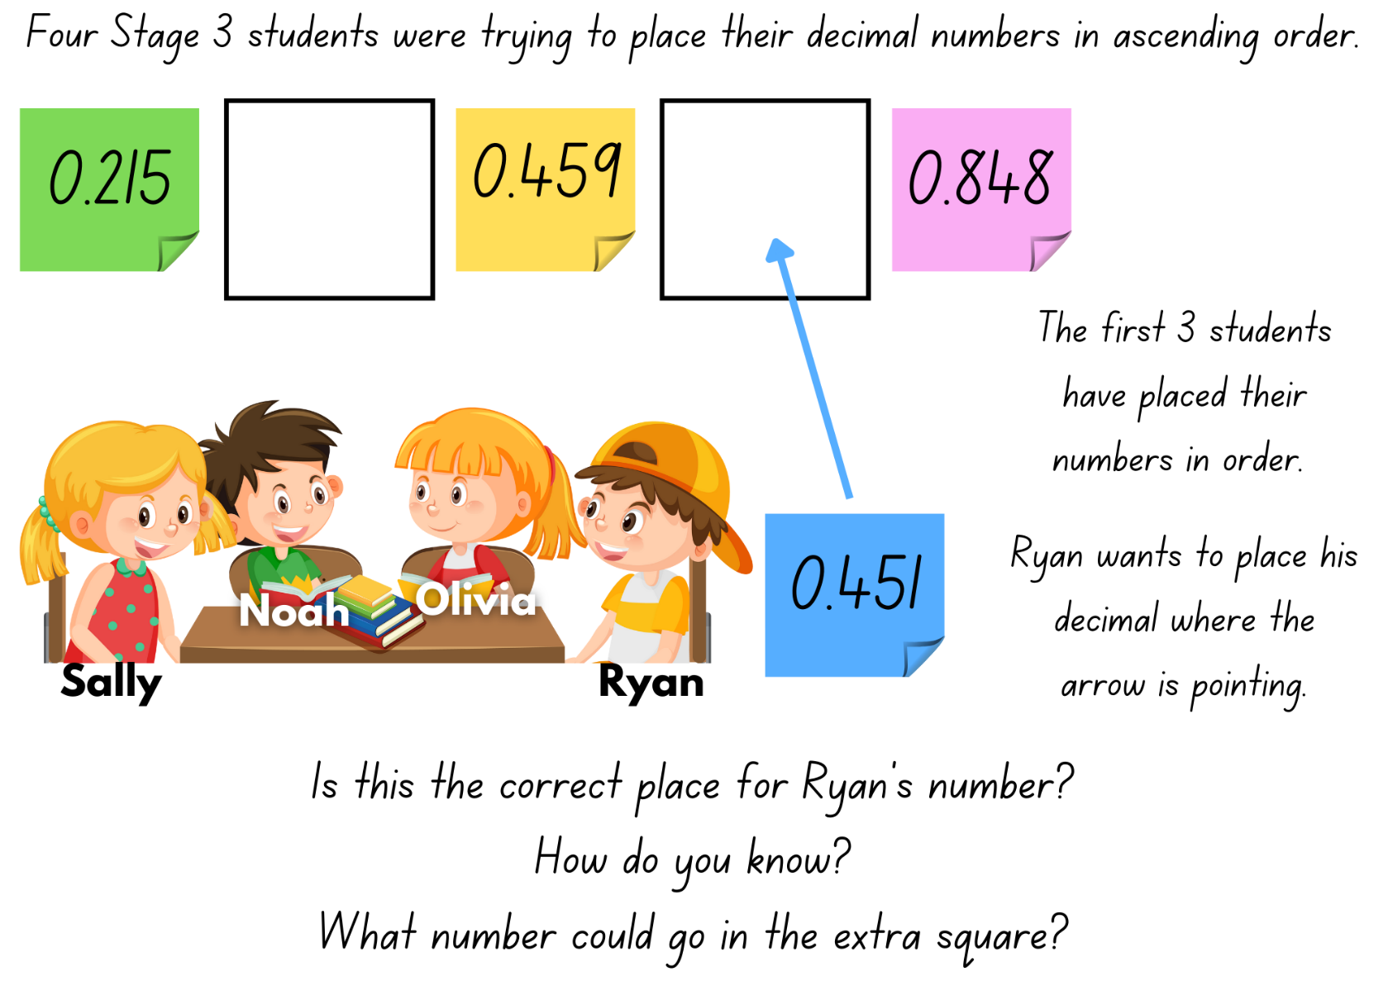

Resource 4 – tenths strips

Resource 5 – Less or greater?
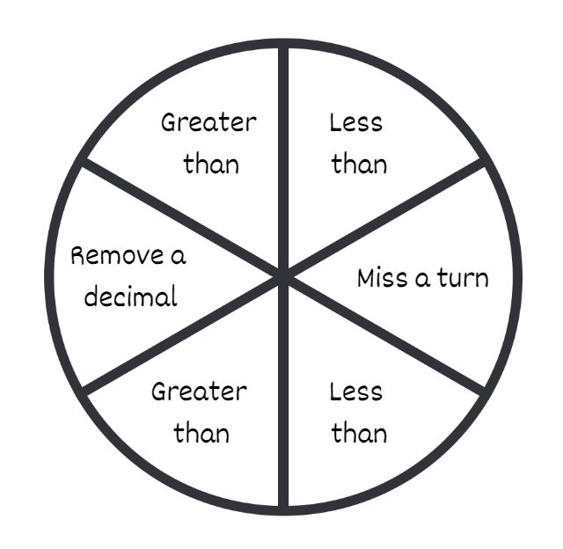

Resource 6 – hundredths strips

Resource 7 – single decimal house
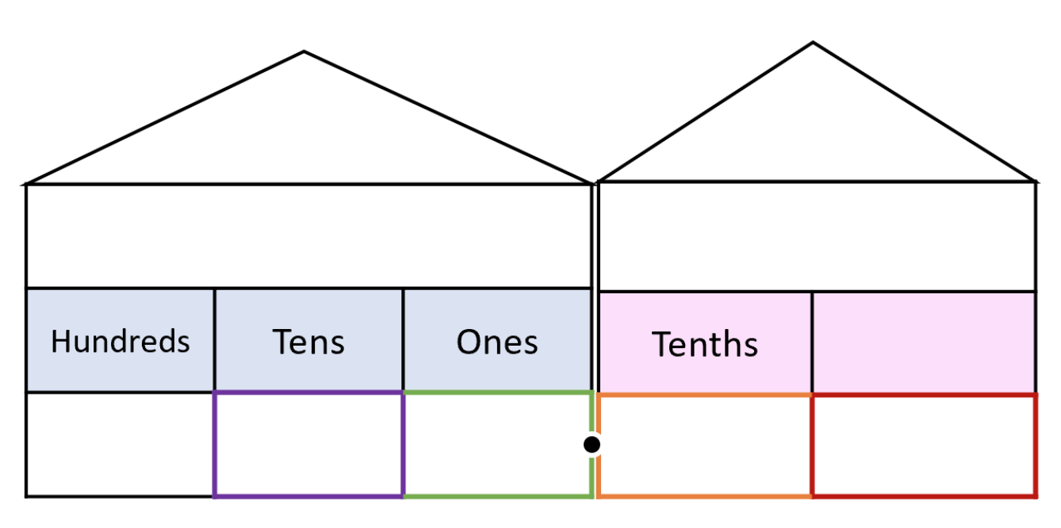

Resource 8 – comparison houses
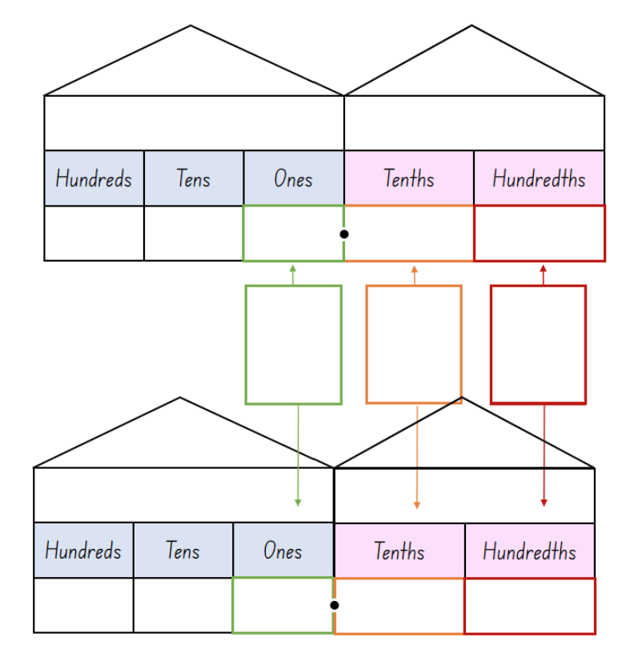

Resource 9 – fitness scores
Student | 100 m run (seconds) | 800 m run (minutes) | High jump (metres) | Fitness test
Ryan | 17.356 | 3.38 | 1.64 | Pass
Carolyn | 16.0 | 3.01 | 1.59 | Fail
Blake | 19.89 | 2.24 | 1.59 | Pass
Nicole | 18.52 | 2.557 | 1.70 | Pass
Jason | 16.48 | 2.55 | 1.49 | Pass
Mark | 17.2 | 3.22 | 1.78 | Fail
Terese | 20.2 | 4 | 1.74 | Pass
Heather | 18.256 | 3.168 | 1.67 | Pass
Arabella | 17.1 | 3.11 | 1.69 | Fail
Leila | 20.32 | 2.51 | 1.71 | Pass
Nat | 16.444 | 2.453 | 1.55 | Fail
Regan | 19.2 | 3.12 | 1.48 | Fail
John | 17.341 | 3.505 | 1.63 | Fail
Ainslie | 17.0 | 3.30 | 1.75 | Pass
Kristy | 18.3 | 3 | 1.50 | Pass
*All students received a mark of ‘pass’ or ‘fail’. The test consisted of 30 push-ups, 50 star jumps and 20 sit ups.

Resource 10 – linear model 1
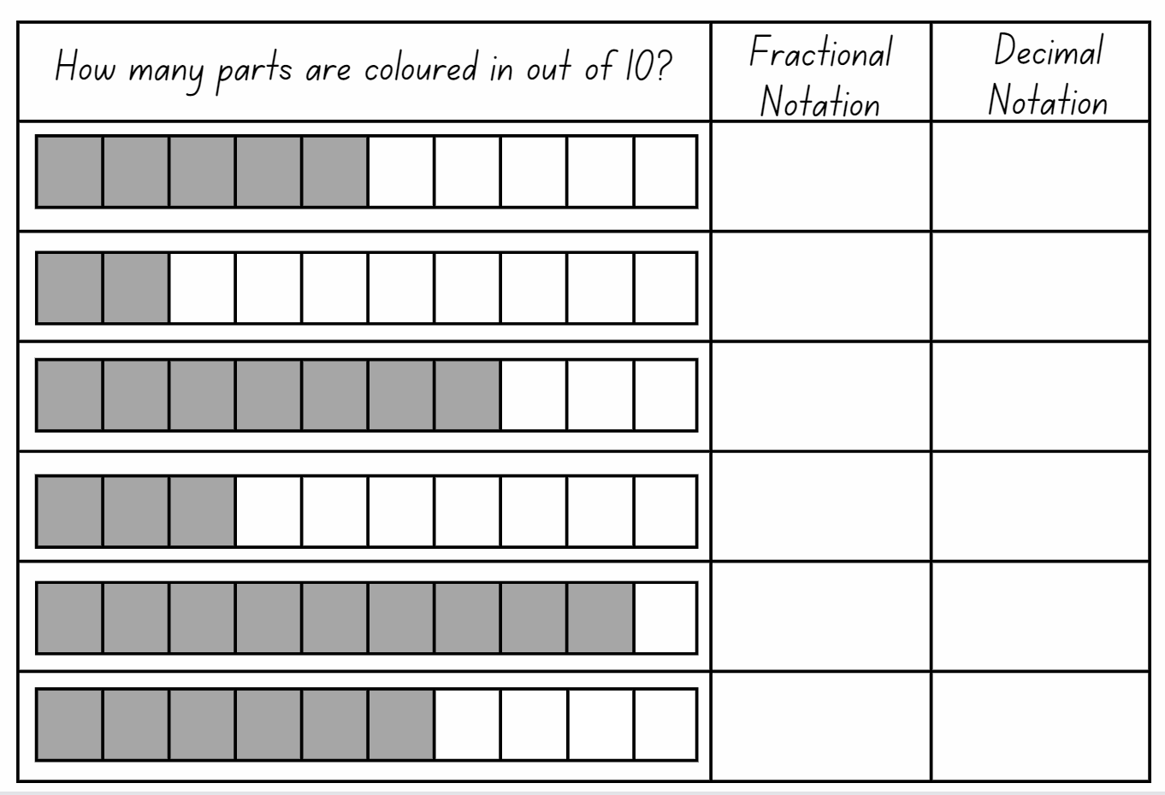

Resource 11 – linear model 2
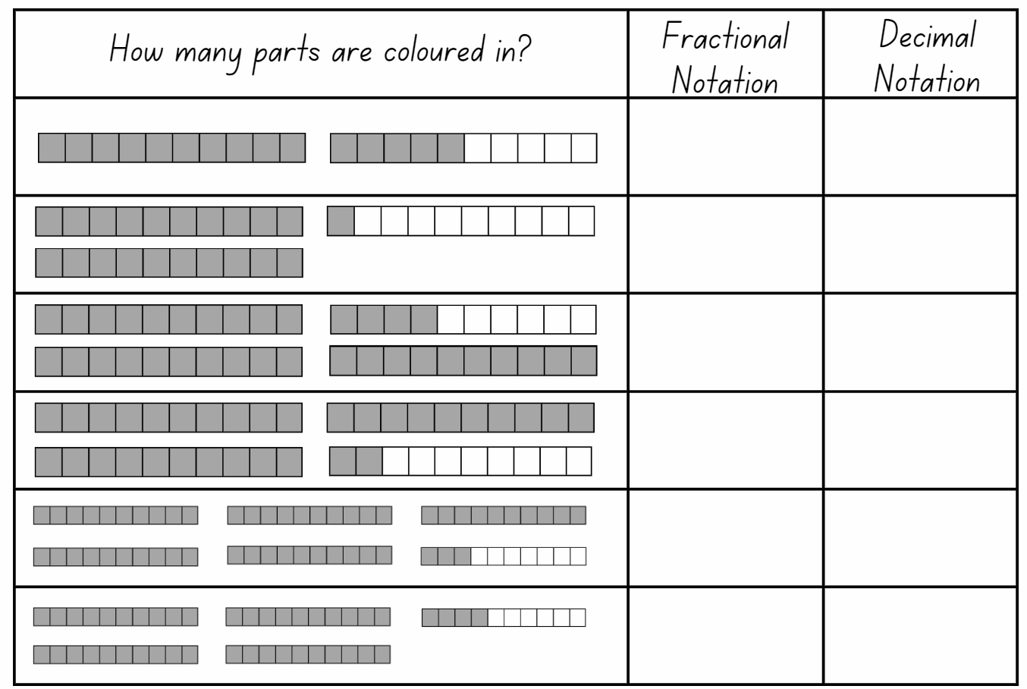

Resource 12 – the vault
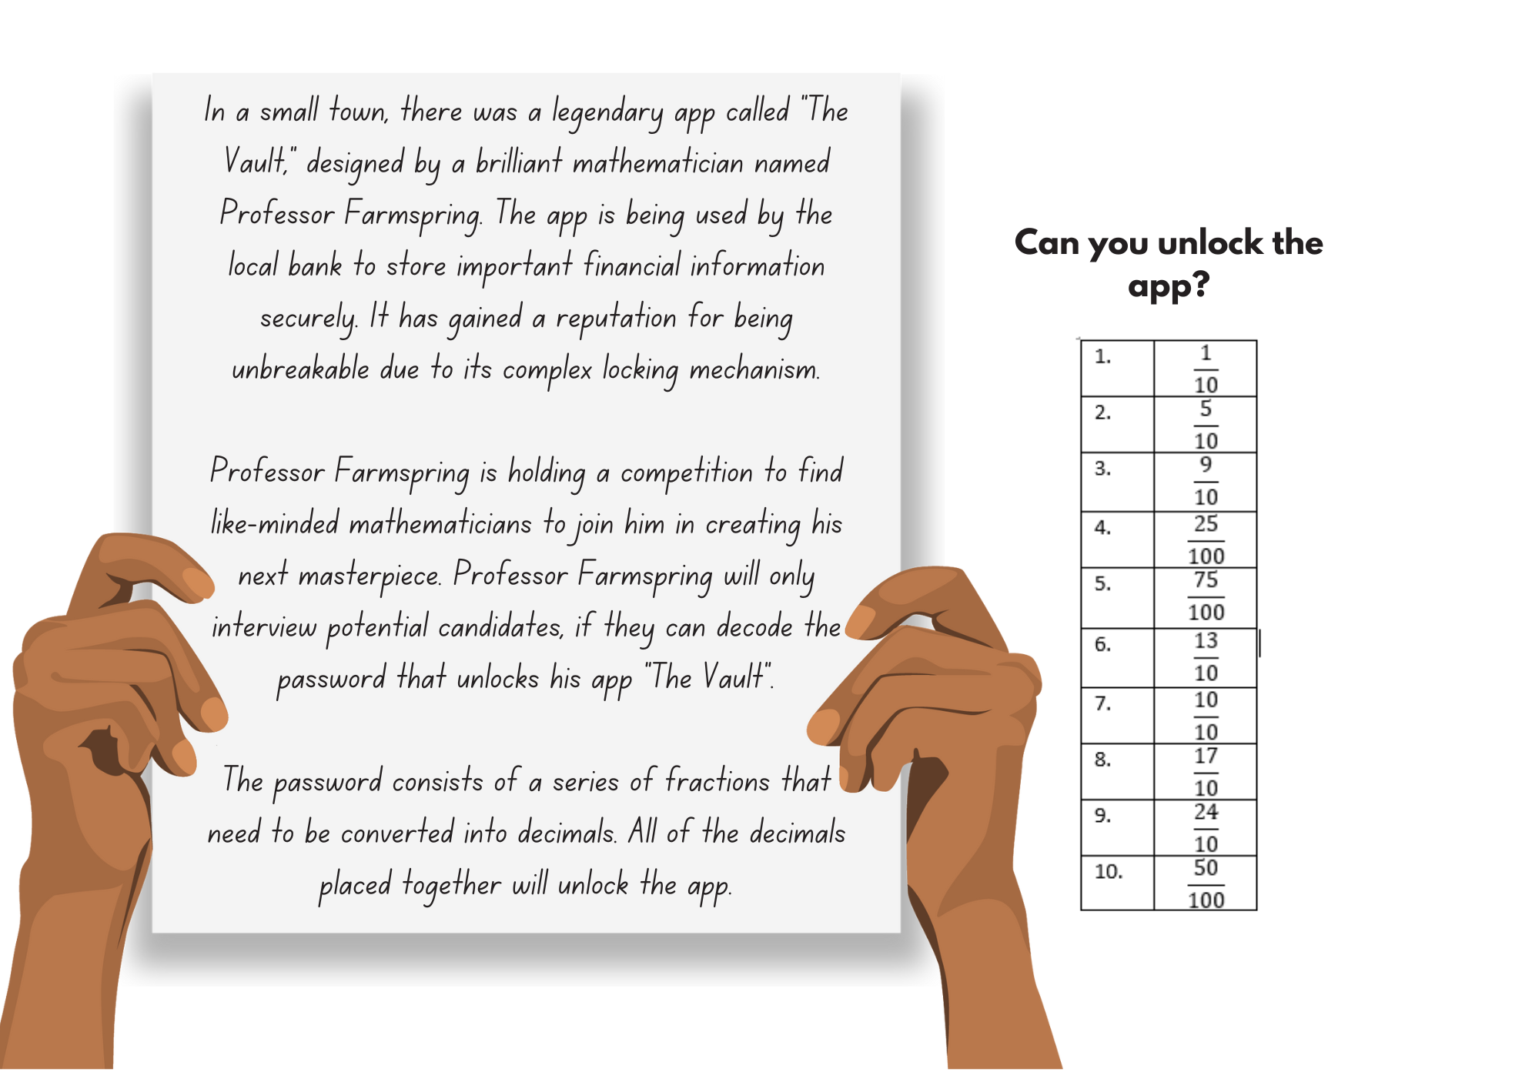

Resource 13 – True or false?
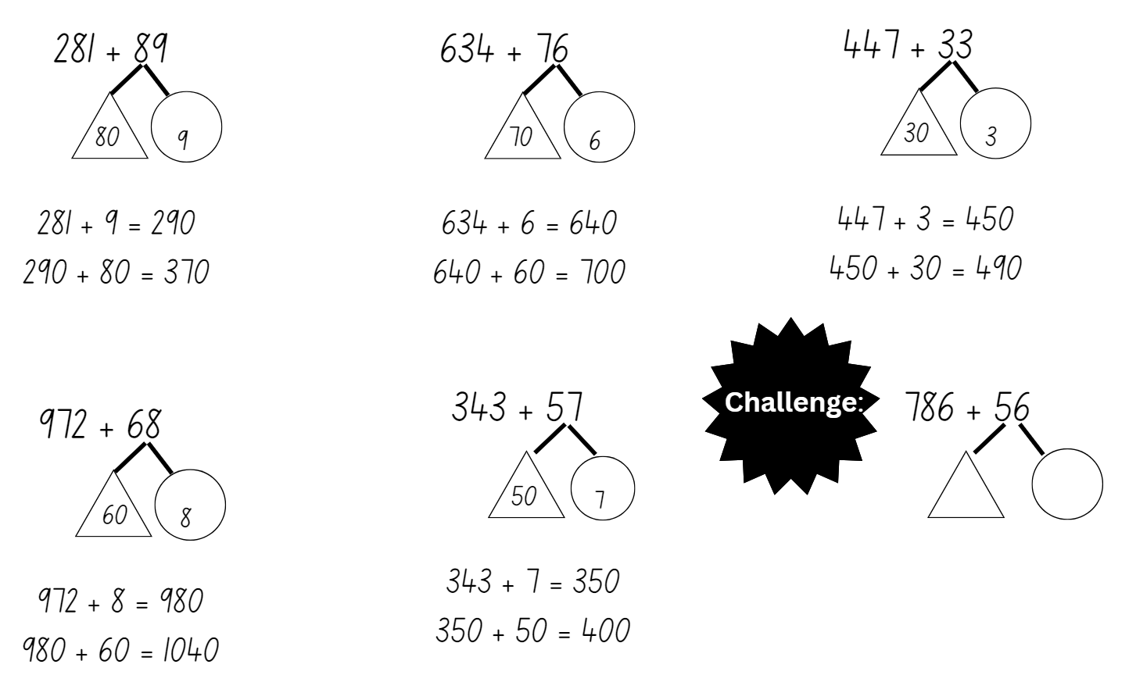

Resource 14 – word problems to thousandths
Word problems to thousandths
A swimmer completes a 100 m race in 54.386 seconds. His competitor completes the race in 53.892. How many thousandths of a second difference was there between the 2 swimmers?
A scientist measures the pH level of a solution and records it as 4.672 on Monday. On Wednesday, the scientist measures the pH level as 7.321. What is the total value from both days of the solution's pH level?
The temperature outside reached 21.749 degrees Celsius. By the afternoon it dropped by 4.83 degrees Celsius and then a further 3.07 degrees. What is the current temperature?
A recipe calls for 0.025 litres of vanilla extract. If you want to make 6 batches of the recipe, how many litres of vanilla extract would you need in total?
A carpenter used 8.503 m of wood to build a table and 3.017 m of wood to build a chair. At the end of the project the carpenter had 7.364 m of wood left. How much did they have at the start of the project?
Sarah bought a book for $15.64 and a pen. In total the cost of the 2 items was less than $19.58. What could have been the cost of the pen?
Maria is planning a school trip to a theme park. She has a budget of $250 to spend on tickets for herself and her friends. The admission ticket costs $28.62 per person. How many of her friends could Maria invite?

Resource 15 – Frayer model
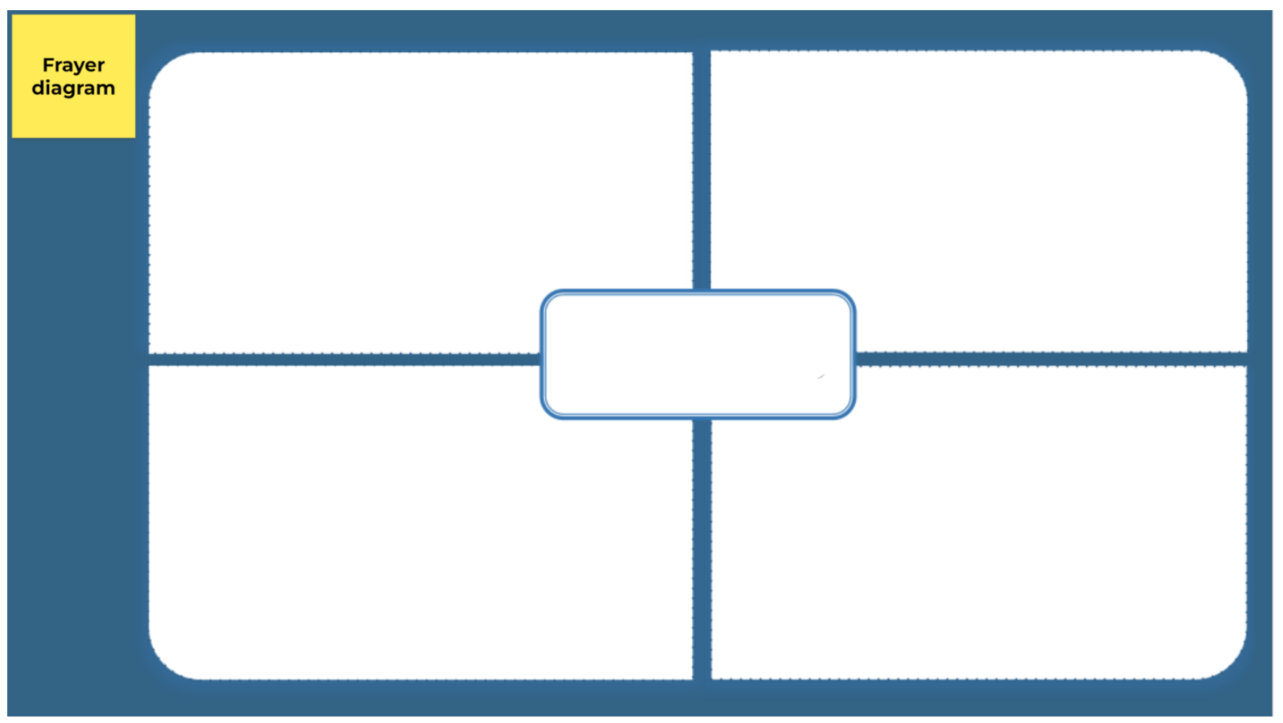

Resource 16 – word problems to tenths
Word problems to tenths
Maria had 3.6 litres of water in a container. She poured 1.2 litres into another container. How much water does she have left in the first container?
A store sold 4.5 kilograms of bananas in the morning and received a delivery of 2.3 kilograms in the afternoon. How many kilograms of bananas does the store have in total?
A rectangular garden measures 6.2 m in length and 4.1 m in width. What is the total perimeter of the garden?
Emma is a long-distance swimmer. On Monday she swam 3.2 kms and on Tuesday she swam 2.9 kms. How many more kilometres does she need to swim on Wednesday, Thursday and Friday to have swum a total of 14.5 km by Saturday?
Sarah and her friend Alex decided to have a lemonade stand on a hot summer day. They made 2 different flavours of lemonade, regular lemonade, and strawberry lemonade. In the morning, Sarah sold 2.5 litres of regular lemonade and 1.3 litres of strawberry lemonade. In the afternoon, they sold another 3.7 litres of regular lemonade and 0.8 litres of strawberry lemonade. Can you help them calculate how much lemonade they sold in total throughout the day? In addition, calculate how much more regular lemonade they sold than strawberry lemonade during the day.

Resource 17 – multi-step problems
Multi-step worded problems
A recipe calls for 2.345 kilograms of flour. Lisa already has 1.225 kilograms of flour. How much more flour does she need to complete the recipe? If she bought an additional 0.875 kilograms of flour, how much flour does she have in total? Is this enough for the recipe? Why or why not?
A company shipped 185.763 units of a product to one warehouse and 239.405 units to another warehouse. If they later transferred 126.178 units from the first warehouse to the second, how many units are left in each warehouse?
The total cost of Jenny’s sunglasses and designer shoes was $197.25. I know that the shoes were at least $48 more than the sunglasses. How much could the shoes cost? What would be the maximum cost of the sunglasses?

Resource 18 – subtraction with partitioning 1
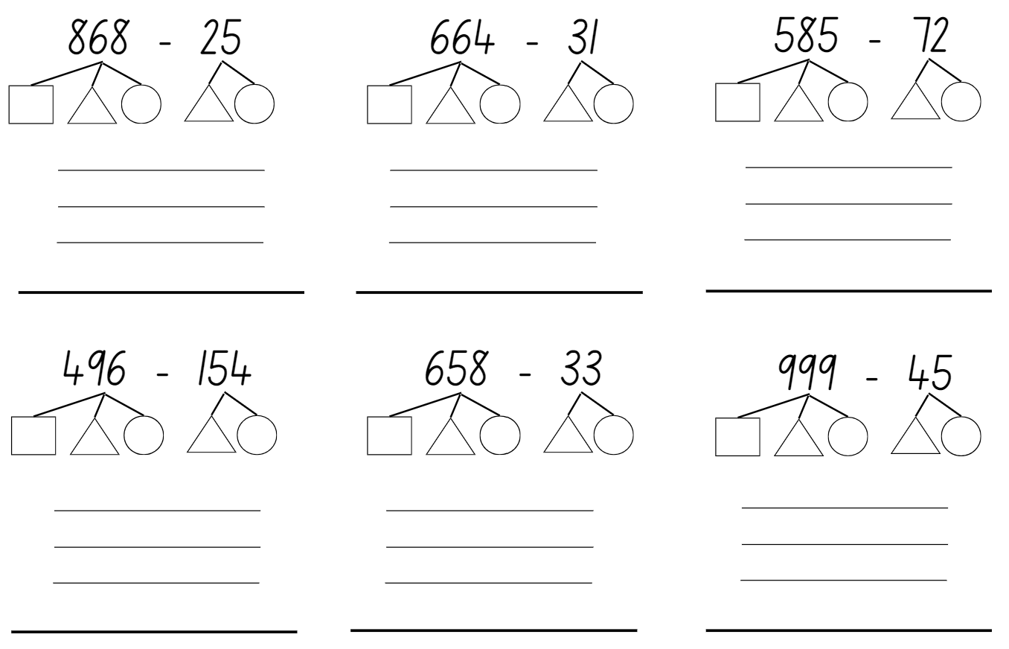

Resource 19 – subtraction with partitioning 2
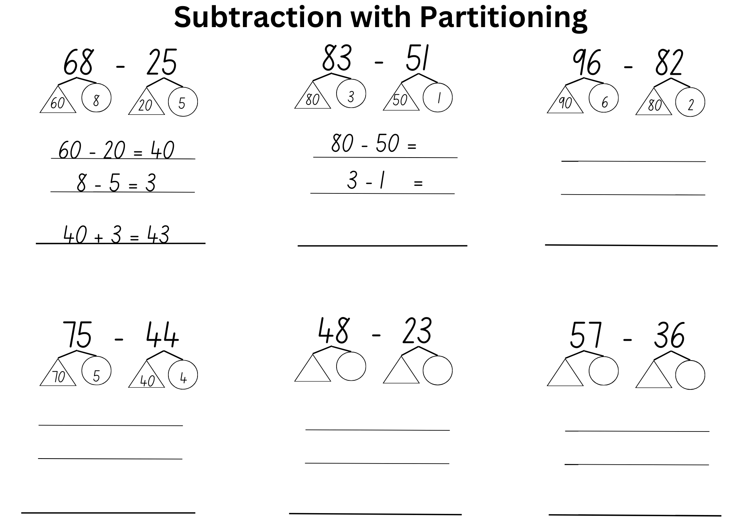

Resource 20 – non-standard partitioning
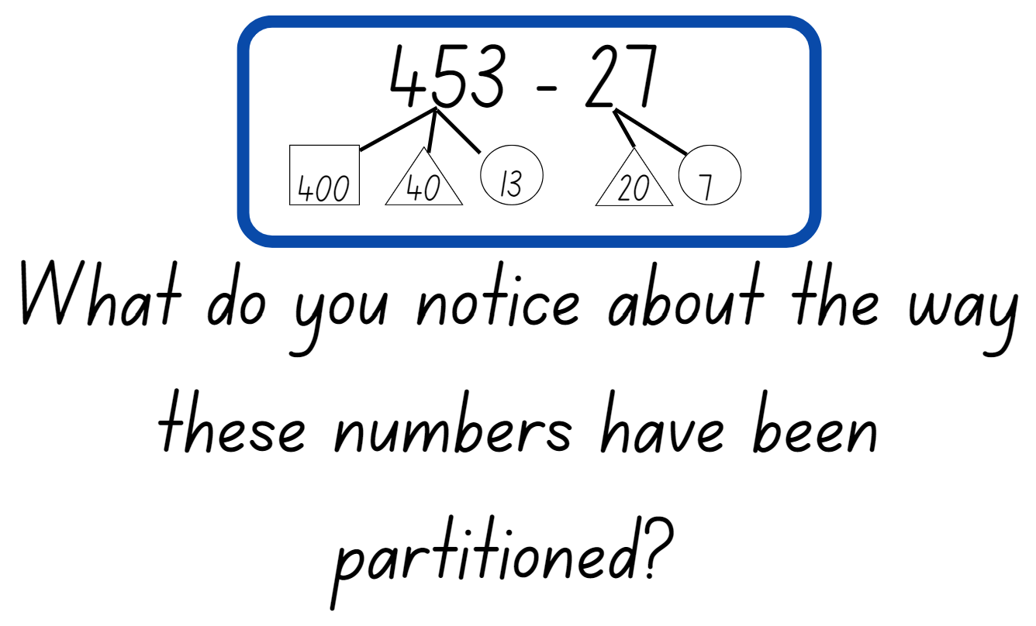

Resource 21 – explanation spinner
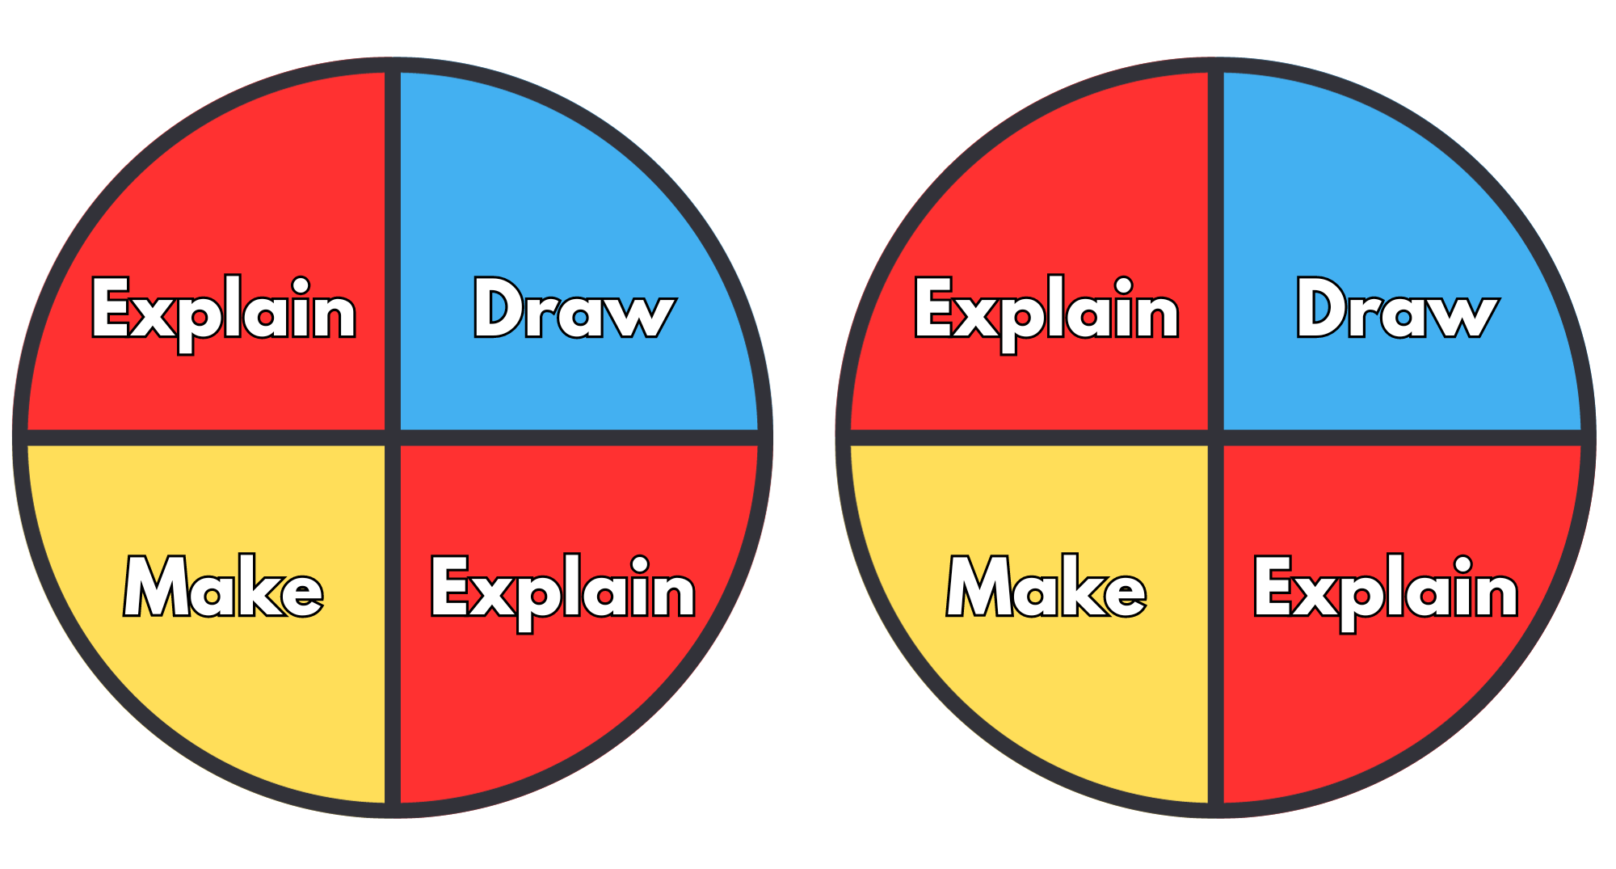

Resource 22 – show us how 1
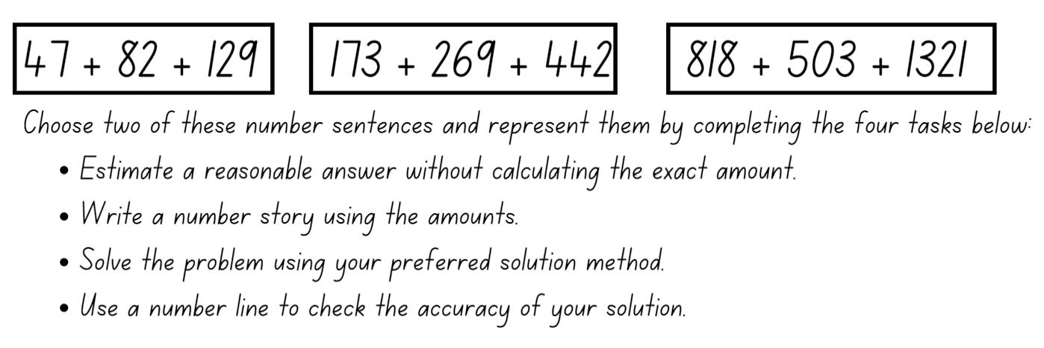

Resource 23 – show us how 2
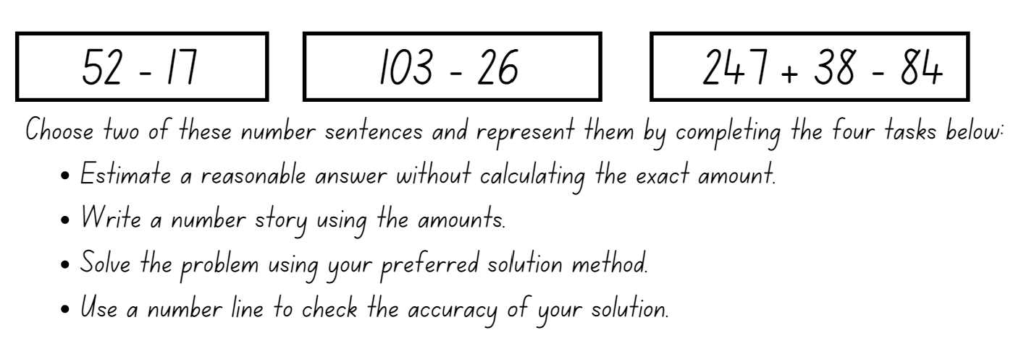

Syllabus outcomes and content

Stage 2
The table below outlines the syllabus outcomes and range of relevant syllabus content covered in this unit. Content is linked to National Numeracy Learning Progression version (3).
Outcomes and content | 1 | 2 | 3 | 4 | 5 | 6 | 7 | 8
Representing numbers using place value A: Whole numbers: Read, represent and order numbers to thousands
MAO-WM-01, MA2-RN-01
- Represent numbers up to and including thousands using physical or virtual manipulatives, words, numerals, diagrams and digital displays | x
- Read and order numbers of up to at least 4 digits | x
Representing numbers using place value A: Whole numbers: Apply place value to partition and regroup numbers up to 4 digits
MAO-WM-01, MA2-RN-01
- Record numbers using standard place value form | x |  |  |  |  | x | x
- Partition numbers of up to 4 digits in non-standard forms (Reasons about quantity) |  |  |  |  |  |  | x
Representing numbers using place value B: Whole numbers: Order numbers in the thousands
MAO-WM-01, MA2-RN-01
- Arrange numbers in the thousands in ascending and descending order | x
- Identify the nearest thousand, 10 thousand or 100 thousand to numbers | x
Representing numbers using place value B: Whole numbers: Apply place value to partition, regroup and rename numbers up to 6 digits
MAO-WM-01, MA2-RN-01
- Name thousands using the place value grouping of ones, tens and hundreds of thousands | x | x |  |  |  | x | x
- Partition numbers of up to 6 digits in non-standard forms |  | x
Representing numbers using place value B: Whole numbers: Recognise and represent numbers that are 10, 100 or 1000 times as large
MAO-WM-01, MA2-RN-01
- Recognise the number of tens, hundreds or thousands in a number | x |  |  |  |  | x | x
Representing numbers using place value B: Decimals: Extend the application of the place value system from whole numbers to tenths and hundredths
MAO-WM-01, MA2-RN-01, MA2-RN-02
- Use the decimal point as a marker to identify the position of the ones digit when expressing tenths as decimals |  |  | x | x | x
- Recognise that 10-tenths is recorded as 1.0 and regroup when using decimal notation |  |  | x | x | x
- Represent and compare tenths as decimals using linear representations (Reasons about relations) |  |  | x | x | x
- Subdivide tenths into 10 equal parts and record hundredths using place value |  |  |  | x
- Express decimals as both tenths and hundredths |  |  |  | x
- Locate and order decimals representing tenths and hundredths on a number line, describing their relative size |  | x |  | x
- Interpret zero digits at the end of a decimal |  |  |  | x
- Distinguish between the role of zero in various positions |  |  |  | x
Representing numbers using place value B: Decimals: Make connections between fractions and decimal notation
MAO-WM-01, MA2-RN-01, MA2-RN-02
- Record equivalent measurements using decimals |  |  |  |  | x
- Compare and order decimals of up to 2 decimal places | x | x | x
- Make connections between fractions and decimal notation for key benchmark values (Reasons about relations) |  |  |  |  | x
Additive relations A: Use the principle of equality
MAO-WM-01, MA2-AR-01
- Recognise equal differences and record them in number sentences |  |  |  |  |  | x | x
- Use the equals sign to mean 'the same as', rather than to perform an operation |  |  |  |  |  | x | x
Additive relations A: Select strategies flexibly to solve addition and subtraction problems of up to 3 digits
MAO-WM-01, MA2-AR-01
- Apply known mental strategies that use partitioning to add and subtract, such as bridging the decades |  |  |  |  |  | x | x | x
- Represent solutions to addition and subtraction problems, including word problems, using an empty number line or bar model |  |  |  |  |  |  |  | x
- Compare and evaluate strategies used to solve addition and subtraction problems, reasoning which strategy may be most efficient |  |  |  |  | x |  | x | x
Additive relations B: Partition, rearrange and regroup numbers to at least 1000 to solve additive problems
MAO-WM-01, MA2-AR-01
- Use quantity values and non-standard partitioning to solve addition and subtraction problems |  |  |  |  |  | x | x | x
- Model addition with and without regrouping and record the method used |  |  |  |  |  | x
- Model subtraction with and without regrouping and record the method used |  |  |  |  |  |  | x
Mathematics K–10 Syllabus © NSW Education Standards Authority (NESA) for and on behalf of the Crown in right of the State of New South Wales, 2022.

Stage 3
The table below outlines the syllabus outcomes and range of relevant syllabus content covered in this unit. Content is linked to National Numeracy Learning Progression version (3).
Outcomes and content | 1 | 2 | 3 | 4 | 5 | 6 | 7 | 8
Represents numbers A: Whole numbers: Recognise, represent and order numbers in the millions
MAO-WM-01, MA3-RN-01, MA3-RN-02
- Name millions using the place value grouping of ones, tens and hundreds | x
- Arrange numbers in the millions in ascending and descending order using place value | x
- Round numbers to a specified place value | x
Represents numbers A: Whole numbers: Apply place value to partition, regroup and rename numbers to 1 billion
MAO-WM-01, MA3-RN-01, MA3-RN-02
- Recognise 1000 thousands is 1 million and 1000 millions is 1 billion |  | x
- Partition numbers to 1 billion in non-standard forms |  | x
Represents numbers A: Decimals and percentages: Recognise that the place value system can be extended beyond hundredths
MAO-WM-01, MA3-RN-02
- Express thousandths as decimals |  |  | x | x | x
- Interpret decimal notation for thousandths |  |  | x | x | x
- Indicate the place value of digits in decimal numbers of up to 3 decimal places |  |  | x
- Use place value to partition decimals |  |  | x
Represents numbers A: Decimals and percentages: Compare, order and represent decimals
MAO-WM-01, MA3-RN-02
- Compare and order decimal numbers of up to 3 decimal places | x | x | x | x | x
- Interpret zero digit(s) at the end of a decimal |  |  |  | x | x
- Place decimal numbers of up to 3 decimal places on a number line |  | x | x
Additive relations A: Apply efficient mental and written strategies to solve addition and subtraction problems
MAO-WM-01, MA3-AR-01
- Solve word problems, including multistep problems |  |  |  |  |  | x | x
- Apply known strategies such as levelling, addition for subtraction, using constant difference, and bridging (Reasons about relations) |  |  |  |  |  |  | x | x
- Use place value to add or subtract 3 or more numbers with different numbers of digits |  |  |  |  |  | x | x | x
- Identify efficient and inefficient multidigit subtraction strategies |  |  |  |  |  | x |  | x
Additive relations A: Use estimation and place value understanding to determine the reasonableness of solutions
MAO-WM-01, MA3-AR-01
- Round numbers appropriately when obtaining estimates to numerical calculations |  |  |  |  |  |  |  | x
- Use estimation to check the reasonableness of solutions to addition and subtraction calculations |  |  |  |  |  |  |  | x
Additive relations B: Choose and use efficient strategies to solve addition and subtraction problems
MAO-WM-01, MA3-AR-01
- Solve multistep word problems, including problems that require more than one operation |  |  |  |  |  | x
- Compare, evaluate and communicate strategies used to solve addition and subtraction problems |  |  |  |  | x |  | x | x
Additive relations B: Applies known strategies to add and subtract decimals
MAO-WM-01, MA3-AR-01
- Model the addition and subtraction of decimals up to 3 decimal places using appropriate representations |  |  |  |  |  | x | x
- Solve word problems involving the addition and subtraction of decimals up to 3 decimal places |  |  |  |  |  | x | x
- Justify why the strategy used to solve addition and subtraction word problems is appropriate (Reasons about quantity) |  |  |  |  |  |  | x
Mathematics K–10 Syllabus © NSW Education Standards Authority (NESA) for and on behalf of the Crown in right of the State of New South Wales, 2022.

References
This resource contains NSW Curriculum and syllabus content. The NSW Curriculum is developed by the NSW Education Standards Authority. This content is prepared by NESA for and on behalf of the Crown in right of the State of New South Wales. The material is protected by Crown copyright.
Please refer to the NESA Copyright Disclaimer for more information https://educationstandards.nsw.edu.au/wps/portal/nesa/mini-footer/copyright.
NESA holds the only official and up-to-date versions of the NSW Curriculum and syllabus documents. Please visit the NSW Education Standards Authority (NESA) website https://educationstandards.nsw.edu.au/ and the NSW Curriculum website https://curriculum.nsw.edu.au/home.
Mathematics K–10 Syllabus © NSW Education Standards Authority (NESA) for and on behalf of the Crown in right of the State of New South Wales, 2022.
National Numeracy Learning Progression © Australian Curriculum, Assessment and Reporting Authority (ACARA) 2010 to present, unless otherwise indicated. This material was downloaded from the Australian Curriculum website (National Numeracy Learning Progression) (accessed 6 October 2023) and was not modified.
Finkel D (2020) ‘Target Number’, Free Lessons, Math for Love website, accessed 27 September 2023.
Frykholm J (2010) Learning to Think Mathematically with the Number Line [PDF 1102 KB], The Math Learning Center, accessed 3 June 2023.
State of New South Wales (Department of Education) (2023a) Flexible additive strategies – Decimals, NSW Department of Education website, accessed 8 September 2023.
State of New South Wales (Department of Education) (2023b) Which one doesn’t belong Stage 3, DET Mathematics K-6 Resources website, accessed 27 September 2023.
Sullivan P (2018) Decimals, Challenging mathematical tasks: Unlocking the potential of all students, Oxford University Press, Australia.
The Mathematical Association of Victoria (2020a) 3–6: Remote Maths – Edition 2 [PDF 417 KB], MAV Learning Activities website, accessed 27 June 2023.
The Mathematical Association of Victoria (2020b) 3–6: Remote Maths – Edition 8 [PDF 542 KB], MAV Learning Activities website, accessed 27 June 2023.
Thompson D, Battista M, Mayberry S, Yeatts K and Zawojewski J (2009) Navigating through Problem Solving and Reasoning in Grade 6, The National Council of Teachers of Mathematics.

Further reading
Siemon D, Warren E, Beswick K, Faragher R, Miller J, Horne M, Jazby D, Breed M, Clark J and Brady K (2022) Teaching Mathematics: Foundations to Middle Years, 3rd edn, Oxford University Press, Australia.
© State of New South Wales (Department of Education), 2023
The copyright material published in this resource is subject to the Copyright Act 1968 (Cth) and is owned by the NSW Department of Education or, where indicated, by a party other than the NSW Department of Education (third-party material).
Copyright material available in this resource and owned by the NSW Department of Education is licensed under a Creative Commons Attribution 4.0 International (CC BY 4.0) license.
This license allows you to share and adapt the material for any purpose, even commercially.
Attribution should be given to © State of New South Wales (Department of Education), 2023.
Material in this resource not available under a Creative Commons license:
- the NSW Department of Education logo, other logos and trademark-protected material
- material owned by a third party that has been reproduced with permission. You will need to obtain permission from the third party to reuse its material.
Links to third-party material and websites
Please note that the provided (reading/viewing material/list/links/texts) are a suggestion only and implies no endorsement, by the New South Wales Department of Education, of any author, publisher, or book title. School principals and teachers are best placed to assess the suitability of resources that would complement the curriculum and reflect the needs and interests of their students.
If you use the links provided in this document to access a third-party's website, you acknowledge that the terms of use, including licence terms set out on the third-party's website apply to the use which may be made of the materials on that third-party website or where permitted by the Copyright Act 1968 (Cth). The department accepts no responsibility for content on third-party websites.

