Mathematics 3-6 multi-age – Year A – Unit 5
Contents
Unit description and duration 5
Syllabus outcomes 5
Working mathematically 6
Student prior learning 7
Lesson overview and resources 8
Lesson 1 15
Daily number sense: Place value mystery – 10 minutes 15
Core lesson 1: Data in action – 15 minutes 17
Core lesson 2: School sport survey – 40 minutes 20
Discuss and connect the mathematics – 5 minutes 23
Lesson 2 24
Daily number sense: Hit it – 10 minutes 24
Core lesson 1: Reaction time – 30 minutes 26
Core lesson 2: Converting to seconds – 15 minutes 29
Consolidation and meaningful practice – 15 minutes 30
Lesson 3 33
Daily number sense: Mystery number – 10 minutes 33
Core lesson 1: Choosing appropriate displays – 20 minutes 35
Core lesson 2: Many-to-one scale – 30 minutes 38
Discuss and connect the mathematics – 10 minutes 39
Lesson 4 42
Daily number sense – 10 minutes 42
Core lesson 1: Our growing population – 20 minutes 42
Core lesson 2: Spreadsheets – 30 minutes 44
Discuss and connect the mathematics – 10 minutes 45
Lesson 5 47
Daily number sense: Number puzzles – 15 minutes 47
Core lesson 1: Creating timelines and tables – 25 minutes 49
Core lesson 2: Interpreting timelines and tables – 20 minutes 52
Discuss and connect the mathematics – 10 minutes 54
Lesson 6 55
Daily number sense: Destination 100 – 15 minutes 55
Core lesson 1: Air temperature – 15 minutes 57
Core lesson 2: Australia’s extreme temperatures – 30 minutes 59
Consolidation and meaningful practice – 10 minutes 61
Lesson 7 65
Daily number sense: Destination 1000 – 15 minutes 65
Core lesson 1: Distribution – 25 minutes 67
Core lesson 2: Data interpretation – 20 minutes 69
Consolidation and meaningful practice – 10 minutes 70
Lesson 8 72
Daily number sense – 10 minutes 72
Core lesson – 40 minutes 74
Discuss and connect the mathematics – 15 minutes 77
Resource 1: Data 79
Resource 2: Data cycle 80
Resource 3: Survey question checklist 81
Resource 4: Reaction time charts 82
Resource 5: Line graph example 83
Resource 6: Data investigation 84
Resource 7: Slow reveal table 86
Resource 8: Population data and checklist 87
Resource 9: Australia’s population 88
Resource 10: Number puzzles 89
Resource 11: Example timeline 90
Resource 12: Fun day options 91
Resource 13: Australian gold rush 92
Resource 14: Australian temperatures 93
Resource 15: Extreme temperatures 94
Resource 16: Temperature tables 95
Resource 17: Unlabelled graphs 96
Resource 18: Table of data 97
Resource 19: Threatened species 98
Resource 20: Solar system distances 99
Resource 21: Team birth years 101
Resource 22: Melting ice 102
Resource 23: Misleading graphs 103
Syllabus outcomes and content 104
Stage 2 104
Stage 3 109
References 113
Further reading 116

Unit description and duration
This unit introduces the big idea that questions can be asked and answered by interpreting data.
In this 2-week unit students are provided opportunities to:
- collect and organise categorical and discrete numerical data through observations or surveys
- represent and interpret data, with and without the use of digital technologies
- recognise, represent, order, and partition numbers within different ranges.
This multi-age unit is informed by the lessons in Stage 2 Year A Unit 5 and Stage 3 Year A Unit 5. Please refer to these units for additional lesson guidance.

Syllabus outcomes
- MAO-WM-01 develops understanding and fluency in mathematics through exploring and connecting mathematical concepts, choosing and applying mathematical techniques to solve problems, and communicating their thinking and reasoning coherently and clearly

Stage 2
- MA2-RN-01 applies an understanding of place value and the role of zero to represent numbers to at least tens of thousands
- MA2-RN-02 represents and compares decimals up to 2 decimal places using place value
- MA2-AR-01 selects and uses mental and written strategies for addition and subtraction involving 2- and 3-digit numbers
- MA2-MR-01 represents and uses the structure of multiplicative relations to 10 × 10 to solve problems
- MA2-DATA-01 collects discrete data and constructs graphs using a given scale
- MA2-DATA-02 interprets data in tables, dot plots and column graphs

Stage 3
- MA3-RN-01 applies an understanding of place value and the role of zero to represent the properties of numbers
- MA3-RN-02 compares and orders decimals up to 3 decimal places
- MR3-MR-01 selects and applies appropriate strategies to solve multiplication and division problems
- MA3-DATA-01 constructs graphs using many-to-one scales
- MA3-DATA-02 interprets data displays, including timelines and line graphs

Working mathematically
In the Mathematics K–10 Syllabus, there is one overarching Working mathematically outcome (MAO-WM-01). The Working mathematically processes should be embedded within the concepts being taught. The Working mathematically processes present in the Mathematics K–10 Syllabus are:
- communicating
- understanding and fluency
- reasoning
- problem solving.
Mathematics K–10 Syllabus © NSW Education Standards Authority (NESA) for and on behalf of the Crown in right of the State of New South Wales, 2022.

Student prior learning
Before engaging in these teaching and learning activities, students would benefit from prior experience with:
- posing questions and organising collected data systematically
- representing and interpreting data using lists, tables, dot plots and column graphs
- forming, regrouping, and renaming numbers within different ranges.
In NSW classrooms there is a diverse range of students, including Aboriginal and Torres Strait Islander students, students learning English as an additional language or dialect, high potential and gifted students and students with disability. Some students may identify with more than one of these groups or possibly all of them. Refer to Curriculum planning for every student – advice for further information.

Lesson overview and resources
To cover the content of the syllabus across Stage 2 and Stage 3, some core lessons in the unit contain both a Stage 2 and a Stage 3 task. Teachers are encouraged to adapt and contextualise the units to meet the needs of their students.
The table below outlines the sequence and approximate timing of lessons, learning intentions and resources.
Lesson | Content | Duration and resources
Lesson 1  Daily number sense  Stage 2:  - Representing numbers using place value B: Whole numbers: Apply place value to partition, regroup and rename numbers up to 6 digits  Stage 3:  - Represents numbers A: Whole numbers: Recognise and represent numbers in the millions | Lesson core concept: data is all around and it is more than a combination of numbers and graphics.  Stage 2:  - Data A: Collect discrete data  - Data B: Select and trial methods for data collection  Stage 3:  - Data A: Collect categorical and discrete numerical data by survey | Lesson duration: 70 minutes  - Resource 1: Data  - Resource 2: Data cycle  - Resource 3: Survey question checklist  - Digital devices (recommended)  - Writing materials
Lesson 2  Daily number sense  Stage 2:  - Representing numbers using place value A: Whole numbers: Apply place value to partition and regroup numbers up to 4 digits  Stage 3:  - Represents numbers A: Whole numbers: Recognise, represent and order numbers in the millions | Lesson core concept: mathematicians collect and record data.  Stage 2:  - Data A: Collect discrete data  - Representing numbers using place value B: Decimals: Extend the application of the place value system from whole numbers to tenths and hundredths  Stage 3:  - Data A: Collect categorical and discrete numerical data by observation or survey  - Represents numbers A: Decimals and percentages: Compare, order and represent decimals | Lesson duration: 70 minutes  - Resource 2: Data cycle  - Resource 4: Reaction time charts  - 0–9 dice  - Rulers  - Writing materials
Lesson 3  Daily number sense  Stage 2:  - Representing numbers using place value A: Whole numbers: Apply place value to partition numbers up to 4 digits  Stage 3:  - Represents number A: Whole numbers: Recognise, represent and order numbers in the millions | Lesson core concept: mathematicians organise and present data in different ways.  Stage 2:  - Data A: Organise and display data using tables and graphs  - Data A: Interpret and compare data  - Data B: Construct and interpret data displays with many-to-one scales  Stage 3:  - Data A: Choose and use appropriate tables and graphs | Lesson duration: 70 minutes  - Resource 2: Data cycle  - Resource 5: Line graph example  - Resource 6: Data investigation  - Grid paper  - Reaction time results from Lesson 2  - Writing materials
Lesson 4  Daily number sense  - teacher-identified task based on student needs | Lesson core concept: data is represented in different ways for different purposes.  Stage 2:  - Representing numbers using place value A: Whole numbers: Read, represent and order numbers to thousands  - Data B: Construct and interpret data displays with many-to-one scales  Stage 3:  - Represents number A: Whole numbers: Recognise, represent and order numbers in the millions  - Data A: Choose and use appropriate tables and graphs  - Data B: Interpret and compare a range of data displays | Lesson duration: 70 minutes  - Resource 2: Data cycle  - Resource 7: Slow reveal table  - Resource 8: Population data and checklist  - Resource 9: Australia’s population
Lesson 5  Daily number sense  Stage 2:  - Multiplicative relations A: Generate and describe patterns  Stage 3:  - Multiplicative relations B: Represent and describe number patterns formed by multiples | Lesson core concept: data can be displayed in different ways, and it can help conceptualise events in history.  Stage 2:  - Data A: Organise and display data using tables and graphs  - Data B: Construct and interpret data displays with many-to-one scales  Stage 3:  - Data A: Choose and use appropriate tables and graphs  - Data B: Interpret and compare a range of data displays | Lesson duration: 70 minutes  - Resource 2: Data cycle  - Resource 10: Number puzzles  - Resource 11: Example timeline  - Resource 12: Fun day options  - Resource 13: Australian gold rush  - Individual whiteboards  - Rulers  - Writing materials
Lesson 6  Daily number sense  Stage 2:  - Additive relations A: Select strategies flexibly to solve addition and subtraction problems of up to 3 digits  Stage 3:  - Multiplicative relations A: Use partitioning and place value to multiply 2-, 3- and 4-digit numbers by one-digit numbers | Lesson core concept: data, represented in many ways for different purposes, can be interpreted to help make decisions.  Stage 2:  - Data A: Organise and display data using tables and graphs  - Data A: Interpret and compare data  Stage 3:  - Represents numbers B: Whole numbers: Locate and represent integers on a number line  - Data B: Interpret data presented in digital media and elsewhere | Lesson duration: 70 minutes  - Resource 2: Data cycle  - Resource 14: Australian temperatures  - Resource 15: Extreme temperatures  - Resource 16: Temperature tables  - 0–9 dice or spinners  - Writing materials
Lesson 7  Daily number sense  Stage 2:  - Additive relations A: Select strategies flexibly to solve addition and subtraction problems of up to 3 digits  Stage 3:  - Multiplicative relations A: Use partitioning and place value to multiply 2-, 3- and 4-digit numbers by one-digit numbers | Lesson core concept: interpreting data helps to solve problems and ask new questions.  Stage 2:  - Representing number using place value A: Whole numbers: Read, represent and order numbers to thousands  - Data A: Organise and display data using tables and graphs  - Data A: Interpret and compare data  Stage 3:  - Represents numbers A: Whole numbers: Recognise, represent and order numbers in the millions  - Data B: Interpret and compare a range of data displays | Lesson duration: 70 minutes  - Resource 2: Data cycle  - Resource 17: Unlabelled graphs  - Resource 18: Table of data  - Resource 19: Threatened species  - Resource 20: Solar system distances  - 0–9 dice or spinner  - Individual whiteboards  - Writing materials
Lesson 8  Daily number sense  - teacher-identified task based on student needs | Lesson core concept: statistical reasoning helps mathematicians interpret and infer information.  Stage 2:  - Representing numbers using place value A: Whole numbers: Read, represent and order numbers to thousands  - Data A: Interpret and compare data  Stage 3:  - Data B: Interpret data presented in digital media and elsewhere | Lesson duration: 65 minutes  - Resource 2: Data cycle  - Resource 21: Team birth years  - Resource 22: Melting ice  - Resource 23: Misleading graphs  - Digital devices to access Excel (if available)  - Student workbooks

Lesson 1
Core concept: data is all around and it is more than a combination of numbers and graphics.

Daily number sense: Place value mystery – 10 minutes
Daily number sense activities for Lessons 1 to 3 ‘activate’ prior number knowledge and support the learning of new content in the unit. These activities can also assist teachers to identify the starting points for learning by revealing the extent of students’ existing knowledge.
The table below contains suggested learning intentions and success criteria. These are best co-constructed with students.
Daily number sense learning intentions | Daily number sense success criteria
Students working towards Stage 2 outcomes are learning to:  - apply place value to partition, regroup and rename numbers up to 6 digits.  Students working towards Stage 3 outcomes are learning to:  - recognise and represent numbers in the millions. | Students working towards Stage 2 outcomes can:  - name thousands using the place value grouping of ones, tens and hundreds of thousands.  Students working towards Stage 3 outcomes can:  - name millions using the place value grouping of ones, tens and hundreds.
This activity is an adaptation from Open-ended Maths Activities: Using ‘Good’ Questions to Enhance Learning in Mathematics, Revised edn by Sullivan and Lilburn.
- Tell students you are thinking of a number. Explain that the:
- number is larger than 10 000
- first 3 digits add to a number greater than 5
- tens of thousands digit is smaller than 4
- thousands digit is even
- hundreds digit is larger than the unit’s digit
- tens digit is larger than the hundreds digit and is odd
- number is a multiple of 5.
- Ask students what they think the number could be and to record their answer.
- Students share their answer with a partner and justify their thinking. Allow time for students to refine their answers.
- As a class, discuss student thinking. Ask questions, such as:
- What is your answer?
- Can you explain why your answer could be correct?
- Is your answer bigger or smaller than your partner’s?
- Can you think of another possible answer?
- Can you think of an incorrect answer and explain why it is incorrect?
- Can you record the number using standard and non-standard place value form?
- In stage pairs, ask students to create their own place value mystery number and create a set of clues.
- Students play the game with their partner.
Multi-age: Stage 2 students recognise, represent and order numbers to at least tens of thousands, while Stage 3 students engage with numbers in the millions.
This table details opportunities for assessment.
Assessment opportunities | Links
What to look for:  - Can Stage 2 students name thousands using the place value grouping of ones, tens and hundreds of thousands? [MAO-WM-01, MA2-RN-01]  - Can Stage 3 students name millions using the place value grouping of ones, tens and hundreds? [MAO-WM-01, MA3-RN-01] | Links to National Numeracy Learning Progressions (NNLP):  - Stage 2 – NPV7  - Stage 3 – NPV7.

Core lesson 1: Data in action – 15 minutes
The table below contains suggested learning intentions and success criteria. These are best co-constructed with students.
Core concept learning intentions | Core concept success criteria
Students working towards Stage 2 outcomes are learning to:  - collect discrete data  - select and trial methods for data collection.  Students working towards Stage 3 outcomes are learning to:  - collect categorical and discrete numerical data by survey. | Students working towards Stage 2 outcomes can:  - pose questions about a matter of interest to obtain information that can be recorded in categories  - create a survey and related recording sheet, considering the appropriate organisation of categories for data collection.  Students working towards Stage 3 outcomes can:  - pose and refine questions to construct a survey to obtain categorical or discrete numerical data about a matter of interest.
- Display the word ‘data.’ Ask students:
- What do you think is meant by the word ‘data’?
- Where have you heard the term used?
- What words do you think go with the topic of data?
Data: facts or units of information collected together.
- Display Resource 1: Data. Ask students if each image is an example of data. Guide discussion to highlight that data comes in many forms. For example, numbers, symbols, pictures or text, with numbers often being the most frequent.
- Explain that the term ‘data’ refers to information that has been collected. Support understanding by providing relevant examples, such as the Aussie Bird Count and WildCount.
- Ask students to brainstorm other everyday places in which data can be found. If needed, prompt students with examples.
- Ask students how some of their examples of data might be useful or interesting. Responses might include:
- weather data to decide what clothes to wear or activities to undertake
- food nutrition data to decide what foods to eat
- voting data to determine who the school leaders will be
- school energy or water use audit data to see where saving practices could be used.
Note: a graphic organiser, such as a fishbone diagram, may be used to display the class’ information.
- Display the website Focus on Participation by Age (AusPlay). For:
- Stage 2 students, display, explore and discuss slide 5 (Comparing age groups – Top 10 activities).
- Stage 3 students, display slide 8 (Sports or physical activities played at different ages). Press play on the interactive. Students may require the interactive to be played multiple times.
- Students Think-Pair-Share, focussing on how the data may have been collected, why the data could be useful and who could use the data.

Core lesson 2: School sport survey – 40 minutes
- Display Resource 2: Data cycle. Read and discuss each component of the data cycle.
- Explain that students will collect data about school sport through a survey.
- As a class, brainstorm broad ideas about school sport and refine them to develop a statistical question for the class. For example, the question could explore what sports are the most or least popular (Stage 2) or whether your school meets the sporting needs of all students (Stage 3).
Note: statistical questions are those mathematicians ask of the data. Survey questions are asked to collect data. Data collected through surveys allows mathematicians to answer statistical questions.
- Display Resource 3: Survey question checklist. Explain that the checklist should be used when writing quality survey questions.
- Provide small groups of students with the checklist and writing materials.
- On paper, groups of students compose 3 quality survey questions to help answer the class’ statistical question, decide the response format for each question and predict what the responses will be.
- Survey questions may include:
- Do you enjoy sport?
- What do you enjoy about sport?
- Which sport(s) do you play at school?
- Is there a sport that you want to learn how to play?
- What is your favourite sport to play at school?
- Do you play sport outside of school?
- Do you prefer team or individual sports?
- Do you think the school has enough sports equipment?
- What equipment would you like to see purchased for the school?
- Do you think the school has enough areas for students to play sport?
- Each group shares their questions with another group. Students give feedback to each other using Resource 3: Survey question checklist and refine their survey questions based on feedback received.
- Discuss and decide if you will conduct a paper survey or a digital survey.
- If using a digital survey, play video Gathering data with Microsoft Forms (4:10) (T4L Kids TV) or Gathering data with Google Forms (4:30) (T4L Kids TV).
- In Microsoft Forms or Google Forms, demonstrate the different response formats, for example, multiple choice, short answer, Likert scale or rating. Students to consider these when writing their questions.
- Provide students with a digital device to access either Microsoft Forms or Google Forms through the Student Portal.
- Groups transfer their survey questions into either Microsoft Forms or Google Forms and have each student in the class complete their survey.
- Groups view their survey data and determine if their predictions were correct.
- Display the class statistical question(s). Students reflect on their data and use thumbs up (yes), thumbs sideways (unsure) or thumbs down (no) to answer the question.
- Choose individual students to justify their answer using their survey questions and data to support their response.
This table details opportunities for differentiation.
Too hard? | Too easy?
Students cannot pose questions to construct a survey.  - Provide students a bank of questions to choose from.  - Brainstorm questions as a class using the process examples in Figure 1. | Students can pose questions to construct a survey.  - Create a second survey with questions about a different activity.  - Students administer their survey across multiple classes in the school and present a summary of the data.
Figure 1 – Example of statistical questions
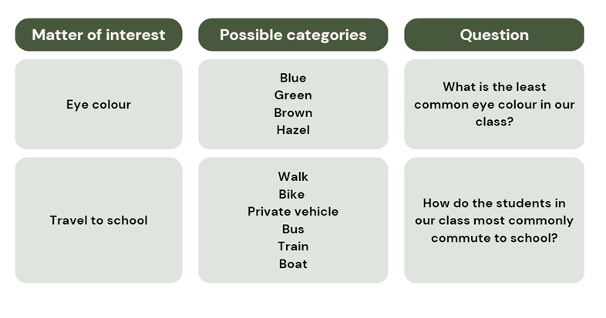

Discuss and connect the mathematics – 5 minutes
- Students reflect on the process of posing and refining questions and collecting data by conducting a survey. Choose students to share their experiences with the class, both positive and negative and what they might do differently next time.
- Explain that in future lessons, students will look at the remaining steps in the data cycle by representing and interpreting data.
This table details opportunities for assessment.
Assessment opportunities | Links
What to look for:  - Can Stage 2 students pose questions to obtain information that can be recorded in categories? [MAO-WM-01, MA2-DATA-01]  - Can Stage 2 students create a survey and related recording sheet, considering the appropriate organisation of categories for data collection? [MAO-WM-01, MA2-DATA-01]  - Can Stage 3 students pose and refine questions to construct a survey to obtain categorical or discrete numerical data about a matter of interest? [MAO-WM-01, MA3-DATA-01] | Links to National Numeracy Learning Progressions (NNLP):  - Stage 2 – IRD2, IRD3  - Stage 3 – IRD3, IRD4, IRD5.

Lesson 2
Core concept: mathematicians collect and record data.

Daily number sense: Hit it – 10 minutes
The table below contains suggested learning intentions and success criteria. These are best co-constructed with students.
Daily number sense learning intentions | Daily number sense success criteria
Students working towards Stage 2 outcomes are learning to:  - apply place value to partition and regroup numbers up to 4 digits.  Students working towards Stage 3 outcomes are learning to:  - recognise, represent and order numbers in the millions. | Students working towards Stage 2 outcomes can:  - record numbers using standard place value form.  Students working towards Stage 3 outcomes can:  - name millions using the place value grouping of ones, tens and hundreds.
This activity is an adaptation of ‘Hit it (3-digit numbers)’ from Mathematics K-6 resources by State of New South Wales (Department of Education).
- In pairs, students choose a target number.
- Each student draws their own gameboard with space for a number, see Figure 2.
Figure 2 – Hit it example
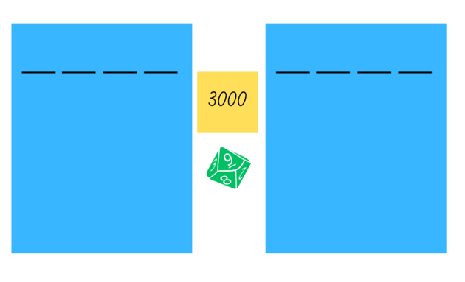
- Students take turns to roll the 0–9 die and record the digit in the thousands, hundreds, tens or ones position. The aim is to get the closest number to the target number.
- Once both players’ boards are full, each student reads their number and determines how far they are away from the target number. They can be over or under the target number.
- The player who is closest to the target number wins a point.
- Students can choose to keep or change their target number between each round.
- The student with the most points after 3 rounds is declared the winner.
- As students play, ask questions such as:
- What number did you roll?
- What would be the best position for that number?
- What might happen if you placed it in a different position?
- What number would you like to roll next?
- How could you make the game easier or harder?
Multi-age: Stage 2 students recognise, represent and order numbers to at least tens of thousands, while Stage 3 students engage with numbers to the millions.
This table details opportunities for assessment.
Assessment opportunities | Links
What to look for:  - Can Stage 2 students record numbers using standard place value form? [MAO-WM-01, MA2-RN-01]  - Can Stage 3 students name millions using the place value grouping of ones, tens and hundreds? [MAO-WM-01, MA3-RN-01] | Links to National Numeracy Learning Progressions (NNLP):  - Stage 2 – NPV4, NPV5, NPV6  - Stage 3 – NPV7.

Core lesson 1: Reaction time – 30 minutes
The table below contains suggested learning intentions and success criteria. These are best co-constructed with students.
Core concept learning intentions | Core concept success criteria
All students are learning to:  - collect categorical and discrete numerical data by observation  - compare, order and represent decimals. | All students can:  - collect data from observation and record it in a table  - compare and order decimal numbers of up to 3 decimal places.
This activity is an adaptation of ‘Reaction time test’ at Mathematics K-6 resources by State of New South Wales (Department of Education).
- Display Resource 2: Data cycle and highlight that this activity involves collecting data and representing it in a table.
- Display online Reaction Timer (NRICH).
- Demonstrate how to click on the screen to make the star disappear and then click again as soon as the star reappears. Explain that the interaction will calculate students’ reaction time.
- Students to take turns predicting and testing their reaction time.
- As a class, discuss that reaction time is the time between a stimulus and a response.
- Brainstorm and record events in students’ lives where reaction time is important. Examples could include starting a race, playing tennis or computer games, saving a penalty in a shootout.
- Discuss what the term ‘best’ reaction time means. Ensure students understand that the fastest reaction time is best.
- Brainstorm and record student wonders about what may impact people’s reactions times, including gender, age, height, time of day, left hand or right hand, or amount of training or practice.
- Students predict what kind of person would have the quickest reaction time and explain their reasoning. For example, different occupations or interests including musicians, gamers and sports people.
- Explain that another way to test reaction time is by using a ruler.
- Demonstrate how to do the activity:
- In pairs, one student holds the ruler at shoulder height. The zero mark on the ruler is at the bottom.
- The other student places their fingers and thumb at the bottom of the ruler, not touching but ready to catch the ruler (see Figure 3).
- At an unannounced time, the first student drops the ruler.
- The reacting student catches it between their fingers and thumb and reads the distance below their thumb (see Figure 3).
- Each student conducts the test 5 times and records the results in a table. Students add a third column to their table to record corresponding reaction times in Core lesson 2 (see Figure 3).
Figure 3 – Reaction time test
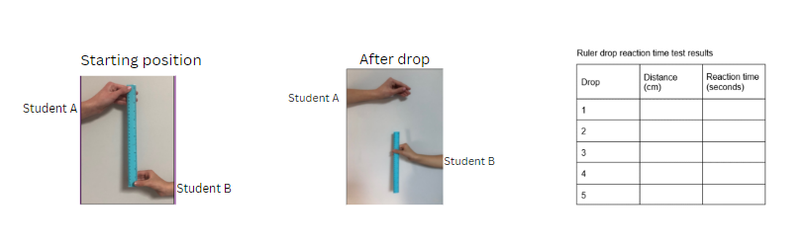
Note: students do not need to time their reaction times. They use the Resource 4: Reaction time charts to match their ruler distances to the corresponding reaction time in seconds. Matching takes place in the second half of the lesson.

Core lesson 2: Converting to seconds – 15 minutes
- Display Resource 4: Reaction time charts and discuss decimal numbers.
Note: to support place value conceptual understanding, 0.132 would be read as one-hundred and thirty-two thousandths. In this context, the time can be read as 132 milliseconds. Students working towards Stage 2 outcomes can read the time 0.13 as 13 hundredths of a second.
- Draw attention to the different place value limits in the charts: Chart A (Hundredths of a second) and Chart B (Milliseconds). Discuss the differences and ask questions, such as:
- What does the 4 in 0.143 represent?
- Why is 0.45 not recorded to 3 decimal places?
- What is the role of the zeros in 0.09?
- Do the numbers get bigger or smaller as the reaction distance increases? Why?
- How do you determine the largest number?
- Which number is larger, 0.12 or 0.128? How do you know?
- Why do some distances in Chart A have the same time, for example, 12 cm and 13 cm? The times are rounded to hundredths of a second.
- Where else in the Chart A have time times been rounded?
- Students record their reaction times from Resource 4: Reaction time charts in a table, such as Figure 4.
Figure 4 – Test results table
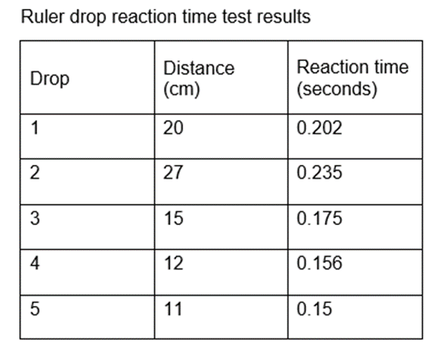

Consolidation and meaningful practice – 15 minutes
- Students order their reaction times from fastest to slowest.
- Model placing decimal numbers up to 3 decimal places on a number line.
Note: make 10 cm long, break up and label into tenths.
- Discuss where zero and one would be placed on their number line.
- Students place their reaction times on a number line.
- Students share their number lines and explain their reasoning behind the spacing between the decimal numbers.
Multi-age: students in Stage 2 work with up to 2 decimal places. Stage 3 students work with numbers up to 3 decimal places.
This table details opportunities for differentiation.
Too hard? | Too easy?
Students cannot order reaction times and position them on a number line.  - Students order reaction time using measurement in whole centimetres.  - Provide a structured number line with intervals for tenths of a second marked. | Students can order reaction times on a number line.  - Students complete the reaction test again and add the additional times to their number line.  - Students use an online reaction time test and compare results with the ruler drop test, justifying their findings.  - Students use the distractor feature of the online reaction time test. Students analyse test results with and without distractors, justifying their findings.
This table details opportunities for assessment.
Assessment opportunities | Links
What to look for:  - Can students collect data from observation and record it in a table? [MAO-WM-01, MA2-DATA-01, MA3-DATA-01]  - Can students compare and order decimal numbers of up to 3 decimal places? [MAO-WM-01, MA2-RN-02, MA3-RN-02] | Links to National Numeracy Learning Progressions (NNLP):  - Stage 2 – IRD3  - Stage 3 – NPV8.  Links to suggested Interview for Student Reasoning (IfSR) tasks:  - Stage 3 – IfSR-PT: 1A5, 1A7.

Lesson 3
Core concept: mathematicians organise and present data in different ways.

Daily number sense: Mystery number – 10 minutes
The table below contains suggested learning intentions and success criteria. These are best co-constructed with students.
Daily number sense learning intentions | Daily number sense success criteria
Students working towards Stage 2 outcomes are learning to:  - apply place value to partition numbers up to 4 digits.  Students working towards Stage 3 outcomes are learning to:  - recognise, represent and order numbers in the millions. | Students working towards Stage 2 outcomes can:  - record numbers using standard place value form.  Students working towards Stage 3 outcomes can:  - name millions using the place value grouping of ones, tens and hundreds.
- Explain that the students will try to identify a mystery 3- or 4-digit number by asking questions that require a ‘yes’ or ‘no’ answer.
- Ask students to provide examples of suitable questions, such as:
- Is the number an even number?
- Is the number a 4-digit number?
- Is the number larger than 500?
- Does the number have less than 7 hundreds?
- Select a 3- or 4-digit number and select students to ask questions.
- Assist students to keep track of possible answers and eliminated numbers by asking questions as students play, such as:
- Could the answer be 458? Why or why not?
- Could the answer have a 4 in the ones place? Why or why not?
- Could the answer have more than 25 tens? Why or why not?
- When the mystery number has been guessed, students record the number using standard place value form. For example, 523 = 500 + 20 + 3 or 5 hundreds, 2 tens and 3 ones.
- Discuss, asking questions such as:
- Which questions were the most useful? Why?
- Can you think of any additional questions that would have been useful to ask?
- How could you make the game easier or harder?
- Repeat twice in pairs, allowing students to alternate between creating and guessing a mystery number.
Multi-age: Stage 2 students recognise, represent and order numbers to at least tens of thousands, while Stage 3 students engage with numbers to the millions.
This table details opportunities for assessment.
Assessment opportunities | Links
What to look for:  - Can Stage 2 students record numbers using standard place value form? [MAO-WM-01, MA2-RN-01]  - Can Stage 3 students name millions using the place value grouping of ones, tens and hundreds? [MAO-WM-01 MA3-RN-01] | Links to National Numeracy Learning Progressions (NNLP):  - Stage 2 – NPV4, NPV5, NPV6.  - Stage 3 – NPV7.

Core lesson 1: Choosing appropriate displays – 20 minutes
The table below contains suggested learning intentions and success criteria. These are best co-constructed with students.
Core concept learning intentions | Core concept success criteria
All students are learning to:  - construct and interpret data displays with many-to-one scales.  Students working towards Stage 2 outcomes are learning to:  - organise and display data using tables and graphs  - interpret and compare data.  Students working towards Stage 3 outcomes are learning to:  - choose and use appropriate tables and graphs. | All students can:  - create a table to organise data  - construct a many-to-one scale column graph.  Students working towards Stage 2 outcomes can:  - describe and interpret information presented in tally tables and column graphs.  Students working towards Stage 3 outcomes can:  - recognise which types of data display are appropriate to represent data.
This activity is an adaptation of ‘Discussing Data’ at NZ Maths by the New Zealand Ministry of Education.
Note: numerical data values are represented as numbers and come from counting or measurement. Counts are discrete (for example, children per family), while measurements are continuous (for example, temperature change over time). Column graphs depict discrete data, and line graphs show continuous data with meaning between points. Stage 2 students work with discrete data, while Stage 3 students use both discrete and continuous data.
- Display Resource 2: Data cycle. Explain that this lesson involves representing data.
- As a class, discuss the best way to display different types of data, including:
- Picture graphs and dot plots – used to show a small number of data values, with one-to-one correspondence.
- Column graphs – used to display categorical or discrete numerical data.
- Line graphs – used to display continuous data.
- Display Resource 5: Line graph example. Ask the class:
- What do you notice and wonder?
- How is a line graph similar and different to a column graph?
- Why is this data represented in a line graph?
Multiage: Stage 2 students deepen understanding of the representation of discrete data on column and dot plot graphs, the line graph can be viewed as a non-example.
- Distribute a copy of Resource 6: Data investigation to each student.
- In pairs, students examine each dataset and determine which representation is most appropriate.
- Select pairs to share and justify their answers. For example, the line graph is the most appropriate choice in dataset C because it is continuous data. Ask other students if they agree or disagree and why.
This table details opportunities for differentiation.
Too hard? | Too easy?
Students cannot recognise which type of data display is appropriate to represent data.  - Using example A from Resource 6: Data investigation students colour code the matching data for each category. Students decide whether the graph or the table is easiest to read and justify their opinion.  - Students rule columns around the images in Example A. Ask students to explain the link between a picture graph and a column graph. | Students can recognise which type of data display is appropriate to represent data.  - Students create their own set of representations to add to the resource.  - Students swap their representations and determine which display is most appropriate to represent the data and why.

Core lesson 2: Many-to-one scale – 30 minutes
Note: a scale of many-to-one correspondence in a column graph or line graph means that one unit is used to represent more than one of what is being counted or measured. For example, one interval on the vertical axis could be used to represent 20 cm of body height.
- Display Resource 2: Data cycle and highlight that this activity involves representing data.
- Asks students to identify their shortest ruler drop distance from Lesson 2.
- In small groups, students record each group member’s shortest ruler drop distance in a table in their workbooks, see Figure 5.
Figure 5 – Table to graph
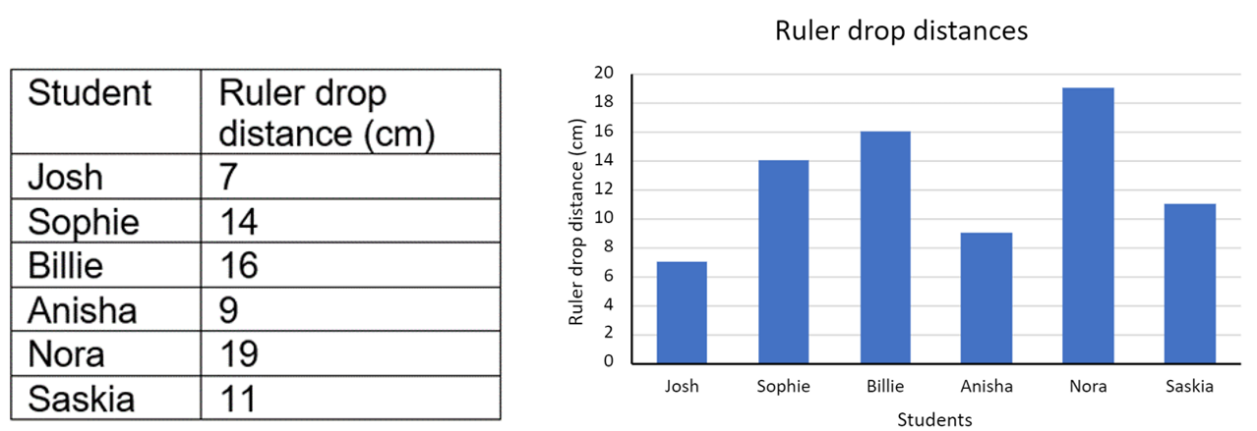
- Explain that a many-to-one scale means that one unit is used to represent more than one of what is being counted or measured and discuss why many-to-one scales are used.
- Brainstorm features that need to be included on a many-to-one scale column graph, such as title, axes names and label and scale.
- As a class, use the ‘Ruler drop distance’ column to determine an appropriate scale to be used to graph the ruler drop data, for example, 1 cm = 2 cm ruler drop distance.
- Using grid paper, students create a column graph for their group’s data, see Figure 5 above.
Too hard? | Too easy?
Students cannot create a many-to-one scale column graph.  - Students construct column graphs with scale intervals of one-for-one, using software where appropriate or using concrete materials (such as centicubes to represent each centimetre).  - Students create the graph on a paper template with a pre-recorded scale on the y-axis. | Students can create a many-to-one scale column graph.  - Students use the same data to make a horizontal column graph.  - Students develop 5 questions about their graph and swap with another group to answer them.

Discuss and connect the mathematics – 10 minutes
- Group and record the whole class’ shortest ruler drop distances in a table on the board.
- Use the data in the table to create a column graph, see Figure 6.
Figure 6 – Class ruler drop table and graph
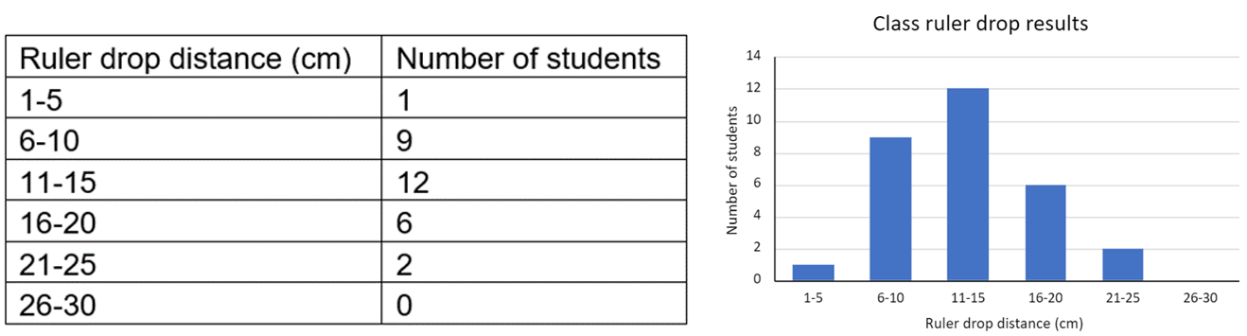
- Discuss the similarities and differences between the 2 graphs created in the lesson.
This table details opportunities for assessment.
Assessment opportunities | Links
What to look for:  - Can students create a table to organise data? [MAO-WM-01, MA2-DATA-01, MA3-DATA-01]  - Can students construct a many-to-one scale column graph? [MAO-WM-01, MA2-DATA-01, MA3-DATA-01]  - Can Stage 2 students describe and interpret information presented in tally tables and column graphs? [MAO-WM-01, MA2-DATA-02]  - Can Stage 3 students recognise which types of data display are appropriate to represent data? [MAO-WM-01, MA3-DATA-01] | Links to National Numeracy Learning Progressions (NNLP):  - Stage 2 – IRD3  - Stage 3 – IRD3.

Lesson 4
Core concept: data is represented in different ways for different purposes.

Daily number sense – 10 minutes
- From a class need surfaced through formative assessment data, identify a short, focused activity that targets students’ knowledge, understanding and skills. Example activities may be drawn from the following resources:
- Mathematics K-6 resources
- Universal Resources Hub.

Core lesson 1: Our growing population – 20 minutes
The table below contains suggested learning intentions and success criteria. These are best co-constructed with students.
Core concept learning intentions | Core concept success criteria
Students working towards Stage 2 outcomes are learning to:  - read, represent and order numbers to thousands  - construct and interpret data displays with many-to-one scales.  Students working towards Stage 3 outcomes are learning to:  - recognise, represent and order numbers in the millions  - choose and use appropriate tables and graphs  - interpret and compare a range of data displays. | Students working towards Stage 2 outcomes can:  - read and order numbers of up to at least 4 digits  - use a given many-to-one scale to represent discrete data in column graphs  - interpret and compare data.  Students working towards Stage 3 outcomes can:  - name millions using the place value grouping of ones, tens and hundreds  - construct column graphs using a many-to-one scale, with the use of digital technologies  - interpret side-by-side column graphs for 2 categorical variables.
- Display Resource 2: Data cycle. Explain that in this lesson, students will be representing data.
- Display Image 1 from Resource 7: Slow reveal table. Ask students to read the numbers aloud, find the largest and smallest numbers and predict what the data represents.
- Reveal Image 2 and then 3. Ask students:
- What new information has been added?
- Has it changed your previous prediction? How?
- Do we have enough information to know what data is being represented?
- Discuss the reasons for collecting population data by asking:
- Who collects this data? (Australian Bureau of Statistics)
- How do they collect the data? (Census every 5 years)
- How could this data be used? (Planning cities and services like schools, hospitals and housing)
- Students list the 2021 population in ascending or descending order.
Multi-age: for Stage 3 students, to work with larger numbers, display and read population data for capital cities of Australia from a reliable source such as the Australian Bureau of Statistics.
This table details opportunities for differentiation.
Too hard? | Too easy?
Students cannot read, represent and order numbers.  - Round each number to the nearest thousand and students order the numbers.  - Select pairs of cities. Students determine which city is larger. | Students can read, represent and order numbers.  - Students round each number to the nearest thousand.  - Students predict each city’s population in 2041 and justify their predictions based on past growth.

Core lesson 2: Spreadsheets – 30 minutes
- Display Resource 8: Population data and checklist to each student. Students select which dataset they are going to work with.
- On individual whiteboards, students order the population of 5 or 6 cities or countries in descending order.
- Using the document Using digital tools to create graphical displays [DOCX 490KB], demonstrate in Microsoft Excel or Google Sheets how to create a many-to-one column graph.
- Distribute Resource 8: Population data and checklist to each student. In pairs, students use the checklist to enter the population data for 5 or 6 places from their chosen dataset and create a graph.
- Ask students:
- What is the scale on your y-axis?
- Why is a scale of one not used for this dataset?
- Why is a line graph not appropriate for this data? (Stage 3)

Discuss and connect the mathematics – 10 minutes
- Display Resource 9: Australia’s population and ask students:
- What do you notice? What do you wonder?
- What data is being displayed?
- How is this graph different to column graphs you have created and interpreted previously?
- What are some advantages and disadvantages of the side-by-side column graph?
- What statements can we make about the population in 1981?
- What statements can you make about the population in 2022?
- What statements can you make about the population changes between 1981 to 2022?
This table details opportunities for assessment.
Assessment opportunities | Links
What to look for:  - Can all students use a given many-to-one scale to represent discrete data in column graphs? [MAO-WM-01, MA2-DATA-01, MA3-DATA-01]  - Can Stage 2 students read and order numbers up to at least 4 digits? [MAO-WM-01, MA2-RN-01]  - Can Stage 3 students name and order numbers in the millions? [MAO-WM-01, MA3-RN-01]  - Can Stage 3 students interpret side-by-side column graphs for 2 categorical variables? [MAO-WM-01, MA3-DATA-02] | Links to National Numeracy Learning Progressions (NNLP):  - Stage 2 – IRD3, NPV5, NPV6  - Stage 3 – IRD3, NPV6, NPV7.  Links to suggested Interview for Student Reasoning (IfSR) tasks:  - Stage 2 – IfSR-NP: 4C.5, 4C.6.

Lesson 5
Core concept: data can be displayed in different ways, and it can help conceptualise events in history.

Daily number sense: Number puzzles – 15 minutes
Daily number sense activities for Lessons 5 to 7 ‘loop’ back to concepts and procedures covered in previous units to assist students to build an increasingly connected network of ideas. These concepts may differ from the core concepts being covered by the unit.
The table below contains suggested learning intentions and success criteria. These are best co-constructed with students.
Daily number sense learning intentions | Daily number sense success criteria
Stage 2 students are learning to:  - generate and describe patterns.  Stage 3 students are learning to:  - represent and describe number patterns formed by multiples. | Stage 2 students can:  - model, describe and record patterns on a number chart.  Stage 3 students can:  - use a given geometric pattern involving multiples to create a table of values.
Note: for Stage 2 students, this activity is an adaptation of ‘Patterns in the hundred chart’ from Mindset Mathematics: Visualising and Investigating Big Ideas, Grade 1 by Boaler et. Al, and revisits content covered in Stage 2 – Unit 1. Stage 3 students are encouraged to explore the patterns in each table of values. Students may need number charts displayed or Resource 10: Number puzzles printed for support.
- Display Resource 10: Number puzzles. Using an individual whiteboard, students draw and fill in the missing numbers, focusing on any patterns they know or find.
- As students are solving each puzzle, ask:
- How did you figure out the missing numbers? How do you know they are correct?
- How does knowing the position of numbers help you fill in the missing numbers?
- What patterns did you find and/or use?
- Select students to share and justify their working.
This table details opportunities for assessment.
Assessment opportunities | Links
What to look for:  - Can Stage 2 students model, describe and record patterns on a number chart? [MAO-WM-01, MA2-MR-01]  - Can Stage 3 students use a given geometric pattern involving multiples to create a table of values? [MAO-WM-01, MA3-MR-01] | Links to National Numeracy Learning Progressions (NNLP):  - Stage 2 – NPA4  - Stage 3 – NPA5.

Core lesson 1: Creating timelines and tables – 25 minutes
The table below contains suggested learning intentions and success criteria. These are best co-constructed with students.
Core concept learning intentions | Core concept success criteria
Students working towards Stage 2 outcomes are learning to:  - organise and display data using tables and graphs  - construct and interpret data displays with many-to-one scales.  Students working towards Stage 3 outcomes are learning to:  - choose and use appropriate tables and graphs  - interpret and compare a range of data displays. | Students working towards Stage 2 outcomes can:  - create a list or table to organise the data  - use a given many-to-one scale to represent discrete data in column graphs.  Students working towards Stage 3 outcomes can:  - draw an accurate timeline using an appropriate scale  - interpret data on a timeline using the given scale.
- Display Resource 2: Data cycle. Explain that this lesson involves representing data. Stage 2 students will use a table. Stage 3 students will use a timeline.
- Display Resource 11: Example timeline. Explain that a timeline is a representation of events listed in chronological order. Ask:
- What do you notice?
- What information is being represented?
- What does the scale mean?
- What would you need to know to create a timeline of your own life?
- What other data could be represented in a timeline?
- Explain that students will create a scaled timeline of their own life.
Multi age: timelines are included in Stage 3 outcomes and content. Stage 2 students will use their personal data to create a table in chronological order by years.
- Brainstorm and record life events that students may place on their personal timeline or table, see Figure 7.
Figure 7 – Student samples
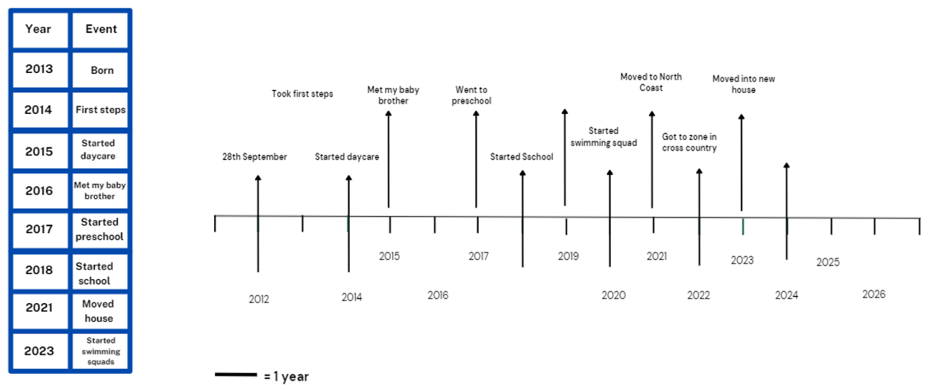
- Explain that on a scaled timeline, events are placed according to the actual time distance between events. Although not all the events occur at equal time intervals, the length of the intervals are proportional to the passage of time.
- Discuss an appropriate many-to-one scale for the students’ personal timeline, for example, 2 cm for every one year of their life.
Many-to-one scale: a scale of many-to-one uses one unit or interval to represent more than one item or response, such as one centimetre representing 5 items or responses.
- Distribute rulers for students to draw a scaled timeline or table of their own life, adding at least 5 major events.
- Students turn and talk to check their partners timeline and discuss:
- What is similar and different about your timelines or tables? Why?
- How are timelines and tables helpful in organising information?
This table details opportunities for differentiation.
Too hard? | Too easy?
Stage 2 students cannot create a list or table to organise the data.  - Provide a pre-made table with placeholders for information. Students can fill the missing blanks with relevant data.  - Provide picture cards representing events or data points. Students can arrange then in table.  Stage 3 students cannot create a timeline with an appropriate scale.  - Give students a timeline with year internals already marked.  - Students add fewer major events to their timeline. | Stage 2 students can create a list or table to organise the data.  - Students use the data to create a scaled timeline.  - Students create a checklist of elements that their table should include.  Stage 3 students can create a timeline with an appropriate scale.  - Students add more events to their timeline, using a decimal scale to represent half years or quarter years.  - Students create a timeline for a famous person’s life.

Core lesson 2: Interpreting timelines and tables – 20 minutes
Note: to ensure the scale is correct, print Resource 13: Australian gold rush on A4 paper and do not resize.
- Provide Stage 2 students with Resource 12: Fun day options and Stage 3 students with Resource 13: Australian gold rush. Ask:
- What do you notice? What type of data is being displayed? How is it being displayed?
- What information is missing from the graph? (Stage 2)
- How does the scale impact the visual representation? (Stage 2)
- How does this table compare to other representations or displays? (Stage 2)
- Is the scale the same as the one on your personal timeline? (Stage 3)
- How do you determine when each event occurred without each event being dated? (Stage 3)
- Ask Stage 2 students to complete a many-to-one column graph for the activities using the scale one interval for 2 students.
- Ask Stage 3 students use a ruler and the scale (2 cm = 10 years) to mark out ten-year increments along the timeline. Ask:
- How would you determine 5 years on the timeline? (1 cm)
- How would you determine 20 years on the timeline? (4 cm)
- Is 2 cm for 10 years an appropriate scale? Why?
- Stage 3 students calculate and record the missing dates of events on the timeline using the given scale. Answers include:
- J McBrien finds first gold in Australia in 1823.
- California gold rush was in 1849.
- Eureka Stockade was in 1854.
- Influx of Chinese miners to Australia in 1870.
- Gold first discovered in Western Australia in 1885.
- Gold discovered in Kalgoorlie in 1893.

Discuss and connect the mathematics – 10 minutes
- Students compare the timelines and tables from the lesson. Ask students:
- How are they similar or different?
- What impacts the scale used in each timeline and table?
- What did you find challenging when interpreting a table or a timeline with a scale?
This table details opportunities for assessment.
Assessment opportunities | Links
What to look for:  - Can Stage 2 students create a list or table to organise the data? [MAO-WM-01, MA2-DATA-01]  - Can Stage 2 students use a given many-to-one scale to represent discrete data in column graphs? [MAO-WM-01, MA2-DATA-01]  - Can Stage 3 students draw an accurate timeline using an appropriate scale? [MAO-WM-01, MA3-DATA-01]  - Can Stage 3 students interpret data on a timeline using the given scale? [MAO-WM-01, MA3-DATA-02] | Links to National Numeracy Learning Progressions (NNLP):  - Stage 2 – IRD2, IRD3  - Stage 3 – IRD4, MeT6.

Lesson 6
Core concept: data, represented in many ways for different purposes, can be interpreted to help make decisions.

Daily number sense: Destination 100 – 15 minutes
The table below contains suggested learning intentions and success criteria. These are best co-constructed with students.
Daily number sense learning intentions | Daily number sense success criteria
Students are learning to:  - select strategies flexibly to solve addition and subtraction problems of up to 3 digits  - use partitioning and place value to multiply 2-, 3- and 4-digit numbers by one-digit numbers. | Students can:  - apply known mental strategies that use partitioning to add and subtract  - use mental strategies to multiply one-digit numbers by 10.
This activity is an adaptation of ‘101 and you're out (2-digit-addition)’ from Mathematics K-6 resources by State of New South Wales (Department of Education).
- In pairs, students make a gameboard by drawing a table with 4 columns and 7 rows. Label the columns from left to right as ‘tens’, ‘ones, ‘number’ and ‘total,’ see Figure 8.
Figure 8 – Destination 100 example
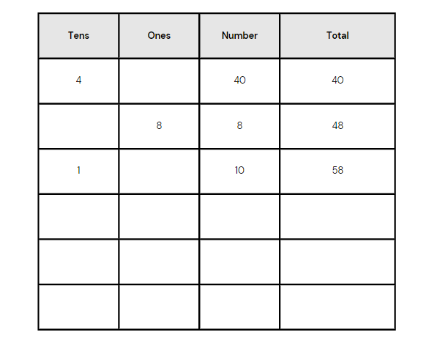
- Using a 0-9 die or spinner, players take turns to roll or spin.
- After every roll, each player decides whether to write the number in the tens or ones column. For example, if a 4 is rolled, players can either write it in the tens column to indicate 40 or in the ones column to indicate 4.
- The game concludes after 6 rolls or spins. The winner is the player whose sum is closest to 100 without going over.
This table details opportunities for assessment.
Assessment opportunities | Links
What to look for:  - Can Stage 2 students apply known mental strategies that use partitioning to add and subtract? [MAO-WM1-01, MA2-AR-01]  - Can Stage 3 students use mental strategies to multiply one-digit numbers by 10? [MAO1-WM-01, MA3-MR-01] | Links to National Numeracy Learning Progressions (NNLP):  - Stage 2 – AdS7, MuS6, MuS7  - Stage 3 – AdS7, MuS6, MuS7.

Core lesson 1: Air temperature – 15 minutes
The table below contains suggested learning intentions and success criteria. These are best co-constructed with students.
Core concept learning intentions | Core concept success criteria
Students working towards Stage 2 outcomes are learning to:  - interpret and compare data  - organise and display data using tables and graphs.  Students working towards Stage 3 outcomes are learning to:  - locate and represent integers on a number line  - interpret data presented in digital media and elsewhere. | Students working towards Stage 2 outcomes can:  - describe and interpret information presented in tally tables and column graphs  - mark equal spaces (intervals) on axes, name and label axes and choose appropriate titles for column graphs.  Students working towards Stage 3 outcomes can:  - recognise the location of negative whole numbers in relation to zero and place them on a number line  - interpret data representations found in digital media and in factual texts.
- Display Resource 2: Data cycle. Explain that lesson involves representing data.
- Display Eyes on the Earth, Air temperature.
Note: below the date, toggle the units to display degrees celsius.
Multi-age: students working towards Stage 2 outcomes can view data on Australian Weather Calendar (bom.gov.au).
- Click on various locations around the globe to show the air temperature.
- Move between the daytime 3-day average and night 3-day average from the drop-down menu on the right-hand side of the screen and ask students:
- What do you notice and wonder?
- Where do you see temperature data in your everyday life?
- Who might collect data about temperature? Why?
- Who might use temperature data? How and why?
- How else could this data be represented?
- Can temperature be measured below zero degrees Celsius? How is this represented? (Stage 3)

Core lesson 2: Australia’s extreme temperatures – 30 minutes
- Provide pairs of Stage 2 students Resource 14: Australian temperatures and Stage 3 students with Resource 15: Extreme temperatures.
- Select students to name each type of data display or representation.
Multi-age: revise or model Venn diagrams. Decide on whether a 2- or 3-part Venn diagram is suitable for your students.
- Students draw a Venn diagram to record similarities and differences between the displays. Students may also record conclusions that can be drawn from the data in each display, see Figure 9.
Figure 9 – Example Venn diagrams
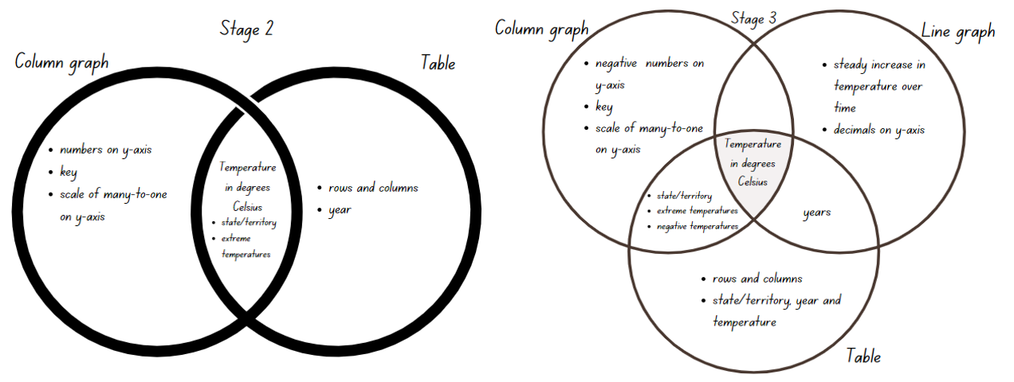
- As a class, students share their answers and add to their Venn diagram if needed.
- In pairs, students write 2 questions related to each of the displays.
- Students swap questions with another pair and use the resource to answer the questions.
- Students share their most challenging question with the class.
- Discuss the data displays as a class, asking questions such as:
- What is the data telling us?
- Can you see any patterns or trends?
- Who collected this data?
- Which data representation is easiest to interpret? Why?
- Which data representation provides the most information? Explain why.
This table details opportunities for differentiation.
Too hard? | Too easy?
Students cannot interpret and compare different data displays.  - Compare only 2 displays using a Venn diagram.  - Identify the key components of each data display, such as axes, labels, title, and data points. | Students can interpret and compare different data displays.  - Students use technology (Excel) to display data of interest and explain the purpose of each type of representation.  - Predict the average annual temperature over the next 10 years and continue the line graph.  - Predict which state or territory will next break its record for the lowest or highest temperature and why.

Consolidation and meaningful practice – 10 minutes
- Provide students with Resource 16: Temperature tables. Read and discuss the datasets.
- Explain that the temperatures in the resource have been rounded to the nearest whole number.
- Explain to Stage 3 students that integers are whole numbers. Ask them to represent the temperatures from Dataset B on a number line using a ruler. Ensure students understand the number line must be proportional and that negative numbers are placed to the left of zero.
- Ask Stage 2 students to use temperature data from Dataset A for each year to create a column graph for years and temperatures. Discuss what, if anything, needs to be done with the information about the state/territory.
- Once complete, ask students:
- What do the x-axis and y-axis represent? Explain why those units were chosen. (Stage 2)
- How does the graph help your understanding of the data compared to just looking at the raw numbers? (Stage 2)
- What improvements could you suggest for your graph? (Stage 2)
- What do you notice about the positive numbers and their relation to zero? (Stage 3)
- How is it used to represent numerical values? (Stage 3)
- What do you notice about the negative numbers and their relation to zero? (Stage 3)
- Which do you find more difficult to place on a number line? Why? (Stage 3)
This table details opportunities for differentiation.
Too hard? | Too easy?
Stage 2 students cannot mark equal spaces (intervals) on axes, name and label axes and choose appropriate titles for column graph.  - Provide students with sample displays and discuss key components.  Stage 3 students cannot record negative integers on a number line.  - Provide a structured number line with marked intervals of 10 from -30 to 50.  - Students record only the positive integers on the number line. | Stage 2 students can mark equal spaces (intervals) on axes, name and label axes and choose appropriate titles for column graph.  - Students select 2 data tables from the BOM website and ask then to create graphs that compare datasets.  Stage 3 students can record negative integers on a number line.  - Use the number line to calculate the difference between the positive and negative temperature for each state.  - Order the states from highest temperature to lowest temperature.
This table details opportunities for assessment.
Assessment opportunities | Links
What to look for:  - Can Stage 2 describe and interpret information presented in tally tables and column graphs? [MAO-WM-01, MA2-DATA-01]  - Can Stage 2 students mark equal spaces (intervals) on axes, name and label axes and choose appropriate titles for column graphs? [MAO-WM-01, MA2-DATA-01]  - Can Stage 3 students interpret data representations found in digital media and in factual texts? [MAO-WM-01, MA3-DATA-02]  - Can Stage 3 students recognise the location of negative whole numbers in relation to zero and place them on a number line? [MAO-WM-01, MA3-RN-01] | Links to National Numeracy Learning Progressions (NNLP):  - Stage 2 – IRD3  - Stage 3 – IRD4, IRD5, NPV9.

Lesson 7
Core concept: interpreting data helps to solve problems and ask new questions.

Daily number sense: Destination 1000 – 15 minutes
The table below contains suggested learning intentions and success criteria. These are best co-constructed with students.
Daily number sense learning intentions | Daily number sense success criteria
Students are learning to:  - select strategies flexibly to solve addition and subtraction problems  - use partitioning and place value to multiply 2-, 3- and 4-digit numbers by one-digit numbers. | Students can:  - apply known mental strategies that use partitioning to add and subtract  - use mental strategies to multiply one-digit numbers by 10, 100, 100 and their multiples.
- In pairs, students make a game board by drawing a table with 4 columns and 7 rows. Label the columns from left to right as ‘hundreds’, ‘tens’, hundreds, ‘number’ and ‘total’, see Figure 10.
Figure 10 – Destination 1000 example
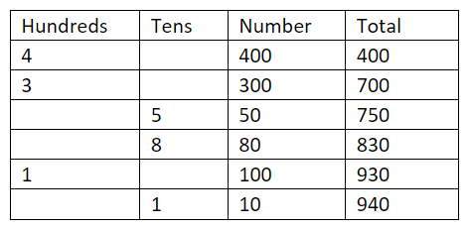
- Using a 0–9 die or spinner, players take turns to roll or spin.
- After every roll, each player decides whether to write the number in the hundreds or tens column, see Figure 10 above.
- The game concludes after 6 rolls or spins. The winner is the player whose sum is closest to 1000 without going over.
Multi-age: to challenge students working beyond mental addition of 3-digit numbers or multiplication by 1000, extend the target to 10 000 or higher. Adjust the columns, dice or spinner and number of turns as needed to challenge students.
This table details opportunities for assessment.
Assessment opportunities | Links
What to look for:  - Can Stage 2 students apply known mental strategies that use partitioning to add and subtract? [MAO-WM1-01, MA2-AR-01]  - Can Stage 3 students use mental strategies to multiply one-digit numbers by 10, 100, 1000 and their multiples? [MAO1-WM-01, MA3-MR-01]? | Links to National Numeracy Learning Progressions (NNLP):  - Stage 2 – AdS7, MuS6, MuS7  - Stage 3 – AdS7, MuS6, MuS7.

Core lesson 1: Distribution – 25 minutes
The table below contains suggested learning intentions and success criteria. These are best co-constructed with students.
Core concept learning intentions | Core concept success criteria
Students working towards Stage 2 outcomes are learning to:  - read, represent and order numbers to thousands  - organise and display data using tables and graphs  - interpret and compare data.  Students working towards Stage 3 outcomes are learning to:  - recognise, represent and order numbers in the millions  - interpret and compare a range of data displays. | Students working towards Stage 2 outcomes can:  - read and order numbers of up to at least 4 digits  - construct column graphs (with scale intervals of one) and dot plots using relevant software where appropriate  - investigate how data is interpreted to make decisions.  Students working towards Stage 3 outcomes can:  - arrange numbers in the millions in ascending and descending order using place value  - round numbers to a specified place value  - interpret and compare different displays in terms of the shape of the distribution, including the range and the most frequent value (mode).
This activity is an adaptation of ‘Data: Making Decisions’ at reSolve: Maths by Inquiry by Australian Government Department of Education.
Note: Stage 3 students are expected to find the range and mode of a dataset. The range is the measure of the spread within a numerical dataset and can be calculated by subtracting the smallest value from the largest. The mode is the most frequently occurring value in a set of data. There can be more than one mode.
- Display Resource 2: Data cycle. Explain that this activity involves representing and interpreting data.
- Provide pairs of students with Resource 17: Unlabelled graphs.
- Ask students to predict what type of data is represented and to describe the shape of the line. Draw students’ attention to the fact it is a line graph is representing continuous data. Explain that each value is recorded as a dot so that the frequencies of each of the values can be counted easily.
Note: students need to look beyond the plotted points and understand what the line is representing. Encourage students to discuss the nature and movement of the line before considering information on the x- and y-axes (Diezmann et al. 2009).
- Brainstorm and record the missing elements of the graph including title, axes names and labels, values and scale.
- Ask students what data the graph might be representing. Answers may include temperature or rainfall over time, plant growth, population data, school attendance rates.
- Distribute Resource 18: Table of data to students. Students transfer the data provided to complete the unlabelled graphs.
- Explain to Stage 3 students that the mode is the value that occurs most frequently in a dataset and the difference between the lowest value and the highest value is called the range. Students find the mode and range using the table or graph.

Core lesson 2: Data interpretation – 20 minutes
- Provide Stage 2 students Resource 19: Threatened species and Stage 3 students Resource 20: Solar system distances.
- As a class discuss what data is being displayed.
- Students work in pairs to answer the questions on their resource sheet.
This table details opportunities for differentiation.
Too hard? | Too easy?
Students cannot interpret data in a graph.  - Students answer questions about one category of data.  - Provide dataset about a fewer number of planets. | Students can interpret data in a side-by-side column graph.  - Students calculate distance between each planet.  - Students identify the planets which are closer to the Earth than they are to the Sun.

Consolidation and meaningful practice – 10 minutes
- Ask students to use the values provided in Resource 19: Threatened species and Resource 20: Solar system distances.
- Students record answers to the following prompts on individual whiteboards.
- Students select 5 values from their data display.
- Stage 2 students round the numbers to the nearest thousand and place them in descending order.
- Stage 3 students round each number to the nearest million and find the range and mode for the dataset, rounded to the nearest million.
- Ask the class how the strategy of rounding can be useful and helpful when interpreting data displays.
This table details opportunities for assessment.
Assessment opportunities | Links
What to look for:  - Can Stage 2 students read and order numbers of up to at least 4 digits? [MAO-WM-01, MA2-RN-01]  - Can Stage 2 students investigate how data is interpreted to make decisions? [MAO-WM-01, MA2-DATA-02]  - Can Stage 3 arrange numbers in the millions in ascending and descending order using place value? [MAO-WM-01, MA3-RN-01]  - Can Stage 3 students interpret and compare different displays in terms of the shape of the distribution, including the range and the most frequent value (mode)? [MAO-WM-01, MA3-DATA-02] | Links to National Numeracy Learning Progressions (NNLP):  - Stage 2 – NPV5, NPV6, IRD3  - Stage 3 – NPV6, NPV7, IRD5.

Lesson 8
Core concept: statistical reasoning helps mathematicians interpret and infer information.

Daily number sense – 10 minutes
- From a class need surfaced through formative assessment data, identify a short, focused activity that targets students’ knowledge, understanding and skills. Example activities may be drawn from the following resources:
- Mathematics K-6 resources
- Universal Resources Hub.
The table below contains suggested learning intentions and success criteria. These are best co-constructed with students.
Core concept learning intentions | Core concept success criteria
Students working towards Stage 2 outcomes are learning to:  - interpret and compare data  - read, represent and order numbers to thousands.  Students working towards Stage 3 outcomes are learning to:  - interpret data presented in digital media and elsewhere. | Students working towards Stage 2 outcomes can:  - describe and interpret information presented in tally tables and column graphs  - represent the same dataset using more than one type of display and compare the displays  - compare and describe the size of numbers by positioning them on a number line.  Students working towards Stage 3 outcomes can:  - identify sources of possible bias in representations of data in the media (Statistical reasoning)  - identify misleading representations of data in the media.
- In this lesson, Stage 2 and 3 students engage in separate content to investigate and interpret various data displays.
- Display Resource 2: Data cycle. Explain that students are representing and interpreting data.
- Explain that both Stage 2 and Stage 3 students will engage in in statistical reasoning. Share the definition and discuss the vocabulary used.
Statistical reasoning: identifying patterns across datasets and making inferences from the data.
- Stage 3 students will also investigate bias in data representations. Share the definition and discuss the definition.
Bias: a systematic favouring of certain outcomes more than others, due to unfair influence (knowingly or otherwise).

Core lesson – 40 minutes

Stage 2 task: Team birth years
- Display Resource 21: Team birth years. Explain that it shows the birth years of players from a professional sport team.
- Divide the class into small groups. Each group displays the data 3 ways by creating a tally table, dot plot and column graph.
- Allow students time to plan and make data displays, using technology if available.
- As a Stage 2 group, compare the data displays and discuss, asking questions such as:
- Which data display was the easiest or most challenging to create? Why?
- Which data display is the easiest to interpret? Why?
- What is the same about the data displays and what is different?
- What is the highest or lowest value? What is the difference between them?
- What is the most common value?
- Do you think that a different team would have similar results? Why or why not?

Stage 3 task: Melting ice
This activity is an adaptation of ‘Data Distortion’ at NZ Maths by the New Zealand Ministry of Education and Melting Arctic Ice [PDF 330KB] at youcubed by the University of Stanford.
- As a Stage 3 group, brainstorm examples of data representations found in the media and factual texts.
- Explain that representations in the media can often be biased and sometimes misleading. Refer to the definitions.
- As a class, discuss and record elements of effective and misleading data representations in the media. Responses could include:
Effective data representations in the media | Misleading data representations in the media
- accurately represent the whole dataset  - grab the reader’s attention  - make text more interesting  - show trends or changes  - are easy to read  - have a title and labels  - uses colour or patterns to show differences. | - use incorrect displays for the data type  - manipulate the axes or scale  - use uneven intervals on the axes  - leave out relevant data  - have axes not starting at zero  - have missing units or axes labels  - exaggerate or minimise differences between numerical values.
- Brainstorm various influences on data collection and representation in the media, such as who funded the data collection, who created the representation (and why), and whether the representation is part of an advertisement.
- Display Resource 22: Melting ice. Ask questions, such as:
- What do you notice about the graph?
- Who do you think created the graph? Why was it created?
- Can you see a trend in the data? What could be causing it?
- Is the graph misleading? Provide reasons why or why not.
Note: the y-axis does not start at zero. Discuss the effect on the y-axis scale, making the decline appear steeper than if the scale started at zero.
- The New York Times released an article saying that some populations of polar bears have declined by 40% between 2000 and 2010. Polar bears live on sea ice. How could this graph be related to the decreasing polar bear population?
- How can we change this graph so that it is not misleading? (Start the y-axis at zero)
- Distribute Resource 23: Misleading graphs to pairs of students. Allocate one graph per group.
- Students critically evaluate a graph by identifying any misleading elements, discussing why the graph might have these elements recording changes to be made to the graph so it is a more accurate representation of the dataset.
- Students share their findings with the Stage 3 group while other students ask clarifying questions.
- Pairs of students create their own misleading data representation, either drawn in their workbooks or using Microsoft Excel or Google Sheets. Use Using digital tools to create graphical displays [DOCX 490KB] (NSW Department of Education) to support the use of Microsoft Excel where necessary.
This table details opportunities for differentiation.
Too hard? | Too easy?
Stage 2 students cannot create or interpret data displays.  - Organise the list by birth year.  - Provide template with pre-drawn axes and labels.  Stage 3 students cannot identify sources of possible bias and misleading representation of data.  - Students identify which elements of the graph are misleading and explain why.  - Provide simplified data representations with only one misleading element. | Stage 2 students can create or interpret data displays.  - Use the birth years in the resource to calculate the age of each player.  - Collect data on player ages from a different sport and compare it with Resource 21: Team birth years. Students to explain the differences and similarities.  Stage 3 students can identify sources of possible bias and misleading representation of data.  - Students examine current media and advertising material for real-life examples of misleading data.  - Students create and conduct a survey that will provide biased data.

Discuss and connect the mathematics – 15 minutes
- Stage 2 students present their data displays to Stage 3 students, explaining the most effective display. Stage 3 student identify any misleading elements of the Stage 2 representations.
- Stage 3 students present their misleading data displays. Stage 2 students attempt to identify any misleading features.
- Reflect on the lesson by asking questions, such as:
- What are some positives and negatives of data representations in the media and factual texts?
- What are some of the common problems with the way data is represented in the media?
- Why are some data representations misleading?
- How do you identify potentially misleading representations?
- What are the possible social consequences of misleading representations?
- Will you look at data representations in the media differently now? Why or why not?
This table details opportunities for assessment.
Assessment opportunities | Links
What to look for:  - Can Stage 2 students describe and interpret information presented in data displays? [MAO-WM-01, MA2-DATA-02]  - Can Stage 2 students represent the same dataset using more than one type of display and compare the displays? [MAO-WM-01, MA2-DATA-01]  - Can Stage 2 students compare and describe the size of numbers by positioning them on a number line? [MAO-WM-01, MA2-RN-01]  - Can Stage 3 identify sources of possible bias in representations of data in the media? [MAO-WM-01, MA3-DATA-02]  - Can Stage 3 students identify misleading representations of data in the media? [MAO-WM-01, MA3-DATA-02] | Links to National Numeracy Learning Progressions (NNLP):  - Stage 2 – IRD3, IRD4, NPV5, NPV6.  - Stage 3 – IRD4, IRD7, IRD8.

Resource 1: Data

Resource 2: Data cycle
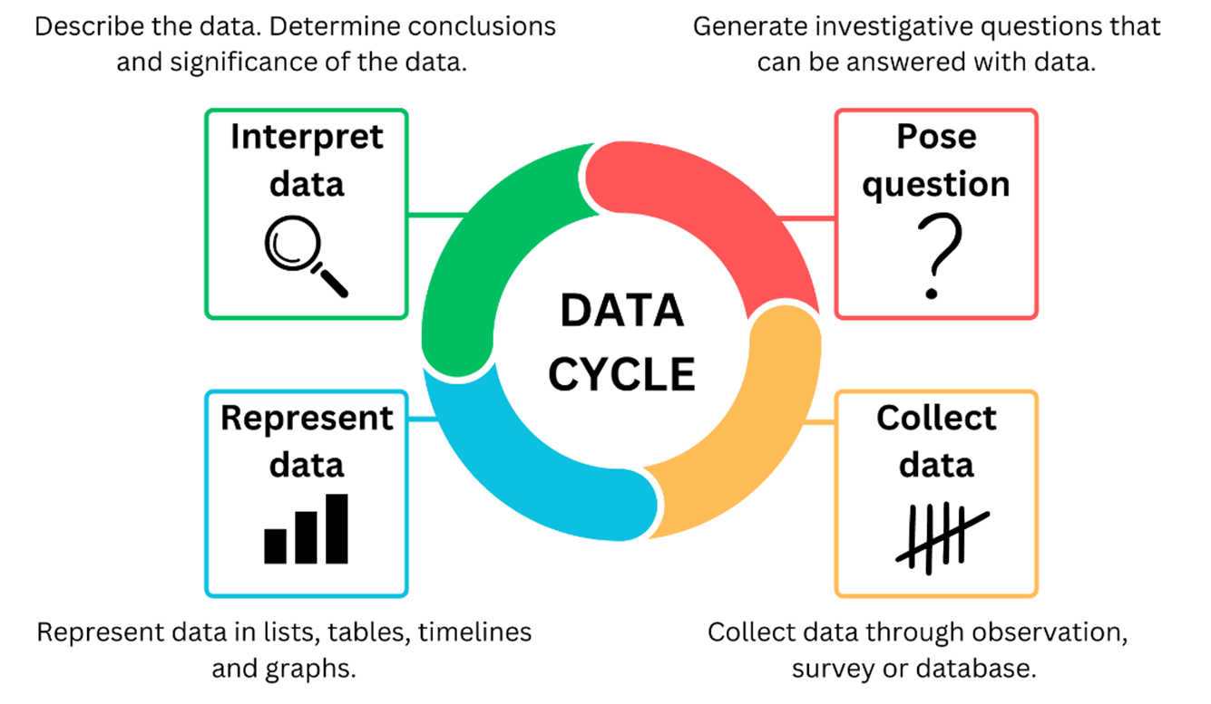

Resource 3: Survey question checklist
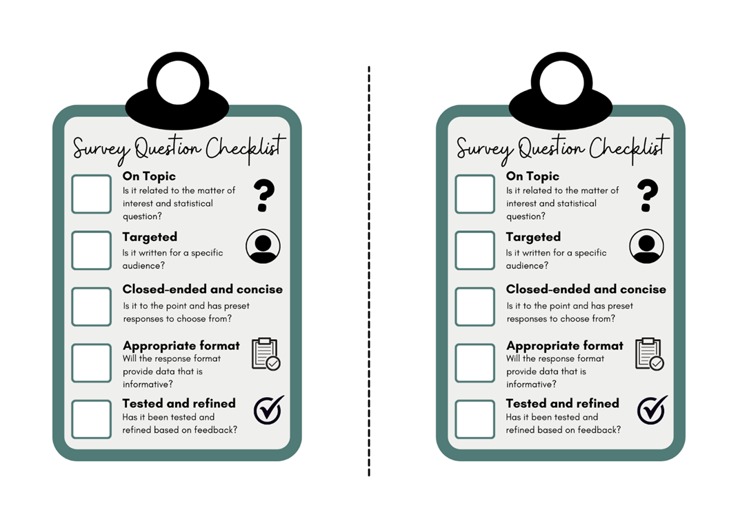

Resource 4: Reaction time charts
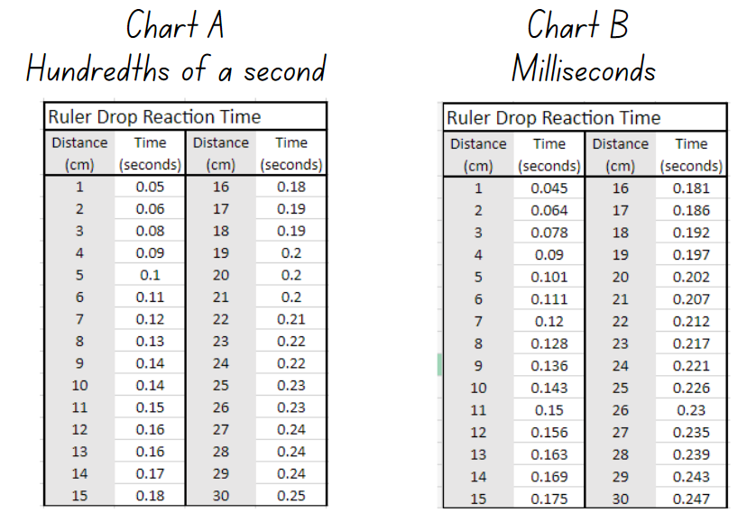

Resource 5: Line graph example
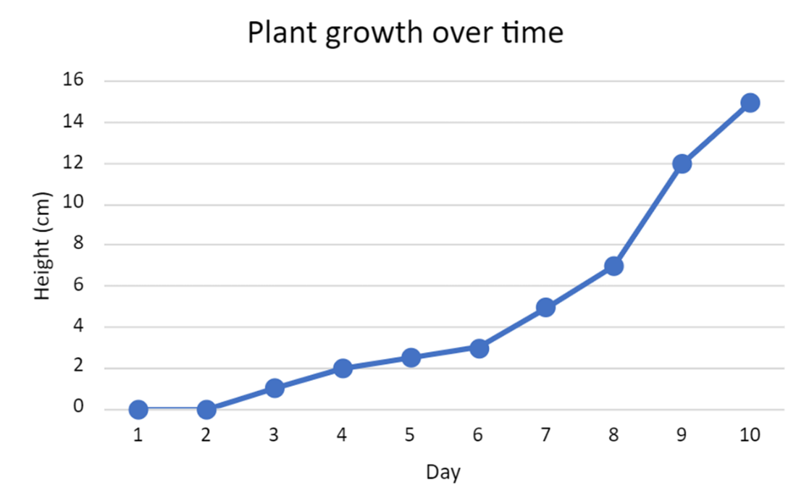

Resource 6: Data investigation
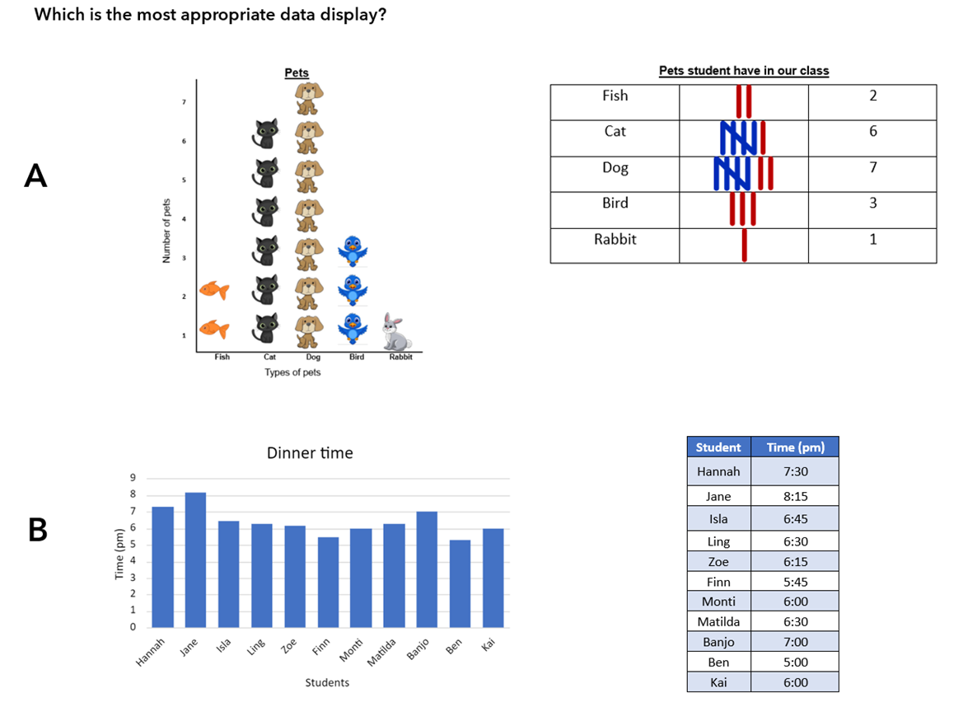
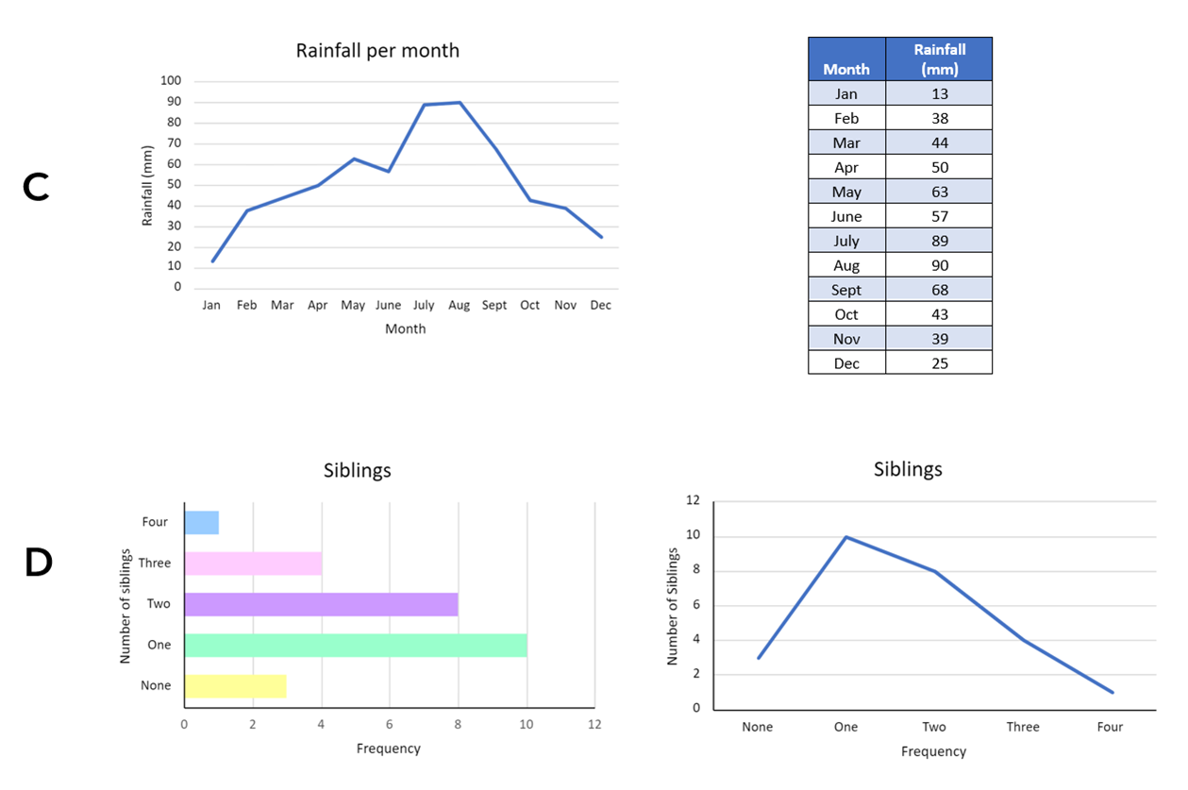

Resource 7: Slow reveal table
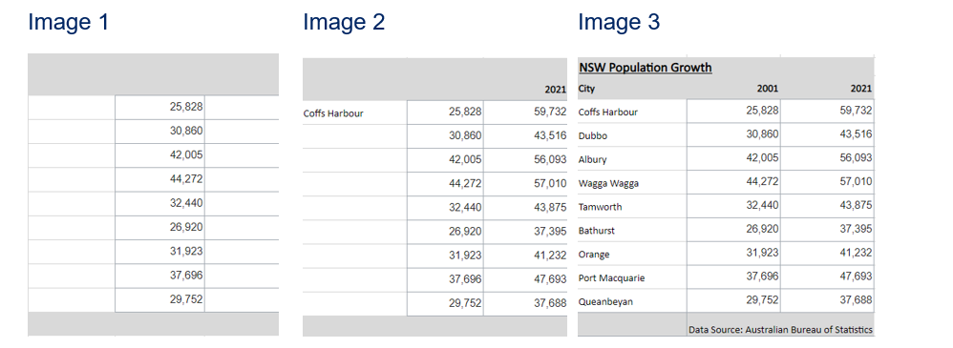

Resource 8: Population data and checklist
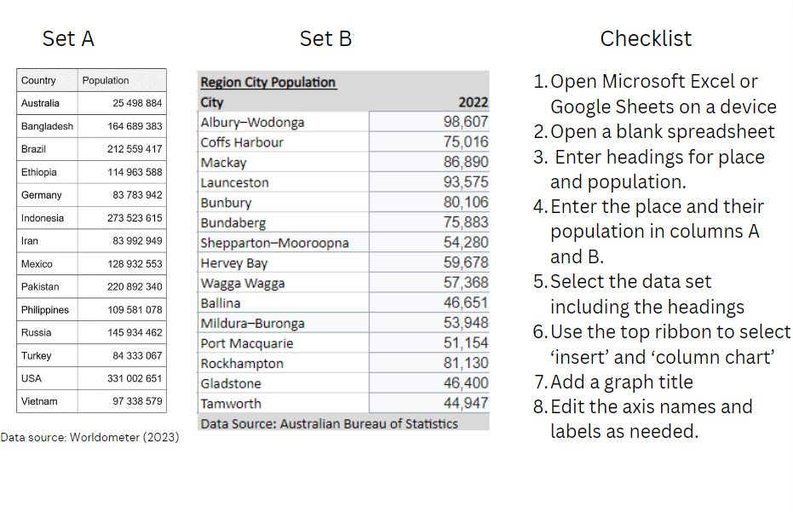

Resource 9: Australia’s population
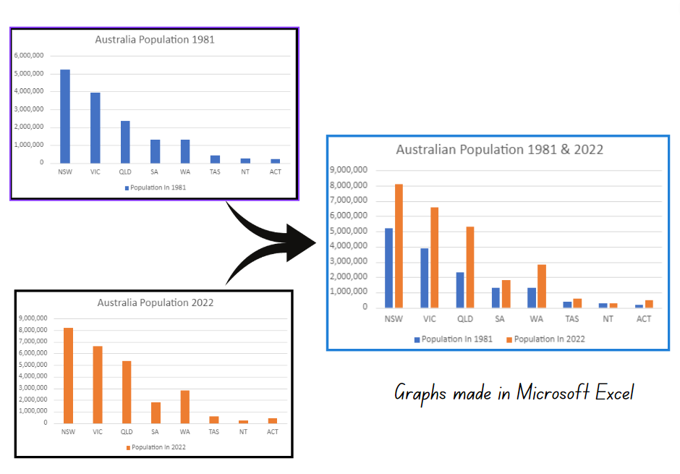

Resource 10: Number puzzles
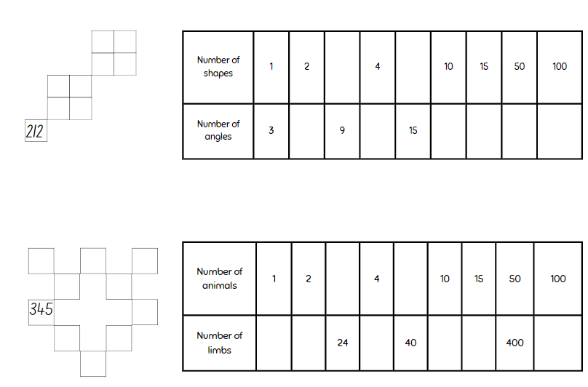

Resource 11: Example timeline

Resource 12: Fun day options
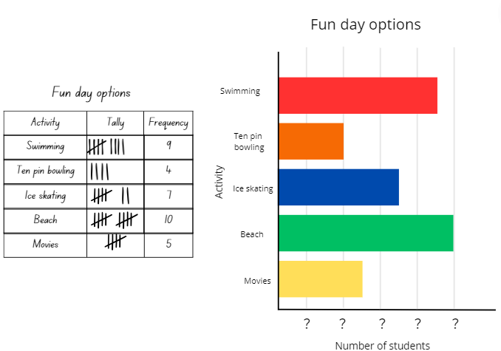

Resource 13: Australian gold rush
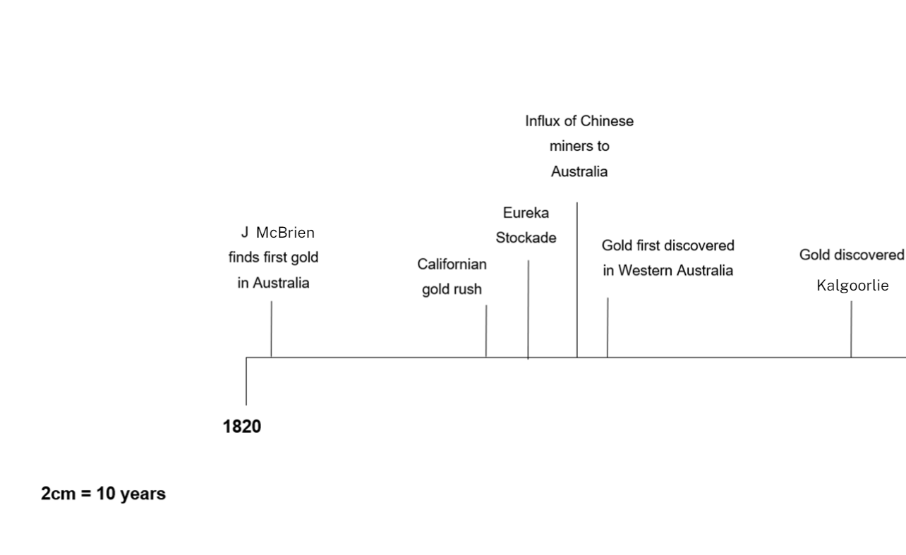

Resource 14: Australian temperatures
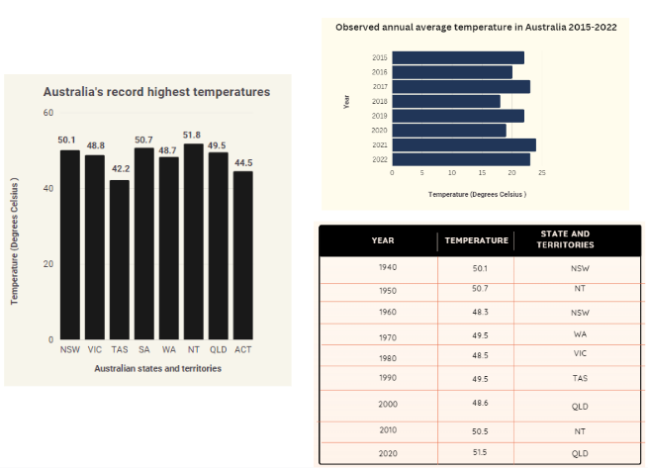

Resource 15: Extreme temperatures
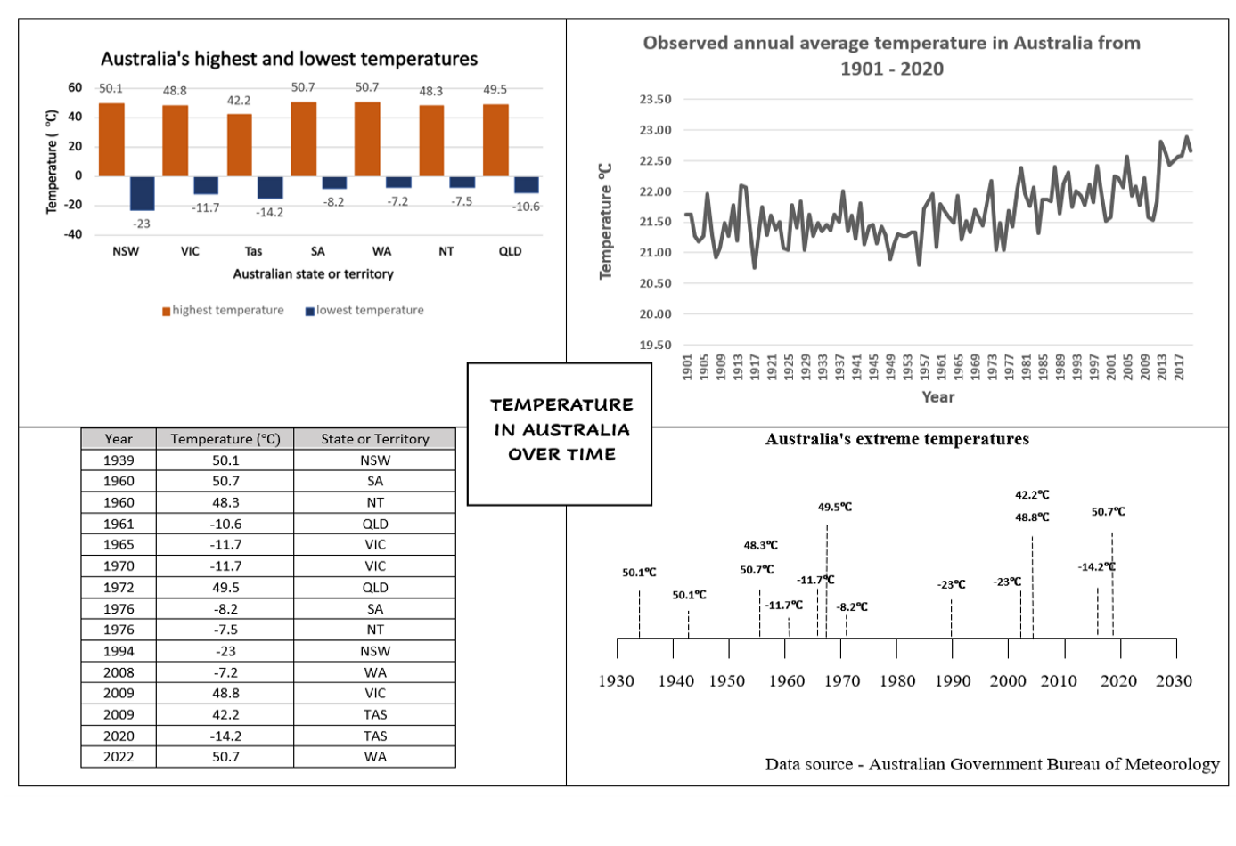

Resource 16: Temperature tables
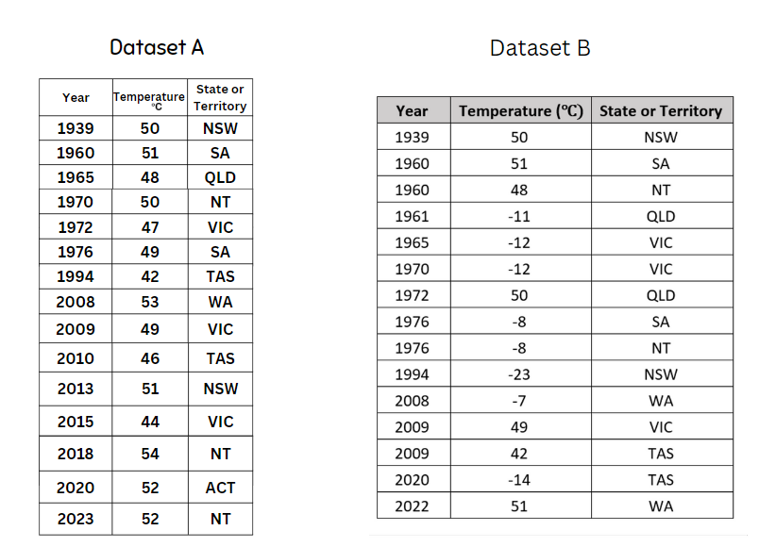

Resource 17: Unlabelled graphs
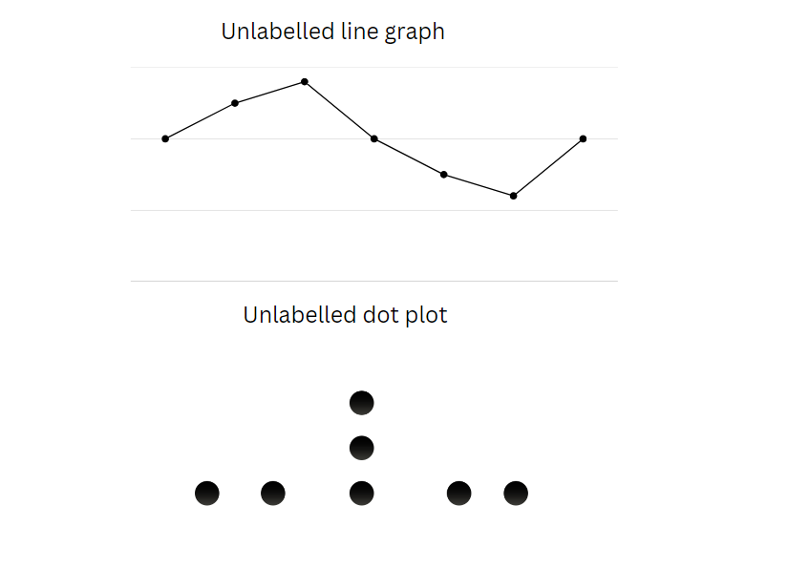

Resource 18: Table of data
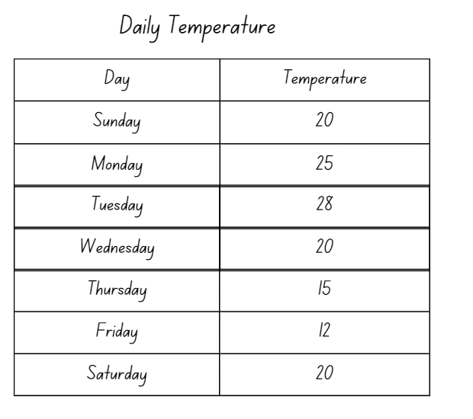

Resource 19: Threatened species
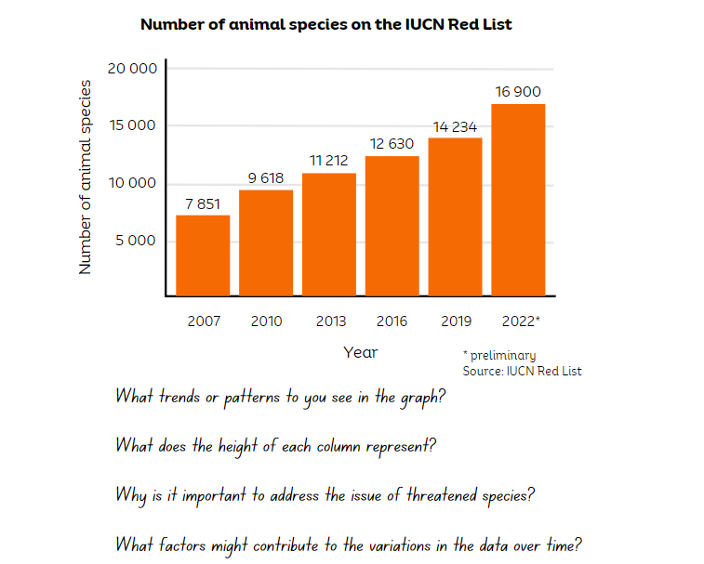

Resource 20: Solar system distances
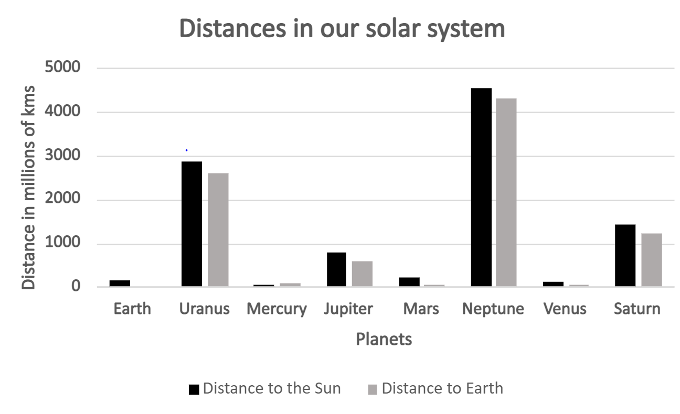
Data sourced from NASA (2023)
Planet | Distance to the Sun (km) | Distance to Earth (km) |  | Activities
 | 4 530 000 000 | 4 311 020 000 |  | - Record the missing planets on the table from the graph provided.
 | 1 437 000 000 | 1 204 280 000 |  | - Which planets are the furthest from and closest to the sun?
Mercury | 57 000 000 | 82 500 000 |  | - What is the range of distances to the sun? How did you calculate your answer?
 | 780 000 000 | 591 970 000 |  | - Which planets are the furthest from and closest to Earth?
Mars | 228 000 000 | 55 650 000 |  | - What is the range of distances to Earth? How did you calculate your answer?
 | 2 871 000 000 | 2 586 880 000 |  | - Which planets would be the hottest and coldest? Why?
Venus | 108 000 000 | 39 790 000 |  | - Order the planets from closest to furthest from the sun and record the distances next to the planet names.
 | 149 000 000 | 0

Resource 21: Team birth years
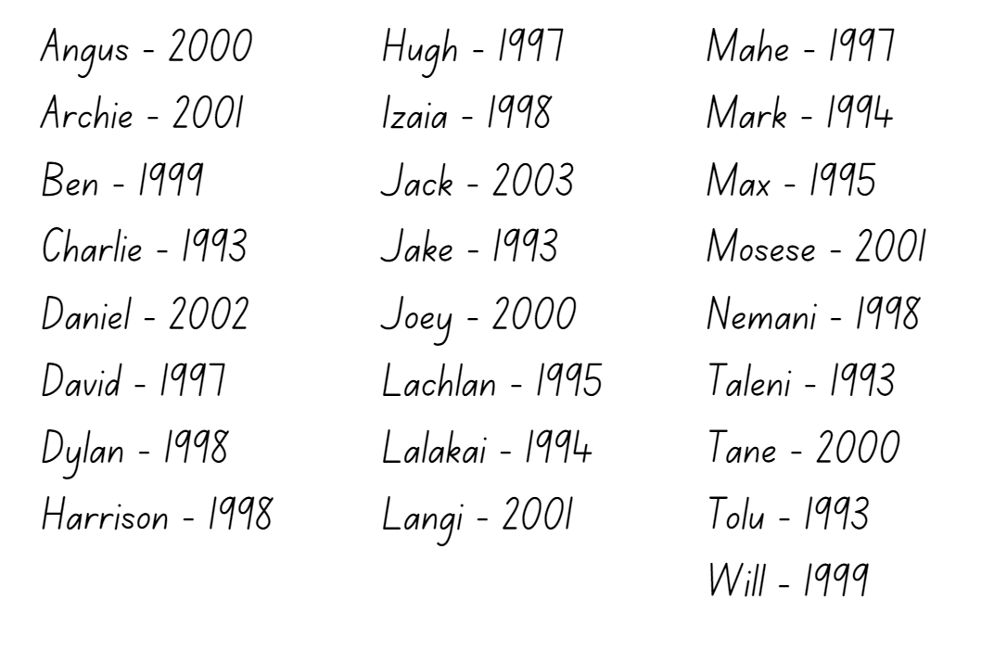

Resource 22: Melting ice
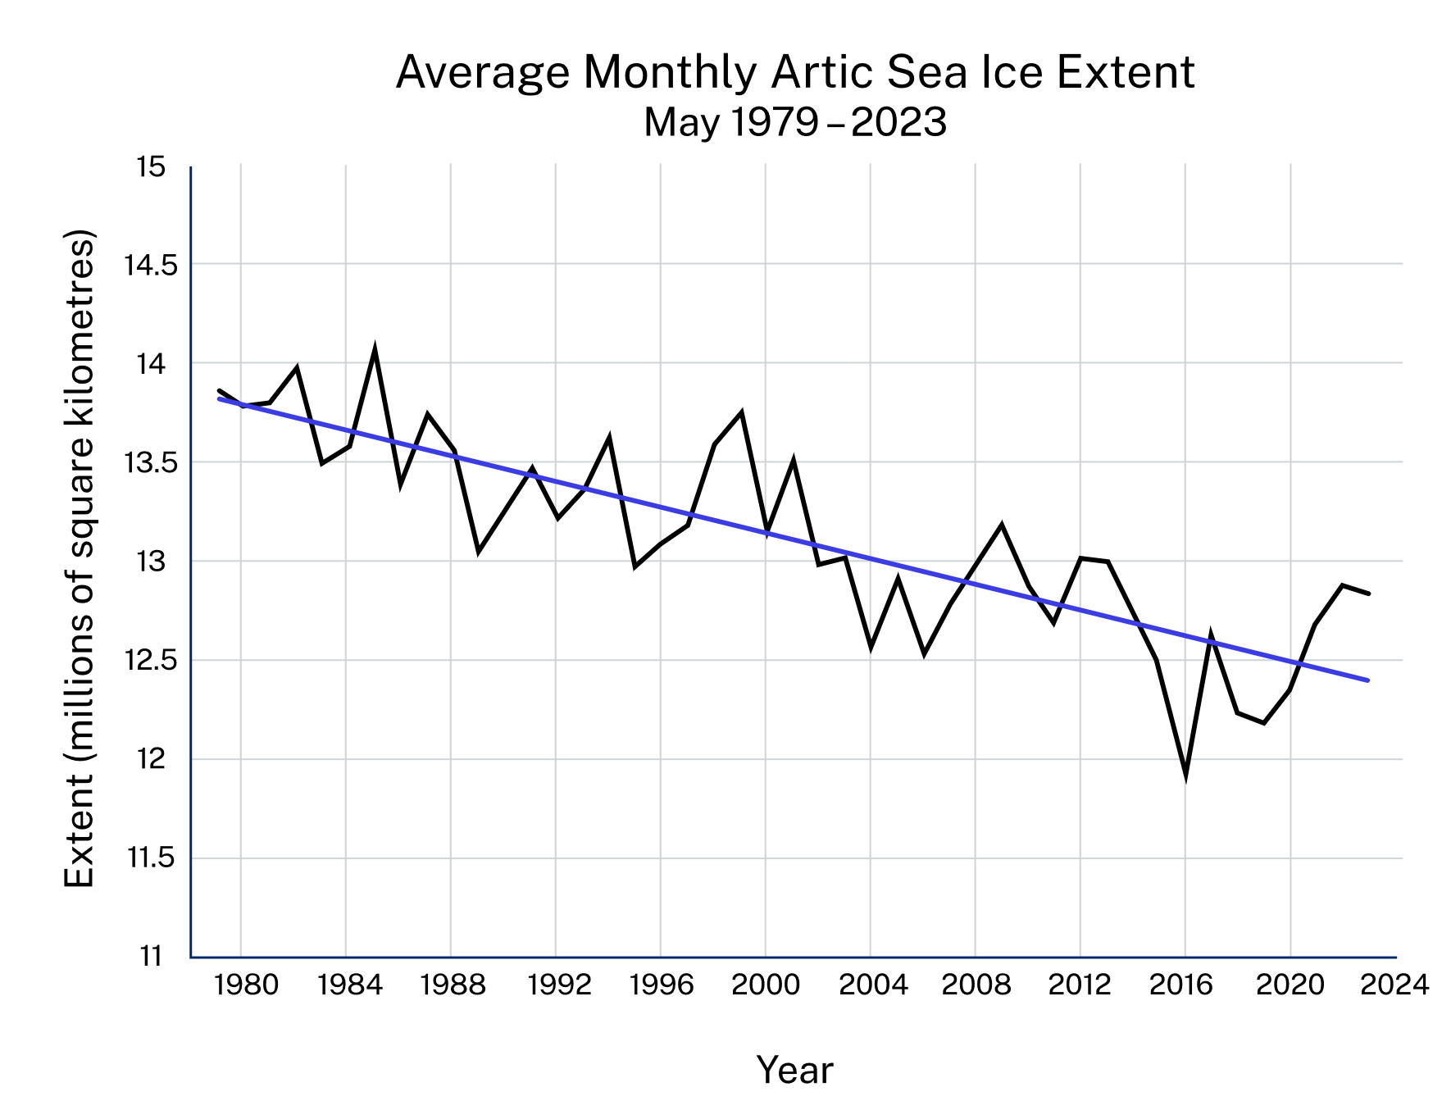
Data sourced from National Snow and Ice Data Center (2023)

Resource 23: Misleading graphs
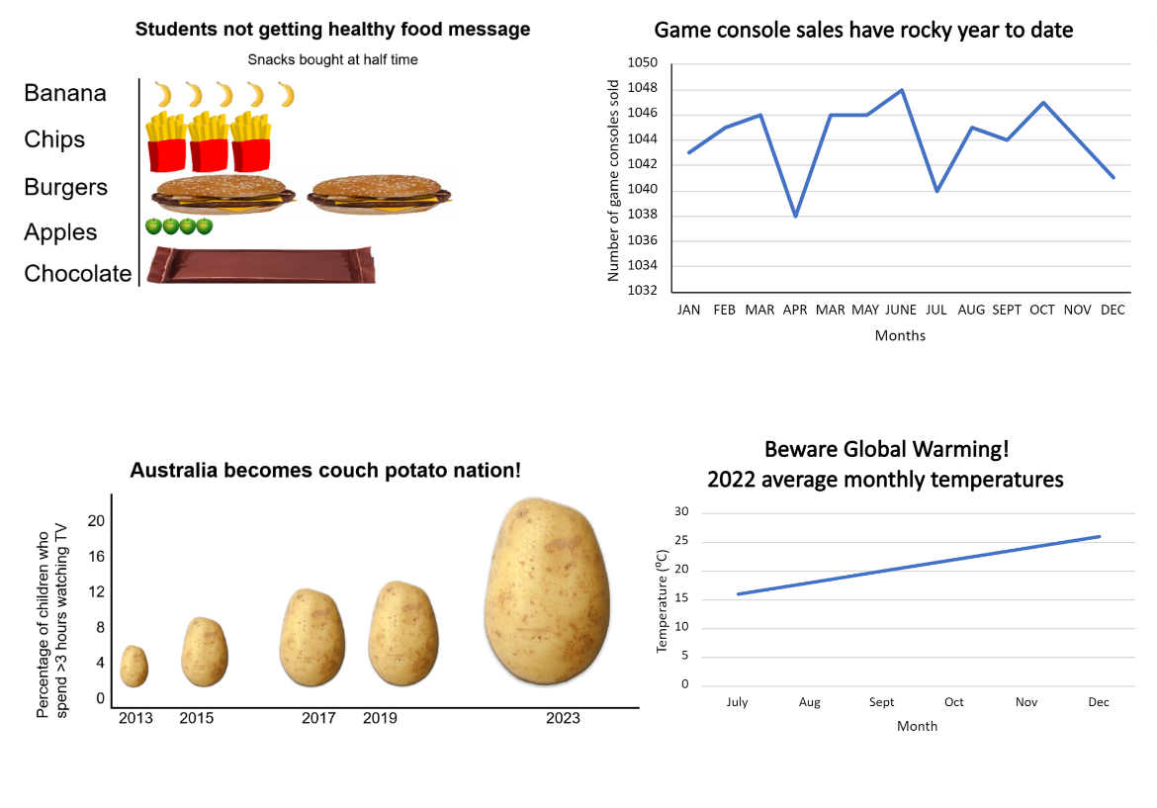

Syllabus outcomes and content

Stage 2
The table below outlines the syllabus outcomes and range of relevant syllabus content covered in this unit. Content is linked to National Numeracy Learning Progression version (3).
Outcomes and content | 1 | 2 | 3 | 4 | 5 | 6 | 7 | 8
Representing numbers using place value A: Whole numbers: Read, represent and order numbers to thousands
MAO-WM-01, MA2-RN-01
- Compare and describe the relative size of numbers by positioning numbers on a number line (Reasons about quantity) |  |  |  |  |  |  |  | x
- Read and order numbers of up to at least 4 digits |  |  |  | x |  |  | x
Representing numbers using place value A: Whole numbers: Apply place value to partition and regroup numbers up to 4 digits
MAO-WM-01, MA2-RN-01
- Record numbers using standard place value form |  | x | x
Representing numbers using place value B: Whole numbers: Apply place value to partition, regroup and rename numbers up to 6 digits
MAO-WM-01, MA2-RN-01
- Name thousands using the place value grouping of ones, tens and hundreds of thousands | x
Representing numbers using place value B: Decimals: Make connections between fractions and decimal notation
MAO-WM-01, MA2-RN-02
- Compare and order decimals of up to 2 decimal places |  | x
Additive relations A: Select strategies flexibly to solve addition and subtraction problems of up to 3 digits
MAO-WM-01, MA2-AR-01
- Apply known mental strategies that use partitioning to add and subtract, such as bridging the decades |  |  |  |  |  | x | x
Multiplicative relations A: Generate and describe patterns
MAO-WM-01, MA2-MR-01
- Model, describe and record patterns of multiples |  |  |  |  | x
Data A: Collect discrete data
MAO-WM-01, MA2-DATA-01, MA2-DATA-02
- Pose questions about a matter of interest to obtain information that can be recorded in categories | x
- Collect data from identified sources |  | x
Data A: Organise and display data using tables and graphs
MAO-WM-01, MA2-DATA-01
- Create a list or table to organise the data |  | x | x |  | x
- Construct column graphs (with scale intervals of 1) and dot plots using relevant software where appropriate |  |  |  |  |  |  | x
- Mark equal spaces (intervals) on axes, name and label axes and choose appropriate titles for column graphs |  |  |  |  |  | x
Data A: Interpret and compare data
MAO-WM-01, MA2-DATA-01
- Describe and interpret information presented in tally tables and column graphs |  |  | x | x |  | x |  | x
- Investigate how data is interpreted to make decisions |  |  |  |  |  |  | x
- Represent the same dataset using more than one type of display and compare the displays (Statistical reasoning) |  |  |  |  |  |  |  | x
Data B: Select and trial methods for data collection
MAO-WM-01, MA2-DATA-01, MA2-DATA-02
- Create a survey and related recording sheet, considering the appropriate organisation of categories for data collection | x | x
Data B: Construct and interpret data displays with many-to-one scales
MAO-WM-01, MA2-DATA-01, MA2-DATA-02
- Use a given many-to-one scale to represent discrete data in column graphs |  |  | x | x | x
Mathematics K–10 Syllabus © NSW Education Standards Authority (NESA) for and on behalf of the Crown in right of the State of New South Wales, 2022.

Stage 3
The table below outlines the syllabus outcomes and range of relevant syllabus content covered in this unit. Content is linked to National Numeracy Learning Progression version (3).
Outcomes and content | 1 | 2 | 3 | 4 | 5 | 6 | 7 | 8
Represents numbers A: Whole numbers: Recognise, represent and order numbers in the millions
MAO-WM-01, MA3-RN-01
- Name millions using the place value grouping of ones, tens and hundreds | x | x | x | x
- Arrange numbers in the millions in ascending and descending order using place value |  |  |  |  |  |  | x
- Round numbers to a specified place value |  |  |  |  |  |  | x
Represents numbers A: Decimals and percentages: Compare, order and represent decimals
MAO-WM-01, MA3-RN-02
- Compare and order decimal numbers of up to 3 decimal places |  | x
Represents numbers B: Whole numbers: Locate and represent integers on a number line
MAO-WM-01, MA3-RN-01
- Recognise the location of negative whole numbers in relation to zero and place them on a number line |  |  |  |  |  | x
Multiplicative relations A: Use partitioning and place value to multiply 2-, 3- and 4-digit numbers by one-digit numbers
MAO-WM-01, MA3-MR-01
- Use mental strategies to multiply one-digit numbers by 10, 100, 1000 and their multiples |  |  |  |  |  | x | x
Multiplicative relations B: Represent and describe number patterns formed by multiples
MAO-WM-01, MA3-MR-01
- Use a given geometric pattern involving multiples to create a table of values |  |  |  |  | x
Data A: Collect categorical and discrete numerical data by observation or survey
MAO-WM-01, MA3-DATA-01
- Pose and refine questions to construct a survey to obtain categorical or discrete numerical data about a matter of interest | x
- Collect ordinal or nominal categorical data, and discrete numerical data through observation or by conducting surveys |  | x
Data A: Choose and use appropriate tables and graphs
MAO-WM-01, MA3-DATA-01
- Tabulate collected data with and without the use of digital technologies such as spreadsheets |  |  | x
- Recognise which types of data display are appropriate to represent data (Statistical reasoning) |  |  | x
- Construct column graphs using a many-to-one scale, with and without the use of digital technologies |  |  | x | x
- Draw an accurate timeline using an appropriate scale |  |  |  |  | x
Data B: Interpret and compare a range of data displays
MAO-WM-01, MA3-DATA-02
- Interpret side-by-side column graphs for 2 categorical variables |  |  |  | x
- Interpret data on a timeline using the given scale |  |  |  |  | x
- Interpret and compare different displays in terms of the shape of the distribution, including the range and the most frequent value (mode) |  |  |  |  |  | x | x
Data B: Interpret data presented in digital media and elsewhere
MAO-WM-01, MA3-DATA-02
- Identify sources of possible bias in representations of data in the media (Statistical reasoning) |  |  |  |  |  |  |  | x
- Identify misleading representations of data in the media |  |  |  |  |  |  |  | x
Mathematics K–10 Syllabus © NSW Education Standards Authority (NESA) for and on behalf of the Crown in right of the State of New South Wales, 2022.

References
This resource contains NSW Curriculum and syllabus content. The NSW Curriculum is developed by the NSW Education Standards Authority. This content is prepared by NESA for and on behalf of the Crown in right of the State of New South Wales. The material is protected by Crown copyright.
Please refer to the NESA Copyright Disclaimer for more information https://educationstandards.nsw.edu.au/wps/portal/nesa/mini-footer/copyright.
NESA holds the only official and up-to-date versions of the NSW Curriculum and syllabus documents. Please visit the NSW Education Standards Authority (NESA) website https://educationstandards.nsw.edu.au/ and the NSW Curriculum website https://curriculum.nsw.edu.au/home.
Mathematics K–10 Syllabus © NSW Education Standards Authority (NESA) for and on behalf of the Crown in right of the State of New South Wales, 2022.
National Numeracy Learning Progression © Australian Curriculum, Assessment and Reporting Authority (ACARA) 2010 to present, unless otherwise indicated. This material was downloaded from the Australian Curriculum website (National Literacy Learning Progression) (accessed 4 September 2023) and was not modified.
Australian Government (Bureau of Meteorology) (2023) ‘Australian Weather Calendar’, Publications, Bureau of Metereology website, accessed 24 August 2023.
Australian Government Department of Education (2019) ‘Authentic Problems: Reaction Time’, Teaching resources, reSolve: Maths by Inquiry website, accessed 24 August 2023.
Australian Government Department of Education (2020) ‘Data: Making Decisions’, Teaching resources, reSolve: Maths by Inquiry website, accessed 24 August 2023.
Australian Sports Commission (2023) AusPlay National data tables – January 2022 to December 2022 [XLSX 495KB], Clearinghouse for Sport, accessed 24 August 2023.
Birdlife Australia (2022) 2022 Aussie Bird Count results, birdlife Australia website, accessed 24 August 2023.
Boaler J, Munson J and William C (2021) Mindset Mathematics: Visualising and Investigating Big Ideas, Grade 1, Jossey-Bass, US.
Commonwealth of Australia (2021–2022) ‘Regional population’, Population, Australian Bureau of Statistics website, accessed 18 August 2023.
Commonwealth of Australia (2022) ‘50 years of capital city population change’, Articles, Australian Bureau of Statistics website, accessed 18 August 2023.
Diezmann C, Lowrie T, Sugars L and Logan T (2009) ‘The Visual Side to Numeracy: Students' Sensemaking with Graphics’, Australian Primary Mathematics Classroom, 14(1):16–20.
International Union for Conservation of Nature and Natural Resources (2023) The IUCN Red List of Threatened Species. Version 2022-2, IUCN Red List website, accessed 24 August 2023.
NASA (2023) Eyes on the Earth - Air Temperature, NASA website, accessed 24 August 2023.
NASA (2023) Planetary Fact Sheet - Metric, NASA website, accessed 24 August 2023.
New Zealand Ministry of Education (n.d) ‘Data Distortion’, Resource Finder, NZ Maths website accessed 24 August 2023.
New Zealand Ministry of Education (n.d) ‘Discussing Data’, Resource Finder, NZ Maths website, accessed 24 August 2023.
New Zealand Ministry of Education (n.d) ‘Planning a statistical investigation (Level 3)’, Resource Finder, NZ Maths website, accessed 24 August 2023.
Siemon D, Warren E, Beswick K, Faragher R, Miller J, Horne M, Jazby D & Breed M (2020) Teaching Mathematics Foundations to Middle Years, 3rd edn, Oxford University Press, Victoria.
Stanford University (2020) Melting Arctic Ice [PDF 330KB], Youcubed, 24 August 2023.
State of New South Wales (Department of Education) (2021) 'Gathering data with Google Forms' [video], T4L Kids TV, NSW Department of Education website, accessed 24 August 2023.
State of New South Wales (Department of Education) (2021) 'Gathering data with Microsoft Forms' [video], T4L Kids TV, NSW Department of Education website, accessed 24 August 2023.
State of New South Wales (Department of Education) (2023) ‘101 and you're out (2-digit-addition)’ Mathematics K-6 resources, NSW Department of Education website, accessed 24 August 2023.
State of New South Wales (Department of Education) (2023) ‘Hit it (3-digit numbers)’, Mathematics K-6 resources, NSW Department of Education website, accessed 24 August 2023.
State of New South Wales (Department of Education) (2023) Graphic organisers, Digital Learning Selector website, accessed 24 August 2023.
State of New South Wales (Department of Education) (n.d.) Using digital tools to create graphical displays [DOCX 490KB], NSW Department of Education, accessed 24 August 2023.
State of New South Wales (Department of Planning and Environment) (2023) WildCount, NSW Department of Planning and Environment website, accessed 24 August 2023.
Sullivan P and Lilburn P (2017) Open-ended Maths Activities: Using ‘Good’ Questions to Enhance Learning in Mathematics, Revised edn, Oxford University Press ANZ, Great Britain.
University of Cambridge (Faculty of Mathematics) (2023) Reaction Timer, NRICH website accessed 24 August 2023.

Further reading

Stage 2
Australian Institute of Family Studies (August 2021) ‘Too much time on screens? Screen time effects and guidelines for children and young people’, Australian Institute of Family Studies, accessed 19 June 2023.
McCarthy N (2020) ‘Brazil Sees Worst Deforestation In A Decade’, Topics, Statista website, accessed 20 June 2023.
New Zealand Ministry of Education (n.d) ‘True or false’, Resource Finder, NZ Maths website, accessed 11 June 2023.
Santos-Longhorn A (27 November 2018) ‘How Many Steps Do People Take Per Day on Average?’, Healthline, accessed 19 June 2023.
State of New South Wales (Department of Education) (2023) ‘Counting game (by multiples of 5)’, Mathematics K-6 resources, NSW Department of Education website, accessed 9 June 2023.
State of New South Wales (Department of Education) (2023) ‘Data toss – Stage 2 and 3’, Mathematics K-6 resources, NSW Department of Education website, accessed 7 June 2023.
University of Cambridge (Faculty of Mathematics) (2023) Largest Even, NRICH website, accessed 9 June 2023.
Van de Walle J, Karp K, Bay-Williams JM, Brass A, Bentley B, Ferguson S, Goff W, Livy S, Marshman M, Martin D, Pearn C, Prodromou T, Symons D and Wilkie K (2019) Primary and Middle Years Mathematics: Teaching Developmentally, 1st Australian edn, Pearson Education Australia, Melbourne.
WWF Australia (2022) ‘Living Planet Report 2022’, What We Do, WWF Australia website, accessed 20 June 2022.

Stage 3
Commonwealth of Australia (Bureau of Meteorology) (2022) ‘Rainfall and temperature records’, Climate extremes, Australian Bureau of meteorology website, accessed 21 June 2023.
Commonwealth of Australia (Bureau of Meteorology) (2023) ‘National, state and territory population’, Population, Australian Bureau of Statistics website, accessed 21 June 2023.
National Snow and Ice Data Center (2023) Artic Sea Ice News and Analysis, National Snow and Ice Data Center website, accessed 21 June 2023.
State of New South Wales (Department of Education) (2023) ‘Let's talk 2 – number talk (15 x 9) Stage 3’, Mathematics K-6 resources, NSW Department of Education website, accessed 15 June 2023.
Worldometer (2023) ‘Countries in the world by population (2023)’, Population, Worldometers.info website, accessed 21 June 2023.

© State of New South Wales (Department of Education), 2023
The copyright material published in this resource is subject to the Copyright Act 1968 (Cth) and is owned by the NSW Department of Education or, where indicated, by a party other than the NSW Department of Education (third-party material).
Copyright material available in this resource and owned by the NSW Department of Education is licensed under a Creative Commons Attribution 4.0 International (CC BY 4.0) license.
This license allows you to share and adapt the material for any purpose, even commercially.
Attribution should be given to © State of New South Wales (Department of Education), 2023.
Material in this resource not available under a Creative Commons license:
- the NSW Department of Education logo, other logos and trademark-protected material
- material owned by a third party that has been reproduced with permission. You will need to obtain permission from the third party to reuse its material.
Links to third-party material and websites
Please note that the provided (reading/viewing material/list/links/texts) are a suggestion only and implies no endorsement, by the New South Wales Department of Education, of any author, publisher, or book title. School principals and teachers are best placed to assess the suitability of resources that would complement the curriculum and reflect the needs and interests of their students.
If you use the links provided in this document to access a third-party's website, you acknowledge that the terms of use, including licence terms set out on the third-party's website apply to the use which may be made of the materials on that third-party website or were permitted by the Copyright Act 1968 (Cth). The department accepts no responsibility for content on third-party websites.

