Mathematics 3–6 multi-age – Year A – Unit 6

Contents
Unit description and duration 6
Syllabus outcomes 6
Stage 2 6
Stage 3 7
Working mathematically 7
Student prior learning 8
Lesson overview and resources 9
Lesson 1 18
Daily number sense – balancing numbers – 15 minutes 18
Core lesson 1 – understanding place value – 15 minutes 20
Core lesson 2 – check the clues – 25 minutes 23
Consolidation and meaningful practice – 10 minutes 24
Lesson 2 26
Daily number sense – balancing number sentences – 10 minutes 26
Core lesson 1 – representing large collections – 35 minutes 28
Core lesson 2 – renaming numbers – 20 minutes 31
Discuss and connect the mathematics – 5 minutes 32
Lesson 3 35
Daily number sense – adding numbers – 10 minutes 35
Core lesson – 40 minutes 37
Stage 2 task – ordering and comparing 4-digit numbers 37
Stage 3 task – thousandths and place value 42
Discuss and connect the mathematics – 15 minutes 47
Lesson 4 49
Daily number sense – 10 minutes 49
Core lesson – 45 minutes 49
Stage 2 task – understanding the role of zero 49
Stage 3 task – comparing decimals 52
Discuss and connect the mathematics – 10 minutes 56
Lesson 5 58
Daily number sense – target number– 15 minutes 58
Core lesson – 45 minutes 60
Stage 2 task – partitioning numbers 60
Stage 3 task – comparing 2 decimals 65
Discuss and connect the mathematics – 5 minutes 67
Lesson 6 69
Daily number sense – guess the number – 10 minutes 69
Core lesson – 45 minutes 72
Stage 2 task – bridging the decades 72
Stage 3 task – addition for subtraction 75
Discuss and connect the mathematics – 10 minutes 79
Lesson 7 81
Daily number sense – reading large numbers – 10 minutes 81
Core lesson – addition and subtraction with number lines – 45 minutes 83
Discuss and connect the mathematics – 5 minutes 87
Lesson 8 89
Daily number sense – 10 minutes 89
Core lesson – 40 minutes 89
Stage 2 task – inverse operations 89
Stage 3 task – choosing efficient strategies 93
Discuss and connect the mathematics – 10 minutes 96
Resource 1 – check the clues 98
Resource 2 – number sentences 99
Resource 3 – number expander 100
Resource 4 – place value houses 101
Resource 5 – decimals example 1 102
Resource 6 – decimals example 2 103
Resource 7 – decimals example 3 104
Resource 8 – decimals example 4 105
Resource 9 – misconceptions – zero 106
Resource 10 – misconceptions – decimals 107
Resource 11 – reaction times 108
Resource 12 – Which doesn’t belong? 109
Resource 13 – collections of 1224 110
Resource 14 – table of combinations 111
Resource 15 – blank decimal grids 112
Resource 16 – comparing decimals 113
Resource 17 – 120 number chart 114
Resource 18 – addition number sentences 115
Resource 19 – subtraction number sentences 116
Resource 20 – efficient additive strategies 117
Resource 21 – codeword 118
Resource 22 – codeword answer sheet 121
Resource 23 – solution scaffold 122
Resource 24 – bar model puzzle 123
Resource 25 – number cards 125
Resource 26 – word problems 126
Resource 27 – representing subtraction 127
Syllabus outcomes and content 128
Stage 2 128
Stage 3 132
References 136

Unit description and duration
This unit develops the big idea that the number system extends infinitely to very large and very small numbers.
In this 2-week unit students are provided opportunities to:
- read, represent and order numbers up to millions
- compare, order and represent decimals (Stage 3)
- use partitioning and place value knowledge to add and subtract
- identify the relationship between addition and subtraction.
This multi-age unit is informed by the lessons in Stage 2 Year A Unit 6 and Stage 3 Year A Unit 6. Please refer to these units for additional lesson guidance.

Syllabus outcomes
- MAO-WM-01 develops understanding and fluency in mathematics through exploring and connecting mathematical concepts, choosing and applying mathematical techniques to solve problems, and communicating their thinking and reasoning coherently and clearly

Stage 2
- MA2-RN-01 applies an understanding of place value and the role of zero to represent numbers to at least tens of thousands
- MA2-AR-01 selects and uses mental and written strategies for addition and subtraction involving 2- and 3-digit numbers

Stage 3
- MA3-RN-01 applies an understanding of place value and the role of zero to represent the properties of numbers
- MA3-RN-02 compares and orders decimals up to 3 decimal places
- MA3-AR-01 selects and applies appropriate strategies to solve addition and subtraction problems

Working mathematically
In the Mathematics K–10 Syllabus, there is one overarching Working mathematically outcome (MAO-WM-01). The Working mathematically processes should be embedded within the concepts being taught. The Working mathematically processes present in the Mathematics K–10 Syllabus are:
- communicating
- understanding and fluency
- reasoning
- problem solving.
Mathematics K–10 Syllabus © NSW Education Standards Authority (NESA) for and on behalf of the Crown in right of the State of New South Wales, 2022.

Student prior learning
Before engaging in these teaching and learning activities, students would benefit from prior experience with:
- reading, representing and ordering numbers up to 6 digits
- standard and non-standard partitioning of numbers up to 6 digits
- using a variety of addition and subtraction strategies, including bridging the decade.
In NSW classrooms there is a diverse range of students, including Aboriginal and Torres Strait Islander students, students learning English as an additional language or dialect, high potential and gifted students and students with disability. Some students may identify with more than one of these groups or possibly all of them. Refer to Curriculum planning for every student – advice for further information.

Lesson overview and resources
To cover the content of the syllabus across Stage 2 and Stage 3, some core lessons in the unit contain both a Stage 2 and a Stage 3 task. Teachers are encouraged to adapt and contextualise the units to meet the needs of their students.
The table below outlines the sequence and approximate timing of lessons, learning intentions and resources.
Lesson | Content | Duration and resources
Lesson 1  Daily number sense  Stage 2:  - Additive relations A: Use the principle of equality  Stage 3:  - Additive relations A: Apply efficient mental and written strategies to solve addition and subtraction problems | Lesson core concept: naming and representing large numbers is a key component of place value.  Stage 2:  - Representing numbers using place value A: Whole numbers: Read, represent and order numbers to thousands  - Representing numbers using place value B: Whole numbers: Order numbers in the thousands  Stage 3:  - Represents numbers A: Whole numbers: Recognise, represent and order numbers in the millions | Lesson duration: 65 minutes  - Resource 1 – check the clues  - 6-sided dice  - Blank paper  - Individual whiteboards  - Whiteboard markers  - Writing materials
Lesson 2  Daily number sense  Stage 2:  - Additive relations A: Use the principle of equality  Stage 3:  - Additive relations A: Apply efficient mental and written strategies to solve addition and subtraction problems | Lesson core concept: numbers can be renamed in equivalent ways using place value.  Stage 2:  - Representing numbers using place value A: Whole numbers: Read, represent and order numbers to thousands  - Representing numbers using place value B: Whole numbers: Apply place value to partition, regroup and rename numbers up to 6 digits  Stage 3:  - Represents numbers A: Whole numbers: Apply place value to partition, regroup and rename numbers to 1 billion | Lesson duration: 70 minutes  - Resource 2 – number sentences  - Resource 3 – number expander  - Resource 4 – place value houses  - Murphy SJ (n.d.) Earth Day – Hooray (Adriani R illus), MathStart website (Online version)  - 10-sided dice (0–9)  - Red, yellow, green and blue counters  - Hoops  - Individual whiteboards  - Whiteboard markers  - Writing materials
Lesson 3  Daily number sense  Stage 2:  - Additive relations A: Select strategies flexibly to solve addition and subtraction problems of up to 3 digits  Stage 3:  - Additive relations A: Apply efficient mental and written strategies to solve addition and subtraction problems | Lesson core concept: the position of each digit in a number corresponds to its size (Stage 2). The place value system can be extended (Stage 3).  Stage 2:  - Representing numbers using place value A: Whole numbers: Read, represent and order numbers to thousands  - Representing numbers using place value B: Whole numbers: Orders numbers in the thousands  Stage 3:  - Represents numbers A: Decimals and percentages: Recognise that the place value system can be extended beyond hundredths  - Represents numbers A: Decimals and percentages: Compare, order and represent decimals | Lesson duration: 65 minutes  - Resource 4 – place value houses  - Resource 5 – decimals example 1  - Resource 6 – decimals example 2  - Resource 7 – decimals example 3  - Resource 8 – decimals example 4  - 6-sided dice  - 9-sided dice or virtual manipulatives  - MAB materials  - Student workbooks  - Writing materials
Lesson 4  Daily number sense  - teacher-identified task based on student needs | Lesson core concept: zeros in numbers can have different roles (Stage 2) and the position of each digit in a number corresponds to its size (Stage 3).  Stage 2:  - Representing numbers using place value A: Whole numbers: Read, represent and order numbers to thousands  - Representing numbers using place value A: Whole numbers: Apply place value to partition and regroup numbers up to 4 digits  Stage 3:  - Represents numbers A: Decimals and percentages: Recognise that the place value system can be extended beyond hundredths  - Represents numbers A: Decimals and percentages: Compare, order and represent decimals | Lesson duration: 65 minutes  - Resource 9 – misconceptions – zero  - Resource 10 – misconceptions – decimals  - Resource 11 – reaction times  - 30 cm rulers  - Individual whiteboards  - Whiteboard markers  - Writing materials
Lesson 5  Daily number sense  Stage 2:  - Additive relations A: Recognise and explain the connection between addition and subtraction  Stage 3:  - Additive relations A: Apply efficient mental and written strategies to solve addition and subtraction problems | Lesson core concept: numbers can be renamed in equivalent ways using place value Stage 2) and decimals can be compared by analysing the place values parts (Stage 3).  Stage 2:  - Representing numbers using place value A: Whole numbers: Read, represent and order numbers to thousands  - Representing numbers using place value A: Whole numbers: Apply place value to partition and regroup numbers up to 4 digits  Stage 3:  - Represents numbers A: Decimals and percentages: Compare, order and represent decimals | Lesson duration: 65 minutes  - Resource 12 – Which doesn’t belong?  - Resource 13 – collections of 1224  - Resource 14 – table of combinations  - Resource 15 – Blank decimal grid  - Resource 16 – comparing decimals  - Individual whiteboards  - MAB materials  - Whiteboard markers  - Writing materials
Lesson 6  Daily number sense  Stage 2:  - Representing numbers using place value B: Whole numbers: Apply place value to partition, regroup and rename numbers up to 6 digits  Stage 3:  - Represents numbers A: Whole numbers: Recognise, represent and order numbers in the millions | Lesson core concept: place value understanding helps solve addition and subtraction problems.  Stage 2:  - Additive relations A: Select strategies flexibly to solve addition and subtraction problems of up to 3 digits  - Additive relations B: Partition, rearrange and regroup numbers to at least 1000 to solve additive problems  Stage 3:  - Additive relations A: Apply efficient mental and written strategies to solve addition and subtraction problems | Lesson duration: 65 minutes  - Resource 17 – 120 number chart  - Resource 18 – addition number sentences  - Resource 19 – subtraction number sentences  - Resource 20 – efficient additive strategies  - Resource 21 – codeword  - Resource 22 – codeword answer sheet  - Resource 23 – solution scaffold  - Interactive 120 Number chart  - Counters  - Individual whiteboards  - Whiteboard markers  - Writing materials
Lesson 7  Daily number sense  Stage 2:  - Representing numbers using place value B: Whole numbers: Apply place value to partition, regroup and rename numbers up to 6 digits  Stage 3:  - Represents numbers A: Whole numbers: Apply place value to partition, regroup and rename numbers to 1 billion | Lesson core concept: number lines help solve addition and subtraction problems.  Stage 2:  - Additive relations A: Select strategies flexibly to solve addition and subtraction problems of up to 3 digits  Stage 3:  - Additive relations A: Apply efficient mental and written strategies to solve addition and subtraction problems | Lesson duration: 60 minutes  - Resource 18 – addition number sentences  - Resource 19 – subtraction number sentences  - 9-sided dice  - Writing materials
Lesson 8  Daily number sense  - teacher-identified task based on student needs | Lesson core concept: addition and subtraction are connected.  Stage 2:  - Additive relations A: Use the principle of equality  - Additive relations A: Recognise and explain the connection between addition and subtraction  - Additive relations A: Select strategies flexibly to solve addition and subtraction problems of up to 3 digits  Stage 3:  - Represents numbers A: Whole numbers: Apply place value to partition, regroup and rename numbers to 1 billion  - Additive relations A: Apply efficient mental and written strategies to solve addition and subtraction problems  - Additive relations A: Use estimation and place value understanding to determine the reasonableness of solutions | Lesson duration: 60 minutes  - Resource 24 – bar model puzzle  - Resource 25 – number cards  - Resource 26 – word problems  - Resource 27 – representing subtraction  - MAB materials  - Student workbooks  - Writing materials

Lesson 1
Core concept: naming and representing large numbers is a key component of place value.

Daily number sense – balancing numbers – 15 minutes
Daily number sense activities for Lessons 1 to 3 ‘activate’ prior number knowledge and support the learning of new content in the unit. These activities can also assist teachers to identify the starting points for learning by revealing the extent of students’ existing knowledge.
The table below contains suggested learning intentions and success criteria. These are best co-constructed with students.
Daily number sense learning intentions | Daily number sense success criteria
Students working towards Stage 2 outcomes are learning to:  - use the principle of equality.  Students working towards Stage 3 outcomes are learning to:  - apply efficient mental and written strategies to solve addition and subtraction problems. | Students working towards Stage 2 outcomes can:  - use the equals sign to mean ‘the same as’, rather than to perform an operation.  Students working towards Stage 3 outcomes can:  - apply known strategies, such as levelling, addition for subtraction, using constant difference and bridging.
This activity is an adaptation of Balancing Act – A dice game [PDF 250 KB] from Primary Learning.
- Give pairs of students a 6-sided die, an individual whiteboard and a whiteboard marker.
- Students roll the die 10 times each and try to use as many of the numbers to make a balanced number sentence. For example, if a student rolls 1, 1, 2, 2, 2, 3, 4, 4, 5, 6, they could make the number sentence 6 + 5 + 4 = 4 + 3 + 1 + 2 + 2 + 2 + 1 (both sides equal 15).
- Students write their equation on the whiteboard for their partner to check.
Multi-age: Stage 2 students must use at least one plus sign on either side of their equation. Stage 2 students use single-digit numbers while Stage 3 students can use 2- and/or 3-digit numbers in their equation. Encourage Stage 3 students to use known strategies such as levelling, addition for subtraction, constant difference and bridging to complete their equations.
- Points are given for the amount of numbers each player uses. If a player uses all 10 numbers, they get 10 points. If they only use 6 numbers, they get 6 points. The first player to reach 100 points wins.
This table details opportunities for assessment.
Assessment opportunities | Links
What to look for:  - Can Stage 2 students use the equals sign to mean 'the same as', rather than to perform an operation? [MAO-WM-01, MA2-AR-01]  - Can Stage 3 students apply known strategies such as levelling, addition for subtraction, using constant difference and bridging? [MAO-WM-01, MA3-AR-01] | Links to National Numeracy Learning Progressions (NNLP):  - Stage 2 – NPA3  - Stage 3 – AdS7, AdS8.  Links to suggested Interview for Student Reasoning (IfSR) tasks:  - Stage 3 – IfSR-AT: 3A.5.

Core lesson 1 – understanding place value – 15 minutes
The table below contains suggested learning intentions and success criteria. These are best co-constructed with students.
Core concept learning intentions | Core concept success criteria
Students working towards Stage 2 outcomes are learning to:  - read, represent and order numbers to thousands.  Students working towards Stage 3 outcomes are learning to:  - recognise, represent and order numbers in the millions. | Students working towards Stage 2 outcomes can:  - arrange numbers in the thousands in ascending and descending order  - name thousands using the place value grouping of ones, tens and hundreds of thousands.  Students working towards Stage 3 outcomes can:  - name millions using the place value grouping of ones, tens and hundreds  - arrange numbers in the millions in ascending and descending order using place value.
- Draw place value houses up to millions onto the board.
- Use the place value houses to explicitly model how to read and write a number up to thousands for Stage 2 and to millions for Stage 3 (see Figure 1).
Figure 1 – place value houses to millions (Stage 3)
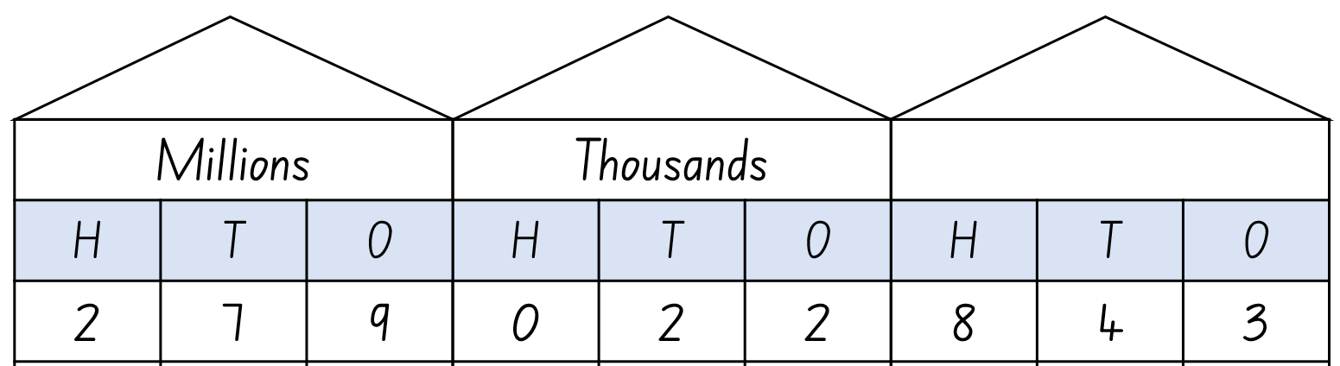
- Ask questions to check students’ understanding of the place value system. For example:
- What is the value of the digit in the hundred millions place? (Stage 3)
- How many thousands can be found in this number? (All students)
- What is the role of the zero is this number? (All students).
- In pairs, students turn and talk to practice saying a number aloud while their partner records it on their whiteboard.
Note: Stage 3 students should work with numbers in the millions, while Stage 2 students should work with numbers in the thousands.
- Partners swap roles.
- Select several Stage 2 and Stage 3 students to read their numbers aloud.
- Write the numbers on the board as separate Stage 2 and Stage 3 lists.
- Model how to order the numbers in ascending and descending order.
- Repeat activity until students are confident in reading and ordering large numbers.

Core lesson 2 – check the clues – 25 minutes
This activity is an adaptation of ‘Check the Clues 5’ from A Whole School Approach to Place Value, Teaching Place Value Year 4 Whole Numbers by Dunstan and Swan.
Note: Stage 2 students learn about numbers in the thousands and Stage 3 students learn about numbers in the millions. Resource 1 – check the clues contains number options and clues for both stages. Explain which numbers and clues are for Stage 2 students and which ones are for Stage 3 students.
- Separate students into groups of 3 or 4 and according to their stage of learning.
- Write one set of 4 numbers from Resource 1 – check the clues on the board and read the clues.
- Students discuss the clues in their small groups, using a process of elimination to determine the solution number.
- Students record the solution number on an individual whiteboard.
- Once students have solved the first set of clues, write the next set of 4 numbers and read out the clues from Resource 1 – check the clues.
Multiage: you may find it helpful to add more number and clue sets according to the stage composition of your class.
- Students order the solution numbers they have identified during the game in ascending and descending order.
This table details opportunities for differentiation.
Too hard? | Too easy?
Students cannot name and order large numbers.  - Assist students by providing clues that are more suited to their level of learning to solve the problem.  - Reduce the complexity of the task by providing students with clues to solve 2- or 3-digit number problems. | Students can name and order large numbers.  - Challenge students to identify numbers that require the fewest clues to solve.  - Ask the students to identify as many other numbers as they can that fit the clues.

Consolidation and meaningful practice – 10 minutes
- Students work in groups of 3 to 4 and use some blank pieces of paper to create their own clue cards for another group to solve.
- Once the clues have been created, groups swap clues.
- Students read the new clue cards created by another group and find the correct solution.
This table details opportunities for assessment.
Assessment opportunities | Links
What to look for:  - Can Stage 2 students arrange numbers in the thousands in ascending and descending order? [MAO-WM-01, MA2-RN-01]  - Can Stage 2 students name thousands using the place value grouping of ones, tens and hundreds of thousands? [MAO-WM-01, MA2-RN-01]  - Can Stage 3 students name millions using the place value grouping of ones, tens and hundreds? [MAO-WM-01, MA3-RN-01]  - Can Stage 3 students arrange numbers in the millions in ascending and descending order using place value? [MAO-WM-01, MA3-RN-01] | Links to National Numeracy Learning Progressions (NNLP):  - Stage 2 – NPV6  - Stage 3 – NPV6, NPV7.  Links to suggested Interview for Student Reasoning (IfSR) tasks:  - Stage 2 – IfSR-NP: 4B.2, 4C.5.

Lesson 2
Core concept: numbers can be renamed in equivalent ways using place value.

Daily number sense – balancing number sentences – 10 minutes
The table below contains suggested learning intentions and success criteria. These are best co-constructed with students.
Daily number sense learning intentions | Daily number sense success criteria
Students working towards Stage 2 outcomes are learning to:  - use the principle of equality.  Students working towards Stage 3 outcomes are learning to:  - apply efficient mental and written strategies to solve addition and subtraction problems. | Students working towards Stage 2 outcomes can:  - use the equals sign to mean 'the same as', rather than to perform an operation.  Students working towards Stage 3 outcomes can:  - apply known strategies such as levelling, addition for subtraction, using constant difference and bridging.
This activity is an adaptation of True or False? from NRICH by University of Cambridge (Faculty of Mathematics).
- Display the number sentence 27 + 13 = 11 + 29 and ask students if the number sentence is true or false. Students turn and talk to a partner to justify their answer.
- Ask students how they know whether a particular number sentence is true or false.
- Emphasise to students that ‘=’ means ‘has the same value as’ and not just the ‘total’ or the ‘answer’.
- Display Resource 2 – number sentences and ask students the following:
- Which statements are true?
- Which are false?
- How do you know?
- Can you decide without doing any calculating?
- What strategies did you use?
- Examine each number sentence and select students to share their thinking.
Multi-age: students working towards Stage 3 outcomes can use number sentences with larger numbers.
This table details opportunities for assessment.
Assessment opportunities | Links
What to look for:  - Can Stage 2 students use the equals sign to mean 'the same as', rather than to perform an operation? [MAO-WM-01, MA2-AR-01]  - Can Stage 3 students apply known strategies such as levelling, addition for subtraction, using constant difference and bridging? [MAO-WM-01, MA3-AR-01] | Links to National Numeracy Learning Progressions (NNLP):  - Stage 2 – AdS7  - Stage 3 – AdS7, AdS8.  Links to suggested Interview for Student Reasoning (IfSR) tasks:  - Stage 2 – IfSR-AT: 2A.1  - Stage 3 – IfSR-AT: 3A.4, 3A.5.

Core lesson 1 – representing large collections – 35 minutes
The table below contains suggested learning intentions and success criteria. These are best co-constructed with students.
Core concept learning intentions | Core concept success criteria
All students are learning to:  - apply place value to partition, regroup and rename numbers.  Students working towards Stage 2 outcomes are learning to:  - read, represent and order numbers to thousands. | All students can:  - regroup numbers in different forms  - use place value to expand the number notation  - partition numbers in non-standard forms.  Students working towards Stage 2 outcomes can:  - group physical objects to show the structure of tens, hundreds and a thousand.
This activity is an adaptation of Chicken Scramble [PDF 111KB] from School Sport Unit by State of New South Wales (Department of Education).
Note: this activity is designed to be taught outside. Prior to the lesson, arrange hoops (one per pair of students) spaced 2 metres apart in a circle on a large, flat area. The collection of counters should be placed in the middle of the circle of hoops and spread out to ensure student safety by avoiding students running into each other. There must be 4 different coloured counters.
- Read the text Earth Day – Hooray by Stuart J Murphy, stopping at page 8.
- Explain that students will be participating in a ‘collection’ just like the characters in the book. In pairs, students will collect as many counters as they can in one minute, returning their collection to their hoop. Students collect one handful of counters at a time.
- After students have collected their counters, inform them of the value of each coloured counter: red – thousands, yellow – hundreds, green – tens, blue – ones.
- Students work in their pairs to count their collection. Observe how students are counting their collection. Look for students who are grouping in tens, hundreds and thousands to make 4-digit numbers.
- Remind students that collections of 10 or more of the same-coloured counters require regrouping. For example, 10 ones will be regrouped into a 10.
- Discuss efficient counting strategies with the class. Ask students:
- How might we group or organise our collection to help with counting?
- How can we group or organise our collection without counting them one by one?
- How could you use skip counting to count large collections?
- Students record the total of their collection as numerals and words on a whiteboard.
- Read Earth Day – Hooray (Adriani R illus) by Stuart J Murphy to the end.
- Compare the strategies used by the students in the story to the strategies used during the lesson.
This table details opportunities for differentiation.
Too hard? | Too easy?
Students cannot group objects to show the structure of tens, hundreds and thousands.  - Students collect all counters as stated above but remove red (thousands) and yellow (hundreds) before counting.  - Assist students by providing Resource 4 – place value houses to highlight the different value of each of the coloured counters. | Students can group objects to show the structure of tens, hundreds and thousands.  - Add more counters to the game that represent 10 thousand and 100 thousand.

Core lesson 2 – renaming numbers – 20 minutes
- Students roll a 10-sided die 6 times to generate a 6-digit number. The same number cannot be used more than once.
- Students record their 6-digit number on Resource 3 – number expander.
- Students write their number on an individual whiteboard using expanded notation, then break their number into its place value parts.
- Students use non-standard partitioning to regroup and rename their number (see Figure 2).
Figure 2 – student work example
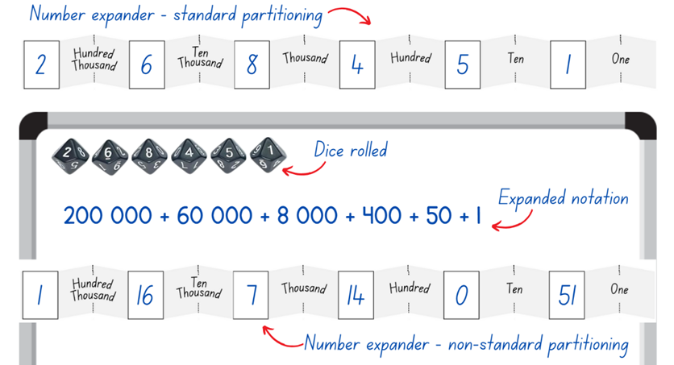
Multi-age: Stage 2 students may start with 4-digit numbers before moving to 5- and 6-digit numbers. Stage 3 students can be challenged to work with larger numbers.
- Students repeat this activity until they demonstrate a clear understanding of regrouping and renaming large numbers.
- Students demonstrate how they used the number expander to read, record, regroup and rename their numbers.
This table details opportunities for differentiation.
Too hard? | Too easy?
Students cannot partition, regroup and rename numbers.  - Support students to represent larger numbers by providing access to physical or virtual MAB materials.  - Reduce the size of the numbers students are working with. | Students can partition, regroup and rename numbers.  - In pairs, students roll a 10-sided die 6 times to make a 6-digit number. Each student must regroup and rename this number in as many ways as they can. Students receive one point for each way that is different to their partner.  - In pairs, students write a 6-digit number using non-standard partitioning. Their partner must work out the original number.

Discuss and connect the mathematics – 5 minutes
- Summarise the lesson together, drawing out key mathematical ideas. Ask:
- When counting your collection, did you use a similar strategy to Earth Day – Hooray?
- How does grouping objects help us count large collections?
- What strategy did you use to regroup and rename your number?
- Was there more than one way to regroup and rename your number?
- Why is working flexibly with numbers important?
This table details opportunities for assessment.
Assessment opportunities | Links
What to look for:  - Can students regroup numbers in different forms? [MAO-WM-01, MA2-RN-01, MA3-RN-01]  - Can students use place value to expand the number notation? [MAO-WM-01, MA2-RN-01, MA3-RN-01]  - Can students partition numbers in non-standard forms? [MAO-WM-01, MA2-RN-01, MA3-RN-01]  - Can Stage 2 students group physical objects to show the structure of tens, hundreds and a thousand? [MAO-WM-01, MA2-RN-01] | Links to National Numeracy Learning Progressions (NNLP):  - Stage 2 – NPV4-6  - Stage 3 – NPV6.  Links to suggested Interview for Student Reasoning (IfSR) tasks:  - Stage 2 – IfSR-NP: 4B.5  - Stage 2 – IfSR-AT: 3B.1, 3B.2, 3B.4  - Stage 3 – IfSR-AT: 3B.4.

Lesson 3
Core concept: the position of each digit in a number corresponds to its size (Stage 2). The place value system can be extended (Stage 3).

Daily number sense – adding numbers – 10 minutes
The table below contains suggested learning intention and success criteria. These are best co-constructed with students.
Daily number sense learning intentions | Daily number sense success criteria
Students working towards Stage 2 outcomes are learning to:  - select strategies flexibly to solve addition and subtraction problems of up to 3 digits.  Students working towards Stage 3 outcomes are learning to:  - apply efficient mental and written strategies to solve addition and subtraction problems. | Students working towards Stage 2 outcomes can:  - apply known mental strategies that use partitioning to add and subtract, such as bridging the decades.  Students working towards Stage 3 outcomes can:  - apply known strategies such as levelling, addition for subtraction, using constant difference and bridging.
This activity is an adaptation of Dicey Operations in Line from NRICH by University of Cambridge (Faculty of Mathematics).
- Stage 2 students draw 6 blank number cells in their workbooks. Stage 3 students draw 9 blank number cells (see Figure 3).
Figure 3 – blank number cells
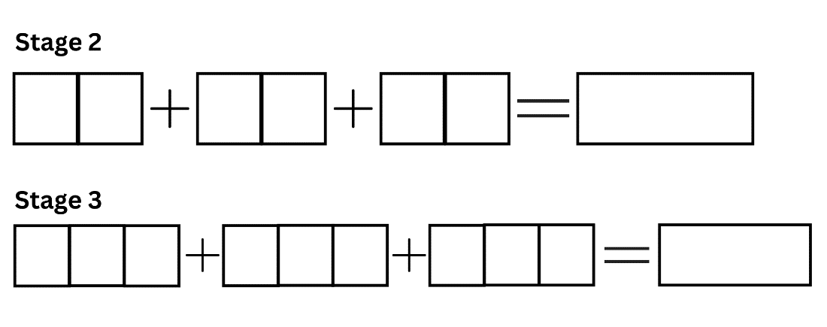
- Students play in pairs, taking turns to roll a 6-sided die. After each roll of the die, students decide which cell to put the number in.
- Students keep rolling the die until they have filled all their cells.
- Students add the 3 numbers. For Stage 2 students, the winner is the student that is closest to 100. For Stage 3 students, the winner is the student that is closest to 1000. The winning number can be higher or lower than the target number.
- Students can play multiple rounds. As students get more familiar with the game, they can work more strategically and fill the cells after they have rolled all their numbers.
This table details opportunities for assessment.
Assessment opportunities | Links
What to look for:  - Can Stage 2 students apply known mental strategies that use partitioning to add and subtract such as bridging the decades? [MAO-WM-01, MA2-AR-01]  - Can Stage 3 students apply known strategies such as levelling, addition for subtraction, using constant difference and bridging? [MAO-WM-01, MA3-AR-01] | Links to National Numeracy Learning Progressions (NNLP):  - Stage 2 – AdS7  - Stage 3 – AdS7, AdS8.

Core lesson – 40 minutes

Stage 2 task – ordering and comparing 4-digit numbers
The table below contains a suggested learning intention and success criteria. These are best co-constructed with students.
Core concept learning intention | Core concept success criteria
Students working towards Stage 2 outcomes are learning to:  - read, represent and order numbers in the thousands. | Students working towards Stage 2 outcomes can:  - group physical or virtual objects to show the structure of tens, hundreds and a thousand  - arrange numbers in the thousands in ascending and descending order  - recognise and describe how rearranging digits changes the size of a number.
- Build student understanding of place value by revising place value houses from Lesson 1. Discuss vocabulary used to order numbers such as ascending and descending.
- Roll four 9-sided dice. Alternatively, virtual manipulatives may be used for this activity.
- Arrange the dice to create a 4-digit number and record this number on the board. Rearrange the dice to create a new 4-digit number and record. Repeat this process until you have created 5 numbers in total (see Figure 4).
Figure 4 – 4-digit numbers
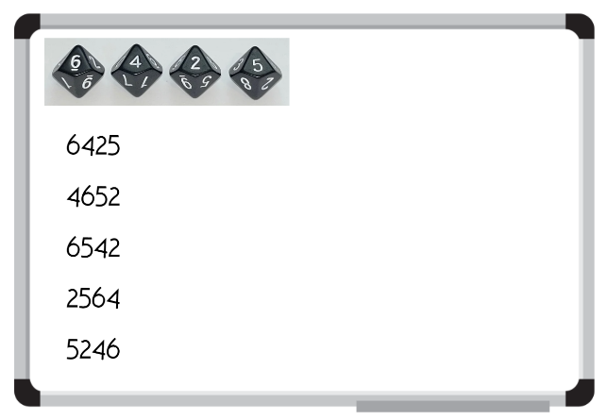
- Model how to arrange the 5 numbers in ascending order, referring to the place value of each digit.
- In pairs, students roll 4 dice to create a 4-digit number.
- Students rearrange the 4 digits to create a new number.
- Students repeat this process until they have created 5 numbers in total and recorded them in their workbooks.
- Using place value knowledge, students write their numbers in ascending order.
- When they are confident their numbers are in the correct order, each pair of students works with another pair to convince them that their numbers are in the correct ascending order, referring to the value of each digit.
- Repeat these steps to create 5 new 4-digit numbers. Students record the numbers in their workbooks and then place them in descending order using place value knowledge.
- Working with a different pair of students, each pair attempts to convince their opponents that their numbers are in the correct descending order, referring to the value of each digit.
This table details opportunities for differentiation.
Too hard? | Too easy?
Students cannot order numbers in ascending and descending order.  - Support students to write their 4-digit number by drawing place value houses to help identify the value of each digit.  - Assist students by reducing the number they create to 3-digits and the amount of numbers to be ordered to 3. | Students can order numbers in ascending and descending order.  - Students to complete same activity, however all 5 of their numbers must have the same digit in the thousands place.  - Challenge students to place their 5 numbers on a blank number line.
- Revise MAB materials, highlighting the value of the units, longs, flats and cubes (see Figure 5).
Figure 5 – MAB understanding
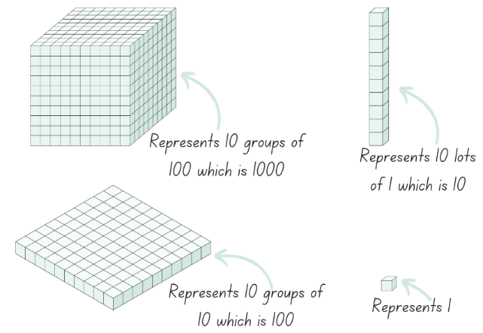
- Describe how making a number 10 times, 100 times or 1000 times as large changes the place value of digits.
- Model how to create the number 463 using MAB materials. Explain that the 4 represents 4 hundreds, which can be renamed as ‘four hundred’.
- Create the number 4271 using MAB materials and explain how the value of the 4 has changed from 4 hundreds to 4 thousands.
- Using MAB materials, students make the numbers from the previous activity, describing the value of each of the digits. For example, Student A creates the largest 4-digit number using MAB materials and explains the role of each of the digits. Student B rearranges the MAB materials to make the second largest number, explaining how the value of each digit has changed. Students repeat for the last 3 numbers and use Resource 4 – place value houses to record their numbers. Support students to identify the value of each digit, starting from the thousands column.
This table details opportunities for differentiation.
Too hard? | Too easy?
Students cannot explain how the value of a number changes when you move its position in a 4-digit number.  - Students write a 3- or 4-digit number in a place value house. Support students to use the headings in their place value house to read the number and identify the value of each digit.  - Students create the number with MAB materials and verbally identify the value of each digit. | Students can explain how the value of a number changes when you move its position in a 4-digit number.  - Students identify numbers which are 10 or 100 more or less than their numbers. Ask students to justify to a friend how they know their answer is correct.  - Challenge students to explain how they could make each of their number without tens or hundreds.

Stage 3 task – thousandths and place value
The table below contains suggested learning intentions and success criteria. These are best co-constructed with students.
Core concept learning intentions | Core concept success criteria
Students working towards Stage 3 outcomes are learning to:  - recognise that the place value system can be extended beyond hundredths  - compare, order and represent decimals. | Students working towards Stage 3 outcomes can:  - express thousandths as decimals  - place decimal numbers of up to 3 decimal places on a number line.
Note: to support place value conceptual understanding, 6.132 would be read as 6 and one hundred and thirty-two thousandths. The word ‘and’ connects the decimal fraction with the whole number and makes a connection with common fractions.
- Write the number 5.3 on the board and ask students how they would read the number (5 and 3 tenths).
- Write the number 5.37 on the board and ask students how they would read the number (5 and 37 hundredths).
- Write the number 5.376 on the board and ask students how they would read the number (5 and 376 thousandths).
- Using Resource 4 – place value houses, students practise reading and writing decimals up to thousandths. For example, Student A writes a decimal in the place value house and reads it aloud to Student B. Student B writes the number in their place value house. Partners then face each other and compare their written decimals. Partners swap roles and repeat.
This table details opportunities for differentiation.
Too hard? | Too easy?
Students cannot read and write decimals up to thousandths.  - Support students by providing Resource 4 – place value houses with the decimals pre-written in the correct places.  - Assist students by reducing the number of decimals places they are attempting to tenths and hundredths. | Students can read and write decimals up to thousandths.  - Students state the number before and after each decimal they have written.  - Working in pairs, students write a number that includes decimals on their whiteboard, without showing their partner. Students take turns to ask questions about their partner’s number. For example, students could ask if their partner’s number has a 4 in the hundreds place or if the numeral in the tenths place is higher than 5. When students think they have enough information, they guess their partner’s number.
This activity is an adaptation of ‘Garden Path’ from State of New South Wales (Department of Education) and ‘Decimals – Good questions’ from Open-ended Maths Activities: Using ‘Good’ Questions to Enhance Learning in Mathematics by Sullivan and Lilburn.
- Display a number line with the numbers 0–10 marked.
- Read aloud the number 5 and three hundred and seventy-six thousandths. Ask students where that number would be on the number line. Students turn and talk and justify their thinking.
- Display Resource 5 – decimals example 1 and explain that the decimal 5.376 is larger than 5 but smaller than 6. Highlight this range on the number line.
- Use this opportunity to reinforce the idea that students should read 5.376 as 5 and 376 thousandths, not five point three seven six.
Note: students may need to revise the trailing zero at the end of a decimal. Highlight that 5 is equivalent to 5.0.
- Display Resource 6 – decimals example 2 and explain that if students zoom in, there are 10 parts between the numbers 5 and 6. 5.376 is larger than 5.3, but smaller than 5.4, so it sits in the range highlighted in purple.
- Display Resource 7 – decimals example 3 and explain that students can zoom in again to see that between these numbers, there are another 10 parts. 5.376 is larger than 5.3, which can be written as 5.30, but is smaller than 5.40. This means there are 100 parts between 5 and 6.
- Display Resource 8 – decimals example 4 and explain that by zooming in again, students can see 10 parts between 5.370 and 5.380. There are now 1000 parts between 5 and 6, because 10 × 10 × 10 = 1000. Explain that students can now find the exact position of 5 and 376 thousandths on the number line (see Figure 6).
Figure 6 – decimal place broken down
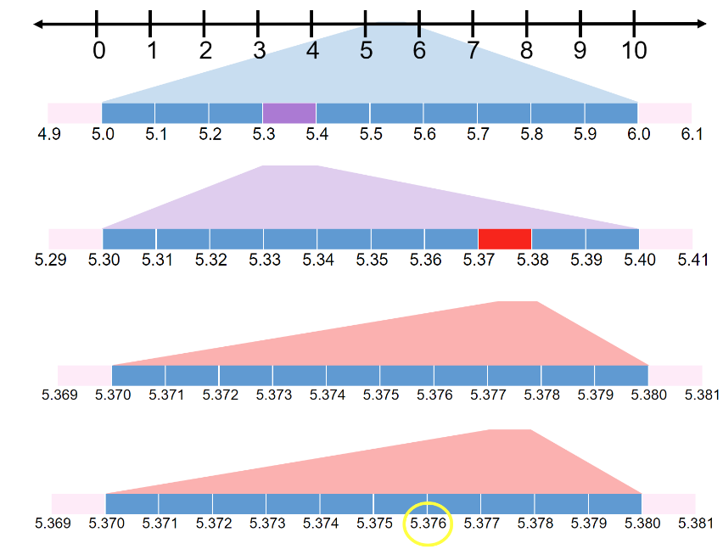
- Display Resource 5 – decimals example 1. Explain that a standard number line doesn’t always show all of the parts, as it would be too hard to show 1000 small parts. Instead, students might show 5.376 on a number line like in the resource.
Note: interpreting decimals used in different contexts can change the way that students read them. In the context of measuring timber, it is appropriate to read the decimal 2.83 as two point eight three metres. Without a relevant context, this decimal is read as two and eighty-three hundredths.
- Write the measurement 2.125 m on the board.
- Pose questions, such as:
- What does the 2 mean in this number?
- What does the 125 mean in this number?
- How does this affect how we deal with these numbers?
- Discuss that 2.125 metres is 2 metres and 125 millimetres.
- Explain that you found a pile of timber pieces that were all different lengths but all measured between 2.1 and 2.2 m long. Ask students how long each piece of timber might be.
- Students work individually or in pairs to find as many solutions as they can and record these on an individual whiteboard.
- Students compare their answers with another group or student, justifying their choices.
This table details opportunities for differentiation.
Too hard? | Too easy?
Students cannot read and write decimals up to thousandths.  - Support students by providing Resource 4 – place value houses with the decimals pre-written in the correct places.  - Assist students by reducing the number of decimal places they are attempting to tenths and hundredths. | Students can read and write decimals up to thousandths.  - Students state the number before and after each decimal they have written.  - Challenge students to choose a whole number that is 2-digits or higher. For example, 23.457.

Discuss and connect the mathematics – 15 minutes
- Ask Stage 2 students:
- How did you know what the value of each digit was?
- How did you know which 4-digit number was the smallest or largest?
- Did you check your answer? How?
- Did using MAB materials support your understanding? Explain your thinking.
- What did you find challenging? How did you overcome any challenges you faced?
- How did you work like a mathematician today?
- Draw a number line and label the ends with 2.1 and 2.2.
- Select Stage 3 students to place one of their answers to the timber problem on the number line and discuss its placement.
- Ask Stage 3 students:
- Why are there multiple solutions?
- Are these all the solutions? Why or why not?
Note: if students do not come to the realisation that the place value system can be extended further by having more decimal places, highlight this during the discussion.
This table details opportunities for assessment.
Assessment opportunities | Links
What to look for:  - Can Stage 2 students group physical or virtual objects to show the structure of tens, hundreds and a thousand? [MAO-WM-01, MA2-RN-02]  - Can Stage 2 students arrange numbers in the thousands in ascending and descending order? [MAO-WM-01, MA2-RN-02]  - Can Stage 2 students recognise and describe how rearranging digits changes the size of a number? [MAO-WM-01, MA2-RN-02]  - Can Stage 3 students express thousandths as decimals? [MAO-WM-01, MA3-RN-02]  - Can Stage 3 students place decimal numbers of up to 3 decimal places on a number line? [MAO-WM-01, MA3-RN-02] | Links to National Numeracy Learning Progressions (NNLP):  - Stage 2 – NPV5, NPV6  - Stage 3 – NPV7, NPV8.  Links to suggested Interview for Student Reasoning (IfSR) tasks:  - Stage 2 – IfSR-NP: 4B.2  - Stage 3 – IfSR-PT: 1A.5, 1A.7  - Stage 3 – IfSR-AT: 4B.1  - Stage 3 – IfSR-NP: 4D.1, 4D.4, 4D.6.

Lesson 4
Core concept: zeros in numbers can have different roles (Stage 2) and the position of each digit in a number corresponds to its size (Stage 3).

Daily number sense – 10 minutes
- From a class need surfaced through formative assessment data, identify a short, focused activity that targets students’ knowledge, understanding and skills. Example activities may be drawn from the following resources:
- Mathematics K-6 resources
- Universal Resources Hub.

Core lesson – 45 minutes

Stage 2 task – understanding the role of zero
The table below contains a suggested learning intention and success criteria. These are best co-constructed with students.
Core concept learning intention | Core concept success criteria
Students working towards Stage 2 outcomes are learning to:  - read, represent and order numbers to thousands. | Students working towards Stage 2 outcomes can:  - identify the role of an internal-zero  - read numbers with an internal-zero  - identify the number before and after a number with an internal zero.
- Display Resource 9 – misconceptions – zero.
- Students decide which answer is correct in Resource 9 – misconceptions – zero and record their answer on an individual whiteboard. Their answer must include the student’s name and why they think that choice is correct.
- Students turn and talk to share their choice. If students are convinced by their partner that their choice is incorrect, they can change their answer.
- As a group, discuss each response in Resource 9 – misconceptions – zero. For example, Pat’s answer is incorrect as he has read the number as 2 separate numbers, not a 4-digit number.
- Write 3402 on the board and invite students to share how they read the number and explain why they read it that way.
- Discuss the role of the internal zero in a 4-digit number. Explain that ‘internal’ means ‘inside’. The zero must be in the tens or hundreds place.
Note: internal zeros in whole numbers can be described as syntactic zeros. They represent a null quantity for a specific power of 10. Internal zeros are more difficult to interpret than lexical zeros, for example, 1002 is more difficult to interpret than 1000. Students need opportunities to learn to read and name the component parts of numbers with internal zeros.
- Repeat the above steps for different numbers containing an internal zero.
- Sit back-to-back with a student. Model writing a 4-digit number, with an internal zero, on an individual whiteboard and then read it to the student. The student attempts to write this number on their own whiteboard.
- Turn to face the student and compare numbers. If your numbers do not match, convince your partner why your number is correct using place value knowledge. For example, ‘I know my number is correct because I said 3021 and my number has a zero in the hundreds place.’
- In pairs, students copy the modelled activity using their own 4-digit numbers with an internal zero.
- Students record the number before and after each number they record on their whiteboard.
This table details opportunities for differentiation.
Too hard? | Too easy?
Students cannot read numbers with an internal-zero digit and identify the number before and after.  - Support students to write their 4-digit number by drawing place value houses to help identify the value of each digit.  - Reduce the number to a 3-digit number. | Students can read numbers with an internal-zero digit and identify the number before and after.  - In pairs, students identify the numbers which are 10 and 100 more and less than the numbers they have written.  - Challenge students to arrange their numbers in ascending and descending order.

Stage 3 task – comparing decimals
The table below contains suggested learning intentions and success criteria. These are best co-constructed with students.
Core concept learning intentions | Core concept success criteria
Students working towards Stage 3 outcomes are learning to:  - recognise that the place value system can be extended beyond hundredths  - compare, order and represent decimals. | Students working towards Stage 3 outcomes can:  - indicate the place value of digits in decimal numbers of up to 3 decimal places  - compare and order decimal numbers of up to 3 decimal places  - place decimal numbers of up to 3 decimal places on a number line.
This activity is an adaptation of Identifies, represents and compares decimals from Universal Resources Hub by State of New South Wales (Department of Education).
- Display Resource 10 – misconceptions – decimals.
- Students to decide which answer is correct in Resource 10 – misconceptions – decimals and record their answer on an individual whiteboard. Their answer must include the student’s name and why they think that choice is correct.
- Students turn and talk to share their choice. If students are convinced by their partner that their choice is incorrect, they can change their answer.
- As a group, discuss each response in Resource 10 – misconceptions – decimals. For example, Kate’s answer is incorrect because she has ignored the decimal point.
Note: NSW Mathematics K–10 Syllabus Teaching Advice outlines potential misconceptions students may have, such as:
- longer decimals are always larger decimals, for example, 0.75 is larger than 0.8
- interpreting the decimal portion as a whole number
- the decimal separator is a space between whole numbers
- when zero is in the tenths place, students sometimes ignore it and treat the following digit as if it is in the tenths place, for example, 0.07 is the same as 0.7.
Mathematics K–10 Syllabus © NSW Education Standards Authority (NESA) for and on behalf of the Crown in right of the State of New South Wales, 2022.
- Display the decimals 0.752 and 0.8 on the board. In pairs, students turn and talk to discuss which decimal they think is the largest.
- Invite some students to share their thoughts with the class and justify their answer.
- Model comparing the place value of each of the digits by drawing them in a place value house and representing it on a number line (see Figure 7).
Figure 7 – longer is larger?
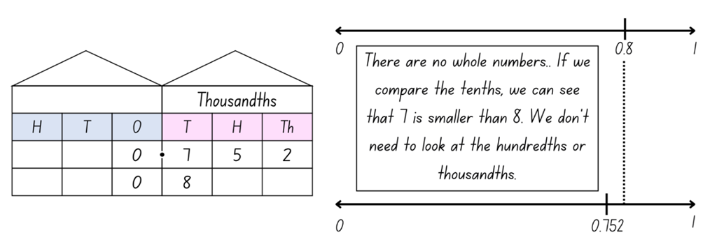
- Explain that there are multiple ways to determine which decimal is largest. There are no whole numbers in either decimal, so students must move to the tenths. Seven-tenths is smaller than eight-tenths, so students don’t need to move onto the hundredths. Students could put a zero in the empty hundredths and thousandths columns to represent that 0.8 is the same as 0.800. This would not change the size of the number; however, it helps with comparing the size of decimals. Explain that students can now see that 752 thousandths or 0.752 is smaller than 800 thousandths or 0.8, proving that the longest decimal is not always the largest.
- Write 2 decimals on the board.
- Students compare the decimals, represent them on an empty number line and determine which is largest.
This table details opportunities for differentiation.
Too hard? | Too easy?
Students cannot indicate the place value of digits in decimal numbers and order decimal numbers.  - Students compare decimals with the same number of decimal places.  - Students write their decimals in Resource 4 – place value houses to assist in comparing.  - Provide students with decimals that are further apart to compare and place on a number line. | Students can indicate the place value of digits in decimal numbers and order decimal numbers.  - Students decrease the range of their number line. For example, if comparing 0.8 and 0.752, label the ends of their number line with 0.7 and 0.9.  - Challenge students to compare 3 or more decimal numbers at a time.
This activity is an adaptation of Reaction time test from Mathematics K-6 resources by State of New South Wales (Department of Education).
- In small groups, students conduct the reaction time test:
- One student holds a ruler at shoulder height with the zero mark at the bottom.
- A second student places their hand around the bottom of the ruler, without touching it, ready to catch.
- The first student drops the ruler at an unpredictable time.
- The second student catches the ruler with their thumb and finger, recording where on the ruler their thumb lands.
- Each student in the group has a turn and all reaction times are recorded.
- Students use Resource 11 – reaction times to determine their reaction times.
- Students order their group member’s reaction times on a number line.

Discuss and connect the mathematics – 10 minutes
- Summarise the lesson together drawing out key mathematical ideas. Ask:
- How did you know what the value of each digit was?
- What is the role of an internal zero? (Stage 2)
- Was it more difficult to determine the number before or after a number with an internal zero? Why? (Stage 2)
- Are longer decimals always larger? Justify your answer. (Stage 3)
- Did you check your answer? How?
- What did you find challenging? How did you overcome any challenges you faced?
This table details opportunities for assessment.
Assessment opportunities | Links
What to look for:  - Can Stage 2 students identify the role of an internal zero? [MAO-WM-01, MA2-RN-01]  - Can Stage 2 students read numbers with an internal zero? [MAO-WM-01, MA2-RN-01]  - Can Stage 2 students identify the number before and after a number with an internal zero? [MAO-WM-01, MA2-RN-01]  - Can Stage 3 students indicate the place value of digits in decimal numbers of up to 3 decimal places? [MAO-WM-01, MA3-RN-02]  - Can Stage 3 students compare and order decimal numbers of up to 3 decimal places? [MAO-WM-01, MA3-RN-02]  - Can Stage 3 students place decimal numbers of up to 3 decimal places on a number line? [MAO-WM-01, MA3-RN-02] | Links to National Numeracy Learning Progressions (NNLP):  - Stage 2 – NPV4, NPV5, NPV6  - Stage 3 – NPV7, NPV8.  Links to suggested Interview for Student Reasoning (IfSR) tasks:  - Stage 3 – IfSR-PT: 1A.5, 1A.7  - Stage 3 – IfSR-AT: 4B.1  - Stage 3 – IfSR-NP: 4D.2, 4D.4, 4D.6.

Lesson 5
Core concept: numbers can be renamed in equivalent ways using place value (Stage 2) and decimals can be compared by analysing the place values parts (Stage 3).

Daily number sense – target number– 15 minutes
Daily number sense activities for Lessons 5 to 7 ‘loop’ back to concepts and procedures covered in previous units to assist students to build an increasingly connected network of ideas. These concepts may differ from the core concepts being covered by the unit.
The table below contains suggested learning intentions and success criteria. These are best co-constructed with students.
Daily number sense learning intentions | Daily number sense success criteria
Students working towards Stage 2 outcomes are learning to:  - recognise and explain the connection between addition and subtraction.  Students working towards Stage 3 outcomes are learning to:  - apply efficient mental and written strategies to solve addition and subtraction problems | Students working towards Stage 2 outcomes can:  - use number relation principles to solve related problems.  Students working towards Stage 3 outcomes can:  - apply known strategies such as levelling, addition for subtraction, using constant difference and bridging.
This activity is an adaptation of Target Number from Math for Love by Finkel.
- Write a 2-digit ‘target’ number on the board.
- Using individual whiteboards, students write down as many different number sentences that have the target number as the answer. They must use addition and subtraction in their number sentence. For example, 32 + 7 − 4 = 35.
- Students turn and talk to a partner to share one of their number sentences and describe the strategies they used to create it.
- Ask the class:
- What would happen if only addition or only subtraction was used?
- What did you notice about the relationship between addition and subtraction?
- What is the longest number sentence you created?
- What strategies did you use to check that your number sentences were correct?
- Can you create a number sentence for the target number that uses every digit from 0–9?
Multi-age: students working towards Stage 3 outcomes should use a larger target number that has at least 3 digits.
This table details opportunities for assessment.
Assessment opportunities | Links
What to look for:  - Can Stage 2 students use number relation principles to solve related problems? [MAO-WM-01, MA2-AR-01]  - Can Stage 3 students apply known strategies such as levelling, addition for subtraction, using constant difference and bridging? [MAO-WM-01, MA3-AR-01] | Links to National Numeracy Learning Progressions (NNLP):  - Stage 2 – AdS6, AdS7  - Stage 3 – AdS7, AdS8.  Links to suggested Interview for Student Reasoning (IfSR) tasks:  - Stage 2 – n/a  - Stage 3 – IfSR-AT: 3.4, 3.5.

Core lesson – 45 minutes

Stage 2 task – partitioning numbers
The table below contains a suggested learning intention and success criteria. These are best co-constructed with students.
Core concept learning intention | Core concept success criteria
Students working towards Stage 2 outcomes are learning to:  - apply place value to partition and regroup numbers up to 4 digits. | Students working towards Stage 2 outcomes can:  - record numbers using standard place value form  - partition numbers of up to 4 digits in non-standard forms.
This activity is an adaptation of Partitioning numbers using place value parts (10:37) from ABC Education by ABC (Australian Broadcasting Corporation).
- Display Resource 12 – Which doesn’t belong? and explain that there are 4 collections to think about. The collections can be sorted and classified several ways. Students Think-Pair-Share and decide which of the collections does not belong.
- Select pairs to share which collection they have decided doesn't belong and explain their reasoning.
Note: it could be argued that all 4 collections don’t belong (see Figure 8). This is something that could be discussed with students once they have had the opportunity to think about their own ideas first.
Figure 8 – all collections don’t belong
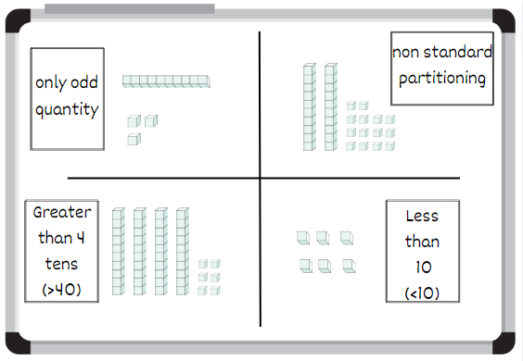
- Display Resource 13 – collections of 1224.
- Prove that the 3 collections have the same amount by identifying how many thousands, hundreds, tens and ones are in each collection. Identify which representation uses standard place value form and which use non-standard place value form.
- Rename the total as 1224 and write it underneath the collection (see Figure 9).
Figure 9 – annotated collections of 1224
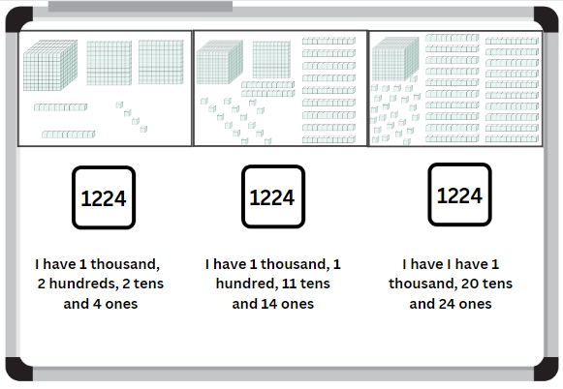
- Model how to organise Resource 13 – collections of 1224 into a table (see Figure 10).
Figure 10 – table containing collections of 1224
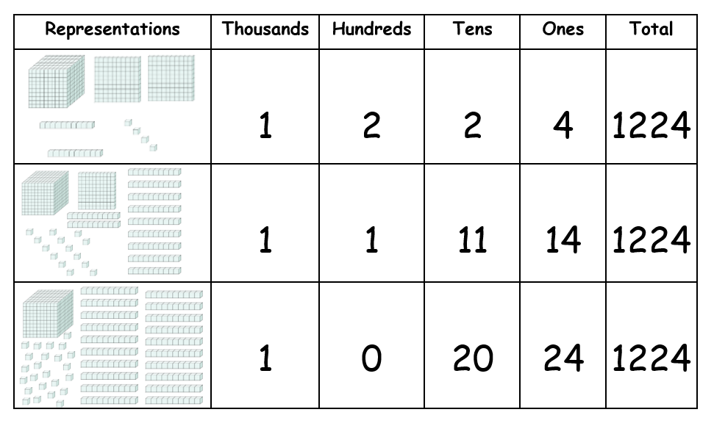
- Students turn and talk to discuss additional ways to represent 1224 using MAB materials.
- Select students to share their thinking. Use MAB materials to represent any additional combinations of 1224 that can be represented.
Note: order the representations based on how many hundreds are in the number to show all possible combinations. Make connections between counting sequences of the hundreds, tens and ones in the combination.
- Provide students with different numbers up to 9999.
- Students use MAB materials to represent the number using standard place value form and additional non-standard forms.
- Students to complete Resource 14 – table of combinations to show the different representations of their number. This could be completed individually or in pairs.
This table details opportunities for differentiation.
Too hard? | Too easy?
Students cannot partition numbers of up to 4 digits in non-standard forms.  - Students identify only the standard place value form to partition numbers.  - Teacher models how to partition the non-standard place value forms and ask students to identify how many thousands, hundreds, tens and ones are in each representation. | Students can partition numbers of up to 4 digits in non-standard forms.  - Students partition 5-digit numbers into standard and non-standard place value form.  - Students explain how they partitioned their 5-digit number.

Stage 3 task – comparing 2 decimals
The table below contains a suggested learning intention and success criteria. These are best co-constructed with students.
Core concept learning intention | Core concept success criteria
Students working towards Stage 3 outcomes are learning to:  - compare, order and represent decimals. | Students working towards Stage 3 outcomes can:  - compare and order decimal numbers of up to 3 decimal places.
This activity is an adaptation of Understanding place value in decimals from Universal Resources Hub by State of New South Wales (Department of Education).
- Explain that 2 babies were born. One weighed 3.5 kg and other 3.25 kg. Ask the class which baby weighed less.
- Provide students with Resource 15 – Blank decimal grid to represent the problem. Use a different colour to represent each weight.
- Students turn and talk to discuss their answer.
- As a class, students share their answers and explain their solutions.
- Model using the language of place value to compare the decimals. For example, 3 and 25 hundredths is the smaller decimal because it has 2 tenths, which is smaller than the 5 tenths in the decimal 5 and 5 tenths.
- In pairs, students use Resource 16 – comparing decimals to compare each pair of decimals.
- As a class, discuss the answers, inviting students to justify their thinking.
- Present Stage 3 students with the following problem: The heights of 3 adults were recorded as 1.7 m, 1.27 m and 1.827 m. Ask which adult is the tallest. Order the heights in descending order.
- Students work independently to order the heights in descending order and record their thinking.
- Stage 3 students share their answers and discuss how they represented their thinking.
- Discuss the different efficient representations used. Explain why using the decimal grid would be an inefficient representation when working with numbers of up to 3 decimal places.
Note: Stage 3 students are not expected to construct a hundredths grid. They need to be able to explain that it can be made by making another 10 squares in each of the 100 squares and then to further explain that the value is smaller. Representing the hundredths on a decimal grid is inefficient.
This table details opportunities for differentiation.
Too hard? | Too easy?
Students cannot compare and order decimals up to 3 decimal places.  - Provide students with numbers that have a reduced number of decimal places to assist students to compare 2 decimals.  - Encourage students to colour Resource 15 – Blank decimal grid to represent each decimal to assist with comparison. | Students can compare and order decimals up to 3 decimal places.  - Students plot their answers on an empty number line.  - Students pick a number in between the 2 original numbers and plot on a number line. Students justify their responses to a classmate.

Discuss and connect the mathematics – 5 minutes
- Reflect on the lesson as a class. Ask students:
- Why is partitioning important when dealing with non-standard collections? (Stage 2)
- How does partitioning help us organise and categorise collections? (Stage 2)
- How did the table help you to organise and represent your thinking? (Stage 2)
- What strategies did you use when comparing the tenths and hundredths places in decimal numbers? (Stage 3)
- What challenges did you find when ordering decimals? (Stage 3)
This table details opportunities for assessment.
Assessment opportunities | Links
What to look for:  - Can Stage 2 students record numbers using standard place value form? [MAO-WM-01, MA2-RN-01]  - Can Stage 2 students partition numbers of up to 4 digits in non-standard forms? [MAO-WM-01, MA2-RN-01]  - Can Stage 3 students compare and order decimals up to 3 decimal places? [MAO-WM-01, MA3-RN-02] | Links to National Numeracy Learning Progressions (NNLP):  - Stage 2 – NPV4, NPV5, NPV6  - Stage 3 – NPV8.  Links to suggested Interview for Student Reasoning (IfSR) tasks:  - Stage 2 – IfSR-AT: 3B.2, 3B.3, 3B.4  - Stage 3 – IfSR-PT: 1A.5, 1A.7  - Stage 3 – IfSR-AT: 4B.1  - Stage 3 – IfSR-NP: 4D.1, 4D.4, 4D.6.

Lesson 6
Core concept: place value understanding helps solve addition and subtraction problems.

Daily number sense – guess the number – 10 minutes
The table below contains suggested learning intentions and success criteria. These are best co-constructed with students.
Daily number sense learning intentions | Daily number sense success criteria
Students working towards Stage 2 outcomes are learning to:  - apply place value to partition, regroup and rename numbers up to 6 digits.  Students working towards Stage 3 outcomes are learning to:  - recognise, represent and order numbers in the millions. | Students working towards Stage 2 outcomes can:  - name thousands using the place value grouping of ones, tens and hundreds of thousands.  Students working towards Stage 3 outcomes can:  - name millions using the place value grouping of ones, tens and hundreds.
This activity is an adaptation of Mastermind from Mathematics K-6 resources by State of New South Wales (Department of Education).
- In pairs, students write down a number without showing the other player.
Muti-age: Stage 2 students record 6-digit numbers and Stage 3 students record 7-digit numbers.
- Players take turns to guess their opponent’s number. Guessed numbers should be written down, said aloud and named correctly using place value grouping.
- After each guess, students tell their opponent how many digits are correct, how many are in the correct place and how many are incorrect by using symbols underneath each number. Students use a tick for the correct number and place, a circle for the correct number but not the correct place and a cross for an incorrect number. If for example, the number is 7 246 384 and the guess is 3 217 689, there are 2 correct digits in the correct place, 3 correct digits in the wrong place and 2 incorrect digits (see Figure 11). The numbers in the tens and hundred thousands place are correct, the numbers in the millions, thousands and hundreds place are in the wrong place and the numbers in the ones and ten thousands place are incorrect.
Figure 11 – example Stage 3 number
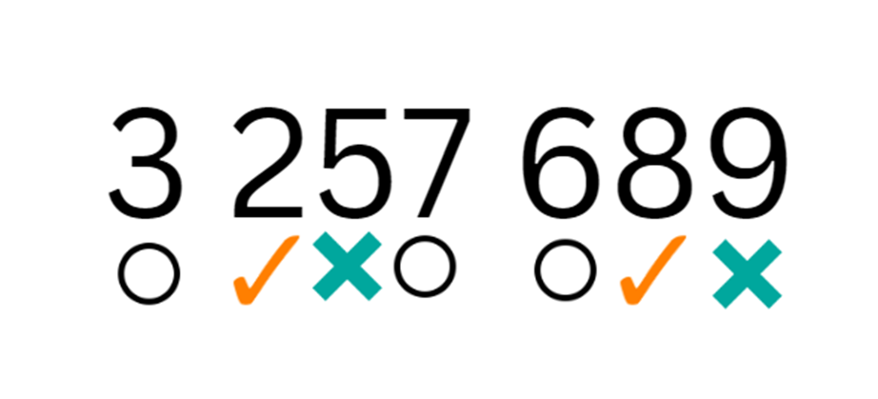
- Players use the information to refine their guess.
- The first player to correctly guess their opponent’s number is the winner.
- After the game, ask questions such as:
- How many guesses did it take to get the correct number?
- What could you do to make it more difficult for your opponent?
- What advice would you give to someone who hasn’t played the game before?
This table details opportunities for assessment.
Assessment opportunities | Links
What to look for:  - Can Stage 2 students name thousands using the place value grouping of ones, tens and hundreds of thousands? [MAO-WM-01, MA2-RN-01]  - Can Stage 3 students name numbers in the millions using the place value groupings of ones, tens and hundreds? [MAO-WM-01, MA3-RN-01] | Links to National Numeracy Learning Progressions (NNLP):  - Stage 2 – NPV7  - Stage 3 – NPV7.

Core lesson – 45 minutes

Stage 2 task – bridging the decades
The table below contains a suggested learning intention and success criteria. These are best co-constructed with students.
Core concept learning intention | Core concept success criteria
Students working towards Stage 2 outcomes are learning to:  - select strategies flexibly to solve addition and subtraction problems of up to 3 digits. | Students working towards Stage 2 outcomes can:  - apply known mental strategies that use partitioning to add and subtract, such as bridging the decades.
Partitioning is dividing a quantity into parts.
Bridging the decade: decades are multiples of 10 (for example, 10, 20, 30 and so on). Bridging decades involves using multiples of 10 as landing points for adding and subtracting (AAMT n.d.).
- Use an interactive 120 number chart or Resource 17 – 120 number chart to demonstrate how to solve the addition problem, 46 + 28. For example, start at 46 and bridge to the nearest decade by counting on 4 ones to reach the landmark number of 50. From 50, count on 2 tens to reach 70. Then count on 4 ones to land on the answer of 74 (see Figure 12).
Figure 12 – 120 number chart for addition
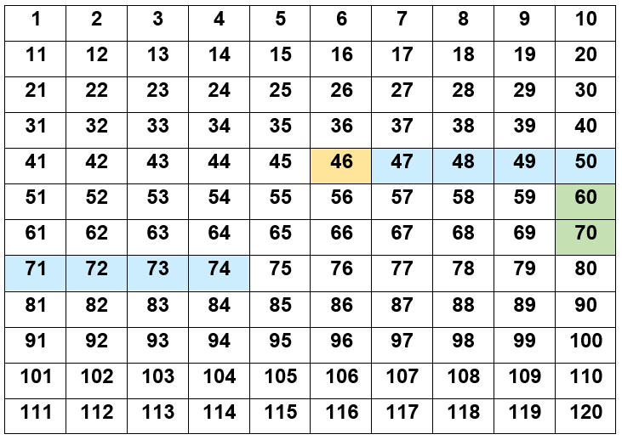
Note: use a different colour to represent the starting number, the ones and the tens. For example, yellow for the starting number, blue for the ones and green for the tens. If using a printed copy of the Resource 17 – 120 number chart use different coloured counters.
- Record each step on the board using a number sentence. For example, 46 + 4 + 20 + 4 = 74.
- In pairs, students use Resource 17 – 120 number chart and Resource 18 – addition number sentences to solve and record the addition problems. For example, Student A reads a number sentence aloud and solves the equation on the number chart. Student B records the steps as a number sentence on an individual whiteboard.
- Demonstrate how to solve the subtraction problem, 52 − 18 (see Figure 13). For example, start at 52 and bridge to the nearest decade by subtracting 2 ones to reach the landmark number of 50. From 50, subtract 1 ten to reach 40. Then subtract 6 ones to land on the answer of 34.
Figure 13 –120 number chart for subtraction
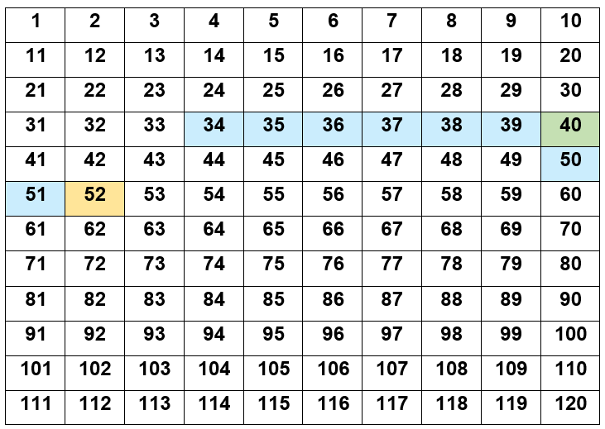
- Record each step on the board using a number sentence. For example, 52 − 2 − 10 − 6 = 34.
- In pairs, students use Resource 19 – subtraction number sentences to solve the subtraction problems. Students record the steps as a number sentence.
This table details opportunities for differentiation.
Too hard? | Too easy?
Students cannot apply known mental strategies that use partitioning to add and subtract, such as bridging the decades.  - Students place counters on each number as they count by ones.  - Provide students with MAB materials to support the count. | Students can apply known mental strategies that use partitioning to add and subtract, such as bridging the decades.  - Students add a 2-digit number and a 3-digit number using the same method.  - Students subtract a 2-digit number from a 3-digit number using the same method.  - Students calculate their sentences mentally, describing the steps to a partner who records the steps on the number chart.

Stage 3 task – addition for subtraction
The table below contains a suggested learning intention and success criteria. These are best co-constructed with students.
Core concept learning intention | Core concept success criteria
Students working towards Stage 3 outcomes are learning to:  - apply efficient mental and written strategies to solve addition and subtraction problems. | Students working towards Stage 3 outcomes can:  - apply the addition for subtraction strategy  - identify efficient and inefficient multidigit subtraction strategies.
- Display Resource 20 – efficient additive strategies and ask students:
- Which strategy is more efficient?
- How do you know?
Note: solving 183 − 96 by making 183 marks and then crossing off 96 before counting the remaining marks is an inefficient strategy. This method is sometimes described as ‘counting from one 3 times’ (count one to draw the 183 marks, count 2 to cross out 96 and count 3 to count how many are left over). Although it ultimately arrives at the answer, this strategy takes too long and is prone to errors. Sometimes it is easier to use addition for subtraction than to subtract the smaller number.
- Model using the addition for subtraction strategy to solve the subtraction problem 209 − 197 = 12 (see Figure 14).
Figure 14 – addition for subtraction example
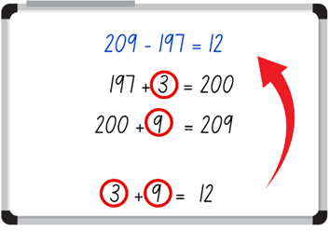
- Display the number sentence 481 − 134. Collaboratively work through the steps with the students as they complete the same problem on their own individual whiteboard (see Figure 15).
Figure 15 – addition for subtraction example 2
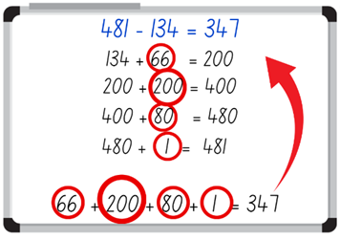
- Repeat this process until students can confidently use the addition for subtraction strategy.
- Using Resource 21 – codeword, students work independently to solve 6 word problems and record their answers on Resource 22 – codeword answer sheet.
Note: Resource 21 – codeword contains 3 differentiated levels to cater for student needs:
Circle: 2-digit number subtracting a 2-digit number.
Triangle: 3-digit number subtracting a 2-digit number.
Square: 3-digit number subtracting a 3-digit number.
Students only need to complete one level for each of the 6 problems.
- After each problem has been solved, students submit their solution and receive a letter for every correct answer. The letters for the codeword spell SOLVED. Letters can be told in any order.
- Once all word problems have been solved, students use the letters to reveal a codeword on Resource 22 – codeword answer sheet.
Note: problems do not need to be solved in order. The activity can be set up as stations around the classroom.
This table details opportunities for differentiation.
Too hard? | Too easy?
Students cannot apply the addition for subtraction strategy.  - Students complete the ‘circle’ word problems.  - Assist students by providing them with Resource 23 – solution scaffold to structure their working out. | Students can apply the addition for subtraction strategy.  - Students complete the ‘square’ word problems.  - Students to create own ‘codeword’ activity for a partner to solve.

Discuss and connect the mathematics – 10 minutes
- Reflect on the lesson as a class. Ask students:
- What information did you need to know to use the strategy ‘bridging the decades’ (Stage 2) or ‘addition for subtraction’ (Stage 3)?
- How is this strategy useful?
- When would you use this strategy?
- What other strategies could you use to solve the addition and subtraction problems?
This table details opportunities for assessment.
Assessment opportunities | Links
What to look for:  - Can Stage 2 students apply known mental strategies that use partitioning to add and subtract, such as bridging the decades? [MAO-WM-01, MA2-AR-01]  - Can Stage 3 students apply the addition for subtraction strategy? [MAO-WM-01, MA3-AR-01]  - Can Stage 3 students identify efficient and inefficient multidigit subtraction strategies? [MAO-WM-01, MA3-AR-01] | Links to National Numeracy Learning Progressions (NNLP):  - Stage 2 – AdS7  - Stage 3 – AdS7, AdS8.  Links to suggested Interview for Student Reasoning (IfSR) tasks:  - Stage 2 – IfSR-AT: 2A.2, 3A.2  - Stage 3 – IfSR-AT: 3A.1, 3A.4, 3A.5.

Lesson 7
Core concept: number lines help solve addition and subtraction problems.

Daily number sense – reading large numbers – 10 minutes
The table below contains suggested learning intentions and success criteria. These are best co-constructed with students.
Daily number sense learning intentions | Daily number sense success criteria
Students working towards Stage 2 outcomes are learning to:  - apply place value to partition, regroup and rename numbers up to 6 digits.  Students working towards Stage 3 outcomes are learning to:  - apply place value to partition, regroup and rename numbers to 1 billion. | Students working towards Stage 2 outcomes can:  - name thousands using the place value grouping of ones, tens and hundreds of thousands.  Students working towards Stage 3 outcomes can:  - recognise 1000 thousands is one million and 1000 millions is one billion.
This activity is an adaptation of ‘Reading large numbers’ from Teaching Mathematics Foundations to Middle Years by Siemon et al.
- Have students take turns to roll a 9-sided die. As each number is rolled, ask students to read it out.
- Write a series of numbers on the board, going from right to left and, as each new number is added, have students read them out. For example, 7, 17, 317, 4317, 94 317.
- Roll the die 9 times, reading each new number as it gets bigger.
Note: this illustrates the re-use of hundreds, tens and ones to name larger place value units and the pattern ‘1000 of these is one of those’ (Siemon et al. 2020).
- Repeat the activity, but this time, record and say the numbers from left to right.
- Discuss how hundreds, tens and ones are re-used to name larger numbers, just as in the place value houses.
Multi-age: students working towards Stage 2 outcomes read numbers to 6 digits.
This table details opportunities for assessment.
Assessment opportunities | Links
What to look for:  - Can Stage 2 students name thousands using the place value grouping of ones, tens and hundreds of thousands? [MAO-WM-01, MA2-RN-01]  - Can Stage 3 students recognise 1000 thousands is 1 million and 1000 millions is 1 billion? [MAO-WM-01, MA3-RN-01] | Links to National Numeracy Learning Progressions (NNLP):  - Stage 2 – NPV7  - Stage 3 – NPV7.

Core lesson – addition and subtraction with number lines – 45 minutes
The table below contains suggested learning intentions and success criteria. These are best co-constructed with students.
Core concept learning intentions | Core concept success criteria
Students working towards Stage 2 outcomes are learning to:  - select strategies flexibly to solve addition and subtraction problems of up to 3 digits.  Students working towards Stage 3 outcomes are learning to:  - apply efficient mental and written strategies to solve addition and subtraction problems. | Students working towards Stage 2 outcomes can:  - apply known mental strategies that use partitioning to add and subtract such as bridging the decades  - represent solutions to addition and subtraction problems, including word problems, using an empty number line.  Students working towards Stage 3 outcomes can:  - apply known strategies such as levelling, addition for subtraction, using constant difference and bridging.  - identify efficient and inefficient multidigit subtraction strategies.
- Demonstrate to students how to solve addition problems using an empty number line to:
- bridge the decade, for example, 46 + 28 = ? (see Figure 16).
- represent partitioning, 471 + 385 = ? (see Figure 17).
Figure 16 – bridge the decade
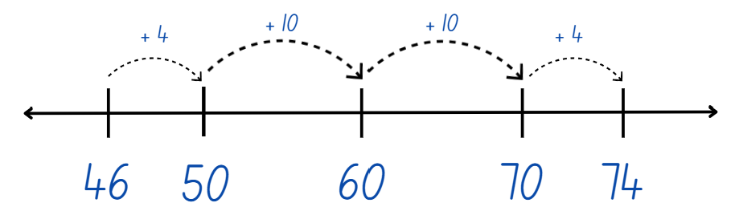
Figure 17 – partitioning
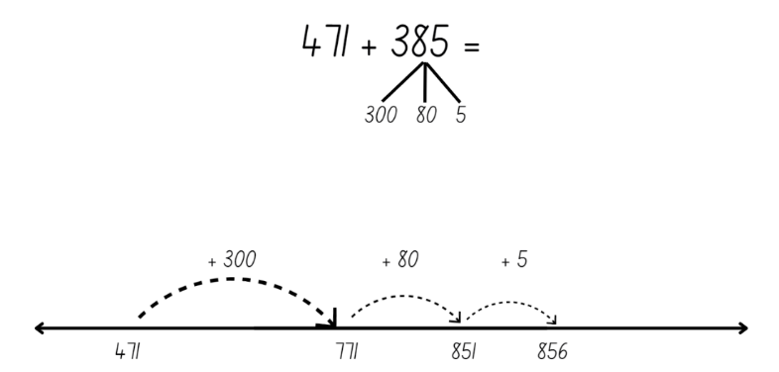
- Students use Resource 18 – addition number sentences from previous lesson and show their thinking on a blank number line.
Multi-age: students working towards Stage 3 outcomes add numbers with 3 or 4 digits.
- Ask students if the same strategy could be used to solve subtraction problems.
- Provide examples using bridging (see Figure 18) for 52 − 18 = ? and standard partitioning (see Figure 19) for 832 − 296 = ?
Figure 18 – subtracting with bridging
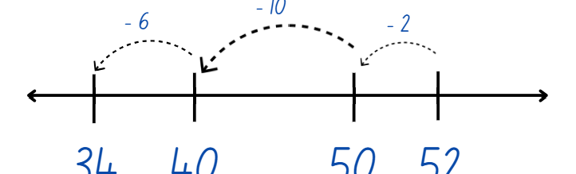
Figure 19 – standard partitioning
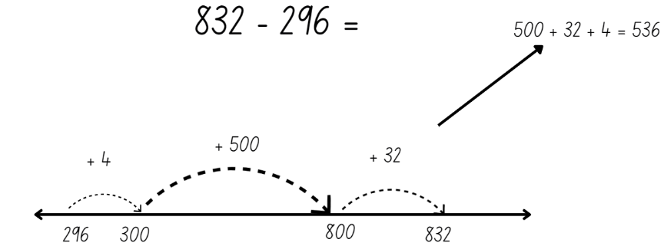
- Students use Resource 19 – subtraction number sentences and show their thinking on a blank number line.
Multi-age: students working towards Stage 3 outcomes subtract numbers with 3 or 4 digits.
- Students share their solutions with a partner and discuss the strategies used.
- Provide an opportunity for students to report back to the class, justifying their decisions and reasoning.
This table details opportunities for differentiation.
Too hard? | Too easy?
Stage 2 students cannot bridge the decade to solve addition and subtraction problems.  - Students use MAB materials.  - Students use a number chart.  Stage 3 students cannot apply place value knowledge to solve addition and subtraction problems.  - Students use 2-digit numbers.  - Students use a number chart to support the count. | Stage 2 students can bridge the decade to solve addition and subtraction problems.  - Students add 2-digit numbers and 3-digit numbers.  - Students subtract 2-digit numbers from 3-digit numbers.  Stage 3 students can apply place value knowledge to solve addition and subtraction problems.  - Students use another strategy to check their calculations, then convince a classmate which strategy is the most efficient.  - Students add or subtract 3 or more numbers with different numbers of digits. They can use a number spinner or dice to create their numbers.

Discuss and connect the mathematics – 5 minutes
- Reflect on the lesson as a class. Ask students:
- What information did you need to know to use this strategy?
- Why do we bridge to the nearest decade?
- How is this strategy useful?
- Is partitioning a number to bridge to the decade an efficient strategy? Why?
- When would you use this strategy?
This table details opportunities for assessment.
Assessment opportunities | Links
What to look for:  - Can Stage 2 students apply known mental strategies that use partitioning to add and subtract, such as bridging the decades? [MAO-WM-01, MA2-AR-01]  - Can Stage 2 students represent solutions to addition and subtraction problems, including word problems, using an empty number line? [MAO-WM-01, MA2-AR-01]  - Can Stage 3 students apply known strategies such as levelling, addition for subtraction, using constant difference and bridging? [MAO-WM-01, MA3-AR-01]  - Can Stage 3 students identify efficient and inefficient multidigit subtraction strategies.? [MAO-WM-01, MA3-AR-01] | Links to National Numeracy Learning Progressions (NNLP):  - Stage 2 – AdS6, AdS7  - Stage 3 – AdS7, AdS8.  Links to suggested Interview for Student Reasoning (IfSR) tasks:  - Stage 3 – IfSR-AT: 3A.4, 3A.5.

Lesson 8
Core concept: addition and subtraction are connected.

Daily number sense – 10 minutes
- From a class need surfaced through formative assessment data, identify a short, focused activity that targets students’ knowledge, understanding and skills. Example activities may be drawn from the following resources:
- Mathematics K-6 resources
- Universal Resources Hub.

Core lesson – 40 minutes

Stage 2 task – inverse operations
The table below contains a suggested learning intention and success criteria. These are best co-constructed with students.
Core concept learning intention | Core concept success criteria
Students are learning to:  - recognise and explain the connection between addition and subtraction. | Students can:  - identify that addition and subtraction are inverse operations  - represent the relationship between addition and subtraction using a bar model.
- Revise the role of the equal sign and discuss that it means ‘equivalence’ when used in a number sentence. For example, the number sentence 40 = 27 + 13 means 40 is the same as 27 + 13 or 40 is equivalent to 27 + 13.
- Show students what a completed bar model looks like, focusing on how it represents part-part-whole (see Figure 20).
Figure 20 – completed bar model
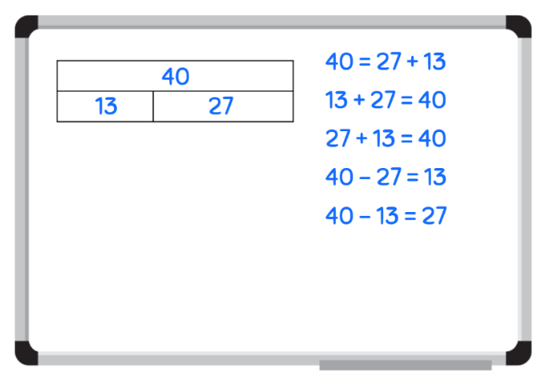
- Give each student a piece of an incomplete bar model from Resource 24 – bar model puzzle. Students must find the other parts that match their puzzle piece to complete the bar model (see Figure 21). By the end of the activity, students should be in groups of 3.
Figure 21 – matching bar model puzzle cards
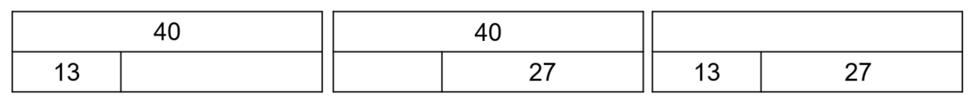
- Ask students:
- Did you find your ability to partition number helpful during this activity? How?
- How does the bar model show a relationship between numbers?
- What mathematical operation did you use to find the missing value?
- What else did you notice?
- Using one of the bar model cards from the puzzle activity, explain how the bar model represents the relationship between addition and subtraction.
- Model writing number sentences, using both addition and subtraction operations (see Figure 22).
Figure 22 – relationship between addition and subtraction
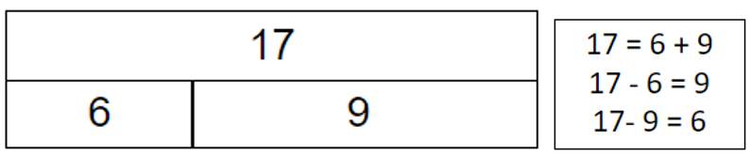
- Use Resource 25 – number cards to draw a blank bar model and complete the number sentences. Highlight the relationship between addition and subtraction when completing this activity (see Figure 23).
Figure 23 – worked example
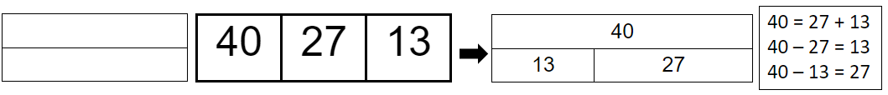
- Students complete the above activity independently for the remaining number on Resource 25 – number cards.
This table details opportunities for differentiation.
Too hard? | Too easy?
Students cannot recognise the relationship between addition and subtraction.  - Provide students with the opportunity to work in pairs to support their learning.  - Give students the completed bar model so that they can write the corresponding inverse number sentences. | Students can recognise the relationship between addition and subtraction.  - Challenge students to create a number problem for their partner to solve.  - Challenge students to write a word problem using Resource 25 – number cards or from the completed bar models from Resource 24 – bar model puzzle.

Stage 3 task – choosing efficient strategies
The table below contains a suggested learning intention and success criteria. These are best co-constructed with students.
Core concept learning intention | Core concept success criteria
Students are learning to:  - apply efficient mental and written strategies to solve addition and subtraction problems. | Students can:  - apply known strategies to solve addition and subtraction problems  - identify efficient and inefficient addition and subtraction strategies  - solve word problems involving addition and subtraction.
- Provide students Resource 26 – word problems and brainstorm strategies students could use to solve the first problem, for example, levelling, addition for subtraction, constant difference, bridging the decade and inverse operations.
- List the strategies on the board.
- Students work independently to solve the problem using an efficient strategy of their choice. Students record their answer and thinking in their workbooks.
- Place student solutions around the classroom and have students conduct a gallery walk.
- Ask students:
- What did you notice?
- Did you see the same strategy that you used?
- Did you see a strategy you might like to try?
- Was there a strategy you didn’t understand?
- Invite students with different strategies to share with the group and reflect on the efficiency or inefficiency of that strategy.
Note: if students do not demonstrate levelling, addition for subtraction, constant difference and bridging, revise as a group.
- Students to solve the second problem on Resource 26 – word problems using a different efficient strategy to the one they used to solve the first problem.
- Place student solutions around the classroom and have students conduct another gallery walk.
- Students share and reflect on the strategies they observed and used.
This activity is an adaptation of 3–6 – Remote Maths – Edition 2 [PDF 417 KB] from MAV Learning Activities by The Mathematical Association of Victoria.
- Students choose a number sentence from Resource 27 – representing subtraction and represent it using the following strategies:
- Word problem: write a number story
- Visual: draw a picture
- Number line: show the problem on a number line
- Concrete materials: use (or draw) concrete materials, such as MAB materials.
- Select students to demonstrate their chosen strategy to the class.
This table details opportunities for differentiation.
Too hard? | Too easy?
Students cannot apply known strategies to solve addition and subtraction word problems.  - Assist students to reduce the complexity of the problem by providing alternative number sentences suited to the student’s ability level.  - Provide manipulatives (physical or virtual) to support students to complete the activity. | Students can apply known strategies to solve addition and subtraction word problems.  - Students write their own multistep problem to be completed by a classmate.  - Students convince a partner why their strategy is more efficient than the one used by the other student.

Discuss and connect the mathematics – 10 minutes
- Reflect on the learning from the lesson. Ask students:
- What did you notice?
- How are addition and subtraction connected? (Stage 2)
- What mathematical term do we use to describe this connection? (Stage 2)
- Which strategies were more efficient than others? (Stage 3)
- Did the 2 problems require different strategies? Why or why not? (Stage 3)
- How would you explain what you learned today to a friend in year 2?
This table details opportunities for assessment.
Assessment opportunities | Links
What to look for:  - Can Stage 2 students identify that addition and subtraction are inverse operations? [MAO-WM-01, MA2-AR-01]  - Can Stage 2 students represent the relationship between addition and subtraction using a bar model? [MAO-WM-01, MA2-AR-01]  - Can Stage 3 students apply known strategies to solve addition and subtraction problems? [MAO-WM-01, MA3-RN-01, MA3-AR-01]  - Can Stage 3 students identify efficient and inefficient addition and subtraction strategies? [MAO-WM-01, MA3-RN-01, MA3-AR-01]  - Can Stage 3 students solve word problems involving addition and subtraction? [MAO-WM-01, MA3-RN-01, MA3-AR-01] | Links to National Numeracy Learning Progressions (NNLP):  - Stage 2 – AdS7  - Stage 3 – AdS7, AdS8.  Links to suggested Interview for Student Reasoning (IfSR) tasks:  - Stage 3 – IfSR- AT: 3A.2, 3A.3, 3A.4, 3A.5.

Resource 1 – check the clues
Number clues | Numbers
The number has a 9 in the thousands place, it has a 3 in the tens place, is odd and the number is between 0 and 10 000. (All students) | 2521, 935, 49921, 1669
The number has the digit 8 in the ones place, an odd number in the thousands place, the number in the tens place equals 20 when 50 is subtracted from it and if 200 was subtracted from 1000, the answer would be represented in the hundreds place. (All students) | 3878, 3297, 9884, 9348.
If you add 2000 to the number, there would be a 9 in the thousands place, the number is less than 10 000, the digit in the tens place is more than the digit in the ones place and there are no even digits in the number. (All students) | 7416, 7551, 5153, 7315
The digit in the tens of thousands place is the same as the digit in the hundreds place, has 400 in it, an even digit in the millions place and if you subtract the digit in the tens of thousands place from the digit in the hundreds of thousands place, it will equal the digit in the tens place. (Stage 3 only) | 6 754 568, 2 827 456, 8 946 456, 4 641 433
The number in the ones place is less than 5, the number has an internal zero, has an odd number in the tens place and the number in the hundreds place is 10 times smaller than the number in the thousands place. (Stage 3 only) | 571 902, 397 910, 809 973, 620 978.

Resource 2 – number sentences
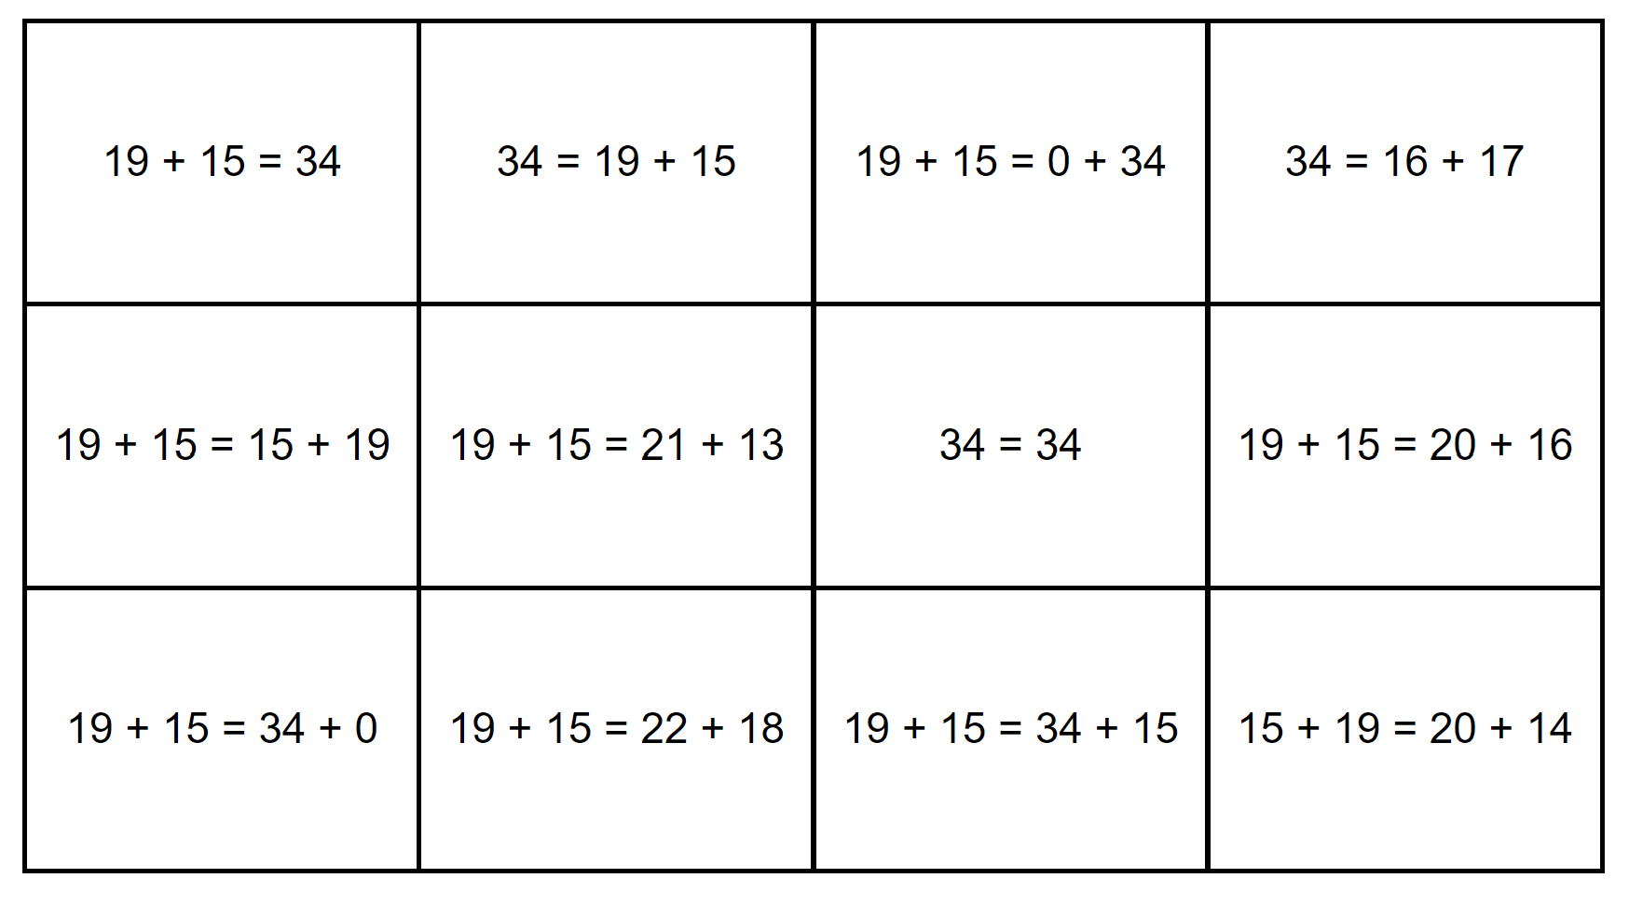

Resource 3 – number expander
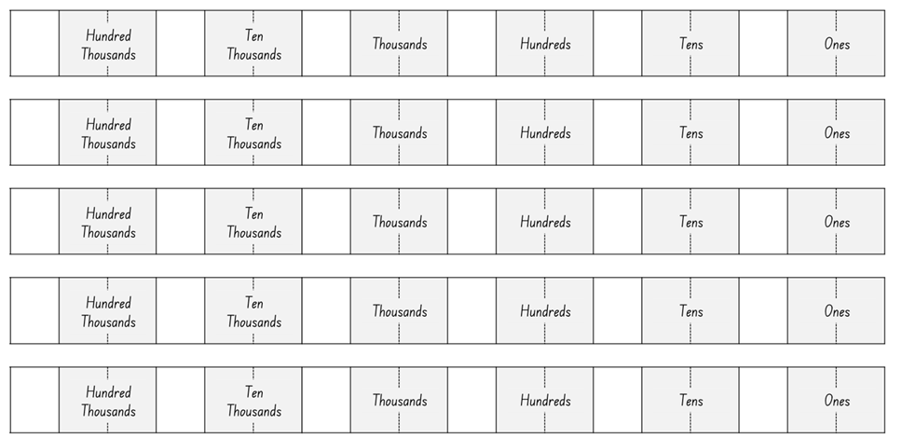

Resource 4 – place value houses
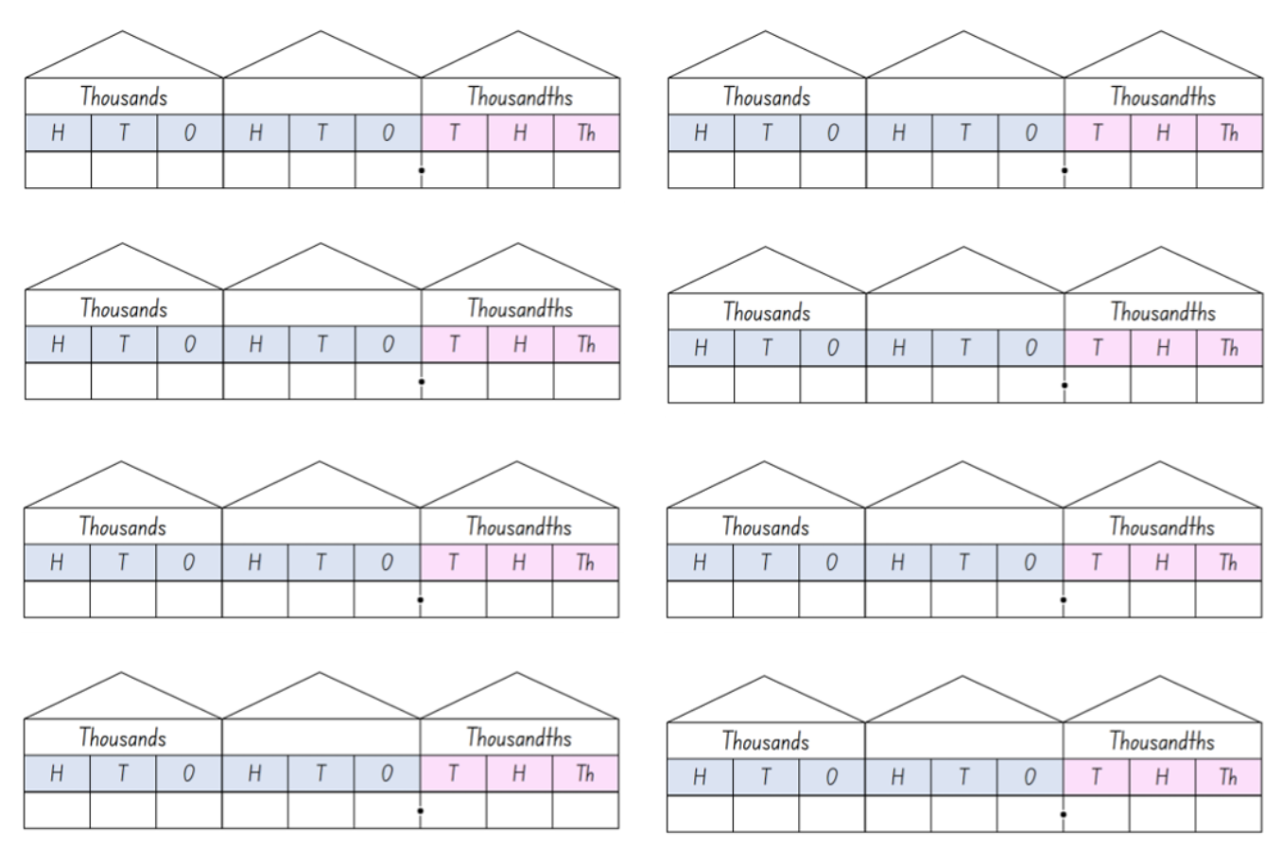

Resource 5 – decimals example 1
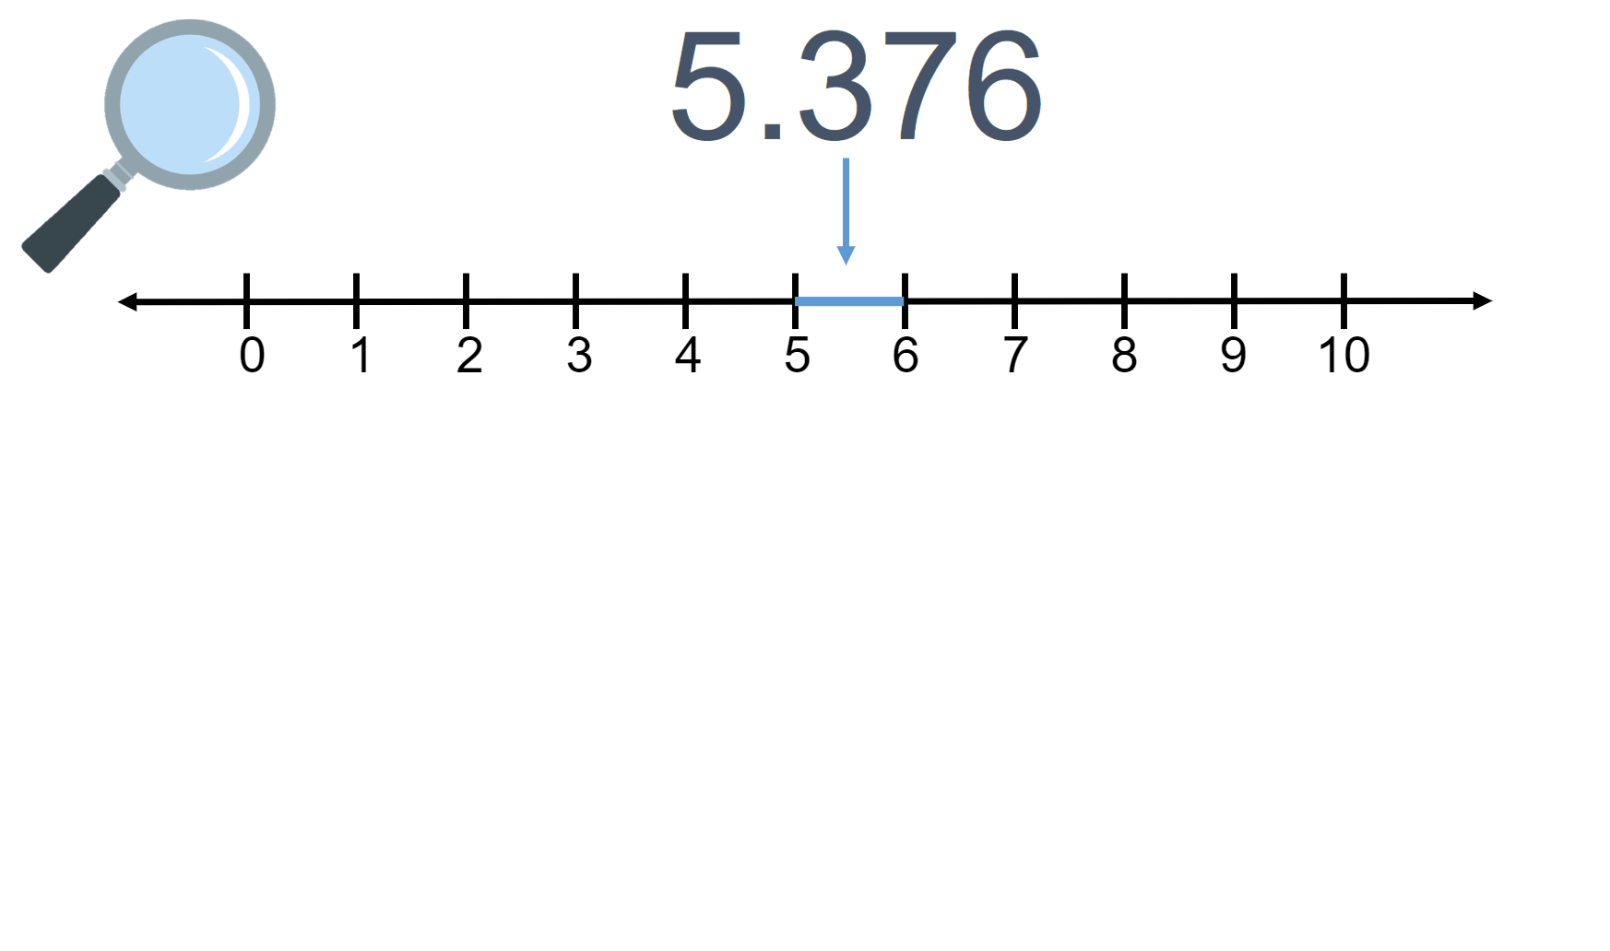

Resource 6 – decimals example 2
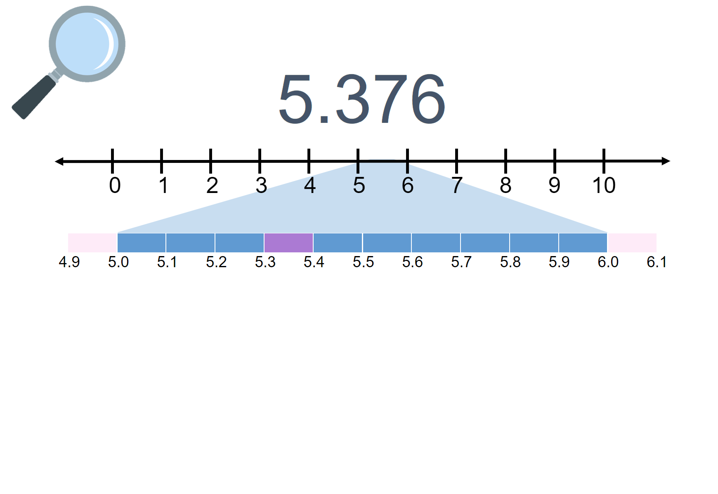

Resource 7 – decimals example 3
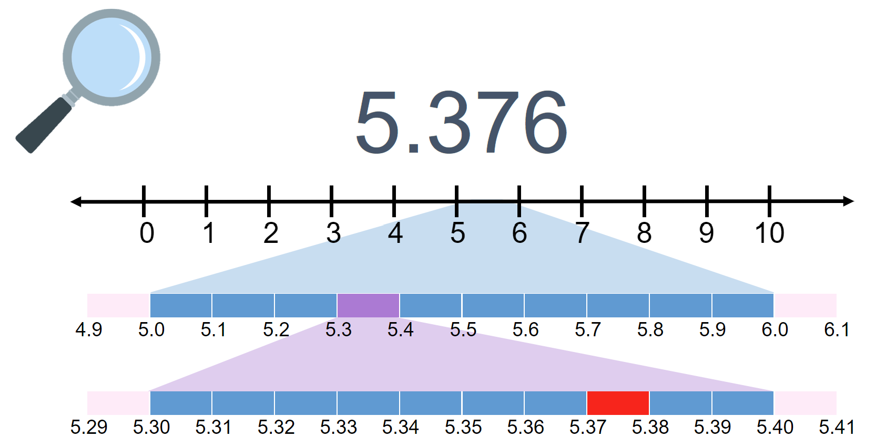

Resource 8 – decimals example 4
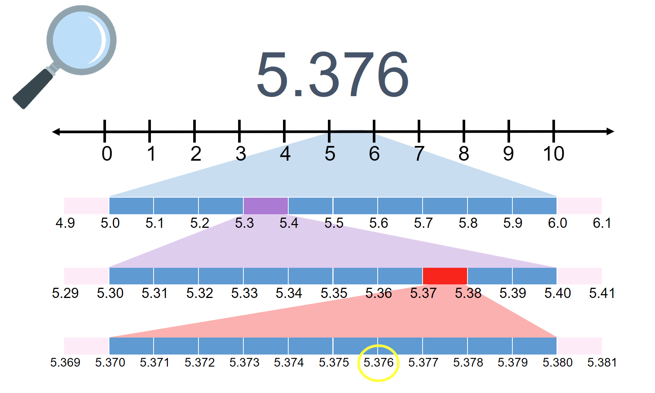

Resource 9 – misconceptions – zero
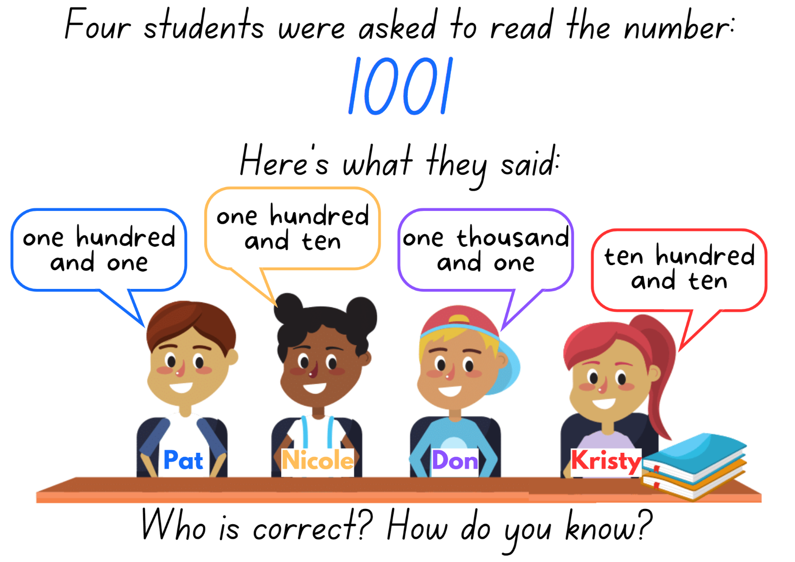

Resource 10 – misconceptions – decimals
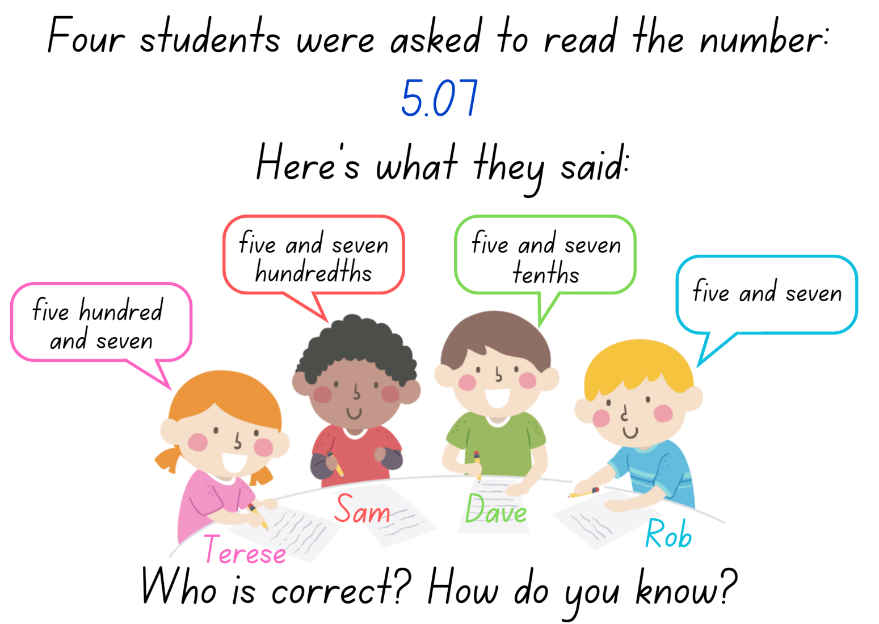

Resource 11 – reaction times
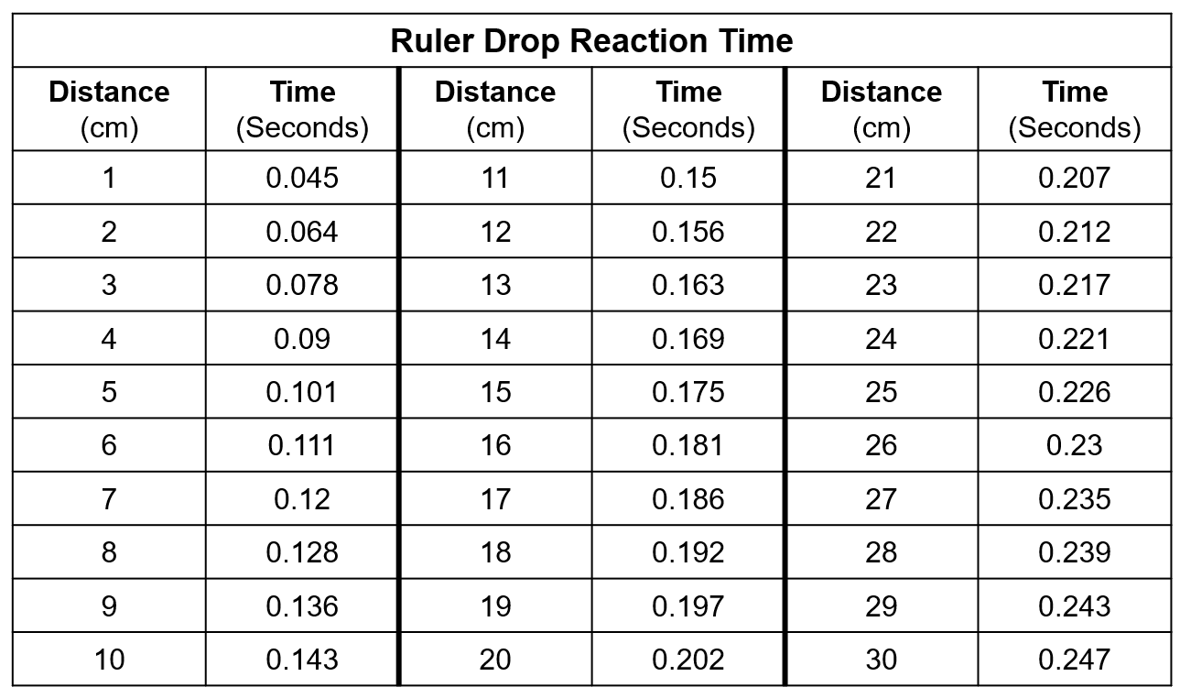

Resource 12 – Which doesn’t belong?
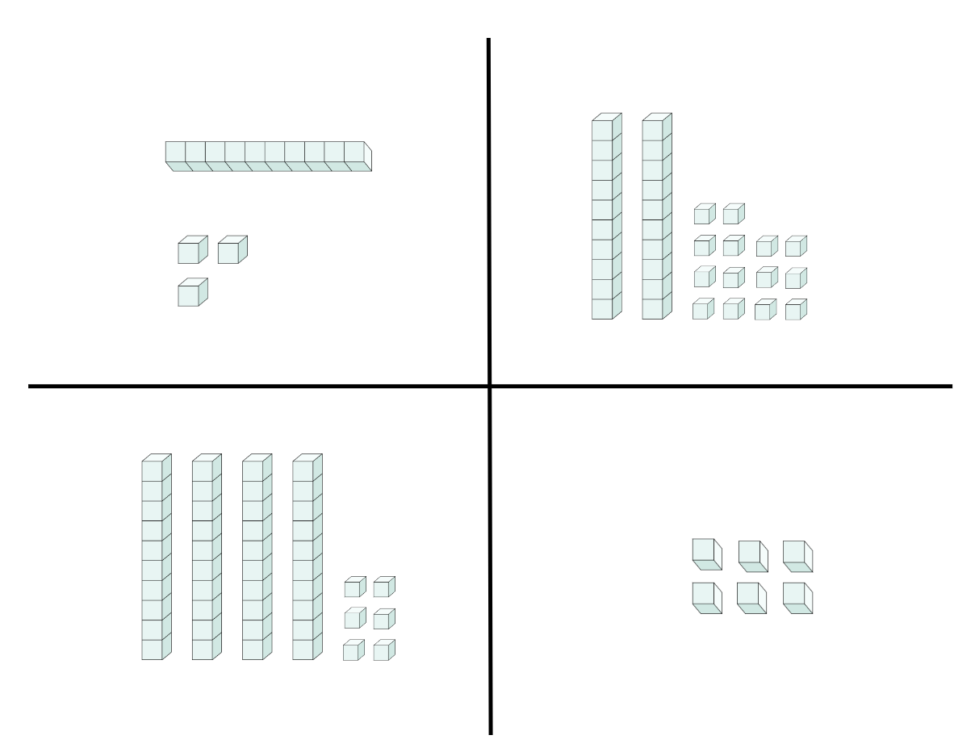

Resource 13 – collections of 1224
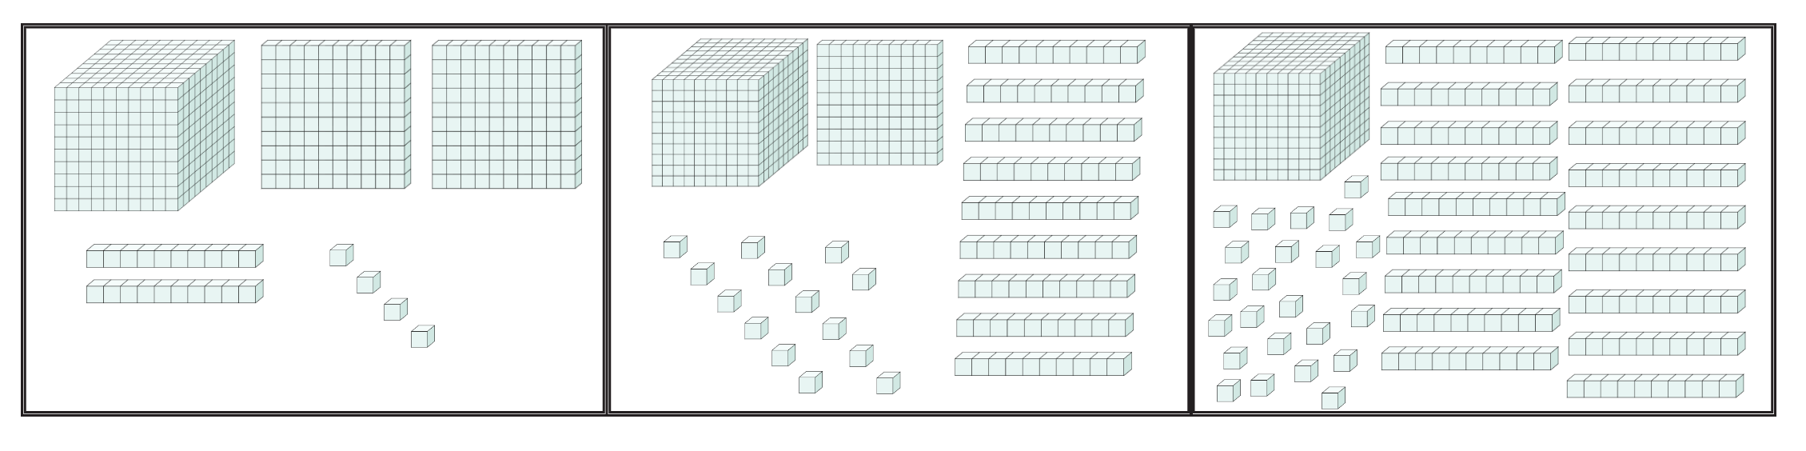

Resource 14 – table of combinations
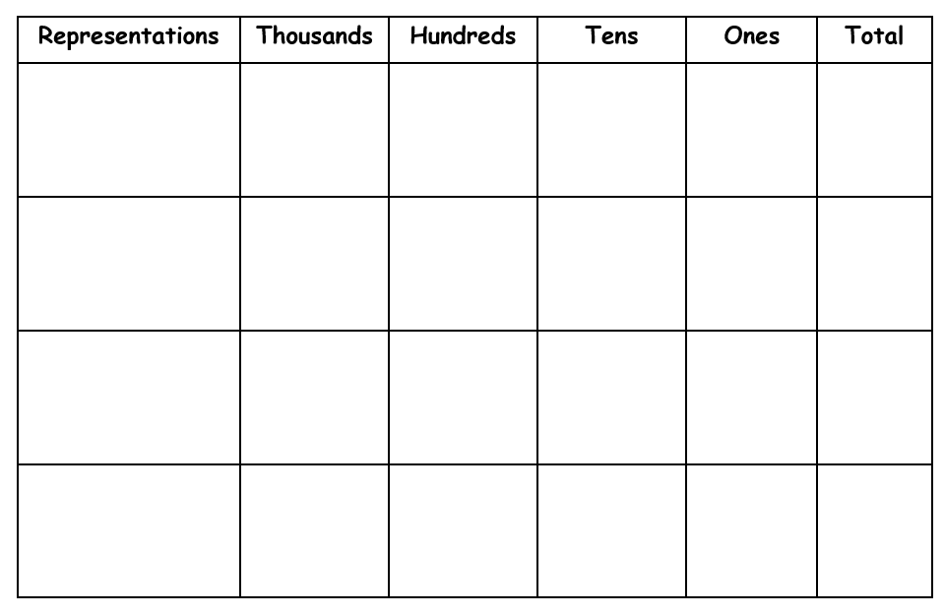

Resource 15 – blank decimal grids
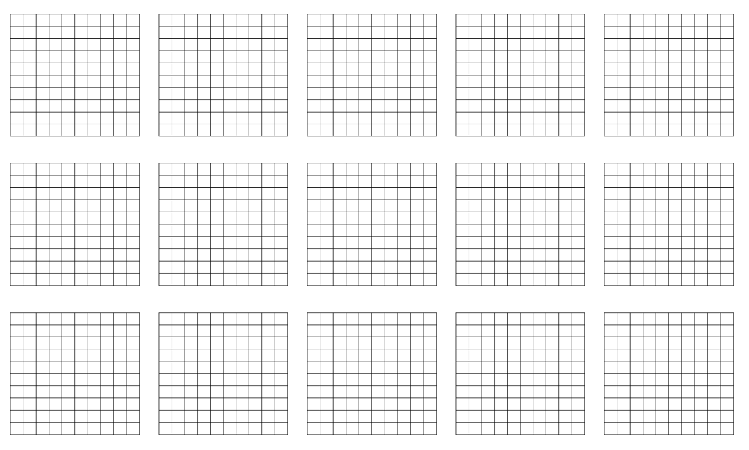

Resource 16 – comparing decimals
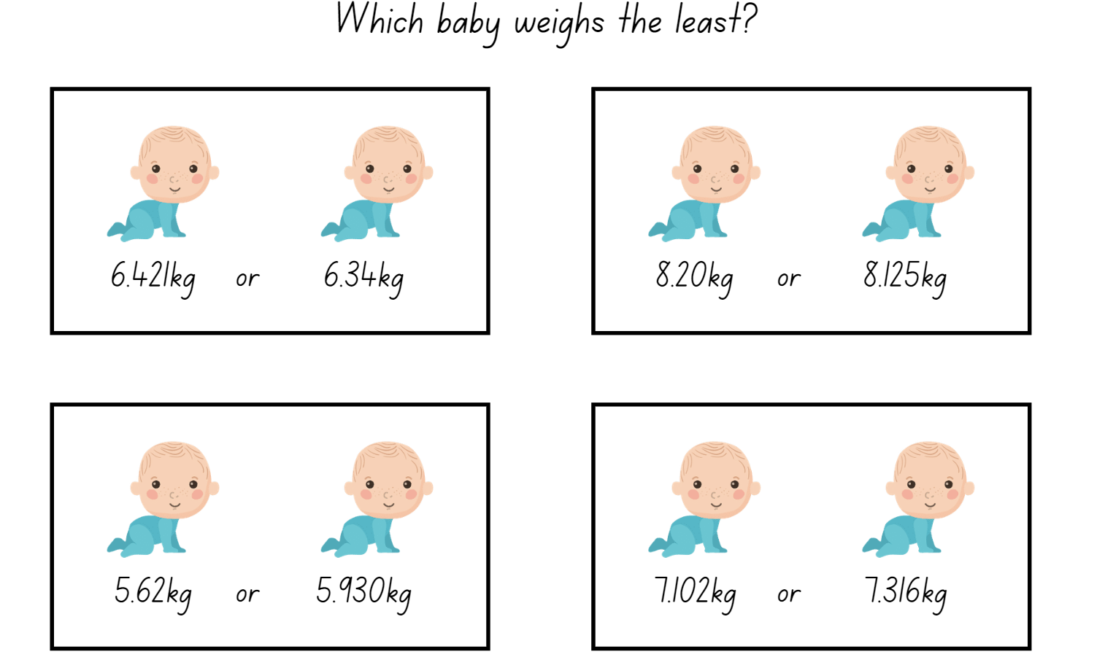

Resource 17 – 120 number chart
1 | 2 | 3 | 4 | 5 | 6 | 7 | 8 | 9 | 10
11 | 12 | 13 | 14 | 15 | 16 | 17 | 18 | 19 | 20
21 | 22 | 23 | 24 | 25 | 26 | 27 | 28 | 29 | 30
31 | 32 | 33 | 34 | 35 | 36 | 37 | 38 | 39 | 40
41 | 42 | 43 | 44 | 45 | 46 | 47 | 48 | 49 | 50
51 | 52 | 53 | 54 | 55 | 56 | 57 | 58 | 59 | 60
61 | 62 | 63 | 64 | 65 | 66 | 67 | 68 | 69 | 70
71 | 72 | 73 | 74 | 75 | 76 | 77 | 78 | 79 | 80
81 | 82 | 83 | 84 | 85 | 86 | 87 | 88 | 89 | 90
91 | 92 | 93 | 94 | 95 | 96 | 97 | 98 | 99 | 100
101 | 102 | 103 | 104 | 105 | 106 | 107 | 108 | 109 | 110
111 | 112 | 113 | 114 | 115 | 116 | 117 | 118 | 119 | 120

Resource 18 – addition number sentences
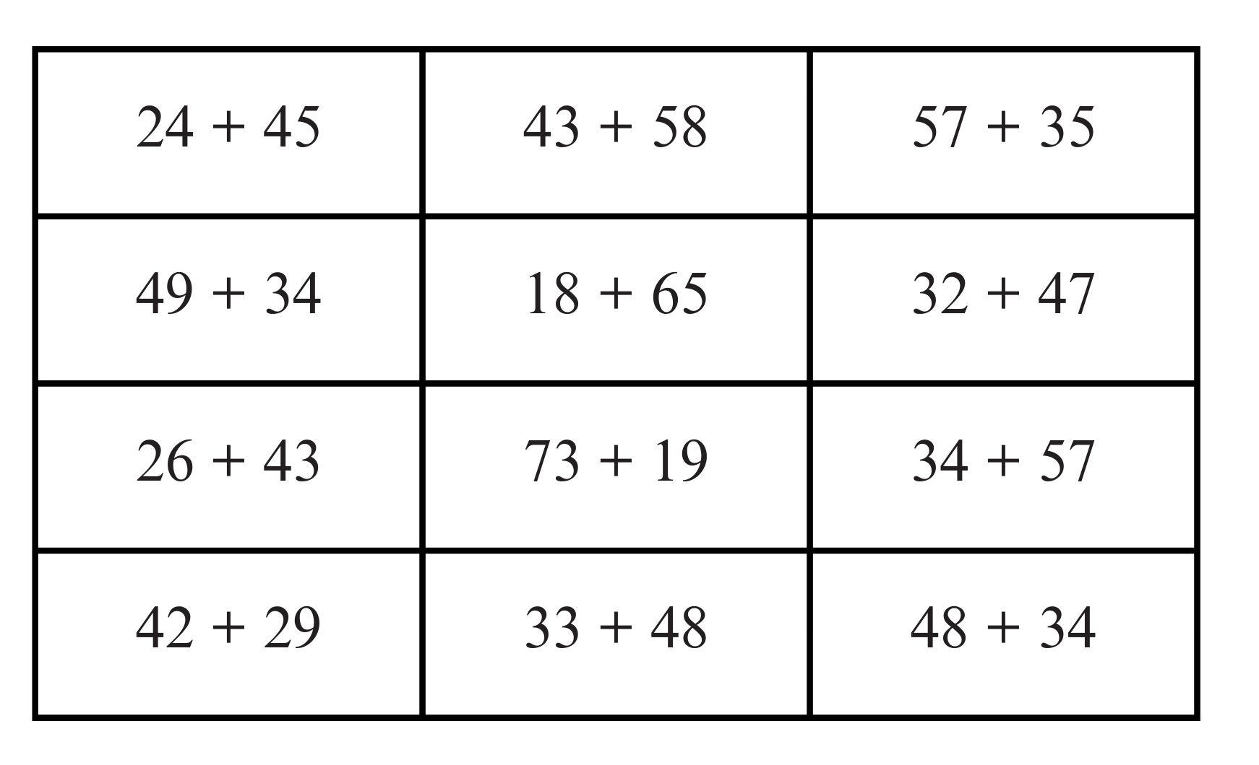

Resource 19 – subtraction number sentences
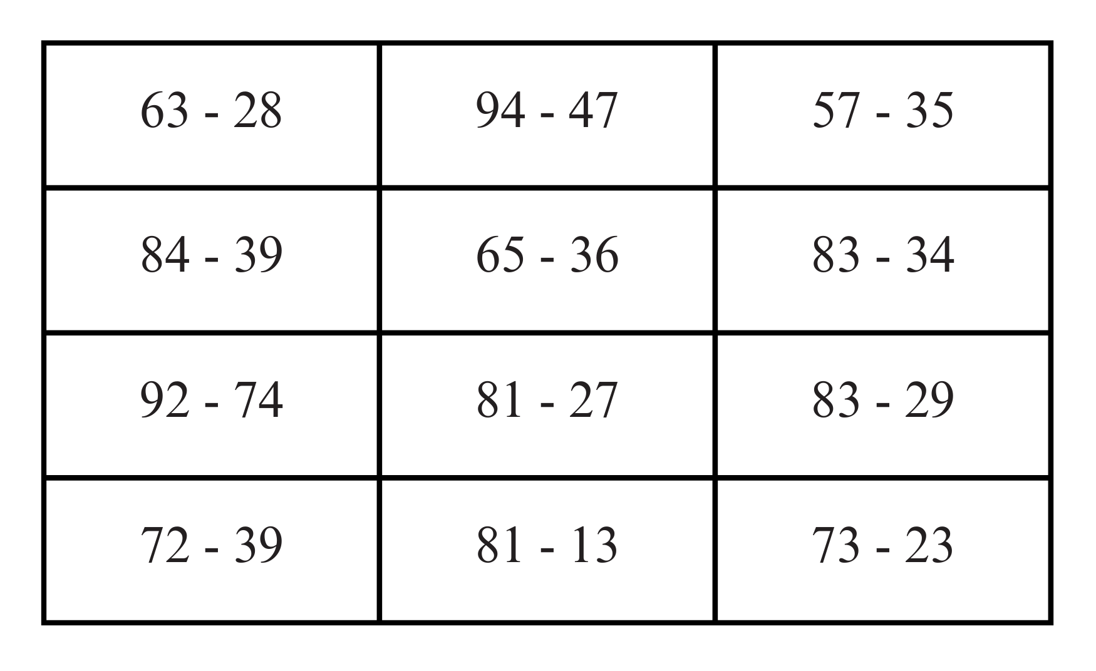

Resource 20 – efficient additive strategies
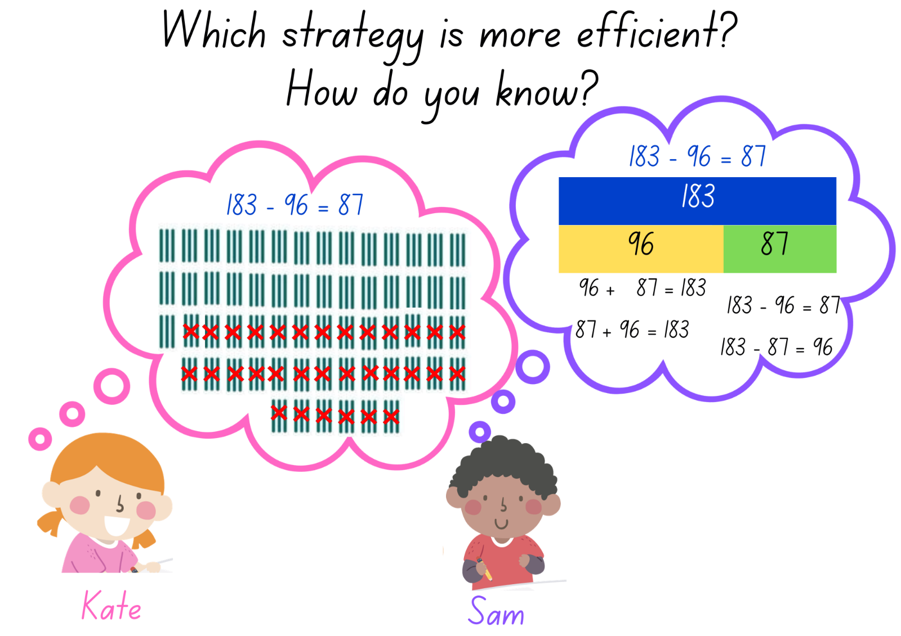

Resource 21 – codeword
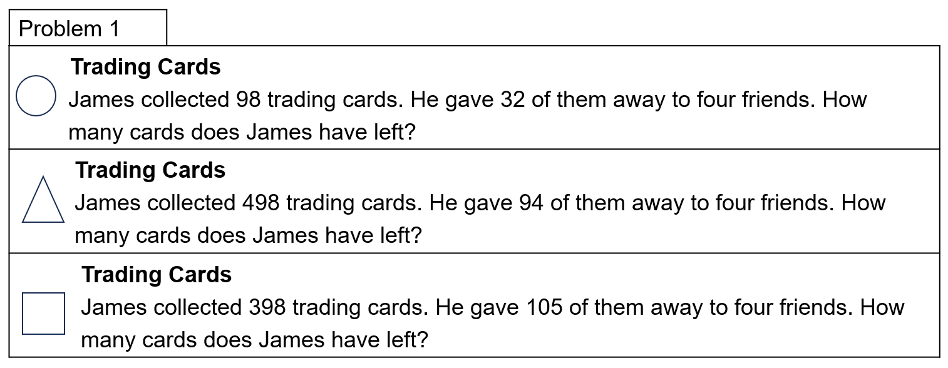
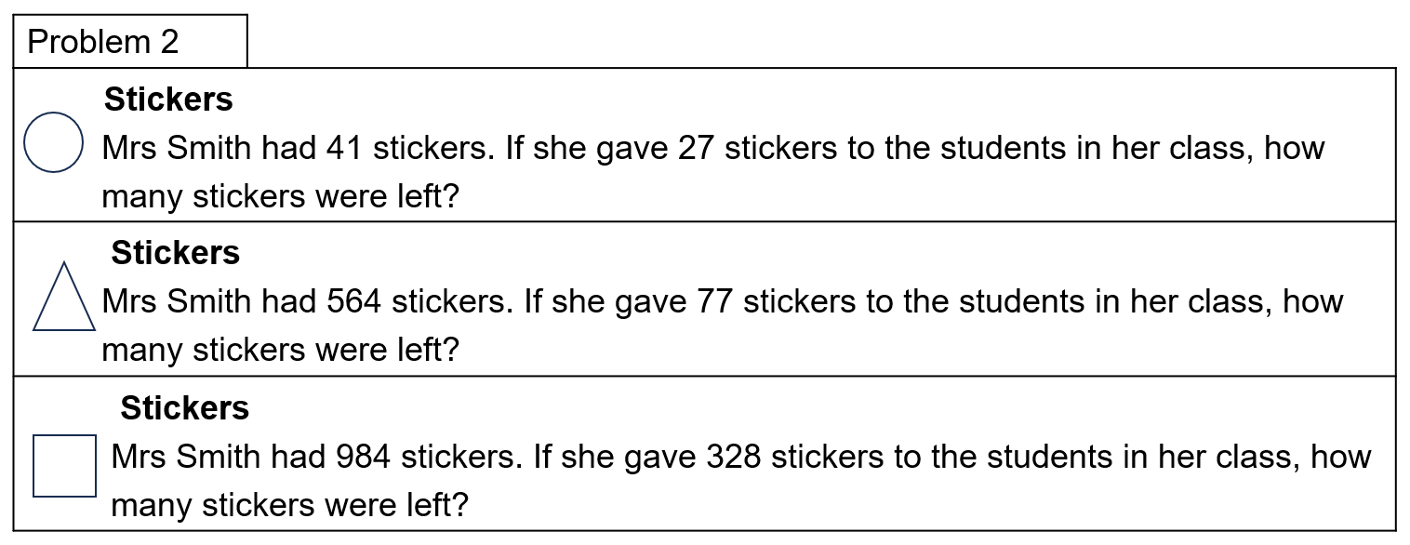
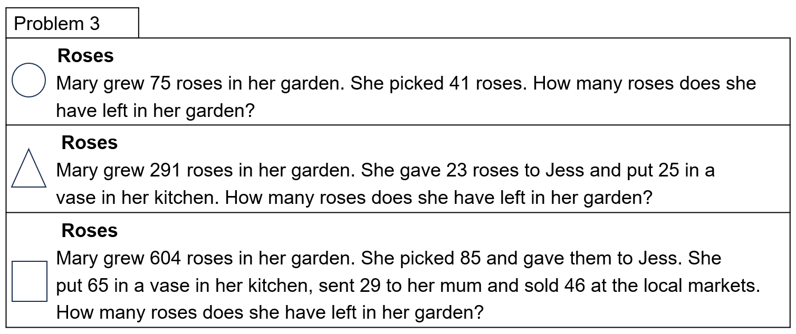
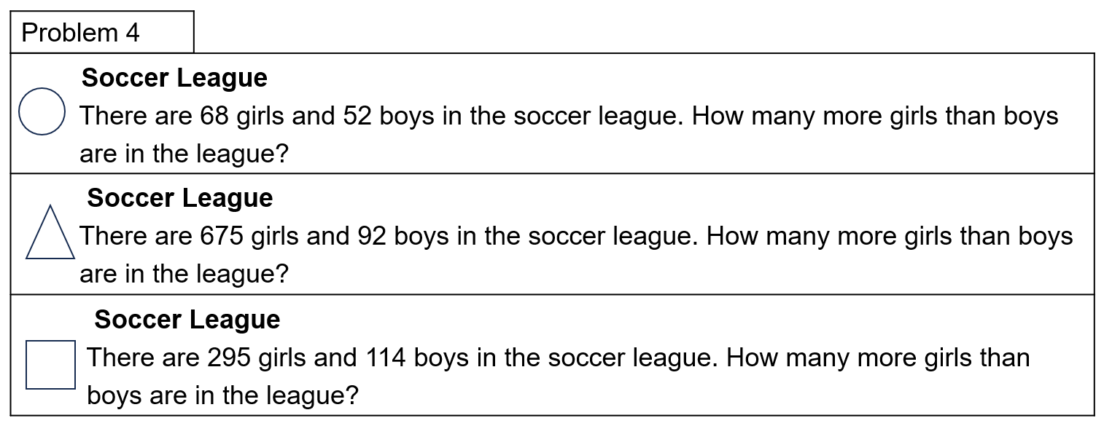

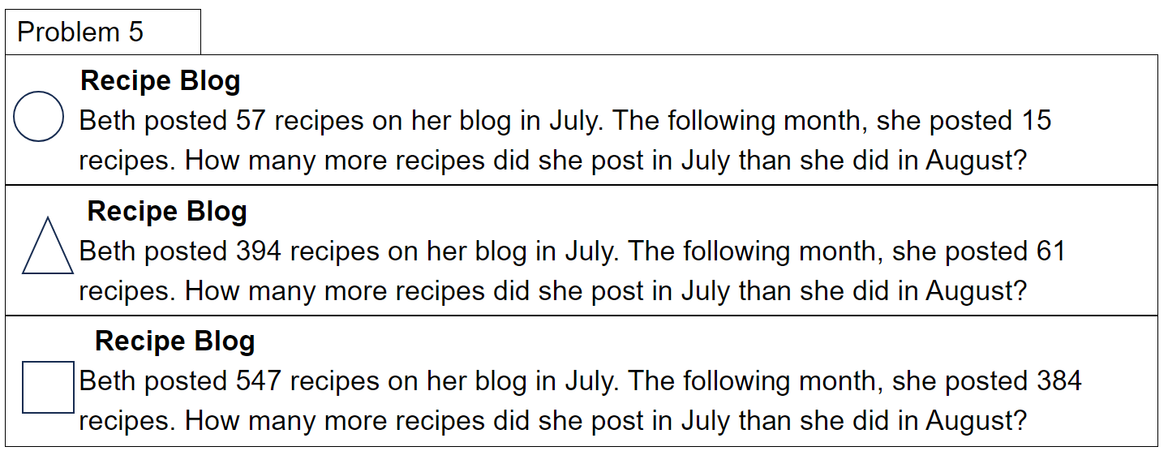
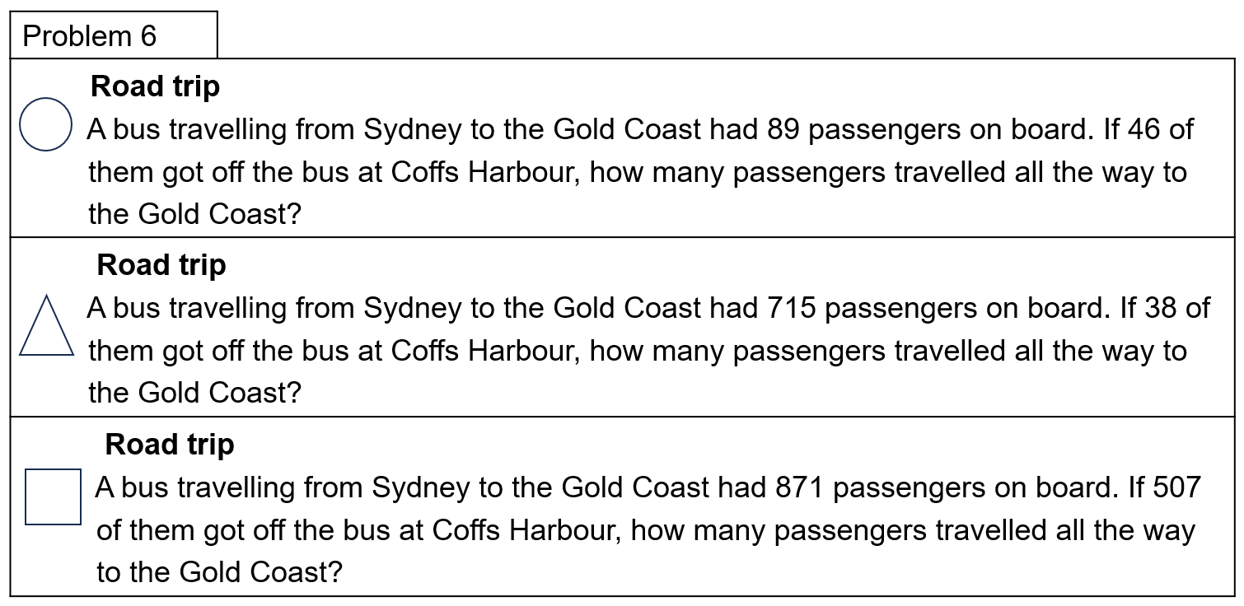

Resource 22 – codeword answer sheet
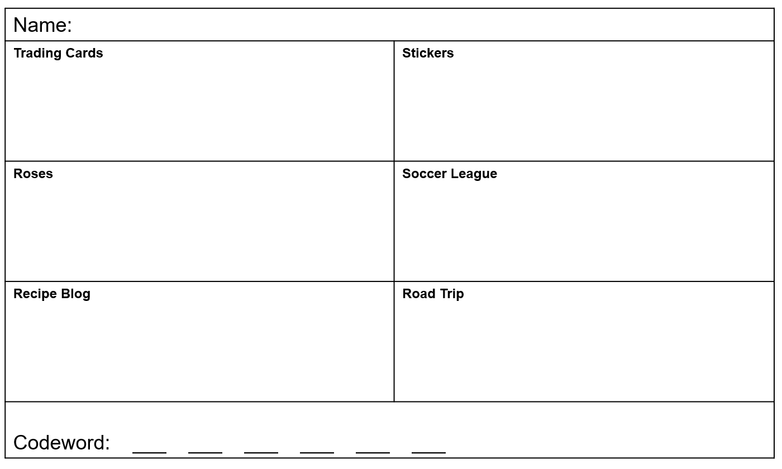

Resource 23 – solution scaffold
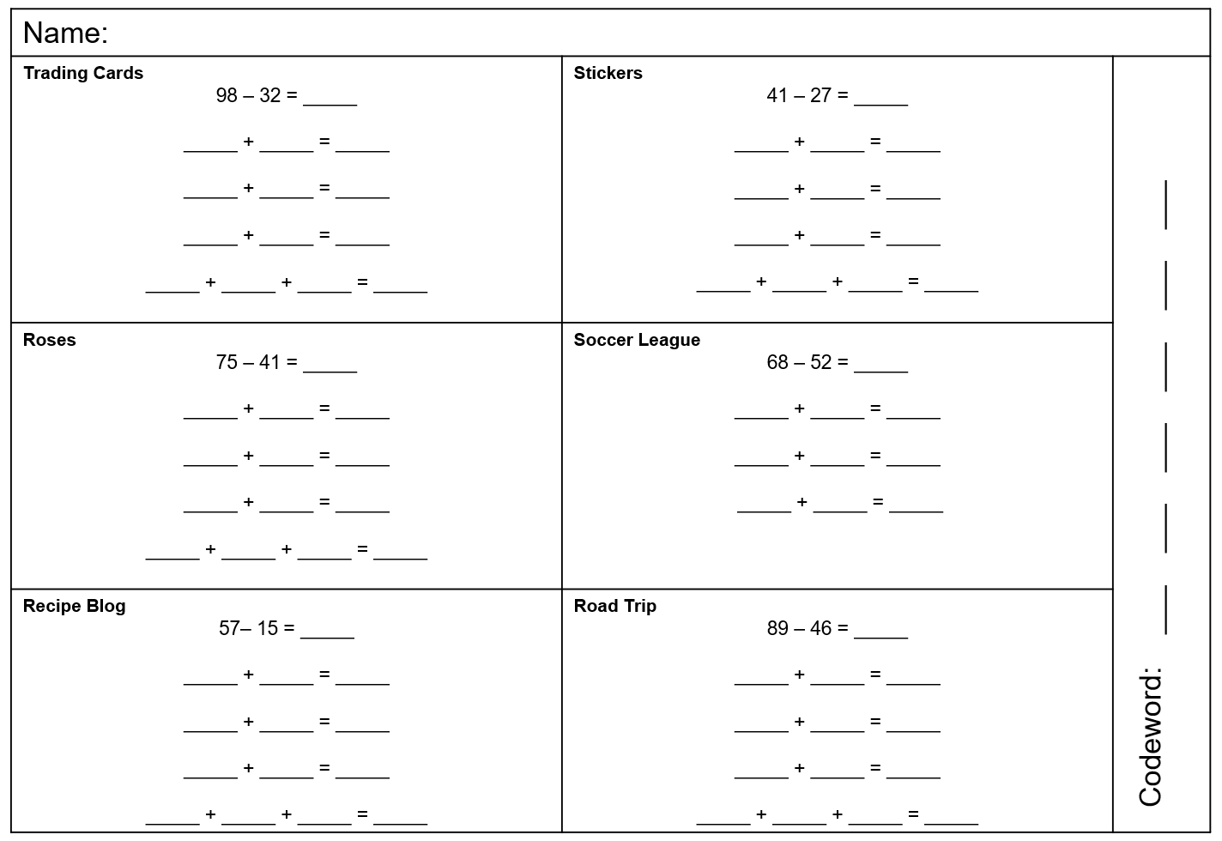

Resource 24 – bar model puzzle
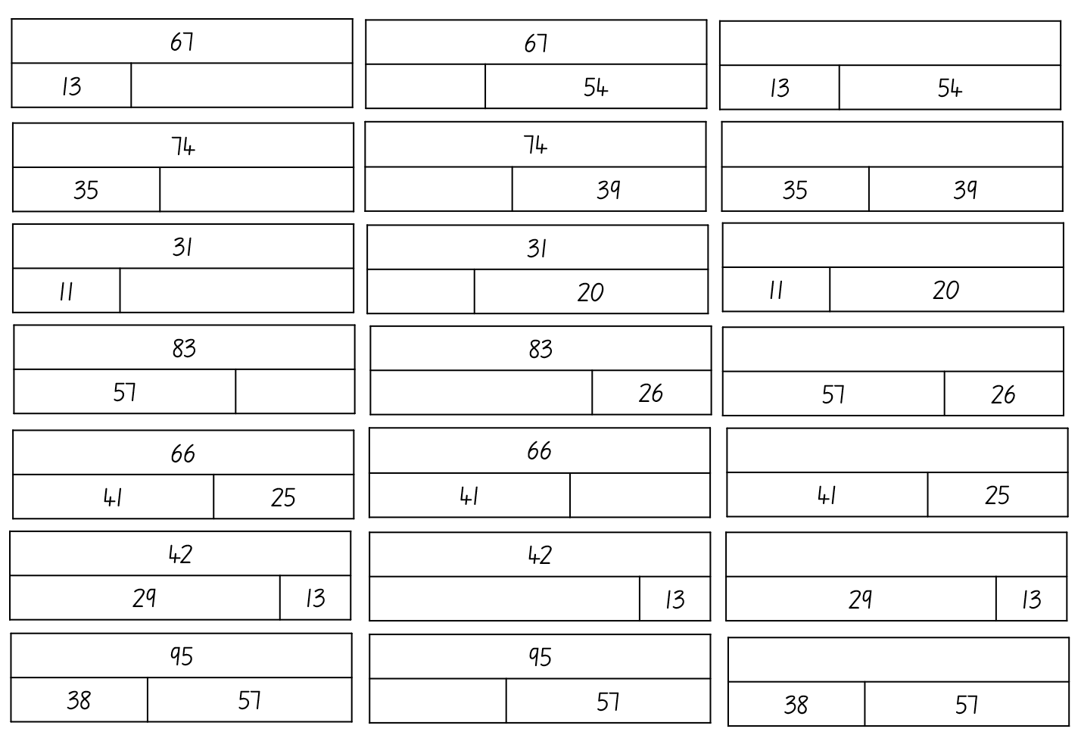

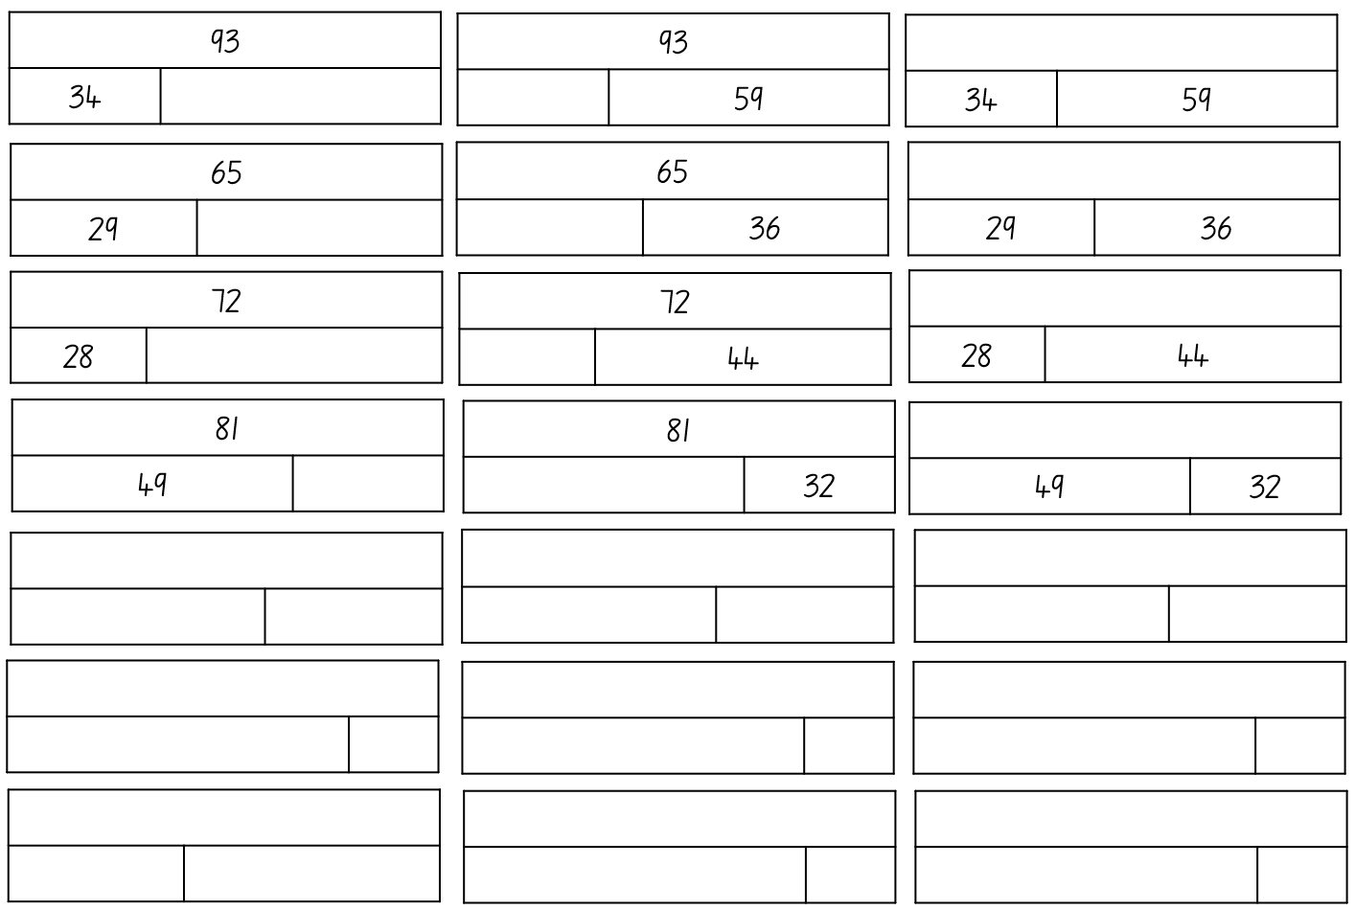

Resource 25 – number cards
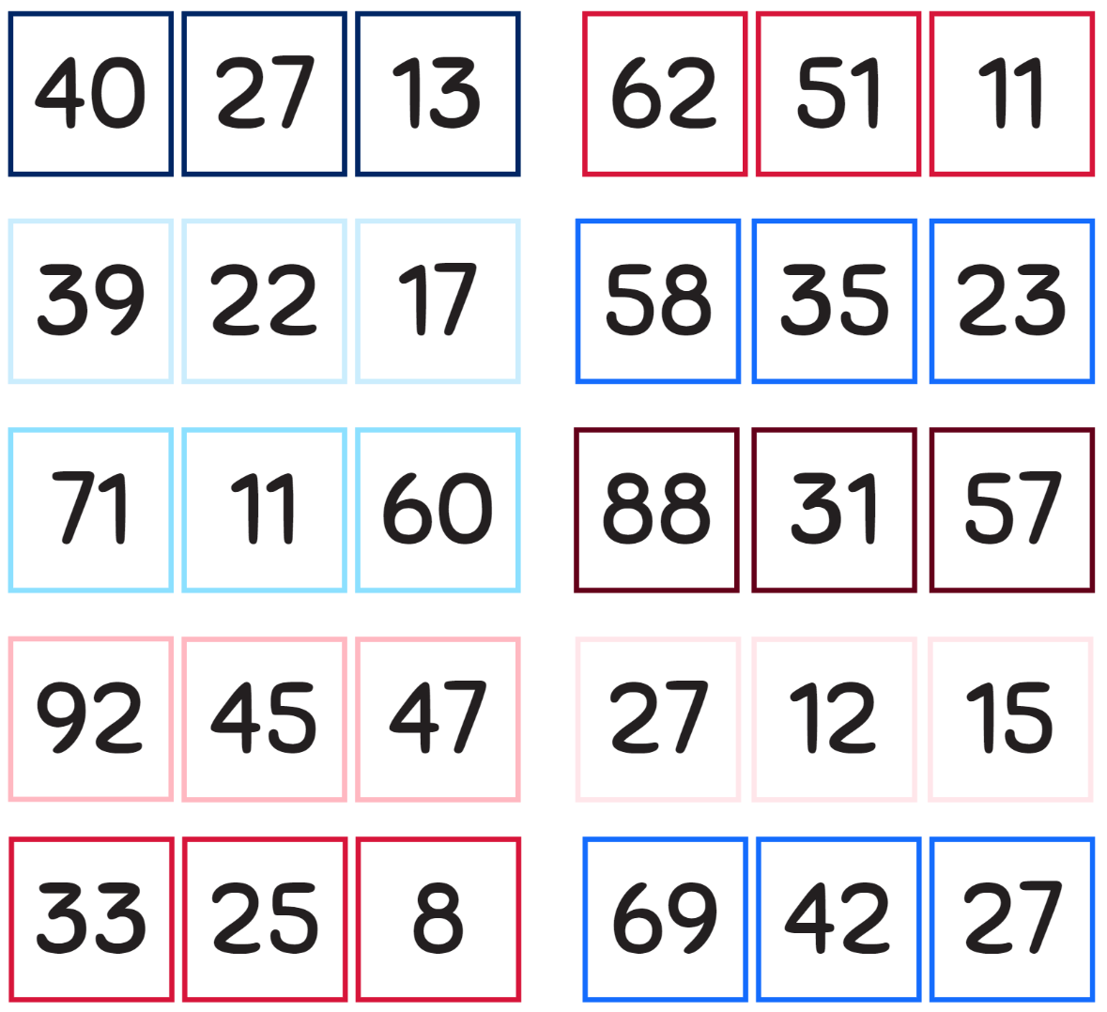

Resource 26 – word problems
- On the weekend 532 people went to see a movie. Halfway through the movie, 67 people left because they didn’t like it.
- How many people watched the whole movie?
- If 213 children watched the whole movie, how many adults watched the whole movie?
- In a school of 783 students, 432 parents visited for a special assembly. Of those 432, 213 took one child home after the assembly. How many children were at school for the remainder of the day?

Resource 27 – representing subtraction
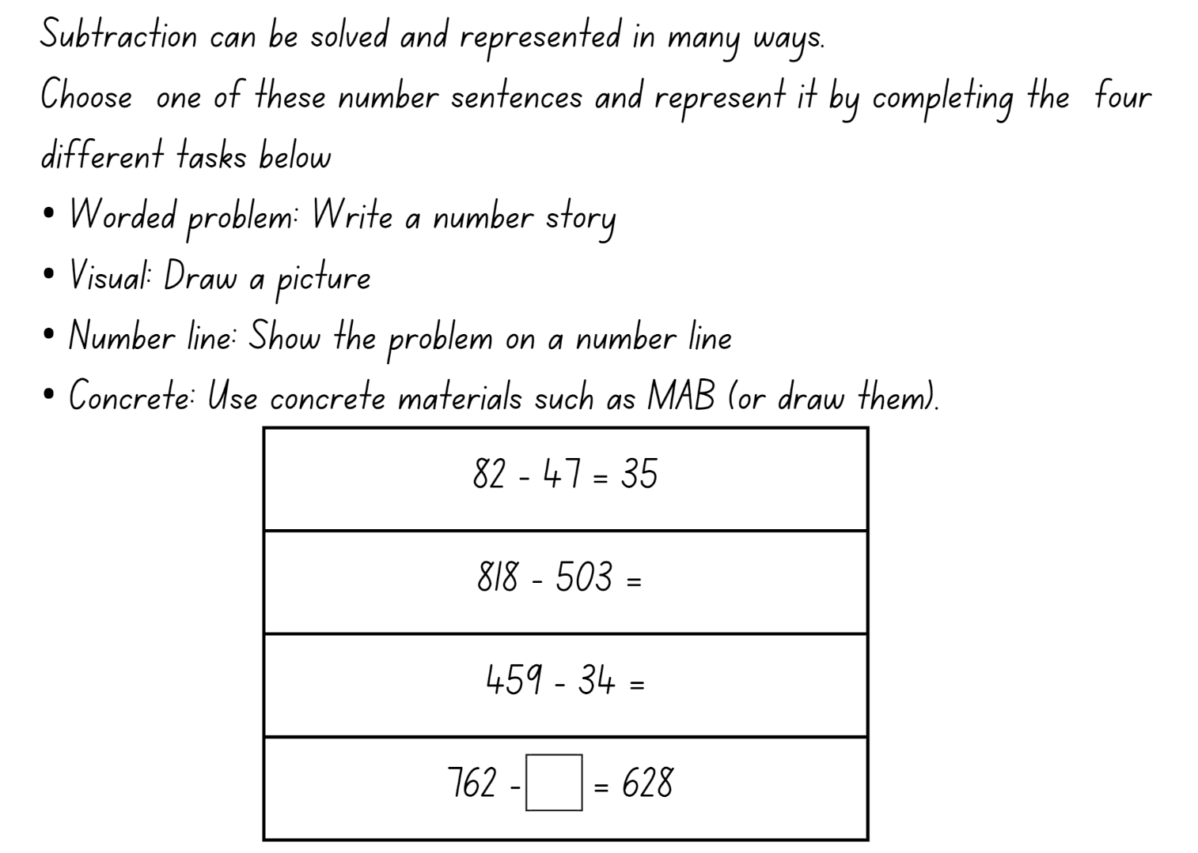

Syllabus outcomes and content

Stage 2
The table below outlines the syllabus outcomes and range of relevant syllabus content covered in this unit. Content is linked to National Numeracy Learning Progression version (3).
Outcomes and content | 1 | 2 | 3 | 4 | 5 | 6 | 7 | 8
Representing numbers using place value A: Whole numbers: Read, represent and order numbers to thousands
MAO-WM-01, MA2-RN-01
- Group physical or virtual objects to show the structure of tens, hundreds and a thousand |  | x | x |  | x
- Regroup numbers flexibly, recognising one thousand as 10 hundreds and one hundred as 10 tens or 100 ones |  | x
- Represent numbers up to and including thousands using physical or virtual manipulatives, words, numerals, diagrams and digital displays | x | x | x | x
- Read and order numbers of up to at least 4 digits | x |  | x
- Identify the number before and after a number with an internal zero digit |  |  |  | x
Representing numbers using place value A: Whole numbers: Apply place value to partition and regroup numbers up to 4 digits
MAO-WM-01, MA2-RN-01
- Record numbers using standard place value form | x | x |  | x | x | x
- Partition numbers of up to 4 digits in non-standard forms (Reasons about quantity) |  | x |  |  | x
Representing numbers using place value B: Whole numbers: Order numbers in the thousands
MAO-WM-01, MA2-RN-01
- Arrange numbers in the thousands in ascending and descending order | x |  | x
- Recognise and describe how rearranging digits changes the size of a number (Reasons about relations) |  |  | x
Representing numbers using place value B: Whole numbers: Apply place value to partition, regroup and rename numbers up to 6 digits
MAO-WM-01, MA2-RN-01
- Name thousands using the place value grouping of ones, tens and hundreds of thousands | x | x |  |  |  | x | x
- Use place value to expand the number notation |  | x |  |  |  | x
- Partition numbers of up to 6 digits in non-standard forms |  | x
Representing numbers using place value B: Recognise and represent numbers that are 10, 100 or 1000 times as large
MAO-WM-01, MA2-RN-01
- Recognise the number of tens, hundreds or thousands in a number | x
- Describe how making a number 10, 100 or 1000 times as large changes the place value of digits |  |  | x
Additive relations A: Use the principle of equality
MAO-WM-01, MA2-AR-01
- Use the equals sign to mean 'the same as', rather than to perform an operation | x | x |  |  |  |  |  | x
Additive relations A: Recognise and explain the connection between addition and subtraction
MAO-WM-01, MA2-AR-01
- Use number relation principles to solve related problems (Reasons about relations) |  |  |  |  | x |  |  | x
- Demonstrate how addition and subtraction are inverse operations |  |  |  |  |  |  |  | x
- Use the complement principle of addition and subtraction (Reasons about relations) |  |  |  |  |  |  |  | x
- Explain and check solutions to problems, including by using the inverse operation |  |  |  |  |  |  |  | x
Additive relations A: Select strategies flexibly to solve addition and subtraction problems of up to 3 digits
MAO-WM-01, MA2-AR-01
- Apply known mental strategies that use partitioning to add and subtract, such as bridging the decades |  |  | x |  |  | x | x | x
- Represent solutions to addition and subtraction problems, including word problems, using an empty number line or bar model |  |  |  |  |  |  | x | x
- Compare and evaluate strategies used to solve addition and subtraction problems, reasoning which strategy may be most efficient |  |  |  |  |  | x | x
Additive relations B: Partition, rearrange and regroup numbers to at least 1000 to solve additive problems
MAO-WM-01, MA2-AR-01
- Use quantity values and non-standard partitioning to solve addition and subtraction problems |  |  |  |  |  | x
- Model addition with and without regrouping and record the method used |  |  |  |  |  | x
- Model subtraction with and without regrouping and record the method used |  |  |  |  |  | x
Mathematics K–10 Syllabus © NSW Education Standards Authority (NESA) for and on behalf of the Crown in right of the State of New South Wales, 2022.

Stage 3
The table below outlines the syllabus outcomes and range of relevant syllabus content covered in this unit. Content is linked to National Numeracy Learning Progression version (3).
Outcomes and content | 1 | 2 | 3 | 4 | 5 | 6 | 7 | 8
Represents numbers A: Whole numbers: Recognise, represent and order numbers in the millions
MAO-WM-01, MA3-RN-01
- Name millions using the place value grouping of ones, tens and hundreds | x |  |  |  |  | x
- Arrange numbers in the millions in ascending and descending order using place value | x
Represents numbers A: Whole numbers: Apply place value to partition, regroup and rename numbers to 1 billion
MAO-WM-01, MA3-RN-01
- Recognise 1000 thousands is 1 million and 1000 millions is 1 billion |  |  |  |  |  |  | x
- Regroup numbers in different forms (Reasons about quantity) |  | x |  |  |  |  |  | x
- Partition numbers to 1 billion in non-standard forms |  | x
Represents numbers A: Decimals and percentages: Recognise that the place value system can be extended beyond hundredths
MAO-WM-01, MA3-RN-02
- Express thousandths as decimals |  |  | x | x
- Interpret decimal notation for thousandths |  |  |  | x
- Indicate the place value of digits in decimal numbers of up to 3 decimal places |  |  |  | x
- Use place value to partition decimals |  |  | x
Represents numbers A: Decimals and percentages: Compare, order and represent decimals
MAO-WM-01, MA3-RN-02
- Compare and order decimal numbers of up to 3 decimal places |  |  | x | x | x
- Interpret zero digit(s) at the end of a decimal |  |  | x | x
- Compare the place value of digits by determining numbers that are 10 or 100 times the original decimal number as well as $\frac{1}{10}$ or $\frac{1}{100}$ times the original decimal numbers |  |  | x | x
- Place decimal numbers of up to 3 decimal places on a number line |  |  | x | x | x
Additive relations A: Apply efficient mental and written strategies to solve addition and subtraction problems
MAO-WM-01, MA3-AR-01
- Solve word problems, including multistep problems |  |  |  |  |  | x |  | x
- Apply known strategies such as levelling, addition for subtraction, using constant difference, and bridging (Reasons about relations) | x | x | x |  | x | x | x | x
- Identify efficient and inefficient multidigit subtraction strategies |  |  |  |  |  | x | x | x
Additive relations A: Use estimation and place value understanding to determine the reasonableness of solutions
MAO-WM-01, MA3-AR-01
- Use place value understanding to check for errors in calculations |  |  |  |  |  | x |  | x
Mathematics K–10 Syllabus © NSW Education Standards Authority (NESA) for and on behalf of the Crown in right of the State of New South Wales, 2022.

References
This resource contains NSW Curriculum and syllabus content. The NSW Curriculum is developed by the NSW Education Standards Authority. This content is prepared by NESA for and on behalf of the Crown in right of the State of New South Wales. The material is protected by Crown copyright.
Please refer to the NESA Copyright Disclaimer for more information https://educationstandards.nsw.edu.au/wps/portal/nesa/mini-footer/copyright.
NESA holds the only official and up-to-date versions of the NSW Curriculum and syllabus documents. Please visit the NSW Education Standards Authority (NESA) website https://educationstandards.nsw.edu.au/ and the NSW Curriculum website https://curriculum.nsw.edu.au/home.
Mathematics K–10 Syllabus © NSW Education Standards Authority (NESA) for and on behalf of the Crown in right of the State of New South Wales, 2022.
National Numeracy Learning Progression © Australian Curriculum, Assessment and Reporting Authority (ACARA) 2010 to present, unless otherwise indicated. This material was downloaded from the Australian Curriculum website (National Numeracy Learning Progression) (accessed 15 September 2023) and was not modified.
AAMT (The Australian Association of Mathematics Teachers) (n.d.) ‘Bridging decades’, Addition and subtraction, Top Drawer Teachers: resources for teachers of mathematics website, accessed 12 September 2023.
ABC (Australian Broadcasting Corporation) (20 October 2021) 'Maths Years 3–4 with Ms Kirszman: Partitioning numbers using place value parts' [video], ABC Education, ABC website, accessed 19 October 2023.
Didax, Inc (2023) ‘120 Number Board’, Virtual Manipulatives, Didax website, accessed 19 October 2023.
Didax, Inc (2023) ‘Dice’, Virtual Manipulatives, Didax website, accessed 19 October 2023.
Dunstan D and Swan P (2023) A Whole School Approach to Place Value, Teaching Place Value Year 4 Whole Numbers, A-Z Type, Australia.
Finkel D (2015) ‘Target Number’, Free Lessons, Math for Love website, accessed 11 September 2023.
Murphy SJ (n.d.) Earth Day Hooray! (Adriani R illus), MathStart website, accessed 18 October 2023.
Primary Learning (2018) Balancing Act – A dice game [PDF 250 KB], Primary Learning, accessed 8 September 2023.
Siemon D, Warren E, Beswick K, Faragher R, Miller J, Horne M, Jazby D and Breed M (2020) Teaching Mathematics: Foundations to Middle Years, 3rd edn, Oxford University Press Australia and New Zealand.
State of New South Wales (Department of Education) (n.d.) Chicken Scramble [PDF 111 KB], School Sport Unit, NSW Department of Education, accessed 12 September 2023.
State of New South Wales (Department of Education) (2020) ‘Garden Path’, Reading and Numeracy Resources, NSW Department of Education website, accessed 12 September 2023.
State of New South Wales (Department of Education) (2023) Identifies, represents and compares decimals, Universal Resources Hub website, accessed 15 September 2023.
State of New South Wales (Department of Education) (2023) ‘Mastermind’, Mathematics K-6 resources, NSW Department of Education website, accessed 11 September 2023.
State of New South Wales (Department of Education) (2023) ‘Reaction time test’, Mathematics K-6 resources, NSW Department of Education website, accessed 15 September 2023.
Sullivan P and Lilburn P (2017) Open-Ended Maths Activities: Using ‘Good’ Questions to Enhance Learning in Mathematics, Revised 2nd edn, Oxford University Press, Melbourne.
The Mathematical Association of Victoria (2020) 3–6 – Remote Maths – Edition 2 [PDF 417 KB], MAV Learning Activities website, accessed 27 June 2023.
University of Cambridge (Faculty of Mathematics) (1997–2023) Dicey Operations in Line, NRICH website, accessed 11 September 2023.
University of Cambridge (Faculty of Mathematics) (1997–2023) True or False?, NRICH website, accessed 18 October 2023.
Williams E (1 June 2023) ‘Primary Maths Dictionary for Kids and Parents: A Guide To The Mathematical Terms Used In KS1 And KS2’, Third Space Learning Blog, accessed 12 September 2023.

© State of New South Wales (Department of Education), 2023
The copyright material published in this resource is subject to the Copyright Act 1968 (Cth) and is owned by the NSW Department of Education or, where indicated, by a party other than the NSW Department of Education (third-party material).
Copyright material available in this resource and owned by the NSW Department of Education is licensed under a Creative Commons Attribution 4.0 International (CC BY 4.0) license.
This license allows you to share and adapt the material for any purpose, even commercially.
Attribution should be given to © State of New South Wales (Department of Education), 2023.
Material in this resource not available under a Creative Commons license:
- the NSW Department of Education logo, other logos and trademark-protected material
- material owned by a third party that has been reproduced with permission. You will need to obtain permission from the third party to reuse its material.
Links to third-party material and websites
Please note that the provided (reading/viewing material/list/links/texts) are a suggestion only and implies no endorsement, by the New South Wales Department of Education, of any author, publisher, or book title. School principals and teachers are best placed to assess the suitability of resources that would complement the curriculum and reflect the needs and interests of their students.
If you use the links provided in this document to access a third-party's website, you acknowledge that the terms of use, including licence terms set out on the third-party's website apply to the use which may be made of the materials on that third-party website or where permitted by the Copyright Act 1968 (Cth). The department accepts no responsibility for content on third-party websites.

