Vamos a celebrar

Activity 1
Practise the conjugations of the verb ir by completing the sentences.
- (Yo) _________ a la fiesta.
- (Tú) _________ a celebrar.
- (Él) _________ a comer.
- (Ella) _________ a bailar.
- (Nosotros) _________ a recibir regalos.
- (Vosotros) _________ a cantar.
- (Ellos) _________ a jugar a juegos.
- (Ellas) _________ a ver el desfile.
- (Usted) _________ a ver fuegos artificiales.
- (Yo) _________ a pasarlo bien.

Activity 2
Use the prompts in the table below to create sentences using the verb ir + a + [activity] to describe what people are going to do. The first one has been done for you as an example.
Pronoun | Activity | Sentence
yo | 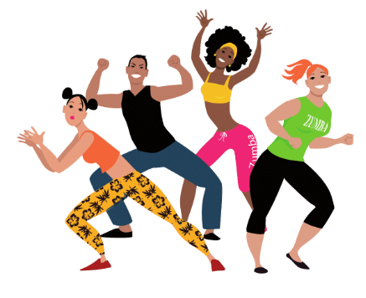 | Voy a bailar.
tú | 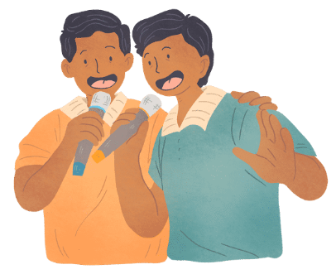
él
ella
nosotros | 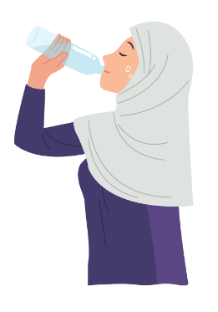
ellas | 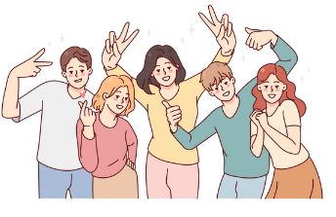
ellas | 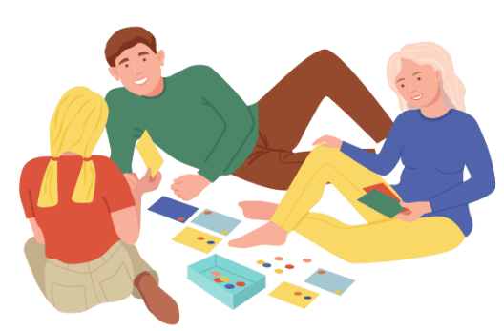
yo | 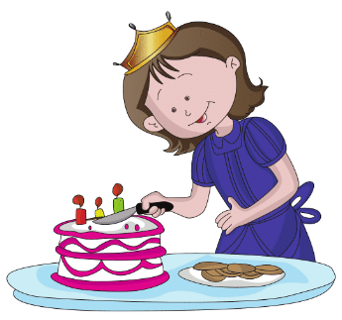
tú | 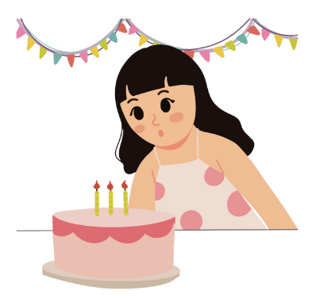
ella
él | 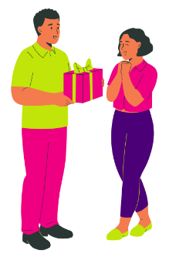

Activity 3 – card games
Work in pairs or groups of 3.

Create sentences 1
Your teacher will provide each pair or group with 2 sets of cards:
- set 1 – pronouns
- set 2 – activities.
Place the 2 piles of cards face down on the table and take turns to draw a card from each pile. Use the visual prompts to form a sentence using the verb ir, for example (yo) Voy a cantar.

Create sentences 2
Your teacher will provide you with an additional set of cards, set 3 – verbs.
Place all of the cards from sets 1 and 3 on the table, facing up. Take turns matching the subject pronouns with the correct conjugations of the verb, placing the cards face up in front of you. When all pronoun and verb cards have been matched, take turns to take a card from set 2 to create a sentence using all 3 cues, for example, Tú vas a bailar.
When you have finished, write 5 of the sentences you have created into your book (or device).

For the teacher
Differentiation example
The following strategy provides a starting point for how you can differentiate this activity for a range of learners. Adapt or design alternatives, to meet the needs of students in your class.
Students requiring additional support – provide students the ‘Let’s celebrate – sentence scaffold’ resource [DOCX 224KB], for additional support if required.

Activity 1
Practise the conjugations of the verb ir by completing the sentences.
- (Yo) voy a la fiesta.
- (Tú) vas a celebrar.
- (Él) va a comer.
- (Ella) va a bailar.
- (Nosotros) vamos a recibir regalos.
- (Vosotros) vais a cantar.
- (Ellos) van a jugar a juegos.
- (Ellas) van a ver el desfile.
- (Usted) van a ver fuegos artificiales.
- (Yo) voy a pasarlo bien.

Activity 2
Pronoun | Activity | Sentence
yo |  | Voy a bailar.
tú |  | Vas a cantar.
él |  | Va a celebrar.
ella |  | Va a comer
nosotros |  | Vamos a beber.
ellas |  | Van a pasarlo bien.
ellas |  | Van a jugar a juegos.
yo |  | Voy a cortar la torta.
tú |  | Va a soplar las velas.
ella |  | Va a recibir regalos.
él |  | Va a llevar regalos.

Activity 3 – card activities
Print as many sets of set 1 (pronouns), set 2 (activities) and set 3 (verbs) as required to provide each pair or group of 3 with one set each.

Create sentences 1
Students use sets 1 and 2 for this activity. Students place the cards face down in 2 piles on the table and take turns to draw a card from each pile. They then use the visual prompts to form a sentence using the verb ir, for example (yo) Voy a cantar.

Create sentences 2
Students use all 3 sets for this activity. Students place the cards from sets 1 and 3 on the table, facing up. Students then take turns matching the subject pronouns with the correct conjugations of the verb, placing the cards face up in front of them. When all pronoun and verb cards have been matched, students take turns to take a card from set 2 to create a sentence using all 3 cues, for example, Tú vas a bailar.
Students then write 5 of the sentences they have created in their books or devices.

Set 1 – pronouns
tú | yo
ella | él
vosotros | nosotros
ellas | ellos
usted | ustedes

Set 2 – activities

Set 3 – verbs
vas | voy
va | va
vamos | vais
van | van
va | van

© State of New South Wales (Department of Education), 2023
The copyright material published in this resource is subject to the Copyright Act 1968 (Cth) and is owned by the NSW Department of Education or, where indicated, by a party other than the NSW Department of Education (third-party material).
Copyright material available in this resource and owned by the NSW Department of Education is licensed under a Creative Commons Attribution 4.0 International (CC BY 4.0) license.
This license allows you to share and adapt the material for any purpose, even commercially.
Attribution should be given to © State of New South Wales (Department of Education), 2023.
Material in this resource not available under a Creative Commons license:
- the NSW Department of Education logo, other logos and trademark-protected material
- material owned by a third party that has been reproduced with permission. You will need to obtain permission from the third party to reuse its material.
Links to third-party material and websites
Please note that the provided (reading/viewing material/list/links/texts) are a suggestion only and implies no endorsement, by the New South Wales Department of Education, of any author, publisher, or book title. School principals and teachers are best placed to assess the suitability of resources that would complement the curriculum and reflect the needs and interests of their students.
If you use the links provided in this document to access a third-party's website, you acknowledge that the terms of use, including licence terms set out on the third-party's website apply to the use which may be made of the materials on that third-party website or where permitted by the Copyright Act 1968 (Cth). The department accepts no responsibility for content on third-party websites.

